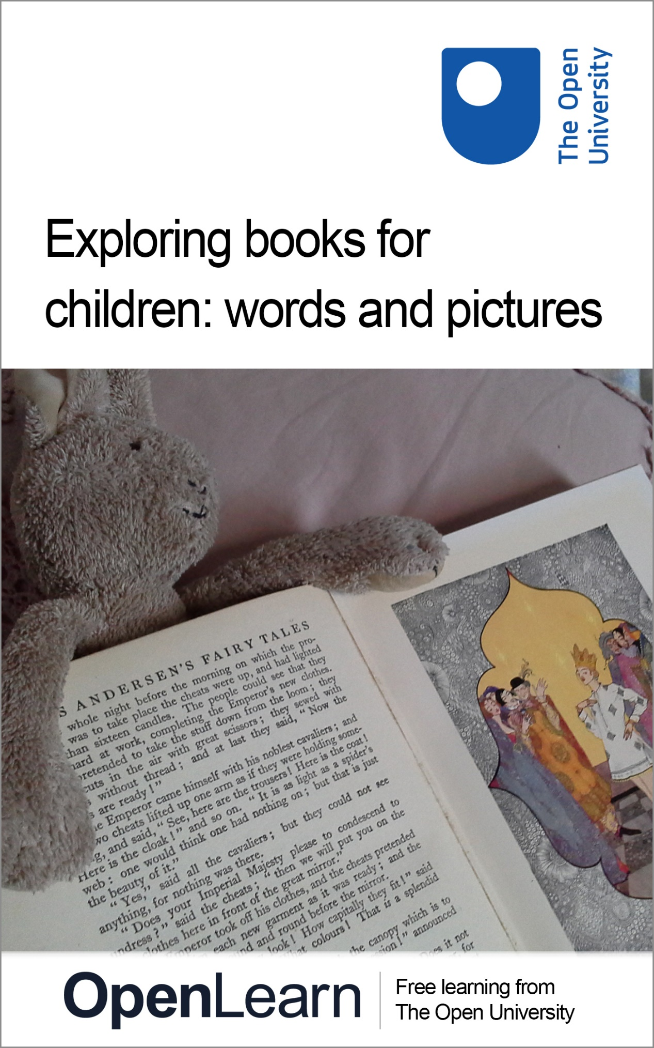

EA300_1

Exploring books for children: words and pictures

About this free course
This free course is an adapted extract from the Open University course EA300 Children’s literature: www.open.ac.uk/courses/modules/ea300.
This version of the content may include video, images and interactive content that may not be optimised for your device.
You can experience this free course as it was originally designed on OpenLearn, the home of free learning from The Open University - www.open.edu/openlearn/history-the-arts/exploring-books-children-words-and-pictures/content-section-0
There you’ll also be able to track your progress via your activity record, which you can use to demonstrate your learning.
Copyright © 2017 The Open University
Intellectual property
Unless otherwise stated, this resource is released under the terms of the Creative Commons Licence v4.0 http://creativecommons.org/licenses/by-nc-sa/4.0/deed.en_GB . Within that The Open University interprets this licence in the following way: www.open.edu/openlearn/about-openlearn/frequently-asked-questions-on-openlearn . Copyright and rights falling outside the terms of the Creative Commons Licence are retained or controlled by The Open University. Please read the full text before using any of the content.
We believe the primary barrier to accessing high-quality educational experiences is cost, which is why we aim to publish as much free content as possible under an open licence. If it proves difficult to release content under our preferred Creative Commons licence (e.g. because we can’t afford or gain the clearances or find suitable alternatives), we will still release the materials for free under a personal end-user licence.
This is because the learning experience will always be the same high quality offering and that should always be seen as positive – even if at times the licensing is different to Creative Commons.
When using the content you must attribute us (The Open University) (the OU) and any identified author in accordance with the terms of the Creative Commons Licence.
The Acknowledgements section is used to list, amongst other things, third party (Proprietary), licensed content which is not subject to Creative Commons licensing. Proprietary content must be used (retained) intact and in context to the content at all times.
The Acknowledgements section is also used to bring to your attention any other Special Restrictions which may apply to the content. For example there may be times when the Creative Commons Non-Commercial Sharealike licence does not apply to any of the content even if owned by us (The Open University). In these instances, unless stated otherwise, the content may be used for personal and non-commercial use.
We have also identified as Proprietary other material included in the content which is not subject to Creative Commons Licence. These are OU logos, trading names and may extend to certain photographic and video images and sound recordings and any other material as may be brought to your attention.
Unauthorised use of any of the content may constitute a breach of the terms and conditions and/or intellectual property laws.
We reserve the right to alter, amend or bring to an end any terms and conditions provided here without notice.
All rights falling outside the terms of the Creative Commons licence are retained or controlled by The Open University.
Head of Intellectual Property, The Open University
978 1 4730 2570 7 (.kdl)
978 1 4730 2571 4 (.epub)

Contents
- Introduction
- Learning outcomes
- 1 Words and pictures in children’s fiction through the ages
- 2 Making sense of pictures
- 3 Combining words and pictures
- 4 Book design and intended readership
  - 4.1 Appealing to different age groups
  - 4.2 Clues for readers of different ages and genders
  - 4.3 Marketing to different readerships
- 5 Illustration
- 6 Illustration as interpretation: the example of Alice
  - 6.1 Interpreting Alice
- 7 Analysing images: composition and symbolism
  - 7.1 Decoding pictures
- 8 An authorstrator comments on his craft
- Conclusion
- References
- Acknowledgements
- Solutions

Introduction
Pictures have played an important role in books for children ever since there have been publications produced particularly with children in mind. But how do stories and picturebooks encountered in childhood fire young imaginations? In this free course Exploring books for children: words and pictures you will learn how children’s fiction, ranging from classics such as Beatrix Potter to contemporary authors like Anthony Browne, combines images and text in remarkably sophisticated ways to communicate with young and old.
This free course is an adapted extract from the Open University course EA300 Children’s literature .

Learning outcomes
After studying this course, you should be able to:
- understand how images communicate meanings to the readers of children’s books
- understand the role of cultural knowledge in making sense of images
- understand how words and pictures can reinforce or contradict one another in a text, with interesting results
- recognise the work of some famous illustrators for children
- understand how the use of images in children’s books has changed over time and what it means to create books for the specific audiences of children and their carers.

1 Words and pictures in children’s fiction through the ages
There is evidence that children were reading books in English with pictures from as early as the sixteenth century: for example, an illustrated 1503 edition of a crusader adventure story, Bevis of Hampton, by Richard Pynson, shows pencil doodlings in the margins that suggest a child’s hand. The earliest known illustrated book specifically produced for children was a Latin text book, dating from the seventeenth century and translated into English in 1659. In the first activity for this course you will watch a video which explores the history of children’s book illustrations.

Activity 1

Iona and Peter Opie’s famous collection of children’s books was acquired by the Bodleian Library in 1988 and contains approximately 20 000 books printed for children between the sixteenth and twentieth centuries. Watch the following video that features a visit to this collection at the Bodleian’s Weston Library in Oxford and think about how have pictures in books for children changed over the years, and why?

Video content is not available in this format.
The history of picture books for children
View transcript - The history of picture books for children

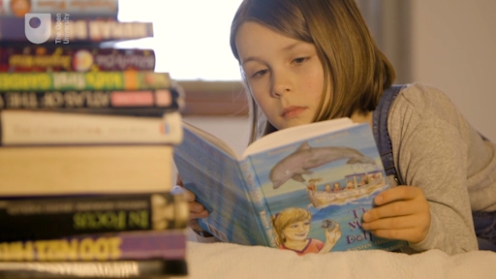

View discussion - Activity 1

2 Making sense of pictures

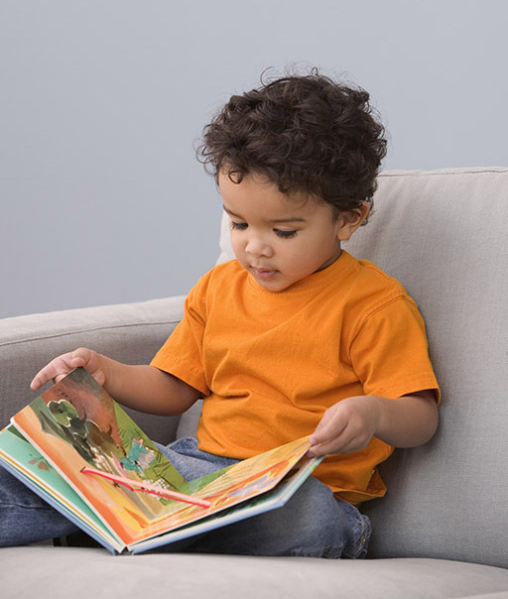
Figure 1 Small child ‘reading’ a picturebook independently
View description - Figure 1 Small child ‘reading’ a picturebook independently

‘A picture tells a thousand words’, or so the saying goes. But how does this happen? Perhaps to an even greater degree than we do with words, we make sense of images by drawing on existing knowledge and experience. As discussed in the introductory video, images become particularly important in the context of books for children. As anyone who has watched a small child ‘reading’ a picture book will know, young children are able to derive a great deal of meaning and pleasure from the activity, even when they cannot yet decode the letters and words. They are able to make connections between the pictures and the words of the story, which have become familiar when read aloud to them by adults and older children. These connections play an important role in helping children learn to read. They are also able to draw on their expanding knowledge of other stories, and of life in their culture more generally, to make sense of pictures that they’ve never seen before.

Activity 2

Consider the illustration below (Figure 2). Can you name the fairy tale it is depicting? How did you arrive at your answer?

Figure 2 A fairy tale. Illustration by Molly Bang (2000, p. 17)
View description - Figure 2 A fairy tale. Illustration by Molly Bang (2000, p. 17)

Provide your answer...
View discussion - Activity 2

Molly Bang is an American illustrator and a teacher of illustration. In the book from which this image comes, she shows how a fairy tale can be constructed visually using a series of shapes (Bang, 2000).

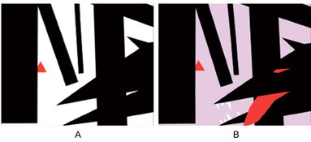
Figure 3 A fairy tale (A on the left, B on the right). Illustration by Molly Bang (2000, pp. 24, 40)
View description - Figure 3 A fairy tale (A on the left, B on the right). Illustration by Molly Bang ...

She starts with a simple red triangle, and adds ‘trees’ (Figure 2). As the scene progresses, Bang resizes Little Red Riding Hood to make her smaller, places her further from the foreground to emphasise her vulnerability, and tilts a ‘tree’ onto the diagonal to add a sense of threat. Starting with three black triangles, she begins to make the wolf (Figure 3 A). Finally, she darkens the background to portray a more threatening sense of darkness and night-time, and adds more geometric shapes to develop the wolf further (Figure 3 B).
What Bang does in this series of illustrations is bring to the fore much of the background knowledge we already have, making this explicit by showing at once the surface simplicity and the deeper complexity of the knowledge that we need in order to read, see and understand picturebooks. In the next section, we will look at the various ways in which texts produce meaning when words and images are combined.

3 Combining words and pictures
So what happens when we put words and pictures together? Illustrations can often be an integral part of literary texts for children and can convey important aspects of the meaning of the text. In some instances, the use of illustration is mostly decorative, but in others it can be a key element of the narrative itself. In fact, literature for children is a field in which the potential of the mixture of words and images is exploited to the full.
One important role of images in a children’s text may be to echo or reinforce the story as conveyed in words. Alternatively, the image may add something more substantial in terms of detail or atmosphere. It may even suggest additional storylines, subplots or a backstory. However, the relationship between word and image may be even more complex and even contradictory. Figure 4 below shows a double-page spread that occurs early on in the book The Tale of Peter Rabbit (1902) by Beatrix Potter. The next activity asks you to think about the ways in which these words and images relate to each other.

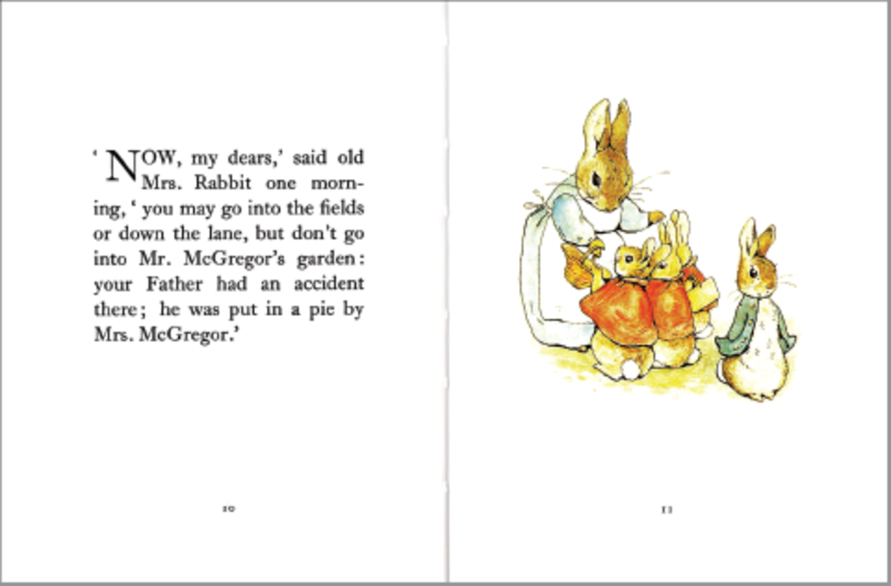
Figure 4 Double page spread from The Tale of Peter Rabbit by Beatrix Potter
View description - Figure 4 Double page spread from The Tale of Peter Rabbit by Beatrix Potter

We know from the words on the left that Mrs Rabbit is issuing instructions and a kindly but stark warning to her children. The image on the facing page, however, alerts us to the fact that, as in all the best stories, things are unlikely to be straightforward, and something will go wrong. Mrs Rabbit is fully focused on her children, who are, in turn, attentive to her words – at least, three of them are. Peter has his back to his mother and is clearly not listening. His coat is a different colour from that of the others – another clue that he is different, in attitude as well as gender. He seems impatient to leave (and his eye direction leads us to turn the page ourselves). Potter is, therefore, providing visual clues for the reader that foreshadow Peter’s disobedience and its almost fatal consequences. This unspoken tension – between the image of the rebellious child hero on one hand and the words which emphasise the parental voice requiring obedience on the other – may be an important part of the thrill for a young reader.

Activity 3

Look at this series of images from children’s books. As you browse through the slide show, consider the following:
- What role is the image playing in the story?
- How fundamental is the image to the story? (Would the story stand alone without the pictures?)
- What kind of audience were the images designed for?
- What can you tell about the historical era in which the book was produced, judging by the images?

Interactive content is not available in this format.
Figure 5 Series of images from children’s books

Provide your answer...
View discussion - Activity 3

4 Book design and intended readership
As you saw in Activity 3, not only do images play an important role in storytelling in children’s books, they are also important in appealing to and addressing particular readers, especially when they are on the front cover. You were probably able to make some guesses about the historical period of a particular book, partly based on your own cultural knowledge about how children, childhood and child readers have been understood differently at different times and in different cultural contexts, and partly based on broader cultural clues. Books for children are also tailored to appeal to children of different age groups, and sometimes of different genders, and again, pictures and the material design of a book play a major role. This is explored further in the activities in this section.

4.1 Appealing to different age groups
When browsing the children’s section of a book shop, most people would fairly quickly be able to identify the titles aimed at younger children. What is more, young children themselves will generally need no assistance in finding the books they like, long before they become readers in the conventional sense. So, what visual clues might readers be responding to that draw them to ‘age-appropriate’ fiction?

Activity 4
Have a look at the three book covers below (you can enlarge them by clicking on each image). Then answer the multiple choice questions about them.

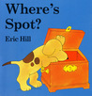
Figure 6 Front cover of Where’s Spot?
View description - Figure 6 Front cover of Where’s Spot?

What age range do you think this book is aimed at?

0–4
5–8
9–12
teenagers
other
View answer - Part

Is it specifically for boys or girls?

boys
girls
both
View answer - Part

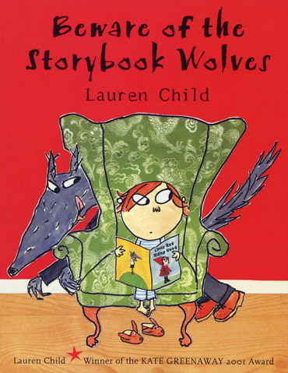
Figure 7 Front cover of Beware of the Storybook Wolves, by Lauren Child

What age range do you think this book is aimed at?

0–4
5–8
9–12
teenagers
other
View answer - Part

Is it specifically for boys or girls?

boys
girls
both
View answer - Part

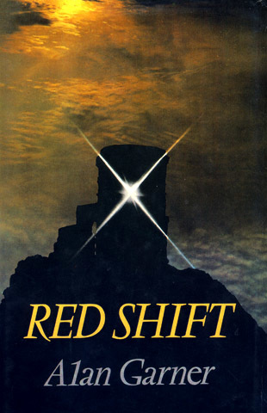
Figure 8 Front cover of Red Shift, by Alan Garner

What age range do you think this book is aimed at?

0–4
5–8
9–12
teenagers
other
View answer - Part

Is it specifically for boys or girls?

boys
girls
both
View answer - Part
View discussion - Part

4.2 Clues for readers of different ages and genders
It is sometimes not even necessary to look at entire images in order to pick up visual clues about the intended readership of a children’s book. Even quite small details on front covers may signal to the potential parent or child buyer (or library customer) who the book is aimed at. The next activity provides some examples for you to explore.

Activity 5

Below are fragments from the covers of two children’s books: answer the multiple-choice questions for each.
Note: When choosing between answers you may feel that, for certain of the books, more than one category is appropriate (for example, ‘young teenagers’ and ‘older teenagers’). If this is the case, you can select multiple answers.

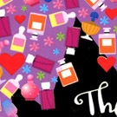
Figure 9A Children’s book cover fragment
View description - Figure 9A Children’s book cover fragment

What age range do you think this book is aimed at?

0–4
5–8
9–12
young teenagers
older teenagers
other
View answer - Part

Is it specifically for boys or girls?

boys
girls
both
View answer - Part

What genre do you think the book is?

adventure
romance
fantasy
realism
View answer - Part

Figure 10A Children’s book cover fragment
View description - Figure 10A Children’s book cover fragment

What age range do you think this book is aimed at?

0–4
5–8
9–12
young teenagers
older teenagers
other
View answer - Part

Is it specifically for boys or girls?

boys
girls
both
View answer - Part

What genre do you think the book is?

adventure
romance
fantasy
realism
View answer - Part

4.3 Marketing to different readerships
Of course, just because a book is aimed and marketed at a particular age-group or gender, doesn’t mean that other children won’t or can’t read and enjoy it. It is interesting to reflect on the extent to which children’s reading choices are influenced by images and other aspects of visual design. Are children’s reading choices unnecessarily restricted by such non-verbal messages? For example, interviews with children conducted for the Open University course EA300: Children’s Literature revealed that boys are reluctant to read books which feature the colour pink on the cover. To what extent might they be missing out on stories that they might enjoy just as much as a girl would? Research by Edward Salmon (1888) showed that even in the nineteenth century girls were often willing or keen to read books which appear to be intended for boys. Nevertheless, some may still be put off by imagery such as the skull and crossbones above. The visual elements are. in these cases. being used to appeal to particular markets, and thus provide an interpretation of the verbal story that is likely to be popular with certain readers. This point is further illustrated in the next activity.

Activity 6

Here are two more fragments from the covers of children’s books. Please answer the multiple-choice questions for each. Again, more than one category may be appropriate, and you can select multiple answers.

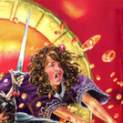
Figure 11A Front cover fragment 1
View description - Figure 11A Front cover fragment 1

What age range do you think this book is aimed at?

0–4
5–8
9–12
young teenagers
older teenagers
other
View answer - Part

Is it specifically for boys or girls?

boys
girls
both
View answer - Part

What genre do you think the book is?

adventure
romance
fantasy
realism
View answer - Part

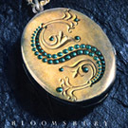
Figure 11B Front cover fragment 2
View description - Figure 11B Front cover fragment 2

What age range do you think this book is aimed at?

0–4
5–8
9–12
young teenagers
older teenagers
other
View answer - Part

Is it specifically for boys or girls?

boys
girls
both
View answer - Part

What genre do you think the book is?

adventure
romance
fantasy
realism
View answer - Part

5 Illustration
Illustration is increasingly recognised as an integral part of children’s book production, playing a role equally, if not more, important than the words of a story. This increased recognition is demonstrated by the fact that, since 1955, the Chartered Institute of Library and Information Professionals, or CILIP, has awarded the Kate Greenaway Medal for ‘distinguished illustration in a children’s book’, alongside the more longstanding Carnegie prize for a work of children’s fiction (inaugurated in 1936). The Greenaway Medal has been awarded to well-known illustrators such as Shirley Hughes, Raymond Briggs, Quentin Blake and Anthony Browne. Another sign of the growing acknowledgement of the artistry and importance of pictures alongside words in children’s fiction is the now quite common use of the term ‘authorstrator’. This term was first coined by illustrator Martin Salisbury to emphasise that the illustrator needs to have an authorial voice in the finished text, as the job of the pictures is just as much a storytelling one as that of the words. In the next activity you will hear Salisbury discussing illustration.

Activity 7

Watch the following video featuring Martin Salisbury, who introduces the work of some well-known and historically important illustrators of children’s books. We have included some examples from these illustrators for you to consider as you listen; you may wish to look on the internet for more. As well as being an illustrator, Martin Salisbury teaches children’s book illustration at Anglia Ruskin University, Cambridge.
As you listen, reflect on what the images, and Salisbury’s commentary on them, tell us about changing ideas about childhood and the child. What do you learn about the complexity of children’s books?

Video content is not available in this format.
Illustrators of children’s books
View transcript - Illustrators of children’s books

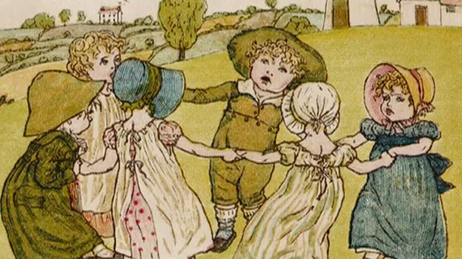

View discussion - Activity 7

6 Illustration as interpretation: the example of Alice
Another way that illustrations can play an important part in a text is by providing a specific interpretation of elements of the verbal narrative.
The illustration below is by John Tenniel, the illustrator for the original editions of Alice’s Adventures in Wonderland and Through the Looking-glass. For many people, this has become the classic image of Alice. If you are familiar with the books containing Tenniel’s illustrations, this may well be the image you have in your mind’s eye when you think of Alice.

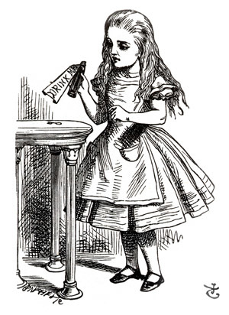
Figure 12 Alice with ‘Drink me’ bottle as portrayed by John Tenniel
View description - Figure 12 Alice with ‘Drink me’ bottle as portrayed by John Tenniel

But this is just one particular illustrator’s interpretation of the character, and some people feel that it does not represent the character created by Lewis Carroll’s narrative. For example, in the words of one commentator, Tenniel’s drawings make Alice look ‘overly serious and expressionless’ (Davis, 1979, p. 6).

Activity 8

Click on the link to view four more illustrations of Alice, and then pass the mouse over each illustration to reveal details about its illustrator. In what ways do you feel that these artists have interpreted Alice’s character differently from Tenniel?

Interactive content is not available in this format.
Figure 13 Different interpretations of Alice
View description - Figure 13 Different interpretations of Alice

Provide your answer...
View discussion - Activity 8

6.1 Interpreting Alice
Illustrations may play a particularly important role in children’s fiction because of its often fantastic and improbable subject matter. Alice in Wonderland again provides us with a good example of this. You may recollect some of the following words that occur at the beginning of Carroll’s famous poem ‘Jabberwocky’, which appears in the novel:

’Twas brillig, and the slithy toves
Did gyre and gimble in the wabe;
All mimsy were the borogoves,

While it is possible to gain some meaning from the verbal text of Lewis Carroll’s poem ‘Jabberwocky’ despite the fact that it consists mostly of newly invented words, it would be very difficult to describe exactly what the Jabberwock looks like based only on the details given in the verbal text.

Activity 9

Part 1

Look at the first four stanzas of the poem, and highlight the words used in it to describe the Jabberwock itself. For words that are in standard English, use the first highlighting tool (by clicking on the yellow button and then highlighting your chosen words). For words that are invented words, use the second highlighting tool (by clicking on the green button before highlighting them). There are six words or phrases to highlight in all.

Interactive content is not available in this format.

View answer - Part 1

Part 2

Based on this slight description, what do you imagine the creature would look like? The image below is how John Tenniel, the book’s original illustrator, portrayed the scene described in ‘Jabberwocky’.
Is Tenniel’s representation similar to how you imagined it from your reading of these lines of the poem? Point the mouse cursor at different parts of the image to reveal details from the poem that Tenniel has included in his illustration.

Interactive content is not available in this format.
Figure 14 Illustration of the Jabberwock from the book Through the Looking-glass, by John Tenniel

View discussion - Part 2

The rest of the image is Tenniel’s own interpretation of the scene. For example, the scale of the creature, which completely dwarfs the diminutive protagonist, is part of this interpretation. In this respect, the image uses similar techniques to those you saw in Section 1, where you came across images in which Molly Bang had manipulated size and positioning of shapes to suggest a particular interpretation. The creature’s shape is also part of the interpretation, as are its various features and its position in the composition. In this way, the raw ingredients are blended to create an image that both complements the verbal text but also extends its meaning.
Below is the poem ‘Jabberwocky’ as it appears on the page of the original text. Although the poem is often taken out of context, as you can see, it occurs in the narrative alongside the illustration and as part of the wider narrative.

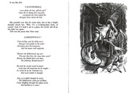
Figure 15 The poem ‘Jabberwocky’ as it appears in the original text
View description - Figure 15 The poem ‘Jabberwocky’ as it appears in the original text

One important aspect from the original context, for example, is that the first stanza is first printed backwards, but Alice then reads it by holding it up to a looking-glass. This element is lost if the poem is taken out of its original context, as is the added meaning and interpretation that comes from the illustration itself. In this example, therefore, we can see that the combination of word, image and context all contribute to the overall effect of reading the text.

7 Analysing images: composition and symbolism
The author of Hansel and Gretel, Anthony Browne, is well known for his stories which depict gorillas in human roles. The gorilla motif recurs throughout Browne’s work, gorillas being a long-term passion of his. The next activity looks at how mood and relationships may be conveyed to the reader in pictures, using two pages from Anthony Browne’s Gorilla (2002). This is the story of a young girl, Hannah, living with her father who is too busy to pay her much attention. She longs for a gorilla; when given a toy one, it comes to life and takes her off on a series of nocturnal adventures, bringing warmth and security into her life. Her relationship with her father also improves as a result.

Activity 10

Part 1

The illustration below is from Anthony Browne’s book Gorilla, and shows the central character, Hannah, having breakfast with her father.

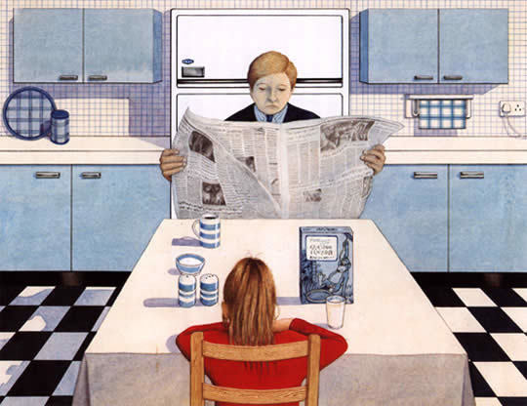
Figure 16 Hannah and her father. Illustration: Copyright © 1983 Anthony Browne. From GORILLA by Anthony Browne. Reproduced by permission of Walker Books Ltd, London SE11 5HJ.
View description - Figure 16 Hannah and her father. Illustration: Copyright © 1983 Anthony Browne. From ...

Based on this illustration, what kind of relationship do you think exists between father and daughter?

Provide your answer...

Consider how the illustration conveys the relationship between Hannah and her father.

Interactive content is not available in this format.
View description - Uncaptioned interactive content

What aspects of the way it is drawn, the use of colour and the composition do you think express the mood of the relationship between father and daughter? Write down three aspects of the picture that you think contribute to the overall effect.
Hold the mouse cursor over each number on the illustration to see some of the ways that it might tell the story of the relationship between Hannah and her father.

Provide your answer...

The illustration below comes later in the book Gorilla. It shows Hannah sitting opposite her toy gorilla, who has come to life.

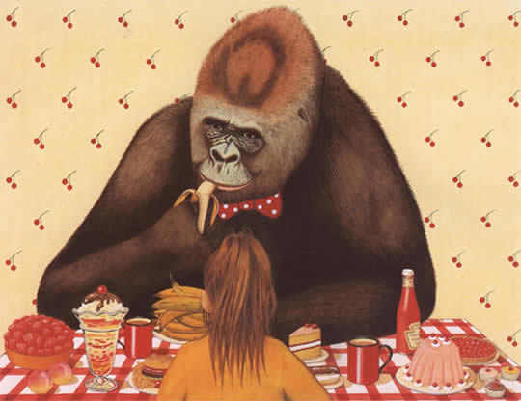
Figure 17 Hannah and the gorilla. Illustration: Copyright © 1983 Anthony Browne. From GORILLA by Anthony Browne. Reproduced by permission of Walker Books Ltd, London SE11 5HJ.
View description - Figure 17 Hannah and the gorilla. Illustration: Copyright © 1983 Anthony Browne. ...

How do you think the mood differs in this picture compared to the previous one? What would you say is the relationship between Hannah and the gorilla?

View answer - Part

Part 2

Now compare the two illustrations.

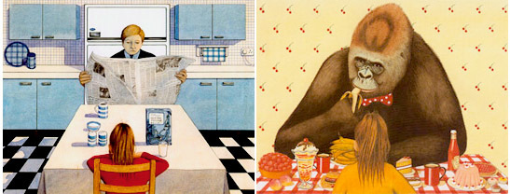
Figure 18 Illustration from the book Gorilla, by Anthony Browne
View description - Figure 18 Illustration from the book Gorilla, by Anthony Browne

What differences are there in (1) the use of colour, (2) the use of composition, and (3) the symbolism of objects?

Provide your answer...

Click on the link to ‘Next’ to see how colour, composition and symbolism feature in the two illustrations.

Interactive content is not available in this format.
View description - Uncaptioned interactive content

View discussion - Part

7.1 Decoding pictures
In this section, we use the ideas of scholars of children’s literature who have tried to look more systematically and in depth at the ways in which children’s books communicate with the reader visually as well as in words. One such scholar, William Moebius, wrote that ‘we can pour emotion and affection’ into the pages of children’s picturebooks and the lovable creatures which inhabit them, reliving a kind of second childhood, or we can choose to ‘watch more closely … and attend to elements of design and expression’ (1986, 142).
Moebius draws on, among others, Maurice Sendak’s Where the Wild Things Are, a book widely analysed in the academic literature on picturebooks. Sendak gained critical acclaim for Where the Wild Things Are – a tale of a young boy, Max, who, having been sent to his room for his wild behaviour, embarks on a fantasy voyage to the land of the Wild Things, where he is made king. You can find out more about this book and see images from it in 10 wild facts about Maurice Sendak’s Where The Wild Things Are . Moebius, in this reading, looks at how images and text work together to create communicative meaning, breaking this down into different aspects of visual communication which he called codes. He identifies these, broadly, as falling into five categories, as shown in Table 1 below. Alongside each code, features which can vary are listed. These are expressed as questions that you can ask about any image.

Table 1 Drawn from Moebius’s codes for interpreting images in children’s books.
Code
position and size | Is the subject positioned centrally or in the margins?  How big or small are figures in relation to others, and to the image as a whole?  Are figures on the left or right of the page? (Left = safe, secure, known, given; right = less secure, unknown, new, unexpected)
perspective | Are there horizons in the image or not?  Is the image flat or does it have depth?  What appears in the foreground, and what in the background?
framing | Are there boundaries around the whole image and/or around parts of it (for example strong horizontal or vertical lines ‘framing’ a figure)?  Are images spilling or pushing outside their frames, or are they contained?
line | Are lines vertical and horizontal (stability), or on the diagonal (unsettling, dynamic, indicating movement or change)?  Are lines sketchy (movement) or thick and intense (intensity, paralysis or stasis)?  Are they smooth and parallel (indicating order) or jagged, angular (spelling trouble, danger, conflict)?  Are there lots of lines and squiggles (energy, anxiety) or few (calm)?
colour | Are colours warm or cool? (Suggesting feelings, relationships)  Bright or dark? (Suggesting feelings of fear or optimism, sadness or happiness)

According to Moebius, these features have the potential to convey specific meanings, due to the cultural associations that they have, at least for Western readers. In the next activity you have the opportunity to try out this kind of analysis for yourself.

Activity 11

Study Figure 19 below; the text and the illustration are on two facing pages in Anthony Browne’s picturebook version of Hansel and Gretel (1981). As you observe details, make a note of the following:
- What details do you notice in terms of Moebius’s codes listed above?
- How might these details be significant for the story?
Don’t worry if you find some codes more difficult to identify than others.

At daybreak, before the sun had risen, the woman came and wakened the children. ‘Get up, you lazybones, we must go to the forest to fetch wood.’ She gave them each a small piece of bread, saying, ‘Here’s something for your dinner, but don’t have it too soon, for you’ll get nothing else.’ Gretel put the bread inside her coat, and Hansel put all the pebbles into his trouser pockets. Then they set out together for the forest.
(Hansel and Gretel, 1981)

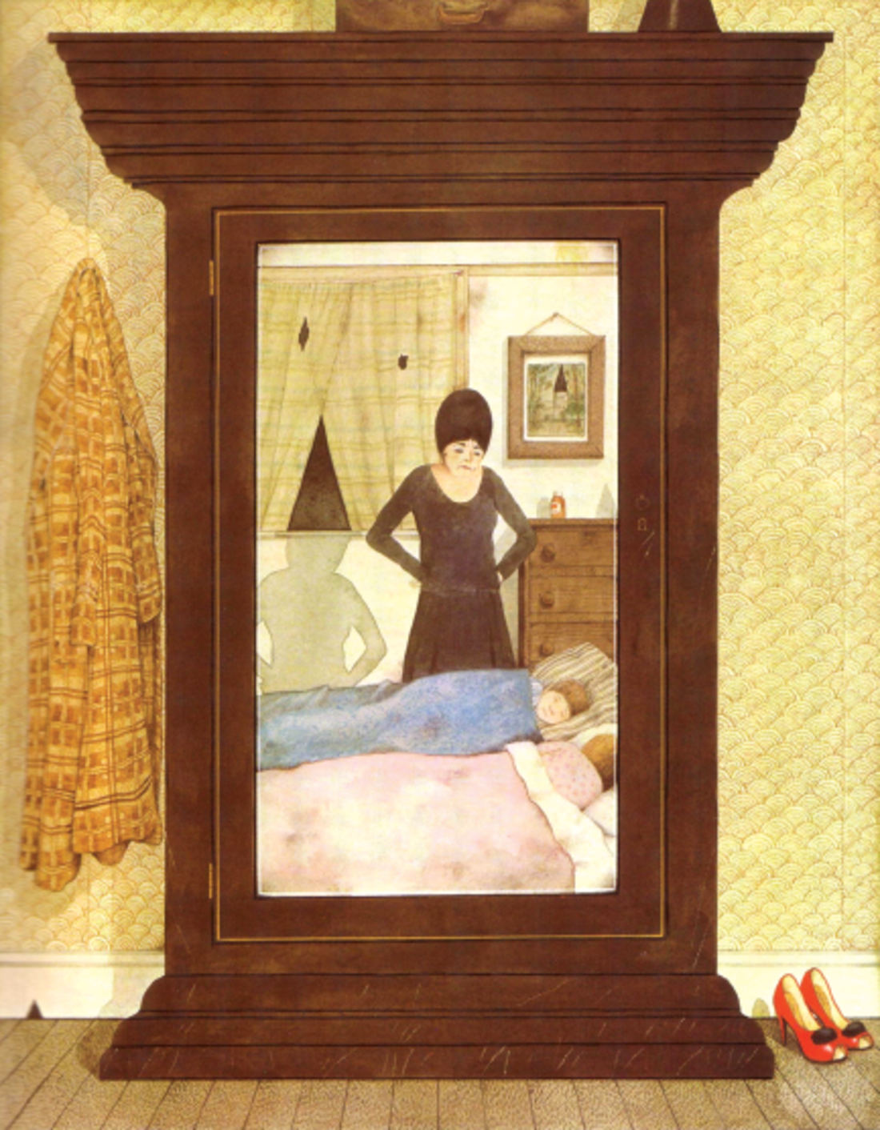
Figure 19 Text and an illustration from Hansel and Gretel (Browne, 1981)
View description - Figure 19 Text and an illustration from Hansel and Gretel (Browne, 1981)

View discussion - Activity 11

8 An authorstrator comments on his craft
In this section we continue to consider the work of authorstrator Anthony Browne whose book Gorilla won the Carnegie Prize in 1983 and who was UK Children’s Laureate 2009-2011. Browne’s illustrations often include a great deal of detail and nuance. He is known for often including reference to well-known images borrowed and sometimes parodied from other sources, especially famous works of art – a feature known as intertextuality. For example, several of his books contain reworkings of Magritte’s paintings, although Browne sometimes substitutes a banana for an object in the original.

Activity 12

Click below to watch a clip in which Anthony Browne talks about how he works with text and images to produce a narrative. You may find it useful to look back at the images in Section 7, especially from Activity 11, as you listen, as Browne does discuss these in some detail.

Video content is not available in this format.
Interview with Anthony Browne
View transcript - Interview with Anthony Browne

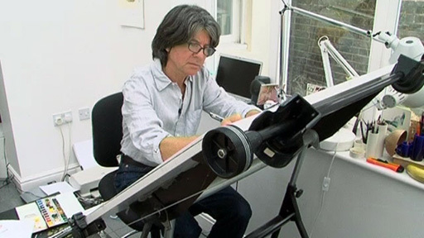

What use does Browne make of pictorial references to famous artworks? Do you think this is likely to appeal to young readers?

View discussion - Activity 12

Conclusion
This free course, Exploring books for children: words and pictures, has shown that images in children’s books are not the simple, childish, unchallenging things that they are often taken to be. Readers make sense of them by drawing on complex cultural knowledge. Many analysts of children’s illustration point to the sophistication and artistry of the images themselves and also to the array of different ways in which images combine with words to tell stories. In many cases, images and the material design of children’s books are not merely incidental illustrations, they are fundamental to the unfolding of the narrative. They also play a key role in the marketing of children’s books to particular groups of readers. Opinions differ as to the merit of detailed academic analysis of the imagery of children’s books, but this course has offered some ways of exploring pictures in depth to see how they work and what they can add to a story. Two author illustrators who you have learned about in this course agree that a good children’s book is one which child readers and their carers return to again and again and get something new each time. We hope that this free course has inspired you to return to the words and pictures in children’s books that you know, and to look at them with fresh eyes.
You might also like to look at the following items available on OpenLearn:
Why do so many children’s stories feature magical creatures? by Dena Attar .
Reading in and out of the nursery by Austen Sanders .
Word and image .
This free course is an adapted extract from the Open University course EA300 Children’s literature .

GCSE English Literature with the NEC

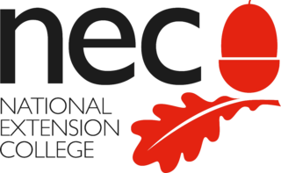

“If I cannot inspire love, I will cause fear!” … discover which iconic protagonist uttered this infamous quote, as you open up a world of literary discovery with the National Extension College’s (NEC) GCSE English Literature online course.
The course introduces and explores a variety of fascinating classic literary works. Gaining a GCSE in English literature is vital for future career progression and a minimum requirement for many further education courses. It’s also a subject that inspires a life-long love of reading and even those who begin the course with the aim of improving their reading skills, end up becoming a bookworm! This GCSE English Literature course offers flexible online learning with course materials developed by subject experts and tutor-marked assignments.
Enrol from £495.
Find out more about GCSE English Literature here.

References
Bang, M. (2000) Picture This: How Pictures Work, New York, SeaStar.
Beckett, S. (2001) ‘Parodic play with paintings in picture books’ in Lennox Keyser, E. and Pfeiffer, J. (eds) Children’s Literature, vol. 29, London, Yale University Press.
Browne, A. (1981) Hansel and Gretel, London, Walker.
Browne, A. (2002) Gorilla, London, Walker.
Carroll, L. (1865) Alice’s Adventures in Wonderland, London, Macmillan.
Carroll, L. (1872) Through the Looking Glass, and What Alice Found There , London, Macmillan.
Davis, J. (1979) ‘Introduction’, in Ovenden, G. (ed.) The Illustrators of Alice in Wonderland and Through the Looking-glass . London, Academy Editions, pp. 5–18.
Moebius, W. (1986) ‘Introduction to picturebook codes’, Word and Image vol. 2, no. 2, pp.141–58.
Potter, B. (1902) The Tale of Peter Rabbit, London, Frederick Warne.
Salmon, E. (1888) ‘What boys read II. What girls read’, in Salmon, E. (ed.) Juvenile Literature as it Is, London, Henry Drane, pp. 11–31.
Sendak, M. (1963) Where the Wild Things Are, New York, Harper & Row.
Scholastic (2006) ‘New study finds that the Harry Potter series has a positive impact on kids’ reading and their school work’, 25 July, PRNewswire [Online]. Available at http://www.prnewswire.com/news-releases/new-study-finds-that-the-harry-potter-series-has-a-positive-impact-on-kids-reading-and-their-school-work-57005427.html (Accessed 12 May 2017).
The Open University (2009), ‘An introduction to illustration – Interview with Martin Salisbury’ [Video], EA300 Children’s Literature, Milton Keynes, The Open University.
The Open University (2009), ‘Interview with Anthony Browne’ [Video], EA300 Children’s Literature, Milton Keynes, The Open University.

Acknowledgements
This free course was written by Sharon Goodman, Philip Seargeant and Jackie Tuck from the Open University’s School of Language and Applied Linguistics.
Except for third party materials and otherwise stated (see terms and conditions), this content is made available under a Creative Commons Attribution-NonCommercial-ShareAlike 4.0 Licence .
The material acknowledged below is Proprietary and used under licence (not subject to Creative Commons Licence). Grateful acknowledgement is made to the following sources for permission to reproduce material in this free course:
Course image
Picture book with a ty rabbit. Courtesy of Jackie Tuck
Images
Figure 1: © Jose Luis Pelaez Inc/Getty Images.
Figures 2, 3A and 3B: Molly Bang, (2000) Picture This: How Pictures Work. By SeaStar Books. © Molly Bang
Figure 5 Series of images from children’s books - slideshow: The front cover of The Best Bat in School, Dorita Fairlie Bruce (1933), Oxford University Press; The front cover of The Wolves in the Walls, Neil Gaiman (2003), Bloomsbury Publishing. Illustration © Dave McKean; We Honestly Can Look After Your Dog, from Charlie and Lola, Lauren Child (2005), Puffin Books 2005, published by Penguin Books; Asterix the Gaul, Written by Rene Goscinny and Illustrated by Albert Uderzo (1961), Orion Publishing Group. © 1961 Goscinny/Uderzo; The Very Hungry Caterpillar, Eric Carle (1969), Puffin, Penguin Books. © Eric Carle; Old MacDonald Had a Farm, (2007), Little Scholastic. © Scholastic Inc 2007; In The Night Garden, TM & © Ragdoll Worldwide Limited (2007), BBC Worldwide Limited
Figure 6: Where’s Spot?. First published by William Heinemann 1980. Frederick Warne (2000), Penguin Group.
Figure 7: Beware of the Storybook Wolves, Lauren Child (2000), Hodder Childrens Books. © Lauren Child 2000.
Figure 8: Red Shift, Alan Garner (1973), Published by William Collins, an imprint of Harper Collins. © Alan Garner 1973.
Figures 9A, 9B: The Princess Diaries, Meg Cabot (2007), Illustration by Nila Aye, Macmillan Childrens Books 2007.
Figures 10A, 10B: Skeleton Key, (2005), Walker Books Ltd. Boy with torch logo TM & © 2005 Stormbreaker Productions Ltd. Walker Books Ltd, London SE11 5HJ.
Figures 11A, 11B: Jason Cockcroft, from Rowling, J.K., (2007) Harry Potter and the Deathly Hallows, Bloomsbury Publishing.
Figure 13 middle left: Alice by Mabel Lucie Atwell. Mabel Lucie Atwell illustration of Alice from The Illustrators of Alice in Wonderland and Through the Looking Glass (ed.) Graham Ovenden, Academy Editions (1972).
Figure 13 far right: Alice by Peter Blake. Illlustrations to Through the Looking Glass ‘Well, this is grand’ said Alice. © Tate London 2009.
Figures 16 and 17: From Gorilla by Anthony Browne, Walker Books Ltd. © 1983 Anthony Browne.
Figure 19: From Hansel and Gretel illustrated by Anthony Browne, Walker Books Ltd. © 1981 2003 Anthony Browne.
Keep on Learning Image: © Konstantin Chagin / iStockphoto.com
Videos
Activity 1 video: © The Open University (2017). Thank you to the Bodleian Library for their contribution.
Activity 7 video: © The Open University (2017) and its licensors.
Activity 12 video: © The Open University and illustrations: courtesy of Anthony Browne.
Every effort has been made to contact copyright owners. If any have been inadvertently overlooked, the publishers will be pleased to make the necessary arrangements at the first opportunity.
Don’t miss out
If reading this text has inspired you to learn more, you may be interested in joining the millions of people who discover our free learning resources and qualifications by visiting The Open University – www.open.edu/openlearn/free-courses.

Solutions

Activity 1

Discussion
The video gives a brief glimpse of the history of pictures in children’s books, and how they changed over the centuries as a result of changing techniques, attitudes and markets. Illustrations in early books designed for children were often crude, cheaply produced wood cuts, since it was not considered necessary to invest effort or money in more sophisticated illustrations for children. The frontispieces were sometimes more expensively produced as these were on display in shop windows. As attitudes towards childhood and child readers changed, pictures in children’s books reflected a gradual decline in moral instruction and a growing emphasis on fun and entertainment. New technologies such as engraving and then lithography emerged and became cheaper, and the quality of illustrations in books for children gradually improved. Colour became affordable: some of the cruder examples of colouring shown would have been carried out by young children in cottage industry settings. Intensely coloured editions, such as the 1863 edition of Red Riding Hood shown in the video, became increasingly common and affordable for the middle classes.
By the late nineteenth and early twentieth century, much work of high quality was in circulation: this period has been called a golden age for children’s literature. The rise of mass education in Britain – specifically as a result of the 1870 Education Act – also created a growing new market of young readers at that time. Later in the course you will learn more about some of the famous golden age illustrators such as Walter Crane, Randolph Caldecott, John Tenniel, Arthur Rackham and Kate Greenaway. However, in the next section we focus on the way in which words and pictures work together to create engaging children’s stories, both classic and contemporary.
Back to - Activity 1

Activity 2

Discussion
The illustration represents the story of Little Red Riding Hood (although other interpretations are certainly possible, such as Hansel and Gretel). You may have made some of the following observations:
- The small red triangle stands out because of its colour and positioning, even though it is smaller than the black lines surrounding it. A hood or cape may take a similar triangular shape; so, aided by the colour red, we can make the link to Red Riding Hood using our background cultural knowledge.
- The strong black vertical lines have an air of permanence and stability, as do trees. Their position, number and different sizing may well suggest a ‘forest’ to you, even though the illustration is actually just an arrangement of two-dimensional geometric shapes. The location of the red triangle amongst ‘trees’ strengthens the link with the fairy tale, if we know the story about Red Riding Hood walking to her grandmother’s house through the wood.
- If the black lines can be interpreted as ‘trees’, it might be possible to see the red triangle as ‘hiding behind a tree’. If we see it this way, it may look small, wary, vulnerable. Again, we can interpret this image in the light of our knowledge of the story, but also in the light of broader cultural associations (in European contexts at least) of woods and forests as potentially dangerous and scary places to be alone.
Back to - Activity 2

Activity 3

Discussion
- The images play a variety of different roles. In some cases, they are purely decorative, as in the case of Walter Crane’s front cover design for Little Red Riding Hood. Some illustrations enhance the text, but the words could stand alone – the example from Alice in Wonderland is a case in point. Others add a significant dimension to the words. The cover illustration of The Best Bat in the School is a good example of this. It depicts a schoolgirl batting energetically in a cricket match; not only is it clearly designed to appeal to female readers, but it also makes a statement about girls being heroic, strong and sporty. In many cases, the visual aspect is fundamental to the text – in the Asterix the Gaul comic book, for example. This image also combines words and graphic techniques – for example, large bold letters for shouting – as a narrative technique. There are other examples of this; for example, the string of words used as a dog lead in Charlie and Lola: We Honestly Can Look After Your Dog .
- In some of the examples for younger children, the visual and material aspects of book design are completely fundamental to the reading of the story – The Very Hungry Caterpillar is a well-known example of this, where a small child’s fingers become the caterpillar. On the In the Night Garden web page, interactive circles of colour are used to guide the reader’s pathway through the story.
- We can infer quite a lot about the type of audience these books are intended for, simply from the way they look. Images aimed at younger children tend to have bright colours and bold lines. It is interesting to note the contrast in the use of colour between Inquisitive Peter and other Funny Tales and the Walter Crane Red Riding Hood. The latter’s sophisticated colours and detailed drawing seem to be aimed at the purchasing adult, while the bright colours and humorous images of the former seem designed to entice the child reader. The Wolves in the Walls, aimed at readers of 7+ years, provides an interesting contrast: its colours are muted and even sombre, reflecting the sometimes darker content of contemporary fiction for this age group.
- The images also give a lot of clues about the historical era when they were produced. They show that styles of illustration have changed over the years, as a result of evolving tastes and book production technologies. For example, the colour palette of The Best Bat in the School has definite echoes of Britain between the two World Wars, and Rackham’s fine line drawings in the Alice in Wonderland example are typical of the nineteenth and early twentieth century.
Back to - Activity 3

Activity 4

Part

Answer
Right:
0–4
Wrong:
5–8
9–12
teenagers
other
The correct answer is 0–4.
Back to - Part

Part

Answer
Right:
both
Wrong:
boys
girls
The correct answer is ‘both’.
Back to - Part

Part

Answer
Right:
5–8
Wrong:
0–4
9–12
teenagers
other
The correct answer is 5–8.
Back to - Part

Part

Answer
Right:
both
Wrong:
boys
girls
The correct answer is ‘both’.
Back to - Part

Part

Answer
Right:
teenagers
Wrong:
0–4
5–8
9–12
other
The correct answer is ‘teenagers’.
Back to - Part

Part

Answer
Right:
both
Wrong:
boys
girls
The correct answer is ‘both’.
Back to - Part

Discussion
You may already be familiar with these books, or the titles may have contributed to your answers. But the visual look of the book also conveys much of the information about their intended readership, as well as other things, such as genre.
None of these books is aimed specifically at either boys or girls. They are, however, aimed at specific age groups. The first book is part of the Where’s Spot? series for very young children. This intended audience is reflected in the design of the cover, which consists of simple, clear illustrations, a plain font and bold use of colour.
The second book, Beware of the Storybook Wolves by Lauren Child, is a retelling of classic fairy tales but with a slight twist. It is probably aimed at 4–6 year olds. Although the design is not quite as simple as Where’s Spot?, the illustration is still colourful and cartoon-like, with a quirky font.
The third book, Red Shift by Alan Garner, is a rather dark narrative about three teenagers. The mood of the book is indicated by the enigmatic image of Mow Cop castle on the front cover. The colours in the design are not as vivid as those in the books for younger children. The choice of a photograph rather than an illustration also suggests an older intended readership.
Back to - Part

Activity 5

Part

Answer
Right:
young teenagers
older teenagers
Wrong:
0–4
5–8
9–12
other
The correct answers are ‘young teenagers’ and ‘older teenagers’.
Back to - Part

Part

Answer
Right:
girls
Wrong:
boys
both
The correct answer is ‘girls’.
Back to - Part

Part

Answer
Right:
romance
Wrong:
adventure
fantasy
realism
The correct answer is ‘romance’.
This is the cover for The Princess Diaries: After Eight by Meg Cabot, one in a series of books telling the story of Mia, a ‘totally normal Manhattan 14-year-old’ who finds out one day that she’s heir to the throne of a small European country. The series chronicles the various adventures that Mia has dealing with being a teenager while adapting to her new role as a princess.
The books in this series are very much aimed at a readership of girls in their early teens. This is indicated on the cover by the use of the colour pink, the cursive font used for the title, and the imagery, which is full of graphic representations of hearts and perfume bottles. The full front cover is shown below:

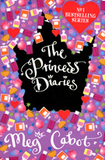
Figure 9B Front cover of The Princess Diaries © Meg Cabot, Macmillan Children’s Books, 2007. Cover illustration by Nila Aye.
View description - Figure 9B Front cover of The Princess Diaries © Meg Cabot, Macmillan Children’s Books, ...

Back to - Part

Part

Answer
Right:
9–12
young teenagers
Wrong:
0–4
5–8
older teenagers
other
The correct answers are 9–12 and ‘young teenagers’.
Back to - Part

Part

Answer
Right:
boys
Wrong:
girls
both
The correct answer is ‘boys’.
Back to - Part

Part

Answer
Right:
adventure
Wrong:
romance
fantasy
realism
The correct answer is ‘adventure’.
This is the cover for Skeleton Key by Anthony Horowitz. Again, this is part of a series – in this case, the Alex Rider books relating the adventures of a teenage spy.
These are very much ‘books for boys’. Again, the cover design suggests this, with the skull-and-cross bones image dominating the picture (providing a visual pun with the title), the clean contrast between silver and green, the bold but simple font and the silhouette of the boy shining his torch towards us. The design is far more austere than the ornate and decorative cover of The Princess Diaries, and suggests a world of danger, secret formulas and intrigue. The full front cover is shown below.

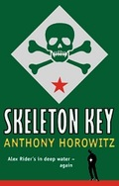
Figure 10B Front cover of Skeleton Key © 2005 Walker Books Ltd. Boy with torch logo ™ & © 2005 Stormbreaker Productions Ltd. Reproduced by permission of Walker Books Ltd, London SE11 5HJ.
View description - Figure 10B Front cover of Skeleton Key © 2005 Walker Books Ltd. Boy with torch logo ...

Back to - Part

Activity 6

Part

Answer
Right:
5–8
9–12
young teenagers
Wrong:
0–4
older teenagers
other
The correct answers are 5–8, 9–12 and ‘young teenagers’.
Back to - Part

Part

Answer
Right:
both
Wrong:
boys
girls
The correct answer is ‘both’.
Back to - Part

Part

Answer
Right:
fantasy
Wrong:
adventure
romance
realism
The correct answer is ‘fantasy’.
Back to - Part

Part

Answer
Right:
older teenagers
other
Wrong:
0–4
5–8
9–12
young teenagers
The correct answers are ‘older teenagers’ and ‘other’.
Back to - Part

Part

Answer
Right:
both
Wrong:
boys
girls
The correct answer is ‘both’.
Back to - Part

Part

Answer
Right:
fantasy
Wrong:
adventure
romance
realism
The correct answer is ‘fantasy’.
These two covers are for the same book: Harry Potter and the Deathly Hallows. The difference is that one is the version marketed for children, and the other is the one marketed for adults. The contents of the books themselves are exactly the same, but the front covers are quite different. Even the font used in the title is a little different, with the one in the adult version being thinner and more elongated. Likewise, the overall colour scheme is far more muted in the adult version, while the children’s version is full of bright colours.
The use of a hand-drawn illustration in contrast to the stylised photographic image is another notable difference. The children’s version offers an image bursting with action and featuring characters from the story, while the adult version has a far more enigmatic and abstract image of a pendant.
The book appears to be marketed to the widest possible audience. According to the educational company Scholastic (2006), the average age at which children start reading the Harry Potter books is nine, and they are slightly more popular with girls than with boys. However, they have been exceptionally popular with both boys and girls, and both children and adults. These two covers suggest how the publishers are attempting to build on this wide readership in the way they present the book.

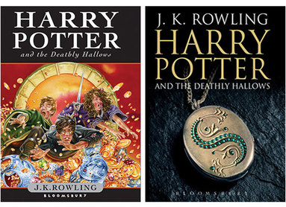
Figure 11C Two different front covers for Harry Potter and the Deathly Hallows. Harry Potter and the Deathly Hallows: (children’s version) cover image by Jason Cockcroft; (adult version) cover image by Michael Wildsmith. Reproduced with permission of Bloomsbury Publishing.
View description - Figure 11C Two different front covers for Harry Potter and the Deathly Hallows. Harry ...

Back to - Part

Activity 7

Discussion
This tour of the work of famous illustrators enables us to see how picture books have evolved according to the social and historical context in which they were produced. Kate Greenaway’s idyllic imagery, for example, suggests that the 1880s were a time of nostalgia in Britain, dominated by an idea of childhood as safe, innocent and carefree. The style, words and imagery of the Smith/Scieszka/Leach partnership, on the other hand, suggest that a certain amount of mischief – even anarchy – is normal and acceptable in a young child. Salisbury’s in-depth knowledge of illustration enables him to present a nuanced assessment of the work of a wide range of children’s illustrators. His commentary shows how complex this field is. For example, illustration is at the heart of debates about what is ‘suitable’ for children, and the level of sophistication that they can cope with. Salisbury appears to be of the view that children can absorb and enjoy very sophisticated images, and that the British market, at least, tends to be rather conservative in this regard.
Back to - Activity 7

Activity 8

Discussion
The images show different interpretations of Alice by four illustrators: Lewis Carroll, Mabel Lucie Attwell, Arthur Rackham and Peter Blake.
The first illustration is by Lewis Carroll. It is a black-and-white drawing of a young girl with long dark wavy hair. Only her upper body is depicted. She is facing front-right, and is wearing a top with short sleeves and a v-neck. She is shown pushing aside a curtain with her left hand as she looks at a key that she is holding up in front of her in her right hand. The caption just below the illustration says, ‘Lewis Carroll, 1886’. When the mouse cursor is held over the image, it enlarges slightly and text appears saying, ‘This is an illustration by Lewis Carroll himself, from 1886. In Davis’s words, “Carroll’s Alice is a serious-minded little girl quite capable of coping with the illogical wonderland” (Davis, 1979, page 9)’.
The second illustration is a black-and-white line drawing by Mabel Lucie Attwell. She portrays Alice as a tall, slender, slightly awkward young girl, with shoulder-length fair hair and long thin legs. She is shown standing, facing frontwards, and holding a fan open in front of her with both hands. She is wearing a short polka-dot puffball of a dress, cinched in at the hips and with oversize sleeves, and dark stockings and white buckled shoes. When the mouse cursor is held over the image, it enlarges slightly and text appears saying, ‘This is an illustration by Mabel Lucie Attwell, from 1910. Attwell was a very popular illustrator in the 1920s and 30s, and was known for her rather cute and nostalgic depictions of children, of which Alice is an example’.
The third illustration of Alice is by Arthur Rackham. Again, Alice is shown as a tall, slender girl. She is standing with her arms behind her back, her body turned towards the right, although her face is looking frontwards, at the viewer. She has long dark hair and rosy cheeks. She is wearing a long-sleeved, full-skirted dress with a pattern of flowers on it, and dark stockings and shoes. The colours in the illustration are very subtle, reminiscent of a charcoal drawing on beige paper with highlights of red chalk. In the top left corner is the word ‘Alice’, while Rackham’s signature and the date are in the bottom left corner. When the mouse cursor is held over the image, it enlarges slightly and text appears saying, ‘Arthur Rackham’s Alice is considered by some to be “maturer” than Tenniel’s (Davis, 1979, page 11). Again there is a seriousness of character to her, which is quite different from the stylised, almost cartoon-quality of Atwell’s interpretation’.
The fourth image is of a watercolour painting by Peter Blake. The colours are clear and vivid, and Alice is portrayed as a modern little girl with long straight brown hair, brown eyes and freckles. Only her head and shoulders are depicted, and she is looking directly out at the viewer, with a serious expression. She is wearing a white top with a red trim bordering the neckline and the top of the sleeves. On her head is what looks like a gold paper crown. Directly behind her is a mass of red, white, pink and yellow flowers, and beyond them are green fields and, in the distance, the outline of green hills. When the mouse cursor is held over the image, it enlarges slightly and text appears saying, ‘Peter Blake, who is most famous for his pop art, created a series of watercolours based on the Alice books in 1970. These have more of a realist element to them than the other illustrations, and show a pensive young girl’.
Back to - Activity 8

Activity 9

Part 1

Answer

Interactive content is not available in this format.

Back to - Part 1

Part 2

Discussion
The image shows John Tenniel’s illustration of the Jabberwock from Chapter 1 of the book Through the Looking-glass. It is a black-and-white engraving which is very densely drawn and atmospheric. Emerging from a dark wood of tall straight trees with thickly tangled upper branches is a strange and gigantic creature. It is dragon-like, with scales, a long tail and two large bat-like wings on its back. It is moving forward on two hind legs that resemble those of a giant turkey. It seems to be half flying, half leaping. Its two huge forelegs are held in front of its body, and from the ends of each are four long vicious-looking talons. Two long, wavy antennae emerge from the top of its head, above glaring bulbous eyes. A pair of catfish-like feelers straddles each side of its snarling mouth. The teeth are large and rabbit-like. Its neck is long and serpentine, and extends out in front of the creature at around shoulder-height. In the bottom right part of the illustration is a young man who is standing with his back to the viewer, his legs apart, wielding a large sword. He has long fair hair and is dressed in doublet and hose. He is small in comparison to the creature, reaching around the height of its knee.
When the mouse is passed over five specific areas of this image, a text box is revealed, each containing the following phrases: jaws that bite, claws that catch, eyes of flame, tulgey wood, vorpal sword.
Back to - Part 2

Activity 10

Part

Answer
At this stage in the story, the gorilla has taken Hannah on an outing to the zoo and then to the cinema. They have had a wonderful time. The relationship between them appears to be far warmer than that between Hannah and her father.
Back to - Part

Part

Discussion
The meanings readers take from any text – whether children or adults – may vary according to their own experience, knowledge, cultural background and so on. The meanings of an image can never be pinned down with 100% accuracy (and some would say that this is true of the meaning of words too). However, these examples do seem to show that the choices of illustrators have a very important role to play; not just in conveying mood and atmosphere, but also in suggesting relationships and plot developments, enhancing and interpreting the story as told in words.
Back to - Part

Activity 11

Discussion
Position and size: Note the prominence of the wardrobe and its occupation at the centre of the image. Within the bold frame created by the wardrobe, the woman standing over the sleeping children is also central. The children are shown lower down on the page than the woman, and Moebius would see this as evidence of their lesser social status or lower degree of power.
Perspective: This image is quite complex in terms of perspective; there is no horizon per se, but there are horizontal lines, made by the wardrobe and by the windowsill and chest of drawers shown in the mirror. There is a window at the back, but the shape made by the almost-closed curtains (and the way that the woman’s shadow falls to meet this shape) hints at sinister developments to come (the shape of a black witch’s hat).
Framing: This is achieved quite clearly by the large, imposing wardrobe: Moebius says that rectangular shapes often indicate problems or encounters with discipline. The window provides another rectangle, and we know from the shadow and the black triangle formed by the curtains that this is unlikely to improve security for the children.
Line: Both verticals and horizontals are present, but also some unsettling diagonals and several triangular shapes.
Colour: This is clearly significant; not only is black used significantly in terms of foreshadowing the woman as ‘witch’, but the colours as a whole are muted and drab. What each colour means is to some extent a question for the viewer’s interpretation, but it seems reasonable to surmise that this is not a happy home.
You could also consider the following questions in relation to this image
- Why are the characters shown reflected in a mirror? (What do mirrors signify in fairy tales? There is no single answer, of course.)
- Why is a wardrobe shown?
- How might the image have been done differently? Perhaps you have another version of Hansel and Gretel at home, to compare?
- Does the transposition of the story into a modern setting disturb or delight you? Why?
The illustrator Martin Salisbury, whom you heard in Activity 8, has expressed scepticism about this kind of visual analysis of children’s picturebooks. He feels that academic interest in these images has been driven mainly by an interest in the educational role of children’s books, whereas he prefers to understand them as art. Rather than looking for non-visual ‘meanings’ behind the pictures, he comments that in many cases ‘very often, the meaning simply is the pictures’ (Interview with Martin Salisbury, 2009).
Having had an opportunity to try out this kind of analysis for yourself, what do you think?
Back to - Activity 11

Activity 12

Discussion
Visual intertextuality of the kind employed by Browne is not uncommon in picturebooks, and may explain part of the appeal of some texts to adults as well as children. A modern day parallel may be found in children’s films which include humorous cultural references which may be missed by younger children but amuse adult viewers. The original can be changed and reworked in various ways: as homage, or to comic effect as humorous spoofing or parody. However, Browne claims that his use of artwork references is not intended to be a kind of ‘conspiratorial wink’ between the adult and the author, excluding the child. Children’s literature scholar Sandra Beckett (2001) notes that, although young children have limited cultural knowledge to draw from, and may therefore miss some of the clues implanted in the text, their exposure to and understanding of intertexts should not be underestimated.
Back to - Activity 12

Figure 1 Small child ‘reading’ a picturebook independently

Description
A toddler sits alone in an armchair, absorbed in leafing through a picturebook with stiff cardboard pages and pop-out features.
Back to - Figure 1 Small child ‘reading’ a picturebook independently

Figure 2 A fairy tale. Illustration by Molly Bang (2000, p. 17)

Description
This image shows an illustration consisting of a white background on which are four black vertical lines of varying widths. The two broadest lines are on either side of the image and extend all the way from the top to the bottom of the illustration. The third line is narrower and is positioned in the centre of the image; it extends to about two thirds of the way down. The fourth line is the narrowest, and is positioned to the right of the third one; it ends about half way down the image. Just behind the broad vertical line on the left-hand side, and positioned fairly close to the bottom, is a red triangle.
Back to - Figure 2 A fairy tale. Illustration by Molly Bang (2000, p. 17)

Figure 3 A fairy tale (A on the left, B on the right). Illustration by Molly Bang (2000, pp. 24, 40)

Description
This image on the left is an adaptation of the previous one. An additional black diagonal line cuts across the top right corner of the image, overlapping the top of the broad line on the right, which has been moved slightly left towards the centre. Emerging from the right edge of the image, two large black triangles and one small one merge together to form the upper and lower jaws, and the ear, of a wolf. These triangles also overlap the broad line on the right. The two narrow vertical lines that were at the centre of the image have now been moved slightly to the left of centre. The one nearest the left is tilted so that it leans against the broad line on the left of the image. Between them, the red triangle is now much smaller. It is still positioned just behind the broad line but is now about half way up. Finally, she darkens the background to portray a more threatening sense of darkness and night-time, and adds more geometric shapes to develop the wolf further.
This image on the right is an adaptation of the previous one. An additional black diagonal line cuts across the top right corner of the image, overlapping the top of the broad line on the right, which has been moved slightly left towards the centre. Emerging from the right edge of the image, two large black triangles and one small one merge together to form the upper and lower jaws, and the ear, of a wolf. These triangles also overlap the broad line on the right. The two narrow vertical lines that were at the centre of the image have now been moved slightly to the left of centre. The one nearest the left is tilted so that it leans against the broad line on the left of the image. Between them, the red triangle is now much smaller. It is still positioned just behind the broad line but is now about half way up. Finally, she darkens the background to portray a more threatening sense of darkness and night-time, and adds more geometric shapes to develop the wolf further.
Back to - Figure 3 A fairy tale (A on the left, B on the right). Illustration by Molly Bang (2000, pp. 24, 40)

Figure 4 Double page spread from The Tale of Peter Rabbit by Beatrix Potter

Description
This image shows two facing pages from the book ‘The Tale of Peter Rabbit’. The left-hand page consists of the following text: ‘“Now, my dears,” said old Mrs. Rabbit one morning, “you may go into the fields or down the lane, but don’t go into Mr McGregor’s garden: your Father had an accident there; he was put in a pie by Mrs. McGregor.”’ On the right-hand page is Beatrix Potter’s illustration to accompany this text. On the left of the illustration is Mrs Rabbit, dressed in a long pale blue dress and white apron. She is handing a basket to one of her three female rabbit children, Flopsy, Mopsy and Cotton-tail, who are all standing with their backs to the viewer, looking attentively up at their mother. They are wearing red shawls. The boy rabbit, Peter, is standing on the right of the illustration. He is turned away from his mother, facing the viewer, and has a wide-eyed, impish expression on his face. He is wearing a little blue jacket with the buttons undone.
Back to - Figure 4 Double page spread from The Tale of Peter Rabbit by Beatrix Potter

Figure 9A Children’s book cover fragment

Description
Back to - Figure 9A Children’s book cover fragment

Figure 9B Front cover of The Princess Diaries © Meg Cabot, Macmillan Children’s Books, 2007. Cover illustration by Nila Aye.

Description
Back to - Figure 9B Front cover of The Princess Diaries © Meg Cabot, Macmillan Children’s Books, 2007. Cover illustration by Nila Aye.

Figure 10A Children’s book cover fragment

Description
Back to - Figure 10A Children’s book cover fragment

Figure 10B Front cover of Skeleton Key © 2005 Walker Books Ltd. Boy with torch logo ™ & © 2005 Stormbreaker Productions Ltd. Reproduced by permission of Walker Books Ltd, London SE11 5HJ.

Description
Back to - Figure 10B Front cover of Skeleton Key © 2005 Walker Books Ltd. Boy with torch logo ™ & © 2005 Stormbreaker Productions Ltd. Reproduced by permission of Walker Books Ltd, London SE11 5HJ.

Figure 11A Front cover fragment 1

Description
Back to - Figure 11A Front cover fragment 1

Figure 11B Front cover fragment 2

Description
Back to - Figure 11B Front cover fragment 2

Figure 11C Two different front covers for Harry Potter and the Deathly Hallows. Harry Potter and the Deathly Hallows: (children’s version) cover image by Jason Cockcroft; (adult version) cover image by Michael Wildsmith. Reproduced with permission of Bloomsbury Publishing.

Description
Back to - Figure 11C Two different front covers for Harry Potter and the Deathly Hallows. Harry Potter and the Deathly Hallows: (children’s version) cover image by Jason Cockcroft; (adult version) cover image by Michael Wildsmith. Reproduced with permission of Bloomsbury Publishing.

Figure 12 Alice with ‘Drink me’ bottle as portrayed by John Tenniel

Description
The image shows one of John Tenniel’s black-and-white line illustrations of Alice, from Chapter 1 of the book Alice’s Adventures in Wonderland. Alice is standing, facing front-left. She is holding a small bottle in her right hand, which has a label on it saying ‘Drink me’. Alice is looking at the bottle with an expression of seriousness and curiosity on her face. She has long fair hair brushed straight back, a high forehead, large eyes and a small nose and mouth. She is wearing a knee-length dress with a fitted bodice, puffed sleeves and a full skirt. Over the dress is a pinafore with two small front pockets. She also has white stockings and black buckled shoes. To the left of Alice is a small round table with three long pillar-like legs. Lying on the table is an old-fashioned key.
Back to - Figure 12 Alice with ‘Drink me’ bottle as portrayed by John Tenniel

Figure 13 Different interpretations of Alice

Description
The images show different interpretations of Alice by four illustrators: Lewis Carroll, Mabel Lucie Attwell, Arthur Rackham and Peter Blake.
Back to - Figure 13 Different interpretations of Alice

Figure 15 The poem ‘Jabberwocky’ as it appears in the original text

Description
The image shows two facing pages from the book Through the Looking-glass. On the left-hand page is the text introducing the poem. At the top of the page are the words ‘It was like this’. This is followed by the first stanza of the poem set in italics and back-to-front like a mirror image. Below this are the words: ‘She puzzled over this for some time, but at last a bright thought struck her. “Why, it’s a Looking-glass book, of course. And, if I hold it up to a glass, the words will all go the right way again.” This was the poem that Alice read’. This is followed by the poem’s title ‘Jabberwocky’ in italicised capital letters, and then the first four of the seven stanzas making up the poem, also set in italics. The first stanza is as follows: ‘’Twas brillig, and the slithy toves Did gyre and gimble in the wabe; All mimsy were the borogoves, And the mome raths outgrabe.’ The second stanza is as follows: ‘“Beware the Jabberwock, my son! The jaws that bite, the claws that catch! Beware the Jubjub bird, and shun The frumious Bandersnatch!”’ The third stanza is as follows: ‘He took his vorpal sword in hand: Long time the manxome foe he sought – So rested he by the Tumtum tree, And stood awhile in thought.’ The fourth stanza is as follows: ‘And as in uffish thought he stood, The Jabberwock, with eyes of flame, Came whiffling through the tulgey wood, And burbled as it came!’ On the right-hand page is John Tenniel’s illustration of the Jabberwock, the same as that described on the previous screen.
Back to - Figure 15 The poem ‘Jabberwocky’ as it appears in the original text

Figure 16 Hannah and her father. Illustration: Copyright © 1983 Anthony Browne. From GORILLA by Anthony Browne. Reproduced by permission of Walker Books Ltd, London SE11 5HJ.

Description
The image shows the little girl, Hannah, sitting at the breakfast table, with her back to the viewer. She is positioned in the foreground, in the centre of the illustration. Her body is partly obscured by two parallel wooden bars that form the back of her chair. She is wearing a bright red jumper, and her long brown hair is tied up in a ponytail. She is propping her arms and elbows on the table as she eats her breakfast. On the table, to her right, is a glass of milk and, just behind that, a blue-and-white box of cereal with an illustration of a monkey on it. On her left is a pair of blue-and-white striped salt-and-pepper shakers and a blue-and-white striped sugar bowl. Hannah’s father is sitting opposite her, facing the viewer. He is clean-shaven, with short fair hair neatly brushed into a side parting. He is having coffee in a blue-and-white striped mug. He is dressed for work in an office in a dark suit, blue shirt and dark tie. He has a rather dour expression on his face, and is not looking at Hannah at all, but is absorbed in reading his broadsheet newspaper. Between them is the white expanse of table cloth. The floor on either side of the table is made up of black-and-white squares in a chequerboard pattern. Behind the father, and framing his figure, is a white refrigerator. On either side of him are two pairs of blue kitchen cupboards, one pair high up on the kitchen wall and the other pair below a white countertop. The kitchen cupboards all have grey metal handles. The kitchen wall around the cupboards is covered in small white tiles. The countertop has very few items on it. On the far left, under the cupboards, a blue-chequered plate and biscuit tin lean side-by-side against the kitchen wall. On the right, under the other set of cupboards, a neatly folded, blue-and-white dish towel hangs from a rail. Further over to the right, on the far edge of the illustration, is a white electric socket with a plug in it.
Back to - Figure 16 Hannah and her father. Illustration: Copyright © 1983 Anthony Browne. From GORILLA by Anthony Browne. Reproduced by permission of Walker Books Ltd, London SE11 5HJ.

Uncaptioned interactive content

Description
The image is the same as that on the previous screen, of Hannah and her father having breakfast together. However, this time, five numerals have been positioned over certain parts of the image; each numeral is red and set inside a circle. As the mouse cursor is moved over each numeral, a text box appears with a comment about a particular aspect of the image. The number one is positioned by the refrigerator in the centre background, directly behind the father’s head. The accompanying text box says: ‘In the very centre of the picture is the fridge, which frames the father. This is probably symbolic and suggests that the father is emotionally cold’. The number two is positioned on the newspaper the father is reading; its accompanying text box says: ‘The newspaper that the father is reading acts as a barrier between him and his daughter. His line of vision is focused directly on this newspaper, emphasising that there is no interpersonal connection between him and his daughter’. The number three is positioned on the table cloth; its accompanying text box says: ‘The table itself acts as a barrier between the two characters. It is a sterile white and looks very big between them’. The number four is positioned just to the left of Hannah, in the foreground; its accompanying text box says: ‘The colours used in the illustration as a whole are all very cold and muted. The picture is mostly in black, white and pale blue. Even the father’s face has blue shadows across it. The only bright colour is Hannah’s red jumper, which could suggest something about her character’. The number five is positioned to the left of the father, in the background, above a kitchen cabinet; its accompanying text box says: ‘The drawing is dominated by straight lines, many of which form grids. The effect of this is to make the kitchen look like a “cage”. This may be significant, as two central themes of the story are Hannah’s desire to visit the zoo and the friendship that she forms with her toy gorilla’.
Back to - Uncaptioned interactive content

Figure 17 Hannah and the gorilla. Illustration: Copyright © 1983 Anthony Browne. From GORILLA by Anthony Browne. Reproduced by permission of Walker Books Ltd, London SE11 5HJ.

Description
The image shows Hannah sitting at a table with her back to the viewer. Again, she is positioned in the foreground, in the centre of the illustration, but this time she is sitting on a chair that does not have a back. Hannah is wearing a yellow jumper, and her long brown hair is tied up in a ponytail. The gorilla is sitting opposite her, facing the viewer. He is large, brown and hairy all over. Hannah’s head is silhouetted against the dark bulk of his body. The gorilla is wearing a red-and-white polka-dot bow tie, and has a kindly amenable expression on his face as he munches a banana that he is holding in his right hand. The table is spread with a red-and-white chequered tablecloth, and is laden with party food. On the right side of the table are a slice of Victoria sponge cake, a chocolate cream éclair, a red mug with tea in it, a bottle of tomato ketchup, a pink jelly decorated with red cherries, a cherry flan, and three fairy cakes, each of them iced with a cherry on top. On the left side of the table, in front of Hannah, is a hamburger with chips, and, in front of the gorilla, a stack of yellow bananas. Next to the bananas is another red mug with tea in it. To the left of this are a knickerbocker glory ice-cream sundae, a basket of plums and a couple of nectarines. The wall behind the gorilla is covered by a cream wallpaper with a pattern of cherries on it.
Back to - Figure 17 Hannah and the gorilla. Illustration: Copyright © 1983 Anthony Browne. From GORILLA by Anthony Browne. Reproduced by permission of Walker Books Ltd, London SE11 5HJ.

Figure 18 Illustration from the book Gorilla, by Anthony Browne

Description
These are the same illustrations as those in previous screens in this section. The illustration on the left shows Hannah and her father sitting at the kitchen table, having breakfast. Hannah has her back to the viewer, and is wearing a bright red jumper. On the table in front of her is her breakfast, including a glass of milk, a blue-and-white cereal box, a pair of blue-and-white striped salt-and-pepper shakers, and a blue-and-white striped sugar bowl. Hannah’s father is sitting opposite her. He is having coffee in a blue-and-white striped mug, and is reading a newspaper. He is wearing a dark suit, blue shirt and dark tie. Between them is the white expanse of table cloth. The kitchen floor is made up of black-and-white squares in a chequerboard pattern. Behind the father, and framing his figure, is a white refrigerator. The kitchen has blue cupboards surrounded by small white tiles on the wall. The countertop is white with few items on it.
The illustration on the right shows Hannah and the gorilla sitting at a table, having tea. Again, Hannah is sitting at a table with her back to the viewer. She is wearing a yellow jumper. In front of her is a hamburger with chips. The gorilla is sitting opposite her. He is large, brown and hairy all over. Hannah’s head is silhouetted against the dark bulk of his body. The gorilla is wearing a red-and-white polka-dot bow tie, and has a kindly amenable expression on his face as he munches a banana that he is holding in his right hand. In front of him is a stack of yellow bananas and a red mug with tea in it. The table is spread with a red-and-white chequered tablecloth, and is laden with party food: a Victoria sponge cake, a chocolate cream éclair, a bottle of tomato ketchup, a pink jelly decorated with red cherries, a cherry flan, three fairy cakes, each of them iced with a cherry on top, a knickerbocker glory ice-cream sundae, a basket of plums and a couple of nectarines. The wall behind the gorilla is covered by a cream wallpaper with a pattern of cherries on it.
Back to - Figure 18 Illustration from the book Gorilla, by Anthony Browne

Uncaptioned interactive content

Description
These are the same two illustrations from the book Gorilla, but here both images have been greyed out. At the bottom right corner of the image of the illustration of Hannah and the gorilla is the word ‘next’ with a small arrow pointing to the right. When the mouse is clicked on this arrow, the colours reappear in each image, except for the central figures: in the kitchen around Hannah and her father, in the left illustration; in the wallpaper, the food on the table, the gorilla’s bow tie and his banana, in the right illustration. Below the illustrations, the following words appear: ‘Use of colour. The colours are much warmer in the second illustration. They are mostly red and yellow, and seem to be related much more to nature.’ On the left, at the bottom corner of the illustration of Hannah and her father, the word ‘back’ appears along with a small arrow pointing to the left. Clicking on this second arrows allows the possibility of reviewing the previous image in the sequence.
When the mouse is clicked on the arrow for a second time, the colours appear in the central figures in the illustrations: in Hannah, her father and the kitchen table, in the left illustration; and in Hannah, the gorilla and the tea table, in the right illustration. The rest of each illustration goes back to being greyed out. Below the images, the following words appear: ‘Composition. In the first illustration, the rest of the room is very visible and the characters are stranded in the middle of it. In the second illustration, the figures are more dominant in the composition; we cannot see much of the background beyond them. The gorilla is making eye contact with Hannah, and the outlines of their bodies actually overlap.’
When the arrow is clicked for the third time, the colours appear in the table area, including the crockery and cereal box in the left illustration; and in the wallpaper, the party food, the tablecloth and the gorilla’s bow tie and banana in the right illustration. The rest of each illustration goes back to being greyed out. Below them, the words are as follows: ‘Symbolism. In the second illustration, the table is absolutely full of food. There is a great deal of fruit, which is also echoed in the wallpaper. Overall, the effect is one of warmth and plenty, compared to the sterile atmosphere evident in the first illustration.’
Back to - Uncaptioned interactive content

Figure 19 Text and an illustration from Hansel and Gretel (Browne, 1981)

Description
Back to - Figure 19 Text and an illustration from Hansel and Gretel (Browne, 1981)

The history of picture books for children

Transcript
[MUSIC PLAYING]
NARRATOR
Many of us have vivid memories of the stories we encountered in childhood. Mostly, we remember the picture books and illustrated tales which fired our young imaginations and transported us to worlds of magic and adventure. Judging by the popularity of picture books today, images continue to play an important role in storytelling for children, even if the medium is changing all the time.
In fact, the tradition of picture books for children goes back a very long way indeed. Nowhere can we find better evidence of this than in remarkable Opie Collection of children’s books housed at the Bodleian Library in Oxford.
Librarianship Clive Hurst showed me some of the hidden treasures in this exceptional collection of rare illustrated books for children.
CLIVE HURST
But they could find the stories.
NARRATOR
The collection ranges widely.
CLIVE HURST
--Published for adults.
NARRATOR
Some of the earliest are the cheaply produced chapbooks of the eighteenth century, mostly moral tales illustrated with simple black and white woodcuts. By the nineteenth century, the customer could buy the coloured version for an extra fee.
CLIVE HURST
But this one--
NARRATOR
These books were often designed to appeal to children’s sense of fun, rather than teaching them moral lessons. And the more expensive technique of engraving was also being used, printed using rolling presses, especially for the frontispieces of books displayed in shop windows to attract passersby. By the mid nineteenth century, illustrations of children’s books are often numerous and richly coloured. Production techniques developed further, and the market grew. Adventure stories aimed at boys and school stories for girls sported attractive covers.
While much has changed over the centuries, much has remained the same. A range of child-friendly features remarkably similar to books for young children today have been used since the eighteenth century. The late nineteenth century has been called a golden age of children’s literature, featuring authors and illustrators, such as Edward Lear, Lewis Carroll and Beatrix Potter.
The Bodleian’s Opie Collection contains many of these beautiful classics and provides a fascinating glimpse into the world of words and pictures in children’s books. If you take this free online course, you’ll have the chance to delve deeper into this colourful world and find out more about how words and images combine to create the particular allure that is the children’s picture book.
Back to - The history of picture books for children

Illustrators of children’s books

Transcript
NARRATOR
The Victorian illustrators were perhaps the key illustrators when we start looking at books specifically for children. Kate Greenaway’s world is one of fragrance and perfect children, rose-filled gardens and cottages, the idyllic childhood. And of course, she appealed enormously to children and, perhaps more importantly, parents with this perfect world.
Water Crane’s illustration work is very much of the arts and crafts period -- extremely decorative, flat colour and shapes, quite formal drawings essentially. Randolph Caldecott’s illustrations I would say are much more earthy than people like Greenaway or Walter Crane. They somehow have that element of naughtiness and stuff going on -- much more a sense of everyday life.
Arthur Rackham is perhaps one of the most influential artists, still very much in print today, just a brilliant technician in terms of his use of watercolour combined with an extraordinary imagination. So his illustration work has great richness.
Perhaps one of the greatest illustrators, or British illustrators, certainly of the 20th century would be Edward Ardizzone. In terms of children’s books, I suppose Edward Ardizzone is best known for the Tim books. He’s often described as the quintessentially English Illustrator. His books are always full of local detail. He lived in Suffolk for a long time, and also in Kent.
Ardizzone wasn’t formally trained as an artist. He began his working life working as a clerk in an office, taking evening classes in life drawing, but was a compulsive doodler. Some people describe his work as occasionally sentimental. I don’t think it’s ever sentimental. I think it’s always affectionate and done with enormous charm.
Quentin Blake -- although his work is instantly recognisable, a very distinctive, stylistic approach -- he actually has enormous range. His work covers humour, obviously. An enormous amount of the work is humorous. But he also deals with more sad stories, famously the Sad Book with Michael Rosen.
Without consciously, stylistically changing, he seems to be able to express these very different moods and emotions through his drawing. He’s also very interested in the relationship between words and pictures. I think one of the best examples is a book he did called Cockatoos, where he’s incredibly inventive in the way he uses the viewpoint of the reader to show that we can see what’s going on, but the hapless Professor DuPont can’t see what’s going on. It’s a brilliant piece of work.
John Burningham, I think, is one of our most original artists and authors working in picture books today. He’s another artist who never talks down to the reader. His books are, at the same time, sophisticated but accessible.
There’s a crudeness to the drawing. He uses materials that you would never normally think of putting together. There’s Biro, and wax crayon, and very sensitive media alongside very crude media. And yet there is such an artistic vision that holds it all together. There’s an indefinable magic in his drawings and an incredible sense of atmosphere. A river bank scene, which is drawn entirely with green Biro, seems to somehow smell of the watery summer day.
One of the most influential picture book artists of recent is the American, Lane Smith, best known for his collaborations with the writer, Jon Scieszka. Smith and Scieszka -- and, importantly, their designer Molly Leach -- are very much a team who come together to create a picture book, and who, between the three of them, really understand the picture book as a medium, and play with it, subvert it. The designer plays a key role because very often the typography in Smith and Scieszka’s books is imagery. We find that characters are speaking about the words, and the layout, the size of the words, the often upside downness of the words, become part of the overall meaning.
Sara Fanelli is a particularly interesting artist working in picture books today. Her work is hugely admired, particularly by art students and artists generally. She’s very much the illustrators’ illustrator, I think. She’s seen as working on the edge, if you like, of contemporary illustration, always pushing the boundaries. She’s also rather batted about as an example of, in some people’s view, certain artists being too indulgent or too sophisticated for children.
It’s always difficult to know what is appropriate for children and what isn’t. I don’t think there are any rules about this. I think often artwork that is described as too sophisticated is not regarded as remotely over-sophisticated in other cultures. Children are incredibly flexible and receptive in terms of how they receive imagery.
Back to - Illustrators of children’s books

Interview with Anthony Browne

Transcript
ANTHONY BROWNE
When I’m starting to think about a book, it can take different forms, really. Sometimes, I have an image in my head. I see an image and that develops into a story. Sometimes, I have two or three little ideas that seem very separate, don’t seem to be going anywhere, but occasionally, by bringing two or three ideas together, it can make a bigger idea. Other times, an idea comes almost like a dream and I don’t really know where it’s come from.
It’s not really a process like writing a story down and thinking of illustrations, and it’s not usually a question of drawing some illustrations and then writing a story around them. It’s more like an idea, I imagine having an idea for a film. The first thing I actually do is to make a storyboard. And I’d have 24 little rectangles and rough little drawings, a few little words. So, in a way, the words and the pictures come together, but it’s more like the scenes of a story rather than the pages of a story at that stage.
It’s the relationship between the pictures and the words that I find so exciting about picture books, how the pictures can sometimes tell us what the words don’t tell us. The words in picture books are usually fairly limited. There aren’t usually very many words. But the pictures in my books, anyway, I like to think, can tell us so much more by showing us how a character is feeling, or what they’re thinking about, or maybe little details in the background, which should suggest what’s going to happen next or maybe what’s happened in the past.
And it’s that back and forwards between the pictures and the words. I like the idea of children reading my books and seeing them for the first time on one level, maybe going back to the book on another occasion and seeing something else, and working out the clues that I’ve put in the pictures.
I don’t aim them specifically at any group of children or any age of children. I suppose if I’m doing them for anybody, I suppose it’s the child that I was; I’m trying to make children’s books that I think I would have liked when I was a child.
The third book I ever made was a book called A Walk in the Park and it was a very simple story about a man, his daughter and dog went for a walk in the park. A woman, her son and dog went for a walk in the park. The dogs immediately played together. The adults and the children sat on opposite ends of the bench and ignored each other. Gradually, the children copied the dogs and started playing together. Then the parents took them home, very, very simple story.
And I started putting funny little things in the background, as I had as a child but there was really no meaning to them. They were there partly because of my lack of confidence in the story, partly because I thought it would be more interesting in the pictures, both for the reader and for me to paint them if I put the funny little things in but they didn’t really have any meaning.
I sort of pretended they were to do with the way that children look at the world for the first time, that everything is new and fresh and exciting to them. But really, it wasn’t really about that. Twenty years later, I went back to that book and retold the story as Voices in the Park.
The main difference between how I work now and how I did then is that I try to use these details in the background to tell us things about the story, about the characters.
I did look at comics a lot when I was a boy and one of the things I used to enjoy was seeing the spot-the-difference pictures. Two pictures which seem to be the same, but when you look closely, they had 10 differences or whatever, and I found myself using that in my books, not in a conscious, deliberate way.
But there are quite a few examples in Gorilla. The two meal scenes, the breakfast scene, Hannah and her father at breakfast and later on, Hannah and the gorilla having a meal in a cafe. And those are two scenes which are showing the same thing, really. It’s a way of telling us something about how Hannah is feeling.
The words don’t say much in Gorilla except that her father didn’t seem to have time for anything. So there he is, reading the newspaper. The paper that’s like a wall between them, a barrier between them. He’s not looking at her. He’s not speaking to her. He’s not listening to her. The colours are all cold. He’s actually sitting in front of a fridge-freezer, the coldest thing one can imagine.
And this is contrasted later on in the cafe scene, where it’s the same scene, but different. I’m taking one scene and just changing it and making it into something completely different, even though ostensibly, it’s the same picture.
I use many pictorial references throughout my books, and they reflect my own interests, I’m sure, a lot of the time. I’m interested in paintings and I do use, in the backgrounds, famous works of art which in some way comment on the stories, in some way tell us something about somebody’s state of mind or what’s happening beneath the story, beneath the words.
And if the child reading the book doesn’t know the original reference, to me, it doesn’t matter. Maybe they’ll see the copy of a Magritte painting or the Mona Lisa or whatever later on and connect it with my version, which might be in the shape of a gorilla or something, and that’s fine.
What I wouldn’t like to do is to share some sort of conspiratorial wink with the adult reader, with the parent or teacher, over the child’s head. I hate the idea of that and I do like the idea of introducing children to art and paintings in a way that they might not see otherwise.
Back to - Interview with Anthony Browne

Figure 6 Front cover of Where’s Spot?

Description
‘Where’s Spot?’ book cover.
Back to - Figure 6 Front cover of Where’s Spot?

