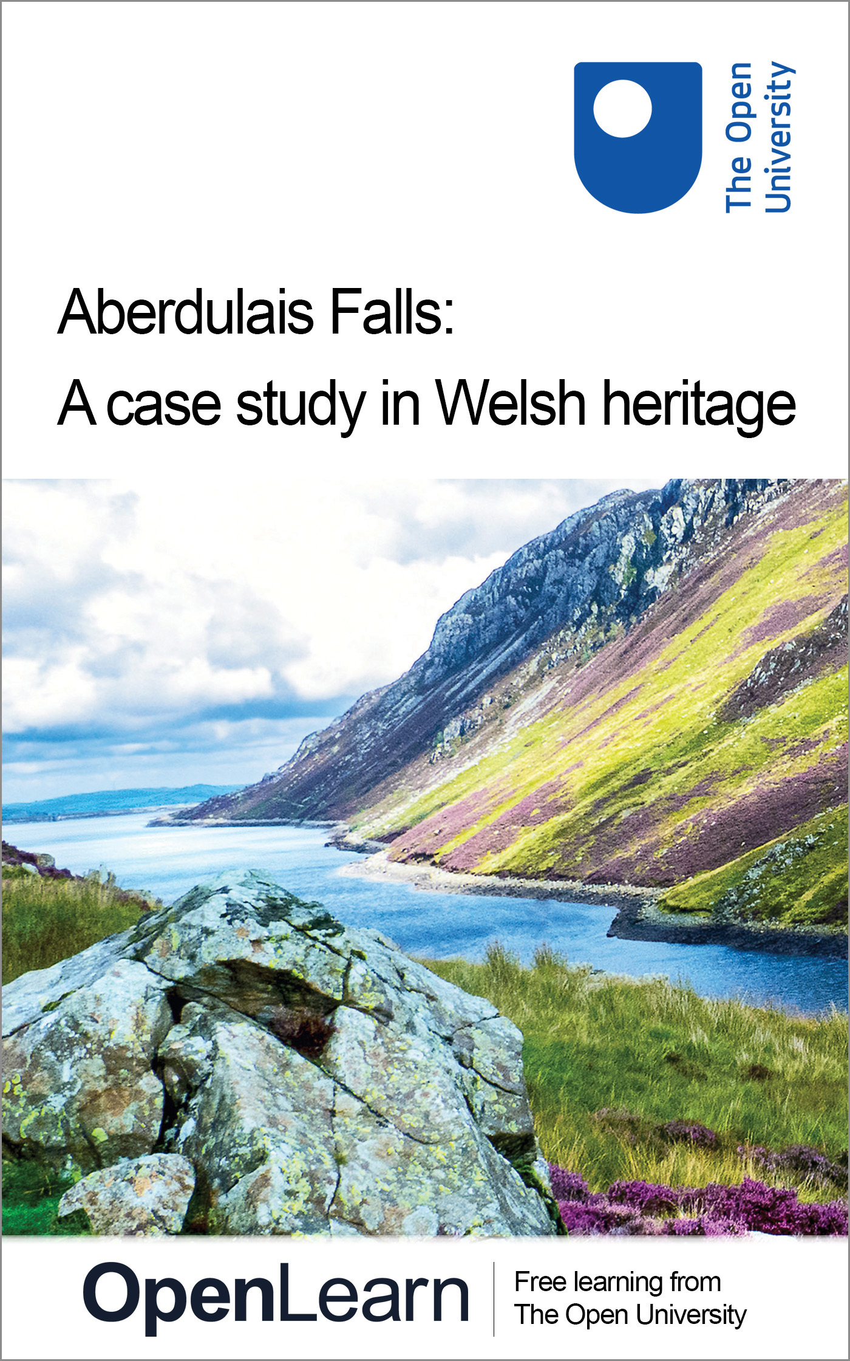

A180_2 Heritage, whose heritage?

Aberdulais Falls: A case study in Welsh heritage
About this free course
This OpenLearn course provides a sample of Level 1 study in Arts and Humanities: http://www.open.ac.uk/courses/find/arts-and-humanities.
This version of the content may include video, images and interactive content that may not be optimised for your device.
You can experience this free course as it was originally designed on OpenLearn, the home of free learning from The Open University – www.open.edu/openlearn/history-the-arts/history/heritage/aberdulais-falls-case-study-welsh-heritage/content-section-0
There you’ll also be able to track your progress via your activity record, which you can use to demonstrate your learning.
The Open University, Walton Hall, Milton Keynes, MK7 6AA
Copyright © 2016 The Open University
Intellectual property
Unless otherwise stated, this resource is released under the terms of the Creative Commons Licence v4.0 http://creativecommons.org/licenses/by-nc-sa/4.0/deed.en_GB. Within that The Open University interprets this licence in the following way: www.open.edu/openlearn/about-openlearn/frequently-asked-questions-on-openlearn. Copyright and rights falling outside the terms of the Creative Commons Licence are retained or controlled by The Open University. Please read the full text before using any of the content.
We believe the primary barrier to accessing high-quality educational experiences is cost, which is why we aim to publish as much free content as possible under an open licence. If it proves difficult to release content under our preferred Creative Commons licence (e.g. because we can’t afford or gain the clearances or find suitable alternatives), we will still release the materials for free under a personal end-user licence.
This is because the learning experience will always be the same high quality offering and that should always be seen as positive – even if at times the licensing is different to Creative Commons.
When using the content you must attribute us (The Open University) (the OU) and any identified author in accordance with the terms of the Creative Commons Licence.
The Acknowledgements section is used to list, amongst other things, third party (Proprietary), licensed content which is not subject to Creative Commons licensing. Proprietary content must be used (retained) intact and in context to the content at all times.
The Acknowledgements section is also used to bring to your attention any other Special Restrictions which may apply to the content. For example there may be times when the Creative Commons Non-Commercial Sharealike licence does not apply to any of the content even if owned by us (The Open University). In these instances, unless stated otherwise, the content may be used for personal and non-commercial use.
We have also identified as Proprietary other material included in the content which is not subject to Creative Commons Licence. These are OU logos, trading names and may extend to certain photographic and video images and sound recordings and any other material as may be brought to your attention.
Unauthorised use of any of the content may constitute a breach of the terms and conditions and/or intellectual property laws.
We reserve the right to alter, amend or bring to an end any terms and conditions provided here without notice.
All rights falling outside the terms of the Creative Commons licence are retained or controlled by The Open University.
Head of Intellectual Property, The Open University
Designed and edited by The Open University
978-1-4730-1400-8 (.kdl)
978-1-4730-0632-4 (.epub)

Contents
- Introduction
- Learning outcomes
- 1 Aberdulais Falls
  - 1.1 Background
  - 1.2 Aberdulais Falls and the National Trust
  - 1.3 Stages of development
  - 1.4 The economics of maintaining a heritage site
  - 1.5 Water power
  - 1.6 Visitor numbers
  - 1.7 Evaluation
  - 1.8 Conflict and tension
  - 1.9 Aberdulais Falls and the local community
  - 1.10 Other considerations
  - 1.11 Facilities and the visitor experience
  - 1.12 Conclusion
- Keep on learning
- Acknowledgements

Introduction
This case study looks at Aberdulais Falls near Neath, South Wales. This is a place of great natural beauty, but also an important industrial heritage site. The course considers the key issues affecting the decision-making of the bodies which are responsible for looking after our heritage. For example, who decides what should be preserved from the past as our heritage, who is this heritage for, and how should it be presented and explained? In this case study, we examine the heritage debates around what to do with places, buildings, things and the memories attached to them in the context of a specific Welsh heritage site.
This OpenLearn course provides a sample of Level 1 study in Arts and Humanities.

Learning outcomes
After studying this course, you should be able to:
- understand some of the issues surrounding natural heritage
- understand some of the issues surrounding industrial heritage
- demonstrate an awareness of why tensions often arise between conservation and the demands of modern tourism.

1 Aberdulais Falls

1.1 Background
Aberdulais Falls is under the control of the National Trust. It is set in an area of outstanding natural beauty that has attracted artists for centuries (Turner visited the ten-metre high waterfall in 1796). Aberdulais Falls also has a four-hundred-year history of industrial use, due to the opportunities it provides for water power. The industrial history of Aberdulais Falls goes back to 1584, when the availability of water power and fuel led to copper ore from Cornwall being smelted there. Copper smelting was superseded by a fulling mill (used in the manufacture of cloth), and later by a corn mill. Corn ceased to be milled there in 1820.
The combination of good canal and road links and water power led to the construction of a tinplate works on the site in 1830. This remained in operation until 1897, after which the works fell into decay, with only a few buildings remaining occupied and maintained. One was Danygraig House; the others were a stable and the former school for tinplate workers' children.
In time, even Danygraig House became derelict, and in 1981 the whole site was taken over by the National Trust.

1.2 Aberdulais Falls and the National Trust
When the National Trust took over the Aberdulais Falls and the associated buildings, the site was derelict, overgrown and dangerous. Prior to the Trust's ownership, public access to the Falls over the land surrounding it had been denied. Important decisions had to be taken regarding the future of the site.
The A465 slices through the site and the suburbs of Neath have encroached on the river bed on both sides.

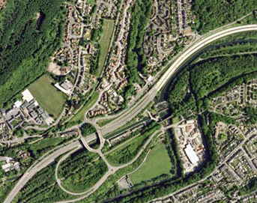
Photo: RGB Aerial Photography. © GeoPerspectives COWI A/S Photo: RGB Aerial Photography.© GeoPerspectives COWI A/S
Figure 1: Aberdulais Falls, Skewen, Neath
View description - Figure 1: Aberdulais Falls, Skewen, Neath

View an interactive version of Aberdulais Falls.
Informed by its stated aims and objectives, the National Trust's decision-making process swung into action. This was, of necessity, complex and time-consuming. It was determined by the interaction of a range of professionals and senior members of the Trust. In addition, any developments to the site had to be agreed by Cadw – the Welsh equivalent of English Heritage.

1.3 Stages of development
As a result of the consultation and decision-making process, it was decided, as a primary objective, to undertake a systematic survey of the site in order to uncover and understand the industrial archaeology of Aberdulais Falls. This involved removing tons of rubbish, infill and vegetation, and examining in detail the archaeological remains discovered.
During this process, no evidence from the sixteenth-century copper smelting works was uncovered, and it is assumed that this lies beneath the archaeology of the later tinplate works.
The next stage was to make the derelict buildings safe, by consolidating the masonry, and to open the site to the public. This occurred in 1984, and initially Aberdulais Falls received about 2000–3000 visitors per year. The site was attractively landscaped and artists could again make use of the site in an aesthetically pleasing environment. However, it would have given little impression of the noise, smell and physically demanding labour of a tinplate works.

1.4 The economics of maintaining a heritage site
The National Trust operates within a complex web of funding. This comes from annual membership fees and from visitor receipts at individual sites. Each National Trust property is responsible for raising the income necessary to fund its own conservation activities and further development (although a large minority of sites cannot cover their costs). Properties raise this income through visitors charges and from catering, shop sales, etc. Failure to raise sufficient income can lead to job losses and the inability to improve facilities or undertake conservation work.
It is therefore important for National Trust properties to increase the volume of visitors, and to maximise the spend-per-head of the visitors they attract.
In the first phase of development at Aberdulais Falls, the emphasis was on the industrial archaeology of the site and on providing visitor access to the area. In the 1990s, the emphasis changed to expanding the amenities and attractions offered by the site.

1.5 Water power
This second phase was achieved by focusing on the water-power potential of the site. Water power had been the catalyst for the original industrial development, and it seemed apt to capitalise on that. It was decided to install a new waterwheel where the original one had been. This provided an important visitor attraction, and also presented the opportunity to use the waterwheel to generate electricity for the site, thus providing significant cost savings. Furthermore, as part of that building work, a water turbine was installed, allowing the Trust to earn additional income from the sale of electricity to the National Grid. The water-power project cost £850,000 and was completed in 1993.
As part of an overall strategy of nature conservation on the site, and as an added visitor attraction, while the water-power systems were being installed a fish pass was incorporated to enable salmon to return to their spawning grounds.
During this extensive phase of building work, the interpretation of the site for visitors was largely completed.
A conscious decision was taken not to attempt to reconstruct the archaeological features of the tinplate works. Rebuilding was only undertaken for structural reasons or to facilitate visitor understanding. Consequently, visitors to the site see only the consolidated lower walls of the original industrial buildings. Interpretation is achieved by the use of external text panels with artists' impressions of the way the tinplate works would have appeared in its heyday.
A fuller interpretation of the site is displayed in an exhibition in the original stable building. This covers the whole history of the site, and describes the experience of working in the tinplate works through the eyes of a number of individual workers – including children.

1.6 Visitor numbers
The National Trust has actively sought to encourage visitors with a wide range of interests to the site, and to broaden the appeal of the site as much as possible:
- displays include interpretation panels devoted to the geology, flora and fauna of the site
- computer interactive displays have been used to expand the information base
- guided tours are run, and information sheets and visitor packs have been produced
- special days for artists are held.
These various initiatives, with the addition of a new visitor centre, full disabled access and better parking facilities, have led to visitor numbers now averaging 24,000 per year.

1.7 Evaluation
The preceding description of the history and development of this particular heritage site possibly gives the impression of some inevitability of development, and of a smooth, conflict-free transition from a derelict industrial site to a successful visitor attraction.
However, alternative approaches could have been undertaken. Some that strike me include the following:
- The site could have simply been surveyed, made safe and provided with one or two robust, external interpretation panels. Access could have been made available without the need to employ staff or provide facilities. It could be argued that such facilities are alien both to the industrial site and to the beauty of the waterfalls.
- An attempt could have been made to restore the site, as far as possible, to how the tinplate works would have appeared in the nineteenth century. Such an approach has been undertaken successfully in many open-air museums across Britain.
- All trace of the industrial past could have been removed in order to focus solely on the impressive natural beauty of the area. This could have allowed more interpretation of the role Aberdulais Falls has played over the centuries in inspiring poets and artists such as Turner.
You can probably think of others.

1.8 Conflict and tension
The management of a site such as Aberdulais Falls by its very nature highlights conflicting interests and tensions. Some relate to problems caused by the decision-making process itself, which can be slow and has to accommodate a range of interests of the various client bodies.
For example, when a new information centre was to be built on the site, the client bodies involved in making decisions about its overall appearance, form and fabric were: the National Trust Planning Committee, the National Trust Archaeological Department, Cadw, the Historic Buildings representative, the Friends’ Association (they provided funds for the new building), and the local authority, all of whom might have had different ideas about how to proceed.
Other areas of conflict are due to the economics of maintaining the site. This demands high visitor numbers, but high visitor numbers pose problems for the site in terms of damage, running repairs, wear and tear, and visitor congestion, which all have cost implications.
There are a number of ways in which visitor numbers to a site such as this could be increased without causing congestion, but these are all in their own way controversial, for example:
- increasing the space available to visitors
- extending opening hours
- restricting or rationing the time individuals or groups can remain on site.
Increasing the space available and encouraging more visitors would require more car parking, and more toilet and catering facilities. Extending the opening hours would require more staff. Both these options involve a difficult cost–benefit analysis. Rationing the time individuals or groups could remain on site would be difficult to police and would be counter to the ethos of the National Trust.

1.9 Aberdulais Falls and the local community
Other potential areas of conflict are with the local authority and local residents, who see the site as of value to themselves and have differing views about how it should be utilised.
The desire to accommodate, to some extent, the demands of the local community, and to engage with that community, has led to a number of initiatives. Examples of these include the use of the site's facilities for hosting lectures, meetings, keep-fit groups, etc. These initiatives can be of use to local businesses and community groups, and help raise additional revenue.
There is clear amenity value of the Falls to the local community, which was enhanced in 1994 by the acquisition of an additional 15 acres of surrounding woodlands. These are slowly being developed to provide woodland walks and nature trails.
Fishing and bird watching are also encouraged, as are field trips by local schools.
However, the Falls are in close proximity to a local housing estate (see Figure 1). At times, there have been problems between the residents of this estate and the National Trust. These have primarily involved fly tipping, vandalism and unauthorised access.
In an attempt to overcome such problems, members of the Trust have adopted a policy of meeting with the residents to discuss the problems and consider collaborative ventures and activities.

1.10 Other considerations
While visitors to Aberdulais Falls seem genuinely to enjoy the experience, there is a possibility that only when they arrive at the site do they realise it is primarily an industrial site, with an attractive waterfall. There is no mention in the Aberdulais Falls title of it being an industrial site. Even the National Trust Handbook and website are a little ambiguous, using the phrase ‘Famous waterfalls and fascinating industrial site’ in its literature. Clearly not all visitors are members of the National Trust, and some may feel disappointed that the waterfalls are not central to the visitor experience, or as accessible as some other waterfalls in the region.

1.11 Facilities and the visitor experience
The quality of any visitor experience is dependent on a number of variables. These include signposting to the tourist attraction, car parking, catering, toilet facilities and overall interpretation.
The lack of adequate parking, especially on public holidays, was something of a problem in the past, there being no parking on the site itself. To overcome this problem, the National Trust leased part of a nearby hotel’s car park, but there were complaints that visitors to the waterfalls were monopolising the hotel car park. This problem has, to some extent, been overcome recently by the creation of a dedicated National Trust car park nearby. This has augmented the use of the hotel car park, which is still leased by the Trust.

1.12 Conclusion
It is clear that there are tensions in the use of the site, in that it attracts quite different audiences. There are also tensions relating to the number of visitors it is logistically possible to accommodate, and the economics of maintaining a viable revenue income.
The debate goes on about how best to develop and maintain the site in line with the Trust's stated aims and objectives.
There is no definitive answer, and the site will inevitably evolve over time. It is now an attractive visitor attraction, which engages well with current interests in nature conservation, renewable energy and the national curriculum. In the future, those interests may change, and the Trust will almost certainly have to respond to those changes with a different approach. Similarly, the economic and political climate may change and further influence the way Aberdulais Falls operates as a visitor attraction.
You can find information about other industrial sites in South Wales on the Herian: Heritage in Action website.

Keep on learning



Study another free course
There are more than 800 courses on OpenLearn for you to choose from on a range of subjects.
Find out more about all our free courses.

Take your studies further
Find out more about studying with The Open University by visiting our online prospectus.
If you are new to university study, you may be interested in our Access Courses or Certificates.

What’s new from OpenLearn?
Sign up to our newsletter or view a sample.

For reference, full URLs to pages listed above:
OpenLearn – www.open.edu/openlearn/free-courses
Visiting our online prospectus – www.open.ac.uk/courses
Access Courses – www.open.ac.uk/courses/do-it/access
Certificates – www.open.ac.uk/courses/certificates-he
Newsletter – www.open.edu/openlearn/about-openlearn/subscribe-the-openlearn-newsletter

Acknowledgements
This course was written by Dr Alan Wilson
Except for third party materials and otherwise stated (see terms and conditions), this content is made available under a Creative Commons Attribution-NonCommercial-ShareAlike 4.0 Licence
Grateful acknowledgement is made to the following sources for permission to reproduce material in this course:
Course image: Robert J Heath in Flickr made available under Creative Commons Attribution 2.0 Licence.
Figure 1 RGB Aerial Photography. © GeoPerspectives COWI A/S
Don't miss out:
If reading this text has inspired you to learn more, you may be interested in joining the millions of people who discover our free learning resources and qualifications by visiting The Open University - www.open.edu/openlearn/free-courses

Figure 1: Aberdulais Falls, Skewen, Neath

Description
Figure 1
Back to Session 1 Figure 1

