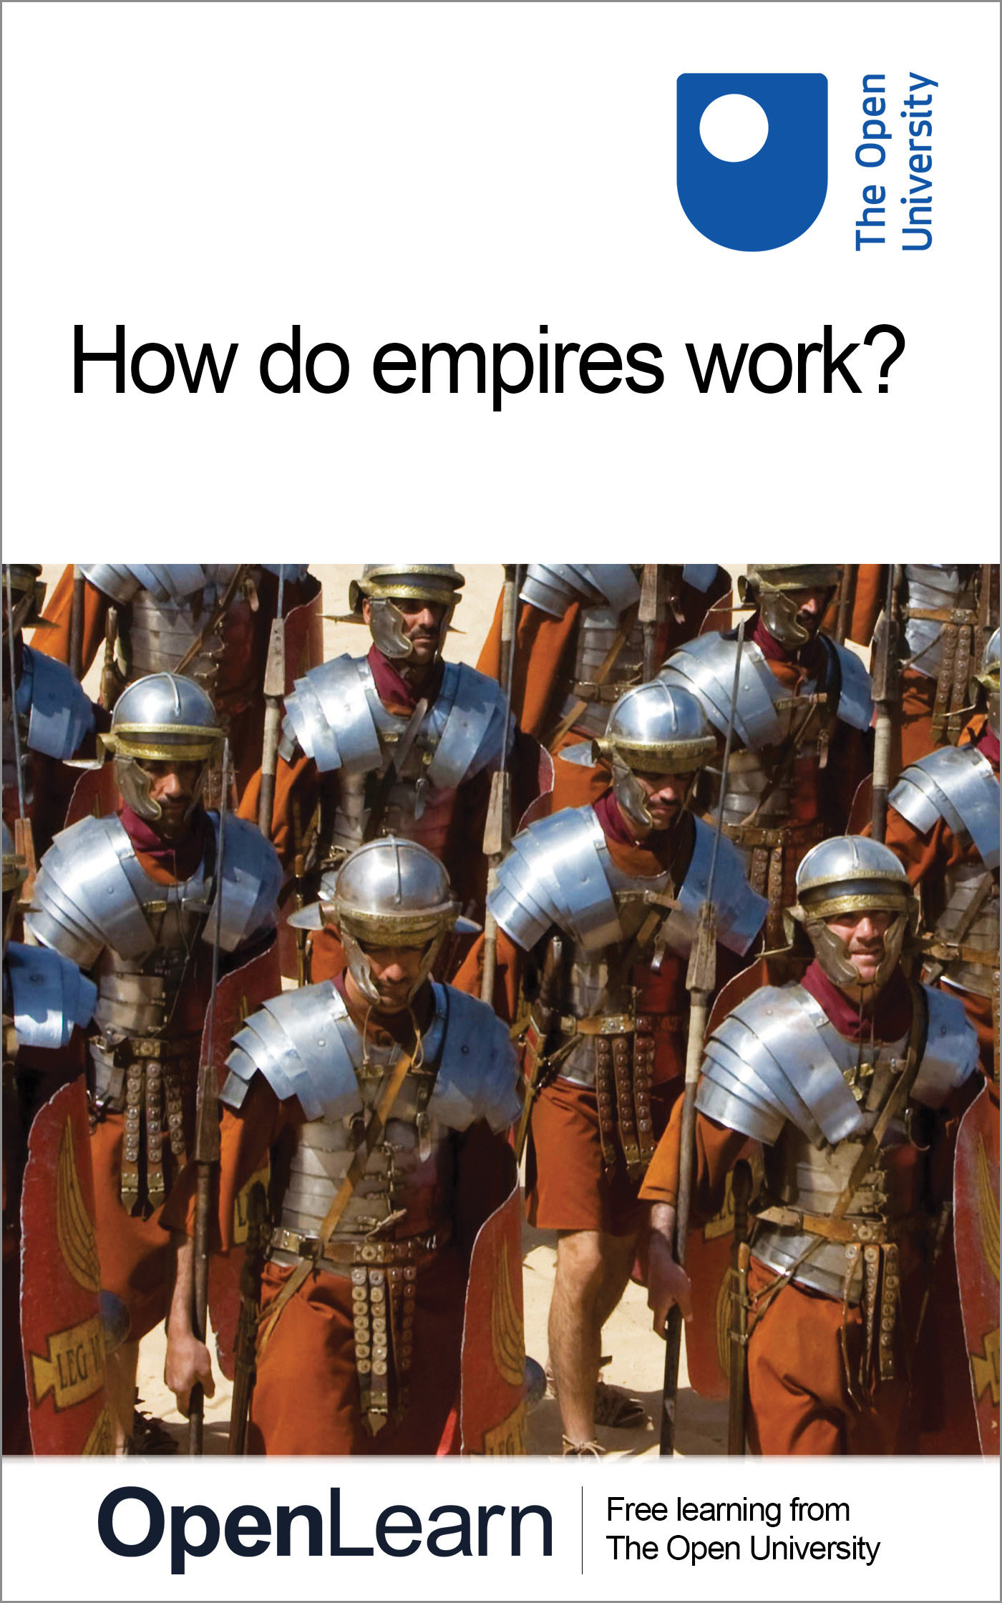

A326_1

How do empires work?
About this free course
This free course is an adapted extract from the Open University course A326 Empire: 1492–1975: www3.open.ac.uk/study/undergraduate/course/a332.htm.
This version of the content may include video, images and interactive content that may not be optimised for your device.
You can experience this free course as it was originally designed on OpenLearn, the home of free learning from The Open University – www.open.edu/openlearn/history-the-arts/how-do-empires-work/content-section-0
There you’ll also be able to track your progress via your activity record, which you can use to demonstrate your learning.
Copyright © 2016 The Open University
Intellectual property
Unless otherwise stated, this resource is released under the terms of the Creative Commons Licence v4.0 http://creativecommons.org/licenses/by-nc-sa/4.0/deed.en_GB. Within that The Open University interprets this licence in the following way: www.open.edu/openlearn/about-openlearn/frequently-asked-questions-on-openlearn. Copyright and rights falling outside the terms of the Creative Commons Licence are retained or controlled by The Open University. Please read the full text before using any of the content.
We believe the primary barrier to accessing high-quality educational experiences is cost, which is why we aim to publish as much free content as possible under an open licence. If it proves difficult to release content under our preferred Creative Commons licence (e.g. because we can’t afford or gain the clearances or find suitable alternatives), we will still release the materials for free under a personal end-user licence.
This is because the learning experience will always be the same high quality offering and that should always be seen as positive – even if at times the licensing is different to Creative Commons.
When using the content you must attribute us (The Open University) (the OU) and any identified author in accordance with the terms of the Creative Commons Licence.
The Acknowledgements section is used to list, amongst other things, third party (Proprietary), licensed content which is not subject to Creative Commons licensing. Proprietary content must be used (retained) intact and in context to the content at all times.
The Acknowledgements section is also used to bring to your attention any other Special Restrictions which may apply to the content. For example there may be times when the Creative Commons Non-Commercial Sharealike licence does not apply to any of the content even if owned by us (The Open University). In these instances, unless stated otherwise, the content may be used for personal and non-commercial use.
We have also identified as Proprietary other material included in the content which is not subject to Creative Commons Licence. These are OU logos, trading names and may extend to certain photographic and video images and sound recordings and any other material as may be brought to your attention.
Unauthorised use of any of the content may constitute a breach of the terms and conditions and/or intellectual property laws.
We reserve the right to alter, amend or bring to an end any terms and conditions provided here without notice.
All rights falling outside the terms of the Creative Commons licence are retained or controlled by The Open University.
Head of Intellectual Property, The Open University
978-1-4730-1317-9 (.kdl)
978-1-4730-0549-5 (.epub)

Contents
- Introduction
- Learning outcomes
- 1 Empires as systems of power
- 2 The Qing empire
- 3 The British empire
- 4 The Anglo-Chinese War
- Conclusion
- Keep on learning
- References
- Acknowledgements

Introduction
This free course asks you to think about what glues empires together: what makes an empire into a ‘system of power’? It does this by looking at dramatic events in 1842, when Royal Navy ships and British East India troops penetrated right into the inland heart of the Chinese empire, 120 miles up the Yangzi River. It shows what military, economic, cultural and logistical components made up the contrasting British (maritime) and Chinese (land) empires. It uses this analysis to explain how Britain could successfully overawe another, mighty empire thousands of miles away from Europe, and so gain Hong Kong.
This OpenLearn course is an adapted extract from the Open University course A326 Empire: 1492–1975.

Learning outcomes
After studying this course, you should be able to:
- understand what a ‘system of empire’ is
- understand the key components – economic, military, logistic and cultural – which can help to make up a system of empire.

1 Empires as systems of power
On 19 July 1842, ships of the Royal Navy and East India Company bombarded Zhenjiang (known in older European works as Chinkiang) – a city 120 miles (190 km) up the River Yangzi (Yangtze). The ships landed Royal Marines and company troops, including Indian sepoys (infantry), totalling around 7000 men. This force stormed the city, leaving the British in control of Zhenjiang, and so of the junction between China’s greatest river, the Yangzi, and the world’s longest artificial waterway, the Grand Canal. British sea and waterborne forces now had the Chinese land-based empire by its throat.
To understand why this was so, we need to understand how the Chinese empire worked; and to do this we need to look at empire as a ‘system of power’. In particular, we need to understand just how vital the Yangzi and Grand Canal were to its internal mechanisms. The Yangzi extended from Shanghai near China’s east coast, past Zhenjiang, inland to the southern capital of Nanjing, and further westwards. It constituted a massive internal artery for east–west communications: stretching 3500 miles (5630 km) from its source on the Tibetan plateau to its estuary at the sea. Hence its modern Chinese name: Changjiang, meaning ‘long river’.
The Yangzi was joined to China’s other great east–west flowing rivers by the Grand Canal, which intersected them roughly at right angles. This latter provided a major north–south artery, stretching 1100 miles (1770 km) from Hangzhou (Hangchow) in south China to Beijing in the north. As such it made vital connections: between natural rivers; between the southern (Nanjing) and northern (Beijing) capitals and dialect areas; and between the great southern rice bowl and the northern plains. Like Russia, the Qing (Ch’ing) system, as a land empire, relied heavily on such inland waterways. You can think of China as an empire that grew up around the great Yellow River in the north, and extended by joining this to other waterborne systems via the Grand Canal and via the coast, and thereby also connecting to the PearlRiver basin in the south (see Figure 1). If you conceive of China as a system bound together this way, rather than merely as a land mass with the Great Wall keeping out central Asian horsemen, the seriousness of China’s defeat at Zhenjiang becomes clear.

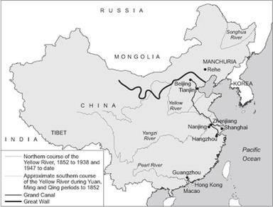
Figure 1 Major Chinese rivers and the Grand Canal in the nineteenth century, imposed on an outline of modern-day China.

The loss of control of these arteries for tax, trade, grains, reinforcements, and for the emperor to reach his inland cities, was thus one factor in bringing the Qing emperor to sue for peace. As long as the British had hammered away only at the margins, the coastal ports and downriver, he could continue the First Anglo-Chinese War (the ‘Opium War’, 1839–42). These external pinpricks were like so many cuts on a rhinoceros hide. Until this last blow, the Chinese land empire could still ensure that tax flowed, and food circulated. But once the yi – barbarians, as the Chinese termed foreigners – had penetrated to the heart of its interior communications, the game was up: regardless of the fact that, at around 400 million, China’s mid-century population dwarfed Britain’s 18.5 million (1841).
Little more than a month later, on 29 August 1842, China signed the Treaty of Nanjing (Nanking). This confirmed cession of the island of Hong Kong to Britain, the opening of five ‘treaty ports’ to British foreign trade and residence, and payment of an indemnity. Strangely, though, the sale of opium, the confiscation of which had been the trigger for war, was not explicitly legalised. This treaty marked the beginning of a serious decline in China’s fortunes as an empire – the Grand Canal itself falling into serious disrepair – and the beginning of Britain’s informal imperialism in China.
Why start with this one battle and place? Because they embody a clash between radically different ways of ‘doing’ empire: militarily, economically, administratively and in terms of ideas. By forcing us to view this moment in the First Anglo-Chinese War as a clash of two empires as distinct ‘systems of power’, it gets to the heart of the question ‘How do empires work?’ For the moment Zhenjiang fell was also the point when a European maritime empire finally persuaded the Qing land empire, after decades of intermittent negotiation and three years of open war, that it had met its match. What I propose in the rest of this course, then, is to continue to open up the question that ‘How do Empires Work’, by unpacking this one incident.
First, some additional words about the opponents at the July 1842 battle for Zhenjiang.

2 The Qing empire
In the eastern corner was the Qing empire. In contrast to the maritime European empires, this was primarily land based. Its emperor at Beijing, and his bureaucracy (some recruited from Manchu banner men – so called because they were organised around clan banners – and some by competitive examinations), provided a vast, mainly rural population with some guarantee against disorder and famine. It achieved this with thinly spread officials, partly by the way its sheer scale facilitated the movement of resources from one region to another. Watercourses such as the Grand Canal helped to make this possible, moving taxes and grain supplies from the central rice bowl of China to the north, and also on occasion moving troops and the emperor around his kingdom.
We have already touched on the economic, military and cultural strands of the Qing empire. But the Qing realm was also a very special ‘double-edged’ type of empire, with internal as well as external elements to its imperialism.
Let us take the external dimension first. In its relations with territories at a distance, it regarded itself as ‘the Central Kingdom’–‘China’s’ name in Mandarin is not ‘China’, but Zhongguo, which means ‘central kingdom’. Its ideology emphasised the Chinese emperor’s supreme position, ruling by ‘mandate of heaven’, superior to all other states.
In the century up to 1839, the Qing had extended by colonising its outer reaches, by military campaigns against northern and western border kingdoms, which were made into provinces, and by incorporating foreign powers (according to Qing rhetoric and propaganda at least) into its ‘tribute system’. Foreign states were expected to acknowledge Chinese superiority by words and tribute, in return for which the Chinese emperor bestowed gifts. For distant countries, this ‘tribute system’ may have functioned more as a form of state to state trade than as an exercise in substantive suzerainty or real ‘imperial’ power.
This conceptualisation of Qing China as an empire had been a constant pain for British officials and traders. Missions, such as Lord Macartney’s in 1793–95, repeatedly failed to persuade the Chinese to allow relations of equality, or the permanent stationing of foreign representatives in Beijing. By 1839, all foreign trade was still supposed to go through Guangzhou (Canton) on the Pearl River in the south. Western powers were allowed to have trading posts at this southern city alone, and even there all trade still had to go through officially sanctioned Chinese merchants or hongs (collectively termed the cohong). So China’s economic organisation, as well as the Qing’s nature as a land empire, are vital backgrounds to understanding the First Anglo-Chinese War.
The internal elements to China’s imperialism, meanwhile, stemmed from its rulers being, and to a degree remaining, foreigners. The Manchu rulers of the Qing dynasty (1644–1911) came from Manchuria in the north. Though they adopted Chinese administrative practices, and to a certain extent culture, the Manchus remained to some degree separate, and continued to divide their army into Manchu, Mongol and Han banners or sections. So China was in part an internal empire over Han Chinese and other groups, and partly an external empire over territories conquered, settled or engaged in tributary relations.

3 The British empire
By contrast, in the western corner was the British empire. This comprised two distinct components of external dominion. On the one hand there was the British East India Company (EIC), whose ships and sepoys had served at Zhenjiang (as well as many other places). The company had lost its last trading monopolies effective from 1834. It was now mainly a land empire, having expanded inland from its bridgeheads in Bengal and at trading ports, gradually supplanting Muslim and Hindu rulers. The company now controlled both its own naval forces and a vast army, which reached 300,000 before 1857, composed partly of Indian-financed British units, but mostly of Indian sepoys who served under British officers. Though technically subordinate to the decayed Mughal empire until 1858, and its emperor in Delhi, in fact the EIC commanded an Indian empire in its own right. From 1784, the company was subject to formal British supervision through a government-appointed Board of Control in London.
The second major component of the British ‘system of power’ was the British empire as controlled from London. This had a relatively small army, and relied heavily on the Royal Navy. Britain’s unique nineteenth-century strength thus came from a combination of Europe-based naval and financial power, and India-based manpower. Victory in the First Anglo-Chinese War was achieved by using the naval power to project Indian troops, alongside small numbers of European infantry and artillery, up Chinese rivers into its inland heart. The defeat of the Qing also came in part because from industrialisation onwards, between 1750 and 1850, Europe opened up a critical lead in military technology. Its sheer density of industrial development meant Europe was now always one step ahead. In the First Anglo-Chinese War, the paddle steamer Nemesis blew Chinese junks out of the water, and Chinese matchlocks were no match for European flintlock guns. By the late nineteenth century, Europeans were introducing rifled guns (lined with ridges that increase accuracy) and, latterly, the Gatling gun, just as the Chinese adopted earlier technology (Hack and Rettig, 2006).
The competition between European maritime powers for naval supremacy was intense, and was characterised by cumulative improvement in naval efficiency. This sustained an increasing gap between European and non-European naval powers, a difference captured by Figure 2, which show the Nemesis in action. European naval powers, meanwhile, were finely balanced among themselves until the Napoleonic Wars of 1795–1815, from which Britain emerged master of the seas.
The Napoleonic Wars thus ended a long period of wordwide struggles for supremacy in the eighteenth century, featuring at their core rivalry between European maritime empires. The British system of power, with its heavy reliance on naval forces and deficit financing (basically, largescale borrowing to finance wars), ultimately triumphed over a very different, and relatively short-lived, Napoleonic system. This latter had a contrasting emphasis on mass conscription, and recruitment of other countries as auxiliaries by making their leaders relatives of, or dependent on, Napoleon.
Comparing the Qing, British and Napoleonic systems of empire brings home the fact that it is not just military might per se that constitutes imperial power, but that taxation and finance – ‘military–fiscal’ matters – are vital too.
Napoleon’s final defeat came in 1815. By removing Britain’s main opponent, this allowed Britain to rule the waves for several decades. That supremacy, backed by a lead in industrialisation, led Britain to try to impose ‘free trade’, or at least trade at low tariffs, on the rest of the world. Its economic nature of its system of empire thus shifted significantly in the early nineteenth century.

4 The Anglo-Chinese War
Again, the First Anglo-Chinese War is a good window into what sort of system of power, in economic terms, that Britain was trying to build from early in the nineteenth century. The First Anglo-Chinese War arose out of economic questions. China had made opium imports illegal from 1796, but the East India Company circumvented this.

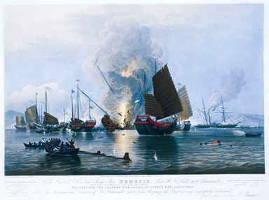
Figure 2 E. Duncan, The Hon. E.I. Co. Iron Steam Ship Nemesis ... with boats of Sulphur, Calliope, Larne, and Starling, destroying the Chinese war junks, in Anson’s Bay, Jan. 7th, 1841, engraving. Published by Messrs Fores, London, 1843. National Maritime Museum, Greenwich, London. Photo: © National Maritime Museum. The few steamers employed during the First Opium War were invaluable, being almost all iron in construction. Their combined fossil power and shallow draught (the depth they lay in the water) made them able to operate regardless of wind conditions, sand bars and shallows in places such as the Pearl River.

The East India Company auctioned off Bengal opium, whose production it monopolised, to private ‘country traders’ such as those of Jardine and Matheson. So successful were these, with the connivance of local Chinese officials, that by the 1820s Chinese consumption was soaring, and the influx of silver into China, to pay for European imports of porcelain, tea and silk, had now turned into an outflow. Alarmed at the moral and fiscal decline of his empire, in 1839 the emperor appointed Lin Zexu (Lin Tse-hsu) as the new commissioner of Guangzhou with orders to stop the trade. Lin had the British traders hand over 20,000 chests of opium, but, misunderstanding the British view on this property, destroyed these rather than negotiating their return or compensation. A cessation of Anglo-Chinese trade resulted, and naval incidents spiralled into war.
But the resulting war was more than simply an attempt to ensure the opium trade continued. It also represented an attempt to foist the new doctrine of ‘free trade’ on China. The EIC had founded Singapore as a free-trade port in 1819, and by the 1840s British duties on imports were being reduced en masse. Britain was by now eager to integrate new areas into a global system of ‘free trade’. In a sense, then, the First Anglo-Chinese War was as much a clash between the Qing way of organising the economics of empire, and the British attempt to construct new rules of global trading, as it was about opium per se. So, how the economic sinews of empire are organised, whether as mercantilist (restricting trade to the empire’s own ships and Europe-bound exports to the metropolis) or free trade, whether limiting outside trade (as China did) or maximising it (as post-1840s Britain hoped to) matters. The new free trade imperialism, and laissez-faire (‘hands off’) approach to markets, could lead both to booming trade on the one hand, and yet to ineffectiveness, if not indifference, in the face of famine and suffering on the other.

Conclusion
Finally, we need to take the discussion of the sinews of empire beyond the realm of guns and chests of opium – into the realm of ideas and culture. What role did ‘Imperial cultures’ play? What ideas, for instance, made Empire seem acceptable to British and French elites? The works of Edward Said and Frantz Fanon have suggested that European culture and science were used to keep colonised people subordinated, not just militarily or economically shackled, but with their very thoughts reprogrammed. By contrast, how far could the colonised both thrive by adopting metropolitan models, and also sometimes challenge them and assert agency? In short, how far did empires rest on non-military mechanisms? How far were empires constructions of the mind – of schools, languages, maps, novels and societies – as well as of the sword.
No brief discussion could do more than scratch the surface of how empire is ‘done’, and systems of power kept in being. But we do believe that when added to the issue of communications systems discussed above, the four themes we have just discussed – military, economic, bureaucratic and cultural – give you the most important four ways of analysing the sinews of empire. If you can at least start to look for and ask informed questions about the different ways these sinews of power are organised, and embedded in institutions, when you meet new imperial situations, this introduction will have been worthwhile.

Keep on learning



Study another free course
There are more than 800 courses on OpenLearn for you to choose from on a range of subjects.
Find out more about all our free courses.

Take your studies further
Find out more about studying with The Open University by visiting our online prospectus.
If you are new to university study, you may be interested in our Access Courses or Certificates.

What’s new from OpenLearn?
Sign up to our newsletter or view a sample.

For reference, full URLs to pages listed above:
OpenLearn – www.open.edu/openlearn/free-courses
Visiting our online prospectus – www.open.ac.uk/courses
Access Courses – www.open.ac.uk/courses/do-it/access
Certificates – www.open.ac.uk/courses/certificates-he
Newsletter – www.open.edu/openlearn/about-openlearn/subscribe-the-openlearn-newsletter

References
Hack, K. and Rettig, T. (2006) Colonial Armies in Southeast Asia, London, RoutledgeCurzon.

Acknowledgements
This free course was written by Karl Hack.
Except for third party materials and otherwise stated (see terms and conditions), this content is made available under a Creative Commons Attribution-NonCommercial-ShareAlike 4.0 Licence.
The material acknowledged below is Proprietary and used under licence (not subject to Creative Commons Licence). Grateful acknowledgement is made to the following sources for permission to reproduce material in this course:
Course image: askii in Flickr made available under Creative Commons Attribution-ShareAlike 2.0 Licence.
Every effort has been made to contact copyright owners. If any have been inadvertently overlooked, the publishers will be pleased to make the necessary arrangements at the first opportunity.
Don't miss out:
If reading this text has inspired you to learn more, you may be interested in joining the millions of people who discover our free learning resources and qualifications by visiting The Open University - www.open.edu/openlearn/free-courses

