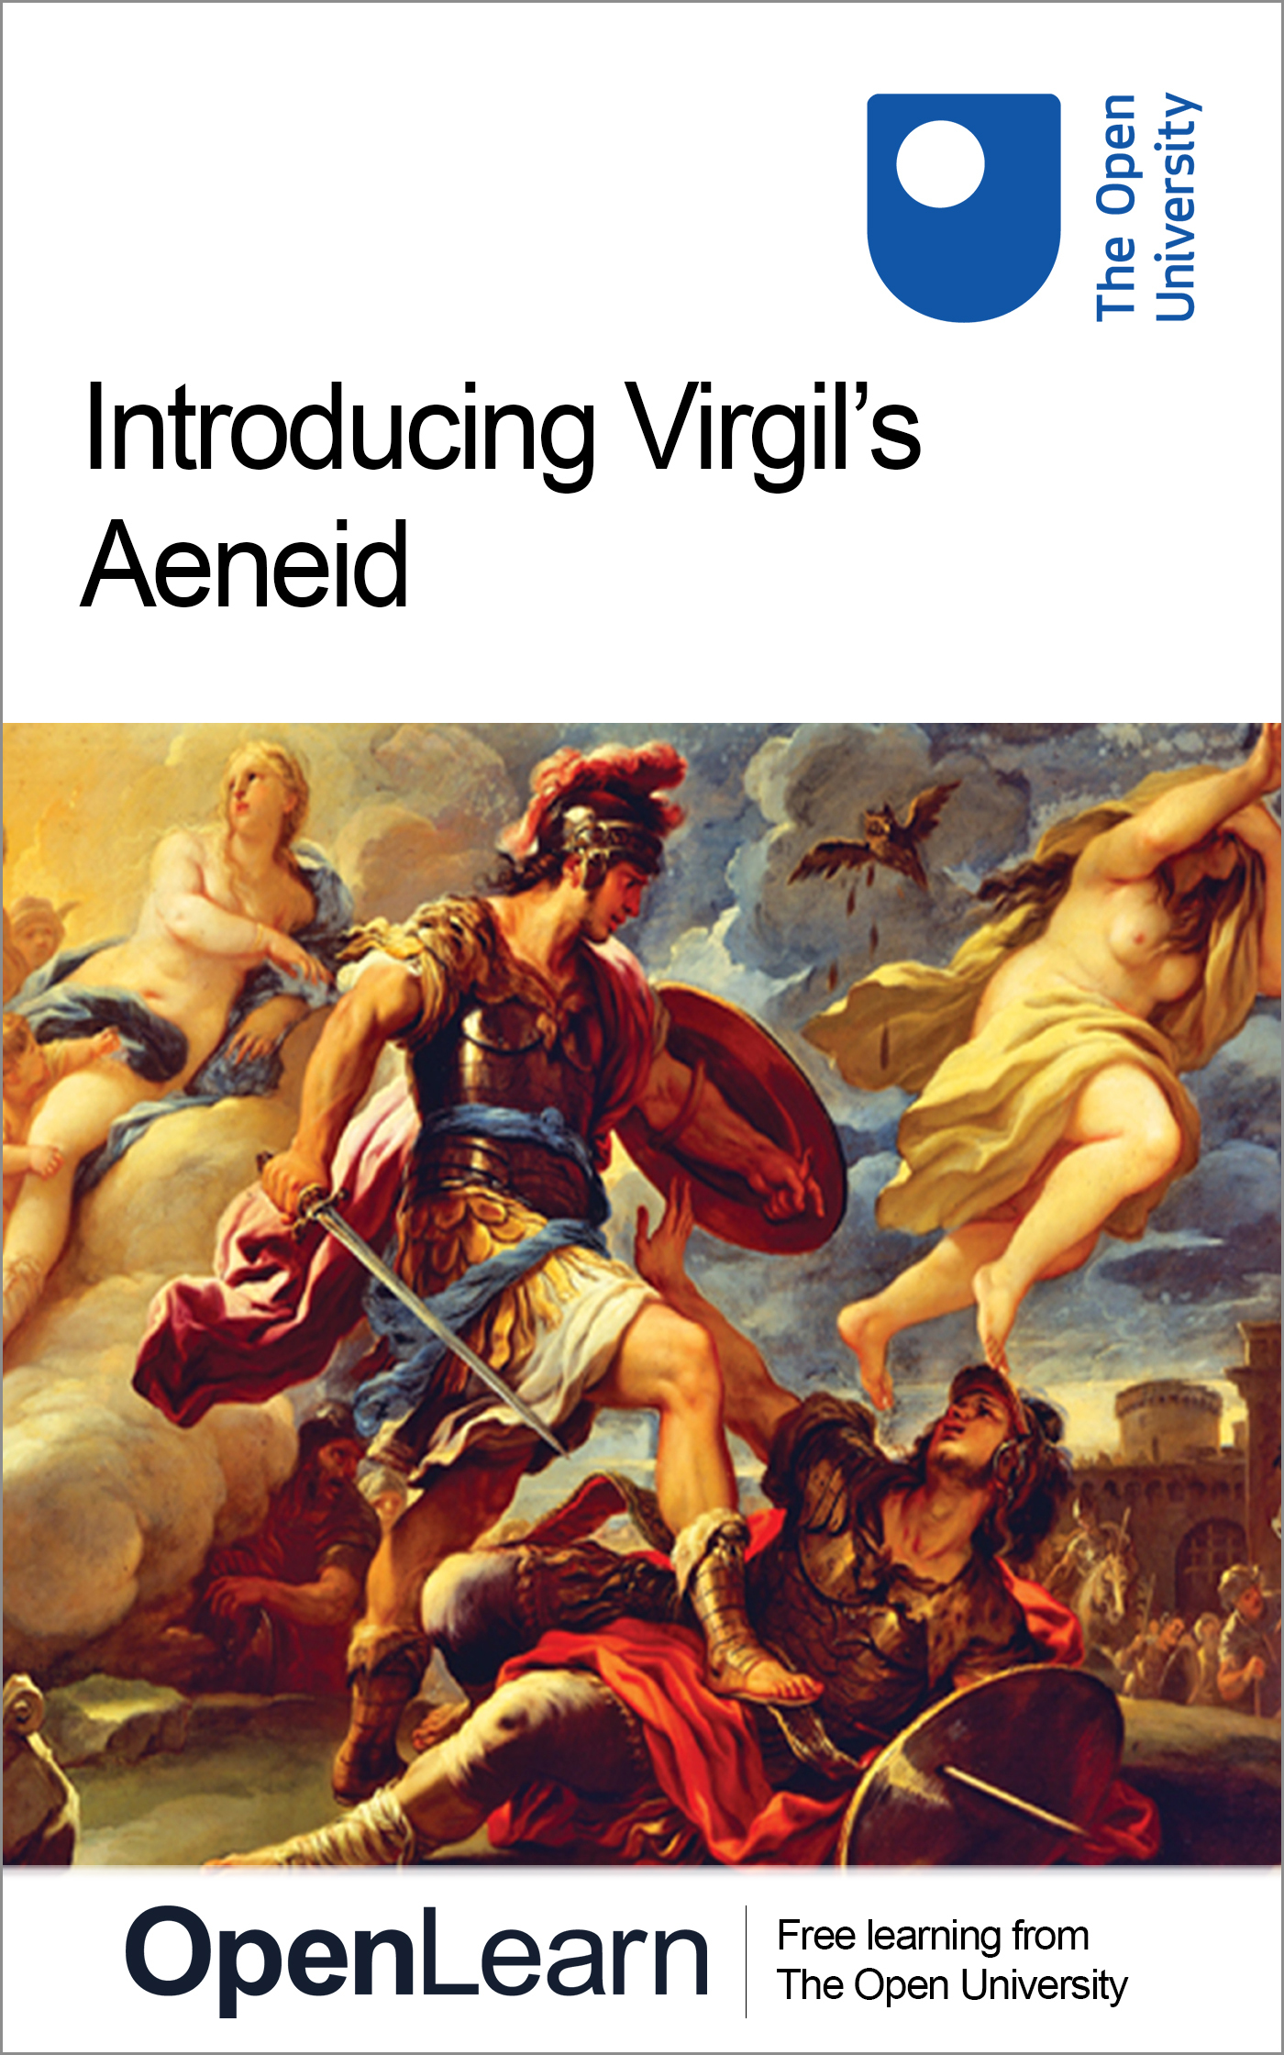

A276_1

Introducing Virgil’s Aeneid
About this free course
This free course is an adapted extract from an Open University course.
This version of the content may include video, images and interactive content that may not be optimised for your device.
You can experience this free course as it was originally designed on OpenLearn, the home of free learning from The Open University: www.open.edu/openlearn/free-courses.
Introducing Virgil’s Aeneid
www.open.edu/openlearn/history-the-arts/introducing-virgils-aeneid/content-section-0
There you’ll also be able to track your progress via your activity record, which you can use to demonstrate your learning.
Copyright © 2015 The Open University
Intellectual property
Unless otherwise stated, this resource is released under the terms of the Creative Commons Licence v4.0 http://creativecommons.org/licenses/by-nc-sa/4.0/deed.en_GB. Within that The Open University interprets this licence in the following way: www.open.edu/openlearn/about-openlearn/frequently-asked-questions-on-openlearn. Copyright and rights falling outside the terms of the Creative Commons Licence are retained or controlled by The Open University. Please read the full text before using any of the content.
We believe the primary barrier to accessing high-quality educational experiences is cost, which is why we aim to publish as much free content as possible under an open licence. If it proves difficult to release content under our preferred Creative Commons licence (e.g. because we can’t afford or gain the clearances or find suitable alternatives), we will still release the materials for free under a personal end-user licence.
This is because the learning experience will always be the same high quality offering and that should always be seen as positive – even if at times the licensing is different to Creative Commons.
When using the content you must attribute us (The Open University) (the OU) and any identified author in accordance with the terms of the Creative Commons Licence.
The Acknowledgements section is used to list, amongst other things, third party (Proprietary), licensed content which is not subject to Creative Commons licensing. Proprietary content must be used (retained) intact and in context to the content at all times.
The Acknowledgements section is also used to bring to your attention any other Special Restrictions which may apply to the content. For example there may be times when the Creative Commons Non-Commercial Sharealike licence does not apply to any of the content even if owned by us (The Open University). In these instances, unless stated otherwise, the content may be used for personal and non-commercial use.
We have also identified as Proprietary other material included in the content which is not subject to Creative Commons Licence. These are OU logos, trading names and may extend to certain photographic and video images and sound recordings and any other material as may be brought to your attention.
Unauthorised use of any of the content may constitute a breach of the terms and conditions and/or intellectual property laws.
We reserve the right to alter, amend or bring to an end any terms and conditions provided here without notice.
All rights falling outside the terms of the Creative Commons licence are retained or controlled by The Open University.
Head of Intellectual Property, The Open University
WEB 03027 0

Contents
- Introduction
- Learning outcomes
- 1 Epic poetry and the Aeneid
  - 1.1 Epic poetry before Virgil
  - 1.2 Virgil and his predecessors
  - 1.3 Politics and Roman identity
- 2 A brief summary of the Aeneid
- 3 Roman values in the Aeneid
  - 3.1 What is pietas?
  - 3.2 Pietas vs furor
  - 3.3 Aeneas and pietas
  - 3.4 A conflicted hero
- 4 Book 12 of the Aeneid
  - 4.1 The death of Turnus
  - 4.2 Vengeance and mercy in the Aeneid
- Conclusion
- References
- Further reading
- Acknowledgements

Introduction
In this free course, you will learn about Virgil’s Aeneid, an epic poem about the origins of the Roman people. The Romans regarded the Aeneid as their great national epic, and it had enormous influence over later writers and thinkers. As well as being powerful literature, the Aeneid tells us a great deal about how the Romans saw themselves and their culture, and what it meant to be a Roman.
I’ll begin by introducing the genre of epic poetry in which the Aeneid was written, and by looking at what happens in the poem, and how it relates to the events of Virgil’s own day. (Virgil lived between 70 and 19 BCE, and wrote the Aeneid at the end of his life.) We’ll then go on to look in detail at some sections of the poem, looking in particular at how it presents Roman values. The discussion will introduce you to a small number of key Latin words used to express these values, though it doesn’t expect or require any knowledge of the Latin language.
This OpenLearn course is an adapted extract from the Open University course A276 Classical Latin: the language of ancient Rome.

Learning outcomes
After studying this course you should have:
- gained a deeper understanding of ‘epic poetry’ in the ancient world
- explored the Aeneid’s central themes, in particular Roman values
- read in detail some passages of the Aeneid and investigated how Virgil uses language to enhance the impact of the poem
- considered some issues involved in reading poetry which was originally written in a different language.

1 Epic poetry and the Aeneid
I don’t know what your immediate associations are when you hear the word ‘epic’, but to me, the English word immediately suggests something big and grand. For example, if someone describes a Hollywood film as being an ‘epic’, I’d assume that the film deals with important and world-changing events, perhaps over a prolonged time period, and probably that it goes on for a long time. The idea of theme and scope is also relevant to ancient epic. Epic poems are usually narratives about the great deeds of heroes, often involving war, dangerous journeys, or adventures. They also tend to be long: the Aeneid, for example, is nearly 10,000 lines of verse. In antiquity ‘epic’ suggested a certain type of metrical form, the dactylic hexameter, which is a type of verse particularly suited to telling narratives. Ancient epic also comes with certain other expectations: for example, it tends to be set in the past and deals with the deeds of ancestors. It describes a world in which people were stronger, more impressive, and closer to the gods, and indeed the gods often play an important role in epic poetry.

1.1 Epic poetry before Virgil
To an educated Roman, epic poetry was a Greek invention, and its most famous examples were Homer’s Iliad and Odyssey, which told stories of the Greek heroes involved in the Trojan War. Although early Italians may well have had their own native traditions of heroic song, no traces of these survive, and the earliest attempt to write epic poetry in Latin was a translation of the Odyssey into the Latin language by Livius Andronicus in the mid third century BCE. Although only fragments of this survive, the fact that Livius chose to translate a Greek epic poem shows the strong association between the genre and Greek culture. However, it wasn’t long before Roman poets began to tell the stories of their own society. The first to do so was Naevius, who wrote a poem on the Punic War with Carthage (also in the third century BCE), followed by the second-century-BCE poet Ennius, whose Annals told the history of Rome to his own day, though as with Livius, only fragments of these are preserved. However, Virgil’s masterpiece, the Aeneid, eclipsed both these poems, becoming the greatest example of Latin epic and a cornerstone of Roman identity, which has continued to inspire writers and artists for over two thousand years.

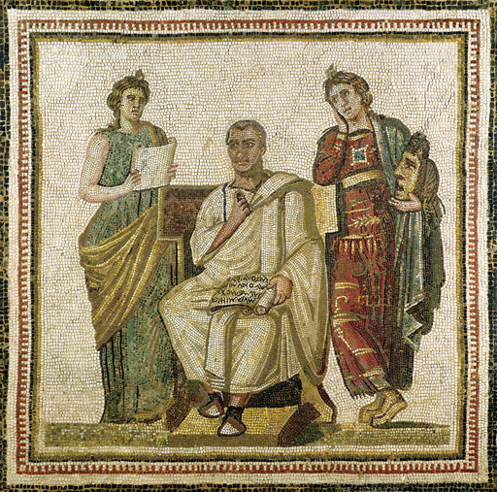
Figure 1 Virgil and the Muses, from Sousse, third century ce, mosaic, 122 ×122.5 cm. Musee National du Bardo, Le Bardo, Tunisia. Photo: Musee National du Bardo/Bridgeman Images.
View description - Figure 1 Virgil and the Muses, from Sousse, third century ce, mosaic, 122 ×122.5 ...

1.2 Virgil and his predecessors
Unlike Livy (a contemporary of Virgil, and author of a multi-volume history of Rome) or Ennius, who tell a series of stories that occur over a long period of time, Virgil chooses to focus on one individual, the Trojan hero Aeneas. The Aeneid tells the story of how Aeneas escaped the fall of Troy and led a band of survivors to Italy, where their destiny was to mix with the native population and create a new chosen race. The story is therefore set long before the foundation of Rome, which Virgil tells his readers was established 333 years after the Aeneid ends. In Virgil’s poem, Romulus and the other early kings of Rome are the distant descendants of Aeneas’ marriage to a native Italian princess, Lavinia; this mixed heritage allows the Romans both to claim a link to the famous Greek myths and to affirm their native roots and their connection to the land of Italy. Setting the Aeneid in the aftermath of the Trojan War helps Virgil to show that he is trying to rival the epic poems of Homer, usually considered the greatest poet of all. The Aeneid is made up of twelve books of about 700 lines each: the first six deal with the travels of Aeneas after the fall of Troy, and the second six with the war he is forced to fight in Italy. This means that the first half of the poem is designed to remind the reader of Homer’s Odyssey, which narrates the wanderings of Odysseus, and the second half reflects the Iliad, which is set during the Trojan War. By combining the travel theme and the military theme in a single poem (with only 12 books, rather than the 24 in each of the Iliad and Odyssey) Virgil could imply that he was outdoing Homer, and that his poem contained all the themes of a heroic epic.

1.3 Politics and Roman identity
However, as we’ll see, Virgil’s story doesn’t only deal with the heroic past, but looks forward to his own time. Virgil had lived through a generation of violence, as successive warlords had torn the Roman Republic apart in their struggles for power. This culminated in the rise of the young Octavian, the adopted son of Julius Caesar, who defeated his rivals Antony and Cleopatra at the Battle of Actium (31 BCE) and established himself as ruler of Rome, with the new name Augustus. Virgil was working on the Aeneid throughout the 20s BCE, by which time Augustus had imposed stability, but the traumas of the past were still a recent memory. Several passages in the Aeneid use prophecy or supernatural knowledge to refer directly to historical events of Virgil’s own day. These passages identify and praise Augustus himself, and Virgil hopes for a new era of peace under his rule. However, the Roman future is not limited to these passages; rather, Virgil uses his mythological setting and characters to reflect upon what it means to be a Roman, and draws links between the past and the present. Thus the struggles that Aeneas and his companions face in Italy are relevant to the broad questions of how a good Roman should live, the values he should hold, and how he should deal with difficult situations.
In this course I’ll be guiding you through some of the crucial passages in the Aeneid that deal with these ideas, and I’ll be encouraging you to reflect on how Virgil handles them. First though, it will be useful for you to read a short summary of the plot of the Aeneid.

2 A brief summary of the Aeneid
The poem opens with the Trojan fleet sailing towards Italy, when they are shipwrecked by a storm on the coast of north Africa, caused by Juno, queen of the gods, who hates them and is trying to prevent them reaching Italy and fulfilling their destiny. Here they encounter Queen Dido, leader of the Carthaginians, who are recent immigrants from Phoenicia (modern Lebanon and Syria), and are founding a new city, Carthage (Book 1). (The map in Figure 2 shows the key places mentioned in the poem.) Aeneas tells Dido of the destruction of Troy (Book 2), and his subsequent travels around the Mediterranean (Book 3). He and Dido soon fall in love, but Aeneas is in danger of forgetting his mission in Italy, so the king of the gods, Jupiter, sends his messenger Mercury to remind him of his duty. Aeneas’ sudden departure leaves Dido devastated, and she commits suicide and pronounces eternal hatred between the future Romans and the Carthaginians (Book 4). After a stop in Sicily (Book 5), Aeneas travels to the underworld to speak to the ghost of his father, and he sees there the souls of the future great Romans (Book 6). He is then finally able to arrive in Italy, where he is initially welcomed by the local king Latinus, who promises him his daughter Lavinia’s hand in marriage to seal peace between Trojans and Latins. However, other Italians resent this arrangement, including Latinus’ wife Amata and the Italian prince Turnus, who hoped to marry Lavinia himself. War soon breaks out between the Trojans and the Italians, to Aeneas’ dismay (Book 7). Aeneas visits another local king, Evander, whose city is built on the site of the future Rome, and Evander agrees to ally his people with the Trojans and sends his son Pallas with Aeneas for his first experience of war. Pallas is presented as a sympathetic character: a brave young man whose life is just beginning, and Aeneas feels a strong affection for him (Book 8). The war in Italy continues to rage (Book 9) and Pallas is killed by Turnus, causing a furious response in Aeneas (Book 10). Aeneas agrees to a temporary truce, and suggests he and Turnus should meet in a duel, to avoid any more loss of life, but while the Italians are debating this, war breaks out again (Book 11). Turnus finally agrees to meet Aeneas in single combat, but Juno arranges for the truce to be broken. However, when Jupiter persuades Juno to give up her hatred of the Trojans and accept the Roman destiny, she removes her protection from Turnus. He and Aeneas meet again on the battlefield, and Aeneas wounds Turnus, who begs for mercy. Aeneas is on the point of sparing him when he sees that Turnus is wearing the belt of Pallas, and kills him in a fit of rage (Book 12).

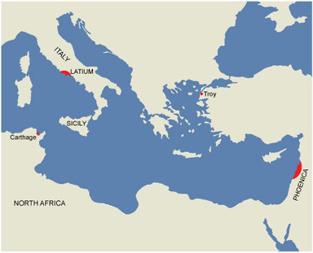
Figure 2 Map showing key places mentioned in Virgil’s Aeneid
View description - Figure 2 Map showing key places mentioned in Virgil’s Aeneid

3 Roman values in the Aeneid
Now that you know a bit more about what happens in the Aeneid, we can turn to look at some passages from the poem in more detail. The activities here will show you how Virgil uses the figure of Aeneas to explore Roman values, and to think about what it takes to be a good Roman.

3.1 What is pietas?
In order to understand Virgil’s depiction of Roman values we need to look at some of the original Latin terms which the Romans used to express moral ideas. The particular quality associated with Aeneas is the abstract Latin noun pietas (whose adjective is pius). In the earliest lines of the poem, Aeneas is described as ‘famous for his pietas’ and throughout he is called ‘pius Aeneas’. I deliberately haven’t translated pietas and pius, because they are difficult concepts to find a single English word for. You might assume that pietas means ‘piety’, and it’s true that this English word derives from the Latin. But while pietas certainly does involve respect for the gods and religious observation, it’s a much broader concept than English ‘piety’.

Activity 1

Here is the definition of pietas given in the Pocket Oxford Latin Dictionary:
- piety; dutifulness; affection, love; loyalty; gratitude
Consider the relationship between these different aspects of pietas. How similar do you think these concepts are? Can you think of other English words that cover some of the concepts associated with the Latin? Can you find a single English word that you think reflects the range of the Latin, or do you think it is a word that will need translating differently in different contexts?

View discussion - Activity 1

3.2 Pietas vs furor
A very different quality from pietas is furor, from which we derive the English words ‘fury’ and ‘furious’. In the Aeneid, furor is found when emotions or other violent forces are allowed to run uncontrolled. Thus, for example, when people act out of passionate love or anger, their behaviour is associated with furor. War always runs the risk of lapsing into furor because of the emotions involved and the devastation it causes, and civil war in particular, which is presented as irrational and hate-filled, is a particular evil caused by furor. Throughout the poem, Virgil uses imagery of powerful forces of nature to describe furor; for example, fire, storm winds and darkness, and lashing waves.

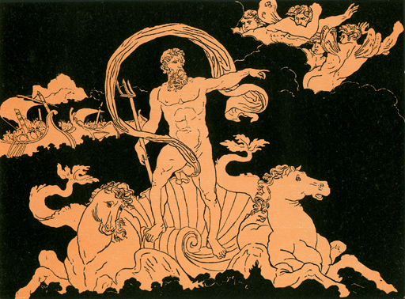
Figure 3 Bartolomeo Pinelli, Neptune Stilling the Waves, colour lithograph from Church, A.J. (1882) Stories from Virgil, London, Seeley Jackson & Halliday Fleet Street. Photo: Private Collection/© Look and Learn/Bridgeman Images.
View description - Figure 3 Bartolomeo Pinelli, Neptune Stilling the Waves, colour lithograph from Church, ...

The clash between furor and pietas is set up in symbolic terms near the start of the poem, when the sea-god Neptune calms the storm sent by Juno (who with her passionate hatred of the Roman destiny embodies the forces of furor). I’ve given you the text below, and have indicated where the words furor and pietas occur in the original Latin.

As often, when rebellion breaks out in a great nation,
and the common rabble rage with passion [furor], and soon stones
and fiery torches fly (frenzy supplying weapons),
if they then see a man of great virtue [pietas], and weighty service,
they are silent, and stand there listening attentively:
he sways their passions with his words and soothes their hearts:
so all the uproar of the ocean died, as soon as their father,
gazing over the water, carried through the clear sky, wheeled
his horses, and gave them their head, flying behind in his chariot.
(Aeneid 1.148–56)

The symbolism of this passage is made clear: we are told that the crowd is influenced by furor, which is causing their anger to boil over into violence. Conversely, the wise statesman is a man of pietas who uses this to calm their anger and return them to their senses. Virgil here switches the usual set of conventions: rather than using imagery from the natural world to describe human passions (e.g. anger is like a storm), he uses imagery from political life to describe a natural phenomenon (a storm is like political discord). This is the passage that first sets up the idea that pietas can overcome furor, and so it’s significant that Virgil chooses the sphere of politics and civil discord as a frame. This will be relevant throughout the Aeneid, as we see Aeneas trying to be a good leader, and it becomes especially relevant in the second half of the poem, in which we see furor causing hatred and war in Italy. It’s also relevant to Virgil’s contemporary readers, who may think of the conflicts they have lived through. One possibility is that we are meant to identify the statesman of pietas in this passage with Augustus, who also imposed order after a time of chaos. Alternatively, the statesman could just be an abstract idealised figure, and a model for all leaders to aspire to.

3.3 Aeneas and pietas

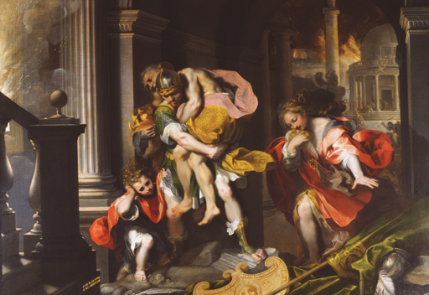
Figure 4 Federico Barocci, Aeneas' Flight from Troy, 1598, oil on canvas, 179 × 253 cm. Galleria Borghese, Rome, Italy. Photo: Galleria Borghese/Bridgeman Images.
View description - Figure 4 Federico Barocci, Aeneas' Flight from Troy, 1598, oil on canvas, 179 × 253 ...

One might expect that Aeneas, the man of destiny, embodies pietas and battles furor wherever he finds it, but Virgil is far too sophisticated a poet to present his story as a simple battle of good versus evil. Aeneas is in many ways an exemplar of pietas. He loves and respects his father Anchises, and is a devoted father to his young son Ascanius.

Activity 2

As Aeneas flees Troy in Book 2, Virgil describes him carrying his elderly father on his back while leading his son by the hand. Read Aeneas’ speech below, in which he gives instructions to his family on how to escape Troy, and note down the ways in which you think Aeneas demonstrates pietas here.

‘Come then, dear father, clasp my neck: I will
carry you on my shoulders: that task won’t weigh on me.
Whatever may happen, it will be for us both, the same shared risk,
and the same salvation. Let little Iulus come with me,
and let my wife follow our footsteps at a distance.
You servants, give your attention to what I’m saying.
At the entrance to the city there’s a mound, an ancient temple
of forsaken Ceres, and a venerable cypress nearby,
protected through the years by the reverence of our fathers:
let’s head to that one place by diverse paths.
You, father, take the sacred objects, and our country’s gods,
in your hands: until I’ve washed in running water,
it would be a sin for me, coming from such fighting
and recent slaughter, to touch them.’
(Aeneid 2.707−20)

View discussion - Activity 2

3.4 A conflicted hero
You’ve now seen how the behaviour of Aeneas is characterised by two important components of pietas: family and the gods. His pietas is also shown by his concern for the well-being of his followers. His first act when he lands safely in north Africa after surviving the storm in Book 1 is to find high ground to see if he can spot any survivors from the other ships in his fleet; next he goes hunting, making sure that he shoots enough meat for all those with him. He is aware that his followers are in low spirits, and makes efforts to comfort them and to conceal his own anxieties. Thus in many ways Aeneas appears to be the ideal Roman leader: able to take charge yet concerned with the greater good of the group rather than his own personal self-interest. If you have time, you might like to explore this section of the Aeneid further and think about how Aeneas is presented. You can find Book 1 of the Aeneid via the ‘Poetry in Translation’ website. To read the section we’ve been discussing here, you will need to click on the link ‘Bk1:157–222 Shelter on the Libyan coast’.
Yet despite Aeneas’ inherent pietas, he often falls prey to his own strong emotions and succumbs to furor. During the sack of Troy, despite repeated messages from the gods, he is frequently overcome by battle-lust and desire to take vengeance on the Greeks, and it is not until his goddess mother intervenes that he accepts his destiny to save the survivors of his people and find a new home. Similarly, in north Africa he falls passionately in love with the Carthiginian Queen Dido, and it is the ‘madness’ of love that makes Aeneas temporarily forget his journey and stay in Carthage. Aeneas and Dido’s love affair is described in terms that evoke furor, with imagery of fire and storms. But the greatest clash in the poem between furor and pietas comes at the very end, and we will explore this in the next section.

4 Book 12 of the Aeneid
When Aeneas arrives in Italy, he initially receives a warm welcome from the local people (the Latins), whose king, Latinus, recognises that it is Aeneas’ destiny to marry his daughter Lavinia. However, another Italian prince, Turnus, who also wishes to marry Lavinia, is furious at the Trojans’ arrival, and, urged on by the goddess Juno, he stirs up war between the Italians and the Trojans. The second part of the Aeneid narrates the events of this war, and by the time we get to the final book of the poem (Book 12), we have encountered many sympathetic young characters who have lost their lives. At this point in the poem, Turnus has killed Aeneas’ young friend Pallas, and Aeneas has been overcome with fury and grief. In Book 11, there has been a brief truce between the two sides, to allow them to gather the dead bodies and mourn them, and Aeneas has proposed that he and Turnus should meet in single combat to settle the conflict, but the truce broke down before a decision could be reached.
At the start of Book 12, Turnus decides to face Aeneas in single combat, and a solemn treaty is drawn up that both sides will abide by the result of the duel. However, Turnus’ followers are unhappy with this arrangement, and are urged on by Turnus’ sister, the goddess Juturna, to break the treaty and attack the Trojans while they are off guard. Aeneas tries to prevent his men joining in the fighting but is wounded by a stray arrow, while Turnus enthusiastically joins in the battle. But when Aeneas is magically healed by his mother, the goddess Venus, and returns to the fray, Turnus realises he must spare his people more suffering and so agrees to a duel again. The king and queen of the gods, Jupiter and Juno, who have been watching events from the heavens, agree between themselves that the war must now end, and Juno agrees to give up her support for Turnus and her hatred of the Trojans, who will now marry the Italians and become Romans.

4.1 The death of Turnus
The summary given in the previous section takes us to the final lines of the poem, in which Aeneas and Turnus finally meet in single combat.

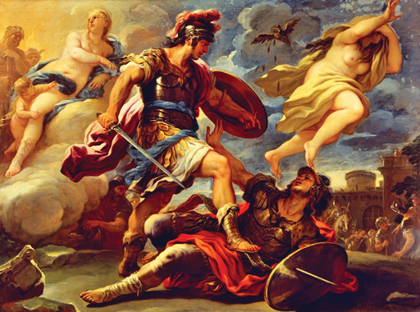
Figure 5 Luca Giordano, Aeneas defeats Turnus, seventeenth century, oil on canvas, 176 × 236 cm. Galleria Corsini, Florence. Photo: De Agostini Editore/L Pedicini
View description - Figure 5 Luca Giordano, Aeneas defeats Turnus, seventeenth century, oil on canvas, ...

Activity 3

I’d now like you to read the poem’s last lines, which you can find by going to the section on Virgil’s Aeneid on the ‘Poetry in Translation’ website. You can find the relevant passage in Book 12 of the poem by clicking on the link ‘Bk XII:887–952 The Death of Turnus’.
Read this passage carefully and make some notes on the following issues:
- How is Turnus presented at this point in the poem?
- Do you think Aeneas should have spared Turnus’ life?
- What do you think of Aeneas’ motivations when he decides to kill Turnus?
- Are you surprised that Virgil ends the poem so abruptly here? What do you think of the ending?

View discussion - Activity 3

4.2 Vengeance and mercy in the Aeneid
Virgil makes it clear that the rational side of Aeneas is on the brink of sparing Turnus, and it is only the sight of Pallas’ belt that changes his mind. Let’s look at the lines that describe Aeneas’ reaction here:

As soon as his eyes took in the trophy, a memory of cruel grief,
Aeneas, blazing with fury [furor], and terrible in his anger, cried:
‘Shall you be snatched from my grasp, wearing the spoils
of one who was my own?’
(Aeneid 12.946–9)

Aeneas acts in impulsive anger, and he acts from furor rather than a considered sense of what is right: indeed, he is ‘blazing’ with it. As we have seen, furor is often associated with fire imagery. Even if Aeneas makes a valid decision in killing Turnus, he seems to be doing it for the wrong reasons, and it’s troubling that the foundational act that will found the Roman race is one of furor and anger.
Virgil has already referred to the issue of vengeance and mercy earlier in the poem, in a scene in which Aeneas is visiting the underworld in Book 6 to consult the ghost of his father, Anchises. Virgil’s underworld contains the souls of those not yet born as well as those of the dead, and Aeneas is allowed to see a parade of future heroes of Rome, including Romulus, Julius Caesar, and Augustus himself. Anchises makes a speech to Aeneas predicting the glory of Rome and introduces the individuals who will make it great; at the end, he turns to the more general question of what it means to be a good Roman, and addresses the hypothetical future Roman:

‘Remember, Roman, it is for you to rule the nations with your power,
(that will be your skill) to crown peace with law,
to spare the conquered, and subdue the proud’.
(Aeneid 6.851–3)

Anchises claims that war is an essential part of the Roman mission, and that peace will come through military conflict. His final words refer to how a good Roman should balance mercy and retribution. In Anchises’ model it is easy to tell where to draw the line: only those who show arrogance should be crushed, while those who have been crushed should be spared. In reality, however, it is harder to tell the difference, and we might well recall his words as we read the final scene, and wonder which category Turnus fits into. His previous actions in the poem have been arrogant, but he is certainly now defeated: does that mean that Aeneas has failed to live up to his father’s advice when he refuses to pardon him?
The fact that the poem ends so abruptly makes this scene even starker. We might expect Virgil to end his poem by describing the end of the war, the reconciliation between the two peoples, perhaps even Aeneas’ marriage to Lavinia or the foundation of Lavinium. Instead, we’re left on a bleak note, as our final image is of the dying Turnus, unmitigated by any of the positive consequences of his death in the future.
Scholars have debated for many years how best to interpret the poem’s ending. We know that Virgil was unhappy with the Aeneid as it stood, and requested on his deathbed that it should be burned, and scholars have sometimes suggested that this is because he wanted to alter the ending. On the other hand, there’s no particular reason to suppose that the ending was the part that Virgil felt was incomplete, and there may have been other aspects that he wanted to change. Indeed, there are other ways in which the Aeneid is obviously unfinished, for example missing parts of lines. In any case, since we have the ending that we have, we need to engage with the poem as it stands, and try to interpret how it works in literary terms.
For some scholars, Aeneas’ killing of Turnus is an act which undermines the Roman future, and calls Augustus’ own achievements into question. For others, Aeneas’ actions show that the world is a complicated place in which idealistic models do not work: killing Turnus may be disagreeable, but it is part of the necessary price for establishing peace.

Conclusion
We have come to the end of this free course on Virgil’s Aeneid, and I hope you have enjoyed your first taste of the poem. As you can see, the Aeneid is not a simple poem to study. Virgil expects his reader to work hard, and we are expected to know about Roman myth and history, and to make connections across the poem between recurring patterns of imagery and word choice. While this makes the Aeneid a challenging text to study, it certainly makes it rewarding, and it’s possible to find new things to appreciate in it every time you read it. The Aeneid is set in the world of myth, but it engages directly with ethical and political issues relevant to Virgil’s own day – and indeed our own – such as what it means to be a good leader, and how moral beliefs work in practice in the messy situations of real life. The fact that the Aeneid does not give straightforward answers but invites us to come to our own conclusions is part of what makes it such powerful literature, and has inspired readers for over two thousand years.

References
Virgil, The Aeneid, trans. A.S. Kline (2002) Poetry in Translation. Available online via the ‘Poetry in Translation’ website. (Accessed 29 October 2015).

Further reading
If you would like to read the whole of the Aeneid in translation, a free online translation can be found on the ‘Poetry in Translation’ website.
If you are interested in learning more about the Latin language, the free course Discovering Ancient Greek and Latin will soon be available on OpenLearn.
If you are interested in studying Latin or Roman culture more formally, you might be interested in the following Open University courses: A276 Classical Latin: the language of Ancient Rome, A219 Exploring the classical world and A340 The Roman Empire.

Acknowledgements
This OpenLearn course was written by Laura Swift, with contributions from Joanna Paul.
Except for third party materials and otherwise stated (see terms and conditions), this content is made available under a Creative Commons Attribution-NonCommercial-ShareAlike 4.0 Licence.
The material acknowledged below is Proprietary and used under licence (not subject to Creative Commons Licence). Grateful acknowledgement is made to the following sources for permission to reproduce material in this free course:
Course image:
Photo: De Agostini Editore/L Pedicini
Text:
All Virgil translations by A.S. Kline. © Copyright 2002 All Rights Reserved. (This work may be freely reproduced, stored, and transmitted, electronically or otherwise, for any non-commercial purpose.)
Images:
Figure 1: Photo: Musee National du Bardo/Bridgeman Images.
Figure 3: Photo: Private Collection/© Look and Learn/Bridgeman Images.
Figure 4: Photo: Galleria Borghese/Bridgeman Images.
Figure 5: Photo: De Agostini Editore/L Pedicini
Every effort has been made to contact copyright owners. If any have been inadvertently overlooked, the publishers will be pleased to make the necessary arrangements at the first opportunity.
Don't miss out:
If reading this text has inspired you to learn more, you may be interested in joining the millions of people who discover our free learning resources and qualifications by visiting The Open University - www.open.edu/openlearn/free-courses

Activity 1

Discussion
You’ll notice that as well as religious duty – conveyed by our English word ‘piety’ - , pietas also incorporates a range of more secular qualities, such as a sense of duty and affection. These might be felt towards one’s family or country, for example. In the Aeneid, pietas is also associated with self-control, compassion and tolerance, as well as with good leadership. It’s hard to find an English word that has exactly the same range of meanings, and ‘piety’ is certainly not right, since its associations are primarily religious. Perhaps the closest might be something like ‘duty’ or ‘dutiful’, but this doesn’t cover all of the meanings of pietas. This means that translators have to choose an English word which they feel best brings out the particular force that pietas or pius has in context. Translation can be particularly difficult when dealing with words that reflect a culture’s moral values, since these do not necessarily map neatly across different societies.
Back to Session 3 Activity 1

Activity 2

Discussion
Aeneas’ love for his father comes through strongly in this passage, and the image of the three generations leaving Troy in this fashion became a famous symbol of pietas and family-mindedness. It was a popular theme in Roman art, and became a favourite subject for later European painters, as you can see from the image used to illustrate this section (Figure 4).
You might have also noticed that Aeneas does not forget the slaves of the household, for whose well-being he is responsible, and gives them instructions as to how to escape and where to meet. Aeneas’ pietas is also shown by his concern for the religious artefacts and statues of the household gods, which he instructs Anchises to carry with him. (In Figure 4 you can see them in Anchises’ right hand.) The gods are the symbol of the Trojan people, and must be kept safe until they can find a new home. Even in the midst of the chaos, Aeneas remembers to observe appropriate religious scruples. Because he is covered with blood, he might defile the holy objects by touching them before he can purify himself, so he makes sure that they are instead carried by Anchises, who as a non-combatant is religiously pure. However, Aeneas’ behaviour towards his wife is perhaps more troubling. Whereas he keeps his father and son close to him, he tells his wife to walk behind ‘at a distance’. Shortly afterwards we find out that Aeneas loses track of her, and that by the time he realises she is not with him, it is too late. Is this simply a tragic accident in the chaos of war, or is Aeneas to blame for what happens?
Back to Session 3 Activity 2

Activity 3

Discussion
The ancient literary critic Servius, who wrote a commentary on the Aeneid in the fourth century CE, didn’t see a moral issue in this passage. According to him, Aeneas was pius to consider mercy, but also pius to avenge Pallas, and so his actions are entirely praiseworthy. It’s true that vengeance was not necessarily considered a bad motive in the ancient world: indeed Augustus was proud to have avenged the murder of his adopted father Julius Caesar, erecting a temple in honour of Mars Ultor (Mars the Avenger) to celebrate this achievement. Most modern scholars, however, have found Servius’ approach oversimplistic, since Virgil goes out of his way to present the situation as ambiguous.
It’s worth bearing in mind that Virgil has deliberately set up a situation in which Aeneas has to make a difficult choice. It’s rare in epic poetry for someone to receive a non-fatal wound, and we might be expecting Aeneas to simply kill Turnus with a single spear cast in battle. Instead Virgil has set up a situation in which Turnus is incapacitated but not killed, and so Aeneas has the option of sparing his life if he chooses to.
I don’t know how you responded to Turnus in this passage, but to me, Virgil stresses his youth and vulnerability at this point. As he lifts the rock to attack Aeneas he is overcome with supernatural weakness and terror caused by divine intervention now that the gods have turned against him. The simile in which Turnus’ experience is compared to the common dream of not being able to run away also speaks to the reader’s own experience and encourages us to empathise with him. It also evokes a very similar passage in Book 22 of Homer’s Iliad, in which the Trojan hero Hector tries to flee from the Greek warrior Achilles. Hector is one of the most sympathetic characters in the Iliad and so, by implicitly comparing Turnus to him, Virgil encourages us to feel pity for the Italian hero. He is alone, abandoned by his sister and by the goddess who previously protected him. In his final speech he humbly accepts his responsibility for causing the war, and offers to give up all his claims, so that Aeneas has total victory without needing to kill him. On the other hand, Turnus has already broken a truce earlier in Book 12. One could argue that he can’t be trusted to keep to his word this time either and that Aeneas needs to do whatever is necessary to secure a lasting peace for the sake of his people.
Back to Session 4 Activity 1

Figure 1 Virgil and the Muses, from Sousse, third century ce, mosaic, 122 ×122.5 cm. Musee National du Bardo, Le Bardo, Tunisia. Photo: Musee National du Bardo/Bridgeman Images.

Description
This is a colour image of a mosaic showing a seated man in a white toga which is decorated around the edges. His left leg is on the floor. His right leg is drawn back and rests on a strut at the base of his chair. On his left knee there is a partially unrolled scroll which he holds in his left hand. In his right hand he is holding a writing implement at chest height above the scroll. Two woman stand behind him, one on either side of his high-backed chair. The woman to the left is wearing a green, sleeveless robe. She holds an unrolled scroll. The woman to the right wears a red, patterned garment with long sleeves. Her head is inclined towards the seated man and she supports her chin with her hand. In the crook of her left arm she holds a tragic mask which can be seen in profile. The figures are set against a background of white tesserae. The mosaic is bordered by narrow bands of black, white and red.
Back to Session 1 Figure 1

Figure 2 Map showing key places mentioned in Virgil’s Aeneid

Description
At the bottom of the map, running horizontally, is the coastline of North Africa, with Carthage marked on a peninsula to the far left and Phoenicia to the far right. Above this is the Mediterranean sea. Troy is shown in the centre of the map, and is on the western coast of Asia. The heel of Italy is more or less parallel with this. Two places in Italy are marked on the map: Sicily, on the inverted triangular island at the toe of Italy; and Latium, an area around halfway up the boot of Italy, on the western side.
Back to Session 2 Figure 1

Figure 3 Bartolomeo Pinelli, Neptune Stilling the Waves, colour lithograph from Church, A.J. (1882) Stories from Virgil, London, Seeley Jackson & Halliday Fleet Street. Photo: Private Collection/© Look and Learn/Bridgeman Images.

Description
This is a lithograph in two colours. The scene is in orange-peach against a black background. It shows a tall bearded man standing on a chariot formed of waves. It is drawn by two curly-maned horses shown either side of him. His left leg is straight and his right leg rests on the crest of a wave. A strip of folded cloth swirls from between his legs and up around his naked body in a billowing arc behind him. He holds a trident in his right hand and his gaze follows his outstretched left arm. He points his finger towards three winged figures with puffed up cheeks, riding on the clouds in the top right-hand corner. Behind him to the left are two high-prowed ships with full sails which are being blown from the right. Their crew and oars are visible.
Back to Session 3 Figure 1

Figure 4 Federico Barocci, Aeneas' Flight from Troy, 1598, oil on canvas, 179 × 253 cm. Galleria Borghese, Rome, Italy. Photo: Galleria Borghese/Bridgeman Images.

Description
This is a colour image of an oil painting. In the centre a soldier wearing a helmet carries a frail old man over his left shoulder. The old man holds on to some possessions. A curly haired young boy can be seen to the left and to the right a young woman clutches a bundle tightly to her chest. They are clambering over a pile of fallen stones and objects which are blocking their way. Smoke is billowing down to the left as they approach a staircase. Other figures can be seen behind them as flames engulf a building in the distance.
Back to Session 3 Figure 2

Figure 5 Luca Giordano, Aeneas defeats Turnus, seventeenth century, oil on canvas, 176 × 236 cm. Galleria Corsini, Florence. Photo: De Agostini Editore/L Pedicini

Description
This is a colour image of an oil painting. The walls of a city can be seen in the background to the right. In the foreground, to the left, a young man in a plumed helmet and body armour pins a man to the ground with his foot. His shield is strapped to his left arm and in his right hand is a sword pointing towards the defeated man. The young man on the ground holds his head back and his right arm out with his palm upwards in front of the victor. Two figures can be seen in the air above them. A female figure with a child by her leg, reclines in the top-left corner behind the victorious soldier; the other female to the top right above the defeated man, scurries away. An owl can be seen between them, shedding feathers from its outspread wings.
Back to Session 4 Figure 1

