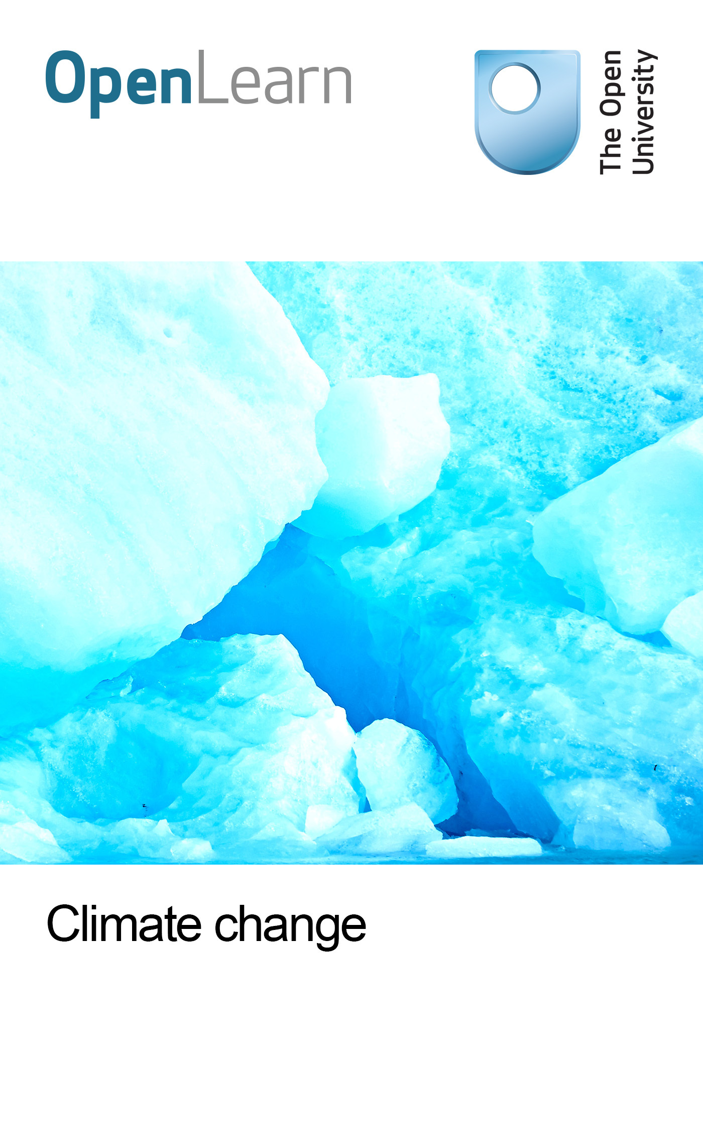

U316_1

Climate change: transitions to sustainability
About this free course
This free course is an adapted extract from the Open University course U316 The environmental web: www.open.ac.uk/courses/modules/u316.
This version of the content may include video, images and interactive content that may not be optimised for your device.
You can experience this free course as it was originally designed on OpenLearn, the home of free learning from The Open University – www.open.edu/openlearn/nature-environment/the-environment/environmental-science/climate-change-transitions-sustainability/content-section-0
There you’ll also be able to track your progress via your activity record, which you can use to demonstrate your learning.
Copyright © 2016 The Open University
Intellectual property
Unless otherwise stated, this resource is released under the terms of the Creative Commons Licence v4.0 http://creativecommons.org/licenses/by-nc-sa/4.0/deed.en_GB. Within that The Open University interprets this licence in the following way: www.open.edu/openlearn/about-openlearn/frequently-asked-questions-on-openlearn. Copyright and rights falling outside the terms of the Creative Commons Licence are retained or controlled by The Open University. Please read the full text before using any of the content.
We believe the primary barrier to accessing high-quality educational experiences is cost, which is why we aim to publish as much free content as possible under an open licence. If it proves difficult to release content under our preferred Creative Commons licence (e.g. because we can’t afford or gain the clearances or find suitable alternatives), we will still release the materials for free under a personal end-user licence.
This is because the learning experience will always be the same high quality offering and that should always be seen as positive – even if at times the licensing is different to Creative Commons.
When using the content you must attribute us (The Open University) (the OU) and any identified author in accordance with the terms of the Creative Commons Licence.
The Acknowledgements section is used to list, amongst other things, third party (Proprietary), licensed content which is not subject to Creative Commons licensing. Proprietary content must be used (retained) intact and in context to the content at all times.
The Acknowledgements section is also used to bring to your attention any other Special Restrictions which may apply to the content. For example there may be times when the Creative Commons Non-Commercial Sharealike licence does not apply to any of the content even if owned by us (The Open University). In these instances, unless stated otherwise, the content may be used for personal and non-commercial use.
We have also identified as Proprietary other material included in the content which is not subject to Creative Commons Licence. These are OU logos, trading names and may extend to certain photographic and video images and sound recordings and any other material as may be brought to your attention.
Unauthorised use of any of the content may constitute a breach of the terms and conditions and/or intellectual property laws.
We reserve the right to alter, amend or bring to an end any terms and conditions provided here without notice.
All rights falling outside the terms of the Creative Commons licence are retained or controlled by The Open University.
Head of Intellectual Property, The Open University
978-1-4730-1467-1 (.kdl)
978-1-4730-0699-7 (.epub)

Contents
- Introduction
- Learning outcomes
- 1 Globalisation and environmental change
  - 1.1 What is 'globalisation'?
  - 1.2 Globalisation is about networks
- 2 Globalisation and the global environment: three views
  - 2.1 Political responses to climate change and the environment
  - 2.2 Vibrant civil societies and a networked globe
- 3 Governance, citizenship and sustainability
  - 3.1 Who will make the decisions?
  - 3.2 Governance – filling the hole where government used to be
  - 3.3 Green governance needs citizens
- 4 Making it happen – sustainability in practice
  - 4.1 Three approaches to global environmental change
  - 4.2 Capitalism – naturally
  - 4.3 Green from the grassroots up
  - 4.4 Signing everyone up to sustainability
- 5 New ways of looking at the world
- 7 Summary and final thoughts
  - 7.1 Questions
  - 7.2 Answers
- 6 Conclusion
- Keep on learning
- References
- Acknowledgements

Introduction
Human societies have to take urgent action to end their dependence on fossil fuels. They also have to prepare to adapt to the uncertainties inherent in global environmental changes, particularly climatic ones. We have to alter the whole path of our development and decision making in order to make our societies both environmentally adaptable and sustainable. This free course takes on the task of trying to chart some of the ways in which this might come about.
The context for these changes by going further into what the term 'globalisation' means in relation to the environment and sustainability. It introduces three different views on the relationship between globalisation and the environment. Each view is an argument about how we might get out of the mess we appear to be in. Section 1 introduces the concept of globalisation. Section 2 looks at three views on globalisation and the global environment. Section 3 asks how our decision making can advance sustainability to make our societies more adaptable to environmental change. It looks at the chances of achieving both accountable global governance and grassroots participation. The final brief section is in three parts. It takes the three views outlined in Section 2 and looks at cases and arguments to see how each sees sustainability being arrived at. Section 4 attends to the idea of sustainability in practice. The conclusion ties up some of the threads of the chapter by reflecting on the importance of the media, and specifically web media, as a key location for moving forward debates about sustainability.
This OpenLearn course is an adapted extract from the Open University course U316 The environmental web.
This OpenLearn course provides a sample of level 3 study in Environmental Sciences [http://www.open.ac.uk/courses/find/environmental-sciences].

Learning outcomes
After studying this course, you should be able to:
- understand the four dimensions of globalisation in relation to climate change
- distinguish between the three approaches to achieve sustainability
- know the difference between ‘government’ and ‘governance’
- identify what makes ecological citizenship distinctive
- understand how the medium of the web can aid transitions to sustainability.

1 Globalisation and environmental change

1.1 What is 'globalisation'?

Activity 1 What does ‘globalisation’ mean to you?

Note down on paper or in your learning journal your first thoughts about what the term ‘globalisation’ means to you. The term ‘globalisation’ can have ecological (movements of species), political (e.g. international politics of climate change) and social or cultural (new kinds of networks of debate and action) meanings.

Provide your answer...
View discussion - Activity 1 What does ‘globalisation’ mean to you?

1.2 Globalisation is about networks
Globalisation is a term that refers to the flows around the world of species, money, goods, ideas, people, etc., and the networks that are integral to these flows. The word is used to attempt to capture a dizzying mix of recent economic, political and socio-cultural developments. The term can also be applied to ecological globalisation. The global transport of people, goods and services has massively increased. Technological and economic networks have developed to smooth trade and economic growth. Communications technologies have underpinned these networks.
You have already seen evidence (and there is more to come) that all networks have the inherent potential to be put to a vast range of uses. Even the internet, with its origins in ambitions for robust military research and development communications networks, can do as much to advance debate and action on sustainability as it can for the profit margins of immense global companies. Once the capacity for networks exists, they cannot easily be owned, directed, managed or, above all, predicted. This is what makes it impossible to capture what is going on in the world.
This section will emphasise that there is not one process called ‘globalisation’ but, rather, a collection of interwoven threads. Furthermore, the processes described are not something new and wholly unique to the present. This course focuses entirely on telling the story of human societies’ apparent responsibility for causing climate change – perhaps the most dramatic example of ecological globalisation there is. This section connects this to the social or cultural and political globalisation that is reflected in the new ways in which people are organising and making their voices heard and the new ways of making decisions beyond and within nation states.

Hence four threads can be identified from these varied uses of the term globalisation.
- Economic The flows of money, goods and services around the world. In any hour of any day, you can be reminded of this by a glance at the labels on the products you use, or at news reports of a company shifting its plant from one part of the world to another (usually cheaper) location. Although the world has seen unprecedented wealth created via economic globalisation, it has also seen inequalities widen. Increasingly interdependent global economic structures present a huge challenge to attempts to reduce greenhouse gas emissions.
- Political The flow of ideas, ideologies and political systems. The process of globalisation has disseminated free market capitalist orthodoxy – generally allied to democratic systems of government – throughout the world. With these processes has come growth in the environmental and social movements. Conventions on climate change, biodiversity and trade agreements, shaped by, among others, global rather than national networks (patterns of interaction) of science, business and NGO interests, are tangible expressions of this political globalisation. Globalisation sees longer (and usually more complex) chains of cause and effect established. It is often pointed out that we don't have well-established institutions of global governance. They certainly can't yet claim to match the pace and extent of economic globalisation.
- Social/cultural The flow of social practices and cultural products. This is often characterised as ‘McDonaldisation’ (Figure 1) – the relentless spread of western (especially American) culture. However, these flows also include counter-currents, such as the global fame or notoriety of the French anti-globalisation campaigner and farmer Joseph Bové, and the Indian author and environmentalist Arundhati Roy. Some authors argue that the emergent ‘global culture’ allows the development of a political and ethical underpinning for sustainable development, and that this will be accelerated by networks (see, for example, Urry, 1999).
- Ecological Global movements of species, specifically in tandem with globalising human activities of development, trade and tourism. Publicity about global flows of pollutants in the 1960s and 1970s drove many people to support environmentalism. More recently, ozone depletion and climate change represent perhaps the most dramatic evidence of globalised and linked processes of environmental change.

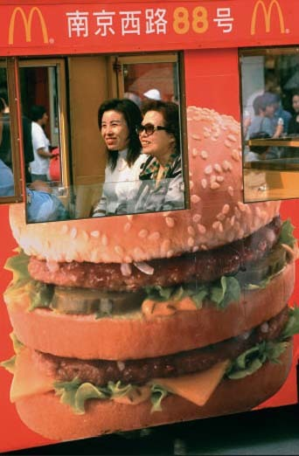
Figure 1 McDonald's – one of the emblems of economic and cultural globalisation – has made its mark in the People's Republic of China. (Photo: Mark Henley/Panos)

- How have the inventions shown in Figure 2 assisted globalisation?
- Goods containers helped to accelerate economic globalisation from the mid-1970s onwards, reducing costs and speeding up the haulage of goods (in turn, having huge environmental consequences in the form of increased road freight). Communications technologies have reduced or eliminated the constraints of time and space on human interactions, thus feeding cultural and political globalisation.

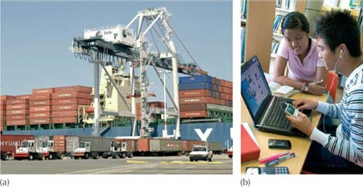
Figure 2 How technology and globalisation are linked: (a) goods container terminal; (b) a laptop showing a web page. (Photos: a, Paul Sakuma/AP Photos; b, Ian Shaw/Alamy)

- What is meant by the words ‘flow’ and ‘network’?
- ‘Flow’ is the movement of goods, people, cultural objects and ideas, or information across space and time. ‘Network’ in this context refers to patterns of interaction between independent people, places or institutions.

2 Globalisation and the global environment: three views

2.1 Political responses to climate change and the environment
Not for the first time in this course, you are faced with a term that is important but difficult to define precisely. Although the fact that plenty of people from different standpoints are using the term ‘globalisation’ is some measure of its importance, it can be confusing to find that there are different ways of framing what it means for humans and the environment today and in the future. In this section, the range of political responses to climate change and environment–economy interactions is organised more generally under three headings: business learns, radical break and sustainability steps(Table 1). It is a little easier to think about what the terms mean if you begin to give them a personality. Figure 3 shows three good examples.
Click here to view document

View document

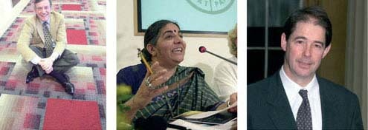
Figure 3 Three different takes on sustainability: how far apart are they? (a) ‘Green’ businessman Ray Anderson; (b) ecologist and campaigner Vandana Shiva; (c) environmentalist and adviser Jonathan Porritt. (Photos: a, Interface Research Corporation; b, Pier Paolo Cito/PA Photos; c, Sean Dempsey/PA Photos)

Who should we have in mind when we think about these three categories? For business learns, think of the sharp-suited business people working for one of the major oil, computing, car or food companies. These have grown from being national concerns (albeit often with an international reach) to immense organisations that are globally networked, often with revenues larger than those of many less-developed countries. Their political power, although difficult to measure, can influence the thinking of the world's most powerful democratically elected governments.
The caricature of corporate executives tends to suggest that their pursuit of profit and growth ensures that they have no concern for the environment or the world's poor people. This is hotly contested by those who believe business must, in its own self-interest, learn to integrate sustainability thinking. This camp sees growth allied to sound economics (that internalises environmental and social externalities) as the only means of achieving sustainable development. They argue that the spread of corporate social and environmental responsibility (i.e. independently audited reporting in parallel with annual financial results), will transform the workings of global capital and lead to sustainability. These new ways of summarising business progress on sustainability are looked at in the next section. Those making the business case for sustainability don't believe the nation state is the best way to organise this transformation (although many accept that a degree of regulation is desirable) but favour voluntarism. In other words, they believe that rational self-interest will see companies choose a sustainable path as the only way to ensure long-term growth (Figure 4). This perspective is generally in favour of taking risks that promise to accelerate development (e.g. nuclear power or genetic-modification technology).

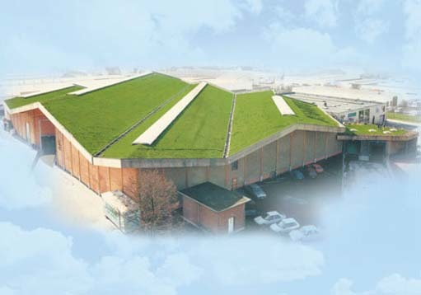
Figure 4 Production proclaiming a clean conscience: the Ecover washing products factory aims to minimise environmental impact from its heat-insulating and biodiversity-friendly green roof downwards. (Source: Ecover Limited)

The radical break view sees this as empty greenwash. The strongest image of radicals is of the anti-globalisation protestors, who from the late 1990s made media events out of the dry textual gymnastics of trade negotiations by organising major demonstrations (Figure 5). These demonstrations have become a regular feature of international meetings on development and/or the environment. The media's love of conflict, and the protestors' gift for creating compelling media images, underlined the sense that a very different way of looking at the world was being presented. The protestors are only the most visible expression of a line of argument that originated intellectually in the 1960s in the ‘new-left’ and the so-called new social movements, including radical environmentalism and feminism. All of these sought radical alternatives to both state socialism and capitalism. The alternative they propose today is difficult to pin down, but generally involves both a revival of state power, with the aim of taming corporations, and a radical localisation on the scale and pervasiveness of the globalisation that they charge with so many ills. It is assumed that the state will regulate environmental protection and social welfare standards and also, via protectionism, nurture locally based economies. Examples of the radicals' vision include the experiments in local currencies that are outlined in the final part of this section. A radically precautionary approach is followed with regard to new technologies that carried apparent social or environmental risks, however small.

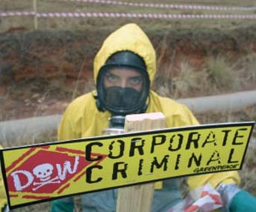
Figure 5 Corporate environmental and social reputations are a battleground. (Photo: Steve Morgan/Greenpeace)

It is less easy to visualise the sustainability steps view, partly reflecting the fact that it is not so easy to categorise in the media or public imagination. This heading can include people who view economic globalisation as a given, but see ways of ameliorating its worst aspects and are realistic about what can be achieved. If we are to place the radicals in an intellectual descent from the new left, those who believe that progress can best be made towards sustainability via incremental steps belong to a different tradition. They link to reformist movements for social democracy; these reformists worked ‘within the system’ to extend the right to vote for women and working-class men, and later created the welfare state. In other words, they seek change, but are looking to bring it about within the existing system and accept its constraints. These ‘sustainability steps’ reformers are offering a descriptive account of what the world is like (flows of capital shaping, and being shaped by, social, political and environmental change). However, they also identify means of progressing towards more environmentally and socially sustainable development. There are already hints about how this view of the sustainable economy might work. One of the most charismatic people who could be placed in the ‘sustainability steps’ category is Jonathan Porritt (Figure 3c). Although he argues for big steps, and soon, he does believe that sustainability within a capitalist system is possible. He summarises his argument thus:

the biophysical limits to growth … will compel a profound transformation of contemporary capitalism … an evolved, intelligent and elegant form of capitalism that puts the Earth at its very centre … and ensures that all people are its beneficiaries in recognition of our unavoidable interdependence.
(Porritt, 2005, p. 324)

One such hint is the rapid growth in developed country markets for fair trade, organic and sustainability-certified goods (e.g. tea, coffee, wine, timber and seafood); these means of making consumption sustainable are described more fully in the next section. Others include the attempts described in Chapter 6 to come up with a single sustainability indicator. The processes of localisation and globalisation are viewed as inextricably linked. Although this has been seen as producing social and environmental ‘bads’ at both ends of the scale, it is precisely this interconnection between local and global perspectives that holds the potential to transform the world for the better.

2.2 Vibrant civil societies and a networked globe
One thing is common to all three attempts to find a route to a sustainable economy and society: in different ways they all assume that people will get actively involved in making human societies more sustainable. But this transformation will not take place through the corporate world's promises, by local protectionism, a return to ‘strong states’ or the publication of numerous indicators. Any of the three positions outlined above requires interactions and feedbacks created by a vibrant civil society. ‘Civil society’ is the term long given to the web of institutions created by citizens. They all lie beyond the state, yet have the power to influence it and other institutions such as global corporations. Stakeholder involvement in improving business decisions, environmental protest, citizens' petitions and ‘green’ consumer demands are all reflections of this.
It is only possible to conceive of civil society being able to react to and cope with the problems of global environmental change because we live in an increasingly networked world. The networked planet is a place where business is under constant surveillance, where NGOs can afford to organise and share information instantly, and where learning and debate can take place beyond the constraints of place and time. Keep these points about a vibrant civil society and global networks in mind as you progress through the rest of this section and the associated activities.

- Define ‘voluntarism’ in the context of business learns.
- Voluntarism is the process whereby business chooses of its own accord to pursue the integration of environmental and social goals within their practices, without intervention by the state.

- What are two of the main alternatives to globalisation proposed by radical breaks?
- The revival of state power to regulate the activity of powerful corporations, and the nurturing of vibrant local economies, in part through protectionism.

- What is the intellectual heritage of sustainability steps?
- Their approach to accepting, but attempting to reform, economic globalisation is inherited from the social democratic tradition. From the late 19th century onwards a reformist route in politics was sought, whether in relation to extending the right to vote, or improving welfare and living or working conditions.

Do you recognise yourself in any of these roughly sketched positions? You will think more about this in the final activity in this section but, whatever your view, you have to be able to outline ways in which socio-political change can come about to have any confidence in the future. The rest of this section is all about these processes. The next section outlines changes in the nature of decision making that global environmental change and sustainability demand. The penultimate section gives examples of ways in which the three positions sketched here can be translated into meaningful progress towards sustainability. The conclusion notes that no transition to sustainability can take place without communication and debate, and focuses on the role of web media.

3 Governance, citizenship and sustainability

3.1 Who will make the decisions?
Where will the decisions be made that will result in meaningful action on climate change, and who will make them stick? Following climate change politics in the media can give the impression that most of the action on climate change is going on between national decision makers in international forums. It is important to keep in mind that these forums have resulted from persistent pressure from a combination of grassroots environmental activists and a global network of science and policy experts. These top-down and bottom-up pressures are just some of the changing conditions under which politicians and government officials have to work. To help you think about how societies can make steps towards sustainable development, this section unpicks this context of new approaches to decision making, and includes discussion of the impact of environmental change issues on these approaches. It looks at the emergence of the notion of governance, and goes on to consider the (related) rise to prominence of new ways of thinking about citizenship.

3.2 Governance – filling the hole where government used to be
Sustainable development emerged as a prominent environmental policy discourse at a time of deep introspection in policy communities. In the 1970s and early 1980s it was widely felt that something was badly wrong with the political process. Commentators from both left and right argued that nation states were losing the authority to govern and the capacity to act effectively. Expressions such as ‘ungovernability’, ‘legitimation crisis’ and ‘crisis of the welfare state’ were coined to indicate the dramatic and hazardous state of affairs.
The global environmental-change issues of biodiversity loss, ozone depletion and, above all, climate change were among the issues that forced the pace further in the second half of the 1980s. As Chapter 6 shows, these issues were driven into public debates by new kinds of politics, and they presented governments with new problems. Novel approaches to decision making were promoted which viewed nation states as only one force among several. Non-state bodies, such as NGOs, began to play a tangible role in shaping international debates. Governance has emerged as the most prominent term in summarising these multilayered processes. The Commission on Global Governance (CGG) defines it as:

the sum of the many ways individuals and institutions, public and private, manage their common affairs. It is a continuing process, through which conflicting or diverse interests may be accommodated and co-operative action may be taken. It includes formal institutions and regimes empowered to enforce compliance, as well as informal arrangements that people and institutions either have agreed to or perceive to be in their interest.
(CGG Report, 1995, p. 2)

To talk about globalisation and governance requires a step back to define nation states and government before going on to explain the relationships between them (see Box 1).

Box 1 What is a nation state?
The following are a few essential features of most nation states.
- They have territorially defined populations who recognise their government.
- The state is served by a specialised civil service (backed on occasions by a military service).
- The state is recognised by other states as independent in its power over its subjects. In other words, it has sovereignty. This power is expressed through, among other things, a body of legal regulation, but laws also act as guarantees of the rights of a state's citizens in relation to the state and each other.
- Ideally, and often in practice, the population of the state forms a community of feeling or identity based on its own sense of national identity.
- Members of a nation state are citizens; they are not purely subject to, but also participate in, processes of government. They also take part in sharing the responsibilities and benefits associated with membership of the nation state.
- Important features of social interaction, particularly the economy and family life, are viewed as beyond the direct control of the state and its institutions.
(Source: adapted from Bromley, 2001)

Nation states have long been viewed as the basic building block of authoritative decision making. If politics is considered as decision making at the level of society as a whole – the activity that delivers collectively binding decisions for everyone – then it makes sense that the lenses of political scientists and theorists have been firmly fixed on nation states all this time. This politics is ‘the making, implementing and enforcing of rules for the collective, public aspects of social life, that is, politics at the level of government and the state’ (Bromley, 2001, p. 6). Nation states do this over fixed territories and their populations and, by so doing, define the scope and limits of the society. The first generation of environmental problems – such as air and water pollution – were dealt with through government, i.e. a process whereby a particular course of action is followed by the nation state in the pursuit of common interests.

Activity 2 Climate politics from the top of the tree to the roots

This activity will help you think about the changing roles of different players – notably the nation state – in shaping outcomes in environmental politics. Try to combine three aspects: what you know about climate change from studying this course; what you learned about globalisation in the last section; and the summary of what constitutes a nation state in Box 1. Go through the six questions below, each of which is based on the points in Box 1, and note down, in a short paragraph for each, your thoughts as you consider the unfolding politics of climate change.
- How well can national politicians represent issues of global climate change in their day-to-day work as democratic representatives?
- Which interests are national civil servants working on climate change seeking to serve?
- How does the concept of ‘sovereignty’ influence climate-change politics at an international level?
- In what ways might the ‘community of feeling’ in the USA shape negotiations?
- How can citizen participation in climate debates influence intergovernmental talks?
- What influence can the state's climate policies really have on the economy or households?

View discussion - Activity 2 Climate politics from the top of the tree to the roots

The failure of the state to deal effectively with old problems, and its inability to respond to new challenges (above all globalisation and emergent global environmental change) has seen political scientists tear up their textbooks and start again.
They have had to acknowledge that their linear models of central decision-making by formalised institutions – whereby policies are generated and implemented in a top-down manner – don't represent the reality of contemporary politics. Similarly, political, business and NGO figures find that the word ‘government’ captures neither reality nor their ambitions for new ways of debating and resolving questions. It is in this context that the loose and open term ‘governance’ has become so quickly and widely popular.

3.2.1 What is the difference between government and governance?
Governance is from the Greek words kybenan and kybernetes, meaning ‘to steer’ and ‘pilot’ or ‘helmsman’. It is the process whereby ‘an organization or a society steers itself, and the dynamics of communication and control are central to the process’ (Rosenau and Durfee, 1995, p. 14). Of course, you could read these words as a pretty sound definition of government but that would be missing the point. Government describes a more rigid and narrower set of activities among a narrower set of participants (usually civil servants, elected politicians and some influential or privileged interests). The word ‘governance’ is often used in this course because it is a better fit for the issues of global environmental change addressed. It has spread like wildfire through debates on a range of issues, but particularly around environment and development issues, because it acknowledges that there is a range of institutions, rules and participants, both within and beyond the nation state, who are involved in making decisions. This is happening at both national and international levels, but also in innovative new forms of organisation that cut across government boundaries.
The state is seen as having progressively lost its monopoly over the control of citizens and the regulation of business and other institutions. It is still a player, but commentators have to take into account a range of other participants and scales. Political scientists are having to think in terms of webs or networks of governance. They have to consider these as being both horizontal and vertical, and as representing new ways of distributing the business of managing societies' concerns across local, national, regional and international scales. Involvement of a wider circle of stakeholders is seen as central.
Although this is true of all discussions of new patterns of governance, it has been particularly true of environmental governance. This is probably best demonstrated by the gradual emergence of environmental and social NGOs as major players in international negotiations, such as around climate change. They can claim to represent a global movement, yet can also draw on very local voices as ‘witnesses’ to environmental problems. They can also keep watch on individual national delegations to underpin their commitment to action. Increasingly, there are instances of NGO representatives being invited to join national delegations, both to represent environmentalist strands within civil society and on account of their expert knowledge of the negotiation processes. Another set of stakeholders known as QUANGOs (quasi non-governmental organisations) has taken on roles that might previously have been associated with government, such as the Environment Agency in the UK. Table 2 lists the distinctions charted thus far between government and governance.

Table 2 The distinctions between government and governance.
Government | Governance
clearly defined participants linked to the state | mixes state and non-state participants (including e.g. NGOs)
linear model | network model
top-down | multi-layer
formal institutions and procedures | evolving and ongoing processes
simple and intuitive representation of citizens through election | power is dispersed or opaque
domination through rules or force may be required to ensure universal acceptance of a decision | acceptance of and support for decisions by all players arises out of wide participation in earlier debate

3.2.2 Good green governance in five easy steps
It would be a serious error to imagine that ‘government’ has evaporated: it still shapes many aspects of our lives from beginning to end (welfare, taxation, transport and, of course, the recording of births and deaths). Governments are the central negotiators of environmental-change policies at international level, and of their implementation at national and local level. Nevertheless, for many areas of life, governance is undeniably a better description both of new processes that are already in play and of ambitions for the shape of decision making in the future. In other words, although the term ‘government’ is descriptive of new patterns of decision making, it is also prescriptive. This is perhaps truer of environmental decision-making than anything else. Perhaps this is not surprising: new thinking about governance appeared at the same time as issues of global environmental change and economic globalisation.
The numerous documents that promote good governance tend to make very similar demands, and are likely to include the following features (use the mnemonic OPASI, from the initial letters, to help you remember them).
- Openness Accessible and understandable language that can reach the general public and improve confidence in complex institutions.
- Participation ‘Quality, relevance and effectiveness’ depend on wide participation throughout the policy chain. Effective participation demands an inclusive approach from all layers of government when developing and implementing policy.
- Accountability Legislative (scrutiny and passing of laws and policies) and executive (initiating and executing policies) responsibilities and powers need to be clearly separate.
- Subsidiarity Taking decisions at the most appropriate level.
- Integration Policies and actions need to be effective: i.e. timely and answering clear objectives, and based on the evaluation of future impact (and, where possible, relevant precedents). They must have coherence: i.e. be easily understood, and hang together in sensible ways.
Table 3 shows these five features in relation to the four main (interacting) levels of governance, concentrating on dimensions relevant to advancing sustainability.
Click here to view document

View document

Activity 3 What makes for good governance?

(a) Pick a sector that is important in terms of sustainability (transport, energy, agriculture or tourism), and note down whether you think ‘good governance’ that promotes sustainable development is being achieved in that sector according to the ‘OPASI’ headings in Table 3.
(b) Which scale matters most in the delivery of good governance?
(c) How can the Web promote ‘good governance’?

View answer - Activity 3 What makes for good governance?

3.3 Green governance needs citizens
The term ‘good governance’ implies that ‘ordinary people’ will be involved in deciding what to do, trying to make it happen, and deciding whether it has happened (debate, implementation, monitoring). But what, in practical terms, might citizen involvement in the governance of an issue such as climate change mean? Citizen involvement in decisions and actions can mean anything from filling in a questionnaire to joining a demonstration to sitting on a committee. One helpful approach is Arnstein's ‘ladder of citizen participation’(Figure 6). On the bottom rungs are well-known and long-practised techniques for keeping the public informed; on the top rungs, power has been handed over to the public.

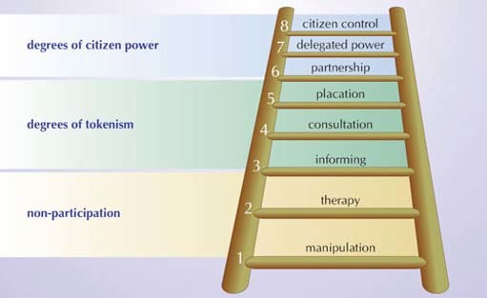
Figure 6 Arnstein's ladder of participation: most decision making gets stuck half-way up (Arnstein, 1969).

Most commentators would say that there is a rather utopian feel to the higher rungs of the ladder of participation, and in the developed world there is little evidence of decisions being ceded by the state to citizens. In less-developed countries there are cases where the higher rungs are being reached, partly because governments have failed to deliver, and international NGOs and agencies are leapfrogging the state to give funds to communities to deliver sustainability on the ground.

- The move from government to citizen participation in governance sounds like a good idea. Is there anything to be cautious about?
- □ Institutions of democratic government can be fairly transparent, and it is intuitively clear what the relationship is between citizens and the state. The lines are not so clearly drawn with governance. It is more difficult to identify where power lies, corruption may occur, and citizens may not feel any more empowered. Conversely, extensive citizen involvement may cause paralysis in decision making. Worse from a climate change point of view: citizens may demand cheap car driving and air flights!

3.3.1 Too late for the nation state?
Nation states have long been thought of as comprising citizens who ‘share the same fate’. For a long time it made sense to think in terms of the shared fate of members of a nation state (although different social classes would generally have experienced different versions of this fate). However, the global economic, political and social flows described in this section, and the global environmental changes charted throughout this course, make it much more difficult to think in terms of clearly bounded societies and of governments that can or will act in the confined interests of its citizens. Although we might be losing some of our cohesion as well-ordered groups of citizens, marked out by national boundaries, there are also signs that many people are thinking of themselves as global, or cosmopolitan citizens. The following factors are driving this.
- People are moving around the world in search of work, security, leisure or new experiences.
- Increasing flows of cultural goods (such as film, music, fashion, food).
- Strengthening and deepening of supranational bodies, such as the EU or the UN, which often advance more international or universal political values.
- Emerging awareness of transboundary and global risks, of which environmental risks are prominent.
- Many people have ambiguous feelings about dependence on expert systems (for physical security, environmental protection, safe food and travel, etc.), which people rely on but may not trust because the systems contradict their daily experiences and lay knowledge.
- There are many more media products, and a variety of ways of accessing them. Unlike national broadcasters such as the BBC of the mid-20th century, these are more diverse, made up of subjects, images and techniques from around the globe (Urry, 1999).
Global environmental changes imply that citizens will constantly be dealing with transboundary issues and processes that will bind them closer together or, in the words of one political scientist, create ‘overlapping communities of fate’ (Held et al., 1999). The main currents of policy debate that have responded to these changes put citizens at the centre. They assume, at a rhetorical level at least, that citizens will be engaged in the democratic regulation of local, national, regional and global environmental governance. In other words, they will practise all sorts of citizenship.

Activity 4 The citizen shopper

This activity invites you to think about how the personal becomes political. How much ‘citizenship’ is involved when you fill your shopping basket? Many people reflect not just their tastes but also their values – you could say their politics – in the products they buy. Look at a recent shopping list and try to find items that do, or could, reflect a kind of exercise of citizenship in their selection. It takes a little imagination to see a few bags of shopping as a site of political action and debate, but the following questions might help guide your thinking.
- Do you buy Fairtrade or organic products?
- Do you buy local products? Think in terms of where and how products are produced and the conditions the producers live in, or the impact on the environment.
- Are there any ways in which the journey the products make down the supply chain can be monitored or impacted on?

View discussion - Activity 4 The citizen shopper

In the activity you were asked to look at long chains of connection between consumers and producers, and similarly long chains of environmental impact. Many people (although far from a majority) have become much more aware of how their consumer choices have significant environmental and social impacts, and have sought to make choices that reduce these, or even contribute to social and environmental goods. They could be said to be putting notions of cosmopolitan or ecological citizenship into practice. Some choose Fairtrademarked products (Figure 7 and Figure 8) which make guarantees to the growers in less-developed countries about pay and welfare conditions. Other people look for organic foods from around the world that carry a certification of high environmental and animal welfare standards. Others, again, would choose to buy mainly locally produced foods, maybe from a home-delivery organic box scheme or farmers market. This reduces the ‘food miles’ (the energy used to transport the food to the household) and supports small local producers as opposed to multinational companies. All these choices are different ways of practising a new kind of citizenship. They are ways of challenging the places and forms of economic globalisation that threaten environmental or social sustainability. Democratic and ecological values are brought into play without the involvement of the nation state.

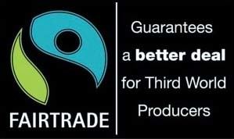
Figure 7 The Fairtrade mark. (Source: Fairtrade Foundation)

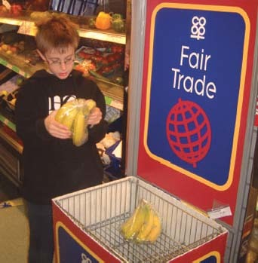
Figure 8 Sales of Fairtrade banana are rocketing. People are increasingly exercising citizenship via their shopping basket. (Photo: Joe Smith)

3.3.2 Citizenship beyond (species) borders
Political philosophers are struggling to fit together conventional ideas of citizenship and issues of global environmental change. Most have simply ignored these momentous challenges: they have failed to fully comprehend the implications of our new understanding of humans' revised place in the world.
However, our advancing awareness of global environmental changes draws us into a very different sense of shared fate from that of the nation state, or even the global citizen. As Chapter 5 shows, some people argue that our political community should stretch even wider than just humans distant in space and time.
If this challenge is taken up, the consequences are far-reaching. Mark Smith suggests that this implies a new politics of obligation in which ‘human beings have obligations to animals, trees, mountains, oceans and other members of the biotic community’ (Smith, 1998, p. 99). He goes on to suggest that ‘the limits this places upon human action are severe … no existing political vocabulary has managed to capture this transformation in the relationship between science and nature.’
These kinds of arguments have often been dismissed with responses not much more sophisticated than: ‘So you want to give trees the right to vote?’ (Figure 9). More serious critiques win the reply that ecological citizenship is one of the conclusions to be drawn from placing humans in their proper place within the workings of the natural world. The implications of such an ecological citizenship need to be considered because they appear to overturn some of the fundamentals of conventional approaches.

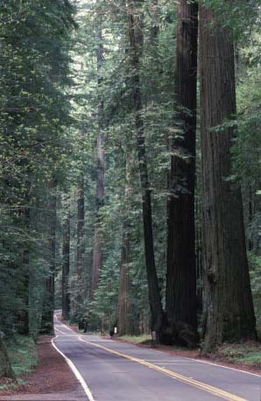
Figure 9 Rethinking our place in the natural world demands some hard thinking, for example, about where, and whether, to build new roads. (Photo: Mike Dodd)

3.3.3 Obligations to trees?
Citizenship is generally held to be based on a contractual view, where rights and obligations are balanced. In other words, you get various rights in return for your commitment to live by your society's rules and expectations. Political philosopher Andrew Dobson suggests that ecological citizenship is based in a non-reciprocal sense of justice or compassion. The discussion of our relationships with past and future generations in Section 1.2 establishes that our obligations to future generations or other species cannot be based on reciprocity by definition. This goes further than a cosmopolitan citizen's obligation to strangers distant in space. We can't hold a contract with the future; there is no all-encompassing ecological political community with which we can construct bargains.
Some political theorists have dismissed this approach, suggesting that it makes no sense to talk about citizenship without having some concept of political community and belonging. They argue that those proposing ecological citizenship are stretching the term too far. The counter-argument is that it is possible to point to some actions of institutions such as the EU and the UN as evidence that we have already started on the first steps down this road. There has been a sea change in environmental politics in how some kinds of policies are talked about and explained. Although the thought is not always explicit, awareness of being inextricably linked to the natural world, and to future and distant human lives, can be seen as the driving force behind some policies rather than some material or abstract sense of exchange or bargain with the state.

- Why might the precautionary principle or carbon taxes be seen as examples of policies based in a ‘non-reciprocal’ sense of justice, or compassion?
- These policies could be seen as reflecting a ‘bedding down’ of non-reciprocal obligations to the future and the non-human natural world. We are bound by these obligations, but this isn't like the deal that was struck when Western European countries set up welfare states, where welfare and economic security were exchanged for strike-free labour relations and social stability. They are, therefore, ‘non-reciprocal’.

3.3.4 Home-grown compassion, not public commitments
It has long been held that we conduct all citizenship, and the obligations it implies, in the public sphere (i.e. outside the private sphere of the home). However, it has been argued that there are other potential sources of obligation. Andrew Dobson argues that the principal duties of the ecological citizen are to act with care and compassion to strangers, both human and non-human – not just in the present, but also those distant in space and time (Dobson, 2000). These virtues of care and compassion are experienced, nurtured and taught not in public spaces – the established domain of citizenship – but in the private sphere (in other words, the family and the home).
Do these features contrast ecological citizenship so sharply with established definitions of citizenship that they should not be considered in the same category? Civic rights enshrined in law are transparent; it is not difficult to see when they are being denied. However, notions such as care and compassion are much more difficult to translate into the language that legislatures and civil servants are comfortable with. These notions are clearly part of how many environmentalists would explain their actions, and these are clearly features of the private rather than the public sphere. It remains a big leap for most political philosophers to see these as aspects of citizenship.
Some ask what the practical use of all these language games is. These critics suggest climate change and biodiversity loss need action not philosophical talk. However, others suggest political philosophy is as important as measurements of global mean surface temperature in thinking through action on climate change. Although a global withdrawal of labour by political philosophers would not lead to a food shortage, or result in hazards or misfortune, it is important to recognise that, if we want to make good decisions in difficult circumstances, we need our thinking to be very sharp. We will need to think hard about what feelings and arguments might be available to underpin action. These are some of the things that philosophical debates can help us to do.
Ecological citizenship is just one way of thinking about people's motivations as you go further in exploring the new kinds of politics surrounding sustainability. It is presented here not as a line of thinking the authors want to promote, but as an example of the sort of philosophical territory that conclusions from science and policy knowledge of global environmental change may be pointing us towards. The question that now needs answering is: can all the talk about green governance and ecological citizenship be turned into meaningful action? Can we act fast enough to reduce human impacts on the global environment to a sustainable level? The final section of this course takes up this challenge.

4 Making it happen – sustainability in practice

4.1 Three approaches to global environmental change
How many ordinary people know that sustainability is the concept that is meant to save the world? How many people who believe in the concept are convinced that it can capture the public imagination? The answer to both questions is ‘not many’. It is easy to lay the charge that the idea has been much talked about in some closed circles, but has no purchase on the public imagination and is little practised. This section takes the three different approaches to global environmental change described in Section 2, and offers examples of how their visions have been put into practice. These are intended as no more than sketches but by the end of this free course you will be in a good position to weigh up the claims of the different camps to have found routes to sustainability.

4.2 Capitalism – naturally
Business can learn to integrate ecological thinking into the core of its thinking and become the hub of a sustainable society. This is the claim of the business learns position. As environmentalists have spent over 30 years portraying business as the arch-villain of the piece, this is a grand claim. One of the people who have stated it most clearly is Ray Anderson, head of the US carpet giant Interface (Figure 3a). Here is the story of his dramatic conversion to a different way of thinking about business and the natural world.

Ray's story: ‘doing well by doing good’
Ray Anderson was in the business of selling vast amounts of carpet around the world. He had no regard for the environment, beyond recognising the obligation to ‘comply, comply, comply’ with regulations. The company was a heavy user of petrochemicals and, once the products left the factory gate, the company would not see them again; their last home would be landfill. One day in 1994 Anderson was asked to talk to a group of his executives about the company's environmental vision. He realised they didn't have one, and he chanced on a book called The Ecology of Commerce by Paul Hawken (1995). The book transformed the way he thought about the whole business world:

While business is part of the problem; it can also be a part of the solution. Business is the largest, wealthiest, most pervasive institution on Earth, and responsible for most of the damage. It must take the lead in directing the Earth away from collapse, and toward sustainability and restoration…
I believe we have come to the threshold of the next industrial revolution. At Interface, we seek to become the first sustainable corporation in the world, and, following that, the first restorative company. It means creating the technologies of the future – kinder, gentler technologies that emulate nature's systems. I believe that's where we will find the right model. Ultimately, I believe we must learn to depend solely on available income the way a forest does, not on our precious stores of natural capital. Linear practices must be replaced by cyclical ones. That's nature's way… We look forward to the day when our factories have no smokestacks and no effluents. If successful, we'll spend the rest of our days harvesting yesteryear's carpets, recycling old petrochemicals into new materials, and converting sunlight into energy. There will be zero scrap going into landfills and zero emissions into the biosphere. Literally, our company will grow by cleaning up the world, not by polluting or degrading it. We'll be doing well by doing good. That's the vision. Is it a dream? Certainly, but it is a dream we share with our 7,500 associates, our vendors, and our customers. Everyone will have to dream this dream to make it a reality, but until then, we are committed to leading the way.
(Anderson, 2002)

The company has been applying life cycle analysis (LCA) to ‘close the loop’ of its resource impacts through efficiencies and cutting pollution (Figure 10). Perhaps most interesting is the new way it started to think about the business's relationship with customers. It seeks to supply service and value rather than material goods. For example, the company leases floor coverings, replacing only those carpet tiles that wear (and recycling them). The result can be reduced environmental impact, satisfied customers and competitive advantage. But it is still a carpet company, turning a profit, with 7500 employees working in 34 countries.

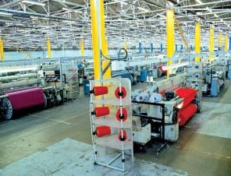
Figure 10 Energy and materials use, waste and processes have all been rethought to meet Interface carpets' sustainability goals. (Photo: Interface Fabrics)

The company makes some grand claims, but its corporate reporting addresses sustainability. Indeed, it claims to have produced the first corporate sustainability report, and followed this up with a dedicated sustainability website (Interface, 2009). The information in Box 2 is drawn from it.

Box 2 Interface's sustainability performance
Interface can certainly talk the talk, but it is clear measurable evidence that counts. The evidence in some key aspects of environmental impact shows meaningful progress. Here is some evidence drawn from their sustainability reporting web pages.

Waste-elimination activities
Interface began its journey to sustainability by focusing on the elimination of waste. It measures its waste in a ‘dollar value’ – something that helps attract the interest and commitment of employees (especially the all-important financial directors) and investors alike. By looking hard at trims and scraps, overuse of raw materials, inventory losses and/or labour to re-inspect or correct a defective product, it claims to have cut waste sent to landfills from carpet manufacturing facilities by 66% since 1996 (Figure 11).

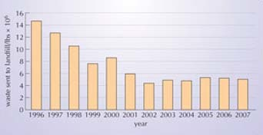
Figure 11 Waste sent to landfill. Interface is US owned, so the figures are in standard American units. (Source: Interfaceglobal.com)

Another of the company's sustainability indicators is the source and quantity of energy it buys. It aims to: (1) decrease the use of non-renewable energy by increasing the efficiency of processes; (2) increase the use of green or renewable energy. The goal is less dependence on fossil fuels and, hence, reduced greenhouse gas emissions. Interface has reduced the total energy used at its carpet factories (per unit of product) by 45% since 1996.
Renewable energy in its plants takes the form of biomass (waste woodchip from a local company) and generating and purchasing green electricity (three Interface sites use photovoltaic arrays and four buy certified green electricity). Its long-term strategy is to increase both efficiency and use of renewable energy (Figure 12).

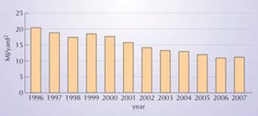
Figure 12 Energy use at carpet-manufacturing facilities. MJ = megajoules. (Source: Interfaceglobal.com)

There are similar goals and progress in its approach to its whole manufacturing and marketing systems, including water use, the reuse of recovered materials (‘closing the loop’) and the replacement of petroleum based products. Its demanding sustainability strategy was seen as high risk in the 1990s, but the company has grown healthily, outperformed many of its rivals, and also been a leader in sustainable business practice. You can track its yearly progress on its website.

Even the brief account of Interface's story in Box 2 sketches out some of the following central messages of the business learns position.

4.2.1 Eco-efficiency = money in the bank
Business can profit from taking the environment into account (generally called eco-efficiency). Poor environmental performance is seen as a reflection of poor business practice in general. Eco-efficiency promotes the economic benefits of energy and materials savings, at the same time being first to market with new technologies or products. Since business sustainability lobbies promoted eco-efficiency in the early 1990s, the creed has gained rapid acceptance, and with good cause. There are numerous eco-efficiency success stories: it has become something of an orthodoxy among global companies. Some commentators point to fourfold increases in efficiency that could easily be achieved by businesses using current and proven technologies (von Weizsäcker and Lovins, 1997). The same authors go further to argue that the true state of environmental problems demands improvement closer to a factor of ten. There are numerous sources of credible eco-modernisation case studies and data. You might start by looking at the work of the World Business Council for Sustainable Development (WBCSD) on the Web.

4.2.3 Business needs sustainability
The second argument is more profound: long-term profitability, and the existence of business itself, is threatened if companies can't transform themselves. This assumes that although the costs of environmental and social impacts can be ignored for a period, in the context of globalisation of environmental, social and political processes, they will come back to haunt businesses, and ultimately threaten their survival. There are several communications and management tools that have been developed to help get business decision makers into an ecological mindset.
The success of a business is generally measured in reports of financial performance. This information is enormously influential in shaping a company's future, whether it relates to its capacity to expand or the likelihood of merger or takeover. However, financial results are increasingly recognised to be only part of the story: businesses that don't put in place means of measuring and benchmarking (i.e. comparing performance against that of other companies) environmental and social performance are at risk. NGOs might destroy a carefully nurtured brand name in the wake of exposure of an environmental or a social ‘crime’. Alternatively, the fast-growing movement for socially responsible investment may begin asking awkward questions, damaging investment potential. Pressure from NGOs, the persistence of corporate accountability scandals and, more positively, some fresh thinking from leading figures within the business world, have resulted in widespread innovations in reporting.
The Web is an excellent source of both individual company reports (variously called environmental, sustainability or corporate social reports) and comparative indices that aim to tell the story of all three dimensions of sustainability – social, environmental and economic. Companies such as Shell and BP, with a track record in the 1990s of damaging public conflicts with NGOs, have been among the leaders of innovation in sustainability reporting, and the Web is often the best way to access the information, and to interact with the companies about it (Figure 13). Openness, both within and outside companies, has become a central claim of business reporting in these areas.

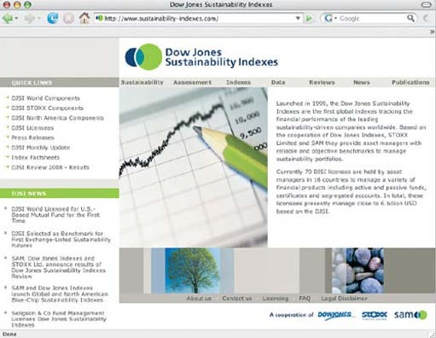
Figure 13 Some commentators claim this kind of information published on the Web has the power to accelerate moves toward sustainability in business. (Source: Sustainability-indexes.com)

The Dow Jones Sustainability Indexes give comparative evidence about corporate performance, measured according to easily accessible sustainability criteria such as the nature of corporate governance, measurements of environmental performance and the quality of engagement with external stakeholders. However, many environmentalists argue that business performance on social and environmental issues is starting from such a pitifully low baseline that such information exercises are of little value unless they are contributing to a dramatic rethinking of what core business practice amounts to. They insist that relying on business voluntarism may result in one or two heart-warming stories, but will still leave most locked in the old way of doing things. Groups of independent-minded radicals have not waited for business or government action, but instead sought over the last three decades to blaze their own trail.

4.3 Green from the grassroots up
People who demand a radical break with the business-dominated path of economic globalisation believe that the claims of the mainstream business community are at best hopelessly inadequate, and at worst deceitful. However, they know they have to come up with some answers of their own. This section outlines ideas that seek to underpin a transition to green economies owned and run at grassroots level. Sounds ambitious? Box 3 describes Findhorn, a groundbreaking community that started out on a windswept caravan park in Scotland.
You can get a fuller picture of how these components contribute to their definition of sustainability by drawing on the plentiful web resources produced by what used to be called communes, but are now sometimes referred to as ‘intentional communities’.
Of course, Findhorn is a very special place, although there are others like it, and it is not easy to imagine urban Britain turning to this way of life in a big way. But it illustrates a movement of experimentation at local level that is generating some ideas that could be scaled up to help make whole societies more sustainable.

Box 3 The Findhorn eco-village – a sustainable future?
In the early 1960s an unemployed couple tried to start growing vegetables on a very unpromising sandy plot on a caravan site on the east coast of Scotland. A powerful founding myth of today's Findhorn community is that their garden grew prodigiously and attracted stunned horticulturalists to the scene. In time, a community grew there too, now numbering 400 people, with a further 4000 people visiting annually for retreats and courses (Figure 14).

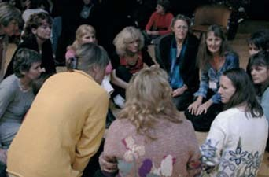
Figure 14 Grassroots decision making is central to the way communities such as Findhorn function. (Photo: Findhorn Foundation)

Findhorn has become one of the best known of a global network of eco-villages. An eco-village is a small community of between 50 and 2000 people, based on shared ecological, social and/or spiritual values. Working on the principle of not taking more from the Earth than you give back, eco-villages aim to be sustainable – indefinitely. The eco-village is a response to the complex problem of how to turn human settlements, be they villages, towns or cities, into sustainable communities, and to integrate them into the natural environment. The Eco-village Project at the Findhorn Foundation aims to be a synthesis of the best current thinking on human habitats. Quality of life, cooperation and co-creation with nature are some of the driving principles. They suggest that eco-village principles can be applied to both rural and urban settings, to developed and less-developed countries. These principles are put into action through a commitment to some or all of:
- ecological building
- renewable energy systems
- local organic food production
- sustainable economics based around local businesses
- social and family support within the community.
(Source: Findhorn Foundation, 2002)

4.3.1 Ecological tax reforms
Communities such as Findhorn already behave as if natural resources need careful management: they work hard to reduce fossil fuel use. A central assumption of this way of thinking is that people need to root economies more locally (Figure 15). To see the same impulse spread through the mainstream economy would require that the price of fossil fuels increases to reflect the real costs of burning fossil fuels. This in turn requires a revival of a nation state's capacity to regulate and redirect economies. Arguably one of the main ways of achieving this is through the tax system. Ecological tax reform implies a shift away from taxing things we value, such as work (via income tax), towards taxation of negative environmental effects. In general, these proposals assume progressive reductions in income tax by raising thresholds. In this scenario, everyone pays the full environmental costs of their lifestyles, without penalising the poorest. Although this way of thinking was for a long time the preserve of green campaigners, it has been interesting to see mainstream political parties from across the left-right spectrum toy with this radical approach to radically revising the tax system.

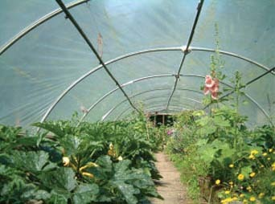
Figure 15 When people argue that we should make ‘the local’ the centre of politics and economics, they often start by growing vegetables. These are from the inspirational Centre for Alternative Technology (CAT) in mid-Wales. (Photo: Joe Smith)

These radical interpretations of what it might mean to try to account for all environmental externalities are argued to be a route to vibrant local economies. Why, given the robust logic that they seem to follow, have they not been more widely adopted by mainstream politicians? You might think that they would welcome an opportunity to cut income tax and promote environmental benefits. But politicians fear that the public are not prepared for such a shift, particularly after a period in which environmental taxation has often been applied in addition to existing taxes, hence encouraging an atmosphere of cynicism around them. The fact also remains that such dramatic shifts in the nature and balance of taxation will inevitably carry unintended consequences. Nobody can say what will happen to inflation, and the introduction of such radical plans in a nation-by-nation manner may, in fact, accelerate environmental damage in countries that do not take the same route. Their success relies on a level of committed global environmental governance that is difficult to envisage.

4.3.2 Complementary currencies
Complementary currencies also demand a rethink of our economy, but have a more imaginative and radical edge. Because of the difficulties with conventional monetary systems, various alternatives are being tried. These are usually restricted to a particular group of people, and so are called ‘local’ or ‘complementary’ currencies. They are generally based in a local community and enable people to exchange goods and services without resorting to ‘traditional’ currency. Some are grassroots initiatives whereas others are set up by local governments for the purposes of community regeneration. There are now examples all over the world. Two of the more common systems are called local exchange trading systems (LETS), and ‘Time Dollars’ (USA) or ‘Time Banks’ (UK). Some use a sort of note, whereas others simply have recorded accounts. The unit of currency in the time-based systems is the Hour, and each LETS has it own currency name (e.g. ‘bons’ in Senegal, ‘Green $’ in Ontario, Canada, and ‘Buzzards’ in Leighton Buzzard, UK).
The biggest difference between local and national currency systems is one of relationship. Because they are restricted to a group of people who have some prior connection, they are more personal and encourage a spirit of trust and community. Bargaining is sometimes backwards: ‘That will be 2 hours.’ ‘No, you put so much into it that I think I should pay for 2.5 hours.’ There is usually no interest and no inflation by the nature of the system. Rather than using banks to create money by lending for interest, with LETS or Time Banks, money is created when one person's account is credited and the other's is debited. The system is fully under the control of the people who use it (Figure 16).

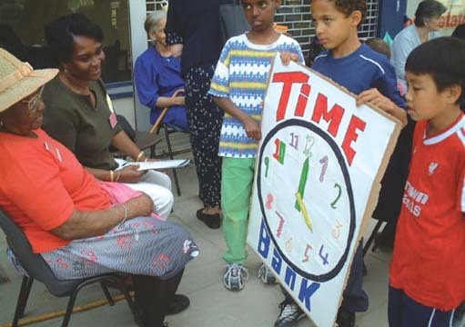
Figure 16 Time Banks: getting a good return on social capital. (Photo: New Economics Foundation)

Local currencies are proposed as the beginnings of a cooperative rather than a competitive economy because they are seen as a form of mutual support within a closed group. Transactions are driven more by need than by the desire to earn money. Although the number of local currency systems is growing rapidly, to date most of them make a useful, but still marginal, contribution to their local economies. In addition to reviving and underpinning a sense of community, these schemes are lauded for promoting a robust local economy. It is argued that this kind of economy has a much smaller environmental imprint than the parallel conventional economy.

4.3.3 Pipe dreams?
The idea underlying complementary currencies – that there is a great well of social capital waiting to be drawn upon to make society more sustainable – is an idea that is becoming quietly influential. ‘Social capital’ is a term frequently used by those mainstream politicians and civil servants tasked with addressing the widening gap between rich and poor people within societies throughout the world. Indeed, investing in and enhancing social capital is now the starting point in many sustainability projects in less-developed countries. Nevertheless, there is no evidence that such ideas are anything other than marginal in policy making.
Ecological tax reform proposals are a different matter. They have also shown their capacity to cross over from rambling conversations in Green Party meetings and rock festival fringe events to become the subject of mainstream political debate. Scandinavian and German governments have taken steps in this direction, and major institutions within the EU promote aspects of this approach. Whether it is road pricing or tax on waste going to landfill, the principle of polluter pays is now a well-established means of raising revenues and signalling the need for a change in behaviour. However, note that incomplete or poorly integrated policies may undermine the principle in the public's mind. For example, measures to firm up waste policies in the UK (Landfill Tax) were compromised in the short term by a massive growth in fly tipping and the appearance of ‘fridge mountains’.
It may be a mistake to think of the arguments of those promoting a radical break with globalising capitalism as being a diametrically opposed alternative. Rather, the ideas the radicals have been generating may be a laboratory of raw but inspiring ideas that have worked in a few specific places. Some of these may be adapted and applied by mainstream policy communities in ‘the world as it is’. Nevertheless, many have felt the need to work harder to connect radical ideas to real world settings; to engage in some uncomfortable bargains that might deliver at least some progress in the near term.

4.4 Signing everyone up to sustainability
The proposers of step-by-step progress towards sustainability would include in their plans many of the ideas proposed in the previous two subsections. However, what distinguishes this group is that they stand in the middle of the scale between faith in unfettered business voluntarism and a conviction that radical transformations are required. Their incrementalism is reflected in the kinds of pragmatic solutions they propose; their radicalism shows in the way they think about new roles and processes being taken up by all key stakeholders.

4.4.1 Partnerships for sustainable consumption
Moderate NGOs, progressive businesses and government all have a stake in seeing roundtable partnerships come up with practical steps that can bring sustainability closer. One area that has attracted the attention of all these players is consumption. Directing or limiting consumption is politically difficult for even the NGOs to promote. Similarly, ‘voluntary simplicity’ of the sort lived at Findhorn eco-village (Box 2) is not something that mainstream business will support. Hence sustainable consumption is an obvious goal around which these partners can gather. Two prominent examples are the Forest Stewardship Council or FSC (Box 4) and the Marine Stewardship Council or MSC, both examples of attempts to create sustainable supply chains of raw materials that are subject to intense and unsustainable exploitation.

- What might the geographical spread of FSC certification say about the governance of forestry? Contrast Europe with Africa.
- Looking at Figure 18, there appear to be wide differences between European and African percentages of certified forestry. There could be a combination of factors:
  - European civil society and government are demanding sustainable forestry practices; management systems in the EU exist in an increasingly tight environmental regulation context;
  - governance of African forestry supply chains may make it more difficult to achieve certification;
  - some of the initial promoters of the FSC approach may be EU based.

Careful research would be required to know what precisely the reasons are, but the information in Figure 18 is a good starting point.

Box 4 Forest Stewardship Council – a partnership for the future of forests
The Forest Stewardship Council is an international non-profit organisation founded in 1993 to support environmentally appropriate, socially beneficial, and economically viable management of the world's forests. With offices in Mexico and Germany, it is an association of members including environmental and social NGOs, the timber trade and the forestry profession, indigenous people's organisations, community forestry groups, and forest product certification organisations from around the world.
Forest certification is a way of assessing and certifying claims to have put sustainable forestry in place. Operations are assessed against a predetermined set of standards. The FSC's standards aim to establish a global baseline to aid the development of region-specific forest-management standards. Independent certification bodies, accredited by the FSC in the application of these standards, conduct impartial detailed assessments of forest operations at the request of landowners. If the forest operations are found to conform with FSC standards, a certificate is issued, enabling the landowner to bring product to market as ‘certified wood’, and to use the FSC trademark logo (Figure 17).

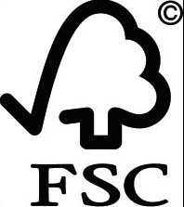
Figure 17 The Forest Stewardship Council (FSC) logo asks the sustainability question all the way along the supply chain. (Source: Forest Stewardship Council)

Chain of custody is the process by which the source of a timber product is verified. To carry the FSC trademark, a timber has to be independently tracked from the forest, through all the steps of the production process, until it reaches the end user. By mid-2002 there were more than 1500 FSC-endorsed Chain of Custody (COC) certificates in the world (Figure 18a). In the space of five years, there was a fivefold increase in the area of FSC forest (Figure 18b).

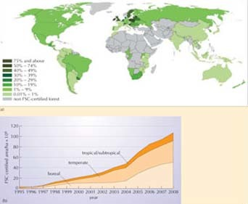
Figure 18 (a) Certified forest sites endorsed by the FSC. (b) Rate of increase of FSC-certified forest (in million hectares) over time. (Sources: Forest Stewardship Council)

The FSC is a compelling and exciting case but it remains a rare one. For sustainability steps to be a convincing way forward, there need to be ways of scaling up the occasional success stories and to make them mainstream.
If you put together enlightened business, concerned and often organised civil society, and a communications system which the world has never seen before, you can expect some progress. However, it is widely believed that this progress will remain marginal, and unsustainability will continue as the norm unless government becomes involved and starts to give some regulatory shape to sustainability principles.

Activity 5 Which path to sustainability?

This activity invites you to assess the usefulness and viability of the three different approaches to achieving sustainability outlined in this section. To do this, ask yourself the following questions and make notes on your answers.
- With which of the three approaches do you most identify?
- Do the examples given in this section convince you that societies can adapt to environmental change and become sustainable?
- Are they exclusive alternatives, or can they be combined?

View discussion - Activity 5 Which path to sustainability?

5 New ways of looking at the world
There is a variety of new approaches or terms that are interlinked, and have been prominent throughout this course. All of them have played a part in this course’s journey through the scientific, political, philosophical and social implications of climate change.
Governance of climate change is about: decision making under uncertainty; understanding and representing vulnerability even when vulnerabilities are difficult to assess or unknowable; and making every aspect of human activity sustainable within the context of economic, socio-cultural and political globalisation.
One feature that distinguishes contemporary culture is that themes and questions such as these are being explored using the uniquely rich, but also problematic, medium of the Web (Figure 19). Sustainable development and the Web grew up together. However, it is not just this accident of timing that makes them such close relations. Consider some of the claims that are often made about the Web. It:
- Plays a role in spreading values globally, and aids development of global civil society – for example, via NGO transboundary organisation.
- Promotes transparency – data and argument can be published regularly and in full, reducing the possibility of manipulation.
- Reduces hierarchy, which facilitates working in small teams.
- Is inclusive in terms of breaking down obstacles of distance.

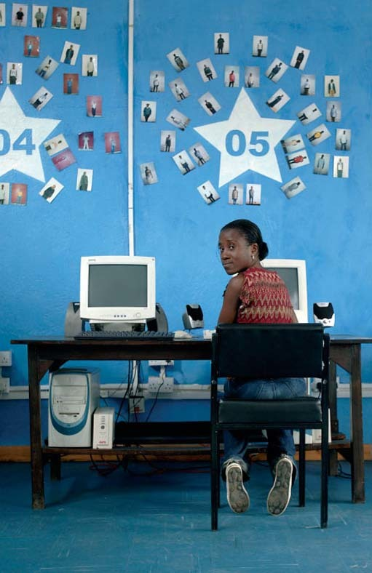
Figure 19 Camilita Ajiambo Siata works with NairoBits, a non-profit Digital Design School which provides education for the young people of Nairobi's slum areas. She earns enough working as a web designer to support her whole family. The Web is opening up new flows of information and debate – key components of sustainable development. (Photo: Sven Torfin/Panos)

If the relatively obscure groupings of policy experts, NGOs and intellectuals who were talking about sustainability in the late 1980s had listed some of the features of a communications environment that progress towards a sustainable world would require, their list would probably have looked like this. These features of the Web could enable ideas and decisions about making progress towards sustainability to be quickly and widely debated and disseminated. While the first decade of widespread use of the Web recognised its potential as an immense and easily searchable repository of knowledge, one of the most interesting features of the second decade of its development is the capacity of users to actively participate in its construction. Wikis, online communities of interest and other forms of social media are opening up new and unpredictable pathways to the generation, testing and dissemination of ideas.
The unfolding awareness of human societies' hazardous impacts on environmental systems really turns up the heat on questions about the future. Climate science suggests that those systems on which we all rely are subject to dramatic changes. This simple fact may increasingly serve to motivate a whole range of players to bring about change on the kind of scale that the problems appear to demand. Section 4 points to the need for (and some evidence of):
- a ‘new industrial revolution’
- a demanding and proactive civil society
- intelligent, consensual approaches to bringing these forces together.
There seems enough evidence in the brief case studies in Section 4 to suggest that we are capable of innovation in our social and economic systems. Intelligence about these innovations can move fast around our networks – be it business, NGOs or the media. The work of all of these networks is accelerated by the Web.
However, it no longer makes sense to see these systems as separate from the natural world. The unfolding science of climate change is an incredibly potent and pressing illustration of how human systems are inevitably interdependent with environmental systems. This course has taken you from current findings in the science of climate change to the conclusion that societies must urgently find ways of becoming environmentally sustainable. The challenges are enormous, but these powerful new insights about the interdependence of the human and non-human natural world are being generated at a time when new ideas can be circulated and debated on a scale and at a speed that no previous generation could imagine. These new ways of looking at the world, and the new ways of communicating such insights, leave plenty of room for optimism.

7 Summary and final thoughts

7.1 Questions
Question 1
What are the four dimensions of globalisation outlined in Section 4?
Question 2
Outline, in no more than 100 words, the distinctions between the three approaches to achieving sustainability outlined in this course.
Question 3
Organise the following under the headings ‘government’ and ‘governance’:
- clearly defined state actors
- linear model
- multi-layer
- power is dispersed or opaque
- top-down
- network model
- domination through rules or force may be required to ensure universal acceptance of a decision
- simple and intuitive representation of citizens through election
- mixes state and non-state actors (including e.g. NGOs)
- evolving and ongoing process
- acceptance of and support for decisions by all players arises out of wide participation in earlier debate
- formal institutions and procedures.
Question 4
List five features (think ‘OPASI’) frequently associated with good governance, and give brief summaries of them. (Please write no more than 100 words for the whole answer.)
Question 5
What makes ecological citizenship distinctive? Give two reasons (a short paragraph on each).
Question 6
Match the following approaches to sustainability – business learns, radical break, or sustainability steps – with the ideas they promote listed below:
best practice databases
ecological tax reform
corporate sustainability reporting
Local Economic Trading Systems
Forest Stewardship Council.
Question 7
In around 100 words, outline what claims are made for the Web as a medium that might aid transitions to sustainability.

7.2 Answers
Question 1
Although most people immediately think of economic globalisation, Section 1 shows how political, social/cultural and ecological globalisation are also significant in the context of global environmental change.
Question 2
The advocates of ‘business learns’ are optimistic about the global free-market civilisation they believe they are building, but they also believe business needs to heed environmental and social concerns for its own sake. ‘Radical break’ sees only a new colonialism, in which US corporations are the hubs of a global empire. Their solution lies in democratic locally based economies. ‘Sustainability steps’ stands between the two. It suggests that changes are needed to make the current trajectory of development sustainable, but societies have opportunities to shape the course and impact of development as a goal around the world.
(Section 2)
Question 3

Government | Governance
Clearly defined state actors | Mixes state and non-state actors (including e.g. NGOs)
Linear model | Network model
Top-down | Multi-layer
Formal institutions and procedures | Evolving and ongoing processes
Simple and intuitive representation of citizens through election | Power is dispersed or opaque
Domination through rules or force may be required to ensure universal acceptance of a decision | Acceptance of and support for decisions by all players arises out of wide participation in earlier debate

(Section 3.2)
Question 4
Openness Accessible and understandable language to reach general public to improve confidence in complex institutions.
Participation ‘Quality, relevance and effectiveness’ depend on wide participation throughout the policy chain. Effective participation demands an inclusive approach from all layers of government.
Accountability Legislative (scrutiny and passing of laws and policies) and executive (initiating and executing policies) responsibilities and powers need to be clearly separate.
Subsidiarity Decisions must be taken at the most appropriate level.
Integration Policies and actions need to be effective, evaluated for future impact, and be coherent.
(Table 3)
Question 5
- No reciprocity: ecological citizenship goes further than the cosmopolitan citizen's obligation to strangers distant in space: we can't hold a contract with the future; there is no all-encompassing ecological political community with which we can construct bargains.
- Duties drawn from the private not the public sphere: it has long been assumed that citizenship is a practice that goes on entirely in the public sphere (i.e. outside the private sphere of the home). However, it has been argued that there are other potential sources of obligation. Dobson argues that the principal duties of the ecological citizen are to act with care and compassion to strangers, both human and non-human, distant in space and time. These virtues of care and compassion are experienced, nurtured and taught not in public spaces – the established domain of citizenship – but in the private sphere.
(Section 3.3)
Question 6
Business learns: corporate sustainability reporting
Radical break: ecological tax reform; Local Economic Trading Systems
Sustainability steps: best practice databases; Forest Stewardship Council
Some of these ideas could appear under other headings (e.g. many in the business community support the principle of ecological tax reform, and probably all who support an incremental ‘sustainability steps’ approach are in favour of corporate sustainability reporting) but this way of organising these ideas does indicate where they originate, and hint at the differences between them. (Section 4)
Question 7
The Web can:
- Play a role in spreading values globally and aids development of global civil society, e.g. via NGO transboundary organisation.
- Promote transparency and, due to its frequent, unmediated and complete nature, reduces the possibilities of manipulation of data.
- Reduce hierarchy, enabling more working in small teams.
- Be inclusive in terms of breaking down obstacles of distance.
This is the kind of communications environment that policy experts, NGOs and intellectuals generally hold is required to progress towards a sustainable world. These features of the Web could enable ideas and decisions about making progress towards sustainability to be widely agreed and disseminated with speed and inclusivity. (Section 5)

6 Conclusion
- It is essential that societies seek ways of becoming environmentally sustainable and adaptable to unknowable environmental changes, particularly in the climate. This must happen in the context of globalisation. The concept of sustainability is coming to prominence at a time when established structures of government are being questioned and new ways of thinking about governance are being explored.
- Globalisation has several dimensions that are relevant to the discussion of environmental change and sustainability. In addition to the widely used economic meaning of the term, political, social or cultural and ecological dimensions of globalisation are drawn out.
- Three different views on the relationship between globalisation and the environment can be identified: ‘business learns’ sustainability (in its own self-interest),‘radical break’ with globalisation (and pursuit of sustainable grassroots alternatives), and ‘sustainability steps’ (incremental progress based in partnership but emphasising a role for government). There are empirical examples of each approach (Interface carpets, the Findhorn eco-village, the Forest Stewardship Council).
- Comparison of the concepts of government and the more recently prominent term ‘governance’ demonstrates some of the strengths, but also the threats, implicit in a shift to more flexible and open-ended decision-making structures.
- New forms of governance imply new ways of practising citizenship: writers now argue for cosmopolitan and ecological citizenship.
- Communication and debate will be important if any – or a mix – of these approaches are to thrive, hence the media, and specifically quality web journalism, are a key location for advancing towards sustainability.

Keep on learning



Study another free course
There are more than 800 courses on OpenLearn for you to choose from on a range of subjects.
Find out more about all our free courses.

Take your studies further
Find out more about studying with The Open University by visiting our online prospectus.
If you are new to university study, you may be interested in our Access Courses or Certificates.

What’s new from OpenLearn?
Sign up to our newsletter or view a sample.

For reference, full URLs to pages listed above:
OpenLearn – www.open.edu/openlearn/free-courses
Visiting our online prospectus – www.open.ac.uk/courses
Access Courses – www.open.ac.uk/courses/do-it/access
Certificates – www.open.ac.uk/courses/certificates-he
Newsletter – www.open.edu/openlearn/about-openlearn/subscribe-the-openlearn-newsletter

References
Anderson, R.C. (2002) Ray's story [online], http://www.interfaceinc.com/getting_there/ Ray.html (Accessed 31 November 2002).
Arnstein, S.R. (1969) ‘Ladder of citizen participation’, Journal of the American Institute of Planners, vol. 35, pp. 216–24.
Bromley, S. (2001). Governing the European Union, London, Sage.
Commission on Global Governance (CGG) Report (1995) Our Global Neighbourhood, Oxford, Oxford University Press.
Dobson, A. (2000) ‘Ecological citizenship: a disruptive influence?’, in Pierson, C. and Tormey, S. (eds) Politics at the Edge, PSA Yearbook 1999, London, Macmillan.
Findhorn Foundation (2002) Website: http://www.findhorn.org/(Accessed 31 November 2002).
Hawken, P. (1995) The Ecology of Commerce: A Declaration of Sustainability, London, Phoenix.
Held, D. et al. (1999) Global Transformations: Politics, Economics and Culture, Cambridge, Polity Press.
Porritt, J. (2005) Capitalism as if the World Matters, London, Earthscan.
Interface (2009) Website: http://www.interfacesustainability.com/metrics.html (Accessed 26 February 2009).
Rosenau, J.N. and Durfee, M. (1995) Thinking Theory Thoroughly: Coherent Approaches to an Incoherent World, Boulder, CO, Westview Press.
Smith, M.J. (1998) Ecologism: Towards Ecological Citizenship, Milton Keynes, Open University Press.
Urry, J. (1999) ‘Globalisation and citizenship’, Journal of World-Systems Research, vol. 2, pp. 311–24. Available online at: http://csf.colorado.edu/jwsr.
von Weizsäcker, E. and Lovins, A.B. (1997) Factor Four: Doubling Wealth – Halving Resource Use: The New Report to the Club of Rome, London, Earthscan.

Acknowledgements
Except for third party materials and otherwise stated (see terms and conditions), this content is made available under a Creative Commons Attribution-NonCommercial-ShareAlike 4.0 Licence
Grateful acknowledgement is made to the following sources for permission to reproduce material in this course:
Course image: Moyan Brenn in Flickr made available under Creative Commons Attribution 2.0 Licence.
Figure 1 Mark Henley/Panos
Figure 2a Paul Sakuma/PA Photos
Figure 2b Ian Shaw/Alamy
Figure 3a Interface Research Corporation
Figure 3b Pier Paolo Cito/Empics
Figure 3c Sean Dempsey/PA Archive/PA Photos
Figure 4 Ecover Ltd.
Figure 5 Steve Morgan/Greenpeace
Figure 6 Joe Smith
Figure 7 Mike Dodd
Figure 8 Interface Research Corporation
Figure 9 Interface Inc
Figure 10 SAM Indexes GmBH
Figure 11 The Findhorn Foundation
Figure 12 Joe Smith
Figure 13 New Economics Foundation
Figure 14 The Forest Stewardship Council
Figure 15 Sven Torfin/Panos
Getty Photodisc
Additional material not in acks
Page 243: Figure 6 – Arnstein’s ladder of participation – not in Acks, probably specially designed
Page 245: Figure 7 – logo of Fairtrade Foundation
Page 257: Figure 1 – logo of Forest Stewardship Council (FSC)
Don't miss out:
If reading this text has inspired you to learn more, you may be interested in joining the millions of people who discover our free learning resources and qualifications by visiting The Open University - www.open.edu/openlearn/free-courses
This free course is adapted from a former Open University course called 'The environmental web (U316)'.

Activity 3 What makes for good governance?

Answer
Answer
(a) Whichever sector you chose, you probably concluded – at best – that it is still early days. Decision making is becoming more open in many areas, aided by both top-down obligations (for example, to the Aarhus Convention) and grassroots pressure, partly facilitated by the Web. But you might also observe that wide participation in some sectors can simply lead to contradiction and conflict rather than desired consensus. It is difficult to assess accountability and subsidiarity in general terms: complex interactions across scales can get in the way of a judgement about local, national or supranational institutions. Ultimately, the degree to which vertical and horizontal integration has been achieved will be the measure of successful governance of sustainability challenges. Will there be occasions when this integration contradicts other components of the recipe for good governance?
(b) It doesn't make sense to separate out scales; each is relevant in different ways. Furthermore, they are interlinked and the delivery of a policy may require different kinds of actions at different levels – and different degrees of fulfilment of the contents of Table 3. There may be more room for openness and participation at local level, but the principle of subsidiarity proposes that decisions should be made at the most appropriate level – sometimes this is international, at other times national or local.
It can promote all five features identified above. Openness, participation and accountability are all made easier by the quick, cheap, searchable and comprehensive nature of this distinctive medium. Claims can be tested and alternative views put. Subsidiarity and integration may be advanced through improved communications and analysis within policy communities, both horizontally – across sectors – and vertically – across scales from global to local within particular policy sectors. ‘Good governance’ as laid out in the pious tomes of the EU, the UN and other organisations is a very high ambition; there are cases where it is claimed to be in place, but it patently isn't. There are cases where it has been practised, but the conditions are difficult to make universal. In other words, if the funding, public support and professional time are available, and the problem at hand is on a manageable scale, the model is good. Hence participation might greatly improve the planning of a new cycle lane or a recycling facility. However, it seems less likely that the transformation of the global political economy to deal with climate change will be achieved by progressively going through all these steps. Yet that is precisely what is being demanded of global environmental governance in the rhetoric of sustainable development. There seems to be something missing. That something may be citizenship.
Back to Session 3 Activity 2

Activity 1 What does ‘globalisation’ mean to you?

Discussion

Comment
This is how one of the authors responded to this question.
When I see the word ‘globalisation’, I'm reminded of my first fairly long-distance trip from the UK. Trabzon in Eastern Turkey was a highly exotic place to me; a cultural and economic crossroads between East and West for thousands of years, it had Roman ruins, mosques in former Byzantine churches, and a vast portrait of Kemal Ataturk, the 20th-century founder of modern secular Turkey, marked out in light bulbs on the hillside above the city. Perhaps I shouldn't have been surprised to see shops and advertising smothered with consumer brands that any British corner shop would stock, or to pass offices of familiar companies. Economic globalisation was very tangible and evidently far-reaching.
But there were other dimensions to the globalisation I felt I was witnessing, including political and cultural ones. There were small demonstrations by Islamic groups protesting at events in another part of the world that had taken place only a couple of hours before; they only knew about it because of the satellite TVs in many of the cafés. The same TVs bring English Premier League football and American soaps. Taken together, these forces both unite and divide people in my home town in the English Midlands and the people of Trabzon. They make the world in some senses smaller and more similar, but in others less predictable – more unruly.
Although they also bring more wealth to some people in Eastern Turkey, you didn't have to look far to see evidence of a widening gulf of inequality in the city. There is an important but less easily perceptible ecological aspect to the globalisations described. As I flew into Trabzon, I sat next to a marine biologist who was travelling the Black Sea region, exploring what appeared to be the devastating impact on the fisheries, and hence local economies, of an ‘alien’ North American species of jellyfish that had been released into the Black Sea via the bilge tanks of freight shipping that had come from the Great Lakes.

Back to Session 1 Activity 1

Activity 2 Climate politics from the top of the tree to the roots

Discussion
- With difficulty! Climate change demands action globally, but in most democratic states a government's actions will be debated and are subjected to its people's scrutiny through elections. Global interests, such as integrating the true costs of burning fossil fuels into fuel prices, are often undermined by politicians seeking to outbid each other in guessing the short-term interests of their electorates. The UN struggles to win commitments to collective action by its constituent nation states.
- Civil servants who negotiate climate change and plan actions within countries are trained to seek out and represent the best outcomes for their nation state; altruism (benefiting another state, perhaps to the cost of your own) is not just unlikely in this context, it might be seen as unprofessional. American and Australian climate-change negotiators have a responsibility to their state long before any responsibility to UN processes, whatever their personal view may be.
- The concept of sovereignty ensures that nation states cannot generally be coerced into a course of action by other states, particularly for climate-change issues. In climate-change negotiations this means that some states (most prominently the United States) can reject an agreement that has been arrived at by the great majority of other nation states by referring to its own sovereignty. But the concept of sovereignty is not static: the European Union (EU) has acted as a unified party in climate-change negotiations. Most commentators interpret this as nation states pooling some of their sovereignty to allow more efficient decision making and to give the EU as a whole a stronger collective voice in negotiations.
- The community of feeling or identity of the USA is strongly bound to a notion of individual freedoms. In the late 20th and early 21st centuries, these were expressed (some would say distorted) in a general pattern of energy-intensive lifestyles (large cars, frequent air travel, energy-hungry appliances, etc.). European societies have followed a similar route, although they have not reached the same intensity of resource use. Although they would rarely put it in these words, many NGOs and commentators are absorbed by the question of whether a high-consumption lifestyle can be divorced from a sense of quality of life and self-worth.
- Citizen pressure adds up to significant pressure on the state, in the form of NGO activity, individual petitioning and other lobbying processes, and individual actions to reduce the environmental impacts of households and communities. In the 1990s, the presence of strong citizen voices demanding action on climate-change complemented messages coming from the science community to pressurise governments into international talks on the issue. By contrast, there are also examples of citizens organising to campaign against environmental policies, for example against energy tax rises.
- One of the great challenges of climate-change politics is that a global problem that is the result of millions of local actions requires that international agreements can result, through the actions of individual nation states, in changes in the behaviours of local economies and households. Not only are such chains of cause and effect very difficult to predict and influence, they can also stir up strong resentment and opposition, such as the fuel price protests mentioned at the end of point 5.
Back to Session 3 Activity 1

Activity 4 The citizen shopper

Discussion
One of the authors responded to this activity as follows.
My own shopping in the last week or so included: fairly traded bananas, honey and tea; organic milk and cheese; organic seasonal fruit and vegetables from a local smallholder. Industrial food giants didn't lose out completely; I ignored the green global citizen in me to buy my family's favourite chocolate and cereal, and some very good coffee whose labelling tells me nothing of its origins or governance. It's difficult for me personally to follow the ‘story’ of these products from their origin to the shopping basket, but I do trust, for example, organic and Fairtrade marks. Someone else is doing the checking all the way along the supply chain for me.
Back to Session 3 Activity 3

Activity 5 Which path to sustainability?

Discussion
Here are some of the author's thoughts.
- You might conclude ‘all of them and none’. Business can deliver creative solutions to problems, and a capitalist economic system can offer the means of replicating them quickly. But such best practice won't be universalised without external pressure from government and civil society. There is no evidence of widespread preparedness for a shift to ‘intentional communities’, or a locally based alternative to economic globalisation, but society at large can benefit from the hard thinking about what quality of life really means. Of course, stepwise progress towards sustainability appears to be the ‘reasonable middle ground’ but that is precisely its problem. It is just a little too well reasoned and sensible to grab people's attention at a time when they are trying to meet their immediate needs and wants.
- Interface, the Findhorn Foundation and the Forest Stewardship Council are impressive and exciting. In different ways and for different audiences, they represent pathfinders for society, but they are very much exceptions.
- Taken as a messy interconnected whole, the approaches begin to offer some sources of hope. However, it would be a mistake to hold your breath waiting for single answers to the issues of global environmental change to appear fully formed.
Back to Session 4 Activity 1

