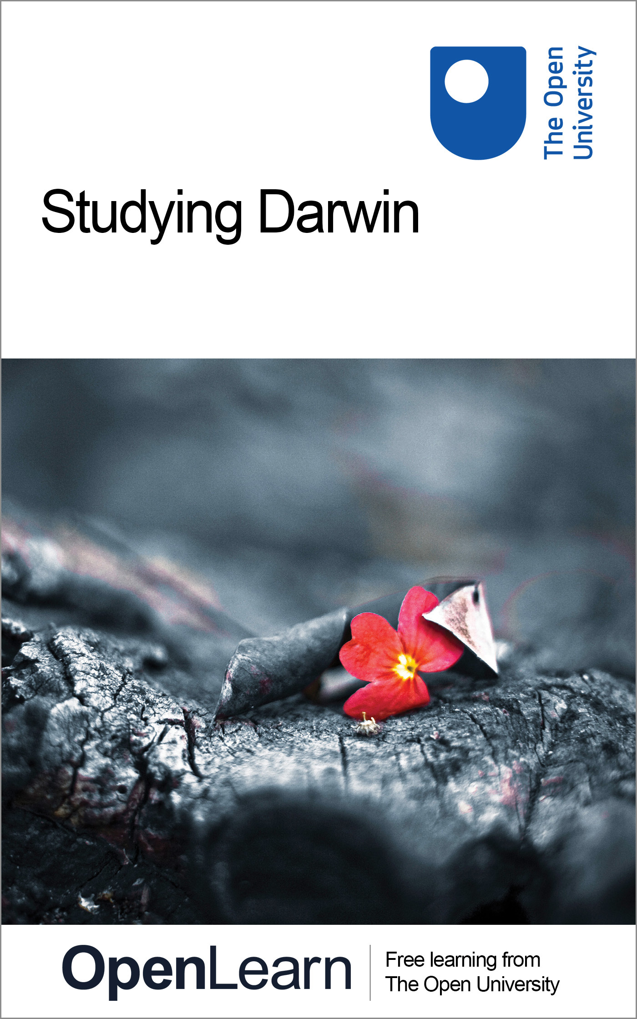

Darwin_1

Studying Darwin
About this free course
This free course provides a sample of Level 1 study in Arts and Humanities www.open.ac.uk/courses/find/arts-and-humanities.
This version of the content may include video, images and interactive content that may not be optimised for your device.
You can experience this free course as it was originally designed on OpenLearn, the home of free learning from The Open University – www.open.edu/openlearn/nature-environment/natural-history/studying-darwin/content-section-0
There you’ll also be able to track your progress via your activity record, which you can use to demonstrate your learning.
The Open University, Walton Hall, Milton Keynes, MK7 6AA
Copyright © 2016 The Open University
Intellectual property
Unless otherwise stated, this resource is released under the terms of the Creative Commons Licence v4.0 http://creativecommons.org/licenses/by-nc-sa/4.0/deed.en_GB. Within that The Open University interprets this licence in the following way: www.open.edu/openlearn/about-openlearn/frequently-asked-questions-on-openlearn. Copyright and rights falling outside the terms of the Creative Commons Licence are retained or controlled by The Open University. Please read the full text before using any of the content.
We believe the primary barrier to accessing high-quality educational experiences is cost, which is why we aim to publish as much free content as possible under an open licence. If it proves difficult to release content under our preferred Creative Commons licence (e.g. because we can’t afford or gain the clearances or find suitable alternatives), we will still release the materials for free under a personal end-user licence.
This is because the learning experience will always be the same high quality offering and that should always be seen as positive – even if at times the licensing is different to Creative Commons.
When using the content you must attribute us (The Open University) (the OU) and any identified author in accordance with the terms of the Creative Commons Licence.
The Acknowledgements section is used to list, amongst other things, third party (Proprietary), licensed content which is not subject to Creative Commons licensing. Proprietary content must be used (retained) intact and in context to the content at all times.
The Acknowledgements section is also used to bring to your attention any other Special Restrictions which may apply to the content. For example there may be times when the Creative Commons Non-Commercial Sharealike licence does not apply to any of the content even if owned by us (The Open University). In these instances, unless stated otherwise, the content may be used for personal and non-commercial use.
We have also identified as Proprietary other material included in the content which is not subject to Creative Commons Licence. These are OU logos, trading names and may extend to certain photographic and video images and sound recordings and any other material as may be brought to your attention.
Unauthorised use of any of the content may constitute a breach of the terms and conditions and/or intellectual property laws.
We reserve the right to alter, amend or bring to an end any terms and conditions provided here without notice.
All rights falling outside the terms of the Creative Commons licence are retained or controlled by The Open University.
Head of Intellectual Property, The Open University
Designed and edited by The Open University
978-1-4730-1507-4 (.kdl)
978-1-4730-0739-0 (.epub)

Contents
- Introduction
- Learning outcomes
- 1 Evolution and natural and artificial selection
- 2 Animals at the extremes
- 3 Studying mammals
- 4 How Darwin has influenced others
- Conclusion
- Keep on learning
- Acknowledgements

Introduction
We have divided the collection under the following headings:
- Evolution and natural selection
- Animals at the extremes
- Studying mammals
- How Darwin has influenced others
These sub-sections can be navigated around by using the section breakdown list on the right-hand of the screen. Within the sections you will see a list of courses that appear elsewhere on the OpenLearn site, click on the link and this will take you to the appropriate course. Please use the ‘back’ button to return to the main Studying Darwin course, or use the breadcrumb trial which you will see above
This OpenLearn course provides a sample of Level 1 study in Arts and Humanities.

Learning outcomes
After studying this course, you should be able to:
- understand Darwin’s theory of evolution and natural selection
- recognise how his theory has influenced other work in this area and beyond.

1 Evolution and natural and artificial selection
In this course, we describe the theory of evolution by natural selection as proposed by Charles Darwin in his book, first published in 1859, On The Origin of Species by Means of Natural Selection, or The Preservation of Favoured Races in the Struggle for Life. We will look at natural selection as Darwin did, taking inheritance for granted, but ignoring the mechanisms underlying it.
Evolution through natural selection
An introduction to biological systematics
Evolution: artificial selection and domestication
In the 18th and 19th century evolutionary biologists, including Darwin, emphasised the similarities between natural evolution and artificial ‘ improvement’ of livestock under domestication. They believed that studying domesticated animals and plants could illuminate the mechanisms of natural evolution.

2 Animals at the extremes
The desert environment
Animal life has adapted to survive in the most unlikely and inhospitable habitats. This course looks at the surprisingly diverse desert climates throughout the world and mammals, birds, lizards and amphibians that survive there. It splits these animals into three groups according to their strategy for survival: evaders, evaporators and endurers, then discusses how these strategies work on a biochemical and physiological level.
Hibernation and torpor
Hibernation is an ingenious adaptation that some animals employ to survive difficult conditions in winter. This course examines the differences between hibernation and torpor, and discusses the characteristic signs of hibernation behaviour. It explores the triggers that bring on hibernation, and whether internal signals or external season cues are predominant. It also examines the physiological adaptations that occur in hibernating animals. This course builds on and develops ideas introduced in the OpenLearn course (Animals at the extreme: the desert environment).
Polar biology
The extreme challenges of life in the polar regions require the animals who make their habitat there to make many adaptations. This course explores the polar climate and how animals like reindeer, polar bears, penguins, sea life and even humans manage to survive there. It looks at the adaptations to physiological proceses, the environmental effects on diet, activity and fecundity, and contrasts the strategies of aquatic and land-based animals in surviving in this extreme habitat. This course builds on and develops ideas from two other 'Animals at the extreme' courses: (The desert environment) and (Hibernation and torpor).
Surviving the winter
In this course, we study one aspect of the fluctuating nature of an organism's environment. We consider how organisms living in a temperate climate, such as that in Britain, are adapted to cope with winter. You will see that there is much diversity of adaptations among organisms, with different species coping with the demands of a fluctuating environment in quite different ways. As cyclic variations are a widespread feature of environments, the range of adaptations to them is an important source of biological diversity.
Changing climate: island life in a volatile world
What impact will global warming really have? This course examines the potential problems faced by the people of the Pacific Island of Tuvalu as a result of rising sea levels. Where would you go if your island is only a few feet above sea level? Who would you blame?

3 Studying mammals
A winning design
The term mammal encompasses a huge variety of animals, including humans. But what makes a mammal a mammal? This course explores some of the features, such as reproduction, lactation and thermoregulation methods, that mammals have in common. It is the first in a series of 10 ‘Studying mammals’ courses.
The insect hunters
From pygmy shrews to armadillos, a wide range of mammals survive on a diet made up largely of insects. Many of these have fascinating adaptations suited to catching or rooting out their prey. In this course you will learn about these adaptations, along with survival strategies for when food is scarce. This is the second course in the ‘Studying mammals’ series.
Chisellers
Ever wondered why rats, mice and squirrels seem to reproduce at such an alarming rate? Rodents are among the most successful of all the mammal groups. In this course you will learn more about some of the evolutionary features that make these creatures so plentiful. This is the third course in the ‘Studying mammals’ series.
Plant predators
From the mouse-deer to the elephant, plant eaters come in all shapes and sizes. But how do they manage to flourish on a salad diet? In this course we will examine the special features that allow them to extract their nutrients from leaves, and see how some plants protect themselves from these predators. This is the fourth course in the ‘Studying mammals’ series.
The meat eaters
The powerful and majestic carnivores are the focus of many television documentaries. In this course we will delve into the lives of these fearsome hunters and explore their physical adaptations and social behaviour. This is the fifth course in the ‘Studying mammals’ series.
The opportunists
Many mammals are food specialists, with complex adaptations that gear them toward a particular food source. So how do the omnivores survive and prosper without these fancy evolutionary features? This course examines the physiology, diet and strategies of some of these opportunistic feeders. It is the sixth course in the ‘Studying mammals’ series.
Return to the water
Some of the most unusual and versatile of all the mammals are the groups that live, feed and reproduce underwater. In this course we will see how these formerly land-based mammals adapted to a return to the water, discussing such challenges as breathing, movement and communication. This is the seventh course in the ‘Studying mammals’ series.
Life in the trees
David Attenborough looks at ‘life in the trees’: examining how species have evolved to cope with arboreal living. You will learn how lemurs, anteaters, bears and many others have developed different methods to help movement and survival.
The social climbers
Monkeys have long fascinated us because of their similarities to the human race. In this course you will find out about some of the characteristics that make them so like us: their physiology, complex social interactions, large brains and intelligence. This is the ninth course in the ‘Studying mammals’ series.
Food for thought
Who were our ancestors? How are apes and humans related? And where does the extinct Homo erectus fit into the puzzle? In this course we will examine culture, tool use and social structure in both apes and humans to gain an understanding of where we come from and why we behave as we do. This is the tenth course in the ‘Studying mammals’ series.

4 How Darwin has influenced others
The link below will take you to a timeline of psychologists. If you scroll down the list of people in the left-hand column and click on Darwin's name you will see from the link how influential Darwin’s work was on others that followed, for example Freud, Pavlov, Dawkins. Read some background on Darwin from this page and then you may wish to click on the other people highlighted on this page to see the relevance and impact on their work, theories and ideas from Darwin’s original theory.
Click here to visit the timeline.

Conclusion
This free course provided an introduction to studying the arts and humanities. It took you through a series of exercises designed to develop your approach to study and learning at a distance and helped to improve your confidence as an independent learner.

Keep on learning



Study another free course
There are more than 800 courses on OpenLearn for you to choose from on a range of subjects.
Find out more about all our free courses.

Take your studies further
Find out more about studying with The Open University by visiting our online prospectus.
If you are new to university study, you may be interested in our Access Courses or Certificates.

What’s new from OpenLearn?
Sign up to our newsletter or view a sample.

For reference, full URLs to pages listed above:
OpenLearn – www.open.edu/openlearn/free-courses
Visiting our online prospectus – www.open.ac.uk/courses
Access Courses – www.open.ac.uk/courses/do-it/access
Certificates – www.open.ac.uk/courses/certificates-he
Newsletter – www.open.edu/openlearn/about-openlearn/subscribe-the-openlearn-newsletter

Acknowledgements
Source: Natural History Museum
All other material within this course originated at The Open University.
Course image: Nishanth Joisin Flickr made available under Creative Commons Attribution 2.0 Licence.
Don't miss out:
If reading this text has inspired you to learn more, you may be interested in joining the millions of people who discover our free learning resources and qualifications by visiting The Open University - www.open.edu/openlearn/free-courses

