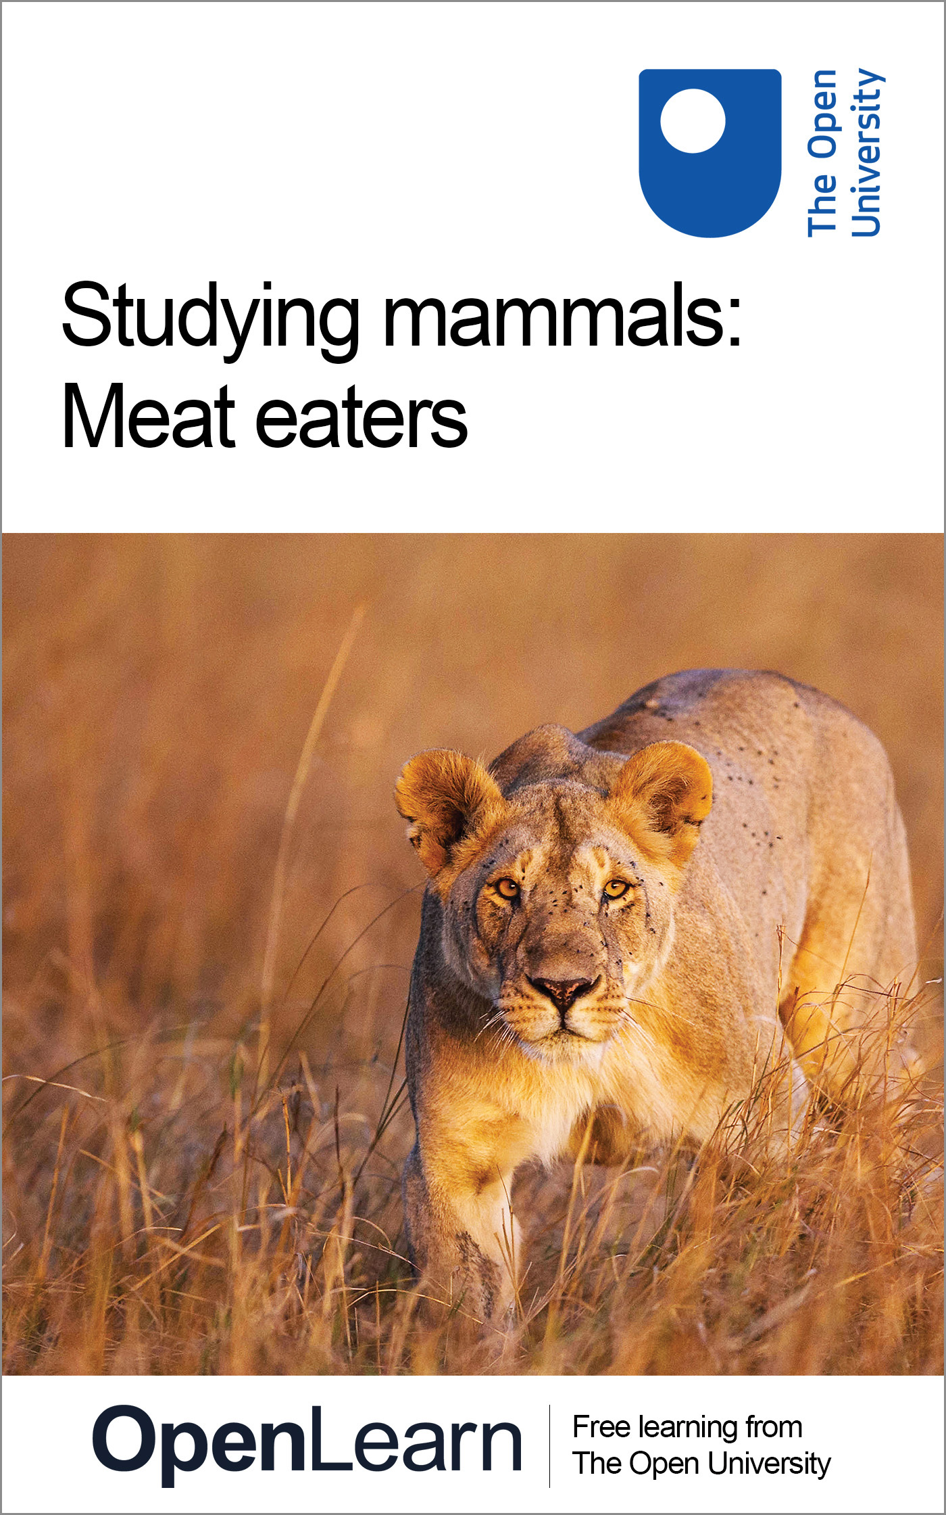

S182_5 Studying mammals

Studying mammals: Meat eaters
About this free course
This free course provides a sample of level 1 study in Environment & Development http://www.open.ac.uk/courses/find/environment-and-development
This version of the content may include video, images and interactive content that may not be optimised for your device.
You can experience this free course as it was originally designed on OpenLearn, the home of free learning from The Open University: http://www.open.edu/openlearn/nature-environment/natural-history/studying-mammals-meat-eaters/content-section-0.
There you'll also be able to track your progress via your activity record, which you can use to demonstrate your learning.
The Open University, Walton Hall, Milton Keynes, MK7 6AA
Copyright © 2016 The Open University
Intellectual property
Unless otherwise stated, this resource is released under the terms of the Creative Commons Licence v4.0 http://creativecommons.org/licenses/by-nc-sa/4.0/deed.en_GB. Within that The Open University interprets this licence in the following way: www.open.edu/openlearn/about-openlearn/frequently-asked-questions-on-openlearn. Copyright and rights falling outside the terms of the Creative Commons Licence are retained or controlled by The Open University. Please read the full text before using any of the content.
We believe the primary barrier to accessing high-quality educational experiences is cost, which is why we aim to publish as much free content as possible under an open licence. If it proves difficult to release content under our preferred Creative Commons licence (e.g. because we can't afford or gain the clearances or find suitable alternatives), we will still release the materials for free under a personal end-user licence.
This is because the learning experience will always be the same high quality offering and that should always be seen as positive - even if at times the licensing is different to Creative Commons.
When using the content you must attribute us (The Open University) (the OU) and any identified author in accordance with the terms of the Creative Commons Licence.
The Acknowledgements section is used to list, amongst other things, third party (Proprietary), licensed content which is not subject to Creative Commons licensing. Proprietary content must be used (retained) intact and in context to the content at all times.
The Acknowledgements section is also used to bring to your attention any other Special Restrictions which may apply to the content. For example there may be times when the Creative Commons Non-Commercial Sharealike licence does not apply to any of the content even if owned by us (The Open University). In these instances, unless stated otherwise, the content may be used for personal and non-commercial use.
We have also identified as Proprietary other material included in the content which is not subject to Creative Commons Licence. These are OU logos, trading names and may extend to certain photographic and video images and sound recordings and any other material as may be brought to your attention.
Unauthorised use of any of the content may constitute a breach of the terms and conditions and/or intellectual property laws.
We reserve the right to alter, amend or bring to an end any terms and conditions provided here without notice.
All rights falling outside the terms of the Creative Commons licence are retained or controlled by The Open University.
Head of Intellectual Property, The Open University
Designed and edited by The Open University
978-1-4730-1628-6 (.kdl)
978-1-4730-0860-1 (.epub)

Contents
- Introduction
- Learning outcomes
- 1 The hunters
- 2 The Carnivora
  - 2.1 Introducing the Carnivora
  - 2.2 What are the common features of Carnivora?
- 3 Characteristics of the hunters
  - 3.1 Speed and endurance
  - 3.2 Other specialisations found in hunters
  - 3.3 Senses: vision
  - 3.4 Senses: hearing
  - 3.5 Senses: smell
  - 4 Living in groups
- Conclusion
- Keep on learning
- Acknowledgements

Introduction
In this course, we will examine the biology of the impressive meat eaters (e.g. wolves, lions and cheetahs), focusing in part on the biological 'equipment' - slashing and gripping teeth, for example - and on the less obvious behavioural characteristics that have contributed to the undoubted success of these fearsome hunters. Many of the meat eaters live and hunt in groups, which raises intriguing questions about the advantages of group living and the types of social behaviour between individuals that help maintain group coherence.
This is the fifth in a series of units about studying mammals. To get the most from these units, you will need access to a copy of The Life of Mammals (2002) by David Attenborough, BBC Books (ISBN 0563534230), and The Life of Mammals (2002) on DVD, which contains the associated series of ten BBC TV programmes. OpenLearn course S182_8 Studying mammals: life in the trees contains samples from the DVD set. You should begin each course by watching the relevant TV programme on the DVD and reading the corresponding chapter in The Life of Mammals. You will be asked to rewatch specific sequences from the programme as you work through the course.
This OpenLearn course provides a sample of level 1 study in Environment & Development

Learning outcomes
After studying this course, you should be able to:
- describe some of the characteristic features of carnivores
- outline the dentition of carnivores and its link with diet
- outline some of the behavioural and sensory characteristics of carnivores, with examples
- explain, with examples, the roles that vision and smell play in the lives of carnivores
- explain the variety of ways in which carnivores assemble in groups.

1 The hunters

As you work through this course you will come across boxes, like this one, which give you advice about the study skills that you will be developing as you progress through the course. To avoid breaking up the flow of the text, they will usually appear at the start or end of the sections.
As well as the course text, you will be using The Life of Mammals book (LoM) and related The Life of Mammals DVDs, as described in the introduction to this course. Before you go any further, watch 'Meat Eaters' on the DVD and read LoM Chapter 5. Unless stated otherwise, all the page references you encounter in this course will be to LoM.

The TV programme 'Meat Eaters' contains some of the most spectacular and memorable film sequences of the Life of Mammals series, notably those showing the chasing and capture of large herbivores (zebra and wildebeest, for example) by powerful and effective hunters, such as lions and hyenas. But the term 'meat eaters' also encompasses more modestly sized hunters - the stoat, for example, whose hunting habits are vividly illustrated in the early sections of both LoM Chapter 5 and the TV programme. Many meat eaters have less spectacular but no less intriguing feeding habits, feeding on smaller and more variable prey. In the UK, the badger is so partial to earthworms to warrant the label 'worm specialist' and yet its Italian relatives are more dependent on insects and olives.
Chapter 5 of LoM described a wide variety of meat-eating habits. Predators kill living prey and eat the fresh carcass. Scavengers eat animals that have died from other causes and/or the remains of predator kills. Many meat eaters, including lions, wolves and hyenas, are both predators and scavengers, but others, notably cheetahs, are exclusively predators - they cannot deal with even slightly rotten meat. In this course, we will examine the biology of the impressive meat eaters (e.g. wolves, lions and cheetahs), focusing in part on the biological 'equipment' - slashing and gripping teeth, for example - and on the less obvious behavioural characteristics that have contributed to the undoubted success of these fearsome hunters. As you'll appreciate from LoM and the programme, many hunters live and hunt in groups, which raises intriguing questions about the advantages of group living and the types of social behaviour between individuals that help maintain group coherence.

2 The Carnivora

2.1 Introducing the Carnivora

Table 1 in this section lists the scientific names of the families of the Carnivora, as well as their common names. You are not expected to recall the family names, though you will probably be able to make links that enable you easily to remember some of them (K9 is a robot dog, Felix is a cartoon cat and Ursa Major is the constellation of the Great Bear, for example). The names can be quite difficult to pronounce too, but you need not worry about that. Often different scientists pronounce the words differently.

Earlier units in this series have highlighted the issue of the success of certain groups of mammals - for example, the herbivores. A useful starting point is to ask what features of meat eaters have made them successful.

SAQ 1

Question: From your general knowledge, earlier TV viewing and reading of LoM, as well as David Attenborough's (DA's) comments in the current programme, list as many features as possible that are needed for success in hunting.

View answer - SAQ 1

The dictionary definition of a carnivore is simply a meat eater, but not all carnivores are mammals. Birds such as owls and hawks, many reptiles, amphibians and fish are carnivorous - as well as numerous invertebrates, ranging from insects such as the praying mantis, to molluscs such as certain squid.
However, in this course (and in LoM) the term carnivore is applied exclusively to those mammals that belong to the order Carnivora. The Carnivora comprise a natural group (i.e. are thought to have a common ancestry) and, as I'll describe later, they have particular anatomical features in common. The earliest recognised ancestors of all present-day carnivores were probably the miacids, forest dwellers of the Eocene, 50 million years ago. In some respects, miacids resemble modern-day genets and civets [pp. 141-142] but fossil evidence reveals adaptations for living in trees, i.e. they were arboreal. So in terms of lifestyle, they have features in common with modern-day carnivores such as the pine marten.

Activity 1

Watch the TV programme again from 04.16-05.31 and make notes on what features of the pine marten equip it for arboreal life.

View discussion - Activity 1

During the subsequent Oligocene (34-24 million years ago) there was an evolutionary explosion in the variety of food plants and in herbivore species. During that time, predatory carnivores rapidly evolved into a range of new groups, able to exploit different conditions and available food prey. Some continued living in trees and others became ground-dwellers. As conditions changed, many of the largest ones became extinct - some in comparatively recent times. Those awesome predators, the sabre-toothed cats, survived until about two million years ago. Their fossil remains are best known because of the massive canine tooth on each side of the upper jaw (see Figure 1).

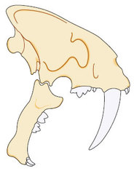
Figure 1 Upper and lower jaw of the extinct sabre-toothed tiger

From the miacids may have evolved the carnivore families that we can recognise today, listed in Table 1. Just seven families are identified in the table, but some taxonomists think of civets and mongooses as sufficiently different to warrant their placement in different families, the latter comprising the Herpestidae. Sometimes the skunks are seen as a subfamily of the mustelids, as implied in Table 1; others argue that they should be accorded the status of a separate family (Mephitidae).

Table 1: The carnivore families
Family |  | Examples
Common name | Scientific name
dogs | Canidae | African hunting dog, wolf, fox
weasels | Mustelidae | stoat, badger, ferret, weasel, otter, (skunks?)
bears | Ursidae | polar bear, brown bear
raccoons | Procyonidae | raccoon, coati, (giant panda?)
cats | Felidae | lynx, lion, tiger, leopard, cheetah, wild cat
hyenas | Hyaenidae | spotted hyena, brown hyena
civets and mongooses | Viverridae | civet, genet, mongoose, meercat
This taxonomic scheme suggests seven present-day families of Carnivora, though some claim the total is nine. The status of the giant panda within the Carnivora is uncertain; most taxonomists place it in the bear family, but some claim it is closer to the Procyonidae - a family you'll read more about if you study the next course in this series. It is generally agreed that the Carnivora can be divided into two groups (or 'great tribes', as DA refers to them in the TV programme) - the feliforms and caniforms - cats and dogs.

SAQ 2

Question: Using the index in LoM, identify which of the species listed in Table 1 feature in Chapter 5.

View answer - SAQ 2

So, a number of Carnivora are not primarily meat eaters - you'll encounter them if you work through the next course, S182_6 Studying mammals: the opportunists. For example, although the giant panda occasionally eats insects and small prey, it is for good reason called the 'bamboo bear'. Clearly, in defining mammalian carnivores, we have to turn to other diagnostic criteria.

2.2 What are the common features of Carnivora?
As LoM and the TV programme reveal, there is great variation in the size and shape of carnivores and also in their lifestyle and behaviour. They have a worldwide distribution - from arctic foxes to equatorial lions. Some (like bears) walk on the soles of the feet (plantigrade) and others such as dogs walk on their toes (digitigrade). All have a fusion of certain bones in the wrist; in non-Carnivora, like ourselves, these three bones of the wrist (the names needn't concern us) are independent. All carnivores have a characteristically small collar bone (or clavicle). Shared characteristics of this sort enabled earlier naturalists to deduce a common evolutionary ancestry - an origin more recently confirmed by modern DNA studies.
As DA writes, the teeth of carnivores are both hunters' weapons and butchers' tools. Figure 2 shows the skull and lower jaw of a carnivore - in this instance, a member of the dog family - and you'll be familiar with the terminology used. The canine (C) and incisor (I) teeth are used for killing prey and also for display and defence. Behind these are the premolars (P), which are used in some species, like hyenas, to crush food and in others, like dogs, to pierce food. The famous carnassial teeth are the fourth upper premolar and the first lower molar on each side. These scissor-blade-like teeth are positioned towards the back of the mouth - so that meat between them can be subjected to the greatest force in just the same sort of position as you would put something really tough in the jaws of a pair of scissors. The carnassials are thought to be of particular evolutionary significance, almost certainly present in the ancestors of carnivores. They are especially prominent in felids and some mustelids (i.e. members of the cat and weasel family, respectively) and in hyenas. In those carnivores that are more inclined to plant-eating (notably pandas) these teeth have surfaces more suited to grinding. But in general, carnivores use the back molar teeth (M) for grinding tough foods, and these teeth are particularly well developed in bears.

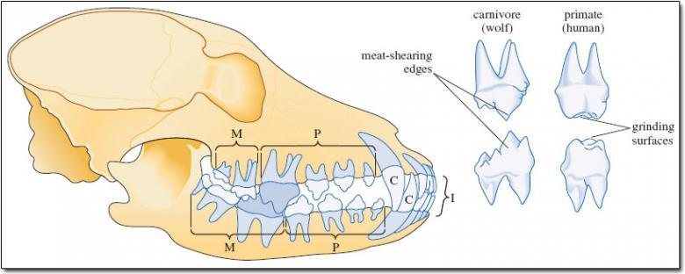
Figure 2: adapted from Macdonald, D. (ed.) (2001) The New Encyclopedia of Mammals, Oxford University Press Figure 2: adapted from Macdonald, D. (ed.) (2001) The New Encyclopedia of Mammals, Oxford University Press
Figure 2 Left, the skull and lower jaw of a member of the dog family, highlighting the carnassials - the fourth upper premolar and the first lower molar. Their structure is shown on the right, the elongated shearing blades contrasting with the grinding surfaces in the same teeth in humans

SAQ 3

Question: What is the dental formula (see course S182_2) for the carnivore in Figure 2?

View answer - SAQ 3

Many carnivores have a complement of 44 teeth, with three molars on the upper jaw. But there is a good deal of variation in the dental formula of the different carnivore families. The domestic cat has the dental formula: I3/3, C1/1, P2/2, M1/1.
You will appreciate why many carnivores have powerful jaw muscles; for example, in the large cats (e.g. lions) great force is needed to provide the pressure for suffocating prey when they grip its throat (see photo in LoM p. 152) and also for crushing bones when the mouth is open. Another set of jaw muscles (the masseter muscle) provides the force to cut flesh and to grind food when the jaws are almost closed.

Activity 2

Watch the TV programme from 01.11-02.59, which shows the capture and killing of a rabbit by a stoat, and lion hunting. Make notes on how the lioness brings down the wildebeest and suffocates it. Apart from the obvious differences of scale, how do the two killing techniques differ? (Look again too at the dramatic photograph in LoM p. 152.)

View answer - Activity 2

Although, in the main, lions prey on large, hoofed mammals, they are known to take animals as small as rodents, hares, birds and reptiles. Table 2 categorises the diet of a range of carnivores - those carnivores that deviate most strongly from meat eating (e.g. raccoon, brown bear) are covered in the next course in this series, following the logic of DA's approach in LoM. Where plant material is abundant in the diet the molars have a 'pestle and mortar' design, used to fragment plant material into small particles.

Table 2: Dietary categories of carnivores, based on proportions of food in scats (droppings) and on observations of feeding and hunting behaviour
Dietary category | Type of food | Examples
meat | more than 70% freshly killed prey (including offal, brains, etc.) | lynx, lion, tiger, jaguar, puma, cheetah, polar bear
meat/bone | more than 70% meat with addition of large bones | spotted hyena, striped hyena
meat/non-vertebrate | 50-70% prey and carrion, with fruit, nuts and/or insects making up the balance | fox, badger, polar bear, coyote, jackal
non-vertebrate/meat | less than 50% vertebrate prey, with fruit and/or insects predominating | raccoon, brown bear, black bear

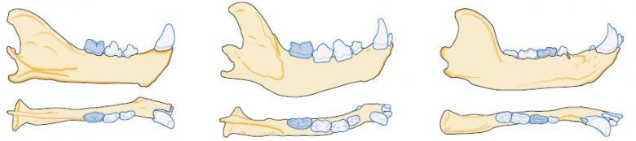
Figure 3: adapted from Gittleman, J. L. (1989) Carnivore Behaviour, Ecology and Evolution, Comstock Publishing Associates, a division of Cornell University Press Figure 3: adapted from Gittleman, J. L. (1989) Carnivore Behaviour, Ecology and Evolution, Comstock Publishing Associates, a division of Cornell University Press
Figure 3 Dental diversity amongst the carnivores, with the mandible drawn from the side (top diagram) and above (bottom diagram). All are drawn to the same 'front-to-rear' length. Note the relative sizes of premolars and grinding molars; the carnassial tooth is shaded blue-grey

SAQ 4

Question: Figure 3, above, shows the jaw bones of the spotted hyena, the brown bear and the puma, but not necessarily in that order. Examine the figure and, together with the information in Table 2, identify which diagram relates to each of these three animals. Explain your reasoning.

View answer - SAQ 4

There are often trade-offs between costs and benefits in mammalian lifestyles. What are the advantages and disadvantages of a mainly meat diet? DA describes it as 'the most energy-packed of all foods' [p. 124]. A modest portion of meat (100 grams) may well contain 800 kilojoules of energy, but the same mass of fruit contains only 200-400 kJ; an equivalent amount of foliage has just 40-80 kJ.
The digestive chemistry of converting prey flesh and bone into predator flesh and bone is much simpler than that needed to convert vegetation to flesh. Flesh eaters, like lynx and wildcat, have a shorter intestine than herbivores - only four times the length of the body; foxes and wolves, which sometimes eat plant materials have an intestine five times the body length and herbivores have even longer intestines. For example, the intestines of Grevy's zebras are 11-12 times the body length, that of the plains zebra 17 times.
But is meat eating all benefits and no costs? Plants are much more abundant and easily caught, which means that less energy is expended in feeding by herbivores. Bones are hard to chew and digest and bone splinters can damage the gut. The spotted hyena's stomach makes a great deal of hydrochloric acid, which dissolves bone and releases nutrients; cats voluntarily vomit to get rid of sharp bones. These examples reveal the complex systems associated with carnivory, which in many respects is a more risky and competitive way of life, as the next sections will illustrate.

3 Characteristics of the hunters

3.1 Speed and endurance

The first question in this section is a mathematical one, in which you are asked to convert from one set of units to another. If you have been following the advice in previous units in this series, you will be reading km h⁻¹ as kilometres per hour and you will probably already think of m.p.h. as miles per hour, so the conversion should not be too difficult. You might find it helpful to look back to Table 1 in course S182_3, where the conversion of kcal g⁻¹ to kJ g⁻¹ was done for you. There a conversion factor was used; 1 kcal = 4.2 kJ. If you check the conversions for yourself, you find that the answers given in the second column of that table are not precisely what appears on your calculator screen. For example, for fat, the numerical part of the calculation is 9 × 4.2 which gives you an answer of 37.8, whereas the table gives 38; the answer has been 'rounded' to the nearest whole number. 37.8 is nearer to 38 than it is to 37, so in this case, the answer is rounded up. Your answers to complete Table 3 should similarly be rounded up or down to the nearest whole number.

Many people when asked to state the main specialisation of carnivores would probably suggest the speed required to catch prey. Maximum speeds can indeed be formidable, as illustrated in Table 3.

Table 3: The maximum running speeds of some carnivores
Species | Maximum speed | Maximum speed
 | in km per hour | in miles per hour
cheetah | 110
lion | 80
red fox | 70
spotted hyena | 65
jackal | 55
wolf | 45

SAQ 5

Question: Convert the values given in Table 3 into speeds expressed in miles per hour, rounded to the nearest whole number. (You can readily find out conversion factors from searching the web, but if this proves difficult use the value 0.6214, which converts kilometres into miles).

View answer - SAQ 5

One of the most exciting wildlife sights is the fastest land mammal, the cheetah, at full speed; it is able to accelerate from a standing start to 96 km h⁻¹ in just three seconds. The cheetah's slight build and long legs are the standard equipment of a fast runner, but DA draws attention to its flexible spine [p. 150] and studying the drawings in Figure 4 reveals the principle at work. Note that in frame 6 the back is arched but in 2 it is fully flexed the other way.

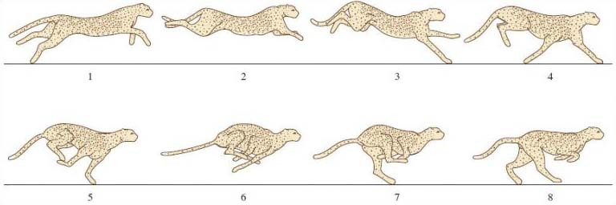
Figure 4 Drawings from film of a sprinting cheetah

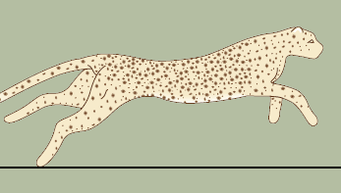
What Figure 4 would look like in motion

Activity 3

Closely observe the TV programme clip of the cheetah and its cubs (from 34.54-39.00) and make notes to enable you to answer the following questions.
(a) What features allow cheetahs to move so fast?
(b) You'll also see the cheetah stalking her prey. Why might this inconspicuous approach be an especially important feature of the cheetah's hunting strategy?
(c) What is the cheetah's response to the swerves and changes in direction made by its prey?
(Rereading LoM pp. 150-151 will be useful.)

View discussion - Activity 3

With the cheetah's great expenditure of energy over a short spurt, the animal's body temperature may shoot up to a dangerously high 40 °C. Gazelles seem more tolerant of increases in core temperature of this magnitude, which improves their chances of escape. But for the cheetah, a sprint of significantly more than 500 metres could prove fatal. The cheetah needs to pant rapidly - more than eight times its normal rate just to aid recovery from an intense sprint - just as a human sprinter breathes more rapidly after a race in order to take in enough oxygen to compensate for the sudden and intense expenditure of energy. The cheetah also may need up to about 20 minutes of rest to cool down. These limitations are examples of evolutionary trade-offs, where endurance is sacrificed for speed. It also seems not to have evolved the skills and weapons to defend its cubs. More than 70% of the cheetah cubs die in the lair (often killed by lions), and in the plains of Serengeti fewer than one in 20 survive to adolescence. (In fact, high infant mortality is true of many large cats.)

3.2 Other specialisations found in hunters

Claws
Claws are important for grabbing prey. They must be kept sharp and trees (or chair legs, as domestic cat owners can confirm) are used as scratching posts. In all cats other than the cheetah, the claws can be retracted into a sheath within the footpad, preventing rapid wear.

Fur
Fur is important in thermoregulation, but a conspicuous coat may proclaim sexual dominance or warn off competitors. It's similarly important for predators to remain unseen for as long as possible. The most familiar type of camouflage is the colour of the hunter merging into the background environment colour - think about stoat in winter (ermine), polar bears against the ice of the Arctic and lions against the baked soil and dried grass of Africa. But equally important is the patterned fur of carnivores such as tigers and leopards. This cryptic coloration disrupts the body outline, making the stalking predator less visible to its prey. In some settings, such as zoos and in snow (the Siberian tiger in the TV programme and on the cover of LoM), tigers may stand out, but field workers reported how cryptic these animals often are in many wild habitats. The tiger's camouflage is effective in long grass and dappled sunlight; bear in mind that the majority of prey animals see the tiger only with black and white vision.

Senses
Being an effective predator requires efficient sense organs. Prey often has to be located from a considerable distance and good spatial awareness comes into play during the moments of capture. The precise mix of sensory inputs used varies a good deal, just as it does in other animal groups; many rely on good eyesight for hunting; for others, smell and/or hearing are especially important. And you'll know from the TV programme (for example, in what was said about the importance of smell in brown hyenas) and from LoM pp. 143-144, these same sensory capacities are important in contexts far removed from hunting - in this instance, in maintaining group cohesion. The following specific examples show just how important such senses are in diverse aspects of the lives of different carnivores.

3.3 Senses: vision
Vision needs to be effective to spot prey, and in many species to allow precise calculation of distances when it comes to the final pounce. In terms of success, an individual can't 'afford' too many failures; the energy expended in the chase needs to be more than compensated for by the energy gained from the food source. The most effective way of judging distance is with stereoscopic vision, i.e. an ability to see in depth, and this depends on the eyes being sufficiently far forward to allow overlap of vision from each eye.
In daylight, members of the cat family have vision that is about as effective as that of humans, but DA mentions that the vision of hunters is about six times more acute at night (the TV commentary quotes an eightfold improvement on human visual acuity for lions in the dark). Sensitivity to light on this scale depends upon getting as much light into the eye as possible through the relatively large pupil - the dark central aperture, which is circular in our own eyes. In poor light, the diameter of the pupil quickly increases, thereby gathering as much light as possible. But increased sensitivity has a price; in very bright sunshine, the amount of light has to be reduced, unless the eye is to be flooded with light. Some cats have a characteristically slit-like pupil, where, unlike our own eyes, almost complete closure of the pupil is possible.

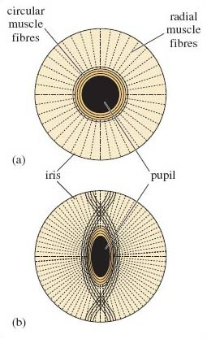
Figure 5: adapted from Wallis, G. L. (1942) The Vertebrate Eye and its Adaptive Radiation, Harper, New York Figure 5: adapted from Wallis, G. L. (1942) The Vertebrate Eye and its Adaptive Radiation, Harper, New York
Figure 5 (a) Front view of a circular pupil in the human eye, with muscle fibres within the surrounding iris. (b) A slit pupil, able to close almost completely

Figure 5a is a front view of our own pupil, with the muscle fibres that control the aperture of the pupil embedded in the structure that surrounds the central pupil - the iris. There are circular muscles, running around the inner edge of the iris and radial muscles that radiate outwards. In bright light, the pupil becomes smaller via the contraction of the circular muscles and the relaxation of the radial muscles. Pupil diameter is limited by how much these circular muscles can contract - and in this arrangement, constriction can never be so pronounced as to close the pupil.

SAQ 6

Question: How is the opening of the pupil in dim light likely to be achieved?

View answer - SAQ 6

The structure of the slit pupil in some cats shows a very different arrangement of circular and radial muscles (Figure 5b). Here the circular muscles are interlaced in such a way as to allow the pupil to close almost completely. But not all cats have pupils that contract to a slit; for example, the eyes of the lynx, though adapted for nocturnal vision in other respects (Figure 6b), contract to a circle. The same is true of the eyes of the large cats; as you can appreciate from the photographs in LoM, these have oval pupils, with just a hint of vertical elongation. On this evidence, there is more versatility in the more conventional pupil arrangement than meets the eye.
In our own eyes (Figure 6a) light enters through the transparent cornea, and passes through the oval-shaped lens, being bent at each stage. For an object to be sharply seen, light from it has to be bent to such an extent that it becomes focused on the light-sensitive part of the eye - the retina. In dim conditions, the amount of light focused on any one area of the retina needs to be maximised. Night hunters, such as the lynx, tend therefore to have a large pupil aperture and a relatively large lens and cornea (Figure 6b). But the rest of the eye is more modestly proportioned - a reduced retina surface area presumably ensures greater sensitivity, with more light falling on any one area. In those many carnivores (such as the puma) whose eyes are adapted to function in both night and day, the juxtaposition and relative proportions of lens, cornea and the remainder of the eye differ, resembling more those of humans (Figure 6c).

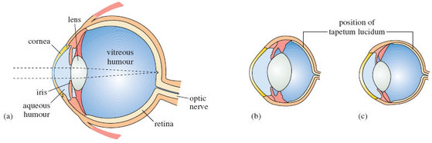
Figure 6: (a) Structure of the human eye, as revealed in vertical section. The path of parallel light rays from a distant object is shown, bent by the cornea and (mostly) by the lens and focused on the retina. Also shown are similar sections through the eye of (b) the lynx, which is nocturnal, and (c) the puma, which can hunt day and night. The position of the tapetum lucidum is indicated in (b) and (c) - in reality, this layer is far too thin to be discernible at this magnification

Nearly all carnivores have an extra reflecting layer, the tapetum lucidum, which is positioned outside the retina (Figure 6b and c). Its presence means that light that has passed through the retina without being absorbed and thereby stimulating the light-sensitive cells of the retina, is reflected back towards the retina, providing a 'second chance' of registering an effect [p. 144].

SAQ 7

Question: Which sequences in the TV programme reveal the presence of the tapetum lucidum in hunters?

View answer - SAQ 7

Other units within this series describe additional adaptations of the eye in nocturnal mammals, especially the relative abundance of the two types of light-sensitive cells in the retina. Those most reactive to low-intensity light (and unable to distinguish colour) are termed rods - as opposed to the colour-sensitive cones that function effectively only at high light intensities. As you'd expect, the retina of nocturnal carnivores, the lynx for example, is rich in rods and hence offers greatest sensitivity to light. Even the best-adapted retina contains some cones, but the capacity to see in colour is probably restricted to those relatively few carnivores that hunt in the day-time - some mongooses, for example, whose diet is sufficiently varied to include fruits and insects, where appreciating colour differences would be advantageous. Whether large hunters see colour is uncertain. Would seeing colour be helpful to large cats such as lions? For understandable reasons, this area of work is unattractive to all but the most intrepid of naturalists.

3.4 Senses: hearing
Hearing involves the capacity not simply to hear sounds of particular frequencies, but also to locate their source.

Activity 4

From your recent viewing of the TV programme, identify at least one example of the use of sound for hunting. Look in corresponding sections of LoM to find out more information about the species you identify.

View answer - Activity 4

Making and hearing sounds are very important features of many carnivores, both with respect to interactions with other individuals and with other species. The howling of grey wolves and the roaring of African lions are both illustrated to good effect in TV5. Most young carnivores can make sounds within minutes of birth in response to cold, hunger or pain; hearing and interpretation of sounds develops later. Functions of acoustic communication include play, threat, satisfaction, submission, dominance, courtship and fighting and identification of individuals, groups and species.

SAQ 8

Question: You will have heard in the TV programme the communication calls of lions. From your general knowledge, which of the above functions would you use to classify the following carnivore sounds: (a) the chorus roaring of lions (as in the programme) and the howling of wolves; (b) the purring of a cat; (c) the hissing of a cat; and (d) the 'rut call' of the red fox?

View answer - SAQ 8

As DA's on-screen reactions revealed (see 30.05-31.20), the lion's roar is an evocative but intimidating sound. All such sounds have a communication function - they are not a consequence of DA's presence! In The New Encyclopedia of Mammals, David Macdonald points out that the most familiar 'roaring' lion - that at the beginning of MGM (Metro Goldwyn Meyer) films - is not demonstrating typical roaring but is 'merely snarling at some annoyance just off camera. In a genuine roar, a lion purses its lips, thrusting out its chin and pointing its mouth towards the horizon, its body heaving in rhythm with the exertions of its groans and grunts. Humans … can hear it from 8 km (5 miles) away through the African night'.
What you saw and heard in the TV programme answered that description, though a little more restrained and foreshortened than the roars offered by males to advertise their possession and intended defence of a territory. Neighbouring male territory-holders roar back in response; the 'wandering groups of males' that DA refers to [p. 154] remain silent, beginning to roar only when such nomadic males are able to define and mark their own territory. For a lioness, the roar of a male from the same pride has been termed 'the sound of reassurance', offering commitment to a defence against marauding incomers who (as DA describes on p. 154) are otherwise intent on killing cubs. Lions and lionesses have at least eight vocalisations (not counting territory-defending ones), each of which has a particular social function.

3.5 Senses: smell
Smell is rightly emphasised in LoM as important to carnivores. It offers advantages over visual and sound signals, which may be difficult to detect, for example at night or in dense vegetation. Furthermore, scent marks 'hang around' longer. The most familiar examples are the urine and faeces deposited regularly at special places.
Who is not familiar with the male dog that leaves token amounts of urine to re-anoint the same lamp post each day? By cocking their legs they raise the level of the scent mark to the nose level of other individuals of the same species (i.e. conspecifics). Wolves also scent mark by urinating; dominant animals are said to do so as often as once every three minutes or so - and indeed more frequently near to the borders of their territory, where they are likely to encounter the scent from strangers.

Activity 5

Watch the TV programme from 13.03-16.03 on prey capture and scent marking in the brown hyena. Write down a brief summary of the ways in which scent is used when marking grass.

View answer - Activity 5

It may well be that the black paste marks an unproductive hunting area, its fading reflecting time elapsed since recent bouts of futile hunting. Each individual brown hyena is estimated to deposit close to 3000 scent marks a year from their anal pouch, in conspicuous and usually elevated sites. Stoats too leave scent marks, here to claim territory, and their sense of smell develops at a very early age. As you read in LoM [p. 125], young female pups are already able to smell and identify a mature male, inviting him to copulate - even though they are too young to have opened their eyes or to reproduce.
The African civet marks its territory with powerfully scented dung heaps. It marks its food using the secretion of glands on its neck and chin; but its most famous scent, produced by another gland, is valued by the makers of the most expensive perfumes. This perineal gland is a small pouch between the anus and the tail and produces several grams each week of a powerful-smelling oily secretion.
The European badger displays 'squat-marking' - pressing the rear end to the ground, to leave a scent mark of gland secretions and faeces. The boundaries of a badger's territory are marked in such a way. Both sexes squat-mark but males do so more often than females, and dominant females more frequently than subdominant ones. They also squat-mark bedding before taking it into the set.
As well as marking objects, it is common for canids, felids, mustelids and viverrids (see Table 1) to mark other members of the species - so-called social marking. A badger squat-marks on the flank of another badger; the frequency of marking in a social group is related to the position occupied in the hierarchy. A dominant boar in a group of six adult badgers has been shown to be responsible for nearly 70% of all social marking. On the darkest night, badgers will sniff each other's flanks, implying recognition by smell. Similarly, domestic dogs sniff each other's anal region; hyenas do so with even greater enthusiasm during their encounters, broadening their attention to the genital areas.
On the basis of what you've read in this section, how important do you consider the sense of smell to be in the life of carnivores? Now speculate on how it could influence group behaviour. (There will be some answers in the section that follows.)

You may have noticed a mention of David Macdonald's The New Encyclopedia of Mammals in this section. If you feel that you would like to follow up in more detail some of the issues that have been raised in this series of units, then I recommend this book.

4 Living in groups

4.1 The advantages
On the basis of LoM and the TV programme, and hearing so much about African hunting dogs and lions, you might be tempted to believe that carnivores generally live in groups.

SAQ 9

Question: Do you think this generalisation is true? Can you think of examples from LoM and the programme of carnivores that lead essentially solitary lives?

View answer - SAQ 9

It's estimated that only about 10-15% of all carnivore species congregate at some period outside the breeding season - a time when for all carnivores a degree of sociability is essential. But in some groups of carnivores, notably the dog family as DA points out, 'sociability is a characteristic that manifests itself again and again' [p. 128]. So, amongst the carnivore group as a whole, there is a range from those that live an almost solitary existence, through animals that live some of their time in groups, to animals that spend their whole lives within the same group of individuals. And grouping takes various forms:
- population groups, which do no more than share a common home range;
- feeding groups, with individuals sharing the same resource for a period;
- foraging groups, with individuals combining forces to search for food;
- breeding groups, where individuals form a reproductive unit.
The nature and permanence of these groupings vary not only between different species, but also within a single species. For example, the clans of spotted hyenas of the Ngorongoro Crater are composed of as many as 55 individuals. The clan divides up into hunting groups of about seven adults, but after prey capture, groups can swell to as many as 19 individuals. A pride of African lions may number 20 or more [p. 151] that share a particular home range, but an individual member of the pride may spend days or weeks on its own or in a small subgroup. Only two or three pride members might hunt at any one time, though many more individuals share the kill.
With such variability, speculating why group living has evolved in some carnivores and not in others is a complex task. We can start by comparing the hunting strategies and habitats of two contrasting 'big cats'.

SAQ 10

Question: From LoM and the TV programme, what are the differences between tigers and lions in terms of (a) habitat, and (b) availability of prey, and what are some of the implications of these differences?

View answer - SAQ 10

This (and a good deal of other) evidence suggests that the likely advantages of foraging in groups, and perhaps the size of any such group, depends both on the availability of prey and density of cover. In lions, for instance, the largest prides are found in the most open terrain, with the most plentiful prey. (Much the same effect is evident in non-carnivores too. For example, baboons - a member of the primate group - are, in the main, herbivorous; they band together in large groups, of 50 or more individuals, only in environments where the food supply is rich.)
By this logic, those carnivores that come together in groups do so because of an increase in their hunting success. Perhaps a group of hunters would have an increased ability to tackle the types of large and dangerous prey that feature in the TV programme and LoM - zebras, wildebeest, bison, for example. This suggestion would imply that in the evolutionary past of such species, there was a strong selection pressure for increasing group size as a consequence of the increased hunting success associated with sociability.

SAQ 11

Question: From the evidence of the TV programme and LoM, what species of carnivore do you think this argument would hold up for?

View answer - SAQ 11

You might argue that the high 'strike rate' of African wild dogs supports such an argument - 85% in one location [p. 140]. But what about wolves where, according to the programme, only 10% of grey wolf hunts are successful? And group hunters are not obliged to go for such large prey; perhaps hunting individually for smaller prey would be just as productive - may be more so.

SAQ 12

Question: To be convinced by the argument that increased hunting success is the main driver for increased group size in carnivores, what clinching evidence would you seek?

View answer - SAQ 12

A good approach is to study a carnivore species that displays variation in group size - the coyote is a good candidate. But in doing so, no simple correlations are evident. For example, coyotes that feed mainly on smaller prey, rodents, have a larger than anticipated group size. As you'll appreciate from LoM pp. 152-154, which discusses lions, there does indeed seem to be more to group living than simply promoting hunting.

SAQ 13

Question: With lions in mind, identify some other possible advantages of living in groups. Rereading LoM pp. 152-154 will help.

View answer - SAQ 13

The same benefit of group living is evident in marmots, as detailed in S182_3. Perhaps yet more advantages of group living can be identified, especially if we spread our attention to the herbivores that live in herds, as discussed in S182_4, so if you have worked through the course you should be aware of some of the arguments.

SAQ 14

Question: It's been claimed that groups are better able than isolated individuals to identify predators. Do you find this proposal convincing, and can you think of examples from LoM and the 'Plant Predators' programme?

View answer - SAQ 14

Carnivores too have predators, especially those that live in open habitat. For African hunting dogs, lions are a big problem; smaller species (like some mongooses) can fall victim to birds of prey. Incidentally, Thomson's gazelles differ in the degree of vigilance that individuals display in the presence of predators. Approaching cheetahs chase the least vigilant of the nearest individuals, more often than would be expected by chance. Thomson's gazelles don't give an alarm call when they spot a predator - they display a 'stare posture' and show their conspicuous white tail. The more alert individuals are more likely to spot these signs in others, so looking around attentively (and in other species listening for alarm calls) brings greater advantages than simply spotting predators directly. What also emerges from this example is that effective hunters are likely to be very expert observers of animal behaviour. They are able to detect vulnerabilities in prey that might well be undetectable by the human eye. Very often, predators selectively attack the infirm and sick, as research on the animals killed by grey wolves clearly shows, and such individuals no doubt inadvertently advertise their susceptibility.
It may be that a predator is less able to wreak havoc once it gets within a group of prey - it may take one individual, while the remainder escape. The combined vigilance of a group may be better at spotting competitors, not just predators. Lions, for example, are said to be at their most cooperative when defending their territory against invaders. (There was a glimpse of their cooperation in hunting at 31.26 in the 'Meat Eaters' programme.)
Other advantages have been claimed for group living - such as improving the chances of locating prey (the 'many eyes' argument again), guarding captured prey from attackers, gaining access to a wider variety of prey. Other claimed benefits include gaining reproductive access to members of the opposite sex, enhancing learning in youngsters, for example teaching them to hunt, or being better able to resist harsh environmental conditions. The list of benefits seems impressively long.

4.2 Aggression
What of the possible disadvantages of living in a group? Think back to the type of interactions between individuals within the groups you saw in the TV programme.
Perhaps the most obvious disadvantage is the increased likelihood of aggression and resulting injury in members of the group. There's also the increased likelihood of spreading disease - parasites or microbial infection spread between the group members. Groups of animals are likely to be easier to spot by predators and I've already touched on the notion of whether group living might decrease the amount of food accessed by some individuals. DA suggests that one of the 'prices to pay' for the disciplined social life of the grey wolf is the restriction on reproduction; recall [p. 134] that only the alpha (i.e. dominant) male and his mate reproduce. Whether such a scheme is disadvantageous to the species as a whole is debatable. Rank positions are not permanent and, as DA explains, young individuals break away to found their own packs. Restricting breeding to prime males and females may in evolutionary terms have been a price for sociability well worth paying.
You'll know from LoM and the programme that serious aggression within groups is generally limited. Lions are often killed by conspecifics, but the victims are not eaten, and violence nearly always stems from the take-over of a group of females by a new male (or coalition of males), or from territorial rivalry between groups. Much of the social behaviour and communication evident in the TV programme is geared towards reducing significant conflict and maintaining social bonds. The development of hierarchies within groups is one such tactic. As you might have surmised from this section, scent-marking helps maintain the hierarchy (recall what was said about social marking). Scent from urine conveys information on social status in the grey wolf; in the African hunting dog, it seems that only the top-ranking individuals scent-mark frequently, so that the 'top dogs' constantly advertise their status to those that are subordinate.
The programme provides examples too of the postures and facial expressions used by social carnivores for communication and to minimise aggression.

Activity 6

Watch the TV programme again from 23.13-28.26, which shows something of the social and hunting strategies of the grey wolf. What signals and body language are used for communication by this carnivore?

View discussion - Activity 6

Figure 7 shows two submissive postures in wolves. In (a), the subordinate lies down and exposes the belly, with the tail forward between its legs. Note too that the ears are pulled back. (b) illustrates the 'tail down, ears held back posture' just described. Tail-wagging is evident here; the action may not simply be an expression of canine delight as we might be tempted to believe. Note the crouched posture adopted by the subordinate, with attempts to nuzzle and lick the more dominant pack member.

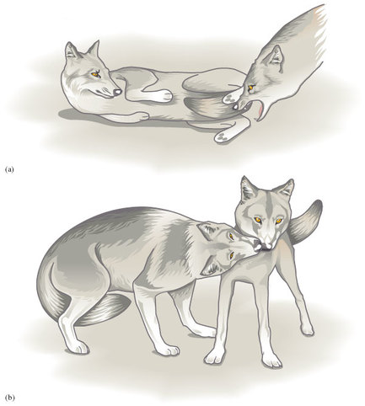
Figure 7 Two forms of submissive posturing in wolves, with the subordinate adopting the lower position. Both resemble infantile responses

SAQ 16

Question: What is striking about the origins of these two postures of submission? If you need to, reread LoM pp. 131-134, paying attention to the photographs.

View answer - SAQ 16

An appeasement gesture based on infantile behaviour makes sense, given the likelihood of its evoking parental rather than aggressive responses.
I've spent some time in this section exploring the issue of communication within groups, and looked at the reasons for the development of group living in carnivores. You'll have noticed that there are no simple answers, especially since my approach here has been to do no more than introduce these topics.
Trying to work out functional explanations of what we observe about the lifestyle and behaviour of carnivores is difficult, in part because of the enormous variety on show. The simplest questions - such as 'Why do lions usually live in groups?' - prove difficult to tackle; LoM pp. 151-153 outlines some of the issues. Devising sensible hypotheses is the easier step. What is more difficult is setting up manageable field experiments or observations that offer unequivocal data. In the case of lions, a leading researcher in the field, perplexed by untidy data and the conflicting conjecture currently to hand, draws attention to what he considers a classic paradox of science - 'the more information we have, the less we seem to know'.

Conclusion
This free course provided an introduction to studying Environment & Development. It took you through a series of exercises designed to develop your approach to study and learning at a distance, and helped to improve your confidence as an independent learner.

Keep on learning



Study another free course
There are more than 800 courses on OpenLearn for you to choose from on a range of subjects.
Find out more about all our free courses.

Take your studies further
Find out more about studying with The Open University by visiting our online prospectus.
If you are new to university study, you may be interested in our Access Courses or Certificates.

What's new from OpenLearn?
Sign up to our newsletter or view a sample.

For reference, full URLs to pages listed above:
OpenLearn - www.open.edu/openlearn/free-courses
Visiting our online prospectus - www.open.ac.uk/courses
Access Courses - www.open.ac.uk/courses/do-it/access
Certificates - www.open.ac.uk/courses/certificates-he
Newsletter - www.open.edu/openlearn/about-openlearn/subscribe-the-openlearn-newsletter

Acknowledgements
Except for third party materials and otherwise stated (see terms and conditions), this content is made available under a Creative Commons Attribution-NonCommercial-ShareAlike 4.0 Licence
Course image: Make it Kenya in Flickr made available under Creative Commons Attribution-NonCommercial-ShareAlike 2.0 Licence.
Grateful acknowledgement is made to the following sources for permission to reproduce material in this course:
The content acknowledged below is Proprietary and is used under licence.
Figure 2 adapted from Macdonald, D. (ed.) (2001) The New Encyclopedia of Mammals, Oxford University Press;
Figure 3 adapted from Gittleman, J. L. (1989) Carnivore Behaviour, Ecology and Evolution, Comstock Publishing Associates, a division of Cornell University Press;
Figure 5 adapted from Wallis, G. L. (1942) The Vertebrate Eye and its Adaptive Radiation, Harper, New York.
Don't miss out:
If reading this text has inspired you to learn more, you may be interested in joining the millions of people who discover our free learning resources and qualifications by visiting The Open University - www.open.edu/openlearn/free-courses

SAQ 1

Answer
I expect that you listed some of the following: strength, speed, keen senses, and methods of catching, killing, dismembering and digesting the prey.
Back to Session 2 SAQ 1

SAQ 2

Answer
Many do: African hunting dog [p. 136], (grey) wolf [p. 130], arctic and fennec fox [pp. 129 and 135], stoat [p. 126], lynx [p. 149], lion [p. 152], tiger [p. 149], leopard [p. 150], cheetah [p. 151], wildcat [p. 155], brown hyena [p. 143], civet [p. 142], genet [p. 141]. Neither the mongoose nor the meercat is mentioned in LoM (though the latter features memorably in the TV programme 'Life in the Trees'); the polar bear, brown bear and racoon are mentioned in LoM Chapter 6, as is the giant panda.
Back to Session 2 SAQ 2

SAQ 3

Answer
I3/3, C1/1, P4/4, M2/3; a total of 42 teeth.
Back to Session 2 SAQ 3

Activity 2

Answer
Stoats generally kill rabbits by (in DA's words) 'stabbing their fangs (i.e. their canines) into the back of the rabbit's neck (a strike only just visible in the TV sequence), which has the effect of smashing the rear end of its skull' [p. 124]. In the programme the lioness first brings down the prey and although it attaches by biting the back of the neck, you can see that it kills by suffocation, using canines and incisors, crushing the prey's windpipe. (Tigers more often kill with a crushing bite to the back of the prey's neck.)
Back to Session 2 Activity 2

SAQ 4

Answer
The bear is (c); as mentioned earlier, the molars here are well developed and offer a substantial grinding surface. Table 2 shows that the puma has a higher meat content in its diet than the spotted hyena, so you'd expect the flesh-shearing carnassials to be prominent and sharply angled, as in (a). In the spotted hyena, strong premolars, as in (b), are linked with its ability to crush bones. (The carnassials of the spotted hyena are especially important in slicing and shearing the hides of its prey - an ability that few other large carnivores have.)
Back to Session 2 SAQ 4

SAQ 5

Answer
Multiplying 110 × 0.6214 = 68.35, which rounds down to 68. The remaining values that you should have in the completed Table 3 are: lion, 50; red fox, 43; spotted hyena, 40; jackal, 34; wolf, 28.
Back to Session 3 SAQ 1

SAQ 6

Answer
By the relaxation of the circular muscles and the contraction of the radial muscles, causing the pupil to become larger.
Back to Session 3 SAQ 2

SAQ 7

Answer
Those of night-time hunting in lions, showing the characteristic eyeshine, which is reflected light from the tapetum. (See the programme from 29.50-33.33.) (Many nocturnal animals - and not just carnivores - have a tapetum lucidum. It also occurs in some diving mammals, enhancing their vision in the low light intensities under water.)
Back to Session 3 SAQ 3

Activity 4

Answer
In LoM [p. 136] DA writes about the fennec fox with its 'huge ears … With these they can detect the slightest sound, even the faint scratching made by a beetle as it clambers over sand grains'. The programme shows something of its hunting technique (see 05.46-07.50).
You will have caught a briefer glimpse of the serval (see 03.51). This small but impressive predator is so dependent on acute hearing to pinpoint prey that it doesn't even bother to hunt on windy days.
Back to Session 3 Activity 2

SAQ 8

Answer
(a) Group identity, though only the dominant male lions usually initiate the chorus! (b) Satisfaction - continuous, pulsed low-intensity sounds. This state is difficult to define in biological terms, and not all cats purr - purring is unknown amongst the big cats (except the puma), though on the evidence of lounging lions in the TV programme (see 33.52), an air of contentedness after feeding is hard to deny. (c) Threat. (d) Courtship - male advertisement prior to mating.
Back to Session 3 SAQ 4

Activity 5

Answer
There are two components to the deposits they leave on grass. The one that is longer-lived (and positioned lower) is rich in fat and milky white when first deposited and lasts several weeks. It is thought to signal to other clans of hyenas to 'keep out' - the area is already occupied. The black paste above it is shorter-lived and is thought to convey information important to the other hyenas in the group.
Back to Session 3 Activity 3

SAQ 9

Answer
If you refer back to Table 1, you're likely to be struck by the number of carnivores that are not notably sociable. Think of bears, mustelids and the many solitary cats - leopard, jaguar, snow leopard, the serval, lynx, cheetah, tiger - even the domestic cat! They are all essentially solitary hunters.
Back to Session 3 SAQ 5

SAQ 10

Answer
(a) The lions you see in the programme live in open terrain, with limited opportunity to use vegetation as cover. The tiger's habitat generally has denser cover, though with eight subspecies recognised, generalisations are difficult. (b) Tigers occupy habitats that have a good many ungulates (deer and wild cattle) but prey is often scattered, so solitary stalking is likely to be more successful; cooperative hunting has not been reported. For lions, prey is generally more concentrated, as the TV sequence (see 29.16) suggests.
Back to Session 3 SAQ 6

SAQ 11

Answer
Perhaps African wild dogs [pp. 137-139] and wolves. 'Common-sense' thinking might suggest that where the prey is very sizeable (as with hunting dogs tackling wildebeest) many individuals, acting in a coordinated way, would be needed to ensure success. (Indeed, some members of the dog pack seem to be specialist 'nose-grabbers', others 'tail-grabbers'.)
Back to Session 3 SAQ 7

SAQ 12

Answer
Perhaps some of the prey animals could be removed from their group, to see if isolation had any effect on the predators' hunting strategies. But this intervention might affect the behaviour and vulnerability of the remaining individuals, and alter more factors than group size alone. A less intrusive approach would be to compare hunting success in different carnivores living in different-sized groups. But comparing 'like with like' would be difficult; there could be other variables that would confound the comparison, perhaps differences in habitat, or body size, or their own vulnerability to prey, or the availability of different prey options.
Back to Session 3 SAQ 8

SAQ 13

Answer
DA speculates [p. 154] that camaraderie amongst females is helpful to successful reproduction and that bonding in males may reflect the difficulty of gaining entry as a single individual. To some degree, lionesses share the tasks of parenting, including suckling. Lionesses within a pride (and African hunting dog females in a pack) are likely to be related, which means that mutual help is entirely consistent with the rules of natural selection. You might have learned in course S182_3 that the notion of inclusive fitness encompasses the reproductive success of close relatives.
Back to Session 3 SAQ 9

SAQ 14

Answer
Yes, this is the 'many pairs of eyes' argument alluded to in S182_4. (You'll see a wonderful example of joint alertness of mammals 'on the lookout' - in this instance, for predators such as yellow cobras - if you watch the opening sequences of the TV programme 'Life in the Trees', which features a group of meerkats.)
Back to Session 3 SAQ 10

SAQ 16

Answer
Both resemble infantile gestures mentioned in LoM. The first is close to what DA describes on p. 132, which promotes the mother's licking (Figure 7b). The second very closely resembles infantile food-begging, as shown in the photograph on p. 134.
Back to Session 3 SAQ 11

Activity 1

Discussion
Most obvious are the semi-retractile claws which, together with large paws, provide the 'superb grip' on branches that DA refers to. As an agile tree-dweller, the pine marten is small, leaping impressively from branch to branch. Its bushy tail is a useful aid for balancing, but none of these features inhibit foraging on the ground where, as the programme shows, the pine marten picks up invertebrate prey.
Back to Session 2 Activity 1

Activity 3

Discussion
(a) The cheetah has long legs and a flexible spine, which enable it to straighten its back and stretch fore- and hindlimbs to a full spread (see Figure 4) and then arch the spine so that the hindlegs reach forwards in advance of the forelegs. Its strides are not only fast but long and all four limbs are off the ground [p. 151] for more than 50% of the time when running at full speed. It runs on its toes, thus increasing the effective length of the limbs and as DA points out [p. 150] the claws are non-retractable and relatively straight, acting like running spikes to grip the ground.
(b) Stalking is important to hunters that have limited endurance, such as the cheetah, where, as DA points out, sprints are seldom longer than about a minute. In the TV sequence, the gazelle escaped - only about half of cheetah pursuits end in capture; getting close undetected before the quick rush begins maximises the chances of success.
(c) Cheetahs are said to have relatively limited manoeuvrability, though on the TV evidence (at 38.02), where (in DA's words) it indeed seems 'so slim and agile that she can rival a gazelle in dodging and swerving'; the straight claws no doubt provide traction.
Back to Session 3 Activity 1

Activity 6

Discussion
Howling is essentially a means of establishing claim to and defending a territory. (Despite DA's success on camera (see 23.30) wolves most often howl in chorus, to communicate to a neighbouring rival pack, who are said to respond in similar voice only if they are a match for their neighbours. Scent-marking is also important in territorial defence.) The social rituals before the hunt begins are rich in body language, just as are the greetings as the group reunites. You are likely to have spotted mounting - though not particularly purposive. As DA points out [p. 133], the high tail is an assertive gesture; a lower tail, typically with the ears held back, is displayed by a subordinate when greeting a dominant member of the pack. It's difficult to make out all the communication going on in the playful huddle of pack members in the TV sequence, but mock biting and the occasional lowered head is evident.
Back to Session 3 Activity 4

