

T319_1

Organisations, environmental management and innovation
This free course is an adapted extract from the Open University course T319 Environmental management 2.
This version of the content may include video, images and interactive content that may not be optimised for your device.
You can experience this free course as it was originally designed on OpenLearn, the home of free learning from The Open University -
www.open.edu/openlearn/nature-environment/organisations-environmental-management-and-innovation/content-section-0.
There you’ll also be able to track your progress via your activity record, which you can use to demonstrate your learning.
Copyright © 2018 The Open University
Intellectual property
Unless otherwise stated, this resource is released under the terms of the Creative Commons Licence v4.0 http://creativecommons.org/licenses/by-nc-sa/4.0/deed.en_GB. Within that The Open University interprets this licence in the following way: www.open.edu/openlearn/about-openlearn/frequently-asked-questions-on-openlearn. Copyright and rights falling outside the terms of the Creative Commons Licence are retained or controlled by The Open University. Please read the full text before using any of the content.
We believe the primary barrier to accessing high-quality educational experiences is cost, which is why we aim to publish as much free content as possible under an open licence. If it proves difficult to release content under our preferred Creative Commons licence (e.g. because we can’t afford or gain the clearances or find suitable alternatives), we will still release the materials for free under a personal end-user licence.
This is because the learning experience will always be the same high quality offering and that should always be seen as positive – even if at times the licensing is different to Creative Commons.
When using the content you must attribute us (The Open University) (the OU) and any identified author in accordance with the terms of the Creative Commons Licence.
The Acknowledgements section is used to list, amongst other things, third party (Proprietary), licensed content which is not subject to Creative Commons licensing. Proprietary content must be used (retained) intact and in context to the content at all times.
The Acknowledgements section is also used to bring to your attention any other Special Restrictions which may apply to the content. For example there may be times when the Creative Commons Non-Commercial Sharealike licence does not apply to any of the content even if owned by us (The Open University). In these instances, unless stated otherwise, the content may be used for personal and non-commercial use.
We have also identified as Proprietary other material included in the content which is not subject to Creative Commons Licence. These are OU logos, trading names and may extend to certain photographic and video images and sound recordings and any other material as may be brought to your attention.
Unauthorised use of any of the content may constitute a breach of the terms and conditions and/or intellectual property laws.
We reserve the right to alter, amend or bring to an end any terms and conditions provided here without notice.
All rights falling outside the terms of the Creative Commons licence are retained or controlled by The Open University.
Head of Intellectual Property, The Open University

Contents
- Introduction
- Learning outcomes
- 1 Reflecting on organisations
  - 1.1 Organisations and purpose
  - 1.2 Multiple perspectives
  - 1.3 Reflecting on innovation
  - 1.4 Defining innovation
  - 1.5 Innovation = creativity?
  - 1.6 Categories of innovation
  - 1.7 Innovation and the S-curve
  - 1.8 Different perspectives
  - 1.9 Wrong thing righter?
  - 1.10 Environmental innovation
  - 1.11 Eco-innovation
  - 1.12 Business models
  - 1.13 System eco-innovation
  - 1.14 Measuring eco-innovation
  - 1.15 Drivers of eco-innovation
  - 1.16 Barriers to eco-innovation
  - 1.17 Accelerating eco-innovation
- 2 Connecting organisations and environment
  - 2.1 Creating environmental issues
  - 2.2 Affected by environmental issues
  - 2.3 Inputs and outputs
  - 2.4 Recognising connections
  - 2.5 Externalising the burden
  - 2.6 Focusing on impacts
  - 2.7 Understanding connections
  - 2.8 Environmental Impact Assessment
  - 2.9 EIA process
  - 2.10 Limitations of EIA
  - 2.11 Ecosystem services
  - 2.12 The supply chain
  - 2.13 Circular economy
  - 2.14 Coupled systems
- Conclusion
- References
- Acknowledgements

Introduction
This free course focuses on organisations, the innovations organisations are developing or using to manage contemporary environmental issues and some innovations in thinking about environmental management in organisations.
There are three main reasons for this focus:
- There are many millions of organisations that have significant impacts on the environments in which we live, from local to global scales.
- Organisations influence the diverse ways in which human–environment relationships are managed, from strategic and international policy to everyday choices.
- Organisations are advancing innovation as a way of improving human–environment relationships.
There is also an added advantage to learning about organisations in that you will also have direct experience of some kind of organisation in relation to environmental management. However, you don’t need to be a member, such as an employee, of a formal organisation, such as business, to engage with the ideas and techniques in this course.
In this course, you will be exploring the connections (sometimes obvious, sometimes not; sometimes positive, sometimes negative) between innovation and environmental management by organisations in order to gain some critical insight into the experiences and practices of innovators in real-world situations. You will explore examples of how organisations have, variously, tried to develop, adopt, adapt to or even ignore innovations in relation to environmental management.
As noted above, there are many millions of organisations in existence. Many are themselves highly innovative, and many adopt successful innovations developed from others but are themselves perhaps not innovative. It is also true that many organisations engaged in innovation have no direct interest in environmental management.
In this course we will focus our attention on those organisations that are aware of and focused (at least in part) on their environmental connections and responsibilities at some level. This could include organisations that directly engage in environmental management as part of their organisational remit, organisations that are already engaging in innovation to improve environmental management performance, or organisations that are aiming to understand and possibly improve their environmental management performance through innovation.
This course assumes some familiarity with ideas about organisations and environment and so does not rehearse the historical ‘development’ of environmental management in relation to organisations.
Some of the key questions in this course include:
- How do we understand innovation in relation to environmental management?
- What kinds of innovations are organisations using in relation to environmental management?
- What are the external and internal drivers for innovative environmental management in organisations (e.g. legislation, costs, leadership, learning, public pressure)?
- What practices does an innovative organisation engage in with respect to environmental management?
Systems ideas are used to explore and develop critical perspectives on innovation in relation to environmental management by organisations. A systems approach raises the question of perspective: who decides what is innovation, what boundary judgements are made, who decides assessment criteria and expected outcomes? These kinds of questions should help you develop a critical perspective of claims for innovations in environmental management.
Systems ideas and concepts are not directly taught in this course so if you want to know more about them then you should either study the specific courses on Systems thinking and practice and Systems diagramming or, if you want to learn them in an environmental context, the courses on Understanding the environment: a systems approach and Understanding the environment: problems with the way we think.
This course is an adapted extract from the Open University course T319 Environmental management 2.

Learning outcomes
After studying this course, you should be able to:
- understand the connections between innovation and environmental management orientated organisations
- explain ideas about innovation and how it shapes organisational approaches to environmental management
- use systems ideas and approaches to explore innovation and environmental management
- explain how environmental management and innovation by organisations is dependent on understanding multiple perspectives, stakeholders and boundaries.

1 Reflecting on organisations
One of the principal reasons for studying organisations in relation to environmental management is due to their significant influence on the environment in many different locales and habitats – aspects that you will explore later on. But organisations are also exceedingly diverse.

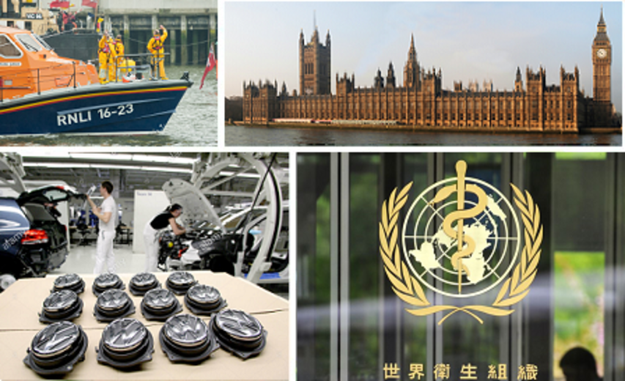
Figure 1 Organisations are all around us
View description - Figure 1 Organisations are all around us

If we are to understand some of the ways in which organisations influence the environment, we first need to explore briefly what we mean by the term ‘organisation’.

Activity 1 Defining ‘organisation’
Allow about 5 minutes

How would you define an organisation? Think about the kinds of organisations you engage with to help develop your answer.
Provide your answer...

Provide your answer...
View discussion - Activity 1 Defining ‘organisation’

Some people interpret organisation very broadly to include non-human organisations. While this model answer also queries if organisations can be non-human, for the purposes of this course we will focus on human organisations.
Even within the human realm, it is often not easy to make sense of the diversity of organisations or understand their different types and configurations. A corporate bank is clearly very different to an independent café which is in turn very different to a local fire station, farm or a local residents’ group. As it is often the most obvious aspect of an organisation’s existence, should an organisation be defined by its building, geographic location, online presence, product or brand?
While it may be that an organisation’s existence may be implied by a building, product or brand, these facets of organisations do not convey the essential quality or component of an organisation: people.
In this course, we will use the term organisation to mean: ‘An organised body of people with a particular purpose [such] as a business, government department, charity’ (OED, 2014).
The simplicity of this definition may be a little surprising, but it offers an insight into organisations irrespective of their size, location and type. In short, this definition suggests organisations are, fundamentally, about three or more people engaging in some kind of organised activity for an agreed and mutual purpose.
You might like to consider the organisations you engage with regularly and see if this definition holds true in your opinion. What is clear is that the above definition gives rise to a question about purpose: what are the groups of people organised for?

1.1 Organisations and purpose
If organisations are defined as groups of people organised for an agreed purpose, determining purpose becomes central to understanding their structure and the ways in which an organisation might act, with implications for innovation and environmental management.

Activity 2 Purpose
Allow about 5 minutes

Identify the different purposes of the organisations you considered while developing your answer for Activity 1.
Provide your answer...

Provide your answer...
View discussion - Activity 2 Purpose

Your answer may have included all kinds of organisations for many different purposes, perhaps a local shop or garage or an online retailer, a global corporation or a small local volunteer or charity group. These descriptions give some clue to their purpose.
However, there is often some tension encountered about whether an organisation’s stated purpose maps directly to any individual working within an organisation. For example, you may have come across the story of the architect Christopher Wren when he was surveying the rebuilding of St Paul’s Cathedral after the Great Fire of London in 1666. Paraphrased, on encountering three stonemasons working on the rebuilding, he asked each the same question: ‘What are you doing?’ The reply from the first was ‘I’m working’, the second, ‘I’m building a wall’, and the third replied ‘I’m building a cathedral to God’.
Looking back at the earlier definition of organisations and its emphasis on agreed purpose, would you say these stonemasons were all part of the same organisation? There is some room for debate here and it depends, in part, on where you draw the boundary between an organisation’s purpose and the activities engaged in by individual members of an organisation to fulfil that purpose.
Your own assessment of organisations should reveal that not everyone in any organisation is doing the same thing all the time. Roles and responsibilities and thus activities differ, but they can still contribute to the overall purpose of the organisation. In one view, all three stonemasons are part of the same organisation: they are still involved in the building of a cathedral, even if their individual sense of purpose differs. In other words, people within organisations can have ‘nested’ sets of purpose which can still (but not necessarily always) contribute to the overall purpose. If someone starts to engage in activities that contravene, or are separate from, the organisation’s overall purpose, then we might consider that they don’t belong to the organisation.

Activity 3 Systems map of purpose
Allow about 10 minutes

Taking one of the organisations familiar to you, identify the main purpose of the organisation, then draw a systems map to identify the different activities undertaken within the organisation to achieve that purpose.
(Note: guidance on drawing systems maps is available in the Systems diagramming course and on the Guide to diagrams.)

View discussion - Activity 3 Systems map of purpose

Your answer should reveal a fairly diverse set of activities within the organisation, even if these are performed by a small number of individuals.
The overall purpose of the organisation is likely to fall into one of three broad categories:
- some organisations exist to make a profit
- some to affect public interests in the form of governance, such as a local authority or regulator
- some to fulfil an identified need that is non-profit-making, such as a social group, charity or non-governmental organisation.
While there are many variants and overlaps between these broad distinctions, and numerous academic books and discussions about the nature of organisations, the above definition of organisations and awareness of purpose offers a working understanding of organisations that provides the basis for exploring the way organisations engage in environmental management in this course.

1.2 Multiple perspectives
Although you now have a basis for thinking about organisations as a group of people organised for a common purpose, it is important to consider whether other people, perhaps not connected to the organisation, share similar perspectives about the organisation and its purpose.
Ultimately, the Wren anecdote reveals the importance of perspectives. Not everyone inside and outside an organisation will share the same perspective about the purpose of an organisation and its associated activities.
A modern corollary of Wren’s encounter with stonemasons would be an organisation claiming to be delivering ‘world-class expertise in oil exploration’, an employee in that organisation ‘earning a salary to pay my mortgage for my house’ and an outside observer of the organisation claiming the organisation is ‘focused on profit at the expense of the global environment and people’.

Activity 4 Considering the perspectives of others
Allow about 10 minutes

Thinking back to the systems diagram you developed for Activity 3, would friends, family, colleagues or associates agree with your representation of your chosen organisation in terms of its activities and, ultimately, its purpose? How might your systems map be altered to reflect some of these different perspectives?
Provide your answer...

Provide your answer...
View discussion - Activity 4 Considering the perspectives of others

Appreciating multiple perspectives is a key element and skill set associated with environmental management which we will come back to later on. Having had a chance to reflect on organisations, our focus now turns to innovation.

1.3 Reflecting on innovation
Innovation is perhaps one of the most defining characteristics of human history. Speech, laws, agriculture, the wheel, metalworking, glass, writing, mathematics, printing, medicine, electricity, flight and computing are all aspects of far-reaching innovations in human history.
With regard to organisations, even the briefest of internet searches on innovation should reveal that there are many thousands of management videos, gurus, books and journal articles exploring and exhorting innovation and how organisations, especially businesses, and individuals should and could be doing more of it.
Innovation is thus considered the lifeblood of organisations: the essential element or imperative that ensures an organisation’s efficiency, competitiveness or uniqueness, and, ultimately, the success of an organisation. This is not to mean that all organisations must generate the innovations themselves – some organisations adopt the innovations provided by others.
In an environmental context, organisations are often seeking or tasked with providing ‘innovative’ solutions to many environmental concerns. Faced with many environmental issues and concerns, innovation is often heralded as providing a solution to environmental problems under the aegis of ‘doing things differently’, ‘joining up our thinking’, ‘installing new technology’, ‘providing a new solution to the problem’, ‘solving the problem’ and so on.
Equally, many innovations have been linked to major environmental consequences: oil distillation, the combustion engine, pesticides, urbanisation and nuclear energy, to name but a few. Innovations may not be as environmentally positive as the word innovation suggests.
All this is both heartening and disheartening in that it presents a problem. What is innovation? We will consider an exact definition in a moment, but the next activity prompts you to reflect on what you currently understand by innovation in relation to organisations.

Activity 5 Innovation in organisations
Allow about 10 minutes

Select an organisation that you engage with that you consider to be innovative in its activities and functions. Choose an organisation that is not overtly ‘environmental’ or engaging in environmental innovations. Remember, an organisation does not have to ‘dream up’ the innovation itself to be innovative. What do you consider to be the hallmark(s) of innovation by this organisation?
Provide your answer...

Provide your answer...
View discussion - Activity 5 Innovation in organisations

It is not always easy to determine what constitutes innovation. Much depends on context and timescales: what is judged as innovation, when, by whom and over what timescale? Organisations might engage in innovation for a number of reasons including profit and maintaining a competitive advantage. Innovation can also carry the risk of failure. As if this were not enough to consider, there is also another dimension: where and when does innovation occur in an organisation? The next activity asks you to reflect on this.

Activity 6 Where and when?
Allow about 10 minutes

Using the same organisation and innovations that you explored in Activity 5, identify where the innovative practices in that organisation occur.
Provide your answer...

Provide your answer...
View discussion - Activity 6 Where and when?

Your answer may reveal that innovation can occur in different ways and in different parts of an organisation. If considering a business organisation, for example, it could be innovation in accounting processes, innovation in ideas and design, innovation in manufacturing processes or innovation in sales approaches – perhaps all having some or no effect in terms of the environmental performance of the organisation. Innovation in fundraising or services provided might be more evident in a non-profit organisation. New forms of policy and regulatory practices might be identified as innovation in the context of a governmental body. Innovations relating to internal decision-making structures and processes could apply to any organisation. If you considered the same organisation over time, it is likely that the type and ‘location’ of innovations themselves would change.
These activities should prompt some initial reflections on innovation as a shift away from ‘business as usual’ and doing something differently. But to explore innovation in relation to environmental management more closely, a more detailed understanding of innovation is required.

1.4 Defining innovation
Having had a few moments to reflect on and consider your understanding of innovation, let’s start with a dictionary definition. The word ‘innovate’ comes from the Latin ‘innovāre’, meaning ‘to renew / alter’ (OED, 2014).
The OED defines the verb ‘to innovate’ as:

- To change (a thing) into something new; to alter; to renew.
- To bring in (something new) the first time; to introduce as new.
- To bring in or introduce novelties; to make changes in something established; to introduce innovations.
(OED, 2014)

There is a subtle difference in the OED definitions: (1) suggests some kind of altering or even transformation of something that already exists; (2) conveys some quality associated with creative and inventive originality. Innovation is thus concerned with renewing or altering something that already exists, as well as the creation and invention of something new.
But what is the ‘it’ that is innovated? Some of your own answers to the earlier activities may provide some insights. Typically, innovation is often linked to some kind of product, a new device or item that represents a new way of doing things. Examples could be cars, mobile phones, computers or similar ‘gadgets’ or technology. But writers about innovation suggest this is quite a narrow, if prevailing view.

Reading 1 McDermott and Sexton, 2004
Approximate reading time: 10 minutes
Read ‘Four myths of innovation’ (McDermott and Sexton, 2004).

Activity 7 Four myths of innovation
Allow about 10 minutes

Identify and summarise the four myths of innovation according to McDermott and Sexton. What are the implications for the way we think about innovation?
Provide your answer...

Provide your answer...
View discussion - Activity 7 Four myths of innovation

From this reading, it is evident that innovation can apply to products as well as services, ideas as well as practices, organisational forms as well as structure, and values as well as purpose of an organisation, to name just a few possible arenas and aspects of innovation. But perhaps the key message from this reading is that innovation is not technology – it is about people and the culture of organisations. Innovative technology may be developed and/or used by an organisation, but this is evidence of innovative organisational context, culture and the set of practices that have brought the technology into existence and/or use.

1.5 Innovation = creativity?
Before we explore innovation in relation to environmental management, we still have to consider the potential overlap between innovation and creativity. This overlap needs some clarification if we are to understand innovation.
On searching the internet for images associated with ‘innovation’, it was quite a surprise to see innovation often depicted as a light bulb (at least at the time of writing). It may be something to do with the idea of a light bulb as a major innovation in lighting technology (compared with candles and oil and gas lamps). But light bulbs are often used to denote creativity or a spark of genius – ‘the light bulb moment’. This suggests that innovation and creativity are closely linked.


Figure 3 Light bulbs – a metaphor for innovation?
View description - Figure 3 Light bulbs – a metaphor for innovation?

But, are innovation and creativity the same thing?
Returning to McDermott and Sexton (2004), they recognise that the two terms are used interchangeably. They note this can cause problems because of the sometimes traditionally negative interpretation of creativity in business situations. They explain:

Creativity, to some, seems applicable only in the domain of artists, poets and other ‘non-business’ types. It implies risk-taking, rule-breaking, and unstructured chaotic activities that make some leaders extremely nervous. We don’t happen to agree with those fears, but we suggest you avoid the potential problem by distinguishing between the two terms this way:
Innovation is the value-added application of a creative idea.
(McDermott and Sexton, 2004, p. 27; emphasis in original)

Innovation as the application of creativity and also invention is reinforced by many writers (for example, West and Altink, 1996; Yusuf, 2009; Sawyer, 2012), not least the seminal work on the distinctions between creativity and innovation by Theodore Levitt in his 1963 paper Creativity is not enough.
In thinking of innovation as the application of creativity, it is also important to be aware that this can include creative thinking. Innovation can occur as a change in perspective – seeing something anew – and adopting a new perspective on the thing or situation in question. For example, an engineer might have a particular perspective on a river as something to be controlled and ‘enclosed’ by concrete flood defences. The same engineer, if they changed their perspective about the river, its functions and dynamics, might see it as something to be allowed ‘room to flood’ in nearby fields. Following major flood risk during the 1990s, such a shift in perspective has underpinned Dutch government initiatives for flood management of the Rhine since 2007 under the Room for the River programme. Could such innovation in thinking address similar problems for the UK?

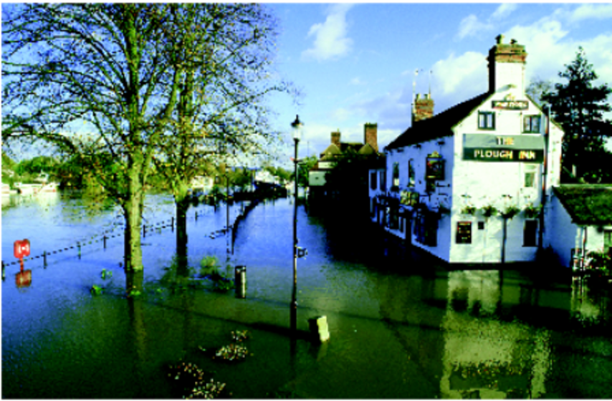
Figure 4 A flooded river
View description - Figure 4 A flooded river

Rather than being creative in terms of specific content, the innovation in flood management arose out of a change in perspective about what a river ‘does’. The river itself has not changed, but the perspective of those trying to manage it has changed. As such, there is an innovation in perspective (and subsequently in ideas and practices) rather than the thing itself (in this case a river). As you go through this course you will see how perspective is important to your thinking about innovation, and how systems ideas and thinking can help inform your perspective of innovations and environmental management.
There is still one key aspect of innovation that we have yet to discuss, but is important for environmental management: is innovation always characterised by a marked change in direction or can it also be incremental? In other words, can we categorise innovation in some way?

1.6 Categories of innovation
So far, you have had an opportunity to reflect on some examples of innovation and explored some writing that suggests innovation is not simply a focus on technology, although much of the focus on innovation remains very centred on technology as innovation. You have also seen that some care is needed about who is judging innovation and over what timescale.
Returning to our dictionary definition, it is not always easy to distinguish whether something is completely new or has been simply altered. To help make the distinction clearer, innovation is often divided into three categories:
- Incremental innovation is focused on iteration and modification of existing technologies or processes, usually to improve efficiency or costs, or reduce use of materials. This type of innovation is still reliant on the same ‘model’ of practice or existing technology. An example might be improved fuel efficiency of an engine design.
- Disruptive innovation is still based on the existing technology, but changes how things are done and what is achieved as a result. An example might be a move from a diesel engine system to a hybrid engine system for cars.
- Radical innovation marks a break with previous technologies, processes, ideas and ways of doing things. Often referred to as ‘breakthrough’ in relation to technologies, radical innovation can also apply to organisations in the way they are restructured to increase efficiencies and improve use of resources. Examples of radical innovation might be designing a car that is completely recyclable or an organisation taking control of its supply chain to ensure environmental standards are met.

Activity 8 Incremental, disruptive or radical?
Allow about 10 minutes

Bearing in mind these categorisations, from your perspective, do you consider a wholly electric car to be an example of incremental, disruptive or radical environmental management innovation?
Provide your answer...

Provide your answer...
View discussion - Activity 8 Incremental, disruptive or radical?

People with different perspectives will have differing views of what constitutes incremental, disruptive or radical innovation. You may have disagreed with the examples provided above for each category of innovation or with the answer to the activity. Your own perspectives, experiences and knowledge will shape how you categorise innovation. When trying to determine which category of innovation to assign to a product, process or idea, there are also other factors to consider.
Over time, a technology or process can move between the categories of innovation. For example, the way Google worked as a search engine was a radical innovation when first developed, but the organisation has since engaged in mostly incremental and occasionally disruptive innovation to make ongoing improvements to its performance as a search engine. However, you could argue it has engaged in radical innovation in the way it runs its server farms to reduce its energy use and emissions.
The categorisations above also do not distinguish between the innovation involved in developing a new product or process and the impact that an innovation has in use. In other words, incremental innovation may have a radical impact on the way things are done or a new technology. Conversely, a radical innovation may have incremental changes depending on the context.
Examples of the former might be the energy-efficient light bulb – a largely incremental innovation that has led to a radical change in lighting in domestic contexts in the UK following EU policy ending the sale of incandescent light bulbs. In this case, the EU policy might be considered the more radical innovation rather than the energy-saving light bulb itself.
Examples of the latter might include solar panels – a radical way of generating domestic electricity, but currently only having incremental impacts because of costs, energy pricing policies and time lag of adoption in the UK.
The different categories of innovation are often represented using ‘S’-curves.

1.7 Innovation and the S-curve
There are many theories of change, but one that is particularly relevant to innovation is centred on the S-curve. It is a way of depicting incremental, disruptive and radical innovation.

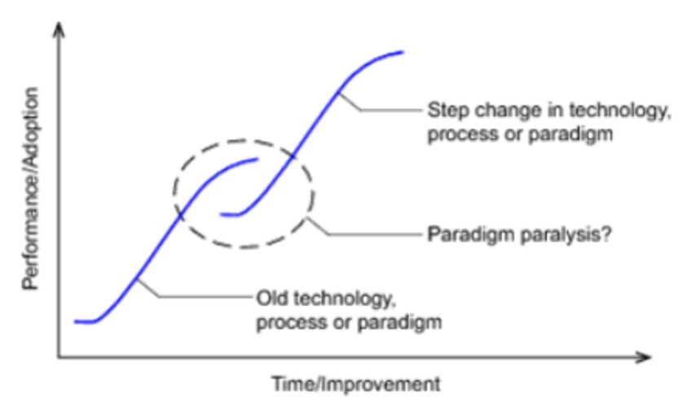
Figure 5 S-curve showing incremental and radical innovation
View description - Figure 5 S-curve showing incremental and radical innovation

In Figure 5, the vertical axis shows the performance of the item under consideration – this is sometimes equated to competitive advantage for business organisations. The horizontal axis shows effort – this could be time, resource investment or similar, which is associated with the innovation and its development. The S-curve shows the innovation from its slow early beginnings as the technology or process is developed, to an acceleration phase (a steeper line) as it matures and, finally, to its stabilisation over time (the flattening curve), with corresponding increases in performance of the item or organisation using it. Over time, the technology reaches its technological limit of usefulness or competitive advantage. At any point, there may be a step change in the technology – a radical innovation – resulting in a new S-curve.
Disruptive innovation can involve some elements from the old technology ‘transferring’ across – hence the S-curve overlaps.
In radical innovation, the ‘gap’ or discontinuity shown in Figure 5 conveys the sense of a break from one technology to the other, newer, radical technology. Thus a radical technology fulfils the same need, but is based on a different knowledge and practice base. An example might be photographic film being largely replaced by digital storage media in digital cameras. Paradigm paralysis is when an organisation resists the shift to the new idea, process or product. One example is the Kodak photographic company, traditionally a hugely innovative company responsible for the invention of the digital camera, but which continued to prioritise its commitment to film and printing of images despite the digital revolution in camera and media technologies. This paradigm paralysis (continuing to support film), which is described in an article titled ‘The moment it all went wrong for Kodak’ in The Independent newspaper (Usborne, 2012), contributed to the bankruptcy and demise of the company in 2012.
The S-curve can also be used to depict the diffusion of innovations in a culture over time. First described by Everett Rogers in the early 1960s, diffusion is the process by which an innovation is communicated and taken up over time. Rogers’ work is important because it emphasises that the innovation itself is not the only determinant of its ‘success’. There must also be communication channels, time and a social system in place to enable the innovation to be used and adopted more and more widely. Rogers also identifies the different categories of adopters: innovators, early adopters, majority (further subdivided into early and late) and laggards (Rogers, 1962). Returning to the example of the solar panels, those households having solar panels by 2015 in the UK would probably still be classed as innovators or early adopters. The social system, comprising policy, legal, finance, information and many other factors, is still not (and may never be) fully in place for solar panels to be installed by the majority of householders.
While there are criticisms of S-curves and Rogers’ diffusion theory, they provide a useful way of understanding how innovation may or may not progress. However, you may be wondering why all this is important for environmental management. This is explored next.

1.8 Different perspectives
Whether we use S-curves or develop categories of innovation, the important element is recognising that they are dependent on perspectives. As you have already seen in the activities so far, different people in the same situation may ‘see’ the innovation differently and thus assign it to different categories. You might consider wind power turbines as a radical innovation, while others will point to the history of using windmills over many hundreds of years and thus identify modern equivalents as incremental or disruptive innovations at best.
It’s important to remember that not everyone will interpret an innovation in the same way.
Whether you categorise something as radical, disruptive or incremental, the word innovation is often synonymous with an improvement. However, it’s important to remember that not everyone will consider an innovation an improvement.
You will now look at two different perspectives on whether energy-efficient light bulbs are in fact a positive innovation (of whatever category) leading to environmental improvements.

Reading 2 McSmith, 2006
Approximate reading time: 5 minutes
Read ‘A bright idea: How changing light bulbs helps beat global warming (and cut bills)’, an article published in The Independent (McSmith, 2006).

While the newspaper article presents some positive messages associated with innovations in light bulb technology, this is only one aspect of the story. A paper in the journal Environmental Science & Technology investigated the environmental toxicities of compact fluorescent (CFL) and light-emitting diode (LED) bulbs compared to regulatory limits in the USA. In the following short quotation, the regulatory limit number refers to the limit for that particular substance. For example, the regulatory limit for lead leachability is five milligrams per litre (mg/l). Exceeding that limit would suggest some environmental toxicity.

We discovered that both CFL and LED bulbs are categorized as hazardous, due to excessive levels of lead (Pb) leachability (132 and 44 mg/l, respectively; regulatory limit: 5) and the high contents of copper (111 000 and 31 600 mg/kg, respectively; limit: 2500), lead (3860 mg/kg for the CFL bulb; limit: 1000), and zinc (34 500 mg/kg for the CFL bulb; limit: 5000), while the incandescent bulb is not hazardous (note that the results for CFL bulbs excluded mercury vapor not captured during sample preparation). The CFLs and LEDs have higher resource depletion and toxicity potentials than the incandescent bulb due primarily to their high aluminum, copper, gold, lead, silver, and zinc. Comparing the bulbs on an equivalent quantity basis with respect to the expected lifetimes of the bulbs, the CFLs and LEDs have 3–26 and 2–3 times higher potential impacts than the incandescent bulb, respectively. We conclude that in addition to enhancing energy efficiency, conservation and sustainability policies should focus on the development of technologies that reduce the content of hazardous and rare metals in lighting products without compromising their performance and useful lifespan.
(Lim et al., 2013, p. 1040)

This work suggests that CFL and LED bulbs exceed the USA regulatory limits for various metals by some considerable margin. This does not mean that the bulbs are therefore toxic, but it does mean they exceed the regulatory limits. (It may be the limits are too stringent.) The energy-efficient light bulb is but one example of where an innovation to improve environmental performance is subject to some critical questioning and doubt.

Activity 9 Benefits and disbenefits
Allow about 15 minutes

Identify the environmental benefits and disbenefits highlighted in the reading and quotation. Do you consider energy-efficient light bulbs to be an innovation in terms of environmental management? Justify your answer.
Provide your answer...

Provide your answer...
View discussion - Activity 9 Benefits and disbenefits

1.9 Wrong thing righter?
The systems writer Russell Ackoff provides a useful commentary, which has a significant bearing on maintaining a critical stance on innovation. In the following extract from his writings, his reference to reformations approximates to incremental innovation and the reference to transformations approximates to more radical innovations, particularly at the system level.

Reformations and transformations are not the same thing. Reformations are concerned with changing the means systems employ to pursue their objectives. Transformations involve changes in the objectives they pursue. Peter Drucker put this distinction dramatically when he said there is a difference between doing things right (the intent of reformations) and doing the right thing (the intent of transformations).
The righter we do the wrong thing, the wronger we become. When we make a mistake doing the wrong thing and correct it, we become wronger. When we make a mistake doing the right thing and correct it, we become righter. Therefore, it is better to do the right thing wrong than the wrong thing right. This is very significant because almost every problem confronting our society is a result of the fact that our public policy makers are doing the wrong things and are trying to do them righter.
(Ackoff, 2004, pp. 1–2)

Activity 10 Eco-innovations – wrong thing right or right thing wrong?
Allow about 10 minutes

Having read the preceding extract, comment on your own experiences of eco-innovation (it could be related to an item, process, idea, etc.). Which eco-innovations would you consider to be doing the ‘wrong thing right’ or doing the ‘right thing wrong’?
Provide your answer...

Provide your answer...
View discussion - Activity 10 Eco-innovations – wrong thing right or right thing wrong?

Multiple perspectives are inevitable in answering these kinds of questions. But Ackoff’s commentary and shorthand phrasing is a potent reminder that humans have innovated throughout our history, but not all innovations have proved to be desirable either in the short or long term. It is also a reminder that it may not be necessary to innovate – i.e. engage in transformation if we are trying to do the right thing in the first place. In this case, incremental innovations might be an appropriate strategy.

1.10 Environmental innovation
Innovation is relevant to environmental management because environmental management is an innovation. That is quite a bold statement, which you are not expected to agree with – especially without some justification. Let me explain.
The last 150 years have seen a significant increase in global, national, community, organisational and individual concerns about environmental health, quality and futures, including climate change. The emphasis on environmental management in policy and practice, from global agreements to national policy through to local level planning, is – in the EU context at least – a change in the managing of human–environment relations. In this respect, environmental management as an idea represents an innovation in the possible governance arrangements for many countries, communities, organisations and individuals. Whether that has translated into viable policies and practice is an entirely different debate.
Evidence that those engaging in environmental management are at the frontier of advocating innovations in human–environment relations can be found in the many governments, businesses and other organisations seeking opportunities in their various inter-organisational relations to support the turn to a more sustainable or ‘green’ economy – even if these initiatives and what constitutes a sustainable or green economy also remains debatable.
The extent of the development of innovations relating to environmental improvements has reached a point where they are often grouped into their own category: so called eco-innovation.

1.11 Eco-innovation
Eco-innovation is a term used to cover all forms of innovation relating to the environment, including technology, processes and organisational forms.

Reading 3 EIO, 2011
Approximate reading time: 10 minutes
Read the short ‘Eco-Innovation Brief’ paper produced by the Eco-Innovation Observatory (EIO, 2011).

Activity 11 Eco-innovation
Allow about 10 minutes

Having read the briefing paper:
- Provide a definition of eco-innovation.
- Comment on whether eco-innovation covers all three types or categories of innovation explored earlier – incremental, disruptive and radical.
Provide your answer...

Provide your answer...
View discussion - Activity 11 Eco-innovation

As you might expect, eco-innovation refers to innovations that have some environmental and/or environmental management element, and are claimed to improve environmental performance. Another report by the EIO defines eco-innovation as:

The introduction of any new or significantly improved product (good or service), process, organisational change or marketing solution that reduces the use of natural resources (including materials, energy, water and land) and decreases the release of harmful substances across the whole life-cycle.
(EIO, 2010, p. 7)

In parallel with ideas about incremental, disruptive and radical innovation, Vasiľová and Drábik (2013) suggest there are three kinds of eco-innovation with different impacts on products and processes:

- Component addition – development of additional components to improve environmental quality without necessarily changing the process
- Sub-system change – implementation of eco-efficient solutions and optimization of sub-systems that aims to use fewer resources and generate less waste and pollution
- System change – redesign of system towards eco-effective solutions with focus on the industrial systems and shift from linear systems to closed loop systems in which waste becomes an input into new products.
(Vasiľová and Drábik, 2013, p. 148)

The emphasis on systems is notable in the eco-innovation literature. The reference to a closed loop system describes a system where a feedback loop exists. In the quote, the waste from a process or activity becomes an input (the feedback) into a new product or process. In this way, eco-innovation aims to develop a more systemic approach to innovation and developing, among other things, new business models.

1.12 Business models
Calls for eco-innovation, and particularly system-level change, are central to calls for greener economies, but there is still considerable uncertainty about whether eco-innovation can and will deliver improvements. In part, much depends on the extent to which existing and future business models can support environmental improvements (for a detailed review, see Schaltegger et al., 2011).
A 2013 article in The Guardian newspaper titled ‘Wanted: truly innovative sustainable business models’ summarised some of the issues associated with innovation and related business models (Whisnant, 2013). The article is worth a read if you have time, but the main points reinforce the idea that technological innovation is, of itself, not enough to bring about significant changes in organisational practices or more sustainable economies and societies. This is because many existing business models are reliant on mispricing or undervaluing resources and environmentally damaging activities. In the light bulb example discussed earlier, the toxicity of some of the materials and metals used in CFLs is ‘undervalued’ and thus CFLs are cheaper and also promoted as ‘green’.

Reading 4 OECD, 2012, pp. 4–11
Approximate reading time: 20 minutes
This kind of undervaluing or mispricing is raised as a concern by the Organisation for Economic Co-operation and Development (OECD) in a paper on eco-innovation titled ‘The Future of Eco-innovation: The Role of Business Models in Green Transformation’ (OECD, 2012).
Read from Section 2.2 ‘Eco-innovation and business models’ on page 4 to the end of Section 3.5 ‘Role of enabling technologies and infrastructures’ on page 11.

Activity 12 Changes to business models
Allow about 15 minutes

From the sections you've read, identify the main concerns about existing business models, and any changes to business models that the OECD paper says are necessary for eco-innovation to develop.
Provide your answer...

Provide your answer...
View discussion - Activity 12 Changes to business models

The OECD report (and the article in The Guardian) suggests that new business models are required to bring about system-level change – a view which is explored next.

1.13 System eco-innovation
As mentioned earlier, much of the innovation literature is focused on individual elements, such as technology or an idea. System eco-innovation is an attempt to move away from this more narrow focus to engage in discussion about system-level change. As you have already seen, quite what is understood as the ‘system’ is dependent on who is describing the system and the boundaries being drawn. In this sense, the ‘system’ may be the individual organisation (and all its component elements) or the organisation as part of a supply chain and particular part of the economy.

Reading 5 EIO, 2013, pp. 36–8
Approximate reading time: 10 minutes
Read Section 4.3 ‘System eco-innovation: measuring up to the challenge’ on pages 36–8 of the EIO’s annual report ‘Europe in Transition: Paving the Way to a Green Economy through Eco-innovation’ (EIO, 2013).

Activity 13 System eco-innovation
Allow about 10 minutes

Briefly define system eco-innovation and summarise the main points made in the reading.
Provide your answer...

Provide your answer...
View discussion - Activity 13 System eco-innovation

The reading also contains an interesting graphical representation of innovation, an interpretation of which is shown in Figure 6.

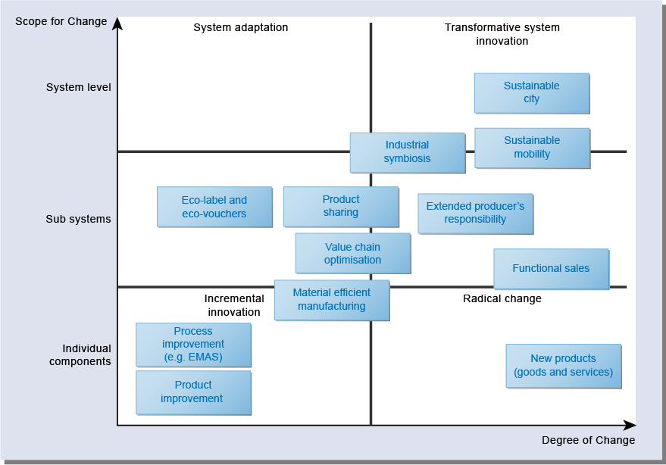
Figure 6 From product improvement to transformative system innovation (adapted from EIO, 2013, p. 37)
View description - Figure 6 From product improvement to transformative system innovation (adapted from ...

While some of the detail is less important, the figure shows innovation according to the degree of change (from incremental to radical) and the scope of change (from individual elements, such as a product, through to system level). You will notice that the figure does not explicitly refer to ‘disruptive’ innovation.
The lower left quadrant is where incremental innovation is located – essentially improving existing components, processes or products. An example would be improving the manufacturing process of a light bulb or reducing its toxic components. Directly above this, innovations in the subsystem encompass some aspects of system, but not all. An example might be innovations in the supply chain of the materials obtained for manufacturing the light bulb. Or innovations in the lighting sector more widely, such as introducing LEDs into domestic markets. The upper left quadrant is when innovations occur at societal level – arguably, the adoption of CFLs in the EU would be situated here.
The lower right quadrant is where radical changes in individual components, processes or ideas are situated. An example might be a solar panel. The middle right quadrant corresponds to subsystem innovations, such as a manufacturer improving the environmental aspects of the supply chain of its solar panel components and, more radically, disposal options, including buy-back. The upper right quadrant is the arena for locating transformative system-level eco-innovation. This might include rethinking the way domestic energy is generated, leading to system-level transformations in domestic energy production and use.
As noted earlier, where a particular product, process or idea is located on this grid is dependent on the perspective of the person. If you consider a CFL light bulb to be a radical lighting technology, you might move it to the right-hand quadrants. If you see it as just one small improvement, you might locate it on the left-hand side of the graphic.
It is also important to be aware that this graphic assumes innovations of any type are essentially positive. It does not provide room for locating negative innovations that could engender system-level transformation but with highly negative environmental impacts. Arguably, the invention of the internal combustion engine and its ubiquitous adoption for personal transport in the twentieth century has led to a wide range of environmental impacts associated with resource use and pollution. On the basis of this graphic, would we be justified in placing the engine, the car and road transport systems on the right-hand side?

1.14 Measuring eco-innovation
You have already considered some aspects of whether an innovation is positive or negative. The light bulb analysis by Lim et al. in the USA suggests that measurement is an important part of determining if something can be claimed to be a positive eco-innovation.
A 2008 report by the consultancy Technopolis identified some key problems with assessing innovation, namely difficulties associated with:

- agreeing on selected key eco-innovation indicators on the micro level, taking into account the whole-life-cycle approach and wider impacts in depicting eco-efficiency aspects of eco-innovations;
- clarifying different analytical levels of eco-innovation analysis and developing insightful data aggregation methods; and
- establishing operational approaches to link different levels of analysing eco-innovations to understand their systemic effects and their relation to other key indicators, most notably to these measuring economic growth and sustainable development.
(Reid and Miedzinski, 2008, p. 7)

In summary, these concerns centre on methodological approaches and developing appropriate indicators that reflect the systemic aspects of innovation relating to wider environmental, social and economic concerns. In other words, claiming a CFL light bulb is an eco-innovation on the basis of energy saved may be insufficient. The environmental impacts of its components and the waste generation from disposal of old lighting systems, to the social impacts of extra purchase costs of light bulbs to users and the economic impacts associated with costs to organisations to change their lighting systems all need to be considered.
There are many models and ideas for assessing innovations, including ecological footprints and life cycle analysis. These are determined on the basis of material flows. The Technopolis report also notes the importance of calculating material flows:

It should be underlined that excessive human made material flows (extraction and displacement of natural resources) cause shifts in the eco-systems, which on one hand contribute to observed welfare levels, but on the other lead to longer term systemic disequilibria such as floods, shortages of water, desertification, erosion, etc. Hence, the primary objective of eco-innovation should be to reduce material flows. In this context, innovation policy should be linked to sustainability objectives.
(Reid and Miedzinski, 2008, p. 10)

The methods and indicators for calculating and measuring material flows, such as material flow analysis (MFA) or material input per service (MIPS), are complex and beyond the scope of this course. But to give you a flavour of the difficulties in determining whether a product or process is eco-innovative, Table 1 outlines some of the possible sets of material flow indicators that might be used in an MFA or MIPS.

Table 1 Material flow indicators
Domestic extraction used (DEU) | DEU measures the flows of materials that originate from the environment and that physically enter the economic system for further processing or direct consumption (they are ‘used’ by the economy).
Direct Material Input (DMI) | DMI represents materials supply. It measures the direct input of materials for use into the economy, i.e. all materials that are of economic value and are used in production and consumption activities.
Total Material Requirement (TMR) | TMR includes, in addition to DMI, the (indirect) material flows that are associated to imports but that take place on other countries. It measures the total ‘material base’ of an economy. Adding indirect flows converts imports into their ‘primary resource extraction equivalent’.
Domestic Material Consumption (DMC) | DMC represents materials use. DMC measures the total amount of material directly used in an economy (i.e. the direct apparent consumption of materials, excluding indirect flows). DMC is defined in the same way as other key physical indicators such as gross inland energy consumption.
Total Material Consumption (TMC) | TMC measures the total material use associated with domestic production and consumption activities, including indirect flows imported (see TMR) but less exports and associated indirect flows of exports.
Physical Trade Balance (PTB) | The PTB reflects the physical trade surplus or deficit of an economy. It is defined as imports minus exports (excluding or including their hidden flows).
Total Domestic Output (TDO) | TDO represents the environmental burden of materials use, i.e. the total quantity of material outputs to the environment caused by economic activity.
(Reid and Miedzinski, 2008, p. 11)

You are not expected to remember or use these indicators, but they do illustrate the complexity and difficulty of determining boundaries, and thus what might be considered as suitable indicators, when attempting to assess whether something (i.e. an idea or a process) might be judged as a positive eco-innovation.
Having briefly considered some of the difficulties in measuring eco-innovation, attention now turns to the drivers and barriers related to eco-innovation.

1.15 Drivers of eco-innovation
Why would an organisation be interested in eco-innovation?

Activity 14 Drivers of eco-innovation
Allow about 10 minutes

Thinking back to the organisations and innovations you reflected on in the first few activities in this course, what are the drivers for these organisations to engage in eco-innovation?
Provide your answer...

Provide your answer...
View discussion - Activity 14 Drivers of eco-innovation

Your answer will probably have two or three main drivers for eco-innovation.
The most obvious and perhaps most compelling answer for most organisations is that the innovation is financially attractive and viable. This could be in the form of cost reductions arising from increased efficiencies of the organisation’s work – such as a reduction in heating costs due to new thermostat-controlling technologies – or a new revenue stream as a result of the innovation – such as a company selling a new type of battery with fewer environmental impacts or offering advice for reducing environmental costs. For business organisations, gaining market share is also a key driver and this may lead to efforts to improve the environmental performance of the product or process they are engaged in, or bringing in innovations developed elsewhere.
In addition to the financial benefits, organisations are often legally required to implement some process- or product-related innovation in order to comply with legal statutes and regulation. Examples might include banning use of toxic materials in manufacturing or specifying waste disposal routes and recycling. Of course, legal requirements can increase costs for any organisation, large or small, business or non-business, such as paying for controlled disposal of electrical equipment under the European Waste Electrical and Electronic Equipment (WEEE) Directive.
An organisation’s culture can also drive innovation. Ethical and moral concerns are a key issue for some organisations wanting to develop more responsible business practices, new business models and business ethics. These are often focused on transparency of organisational practices and taking on responsibilities within the supply chain. This can apply to business organisations as much as non-business organisations. A voluntary charity may want to demonstrate its commitment to ethical issues and only buy services and products from suppliers it considers to be socially and environmentally responsible.
Social drivers may also be significant to an organisation, particularly if there is a risk to revenues and the organisation’s reputation in terms of environmental performance. For very large organisations, some may want to be seen as leaders in their sector. Social drivers might arise from various groups with an interest in the organisation, including shareholders, staff, customers, users and external groups, particularly environmental NGOs.

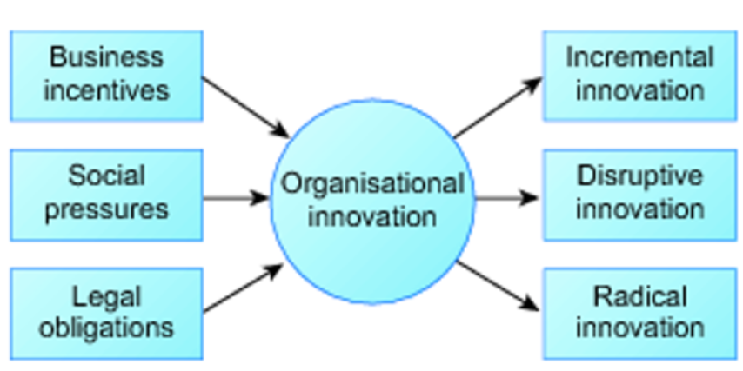
Figure 7 Input–output diagram of innovation drivers
View description - Figure 7 Input–output diagram of innovation drivers

These drivers are not exclusive of each other: changes in social values might prompt staff to lobby an organisation’s management to make changes to practices, which may lead to cost savings, which might result in a shift in the organisation’s culture regarding environmental performance. Equally, an organisation may identify a (market) opportunity by engaging in eco-innovations, and initiate a change programme with staff.

1.16 Barriers to eco-innovation
In the same way that organisations may experience a range of drivers for eco-innovation, they will also experience obstacles and barriers.

Activity 15 Barriers and obstacles to eco-innovation
Allow about 10 minutes

For the same organisations you chose earlier, identify some of the possible obstacles and barriers to eco-innovation.
Provide your answer...

Provide your answer...
View discussion - Activity 15 Barriers and obstacles to eco-innovation

The Technopolis report referred to earlier also explored innovation performance and potential in the EU in several sectors: food/drink, machinery/equipment, textiles, chemicals, energy, ICT, space and aeronautics, and automotives. The findings suggest that amongst barriers on eco-innovation, costs are the most important factor for both innovative and non-innovative business organisations. Lack of finance for the investment required for innovation and concerns about the economic risk are also major concerns. The following table shows the main barriers.

Table 2 Innovation barriers perceived as high by eco-innovators
Innovation barrier | Eco-innovation (% of companies)
 | Innovative companies | Non-innovative companies
Innovation costs too high | 29.6 | 25.6
Lack of appropriate sources of finance | 22.7 | 19.3
Excessive perceived economic risks | 20.4 | 16.8
Lack of qualified personnel | 14.1 | 12.7
Insufficient flexibility of regulations or standards | 12.0 | 8.1
Lack of customer responsiveness to new goods or services | 8.8 | 6.9
Lack of information on markets | 7.4 | 5.4
Organisational rigidities within the enterprise | 6.8 | 5.9
Lack of information on technology | 6.1 | 4.2
(Reid and Miedzinski, 2008, p. 35)

More recent research on behalf of the European Commission’s (EC) Directorate-General of the Environment (EC, 2012) suggests little has changed since 2007, particularly amongst business organisations. In response, initiatives to promote eco-innovation more widely in the EU have been promoted as part of the EU Eco-Innovation Action Plan (EcoAP) from 2011 onwards. The EcoAP initiative aims to expand from a focus on green technologies to include products and services. Analysis undertaken by the EU survey used by the EcoAP on the main barriers for eco-innovation in small and medium enterprises (SMEs) is shown in Figure 8.

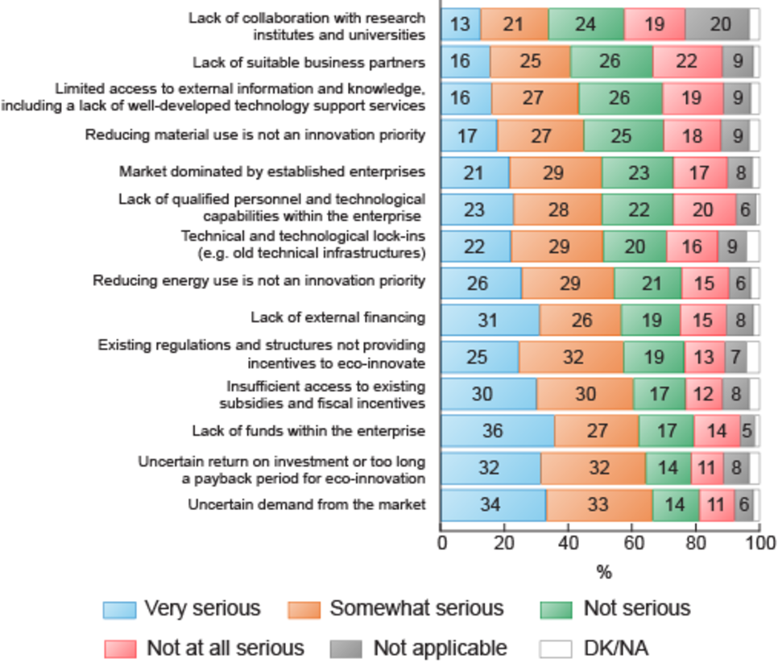
(EC, 2011, p. 4)
Figure 8 Barriers to accelerated eco-innovation uptake and development for companies (DK/NA = don’t know/no answer)
View description - Figure 8 Barriers to accelerated eco-innovation uptake and development for companies ...

Activity 16 Barriers to eco-innovation uptake
Allow about 10 minutes

Review Figure 8. Identify the main barriers to uptake of eco-innovation.
Provide your answer...

Provide your answer...
View discussion - Activity 16 Barriers to eco-innovation uptake

1.17 Accelerating eco-innovation
Efforts to address these barriers were also considered within the same report and are shown in Figure 9.

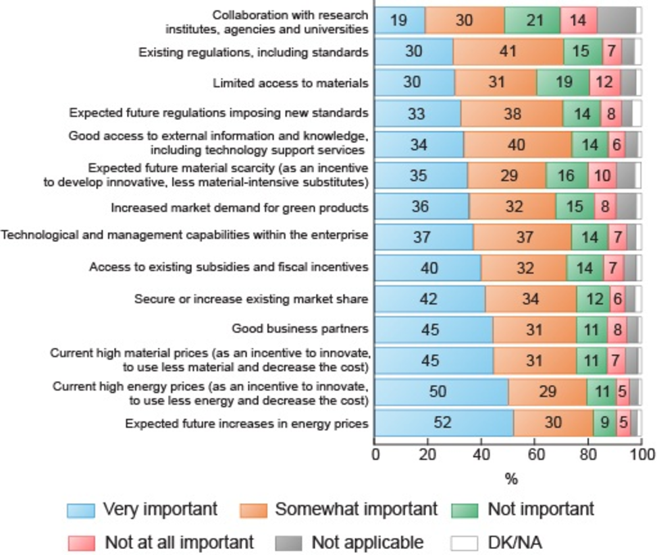
(EC, 2011, p. 5)
Figure 9 Accelerating eco-innovation uptake and development
View description - Figure 9 Accelerating eco-innovation uptake and development

Activity 17 Accelerating eco-innovation
Allow about 10 minutes

Review Figure 9. Identify the main drivers that might address the barriers and accelerate the uptake of eco-innovation.
Provide your answer...

Provide your answer...
View discussion - Activity 17 Accelerating eco-innovation

It is important to remember that these tables are reporting on business organisations and, within that, SMEs. The drivers for other types of organisation may vary, but it is likely that for many organisations finance and uncertainty of several aspects (e.g. payback and performance) are likely to remain key barriers.

2 Connecting organisations and environment
Although you have already begun to explore some ways in which organisations might be connected to the environment in previous activities, it is possible that some organisations will argue that they have no particular connection to the environment. Examples might be a medical charity set up to help patients access care services on leaving hospital, a local legal firm or a pizza takeaway. In this sense the organisations might identify themselves as being completely separate from environmental concerns. Is this sense of separation valid?

Activity 18 Connecting organisations and environment
Allow about 20 minutes

Select a (non-environmental) organisation that you have some familiarity with (remember you don’t need to be an employee or similar). Identify any possible connections to the natural environment using a spray diagram.
(Note: guidance on drawing spray diagrams is available in the Guide to diagrams.)

View discussion - Activity 18 Connecting organisations and environment

Your spray diagram should indicate some connection to the environment. It is almost inevitable that all organisations will have connections, however limited in scope and extent, to the natural environment. This is not entirely surprising if you remember that an organisation is a group of people organised for a purpose. As a result, even the least environmentally ‘connected’ organisation is still likely to be ‘connected’ in the form of energy, water, land and materials used, and wastes and emissions generated by the members of the organisation as they go about their activities within the organisation. Whether the organisation recognises these connections is a different question. Nonetheless, it is quite a challenge to conceive of an organisation that does not have some kind of connection to the natural environment – you are welcome to try!
In this course, we will accept that, for all practical purposes, all organisations are connected to the natural environment in some fashion. It follows that some exploration of those connections is possible and important for understanding and managing human–environment relations, and the extent to which (and how) they are changed through innovation.
To start with, let’s consider the two simplest ways organisations might be connected to their environment: the involvement of an organisation in creating or contributing to the environmental issue of concern; and the effect of environmental issues on an organisation. We explore both dimensions briefly.

2.1 Creating environmental issues
In this course, we assume that you have some familiarity with a range of environmental issues, concerns and problems that are now part of contemporary life. Whether losses of and threats to species, habitats, landscapes or traditional livelihoods, many of these issues are often associated with or directly linked to the activities of organisations.

Activity 19 Organisations creating environmental issues
Allow about 10 minutes

Using your spray diagram from Activity 18, note some possible ways in which the organisation may be involved in contributing to or creating environmental issues.
Provide your answer...

Provide your answer...
View discussion - Activity 19 Organisations creating environmental issues

The range of environmental issues in your answer is likely to be as diverse as the organisations themselves and will also be shaped by your own interests in the environment. Some links between an organisation and an environmental issue, such as a chemical spill into a river from a factory, will be relatively straightforward. In others, there will be more uncertainty. Does the (seemingly constant) use of the kettle for making tea at the local community centre contribute to climate change? Debates about climate change are a good example of controversy and uncertainty concerning the role of organisations in contributing to environmental issues.
You will explore more about the role of organisations in ‘creating’ environmental management issues later on. For the moment, we briefly explore the other dimension: how organisations are affected by environmental issues.

2.2 Affected by environmental issues
What kinds of environmental issues do organisations face? Are environmental issues, by their nature, any different to the many other types of issues that organisations are expected to address? Are they any different to the kinds of problems and issues faced by individuals or communities?
Discussion on the nature and origins of contemporary environmental issues is not limited to concerns about organisations, but it does have significant bearing on the way organisations think about environmental issues and how they are affected, so it is important to reflect on this.

Activity 20 Contemporary environmental issues
Allow about 10 minutes

What do you consider to be the main characteristics of contemporary environmental management issues for the organisations you engage with? Do you consider these to be unique or are they shared by other kinds of issues that organisations have to address?
Provide your answer...

Provide your answer...
View discussion - Activity 20 Contemporary environmental issues

Given these characteristics, many organisations can be affected by environmental issues in many ways. An organisation can be required to meet certain legal obligations on waste and emissions and a wide range of local operating conditions, which are often linked to planning and licence permissions. But for issues which are still ‘in dispute’, such as global warming, the uncertainty can be considerable and hamper an organisation’s medium- and long-term planning. It can be difficult to generalise given the diversity of issues that equally diverse organisations face. Indeed, this diversity can add to the complexity and uncertainty associated with many environmental issues and situations and their interconnections with different aspects of the organisation. One way of representing this in more systemic terms is to think about the connections between an organisation and its environment in terms of flows: what is coming into the organisation and what is going out of the organisation.

2.3 Inputs and outputs
An input–output model can show the inputs into an organisation, the transformation processes within the organisation using the inputs, and the outputs arising from the transformation process. A simple example might be the input of water into a car wash, the transformation of a dirty car into a clean car and the output of waste water probably containing various soaps, oils and dirt.
One example of an input–output diagram is shown in Figure 11. It is produced by the Australian National Audit Office as a guide for organisations auditing their environmental performance.
Figure 11 shows the organisation (in this case an office-based organisation) and some of its main areas of activity (e.g. procurement decisions, data centres). To the left of the organisation, some inputs are shown and to the right are various outputs.

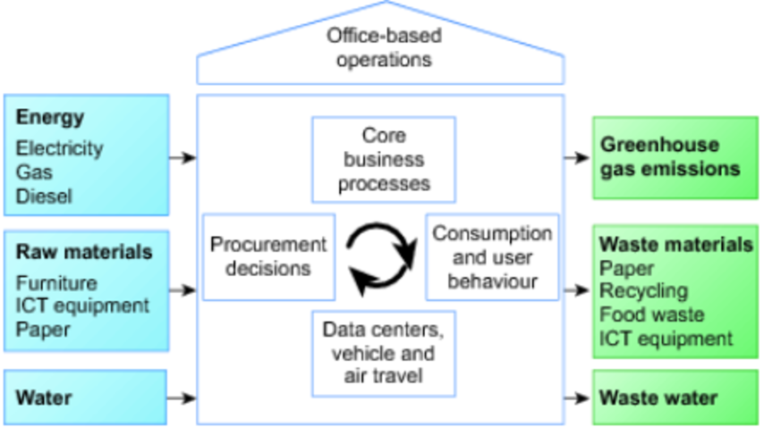
(ANAO, 2012, p. 12)
Figure 11 Input and output model of an office-based operation
View description - Figure 11 Input and output model of an office-based operation

Activity 21 Input–output model of an organisation
Allow about 20 minutes

Draw a basic input–output model to explore some of the different environmental aspects related to the activities of an organisation familiar to you – you can use the same organisation used in earlier activities. Don’t worry too much about detail or technicalities.

View discussion - Activity 21 Input–output model of an organisation

Compiling an input–output diagram is not always straightforward as it often requires a certain amount of knowledge about the activities of an organisation. In some cases, you will be faced with uncertainty about any or all of the inputs, outputs and transformation processes or operations. In many cases, determining, assessing and measuring the varied inputs and outputs and the various pathways of feedback loops is problematic.
Even so, it should be evident that the environmental situation faced by an organisation is often not just limited to one aspect of the environment (e.g. water), nor singularly as just either an input or output. In terms of feedback, often the inputs are affected by the outputs – such as outputs of waste products getting into inputs of water, for example. Even if the organisation responsible for the output avoids this, it may affect individuals, other organisations and communities locally or internationally.
Your input–output model and some assessment of possible feedback loops should begin to reveal a more complex set of relationships between an organisation and its environment. In other words, you can begin to reflect on the systemic nature of many environmental situations faced by organisations, rather than a singular focus on just one aspect of an organisation’s operations.
The systemic nature of environmental issues has implications for the ways in which organisations approach environmental management and innovation. Not least is the notion that more complex environmental issues and situations require organisations and their members to be thinking and acting in more systemically innovative ways.

2.4 Recognising connections
Recognising connections is not always easy or desirable, or accepted by those who manage, own, invest or work in organisations or those who may be affected by an organisation’s activities. In other words, the connections between an organisation and its natural environment are often ignored or disputed or not fully understood.

Reading 6 Kiernan, 2012
Approximate reading time: 5 minutes
Read the article ‘Why investors don’t care about corporations’ environmental performance’ (Kiernan, 2012).

Activity 22 Understanding connections
Allow about 5 minutes

What are the key points raised in the article about the way organisations recognise environmental connections?
Provide your answer...

Provide your answer...
View discussion - Activity 22 Understanding connections

You may or may not agree with the main premise of the article, but it does highlight that you cannot assume an organisation, as a whole, accepts its connections and responsibilities to the natural environment. In particular, the article is a reminder that organisations have tended to see environmental connections as a negative element in traditional business models.

2.5 Externalising the burden
The sense of negativity about environmental issues arises because organisations have historically tended to externalise environmental issues and costs – i.e. placing them outside the boundary of the organisation and, especially, its financial and accounting systems. Environmental changes, such as pollution caused by an organisation’s activities, become someone else’s responsibility to deal with and pay for. This approach has been critiqued by many, for example in the book The Necessary Revolution (Senge, 2008).
Much of the innovation in environmental policy and legislation of the last 100 years has been centred on trying to (re)connect organisations to the natural environment, most simply illustrated by the emphasis on the ‘polluter pays’ principle. In essence, this principle aims to place the responsibility on the person or organisation creating the pollution. It was a key element in the principles of the 1992 Earth Summit and is now to be found in many legal statutes, such as the Environmental Liability Directive (Directive 2004/35/EC of the European Parliament and of the Council of 21 April 2004 on environmental liability with regard to the prevention and remedying of environmental damage). The ‘polluter pays’ principle also underpins the development of global carbon markets and carbon-related taxes.
Whether such approaches and innovations work and are effective in changing mindsets, behaviours and practices is another matter. For example, you may consider that paying a carbon-related tax for using a car or flying does little to develop a sense of connection with the natural environment or influence your or others’ behaviours and choices.

2.6 Focusing on impacts
Many environmental innovations have tended to focus on impacts, whether of a product or of an organisation. This is a very common way in which connections are conceptualised: an organisation does X and then the impact on the natural environment is Y (even if Y is difficult to measure and model). The term ‘impact’ tends to be interpreted as a negative, but impacts can also be positive. For example, a wind turbine might have negative impacts in terms of visual amenity, noise to nearby households and communities, and be implicated in bird deaths, but might have positive impacts to humans and the natural environment in terms of electricity generation.
We can therefore think of an impact as any change to the natural environment and also the human environment. In other words, impacts are a key part of determining and shaping human–environment relations.

2.7 Understanding connections
There are several different techniques and models that can be used to understand and explain an organisation’s connections to the natural environment. Some of these are covered over the next pages. Although we do not explore them in detail, it is important to be aware of them as they offer insights into how connections are conceptualised, and are variously used by many environmental managers and practitioners in different environmental contexts.

2.8 Environmental Impact Assessment
The emphasis on impacts underpins many assessment and reporting mechanisms and modelling tools that aim to identify and, in some cases, measure impacts. The most widely used assessment process by organisations of all shapes and sizes is the Environmental Impact Assessment (EIA). In many respects, the EIA process represents a possible innovation in environmental management because it attempts to establish and understand the range of connections between an organisation and the natural and human environment.
EIA is also a mainstay of environmental management processes globally. It was developed in the 1960s as a way of enabling organisations to identify and assess their environmental connections and any negative and positive consequences of their decision-making and activities. The ‘impact’ referred to in EIA is the difference between what would happen with the action and what would happen without it. In terms of an EIA, impacts can be both positive and negative.
EIA initially focused on biophysical concerns, but has, as an innovation in thinking about impact types, since been widened to visual, cultural and socio-economic concerns. The International Association of Impact Assessment (IAIA) offers a definition of EIA as:

The process of identifying, predicting, evaluating and mitigating the biophysical, social, and other relevant effects of development proposals prior to major decisions being taken and commitments made.
(IAIA, 2009, p. 1)

As the EIA is timed before any decisions to proceed are made, the EIA can be considered as a decision aid rather than a decision-making tool. EIA has been used on a global basis and was first introduced in the EU in 1985. Currently, the main legislation is the Environmental Impact Assessment Directive for individual projects, such as a dam, motorway, airport or factory (Directive 2011/92/EU of the European Parliament and of the Council of 13 December 2011 on the assessment of the effects of certain public and private projects on the environment).
The directive aims to ensure that an assessment is made of the environmental implications of projects that are expected to have significant environmental impacts – often predominantly negative impacts.
EIAs are thus mandatory for certain projects (listed under Annex I of Directive 2011/92/EU) with expected significant environmental impacts – e.g. long-distance railway lines, motorways, larger airports, hazardous waste facilities and water treatment plants. Other projects (listed under Annex II) are subject to EIA at the discretion of member states using a screening procedure to determine if a project should be subject to an EIA.

2.9 EIA process
The main stages of the EIA process are shown in Figure 13.

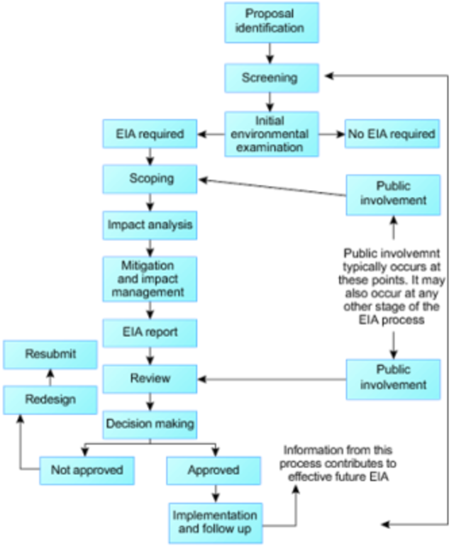
(UNU, 2007, Section 1.5)
Figure 13 Main stages of the EIA process
View description - Figure 13 Main stages of the EIA process

Typically, the EIA report will cover the following:
- description of the project
- alternatives that have been considered
- description of the environmental context
- description of the possible significant environmental impacts
- mitigation strategies
- non-technical summary (usually the environment impact statement)
- assessment of knowledge gaps and/or technical difficulties.
There are many aspects of each stage that shape how the EIA is undertaken and its subsequent findings. Key to these are the interpretation of ‘significant’ and also the boundaries chosen to determine impacts.
Significant effects are determined with reference to a range of criteria relating to:
- possible environmental loss and deterioration (e.g. species loss)
- possible social impacts resulting directly or indirectly from environmental change (e.g. human health)
- possible non-conformity with environmental standards, objectives and guidelines (e.g. air quality standards)
- the likelihood and acceptability of risk (e.g. possibility of exposure to a hazard).
EIAs can be quite complex and technical, and are usually carried out by environmental consultants. Many large infrastructure projects will have an EIA of some kind. Some are more extensive than others. The EIA for High Speed 2, the high-speed rail proposal linking Birmingham and London, has an EIA of around 50,000 pages! While the EIA might be considered innovative in providing a systematic review of possible impacts, the EIA process and approach for understanding connections is not without its critics.

2.10 Limitations of EIA
A 2009 review of the EIA Directive by the European Commission (EC, 2009) noted that while EIAs have been innovative in helping to integrate environmental considerations and public opinion into projects and development, a number of problems remain relating to:
- the appropriate use of screening criteria to determine if EIAs are needed
- quality control of the data and data gaps
- quality of the process and methodological rigour
- lack of harmonised procedures for involving the public
- focus on site boundaries
- trans-boundary problems involving more than one member state
- lack of coordination between EIA and other directives.
The focus on site boundaries is particularly important, as noted in the earlier discussion on differences between organisational boundaries and impact boundaries.
The last point is also noteworthy as the review makes clear that climate change is, for all intents and purposes, excluded from EIAs, as the following extract explains:

The EIA Directive does not expressly address climate change issues. Most of the [Member States] recognise that climate change issues are not adequately identified and assessed within the EIA process. Any review of the impacts of climate change is often limited to CO₂ and other greenhouse gas emissions from industry and from increases in transport as part of air quality studies or as indirect impacts. The EIA assessment will often not go beyond evaluating existing emissions and ensuring that ambient air quality standards are met. In addition, the effects on global climate, the cumulative effects of an additional project and adaptation to climate change are not sufficiently considered within the EIA.
(EC, 2009, pp. 9–10)

This leads to a concern as to whether the EIA can be claimed to be innovative as a way of understanding and making sense of the connections between an organisation and the natural and human environments. It also raises a concern as to whether the EIA is a useful approach in assessing eco-innovations claimed as part of a development.
Partly in response to these kinds of concerns, as well as political changes and an emphasis on growth and developments in other appraisal tools, in late 2012, the European Commission signalled its intention to review and streamline the EIA Directive by reducing administrative burdens and making it easier to assess the potential impacts of major projects (see EC, 2012).
The newly amended Environmental Impact Assessment (EIA) Directive (2014/52/EU) entered into force on 15 May 2014 to simplify the rules for assessing the potential effects of projects on the environment and reduce administrative burdens. Greater attention is also given to resource efficiency, climate change and disaster prevention (EC, 2014).
The fine details of these changes are beyond the scope of this course. But it is particularly noteworthy that the newly amended directive adopts the language of ecosystem services, which is explored next.

2.11 Ecosystem services
You may already be familiar with the term ‘ecosystem services’. This very old notion maintains that humans derive certain ‘services’ from natural environments, such as drinking water, materials, food, air and so on. The history of ideas relating to ecosystem services is beyond the scope of this course, but it's important to be aware of it, as it does have some bearing on the way environmental issues are being understood by contemporary environmental managers within organisations. In many respects, the notion of ecosystem services is being claimed as an innovation in the way organisations try to make sense of their connections to the natural environment. Its increasing prevalence in policy means ecosystem services are an important aspect of environmental management.
In brief, ecosystem services are divided into four main categories, each resulting in some kind of service:
- Provisioning services: products obtained from ecosystems
- Regulating services: benefits obtained from the regulation of ecosystem processes
- Cultural services: non-material benefits, e.g. aesthetic and well-being, cognitive development, reflection, recreation
- Supporting services: necessary for the production of all other ecosystem services.

Activity 23 Ecosystem services
Allow about 5 minutes

Match the following examples of ecosystem services to the relevant category.

Provisioning services
Regulating services
Cultural services
Supporting services
Water
Waste processing
Seed dispersal
Scientific discovery
View discussion - Activity 23 Ecosystem services

Attempts to assess impacts on ecosystem services have been gaining ground in recent years. One of the most ambitious is The Economics of Ecosystems and Biodiversity (TEEB) report (2013), which attempted to draw attention to the global extent of biodiversity loss.

Reading 7 TEEB, 2013, pp. 7–13
Approximate reading time: 20 minutes
Read the ‘Executive Summary’ (pp. 7–13) section of the TEEB report on biodiversity titled ‘Natural Capital at Risk’ (TEEB, 2013).

Activity 24 The TEEB report
Allow about 20 minutes

Focusing on the general aspects (rather than the detail), what are the main concerns about the use and pricing of ecosystem services by the organisations considered in the document? Summarise the recommendations for companies and governments.
Provide your answer...

Provide your answer...
View discussion - Activity 24 The TEEB report

The reading was quite challenging to summarise, but hopefully you have at least gained a sense of how the notion of ecosystem services can be used to convey economic costs – a language familiar to policy-makers and businesses.
However, you may also have noticed that ecosystem services place the emphasis on the services that arise from the item or thing itself and have less emphasis on the item itself. This suggests a rather anthropocentric view of the environment where something is not valued intrinsically, but rather by the service it provides. Critics have suggested the concept of ecosystem services remains within an economic language and economic framework, which had created the problems in the first place and led to understanding the environment as an ‘immense collection of service commodities’ (Robertson, 2012, p. 386). In other words, ecosystem services are a way of placing an economic valuation on environmental goods and services within a framework of economic growth as an indicator of well-being – a framework that increases pressure on the natural environment as part of trade-offs between development and the environment.
Thus, the extent to which ecosystem services represent an innovation in conceptualising and managing human–environment relations and the extent to which it can be used to foster innovations in development is subject to some debate, as is the extent to which ecosystem services are likely to be a helpful addition to the EIA. If we return to Ackoff, is the concept and practice of ecosystem services an example of doing the wrong thing righter? There are no immediate answers to the question, but this debate is discussed in Reading 8, part of a special issue on ecosystem services in the journal Environmental Impact Assessment Review.

Reading 8 Baker et al., 2013, pp. 5–9
Approximate reading time: 20 minutes
Read Sections 4 and 5 (pp. 5–9) of ‘Ecosystem services in environmental assessment – Help or hindrance?’ (Baker et al., 2013).

Activity 25 Ecosystem services – help or hindrance?
Allow about 15 minutes

Based on the research explored in the paper, what do the authors consider to be the main strengths and weaknesses of using ecosystem services in environmental assessment? Does the paper make any suggestions as to whether ecosystem services represent an innovation in environmental assessment approaches?
Provide your answer...

Provide your answer...
View discussion - Activity 25 Ecosystem services – help or hindrance?

Experience of ecosystem services in environmental assessment is still growing and commentaries are beginning to adopt more critical perspectives on ecosystem services (see Schröter et al., 2014).
However, some organisations are claiming they are using other innovative ways to make connections with the natural environment more explicit and more embedded in the life of organisations.

2.12 The supply chain
The sense of connection to the natural environment depends on where the boundary of an organisation’s responsibilities is drawn and by whom. Some organisations are attempting to engage in a more system-level understanding of these connections in terms of the whole organisation.
One of the most high profile in the UK is the retailer Marks & Spencer. It has publicly committed to improving its sustainability profile by making connections to the natural environment as well as social concerns through all aspects of its supply chain and activities under the aegis of its ‘Plan A’ programme.
At the heart of the Plan A programme is an attempt to connect the organisation more fully to its supply and waste chain – i.e. the life cycle of its different operations. In systems language, this would equate to the environment in the system sense – i.e. those things outside the organisation, but which influence its operations. The innovations being explored within Plan A include improving the efficiency of its activities – such that ‘waste’ (e.g. wood packaging) becomes a resource to be used in some other part of the system, for example, by being offered to community groups. In other words, one organisation’s waste is another organisation’s input of raw material.
It is this more systemic understanding of connections that underpins the attempt to move away from the prevailing linear conceptualisation of the economy and economic model where inputs and outputs are largely divorced from the responsibilities of the organisations utilising them.

2.13 Circular economy
The Ellen MacArthur Foundation, set up by the British yachtswoman Ellen MacArthur, has engaged in a critique of the linear economic model based on ‘take, make, dispose’.

Reading 9 EMF, 2014, pp. 12–24
Approximate reading time: 30 minutes
Read the first section titled ‘The benefits of a circular economy’ (pp. 12–24) from the report ‘Towards the Circular Economy’ by the Ellen MacArthur Foundation (EMF, 2014).

Activity 26 Circular economy
Allow about 20 minutes

What are the main points raised in this critique of the linear economy? Summarise the key principles and features of the circular economy.
Provide your answer...

Provide your answer...
View discussion - Activity 26 Circular economy

The circular economy is offered as a way of connecting organisations to the environment and ensuring that environmental aspects are valued more appropriately.
You may or may not agree with the critique and alternative suggestions for a circular economy, but it does provide a means to at least engage in a system-level understanding of the activities of organisations and ways in which organisations can connect to their environment in a systems sense – i.e. with the wider context in which they operate, and connecting to biophysical and social elements in the system beyond the organisation. As an innovation in conceptualising the systemic nature of connections, the idea of the circular economy could be understood as a radical innovation at a system level. At the heart of this system-level transformation is the potential for the circular economy to avoid discussion about trade-offs, where the environment tends to be undervalued, and move to a more positive realisation of economic as well as environmental benefits.
In systems language, one way of conceptualising this innovation in making connections is through the idea of a coupled system.

2.14 Coupled systems
Building on the idea of connections and interdependencies between an organisation and its environment, organisations and the natural environment can be considered in a more systemic way: as a coupled system.
The concept of a coupled system is such that an organisation, as a system, is interconnected with the natural environment, as a wider system. Each interacts and influences the other over time through feedback systems so that the two (the organisation and the natural environment) become co-dependent and co-evolve over time.

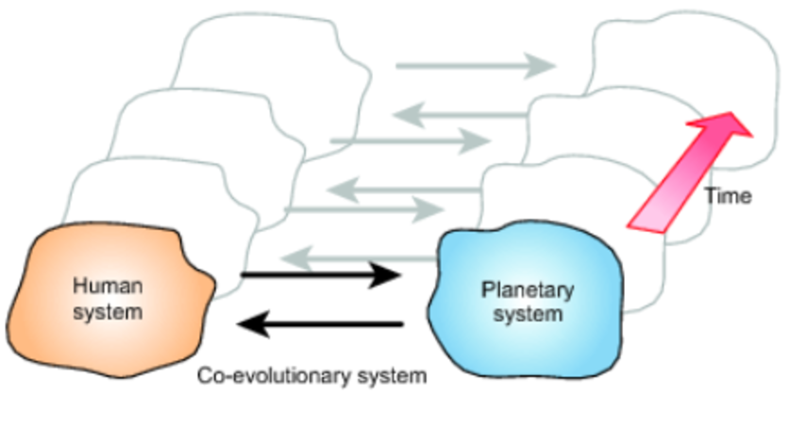
Figure 14 Coupled system
View description - Figure 14 Coupled system

The graphic shown here implies that the range of possible connections which constitute human–environment relations are more varied and far-reaching than the linear, one-way impact an economic model might suggest. In other words, organisations are not just connected to their natural environment in a linear model. Organisations are also a product of and linked to the other organisations they engage with and the social and economic systems in which they operate – even if the social systems span several continents for some organisations. All these are part of the organisation’s environment in a systems sense – a perspective which offers a more innovative way of understanding connections.
In many respects, an organisation is a product of one or more societies and so the organisation can be located within a coupled socio-ecological system spanning several societies and environmental zones. Thus, the boundary of the coupled system can be expanded from an individual organisation and its natural environment to a range of organisations interacting with each other within a wider natural environment and also across different societies.
The implications for our understanding of organisations and their connections to the environment are significant and represent a major innovation in thought. Rather than just a focus on linear impacts from the organisation to its natural environment, it demands a more dynamic conceptualisation of the relationships between an organisation and its environment in a systems sense, including the society in which it operates and its environmental context.

Conclusion
This course should have prompted some reflections on your thinking and ideas about organisations, environmental management and innovation. Perhaps most importantly, you should have had an opportunity to further your understanding of why innovation is seen as key to environmental management, and to develop a critical view of the terms innovation and eco-innovation. This will help you begin to assess a range of environmental claims that an organisation may make concerning its operations and practices. This is not to say those claims are invalid, but you need to be aware of how innovation is being used – as well as when and why – in relation to environmental management.
As you have seen, innovation can be defined as incremental, disruptive and radical. The emphasis on eco-innovation, to signify the environmental aspects of a particular innovation, has also prompted thinking about the scale of the innovation from component to subsystem to system level, eventually leading to transformation of the system – expressed as, for example, more sustainable cities, societies or economies. You’ve also begun to explore that what is considered ‘innovative’ is dependent on who is making the judgement, from what perspective, over what timescale and at what point in time. In other words, innovation is a relative term. Yesterday’s innovation may be today’s environmental disaster. An innovation adopted by an organisation today might be commonplace for another organisation that has been benefiting from it for several years. But above all, innovation is dependent on one’s perspective.
This course has also given you the opportunity to explore innovative ways of thinking about connections between organisations, environmental management and innovation. While notions of impacts are important, attempts such as ecosystem services and notions of the circular economy are trying to explore system-level understanding of connections. Equally the idea of a coupled system offers a more innovative and dynamic way of conceptualising the inter-connected aspects of human–environment relations.

References
Ackoff, R. L. (2004) ‘Transforming the systems movement’, Third International Conference on Systems Thinking in Management, Philadelphia, PA, 26 May 2004. University of Pennsylvania [Online]. Available at http://www.acasa.upenn.edu/RLAConfPaper.pdf (Accessed 12 June 2014).
ANAO (2012) Public Sector Environmental Management: Reducing the Environmental Impacts of Public Sector Operations, Canberra, Australia, Australian National Audit Office [Online]. Available at http://nla.gov.au/tarkine//nla.obj-494729180/pdf (Accessed 30 June 2018).
Baker, J., Sheate, W. R., Phillips, P. and Eales, R. (2013) ‘Ecosystem services in environmental assessment – Help or hindrance?’, Environmental Impact Assessment Review, vol. 40, pp. 3–13.
DEFRA (2007) An Introductory Guide to Valuing Ecosystem Services, London, UK, Department for Environment, Food and Rural Affairs [Online]. Available at https://www.gov.uk/government/uploads/system/uploads/attachment_data/file/221092/pb12852-eco-valuing.pdf (Accessed 30 June 2014).
EC (2009) Report from the Commission to the Council, the European Parliament, the European Economic and Social Committee and the Committee of the Regions on the Application and Effectiveness of the EIA Directive (Directive 85/337/EEC, as amended by Directives 97/11/EC and 2003/35/EC), Brussels, Belgium, European Commission [Online]. Available at http://eur-lex.europa.eu/legal-content/EN/ALL/?uri=CELEX:52009DC0378 (Accessed 30 June 2014).
EC (2011) Communication from the Commission to the European Parliament, the Council, the European Economic and Social Committee and the Committee of the Regions: Innovation for a Sustainable Future – The Eco-innovation Action Plan (Eco-AP), Brussels, Belgium, European Commission [Online]. Available at http://eur-lex.europa.eu/legal-content/EN/TXT/?uri=CELEX:52011DC0899&qid=1403881508166 (Accessed 12 June 2014).
EC (2012) The Development and Diffusion of Environmental Technologies: Technology Transfer, Knowledge Flows and International Cooperation, Brussels, Belgium, European Commission [Online]. Available at http://ec.europa.eu/environment/ecoap/pdfs/final-executive-summary-final-report-idea-consult-env_tech-transfe-13-11-2012_en.pdf (Accessed 12 June 2014).
EC (2012) Proposal for a Directive of the European Parliament and of the Council Amending Directive 2011/92/EU on the Assessment of the Effects of Certain Public and Private Projects on the Environment, Brussels, Belgium, European Commission [Online]. Available at http://eur-lex.europa.eu/legal-content/EN/ALL/?uri=CELEX:52012PC0628 (Accessed 12 June 2014)
EC (2014) Review of the Environmental Impact Assessment (EIA) Directive, Brussels, Belgium, European Commission [Online]. Available at http://ec.europa.eu/environment/eia/review.htm (Accessed 6 Feb 2018).
EIO (2010) Methodological report, Eco-Innovation Observatory, European Commission [Online]. Available at http://www.eco-innovation.eu/media/Methodological_Report_2010.pdf (Accessed 12 June 2014).
EIO (2011) Introducing Eco-innovation: From Incremental Changes to Systemic Transformations, Eco-Innovation Observatory, European Commission [Online]. Available at http://www.eco-innovation.eu/index.php/reports/eco-innovation-briefs?download=1:eio-brief-01 (Accessed 12 June 2014).
EIO (2013) Europe in Transition: Paving the Way to a Green Economy through Eco-innovation, Eco-Innovation Observatory, European Commission [Online]. Available at http://www.eco-innovation.eu/images/stories/Reports/EIO_Annual_Report_2012.pdf (Accessed 12 June 2014).
EMF (2014) Towards the Circular Economy: Accelerating the scale-up across global supply chains, Ellen MacArthur Foundation [Online]. Available at https://www.ellenmacarthurfoundation.org/assets/downloads/publications/Towards-the-circular-economy-volume-3.pdf (Accessed 17 July 2014).
IAIA (2009) What is Impact Assessment?, Fargo, ND, International Association for Impact Assessment [Online]. Available at http://www.iaia.org/publicdocuments/special-publications/What%20is%20IA_web.pdf (Accessed 30 June 2014).
Kiernan, M. (2012) ‘Why investors don’t care about corporations’ environmental performance’, GreenBiz.com, 12 November [Online]. Available at http://www.greenbiz.com/blog/2012/11/12/investors-corporations-environmental-performance (Accessed 30 June 2014).
Levitt, T. (1963) ‘Creativity is not enough’, Harvard Business Review, vol. 41, no. 3, pp. 72–83.
Lim, S. R., Kang, D., Ogunseitan, O. A. and Schoenung, J. M. (2013) ‘Potential environmental impacts from the metals in incandescent, compact fluorescent lamp (CFL), and light-emitting diode (LED) bulbs’, Environmental Science & Technology, vol. 47, no. 2, pp. 1040–7 [Online]. Available at http://dx.doi.org/10.1021/es302886m (Accessed 12 June 2014).
McDermott, B. and Sexton, G. (2004) Leading Innovation: Creating Workplaces where People Excel so Organisations Thrive, Herentals, Belgium, Nova Vista Publishing.
McSmith, A. (2006) ‘A bright idea: How changing light bulbs helps beat global warming (and cut bills)’, The Independent, 3 July [Online]. Available at http://www.independent.co.uk/environment/a-bright-idea-how-changing-light-bulbs-helps-beat-global-warming-and-cut-bills-406494.html (Accessed 12 June 2014).
OECD (2012) The Future of Eco-innovation: The Role of Business Models in Green Transformation, Copenhagen, Denmark, Organisation for Economic Co-operation and Development/European Commission/Nordic Innovation Joint Workshop [Online]. Available at http://www.oecd.org/sti/inno/49537036.pdf (Accessed 12 June 2014).
OED (2014) Oxford English Dictionary [Online]. Available at http://www.oed.com/ (Accessed 26 June 2014).
Reid, A. and Miedzinski, M. (2008) Eco-innovation: Final Report for Sectoral Innovation Watch, Brussels, Belgium, Technopolis Group [Online]. Available at http://www.casi2020.eu/app/web1/files/download/eco-innovation.pdf (Accessed 12 June 2014).
Robertson, M. (2012) ‘Measurement and alienation: making a world of ecosystem services’, Transactions of the Institute of British Geographers, vol. 37, no. 3, pp. 386–401 [Online]. Available at http://dx.doi.org/10.1111/j.1475-5661.2011.00476.x (Accessed 17 July 2014).
Rogers, E. M. (1962) Diffusion of Innovations, New York, NY, Free Press of Glencoe.
Sawyer, R. K. (2012) Explaining Creativity: The Science of Human Innovation, 2nd edn, Oxford, UK, Oxford University Press.
Schaltegger, S., Lüdeke-Freund, F. and Hansen, E. G. (2011) Business Cases for Sustainability and the Role of Business Model Innovation: Developing a Conceptual Framework, Lüneburg, Germany, Centre for Sustainability Management, Leuphana Universität Lüneburg [Online]. Available at http://www2.leuphana.de/umanagement/csm/content/nama/downloads/download_publikationen/Schaltegger_Luedeke_Freund_Hansen_Business_Case_Sustainability.pdf (Accessed 12 June 2014).
Schröter, M., van der Zanden, E. H., van Oudenhoven, A. P., Remme, R. P., Serna-Chavez, H. M., de Groot, R. S. and Opdam, P. (2014) ‘Ecosystem services as a contested concept: a synthesis of critique and counter-arguments’, Conservation Letters, 17 February [Online]. Available at http://dx.doi.org/10.1111/conl.12091 (Accessed 17 July 2014).
Senge, P. M., Smith, B., Kruschwitz, N., Laur, J. and Schley, S. (2008) The Necessary Revolution, New York, NY, Doubleday.
TEEB (2013) Natural Capital at Risk: The Top 100 Externalities of Business, TEEB for Business Coalition and Trucost [Online]. Available at http://naturalcapitalcoalition.org/wp-content/uploads/2016/07/Trucost-Nat-Cap-at-Risk-Final-Report-web.pdf (Accessed 30 June 2014).
UNU (2007) Environmental Impact Assessment: Course Module, United Nations University [Online]. Available at http://eia.unu.edu/course/index.html%3Fpage_id=173.html (Accessed 30 June 2014).
Usborne, R. (2012) ‘The moment it all went wrong for Kodak’, The Independent, 20 January [Online]. Available at https://www.independent.co.uk/news/business/analysis-and-features/the-moment-it-all-went-wrong-for-kodak-6292212.html (Accessed 3 July 2018).
Vasiľová, M. and Drábik, P. (2013) ‘Eco-innovation and sustainable business models’, Current Challenges of Marketing and their Application in Practice (Proceedings of). Ekonomická Univerzita, Bratislava, Slovakia, pp. 147–53 [Online]. Available at http://www.academia.edu/3814140/Eco-innovation_and_Sustainable_Business_Models (Accessed 12 June 2014).
West, M. A. and Altink, W. M. M. (1996) ‘Innovation at work: Individual, group, organizational, and socio-historical perspectives’, European Journal of Work and Organizational Psychology, vol. 5, no. 1, pp. 3–11 [Online]. Available at http://doi.org/10.1080/13594329608414834 (Accessed 12 September 2014).
Whisnant, R. (2013) ‘Wanted: truly innovative sustainable business models’, The Guardian, 2 September [Online]. Available at https://www.theguardian.com/sustainable-business/innovative-sustainable-business-models (Accessed 3 July 2018).
Yusuf, S. (2009) ‘From creativity to innovation’, Technology in Society, vol. 31, no. 1, pp. 1–8 [Online]. Available at http://doi.org/10.1016/j.techsoc.2008.10.007 (Accessed 12 September 2014).

Acknowledgements
This course was written by Kevin Collins and Andy Lane.
Except for third party materials and otherwise stated in the acknowledgements section, this content is made available under a Creative Commons Attribution-NonCommercial-ShareAlike 4.0 Licence.
The material acknowledged below is Proprietary and used under licence (not subject to Creative Commons Licence). Grateful acknowledgement is made to the following sources for permission to reproduce material in this course:

Text
Reading 1 McDermott, B. and Sexton, G. (2004) Leading Innovation: Creating Workplaces where People Excel so Organisations Thrive, Herentals, Belgium, Nova Vista Publishing.
Reading 2 McSmith, A. (2006) ‘A bright idea: How changing light bulbs helps beat global warming (and cut bills)’, The Independent, 3 July [Online]. Available at http://www.independent.co.uk/environment/a-bright-idea-how-changing-light-bulbs-helps-beat-global-warming-and-cut-bills-406494.html (Accessed 12 June 2014)
Reading 3 EIO (2011) Introducing Eco-innovation: From Incremental Changes to Systemic Transformations, Eco-Innovation Observatory, European Commission [Online]. Available at http://www.eco-innovation.eu/index.php/reports/eco-innovation-briefs?download=1:eio-brief-01 (Accessed 12 June 2014).
Reading 4 OECD (2012) The Future of Eco-innovation: The Role of Business Models in Green Transformation, Copenhagen, Denmark, Organisation for Economic Co-operation and Development/European Commission/Nordic Innovation Joint Workshop [Online]. Available at http://www.oecd.org/sti/inno/49537036.pdf (Accessed 12 June 2014).
Reading 5 EIO (2013) Europe in Transition: Paving the Way to a Green Economy through Eco-innovation, Eco-Innovation Observatory, European Commission [Online]. Available at http://www.eco-innovation.eu/images/stories/Reports/EIO_Annual_Report_2012.pdf (Accessed 12 June 2014).
Reading 6 Kiernan, M. (2012) ‘Why investors don’t care about corporations’ environmental performance’, GreenBiz.com, 12 November [Online]. Available at http://www.greenbiz.com/blog/2012/11/12/investors-corporations-environmental-performance (Accessed 30 June 2014).
Reading 7 TEEB (2013) Natural Capital at Risk: The Top 100 Externalities of Business, TEEB for Business Coalition and Trucost [Online]. Available at http://naturalcapitalcoalition.org/wp-content/uploads/2016/07/Trucost-Nat-Cap-at-Risk-Final-Report-web.pdf (Accessed 30 June 2014).
Reading 8 Baker, J., Sheate, W. R., Phillips, P. and Eales, R. (2013) ‘Ecosystem services in environmental assessment – Help or hindrance?’, Environmental Impact Assessment Review, vol. 40, pp. 3–13.
Reading 9 EMF (2014) Towards the Circular Economy: Accelerating the scale-up across global supply chains, Ellen MacArthur Foundation [Online]. Available at https://www.ellenmacarthurfoundation.org/assets/downloads/publications/Towards-the-circular-economy-volume-3.pdf (Accessed 17 July 2014).

Images
Course image © Picography / pixabay
Figure 1 (top left) © Steve Mann / www123rf.com
Figure 1 (top right) © Alvesgaspar / http://en.wikipedia.org/ wiki/ File:London_Parliament_2007-1.jpg. This file is licensed under the Creative Commons Attribution-Share Alike Licence http://creativecommons.org/ licenses/ by-sa/ 3.0/
Figure 1 (bottom left) © Bernhard Classen / Alamy
Figure 1 (bottom right) © Fabrice Coffrin / Getty Images
Figure 2 © The Open University
Figure 3 © Chuck Coker. Covered under Creative Commons Licence. https://creativecommons.org/licenses/by-nd/2.0/
Figure 4 © Richard Packwood / Getty Images
Figure 5 © The Open University
Figure 6 © European Union, 1995-2014
Figure 7 © The Open University
Figure 8 © European Union, 1995-2014
Figure 9 © European Union, 1995-2014
Figure 10 © The Open University
Figure 11 © Commonwealth of Australia 2014
Figure 12 © The Open University
Figure 13 © Main stages of the EIA process United Nations University. This file is licensed under the Creative Commons Attribution-Noncommercial-ShareAlike Licence http://creativecommons.org/ licenses/ by-sa/ 3.0/
Figure 14 © The Open University
Every effort has been made to contact copyright owners. If any have been inadvertently overlooked, the publishers will be pleased to make the necessary arrangements at the first opportunity.
Don't miss out:
If reading this text has inspired you to learn more, you may be interested in joining the millions of people who discover our free learning resources and qualifications by visiting The Open University – www.open.edu/openlearn/free-courses.

Activity 1 Defining ‘organisation’

Discussion
I’m thinking of my employer, my family, the group of people I play sport with, a retail store and my bank. They are all quite different. But the word ‘organisation’ suggests some structure and ordering which implies there is a purpose to the ordering – it is organised in a way to achieve something. These examples of organisations all have more than one person involved. Each person within the organisation might have slightly different roles or are performing the same role at different times. This suggests that structure, purpose and people are an important part of defining an organisation. Equally, perhaps it shouldn't be assumed that an organisation has to be human-centred. Do non-human organisations also exist? The collective nouns for many animals are suggestive of some sense of loose organisation: a pride of lions, a school of dolphins or a swarm of bees. Are these also organisations?
Back to Session 1 Activity 1

Activity 2 Purpose

Discussion
My employer’s stated purpose is to provide students with learning opportunities; my family’s purpose is to provide a support and learning structure for those in it; the sports group’s purpose could be to engage in a mix of socialising and exercise; the retail store’s and bank’s purpose could be defined as profit-orientated through provision of goods and services.
Back to Session 1 Activity 2

Activity 3 Systems map of purpose

Discussion

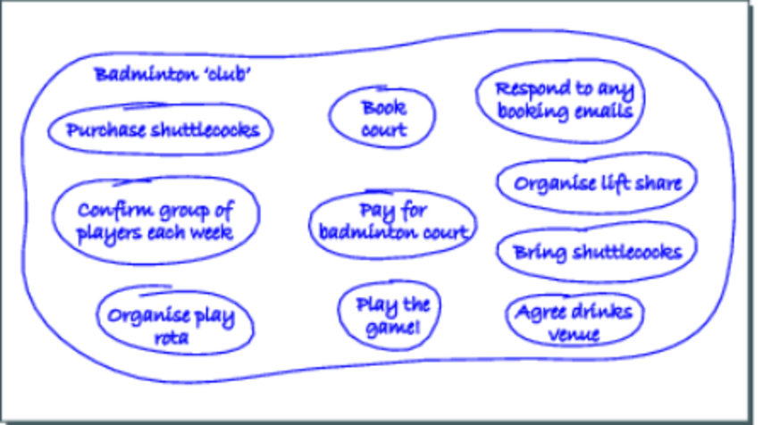
Figure 2
View description - Figure 2

I’ve chosen the informal badminton club I belong to. It is less of a club, more of an informal group of friends. The main purpose is to play badminton for enjoyment and socialising. My systems map shows the main activities associated with this purpose. Not everyone does all of the activities all of the time, but they are necessary to enable the organisation to function.
Back to Session 1 Activity 3

Activity 4 Considering the perspectives of others

Discussion
My systems map is quite focused on the practicalities of the badminton aspects. My fellow players might develop the socialising aspects more – perhaps by adding in food as well as drinks to the post-game activities and choosing a venue where we are able to discuss topics of the day. Exercising might also play a more prominent role for some as well as improving their badminton skills. I’m pretty sure that our various partners might consider the weekly badminton session as a way to meet up with friends and go for a drink afterwards rather than being focused on badminton.
Back to Session 1 Activity 4

Activity 5 Innovation in organisations

Discussion
My chosen organisation is a local restaurant. I think it is innovative in the way it allows customers to book a table online and also provides menus online, often along with special offers and discounts. This makes it easier for me to decide if I want to eat there and might just persuade me to book a table. It is also trying to innovate in terms of sourcing local ingredients and supporting local suppliers.
The hallmark of these innovations is that it is trying to redefine what it is that a restaurant does by offering the customer ease of use and supporting the local economy. It has to be said that neither of these are particularly innovative in themselves (many restaurants offer this), but it is new to this restaurant and its customers.
Back to Session 1 Activity 5

Activity 6 Where and when?

Discussion
The innovations in the restaurant occur in different parts of the organisation. The related innovations are ‘located’ in the kitchen and among the chef and cooking staff. There may also be some input from the owners and senior managers. Innovations in the ICT system could be ‘located’ in the management team and also any external organisations managing the web-based booking systems and external advertising. Another locus of innovation could, of course, be the restaurant’s customer base.
Back to Session 1 Activity 6

Activity 7 Four myths of innovation

Discussion
- Technology is innovation. The authors argue that technology is the product or outcome of innovation by people, rather than the innovation itself.
- Innovation is for artists and ‘eccentrics’. Innovation is now a central concern for many organisations who are seeking to help their employees, at many different levels, develop new ideas and practices.
- All organisations encourage innovation among their staff. Despite beliefs and commitments to the contrary, many organisations fail to engage with their staff to utilise creativity and develop innovations.
- Innovation is a passing fad. Rather than being a practice or thing that can be used and discarded as needed, the authors suggest that innovation is a way of being and a mindset. This requires ongoing and significant commitment to enable innovation in all aspects of the organisation.
Back to Session 1 Activity 7

Activity 8 Incremental, disruptive or radical?

Discussion
The technology for the engine is not new, in that electric engines have been in existence for decades. But it may be significantly improved, perhaps by enhancing the longevity of the battery and range of the car. In which case, it might be categorised as disruptive because it marks a shift away from traditional and even hybrid (petrol/electric) cars. But it is still a car. And while the engine system may reduce emissions at the point of use, it still requires materials for manufacturing and energy for use, requires roads to be built and maintained, and whatever engine technology is used contributes to traffic congestion problems – perhaps leading to more emissions from non-electric cars. In which case, the wholly electric car itself might be considered incremental innovation – it is just an ‘improvement’ on the existing model of private, car-based transport.
Back to Session 1 Activity 8

Activity 9 Benefits and disbenefits

Discussion
Some of the benefits noted include:
- improved performance and longevity
- reduces CO₂ production
- uses existing, readily available technologies
- saves money (approximately £1,300bn)
- avoids need for additional air conditioning.
Some of the disbenefits noted include:
- higher installations costs, especially in the short term
- high and potentially hazardous levels of some metals
- materials have a greater environmental impact.
It is hard to disagree that energy-saving light bulbs are an innovation – at least in the technology and some aspects of performance. But a wider perspective does raise some serious doubts as to their overall classification as an innovation.
On the one hand, it is not an innovation to increase possible exposure to and use of hazardous metals; however, reducing CO₂ emissions is welcome. On balance, perhaps it is a partial innovation, but it is good to remain sceptical rather than accept any claims uncritically.
Back to Session 1 Activity 9

Activity 10 Eco-innovations – wrong thing right or right thing wrong?

Discussion
Using Ackoff’s ideas, it is possible to conclude that the invention of the car was a major transformation in transport systems. All the subsequent improvements and refinements might justifiably be considered as reformations – perhaps with the exception of electric cars – because they are still within the framing of an oil-based engine. In which case, we could conclude the modern car, however efficient, is more of the same – i.e. doing the wrong thing righter. But cars are also becoming more fuel- and material-efficient. Is the increasing move to more fuel-efficient and electric cars evidence of some transformation?
Back to Session 1 Activity 10

Activity 11 Eco-innovation

Discussion
- Eco-innovation is any innovation in a product, service or process ‘that reduces the use of natural resources and decreases the release of harmful substances across the whole lifecycle’ (EIO, 2011, p. 1). Characteristically, eco-innovation is claimed to result in both economic and environmental benefits.
- The briefing paper suggests that eco-innovation covers all three categories of innovation, but itself only mentions incremental and disruptive – the latter understood as bringing about system level changes. The difference in language is noteworthy.
Back to Session 1 Activity 11

Activity 12 Changes to business models

Discussion
The main concerns about existing business models include:
- propensity for gradual rather than fundamental, radical changes
- aversion to risk and uncertainty
- environmental sustainability rarely part of the core values of business models.
The authors note a range of internal and external barriers to changing business models, including:
- traditional mindsets on business models
- lack of knowledge about sustainability issues
- insufficient understanding of alternative business models
- poor integration of different organisational structures
- lack of skills in research and development
- lack of market ‘pull’
- lack of capital for ‘risky’ investments
- lack of fit with existing organisations
- regulation
- consumer acceptance, awareness and practices.
The main changes to business models considered necessary for eco-innovations to develop include:
- using enabling technologies, especially ICT, to help create systemic changes
- developing alliances with other organisations and stakeholders to enable win–win type opportunities
- moving to open, non-secretive communication with other organisations and stakeholders
- developing a sense of corporate social responsibility
- leadership commitment to implement eco-innovation.
Back to Session 1 Activity 12

Activity 13 System eco-innovation

Discussion
System eco-innovation is defined as a ‘series of connected innovations that improve or create new systems delivering desired functions while reducing environmental impact’ (EIO, 2013, p. 36).
As set out in the accompanying text, notably, this definition refers to the whole system rather than a focus on its individual components or elements.
The main points discussed in this section include the following:
- Use of systems concepts and linking these to system level eco-innovation.
- Applicability of the notion to a range of systems of different scales.
- System eco-innovation can vary from system level adaptation to a more radical transformative system innovation, based on scope of the innovation and degree of implemented change. System innovation occurs at subsystem and system level, but can be incremental and lead to adaptation of an existing system. Conversely, transformative system eco-innovation results from more radical redesign of existing systems resulting in a transformative change in the process, product, service or idea.
- System eco-innovation is challenging and focuses on identifying the root causes of systemic problems to enable shifts to more sustainable forms.
- Individual elements of innovation, while important, are unlikely to be taken up unless considered as part of the wider system.
- System eco-innovation sees barriers to eco-innovation as part of the system and aims to address these as part of the innovation process.
Back to Session 1 Activity 13

Activity 14 Drivers of eco-innovation

Discussion
It's likely that most of the drivers to eco-innovation will be centred on cost reduction and maximising profit. While it is reasonably convincing that the individuals and management team are keen to be as ‘green’ as possible, without a convincing economic and/or management rationale it is unlikely to be adopted. If it can be green and improve the bottom line or improve organisational practices then it is likely to be accepted.
Back to Session 1 Activity 14

Activity 15 Barriers and obstacles to eco-innovation

Discussion
Some possible barriers to introducing eco-innovations in the restaurant are likely to include:
- costs and availability of funds to pay for the eco-innovation up front
- uncertainty of effectiveness
- uncertainty over payback time
- staff resistance (will it make their lives easier?)
- customer experience.
The latter is an important consideration. For example, paying for new energy-efficient hand-dryers and light bulbs in the restaurant toilets will ‘backfire’ if the hand-dryers don’t actually dry within a given time and the lights make the toilet areas look ‘dingy’. The restaurant would surely want to avoid customer complaints.
Back to Session 1 Activity 15

Activity 16 Barriers to eco-innovation uptake

Discussion
Figure 8 shows that lack of funds within the organisation, uncertainty regarding the market and payback times and lack of external funding, subsidies and incentives are all key barriers.
Back to Session 1 Activity 16

Activity 17 Accelerating eco-innovation

Discussion
Focusing on the top five main drivers (those identified as very important) to accelerate eco-innovation, Figure 9 suggests these are related to market share, being a good business partner and, most important of all, a range of drivers related to reducing exposure to costs. Notably, within the ‘somewhat important’ category, the main drivers are existing regulations and standards, access to information, and knowledge and support services, closely followed by expectations of future regulatory standards. Overall, this graph suggests costs and regulatory requirements are key drivers of eco-innovation.
Back to Session 1 Activity 17

Activity 18 Connecting organisations and environment

Discussion

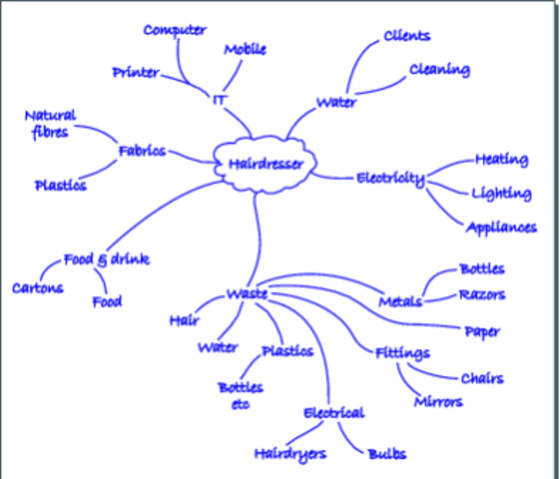
Figure 10 Spray diagram
View description - Figure 10 Spray diagram

My spray diagram is of my hairdressers (or perhaps more precisely, barbers). Water is used for cleaning the shop and for clients; electricity is used for several purposes, including lighting and powering various appliances. Waste is generated in many forms and types, suggesting this could be a significant way in which the hairdressers is connected to the environment. Other connections include food and drink provision for clients and staff, and, of course, ICT equipment including computer and telephones.
Far from being unconnected, the spray diagram shows that this organisation has a wide range of environmental connections.
Back to Session 2 Activity 1

Activity 19 Organisations creating environmental issues

Discussion
As hinted at in the description of the spray diagram, the hairdressers is creating or contributing to environmental issues through energy use, resource use and generation of waste. Some of these are created ‘every day’, i.e. energy and water and some forms of waste. Some are likely to be more intermittent, such as replacing fixtures and fittings or appliances which may happen once every three years or so. The organisation may also be creating issues in terms of the choices it makes – does it buy energy-efficient appliances, for example?
Back to Session 2 Activity 2

Activity 20 Contemporary environmental issues

Discussion
Perhaps the main characteristics centre on the diversity of environmental issues which an organisation may face. My example of a hairdressers reveals a wide range of different environmental connections that the organisation could consider if wishing to improve its environmental performance. Add to this varying geographic scale: does the organisation recognise the connection between the computer it has purchased, the manufacturing plants in China, energy consumed in production and use, and global warming? These multiple connections give rise to multiple stakeholders – who should an organisation consider as being ‘connected’ to its activities? The complexity of interconnections is compounded by uncertainty: is an issue fully understood and is the science and policy clear on appropriate responses? What are the risks of a particular decision path for an organisation? These characteristics are similar to many types of issues, but an organisation’s understanding and skill set to deal with environmental issues is sometimes limited as, until the last 20 years, there has been little ‘precedent’ for dealing with environmental issues in the history of most organisations.
Back to Session 2 Activity 3

Activity 21 Input–output model of an organisation

Discussion

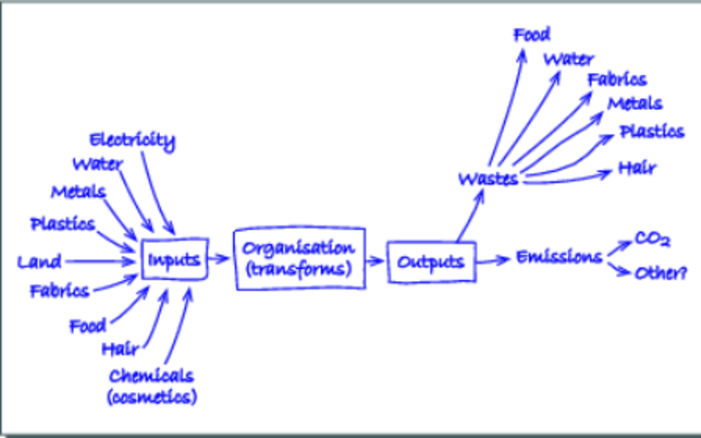
Figure 12 Input–output diagram
View description - Figure 12 Input–output diagram

The diagram is for the hairdresser organisation explored in previous activities. The inputs are relatively straightforward based on the previous activities. It was surprising that the main outputs were a range of wastes and emissions – I expected to be able to identify a wider range of environmental outputs.
In terms of feedback, waste water could be linked back to water and land and food inputs (through various ‘paths’). Metals, plastics and fabrics could be recycled/reused and thus become part of the inputs. CO₂ emissions could be linked back to water and also food and land, but could be connected to other inputs more indirectly.
Back to Session 2 Activity 4

Activity 22 Understanding connections

Discussion
According to the article, an organisation’s environmental connections are often ignored or unseen for two main reasons. First, because the majority of investors do not see a direct connection between environmental performance and financial results. Second, because if a connection is recognised, it is generally regarded as a negative connection – i.e. it will increase costs for the organisation.
The article goes on to explore a disconnect in some organisations that espouse and support environmental causes through various means, but continue to pursue strategies and investments that undermine their environmental aspirations.
Back to Session 2 Activity 5

Activity 23 Ecosystem services

Discussion
A few more examples are provided in the following table:

Table 3 Ecosystem services
Category | Examples of service
Provisioning services  (products obtained from ecosystems) | - foods of all types  - water  - minerals  - chemicals  - energy sources
Regulating services  (benefits obtained from the regulation of ecosystem processes) | - climate regulation  - waste processing  - purification of water and air  - crop pollination  - pest and disease control
Cultural services  (non-material benefits, e.g. aesthetic and well-being, cognitive development, reflection, recreation) | - cultural, intellectual, religious and spiritual inspiration  - recreational experiences (including eco-tourism)  - scientific discovery
Supporting services  (necessary for the production of all other ecosystem services) | - nutrient dispersal  - seed dispersal  - primary production
(Adapted from DEFRA, 2007, p. 11)

Back to Session 2 Activity 6

Activity 24 The TEEB report

Discussion
The main concerns are that the depletion of and damage to ecosystem services are not being included in the pricing systems of organisations and products. Environmental costs are therefore ‘externalised’, particularly where regulation – a way of ensuring organisations take account or internalise environmental costs – is weak. Even where environmental costs are normally externalised, droughts or floods can cause rapid internalisation of costs through increased commodity prices. This can mean many organisations are exposed to environmental risks within their supply chain.
Although there are some modelling issues to consider, the study suggests that the currently unpriced cost of natural capital used (i.e. land use, water consumption, greenhouse gas emissions, air, land and water pollution, and waste) is approximately $7 trillion (at 2009 prices) and could be higher if all parts of the supply sector were included.
Globally, greenhouse gas emissions from coal-fired power stations in East Asia, and cattle ranching and farming in South America, have the greatest environmental impacts accounting for natural capital costs of over $673 billion.
The report suggests that the consumer sector, in particular food and timber processing, as well as leather and hide tanning, are the sectors with supply chains most at risk from volatile environmental costs. This can affect consumers and suppliers in different countries and is prompting some organisations to develop close links with suppliers. The highest impacts are soybean and oil seed processing and animal production.
The report suggests risks to agricultural commodity prices are particularly notable because, overall, costs to natural capital exceeds revenue. However, organisations that seek to align business models with more sustainable use of natural capital in their supply chains should be able to be more competitive because of greater resilience to environmental impacts, reduced costs and improved security of supply.
The main recommendations for companies centre on developing better data on supply chain risks, internalising natural capital costs, improving resource efficiency in supply chains and exploring alternative suppliers. The recommendations for governments centre on understanding how risks to natural capital are distributed in the economy, understanding how natural capital costs could affect global competitiveness and developing policies for internalising costs to the economy.
Back to Session 2 Activity 7

Activity 25 Ecosystem services – help or hindrance?

Discussion
According to the authors, the main strengths of using ecosystem services in environmental assessment are:
- It allows for integration of bundles of services rather than ‘discrete’ environmental topics.
- The environment is described in terms of benefits rather than things that can help in communication and policy-making.
- Ecosystem services may resonate more easily with stakeholders and members of the public.
- The concept can avoid ‘either/or’-type arguments by emphasising environmental and economic benefits.
- Possible impacts of the environment on the plan or project subject to an EIA can also be considered using ecosystem services.
- The value of the environment is made explicit through ecosystem services.
Some weaknesses include:
- The language of ecosystem services may not connect with all stakeholders.
- Ecosystem services is conceptually complex.
- The legal framework of environmental assessment may be undermined by the contested nature of ecosystem services valuation.
- An ecosystem services assessment can be very resource intensive.
- The different plans, programmes or projects and institutional contexts may mean ecosystem services is irrelevant in some cases.
The extent to which ecosystem services represents an innovation is therefore debatable.
On one hand, it does bring the discussion of environment and economics into a single arena and allows new ways of thinking about the environment as a service provider. This leads to a monetary valuation, thereby allowing an environmental assessment to determine environmental costs.
On the other hand, it may just be another conceptual framing that continues the economic model of the environment as a resource and assumes the environment can be valued and costed. In any case, ecosystem services may not be appropriate to the particular context and situation.
Back to Session 2 Activity 8

Activity 26 Circular economy

Discussion
The critique of the linear economy includes:
- a ‘take-make-dispose’ pattern of resource use, leading to increased resource inputs and waste outputs
- increases an organisation’s exposure to risk, especially price volatility and supply disruptions
- manufacturing efficiency gains are largely incremental and do not entail competitive advantage
- unintended and accelerated energy use and resource depletion because of increased efficiencies (an LED light bulb is cheap to run and therefore can be left on longer)
- slow growth in agricultural productivity
- increased risks to globally distributed supply chains
- competition for virgin resources.
By way of contrast, the circular economy aims to be restorative or regenerative (replacing the take-make-dispose model). The report suggests this will be achieved through the ‘superior design of materials, products, systems and business models’ (p. 14) to eliminate waste and shifting towards renewable energy. The main principles of the circular economy are:
- designing out waste (waste does not exist)
- differentiation between the consumable and durable components of a product
- energy to power the circular cycle should be renewable.
The move to a circular economy would require and encourage innovative business models, especially shifting from ownership to performance-based payment methods (i.e. leasing rather than buying) to ensure that products are designed to be re-used and/or disassembled easily.
Back to Session 2 Activity 9

Figure 1 Organisations are all around us

Description
This figure is a series of four photographs depicting a diverse range of organisations. They show a Royal National Lifeboat Institution lifeboat, the UK Houses of Parliament, a Volkswagen car production line, and the logo of the World Health Organisation (showing the French version of its name – Organisation mondiale de la santé).
Back to Session 1 Figure 1

Figure 2

Description
This drawn diagram shows the activities undertaken within a badminton club. The activities are:
- Purchase shuttlecocks
- Confirm group of players each week
- Organise play rota
- Book court
- Pay for badminton court
- Play the game
- Respond to any booking emails
- Organise lift share
- Bring shuttlecocks
- Agree drinks venue
Back to Session 1 Figure 2

Figure 3 Light bulbs – a metaphor for innovation?

Description
This figure is a photograph of a lit light bulb. It is being used as a metaphor for innovation.
Back to Session 1 Figure 3

Figure 4 A flooded river

Description
This figure is a photograph of a river that has flooded. A river is seen to the left of the picture with a flooded street, including a public house, on the right of the picture.
Back to Session 1 Figure 4

Figure 5 S-curve showing incremental and radical innovation

Description
This figure shows two ‘S-curves’ on graphical axes. The vertical axis is labelled ‘Performance/Adoption’ and the horizontal axis is labelled ‘Time/Improvement’. Each S-curve is a line on the graph in the approximate shape of the letter ‘S’ – the line moves horizontally before moving upwards, and then it flattens and tails off.
The first line starts in the bottom left corner of the graph and is labelled ‘Old technology, process or paradigm’. Although the lines do not touch, an area of overlap between the two is shown. This area is labelled ‘Paradigm paralysis?’. The second line is labelled ‘Step change in technology, process or paradigm’.
Back to Session 1 Figure 5

Figure 6 From product improvement to transformative system innovation (adapted from EIO, 2013, p. 37)

Description
This figure shows an ‘innovation matrix’. The matrix is a graph divided into six sections (three vertical by two horizontal). The vertical axis is labelled ‘Scope for change’ and the horizontal axis is labelled ‘Degree of change’.
The top two sections are for changes/innovations that can be described as ‘System level’. The top left box is labelled ‘System adaption’ and the top right box is labelled ‘Transformative system innovation’. The middle two sections are for changes/innovations to ‘Sub systems’. The individual boxes are not labelled. The bottom two sections are for changes/innovations to individual components. The bottom left box is labelled ‘Incremental innovation’ and the bottom right box is labelled ‘Radical change’.
Changes/innovations can be placed anywhere on the matrix, potentially overlapping the matrix sections as required. The changes/innovations and their position in the matrix are as follows:

Innovation/change | Box it is mostly in | Approximate position within box
Sustainable city | Top right (Transformative system innovation) | Right of centre
Sustainable mobility | Top right (Transformative system innovation) / middle right sub system | On horizontal line, right of centre
Industrial symbiosis | Top right (Transformative system innovation) / middle right sub system | On horizontal line, left of centre
Eco-label and eco-vouchers | Middle left sub system | Centre
Product sharing | Middle left sub system / right sub system | On vertical line, left of centre
Value chain optimisation | Middle left sub system / right sub system | On vertical line, left and below of centre
Extended producer’s responsibility | Middle right sub system | Centre
Functional sales | Middle right sub system | Lower left, touching horizontal line
Material efficient manufacturing | Bottom left (Incremental innovation) | Top right, touching horizontal and vertical lines
Process improvement (e.g. EMAS) | Bottom left (Incremental innovation) | Left of centre
Product improvement | Bottom left (Incremental innovation) | Lower left
New products (goods and services) | Bottom right (Radical change) | Right of centre

Back to Session 1 Figure 6

Figure 7 Input–output diagram of innovation drivers

Description
This figure is an input-output diagram. Inputs are:
- Business incentives
- Social pressures
- Legal obligations
The transformation process in the centre of the diagram is ‘Organisational innovation’. Outputs are:
- Incremental innovation
- Disruptive innovation
- Radical innovation
Back to Session 1 Figure 7

Figure 8 Barriers to accelerated eco-innovation uptake and development for companies (DK/NA = don’t know/no answer)

Description
This figure is a bar graph. The information is displayed in the following table. (Note: the figures for ‘don't know/no answer’ were not shown in the original source image and so the numbers are based on our reading of the graph. The exact numbers are less important than their relative proportions when interpreting the data)

 | Very serious | Somewhat serious | Not serious | Not at all serious | Not applicable | DK/NA
Lack of collaboration with research institutes and universities | 13 | 21 | 24 | 19 | 20 | 3
Lack of suitable business partners | 16 | 25 | 26 | 22 | 9 | 2
Limited access to external information and knowledge, including a lack of well-developed technology support services | 16 | 27 | 26 | 19 | 9 | 3
Reducing material use is not an innovation priority | 17 | 27 | 25 | 18 | 9 | 4
Market dominated by established enterprises | 21 | 29 | 23 | 17 | 8 | 2
Lack of qualified personnel and technological capabilities within the enterprise | 23 | 28 | 22 | 20 | 6 | 1
Technical and technological lock-ins (e.g. old technical infrastructures) | 22 | 29 | 20 | 16 | 9 | 4
Reducing energy use is not an innovation priority | 26 | 29 | 21 | 15 | 6 | 3
Lack of external financing | 31 | 26 | 19 | 15 | 8 | 1
Existing regulations and structures no providing incentives to eco-innovate | 25 | 32 | 19 | 13 | 7 | 4
Insufficient access to existing subsidies and fiscal incentives | 30 | 30 | 17 | 12 | 8 | 3
Lack of funds within the enterprise | 36 | 27 | 17 | 14 | 5 | 1
Uncertain return on investment or too long a payback period for eco-innovation | 32 | 32 | 14 | 11 | 8 | 3
Uncertain demand from the market | 34 | 33 | 14 | 11 | 6 | 2

Back to Session 1 Figure 8

Figure 9 Accelerating eco-innovation uptake and development

Description
This figure is a bar graph. The information is displayed in the following table. (Note: the figures for ‘not applicable’ and ‘don't know/no answer’ were not shown in the original source image and so the numbers are based on our reading of the graph. The exact numbers are less important than their relative proportions when interpreting the data)

 | Very important | Somewhat important | Not important | Not at all important | Not applicable | DK/NA
Collaboration with research institutes, agencies and universities | 19 | 30 | 21 | 14 | 15 | 1
Existing regulations, including standards | 30 | 41 | 15 | 7 | 5 | 2
Limited access to materials | 30 | 31 | 19 | 12 | 6 | 2
Expected future regulations imposing new standards | 33 | 38 | 14 | 8 | 4 | 3
Good access to external information and knowledge, including technology support services | 34 | 40 | 14 | 6 | 5 | 1
Expected future material scarcity (as an incentive to develop innovative, less material-intensive substitutes) | 35 | 29 | 16 | 10 | 7 | 3
Increased market demand for green products | 36 | 32 | 15 | 8 | 7 | 2
Technological and management capabilities within the enterprise | 37 | 37 | 14 | 7 | 3 | 2
Access to existing subsidies and fiscal incentives | 40 | 32 | 14 | 7 | 5 | 2
Secure or increase existing market share | 42 | 34 | 12 | 6 | 4 | 2
Good business partners | 45 | 31 | 11 | 8 | 4 | 1
Current high material prices (as an incentive to innovate to use less material and decrease the cost) | 45 | 31 | 11 | 7 | 5 | 1
Current high energy prices (as an incentive to innovative, to use less energy and decrease the cost) | 50 | 29 | 11 | 5 | 4 | 1
Expected future increases in energy prices | 52 | 30 | 9 | 5 | 3 | 1

Back to Session 1 Figure 9

Figure 10 Spray diagram

Description
This figure is a spray diagram. The central element is ‘Hairdresser’. Arranged around this are:
IT:
- Printer
- Computer
- Mobile phones
Water:
- Clients
- Cleaning
Electricity:
- Heating
- Lighting
- Appliances
Waste:
- Hair
- Water
- Plastics
  - Bottles etc.
- Electrical:
  - Hairdryers
  - Bulbs
- Fittings:
  - Chairs
  - Mirrors
- Paper
- Metals:
  - Bottles
  - Razors
- Food and drink:
  - Cartons
  - Food
- Fabrics:
  - Natural fibres
  - Plastics
Back to Session 2 Figure 1

Figure 11 Input and output model of an office-based operation

Description
This figure is an input-output diagram. Inputs are:
- Energy
  - Electricity
  - Gas
  - Diesel
- Raw materials
  - Furniture
  - ICT equipment
  - Paper
- Water
The transformation process is labelled ‘Office-based operations’. This includes four processes:
- Core business processes
- Consumption and user behaviour
- Data centers, vehicle and air travel
- Procurement decisions
The outputs are:
- Greenhouse gas emissions
- Waste materials
  - Paper
  - Recycling
  - Food waste
  - ICT equipment
- Waste water
Back to Session 2 Figure 2

Figure 12 Input–output diagram

Description
This figure is an input–output diagram. Inputs are:
- Electricity
- Water
- Metals
- Plastics
- Land
- Fabrics
- Food
- Hair
- Chemicals (cosmetics)
The transformation process is labelled ‘Organisation (transforms)’.
The outputs are:
- Wastes
  - Food
  - Water
  - Fabrics
  - Metals
  - Plastics
  - Hair
- Emissions
  - Carbon dioxide
  - Other?
Back to Session 2 Figure 3

Figure 13 Main stages of the EIA process

Description
This figure shows the main stages of the EIA process as a flow chart. ‘Proposal identification’ runs to ‘Screening’, which runs to ‘Initial environmental examination’. This splits into two: on the right, ‘No EIA’ required; on the left, ‘EIA required’. ‘EIA required’ runs to ‘Scoping’, which runs to ‘Impact analysis’, which runs to ‘Mitigation and impact management’, which runs to ‘EIA report’, which runs to ‘Review’, which runs to ‘Decision making’. This splits into two: on the right, ‘Approved’, which runs to ‘Implementation and follow up’, which runs to ‘Information from this process contributes to effective future EIA’; on the left, ‘Not approved’, which runs to ‘Redesign’, which runs to ‘Resubmit’.
The diagram also shows that public involvement typically occurs at the ‘Scoping’ and ‘Review’ stages, although it may occur at any other stages in the EIA process.
Back to Session 2 Figure 4

Figure 14 Coupled system

Description
This figure shows an example of a coupled or co-evolutionary system. It depicts the interaction between a ‘Human system’ and a ‘Planetary system’. The interaction is shown to exist through a time dimension.
Back to Session 2 Figure 5

