Entering data into Jamovi

The following data comes from a fictional study investigating whether reading speed is affected by the colour of the paper the words are printed on.

In this study the researched wanted to compare two paper colours: yellow and white. Each participant was asked to read the same passage from either the yellow paper or from the white paper. To measure reading speed the researchers used number of words per minute. But since memory of the passage is also an important criterion for reading performance they also measured performance on remembering ‘facts’ from the read passage.

The data table is given as follows:

Paper | Words | Memory
White | 230 | 10
White | 211 | 3
White | 145 | 14
Yellow | 321 | 0
Yellow | 276 | 7
Yellow | 187 | 12

Using the values in this table add this data to a blank Jamovi data file. You will need to do the following in the order indicated:

- Open Jamovi
- Define the variables in the Variables menu
- Enter the data above in the Data tab.
- To see whether you have done this correctly, compare your file dataset to the screenshots on the following pages.

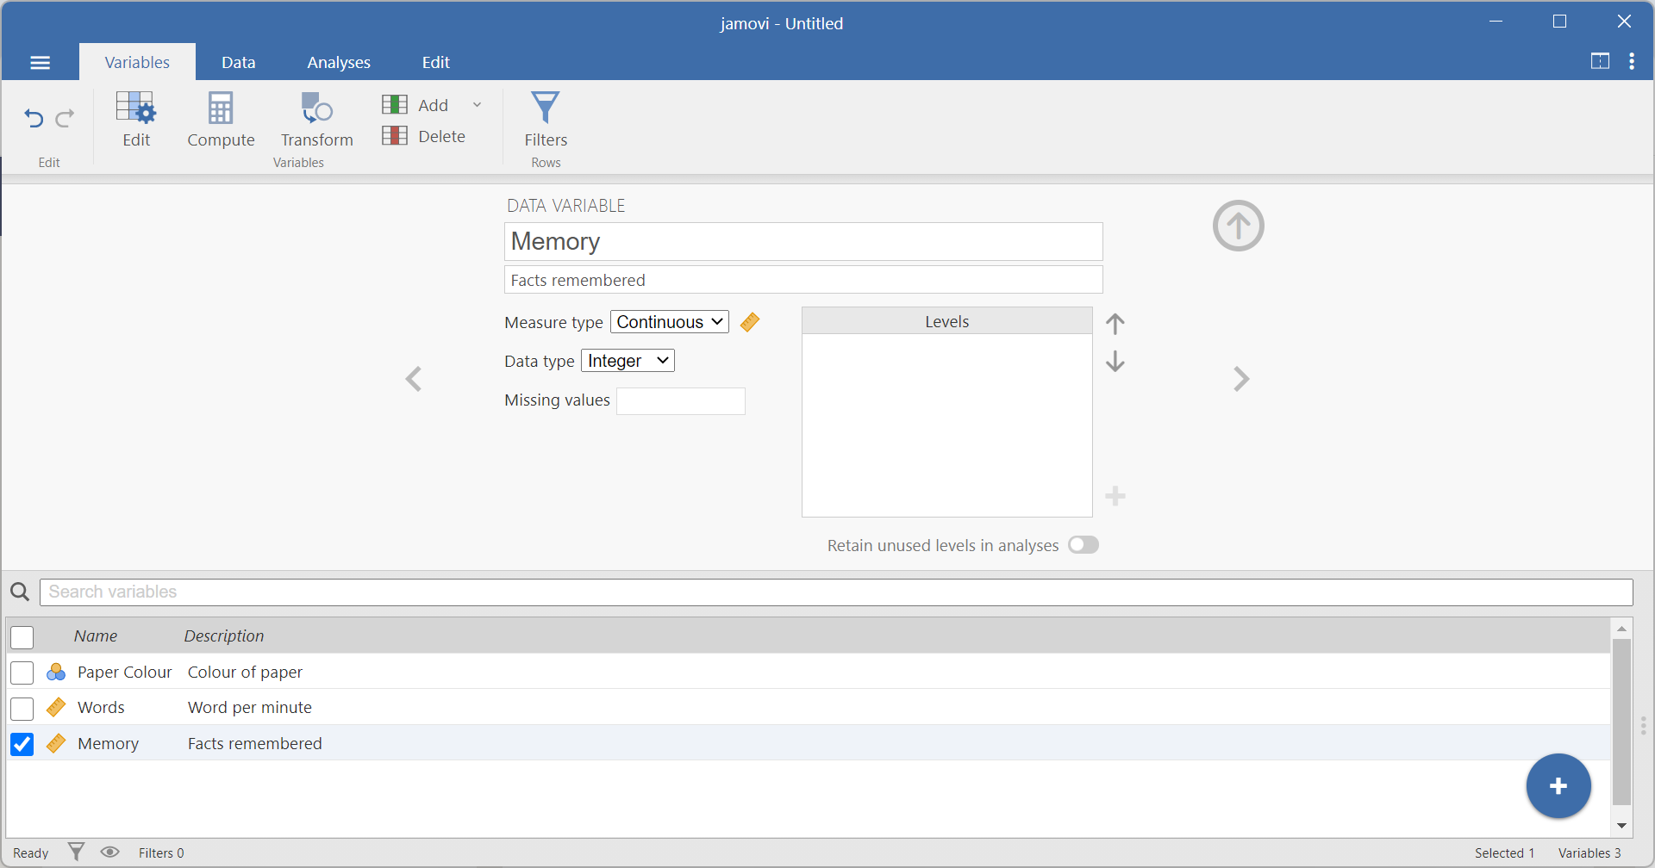

In Variables menu you should have entered 3 variables.
Their names might differ to those in the screen shot, but they should represent:
- Paper Colour, which is nominal, as there are 2 categories: Yellow and White
- Number of Words Read per Minute (or Reading Speed, which is measure type: continuous and data type: integer)
- Number of Words Remembered (which is also measure type: continuous and data type: integer)

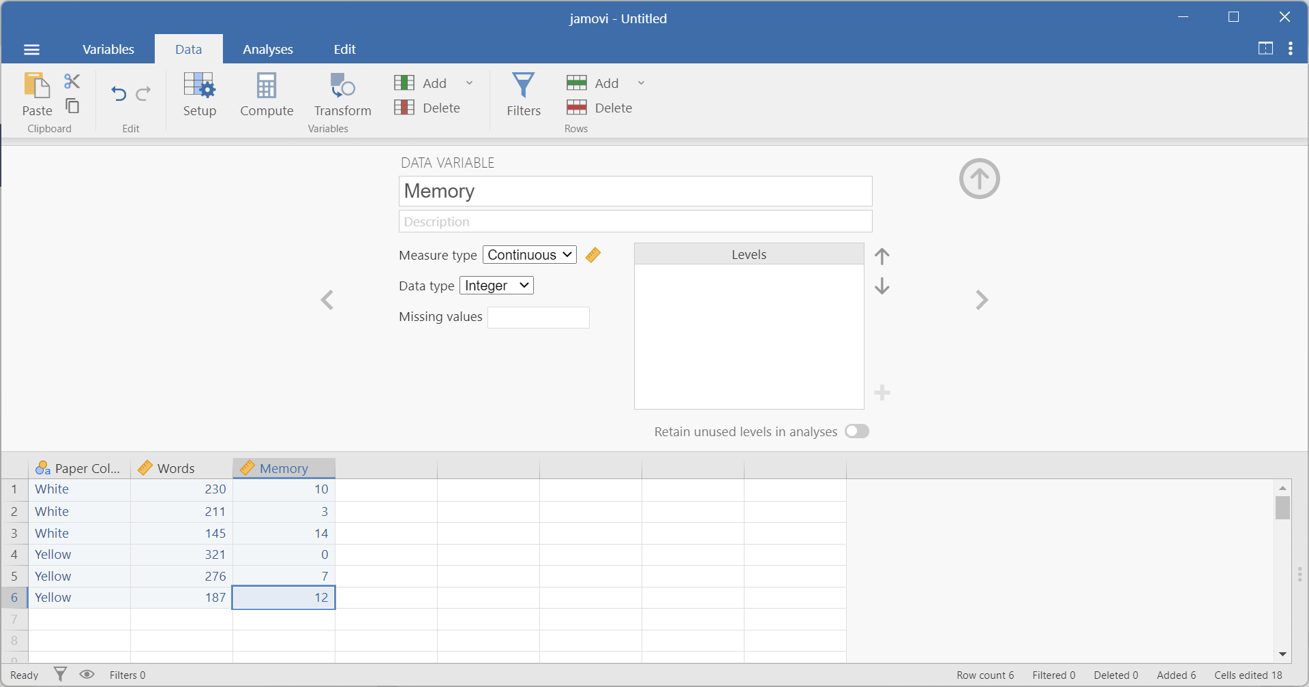

In Data tab, you should have entered the data so that the same information from the same participant is on one row.
The data in the Paper column should be entered using the names of the two conditions.
Numerical scores for the other variables can be entered directly.

