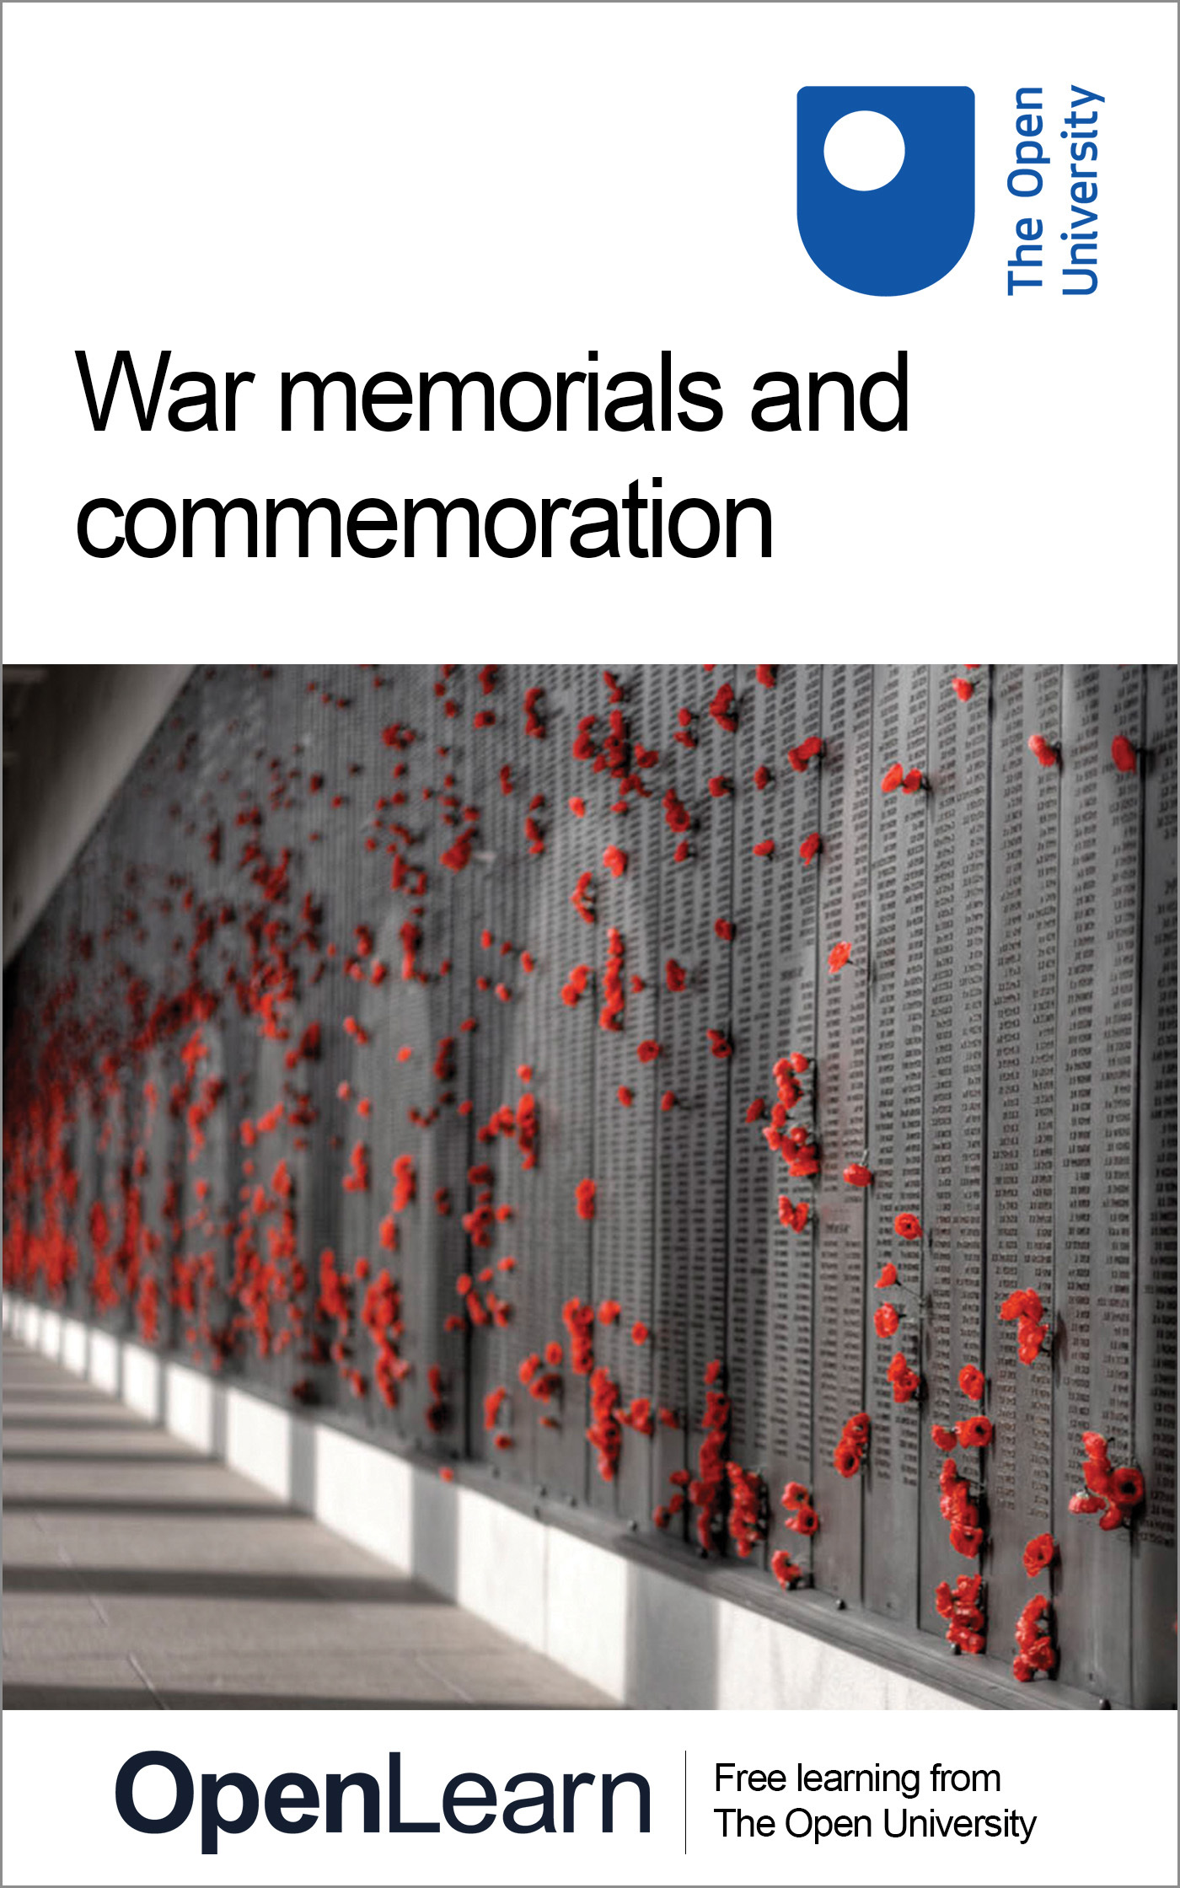

A103_2

War memorials and commemoration
About this free course
This OpenLearn course provides a sample of Level 1 study in Visual Art: www.open.ac.uk/courses/qualifications/q01
This version of the content may include video, images and interactive content that may not be optimised for your device.
You can experience this free course as it was originally designed on OpenLearn, the home of free learning from The Open University – www.open.edu/openlearn/history-the-arts/war-memorials-and-commemoration/content-section-0
There you’ll also be able to track your progress via your activity record, which you can use to demonstrate your learning.
Copyright © 2016 The Open University
Intellectual property
Unless otherwise stated, this resource is released under the terms of the Creative Commons Licence v4.0 http://creativecommons.org/licenses/by-nc-sa/4.0/deed.en_GB. Within that The Open University interprets this licence in the following way: www.open.edu/openlearn/about-openlearn/frequently-asked-questions-on-openlearn. Copyright and rights falling outside the terms of the Creative Commons Licence are retained or controlled by The Open University. Please read the full text before using any of the content.
We believe the primary barrier to accessing high-quality educational experiences is cost, which is why we aim to publish as much free content as possible under an open licence. If it proves difficult to release content under our preferred Creative Commons licence (e.g. because we can’t afford or gain the clearances or find suitable alternatives), we will still release the materials for free under a personal end-user licence.
This is because the learning experience will always be the same high quality offering and that should always be seen as positive – even if at times the licensing is different to Creative Commons.
When using the content you must attribute us (The Open University) (the OU) and any identified author in accordance with the terms of the Creative Commons Licence.
The Acknowledgements section is used to list, amongst other things, third party (Proprietary), licensed content which is not subject to Creative Commons licensing. Proprietary content must be used (retained) intact and in context to the content at all times.
The Acknowledgements section is also used to bring to your attention any other Special Restrictions which may apply to the content. For example there may be times when the Creative Commons Non-Commercial Sharealike licence does not apply to any of the content even if owned by us (The Open University). In these instances, unless stated otherwise, the content may be used for personal and non-commercial use.
We have also identified as Proprietary other material included in the content which is not subject to Creative Commons Licence. These are OU logos, trading names and may extend to certain photographic and video images and sound recordings and any other material as may be brought to your attention.
Unauthorised use of any of the content may constitute a breach of the terms and conditions and/or intellectual property laws.
We reserve the right to alter, amend or bring to an end any terms and conditions provided here without notice.
All rights falling outside the terms of the Creative Commons licence are retained or controlled by The Open University.
Head of Intellectual Property, The Open University
978-1-4730-1396-4 (.kdl)
978-1-4730-0628-7 (.epub)

Contents
- Introduction
- Learning outcomes
- 1 War memorial and commemoration
- 2 The need to commemorate
- 3 Location of a war memorial
  - 3.1 Introduction
  - 3.2 Public or private memorial?
- 4 Form of memorial
- 5 Function of a memorial
- 6 Personal response to a memorial
- 7 Matching form and purpose
- 8 Conclusion
- Keep on learning
- References
- Acknowledgements

Introduction
This course gives you the opportunity to practise good study techniques using the theme of commemoration and memorials. It will help you to begin to think about how form influences meaning in the arts and how ideas influence approaches to the humanities.
This OpenLearn course provides a sample of Level 1 study in Visual Art

Learning outcomes
After studying this course, you should be able to:
- demonstrate an awareness of the processes of study in the arts and humanities
- understand key concepts in the arts and humanities.

1 War memorial and commemoration
In this course you will have an opportunity to practise good study techniques using a framework within which to use them. Obviously, since you are shortly to begin your study of a range of disciplines, it will make sense to use a framework, or theme, that is relevant to the arts as a whole. The theme we have selected is that of commemoration and memorials.
Studying this course will give you the experience of looking at, and thinking about, ideas that form the study of the humanities. At points in the text we have indicated words in bold which we think you need to take particular care to understand.
Arts Good Study Guide, Chapter 6: Processes of study in the arts and humanities

Exercise 1

At this point, read Chapter 6, ‘Processes of study in the arts and humanities’, in The Arts Good Study Guide.

View discussion - Exercise 1

2 The need to commemorate
The subject of memorial is a good one. People often have a powerful need to commemorate those who have died. They may have lost someone close to them, or they may be thinking about loss of life in disaster, or war. You may well recognise that feeling. Such memorials take different forms, from flowers left at a particular spot, to public triumphal arches and works of art dedicated to the memory of specific individuals. But to begin, we want to focus on a particular form of remembrance – war memorials.
I would like you first of all to look at Illustration A. I don't think that you will have difficulty in deciding what Illustration A is – a war memorial. Please stop at this point and answer the question in Exercise 2.

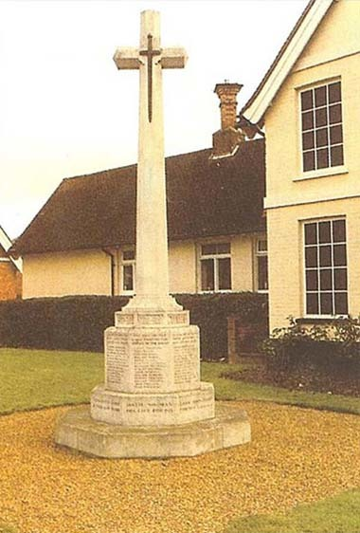
Illustration A Woburn, Bedfordshire, Mike Levers/The Open University

Exercise 2

Is there a war memorial in your locality? Do you know where it is?

View discussion - Exercise 2

3 Location of a war memorial

3.1 Introduction
Let us take up the question of the location of the war memorial. I am going to give you a list of places in which I would expect you to find your war memorial:

local parish church | local parish churchyard
centre of your town or village | village green
local park or garden | school or college

You may well be able to add to that list. Illustration A shows a war memorial set in an open space and surrounded by gravel, in Woburn, Bedfordshire.
Is its location important, do you think? What about the location of ‘your’ memorial? Let us explore this.

Exercise 3

What reasons can you think of for your war memorial being sited where it is?

View discussion - Exercise 3

3.2 Public or private memorial?
The choice of location has wider implications, too. If the chosen site is in a public place, such as a park or village green in public ownership, then the building is accessible to all. No specific interest controls it (though of course there may be special arrangements made for its upkeep) and no particular individual owns it.
On the other hand, if a memorial is created by a family in memory of an individual, then the location of the memorial reflects that gift. Such memorials are often found in a church where the family worship, and in that way the church is linked to the family, and the family to the church. Churchyards, and churches themselves, often contain memorials for the use of the whole parish, with their location signifying a specific connection to that church, community, and a particular faith.
So, already in thinking about the location of a war memorial, we are beginning to raise questions about its positioning, and who controls decisions about its design and its setting. You may already be realising that the siting of a war memorial may hold more implications than originally thought. Let's spend a few moments thinking even more widely, beyond the particular memorial you have identified.
There are memorials to the dead in every country that participated in either or both of the two World Wars, and in practically every village, town and city. That was why I was so certain that you would have a memorial in your vicinity. War memorials are probably the most numerous of all public monuments, and certainly the most widespread. There are war memorials in every major city of the United Kingdom, and in the countries of continental Europe that were affected by those two wars.
However, although – as we shall see – the period immediately after the First World War produced the majority of these memorials, memorials to war, and battle, were often erected in the past. In addition, they have common properties: they are placed where people can see them and expect to have access to them, whether the site is within a church, on the top of a hill, or in the centre of a town.
If you live in the UK, you may have thought of the location of the Cenotaph in London, close to Parliament and the offices of government, which is the national monument for the UK. You might also think of the locations in Paris, Washington, Berlin, Canberra, Cardiff, Brussels – and so on. You might possibly have taken a photograph of one that you felt to be particularly striking, or had personal associations. All in all, I want to make the point that there are many examples of memorials to those who died in war.

4 Form of memorial
I now want you to think about the form of ‘your’ war memorial. I don't think you will have had any difficulty in knowing what to look for when I asked you whether you had a memorial near to you, and where it was. You may have had to think about the question, and search for the memorial, but you knew what you were looking for.

Exercise 4

Can you recall what you expected 'your' memorial to look like and, if you have now seen it, what it did look like? I suggest that you answer that question by writing a list on the left-hand side of your page, and one to correspond on the right. If need be, use Illustration A.

What I expected | What I found

View discussion - Exercise 4

In asking what you expected it to look like, I could assume that you knew what I meant by the term ‘war memorial’. I could also assume that we would share certain ideas about what a war memorial in the UK looks like. We can say that there is a general idea about this, and that this general idea is based upon what we think an appropriate form should be for the function a memorial holds.
We could also say that it was appropriate for the war memorial, in a Christian country or location, to refer to Christ and not the devil; to look solemn and not be gaudily painted. Other memorials commemorating dead of other religions may have different forms.
In addition, we might also agree that it was appropriate for the war memorial to be in a prominent position and not be hidden away in a back alley or on a town's busy bypass. Look at the positioning of the war memorial in the market square in Olney, Buckinghamshire (Illustration C).

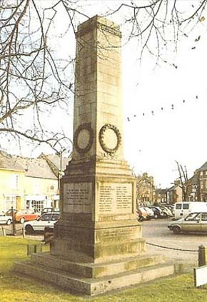
Illustration C Olney, Buckinghamshire, Mike Levers/The Open University

5 Function of a memorial
We could, of course, extend this notion of appropriateness into other forms of civic building. If I had asked you to consider your local town hall, shopping centre or supermarket, we could have asked many of the same questions about function and appropriateness. We expect a shopping centre to be organised so that shopping and spending money are easy. If it is not well organised, we might go elsewhere. We expect civic offices to be accessible and central to the area they serve; and we are annoyed if this is not so.
But these functions are self-evident, arising directly from their purpose, in an unambiguous way. We are not much concerned about the meanings they demonstrate (except possibly the knowledge that a shopping centre demonstrates commercial aspects of life, and the spending of money). I suspect, however, that you agree with me that the appropriateness of form and function for a war memorial is a little different, and it is to the question of why this should be so that we now turn.

Exercise 5

What function do you think a war memorial has?
Again, make a list in response to this seemingly obvious question, and try to do so before reading on to my own list below.

View discussion - Exercise 5

Whatever our lists, I think that we can reach agreement about most of these functions. This agreement may not be a simple one, for how we perceive a war memorial may depend on our own personal circumstances and the beliefs we hold. We may have lost a relative or friend in war. We may have strong Christian belief, or none at all; we may have a belief in another faith. We may have direct experience of war, or it may not have touched us. We may hold pacifist views and refuse to accept the necessity of any war.
I am conscious that in my own response I ignored the notion of conquering, and of winning battles; and I'm also aware that the thought of a general loss of human life was uppermost in my mind.

Exercise 6

Can you decide what was uppermost in your mind when you constructed your list? Stop for a moment and jot down your thoughts in your notebook so that you can refer to them during my discussion.

View discussion - Exercise 6

6 Personal response to a memorial
But, you may be thinking, all our agreement up to now has shown that these perceptions and assumptions come from a common understanding of the appropriate form and meaning of a war memorial. Where, might you ask, does personal response come in? Are we not individuals who have different ways of looking at artefacts and of deciding what – if anything – they mean? This question opens up a big area of discussion, one which will be taken up many times later.
Clearly, as individuals, we might agree or disagree with any meaning, but in doing so we do not deny that it has a meaning, and that meaning is the result of its form and its function. I shall return to this point later on when we look at a specific monument. All I want to say here is that I think we shall understand more if we work out how meaning is conveyed, and what goes into our own personal response to this.
Turn back to the list I made of what I expected to find on a war memorial. I had included poppies, and when I looked at my war memorial I found them. You may have expected to find, and perhaps did find, poppies on your example. If you did not, have a look at Illustrations D and E.

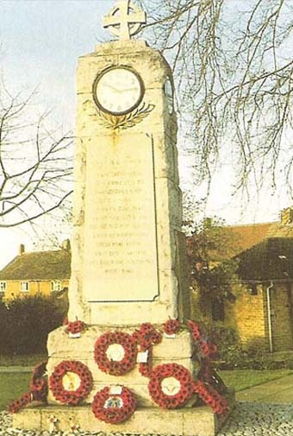
Illustration D Woburn Sands and Aspley Heath, Buckinghamshire, Mike Levers/The Open University

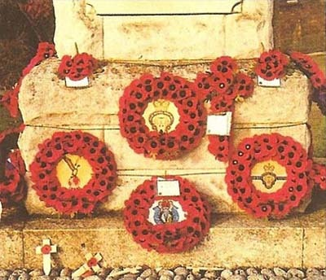
Illustration E Woburn Sands and Aspley Health, Buckinghamshire, Mike Levers/The Open University

The poppy grew in the region where much of the severest fighting of the First World War took place. The flower is often mentioned by soldiers writing home. It was perhaps its blood-red colour and its abundance that led to its becoming a symbol for the loss of life in the war. Also Homer in the Iliad in the 8th-7th century BCE had used the image of a fallen poppy to describe the death of a young warrior.
Poppies also grew in abundance where these Homeric battles took place, near the coast of Asia Minor – the sight too of the battle of Gallipoli in the First World War. We also know that the Homeric images of poppies were known to many soldiers and poets. We can agree, I think, that the poppy has a function when it is placed on a war memorial, and that it is a particularly British symbol. We have others, too – lilies, laurel; and other nations will have similar symbols.
But you will have realised that the poppy, or whatever flower is being used, becomes a symbol only in certain circumstances. A field of poppies in summer does not hold, I think, any symbolism, though we might be reminded of their use elsewhere. In a similar way, a red rose exists as a red rose, becoming a symbol of love only when it is used to express that feeling. Poppies and lilies become symbols when they, as flowers, are re-presented as another form, becoming bouquets, wreaths, artificial buttonholes and garlands.
Artificial poppies also hold a different element of meaning when they are sold to raise money, for wearing them says not only ‘I remember’ but also ‘I have paid’. It is interesting to note that the meaning given to the red poppy has been used even by those who totally reject war: they have built upon the red poppy's symbolism by using a white poppy in contrast, to denote pacifism.
So we can say that the poppy's form (as a re-presentation of a well-known flower) and its function (acting as a symbol for the bloodshed of war) are woven together to provide us with its meaning.

7 Matching form and purpose
Now let us look at war memorials themselves. We have already agreed that their form takes a shape that we think appropriate. The question to ask is: Why do we think that one building, one shape, is more appropriate than another?

Exercise 7

Please turn back to your own example, and let me ask you … What other examples of war memorials can you think of, in this country or elsewhere?

View discussion - Exercise 7

For this, we need to look back to the past. The notion of commemoration of war, and of loss in war, is not confined to the First and Second World Wars, though it was particularly in the aftermath of the First World War that the construction of the war memorials we are familiar with was so widespread among the opposing nations. But we have many examples in existence from previous times, and previous civilisations.
The Egyptians gave us one form, the obelisk, which continued to be used by both the Greeks and the Romans. It was, however, the Romans who developed the use of the column, particularly as a victory celebration. Whereas Egyptian obelisks are constructed from one piece of stone, columns are, generally speaking, constructed from separate pieces placed on one another, and different materials could be used – stone, but also marble and, eventually, concrete. You will be able to think of many examples of columns. No prizes for recalling Nelson's column in Trafalgar Square in London, commemorating both victory over the French and also commemorating Nelson himself.

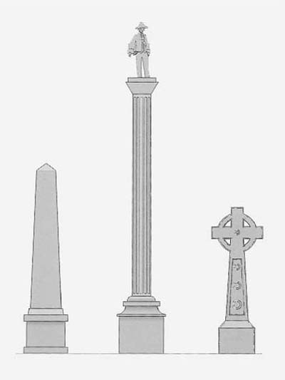
Figure 1 Obelisk, column and cross
View description - Figure 1 Obelisk, column and cross

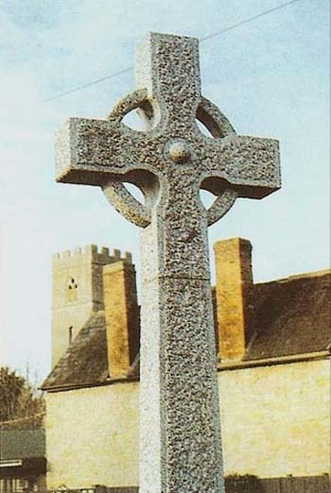
Illustration F Lavendon, Buckinghamshire, Mike Levers/The Open University

The third form is the cross. This had no part in the ancient world of Egypt or, in any significant way, in Rome. But the cross evolved over the centuries as Christianity spread: it formed the sign of the crusaders who occupied themselves in religious wars. It forms for Christians now a major part of their symbolism.
These three constructions, therefore – obelisk, column and cross – are still the forms most often found in memorials dating from the First World War. But there are other forms that we would recognise as having a memorial function, however long ago they were constructed.
Arches are used in many places, particularly where a large focus is needed for a triumphal setting, as with the Arc de Triomphe in Paris. The cenotaph – the word comes from the Greek for ‘empty tomb’ and means a monument that commemorates people buried elsewhere – is another form of memorial, and in addition to the Cenotaph in London there are many others. The desire for a memorial may result in a building. Some were constructed centuries ago, and are still in use, such as the Chelsea Hospital in London, built in 1682 by Charles II to offer a home to unmarried soldiers, and to commemorate their colleagues who did not survive.
Additions were made to existing buildings, in the form of chapels, a hospital wing, or a village hall. Some memorials may use statues – a general mounted on horseback on the top of a column, a group of soldiers forming a memorial to a whole regiment's loss – and we will be looking in detail at one such memorial. Then there are many examples of plaques containing lists of names, found often on church walls, school and university chapels, in clubs, large organisations, shops, stations.
I haven't mentioned all the possible forms of war memorial, and you may easily think of others. The point is that, whatever the shape of the memorial, there has to be agreement that the form is appropriate in order that the meaning, and therefore the function, is assured. Many issues are raised by this: whose opinion prevails, who pays, how do memorials get built?
Any agreement reached has complex origins; and it is interesting to think of instances where this agreement is not maintained, or to some extent compromised, and why this should be so. But what we can be clear about at this point is that the agreement or disagreement arises out of our history and cultural background.

8 Conclusion
I hope that you will agree that we have moved a long way from my original request to you to look at your local war memorial. You may have been stimulated to seek out other war memorials, and at the very least I hope that you will not pass one without noting its shape, location and form.
Even if you go no further with the subject, we have, I hope, seen how something whose existence, location and meaning we may well have taken for granted can yield interesting discussion. In thinking and inquiring about why it is as it is, we find ourselves analysing our own particular reactions to it, and seeking explanations for its form and its meaning.
To bring this course to a conclusion, we would like you to do two things. First of all, we suggest below two exercises to round off your work on the theme of war memorials, using three types of memorial. In suggesting these exercises, we particularly want you to use the expressions we have highlighted in bold in the preceeding pages: concept, meaning, perception, symbol and culture. Look back to these now if you need to remind yourself.
Secondly, we would like you, when you have completed these exercises, to reflect on them and to make a note of what you found easy, and what was more difficult. Add a note about the language you have used: have you found it helpful to use the words printed in bold type? Or have you found them difficult to build in to your writing? If so, we hope it will get easier as you work with them.

Exercise 8

So here goes with the exercises. This is a fair-sized piece of work for which you need time; but we hope that you will welcome such a task.
We want you to look closely at illustrations of three war memorials – a plaque on a wall at Newton Blossomville (Illustration G), a traditional Christian cross in Newport Pagnell (Illustration H) and the Canadian National Memorial at Vimy Ridge in France (Figure 2).
You may find it helpful to know that the plaque at Newton Blossomville (a village in Buckinghamshire) is on the outside of a house, on the other side of the road from the church, facing a little green called the Green Hill.
In Newport Pagnell (a small town near Milton Keynes in Buckinghamshire), the memorial is only a few feet from the church porch, and is near the main path up to the church from the High Street. It is in a rather confined space between some old buildings.
The Canadian memorial marks the site of a battle in 1917. But its purpose is to commemorate the 60,000 Canadians who lost their lives in the First World War. On the top of the monument are a series of figures representing Peace, Justice, Truth and Knowledge: there are figures also at the base of the monument, including one inscribed ‘Canada mourning her dead’.
I would like you to write two paragraphs about each of these memorials in turn:
First, write a paragraph describing what you see in Illustration G. In your second paragraph, consider the location of this memorial at Newton Blossomville, and whether the memorial's size is appropriate, and its form fitting to its function. Comment on any symbolism you see in the form of the memorial, and what the symbolism conveys. Your two paragraphs should total about 300 words.
Do the same for each of the other two memorials, answering the same questions, so that you have two paragraphs on the memorial at Newport Pagnell, and two on the Canadian memorial.
Finally, write a single paragraph contrasting the three memorials and your personal reactions to them.

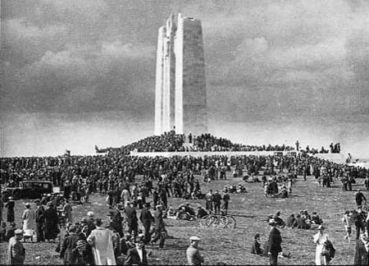
Figure 2 The Canadian National Memorial at Vimy Ridge, France; the crowd gathered to attend the unveiling in July 1936. (Photograph: Popperfoto)
View description - Figure 2 The Canadian National Memorial at Vimy Ridge, France; the crowd gathered ...

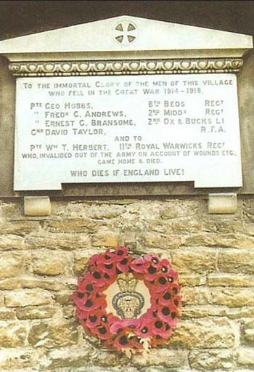
Illustration G Newton Blossomville, Buckinghamshire, Mike Levers/The Open University

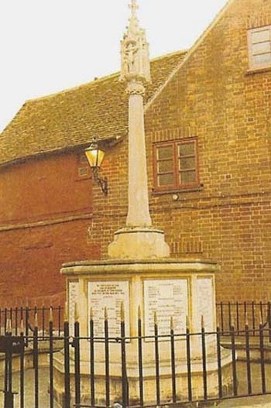
Illustration H Newport Pagnell, Buckinghamshire, Mike Levers/The Open University

Exercise 9

Look at Figure 3, the Carillon Tower in Loughborough, Leicestershire. Read the following information on its origin.

In 1919 the population of Loughborough was asked to vote for the kind of memorial they wished to see in the town to commemorate those who had died in the First World War. They voted for a carillon. A site in Queen's Park, and an architect, Mr Walter Tapper, was chosen; the foundation stone was laid in 1922. A subscription list raised £20,000, a considerable sum for a town of Loughborough's size. The carillon tower's height is 151 ft, and contains 47 bells. The tower was built with local labour, and the bells were cast in the town's foundry. Each of the bells carries an inscription giving the name of the donor, and the men commemorated; amongst the inscriptions are:
‘The gift of the sons of William and Anne Moss, Third Mayor and Mayoress of this Borough, two of whose grandsons Howard James Harding Moss (2nd Lieut, 5th Leicesters) and Gerald Alec Moss (2nd Lieut, 2nd Manchesters) fell in the Great War.’
The gift of the Loughborough Grammar School (Past and Present) in memory of the 57 Old Boys who fell in the Great War.’
The gift of the Engineering and Allied Trades of Loughborough.’
(Bray, 1981)

Write about 300 words on the Loughborough Carillon and its origins, considering especially how it came into being and the form the memorial takes. What does it tell you about the feelings of the citizens of Loughborough after the Great War? Would you have voted for a carillon, or for one of the other possibilities – a health centre or a conventional monument? Why?

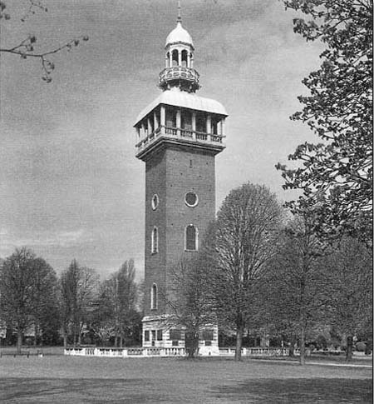
Figure 3 The Carillon Tower, Queen's Park, Loughborough, designed by Sir Walter Tapper, 1922–3. (Photograph: A.F. Kersting)
View description - Figure 3 The Carillon Tower, Queen's Park, Loughborough, designed by Sir Walter ...

Keep on learning



Study another free course
There are more than 800 courses on OpenLearn for you to choose from on a range of subjects.
Find out more about all our free courses.

Take your studies further
Find out more about studying with The Open University by visiting our online prospectus.
If you are new to university study, you may be interested in our Access Courses or Certificates.

What’s new from OpenLearn?
Sign up to our newsletter or view a sample.

For reference, full URLs to pages listed above:
OpenLearn – www.open.edu/openlearn/free-courses
Visiting our online prospectus – www.open.ac.uk/courses
Access Courses – www.open.ac.uk/courses/do-it/access
Certificates – www.open.ac.uk/courses/certificates-he
Newsletter – www.open.edu/openlearn/about-openlearn/subscribe-the-openlearn-newsletter

References
Bray, M. (1981) Bells of Memory: a history of the Loughborough Carillion, Loughborough, BRD Publishing.

Acknowledgements
Except for third party materials and otherwise stated (see terms and conditions), this content is made available under a Creative Commons Attribution-NonCommercial-ShareAlike 4.0 Licence.
The material acknowledged below is Proprietary and used under licence (not subject to Creative Commons Licence). Grateful acknowledgement is made to the following sources for permission to reproduce material in this free course:
Course image: Prescott Pym in Flickr made available under Creative Commons Attribution-NonCommercial 2.0 Licence.
Figure 2 Popperfoto;
Figure 3 A. F. Kersting;
Illustrations A–H: Mike Levers/The Open University.
Figure 6.1 (p. 192) Raphael, “The Madonna and Child with the Infant Baptist (The Garvagh Madonna)”, probably 1509-10, oil on wood, 39 x 33cm. Photo: Scala
Figure 6.2 (p. 200) Nicolas Poussin, “Landscape with a Man Killed by a Snake”, 1648, oil on canvas, 119 x 199cm. Photo: © National Gallery Collection; By kind permission of the Trustees of the National Gallery, London/CORBIS.
Every effort has been made to contact copyright owners. If any have been inadvertently overlooked, the publishers will be pleased to make the necessary arrangements at the first opportunity.
Don't miss out
If reading this text has inspired you to learn more, you may be interested in joining the millions of people who discover our free learning resources and qualifications by visiting The Open University – www.open.edu/openlearn/free-courses.

Exercise 1

Discussion
We know that this reading will prove useful as you work through this course. At the end of the sections, we suggest that you return to the words in bold type, and consider whether their use helped you to understand, and to express, the ideas in the text: at an early stage we want you to be aware of the importance of using a vocabulary that effectively expresses ideas.
Back to Session 1 Activity 1

Exercise 2

Discussion
Of course, I do not know what your answer is. But I would be surprised if there were not a war memorial somewhere near you. Did you have to think where it was? Perhaps you knew at once: you may pass one regularly, or you may visit it. Or perhaps you had to spend time thinking. If you can go and look at the memorial nearest to you (or, for that matter, a war memorial anywhere) so that you can immediately recall its location and shape, you will increase your understanding and awareness of many of the points made in this course. But if it is impossible for you to do that, and you are not sufficiently familiar with a war memorial to keep the image of it in your mind, please use Illustration A when I ask questions about ‘your’ memorial.
Back to Session 2 Activity 1

Exercise 3

Discussion
You might perhaps think of, or even have personal knowledge of, the fact that the location of the memorial was carefully considered. But we must be wary of assuming that this happened in every case; and we will look later at the kind of discussion that was needed before two particular memorials came into being. Those involved in deciding on the location might include the designer or sculptor of the memorial, a group of people who paid for the memorial, civic leaders who wished to use public money for commemoration, or an individual wishing to fund a memorial to a specific person.
The sculptor would need to design the memorial in relation to the site in which it was to be located. The benefactor's views, and the views of the people who have raised the money for the provision of it, would need to be represented in decisions about its building and setting. It is easy to see that the owner of the land on which the memorial was to be built could have a large say in where the memorial should be.
Back to Session 3 Activity 1

Exercise 4

Discussion
I wonder if you have different things in your two columns? Overleaf is the list I made looking at the war memorial at Lavendon, Buckinghamshire (Illustration B).

What I expected | What I found
A cross, in stone or marble | A cross, carved
A list of names | A list of names, many more from the First World War than from the Second, but three names from wars since 1945
A surround, perhaps a square | A plinth and surround
Grass | No grass
A wreath of poppies | Poppies, empty flower-holders
A carved figure, perhaps a soldier | No soldier, some carvings, probably religious ones
An angel | No angels

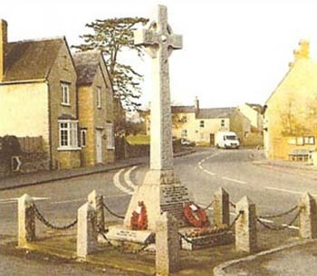
Illustration B Lavendon, Buckinghamshire, Mike Levers/The Open University

Was there any similarity between your two lists? There was, to some extent, with mine. When you wrote your list on the left-hand side, I imagine that you had, as I had, some notion of what a war memorial should look like. It might have just been a hazy idea, or perhaps you had a much clearer image or general idea – a concept.
Back to Session 4 Activity 1

Exercise 5

Discussion
My list may be different from yours, though I would be surprised if we did not have some points in common. Here is my list for you to think about and relate to your own. In my view, we have war memorials to provide
- a public record of names of those who died
- a local record of loss
- a focus for personal remembrance
- a focus for civic commemoration
- a religious commemoration for loss of life
- a public record of gratitude for sacrifice.
Back to Session 5 Activity 1

Exercise 6

Discussion
Perhaps you made the point that when we think about the function of a war memorial, we draw on our own knowledge and experience. We may recognise its significance in a highly personal way, or we may feel detached from it. When I looked at ‘my’ memorial, I saw a column and a cross, and that was how I recognised it as a memorial. The form of the memorial is what I saw, and one function of the design of the memorial was to alert me to its being a war memorial. So both the form and the function of it held a meaning, and I responded to that. I can say that I have a personal perception of the memorial and its meaning. Form and function together conveyed a meaning to me.
Back to Session 5 Activity 2

Exercise 7

Discussion
I expect that you found at least one example. War memorials come in many shapes, and may have added purposes. Your original example may have been in the shape of an obelisk, a column or a cross (Figure 1). These are the most widely used forms. But there are lots of other forms. You may have found, or may know of, a set of memorial gates leading to a churchyard, or a chapel added to a church or a school. There might be a functional element to the memorial – a clock, a fountain or a village hall. There may be statues, free-standing or as decoration on other forms. Let us look closer at why memorials take the form they do.
Back to Session 7 Activity 1

Figure 1 Obelisk, column and cross

Description
Figure 1
Back to Session 7 Figure 1

Figure 2 The Canadian National Memorial at Vimy Ridge, France; the crowd gathered to attend the unveiling in July 1936. (Photograph: Popperfoto)

Description
Figure 2
Back to Session 8 Figure 1

Figure 3 The Carillon Tower, Queen's Park, Loughborough, designed by Sir Walter Tapper, 1922–3. (Photograph: A.F. Kersting)

Description
Figure 3
Back to Session 8 Figure 4

