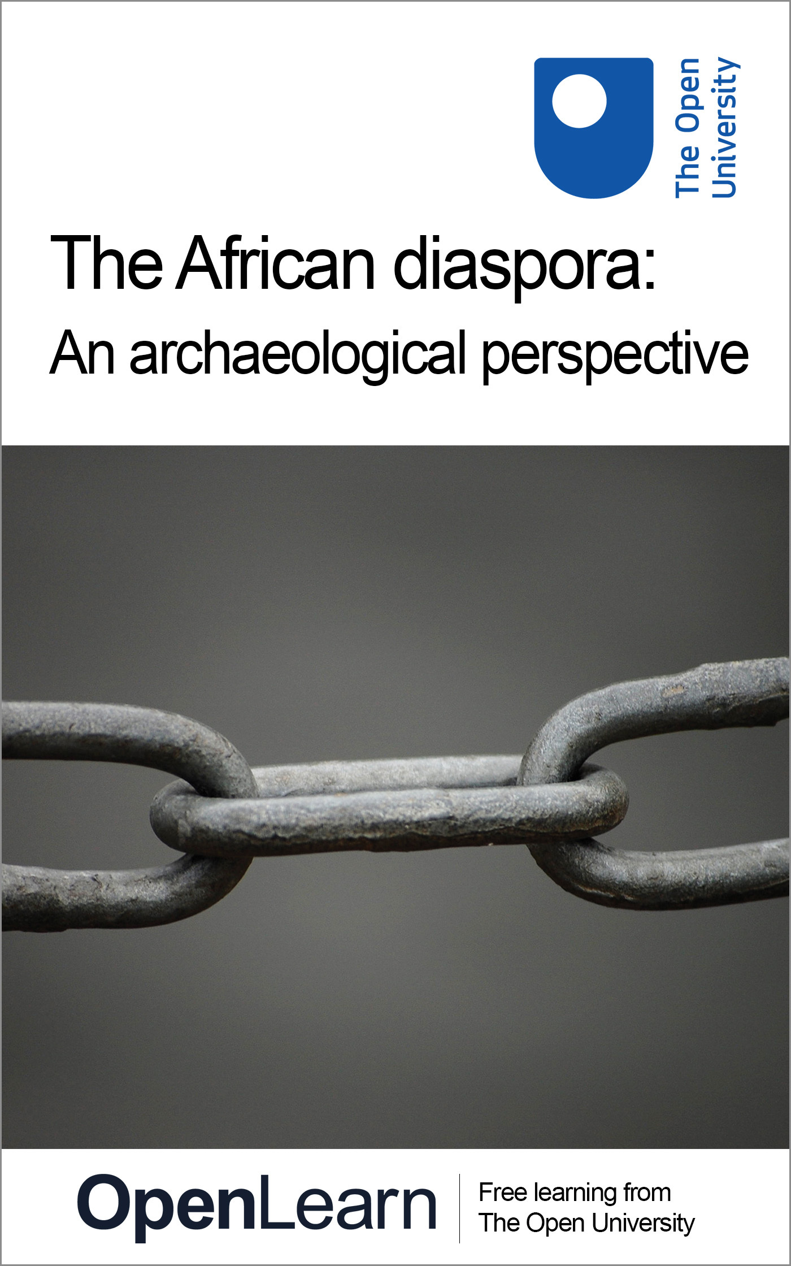

A251_1 The African diaspora: An archaeological perspective

The African diaspora: An archaeological perspective
About this free course
This OpenLearn course provides a sample of Level 2 study in Arts and Humanities: http://www.open.ac.uk/courses/find/arts-and-humanities.
This version of the content may include video, images and interactive content that may not be optimised for your device.
You can experience this free course as it was originally designed on OpenLearn, the home of free learning from The Open University - www.open.edu/openlearn/history-the-arts/history/social-economic-history/the-african-diaspora-archaeological-perspective/content-section-0.
There you’ll also be able to track your progress via your activity record, which you can use to demonstrate your learning.
Copyright © 2016 The Open University
Intellectual property
Unless otherwise stated, this resource is released under the terms of the Creative Commons Licence v4.0 http://creativecommons.org/licenses/by-nc-sa/4.0/deed.en_GB. Within that The Open University interprets this licence in the following way: www.open.edu/openlearn/about-openlearn/frequently-asked-questions-on-openlearn. Copyright and rights falling outside the terms of the Creative Commons Licence are retained or controlled by The Open University. Please read the full text before using any of the content.
We believe the primary barrier to accessing high-quality educational experiences is cost, which is why we aim to publish as much free content as possible under an open licence. If it proves difficult to release content under our preferred Creative Commons licence (e.g. because we can’t afford or gain the clearances or find suitable alternatives), we will still release the materials for free under a personal end-user licence.
This is because the learning experience will always be the same high quality offering and that should always be seen as positive – even if at times the licensing is different to Creative Commons.
When using the content you must attribute us (The Open University) (the OU) and any identified author in accordance with the terms of the Creative Commons Licence.
The Acknowledgements section is used to list, amongst other things, third party (Proprietary), licensed content which is not subject to Creative Commons licensing. Proprietary content must be used (retained) intact and in context to the content at all times.
The Acknowledgements section is also used to bring to your attention any other Special Restrictions which may apply to the content. For example there may be times when the Creative Commons Non-Commercial Sharealike licence does not apply to any of the content even if owned by us (The Open University). In these instances, unless stated otherwise, the content may be used for personal and non-commercial use.
We have also identified as Proprietary other material included in the content which is not subject to Creative Commons Licence. These are OU logos, trading names and may extend to certain photographic and video images and sound recordings and any other material as may be brought to your attention.
Unauthorised use of any of the content may constitute a breach of the terms and conditions and/or intellectual property laws.
We reserve the right to alter, amend or bring to an end any terms and conditions provided here without notice.
All rights falling outside the terms of the Creative Commons licence are retained or controlled by The Open University.
Head of Intellectual Property, The Open University
978-1-4730-0928-8 (.epub)
978-1-4730-1696-5 (.kdl)

Contents
- Introduction
- Learning outcomes
- 1 Why study slavery through archaeology?
- 2 What is slavery?
- Conclusion
- Keep on learning
- References
- Further reading
- Acknowledgements

Introduction
The African diaspora, in its broadest terms, is the dispersal of people of African descent from Africa to other parts of the world – particularly Europe, America and Southwest Asia. The process has been occurring over much of the past 2,000 years in various ways, with different cultures and societies involved.
Through much of this time, slavery has been the driving force behind the diaspora. The Roman Empire drew some of its slaves from sub-Saharan Africa. Arab slave traders drew slaves from northern sub-Saharan Africa and East Africa for more than 1,000 years, taking them to Southwest Asia. Slaves were taken from Africa by Christian slave traders to work in the Americas from soon after the time it was visited by Columbus (sometimes called the post-Columbian period) to the middle of the nineteenth century, when the trade was finally eradicated.
This OpenLearn course provides a sample of Level 2 study in Arts and Humanities.

Learning outcomes
After studying this course, you should be able to:
- understand the modern academic approaches to the study of African slavery
- show an awareness of the links between archaeology and related academic disciplines, such as history, in the study of the past
- understand the classification of different forms of slavery in the past.

1 Why study slavery through archaeology?
The transatlantic slave trade has had a significant social and cultural impact on the modern Western world. But surely this is a historical question, so what can archaeology have to do with it?
Archaeology has a distinctive position as a subject because it is essentially interdisciplinary, drawing upon the Humanities, Arts, Social Sciences, Sciences or indeed any other subject that might be relevant in order to investigate the human past through its material remains. Just as now, people in the past created all kinds of material traces of their lives and, because of this, archaeology can study literally anything that people have done. This freedom enables archaeologists to study things from any time in the past and, possibly more importantly, to evaluate how things have changed from one time to the next.
Archaeology is also uniquely placed to study non-elite parts of societies through their material culture (be it from prehistory or historical periods). Written documents relating to the African diaspora to the Americas are overwhelmingly written by the enslavers, not the slaves. Archaeology has the opportunity to apply its particular approaches to the academic study of the subject.
However, as you will soon see, it has been slow to take up the challenge. Although Greek and Roman slavery has long been studied, it is rarely given an explicitly African focus. There has been virtually no archaeological study of the East African slave trade (Alexander, 2001). The archaeological study of the transatlantic diaspora has only recently developed out of the archaeological interest in the first Western settlers in North America, and the remains of their colonial settlements.

2 What is slavery?
Social inequalities have been a recurrent feature of virtually every society. From the first recognisable ‘cultures’, the Natufians, some people received different treatment after death. We may not know all that much about it, but it is a form of inequality. In the Inca empire, the Inca themselves were an exclusive elite and exploited other members of society to provide forced labour. This was a clear example of inequality between different sections of a society.
Only very rarely has a society been identified as possibly ‘egalitarian’ (i.e. without an elite), for example the Indus civilisation. An extreme form of inequality, closely related to the African diaspora, is slavery. To be more precise, a specific form of slavery, ‘chattel slavery’, has been a feature of all the phases of the diaspora that have been discussed so far. There are various forms of slavery and chattel slavery, perhaps the most severe, has been deﬁned as follows:

‘A slave is a human being who is the property of, and entirely subject to, another human being under the religious, social and legal conventions of the society in which he or she lives.’ Being ‘the property of’ means that an owner, restricted only by the conventions of his society, is able to buy, sell, free, adopt, ill-treat or kill his slave whose children belong to their owner and can be treated in the same way. A slave has no freedom or personal rights and can become one voluntarily, by a legal decision or by force.
(Alexander, 2001, p.45)

Slavery seems to have been a common, if not constant, feature of human societies. However, there are relatively few in-depth discussions of the subject in traditional archaeological literature. Perhaps one reason for this is that slavery is difficult to detect in archaeology – after all, it is an intangible expression of power and identity (master or mistress and slave), rather than an expression of material culture. Typically, the study of slavery has been approached through the study of historical documents, but although it may be challenging, it is not impossible to study slavery using archaeological methods.

Activity 1 Read and response exercise

Now read the article, ‘The Archaeology of the African diaspora’, by Charles Orser (Orser, 1998), linked below (right-click to open it in a new window or tab).
The main purpose of this reading is to introduce you to a new area of archaeology and enable you to see how this field can be used to approach an apparently non-archaeological topic of contemporary importance. You will meet the concept of ‘maroon’ settlement – this refers to settlements established by escapee slaves.
As you read, take brief notes on the major points that Orser makes regarding the phenomenon of slavery and its implications for modern.
Click to open ‘The Archaeology of the African diaspora’.

View discussion - Activity 1 Read and response exercise

Orser’s article was written in 1998 and the archaeology of slavery has moved on since then. Search the internet for ‘archaeology slavery’ for an update. In 2001, an edition of the journal World Archaeology was dedicated to the subject.

Conclusion
This free course provided an introduction to studying the arts and humanities. It took you through a series of exercises designed to develop your approach to study and learning at a distance and helped to improve your confidence as an independent learner.

Keep on learning



Study another free course
There are more than 800 courses on OpenLearn for you to choose from on a range of subjects.
Find out more about all our free courses.

Take your studies further
Find out more about studying with The Open University by visiting our online prospectus.
If you are new to university study, you may be interested in our Access Courses or Certificates.

What’s new from OpenLearn?
Sign up to our newsletter or view a sample.

For reference, full URLs to pages listed above:
OpenLearn – www.open.edu/openlearn/free-courses
Visiting our online prospectus – www.open.ac.uk/courses
Access Courses – www.open.ac.uk/courses/do-it/access
Certificates – www.open.ac.uk/courses/certificates-he
Newsletter – www.open.edu/openlearn/about-openlearn/subscribe-the-openlearn-newsletter

References
Alexander, J. (2001) ‘Islam, archaeology and slavery in Africa’, World Archaeology, vol.33, no.1, pp.44–60.

Further reading
Alexander, J. (2001) ‘Islam, archaeology and slavery in Africa’, World Archaeology, vol.33, no.1, pp.44–60.
Bellwood, P. (2005) The First Farmers: The Origins of Agricultural Societies, Oxford, Blackwell. Chippindale, C. and Tacon, P.S.C. (eds) (1998) The Archaeology of Rock-Art, Cambridge, Cambridge University Press.
Ferguson, L. (2004) Uncommon Ground: Archaeology and Early African America, 1650–1800, Upper Saddle River, NJ, Prentice Hall & IBD.
Heath, B. (1999) Hidden Lives: The Archaeology of Slave Life at Thomas Jefferson’s Poplar Forest, Charlottesville, University of Virginia Press.
Lilley, I. (ed.) (2006) Archaeology of Oceania: Australia and the Paciﬁc Islands, Oxford, Blackwell.

Acknowledgements
This free course is an adapted extract from the course A251 The African diaspora: An archaeological perspective, which is currently out of presentation
Except for third party materials and otherwise stated (see terms and conditions), this content is made available under a Creative Commons Attribution-NonCommercial-ShareAlike 4.0 Licence
Grateful acknowledgement is made to the following sources for permission to reproduce material within this publication:
Course image: Michael Randall in Flickr made available under Creative Commons Attribution-NonCommercial-ShareAlike 2.0 Licence.
Every effort has been made to contact copyright holders. If any have been inadvertently overlooked, the publishers will be pleased to make the necessary arrangements at the first opportunity.
Don't miss out:
If reading this text has inspired you to learn more, you may be interested in joining the millions of people who discover our free learning resources and qualifications by visiting The Open University - www.open.edu/openlearn/free-courses

Activity 1 Read and response exercise

Discussion
Orser makes some big claims for his specialist area, but he does have some good points to make. It is worth noting that when he refers to ‘historical archaeology’ he means historical archaeology of (and in) the USA. He is not taking into account European medieval archaeology or industrial archaeology, for example.
The first major point he makes is that the archaeology of the African diaspora is not simply the archaeology of slavery: slavery is only one part of a larger story of how people of African origin have spread around the globe. This is reinforced by the discussion of the positive potential of studying maroon settlements rather than the negative experience of slaves.
Orser discusses the potential for employing archaeological approaches developed in the study of other cultures to address the material identification of African identity and the material aspects of maroon culture. However, there seem to be very few cases where it is possible to identify clearly a distinctive African material culture in the slave or maroon settlements.
In fact, he rejects the simplistic equation of a people, ethnic or racial group with a distinctive type of material culture when he discusses the fact that the relationship between people and the objects they use has a complex nature. In parallel with this, Orser also considers that simplistic polarisations of racial categories are not a valid basis for the investigation of past identities.
Orser also squarely addresses the fact that Archaeology can have a contemporary political and social relevance when it addresses topics such as race, and that it is not necessarily an isolated academic activity.
Back to Session 2 Activity 1

