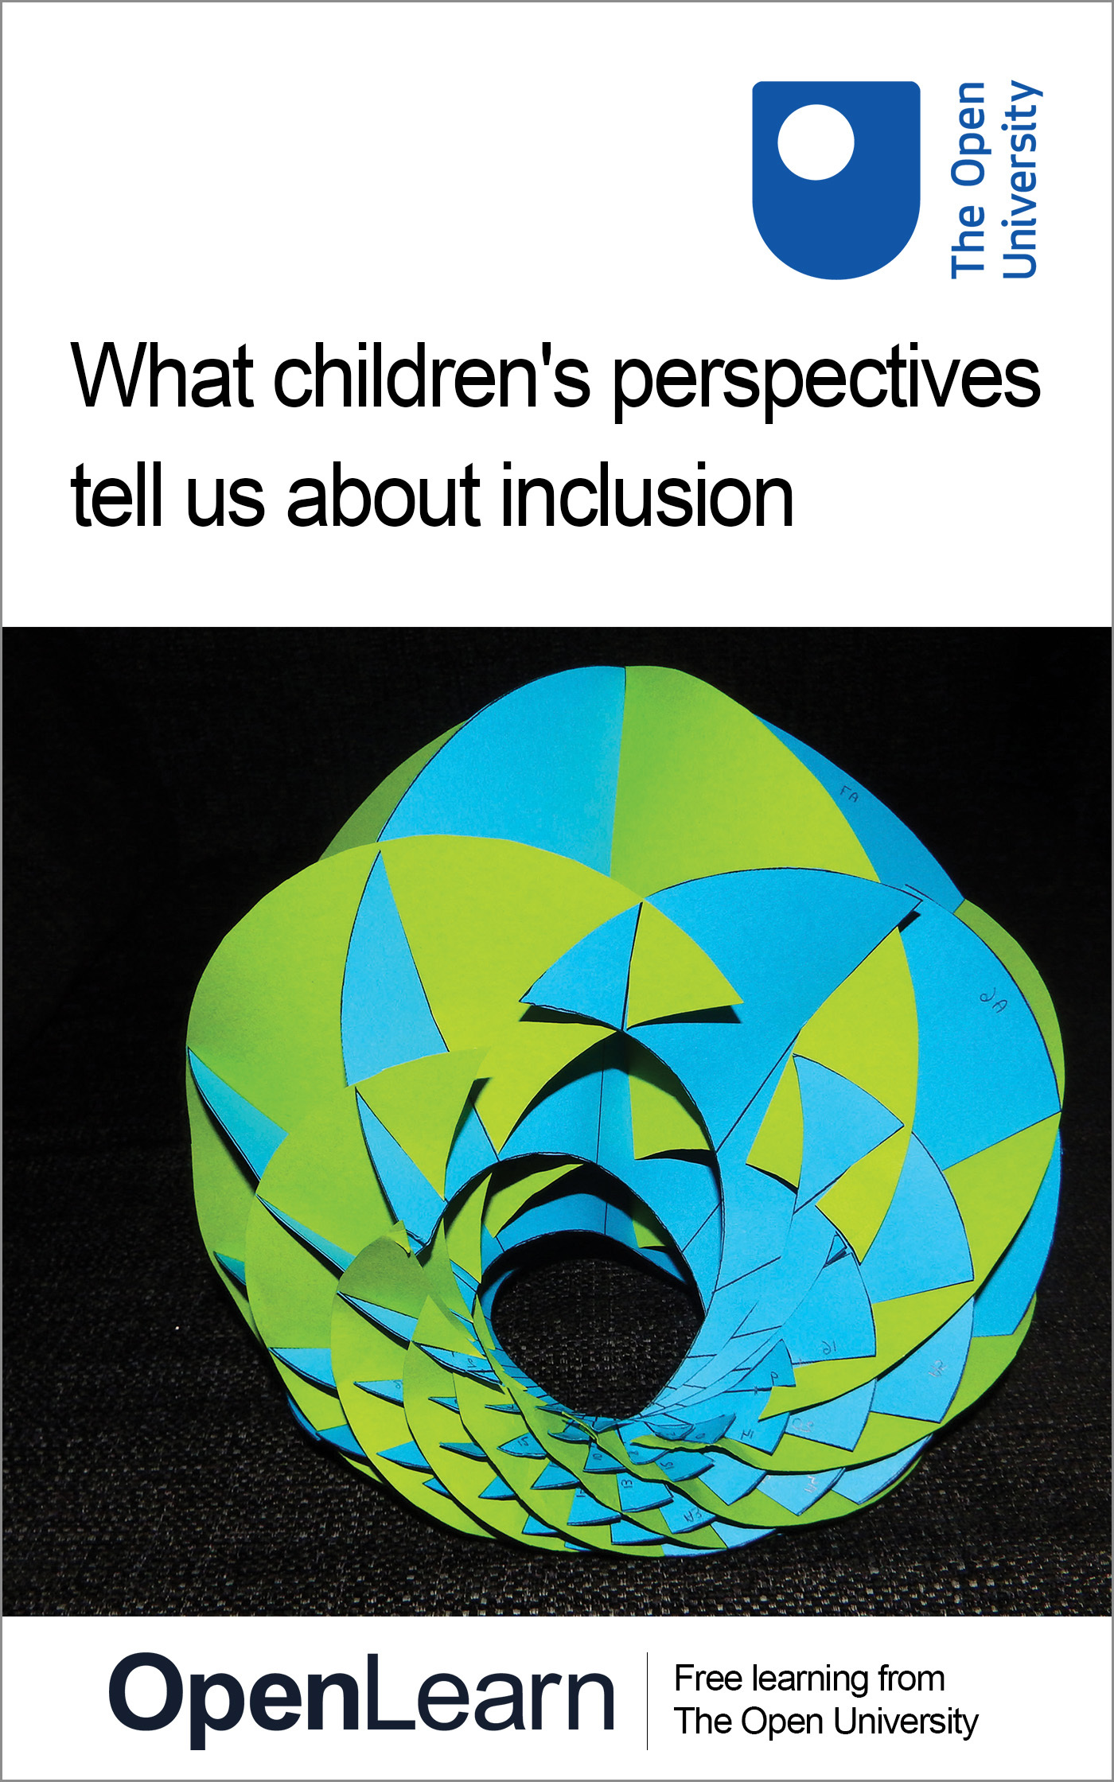

E243_1 Inclusive education: learning from each other

What children's perspectives tell us about inclusion
About this free course
This free course provides a sample of Level 2 study in Education, Childhood & Youth qualifications: www.open.ac.uk/courses/find/education-childhood-and-youth
This version of the content may include video, images and interactive content that may not be optimised for your device.
You can experience this free course as it was originally designed on OpenLearn, the home of free learning from The Open University: www.open.edu/openlearn/education/educational-technology-and-practice/educational-practice/what-childrens-perspectives-tell-us-about-inclusion/content-section-0.
There you’ll also be able to track your progress via your activity record, which you can use to demonstrate your learning.
The Open University, Walton Hall, Milton Keynes MK7 6AA
Copyright © 2016 The Open University
Intellectual property
Unless otherwise stated, this resource is released under the terms of the Creative Commons Licence v4.0 http://creativecommons.org/licenses/by-nc-sa/4.0/deed.en_GB. Within that The Open University interprets this licence in the following way: www.open.edu/openlearn/about-openlearn/frequently-asked-questions-on-openlearn. Copyright and rights falling outside the terms of the Creative Commons Licence are retained or controlled by The Open University. Please read the full text before using any of the content.
We believe the primary barrier to accessing high-quality educational experiences is cost, which is why we aim to publish as much free content as possible under an open licence. If it proves difficult to release content under our preferred Creative Commons licence (e.g. because we can’t afford or gain the clearances or find suitable alternatives), we will still release the materials for free under a personal end-user licence.
This is because the learning experience will always be the same high quality offering and that should always be seen as positive – even if at times the licensing is different to Creative Commons.
When using the content you must attribute us (The Open University) (the OU) and any identified author in accordance with the terms of the Creative Commons Licence.
The Acknowledgements section is used to list, amongst other things, third party (Proprietary), licensed content which is not subject to Creative Commons licensing. Proprietary content must be used (retained) intact and in context to the content at all times.
The Acknowledgements section is also used to bring to your attention any other Special Restrictions which may apply to the content. For example there may be times when the Creative Commons Non-Commercial Sharealike licence does not apply to any of the content even if owned by us (The Open University). In these instances, unless stated otherwise, the content may be used for personal and non-commercial use.
We have also identified as Proprietary other material included in the content which is not subject to Creative Commons Licence. These are OU logos, trading names and may extend to certain photographic and video images and sound recordings and any other material as may be brought to your attention.
Unauthorised use of any of the content may constitute a breach of the terms and conditions and/or intellectual property laws.
We reserve the right to alter, amend or bring to an end any terms and conditions provided here without notice.
All rights falling outside the terms of the Creative Commons licence are retained or controlled by The Open University.
Head of Intellectual Property, The Open University
Edited and designed by The Open University.
978-1-4730-1518-0 (.kdl)
978-1-4730-0750-5 (.epub)

Contents
- Introduction
- Learning outcomes
- 1. Overview
  - 1.1 What children's perspectives tell us about inclusion
  - 1.2 Why do you come here?
  - 1.3 What makes you happy at school?
- Conclusion
- Keep on learning
- References
- Acknowledgements
- Solutions

Introduction
The underlying premise of this course is that we are all experts in different ways, and that our different experiences and understandings are of value. Inclusive education is presented and discussed as under construction, both in educational settings and as a concept. The materials to be found in this course are largely rooted in the social model of disability and human/disability rights frameworks.
This OpenLearn course provides a sample of Level 2 study in Education, Childhood & Youth qualifications.

Learning outcomes
After studying this course, you should be able to:
- understand a context in which listening to the perspectives of children is important in developing inclusive education
- demonstrate an insight into the varying perspectives of children
- reflect on how children's perspectives fit into a personal developing model of good practice and how they relate to a personal set of perspectives.

1. Overview

1.1 What children's perspectives tell us about inclusion
Every child's experience of education is different and this means that inevitably all children will be at different stages of the ‘journey’ towards inclusion that we are considering in this course. In reflecting children's perspectives it is, therefore, difficult to avoid descriptions of situations that are far from ideal. However, these situations can be seen as steps along the way. This will not, sadly, reduce the impact of unsatisfactory situations on the children themselves. Certainly the education system in the UK has progressed enormously since Mabel Cooper's school days.

There used to be children, there used to be two wards of children. One for little boys and one for girls. There was no school there, they only let you use your hands by making baskets and doing all that sort of thing. That's all you did. In them days they said you wasn't able to learn so you didn't go to school you went to like a big ward and they had tables. You just went there and made baskets or what-have-you. Because in them days they said you wasn't capable enough to learn to do anything else, so that's what you did.
(Cooper, 2003)

Today, after the closure of such institutions, Mabel works for the People First self-advocacy group helping to give a voice to people who have been kept in silence. Within one person's lifetime we have come a long way in what we expect from educational experiences and who we listen to. Society is now beginning to ask people about their experiences and opinions of the services that are designed for them. This may be seen as the start of a more participatory and inclusive approach.

1.2 Why do you come here?

1.2.1 Children's perceptions of play and learning
An innovative study looked at why children thought they came to their particular schools and centres. Researchers collected the things that children said and analysed the ways in which they said them. The intention behind this was to inform the development of the services the children and their families received (Farrell, Taylor, Tennent and Gahan, 2002). By taking this approach, the children became active and important participants in the work. Building the children's views into the development of their education services was an acknowledgement of their right to participate in the social processes affecting their lives.

No social organization can hope to be built on the rights of its members unless there are mechanisms whereby those members may express themselves and wherein those expressions are taken seriously. Hearing what children say must, therefore, lie at the root of an elaboration of children's rights …
(Eekelaar, 1992, cited in Farrell et al., 2002)

Telling stories and playing with narratives about ourselves and experiences is a way in which we build our notions of ‘self’, who we are and our place in the world (Harrett, 2002).
Iris Keating and her colleagues visited ten primary schools in the north-west of England and asked young children about the things that they were doing in their reception classes. One child who had done PE, music and sand in a day commented, ‘Well I've not done any work today, I don't know why I came to school’ (Keating et al., 2000, p. 443). ‘Real work’ was identified by children as reading and writing: ‘Looking at books. That's not playing. Painting – that's playing. Writing is work’ (Keating et al., 2000, p. 443). Moreover, these reception-age children saw play as inferior to work:

Interviewer: You told me that work is important. Is playing important?
Child: No.
(Keating et al., 2000, p. 443)

Children did recognize implicitly that things could be learnt through play: ‘You learn to make stuff’ (child quoted in Keating et al., 2000, p. 444). This wasn't a school ‘thing’; school is the place for proper schoolwork to take place.
What are the implications for children who do not accomplish the ‘real work’ of the reception class quickly? How will they come to view themselves and others? These children see writing as ‘real work’, that is the thing that they have come to school to learn and at which they need to succeed. It counts. Yet around 46 per cent of six and seven year olds have difficulty with letter formation (Alston, 1995). By the time they are eleven years old, children will have spent thousands of hours, usually one-third of their time in class, involved in language-related handwriting tasks (Alston, 1995). At this stage 20 per cent of boys and 10 per cent of girls report that they ‘hated writing’ and, in addition, 37 per cent of boys and 23 per cent of girls claimed to write as little as possible and only when they had to do so (Alston, 1995; Sheehy and Jenkin, 1999). This situation will affect children's attitudes to themselves and their relationship to learning.

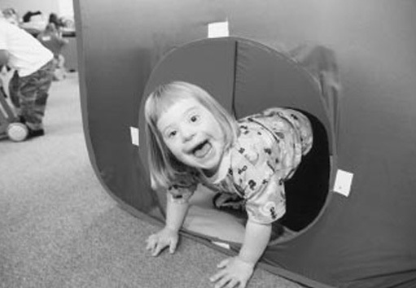

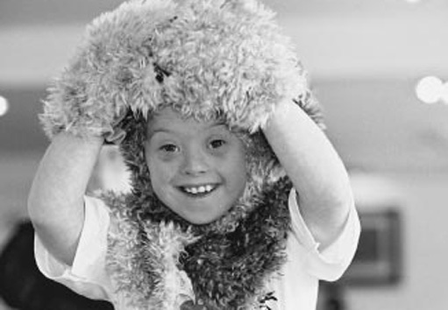
Playing isn't work.

Already at an early age therefore some pupils are beginning to feel that the things they can do in school are not valued and that they are in some way ‘outside’ the valued groups. John Davis and Nick Watson have shown that this process of exclusion takes place in both mainstream and special schools. They found that children in special schools picked up adult perceptions and ‘mirrored adult discourses’; when a child in a special school was asked the question ‘Why are you here?’, their answer was ‘Because I'm not very bright’ (Davis and Watson, 2001).

1.2.2 How older pupils view school
For older children the work of school becomes less important in itself. Research that explored Scottish secondary school pupils' ideas about why they went to school revealed that for many pupils school served primarily as a social experience during the first two years and then later was seen as being instrumental in what would happen in their future lives:

‘You don't want to be one of these drunks and that you see on the streets every day selling ”The Big Issue”.’
‘You'll no get a decent job if you've no got any brains.’
‘Now it's only four years, you'll go to university and then get a life.’
(Pupils quoted in Duffield, Allan, Turner and Morris, 2000, p. 266)

For these young people, school was just something to get through. Their perceptions of school suggested that it had largely instrumental goals. Getting through school was about learning the correct performance. Pupils who found this difficult felt ‘excluded by factors beyond their control’ (Duffield et al., 2000, p. 271) and excluded from participation in their own learning. Others were aware of how social influences affected their learning:

‘It's better getting a bad mark then you dinnae get slagged as much … [I want to be] just in between – about what everybody else gets, not do too well.’
'Some people say if you come from [area] and you get good marks … or speak differently then you're a snob – when I first came to this school I was scared of a lot of people … now I just ignore them – say shut up … it's not my friends that do it, just people I don't like.’
(Pupils quoted in Duffield et al., 2000, p. 268)

Resentments were aired by boys about extra help being given to girls or to those with ‘special needs’. It is interesting to note that analysis of the distribution of ‘help’ within schools does reveal a gender bias and we will consider experiences of this next.

1.2.3 Gender bias in experiences of education
Research shows that historically boys, in fact, were 70 per cent more likely to receive additional help than girls, when all other factors, such as academic test scores, behaviour ratings and family background, were equal (Sacker, Schoon and Bartley, 2001). There is also more recent evidence that this form of gender bias continues to exist (Daniels et al., 1999, cited in Sacker et al., 2001).
After looking at gender differences in a school chess club, Ingrid Galitis concluded that, even in our ‘arguably enlightened age of gender awareness’, schools continue to ‘transmit and reinforce inequalities between the sexes, albeit in more subtle and less overt forms than in the past’ (Galitis, 2002, p. 71). The following field observations, made in a streamed secondary context, illustrate the gendered experiences of pupils in PE lessons:

Leanna's team always comes last – she moves very slowly, and has difficulty with the games that involve a ball and/or feature complex instructions. Jonathon is also on the losing team, and he is getting fed up, remarking at first to himself, and then publicly, ‘this is a rubbish team’. Ken re-divides the children for the last game, into two teams. The game requires each pair of children to sit facing each other at a distance, race around the edge of the hall when their pair's turn comes, run into the middle, and kick a ball over one of the benches which have been upturned at the end of the ‘ladder’ of children. Leanna cries at first, because she doesn't understand what to do. I find myself at first thinking how damaging competition is, and how the problem here is that there have to be winners and losers. But then I find myself getting really into the competition, especially when the pairs are evenly matched – it's exciting. When all of the pairs have had a turn, Ken ends the lesson. As they line up, Karl notes to Iftekar that ‘your team won because you were nearly all boys, our team only had two boys’.
(George Holt quoted in Benjamin et al., 2002, p. 6)

Gender, one aspect of identity, can be used to build or maintain exclusionary processes. Pupils themselves can act as inclusion ‘gate keepers’ (Allan, 1999) by allowing others into or excluding them from aspects of school life, social and curricula.

1.2.4 Different classrooms, different experiences
The inclusive classroom is one that provides for the learning of a diverse range of children. The pupils in the above example were in streamed secondary education. The 1997 White Paper on education (DfEE, 1997) supported the policy of streaming by attainment in primary schools. Doug McAvoy, a former leader of a teaching union, interpreted this as ‘setting is good and mixed ability is bad’ (McAvoy, 1997, cited in Lyle, 1999). The practice of setting is endorsed through the National Literacy Strategy and statements from Her Majesty's Inspectorate (Lyle, 1999). This practice has been encouraged despite a lack of research evidence to support it and without seeking the opinions of the children themselves. So what do children think of different groupings for learning? We turn to look at this next.

Children's attitude to mixed-ability groupings
Sue Lyle interviewed children from a school in Swansea that had run a ‘mixed ability’ and ‘mixed gender’ project designed to improve pupils’ literacy. The tasks in the project were designed so that pupils were collaboratively involved with the activities and texts being studied.
Children expressed the view that there were some benefits gained from working in this mixed-ability, collaborative way. One pupil explained this was ‘… because you get more information because people share ideas’ (pupil quoted in Lyle, 1999, p. 289).

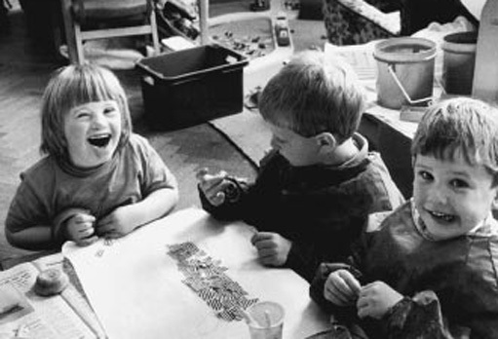
Children working collaboratively.

Pupils were also aware that they were learning a way of interacting with one another, particularly where disagreements arose:

‘It was like team work.’ ‘You might have an idea and someone will say, “no, let's have this one”, and then you all start arguing. Then you discuss it to come up with the best idea.’
(Pupils quoted in Lyle, 1999, p. 290)

The children mentioned rules that were important for this way of working, such as ‘give the others a chance’ and ‘be nice to each other’. They also said that they had made new friends as a result of this way of learning: ‘We've got closer, because before we thought they were dorks and stupid but we realize that they really, really are … nice’ (pupil in Lyle, 1999, p. 292). Further, children said they learnt from both helping and being helped by others in the class. ‘When asked if they thought their work would have been as good if they had worked on their own there were unanimous cries of, “No!”, “No Way!”’ (Lyle, 1999, p. 290).
This way of working seems to be valued by the children and to benefit them in several ways. The positive feelings expressed by the children about this way of working seem to fit with research that asked children about what makes them happy in school.

1.3 What makes you happy at school?

1.3.1 The importance of friendship
When children are asked about the things that are important in their experience of education one factor appears to be important above all others – friendship.
In a study of 2,527 children in 500 primary and secondary schools in one local education authority (LEA) in the north-west of England 62.8 per cent stated that happiness at school was the result of friendships (Whittaker, Kenworthy and Crabtree, 1998). This included best friends and also friendly teachers and other friendly pupils. Along with this, ‘feeling safe, making other children happy and being trusted by others’ also added to their happiness (Whittaker et al., 1998).

‘When everybody is kind and helpful and everybody are friends’ Female, Year 6
‘Playing nice’ Female, Year 2
‘Feeling safe’ Female, Year 6
‘When everybody else is happy’ Female, Year 6
(Whittaker et al., 1998)

1.3.2 The effect of bullying
When asked about what makes them unhappy the most commonly cited factor was bullying, either directly of themselves or of others within the school. Children gave the following reasons for feeling unhappy:

‘When people make fun of me’ Male, Year 6
‘Being called [names] for something you can't help …being shy’ Female, Year 10
‘Being told off and called names by the teacher and friends’ Male, Year 6
‘When you hear about other pupils that are being bullied’ Female, Year 10
‘When people pick on me and call me fat’ Female, Year 6
‘Not fitting in’ Female, Year 6
‘The teacher asks for suggestions and I put my hand up all the time and never get asked once …’ Male, Year 5
(Whittaker et al., 1998)

1.3.3 Feeling safe and secure in school
As we noted above, children place importance on feeling safe and secure. This desire could be used as an argument both in favour of and against inclusive education. It is a fundamental characteristic of most conceptualizations of inclusive schools that they are places where all children can feel secure about being themselves. Opponents of inclusion might argue, though, that a fundamental problem in mixing children together is that they may be exposed to situations where they feel and experience the opposite of this.
This leads us to ask the question: how can schools develop this aspect of school life and counter experiences of isolation and bullying? In a survey of English primary and secondary schools, Audrey Osler (2000) asked children for positive suggestions about reducing bullying. Two factors were raised consistently: teacher–pupil relationships and the ability to participate in school life. Pupils suggested that teachers should:
- give praise for good behaviour;
- listen to pupils;
- take trouble to sort out the underlying causes of disputes instead of just dealing with the immediate effects of violent behaviour;
- recognize bullying, racial and sexual-name calling and abuse as real problems among pupils;
- care more;
- investigate before they punish;
- show respect for all pupils.
(Osler, 2000, p. 54)

Activity: Comparing viewpoints, understanding perspectives

Think back over the children's voices and their views of their experiences of education that we have read in this course. How do your own views, as an adult, compare to those of these children?
Can you think of any other factors that might influence how they see school and their own place in school? What are the implications of the pupils' views that we have discussed in this course for education in segregated settings, and for grouping and streaming?
Write down your thoughts.

View answer - Activity: Comparing viewpoints, understanding perspectives

Conclusion
This free course provided an introduction to studying Education, Child and Youth Qualifications. It took you through a series of exercises designed to develop your approach to study and learning at a distance and helped to improve your confidence as an independent learner.

Keep on learning



Study another free course
There are more than 800 courses on OpenLearn for you to choose from on a range of subjects.
Find out more about all our free courses.

Take your studies further
Find out more about studying with The Open University by visiting our online prospectus.
If you are new to university study, you may be interested in our Access Courses or Certificates.

What’s new from OpenLearn?
Sign up to our newsletter or view a sample.

For reference, full URLs to pages listed above:
OpenLearn – www.open.edu/openlearn/free-courses
Visiting our online prospectus – www.open.ac.uk/courses
Access Courses – www.open.ac.uk/courses/do-it/access
Certificates – www.open.ac.uk/courses/certificates-he
Newsletter – www.open.edu/openlearn/about-openlearn/subscribe-the-openlearn-newsletter

References
Allan, J. (1999) Actively Seeking Inclusion: pupils with special needs in mainstream schools, London, Falmer Press.
Alston, J. (1995) Assessing and Promoting Writing Skills, Stafford, NASEN Enterprises Ltd.
Benjamin, S., Nind, M., Hall, K., Collins, J. and Sheehy, K. (2002) ‘Moments of inclusion and exclusion: pupils negotiating classroom contexts’, paper presented at British Educational Research Association Conference, Exeter, September 2002.
Davis, J. M. and Watson, N. (2001) ‘Where are the children's experiences? Analysing social and cultural exclusion in “special” and “mainstream” schools’, Disability & Society, 16(5), pp. 671–87.
Department for Education and Employment (1997) Excellence in Schools, Command paper CM/3681, London, HMSO.
Duffield, J., Allan, J., Turner, E. and Morris, B. (2000) ‘Pupils' voices on achievement: an alternative to the standards agenda’, Cambridge Journal of Education, 30(2).
Farrell, A., Taylor, C., Tennent, L. and Gahan, D. (2002) ‘Listening to children: a study of child and family services’, Early Years: the Journal of International Research and Development, 22(1), pp. 27–38.
Galitis, I. (2002) ‘Stalemate: girls and a mixed-gender chess club’, Gender and Education, 14(1), pp. 71–83.
Harrett, J. (2002) ‘Young children talking: an investigation into the personal stories of Key Stage One infants’, Early Years: the Journal of International Research and Development, 22(1), pp. 19–26.
Keating, I., Fabian, H., Jordan, P., Mavers, D., Roberts, J. (2000) ‘Well, I’ve not done any work today, I don't know why I came to school: perceptions of play in the reception class’, Educational Studies, 26(4), pp. 437–54.
Lyle, S. (1999) ‘An investigation of pupil perceptions of mixed-ability grouping to enhance literacy in children aged 9–10’, Educational Studies, 25(3), pp. 283–96.
Osler, A. (2000) ‘Children's rights, responsibilities and understandings of school discipline’, Research Papers in Education, 15(1), pp. 49–67.
Sacker, A., Schoon, I. and Bartley, M. (2001) ‘Sources of bias in special needs provision inmainstreamprimary schools: evidence from two British cohort studies’, European Journal of Special Needs Education, 16(3), pp. 259–76.
Sheehy, K. and Jenkin, L. (1999) ‘An evaluation of the Teodorescu Perceptuo-Motor Programme of Handwriting’, REACH: The Journal of Special Needs Education in Ireland, 13(1), pp. 35–47.
Whittaker, J., Kenworthy, J. and Crabtree, C. (1998) ‘What children say about school’, Bolton Data for Inclusion Data, 24, September 1998. Available from: Bolton Data for Inclusion, (accessed October 2003).

Acknowledgements
The content acknowledged below is Proprietary (see terms and conditions). This content is made available under a Creative Commons Attribution-NonCommercial-ShareAlike 4.0 Licence
Grateful acknowledgement is made to the following sources:
Course image: fdecomite in Flickr made available under Creative Commons Attribution 2.0 Licence.
Pages 101 and 104; courtesy of Down’s Syndrome Association.
All other materials included in this course are derived from content originated at the Open University.
Don't miss out:
If reading this text has inspired you to learn more, you may be interested in joining the millions of people who discover our free learning resources and qualifications by visiting The Open University - www.open.edu/openlearn/free-courses

Solutions

Activity: Comparing viewpoints, understanding perspectives

Answer
The children seemed to respond well to collaborative experiences, positive interpersonal relationships and a ‘safe’ school environment. School ethos, the ways teachers work with classes and the social setting of the school would all influence the extent to which children could become active participants in their own school lives.
Back to - Activity: Comparing viewpoints, understanding perspectives

