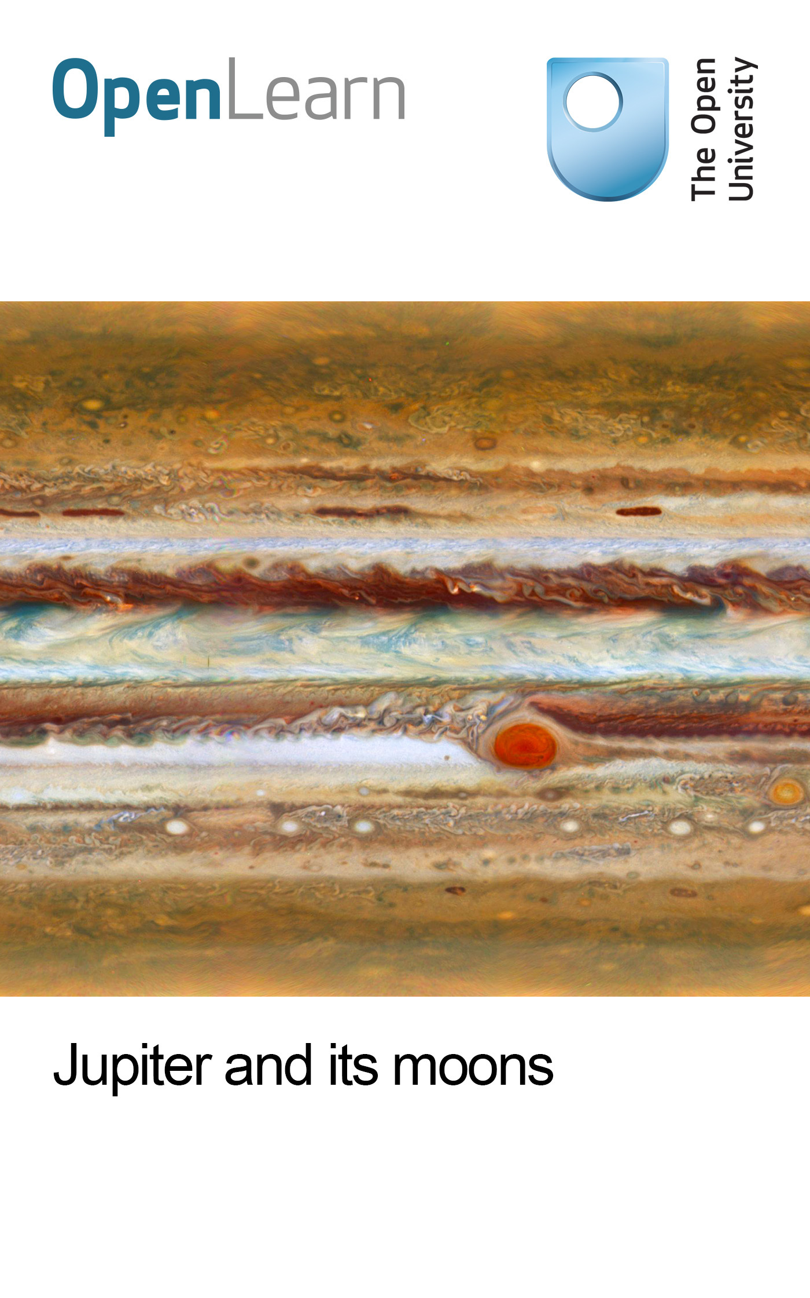

S196_1

Jupiter and its moons
About this free course
This free course provides a sample of level 1 study in Science http://www.open.ac.uk/courses/find/science
This version of the content may include video, images and interactive content that may not be optimised for your device.
You can experience this free course as it was originally designed on OpenLearn, the home of free learning from The Open University: http://www.open.edu/openlearn/science-maths-technology/science/physics-and-astronomy/jupiter-and-its-moons/content-section-0.
There you'll also be able to track your progress via your activity record, which you can use to demonstrate your learning.
The Open University, Walton Hall, Milton Keynes MK7 6AA
Copyright © 2016 The Open University
Intellectual property
Unless otherwise stated, this resource is released under the terms of the Creative Commons Licence v4.0 http://creativecommons.org/licenses/by-nc-sa/4.0/deed.en_GB. Within that The Open University interprets this licence in the following way: www.open.edu/openlearn/about-openlearn/frequently-asked-questions-on-openlearn. Copyright and rights falling outside the terms of the Creative Commons Licence are retained or controlled by The Open University. Please read the full text before using any of the content.
We believe the primary barrier to accessing high-quality educational experiences is cost, which is why we aim to publish as much free content as possible under an open licence. If it proves difficult to release content under our preferred Creative Commons licence (e.g. because we can't afford or gain the clearances or find suitable alternatives), we will still release the materials for free under a personal end-user licence.
This is because the learning experience will always be the same high quality offering and that should always be seen as positive - even if at times the licensing is different to Creative Commons.
When using the content you must attribute us (The Open University) (the OU) and any identified author in accordance with the terms of the Creative Commons Licence.
The Acknowledgements section is used to list, amongst other things, third party (Proprietary), licensed content which is not subject to Creative Commons licensing. Proprietary content must be used (retained) intact and in context to the content at all times.
The Acknowledgements section is also used to bring to your attention any other Special Restrictions which may apply to the content. For example there may be times when the Creative Commons Non-Commercial Sharealike licence does not apply to any of the content even if owned by us (The Open University). In these instances, unless stated otherwise, the content may be used for personal and non-commercial use.
We have also identified as Proprietary other material included in the content which is not subject to Creative Commons Licence. These are OU logos, trading names and may extend to certain photographic and video images and sound recordings and any other material as may be brought to your attention.
Unauthorised use of any of the content may constitute a breach of the terms and conditions and/or intellectual property laws.
We reserve the right to alter, amend or bring to an end any terms and conditions provided here without notice.
All rights falling outside the terms of the Creative Commons licence are retained or controlled by The Open University.
Head of Intellectual Property, The Open University
The Open University
Printed and bound in the United Kingdom by Jarrold Book Printing, Norfolk, England.
978-1-4730-1583-8 (.kdl)
978-1-4730-0815-1 (.epub)

Contents
- Introduction
- Learning outcomes
- 1 Chapter 9 of Teach Yourself Planets
  - 1.1 Rotation and orbit
  - 1.2 Missions to Jupiter
  - 1.3 The interior
  - 1.4 The atmosphere
  - 1.5 The Shoemaker Levy 9 impacts
  - 1.6 Rings
  - 1.7 Satellites
  - 1.8 Io
  - 1.9 Europa
  - 1.10 Ganymede
  - 1.11 Callisto
- 2 Discussion of Chapter 9: Jupiter itself
  - 2.1 Jupiter and its missions: an update
  - 2.2 Jupiter's magnetic field and radiation zone
  - 2.3 Jupiter's atmosphere
  - 2.3 Movie 1 - Voyager 1 'Blue Movie'
  - 2.3 Movie 2 - Red Spot Movie
  - 2.3 Movie 3 - Jupiter Polar Winds Movie
  - 2.3 Movie 4 - Planetwide Colour Movie
  - 2.3 Movie 5 - Small Storms Near Great Red Spot
  - 2.3 Movie 6 - Jupiter Hot Spot
  - 2.3 Movie 7 - Jupiter's High Latitudes
  - 2.3 Jupiter's atmosphere (continued)
- 3 Discussion of Chapter 9: Rings and the satellite family
  - 3.1 Jupiter's rings and satellites
  - 3.2 Io
  - 3.3 Europa
  - 3.4 Ganymede and Callisto
- 4 Questions
- Conclusion
- Keep on learning
- Acknowledgements

Introduction
The core of this course is Chapter 9 of Teach Yourself Planets, by David Rothery, which is found in Section 1 of this course page by page, followed by a guided discussion and questions in Sections 2 through 4. Note that all references in Chapter 9 of Teach Yourself Planets to other chapters, are to other chapters of Teach Yourself Planets - these references are not to other sections of this course.
Jupiter is the first of the giant planets and has a large family of satellites. Four of these are much more substantial than any asteroid and can justifiably be regarded as worlds in their own rights.
This OpenLearn course provides a sample of level 1 study in Science

Learning outcomes
After studying this course, you should be able to:
- retrieve, evaluate and interpret data and information about Jupiter and its moons, so that (for example) using a close-up picture of Jupiter and its moons’ surfaces it is possible identify the types of feature visible and recognise the processes responsible for creating them.

1 Chapter 9 of Teach Yourself Planets
David A. Rothery Teach Yourself Planets, Chapter 9, pp. 107-39, Hodder Education, 2000, 2003.
Copyright © David Rothery
In this chapter you will learn:
- about the largest giant planet in the Solar System: about its dense interior, its deep and dynamic atmosphere, and what happened when it was struck by comet fragments in 1993
- about Jupiter's slender rings and amazingly diverse family of satellites.
Planetary facts
Equatorial radius (km) | 71,492
Mass (relative to Earth) | 317.7
Density (g/cm³) | 1.33
Surface gravity (relative to Earth) | 2.36
Rotation period | 9.93 hours
Axial inclination | 3.1°
Distance from Sun (AU) | 5.20
Orbital period | 11.86 years
Orbital eccentricity | 0.048
Composition of surface | gassy
Mean cloud-top temperature | -150°C
Composition of atmosphere | hydrogen (90%),
 | helium (10%),
 | methane (0.3%),
 | ammonia (0.03%)
Number of satellites | 40 [now estimated to be 63]
David A. Rothery, Teach Yourself Planets, p. 108, Hodder Education, 2000, 2003. Copyright © David Rothery
At Jupiter, the character of the Solar System takes a new turn. Jupiter is the first of the giant planets, and contains more mass than all other planetary bodies in the Solar System put together. The table below shows some lists some of the key facts about the planet. Its internal structure is compared with that of the other giant planets in Figure 2.5 [figure not included in this course].

1.1 Rotation and orbit
David A. Rothery Teach Yourself Planets, Chapter 9, pp. 107-39, Hodder Education, 2000, 2003.
Copyright © David Rothery
Jupiter's orbital velocity is about 13 km per second, little more than half that of Mars, allowing Earth to overtake it every 399 days. Jupiter's orbit is less eccentric than Mars's, and its distance at opposition varies between 590 million and 670 million km. Its large size and the reflectivity of its cloud tops make it a consistently conspicuous object, brighter than Mars except when Mars is at its closest opposition distance.
Jupiter rotates in just under ten hours, a shorter period than for any other planet. The value of 9.93 hours quoted in the planetary facts table is the rotation period of the interior, as deduced from the rotation of Jupiter's magnetic field and corresponding periodic variations in radio emissions. The cloud tops that act as Jupiter's visible surface rotate faster than this near the equator, where the cloud top rotation period is 9.84 hours. This corresponds to a westerly (i.e. eastward-blowing) wind of about 150 m per second (540 km per hour!) A notable consequence of Jupiter's rapid rotation is that its shape is perceptibly flattened (Figure 9.1). Its radius measured from centre to pole is only 66,854 km, which is 6.5 per cent less than its equatorial radius.
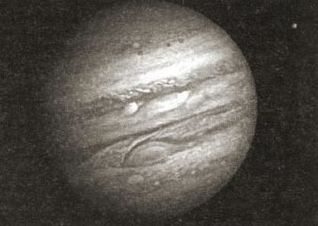
NASA NASA
Figure 9.1: Voyager 1 image of Jupiter showing nearly a full disc[.] The cloud bands run parallel to lines of latitude, and the flattening of the planet's shape towards the poles is apparent[.] The famous Great Red Spot is visible below the centre of the disc[.] The small object above right of Jupiter is its innermost large satellite, lo[.]
Jupiter's axial inclination is slight, so that the plane of its equator is very close to the plane of its orbit. Jupiter has 40 known satellites. The eight innermost ones orbit almost exactly in the equatorial plane, but the orbits of the next six are inclined at between 27° and 43°. The rest have orbits inclined at between 147° and 165°, so that their motion is retrograde. This family of satellites and its more important members are described later in this chapter.

1.2 Missions to Jupiter
David A. Rothery Teach Yourself Planets, Chapter 9, pp. 107-39, Hodder Education, 2000, 2003.
Copyright © David Rothery
The outer Solar System has been less thoroughly explored than Earth's immediate neighbourhood, but the lure of Jupiter and its amazing satellite system is such that nevertheless it has received considerable attention (Table 9.1).
Table 9.1: Successful and anticipated missions to Jupiter (all NASA except Ulysses joint with the European Space Agency) (? = exact date unknown)
Name | Description | Date of fly-by or operational period
Pioneer 10 | fly-by; first close-up pictures, first determination of magnetic field and charged particles, atmospheric measurements | Dec. 1973
Pioneer 11 | fly-by; similar to Pioneer 10 | Dec. 1974
Voyager 1 | fly-by; first detailed pictures of Jupiter's satellites, discovered active volcanoes on Io | Mar. 1979
Voyager 2 | fly-by; similar to Voyager 1 | July 1979
Ulysses | fly-by as a means to go into polar orbit about the Sun; magnetospheric measurements | Feb. 1992
Galileo | entry probe and orbiter; atmospheric measurements, long duration detailed imaging of satellites | Dec. 1995 (entry probe) - 2003
Cassini | fly-by en route to Saturn | Oct. 2000 - March 2001
Europa Orbiter [cancelled] | orbiter; imaging, ice-penetrating radar, surface altimetry | 2010 - 2012?
David A. Rothery, Teach Yourself Planets, p. 110, Hodder Education, 2000, 2003. Copyright © David Rothery
The first probes to venture Jupiterwards were Pioneers 10 and 11, which were launched in 1972 and 1973. Their safe crossing of the asteroid belt dispelled fears that this region of space might be so full of meteorite debris that it would be impossible for spacecraft to survive passage through it without unfeasibly robust shielding. Furthermore, by determining the intensity of radiation in the zones of charged particles trapped by Jupiter's magnetic field they enabled the design and trajectories of future missions to be planned within safe limits.
In addition to mapping Jupiter's magnetic field, the Pioneers returned the first close-up images of the planet itself. Probably of more importance than the images were the determinations of pressure, density and temperature in the atmosphere made using infrared detectors and by radio occultation, which depended on measuring the way the Pioneers' radio signals faded out as they passed temporarily out of sight behind the planet. In particular these showed that Jupiter's atmosphere is hydrogen-rich but mixed with a significant amount of helium, thereby lending support to the model of Jupiter's growth by scavenging gas from the solar nebula that was described in Chapter 02.
Jupiter and its satellites were explored in more detail by two Voyager probes that flew past in 1979. These recorded detailed time series views of Jupiter's atmospheric circulation and the first ever high resolution views of Jupiter's four largest satellites, revealing active volcanoes on one of them, and also discovering three inner satellites and Jupiter's slender main ring. Each Voyager probe took advantage of Jupiter's gravitational field to alter its trajectory and speed it on its way to Saturn, using the so-called 'gravitational sling-shot' effect otherwise known as a gravity assist trajectory. Voyager 2 must rank as the most productive spaceprobe in history, proceeding beyond Saturn to encounters with Uranus and then Neptune (Figure 9.2).
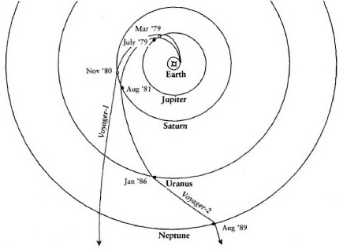
David RotheryDavid Rothery
Figure 9.2: Trajectories of the two Voyager spacecraft[.] Voyager 1's encounter flung it onwards above (north of) the plane of the Solar System, whereas after Neptune Voyager 2 continued on a course below (south of) this plane[.]
As the new millennium dawned both Voyagers were still functioning 76 and 60 AU from the Sun respectively, having overtaken the slower-moving Pioneer probes with which communications ceased in 1997, and returning data on the interplanetary environment. Voyager 1 is expected to be the first human artefact to penetrate the interstellar medium (space beyond the influence of the solar wind) in about 2019.
After the Voyagers there was an interval of more than a dozen years before Jupiter received its next visitor from Earth. This was Ulysses, a probe designed to study the Sun. However, in order to get Ulysses into a high-inclination orbit, it was sent first to Jupiter so that by swinging over the planet's north pole the gravitational sling-shot effect would direct it south of the ecliptic plane into an orbit passing over the Sun's south and north poles in turn. This Jupiter swing-past provided a useful opportunity to map the high-latitude parts of Jupiter's magnetosphere, but Ulysses had no imaging system.
For new pictures, the world had to wait for the arrival of Galileo in 1995. This was named after Galileo Galilei, the discoverer of Jupiter's four large satellites, and was the first mission to go into orbit about a giant planet. It swung several times past each of the large satellites in order to produce higher resolution and more complete image coverage than the Voyagers had managed and was still functioning in 2003. Galileo also dispatched a probe into Jupiter's atmosphere. This survived for over an hour reaching nearly 160 km below the cloud tops, where the temperature was 153°C and the pressure was 22 times that at sea-level on Earth. Entering the atmosphere at 6.5° north of the equator, the probe demonstrated that the westerly wind continues below the cloud tops, with its speed actually increasing to about 190 m per second at the depth where the probe lost contact.
The next mission with Jupiter as its goal will probably be one targetted specifically at Jupiter's satellite Europa, listed as Europa Orbiter in Table 9.1. This will initially go into orbit around Jupiter itself, possibly in 2010 [this mission has now been cancelled]. However, by means of multiple gravity assist fly-bys of Europa and other satellites it will ease itself into a position from which it can be captured into a high inclination orbit about Europa. There may be an earlier opportunity to collect close-up data on the Jupiter system in March 2007 when a Pluto-bound probe called New Horizons is provisionally scheduled to swing past Jupiter on a gravity assist trajectory.

1.3 The interior
David A. Rothery Teach Yourself Planets, Chapter 9, pp. 107-39, Hodder Education, 2000, 2003.
Copyright © David Rothery
Impressive as was the descent of the Galileo entry probe, it penetrated less than a third of a per cent of the way to Jupiter's centre. Our picture of the planet's interior is therefore based on theoretical models of how a large mass of what we understand to be Jupiter's composition should behave, supplemented by insights from the planet's gravity and magnetic fields. As Figure 2.5 shows [figure not included in this course], the outer layer, composed dominantly of molecular hydrogen (mixed with helium), extends below the cloud tops to a depth of about 10,000 km. It would be an oversimplification to refer to the whole layer as 'the atmosphere', because in its lower part (where the pressure exceeds a hundred thousand times the Earth's atmospheric pressure) this hydrogen would behave more like a liquid than a gas.
However, the first clear break in properties is believed to occur at about 10,000 km depth, where pressure is about a million times that at sea-level on Earth and temperature is about 6000°C. Under these conditions the bonds holding together the hydrogen molecules (each consisting of two hydrogen atoms) must break. In this situation, the hydrogen atoms are unbound and the electrons are free to wander through the spaces between the atoms, rather than forming chemical bonds as they would under lower pressure. These are the properties of a molten metal, and hence this layer is described as metallic hydrogen in Figure 2.5. Below this layer Jupiter must have a shell of high pressure ice (probably mostly water in composition), surrounding a core of rock and possibly an inner core of iron. The pressure in the core is probably about 40 million times Earth's atmospheric pressure and the temperature about 17,000°C. The state of the rocky material in Jupiter's core is unknown. It is probably molten, but the tremendous pressure (20 times that occurring within the Earth) could compress it into a solid. If so, the minerals would be high-density varieties rather than those familiar on Earth. Jupiter's core may look small at the scale of Figure 2.5, but probably contains 10-20 times the mass of the Earth.
Jupiter has by far the strongest magnetic field of all the planets, 20,000 times the strength of the Earth's. It is tilted at 9.6° relative to the planet's rotational axis, and appears to be generated by convection within Jupiter's thick metallic hydrogen layer. This powerful magnetic field holds in place a belt of ionized sulfur centred about the orbit of Jupiter's innermost large satellite, Io, and channels high energy electrons towards Jupiter's poles, where they produce spectacular auroral displays (Figure 9.3 [Figure 6 is a higher quality version of this image]).
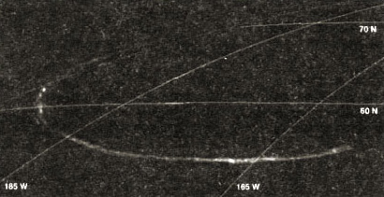
NASANASA
Figure 9.3: Visible evidence of Jupiter's internally generated magnetic field: an aurora (glow from ionized atoms) seen by the spaceprobe Galileo on Jupiter's night-side[.] Lines of latitude and longitude have been superimposed[.]
A notable property of Jupiter, which it shares with Saturn and Neptune though not Uranus, is that it radiates to space about twice as much energy as it receives from the Sun. This rate of heat loss, about seven watts per square metre, is 1000 times the feasible rate of radiogenic heat production in Jupiter's rocky core. Instead, it probably indicates that Jupiter is still contracting in size, converting gravitational potential energy into heat. If Jupiter had been about thirteen times more massive, this process would have been sufficient to raise its internal pressure and temperature to the point where nuclear fusion of hydrogen begins, and Jupiter would have become more like a star than a planet.

1.4 The atmosphere
David A. Rothery Teach Yourself Planets, Chapter 9, pp. 107-39, Hodder Education, 2000, 2003.
Copyright © David Rothery
It is probably the heat from Jupiter's interior that powers Jupiter's winds. This is in contrast to the Earth's atmosphere, where solar heating and condensation of water vapour provide the impetus for winds. Jupiter's prevailing winds follow a pattern that is described as 'zonal', meaning confined into discrete zones of latitude. The fast westerly winds near Jupiter's equator have already been mentioned. This atmospheric stream coincides with the pale equatorial zone visible in Figure 9.1. To both north and south there is a darker belt where the wind blows in the opposite direction at several tens of metres per second. The winds become super fast again in the direction of the planet's rotation in each of the pale zones at higher latitudes. As might be expected, where zones of opposite flowing winds touch, the shearing between air masses creates complex patterns (Figure 9.4).
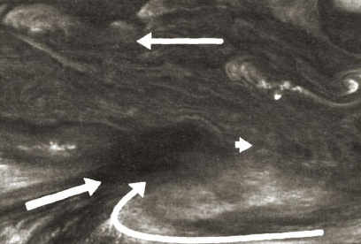
NASA
Figure 9.4: Galileo image, 34,000 km wide, showing the boundary between westerly (eastward-blowing) winds in Jupiter's pale equatorial zone (lower third of the image) and the easterly winds in the darker belt to its north[.] Arrows show wind speed and strength relative to the dark spot, which is a site upon which dry atmosphere is converging and sinking[.]
Generally, the atmosphere is rising in the pale zones and sinking in the dark belts, and effectively Jupiter has a series of several Hadley cells between the equator and the two poles. Jupiter shows very little latitudinal variation in temperature, so these cells must be very efficient at transferring heat from the equator towards the poles. However, the situation is complicated by the fact that so much heat comes from inside the planet too.
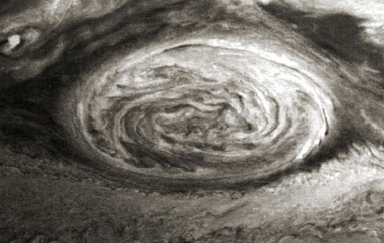
NASA
Figure 9.5: Galileo image, 30,000 km across, showing the Great Red Spot in June 1996[.] The spiral pattern within the Great Red Spot is apparent, reflecting its anticlockwise rotation, and smaller spots and eddies can be seen at the edge of the south tropical zone to its south[.] This image was recorded in near infrared light, at which wavelength the Great Red Spot is more reflective than its surroundings[.]
A particularly notable feature of the interaction between competing zonal winds is the generation of eddies where the wind flows in a circular or spiral pattern. The most famous of these is Jupiter's Great Red Spot (Plate 7, Figure 9.5), which has been apparent in telescopic observations since at least 1830 and sits in the dark belt between the pale equatorial zone and the pale south tropical zone. It takes about a week for the Great Red Spot to rotate, and winds around its periphery can reach over 100 m per second. Jupiter has many other storm systems, usually white rather than red, that can individually persist for several years or even decades (Figure 9.6).
[Click 'view document' to open Plate 7, Voyager view of part of Jupiter and its Great Red Spot. This spiral storm pattern is about twice the width of the Earth and takes about a week to rotate. NASA.]
View document
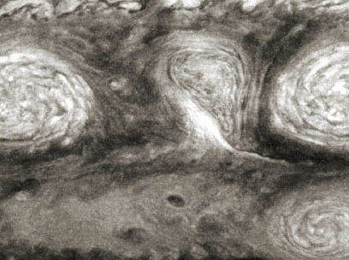
NASA
Figure 9.6: Galileo image, 25,000 km across, showing a remarkable confluence of spiral storm systems on Jupiter in February 1997[.] The two large white ovals at left and right were storm systems first identified telescopically in 1938[.] They were rotating anticlockwise, whereas the pear-shaped mass between them was rotating clockwise[.] These three systems merged into a single feature early in 1998[.] The spiral storm system in the lower right corner was drifting eastward at 500 km per day relative to its more northerly neighbours[.]
In addition to water and the atmospheric constituents listed in the planetary facts table, spectroscopic studies have shown that Jupiter's atmosphere contains traces of gases such as water vapour, hydrogen deuteride (HD, a molecule consisting of an atom of ordinary hydrogen bonded to an atom of 'heavy' hydrogen), ethane (C₂H₆), ethyne (C₂H₂), phosphine (PH₃), carbon monoxide (CO) and germane (GeH₄).
The issue of what imparts the colour to features such as the Great Red Spot is a controversy that has not been resolved despite the Galileo entry probe's success. Compounds of sulfur, phosphorous and carbon have all been suggested. However, we do at least have a reasonable knowledge of the basic composition of the clouds. Clouds occur where conditions of temperature and pressure are such that a constituent in the atmosphere, which may be only a trace (as, for example, water in the atmosphere of Earth and Mars), is more stable as a liquid or solid than as a gas.
The whiteness of Jupiter's pale zones is caused by condensation of ammonia-ice (NH₃) as the atmosphere rises and cools towards the cloud top temperature of about -150°C. In the dark belts, as the atmosphere sinks it becomes hotter, so the ammonia clouds evaporate allowing us to see to deeper and darker levels. About 50 km below the ammonia clouds is a layer of clouds of ammonium hydrosulfide (NH₄HS) at about 0°C and below this probably a layer of water-ice clouds at about 50°C. The Galileo entry probe passed through the ammonium hydrosulfide cloud layer, but failed to find the water clouds, probably because it arrived in a dry downwelling zone where the water content of the atmosphere was lower than average.

1.5 The Shoemaker Levy 9 impacts
David A. Rothery Teach Yourself Planets, Chapter 9, pp. 107-39, Hodder Education, 2000, 2003.
Copyright © David Rothery
A remarkable opportunity to study Jupiter's atmosphere presented itself with the discovery in March 1993 of comet Shoemaker Levy 9 on a collision course with the planet. The comet had evidently been captured into orbit about Jupiter some decades previously, but this orbit was unstable. It had made an unnoticed close pass by Jupiter in July 1992, only about 21,000 km above the cloud tops, which had tidally disrupted it into a string of about 20 fragments (showing that this comet, like many asteroids, was a loosely bound rubble pile). When discovered these fragments were heading away from Jupiter prior to falling back for a series of 60 km per second impacts over the period 16-22 July 1994.
The impact coordinates were on Jupiter's night-side just out of direct view from the Earth, but fortunately in a position where Jupiter's rapid rotation would bring the site of each impact into sunlight and direct view from the Earth about 25 minutes later. Even more fortunately, the Galileo spacecraft, still 240 million km and 17 months away from arrival but with a significantly different vantage point, had a direct view of the impact site. Some images of the impacts are shown in Figure 9.7.
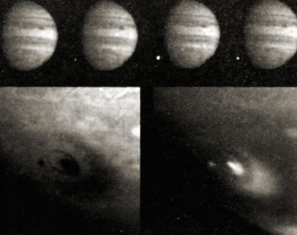
NASA and AURA STScI; NASA and AURA STScI
Figure 9.7: Top: series of four images recorded by Galileo over a seven-second period, showing the beginning, brightening and fading of the fireball produced by the impact of the final fragment of comet Shoemaker Levy 9 on Jupiter on 22 July 1994[.] Bottom: Hubble Space Telescope views recorded on 18 July 1994 showing part of Jupiter's southern hemisphere 105 minutes after a fragment of the comet had collided with the planet[.] The view on the left was recorded through a green filter, and ejecta that had been thrown out by the impact appears dark[.] The view on the right was recorded at a near infrared wavelength at which methane absorbs very strongly, so only features high enough to be above most of the atmospheric methane show up brightly[.] The central spot in each case is the actual impact site, and the crescent shape to its southeast is assymetrically distributed ejecta, that escaped up the angled 'tunnel' drilled through the atmosphere by the comet fragment[.] The ring about the spot is a shock wave travelling through the atmosphere[.]
The Hubble Space Telescope images in this figure show a spot to the left of the most recent impact, which marks the site of an impact that happened 19 hours 43 minutes (almost two rotations) previously. These impact scars were remarkably persistent, some remaining visible for many months before shearing in the atmosphere completely disrupted them. The nature of the dark material, which was probably ejected from some 30 km below the cloud tops remains uncertain, even the professional literature referring to it simply as 'dark stuff'.

1.6 Rings
David A. Rothery Teach Yourself Planets, Chapter 9, pp. 107-39, Hodder Education, 2000, 2003.
Copyright © David Rothery
Planetary rings consist of hordes of particles sharing orbits in their planet's equatorial plane, and occur around each of the four giant planets. Their width varies from planet to planet, but in general their thickness is no more than a few tens of kilometres. They generally lie close to their planet, inside what is known as the Roche limit where no large solid body could exist because it would be pulled apart by tidal forces. Therefore rings may represent material from that part of an orginal circumplanetary disc that was inside the Roche limit and so could not aggregate into a large body. Alternatively they may owe their origin to a satellite or comet that strayed within the Roche limit and was ripped apart. Some less substantial rings may be supplied by dust sprayed from a nearby satellite into space by impacts or volcanic activity.
The rings of Saturn have been known since the dawn of the telescopic era, although Galileo Galilei himself could not make out what they were. Jupiter's far less spectacular rings were not discovered until Voyager 1's arrival in 1979. Part of the reason for their inconspicuousness is that even the main one is far narrower than Saturn's. Another important factor is that Jupiter's rings reflect less than 5 percent of the incident sunlight (in other words their albedo is <0.05), presumably because they are made of silicate- or carbon-rich material, whereas Saturn's are icy and reflect up to 80 per cent (albedo up to 0.8).
Jupiter's rings are easier to see in forward-scattered light, i.e. when looking at them towards the Sun (Figure 9.8), than when seen in back-scattered light, which is the only view we ever get of them from Earth. This reveals that they are made mostly of very small particles, about a micrometre in size. There could be plenty of larger chunks too, but the total volume of matter in the rings is probably no more than required to make a single object about a kilometre across.
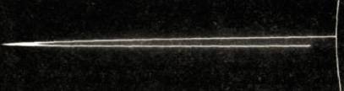
NASA
Figure 9.8: Jupiter's main ring, as seen by Galileo looking towards the Sun and obliquely down on the ring system[.] The arc on the extreme right is sunlight scattered by Jupiter's uppermost atmosphere[.] The nearest part of the ring is invisible because it lies in the planet's shadow[.] Above and below the main ring can be seen a faint halo consisting of particles forced out of the main ring by electromagnetic forces[.]
Micrometre-sized particles can survive in a ring for only about 1000 years before radiation pressure and interactions with the planet's magnetic field disperse them. Therefore either Jupiter's rings are young and ephemeral (which seems improbable) or there is a continual supply of fresh particles.
There are three components to Jupiter's ring system. The main ring is no thicker than 30 km and has an inner radius of 123,000 km and an outer radius of 129,000 km. Its outer edge coincides with the orbit of the tiny satellite Adrastea, whereas the innermost known satellite, Metis, actually orbits within the ring at a radius where the ring shows a marked drop in brightness (not perceptible in the oblique view of Figure 9.8). Apparently unique to Jupiter, there is a 20,000-km-thick halo above and below the main ring that is believed to consist of small particles forced out of the ring plane by electromagnetic forces. Beyond the rim of the main ring lies the so-called gossamer ring that is tenuous in the extreme, but is even thicker than the halo and contains the orbits of the satellites Amalthea and Thebe which are presumably the sources of the particles making up this ring.

1.7 Satellites
David A. Rothery Teach Yourself Planets, Chapter 9, pp. 107-39, Hodder Education, 2000, 2003.
Copyright © David Rothery
The satellite system of each giant planet begins closest to the planet with small moonlets associated with the ring system in near-circular orbits, then come larger 'regular' satellites also in near-circular orbits close to the planet's equatorial plane, followed by an outer family of small 'irregular' satellites in elongated, inclined and in most cases retrograde orbits.
Most satellites are in synchronous rotation, always keeping the same face towards their planet. This means that one side of a satellite, known as the 'leading hemisphere', faces permanently towards the direction of orbital travel while the 'trailing hemisphere' faces away from the direction of travel. We know comparatively little about most of the inner moonlets and small outer satellites of the giant planets in general, other than that most have densities probably less than that of ice and so are likely to be heaps of rubble and that the inner moonlets are probably the sources of the ring material.
Chapter 02 described how most large satellites of giant planets grew from a disc of gas and dust around each planet. Most inner moonlets are probably fragments of formerly larger satellites that were destroyed by collisions or tidal forces, whereas the irregular outer satellites, especially those in retrograde orbits, are likely to be captured comets or asteroids. These are very dark, and are probably covered by tholins or other carbonaceous material, whatever their internal compositions.
Some basic information about Jupiter's family of satellites is given in Table 9.2. Images of its inner moonlets (Figure 9.9) show that these have the irregular shapes expected of bodies too small for their own gravity to pull them into spheres, the size limit for which appears to be a radius of about 200 km for an icy body. Amalthea and Thebe both have craters that are quite large relative to their own sizes, especially on their leading hemispheres, which is the side most vulnerable to impact damage. Amalthea is dark red in colour, which could be a sulfurous coating derived from its volcanically active neighbour Io, or indicate a tholin-rich surface similar to Jupiter's Trojan asteroids or Centaurs.
Table 9.2: Satellites of Jupiter [not including discoveries made in 2003 and subsequently][.] Orbital distances and periods of the unnamed (provisionally designated) satellites are uncertain (R = retrograde, ? = value unknown)[.]
Name | Distance from planet's centre | Radius (km) | Orbital period (days) | Mass | Denary (g/cm3)
Metis | 127,960 | 30 × 17 | 0.295 | 1 × 10¹⁸ kg | 3.0
Adrastrea | 128,980 | 13 × 10 × 8 | 0.298 | 0.2 × 10¹⁸ kg | 3.0
Amalthea | 181,300 | 131 × 73 × 67 | 0.498 | 7.5 × 10¹⁸ kg | 3.1
Thebe | 221,900 | 55 × 45 | 0.675 | 0.8 × 10¹⁸ kg | 3.0
Io | 421,600 | 1821 | 1.769 | 8.93 × 10²² kg | 3.53
Europa | 670,900 | 1565 | 3.552 | 4.80 × 10²² kg | 3.01
Ganymede | 1,070,000 | 2,631 | 7.155 | 14.8 × 10²² kg | 1.94
Callisto | 1,883,000 | 2,403 | 16.69 | 10.8 × 10²² kg | 1.83
Themisto | 7,507,000 | 4 | 130.0 | ? | ?
Leda | 11,165,000 | 10 | 240.9 | ? | ?
Himalia | 11,461,000 | 85 | 250.6 | ? | ?
Lysithea | 11,717,000 | 18 | 259.2 | ? | ?
Elara | 11,741,000 | 43 | 259.6 | ? | ?
S/2000 J11 | 12,555,000 | 2.0 | 287 | ? | ?
S/2001 J10 [Euporie] | 19,394,000 | 1.0 | 553 R | ? | ?
S/2001 J7 [Euanthe] | 21,027,000 | 1.5 | 620 R | ? | ?
Harpalyke | 21,105,000 | 2.2 | 623 R | ? | ?
S/2001 J9 [Orthosie] | 21,116,000 | 1.0 | 623 R | ? | ?
Praxidike | 21,147,000 | 3.4 | 625 R | ? | ?
S/2001 J3 [Hermippe] | 21,252,000 | 2.0 | 632 R | ? | ?
locaste | 21,269,000 | 2.6 | 631 R | ? | ?
Ananke | 21,276,000 | 10 | 630 R | ? | ?
S/2001 J2 [Thyone] | 21,312,000 | 2.0 | 632 R | ? | ?
S/2002 J1 | 22,931,000 | 1.5 | 714 R | ? | ?
S/2001 J6 [Pasithee] | 23,029,000 | 1.0 | 716 R | ? | ?
S/2001 J8 [Kale] | 23,124,000 | 1.0 | 721 R | ? | ?
Chaldene | 23,179,000 | 1.9 | 724 R | ? | ?
Isonoe | 23,217,000 | 1.9 | 726 R | ? | ?
S/2001 J4 [Eurydome] | 23,219,000 | 1.5 | 721 R | ? | ?
Erinome | 23,279,000 | 1.6 | 728 R | ? | ?
Taygete | 23,360,000 | 2.5 | 732 R | ? | ?
Carme | 23,404,000 | 15 | 734 R | ? | ?
S/2001 J11 [Aitne] | 23,547,000 | 2.0 | 741 R | ? | ?
Kalyke | 23,583,000 | 2.6 | 743 R | ? | ?
Pasiphae | 23,624,000 | 18 | 744 R | ? | ?
Megaclite | 23,806,000 | 2.7 | 753 R | ? | ?
S/2001 J5 [Sponde] | 23,808,000 | 1.0 | 749 R | ? | ?
Sinope | 23,939,000 | 14 | 759 R | ? | ?
Callirrhoe | 24,102,000 | 4 | 759 R | ? | ?
S/2001 J1 [Autonoe] | 24,122,000 | 2.0 | 765 R | ? | ?
David A. Rothery, Teach Yourself Planets, p. 122, Hodder Education, 2000, 2003. Copyright © David Rothery
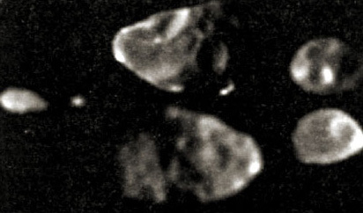
NASA
Figure 9.9: Jupiter's four innermost known satellites, imaged by Galileo and shown at their correct relative sizes[.] From left to right: Metis (60 km long), Adrastea (20 km long), Amalthea (247 km long) and Thebe (116 km long)[.] Two views are shown for Amalthea and Thebe: top the leading hemisphere, bottom the trailing hemisphere[.]
Jupiter's irregular satellites are very poorly known. Many of them are recent telescopic discoveries, as can be deduced from the provisional designations that some bear instead of names in Table 9.2. There may be hundreds of others more than 1 km across that still await discovery. The satellite S/1975 J1 was first seen briefly in 1975 but was lost again until 2000, when it was designated as S/2000 J1 until it became clear that the two objects were the same. It received the name Themisto late in 2002, when ten other discoveries from 1999 and 2000 were also given names. Leda, Himalia, Lysithea, Elara and S/2000 J11 are the only other irregular satellites to have prograde orbits, and those five could be remnants of a single body that broke apart during capture by Jupiter. The outermost satellites all have retrograde orbits. These tend to fall in groups, in which several adjacent orbits have almost the same inclination. Each group is probably the remains of a body that broke apart during capture by Jupiter.
Jupiter has four large satellites, Io, Europa, Ganymede and Callisto, orbiting between its inner and outer satellite families. These were discovered in 1610 by Galileo Galilei, and are known collectively as the galilean satellites. Individually they are substantial bodies and are really worlds in their own rights. Some of their important properties are listed in Table 9.3.
Table 9.3: Planetary facts for the galilean satellites
 | Io | Europa | Ganymede | Callisto
Equatorial radius (km) | 1821 | 1565 | 2631 | 2403
Mass (relative to Earth) | 0.0149 | 0.00803 | 0.0248 | 0.0181
Density (g/cm³) | 3.53 | 3.01 | 1.94 | 1.83
Surface gravity (relative to Earth) | 0.18 | 0.13 | 0.14 | 0.13
Composition of surface | rocky | salty ice | dirty ice | dirty ice
Mean surface temperature | −150°C | −150°C | −160°C | −160°C
David A. Rothery, Teach Yourself Planets, p. 124, Hodder Education, 2000, 2003. Copyright © David Rothery
The decrease in density outwards from Io through Europa to Ganymede and Callisto reflects the fact that Io is ice-free, Europa has a 100 km thick covering of ice, and Ganymede and Callisto each contain about 40 per cent of ice. This would be a natural consequence of a decrease in temperature with distance away from the hot, young Jupiter within the disc of gas and dust from which these bodies grew. They are described in turn in the following sections.

1.8 Io
David A. Rothery Teach Yourself Planets, Chapter 9, pp. 107-39, Hodder Education, 2000, 2003.
Copyright © David Rothery
Of the welter of revelations provided by the Voyager tours of the outer Solar System, the discovery of active volcanoes on Io probably ranks top of the list. Prior to this, most people had assumed that bodies of Io's size, whether rocky like Io or icy like its companions, would be geologically dead like our own, similarly sized, Moon. This is because their small size makes them incapable of having retained enough primordial heat or generating adequate radiogenic heat to keep their lithospheres thin and to drive mantle convection sufficiently close to the surface for melts to escape.
However, it is now realized that the orbital resonance that exists between the three innermost galilean satellites results in tidal heating. For every one orbit completed by Ganymede, Europa completes two and Io four. This means that the satellites repeatedly pass each other at the same points in their orbits, and the consequent internal stresses experienced by the satellites provide a source of heat that keeps their interiors warmer than they would otherwise be. The effect is greatest for Io, which is closest to Jupiter and hence experiences the strongest tidal forces.
There are often more than a dozen volcanoes erupting on Io at any one time. These are identified either by seeing an 'eruption plume' powered by the explosive escape of sulfur dioxide and rising 100-400 km above the surface (Plate 8), or by infrared detection of a hot spot. The record for the highest local temperature is at least 1400°C.
[Click 'view document' to open Plate 8. Galileo image of lo recorded on 28 June 1997. There are two eruption plumes visible. One is 140 km high and is seen in profile above the limb; this emanates from a volcano named Pillan Patera. The other plume, from a volcano named Prometheus, is seen from directly above, and lies near the centre of the disc. It is shown enlarged in the inset at upper left; the bluish dark ring is the outline of the plume and this casts a reddish shadow over the surface to its right. NASA.]
View document
Io's density is slightly greater than that of the Moon, and it is clear that Io is a dominantly silicate body, like the terrestrial planets. Gravity and magnetic observations by Galileo confirm that it has a dense, presumably iron-rich core below its rocky mantle. Spectral data show that Io's surface is covered by sulfur, sulfur dioxide frost and other sulfur compounds. However, these are no more than thin, volatile, veneers resulting from volcanic activity and the crust as a whole is some kind of silicate rock.
Io has an atmosphere of sulfur dioxide, and atomic oxygen, sodium and potassium. The surface pressure is less than a millionth of the Earth's but nearly a billion times greater than the atmospheric pressure of the Moon or Mercury. Io's atmosphere continually leaks away into space, contributing to a 'cloud' of sodium and potassium that falls inwards towards Jupiter and to a magnetically confined belt of ionized sulfur that stretches right round Jupiter, concentrated around Io's orbit. The atmosphere is replenished by a combination of volcanic activity and collisions onto Io's surface by high-speed ions channelled by Jupiter's magnetic field. When Io passes into the shadow of Jupiter its atmosphere can be seen faintly glowing in an auroral display caused by these same magnetospheric ions impinging on the atmosphere (Figure 9.10).
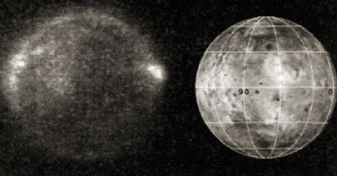
NASA
Figure 9.10: Left: the visible glow over lo's leading hemisphere produced by its atmosphere interacting with high-speed ions channelled by Jupiter's magnetic field[.] The more brightly glowing patches coincide with volcanic eruption plumes, where the atmosphere is densest[.] This image was recorded by Galileo when Io was in Jupiter's shadow in May 1998[.] Right: sunlit view of the same hemisphere, with latitude and longitude superimposed (0 degrees longitude is at the centre of the side that always faces Jupiter, and 90 degrees longitude is the centre of the leading hemisphere)[.]
Io's surface is totally dominated by the results of volcanic activity (Figure 9.11). There are lava flows up to several hundred km in length and vast swathes of mostly flat terrain covered by fallout from eruption plumes. Most of the lava flows are now believed to have formed from molten silicate rock, which is often discoloured by a sulfurous surface coating, but there are probably some flows that formed from molten sulfur too. Here and there volcanoes rise above the general level of the plains, and their summits are occupied by volcanic craters (described as 'calderas') up to 200 km across formed by subsidence of the roof of the volcano after magma has been erupted from within. No impact craters are visible, because the volcanic eruptions deposit fresh materials across the globe at an average rate of something like a centimetre thickness per year.
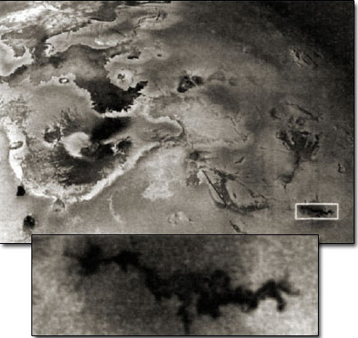
NASA
Figure 9.11: 1500 km wide Galileo image of part of Io recorded in November 1996[.] An enormous dark lava flow, presumably silicate in composition, occupies the upper left[.] The two dark spots in the lower left corner and the one to the right of the lava flow are volcanic vents that appear hot in the infrared[.] The smaller lava flow within the box at the lower right is shown below in a high-resolution view recorded in July 1999[.] This flow, from a volcanic vent named Zamama, was not present in Voyager images, and therefore formed some time between 1979 and 1996[.]
Over 500 volcanoes have been identified on Io, and about 100 have been seen to erupt on images from Voyager or Galileo (or both), or by means of infrared telescope studies. The long duration of the Galileo mission enabled many changes on Io's surface to be documented (Figure 9.12).
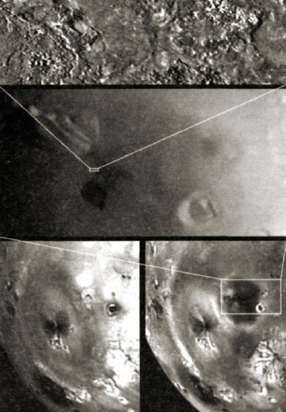
NASA
Figure 9.12: Below: Galileo view of a 1200-km-wide region of Io on 4 April 1997 (left) and 19 September 1997 (right)[.] Between these two dates a short-lived high-temperature eruption plume occurred at Pillan Patera (see Plate 8) that distributed a 400-km-wide patch of dark material around the vent, which is the most obvious difference between the two images[.] The fainter 1000-km-diameter ring to the left marks the edge of the plume from a long-lived eruption of Pele volcano[.] Above: successive close-up views of the area indicated, culminating with a 7.2-km-long strip of lava-covered terrain imaged by Galileo from a range of 617 km during a close fly-by of Io on 10 October 1999[.]
Io's volcanoes appear to be randomly distributed, and Io certainly lacks the kind of well-defined global pattern displayed by the Earth (Figure 5.5 [figure not included in this course]). Thus unlike Earth, which gets rid of heat from its interior by plate tectonics, and Venus, where heat escapes by conduction probably punctuated by orgies of resurfacing every half billion years or so, Io's heat escapes by means of hordes of volcanoes. One factor that probably influences the difference between the Earth and Io is that, to maintain a steady state, Io has to lose heat at a rate of about 2.5 watts per square metre, compared to only 0.08 watts per square metre in the case of the Earth. Possibly, the tidal heating experienced by Io is sufficient to keep a large fraction of its mantle partially molten.

1.9 Europa
David A. Rothery Teach Yourself Planets, Chapter 9, pp. 107-39, Hodder Education, 2000, 2003.
Copyright © David Rothery
For all Io's majesty, its neighbour Europa excites the greatest scientific interest. Europa is a transitional world, with a density almost in the terrestrial planet league but an exterior that is icy down to a depth of about 100 km. It is not known whether the ice is solid throughout, or whether its lower part is liquid, which raises the fascinating possibility of a global ocean sandwiched between the solid ice and the underlying rock. Gravity data from Galileo show that, like Io, Europa has a dense, presumably iron-rich core (about 620 km in radius) below its rocky mantle. Europa has its own magnetic field, but it is not clear whether this is generated by convection within a liquid core or within a salty ocean beneath the ice.
Europa has a highly reflective surface with an albedo of about 0.7, and it has been known since the 1950s from spectroscopic studies that its composition is essentially that of clean water-ice. More detailed recent observations by Galileo and the Hubble Space Telescope reveal some regions where the ice appears to be salty, and also the presence of molecular oxygen (O₂) and ozone (O₃). The oxygen and ozone are thought to result from breakdown of water molecules in the ice because of exposure to solar ultraviolet radiation and charged particles. The hydrogen so liberated would escape rapidly to space, which has been observed on Ganymede though not on Europa. It is not known whether the oxygen and ozone detected on Europa constitute an extremely tenuous atmosphere or are mainly trapped within the ice.
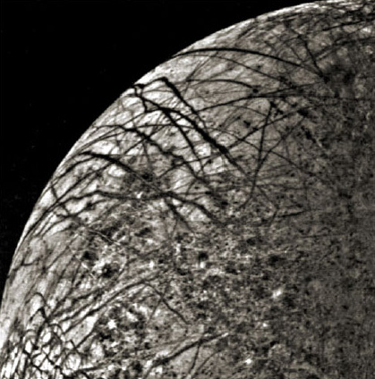
NASA
Figure 9.13: Voyager 2 view of part of Europa[.] Bright plains cover most of this view, with mottled terrain occupying the lower right[.]
Europa's surface is relatively smooth and much younger than that of other icy satellites, to judge from the paucity of impact craters. This demonstrates that Europa experiences a significant amount of tidal heating, though less than Io. Images at Voyager resolution, such as Figure 9.13, show bright plains criss-crossed by a complex pattern of cracks filled by darker ice. There are several places where the pattern of these bright plains becomes blotchy, and these were dubbed 'mottled terrain' by the Voyager investigators.
The high resolution images sent back by Galileo show that the bright plains are amazingly complex in detail (Figure 9.14), being composed of a pattern of straight or slightly curved ridges, each usually bearing a central groove. The appearance of these parts of Europa has been described as resembling the surface of a ball of string; an apt description but not much help in trying to decipher how the surface was created. Each grooved ridge could represent a fissure that was the site of an eruptive episode, when some kind of icy lava was erupted.
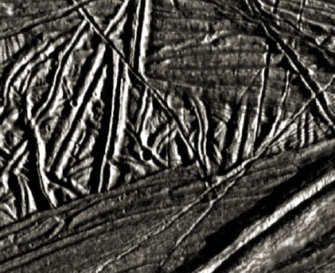
NASA
Figure 9.14: 15-km-wide Galileo view of part of Europa, showing the level of complexity revealed in Europa's bright plains by Galileo's high resolution[.] The relatively smooth area in the lower third of this view corresponds to a dark crack at Voyager resolution, whereas the complexly rigid surface elsewhere looks bright and featureless on images like Figure 9.13[.] The large ridge cutting across the lower right is 300 m high[.] There is a 300-m-diameter impact crater near the centre and several smaller ones, so although young by Solar System standards this surface is likely to be at least several million years old[.]
It may seem strange to read of 'icy lava', but Solar System ice shares many important properties with the silicate rock that melts to produce lava on the terrestrial planets. Unless the ice is absolutely pure water, these properties include:
- existing in the solid state as intergrown crystals of differing compositions
- rock-like strength and rigidity under prevailing surface conditions contrasted with the ability to flow slowly and act as an asthenosphere at depth
- the capacity to partially melt, yielding melts different in composition to the starting material.
Planetary scientists often use the term cryovolcanism to denote icy rather than silicate volcanism. Although by far the most abundant component in Europa's ice is water, it is likely to be contaminated by various salts (such as sulfates, carbonates and chlorides of magnesium, sodium and potassium) resulting from chemical reactions between water and the underlying rock. The spectroscopic data for Europa are most consistent with the salt-rich areas of surface being rich in hydrated sulfates of magnesium or carbonates of sodium, but could also indicate the presence of frozen sulfuric acid.
Contaminants such as these could make any melt liberated from the ice behave in a much more viscous (i.e. less runny) manner than pure water. If erupted as a liquid this type of lava would not necessarily spread very far before congealing, especially if confined by a chilled skin of the sort likely to form upon exposure to the vacuum of space in the cold outer Solar System. Contaminants also allow the ice to begin to melt at a much lower temperature than pure water-ice: salts can depress the melting temperature by a few degrees and sulfuric acid by as much as 55 degrees.
Maybe, then, Europa's ridges are simply highly viscous cryovolcanic flows fed from their central fissures. Alternatively, the cryovolcanic lava may not have flowed across the ground at all: it could have been flung up from the fissure in semi-molten clods by mild explosive activity, like a 'fire fountain' from a volcanic rift on Earth, and fallen back to coalesce as a rampart on either side of the fissure.
Irrespective of refinements such as this, it seems inescapable that each fissuring event must represent the opening of an extensional fracture in the crust. This cannot happen across an entire planetary body unless the globe is expanding, which seems highly unlikely. Therefore there must be some regions on Europa where surface has been destroyed at a rate sufficent to match the crustal extension elsewhere. Likely candidates for this on Europa are regions described as 'chaos', and part of one of Europa's chaos regions is shown in Plate 9.
[Click 'view document' to open Plate 9. Galileo image of a 60 km wide region of Europa known as Conamara Chaos. The surface of the former bright plains has been broken into rafts or ice floes that drifted apart before the intervening slush or water re-froze. Bright patches on the left are splashes of recent ejecta from a 26 km diameter impact crater 1000 km to the south.]
View document
Here typical-looking bright plains crust has been broken into rafts that have drifted apart, maybe because an underlying liquid ocean broke through to the surface. The areas intervening between rafts are a jumbled mess reminiscent of re-frozen sea-ice on Earth. Some rafts can be fitted back together, but it is apparent that many pieces of the 'jig-saw puzzle' are missing. Perhaps these missing pieces have sunk or been dragged down beneath the surface.
Regions like Plate 9 appeared as mottled terrain on Voyager images, but so did the region shown in Figure 9.15. Here, the surface of what was formerly normal looking bright terrain has been forced up into a number of domes up to 15 km across. Presumably this is because of the rise of pods of molten or semifluid low density material (described geologically as 'diapirs') toward the surface. In some cases the upwelling pod has actually ruptured the surface, to form a small chaos region bearing raftlets of surviving crust.
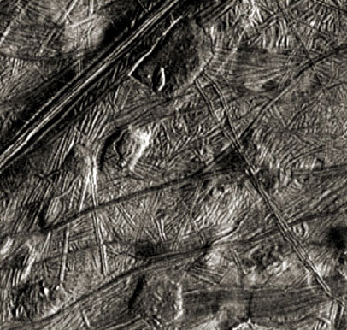
NASA
Figure 9.15: 60-km-wide Galileo view of part of Europa[.] This region, mapped as mottled terrain on Voyager images, is revealed to be conventional bright plains with 'ball of string' texture disrupted by a number of domes, some of which have pierced the former surface[.]
Although we understand all too little about the processes that have shaped Europa's surface, it is clear that it has had a complicated history. We cannot tell for sure how old each region of surface is, but there are abundant signs that there is, or has been, a liquid zone below the surface ice. A salty ocean below several km of ice is not necessarily a hostile environment for life, and indeed life down there could be much richer and complex than anything that is likely to have survived on Mars. In the depths of the Earth's oceans there are whole living communities that are independent of photosynthetic plants (requiring sunlight to live) and depend instead on bacteria-like microbes that make a living from the chemical energy supplied by springs of hot water ('hydrothermal vents') on the ocean floor.
Given that Europa is tidally heated, we can imagine zones where water is drawn down into the rocky mantle, becomes heated, dissolves chemicals out of the rock, and emerges at hydrothermal vents surrounded by life. This may sound far-fetched, but hydrothermal vents are now mooted as the most likely venue for life to have begun on Earth, so if it could happen here then why not on Europa too? It is the possibility of a life-bearing ocean below the ice that is the main driver for plans for the future exploration of Europa. [More information on the possibility for life on Europa can be found in the NASA video 'Europa: Cool Destination for Life?'.]
The proposed Europa Orbiter mission (Table 9.1) has primary goals of verifying the existence of an ocean below the ice, and identifying places where the ice is thin enough for future landing missions to release robotic submarines ('hydrobots') under the ice so that they can go hunting for hot springs and their attendant life. It will achieve this by gravity studies, by using an altimeter to determine the height of the tide raised on Europa by Jupiter (only 1 m if the ice is solid throughout, but about 30 m for 10 km of ice overlying a global ocean), and by using ice-penetrating radar to map ice thickness. High resolution conventional images will identify sites of recent eruptions. [The Europa Orbiter mission has since been cancelled by NASA.]
Insights into how best to go about the future exploration of Europa's ocean will probably be gained by study of Lake Vostok, a lake of 10,000 square km beneath 4 km of ice that was discovered in Antarctica in 1996. Its waters may have been isolated from the surface for as long as 30 million years, and may host a unique ecosystem. The development of technology to drill through the ice and explore Lake Vostok, and also the adoption of protocols to avoid biological contamination of this special environment should both provide valuable experience.

1.10 Ganymede
David A. Rothery Teach Yourself Planets, Chapter 9, pp. 107-39, Hodder Education, 2000, 2003.
Copyright © David Rothery
Ganymede is the largest planetary satellite in the Solar System, being bigger (though less massive) than the planet Mercury. It is shown in comparison with its outer neighbour Callisto in Figure 9.16. Although these two satellites are similar in size, with bulk densities implying a roughly 60:40 rock:ice mixture in each, Galileo indicated that Ganymede is a fully differentiated body, with an iron inner core (filling 22 per cent of its radius), a silicate outer core (filling 55 per cent of its radius) and an icy mantle, but that Callisto is only weakly differentiated. The difference in evolution between these two bodies is probably because Ganymede was formerly subject to much more intense tidal heating than it receives today, whereas Callisto has never experienced much heating, tidal or otherwise. Ganymede has a magnetic field with about 1 per cent the strength of the Earth, which could be generated in the core or in a salty ocean deep within the ice layer.
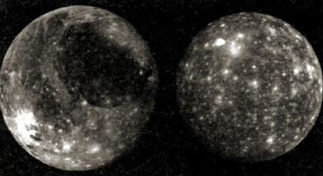
NASA
Figure 9.16: Ganymede (left) and Callisto (right) seen at the same relative scales[.] The distinct pale and dark terrains on Ganymede are obvious[.] Callisto has no such distinction, and is dark all over (its brightness has been exaggerated here to help it show up)[.] The bright spots on both bodies are relatively young impact craters, made prominent by their surrounding blankets of pale ejecta[.]
With an albedo of about 0.45, Ganymede's surface is darker than Europa's. Spectroscopic studies show that it is dominantly water-ice, with scattered patches of carbon dioxide ice, and that the darkening is caused by silicate minerals (probably in the form of clay particles) and tholins. The darkening is at least partly attributable to the much greater age of Ganymede's surface, allowing more time for the action of solar radiation to produce tholins and for silicate grains to become concentrated in the regolith by the preferential loss of ice during impacts.
There are also faint traces of oxygen and ozone, apparently trapped within the ice as suggested for Europa, and Galileo found an extremely tenuous (and continually leaking) atmosphere of hydrogen that is presumably the counterpart to the oxygen produced by the breakdown of water molecules.
It is obvious even on images of the resolution of Figure 9.16 that there are two distinct terrain types on Ganymede, one darker than the other. At higher resolution (e.g. Figure 9.17) it is apparent that the pale terrain must be younger than the dark terrain, because belts of pale terrain can be seen to cut across pre-existing tracts of dark terrain. However, the density of impact craters on both terrain units shows that each must be very old, perhaps as much as 3 billion years.
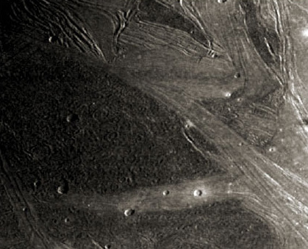
NASA
Figure 9.17: 600-km-wide Galileo view of part of Ganymede, showing belts of pale terrain cutting dark terrain (lower left) and several generations of cross-cutting pale terrain (notably near the top)[.] There are plenty of young, crisp-looking impact craters on both terrain types, and the dark terrain also has large numbers of more subdued-looking older craters[.]
Considered in more detail, it becomes clear that multiple episodes of pale terrain generation are required to explain the cross-cutting relationships between belts of pale terrain. Images like Figure 9.17 and others at a higher resolution, show the complex grooved nature of the pale terrain and hint that each belt of pale terrain might require just as complex a series of events to explain it as parts of the bright plains on Europa.
This is not to say that the same processes were involved. One important difference between the two bodies is that on Europa there is abundant evidence of the two halves of a split tract of terrain having been moved apart to accommodate the new surface that has formed in between, whereas on Ganymede signs of lateral movement are scarce. Ganymede's pale terrain appears to occupy sites where the older surface has been dropped down by fault movements, allowing cryovolcanic fluids to spill out. It remains a matter of debate whether the grooves within each belt of pale terrain represent constructional cryovolcanic features or reflect subsequent deformation, perhaps related to underlying faults.

1.11 Callisto
David A. Rothery Teach Yourself Planets, Chapter 9, pp. 107-39, Hodder Education, 2000, 2003.
Copyright © David Rothery
Callisto, the outermost galilean satellite, has a dark heavily cratered surface (Figure 9.18) with an albedo of only 0.2. It is the only one of its family to resemble what was expected before the role of tidal heating became appreciated. Callisto is not currently in orbital resonance with any of its neighbours, and shows no clear sign of having experienced tidal heating in the past.
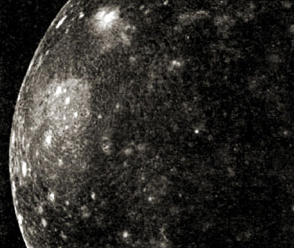
NASA
Figure 9.18: Galileo view of a large part of Callisto showing its dark, heavily cratered surface[.] The younger impact craters are the most prominent, because their ejecta blankets have not yet become radiation-darkened[.] Towards the left is a multiringed impact basin named Valhalla[.] The 600-km-diameter pale zone in Valhalla's centre marks the site of the original crater, but this was too large a structure for the lithosphere to support and it has long since collapsed[.] This is surrounded by rings of concentric fractures, the outermost having a diameter of 4000 km[.]
Despite this, Callisto is far from boring. Its weakly differentiated structure has already been remarked upon, and appears to consist of an ice-rock mixture throughout except for an ice-rich crust. There could possibly be a rocky core occupying up to 25 per cent of Callisto's radius, but an iron core would seem to be ruled out by the Galileo gravity data. Therefore it is surprising that Galileo found that a magnetic field is induced within Callisto by its passage through Jupiter's magnetosphere.
Given the lack of an iron core, the only reasonable way to explain this magnetic field is to appeal to a salty (and therefore electrically conducting) ocean at least 10 km thick and no more than 100 km below the surface. A liquid layer at such a shallow depth seems incompatible with the undeformed, ancient and heavily cratered nature of Callisto's surface, so here is yet another mystery awaiting resolution.
However, some features on Callisto that used to be a mystery are now understood thanks to comet Shoemaker Levy 9. These are linear chains of overlapping craters (Figure 9.19). It is now agreed that each chain is the scar of impacts by fragments of a different comet, each of which hit Callisto on its outward path immediately after having been tidally disrupted during a close passage by Jupiter. There are about a dozen of these, mostly on Callisto's leading hemisphere which is the side most exposed to the risk of such impacts.
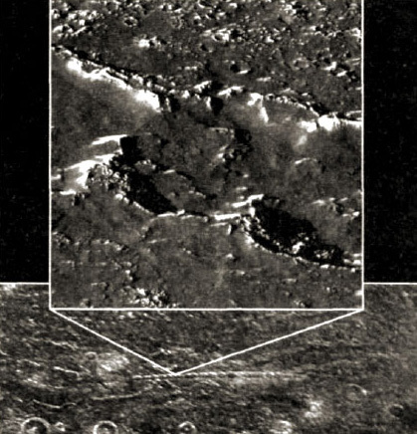
NASA
Figure 9.19: A chain of 25 10-km-diameter craters on Callisto believed to result from the serial impacts of fragments of a tidally disrupted comet[.] Bottom: Voyager image showing the whole chain in context[.] Top: Galileo view, showing an oblique close-up view of parts of three overlapping craters in this chain[.]
High resolution views like the Galileo image in Figure 9.19 reveal a surprising paucity of craters less than 1 km across. Given the number of larger craters that are present, it is inconceivable that smaller craters have not formed in even greater abundance. Therefore something must be acting to remove them. The Figure 9.19 Galileo image contains clues as to what might be going on. Hilltops and some slopes are markedly brighter than the dark surface from which they crop out. This can be explained if the bright surfaces are relatively clean ice whereas the dark surfaces are covered by a regolith that is enriched in rock debris.
This may be a result of the continual bombardment of the surface by charged particles and micrometeorites. We have seen that this contributes to the breakdown of water molecules, but it can also simply vaporize the ice. On Callisto, those water vapour molecules that do not escape to space or become split into hydrogen and oxygen will recondense on any icy surface that they bump into. This condensation process is at its most efficient on hilltops because these are exposed to the sky all round and so are slightly colder than the surrounding area. Once the brightness difference is established, the temperature contrast gets reinforced because the brighter surfaces will absorb less solar warmth than the darker ones. Therefore, over time frost migrates towards the bright hilltops and other exposed areas, and the residual silicate dust becomes progressively concentrated in the places from where the ice is being selectively removed. Perhaps this process is capable of eroding the rims of small craters faster than the average rate at which such craters are forming.
Another erosional process that occurs on Callisto is landslips, as can be seen in Figure 9.20, where the inner part of a crater rim has collapsed.
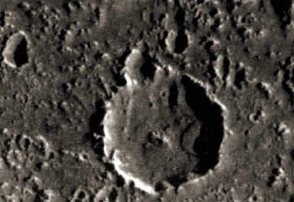
NASA
Figure 9.20: Galileo image showing a 12-km-wide crater on Callisto with a landslip extending a third of the way across its floor from its eastern rim[.] Note the degraded morphologies of many of the smaller craters, and the relative brightness of the hilltops compared to the dustier low ground[.]

2 Discussion of Chapter 9: Jupiter itself

2.1 Jupiter and its missions: an update
Jupiter's visibly flattened shape is a result of the planet's rapid rotation. The flattening is not really apparent in Figure 9.1, because the terminator (the day-night boundary) is within the left-hand edge of the visible half of the globe. The flattened shape is better seen in Figure 1 below, in which the sunlit hemisphere is seen full-on.
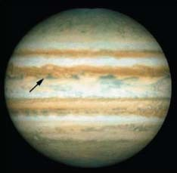
Space Telescope Science Institute and NASA
Figure 1: A Hubble Space Telescope image of Jupiter, showing the complete sunlit hemisphere as it appeared on 5 October 1995. The arrow indicates the site where the Galileo entry probe descended below the cloud tops 63 days later.
Teach yourself planets (TYP) Table 1 lists a future mission named Europa Orbiter. Unfortunately, this has since been cancelled, after which NASA instead proposed a highly ambitious mission provisionally called Jupiter Icy Moons Orbiter for launch in 2011 at the earliest. However, this mission was also cancelled due to budgetary changes in 2005. There is now (2008) a planned mission called the Jupiter Polar Orbiter (Juno), with a proposed launch date of 2011, and a mission concept called Europa Explorer, which does not yet have a launch date. If you have Internet access and want to keep track of plans as they evolve, you can do so by selecting the Jupiter option at http://missionjuno.swri.edu/.
The latter part of Section 1.3 mentions the onward journeys of the two Voyager spacecraft towards interstellar space. By January 2003, Voyager 1 had reached over 87 AU from the Sun and Voyager 2 over 69 AU. Both spacecraft were healthy, with enough power to keep them operational until at least 2020.

2.2 Jupiter's magnetic field and radiation zone
The latter part of Section 1.4 describes Jupiter's enormously strong magnetic field, and Section 1.3 mentions the associated radiation belt of magnetically-confined charged particles that are liable to damage the electronics of any spacecraft that lingers too long. Figure 2 shows views of the inner and most intense part of the radiation zone. Another version is shown in Figure 3.
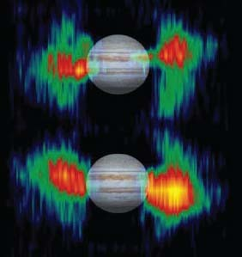
Figure 2: Two views of Jupiter recorded about half a rotation (5 hours) apart by Cassini, a Saturn-bound mission that flew past Jupiter at the start of 2001. The planet is seen in visible light, but the colourful patches on either side indicate the intensity of radiation mapped by a detector of microwaves.
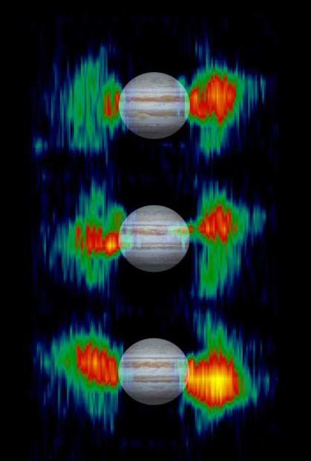
NASA/JPL
Figure 3: Jupiter's inner radiation belts. Details in radiation belts close to Jupiter are mapped from measurements that NASA's Cassini spacecraft made of radio emission from high-energy electrons moving at nearly the speed of light within the belts.
Figure 4 shows a greater extent of the radiation zone detected by a different method. A colour version of Figure 5 showing an aurora where the magnetic field channels charged particles into the atmosphere appears as Figure 6, and a more powerful and spectacular aurora recorded in the ultraviolet is shown in Figure 7.
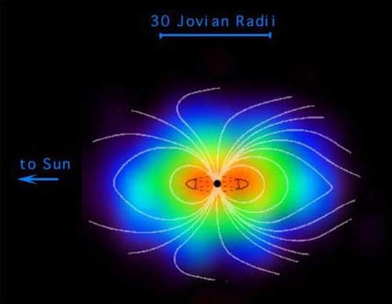
NASA/JPL/Johns Hopkins University Applied Physics Laboratory
Figure 4: The vast magnetosphere of (normally invisible) charged particles, whirling around Jupiter, here imaged by a new type of instrument aboard NASA's Cassini spacecraft
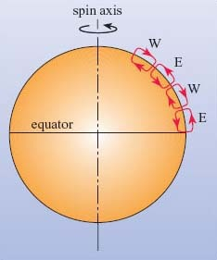
Figure 5: The traditional view of Hadley cells in Jupiter's atmosphere. E means that there is flow to the east, and W to the west.
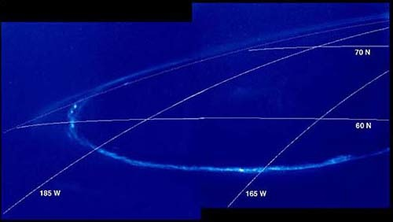
NASA/California Institute of Technology
Figure 6: Visible evidence of Jupiter's internally-generated magnetic field: an aurora (glow from ionized atoms) seen by the spaceprobe Galileo on Jupiter's night-side. Lines of latitude and longitude have been superimposed (D.A. Rothery).
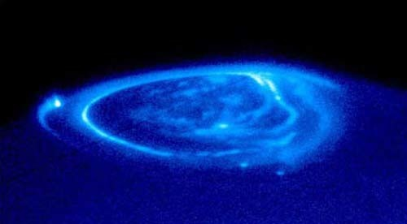
NASA and the Hubble Heritage Team (STScI/AURA). Acknowledgment: NASA/ESA, John Clarke (University of Michigan)
Figure 7: Satellite footprints seen in aurora. This is a spectacular NASA Hubble Space Telescope close-up view of an electric-blue aurora that is eerily glowing one half billion miles away on the giant planet Jupiter. Auroras are curtains of light resulting from high-energy electrons racing along the planet's magnetic field into the upper atmosphere.
The strong radiation zone in Figure 2 is actually hoop-like in shape, and runs right round the planet. However, the figure makes it look like separate patches to either side of the globe because this is where our line of sight passes through the greatest extent of the zone. To visualize this, imagine sticking a knitting needle into a ring doughnut: a needle pointing towards the centre would only pass through a couple of centimetres before reaching the hole, whereas a needle parallel to this but off to the side would miss the hole and pass through a lot more cake before emerging again.

Question 1
Bearing in mind information given in Section 1.4, why do you think the location of the radiation belt relative to the planet appears to change between the two images in Figure 2?
View answer - Question 1

2.3 Jupiter's atmosphere
The circulation of Jupiter's atmosphere is discussed in Section 1.5, and the movies below document various scales of atmospheric motion, including rotation of the Great Red Spot. The clouds forming the opaque 'surface' to Jupiter's atmosphere are presumed to be created by ammonia (NH₃) condensing out of a vapour to form tiny suspended crystals of ammonia ice.

2.3 Movie 1 - Voyager 1 'Blue Movie'
Voyager 1 'Blue Movie'
View document
This is the original Voyager 'Blue Movie' (so named because it was built from Blue filter images). It records the approach of Voyager 1 during a period of over 60 Jupiter days. Notice the difference in speed and direction of the various zones of the atmosphere. The interaction of the atmospheric clouds and storms shows how dynamic the Jovian atmosphere is.
As Voyager 1 approached Jupiter in 1979, it took images of the planet at regular intervals. This sequence is made from 66 images taken once every Jupiter rotation period (about 10 hours). This time-lapse movie uses images taken every time Jupiter longitude 68W passed under the spacecraft. These images were acquired in the Blue filter from 6 January to 3 February 1979. The spacecraft flew from 58 million km to 31 million km from Jupiter during that time.

2.3 Movie 2 - Red Spot Movie
Red Spot Movie
View document
This brief movie shows counterclockwise atmospheric motion around Jupiter's Great Red Spot. The clip was made from blue-filter images taken with the narrow-angle camera on NASA's Cassini spacecraft during seven separate rotations of Jupiter between 1 October and 5 October 2000.
The clip also shows the eastward and westward motion of the zonal jets, seen as the horizontal stripes flowing in opposite directions. The zonal jets circle the planet. As far as can be determined from both Earth-based and spacecraft measurements, the positions and speeds of the jets have not changed for 100 years. Since Jupiter is a fluid planet without a solid boundary, the jet speeds are measured relative to Jupiter's magnetic field, which rotates, wobbling like a top because of its tilt, every 9 hours 55.5 minutes. The movie shows motions in the magnetic reference frame, so winds to the west correspond to features that are rotating a little slower than the magnetic field, and eastward winds correspond to features rotating a little faster.
Because the Red Spot is in the southern hemisphere, the direction of motion indicates it is a high-pressure center. Small bright clouds appear suddenly to the west of the Great Red Spot. Scientists suspect these small white features are lightning storms. The storms eventually merge with the Red Spot and surrounding jets, and may be the main energy source for the large-scale features.
The smallest features in the movie are about 500 km across. The spacing of the movie frames in time is not uniform; some consecutive images are separated by two Jupiter rotations, and some by one. The images have been re-projected using a simple cylindrical map projection. They show an area from 50 degrees north of Jupiter's equator to 50 degrees south, extending 100 degrees east-west, about one quarter of Jupiter's circumference.

2.3 Movie 3 - Jupiter Polar Winds Movie
Jupiter Polar Winds Movie
View document
Bands of eastward and westward winds on Jupiter appear as concentric rotating circles in this movie composed of Cassini spacecraft images that have been re-projected as if the viewer were looking down at Jupiter's north pole and the planet were flattened. The sequence covers 70 days, from 1 October to 9 December 2000. Cassini's narrow-angle camera captured the images of Jupiter's atmosphere in the near-infrared region of the spectrum.
What is surprising in this view is the coherent nature of the high-latitude flows, despite the very chaotic, mottled and non-banded appearance of the planet's polar regions. This is the first extended movie sequence to show the coherence and longevity of winds near the pole and the features blown around the planet by them.
There are thousands of spots, each an active storm similar to the size to the largest of storms on Earth. Large terrestrial storms usually last only a week before they dissolve and are replaced by other storms. But many of the Jovian storms seen here, while occasionally changing latitute or merging with each other, persist for the entire 70 days. Until now, the lifetime of the high-latitude features was unknown. Their longevity is a mystery of Jovian weather.

2.3 Movie 4 - Planetwide Colour Movie
Planetwide Colour Movie
View document
The first colour movie of Jupiter from NASA's Cassini spacecraft shows what it would look like to peel the entire globe of Jupiter, stretch it out on a wall into the form of a rectangular map, and watch its atmosphere evolve with time. The brief movie clip spans 24 Jupiter rotations between 31 October and 9 November 2000.
Various patterns of motion are apparent all across Jupiter at the cloudtop level seen here. The Great Red Spot shows its counterclockwise rotation, and the uneven distribution of its high haze is obvious. To the east (right) of the Red Spot, oval storms, like ball bearings, roll over and pass each other. Horizontal bands adjacent to each other move at different rates. Strings of small storms rotate around northern-hemisphere ovals. The large grayish-blue 'hot spots' at the northern edge of the white Equatorial Zone change over the course of time as they march eastward across the planet. Ovals in the north rotate counter to those in the south. Small, very bright features appear quickly and randomly in turbulent regions, candidates for lightning storms.
The clip consists of 14 unevenly spaced timesteps, each a true colour cylindrical projection of the complete circumference of Jupiter, from 60 degrees south to 60 degrees north. The maps are made by first assembling mosaics of six images taken by Cassini's narrow-angle camera in the same spectral filter over the course of one Jupiter rotation and, consequently, covering the whole planet. Three such global maps - in red, green and blue filters - are combined to make one colour map showing Jupiter during one Jovian rotation. Fourteen such maps, spanning 24 Jovian rotations at uneven time intervals comprise the movie. Occasional appearances of Io, Europa, and their shadows have not been removed.
The smallest visible features at the equator are about 600 kilometers (about 370 miles) across. In a map of this nature, the most extreme northern and southern latitudes are unnaturally stretched out.

2.3 Movie 5 - Small Storms Near Great Red Spot
Small Storms Near Great Red Spot
View document
This movie clip, created from images taken by NASA's Cassini spacecraft, shows small spots slipping over each other east of Jupiter's Great Red Spot. These small storms are born in the turbulent region west of the Great Red Spot, then move westward all the way around the planet until they again encounter the Red Spot from the east, when they are often swallowed by the Red Spot.

2.3 Movie 6 - Jupiter Hot Spot
Jupiter Hot Spot
View document
In this movie clip, created from images taken by NASA's Cassini spacecraft, the blue region in the center is a relatively cloud- free area where thermal radiation from warmer, deeper levels emerges. NASA's Galileo probe in 1995 entered Jupiter's atmosphere in a similar area.

2.3 Movie 7 - Jupiter's High Latitudes
Jupiter's High Latitudes
View document
This movie clip, created from images taken by NASA's Cassini spacecraft, shows a high-latitude area of Jupiter. At latitudes above 45 degrees, the banded appearance of Jupiter's clouds gives way to a more mottled appearance. The cause of this transition is not fully understood.

2.3 Jupiter's atmosphere (continued)

Question 2
In what way does the composition of Jupiter's clouds differ from those in the Earth's atmosphere?
View answer - Question 2
Jupiter's topmost cloud layer does not mark the top of the atmosphere, which continues for some hundreds of kilometres above the cloud deck, becoming ever more tenuous with altitude. The traditional interpretation of Jupiter's Hadley circulation (illustrated in Figure 5 and described in Section 1.5) is that the atmosphere rises in the zones and sinks in the intervening belts (which appear darker because the cloud tops are seen through a greater depth of atmosphere). However, thorough analysis of Jupiter images recorded between October 2000 and March 2001 by the Saturn-bound Cassini mission (Table 9.1) suggests that, on the contrary, the belts are where the atmosphere rises.
See Box 1 for the story as released by NASA to the press in March 2003 (too late to be incorporated in Teach Yourself Planets).

Box 1: NASA Press Release
Rising Storms Revise Story of Jupiter's Stripes - March 6, 2003
Pictures of Jupiter, taken by a NASA spacecraft on its way to Saturn, are flipping at least one long-standing notion about Jupiter upside down.
Stripes dominate Jupiter's appearance. Darker 'belts' alternate with lighter 'zones'. Scientists have long considered the zones, with their pale clouds, to be areas of upwelling atmosphere, partly because many clouds on Earth form where air is rising. On the principle of what goes up must come down, the dark belts have been viewed as areas where air generally descends.
However, pictures from the Cassini spacecraft show that individual storm cells of upwelling bright-white clouds, too small to see from Earth, pop up almost without exception in the dark belts. Earlier spacecraft had hinted so, but not with the overwhelming evidence provided by the new images of 43 different storms.
'We have a clear picture emerging that the belts must be the areas of net-rising atmospheric motion on Jupiter, with the implication that the net motion in the zones has to be sinking,' said Dr Tony Del Genio, an atmospheric scientist at NASA's Goddard Institute for Space Studies, New York. 'It's the opposite of expectations for the past 50 years,' he said.
Del Genio is one of 24 co-authors from America and Europe reporting diverse results from the Cassini imaging of Jupiter in Friday's edition of the journal Science. Cassini's camera took about 26,000 images of Jupiter, its moons and its faint rings over a six-month period as the spacecraft passed nearby two years ago.
In fact, no one has actually measured Jupiter's atmosphere rising or sinking. The new theory announced in 2003 merely infers that the atmosphere in the belts is rising because the 'small' bright clouds within the belts that are referred to in the press release seem to indicate storm turbulence of a kind that ought to occur only during uprise, but not during sinking. Only time will tell whether this radically new interpretation of Jupiter's atmosphere becomes accepted. This is a timely reminder that little in planetary science is known with absolute certainty. Many mysteries remain, ranging from the apparently trivial, such as the scarcity of very small craters on Eros to the fundamental, such as this example of how the atmosphere of the biggest planet circulates.
The successive collisions of fragments of comet Shoemaker Levy 9 onto Jupiter captivated the world's media in July 1994, and you may remember these events yourself. A view of the tidally disrupted comet six months before the collision is shown in Figure 8 and you can watch a movie of the collision below.
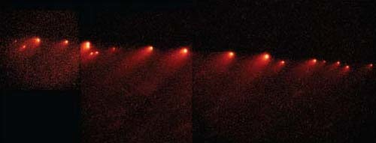
Space Telescope Science Institute and NASA
Figure 8: Hubble Space Telescope view of the strung-out fragments of comet Shoemaker Levy 9 on 24 January 1994.
Fragment A collision movie
View document
This is a beta release of a movie of the Fragment A collision from Saturday 16 July 1994. It consists of 55 frames taken on Calar Alto (Spain).
The bright object to the right is the closest Galilean satellite Io, moving slowly towards Jupiter. The fainter oval structure in the southern hemisphere is the well-known Great Red Spot. The impact appears above the southeast (lower left) limb of the planet.
The bright spots near the Great Red Spot appearing in some frames are not real, but bad pixels, they will be corrected in the final release of the movie.
Try the following questions to help to test your understanding of Jupiter's atmosphere and interior before continuing with the rest of the course.

Question 3
- How does Jupiter's Hadley circulation differ from that in the atmospheres of the terrestrial planets, and what might be the main reasons for the differences? (For the purposes of this answer, you can assume that the 'traditional' interpretation of Jupiter's atmosphere is correct.)
- What other factors distinguish Jupiter's atmosphere from these others?
View answer - Question 3

Question 4
What are the composition and physical state of Jupiter's interior thought to be at a depth of about 12000 km?
View answer - Question 4

3 Discussion of Chapter 9: Rings and the satellite family

3.1 Jupiter's rings and satellites
There can be few people who have never heard of the rings of Saturn, but you may be surprised to discover that every one of the giant planets has rings, including Jupiter. Another feature common to the giant planets is that each has a numerous family of satellites. The likeness goes deeper than that, because there are strong similarities in the organization of each of these families.
There are small inner satellites ('moonlets') in near-circular prograde orbits that lie virtually in the plane of the planet's equator, some of which are intimately associated with the ring system. Farther out come the 'regular satellites', which are the only ones large enough to have taken on spherical shapes, and except at Neptune these are also in low-inclination near-circular prograde orbits. There are four of these at Jupiter, which are the ones discovered by Galileo Galilei in 1610 and collectively referred to as the galilean satellites. Beyond these are smaller 'irregular satellites' in less circular and more strongly inclined orbits, which are commonly retrograde.
Generally speaking, the outer satellites are thought to have originated as asteroids, comet nuclei or Kuiper belt objects that strayed close enough to the planet to become captured. In contrast, the large prograde satellites grew in association with their planet from a circumplanetary disc of gas and dust.. The small inner satellites are probably remnants of larger satellites that were destroyed by collision or came within the planet's Roche limit and were ripped apart by tides. The same processes could account for some of the ring material too.
Twenty-two outer satellites of Jupiter were identified in the period 1999-2001, and many of these are still denoted by provisional designations in Table 9.2. These were all telescopic discoveries, and the discovery images (i.e. the images on which the object was discovered) of one of them are shown in Figure 9.
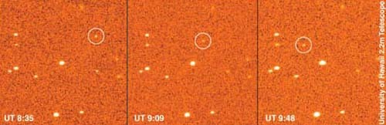
University of Hawaii and Scott Sheppard/David Jewett
Figure 9: The discovery images of S2000 J8 (which was awarded the name Magaclite in October 2002), made on 5 December 2000 by the University of Hawaii 2.2 m telescope. Three images are shown, covering a 71 minute period. The satellite (with a circle put round it to help you see it) clearly moves relative to the background stars.
The provisional designation system for satellites is simpler than that for minor planets, as you can deduce from the examples in the table. They begin with S (to signify a presumed satellite) followed by the year of discovery. Next comes a letter to indicate the planet (J for Jupiter, S for Saturn, U for Uranus) followed by a number to indicate the order of discovery for that planet in that year. Only one discovery from the year 2000 still bears its provisional designation in the table, all the others having been awarded names in October 2002.
Too late for inclusion in the edition of Teach Yourself Planets from which Section 1 was extracted, telescopic discoveries of a further 20 retrograde and one prograde irregular outer satellites of Jupiter were announced in March-May 2003.

Question 5
What provisional designations will have been allotted to these bodies?
View answer - Question 5
None of these exceeds about 4 km in size. The innermost of the 20 new retrograde satellites (S/2003 J3) has an orbit about a million kilometres within that of S/2001 J10, and the outermost (S/2003/J2) holds the current record as the outermost of Jupiter's entire family at 28.6 million km. S/2003 J20 became the outermost known prograde satellite, with an orbital radius of about 17 million km.
Note that these discoveries increase the total of Jupiter's known satellites to 61. You may like to reflect this by mentally correcting the total in the Jupiter planetary facts table. However, the number will go down if any of the new discoveries is discredited or, more likely, will increase as additional discoveries are announced.

Question 6
What do you think had happened that allowed the year 2000 discoveries other than S/2000 J11 to receive official names by the time Table 9.2 was prepared?
View answer - Question 6
All the names of Jupiter's longer-known satellites are of characters associated with Jupiter, or his equivalent Zeus, in Greco-Roman mythology. The IAU has continued this theme for the new discoveries, with the refinement among the outer satellites that those in prograde orbits have been given mainly Latin names ending in -a whereas those in retrograde orbits have been given mainly Greek names ending in -e. Figure 10 illustrates the general disposition of the outer satellite orbits.
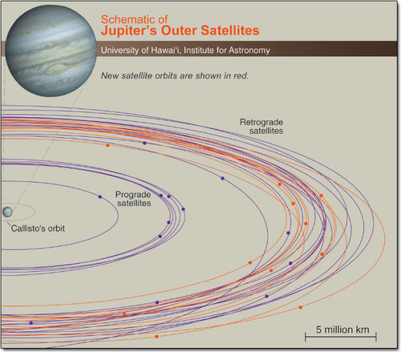
University of Hawaii and Scott Sheppard/David Jewett
Figure 10: A perspective diagram of Jupiter's satellite system, showing all orbits from Callisto (the outermost galilean satellite) outwards. The orbits of 2001 discoveries are distinguished in red. Discoveries announced after the end of 2002 are not included.
We probably now know more about each of the galilean satellites than we do about Mercury. Their diverse properties and large size fully justify treating them individually as we do in the following sections.

3.2 Io
Io is one of the most marvellous bodies in the Solar System, but the intense radiation bathing its surface (Figure 2) makes it unlikely that anyone will ever be able to visit. Even robotic spacecraft cannot survive this close to Jupiter for very long, so the Galileo Jupiter orbiter made very few close fly-bys of Io. However, there is by now a remarkable collection of images from close fly-bys and farther away, represented in Chapter 9 of Teach Yourself Planets by Plate 8 (see Section 1.9), Figure 9.10, Figure 9.11, Figure 9.12 and the additional Io images below.
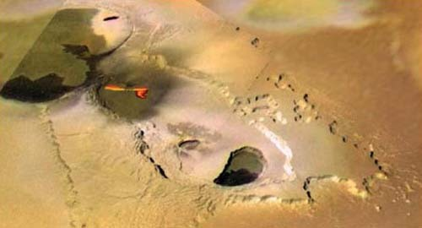
Figure 11: Io seen in visible light during a close-pass by Galileo on 29 November 1999. Most of the red-hot area is a 10 km high curtain of incandescent lava fragments erupting from a 100 km long fissure. A short glowing lava flow can also be seen. The image is 800 km across.
One of the most spectacular Galileo images of Io is reproduced in Figure 11. On this image the orange glow of the incandescent lava is genuine. It was recorded in visible light, and represents pretty much what you could have seen with your own eyes (before you were killed by the radiation!). This contrasts with most other images of active lava flows on Io (see images below) on which the hot areas were detected using infrared radiation, but were not necessarily hot enough or powerful enough to generate a detectable glow in the visible part of the spectrum. On those false-colour images, the infrared signal is displayed in red.
Most of the names on Io are taken from gods and heroes associated with fire, thunder or the Sun, or from Dante's Inferno. Eruptive centres on Io share with impact craters the distinction of being the only features whose names are not qualified by a descriptor term. Thus Prometheus (Plate 8, see Section 1.9), Zanama (Figure 9.11) and Pele (Figure 9.12) are complete names with nothing missing. However, a few eruptive centres identified by some kind of topographic attribute do take descriptor terms, one example being Pillan Patera in Plate 8 and Figure 9.12. The fissure-shaped vent in Figure 11 has not been named, but the larger feature in which it occurs is called Tvashtar Catena.
The most important general point to learn from study of Io is that it demonstrates how tidal heating can add enormously to the supply of heat leaking towards the surface of a planetary body. Tidal heating operates among the inner three galilean satellites because they are in orbital resonance (with a ratio between their periods of 1:2:4). The details of how orbital resonance leads to tidal heating are beyond the scope of this course. All you need to know is that it is to do with the regularly repeated gravitational tugs between satellites as they pass and the extent to which this prevents the tidal drag of the planet from forcing the satellite's orbits to become circular. (See Box 2 for a further clarification about orbital resonance.)

Box 2: Orbital resonance: further clarification
When it comes to causing tidal heating, the ratio between the orbital periods of two satellites has to be very close to a simple ratio. Two satellites of a large planet having a ratio between their orbital periods of 2.1:1 certainly will not experience tidal heating, because this ratio is too different from exactly 2:1. However, 2.01:1 or 1.99 :1 would probably be close enough.

3.3 Europa
Although Io may be more spectacular, Europa is perhaps more intriguing. To get the most out of this section you needed to look again carefully at images in Chapter 9 of Teach Yourself Planets (such as Figure 9.14, Figure 9.15 and Plate 9 in Section 1.10). This is because even though Europa's landscape is so alien, the images contain clues as to the processes that have shaped it. Figure 12 shows part of the larger region surrounding Figure 9.14 and Plate 9 (in Section 1.10).
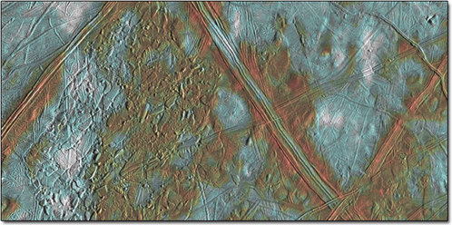
Figure 12: A 200 km wide area of Europa, illuminated from the right. 'Ball-of-string' surface patterns predominate, but this surface pattern has been disrupted in several places, notably in Conamara Chaos on the left, which is shown in a more detailed image in Plate 9 in Section 1.10. The colours are exaggerated. The reddest areas are probably the saltiest, purer ice appears blue, and white patches are powdery ejecta from a distant impact crater.

Question 7
Look carefully at the area shown in Figure 12 and see if you can use your logic to put the following events into the correct time sequence within this area, starting with the oldest first:
(a) disruption of surface by breakup into chaos
(b) generation of ball-of-string surface (refer to Figure 9.14 for a good example of ball-of-string surface)
(c) formation of ridge systems larger in scale than the typical ball-of-string texture
(d) patchy distribution of white ejecta.
This is a challenging question. If you are really stuck then study the answer carefully, but please have a go first - working this out does not depend on any skills specific to planetary science, instead it is a matter of logic and common sense.
View answer - Question 7
Section 1.10 introduces the properties of Solar System ice that enable it to behave so much like rock, and the strange term 'cryovolcanism' that you will meet in connection with several other icy satellites. Europa is atypical because the ice (being so thin and warm at its base) can sometimes behave rather like frozen sea-ice on Earth, but on the other icy satellites of the outer planets the likenesses to silicate rock in a terrestrial planet are much stronger.
The Europa section concludes with speculation about the possibility of life nourished by chemical energy beside hot springs on the floor of Europa's ocean. This is the kind of setting where it is now believed that life is most likely to have begun on the Earth. However, you should bear in mind that there is no proof that Europa's ocean exists, although at present that does seem to be the simplest way to explain the drifted rafts in some of the chaos regions.

3.4 Ganymede and Callisto
The images of Ganymede and Callisto in Section 1.11 and Section 1.12 and below demonstrate that ancient icy surfaces can display just as large a range of features as any rocky world. Given the similarity in properties between ice and rock listed in Section 1.10, this should not be surprising. For example, most impact craters on Callisto and the younger impact craters on Ganymede (Figure 13) look pretty much the same as impact craters on Mercury, the Moon or Mars. Similarly, Callisto's Valhalla impact basin (Figure 9.18) resembles multiringed impact basins of terrestrial planets such as Mercury's Caloris basin.
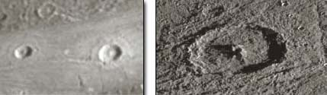
Figure 13: Left: relatively young craters on Ganymede, the largest having a well-formed central peak. This is an enlarged extract of part of Figure 9.17. Right: a higher resolution view of a similar crater on Ganymede, 32 km in diameter.

Question 8
From which direction is the illumination coming in each of the images in Figure 13?
View answer - Question 8
The only important distinction between cratering on the terrestrial planets and on Jupiter's satellites concerns the rate of cratering. There is clear evidence from the relative abundances of craters of different sizes that the population of impactors responsible for craters on Ganymede and Callisto differs from the population that caused the cratering of the terrestrial planets. The reason is that the latter is probably dominated by asteroids, whereas the former may include a greater proportion of comets plus locally generated debris arising from collisions within the particular satellite system.
Whatever the explanation, it means that we cannot use the lunar cratering time-scale to determine the absolute ages of the surfaces of the galilean satellites. Even more frustrating is that the impactor populations at Saturn, Uranus and Neptune all seem to have been different, so that we cannot use craters to compare ages between satellite systems in the outer Solar System. All that it is usually safe to assume is that when comparing regions on the same body, a more densely cratered surface must be older than a less densely cratered surface.
The surfaces of Ganymede and Callisto are much older than any surface that has survived on Europa, and this is where you first meet the concept of icy surfaces becoming darker as they age. This is a principle that seems to apply pretty well among the satellites of the outer planets. Age-darkening is a combination of two processes. One is the gradual concentration of residual rocky or sooty (carbonaceous) particles as the ice is removed by molecules being broken apart by radiation (water ice, for example, gets split into hydrogen and oxygen) or vaporised in small meteorite impact events. The other is loss of oxygen or hydrogen from carbon-bearing ice molecules (such as carbon dioxide, CO₂, or methane, CH₄) to leave sooty carbon or tarry molecules known as tholins.
Age is not the only factor controlling the albedo of ice. Its physical state is important too. If you make a powder out of anything solid, the powder will probably be paler than what you started with. This is why young craters and their ejecta are usually such bright features, although these too darken with age. Age-darkening is too slow to have affected Europa's young surface, and here the contrast between pale and dark areas must be largely due to the texture of the ice. For example, in Figure 9.13 the dark 'cracks' are clearly younger than the bright plains that they cut. Rather than being related to age, this contrast could reflect differences in the size of the ice crystals or the roughness of the surface.
Try to bear in mind when you compare images of different icy satellites that this will not usually tell you about their albedos, because the brightness of each image will usually have been adjusted to show each body to the best advantage. For example, in Figure 9.16 Callisto has been brightened relative to Ganymede so that features in each one show up well. With an average albedo of 0.7, Europa is more than three times as reflective as Callisto, whose albedo is only 0.2. Figure 14 below shows the true relative brightnesses of the three icy galilean satellites.
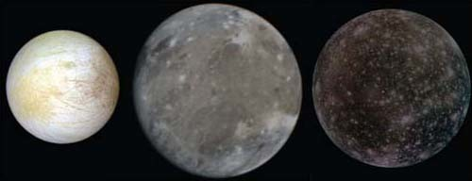
Figure 14: Europa, Ganymede and Callisto shown at their correct relative sizes and their correct relative brightnesses. In this rendering, the image of Europa is rather too bleached out to show its features well, whereas Callisto is very dark except for its more recent impact craters.
You should not come away from this course with the impression that the galilean satellites are well understood. For example, the great abundance of craters on Callisto suggests an ancient surface, and the absence of fractures or cryovolcanic features suggests that its outer shell (which would equate with the lithosphere of a terrestrial planet) must be very thick. However, Callisto's magnetic field suggests a salty ocean no more than 100 km below the surface. It is hard to see how both can be right. I am inclined to suspect that the magnetic data collected by Galileo have been misinterpreted, and that Callisto has no ocean, or at least not at such a shallow depth - but I could be wrong.

4 Questions
Now try to answer the following questions, to remind you of some of the things you have learned and test your understanding of them.

Question 9
To the nearest order of magnitude, how much greater is the estimated rate of heat loss per square metre of surface on Io than on Earth?
View answer - Question 9

Question 10
From the list, which is the correct reason why Io is so volcanically active?
- Io orbits within a strong, magnetically confined, belt of radiation.
- Io is tidally heated.
- Io contains an anomalously high concentration of radioactive elements.
- A lot of primordial heat is still leaking away on Io.
View answer - Question 10

Question 11
Apart from the fact that they orbit Jupiter rather than the Sun, do (a) Io and (b) Europa lack any properties that would otherwise allow them to be regarded as terrestrial planets?
View answer - Question 11

Question 12
From the list, which of the following is not likely to happen to molecules of water on Europa or Ganymede?
- Radiation can break them down into oxygen and hydrogen.
- Radiation can turn them into tholins.
- They can react with chemicals in rock.
- They can become components in cryovolcanic fluids.
View answer - Question 12

Question 13
Look at the image in Figure 15. This is part of a map of one of the galilean satellites derived from a mixture of Voyager and Galileo images and which shows some IAU-approved names. This extract covers 80° of longitude and nearly 60° of latitude.
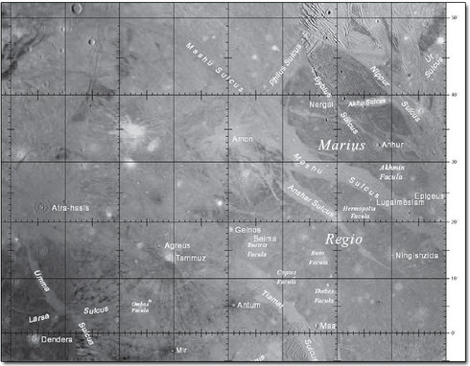
Figure 15: An image-based map showing part of one of the galilean satellites.
- (a) What are the features with one-word names, such as Dendera, Antum and Maa?
- (b) What is the meaning of 'Sulcus' in two-word names such as Umma Sulcus and Nippur Sulcus?
- (c) Which of the galilean satellites is this map from, and how can you tell?
View answer - Question 13

Conclusion
This free course provided an introduction to studying Science. It took you through a series of exercises designed to develop your approach to study and learning at a distance, and helped to improve your confidence as an independent learner.

Keep on learning


Study another free course
There are more than 800 courses on OpenLearn for you to choose from on a range of subjects.
Find out more about all our free courses.

Take your studies further
Find out more about studying with The Open University by visiting our online prospectus.
If you are new to university study, you may be interested in our Access Courses or Certificates.

What's new from OpenLearn?
Sign up to our newsletter or view a sample.
For reference, full URLs to pages listed above:
OpenLearn - www.open.edu/openlearn/free-courses
Visiting our online prospectus - www.open.ac.uk/courses
Access Courses - www.open.ac.uk/courses/do-it/access
Certificates - www.open.ac.uk/courses/certificates-he
Newsletter - www.open.edu/openlearn/about-openlearn/subscribe-the-openlearn-newsletter

Acknowledgements
The content acknowledged below is Proprietary (see terms and conditions) and is used under licence.
Course image: NASA Goddard Space Flight Center in Flickr made available under Creative Commons Attribution-NonCommercial-ShareAlike 2.0 Licence.
Grateful acknowledgement is made to the following sources for permission to reproduce material in this course:
Rothery, David A. Teach Yourself Planets, Chapter 9, pp107-139, Hodder Education, 2000, 2003. Copyright © David Rothery
Figures 9.1, 9.3, 9.4, 9.5, 9.6, 9.8, 9.9, 9.10, 9.11, 9.12, 9.13, 9.14, 9.15, 9.16, 9.17, 9.18, 9.19, 9.20, Plates 7, 8,9: NASA
Figure 9.7: NASA and AURA STScI.
Figure 9.2: David Rothery
Figures 1, 8: Space Telescope Science Institute & NASA;
Figures 9, 10: University of Hawaii and Scott Sheppard/David Jewitt.
NASA: http://www.nasa.gov/
Movie 1: NASA/JPL
Movies 2, 4, 5, 6, 7: NASA/JPL/University of Arizona
Movie 3: NASA/JPL/Southwest Research Institute
Section 2.3: Calar Alto Observatory in Spain
Don't miss out:
If reading this text has inspired you to learn more, you may be interested in joining the millions of people who discover our free learning resources and qualifications by visiting The Open University - www.open.edu/openlearn/free-courses

Question 1

Answer
The two images were obtained half a rotation apart, and the 'wobble' in the orientation of the radiation belt arises because the axis of the magnetic field is tilted relative to Jupiter's rotation axis (by nearly 10° according to Section 1.4.
Back

Question 2

Answer
Clouds on Earth are made of water; usually in the form of tiny liquid droplets, but sometimes as ice crystals, especially for the highest clouds.. Jupiter's topmost clouds have a different composition (ammonia), and are tiny crystals rather than liquid droplets. The same goes for Jupiter's next layer of cloud below the visible one, which is of ammonium hydrosulfide, but there is believed to be a (hitherto unproven) third layer of cloud made of water ice crystals below this (end of Section 1.5).
Back

Question 3

Answer
(a) Jupiter has four Hadley cells in each hemisphere between the equator and the pole. The Earth has only three., Venus has only one per hemisphere, and Mars has an even simpler pattern with a single dominant cell rising at the sub-solar latitude and flowing across the equator towards the pole in the opposite hemisphere. The differences among the terrestrial planets are caused by Venus's very slow rotation, and the lack of oceans to even out solar heating on Mars. Jupiter's extra cell relative to the Earth is primarily because Jupiter rotates much faster than the Earth, which restricts how far a parcel of atmosphere can travel in a north-south direction before being deflected sideways into zonal (east-west) winds.
(b) Other differences are that Jupiter's atmosphere receives more energy from the planet's interior than from the Sun, and that it is much deeper, with no clearly defined base. The chemistry is different too: Jupiter's atmosphere is almost entirely hydrogen and helium (similar to the Sun) coloured with traces of hydrogen-bearing compounds, whereas the carbon dioxide and nitrogen common to all three main terrestrial planets occur in insignificant proportions. [Comment: This difference is because the atmospheres of the terrestrial planets originated by gas escaping from the rocky interior , whereas the atmospheres of the giant planets were captured directly from the solar nebula, thanks to these planets' much stronger gravity.]
Back

Question 4

Answer
According to Section 1.4, at depths greater than about 10 000 km, Jupiter consists mostly of hydrogen having the properties of a molten metal, described as 'metallic hydrogen'. This zone continues much deeper than 12 000 km and at 12 000 km we can infer from Section 1.4 that the pressure must be greater than a million times the Earth's sea-level atmospheric pressure, and the temperature must be greater than 6000°C (which are the values quoted for 10000 km depth).
Back

Question 5

Answer
The first was designated S/2003 J1, the second was S/2003 J2, and so on up to S/2003 J21.
Back

Question 6

Answer
A sufficient number of observations had been made for their orbital motion about Jupiter to be adequately determined. This is the same principle as applied to the awarding of names to minor planets. Also, appropriate names (usually suggested by the discoverers) had been agreed by a committee of the IAU.
Back

Question 7

Answer
The correct sequence is (b), (c), (a), (d), although there may be local exceptions. Generally, ball-of-string texture is the oldest. Several generations of larger ridges can be seen cutting across (overprinting) the finer scale ball-of-string texture, so these larger ridges must be younger. Ball-of-string texture and some of the larger ridges are both disrupted into chaos, notably in the large area of Conamara chaos in the left (see Plate 9) but also in smaller chaos regions that cut across some of the large ridge systems in the lower right, so chaos generation is younger than ridge generation. Distribution of the ejecta patches is probably the last event, because the splashes of white can be seen even on the re-frozen matrix between the chaos rafts (most clearly seen in the lower left of Plate 9).
Back

Question 8

Answer
The shadows on the crater floors cast by the walls and central peaks demonstrate that the illumination is from the right in both cases.
Back

Question 9

Answer
The end of Section 1.9 quotes Io's heat loss as 2.5 watts per square metre and the Earth's as 0.08 watts per square metre. Dividing these two numbers we get 2.5/0.08 = 250/8 = 31.25.
This is closer to 10 than to 100, so Io's rate of heat loss per square metre is approximately one order of magnitude greater than the Earth's.
Back

Question 10

Answer
Io does indeed orbit within a zone of magnetically confined radiation; but this is not the origin of the heat that powers Io's volcanoes. The correct answer is 2, Io is tidally heated (Section 1.9).
Back

Question 11

Answer
Both are believed to have a dense, iron-rich core surrounded by a rocky mantle, which is the key characteristic of terrestrial planets. In terms of size and density they are both similar to the Moon, which is often regarded as a terrestrial planet. The composition of Io's volcanic surface is likely to be sufficiently different from its mantle to be regarded as a distinct crust, which is another feature of terrestrial planets. Europa has about 100 km of ice (or ice + water) hiding its rocky part; this thickness is only a small fraction of the global radius, and in this respect Europa is transitional between a 'normal' terrestrial planet and a large icy body, such as Ganymede, in which the ice is much thicker.
Back

Question 12

Answer
1, 3 and 4 are all believed likely to happen, although 3 is described in Chapter 9 of Teach Yourself Planets only for Europa. 2 is impossible, because tholins are tarry substances and therefore require carbon (Section 3.4), which is not present in a molecule of water (H₂O). [Comment: The tholins that may contribute to radiation-darkening of Ganymede's ice could originate from the action of radiation on carbon dioxide ice.]
Back

Question 13

Answer
(a) These features are rather too small for you to make out their nature on this figure, but the only kinds of feature that are given names without a descriptor term are (impact) craters and eruptive centres. There are no signs of eruption here, and in fact these are impact craters.
(b) 'Sulcus' is a descriptor term meaning parallel (or nearly parallel) ridges and furrows.
(c) The map shows belts of pale terrain cutting through dark terrain. This is a characteristic feature of Ganymede, and the identification is backed up by the abundance of impact craters (few of them actually named) on both terrain types. The sulci are belts of pale terrain that cut through dark terrain, and 'nearly parallel ridges and furrows' is a fair description of the visual appearance of Ganymede's pale terrain. Nippur Sulcus, near the northeast (top right) corner of the map, is in fact the belt of pale terrain that runs diagonally across Figure 9.17. That figure also shows Akitu Sulcus, the tapering belt of pale terrain that extends westwards from Nippur Sulcus.
Back

