

S205_2

The molecular world
About this free course
This free course provides a sample of level 2 study in Science http://www.open.ac.uk/courses/find/science
This version of the content may include video, images and interactive content that may not be optimised for your device.
You can experience this free course as it was originally designed on OpenLearn, the home of free learning from The Open University: http://www.open.edu/openlearn/science-maths-technology/science/chemistry/the-molecular-world/content-section-0.
There you'll also be able to track your progress via your activity record, which you can use to demonstrate your learning.
Copyright © 2016 The Open University
Intellectual property
Unless otherwise stated, this resource is released under the terms of the Creative Commons Licence v4.0 http://creativecommons.org/licenses/by-nc-sa/4.0/deed.en_GB. Within that The Open University interprets this licence in the following way: www.open.edu/openlearn/about-openlearn/frequently-asked-questions-on-openlearn. Copyright and rights falling outside the terms of the Creative Commons Licence are retained or controlled by The Open University. Please read the full text before using any of the content.
We believe the primary barrier to accessing high-quality educational experiences is cost, which is why we aim to publish as much free content as possible under an open licence. If it proves difficult to release content under our preferred Creative Commons licence (e.g. because we can't afford or gain the clearances or find suitable alternatives), we will still release the materials for free under a personal end-user licence.
This is because the learning experience will always be the same high quality offering and that should always be seen as positive - even if at times the licensing is different to Creative Commons.
When using the content you must attribute us (The Open University) (the OU) and any identified author in accordance with the terms of the Creative Commons Licence.
The Acknowledgements section is used to list, amongst other things, third party (Proprietary), licensed content which is not subject to Creative Commons licensing. Proprietary content must be used (retained) intact and in context to the content at all times.
The Acknowledgements section is also used to bring to your attention any other Special Restrictions which may apply to the content. For example there may be times when the Creative Commons Non-Commercial Sharealike licence does not apply to any of the content even if owned by us (The Open University). In these instances, unless stated otherwise, the content may be used for personal and non-commercial use.
We have also identified as Proprietary other material included in the content which is not subject to Creative Commons Licence. These are OU logos, trading names and may extend to certain photographic and video images and sound recordings and any other material as may be brought to your attention.
Unauthorised use of any of the content may constitute a breach of the terms and conditions and/or intellectual property laws.
We reserve the right to alter, amend or bring to an end any terms and conditions provided here without notice.
All rights falling outside the terms of the Creative Commons licence are retained or controlled by The Open University.
Head of Intellectual Property, The Open University
978-1-4730-1587-6 (.kdl)
978-1-4730-0819-9 (.epub)

Contents
- Introduction
- Learning outcomes
- 1 Everything that you can see is made of atoms
  - 1.1 Introduction
  - 1.2 Chemical elements
  - 1.3 Chemical compounds
  - 1.4 Molecular substances
  - 1.5 Non-molecular substances
  - 1.6 Binding forces in molecular and non-molecular substances - a first look
  - 1.7 Summary of Section 1
- 2 Chemical patterns are to be found in the periodic table
  - 2.1 Chemical periodicity
  - 2.2 The Group number of the noble gases
  - 2.3 Elements on parade: an audiovisual interlude
  - 2.4 Summary of Section 2
- 3 Chemistry can often be explained by electronic structure
  - 3.1 Introduction
  - 3.2 The electronic configurations of atoms
  - 3.3 Electronic configurations and the Periodic Table
  - 3.4 Outer electronic configurations and the Periodic Table
  - 3.5 Electron states and box diagrams
  - 3.6 Summary of Section 3
- 4 Chemical bonds consist of shared pairs of electrons
  - 4.1 Introduction
  - 4.2 Ionic and covalent bonding
  - 4.3 Metallic bonding
  - 4.4 A classification of chemical substances
  - 4.5 More about covalent bonding
  - 4.6 Summary of Section 4
- 5 Molecular reactivity
  - 5.1 Molecular reactivity is concentrated at key sites
  - 5.2 Summary of Section 5
- 6 Molecular shape affects molecular reactivity
  - 6.1 Introduction
  - 6.2 The shapes of some molecules
  - 6.3 Valence-shell electron-pair repulsion theory
  - 6.4 Summary of Section 6
- 7 Reactivity needs a favourable rate and equilibrium constant
  - 7.1 Introduction
  - 7.2 Is the equilibrium position unfavourable?
  - 7.3 Is the rate of reaction very slow?
  - 7.4 Equilibrium positions and rates of reaction in this course
  - 7.5 Summary of Section 7
- Conclusion
- Keep on learning
- Acknowledgements

Introduction
This course will provide you with a detailed understanding of some of the important problems and topics that are being studied by the chemists of today, and of the ways in which associated problems might be solved by chemical methods. But to acquire this understanding you must have a good grasp of fundamental chemical ideas, which in this course are covered under seven main headings and an overview. Each of those headings consists of a general idea that is of great importance to chemists. We begin with the idea that comes closest to defining the nature of chemistry itself.
This OpenLearn course provides a sample of level 2 study in Science

Learning outcomes
After studying this course, you should be able to:
- explain what is meant by isotopes, atomic numbers and mass numbers of the atoms of chemical elements by referring to the Rutherford model of the atom
- give an example of how differences in the molecular structures of chemical compounds give rise to differences in macroscopic properties
- indicate ways in which the chemical periodicity represented by a Periodic Table matches the periodicity in the electronic structure of atoms
- use the Lewis structures of one or two simple chemical substances to illustrate the ideas of the octet rule, the electron-pair bond and the valence-shell repulsion theory of molecular shape
- select a set of organic molecules, each of which contains the same functional group, and use its reactions to show why the functional group concept is useful.

1 Everything that you can see is made of atoms

1.1 Introduction
The idea that everything that we can see is an assembly of tiny particles called atoms is chemistry's greatest contribution to science. There are about 120 known kinds of atom, and each one is distinguished by a name, by a chemical symbol, and by a number called the atomic number. The meaning of atomic number is best understood from the Rutherford model of the atom (Figure 1). Each atom has a tiny positively charged nucleus, where nearly all of its mass resides. Around this nucleus move negatively charged particles called electrons. Any atom is electrically neutral, but each electron carries a negative charge, to which we give the symbol −e.

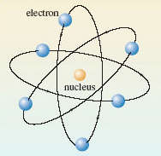
Figure 1 The Rutherford model of the atom.

Question 1

So what is the charge carried by the nucleus of the atom in Figure 1?

View answer - Question 1

In fact, the positive charge on the nucleus of any atom is provided by minute positively charged particles called protons, each of which carries a charge of +e.

Question 2

How many protons are there in the nucleus of the atom in Figure 1?

View answer - Question 2

The atomic number of an atom is the number of protons in its nucleus. It is also equal to the number of electrons in the neutral atom. The atomic number of the atom in Figure 1 is therefore six.

1.2 Chemical elements
Atoms of the same atomic number behave virtually identically in chemical reactions. They are therefore given the same chemical name and chemical symbol. For example, the atom of atomic number 6, which is shown in Figure 1, is a carbon atom, whose symbol is C. All materials are made of atoms, but there is a special class of substance whose members consist of atoms of the same atomic number. They are called chemical elements and about 120 of them are known. Each element is allocated a name and a chemical symbol which is the same as that given to the atoms it contains. Thus, the element carbon (C), which is the major constituent of pencil 'leads', consists entirely of carbon atoms (C), all with atomic number 6. Six other examples are shown in Figure 2. Before the nineteenth century, such substances were recognised as materials that defied all attempts to break them down into simpler chemical components. Chemistry's greatest contributions to scientific thought can all be traced back to the subsequent marriage of this concept of a chemical element with the atomic theory (see Box 1).
One of the implications of this Section, and of Figure 2, is that chemical symbols have two meanings: they can represent either a chemical element or a type of atom. Thus, the symbol S can represent either the yellow solid in Figure 2c, or the type of atom of which that solid is composed. With experience, you will find that when you meet chemical symbols, the context will reveal which meaning is appropriate.

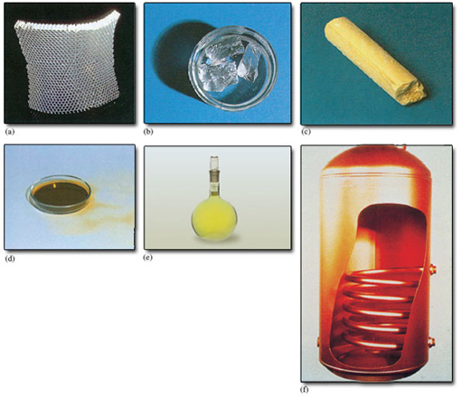
Figure 2 The chemical elements may be solids, liquids or gases at room temperature: (a) aluminium (symbol Al, atomic number 13); (b) sodium (symbol Na, atomic number 11) is kept under oil to prevent reaction with air or water; (c) sulfur (symbol S, atomic number 16); (d) bromine (symbol Br, atomic number 35) is a dark-red liquid; (e) chlorine (symbol Cl, atomic number 17) is a yellow-green gas; (f) copper (symbol Cu, atomic number 29).

Box 1: Atoms in view?
The Greek philosophers Democritus (460-370BC) and Epicurus (340-270BC) believed in a world made of tiny hard atoms in endless motion. Their ideas have come down to us through a poem, De Rerum Natura ('The Way Things Are'), written by the Roman poet Lucretius (90-40BC). Lucretius was profoundly hostile to contemporary ideas of an after-life, in which there was punishment by the gods for former sins. This turned the atomic theory into useful propaganda. After death, one's atoms were dispersed into the larger world and assumed new forms. So there could be no question of reassembly for punishment:

…all our atoms went
Wandering here and there and far away
So we must think of death as being nothing,
As less than sleep, or less than nothing even,
Since our array of matter never stirs
To reassemble, once the chill of death
Has taken over.
Lucretius

Atoms became a part of modern science when John Dalton (1766-1844) suggested that the atoms of each element are identical, especially in mass. Ultimately, this was proved wrong because of the discovery of isotopes (Section 1.2.1), but it was also immensely fruitful. Even in 1900, there were eminent scientists who did not believe in the reality of atoms. But between 1900 and 1920, phenomena as varied as the motion of pollen grains in water, diffusion in liquids, radioactivity and the diffraction of X-rays by crystals, all gave similar values for the sizes of atoms. This convergence of data from such different directions destroyed any serious opposition.
In scanning tunnelling microscopy (STM), a small voltage is applied between a 'probe' and a surface that the probe moves across. The observed current is sensitive to the surface contours at an atomic level, and its variation can be stored, computer enhanced and plotted out as a map of the surface (Figure 3). This technique earned Gerd Binning and Heinrich Rohrer of IBM's Zurich Laboratory the 1986 Nobel Prize for Physics. It is the nearest one can get to 'seeing atoms'. But how do we know that it is atoms that are displayed on the computer screen rather than, say, some microscopic set of dentures? The answer is that their size agrees with the values obtained by the classical methods mentioned above. Both classical and modern methods give similar values for atomic size. Pictures like Figure 3 have only enhanced a convergence that already existed in the results of other methods.

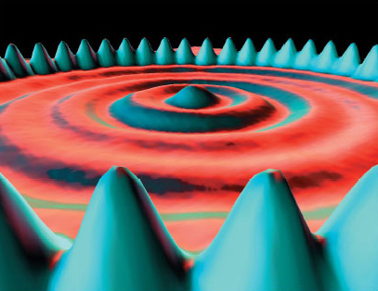
Figure 3 A ring of 48 iron atoms on a copper surface observed by STM. Notice the wave-like crests and troughs inside the ring. These are thought to be due to the wave-like properties of electrons confined within the ring

1.2.1 Isotopes
All atoms of the same element have identical atomic numbers, and are chemically similar, but they may not be identical in other ways. Figure 2f shows copper. All copper atoms have atomic number 29: all their nuclei contain 29 protons. But they also contain uncharged particles called neutrons. In natural copper, the atoms are of two kinds. One has 29 protons and 34 neutrons in the nucleus; the other has 29 protons and 36 neutrons (Figure 4).

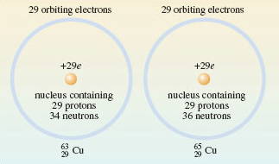
Figure 4 The distribution of protons, neutrons and electrons in the atoms of the two isotopes of copper present in copper metal. In both cases, the atomic number is 29: there are 29 protons in the nucleus. This makes both types of atom, atoms of copper, but they differ in the number of neutrons contained in their nucleus

The two different kinds of atom are called isotopes of copper. The neutron has a mass very similar to that of the proton, so the two isotopes differ in mass. The sum of the numbers of neutrons and protons for a particular isotope is called the mass number.

Question 3

What are the mass numbers of the two copper isotopes in Figure 4?

View answer - Question 3

The two isotopes are written, and where the mass number and atomic number precede the chemical symbol as a superscript and subscript, respectively (Figure 5).
The mass number of any isotope is equal to the relative atomic mass of its atom, rounded to the nearest whole number. The atoms of natural copper are about 70% and 30% . Thus, the relative atomic mass of natural copper (63.5) lies between 63 and 65, but closer to 63 because that is the relative atomic mass of the more abundant isotope. But although copper contains two different isotopes, each isotope has the same atomic number, and therefore a virtually identical chemistry.

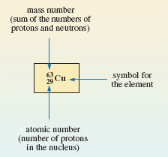
Figure 5 A symbolism showing the number of neutrons, protons and electrons in the neutral atom of an isotope

1.3 Chemical compounds
Chemical elements contain atoms of the same atomic number. But most materials consist of chemical compounds. These are a combination of the atoms of two or more chemical elements. Such combinations often occur in simple numerical ratios. Thus, when sodium metal (Figure 2b) and chlorine gas (Figure 2e) are brought into contact, they react vigorously, and white crystals of common salt (sodium chloride) are formed. In these crystals, there are equal numbers of sodium and chlorine atoms; that is, the sodium and chlorine atoms are combined in the simple ratio 1:1. This is expressed by writing sodium chloride as NaCl. In this formula, there is one chlorine atom (Cl) for every sodium atom (Na).
Likewise, aluminium (Figure 2a) and liquid bromine (Figure 2d) will react violently after a short interval, and yield a white solid called aluminium bromide. In this solid there are three bromine atoms for every aluminium atom.

Question 4

Write a chemical formula for aluminium bromide.

View answer - Question 4

Formulae such as NaCl and AlBr₃ tell us the ratios in which atoms are combined in compounds. When they are written down, the ratio is reduced to the lowest possible whole number, and the chemical formulae obtained in this way are then called empirical formulae. Most chemical elements are metals, and the formulae quoted for compounds of these metallic elements are usually empirical formulae. But they tell us nothing about the way that the atoms are grouped within the compound. For this, we need formulae of a different type.

1.4 Molecular substances
Chlorine, bromine and iodine belong to a family of elements called the halogens. At room temperature, chlorine (Figure 2e) is a gas, bromine (Figure 2d) is a liquid and iodine is a dark-purple solid. All three substances are chemical elements. One's first thought might be that the tiny particles of which, say, chlorine gas is composed are single atoms.

Question 5

Is this the case?

View answer - Question 5

A gas, like chlorine, occupies much more space than a solid or liquid, so the distance between the molecules is comparatively large. At normal temperatures and pressures, it averages about 3 500 pm (1 pm ≡ 10⁻¹²m), compared with a distance of only 198 pm separating the chlorine atoms in gaseous Cl₂ molecules (Figure 6a). This disparity is less extreme, but still evident in liquid bromine and solid iodine. The positions of atoms in solids can be determined by X-ray crystallography. In solid iodine (Figure 6b), each iodine atom has a second iodine atom at a distance of only 271 pm. By contrast, in other directions, the shortest distance to another iodine atom is considerably greater (350 pm). So the iodine atoms can be grouped into pairs; hence we conclude that solid iodine contains I₂ molecules.

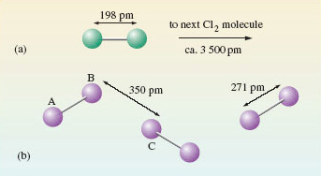
Figure 6 (a) The distance between the atoms in Cl₂ molecules is small compared with the average distance between the molecules in a jar of chlorine gas. On the scale set by our Cl₂ molecule, that average distance puts the next Cl₂ molecule on the opposite page. (b) In solid iodine, I₂ molecules (e.g. AB) can be identified through their separation by a distance of 271 pm. These molecules are separated by longer distances of at least 350 pm (BC)

Similar reasoning can be used to identify molecules in compounds. At room temperature, carbon dioxide is a gas containing CO₂ molecules. On cooling, it becomes a solid ('dry ice'). In dry ice (Figure 7), each carbon atom, A, has two oxygen atom neighbours, B and C, at a distance of 116 pm. These three atoms are colinear. The next nearest atom is another oxygen, D, at 311 pm. Here is evidence that solid carbon dioxide contains linear CO₂ molecules, with the atom sequence O—C—O.

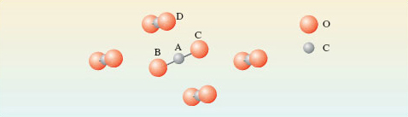
Figure 7 The environment of a carbon atom, labelled A, in solid carbon dioxide, 'dry ice'. Note that molecule BAC is in the plane of the paper; the other four molecules shown are not

The formulae Cl₂, Br₂, I₂ and CO₂ that we have identified for the three halogens and carbon dioxide are called molecular formulae. They tell us how the atoms are grouped together in the molecules from which the substance is built up. Likewise, the four substances are called molecular substances because they have structures that allow discrete molecules to be picked out. So far, we have examined just one molecular compound (CO₂) and its molecular formula is identical with its empirical formula, but often this is not so. In Section 1.2, we discussed solid aluminium bromide with empirical formula AlBr₃. Here, the molecular and empirical formulae are not identical: the crystal structure contains Al₂Br₆ molecules (Figure 8).

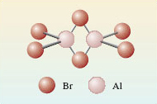
Figure 8 The structure of the Al₂Br₆ molecule. The two aluminium atoms, and four of the bromine atoms at the ends of the molecule, lie in the same plane (at right-angles to the plane of the paper). The two bromines that bridge the aluminiums lie above and below this plane

Question 6

Do these molecules have the same empirical formula as the solid in which they are found?

View answer - Question 6

The so-called organic compounds formed by the element carbon are almost entirely molecular. To mark this point, we show, in Figure 9, the grouping of the atoms in the molecules of two important solid organic compounds. Figure 9a shows the structure of aspirin, the best-known painkiller, which is also used in the precautionary treatment of heart conditions. The molecule in Figure 9b is RDX, the most common military high explosive. Here, you need not worry about the names used for organic compounds. In this course, relatively few such compounds are discussed, and we shall be concerned only with differences in the structure of their molecules; the names are just labels.

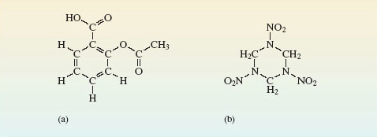
Figure 9 Molecules of: (a) acetylsalicylic acid (aspirin); (b) 1,3,5-trinitroperhydro-1,3,5-triazine, also known as RDX (Research Department Explosive!) or cyclonite.

1.5 Non-molecular substances
Non-molecular substances defy attempts to pick out discrete molecules from their structures. One example is common salt, NaCl, which is built up from the tiny cubes shown in Figure 10a. Look first at the sodium at the centre of the cube.

Question 7

What kind of atom is closest to the sodium, and how many of them are there?

View answer - Question 7

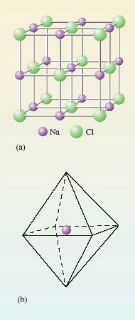
Figure 10 (a) Structure of common salt or sodium chloride; (b) a regular octahedron whose corners represent the positions of the chlorines around each sodium

The six chlorines lie at the corners of a three-dimensional figure called a regular octahedron (a solid figure with eight faces; see Figure 10b). The formula NaCl for sodium chloride is an empirical formula: it merely tells us that in sodium chloride there are equal numbers of sodiums and chlorines. This condition is automatically fulfilled when many cubes of the Figure 10a type are joined through their faces. But Figure 10 provides no evidence that NaCl is the molecular formula of sodium chloride. Indeed, quite the opposite, because the six chlorines around the sodium in Figure 10a all lie the same distance away. There are no grounds for singling out just one of them and coupling it with the sodium as an NaCl molecule. There is no evidence of discrete NaCl molecules in the solid; NaCl is a non-molecular compound, and the concept of a 'molecular formula' is not appropriate in solid NaCl.
Similar considerations apply to silicon dioxide or silica, SiO₂. This is the main component of sand, and it has the same type of empirical formula as carbon dioxide. In solid carbon dioxide, two of the oxygen atoms around each carbon were much closer than the others, so we could identify a CO₂ molecule. However, in silica (Figure 11), each silicon atom sits at the centre of a tetrahedron of oxygen atoms: the silicon is surrounded by four oxygen atoms, all at the same distance of 162 pm. There is no evidence of discrete SiO₂ molecules.

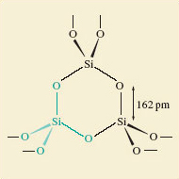
Figure 11 The structure of silica, SiO₂, in the form of quartz. One SiO₄ tetrahedron is highlighted in green.

Most of the chemical elements are non-molecular substances. Figure 12 shows the environment of each atom in diamond and metallic aluminium. In diamond (Figure 12a), there are four surrounding carbon atoms at the corners of a regular tetrahedron, and the C—C distance is 154 pm. In aluminium (Figure 12b), there are twelve surrounding aluminium atoms, and the Al—Al distance is 286 pm. There is no justification for dividing the structure up into molecules containing two or more atoms. Any such 'molecule' extends throughout a crystal of the substance, and its formula will vary with the crystal size. For this reason, the phrase extended structure is sometimes used to describe non-molecular substances.

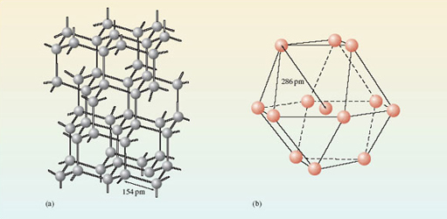
Figure 12 The environment of each atom in (a) the diamond form of the element carbon; (b) the metallic element aluminium. Both substances are non-molecular, and have extended structures.

In Figures 12a and 12b, the extension occurs in three dimensions, but it may sometimes reveal itself in only one or two. Figure 13 shows the structure of graphite, the form of carbon used in pencil 'leads'. There are regular hexagons of carbon atoms arranged in parallel sheets. Within the sheets, the C—C distance is only 142 pm, but the shortest distances between the sheets is 340 pm.

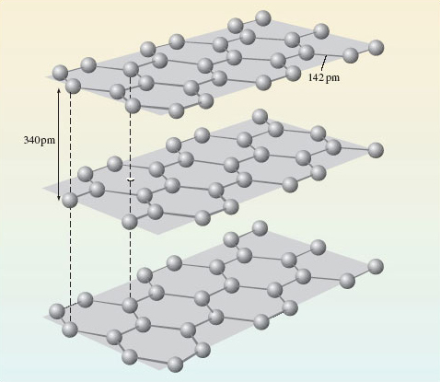
Figure 13 The structure of the graphite form of the element carbon

Question 8

If one regards a single crystal of graphite as an extended structure, does the extension occur in one, two or three dimensions?

View answer - Question 8

These sheets, however, are not repeating molecules because, again, their size varies with the size of the crystal. Graphite is therefore classified as a non-molecular substance with an extended structure.
Figures 12a and 13 show that the element carbon occurs in different solid forms, each of which has a different structure. These different solid forms of the same element are known as allotropes (or polymorphs). Phosphorus, sulfur and tin are other examples of elements that occur as more than one allotrope.

1.6 Binding forces in molecular and non-molecular substances - a first look
As we shall see in Section 4, elementary bonding theories imply that materials as different as salt, iodine and aluminium are held together by different types of chemical bond. However, all binding forces between atoms are essentially electrical, and arise from a balance of forces acting between positively charged nuclei and negatively charged electrons. As electrical forces are stronger at short distances, in solid iodine (Figure 6b) the short distances between the pairs of atoms (I₂ molecules) suggest that the forces holding these atoms together are strong. By contrast, the longer distance between different pairs (molecules) tells us that the forces acting between one I₂ molecule and another are much weaker.
Now, iodine melts at only 114 °C and boils at 185 °C.

Question 9

Why does iodine have low melting and boiling temperatures?

View answer - Question 9

This also explains another property of iodine: it dissolves fairly easily in an organic solvent like petrol. The solid crystal falls apart and individual I₂ molecules drift off into solution. As organic compounds are molecular, they too, often dissolve in petrol. The organic polymers you meet in everyday life have unusually large molecules, but being molecular they may also be vulnerable (Figure 14).

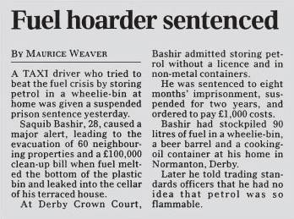
Figure 14 From the Daily Telegraph, 6 April 2001 (Note the erroneous use of 'melt' for 'dissolve' in this extract)

By contrast, in salt, silica or aluminium, the bonding is more evenly distributed through the crystal, and there are no points of weakness where discrete molecules can be prised apart. So the melting and boiling temperatures of non-molecular substances tend to be greater than those of molecular ones. Salt, silica and aluminium, for example, melt at 801 °C, 1 713 °C and 660 °C, respectively.

1.7 Summary of Section 1
- All materials are made of atoms of about 120 different chemical elements, each element being characterised by an atomic number which lies in the range 1-120.
- Each atom has a nucleus where most of its mass resides. The atomic number is equal to the number of units of positive charge on the nucleus, the number of protons in the nucleus, and to the number of surrounding electrons in the neutral atom.
- The nuclei of nearly all atoms contain neutrons as well as protons. The mass number of an atom is the sum of the numbers of neutrons and protons.
- All atoms of an element contain the same number of protons, but they may differ in the number of neutrons. This gives rise to atoms of an element with the same atomic number but different mass numbers. These different types of atom are called isotopes. In chemical changes isotopes behave almost identically.
- Chemical compounds are combinations of the atoms of two or more chemical elements. The empirical formula of a compound tells us the ratio in which the atoms of its elements are combined.
- Molecular substances have structures from which discrete molecules can be picked out by using interatomic distance as a criterion; non-molecular substances do not. The formula of these discrete molecules is called the molecular formula. Most molecular compounds contain just one type of molecule, which then has the same empirical formula as the compound. Most organic compounds are molecular substances.
- Molecular substances usually have lower melting and boiling temperatures than non-molecular ones. They also tend to dissolve more easily in organic solvents such as petrol.

Question 1

The element aluminium (symbol Al; atomic number 13) has a relative atomic mass of 27.0; in nature it contains just one isotope.
- (a) State the number of protons in the aluminium nucleus.
- (b) State the number of orbiting electrons around the nucleus of an aluminium atom.
- (c) If the electronic charge is written −e, what is the total charge on the nucleus of the aluminium atom?
- (d) State the number of neutrons in the aluminium nucleus.
- (e) Write down the isotope that is present in natural aluminium by combining mass number, atomic number and chemical symbol.

View answer - Question 1

Question 2

The molecular formula of an oxide of phosphorus is P₄O₁₀.
- (a) What is the empirical formula of the oxide?
- (b) Can the empirical formula of a molecular compound consisting of one type of molecule, contain more atoms than its molecular formula? Explain your answer.

View answer - Question 2

Question 3

Figure 15a shows the structure of solid hydrogen fluoride, HF, which consists of zigzag chains containing hydrogen and fluorine atoms. Figure 15b shows the structure of solid silicon carbide, SiC.
- (a) Classify the compounds as molecular or non-molecular.
- (b) One of the compounds (X) melts at −83 °C and is slightly soluble in petrol. The other (Y) remains solid even at 2 500 °C and is insoluble in petrol. Which is which? Explain your answer.

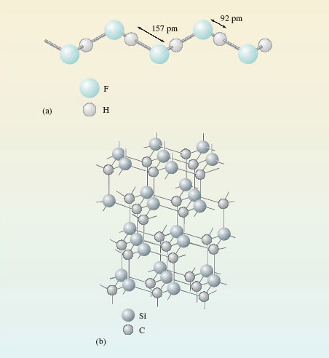
Figure 15 The structures of: (a) zigzag chains in solid hydrogen fluoride; (b) solid silicon carbide, in which all distances between atoms linked by lines are 165 pm

View answer - Question 3

2 Chemical patterns are to be found in the periodic table

2.1 Chemical periodicity
The chemistry of the elements is immensely varied. But amidst that variety there are patterns, and the best known and most useful is chemical periodicity: if the elements are laid out in order of atomic number, similar elements occur at regular intervals.
The discovery of chemical periodicity is particularly associated with the nineteenth-century Russian chemist Dmitri Ivanovich Mendeléev (Figure 16). The periodicity is represented graphically by Periodic Tables. Figure 17 shows the Periodic Table used in this course. Chemical periodicity is apparent from the appearance of similar elements in the same column. For example, the alkali metals appear in the first column on the left of the Table, and the noble gases in the last column on the right. Horizontal rows are called Periods; vertical columns are called Groups. The Table can be neatly divided up into blocks of elements (transition elements, lanthanides, actinides and typical elements), each with their own distinctive properties. Above each element is its atomic number. These numbers run from 1-118, 118 being the highest atomic number so far [2001] claimed for any observed atom.

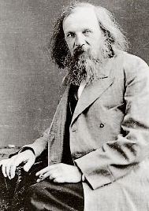
Figure 16 The hypnotic face of Dmitri Mendeléev (1834-1907) has been likened to that of Svengali or Rasputin. Such comparisons are encouraged by his insistence on having just one haircut a year. His scientific fame rests mainly on his boldness in using his Periodic Law to predict the properties of undiscovered elements. For example, after Lecoq de Boisbaudron had announced the discovery of the new element gallium in 1875, he received a letter from Mendeléev. The letter informed him that Mendeléev had already predicted the properties of gallium, and that his experimental value for its density appeared to be wrong. de Boisbaudron then redetermined the density of gallium, and found that Mendeléev's assertion was indeed correct!

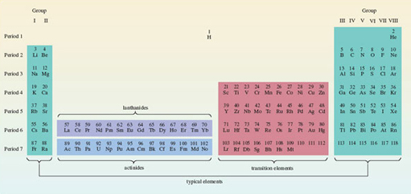
Figure 17 The complete Periodic Table used in this course. Note how the position of hydrogen has been left undecided. Some of its properties point to a position in Group I with the alkali metals; others to a position in Group VII with the halogens

Click to view larger version for Figure 17
View document
This course is largely concerned with the typical elements. These occur on the extreme left and extreme right of Figure 17. It is convenient, therefore, to create from Figure 17 a mini-Periodic Table that contains the typical elements alone. By removing the transition elements, the lanthanides and actinides, and by pushing the two separate blocks of typical elements together, we arrive at Figure 18. This mini-Periodic Table consists of seven Periods and eight Groups. The seven Periods are numbered from 1 to 7, but it is more difficult to settle on the best way of labelling the Groups.
In Figure 18, they are numbered in roman numerals from I to VIII. This is the principal Group numbering scheme used in this course, but other ways of numbering the Groups are mentioned in Sections 2.2 and 2.3.

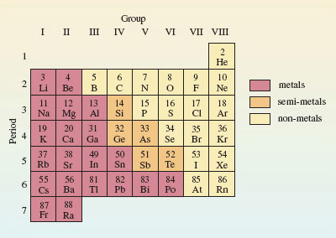
Figure 18 A mini-Periodic Table containing the typical elements up to radium; it consists of eight columns or Groups, and seven rows or Periods. Hydrogen has been omitted for the reasons cited in the caption to Figure 17

Clear examples of chemical periodicity are revealed by Figure 18. Many involve the valencies of the elements. Here we use valency in the classical sense: a number that determines the ratios in which atoms combine. Table 1 shows the most important valencies of some common elements.

Table 1 The most important valencies of some common elements
Valency
1 | 2 | 3 | 4
hydrogen (H) | oxygen (O) | nitrogen (N) | carbon (C)
lithium (Li) | sulfur (S) | phosphorus (P) | silicon (Si)
sodium (Na) | magnesium (Mg) | aluminium (Al) | tin (Sn)
potassium (K) | calcium (Ca)
fluorine (F) | barium (Ba)
chlorine (Cl)
bromine (Br)
iodine (I)

Question 4

What does Table 1 suggest for the empirical formula of an oxide of tin?

View answer - Question 4

We now list three instances of chemical periodicity in Figure 18 that you should be able to exploit:
- (i) As the colour coding of Figure 18 shows, metals lie to the left, and non-metals to the right, with semi-metals in between.
- (ii) When an element in Figure 18 forms one or more hydrides, then across the eight columns of the Table, the valency of the element in the highest hydride (the hydride that contains most hydrogen) runs in the order 1, 2, 3, 4, 3, 2, 1, 0. Thus, nitrogen occurs in the fifth column, so its hydride is NH₃ (ammonia).
- (iii) The empirical formulae of fluorides and normal oxides provide an especially important example of chemical periodicity. Normal oxides are compounds in which single oxygen atoms are combined with atoms of other elements. For most of the elements in Figure 18, the highest observed valencies are equal to the Group number of the element. This allows the empirical formulae of the highest fluorides and highest normal oxides of the elements to be predicted. Thus, aluminium occurs in Group III, so the highest fluoride is AlF₃, and the highest normal oxide is Al₂O₃.
These generalisations are not perfect. For example, the oxide trend does not work for the elements Po, F, Br, I, He, Ne, Ar, Kr and Rn; the fluoride trend does not work for N, O, Cl, Br, or for any of the noble gases. There is a further comment on this in the next section. Nevertheless, each generalisation is true enough to be very useful.

2.2 The Group number of the noble gases
In Figure 18, the Period numbers increase steadily from 1 to 7 down the columns. It obviously seems appropriate that the Group numbers should show a similar steady increase from I to VIII across the rows. However, this numbering scheme puts the noble gases in Group VIII. As Section 2.1 makes clear, almost none of these six elements then obeys generalisation (iii). For example, with this Group numbering, generalisation (iii) predicts the formula AO₄ for the highest normal oxides of the noble gases, where A represents a noble gas atom. Only for xenon is such a compound known.
The situation is improved if one changes the Group number of the noble gases from VIII to zero. This is because there are no known oxides or binary fluorides of helium, neon or argon. In the case of the noble gases, generalisation (iii) then fails only at xenon when predicting oxide formulae, and at krypton, xenon and radon when predicting fluoride formulae. So in introducing chemical periodicity through generalisations (ii) and (iii), it makes sense to number the first 7 Groups from I to VII as in Figure 18, but to use zero for the noble gases (Group 0). This was also the Group numbering favoured by Mendeléev. In this course, however, we shall use the scheme of Figure 18 in which the noble gases are designated as Group VIII, and the Group numbers increase regularly across each row. The reasons for this change are given in Section 3.4.

2.3 Elements on parade: an audiovisual interlude
Here you have the opportunity of viewing seven video sequences which show both reactions and properties of some chemical elements. The seven sequences provide examples of the way in which Periodic Tables such as Figures 17 or 18 elicit similarities or patterns in chemical behaviour.
The following video clip takes a look at the alkali metals.

Video content is not available in this format.
Video 1
View transcript - Video 1

The following video clip compares the four halogens.

Video content is not available in this format.
Video 2
View transcript - Video 2

The following video clip shows the process of burning a diamond.

Video content is not available in this format.
Video 3
View transcript - Video 3

The following video clip takes a look at the oxidation states of vanadium.

Video content is not available in this format.
Video 4
View transcript - Video 4

The following video clip provides a brief introduction to the lanthanides.

Video content is not available in this format.
Video 5
View transcript - Video 5

The following video clip describes the oxidation states of uranium.

Video content is not available in this format.
Video 6
View transcript - Video 6

The following video clip describes the separation of uranium from plutonium.

Video content is not available in this format.
Video 7
View transcript - Video 7

2.4 Summary of Section 2
- The typical elements can be displayed in a mini-Periodic Table of eight Groups and seven Periods (Figure 18). The Periods are numbered from 1 to 7 and the Groups are labelled I-VIII.
- Metals appear on the left of this table, non-metals on the right and semi-metals in between.
- In their highest fluorides and normal oxides, the valencies of the typical elements are usually equal to their Group numbers in Figure 18. In their highest hydrides, their valencies usually follow the pattern 1, 2, 3, 4, 3, 2, 1, 0 across the Period.

Question 5

A typical element Z from Figure 18 is a semi-metal and forms oxides with empirical formulae ZO₂ and ZO₃, and a single hydride, ZH₂. Identify the element, and state the Group and Period of Figure 18 in which it lies. What is the formula of the highest fluoride of the element?

View answer - Question 5

3 Chemistry can often be explained by electronic structure

3.1 Introduction
Section 2 used some simple examples to illustrate chemical periodicity. But how can we explain such periodicity? The answer lies in the way that the electrons in atoms are arranged about the positively charged nucleus. In chemical reactions, atoms change partners. We know that the outsides of atoms consist of electrons, so contact and connection between atoms is likely to take place through their electrons, and in particular, through the electrons in their outer shells. So similarities in the arrangement of the outer electrons in the atoms of two different elements lead to similarities in the chemistry of the two elements. To see the truth of this idea, you must be able to write down the electronic configurations of atoms.

3.2 The electronic configurations of atoms
The quantum theory of the atom tells us that we cannot say exactly where an electron in an atom will be at any particular moment; we can speak only of the probability of finding an electron at a particular point. So the precise orbits shown in the Rutherford model of Figure 1 misrepresent the arrangement of electrons about the nucleus. We say instead that the electrons in atoms are arranged around the nucleus in shells. The shells are regions where the probability of finding an electron is relatively high, and where, over an extended period, the electrons spend most of their time. Shells are numbered 1, 2, 3, etc., starting from 1 nearest the nucleus. This number is called the principal quantum number, and is given the symbol n.
Now these shells of electrons can be divided into sub-shells, and each sub-shell is specified by a second quantum number l.

Question 11

How many sub-shells are there in a shell of principal quantum number 4? Assign an l value to each sub-shell.

View answer - Question 11

An alternative way of specifying sub-shells uses letters in place of the quantum number l. The following letters are used in this notation: s for sub-shells with l = 0, p for sub-shells with l = 1, d for sub-shells with l = 2, f for sub-shells with l = 3. Thus, the four sub-shells in the shell for which n = 4 are written 4s, 4p, 4d and 4f.
There is an upper limit on the number of electrons that each kind of sub-shell can hold. This limit is 2(2l + 1), where l is the second quantum number of the sub-shell.

Question 12

What is this upper limit for each of the s, p, d and f sub-shells?

View answer - Question 12

So in s, p, d and f sub-shells, there can be no more than 2, 6, 10 and 14 electrons, respectively. These limits, and other quantum rules from this Section are summarised in Figure 20.

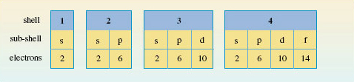
Figure 20 The sub-shells in the shells of principal quantum numbers 1-4, and the maximum number of electrons that each type of sub-shell can hold

To assign electronic configurations to atoms, you need only one more piece of information. This is an energy-level diagram displaying the order in which the sub-shells are filled. Surprisingly, electronic configurations can be correctly assigned to nearly all atoms using just one such diagram, Figure 21.

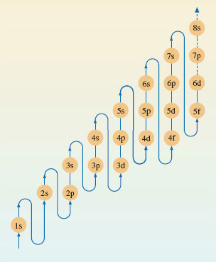
Figure 21 A pathway showing the order in which the sub-shells should be filled when writing out the electronic configurations of atoms

Question 13

The atomic number of silicon is 14. Write down the electronic configuration of the silicon atom.

View answer - Question 13

This is established as follows. Assign the fourteen electrons in the silicon atom to the sub-shells in Figure 21. The 1s and 2s levels on the left can each take two electrons. The next highest level is 2p and this sub-shell is filled by the next six electrons. The 3s sub-shell then takes another two electrons and the thirteenth and fourteenth electrons go into the sub-shell of next highest energy, which is 3p.
Notice that the value of n for the outermost shell of the electronic configuration of the silicon atom is three. This outer shell contains four electrons, two of which are in an s sub-shell, and two in a p sub-shell. We say, therefore, that the outer electronic configuration of the silicon atom is of the type s²p².

3.3 Electronic configurations and the Periodic Table
Figure 21 has been designed for use in a particular thought experiment. The purpose of the thought experiment is to see how the electronic configuration of the atoms changes as one moves through the Periodic Table from beginning to end. We start with the hydrogen atom, which has one proton and one electron. Then we proceed through a series of stages in each of which we add one new proton to the nucleus, and one new electron to the clutch of surrounding electrons. At each stage, the filling order of Figure 21 tells us what sub-shells are occupied, and how many electrons those occupied sub-shells contain. In addition, the filling of successive sub-shells in this thought experiment generates the form of the Periodic Table shown in Figure 22, in which the winding arrowed pathway follows the filling order of Figure 21. The different blocks of elements span regions in which particular types of sub-shells are being filled up. With the typical elements, the sub-shell type is either s or p; in the case of the transition elements, with rows of ten, it is d; for the lanthanides and actinides, with rows of fourteen, it is f. Indeed, because of this connection, one can think of Figure 22 as a demonstration of how the filling order of Figure 21 can be deduced from the form of the Periodic Table.

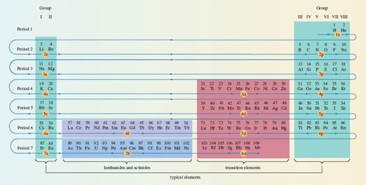
Figure 22 The winding pathway shows how the order of sub-shell filling (Figure 21) generates the full Periodic Table. Elements in the same column usually have similar outer electronic configurations. Hydrogen has been juxtaposed with helium to indicate the filling of the 1s sub-shell

Click to view larger version of Figure 22
View document

3.3.1 Writing out electronic configurations
In Section 3.2, we described Figure 21 as an energy-level diagram, which represented the build-up of electronic configurations as electrons were inserted into sub-shells of progressively increasing energy. However, Figure 21 has been designed for just one purpose: to generate the correct electronic configurations in our thought experiment in which, to quote Niels Bohr, 'the neutral atom is built up by the capture and binding of electrons to the nucleus, one by one'. What Figure 21 tells us, at any stage of the thought experiment, is which of the still unfilled sub-shells has the lowest energy. That sub-shell then receives the next electron.
Figure 21 is therefore designed to give the order of energies only for those sub-shells that, at any stage of the thought experiment, are candidates for the reception of the next electron. It does not necessarily give the correct order of energies for all of the sub-shells in any one particular atom. Consider lead, atomic number 82.

Question 14

Use Figure 21 to write out the electronic configuration of the lead atom.

View answer - Question 14

In the lead atom, the occupied sub-shells of highest energy are 6s² and 6p². The four electrons in these sub-shells are the ones that most influence the chemistry of lead. They are the outermost electrons, and the most easily removed, being furthest from the nucleus. But the sub-shell sequence from Figure 21 does not give this impression. Although 6p² appears at the end, suggesting that these are outermost electrons, 6s² does not. A more correct order of energies in any particular atom is obtained by grouping the sub-shells first in order of increasing value of n, and then, within each n value, in the order s, p, d and f.

Question 15

Do this for the configuration of the lead atom.

View answer - Question 15

The electronic configurations of the atoms within this course have been written in this style. One of its merits is that the outer electrons with the highest principal quantum numbers appear at the right-hand end. In this case, they show that the outer electronic configuration of lead is of the type s²p². This is less apparent in the earlier configuration that was derived directly from Figure 21.

3.4 Outer electronic configurations and the Periodic Table
The essential message of Figure 22 is that the Groups of elements that appear in columns of the Periodic Table usually have atoms with similar outer electronic configurations. Figure 23 incorporates these configurations into our mini-Periodic Table of typical elements; they appear at the top of each Group. They imply that the typical elements have outer electronic configurations either of the type ns^{x}, where x = 1 or 2, or of the type ns²np^{x}, where x runs from 1 to 6. For any particular element, n is the principal quantum number of the outer occupied shell. This can easily be found from Figure 23, because it is equal to the number of the Period in which the element is to be found. The outer electrons are simply those in occupied sub-shells with this principal quantum number.

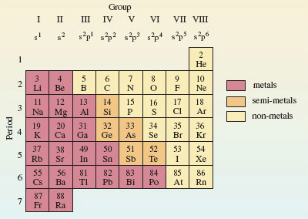
Figure 23 A mini-Periodic Table for the typical elements up to radium. Along the top are the Group numbers in roman numerals, and the outer electronic configurations of the elements of each Group. As in Figure 18, hydrogen has been omitted

Question 16

According to Figure 23, what are the principal quantum numbers of the outer occupied shells for the atoms of silicon and lead?

View answer - Question 16

According to Figure 23 therefore, silicon and lead have outer electronic configurations of the type ns²np², with n = 3 for silicon and n = 6 for lead. This is just what you got when you worked out the full electronic configuration of the silicon and lead atoms in Sections 3.2 and 3.3.1, respectively.

Question 17

According to Figure 23, what is the relationship between the Group number for silicon and lead, and the outer electronic configurations of their atoms?

View answer - Question 17

Here is confirmation of the explanation of chemical periodicity mentioned at the beginning of Section 3. Elements in the same Group of the Periodic Table behave similarly because they usually have similar outer electronic configurations. It also demonstrates that, for the typical elements, the total number of outer electrons is equal to the Group number. It is to preserve this generalisation that, in this course, we take the Group number of the noble gases to be VIII rather than zero. Apart from helium (1s²), they have eight outer electrons (s²p⁶).
Finally, notice that Figures 17 and 22 imply that the atoms of highest known atomic number (113-118) at the outer limit of the Periodic Table are expected to be typical elements. This is only one of the reasons that makes them of special interest (see Box 2 The island of stability).

Box 2: The island of stability
The elements of highest atomic number are made through the collision of atoms and ions of lighter elements in particle accelerators. Success does not come easily, because the atoms that are formed are highly radioactive and very short lived. However, theory suggests that somewhere above atomic number 110 there is an 'island of stability', where the atoms will have longer lifetimes. This island is marked by favourable combinations of neutrons and protons, with its summit centred around an atom of atomic number 114 and mass number 298. So far [2007], the elements of highest atomic number for which isotopes have been identified are 114, 116 and 118. These may therefore supply evidence for the existence of the island.
In 1999, scientists at Dubna in Russia made the first atoms of element 114, to which we shall give the provisional name auditorium (Ad)! Ions of the isotope
were accelerated to 30 000 km h⁻¹, and directed on to a target containing the plutonium isotope . Two nuclei fused, three neutrons were ejected, and an atom of the 289 isotope of element 114 was produced:

The half-life of proved to be 30 seconds. It underwent α-decay to the 285 isotope of element 112, whose half-life is 15.4 minutes. These half-lives may seem short, but you must go back to element 103 to find known isotopes which are as long lived.
Figure 24 shows the half-lives of the known isotopes of elements 112-118. and the two other isotopes of element 114 support the emergence of an island of stability, but we are still a long way (9 neutrons) from the predicted summit at 184 neutrons. There is a reason for this. The proportion of neutrons in the most stable isotope of an element increases with atomic number. So the lighter isotopes such as and , from which the new heavy elements are made, lack the neutrons needed to produce the most stable isotope of the heavier element that they create.
This is simultaneously encouraging and discouraging. It means that the expected summit of the island of stability will be hard to reach. But if we do get there, we may find very stable elements. It may even be possible to study their chemistry.
In the most recent piece of research [2007], collaboration between Californian and Russian scientists is believed to have produced the 294 isotope of element 118 (176 neutrons). This has a half-life of about one millisecond and decays to the 290 isotope of element 116 which has a half-life of 10 milliseconds.

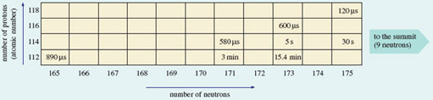
Figure 24 As the number of neutrons in known isotopes of each of the elements 112-118 increases above 165, the half-lives increase (even-numbered elements only shown). This indicates the emergence of an island of stability whose summit is predicted to be at 114 protons and 184 neutrons. (1 μs = 10⁻⁶ s; 1 min = 1 minute)

3.5 Electron states and box diagrams
So far, we have represented the electronic state of an atom as a collection of sub-shells. Now we turn to the states of the electrons within those sub-shells. Just as shells can be broken down into sub-shells, so sub-shells can be broken down into atomic orbitals. Each atomic orbital describes an allowed spatial distribution about the nucleus for an electron in the sub-shell. Here we shall only be concerned with their number.
Consider the formula for the sub-shell electron capacities, which is 2(2l + 1), l being the second quantum number. The factor (2l + 1) tells us the number of atomic orbitals in the sub-shell.

Question 18

How many atomic orbitals are there in an s sub-shell, and how many in a p sub-shell?

View answer - Question 18

It turns out that each orbital in a sub-shell can contain up to two electrons. This is connected to a property of the electron called spin. This spin occurs in one of two senses, which are physically pictured as clockwise and anticlockwise (Figure 25).

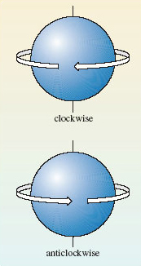
Figure 25 The two senses of electron spin.

When an atomic orbital contains its maximum complement of two electrons, those two electrons must always have spins of opposite sense. This phenomenon of electron spin accounts for the '2' that precedes the bracket in the formula for sub-shell capacities, 2(2l + 1). For example, as we have seen, the factor (l + 1) tells us that there are three atomic orbitals in a p sub-shell. Each of the three orbitals can accommodate up to two electrons with opposed spins. So a p sub-shell can contain a maximum of 2 × 3 or 6 electrons.
A full atomic orbital, therefore, contains two electrons with spins of opposite sense. This is represented by writing one electron as an upward-pointing half-headed arrow, and the other as a downward-pointing half-headed arrow. For example, the helium atom has the electronic configuration 1s². The 1s sub-shell contains just one orbital, which can be represented by a single box containing the two electrons of opposite spin:
Two such electrons with opposed spins are said to be paired and the diagram that puts these electrons into boxes is referred to as a box diagram. Now consider the case of nitrogen, whose atom has the configuration 1﻿s﻿²﻿2﻿s﻿²﻿2﻿p﻿³. The 1s and 2s sub-shells contain one orbital each, and the 2p sub-shell contains three. The box diagram that must be filled therefore takes the form:
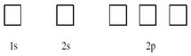

Question 19

Assign the two 1s and two 2s electrons of nitrogen to boxes in this diagram.

View answer - Question 19

The final step is the assignment of the three 2p electrons to the three 2p boxes. There are several possibilities, but the one we want is the ground-state arrangement, the state of lowest energy. There is a simple rule, called Hund's rule, that tells us what this is:

Within any sub-shell, there will be the maximum number of electrons with spins of the same sense.

Because electrons in the same box must have opposed spins, we must put the electrons, as far as possible, in different boxes with spins of the same sense, or, as it is usually termed, with parallel spins. In this case there are three 2p electrons and three boxes, so each box can take one electron with the same spin, and this is the preferred arrangement according to Hund's rule. The final result for the nitrogen atom is therefore:
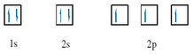

Question 19a

The oxygen atom, with the configuration 1s²2s²2p⁴, has one more electron than the nitrogen atom. Draw the box diagram for the oxygen atom.

View answer - Question 19a

3.6 Summary of Section 3
- The electronic configuration of an atom can be obtained by allocating its electrons to s, p, d and f sub-shells in the order given by Figure 21. This procedure generates a periodicity in electronic configuration which matches that of the Periodic Table.
- The typical elements have outer electronic configurations of the type ns^{x}, where x = 1 or 2, or of the type ns²np^{x}, where x runs from 1 to 6, and n, the principal quantum number, is equal to the number of the Period.
- In Figure 23, the Group numbers are equal to the number of outer electrons, except in the case of helium.
- The ground (electronic) state of an atom can be represented by a box diagram in which each sub-shell of the electronic configuration is broken down into atomic orbitals. Each orbital is portrayed as a box that can accommodate up to two electrons with opposite spins. In incomplete sub-shells, the electrons are assigned to the boxes so as to maximise the number of parallel spins (Hund's rule).

Question 6

Use Figure 23 to identify the elements whose outer electronic configurations are (a) 3s²3p⁵; (b) 4s²4p³; (c) 6s²6p¹.

View answer - Question 6

Question 7

Write down the electronic configurations of (a) the calcium atom (atomic number 20); (b) the bromine atom (atomic number 35); and (c) the tin atom (atomic number 50). Make sure you order the sub-shells according to their principal atomic number.

View answer - Question 7

Question 8

Substance A is both a typical element and a metal. It forms two normal oxides, A₂O₃ and A₂O₅, and two fluorides AF₃ and AF₅. Identify A, and state its outer electronic configuration.

View answer - Question 8

Question 9

Represent the electronic ground state of the chlorine atom by a box diagram.

View answer - Question 9

4 Chemical bonds consist of shared pairs of electrons

4.1 Introduction
Simple theories of chemical bonding are based on the idea of the electron-pair bond, and the extent to which the electron pair is shared between the bound atoms. There is also an assumption that the electronic structures of noble gas atoms are especially stable, and that many elements try to attain these structures when they react to form chemical compounds. These ideas were the brainchild of the American chemist, G. N. Lewis (Box 3). In developing them, we shall simplify the electronic configurations of atoms by writing shell structures that merely show the electron content of successive shells. Shell structures for atoms of elements 2-20 are shown in Figure 27.

Box 3: G.N. Lewis
Until he was 14, Gilbert Newton Lewis (1875-1946; Figure 26) was educated at home in Nebraska by his parents. It is remarkable that he did not win a Nobel Prize, because, as J. W. Linnett, sometime Professor of Physical Chemistry at Cambridge said, his idea of the electron-pair bond is 'the most productive and important contribution that has ever been made to the subject of valency and chemical binding'. In 1912, he became Chairman of a rather lacklustre chemistry department at the University of Berkeley in California. He set about reorganising and revitalising the department, appointing staff with a broad chemical knowledge rather than specalists. Under his direction, it quickly acquired the world reputation that it still enjoys today. During the First World War, he trained gas warfare specialists and was made a Lieutenant-Colonel. A love of cigars may have contributed to his death from heart failure while doing an experiment.

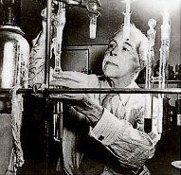
Figure 26 G.N. Lewis

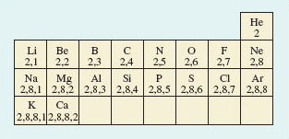
Figure 27 A part Periodic Table showing shell structures for atoms of elements 2-20

4.2 Ionic and covalent bonding
We begin by applying simple bonding theories to molecular chlorine gas (Cl₂) and non-molecular sodium chloride (NaCl), whose structures were discussed in Section 1. Figure 28 shows the result.

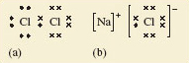
Figure 28 Lewis structures for (a) gaseous Cl₂ and (b) solid NaCl. Chlorine has seven outer electrons, but can acquire an additional electron to give eight, and the shell structure of argon, if an electron pair is shared between the two atoms in Cl₂. Sodium has one outer electron, so sodium can acquire a neon shell, and chlorine an argon shell structure if this electron is transferred to a chlorine atom. This generates the Na + and Cl− ions in sodium chloride

Figure 28a shows the Lewis structure of the Cl₂ molecule. Note that the electrons are grouped in pairs. This reflects the pairing of electrons in atomic orbitals noted in Section 3.5. The ions in sodium chloride have also been represented in this way in Figure 28b. The chloride ion has the shell structure of argon, with eight outer electrons, and the electron transferred from the sodium atom is marked by a small filled circle. In both structures, the formation of a chemical bond involves the production of a new electron pair in the outer shell of chlorine. However, in Cl₂, because the two atoms are identical, the electron pair must be equally shared between the two atoms; in NaCl by contrast, it resides on the resulting chloride ion.
From this contrast flows the difference in properties between the two substances. The transference of the electron to chlorine in NaCl produces ions, each of which can exist independently of any one partner. So in sodium chloride, each ion is surrounded by as many ions of opposite charge as space allows. In this case the number is six, as you saw in Figure 10. Figure 29 is Figure 10 adjusted to show the presence of ions. Because of the strong attractive forces existing between the closely packed ions of opposite charge, the sodium chloride structure is not easily broken down: it has a high melting temperature and does not dissolve in organic solvents like the liquid hydrocarbons found in petrol, or dry-cleaning fluid. When it does melt, or dissolve in water, the ions separate and the resulting ionic fluid conducts electricity. Compounds of this type are called ionic, and the type of bonding is called ionic bonding.

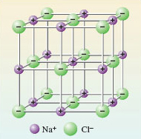
Figure 29 An ionic picture of solid sodium chloride which explains important properties of the substance. The solid is regarded as an assembly of Na ⁺ and Cl⁻ ions

By contrast, in Cl₂, the electron pair is shared. This is called covalent bonding. Here, the bonding can be maintained only if the atoms stay together in pairs, so it gives rise to a molecular substance: elemental chlorine consists of discrete Cl₂ molecules with only weak forces acting between them. It is a gas at room temperature, and dissolves easily in liquid hydrocarbons, including petrol. However, because a solution of chlorine contains no ions, it does not conduct electricity.

Question 20

According to this picture, ionic and covalent bonding are the same process carried to different extents; what is the process, and how do the extents differ?

View answer - Question 20

This link between ionic and covalent bonding is clarified by the concept of electronegativity. The electronegativity of an element is a measure of the power of its atom to attract electrons to itself when forming chemical bonds. In the Cl₂ molecule, the two identical atoms have an equal appetite for electrons: their electronegativities are equal, so the electron pair is shared equally between them. Now consider sodium chloride.

Question 21

Which atom is the more electronegative, sodium or chlorine?

View answer - Question 21

So chlorine, near the end of Period 3, has a greater electronegativity than sodium, at the beginning. This contrast applies generally: the electronegativities of atoms increase across a Period of the Periodic Table; electronegativities also usually increase up a Group from the bottom to the top. These trends are explained in Figure 30.

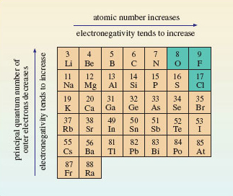
Figure 30 Across a Period of the Periodic Table, the atomic number, or positive charge on the nucleus, increases. This increases the attraction of the outer electrons to the nucleus, so the electronegativity of the elements also increases. The principal quantum number of the outer electrons decreases from the bottom to the top of a Group. This means that they get closer to the positively charged nucleus. The result is, again, that the outer electrons are attracted more strongly, and the electronegativity usually increases. The three most electronegative elements are shown on a green background

Figure 30 shows that the most electronegative elements lie towards the top right-hand corner of the Periodic Table. Electronegativities refer to an attraction for outer electrons when an element is forming compounds. The noble gases have been omitted from Figure 30 because at normal temperatures helium, neon and argon form no compounds; hence electronegativities are not assigned to them. Consequently, fluorine is the most electronegative element, followed by oxygen and chlorine.
Figure 30 confirms that chlorine is much more electronegative than sodium. Because of this large difference in electronegativity, the electron pair of Figure 28b spends all its time on chlorine, the charges on sodium and chlorine are +1 and −1, respectively, and NaCl is ionic. So the electronegativity trends in Figure 30 explain why ionic compounds arise when a metallic element of low electronegativity from the left of the Periodic Table combines with a non-metallic element of high electronegativity from the right. In Cl₂, by contrast, the electronegativity difference between the bound elements is zero; the shared electrons spend equal times on each chlorine atom, both chlorines are uncharged, the substance is molecular, and is held together by covalent bonding. Covalently bound molecular substances such as Cl₂, I₂ and CO₂ (Section 1.4) are combinations from the right of Figure 30, because, although for these elements the individual electronegativities are large, the electronegativity differences between them are small.
These two cases deal with combinations of elements with very different electronegativities from the left and right of Figure 30 (ionic bonding), and with combinations of elements of high but similar electronegativity from the right (covalent bonding). But what is the result of combining elements of low but similar electronegativity from the left? The reasoning that we have pursued until now suggests that, in this case, electronegativity differences between atoms will be small, so again we would expect shared electron-pair bonds and covalent substances, possibly of the molecular type typified by Cl₂.

Question 22

Is this correct? Answer by considering what happens when sodium atoms become bound together at room temperature.

View answer - Question 22

So let us look more closely at the bonding in metals.

4.3 Metallic bonding
Two familiar properties of metals point to a simple model of metallic bonding. Firstly, metals have a strong tendency to form positive ions. Thus, when sodium reacts with water, and when magnesium and aluminium react with acids, hydrogen gas is evolved and the ions N﻿a﻿⁺﻿(﻿a﻿q﻿), M﻿g﻿²⁺(﻿a﻿q﻿) and A﻿l﻿³⁺(﻿a﻿q﻿)﻿, respectively, are formed. Secondly, metals are good conductors of electricity: when a voltage difference is applied across two points on a piece of metal, there is a movement of electrons between the two points, and an electric current flows.
Figure 31 exploits these two observations to produce a model of the bonding in a metal like sodium. The sodium sites in the metallic crystal are assumed to be occupied by Na⁺ ions with the shell structure of neon. The Na⁺ ions are formed by removing the single outer electrons from each sodium atom. The electrons so removed are no longer tied to individual sodium sites, and are allowed to move freely throughout the entire volume of the metallic substance. These free electrons, sometimes described as an 'electron gas', are responsible for a metal's ability to conduct electricity. At the same time, they occupy the space between the positive sodium ions, so their negative charge acts like a binding glue pulling the sodium sites together.

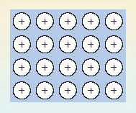
Figure 31 In the electron gas model of metallic bonding for metals and alloys, an array of positive ions is steeped in a pool of negatively charged free electrons (indicated by the background blue tone). The electrons pull the positive ions together

So electron-sharing has taken place as predicted at the end of Section 4.2, but in a different way: because all the atoms have low electronegativities, they are prepared to surrender electrons to other atoms, either by electron transfer or electron-pair sharing. However, the low electronegativities mean that none of the atoms present will readily take on these electrons, either by forming a negative ion, or by accepting a share in electron-pair bonds. Consequently, a pool of free electrons is created which is like hot money: they are passed quickly from hand to hand, and can find no permanent home! This is the situation pictured in Figure 31. So far in this Section, we have only considered cases where all the combining atoms are the same, and a metallic element is the result. However, such metallic substances can be formed from two or more elements, and they are then called alloys.

4.4 A classification of chemical substances
We now have a provisional but useful classification of chemical substances. First they are divided into molecular and non-molecular types, largely on the basis of their structures. Then a further division is made according to the major source of the chemical bonding holding their atoms together. In molecular substances, the bonding is covalent, but in the non-molecular class, it may be covalent, ionic or metallic. This classification is shown in Figure 32. For a recent and interesting example of a substance changing categories within this classification, see Box 4.

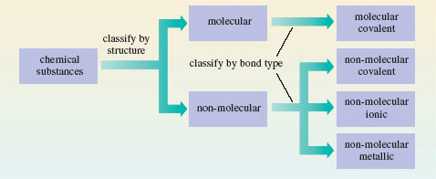
Figure 32 A classification of chemical substances using, first, structure, and then bond type, as criteria

Box 4: Turning dry ice into sand
As Mendeléev emphasised, the highest valencies of the elements are the clearest chemical sign of periodicity. At first glance, the highest oxides of carbon and silicon are quite different. CO₂ is a gas, which freezes to a molecular solid at −79 °C; SiO₂ is a non-molecular solid melting at over 1 500 °C. But despite these differences, both are dioxides. In both compounds, carbon and silicon exercise a valency of four, and this is why Mendeléev put both elements in the same Group.
Even the differences are not unalterable. In solid carbon dioxide (Figure 7), the distances between molecules are relatively large. The quartz structure of SiO₂ (Figure 11) is non-molecular, with identical short distances between neighbouring atoms. It is therefore more compact. When pressure is applied to a solid, it encourages a change into more compact forms. So at high pressures, solid CO₂ might shift to a silica-like structure. Raising the temperature should also help by speeding up any change.
In 1999, scientists at the Lawrence Livermore laboratory in California subjected solid carbon dioxide to 400 kilobars pressure. This is 400 times the pressure at the bottom of the Mariana Trench, the deepest point in the world's oceans. At these pressures, the CO₂ stayed solid even when the temperature was raised to 2000 °C. The Livermore scientists then used the following technique: they determined the Raman spectrum of the solid, a type of vibrational spectrum. It showed (Figure 33) that under these conditions the carbon dioxide had assumed a silica-like structure. Dry ice had taken on the structure of sand!

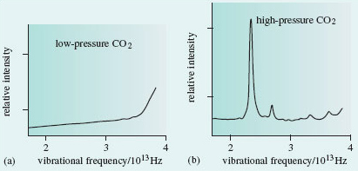
Figure 33 (a) At normal pressures, solid carbon dioxide is molecular, and its vibrational spectrum shows no peaks in the frequency range 2 × 10¹³ - 4 × 10¹³ Hz. (b) After heating at a pressure of 400 kilobars, a peak appears at 2.37 × 10¹³ Hz. This is characteristic of the vibrations of two carbon atoms bound to, and equidistant from, an oxygen atom. It suggests that solid CO₂ has assumed a silica-like form

4.5 More about covalent bonding
So far, the valencies in Table 1 have just been numbers that we use to predict the formulae of compounds. But in the case of covalent substances they can tell us more. In particular, they can tell us how the atoms are linked together in the molecule. This information is obtained from a two-dimensional drawing of the structural formula of the molecule. (Note that structural formulae cannot be assumed to carry any implications about molecular shape.) Consider, for example, the molecules H₂, Cl₂, NCl₃ and CH₄. Their structural formulae are shown here as Structures 5.1-5.4. They can be drawn correctly by ensuring that the number of lines or bonds emerging from any atom is equal to its valency. Thus, in Structure 5.3, three bonds emerge from the nitrogen atom and one from each chlorine atom. The single lines of Structures 5.1-5.4 represent single bonds, but bonds may also be double or triple.
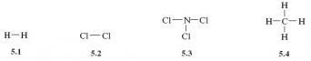

Question 10

Check that you are comfortable with the bonding ideas discussed above by using the valencies of Table 1 to draw structural formulae for the following molecular substances: hydrogen chloride (HCl), ammonia (NH₃), water (H₂O), oxygen (O₂), carbon dioxide (CO₂), ethene (C₂H₄), hydrogen cyanide (HCN), ethyne (C₂H₂) and ethanal (CH₃CHO).

View answer - Question 10

4.5.1 Lewis structures
G.N. Lewis used the shared electron-pair bond to re-express structural formulae in an electronic form. Examples appeared in Figure 28, where the sharing leads to Lewis structures in which each atom has the shell structure of a noble gas.

Question 23

Use the shell structures of Figure 27 to write down Lewis structures for (a) NH₃; (b) H₂O; (c) CO₂; (d) HCN.

View answer - Question 23

Note that the electron pairs in these Lewis structures are of two types. The pairs shared between atoms represent chemical bonds and are called bond pairs. But there are also pairs that remain on just one atom and are unshared. These are called non-bonded electron pairs or lone pairs.

Question 24

How many bond pairs and non-bonded electron pairs are there in (a) the ammonia molecule; (b) the water molecule?

View answer - Question 24

So far, we have only written Lewis structures for neutral molecules, but they can also be drawn for ions, such as the hydroxide ion, HO⁻ and the ammonium ion, NH₄⁺. However, to take the charges into account we must begin by adding or subtracting electrons from particular atoms. To create a systematic procedure, we shall apply this process of addition or subtraction at the atom of highest valency. In HO⁻, this is the oxygen atom; in NH₄⁺, it is the nitrogen atom. As the hydroxide ion carries a single negative charge, we add one electron to the shell structure of the oxygen atom which is (2,6). This gives (2,7).

Question 25

What shell structure does a corresponding adjustment to the nitrogen atom in NH₄⁺ generate?

View answer - Question 25

By allowing the ions O⁻ and N⁺ to form single bonds to hydrogen atoms, we can generate Lewis structures for OH⁻ (Structure 5.9) and NH₄⁺ (Structure 5.10) in which each atom has a noble gas electronic structure:
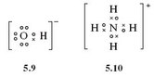

4.5.2 Noble gas configurations under stress
It is remarkable how many molecules and ions of the typical elements can be represented by Lewis structures in which each atom has a noble gas shell structure. Nevertheless, many exceptions exist. According to the periodic trends summarised in Section 2, the highest fluorides of boron and phosphorus are BF₃ and PF₅. However, phosphorus, in accordance with Table 1, also forms the lower fluoride PF₃. All three compounds are colourless gases at room temperature and contain the molecules BF₃, PF₃ and PF₅. As the valency of fluorine is one (Table 1), each bond in these molecules is a shared electron pair, and we may write the Lewis structures as follows:
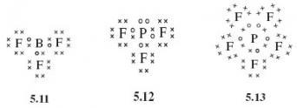

Question 26

In how many of these Lewis structures do all the atoms have noble gas shell structures?

View answer - Question 26

You will meet more exceptions of this sort in Section 6. Here, we merely note their existence, and observe that they are a consequence of our assumption that a chemical bond consists of two electrons shared between two atoms.

4.5.3 Dative bonds
So far, the bonds in our Lewis structures have been shared electron pairs made by taking one electron from each of the two bound atoms. But this need not necessarily be the case. In Sections 4.5.1 and 4.5.2, we encountered the colourless gases NH₃ and BF₃. When these gases are mixed, a solid compound H₃NBF₃ is formed as a dense white smoke. The chemical equation for the process is:

NH₃(g) + BF₃(g) = H₃NBF₃(s) (5.1)

(The notation used in chemical equations is discussed in Box 5.)

Box 5: Chemical equations and state symbols
Equation 5.1 is balanced. In this course, the two sides of balanced equations like this are connected by an equals sign, symbolising the equality in the numbers of the different types of atom on each side. Unless otherwise stated, such equations should be understood as having a direction: they proceed from reactants on the left to products on the right. This is also true of the commonly used alternative to the equals sign-an arrow pointing from left to right. In this course, such arrows are reserved for different sorts of chemical equation (see, for example, the introduction to Section 5).
Equation 5.1 also has bracketed state symbols after each of the chemical formulae. The four most common such symbols are (s), (l), (g) and (aq), representing solid, liquid, gas and aqueous ion, respectively.

How are we to understand Reaction 5.1? In Section 4.5.1, we saw that the Lewis structure of ammonia (Structure 5.5) provided each atom with a noble gas shell structure, one non-bonded pair being allocated to nitrogen. In Section 4.5.2 we saw that the Lewis structure of boron trifluoride (Structure 5.11) left the boron atom two electrons short of a noble gas configuration. If we create an electron-pair bond by allowing the non-bonded electron pair on nitrogen in the ammonia molecule to be shared between the nitrogen and boron atoms, we can write a Lewis structure (Structure 5.14) in which all atoms, including boron, have a noble gas shell structure. (Note that, in order to focus attention on the bonding electrons, the non-bonded electron pairs on the fluorine atoms have been omitted from Structure 5.14.)
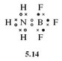
A bond in which the electron pair is provided by just one of the bonded atoms is called a dative bond. We need to differentiate such bonds from the more familiar bonds in which each bound atom contributes an electron to the electron pair. To do this, we write the dative bonds as arrows running from the 'donor' atom (in this case nitrogen) to the 'receptor' atom (in this case boron). Then Equation 5.1 becomes:

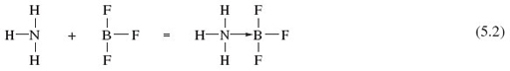

Another puzzle solved by the use of dative bonds is the electronic structure of carbon monoxide, CO. If we write the compound C=O, then we get Lewis structure 5.15, in which oxygen, with two non-bonded pairs, has an octet, but carbon is two electrons short of this noble gas state. Suppose, however, that, in addition, a dative bond is formed by allowing one of the oxygen non-bonded pairs to become shared between oxygen and carbon.
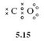
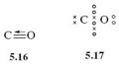
Dative bonds are also useful when writing Lewis structures for oxoions such as carbonate, CO₃²⁻. We begin in the usual way (Section 4.5.1) by adding the overall charge to the central atom with highest valency, namely carbon. This means adding two electrons to carbon, which gives the shell structure (2,6). Formation of one C=O double bond and two C→O dative bonds then gives Lewis structure 5.18, which is equivalent to structural formula 5.19.
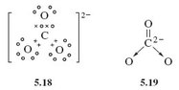
Before leaving dative bonds, we shall introduce an alternative way of writing them that proves especially useful in organic chemistry. Suppose that atom A forms a dative bond with atom B by donating a non-bonded electron pair to it:

A : + B = A : B (5.3)

So far, we have written the dative bond as A→B. But consider atom A before the bond is formed. If we remove one of its lone pair electrons, and put that electron on atom B, we end up with the separate ions [A•] ⁺ and [B•]⁻. Suppose we now form a conventional shared electron-pair bond from the odd electrons on the two ions. The electrons are shared between the A and B sites in just the way that they are on the right-hand side of Equation 5.3, but the bond would now be written as .
Thus, A→B and are equivalent ways of writing the dative bond between A and B, and both are equally valid. The structures H₃N→BF₃ and CO can therefore also be written as H₃−F₃ and .

Question 28

Transform Structure 5.19 for the carbonate ion into this new dative bond representation.

View answer - Question 28

4.5.4 Resonance structures
Gaseous oxygen occurs as O₂ molecules. But ultraviolet light or an electric discharge converts some of the oxygen to ozone (Box 6). This has the molecular formula O₃.

Box 6: Ozone is blue
Many people know that gaseous ozone in the stratosphere protects us from harmful solar radiation, and that at low altitude it is a source of photochemical smog. But few know that the gas is blue. In the laboratory, ozone is made by exposing O₂ gas to an electric discharge. This yields oxygen containing only 10-15% ozone, and the colour of ozone is then almost imperceptible. But if the gas is passed through a vessel immersed in liquid O₂, it condenses to a liquid mixture of O₂ and ozone; this is cornflower blue. If the liquid is kept cold, a vacuum pump will suck the more volatile O₂ out of it, and the liquid soon separates into two layers. The upper layer is deep blue, and is a 30% solution of ozone in liquid O₂. The lower layer is 30% O₂ in liquid ozone, and has a dark violet colour.
Continued pumping on the lower layer eventually leaves pure liquid ozone, with a deep indigo colour and a boiling temperature of −﻿112 °C (Figure 34). Evaporation normally leads to a violent explosion caused by the decomposition reaction:

2O₃(g) = 3O₂(g) (5.4)

However, clean procedures that exclude dust and organic matter allow slow uninterrupted evaporation. The product is a deep blue gas, which is almost 100% ozone.

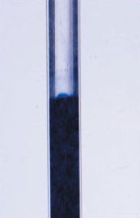
Figure 34: The very dark indigo colour of liquid ozone viewed through a cooling bath and the glass of a surrounding vacuum flask

A Lewis structure for the O₂ molecule is shown in Figure 35a. For ozone too, a Lewis structure can be written which gives each atom a noble gas shell structure (Figure 35b); Figures 35c and 35d give the corresponding structural formulae with alternative representations of the dative bond.

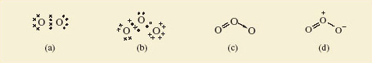
Figure 35: (a) Lewis structure for O², each oxygen having the shell structure of neon; (b) Lewis structure for ozone, O³; (c) and (d) show structural formulae for ozone containing alternative representations of the dative bond

Question 29

Do Figures 35c and d suggest that the lengths of the two bonds in the ozone molecule should be equal or unequal?

View answer - Question 29

But experimental measurement shows that both bonds have the same length (127.8 pm). To account for this, we note that the structures shown in Figures 35c and d have companions in which the double and single bonds have simply been exchanged. Figure 36, for example, shows Figure 35d and its partner. The real structure of the molecule with its equal bond lengths is a sort of average of the two. In situations like this, where a molecule is not adequately represented by a single Lewis structure and seems like a composite of two or more, the competing structures are written down and linked by a double-headed arrow, as shown in Figure 36.
The two structures are called resonance structures, and the real structure of ozone is said to be a resonance hybrid of the two. The significance of the representations in Figure 36 is that in ozone, each bond is a mixture of one-half of a double bond and one-half of a single dative bond. Note that Figure 36 is not meant to imply that the molecule is constantly changing from one resonance structure to the other. It is a hybrid in the same sense that a mule is a hybrid: it does not oscillate between a horse and a donkey.

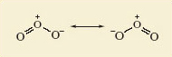
Figure 36:The two resonance structures of ozone. The equality of the bond lengths in the real ozone molecule suggests that its actual structure is an average, or superposition of the two

To clarify this, we turn to benzene, C₆H₆. Like ozone, it can be represented as a resonance hybrid of two resonance structures in which all atoms have noble gas configurations (Figure 37).

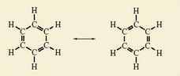
Figure 37 The two resonance structures of benzene

A typical C—C single bond length in an alkane hydrocarbon such as ethane, C₂H₆ (Structure 5.21), is 154 pm; in contrast, a typical C—C bond length in an alkene hydrocarbon such as ethene, C₂H₄ (Structure 5.22), is 134 pm. The individual resonance structures in Figure 37 therefore suggest that the carbon-carbon bond lengths in benzene should alternate between about 134 pm and 154 pm around the ring.
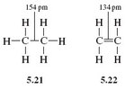

Question 30

But what does the whole of Figure 37 suggest?

View answer - Question 30

This is precisely the case: all carbon—carbon bond lengths in benzene are 140 pm!
Number the carbon—carbon bonds in a benzene ring of Figure 37 clockwise from 1-6. All bonds contain at least one pair of electrons. However, in one of the resonance structures, bonds 1, 3 and 5 are double bonds, each containing a second electron pair; in the other resonance structure, the double bonds and extra pair of electrons are found at bonds 2, 4 and 6. The implication of Figure 37 is that in the resonance hybrid these three extra pairs of electrons are not confined to, or localised within, just half of the bonds in the ring. Instead, they are delocalised around the ring and equally shared within all six bonds. Although, in this course, we shall draw benzene and its derivatives as a single resonance hybrid (Structure 5.23), remember that this delocalization makes the bond lengths in the ring equal, contrary to the implications of Structure 5.23.
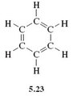
We conclude with a resonance hybrid which is an ion. Structure 5.20 suggests unequal bond lengths in the carbonate ion. In fact, X-ray crystallography of carbonates suggests that all three bond lengths are equal, at about 129 pm; standard values for C—O and C=O bond lengths are around 143 pm and 120 pm, respectively. Three resonance structures, all equivalent to Structure 5.20 contribute to a resonance hybrid that accounts for the bond length (Figure 38).

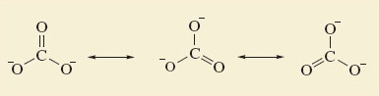
Figure 38 The three resonance structures for the carbonate ion. They suggest that all three bonds should be of equal length

4.6 Summary of Section 4
- The chemical formulae of many substances can be understood by arguing that their atoms attain noble gas structures by chemical combination.
- In ionic compounds, this is achieved by the transfer of electrons from one atom to another; in molecular substances, it happens through the sharing of electron pairs in covalent bonds. But in both cases, bonds between atoms consist of shared pairs of electrons. In covalent compounds the sharing is fairly equitable; in ionic compounds it is much less so.
- In metals, the sharing takes a different form. An 'electron gas' is created by removing electrons from the atoms of the metallic elements. The result is an array of ions steeped in a pool of free electrons. The negatively charged electron gas occupies the space between the ions and pulls them together.
- Atoms with high but similar electronegativities from the right of Figure 30 combine to form covalent substances; those with low but similar electronegativities from the left of Figure 30 yield metallic substances. The combination of atoms of low and high electronegativity from the left and right of Figure 30 produces ionic compounds.
- Chemical substances can now be classified, first structurally as either molecular or non-molecular, and second by bond type as ionic, covalent or metallic.
- In Lewis structures, each covalent bond is represented by a shared electron pair. Double bonds, as in CO₂, require two shared pairs; a triple bond, as in HCN, requires three. These allocations often leave some atoms with non-bonded electron pairs.
- In many cases, this operation provides each atom with a noble gas shell structure, especially if we introduce dative bonds in which both electrons are contributed by one atom. But in some cases, such as PF₅, it does not.
- Sometimes the bond lengths in a chemical substance are such that the substance cannot be represented by a single Lewis structure or structural formula. It is better described as a resonance hybrid-an average or superposition of two or more structural formulae called 'resonance structures'.

Question 11

Consider the compounds IBr, CaCl₂ and CaMg₂. One is ionic, one is covalent, and one is metallic. Identify which is which, and match each compound to one of the descriptions below. In each case, suggest whether the compound is molecular or non-molecular.
- (i) White solid that melts at 782 °C. It is a poor conductor of electricity in the solid state, but a good one when melted or dissolved in water.
- (ii) Brown-black solid that melts at 41 °C to give a liquid with low electrical conductivity.
- (iii) Silvery-looking solid that melts at 720 °C. Whether solid or molten, it is an excellent conductor of electricity.

View answer - Question 11

Question 12

Write single Lewis structures, and the corresponding structural formulae, for the following molecules or ions: (a) hypochlorous acid, HOCl; (b) sulfur hexafluoride, SF₆; (c) nitrosyl chloride, ONCl; (d) the amide ion, NH₂⁻. In each case, state the number of bonding electron pairs and non-bonded pairs on the atom of highest valency. In which of the four Lewis structures do some atoms not have a noble gas shell structure?

View answer - Question 12

Question 13

In the nitrate ion, NO₃⁻, the nitrogen atom is central and surrounded by three oxygens. Draw a single Lewis structure for this ion which gives each atom a noble gas shell structure. Also draw two structural formulae for this Lewis structure, each containing a different representation of any dative bonds.

View answer - Question 13

Question 14

For the Al₂Br₆ molecule (Figure 8), write a single Lewis structure that contains dative bonds and gives each atom a noble gas structure (the bromine atom, like chlorine, has seven electrons in its outer shell). Use the two different representations of the dative bond to draw two structural formulae for the Lewis structure. Experiments on this molecule show that all bond lengths in the Al—Br—Al bridges are identical. Which of your two structural formulae best fits this observation?

View answer - Question 14

Question 15

In the nitrate ion, NO₃⁻, all three nitrogen-oxygen bonds are of equal length. Is either of the structural formulae in your answer to Question 12 consistent with this observation? If not, how do you explain the discrepancy?

View answer - Question 15

5 Molecular reactivity

5.1 Molecular reactivity is concentrated at key sites
Reactivity is not spread evenly over a molecule; it tends to be concentrated at particular sites. The consequences of this idea are apparent in the chemistry of many elements. However, in organic chemistry, the idea has proved so valuable that it receives specific recognition through the concept of the functional group. Structure 6.1 shows the abbreviated structural formula of hexan-1-ol, an alcohol.

CH₃—CH₂—CH₂—CH₂—CH₂CH₂—OH (6.1)

Question 31

Identify the functional group in this molecule.

View answer - Question 31

Because reactivity is concentrated at the —OH site, we can, through an informed choice of other chemical reactants, change that site (and sometimes the atoms immediately adjacent to it) into something else while leaving the rest of the molecule unchanged. For example, the liquid thionyl chloride, SOCl₂, will convert hexan-1-ol into 1-chlorohexane:

(Note that in the formulae in this equation we have omitted all the bonds apart from the ones connecting the functional groups to the rest of the molecule; these are known as condensed structural formulae.) In this reaction the —OH group has been replaced by —Cl. An example of a change in both the functional group and its adjacent atoms is the reaction of hexan-1-ol with chromic acid, H₂CrO₄, which yields hexanoic acid:

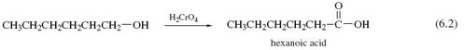

Here, the terminal —CH₂OH fragment has been converted into the carboxylic acid functional group, —COOH. (Note that an arrow has been used in Equation 6.2. An equals sign - see Box 5 - would be inappropriate because the equation is not balanced. This type of equation allows us to concentrate attention on the way in which one molecular fragment, —CH₂OH, is transformed into another, —COOH. Organic chemists often write equations of this sort, the reagent that brings about the change appearing above the arrow.)
We can divide organic molecules into three parts: the functional groups, their immediate environment, and the rest of the molecule. To a first approximation, we expect a functional group and its immediate environment to respond to a reactant in exactly the same way whatever the rest of the molecule is like. Thus, if we write the many molecules containing an alcohol functional group as R—OH, the general form of Reaction 6.1 becomes

Likewise, if we write the many molecules that terminate in the unit —CH₂OH as R—CH₂OH, then the general form of Reaction 6.2 becomes:

In principle therefore, Reactions 6.3 and 6.4 allow us to predict the response of many very different molecules to thionyl chloride and chromic acid.
To a first approximation, the behaviour of organic functional groups is therefore unaffected by the larger environment of the molecules in which those groups are set. A good example is the reaction of some alcohols with nitric acid, HNO₃ (or HONO₂), to give nitrate esters:

Thus, hexan-1-ol (Structure 6.1) yields hexyl nitrate, CH₃CH₂CH₂CH₂CH₂CH₂—O—NO₂.
Two organic molecules that contain more than one alcohol functional group are glycerol (Reaction 6.6), made by heating natural fats or oils with sodium hydroxide, and pentaerythritol (Reaction 6.7). Reactions 6.6 and 6.7 show how a mixture of concentrated nitric and sulfuric acid replaces all of the —OH groups with —O—NO₂ groups, leaving the rest of the molecules unchanged.

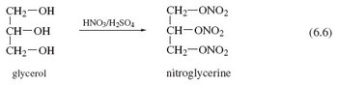

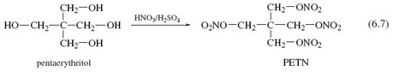

Finally, we consider cotton, whose fibres consist of the polymer cellulose. A typical fibre has the formula [C₆H₇O₂(OH)₃]_{n}, where n varies, but may be as large as 2 000. Each C₆H₇O₂(OH)₃ unit contains three —OH groups, and at the left of Figure 39 two of the units are shown linked together. Figure 39 also shows that despite this polymeric situation, all of the —OH groups can still be replaced by —O—NO₂ groups through a reaction with mixed nitric and sulfuric acids.
The products of Reactions 6.6, 6.7 and Figure 39 are called nitroglycerine, pentaerythritol tetranitrate (PETN) and nitrocellulose, respectively. They are three important high explosives.
What makes functional groups such as —OH so much more reactive than the carbon-hydrogen skeleton to which they are attached? Look again at Structure 6.1 (hexan-1-ol).

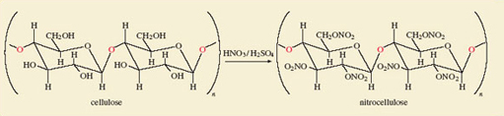
Figure 39 Cotton is nearly pure cellulose, which is Nature's most common polymer. It is composed of glucose molecules linked through bridging oxygen atoms - a glycosidic linkage (highlighted in red). To the left of the reaction arrow two units are so joined. The six-membered rings are composed of five carbon atoms and one oxygen atom, but here the carbon atom labels have been omitted. Notice the terminal bonds through which the extended chains of the cotton fibre are formed. Replacement of the —OH groups by nitrate groups using a mixture of concentrated nitric and sulfuric acids gives nitrocellulose, a high explosive

Question 32

Which of the 21 atoms in the molecule have non-bonded electron pairs?

View answer - Question 32

Chemical reactions often occur in steps; in each step, groups of atoms attach themselves to the molecule, undergo change, and then depart. Attractive points of attachment in a molecule will therefore make a reaction more likely.

Question 33

Why are non-bonded electron pairs possible points of attachment?

View answer - Question 33

Such bonds cannot be formed by carbon and hydrogen atoms in hexan-1-ol, because all their outer electrons are used to form strong C—H and C—C bonds. This, then, is one reason why the —OH functional group in 6.1 is the most probable site for a reaction.
Another arises from the fact that functional groups often introduce electronegativity differences into an organic system. For example, the oxygen atom is very electronegative (Figure 30). Thus, in the C—O—H sequence of bonds in any alcohol, the oxygen atom attracts electrons from the adjacent carbon and hydrogen atoms (carbon and hydrogen have similar electronegativities). The oxygen atom of an alcohol therefore carries a fractional negative charge, and the carbon and hydrogen atoms carry fractional positive charges. Any one of the three atoms then becomes a possible point of attachment for the atom of a reagent that carries a fractional charge of opposite sign.
Finally, we remind you of a reservation that we made about functional groups: the idea that their reactions are unaffected by the rest of the molecule is only an approximation. We illustrate the point with another powerful explosive. In phenol, on the left of Reaction 6.8, an —OH group is attached to the benzene ring of Structure 5.23. Through Reactions 6.5-6.7 and Figure 39, we know that the combination HNO₃/H₂SO₄ usually converts an —OH group to a nitrate, —﻿ONO₂, group. But Reaction 6.8 is an exception. The —OH group is untouched, and hydrogen atoms at three points on the benzene ring are replaced by the nitro group, —NO₂. The product is a yellow crystalline solid known as 2,4,6-trinitrophenol or picric acid, whose explosive power exceeds that of TNT (see Box 7). Our expectations about the nitration of —OH functional groups were worked up from cases where the hydrocarbon skeleton is saturated; that is, all carbon valencies in the skeleton are used to form single bonds to either hydrogen or other carbon atoms. Evidently, the benzene ring, which is not saturated, enhances the reactivity of the hydrogen atoms attached to it, and simultaneously diminishes that of the attached —OH group. The behaviour of a functional group can therefore be affected by its immediate environment.

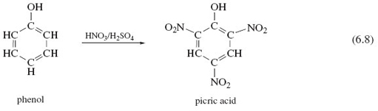

Box 7: High explosives and propellants
High explosives generate shock waves moving with a velocity of 7 000-9 000 ms⁻¹. Their commercial production began in 1863 when Immanuel Nobel and his son Alfred began manufacturing nitroglycerine at Helenborg near Stockholm (Figure 40). Nitroglycerine is a yellow oil prone to accidental explosion, and in 1864, the factory blew up, killing Alfred Nobel's brother Emil. Nevertheless, nitroglycerine proved invaluable in nineteenth-century mining engineering projects which required extensive blasting. It was used, for example, to make a way for the Central Pacific railway over the Sierra Nevada, and thus enabled the United States to create the first transcontinental railroad (Figure 41). The availability of so dangerous a material in frontier conditions caused many accidents. There are tales of nitroglycerine being mistakenly used in spirit lamps and as a lubricant, things which, as Nobel's biographer laconically remarks, 'were seldom done more than once by the same person'.

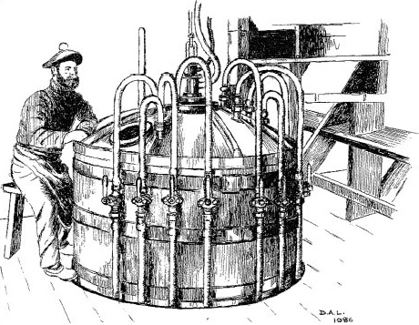
Figure 40 Alfred Nobel (1833-1896) made his fortune through the manufacture of high explosives. In his will, the bulk of his estate was used to fund in perpetuity from 1901 the five Nobel Prizes (for Chemistry, Literature, Peace, Physics, and Physiology or Medicine; a sixth Nobel Prize for Economics was added in 1968), which are awarded annually by Swedish or Norwegian organizations. Nobel appears here at the controls of the equipment that he invented for the manufacture of nitroglycerine. The dangerous nature of the work is revealed by the one-legged stool on which he sits. It protects the operator from the mortal dangers of falling asleep on the job!

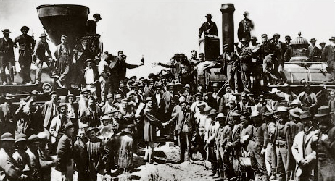
Figure 41 The creation of the first transcontinental railroad: the Central Pacific, working from the West (left), and the Union Pacific from the East (right) meet at Promontory Point, Utah, where, on 10 May 1869, the 'wedding of the rails' was established with a golden spike driven home with a silver sledgehammer. The Central Pacific outbuilt their rivals by using immigrant Chinese labour and nitroglycerine for blasting

Subsequently, Alfred developed the safer dynamites, first by absorbing nitroglycerine with the clay, kieselguhr (guhr dynamite), and then by mixing it with nitrocellulose to form a gel (gelatin dynamite). A mixture of nitrocellulose and nitroglycerine called cordite was the propellant that launched shells from the guns of Royal Navy battleships in both World Wars.
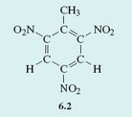
When the hydrocarbons in petrol burn, they acquire the necessary oxygen from the air. High explosives carry their own oxygen, usually in the form of —NO₂ groups, which are bound either to oxygen in nitrate esters, or to nitrogen as in RDX (Figure 9b), or to carbon as in TNT (Structure 6.2). In a typical explosion, this oxygen converts the carbon-hydrogen skeleton to steam and oxides of carbon, leaving nitrogen as N₂ molecules. The heat liberated raises the temperature of the products to about 4000 °﻿C. Thus, for PETN (Reaction 6.7):

C(CH₂ONO₂)₄(s) = 2CO(g) + 3CO₂(g) + 4H₂O(g) + 2N₂﻿(g) (6.9)

During the First World War, the principal high explosive used for bursting charges was TNT, supplemented by other substances such as picric acid and ammonium nitrate. In the Second World War, this role was assumed by RDX, supplemented by TNT and PETN. Currently, the chief military explosive is RDX. Semtex, the explosive favoured by terrorists, takes various forms; it usually consists of crystals of RDX embedded in a rubber-like matrix made from a polymer such as polystyrene, or from a wax.

5.2 Summary of Section 5
- The structural formulae of organic molecules can be divided into the carbon-hydrogen framework or skeleton, and the functional group(s). In the first approximation, the functional groups are the sites where reaction occurs, the framework remaining unreactive.
- This approximation works best when the framework consists of saturated carbon atoms.

Question 16

The compound ethene glycol (ethane-1,2-diol), HO—CH₂—CH₂−OH, is used as antifreeze in car engine coolants. Identify any functional groups in this molecule. Explain how you might make a powerful explosive from ethene glycol, and write down its structural formula.

View answer - Question 16

6 Molecular shape affects molecular reactivity

6.1 Introduction
Structural formulae of, for example, hexan-1-ol (Structure 6.1) and PF₅ (Structure 5.13) merely tell us the immediate neighbours of any particular atom. They are two-dimensional drawings, which ignore the three-dimensional shapes of the molecules. But in studying the structures obtained by X-ray crystallography in Section 1, we recognised that the atoms in a substance have a definite three-dimensional arrangement in space. In other words, molecules have a definite shape and size. Those shapes and sizes are often a key to the understanding of chemical reactions.
Let us start with methane, CH₄, and bromomethane, CH₃Br. In both molecules, the carbon atoms form four single bonds. It turns out that the four bonds are directed towards the corners of a tetrahedron. The resulting molecular shapes are shown in Figure 42 as ball-and-stick representations.

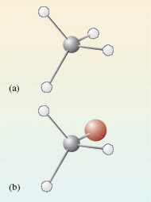
Figure 42 The structures of (a) methane, CH₄; (b) bromomethane, CH₃Br

We now take bromomethane (Figure 42b) and successively replace each hydrogen atom by a methyl group, CH₃, to give the molecules C﻿H﻿₃﻿C﻿H﻿₂﻿B﻿r, (﻿C﻿H﻿₃﻿)﻿₂CHBr and (﻿C﻿H﻿₃﻿)﻿₃﻿CBr. Ball-and-stick representations of each of these molecules are shown at the top of Figure 43. At each carbon atom, there are four bonds directed towards the corners of a tetrahedron, and the complexity of the molecular shape therefore increases from left to right, as the number of carbon atoms increases from one to four.

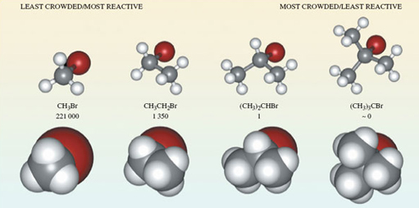
Figure 43 The molecules (a) bromomethane, CH₃Br; (b) bromoethane, CH₃CH₂Br; (c) 2-bromopropane, (CH₃)₂CHBr; (d) 2-bromo-2-methylpropane, (CH₃)₃CBr, shown in both ball-and-stick (top) and space-filling representations (bottom). Also shown are the relative rates of reaction of the four compounds when they are treated with lithium iodide in acetone (propanone) solution

Ball-and-stick representations are a natural three-dimensional development of structural formulae, and they show the disposition of the atoms in space. But by emphasising the bonds, they fail to reveal the subtleties of the molecular shape created by the different sizes of atoms. In this respect, space-filling models are better. These appear at the bottom of Figure 43. In each case, the viewing direction is the same as the ball-and-stick model above.
Now we shall look at a reaction of these four molecules, all of which contain the same functional group.

Question 34

Identify this functional group.

View answer - Question 34

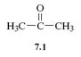
So the molecules are of the general type, RBr, where R is the framework to which the functional group is attached. When such bromo compounds are treated with a solution of lithium iodide in the solvent propanone (acetone, Structure 7.1), they often undergo a reaction in which the bromo group is replaced by an iodo group:

RBr + I⁻ = RI + Br⁻ (7.1)

What happens in this reaction at the molecular level? As Figure 43 shows, the reactant R—Br contains a carbon-bromine bond, C—Br. Bromine is more electronegative than carbon, so the carbon atom in this bond carries a partial positive charge, written δ+, and the bromine atom a partial negative charge, written δ− (Structure 7.2). The negatively charged iodide ion will then tend to approach, and become attached to, the positive carbon. As a carbon-iodine bond is formed, the carbon-bromine bond breaks and a bromide ion is ejected. The reaction is therefore a good illustration of an important point made at the end of Section 5: electronegativity differences often contribute to the reactivity of functional groups.
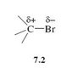
What is interesting, however, is that in this case, the four bromo compounds respond at very different speeds; Figure 43 contains their relative rates of reaction with iodide. They decrease from left to right. For example, CH₃Br reacts 221 000 times as quickly as (CH₃)₂CHBr, and the reaction of (CH₃ )₃CBr is so slow that it appears not to take place at all.
The space-filling molecules explain this. The reaction is one in which an iodide ion must approach and become attached to the carbon atom that is bound to the bromine atom. There is most room for such an approach on the side of the carbon atom that is opposite to the bulky bromine atom - in other words, according to the direction of view depicted in Figure 43. Now look at the space-filling models at the bottom of Figure 43.

Question 35

Why do you think the reaction with iodide should be easier for CH₃Br than for (CH₃)₃CBr?

View answer - Question 35

The effect that an organic group produces by virtue of its bulk is described as steric. Our chosen example is a crude one, but it illustrates an important idea. Whether the reaction occurs or not depends on the ease with which the iodide ion can gain access to the crucial site on the surface of the molecule. Such ideas can be applied to enzymes. Enzymes are protein molecules that facilitate vital biological reactions. They can do this because their molecular surfaces contain active sites to which the molecules participating in the reaction (known as substrates) can become temporarily bound. The active sites are crevices in the enzyme surface, often of a complicated shape. The substrate has the precise shape required to fit the crevice, but potential competitors that lack this shape are excluded (Figure 44). The need for the substrate to bind to the enzyme surface will often weaken other bonds within the substrate itself, encouraging the changes that the enzyme facilitates. So molecular shape has a fundamental role in the chemistry of life. Let us take a more careful look at it.

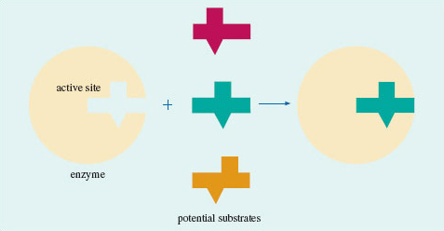
Figure 44 A model for enzyme action: only one of the three molecules has the shape required to fit the cavity on the enzyme surface; the other two are excluded

6.2 The shapes of some molecules
Here we shall look at the shapes of some simple molecules of the typical elements. In doing so, we shall meet the problem of representing three-dimensional shapes on two-dimensional paper. Let's use methane, CH₄, as an example. A ball-and-stick representation of this tetrahedral molecule is shown in Figure 45. To draw such structures in this course, we shall often make use of the 'flying-wedge notation'. A flying-wedge representation of the methane molecule of Figure 45 is shown in Figure 46. The atom at the pointed or thin end of the wedge is assumed to be in the plane of the paper, and the atom at the thick end is in front of the plane. The connection between this wedge and the perspective of Figure 45 is obvious. A continuous line (—) joins two atoms that both lie in the plane of the paper. A dashed line (- -) joins together two atoms, one of which is in the plane of the paper, whereas the other is behind it.

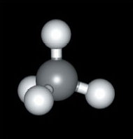
Figure 45 A ball-and-stick model of methane, CH₄

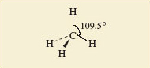
Figure 46 A flying-wedge representation of methane

Having established this convention, we shall now examine the shapes of some simple fluorides. In Section 2, we reminded you how to use the Periodic Table to predict the highest fluoride of a typical element.

Question 36

Use Figure 18 to predict the highest fluorides of beryllium, boron, carbon, iodine, phosphorus and sulfur.

View answer - Question 36

These predictions are correct. All these molecules exist, and their shapes, which have been experimentally determined, are shown in Figure 47.

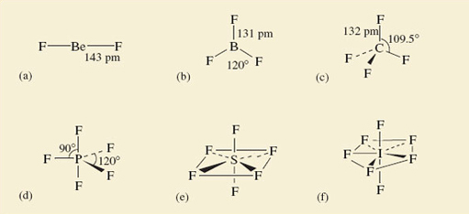
Figure 47 The shapes of some fluoride molecules: (a) BeF₂; (b) BF₃; (c) CF₄; (d) PF₅; (e) SF₆; (f) IF₇

Beryllium difluoride is a glassy non-molecular solid at room temperature, but the BeF₂ molecule (Figure 47a) is obtained when the solid is vaporized by heating it to 1 200 °C. It is linear; that is, the sequence of atoms F—Be—F lies on a straight line. The spatial arrangement of the neighbouring atoms around a particular atom is said to be the coordination of that atom. In BeF₂, therefore, the beryllium is in linear coordination.
At 25 °C, BF₃, CF₄, PF₅, SF₆ and IF₇ are all gases containing molecules with the shapes shown in Figure 47b-f. In BF₃, all four atoms lie in the same plane, the boron atom forming three B—F bonds to three fluorine atoms at the corners of an equilateral triangle (see Maths Help below). This arrangement of fluorines around boron is called trigonal planar. In CF₄, we have the tetrahedral coordination around carbon that we have already noted in methane (Figures 45 and 46)

Maths help: equilateral triangles
An equilateral triangle (Figure 48) has three equal sides, and three internal angles of 60°. The three fluorine atoms in BF₃ lie at the corners of an equilateral triangle. The four faces of a regular tetrahedron, like the one whose corners are defined by the four hydrogen atoms of methane (Figure 45), are equilateral triangles. So are the eight faces of a regular octahedron, like the one whose corners are defined by the six chloride ions around each sodium ion in NaCl (Figure 10b).

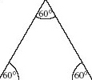
Figure 48 An equilateral triangle

The coordination in PF₅, SF₆ and IF₇ is best described by starting with the horizontal planes containing the central atom of these molecules. In PF₅, this plane contains three P—F bonds directed towards the corners of an equilateral triangle as in BF₃; in SF₆, it contains the sulfur atom with four surrounding fluorines at the corners of a square.

Question 37

What does this horizontal plane contain in IF₇?

View answer - Question 37

In all three cases, the coordination is then completed by two other bonds to fluorine at 90° to those in the horizontal plane, one pointing up, and the other pointing down. These arrangments in PF₅, SF₆ and IF₇ are called trigonal bipyramidal, octahedral and pentagonal bipyramidal, respectively.
In the octahedral molecule SF₆, all the fluorine atoms are equivalent. From each of the fluorine atoms, the view of the rest of the molecule looks the same. But in PF₅ and IF₇, this is not so. There are two kinds of fluorine position: equatorial positions in the horizontal plane, and axial positions at right-angles to it. In Figure 49, these two kinds of position are labelled for the trigonal-bipyramidal arrangement in PF₅.

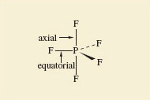
Figure 49 Axial and equatorial positions in PF₅

Why are such arrangements adopted? We can imagine that SF₆ might have the shape shown in Structure 7.3, where the sulfur atom has six S﻿—﻿F bonds directed towards the corners of a regular hexagon, and all seven atoms are in the same plane. But experiment shows the actual shape is the octahedral one shown in Figure 47e.
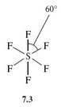

Question 38

Suggest a reason for this preference.

View answer - Question 38

All the shapes shown in Figure 47 conform to this principle by enforcing a good separation of the bonds in space. The principle looks even more reasonable when we remember that we have identified the bonds with pairs of electrons; the like charges of these electron pairs lead to an expectation that one pair will repel another.
However, two very common molecules will soon dispel the notion that repulsion between bonding pairs of electrons is the sole determinant of molecular shape. These are water, H₂O, and ammonia, NH₃.

Question 39

What would be the shapes of H₂O and NH₃ molecules if they were dictated only by bond-bond repulsions?

View answer - Question 39

The observed shapes are shown in Structures 7.4 and 7.5. H₂O is V-shaped and NH₃ is pyramidal. In both cases the inter-bond angle is much closer to the tetrahedral angle of 109.5° than to our predicted values of 180° and 120°, respectively.
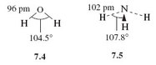

Question 40

What is present in H₂O and NH₃ that might explain these deviations?

View answer - Question 40

Lewis structure 5.6 (Section 4.5.1 click to reveal the answer to the first question to see the structure) shows that, around the oxygen atom in water, there are two bonding pairs of electrons and two non-bonded pairs. Structure 5.5 shows that around the nitrogen atom in ammonia, there are three bonding pairs and one non-bonded pair. Thus, both central atoms are surrounded by four pairs of electrons. If these four pairs repel one another, they will be directed towards the corners of a tetrahedron like the four C—F bonds of CF₄ in Figure 47c. The resulting arrangements are shown in Figure 50. They predict a V-shaped H₂O and a pyramidal NH₃ molecule, with inter-bond angles close to the tetrahedral angle. This agrees with the experimental results indicated in Structures 7.4 and 7.5. So, if we take account of both bond pairs and non-bonded pairs, can we predict the shapes of molecules of the typical elements?

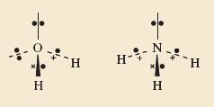
Figure 50 The shapes of the H₂O (left) and NH₃ (right) molecules are consistent with the idea that the four pairs of electrons around the central atoms try to get as far apart as possible. The non-bonded pairs as well as the bonding pairs are involved in this repulsion

6.3 Valence-shell electron-pair repulsion theory
The theory of molecular shape that we have been working towards is called valence-shell electron-pair repulsion theory (VSEPR theory). When applied to molecules and ions of the typical elements, its success rate is high. Here is a stepwise procedure that you can follow when applying this theory. It is illustrated with the molecule XeF₄ and the ion C1O₃⁻. Xenon tetrafluoride is one of the select band of noble gas compounds that were unknown before 1962. The chlorate ion, ClO₃⁻, is found in potassium chlorate, KClO₃, which is a major ingredient of matches. The steps are as follows:
1 Count the number of outer or valence electrons on the central atom.
Our central atoms are xenon and chlorine, for which the numbers of outer electrons are eight and seven, respectively (Figure 23).
2 If you are dealing with an ion, add one electron for each negative charge and subtract one electron for each positive charge.
XeF₄ is a neutral molecule, so the number of valence electrons remains eight. The ion ClO₃⁻ carries a single negative charge, so the number of valence electrons is also eight (7 + 1).
3 Assign these electrons to the bonds.
We assume that the bonds formed by the central atom with the halogens or hydrogen are single bonds consisting of one electron pair. Each atom of the bond contributes one electron to this pair. In XeF₄, xenon forms four such bonds, so four of its eight outer electrons are used in this way.
At first sight, bonds formed to oxygen are more complicated. Oxygen has six outer electrons, and it can complete its octet in two ways. Both ways are apparent in the structure for ozone (Figure 35c and d). One of the terminal oxygen atoms forms a double bond with the central atom; this bond consists of two shared electron pairs. The other terminal oxygen atom receives a pair of electrons from the central atom, which is the donor in a dative bond. But in both types of bond, the central atom contributes two electrons. Now in C1O₃⁻ the central chlorine forms three bonds to oxygens. Six of its eight electrons are therefore used in these bonds.
4 Divide any outer electrons not used in bonding into non-bonded pairs as far as possible.
In XeF₄, subtraction of the four xenon bonding electrons from the total of eight leaves four electrons or two non-bonded pairs. In C1O₃⁻, subtraction of the six bonding chlorine electrons from the total of eight leaves one non-bonded pair. Each bond, and each non-bonded pair, is now regarded as a repulsion axis, an axis of negative charge that repels other such axes.
5 Count each non-bonded pair and each bond as a repulsion axis. Select the appropriate disposition of these repulsion axes from Figure 47.
The theory assumes that the repulsion axes mimic the bonds formed with fluorine in Figure 47 by getting as far apart as possible. For XeF₄, four bonds and two non-bonded pairs give six repulsion axes, and Figure 47 tells us that these will have an octahedral disposition. For C1O₃⁻, three bonds and one non-bonded pair give four repulsion axes with a tetrahedral disposition.
6 Choose between any alternative arrangements by minimising inter-axis repulsion.
In many cases, the shape is fully determined at the end of step 5. This is the case for C1O₃⁻. We have predicted the shape shown in Structure 7.6, and this suggests that C1O₃⁻ should be pyramidal with an inter-bond angle close to the tetrahedral angle of 109.5°. The experimentally observed value is 105°.
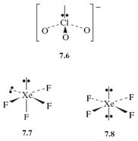
In some cases, however, a choice between two or more possibilities must be made. XeF₄ is one of these. The two non-bonded pairs and four bonds can be octahedrally disposed in two ways (Structures 7.7 and 7.8). It can be quite difficult to choose between such competing arrangements, but a useful procedure assumes that the inter-axis repulsions vary as follows:

non-bonded pair-non-bonded pair > non-bonded pair-bond pair > bond pair-bond pair

The shape can then usually be obtained by choosing that possibility in which the strongest of these different repulsions is minimised. In the case of XeF₄, the strongest repulsion is of the non-bonded pair-non-bonded pair type.

Question 41

Is this type of repulsion lower in Structure 7.7 or Structure 7.8?

View answer - Question 41

This suggests that XeF₄ is planar in shape, the xenon atom being surrounded by four fluorines at the corners of a square (hence the shape is referred to as square planar). Experimentally this is found to be the case.

6.3.1 Refinements and difficulties
In Section 6.2, we said that inter-axis repulsions vary in the order:

non-bonded pair-non-bonded pair > non-bonded pair-bond pair > bond pair-bond pair

There is evidence for this in the inter-bond angles in molecules. For example, in water and ammonia (Structures 7.4 and 7.5), the bond angles are about 5° and 2° less than the tetrahedral angle of 109.5°.

Question 42

Does this support the quoted order of inter-axis repulsions?

View answer - Question 42

Similar effects suggest that there are differences in the repulsive effects of single, double and triple bonds. As Lewis theory implies that these consist of one, two and three pairs of electrons, we might expect that their repulsive effects would vary in the order:

triple bond > double bond > single bond.

The geometry of the ethene molecule can be seen in Structure 7.9. The four outer electrons on each carbon atom are distributed between three repulsion axes: one double bond to carbon and two single bonds to hydrogen.
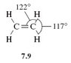

Question 43

Do the inter-bond angles support our assumed difference in the repulsive effects of single and double bonds?

View answer - Question 43

Recognition of the different repulsive effects of single and double bonds can therefore be useful in choosing a molecular shape or predicting bond angles.
Nevertheless, when step 5 of the procedure of Section 6.2 leaves us with two or more structures to choose from, it is sometimes hard to make an informed choice. Minimising the strongest repulsions is usually effective, but not always. A particular problem can arise when there are five repulsion axes - the trigonal-bipyramidal disposition. We can illustrate it with ClF₃, a liquid that boils at 12 °C, and reacts with water with a sound like the crack of a whip. The central chlorine atom has seven outer electrons, three of which are used in forming the three Cl\F bonds. The other four electrons become two non-bonded pairs, which, with the three bonds, give us five repulsion axes disposed in the trigonal-bipyramidal arrangement. There are three possibilities (Structures 7.10-7.12):
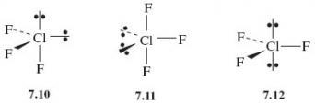
In all three, the strongest repulsive interaction is of the non-bonded pair-non-bonded pair type. If we minimise this, we would decisively reject 7.10, where the non-bonded pair axes are at right-angles, and choose 7.12, where they both occupy the axial positions and so are at 180° to one another. This predicts a planar ClF₃ molecule. But experiment shows that the correct structure is 7.11, where the non-bonded pairs occupy equatorial positions at 120° to each other. Indeed, it seems that in molecules based on the trigonal-bipyramidal disposition of repulsion axes, the non-bonded pairs avoid the axial, and occupy the equatorial sites. In this case, our recommended procedure must be modified.
Note that throughout this Section we have confined ourselves to typical element molecules containing an even number of valence electrons. The valence electrons can then always be divided into pairs, and each repulsion axis consists of a pair or pairs of electrons. But a few typical element molecules contain an odd number of electrons, and the application of VSEPR theory then forces us to deal with repulsion axes consisting of a single electron. An example of this sort is considered in Question 21 below.
Finally, you should recognise that the restriction of VSEPR theory to typical elements is important. It is very much less successful in predicting the molecular shape of transition-metal compounds.

6.4 Summary of Section 6
- Molecules have a three-dimensional shape. Bulky irregularities in the shape of a molecule around a reactive site can exclude a potential reactant. Such effects are described as steric.
- A sufficient refinement of the molecular shape in the region of the reactive site can make that site specific to just one particular reactant. Many enzymes operate in this way.
- The shapes of simple molecules can be predicted using valence-shell electron-pair repulsion theory. The valence electrons of a central atom are divided between the bonds to other atoms, and non-bonded pairs, each bond or non-bonded pair constituting a repulsion axis. The total number of repulsion axes determines their arrangement in space (see Figure 47): two, linear; three, trigonal planar; four, tetrahedral; five, trigonal bipyramidal; six, octahedral; seven, pentagonal bipyramidal.
- A choice between alternative distributions of bonds and non-bonded pairs within any one of these arrangements can usually be made by minimising the strongest types of repulsion. In making this choice, the following points are relevant:
  - (i) Repulsive effects involving non-bonded pairs and bond pairs vary in the order: non-bonded pair-non-bonded pair > non-bonded pair-bond pair > bond pair-bond pair
  - (ii) Multiple bonds exert stronger repulsions than single bonds.
  - (iii) In a trigonal-bipyramidal distribution of repulsion axes, non-bonded pairs occupy equatorial rather than axial positions.

Question 17

The six carbon atoms of benzene, C₆H₆, lie at the corners of a regular hexagon, and each one carries a hydrogen atom. In compounds 7.13-7.16 below, some of these hydrogen atoms have been replaced by other groups. In each case, a carboxylic acid functional group, —﻿COOH, is present.
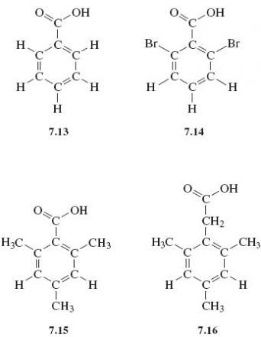
The —COOH group is normally converted to —COOCH₃ when a compound containing it is heated in a solution containing hydrogen chloride and methanol, CH₃OH. When compounds 7.13-7.16 are subjected to this treatment, 7.13 and 7.16 react as expected, forming C₆H₅COOCH₃ and (CH₃)﻿₃C₆H₂CH₂COOCH₃, respectively. But compounds 7.14 and 7.15 undergo little or no reaction. Explain these differences.

View answer - Question 17

Question 18

By heating the solids BeCl₂ and SnCl₂ to quite moderate temperatures, discrete gaseous BeCl₂ and SnCl₂ molecules can be obtained. What shapes and bond angles would you expect the molecules to have?

View answer - Question 18

Question 19

Predict the shapes of the ions (i) NH₄⁺; (ii) ICl₂− (central atom I); (iii) PCl₆− (central atom P).

View answer - Question 19

Question 20

Predict the shapes and bond angles in the molecules (i) BrF₅ (central atom Br) and (ii) SF₄ (central atom S).

View answer - Question 20

Question 21

Predict the shape and bond angle of (i) the sulfur dioxide molecule, SO₂ (central atom S), and (ii) the shape of the molecule XeOF₄ (central atom Xe).

View answer - Question 21

Question 22

For a compound of the typical elements, the brown gas nitrogen dioxide, NO₂, is unusual in that its molecule contains an odd number of electrons. Consequently, when applying VSEPR theory to it, a repulsion axis consisting of a single electron is the result. Use VSEPR theory to predict the shape and likely bond angle of NO₂ by assessing the repulsive effect that this single-electron repulsion axis might have.

View answer - Question 22

7 Reactivity needs a favourable rate and equilibrium constant

7.1 Introduction
So far, we have concentrated on the electronic and spatial structures of chemical substances, but we have not said much about chemical reactions. Now we turn to the question of why chemical reactions happen. To remind you of the basic ideas, we shall concentrate on one particular reaction which occurs in the modern motor car.
Table 2 shows typical percentages of the main constituents of the exhaust gas that emerges from a modern car engine. The two most dangerous pollutants are carbon monoxide, CO, and nitric oxide (strictly known as nitrogen monoxide), NO. Both are very poisonous gases. For example, when nitric oxide emerges from the exhaust into the open air and cools down, it reacts with oxygen to form nitrogen dioxide, NO₂ (Figure 51). This causes respiratory problems even at very low concentrations, and features in the 'air watch' bulletins given in regional weather forecasts.

Table 2 The percentage by volume of the different gases in a typical car exhaust stream
Gas | Volume per cent
nitrogen and argon | 71.00
carbon dioxide | 13.50
water vapour | 12.50
carbon monoxide | 00.68
oxygen | 00.51
hydrogen | 00.23
nitric oxide | 00.11
hydrocarbons | 00.05

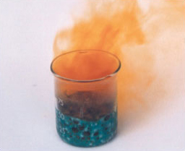
Figure 51 Brown nitrogen dioxide gas being produced, in this case, by the reaction of copper with concentrated nitric acid

Given these dangers, there is a reaction that could be very beneficial:

2NO(g) + 2CO(g) = N₂(g) + 2CO₂(g) (8.1)

If NO and CO reacted like this, then the nitric oxide in the exhaust would disappear, and take a substantial amount of poisonous carbon monoxide with it. Unfortunately, the reaction does not seem to happen. Why is this?

7.2 Is the equilibrium position unfavourable?
The first possibility is that the reaction system has been able to reach chemical equilibrium, but the equilibrium position is not favourable. How does this come about? If equilibrium has been reached, then the forward (left to right) and backward (right to left) reactions are occurring at equal rates. In such a case, we can emphasise the fact by writing the reaction with two opposed, half-headed arrows:

2NO(g) + 2CO(g) N₂(g) + 2CO_{2(g)} (8.2)

This indicates that both the forward reaction:

2NO(g) + 2CO(g) N₂(g) + 2CO₂(g) (8.3)

and the backward reaction:

N₂(g) + 2CO₂(g) 2NO(g) + 2CO(g) (8.4)

are taking place: at the microscopic, molecular level there is ceaseless change in both directions. However, at equilibrium, the overall rates of the forward and backward reactions are equal. The reaction system then seems static because, at the macroscopic level where we measure things, there is no apparent change in the amounts or concentrations of any of the four gases involved. Suppose that Reaction 8.1 appears not to occur because, although it has reached equilibrium, the equilibrium position is unfavourable. Then it must be that the rates of the forward and backward reactions become equal when the concentrations of the reactants (NO and CO) are very high, and those of the products (N₂ and CO₂) are very small, so small as to be undetectable. This possibility can be tested by examining the equilibrium constant, K, for the reaction.

7.2.1 The equilibrium constant
An expression for the equilibrium constant of a reaction can be put together from the concentrations of the reactants and products at equilibrium. A concentration of a reactant or product is represented by enclosing its chemical formula in square brackets. Thus, the concentration of NO(g) is written [NO(g)].
To write down the equilibrium constant of a reaction, we start with the concentrations of the products. Each one is raised to the power of the number that precedes it in the reaction equation, and the corresponding terms for each product are then multiplied together.

Question 44

Do this now for the products of the equilibrium system 8.2.

View answer - Question 44

Question 45

Now repeat the operation for the reactants in Equation 8.2.

View answer - Question 45

The equilibrium constant, K, is obtained by dividing the result for the products by the result for the reactants:

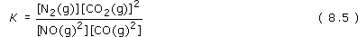

We have raised the possibility that Reaction 8.1 does not happen because the equilibrium position for equilibrium system 8.2 lies well over to the left. In other words, at equilibrium, the concentrations of NO(g) and CO(g) are very high, and those of N₂ (g) and CO₂(g) are so small as to be undetectable.

Question 46

If so, will K be large or small?

View answer - Question 46

The value of K can be determined experimentally. A typical temperature in a car exhaust system is 525 °C. At this temperature, K turns out to be 10⁴⁰ mol⁻¹ litre.

Question 47

Given this information, does the equilibrium position lie to the left of Equation 8.2?

View answer - Question 47

7.3 Is the rate of reaction very slow?
If the equilibrium position is very favourable, then the reason why Reaction 8.1 fails to occur at 525 °C must be that its rate is very slow. Usually, a reasonable response would be to increase the temperature yet further, but the structure and economy of the car gives us little scope to do this. The alternative is to use a catalyst, which leaves the equilibrium constant unchanged, while speeding the reaction up.
Let us look at the changes that take place in the internal energy as reactants change progressively into products. Figure 52 shows a simplified version. The internal energies of the reactants (2NO + 2CO) and products (N₂ + 2CO₂) are marked by two 'platforms'. The platform for the products lies lower than that for the reactants. This shows that the internal energy change during the reaction is negative.

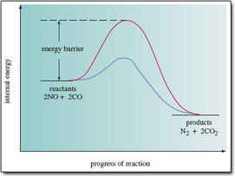
Figure 52 A simplified version of the change that takes place in the internal energy of the molecules as nitric oxide and carbon monoxide change into nitrogen and carbon dioxide. The upper (red) curve shows the change in the absence of a catalyst; the lower (blue) curve, the change when a catalyst is present

Between the reactants and products, the internal energy does not decrease gradually as the reaction progresses; instead, it rises initially, reaches a maximum, and then declines. The upper curve shows the situation in the absence of a catalyst. The internal energy of the reacting molecules must first increase by an amount marked 'energy barrier' in Figure.

Question 48

How might the reactants, NO and CO, acquire this extra energy?

View answer - Question 48

This also explains why an increase in temperature increases the rate of a reaction: a temperature rise increases the speed of the molecules, and the required increase in internal energy following collisions then becomes more probable. But as we have seen, in this case the rate is not great even at 525 °C. The energy barrier must be high. The main reason is a property of nitric oxide. In Reaction 8.1, the nitrogen and oxygen atoms in NO must be separated at some point, but the bond that holds them together is very strong. A large input of energy is therefore needed to bring the separation about, so the energy barrier is high and the reaction is slow.

Box 8: The three-way catalytic converter
The solution to the high energy barrier for Reaction 8.1 is to involve a third party - a catalyst. A suitable material is the metal rhodium. When NO and CO molecules enter a catalytic converter, they become bound to rhodium surfaces. The binding of NO to rhodium weakens the bond between the N and O atoms, and the NO unit becomes more vulnerable to change. For example, it is believed that in some cases, the bond is so weakened that the N and O atoms separate completely, and move about on the rhodium surface. Pairs of nitrogen atoms can then meet, combine and leave the surface as N₂(g); oxygen atoms can meet and combine with CO molecules on the surface, leaving as CO₂(g).
Obviously, this type of reaction pathway is very different from one that takes place entirely in the gas phase with no catalyst present. Most particularly, because the catalyst surface assists the breaking of the bond in the NO molecule, it has a lower energy barrier (see Figure 52) and is much faster. In a three-way catalytic converter, some 90 per cent of the nitric oxide in the exhaust stream is converted to nitrogen and carbon dioxide. Figure 53 shows an example. The catalyst actually contains rhodium and platinum. The platinum catalyses the reactions of both carbon monoxide and unburnt hydrocarbons (from the petrol) with oxygen, giving carbon dioxide and steam. The converter is called 'three way' because it thereby removes all three main types of pollutant: nitrogen oxides, carbon monoxide and unburnt hydrocarbons. Figure 54 provides you with further details.

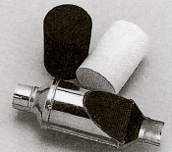
Figure 53 A three-way catalytic converter; the metal shell has been partially cut away, exposing a gauze lining, inside which is the cylindrical grid of exhaust channels. A separate grid of this type is shown above and to the left. It is black because the platinum-rhodium catalyst has been dispersed over its surfaces. Before the catalyst is spread over it, the ceramic grid is white, as shown above and to the right.

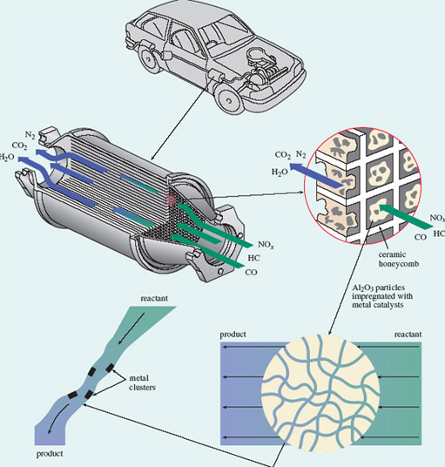
Figure 54 The core of a typical three-way catalytic converter

The core of a typical three-way catalytic converter consists of a cylindrical grid of thin-walled channels of square cross-section, composed of a ceramic material made from oxides of magnesium, aluminium and silicon (Figure 54). The platinum-rhodium catalyst is dispersed over granules of solid aluminium oxide, Al₂O₃, which have been specially prepared with a high surface area. The catalyst-coated granules are mixed with water to form a slurry, and passed through the grid, which is then heated in a furnace. The process leaves Al₂O₃, impregnated with catalyst particles, dispersed on the walls of the channels. In passing through the channels, exhaust pollutants traverse pores in the Al₂O₃ granules, encountering metal catalyst sites where reactions such as that shown in Equation 8.1 occur. Efficient conversion occurs only if the air-fuel ratio on entry to the converter is right. The ratio is controlled mainly by measuring the oxygen with a sensor and then making any necessary adjustments to the air and fuel supply (NO_{x} denotes oxides of nitrogen; HC denotes hydrocarbons)

7.4 Equilibrium positions and rates of reaction in this course
Section 7 showed that if a reaction is to occur at a particular temperature, two conditions must be fulfilled: its equilibrium constant must be sufficiently large, and its rate sufficiently great. We finish by pointing out how this crucial distinction between the equilibrium constant and the rate reveals itself in Figure 52. The figure shows two different pathways by which the reactants can change into the products, but both routes begin at the same reactant energy level, and finish at the same product energy level. Regardless of reaction pathway, the energy difference between reactants and products is the same. It is an energy difference between reactants and products that determines the equilibrium constant of a reaction, and therefore the equilibrium position. The fact that both pathways have the same energy difference, and therefore the same equilibrium constant, shows that the equilibrium constant in a reaction is quite unaffected by how reactants change into products. With equilibrium constants, the nature and energies of the initial and final states are everything; what happens in between is immaterial.
When we turn to reaction rates, this is not so. In Figure 52, both routes start with the same reactants, and end with the same products, but the intervening stages along each pathway are very different. Such sequences of intervening stages are called reaction mechanisms, and the mechanism in the presence of a catalyst delivers a smaller energy barrier and a faster rate than the one that pertains when the catalyst is absent. With rates of reaction, therefore, the mechanism is crucial.

7.5 Summary of Section 7
- The equilibrium constant of a reaction is fixed at any particular temperature. It depends only on the natures of the initial reactants and the final products; what happens as reactants change into products has no effect on the equilibrium constant or position of equilibrium.
- The rate of a chemical reaction is affected both by the temperature and by the pathway (reaction mechanism) through which reactants change into products. This pathway can sometimes be altered, for example by the introduction of a catalyst.
- The catalyst causes a change in the reaction mechanism which leads to a lowering of the energy barrier and to a greater rate of reaction.

Question 23

The combination of sulfur dioxide with oxygen, and the decomposition of steam into hydrogen and oxygen are both reactions of great potential practical value. These reactions, and their equilibrium constants at 427 °C (700 K) are as follows:

Write down expressions for the equilibrium constants of the two reactions. When the two reactions are attempted at 700 K, neither seems to occur. Which of the two might be persuaded to occur at this temperature, and what form might your 'persuasion' take?

View answer - Question 23

Conclusion
Figure 55 is a conceptual diagram that summarises this course. Molecules are made of atoms, so it was with atoms, to the left of Figure 55, that we began. Early in Section 1 they acquired a structure with a positively charged nucleus surrounded by negatively charged electrons. To a chemist, the most important property of an atom is the number of positive charges in its nucleus. This atomic number distinguishes one chemical element from another: atoms with the same atomic number are atoms of the same chemical element. This is true even when those atoms have different numbers of neutrons in their nuclei. They are then said to be isotopes of the same chemical element.
Having labelled atoms with a chemical symbol for the elements that they represent, we then looked, in the rest of Section 1, at how atoms combine with each other. Combination can occur with other atoms of the same element; this yields the elements that are familiar to us as chemical substances. Alternatively, combination can occur between atoms of different elements when a chemical compound is produced. In both cases, it proved useful to look at the distribution of the atoms in space. This led to a classification of chemical substances into molecular and non-molecular types. Molecular substances contained discrete molecular units well separated from other units of the same formula. For non-molecular substances, this separation could not be made.
In Section 2, atomic number was exploited again: when the chemical elements are laid out in order of atomic number, elements with similar properties appear at regular intervals. This chemical periodicity is represented by Periodic Tables, which reveal many regularities in chemical properties. This course is concerned especially with the typical elements, and therefore with the mini-Periodic Table containing just this sub-set. To explain chemical periodicity, we looked at the arrangement of the negatively charged electrons around the positively charged nuclei of the different elements. This was done in Section 3. The electronic structures of the ground states of atoms were represented both by electronic configurations, which allocate electrons to sub-shells, and by box diagrams, which also show the spin of the electrons and the number of atomic orbitals within each sub-shell. It transpires that atoms in the same group of the Periodic Table have similar outer electronic configurations, and this points to explanations of chemical properties that depend on electronic structure.
These explanations require an understanding of the chemical bonding through which the atoms of an element express their valencies. In Section 4, we revisited the simplest theories of chemical bonding, which involve the sharing of electron pairs. This sharing, whose nature depends on the electronegativities of the elements, can result in ionic, covalent or metallic bonding. Structure from Section 1, and bonding from Section 4, then combined to provide a classification of chemical substances in general: they are molecular covalent, non-molecular ionic, non-molecular covalent or non-molecular metallic. Many compounds of the typical elements, including nearly all organic compounds, are of the molecular covalent type.

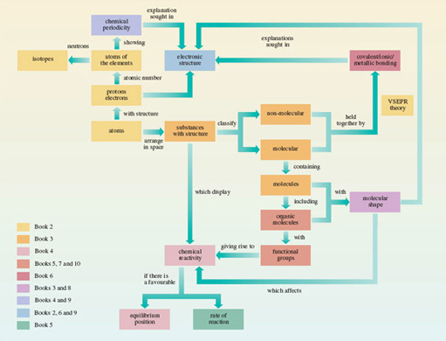
Figure 55 A conceptual diagram showing important ideas and the relationship between them

Click to view larger version of Figure 55
View document
The rest of Section 4 modified and extended the ideas of shared electron pair bonds. The shared pair can sometimes come from just one of the two atoms in the bond, which is then said to be dative. For many typical element compounds, it is possible to claim both electron-pair bonds and the attainment of a noble gas configuration for the constituent atoms. In some compounds, such as benzene and ozone, the bond lengths call for a representation that is an average of two or more Lewis structures, rather than just one. This phenomenon is called 'resonance'. This part of Section 4 was a piecemeal attempt to patch up elementary bonding theories initiated in particular by the work of G. N. Lewis. It signals the need for a fresh look at the whole subject of chemical bonding.
From chemical bonding, we turned, in Section 5, to chemical reactions at the molecular level. Some parts of a molecule are more vulnerable to attack by a particular reactant than others, a point well illustrated by the functional groups of organic molecules. The reactions of functional groups, however, are not entirely independent of their immediate molecular environment. The shapes of organic molecules also influence them. In Section 6, we pointed to the important steric influences of molecular shape, which reach a very sophisticated degree of development in the workings of enzymes. Although the three-dimensional distribution of the atoms within substances was a part of Sections 1 and 4, this explicit recognition of its importance calls for a theory of molecular shape. For the typical elements this is provided by valence-shell electron-pair repulsion theory (VSEPR theory), in which the molecular shape is dictated by repulsions between bonding and non-bonding pairs of valence electrons.
Our growing emphasis on chemical reactivity at the expense of structure and bonding became paramount in Section 7, where the question of why chemical reactions happen was analysed in terms of equilibrium positions and rates of reaction. In a closed system, a reaction with a tiny equilibrium constant cannot happen under any circumstances; but if a reaction that does not occur is found to have a large equilibrium constant, then the failure to react must be caused only by a slow rate; this can sometimes be increased by the use of a catalyst.

Keep on learning



Study another free course
There are more than 800 courses on OpenLearn for you to choose from on a range of subjects.
Find out more about all our free courses.

Take your studies further
Find out more about studying with The Open University by visiting our online prospectus.
If you are new to university study, you may be interested in our Access Courses or Certificates.

What's new from OpenLearn?
Sign up to our newsletter or view a sample.

For reference, full URLs to pages listed above:
OpenLearn - www.open.edu/openlearn/free-courses
Visiting our online prospectus - www.open.ac.uk/courses
Access Courses - www.open.ac.uk/courses/do-it/access
Certificates - www.open.ac.uk/courses/certificates-he
Newsletter - www.open.edu/openlearn/about-openlearn/subscribe-the-openlearn-newsletter

Acknowledgements
The content acknowledged below is Proprietary (see terms and conditions) and is used under licence.
Course image: Wikimedia made available under Creative Commons Attribution-NonCommercial-ShareAlike 2.0 Licence.
Grateful acknowledgement is made to the following sources for permission to reproduce material in this course:
Figure 2(f) © National Power;
Figure 3 Courtesy of IBM Corporation, Research Division, Almaden Research Center;
Figure 14 'Fuel hoarder sentenced' by Maurice Weaver, printed 6 April 2001, Telegraph Group Limted;
Figure 16 Ann Ronan/Image Select;
Figure 26 © University of California Archives;
Figure 40 © ICI Nobel Explosive Co/Science Photo Library;
Figure 41 © Bancroft Library, University of California;
Figure 53 Johnson Matthey, Royston, Herts.
Don't miss out:
If reading this text has inspired you to learn more, you may be interested in joining the millions of people who discover our free learning resources and qualifications by visiting The Open University - www.open.edu/openlearn/free-courses

Question 1

Answer
+6e; the atom in Figure 1 contains six electrons whose total charge will be −6e. To generate an overall charge of zero, the positive charge on the nucleus must be +6e.
Back to Session 1 SAQ 1

Question 2

Answer
6; the nucleus carries a total charge of +6e, and each proton has a charge of +e.
Back to Session 1 SAQ 2

Question 3

Answer
63 and 65 — that is, (29 + 34) and (29 + 36), respectively.
Back to Session 1 SAQ 3

Question 4

Answer
AlBr₃; the subscript three following the bromine marks the fact that the Al : Br atomic ratio is 1 : 3.
Back to Session 1 SAQ 4

Question 5

Answer
No; the tiny particles or molecules consist of pairs of chlorine atoms, Cl₂.
Back to Session 1 SAQ 5

Question 6

Answer
Yes; the molecular formula is Al₂Br₆, but in both the molecules and the solid, the ratio of aluminium atoms to bromine atoms is 1 : 3. In molecular substances that contain just one type of molecule, that molecule has the same empirical formula as the compound.
Back to Session 1 SAQ 6

Question 7

Answer
The sodium is surrounded by six chlorines at the centres of the cube faces.
Back to Session 1 SAQ 7

Question 8

Answer
In two; the internuclear distances allow us to break the structure up into two-dimensional sheets extending throughout the entire crystal.
Back to Session 1 SAQ 8

Question 9

Answer
In solid iodine, different I₂ molecules are held together by weak forces, so only a little thermal energy is needed to separate them and create first a liquid, and then a gas. Both liquid and gaseous iodine also contain I₂ molecules. To melt and then boil iodine it is not necessary to break up the I₂ molecules themselves.
Back to Session 1 SAQ 9

Question 1

Answer
(a) 13;
(b) 13;
(c) +13e;
(d) 14;
(e) . Because the atomic number of aluminium is 13, there are 13 protons in the nucleus, 13 orbiting electrons in the atom, and the total charge on the nucleus is + 13e. As the relative atomic mass is 27.0, and there is just one isotope, the mass number is 27. Therefore, the number of neutrons is (27 − 13) = 14. The mass number is the preceding superscript, and the atomic number is the preceding subscript in the symbol .
Back to Session 1 Activity 1

Question 2

Answer
(a) P₂O₅.
(b) No. The empirical formula can be obtained from the molecular formula by reducing the ratio between the numbers of atoms to the lowest possible whole numbers. A molecule containing fewer atoms than the empirical formula would therefore consist of fractions of atoms. In chemistry, the term 'fraction of an atom' is meaningless.
Back to Session 1 Activity 2

Question 3

Answer
- (a) HF is molecular; SiC is non-molecular.
- (b) X is HF and Y is SiC. The chains in Figure 15a show that hydrogen and fluorine atoms in solid HF are separated by either a shorter distance of 92 pm or a longer distance of 157 pm. We take a hydrogen and fluorine atom separated by the shorter distance of 92 pm to be a discrete HF molecule. The shortest distance between two HF molecules is then 157 pm. In SiC, all atoms are surrounded by four others of a different type at the corners of a regular tetrahedron, the four interatomic distances being identical. There is no point at which one can stop and claim that one has reached the boundary of a molecule. SiC is therefore non-molecular. The molecular substance HF should have the lower melting and boiling temperatures, and the higher solubility in petrol. This is in fact the case.
Back to Session 1 Activity 3

Question 4

Answer
SnO₂; we start with the valencies of tin (4) and oxygen (2). Exchanging the numbers against the elements gives us tin (2) and oxygen (4). This tells us the combining ratio: two tin atoms combine with four oxygen atoms. To get the empirical formula, the ratio 2 : 4 is converted to the lowest possible whole numbers; the result is 1 : 2. So the predicted formula of the oxide of tin is SnO₂.
Back to Session 2 Activity 1

Question 5

Answer
Z is tellurium (Te). The highest normal oxide ZO₃ suggests (point iii of Section 2.1) a highest valency of six and, therefore, a Group VI element. Point ii confirms that these elements form a hydride ZH₂. The only Group VI element that is a semi-metal is tellurium. It lies in Period 5. Its highest fluoride (point iii again) should have the empirical formula TeF₆, and in fact it does.
Back to Session 2 Activity 2

Question 11

Answer
There are four. For a shell of principal quantum number n, l can take values from zero up to (n−1). Thus, in the shell for which n = 4, there are four sub-shells with the values l = 0, 1, 2 and 3.
Back to Session 3 SAQ 1

Question 12

Answer
The values are: 2﻿[﻿(2 × 0) + 1] = 2; 2﻿[﻿(﻿2 × 1﻿) + 1] = 6; 2﻿[﻿(﻿2 × 2) + 1﻿] = 10; and 2﻿[﻿(﻿2 × 3) + 1] = 14, respectively.
Back to Session 3 SAQ 2

Question 13

Answer
1s²2s²2p⁶3s²3p².
Back to Session 3 SAQ 3

Question 14

Answer
1s²2s²2p⁶3s²3p⁶4s²3d¹⁰4p⁶5s²4d¹⁰5p⁶6s²4f¹⁴5d¹⁰6p².
Back to Session 3 SAQ 4

Question 15

Answer
1s²|2s²2p⁶|3s²3p⁶3d¹⁰|4s²4p⁶4d¹⁰4f¹⁴|5s²5p⁶5d¹⁰|6s²6p². For clarification, the individual shells have been separated by vertical lines.
Back to Session 3 SAQ 5

Question 16

Answer
Three and six, respectively: silicon appears in Period 3 and lead in Period 6.
Back to Session 3 SAQ 6

Question 17

Answer
In both cases, the Group number is four and there are four outer electrons: two s electrons and two p electrons.
Back to Session 3 SAQ 7

Question 18

Answer
One and three, respectively; for s and p sub-shells, l = 0 and 1, so (2l + 1) = 1 and 3, respectively.
Back to Session 3 SAQ 8

Question 19

Answer
The 1s and 2s boxes should now both look like the 1s box for the helium atom above: they should each contain two electrons with opposed spins.
Back to Session 3 SAQ 9

Question 19a

Answer
As there are four 2p electrons and only three 2p boxes, the fourth 2p electron cannot have a spin parallel to the other three. It must go into a box that is already occupied by one electron with opposite spin:
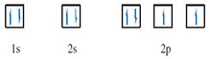
Back to Session 3 SAQ 10

Question 6

Answer
The elements are: (a) chlorine, Cl; (b) arsenic, As; and (c) thallium, Tl. The outer electronic configurations contain seven, five and three electrons, respectively, and are therefore characteristic of Groups VII, V and III, respectively. The principal quantum numbers of the outer electrons are three, four and six, respectively, and are equal to the Period numbers. These Group and Period numbers identify the elements when Figure 23 is used as a grid.
Back to Session 3 Activity 1

Question 7

Answer
(a) 1s²|2s²2p⁶|3s²3p⁶|4s²;
(b) 1s²|2s²2p⁶|3s²3p⁶3d¹⁰|4s²4p⁵;
(c) 1s²|2s²2p⁶|3s²3p⁶3d¹⁰|4s²4p⁶4d¹⁰|5s²5p².
With atomic numbers 20, 35 and 50, the calcium, bromine and tin atoms will contain 20, 35 and 50 electrons, respectively. Putting 20, 35 and 50 electrons into the sub-shells in the order given in Figure 21 yields:
(a) 1s²2s²2p⁶3s²3p⁶4s²;
(b) 1s²2s²2p⁶3s²3p⁶4s²3d¹⁰4p⁵;
(c) 1s²2s²2p⁶3s²3p⁶4s²3d¹⁰4p⁶5s²4d¹⁰5p².
Our answers are obtained from these sequences by regrouping the sub-shells in cases (b) and (c) so that they are arranged in order of increasing n value.
Back to Session 3 Activity 2

Question 8

Answer
A is bismuth, Bi, and its outer electronic configuration is 6s²6p³. The existence of the compounds A₂O₅ and AF₅ suggests that the highest valency of A is five. This implies a Group V element. According to Figure 23, the only Group V element that is a metal is bismuth. As it lies in the Period 6, the outer electronic configuration of the atom is 6s²6p³.
Back to Session 3 Activity 3

Question 9

Answer
There are 17 electrons in the chlorine atom and, from Figure 21, the electronic configuration is 1s²2s²2p⁶3s²3p⁵. Turning this into a box diagram, the 1s and 2s boxes are each filled with a pair of electrons with opposite spins. The three orbitals in the 2p sub-shell and the single 3s orbital each take pairs of opposite spins in a similar way. This leaves five electrons for the three orbitals of the 3p sub-shell. We start by assigning one electron to each of the three orbitals, making sure that all three have the same spin. This maximises the number of electrons with the same spin. The final two electrons must then go into different 3p boxes with spins opposed to the other three.
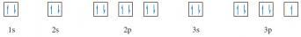
Back to Session 3 Activity 4

Question 20

Answer
The common process is the formation of an electron-pair bond; in covalent bonding the electron pair is shared between the atoms involved; in ionic bonding it resides on just one of them.
Back to Session 4 SAQ 1

Question 21

Answer
In sodium chloride, the electron pair has been completely taken over by chlorine, which forms a chloride ion. Imagine the sodium and chlorine atoms competing for electrons; the chlorine atoms win, so chlorine is the more electronegative.
Back to Session 4 SAQ 2

Question 22

Answer
It is incorrect; at room temperature, sodium atoms do not yield Na₂ molecules. Instead, they form a non-molecular metal.
Back to Session 4 SAQ 3

Question 10

Answer
Structures Q.1-Q.9 show the structural formulae. In each case, the number of lines issuing from each atom is equal to the element's quoted valency in Table 1.
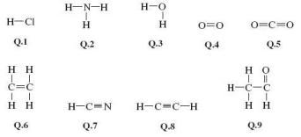
Back to Session 4 Activity 1

Question 23

Answer
See Structures 5.5-5.8; single, double and triple bonds are represented by one, two and three shared pairs of electrons, respectively. Hydrogen attains the shell structure of helium, with 2 outer electrons; carbon, nitrogen and oxygen attain that of neon, with 8 outer electrons.
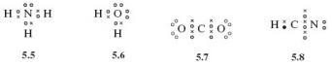
Back to Session 4 SAQ 4

Question 24

Answer
NH₃ contains three bond pairs and one non-bonded pair. In H₂O there are two of each.
Back to Session 4 SAQ 5

Question 25

Answer
(2,4); the single positive charge on the ammonium ion requires the removal of one electron from the nitrogen atom shell structure, which is (2,5)
Back to Session 4 SAQ 6

Question 26

Answer
In only one, namely that of PF₃; in Structure 5.11, the three shared electron pairs around the boron atom are two electrons short of the shell structure of neon, and in Structure 5.13, the five electron pairs around the phosphorus atom give us two electrons more than the shell structure of argon.
Back to Session 4 SAQ 7

Question 28

Answer
See Structure 5.20; each C→O bond is replaced by −, and as the carbon atom forms two dative bonds, a charge of +2 must be added to the double negative charge on carbon in Structure 5.19. This gives zero charge on carbon in the new version, but as there is now a single negative charge on each of the two singly bonded oxygens, the total charge on the ion is −2 as before.
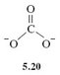
Back to Session 4 SAQ 8

Question 29

Answer
Unequal; one is a double bond and the other a single dative bond. We would expect this difference to influence their lengths.
Back to Session 4 SAQ 9

Question 30

Answer
The real structure of benzene is a hybrid of the individual structures, and each carbon-carbon bond will be a mixture of one-half single and one-half double bonds; all carbon-carbon bond lengths should be equal and lie between 134 and 154 pm.
Back to Session 4 SAQ 10

Question 11

Answer
(i) CaCl₂; (ii) IBr; (iii) CaMg₂.
The properties listed are characteristic of (i) an ionic substance, (ii) a molecular covalent substance, and (iii) a metallic substance. CaCl₂ is a combination of elements from the extreme left and extreme right of Figure 30, so the electronegativity difference will be large and CaCl₂ will be the ionic compound; such compounds are non-molecular. IBr will be covalent because it is a combination of elements of high electronegativity from the extreme right of Figure 30. CaMg₂ will be a metallic alloy because it is a combination of metallic elements with low electronegativity from the left of Figure 30. Such alloys are non-molecular.
Back to Session 4 Activity 2

Question 12

Answer
- (a) For hypochlorous acid, see Structures Q.10 and Q.11. The oxygen has two non-bonded pairs and two bonding pairs.
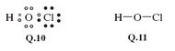
- (b) For SF₆, see Structures Q.12 and Q.13. The sulfur atom has six bonding pairs and no non-bonded pairs.
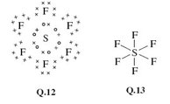
- (c) For ONCl, see Structures Q.14 and Q.15. The nitrogen has one non-bonded pair and three bonding pairs.
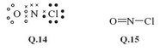
- (d) For NH₂⁻, the amide ion, see Structures Q.16 and Q.17 . The nitrogen has two bonding pairs and two non-bonded pairs.
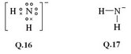
All the atoms in Lewis structures Q.10, Q.12, Q.14 and Q16 have noble gas shell structures, except for sulfur in SF₆, which is assigned twelve outer electrons.
Back to Session 4 Activity 3

Question 13

Answer
The Lewis structure of NO₃⁻ is shown as Structure Q.18. The atom of highest valency is nitrogen, so the single negative charge on the NO₃⁻ ion is assigned to nitrogen, giving the shell structure (2,6). All atoms gain the shell structure of neon if nitrogen forms one double bond and two single dative bonds to oxygen. Structure Q.19 shows the two dative bonds as arrows. In the alternative representation, one of the two positive charges at the nitrogen end of the two dative bonds is cancelled by the single negative charge of the central nitrogen. This gives Structure Q.20.
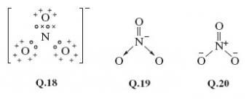
Back to Session 4 Activity 4

Question 14

Answer
See Structures Q.21-Q.23.
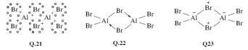
In the Lewis structure Q.21, each bridging bromine atom forms one shared electron pair bond with one aluminium and one dative bond to the other aluminium. All atoms gain a noble gas shell structure with eight outer electrons. Structural formula Q.22 shows the dative bonds as arrows, and suggests that the two bonds formed by each bridging bromine are different. The alternative Q.23 makes these two bonds identical. It is therefore a better representation of the experimental data. Nevertheless, although the single formula Q.22 is not compatible with the equal Al—Br bond lengths, this way of representing the dative bonds can be made consistent with them by using the two resonance hybrids shown in Structure Q.24.
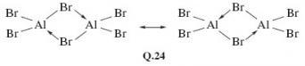
Back to Session 4 Activity 5

Question 15

Answer
In the answer to Question 12, both Structure Q.19 and Structure Q.20 contain one double bond and two single dative bonds. Neither is therefore consistent with three equal bond lengths. To explain the discrepancy we represent the nitrate ion as the resonance hybrid shown as Structure Q.25.
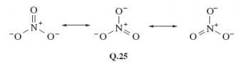
Back to Session 4 Activity 6

Question 31

Answer
It is the fragment —OH, which is known as the alcohol functional group.
Back to Session 5 SAQ 1

Question 32

Answer
Only one; the oxygen atom of the functional group has two non-bonded electron pairs.
Back to Session 5 SAQ 2

Question 33

Answer
In Section 4.5.3, you saw that they allow formation of dative bonds.
Back to Session 5 SAQ 3

Question 16

Answer
The ethene glycol molecule contains two alcohol functional groups, —OH. These should both be replaceable by ONO₂ groups when ethene glycol is treated with a mixture of concentrated nitric and sulfuric acids. The expected product has the structural formula Q.26. These expectations are correct. The product is a colourless liquid, ethene glycol dinitrate (EGDN), and it is indeed a powerful explosive.
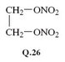
Back to Session 5 Activity 1

Question 34

Answer
It is the bromo group, —Br.
Back to Session 6 SAQ 1

Question 35

Answer
In CH₃Br, the carbon atom is very exposed to the incoming iodide. But if hydrogen atoms are replaced by the more bulky methyl groups, this exposure diminishes, until at (CH₃)₃CBr the carbon atom attached to bromine lies at the bottom of a small cavity created by the three surrounding methyl groups. The iodide cannot reach this carbon atom, so no reaction occurs.
Back to Session 6 SAQ 2

Question 36

Answer
The Group numbers are: beryllium, II; boron, III; carbon, IV; phosphorus, V; sulfur, VI; iodine, VII. The predicted highest fluorides are therefore BeF₂, BF₃, CF₄, PF₅, SF₆ and IF₇.
Back to Session 6 SAQ 3

Question 37

Answer
The iodine atom, and five I—F bonds directed towards five fluorine atoms at the corners of a regular pentagon.
Back to Session 6 SAQ 4

Question 38

Answer
What we are looking for is the idea that the S—F bonds repel one another, so that they get as far apart in space as possible. In Structure 7.3, they are confined to a single plane and the angle between them is only 60°. By adopting octahedral coordination, the greatest possible separation of the S—F bonds is achieved, the angle being increased to 90°.
Back to Session 6 SAQ 5

Question 39

Answer
The two O—H bonds of H₂O and the three N—H bonds of NH₃ would get as far apart as possible: H₂O would be linear like BeF₂, and NH₃ would be trigonal planar like BF₃ (see Figure 47).
Back to Session 6 SAQ 6

Question 40

Answer
In Section 4.5.1 you saw that the central atoms in these molecules, O and N, carry non-bonded electron pairs. In the molecules of Figure 47 this is not the case. If these non-bonded pairs, like the bonding pairs, also exert repulsions, this might explain the unexpected shapes of Structures 7.4 and 7.5.
Back to Session 6 SAQ 7

Question 41

Answer
In Structure 7.8, where the angle between the non-bonded pairs is 180°, so they are as far apart as possible.
Back to Session 6 SAQ 8

Question 42

Answer
Yes; non-bonded pair-bond pair repulsions tend to reduce the inter-bond angle; bond pair-bond pair repulsions tend to increase it. The observed reduction shows that non-bonded pair-bond pair repulsions are dominant. The reduction is greater in H₂O than NH₃ because the water molecule has two non-bonded pairs.
Back to Session 6 SAQ 9

Question 43

Answer
Yes; the stronger repulsion exerted by the C=C bond forces the two C—H bonds together. The inter-bond angle falls below 120°, the value for regular trigonal-planar coordination.
Back to Session 6 SAQ 10

Question 17

Answer
We shall number the carbon atoms of the benzene ring from 1 to 6, calling the atom to which the —COOH or —CH₂COOH units are attached, carbon number 1. In Structure 7.13, hydrogen atoms (relatively small) are attached to positions 2 and 6. Incoming reactants attacking the —COOH group attached to carbon 1 are therefore relatively unimpeded, and reaction occurs readily. In Structures 7.14 and 7.15, the 2 and 6 positions are occupied by the much more bulky —Br and —CH₃ groups, respectively. These impede access of the incoming reactant to the —COOH group, thereby hindering the reaction. In Structure 7.16, the insertion of a —CH₂— unit between the —COOH group and carbon 1 increases the distance between the —CH₃ groups in positions 2 and 6 and the —COOH group. Steric hindrance is no longer severe and reaction once more occurs readily.
Back to Session 6 Activity 1

Question 18

Answer
Beryllium has two valence electrons. Both are used up in forming the two bonds to chlorine. There are two repulsion axes, so BeCl₂ should be linear; this is the case. Tin has four valence electrons. Two are used in forming the two single bonds to chlorine, and this leaves one non-bonded pair. There are three repulsion axes, which should therefore be disposed in a triangular sense (see Structure Q.27), so SnCl₂ should be V-shaped with a bond angle slightly less than 120° because of the primacy of the non-bonded pair-bond pair repulsions. Experimentally, this is found to be so.
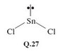
Back to Session 6 Activity 2

Question 19

Answer
- (i) Nitrogen has five valence electrons, but as the NH₄⁺ ion carries a positive charge, one must be subtracted, leaving four. All four electrons are used to form the four bonds to hydrogen, so there are just four repulsion axes, and the ion has a tetrahedral shape.
- (ii) Iodine has seven valence electrons, and if one electron is added for the single negative charge on ICl₂⁻, this becomes eight. Two of the eight electrons are used in forming single bonds to the two chlorines, leaving six which are divided into three non-bonded pairs. There are therefore five repulsion axes, which take on a trigonal-bipyramidal disposition (cf. PF₅, Figure 47d). In this arrangement, non-bonded pairs occupy equatorial positions leaving the axial positions for the two chlorines. Thus, ICl₂⁻ is linear (Structure Q.28).
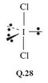
- (iii) Phosphorus has five valence electrons, and the negative charge of PCl₆⁻ makes six. All six are used in forming single bonds to the six chlorines, so there are six repulsion axes: PC1₆⁻ is octahedral like SF₆ in Figure 47e.
Back to Session 6 Activity 3

Question 20

Answer
- (i) Bromine has seven valence electrons, and five of them are used to form the five Br—F bonds, leaving two as a non-bonded pair. The six repulsion axes take on an octahedral disposition, giving a square-pyramidal BrF₅ molecule (Structure Q.29). Because of the strong repulsive effect of the non-bonded pair, we would expect the angle α to be less than 90°. Experimental measurement shows this to be so (85°).
- (ii) In SF₄, the sulfur has six valence electrons, four of which are used to form the four S—F bonds. This leaves two as a non-bonded pair. The five repulsion axes adopt the trigonal bipyramidal arrangement (Figure 49), with the non-bonded pair in an equatorial position. Consequently, SF₄ has the shape shown in Structure Q.30, the repulsive effect of the lone pair giving an angle β slightly less than 90°.
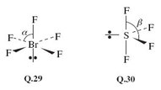
Back to Session 6 Activity 4

Question 21

Answer
- (i) Sulfur has six valence electrons, and four are used up in forming two double bonds to oxygen. This leaves one non-bonded pair, giving a total of three repulsion axes. We predict a V-shaped molecule (Structure Q.31), with a bond angle close to 120°. The experimental value is 119.5°.
- 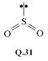
- (ii) In XeOF₄, two of the eight xenon electrons are involved in the double bond to oxygen, and four in the Xe—F bonds, leaving one non-bonded pair. There are therefore six repulsion axes, and with four electrons assigned to the Xe—O bond, we might expect the repulsions between this bond and the non-bonded pair to be the greatest. The structure that minimises this repulsion is the square-pyramidal Q.32, and this is confirmed by experiment.
- 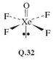
Back to Session 6 Activity 5

Question 22

Answer
Nitrogen has five valence electrons and four of them will be used in forming two bonds to oxygen. This leaves a single electron. We therefore have three repulsion axes with a trigonal-planar disposition, one of them being a single electron. Structure Q.33, in which the nature of the N—O bonds (dative or double) is nonspecific, shows this arrangment. A single non-bonded electron would be expected to exert a smaller repulsive effect than bonds or non-bonded pairs containing at least two electrons, so the angle α should be greater than 120°. The experimentally observed value is α = 134°.
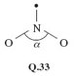
Back to Session 6 Activity 6

Question 44

Answer
The result is [N₂(g)] × [CO₂(g)]², or, taking the multiplication sign as understood, [N₂(g)][CO₂(g)]². In Equation 8.2, CO₂(g) is preceded by a two, so its concentration is squared.
Back to Session 7 SAQ 1

Question 45

Answer
The result is [NO(g)]²[CO(g)]²; in Equation 8.2, both NO(g) and CO(g) are preceded by a two.
Back to Session 7 SAQ 2

Question 46

Answer
It will be very small because the large quantities ([NO﻿(g)] and [CO﻿(g)]) occur on the bottom of Equation 8.5, and the small quantities ([N₂﻿(g)] and [CO₂﻿(g)]) occur on the top.
Back to Session 7 SAQ 3

Question 47

Answer
No; K is immense, so at equilibrium, the concentrations of the products (which appear on top of the fraction in Equation 8.5) must be much greater than those of the reactants (which appear on the bottom). The equilibrium position for Reaction 8.2 at 525 °C therefore lies well over to the right.
Back to Session 7 SAQ 4

Question 48

Answer
One possible source is the kinetic energy of other molecules. Lucky collisions may provide some NO and CO molecules with unusually high energies. If these high-energy molecules then chance to collide with each other, they might be able to surmount the energy barrier and react with each other.
Back to Session 7 SAQ 5

Question 23

Answer
The equilibrium constant of the first reaction, K₁, is given by

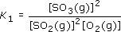

That of the second,

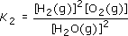

The data show that K₂ is tiny: at equilibrium, the concentrations of the hydrogen and oxygen in the numerator (the top line of the fraction) are minute in comparison with the concentration of steam in the denominator (the bottom line of the fraction). So in a closed system at 700 K, significant amounts of hydrogen and oxygen will never be formed from steam.
By contrast, K₁ is large, so the equilibrium position at 700 K lies well over to the right of the equation, and conversion of sulfur dioxide and oxygen to sulfur trioxide is favourable. The fact that the reaction does not occur must be due to a slow rate of reaction. We may therefore be able to obtain sulfur trioxide in this way if we can find a suitable catalyst to speed up the reaction. A suitable catalyst is divanadium pentoxide, V₂O₅, and at 700 K, this reaction is the key step in the manufacture of sulfuric acid from sulfur, oxygen and water. Figure 52 shows a similar comparison between uncatalysed and catalysed progress of reaction plots that would reflect the sulfur dioxide to sulfur trioxide conversion.
Back to Session 7 Activity 1

Video 1

Transcript
Narrator
There are six alkali metals; lithium, sodium, potassium, rubidium, caesium and francium. They're all soft metals which can be cut with a knife. In air the elements quickly become coated with compounds that form on the metals' surface. Here for example is lithium. When we slice it you can see the metallic lustre, but the black coating quickly reappears.
Sodium is kept under oil to prevent reaction with air. Again when we cut it the metal surface can be seen but this time corrosion occurs even more quickly.
With the next alkali metal, potassium, the corrosion in air is so quick that it's hard to see the metallic lustre at all. As we go down the group the elements seem to react more quickly with air.
Now let's see another reaction of the alkali metals, the reaction with water. We'll start with lithium. The metal floats on the water and reacts with it, giving off hydrogen gas.
Now for sodium; the same sort of thing happens although the reaction is a bit more vigorous. All the alkali metals react with water in the same way. Let's see an equation for the reaction. Hydrogen gas is produced and the metal dissolves to give an aqueous cation with a single positive charge.
Now for potassium; this time you'll see a flame. The heat given out by the reaction is produced so quickly that the hydrogen gas catches fire. It burns with a lilac flame.
The next element is rubidium. this time we put a safety screen between us and the reaction. You can see that things gradually become more terrifying as we go down the group.
Let's try caesium, our fifth alkali metal.
Back to Session 2 MediaContent 1

Video 2

Transcript
Narrator
Here are the four halogen elements, fluorine, chlorine, bromine and iodine. Fluorine on the left is almost colourless. Next comes chlorine which is greenish yellow. Fluorine and chlorine are both gases at room temperature. But bromine is a liquid and iodine is a solid; even so, they're both quite volatile. You can see the coloured vapours - orange-red above the liquid bromine and purple above the solid iodine.
Whether solid, liquid or gas, the halogen elements consist of diatomic molecules; F2, Cl2, Br2 and I2.
Fluorine reacts, often ferociously, with almost everything else. A stream of fluorine instantly sets iron wool on fire and it does the same thing to charcoal. Now lets see the reaction with hydrogen. There's hydrogen in the balloon. A jet of fluorine gas pierces the balloon and explodes with the hydrogen inside. Let's see it again in slow motion. Now you can see the fireball more clearly.
Now the reaction between hydrogen and chlorine. I light the hydrogen at the jet and lower it into a jar of chlorine. The hydrogen carries on burning but with a pale blue flame.
When the halogens react with hydrogen, the hydrogen halides are produced; HF, HCl, HBr and HI. In each compound the halogen has a valency of one. All four compounds are gases.
They're also very soluble in water. Here's water swallowing a jar of hydrogen chloride.
Now let's see how the halogens react with aluminium. When aluminium powder meets fluorine gas the reaction's over in a flash.
To get chlorine to react with aluminium, I'll heat some foil in a stream of the gas. The white fumes are aluminium trichloride.
With bromine I just drop aluminium foil into the liquid. There's a short delay but normal service is soon resumed. Once the reaction gets going it quickly takes on the appearance of the pit of hell. As with the chlorine reaction there's white smoke; that's aluminium tribromide.
The reaction with iodine is just as spectacular. A little warming helps to get things moving, but once the reaction's off it needs no further assistance.
The products of all four of these reactions are white solids and they're all trihalides, AlF3, AlCl3, AlBr3 and AlI3. Now aluminium is a trivalent element so in these compounds the halogens are all showing a valency of one. That valency of one is also satisfied when the halogen atoms bind to one another in the diatomic molecules with which I started this sequence.
Back to Session 2 MediaContent 2

Video 3

Transcript
Narrator
This emphasis on the formulae of compounds; on the ratios in which atoms combine and what Mendeleev knew as the valencies of the elements lies at the heart of the periodic law. Without it the law would often seem ridiculous. For example look at these elements, silicon and carbon. They lie at the top of Group IV.
One form of carbon is diamond. Now you may have read somewhere that diamonds are forever. After you've seen this, you'll never believe that again. (a diamond is heated and placed in liquid oxygen)
So when diamonds burn they form a gas. As you can see it's quite heavy. Now we could have burned silicon in the same way but the product wouldn't have been a gas it would have been this. This is the oxide of silicon. It's some sand that I picked up on a Norfolk beach. So when carbon and silicon are burnt in oxygen the products look completely different; they have completely different structures too but they both have the same kind of formula. They're both dioxides. In both compounds there are two oxygen atoms for every carbon or silicon atom. It was this similarity in the formulae of the highest oxides that led Mendeleev to put carbon and silicon in the same group.
Back to Session 2 MediaContent 3

Video 4

Transcript
Narrator
It's not difficult to bring a little colour to the chemistry of vanadium. If I dissolve sodium vanadate in dilute acid I get this solution. It's yellow because it contains the ion (VO2)+. I'm going to shake this solution with zinc amalgam which is made by stirring up zinc with mercury. The first new product has a rich blue colour. This is the ion VO2+. More shaking gives us the bottle green tripositive ion V3+. There's one more stage and a lot of shaking to go. Eventually the lavender colour of the aqueous dipositive ion V2+ appears. Here's a shot of the starting material and our three products. Chemistry doesn't come much prettier than this.
Back to Session 2 MediaContent 4

Video 5

Transcript
Narrator
In this section we give you the chance to look more closely at the lanthanide elements and their chemistry. For now let’s shrink the main table.
First of all, the lanthanides are all metals. Here's a selection. Here’s lanthanum … samarium … dysprosium.
If it's heated in chlorine dysprosium forms a trichloride, and all the other lanthanide metals do the same. Chlorine oxidizes all of them to the +3 oxidation state. But the simplest way of reaching this oxidation state is to dissolve the metals in dilute acid.
Here's praseodymium. Hydrogen is evolved, and if the reaction is done in air, then whatever the lanthanide metal, the final product is the aqueous tripositive ion. In this case it's green.
Compounds or ions in other oxidation states are much less stable. For instance the dipositive aqueous ion of samarium can be made. It's blood red. But it's quickly oxidized by water or hydrogen ions to the pale yellow tripositive ion. The highest known oxidation state of any lanthanide element is +4. The most stable example is cerium(IV) which occurs in cerium dioxide. This is almost colourless. Sulfuric acid converts the dioxide to a sulfate of cerium(IV). It consists of orange crystals. When the orange sulfate is dissolved in water, the orange tetrapositive aqueous ion is formed. But even cerium(IV) species are easily reduced to the +3 state. We'll use hydrogen peroxide as the reducing agent and add it to the orange aqueous ion. Oxygen is evolved as cerium(IV) is reduced. The colourless product is the aqueous tripositive ion of cerium.
So for all of the lanthanides the +3 state is very stable to oxidation or reduction. the lanthanide series which begins with lanthanum and ends with ytterbium is a set of unusually similar elements. Take a little time to study the pictures and information that we've provided on the different metals. And as you examine the reactions with acid ask yourself how these elements differ from the reactions that you studied earlier in the transition metal program.
Back to Session 2 MediaContent 5

Video 6

Transcript
Narrator
The aqueous tripositive ion of uranium is an intense claret colour. When air is bubbled through it, oxidation occurs. A green solution of uranium(IV) is formed. Let’s take some of this uranium(IV) and add nitric acid. On heating the solution gradually turns yellow. This is a solution of the uranyl ion; uranium in oxidation state six. So these are the common oxidation states of uranium in aqueous solution. Yellow uranium(VI), green uranium(IV) and claret-coloured uranium(III).
Back to Session 2 MediaContent 6

Video 7

Transcript
Narrator
Here's the key step in nuclear fuel reprocessing. A mixture of uranium and plutonium in kerosene oil has been shaken with hydroxylamine and nitric acid in water. Now it's all settling out. Before shaking, the kerosene solution at the top was green. Now it's yellow. That's because it now contains only uranium as yellow uranyl dinitrate. The plutonium has moved into the lower aqueous layer as blue plutonium trinitrate. When the bottom layer is run off you have a solution of the blue, aqueous, tripositive ion of plutonium
Back to Session 2 MediaContent 7

