

S282_1 Astronomy

Comparing stars
About this free course
This free course is an adapted extract from the Open University course S282 Astronomy http://www3.open.ac.uk/study/undergraduate/course/s282.htm.
This version of the content may include video, images and interactive content that may not be optimised for your device.
You can experience this free course as it was originally designed on OpenLearn, the home of free learning from The Open University: http://www.open.edu/openlearn/science-maths-technology/science/physics-and-astronomy/comparing-stars/content-section-0.
There you'll also be able to track your progress via your activity record, which you can use to demonstrate your learning.
Copyright © 2016 The Open University
Intellectual property
Unless otherwise stated, this resource is released under the terms of the Creative Commons Licence v4.0 http://creativecommons.org/licenses/by-nc-sa/4.0/deed.en_GB. Within that The Open University interprets this licence in the following way: www.open.edu/openlearn/about-openlearn/frequently-asked-questions-on-openlearn. Copyright and rights falling outside the terms of the Creative Commons Licence are retained or controlled by The Open University. Please read the full text before using any of the content.
We believe the primary barrier to accessing high-quality educational experiences is cost, which is why we aim to publish as much free content as possible under an open licence. If it proves difficult to release content under our preferred Creative Commons licence (e.g. because we can't afford or gain the clearances or find suitable alternatives), we will still release the materials for free under a personal end-user licence.
This is because the learning experience will always be the same high quality offering and that should always be seen as positive - even if at times the licensing is different to Creative Commons.
When using the content you must attribute us (The Open University) (the OU) and any identified author in accordance with the terms of the Creative Commons Licence.
The Acknowledgements section is used to list, amongst other things, third party (Proprietary), licensed content which is not subject to Creative Commons licensing. Proprietary content must be used (retained) intact and in context to the content at all times.
The Acknowledgements section is also used to bring to your attention any other Special Restrictions which may apply to the content. For example there may be times when the Creative Commons Non-Commercial Sharealike licence does not apply to any of the content even if owned by us (The Open University). In these instances, unless stated otherwise, the content may be used for personal and non-commercial use.
We have also identified as Proprietary other material included in the content which is not subject to Creative Commons Licence. These are OU logos, trading names and may extend to certain photographic and video images and sound recordings and any other material as may be brought to your attention.
Unauthorised use of any of the content may constitute a breach of the terms and conditions and/or intellectual property laws.
We reserve the right to alter, amend or bring to an end any terms and conditions provided here without notice.
All rights falling outside the terms of the Creative Commons licence are retained or controlled by The Open University.
Head of Intellectual Property, The Open University
978-1-4730-1434-3 (.kdl)
978-1-4730-0666-9 (.epub)

Contents
- Introduction
- Learning outcomes
- 1 The Hertzsprung-Russell diagram
  - 1.1 Constructing the H-R diagram
  - 1.2 The main classes of stars
  - 1.3 How can we explain the distribution of stars on the H-R diagram?
  - 1.4 Stellar masses and stellar evolution
  - 1.5 Star clusters and stellar evolution
- 2 Observing through the interstellar medium
  - 2.1 Introduction
  - 2.2 Interstellar space is not empty
  - 2.3 The effect of interstellar gas
  - 2.4 The effect of interstellar dust
  - 2.5 Using stars to probe the interstellar medium
- 3 Summary
  - 3.1 The H-R diagram
- 4 Questions
- Conclusion
- Keep on learning
- Acknowledgements

Introduction
We can study the individual properties of individual stars, such as photospheric temperature, luminosity, radius, composition and mass. If we wish to understand more about stars and obtain some insight into their evolution, we need to look at the overall distribution of stellar properties. We would like to know the answers to such questions as 'Can stars have any combination of these properties?' and 'How many stars are there of each type?' We can potentially learn a lot more about the stars if we compare them, but what should be the basis of our comparison? We certainly want to use intrinsic properties, such as luminosity, and not properties that depend on the distance to the star, such as the flux density received on Earth. Also, as an initial step, we want to avoid properties that are well removed from what we actually observe. In this course we look at probably the most important diagram in stellar astronomy, the Hertzsprung-Russell diagram, and how it is used to identify the main classes of stars.
This OpenLearn course is an adapted extract from the Open University course S282 Astronomy.

Learning outcomes
After studying this course, you should be able to:
- describe and comment on the main features of a Hertzsprung-Russell diagram of stars in general, and of stars in a cluster
- outline a broad model of stellar evolution based on the observed properties of large numbers of stars, and describe how stars of different initial mass might evolve
- describe the effects of interstellar material on starlight, and outline some of the processes by which such material might be a source of electromagnetic radiation.

1 The Hertzsprung-Russell diagram

1.1 Constructing the H-R diagram
Three properties which are suitable for comparing stars are temperature, luminosity and radius. However, we don't need all three.

Question 1

Why not?

View answer - Question 1

Temperature and luminosity are more directly measurable for a far greater number of stars than radius, and so it is these two properties that are used, as shown in Figure 1. Each point displays the temperature and luminosity of a particular star: you should check that the values given for the Sun are in accord with the values given earlier. Note the logarithmic scales on both axes, and that temperature increases to the left.
Such a diagram is called a Hertzsprung-Russell diagram, or H-R diagram, after the Danish astronomer Ejnar Hertzsprung and the US astronomer Henry Norris Russell.

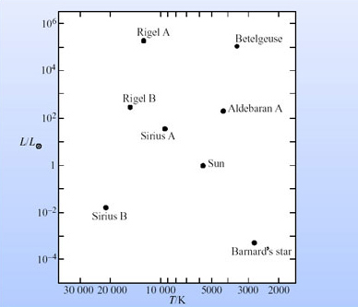
Figure 1 The Hertzsprung-Russell diagram for the Sun and a few nearby stars.

Ejnar Hertzsprung (1873-1967) and Henry Norris Russell(1877-1957)
Ejnar Hertzsprung (Figure 2a) born in Denmark, initially chose chemical engineering as a career because of the poor financial prospects in astronomy. However, after developing his astronomical skills as a private astronomer, he became Assistant Professor of Astronomy at Göttingen Observatory in Germany and then Professor and Director of Leiden Observatory in the Netherlands. He proposed the concept of the absolute magnitude of a star as its magnitude at a distance of 10 parsecs. In 1906 he plotted a graph of the relationship between the absolute magnitudes and colour of stars in the Pleiades and coined the terms red giant and red dwarf. He published his work in a photographic journal without the diagrams and they were unknown to other astronomers.
In 1913 Henry Norris Russell (Figure 2b), then Director of the University Observatory at Princeton, plotted Annie Cannon's spectral classification against absolute magnitude and found that most stars lay in certain regions of the diagram. The diagram, which became a fundamental tool of modern stellar astronomy, was eventually called the Hertzsprung-Russell diagram in recognition of their independent work. One of the first applications of the H-R diagram was in the development of spectroscopic parallax by Hertzsprung, using observations of Cepheid variable stars made by Henrietta Leavitt.

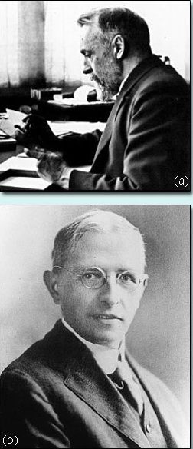
Figure 2 (a) Ejnar Hertzsprung and (b) Henry Norris Russell. ((a) Royal Astronomical Society; (b) Science Photo Library)

Question 1

Where, in the H-R diagram, do the following types of star appear: hot, high luminosity stars; hot, low luminosity stars; cool, low luminosity stars; cool, high luminosity stars?

View answer - Question 1

The H-R diagram in Figure 1 contains too few stars to give us an overall picture. Before we examine a diagram containing many more stars we can speculate on what we might find. Will we find that the stars are fairly uniformly peppered over the diagram, with, for example, as many hot, high luminosity stars as any other kind? Or will we find that certain combinations of luminosity and temperature are more common than others? In any general population there are usually more small things than big things, more faint things than bright, and more cool things than hot. Therefore we might expect there to be more stars towards the bottom of the H-R diagram and more towards the right. To some extent these explanations are borne out but with some surprises. When more data are plotted, more stars are found towards the bottom right of the H-R diagram (Figure 3) but there are also noticeable empty zones, and a striking locus from hot bright to cool faint stars. The shaded regions show where stars tend to concentrate: the darker the shading, the greater the concentration. Each concentration defines a particular class of stars, and we shall shortly examine each main class in more detail, but first let's add stellar radius to Figure 3.

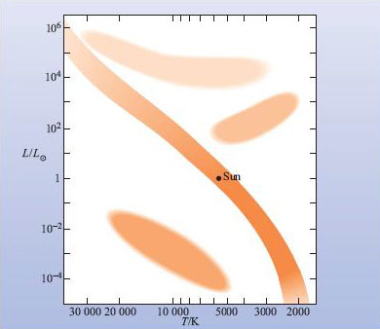
Figure 3 An H-R diagram, showing where stars tend to concentrate.

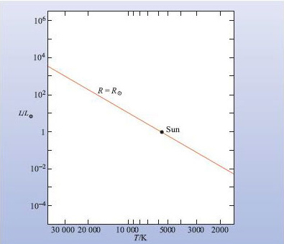
Figure 4 An H-R diagram, showing where stars of solar radius lie.

From the relationship between radius, temperature and luminosity in Equation A, we see that at each point in the H-R diagram there is a unique stellar radius, given by R = [L/(4σT⁴)]^{1/2}. Let's now add to the diagram lines of constant radius. For example, consider stars with a radius equal to that of the Sun, R⊙. From Equation A we see that any other star with the same radius will have its luminosity and temperature related by L ≈ (4R⊙²σ)T⁴. Thus, as T increases, L also increases since for a given radius, the hotter the star the more power it radiates. With T increasing to the left in the H-R diagram, this gives a line sloping upwards from lower right to upper left, as in Figure 4. The line is straight because we are using logarithmic scales.

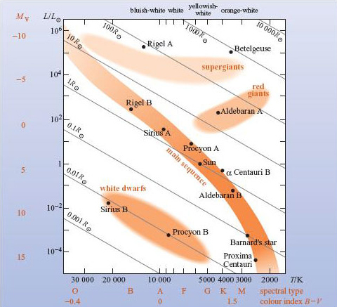
Figure 5 The H-R diagram in Figure 3, with the addition of stellar radii, and other information. (Adapted from Seeds, 1984)

Figure 5 is the H-R diagram in Figure 3 with several lines of constant radius added, and you can see that there are some classes of stars that are considerably smaller and some that are considerably larger than the Sun. These relative sizes are reflected in the names given to many of the classes, as shown in Figure 5; white dwarfs, red giants, supergiants. As you might expect, white dwarfs are small, red giants are large, and supergiants even larger.

Question 2

In terms of the Earth's radius, and the Earth's distance from the Sun, how large are white dwarfs and red giants?

View answer - Question 2

The class names are descriptive in ways other than size.

Question 2

Why white dwarfs, red giants?

View answer - Question 2

We have added to Figure 5 an indication of the colour associated with each temperature. However, to the unaided eye, star colours are in many cases not very striking. This is partly because too little light is being received for our colour vision to be strongly excited, and partly because the colours are, in any case, rather weak. However, stellar colours can be emphasized photographically (as you will see in Figure 14).
The H-R diagram can be represented in a number of different ways; the colour index of a star is a measure of its temperature and the spectral classification scheme is also a temperature sequence. Another way of representing stellar luminosity is through the absolute visual magnitude. It should be clear therefore that the luminosity axis of the H-R diagram could equally well be plotted as absolute visual magnitude and the temperature axis with spectral type or colour index. These kinds of diagrams are often used by astronomers as these are quantities that are obtained more directly from observation. A particular type of H-R diagram, called a colour-magnitude diagram, shows M_{v} against B - V. Figure 5 illustrates the approximate values of absolute visual magnitude and colour index as well as spectral type. The exact appearance of the H-R diagram will be slightly different when these alternative axes are used (e.g. the absolute visual magnitude M_{v} is directly related to the luminosity in the V band, L_{v}, and not the total luminosity L). Also, spectral type depends weakly on luminosity.
Let's now look at the main classes of stars in more detail.

1.2 The main classes of stars
The main classes of stars are shown in Figure 5.
The main sequence is 'main' in the sense that about 90% of stars fall into this class, and 'sequence' in the sense that it is a long, thin region that trails across the H-R diagram, covering a very wide range of temperatures and luminosities. The Sun is a main sequence star, of very modest temperature and luminosity, and correspondingly modest radius. It is yellowish-white. Sirius A is a main sequence star rather hotter than the Sun, and appears bluish-white. It has the greatest apparent visual brightness (most negative apparent visual magnitude!) of any star in the night sky. This is, as we have seen, not because it is very luminous, but because it is both fairly luminous and rather close - at 2.63 pc it's the seventh closest star after the Sun.
Above the lower part of the main sequence we come first to the red giants. These stars are cool, hence their orange tinge, and are of order 10 to 100 times larger in radius than main sequence stars of comparable temperatures. Thus if our Sun were a large red giant, its surface would extend a considerable distance towards the Earth (as we saw in Question 2)!

Question 3

If you knew that a red giant was larger than a main sequence star of comparable temperature, what could you say about its luminosity?

View answer - Question 3

The bright star Aldebaran A ( Tau) is a red giant. (It's actually a visual binary, but the red giant is dominant.)
Above and to the left of the red giants we come to the supergiants. These are larger, and thus more luminous than red giants of comparable temperature, but they also extend to higher temperatures, where they are larger and more luminous than main sequence stars of comparable temperature. Rigel A is a hot supergiant, which appears bluish-white whereas Betelgeuse is a cooler supergiant, and it appears distinctly orange-white.
Though we have not marked it on Figure 5, there is a class of stars that comprises the red giants plus the stars to their left that lie between the main sequence and the supergiants. This class is the giants and is broader than that of red giants alone.
You can see from Figure 5 that white dwarfs are, as their name implies, hot and small, only about the size of the Earth (Question 2). Consequently their luminosities are low. Indeed, there are no white dwarfs sufficiently close to us to be visible to the unaided eye. The closest is Sirius B, the faint companion to Sirius A, but its visual magnitude is only 8.4, well outside the limit of about 6 for very good, unaided human eyes, in the very best observing conditions. Even if it were a bit brighter, its light would be swamped by Sirius A, and we would still be unable to see it.
The width of spectral lines gives an indication of the luminosity of a star. We can now see how this is reflected in the H-R diagram and the description of stellar spectral types. Giant stars have narrower spectral lines than dwarf stars and stronger lines due to certain ionized atoms. These characteristics are used to define a luminosity class, designated by roman numerals I to V, with I being brightest. Class I is often sub-divided into Ia and Ib.
Figure 6 illustrates the positions of these luminosity classes on the H-R diagram.

Question 4

From your knowledge of the Sun's position on the H-R diagram, what is its luminosity class?

View answer - Question 4

The full designation of a star's spectral type also includes its luminosity class. The Sun is spectral type G2 V and Betelgeuse is spectral type M2 Ia.
White dwarfs are usually designated by a prefix 'D' or 'w' as in the case of Sirius B which is spectral type D A5 or w A5. Other suffixes are used for special characteristics such as 'e' for emission lines or 'p' for peculiar spectrum.

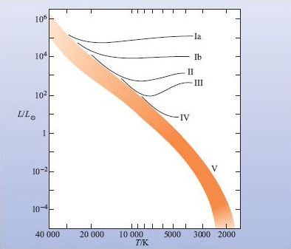
Figure 6 The H-R diagram indicating the approximate positions of luminosity classes I to V. Luminosity class V applies to the whole of the main sequence.

The tendency for stars to concentrate into certain regions of the H-R diagram is clearly meaningful. But what does it mean?

1.3 How can we explain the distribution of stars on the H-R diagram?
Here is a possible explanation for the concentration of stars into certain regions on the H-R diagram. It is based on the reasonable assumptions that:
- Any particular star is luminous for only a finite time;
- There are distinct stages between the star's cradle and grave, each stage being characterized by some range of temperature and luminosity; the star thus moves around the H-R diagram as it evolves;
- The stars we see today are not all at the same stage of evolution.
From these reasonable assumptions it follows that if we observe a large population of stars today, then the longer a particular stage lasts the greater will be the number of stars that are observed in that stage. Conversely, we will catch very few stars going through a short-lived stage.
We can thus explain the concentrations on the H-R diagram as those regions where the stars spend a comparatively large fraction of their lives. On this basis a star must spend most of its life on the main sequence, because this is where about 90% of the stars lie. Where it lies before it joins the main sequence, and where it goes afterwards, we cannot tell without further information, but the red giant, supergiant and white dwarf regions are where, on our assumptions, we might expect some stars to dwell for a while.
There are two other factors that influence the concentrations of stars on the H-R diagram. First, the concentration depends not only on how quickly a star passes through a region, but also on what fraction of stars pass through the region at all. Second, some regions of the H-R diagram might be bereft of stars simply because they correspond to stages in a stellar lifetime when stars tend to be shrouded in cooler material and are therefore not observable directly.
We clearly need more observational data to make further progress. Observations of individual stars actually evolving would be of enormous value. Can we see such evolution by making observations over a period of time?
Unfortunately, with very few exceptions, we can't. This is because stars evolve extremely slowly. We have good evidence that the Sun is about 4.5 × 10⁹ years old, and that it will be about as long again before it runs out of hydrogen fuel in its core. The lifetime of an astronomer, or indeed the whole history of astronomy, are both tiny fractions of this 4.5 × 10⁹ year timescale. Changes in the Sun and other stars in short times are usually small. No matter how obvious the changes in the Sun are to us, if we had to view the Sun as a star from a great distance they would be insignificant. However, some stars do change on short timescales - the spectacular supernovae and variable stars.
One type of supernova, the Type II supernova, marks the end of a supergiant star. Thus, Betelgeuse and Rigel A seem fated to disappear after a final blaze of glory, their luminosity rising 10⁸ times in a few days, followed by a few months of decline into oblivion, when they will vanish from the sky and from the H-R diagram.
All types of novae, which exhibit one or more short-lived outbursts, are in binary systems. In a minority of binary systems the two stars are so close together that they interfere with each other's evolution. In some cases, this will lead to one of the two undergoing a nova outburst. Observations of novae thus help us to understand disturbances to the normal course of stellar evolution, and this also helps us to understand the normal course itself.
The irregular variable T Tauri stars lie just above the main sequence on the H-R diagram (Figure 7) in a zone that covers a wide range of temperatures, including that of the Sun, and they lie among traces of the sort of interstellar material from which stars are thought to form. These observations suggest strongly that they are very young stars, about to settle on to the main sequence. Indeed, some T Tauri stars probably have been seen to do just this. Therefore, the early phase of stellar evolution can be elucidated by the study of these stars.
Cepheids and other types of regular pulsating variable stars also help us to understand some of the processes that drive evolution at certain stages in a star's life.
Have we now exhausted the main sources of observational data that help us to build models of the stars and of their evolution? No, there is one further property of enormous importance, and this is a star's mass.

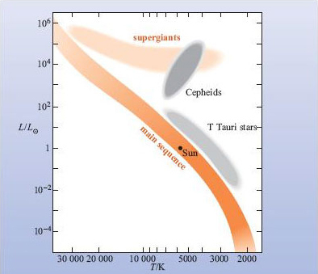
Figure 7 An H-R diagram, showing where the T Tauri stars and Cepheids lie.

Question 3

If most stars were to end their lives quietly, by gradually cooling at roughly constant radius, what sort of tracks would they make across the H-R diagram?

View answer - Question 3

1.4 Stellar masses and stellar evolution
Measured masses range from about 0.08M⊙ to about 50M⊙, a large range, with the Sun again showing up as an average sort of star. At the upper end we have some true monsters, but even at the lower end we have bodies that are still far more massive than the planets.

Question 5

What is the mass of a 0.08M⊙ star, in Earth masses?

View answer - Question 5

The lower the mass the greater the number of stars; the monsters are rare, and stars less massive than the Sun are more common than stars of around solar mass. These relative numbers, and the upper and lower mass limits, are all things that the stellar theories have to explain.
We can, however, throw some light on stellar evolution if we plot stellar masses on an H-R diagram. This is done in Figure 8, where a handful of representative stellar masses have been included. Note the following important features.
- The supergiants tend to be more massive than the red giants, which in turn tend to be more massive than the white dwarfs.
- Within each of the supergiant, red giant, and white dwarf classes, there is no correlation of mass with luminosity or photospheric temperature - the relationship is jumbled.
- Among the main sequence stars, mass correlates closely with luminosity, and hence with temperature: as mass increases, luminosity and temperature increase. (The increase in luminosity is enormous: the 500 to 1 increase in mass along the main sequence corresponds to a 10¹⁰ increase in luminosity.)
- In the lower part of the main sequence, the masses are comparable with the red giants, and in the upper part, with the supergiants.

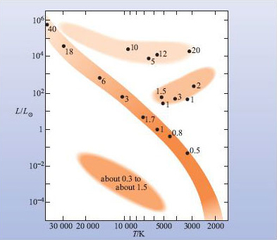
Figure 8 Stellar mass and the H-R diagram. Masses are given in multiples of M⊙.

Before we try to construct a model of stellar evolution based on these striking features, we have to address the question 'do stars change their mass during their evolution?' There is a good deal of observational evidence to help us to answer it. We observe main sequence stars, red giants and supergiants losing mass in the form of stellar winds streaming outwards. However, the accumulated totals of mass lost by stellar winds are estimated to be only a small fraction of the initial mass of a star. A more impressive mass loss is shown in Figure 9, where you can see shells of material that have been flung off by the central star. Such an object is misleadingly called a planetary nebula (plural: planetary nebulae), because it looks a bit like a planetary disc when viewed under low magnification. They can account for a substantial fraction of the star's mass. In passing, we note that the central star of a planetary nebula now occupies a region in the H-R diagram somewhat hotter and more luminous than the white dwarfs, and it is plausible that it could cool to become a white dwarf.

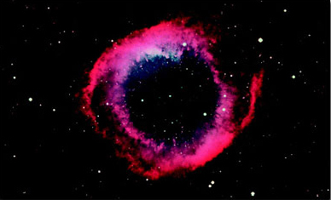
Figure 9 A planetary nebula: The Helix nebula is the result of a star losing its outer layers at the end of its life. The gas is really in a shell about the remnant of the star but it appears as a ring because we see through it most easily in the direction of our line of sight to the central star. (D. Malin/AAO)

Some stars end their lives more violently than by shedding a planetary nebula.

Question 6

What stars are these, and how do they end their lives?

View answer - Question 6

In fact, in a Type II supernova, most of the star's mass is blown away.
It thus seems to be the case that throughout most of the life of a star, severe mass loss occurs only when a planetary nebula is shed, with the resulting stellar remnant becoming a white dwarf, or when a massive star ends its life as a Type II supernova.
We are now in a position to suggest a plausible model for some of the stages of stellar evolution based on the features listed above, and on what we know about mass loss. During its main sequence phase, a star does not change its luminosity or photospheric temperature very much, otherwise it would move a good way along the main sequence, and this does not fit in with the large differences in mass along the main sequence (in fact, stars do drift very slightly above the main sequence, so it is a band rather than a narrow line on the H-R diagram). After the main sequence phase the less massive stars become red giants, and the more massive stars become supergiants: you can see that this is consistent with the masses in Figure 8. It is also consistent with the rarity of supergiants: there are very few main sequence precursors. Finally, red giants evolve to the point where they shed planetary nebulae, the stellar remnant evolving to become a white dwarf. Supergiants become star-destroying Type II supernovae.
We are thus continuing to unfold the story of stellar evolution. But there is one huge aspect of the story that, as yet, we have barely touched, and this is whether stars of different mass all evolve at about the same rate. Star clusters provide good observational evidence to help answer this question.

1.5 Star clusters and stellar evolution
Detailed observations of star clusters suggest that they occur because the stars in them form at about the same time. Moreover, the compositions of the stars are similar. Isolated stars (including isolated binary stars) result from the later partial or complete dispersal of a cluster.
The crucial points for us here are that all the stars in a cluster formed at about the same time, and all have similar compositions.

Question 7

Why are these the crucial points?

View answer - Question 7

These relative rates are conveniently revealed by plotting the H-R diagram of a cluster. Figure 10 shows two contrasting cases: the Pleiades, and a cluster that has only a catalogue number, M67 (the 67th object in a catalogue of nebulae that may be confused with comets, produced by French comet hunter Charles Messier (1730-1817)). In the case of the Pleiades, almost all the stars are on the main sequence, suggesting that this cluster is not old enough for many stars to have reached the end of this phase. The most luminous stars visible on this diagram appear to be moving away from the main sequence. The upper end of the main sequence, where the most massive stars are expected to lie (Figure 8), is unpopulated in this cluster. For the Pleiades, the most massive stars have already left the main sequence and therefore must have shorter main sequence lifetimes. In fact, the point at which this depopulation occurs, called the main sequence turn-off, is used as an indicator of the ages of clusters. The case of M67 (Figure 11) is the subject of Question 4.

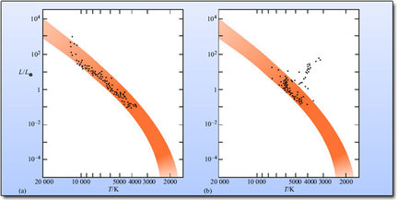
Figure 10 The H-R diagrams of two star clusters: (a) The Pleiades; (b)M67.

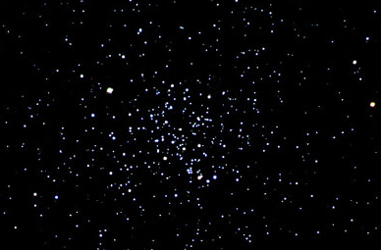
Figure 11 This cluster, M67, is one of the oldest open clusters known, at around 3 × 10⁹ years (almost the age of the Sun). (N. A. Sharp, M. Hanna/NOAO/ AURA/NSF)

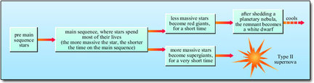
Figure 12 A model for stellar evolution.

We have come a long way in constructing a plausible model of stellar evolution, and it is summarized in Figure 12. We have described some of the observational basis of this model; further observations not only support it, but fill in some of the missing details. However, the time has now come to move away from pure observations as the sole basis for model building, and to involve a powerful body of physical theory in the modelling process. In the following sections we thus continue to develop the story of the stars, and of their evolution, but with considerable reliance on physical theory. This will necessarily involve us in modelling not only external events, but also stellar interiors.

Question 4

Figure 10b shows the H-R diagram of the star cluster M67. (a) Discuss whether this is consistent with the model of stellar evolution in Figure 12. (b) Why is it reasonable to conclude that M67 is older than the Pleiades?

View answer - Question 4

2 Observing through the interstellar medium

2.1 Introduction
In all the analysis of stellar properties discussed so far we have made an implicit assumption - that light emitted by a star is not changed between its emission and its arrival outside the Earth's atmosphere, except by the inverse square law (i.e. it is reduced by a factor of d², where d is the distance to the star) and by the Doppler effect. However, this may not be the case.

Question 8

What will happen to the position of a star on the H-R diagram if interstellar material causes a reduction in its brightness?

View answer - Question 8

We will now investigate some of the properties of the interstellar material and how it affects the radiation we observe from stars.

2.2 Interstellar space is not empty
The difference between the apparent brightness of a star (as measured by its apparent magnitude), and its luminosity (represented by its absolute magnitude) is defined by the distance of the star. We can explicitly state this relationship as in Equations B and C:

where L, F and d are respectively the luminosity, flux density and distance of the star, M and m are the absolute and apparent magnitude and d the distance in parsecs.
However, in stating this relationship we are making the assumption that there is no intervening material that could alter the amount of light from the star that reaches the observer. In fact, interstellar space is not empty and some light is absorbed by gas and dust.
Let's imagine a star for which the visible flux density F_{v} is measured and its luminosity is derived using the method of spectroscopic parallax.

Question 9

If we derive the distance of the star using Equation B rearranged, d = [L_{v}/(4F_{v})]^{1/2}, how would the interstellar absorption affect the result?

View answer - Question 9

Conversely, if the distance to a star is known then the luminosity of the star will be underestimated if there is interstellar absorption present that is not accounted for.
In order to take account of this absorption, Equation D is written

where A is the absorption in magnitudes. The value of A depends on the amount of material between the star and the observer and how efficiently that material absorbs the light. That efficiency depends on the composition of the material and the wavelength of light being observed.
We have used the term absorption rather loosely here. In fact, there are a range of processes which remove energy from the beam of light coming from the star in the direction of the observer (and some that add to it!).
Until as recently as the 1920s, most astronomers believed that interstellar matter was confined to a handful of isolated clouds, some glowing brightly (e.g. the Orion nebula, shown in close-up in Figure 13) and some, through their obscuration of stars, appearing dark, as in Figure 14. The truth began to emerge from long-exposure photographs, which showed that such clouds are far more common than had previously been thought. Furthermore, by 1930 it had become clear that interstellar matter is not confined to such clouds, but is widespread in the spaces between them. There were three pieces of evidence for this.

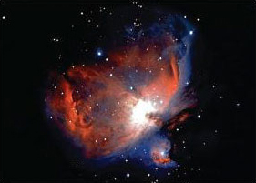
Figure 13 The Orion Nebula. The gas, mainly hydrogen, is made to glow, in the main, by four very bright, massive stars that are located in the centre of the brightest region. These stars are called 'The Trapezium' and are part of a very young cluster of a few hundred stars born less than a million years ago. The dense cloud that gave birth to this cluster is apparent through the obscuration caused by the dust in it. The glowing gas is just on our side of the cloud and is material left over after star formation. (NASA)

First, it had already been observed that, in many directions in space, there are absorption lines in stellar spectra that, for various reasons, could not have originated in the stellar atmospheres, but must have originated in cool gas between us and the star. For example, the lines are very narrow, suggesting that they originate in a medium far cooler and less dense than a stellar atmosphere. In a stellar atmosphere the higher random thermal speeds of atoms or ions mean that they may be moving towards or away from an observer when they are absorbing photons. This causes a blue- or red-shift (due to the Doppler effect relative to the average position of the line. In addition, the higher densities in stellar atmospheres cause broadening of lines ('pressure broadening').
Secondly, a characteristic type of attenuation of starlight had been observed in many directions in space, and it had been shown that this is caused by dust particles with sizes of the order of the wavelength of visible light, about 10⁻⁶ m. This dust attenuates starlight, partly by absorbing it and partly by scattering it. You can picture scattering as a process in which photons bounce off particles in random directions, and so some of the photons that were travelling towards us from the star do not reach us. Scattering plus absorption is called extinction.
Thirdly, not only did stars in distant clusters appear to be fainter than expected, they were also redder than expected. This change in colour is a result of the greater effectiveness of the dust grains at scattering shorter wavelengths (we will discuss this further in Section 2.4).

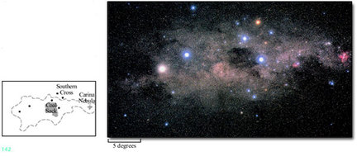
Figure 14 A panorama of the Southern Skies in the direction of the centre of the Galaxy. The dark region at centre right is known as the Coal Sack. It is not a star-free tunnel but a cool dense cloud, the dust in it obscuring the light from the stars behind. The reddish glow at far right is the Carina Nebula, a glowing gas cloud lit by young stars embedded in it. Near the Coal Sack is the famous Southern Cross. Note that the different star colours have been exaggerated in this image. (Photo: Akira, Fujii, Tokyo)

Today, the interstellar medium (often shortened to ISM) is studied at a great variety of wavelengths. These studies allow astronomers to determine the composition of the gas, and to infer the likely composition of the dust. Such studies also reveal the temperatures, densities, motions, and magnetic fields within the ISM.

2.3 The effect of interstellar gas
You have seen that the ISM has been studied through the radiation that the gas and dust absorb, emit and scatter. Figure 15 summarizes the differences between these three phenomena.
Let's first consider the three phenomena in relation to the gas. The gas scatters very little light and so we need only consider absorption and emission of radiation. You have already met absorption and emission of photons by atoms (which we shall call photoexcitation and photoemission, respectively). Atoms can also be excited by collisions between each other as the result of their random thermal motion (collisional excitation). For thermal motion, the average translational kinetic energy of an atom E_{k} is related to the temperature T of the gas via

where k is the Boltzmann constant. For a reasonable proportion of such collisions to be sufficiently energetic to excite an atom, E_{k} must be at least as large as the difference in energy between the excited and non-excited state, ε. So in order to obtain E_{k} ≥ ε we require

for collisional excitation to be important.
The most prominent lines from atoms in the interstellar medium are those of ionized calcium. Although these lines are also prominent in the spectra of stars of spectral class G and K due to ionized calcium in their atmospheres, the interstellar lines have very different characteristics. They are much narrower than the stellar spectral lines. Also, even though they are often much fainter than the stellar lines they are usually observable because their wavelengths are Doppler shifted due to the difference in radial velocity of the interstellar gas and the star itself. In spectroscopic binaries you can see the interstellar lines remaining at a fixed wavelength while the stellar lines move due to their orbital motion.
The processes of photoemission, photoexcitation and collisional excitation also operate in molecules, which are found in many parts of the ISM. Molecules are formed when atoms are bound together by chemical bonds. The electrons are 'shared' between the atoms (you could visualize this as an electron cloud surrounding the nuclei). The electrons in molecules occupy particular energy levels in a similar way to individual atoms (even though the electrons are 'shared'). Electronic transitions can take place leading to excitation, de-excitation and ionization of the molecule. The molecules also have discrete vibrational and rotational energy states and so can also undergo vibrational and rotational transitions. The vibrational energy states correspond to particular internuclear distances; when the distance becomes so large the atoms are no longer bound together, dissociation has occurred. A molecule can also rotate at different rates (and about different axes) resulting in discrete rotational energy states. At the molecular level, vibration and rotation, like electron energy, is quantized, contrary to our expectations from the large-scale world where we observe an apparently continuous range of these properties. Let's look at each of these in turn. The CO (carbon monoxide) molecule is a simple case that serves to introduce the important ideas.

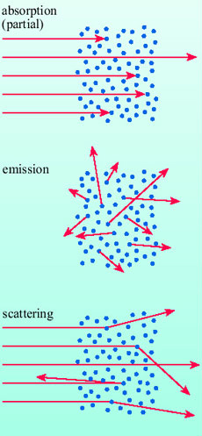
Figure 15 Absorption, emission and scattering of radiation.

Figure 16 shows the electronic energy levels of the CO molecule. The levels above the lowest one correspond to the various excited states of just one of the 14 electrons that this molecule contains, in particular one of the outermost electrons, which are the least tightly bound and thus require less energy to excite them than the inner, more tightly bound electrons. For comparison, the electronic energy levels for atomic hydrogen are also shown. The excitation of a CO molecule from a lower electronic energy level to a higher one can happen through photoexcitation or through collisional excitation.

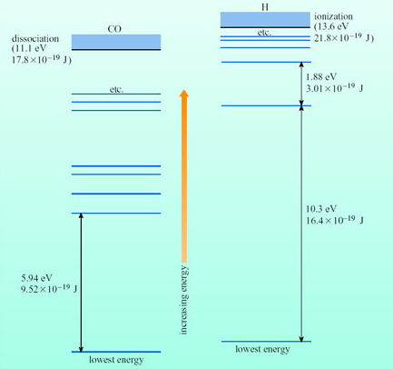
Figure 16 Electronic energy levels in CO and in H.

Question 5

For the excitation of CO from its lowest electronic energy level to the one above it, calculate (a) the maximum photon wavelength for photoexcitation and (b) the minimum gas temperature for appreciable collisional excitation.

View answer - Question 5

Thus, CO remains in its lowest electronic energy level unless it is exposed to photons at least as energetic as those in the near-UV region, or is at a temperature of order 10⁵ K, or greater. These are the same sorts of criterion obtained for many atoms, and for many other molecules too, though in some atoms and molecules the lower electronic levels are not quite so widely spread.
Not all electronic excitations require such large energies. Thus, the higher electronic energy levels (Figure 16) are much more closely spaced, and excitations among them can be achieved by longer wavelength photons, and at lower temperatures.
A vibrational transition of CO is illustrated schematically in Figure 17, along with the lowest few vibrational energy levels for the case in which the molecule remains in the electronic state corresponding to the lowest electronic energy level. Note how much smaller are the gaps between the energy levels than is the case for the electronic transitions in Figure 16. This means that photoexcitation can take place at infrared (IR) wavelengths, and collisional excitation at temperatures down to the order of 10³ K. These criteria are typical for vibrational transitions in molecules.
A rotational transition of CO is illustrated schematically in Figure 18, along with the lowest few rotational energy levels corresponding to the lowest energy electronic and vibrational states. The energy gaps are yet smaller, and photoexcitation can now be caused by microwaves, and collisional excitation occurs at temperatures down to the order of a frigid 10 K. Again, these criteria are typical, though many molecules have even smaller rotational energy gaps, and a few have much larger gaps.
A transition from a lower to a higher energy level can also involve some combination of electronic, vibrational and rotational energy changes, necessarily so in some cases.

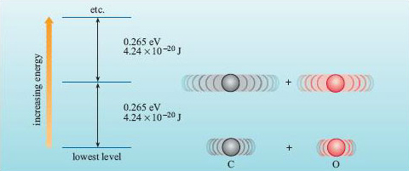
Figure 17 Vibrational transitions and vibrational energy levels in CO. To the right are the vibrational states corresponding to the lowest two energy levels.

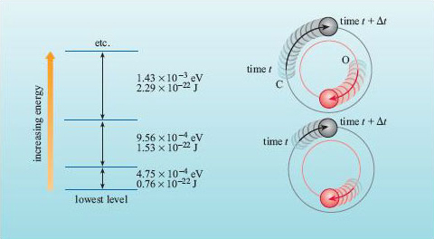
Figure 18 Rotational transitions, and rotational energy levels in CO. To the right are the rotational states corresponding to the lowest two energy levels.

Photoemission is the reverse process of photoexcitation, and so yields photons at wavelengths equal to those that would have caused photoexcitation between the two levels concerned.
Not all transitions involving photoexcitation and photoemission are equally probable, and so some spectral absorption and emission lines tend to be far weaker than others, and some are completely absent. Molecules consisting of two identical atoms, such as H₂, have particularly weak vibrational and rotational lines.
We have examined the processes which can cause interstellar atoms and molecules to absorb or emit radiation; let's now see what happens to starlight passing through a cloud of interstellar gas. Figure 19 illustrates what is seen by observers when the cloud is in the line of sight to the star and when it is out of the line of sight. Note that the prominent absorption lines in the spectrum of the star arising from the stellar photosphere are seen by the observer in the line of sight (Figure 19b) together with the superimposed, generally narrower, interstellar lines.

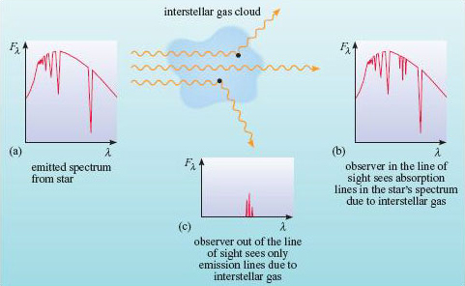
Figure 19 The effect of interstellar gas on radiation from a star. (a) is the spectrum emitted from the star. Spectrum (b) is seen by an observer looking at the star through the gas cloud, while spectrum (c) is seen by an observer looking at the gas cloud against a star-less background.

2.4 The effect of interstellar dust
Let's now consider the dust. Photoexcitation (by absorption of photons) and collisional excitation (by atoms/molecules) occur in the atoms and molecules that constitute the surface of a dust grain. Much of this energy is shared throughout the grain, raising its temperature until thermal radiation from the grain balances the energy absorbed. An alternative fate for an incident photon is to be scattered (Figure 15), a process that is very efficient at certain wavelengths. Figure 20 illustrates what is seen by observers when a cloud of interstellar dust is in the line of sight to the star and when it is out of the line of sight. The typical size of the interstellar dust grains means that they scatter short wavelengths most efficiently. This means that relatively more blue light is removed from the star's spectrum after passing through the cloud and it therefore appears redder when viewed from behind the cloud (position b in Figure 20). This process is called interstellar reddening. If the cloud is observed from out of the line of sight to a star then the dust cloud can appear as a faint blue glow from the scattered starlight.

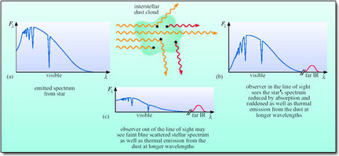
Figure 20 The effect of interstellar dust on radiation from a star. (a) is the spectrum emitted from the star. Spectrum (b) is seen by an observer looking at the star through the dust cloud, while spectrum (c) is seen by an observer looking at the dust cloud against a star-less background.

The combined effects of absorption and scattering (extinction) by interstellar dust are shown in Figure 21. Note how the extinction increases strongly through visible wavelengths, and on into the UV. Note also how broad the spectral features are, which makes it difficult to determine the composition of the dust from such spectral studies. Not much more about composition is revealed by the emission spectrum of the dust, which is a broad smooth thermal spectrum, depending on the dust temperature, the particle size, and only weakly on its composition. At 20 K, the dust emission lies right across the far-IR and microwave parts of the spectrum.

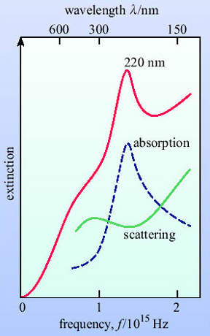
Figure 21 Extinction by interstellar dust: the top curve is the sum of the other two. The extinction is measured in magnitudes per unit distance (usually per kiloparsec).

We have seen that absorption of starlight by interstellar dust can cause stars to appear fainter than they should and therefore cause us to overestimate their distance or underestimate their luminosity. In addition, interstellar reddening can cause stars to appear redder than they should. Since colours, as measured by the colour index, are often used to infer temperature, the temperature can also be underestimated. If plotted on the H-R diagram a star will appear in the wrong place if the effects of interstellar absorption and reddening are not accounted for.

Question 6

A star like our Sun is located in a star cluster at a known (large) distance and is subject to significant interstellar extinction. If its absolute visual magnitude m^{V} is derived from its apparent visual magnitude m_{v} using Equation C and its temperature determined from its observed colour index, B - V, what will be the effect on its position in the H-R diagram (Figure 5)? Explain how its true position can be determined if its spectrum is observed.

View answer - Question 6

2.5 Using stars to probe the interstellar medium
The effects of interstellar material on starlight can be used to probe the properties of the interstellar medium itself. A few examples are:
- The presence of particular interstellar atoms or molecules may be determined by identifying the observed spectral lines or bands.
- The temperature of the gas may be determined from the relative strengths of different lines or bands produced by different energy state changes of the same atom or molecule.
- The Doppler shift of spectral lines from interstellar gas can be used to infer the radial velocities of interstellar clouds along the line of sight to a star.
- The amount of dust along the line of sight may be inferred from the reddening if the true colour of a star can be determined independently and compared with the observed colour.
From these and other observations we have a general picture of the interstellar medium:
The chemical elements are present in relative abundances that are not very different from the Solar System abundances. Thus, the relative percentages of atomic nuclei of hydrogen, helium and 'heavy' elements (atomic number Z > 2), are approximately 92% : 7.8% : 0.2%, though the proportion of an element present as ions, atoms, or combined in molecules or dust, does vary in different regions of the interstellar medium.
Dust accounts for roughly 1% of the mass of most types of region. The particles are very small - about 10⁻⁷ m to 10⁻⁶ m in diameter - and consist of some fraction of each of the less volatile substances found in the ISM, such as carbon and silicates. In the cooler regions of the ISM, substances with greater volatility also condense to form icy coatings on the grains, so there are regional differences in the composition of the dust. The gas is always dominated by hydrogen and helium, which are abundant and very volatile.
There is a wide variety of conditions present in different regions of the interstellar medium, with temperatures ranging from a few kelvin in dense star-forming regions to 10⁶ K in supernova remnants. Densities vary from ~10³ atoms per m³ in rarefied regions of the ISM to more than 10¹⁰ atoms per m³ in dense clouds.
The various types of region are far from quiescent, being racked by internal motions, and by physical and chemical transformations, often rapid compared with many astronomical changes. Each type of region is also highly structured, and far from uniform.

3 Summary

3.1 The H-R diagram
- The Hertzsprung-Russell (H-R) diagram displays the photospheric temperatures and luminosities of the stars. The corresponding radii are obtained from Equation A. The H-R diagram is a very useful aid to our understanding of the stars and their evolution.
- The stars tend to concentrate into certain regions of the H-R diagram, and so some combinations of temperature and luminosity occur far more commonly than others. These concentrations define various classes of stars, the main classes being main sequence stars (about 90% of observed stars), red giants, supergiants, and white dwarfs.
- We can explain the concentrations on the H-R diagram as places where stars spend comparatively large fractions of their lives, the main sequence phase accounting for the largest fraction.
- Different types of variable stars help our understanding of stellar evolution. The supergiant phase ends in a Type II supernova - a huge explosion that destroys the star. The T Tauri stars (one type of irregular variable) seem to be on the threshold of joining the main sequence, approaching it from above on the H-R diagram. Regular variables, such as the Cepheids, give us clues about some of the processes that are of importance in stellar evolution. The novae (another type of irregular variable) help us to understand disturbances to the normal course of evolution that occur in binary systems, and this aids our understanding of the normal course itself.

3.1.1 Stellar masses and stellar evolution
- Measured stellar masses range from about 0.08M⊙ to about 50M⊙, with stars of lower mass being more common.
- Stars lose a rather small fraction of their masses during much of their lifetimes, but much larger fractions when they shed planetary nebulae, or when they undergo supernova explosions.
- When stellar masses are placed on an H-R diagram, and coupled with observations of mass loss, we obtain important clues to stellar evolution, leading us to a plausible model of some of the stages, as follows:
  - after the main sequence phase the less massive stars become red giants, and the more massive stars become supergiants
  - red giants evolve to the point where they shed planetary nebulae, the stellar remnant evolving to become a white dwarf
  - supergiants end their lives as star-destroying Type II supernovae.

3.1.2 Star clusters and stellar evolution
- Since all the stars in a cluster formed at about the same time, and all have similar compositions, they provide a powerful tool for the study of stellar evolution.
- The lack of massive stars lying at the top of the main sequence in clusters indicates that they evolve fastest. The ages of clusters are inferred from the position of the main sequence turn-off.

3.1.3 Observing through the interstellar medium
- Material in the interstellar medium absorbs radiation. An extra term, A, the absorption in magnitudes, is required in Equation C:

- Radiation is both scattered and absorbed by interstellar matter. The combined effect of scattering and absorption is called extinction.
- Atoms (and molecules) can be excited by collisions as well as by absorption of photons.
- Molecules have quantized vibrational and rotational energy states in addition to electron energy states. The energy gaps for vibrational and rotational states are generally much smaller than for electronic states so photoexcitation of (and photoemission from) vibrational states occurs at infrared wavelengths and of rotational states at microwave wavelengths.
- Interstellar dust causes greater extinction at short wavelengths. Distant stars therefore appear fainter and redder due to interstellar extinction.
- The properties of the interstellar medium itself can be inferred from its effects on starlight.

4 Questions

Question 7

In what ways, if any, does the distance to a star influence its position on an H-R diagram?

View answer - Question 7

Question 8

The photospheric temperatures and luminosities of five stars that are visually fairly bright in the sky are given in Table 1.

Table 1
Star | 77K | L/W
Alkaid(η UMa) | 17000 | 6.1 × 10²⁹
Alcyone (in the Pleiades) | 12000 | 3.2 × 10²⁹
ε Eridani | 4700 | 1.4 × 10²⁶
Propus (η Gem) | 3000 | 4.2 × 10²⁹
Suhail(λ Vel) | 2600 | 1.8 × 10³⁰

(a) Plot these stars on an H-R diagram (such as Figure 5), and hence try to assign each star to one of the main stellar classes described in Section 2.2.
(b) Suppose that we were to compare stars by preparing an H-R diagram that includes only the stars with the greatest apparent visual brightness. Discuss why such a diagram would be unrepresentative of stars as a whole.

View answer - Question 8

Question 9

In terms of photospheric temperature, luminosity and radius, compare the Sun with other main sequence stars.

View answer - Question 9

Question 10

Given that T Tauri stars become main sequence stars with little change in photospheric temperature, discuss whether this transition is accompanied by a change in stellar radius.

View answer - Question 10

Question 11

Discuss whether we can rule out the evolution of red giants to form supergiants.

View answer - Question 11

Conclusion
This free course provided an introduction to studying Science. It took you through a series of exercises designed to develop your approach to study and learning at a distance, and helped to improve your confidence as an independent learner.

Keep on learning



Study another free course
There are more than 800 courses on OpenLearn for you to choose from on a range of subjects.
Find out more about all our free courses.

Take your studies further
Find out more about studying with The Open University by visiting our online prospectus.
If you are new to university study, you may be interested in our Access Courses or Certificates.

What's new from OpenLearn?
Sign up to our newsletter or view a sample.

For reference, full URLs to pages listed above:
OpenLearn - www.open.edu/openlearn/free-courses
Visiting our online prospectus - www.open.ac.uk/courses
Access Courses - www.open.ac.uk/courses/do-it/access
Certificates - www.open.ac.uk/courses/certificates-he
Newsletter - www.open.edu/openlearn/about-openlearn/subscribe-the-openlearn-newsletter

Acknowledgements
Course image: Aaron Landry in Flickr made available under Creative Commons Attribution-NonCommercial-ShareAlike 2.0 Licence.
The content acknowledged below is Proprietary (see terms and conditions) and is used under licence.
Grateful acknowledgement is made to the following sources for permission to reproduce material in this course:
The following appears in Chapter 4 'Comparing stars' from An Introduction to the Sun and Stars, published in association with Cambridge University Press (2004) which has been adapted for openlearn:
Figure 2a © The Royal Astronomical Society;
Figure 2b Science Photo Library;
Figure 5 adapted from Seeds, M.A. (1984) Foundations of Astronomy, Thompson Learning Global Rights Group;
Figure 9 Anglo-Australian Observatory, photograph by David Malin;
Figure 11 Nigel Sharp, Mark Hanna/AURA/NAO/NSF;
Figure 13 NASA;
Figure 14 © Akira, Fujii, Tokyo.
Figure 13 NASA
Don't miss out:
If reading this text has inspired you to learn more, you may be interested in joining the millions of people who discover our free learning resources and qualifications by visiting The Open University - www.open.edu/openlearn/free-courses

Question 1

Answer
Since stars emit like black bodies, temperature, luminosity and radius are related, via Equation A:

where L, R and T are respectively the luminosity, radius and temperature of the star, and σ is a constant. Thus, if we know any two, we can obtain the third.
Back to Session 1 SAQ 1

Question 1

Answer
The positions in the H-R diagram of these types of star are as follows:

hot, high luminosity stars | top left
hot, low luminosity stars | bottom left
cool, low luminosity stars | bottom right
cool, high luminosity stars | top right

Back to Session 1 Activity 1

Question 2

Answer
From Figure 5, we see that white dwarfs have radii of order 0.01R⊙, which is about the radius of the Earth. Likewise, we see that red giants have radii of order 30R⊙, which is about 3000 times the Earth's radius, or about a tenth of the distance of the Earth from the Sun. Note that the ranges of radii for white dwarfs, and particularly for red giants, are large.
Back to Session 1 Activity 2

Question 2

Answer
White dwarfs have temperatures that result in yellowish-white to bluish-white colours. Red giants have tints towards the red end of the visible spectrum, embracing orange-white and yellowish-white.
Back to Session 1 SAQ 2

Question 3

Answer
From Equation A we could say that its luminosity is greater than that of the main sequence star. (This conclusion is borne out by Figure 5.)
Back to Session 1 SAQ 3

Question 4

Answer
The Sun is a main sequence star so its luminosity class is V.
Back to Session 1 SAQ 4

Question 3

Answer
Such stars would move diagonally to the right and downwards, the luminosity as well as the temperature decreasing. You will see later that many stars do indeed end their lives in this way.
Back to Session 1 Activity 3

Question 5

Answer
Nearly 30 000 Earth masses.
Back to Session 1 SAQ 5

Question 6

Answer
Supergiants, which end their lives as Type II supernovae.
Back to Session 1 SAQ 6

Question 7

Answer
If the stars in a cluster have different masses, then we can discover the relative rates of evolution of stars that differ only in their mass.
Back to Session 1 SAQ 7

Question 4

Answer
(a) The H-R diagram of M67 in Figure 10b is notable for the absence from the main sequence of all but the low-mass stars (Figure 8), and the presence of considerable numbers of stars between the main sequence and the red giant region, which could represent the higher masses missing from the main sequence. This suggests that the more massive a star, the sooner it leaves the main sequence, and that most stars that have left the main sequence go on to become red giants. Supergiants are absent in M67, and this could be because massive main sequence stars, which are their precursors, are rare. Also, if, as it seems, massive stars evolve rapidly, then any supergiants could have become Type II supernovae, and have thus vanished from the H-R diagram. The absence of white dwarfs is presumably because they are too faint to detect. Thus, the H-R diagram for M67 is consistent with the model of stellar evolution in Figure 12.
(b) Assuming the model is right, we can conclude that M67 is older than the Pleiades, because in the Pleiades the main sequence is populated to higher stellar masses than the main sequence in M67 (Figure 10). This occurs because the more massive the star the sooner it leaves the main sequence. In M67 there has been enough time for all but the low mass stars to leave the main sequence, whereas the Pleiades is too young for this to have happened.
Back to Session 1 Activity 4

Question 8

Answer
If the interstellar material causes light to be absorbed then the star will appear fainter and hence be placed lower than its true position on the H-R diagram.
Back to Session 2 SAQ 1

Question 9

Answer
The absorption by the interstellar material would make the star appear fainter (FV smaller) and hence the derived distance would be too large.
Back to Session 2 SAQ 2

Question 5

Answer
From Figure 16 we see that, for CO, the difference in energy ε between the lowest electronic level and the one above it is 5.94 eV (= 9.52 × 10⁻¹⁹ J).
ε corresponds to a photon wavelength given by

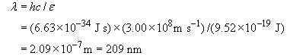

This is the maximum photon wavelength (minimum energy) for this excitation.
(b) From Equation 3, the minimum temperature is given by

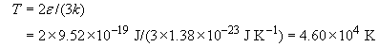

So typically a temperature of at least 5 × 10⁴K is required for the collisional excitation of this electronic state in CO molecules.
Back to Session 2 Activity 1

Question 6

Answer
Equation C does not take account of interstellar extinction, A, as in Equation D:

The derived absolute visual magnitude will therefore be too faint (M numerically too large). Since interstellar dust also causes reddening, the B - V colour will be redder and therefore the derived temperature will be too low. Examination of the axes of the H-R diagram in Figure 5 shows that the star will appear below and to the right of its correct position.
If a spectrum is observed, the temperature can be derived from its spectral type (based on the strengths of certain spectral lines) and therefore not affected by interstellar reddening. Its luminosity can also be inferred directly from its spectrum and hence its true position on the H-R diagram can be determined.
Back to Session 2 Activity 2

Question 7

Answer
The distance to a star does not influence its position on the H-R diagram: photospheric temperature and luminosity are intrinsic properties of a star. However, we sometimes have to apply corrections to our observations, because of interstellar extinction, in order to obtain intrinsic properties.
Back to Session 4 Activity 1

Question 8

Answer
(a) Figure 22 shows the five stars plotted on an H-R diagram. By comparison with Figure 5, we can make the following assignments given in Table 2.

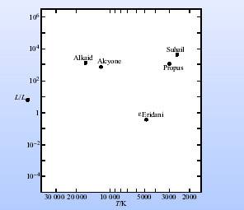
Figure 22 An H-R diagram with five stars, from Question 8.

Table 2
Star | Main stellar class | Comment
Alkaid | main sequence
Alcyone | giant
ε Eridani | main sequence | a nearby (3.2 pc), solar-type star
Propus | red giant
Suhail | red giant/supergiant | some stars fall between the four main classes

(b) Low luminosity stars can have a large apparent visual brightness only if they are particularly close to us. Thus, low-luminosity stars will be under-represented in an H-R diagram that contains only the stars with the greatest apparent visual brightness. (There is always a likelihood that low-luminosity stars will be under-represented, simply because any detection system will fail to detect stars that give too low a flux density at the detector. This is an example of a selection effect.)
Back to Session 4 Activity 2

Question 9

Answer
From Figure 5 we see that the Sun's photospheric temperature, T⊙, luminosity, L⊙, and radius, R⊙, have the following relationships to the temperature T, luminosity L and radius R of stars near the upper and lower ends of the main sequence:
upper end: T~ 6T⊙, L ~10⁶L⊙, R~10R⊙
lower end: T~0.3 T⊙, L~10⁻⁴L⊙, R~0.03R⊙
Thus, the Sun is a very modest main sequence star.
Back to Session 4 Activity 3

Question 10

Answer
The region where T Tauri stars are found on the H-R diagram is shown in Figure 7. Since the question states that T Tauri stars approach the main sequence with little change in temperature, they must follow vertical paths from this region to the main sequence. By inspection of Figure 5 it can be seen that by following a vertical track from the T Tauri region to the main sequence a small reduction in radius must occur.
Back to Session 4 Activity 4

Question 11

Answer
To evolve into a supergiant, the red giant would have to acquire a lot of mass: see Figure 8. However, observations suggest that red giants lose mass (in the form of stellar winds), and so we can rule out the scenario in which a red giant evolves into a supergiant.
Back to Session 4 Activity 5

