

S365_1 Evolution: A biological and palaeontological approach

An introduction to biological systematics
About this free course
This free course provides a sample of Level 3 study in Science: http://www.open.ac.uk/courses/find/science.
This version of the content may include video, images and interactive content that may not be optimised for your device.
You can experience this free course as it was originally designed on OpenLearn, the home of free learning from The Open University – www.open.edu/openlearn/nature-environment/natural-history/introduction-biological-systematics/content-section-0
There you’ll also be able to track your progress via your activity record, which you can use to demonstrate your learning.
The Open University, Walton Hall, Milton Keynes, MK7 6AA
Copyright © 2016 The Open University
Intellectual property
Unless otherwise stated, this resource is released under the terms of the Creative Commons Licence v4.0 http://creativecommons.org/licenses/by-nc-sa/4.0/deed.en_GB. Within that The Open University interprets this licence in the following way: www.open.edu/openlearn/about-openlearn/frequently-asked-questions-on-openlearn. Copyright and rights falling outside the terms of the Creative Commons Licence are retained or controlled by The Open University. Please read the full text before using any of the content.
We believe the primary barrier to accessing high-quality educational experiences is cost, which is why we aim to publish as much free content as possible under an open licence. If it proves difficult to release content under our preferred Creative Commons licence (e.g. because we can’t afford or gain the clearances or find suitable alternatives), we will still release the materials for free under a personal end-user licence.
This is because the learning experience will always be the same high quality offering and that should always be seen as positive – even if at times the licensing is different to Creative Commons.
When using the content you must attribute us (The Open University) (the OU) and any identified author in accordance with the terms of the Creative Commons Licence.
The Acknowledgements section is used to list, amongst other things, third party (Proprietary), licensed content which is not subject to Creative Commons licensing. Proprietary content must be used (retained) intact and in context to the content at all times.
The Acknowledgements section is also used to bring to your attention any other Special Restrictions which may apply to the content. For example there may be times when the Creative Commons Non-Commercial Sharealike licence does not apply to any of the content even if owned by us (The Open University). In these instances, unless stated otherwise, the content may be used for personal and non-commercial use.
We have also identified as Proprietary other material included in the content which is not subject to Creative Commons Licence. These are OU logos, trading names and may extend to certain photographic and video images and sound recordings and any other material as may be brought to your attention.
Unauthorised use of any of the content may constitute a breach of the terms and conditions and/or intellectual property laws.
We reserve the right to alter, amend or bring to an end any terms and conditions provided here without notice.
All rights falling outside the terms of the Creative Commons licence are retained or controlled by The Open University.
Head of Intellectual Property, The Open University
Designed and edited by The Open University
978-1-4730-0845-8 (.epub)
978-1-4730-1613-2 (.kdl)

Contents
- Introduction
- Learning outcomes
- 1 Systematics and the reconstruction of phylogeny
  - 1.1 Introduction
  - 1.2 Taxa and relationships
  - 1.3 Relationships between species
  - 1.4 Grades and clades
  - 1.5 Clades and mammals
  - 1.6 Clades and reptiles
  - 1.7 Homologies
- 2 A first approach to systematics
  - 2.1 Introduction
  - 2.2 Darwin, Linnaeus and Simpson
  - 2.3 What does relationship mean in systematics? G.G. Simpson
  - 2.4 What does relationship mean in systematics? E. Mayr
  - 2.5 What does relationship mean in systematics? W. Hennig
  - 2.6 Three schools of classification
  - 2.7 Inferring relationships of common ancestry
  - 2.8 Systematic hierarchy
  - 2.9 Conflicting morphological characters
  - 2.10 Chimps, gorillas and humans
  - 2.11 Consequences of human / chimp pairing
  - 2.12 Translating a cladogram into a classification
  - 2.13 Systematics and biogeography
  - 2.14 Summing up
- Conclusion
- Keep on learning
- Acknowledgements

Introduction
This course is concerned with macroevolution the patterns and processes of evolution above the species level.
A crucial consideration in macroevolutionary studies is that of the evolutionary relationships (phylogeny) of the organisms in question. The course begins with an introduction to the scope of macroevolutionary studies and illustrates methods of reconstructing phylogeny, from both morphological and molecular data.
It is important to appreciate the differences between the three methods of phylogenetic analysis that are described, namely
- evolutionary systematics
- phenetics
- cladistics
A further illustration of these concepts is provided by a sequence of audio clips featuring the late Dr. Colin Patterson, which will give you a second chance to familiarise yourself with the concepts involved.
This OpenLearn course provides a sample of Level 3 study in Science.

Learning outcomes
After studying this course, you should be able to:
- understand the patterns and processes of evolution above the species level
- appreciate the differences between the three methods of phylogenetic analysis: evolutionary systematics, phenetics, cladistics.

1 Systematics and the reconstruction of phylogeny

1.1 Introduction
To the lay person, it might seem surprising that there is any problem with the recognition of higher taxa. The very existence of long-established vernacular names for inclusive groupings of species (e.g. finches, thrushes, parrots and hawks as distinct groups of birds) suggests that higher taxa are self-evident. Accordingly, the task of the taxonomist might seem merely to consist of recognising these groupings and assembling them in a hierarchy of increasingly inclusive categories.
Indeed, taxonomists had been at work on this task long before Darwin's time. The original intention of most earlier taxonomists had been to reveal the divine plan of Creation’: each higher taxon was seen to be united by a common basic design, and the differences between its constituent species to be derived from the specific adaptations of the design for different places in nature. The relative ‘affinities’ (similarities of basic design) between species were thus widely held to reflect a natural order before Darwin and Wallace re-interpreted them as indicating phylogenetic relationships. In the light of evolution, the hierarchy of taxa could now be seen as reflecting the phylogenetic tree of life.
If the phylogeny of life were itself known, there would be little problem in recognising higher taxa: the only arbitrary part of the exercise, of deciding where to ‘sever’ the branches to delimit the higher taxa, could simply be a matter for consensus. The problems arise because, as noted earlier, the true phylogeny is unknown, and can only be inferred from the available evidence. In practice, then, organisms are grouped according to criteria deemed to reflect relationship, and phylogeny is construed from these groupings. Conclusions may vary not only according to the characteristics of the organisms which are investigated, but also according to how they are analysed.

1.2 Taxa and relationships
Until the mid-20th century, inferences about evolutionary relationships between species were generally based upon as wide a range of evidence as could be mustered. Evolutionary systematics is the name given to this eclectic approach, because of its explicit focus on evolutionary conclusions. The disparate nature of the evidence used (ranging from the taxonomic attributes and geographical distribution of living organisms to the stratigraphical distribution of fossils) meant that there was no single underlying method of analysis, and so the conclusions were reached by a variety of lines of reasoning. Consequently, the discipline became notoriously the domain of widely experienced experts, who tended to acquire an unfortunate reputation in the popular imagination as a sort of unassailable priesthood. Frustration with the lack of a consistent method of analysis, and hence with the ultimately subjective nature of evolutionary systematics, led, in the 1950s, to the development of two new approaches to systematics both of which claimed to be more objective: in phenetics, species are clustered according to their overall morphometric similarities; in cladistics, relationships are inferred from the extent to which different species share evolutionarily modified features apparently derived from common ancestors. Yet neither new approach proved to be without its problems, and so all three continue to be practised today. The methods and the advantages and disadvantages of each approach will be discussed in the following sections. Nevertheless, cladistics has emerged in recent years as the most powerful and widely used method of phylogenetic analysis in most instances, and so most emphasis will be given here to this approach.
Before considering the different approaches to phylogenetic analysis, some general points need to be made concerning evolutionary relationships.

1.3 Relationships between species

SAQ 1

Using the idea of blood relationships in people as an analogy, can you think of two distinct types of relationship between species?

View answer - SAQ 1

1.4 Grades and clades
If species are grouped together because they show a similar extent of accumulated anagenetic change with respect to their ancestors, then the taxa so formed constitute grades. In Figure 1, morphological change is represented along the horizontal axis. The three columns show grades of anagenetic modification, with parts of the phylogeny occupying each grade. Grades are easy to recognise, because they are based upon raw similarities between species, but they may be misleading as far as the reconstruction of phylogeny is concerned.

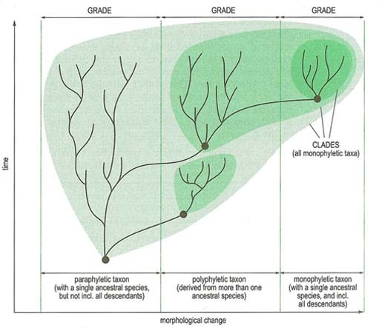
Figure 1 Morphological change
View description - Figure 1 Morphological change

SAQ 2

Why may some grades contain more than one branch of a phylogenetic tree (as in the central column of Figure 1)?

View answer - SAQ 2

Not all grades are polyphyletic, however, and grade groupings which do include their common ancestor (as in the left and right columns in Figure 1) make up modem classifications. In Figure 1, for example, birds and mammals represent groupings considered to differ sufficiently from their reptilian ancestors to be recognised as distinct grades.
If, alternatively, the pattern of cladogenesis (i.e. shared ancestry) is taken as the sole criterion for recognising higher taxa, then all the descendants of a common ancestral species must be grouped together (along with the ancestral species itself), to form a clade (Figure 1: various clades are enclosed by different shades of green). A clade represents a single whole branch from a phylogeny, and, because it is derived from a single common ancestor, it is said to be a monophyletic grouping.

1.5 Clades and mammals

SAQ 3

Are the mammals a clade?

View answer - SAQ 3

If the taxonomic hierarchy is to give an unambiguous reflection of phylogenetic relationships, then the recognition of clades is the most desirable objective of systematics: members of any taxon, so recognised, will be more closely related to each other than to any member of any other taxon, by definition. A classification based purely on a hierarchy of clades is the objective of cladistics.

SAQ 4

What aspect of evolutionary pattern is missing from such a scheme of classification?

View answer - SAQ 4

1.6 Clades and reptiles

SAQ 5

Are the reptiles a proper clade?

View answer - SAQ 5

So much for the nature of higher taxa, but how are the constituent species grouped together in the first place? The short answer is ‘through comparison of their characters’, but this begs the question of what is a ‘character’. Because organisms are so complex and so highly integrated, the identification of separate aspects to be treated as taxonomic characters has to be arbitrary, and is thus a subjective issue which presents problems whatever the approach to phylogenetic reconstruction. A particular problem with most morphological characters is that the genetic controls on their development are complex and often poorly understood. As with the selection of variates (i.e. shared but variable characters) for the morphometric description and discrimination of closely related species, the choice of characters for phylogenetic analysis is pragmatic. Those features which are reasonably consistent within each species, but which differ sufficiently in expression from species to species so as to permit degrees of similarity between species to be noted, tend to be used. One fundamental consideration must be mentioned here. As noted earlier in reference to the ‘pachyderms’, the similarities of some features will be misleading as an indicator of relationship if they result from evolutionary convergence. Features showing similarities due to convergence are said to be analogous, and a prime objective of modern systematic methods is to avoid the confusion they can cause in classification. Other features, in contrast, are interpreted as being of similar construction because they have been inherited from a common ancestor. These features are said to be homologous.

1.7 Homologies
If homologies could be recognised as such, then the relationships between species could be inferred from their shared homologies. Unfortunately, however, homologies and analogies cannot always be unambiguously distinguished in practice. The risk of confusion is especially great when closely related species are compared, because similarities in their morphology and ecology make the parallel evolution of analogous features in separate lineages quite likely. As with other statements concerning history, homologies must themselves be inferred. In some cases, this may seem easy enough. Figure 2 shows the structure of a human arm, a bird's wing and an insect's wing. We readily recognise the first pairing as being homologous and the second as being analogous, but why?

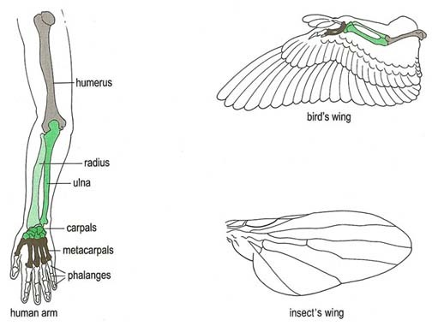
Figure 2 Human arm, insect's wing
View description - Figure 2 Human arm, insect's wing

SAQ 6

What aspect of the human arm and the bird's wing would suggest that they are homologous?

View answer - SAQ 6

Thus the mode of construction seems to offer a clue, and a useful concept in this respect is that of the information content of features. The more numerous the points of resemblance between structures being compared, in terms of the elements making them up, their positional relationships with respect to each other and their pattern of development, the more likely they are to be homologous. In other words, there would be an improbably large amount of detailed similarity to explain away as coincidental convergence. The appendages in Figure 2 are all features of high information content, and so the numerous structural similarities of the first pairing strongly imply homology, while the lack of them for the second pairing implies analogy.
Many other examples are less easy to resolve, however, and continue to create systematic problems to this day. This is a common problem with many fossil taxa. Many of the morphological features of simple fossil shells, for example, have a very low information content, and so homology and analogy are readily confused.
Other approaches to the problem of distinguishing homology from analogy can be adopted, but these vary according to the different systematic methods, which must be considered.

2 A first approach to systematics

2.1 Introduction
The late Dr. Colin Patterson was a palaeontologist at the Natural History Museum, and an authority on systematic methods. He played a prominent role in promoting cladistics, the method now most widely employed for phylogenetic analysis. He introduces the sequence of audio clips by drawing attention to the connection perceived by Darwin beteen the systematic grouping of species into higher taxa and the closeness of their evolutionary relationships (‘propinquity of descent’).
This leads on to a consideration of what the term ‘relationship’ means to systematists today and the implications for classification. Three different schools of thought have arisen, and are illustrated using quotations from leading proponents: evolutionary systematics is explained through the words of George Gaylord Simpson, phenetics through those of Ernst Mayr, and cladistics through those of the founder of that school, Willi Hennig. Of these, cladistics has now become the preferred method for phylogenetic analysis, for reasons explained by Dr. Patterson.
The rest of the sequence is devoted to explaining how the method is employed, with reference to both morphological and mocecular data on the higher primates, especially the apes, or hominoids (including our own species). The inference of cladistic relationships, the erection of a classification fimagerom them, and the analysis of biogeographical patterns are all illustrated.
The following sequence consists of a set of audio clips. Each of the clips relate to the image, or images, presented on the page.
Click to view a PDF containing all the images that are referred to in the audio sequence.
Click to view a PDF containing the full transcripts of the video clips used in this course.

2.2 Darwin, Linnaeus and Simpson

Activity 1
0 hours 15 minutes

In the first clip, Dr. Colin Patterson introduces and explains Darwin’s ‘tree of life’, image, shown below (Figure 3). This was the only image included in his book, Origin of Species.

Audio content is not available in this format.
Audio clip 1
View transcript - Audio clip 1

The second clip begins with some background into the system of hierarchy formalised by Linnaeus in the eigthteenth century. Dr. Patterson then asks the question ‘what does “relationship” mean in systematics?’ He looks for answers in the works of three eminent systematists, beginning here with George Gaylord Simpson.

Audio content is not available in this format.
Audio clip 2
View transcript - Audio clip 2

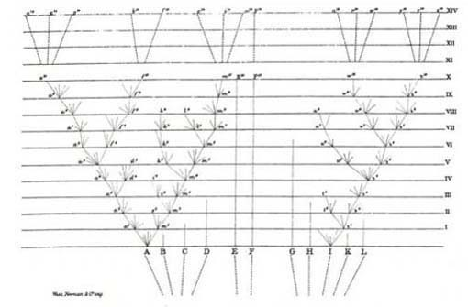
Darwin, C. R. (1859) On the Origin of Species From Darwin, C. R. (1859) On the Origin of Species ..., facing p.117
Figure 3: From Darwin, C. R. (1859) On the Origin of Species ..., facing p.117. Hypothetical evolutionary lineages derived from 11 ancestral species (A-L), are shown over successive time intervals (I-XIV)

2.3 What does relationship mean in systematics? G.G. Simpson

Activity 2
0 hours 5 minutes

Dr. Patterson continues to look at Simpson’s answer to the meaning of ‘relationship’ in systematics, and illustrates this by referring to a diagrams showing how the systematist viewed the relationship between phylogeny and higher and lower taxa (Figure 4).

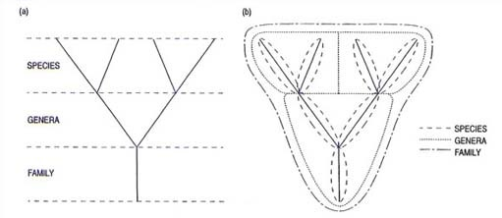
Figure 4 The relationship between phylogeny and higher and lower taxa, according to Simpson, G. G. (1961) Principles of Animal Taxonomy, p. 190, Figure 19 (redrawn). (a) 'Phylogenetic tree with stems and branches incorrectly conceptualized as corresponding with taxa at different levels'. (b) 'Same correctly subdivided into taxa.'

Audio content is not available in this format.
Audio clip 3
View transcript - Audio clip 3

2.4 What does relationship mean in systematics? E. Mayr

Activity 3
0 hours 5 minutes

Dr. Patterson looks at the second of his three systematists, Ernst Mayr. Mayr’s answer to the meaning of ‘relationship’ in systematics comes from the point of view of an evolutionist. This clip refers to a diagram from a 1974 paper written by Mayr’s (Figure 5).

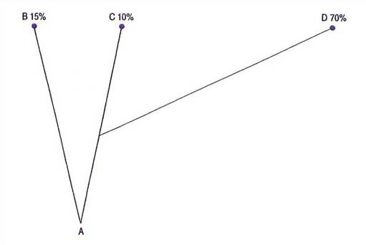
Figure 5 Relationships according to 'inferred percentual difference from ultimate ancestor (A)', following Mayr, E. (1974) Cladistic analysis or cladistic classification?, Z. Zool. Syst. Evolut.-forsch., 12, 94–128, Figure 1 (redrawn). Mayr states, 'Taxon C is more closely related to B than to D, even though it shares a more recent common ancestor with D'

Audio content is not available in this format.
Audio clip 4
View transcript - Audio clip 4

2.5 What does relationship mean in systematics? W. Hennig

Activity 4
0 hours 5 minutes

In this clip, Dr. Patterson introduces his third systematist, a German entomologist named Willi Hennig. This offers a third meaning of ‘relationship’, which is illustrated through a diagram showing Hennig’s conception of the relationship between phylogeny and classification (Figure 6). At the end of the clip, Dr. Patterson refers back to Simpson’s diagrams (Figure 4). This figure is repeated below the clip.

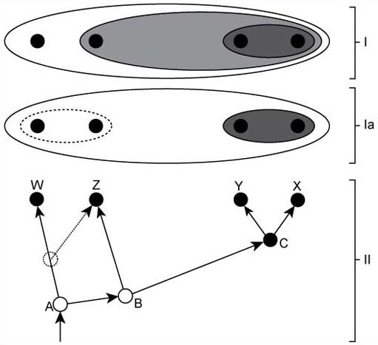
Figure 6 Diagram to show Hinnig's conception of the relationship between phylogeny (II) and classification (I), redrawn from Hinnig, W. (1966) Phylogenetics Systematics, Figure 19, p. 75. I shows a cladistic classification and Ia shows the classification a pheneticist would adopt

Audio content is not available in this format.
Audio clip 5
View transcript - Audio clip 5

Figure 4 The relationship between phylogeny and higher and lower taxa, according to Simpson, G. G. (1961) Principles of Animal Taxonomy, p. 190, Figure 19 (redrawn). (a) 'Phylogenetic tree with stems and branches incorrectly conceptualized as corresponding with taxa at different levels'. (b) 'Same correctly subdivided into taxa.'

2.6 Three schools of classification

Activity 5
0 hours 10 minutes

This clip explores the three kinds of relationships that have been explained so far, in terms of the work of Simpson, Mayr and Hennig, which are referred to as Simpsonian, Mayrian and Hennigian relationships.
Dr. Patterson links each of the systematists with a particular school of classification – phenetics, cladistics and evolutionary systematics, or eclectics, and establishes which one of these most directly matches the ideas of molecular systematists.
This clip refers to Figures 4, 5 and 6. You may want to review these diagrams before listening to the clip.

Audio content is not available in this format.
Audio clip 6
View transcript - Audio clip 6

Figure 4 The relationship between phylogeny and higher and lower taxa, according to Simpson, G. G. (1961) Principles of Animal Taxonomy, p. 190, Figure 19 (redrawn). (a) 'Phylogenetic tree with stems and branches incorrectly conceptualized as corresponding with taxa at different levels'. (b) 'Same correctly subdivided into taxa.'

Figure 5 Relationships according to 'inferred percentual difference from ultimate ancestor (A)', following Mayr, E. (1974) Cladistic analysis or cladistic classification?, Z. Zool. Syst. Evolut.-forsch., 12, 94-128, Figure 1 (redrawn). Mayr states, 'Taxon C is more closely related to B than to D, even though it shares a more recent common ancestor with D'

Figure 6 Diagram to show Hinnig's conception of the relationship between phylogeny (II) and classification (I), redrawn from Hinnig, W. (1966) Phylogenetics Systematics, Figure 19, p. 75. I shows a cladistic classification and Ia shows the classification a pheneticist would adopt

2.7 Inferring relationships of common ancestry

Activity 6
0 hours 10 minutes

This clip addresses the question of how one might go about building a tree, or inferring relationships of common ancestry, by recognising evolutionary novelties, or shared derived characters, or synapomorphy. Dr. Patterson uses a diagram developed by Andrews and Martin to explain this, which he refers to as ‘number 5’. This is Figure 7. The clip ends with an explanation of Von Baer’s Law.

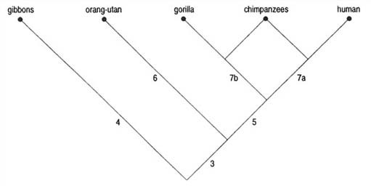
Figure 7 Cladogram for the Hominoidea, from Andrews, P. and Martin, L. (1987) Cladistic analysisof extant and fossil hominoids, J. Human Evol., 16, 101–118, Figure 3 (redrawn)

Audio content is not available in this format.
Audio clip 7
View transcript - Audio clip 7

2.8 Systematic hierarchy

Activity 7
0 hours 10 minutes

This clip builds on the idea that development recapitulates systematic hierarchy, by trying it out with the wrist bones of hominoids.
At the end of the clip, Dr. Patterson refers back to the Andrews and Martin diagram (Figure 7), illustrating the hominoid tree (‘Cladogram for the Hominoidea’. This figure is repeated below the clip.

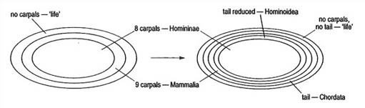
Figure 8 Venn diagrams for the classification of the Homininae

Audio content is not available in this format.
Audio clip 8
View transcript - Audio clip 8

Figure 7 Cladogram for the Hominoidea, from Andrews, P. and Martin, L. (1987) Cladistic analysisof extant and fossil hominoids, J. Human Evol., 16, 101–118, Figure 3 (redrawn)

2.9 Conflicting morphological characters

Activity 8
0 hours 10 minutes

This clip looks at conflicting morphological characters and at how it is possible to resolve them, with the aid of a table of molecular characters (Figure 9).
Dr Patterson also explains how to determine whether a nucleotide shared by two or more species is derived or primitive.

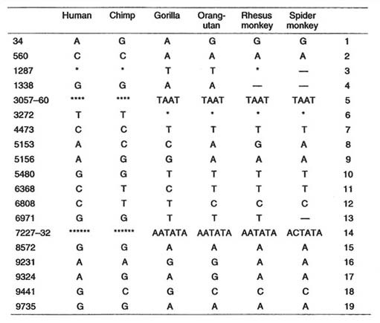
Figure 9 Nucleotides at selectived positions (left column) in sequences of non-coding DNA in the region of the beta haemoglobin family of genes in various higher primates. Asterisks denote gaps in the sequences of the species concerned. Based on Williams, S. A. and Goodman, M. (1989) A statistical test that supports a human/chimpanzee clade based on non-coding sequence data, Mol. Biol. Evol., 6, 325–330

Audio content is not available in this format.
Audio clip 9
View transcript - Audio clip 9

2.10 Chimps, gorillas and humans

Activity 9
0 hours 10 minutes

Dr. Patterson uses a diagram showing alternative cladograms for humans, chimpanzees and gorillas (Figure 10) to summarise evidence supporting the hypothesis that chimps are our closest relatives. He also provides two reasons why this theory should be accepted.

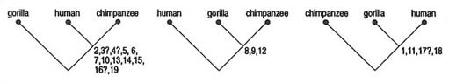
Figure 10 Alternative cladograms for humans, chimpanzees and gorillas

Audio content is not available in this format.
Audio clip 10
View transcript - Audio clip 10

2.11 Consequences of human / chimp pairing

Activity 10
0 hours 10 minutes

This clip refers back to the table of molecular characters, which is shown again here (Figure 9). It explains the consequences of human / chimp pairing in terms of homologous and non-homologous characters.

Figure 9 Nucleotides at selectived positions (left column) in sequences of non-codingg DNA in the region of the beta haemoglobin family of genes in various higher primates. Asterisks denote gaps in the sequences of the species concerned. Based on Williams, S. A. and Goodman, M. (1989) A statistical test that supports a human/chimpanzee clade based on non-coding sequence data, Mol. Biol. Evol., 6, 325-330

Audio content is not available in this format.
Audio clip 11
View transcript - Audio clip 11

2.12 Translating a cladogram into a classification

Activity 11
0 hours 10 minutes

This clip begins with a diagram by Ernst Haeckel published in 1866 (Figure 11). This is an illustration of how little ideas on the relationships of higher primates have changed in over a century.
The clip’s main focus is the information presented in the second diagram (Figure 12). The diagram is taken from an article by Dr. Patterson, which featured in New Scientist in the early 1980s. It shows three cladograms. The first of these (a) matches the pattern shown in the Andrews and Martin tree diagram (Figure 7), which you will be reminded of below the clip. An explanation of each of the cladograms show how they can be translated into a classification.

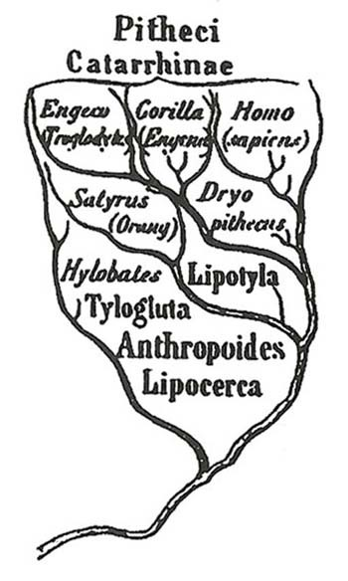
Figure 11 Haeckel's evolutionary tree, published in 1866. Engeco is the chimpanzee, and Hylobates, the gibbons

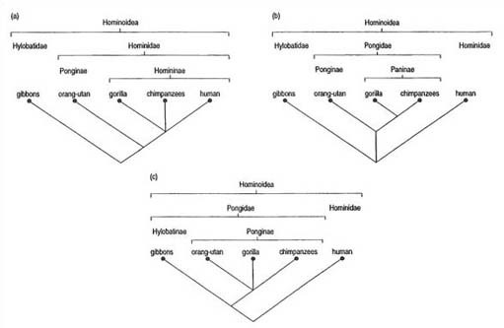
Figure 12 Classifications and implied cladograms of huminoids. The ancestry of humans and apes, as currently understood, is shown in (a), with the classificaion that fits this analysis. Two other classifications in use are shown in (b) and (c), with the cladistic relationships they imply. Redrawn from Patterson, C. (1982) Cladistics and classification, New Scientist, 94, 303–206, Figure 6

Audio content is not available in this format.
Audio clip 12
View transcript - Audio clip 12

Figure 7 Cladogram for the Hominoidea, from Andrews, P. and Martin, L. (1987) Cladistic analysisof extant and fossil hominoids, J. Human Evol., 16, 101–118, Figure 3 (redrawn)

2.13 Systematics and biogeography

Activity 12
0 hours 10 minutes

In this clip, Dr. Patterson introduces the concept of systematics and biogeography. He uses a diagram showing two cladograms (Figure 13) – one representing the higher primates that have been discussed in the course, and the other showing where they are found. Area cladograms can be used to answer questions like ‘Where did man originate?’

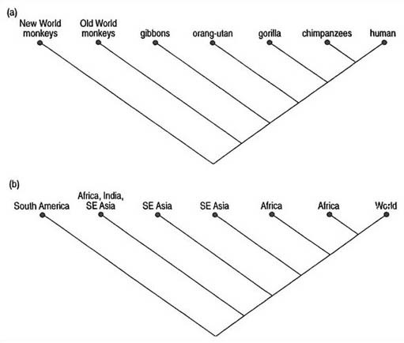
Figure 13 (a) Cladogram of the higher primates. (b) Area cladogram, with the names of the groups in (a) replaced by the names of the areas where they are found

Audio content is not available in this format.
Audio clip 13
View transcript - Audio clip 13

2.14 Summing up

Activity 13
0 hours 5 minutes

Dr. Peterson concludes the audio sequence with a summary of all the points covered.

Audio content is not available in this format.
Audio clip 14
View transcript - Audio clip 14

Conclusion
This free course provided an introduction to studying Science. It took you through a series of exercises designed to develop your approach to study and learning at a distance and helped to improve your confidence as an independent learner.

Keep on learning



Study another free course
There are more than 800 courses on OpenLearn for you to choose from on a range of subjects.
Find out more about all our free courses.

Take your studies further
Find out more about studying with The Open University by visiting our online prospectus.
If you are new to university study, you may be interested in our Access Courses or Certificates.

What’s new from OpenLearn?
Sign up to our newsletter or view a sample.

For reference, full URLs to pages listed above:
OpenLearn – www.open.edu/openlearn/free-courses
Visiting our online prospectus – www.open.ac.uk/courses
Access Courses – www.open.ac.uk/courses/do-it/access
Certificates – www.open.ac.uk/courses/certificates-he
Newsletter – www.open.edu/openlearn/about-openlearn/subscribe-the-openlearn-newsletter

Acknowledgements
Except for third party materials and otherwise stated (see terms and conditions), this content is made available under a Creative Commons Attribution-NonCommercial-ShareAlike 4.0 Licence
Grateful acknowledgement is made to the following sources for permission to reproduce material in this course:
Course image: princess of the sun ★ in Flickr made available under Creative Commons Attribution-ShareAlike 2.0 Licence.
This extract is taken from S365 produced by the BBC on behalf of the Open University © 2002 The Open University
The following material appears in Evolution: A Biological and Palaeontological Approach, (Peter Skelton, editor), published by Pearson Prentice Hall in association with The Open University. This book forms part of The Open University course S365 Evolution. © The Open University 1993.
Chapter 11 (11.2) Evolutionary relationships and history, pages 516–521
Figure 13 Display: Janet Haresnape; Photograph: Peter Skelton
Don't miss out:
If reading this text has inspired you to learn more, you may be interested in joining the millions of people who discover our free learning resources and qualifications by visiting The Open University - www.open.edu/openlearn/free-courses

SAQ 1

Answer
One is the relationship of descent – as in the parent–child relationship – and the other is that of shared parentage, as with brothers and sisters. Similarity between species may reflect either of these two kinds of relationship. It would be misleading to push the analogy too far, though, for two reasons. First, with the exception of allopolyploid hybrid species, new species are derived from single parental species. Secondly, a newly evolving species derives its characteristics directly from those currently present in the ancestral population: there is nothing in a species population that corresponds to the unchanging germ line of individual parent organisms. Two fundamental patterns of change in a phylogeny thus give rise to the differences between related species: anagenesis refers to descent with modification, within any given single lineage; and cladogenesis refers to the evolutionary division of lineages causing a proliferation of species. The grouping of species to form higher taxa can emphasise either or both of these components of phylogeny (Figure 1).
Back to Session 1 SAQ 1

SAQ 2

Answer
Convergent features may have evolved independently in separate lineages. A grade grouping of such species based on these features (as in the central column of Figure 1) would thus exclude their latest common ancestor (which remains in the left-hand column in Figure 1). Thus the central grade grouping in Figure 1 does not comprise a single branch from a phylogenetic tree. A grouping which assembles species with independently evolved similarities is said to be polyphyletic. Some early Victorian naturalists, for example, grouped elephants and rhinoceroses together as ‘pachyderms’, because of their thick skins (which is what the name means in Greek). However, it has long since been recognised that this feature is convergent in these animals, and so the name is no longer used for systematic purposes. Modern taxonomists attempt to avoid using polyphyletic taxa because they are misleading in phylogenetic reconstruction. To continue to talk about ‘pachyderms’, for example, might create the false impression that elephants and rhinoceroses are more closely related to each other than either is to, say, horses. Numerous other lines of evidence indicate. rather, that horses and rhinoceroses are the more closely related pair.
Back to Session 1 SAQ 2

SAQ 3

Answer
Yes, despite Simpson's earlier reservations about their possible polyphyletic origins, morphological and molecular data now strongly suggest that they are all indeed derived from a single ancestral mammalian species. So the mammals are both a clade and a grade grouping (as are also the birds).
Back to Session 1 SAQ 3

SAQ 4

Answer
Because cladistic hierarchies reflect only increasing levels of inclusiveness of the branchings in a phylogeny, they cannot reflect the different amounts of evolutionary change between ancestral and descendent organisms. In other words, they ignore the anagenetic component of pattern, upon which grades are based.
Back to Session 1 SAQ 4

SAQ 5

Answer
No, because despite the reptiles being derived from a common ancestor, two descendent groups – the birds and the mammals – have been removed from them. The reptiles therefore do not include all the descendants of the primordial reptile species and so are not a complete monophyletic taxon. A taxon which thus comprises a single branch from which one or more clades have been removed is called a paraphyletic taxon (as in the left column of Figure 1): the reptiles are therefore paraphyletic. In cladistic classifications, paraphyletic taxa are not recognised, and so the ‘reptiles’ would not be accepted in such a scheme.
Back to Session 1 SAQ 5

SAQ 6

Answer
In spite of the differences of their superficial form, they share the same basic construction: corresponding bones, with the same spatial relationships, though with differing proportions, may be recognised (indicated by different shadings in the figure). The similarity of the wings of the bird and the insect, in contrast, is only superficial (reflecting their common adaptation to flight); they are of markedly different construction, the insect's wing, of course, having no bones at all.
Back to Session 1 SAQ 6

Figure 1 Morphological change

Description
Figure 1 Hypothetical phytogeny illustrating different kinds of taxonomic grouping. The three columns represent morphological grades.
Back to Session 1 Figure 1

Figure 2 Human arm, insect's wing

Description
Figure 2: Diagram of the structure of a human arm. a bird's wing and an insect's wing.
Back to Session 1 Figure 2

Audio clip 1

Transcript
Dr. Colin Patterson
Darwin's diagram is bound in with his chapter on natural selection, and he used nine pages of that chapter to explain it. He gave the diagram another three pages in the chapter on geological succession, and then another five pages in the chapter on classification.
Of course we don't have time to work right through Darwin's seventeen pages, but the format of the diagram is probably familiar to you. It has a vertical time-scale of fourteen periods, which Darwin says might each represent a thousand generations, or ten thousand generations, or a million, or even a hundred million. The capital letters A to L, at the bottom of the diagram, represent, "the species of a genus large in its own country," in Darwin's words.
If you take a species capital A as an example, the diverging and branching dotted lines represent its offspring, and the lower case letters and superscript numbers, going from a1 to a14, m1 to m14, and so on, represent well-marked varieties, with distance along the horizontal axis indicating amount of divergence. So, if each time period represents a thousand generations, then after 14,000 generations, at the top of the diagram, species A has produced eight descendant species, numbered a14 to m14. And Darwin says, "Thus, as I believe, species are multiplied and genera are formed".
Among those eight species, Darwin says that the three on the left, a14, q14 and p14, "will be nearly related from having recently branched off from a10, whereas b14 and f14 will be more distinct from those three, and o14, e14 and m14, the three on the right, will be nearly related to each other, but having diverged at the first commencement of the process of modification, will be widely different from the other five species, and may constitute a distinct genus," end of quote.
Darwin goes on to say that the six species descended from species I at the top right of the diagram, will have to be ranked in a different subfamily from the species descended from A. And then he says that he sees no reason to limit this kind of descent with modification to species and genera alone. If the amount of change in each time period was greater, we might end up with two different orders, represented by the descendants of species A and I.
In his chapter on classification, Darwin uses the diagram to show how his theory of descent with modification predicts and explains what he calls, quote, "the grand fact in natural history of the subordination of group under group, which, from its familiarity, does not always sufficiently strike us". And then he goes on, "propinquity of descent - the only known cause of the similarity of organic beings - is the bond, hidden as it is by various degrees of modification, which is partially revealed to us by our classifications," end quote. And then Darwin goes on, "that the natural system is founded on descent with modification; that the characters which naturalists consider as showing true affinity between any two or more species, are those which have been inherited from a common parent, and, in so far, all true classification is genealogical; that community of descent is the hidden bond which naturalists have been unconsciously seeking".
Back to Session 2 MediaContent 1

Audio clip 2

Transcript
Dr. Colin Patterson
I shall quote no more from Darwin, but I want to emphasise the fact that he saw classification as one of the most important pieces of evidence bearing on his theory. Since antiquity, naturalists have found that animals and plants fall into a hierarchy, a system of groups and subgroups. And this system was formalised by Linnaeus in the 18th century, into classes containing orders, orders containing families, families containing genera and so on.
Linnaeus, and most other systematists before Darwin, saw this natural hierarchy as an expression of an abstract natural order, the creator's plan. But Darwin saw it in material, or concrete, terms, as the inevitable result of descent with modification, and as something predicted by and so explained by his theory. That's why he said that all true classification is genealogical.
So now, having worked through Darwin's diagram, and his comments on it, we might be ready to answer some questions. The first, and the most basic, is this, “What does „relationship‟ mean in systematics?” I shall outline three different answers, each of them given by one of the three most influential and authoritative systematists.
The first answer's by George Gaylord Simpson, who lived from 1902 to 1984. Here's what he said in his 1961 book, "Principles of Animal Taxonomy": "Is a man more closely related to his father, son, or brother? The degree of genetical relationship to father and son is invariably the same, 0.5 on proportion of shared chromosomes. Genetical relationship to a brother is variable, from 1.0 to 0.0 in terms of chromosomes, although the probability of those extremes is exceedingly low, but the mean value is the same as for father and son, 0.5. Unfortunately, relationships among taxa do not have such fixed a priori expectations. The same two kinds of relationships nevertheless exist among successive taxa in an ancestral-descendant lineage, and among contemporaneous taxa of more or less distinct common origin. The former relationships are called vertical, and the latter horizontal," end of quote.
Now we can easily picture Simpson's two kinds of relationship by looking back at Darwin's diagram. If you find the point in the left-hand lineage, the A line, where it splits at a3 and gives rise to a4 and d4, you can see that the relation between a3 and a4 is the „father-son‟ kind, Simpson's vertical relationship, and the relation between a4 and d4 is the „brother‟ kind, Simpson's horizontal relationship.
Simpson goes on to say that one kind of relationship is obviously just as objective as the other, that classification by either vertical or horizontal relationships alone is absolutely impossible, and that the art of taxonomy is in using your taste and ingenuity to effect a compromise between the two kinds of relationship. That's Simpson's answer to the question "what is relationship", and it leads him to see classification as an art, a matter of taste and ingenuity.
Back to Session 2 MediaContent 2

Audio clip 3

Transcript
Dr. Colin Patterson
We can understand and criticise Simpson's solution better with the help of a diagram, which shows his idea of incorrect and correct ways of looking at a phylogenetic tree.
In the left hand tree, the successive levels are equated with taxa, and the result's a family containing two genera, each with two species. Now Simpson called this idea ‘flatly false’, and said that the correct classification is the one in the right hand diagram, where we have a family containing three genera - two living ones with two species, and a third ancestral genus with three species.
Back to Session 2 MediaContent 3

Audio clip 4

Transcript
Dr. Colin Patterson
The second answer to the question, "What does ‘relationship’ mean?" comes from Ernst Mayr. Here's a quotation from his 1969 book ‘Principles of Systematic Zoology’ … "To the evolutionist, ‘relationship’ means “inferred genetic similarity, as determined both by distance from branching points and subsequent rate of divergence," end quote.
Again, we can understand Mayr's concept better with the help of a diagram. It comes from a 1974 paper by Mayr, and it shows four species - an ancestral species A, and three descendants, B, C, and D. The numbers show the genetic difference of each species from the ancestor: C differs from A by only 10%, B differs by 15%, and D has diverged very rapidly, and differs from A by 70% of its genome.
Mayr says, "Taxon C is more closely related to B than to D, even though it shares a more recent common ancestor with D".
So that's Mayr's solution - relationship means genes in common, or genetic similarity.
Back to Session 2 MediaContent 4

Audio clip 5

Transcript
Dr. Colin Patterson
The third answer to the meaning of ‘relationship’ comes from Willi Hennig, a German entomologist, who lived from 1913 to 1976. Here's a quotation from Hennig's 1966 book, "Phylogenetic Systematics" … "The concept of 'relationship’ may be defined as follows: a species x is more closely related to another species y, than it is to a third species z if, and only if, it has at least one stem species in common with species y, that is not also a stem species of z," end quote.
Hennig's definition sounds formal and Germanic, but it's easy enough to follow with the help of a picture, which comes from the page facing the definition in Hennig's book. I've added the letters X, Y and Z so that we can match his definition to the diagram. He says that X is more closely related to Y than to Z, because X and Y share a stem species - which I've labelled C - which is not also a stem species of Z.
Above Hennig's tree are two Venn diagrams .- patterns of nested ellipses. It's a feature of Hennig's view of classification that the tree and the classification should be exact images of each other. His upper Venn diagram, labelled 1, is an exact match with the relationships shown in the tree. His lower Venn diagram, labelled la, shows a different pattern, a pattern we should get if we followed Mayr's definition of relationship - shared genes - because the distance between stem species A and B is much less than that between B and C. The shared similarity of species W and Z would make Mayr classify them together, with the result shown by the dotted line in the tree, and by the dotted ellipse in the lower Venn diagram. The pattern of relationship shown by the tree can't be recovered from the classification shown by the lower Venn diagram, which gives a different tree.
As for Simpson's concept of relationship, his right-hand diagram, number 2B, is presented both as a tree and a Venn diagram, and you might try copying out the Venn diagram part of it with these seven species, and seeing what tree you recover from it. As you'll find, the tree you get is quite different from his original … but Simpson's left-hand diagram, the concept that he called ‘flatly false’, exactly matches a Venn diagram expressing the relationships in the tree.
Back to Session 2 MediaContent 5

Audio clip 6

Transcript
Dr. Colin Patterson
Now the three kinds of relationship I've been talking about have been called Simpsonian, Mayrian and Hennigian relationship. And they can be fitted very neatly to the three different schools of classification that developed during the 1960s, and were much disputed through the 1970s. These three schools are called phenetics, cladistics and evolutionary systematics, or eclectics.
Phenetics relies on overall similarity as a measure of relationship, and so it classifies similar organisms together. This matches Mayr's definition of relationship as shared genotype. Cladistics aims to classify by inferred recency of common ancestry, and so it matches Hennig's definition of relationship. And eclectics, or evolutionary systematics, classifies by a mixture of similarity and inferred common ancestry, using taste or judgement as to when one criterion's given precedence. And so it matches Simpson's discussion of relationship, and how one ought to classify.
But notice that there are only two criteria of relationship - the phenetic one of similarity, and the cladistic one of inferred common ancestry. Eclectics merely uses a mixture of the two. Well, which school is correct, or is best?
The overwhelming consensus, after twenty years of argument, is that cladistics is best, and it's unusual these days to find a systematist, who has given any thought to the fundamentals, who isn't a cladist.
Cladistics has won through, I think, for two main reasons. First, it has a consistent and coherent philosophy, and second, it developed at the same time as the early work in molecular systematics, when protein sequences and other molecular evidence was first brought to bear on problems of relationship and classification.
Let me explain quickly why this is so. A molecular biologist can only sample living taxa. He ends up with a set of data, let's say DNA sequences, from which he wants to recover a tree, or a classification. The sequences are necessarily seen as terminals of the tree. No-one would dream of seeing a DNA sequence from one species as ancestral to a sequence from another species. And, in a tree, it's ancestors that occupy the internal nodes and branches.
So molecular systematists, from the beginning, worked with samples from the tips of the tree, and tried to reconstruct the tree by one method or another. Now, if we look back to the diagrams explaining Simpson's, Mayr's and Hennig's ideas about relationship, we see that Hennig's is the only one that deals just with terminals of the tree. He's trying to classify species W, X, Y and Z, four terminals of the tree in his diagram. Simpson's trying to classify ancestors, as we can see from his diagram recommending combining three ancestral species into a genus ancestral to the four living or terminal species. And, in Mayr's diagram, the three terminals, B, C and D, are labelled with their percent genetic difference from A, the ancestor. Obviously, if we can tell that C differs from A by only 10%, whereas D differs from it by 70%, we must have access to A.
So among these three, Hennig is the only one whose definition of relationship treats the terminals of the tree as real, and the internal part of the tree as hypothesis or conjecture. And that's why his system directly matches the ideas of molecular systematists.
Back to Session 2 MediaContent 6

Audio clip 7

Transcript
Dr. Colin Patterson
If we can agree that Hennig's is the only theoretically justifiable definition of relationship, and the one we should accept, how do we set about building a tree, or inferring relationships of common ancestry?
If you think about the problem, you'll realise that the ideal way of building the tree would be by recognising evolutionary novelties, the innovations that characterise different lineages or groups of species. In an ideal tree, each node would be marked by one or more novelties, characters unique to the group of species stemming from that node. I've put an example as number 5, one dealing with familiar animals, the apes, or hominoids. That tree has one peculiar feature, the way the chimpanzee is linked to two different places. But that's done to emphasise a particular problem, that we'll get to in a minute, the fact that there are two different sets of characters - the ones labelled 7a and 7b, and each suggests different relationships for the chimpanzee.
The question I want to tackle, at the moment, is how this tree was built up by recognising evolutionary novelties, or shared derived characters. Synapomorphy is the technical term for a shared derived character. Here the word ‘derived’ is used in the evolutionary sense of advanced, or specialised.
The authors of this tree of hominoids, Peter Andrews and Lawrence Martin, gave a list of characters for each of the numbered branches of the tree. As an example, let's take branch 5, the one distinguishing African apes and us from the orang-utan. They listed about 10 characters for that branch, but I'll just mention three of them. The first is fusion of the os centrale, the second is that the frontal sinus is developed, and the third relates to mutations in DNA. And I want to ask how you might decide that these features are innovations or synapomorphies.
Take the os centrale first. It's a bone in the wrist, one of the carpals. In orangs and gibbons, there are nine bones in the wrist - nine carpals - but in African apes and us there are only eight. Given that information, either state might be primitive or derived, so how do we decide that eight is derived?
In this case it's easy, because in the embryo of all these animals, there are nine carpals, but in us, and in African apes, two of them - the centrale and the scaphoid - fuse together. So we begin life with no carpals, then we develop nine carpals, and we end life with eight of them.
Now, in using this developmental sequence as evidence for evolutionary transformation, we aren't just appealing to the theory of recapitulation - the idea that ontogeny recapitulates phylogeny. We're using a much older theory, or law - one proposed by the embryologist von Baer, in the 182Os. Von Baer's Law says that development proceeds from the general to the particular. The most general characters appear first, and the most particular, or restricted, appear last. The idea here is that development recapitulates not phylogenetic history, but the systematic hierarchy, so that characters of the largest groups appear first, and characters of the most restricted groups appear last.
Back to Session 2 MediaContent 7

Audio clip 8

Transcript
Dr. Colin Patterson
We can try out that idea with the wrist bones of hominoids. The first condition, in the egg and the very early embryo, is to have no bones or cartilages in the wrist - the skeleton hasn't yet started to develop.
The next stage is to develop nine carpals. And the final stage, in African apes and us, is to fuse two of them, leaving eight carpals. Given those three conditions, we could convert them into a Venn diagram, with each condition characterising a group. The group with no carpals is the whole of life, including plants and bacteria. The group with nine carpals happens to be mammals. And the group with eight is African apes and us, the subfamily Homininae.
Now the hominoids have another character that behaves like this, with ontogenetic or developmental evidence on transformation. The character is reduction of the tail. All adult apes have just a rudiment of a tail, but during embryonic life they develop a long tail, like all other vertebrates, and then it becomes reduced to a vestige by differential growth. So we can get another Venn diagram from the tail, and I've combined it with the carpal diagram. I'm sure you get the idea. We’re building up a picture of groups and sub-groups, and with just those two characters, the carpals and the tail, we could get a simple tree from the Venn diagram.
I mentioned one other feature shared by us and African apes, the frontal sinus, which is a space in the bones of the face developed during ontogeny, as an outgrowth or expansion of the ethmoid sinus. And again, we could use development from the general, absence of sinuses, to the more particular, presence of an ethmoid sinus, to the still more particular, presence of the frontal sinus. And so we could get another series of groups to add to the Venn diagram.
Now all this probably seems much too simplified and, in real life, characters are often much more difficult to sort out. There's a good example in the hominoid tree, where the chimp is linked to both the human and gorilla lines. This is a case where there are two conflicting sets of characters, the ones labelled 7a and 7b on the tree. Just to take a couple of examples, chimps are linked to us by having the premaxilla and maxilla fused in the adult. But chimps are linked to gorillas by having six vertebrae involved in the sacrum, instead of the five that we have and orangs have. And chimps and gorillas also share a number of features of the arm and hand, associated with their habit of walking on the knuckles.
Back to Session 2 MediaContent 8

Audio clip 9

Transcript
Dr. Colin Patterson
So here we've got conflicting morphological characters, and all of them seem to be derived. They can't both be true, so how do we resolve the conflict?
I’ve given you a table of molecular characters that help to resolve it. These are selected positions in an alignment of over ten thousand nucleotides, from non-coding DNA in the region of the beta haemoglobin genes. We don't yet know the DNA sequence for this region in gibbons, but the table includes the other four apes, and also a couple of monkeys - the Rhesus monkey, Macaca Mulatta from the Old World, and the Spider monkey, Ateles, one of the New World monkeys from South America.
I want to use this table as an example in tackling the particular question of the conflict on chimpanzee relationships, but also in tackling the more general question of deciding on primitive and advanced characters. The method I've just been describing, using ontogeny or development to resolve general and special features in morphology, obviously won't work with DNA, because DNA has no development. Barring accidents, we're born and we die with the same DNA sequences in our chromosomes.
So how can we determine whether a nucleotide shared by two or more species is derived or primitive? Take the first row in the table, the one numbered 34. You'll see that five of the animals have G, Guanine, at that position, but human and gorilla share A, Adenine. This implies that human and gorilla are related, and the criterion we're using to make that guess is called outgroup comparison. We've already found, or others have found, a whole series of characters saying that apes form a group and that, within the apes, humans, chimpanzees and gorillas form a subgroup. Then there's another series of characters showing that the closest relatives of apes are the Old World monkeys, with Rhesus monkey as an example in this table. And then there's another set of characters showing that the next group out is the New World monkeys, with Spider monkey as the example here. So outgroup comparison tells us that for the first character in the table, Guanine is primitive and Adenine is derived.
So that shared adenine, in the first row of the table, implies that gorilla is our nearest relative. Are there any other shared nucleotides supporting that idea? Yes, there are two more. There's one at position 6368, where human and gorilla share Cytosine, C, and all the others have Thymine, T. And then another near the end of the table at 9441, where human and gorilla have Guanine, G, and all the others have Cytosine, C. There's also an Adenine shared by human and gorilla at position 9324, but here outgroup comparison shows that this could well be primitive, because both the monkeys have Adenine too.
Now look at the second row in the table, position 560. Here human and chimp share Cytosine, and all the others have Adenine. So this is a site at which outgroup comparison says that chimps are our nearest relatives. Are there any other positions supporting that idea? Yes, there are lots. The third row, position 1287 is an example. Here, human and chimpanzee share an asterisk, which means they have a gap in the alignment - a gap that has to be put there to preserve matching in the neighbouring parts of the sequence.
The evolutionary interpretation of that gap is that it's a deletion of one nucleotide. Now this position is ambiguous by outgroup comparison, because although gorilla and orang have Thymine there, the Rhesus monkey also has a gap, and the Spider monkey has a hyphen, meaning "missing". The Spider monkey lacks this whole part of the sequence, which is an inserted repeat.
But never mind that one, because there are two more substantial deletions showing that chimps are our nearest relatives, the four-base deletion at position 3057, and the six-base deletion at 7227.
Back to Session 2 MediaContent 9

Audio clip 10

Transcript
Dr. Colin Patterson
I've summarised the information on the relationships between us, chimps and gorillas. On each of the three possible cladograms, I've entered the characters supporting it, using the numbers down the right side of the table. You can check it through in detail later but, as you can see, there are twelve possible human / chimp synapomorphies, three possibles for the chimp / gorilla pairing, and four possibles for the human / gorilla pair. Now if we chuck out all the dubious ones, where outgroup comparison is ambiguous, there are nine unambiguous characters favouring the human / chimp relationship, and three each for the other two possibilities.
Given that evidence, we should accept the hypothesis that chimps are our closest relatives. And I'll suggest two different reasons why we should accept it.
The first brings in the principle of parsimony, or economy of explanation. There are nineteen characters in the table, and the hypothesis that chimps are our nearest relative explains twelve of them, as the result of common ancestry. The other two alternative hypotheses, the chimp / gorilla and human / gorilla pairings, each explain only three or four of the nineteen characters. Now, in using the principle of parsimony to choose between hypotheses, we aren't implying that evolution is parsimonious - that it goes by the shortest route. We don't know whether it does or not. Parsimony says nothing about evolution. It's simply a principle of rational explanation.
The second reason why we should choose the human / chimp hypothesis concerns probability. Given the three alternative trees, one of them supported by twelve characters, one by three, and one by four, you could do statistical tests to find out what chance there is that a wrong tree should be supported by so many characters. The test and the result will depend on the assumptions you make, but the people who published this table reckoned that the result is significant at about the 3% level.
So we can accept the human/chimp pairing. This doesn't mean we accept it unconditionally, but that, like every other hypothesis in science, it's subject to test. And specifically, the hypothesis predicts that other samples of characters will show the same distribution, with the majority of them favouring the human / chimp pairing.
We can get one test from another set of DNA sequences. They're from an immunoglobulin pseudogene and, again, they favour the chimp / human pairing by 3:1, and they bring the significance of the result below 1%, meaning odds of over 100:1 in its favour.
Back to Session 2 MediaContent 10

Audio clip 11

Transcript
Dr. Colin Patterson
Now accepting this human / chimp pairing has various consequences. One is that it means that characters uniquely shared by humans and chimps - like the twelve nucleotides in the table, or the fusion of premaxilla and maxilla in the adult - are homologous. But characters uniquely shared by chimps and gorillas, or by humans and gorillas, aren't necessarily non-homologous.
Look at character 9 in the table, position 5156, where chimp and gorilla share Guanine. We can explain that in two ways. Either the Guanine was independently acquired in chimp and gorilla by two separate mutations from the ancestral Adenine, or Guanine was acquired by a mutation in the common ancestry of human, chimp and gorilla, and then humans reverted to adenine by a second mutation. Each explanation requires just two mutations, so they're equally parsimonious. But the explanation by independent mutations in chimps and gorillas says that the two Guanines are non-homologous – they’re convergent or chance similarity.
The other explanation, a mutation in the common ancestry of human, chimp and gorilla, says that the two Guanines are homologous, but are primitive for apes, just as Adenine is primitive at this site for the whole group in the table. This same sort of argument works for morphology. I said, a few minutes ago, that chimps and gorillas share various features of the hand and arm, associated with knuckle-walking. Now, given that chimps are most closely related to us, we can explain that in two ways. Either chimps and gorillas independently acquired knuckle-walking, or it developed in the common ancestry of humans and African apes, and was then lost in the human line. In the first case, the features are non-homologous in chimps and gorillas, but were acquired by parallel evolution. And, in the second case they are homologous. In this instance, we might guess that knuckle-walking is too complex to develop twice in exactly the same way, so it's probably primitive for the group, and is lost in us. Or, we could guess that knuckle-walking is obviously adaptive, and might well develop by natural selection, independently in two closely related lines.
I think all you need remember from this is that homology is a conclusion we infer from a tree or a cladogram. It's not something we can establish directly. And then that there are two kinds of homologies, derived ones and primitive ones. But every homology has to fit on the tree somewhere, as a derived character, a synapomorphy of a group.
Back to Session 2 MediaContent 11

Audio clip 12

Transcript
Dr. Colin Patterson
Finally, let me go on with this example of humans and apes to say something about translating a cladogram into a classification, and about the use of cladograms in biogeography.
The next little diagram is from Ernst Haeckel's evolutionary tree of mammals, published in 1866. I stuck this one in to show that ideas on the relationships of higher primates haven't changed much in over a century. The next diagram, is from an article of mine in New Scientist in the early 1980s when the question of the relationship between us and chimpanzees wasn't as clearly resolved as it is today. The first of the three cladograms shows the position as I saw it then, with us, chimps and gorillas put as a trichotomy or trifurcation.
Above this first cladogram, there's a classification that's consistent with it, because it names all the monophyletic groups in the diagram. We have a superfamily Hominoidea for the whole lot, a family Hylobatidae for the gibbons, and a family Hominidae for the rest. Within the hominids, there are two subfamilies - Ponginae containing Pongo, the orang-utan, and Homininae containing us, chimps and gorillas. As we've just seen, relationships within Homininae seem to be resolved now. And you might like to think how one would express the relationship between humans and chimps in this classification. One obvious solution would be to make two tribes - one for gorilla and one for us and chimps.
At the top of the other two diagrams, I've set out two widely used classifications in the form of brackets. And underneath the brackets is the cladogram or pattern of relationships that each classification implies. The middle classification, (b), has the hominoids divided into three families, Hylobatidae for gibbons, Pongidae for the three great apes, and Hominidae for us. This classification's still in use, for example, in a book published in 1990, R. D. Martin's 'Primate Origins and Evolution'.
Now Bob Martin doesn't disagree with the pattern of ape relationships shown in the first diagram, but he thinks it's more useful to classify the three great apes together. In doing so, he's produced what's called a paraphyletic group.
Paraphyletic groups can be defined in two ways, either in terms of a tree, a cladogram - where there are groups that include some but not all of the descendants of a common ancestor - or paraphyly can be defined in terms of characters - where it means a group sharing only primitive characters.
The easiest way of recognising a paraphyletic group is that it can serve as an ancestor. For example, if someone says, "humans evolved from apes," all they’re saying is that apes are paraphyletic, defined only by lacking the characters of the descendants.
In just the same way, if you say that vertebrates evolved from invertebrates, or tetrapods evolved from fishes, all you're saying is that invertebrates are a paraphyletic group lacking the characters of vertebrates. And fishes are vertebrates lacking the characters of tetrapods. So in general, paraphyletic groups convey no information, and they're best avoided.
The last of these three diagrams, (c), is a more traditional classification, the one you find in Simpson's classification of mammals, for example. There are just two families of hominoids - one for us, and one containing the gibbons in one subfamily, and the great apes in another. This conveys a pattern that's even further from the truth. And, once again, it does it by using a paraphyletic grouping for the apes. In this classification the pongids are all hominoids that lack the features of humans. It should be obvious that I favour classification (a), because it's the only one that expresses our ideas about hominoid relationships.
Back to Session 2 MediaContent 12

Audio clip 13

Transcript
Dr. Colin Patterson
Finally, a few words on systematics and biogeography - or how one can use cladograms in biogeography. The next diagram is the cladogram of higher primates that we've been working through, from New World monkeys, the Cebidae, through to ourselves. Next to it, (b) is the same diagram with the names of the groups replaced by the names of the areas where they’re found. This is an area cladogram, based on higher primates. And the idea behind it is that we can use the relationships between organisms to investigate earth history, or the relationships between geographic areas.
This area cladogram suggests various things about geography. For example, that Africa is more closely related to India and Southeast Asia, than to South America.
How might we check or test that idea? The best way would be by using the relationships of other groups - animals or plants, that live in South America, Africa, and the other areas - to see if they give the same area cladogram, or a different one. If all or most of them give the same area cladogram, then we'd have strong evidence for a common history of those groups, and of the areas they inhabit.
One can also use an area cladogram to answer questions like, “Where did man originate?” If you apply outgroup comparison to diagram (b), our two nearest relatives are both African. So the inference would be that we too originated in Africa, and spread from there to the rest of the world.
Back to Session 2 MediaContent 13

Audio clip 14

Transcript
Dr. Colin Patterson
I’ll finish by summing up the points we've covered.
The first part of this talk was about Darwin's views on classification, including the point that evolution, or descent with modification, is an explanation for the observed hierarchy of natural groups.
The next part was about the meaning of relationship - does it just mean similarity, or does it mean what Darwin called ‘propinquity of descent’? We settle for propinquity of descent, or closer common ancestry.
Then we got to the problem of how you infer relationships of common ancestry, with the idea of shared derived characters, synapomorphies, as the key, and two methods of identifying shared derived characters, by ontogeny or development, and by outgroup comparison. We used higher primates as an example, and touched on how homology is deduced from congruence of characters, and how a cladogram is converted into a classification, with the distinction between monophyletic and paraphyletic groups.
And finally there were a few thoughts on the use of cladograms in biogeography.
Back to Session 2 MediaContent 14

