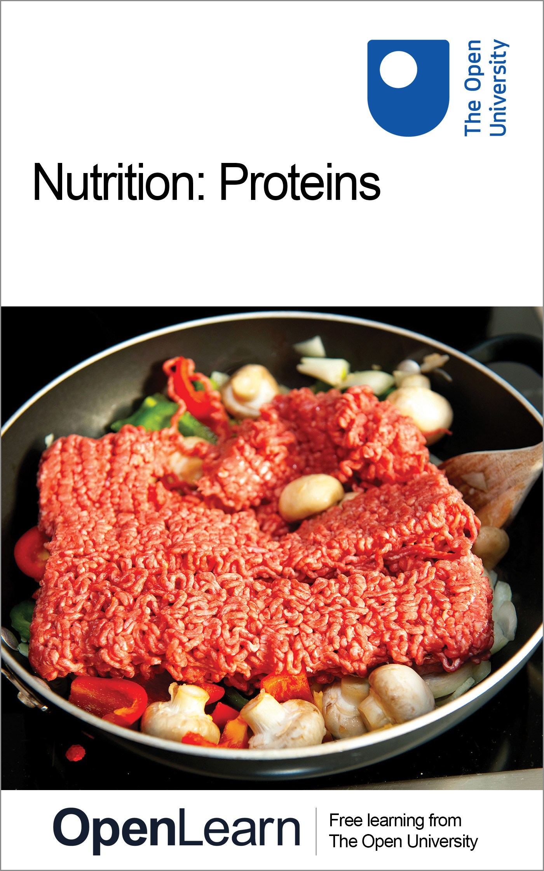

SK183_1 Studying Human Nutrition

Nutrition: Proteins
About this free course
This free course provides a sample of Level 1 study in Science: http://www.open.ac.uk/courses/find/science.
This version of the content may include video, images and interactive content that may not be optimised for your device.
You can experience this free course as it was originally designed on OpenLearn, the home of free learning from The Open University - www.open.edu/openlearn/science-maths-technology/science/biology/nutrition-proteins/content-section-0.
There you’ll also be able to track your progress via your activity record, which you can use to demonstrate your learning.
TheOpenUniversity, WaltonHall, MiltonKeynes, MK76AA
Copyright © 2016 The Open University
Intellectual property
Unless otherwise stated, this resource is released under the terms of the Creative Commons Licence v4.0 http://creativecommons.org/licenses/by-nc-sa/4.0/deed.en_GB. Within that The Open University interprets this licence in the following way: www.open.edu/openlearn/about-openlearn/frequently-asked-questions-on-openlearn. Copyright and rights falling outside the terms of the Creative Commons Licence are retained or controlled by The Open University. Please read the full text before using any of the content.
We believe the primary barrier to accessing high-quality educational experiences is cost, which is why we aim to publish as much free content as possible under an open licence. If it proves difficult to release content under our preferred Creative Commons licence (e.g. because we can’t afford or gain the clearances or find suitable alternatives), we will still release the materials for free under a personal end-user licence.
This is because the learning experience will always be the same high quality offering and that should always be seen as positive – even if at times the licensing is different to Creative Commons.
When using the content you must attribute us (The Open University) (the OU) and any identified author in accordance with the terms of the Creative Commons Licence.
The Acknowledgements section is used to list, amongst other things, third party (Proprietary), licensed content which is not subject to Creative Commons licensing. Proprietary content must be used (retained) intact and in context to the content at all times.
The Acknowledgements section is also used to bring to your attention any other Special Restrictions which may apply to the content. For example there may be times when the Creative Commons Non-Commercial Sharealike licence does not apply to any of the content even if owned by us (The Open University). In these instances, unless stated otherwise, the content may be used for personal and non-commercial use.
We have also identified as Proprietary other material included in the content which is not subject to Creative Commons Licence. These are OU logos, trading names and may extend to certain photographic and video images and sound recordings and any other material as may be brought to your attention.
Unauthorised use of any of the content may constitute a breach of the terms and conditions and/or intellectual property laws.
We reserve the right to alter, amend or bring to an end any terms and conditions provided here without notice.
All rights falling outside the terms of the Creative Commons licence are retained or controlled by The Open University.
Head of Intellectual Property, The Open University
The Open University
Printed and bound in the United Kingdom by CPI, Glasgow
978-1-4730-0865-6 (.epub)
978-1-4730-1633-0 (.kdl)

Contents
- Introduction
- Learning outcomes
- 1 Proteins
  - 1.1 Atoms and molecules
  - 1.2 Chemical compounds
  - 1.3 The importance of protein
  - 1.4 The chemistry of amino acids
  - 1 5 Linking amino acids
  - 1.6 Protein shapes and functions
  - 1.7 Protein digestion and absorption
  - Conclusion
- Keep on learning
- Acknowledgements

Introduction
This course studies 'proteins'. Starting with a simple analysis of their molecular make up, the course moves on to look at the importance of proteins and how they are digested and absorbed.
This OpenLearn course provides a sample of Level 1 study in Science.

Learning outcomes
After studying this course, you should be able to:
- understand that the human body, and everything else, is made up of atoms and that there are about 26 different sorts of atom in the human body, combined into numerous different sorts of molecules
- understand that amino acids contain carbon, nitrogen, oxygen and hydrogen atoms, some contain an atom of sulphur and that there are about 20 different amino acids, with different side-chains (R groups)
- understand that amino acids are linked via peptide bonds to make polypeptides and proteins
- understand that each protein molecule can be hundreds of amino acids long and the amino acids must be joined in a precise order, which is specified by a code in the DNA in the chromosomes
- understand that the side-chains (R groups) of the amino acids can interact with one another to fold the protein into a particular shape which is essential for the protein to function correctly.

1 Proteins
To understand the composition, digestion, function in the body, etc., of a protein you will need to have some knowledge of chemistry.
As you read on, you will find that the word ‘mass’ is used, when you might expect to read ‘weight’. Scientifically speaking, the amount of matter in an object is called its mass, while the word ‘weight’ is used to describe the downward pull on the same object due to gravity. If you were to go to the Moon, your mass, measured in kilograms, would remain the same, but your weight would be much less because the force of gravity is only about one-sixth as strong on the Moon as on the Earth.

1.1 Atoms and molecules
Everything around us, and in us, is made up of atoms, which you can consider as minute spheres. They are very, very small. A page of a book is about one million (1 000 000) atoms thick. There are about 100 or so different types of atom, including oxygen atoms, carbon atoms, nitrogen atoms, gold atoms and iron atoms, and atoms provide the basic building blocks for everything. It is like having a ‘Lego’ set with about a hundred different types of brick. Each type of atom is a different size and has a different mass from all the other types. Because atoms are so very small, chemists do not deal with their actual mass, but instead they give the smallest and lightest atom, which is hydrogen, a mass of 1 and then express the mass of all the other atoms relative to that. So, for example, an oxygen atom is 16 times as heavy as a hydrogen atom and so it has a relative atomic mass of 16. The different types of atoms are called chemical elements or just elements, for short. By using different atoms, and joining them in different ways, you can produce water, sugar, salt, proteins, paper, rocks and, in fact, everything in the Universe! Different materials can exist as either a solid, a liquid or a gas, but one of these ‘states’ is most familiar. For example, water is generally thought of as a liquid, but it can freeze to a solid, ice, and it can occur as a gas, water vapour or steam.

Activity 1

Air is not a pure gas, but a mixture of various different gases. Spend a few moments thinking of as many gases as you can, either occurring in the air or elsewhere.

View discussion - Activity 1

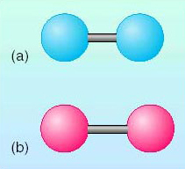
Figure 1 Two of the elemental gases in the air, represented as ball-and-stick models. Molecules of (a) nitrogen (shown in blue) and (b) oxygen (shown in red) exist as pairs of atoms

Helium and neon both exist as individual atoms in the atmosphere. But the smallest gaseous particle of hydrogen, oxygen, chlorine and nitrogen is composed of two identical atoms of the element attached together to form a molecule. The link between atoms, usually referred to as a chemical bond, can be represented by drawing a ‘stick’ holding the two ‘balls’, representing the atoms, together (Figure 1).

Activity 2

The relative atomic mass of nitrogen is 14, so are nitrogen atoms heavier or lighter than oxygen atoms?

View discussion - Activity 2

1.2 Chemical compounds
Many molecules consist of atoms of more than one type of element, and they are called compounds. Carbon dioxide, methane and water from the list of gases above are all chemical compounds. Water is the most abundant compound in living matter, and indeed on Earth, accounting for an average of 60% of total human body mass. A molecule of water, whether it exists as a gas in the atmosphere, as liquid water in our bodies or in lakes, rivers or seas, or as a solid in the form of ice, always has the same structure. It is a compound of two of the elements we have already met as gases, hydrogen and oxygen. A water molecule consists of two atoms of hydrogen and one atom of oxygen and can again be represented by a ball-and-stick model (Figure 2a).
Carbon dioxide (Figure 2b) consists of one carbon atom and two oxygen atoms.

Activity 3

Look at the structure of a methane molecule in Figure 2c. Which atoms does it contain? Is methane a compound?

View discussion - Activity 3

You will notice that the molecules of water, carbon dioxide and methane are different shapes. The water molecule has a ‘bend’ in it (all water molecules are exactly the same with a ‘bend’ of exactly the same angle). The atoms forming the carbon dioxide molecule are arranged in a straight line and the methane molecule is in the form of a triangular pyramid, called a tetrahedron, with hydrogen atoms at the corners and the carbon atom in the middle. Different molecules have different shapes and these shapes often play a crucial role in the behaviour (‘properties’) of the molecules in the human body and in other living things.

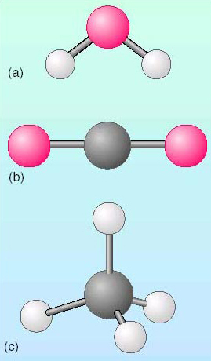
Figure 2 Ball-and-stick representations of three small molecules. (a) A water molecule; oxygen and hydrogen atoms are represented by red and white balls, respectively. (b) A carbon dioxide molecule; carbon and oxygen atoms are represented by dark grey and red balls, respectively. (c) A methane molecule, using the same colour code

To make things quicker to draw when we are dealing with larger molecules, the atoms are not usually represented as coloured balls but by the chemical symbol for the element, and the bonds between the atoms are drawn as lines. Chemical analysis of the human body shows that 13 major elements, with small contributions from about 13 more, are present in a huge variety of different molecules. These elements and their chemical symbols are listed in Table 1.

Tables are used to provide information in a form which is easier to understand than if the same information were presented in normal text. As with diagrams, the first thing to read is the caption, which tells you what the table is about. Then look at the headings in the table, across the top of the columns or at the start of the rows, or sometimes both. In Table 1, the headings – ‘Element’, ‘Symbol’ and ‘Percentage of total body mass’ – are across the top of the columns. So then you should glance down each column to see what it shows. The first column here is a list of names of chemical elements, but not, as you might expect, in alphabetical order. That should alert you to look elsewhere for the reason why that particular order has been chosen. The second column is the chemical symbol for each of the elements in the first column, in the same order. The third column is the percentage of the body mass that is made up of each of the elements and now the reason for the order of the elements becomes clear. As you glance down the ‘Percentage of total body mass’ column, you see that the numbers are in decreasing order, with oxygen being the element that makes up the greatest percentage of the body mass. Including ‘percentage’ in the column heading avoids the need for writing the symbol ‘%’ beside every numerical value. Scanning down that column gives you more information about the relative quantities of the various elements in the body. Often it is more important to be aware of the general trends shown in a table of figures, rather than the exact values. In this case you might notice that oxygen, carbon and hydrogen together make up a very high percentage (actually 93%) of the body mass. The remaining small percentage (7%) is made up of small amounts of the other elements. You will have further opportunities to develop the skills of reading tables as you progress through the course.

Table 1 The major elements by mass found in the human body (and most other mammals)
Element | Symbol | Percentage of total body mass
oxygen | O | 65.0
carbon | C | 18.5
hydrogen | H | 9.5
nitrogen | N | 3.2
calcium | Ca | 1.5
phosphorus | P | 1.0
potassium | K | 0.4
sulfur | S | 0.3
sodium | Na | 0.2
chlorine | Cl | 0.1
magnesium | Mg | 0.1
iodine | I | 0.1
iron | Fe | 0.1

If you check the chemical symbols in Table 1, you will find that many of them are the single initial letter of the element's name.

Activity 4

In Table 1, identify the chemical symbols for oxygen, carbon and hydrogen.

View discussion - Activity 4

Sometimes two letters are used, in which case the second one is written as a lower case (small) letter.

Activity 5

What are the symbols for the following elements: calcium, chlorine, iodine, iron, magnesium, phosphorus, potassium and sodium?

View discussion - Activity 5

Some of these are obviously the first letter or two letters of the name of the element, as in Ca for calcium, or an obvious pair of letters, such as Mg for magnesium. Others are not so easy to work out. The symbol for sodium (Na) comes from the Arabic word natron, which is a salt lake in Egypt. The symbol for iron (Fe) comes from the Latin word ferrum which means iron or any implement made of iron.

Activity 6

Draw the structure of a molecule of water (Figure 2a) replacing the balls by letters and omitting the bend in the molecule.

View discussion - Activity 6

A water molecule can also be written by adding together the atoms to give H₂O, which is called the molecular formula.

Activity 7

What is the disadvantage of writing the water molecule as H₂O?

View discussion - Activity 7

Activity 8

Look back at the structure of a methane molecule in Figure 2c. Re-draw the molecule using the symbols for the atoms instead of balls, drawing it flat on the page, rather than as a three-dimensional representation. Then add the atoms together and write the molecular formula.

View discussion - Activity 8

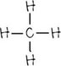
In most of the molecules that you will meet, each type of atom has a fixed number of bonds to other atoms.

Activity 9

Look back at the structural formulae of water and methane. How many bonds can each type of atom form?

View discussion - Activity 9

Some people find it easier to think of the number of bonds as the number of ‘arms’ (or ‘hooks’) that an atom has. So, hydrogen has one ‘arm’ and can therefore ‘hold hands’ with only one other atom.

Activity 10

The molecular formula for carbon dioxide is CO₂. Try to draw its structural formula giving the carbon and oxygen atoms the correct number of bonds.

View discussion - Activity 10

Carbon is a very unusual element as carbon atoms can bond with each other to form long chains, joined usually by single bonds, and sometimes by double bonds.

Activity 11

Draw a line of six carbon atoms, joined to each other by single bonds. Remember to give each carbon atom the correct number of bonds (‘arms’) even though some of them will have nothing to bond to.

View discussion - Activity 11

This structure, of course, does not represent a complete molecule; but if a hydrogen atom is present on each of the bonds, then it is the compound hexane, which is a relative of the gas methane and behaves in similar ways. Its molecular formula would be C₆H₁₄.
Carbon atoms can also join together to form rings. Cyclohexane has its six carbon atoms arranged in a circle, as shown here.
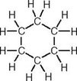

Activity 12

How many fewer hydrogen atoms are there in cyclohexane, compared with the straight-chain hexane above?

View discussion - Activity 12

Activity 13

A compound called benzene is another example of a molecule composed of a ring of six carbon atoms, but this molecule has alternate double and single bonds between them. Draw a benzene molecule, remembering to ensure that each carbon atom has four bonds and to attach hydrogen atoms to all the spare bonds. Write down the molecular formula of benzene.

View discussion - Activity 13

Carbon is the basis of all the molecules that make up the macronutrients in our diet. Since the molecules consist of large numbers of carbon atoms, they can also be called macromolecules. So, with this chemical background, we will now move on to look at the detailed structure of the first of the macronutrients in our diet, protein.

1.3 The importance of protein

Activity 14

From general knowledge about foods, what would you say are the main sources of protein in the average person's diet in the UK?

View discussion - Activity 14

Protein occurs in a wide range of foods as shown in Table 2.

You will notice that the column headings in Table 2 which indicate the amount of protein in the various foods are written as ‘Protein content/%’. You can read this as ‘Protein content expressed as %’. This is the scientifically correct way to show the units of the values given in a table. The same method is also used for labelling the axes of graphs. So the value shown has been divided by the course in which it is measured.

Table 2 The protein content (as % by mass) of some common foods
Animal-derived foods | Protein content/% | Plant-derived foods | Protein content/%
cheese (Cheddar) | 26 | soya flour (low fat) | 45
chicken (no skin) | 25 | soya flour (full fat) | 37
bacon (lean) | 20 | peanuts | 24
beef (lean) | 20 | bread (wholemeal) | 9
Cod | 17 | bread (white) | 8
Herring | 17 | rice | 7
Eggs | 12 | peas (fresh) | 6
Milk | 3 | potatoes (old) | 2
cheese (cream) | 3 | bananas | 1
Butter | less than 1 | apples | less than 1

Activity 15

Eggs are usually considered to be a high-protein food and yet they contain only 12% protein. Can you suggest any reason why this value is apparently so low? Think about the physical composition of the inside of an egg, compared with that of the high protein foods listed in the table.

View discussion - Activity 15

Although Table 2 and the nutritional information on food packaging lists ‘protein’ as though it were a single substance, there are tens of thousands of different proteins in living organisms. Life is based on proteins and the word ‘protein’ itself is derived from a Greek word meaning ‘holding first place’. Proteins form an integral part of the components of all living cells and a typical cell in the human body contains 18% protein, though some cell types, such as muscle cells, contain much more. In fact, most of the food that we call ‘meat’ is actually muscle. Some proteins have a largely structural role in the body, forming tendons and hair, others are produced in and then released from cells (secreted) and function as enzymes and hormones. The proteins we eat are digested by enzymes, which are themselves proteins. Some types of protein form part of the immune system, which protects us against infection, while others play a vital part in blood clotting. However, they all have the same fundamental structure. They are built of small molecules called amino acids. Large molecules composed of small subunits are called polymers, and the subunits, in this case the amino acids, are monomers. So protein polymers are made up of amino acid monomers.

1.4 The chemistry of amino acids
Human proteins are composed of 20 different amino acids (Table 3).

Activity 16

Look through the names of the amino acids. With a few exceptions, what common feature do you notice in the names?

View discussion - Activity 16

Eight of the 20 are the so-called essential amino acids; that is, they cannot be made in the human body and so have to be present in the diet. There are two others (tyrosine and cysteine) that can only be synthesised from essential amino acids and a further one (histidine) that is made in only small amounts and so should be included in the diet. The amino acid arginine is essential only for young children.

Table 3 Essential and non-essential amino acids (with their 3-letter abbreviations)
Essential amino acids | Amino acids synthesised from essential amino acids | Non-essential amino acids
lysine (Lys) | tyrosine (Tyr)* | glycine (Gly)
methionine (Met) | cysteine (Cys)† | alanine (Ala)
threonine (Thr) |  | serine (Ser)
leucine (Leu) |  | proline (Pro)
isoleucine (Ile) |  | glutamate (Glu)
Valine (Val) |  | glutamine (Gln)
phenylalanine (Phe) |  | aspartate (Asp)
tryptophan (Try) |  | asparagine (Asn)
histidine (His) – made only in very small amounts in the body
arginine (Arg) – for young children

*Synthesised from phenylalanine.
†Synthesised from methionine.

Activity 17

Suggest why arginine is not an essential amino acid in adults.

View discussion - Activity 17

The many thousands of different proteins, each with a particular biological function, have an enormous variety of structures. How can this be if there are only 20 different amino acids? The answer is that when several hundred of the 20 different types link up to form a protein chain, there is a huge number of possible sequences. Each particular type of protein molecule has its own unique sequence of amino acids along its length. Some amino acids may not be used at all in a protein, while others may occur many times.
The basic structure of all amino acids is similar and is based around a carbon atom with different atoms, or groups of atoms, attached to each of its four bonds. Remember that the bonds of a carbon atom are actually arranged in a tetrahedral shape (see Figure 2c) with the carbon atom at the centre, but we shall be drawing the molecules as though they were flat, for simplicity.

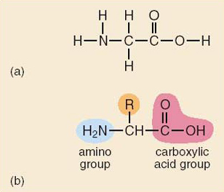
Figure 3 (a) Structural formula of the simplest amino acid, glycine. (b) Structural formula of a generalised amino acid

Activity 18

Devise a simple table giving the names, chemical symbols and number of bonds expected for all the elements present in the simplest amino acid, glycine, whose structure is shown in Figure 3a.

View discussion - Activity 18

Table 4 Elements found in the amino acid glycine, with their chemical symbols and number of bonds
Name of element | Chemical symbol | Number of bonds
Carbon | C | 4
Nitrogen | N | 3
oxygen | O | 2
hydrogen | H | 1

You might like to check that all the atoms in glycine have the correct number of bonds. Two of the bonds from the central carbon are attached to hydrogen atoms, one pointing upwards and one pointing down. To the left, the carbon atom is attached to a nitrogen atom, which itself has two hydrogen atoms attached. This group of three atoms, which can be written as NH₂ (or the other way round as H₂N), is called an amino group. To the right, the central carbon atom is attached to another carbon atom, and that one is attached to one oxygen atom, pointing up, by a double bond, and via a single bond to another oxygen atom, which has a hydrogen atom bonded to it. That group of atoms, COOH, is called a carboxylic acid group (or sometimes just a carboxyl group). Conventionally, amino acids are drawn this way round, with the amino group to the left and the acid group to the right, as their name suggests.

Activity 19

How many atoms in total, and how many of each element, are present in a molecule of glycine?

View discussion - Activity 19

Activity 20

Now look at Figure 3b which gives the formula of a generalised amino acid, and identify four differences between that and the representation of the glycine molecule in Figure 3a.

View discussion - Activity 20

So the only real difference is the presence of the R. There is no element with the symbol R. This R is used to indicate that a number of different atoms or groups of atoms can be placed here – each amino acid has a different one. The smallest amino acid is glycine, where R is simply a hydrogen atom.

Activity 21

How many different R groups would you expect to find in the amino acids named in Table 3?

View discussion - Activity 21

The formulae of some of these R groups are given in Table 5.

Table 5 Seven amino acids found in proteins
Name and pronunciation | Formula of R group
glycine (‘gly-seen’)
phenylalanine (‘fee-nile-alla-neen’) | 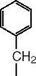
lysine (‘lie-seen’) alanine (‘alla-neen’) | 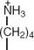
alanine (‘alla-neen’)
aspartate (‘ass-part-ate’) | 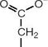
serine (‘seer-een’)
cysteine (‘sis-tayn’)

Activity 22

What structure do you recognise in the R group of phenylalanine?

View discussion - Activity 22

1 5 Linking amino acids

1.5.1 Linking two amino acids
As we have seen earlier, atoms can combine to form molecules and now we will see how molecules can combine together to make bigger molecules. If two glycine molecules are placed side by side, as in Figure 4a, we can see how it is possible to remove one hydrogen and one oxygen atom from the left-hand one, and one hydrogen atom from the right-hand one, to make a water molecule, leaving a spare bond (‘arm’) to link the carbon (C) atom from the amino acid on the left with the N atom from the one on the right, as in Figure 4b. This bond is called a peptide bond (or sometimes an amide bond) and the new molecule is called a dipeptide (the prefix di- means ‘two’). The word ‘peptide’ comes from the Greek peptos meaning ‘digested’. You might like to check that after this joining process, all the atoms involved still retain the correct number of bonds – 4 for carbon, 3 for nitrogen, 2 for oxygen and 1 for hydrogen.

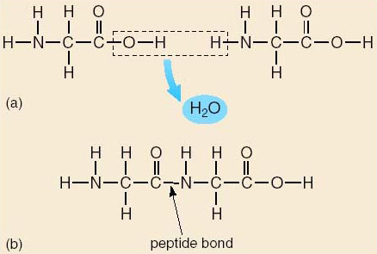
Figure 4 (a) Two molecules of glycine, side by side, showing how a water molecule can be formed using OH from one and H from the other. (b) The two glycine molecules are linked together to form a dipeptide

1.5.2 Linking more amino acids
Consider what would be possible if you placed another glycine molecule to the right of the dipeptide shown in Figure 4b. Another peptide bond could be formed between them to give a chain of three glycine molecules, a tripeptide (tri-means ‘three’ as in a word like tricycle). Adding another one would give a chain of four glycines, and so on. In fact, you could make a molecule of as many glycine molecules as you wanted. You might find it easier to think of them as railway trucks, with a hook on each end, being joined together to form a long train. Of course, all the amino acids have ‘hooks’ on each end of the molecule, so an almost infinite variety of proteins are possible, using the whole range of amino acids. In the train analogy, you could join all sorts of different trucks and carriages together to make a train, as long as they all had the same sort of hook on the end of them. In chemical terms, a chain of many amino acids joined together is called a polypeptide (poly- means ‘many’). A long polypeptide chain, with various amino acids attached together in the correct order is called a protein, though some proteins are made up of more than one polypeptide chain. Biologists often use the words ‘polypeptide’ and ‘protein’ interchangeably.

Activity 23

Can you recall from Figure 4, how many amino acids are linked together to form a typical protein molecule?

View discussion - Activity 23

1.5.3 Amino acid sequences
With 20 different amino acids as constituents and proteins several hundred amino acids long, it would in theory be possible to construct an almost infinite number of different protein molecules. But a particular protein only functions correctly in the body if it is made of a particular set of amino acids joined together in precisely the correct sequence.

Activity 24

In what form does the code exist that enables cells to make proteins and all their other components?

View discussion - Activity 24

The first protein whose amino acid sequence was worked out in the laboratory was insulin, a hormone secreted by the pancreas. Although insulin is composed of only 51 amino acids (as you will see later in Figure 8), it nevertheless took almost six years for a group of research scientists in Cambridge to complete the task. The group was headed by Frederick Sanger, who was awarded the Nobel Prize for this work in 1958. Since then, the speed of finding out the sequence of amino acids in a protein (a process known as ‘sequencing’) has increased hugely and the time for the process can now be measured in hours, rather than years.

1.6 Protein shapes and functions

1.6.1 Introduction to shapes and functions
Although a protein may be composed simply of a single long chain of amino acids, it does not remain as an elongated string, but folds up into a very precise shape. The three-dimensional shape of most proteins consists of a mixture of these different arrangements. However, unlike a piece of string, each molecule of the protein is, in fact, folded into precisely the same shape and that shape is crucial to its correct functioning in the body.

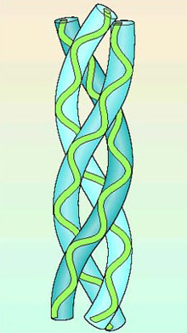
Figure 5 Structure of collagen, an important component of skin, tendons, bone and many other tissues. A collagen molecule is a triple helix, composed of three polypeptide chains, which are themselves helical, coiled around each other

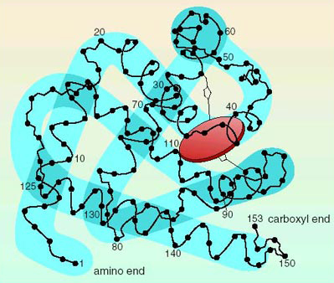
Figure 6 Structure of myoglobin, a protein that binds to oxygen molecules in muscles. The black dots, some of which are numbered, are the amino acids and the red disc is the oxygen-binding group. The ‘folded sausage’ shows the overall shape of the protein. Note that numbering always goes from the amino (‘left hand’) end to the carboxyl (‘right hand’) end of a protein, and this reflects the order in which the amino acids are put together when the protein is made by a cell

1.6.2 Determining the shape

During your studies you will meet a number of words which have Latin or Greek roots and whose meaning you may be able to work out. Coming up very soon are the words ‘hydrophobic’ and ‘hydrophilic’. You probably recognise hydro- as being related to ‘water’ (it is from the Greek word for water), since it occurs in words like hydroelectric, hydrothermal, hydroponics, hydrostatic, etc. Even the element hydrogen was named because it was originally generated (genos in Greek means ‘descent’) from water. The second half of the words, -phobic and -philic, mean ‘hating’ and ‘beloved’, respectively, from the Greek words phobos which means ‘fear’ and philos,‘friend’. As you read on, you will meet disulfide – where di-means ‘two’ (from the Greek dis meaning twice) and -sulfide means related to the element sulfur. You have already met carbon dioxide (a gas made up of one carbon and two oxygen atoms) and dipeptide, two amino acid molecules joined together. Sometimes the Latin prefix bi- is used as an alternative for ‘two’ as in bicycle, binoculars, etc. Tri-means ‘three’ (the Latin and Greek roots are similar), as in tripod (podos is ‘foot’ in Greek), and poly- (as in polypeptide) means ‘many’ (polys is ‘much’ in Greek).

The way in which each particular protein molecule folds is determined by a range of different interactions between the amino acids that make it up. Four of the most important ones will be considered here.
Firstly, some of the side chains of the amino acids – the R groups – a few of which were listed in Table 5 are hydrophobic, that is, they tend to associate with one another and to repel (or exclude) water molecules. The side chain of phenylalanine, containing the benzene ring, is one example. Since the inside of the body provides a watery (aqueous) environment, the protein chain folds up with these hydrophobic groups clustered together on the inside, and the hydrophilic groups on the outside, as shown in Figure 7.

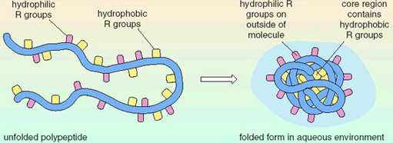
Figure 7 How a protein folds with its hydrophobic amino acids interacting with each other on the interacting with each other on the inside, and its hydrophilic groups interacting with water, on the outside

Secondly, some of the amino acid R groups carry a positive or negative electrical charge, written as + or − , on one of their atoms. Opposite charges ( + and −) attract one another, and similar charges repel each other. These attractions and repulsions, called ionic interactions since the charged molecules are called ions, play a part in determining the shape that the protein adopts.

Activity 25

From Table 5, identify two amino acids that will attract one another and two that will repel one another.

View discussion - Activity 25

The third type of interaction is called hydrogen bonding. Although hydrogen bonds are weaker than the bonds that hold the atoms together to make up the amino acids in the protein chain, hydrogen bonding nevertheless plays a very important role, not only in protein folding, but elsewhere in chemistry too, particularly in conferring on water its unique properties. Hydrogen bonding depends on partial positive and negative charges (much smaller than those mentioned above) which are present in some molecules. A hydrogen bond can occur between a hydrogen atom with a partial positive charge (by virtue of its attachment to an oxygen or a nitrogen atom) in one part of the molecule, and a different oxygen atom or nitrogen atom (which has a partial negative charge), elsewhere in the same molecule, or in another molecule. A hydrogen bond is normally represented by a dashed (or dotted) line, as follows:

Activity 26

Look back at Figure 4b and identify which of the hydrogen bonding types (i)-(iv) could occur in proteins.

View discussion - Activity 26

These hydrogen bonds hold parts of the protein together and they constitute another of the reasons the molecule adopts a particular shape.
Finally, the shape of a protein molecule can be stabilised by disulfide bridges which are standard bonds that form between two sulfur atoms in the R groups of the amino acid, cysteine (see Table 5). This type of bond can occur both between two cysteines in the same polypeptide chain (intra-chain bridge) and between cysteines in adjacent polypeptide chains (inter-chain bridge), holding together two polypeptide chains to form a single protein molecule. You can see both intra- and inter-chain disulfide bridges in the hormone insulin in Figure 8.

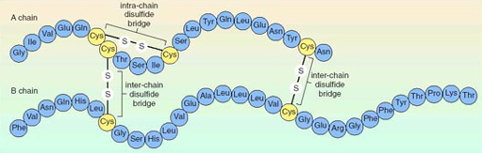
Figure 8 Simplified structure of insulin, a protein containing disulfide bridges

Activity 27

Reading from the left-hand end, list the names of the first seven amino acids in the B chain of the insulin molecule in Figure 8. You will need to use Table 3.

View discussion - Activity 27

Activity 28

(a) List the four interactions described above that determine the shape of a protein molecule, and briefly summarise the features of each one.
(b) Occasionally, due to a change (mutation) in the DNA code for a particular protein, a protein is synthesised with an incorrect amino acid at one position along the chain. Taking each of the four interactions in turn, consider whether a change in that single amino acid is likely to alter the shape and therefore disrupt the function of the protein in the body.

View answer - Activity 28

1.6.3 A faulty shape
An example of the effect of a single change in the amino acid sequence of a protein is provided by haemoglobin, the protein in the red blood cells that binds oxygen as it is transported from the lungs to the cells elsewhere in the body. The sixth amino acid in the haemoglobin chain starting from the amino end, is normally glutamate, but in some individuals, valine appears there instead, profoundly altering the shape of the haemoglobin molecule.

Activity 29

The R groups of glutamate and valine are shown below.
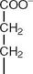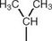
Why do you think the shape of the haemoglobin molecule is affected so much when valine replaces glutamate?

View discussion - Activity 29

Haemoglobin molecules with valine at position 6 fold up into the wrong shape. The red blood cells containing this type of haemoglobin assume a curved ‘sickle’ shape under certain conditions, as shown in Figure 9a, instead of the normal disc shape (see Figure 3). This altered shape is distinctive of the condition known as ‘sickle cell disease’. The characteristics of the disease are shown in Figure 9b. This case is just one example of how the correct amino acid sequence of a protein is fundamental to the way that the protein functions.

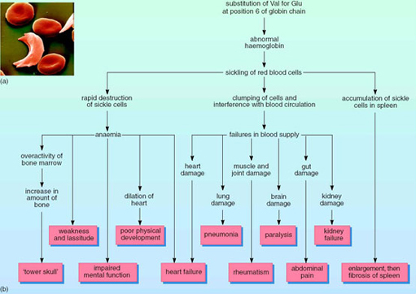
Figure 9 Sickle cell disease. (a) Red blood cells of a person with sickle cell disease, at various stages of sickling. (b) Origin and characteristics of sickle cell disease

1.6.4 Cooking eggs
Many solids melt as they get hotter, but eggs do not. They start as quite liquid in the fresh state and when they are heated, they go solid. This behaviour is a result of the effect of the heat on the proteins they contain. The proteins of both the egg yolk and white are folded into precise shapes ( each molecule forming a minute ball called a globular protein. But when these proteins are heated, some of the interactions holding the protein molecules into their precise globular shapes are broken and the molecules begin to unravel. This enables the separate protein chains to become entangled with one another and new interactions can form, particularly hydrogen bonds and the stronger disulfide bridges, which create a solid three-dimensional network of protein molecules, leading to a soft-boiled or eventually a hard-boiled egg.

Activity 30

Which amino acid forms disulfide bridges and which element does it contain?

View discussion - Activity 30

When an egg begins to go ‘bad’, its proteins break down and the sulfur from the cysteines forms a gas called hydrogen sulfide (H₂S), which has the characteristic and very unpleasant smell of ‘rotten eggs’.
Coagulation (solidification) of proteins can be caused by acidity, as well as by heat. Some people add vinegar or lemon juice to the water in which they are boiling eggs. If the eggshell cracks, and the white of the egg (albumen) begins to escape, the protein in it coagulates more quickly in the slightly acidic water than it would do in ‘plain’ (neutral) water, sealing the crack.
Whisking egg whites also causes the globular proteins to unravel and take up new shapes, but this time air is trapped in the three-dimensional network that they form. Baking the whisked egg white causes coagulation, and the protein becomes solid, forming a meringue. If fat molecules are present, they coat the globular proteins and prevent them from unravelling and tangling when they are whisked, which is why you cannot make a meringue if any of the egg yolk, which contains fat, is present in the egg white.

1.7 Protein digestion and absorption
The process of digestion is defined as the ‘process by which macromolecules in food are broken down into their component small-molecule subunits’.

Activity 31

In the case of proteins, what are the ‘macromolecules’ and what are the ‘small-molecule subunits'? What type of bond has to be broken to separate the subunits?

View discussion - Activity 31

This breakdown would happen impossibly slowly without the involvement of digestive enzymes, which are themselves proteins. Enzymes are often named by adding the ending ‘-ase’ to the name of the substance on which they work. So, the enzymes that break down peptide bonds are called peptidases (protein-digesting enzymes). Although all amino acids are joined by the same peptide bond, the type of R group on the amino acids on either side of the bond affects the action of the peptidases so much that several different enzymes are usually needed to digest a protein molecule completely.
Protein digestion starts in the stomach, the walls of which secrete hydrochloric acid.

Activity 32

What effect would you expect hydrochloric acid to have on proteins? (Hint: recall the effect of adding vinegar to the water in which eggs are being boiled.)

View discussion - Activity 32

An enzyme, called pepsin, produced by cells lining the wall of the stomach, starts to attack some of the peptide bonds and splits the long protein chains into shorter polypeptides. Then more peptidases are released from the pancreas into the small intestine, where they split the polypeptide chains into even smaller lengths and begin to remove individual amino acids from the ends of the chains. Digestion of virtually all the protein in the food into individual amino acids is completed by more peptidases released directly from the cells lining the small intestine. The amino acids are then transported across the wall of the small intestine into the bloodstream. The blood carries them to all the cells of the body, where they can be absorbed and used by each type of cell to make its own particular types of protein by linking them together again, in the order determined by the DNA in the chromosomes.

Activity 33

You should now try to summarise this information about protein digestion and absorption in the form of a diagram or flow chart, or a mix of both. The process of trying out various kinds of diagrams, and discovering which ways are more successful and which less so, is as valuable in terms of clarifying your understanding of the topic as the end-product will be. So, take a sheet of paper, and try to summarise the information on protein digestion in a diagrammatic way. Then compare your version, or versions, with those at the end of this study period. Make a note of how you think you could improve on your version if you were asked to do a similar exercise again.

View discussion - Activity 33

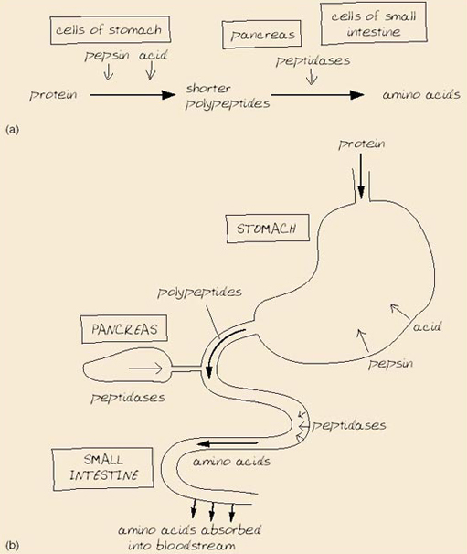
Figure 10 Two possible ways of summarising information on protein digestion: (a) a flow chart, and (b) a diagram

Protein digestion is normally very efficient and virtually all of the protein (98%) that is eaten by an adult is fully digested to amino acids and absorbed. However, the digestive systems of newborn babies are somewhat less efficient, which has important functional implications. Mothers' milk contains antibodies, which are a type of protein important in providing immunity against infections. If the infant digestive system were as efficient as that of an adult, these antibodies would be digested like any other protein. However, a slightly less efficient digestive system allows the antibodies to remain intact and to pass from the gut into the bloodstream, so providing essential immunity for the new baby. However, other proteins, such as those in cows' milk could also pass through to the baby's bloodstream undigested and can be the source of some allergies or food intolerances later in life. Artificial (formula) milks for babies are designed to minimise this risk, but this is an important reason in favour of breastfeeding where possible.

1.7.1 Protein balance
The blood vessels that pass close to the digestive system and collect the amino acids absorbed from the small intestine, travel first to the liver. The liver appears to monitor the amounts of the different amino acids in the blood and it is in the liver that some amino acids can be converted chemically from one type to another, to fulfil the body's requirements for the synthesis of its own proteins. Normal human diets do not contain the exact mix of amino acids that the body needs, and so this interconversion is a vital part of the body's metabolism.

1.7.2 Too much protein
There is no way of storing large quantities of amino acids in the human body and so if more are present in the blood than are needed, the surplus ones have to be broken down and removed from the body. The liver carries out this crucially important function. The amino (nitrogen-containing) part of the amino acid is converted into a substance called urea, which contains the unwanted nitrogen. The urea is then carried round in the bloodstream to the kidneys where it is removed and then excreted from the body dissolved in water in the urine. All animals have to undertake a similar process to get rid of their excess amino acids, though the form of the nitrogen-containing waste product depends on how much water is available to dilute it. Fish produce ammonia, which is soluble and needs large amounts of water to remove it from the body, and can be toxic at high concentrations in the blood. Ammonia (in solution) is lost via their gills. Birds, which often do not have easy access to water, produce a semi-solid white sludge of uric acid. The remaining (carbon-containing) part of the amino acid can be broken down in humans and other animals, to provide energy or it can be stored by being converted to carbohydrate or fat, depending on the identity of the R group.

1.7.3 Too little protein
If insufficient protein is present in the diet for the body's needs, then it starts to break down its own proteins. Since muscles contain large amounts of protein, the result of a low-protein diet is muscle-wasting. Individuals who have a poor appetite, perhaps due to some underlying medical condition, may also be short of protein and muscle weakness is common. Muscle wasting is particularly hard to detect in obese patients where the reduction in size of the muscles is not easily detectable beneath the layer of fat.
In some parts of the world, many millions of people are short of protein in their diet, though they are probably short of other essential dietary components too, and it is not easy to identify the particular part that protein deficiency plays in their overall malnutrition. Protein-energy malnutrition (PEM) is a condition where the diet of adults and children is lacking in a range of nutrients and overall food intake is too low for their bodily requirements. Marasmus is a severe form of PEM, resulting from a long-term insufficiency in energy intake. It is a condition that is often seen in famines, although low-level marasmus can occur throughout a vulnerable population, with only the most severe cases being noticed. If no other source of energy is available, the protein in the body's muscles and organs is broken down to provide energy. The cells lining the digestive system are affected, leading to poor absorption of nutrients from the inadequate diet. This cycle of inadequate diet and poor absorption of nutrients leads to the severe body wasting seen in famine victims. Kwashiorkor is protein deficiency in children. It can occur when children are weaned from breast milk onto protein-poor foods such as cassava (a root vegetable) or plantain (green bananas). Repeated childhood infections and a lack of vitamins and minerals make the condition worse. The characteristic features are oedema, which is swelling of parts of the body due to fluid retention, and a general lack of energy for any activity. Growth stops and there is severe liver damage, loss of weight and loss of pigmentation from the skin.

1.7.4 Nitrogen balance
In a healthy person, there should be a balance between the input of nitrogen to the body and its output. The input is mostly from protein, though some other foods may contain small quantities of nitrogen too. The output of nitrogen is mainly in urine, with a little in the faeces from undigested protein, from cells shed from the gut lining and from bacteria that live in the colon. Nitrogen is also lost from the body in the proteins of skin cells which are continuously shed, and in hair and nails, which consist of the protein keratin. Studies indicate that if there is no protein in the diet, 0.34 g protein per kg of body mass is lost from the body each day.

Activity 34

For a person with a body mass of 60 kg, how much protein would be needed in the diet each day to replace the amount lost?

View discussion - Activity 34

However, for good health, more protein than this theoretical amount is needed. For example, for females aged between 19 and 50, the estimated average requirement, EAR, is 36.0 g per day, while the reference nutrient intake, RNI, is 45.0 g per day.

Activity 35

Why is the EAR value lower than the RNI value for protein?

View discussion - Activity 35

Extra dietary protein is needed by people who are suffering from injury, infection, burns and cancer, as all these conditions increase the rate of loss of protein from the body. The upper safe limit of protein intake is probably around 1.5 g per kg of body mass per day. Higher intakes may cause loss of minerals from the bones (which can result in more fractures), possibly due to the loss of more calcium in the urine, and may possibly contribute to a decline in kidney function, although this effect has yet to be confirmed.

Activity 36

The Expenditure and Food Survey (DEFRA 2001/2) gives a value of 71.3 g for the daily intake of protein in the UK. How much greater than the RNI is this value for a female aged 40, expressed (a) as an amount and (b) as a percentage of the RNI?

View answer - Activity 36

Activity 37

- For a woman weighing 60 kg, what is the safe (maximum) limit of protein intake?
- How many times greater is this value than the EAR value?
- Use Table 2 to calculate how much protein is present in a 250 g (about 8 oz) lean steak and thus whether eating this amount of meat on a daily basis would exceed the safe limit.

View answer - Activity 37

Activity 38

For women over 50, the EAR for protein is 37.2 g and the RNI is 46.5 g. For men over 50, the corresponding values are 42.6 g and 53.3 g. For men between 19 and 50, the values are 44.4 g and 55.5 g.
- Construct a table to present the values clearly for both genders and the two age ranges.
- Identify which values are appropriate to you, or another adult whom you know. Use the information from Table 2, and perhaps information on the protein content from food labels, to estimate that person's daily protein intake and compare it to the values in your table.

View discussion - Activity 38

Conclusion
- The human body, and everything else, is made up of atoms.
- There are about 26 different sorts of atom in the human body, combined into numerous different sorts of molecules.
- Amino acids contain carbon (C), nitrogen (N), oxygen (O) and hydrogen (H) atoms, and some contain an atom of sulfur (S).
- There are about 20 different amino acids, with different side chains (R groups).
- Amino acids are linked via peptide bonds to make polypeptides and proteins.
- Each protein molecule can be hundreds of amino acids long and the amino acids must be joined in a precise order, which is specified by a code in the DNA in the chromosomes.
- The side-chains (R groups) of the amino acids can interact with one another to fold the protein into a particular shape which is essential for the protein to function correctly.
- When protein food is eaten, the amino acids are released by the activity of peptidase enzymes during digestion. The amino acids are then absorbed into the blood and used to build up the body's own proteins.
- The amount of protein needed in a balanced diet differs according to age and gender. Insufficient or excess protein in the diet can cause health problems.

Keep on learning



Study another free course
There are more than 800 courses on OpenLearn for you to choose from on a range of subjects.
Find out more about all our free courses.

Take your studies further
Find out more about studying with The Open University by visiting our online prospectus.
If you are new to university study, you may be interested in our Access Courses or Certificates.

What’s new from OpenLearn?
Sign up to our newsletter or view a sample.

For reference, full URLs to pages listed above:
OpenLearn – www.open.edu/openlearn/free-courses
Visiting our online prospectus – www.open.ac.uk/courses
Access Courses – www.open.ac.uk/courses/do-it/access
Certificates – www.open.ac.uk/courses/certificates-he
Newsletter – www.open.edu/openlearn/about-openlearn/subscribe-the-openlearn-newsletter

Acknowledgements
Except for third party materials and otherwise stated (see terms and conditions), this content is made available under a Creative Commons Attribution-NonCommercial-ShareAlike 4.0 Licence
Grateful acknowledgement is made to the following sources for permission to use material:
Course image: Bob Peters in Flickr made available under Creative Commons Attribution 2.0 Licence.
Figure 9 Eye of Science / Science Photo Library
Don't miss out:
If reading this text has inspired you to learn more, you may be interested in joining the millions of people who discover our free learning resources and qualifications by visiting The Open University - www.open.edu/openlearn/free-courses

Activity 28

Answer
(a) The four interactions are:
- Hydrophobic interactions. Those R groups that attract water molecules mostly lie on the outside of the folded protein; those that do not interact with water are clustered together on the inside of the folded chain.
- Ionic interactions. Some amino acids have charged R groups, which attract oppositely charged R groups and repel those with like charges.
- Hydrogen bonds. Depend on partial charges. They occur between H attached to O or N, and O or N elsewhere in the polypeptide chain or in a different chain.
- Disulfide bridges. Occur between the sulfur atoms in the R groups of cysteine molecules in different parts of the same polypeptide chain, or in different chains.
(b) If the change in the amino acid was from one with a hydrophobic R group to one with a hydrophilic R group (or vice versa), then it could cause the protein chain to fold differently. Similarly, if the change in the amino acid produced a change in the charge of the R group, then this could affect the ionic interactions and could affect the folding. Since hydrogen bonding can occur between R groups, a change could affect those interactions too, and thus affect folding. Disulfide bridges occur only between cysteines, so if the change involved a cysteine, then the folding would be affected, whereas if not, the disulfide bridges would remain unchanged. (SP4.6.2 looks at a protein that is affected in a major way by a single amino acid change.)
Back to Session 1 Activity 28

Activity 36

Answer
(a) RNI for a female aged 40 is 45.0 g of protein per day. So the daily intake of protein is 71.3 g – 45.0 g=26.3 g greater than the reference nutrient intake.
(b) Expressed as a percentage of RNI, this value would be

So the average daily intake of protein is over half as much again as the reference nutrient intake for a female aged 40.
Back to Session 1 Activity 36

Activity 37

Answer
(a) The safe limit for protein intake for a 60 kg woman would be 60 × 1.5 g protein per day=90 g
(b) The estimated average requirement EAR is only 36 g per day. So, the safe limit is times greater=2.5 (or two and a half) times greater than the estimated average requirement.
(c) Table SP4.2 shows that lean beef is 20% protein. So, a 250 g steak contains protein=50 g protein. So this alone does not exceed the safe limit for protein, though for other reasons it might not be the basis for healthy diet, and of course, significant amounts of protein would be consumed in other foods during the day.
Back to Session 1 Activity 37

Activity 1

Discussion
The following may be amongst the ones you have listed: oxygen, nitrogen, carbon dioxide, helium (familiar for its use to fill balloons, but also has many industrial uses), neon (in coloured signs), methane (the main component of natural gas), chlorine and hydrogen.
Back to Session 1 Activity 1

Activity 2

Discussion
As given above, an oxygen atom is 16 times heavier than a hydrogen atom. Oxygen has a relative atomic mass of 16. So oxygen atoms are slightly heavier than nitrogen atoms, whose relative atomic mass is 14 (each one is 14 times heavier than a hydrogen atom).
Back to Session 1 Activity 2

Activity 3

Discussion
The atoms in methane are carbon and hydrogen – one carbon atom and four hydrogen atoms. Since the molecule is made up of two different elements, methane is a compound.
Back to Session 1 Activity 3

Activity 4

Discussion
The symbols are the single capital letters O, C and H, respectively.
Back to Session 1 Activity 4

Activity 5

Discussion
Calcium, Ca; chlorine, Cl; iodine, I; iron, Fe; magnesium, Mg; phosphorus, P; potassium, K; sodium, Na.
Back to Session 1 Activity 5

Activity 6

Discussion
The structure of a water molecule is H—O—H; this is called its structural formula.
Back to Session 1 Activity 6

Activity 7

Discussion
The molecular formula does not show the way in which the atoms are joined together, whereas the structural formula H—O—H shows that the oxygen atom is in between the two hydrogen atoms. The order in which the atoms are attached together in molecules is important and so you often find molecules drawn in the extended form.
Back to Session 1 Activity 7

Activity 8

Discussion
The structural formula of methane is usually represented as shown here. Its molecular formula is CH₄ which indicates one carbon atom and four hydrogen atoms but does not show clearly how they are linked.
Back to Session 1 Activity 8

Activity 9

Discussion
Hydrogen atoms (H) can only ever form one bond; oxygen atoms (O) can form two bonds and carbon atoms (C) can form four bonds. These numbers are important and worth remembering as carbon, hydrogen and oxygen are the most important atoms in living things. If you remember H₂O and CH₄, you will always be able to work out the number of bonds that each atom (H, O and C) can form.
Back to Session 1 Activity 9

Activity 10

Discussion
You may have found this quite difficult. Carbon has four ‘arms’ and each oxygen has two ‘arms’. So, if each oxygen ‘holds hands’ with two of carbon's ‘hands’, then the formula would be as shown here. When there are two lines joining two atoms, then the bond is known as a double bond. So in this case we have a double bond between each of the oxygen atoms and the carbon atom.
Back to Session 1 Activity 10

Activity 11

Discussion
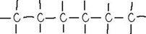
Back to Session 1 Activity 11

Activity 12

Discussion
There are two less (14 in straight-chain hexane and only 12 in cyclohexane), because the end two carbon atoms of straight-chain hexane are bonded to one another in cyclohexane, reducing the number of ‘arms’ available to bond to hydrogen.
Back to Session 1 Activity 12

Activity 13

Discussion
See below – there are six carbon atoms and six hydrogen atoms, so the molecular formula of benzene is C₆H₆. This structure is often drawn just showing the ring shape and the double bonds, omitting the carbon and hydrogen atoms (as you will see shortly).
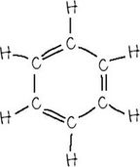
Back to Session 1 Activity 13

Activity 14

Discussion
Most people think of meat, fish, eggs and cheese as the main protein sources, though someone on a strictly vegetarian diet would list quite different sources, such as nuts and pulses (peas and beans).
Back to Session 1 Activity 14

Activity 15

Discussion
None of the high-protein foods listed contain very much water. In their normal condition, all of them are dry solids. Yet fresh eggs contain a great deal of water, which is why the inside of an egg is rather runny. Dried egg contains a much higher percentage of protein. You might think that a hard-boiled egg, which is fairly solid, is also dry. Does it contain less water? No, it does not; the water is still present, but trapped amongst the protein molecules. You will discover more about eggs later. The protein contents of meat and fish are similarly lower than those of flour, cheese and peanuts, due to the inclusion of significant amounts of water in them.
Back to Session 1 Activity 15

Activity 16

Discussion
Nearly all of them end in the three letters ‘-ine’. You may find this suffix a useful way to recognise an amino acid name in this course, although lots of other biological molecules end in ‘-ine’ and are not amino acids.
Back to Session 1 Activity 16

Activity 17

Discussion
The most likely reason is that older children and adults can synthesise arginine from other amino acids.
Back to Session 1 Activity 17

Activity 18

Discussion
Table 4 is my version of the table, together with a suitable title. I could have listed the elements in a different order, such as alphabetically, but I chose to list them in order of decreasing number of bonds.
Back to Session 1 Activity 18

Activity 19

Discussion
There are 10 atoms in glycine; five hydrogen atoms, two each of carbon and oxygen, and one nitrogen atom.
Back to Session 1 Activity 19

Activity 20

Discussion
The differences are:
- The upward pointing hydrogen atom H, on the central carbon C, has been replaced by R.
- The downward pointing hydrogen atom H has been written beside the central carbon atom, as CH.
- The two hydrogen atoms attached to the nitrogen atom N have been written beside it as H₂N. You will recall that this is the amino group, which can also be written as NH₂. Writing it here as H₂N shows more clearly that it is the N atom (and not one of the hydrogen atoms) that is bonded to the C atom.
- The hydrogen atom H to the right has been written beside the oxygen O atom, as OH.
Back to Session 1 Activity 20

Activity 21

Discussion
There are 19 other amino acids, excluding glycine, so there will be 19 different groups, one for each of them.
Back to Session 1 Activity 21

Activity 22

Discussion
Phenylalanine has a ring that looks very much like benzene attached to a —CH₂— group. Look back to Figure 2 if you don't remember what the complete benzene molecule looks like. Note that in this representation, the C and H atoms are omitted.
Back to Session 1 Activity 22

Activity 23

Discussion
Several hundred amino acids is typical. For example, the protein part of the haemoglobin molecule, which transports oxygen around the body consists of four polypeptide chains, two made up from 141 amino acids and two from 146 amino acids.
Back to Session 1 Activity 23

Activity 24

Discussion
The code exists in the DNA, which is present in chromosomes in the nuclei of human cells. This code gives the sequence of amino acids needed to make each protein.
Back to Session 1 Activity 24

Activity 25

Discussion
The amino acid lysine has a positive charge, whereas aspartate has a negative charge. If these amino acids occur in a protein, they can attract one another and bend the protein chain so that they lie close together. On the other hand, two lysines, both with a positive charge, will repel one another, pushing the two parts of the protein chain apart where they occur. Similarly, two aspartates, each with a negative charge, will also repel one another.
Back to Session 1 Activity 25

Activity 26

Discussion
All of these are possible. Figure 4b shows only two amino acids joined together, but a complete polypeptide molecule would contain C=O and N—H groups at regular intervals along the chain. So, type (i) could occur between an O—H group at the end of each protein chain, or an O—H group in the R group of an amino acid such as serine (see Table 5), and an O atom in any one of the C=O groups. Type (ii) could occur between the same O—H groups and a N atom in one of the N—H groups. Type (iii) could occur between the H from one of the N—H groups and an O atom from a C=O group elsewhere in the chain and type (iv) between an H from one N—H group and a N atom from another N—H group elsewhere. There will also be hydrogen bonding between some of the R groups of the amino acids making up the protein chain.
Back to Session 1 Activity 26

Activity 27

Discussion
The amino acids are: phenylalanine (Phe), valine (Val), asparagine (Asn), glutamine (Gln), histidine (His), leucine (Leu) and cysteine (Cys).
Back to Session 1 Activity 27

Activity 29

Discussion
The R group of glutamate carries a negative charge (—COO⁻, carboxylate group), which interacts with other charged groups and is important in determining the overall shape of the haemoglobin molecule. The R group of valine has no charge and so is unable to take part in such interactions.
Back to Session 1 Activity 29

Activity 30

Discussion
Disulfide bridges form between the R side-chains of the amino acid cysteine, which contains sulfur (Figure 8).
Back to Session 1 Activity 30

Activity 31

Discussion
The macromolecules are, of course, the proteins or polypeptides themselves, and the subunits are the amino acids. The bonds holding the subunits together are peptide bonds (see Section 6.1).
Back to Session 1 Activity 31

Activity 32

Discussion
Acids cause proteins to coagulate, by affecting the bonds holding globular proteins into their normal shape.
Back to Session 1 Activity 32

Activity 33

Discussion
Figure 10 shows two possible ways in which the information on protein digestion can be summarised, though your version could be just as good, or even better, and be quite different from either of these.
Back to Session 1 Activity 33

Activity 34

Discussion
The amount of protein needed would be (0.34×60) g=20.4 g.
Back to Session 1 Activity 34

Activity 35

Discussion
The EAR is the average amount of protein required for the whole population, so half of the population (50%) would need more than this value (and half would need less). The RNI on the other hand, is the protein intake that would be sufficient for 97.5% of the population, so only 2.5% would need more than this. So inevitably the EAR value will be lower than the RNI value.
Back to Session 1 Activity 35

Activity 38

Discussion
(a) Your table might look something like Table 6, though you may have chosen to put the EAR and RNI values as the row headings and the different genders and ages as the columns, which is just as good. The data for women between 19 and 50 is given in the preceding text.

Table 6 Dietary reference values for protein for adults
Gender and age | Estimated average requirement, EAR/g per day | Reference nutrient intake, RNI/g per day
Men
19–50 years | 44.4 | 55.5
over 50 years | 42.6 | 53.3
Women
19–50 years | 36.0 | 45.0
over 50 years | 37.2 | 46.5

(b) Your answer to this part will depend on the person you chose and their diet. If they ate foods which are rather different from those given in Table 2, you may not have been able to estimate the daily protein intake very accurately. Here is an example:

Meal | Food eaten | Estimated protein content/g
Breakfast | Cereal with milk (8 g per 40 g serving, with milk, according to packet) | 8
Lunch | White bread, 100 g (8% protein) | 8
 | Cheese, 50 g (26% protein) | 13
 | A little butter (less than 1% protein) | negligible
 | 6 cherry tomatoes | unknown
 | Piece of fruit cake | unknown
 | Banana, 120 g fruit (1% protein) | 1.2
Evening meal | Beef stew, made with 150 g beef (20% protein) | 30
 | Baked potato, 150 g (2% protein) | 3
 | Frozen green beans, 75 g (1.3 g per 75 g serving, according to packet) | 1.3
 | Yoghurt, 150 g (5 g protein per 100 g) | 7.5
Hot drinks | Made with about 150 ml milk (about 150 g, with 3.4 g protein per 100 g, according to carton) | 5.1
Snack | Apple, 100 g (less than 1% protein); cheese, 25 g (26% protein) | about 6
 | Total protein | about 83

This person (female, over 50) has eaten about 83 g protein during this day, significantly more than both the estimated average requirement (EAR) of 37.2 g protein and the reference nutrient intake (RNI) of 46.5 g protein. It is also more than the 71.3 g estimated daily protein intake in the UK determined by the Expenditure and Food Survey, referred to in Question 2, but less than the safe limit of 90 g per day, calculated in Question 3 for a woman weighing 60 kg.
Back to Session 1 Activity 38

