SMT359_2 Topics in the history of mathematics

James Clerk Maxwell

About this free course
This free course course provides a sample of Level 3 study in Science: http://www.open.ac.uk/courses/find/science.
This version of the content may include video, images and interactive content that may not be optimised for your device.
You can experience this free course as it was originally designed on OpenLearn, the home of free learning from The Open University - www.open.edu/openlearn/science-maths-technology/science/physics-and-astronomy/james-clerk-maxwell/content-section-0.
There you’ll also be able to track your progress via your activity record, which you can use to demonstrate your learning.
The Open University, Walton Hall, Milton Keynes, MK7 6AA
Copyright © 2016 The Open University
Intellectual property
Unless otherwise stated, this resource is released under the terms of the Creative Commons Licence v4.0 http://creativecommons.org/licenses/by-nc-sa/4.0/deed.en_GB. Within that The Open University interprets this licence in the following way: www.open.edu/openlearn/about-openlearn/frequently-asked-questions-on-openlearn. Copyright and rights falling outside the terms of the Creative Commons Licence are retained or controlled by The Open University. Please read the full text before using any of the content.
We believe the primary barrier to accessing high-quality educational experiences is cost, which is why we aim to publish as much free content as possible under an open licence. If it proves difficult to release content under our preferred Creative Commons licence (e.g. because we can’t afford or gain the clearances or find suitable alternatives), we will still release the materials for free under a personal end-user licence.
This is because the learning experience will always be the same high quality offering and that should always be seen as positive – even if at times the licensing is different to Creative Commons.
When using the content you must attribute us (The Open University) (the OU) and any identified author in accordance with the terms of the Creative Commons Licence.
The Acknowledgements section is used to list, amongst other things, third party (Proprietary), licensed content which is not subject to Creative Commons licensing. Proprietary content must be used (retained) intact and in context to the content at all times.
The Acknowledgements section is also used to bring to your attention any other Special Restrictions which may apply to the content. For example there may be times when the Creative Commons Non-Commercial Sharealike licence does not apply to any of the content even if owned by us (The Open University). In these instances, unless stated otherwise, the content may be used for personal and non-commercial use.
We have also identified as Proprietary other material included in the content which is not subject to Creative Commons Licence. These are OU logos, trading names and may extend to certain photographic and video images and sound recordings and any other material as may be brought to your attention.
Unauthorised use of any of the content may constitute a breach of the terms and conditions and/or intellectual property laws.
We reserve the right to alter, amend or bring to an end any terms and conditions provided here without notice.
All rights falling outside the terms of the Creative Commons licence are retained or controlled by The Open University.
Head of Intellectual Property, The Open University
Designed and edited by The Open University
978-1-4730-0679-9 (.epub)
978-1-4730-1447-3 (.kdl)

Contents
- Introduction
- Learning outcomes
- 1 Maxwell's greatest triumph
- 2 The equation of continuity
- 3 The Ampère–Maxwell law
  - 3.1 Limitations of Ampère's law
  - 3.2 Generalising Ampère's law
  - 3.3 The Ampère–Maxwell law in action
- 4 Maxwell's equations
- 5 Let there be light!
  - 5.1 Electromagnetic waves
  - 5.2 The energy of electromagnetic waves
- 6 Appendix: a note on displacement current density
- Conclusion
- Acknowledgements
- Solutions

Introduction
James Clerk Maxwell produced a unified theory of the electromagnetic field and used it to show that light is a type of electromagnetic wave. This prediction dates from the early 1860s when Maxwell was at King's College, London. Shortly afterwards Maxwell decided to retire to his family estate in Galloway in order to concentrate on research, unhindered by other duties. He was lured out of retirement in 1871, when he became the first professor of experimental physics in the Cavendish Laboratory, Cambridge. Given Maxwell's present status as one of the greatest of all physicists, it is astonishing to learn that he was the third choice for this job. Incidentally, Clerk Maxwell (without a hyphen) is a surname; Maxwell's father, John Clerk, simply appended ‘Maxwell’ to his own name in order to smooth a legal transaction.
This OpenLearn course provides a sample of Level 3 study in Science.

Learning outcomes
After studying this course, you should be able to:
- explain the meaning of the emboldened terms and symbols, and use them appropriately
- state the equation of continuity and use it in simple problems
- state the conditions under which Ampère's law is true and explain why it does not apply more generally
- state the Ampère–Maxwell law and explain why it has a greater domain of validity than Ampère's law
- state and name the differential versions of Maxwell's four laws of electromagnetism.

1 Maxwell's greatest triumph
This course presents Maxwell's greatest triumph – the prediction that electromagnetic waves can propagate vast distances through empty space and the realisation that light is itself an electromagnetic wave. Visible light has a very narrow range of wavelengths, but this tells us more about the sensitivity of our eyes than about the nature of electromagnetic radiation. A few years after Maxwell's death other types of electromagnetic radiation, including radio waves, X-rays and gamma rays, were discovered. Compared to light, radio waves have very long wavelengths, while X-rays and gamma rays have very short wavelengths. Different parts of the electromagnetic spectrum are used in different ways (Figure 1). Radio waves are used for broadcast radio and television, satellite communications and mobile phones. Gamma rays are used to treat cancer and X-rays are used in medical diagnosis. Yet all these waves have the same underlying description in terms of electric and magnetic fields.

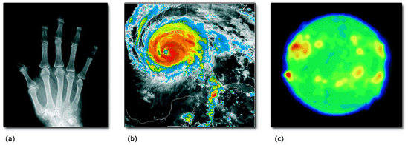
Figure 1a: Neil Borden/Science Photo Library; Figure 1b: NOAA/Science Photo Library; Figure 1c: Max-Planck-Institute for Radio Astronomy/Science Photo Library Figure 1a: Neil Borden/Science Photo Library; Figure 1b: NOAA/Science Photo Library; Figure 1c: Max-Planck-Institute for Radio Astronomy/Science Photo Library
Figure 1 (a) An X-ray image of a hand; (b) an infrared image of Hurricane Rita (2005); and (c) a radio image of the Sun taken at a wavelength of 2.8 cm. In (b) and (c) emission ranges from low (blue) to high (red).

Maxwell was in a position to predict the existence of electromagnetic waves because, by the mid-1860s, he had developed a comprehensive theory of electromagnetism. You may already have met some or all of Maxwell's four equations: let's take a brief look at Gauss's law, the no-monopole law and Faraday's law first. These three laws can be expressed in terms of volume, surface and line integrals or in terms of partial derivatives. In this course we will make use of the differential versions of Maxwell's equations.

SAQ 1

Write down the differential versions of Gauss's law, the no-monopole law and Faraday's law. Are these laws true under all circumstances?

View answer - SAQ 1

The differential version of Ampère's law is

where J is the current density and μ₀ is the permeability of free space. However, Ampère's law has a different status: it requires steady currents and is not valid for currents that vary in time. This means that Ampère's law is not general enough to count as one of Maxwell's four laws of electromagnetism.
Fortunately, Ampère's law can be rescued. Maxwell realised that an extra term, , can be added to the right-hand side of Ampère's law. This term makes no difference in static situations, but it extends the validity of the law to general, time-varying situations. The extended equation is called the Ampère–Maxwell law and takes the form

Our first task is to justify this law. To achieve this, we will make use of a basic principle of electromagnetism – the conservation of charge. Section 2 will show that the law of conservation of charge leads to a relationship between current density and charge density known as the equation of continuity. This relationship will be used in Section 3 to help justify the Ampère–Maxwell law. Then, with all four of Maxwell's equations in place, we will be in a position to demonstrate that electromagnetic waves are a direct consequence of the laws of electromagnetism.

2 The equation of continuity
The conservation of charge is a basic tenet of electromagnetism. It can be simply expressed by the equation

where Q_{tot} is the total charge in the Universe. However, such an equation does not really help us very much, because we are not usually concerned with anything as grand as the whole Universe. Moreover, it leaves out some important physics.
The most interesting aspect of the law of conservation of charge is that it applies locally as well as globally. If an electron were miraculously created here, and a proton were simultaneously, and equally miraculously, created on Mars, the total charge of the Universe would remain constant. But these two miracles would both violate the law of conservation of charge because they do not conserve charge locally, either here or on Mars. Electric charge is conserved in every region of space. We can therefore make a more powerful statement:

The law of conservation of charge
Any variation in the total charge within a closed surface must be due to charges that flow across the surface.

To express this law in mathematical terms, consider a volume V bounded by the closed surface S (Figure 2). Electric current is defined to be the rate of flow of charge across a surface so the law of conservation of charge tells us that

where I is instantaneous current flowing outwards through S into the exterior space and Q is the instantaneous charge in the enclosed volume V. The minus sign arises because a current flowing outwards across the surface produces a loss of charge within the surface.

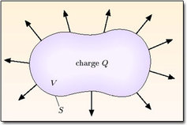
Figure 2 The current flowing across the closed surface S tells us the rate of loss of charge in the volume V enclosed by S

Now we can express the current I as a surface integral of the current density J:

Using the divergence theorem, we can also write this as

We can express the charge Q as a volume integral of the charge density ρ:

The rate of change of Q within this volume is therefore

Note the use of ordinary differentiation outside the integral and partial differentiation inside the integral. Ordinary differentiation is appropriate outside the integral because Q(t) is a function of time only. By contrast, the charge density depends on spatial coordinates as well as on time. These spatial coordinates remain fixed, so partial differentiation with respect to time is appropriate inside the integral.
Combining Equations 7.1, 7.2 and 7.3 , we conclude that

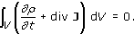

The fact that this volume integral vanishes for all volumes (no matter how small) implies that the integrand must be equal to zero everywhere, so we have

This is called the equation of continuity. It applies at each point in space and each instant in time and is a direct expression of the local law of conservation of charge. It is a fundamental fact about electromagnetism which applies in all situations and in all frames of reference.
The case of magnetostatics, where all the currents are steady, is of special importance. In this case, we can argue that ∂ρ/∂t must be equal to zero. For, if ∂ρ/∂t were positive at any particular point, it would remain positive there forever, since all the currents are steady. This would lead to an unphysical boundless build-up of charge. A similar argument rules out a negative value of ∂p/∂t. Therefore realistic steady currents are characterised by

However, this is a very special situation. If the currents are not steady, we would expect concentrations of charge to build up in different regions, and then ebb away. In general, ρ varies in time, and div J ≠ 0.

Exercise 1

A one-dimensional rod is aligned with the z-axis. At any point along the rod, the current density is given by

where k, ω and A are constants. What can be said about the charge density along the rod? You may assume that the time-average of charge density is zero at each point along the rod.

View answer - Exercise 1

3 The Ampère–Maxwell law

3.1 Limitations of Ampère's law
In order to analyse the limitations of Ampère's law, and suggest ways of overcoming them, we need to use some properties of divergence. For ease of reference, these properties are given below:

Some properties of divergence
- The divergence of any curl is equal to zero:

- A constant k can be taken outside a divergence:

- A time derivative can be taken outside a divergence:

You can take these properties on trust if you wish, but it is easy enough to prove them by expanding both sides in Cartesian coordinates.

SAQ 2

Prove Equation 7.5.

View answer - SAQ 2

Now let's examine the differential version of Ampère's law, which states that

The limitations of this law are revealed by taking the divergence of both sides. This gives

The divergence of any curl is equal to zero so, using Equation 7.6 and the equation of continuity, we have

We therefore see that Ampère's law requires the charge density to remain constant. Put another way:

Ampère's law fails when the charge density changes in time.

3.2 Generalising Ampère's law
We need to generalise Ampère's law beyond the confines of static charge densities. Let's try adding an extra (and at this stage unknown) vector field, K to the right-hand side of the differential form of Ampère's law. The modified equation then reads

What can be said about the term K? Taking the divergence of both sides of the modified equation, and using the fact that the divergence of any curl is equal to zero, we obtain

So, using the equation of continuity (Equation 7.4), we have

Now Gauss's law tells us that

so, using Equation 7.7 to interchange the order of the time and space derivatives,

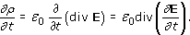

We conclude that

The simplest solution to this equation is

but there are other solutions as well. In fact, the most general solution is

where X is any smooth vector field. You can easily verify that this satisfies Equation 7.8, because taking the divergence of both sides gives

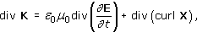

and the last term vanishes, being the divergence of a curl.
This is as far as mathematical analysis can take us. It is not too surprising that we still have a choice to make. You should not expect to derive a fundamental law of physics from other laws. As a general rule, however, it is sensible to adopt the simplest law that is consistent with all the known facts. That is what Maxwell did, and we shall follow his lead. We assume that curl X = 0 in Equation 7.9, and replace Ampère's law by

This equation is called the Ampère–Maxwell law and the additional term, ε₀μ₀∂E/∂t, is called the Maxwell term. Some authors refer to the Maxwell term as μ₀ times the displacement current density. We will not use this terminology in this course, but an optional appendix (best read after this section) describes the curious logic behind it (see Section 6). The Ampère–Maxwell law is the last of Maxwell's four equations of electromagnetism. It is believed to be true in all situations, both static and dynamic.
The above argument for the Ampère–Maxwell law is driven by theory. If we believe the law of conservation of charge (as we do), our mathematical analysis shows that Ampère's law must be modified for time-dependent situations. The simplest modification, consistent with Gauss's law and the equation of continuity, is then given by the Ampère–Maxwell law. Physics walks forward on the two legs of theory and experiment. Sometimes experiment strides ahead and reveals new facts which cry out for theoretical interpretation. The Ampère–Maxwell law is an early example of the opposite process – a law that emerged from a theoretical argument, and cried out for experimental confirmation.
In Maxwell's day, there was no direct experimental evidence requiring a modification to Ampère's law. The Maxwell term ε₀μ₀∂E/∂t is usually very small in comparison with the term associated with the current density, μ₀J. For example, if a mains-frequency current is uniformly distributed throughout a copper wire, the Maxwell term in the wire is only about 5 × 10⁻¹⁷ as large as μ₀J. On this basis, it is tempting to dismiss the Maxwell term as a practical irrelevance, but this would be a serious error of judgement. Although small, the Maxwell term can exist in empty space, where no real currents exist, and there it plays a vital role in sustaining the propagation of electromagnetic waves, as you will soon see. Ultimately, the existence of these waves provides the best evidence for the whole of Maxwell's theory, including the Maxwell term and the Ampère–Maxwell law.

Exercise 2

Equation 7.10 is the differential version of the Ampère–Maxwell law. Show that the corresponding integral version is

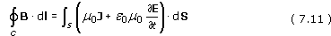

where C is a closed loop and S is any open surface that has C as its perimeter. The sense of positive progression around C and the orientation of S are related by the right-hand grip rule.

View answer - Exercise 2

3.3 The Ampère–Maxwell law in action
To give some further insight into the Ampère–Maxwell law, we will now consider two situations where it plays a significant role.

3.3.1 An expanding sphere of charge
First consider an expanding spherically-symmetric ball of positive charge. This is not an implausible state of affairs. If the charges in the distribution are not held in place, their mutual repulsion leads to a spherically-symmetric expansion and a spherically-symmetric outward flow of current. Any spherically-symmetric distribution of current is magnetically silent – that is, it produces no magnetic field. This is true both outside and inside the current distribution. We will now show that this rather surprising result is fully consistent with the Ampère–Maxwell law.

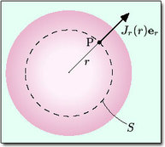
Figure 3 An expanding sphere of charge.

Using a spherical coordinate system with its origin at the centre of the charge distribution, we consider a point P with radial coordinate r (Figure 3). Because the charge distribution is spherically-symmetric, the electric field at P is

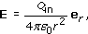

where Q_{in} is the total charge inside a sphere of radius r (the dashed sphere in Figure 3). The outward current through the surface of the dashed sphere is equal to the rate of decrease of charge inside it, so we have

where S is the surface of the dashed sphere and J = J_{r}(r) e_{r} is the current density on the surface of this sphere. It follows that the Maxwell term at point P on S is

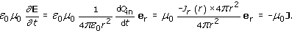

Combining this equation with the Ampère–Maxwell law (Equation 7.10), we finally obtain

which is consistent with B = 0. Note that the Maxwell term is essential for this cancellation. Ampère's law would wrongly imply that curl B ≠ 0 at points where J ≠ 0.
(Incidentally, div B is also equal to zero, by virtue of the no-monopole law. Although we shall not prove it, the fact that both curl B and div B vanish everywhere, and the natural assumption that B tends to zero at infinity, turns out to be sufficient to guarantee that B = 0 everywhere.)

3.3.2 A capacitor with time-varying charges on its plates
Figure 4 shows a parallel plate capacitor with circular plates, which is being charged by steady currents flowing along straight wires. We know that there is a circular pattern of magnetic field lines around the wires, but what happens inside the capacitor, between the plates?

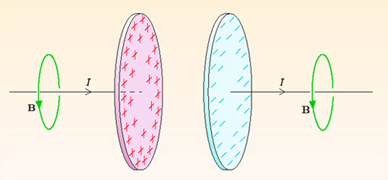
Figure 4 Charging the plates of a capacitor.

The situation illustrated in Figure 4 is difficult to analyse quantitatively. Charge spreads out over the plates from the points of contact with the wires so, at any given moment, the plates are unevenly charged and radial currents flow over their surfaces. We will avoid such complications by imagining that the charge is conveyed by a uniform steady current density that is perpendicular to the full area of the plates. One way of approaching this ideal would be to replace the arrangement of Figure 4 by thick cylinders separated by a narrow gap, as in Figure 5. The gap between the cylinders is tiny compared to their diameters, so the system behaves like an infinite parallel plate capacitor, with the end-faces of the cylinders serving as the capacitor plates.

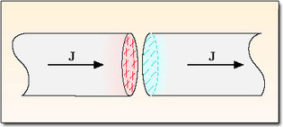
Figure 5 A parallel plate capacitor formed from thick cylinders.

Between the plates, there is no charge flow so the current density J is equal to zero. However, the Maxwell term is non-zero there because the increasing charge on the plates produces a steadily increasing electric field between the plates. Taking the gap between the plates to be tiny (so that we can ignore edge effects), the electric field between the plates is uniform and has the instantaneous value

where Q(t) is the instantaneous charge on the positive plate, A is the area of a plate and e_{z} is a unit vector pointing from the positive plate to the negative plate. The Maxwell term in the gap is

so the differential version of the Ampère–Maxwell law in the gap is

The corresponding integral equation is

where S is an open surface and C is its perimeter.
Exploiting the axial symmetry of the situation, we use cylindrical coordinates with the z-axis along the line of symmetry. We also assume that the magnetic field has the form

For the moment, we have allowed for a possible dependence of B_{φ} on z. This is a wise precaution because the present situation does not have translational symmetry, but you will soon see that it is not necessary.
To apply the Ampère–Maxwell law, we choose the circular path C shown in Figure 6, together with the disc S that has C as its boundary. Equation 7.14 then gives

So

and the magnetic field between capacitor plates is

This is independent of z, and is also independent of time because we are assuming that the capacitor is being charged at a constant rate by a steady current.

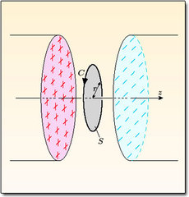
Figure 6 A circular path C and a disc S used to find the magnetic field inside a capacitor that is being charged.

I should perhaps point out that I am not claiming that the Maxwell term causes the magnetic field inside the capacitor. It would be silly to neglect the currents that bring charge to the capacitor plates. These currents do not flow inside the capacitor, but there is nothing to prevent them from producing a magnetic field inside the capacitor. Indeed, if the gap between the plates is small, the magnetic field inside the capacitor due to external currents must overwhelm anything else. This may lead you to wonder why the above calculation, based on the Maxwell term, is valid. The logic is as follows. First, the time-varying charges on the capacitor plates produce a time-varying electric field between the plates. Then the Ampère–Maxwell law provides a relationship between the time-varying electric field and the circulation of the magnetic field. This relationship must be satisfied by all electric and magnetic fields, and it allows us to deduce the magnetic field from the known electric field irrespective of what the causes of these fields might be.
It is also instructive to calculate the magnetic field inside the capacitor by an alternative route. Instead of choosing S to be a disc, we can take it to be the open cylinder shown in Figure 7, with its end-cap outside the capacitor. The unit normal to the end-cap is chosen to point along the positive z-axis, in accordance with the usual right-hand grip rule.

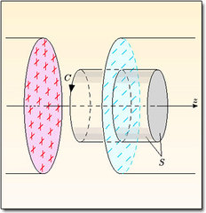
Figure 7 A circular path C and an open cylinder S used to find the magnetic field inside the capacitor. The open cylinder has an end-cap on right, but no end-cap on the left.

Outside the infinite parallel plate capacitor, there is no time-dependent electric field, so there is no Maxwell term. However, there is the steady uniform current density that brings charge to the capacitor plates. This current density obviously obeys

Now, both the Maxwell term inside the capacitor and the current density outside the capacitor are perpendicular to the capacitor plates (remember, we have carefully avoided any radial flow of current). So, if we apply the integral version of the Ampère–Maxwell law (Equation 7.11) to the surface in Figure 7, the curved sides of the cylinder contribute nothing, and we are left with an integral over the end-cap. The Ampère–Maxwell law then gives

exactly as before. This shows why the Maxwell term is needed. Without it, these two methods of calculating the magnetic field inside the capacitor would give different answers, leading to a contradiction. Very similar calculations show that the magnetic field outside the capacitor is given by exactly the same expression, so there is no difference between the magnetic field inside and outside the capacitor.
Finally, it is interesting to note that the predictions of the Ampère–Maxwell law can be put to a direct experimental test. In 1973, Carver and Rajhel carried out a demonstration using the apparatus sketched in Figure 8. An oscillating voltage was applied across the circular plates of a large parallel plate capacitor, producing an oscillating electric field inside the capacitor. From the above argument, we would expect this to be accompanied by an oscillating B_{φ} field. The toroidal coil in Figure 8 was designed to detect this. The oscillating magnetic flux through the toroidal coil induced an oscillating voltage, which was easily detected on an oscilloscope.

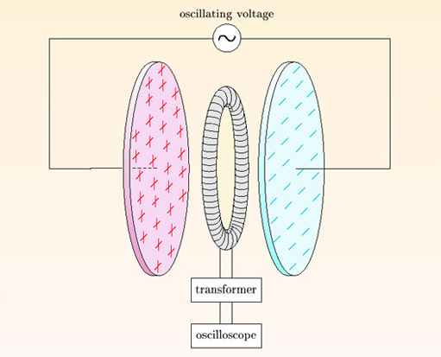
Figure 8 A direct test of the Ampère–Maxwell law.

4 Maxwell's equations
We have reached a major milestone. All four of Maxwell's equations are now in place. This is an appropriate place to review their meaning and significance. We concentrate here on the differential versions, which are as follows:

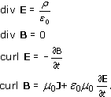

SAQ 3

Name the above equations.

View answer - SAQ 3

Maxwell's equations are of great generality. They apply to all charge and current densities, whether static or time-dependent. Together, they describe the dynamical behaviour of the electromagnetic field. Each of Maxwell's equations is a local equation, relating field quantities at each point in space and at each instant in time, so all trace of instantaneous action at a distance has been eliminated. The revolutionary nature of this description was recognised by Einstein, who wrote:

‘The formulation of [Maxwell's] equations is the most important event in physics since Newton's time, not only because of their wealth of content, but also because they form a pattern for a new type of law … Maxwell's equations are laws representing the structure of the field … All space is the scene of these laws and not, as for mechanical laws, only points in which matter or charges are present.’

Maxwell's equations are partial differential equations. They link the spatial and temporal rates of change of electric and magnetic fields, and they show how these rates of change are related to the sources of the fields – charge and current densities. The spatial rates of change of the fields are neatly bundled up as div E, div B, curl E and curl B – divergences and curls. This, in itself, is an immense simplification. Each field has three components, which can be partially differentiated with respect to three coordinates, so there are 18 first-order spatial partial derivatives of the electric and magnetic fields. The divergences and curls collect these partial derivatives together, focusing attention on only eight quantities of interest (a scalar for each divergence and three components for each curl). Moreover, divergences and curls have clear physical interpretations, telling us how the fields spread out and circulate at each point.
Where do the electric and magnetic fields come from? The modern answer is that they come from the terms in Maxwell's equations that describe matter – the charge and current densities, ρ and J. To be explicit about this, we can re-order and rearrange Maxwell's equations so that the two source terms appear on the right-hand sides of the first two equations:

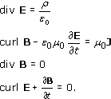

In regions where there are no charges or currents, all four equations have zero on the right-hand sides. They then tell us the conditions that electric fields and magnetic fields must satisfy in empty space. These conditions describe the internal structure and dynamics of the electromagnetic field. We will discuss this dynamics in the next section, and you will see that it allows the propagation of wave-like disturbances – electromagnetic waves.
In regions where there are charges and currents, the first two equations have an additional role. They tell us how the electromagnetic field is coupled to matter, and the left-hand sides of these equations describe the response of the electromagnetic field to the local charge and current densities. The last two equations do not have this role, so Maxwell's equations are asymmetrical. The absence of source terms in the last two equations arises because magnetic monopoles, and monopole currents, are assumed to be non-existent.
When Maxwell introduced his equations, he expected them to apply in a special frame of reference – the frame of the stationary ether. This is not the modern view. We now believe equations apply in all inertial frames of reference – that is, all frames in which free particles move uniformly, with no acceleration. Maxwell's equations are also unaffected by time-reversal and by reflections in space.
Only one caveat need be mentioned. Maxwell's equations do not apply in non-inertial frames. In a rotating frame of reference, for example, the electric flux over a closed surface can be non-zero even though the surface encloses no net charge – a clear violation of Gauss's law. This should not alarm you. Most laws of physics, including the laws of conservation of energy and momentum, are restricted to inertial frames of reference, and Maxwell's equations are no exception.

Exercise 3

Show that Maxwell's equations are unchanged by the operation of time-reversal, which changes t → −t, J → −J and B → −B, but leaves ρ and E unchanged.

View answer - Exercise 3

Exercise 4

Show that the equation of continuity is contained within the Ampère–Maxwell law and Gauss's law.

View answer - Exercise 4

5 Let there be light!

5.1 Electromagnetic waves
This section gives a brief introduction to light and electromagnetic waves.
The idea that light is an electromagnetic wave had occurred to Faraday while Maxwell was still a schoolboy, but Maxwell was the first person to possess a complete set of equations describing the dynamical behaviour of electric and magnetic fields. Believing that Faraday was correct, Maxwell set out to show that his equations have wave-like solutions that propagate through empty space at the speed of light.
Electric and magnetic fields are produced by charges and currents, but these fields also extend into surrounding regions of empty space. For example, charges and currents in the Sun produce electromagnetic fields which travel across almost empty space before reaching sunbathers on a beach on Earth. The detailed relationship between the fields and their sources will not be discussed here. Instead, we take the existence of time-varying electric and magnetic fields for granted, and concentrate on their propagation through space. In empty space, the charge and current densities are equal to zero, so Maxwell's equations become

Our aim is to show that these equations have wave-like solutions which describe oscillating electric and magnetic fields that propagate through space. These wave-like solutions are called electromagnetic waves.

5.1.1 Starting points
We begin by making some simplifying assumptions about the electric field. This is legitimate because we are not looking for the most general solution to Maxwell's equations, but only for special solutions that exhibit wave-like behaviour. We will ultimately check that our solutions for the fields satisfy all of Maxwell's equations, and hence obtain retrospective support for our initial assumptions.
If you drop a pebble in a pond, waves spread out in all directions on the surface. Many electromagnetic waves spread out radially like this, but we will consider a disturbance that propagates in a fixed direction, like the parallel beam from a searchlight. We will take the direction of propagation to be the z-axis. For simplicity, we assume that the electric field depends only on z and t, and does not depend on x or y at all. At any given instant, the surfaces on which the electric field has a constant value are planes perpendicular to the z-axis. These planes are infinite in extent, corresponding to an infinitely wide beam. Disturbances of this type are called plane waves. We will also assume that the electric field oscillates along a fixed direction. Disturbances of this type are called linearly polarised waves.
With these assumptions, the electric field takes the form

where f (z, t) is some (as yet unspecified) function of z and t and u = u_{x}e_{x} + u_{y} e_{y} + u_{z} e_{z} is a fixed unit vector. This electric field, and any associated magnetic field, must satisfy all four of Maxwell's equations in empty space. We will now show that this can be achieved provided that certain conditions are met. So our confirmation that electromagnetic waves can exist will also predict some of their properties.

5.1.2 Getting agreement with Gauss's law
Substituting the assumed form of the electric field (Equation 7.20) into the empty-space version of Gauss's law (Equation 7.16) gives

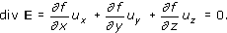

The first two partial derivatives are equal to zero because f does not depend on x or y. So we obtain

We are interested in disturbances that propagate in the z-direction, so can ignore the possibility that ∂f/∂z = 0 everywhere. It follows that u_{z} = 0. This means that u is a unit vector perpendicular to the z-direction. With no loss in generality, we can choose u to be equal to e_{x}. It is then appropriate to replace f by E_{x}, and write Equation 7.20 in the form

A wave of this type, in which the variable of interest oscillates perpendicular to the direction of propagation, is said to be transverse.

5.1.3 Getting agreement with Faraday's law
Substituting Equation 7.21 into Faraday's law gives

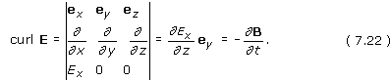

This shows that a propagating electric wave is automatically accompanied by a transverse magnetic wave. The magnetic field oscillates in the y-direction, which is perpendicular to the direction of propagation and to the electric field. Expressing the magnetic field as

Equation 7.22 requires that

This condition makes good sense. Faraday's law links the rate of change of the magnetic field to the spatial variation of the electric field. The consequences of this condition will be explored at the end of our analysis, after agreement with the remaining two Maxwell equations has been checked.

5.1.4 Getting agreement with the no-monopole law
Substituting Equation 7.23 into the no-monopole law gives immediate agreement because

The no-monopole law is analogous to Gauss's law in empty space, and it leads to a similar conclusion: the magnetic wave must be transverse. This has already been established using Faraday's law, so no further conditions are added at this stage.

5.1.5 Getting agreement with the Ampère–Maxwell law
Finally, our electric and magnetic fields must satisfy the Ampère–Maxwell law in empty space. Using Equations 7.21 and 7.23, we obtain

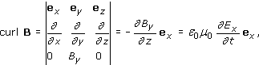

which requires that

This condition is analogous to that obtained using Faraday's law. The Ampère–Maxwell law links the rate of change of the electric field to the spatial variation of the magnetic field.

5.1.6 Pulling it all together
The electric and magnetic fields given by Equations 7.21 and 7.23 can satisfy all four of Maxwell's equations in empty space. Gauss's law and the no-monopole law are immediately satisfied because the fields are transverse. Faraday's law and the Ampère–Maxwell law will also be satisfied if we can find electric and magnetic fields that obey Equations 7.24 and 7.26.
We are looking for wave-like solutions, so it is sensible to try

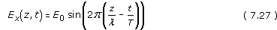

which is a typical expression for a monochromatic plane wave propagating in the z-direction. In this equation, E₀ is the maximum value of the electric field: this is the amplitude of the wave. At any fixed time, λ is the distance between successive wave crests: this is the wavelength of the wave. At any fixed position, T is the time between successive wave crests: this is the period of the wave. Because there is only one wavelength associated with the wave, it is said to be monochromatic. Figure 9 shows the progression of the wave at times t = 0, T / 4, T / 2, 3T / 4 and T. The sinusoidal shape travels undistorted in the positive z-direction at the constant speed c = λ / T.

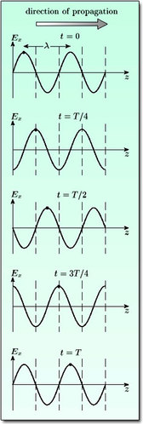
Figure 9 A monochromatic plane wave propagating in the z-direction.

Equation 7.27 is more commonly written in the form

where k = 2/λ is the wavenumber of the wave and ω = 2/T is the angular frequency (not to be confused with the frequency f = 1/T). The speed of the wave is then given by

Substituting this expression for the electric field into Equation 7.24 (a consequence of Faraday's law) we obtain

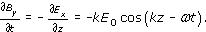

This equation can be integrated to give

where K (x,y,z) is any time-independent function. Time-independent fields such as K can always exist, but they obviously play no part in the propagation of electromagnetic waves. It is therefore sensible to set K = 0. Remembering that the speed of the wave is given by c = ω/k, we can write

Figure 10 shows how the electric and magnetic fields are related to one another. The electric and magnetic waves have similar shapes and are exactly in phase with one another. At all times E = cB, and both waves travel through empty space at the speed c.

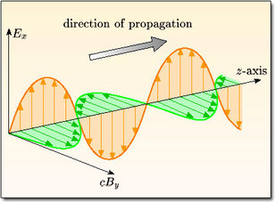
Figure 10 An electromagnetic wave travelling in the z-direction.

Finally, we impose the condition given in Equation 7.26 (a consequence of the Ampère–Maxwell law). Rearranging this equation and inserting our expressions for the electric and magnetic fields (Equations 7.28 and 7.29), we obtain

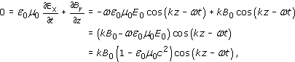

where we have used ω = ck and E₀ = cB₀ in the final line.
We therefore conclude that, in empty space, electromagnetic waves propagate at the fixed speed

Now for the moment of truth. The constants ε₀ and μ₀ can be found by measuring electrostatic and magnetostatic forces. In fact, the proportionality constant in Coulomb's law is

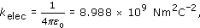

and the proportionality constant in the Biot–Savart law is

The speed of electromagnetic waves in empty space is the square root of the ratio of these proportionality constants:

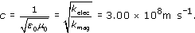

To a fanfare of trumpets, we note that this is numerically the same as the measured speed of light in a vacuum. In 1865, Maxwell wrote:

‘This velocity is so nearly that of light that it seems we have strong reason to conclude that light itself (including radiant heat, and other radiations if any) is an electromagnetic disturbance in the form of waves propagated through the electromagnetic field according to electromagnetic laws.’

Maxwell's ‘strong reason’ was irresistible – it is now fully accepted that light is an electromagnetic wave, with frequencies in the narrow band that our eyes can detect. Optics has become a branch of electromagnetism.
Maxwell also hinted that other electromagnetic waves, with frequencies beyond the visible range, might exist, but he suggested no mechanism for producing these waves. The problem was not just to generate the waves, but also to detect them and measure their properties. In 1887, Heinrich Hertz embarked on a magnificent series of experiments which succeeded in doing all of this (Figure 11). Feeding an oscillating current into a circuit containing two metal spheres, he created an oscillating electric dipole. This generated electromagnetic waves with wavelengths more than 10⁷ times greater than the wavelength of visible light. The electric field of these waves was detected by the spark it produced across a narrow gap in a conducting metal loop. Using this primitive equipment, Hertz measured the speed of the waves and confirmed that it agreed with the known speed of light. He showed that the waves are transverse rather than longitudinal, and he observed refraction, reflection and focusing of the waves. Everything was similar to visible light, but on a much larger length-scale and a much more leisurely time-scale.

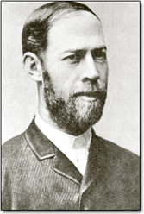
Science Photo Library Science Photo Library
Figure 11 Heinrich Hertz (1857–1894).

Hertz's work had a dual effect. It provided vital confirmation of Maxwell's theory, and it also led to rapid technological developments. In 1895 a radio signal was transmitted a distance of one mile; by 1900, the range had increased to 200 miles, and in 1901 a signal crossed the Atlantic. The first broadcasting radio station opened in Pittsburgh in 1920. The rest, as they say, is history. Society has been totally transformed by broadcast radio and television, satellite communication, mobile phones and wireless internet connection.
Today, the known electromagnetic spectrum extends over at least 20 orders of magnitude, from gamma rays to very low-frequency radio waves. There is no reason to believe that it does not stretch further, but there are practical difficulties in producing significant amounts of electromagnetic radiation at the extremes of frequency. Figure 12 shows the entire spectrum, with named regions characterised by their wavelength and frequency. The visible part of the spectrum occupies only a tiny fraction of the whole – from 4 × 10¹⁴ Hz for red light to 8 × 10¹⁴ Hz for violet light.

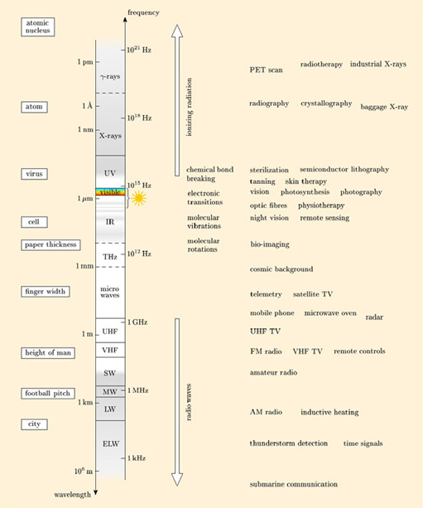
Figure 12 The electromagnetic spectrum and its applications in various areas of medicine, technology and astronomy. The spectrum is displayed on logarithmic wavelength and frequency scales. Various parts of the spectrum are given the following abbreviations: extra long wave (ELW), long wave (LW), medium wave (MW), short wave (SW), very high frequency (VHF), ultra high frequency (UHF), terahertz (THz), infrared (IR) and ultraviolet (UV). The region indicated by the Sun symbol accounts for 99% of the Sun's output. The grey regions are significantly absorbed or reflected by the Earth's atmosphere, and so are of limited use to astronomers. The left-hand side of the diagram shows some typical lengths for comparisons with the wavelength scale. The right-hand side of the diagram shows how different wavelengths are used in applications. In some cases, a range of wavelengths is involved and a typical value is indicated.

Click to view a larger version of figure 12 (you will need to zoom in after opening it).

Exercise 5

An electromagnetic wave is incident on a filter which absorbs all the electric field. Describe the magnetic field beyond the filter.

View answer - Exercise 5

Exercise 6

How many cycles of orange light pass a given point in 1.0 × 10⁻¹⁴ s? (Orange light has a wavelength 600 nm.)

View answer - Exercise 6

Exercise 7

A moving charged particle travels at speed v in the same direction as an electromagnetic wave. What is the ratio of the magnitudes of the electric and magnetic forces exerted on the particle by the electromagnetic wave? Under what conditions do these two force magnitudes become comparable?

View answer - Exercise 7

5.2 The energy of electromagnetic waves
The energy density of an electric field E is

Although we will not prove it in this course, a very similar result applies to magnetic fields. The energy density of a magnetic field B is

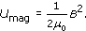

It follows that an electromagnetic wave has a certain energy density, and as the wave travels through space, this energy is transported with it. Energy transport is clearly an important feature of electromagnetic waves, and explains how we can benefit from the energy generated in the Sun, 1.5 × 10⁸ km away.
Let's compare the energy densities in the electric and magnetic waves in an electromagnetic wave. If E and B are the magnitudes of the electric and magnetic fields at a given point, we have

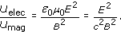

However, we know from Equations 7.28 and 7.29 that E = cB at any point in an electromagnetic wave. So the electric and magnetic waves have equal energy densities.
In a small time interval Δt, the amount of energy transported across an area ΔS, perpendicular to the direction of propagation of the wave, is given by the energy in the shaded volume in Figure 13. Allowing for the equal energy densities of the electric and magnetic waves, this is

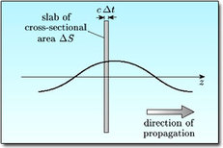
Figure 13 The electromagnetic energy in the shaded volume has crossed the area ΔS in time Δt.

The rate of transfer of energy per unit area perpendicular to the direction of propagation of the wave is called the energy flux, so we have

Note: The energy flux is per unit area, and is a scalar field defined at each point in space. It has a different character from electric or magnetic fluxes which are not per unit area and are defined over specified surfaces.
The energy flux varies rapidly as peaks and troughs of the electromagnetic wave pass through the given area. Generally, we wish to know the average energy flux over one period of the wave. For a monochromatic, plane electromagnetic wave travelling in the z-direction, the electric field is proportional to E₀ cos(kz − ωt), so we need to average cos²(kz − ωt) over one period. Using the identity cos² θ = (1 + cos 2θ) / 2, we have

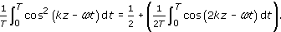

Because T = 2/ω, the integral on the right-hand side is the integral of a cosine over a whole number of periods, and so is equal to zero. We therefore conclude that

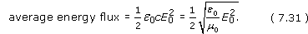

Exercise 8

At a receiver, a strong radio signal has an electric field of amplitude 0.01 V m⁻¹. What is the average energy flux associated with this signal?

View answer - Exercise 8

This is a suitable point at which to end this course. All of Maxwell's equations have been introduced, and you have seen that these equations permit electromagnetic waves to travel through empty space. Electric and magnetic fields are not just mathematical abstractions, but are real enough to transport energy from distant sources. You are bathed in various hues of light from the objects you see around you. Radio waves from radio and TV stations and a vast number of transmitting mobile phones are passing through you. In addition, there is a cosmic microwave background from the first minutes of the Universe and gamma rays from the most distant stars. No wonder Richard Feynman felt able to make the following judgement:

‘From a long view of the history of mankind – seen from, say, ten thousand years from now – there can be little doubt that the most significant event of the 19th century will be judged as Maxwell's discovery of the laws of electrodynamics.’

6 Appendix: a note on displacement current density
This appendix is optional reading. It is included for the sake of comparison with other texts.
The Ampère–Maxwell law,

is sometimes expressed in the form

where J_{d} = ε₀∂E/∂t is called the displacement current density. The Maxwell term is then equal to μ₀J_{d}. Setting aside the adjective ‘displacement’ for the moment, this terminology appears to be reasonable because Equation 7.32 shows that J_{d} has the same units as the current density J. Regrouping and renaming terms in this way cannot affect our predictions, but it does affect the language we use to describe electromagnetism, and has provoked heated discussions between physicists.
The origins of the dispute go back to Maxwell himself, who did not know that charge is a property of particles, but thought of it as a distortion or displacement in the ether. With this background, Maxwell saw no reason to place the displacement current density on a different footing to the ordinary current density, and regarded both as contributing to a total current density (J + J_{d}). Although this interpretation arose from a murky understanding of the nature of charge and current, it is still in fairly common use today.
This course gives a different description, which can be traced back to Lorentz. About twenty years after Maxwell's death, Lorentz promoted the modern view that charge is carried by particles, and that currents are just flows of charged particles. Lorentz insisted that charge and current densities are only sources of electric and magnetic fields. The term ε₀μ₀∂E/∂t in the Ampère–Maxwell law is therefore regarded as part of the response of the electromagnetic field, not as one of its sources. This is why I have called it the ‘Maxwell term’ – a neutral expression which carries no implication that we are dealing with any kind of current density.
Although we cannot go into the details here, Lorentz solved Maxwell's equations to show that the values of the electric and magnetic fields at a given point and time (not just their divergences and curls) can be related to the charge and current densities throughout space. Because it takes time for information to travel from distant sources to the point at which the fields are measured, we need to know the charges and currents at times before the instant when the fields are measured. This delay emerges naturally from Lorentz's solutions to Maxwell's equations. An analogy can be drawn with throwing a stone into a pond. If you want to know about the ripples reaching the sides of the pond, you need to know about the motion of the stone at an earlier time, when it struck the water.
Things are very different in the description that treats the displacement current density as a source term. In this description, the spirit of Ampère's law is retained, while the definition of the total current density is modified. The Biot–Savart law is equivalent to Ampère's law, so this means that the Biot–Savart law can be extended to time-dependent situations provided that we use the total current density (J + J_{d}) to define current elements. However, when we do this, it is essential to use the present values of J and J_{d} – the values at the precise instant when the field is measured. No delays are involved. That is why I cannot take this description literally. Since the advent of relativity, it is much more natural to use Lorentz's description, which has all the expected delays built into it.
Having said all this, it is important to remember that we are only talking about semantics. If you hear that there is a debate about the existence of the displacement current, this will almost certainly be about the interpretation of the Ampère–Maxwell law, rather than about its validity. An analogy can be drawn with the concept of centrifugal force in mechanics. Modern textbooks describe this as the fictitious outward force you feel when you are swung in a circle, and tend to use the inward centripetal force instead. Taking a leaf from mechanics, the displacement current density might be called a fictitious current density, though I have never seen this done. No doubt, tradition and respect for Maxwell are inhibiting factors.

Conclusion
Section 2
The law of conservation of charge applies locally at each point and time, so any variation of the total charge within a closed surface must be due to charges that flow across the surface of the region. This principle leads to the equation of continuity:

where ρ is the charge density and J is the current density at any given point and time. In magnetostatic situations, ∂ρ / ∂t = div J = 0.
Section 3
Ampère's law, curl B = μ₀J, is a law of magnetostatics. It applies when ∂ρ / ∂t = div J = 0. The appropriate generalisation, valid for time-dependent charge and current densities, is the Ampère–Maxwell law:

The extra term, ε₀μ₀∂E / ∂t, on the right-hand side is called the Maxwell term.
Section 4
Maxwell's four equations

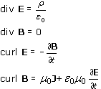

describe the dynamical behaviour of electromagnetic fields. They are the same in all inertial frames of reference and are unaffected by time-reversal. They are not valid in rotating frames of reference.
Section 5
An electromagnetic wave is an oscillating disturbance of electric and magnetic fields that propagates in accordance with Maxwell's equations. We concentrate on linearly polarised monochromatic plane waves. In empty space, the electric and magnetic waves are in phase with one another, with B = E / c. They are mutually perpendicular and transverse to the direction of propagation. In empty space, electromagnetic waves travel at speed

Electromagnetic waves with frequencies in the visible range, 4 × 10¹⁴ Hz to 8 × 10¹⁴ Hz, all called light, but the known electromagnetic spectrum also embraces radio waves, microwaves, infrared, ultraviolet, X-rays and gamma rays. Electromagnetic waves transport energy. The amount of energy carried by the magnetic wave is the same as that carried by the electric wave. The energy flux is the total energy transported per unit area per unit time across a plane area perpendicular to the direction of propagation of the electromagnetic wave. Averaging over a complete cycle,

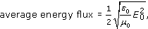

where E₀ is the amplitude of the electric wave.

Acknowledgements
The material acknowledged below is Proprietary and used under licence (not subject to Creative Commons licence). See Terms and Conditions.
Grateful acknowledgement is made to the following for permission to reproduce:
Course image: tom_bullock in Flickr made available under Creative Commons Attribution 2.0 Licence.
Figure 1a: Neil Borden/Science Photo Library; Figure: 1b NOAA/Science Photo Library; Figure 1c: Max-Planck-Institute for Radio Astronomy/Science Photo Library; Figure 11: Science Photo Library; Figure 14: Science Museum.
Don't miss out:
If reading this text has inspired you to learn more, you may be interested in joining the millions of people who discover our free learning resources and qualifications by visiting The Open University - www.open.edu/openlearn/free-courses

Solutions

SAQ 1

Answer
The three laws are:

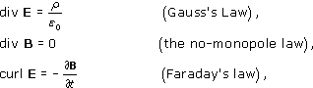

where E and B are the electric and magnetic fields, ρ is the charge density and ε₀ is the permittivity of free space. All three laws have general validity: they apply to time-varying situations as well as static or steady-state ones.
Back to - SAQ 1

Exercise 1

Answer
The current density only has a z-component, so the equation of continuity becomes

Integrating with respect to time, the charge density is

where C(z) is an arbitrary function. In general, it is necessary to allow for such a function, which describes a fixed charge density distributed along the rod. However, C(z) is the time-average of the charge density at position z, which is equal to zero according to information given in the question. Hence,

Back to - Exercise 1

SAQ 2

Answer
Expanding the left-hand side of Equation 7.5 gives

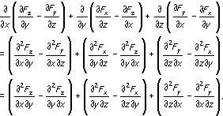

which vanishes because mixed partial derivatives do not depend on the order of partial differentiation.
Back to - SAQ 2

Exercise 2

Answer
Taking the surface integral of both sides of Equation 7.10 over an open surface S gives

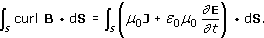

Using the curl theorem on the left-hand side we obtain

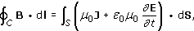

where the sense of positive progression around C and the orientation of S are related by the right-hand grip rule. This is the required integral version of the Ampère–Maxwell law.
Back to - Exercise 2

SAQ 3

Answer
In the order presented, the equations are called: Gauss's law, the no-monopole law, Faraday's law and the Ampère–Maxwell law. It would be a real advantage to remember them. This may come naturally, after sufficient use.
Back to - SAQ 3

Exercise 3

Answer
Applying the transformation rules for time-reversal given in the question does not affect Gauss's law. The remaining Maxwell equations transform as follows:

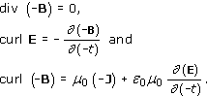

In each case, the transformed equation can be rearranged to recover the original Maxwell equation, so Maxwell's equations are unchanged by time-reversal.
Back to - Exercise 3

Exercise 4

Answer
Taking the divergence of the Ampère–Maxwell law (Equation 7.10) gives

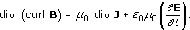

The left-hand side is equal to zero (from Equation 7.5). Interchanging the divergence and time derivative on the right-hand side and cancelling the factor μ₀, then gives

Using Gauss's law, div E = ρ/ε₀, we finally obtain

which is the equation of continuity. Maxwell wrote down the equation of continuity alongside his other equations, but it is not counted as one of his four laws of electromagnetism because it is a consequence of two of the other laws.
Back to - Exercise 4

Exercise 5

Answer
The electric wave does not exist beyond the filter, so its curl is equal to zero there. There can be no curl due to electrostatic fields either because electrostatic fields have zero curl. Faraday's law, curl E = −∂B/∂t, therefore shows that the magnetic field must be independent of time beyond the filter. There is no magnetic wave beyond the filter.
Back to - Exercise 5

Exercise 6

Answer
In time Δt, a wave crest moves a distance Δz = cΔt. If n cycles of the wave pass the given point in this time, nλ = cΔt so

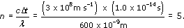

Back to - Exercise 6

Exercise 7

Answer
The magnitude of the electric force is qE. Because the magnetic wave is transverse, perpendicular to the velocity of the particle, the magnitude of the magnetic force is qvB. In an electromagnetic wave, E = cB, so the ratio of the force magnitudes is

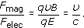

The magnetic force is much smaller than the electric force for non-relativistic particles, but the two forces become comparable for a charged particle that travels close to the speed of light.
Back to - Exercise 7

Exercise 8

Answer
The average energy flux is

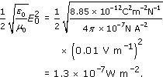

using the unit conversions 1 C = 1 A s, 1 A V = 1 W and 1 N m s⁻¹ = 1 W.
Comment: The small value of this energy flux shows that amplification is an essential function of any radio receiver.
Back to - Exercise 8

