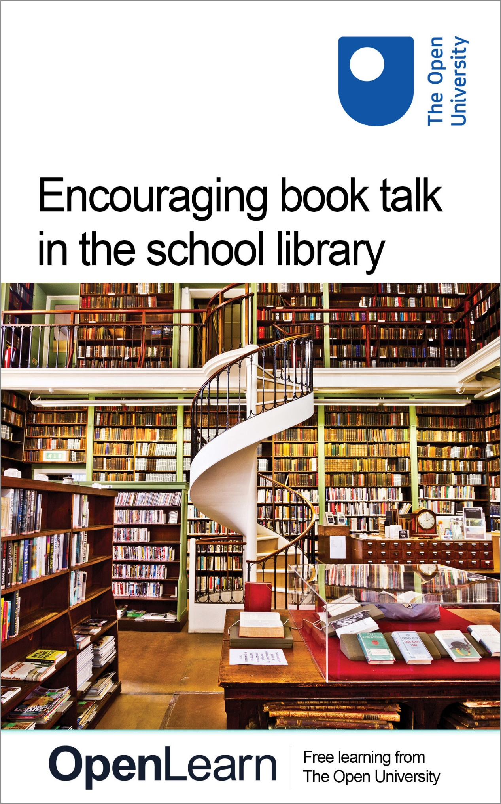

TL_LIBRARY

Encouraging book talk in the school library

About this free course
Find out more about studying with The Open University by visiting our online prospectus.
This version of the content may include video, images and interactive content that may not be optimised for your device.
You can experience this free course as it was originally designed on OpenLearn, the home of free learning from The Open University: http://www.open.edu/openlearn/education/encouraging-book-talk-the-school-library/content-section-0 .
There you’ll also be able to track your progress via your activity record, which you can use to demonstrate your learning.
The Open University, Walton Hall, Milton Keynes, MK7 6AA
Copyright © 2016 The Open University
Intellectual property
Unless otherwise stated, this resource is released under the terms of the Creative Commons Licence v4.0 http://creativecommons.org/licenses/by-nc-sa/4.0/deed.en_GB . Within that The Open University interprets this licence in the following way: www.open.edu/openlearn/about-openlearn/frequently-asked-questions-on-openlearn . Copyright and rights falling outside the terms of the Creative Commons Licence are retained or controlled by The Open University. Please read the full text before using any of the content.
We believe the primary barrier to accessing high-quality educational experiences is cost, which is why we aim to publish as much free content as possible under an open licence. If it proves difficult to release content under our preferred Creative Commons licence (e.g. because we can’t afford or gain the clearances or find suitable alternatives), we will still release the materials for free under a personal end-user licence.
This is because the learning experience will always be the same high quality offering and that should always be seen as positive – even if at times the licensing is different to Creative Commons.
When using the content you must attribute us (The Open University) (the OU) and any identified author in accordance with the terms of the Creative Commons Licence.
The Acknowledgements section is used to list, amongst other things, third party (Proprietary), licensed content which is not subject to Creative Commons licensing. Proprietary content must be used (retained) intact and in context to the content at all times.
The Acknowledgements section is also used to bring to your attention any other Special Restrictions which may apply to the content. For example there may be times when the Creative Commons Non-Commercial Sharealike licence does not apply to any of the content even if owned by us (The Open University). In these instances, unless stated otherwise, the content may be used for personal and non-commercial use.
We have also identified as Proprietary other material included in the content which is not subject to Creative Commons Licence. These are OU logos, trading names and may extend to certain photographic and video images and sound recordings and any other material as may be brought to your attention.
Unauthorised use of any of the content may constitute a breach of the terms and conditions and/or intellectual property laws.
We reserve the right to alter, amend or bring to an end any terms and conditions provided here without notice.
All rights falling outside the terms of the Creative Commons licence are retained or controlled by The Open University.
Head of Intellectual Property, The Open University
the Open University
978-1-4730-1460-2 (.kdl)
978-1-4730-0692-8 (.epub)

Contents
- Introduction
- Learning outcomes
- 1 What makes a good book?
- 2 Book reviews
- 3 Book awards
- 4 Reading clubs
- Conclusion
- Keep on learning
- References
- Acknowledgements

Introduction
As adults we sometimes struggle to justify our feelings about particular books, but children are quite clear about what they like and don't like.
It is possible to get children to discuss why they liked or did not like particular books and to encourage them to think more deeply about the books they read.
This unit offers ideas and activities to engage pupils in discussing books. It is aimed at librarians, teaching assistants and other adults working with pupils in school libraries.
Find out more about studying with The Open University by visiting our online prospectus.

Learning outcomes
After studying this course, you should be able to:
- clarify ideas on literacy criticism
- explore with pupils what makes a good book
- produce a range of writing frames to encourage pupils to write book reviews
- encourage pupils to follow some of the award schemes for children's books and perhaps start a new one.

1 What makes a good book?

I met a dragon face to face
I met a dragon face to face
The year when I was ten,
I took a trip to outer space,
I braved a pirate's den,
I wrestled with a wicked troll,
And fought a great white shark,
I trailed a rabbit down a hole,
I hunted for a snark.
I stowed aboard a submarine,
I opened magic doors,
I travelled in a time machine,
And searched for dinosaurs,
I climbed atop a giant's head,
I found a pot of gold,
I did this all in books I read
When I was ten years old
Jack Prelutsky: ‘Good Books: Good Times’, HarperCollins 1990

Maybe it was Custard that Jack Prelutsky met, maybe not; we all have our favourite books and those we hate. How did we develop our personal taste and critical awareness?

All good books have one thing in common – they are truer than if they really happened and after you have finished reading one you will feel that all that happened to you.
Ernest Hemingway (1899–1961)

Here are some points you could raise in discussion with pupils to try to encourage them to think about the books they read. I am sure you will think of many more.
- Did the book they just read surprise them? Why did they choose it? Did they expect to like or not like it because of the blurb or dust jacket?
- Did the characters seem real? Did they feel sympathy for the characters? Do they know anyone like the character?
- Did the book take them to new places? Were they real places or imaginary lands? Did they learn anything about the setting from reading the book?
- Did the author know about the background or topic of the book? Were there any mistakes?
- Did they want to go on reading more after the book had ended?
Above all, we need to let children know that it is all right not to like a book – even if it is critically acclaimed!

Activity 1

What do you think makes a good book?
Try listing six key features you would look for when reviewing a book.
You could try this question out on your pupils too.

Provide your answer...

2 Book reviews
The comments below all relate to the same book, Ruby Holler by Sharon Creech, and have been made by pupils at Churchill Community School, North Somerset – the ‘Churchill Chatterboxes’.

A captivating yet far-fetched book, I feel this would suit most younger readers but older readers would want something more demanding. (Margaret)
I think Ruby Holler is a very moving book, especially when Dallas can tell that Florida is in trouble. I would say that is good enough to take up some space on your bookshelf. (Alice)
Ruby Holler is a book about twin orphans who are sent to an elderly couple. This is a good book because it brings to the reader a sense of what it is like to be an orphan. (Becky)

Writing reviews and sharing opinions about what they read is a good way to get pupils talking about books and introducing them to the concept of literary criticism.
Here's one example of a website with reviews of books suitable for various ages:
The Children's Book Review
Children often find it easier to write a book review if they have a framework to write to. You can see various examples online, such as this person's template on the TES website.
The Toppsta website has lists of recommendations for various ages, and many reviews written by children. It provides an online form for pupils to submit their own reviews. Go to:
Toppsta
There are plenty of places on the web where children can find reading suggestions that will help them to develop their own taste in reading.
The Guardian's website has a children's books section, which can be filtered into articles relevant to different age bands; it contains news and reviews, about a variety of new books and classics.
The Guardian
UK Children's Books (formerly known as The Word Pool) arranges its lists by topic and type rather than age.
UK Children's Books
The Reading Is Fundamental project has age-related lists plus suggestions for motivating children to read, books for reading aloud and seasonal ideas.
Reading is Fundamental

Activity 2

Click on "view document" below and look at an example of a book review writing frame.
View document
Now produce a writing frame or pro forma of your own to prompt pupils in your school to write book reviews. You might want to write different frames for different groups of pupils.

3 Book awards
Members of the Chartered Institute of Library and Information Professionals will be familiar with the Carnegie medal, which is awarded for an outstanding children's book each year.
The BookTrust website lists a variety of different awards for children's books and, although the majority are judged by publishers and critics, some involve children in the selection process. You might like to investigate how you can get your own pupils involved in selecting books for awards.
Although the Carnegie Medal winner is selected by a panel of librarians, children from all over the UK shadow the process and make recommendations. Look at the Carnegie website for further information about the awards.
The Waterstones Children's Book Prize aims to uncover hidden talent in children's writing, awarding prizes in various different categories to authors who are still relatively new voices.
The Blue Peter Book Awards are run by the BBC programme in collaboration with the public library project Reading Relay. The awards include judges’ awards and voters’ awards.
The Children's Book Award, from the Federation of Children's Book Groups, is chosen by nominations from children throughout the UK.
Some local library services have established their own awards and these are totally chosen by children. Take a look at facilities in your local area to find out if something like this is available.

Activity 3

Plan to get your own pupils involved in choosing books they think should get an award.
You might like to shadow the Carnegie Medal, or get involved with Reading Relay and Blue Peter.
The criteria for the selection of the Carnegie Medal provide a useful checklist for those wanting to think about why a book is good.
Click on "view document" below to see these criteria.
View document
You could establish your own school's award. Any author would be glad to hear that their book had been chosen by a group of children – even if there was no huge monetary prize!

4 Reading clubs

Reading opens minds. Through books, a reader enters different worlds, sees other points of view, experiences new emotions and situations. A reading club is a great chance to read different books, to find books you might never have considered yourself. To share your views with others is much more fun than looking away inside your head.
Nicola Morgan

There is plenty of support to help you run a reading club in your own school.
Chatterbooks is an educational initiative associated with The Reading Agency, which works with public libraries and schools to run children's reading groups.
Scholastic has information and various links related to setting up and joining book clubs.
Your pupils could get involved with the CBBC Book Club and talk about the books they like on this website.
Best of all, you could start your own reading club and get pupils talking and engaged with book-related activities.

Activity 4

Investigate the possibility of starting a book or reading club in your own school.
Prepare an e-mail or memo to invite colleagues to discuss the possibility and to enlist support.

Conclusion
This free course provided an introduction to studying Education, Childhood & Youth. It took you through a series of exercises designed to develop your approach to study and learning at a distance, and helped to improve your confidence as an independent learner.

Keep on learning

Study another free course
There are more than 800 courses on OpenLearn for you to choose from on a range of subjects.
Find out more about all our free courses.

Take your studies further
Find out more about studying with The Open University by visiting our online prospectus.
If you are new to university study, you may be interested in our Access Courses or Certificates.

What’s new from OpenLearn?
Sign up to our newsletter or view a sample.

For reference, full URLs to pages listed above:
OpenLearn – www.open.edu/openlearn/free-courses
Visiting our online prospectus – www.open.ac.uk/courses
Access Courses – www.open.ac.uk/courses/do-it/access
Certificates – www.open.ac.uk/courses/certificates-he
Newsletter – www.open.edu/openlearn/about-openlearn/subscribe-the-openlearn-newsletter

References
Nicola Morgan at ContinYou, [http://www.readingclub.org.uk, accessed 26 January 2007].
Jack Prelutsky, ‘I Met a Dragon Face to Face’ in Good Books, Good Times! By Lee Bennett Hopkins and Harvey Stevenson, HarperCollins.

Acknowledgements
This unit was originally prepared for TeachandLearn.net by Jenny Brown, who is a chartered librarian and has worked as a school librarian in London for 15 years. She was one of the first to obtain the RSA Diploma in Technology for Teachers. Jenny has always had a keen interest in independent learning and higher-order thinking skills, and has championed the key role that librarians can play in developing these. While working for BECTa she managed a number of UK and Europe wide projects in schools and was closely involved in the development and delivery of the NOF training programme for school librarians.
Except for third party materials and otherwise stated (see terms and conditions), this content is made available under a Creative Commons Attribution-NonCommercial-ShareAlike 4.0 Licence
Grateful acknowledgement is made to the following sources for permission to reproduce material in this unit:
© Getty Images
‘I Met a Dragon Face to Face’ by Jack Prelutsky, from “Once Upon A Time”, © 1986 by G.P. Putnam’s Sons, used with permission.
All other materials included in this unit are derived from content originated at the Open University.
Every effort has been made to contact copyright holders. If any have been inadvertently overlooked the publishers will be pleased to make the necessary arrangements at the first opportunity.
Don't miss out:
If reading this text has inspired you to learn more, you may be interested in joining the millions of people who discover our free learning resources and qualifications by visiting The Open University - www.open.edu/openlearn/free-courses

