

T838_1 Design and manufacture with polymers

Introduction to polymers
About this free course
This free course provides a sample of level 3 study in Science http://www.open.ac.uk/courses/find/science
This version of the content may include video, images and interactive content that may not be optimised for your device.
You can experience this free course as it was originally designed on OpenLearn, the home of free learning from The Open University: http://www.open.edu/openlearn/science-maths-technology/science/chemistry/introduction-polymers/content-section-0.
There you’ll also be able to track your progress via your activity record, which you can use to demonstrate your learning.
The Open University Walton Hall Milton Keynes MK7 6AA United Kingdom
Copyright © 2016 The Open University
Intellectual property
Unless otherwise stated, this resource is released under the terms of the Creative Commons Licence v4.0 http://creativecommons.org/licenses/by-nc-sa/4.0/deed.en_GB. Within that The Open University interprets this licence in the following way: www.open.edu/openlearn/about-openlearn/frequently-asked-questions-on-openlearn. Copyright and rights falling outside the terms of the Creative Commons Licence are retained or controlled by The Open University. Please read the full text before using any of the content.
We believe the primary barrier to accessing high-quality educational experiences is cost, which is why we aim to publish as much free content as possible under an open licence. If it proves difficult to release content under our preferred Creative Commons licence (e.g. because we can’t afford or gain the clearances or find suitable alternatives), we will still release the materials for free under a personal end-user licence.
This is because the learning experience will always be the same high quality offering and that should always be seen as positive – even if at times the licensing is different to Creative Commons.
When using the content you must attribute us (The Open University) (the OU) and any identified author in accordance with the terms of the Creative Commons Licence.
The Acknowledgements section is used to list, amongst other things, third party (Proprietary), licensed content which is not subject to Creative Commons licensing. Proprietary content must be used (retained) intact and in context to the content at all times.
The Acknowledgements section is also used to bring to your attention any other Special Restrictions which may apply to the content. For example there may be times when the Creative Commons Non-Commercial Sharealike licence does not apply to any of the content even if owned by us (The Open University). In these instances, unless stated otherwise, the content may be used for personal and non-commercial use.
We have also identified as Proprietary other material included in the content which is not subject to Creative Commons Licence. These are OU logos, trading names and may extend to certain photographic and video images and sound recordings and any other material as may be brought to your attention.
Unauthorised use of any of the content may constitute a breach of the terms and conditions and/or intellectual property laws.
We reserve the right to alter, amend or bring to an end any terms and conditions provided here without notice.
All rights falling outside the terms of the Creative Commons licence are retained or controlled by The Open University.
Head of Intellectual Property, The Open University
The Open University
Hobbs the Printers Limited, Brunei Road, Totton, Hampshire, SO40 3YS
978-1-4730-1676-7 (.kdl)
978-1-4730-0908-0 (.epub)

Contents
- Introduction
- Learning outcomes
- 1 Polymer materials
  - 1 1The growth of poymers
  - 1.2 Polymer types
  - 1.3 Product design and manufacture
- 2 Molecular engineering
  - 2.1 Understanding the polymer state
  - 2.2 Chain repeat units
  - 2.3 Chain configuration
  - 2.4 Chain conformations
  - 2.5 Structure-property relationships
  - 2.6 Molecular mass distribution
  - 2.7 Commercial polymers
- 3 Manufacture of monomers
  - 3.1 Primary sources of synthetic polymers
  - 3.2 Petrochemical processing
  - 3.3 Petrochemical intermediates and monomers
  - 3.4 The petrochemical industry
- 4 Polymerization
  - 4.1 Understanding the polymerization process
  - 4.2 Chain and step growth
  - 4.3 Chain growth polymerization
  - 4.4 Step growth polymerization
  - 4.5 Copolymerization
  - 4.6 Polymer grades
- 5 Physical properties of polymers
  - 5.1 The behaviour of polymers
  - 5.2 Viscoelasticity of polymers
  - 5.3 Viscoelasticity and master curves
  - 5.4 Dynamic mechanical properties
  - 5.5 Orientation in polymers
  - 5.6 Crystallisation of polymers
- 6 Design in polymers
  - 6.1 A fresh approach?
  - 6.2 Manufacturing and process methods
  - 6.3 Materials selection
  - 6.4 Case history: the Topper boat
  - 6.5 Market experience
- Conclusion
- Acknowledgements
- Solutions

Introduction
Polymers are materials composed of long molecular chains that are well-accepted for a wide variety of applications. This unit explores these materials in terms of their chemical composition, associated properties and processes of manufacture from petrochemicals. The unit also shows a range of products in which polymers are used and explains why they are chosen in preference to many conventional materials.
This OpenLearn course provides a sample of level 3 study in Science

Learning outcomes
After studying this course, you should be able to:
- isolate the key design features of a product which relate directly to the material(s) used in its construction
- indicate how the properties of polymeric materials can be exploited by a product designer
- describe the role of rubber-toughening in improving the mechanical properties of polymers
- identify the repeat units of particular polymers and specify the isomeric structures which can exist for those repeat units
- estimate the number- and weight-average molecular masses of polymer samples given the degree of polymerisation and mass fraction of chains present.

1 Polymer materials

1 1The growth of poymers
Polymers, or materials composed of long molecular chains, are now well-accepted for a wide variety of applications, both structural and non-structural, and for mass-manufactured as well as one-off speciality products. The growth in their use has continued in the last two decades or more, despite the effects of several recessions in industrial activity (Figure 1). In the same period the demand for traditional materials like metals, ceramics and glasses has remained static or even fallen. Steel usage in the UK, for example, has fallen from about 14 million tonnes in the 1970s to about 12 million tonnes in the 1990s, while that of aluminium has stayed at about 600 000 tonnes. The growth in use of polymers is forecast to continue into the next millennium, with consumption approaching 4 million tonnes in the UK. In one of the most active areas, that of thermoplastic polymers, consumption is divided between packaging, building, and a wide range of other applications (Figure 2).

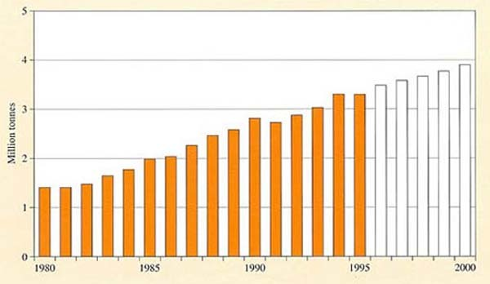
Source: data from British Plastics Federation
Figure 1 Growth in demand for polymers in the UK, 1980–2000.

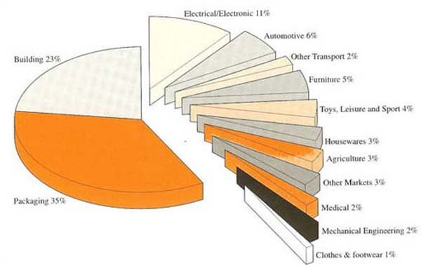
Source: data from BPF Statistics, 1995
Figure 2 UK plastics applications 1995.

1.2 Polymer types
Traditionally, the industry has produced two main types of synthetic polymer – plastics and rubbers (Figure 3). The distinction is that plastics are, by and large, rigid materials at service temperatures while rubbers are flexible, low modulus materials which exhibit long-range elasticity. Plastics are further subdivided into thermoplastics and thermosets, the latter type being materials where the long chains are linked together by crosslinks, a feature they share with conventional vulcanized rubbers. As Figure 3 shows, however, the distinction in terms of stiffness has become blurred by the development of thermoplastic elastomers (TPEs). Moreover, all polymers, irrespective of their nature, can be reinforced by a very wide range of fillers to produce composite materials.

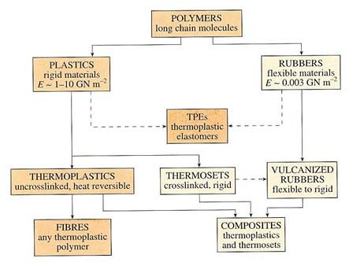
Figure 3 Classification of polymers by property

Another way of classifying polymers is in terms of their form or function, varying from additives to other bulk materials (e.g. viscosity modifiers in plaster), coatings to products (e.g. paints), film and membranes to fibres (e.g. textiles) and bulk products such as pipe, containers and mouldings (Figure 4). Some of these materials are of course used as products in their own right, or manipulated further into finished products. This does not always happen, however, some polymers being a disposable intermediary in certain industrial processes. Thus photoresists are used to create the circuit patterns on semiconductor chips through controlled degradation, and are entirely absent in the final product.

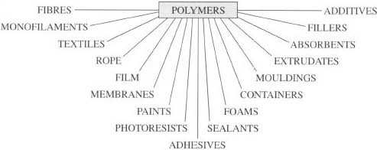
Figure 4 Classification of polymers by design function

Exercise 1

Identify the products in a typical modern house associated with the supply and disposal of water (or prevention of entry) which may be of polymeric origin, giving details of their generic type (Figure 3) and form or function (Figure 4).

View answer - Exercise 1

The first polymeric materials to be used were entirely natural in origin and required relatively little modification to be adapted for useful purposes. Such materials included wood from various species of tree, fibres for rope and textile fabrics, and amber adhesive for attaching stone and metal tools to wooden handles. Rubber was used by the early Americans for containers, shoes and balls. Ways of processing them to shape and improving their properties were developed during the Victorian era (see Box 1), but it was not until the growth of the organic chemical industry that the first synthetic polymers were made. The true molecular nature of materials like natural rubber and synthetics like Bakelite was not understood until about the 1920s when Hermann Staudinger recognised their chain-like structure. That period saw the growth of polymer chemistry, by which monomers could be synthesised and polymerized in a controlled way to give macromolecular materials. Some of today's major polymers were discovered in this period and were commercialised in the 1930s and 1940s. They included materials like polychloroprene (Neoprene rubber), nylon, polyester (Terylene or Dacron) and polyethylene (Polythene – note that trademarks for polymers are shown as proper names).
The raw materials for making the monomers had at first been based on coal tar derivatives but, with the rise of the petrochemical industry based on oil and natural gas, a much wider range of basic chemical building blocks became available. Fundamental advances in the understanding of catalysis led to the discovery of many new polymers in the post-1945 period – variations on simple polymers like polyethylene as well as entirely new stereoregular polymers like polypropylene. That progress has continued at an increasing rate up to the present. Novel polymers, like aromatic polyamides and polyimides which were discovered only in the 1960s, have been developed, while speciality, high temperature materials like polysulphones have penetrated new markets hitherto inaccessible to the traditional range of commercial polymers. The achievement has been a direct result of pioneering scientific research closely linked to development by industry.

Box 1 Plastics in Victorian times
The use of shellac as a moulding material was pioneered in the 1850s by Samuel Peck and Co. of the USA who added such refinements as the insertion of hinges during the moulding process. Metal inserts into thermoplastic mouldings are commonplace today. Casein made from skimmed milk was an early and reasonably successful protein plastic with a first patent in 1885 in Germany. The curds were separated from the whey, then after compounding with plasticizers and colours, they were pressed into sheets, rods, tubes or discs. Finally the casein was hardened by immersion in formaldehyde. It made a tough material capable of accepting a high polish and hence was a popular substitute for horn, ivory and amber.
The first synthetic thermoplastic was developed in the 1860s when Parkes in England and Hyatt in the USA produced a mouldable cellulose nitrate by softening it (plasticizing it) through the addition of camphor. Parkesine has not survived as a product name or material, but Hyatt's Celluloid is still used commercially. Compounding polymers with additives to give a controlled range of properties is an essential step in the production of almost all the polymers used today.
The availability of phenol from cheap coal tar and formaldehyde from the oxidation of methanol led in 1877 to the development of phenol formaldehyde resin by Baekeland and Swinburne, working in the USA and Britain. These first condensation products of the controlled reactions between phenol and formaldehyde produced hard but relatively weak and brittle materials. Swinburne commercialised his resin as a range of varnishes but Baekeland mixed the resin with significant amounts of woodflour to produce the first polymer composite – Bakelite . It was the first synthetic thermoset, a material which becomes irreversibly hard (cures) either on heating as with Bakelite or by cold curing.

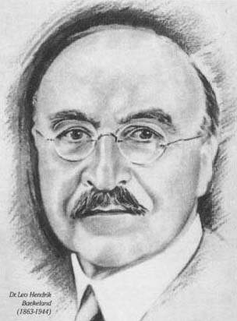
Figure 5 Dr Leo Hendrick Baekeland

1.2.1 Natural and synthetic rubbers
Natural rubber was the first major polymer to be imported and used for commercial purposes. Long ago the natives of South America learned to tap the indigenous Hevea Brasiliensis trees to collect, dry and coagulate the latex. Today the main rubber plantations are in Malaysia and Indonesia. Natural rubber is well established as an important and versatile engineering material with an excellent balance of properties. However, almost two-thirds of the rubber now consumed world-wide is synthetic. The development of synthetic rubbers in Western Europe and the USA was accelerated by the demands of the Second World War and the associated loss of access to the natural rubber plantations in the Far East. Today's engineers have a complete spectrum of synthetic rubbers available to them, with properties ranging from the general-purpose to the highly specific. Hence the term ‘rubber’ or ‘elastomer’ is more properly the generic name for a class of polymeric materials of widely varying properties. The properties and common uses of a selection of both general-purpose and speciality rubbers are shown in Table 1.

Table 1 General-purpose and speciality rubbers: properties and uses
 | Rubber | General properties | Typical uses
BR | butadiene (polybutadiene) | Special-purpose rubbers of density 0.93 Mg m⁻³. Good low-temperature properties and abrasion resistance. High resilience (low damping) and therefore low heat build-up at ordinary temperature. Poor resistance to oils and hydrocarbons. | Resilient mounts, tyre sidewalls (blended with NR)
CR | chloroprene (Neoprene) | Versatile special-purpose rubbers of density 1.20 Mg m⁻³ and good mechanical and electrical properties. Very good resistance to ozone oxidation, heat and flame. | Car radiator hose, gaskets, seals, conveyor belts, bridge bearings
EPM, EPDM | ethylene-propylene copolymer and terpolymer | The copolymer (EPM) and terpolymers (EPDM) are general-purpose rubbers of density about 0.85 Mg m⁻³ Good mechanical properties and resilience. Can accept very high loadings of oils and fillers. Very good resistance to ozone, oxidation, chemical, weathering and high and low temperatures. | Conveyor belts, hose, general goods
NR | natural rubber (cis-polyisoprene) | An excellent general-purpose rubber of density 0.93 Mg m⁻³ High resistance to tearing and abrasion. High resilience at 20 °C and thereforelow heat build-up under the action of dynamic stresses. Swells in mineral oils and degreasing solvents. | Tyres, suspension systems, bushes, bridge bearings
NBR | nitrile (acrylonitrile- butadiene copolymer) | Special-purpose rubbers of density 1.0 Mg m⁻³ and moderate mechanical properties. Poor cold resistance. Excellent resistance to swelling in hydrocarbons and alcohols. The greatest oil and alcohol resistance occurs in rubbers with a high acrylonitrile content. | Fuel lines and linings
SBR | styrene-butadiene copolymer | A good general-purpose rubber of density 0.94 Mg m⁻³, competitive in properties with NR when reinforced with carbon black. Very good abrasion resistance. Swelling and adhesion properties similar to NR, ageing resistance better than NR. | Tyres, often in direct competition with NR

1.2.2 Thermoplastics and thermosets
As already stated, polymers including rigid plastics were first developed in the last century from natural precursors. The sealing wax employed by the Victorians, for example, was usually based on the natural polymer shellac, an exudate of the Indian lac insect. Shellac is an early natural thermoplastic – defined as a material which softens and hardens reversibly on heating and cooling. In theory these reversible physical changes will take place without a corresponding change in the chemical structure of the material. This is why scrap thermoplastic can be re-used. In practice, some thermal and oxidative degradation occurs and recycling must be done only with an understanding of the effect that it has upon the properties of the final moulding.
Thermosets can be defined as those polymers which become irreversibly hard on heating or by addition of special chemicals. This hardening involves a chemical change (curing) and hence scrap thermoset cannot be recycled except as a filler material. The curing process invariably involves a chemical reaction which connects the linear molecules together to form a single macromolecule. These connections are known as crosslinks.
Scrap rubbers cannot be recycled easily, because of vulcanization which crosslinks the chains during moulding. It will be seen later that rubbers at the early stages of their processing can be considered to fit the definition of thermoplastics, but in their final moulded state they are properly defined as thermosets.
As with rubbers, the impetus for the development of new and better synthetic plastics followed supply and demand. Initially the demand was for cheaper substitutes for traditional materials, but today no plastic is cheap and some are extremely expensive with unique properties designed to satisfy the stringent requirements of sophisticated products. Table 2 lists the names and acronyms of the bulk-use commodity plastics and some of the more specialised and expensive materials, and comments on their important properties and uses.

Table 2 General-purpose and speciality plastics
 | Plastic | Comments
PMMA | acrylic, poly(methyl methacrylate) | Thermoplastic. A transparent rigid polymer.
ABS | acrylonitrile-butadiene-styrene | Based on SAN resin modified with polybutadiene rubber.
EP | epoxy | Thermoset. Resins used for encapsulation, adhesives, surface coatings and high-strength fibre-reinforced composites.
GRP | glass-reinforced plastic (mainly polyester) | Thermoset. Reinforced with glass fibre in various forms, such as chopped strand mat (CSM) and woven rovings (WR). Used for pipes, tanks, boat hulls, etc. May be applied as SMC or DMC.
HDPE | high density polyethylene | Thermoplastic. Linear polyolefin widely used in blow moulding.
HIPS | high impact polystyrene | Thermoplastic. A polystyrene modified by copolymerization with butadiene to improve its toughness.
LDPE | low density polyethylene | Thermoplastic. Branched polyolefin used for film and as electrical insulator, made at high pressures.
MF | melamine formaldehyde | Thermoset. Used in domestic ware, switches, plugs, etc.
PA | nylon, polyamide | Thermoplastic. Used in bearings, gears, mouldings, wall plugs, etc.
PF | phenolic, phenol formaldehyde | Thermoset. Moulding material and laminating resin. Sometimes known as Bakelite.
PAN | polyacrylonitrile | A fibre-forming thermoplastic polymer. One of the base polymers used to make carbon fibre.
UPR | polyester (unsaturated polyester resin) | Thermoset. A solution of polyester containing unsaturated groups in styrene or other polymerizable solvent. Matrix resin for GRP.
PET | poly(ethylene terephthalate) | Thermoplastic. A major fibre-forming polymer and a moulding material for beer bottles, etc. In competition with poly(butylene terephthalate) (PBT), a related thermoplastic polyester.
PVC | poly(vinyl chloride) | Thermoplastic. Can be plasticized to produce a leathery material. Unplasticized PVC (uPVC) used for rainwater goods, pipes, etc.
SAN | styrene-acrylonitrile | Thermoplastic. Rigid transparent material used for water jugs and beakers, etc.
SMC | sheet moulding compound | Thermoset. Sheets of glass fibre impregnated with polyester resin (td)

1.2.3 Consumption of plastics
The consumption of plastics in the UK today is shown in Figure 6, with usage being dominated by PVC, closely followed by a range of polyolefins (polypropylene, various polyethylenes) and materials based on styrene monomer (PS and HIPS). These are the ‘big five’ bulk commodity polymers which dominate the market, and which have found application in almost every sphere of human activity (Figure 2). PVC is produced either in a flexible, elastomeric form (plasticized PVC) or as the rigid material familiar in pipes and profiles (unplasticized or uPVC). The ubiquitous plastic bag is usually made from any of the grades of polyethylene, and polypropylene is widely used for wrapping of consumer products. Polystyrene by itself is quite brittle, so is often used in its reinforced form (HIPS), or alternatively as a lightweight foam for insulation or protecting sensitive goods in transit.

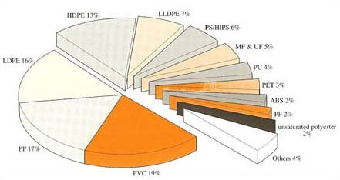
Figure 6 UK consumption of plastics, 1995

These five are followed by thermosetting melamine and urea formaldehyde, widely used for electrical insulation products as well as for reinforcing wood products. Polyurethanes are a very versatile group of polymers – they may be thermoplastic or thermosetting, and range in stiffness from flexible elastomers to stiff plastics. Stiff grades are used for car body panels, and in foam form for insulation, flexible foam being used in furniture. Another grade is widely used in paint varnishes. Polyester, PET, originally mainly used as a strong fibre, is often nowadays used in blends with cotton in textile fabrics. But its greatest application today is in tough lightweight bottles, displacing glass for its safer properties. ABS is a derivative of PS, being much tougher by blending with rubber particles, and so is widely used for enclosures. The oldest synthetic thermoset, PF, is used for reinforcing wood products, while unsaturated polyester forms the main matrix material for glass-fibre reinforced composites. Acrylics, which comprise PMMA and related polymers, first found use in transparent aircraft windows during the Second World War, especially since they could be easily formed into complex shapes. They should not be confused with acrylic fibre, actually based on a quite different chain structure, that of polyacrylonitrile or PAN.
Although consumption of the remaining named polymers in Figure 6 is relatively low, they represent a growing class of so-called engineering polymers, whose properties are often so unusual or interesting as to find unique application in addition to displacing traditional materials. The family of nylons centres around nylon 6,6 and 6, both invented in the 1930s, the former still popular as a fibre, although both forms are used for mouldings. A more spectacular example is aramid fibre, developed in the late 1970s in the USA, for its very high stiffness and resistance to high temperatures. These properties have resulted in aramid fibre being widely used in textiles, ropes and composite structures such as aircraft tailplanes and rotor blades (often in combination with epoxy resins). Acetal is a tough, crystalline polymer which until recently was widely used for domestic kettles. Polycarbonate also finds use as a tough material for consumer products, and displaces PMMA owing to its greater toughness. PBT is another kind of thermoplastic polyester mainly used as a moulding material. The fluoropolymers are a unique class of polymer exemplified by PTFE, the parent material used most frequently for its exceptionally low coefficient of friction and temperature resistance as in non-stick frying pans, plumbing tape and support pads for moving heavy equipment. A related elastomer, Viton rubber, is used for engine seals and aircraft hose.

Exercise 2

For the various polymer plumbing applications in modern houses, identified in Exercise 1, attempt to identify the specific polymers used in each product or range of products.

View answer - Exercise 2

1.3 Product design and manufacture
So what are the reasons for the continued growth in the use of polymers as shown in Figure 1? It cannot be raw material cost, since the source of synthetic polymers is crude oil or natural gas, prices of which have risen over the same period of time. The comparative prices of polymers are considerably greater than traditional materials like mild steel, so we must look elsewhere for their success.
It is really necessary to focus on their end uses, as finished products, to even begin to attempt an answer. The largest area of consumption is that of packaging (Figure 2), where plastics are used to enclose perishable products such as food, drink, and fragile goods such as glassware and ceramics. Food preservation is a vital service today, where perishing by drying out or bacterial contamination has been reduced in Britain from between 30 to 50 per cent to 2–3 per cent in the last 50 years. Such packaging as shrink-wrap film, plastic bags and other containers, and foamed PS are now commonplace both for cooked and raw foodstuffs. Plastics are not alone here, because the ‘tin’ (actually steel or aluminium) can and glass bottle have also helped reduce wastage and harmful contamination (Figure 7). However, polymers do have a competitive edge in their low density and hence lower weight during transport. Thus vegetables are much more widely distributed in plastic packs, where deterioration is halted not by totally enclosing them in a metal can (so excluding air) but by freezing the vegetables and maintaining them at a low temperature in a film of low-air permeability. Carbonated soft drinks bottles are now almost universally made from PET, a tough transparent polymer, which cannot injure the consumer if it breaks and is substantially lighter than its glass equivalent. The barrier behaviour of polymers is not always as good as inorganic materials, but careful selection of impermeable polymers can reduce air penetration to a minimum. Thus PVDC is widely used to coat PET beer and cider bottles to prevent diffusion of air into these products and hence prolong their useful shelf-lives. Even with metal cans, plastic coatings are normal because they can be printed easily, and can contribute to product strength and barrier resistance.

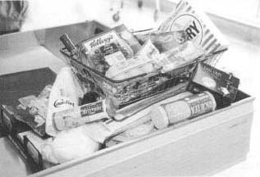
Figure 7 Various foods packaged in different materials including glass, PVC, PET, PP and LDPE

Exercise 3

In building products, polyethylene DPC (damp proof course) and uPVC rainwater goods have largely displaced traditional materials like slate and steel or cast iron. Indicate what design factors have created this situation.

View answer - Exercise 3

So polymers do have certain intrinsic property advantages which have helped in designing new products. The most obvious one is low density for ease of transport and installation, but corrosion resistance is also important for products destined for a long life in a building (Figure 8). Ease of manufacture helps lower production costs, and also enables large sizes to be made. Most of these properties are also important in other areas of product design, especially in automotive, consumer, household products and office equipment (Figure 2).

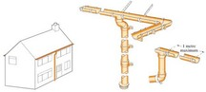
Figure 8 uPVC rain water goods for a detached house

1.3.1 Parts consolidation
The most obvious use of polymers is for enclosures for working equipment, such as power and garden tools as well as cooking devices, and electronic products such as computers, video recorders and fax machines (as well as the products used in those machines). They are not just boxes for containment; such plastic enclosures can incorporate carefully designed ribs, webs and flanges on the hidden, inner sides to hold working components securely in place when in operation (Figure 9).

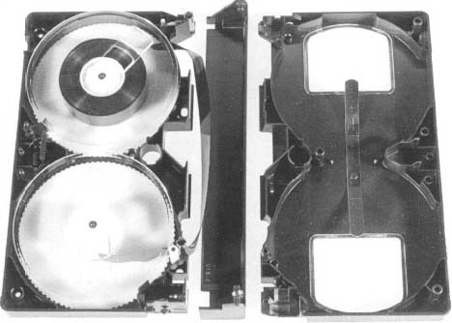
Figure 9 Video cassette enclosure in polystyrene, separated to show internal working mechanism and supporting ribs, each part moulded in one piece. The spools are in transparent PS, the case parts in carbon black filled PS. The tape itself is PET loaded with soft magnetic particles

Polymers offer several intrinsic advantages over conventional materials, and they include
- electrical insulation since non-conducting
- toughness to resist mechanical abuse such as impact
- vibration attenuation
- low weight
- one shot manufacture.
The final point in the listing may be difficult to appreciate fully since it involves an understanding of the nature of plastics moulding. Put briefly, it means that several separate functions can be incorporated in one (or two, since working parts must be inserted into the housing to make the finished product) component part, the enclosure.
Thus some of the internal ribs of a drill housing will support the electric motor, separate flanges will protect the trigger mechanism, while other inner ribs will form sockets to protect and support the wiring and leads. Even vents for cooling hot parts of the working mechanism can be incorporated into the form of the design during processing to shape without the need for a separate cutting operation. In early designs for such products, the support and protection were provided by separate parts which needed many assembly steps to make the finished product. This was especially true for sheet metal enclosures where complex internal projections are difficult if not impossible to incorporate in a single pressing operation. The underlying design philosophy with plastics materials is known as parts consolidation. The same philosophy can be seen at work in entirely new products where no conventional materials have been displaced, such as the videocassette cartridge (Figure 9).

Exercise 4: You should now watch the video sequence ‘A cut above the rest?’

The video, presented by Peter Lewis from the Open University was recorded in 1983/4 at Flymo-Electrolux Ltd., Newton Aycliffe, Co. Durham, and includes an interview with Peter Ginger, Plastics Division Manager of Electrolux. The video shows the range of polymer processes used by a major manufacturer of consumer goods, and it indicates the way in which advanced technology can be applied both to primary shaping methods like injection moulding and secondary methods like assembly.

Click the 'View document' link below to read pre-viewing comments.
View document

Video content is not available in this format.

Video content is not available in this format.

Click the 'View document' link below to read the post-viewing comments.
View document

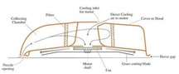
Figure 10 Cross-section of a hover mower

Self assessment question 1

Figure 10 shows a cross-section of a small lawnmower. It is a hovermower powered by electricity, provided by a cable attached to the mains supply. The 2 kW motor drives the rotor cutting blade in the base of the mower by a direct drive, to which a fan for the downdraft is fitted. It also creates an updraft by means of another fan to suck grass cuttings into a collecting bag. Why is the casing made using a tough plastic like ABS? Would alternative materials such as sheet steel be an appropriate choice for the hood? Give reasons for your answers in terms of
- materials properties;
- suitability for function; and
- ease of manufacture including assembly.

View answer - Self assessment question 1

There is another benefit to product function from parts consolidation, which might also escape superficial attention. All the internal projections improve the overall stiffness of the final product, which must achieve a minimum level to act as a safe and secure platform for the working mechanism. Very often, sufficient product stiffness can be achieved using a constant and relatively thin wall of uniform thickness throughout the housing. So product design, product function, manufacture and material of construction are actually intimately linked.

1.3.2 Human/product interaction
The balance of properties needed in a particular product varies enormously, depending on the exact duty that product will perform in service, the environment in which it will operate, and the way it will interact with the user or consumer. The last factor has assumed much greater influence in product design as competition between different manufacturers sharpens the perception of quality in users’ eyes. The study of human-product interactions is variously known as human factors or ergonomics. The academic subject seeks to isolate those ways in which machine or product and the user interact, and how product design influences the effectiveness, or efficiency or safety of the product concerned.
So what polymer properties are important here? One argument might point towards the generally low stiffness of most polymers and their products, not dissimilar in fact to that of the users’ hands or skin. Human skin is mainly composed of a natural polymer, the protein elastin, which is an elastomer and hence highly extensible and of low intrinsic stiffness. So external surfaces of products which must be handled are more compatible when the material is polymeric. Polymers also have low thermal conductivities, so such surfaces will not feel cold, and the user will be able to hold polymeric products longer and with greater ease than in the case of metals, for example. Plastic or rubber handles for tools are thus the preferred materials, and. in a way, the power tool enclosures examined above are really just an extension of the handle to encompass the whole tool.
In a similar vein, polymeric textiles must be highly flexible to accommodate movement of the human body, so are composed of fibre assemblies where the stiffness is lowered further by the small diameter of the individual fibre. Low density and low thermal conductivity reinforce the selection of polymers for this product specification. Advances in polymer technology in the last few decades have further enhanced the profile of properties expected from polymeric materials however. Thus metal chain mail has in the past been the main way of protecting the human body from high external stresses, such as ballistic forces. Many polymers can now be processed into fibres of very high intrinsic stiffness, approaching if not exceeding that of inorganic materials. Such high-performance fibres can be woven into textile fabrics and they offer substantial ballistic protection, so can be used for bullet-proof jackets and rip-resistant clothing for sports competitors (Figure 11).

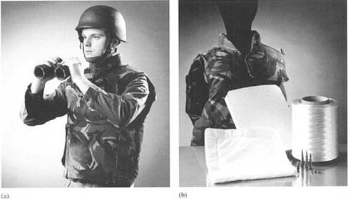
Figure 11 Military applications of high performance PE fibre ( Dyneema) (Dutch State Mines)

1.3.3 Speciality sectors
There are many sectors of the market where polymers have made dramatic inroads, including medical/ethical, leisure and aerospace products. The influence of density as a property is most dramatic in the last area, simply because weight saving on aircraft fuselages creates large savings in fuel usage or, alternatively, means that more passengers and/or freight can be carried per aircraft. Although complete polymeric fuselages are rare, only being used to date in small aircraft (such as the ‘Learjet’ and ‘Gossamer’ man-powered plane) or military craft (such as the ‘Stealth’ fighter and bomber), composite wings, tailplanes and rotor blades are increasingly displacing conventional aluminium equivalents (Figure 12). And the reasons for this move are not just for the great weight savings offered. A crucial reason is the increase in mechanical integrity, since the fatigue resistance of composite structures is much greater than metal alloy because cracks are difficult to initiate and propagate owing to the multiplicity of interfaces within the material. Catastrophic propagation following slow and often undetectable hairline cracking from fatigue is a well-known failure mode for all metal aircraft. The increase in product integrity is well worth the extra manufacturing cost of composite materials.

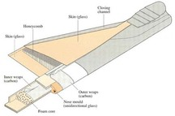
Figure 12 Sea King rotor blade composite blade construction

Products now widely used and accepted include catheters, serum bags and stents (Figure 1). In all these areas, polymers offer resistance to body fluids, and mechanical compatibility with body tissues, such properties being related to those already discussed above, namely, corrosion resistance and low and controllable stiffness.

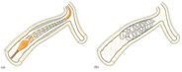
Figure 13 Medical applications of polymers in balloon catheter used to expand stent in coronary artery: (a) catheter inserted into stent over un-inflated baloon. (b) balloon inflated to expand stent which is left in place to support artery after catheter has been removed

Other materials are used in combination with polymers, where specially high stiffness may be required (e.g. needles) or where shaping is easier (e.g. the ball part of the joint in replacement hip joint. Similarly, stents for supporting weakened or collapsed veins and arteries are more often made using special metals such as tantalum and platinum rather than polymers. The balloon catheters which inflate them in place, however, are universally elastomeric since the long-range elasticity needed is a property unique to this group of polymers.
Medicine and surgery have also seen a dramatic increase in the uses of polymers, enabling people to live longer lives with implants which replace diseased body parts. Such devices range from hip joints and heart valves to synthetic skin and bone. Invasive surgery has exploited many of the new polymers for a wide range of equipment, where disposability is actually an added bonus for the reduction in the chance of infection.
With improved productivity across wide swathes of industry, there are now much greater opportunities for leisure activities. In this area, there has been much inventiveness in product design, with new sports based on or using polymer products. Surfboarding and windsurfing are activities which demand lightweight products, often composed of thermoplastic or composite skins, sometimes reinforced with foam interiors. Highspeed yachting has shown similar developments in the use of high-performance polymers (Figure 14). In athletics, the Olympic record for polevaulting has increased, partly due to the displacement of wood or metal by composite poles. Tennis too, has benefited, especially with composite rackets which have increased product lifetime by reducing fatigue, and increased performance through the use of light-weight materials.

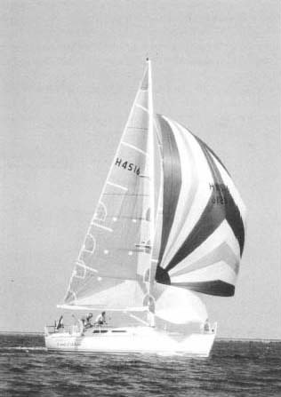
Figure 14 Spinnaker and mainsail made from high performance PE fibre (Dyneema). Source: Dutch State Mines

Self assessment question 2

Thermoplastics have come to predominate as the preferred material for toys. A common design of children's building blocks involves the blocks locking together on one of their longer sides by means of raised bosses which fit into recesses in the bases of the blocks. Discuss the design factors which have made plastics the preferred choice of material. Include in your discussion mention of
- polymer chemical properties,
- physical properties,
- product safety, and
- ease of manufacture.

View answer - Self assessment question 2

2 Molecular engineering

2.1 Understanding the polymer state
It was the pioneering scientific work of Hermann Staudinger in the early part of the twentieth century which led to an understanding of the polymer state at an atomic and molecular level. Until then, plastics and rubbers had been developed from naturally occurring substances or discovered during routine synthesis. His research laid the basis for all subsequent discoveries and their commercial development. In essence, he realised that polymers were large molecules built up by the repetition of small chemical units, known as repeat units, to create linear chains. More complicated structures consisted of linear chains with branches, and crosslinked molecules were effectively a single macromolecule of almost infinite molecular mass.
The development of entirely new polymer structures relies on a thorough understanding of the various ways in which non-metal atoms can be manipulated into chain structures, limited only by their valency and bonding properties. This subject is known as molecular engineering, and a glossary of terms in the subject is shown in Box 2. Owing to the versatility of carbon, it is this element more than any other which has been exploited in molecular engineering. Even now, fundamental discoveries about carbon are still being made by research scientists. Witness the discovery and development of fullerenes, molecules in which carbon atoms are linked together into closed three-dimensional structures such as balls and cylinders (Figure 15).

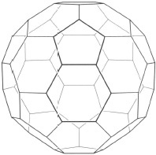
Figure 15 Fullerene structure in elemental carbon (C₆₀)

Box 2 Structural and bonding terms
aliphatic: a term used to describe non-aromatic carbon compounds, so includes both saturated and unsaturated linear, branched or cyclic compounds or structures.
alkane: a carbon compound where all the carbon-carbon bonds are single and saturated (C—C), like ethane and propane (also paraffins).
alkene: any organic compound containing a carbon-carbon double bond (C=C), like ethene (ethylene) or propene (propylene) (also olefins).
alkyne: any compound with the carbon-carbon triple bond (C≡C), like ethyne (acetylene).
aromatic: any structure possessing a benzene ring or higher derivatives such as naphthalene, and also heterocyclic rings as in polyimides.
asymmetric carbon atom: a saturated carbon atom where the four substituents are all dissimilar, so giving rise to stereoisomerism.
branched polymer: a linear chain to which are attached side chains.
catenation: the tendency of atoms of an element to link together to form chains.
cis: an isomer of a double bond in which two similar substituents are on the same side of the bond (inverse of trans isomer).
crosslink: any kind of tie between chains, whether covalent (as in vulcanized rubber) or based on secondary bonds (as in TPEs).
copolymer: chains in which there are two or more different types of repeat unit.
configuration: the structure of a chain fixed by covalent bonds. conformation: the structure of a chain determined by intramolecular rotation.
covalent bond: the strongest bond between atoms, where the outer electrons are shared between the participating atoms (also called primary bond, chemical bond).
homopolymer: a chain composed of identical repeat units.
hydrogen bond: a secondary bond type, between hydrogen and nitrogen or oxygen; important in nylons, polyurethanes, cellulosics and nucleic acids (e.g. DNA) as well as in small molecules such as water.
intermolecular bond: any bond between molecules.
intramolecular bond: any bond within a particular molecule.
ionic bond: any bond in a molecule where the attraction between the atoms is electrostatic, the electrons being passed from one atom to another, so that one part is cationic (+ve charge), the other anionic (−ve charge).
isomerism: phenomenon where polymers or small molecules have the same chemical formula, but different structures.
random coil: conformation adopted by single polymer chain where each repeat unit is randomly placed relative to its predecessor or successor.
stereoisomers: polymers or small molecules with the same formula but which differ in the spatial arrangement of the substituent atoms, as in tactic polymers; caused by presence of an asymmetric carbon atom.
tacticity: type of isomerism found in vinyl polymers, and caused by an asymmetric carbon atom in the main chain; as in isotactic, syndiotactic and atactic polymers.
van der Waals bond: type of weak, secondary bond between atoms and molecules; occurs widely in organic compounds or polymers, especially between distinct molecules.

Realisation of theoretical ideas on the structural possibilities, however, has always presented practical problems of synthesis, availability and cost of raw materials, and ingenuity in finding application in real products which will sell in the open market. Thus, as of 1997, fullerenes remain a laboratory curiosity in terms of commercial application. Nevertheless, it is only a matter of time and development before such compounds and their isomers are of practical benefit and use.

2.2 Chain repeat units
The repeat units of a range of polymers together with the monomer units from which they are derived are shown in Table 3. The simplest repeat unit is that for polyethylene, and consists of two carbon atoms linked to four hydrogen atoms. The difference between the monomer and the repeat unit is the loss of the double bond in the former to give the chain-linked repeating group. Thus the molecular masses of both monomer and unit are identical at 28. The molecular mass of the repeat unit is usually designated M_{R} and is simply the sum of the atomic masses A_{i} of the component atoms (i) of the repeat unit:

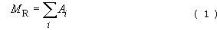

Table 3 Repeat units of some polymers
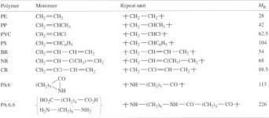

The M_{R} of polypropylene (PP) is (3 × 12) + (6 × 1) = 42. The number of repeat units in a chain is specified by the degree of polymerization, n , but a much more commonly used measure is the chain molecular mass M

Various types of polymer can be generated from similar monomer units, and Table 3 shows three families of closely related polymers. Replacing a single hydrogen atom in ethylene by a methyl group (—CH₃) yields propylene, which when polymerized forms polypropylene (PP). When a chlorine atom (Cl) is substituted, the polymer is PVC and when a benzene ring (—C₆H₅) is substituted, the polymer is polystyrene. M_{R} increases in this series, so that a polystyrene sample of molecular mass 10 000 will possess only 10⁴/104 or roughly 100 repeat units compared to nearly 360 for a linear polyethylene of the same molecular mass. When just one hydrogen atom is substituted in the ethylene molecule, so-called vinyl polymers are created. When both hydrogen atoms on one of the two carbon atoms in the repeat unit are substituted, vinylidene polymers are formed. Thus poly(vinyl fluoride) has the repeat unit [CH₂—CHF]_{n} while poly(vinylidene fluoride) or PVDF has the repeat unit [CH₂—CF₂]_{n}. Polymerization of tetrafluoroethylene monomer of structure CF₂=CF₂ yields PTFE ( Teflon ).
While most vinyl polymers are rigid thermoplastics at room temperature, introduction of a double bond into the repeat unit creates some of the common rubbers already described (see Table 1). The precursor monomer units are dienes, that is, they possess two double bonds as shown by BR and NR in Table 2.
A quite different way of constructing polymer chains is shown by the repeat units of polyamide 6 and 6,6 (nylon 6 and nylon 6,6). Here the monomer molecules are linked together by acid and amine groups at their ends. They are known as functional groups and play a significant role in controlling the physical properties of the final polymer. An important way of studying such functional groups, and other ways in which atoms are linked together in polymer chains, is spectroscopy (Box 3).

2.3 Chain configuration
The structure of repeat units is fixed by the chemical bonds between adjacent atoms. The shape or shapes thus created is known as the configuration, and for chains will be the chain configuration. Like children's plastic building blocks, however, there can be many different configurations for a given set of atoms of a particular type. The different structures which have identical chemical formulae are known as isomers, and such isomers can have quite different properties. Isomerism becomes an important structural feature as the complexity of molecules increases, and is thus very important for long polymer chains. There are various types of isomerism of especial interest for polymers, all essentially based on the nature of the carbon bond and the way carbon bonds are oriented in space.

2.3.1 Structural isomerism
In the saturated hydrocarbons, whose structural formulae are shown in Figure 16, it is not possible to form distinct isomers with just three or less carbon atoms linked together. There is only one way in which one carbon and four hydrogen atoms can be linked together, the single compound being methane, CH₄. A similar situation holds for ethane, C₂H₆ and propane, C₃H₈. But with butane, two possible structures can be formed: n-butane, which has a linear structure, and iso-butane, where the central carbon atom is linked to three adjacent carbons rather than one (Figure 16). Their physical properties are slightly different, for example their boiling points differ by 10 °C, but otherwise they are very similar compounds. Drawing the possible structures (or using structural models) of the isomers gives 3 isomers for pentane, 5 for hexane, 9 for heptane, and so on. As the number of possible structures increases, their properties diverge: the boiling points of the heptanes range over 20 °C and the melting points by no less than 110 °C. The chemical properties differ too: witness the different combustion behaviour of n- and iso-octane in petrol engines. The straight chain isomer causes ‘pinking’ during combustion, while the branched chain burns smoothly in the engine chambers (hence the familiar ‘octane rating’ for petrols).

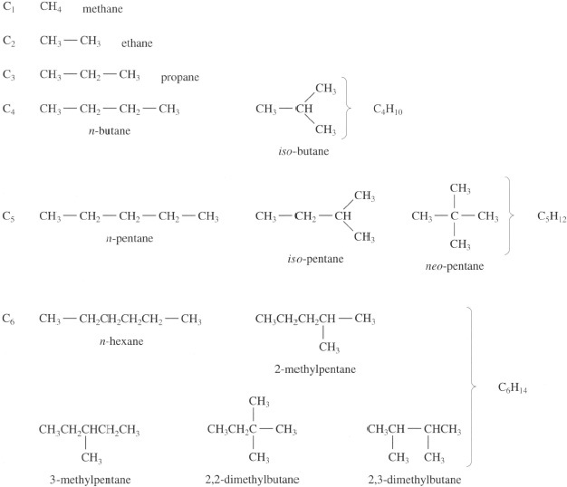
Figure 16 Configurational isomers of saturated hydrocarbons (alkanes). The number of isomers increases rapidly with the number of carbon atoms in the structure. There are no isomers for the first three members of the series, two for butane (C₄), three for pentane (C₅) and five for hexane (C₆)

The increase in isomeric structures is so rapid that at C₃₀, there are no less than 4 111 846 763 theoretically possible compounds! So with even the lowest molecular mass polyethylene, there is an almost infinite number of isomers. Fortunately, the situation is simplified enormously by the way polymerization occurs and in fact there are relatively few chemically distinct polyethylenes. As we shall see later, the concept of a distinct molecular formula is redundant with most commercial polymers since chain lengths are very variable even within a single sample, but the idea of branching is important for polyethylene in particular.

Exercise 5

Calculate the molecular mass of a polystyrene chain molecule of degree of polymerization 500 using Table 3 for your calculation.

View answer - Exercise 5

Box 3 Spectroscopy and polymer analysis
Although information on the polymer or polymers used in a specific product may be provided on the packaging or the product itself, it is often absent, and so some way of analysing the material is needed for identification. It is usually provided by spectroscopic analysis, where a small sample is exposed to electromagnetic radiation and the absorption by the material of specific frequency bands is usually diagnostic of the functional groups present in the polymer. UV or ultraviolet spectroscopy is most useful for detecting aromatic groups in polymer chains, such as the side chain benzene rings in polystyrene. It is infrared or IR spectroscopy which is most useful, however, for analysis of polymers. The method essentially detects radiation absorbed by different bonds vibrating within the chains. Real chains are always moving and vibrating in polymers (unlike the static models for chains shown in this text!), and their vibration frequencies depend on the sizes and masses of the atoms which the covalent bonds link together. There are also different ways in which the bonds can vibrate: they can stretch along or bend (rock) about the bond axis, for example:

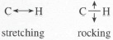
Figure 17

Stretching involves a higher energy input than bending, so radiation is absorbed at a higher frequency than rocking. Since frequency, v is inversely proportional to wavelength, λ (from the formula λ = c/v, where c is the velocity of light), C—H bonds will absorb IR radiation at a lower wavelength when stretching compared to rocking. Of functional groups, the carbonyl group (C=O) is especially important for diagnosis of the polymer since it occurs in nylons and polyesters. Bond stretching occurs in a very narrow band centred at about 6 μm wavelength, so when a strong peak is detected at this position in the IR spectrum, it is likely that the carbonyl group is present in the polymer. It doesn't necessarily follow that the polymer is a nylon or polyester, however, because such groups can be present even in polyethylene chains as a result of oxidation. Band 3 of the AV cassette gives an account of a forensic investigation concerning a PE product which fractured as a result of oxidation and chain degradation. IR and UV spectroscopy were critical tools in the determination of the causes of the failure of the product.

2.3.2 Chain branching
A germ of the idea is shown by the formulae for 2- and 3-methylpentane in Figure 16. A single methyl group (CH₃—) can occur in two different positions along an essentially linear carbon-carbon chain. The methyl group is a very simple kind of branch along the chain, and it is easy to extend the idea to much larger molecules. Thus LDPE is a polymer based on a linear backbone chain with the repeat unit [CH₂CH₂], but is in addition branched with very long chains at infrequent points along the main chain (about 1 in 1000), as shown in Figure 18. Branching is caused during polymerization at high pressure by growth sometimes starting from an initiation point in a chain rather than at the end. An alternative way of making polyethylene is at low pressure using a special catalyst, and this usually results in a highly linear chain without branching (HDPE).

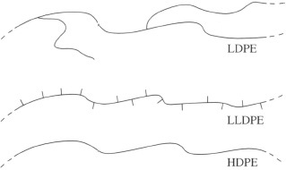
Figure 18 Different chain configurations caused by branching of main back bone chain in HDPE (lower). LDPE has a small number of long chain branches, LLDPE a large number of short branches

However, it is easy to polymerize a mixture of ethylene with a higher alkene such as hex-1-ene, so that the new units co-polymerize together to form a chain where a certain proportion of the chains have tails or short branches along the linear sequence (Figure 18). This and similar copolymers are generically part of the polyethylene family, and are known as LLDPE, short for linear low density polyethylene.
This kind of structural variation is important because it affects the properties of the polymers, as their names indicate. Thus branches along the chain hinder crystallisation of the chains, resulting in a less dense and lower modulus material. LDPE typically has a density of 0.92 Mg m⁻³ while HDPE has a higher density of 0.96 Mg m⁻³. (Note that these density values are numerically identical to those expressed in g cm⁻³.) Intermediate grades, MDPE, are other important relatives, finding wide application in gas pipes, for example.

2.3.3 Geometrical isomerism
A second type of isomerism occurs with diene monomers, and is present in both NR and butadiene rubbers (BR). It occurs because the single double bond in the final polymer can exist in two ways: a cis form and a trans form. The repeat unit shown in Table 3 for NR does less than justice to the two-dimensional structure of this material (Figure 17). In this planar formula where the bonds are shown in their correct orientation to one another, the base polymer in natural rubber can be seen to be m-polyisoprene, where the pendant methyl group appears on the same side as the lone hydrogen atom. The two parts of the chain in which this single repeat unit sits, lie on the opposite side of the double bond.

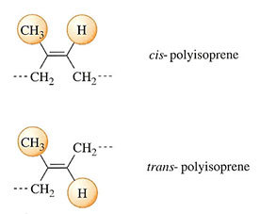
Figure 19 Geometrical isomerism in polyisoprene. Cis-polyisoprene in the main polymer occurs in natural rubber, trans-polyisoprene in gutta percha

But there is an alternative structure with exactly the same formula: the polymer is gutta percha, and its structural formula is shown below that of NR in Figure 19. Here, the two parts of the chain are on opposite sides of the double bond, giving the overall chain a zig-zag appearance. It is also a naturally occurring polymer, but has quite different properties to natural rubber. It is a highly crystalline and rigid material without the long-range elasticity characteristic of an elastomer. It was used formerly as an electrical insulator, but has now been largely superseded by synthetic plastics.

2.3.4 Stereoisomerism
A final type of isomeric variation occurs as a result of the three-dimensional structure of some polymers. It is possible because a four-valent atom like carbon can exist in two different forms when the subsidiary groups or atoms attached to the carbon are all different. The carbon atom is then known as an asymmetric carbon atom. A very simple example of the phenomenon is the structure of a small molecule, lactic acid. As Figure 20 shows, it can exist in two forms which are mirror images of one another. One of the two possible compounds, laevo- (standing for left-handed), or l-lactic acid occurs in muscle after vigorous, anaerobic exercise and causes muscle cramp. It is a good example of stereoisomerism in a small molecule, a feature it also shares with a large number of biological molecules, as well as some polymers.
The carbon atom in a vinyl polymer to which is attached the pendant side group (i.e. every alternate carbon atom in the main chain) is another example of an asymmetric carbon atom. It gives rise to tacticity. When the zig-zag chain is written with the plane of the chain in the plane of the paper, there are three ways in which the position of the pendant side group can exist. The methyl groups in polypropylene, for example, can occur all on one side (isotactic), on alternate sides (syndiotactic) or placed at random (atactic). These possibilities are shown in Figure 20(c). The properties of each type of polymer are quite different to one another, primarily because isotactic and syndiotactic PP have ordered chains and so can crystallise, but atactic chains are quite irregular and cannot crystallise. Isotactic PP is the common form of the commercial material, although atactic PP is used as a binder for paper for example. Syndiotactic PP has recently become available commercially (1997) being made using a new family of catalysts, known as metallocenes (see Section 4.2.5).

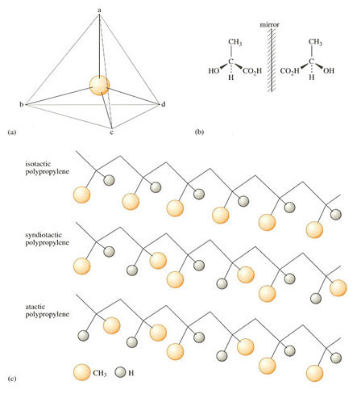
Figure 20 (a) Tetrahedral configuration of single carbon atom; (b) left and right-handed forms of lactic acid; (c) tacticity in polypropylene

2.3.5 Repeat unit placement
A final kind of isomerism in homopolymers is possible when monomer units are added to a growing chain in reverse rather than in their normal position. Because monomer molecules have a particular shape in space, they will normally approach a growing chain end to minimise any spatial interaction, and a regular chain structure results from head-to-tail joints. A defective joint can sometimes occur, however, when heads combine to form a head-to-head joint (Figure 21). Although the chain units are fully chemically bonded together, it represents a weak link in the chain because less energy is needed to break the chain here than elsewhere. So in failure problems, such as thermal degradation, breakage will start here rather than in the normal chain. The occurrence of head-to-head joints is less than 1 per cent in normal polymers.

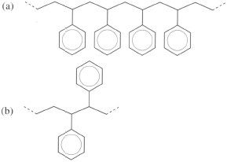
Figure 21 (a) Regular head-to-tail repeat units in polystyrene; (b) irregular head-to-head joint in polystyrene chain

2.3.6 Copolymers
So far, the discussion has been confined to polymers with only a single type of repeat unit, but in reality, a large and growing number of commercial polymers are actually composed of different types of unit attached together by chemical covalent bonds. They are known as copolymers, and can comprise just two different units (binary copolymers) or three (ternary), and so on. It is one of the common strategies used by molecular engineers to manipulate the properties of polymers to gain just the right combination of properties for a specific application.
One of the best known examples involves polystyrene. In its homopolymer form, it is a rigid, transparent thermoplastic which is also very brittle. It thus finds little application for stressed applications in its original state. It also shows a glass transition temperature of about 97 °C, so is useless for containers which could hold boiling water (like very hot coffee). The glass transition temperature (T_{g}) is the temperature at which an amorphous thermoplastic becomes flexible and rubbery (Box 4). This problem can be solved by copolymerizing styrene with acrylonitrile to produce SAN polymer, where the styrene and acrylonitrile units alternate along the backbone chain of the material (Figure 22). SAN is commonly used for transparent drinks containers since the acrylonitrile units raise the T_{g} to about 107 °C.
The problem of brittleness can be solved in a quite different way. Paradoxically, if rubber (polybutadiene) chains are grafted onto the main backbone polystyrene chain, the graft copolymer so formed (Figure 22) is much tougher owing to molecular segregation of the rubber chains into tiny particles. Although they reduce the stiffness of the copolymer compared with the parent PS, the particles act as nuclei for minute crazes. Such crazes are so plentiful when the solid is stressed, that a great deal of energy is absorbed and so the bulk material appears ductile and tough. The material is HIPS or high-impact polystyrene. The benefits of both high T_{g} and toughness are achieved with ABS, a terpolymer of the three component repeat units, with butadiene present to about 25 weight % (Figure 22). The strategy of adding rubber particles to toughen a brittle polymer is known as rubber-toughening.

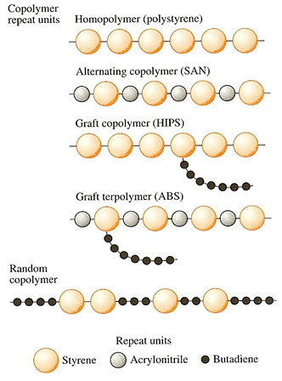
Figure 22 Various configurations of styrene, butadiene and acrylonitrile in different copolymer structures

Because the different repeat units added to the original polymer are always covalently bonded, they are in effect locked into the structure, so in theory at least, the composition is infinitely variable. This is quite unlike metal alloys or mixed glasses, where the composition is only possible between certain, fixed limits. Thus mild steel is an alloy with 0.1–0.4% carbon and small deviations above or below cause large changes in properties. So what happens if the second rubbery component in a copolymer is increased? Not surprisingly, the properties change from those of a plastic to that of a reinforced rubber. In fact, copolymerization of butadiene and styrene was employed at a very early stage in the development of synthetic rubber during the last World War particularly. It was found that the stiffness of polybutadiene rubber could be improved by copolymerization with about 24 weight% styrene, to give a random copolymer of the two units, known as SBR (Figure 22).

Box 4 Thermal transitions in polymers
The two most important thermal transitions exhibited by polymers are the glass transition temperature, T_{g} and the crystalline melting temperature, T_{m} . The glass point is the temperature at which amorphous polymer becomes elastomeric and flexible as the temperature is raised. The crystalline melting point is that point when the crystalline component loses coherence and long-range order. Since most polymers are rarely completely crystalline owing to chain entanglements, most crystalline polymers will show both a T_{g} and a T_{m}. This is illustrated below by the thermogram for polyethylene terephthalate) or PET (Figure 23), where the T_{g} is shown at about 84 °C by the inflection in the curve. The material used was sampled from a soft drinks bottle.
The large dip at about 248 °C represents the melting point. The thermogram was obtained using a technique known as differential scanning calorimetry or DSC for short. It is a very accurate way of evaluating the thermal properties of polymers, the apparatus needing only a few milligrams of the polymer for analysis. The temperature of the sample is raised in a controlled and regular way (horizontal scale of Figure 23). The device measures heat flow into or from the sample, as shown by the vertical scale in Figure 23.

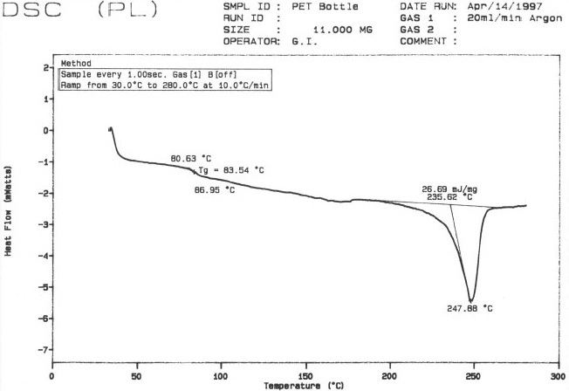
Figure 23

Exercise 6

What is the mole fraction of styrene in SBR rubber? (The mole fraction is based on the relative number of each unit present, rather than weight:
weight fraction = w₁/(w₁ + w₂)
and, n = w/M _{R}
where n is the number of moles, and w the weight of any component.)

View answer - Exercise 6

Alternatively, it was found in the 1960s that another way of putting the units together was possible. If, rather than using a mixture of monomers, they were added sequentially, then a block copolymer resulted (Figure 24). The properties are different again to those of the random copolymer because each type of chain segregates together to form minute domains, as shown by the microstructure of Figure 24. Such materials retain thermoplastic behaviour yet behave as crosslinked rubbers, and the SBS block copolymer was the first commercial thermoplastic elastomer or TPE. Although most polymer chains are incompatible with one another, there are some exceptions to the rule. One in particular has gained commercial success, and is a blend of polystyrene and poly(phenylene oxide) (PPO). The T_{g} is increased as is the toughness of the resulting physical mixture of different chains, and the polymer mixture is known by the trade name Noryl. It is used widely for enclosure of consumer products.

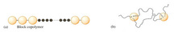
Figure 24 Block copolymers are formed by sequential addition of monomer in polymerization: (a) SBS block copolymer; (b) microstructure with polystyrene and chains segregated to form 10–20 nm diameter domains

Self assessment question 3

uPVC for window frames is too brittle to be acceptable in a product destined to last more than 50 years without damage. The plastic currently used for such products is a copolymer where poly (ethyl aery late) rubber of repeat unit structure
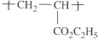
is grafted onto PVC backbone chains. What will be the microstructure of the material, why should it be a more acceptable material for window frames, and what composition should the copolymer possess?

View answer - Self assessment question 3

2.4 Chain conformations
The repeat units or chains shown in the previous figures are all static representations of real chains and they are therefore of limited use. The key idea we need to explore real chains, and their influence on properties is that of the conformation of a chain. A single conformation is just a single shape that a chain can adopt, so that for example, when a polyethylene chain is shown as a linear zig-zag, this is one possible conformation. Static formulae do not show an important aspect of real chains – their oscillation and movement as a result of thermal vibrations of the molecular structure. These chain molecular motions increase in both frequency and amplitude as the temperature is raised, the most important being rotation about single bonds. By contrast, double bonds are rigid and the adjacent atoms are immobile. As a consequence of extra rotational motion, the number of conformations a chain can adopt increases rapidly with increasing temperature. The question then arises whether or not there are any conformations which are more stable than others at any particular temperature, given the chemical structure of the repeat unit.
To answer the question, consider the simple molecule of n-butane (Table 4), which consists of four carbon atoms linked together in a linear chain together with hydrogen atoms along the periphery. There will be considerable interference between adjacent hydrogen atoms when they are aligned. The interference will be lower when they rotate about their own axis to give a staggered conformation (Figure 25 (a)). Concentrating on the two central carbon atoms (C₂ and C₃), and looking along the C₂—C₃ axis, it is also clear that there are two different ways in which the outer carbon atoms (C₁ or C₄) can be situated with respect to one another. One position where C₁ and C₄ are in opposite positions is known as the trans conformation, the other where they are adjacent is known as the gauche conformation. It will be readily apparent from the butane model that interference occurs between the hydrogen atoms on C1 and C₄ carbon atoms in the gauche conformation. This so-called steric hindrance makes the gauche conformation of higher energy than the trans conformation, as shown in Figure 25(b). The net effect then is that the trans conformation is favoured and this also applies in longer chain hydrocarbons.

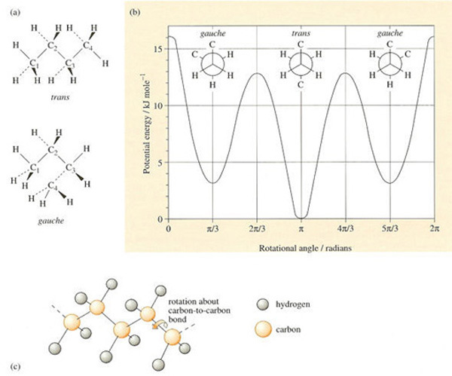
Figure 25 (a) Rotational isomerism in n-butane; (b) potential energy wells for gauche and trans conformers in butane (views along C—C bond); (c) rotational isomerism in polyethylene

Table 4 Properties of linear saturated hydrocarbons
Name | Formula | n | T_{m} /°C | Density of liquid/Mg m⁻³ | State at 20 °C
ethane | C₂H₆ | 1 | −172 | 0.5462 | gas
n-butane | C₄H₁₀ | 2 | −135 | 0.5788 | gas
n-octane | C₈H₁₈ | 4 | −57 | 0.7028 | liquid
n-hexadecane | C₁₆H₃₄ | 8 | 18 | 0.7749 | liquid
n-triacontane | C₃₀H₆₂ | 15 | 66 | 0.7786 | waxy solid
n-heptacontane | C₇₀H₁₄₂ | 35 | 105 | 0.7940 | waxy solid
polyethylene | C₇₀₀H₁₄₀₂ | 350 | 130–140 | ca. 0.08 | solid polymer

When polyethylene crystallises it adopts an overall linear conformation in which the carbon atoms form a planar zig-zag, where they are all trans with respect to their near neighbours. In the non-crystalline state, the relative proportion of trans and gauche conformations, N_{t} and N_{g}, can be predicted using Boltzmann's equation:

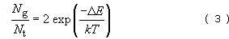

where ΔE is the net energy difference between the two states (≈3 kJ mole⁻¹ in this instance), k is Boltzmann's constant and T the absolute temperature. The factor of two is necessary because two gauche states are possible. Since

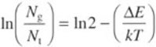

it follows that, as the temperature rises, the energetic contribution decreases and so the right-hand term increases; this means that more and more gauche conformations are adopted as the temperature rises. The net result is that the randomly coiled polyethylene chain tends to contract in size with rise in temperature as linear zig-zag trans conformers become less likely along the chain.

Exercise 7

The viscosity of engine oil is very sensitive to changes in temperature, but can be made much less sensitive by adding a polymer whose chain expands as the temperature rises. One such additive is poly(ethylene oxide) (PEO), whose randomly coiled chain expands in size when the temperature is raised. Explain the effect in terms of rotation about single bonds in the main chain.

View answer - Exercise 7

2.5 Structure-property relationships
Given the large number of possible configurations in polymers, what guides to likely properties are available? We have already seen some of the effects on properties of changing tacticity, for example, which can affect crystallinity. Control of copolymer structure, too, can have substantial effects on their thermal properties.

2.5.1 Homologous series
Another approach to the problem is to consider what happens to the properties of a related series of compounds of increasing chain length. The simplest precedent is the sequence of properties for the saturated paraffin hydrocarbons (normal alkanes). Such a series of compounds is known as an homologous series. The lowest members are gases like methane and ethane, but as the length of the chain increases the hydrocarbons become first liquids and then waxy solids. Both the melting points and densities increase in a regular manner. When many hundreds of carbon atoms are linked together the properties reach a plateau, and it is only here that one can talk of true polymeric properties (Table 4). During investigations of other types of repeat unit, considerable efforts were and still are made to determine how properties vary with increasing chain length for the lower members (oligomers) of the family, and how it may affect the final properties of the true polymers.

2.5.2 Polymer families
But how do small changes in chain configuration for a given family of polymers affect their properties? A very clear example of slight changes in the repeat unit structure is exhibited by polyamides, polyesters and polyurethanes. They are all polymers linked together by a particular kind of functional group, which gives the name to each family. Their backbone chain may either be aliphatic or aromatic in nature, although here we'll only be examining trends for the aliphatic polymers. One way of looking at their structure is to regard them as comprising a polyethylene chain into which is inserted the functional group of interest.
They are crystalline polymers which show a distinct melting point (T_{m}) and we are interested in the effect on T_{m} of changing the chain length of the sectors between functional groups. Since such polymers are made from two separate monomers (cf. the repeat unit in nylon 6,6 of Table 3), only one of the sectors will be varied. The melting temperatures are shown in Figure 11 as a function of increasing sector chain length. The constant melting point of HDPE is shown on the same figure for comparison.

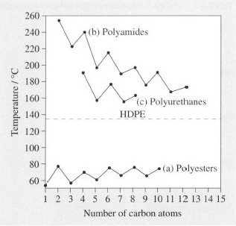
Figure 26 Dependence of T _{m} on polar group spacing. Number of carbon atoms refers to (a) acid for polyesters made with decamethylene glycol, HO(CH₂)₁₀OH; (b) diamine for polyamides made with sebacic acid, HOOC(CH₂)₁₀COOH; (c) diisocyanate for polyurethanes made with fetramethylene glycol HO(CH₂)₄OH

The first point of interest is that the polyamides and polyurethanes always have melting points above that of HDPE, an effect due to hydrogen-bonding between adjacent chains. This is a secondary kind of bonding between hydrogen and oxygen or nitrogen, which occurs in water and ice as well as many natural polymers. Hydrogen bonds occur between the functional groups on neighbouring chains and effectively tie the chains together in a weak kind of crosslink. This means that the crystalline chains are held together in an energetically more stable conformation than in polyethylene itself, so a higher temperature is needed to melt or decompose the crystals. Hydrogen bonding is absent from polyesters, so the crystals actually show a lower melting temperature than PE because the functional groups make for a less well packed, and hence less stable, structure.
The effect of increasing the number of carbon atoms in the intervening PE chains in the amides and urethanes is similar, lowering T_{m} in a regular way and approaching the limiting value for HDPE. The decrease is not smooth, however, values oscillating about the line. This effect is caused by packing effects in the crystal structure, odd numbers of carbon atoms fitting together less easily than even numbered chains. With the polyesters, the packing effect still creates oscillations, but increasing chain length has a minimal overall effect on melting temperature.
Such trends are important in choosing specific grades for specific end products, or providing designers and manufacturers with a set of polymers with slightly different thermal properties but whose other properties remain the same. For example, nylon 6 is a high melting polyamide (T_{m}= 225 °C), and it might be desired to lower this temperature for saving energy during processing. Nylon 11 with a T_{m} of circa 180 °C might then be good choice of material. The hydrogen bonds in the chain still confer the useful property of solvent resistance, for example, and this resistance is unlikely to be affected by lengthening the chain sector between functional groups.

Table 5 Glass transition temperatures and repeat unit structures
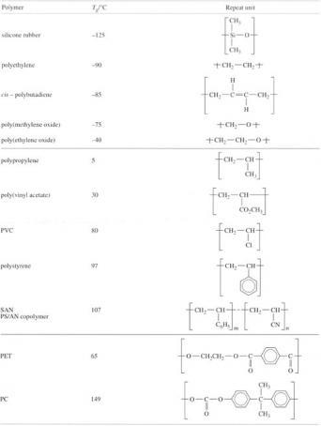

2.5.3 Structure and the glass transition temperature
There is a relation between the ease of chain rotation (controlling conformation) and the locked-in configuration of polymer backbone chains. It is most easily appreciated by examining the effect of different backbone configurations on the glass-transition temperature or T_{g}. As already noted above, the T_{g} is the temperature when a rigid amorphous thermoplastic becomes elastomeric, and its stiffness drops steeply. How can this transition temperature be interpreted at a molecular level?
The simplest way at looking at the problem is in terms of the chain rotational model of Section 2.3, where the effect of raising temperature on the conformation of polyethylene was considered. It was of course implicitly assumed that the chain was flexible, and that rotation about carbon-carbon bonds created chain flexibility. And that is true at ambient temperatures of 25 °C, say, provided the level of crystallinity is low or absent. But what happens if the temperature is lowered? As the temperature decreases, there must come a point when all rotation about chain bonds ceases entirely; in other words, the energy available locally in the form of thermal vibration is insufficient to cause neighbouring atoms to twist around one another. The energy needed to achieve rotation is actually shown by the potential energy banners in Figure 22(b). They lie at about 13 kJ mole⁻¹ and 16 kJ mole₋₁ above the energy minimum for the trans conformer in n-butane.
The temperature at which chain molecular rotation ceases is the glass transition temperature, because the chains can no longer respond to external strain by uncoiling and lengthening by chain rotation. In other words, the polymer becomes glassy and rigid. For polyethylene, the T_{g} is very low and occurs at about −90 °C. However, it is important to mention that the T_{g} is not necessarily a sharp transition, like the melting point, for example. It can be very broad indeed, with a progressive stiffening effect as temperature is lowered. Indeed with PE, substantial stiffening is already present by −20 °C.
So how do changes in chain structure affect T_{g}, if the transition is largely controlled by rotation about chain bonds? Introduction of atoms like oxygen where there are no hydrogens to create steric hindrance in the chain would be expected to lower T_{g}, and this is found to be in general the case (Table 5). POM or acetal resin and PEO also have low T_{g}S, and silicone polymer is exceptional in having one of the lowest T_{g}S of any material, at −125 °C. This is why the (crosslinked) rubber is widely used in gaskets and fuel hose for aircraft, where low temperatures will be encountered when flying at height.
It would also be expected that chains having double bonds, such as BR and NR might have low T_{g}s since there is little steric hindrance adjacent to this bond. Again, this is found to be the case (Table 5).
On the other hand, if ways of hindering chain rotation are used, for example by increasing the physical size of pendant groups, then the T_{g} would be expected to increase. Thus polypropylene with a large methyl group on every alternate chain atom has a T_{g} of about 5 °C. a value that implies PP milk bottle crates could crack on a frosty morning! This problem was overcome by using a copolymer grade with ethylene to lower the T_{g} to below 0 °C. Increasing the size of the side group in vinyl polymers shows a reasonably regular increase in T_{g}, with PVA having a value of about 30 °C, PVC a value of about 80 °C and polystyrene with a very large benzene pendant ring hindering rotation has a T_{g} of 97 °C.
Larger side groups than this are uncommon, so it is worth returning to the structure of the main chain. Benzene rings trapped within the backbone should increase steric hindrance, and hence T_{g}. The effect is shown in many polymers and was indeed a strategy used for developing polymers stable to high-temperatures. PET for example, is an aromatic polyester and contains such a ring (C₆H₄) in its repeat unit together with a short aliphatic portion (Table 5). It has a T_{g} of about 65 °C, but a polymer like polycarbonate is much more hindered by its repeat unit, since the short chain is absent. Here, the large group which forms the bulk of the unit is a bisphenol A group consisting of two benzene rings connected by a carbon atom with two pendant methyl groups, so there is considerable resistance to rotation. Its T_{g} is about 149 °C. Finally, there are materials like aramids and polyimides where the chain is either completed prevented from rotation at all (PI), or degrades by chain breakage before rotation is possible (aramids). The concept of T_{g} in these cases becomes redundant.

2.5.4 Melting and structure
For those polymers which can crystallise, one would expect some relation between chain rotation and melting. Since all crystallisation demands that chains form an ordered conformation (e.g. the PE planar zig-zag) before they can pack together, the chance of this happening should be related to the ease of twisting into the required conformation. That there is a rough correlation between T_{g} and T_{m} can be judged from Figure 12, where the two transition temperatures are plotted against one another. Averaging over the scatter of points shows that when the transitions are plotted in kelvins, then

Some care is needed in interpreting such a rule of thumb, and there are known to be other factors at work, such as hydrogen bonding as we've already seen above in polyamides. But overall, there does indeed appear to be a correlation between ease of chain rotation and the most important thermal transitions observed in polymers. Such relations can be a guide to synthesis of new repeat units.

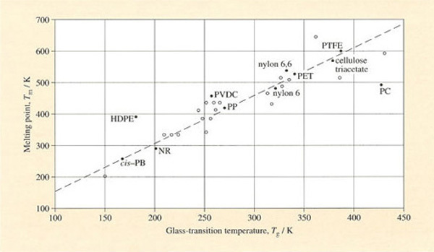
Figure 27 The melting points T_{m} of crystallisable polymers plotted against their glass transition temperatures T_{g}. The dotted line shows T_{g} ≈2/3 T_{m}

2.6 Molecular mass distribution

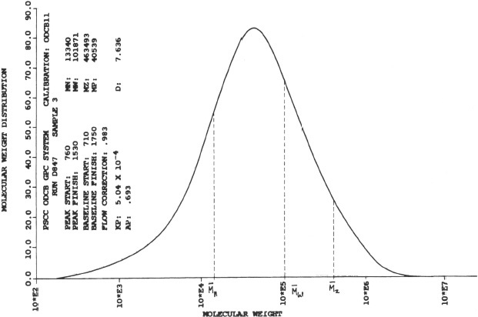
Figure 28 Molecular mass distribution for a typical high density polyethylene (HDPE).

In Figure 28 the peak (M_{p}) is at about 40 000. Number average () and weight average () molecular masses fall below and above the peak value. Determined using high temperature GPC
Chain molecules give rise to types of structure which are not formed in small molecules, and they exhibit molecular mass variations which are critical not only for their properties but also for processing into shape. In general, commercial polymers do not consist of assemblies of chains of constant length but rather a distribution of lengths, so that statistical techniques of analysis are needed to characterize them. The spectrum of molecular masses for a typical HDPE is shown in Figure 28, with M varying from M=200 through a peak at about 40 000 to over a million. Such a distribution can be described by average molecular masses, of which the most important are the number-average molecular mass

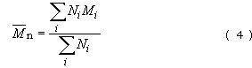

the weight-average molecular mass

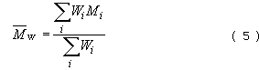

and the z-average molecular mass

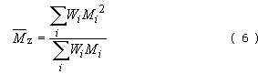

where N _{i} and W _{i} are the number and weight of chains of molecular mass M respectively. Since W_{i} = N_{i}M_{i}, Equation (5) can be rewritten as

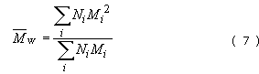

and Equation (6) becomes

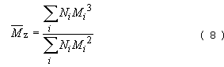

Each measure of molecular mass gives a different emphasis. emphasises the smaller molecules present whereas and emphasise the larger molecules. It is clear therefore that as shown in Figure 28. A simple example suffices to demonstrate the point. An equimolecular (i.e. equimolar) mixture of samples of molecular mass 50 000 and 100 000 will have the following average values:

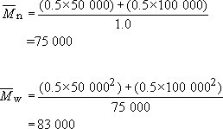

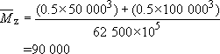

The breadth of the distribution is usually defined by the dispersion, which is the simple ratio of weight- to number-average molecular masses

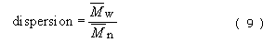

which is unity for a monodisperse polymer but is usually greater than unity. High density polyethylenes have values from 6 to 12 while LDPE is usually much broader in distribution ( up to ca. 30). New metallocene polyolefins, however, have low dispersions of about 2.5. In polymers like nylon it is also much sharper, with values in the region of 2.0.
The molecular mass distribution (MMD) is important for many physical properties of the polymer and is best expressed by a complete curve as shown in Figure 28, obtained directly by a method known as gel permeation chromatography (GPC) (Box 5).
Single-point averages can be obtained by other means such as osmometry (M_{n}), light scattering (M_{w}) or ultracentrifugation (M_{z}). Dilute solution viscometry gives a direct measure of the viscosity-average molecular mass M_{v}, which usually lies between M_{n} and M_{w}. It is defined by the equation

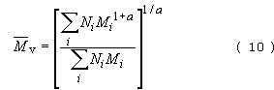

where a is a constant in the equation

[η] is the intrinsic viscosity of a polymer in solution and K is another constant characteristic of the solution. K usually lies between 0.5 × 10⁻⁴ and 5 × 10⁻⁴, while a typically lies in the range 0.6–0.8.

Self assessment question 4

To improve processing properties, an equal weight of low molecular mass nylon 6 (degree of polymerization n = 100) is blended with a moulding grade of nylon 6 (n = 500). Assuming both materials are monodisperse, what will be
- the weight-average molecular mass,
- the number-average molecular mass,
- the dispersion of the blend?

View answer - Self assessment question 4

Box 5 Gel permeation chromatography (GPC)
GPC is a technique for determining the molecular mass distribution of a polymer by analysis of a solution of the polymer concerned. It is normally a rapid and accurate way of determining the MMD compared with older methods such as osmometry or light scattering. Moreover, it gives the whole distribution in one pass, while the other methods give only single point averages. Light scattering, for example, only yields the weight-average molecular mass. When the complete MMD is available from GPC, any average molecular mass can be computed simply and easily.
But since a solution is the basis for analysis using GPC, the technique is limited to thermoplastic, uncrosslinked polymers. Polymers vary widely in their ability to form solutions. Some, such as polystyrene and polycarbonate are soluble in a wide selection of organic media. Tetrahydrofuran or THF is a useful solvent for their GPC analysis. Many other plastics materials, however, are quite insoluble in the range of solvents commonly available. They include the polyolefins, PE and PP, as well as PET and other engineering polymers with high T_{g}S. GPC in a high boiling point solvent such as decalin (Tb = 169 °C) is often used for such intractable materials.
So what is the basis of GPC? The method involves passing the polymer solution down a column containing gel spheres into which the smallest chains will diffuse most easily, the largest with extreme difficulty. The latter are thus the first to be passed out at the bottom of the column, at low elution counts, while the smallest chains diffuse out last of all. The polymer concentration is measured in the eluate, so giving an estimate of the MMD. The method demands calibration with standard samples, usually monodisperse polystyrene of various molecular masses (Figure 29).

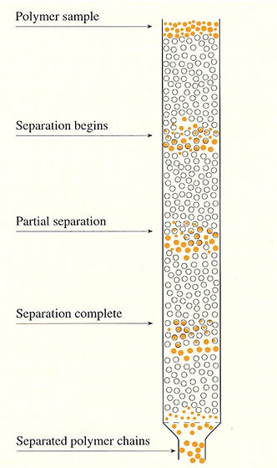
Figure 29

When is GPC used? Basically, whenever a user wants to check the MMD of a polymer specimen against, say, a virgin or unused sample. The user may be interested in checking whether the correct grade of polymer has been used, for example, in a plastic moulding, or alternatively, the effects of chain degradation.

2.7 Commercial polymers
The increasing control of polymer structure by fine-tuned catalysis of polymerization opened up an enormous area for commercial exploitation, and new polymers are still being produced in this way (such as the metallocene polymers). A revolution of equal magnitude has occurred with polymers containing functional groups, for example, the nylons, polyesters and polyurethanes, resulting in polymers ranging from quite simple structures like aramid fibre to relatively complex repeat units like those in polyimide or polycarbonate. These polymers are mainly based on carbon-carbon, carbon-oxygen or carbon-nitrogen bonds, but a significant amount of research is also being put into polymers like the silicones (Table 6) which are termed ‘inorganic’ (Box 6). Silicone polymers have been known since the 1940s and were developed for both low and high temperature resistant seals for aircraft engines, although many other uses were found for their water-repelling properties. A number of speciality silicones now exist, mainly varying in molecular mass and the pendant organic side groups.
Polymeric adhesives were traditionally based on concentrated solutions of latex rubber, PVA or epoxy resins, but a novel approach developed in the sixties involved direct polymerization of cyanoacrylate monomer at the surfaces to be bonded. The main advantage is ease of application of the liquid monomer to the surfaces, where its low viscosity enables it to penetrate into the finest crevices. The monomer polymerizes very rapidly by contact with traces of water and gives a very strong bond. It is now finding widespread use in industrial assembly as well as for domestic purposes. Poly(vinyl butyral) is another speciality adhesive primarily used for bonding glass sheets together to form laminated or safety glass. PVA is partially reacted with butyraldehyde to make the adhesive which is then bonded to the glass surfaces. In service, it acts to stop crack growth penetrating from one glass sheet to the next by absorbing energy like a rubber.

Table 6 Some speciality polymers
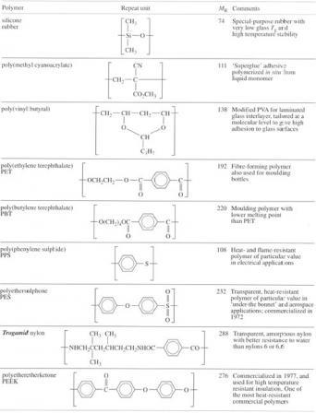

Box 6 Inorganic polymers
Silicone rubber is an example of an inorganic polymer, one member of a very large family of inorganic materials which have a chain or sheet molecular structure. Elements which can link together with themselves (‘catenation’) are not limited to carbon, with nitrogen forming a dimer (N₂ gas), phosphorus in its coloured forms (P_{n}), plastic sulphur (Se_{n}) and amorphous selenium (Se_{n} ). Generally, it is those non-metals or metalloids lying near carbon which catenate, as highlighted in Figure 30. The polymers formed by linkage with another element are much more common, however, silicon being an element which forms extremely strong bonds with oxygen (Si-O) in many silicate minerals, for example. Chain formation in inorganic silica-based glasses is shown by the amorphous, non-crystalline nature of the material (transparent window glass, for example) and the high viscosity of molten glasses. The strength of Portland cement derives from the formation of a polymerized calcium silicate formed during setting.
Phosphorus also forms very strong chemical bonds with oxygen, frequently forming long chain polymers. Indeed. DNA, the stuff of life itself, possesses a backbone chain which is a copolymer of phosphate groups (PO4) with sugar molecules.

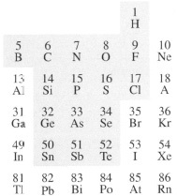
Figure 30

Functional groups which form part of the main chain offer very great flexibility in synthesis not only because of the variety which exists but because of the very large number of possible structures that can be linked together. The selection shown in Table 6 includes staple polymers like PET, which has recently received a boost through development of blow moulding grades, but also high technology materials like PEEK. Traditional bulk polymers like the polyolefins, PVC and PS are limited in application particularly for engineering use by virtue of their low melting or glass transition temperatures. The concept of rotational isomerism stimulated research into ways of stiffening chains by the introduction of aromatic groups. Outstanding success stories include polycarbonate, a tough transparent thermoplastic discovered in 1954 and available commercially in the early sixties, Kevlar aramid fibre (1968) and the polysulphones. They show progressively increasing temperature resistance: PC has a T_{g} of 145 °C, but polyethersulphone a T_{g} of about 230 °C. Polyetheretherketone (PEEK) exhibits a T_{g} of 144 °C but melts at 335 °C. These polymers are also highly resistant to burning, a feature which reflects the chemical stability of the aromatic benzene rings. It is a characteristic which reaches its ultimate in refractory graphite, which can resist temperatures above 3000 °C. Thus PPS has an oxygen index of 0.53 (the fraction of oxygen in air needed before burning will occur) compared to most common polymers which have indices less than 0.21, which is the normal oxygen content of the atmosphere. Introduction of aromatic rings into the nylons has similar effects, stiffening the chain and providing chemical stability. It is seen most dramatically with aramid fibre, and to a lesser extent with Trogamid nylon (Table 6). This polymer has a high T_{g} of about 150 °C yet is completely non-crystalline, and thus transparent, owing to the disruption of the crystal lattice by the irregular aliphatic diamine chain. The T _{g} of nylon 6 or 6,6 is about 0 °C but varies with the amount of water absorbed in the material.

2.7.1 Thermosets
There are some limitations to the concept of the repeat unit when applied to crosslinked polymers, the thermosets. This is because of the complexity of the crosslinking reactions, the way molecules link together chemically during thermoset processing. For example, phenolic resins (the basis for materials like Bakelite) are prepared initially as prepolymers, i.e. polymers of low molecular mass (ca. 1000) by reaction between phenol and formaldehyde (Figure 31). Reaction can occur in several ways depending on the catalyst used and the ratio of phenol to formaldehyde: acid catalysis gives novolaks (Figure 31(b)) and alkaline catalysis produces resols (Figure 31(c)). The latter always possess free alcohol groups which are not present in novolaks. The prepolymers are blended with fillers before moulding to shape. With resols, no extra crosslinking agent is needed whereas multi-functional agents such as hexamine are added to novolaks to ensure crosslinking. Since the reaction occurs at three possible sites on the phenol molecule (Figure 31(a)), it is clearly not possible to specify a repeat unit in a simple way. The molecular mass is practically infinite since all parts of the polymer are linked together by chemical covalent bonds.

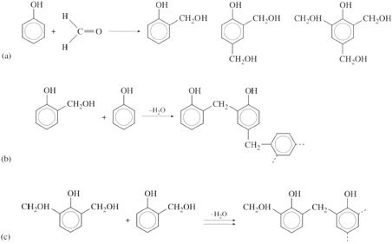
Figure 31 Preparation of phenolic prepolymers from aromatic phenol and formaldeyde; (a) several possible structures can be formed; (b) novolaks result during acid catalysis; (c) resols result from an excess of formaldehyde and alkaline catalysis

Self assessment question 5

Nomex is a polymer fibre with the following repeat unit:
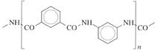
It is widely used in aircraft composites as a reinforcing fibre. From an examination of the structure, indicate whether you would expect the polymer to be crystalline. Briefly indicate what thermal properties you might expect from this material. Include mention of thermal transitions and fire-resistance by relating chain rotation to the effects of temperature on the structure.

View answer - Self assessment question 5

3 Manufacture of monomers

3.1 Primary sources of synthetic polymers
The most important primary sources of synthetic polymers are crude oil, natural gas and, to a minor extent, coal. Because all are primarily fuels rather than sources of materials, the manufacture of polymers is susceptible to changes in price or supply. However, this is also true of other materials, since fuel costs are an important component of metal, ceramic and glass manufacture where very high reaction temperatures are needed for reduction of ore to metal and/or smelting. Where polymer manufacture is different is in the range of sources of the basic building blocks for the polymer repeat units. Both oil and natural gas can be used to make polyethylene for example. In parallel with the advances that have been made in polymerization and polymer structures, there have been major advances in making intermediates more efficiently using tailor-made catalysts. A wider variety of intermediate petrochemicals is also now available, particularly for speciality materials.

3.2 Petrochemical processing
Following distillation of petroleum into the major fractions (gasoline C₅ up to 95 °C, naphtha 75–175 °C, kerosine 175–225 °C), the naphtha cut is subjected to cracking to yield smaller, double bonded molecules. The reaction is conducted at high temperatures (400–800 °C), but under low pressure using steam for cracking. This process can yield monomers directly, such as ethylene (C₂), propylene (C₃) and butadiene (C₄), but often further reactions are required to add other elements such as oxygen and chlorine. Since cracked naphthas are complex mixtures, expensive separation procedures are needed for the co-products.

3.2.1 Thermal cracking
The bulk of the major monomer and intermediate, ethylene (C₂H₄), is still produced in the UK by steam cracking without the use of catalysts. Paraffinic feedstocks are best for optimising ethylene yields, and the severity of cracking is specified by the rate of disappearance of a marker compound, usually n-pentane. The severity of the reaction can then be defined as follows:

where k ₅ is the rate constant (per second) for the cracking of n-pentane (C₅) and t is the time in seconds. The rate of disappearance can be simply related to the degree of conversion, α, assuming first-order kinetics:

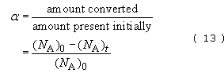

and

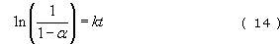

where (N_{A})₀ and (N_{A})₀ are the number of molecules (or moles) of compound A present at t=0 and t seconds respectively. Cracking severity is also dependent on temperature T through the Arrhenius equation

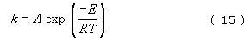

where E is the activation energy for the process, A and R are constants and k is the rate constant as in Equation (12).
The exponential dependence of rate constants on temperature for a variety of simple hydrocarbons in thermal cracking is shown in Figure 32 and it is clear that large molecules are easier to crack than smaller ones. Ethane for example cracks more than 20 times more slowly than n-hexane at 1000 K. But what products are formed? Unfortunately, ethane can break down more easily to methane and hydrogen and ultimately to carbon, particularly under the rather crude conditions of thermal cracking. Propane and higher homologues give higher yields of ethylene under similar cracking conditions but cyclic paraffins (cycloalkanes) give rather less.

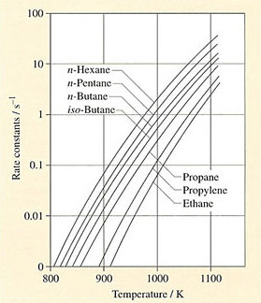
Figure 32 Rate constants for the thermal cracking of selected hydrocarbons

The fractionated naphtha is divided into two streams, one to the thermal cracker (olefin plant) and the other to the reformer (aromatics plant). The exit streams are separated and individual chemicals subjected to separate treatments depending on the intermediates, monomers or polymers required.
A highly paraffinic naphtha is thus the best cracking feedstock for high yields of ethylene, and Figure 33 shows the kind of product distribution from a Kuwaiti naphtha under various cracking conditions. The major co-products – ethylene, propylene, butadiene (C₄H₆), mixed butene/butane (C₄H₈, C₄H₁₀) and pyrolysis gasoline (C₅₊) − vary in concentration depending on cracking severity. With naphthas derived from other crudes, the product distribution will be quite different (see Box 7). The proportion of unwanted byproducts like hydrogen, methane and carbon coke (not shown in the figure, but which gradually accumulate within the cracking tubes) increases with cracking severity. However, the product distribution may not coincide with polymer demand and consumption of ethylene for other chemicals.

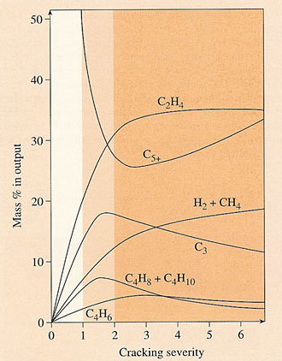
Figure 33 Co-product yields for a thermal cracking of a paraffinic naphtha. Ethylene yield is maximised at severities greater than two, but the maximum propylene yield occurs at about 1.5. Severe cracking occurs between values of about 2.0 and 4.0

3.2.2 Ethane cracking
Although ethane can be cracked thermally, the reaction is slow and does not necessarily yield ethylene at high severity. Careful control of reaction conditions, however, allows the reaction to occur

The yield of ethylene is typically nearly 50 wt% with the rest composed of unreacted ethane (40 per cent) and some methane and hydrogen (10 per cent). The ethane is separated and recycled to the start. This process is practised widely in the US, where ‘wet’ natural gas has traditionally been abundant and cheap. With supplies arriving in Scotland from the Brent complex, ethane and propane are cracked at the Shell-Esso petrochemical works at Mossmoran, Fife and the BP Grangemouth complex near Edinburgh.

Box 7 North Sea oil
Although we all know that Britain is effectively self-sufficient in oil and gas, and indeed exports substantial quantities, it may not be so widely appreciated that our oil is of very high quality. It attracts a high price on the Rotterdam market because it is low in the impurity sulphur and is also very light. Thus the marker crude oil. Brent, from the UK sector of the North Sea has a sulphur content of only 0.26 per cent compared with 2.5 per cent for Kuwaiti crude. Why should this be important? One of the reasons is that in much petrochemical processing (to make polymers, for example) catalysts are use to speed up process reactions; sulphur poisons such catalysts, so must be removed in expensive purification processes before catalysis. It will also burn in fuels made from crude oil (fuel oil, petrol, paraffin etc.) to pollute the environment, so low sulphur oils generally command a premium on the market.
North Sea crudes are also very light, with a density much lower than Middle East crudes. Thus Brent oil has a gravity of about 38 API degrees compared to 27 API degrees for Alaskan crude, for example. This means that it yields more light fraction liquids such as petrol (gasoline), which are more valuable than heavier fractions. Thus Brent yields about 20 weight % petrol compared with only 10 per cent for Alaskan crude. There is a more subtle reason why our oil is of greater value, the reason lying in its molecular composition. Although an incredibly complex mixture of organic compounds, oil composition can be expressed in terms of paraffins (alkanes), naphthenes (cyclic paraffins) and aromatics. The compositions of a typical North Sea crude and Kuwaiti crudes are shown in Figure 34, where it is clear that North Sea oil is much more naphthenic and aromatic than Kuwaiti. This is important for petrochemical extraction of high value aromatics for polymers like PS and PET, as well as increasing the octane rating of car petrols, especially for lead-free varieties.

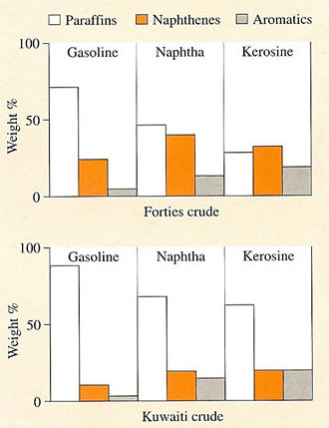
Figure 34

In the US, however, ethane and propane are becoming more expensive, so that thermal cracking of naphtha to produce ethylene is increasing. There is no doubt that thermal processing of ethane and propane to produce monomer is more efficient because separation costs both before and after processing are much lower; it also means that dependence on a semi-fixed product distribution is much less (Figure 33).
In recent years, there have also been attempts to recover previously flared wet gases from the rich oilfields of the Middle East; conversion to petrochemical building blocks like ethylene clearly offers greater added-value products like polyethylene. There is now a large and growing petrochemical industry in the Middle East, and interestingly, Norway, where the enormous reserves of high-grade oil and wet gases from the North Sea assure supplies for many years to come.

3.3 Petrochemical intermediates and monomers
About 80 per cent of all petrochemicals end up in polymers, the most important building blocks being ethylene, propylene, butadiene and benzene. The first three can be polymerized directly but an important slice of their production is used to create more complex monomers. Ethylene is the progenitor of most vinyl monomers (Figure 35), so the pressure on ethylene supply is particularly strong compared for example to propylene. The C₂ and C₃ building blocks can be combined with benzene to form another set of monomers and intermediates, particularly valuable for constructing the complex repeat units noted in the last section. Other chemicals are also produced, such as plasticizers which are then added in a subsequent stage to polymers to modify their properties.

3.3.1 Ethylene, propylene and butadiene
Nowadays ethylene is the most important building block for the chemical industry, particularly as a monomer in its own right, as a co-monomer with other vinyls, and as a source of vinyl monomers. It is the prime source for ethylene oxide, which is another major source of polymers, glycols and ethers. They can also be used to build up more complex C₄ molecules and aromatics.
Some of the ways in which the ethylene molecule is modified to create other chemicals and polymers are shown in Figure 35. In terms of gross tonnage, the two most important are the reaction with benzene to form ethylbenzene and hence styrene, and the formation of vinyl chloride monomer by two steps with chlorine. PVA, a staple ingredient of emulsion paints and adhesives, comes from the monomer by a simple reaction with acetic acid and oxygen. In a similar way, vinyl chloride monomer is produced by a pathway which also yields chlorinated hydrocarbon solvents.

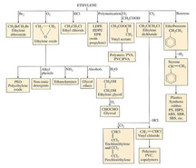
Figure 35 Ethylene as a petrochemical intermediate and monomer

As a co-product of ethylene from steam cracking, propylene is a useful intermediate for building C₃ monomers: propylene oxide, acrylonitrile and methyl methacrylate. Although the repeat unit of PMMA contains five carbon atoms, it is in fact produced from acetone and hydrocyanic acid (HCN). Acetone itself comes from an interesting reaction between benzene and propylene to produce cumene, which is then split to make phenol and acetone:
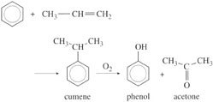
UK production of ethylene in the last twenty years has risen faster than that of propylene because of the greater usefulness of ethylene as a building block. This has been achieved by running crackers at higher severity (Figures 32, 33) to try to match market demand. This has not been totally successful, with the consequence that propylene prices have risen slower than those of ethylene.
Hydrocarbons with four carbon atoms are also produced in thermal cracking; the rate of production is related to the cracking severity and the type of feedstock used (Figure 33). Naphtha cracking produces large amounts of butene and only small quantities of butadiene, which is the more valuable component and is used in the production of synthetic rubbers. Nevertheless the amount produced is currently adequate to satisfy demand, mainly because the synthetic rubber industry has reached a mature plateau of production.

3.3.2 Benzene, toluene and xylene
In addition to benzene itself, the catalytic reformer also produces ethylbenzene, toluene and the isomeric xylenes directly. The demand for ethylbenzene is always great as a source of styrene monomer, but toluene does not find great use apart from a relatively small application in polyurethane. This is why most toluene is de-alkylated to increase overall benzene production. A similar problem exists with the xylenes:
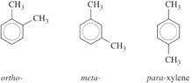
Para-xylene is most widely used as a source of terephthalic acid for PET (Table 5), a blow moulding and fibre forming polymer. Although demand is lower, the ortho isomer is used to make phthalic anhydride of use in thermosetting resins and paints,
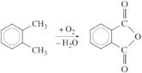
The unused meta- and ortho-xylenes are downgraded to a mixed solvent, a step which clearly represents a loss of added value. Some attempts have been made to use meta-substituted groups in polymers, Nomex fibre for example, but the demand for this speciality material is insufficient to exploit the amount of meta-xylene available from reformed naphtha.
A much more complex procedure is necessary to make the two monomers for nylon 6,6. Benzene must first be hydrogenated back to cyclohexane which then undergoes oxidation and ring scission to create hexamethyl-enediamine and adipic acid in five and four steps respectively. It is an irony of petrochemical processing that such a long-winded procedure is needed – and it is a direct consequence of the complex mixtures of hydrocarbons produced in the first major processes of refining.

3.3.3 Higher aromatics
Benzene rings can be fused in various ways to create component parts for some of the complex aromatic repeat units shown in Table 5. One of the most important is bisphenol A, made by fusing two phenol rings with acetone:
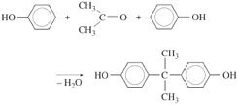
This intermediate is important for a number of speciality polymers, for example, polycarbonate and epoxy resins. Epoxies were developed in the early 1940s, and they found eventual use in aircraft construction for high-strength adhesive bonding. They continue in popularity as speciality adhesives and are also important in polymer composite materials, where they are used as the matrix for glass and carbon fibres. Condensation of bisphenol A and epichlorhydrin yields prepolymers of the kind:
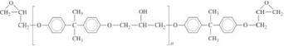
Since M_{R} is very large (284), n = 1 to ca. 10 in the prepolymers of molecular masses up to 3000. Not only are there reactive epoxy groups at the chain ends but also hydroxyl groups in the repeat units which are available for crosslinking by multi-functional amines.
With bisphenol A available commercially as a relatively cheap intermediate, its potential for use in thermoplastic materials was exploited in the development of polycarbonate resins by simply reacting the material with phosgene gas, COC1₂:
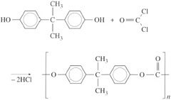
More recent exploitation of this linked phenol has occurred in certain grades of polysulphones and polyimides.

3.4 The petrochemical industry
The four-fold increase in the price of oil in 1973–4, together with associated political events, proved a powerful stimulus in the development and exploitation of North Sea crude oil. Increasing the price of oil does not mean that the price of the final plastic moulding increases by the same amount. For example if oil prices were doubled again then naphtha prices would typically increase by about 80 per cent, although there is no simple and fixed gearing mechanism between the two prices. The bulk of naphtha is used for gasoline with most of the balance used as petrochemical feedstock. Hence the price of naphtha at any time reflects the balance of supply with demand in both of the downstream markets.
An 80 per cent increase in the price of naphtha would mean that the price of ethylene would increase by about 52 per cent and polyethylene by about 28 per cent. A typical polyethylene pipe would cost about 12 per cent more. Crude oil and naphtha are traded in dollars. For the UK plastics producers each one per cent reduction in the value of sterling relative to the dollar raises the price of naphtha by about £1 per tonne.
However, the situation has changed with the availability of NGL (natural gas liquids) and the consequent direct cracking to ethylene and propylene. These processes were originally developed in Europe with Ekofisk NGL delivered to Teeside and shipped back to Norway. It enabled Norwegian companies like Norsk Hydro to develop greenfield petrochemical sites and gave them a headstart in polymer production. The same has happened in Scotland and helps to keep intermediate prices down through effective competition. Another development is the mixing of NGL with naphtha so that it can be fed into conventional thermal crackers, but this is an interim solution which does not realize the full intrinsic value of these feedstocks. Where petrochemical companies do not have easy access to feedstocks, there are problems both fundamental and political in nature. Companies like ICI, who obtain naphtha on the international market in Rotterdam, pay import levies which increase feedstock prices over and above what companies like Shell-Esso pay for their own UK supply of NGL. Some collaboration occurs between the large companies in petrochemicals – an ethylene pipeline from Shell-Esso's Mossmorran plant to BP's Grangemouth complex for example.
The production of monomers and intermediates is clearly tied to the market penetration and sales of particular polymers. Since the distribution of hydrocarbon structures in the feedstocks does not coincide closely with the repeat structures of tonnage polymers, there are clear problems of balancing supply with demand. Since vinyl polymers are in a mature stage of development, the demand for ethylene exceeds that for propylene with the result that polypropylene prices are much lower than they would be otherwise. Moreover, there are many unused co-products (meta-xylene is a good example) which cannot be used in quantity to make polymers. Even if new and interesting polymers based on these intermediates were developed, it would be many years before market penetration would mop up available supplies of this chemical. The trend towards polymers with high aromatic content will be helped by the high aromatic content of North Sea naphtha, although it is worth pointing out that the UK still imports considerable quantities of Middle East crude because of its high paraffin content for naphtha cracking. The difference between our own production and imports is largely exported to the USA and Germany where the higher light end content of North Sea oil is exploited to the full.

Exercise 8

Norway has one of Europe's largest petrochemical industries, as well as a much older and very well developed metallurgical industry. Low cost electricity is produced by a network of hydro-electric power stations and enables the country to produce chlorine, a common inorganic intermediate, by the electrolysis of brine. Explain why Norway is one of the largest producers of PVC in Europe.

View answer - Exercise 8

4 Polymerization

4.1 Understanding the polymerization process
Converting monomer to long chain polymer is the final step in the polymer manufacturing sequence. Polymerization is usually highly favourable in thermodynamic terms, mainly on energetic grounds because ordering molecules into linked chains is a process where the entropy is decreased. Heat is always given out during polymerization owing to the very favourable energetics of reaction, a point you may have noticed if you have ever made GRP parts for your car, for example!
Advances in catalysis have given a high degree of control over both structure and molecular mass so that grades of a given polymer can be tailored for specific end usage. It is possible to look at polymerization in at least two different ways: the nature of the catalyst used, and the way the chains grow to form the final product. Polymerizations can be conducted in the gaseous, liquid or solid state, and now in the liquid crystal state to produce highly oriented macromolecules. An appreciation of the kind of advances that have been made is important because of the new possibilities for manufacturing finished products that are becoming available.
A basic understanding of polymerization processes is important not only because polymerization affects structure, and hence properties, but also because some processing routes can convert monomers directly to a finished shape. They offer manufacturing industry considerable benefits both in direct and indirect costs. An extra dimension to polymer structure is added by the possibilities of copolymerization, where two or more different monomers are polymerized together. In one sense it is comparable to alloying different metals to produce an appropriate balance of properties in the final product.

4.2 Chain and step growth
There are two basic ways of making chains. The first is to activate a small number of monomer units M which then successively consume other monomers. This mechanism is known as chain growth and is shown schematically in Figure 36 (a), where a monomer unit is activated by initiator I and forms a chain very quickly. After 75 per cent of the monomer molecules have reacted in this case the degree of polymerization n = 12.
The second mechanism is to activate all the monomer M present so that larger and larger fragments are formed throughout the material in the reaction vessel. This is known as step growth and is shown in Figure 36 (b). Since all the monomer molecules can interact with one another, the length of the chains increases more slowly during the course of polymerization. Thus at 75 per cent completion, the average degree of polymerization ( ) is one quarter of that for a chain growth reaction. All double-bonded monomers, like the vinyls and dienes, polymerize in a chain growth mechanism whereas monomers with functional end groups react in a stepwise fashion, for example, terephthalic acid and ethylene glycol (Table 5) which form PET.

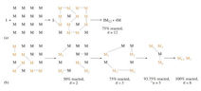
Figure 36 Schematic of the two major types of polymerization, showing high molecular mass produced immediately in chain growth: (a) compared with step growth (b) where all monomer molecules are reactive

4.3 Chain growth polymerization
Chain growth polymerization is basically a three-stage process, involving initiation of active molecules, their propagation and termination of the active chain ends.

4.3.1 Initiation
Initiation is the mechanism which starts the polymerization process. Vinyl monomers are quite easily polymerized by a variety of activating methods. Styrene, for example, can be converted to solid polymer simply by heating, and ultraviolet light can have exactly the same effect. Usually, however, an activating agent is used. This is an unstable chemical which produces active species that attack the monomer. A good example is benzoyl peroxide which splits up when heated:
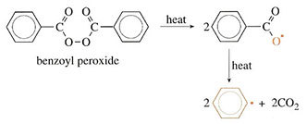
The formulae of the products are written with a dot alongside to show that they are free radicals. A free radical is a molecule in which there is an unpaired electron. This free radical is very reactive and will attack monomer molecules when introduced into a polymerization vessel. Thus, as benzoyl peroxide is added to styrene (a reaction used with GRP), the peroxide splits to make free radicals, which react as follows:
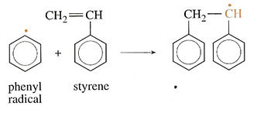
The net result is that the reactants have been linked together but the product is still a radical and so is capable of attacking further monomer molecules. In each instance the attack will lead to a larger molecule but the free radical will be preserved. The reaction is referred to as free radical polymerization.
Free radicals are not the only way of initiating reactions. Charged molecules can often exert the same effect. Ethyllithium, for example, is a relatively unstable molecule which can dissociate to form an ion pair:

Styrene can also be polymerized by this compound:
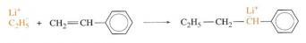
This mechanism is called anionic polymerization. The next two sections refer to free radical polymerization. Ionic polymerization will be discussed in Section 4.2.4.

4.3.2 Propagation
Once a small number of chains have been started, propagation involves successive addition of monomer units to achieve chain growth. At each step the free radical is regenerated as it reacts with the double bond. So in the case of styrene the propagation step is
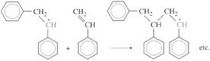
The free radical can also add on in a different way to produce
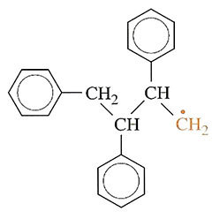
but this process happens only rarely since the free radical is less stable than in the first case.
The junction that is formed normally is known as a head-to-tail link while the abnormal link is head-to-head. The effect is limited to about 1 per cent of the total number of monomer links in normal polystyrene, but it is important because the head-to-head links are weaknesses in the chain. Since they are of higher energy, thermal degradation can start at these defective junctions.

4.3.3 Termination and transfer
There are basically three ways in which chains terminate.
The first is known as coupling and occurs when two free radicals join together. This can be represented by the general equation

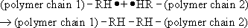

Such a mechanism significantly increases molecular mass, if it results in two polymer chains joining. This is the main mechanism which terminates the polymerization of styrene.
An alternative mechanism that may occur when two radicals interact is known as disproportionation. In this case, one molecule abstracts a hydrogen atom from the other and the other molecule forms a double bond

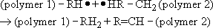

Disproportionation has no effect on molecular mass. Poly(methyl methacrylate) (PMMA) terminates by a mixture of coupling and disproportionation.
The third method of termination is chain transfer in which a radical abstracts a hydrogen atom from a neighbouring molecule. In the case of polystyrene the effect will be as shown in Figure 37, where (a) shows the situation before the interaction and (b) shows the structures after chain transfer in which the radical is transferred to one of the mid-chain carbon atoms. The new radical may now attack further styrene (Figure 37(c)) but, because it is not on the end of the chain, side branching occurs.

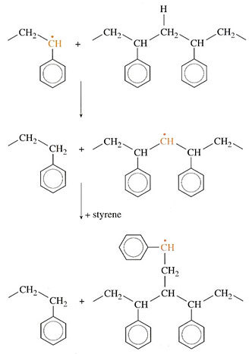
Figure 37 Formation of branched polymer in free radical polystyrene. The growing chain end abstracts a hydrogen atom from neighbouring polymer (top) and (middle), which then propagates with styrene monomer to form a single branch (bottom)

A similar mechanism accounts for the side branches in LDPE where it is a more important mode of termination than in polystyrene. Transfer to monomer; initiator or solvent (if present) can also occur in free radical polymerization, and effectively increases the dispersion of the molecular mass of the final polymer.
If termination is simply by disproportionation, then

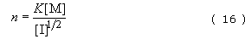

where K is a constant, [M] the concentration of monomer, [I] the concentration of initiator, e.g. peroxide, and n the degree of polymerization. The square root arises because two free radicals react together during termination. If termination is by coupling there will be an extra factor of two in the constant compared to disproportionation. So the degree of polymerization or molecular mass can be controlled by varying monomer concentration – for example, by conducting the reaction in solvent – or by varying initiator concentration.
Controlling polymerizations on an industrial scale is of critical importance for molecular mass, and hence the processability and physical properties of the polymer, and one of the most important variables is the temperature of reaction. All polymerizations are exothermic (heat is liberated due to bond formation) and the heat must be conducted away to maintain a uniform reaction temperature. This is much more easily achieved when an inert solvent is used. Another method very commonly used industrially is to emulsify the monomer with a soap and conduct the reaction in water – so-called emulsion polymerization (Figure 38). Since control of molecular mass is so vital, extra aids are used industrially in addition to varying monomer and initiator concentrations. Reactions are ‘short stopped’ before all monomer is consumed by adding a specific chemical which reacts with free radicals, stopping them dead. Other chemicals can be added to induce transfer reactions, so controlling molecular mass distribution.

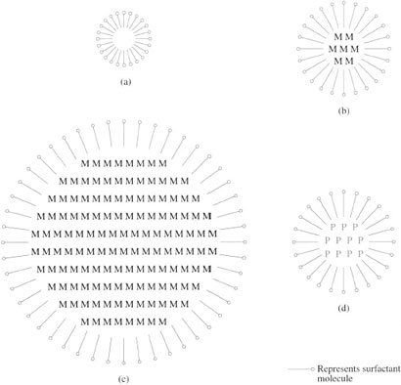
Figure 38 Emulsion polymerization of vinyl monomers is conducted in water to aid heat dissipation. Soap micelles (a) swell with monomer (b) which migrates from monomer droplets stabilised by soap molecules (c). The process yields a polymer latex (d) which can be used directly or reduced to bulk polymer

4.3.4 Ionic polymerization
Free radicals are indiscriminate in the compounds they attack, and their non-selective nature in polymerization reactions leads to problems such as chain branching and transfer which affect the structure of the polymer produced. Anionic polymerization overcomes many of these problems.
A typical commercial (but also see Box 8) anionic reaction is the polymerization of styrene using butyllithium, C₄H₉Li, in an inert solvent such as n-hexane. Termination does not occur by polymer-polymer interaction but by reaction with small molecules such as water:

This type of polymerization gives rise to very sharp molecular mass distributions because transfer processes are absent. If the solvent is extremely pure, the polymer chains will still be active after all the monomer has been consumed. Such activated systems are known as living polymers and it is possible to continue feeding monomer into the reaction vessel without killing the living chains. The degree of polymerization is simply

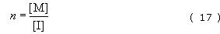

Since the chain ends are relatively few in number only a very small amount of water need be present to kill the polymer, and so all ingredients must be rigorously purified. Paradoxically, it is easier to conduct the reaction on an industrial scale than in a laboratory flask. An important source of contamination is the sides of the reaction vessel itself. Since the surface area of a sphere (assuming a spherical reaction vessel of radius r) increases as r ² while the volume increases as r ³ the problem of surface contamination will be less serious in large, industrial reactors than in laboratory-scale reaction vessels.
Just as negatively charged initiators can be used to start polymerization, so positively charged species can initiate chain growth. The most important commercial operation is the polymerization of iso-butylene giving butyl rubber using aluminium chloride. The reaction conditions are unusual in that high molecular mass polymer is formed very rapidly at very low temperatures (−100 °C for example).

Box 8 Superglue
A more familiar example of anionic polymerization occurs when you use cyanoacrylate liquid (”superglue’) to stick a broken pot together. The monomer is

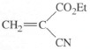
Figure 39

and being a small molecule, has a very low viscosity (Et is the abbreviation for the ethyl group −C₂H₅). This is an important property for adhesion, because it means that the liquid when applied to the broken pot will penetrate even the finest cracks in the fractured surfaces. Such surfaces will normally already be very slightly wet with water from the atmosphere (a monomolecular film is enough), and the monomer will start to polymerize anionically. The anion is supplied by the small amount of hydroxyl ions present in water:

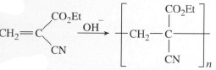
Figure 40

Reaction is very fast, and since this is a chain growth mechanism, high molecular mass polymer is created very rapidly. You might, if unlucky, already have experienced this effect if you accidentally spilt the monomer on your fingers and they made contact! The sweat present there is more than enough to initiate polymerization. The good news is that since the polymer is thermoplastic, there are solvents available for swelling or dissolving the bond and so releasing your fingers. Termination occurs when no more monomer is present, so that all the liquid monomer present at the interface between the two parts of the pot becomes solid polymer. The polymer chains pass from one broken surface to the other, so adhesion is excellent, and strength will be maximised. A range of such cyanoacrylate monomers is available now with varying rates of polymerization and modes of initiation (e.g. thermal or pressure initiation), as well as grades which react without air or water being present, the so-called anaerobic superglues. These adhesives have slightly different substituents, so affecting the way the monomer behaves during reaction.

Self assessment question 6

An anionic polymerization is initiated with a solution containing 0.1 moles of n-butyllithium in 100 ml of n-hexane. Initiator (1 ml) is added to a litre of hexane solution containing 1 mole of styrene monomer. At the end of the reaction, another mole of styrene is added and the reaction is terminated with water. What is the molecular mass of the polystyrene extracted from the solution?

View answer - Self assessment question 6

4.3.5 Co-ordination polymerization
While most free radical and ionic polymerizations are carried out homogeneously, there is another important class of reaction which is often performed with solid catalysts. These reactions, discovered in the mid-fifties, have revolutionized polymer manufacture by permitting much less severe polymerization conditions than with other systems and by allowing a greater degree of control of polymer structure. Ziegler-Natta catalysts, as they are called, will convert vinyl and diene monomers to highly linear, stereoregular structures under ambient conditions.
The prototype of all vinyl polymers, polyethylene, was first discovered quite accidentally in the 1930s as the result of a very high pressure experiment; low density polyethylene is still made under such conditions. However, the thermodynamics of the polymerization reaction indicated that the reaction should be possible at a pressure of 1 atmosphere and a temperature of 300 K, if the right catalyst could be discovered. Suitable catalysts were found to be complexes of aluminium alkyls and titanium halides. It has been suggested that the mechanism of polymerization involves monomer approaching the surface of the catalyst and probably forming a bridge between the metal atoms, while becoming activated at the same time. This is why the mechanism is termed coordination polymerization. More monomer can approach the surface site, react with the active end and grow into chain. The chain thus grows from the surface of the catalyst. Since the activated end is probably partly charged, transfer reactions are much less likely than in free radical situations, so that branching is unlikely. As the monomer molecule must sit in a rather specific position to react, stereoregular polymers can be made.
Molecular masses in Ziegler-Natta polymerizations are often very high, sometimes too high for the polymer to be useful commercially, because too high a molecular mass makes the polymer too viscous to process easily. Molecular mass distributions are often quite broad, probably because active sites on the catalyst surface are sensitive to catalyst poisons.
Metallocene polymers are of much more recent origin (1990s). Metallocenes are sandwich compounds of cyclics and metal ions. Monomer is polymerized by the metal ion in a controlled way:
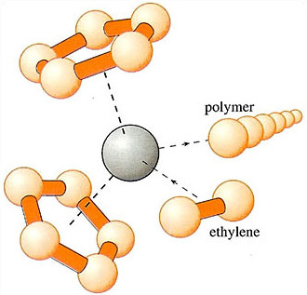
Molecular mass distributions are narrow compared to Ziegler-Natta polymers, with a typical dispersion of 2.5. Such polymers are finding application in packaging and mouldings.

4.4 Step growth polymerization

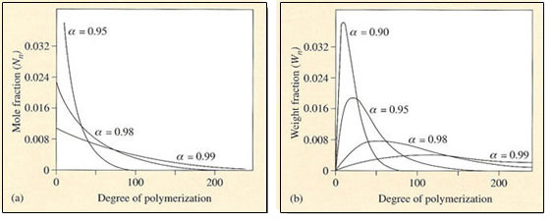
Figure 41 Molecular mass distributions in step growth polymerization. The number distribution (a) is shown for three different extents of reaction, α. The mass distribution (b) shows a single narrow peak which progressively broadens and shifts to high molecular mass as α approaches unity

In contrast to chain growth reactions, where high molecular mass polymers are formed almost from the start of the reaction, a stepwise reaction results in the molecular mass of the polymer increasing slowly as the reaction progresses (Figure 41). Simple statistical arguments can be used to show how the distribution develops with extent of reaction . Since is simply the fraction of functional groups which has disappeared after time t (see Equation (13)), it can be interpreted as the probability that a functional group has reacted after time t. The probability of finding an unreacted functional group is thus (1 − ). To determine the molecular mass distribution, it is necessary to find the probability that a molecule selected at random is an rimer. The probability of finding a single peptide group in a nylon molecule for example will be , and the probability of finding n − 1 of them will be ^{n−1}. The factor of unity appears because the end of the molecule will possess an unreacted carboxyl or amine group, which will have a probability of (1 − ). So the probability of finding the complete n-mer is simply ^{n−1}(1 − ). This in turn is the fraction of n-mers in the entire assembly, so

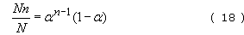

where N_{n} is the number of n-mers present and N the total number of oligomers present. If the total number of repeat units present is N₀ , then N=N₀(1 − ). This is reasonable since when = 0, the total number of molecules present is just the number of monomer units present. As monomers combine together → 1, N falls to a very small number and in the limit is just unity. Hence

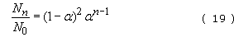

This equation represents the number distribution function for a linear stepwise polymerization (Figure 41(a)).
The mass distribution is simply

and this distribution is shown in Figure 41(b) for several different extents of reaction. It can also be shown that the dispersion is given by the equation

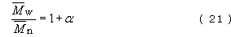

so that as .
High molecular mass material is developed only in the very final stages of reaction ( = 0.99 and beyond). When the reaction is 90 per cent completed, the peak degree of polymerization is only about 10. For nylon 6, this represents a molecular mass of 1130. At 95 per cent completion, it is still only about 5650. Only at 99 per cent completion does the molecular mass begin to approach the useful region, with a peak of about 11 130. This feature of step-growth reactions creates severe problems for monomer purity (see Box 9). In fact the peak in the mass distribution is given by the equation

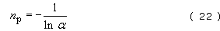

and this value is close to the number-average molecular mass . For thermoplastic polyesters, for example poly(ethylene terephthalate), must exceed about 10 000 for film formation and about 14 000 for fibre formation. For polyamides on the other hand, of commercial fibre forming polymer is 12 000–13 000, which for nylon 6,6 is equivalent to an average degree of polymerization of 53–58. The lower molecular masses needed for polyamides compared to polyesters reflects the strengthening characteristics of interchain hydrogen bonding.

Self assessment question 7

An equi-unimolar mixture of terephthalic acid and ethylene glycol is polymerized to give PET. It is known that the glycol contains 1% by weight of methyl alcohol (CH₃OH). What is the number-average molecular mass and dispersion of the PET so formed? The structures of acid and glycol are:
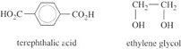

View answer - Self assessment question 7

4.5 Copolymerization
The alloying of metals to improve their properties is widespread and although many polymers used today are relatively pure (e.g. polystyrene, nylon), an increasing number are mixtures of two or more polymers. As with metals, one reason for doing this is to increase the range of properties. The major practical problem, however, is that homopolymers blend together with difficulty and even where blends are possible, as in some thermoplastics, phase separation can occur readily.
This problem is often overcome by polymerizing a mixture of monomers, a process known as copolymerization. It gives a much greater range of structures than is possible by mixing homopolymers because of the possibility of branching, structural isomerism within a single monomer, and the way in which the different repeat units can be added together. In addition, composition can be varied over very wide limits and, of course, molecular mass can be varied to achieve the desired balance of properties in the final product.
One central problem of copolymerization is manipulation of the order of repeat units along the length of the chain. To illustrate this, suppose that two monomers, A and B, are copolymerized. The chain could start with either a molecule of A or a molecule of B, and at each successive addition there are always two possibilities as to which monomer molecule will be attached. As shown in Table 7, the number of possible chain structures grows rapidly as n increases. Since the number of possible structures is proportional to 2^{n}, it is easy to see that even for low degrees of polymerization the number of possible copolymers is very large indeed. Some of these molecules are identical however (AB is the same as BA for example), so that the number of real structures will be somewhat lower, as shown in Table 7.

Box 9 Making nylon
Nylon is a familiar polymer both as a fibre (in textiles and ropes), monofilament (in fishing lines and toothbrushes) and in mouldings (such as the plugs on large screws for making attachments to brick and concrete walls). It was first made in the USA in 1936/7 by a university chemist employed by DuPont, W.H. Carothers by name. He more than any other scientist opened up the then obscure subject of polymers to commercial exploitation. He was also closely involved in the development of one of the most important synthetic rubbers, polychloroprene (Neoprene) during the same period. In April 1937, the first experimental nylon 6,6 stockings were made, followed rapidly by full plant production in 1938 after a good reception from the (female) consumer. The stockings, for example, proved cheaper and more durable than the silk stockings which then dominated the market. Most nylon however, was produced for parachutes, tyre cord, and rope for military use in the Second World War, which then intervened. The Germans competed by making nylon 6 in 1941–2, and the two types still compete in the market.
The industrial production of nylon (or aliphatic polyamide) is beset with problems, however. An important practical consequence of step growth behaviour, for example, is that small amounts of impurity can seriously inhibit the growth of high molecular mass polymer. To counter this problem, monomers must be purified carefully and, in the case of the nylons, the monomers must be in such a form that the numbers of different functional groups are exactly equal:

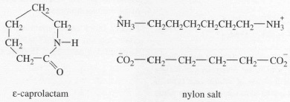
Figure 42

Nylon 6 is prepared by breaking the ring in ε-caprolactam and nylon 6,6 by heating nylon salt, when the ionic structure breaks down to form linear chains. In both cases, the amine and acid groups are of equal concentration. With other step growth polymers, there are similar problems, prepolymers often being made to overcome the stringent requirements of the process.

Table 7 Possible and real structures of linear copolymer chains created from two monomers, A and B
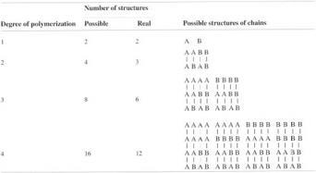

In fact, the structures which form are not entirely random if the reaction is started with a particular mixture of monomers. Table 7 shows that the composition varies from chains of only monomer A (homopolymer A) to chains containing only monomer B (homopolymer B). Between these two extremes it is possible to identify structures of the type AAA… BBB… where there are relatively long sequences of either A or B monomer units; these are known as block copolymers. There are also structures of the type ABAB… known as alternating copolymers (see section 2.2.6).
In many of the structures no regularity can be detected, although there will be short sequences of one type of unit, and the copolymer can be regarded as completely random; such copolymers are usually said to be ideal copolymers. These possible copolymer structures are shown schematically in Table 7.

4.5.1 The copolymer equation
It can be shown that the rate of change of monomer concentration in any copolymerization is given by the equation

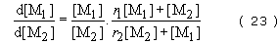

where [M₁] and [M₂] are the concentrations of monomers 1 and 2 at any instant and r₁ and r₂., are reactivity ratios. The reactivity ratios represent the rate at which one type of growing chain end adds on to a monomer of the same structure relative to the rate at which it adds on to the alternative monomer. The copolymer equation can be used to predict chain structure in the three different ways, already mentioned.
The formation of regular alternating copolymers of the type ABAB… is favoured when each growing radical prefers to add to monomer of the opposite type. In this case

and Equation (23) therefore becomes

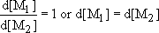

In other words both monomers will disappear from the reaction vessel at the same rate.
An ideal copolymer will tend to form when each type of chain end shows an equal preference for adding on to either monomer. In this case,

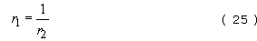

and the copolymer equation becomes

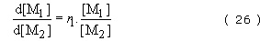

Hence composition depends on the relative amounts of monomer present at any time and the relative reactivities of the two monomers.
Finally, block copolymers are formed when the growing chain end has a marked preference for adding on to the same kind of monomer. In this case

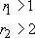

As can be seen from Table 8, this is rarely achieved in free radical copolymerization. However, it is possible to form block structures in anionic polymerization simply by feeding different monomers to the living polymer. Step growth copolymerizations produce ideal (random) copolymers since in this special case r ₁ = r ₂ = 1.

Table 8 Reactivity ratios for free radical chain growth polymerization
Monomer 1 | Monomer 2 | r₁ | r₂
acrylonitrile | 1,3-butadiene | 0.02 | 0.3
 | methyl methacrylate | 0.15 | 1.22
 | styrene | 0.04 | 0.40
 | vinyl acetate | 4.2 | 0.05
 | vinyl chloride | 2.7 | 0.04
1,3-butadiene | methyl methacrylate | 0.75 | 0.25
 | styrene | 1.35 | 0.78
 | vinyl chloride | 8.8 | 0.035
methyl methacrylate | styrene | 0.46 | 0.52
 | vinyl acetate | 20 | 0.015
 | vinyl chloride | 10 | 0.1
styrene | vinyl acetate | 55 | 0.01
 | vinyl chloride | 17 | 0.02
vinyl acetate | vinyl chloride | 0.23 | 1.68

4.5.2 Commercial copolymers
The main reason for copolymerizing different monomers is to adjust the physical properties of a given homopolymer to meet a specific demand. SBR elastomer, for example (Table 1), based on 24 wt% styrene monomer shows better mechanical properties and better resistance to degradation than polybutadiene alone. By increasing the styrene content to 35 per cent, a high hysteresis (energy absorbing) material ideal for tyre treads is produced. Another example is nitrile rubber, which is produced by a free radical emulsion copolymerization of butadiene and acrylonitrile to make an oil-resistant rubber suitable for oil and petrol lines.
A second reason for copolymerization is to enhance the chemical reactivity of a polymer, particularly to aid crosslinking. Conventional vulcanization in rubbers is brought about by forming sulphur crosslinks at or near double bonds in the chain. In polyisobutylene where the main chain repeat unit is
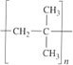
there are no such bonds. So the isobutylene monomer is copolymerized with a few weight percent isoprene units to make IIR (butyl rubber) which can be vulcanized easily.
This is also the reason why EPDM rubber consists of no less than three different monomer units copolymerized together (ethylene, propylene and a diene) using Ziegler-Natta catalysts. The copolymer structure is random, so crystallinity is low and the material behaves like a rubber when vulcanized across the diene double bonds.
To show the dramatic effect of copolymer structure on physical properties, consider the change from random SBR copolymer to a block copolymer of exactly the same chemical composition but where the styrene and butadiene parts are effectively homopolymer chains linked at two points:
The material behaves like a vulcanized butadiene rubber without the need for chemical crosslinking since the styrene chains segregate together to form small islands or domains within the structure. Such so-called thermoplastic elastomers (TPEs) today form an important growth area for new polymers because of the process savings in manufacture that can be achieved with their use.
Among rigid thermoplastics, the most widely used copolymers are those of styrene and they include ABS, HIPS and SAN. Both HIPS and ABS are graft block copolymers where the elastomeric side chains are deliberately introduced to improve the toughness of the material (see section 2.2.6).

Self assessment question 8

What are the structures of the following free radical polymerized copolymers
- vinyl chloride-vinyl acetate copolymer containing 10 per cent vinyl acetate,
- SBR containing 24 per cent styrene,
- SAN containing 76 per cent styrene?

View answer - Self assessment question 8

4.6 Polymer grades
Polymers synthesised by a variety of routes are available in many grades from the large polymer manufacturing companies. Naturally enough, the grades of bulk tonnage polymers, such as LDPE, PVC, HDPE and PP, run into the hundreds simply because of the multiplicity of different process routes and end functions. So what are the basic differences between grades of just one polymeric material? The most important distinguishing characteristics are structure and molecular mass.
Most suppliers of polypropylene offer grades ranging from isotactic polypropylene to crystalline ethylene propylene partial block copolymers with up to about 10 wt% ethylene comonomer. The copolymer grades offer greater toughness over a wider temperature range (particularly below 0 °C) at the expense of stiffness. The applications for copolymer grades are, by and large, more demanding than those for equivalent homopolymer grades. Each polymer is available in several different melt flow grades. Melt flow index (MFI or MFR) is a widely adopted practical way of measuring the ease of flow of a polymer grade, and so is of use in indicating the relative magnitude of process parameters for shaping the polymer granules or powder to create a finished article. It is inversely related to molecular mass, so that high MFI grades correspond to low molecular masses and vice versa. High molecular mass polymers often possess the best physical properties, which is why the most demanding uses of PP such as safety helmets and pipe fittings require low MFI grades.
Beyond the standard grades are filled and special grades which use the basic range of polymers as a matrix for other materials, such as talc, mica and glass fibre, to modify physical properties in other ways (Box 10). Chemical additives are also used (in smaller proportions) to improve resistance to sunlight or oxidation (AVI). Special grades have, in many cases, been developed by polymer manufacturers for very specific functions and may include, for example, added pigments and flame-retardant compounds.

4.6.1 Prices of polymers
Prices of bulk and speciality polymers (Table 9) broadly reflect the degree of chemical processing and treatment needed to make them. Thus the polyolefins, which are directly polymerized from cracker streams, are generally the cheapest followed by vinyl derivatives of ethylene like PS and PVC. Derived polymers which require more complex treatment, such as ABS, PET and polyester thermosets are generally more expensive by factors of between two and four. Speciality engineering polymers tend to range in price (1995) from about £2000 up to £7500 per tonne or more for a material like polysulphone (PSu). These prices reflect not only more expensive feedstocks and polymerization methods but also the manufacturers’ desire to recoup development costs through a premium for their special properties.

Box 10 Additives for polymers
Polymer products without additives in the matrix material are rare, medical products which are in intimate contact with the human body, being the exception because of the problem of leaching by bodily fluids. But in the vast majority of products, additives are used to modify properties in a controllable way. So what are the principal types of additive? It is a surprisingly long list and includes
- inorganic fillers
- bulking agents
- coupling agents
- crosslinking agents
- colourants (pigments and dyes)
- impact modifiers
- plasticizers
- lubricants and process aids
- stabilizers
- flame retardants and smoke suppressants
- antioxidants, antiozonants.
Fillers are added where transparency or translucency are not key design factors, and where stiffness can be enhanced. Many fillers are inorganic (such as glass fibre, talc and mica) and hence of higher inherent stiffness, but strength is usually sacrificed since particles are stress concentrators and may initiate cracks. Bulking agents (e.g. chalk, sawdust) have a much smaller effect on stiffness, and the prime motive is to reduce cost. One important factor in achieving best filler action is to ensure that there is good wetting between the polymer matrix and the filler. With silicate fillers, coupling agents are used to give a good bond between the two species. Silanes (organic monosilicates) are frequently used to bond glass fibre to polymer by reaction at the surface of the filler. The other ends then either react with the polymer or blend homogeneously to form the bonded interface.
Crosslinking agents are a vital part of thermoset formation, although modification of the backbone chain may be needed to achieve the desired effect (as in butyl rubber, or EPDM). Pigments are simply added to give the product colour, giving plastics decisive advantage over other materials since they offer extra freedom for designers. Dyeability of fibres is of fundamental commercial importance, so dye retention is an important property, especially for textile fabrics which are washed repeatedly. Many of the first block copolymers were in fact developed for fibre dyeability, since if the inserted blocks react with the dye, then it is held fast by strong chemical bonds (as in PET/polyether block polymers; ICI, 1950). The same philosophy has been used with impact modifiers, where rubber chains are permanently anchored to backbone chains, as in HIPS and ABS. Plasticizers are used extensively in PVC, producing a flexible rather than rigid product. Lubricants and stabilizers are also closely connected with PVC, improving processing and stability against degradation (like antioxidants and antiozonants which have more specific functions).

Table 9 Raw material prices
 | Price (tonne lots) /£ tonne⁻¹, 1995 | Price (tonne lots) /£m⁻³
Thermoplastics
polyethylene, HDPE | 450 | 432
polyethylene, LDPE/LLDPE | 460 | 420
polypropylene | 475 | 437
PVC (unplasticized) | 500 | 530
polystyrene /HIPS | 730/780 | 775/825
PET bottle grades | 900 | 1220
polyester SMC/DMC | 1300/1400 | 2270/2450
acrylonitrile-butadiene-styrene, ABS | 1500–1800 | 1530–1835
nylon 6 | 2550 | 2855
polycarbonate, PC | 2700 | 3270
polysulphone, PSu | 7500 | 9300
liquid crystal polymers, LCPs | 17 500 | —
PEEK | 45 000 | 5850
Metals (LME)
lead | 405 | 4600
zinc | 680 | 5180
aluminium | 980 | 2650
copper | 1560 | 13 930
tin | 3560 | 26 000
nickel | 4360 | 38 800
Mild steel | 400 | 3150
Rubbers
standard Malaysian rubber (SMR) | 790 | 730
SBR 1712 | 870 | 820
neoprene | 1975 | 2430

However, it should be noted that the prices shown in the table will vary substantially depending on current supply and demand. Plant shutdowns, for example, can cause temporary price rises because supplies are often limited to a few major petrochemical plants worldwide. On the other hand, prices may slump if plant shutdowns occur (by fire damage, for example). The specific grade chosen will also affect price, those grades having many additives attracting the necessarily higher price than the raw material. The quantity purchased will influence the unit price paid by the buyer. Clearly large quantities will attract substantial discounts, and most polymer buyers will liaise with traders worldwide to achieve the best prices.
Although increases in the traded price of crude oil can push up prices of materials derived from it, the effects have been felt on all materials because of the consequent high energy costs in reducing ore to metal and subsequent processing. In fact, the real price of crude oil is now (1997) low in real terms compared with prices in the 1970s and 1980s. Economic recession has a much more important effect on trade prices. Thus the recession of the early 1990s caused prices to drop substantially, and polymer prices have only recently recovered to pre-recession levels.
Another factor which has helped to keep the Retail Price Index (RPI) indexed polymer prices relatively low has been the over-capacity for petrochemical production. During the 1960s, ever-larger petrochemical plants were built for the economies of scale in production. But the demand was effectively halted by the OPEC price rises, with the result that major chemical companies had been losing heavily on bulk polymers until only recently (1995). With many speciality polymers, the reverse has happened – demand has risen continuously over the years, and continues to rise at a fast rate, so contributing to the rise in polymer consumption which was shown in Figure 1.
When compared on a weight basis, light metals like zinc and aluminium are similar in price to engineering polymers like polyester or ABS, although the cost on a volume basis is considerably lower for polymers than for metals. Thus the cost per unit volume of polypropylene works out at about £440 m⁻³ compared with a price of over £3000 m⁻³ for mild steel. Light metals like aluminium are considerably more expensive when costed on this basis (£2650 m⁻³). Speciality engineering polymers like polycarbonate at £3270 m⁻³ are slightly more expensive than light metals using this criterion.
In addition, most materials are used in the form of alloys, composites or mixtures which will push the alloyed price above those shown in Table 9. For example, aluminium is frequently alloyed with copper to improve its stiffness and strength, and additives such as expensive antioxidants or pigments are often mixed with polyolefins. On the other hand, fillers like chalk dust, mica and carbon black can reduce the cost of the blended product while often enhancing the valuable properties of the end product. So the prices of various grades of polypropylene will vary according to the fillers and other additives incorporated. However, it is also important to be aware of the fluctuations which occur in raw materials prices – this is particularly important for general-purpose materials subject to the market forces of supply and demand.

4.6.2 Material costs in manufacturing
For high added-value products like boats and cars, material costs form a relatively small proportion of total costs. For directly manufactured products, however, which are sold without much assembly or finishing, material costs do form a relatively large proportion of the total production cost. This applies particularly to polymeric containers for foods and drinks but not, for example, to containers for more sophisticated products like electronic or electrical goods. What is much more important in high added-value products is that the polymer container protect the contents from the environment for which that product is destined. Equally relevant is the way that the container is produced, because different routes of production have significantly different costings.

5 Physical properties of polymers

5.1 The behaviour of polymers
The manufacture of polymer products is controlled by two often conflicting demands: the quality of the finished article in terms of its response to its environment and the ease or difficulty of processing it to shape. Both factors are controlled by what is termed viscoelasticity, namely, the behaviour of the polymer in response to applied stress or strain, and temperature. It is important to appreciate the duality in terms of the elastic and viscous responses of polymer solids and polymer melts, especially for thermoplastics used in engineering applications. For thermosets, the problems of creep and stress relaxation may be less critical (although still important), but their viscous behaviour during processing is vital for an appreciation of the limitations of moulding them to shape.

5.2 Viscoelasticity of polymers
The simplest models for the deformation behaviour of an ideal material are those of Hookean linear elasticity in the solid state, and Newtonian linear viscosity in the liquid state. The end point of elastic deformation is either fracture or plastic flow, with the latter taking place at a constant yield stress in the ideal case. Whilst the behaviour of many real materials does approximate to these idealised models, that of polymers deviates markedly from them. In particular, their solid state deformation is time-dependent and nonlinear and so resembles some combination of elastic and viscous responses, whilst their melt rheology is also significantly nonlinear. To start with, let's consider polymer behaviour in the context of the idealised models of elastic deformation and of viscous flow.

5.2.1 Elastic and viscoelastic behaviour
When an elastic (not elastomeric, or long range elastic) material is stressed, there is an immediate and corresponding strain response. Figure 43 illustrates this by showing schematically the strain response to a particular stress history. Note that when the stress is removed the strain also returns to zero. So in a perfectly elastic material all the deformation is returned to the forcing agency. If this energy had not been stored elastically then it would have been dissipated as either heat or sound. Tyre squeal and the heat build-up in the sidewalls of car tyres are good examples of such dissipation.

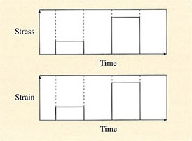
Figure 43 When stressed, a perfectly elastic material deforms in proportion to the applied stress and returns to its original state when the stress is released

If the material is linear and elastic then the applied stress σ directly proportional to the strain ε. Then, for simple tension,

where E is a constant known as Young's modulus, and is considered to be a property of the material. For polymers, due to time-dependence and nonlinearity, E is not a constant and the term tensile modulus is used to reflect this. The stress-strain curves for PS, HIPS and two types of rubber are shown in Figure 44. While polystyrene apparently obeys Hooke's law (Equation (27)), HIPS yields and necks before failing. By contrast, rubbers exhibit long-range elasticity and fail only at many hundred per cent strain.

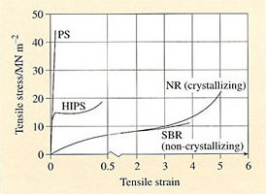
Figure 44 Tensile stress-strain curves for some rubbers and plastics

So some plastics like HIPS yield, but others fracture in a brittle manner like polystyrene. Rubbers do not yield, but at high strains some of them crystallise and hence stiffen. When the stresses are removed from a polymeric material before fracture, the strain recovery path is not necessarily identical to that of the loading part of the deformation cycle. So energy must have been dissipated during the deformation of such materials – another indication of deviation from perfect elasticity. Both the deformation and the subsequent recovery are time-dependent, suggesting that some part of their behaviour is viscous. In fact solid polymers show a combination of elastic and viscous behaviour known as viscoelasticity. The degree of viscoelasticity is strongly dependent upon the temperature of test and the rate at which the polymer is deformed, as well as such structural variables as degree of crystallinity, crosslinking, and molecular mass.

5.2.2 Viscous behaviour
Viscous flow is not recoverable. When the stress is removed from a viscous fluid the strain remains. Hence the work energy is not returned to the forcing agency and has to be otherwise dissipated. Figure 45 illustrates this schematically by showing the strain response in such a viscous material when a simple stress history has been imposed upon it.

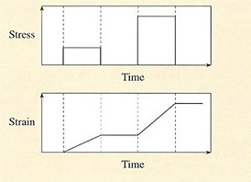
Figure 45 A viscous fluid is deformed permanently by an applied stress and continues to deform if stressed again

For a linear viscous material, the rate of change of shear
strain with time, is directly proportional to the imposed tensile stress σ

where η is the Newtonian viscosity of the fluid. In polymer melts, η is not a constant, but depends on the shear strain rate , with, in general, η decreasing as increases. The viscosity is also directly dependent on molecular mass and so inversely related to melt flow index. These factors are thus of direct importance to a processor or moulder.
Viscous properties dominate during the earlier stages of processing but elastic effects are also important. Molten thermoplastics are obviously highly viscous as are partially polymerized and uncured thermosets and masticated and unvulcanized rubbers. However, observable features such as the swelling of extrudates as they leave dies are manifestations of melt elasticity.
In essence, elasticity in molten polymers arises from the entropy factor or the tendency of the macromolecules to coil into their configurations of maximum disorder. This is in opposition to the stretching which occurs as the material flows under the influence of the stress field.

5.3 Viscoelasticity and master curves
An immediate consequence of the viscoelasticity of polymers is that their deformations under stress are time dependent. If the imposed mechanical stress is held constant then the resultant strain will increase with time, i.e. the polymer creeps. If a constant deformation is imposed then the induced stress will relax with time (stress relaxation). Figure 46 shows the creep strain response to a constant stress followed by unloading. Note that in the recovery stage the strain has still not returned to zero even a considerable time after the stress has been removed.

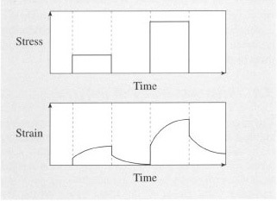
Figure 46 The creep strain response of a viscoelastic material subjected to a constant stress of finite duration

There are many examples of products which creep in service. For example, the plastic tub of an automatic washing machine will successively creep and recover as it is loaded and unloaded several times during the washing cycle. Viscoelastic stress analysis during the design of the tub ensures that the maximum strain due to this loading pattern is well within the strain limits for the material and the application.
The creep and stress relaxation properties of a polymer can be described by the time-dependent moduli E_{c} (t) and E_{R} (t). The creep modulus is the ratio of an imposed constant stress σ₀ to the time-dependent strain ε(t)), while the stress relaxation modulus is the ratio of the time-dependent stress σ(t) to an imposed constant strain σ₀, i.e.

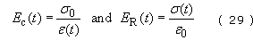

Practical examples of the need to design for stress relaxation are in seals where the sealing force must remain adequate under conditions of constant deformation, or when a metal peg needs to be held in a plastic block by push fitting into an undersized hole. The oversize peg results in a constant hoop strain in the plastic. The corresponding hoop stress will decay with time but must always be sufficient to hold the peg in place. Both creep and stress relaxation are factors that have to be considered in design, although they are not necessarily always deleterious (see Box 11).
E_{R} (t) is characteristic of the polymer concerned at a particular strain and temperature. It is the tensile stress relaxation modulus if the corresponding strains and stresses are tensile. Alternatively if the strains and stresses relate to shear or hydrostatic changes then the corresponding material parameters are the shear and bulk relaxation moduli respectively. As noted earlier, for polymers, the tensile modulus should not be referred to as Young's modulus. Young's modulus is the limiting case of the tensile modulus when the induced strains can be considered infinitesimal and independent of time.

5.3.1 Time-temperature superposition
For amorphous polymers above their T_{g}s, there is a convenient approximation which makes experiments easier. It is known as time-temperature superposition, and it relates time to temperature for viscoelastic materials. A sequence of measurements of E_{R} (t) is performed at different temperatures at a fixed initial strain. The time scale might be limited between several seconds and say 100 hours. The curves obtained on uncrosslinked polyisobutylene (PIB) are shown in the lefthand portion of Figure 47, with temperatures of measurement varying from −80.8 °C up to +50 °C. The curves span many decades of modulus, reflecting the change in behaviour of the material. At the lowest temperatures PIB is becoming glass-like, so E_{R} (t) is very high. As the material passes through the transition region, the modulus drops rapidly – the material is becoming rubbery in its response to the applied stress. The onset of true elastomeric behaviour is marked by the so-called rubbery plateau. This is followed by another steep fall in modulus where viscous flow occurs as the temperature is raised further.

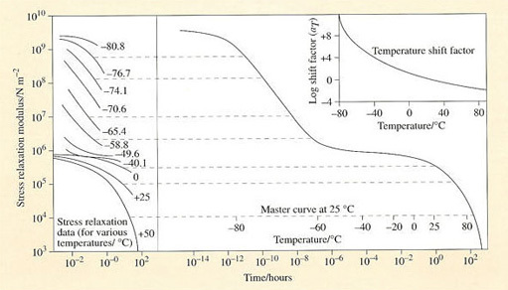
Figure 47 Construction of the viscoelastic master curve for PIB at 25 °C reference temperature by shifting stress relaxation curves obtained at different temperatures horizontally along the time axis. The shift factor, a_{T} varies with temperature as shown in the inset at upper right

Box 11 Why creep and stress relaxation are often needed
It is usually said of engineering polymers that they are ‘difficult’ and ‘problematic’ materials for designers to use in stressed applications. Such comments often come from engineers who have been brought up with mild steel as the material of choice for any application, since design calculations are normally much more straightforward when the extra variable of time can be neglected (not that you can neglect time when corrosion is possible!). But a brief consideration of many consumer products shows that creep and stress relaxation are sometimes necessary for the correct functioning of many products and devices.
Consider leather shoes and boots where the stress relaxes under the constant strain of the foot, or clothes which relax from the strain applied by the human body. Rigid and inflexible materials would be quite inappropriate for protecting the human body comfortably. There are other examples too, from civil engineering, where viscoelastic timbers in a bridge or building creep and relax to accommodate imposed stresses and strains. In old buildings, such shape changes are regarded as of positive value in assessing its age and integrity.
Mastic polymer is used to seal joints in buildings where some movement is likely: its function depends on being able to flow and ‘give’ when strained, so maintaining a good seal.
Nevertheless, in many applications, creep and relaxation must be faced and appreciated; too much distortion may cause the part to drop away and so the product ceases to function. Loss of sealing stress in rubber joints can cause leakage of oil from engines, and hence failure. It is only by careful design in matching product function and material that such problems can be solved.

The curves can be fitted together like a jigsaw puzzle, as shown in the right-hand portion of Figure 47 to form a ‘master’ curve, a single curve which represents the stress relaxation behaviour of PIB at a reference temperature of 25°C. The two scales, time, t, and temperature, T, are shown for the master curve. The derived relation between time and temperature a_{T} is plotted in the upper right-hand inset of the figure and can be modelled by the Williams-Landel-Ferry (WLF) equation

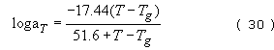

when the reference temperature for the shift is chosen to be T_{g} and the numerical factors are the fitting parameters for this grade of PIB.
The master curve of Figure 47 indicates how PIB responds to stress at much shorter times than are accessible directly by this type of experiment and also re-emphasises the common polymeric behaviour of both rubbers and thermoplastics. They differ only in their glass transition temperatures: an amorphous thermoplastic is rigid at ambient temperature because its T_{g} lies above ambient temperature, and conversely a rubber is flexible because its T_{g} lies below ambient temperature. Any rubber will become rigid or glasslike if the temperature of the environment is low enough, and any thermoplastic will become rubbery at high temperatures.

5.3.2 Effects of structure on viscoelasticity
If a single measurement of E_{R}(t) is taken at an arbitrary but fixed interval of time, say 10 seconds, then it will vary with temperature in a way rather similar to the viscoelastic master curve. Such a curve for atactic polystyrene is shown in Figure 48, where the various zones of behaviour are identified. The effect of lightly crosslinking the material is to eliminate flow of any kind, extending the region of elastomeric behaviour to higher temperatures. Heavier crosslinking will move the rubbery plateau upwards and the same net effect is achieved by crystallisation. Although atactic PS is inherently non-crystallisable, the isotactic form can crystallise and its melting point (T_{m}) is about 230 °C. The stress relaxation modulus of this polymer drops much less at 7V, from about 5000 MN irr² to about 100 MN m⁻² at 140 °C. At the same temperature, atactic polystyrene is completely rubbery with a modulus of about 0.5 MN m⁻². Thereafter, the modulus of the crystalline polymer drops.
Molecular mass also affects the stress relaxation spectrum, particularly at intermediate and higher temperatures (>100°C). For high molecular masses, only the rubbery plateau and viscous flow regions differ markedly; the glassy and transition regions are unaffected. Increasing molecular mass clearly improves some mechanical properties, but nowhere near as effectively as crystallisation.

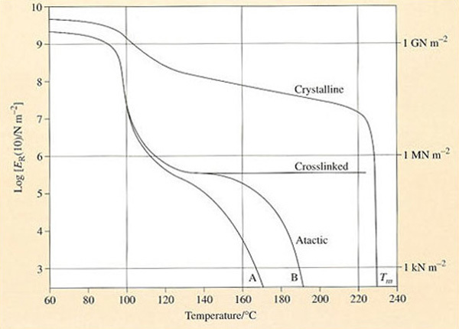
Figure 48 Variation of stress relaxation modulus of polystyrene with temperature. The top curve represents the behaviour of partially crystalline isotactic PS with melting point T_{m}.

In Figure 48 the main lower curve (B) is that for atactic PS of = 217 000 and the lower subsidiary curve (A) for a = 140 000. Crosslinking eliminates the rubber and viscous flow regions

Self assessment question 9

Uncrosslinked silicone rubber treated with boron oxide exhibits curious mechanical properties. If hit hard with a hammer, it shatters like glass, but if dropped from a height of 1 metre it bounces like a rubber ball. When kneaded in the hand it behaves like putty but when left on a flat surface it flows like a liquid.
Sketch the viscoelastic master curve for the material. Assume that the hammer is travelling at a maximum velocity of 20 m s⁻¹ and that the acceleration due to gravity g is 9.8 m s⁻². At what velocity would a well-vulcanized NR ball cease to bounce? Assume that both NR and silicone balls are 2 cm in diameter, and that the terminal velocity v of an object dropped from rest over a distance s is .

View answer - Self assessment question 9

5.4 Dynamic mechanical properties
Viscoelasticity is not experienced just under quasi-static conditions, i.e. when the imposed stresses and strains are constant or change only slowly. Polymers, and particularly rubbers, are often deliberately selected for products which are to be subjected to dynamic mechanical loading. Tyres are an obvious example where the unique high strain elasticity and energy absorbing qualities of rubbers make them the natural choice of material. Stress analysis involves the use of the frequency-dependent dynamic moduli of the polymers. Assume, for example, that the polymer is subjected to a sinusoidal stress σ of amplitude σ_{o} and frequency ω, i.e. σ = σ ₀ sin ωt. Stress analysis concerned with the dynamic mechanical properties normally assumes that polymers are linearly viscoelastic. Hence the strain response e to the imposed sinusoidal stress can be described as ε = ε ₀ sin (wt − δ) where δ is the phase angle. This is shown diagrammatically in Figure 50.
Note that the strain response lags behind the stress by the phase angle – owing to the viscous component of the material. Some, but not all, of the energy stored during the deformation of the material is dissipated. Since the material is assumed to be linear, the stress is proportional to the strain at all times, i.e. σ = Eε, but E is a function of the frequency ω. Because the stress and strain are not in phase, E must be treated as a complex function:

where , and E″ and E″ are the in-phase and out-of-phase components of the modulus.
From the above definitions of the dynamic moduli and by manipulation of the linear relationship between the sinusoidal stress and the corresponding strain response, the phase angle δ can be expressed as follows:

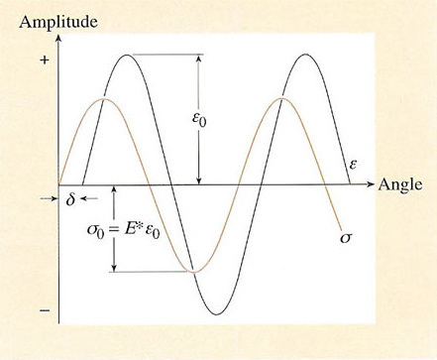
Figure 50 The sinusoidal stress cr and corresponding strain ε response for a linear viscoelastic material. The imposed stress and the material response do not coincide, and the phase angle δ is the difference between the two curves.

Tan δ is commonly called the loss tangent or damping factor. E″ and tan δ are the most commonly measured dynamic properties of rubbers, representing the elastic stiffness and damping or hysteresis properties respectively. Figure 51 is a schematic representation of E′ and tan δ as a function of frequency for natural rubber, and shows the effect of crosslinking on damping and hence heat dissipation. Different rubbers will have different curves, and some care is needed in rubber product design to match the material with expected imposed frequencies. Fillers such as carbon black will also affect the shape and position of the damping maximum. Sometimes the ‘argument’ of the complex modulus |E| is used instead of E*, and is given by the equation

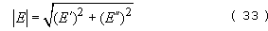

At very high frequencies (ω = 10⁴−10⁸ cycles s⁻¹ or Hz) rubber is very stiff with a glass-like modulus. At these frequencies the polymer molecules do not have time to react in response to the forcing oscillations. The damping factor is then small but it increases to a maximum value in the ‘leathery’ transition region between the glassy modulus and the usual (low) modulus which is characteristic of rubbers that are deformed slowly (ω< 1 cycle s⁻¹ or Hz).

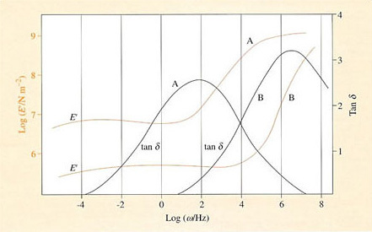
Figure 51 The elastic modulus and damping factor of an unvulcanized (curve B) and a well-vulcanized (curve A) natural rubber showing the shift in damping caused by crosslinking. Increasing the frequency of oscillation is equivalent to decreasing the temperature

It will be noticed from Figure 51 that decreasing the frequency of oscillation imposed on the material is equivalent to increasing the temperature (glass-like behaviour is experienced at high frequencies). This is another manifestation of viscoelasticity, in which the effect of the three basic variables, time (t), temperature (T) and frequency (ω), on a polymer are all closely interrelated. Since decreasing the time scale of an experiment is equivalent to decreasing the temperature (Figure 47 and the WLF Equation (30)), so decreasing the frequency is equivalent to increasing the time scale (and hence increasing temperature).

Self assessment question 10

What is the effect of increasing the speed of a car on the rubber material of the tyre treads? Use the WLF equation and time-temperature superposition principle to justify your argument.
Assuming that a car tyre is 0.3 m in diameter, evaluate the effect of increasing car speed on the dynamic properties of the tread material (use Figure 51 as a source of information on the material of the tread). What other factors might you need to take into account to evaluate the dynamic properties?

View answer - Self assessment question 10

5.5 Orientation in polymers
Viscoelasticity, like thermodynamics, is concerned with the correlation of controllable variables and bulk, macroscopic phenomena. But one unique feature of polymeric materials is that the molecular unit, the polymer chain, can be highly anisotropic, i.e. the chain can be fully extended, or curled up in an amorphous equilibrium state without any net orientation. In fact, unoriented polymer is rarely encountered in manufactured products because of the different ways it is processed to shape. By its very nature, forcing viscous polymer fluid into cool moulds or through dies by extrusion gives some molecular orientation depending on the stresses to which it has been subjected during manufacture. The control of orientation (and the related effect of crystallisation) during shaping is the key to product quality and the properties that product will exhibit in service. A related problem concerns non-uniform distribution of filler particles in a polymer matrix.

5.5.1 Non-uniform mixtures
Moulded rubbers and plastics are compounds of a polymer matrix and a variety of additives. The mixing history of the material before and during the moulding process can have a critical influence upon the final product properties. If mixing is done badly then the microstructure of the moulding can be non-uniform. Lack of uniformity can cause variations of strength and other physical properties within the moulding. The degree of dispersion or distribution of relatively minor quantities of additives can have a significant effect upon the properties of the product. This is illustrated in Figure 52 which shows a thin slice of polyethylene tubing of diameter 5 cm. PE masterbatch, heavily pigmented with carbon black, has been added to the unpigmented granules in the hopper of the extruder, in order to improve UV resistance. The poor state of mixing gives a laminated section to the tube, very like a rolled-up newspaper. The outside surface appears black and so gives some measure of protection against sunlight, but the maldistribution of carbon black weakens the material by concentrating stress locally at clusters of particles. Although the apparent degree of orientation is high, the polymer molecules in reality have a relatively low degree of orientation.

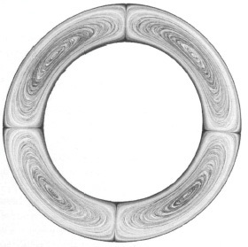
Figure 52 Thin slice of part of a PE tube 5 cm outer diameter (o.d.) showing the poor distribution of carbon black masterbatch during extrusion. The carbon black is added to give protection from sunlight but because of poor mixing can weaken the product substantially. The quadrants are created by spiders in the extrusion head which divide the mixing polymer melt. Source: RAPRA

Many plastics composites use fibres as the reinforcing agents within a polymer matrix. The distribution of orientations of the fibres then determines the overall anisotropy of the components. Suppose for example that a laminate is made from sheets of resin-impregnated glass fibre cloth, plied together so that the warp and weft directions of successive layers coincide.
The properties in the orthogonal warp and weft directions are different from each other and are different again from the properties through the thickness of the laminates. Similar symmetry applies to the biaxially oriented stretched films which are used as outer wrappings for many consumer goods and supermarket foodstuffs, as well as PET bottles, although in these examples the orientation is molecular in origin.

5.5.2 Molecular orientation
As polymers are processed and shaped by flowing into moulds the shear stress fields induce preferred orientations in the molecules. The hydrostatic components of the stress field cause packing. These orientation and packing effects will relax with time if the temperatures are high enough, but the moulding cycle is frequently such that they are ‘frozen-in’ by cooling or perhaps fixed into the structure because the material has been crosslinked. The consequent moulded-in or residual stresses and strains may
- subsequently warp the moulding and
- can increase the likelihood of fracture or cracking, particularly in the presence of some hostile chemicals.
Molecular orientation due to moulding sometimes results in physical properties which vary significantly with direction, i.e. the properties are anisotropic. This can be beneficial and is therefore sometimes induced deliberately. For example, when synthetic fibres are spun they are oriented uniaxially to increase the strength in the fibre direction. In this way, the high potential strength and stiffness of carbon-carbon bonds in the backbone chain of linear high polymers can be achieved if the chains can be fully aligned along the fibre axis. This has been achieved in aramid fibres and other aliphatic fibres also show significant improvements although nowhere near as great as with aramid fibres like Kevlar . Its tensile modulus of 60-124 GN m⁻² may be compared with that for carbon fibre of 200-500 GN m⁻², glass fibre (about 70-80 GN m⁻²) and PET fibre (5500 MN m⁻²). However, when sheet polymer is oriented by cold drawing (the plateau of HIPS in Figure 44), enhancement of stiffness in and orthogonal to the drawing direction is compensated by a reduction of stiffness from an angle of about 20° to 70° to the draw direction (Figure 53). The dotted line in the figure denotes the unoriented value of the tensile modulus. Another kind of orientation effect results from high strains in crystallising rubbers (Figure 44). In this case, orientation gives rise to crystallisation with a consequent rise in tensile strength over and above that for non-crystallising rubbers like SBR. Unlike cold drawing, the effect is reversible except for low temperatures (below 0 °C) when crystallisation occurs at zero strain and so called stark rubber is formed.

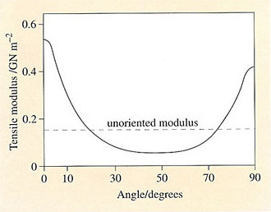
Figure 53 Variation of the tensile modulus with angle to the stretch direction of a sheet of LDPE which has been cold drawn

5.6 Crystallisation of polymers
The major benefits of crystallisation of chain molecules to end users are:
- since T_{m} > T_{g}, the maximum service temperatures are higher than with amorphous polymers;
- above T_{g} , the modulus of a crystalline polymer is higher than that of an amorphous polymer owing to reinforcement and physical crosslinking of the amorphous matrix by the crystallites.
Both effects are evident by comparing the stress relaxation curves of atactic and isotactic PS of Figure 48. However, crystallisation morphology and kinetics differ from polymer to polymer as a result of structural and energetic factors.

5.6.1 Morphology of polymer crystallites
The fundamental unit of structure formed by crystalline polymers which is accessible using the optical microscope is the spherulite. Isolated spherulites are formed easily at relatively slow spherulite growth rates such as those exhibited by polypropylene and isotactic polystyrene. Unlike aramid fibres where the degree of crystallisation is close to 100 per cent (Figure 54), most crystalline polymers contain significant amounts of amorphous polymer either between spherulites or present at crystallite boundaries within individual spherulites.
By cooling solutions of polymers in organic solvents, it is possible to obtain minute platelets (lamellae) which represent the smallest crystal elements within much more complex structures like spherulites (Figure 55). Such lamellae vary in thickness between 10 and 40 nm and may be several micrometres (μm) wide. The chains in each crystal, which in polyethylene are in a zig-zag conformation (Figure 55(a)), are folded one upon the other as shown schematically in Figure 55(b). It is thought that similar folds occur in bulk polymers, although there is probably more disorder at the fold surface where chains interconnect with other lamellae (Figure 55(c)).Clearly, such chain segments represent non-crystalline polymer; although their modulus is lower they provide the essential links between crystals and so bind the material together like a composite.

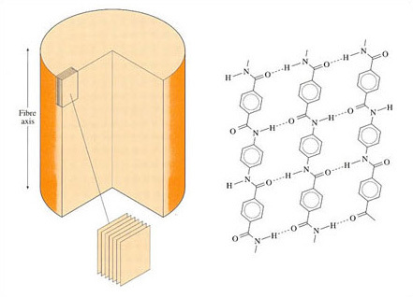
Figure 54 Crystalline structure of aramid fibre

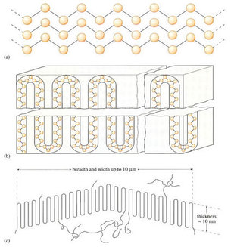
Figure 55 (a) Zig-zag conformation of HDPE, with stacking in crystal; (b) chain folded model for HDPE in lamella; (c) dimensions of HDPE single crystal showing non-crystalline tie molecules

A spherulite can grow from a single crystal nucleus very much in the way suggested by the sequence shown in Figure 56(a). Growth occurs when chains continue the folding action and crystal defects lead to lamellar twisting and branching. Fibrillar structures are thus formed which successively twist round to form a ‘wheatsheaf’. Continued growth ultimately yields a spherulite which then grows uniformly as a sphere. For HDPE and nylon 6,6, nucleation and growth are very rapid, radial growth rate for HDPE is about 5000 μm min⁻¹), so that spherulite impingement is the norm (Figure 56(b)). In polymers with lower growth rates, such as polypropylene (growth rate about 20 μm min⁻¹, specific nucleating agents are often added to increase the degree of crystallinity developed in objects during processing. Such agents are usually organic salts like calcium stearate.

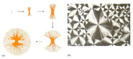
Figure 56 (a) Stages in the formation of a spherulite from a stack of lamellae; (b) a polarised-light micrograph of spherulites in poly(ethylene oxide)

5.6.2 Structure and crystallinity
In addition to the structural constraints mentioned in Section 2, where tacticity and geometrical isomerism control whether or not a polymer chain can crystallise, molecular mass and copolymerization are other important variables which can influence crystallising properties. A related effect is plasticization where a low molecular mass material is deliberately added to lower T_{g} or T_{m}.
The lowering of melting point caused by copolymerization will generally affect T_{g} in a similar way. It can be shown from classical thermodynamics that the melting point of a crystalline homopolymer (T_{m}°) will be lowered to a value T_{m} (in K) by the presence of x mole fraction of randomly copolymerized repeat units (B) according to the equation

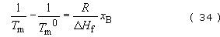

where R is the gas constant and ΔH _{f} the heat of fusion per mole of homopolymer repeat unit. The equation predicts that the melting point depression is directly proportional to the mole fraction of the second component (B) and inversely proportional to the heat of fusion.
Since chain ends can also be regarded as ‘impurities’ in a chain which will lower the melting point, a similar equation can be derived for the effect of molecular mass:

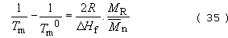

Since most polymers show less than 100 per cent crystallinity, observable heats of fusion will be proportionally lower depending on the exact degree of crystallisation. However, the melting points are unaffected by the presence of amorphous material. A further quantity of interest for crystalline polymers is the entropy of fusion, ΔS _{f}. It is simply related to T _{m} ⁰ by the equation

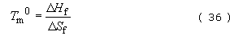

Self assessment question 11

(a) At what number-average molecular mass will the melting point of polypropylene be 99.9 per cent of that for very high molecular mass polymer?
(b) In material of molecular mass such that chain ends are not important, what is the effect on the crystalline melting temperature T_{m} of randomly copolymerizing 10 mole% ethylene into the homopolymer? What would be the practical consequences in terms of processing the copolymer to shape and the service properties of the copolymer?

View answer - Self assessment question 11

5.6.3 Conformation and crystallinity
If there are key connections between the chain configuration and crystallisation, you might also expect some more subtle effects from rotation about chain bonds. After all, polymer chains must be able to twist into the regular conformation demanded for crystal structures (Figure 57(a)). And what influence will rotation have on the precise conformation adopted by the chain?

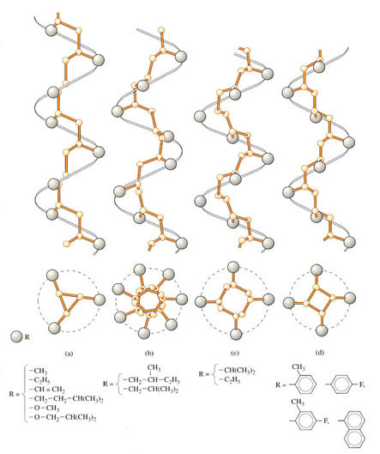
Figure 57 Helical conformations of isotactic vinyl polymers (Gaylord and Mark, 1959)

Polyethylene crystallises into the most stable conformation represented by the linear zig-zag, but when substituents are present, as in propylene, then there is substantial steric hindrance from the pendant methyl group at each alternate carbon atom. In polypropylene and related polyolefins, the chains adopt a helical conformation (Figure 57) where the extra side groups are accommodated on the outside of the helix by regular twisting of the whole chain. And as you might expect, the larger and longer the side group, the larger the diameter (Figure 57(b) and (c)). With large aromatic side groups, the pitch of the helical conformation grows (Figure 57(d)), but the diameter actually shows a slight decrease. A similar effect occurs in PTFE, –[CF₂–CF₂,]– where the fluorine atoms present on all the carbon atoms, pack neatly together into the helix (Figure 58). The figure is based on a so-called space filling rather than outline model (as shown in the previous figure), so that the true atom sizes are taken into account. This is useful, because it demonstrates that no part of the backbone chain itself is visible. It is thought that this is one of the reasons for the exceptionally low coefficient of friction of PTFE μ∼0.04), because fluorine has extremely weak van der Waals bonds with others around it, whether other fluorine atoms or foreign atoms at an interface.

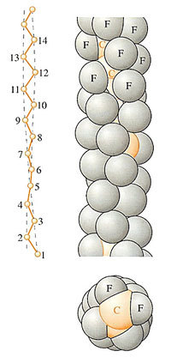
Figure 58 Structure of the molecule of PTFE showing a helical conformation

There is also the problem of rate of crystallisation. One might expect hindered repeat units to crystallise only slowly. This explains why polypropylene crystallises so slowly when compared with polyethylene.

6 Design in polymers

6.1 A fresh approach?
Polymeric materials offer substantial benefits over conventional materials in terms of their low density, relative freedom from corrosion, transparency or translucency, and a range of physical properties which cannot be achieved with metals, glasses or ceramics. Such unique properties include low coefficients of friction (e.g. PTFE), resistance to extreme environments (e.g. PTFE, silicones) as well as the ability to absorb and modulate damaging vibrations (e.g. most rubbery polymers). It is these properties which have excited designers because of their potential in manufactured products, despite the generally low short-term moduli of these materials compared to metals.
But an additional bonus is offered by the great and ever-expanding range of routes by which they can be processed into shape and assembled into relatively complex artefacts. A company manufacturing with traditional materials today is often presented with the problem of developing new polymer products. This may arise in several ways:
- competitor companies develop products which are lighter, or more efficient functionally, or more aesthetically acceptable;
- the company may decide to redesign its products to fulfil new consumer needs in response to market demand;
- the company may see possibilities for entirely new products which fit into its existing range, or exploit its existing expertise.
Such pressures require a fresh approach using the newer materials, and more rapid or more flexible production methods. The response will vary according to the breadth of expertise and equipment already present in-house. Thus companies with much moulding machinery should be better placed to exploit new opportunities. If the equipment is rather old, however, they might fail to gain all the benefits that are currently available using entirely new machines. The rate of obsolescence in plastics processing equipment has been very high in the last two decades or so, for a number of reasons, especially the introduction of computer control systems, both in the machine itself and between different machines and the staff. This might give a competitive advantage to companies entering the field for the first time, provided, of course, that they are aware of the pros and cons of the various processes available.
Alternatively, it may be preferable to hire the specialist expertise and equipment needed, by using so-called ‘trade moulders’ for example. This is a very active sector of SMEs, where entrepreneurial skills are applied to generate new business. Sometimes, such enterprise is exceptional in producing new designs and new ways of using existing machines. Such is the story of the Topper boat (Section 6.3).

6.2 Manufacturing and process methods
Different production routes entail significantly different costings, and the selection of the manufacturing method is therefore a key step in the development of a product. For example a simple closed box in a thermoplastic could in theory be made in several different ways:
- fabricating from cut sheet, e.g. by welding
- rotationally moulding from polymer powder
- vacuum forming from sheet material
- blow moulding from molten polymer
- injection moulding two subcomponents which are joined in a subsequent welding operation.
The first option, fabrication, involves a small capital investment but, like GRP hand lay-up, is very labour intensive. In all the other process routes, some form of metal mould is required to reproduce the final shape of the container. In the case of rotational casting this might involve a mould welded from sheet metal. The required weight of polymer powder is placed in the mould which is closed and rotated in an oven. The powder spreads uniformly over the mould inner surface and melts together. The mould is designed to be easily split so that the object can be removed after cooling and solidifying. Rotational moulding (or rotomoulding) is widely used for completely closed objects like footballs or for containers of relatively simple shape. The time required to produce such castings can be up to 30 minutes or more.
A somewhat more advanced way of using a female mould to produce open objects like domestic baths is vacuum forming. Sheet of the required size is heated to a softening point, well below its melt temperature, so that it is in a flexible rubbery state. It can then be literally sucked into the polished metal mould by an applied vacuum so that it assumes the desired shape. Vacuum forming can also use male moulds which are pushed into the softened sheet before the vacuum is applied between the sheet and the mould. Although faster than rotocasting, the method is severely limited by the shapes that can be formed. Capital costs are modest.
Blow moulding is an entirely different method of achieving the final product shape. A tube of molten polymer is blown so that it expands as a bubble until it meets the surface of the surrounding cool metal mould, which can then be split to extract the solidified moulding. The method is ideal for long production runs of relatively simple hollow shapes such as containers. The tubes which are to be blown can be produced by high-speed production techniques based on extrusion or injection moulding. Capital costs are quite high. As with most of the other methods already discussed there are quite severe restrictions on component shape.
Injection moulding overcomes most of the previous restrictions on product shape but the capital cost for machinery and moulds is the highest of all the process methods. High production rates are possible with moulding cycle times measured in tens of seconds. Long production runs are normally essential to recoup the initial investment. This is reflected in Figure 59 which shows the unit cost for a simple 200 g box container as a function of the annual production rate. Comparative data are shown for the other production methods. With the exception of the labour intensive simple fabrication, all reflect the economy of longer production runs offsetting the higher capital costs. However, the relative positions and the points at which the curves flatten out differ significantly owing to the different investment and labour cost of each technique.

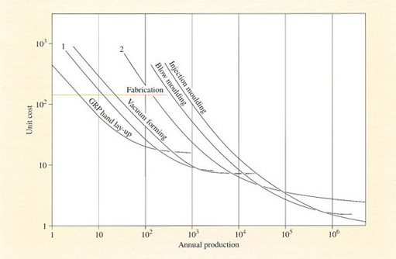
Figure 59 Comparative costs for making a 200 g polymer box by different process routes. 1 – Rotational moulding using simple equipment. 2 – More sophisticated rotational moulding

A consequence of the heavy investment in machinery and tools is extra pressure on management to maximise plant potential. In operational terms this effectively means using the full capability of the moulding machines whilst minimising the time it takes each machine to produce the desired product.

6.3 Materials selection
Good design fulfils the product specification under the required service conditions as well as contributing to the cost effectiveness of its manufacture and maintenance. The product specification itself must be an interpretation of the market needs. Hence good design means giving product appeal at the point of sale. Selecting the polymer is just one stage in this design exercise, both in terms of information on various properties of materials, as well as the detailed evaluation and selection of the best material for the product in question (Figure 60). It is obviously an important stage, however, and the variety of polymer types plus the many different grades within each type make that selection relatively difficult. Furthermore, each materials manufacturer supplies only proprietary products. Although a polymer type will be available from several sources the detailed characteristics of each grade will be unique to the supplier concerned. Hence a systematic approach to material selection is sensible.

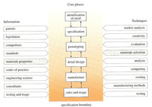
Figure 60 Design process model showing sources of information and techniques used in progressing through the core phases

The first selection stage is to eliminate those materials which do not have reasonable mechanical properties at the extremes of the anticipated service temperatures and when in contact with any fluids, greases, etc., which may be encountered. Note the concentration on what the materials cannot do. Understandably, but unfortunately, data from materials suppliers tends to concentrate on the positive qualities of their materials. Frequently there are clear-cut requirements for the material, e.g. it must be transparent, or must meet a fire performance specification of the Underwriters’ Laboratory. These go / no-go factors should also be considered at an early stage in order to reduce further the number of candidate materials. Some of the most important properties used for such initial screening include density, short-term tensile modulus and tensile strength at ambient temperature. Detailed property data for design must be obtained from the suppliers of the materials and may need to be supplemented by in-house testing. However, materials selection cannot be finalised without making and testing prototypes.

6.3.1 Prototyping
The first prototypes may be made of any convenient material, such as clay, plaster-of-Paris or wood. Plastic models can also be made by fabrication or vacuum forming of thin sheet. Their primary function is to ensure that the product has ‘customer appeal’ when considered in aesthetic or ergonomic terms. This is particularly important for products which are to be consumer durables. It may be the first time in the design process that the concept sketches and initial engineering drawings are translated into 3-D models which can be readily appreciated by non-technical people, e.g. the company salesmen, who can then make key contributions to the further design because of their detailed understanding of what their customers want.
Testing is much more meaningful if the prototype has been made by the same method or material as that intended for full production (Figure 60). Choice of the manufacturing process influences the choice of material. For example, if the production quantities justify laying down expensive moulds then ease of injection moulding is clearly a material property to be taken into account. In recent years, developments such as low-pressure reaction injection moulding have introduced further options in manufacturing and hence materials. Companies are also influenced in their materials selection by the in-house availability of plant. For example Western Electric in the USA have used their existing metal-forming presses to produce large cable connector cases by warm stamping polypropylene sheet coupled to, and sandwiching glass fibre mat.
Choice of the processing route can be important for its effect on properties and performance of the final product, through polymer chain orientation for example. Obviously the later prototypes should also be made from the shortlisted materials so that a final choice between them can be made. To facilitate this final stage much effort has been put into the development of cheap moulds particularly for injection moulding. They can be machined out of aluminium or cast in aluminium using established foundry practices. A well-made cast aluminium mould can be used to produce up to 10 000 injection mouldings in glass fibre reinforced nylon without unacceptable wear. Such a tool typically costs under £3000 compared with many times that cost for a hardened steel production tool. Moulds can alternatively be made out of low melting point metal alloys or metal-filled epoxy resins or by metal spraying a pattern of the product. In the latter case the metal coating is stripped from the pattern and then stiffened with an appropriate backing material. At the end of the prototyping and prototype testing stage, the design engineer should be in a position to design the metal mould for mass production, a critical phase of the operation owing to the large costs incurred in mould manufacture.

6.4 Case history: the Topper boat
Replacement of one polymeric material by another may be undertaken entirely for manufacturing reasons, and this is what happened in the redesign of the Topper dinghy for thermoplastic polymer. The dinghy was originally designed for hand lay-up GRP in 1969 by Ian Proctor, a well known designer of small boats and yachts (Figure 61, Table 10). but sales had been restricted by the low output rates. The potential production rate if the boat could be injection moulded was very much greater, provided that a suitable thermoplastic could be found.

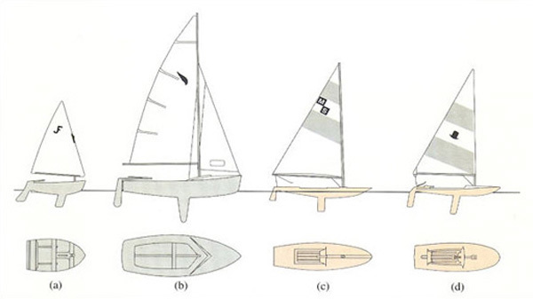
Figure 61 Evolution of the Topper from earlier Proctor designs: (a) Jiffy dinghy for children; (b) Kestrel family sailboat (1960); (c) Minisail sailing surfboard (1964); (d) Topper dinghy (1969). All were designed for GRP except the early versions of the Minisail

It was thought at the time of the design exercise in the late 1970s, that there was market demand for a small lightweight sailing boat which could be easily lifted on to a car roof-top for transport. Leisure activities had increased in the seventies, and the membership of sailing schools had increased during this period (Table 11). In addition, the existence of the GRP boat meant that there was already substantial experience of the craft in terms of its sailing characteristics, so that prototyping might not be necessary. There were clear cost savings to be made by jumping this step in the design sequence (Figure 60).

Table 10 Some data for various popular small dinghies
Class | Designer | Overall length/m | Approx. sailing mass/kg | Sail area/m² | Hull material | Crew
Jiffy | Ian Proctor | 2.29 | 36.2 | 3.34 | GRP | 1–2
Optimist | Clark Mills | 2.31 | 35.0 | 3.25 | marine plywood | 1–2
Durafloat | Colin Mudie | 2.29 | 27.2 | 3.25 | ABS (acrylonitrile-butadiene-styrene) plastic | 1–2
Cadet | Jack Holt | 3.22 | 65.6 | 5.20 | GRP or marine plywood | 2
Mirror | Jack Holt, Barry Bucknall | 3.30 | 61.3 | 6.41 | marine plywood | 1–2
Gull | Ian Proctor | 3.35 | 93.0 | 6.50 | GRP or marine plywood | 1–3
Moth | various | 3.35 | 65.6 | 6.26 | mainly GRP or marine plywood | 1
Topper | Ian Proctor | 3.35 | 54.1 | 5.20 | GRP | 1–2

Table 11 Estimated UK ‘boat park’ by boat type in 1978
Boat type | Number of craft | Share (%)
Sea yachts | 40 000 | 7
Class sailboats | 148 000 | 24
Small funboats | 235 000 | 39
Open power craft | 120 000 | 20
Motor cruisers | 67 000 | 10
TOTALS | 610 000 | 100
Source: O'Connor, M., 1978, Management and Design in the British Small Boat Industry, Report to the Design Council.

In terms of physical properties alone, GRP is an excellent boat-building material because of its high stiffness and high specific strength. Chopped strand mat (CSM), where randomly oriented glass fibres ca. 5 cm long are embedded in a polyester matrix, is the normal form of GRP used for small boats; it possesses an average tensile modulus of 8500 MN m⁻² and a tensile strength of about 170 MN m⁻². One way of assessing the relative merit of different materials for a particular application is by calculating so-called merit indices. One of the simplest merit indices is for a tensile application, where the product is subjected to a pulling force along one axis, viz, a tensile force. In this case, the merit index is just

where E is the tensile modulus of the material, and ρ its density. The merit index, the specific stiffness, provides a measure of the mass of material required to achieve a given level of stiffness in a product. Such an index is clearly of interest to a designer when weight-saving is an important design criterion. Thus this index will be of great importance when a product is used primarily in tension, such as a rope or textile fibre which must be lifted or handled. Since CSM has a density of 1.5 Mg m⁻³, this gives a specific stiffness of 5.6 and specific strength of 0.11. Clearly, any material chosen to replace GRP should have a greater merit index.
A more important design criterion for small boat hulls is the flexural stiffness. It can be shown from simple beam theory that the specific flexural stiffness is E ^{1/3}/ρ. Direct comparison of merit indices of different materials shows which represent the best value in terms of flexural stiffness per unit mass: materials with a high merit index are lighter than those with a low merit index for an identical stiffness in bending. Another common hull material is marine ply (E=6500 MN m⁻², ρ= 0.5 Mg m⁻³) with a merit index of 6500^{1/3}/0.5 = 37.3. The merit index for GRP is 13.6, so that a GRP hull will be 37.3/13.6 or 2.75 times as heavy as a marine ply hull of the same flexibility. Unfortunately, marine ply cannot be shaped easily unless cut and bonded together. Monocoques of uniform structure are thus difficult, if not impossible, in marine ply.
It can also be shown that the hull thickness t is related to modulus by the expression

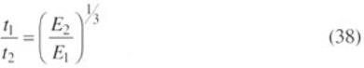

A marine ply hull will therefore be (8500/6500)^{1/3} or 1.09 times as thick as an equivalent GRP hull.

6.4.1 Materials selection
Among the common thermoplastics available in the mid-1970s, polypropylene appeared as a front runner on grounds of toughness, density and cost Table 9). However, it is subject to creep (being uncrosslinked) and possesses a low tensile modulus of ca. 1500 MN m⁻². Its merit index is 12.7 due to the low density of 0.9 Mg m⁻³, making it comparable to GRP. If it replaced GRP, here would be a weight penalty of 3.6/12.7 = 1.07 or about 7 per cent. On the other hand, the hull would have to be considerably thicker:

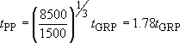

the original boat the GRP hull was 2.4 mm thick, so that the polypropylene boat needed to be 2.4 × 1.78 or 4.3 mm thick to give the same flexural stiffness. The assembled hull (Figure 62) possessed considerable intrinsic stiffness owing to the monocoque construction, with the deck and hull joined at the gunwale.

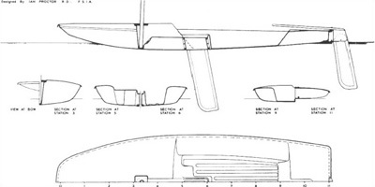
Figure 62 Design of the Topper boat showing monocoque construction for the two halves (deck and hull) which are welded together at the gunwale. This is a scale drawing with dimensions in feet

Self assessment question 11

Assess the importance of polymer choice on the torsional rigidity of the monocoque hull structure of the Topper using the equation for the angle of twisting, θ (radians), produced by a torque T (in N m) on a hollow cylinder of thickness t, radius r and length L.

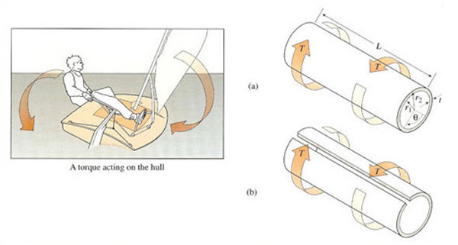
Figure 63 Torque, T, acting on hollow tubes of identical length, L internal and external radii, r ₁ and r ₂, respectively, and wall thickness, t to produce an angle of twist θ. (a) is an integral tube and (b) has a slit along its length
View description - Figure 63 Torque, T, acting on hollow tubes of identical length, L internal ...

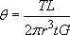

G is the shear modulus and may be taken as E/2.6 for both GRP and polypropylene. Use Figure 62 for approximate dimensions and calculate the angular distortion created by a maximum torque of 100 N m. (Figure 63)

View answer - Self assessment question 11

Table 12 Some of the main grades of Propathane polypropylene available for the Topper dinghy hull
Polymer grade | Melt flow index at 190 °C (10 kg load) | Flexural modulus/ MNm⁻² | Toughness (Izod impact) at 23 °C/J m⁻¹ | Softening temperature/ °C
GW522M | 22 | 1800 | 45 | 148
GX543M | 60 | 1800 | 40 | 148
GY545M | 120 | 1800 | 40 | 148
GY621M(copolymer) | 100 | 1410 | 80 | 147
GY703M (copolymer) | 11 | 1000 | 500 | 143
GY702M (copolymer) | 60 | 1100 | 100 | 145
Source: ICI Technical Data Booklet PPSO, 1981

The design team at Rolinx evaluated the torsional stiffness of the new Topper by covering the forward part of the deck with a grid of lines to give a visual check on distortion during sailing. The distortion was certainly visible, but did not apparently affect sailing characteristics too seriously.
Similarly, the problem of creep was thought not to be important, partly because of the intermittent nature of sailing stresses, both in terms of magnitude and direction, and partly because of the short-term expected loadings. Small sail boats are used perhaps a few hours a day before disassembly and storage. Creep, and distortion resulting from creep, increase with time and severity of loading.
The main grades of Propathane polypropylene available to the moulders are shown in Table12; they encompass both homo- and copolymer grades of varying MFI, flexural modulus, impact strength and softening points. The impact strength in the Izod test is measured on a standard centrally notched bar of material, which is struck with a falling pendulum. The impact strength is simply the energy absorbed per metre of notch when the specimen breaks in a brittle fashion. The variation in impact strength at ambient temperature is much greater than the variation in modulus, and it was this parameter which assumed greater importance as the project developed. Sailing hulls, particularly those for small, hand launched boats, suffer a considerable number of impacts in service and it could prove catastrophic if a brittle crack were to propagate through the hull!
The upper softening point – the temperature when the polymer starts to deform, which is some distance below the true melting point – was not an important design parameter. The greatest temperatures to which the boat could possibly be exposed did not exceed 70 °C (hull surface temperature in bright sunshine in Middle Eastern climates), well below possible softening points. The lower limit was felt to be important however; the hull could be exposed to sub-zero temperatures when sailed in freezing sea water. The copolymer grades possessed much greater strength below 0 °C owing to the depressant effect of the ethylene component on the glass transition temperature.
Despite the greater flexibility of the toughest grade (GY703M), it represented the best choice on the grounds of toughness over a wide temperature range. However, the constraints of manufacture meant that a compromise with a lower molecular mass grade was necessary.

6.4.2 Manufacturing the boat
Filling the mould is a serious problem in injection moulding: the lower the MFI, the more difficult it is to push molten polymer down narrow tubes into a metal mould. The engineers at Rolinx, the trade moulders who initiated the thermoplastic project, were working at the limits of their machinery in moulding such large objects in one operation. In the event, they were forced to blend the low MFI copolymer grade with a higher MFI grade material (GY702M) in order to achieve their objective (Figure 64). Following injection of the hull and deck, the two parts are fused together near the waterline by incorporating a tape made from metal wire and PP fibre at the joint. When a large electrical current is passed in the wire, it heats up and the two parts fuse together, a process aided by the application of an external load (Figure 65). Apart from several fixed parts such as protective plates for the rudder zone, the accessories (mast, rudder, daggerboard, etc.) can then be added by hand assembly, a particularly easy task since the boat is designed for ease of disassembly for the consumer or user. Indeed, these items are usually packed in kit form for ease of transport to the point of sale.

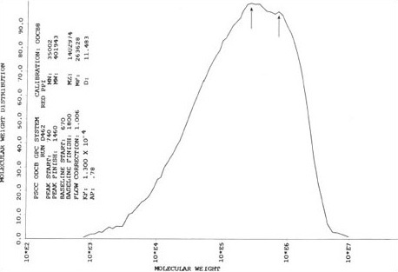
Figure 64 Molecular mass distribution of propylene copolymer determined by high temperature GPC. The curve shows two peaks since it is a blend of low and high MFI materials

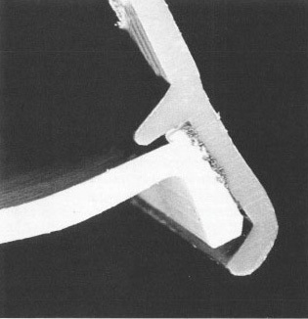
Figure 65 A section through the hull-deck weld showing how the flange on the hull section fits into a recess in the deck section, and the joint fusion welded using sacrificial metal tape

The sailing, if not commercial, success (total sales about 2000) of the original GRP Topper provided the Rolinx engineers with design guidelines which were explored in depth with the original designer, Ian Proctor. In one sense, the early GRP boat replaced a conventional prototype, but with the benefit of market feedback. Switching to thermoplastic produced many design changes, some such as a higher rake angle for injection moulding (Figure 66). In addition, most accessories were replaced by thermoplastic equivalents which have proved successful in the new version. At the same time, the redesigned hull incorporated several features which enhanced its ease of assembly, performance and integrity: for example, the sacrificial daggerboard box, which provides failsafe protection for the hull against grounding forces (Figure 67), and the mast locking gate which enables rapid insertion of the sail and mast on launching (Figure 68). The rudder and daggerboard are parts which must be able to withstand severe impact blows without failure, and both are made from glass-reinforced polypropylene. To reduce the weight as well as improve manufacturing efficiency, both are made by foam moulding, where a foaming agent is added to the solid polymer before injection, so that it expands on heating the tool to create a foamed interior.

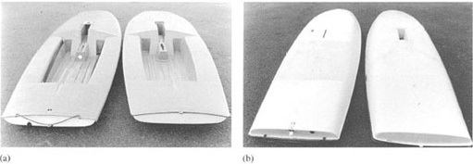
Figure 66 The GRP (left-hand side) and (right-hand side) Topper boats compared: (a) deck sections, (b) hull sections. The redesigned boat incorporated a higher rake angle on the mast access slot and a daggerboard box with failsafe plate

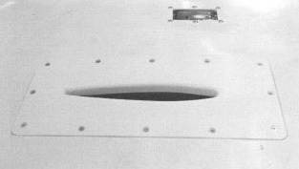
Figure 67 Sacrificial dagger board plate attached to base of hull – grounding forces will only damage the plate and cracks cannot propagate into the hull itself

By 1984, sales had exceeded 23 000 and the boat was still selling over 2000 per annum, so the high capital investment in the tools and machinery had been well justified. The story of the Topper is one of relatively small businesses and companies spotting the potential for efficient mass production of a high added-value consumer product. Design in polymeric materials demands a bipartisan approach – design for function and design for manufacture (but see Box 12).

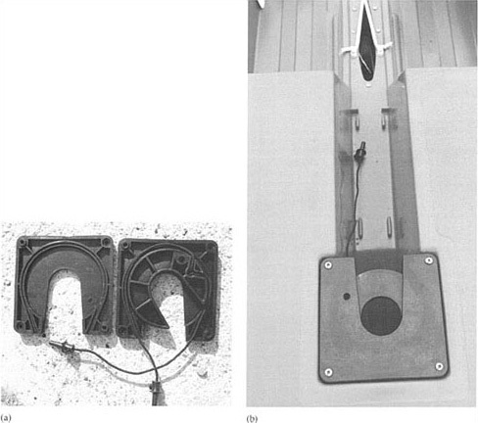
Figure 68 Mast locking gate for the Topper dinghy redesigned in glass-filled polypropylene: (a) split apart to show component parts. Upper and lower plates and rotating cam activate by drawcord; (b) shown in situ in closed position without mast. The composite moulding replaced a single marine ply board drilled with a single hole for the mast

Box 12 The Toucan boat
Following the successful development of the Topper boat, attempts were made to design a larger boat using injection moulding. It was thought that a large rowing boat could be designed in the same way, having a significant competitive edge over wooden equivalents owing to the rot-resistant properties of polypropylene. The resultant prototype, the Toucan, is shown below in Figure 69, compared with the Topper at left.
Although the lower hull was moulded in one piece, the structure was by its very nature, an open-sided shell. The deck was positioned below the top of the hull, and was itself composed of several subsidiary moulded parts. So the project involved more than the two tools needed for the Topper, in itself increasing the development costs. The stiffening element of the monocoque structure of the Topper was much less significant with the Toucan, making the boat more flexible (especially when loaded in torsion). Finally, the design did not exploit the lightweight properties of the plastic to its greatest advantage. The Topper is designed to hydroplane over the surface of the water, giving the user exciting sailing at speed when under wind. The same couldn't be said about the Toucan, a boat with a deep hull designed more to plough through the water rather than skim along the top. The project was eventually abandoned following poor performance in trials, showing the limits of plastic materials when simply used to copy existing conventional designs without allowing for the problem of high flexibility. Existing wooden dinghies exploit the properties of wood, a natural composite, to its greatest advantage. Thus the side timbers of the hull are planks following the grain, so are intrinsically stiff and resistant to imposed bending and torsion loads. This gives a stiff structure capable of resisting sailing stresses, and so giving safe and predictable sailing.

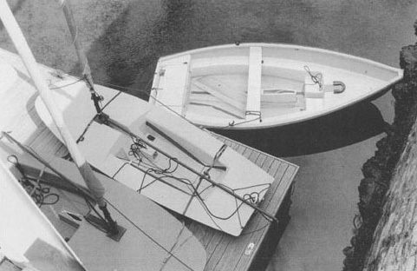
Figure 69

6.5 Market experience
It is some 20 years since the Topper project was conceived by Peter Bean, Technical Director of Rolinx and Ian Proctor, the designer of the original GRP boat. Sales initially were excellent, especially to sailing schools and clubs where there was much demand for a small, light and very safe sailing boat for children. But after that, the market became saturated, sales were heavily dependant on individuals and families, so decreased despite attempts to export the boat to the USA and Israel, for example. The sales company moved from its location in Torpoint to Kent, and the tools were moved to Germany for injection moulding of the hull and deck.
However, sales have picked up again with the expansion of leisure activities, and the personal market remains active. The boat has clearly filled a particular niche in the market, where larger boats such as the Laser (a GRP boat) are too difficult to handle for children, and alternatives such as the Mirror (self-assembled in kit form marine ply) cannot offer the same intrinsic safety as the all polypropylene boat. The design, in other words, has proven right for the market it is aimed at, and the consumer or user have voted with their pockets for the product. Sales now (1997) exceed 41 000, the boat has official International Status and has a flourishing Class Association. Large moulding machines capable of making the boat are also available commercially now, so proving the validity of the original exercise. But have any changes in the design been necessary? One important change is related the flexibility of the construction material, polypropylene. The monocoque construction, where hull and deck are fused together thermally, ensures that the boat is much stiffer as a product than either hull or deck alone. However, there are areas such as the front part of the deck ahead of the mast, where point loads may deflect it unduly (such as standing on it!). This has now been solved by incorporating a foam block of polystyrene to resist such loads (Figure 70). Such a solution harks back to the use of foam-core sailboards and windsurfers, and is a very common way in which hollow plastic structures can be reinforced.

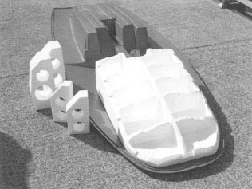
Figure 70 Foam interior to front deck to improve compressive stiffness against point loads.

Conclusion
Polymers are long chain molecules with properties dominated by their chain behaviour and the nature of their chemical make-up or constitution. The distinction between thermoplastics and thermosets has become rather blurred with the development of new materials for more demanding environments than previously. They include high performance polymers which are more resistant to high temperatures, possess greater moduli or strengths, and can be combined with additives to enhance their intrinsic properties yet further. An understanding of the atomic and molecular construction of polymers provides an insight into how improved materials can be developed, in the subject of molecular engineering. It includes an understanding of both molecular configuration and conformation.
The manufacture of polymers from oil and gas feedstocks is dominated by a handful of processes operated in large scale petrochemical complexes. Intermediates and monomers are often interconvertible so that supply and demand can be matched. However, in the thermal cracking of naphtha the production of olefins varies within relatively narrow margins, so that excess quantities of propylene, for example, may be produced at medium and high cracking severity. Ethylene is the major petrochemical building block for vinyl chain growth polymers, and benzene and para-xylene are the main sources of aromatic structures within polymer repeat groups. Polymer consumption continues to grow and the range of both general-purpose materials and speciality polymers has widened considerably over the past two decades. Within each polymer type the range of grades available to the design engineer has also continued to widen, owing to the close control over molecular mass and structure that is available with the latest polymerization catalysts. Copolymerization, for example, is a major way in which structure can be tailored at a molecular level to produce the desired balance of physical properties in the end product. It allows both T_{g} and T_{m} to be modified to match the temperature scale of exposure of the end product, as well as affecting other properties like toughness and stiffness. A compromise between conflicting property demands often needs to be reached in the selection of the appropriate grade for a particular product. But there is an extra level of complexity in the effect of processing – it can affect molecular orientation and crystallisation and hence end properties. In addition, the constraints of processing can severely restrict the grades which can be processed effectively. So some compromise between design for function and design for manufacture must be planned in order to maximise and exploit the extra design freedom that polymers offer.

Acknowledgements
Except for third party materials and otherwise stated (see terms and conditions), this content is made available under a Creative Commons Attribution-NonCommercial-ShareAlike 4.0 Licence
Grateful acknowledgement is made to the following sources for permission to reproduce material in this block:
Figures 1, 2 Courtesy of the British Plastics Federation; Figure 5 Bakelite AG; Figure 10 Courtesy of Flymo; Figures 11, 14 DSM High Performance Fibers; Figure 13: Cook (UK) Limited; Figure 28: Courtesy of RAPRA; Figure p. 45 Ewen, J. A. (1997) ‘New chemical tools to create plastics’, Scientific American; May 1997. Reprinted with permission from BioGrafx, New York; Figure 41 Flory, P. J. (1949) Frontiers in Chemistry, vol VI, John Wiley and Sons Inc. Reprinted by permission of John Wiley and Sons Inc.; Figure 47: Nielsen (1962) Mechanical Properties of Polymers, Van Nostrand Reinhold; Figure 48 Tobolsky, A. V. (1962) Properties and Structures of Polymers, © Dr Dorothy E. Tobolsky. John Wiley and Sons Inc. Reprinted by permission of John Wiley and Sons Inc.; Figure 50 Lockett, F. J. (1982) Engineering Design for Plastics, National Physics Laboratory; Figure 56a Hall, C. (1981) Polymer Materials, Macmillan Press Ltd, © 1981 C. Hall; Figure 56b Bassett, D. C. (1981) Principles of Polymer Morphology, Cambridge University Press; Figure 57 Gaylord, N. G. and Mark, H. F. (1959) Linear and Stereoregular Addition Polymers, The Interscience Publishers, New York; Figure 58: Reprinted with permission from Nature, 174, Bunn, C. W. and Howells, E. R. (1954) p. 549, Copyright 1954 Macmillan Magazines Limited; Figure 61: Burret, A. R. (1974) Dinghy Recognition, The Blandford Press; Figure 62: Courtesy of Ian Proctor; Figure 70: Topper International Ltd;
Table 11 O'Connor, M. (1978) Management and Design in the British Small Boat Industry. Report to the Design Council; Table 12 From the 1CI Technical Data Booklet PPSO (1981), Courtesy of ICI.
Figures 1.1, 1.2 and 1.4: Courtesy of Electrolux Manufacturing Ltd
Don't miss out:
If reading this text has inspired you to learn more, you may be interested in joining the millions of people who discover our free learning resources and qualifications by visiting The Open University - www.open.edu/openlearn/free-courses

Solutions

Exercise 1

Answer
A modern house might typically contain the following polymeric products for use in plumbing your water supply, and for its disposal after use. Rainwater products are also usually polymeric in origin. Your list will be determined by the age of your house and its exact design, should you choose it as the basis for your answer.
- Water supply pipe, tank and moulded fittings, all thermoplastic
- Bath and some fittings, composite and thermoplastic
- Thermoplastic film covering to hot water tank insulation
- Hot water tank insulation, if moulded around tank
- Sewage pipe and fittings, mainly thermoplastic
- Rainwater guttering, downpipe and fittings, all thermoplastic
- Damp proof membranes (DPCs)
- Flat roof coverings.
Back to - Exercise 1

Exercise 2

Answer
- water supply pipe: uPVC or HDPE or polybutene; tank fittings: PE, PP, nylon or POM.
- bath: PMMA/GRP or ABS
- fittings: often ABS
- film covering: LDPE
- moulded tank insulation: UF foam
Sewage pipe: uPVC; fittings: PP or HDPE
- Rainwater goods: uPVC
- DPC: LDPE
Flat roofs: bitumen/fabric or EPDM vulcanized rubber.
Back to - Exercise 2

Exercise 3

Answer
Slate DPCs have been displaced by LDPE membranes for several reasons. LDPE film can be made in very large sizes (metres in width and length) whereas slate is limited to small sizes (cm in width and length). Slate is also expensive, occurs only in limited locations and is of much higher density, so incurs high transportation costs when compared with LDPE. It is a brittle material, so cracks may develop and encourage water permeation, so affecting the integrity of the product when in place. LDPE, by contrast, is tough and ductile, so can withstand high stresses imposed during installation or use.
Rainwater products such as guttering and downpipe in uPVC are the preferred alternative to cast iron, mainly because they are substantially lighter (so installation is easier), easier to make in large lengths, safer to install since PVC is tougher than brittle cast iron and cheaper as a manufactured product. It is also much more corrosion resistant than steel guttering or pipe, so should last very much longer.
Back to - Exercise 3

Self assessment question 1

Answer
Being a hover mower, the main casing must be light enough to be lifted by the down draft created by the main fan, despite the effect of the collection fan. Although sheet steel could be made thin and light enough to act as a casing, the complex internal rib system would be impossible to produce in a single operation. In addition, steel would be vulnerable to rusting in normal garden usage. It might be tough enough to withstand abuse, but a preferred option is to use a tough, lightweight polymer such as ABS. Being rubber toughened, it should be capable of resisting external impacts with garden objects as well as stones thrown up by the cutting blade. Two parts could be manufactured, and bonded or bolted to one another after insertion of the motor assembly. The plastic hood offers good electrical resistance compared to highly conducting steel, so is also better on safety criteria.
Back to - Self assessment question 1

Self assessment question 2

Answer
Building blocks of the kind shown can be moulded in one piece in a single operation, so displacing wood as the preferred material. Wood requires several machining operations to create complex shapes, so would be more expensive to use for this shape. In terms of chemical properties, plastic is resistant to rot and natural degradation, but care might be needed in additives used because the product might be chewed by the user!. The properties are similar in all directions, while wood varies depending on the direction. The stiffness of plastics is lower than wood, so care would be needed in design to ensure that the wall thickness is great enough to withstand handling stresses as well as the pushfit stresses. A tough thermoplastic should be used to resist impact loads.
Back to - Self assessment question 2

Exercise 5

Answer
From Table 3, the molecular mass of the repeat unit of polystyrene is 104. Hence the molecular mass of a sample of DP 500 is simply 500 × 104 = 52 000.
Back to - Exercise 5

Exercise 6

Answer
For 100 g of SBR, there will be a mass of 24 g of styrene units and 75 g of butadiene present in the copolymer. Hence the number of moles of each will be:
n_{S} = 25/ = 25/104 = 0.24
n_{B} = 75/ = 75/54 = 1.39
Thus the mole fraction of styrene is:
0.24/(0.24 + 1.39) = 0.24/1.63 = 0.147 or 14.7%
Back to - Exercise 6

Self assessment question 3

Answer
The structure of a grafted polymer would comprise domains of the rubber phase embedded in a matrix of PVC. The domains would be very small, and toughen the plastic matrix by creating tiny crazes when or if stressed. It would be tough and resist the formation of brittle cracks. This is an essential requirement for a window frame, which must sit in a building for 50 years or more. The worst stresses might occur through faulty fitment, distortion in the opening from ground movement or settlement. They might be expected to be worst at corners in the frame, where there are sharp changes in shape. Such corners are weak points in the structure owing to the need for welding of the material here. The optimum composition would be about 25 wt% rubber to give the best toughening effect.
Back to - Self assessment question 3

Exercise 7

Answer
The effect must be the opposite of that in polyethylene, namely, the trans conformers have a higher energy than the gauche conformers. In other words, the linear zig-zag conformation formed by a succession of trans positions along the backbone chain becomes more favourable as the temperature is raised. The chain is now much longer than in a random coil conformation, so the viscosity would be expected to be higher.
Back to - Exercise 7

Self assessment question 4

Answer
From Table 3, the molecular masses of the additive (1) and the base (2) can be calculated knowing n, the degree of polymerization:

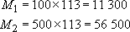

(a)Now from Equation (5),

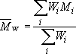

so for equal weights of each component.

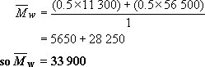

(b)Now N_{i} = W_{i}/M_{i} so that the number of moles of each component

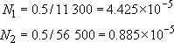

So from Equation (4),

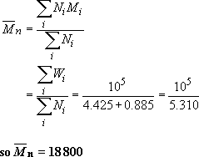

(c) Hence
Back to - Self assessment question 4

Self assessment question 5

Answer
Nomex has a repeat unit which cannot show any form of configurational isomerism so, provided there is enough energy to overcome any rotational barriers, should be crystalline. The barrier to rotation should be high, simply because the aromatic benzene ring is a fused structure, so any rotation that can occur is limited to the amide group (﻿–﻿NH–CO–). This shows hydrogen bonding with other amide groups, so the barrier to rotation should be very high, especially as there may be hindrance from the adjacent benzene rings. This implies that T_{g}, and T_{m}(since T_{g}T_{m}≈ 2/3) should both be high, considerably higher than the equivalent transitions of nylon 6.6 for example, the nearest analogue polyamide. By increasing such values, it will improve the fire resistance of the material owing to the presence of the very stable aromatic ring.
Back to - Self assessment question 5

Exercise 8

Answer
Figure 35 shows that PVC is made by addition of chlorine to ethylene, followed by dehydrochlorination to give vinyl chloride monomer. Ethylene will be one of the main products of Norway's petrochemical industry, and chlorine will be readily available by the electrolysis of brine. Since both intermediates are readily available at low cost, it is natural that PVC should be a staple product of the Norwegian petrochemicals industry.
Back to - Exercise 8

Self assessment question 6

Answer
The degree of polymerization can be calculated from Equation (17)

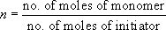

since the volume of the reaction can be assumed to be constant. As the polymer will still be living at the end of the first phase of reaction, the total number of moles of monomer is simply 1 + 1 = 2 moles of styrene. The initiator solution comprises 100 ml of hexane containing 0.1 moles of butyllithium. So 1 ml added to the reaction vessel will contain
0.1 × 10⁻² = 10⁻³ moles of initiator
Hence

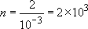

The molecular mass can be simply determined from Equations (1) and (2), the atomic masses of carbon (12) and hydrogen (1) and the repeat unit structure
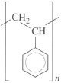
So M_{R} = (8 × 12) + (8 ×1) = 104
Hence M = 208 000
Back to - Self assessment question 6

Self assessment question 7

Answer
The molecular mass of ethylene glycol = 24 + 32 + 6 = 62. Therefore the mixture contains 62 g of glycol of which 1 per cent or 0.62 g is methyl alcohol.
The molecular mass of methyl alcohol = 16 + 12 + 4 = 32. So the number of moles of CH₃OH present = 0.62/32 = 0.0194 moles.
Now the hydroxyl (—OH) group in the alcohol will react with acidic groups to form dead polymer end groups:

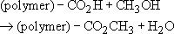

The net effect will be to lower the molecular mass of the PET formed. The number of moles of glycol available for step growth polymerization will be 1 − 0.0194 = 0.9806. This then will be the maximum extent of reaction.
So = 0.9806
From Equation (22),

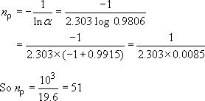

The repeat unit molecular mass is 192 (Table 5), so that

From Equation (21)

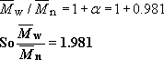

Back to - Self assessment question 7

Self assessment question 8

Answer
The copolymer structures can be determined by referring to the reactivity ratios of the relevant monomers (Table 8).
(a) For vinyl acetate reacting with vinyl chloride, the reactivity ratios are

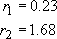

The product r₁ r₂ = 0.39. This value is less than 1, so the structure will be random with a pronounced tendency for alternation between the repeat units of each monomer in the chain. Both repeat units are potentially stereoisomeric but atactic structures are usually formed in free radical polymerization so that the copolymer is non-crystalline.
(b) SBR approaches the ideal or random copolymer structure most closely because r₁ r₂ = 0.78 × 1.35 = 1.05. The butadiene repeat unit is capable of geometrical isomerism, with three possible structures: cis, trans and vinyl. These are randomly distributed through the chain structure owing to the unspecific nature of free radical polymerization.
(c) Styrene-acrylonitrile (r₁ r₂ = 0.016) is very close to being an alternating copolymer with the repeat unit
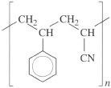
This material would have a molar composition of 50 per cent styrene, but taking the different M_{R}s into account (styrene = 104, acrylonitrile = 53) the weight composition is 66 per cent styrene, not far removed from the actual composition of 74 per cent styrene. Both repeat units are atactic, so the material is non-crystalline.
Back to - Self assessment question 8

Self assessment question 9

Answer
(a) The viscoelastic master curve can be sketched from a knowledge of the approximate modulus and time scale for each of the different states. Since all amorphous polymers including silicone show similar moduli for the glassy and elastomeric states, these values can be taken directly from Figures 47 and 48. It remains to estimate the time scales involved for each state.
(i) When hit with a hammer travelling at 20 m s⁻¹, a 2 cm diameter ball will respond in a time scale of about

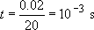

(ii) When dropped, the velocity can be calculated from simple dynamics:

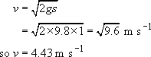

The time scale of the experiment is thus

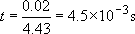

(iii) When kneaded, the time scale is of the order of 10⁻²−10⁰ s.
(iv) When allowed to flow, t = 10−10² s. The resultant master curve is shown in comparison with that of PIB in Figure 49.

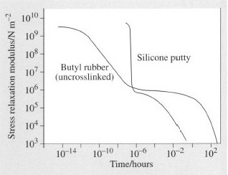
Figure 49 Sketch of master curve for silicone putty

(b) For a well-vulcanized NR ball, Figure 51 can be used to estimate the point at which it ceases to bounce – at the maximum of the tan δ versus ω curve. Interpolating from the figure, the maximum damping occurs at ω ≈ 10² Hz, so t = 1/ω = 10⁻² s. Using the same arguments as above,
then

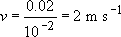

Back to - Self assessment question 9

Self assessment question 10

Answer
Increasing the speed of a car means increasing the rate of rotation of the car wheels. The frequency of rotation, ω, will thus increase with speed, and this increase in ω will be imposed on the rubber of the tread in direct contact with the road. From the WLF equation and the time-temperature superposition principle, an increase in ω is equivalent to a reduction in time scale, t or a reduction in temperature; the rubber will become stiffer as the speed increases. Heat dissipation may also increase as the maximum in tan δ is approached (Figure 51).
Note that the frequency is shown in the figure as a logarithm term, so that maximum heat dissipation will occur at a frequency of 10², or 100 cycles per second for the well-crosslinked NR compound. For a car tyre about 0.3 m in diameter, then since the circumference is

Thus 1 Hz or 1 cycle per second, is equivalent to a car speed of about 1 m s⁻¹, or about 3.6 kph. A frequency of 100 Hz is thus equivalent to 360 kph, a speed normally well above the capabilities of normal saloons! However, the diagram shows that heat dissipation will increase rapidly with increasing speed, and in adverse conditions (dry road, rough surface) could lead to tyre burn and tread loss. Wet conditions will help to absorb any heat in the tyre, and a rough road will increase the effective frequency of deformation of the tread by imposing extra vibrations on the structure.
The rubber used in the tread will be important in evaluating heat loss, as will the presence of any fillers, especially carbon black. Crosslink density will also be important in controlling the response of the tyre (Figure 48).
Back to - Self assessment question 10

Self assessment question 11

Answer
(a) The effect of molecular mass on the melting point is readily evaluated from Equation (35):

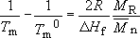

i.e.

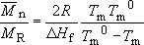

If T_{m} = 0.9997T_{m} ⁰, then

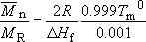

The following are values for polypropylene :

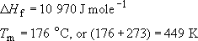

So using these values in the above equation, together with a value for R = 8.314 J K⁻¹ mole⁻¹

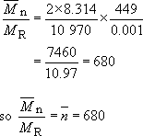

The molecular mass of the polypropylene repeat unit is
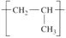
(3 × 12) + (6 × 1) = 42, so the number average molecular mass of PP will be 42 × 680 or 28600. The melting point at this value of is about 448.5 K, about half a degree less than the value for very high molecular mass material.
(b) The effect of randomly copolymerizing 10 per cent; ethylene can be found from Equation (34)

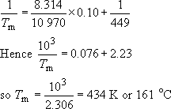

The net result is that the melting point is depressed by 15 °C, which means that processing to shape will be less energy consuming. On the other hand, the upper limit on service temperature will also be reduced compared to the homopolymer. The lower limit, which is related to T_{g} rather than T_{m} will be depressed below 0 °C – a big advantage for low temperature usage. Milk crates or other containers exposed to UK outside temperatures would be better constructed from copolymer rather than homopolymer. The depressant effect for partial block copolymers will not be dissimilar to that produced in random copolymerization. The degree of crystallinity will also be depressed owing to the disruption of the crystalline lattice by the copolymer blocks. This will reduce the stiffness of the material.
Back to - Self assessment question 11

Self assessment question 11

Answer
The comparative effect of replacing a GRP hull by a polypropylene hull of the same dimensions except thickness can be simply calculated from the torsion equation:

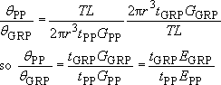

Inserting the known values of modulus and thickness,

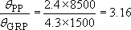

In other words, the thicker polypropylene hull will distort over three times as much as the GRP hull despite the fact that their flexural stiffnesses are very similar.
An absolute value for angular distortion can be estimated very roughly by assuming r = 0.5 m and L = 3.4 m (Figure 62):

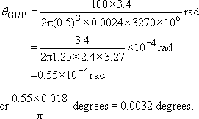

so θGRP=0.0032 degrees or 0.19 minutes, and θpp ≈ 0.6 minutes.
A moment of 100 N m is equivalent to a 50 kg individual exerting a lever 20 cm from the centre of gravity of the craft – not an untypical sailing moment. Such distortion would be detectable on a small craft but would not be serious enough to affect sailing characteristics to any great extent.
Back to - Self assessment question 11

Figure 63 Torque, T, acting on hollow tubes of identical length, L internal and external radii, r 1 and r 2, respectively, and wall thickness, t to produce an angle of twist θ. (a) is an integral tube and (b) has a slit along its length

Description
A torque acting on the hull
Back to - Figure 63 Torque, T, acting on hollow tubes of identical length, L internal and external radii, r 1 and r 2, respectively, and wall thickness, t to produce an angle of twist θ. (a) is an integral tube and (b) has a slit along its length

