

TA212_1 The technology of music

Sound for music technology: An introduction
About this free course
This OpenLearn course provides a sample of Level 2 study in Technology http://www.open.ac.uk/courses/find/technology.
This version of the content may include video, images and interactive content that may not be optimised for your device.
You can experience this free course as it was originally designed on OpenLearn, the home of free learning from The Open University: www.open.edu/openlearn/free-courses.
Sound for music technology: An introduction
www.open.edu/openlearn/science-maths-technology/engineering-and-technology/technology/sound-music-technology-introduction/content-section-0
There you’ll also be able to track your progress via your activity record, which you can use to demonstrate your learning.
The Open University Walton Hall, Milton Keynes, MK7 6AA
Copyright © 2019 The Open University
Intellectual property
Unless otherwise stated, this resource is released under the terms of the Creative Commons Licence v4.0 http://creativecommons.org/licenses/by-nc-sa/4.0/deed.en_GB. Within that The Open University interprets this licence in the following way: www.open.edu/openlearn/about-openlearn/frequently-asked-questions-on-openlearn. Copyright and rights falling outside the terms of the Creative Commons Licence are retained or controlled by The Open University. Please read the full text before using any of the content.
We believe the primary barrier to accessing high-quality educational experiences is cost, which is why we aim to publish as much free content as possible under an open licence. If it proves difficult to release content under our preferred Creative Commons licence (e.g. because we can’t afford or gain the clearances or find suitable alternatives), we will still release the materials for free under a personal end-user licence.
This is because the learning experience will always be the same high quality offering and that should always be seen as positive – even if at times the licensing is different to Creative Commons.
When using the content you must attribute us (The Open University) (the OU) and any identified author in accordance with the terms of the Creative Commons Licence.
The Acknowledgements section is used to list, amongst other things, third party (Proprietary), licensed content which is not subject to Creative Commons licensing. Proprietary content must be used (retained) intact and in context to the content at all times.
The Acknowledgements section is also used to bring to your attention any other Special Restrictions which may apply to the content. For example there may be times when the Creative Commons Non-Commercial Sharealike licence does not apply to any of the content even if owned by us (The Open University). In these instances, unless stated otherwise, the content may be used for personal and non-commercial use.
We have also identified as Proprietary other material included in the content which is not subject to Creative Commons Licence. These are OU logos, trading names and may extend to certain photographic and video images and sound recordings and any other material as may be brought to your attention.
Unauthorised use of any of the content may constitute a breach of the terms and conditions and/or intellectual property laws.
We reserve the right to alter, amend or bring to an end any terms and conditions provided here without notice.
All rights falling outside the terms of the Creative Commons licence are retained or controlled by The Open University.
Head of Intellectual Property, The Open University
Designed and edited by The Open University
978-1-4730-1678-1 (.kdl)
978-1-4730-0910-3 (.epub)

Contents
- Introduction
- Learning outcomes
- 1 Sound basics
  - 1.1 Music and technology
  - 1.2 What is sound?
  - 1.3 Describing sound
  - 1.4 Summary
- 2 Sinusoidal pressure waves
  - 2.1 The importance of sine waves
  - 2.2 Pressure in the atmosphere
  - 2.3 Pressure waves and cycles
  - 2.4 Period
  - 2.5 Wavelength
  - 2.6 Pressure variations in one place
  - 2.7 Summary
- 3 Frequency
  - 3.1 Frequency and period
  - 3.2 Summary
- 4 The speed of sound
  - 4.1 The experimental result
  - 4.2 Frequency, wavelength and the speed of sound
  - 4.3 Summary
- 5 Phase
  - 5.1 Phase and phase difference
  - 5.2 Cancellation and reinforcement
  - 5.3 Summary
- 6 Amplitude
  - 6.1 Defining amplitude
  - 6.2 Practical units of amplitude
  - 6.3 Root-mean-square amplitude
  - 6.4 Summary
- 7 Pitch and loudness
  - 7.1 The subjective experience
  - 7.2 Summary
- 8 The octave
  - 8.1 The octave sound
  - 8.2 Octave pitch and frequency increments
  - 8.3 Summary
- 9 The ranges of human hearing
  - 9.1 Frequency range
  - 9.2 Dynamic range
  - 9.3 Summary
- 10 The decibel
  - 10.1 Introduction
  - 10.2 Adding decibels
  - 10.3 The decibel as a measure of sound amplitude
  - 10.4 Summary
- Conclusion
- Acknowledgements

Introduction
This course contains material that is essential to learning about music technology. Here you will explore the concept of sound and be introduced to the physics behind travelling pressure waves as the physical manifestation of sound. You will also learn about the subjective perception of pitch and loudness, in particular their relationship to frequency and amplitude.
This OpenLearn course provides a sample of Level 2 study in Technology http://www.open.ac.uk/courses/find/technology.

Learning outcomes
After studying this course, you should be able to:
- explain correctly the meaning of the emboldened terms in the main text and use them correctly in context
- describe simply what a pressure wave is and give a simple explanation of sound in terms of a travelling pressure wave
- explain ‘cycle’ in terms of an oscillating source and the pressure wave it produces
- relate amplitude (including peak-to-peak and r.m.s.), frequency, period and wavelength to a sinusoidal waveform
- calculate the wavelength of a pressure wave from a graph of pressure against distance

1 Sound basics

1.1 Music and technology
Music technology in one guise or another is part of everybody's life, because music is a part of almost everybody's life. For instance, if you are an instrumental performer of music, professional or not, then your instrument, be it the harp or the rock'n'roll drums, will be the result of considerable technological expertise on the part of the instrument maker. On the other hand, if you are not a performer but like to listen to music, the chances are that most of your listening is done via a home hi-fi system or a car radio rather than in a concert hall. In this case your music is relayed to you via various technological devices; well before the music reaches a compact disc (CD) or radio it will have been manipulated in various way using studio devices for recording, mixing and mastering. From the traditional acoustic instruments to the modern computer-based sampler or synthesiser, from the museum gramophone to the latest MP3 player, whatever your choice of musical style and whatever your relationship with music, technology is virtually inescapable.
Technology and music have been closely associated since the first musical instruments were constructed. This may come as a surprise to people who are used to thinking of music technology in terms of electric or electronic devices. The piano, for example, has taken centuries of evolving technological expertise to become what it is today. Throughout its history, music has freely exploited state-of-the-art technological developments, and has had an intimate relationship with sciences such as physics, mathematics and, more recently, electronics and computing. T212 The Technology of Music, the OU's course on music technology, explores many examples that highlight this close relationship of music with both technology and the sciences.
The first block of TA212, specifically, explores sound, which is the basis of all music. Music, of course, implies sound. Music technology, essentially, has the purpose of enabling sound production, manipulation, storage and reproduction. But what is sound? Throughout the block registered students explore the various aspects that, together, comprise a basic model of sound. In this OpenLearn unit, in particular, you will get started in this exploration by learning about the various ways of interpreting the word ‘sound’, concentrating at first on a more formal approach to sound from the perspective of physics.

1.2 What is sound?
In the previous section I posed a question: what is sound? Take a few minutes to think about this. This may seem a straightforward question, but in fact sound is a rather more complicated thing to pin down than you might think on a first analysis. In this section I would like to explore and map out this complexity, and we shall do this together, based on your own experience with sound. To start, I'd like to propose some listening activities.

Activity 1 (Listening, Exploratory)

Listen to the eight audio tracks associated with this activity. The purpose of this activity is to put your understanding of sound into perspective, to provide a basis for the exploration of sound undertaken in this unit. Jot down a few words to describe what you hear. Use whatever terms seem appropriate to the sound you hear.
Click 'Play' to listen to Audio Clip 1

Audio content is not available in this format.

Click 'Play' to listen to Audio Clip 2

Audio content is not available in this format.

Click 'Play' to listen to Audio Clip 3

Audio content is not available in this format.

Click 'Play' to listen to Audio Clip 4

Audio content is not available in this format.

Click 'Play' to listen to Audio Clip 5

Audio content is not available in this format.

Click 'Play' to listen to Audio Clip 6

Audio content is not available in this format.

Click 'Play' to listen to Audio Clip 7

Audio content is not available in this format.

Click 'Play' to listen to Audio Clip 8

Audio content is not available in this format.

View discussion - Activity 1 (Listening, Exploratory)

Activity 2 (Listening)

Listen to the audio tracks associated with Activity 1 again, this time looking at my descriptions to familiarise yourself with them, as the next activity will build on this previous work.

Activity 3 (Listening, Exploratory)

Listen to the audio tracks associated with Activity 1 again, as many times as you like, and then consider the descriptions I produced in Activity 1. Examining the words used in my descriptions, can you think of any similarities between them, perhaps more general threads that may bring two or more descriptions together as one broader class?

View discussion - Activity 3 (Listening, Exploratory)

Activity 4 (Exploratory)

Look at the descriptions you produced for the audio tracks in Activity 1. Do they seem to belong to these categories of description?

View discussion - Activity 4 (Exploratory)

1.3 Describing sound
Let's now take a closer look at my list of categories from Activity 3, starting with item (a). In each of my descriptions of this sort, I referred to the source–cause of the sound: that is, an object or an instrument (the source of the sound) and ways of using it to produce a sound (the cause of the sound). Here are other examples of source-cause descriptions:
- Violin (source) played pizzicato (cause); pizzicato is a plucking technique for string instruments that are normally played with a bow.
- Piano strings (source) struck with a felt-covered hammer (cause); this is the basic mechanism of a modern piano.
- Hand (source) clapping (cause); this is central to traditional Spanish flamenco music.
Source–cause descriptions are probably the most common way of describing sounds. Your list probably resembles mine in this respect. Such descriptions are particularly interesting because it is quite remarkable how descriptions of sounds seem to rely so much on things that are not the sounds themselves. Consider the way we would generally describe an object we see. Normally we would describe an object by mentioning a label (let's say, ‘chair’) accompanied by some qualities that, we feel, make the object distinct from others (for example, ‘a wooden, white-painted chair in the corner of the room’). With a verbal explanation, we can characterise the object so that it can be distinguished from other nearby or similar objects. Instead, where sounds are concerned we tend to mention their origins. This sort of description of sounds might be compared to describing objects we see by talking about how they are produced. Perhaps this is because the recognition of the source–causes of sounds is one of the most basic listening abilities – an instinctive ability.
My second category of descriptions (ones that refer to musical elements) is a bit more specific. If you did not have a musical background before you started this unit, you might not have used or mentioned this sort of terminology at all – in the first two tracks, for example, you might have kept your description to the identification of the instrument or instrumental family. You might have been able to add yet more detail (for example, mentioning the types of scale in the first track); you may even have recognised the interval between the two notes in the second track as a minor seventh (or at least, if you did not recognise the interval you should know that, with time, you could work it out). Naturally, the use of musical terminology depends on musical training, but some of the traditional terms have crept into colloquial speech, perhaps due to some form or other of musical training received in early schooling. As you know, ‘note’, ‘key’ and ‘chord’, for example, have specific meanings in music but also have become part of everyday language, as in ‘that strikes a chord’.
My final category, item (c) ‘descriptions that use metaphors’, is a most interesting one, as it relates to a sort of informal language used commonly by musicians and experienced music listeners. (If you want to remind yourself about what a metaphor is, see Box 1.) Qualities like brightness, darkness and depth are commonly attributed to sounds, although these are clearly attributes of things we perceive visually. Interestingly, pitch is supposed to have been originally associated with a metaphor of high/low, which expressed the impression of highness/ lowness of the singing voice. This is still reflected in the physical arrangement of singers in a choir according to their type of voice.

Box 1: Metaphor
According to the Oxford Concise Dictionary, eighth edition (1990), a metaphor is ‘the application of a name or descriptive term or phrase to an object or action to which it is imaginatively but not literally applicable (e.g. a glaring error).’

My three categories have one thing in common. All of them rely on perception: that is, on the sense of hearing. Perceptual categories are most useful and, indeed, necessary because a lot of the sense we make of the world around us is enabled by what we see, hear, smell – that is, generally, perceive. There is no pun intended here: we make a lot of sense of things using our senses. Music technology, in particular, relies much on perception: if the proof of the pudding is in the eating, the ‘proof’ of music technology is in the hearing.
Additionally, though, in technological analyses we need a different way of describing sounds, a way that allows their formal assessment and numerical representation. Essentially, we need to be sure we are talking about the same thing, which is quite difficult to achieve if we rely exclusively on subjective perception. Therefore, a way of approaching sound is borrowed from physics – specifically, from acoustics – and this is the perspective you will be exploring in the remainder of this unit.
In summary, I have used the word ‘sound’ to refer to things that are, indeed, quite different in nature. Sound refers both to what is perceived – a sensation – and to the stimulus that suggests the sensation – a physical phenomenon involving vibrations and energy. It may be a bit perplexing that the same word has such different meanings, and some authors do prefer to use different words. However, in this unit we have decided to stick to one term only, because it is normally quite easy to understand what it refers to from the context in which it appears. The remainder of this unit is a short introduction to the phenomenon of sound: what it is physically, how we quantify it and, at a basic level, how its physical properties are interpreted as sensations.

1.4 Summary
The close relationship between music and technology is not new, and is not confined to electronically generated or computer-generated music. Historically there is a long association between music and technology, and this continues in the way instruments are made and the way music is disseminated. Additionally, for a good proportion of listeners throughout the world, listening to music is almost synonymous with listening to electronically processed and delivered music, through recordings, broadcasts or the internet.
Sound, which is fundamental to all varieties of music, can be considered objectively and subjectively. As an objective phenomenon it can be measured and described using a scientific, and to some extent a musical, vocabulary. As a subjective phenomenon it is experienced as a perception, and descriptions tend to be metaphorical, although some musical terminology also relates to subjective perception.

2 Sinusoidal pressure waves

2.1 The importance of sine waves
For much of the rest of this unit we shall be concerned with the properties of a type of sound wave that when represented as a graph has a characteristic shape known as a sine wave. Figure 1 shows you what a sine-wave graph looks like. For the moment you need not be concerned with what this graph represents.

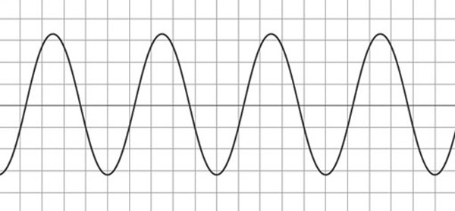
Figure 1 A sine wave

Despite their theoretical importance, sine waves are of limited use in the actual business of creating music – at least music of conventional kinds. Few instruments, for instance, produce a sine-wave type of sound when played in the normal way, although in electronic music sine waves can be a basic component of synthesised sounds.
Because pure sine-wave sounds are not often heard in music, I ought to begin this study by giving a few reasons why they are so important. One reason has already been hinted at in my reference to electronic synthesis. For our purposes sine waves are important for three main reasons:
- They can be used to define some basic terms and quantities relating to sound of all kinds. They therefore give us a basic vocabulary for talking about the physical properties of sound.
- They allow us to explore the relationships between the purely physical properties of sound and the subjective experience of hearing it.
- They are fundamental to the analysis and synthesis of sounds that are used musically (and also non-musically).
In this unit I will focus on the first two reasons.
Sine waves are fundamental in many areas of mathematics, science and technology, not just in sound. Many of the properties of sine waves, which I shall discuss later in this unit, are therefore of wider application than sound, although I shall not be referring to these other applications to any significant extent. However, before I can say anything further about sine waves, I need to prepare the ground by discussing pressure waves.

2.2 Pressure in the atmosphere
The sounds we hear generally consist of rapid fluctuations of air pressure in the atmosphere that surrounds us. Sound can also be transmitted through other media, for instance water, so not all sound consists of fluctuations in air pressure. However, for the purposes of this discussion I shall confine myself to sound in air.
These fluctuations in air pressure are caused by a local disturbance to the air pressure, which might be sudden and transient – for example, when a paper bag is burst – or continuous and regular – for example, when someone sings a steady note. Whatever the nature of the disturbance, the pressure variations spread outwards from the source through the surrounding air, becoming gradually weaker. At a sufficient distance from the source, the pressure variations die away completely.
For a listener in the vicinity of the sound source, the pressure variations act on the listener's hearing mechanism, causing the eardrum to move in sympathy with the source of the pressure variations. The movements of the eardrum are detected by a mechanism in the middle ear, and are interpreted by the brain as sound.
The pressure variations we hear can also sometimes be felt. You may be familiar with the experience of holding an inflated balloon and feeling it vibrate in response to nearby sounds, or standing near a loudspeaker and feeling vibrations from the bass notes. In the case of the balloon, pressure variations cause the skin of the balloon to vibrate in just the same way as they cause the eardrum to vibrate. Similarly, all drummers and percussion players are familiar with the way drumskins resonate in sympathy with sound from nearby instruments, and often need to be damped to prevent unwanted noises being generated.
The air around us presses on everything it touches, and this is roughly what is meant by the atmospheric pressure. Generally we are unaware of the pressure because it acts equally in all directions, and so its effects are self-cancelling. However, if you removed some of the air from an empty, thin-walled plastic bottle, the pressures inside and outside the bottle would cease to be self-cancelling, and the bottle would buckle (Figure 2). The kinds of pressure imbalance that would make a plastic bottle buckle are, however, much larger than the pressure fluctuations associated with sound.

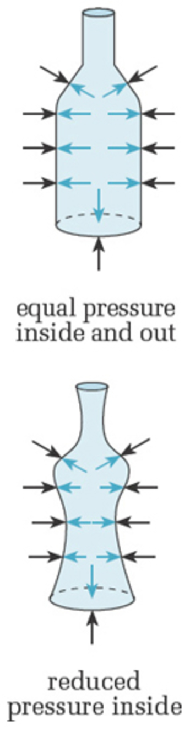
Figure 2 A plastic bottle can be buckled by unbalanced pressure

With regard to sound and the way it travels, we need to think about pressure in relation to the arrangement of molecules in the air. Atmospheric air is a mixture of gases, and at the submicroscopic scale consists of a mixture of gas molecules. These molecules are so tiny that they are only detectable individually by sophisticated scientific apparatus. In a moderately sized volume of air, such as inside a bottle, there is a colossal number of such molecules, and between them there is empty space. The molecules are not static, but continually move around, bouncing off other molecules or off any solid or liquid objects in their vicinity. In general, if there is no sound or other disturbance to the pressure of a sample of air, the molecules are evenly (though randomly) distributed throughout the sample.
The pressure of air (or any gas) is related to how closely packed its molecules are (Figure 3). If the molecules are widely dispersed, the pressure is lower than when they are closer together – other things being equal (principally temperature).

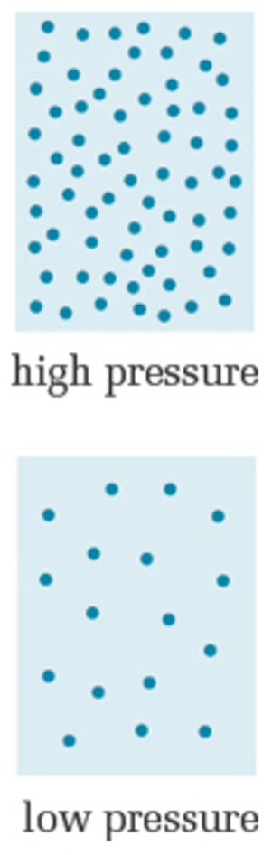
Figure 3 High pressure corresponds to closer molecular spacing

When you pump up a bicycle tyre, by driving more air into the tyre you squash the molecules together more closely than they are outside the tyre. Hence the pressure inside the tyre is higher than that outside.
The message to remember from this section is that sound consists of rapid fluctuations of atmospheric pressure, and that, at the molecular level, high pressure corresponds to air molecules being bunched together, and low pressure corresponds to air molecules being relatively widely separated.

Activity 5 (Self-Assessment)

The science fiction film Alien (1979) was promoted with the grim slogan, ‘In space, no one can hear you scream’. Is this slogan true in the following cases?
- (a) In a space craft where there is an artificial atmosphere to sustain the crew.
- (b) Outside the space craft, where there is a vacuum and the crew need to wear space suits to survive.
- (c) On a planet where there is a poisonous atmosphere and where the crew need to wear space suits (which are not soundproof).

View answer - Activity 5 (Self-Assessment)

2.3 Pressure waves and cycles
In this section we shall be looking at the behaviour and properties of pressure waves in the atmosphere.
Sound originates from the motion or vibration of an object. Let's look at an example of a sound wave generated by a vibrating tuning fork. The prongs of the tuning fork move backwards and forwards cyclically. A cycle is a complete series of movements up to the point where the movement starts to repeat itself. As the prongs of the fork vibrate back and forth they push on neighbouring air particles. The forward and backward motion of a prong alternately pushes air molecules together and then pulls them apart. When the molecules bunch together the local air pressure increases then as the prong retracts backwards a region of low pressure is created allowing the air molecules to move back to the left. Because the tuning fork is vibrating regularly, the result is a regular pattern of pressure variations, of high pressure regions where the air particles are compressed together and low pressure regions where the air particles are spread apart. This pattern of pressure variations moves away from the tuning fork. Hence the sound wave consists of a repeating pattern of high pressure regions and low pressure regions passing through the air and is sometimes referred to as a pressure wave. A different tuning fork might vibrate at a different rate. If a second fork vibrates at twice the rate of the first, the pressure variations woould be squashed together. The pressure wave, however, still travels at the same speed away from the fork.
Figure 4 shows that a vibrating object, a tuning fork, creates alternating regions of high and low pressure. These alternating pressure regions travel away from the fork in all directions, though we shall concentrate on only one direction.

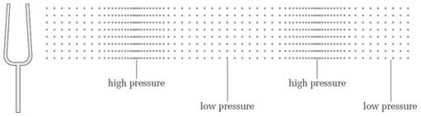
Figure 4 Pattern of pressure variations caused by a vibrating tuning fork

In reality, molecules are not neatly arranged in rows and columns in the way represented in Figure 4. These representations are therefore simplified images of what is happening at the molecular level. They are nevertheless a convenient way of showing the bunching up and spreading out of molecules created by the vibration of the tuning fork's prongs.
A regular pattern of high- and low-pressure regions like this is known as a pressure wave. Because the wave travels away from its source, it is also known as a travelling wave, to distinguish it from another type of wave, the standing wave. Note that not all travelling waves are pressure waves. Light, for instance, is a travelling wave but not a pressure wave.
Among other things, a travelling wave is a way of transmitting energy. In the case of the tuning fork, the energy imparted to the tuning fork when it is made to vibrate is conveyed by the pressure wave into the environment. If the tuning fork were suspended in a vacuum and had no mechanical connection to anything else, it would not only be inaudible but it would also continue to vibrate for much longer because there would be nothing to transfer its energy into the environment.
Notice that although the pressure wave travels away from the tuning fork, the molecules do not travel away from the fork, at least not in the long term. In the simplified representation of Figure 4, each molecule moves regularly backwards and forwards about a fixed point. Motion such as this, which repeats itself regularly, is known as cyclic (or cyclical) motion, or oscillatory motion. One cycle or oscillation is one complete sequence of motion up to the point at which the motion starts to repeat itself. (The motion of the tuning fork's prongs is also cyclic or oscillatory.)
As a final characterisation of the type of wave we are dealing with, notice that the oscillations of the molecules are back and forth along a line that is also the direction of travel of the wave. The wave is said to be longitudinal for this reason. There are other kinds of wave, and you can learn about them in OpenLearn unit T212_2 Creating musical sounds, where the oscillation in the medium is at right angles to the direction of the wave's travel. These are known as transverse waves. An example can be seen in the ripples on the surface of water: the water oscillates up and down as the wave radiates outwards from the source.

Activity 6 (Self-Assessment)

Below are three true statements (1 to 3).
- Sound waves are pressure waves.
- Sound waves emanating from a single source in the open (away from buildings etc.) are travelling waves.
- Sound waves are longitudinal waves.
Here are three explanations ((a) to (c)) of the above statements. These are in the wrong order. Which explanation goes with which statement?
- (a) Because the molecular oscillations are along the line of travel of the wave.
- (b) Because the pressure variations radiate outwards from their source, conveying energy away from the source.
- (c) Because they consist of cyclical changes of pressure.

View answer - Activity 6 (Self-Assessment)

2.4 Period
You saw in Section 2.3 that the prongs of the tuning fork vibrate cyclically. You also learned that a cycle of the prongs' vibration is a complete sequence of motion up to the point at which the motion starts to repeat itself. Another term for this repetitive kind of motion is periodic motion. The time taken for one cycle to occur is called the period of the vibration, and in theoretical work it is usually represented by T, or by the Greek letter tau, τ.
Properly speaking, in periodic or cyclical motion every cycle is identical to every other. With a practical tuning fork, however, no two cycles are identical. This is because each cycle is slightly weaker than the one before, as the vibration of the prongs diminishes from the moment the fork is struck. Nevertheless, it takes several seconds for a tuning fork to become silent, during which time there will be thousands of cycles of vibration. Thus over the course of a few cycles there will be very little change from one cycle to the next and we can regard the motion as periodic.

Activity 7 (Self-Assessment)

Approximately how many cycles of the fork's vibration were required to create the pressure pattern shown in Figure 5?

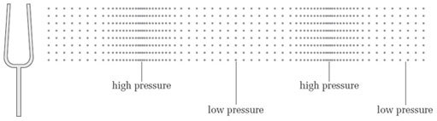
Figure 5: Pressure variations for Activity 7

View answer - Activity 7 (Self-Assessment)

For a pressure wave created by a particular tuning fork, the distance from one high-pressure region to the next is fixed. A different tuning fork (that is, one that vibrates at a different rate) will produce a different separation of high- and low-pressure regions.

2.5 Wavelength
So far we have seen that sound is a pressure wave, and that the spacing of the pressure variations is related to the period of vibration of the source.
A graphical representation of the pressure wave from a tuning fork closely approximates to a certain type of wave known as a sine wave.
If we freeze the pressure wave as a snap shot in time, the variations in pressure with distance from the tuning fork can be plotted as a sine wave. The vertical axis is pressure so the crests of the waves correspond to the high pressure regions and the troughs to the low pressure regions. The wave length of the wave is simply the distance that the wave travels through the medium in one complete wave cycle, i.e. the distance from one region of high pressure to the next or from one region of low pressure to the next.
So if we freeze the pattern of high- and low-pressure regions in the pressure wave, we have the pattern shown in Figure 6(a), for which we can draw a graph relating pressure to distance from the fork (Figure 6(b)).

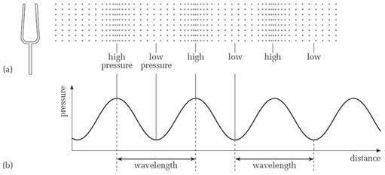
Figure 6 A graph of the pressure wave produced by a tuning fork is a sine wave

For the kind of pressure wave produced by a tuning fork, the transitions from high pressure to low pressure are not sudden. This can be seen from the graph of the pressure wave in Figure 6(b). Notice that the peaks of the graph line up with the high-pressure regions, and the troughs line up with the low-pressure regions. In between there is a smooth change of pressure.
This graph of pressure variation has a very characteristic shape, known as a sinusoidal shape. Alternatively, we can describe the graph as being a sine wave. Not many instruments produce pure sine waves, at least not when they are played in the normal way, so, as I said at the start of this unit, the use of sine waves as musical tones is limited in practice. Nevertheless, sine waves do have a characteristic sound, which it is worth becoming familiar with. The following activity gives you a chance to hear some.

Activity 8 (Listening, Exploratory)

Listen to the audio track below, which contains a variety of sine waves. How would you describe these sounds?
Click 'Play' to listen to Audio Clip

Audio content is not available in this format.

View discussion - Activity 8 (Listening, Exploratory)

A full discussion of sine waves and their properties would entail quite a lot of mathematics, which is beyond the scope of this unit. However, you may be interested to know that the oscillations of many smoothly vibrating systems, when plotted as a graph, have the characteristic sine-wave shape. Other examples would include the oscillations of a mass on a spring and the swinging of a pendulum, provided the oscillations are relatively small in each case.
Notice that in the pressure wave in Figure 6, the distance between any two adjacent regions of high pressure (or low pressure) is the same. This distance is called the wavelength of the sound, and is usually represented by the Greek letter lambda, λ. In fact, the distance between any two corresponding points of consecutive cycles is the wavelength. For instance, in Figure 7, points A and B are one wavelength apart, as are C and D.

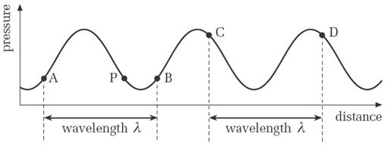
Figure 7 Wavelength

However, although point P in Figure 7 is at the same pressure as A and B, this pressure was generated at a different part of the cycle from that which generated A and B. So the distance from A to P is not a wavelength, nor is that from P to B.
All sine waves that we would describe from their sound as continuous and unchanging (like those in Activity 8) have an unchanging wavelength. The wavelengths of audible sine waves typically range from a few centimetres to several metres.
Although I have defined wavelength in terms of pressure variations produced by a tuning fork, which have a characteristic sine-wave shape, the same definition applies to non-sinusoidal periodic waves, which are the sorts of wave more frequently encountered in music.

Activity 9 (Self-Assessment)

Figure 8 gives two sinusoidal graphs of pressure variations. What are the wavelengths of these pressure waves?

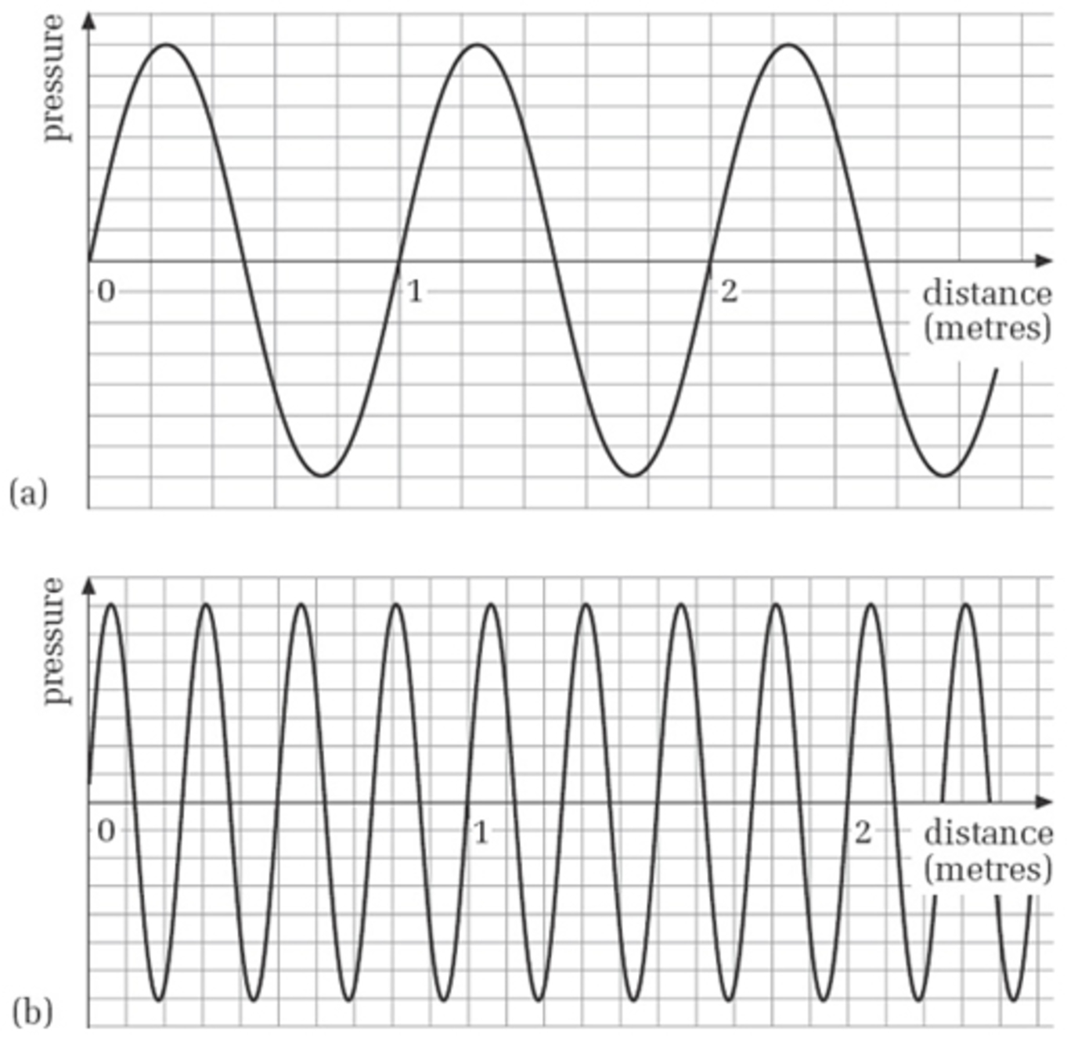
Figure 8 Sine waves for Activity 9

View answer - Activity 9 (Self-Assessment)

Note that in the time it takes a pressure wave to travel a distance equal to one wavelength, the source performs one complete cycle of oscillation. To see why this is so, consider Figure 9(a). The fork is at a particular part of its cycle, and the point X on the pressure wave is adjacent to the fork.

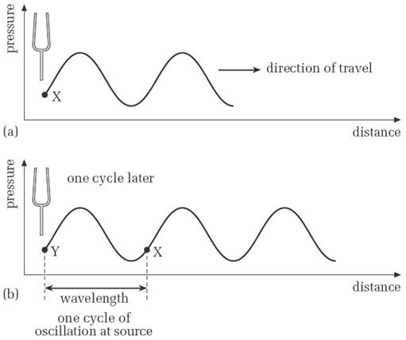
Figure 9 Pressure wave travels one wavelength in one cycle of oscillation

Figure 9(b) shows the situation one cycle later. The prongs of the fork are back at the same part of the cycle as in (a), and the pressure at point Y is at exactly the same part of the cycle of pressure variation as X was. In the meantime, X has travelled away from the fork a distance equal to one wavelength. Thus, in the time it has taken for the source to go through one cycle of oscillation, the wave has travelled a distance equal to one wavelength away from the fork. This is an important point, which I shall return to when we come to look at the speed of sound.

Activity 10 (Self-Assessment)

A particular tuning fork generates pressure waves with a wavelength of 1.5 metres. In the time it takes the tuning fork to perform 200 cycles of vibration, how far does the pressure wave travel?

View answer - Activity 10 (Self-Assessment)

2.6 Pressure variations in one place
So far, when we have been thinking about pressure waves we have visualised a pattern of pressure variations extending through space, and travelling away from the source of the vibration.
I now want to consider how the pressure variations change at one particular place in the vicinity of the tuning fork as time passes. You could think of this as examining how the pressure at your eardrum varies from moment to moment as you listen to a tuning fork's sound, or how the pressure changes at any fixed point in the vicinity of a source or instrument.
We can consider the progress of a wave with respect to time by looking at a pressure wave reaching a detector at a fixed point. At one instant in time a region of high pressure is detected with the arrival of a compression, at the next the detector might detect normal pressure followed then by low pressure. These variations in pressure will occur at regular periodic time intervals, and the plot of pressure versus time would appear as a sine curve with the crests of the wave again corresponding to compressions and the troughs to low pressure regions. In this case the measurement in time from one compression to the next is given by the period of the wave – the time taken for one cycle. The reciprocal of this, that is one over the period, is called the frequency. It is equivalent to the number of cycles per second and has the unit ‘hertz’. We shall be looking at frequency in more detail shortly.
Figure 10(b) shows a graph with a familiar sinusoidal shape.

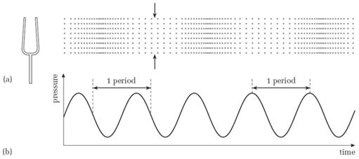
Figure 10 (a) Pressure wave, with one point indicated by arrows. (b) Pressure variations at the point indicated in (a) as time passes
View description - Figure 10 (a) Pressure wave, with one point indicated by arrows. (b) Pressure variations ...

It is important to appreciate the distinction between the graph in Figure 10(b) and the one shown earlier in Figure 6(b). In Figure 6(b), it was as though we could survey the whole of the region in which the tuning fork was audible, and at a particular instant see where the high-pressure regions were and where the low-pressure regions were. In Figure 10 we are focusing our attention on one region of space, such as that between the pair of arrows in Figure 10(a), and observing what happens as time passes rather than at one instant of time. The graph in Figure 10(b) shows the variations of pressure in this region as the wave goes by. It has the familiar sinusoidal shape, but the pressure is shown as a variation with time instead of with distance. (Notice that the horizontal axis now carries the label ‘time’.)
Just as the prongs of the fork cyclically go backwards and forwards, so the pressure at any particular point, such as that indicated by the arrows, cyclically rises and falls. In other words, the pressure variations at any point are periodic, just as the motion of the fork's prongs are periodic. In the time it takes for the prongs to complete one cycle of movement there is one complete cycle of pressure variation (from high to low and back to high again, for instance). Hence, the period of one complete cycle of pressure variation is the same as the period of the tuning fork.
The duration of a cycle (the period) is the time interval between any two corresponding points on consecutive cycles of the pressure wave. Figure 10(b) shows the period marked at two different places on the graph, but there are infinitely many places from which to measure the period of the oscillation.

Activity 11 (Self-Assessment)

What are the periods of the pressure variations represented by the graphs in Figure 11?

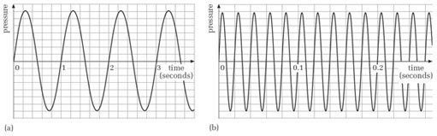
Figure 11 Pressure graphs for Activity 11

View answer - Activity 11 (Self-Assessment)

The period of the waves encountered in music is generally very short. For instance, a typical value might be 0.001 s, or a thousandth of a second. When dealing with such short times as these, it is often more convenient to use the millisecond as the unit of time. One millisecond (1 ms) is a thousandth of a second (or 1 × 10⁻³ s).

2.7 Summary
Pressure in the air is related to how closely packed the molecules are. Other things being equal, more closely packed molecules are at a higher pressure than more dispersed molecules. Sound is associated with fluctuations of the air pressure caused by local disturbance. Fluctuations of pressure travel outwards away from the disturbance, carrying energy imparted by the disturbance.
A simple form of local disturbance to air pressure is a vibrating tuning fork. It generates a pressure wave, consisting of alternating regions of high and low pressure which travel away from the fork. (The molecules in the air oscillate longitudinally, but do not themselves travel away from the source.) Because the pressure wave radiates away from the source, it is known as a travelling wave.
One cycle of oscillation of the tuning fork has a characteristic time (depending on how quickly the prongs oscillate) known as the period of oscillation, symbol T or τ. In a single cycle of the fork's oscillation, one complete high-pressure region and one complete low-pressure region in the pressure wave are produced.
For a pressure wave produced by a tuning fork, a graph of pressure plotted against distance is a sine wave. Sounds with a sinusoidal pressure wave are considered to be pure, neutral or flute-like. A sinusoidal pressure wave has a characteristic distance, known as the wavelength (symbol λ), between adjacent regions of high pressure (or low pressure) in consecutive cycles. The size of the wavelength is determined by the period of oscillation of the source: a quickly vibrating source produces a shorter wavelength than a more slowly vibrating source. The wavelength is also the distance the pressure wave travels in the time it takes the source to complete one cycle.
If we monitor the pressure at a fixed point in the vicinity of a sinusoidally oscillating source and plot the results as a graph of pressure against time, the result is again a sine wave. The period of the pressure variations is the same as that of the source.

3 Frequency

3.1 Frequency and period
In Figure 11 you saw that waveform (b) had a much shorter period than waveform (a). Hence waveform (b) completes more cycles of oscillation in a second than does waveform (a). Waveform (b) is said to have a higher frequency than waveform (a). The frequency of an oscillation (usually represented by the symbol f) is the number of cycles there are in a second. This may or may not be a whole number. For instance, a certain wave might have 25.5 cycles in a second; another might have exactly 100. In either case, though, the number quoted is acceptable as a frequency.
The unit of frequency used to be ‘cycles per second’, which had the merit of being self-explanatory. Nowadays it is given the internationally agreed unit hertz (symbol Hz), named after the German physicist Heinrich Hertz (1857–1894). A typical tuning fork might have a frequency of oscillation of 440 Hz (or 440 hertz), meaning that the prongs perform 440 oscillations every second. For high frequencies the kilohertz is often used as a unit of frequency. One kilohertz (1 kHz) is a thousand hertz. (Larger units than the kilohertz are not required for sound, although they may be used in connection with equipment used in sound technology.)
The frequency of an oscillation is directly related to the period of the oscillation. Suppose a source of pressure waves vibrates at the rate of 100 Hz, that is, 100 cycles per second. It is fairly clear that each cycle must last for one hundredth of a second. Mathematically we express this relationship as:

In symbols

Activity 12 (Self-Assessment)

Figure 11 showed sine waves with periods of 1 second and 0.02 second. What are the frequencies of these waves?

View answer - Activity 12 (Self-Assessment)

3.2 Summary
The number of cycles of oscillation per second, both for a vibrating source and a pressure wave, is known as the frequency, symbol f Frequency is specified in hertz (Hz) or kilohertz (kHz). One hertz is one cycle per second; one kilohertz is one thousand cycles per second. Frequency and period are directly related. Frequency is the reciprocal of period:

4 The speed of sound

4.1 The experimental result
One way to establish the speed of sound is to measure it experimentally. That is, one measures how long the sound takes to travel a known distance, and from this works out the speed. The answer turns out to depend somewhat on the prevailing temperature and humidity. At an air temperature of 14 °C the speed is 340 metres per second and at about 22.5 °C it is 345 metres per second. That is a change of speed of less than 1.5 per cent for an appreciable change of temperature. To a reasonable approximation, therefore, we can regard the speed of sound in air as constant, and a value of 340 metres per second is a good general-purpose approximation to use. You do not need to memorise this number.
Although the speed of sound is fast by everyday standards, it is far from instantaneous. Light, for instance, travels much faster, which is why a flash of distant lightning is always seen before the arrival of the associated thunderclap.
For performers in large spaces the finite speed of sound can have practical implications. For instance, in a cathedral or large church, the reflected sound can arrive back at the performers after a perceptible delay, which can be confusing for them. Also, for spatially distributed groups of performers in antiphonal music (see Box 2), there can be synchronisation problems.

Box 2: Antiphonal music and the speed of sound

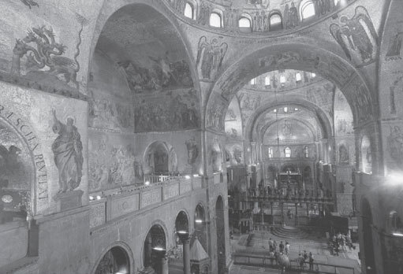
Photo: Robert Harding Picture Library/ Alamy Photo: Robert Harding Picture Library/ Alamy
Figure 12 Interior of St Mark's Cathedral, Venice

At St Mark's Cathedral in Venice (Figure 12) there developed a tradition of performance with groups of performers located in different galleries of the building. Compositions by Andrea Gabrieli (1532/3–1585) and his nephew Giovanni Gabrieli (1554–1612) were specially written to exploit these spatial effects. This type of composition, where performers are grouped in spatially distributed ensembles, is known as antiphonal. The problem of synchronisation suggests that the performers in this kind of music may not have been as widely separated as has often been claimed, as the following indicates:

‘The amount of spatial separation between the choirs of instruments and voices used by composers such as Giovanni Gabrieli has often been overstated. Vocal polychoral pieces a due cori [for two choirs] were generally performed with no spatial separation of the performing forces, but with a division between soloists and ripieno [the rest of the performers]; the total number of singers could be as few as 12. Some of the most extravagant late 16th-century performances saw one group in each of the organ lofts, situated on either side of the altar, and a third group on a specially built temporary stage on the main floor of the church, not far from the main altar.’

(New Grove Dictionary of Music and Musicians, second edition, Macmillan, 2001, ‘Venice’)

Activity 13 (Self-Assessment)

Suppose two groups of performers, A and B, are 34 metres apart. Group B synchronises itself to the sounds it hears from Group A.
To the members of Group A, does Group B appear to be synchronised with Group A? If not, what is the apparent discrepancy (in seconds)? Take the speed of sound to be 340 metres per second.

View answer - Activity 13 (Self-Assessment)

A delay of 0.2 second, as in the last activity, is not insignificant, as you can hear in the following activity.

Activity 14 (Listening)

Listen to the audio track below. The audio begins on one of the stereo channels. After a few seconds, you will hear a duplicated version of the audio enter on the other channel, but this version is delayed by 0.2 second relative to the first.
Click 'Play' to listen to Audio Clip

Audio content is not available in this format.

One way to bring two spatially separated groups of performers into synchrony is to have them take their cue from a conductor placed midway between them. To the conductor and to listeners midway between the groups, the performers will be synchronised. To each of groups A and B, however, the other group appears to lag.

Activity 15 (Listening)

Now listen to the sample of the music of Giovanni Gabrieli. It is his Canzona No. 13 from the Sacrae Symphoniae of 1597.
Click 'Play' to listen to Audio Clip

Audio content is not available in this format.

4.2 Frequency, wavelength and the speed of sound
The speed of sound has a joint relationship with both the wavelength and the frequency of the sound. To see why, recall that at the end of Section 2.5, in connection with the wave produced by a tuning fork, I said ‘in the time it has taken for the source to go through one cycle of oscillation, the wave has travelled a distance equal to one wavelength …’.
The time taken for the source to perform one cycle of oscillation is its period T. So, in one period of oscillation, the wave travels a distance λ. To determine the speed of the wave, we need to know how far it travels in a second, rather than in one period. In a second there are f cycles of oscillation, where f is the frequency, so in one second the wave travels f times as far as it travels during just a single cycle of oscillation. Thus:
speed = frequency × wavelength
Or, if we let the speed be represented by v:

This can be restated in two other ways:

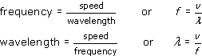

Note that when using these equations in calculations, it is necessary to specify wavelengths in metres and frequencies in hertz (rather than kilohertz or megahertz) in order to be consistent with a speed expressed in metres per second.

Activity 16 (Self-Assessment)

A tuning fork has a frequency of 384 Hz. Is the wavelength of the sound it produces greater than 1 metre or less than 1 metre? Take the speed of sound to be 340 metres per second. No calculator is needed.

View answer - Activity 16 (Self-Assessment)

The relationship v = f × λ might seem to suggest that the speed of a sound is dependent in some way on its frequency or its wavelength. But experiments show the speed to be constant (more or less). The correct interpretation of this relationship is that frequency and wavelength are inversely proportional to each other. This is what we would expect, because a tuning fork that vibrates more quickly creates high-pressure regions (and low-pressure regions) at a greater rate. The speed at which the pressure wave travels is fixed, so the regions of high (or low) pressure must pack more closely together. The equation v = f × λ shows that if one of for λ is doubled, the other must halve so that the product f × λ remains unchanged; if one is tripled, the other must reduce to a third of its former value; and so on.

4.3 Summary
The speed of sound in air, symbol v, is approximately constant at 340 metres per second. (You do not need to memorise this value.) As temperature increases, the speed increases slightly.
Speed, frequency and wavelength are related by the formula v = f × λ. Other forms of this relationship are f = v/λ and λ = v/f. Because the speed is approximately constant, it follows that frequency and wavelength are inversely proportional: doubling the frequency halves the wavelength, etc.

5 Phase

5.1 Phase and phase difference
In this section I am considering sine waves that have the same frequency, but are out of step with each other.
Suppose we have two detectors at fixed points, A and B. At this moment in time A is in a high pressure region and B in a low pressure region. If we were to look again shortly later B would now in a high pressure region and A in a low pressure region. The pressures at A and B would be out of step with each other. The pressure variation at B is not in phase with that at A. The exception is when A and B are an exact number of wavelengths apart, in this case the pressure variations at A and B are in phase.
Figure 13 shows how the pressure varies with time near the tuning fork (Figure 13 (a)) and at a distance (Figure 13(b)).

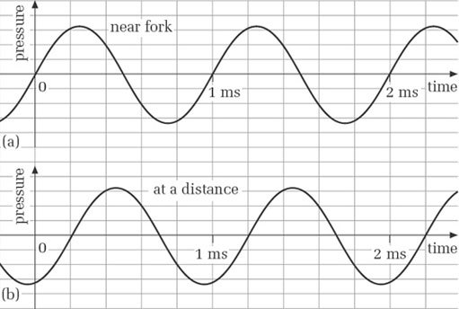
Figure 13 Pressure variations (a) near the tuning fork and (b) at a distance

Although the two graphs have the same frequency, they are not in step. At any given moment, each is at a different part of its cycle. For example, if you look at the 1 ms point on each graph you can see that the curves are at different parts of a cycle.
We use the word phase to refer to the part of a cycle that a particular vibrating system is in at any moment. In practice we are often less concerned with the phase of a single wave than with the phase difference between two (or more) waves having the same frequency. (The stipulation ‘having the same frequency’ is necessary because we cannot really speak of a fixed phase difference between sine waves with different frequencies.) Another way of saying that there is a phase difference between two sine waves is to say that they are out of phase. When the waves have the same phase, they are said to be in phase.
In Figure 13, on each graph's horizontal axis events to the right are happening later than events to the left. Thus, because the first peak in (b) is to the right of the first peak in (a), we say that the pressure variations in (b) are lagging in phase behind those in (a). Alternatively, we can say that the pressure variations in (a) are leading in phase those in (b).

Activity 17 (Self-Assessment)

By how many milliseconds does Figure 13(b) lag behind Figure 13(a)?

View answer - Activity 17 (Self-Assessment)

In the last activity there was a phase difference of 0.2 ms, but phase differences are not always expressed in units of time. Instead, a phase difference is commonly expressed quantitatively in one of the following two ways:
- (a) as a fraction of a cycle
- (b) as an angle.
The first of these is fairly straightforward, as the following activity demonstrates.

Activity 18 (Self-Assessment)

In Figure 13, by what fraction of a cycle does (b) lag (a)?

View answer - Activity 18 (Self-Assessment)

Expressing a phase difference as an angle depends on the fact that in a periodic wave, every cycle is identical to every other, and we can regard one cycle as being like a complete rotation round a circle: 360 degrees. After one cycle, we are back at the part of the cycle where we began. After half a cycle we are halfway to the part of the cycle where we began.
The phase difference in Figure 13 was calculated in Activity 17 to be a fifth of a cycle. To express this as a phase difference in degrees we simply calculate a fifth of 360 degrees, because one cycle corresponds to 360 degrees. The answer is 72 degrees.
If the phase lag were increased continuously beyond 72 degrees, it would eventually reach 360 degrees, which would bring the two sine waves back into phase again. If the phase difference continued to increase, the waves would next be in phase at 720 degrees, and so on.

5.2 Cancellation and reinforcement
I have shown that a phase difference between two points in space arises as a natural consequence of the finite time it takes a pressure wave to travel between two points in space. This is not the only way in which a phase difference can arise. A phase difference can arise between two sine waves if one is delayed relative to the other. Also, almost any form of electronic sound-processing equipment affects the phase of the signal it is processing, so that what comes out is not in phase with what goes in. This applies to common pieces of equipment such as amplifiers, filters, mixing desks, and so on, as well as recording equipment and effects units. The extent to which such shifts of phase are audible is contentious, but experiments suggest that a varying phase shift can be audible, whereas an unchanging one is inaudible.
One of the reasons for being interested in phase arises from the consequences of mixing, or adding, two sine waves that are phase-shifted relative to each other. Figure 14 shows two sine waves that are completely out of phase.

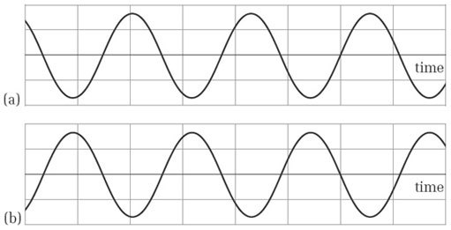
Figure 14 Out-of-phase sine waves

Activity 19 (Self-Assessment)

What is the phase difference between these waves in degrees?

View answer - Activity 19 (Self-Assessment)

The consequence of adding or mixing two sine waves that are 180° out of phase is complete cancellation of one wave by the other. This is the basis of a noise-reduction technique sometimes used in noisy environments: an out-of-phase version of the noise is played through amplifiers and loudspeakers into the noisy environment, causing cancellation and thus elimination of the noise. (Incidentally, the term ‘out of phase’ is used here to mean ‘180° out of phase’ rather than just ‘not in phase’.)
When two sine waves are in phase, there is mutual reinforcement. For instance, in Figure 15 sine waves (a) and (b) are in phase. When they are added or mixed the result is (c). Note that (c) is a sine wave with the same period (and hence the same frequency) as (a) and (b).

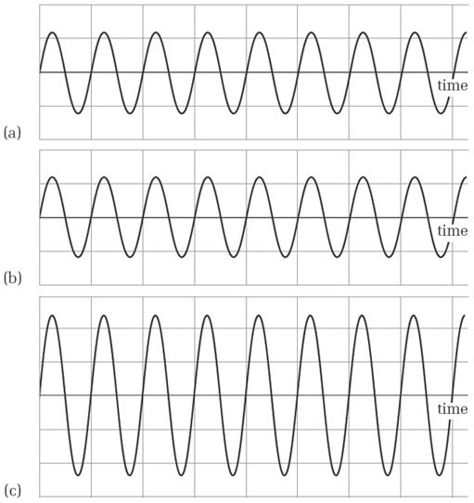
Figure 15 In-phase sine waves, (a) and (b), produce maximum reinforcement when added, (c)

Intermediate amounts of phase shift, between completely in phase and completely out of phase, produce intermediate amounts of cancellation or adding. However, the result is always a sine wave with the same frequency as the waves being combined. The term interference is sometimes used to describe an interaction between two or more sine waves leading to reinforcement or cancellation.
Reinforcement and cancellation of musical sound through phase shifting is exploited in the effect known as phasing or flanging. In the original version of this effect, first used in the 1960s, a piece of music was mixed with a slightly delayed version of itself. This led to selective cancelling and reinforcement throughout the spectrum of frequencies in the music. If the amount of delay is varied the result is a very characteristic sound used in popular music. Nowadays the effect is usually created electronically, rather than by mixing a delayed version with the original sound.

Activity 20 (Listening)

Listen to the audio track below, which illustrates the effect of flanging (or phasing).
Click 'Play' to listen to Audio Clip (30 seconds)

Audio content is not available in this format.

Other instances of the effects of phase shifting in sound technology are too numerous to list, but one that you are sure to have heard is the ear-splitting whistling produced by (for instance) public address systems when the volume is too high and the microphone picks up sound from the loudspeaker. Here, at one particular frequency, there is an exact phase shift of 360 degrees between the microphone and sounds returning to the microphone from the loudspeaker. There is thus reinforcement, and under the right conditions a sine wave with a continually growing volume is produced at that particular frequency.

5.3 Summary
The term phase is used to refer to the part of a cycle that an oscillating system is in at a particular moment. For two sine waves of the same frequency that are not in step, one wave lags or leads the other in time. We can express the amount by which they are out of step as a phase difference. Usually phase difference is expressed as a fraction of a cycle or as a certain number of degrees (one complete cycle corresponding to 360°).
If two (or more) sine waves are completely out of phase (a phase difference of 180° or odd multiples thereof), there is complete cancellation when the waves are combined by adding. If the sine waves are completely in phase (a phase difference of 0°, 360° or multiples thereof), there is complete reinforcement. When the phase difference lies between these extremes, there is partial reinforcement or partial cancellation. The result, however, is always a sine wave of the same frequency as the ones being combined.

6 Amplitude

6.1 Defining amplitude
Another important property of a sine wave we need to be able to specify is its amplitude. In essence, the amplitude of a sine wave is its size. Unfortunately there are various ways of defining what is meant by the size of a sine wave, and you are likely to come across many of them in material you look at outside this unit. Before I explain what our definition is, it will help matters if we look at what is meant by the average value of a sine wave.
Figure 16 shows a sinusoidally alternating voltage. The curve is symmetrical around the time axis, which is also the line of zero voltage. The average value of this sine wave over many cycles is therefore zero.

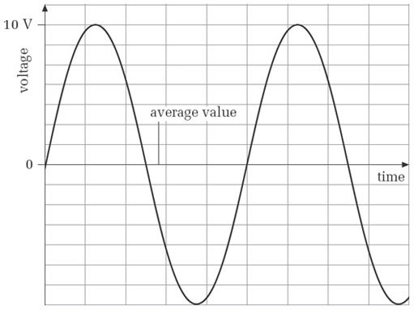
Figure 16 Average value of a sine wave is midway between the peaks and troughs

All sine waves are symmetrical around a line running through the middle, midway between the peaks and troughs of the wave. However, it does not follow that all sine waves have an average value of zero. Look at Figure 17. This is an exaggerated graph of a sinusoidal pressure variation in the air.

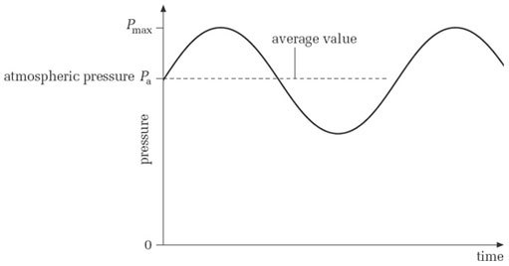
Figure 17 Exaggerated graph of a sinusoidal pressure variation in air: the average value here is not zero

Once again, the average value over many cycles runs midway between the peaks and troughs, but now its value is not zero. The average value is the prevailing atmospheric pressure.
A standard way of defining the amplitude of a sine wave is in terms of its maximum departure from its average value. To see what this means, look at Figure 18.

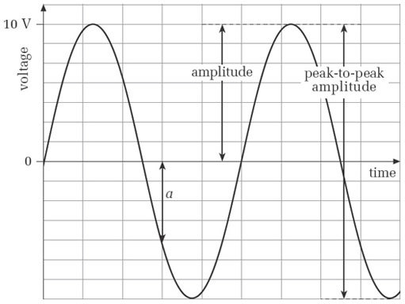
Figure 18 Amplitude for a sine wave of zero average value

The amplitude is the height of the peak relative to the average value. In this case, because the average value is zero, the amplitude is just the peak value of the sine wave, namely 10 volts. However, in Figure 19 the amplitude is not simply the peak value.

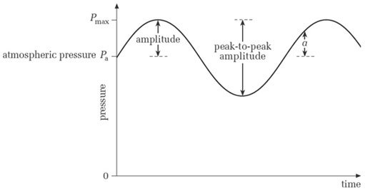
Figure 19 Amplitude for a sine wave of non-zero average value

Here, because the sine wave does not have an average value of zero, the amplitude is the difference between the peak value and the average value, that is, P_{max} − P_{a}.
In general, the amplitude of a sine wave is the maximum deviation of the sine wave from its average value. In other words, it is the difference between its peak value and its average value. Another way to express this is half the height of the wave from peak to peak.
Sometimes the peak-to-peak height itself is used as a measure of a sine wave's size, because it is easy to read from graphical displays. Such a reading is invariably referred to as the peak-to-peak amplitude, and is twice the amplitude as defined above. It is marked on Figures 18 and 19.
Some authors give a rather different definition of the word ‘amplitude’ from the one given above. For them, the moment-by-moment deviation of a sine wave from its average value is its amplitude. In this usage, the amplitude is constantly changing, and can be specified only at a particular moment. In Figures 18 and 19, a marks an amplitude according to this particular usage. Although we shall not be adopting this usage in this unit, you can expect to encounter it if you look at other books on the subject.
Earlier in this unit, in Figures 6 and 7, you saw graphs representing sound waves travelling away from a source. The amplitudes of the sine waves were constant. In reality the amplitude of a sound wave must decrease with distance from the source. Figure 20 shows how amplitude can decay with distance from a source.

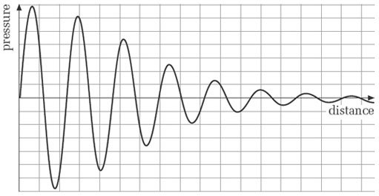
Figure 20 Decaying amplitude of a sound wave

6.2 Practical units of amplitude
The amplitude of a sine wave is measured in whatever units are used to calibrate the vertical axis, as you saw in connection with Figures 18 and 19. Nearly all the graphs you have seen so far in this unit have had pressure plotted up this axis. You may know that the unit of pressure is the pascal (symbol Pa), but this is a large unit. A more appropriate unit in relation to sound pressure variations is the micropascal (symbol μPa), which is a millionth of a pascal. Another unit often used in connection with sound is the decibel. This is a very different kind of unit from the pascal, and merits a section to itself. I shall return to it at the end of the unit.
Because in music technology we are often dealing with electrical representations of sound, the volt is another common unit for amplitude. As electrical signals can be quite small, the millivolt (symbol mV), which is a thousandth of a volt, and the microvolt (μV), which is a millionth of a volt, are often used.

Activity 21 (Self-Assessment)

What are the amplitudes of the sine waves in Figure 21?

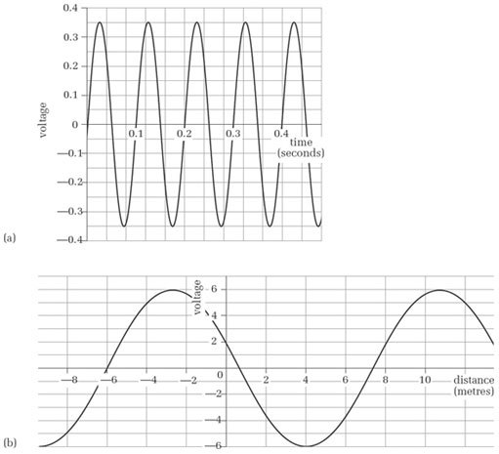
Figure 21 Sine waves for Activity 21

View answer - Activity 21 (Self-Assessment)

6.3 Root-mean-square amplitude
One drawback of the amplitude as I have defined it is that although it allows the relative sizes of sine waves to be compared, it does not give a good idea of what a sine wave can deliver in absolute terms. For instance, a sine wave with an amplitude of 10 volts has twice the amplitude of one with an amplitude of 5 volts. But is a power source that delivers a sine wave with an amplitude of 10 volts as powerful as, say, a 10 volt battery? Could you use it to drive a bulb and get the same illumination? The answer is ‘no’, and the discrepancy is due to the fluctuating nature of the sine wave, which for most of each cycle is well below its maximum value. It is thus often useful to specify the magnitude of a sine wave in a way that facilitates direct comparison with a non-oscillatory source of energy. One benefit of this is that it enables us to say how big a non-oscillatory source would be needed to deliver the same energy as the sine wave delivers in a particular length of time.
A tempting solution might simply be to use the average value of the sine wave over several cycles, but this turns out not to be useful. For instance, the average value of the sine wave in Figure 16 is zero, but this sine wave would certainly be capable of transferring energy.
The solution to the problem is found in the concept of the root-mean-square amplitude (r.m.s. amplitude) of a sine wave, which is mainly used in the context of electrical sine waves. You can think of this as an alternative way of specifying how big a sine wave is, but with the advantage of allowing direct comparison with a non-oscillating source of energy. The root mean square is a kind of average, but it is derived by calculating the average power of a sine wave.
The root-mean-square amplitude of a sine wave is its amplitude multiplied by a factor of approximately 0.71. (The actual value is , which to five decimal places is 0.70711.) Thus, a sine wave with an amplitude of 10 volts has an r.m.s. amplitude of (approximately) 0.71 ×10 volts, which is 7.1 volts. It therefore conveys energy at the same rate as a steady 7.1 volt source, other things being equal. The r.m.s. amplitude of a sine wave is proportional to the amplitude as I defined it earlier. Doubling one doubles the other; tripling one triples the other; and so on.

Activity 22 (Self-Assessment)

A sine wave has a peak-to-peak amplitude of 2 volts.
- (a) What is its amplitude?
- (b) What is its r.m.s. amplitude?
- (c) What steady source of voltage (e.g. a battery) would deliver energy at the same rate, other things being equal?

View answer - Activity 22 (Self-Assessment)

6.4 Summary
Amplitude refers to the size of a sine wave. It can be defined in various ways, but a standard definition is that it is the maximum value of a wave's departure from its average value. (The average value of a sine wave lies midway between its peaks and troughs.) The size of a sine wave is sometimes also expressed as a peak-to-peak amplitude, which is the vertical distance from peak to trough.
Root-mean-square (r.m.s.) amplitude is a way of specifying the size of a sine wave so that comparisons can more easily be made with steady, non-oscillating sources. The r.m.s. amplitude is the amplitude as defined above multiplied by approximately 0.71 (you do not need to memorise this figure). A steady source equal in value to the r.m.s. amplitude of an oscillating source supplies energy at the same rate as the oscillatory source, other things being equal. Root-mean-square amplitudes are often met in electrical contexts.

7 Pitch and loudness

7.1 The subjective experience
Two of the properties of sound that we have examined from an objective stance, frequency and amplitude, have a fundamental importance to our appreciation of sound and music. In this section I want to look more closely at the subjective interpretation of these two properties of sound. I should stress that I am talking about sine-wave sounds in this section. The complex, non-sinusoidal sounds encountered in music add extra layers of complexity to the relationships I am discussing here.
Keeping the frequency of a sine wave constant and varying the amplitude changes the loudness: the bigger the amplitude, the louder the sound.
The effect of changing the frequency of a sine wave is rather harder to pin down. Changing the frequency changes the pitch; you might say that the sound becomes higher or lower.
To summarise this message:
- Loudness is the subjective property of sound that is heard to change when the amplitude is changed while the frequency is held constant.
- Pitch is the subjective property of sound that is heard to change when the frequency is changed while the amplitude is held constant.
Generally, pitch is felt to exist on a continuum from low to high. Low pitches are associated with low frequencies, and high pitches are associated with high frequencies. However, although pitch is experienced as being on a continuum, for musical purposes a series of more-or-less fixed points on the continuum is usually defined. These are the pitches to which we give letter names, such as A, B, B, and so on.
These apparently simple correspondences between amplitude and loudness, and between frequency and pitch, are complicated by a number of factors. One of these is the uneven response of the hearing system. The human ear is not equally sensitive to all frequencies within the range of human hearing, being most sensitive at around 4 kHz. Changing the frequency of a sine wave, particularly over a wide range, while holding the amplitude constant can result in a change of loudness. It is also true that changing the amplitude of a sound while holding the frequency constant can result in a slight shift of pitch. Nevertheless, it is broadly true that we experience changes of amplitude as changes of loudness, and changes of frequency as changes of pitch.
Another factor that complicates the relationship between the objective and subjective properties of sound is the way the ear judges changes of amplitude. This is something I shall return to when I discuss decibels.
Does reducing the amplitude of a sound by half mean that the sound is half as loud? This question is concerned with the subjective interpretation of amplitude, so there is no hard-and-fast answer that everyone is sure to agree with. In fact, you may have find the concept of halving the loudness of a sound to be almost meaningless. Nevertheless, most people find that halving the amplitude does not halve the loudness. Usually a bigger reduction is required to give the impression of a halving of loudness. Another way to express this is to say that the amplitude must be more than doubled to give the impression of a doubling of loudness.
We shall return to the relationship between amplitude and loudness when we look at decibels later in this unit.
The correspondence between frequency and pitch, though not exact, is sufficiently close for us to use frequency to define the pitches used in music. For example, in the pitch standard known as concert pitch, the pitch of the note A above the note middle C (Figure 22) is set at 440 Hz (A₄).

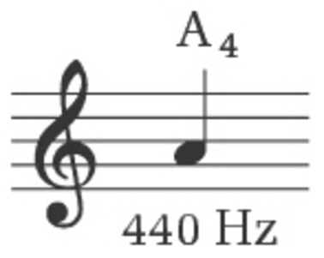
Figure 22 Frequency of A₄ in concert pitch

Other pitch standards are in use, particularly for the performance of older music, and even concert pitch is not universally used by contemporary performers.

Activity 23 (Self-Assessment).

Two of the following statements are true and one is false. Find the true and false statements.
- (a) If two equal-amplitude sine waves A and B are exactly in phase, the result of adding them will sound twice as loud as A or B by itself.
- (b) Reducing the amplitude of a sine wave always reduces its loudness if the frequency is held constant.
- (c) A sound of a particular amplitude may be audible at about 4 kHz, but inaudible at 1 kHz.

View answer - Activity 23 (Self-Assessment).

7.2 Summary
Pitch and loudness are subjective properties of sound. Pitch is closely correlated with frequency, and loudness is closely correlated with amplitude. However, under certain circumstances, slight changes of pitch can be created by changes of amplitude, and changes of loudness can be created by changes of frequency. The ear's uneven response is part of the explanation for these latter phenomena. In the pitch standard known as concert pitch, the note A₄ (the A above middle C) is set to a frequency of 440 Hz.

8 The octave

8.1 The octave sound
One feature of pitch that seems to be universal to all cultures is that for musical purposes the pitch range is divided into discrete steps: for instance, the notes of a scale. This is not to say that musicians rigidly adhere to those steps when they play, but the existence of such steps is fundamental to the way music is conceived and organised. Different cultures have different ways of defining the steps in their scale of pitches, but nearly all cultures take the octave as their starting point. It has a very characteristic sound, and it corresponds precisely to a particular relationship of frequencies.

Activity 24 (Optional)

If you have access to a keyboard, play middle C (C₄) and the C one octave above it (C₅). Figure 23 is a reminder of the notes you need to play. Play them one after the other (in either order), Listening carefully to the sound of the two notes. You know that in musical terms these two notes are an octave apart, but can you describe the relationship between the two pitches?

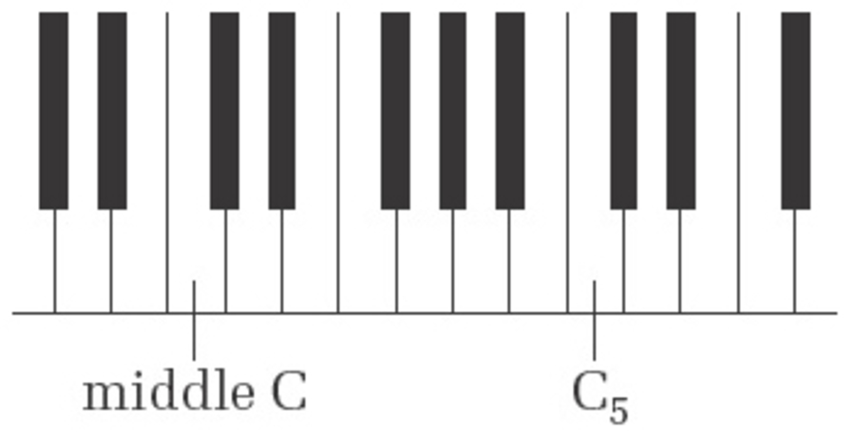
Figure 23 Section of keyboard for Activity 24

View discussion - Activity 24 (Optional)

As you know, the two pitches played in the last activity are an octave apart − C₅ is an octave above middle C (C₄). The eighth note to the right of C₅ is another C (C₆), and is two octaves above middle C. Similarly, the eighth note to the left of middle C is an octave below middle C and is the note C₃.
Sine waves whose pitches are an octave apart have frequencies in the ratio 2:1. That is, the higher pitch has a frequency that is twice that of the pitch below it. Alternatively, the lower pitch has a frequency that is half that of the pitch an octave above.

Activity 25 (Self-Assessment)

The note A₄ has a frequency of 440 Hz in concert pitch. What is the frequency of the note A₇?

View answer - Activity 25 (Self-Assessment)

We saw earlier that doubling the frequency of a sine wave corresponds to a halving of its wavelength. This follows directly from the relationship v = f × λ. Thus a sine wave that is an octave above another sine wave has half its wavelength.

8.2 Octave pitch and frequency increments
Because a doubling of frequency corresponds to an octave increase of pitch, it follows that there is no constant increment of frequency that always corresponds to a one-octave increment of pitch. That is to say, there is no fixed amount by which a frequency can be augmented that will always produce a one-octave pitch rise.
For instance, starting at the pitch A₄ with a frequency of 440 Hz, we need to augment the frequency by 440 Hz to get the pitch one octave above (880 Hz). But a further augmentation of 440 Hz does not take us to the next A. We need an augmentation of 880 Hz to reach the next A. Clearly the frequency steps get bigger as the frequency (and pitch) get higher. In Figure 24, the horizontal axis shows a series of As an octave apart. Notice that they are equally spaced, corresponding to the equal pitch step of one octave between each. The vertical axis shows the frequency corresponding to each pitch. Notice that these frequencies are not equally spaced.

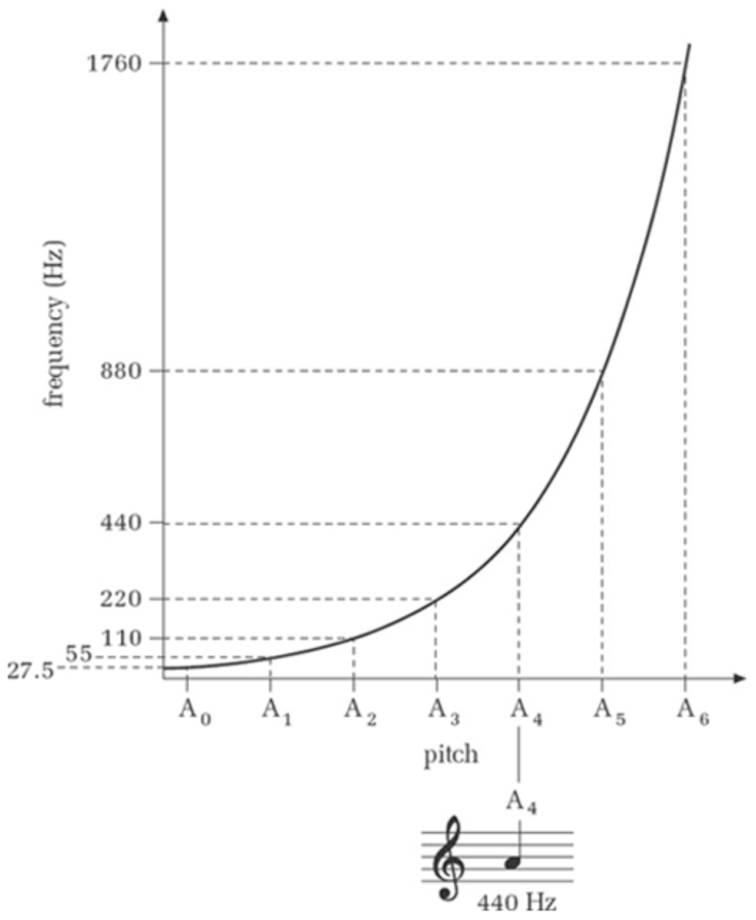
Figure 24 Pitch/frequency graph

The same effect is found with any pair of pitches as we move up through the frequency range. For instance, the step from any C to the G above is five white notes on a piano keyboard, irrespective of whether you play it at the top end of the keyboard or at the bottom. In terms of named musical pitches, therefore, the step is always the same size: five notes. The size of the frequency step, however, is not at all constant, being much wider at the upper end of the keyboard than at the lower. What is constant is the ratio of the frequencies, being 1.5:1 for G and C (that is, the frequency of G is 1.5 times that of the first C below it, whatever the region of the keyboard). Similarly, the frequency step for a single tone, from C to the D above it for example, is not a fixed amount and varies from octave to octave; but the ratio of their frequencies is always the same. It is generally true that equal increments of musical pitch correspond to equal ratios of frequency, not equal increments of frequency.
You will have noticed that I have used the subscript convention for octave ranges. However, there are a number of alternative conventions in use that you may come across outside this unit. As a reminder, Box 3 restates the subscript convention, but also mentions two other systems.

Box 3: Typographical notations for octave ranges
Several typographical systems have been devised for indicating the octave range in which a particular pitch is situated. A common convention, and the one used in the course, uses numerical subscripts. In this convention, each new octave is regarded as starting on C and ending on the B above, and the lowest range is given the subscript 0. Figure 25 shows a keyboard and a notational representation of this convention.

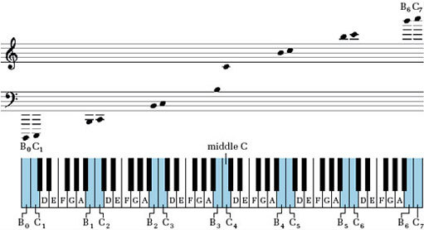
Figure 25 Subscript system for indicating pitch regions

Another system you might come across is the so-called Helmholtz system. In this system C″ stands for C₀, C′ for C₁, C for C₂, c for C₃, c′ for C₄, c″ for C₅, etc.
Yet another system uses CCCC for C₀, CCC for C₁, CC for C₂, C for C₃, c for C₄, c′ for C₅, c″ for C₆, etc.

Activity 26 (Self-Assessment)

Suppose the keys on a piano keyboard were spaced in proportion to their frequency.
- (a) At which end of the keyboard would the keys be closer together?
- (b) On a four-octave keyboard where the bottom octave occupied 20 centimetres, what would be the total width of the keyboard?

View answer - Activity 26 (Self-Assessment)

8.3 Summary
A fundamental musical and acoustical relationship is the octave. Pitches that are one or more octaves apart are heard musically as different instances of the same sound. A one-octave increase in pitch corresponds to a doubling of frequency.
For musical purposes, a pitch range of one octave is divided into discrete steps, known as scales, the individual pitches of which are given letter names (A, A, B, etc.). The pattern of pitches in a scale is repeated in other octave ranges, as can be seen on a piano keyboard, and pitches that are one or more octaves apart share the same musical letter name. Subscripts are sometimes added to the letter name to distinguish different pitches that share the same name, for instance A₁, A₂, A₃, etc.
Equal separation of pitch does not correspond to equal separation of frequency. For instance, the pitch step from A₄ to B₄ is the same as the pitch step from A₅ to B₅, but the frequency step is different. However, the ratio of the frequencies in each step is the same.

9 The ranges of human hearing

9.1 Frequency range
The lowest frequency humans can hear is approximately 20 Hz. The upper limit for humans is nominally 20 000 Hz (20 kHz), but this limit tends to decline with age, and for most of us it is well below this figure.

Activity 27 (Self-Assessment)

Taking the upper limit of frequency as 20 kHz, how many octaves span the range of human hearing?

View answer - Activity 27 (Self-Assessment)

Activity 28 (Self-Assessment)

With age, your upper limit might drop from 20 kHz to 10 kHz. How many octaves have you lost?

View answer - Activity 28 (Self-Assessment)

Although human hearing covers a range of, say, ten octaves at best, seven of these octaves cover the bottom eighth of the range, from 20 Hz up to 2500 Hz, which corresponds roughly to the pitch range from E₀ to E₇ (Figure 26). As far as music is concerned, this is where the action is concentrated. Of the standard acoustic instruments, only the piano, harp and piccolo go higher than E₇, and those not by very much.
At the lower end of the musical pitch range, the bottom note on a double bass or bass guitar, E₁, has a frequency of just over 40 Hz. Not many instruments can go below this – the main ones are the harp, piano, double bassoon and organ. (The keyboard in Figure 26 is extended below the limit of a normal piano keyboard.)

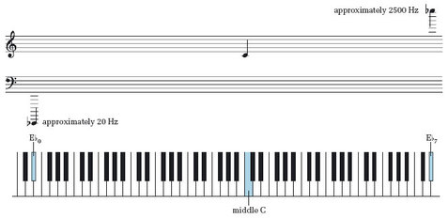
Figure 26 Range of musical pitch

To say that musical instruments rarely produce pitches above E₇ is not the same as saying that they rarely produce frequencies above 2500 Hz. The sounds produced by virtually all instruments are not pure sine waves. Instead, they are more or less complex mixtures of sine waves, covering a range of frequencies above the one that corresponds to the pitch being played. The important point to bear in mind is that the mixture of frequencies associated with a single musical pitch can extend well above the frequency corresponding to the pitch that is heard. The presence of these additional frequencies (sometimes called overtones, partials or harmonics) is partly what gives individual instruments their particular timbre.

Activity 29 (Self-Assessment)

The ear is at its most sensitive around 4 kHz. Is this within the range occupied by the pitches mainly used in music?

View answer - Activity 29 (Self-Assessment)

9.2 Dynamic range
The quietest sound we can hear corresponds to a pressure wave with an amplitude of about 10 μPa, which is a very small pressure amplitude indeed. It is about 0.000 000 01 per cent of nominal atmospheric pressure, and the resultant displacement of the eardrum is less than a tenth of the diameter of a hydrogen molecule.
At the upper end of the scale, a sound that is distressingly loud might typically correspond to a pressure wave with an amplitude of 0.01 per cent of nominal atmospheric pressure or more. (Atmospheric pressure itself varies from day to day, which is why I refer to a ‘nominal’ value of atmospheric pressure.) We call a range of sound amplitudes such as this a dynamic range. From the figures given here, it is clear that the loudest sounds we encounter can have an amplitude more than a million times greater than the quietest.
The size of the human dynamic range comes as a surprise to many people. Loud sounds, subjectively, do not seem to exceed quiet ones by a factor of a million. The reason for this relates to the non-proportional relationship between amplitude and loudness that we met in Section 6. With quiet sounds, we readily notice a small increase in the amplitude. For instance, two bicycle bells ringing sound distinctly louder than one. But if the same increase is made to a louder sound (for instance, 11 bicycle bells instead of 10), the change is not so noticeable. Research into the perception of sound indicates that instead of hearing equal increments of amplitude as equal increments of loudness, we hear equal multiples of amplitude as equal increments. For instance, successive doublings of the amplitude of a sound are generally perceived as equal increments of loudness. This is somewhat akin to the way we hear successive doublings of frequency as equal increments of pitch.

Activity 30 (Listening, Exploratory)

Listen to the audio below.
- (a) In the first part, you hear a quiet sine wave that grows in amplitude by successive doublings and then decreases by successive halvings. Does the loudness seem to change by the same amount each time?
- (b) In the second part, you hear the sine wave grow in amplitude by equal increments and then decrease by equal decrements. Does the loudness seem to change by the same amount each time?
Click 'Play' to listen to Audio Clip

Audio content is not available in this format.

View discussion - Activity 30 (Listening, Exploratory)

9.3 Summary
The nominal frequency range of human hearing is 20 Hz to 20 kHz, though most people cannot hear to 20 kHz. However, the pitches used in music correspond roughly to frequencies in the range from 20 Hz to 2.5 kHz. Generally, musical tones are not pure sine waves but are mixtures of sine waves with frequencies that can extend well beyond 2.5 kHz. However, although they are mixtures of sine waves, they are usually heard as having a single pitch.
The dynamic range of human hearing refers to the range of amplitudes the ear can cope with. It covers a range of more than 1 000 000:1. Equal increments of amplitude are not heard as equal increments of loudness.

10 The decibel

10.1 Introduction
For a variety of reasons, not least the very wide dynamic range of human hearing, the decibel (symbol dB) is often used as a unit for the amplitude of sound waves. The decibel is also used in other contexts, such as specifying the amplification of amplifiers or the degree to which a signal is affected by noise. In the context of sound, the use of the decibel as a unit captures something of the subjective impression of the way loudness changes with amplitude.
The decibel unit has two rather unusual properties in comparison with other more conventional units you have probably met, such as the metre or the second:
- It indicates a ratio, rather than an absolute value. Thus the decibel can be used as a way of comparing one amplitude with another.
- Equal decibel increments correspond to equal multiplications of ratio.
Because the decibel expresses a ratio rather than an absolute value, it cannot by itself specify the absolute amplitude of a sound. I shall explain shortly how it can be adapted for the expression of absolute values, but first I want to pursue the second feature I listed above, namely that equal decibel increments correspond to equal multiplications of ratio. I want to do this in the context of ratios of amplitude.
Figure 27 relates ratios to their decibel equivalents, and Table 1 does the same thing for a few discrete values.

Table 1 Amplitude ratios for selected decibel values
Decibels | Amplitude ratio
−12 | 0.25:1
−6 | 0.5:1
0 | 1:1
6 | 2:1
12 | 4:1
18 | 8:1
20 | 10:1
24 | 16:1
30 | 32:1
36 | 64:1
40 | 100:1
60 | 1000:1

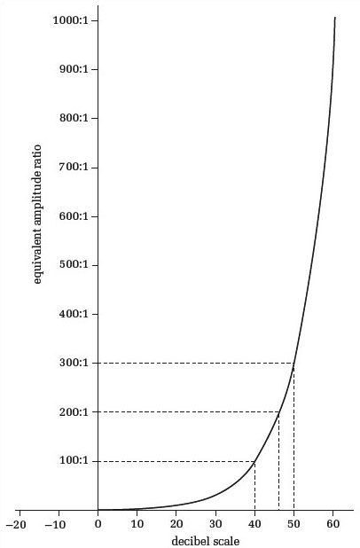
Figure 27 Relationship of amplitude ratios to decibels

One thing that is immediately clear from Figure 27 is the exponential relationship between decibels and their equivalent amplitude ratios. For instance, the graph shows that an amplitude ratio of 100:1 has a decibel equivalent of 40 decibels, but an amplitude ratio that is twice as big (200:1) does not have 80 decibels as its decibel equivalent. In fact its decibel equivalent is about 46 decibels. A proportional relationship between decibels and their corresponding amplitude ratios would have a straight-line graph. Notice also (from Table 1) that 0 dB corresponds to a ratio of 1:1, and that for ratios between 1:1 and 0:1 the decibel equivalent has a negative value.
In the first part of the audio track for Activity 30 you heard a sound clip that doubled in amplitude at each reappearance. However, the sound appeared to be getting louder by an equal amount each time. What does a doubling of amplitude look like when measured in decibels? Let's say that the starting amplitude of the sound was 1 unit on a convenient scale of pressure or voltage. In Table 2 the first column shows the successive amplitudes of the waves that you heard in terms of this unit. Notice that in each line of the table the amplitude is twice that in the line above.

Table 2 Amplitude ratios and decibel equivalents
Amplitude | Amplitude ratio | Decibel equivalents
1 unit | 1:1 | 0 dB
2 units | 2:1 | 6 dB
4 units | 4:1 | 12 dB
8 units | 8:1 | 18 dB
16 units | 16:1 | 24 dB

The second column gives these amplitudes as a ratio of the starting amplitude in the first line. The third column expresses these ratios in decibels, using data from Table 1.

Activity 31 (Exploratory)

How do the values in the decibel column of Table 2 increase from line to line?

View discussion - Activity 31 (Exploratory)

The equality of the decibel increment you saw in the last activity therefore matches our subjective sense of equal increments of loudness when the amplitude is multiplied by a constant factor (2 in this case).

10.2 Adding decibels
A feature of decibels is that adding two decibel values is equivalent to multiplying the ratios they represent. To see how this comes about, consider another context in which a decibel measurement is often used, that of signal amplification.
In Figure 28, the triangular symbol represents an amplifier that amplifies a signal one-thousandfold. A sine wave enters the amplifier on the left and emerges on the right with its amplitude enlarged. (The sine waves are not drawn to scale.) The ratio of the output voltage amplitude to the input voltage amplitude is 1000:1; so, from Table 1, we can say that the voltage amplification is 60 dB. Such an amplifier is sometimes said to have a voltage gain of 1000, or 60 decibels.

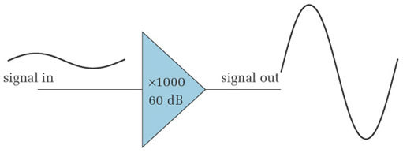
Figure 28 A single-stage amplifier

An amplification of a thousand times could also be achieved in two separate stages, as shown in Figure 29. The first stage gives a tenfold amplification, and the second gives a one-hundredfold amplification. In terms of decibels, the first stage gives a gain of 20 dB and the second a gain of 40 dB. Adding these gives 60 dB, which we saw in Figure 28 (or Table 1) to be the decibel equivalent of an amplitude ratio of 1000:1. Thus adding decibels is equivalent to multiplying their corresponding ratios.

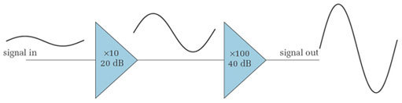
Figure 29 A two-stage amplifier

Activity 32 (Self-Assessment)

- (a) A two-stage amplifier consists of a stage that gives a gain of 12 decibels followed by a stage that gives a gain of 18 decibels. What is the overall amplification of the amplifier, both in decibels and as a ratio of natural numbers?
- (b) A two-stage amplifier has a first stage that amplifies by a factor of 8 and a second that amplifies by a factor of 10. What is the overall amplification of the amplifier, both in decibels and as a ratio of natural numbers?

View answer - Activity 32 (Self-Assessment)

The property of decibels whereby adding them is equivalent to multiplying their corresponding ratios results from the fact that they are based on logarithms. Box 4 explains their mathematical background.

Box 4: Mathematical definition of decibels
Decibels were originally devised as a way of expressing a ratio of powers. Given two powers P₁ and P₂, which have a ratio P₁/P₂, the decibel equivalent is defined to be:

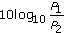

For sound waves, the power is proportional to the square of the pressure amplitude. Hence, if the amplitudes corresponding to the power levels P₁ and P₂ are A₁ and A₂ respectively, the decibel equivalent of this power ratio can be written as:

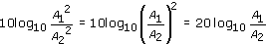

This is the equation used to give the values in Table 2. If you have already worked with decibels as power ratios you might find the decibel values given in Table 1 are double what you are used to seeing for the corresponding ratios. The difference arises because Table 1 shows the decibel equivalents of amplitude ratios rather than power ratios.

10.3 The decibel as a measure of sound amplitude
As I mentioned earlier, because a decibel is a way of expressing a ratio, it cannot by itself express the absolute size of anything. To express absolute values it must be referred to a fixed reference quantity, against which whatever is being measured can be compared. In the context of acoustics the reference used is the lower limit of audibility – the threshold of audibility. This varies from person to person, but has a nominal value that can be expressed as a pressure wave with an amplitude of about 0.000 000 01 per cent of atmospheric pressure. This is taken to be 0 dB. If a sound level is described as being ‘40 dB’, it means that its amplitude is 40 dB relative to the agreed threshold of audibility. This means that its amplitude is 100 times greater than that of the audibility threshold. Sound amplitudes expressed in decibels in this way are said to have a sound pressure level (SPL) of so many decibels (see Box 5).

Box 5: Sound pressure level
The sound pressure level (SPL) in decibels of a sound with a given pressure amplitude is:

The figure of 2 × 10 ⁻⁵ in the denominator is the amplitude in pascals of a pressure wave at the lower limit of audibility at a frequency of 1 kHz.

Activity 33 (Self-Assessment)

The amplitude of a sound is 1000 times greater than the reference value. What is its sound pressure level in decibels? Use either the graph in Figure 27 or Table 1.

View answer - Activity 33 (Self-Assessment)

The following activity is designed to give you a flavour of what a change in sound pressure level of a few decibels corresponds to.

Activity 34 (Listening)

Listen to the audio track below, where you will hear a sine wave in which the sound pressure level changes in 3 dB steps. You might like to compare it with the first part of the audio track of Activity 30 where the sound pressure level changed in 6 dB steps.
Click 'Play' to listen to Audio Clip

Audio content is not available in this format.

Activity 35 (Self-Assessment)

I mentioned earlier that a sound level that was a million times greater than the threshold of audibility would be distressingly loud for most people. Given that 0 dB is the level assigned to the threshold of audibility, use Table 1 and the additive property of decibels to find the sound pressure level of such a loud sound.

View answer - Activity 35 (Self-Assessment)

Table 3 gives some approximate sound pressure levels. You might be surprised at how loud some instruments are. We do not normally think of the violin and flute as loud instruments. However, because of the close proximity of the player's ear to the sound source, sound pressure levels for the performer are not far from levels that can damage the player's hearing. Frequent, extended playing of these instruments at high volume, as may happen in orchestras, can result in hearing loss for the player. Players of other instruments, particularly brass instruments, are similarly at risk, as are users of personal stereo systems with headphones if they are regularly used at high volume.

Table 3 Some typical sound pressure levels
Sound | Sound pressure level
Threshold of hearing | 0 dB
Breeze through leaves | 10 dB
Empty concert hall | 20 dB
Bedroom | 30 dB
Domestic living room | 40 dB
Office noise | 50 dB
Conversation at 1 m | 60 dB
Piano practice | 60–70 dB
Car interior/Singer fortissimo at 1 m | 70 dB
Chamber music in small auditorium | 75+ dB
Heavy car traffic at about 10 m | 80 dB
Violin, flute at player's ear | 85+ dB
Orchestral music during loud passages, experienced by | 90+ dB
performers (permanent hearing damage on prolonged exposure)
Rock performance at close range | 100+ dB
Timpani and bass drum rolls | 106 dB
Peak levels in dance club | 110+ dB
Jet taking off at 100 m | 120 dB
Threshold of pain | 130 dB

10.4 Summary
The decibel (symbol dB) is a way of expressing a ratio. It is based on logarithms, and so adding decibels is equivalent to multiplying their corresponding ratios. Decibels can be used to express absolute values by referring them to a reference value.
A common use of decibels is to express ratios of amplitudes. For instance, the amplification (or gain) of an amplifier can be expressed either as the ratio of the output and input amplitudes, or as a certain number of decibels. With a multi-stage amplifier where the gain of each stage is expressed in decibels, the overall gain in decibels is just the sum of the individual stages' gains.
The sound pressure level (SPL) is a unit for expressing the amplitudes of sound waves relative to the threshold of hearing. The SPL system uses units of decibels, and the lower threshold of hearing has a value of 0 dB. An advantage of the SPL as a unit is that it reflects the way loudness is experienced. That is to say, equal increments of SPL are heard as approximately equal increments of loudness.

Conclusion
This free course provided an introduction to studying Technology. It took you through a series of exercises designed to develop your approach to study and learning at a distance, and helped to improve your confidence as an independent learner.

Acknowledgements
The content acknowledged below is Proprietary (see terms and conditions) and is used under licence.
Grateful acknowledgement is made to the following sources for permission to reproduce material in this unit:
Course image: altemark in Flickr made available under Creative Commons Attribution 2.0 Licence.
This extract is taken from TA212. © 2007 The Open University.
Figure 12 Photo: Robert Harding Picture Library/ Alamy
http://en.wikipedia.org/wiki/Image:Giovanni_Gabrieli.jpg
All other materials included in this unit are derived from content originated at the Open University.
Every effort has been made to contact copyright owners. If any have been inadvertently overlooked, the publishers will be pleased to make the necessary arrangements at the first opportunity.
Don't miss out:
If reading this text has inspired you to learn more, you may be interested in joining the millions of people who discover our free learning resources and qualifications by visiting The Open University - www.open.edu/openlearn/free-courses

Activity 1 (Listening, Exploratory)

Discussion
Here are my descriptions.
- Track 1: A major and a minor scale played on the piano.
- Track 2: A low-pitched note followed by a high-pitched note played on the recorder.
- Track 3: A drum solo.
- Track 4: Humming of machinery.
- Track 5: Sound of an ambulance siren.
- Track 6: Sounds of sea waves.
- Track 7: A tune sung by a male voice.
- Track 8: Sounds of three female voices speaking in different languages.
Your descriptions will almost certainly be different from mine because people have different musical backgrounds and experiences. This is to be expected and is not at all a problem, as you should be able to relate your descriptions to the main points I shall be making shortly. However, I do hope you recognised the first track as containing a major scale followed by a minor scale (a melodic minor in this case, as the ascending and descending versions are different).
Back to - Activity 1 (Listening, Exploratory)

Activity 3 (Listening, Exploratory)

Discussion
I can group my descriptions of the sounds in Activity 1 into three categories, based on the types of things I have said:
- (a) descriptions that refer to the objects or phenomena used to create the sounds: for example, musical instruments (piano, recorder), environmental sounds (siren, waves) and human voice (speech, song, male, female);
- (b) descriptions that refer to musical elements: major, minor, scale, note, pitch;
- (c) descriptions that use metaphors: high/low, humming.
Back to - Activity 3 (Listening, Exploratory)

Activity 4 (Exploratory)

Discussion
Naturally I do not know what your descriptions were like, but I would be very surprised if most of them could not be put into one of these categories.
Back to - Activity 4 (Exploratory)

Activity 5 (Self-Assessment)

Answer
- (a) Sound would be conveyed by the atmosphere within the craft, so the slogan does not apply here.
- (b) In the vacuum of space there is no medium within which there can be pressure fluctuations, so the slogan applies here.
- (c) The atmosphere on the planet would be able to sustain pressure variations, so the slogan does not apply here.
Back to - Activity 5 (Self-Assessment)

Activity 6 (Self-Assessment)

Answer
The following are the correct pairings:
- 1 and (c)
- 2 and (b)
- 3 and (a).
The following is the correct text:
Sound waves are pressure waves, because they consist of cyclical changes of pressure.
Sound waves emanating from a single source in the open (away from buildings etc.) are travelling waves because the pressure variations radiate outwards from their source, conveying energy away from the source.
Sound waves are longitudinal waves, because the molecular oscillations are along the line of travel of the wave.
Back to - Activity 6 (Self-Assessment)

Activity 7 (Self-Assessment)

Answer
It took two complete cycles, and a little bit more, to create this pattern. To see why, notice that the right-hand fork is at the centre of the low-pressure part of the cycle, when the prongs are closest. To the right there are two other low-pressure zones, so to create this pattern two complete cycles were needed (Figure 5a), plus a bit extra to account for the region to the right of the diagram.

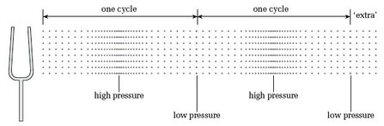
Figure 5a Pattern of pressures for Activity 8
View description - Figure 5a Pattern of pressures for Activity 8

Back to - Activity 7 (Self-Assessment)

Activity 8 (Listening, Exploratory)

Discussion
Using the source–cause type of description, you might have described some of the sine waves as flute-like, the flute being one of the few common instruments that can produce a sine wave, or a close approximation to one.
As far as metaphorical descriptions go, sine waves are often described as ‘neutral’, ‘pure’ or ‘colourless’. You may disagree – particularly if you are a flute player.
Back to - Activity 8 (Listening, Exploratory)

Activity 9 (Self-Assessment)

Answer
- Each cycle of the pressure wave occupies 1 metre, so this is the wavelength.
- We cannot directly read a single wavelength here, but four cycles occupy 1 metre, so the wavelength is 0.25 metre.
Back to - Activity 9 (Self-Assessment)

Activity 10 (Self-Assessment)

Answer
It travels 300 metres. To see why, recall that in the time it takes for one cycle of the fork the wave travels one wavelength, which is 1.5 metres. So in the time required for 200 cycles the wave travels 200 times as far, which is 200 × 1.5 metres = 300 metres.
Back to - Activity 10 (Self-Assessment)

Activity 11 (Self-Assessment)

Answer
With calibrated graphs like these, it makes sense to measure a period from the point where the curve crosses the horizontal axis to the corresponding point on the next cycle.
- (a) It is clear from this graph that one cycle takes one second. Hence the period is one second.
- (b) In this graph it is not so easy to read the time for a single cycle. However, five cycles clearly take 0.1 second, so a single cycle would take one-fifth of this. The period is therefore 0.02 second.
Back to - Activity 11 (Self-Assessment)

Activity 12 (Self-Assessment)

Answer
The sine wave with a period of 1 second has a frequency of 1 Hz. The sine wave with a period of 0.02 second has a frequency of (1 / 0.02) Hz, or 50 Hz.
Back to - Activity 12 (Self-Assessment)

Activity 13 (Self-Assessment)

Answer
To members of Group A, Group B appears to be lagging by 0.2 second. It takes 0.1 second for the sound to travel 34 metres from A to B at a speed of 340 metres per second, and a further 0.1 second for the sound to travel from B back to A. This makes a total delay of 0.2 second for the round trip.
Back to - Activity 13 (Self-Assessment)

Activity 16 (Self-Assessment)

Answer
The wavelength is less than 1 metre. Using λ = v/f, we can see that the wavelength in metres is 340 ÷ 384. Without using a calculator this can be seen to be less than one. In fact its value is about 0.89 metre.
Back to - Activity 16 (Self-Assessment)

Activity 17 (Self-Assessment)

Answer
The delay is 0.2 ms.
One way to answer the question would be to look at where the first peak occurs in each graph and to try to read the time difference. This is not easy because neither peak occurs on a grid line, and finding the exact summit of a smoothly curving sine wave is not easy. In cases like this it makes more sense to compare the points where the graphs cross the horizontal axis at the end of corresponding cycles. In Figure 13(a) the end of the first cycle occurs at 1 ms. In Figure 13(b) the end of the corresponding cycle occurs at the next vertical grid line after 1 ms. As there are five grid lines between 1 ms and 2 ms, the space between each pair of adjacent lines represents 0.2 ms. Hence there is a delay of 0.2 ms.
Back to - Activity 17 (Self-Assessment)

Activity 18 (Self-Assessment)

Answer
The phase difference is 0.2 millisecond, and the period is 1 millisecond, so the phase lag is 0.2 of a cycle, or one-fifth of a cycle.
Back to - Activity 18 (Self-Assessment)

Activity 19 (Self-Assessment)

Answer
The phase difference is half a cycle, or 180 degrees. We could equally say the waves were one-and-a-half cycles apart, or two-and-a-half, and so on, which would give phase differences of 540 degrees and 900 degrees respectively. However, it is customary to speak of a phase difference like this as 180 degrees.
Back to - Activity 19 (Self-Assessment)

Activity 21 (Self-Assessment)

Answer
- (a) The amplitude is 0.35 volt. The tops of the peaks fall halfway between 0.3 and 0.4 volt, hence the value of 0.35 volt.
- (b) The amplitude is 6 volts.
Back to - Activity 21 (Self-Assessment)

Activity 22 (Self-Assessment)

Answer
- (a) The amplitude is half the peak-to-peak amplitude, so the answer is 1 volt.
- (b) The r.m.s. amplitude is approximately 0.71 of the answer in (a), so the answer is 0.71 volt.
- (c) The r.m.s. amplitude is the size of a steady source that would deliver energy at the same rate, other things being equal. So the steady source needs to be 0.71 volt.
Back to - Activity 22 (Self-Assessment)

Activity 23 (Self-Assessment).

Answer
- (a) False. The sum of A and B will have double the amplitude of A or B because A and B are in phase. A doubling of amplitude does not produce a doubling of loudness.
- (b) This is true.
- (c) True. The ear is most sensitive around 4 kHz.
Back to - Activity 23 (Self-Assessment).

Activity 24 (Optional)

Discussion
Although the two pitches are clearly different (C₅ has a higher pitch than middle C), most people find that there is nevertheless something very similar about them. One way to express this idea is to say that they are two versions of the same musical sound. To reinforce this idea, play a C major scale from middle C upwards to C₅. When you reach C₅ it feels like a return to base, although naturally you have not returned to middle C.
Back to - Activity 24 (Optional)

Activity 25 (Self-Assessment)

Answer
The pitch three octaves above A₄ has a frequency of 3520 Hz.
Unless you are familiar with this type of calculation, it is sensible to do it an octave at a time, as follows.
One octave above has a frequency of 2 × 440 Hz = 880 Hz (A₅).
Two octaves above has a frequency of 2 × 880 Hz = 1760 Hz (A₆).
Three octaves above has a frequency of 2 × 1760 Hz = 3520 Hz (A₇).
The reason for doing the calculation a step at a time is to avoid a couple of traps that can easily be fallen into. First, note that a three-octave rise does not correspond to a tripling of frequency. Secondly, note that three successive doublings of frequency do not amount to a sixfold increase in frequency overall. That misapprehension would have given an answer of 2640 Hz. In fact, three successive doublings of frequency amounts to an eightfold increase. Hence the factor by which we need to multiply the original frequency is (2 × 2 × 2) or 2³.
Back to - Activity 25 (Self-Assessment)

Activity 26 (Self-Assessment)

Answer
- (a) Figure 24 showed that the frequency increments become smaller as we go down in pitch, so the bottom end of the keyboard (the left-hand end) would be where the keys were closest together.
- (b) It is safest to do this calculation in stages. The width of the second octave would be 2 × 20 cm = 40 cm. The width of the third octave would be 80 cm, and the width of the fourth octave would be 160 cm. The total width would therefore be:
20 cm + 40 cm + 80 cm + 160 cm = 300 cm, or 3 metres
Back to - Activity 26 (Self-Assessment)

Activity 27 (Self-Assessment)

Answer
Ten octaves. A simple approach is to divide 20 000 Hz repeatedly by two until we reach the lower limit of the human frequency range. The number of times the division can be carried out is the number of octaves. Thus, starting at the upper end of the range:

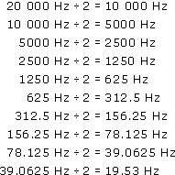

Hence the span is ten octaves.
Back to - Activity 27 (Self-Assessment)

Activity 28 (Self-Assessment)

Answer
One octave, corresponding to a halving of the upper frequency limit.
Back to - Activity 28 (Self-Assessment)

Activity 29 (Self-Assessment)

Answer
It is above the frequency of the pitches produced by virtually all instruments. However, it is within the range of the harmonics of some instruments.
Back to - Activity 29 (Self-Assessment)

Activity 30 (Listening, Exploratory)

Discussion
I expect you answered ‘yes’ to (a) and ‘no’ to (b). (Depending on your audio equipment, you may not have heard all the changes in (b). There are as many steps in (b) as in (a).)
Back to - Activity 30 (Listening, Exploratory)

Activity 31 (Exploratory)

Discussion
The decibel value on each line is an equal increment on the decibel value in the line above. The increment is 6 decibels each time. Thus in the first part of the audio track in Activity 30 there was a 6 decibel increase of amplitude with each recurrence of the sound.
Back to - Activity 31 (Exploratory)

Activity 32 (Self-Assessment)

Answer
- (a) The overall amplification is 12 dB + 18 dB = 30 dB. From Table 1 this can be seen to be equivalent to a ratio of 32:1. Multiplying the amplifications of the individual stages confirms this. The first gives an amplification ratio of 4:1 and the second an amplification ratio of 8:1.
- (b) The overall amplification ratio is 80:1. Table 1 does not give a decibel equivalent for this, but it must be the sum of the decibel equivalents for each stage. From Table 1 these are 18 dB and 20 dB, so the overall amplification is 18 dB + 20 dB, or 38 dB.
Back to - Activity 32 (Self-Assessment)

Activity 33 (Self-Assessment)

Answer
From Table 1 or from the graph, an amplitude ratio of 1000:1 is equivalent to 60 dB. This is the sound pressure level of this sound.
Back to - Activity 33 (Self-Assessment)

Activity 35 (Self-Assessment)

Answer
Table 1 does not give us a decibel equivalent directly for an amplitude ratio of a million to one. However, Table 1 shows that a ratio of 1000:1 has a decibel equivalent of 60 dB. Hence 1000 000, which is 1000 × 1000, has a decibel equivalent of 60 dB + 60 dB, which is 120 dB. This sound pressure corresponds to a jet taking off when heard from a distance of 100 m.
Back to - Activity 35 (Self-Assessment)

Figure 5a Pattern of pressures for Activity 8

Description
Figure 5 (a)
Back to - Figure 5a Pattern of pressures for Activity 8

Figure 10 (a) Pressure wave, with one point indicated by arrows. (b) Pressure variations at the point indicated in (a) as time passes

Description
Figure 10 (a)
Back to - Figure 10 (a) Pressure wave, with one point indicated by arrows. (b) Pressure variations at the point indicated in (a) as time passes

