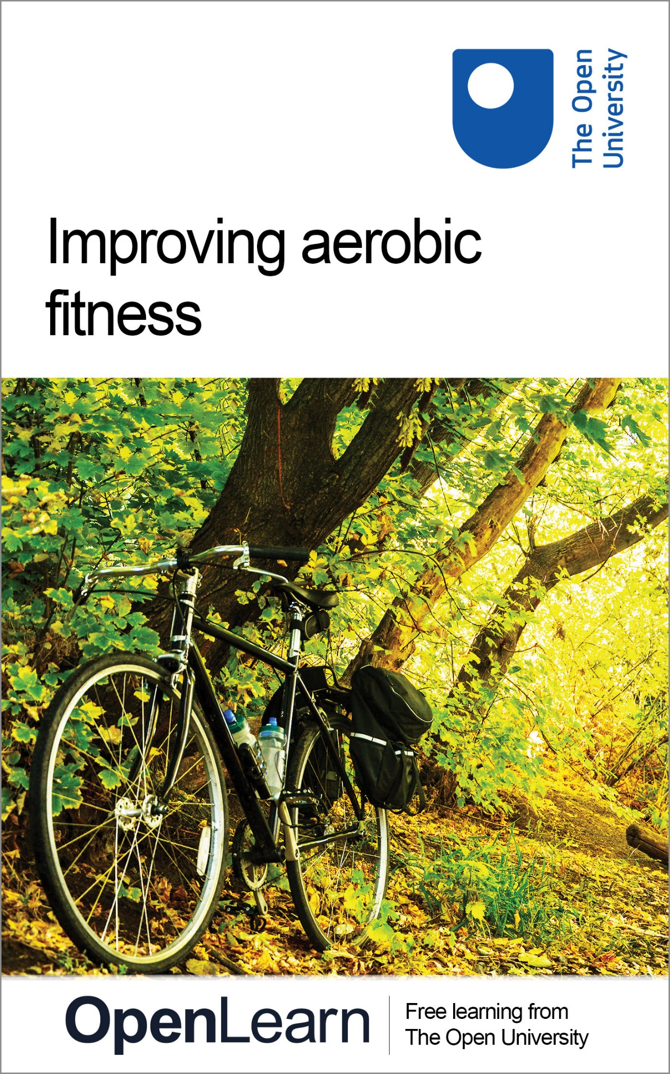

E112_2

Improving aerobic fitness

About this free course
This OpenLearn course provides a sample of level 1 study in Sport. You might be particularly interested in the Open University course E117 Introduction to sport and fitness www.open.ac.uk/courses/modules/e117.
This version of the content may include video, images and interactive content that may not be optimised for your device.
You can experience this free course as it was originally designed on OpenLearn, the home of free learning from The Open University: www.open.edu/openlearn/health-sports-psychology/health/sport-and-fitness/improving-aerobic-fitness/content-section-0.
There you’ll also be able to track your progress via your activity record, which you can use to demonstrate your learning.
The Open University, Walton Hall, Milton Keynes, MK7 6AA
Copyright © 2017 The Open University
Intellectual property
Unless otherwise stated, this resource is released under the terms of the Creative Commons Licence v4.0 http://creativecommons.org/licenses/by-nc-sa/4.0/deed.en_GB. Within that The Open University interprets this licence in the following way: www.open.edu/openlearn/about-openlearn/frequently-asked-questions-on-openlearn. Copyright and rights falling outside the terms of the Creative Commons Licence are retained or controlled by The Open University. Please read the full text before using any of the content.
We believe the primary barrier to accessing high-quality educational experiences is cost, which is why we aim to publish as much free content as possible under an open licence. If it proves difficult to release content under our preferred Creative Commons licence (e.g. because we can’t afford or gain the clearances or find suitable alternatives), we will still release the materials for free under a personal end-user licence.
This is because the learning experience will always be the same high quality offering and that should always be seen as positive – even if at times the licensing is different to Creative Commons.
When using the content you must attribute us (The Open University) (the OU) and any identified author in accordance with the terms of the Creative Commons Licence.
The Acknowledgements section is used to list, amongst other things, third party (Proprietary), licensed content which is not subject to Creative Commons licensing. Proprietary content must be used (retained) intact and in context to the content at all times.
The Acknowledgements section is also used to bring to your attention any other Special Restrictions which may apply to the content. For example there may be times when the Creative Commons Non-Commercial Sharealike licence does not apply to any of the content even if owned by us (The Open University). In these instances, unless stated otherwise, the content may be used for personal and non-commercial use.
We have also identified as Proprietary other material included in the content which is not subject to Creative Commons Licence. These are OU logos, trading names and may extend to certain photographic and video images and sound recordings and any other material as may be brought to your attention.
Unauthorised use of any of the content may constitute a breach of the terms and conditions and/or intellectual property laws.
We reserve the right to alter, amend or bring to an end any terms and conditions provided here without notice.
All rights falling outside the terms of the Creative Commons licence are retained or controlled by The Open University.
Head of Intellectual Property, The Open University
Designed and edited by The Open University
978-1-4730-1354-4 (.kdl)
978-1-4730-0586-0 (.epub)

Contents
- Introduction
- Learning outcomes
- 1 Exercise prescription fundamentals
- 2 Principles of training
- 3 Frequency, intensity, time and type (FITT)
  - 3.1 Frequency
  - 3.2 Intensity
  - 3.3 Time
  - 3.4 Type
- 4 Aerobic fitness training methods
- Conclusion
- References
- Acknowledgements
- Solutions

Introduction
Aerobic fitness is important for sports performance and health, but what sort of exercise should you be doing to develop your aerobic fitness? This course will help you to answer this question by introducing you to principles of aerobic exercise prescription.
This OpenLearn course provides a sample of level 1 study in Sport. You might be particularly interested in the Open University course E117 Introduction to sport and fitness.

Learning outcomes
After studying this course, you should be able to:
- apply the principles of training to aerobic fitness development
- consider the appropriate frequency, intensity, time/duration and type of exercise to develop aerobic fitness.

1 Exercise prescription fundamentals
You are probably already familiar with the term prescription in a medical context (i.e. a doctor might prescribe a medication). Exercise prescription is the term used to describe the exercise programme that an instructor gives to a participant (i.e. the exercise they prescribe). When prescribing aerobic exercise there are two key areas to consider – the principles of training and ‘FITT’ (frequency, intensity, time and type of exercise). We will look at each of these factors in turn.

2 Principles of training
When designing training sessions or programmes, it is important to consider the principles of training which include the principles of overload, progression, specificity, individual response and reversibility. These principles apply to all components of fitness, not just aerobic fitness,

Overload
In order to increase our fitness, we need to ‘overload’ our body systems. For example, to increase our aerobic fitness we have to ‘overload’ the cardiorespiratory system or make it work harder than it is used to. This can be achieved by increasing the frequency, intensity or duration of training to create an overload. We will examine this in Section 3.

Progression
Overload needs to be applied in a steady progression; that is, we shouldn’t do too much too soon. If someone who has never run before has a goal of running a marathon, we would not get them to try to run twenty-six miles straight away. We would start them off running a much shorter distance and then gradually increase the distance over a period of time.

Specificity
Specificity means that all aspects of training are specific to the needs and demands of the activity that the individual is training for. Specificity involves replicating the movements of an activity in training. For example, a long distance runner would obviously need to perform running training, but they would perform very different running training to that of a sprinter. Specificity refers to ensuring the training is designed to maximise the performance in response to the demands of the sport or activity.

Individual response
Individuals will always be unique. With uniqueness comes a challenge to trainers, coaches, and instructors. It is important to remember that if you coach or instruct a group of people they will all respond differently to the training sessions you set. The challenge is to find the right training load to meet the needs and responses of each individual. People respond to training in different ways and this is due to many factors, including their genes, their stage of development or maturity (e.g. children vs adults), the fuels they consume (i.e. nutrition), how much rest they get (including the quality and quantity of sleep), their pre-existing fitness levels, any underlying illness or injuries, and ultimately, their motivation to train (Sharkey and Gaskill, 2013).

Reversibility
This principle can be summed up by the phrase ‘If you don’t use it, you lose it’, which means that while training/exercise using the principles of overload and progression will increase our fitness, not exercising will lead to a decrease in our fitness.
The principles of training must be considered when designing a programme to allow the full potential of each individual to be realised. In order to apply the principles, we need to be able to adjust the training load. There are four ways in which we can adjust the training load – by changing either the frequency, intensity, time or type of training (FITT). We examine FITT in the next section.

3 Frequency, intensity, time and type (FITT)
In the previous section the principles of training were considered. When designing an exercise session or programme there are four factors that can be manipulated to adjust the training load – frequency (how often), intensity (how hard), time (how long) and type (what mode), which are commonly referred to by the acronym ‘FITT’.

3.1 Frequency
Frequency refers to how often or how frequently someone should exercise. To improve aerobic fitness, the American College of Sports Medicine (ACSM) recommends an exercise frequency of three days per week of vigorous exercise or five days of moderate exercise for healthy adults (Garber et al., 2011). The terms ‘vigorous’ and ‘moderate’ will be defined in the next section.
A frequency of 3–5 days per week using a combination of moderate and vigorous exercise is also recommended. The frequency used should be tailored to the participant’s needs and goals (specificity principle). For example, people training for sport may need to exercise more frequently that the average person.

3.2 Intensity
Exercise intensity refers to the level of effort or workload at which someone should exercise to stimulate an improvement in their fitness. As mentioned in the previous section, to improve aerobic fitness the ACSM recommend moderate and/or vigorous intensity activity for most adults (Garber et al., 2011). Table 1 summarises what moderate and vigorous mean.
Exercise intensity can be measured using either heart rate or the rating of perceived exertion (RPE) method. We will look at each of these methods in turn. There are two methods of using heart rate to measure exercise intensity: the percentage of maximal heart rate (HRmax) method and the heart rate reserve (HRR), or Karvonen method.

Table 1 Classification of exercise intensity
Intensity | %HRR | %HRmax | Perceived exertion (rating on 6–20 RPE scale)
Moderate | 40–59 | 64–76 | Fairly light to somewhat hard (RPE 12–13)
Vigorous | 60–89 | 77–95 | Somewhat hard to very hard (RPE 14–17)
(Source: adapted from Garber et al., 2011, p. 1341)

As its name suggests, the percentage of maximal heart rate method involves prescribing exercise at a certain percentage of maximum heart rate. To find out a person’s true maximum heart rate we need to measure it in a laboratory. However, for most people this is impractical; therefore we can estimate maximum heart rate using the formula ‘220 – age’ (see Box 1).

Box 1: Percentage heart rate method

Case study: ‘Mariella’, age 30

Step 1 – Calculate maximum heart rate (HR_{max})
Estimated HR_{max} = 220 – age
= 220 – 30
= 190 bpm (beats per minute)

Step 2 – Calculate exercise intensity
ACSM guidelines = 55–90% of HR_{max}
Lower target (55%) = 190 × 55%
= 190 × 0.55
= 104.5 bpm (we would round this up to 105 bpm)
Upper target (90%) = 190 × 90%
= 190 × 0.90
= 171 bpm
This formula gives us an idea of maximum heart rate, but we must remember that it is just an estimate and not completely accurate. Therefore using this method, according to ACSM guidelines, Mariella should exercise at a heart rate somewhere between 105 and 171 bpm. This is quite a wide range so, depending on her fitness levels, you would need to decide whether to prescribe Mariella exercise to the upper or lower end of this scale.

The HRR method is thought to be more accurate than the percentage of maximal heart rate method because it takes the individual’s resting heart rate into account. The formula for calculating HRR can be seen in Box 2. As outlined in Table 2 it is recommended that to improve aerobic fitness, exercise intensity should be set at a moderate or vigorous level. The exact intensity set will depend on the individual's fitness level. Someone with relatively low levels of fitness who has just started an exercise programme may need to work at a lower intensity, whereas someone who has a higher level of fitness, perhaps who has been exercising for a while, may need to work at a higher intensity. This demonstrates the importance of progression in an exercise programme.

Box 2: Heart rate reserve method

Case study: ‘Mariella’, age 30

Step 1 – Calculate maximum heart rate (HR_{max})
Estimated HR_{max} = 220 - age
= 220 – 30
= 190 bpm (beats per minute)

Step 2 – Measure resting heart rate (HR_{rest})
You would measure this either using a heart rate monitor or manually, using your fingers. Ideally it should be measured first thing in the morning. Let's imagine that Mariella's HR_{rest} has been measured at 70 bpm.

Step 3 – Calculate heart rate reserve (HRR)
HRR = HR_{max} – HR_{rest}
= 190 – 70
= 120 bpm

Step 4 – Calculate exercise intensity
ACSM guidelines = 40–85% HRR
Lower target (40%) = (HHR × 40%) + HR_{rest}
= (120 × 0.40) + 70
= 48 + 70
= 118 bpm
Upper target (85%) = (HHR × 85%) + HR_{rest}
= (120 × 0.85) + 70
= 102 + 70
= 172 bpm
Using this method, according to ACSM guidelines, Mariella should exercise somewhere between 118 and 172 bpm.
Please note that there are online calculators available to calculate all of this information for you, which you can find by putting 'target heart rate calculator' into a search engine. Once such example can be found at the link below.
Active.com

An alternative to using heart rate methods is the RPE method of measuring exercise intensity. Essentially, the RPE method involves an individual rating how hard they feel they are working on a scale of 6–20. An RPE of approximately 12–17 is recommended to improve aerobic fitness (Garber et al., 2011). However, you should note that it is difficult to give a general recommendation for RPE, as it is by its very nature open to personal interpretation; that is, what I consider to be a 12 may be different to what you consider to be a 12.
RPE can be a useful way of measuring exercise intensity when heart rate monitoring is difficult or inappropriate. For example, some types of medication (e.g. beta blockers) given to people with hypertension (high blood pressure) lower the heart rate, and therefore heart rate measurement is not appropriate for people on this type of medication.

3.3 Time
The recommended duration of an aerobic exercise session is dependent on several factors, such as the participant’s goals and fitness levels, and the intensity of exercise. Obviously, the higher the intensity of the exercise, the shorter will be its duration. The ACSM 2011 position stand recommends 30-60 minutes of purposeful moderate exercise per session, 20–60 minutes of vigorous exercise per session, or 20–60 minutes of a combination of moderate and vigorous exercise per session for healthy adults (Garber et al., 2011). Again, the requirements for sportspeople will be dependent on the demands of their sport (specificity principle). Current UK physical activity guidelines suggest that adults should engage in daily moderate intensity physical activity adding up to at least 150 minutes per week (often recommended as at least 5 x 30 minute bouts per week) (Department of Health, 2011).

3.4 Type
To improve aerobic fitness the ACSM recommends exercise that employs large muscle groups, is rhythmic or dynamic, can be maintained continuously and is aerobic in nature (Garber et al., 2011). This type of exercise results in larger increases in aerobic fitness. Activities that would fit into this category include walking, running, swimming and cycling. This again depends upon the level of the individual and their goals and demands of their activity or sport.
Frequency, intensity, time (duration) and type (mode) of exercise are key factors to consider when prescribing aerobic or any other type of exercise. As you can see, in addition to the FITT guidelines and prescription factors already mentioned, the principles of training also need to be taken into consideration when planning an exercise programme. Next we explore some of the training methods used to develop aerobic activity.

4 Aerobic fitness training methods
Various training methods can be employed to develop aerobic fitness. In the activity below we explore some examples used by a team of footballers.

Activity 1
Allow about 40 minutes

Watch the video Pre-season training: stamina in which we see a sports scientist discussing the training used to develop aerobic fitness with a group of footballers. (You should open the video in a new tab or window by holding down Ctrl (or Cmd on a Mac) when you click on the link so you can return here when you have finished.)
As you watch, answer the following questions:
- Why is it important for the players to develop their aerobic fitness?
- What methods of training are used to develop the players’ aerobic fitness?

View discussion - Activity 1

Conclusion
This free course, Improving aerobic fitness, provided an introduction to studying Health & Wellbeing. It took you through a series of exercises designed to develop your approach to study and learning at a distance and helped to improve your confidence as an independent learner.
The course has given you an introduction to some of the factors that need to be considered when developing an exercise programme to improve aerobic fitness. The principles of training and FITT apply not only to developing aerobic fitness, but also to developing other aspects of our fitness e.g. anaerobic fitness or strength.
This OpenLearn course provides a sample of level 1 study in Sport. You might be particularly interested in the Open University course E117 Introduction to sport and fitness.

References
Department of Health (2011) UK Physical Activity Guidelines [Online], Available from https://www.gov.uk/government/publications/uk-physical-activity-guidelines (Accessed 3 December 2016).
Garber, C.E., Blissmer, B., Deschenes, M.R., Franklin, B.A., Lamonte, M.J., Lee, I.M., Nieman, D.C. and Swain, D.P. (2011) ‘American College of Sports Medicine position stand. quantity and quality of exercise for developing and maintaining cardiorespiratory, musculoskeletal, and neuromotor fitness in apparently healthy adults: guidance for prescribing exercise’, Medicine and Science in Sports and Exercise, vol. 43, no. 7, pp. 1334-59.
Sharkey, B.J. and Gaskill, S.E. (2013) Fitness and health, 7th edn, Leeds, Human Kinetics.

Acknowledgements
Except for third party materials and otherwise stated (see terms and conditions), this content is made available under a Creative Commons Attribution-NonCommercial-ShareAlike 4.0 Licence
Course image: r. nial bradshaw in Flickr made available under Creative Commons Attribution 2.0 Licence.
Don't miss out:
If reading this text has inspired you to learn more, you may be interested in joining the millions of people who discover our free learning resources and qualifications by visiting The Open University - www.open.edu/openlearn/free-courses
This free course is adapted from a former Open University course E112 Introduction to sport, fitness and management. You might be interested in its replacement, E117 Introduction to sport and fitness

Solutions

Activity 1

Discussion
- While the predominant energy system in football is the anaerobic system it is also important for footballers to develop good base levels of aerobic fitness in pre-season. With this in mind it is essential for their training to include activities that are going to overload and allow progression of their aerobic capacity.
- The sports scientist uses training methods including:
  - Continuous training which involves performing light- to moderate-intensity aerobic exercise at a consistent pace.
  - Interval training which involves interspersing periods of exercise with periods of rest or recovery.
Continuous and interval training methods have been shown to be equally effective in improving aerobic fitness and therefore either could be used in aerobic exercise prescription.
Back to - Activity 1

