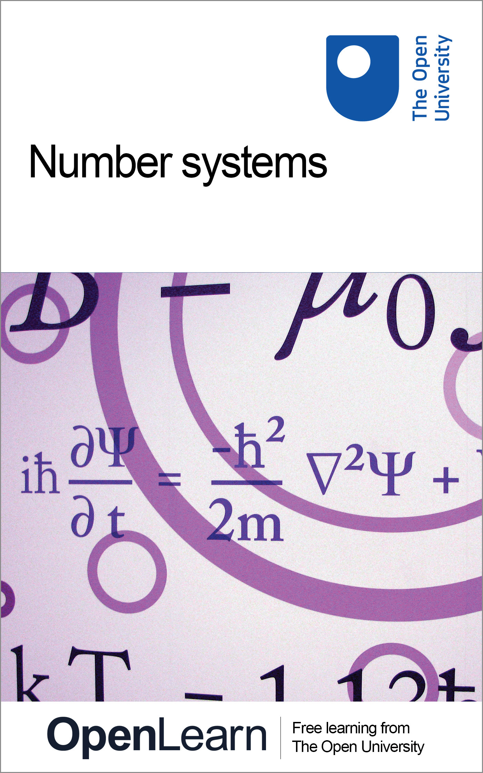

M208_6 Pure mathematics

Number systems
About this free course
This free course is an adapted extract from the Open Unviersity course M208: Pure Mathematics www3.open.ac.uk/study/undergraduate/course/m208.htm
This version of the content may include video, images and interactive content that may not be optimised for your device.
You can experience this free course as it was originally designed on OpenLearn, the home of free learning from The Open University: www.open.edu/openlearn/science-maths-technology/mathematics-and-statistics/mathematics/number-systems/content-section-0.
There you’ll also be able to track your progress via your activity record, which you can use to demonstrate your learning.
The Open University, Walton Hall, Milton Keynes, MK7 6AA
Copyright © 2016 The Open University
Intellectual property
Unless otherwise stated, this resource is released under the terms of the Creative Commons Licence v4.0 http://creativecommons.org/licenses/by-nc-sa/4.0/deed.en_GB. Within that The Open University interprets this licence in the following way: www.open.edu/openlearn/about-openlearn/frequently-asked-questions-on-openlearn. Copyright and rights falling outside the terms of the Creative Commons Licence are retained or controlled by The Open University. Please read the full text before using any of the content.
We believe the primary barrier to accessing high-quality educational experiences is cost, which is why we aim to publish as much free content as possible under an open licence. If it proves difficult to release content under our preferred Creative Commons licence (e.g. because we can’t afford or gain the clearances or find suitable alternatives), we will still release the materials for free under a personal end-user licence.
This is because the learning experience will always be the same high quality offering and that should always be seen as positive – even if at times the licensing is different to Creative Commons.
When using the content you must attribute us (The Open University) (the OU) and any identified author in accordance with the terms of the Creative Commons Licence.
The Acknowledgements section is used to list, amongst other things, third party (Proprietary), licensed content which is not subject to Creative Commons licensing. Proprietary content must be used (retained) intact and in context to the content at all times.
The Acknowledgements section is also used to bring to your attention any other Special Restrictions which may apply to the content. For example there may be times when the Creative Commons Non-Commercial Sharealike licence does not apply to any of the content even if owned by us (The Open University). In these instances, unless stated otherwise, the content may be used for personal and non-commercial use.
We have also identified as Proprietary other material included in the content which is not subject to Creative Commons Licence. These are OU logos, trading names and may extend to certain photographic and video images and sound recordings and any other material as may be brought to your attention.
Unauthorised use of any of the content may constitute a breach of the terms and conditions and/or intellectual property laws.
We reserve the right to alter, amend or bring to an end any terms and conditions provided here without notice.
All rights falling outside the terms of the Creative Commons licence are retained or controlled by The Open University.
Head of Intellectual Property, The Open University
Designed and edited by The Open University
978-1-4730-1383-4 (.kdl)
978-1-4730-0615-7 (.epub)

Contents
- Introduction
- Learning outcomes
- 1 Real numbers
  - 1.1 Rational numbers
  - 1.2 Real numbers
  - 1.3 Further exercises
- 2 Complex numbers
  - 2.1 What is a complex number?
  - 2.2 The complex plane
  - 2.3 Complex arithmetic
  - 2.4 Complex conjugate
  - 2.5 Modulus of a complex number
  - 2.6 Division of complex numbers
  - 2.7 Arithmetical properties of complex numbers
  - 2.8 Polar form
  - 2.9 Roots of polynomials
  - 2.10 The complex exponential function
  - 2.11 Further exercises
- 3 Modular arithmetic
  - 3.1 Division
  - 3.2 Congruence
  - 3.3 Operations in modular arithmetic
  - 3.4 Modular multiplication
  - 3.5 Further exercises
- 4 Equivalence relations
  - 4.1 What is a relation?
  - 4.2 Equivalence relations
  - 4.3 Further exercises
- Conclusion
- Keep on learning
- Acknowledgements

Introduction

As part of a review of content, this course will be deleted from OpenLearn on 13 January 2020. You can find more Mathematics courses on OpenLearn here.

In this course we look at some different systems of numbers, and the rules for combining numbers in these systems. For each system we consider the question of which elements have additive and/or multiplicative inverses in the system. We look at solving certain equations in the system, such as linear, quadratic and other polynomial equations.
In Section 1 we start by revising the notation used for the rational numbers and the real numbers, and we list their arithmetical properties. You will meet other properties of these numbers in the analysis units, as the study of real functions depends on properties of the real numbers. We note that some quadratic equations with rational coefficients, such as x² = 2, have solutions which are real but not rational.
In Section 2 we introduce the set of complex numbers. This system of numbers enables us to solve all polynomial equations, including those with no real solutions, such as x² + 1 = 0. Just as real numbers correspond to points on the real line, so complex numbers correspond to points in a plane, known as the complex plane.
In Section 3 we look further at some properties of the integers, and introduce modular arithmetic. This will be useful in the group theory units, as some sets of numbers with the operation of modular addition or modular multiplication form groups.
In Section 4 we introduce the concept of a relation between elements of a set. This is a more general idea than that of a function, and leads us to a mathematical structure known as an equivalence relation. An equivalence relation on a set classifies elements of the set, separating them into disjoint subsets called equivalence classes.
This OpenLearn course is an adapted extract from the Open Unviersity course M208: Pure Mathematics

Learning outcomes
After studying this course, you should be able to:
- understand the arithmetical properties of the rational and real numbers
- understand the definition of a complex number
- perform arithmetical operations with complex numbers
- explain the terms modular addition and modular multiplication
- explain the meanings of a relation defined on a set, an equivalent relation and a partition of a set.

1 Real numbers

1.1 Rational numbers
In OpenLearn course M208_5 Mathematical language you met the sets
- = {1, 2, 3, …}, the natural numbers;
- = {…, −2, −1, 0, 1, 2, …}, the integers;
- = {p/q : p , q }, the rational numbers.
is the set of numbers that can be written as fractions, such as and –1.7 = .
Notice that each set in this list is a subset of the succeeding one; that is,
To represent the rational numbers geometrically, we use a number line. We begin by drawing a line and marking on it points corresponding to the integers 0 and 1. If the distance between 0 and 1 is taken as a unit of length, then the rational numbers can be arranged on the line in a natural order. For example, the rational 4/3 is placed at the point which is one third of the distance from 1 to 2.
We sometimes use ‘rational’ as shorthand for ‘rational number’ and ‘real’ for ‘real number’.

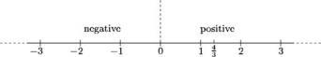

Each rational number also has a decimal representation, which is either a terminating (that is, finite) decimal, such as 1.54, or a recurring decimal such as 2.134 734 734 7 …, in which the digits repeat in a regular pattern from some position onwards. The decimal representation of any rational number p/q can be obtained by using long division to divide q into p.
One of the surprising mathematical discoveries made by the ancient Greeks was that the system of rational numbers is not adequate to describe all the lengths that occur in geometry. For example, consider the diagonal of a square of side 1. What is its length? If the length is x, then, by Pythagoras' Theorem, x must satisfy the equation x² = 2. However, there is no rational number that satisfies this equation.

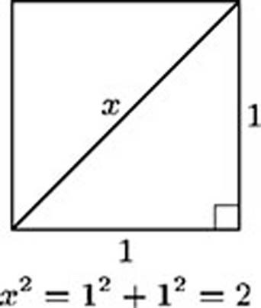

Theorem 1
There is no rational number x such that x² = 2.

Proof Suppose that such a rational number x exists. Then we can write x = p/q, where p, q . By cancelling, if necessary, we may assume that the greatest common factor of p and q is 1.
This is a proof by contradiction.
The equation x² = 2 now becomes

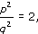

so

The square of an odd number is odd, so p cannot be odd. Hence p is even, so we can write p = 2r, say. Equation (1.1) now becomes
so
We have

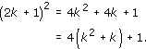

Reasoning as before, we find that q is also even.
Since p and q are both even, they have a common factor of 2, which contradicts our earlier statement that the greatest common factor of p and q is 1.
Since we have obtained a contradiction, our original assumption must be false; therefore no such rational number x exists.

Exercise 1

By imitating the proof above, show that there is no rational number x such that x³ = 2.

View answer - Exercise 1

Since we expect equations such as x² = 2 and x³ = 2 to have solutions, we must introduce new numbers that are not rationals. We denote the positive solutions of these two equations by , and , respectively; thus ()² = 2 and . Of course, we must introduce many other new numbers, such as , , and so on. Indeed, it can be shown that if m and n are natural numbers, and the equation x^{m} = n has no integer solution, then the positive solution of this equation, written as , cannot be rational.
The case m = 2 and n = 3 is treated in Exercise 5.
There are many other mathematical quantities which cannot be described exactly by rational numbers. For example, the number , which denotes the area of a disc of radius 1 (or half the length of the perimeter of such a disc), cannot be described by a rational number, and neither can the number e.
Johann Heinrich Lambert proved in 1761 that is irrational. He was a colleague of Euler and Lagrange at the Berlin Academy of Sciences, and is best known for his work on .
All these numbers are known as irrational numbers.

1.2 Real numbers
The rational and irrational numbers together make up the real numbers. The set of real numbers is denoted by . Like rationals, irrational numbers can be represented by decimals, but unlike the decimals for rational numbers, those for irrationals are neither finite nor recurring. All such infinite non-recurring decimals represent real numbers. Each real number can be represented as a point on the number line considered in Section 1.1, which is often known as the real line, and each point on this line represents a real number.
We shall need to use the usual arithmetical operations on real numbers, and we now list the properties which we assume these operations satisfy.

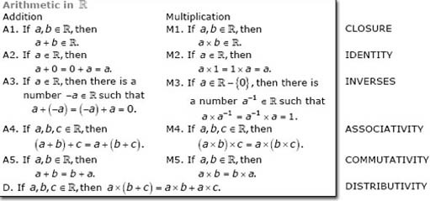

In properties A3 and M3 the numbers −a and a⁻¹ are known as the additive inverse (or negative) of a and the multiplicative inverse (or reciprocal) of a, respectively.
The rational numbers also satisfy all the above properties; that is, if is replaced by throughout in the box above, then the properties are still true. We shall show later that the same is true for the complex numbers and for some sets of numbers in modular arithmetic. However, if we restrict ourselves to the integers , then one of these properties is no longer true.
A set with all these properties is known as a field.

Exercise 2

- (a) Show by means of a counter-example that does not have property M3.
- (b) Which integers have a multiplicative inverse in ?

View answer - Exercise 2

In this course we shall be concerned with polynomial equations.

Definition
A polynomial equation in x of degree n is an equation of the form p(x) = 0, where p(x) is a polynomial of degree n.
Polynomial equations (and polynomials) of degrees 1, 2 and 3 are called linear, quadratic and cubic, respectively.

Recall that the formula for the solutions of the quadratic equation ax² + bx + c = 0 is

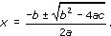

This equation is known as the quadratic formula.

Exercise 3

Solve the following quadratic equations, stating how many solutions each equation has in .
- (a) x² − 7x + 12 = 0
- (b) x² + 6x + 9 = 0
- (c) 2x² + 5x − 3 = 0
- (d) 2x² − 2x − 1 = 0
- (e) x² − 2x + 5 = 0

View answer - Exercise 3

We notice from the results of Exercise 3 that some quadratic equations have two real solutions, some have only one and some have none. In either of the first two cases, the solutions may be rational or irrational. Although you may be accustomed to equations with integer coefficients such as those in Exercise 3, these results still apply if some or all of the coefficients are irrational; that is, if the coefficients are any real numbers. Since a quadratic equation with coefficients in can have no solution in , working with the set of real numbers does not enable us to find solutions to all quadratic equations.
We end this section by showing that although a quadratic equation may have no real solutions, this is not true for a cubic equation.
Consider the cubic polynomial

For x ≠ 0, the polynomial can be written as

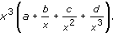

Since , and as , the sign of the polynomial will be positive when x is large and positive, and negative when x is large and negative. Hence the value of the polynomial must change from negative to positive at least once as x increases, so it would appear that it must be zero at one value of x (at least). A similar argument can be used if a < 0. Hence the equation ax³ + bx² + cx + d = 0, where a ≠ 0, has at least one real solution. This result can be generalised to show that any polynomial equation of degree n, where n is odd, has at least one real solution.
We are assuming here that the graph of a cubic polynomial is an unbroken curve – an assumption we made in OpenLearn course M208_4 Real functions and graphs. This assumption will be justified in the analysis units.

1.3 Further exercises

Exercise 4

Solve the following linear equations.
- (a) 5x + 8 = −2
- (b) x + 2 = −5
- (c) 2x −1 = 5
- (d) 5x + 4 = 3
State in each case whether the solution belongs to , , and/or .

View answer - Exercise 4

Exercise 5

Show that there is no rational number x such that x² = 3.

View answer - Exercise 5

2 Complex numbers

2.1 What is a complex number?
We will now discuss complex numbers and their properties. We will show how they can be represented as points in the plane and state the Fundamental Theorem of Algebra: that any polynomial equation with complex coefficients has a solution which is a complex number. We will also define the function exp of a complex variable.
Earlier we mentioned several sets of numbers, including , , and . In each case, the numbers correspond to points on the real line. We now introduce numbers of a new kind, the so-called complex numbers, which correspond to points in the plane.
Complex numbers arise naturally as solutions of quadratic equations. For example, you showed in Exercise 3(e) that the equation x² − 2x + 5 = 0 has no real solutions because there is no real number whose square is −16.
But suppose now that we ‘extend’ the set of real numbers by introducing a new number, denoted by i, which is defined to have the property that i² = −1. Suppose further that i combines with itself, and with real numbers, according to the usual rules of arithmetic. In particular, assume that we can multiply i by any real number b to obtain the product ib, and that we can add on any real number a to obtain the sum a + ib. Such sums are known as complex numbers, and they are the numbers we need to solve the quadratic equation above.
We have ib = bi, and we can also write a + ib as a + bi.

Definitions
A complex number is an expression of the form x + iy, where x and y are real numbers and i² = −1. The set of all complex numbers is denoted by .
A complex number z = x + iy has real part x and imaginary part y; we write

Two complex numbers are equal when their real parts and their imaginary parts are equal.
For example, if z = 2 − 3i, then Re z = 2 and Im z = −3.

Remarks
- Any given real number x can be written in the form x + i0, and any complex number of the form x + i0 is usually written simply as x. In this sense, is a subset of . The zero complex number 0 + i0 is written as 0.
- We usually write a general complex number as x + iy, and a particular complex number as, for example, 2 + 3i, rather than 2 + i3. We write 2 − 3i rather than 2 + (−3)i.
- Note that Re z and Im z are both real numbers.
- A complex number of the form 0 + iy (where y ≠ 0) is sometimes called an imaginary number.
Since i² = −1, we can regard the number i as a square root of −1. If we assume that the usual rules of arithmetic apply, then we can solve quadratic equations using the quadratic formula and the fact that . For example, consider the equation

This is the equation from Exercise 3(e), rewritten using z as the variable name. We often use the letter z for a complex variable (a variable that represents a complex number).
For the above equation, the quadratic formula gives

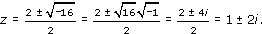

We can check that these two complex numbers satisfy the equation we were trying to solve. We use the usual rules of arithmetic, and substitute −1 for i² wherever it appears.
For example, if z = 1 + 2i, then

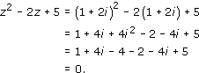

4i² = 4(−1) = −4, since i² = −1.
The solution z = 1 − 2i can be checked similarly.
The use of the number i enables us to solve any quadratic equation in a similar way. We shall see later in the section that the use of i ensures that all polynomial equations have solutions, even those whose coefficients are themselves complex. This, in turn, means that any polynomial can be factorised into a product of linear factors; for example,

Exercise 6

Solve the following equations, giving all solutions in .
- (a) z² − 4z + 7 = 0
- (b) z² − iz + 2 = 0
- (c) z³ − 3z² + 4z − 2 = 0 (Hint: z = 1 is one solution.)
- (d) z⁴ − 16 = 0

View answer - Exercise 6

2.2 The complex plane
Just as there is a one-one correspondence between the real numbers and the points on the real line, so there is a one-one correspondence between the complex numbers and the points in the plane. This correspondence is given by

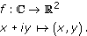

Thus we can represent points in the plane by complex numbers and, conversely, we can represent complex numbers by points in the plane. When we represent complex numbers by points in the plane, we refer to the plane as the complex plane, and we often refer to the complex numbers as points in the complex plane. A diagram showing complex numbers represented as points in the plane in this way is sometimes called an Argand diagram.
The French mathematician Jean-Robert Argand's publication of the idea in 1806 was the first to be generally recognised.
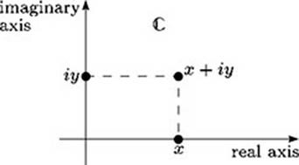
Real numbers are represented in the complex plane by points on the x-axis; this axis is called the real axis. Similarly, numbers of the form iy are represented by points on the y-axis; this axis is called the imaginary axis.

Exercise 7

Draw a diagram showing each of the following points in the complex plane:

View answer - Exercise 7

2.3 Complex arithmetic
Arithmetical operations on complex numbers are carried out as for real numbers, except that we replace i² by −1 wherever it occurs.

Example 1

Let z₁ = 1 + 2i and z₂ = 3 − 4i. Determine the following complex numbers.
- (a) z₁ + z₂
- (b) z₁ − z₂
- (c) z₁z₂
- (d)

View answer - Example 1

Exercise 8

Determine the following complex numbers.
- (a) (3 − 5i) + (2 + 4i)
- (b) (2 − 3i)(−3 + 2i)
- (c) (5 + 3i)²
- (d) (1 + i)(7 + 2i)(4 − i)

View answer - Exercise 8

Example 1 illustrates how we add, subtract and multiply two given complex numbers. We can apply the same methods to two general complex numbers z﻿₁ = x₁ + iy₁ and z₂ = x₂ + iy₂, and obtain the following formal definitions of addition, subtraction and multiplication in .

Definitions
Let z₁ = x₁ + iy₁ and z₂ = x₂ + iy₂ be any complex numbers. Then the following operations can be applied.
addition z₁ + z₂ = (x₁ + x₂) + i(y₁ + y₂)
subtraction z₁ − z₂ = (x₁ − x₂) + i(y₁ − y₂)
multiplication z₁z₂ = (x₁x₂ − y₁y₂) + i(x₁y₂ + y₁x₂)

With these definitions, most of the usual rules of algebra still hold, as do many of the familiar algebraic identities. For example,

and

There is no need to remember or look up these formulas. For calculations, the methods of Example 1 may be used.
An obvious omission from this list of definitions is division. We return to division after discussing the complex conjugate and modulus of a complex number.

2.4 Complex conjugate
Many manipulations involving complex numbers, such as division, can be simplified by using the idea of a complex conjugate, which we now introduce.

Definition
The complex conjugate of the complex number z = x + iy is the complex number x − iy.

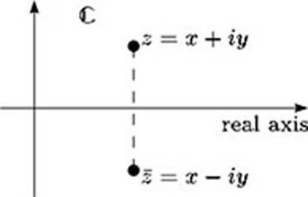
For example, if z = 1 − 2i, then . In geometric terms, is the image of z under reflection in the real axis.

Exercise 9

Let z₁ = −2 + 3i and z₂ = 3 − i.
Write down and , and draw a diagram showing z₁, z₂, and in the complex plane.

View answer - Exercise 9

The following properties of complex conjugates are particularly useful.

Properties of complex conjugates
Let z₁, z₂ and z be any complex numbers. Then:
- ;
- ;
- ;
- .

In order to prove property 1, we consider two arbitrary complex numbers.
Let z₁ = x₁ + iy₁ and z₂ = x₂ + iy₂. Then

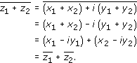

Exercise 10

Use a similar approach to prove properties 2, 3 and 4.

View answer - Exercise 10

2.5 Modulus of a complex number
We also need the idea of the modulus of a complex number. Recall that the modulus of a real number x is defined by

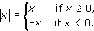

For example, |7| = 7 and |−6| = 6.
In other words, |x| is the distance from the point x on the real line to the origin. We extend this definition to complex numbers as follows.

Definition
The modulus |z| of a complex number z is the distance from the point z in the complex plane to the origin.
Thus the modulus of the complex number z = x + iy is

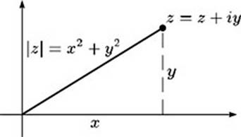
For example, if z = 3 − 4i, then
.

Exercise 11

Determine the modulus of each of the following complex numbers.
- (a) 5 + 12i
- (b) 1 + i
- (c) −5

View answer - Exercise 11

The modulus of a complex number has many properties similar to those of the modulus of a real number.

Properties of modulus
- |z| ≥ 0 for any z , with equality only when z = 0.
- |z₁z₂| = |z₁||z₂| for any z₁, z₂ .

Property 1 is clear from the definition of |z|. Property 2 can be proved in a similar way to property 2 of complex conjugates given in Exercise 10.
The following useful result shows the link between modulus and distance in the complex plane.

Distance Formula
The distance between the points z₁ and z₂ in the complex plane is |z₁ − z₂|.

This is obtained by applying Pythagoras' Theorem to the triangle in the diagram below.
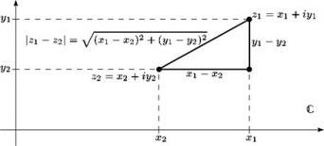

Exercise 12

For each of the following pairs z₁, z₂ of complex numbers, draw a diagram showing z₁ and z₂ in the complex plane, and evaluate |z₁ − z₂|.
- (a) z₁ = 3 + i, z₂ = 1 + 2i.
- (b) z₁ = 1, z₂ = i.
- (c) z₁ = −5 − 3i, z₂ = 2 − 7i.

View answer - Exercise 12

The following properties describe the relationship between the modulus and the complex conjugate of a complex number.

Conjugate–modulus properties
- for all z .
- for all z .

To prove these properties, we let z = x + iy. Then
,
so

and

2.6 Division of complex numbers
The second of the conjugate–modulus properties enables us to find reciprocals of complex numbers and to divide one complex number by another, as shown in the next example. As for real numbers, we cannot find a reciprocal of zero, nor divide any complex number by zero.

Example 2

- (a) Find the reciprocal of 2 − 5i.
- (b) Find the quotient

View answer - Example 2

The method used in Example 2, of multiplying the numerator and denominator by the complex conjugate of the denominator, enables us to find the reciprocal of any non-zero complex number z, and the quotient z₁/z₂ of any two complex numbers z₁ and z₂, where z₂ ≠ 0. We can obtain general formulas as follows.
For the reciprocal, we have

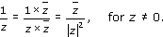

If z = x + iy, so and |z|²= x² + y², we obtain

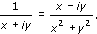

For the quotient z₁/z₂, we have

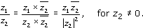

If z₁ = x₁ + iy₁ and z₂ = x₂ + iy₂, this can be rewritten as

These formulas may be used in theoretical work, but for calculations of reciprocals and quotients it is simplest to use the method of Example 2.

Exercise 13

Find the reciprocal of each of the following complex numbers.
- (a) 3 − i
- (b) −1 + 2i

View answer - Exercise 13

Exercise 14

Evaluate each of the following quotients.
- (a)
- (b)

View answer - Exercise 14

2.7 Arithmetical properties of complex numbers
The set of complex numbers satisfies all the properties previously given for arithmetic in . We state (but do not prove) these properties here.

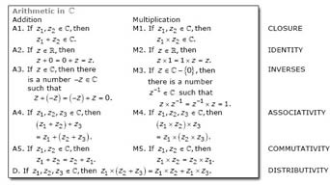

In particular, 0 = 0 + 0i plays the same role in as the real number 0 does in , and 1 = 1 + 0i plays the same role as 1. These numbers are called identities for addition and multiplication respectively.
We also have that the additive inverse (or negative) of z = x + yi is −z = −x − yi, and the multiplicative inverse (or reciprocal) of z = x + yi is

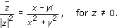

There is one important difference between the set of real numbers and the set of complex numbers, however; namely that, unlike the real numbers, the complex numbers are not ordered.
For any two real numbers a and b, exactly one of the three properties

is true. But this is not the case for the complex numbers; we cannot say, for example, that

Inequalities involving complex numbers make sense only if they are inequalities between real quantities, such as the moduli (moduli is the plural of modulus) of the complex numbers. For example, inequalities such as

are valid.

2.8 Polar form
You have seen that the complex number x + iy corresponds to the point (x, y) in the complex plane. This correspondence enables us to give an alternative description of complex numbers, using so-called polar form. This form is particularly useful when we discuss properties related to multiplication and division of complex numbers.
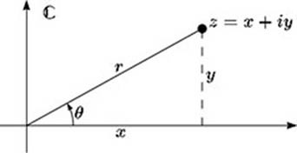
Polar form is obtained by noting that the point in the complex plane associated with the non-zero complex number z = x + iy is uniquely determined by the modulus ,
together with the angle θ (measured in an anticlockwise direction in radians) between the positive direction of the x-axis and the line from the origin to the point, as shown in the graph above. We have

so the complex number z can be expressed as

This description of z in terms of r and θ is not unique because the angle θ is determined only up to multiples of 2; that is, the angles θ ± 2, θ ± 4, θ ± 6, …, also determine the same complex number. However, if we restrict the angle θ to lie in the interval (−, ], then the description is unique. The origin is an exception, however: at the origin the value of r is 0, and θ is not defined.
Some texts restrict θ to lie in the interval [0, 2).

Definitions
A non-zero complex number z = x + iy is in polar form if it is expressed as

where r = |z| and θ is any angle (measured in radians anticlockwise) between the positive direction of the x-axis and the line joining z to the origin.
(Some texts use r cis θ or 〈r, θ 〉 as shorthand for r(cos θ + i sin θ).)
Such an angle θ is called an argument of the complex number z, and is denoted by arg z. The principal argument of z is the value of arg z that lies in the interval (−, ], and is denoted by Arg z.
Here principal argument is a shortened form of the more conventional ‘principal value of the argument’.

Remark
Sometimes we refer to z = x + iy as the Cartesian form of z, to distinguish it from polar form.
We now discuss how to convert a complex number from polar form to Cartesian form, and vice versa.
When carrying out such conversions, it is useful to remember the values in the table below, as these will help you in some special cases. You may find it easier to remember the triangles, from which you can work out most of the values in the table.
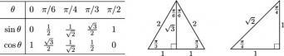
The following formulas are also helpful. For any θ :

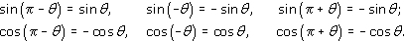

You will need only the first two equations in each row; the other equations are given for completeness.
You may be able to remember these formulas by roughly sketching graphs of the sine and cosine functions, and using their symmetry. For example, we can sketch the sine function as follows.
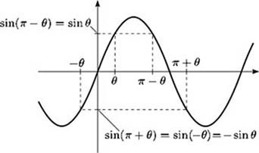
To convert a complex number from polar form to Cartesian form is straightforward: we use the equations

to find x and y given r and θ.
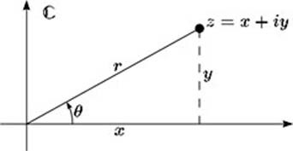
This is illustrated in the following example.

Example 3

Express each of the following complex numbers in Cartesian form.
- (a) 3(cos(/3) + i sin(/3))
- (b) cos(−/6) + i sin(−/6)

View answer - Example 3

Exercise 15

Express each of the following complex numbers in Cartesian form.
- (a) 2(cos(/2) + i sin(/2))
- (b) 4(cos(−2/3) + i sin(−2/3))

View answer - Exercise 15

To convert a non-zero complex number z from Cartesian form x + iy to polar form r(cos θ + i sin θ), we first find the modulus r using the formula

If z is either real or imaginary, then it lies on one of the axes and has principal argument 0, /2, or −/2, as shown in diagram (a) below. Otherwise, to find the principal argument θ, we need to solve the equations

We can do this by first finding the first-quadrant angle φ that satisfies the related equation

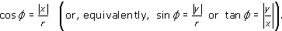

The relationship of φ to the principal argument θ depends on the quadrant in which z lies, as indicated in diagram (b) below.
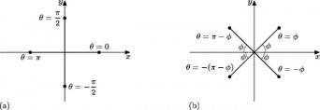
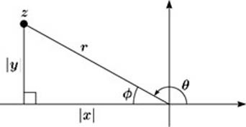
Note: φ is the angle at the origin in the right-angled triangle formed by drawing the perpendicular from z to the real axis, as illustrated above, in the case where z lies in the second quadrant. We have

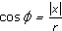

and the relationship between θ and φ can be seen to be as given in diagram (b).
The quadrant in which z lies can be found from the values of x and y, and θ can then be deduced by using the appropriate equation from diagram (b). (You may find it helpful to sketch z on an Argand diagram.)
This method for finding θ is used in the next example, which illustrates how the Cartesian form of a complex number is converted into polar form.

Example 4

Express each of the following complex numbers in polar form, using the principal argument.
- (a) 2 + 2i
- (b)

View answer - Example 4

Exercise 16

Draw a diagram showing each of the following complex numbers in the complex plane, and express them in polar form, using the principal argument.
- (a) −1 + i
- (b) 1 − i
- (c) −5

View answer - Exercise 16

Polar form gives us a simple way to multiply complex numbers. Let

then

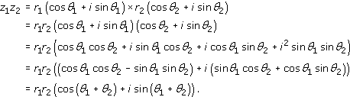

(Here we use the addition formulas for the trigonometric functions.)
That is, to multiply two complex numbers in polar form, we multiply their moduli and add their arguments. For example,

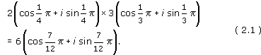

Note:

In the rest of this section we usually write /4 as , and similarly for other fractions of . You may use either form, or the form , as you wish.
We can also use formula (2.1) for the product of two complex numbers in polar form to establish a similar formula for the quotient of two complex numbers. Specifically, we show that if

with z₂ ≠ 0, then z₁/z₂ is the complex number

z₂ ≠ 0 r₂ ≠ 0
To see this, notice that since r₁ = rr₂ and θ₁ = θ + θ₂ it follows from the above discussion that z₁ = zz₂. Hence z₁/z₂ = z, as required. We can write the formula as

That is, to divide a complex number z₁ by another complex number z₂, we divide the modulus of z₁ by the modulus of z₂, and subtract the argument of z₂ from the argument of z₁.
For example,

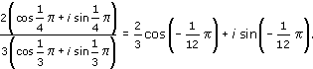

In particular, if z = r(cos θ + i sin θ) with r ≠ 0, then the reciprocal of z is

The above methods for multiplying and dividing complex numbers in polar form are summarised below.

Strategy 1
To multiply two complex numbers given in polar form, multiply their moduli and add their arguments.
To divide a complex number z₁ by a non-zero complex number z₂ when both are given in polar form, divide the modulus of z₁ by the modulus of z₂, and subtract the argument of z₂ from the argument of z₁.

Remark
If you require the principal argument of the product or quotient, then you may need to add or subtract 2 from the argument calculated.

Exercise 17

Determine each of the following products and quotients in polar form in terms of the principal argument.
- (a)
- 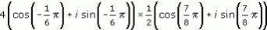
- (b)
- 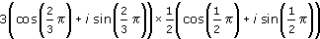
- (c)
- 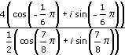
- (d)
- 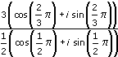

View answer - Exercise 17

2.9 Roots of polynomials
We begin by reminding you of what we mean by the word ‘root’. In this course we use this term in two different, but related, senses, as given below.

Definition
If p(z) is a polynomial, then the solutions of the polynomial equation p(z) = 0 are called the roots of p(z).
If a is a complex number, then the solutions of the equation z^{n} = a are called the nth roots of a.

The roots of a polynomial are also called its zeros.
Thus the nth roots of a are the roots of the polynomial z^{n} − a.
In this subsection we explain how to find the nth roots of any complex number and we discuss the roots of polynomial equations more generally.
The formula obtained in the previous section for finding the product of two complex numbers in polar form can be generalised to a product of several complex numbers.

Strategy 2
To find the product of the complex numbers z₁, z₂, …, z_{n} given in polar form, multiply their moduli and add their arguments.

Exercise 18

Let z₁ = −1 + i, and z₃ = −5.
Use the solution to Exercise 16 to express z₁z₂z₃ and in polar form.

View answer - Exercise 18

An important special case of the result in Strategy 2 is obtained when z₁ = z₂ = … = z_{n} = r(cos θ + i sin θ); that is, when the complex numbers z₁, z₂, …, z_{n} are all equal. In this case, the result gives

Note: nθ may not be the principal argument of (cos θ + isin θ)^{n}.

Example 5

Find z⁴, where z = 1 + i.

View answer - Example 5

The significant new information obtained from equation (2.4) is that

This result is true for all n and is known as de Moivre's Theorem.
Abraham de Moivre was a French mathematician who worked in England from 1685 after the expulsion of the Huguenots from France.

Theorem 2: de Moivre's Theorem
If z = cos θ + i sin θ, then, for any n ,

We have seen that de Moivre's Theorem is true when n is a positive integer. We now show that it is true for other integers.
For n = 0,

For n = −m, where m is a positive integer,

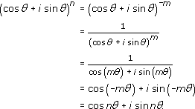

Here we use formula (2.3).
One application of de Moivre's Theorem is in finding the nth roots of complex numbers; that is, in solving equations of the form z^{n} = a, where a . Before we illustrate this, we use the theorem to verify some solutions of such an equation.

Exercise 19

- (a) Express the complex number 1 in polar form.
- (b) Show that each of the three complex numbers with polar forms 1(cos 0 + i sin 0),
- 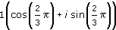
- and
- 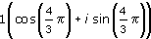
- satisfies the equation z³ = 1.
- (c) Express in Cartesian form the three solutions to the equation z³ = 1 given in part (b).

View answer - Exercise 19

The solution to Exercise 19 verifies that the three given complex numbers are solutions of the equation z³ = 1. However, what we really want is a method which will enable us to find solutions of such an equation without knowing them in advance. Fortunately, de Moivre's Theorem enables us to do this.

Example 6

- (a) Express the equation z³= −27 in polar form.
- (b) Find three different solutions of the equation z³= −27, by using the fact that adding any multiple of 2 to an argument of −27 gives another argument of −27.

View answer - Example 6

Now we show how we can use the method of Example 6 to find the solutions of any complex equation of the form

where a is a known complex number. We write both z and a in polar form so that, say,

where r and θ are variables whose values we must find, and ρ and φ are known real numbers.
Then z^{n} = a gives, using de Moivre's Theorem,
Hence we must have r^{n} = ρ, so r = ρ^{1/n}. Also nθ must represent the same angle as φ. Now we use the fact that a complex number has many arguments. Since adding on any multiple of 2 to the argument φ of a gives the same complex number a, we can have

that is,

If k = n we have θ = φ/n + 2, which is the same angle as φ/n. So taking k = 0, 1, 2, …, n − 1 will give the n different solutions of the equation z^{n} = a. We thus arrive at the following conclusion.

Roots of a complex number
Let a = ρ(cos φ + i sin φ) be a complex number in polar form. Then, for any n , the equation z^{n} = a has n solutions, given by

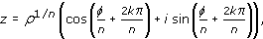

for k = 0, 1, …, n − 1.

Exercise 20

- (a) Express the equation z⁶ = 1 in polar form.
- (b) Use the method described above to find the six solutions of z⁶ = 1 in polar form.
- (c) Sketch the position of each solution in the complex plane.
- (d) Find the Cartesian form of each solution.

View answer - Exercise 20

In Exercise 20 you found the solutions of the equation z⁶ = 1. These are known as the sixth roots of unity, and in the complex plane they are equally spaced around the circle of radius 1, centre the origin. More generally, the solutions of the equation z^{n} = 1 are known as the nth roots of unity and in the complex plane they are equally spaced around the circle of radius 1, centre the origin. For any n , one of the nth roots of unity is 1.
The nth roots of any complex number are equally spaced around a circle with centre the origin, but the circle may not have radius 1 and there may not be a root on the real axis.

Exercise 21

Solve the equation z⁴ = −4, expressing your answers in Cartesian form. Mark your solutions on a diagram of the complex plane.

View answer - Exercise 21

Exercise 22

Solve the equation z³ = 8i, expressing your answers in Cartesian form. Mark your solutions on a diagram of the complex plane.

View answer - Exercise 22

The result in the box above gives the n solutions of any equation of the form z^{n} = a, where a is a non-zero complex number. Now the equation z^{n} = a, which can be written as z^{n} − a = 0, is an example of a polynomial equation whose coefficients are complex numbers. Other examples of polynomial equations with complex coefficients are

and

Remarkably, it can be shown that any polynomial equation

where a_{n}, a_{n−1}, …, a₀ and a_{n} ≠ 0, has at least one solution in . Moreover, it cannot have more than n solutions.
Note: If we count coincident solutions separately so that, for example, in the equation

the solution 1 is counted three times, the solution −4 is counted twice and the solution 5 is counted once, then a polynomial equation of degree n has exactly n solutions.
The complex numbers are, unlike the reals, an ‘algebraically closed’ system of numbers. By this we mean that any polynomial equation with coefficients in has a solution in . The fact that any polynomial equation with complex coefficients necessarily has a complex solution is called the Fundamental Theorem of Algebra. We do not prove this theorem in this course.
It is often not easy to find such solutions! However, in some cases we can combine the methods of the Polynomial Factorisation Theorem below and the use of de Moivre's Theorem to find solutions of a polynomial equation.
You met the Polynomial Factorisation Theorem for real roots of a polynomial in OpenLearn course M208_5 Mathematical language. The theorem is also true in .

Theorem 3: Polynomial Factorisation Theorem
Let p(z) be a polynomial of degree n with coefficients in and let . Then p() = 0 if and only if

where q(z) is a polynomial of degree n−1 with coefficients in .

In this statement of the theorem, we have used z in place of x, as this is the label usually used for a complex variable. The proof is otherwise exactly the same as the proof for the theorem in , so we do not include it here.
From the Fundamental Theorem of Algebra, mathematical induction and the Polynomial Factorisation Theorem, we can deduce the following important corollary.

Corollary
Every polynomial p(z) = a_{n}z^{n} + a_{n−1}z^{n−1} + ··· + a₁z + a₀, where n ≥ 1, a_{i} for each i and a_{n} ≠ 0, has a factorisation

where the complex numbers ₁, ₂, …, _{n} are the roots (not necessarily distinct) of p(z).

Proof
Let S(n) be the statement of the corollary for general n ≥ 1.
Note: S(n) is the statement in the box above. We use the notation S(n) instead of the more usual P(n) to avoid confusion with the polynomial p(z).
Then S(1) is true, since the polynomial

(where a₁ ≠ 0) has the root ₁ = −a₀/a₁ and has a factorisation

Now suppose that S(k) is true, and consider any polynomial of degree k + 1:

where a_{k+1} ≠ 0. By the Fundamental Theorem of Algebra, the equation p(z) = 0 has at least one solution, say _{k+1}, in . Then, by the Polynomial Factorisation Theorem,

where q(z) is a polynomial of degree k. Now the coefficient of z^{k} in q(z) must be a_{k+1}. Thus, by S(k), this polynomial has a factorisation

Thus

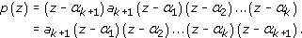

Therefore S(k) true S(k + 1) true, so by mathematical induction S(n) is true for every positive integer n.
You may have noticed that it follows from the quadratic formula (see Exercise 3) that, for a quadratic equation with real coefficients, the roots are either both real or occur as a complex conjugate pair.
This holds for polynomial equations in general; if p(z) is a polynomial in z with real coefficients, then whenever is a root of p, so is . (We omit the proof of this result.) Moreover, the factors z − and can be combined to give a real quadratic factor of p(z), namely

which has real coefficients, since
and .

Example 7

- (a) Show that z = i is a root of the polynomial

- (b) Hence find all the roots of p(z).

View answer - Example 7

Exercise 23

Find, in the form a_{n}z^{n} + … + a₁z + a₀, a polynomial whose roots are 1, −2, 3i and −3i.

View answer - Exercise 23

Earlier in this subsection we used de Moivre's Theorem to find roots of complex numbers. Another use of de Moivre's Theorem is to find further trigonometric identities similar to those given in OpenLearn course M208_4 Real functions and graphs.

Exercise 24

Using de Moivre's Theorem, we have

for all θ .
- (a) Expand the left-hand side of the above expression using the Binomial Theorem. Then express your answer in the form x + iy, where x and y are expressions involving cos θ and sin θ.
- (b) By equating real and imaginary parts, use your answer to part (a) to obtain formulas for cos 3θ and sin 3θ in terms of cos θ and sin θ.
- (c) Use your answer to part (b) and the identity cos² θ + sin² θ = 1 to obtain a formula for cos 3θ in terms of cos θ and a formula for sin 3θ in terms of sin θ.

View answer - Exercise 24

The method of the solution to Exercise 24 generalises to produce formulas for cos nθ and sin nθ for all n .

Exercise 25

- (a) Use de Moivre's Theorem to obtain formulas for cos 5θ and sin 5θ in terms of cos θ and sin θ.
- (b) Use your answer to part (a) and the identity cos² θ + sin² θ = 1 to find a formula for cos 5θ in terms of cos θ and a formula for sin 5θ in terms of sin θ.

View answer - Exercise 25

2.10 The complex exponential function
Consider the real exponential function f (x) = e^{x} (that is, f (x) = exp x). We now extend the definition of this function to define a function f(z) = e^{z} whose domain and codomain are .
We expect complex powers of e to satisfy the familiar properties of real powers of e. For example, we expect that

If this is to be achieved, then the definition of e^{z} has to be as follows.

Definition
If z = x + iy, then e^{z} = e^{x}e^{iy} = e^{x}(cos y + i sin y).

Example 8

Show that

for all complex numbers z₁ and z₂.

View answer - Example 8

Exercise 26

- (a) Using the above definition for e^{z} and de Moivre's Theorem, show that

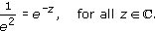

- (b) Show that e^{z}₁/ e^{z}₂ = e^{z}₁^{−z}₂, for all z₁, z₂ .

View answer - Exercise 26

So the rules for multiplication and division of complex powers of e are exactly the same as those for real powers. Furthermore, when the exponent z is real, that is when z = x + 0i, where x , the definitions of a real and a complex power of e coincide, since

On the other hand, if z = 0 + iy, where y , then the definition gives

This is known as Euler's formula. Putting y = , we obtain

or

This is a remarkable relationship between five important numbers: 0, 1, i, and e.
The formula e^{iy} = cos y + i sin y gives us an alternative form for the expression of a complex number in polar form. If

then we can write cos θ + i sin θ as e^{iθ}, so

Some texts refer to re^{iθ} as polar form.
A complex number expressed in this way is said to be in exponential form. Using this notation, de Moivre's Theorem becomes the simple result

We can use the complex exponential function to find some further useful trigonometric identities. At the end of Section 2.9 we showed how de Moivre's Theorem can be used to express the sine or cosine of a multiple of θ in terms of powers of sin θ and cos θ. Here we do the opposite, expressing a power of sin θ or cos θ as a combination of sines or cosines of multiples of θ.
First, we deduce two useful equations. We know that, for all θ ,

Also, since cos(−θ) + i sin(−θ)=cos θ − i sin θ, we have

Adding equations 2.6 and 2.7 gives

and subtracting them gives

Equations 2.8 and 2.9 enable us to express cos θ and sin θ as combinations of complex exponentials, and it is these equations we use to obtain the identities we are looking for.

Example 9

- (a) Show that
- 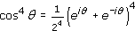.
- (b) Expand the expression (e^{iθ} + e^{−iθ})⁴ using the Binomial Theorem, and hence show that

View answer - Example 9

Exercise 27

- (a) Show that
- 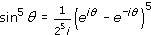.
- (b) Expand (e^{iθ} − e^{−iθ})⁵ using the Binomial Theorem, and hence show that
- .

View answer - Exercise 27

2.11 Further exercises

Exercise 28

Let z₁ = 2 + 3i and z₂ = 1 − 4i. Find z₁ + z₂, z₁ − z₂, z₁z₂, , , z₁/z₂ and 1/z₁.

View answer - Exercise 28

Exercise 29

Draw a diagram showing each of the following complex numbers in the complex plane, and express them in polar form, using principal arguments.
- (a) − i
- (b) −5i
- (c) −2 − 2i

View answer - Exercise 29

Exercise 30

Express each of the following complex numbers in Cartesian form.
- (a) 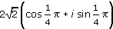
- (b) 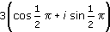
- (c)

View answer - Exercise 30

Exercise 31

Let z₁ = − i, z₂ = −5i and z₃ = −2 −2i. Use the solution to Exercise 29 to determine the following complex numbers in polar form in terms of the principal argument.
- (a) z₁z₂z₃
- (b)

View answer - Exercise 31

Exercise 32

Solve the equation z⁵ = −32, leaving your answers in polar form.

View answer - Exercise 32

Exercise 33

Solve the equation z³ + z² − z + 15 = 0, given that one solution is an integer.

View answer - Exercise 33

Exercise 34

Determine a polynomial of degree 4 whose roots are 3, −2, 2 − i and 2 + i.

View answer - Exercise 34

Exercise 35

Use de Moivre's Theorem to obtain formulas for cos 6θ and sin 6θ in terms of cos θ and sin θ.

View answer - Exercise 35

Exercise 36

Use the definition of e^{z} to express the following complex numbers in Cartesian form.
- (a)
- (b)
- (c)

View answer - Exercise 36

3 Modular arithmetic

3.1 Division
In this section, instead of enlarging the number system , we do arithmetic with finite sets of integers, namely the sets of possible remainders when we divide by particular positive integers. This type of arithmetic is important in number theory (the study of the integers) and in cryptography. It is used frequently in group theory.
If we divide one positive integer by another we obtain a quotient and a remainder. For example, 29 divided by 4 gives quotient 7 and remainder 1 because 29 = 7 × 4 + 1. If we divide any positive integer by 4, the remainder will be one of the numbers 0, 1, 2, 3.
This idea can be extended to the division of a negative integer by a positive integer. For example, −19 divided by 4 gives quotient −5 and remainder 1 because −19 = (−5) × 4 + 1. If we divide any negative integer by 4, the remainder is again one of the numbers 0, 1, 2, 3.
This result can be generalised to the following theorem.

Theorem 4 Division Algorithm
Let a and n be integers, with n > 0. Then there are unique integers q and r such that

Strictly speaking, this theorem is not an algorithm, but ‘division algorithm’ is the traditional name for it.
We say that dividing a by the divisor n gives quotient q and remainder r.
We do not give a formal proof of Theorem 4, but it can be illustrated as follows. We mark integer multiples of n along the number line as shown in the diagram below, and then observe in which of the resulting intervals of length n the integer a lies. Suppose that a lies in the interval [qn, (q +1)n)
so that qn ≤ a < (q + 1)n.
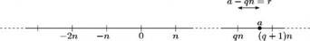
Then, if we let r = a − qn, we have a = qn + r and 0 ≤ r < n, which is the required result.

Exercise 37

For each of the following integers a and n, find the quotient and remainder on division of a by n.
- (a) a = 65, n =7
- (b) a = −256, n =13

View answer - Exercise 37

Exercise 38

- (a) What are the possible remainders on division of an integer by 7?
- (b) Find two positive and two negative integers all of which have remainder 3 on division by 7.

View answer - Exercise 38

3.2 Congruence
The Division Algorithm tells us that, when we divide any integer by a positive integer n, the set of possible remainders is {0, 1, 2, …, n − 1}. Integers which differ by a multiple of n have the same remainder on division by n and are, in this sense, ‘the same’ as each other. We now introduce some notation and terminology for this idea of ‘sameness’, which is known as congruence.

Definitions
Let n be a positive integer. Two integers a and b are congruent modulo n if a − b is a multiple of n; that is, if a and b have the same remainder on division by n.
In symbols we write

(We say ‘a is congruent to b modulo n’.)
Such a statement is called a congruence, and n is called the modulus of the congruence.
Note: This is a different meaning for the word ‘modulus’ from others you may have met. It is important to interpret technical terms according to their context.

Example 10

Which of the following congruences are true, and which are false?
- (a) 27 ≡ 5 (mod 11)
- (b) 14 ≡ −6 (mod 3)
- (c) 343 ≡ 207 (mod 68)
- (d) 1 ≡ −1 (mod 2)

View answer - Example 10

Exercise 39

Find the remainder on division by 17 of each of the numbers 25, 53, −15, 3 and 127, and state any congruences modulo 17 that exist between these numbers.

View answer - Exercise 39

We shall need to use some properties of congruences in the following sections, and we state these properties here.

Theorem 5 Properties of congruences
Let n and k be positive integers, and let a, b, c, d be integers. Then
- (a) a ≡ a (mod n);
- (b) if a ≡ b (mod n), then b ≡ a (mod n);
- (c) if a ≡ b (mod n) and b ≡ c (mod n), then a ≡ c (mod n);
- (d) if a ≡ b (mod n) and c ≡ d (mod n), then a + c ≡ b + d (mod n);
- (e) if a ≡ b (mod n) and c ≡ d (mod n), then ac ≡ bd (mod n);
- (f) if a ≡ b (mod n), then a^{k} ≡ b^{k} (mod n).
Although this may seem a long list, these properties are quite simple.

Proof
We prove properties (a)–(d) here and ask you to prove properties (e) and (f) in Exercise 40.
- (a) a − a = 0 = 0 × n, so a ≡ a (mod n).
- (b) Suppose that a ≡ b (mod n). Then a − b = kn for some integer k.
- Hence b − a = (−k)n, so b ≡ a (mod n).
- (c) Suppose that a ≡ b (mod n) and b ≡ c (mod n). Then a − b = kn and b − c = ln for some integers k and l. Hence

- so a ≡ c (mod n).
- (d) If a ≡ b (mod n) and c ≡ d (mod n), then a − b = kn and c − d = ln for some integers k and l. Hence a = b + kn and c = d + ln, so

- Hence (a + c) − (b + d) = (k + l)n, so a + c ≡ b + d (mod n).

Exercise 40

- (a) Use a similar method to that used in part (d) of the above proof to prove property (e) of Theorem 5.
- (b) Use property (e) and mathematical induction to prove property (f) of Theorem 5.

View answer - Exercise 40

The properties in Theorem 5 are particularly useful when finding the remainder of a large integer on division by another integer.

Example 11

- (a) Find the remainders of both 2375 and 5421 on division by 22.
- (b) Find the remainder of 2375 × 5421 on division by 22.
- (c) Find the remainder of (2375)¹⁵ on division by 22.
(2375)¹⁵ is too large to fit into the memory of most computers, so there is a real advantage in this method.

View answer - Example 11

3.3 Operations in modular arithmetic
The Division Algorithm tells us that all the possible remainders on division by an integer n lie in the set

We denote this set by _{n}. For each integer n ≥ 2 we have a set _{n}, and it is on these sets that we perform modular arithmetic. The modular addition operations +_{n} and modular multiplication operations ×_{n} are defined as follows.

Definitions
For any integer n ≥ 2,

For a and b in _{n}, the operations +_{n} and ×_{n} are defined by:
- a +_{n} b is the remainder of a + b on division by n;
- a ×_{n} b is the remainder of a × b on division by n.
The integer n is called the modulus for this arithmetic.
Note: a +_{n} b is read as a plus b (mod n), and may also be written a + b (mod n). Similarly, a ×_{n} b is read as a times b (mod n) and may also be written as a × b (mod n).

For example, ₇ = { 0,1,2,3,4,5,6} and we have

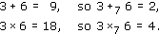

You have certainly met some modular arithmetic before, as the operations +₁₂ and +₂₄ are used in measuring time on 12-hour and 24-hour clocks, respectively.

Exercise 41

Evaluate the following.
- (a) 3 +₅ 7, 4 +₁₇ 5, 8 +₁₆ 12.
- (b) 3 ×₅ 7, 4 ×₁₇ 5, 8 ×₁₆ 12.

View answer - Exercise 41

In Sections 1 and 2 we listed some properties satisfied by the real and complex numbers. We now investigate whether the sets _{n} satisfy similar properties.
We also investigate what equations we can solve in _{n}; for example, can we solve the equations

These may look much simpler than the equations that we were trying to solve in , but they pose interesting questions. We shall see that the answers may depend on the modulus that we are using.
Before we discuss these questions further, we look at addition and multiplication tables, which provide a convenient way of studying addition and multiplication in _{n}.
We consider addition first. Here are the addition tables for ₄ and ₇.
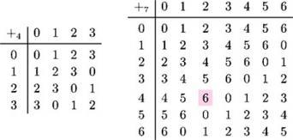
In order to evaluate 4 +₇ 2, say, we look in the row labelled 4 and the column labelled 2 in the second table to obtain the answer 6.

Exercise 42

- (a) Use the tables above to solve the following equations.
  - (i) x +₄ 3 = 2
  - (ii) x +₇ 5 = 2
  - (iii) x +₄ 2 = 0
  - (iv) x +₇ 5 = 0
- (b) What patterns do you notice in the tables?

View answer - Exercise 42

Exercise 43

- (a) Construct the addition table for ₆.
- (b) Solve the equations x +₆ 1 = 5 and x +₆ 5 = 1.

View answer - Exercise 43

For every integer n ≥ 2, the additive properties of _{n} are the same as the additive properties of , as follows.

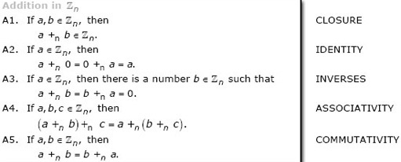

Property A1 follows from the Division Algorithm and the definition of _{n}. The other properties can be deduced from the corresponding properties for integers.

Exercise 44

By using the corresponding property for integers, prove property A5.

View answer - Exercise 44

If a, b _{n} and a +_{n} b = 0, then we say that b is the additive inverse of a in _{n}. For example, 4 and 5 belong to ₉ and 4 +₉ 5 = 0, so 5 is the additive inverse of 4 in ₉. Property A3 states that every element of _{n} has an additive inverse in _{n}.
Additive inverses are sometimes written in the form −_{n}a; that is, if a +_{n} b = 0, then we write b = −_{n}a. For example, 5 = −₉4.

Exercise 45

- (a) Use the addition table for ₇ (which appear above Exercise 42) to complete the following table of additive inverses in ₇.
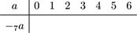
- (b) Complete the following table of additive inverses in _{n}, explaining why your answers are correct.
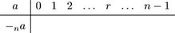

View answer - Exercise 45

The existence of additive inverses means that, as well as doing addition modulo n, we can also do subtraction. We define a −_{n} b or, equivalently, a − b (mod n), to be the remainder of a − b on division by n.
(With this definition, a −_{n} b is equal to a +_{n} (−_{n}b).)
For example, to find 2 −₈ 7, we have

Since 3 ₈, it follows that

3.4 Modular multiplication
In the last subsection we stated that, for any integer n ≥ 2, the set _{n} satisfies the same rules for addition modulo n as the real numbers satisfy for ordinary addition. When it comes to multiplication in _{n}, most of the familiar rules for multiplication of the real numbers are true. In particular, the following properties hold.

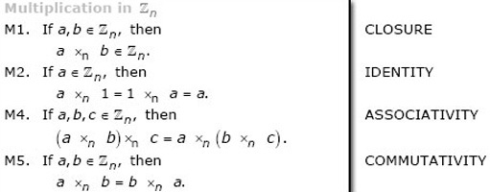

The following property also holds.

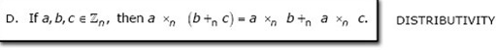

These properties can be proved in a similar way to the additive properties. You will notice that one property is missing from the list of multiplicative properties; namely, the multiplicative inverse property M3.
We say that b is the multiplicative inverse of a in _{n} if a, b _{n} and a ×_{n} b = b ×_{n} a = 1. These equations can also be written as ab ≡ ba ≡ 1 (mod n). We denote the multiplicative inverse b of a by a⁻¹, when it exists, and it may be referred to as the multiplicative inverse of a modulo n. We now investigate the existence of multiplicative inverses.
(For example, from the table for ₇ below, 3 ×₇ 5 = 5 ×₇ 3 = 1, so 5 is the multiplicative inverse of 3 in ₇.)
Here are the multiplication tables for ₄ and ₇.
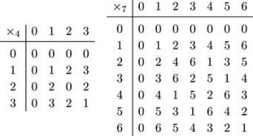

Exercise 46

- (a) Use the tables above to answer the following.
  - (i) Which integers in ₄ have multiplicative inverses?
  - (ii) Find the multiplicative inverse of every integer in ₇ except 0.
- (b) Construct a multiplication table for ₁₀, and decide which integers in ₁₀ have multiplicative inverses.

View answer - Exercise 46

From the solution to Exercise 46, it is clear that, unlike and , some systems _{n} contain non-zero elements that do not have a multiplicative inverse. The question of whether an element a _{n} has a multiplicative inverse in _{n} is connected with the common factors of a and n.

Definitions
Two positive integers a and b have a common factor c, where c is a positive integer, if a and b are both divisible by c.
Two positive integers a and b are said to be coprime, or relatively prime, if their only common factor is 1.
(The greatest common factor of a and b is the largest of their common factors.)

Later in this subsection we prove that an element a of _{n} has a multiplicative inverse in _{n} if and only if a and n are coprime. First we look at a method for finding multiplicative inverses where they exist. Although we can find such inverses by trial and error, or by writing out the multiplication table for _{n}, as n becomes larger the method illustrated in the following example becomes more efficient. It is known as Euclid's Algorithm, and was described in Euclid's Elements, which dates from around 300 BC. (Euclid did not express the algorithm in this form, however.)

Example 12

Find the multiplicative inverse of 10 in ₂₇.

View answer - Example 12

Exercise 47

Use Euclid's Algorithm to find
- (a) the multiplicative inverse of 7 in ₁₆;
- (b) the multiplicative inverse of 8 in ₅₁.

View answer - Exercise 47

We now use Euclid's Algorithm to prove our main result.

Theorem 6
Let n and a be positive integers, with a in _{n}. Then a has a multiplicative inverse in _{n} if and only if a and n are coprime.

Proof
First we prove the ‘if’ part; that is, a has a multiplicative inverse in _{n} if a and n are coprime.
We use Euclid's Algorithm repeatedly and show that, if a and n are coprime, then the final remainder before we reach 0 must be 1.
Let

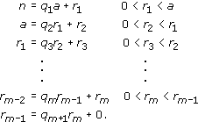

Since the remainders decrease by at least 1 with each step, they must eventually reach 0.
The final equation shows that r_{m} is a factor of r_{m−1}, and thus the penultimate equation shows that r_{m} is a factor of r_{m−2}, and so on. Continuing in this way, we find that r_{m} is a factor of all the remainders, and so of both a and n. Since a and n were assumed to be coprime, we deduce that r_{m} = 1.
Therefore we have, from the penultimate equation,

and, by successively substituting for the remainders, we find that there are integers k and d such that 1 = kn + da. Hence da = −kn + 1, so d ×_{n} a = 1.
It is possible that d does not belong to _{n}, but in that case d ≡ b for some b _{n}, where b ≠ 0, so we also have b ×_{n} a = 1.
Hence a has a multiplicative inverse b in _{n}; we write b = a⁻¹ (mod n).
Now we prove the ‘only if ’ part; that is, a has a multiplicative inverse in _{n} only if a and n are coprime.
Suppose that a has a multiplicative inverse in _{n}; that is, there is a number b such that b ×_{n} a = 1. Then ba = kn + 1 for some integer k, so ba − kn = 1.
If a and n have a common factor c, say, then c is a factor of ba − kn and hence of 1. Therefore c can only be 1, so a and n are coprime.
Theorem 6 gives us an important corollary in the case when the modulus n is a prime number.

Corollary
Let p be a prime number. Then every non-zero element in _{p} has a multiplicative inverse in _{p}.

Proof
If p is prime, then every non-zero element in _{p} is coprime with p, and so has a multiplicative inverse in _{p} by Theorem 6.
It follows that if we take multiplication in _{p}, where p is prime, then we can add the following property to the list of properties for multiplication in _{n}:
- M3. If a _{p}, and a ≠ 0, then a has a multiplicative inverse a⁻¹ _{p}
- such that a ×_{p} a⁻¹ = a⁻¹ ×_{p} a = 1.
But this property does not hold for _{n} if n is not prime, as in that case some elements a _{n} do not have multiplicative inverses.
We now return briefly to the question of whether we can solve equations in modular arithmetic. We begin by considering linear equations, that is, equations of the form

where a, c _{n}. We seek all solutions x _{n}.
First we consider the case where a and n are coprime. In this case, by Theorem 6, a has a multiplicative inverse a⁻¹ and we can solve Equation 3.3 by multiplying both sides by this inverse.

Example 13

Solve the equation 10 ×₂₇ x = 14.

View answer - Example 13

In general, by an argument similar to that of Example 13, if a and n are coprime, then Equation 3.3 has the unique solution x = a⁻¹ ×_{n} c.
(In particular, if a and n are coprime, then Equation 3.3 has a solution for every c _{n}, so every element of _{n} appears in the row labelled a of the multiplication table for _{n}.)

Exercise 48

Use the method of Example 13 and the solution to Exercise 47 to solve the following equations.
- (a) 7 ×₁₆ x = 3
- (b) 8 ×₅₁ x = 19

View answer - Exercise 48

To use the method of Example 13, first we need to find the multiplicative inverse in _{n} of the coefficient a of x. If we have not already found this inverse (for example, by using Euclid's Algorithm), and the modulus n is fairly small, then the quickest way to solve the equation may be just to try different values of x. We know that there is a unique solution, so we can stop trying values once we have found a solution. Sometimes a solution can be spotted by using conguences.

Example 14

Solve the equation 5 ×₁₂ x =7.

View answer - Example 14

Now consider Equation 3.3 in the case where a and n are not coprime: suppose that a and n have a common factor d ≥ 2. Then Equation 3.3 has a solution only if d is also a factor of c. To see this, notice that Equation 3.3 is equivalent to

(Thus if a and n have a common factor d ≥ 2, then all the elements in the row labelled a of the multiplication table for _{n} have common factor d.)
If there exists an integer solution x = b of this equation, then

and, since d is a factor of both a and n, it follows that d is a factor of c.
If a, n and c have a common factor d ≥ 2, then Equation 3.3 has more than one solution. In fact, although we do not prove it here, if d is the greatest common factor of a, n and c, then Equation 3.3 has d solutions, given by

where x = b is the smallest solution. That is, we add multiples of n/d to the smallest solution.
Note: You can prove that these are solutions by using substitution. For example, x = b + n/d is a solution because

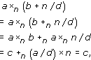

where the last but one line follows because x = b is a solution and a/d _{n}.
There is a method for finding the smallest solution which is similar to the method used in Example 13 for the case where a and n are coprime, but we do not cover it in this course. If n is fairly small, then we can find the smallest solution by trying values. Alternatively, it may be possible to spot a solution, but as this may not be the smallest solution, we may need to subtract multiples of n/d as well as, or instead of, adding them.

Example 15

Solve each of the following equations.
- (a) 4 ×₁₂ x = 6
- (b) 4 ×₁₂ x = 8

View answer - Example 15

Exercise 49

Find all the solutions of the following equations.
- (a) In ₁₂: 3 ×₁₂ x = 6, 8 ×₁₂ x = 7, 5 ×₁₂ x = 2.
- (b) In ₁₆: 4 ×₁₆ x = 12, 3 ×₁₆ x = 13, 8 ×₁₆ x = 2.

View answer - Exercise 49

Near the beginning of Section 3.3 we posed the question: can we solve the equation x ×₉ x = 2? That is, is there an element of ₉ whose square 2?

Example 16

Show that there is no element of ₉ whose square is 2.

View answer - Example 16

Exercise 50

- (a) Find all the solutions of the equation x ×₈ x = 4.
- (b) Find all the values of c in ₈ for which it is possible to solve the equation x ×₈ x = c.

View answer - Exercise 50

In general, the solution of quadratic equations in modular arithmetic is more complicated than that of linear equations. You will study this topic further if you take a course in number theory.

3.5 Further exercises

Exercise 51

Evaluate the following sums and products in modular arithmetic.
- (a) 21 +₂₆ 15, 21 ×₂₆ 15.
- (b) 19 +₃₃ 14, 19 ×₃₃ 14.

View answer - Exercise 51

Exercise 52

Use Euclid's Algorithm to find:
- (a) the multiplicative inverse of 8 in ₂₁;
- (b) the multiplicative inverse of 19 in ₃₃.

View answer - Exercise 52

Exercise 53

Construct the multiplication table for ₁₁, and hence find the multiplicative inverse of every non-zero element in ₁₁.

View answer - Exercise 53

Exercise 54

Use the solution to Exercise 52 to solve the following equations.
- (a) 8 ×₂₁ x = 13
- (b) 19 ×₃₃ x = 15

View answer - Exercise 54

Exercise 55

Find all the solutions of the following equations.
- (a) In ₈: 3 ×₈ x = 7, 4 ×₈ x = 7, 4 ×₈ x = 4.
- (b) In ₁₅: 3 ×₁₅ x = 6, 4 ×₁₅ x = 3, 5 ×₁₅ x = 2.

View answer - Exercise 55

Exercise 56

- (a) Show that the equation x ×₁₂ x = 7 has no solutions.
- (b) Find all the solutions of x ×₁₂ x = 4.

View answer - Exercise 56

4 Equivalence relations

4.1 What is a relation?
In this final section we look at a method of classifying the elements of a set by sorting them into subsets. We shall require that the set is sorted into disjoint subsets – so each element of the set belongs to exactly one subset. Such a classification is known as a partition of a set. In order to achieve a partition, we need to have a method which enables us to decide whether or not one element belongs to the same subset as another. We look first at the general idea of a relation, and then at the particular properties needed by a relation in order to partition a set. A relation which satisfies these special properties is known as an equivalence relation, and the subsets into which the set is partitioned are called equivalence classes.
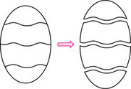
Equivalence relations occur in all branches of mathematics. For example, in geometry, two possible relations between the set of all triangles in the plane are is congruent to and is similar to. These are both equivalence relations: the relation is congruent to partitions the set of triangles into classes such that all the triangles within each class are congruent to each other, whereas is similar to partitions the set into classes of similar triangles. These partitions are different: triangles of the same shape but different sizes are similar to, but not congruent to, each other.
Equivalence relations are not confined to sets of mathematical objects. For example, relations between people such as is the same height as and has the same birthday as are equivalence relations.

Relations
We shall use the symbol (known as tilde or twiddle) to represent a relation between two elements of a set.
Some texts use ρ, rather than , for an arbitrary relation. Certain relations have special symbols; for example,
- < means is less than,
- = means is equal to.

Definition
We say that is a relation on a set X if, whenever x, y X, the statement x y is either true or false.
- If x y is true, then x is related to y.
- If x y is false, then x is not related to y and we write x y.

The statement x y can be read as ‘x is related to y’ or ‘x twiddles y’.

Examples
- 1. The condition ‘is equal to’ is a relation on any set of real numbers because, for any x, y in the set, the statement ‘x is equal to y’ is either definitely true or definitely false. This relation is usually denoted by the symbol =. For this relation, each real number in the set is related only to itself!
- 2. The condition ‘is less than’ is a relation on any set of real numbers, and we usually denote it by the symbol <. For example, −2 < 1, but 1 −2 and 3 3.
- 3. The condition ‘is the derivative of’ is a relation on any set of functions. We can define

- For example, let f(x) = x³, g(x) = 3x² and h(x) = 2e^{x}. Then g f because g is the derivative of f, and h h because h is the derivative of h, but f g because f is not the derivative of g.
- 4. On , we can define a relation

- that is, z₁ is related to z₂ if the distance between z₁ and z₂ in the complex plane is less than or equal to 4. For example, 1 + i 2 − i because

- but 1 + i 3+ 5i because

4.2 Equivalence relations
Our formal definition of an equivalence relation involves three key properties. A relation that has these three properties partitions the set on which the relation is defined, as we show later in this subsection.

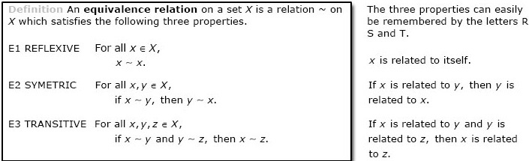

The reflexive, symmetric and transitive properties are independent, in the sense that relations exist with every combination of these properties. (However, relations which are symmetric and transitive but not reflexive are usually somewhat contrived.)
If a relation is symmetric, then ‘x is related to y’ means the same as ‘y is related to x’, and we can use either phrase, or simply say ‘x and y are related’; we can write either x y or y x.
We now consider the examples in the previous subsection to see whether they satisfy any or all of the three properties.

Examples
- 1. The relation ‘is equal to’ on is reflexive, symmetric and transitive.
- It is reflexive since, for all x , x = x.
- It is symmetric since, for all x, y , if x = y, then y = x.
- It is transitive since, for all x, y, z , if x = y and y = z, then x = z.
- Hence this relation is an equivalence relation.
- 2. The relation ‘is less than’ on is neither reflexive (since it is not true that x < x for all x ) nor symmetric (since, if x < y, then it does not follow that y < x), but it is transitive, since, if x < y and y < z, then x < z.
- 3. The relation ‘is the derivative of ’ on a set of functions has none of the reflexive, symmetric and transitive properties.
- 4. The relation defined on by

- is reflexive, since |z − z| = 0 ≤ 4 for all z . It is also symmetric, since, if |z₁ − z₂| ≤ 4, then |z₂ − z₁| = |z₁ − z₂| ≤ 4. However, it is not transitive. The counter-example z₁ = 0, z₂ = 4, z₃ = 4 + i shows that property E3 fails:

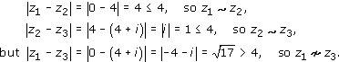

So only the first of the four examples above is an equivalence relation.

Example 17

Prove that the relation defined on by

is an equivalence relation on .

View answer - Example 17

Exercise 57

For each set A and given relation, decide whether the relation has the reflexive, symmetric and transitive properties, and thus whether it is an equivalence relation. For each property, either prove that it holds or give a counter-example to show that it does not hold.
- (a) A = ; x y if x − y is odd.
- (b) A = ; x y if x − y is even.
- (c) A is the set of all lines in the plane; ℓ₁ ℓ₂ if the lines ℓ₁ and ℓ₂ are parallel. (Take the definition of parallel to be ‘in the same direction as’.)
- (d) A = ; z₁ z₂ if z₁ − z₂ is real.

View answer - Exercise 57

At the beginning of this section we stated that we were looking at a method of classifying objects in a set by partitioning them.

Definition
A collection of non-empty subsets of a set is a partition of the set if every two subsets in the collection are disjoint and the union of all the subsets in the collection is the whole set.
(Two sets are disjoint if they have no elements in common.)

We now show why an equivalence relation partitions the set on which the relation is defined. First we need another definition.

Definition
Let be an equivalence relation defined on a set X; then the equivalence class of x X, denoted by x, is the set

Thus x is the set of all elements in X related to x.

Example 18

Find the equivalence classes for the following equivalence relations:
- (a) ‘is equal to’ on a set of real numbers;
- (b) the relation of Example 17: z₁ z₂ if |z₁| = |z₂|, on the set .

View answer - Example 18

Theorem 7
The equivalence classes associated with an equivalence relation on a set X have the following properties.
- (a) Each x X is in an equivalence class.
- (b) For all x, y X, the equivalence classes x and ﻿y﻿ are either equal or disjoint.
- (Equivalence classes (being sets) are equal if they have exactly the same elements.)
Thus the equivalence classes form a partition of X.

Proof
Let be an equivalence relation on a set X.
- (a) Let x X. The relation is reflexive, so x x, and hence x belongs to the equivalence class x.
- (b) Let x and y be equivalence classes with at least one element a in common.
- Then, since x and y are not disjoint, we have to prove that they are equal.
- First we show that x y. Suppose that b x; we have to show that b y.
- Since a y, a x and b x, we have

- respectively. (By definition, a x implies that x a, but since is symmetric, this means the same as a x.)
- Since is transitive, the first two statements of statements (4.1) together imply that y x, and this, together with the third statement of statements (4.1), implies that y b. Hence b y.
- This shows that x y. We can show similarly that y x (we interchange the roles of x and y in the proof that x y).
- Hence x = y.
As an illustration of Theorem 7, consider the equivalence relation in Example 18(b). We saw that the equivalence classes of this relation are of the form

where r . That is, this relation partitions the complex plane into concentric circles with centre the origin.
(Here we think of the class containing the origin alone as a circle of radius 0.)
It follows from Theorem 7 that if two elements x and y are related by an equivalence relation, then x = y. Thus, in general, there is more than one way to denote each equivalence class using the notation : a class can be denoted by x where x is any one of its elements. It is sometimes useful to choose a particular element x in each equivalence class and denote the class by x. The element x that we choose is called a representative of the class.
For example,

is one of the equivalence classes of the equivalence relation in Example 18(b). This class contains 4, −4i and 2 + 2i, for example, so we could denote it by any of 4, −4i or 2+2i. We might decide to choose the representative 4 and denote the class by 4. In general, the equivalence class

Exercise 58

Determine the equivalence classes for the equivalence relations in Exercise 57(b), (c) and (d).

View answer - Exercise 58

The solutions to Exercise 57(b) and Exercise 58 show that the relation on given by

is an equivalence relation, with equivalence classes

and

that is, the even integers form one class and the odd integers the other. You have already met this idea in Section 3: the relation ‘x y if x − y is even’ is congruence modulo 2.
For any n, congruence modulo n on , given by

is an equivalence relation; the first three properties given in Theorem 5 are the reflexive, symmetric and transitive properties. The equivalence classes for this relation are the sets

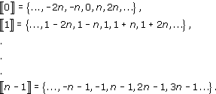

The representatives that we have used to denote the classes are 0, 1, 2, …, n − 1, which are the elements of _{n}. Thus _{n} is a set of representatives of the equivalence classes of congruence modulo n; that is, each equivalence class has exactly one representative in the set _{n}. The definitions of the modular operations +_{n} and ×_{n} can be rephrased using the idea of equivalence classes as follows: for all a, b _{n},

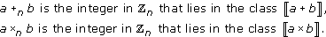

For example, in ₅,

because 3 + 4 = 7 and the equivalence class 7 of congruence modulo 5 contains the element 2 of ₅.
So far, we have taken congruences only on , but it is possible to take congruences also on , and the modulus does not need to be an integer.

Example 19

Show that the relation defined on by

is an equivalence relation, and describe the equivalence classes.

View answer - Example 19

The equivalence relation in Example 19 is congruence modulo 2. For example,

and we write

because

We have seen that congruence modulo n on corresponds to modular arithmetic on _{n}, which is a set of representatives of the equivalence classes of congruence modulo n. In a similar way, congruence modulo 2 on corresponds to modular arithmetic on a set of representatives of the equivalence classes of congruence modulo 2. A suitable set of representatives is the interval (−, ], since every equivalence class has exactly one representative in this interval. (Other intervals can be used, for example [0, 2), but (−, ] is useful as it corresponds to our definition of the principal argument of a complex number.) We define modular operations and on the interval (−, ] as follows: for all x, y (−, ],

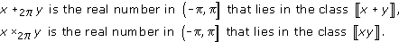

For example,

( and contains ) .
This is effectively what we do when we take the principal argument of a complex number arising from some calculation.
Arithmetic modulo 2 on the interval (−, ] gives us a concise way to express some results about complex numbers. For example, we saw earlier that, if z₁ and z₂ are any two complex numbers, then Arg z₁ + Arg z₂ is an argument of z₁z₂, but is not necessarily the principal argument. The principal argument is Arg z₁ Arg z₂, so we can now state that

(Recall that Arg z denotes the principal argument of z.)

4.3 Further exercises

Exercise 59

Let be the relation defined on by

Give counter-examples to show that is not reflexive, symmetric or transitive.

View answer - Exercise 59

Exercise 60

Let A be the set of all functions with domain and codomain , and let be the relation defined on A by

Show that this is an equivalence relation and describe the equivalence classes.

View answer - Exercise 60

Exercise 61

Let be the relation defined on by

where

Show that this is an equivalence relation and describe the equivalence classes.

View answer - Exercise 61

Conclusion
This free course provided an introduction to studying Mathematics. It took you through a series of exercises designed to develop your approach to study and learning at a distance and helped to improve your confidence as an independent learner.

Keep on learning



Study another free course
There are more than 800 courses on OpenLearn for you to choose from on a range of subjects.
Find out more about all our free courses.

Take your studies further
Find out more about studying with The Open University by visiting our online prospectus.
If you are new to university study, you may be interested in our Access Courses or Certificates.

What’s new from OpenLearn?
Sign up to our newsletter or view a sample.

For reference, full URLs to pages listed above:
OpenLearn – www.open.edu/openlearn/free-courses
Visiting our online prospectus – www.open.ac.uk/courses
Access Courses – www.open.ac.uk/courses/do-it/access
Certificates – www.open.ac.uk/courses/certificates-he
Newsletter – www.open.edu/openlearn/about-openlearn/subscribe-the-openlearn-newsletter

Acknowledgements
The content acknowledged below is Proprietary (see terms and conditions). This content is made available under a Creative Commons Attribution-NonCommercial-ShareAlike 4.0 Licence
Course image: Bill Burris in Flickr made available under Creative Commons Attribution-ShareAlike 2.0 Licence.
All written material contained within this course originated at the Open University.
Don't miss out:
If reading this text has inspired you to learn more, you may be interested in joining the millions of people who discover our free learning resources and qualifications by visiting The Open University - www.open.edu/openlearn/free-courses

Exercise 1

Answer

Solution
Suppose that there exists a rational number x such that x³ = 2. We can write x = p/q, where p and q are positive integers whose greatest common factor is 1. Then the equation x³ = 2 becomes

Now the cube of an odd number is odd because

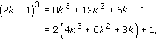

so p must be even. If we write p = 2r, then our equation becomes

so we have

Hence q is also even, so 2 is a common factor of p and q. This contradiction shows that such a number x cannot exist.
Back to - Exercise 1

Exercise 2

Answer

Solution
- (a) There is no integer 2⁻¹ such that 2 × 2⁻¹ = 2⁻¹ × 2 = 1, for example.
- (b) The numbers 1 and − 1 both have a multiplicative inverse in . In each case the number is its own inverse; such a number is sometimes described as being self-inverse.
Back to - Exercise 2

Exercise 3

Answer

Solution
- (a) This equation has two solutions in .

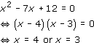

- (b) This equation has one solution in .

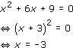

- (c) This equation has two solutions in .

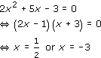

- (d) This equation has two solutions in .

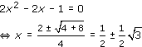

- (e) Since 4 − 20 = −16, which is negative, this equation has no solutions in .

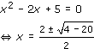

Back to - Exercise 3

Exercise 4

Answer

Solution
- (a) x = −2, which belongs to (and hence to and ).
- (b) 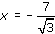, which belongs to .
- (c) x = 3, which belongs to (and hence to , and ).
- (d) , which belongs to (and hence to ).
Remark Each linear equation with coefficients in has a solution in (because the equation ax + b = 0 where a, b and a ≠ 0 has solution x = − b/a, which involves only additive inverses and division of rational numbers). Similarly each linear equation with coefficients in has a solution in . The same is not true of , as part (d) illustrates.
Back to - Exercise 4

Exercise 5

Answer

Solution
Suppose there is a rational number x such that x² = 3. Then we can write x = p/q, where p and q are positive integers whose greatest common factor is 1.
Then the equation x² = 3 becomes

Now p is either divisible by 3 or has remainder 1 or 2 on division by 3;
that is, p = 3k or 3k + 1 or 3k + 2 for some integer k.
But if p = 3k + 1, then p² = 9k² + 6k + 1 is not divisible by 3, and if p = 3k + 2, then

is not divisible by 3. So, since 3q² is divisible by 3, we conclude that p = 3k.
Hence (3k)² = 3q², so q² = 3k².
But then the same argument applies to q to show that q must also be divisible by 3.
Hence 3 is a common factor of p and q.
This is a contradiction, so we conclude that the assumption must have been false. Hence there is no rational number x such that x² = 3.
Back to - Exercise 5

Exercise 6

Answer

Solution
- (a) The equation z² − 4z + 7 = 0 has solutions

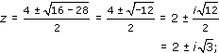

- that is, z = 2 + iand z = 2 − ii.
- (b) The equation z²− iz + 2 = 0 has solutions

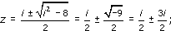

- that is, z = 2i and z = − i.
- (c) We can factorise the equation

- as

- Hence z = 1 or 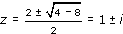,
- so the solutions are z = 1, z = 1 + i and z = 1 − i.
- (d) z⁴− 16 = 0 can be factorised as

- giving z² = 4 or z² = −4.
- Hence z = 2 or z = −2 or z =2i or z = −2i.
Back to - Exercise 6

Exercise 7

Answer

Solution
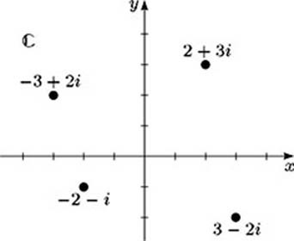
Back to - Exercise 7

Example 1

Answer

Solution
Using the usual rules of arithmetic, with the additional property that i² = −1, we obtain the following.
- (a) z₁ + z₂ = (1 + 2i) + (3 − 4i) = (1 + 3) + (2 − 4)i = 4 − 2i
- (b) z₁ − z₂ = (1 + 2i) − (3 − 4i) = (1 − 3) + (2 + 4)i = − 2 + 6i
- (c) z₁z₂ = (1 + 2i)(3 − 4i) = 3 + 6i − 4i − 8i² = 3 + 2i + 8 = 11+ 2i
- (d)
Back to - Example 1

Exercise 8

Answer

Solution
- (a) (3 − 5i) + (2 + 4i) = 5 − i
- (b) (2 − 3i)(−3 + 2i) = −6 + 9i + 4i − 6i² = 13i
- (c)

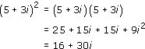

- (d) We find

- so

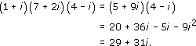

Back to - Exercise 8

Exercise 9

Answer

Solution
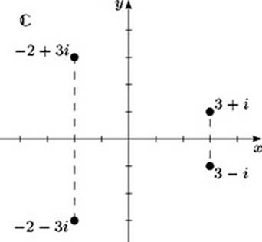
Back to - Exercise 9

Exercise 10

Answer

Solution
Property 2
Let z₁ = x₁ + iy₁ and z₂ = x₂ + iy₂. Then

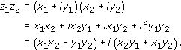

so

Also,

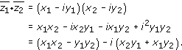

Therefore

Property 3
Let z = x + iy. Then

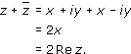

Property 4
Let z = x + iy. Then

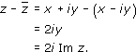

Back to - Exercise 10

Exercise 11

Answer

Solution
- (a)
- (b)
- (c)
Back to - Exercise 11

Exercise 12

Answer

Solution
- (a)
- 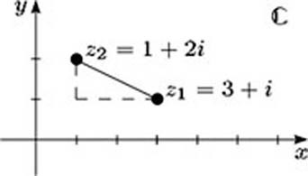
- Here

- so

- (b)
- 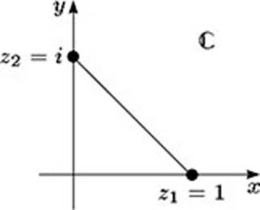
- Here

- so

- (c)
- 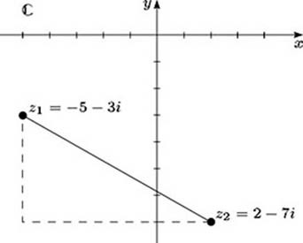
- Here

- so

Back to - Exercise 12

Example 2

Answer

Solution
- (a) We want to find the complex number which represents
- We multiply the numerator and denominator by 2 + 5i, the complex conjugate of 2 − 5i, to give

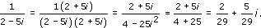

- (b) We multiply the numerator and denominator by 1 −2i, the complex conjugate of 1 + 2i, to give

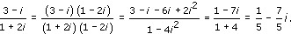

Back to - Example 2

Exercise 13

Answer

Solution
In each case we multiply both the numerator and the denominator by the complex conjugate of the denominator.
- (a)

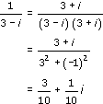

- (b)

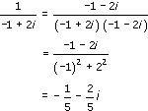

Back to - Exercise 13

Exercise 14

Answer

Solution
In each case we multiply the numerator and denominator by the complex conjugate of the denominator.
- (a)

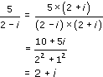

- (b)

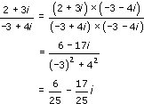

Back to - Exercise 14

Example 3

Answer

Solution
- (a) Here r = 3 and θ = /3. Thus the required form is x + iy, where

- and

- The Cartesian form is therefore
- .
- (b) Here r = 1 and θ = −/6. Thus the required form is x + iy, where

- and

- The Cartesian form is therefore
- .
Back to - Example 3

Exercise 15

Answer

Solution
- (a) The required form is x + iy, where

- and

- The Cartesian form is therefore 2i.
- (b) The required form is x + iy, where

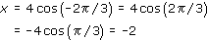

- and

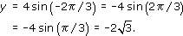

- The Cartesian form is therefore − 2 − 2i.
Back to - Exercise 15

Example 4

Answer

Solution
- (a) Let z = x + iy = 2 + 2i, so x = 2 and y = 2.
- Then z = r(cos θ + i sin θ), where

- To find θ, we calculate

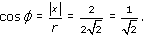

- So φ = /4, and z lies in the first quadrant so θ = φ = /4.
- 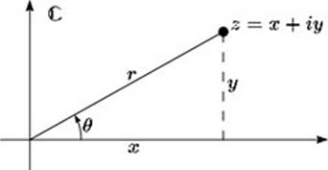
- The polar form of 2 + 2i in terms of the principal argument is therefore

- (b) Let , so and .
- Then z = r(cos θ + i sin θ), where

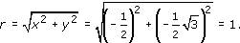

- To find θ, we calculate

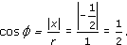

- So φ = /3, and z lies in the third quadrant so θ = −( − φ) = −2/3.
- 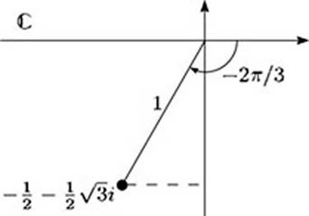
- The polar form of in terms of the principal argument is therefore

Back to - Example 4

Exercise 16

Answer

Solution
- (a) Let z = x + iy = −1 + i, so x = −1 and y = 1. Then z = r(cos θ + i sin θ), where

- Also

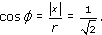

- So φ = /4, and z lies in the second quadrant, so θ = − φ = 3/4.
- 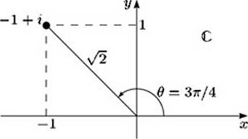
- Thus the polar form of −1 + i in terms of the principal argument is

- (b) Let z = x + iy = 1 − i, so x = 1 and y = − . Then z = r(cos θ + i sin θ), where

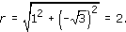

- Also

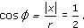

- So φ = /3, and z lies in the fourth quadrant, so θ = − φ = − /3.
- 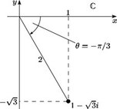
- Thus the polar form of 1 − √3i in terms of the principal argument is

- (c) Let z = x + iy = −5, so x = −5 and y = 0. Then z = r(cos θ + i sin θ), where

- Also z lies on the negative half of the real axis, so θ = .
- 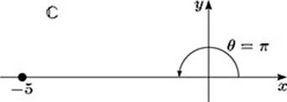
- Thus the polar form of −5 in terms of the principal argument is

Back to - Exercise 16

Exercise 17

Answer

Solution
- (a) The modulus of the product is

- An argument is

- Since this argument lies in (− , ], it follows that it is the principal argument. The required product is therefore

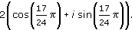

- (b) The modulus of the product is

- An argument is

- The principal argument is therefore

- The required product is therefore

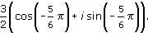

- (c) The modulus of the quotient is

- An argument is

- The principal argument is therefore

- The required quotient is therefore

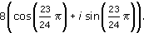

- (d) The modulus of the quotient is

- An argument is

- Since this argument lies in (− , ], it follows that it is the principal argument. The required quotient is therefore

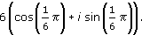

Back to - Exercise 17

Exercise 18

Answer

Solution
From the solution to Exercise 16,

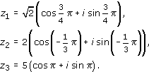

Hence

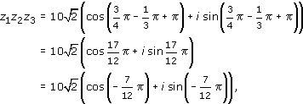

using the principal argument.
Also

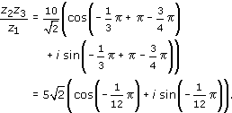

Back to - Exercise 18

Example 5

Answer

Solution

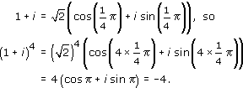

So z⁴ = −4.
Back to - Example 5

Exercise 19

Answer

Solution
- (a) 1 = 1(cos 0 + i sin 0)
- (b)

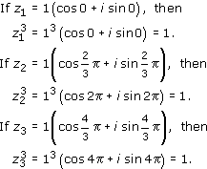

- (c) In Cartesian form,

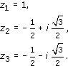

Back to - Exercise 19

Example 6

Answer

Solution
- (a) In polar form, −27 = 27(cos + i sin ). If z = r(cos θ + i sin θ), then the equation z³= −27 can be written as

- (b) From equation (2.5), r³ = 27, so r = 3.
- Also from equation (2.5), cos 3θ = cos and sin 3θ = sin , so one solution for θ is obtained by taking 3θ = , so
- .
- However, we could also take 3, 5, 7, … as arguments of −27, so 3θ = 3, 3θ = 5, 3θ = 7, … also give solutions. Hence we can have
- ....
- But , so taking gives the same complex number as .
- Similarly, increasing the value of the argument of −27 by any further multiple of 2 repeats solutions we already have.
- So the three different solutions of z³ = −27 are given by

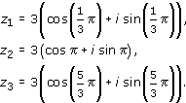

- These solutions can also be written in Cartesian form as

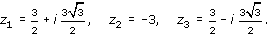

- They are shown in the diagram below.
The solution z₃ could be rewritten in terms of its principal argument as 3(cos(−/3) + i sin(−/3)).
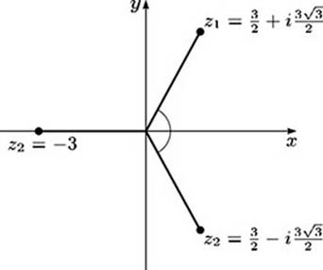
Back to - Example 6

Exercise 20

Answer

Solution
- (a) Let z = r(cos θ + i sin θ). Then, since

- we have

- (b) Hence r = 1^{1/6} = 1 and

- for k = 0, 1, … 5, and the six solutions of z⁶ = 1 are given by

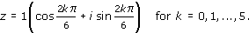

- Hence the solutions are

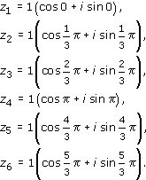

- (c)
- 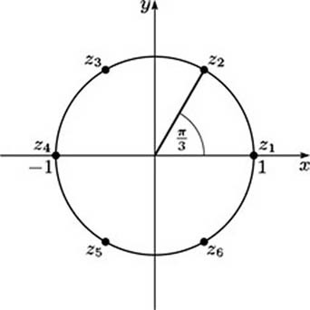
- (d)

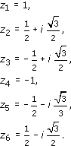

Back to - Exercise 20

Exercise 21

Answer

Solution
Let z = r(cos θ + i sin θ). Then, since

we have

Hence r = 4^{1/4} = and for k = 0, 1, 2, 3.
So the solutions are

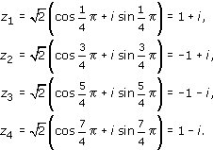

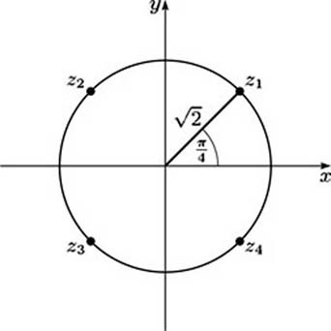
Back to - Exercise 21

Exercise 22

Answer

Solution
Let z = r(cos θ + i sin θ).
Since , we have

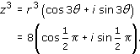

Hence r = 8^{1/3} = 2 and for k = 0, 1, 2.
So the solutions are

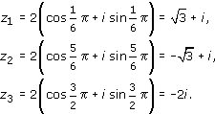

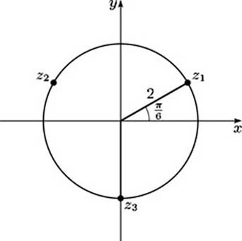
Back to - Exercise 22

Example 7

Answer

Solution
- (a) 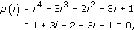
- so i is a root of p(z).
- (b) Since p has real coefficients, z = −i is also a root of p(z), so (z −i)(z + i) = z² + 1 is a factor of p(z). By equating coefficients, we obtain

- So the remaining two roots of p(z) are given by the solutions of the equation z² − 3z + 1 = 0.
- Using the quadratic formula, we have

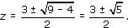

- Hence the four roots of p(z) are i, −i,
- 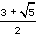
- and
- 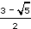.
Back to - Example 7

Exercise 23

Answer

Solution
A suitable polynomial is

that is,

or

Back to - Exercise 23

Exercise 24

Answer

Solution
- (a)

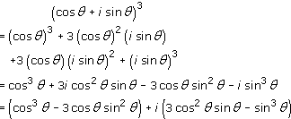

- (b)
- By part (a),

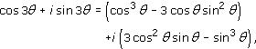

- so

- and

- (c) Since sin² θ = 1 − cos² θ and cos² θ = 1 − sin² θ, we have

- so

- and

- so

Back to - Exercise 24

Exercise 25

Answer

Solution
- (a)

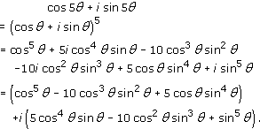

- Equating real and imaginary parts gives

- and

- (b)
- Since sin² θ = 1 − cos² θ and sin⁴ θ = (sin² θ)² =(1 − cos² θ)², on substituting into the formula for cos 5θ found in part (b) we obtain

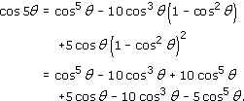

- so

- Similarly,

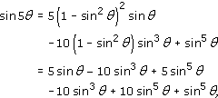

- so

Back to - Exercise 25

Example 8

Answer

Solution
We use Strategy 1.
Suppose that z₁ = x₁ + iy₁ and z₂ = x₂ + iy₂. Then

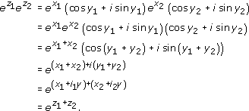

We assume that if x₁, x₂ are real numbers, then

Back to - Example 8

Exercise 26

Answer

Solution
- (a) Let z = x + iy; then

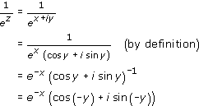

- (by de Moivre's Theorem with n = − 1)

- (b)

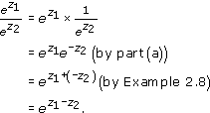

Back to - Exercise 26

Example 9

Answer

Solution
- (a) 2cos θ = e^{iθ} + e^{−iθ}, so (2 cos θ)⁴ = (e^{iθ} + e^{iθ})⁴.
- Hence
- .
- (b)

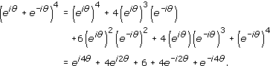

- Hence

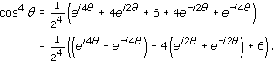

- Using Equation 2.8 first with 4θ in place of θ and then with 2θ in place of θ, we have

- as required.
Back to - Example 9

Exercise 27

Answer

Solution
- (a) 2i sin θ = e^{iθ} − e^{− iθ}, so (2i sin θ)⁵ =(e^{i θ} − e^{−i θ})⁵.
- Hence

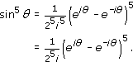

- (b)

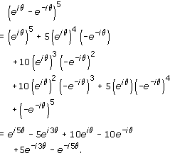

- Hence

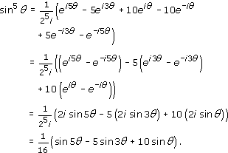

Back to - Exercise 27

Exercise 28

Answer

Solution
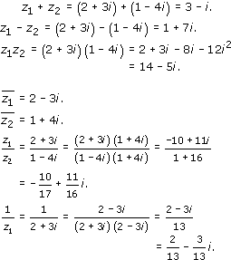
Back to - Exercise 28

Exercise 29

Answer

Solution
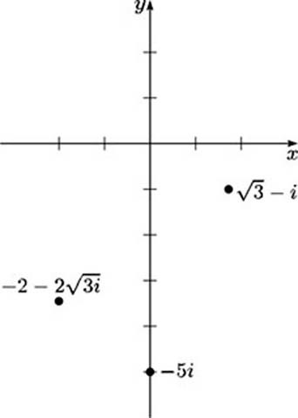
- (a) Let z = x + iy = − i, so x = and y = − 1. Then z = r(cos θ + i sin θ), where

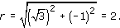

- Also 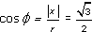. So , and z lies in the fourth quadrant, so .
- Hence the polar form of − i in terms of the principal argument is

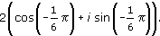

- (b) Let z = x + iy = −5i, so x = 0 and y = −5. Then z = r(cos θ + i sin θ), where

- Also z lies on the negative half of the imaginary axis, so .
- Hence the polar form of −5i in terms of the principal argument is

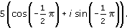

- (c) Let z = x + iy = −2 − 2i, so x = −2 and y = −2. Then z = r(cos θ + i sin θ), where

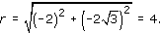

- Also 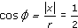. So , and z lies in the third quadrant, so
- .
- Hence the polar form of −2 − 2i in terms of the principal argument is

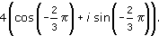

Back to - Exercise 29

Exercise 30

Answer

Solution
- (a) The required form is x + iy, where

- and

- so the Cartesian form is 2 + 2i.
- (b) The required form is x + iy, where

- so the Cartesian form is 3i.
- (c) The required form is x + iy, where

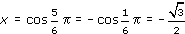

- and

- so the Cartesian form is
- 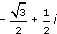
Back to - Exercise 30

Exercise 31

Answer

Solution
From the solution to Exercise 29, we have

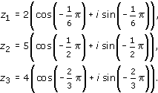

- (a) Hence

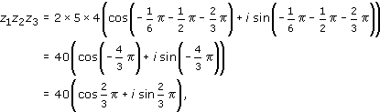

- using the principal argument.
- (b)

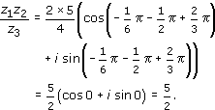

Back to - Exercise 31

Exercise 32

Answer

Solution
Let z = r(cos θ + i sin θ).
Then, since −32 = 32(cos + i sin ), we have

Hence r = 2 and for any integer k, and the five solutions of z⁵ = −32 are given by

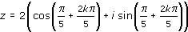

for k = 0, 1, 2, 3, 4.
Hence the solutions are

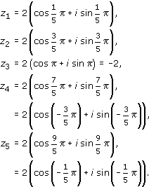

Back to - Exercise 32

Exercise 33

Answer

Solution
The integer solution must be a factor of the constant term 15,
so it must be one of ± 1, ± 3, ± 5, ± 15.
Testing these, we find z = −3 is a root, since

Hence z + 3 is a factor, and we find that

The solutions of z² −2z + 5 = 0 are given by

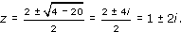

Hence the solutions of z³ + z² − z + 15 = 0 are z = −3, z =1 + 2i and z = 1 − 2i.
Back to - Exercise 33

Exercise 34

Answer

Solution
A suitable polynomial is

that is,

or

Back to - Exercise 34

Exercise 35

Answer

Solution

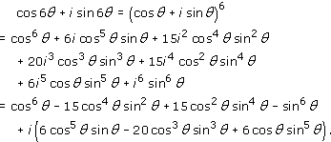

Hence

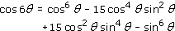

and

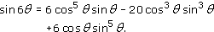

Back to - Exercise 35

Exercise 36

Answer

Solution
- (a)

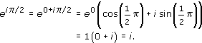

- (b)

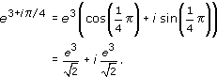

- (c) = e⁻¹(cos + isin) = −e⁻¹.
Back to - Exercise 36

Exercise 37

Answer

Solution
- (a) 65 = 9 ×7 + 2, so the quotient is 9 and the remainder is 2.
- (b) −256 = −20 × 13 + 4, so the quotient is −20 and the remainder is 4.
Back to - Exercise 37

Exercise 38

Answer

Solution
- (a) The possible remainders are 0, 1, 2, 3, 4, 5 and 6.
- (b) There are many possible answers here; for example, 3, 10, −4 and −11.
Back to - Exercise 38

Example 10

Answer

Solution
- (a) 27 − 5 = 22, which is a multiple of 11, so this congruence is true.
- Alternatively, we could note that 27 = 2 ×11 + 5 and 5 = 0 ×11 + 5, so 27 and 5 both have remainder 5 on division by 11.
- (b) 14 − (−6) = 20, which is not a multiple of 3, so this congruence is false.
- Alternatively, 14 = 4 × 3 + 2 and −6 = (−2) × 3 + 0, so 14 has remainder 2 on division by 3, but −6 has remainder 0.
- (c) 343 − 207 = 136 = 2 × 68, so this congruence is true.
- Alternatively, 343 = 5 × 68 + 3 and 207 = 3 ×68 + 3, so 343 and 207 both have remainder 3 on division by 68.
- (d) 1 − (−1) = 2, so this congruence is true.
- Both 1 and −1 have remainder 1 on division by 2.
It is often simplest to check a congruence a ≡ b (mod n) by considering the difference a − b.
Back to - Example 10

Exercise 39

Answer

Solution
We have

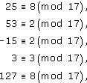

so the remainders are 8, 2, 2, 3 and 8, respectively. So 25 ≡ 127 (mod 17) and 53 ≡ −15 (mod 17).
Back to - Exercise 39

Exercise 40

Answer

Solution
- (a) Suppose that a ≡ b (mod n) and c ≡ d (mod n). Then a = b + kn and c = d + ln for some integers k and l.
- Hence

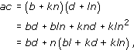

- so ac − bd = (bl + kd + kln)n, so ac ≡ bd (mod n).
- (b) Suppose that a ≡ b (mod n) and let P(k) be the statement a^{k} ≡ b^{k} (mod n).
- Then P(1) is true, since we know that a ≡ b (mod n). Suppose that r ≥ 1 and P(r) is true, that is, a^{r} ≡ b^{r} (mod n). Then, by property (e), since a^{r} ≡ b^{r} and a ≡ b (mod n), we have a^{r} × a ≡ b^{r} × b (mod n), that is,

- Hence P(r) true P(r + 1) true, so by mathematical induction P(k) is true for all positive integers k.
Back to - Exercise 40

Example 11

Answer

Solution
- (a) Using property (c), we can add or subtract any convenient multiples of 22, and make a list of congruences. We have

- (here we have subtracted 2200, then 110, then 66; then added 22)
- and

- (here we have subtracted 4400, then 880, then 110, then 22)
- so 2375 has remainder 21 on division by 22, and 5421 has remainder 9 on division by 22.
- (b) Using property (e), we obtain

- so 2375 × 5421 has remainder 13 on division by 22.
- (c) Using property (f), we obtain

- so (2375)¹⁵ has remainder 21 on division by 22.
Back to - Example 11

Exercise 41

Answer

Solution
- (a) 3 +₅ 7 = 0, 4 +₁₇ 5 = 9, 8 +₁₆ 12 = 4.
- (b) 3 ×₅ 7 = 1, 4 ×₁₇ 5 = 3, 8 ×₁₆ 12 = 0.
Back to - Exercise 41

Exercise 42

Answer

Solution
- (a)
  - (i) 3 +₄ 3 = 2, so x = 3.
  - (ii) 4 +₇ 5 = 2, so x = 4.
  - (iii) 2 +₄ 2 = 0, so x = 2.
  - (iv) 2 +₇ 5 = 0, so x = 2.
- (b) You may have noticed that:
  - each element appears exactly once in each row and exactly once in each column;
  - there is a pattern of diagonal stripes running down from right to left.
Back to - Exercise 42

Exercise 43

Answer

Solution
- (a)
- 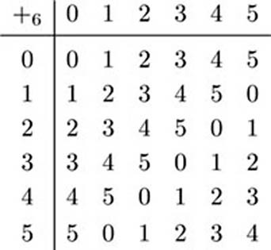
- (b) x +₆ 1 = 5 has solution x = 4.
- x +₆ 5 = 1 has solution x = 2.
Back to - Exercise 43

Exercise 44

Answer

Solution
By definition, a +_{n} b and b +_{n} a are the remainders of a + b and b + a, respectively, on division by n. But a + b = b + a, so a +_{n} b = b+_{n} a.
Back to - Exercise 44

Exercise 45

Answer

Solution
- (a)
- 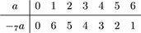
- (b)
- 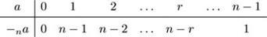
- The additive inverse of 0 is always 0, since 0 +_{n} 0 = 0. For any integer r > 0 in _{n}, n− r _{n} and r + (n − r) = n, so r +_{n} (n − r) = 0.
Back to - Exercise 45

Exercise 46

Answer

Solution
- (a)
  - (i) 1 and 3 have multiplicative inverses in ₄, since 1 ×₄ 1 = 1 and 3 ×₄ 3 = 1.
  - (ii) The multiplicative inverses in ₇ are given by the following table, where b is the multiplicative inverse of a.
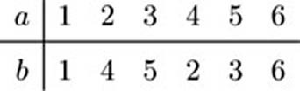
- (b)
- 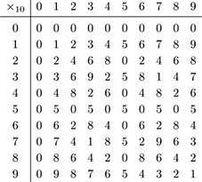
- The integers 1, 3, 7 and 9 have multiplicative inverses in ₁₀.
Back to - Exercise 46

Example 12

Answer

Solution
We apply the Division Algorithm repeatedly, starting by dividing the modulus 27 by the integer 10, whose multiplicative inverse we seek:

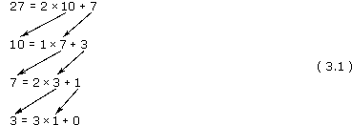

Note: The first part of the method, consisting of repeated application of the Division Algorithm, is the procedure known as Euclid's Algorithm. When it is applied to any two positive integers a and b, the last but one remainder is the greatest common factor of a and b. The second part of the method, which involves starting with the last but one equation from the first part, is often described as working backwards through Euclid's Algorithm.
At each step we divide the divisor in the row above by the remainder in the row above, repeating the process until we reach a remainder of 0 (which must occur because the remainders decrease by at least 1 at each step).
Now we use Equations 3.1 to find the required multiplicative inverse. Starting with the last but one equation, and working upwards, we have

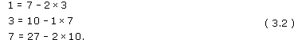

(We rearrange each equation so that only the remainder is on the left-hand side.)
We write down the first of Equations 3.2, and use the other two equations to eliminate multiples of 3 and 7 by successive substitutions.

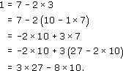

(The multiples may be negative; for example, −8 × 10 is a multiple of 10.)
After each substitution, 1 is expressed as a multiple of one integer plus a multiple of another integer, where the two integers are a neighbouring pair from the list 27, 10, 7, 3 of left-hand sides of Equations 3.1. The last equation expresses 1 in terms of multiples of the two integers that we started with, 10 and 27. Rearranging this equation gives

so

Now the integer −8 does not belong to ₂₇, but, since −8 ≡ 19 (mod 27), we have

and hence

Hence 19 is the multiplicative inverse of 10 in ₂₇ and we can write 10⁻¹ = 19 (mod 27).
As a check:

Back to - Example 12

Exercise 47

Answer

Solution
- (a)

- Starting with the last equation, we have

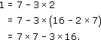

- Hence 7 × 7 = 3 × 16 + 1, so 7 ×₁₆ 7 = 1 and the multiplicative inverse of 7 in ₁₆ is 7.
- (b)

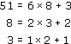

- Starting with the last equation, we have

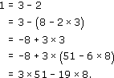

- Hence (−19) × 8 ≡ 1 (mod 51), so

- Hence 32 ×₅₁ 8 = 1 and the multiplicative inverse of 8 in ₅₁ is 32.
Back to - Exercise 47

Example 13

Answer

Solution
In Example 12 we found that the multiplicative inverse of 10 in ₂₇ is 19. Hence we have

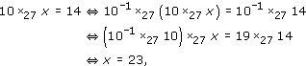

so the given equation has the unique solution x = 23.
Back to - Example 13

Exercise 48

Answer

Solution
- (a) Since the multiplicative inverse of 7 in ₁₆ is 7 (see the solution to Exercise 47(a)), we have

- (b) Since the multiplicative inverse of 8 in ₅₁ is 32 (see the solution to Exercise 47(b)), we have

Back to - Exercise 48

Example 14

Answer

Solution
Observe that 7 ≡ −5 (mod 12), so we have

The integer −1 is not an element of ₁₂, but −1 ≡ 11 (mod 12), so

Hence the solution of the given equation is x = 11.
Back to - Example 14

Example 15

Answer

Solution
- (a) This equation has no solutions, since 4 is a factor of both 4 and 12 but is not a factor of 6.
- (b) One solution of this equation is x = 2. Also n/d = 12/4 = 3, so the other solutions are x = 2 + 3 = 5 and x = 2 + 2 × 3 = 8.
Back to - Example 15

Exercise 49

Answer

Solution
- (a) One solution of the equation 3 ×₁₂ x = 6 is x = 2. Also n/d = 12/3 = 4, so the other solutions are x = 2 + 4 = 6 and x = 2 + 2 × 4 = 10.
- The equation 8 ×₁₂ x = 7 has no solutions because 8 and 12 have common factor 4 but 7 does not.
- Because 5 and 12 are coprime, the equation 5 ×₁₂ x = 2 has a unique solution. The solution, x = 10, can be found in various ways: for example, by calculating x = 5⁻¹ ×₁₂ 2, or by testing possible values for x, or by spotting that 2 ≡ −10 (mod 12) and using the fact that the congruence 5 × (−2) ≡ −10 (mod 12) implies 5 × 10 ≡ 2 (mod 12) giving 5 ×₁₂ 10 = 2.
- (b) One solution of the equation 4 ×₁₆ x =12 is x = 3. Also n/d = 16/4 = 4, so the other solutions are x = 3 + 4 = 7, x =3 + 8 = 11 and x = 3 + 12 = 15.
- Because 3 and 16 are coprime, the equation 3 ×₁₆ x = 13 has a unique solution. The solution, x = 15, can be found in various ways: for example, by calculating x = 3⁻¹ ×₁₆ 13, or by testing possible values for x, or by spotting that 13 ≡ −3 (mod 16) and using the fact that the congruence 3 × (−1) ≡ −3 (mod 16) implies 3 × 15 ≡ 13 (mod 16) giving 3 ×₁₆ 15 = 13.
- The equation 8 ×₁₆ x = 2 has no solutions because 8 and 16 have common factor 4 but 2 does not.
Back to - Exercise 49

Example 16

Answer

Solution
We solve this problem by exhaustion, by writing down the squares of all the elements of ₉.
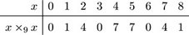
We can see from this table that there is no element of ₉ whose square is 2. In fact, we can go further and say that the remainder of a square modulo 9 can be only 0, 1, 4 or 7. That is, 0, 1, 4 and 7 are the only elements of ₉ that are squares of other elements.
Back to - Example 16

Exercise 50

Answer

Solution
We find all the values of x ×₈ x.
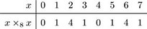
- (a) The solutions of x ×₈ x = 4 are x = 2 and x = 6.
- (b) The equation x ×₈ x = c can be solved for c = 0, 1, 4.
Back to - Exercise 50

Exercise 51

Answer

Solution
- (a) 21 +₂₆ 15 = 10, 21 ×₂₆ 15 = 3.
- (b) 19 +₃₃ 14 = 0, 19 ×₃₃ 14 = 2.
Back to - Exercise 51

Exercise 52

Answer

Solution
- (a)

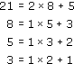

- Hence

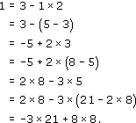

- Hence 8 × 8 = 3 × 21 + 1, so

- so the multiplicative inverse of 8 in ₂₁ is 8.
- (b)

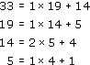

- Hence

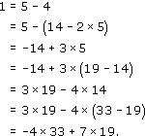

- Hence

- so

- so the multiplicative inverse of 19 in ₃₃ is 7.
Back to - Exercise 52

Exercise 53

Answer

Solution
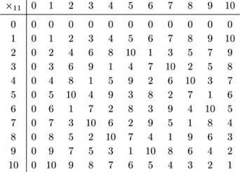
Hence we have the following multiplicative inverses in ₁₁.
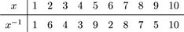
Back to - Exercise 53

Exercise 54

Answer

Solution
- (a) We have 8 ×₂₁ x = 13. Multiplying by 8, which is the multiplicative inverse of 8 mod 21 (see the solution to Exercise 52(a)), we have

- so

- (b) We have 19 ×₃₃ x = 15. Multiplying by 7, which is the multiplicative inverse of 19 mod 33 (see the solution to Exercise 52(b)), we have

- so

Back to - Exercise 54

Exercise 55

Answer

Solution
- (a) Because 3 and 8 are coprime, the equation 3 ×₈ x = 7 has a unique solution. The solution, x = 5, can be found in various ways: for example, by calculating x = 3⁻¹ ×₈ 7, or by testing possible values for x, or by spotting that 7 ≡ 15 (mod 8) and using the fact that the congruence 3 × 5 ≡ 15 (mod 8) implies 3 × 5 ≡ 7 (mod 8) giving 3 ×₈ 5 = 7.
- The equation 4 ×₈ x = 7 has no solutions because 4 and 8 have common factor 4 but 7 does not.
- One solution of the equation 4 ×₈ x = 4 is x = 1. Also n/d = 8/4 = 2, so the other solutions are x = 1 + 2 = 3, x = 1 + 4 = 5 and x = 1 + 6 = 7.
- (b) One solution of the equation 3 ×₁₅ x = 6 is x = 2. Also n/d = 15/3 = 5, so the other solutions are x = 2 + 5 = 7 and x = 2 + 10 = 12.
- Because 4 and 15 are coprime, the equation 4 ×₁₅ x = 3 has a unique solution. The solution, x = 12, can be found in various ways: for example, by calculating x = 4⁻¹ ×₁₅ 3, or by testing possible values for x, or by spotting that 3 ≡ −12 (mod 15) and using the fact that the congruence 4 × (−3) ≡ −12 (mod 15) implies 4 × 12 ≡ 3 (mod 15) giving 4 ×₁₅ 12 = 3.
- The equation 5 ×₁₅ x = 2 has no solutions because 5 and 15 have common factor 5 but 2 does not.
Back to - Exercise 55

Exercise 56

Answer

Solution
We find all the values of x ×₁₂ x.
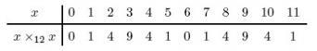
- (a) Hence there is no integer x ₁₂ such that x ×₁₂ x = 7.
- (b) The solutions of x ×₁₂ x = 4 are x = 2, 4, 8, 10.
Back to - Exercise 56

Example 17

Answer

Solution
We show that properties E1, E2 and E3 hold.

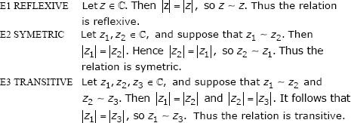

Hence this relation is an equivalence relation.
Back to - Example 17

Exercise 57

Answer

Solution
- (a) This relation is not reflexive; for example, 2 2 since 2 − 2 = 0 which is not odd.
- The relation is symmetric; if x y then x − y is odd, so y − x = − (x − y) is also odd, so y x.
- The relation is not transitive; for example, 5 2 since 5 − 2 is odd, 2 1 since 2 − 1 is odd, but 5 1 since 5 − 1 is even.
- The relation is not an equivalence relation.
- (b) This relation is reflexive, since x − x = 0, which is even, for all x .
- It is symmetric, since if x y, then x − y is even, so y − x = − (x − y) is even, so y x.
- It is transitive, since if x y and y z, then x − y is even and y − z is even, so x − z = x − y + y − z is the sum of two even numbers, so is even, so x z.
- The relation is an equivalence relation.
- (c) Any line ℓ is parallel to itself, so this relation is reflexive.
- It is symmetric, since if ℓ₁ is parallel to ℓ₂, then ℓ₂ is parallel to ℓ₁.
- It is transitive, since if ℓ₁ is parallel to ℓ₂ and ℓ₂ is parallel to ℓ₃, then ℓ₁ is parallel to ℓ₃.
- The relation is an equivalence relation.
- (d) This relation is reflexive, since for all z we have z − z = 0, which is real, so z z.
- It is symmetric, since if z₁ − z₂ is real, then z₂ − z₁ = − (z₁ − z₂) is also real.
- It is transitive because, if z₁ − z₂ is real and z₂ − z₃ is real, then z₁ − z₃ = z₁ − z₂ + z₂ − z₃ is the sum of two real numbers and so is real.
- The relation is an equivalence relation.
Back to - Exercise 57

Example 18

Answer

Solution
- (a) Since x = y only if y is the same real number as x, the equivalence class of the real number x contains only the number x itself. So here each element lies in a single-element equivalence class.
- (b) The equivalence class of a particular complex number z₀, say, is z₀ = {z : z z₀}. Now z z₀ means that |z| = |z₀|, so z₀ = {z : |z| = |z₀|}. Hence the equivalence class of z₀ is the set of all complex numbers with the same modulus as z₀. If |z₀| = r, say, then z₀ = {z : |z| = r}; this set forms the circle with centre 0 and radius r in the complex plane. Hence the equivalence classes for this relation are circles with centre 0. (The origin is an equivalence class containing just the complex number 0 + 0i; it can be thought of as a circle of radius 0.)
Back to - Example 18

Exercise 58

Answer

Solution
For the equivalence relation in Exercise 57(b), the equivalence class m of a particular integer m is the set of integers that differ from m by an even integer. That is,

In particular,

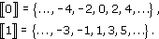

These are the only equivalence classes (since the equivalence class of any other integer is equal to one of these two). So the equivalence classes are the even integers and the odd integers.
For the equivalence relation in Exercise 57(c), the equivalence class of a particular line is the set of all lines that are parallel to that line. So each equivalence class consists of all lines with a particular gradient. For example, all vertical lines form one equivalence class, and all lines with gradient 3 form another.
For the equivalence relation in Exercise 57(d), the equivalence class of a particular complex number z₀ is

If z₀ = x₀ + iy₀ and z = x + iy, then

which is a real number if and only if y = y₀. Thus z₀ consists of all complex numbers with the same imaginary part as z₀. So each equivalence class consists of all complex numbers with a particular imaginary part. For example, all complex numbers of the form x + 3i, where x , form one equivalence class, and all complex numbers of the form x − i, where x , form another. The equivalence classes thus form horizontal lines in the complex plane.
Remark These solutions are quite detailed, but you may find that you can determine equivalence classes with less working as you become more familiar with them.
Back to - Exercise 58

Example 19

Answer

Solution
We show that properties E1, E2 and E3 hold.

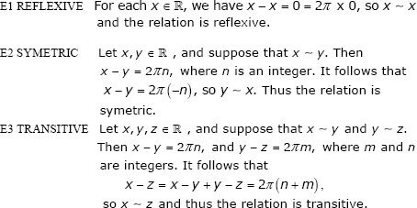

The equivalence class r of any real number r is the set of all real numbers related to r by ; that is, r is the set of all real numbers that differ from r by a multiple of 2. So

Back to - Example 19

Exercise 59

Answer

Solution
is not reflexive because, for example, 1 1 since 2 × 1 − 1 = 1 is not divisible by 7.
is not symmetric because, for example, 5 3 since 2 × 5 − 3 = 7 which is divisible by 7, but 3 5 since 2 × 3 − 5 = 1 which is not divisible by 7.
is not transitive because, for example, 5 3 and 3 6 since 2 × 5 − 3 = 7 and 2 × 3 − 6 = 0 which are both divisible by 7, but 5 6 since 2 × 5 − 6 = 4 which is not divisible by 7.
Back to - Exercise 59

Exercise 60

Answer

Solution
We show that properties E1, E2 and E3 hold.
- E1 For any function f : → , f(0) = f(0), so f f and hence the relation is reflexive.
- E2 If f g so that f(0) = g(0), then g(0) = f(0), so g f and hence the relation is symmetric.
- E3 If f g and g h so that f(0) = g(0) and g(0) = h(0), then f(0) = h(0), so f h and hence the relation is transitive.
Therefore this is an equivalence relation.
Each equivalence class consists of all functions in A that take a particular value at 0; that is, each equivalence class is of the form

for some r .
Back to - Exercise 60

Exercise 61

Answer

Solution
We show that properties E1, E2 and E3 hold.
- E1 Let z = x + iy . Then

- so z z. Hence the relation is reflexive.
- E2 Let z₁ = x₁ + iy₁ and z₂ = x₂ + iy₂ be elements of .
- Suppose that z₁ z₂ so that x₁ − x₂ = 5(y₁ − y₂). Then

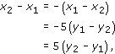

- so z₂ z₁. Hence the relation is symmetric.
- E3 Let z₃ = x₃ + iy₃, and suppose that z₁ z₂ and z₂ z₃ so that

- and

- Then

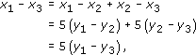

- so z₁ z₃. Hence the relation is transitive.
Therefore this is an equivalence relation.
Two complex numbers x₁ + iy₁ and x₂ + iy₂ are related by this relation if

that is, if

Hence the equivalence classes are the lines x − 5y = r, for each real number r; that is, the lines with gradient .
Back to - Exercise 61

