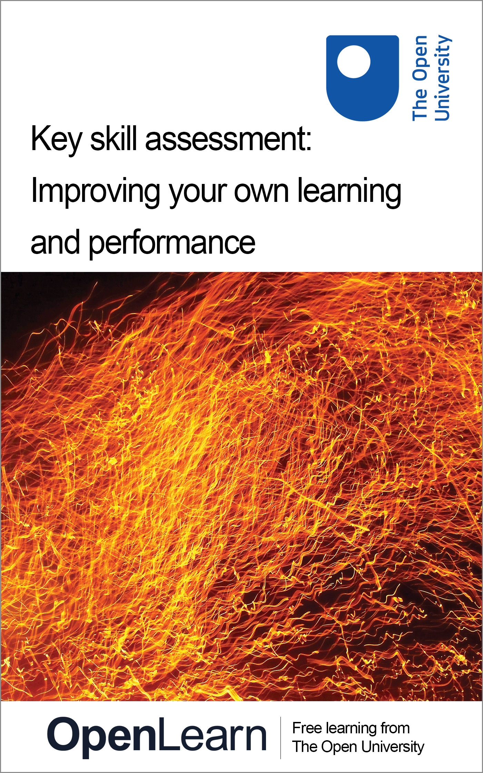

U071_1 Key skill assessment course

Key skill assessment: improving your own learning and performance
About this free course
This free course provides a sample of Level 1 study in Education www.open.ac.uk/courses/find/education-childhood-and-youth.
This version of the content may include video, images and interactive content that may not be optimised for your device.
You can experience this free course as it was originally designed on OpenLearn, the home of free learning from The Open University – http://www.open.edu/openlearn/education/key-skill-assessment-improving-your-own-learning-and-performance/content-section-0
There you’ll also be able to track your progress via your activity record, which you can use to demonstrate your learning.
The Open University, Walton Hall, Milton Keynes, MK7 6AA
Copyright © 2016 The Open University
Intellectual property
Unless otherwise stated, this resource is released under the terms of the Creative Commons Licence v4.0 http://creativecommons.org/licenses/by-nc-sa/4.0/deed.en_GB. Within that The Open University interprets this licence in the following way: www.open.edu/openlearn/about-openlearn/frequently-asked-questions-on-openlearn. Copyright and rights falling outside the terms of the Creative Commons Licence are retained or controlled by The Open University. Please read the full text before using any of the content.
We believe the primary barrier to accessing high-quality educational experiences is cost, which is why we aim to publish as much free content as possible under an open licence. If it proves difficult to release content under our preferred Creative Commons licence (e.g. because we can’t afford or gain the clearances or find suitable alternatives), we will still release the materials for free under a personal end-user licence.
This is because the learning experience will always be the same high quality offering and that should always be seen as positive – even if at times the licensing is different to Creative Commons.
When using the content you must attribute us (The Open University) (the OU) and any identified author in accordance with the terms of the Creative Commons Licence.
The Acknowledgements section is used to list, amongst other things, third party (Proprietary), licensed content which is not subject to Creative Commons licensing. Proprietary content must be used (retained) intact and in context to the content at all times.
The Acknowledgements section is also used to bring to your attention any other Special Restrictions which may apply to the content. For example there may be times when the Creative Commons Non-Commercial Sharealike licence does not apply to any of the content even if owned by us (The Open University). In these instances, unless stated otherwise, the content may be used for personal and non-commercial use.
We have also identified as Proprietary other material included in the content which is not subject to Creative Commons Licence. These are OU logos, trading names and may extend to certain photographic and video images and sound recordings and any other material as may be brought to your attention.
Unauthorised use of any of the content may constitute a breach of the terms and conditions and/or intellectual property laws.
We reserve the right to alter, amend or bring to an end any terms and conditions provided here without notice.
All rights falling outside the terms of the Creative Commons licence are retained or controlled by The Open University.
Head of Intellectual Property, The Open University
Designed and edited by The Open University
978-1-4730-1680-4 (.kdl)
978-1-4730-0912-7 (.epub)

Contents
- Introduction
- Learning outcomes
- 1 Understanding how you learn
- 2 Sources of help
- 3 Key skills assessment courses
- 4 Structure of the assessment courses
- 5 Improving own learning and performance
- 6 What you should present
- 7 Part A: Evidencing skills to develop a strategy, monitor progress and evaluate performance
  - 7.1 Evidence required
  - 7.2 Developing a strategy
  - 7.3 Monitoring progress
  - 7.4 Evaluating your strategy and assessing your work
- 8 Part B: Evidencing your learning
  - 8.1 Evidence required
  - 8.2 Evidence
  - 8.3 Synthesis
  - 8.4 Assessing your work
- 9 Notes to help you complete your assessment
- Conclusion
- Acknowledgements

Introduction
This key skill is about helping you understand how you learn; think about how you can improve your own learning and performance, and consider how you might generalise the principles and processes for future learning.
Improving your learning and performance could be considered to be a ‘meta-skill’, that is the skill of learning how to learn. This course, then, is a little different from the other skills courses because improving your own learning and performance is not a separate option that you can choose to concentrate on or not – it is the basis of the three-stage framework of developing a strategy, monitoring progress and evaluating performance which you will use to develop and improve other key skills and your learning more generally. The key skill of improving your own learning and performance can be practised and developed like other skills, but unlike other skills it seems more difficult to measure and assess. What is possible, however, is to use the structure and activities presented in the OpenLearn course U529 Key skills – making a difference to help you think about what you are doing and how well you are doing it, and then at regular intervals stand back and look at your own progress objectively. This course is designed to be studied for 1 hour per week over 50 weeks.
This OpenLearn course provides a sample of Level 1 study in Education.

Learning outcomes
After studying this course, you should be able to:
- demonstrate a strategy for using skills in improving learning and performance over an extended period of time
- monitor progress and adopt a strategy, as necessary, to achieve the quality of outcomes required
- evaluate this overall strategy and present the outcomes of the work.

1 Understanding how you learn
This Key Skill Assessment Course offers an opportunity for you to select and prepare work that demonstrates your key skills in the area of: improving your own learning and performance.
This course provides you with advice and information on how to go about presenting your key skills work as a portfolio.
In presenting work that demonstrates your key skills you are taking the initiative to show that you can develop and improve a particular set of skills, and are able to use your skills more generally in your studies or at work. Skills development is all about taking responsibility for extending and improving your learning and performance in a wide range of contexts. We hope, therefore, that you will see this guide as a way of supporting your learning and skills development while you are studying, working and in your other activities. However you view it, we hope that they will help make skills development something you value personally.

2 Sources of help
This assessment course is designed to be self-contained. However you might like to access the following sources for support and guidance if you need it. These sources include:
- U529 Key skills – making a difference: This OpenLearn course is designed to complement the assessment courses. It provides detailed guidance and activities to help you work on your key skills, gives examples of key skills work from students, and helps you prepare and select work for a portfolio.
- Your main course of study: If you are studying a course with the Open University or elsewhere which includes key skills outcomes you may get feedback from your tutor.
- Skills workshops/training courses: You may have opportunities to attend training courses at work.
- Skills resources: Your main course of study may recommend books, study guides and websites to help you tackle skills such as essay writing, using diagrams and graphs, or organising your learning.
- The Good Study Guide series: offers advice and examples of good practice: Chambers, E. and A. Northedge (1997) The Arts Good Study Guide. Milton Keynes: The Open University.
Northedge, A. (2005) The Good Study Guide. Milton Keynes: The Open University. There is a companion website to the book at www.open.ac.uk/goodstudyguide/index.htm.
Northedge, A. et al. (1997) The Sciences Good Study Guide. Milton Keynes: The Open University.
- SAFARI: www.open.ac.uk/safari This is an online tutorial with interactive activities that will help you to develop your information skills, including searching with electronic tools, evaluating and managing information.
- OU library and website: www.open.ac.uk/library
- Skills for OU study: www.open.ac.uk/skillsforstudy/index.php Offers online resources to help you develop skills needed for learning.
- OpenLearn information skills courses: Arts and History; Business and Management; Education; Health and Lifestyle; IT and Computing; Mathematics and Statistics; ModernLanguages; Science and Nature; Society and Technology.

3 Key skills assessment courses
This section gives advice and guidance to help you compile and present a portfolio of selected work. You are strongly advised to read through this section so that you have an idea of what is expected.
The key skills assessment courses provide an opportunity for you to integrate your development of key skills with your work or study. You may choose to concentrate on skills that you need to develop and improve for your job, for a new course, or personally to help you keep abreast of new developments or career changes. Developing skills is part of learning. The key skills approach provides you with a structure to help you think about how you learn and how you might improve both your learning skills and your performance. The key skills assessment courses give you an opportunity to demonstrate your capabilities in particular skills, and show that you can strategically plan your learning, monitor your progress and evaluate your work over a period of time.
Key skills are also about making connections between different aspects of your life – your study, your work and your other activities. All these might provide examples of work that you can select to demonstrate your skills. As you develop and improve your key skills you will also be improving the quality of your performance overall.
The Open University defines key skills in terms of seven broad areas: improving own learning and performance; communication; information technology; information literacy; application of number; problem solving and working with others. You, or your work place, may have used different terms to describe the skills but they are likely to cover broadly similar areas.
If you want to find out more about each of the key skills, the OpenLearn Course U529 Key skills – making a difference includes detailed descriptions and more general information about learning and skills.
The key skills descriptions (except for information literacy) used by the Open University are based on national standards developed by the Qualifications and Curriculum Authority (QCA). Details of the national standards can be found by searching for key skills standards and guidance on the QCA website at: http://www.qca.org.uk/
The key skills assessment courses have been designed to take account of these national standards and are referenced against them.

4 Structure of the assessment courses
This key skill assessment course does not have specific questions with word limits and no statements indicating you include, say, an essay or a report. Instead, as you tackle the course you need to ask yourself ‘Which pieces of work show my skills and capabilities to best advantage?’ When you have identified and selected evidence of your skills, you must then relate this evidence directly to the criteria.
This method of building a portfolio is based not on providing right or wrong answers to questions but presenting selected work (called evidence) which shows your capabilities. However, submitting a portfolio of evidence for key skills is not simply a case of gathering together all your course or training material in a folder. Indeed, you are unlikely to show your achievements to best advantage by doing this. Your portfolio for key skills needs to be a ‘showcase’ of your work. It needs to be organised and indexed to both show and explain what it is you do as you go about improving and applying your skills within your study or work activities.
Each of the assessment courses asks you to select work to demonstrate achievement of particular criteria. The work or evidence you select may be from your study or work activities. However, there is an important aspect of creating a ‘showcase’ portfolio. It is that you select just enough evidence to meet the relevant criteria. For example, if you are selecting work for the IT key skill, your evidence may come from assignments associated with a course. Any one assignment may not provide exactly the evidence you need – you may find that you need to use work from two or even three different assignments. But the three assignments together may include material that is not relevant to the key skill. In this case, you need to create an example from your assignments that includes only the relevant material and annotate it to show what it is and what you are demonstrating.
All the key skills assessment courses have a common two-part structure that should tell the story of your learning journey as you completed the course. The two parts, A and B, are designed to help you create a portfolio of your work that will show how you applied your key skill capabilities within a particular discipline or work area.

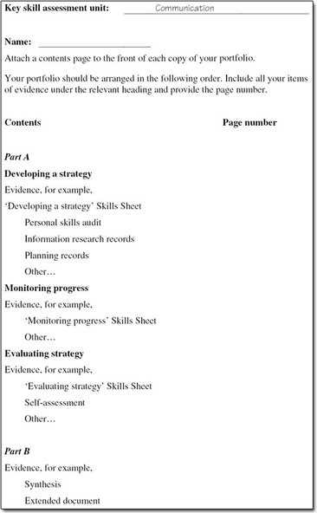
Figure 1 Sample key skill assessment course: contents page

Part A should give details of what you did to achieve your goal. It is concerned with the processes of improving and learning – how you plan, research tasks, adapt and apply your skills, learn new skills, implement ideas, get feedback, and evaluate your work overall. This framework comprises the three stages Develop a strategy, Monitor progress and Evaluate strategy that are introduced in the OpenLearn course U529 Key skills – making a difference.
Part B asks you to select evidence to show your capabilities in the particular key skill you are developing (for example communication, or information technology). You will need to select work that meets the set of criteria associated with the particular skill. This requires you to take responsibility for selecting your best work and checking that it meets the criteria.
Many activities you complete as part of your course or work may be eligible for inclusion in your key skills portfolio. However, because the portfolio is intended to be consciously and carefully selective, you should choose one or at most two pieces of work for Part B. If you choose more, be sure you can explain why these extra examples of your work are needed.
Overall, the two parts of the portfolio should integrate your selected work to show that you can improve and apply your skills. Your key skills work needs to be carefully planned to enable you to integrate it into the demands of your study or work activities. This means that at an early stage you need to identify your goals and plan what you will do to achieve them. As you implement your plans, you should schedule periods when you can concentrate on your skills, and review points to help you monitor and reflect on your progress. When you have completed your study or work activities, you need to be able to stand back, evaluate and reflect on how things have gone, what you have learned and how this will help you for future work.
In summary, Part A should tell the story of your learning journey in improving and applying your skills; Part B presents the results, the goals you have achieved.

5 Improving own learning and performance
A main purpose of this assessment course is to help you improve your learning and performance as you pursue your main area of study or work. It involves identifying an aspect of your learning you want to work on and using skills to help you improve your learning and performance. For example, you may want to concentrate on note taking and improving your time management skills as you study, or you may find you need to learn new IT skills and information search skills at work.
The evidence you present needs to show: what you do to plan and meet targets you set; ways you keep track of what you are doing and how well things are going; and, when you have completed the work, how you evaluate what went well and not so well. You need to show that you can use skills to help you improve your learning and performance, including: managing your time effectively; selecting and using different ways to learn; and using feedback and support to improve the quality of your performance. You can use the guidance, Bookmarks and Skill Sheets included in OpenLearn course U529 Key skills – making a difference to help you prepare, structure and present your work.
As you work on this assessment course, use the criteria in Table 1 to help you keep track of your progress and to check that it meets the required standard. Use the statements alongside the criteria to help you check that your work shows you have met the criteria, and label your work so that an assessor could identify easily what your evidence is showing.
Click here to view Table 1 (PDF, 2 pages, 0.1MB).
To get the best from this course, it is important to think and plan ahead. At an early stage take time to complete your strategy and plan of action, identifying work you can use as evidence of your learning. You can then monitor your progress by keeping a log or diary, and practise your skills as you work on your course or work activities. When you have completed your work you can take stock of how things went, evaluate your strategy and think about the next steps on your learning journey. You should allow at least three months to improve, apply your skills and put together your portfolio.

6 What you should present
There are two main parts to this assessment course that, together, must show you can: plan to improve your learning and performance; monitor your progress; and evaluate your strategy overall as you produce a piece of work, for example, a project report, assignment, video recording, etc.
Although Parts A and B are presented separately, you should think of them as parts of a whole, that is, each should relate to the other.

7 Part A: Evidencing skills to develop a strategy, monitor progress and evaluate performance

7.1 Evidence required
You must present evidence to show you can:
- Develop a strategy for using skills to improve your learning and performance over an extended period of time.
- Monitor progress in using skills to improve your learning and performance and adapt your strategy as necessary in the production of your work
- Evaluate your strategy overall and assess your work.

7.2 Developing a strategy
Present notes/records to show you have planned to use skills to improve your learning and performance. Include:
- A review of your current capabilities and your goals over an extended period of time (at least three months). Indicate how your goals relate to the context in which you are working and your current capabilities.
Your evidence could include a skills audit based on the key skills criteria and other criteria given as part of your course or work activities, together with information from your academic and/or performance review records. In your review, try to be objective in your own self-assessment of your capabilities by citing evidence to support your own judgements. For example, refer to previous work/study comments and records, personal skills audit, information from others, etc.
- The resources you might use to improve your skills, for example, course materials, tutor feedback, discussions with others.
- A plan of action, that includes:
  - targets you have set on those aspects you want to improve and notes on how you plan to achieve them;
  - the opportunities you can use to practise your skills; for example, completing assignments, attending skills workshops or training courses;
  - a time schedule that includes deadlines and review points to complete the work.
As part of your strategy, plan what you intend to do to keep track of your time and the opportunities you might have to get feedback comments. Indicate the evidence you plan to present (that is, the example of work, say an assignment, project report, performance, video, etc.) for Part B, making sure that it shows you can learn using different ways of learning (see Part B below).
You could perhaps discuss your strategy with a study advisor and receive feedback. You could then use this feedback to help you assess your own progress as your work develops.

7.3 Monitoring progress
Present a reflective commentary that makes reference to your ongoing notes and records and includes:
- What you did to manage your time as you worked on your course or work activities, and your own assessment of the effectiveness of your time management. For example, the use you made of your planning schedules, any changes you made to your deadlines, what you did about unexpected priorities and whether you feel your time management is effective.
- Ways you use to learn, how these support your learning and why you selected particular ways. For example, the methods, approaches and resources you use to work towards your targets and your reflections on what is and what is not helping your progress; the decisions you took when you felt ‘stuck’ on particular ideas and how effective those decisions were.
- What you did to seek and use feedback and support, and your reflections on the effect of this feedback on the quality of your work and your progress.
- The choices you made to achieve your targets and improve your learning, and how effective they were. Include any changes you made to your strategy explaining the reasons for the changes. For example, with hindsight, would you change your approach to seeking and using feedback in the future?

7.4 Evaluating your strategy and assessing your work
Present an evaluation that includes a summary of how effective your overall strategy has been in helping you use skills to improve your learning and performance, giving details of:
- those factors that worked well to help you improve and those that have worked less well; which factors had the greatest effect on your achievement of what you set out to do?
- an assessment, referring to your review and targets, of your own progress and performance in those skills you set out to improve, including where you feel you have made the greatest progress;
- the changes you intend to make in your way of working in the future as a result of working through this course and the skills you plan to work on in the future;
- an assessment of the work you are submitting for this key skill assessment course, including comments on those areas that were well achieved, justifying your assessment using the relevant criteria; try to be as specific as you can, indicating the problems or difficulties you have had.

8 Part B: Evidencing your learning

8.1 Evidence required
For Part B you must present:
- an example from your study or work (say, an assignment, project report, video recording) that shows you can learn using different ways of learning; and,
- a synthesis of what you have learned, using the different ways of learning included in your example (in 1 above).

8.2 Evidence
The purpose of the evidence you present is to show you can use different ways to learn. This means your example could be an assignment, project report, video recording, etc. that includes activities where you have taken responsibility for when and how you learned, perhaps as part of a distance-learning course (independent learning), and work you have learned using a different approach, perhaps by attending a tutorial, seminar, taking part in an e-conference, workshop, training session with a mentor, line manager, etc. (directed learning).
Wherever possible, try to present only one example of evidence that includes two different ways of learning. (If this is not possible, you should not include more than two examples.) Your example might be an extended essay or assignment that you have completed independently and have also attended a tutorial that covers some of the content. At work, you may have been involved in a project but have taken responsibility to develop or improve an aspect of your work that contributes to the project; for example, presentation skills, learning a new technique using a manual, improving your report writing skills by practice and using skills resources, etc. When you have selected your evidence, put yourself in the position of assessing it and annotate it clearly to show the ways of learning you have used for particular aspects.

8.3 Synthesis
Your synthesis of what you have learned needs to show you can comment critically and reflectively on the ways of learning you have used. Think about what you had to learn, how you learned it and make an assessment of how well you learned it. On reflection, would you change anything? If so, what would you do differently? Your synthesis does not have to be long (e.g. one side of an A4 page), but it does need to show you can think critically about your learning, relate it to specific work (that is, the work you present as evidence), and identify what worked well and/or how you might improve your learning for future work.

8.4 Assessing your work
Table 1 below gives the outcomes (italic) and criteria for assessment of your work. Alongside the criteria is a checklist to help you consider and assess your work.

Table 1: Criteria for assessment of your improving own learning and performance portfolio and a checklist to help you assess your work against the criteria
Criteria for assessment: evidence you present must show you can: | Checklist: check that your evidence shows what you have done to:
Develop a strategy for improving your own learning and performance.
Review your current capabilities and clearly identify what you hope to achieve in the future. | Identify patterns of strengths and weaknesses to identify goals and explain why these are important to you.
Research information on relevant learning opportunities and ways to improve your performance, to inform planning. | Identify where you can use skills to improve your learning and performance (i.e. time management, methods of learning, and seeking and using feedback) within your study or work activities.
 | List reference sources that you might use, including people.
Set SMART targets and plan how these will be met, prioritising tasks and making a reasoned choice of methods and resources. | Write down a plan for accomplishing your goal(s) that:
 | • divides the work into parts;
 | • identifies interim targets;
 | • gives a time schedule/deadlines for the parts.
 | Keep notes of revisions and a log that records why you made modifications.
 | Include the methods you intend to use to achieve your goals.
Monitor progress and adapt your strategy to improve your performance.
Manage your time effectively and take responsibility for using different ways of learning to meet new demands. | Use plans and make adjustments when required.
 | Identify what the learning task involves and make decisions about the method to learn.
Seek and actively use feedback and support from a variety of sources, to help meet your targets. | Use feedback and your own self-assessment to develop a picture of your performance.
 | Use criteria to help you monitor your progress.
Reflect critically on your learning and adapt your strategy as necessary to improve your performance. | Use interim checks and adjustments to see if:
 | • targets/sub-goals are being met;
 | • attempted methods are approaching your goals.
 | Describe the changes you had to make in your plan along the way.
 | Identify modifications that have or should have taken place.
 | ‘Stand back’ at critical points to reflect on performance.
Evaluate your strategy and present the outcomes of your learning.
Review the different ways you have learned and the extent to which you have met your targets. | Identify and label activities you have learned using different ways of learning.
Bring together and clearly illustrate what you have learned, organising evidence to support your purpose. | Consider any aspects of your learning that have changed.
Assess the effectiveness of your strategy, including factors that affected the outcomes, and identify ways of further improving your own learning and performance. | Assess the quality of your work by making connections between criteria, feedback comments and your own judgement of your performance.
 | Identify those factors that affected the production and presentation of your work.
 | Relate goals for improvement to progress so far, and to possibilities for future development.

9 Notes to help you complete your assessment
To complete your portfolio, you must include a contents page indicating how your reflective commentary in Part A and your evidence in Part B are related. An example of a suitable format for the contents page is shown in Figure 1.
Click here to view Figure 1 (PDF, 1 page, 0.1MB).
Although the requirements of Parts A and B are listed separately you should think of them as parts of a whole in which each part relates to the others. Parts A and B together must show that you can plan strategically to improve your skills, monitor your progress and evaluate your overall strategy as you produce a piece of work.
The work you put into your portfolio should meet the criteria given in Table 1. As you work on this assessment course, use the criteria to help you keep track of your progress and to check that it meets the required standard. Your evidence and commentary should be sufficient to allow the assessor to verify your achievements.

Conclusion
This free course provided an introduction to studying education. It took you through a series of exercises designed to develop your approach to study and learning at a distance and helped to improve your confidence as an independent learner.

Acknowledgements
The content acknowledged below is Proprietary (see terms and conditions). This content is made available under a Creative Commons Attribution-NonCommercial-ShareAlike 4.0 Licence
Course image: Brittany Wallin in Flickr made available under Creative Commons Attribution-ShareAlike 2.0 Licence.
Wonderlane: www.flickr.com/photos/wonderlane/37529792/
All other materials included in this course are derived from content originated at the Open University.
Don't miss out:
If reading this text has inspired you to learn more, you may be interested in joining the millions of people who discover our free learning resources and qualifications by visiting The Open University - www.open.edu/openlearn/free-courses

