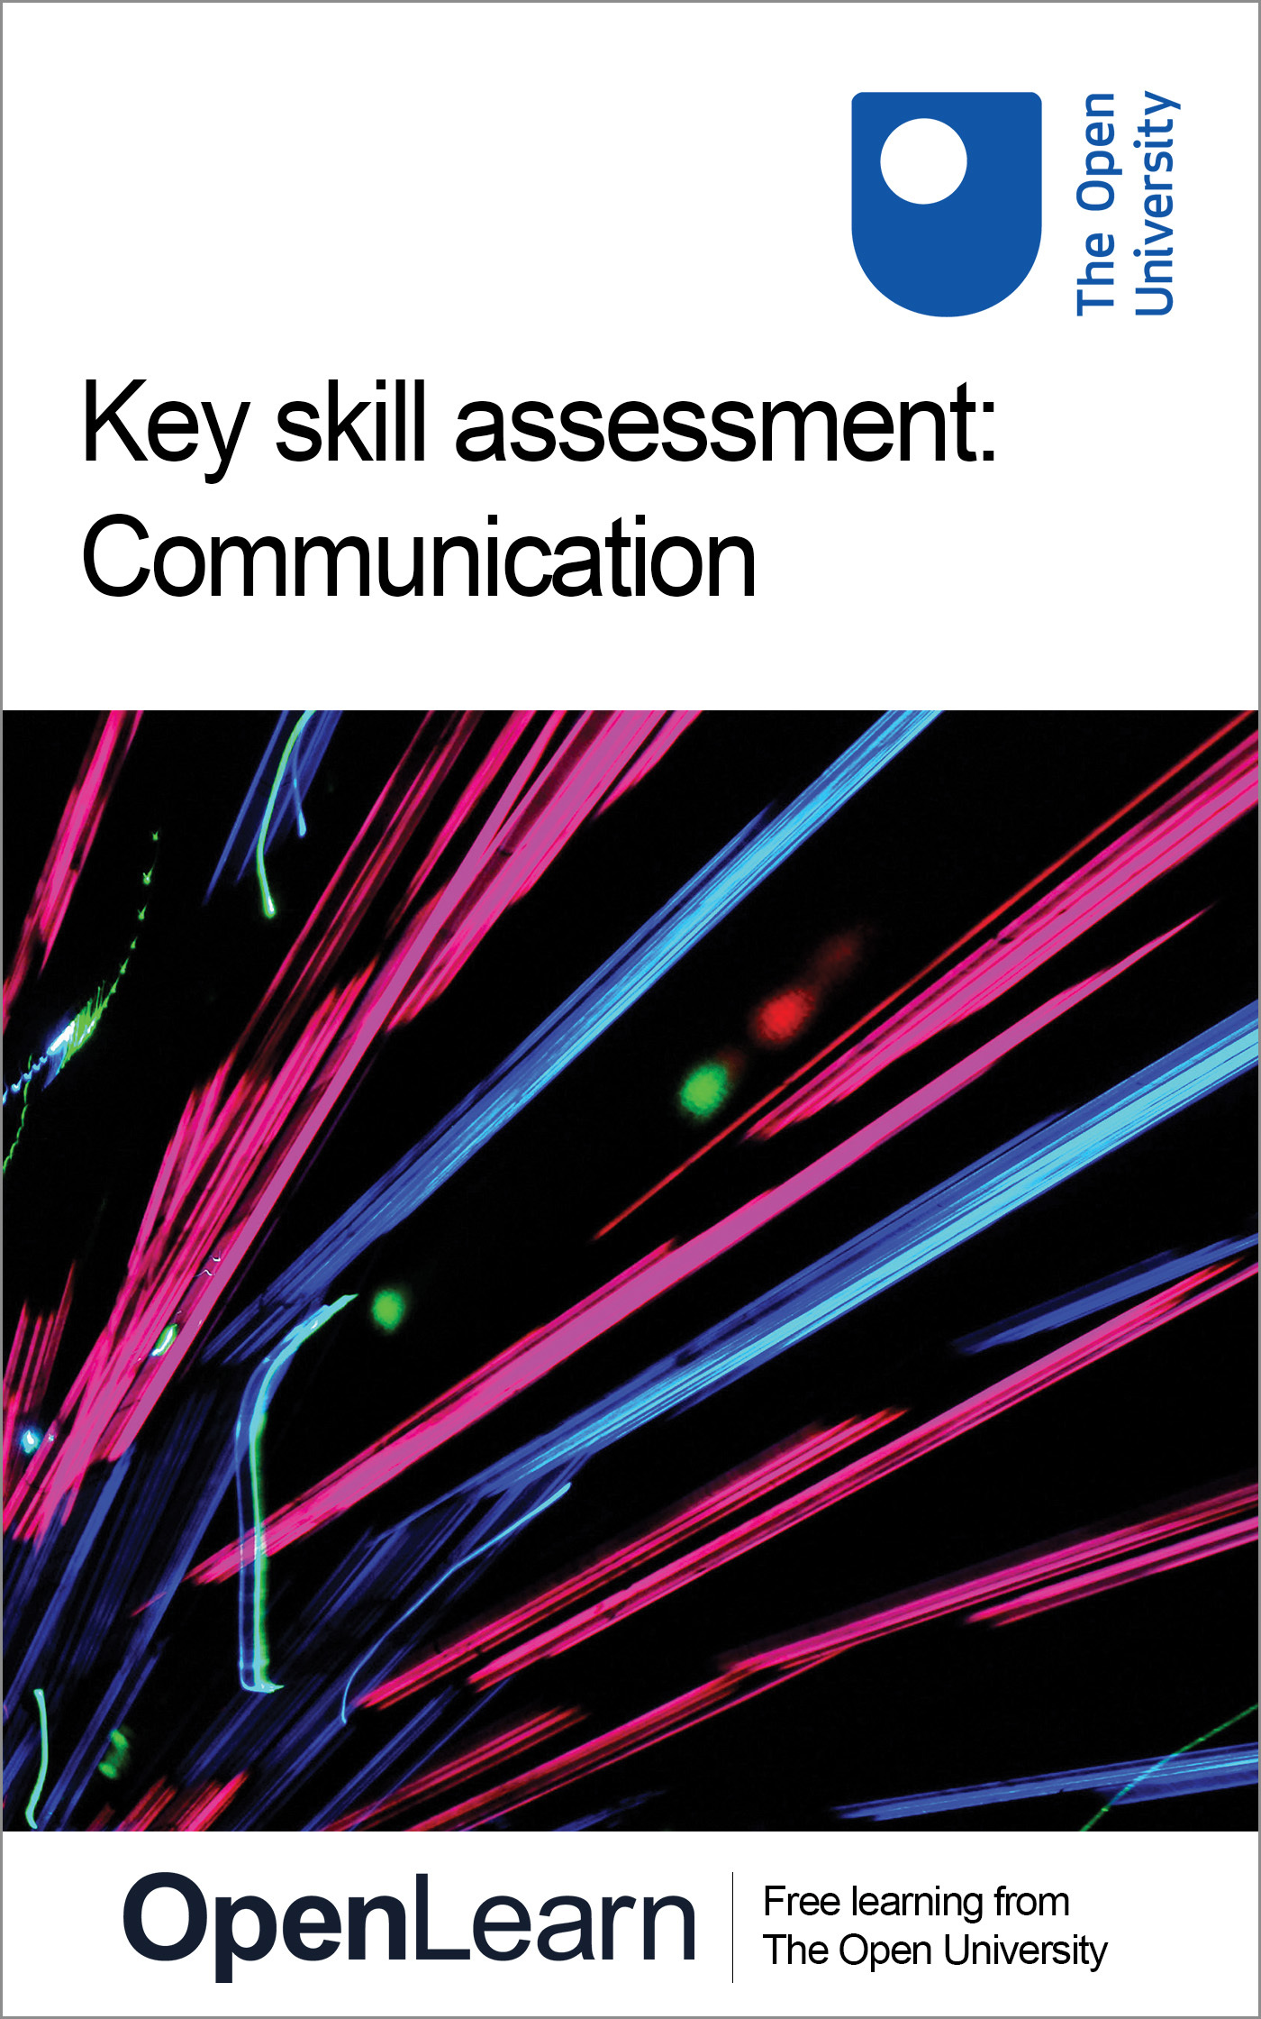

U072_1

Key skills assessment: communication
About this free course
This free course provides a sample of Level 1 study in Education www.open.ac.uk/courses/find/education-childhood-and-youth.
This version of the content may include video, images and interactive content that may not be optimised for your device.
You can experience this free course as it was originally designed on OpenLearn, the home of free learning from The Open University – http://www.open.edu/openlearn/education/key-skill-assessment-communication/content-section-0
There you’ll also be able to track your progress via your activity record, which you can use to demonstrate your learning.
The Open University, Walton Hall, Milton Keynes, MK7 6AA
Copyright © 2016 The Open University
Intellectual property
Unless otherwise stated, this resource is released under the terms of the Creative Commons Licence v4.0 http://creativecommons.org/licenses/by-nc-sa/4.0/deed.en_GB. Within that The Open University interprets this licence in the following way: www.open.edu/openlearn/about-openlearn/frequently-asked-questions-on-openlearn. Copyright and rights falling outside the terms of the Creative Commons Licence are retained or controlled by The Open University. Please read the full text before using any of the content.
We believe the primary barrier to accessing high-quality educational experiences is cost, which is why we aim to publish as much free content as possible under an open licence. If it proves difficult to release content under our preferred Creative Commons licence (e.g. because we can’t afford or gain the clearances or find suitable alternatives), we will still release the materials for free under a personal end-user licence.
This is because the learning experience will always be the same high quality offering and that should always be seen as positive – even if at times the licensing is different to Creative Commons.
When using the content you must attribute us (The Open University) (the OU) and any identified author in accordance with the terms of the Creative Commons Licence.
The Acknowledgements section is used to list, amongst other things, third party (Proprietary), licensed content which is not subject to Creative Commons licensing. Proprietary content must be used (retained) intact and in context to the content at all times.
The Acknowledgements section is also used to bring to your attention any other Special Restrictions which may apply to the content. For example there may be times when the Creative Commons Non-Commercial Sharealike licence does not apply to any of the content even if owned by us (The Open University). In these instances, unless stated otherwise, the content may be used for personal and non-commercial use.
We have also identified as Proprietary other material included in the content which is not subject to Creative Commons Licence. These are OU logos, trading names and may extend to certain photographic and video images and sound recordings and any other material as may be brought to your attention.
Unauthorised use of any of the content may constitute a breach of the terms and conditions and/or intellectual property laws.
We reserve the right to alter, amend or bring to an end any terms and conditions provided here without notice.
All rights falling outside the terms of the Creative Commons licence are retained or controlled by The Open University.
Head of Intellectual Property, The Open University
Designed and edited by The Open University
978-1-4730-1681-1 (.kdl)
978-1-4730-0913-4 (.epub)

Contents
- Introduction
- Learning outcomes
- 1 Information and communication
- 2 Sources of help
- 3 Key skills assessment courses
- 4 Structure of the assessment courses
- 5 Effective communication
- 6 What you should present
- 7 Part A: Evidencing skills to develop a strategy, monitor progress and evaluate performance
  - 7.1 Evidence required
  - 7.2 Developing a strategy
  - 7.3 Monitoring your progress
  - 7.4 Evaluating your strategy and assessing your work
- 8 Part B: Evidencing your communication skills
  - 8.1 Evidence required
  - 8.2 Extended written communication
  - 8.3 Synthesis of information
- 9 Notes to help you complete your assessment
- Conclusion
- Keep on learning
- Acknowledgements

Introduction
This key skill focuses on the ways in which you receive and respond to information and communicate with other people in your work, study and everyday life. Communication skills include speaking, listening, reading and writing for different purposes. Techniques such as note taking and writing summaries are important, but so, too, are the techniques of evaluation and application, such as evaluating the relevance and quality of information.
Communication is part of everyone's life and improving your skills also involves you being able to integrate changes in the way you communicate into your study or work. Essentially, this means you will be improving your skills while communicating what you are learning. This is much more than developing your presentation skills or tackling an essay. It is also about strategically planning how to communicate, applying your skills in different situations, and critically reflecting on your performance, that is being consciously aware of what you are doing and how well you are doing it. This course is designed to be studied for 1 hour per week over 50 weeks.
This OpenLearn course provides a sample of Level 1 study in Education.

Learning outcomes
After studying this course, you should be able to:
- demonstrate a strategy for using communication skills over an extended period of time
- monitor and critically reflect on these communication skills, adapting the strategy as necessary, to produce the quality of outcomes required
- evaluate this overall strategy and present outcomes.

1 Information and communication
This Key Skills Assessment Course offers an opportunity for you to select and prepare work that demonstrates your key skills in the area of communication.
This course provides you with advice and information on how to go about presenting your key skills work as a portfolio.
In presenting work that demonstrates your key skills you are taking the initiative to show that you can develop and improve a particular set of skills, and are able to use your skills more generally in your studies or at work. Skills development is all about taking responsibility for extending and improving your learning and performance in a wide range of contexts. We hope, therefore, that you will see this guide as a way of supporting your learning and skills development while you are studying, working and in your other activities. However you view it, we hope that they will help make skills development something you value personally.

2 Sources of help
This assessment course is designed to be self-contained. However you might like to access the following sources for support and guidance if you need it. These sources include:
- U529_1 Key skills – making a difference: This OpenLearn course is designed to complement the assessment courses. It provides detailed guidance and activities to help you work on your key skills, gives examples of key skills work from students, and helps you prepare and select work for a portfolio.
- Your main course of study: If you are studying a course with the Open University or elsewhere which includes key skills outcomes you can get feedback from your tutor.
- Skills workshops/training courses: You may have opportunities to attend training courses at work.
- Skills resources: Your main course of study may recommend books, study guides and websites to help you tackle skills such as essay writing, using diagrams and graphs, or organising your learning.
- The Good Study Guide series: offers advice and examples of good practice: Chambers, E. and A. Northedge (1997) The Arts Good Study Guide. Milton Keynes: The Open University.
Northedge, A. (2005) The Good Study Guide. Milton Keynes: The Open University. There is a companion website to the book at www.open.ac.uk/goodstudyguide/index.htm.
Northedge, A. et al. (1997) The Sciences Good Study Guide. Milton Keynes: The Open University.
- SAFARI: www.open.ac.uk/safari This is an online tutorial with interactive activities that will help you to develop your information skills, including searching with electronic tools, evaluating and managing information.
- OU library and website: www.open.ac.uk/library.
- Skills for OU study: www.open.ac.uk/skillsforstudy/index.php Offers online resources to help you develop skills needed for learning.
- OpenLearn information skills courses: Arts and History; Business and Management; Education; Health and Lifestyle; IT and Computing; Mathematics and Statistics; ModernLanguages; Science and Nature; Society and Technology.

3 Key skills assessment courses
This section gives advice and guidance to help you compile and present a portfolio of selected work. You are strongly advised to read through this section so that you have an idea of what is expected.
The key skills assessment courses provide an opportunity for you to integrate your development of key skills with your work or study. You may choose to concentrate on skills that you need to develop and improve for your job, for a new course, or personally to help you keep abreast of new developments or career changes. Developing skills is part of learning. The key skills approach provides you with a structure to help you think about how you learn and how you might improve both your learning skills and your performance. The key skills assessment courses give you an opportunity to demonstrate your capabilities in particular skills, and show that you can strategically plan your learning, monitor your progress and evaluate your work over a period of time.
Key skills are also about making connections between different aspects of your life – your study, your work and your other activities. All these might provide examples of work that you can select to demonstrate your skills. As you develop and improve your key skills you will also be improving the quality of your performance overall.
The Open University defines key skills in terms of seven broad areas: improving own learning and performance; communication; information technology; information literacy; application of number; problem solving and working with others. You, or your work place, may have used different terms to describe the skills but they are likely to cover broadly similar areas.
If you want to find out more about each of the key skills, the OpenLearn course U529_1 Key skills – making a difference includes detailed descriptions and more general information about learning and skills.
The key skills descriptions (except for information literacy) used by the Open University are based on national standards developed by the Qualifications and Curriculum Authority (QCA). Details of the national standards can be found by searching for key skills standards and guidance on the QCA website at: http://www.qca.org.uk/
The key skills assessment courses have been designed to take account of these national standards and are referenced against them.

4 Structure of the assessment courses
This key skills assessment course does not have specific questions with word limits and no statements indicating you include, say, an essay or a report. Instead, as you tackle the course you need to ask yourself ‘Which pieces of work show my skills and capabilities to best advantage?’ When you have identified and selected evidence of your skills, you must then relate this evidence directly to the criteria.
This method of building a portfolio is based not on providing right or wrong answers to questions but presenting selected work (called evidence) which shows your capabilities. However, submitting a portfolio of evidence for key skills is not simply a case of gathering together all your course or training material in a folder. Indeed, you are unlikely to show your achievements to best advantage by doing this. Your portfolio for key skills needs to be a ‘showcase’ of your work. It needs to be organised and indexed to both show and explain what it is you do as you go about improving and applying your skills within your study or work activities.
Each of the assessment courses ask you to select work to demonstrate achievement of particular criteria. The work or evidence you select may be from your study or work activities. However, there is an important aspect of creating a ‘showcase’ portfolio. It is that you select just enough evidence to meet the relevant criteria. For example, if you are selecting work for the IT key skill, your evidence may come from assignments associated with a course. Any one assignment may not provide exactly the evidence you need – you may find that you need to use work from two or even three different assignments. But the three assignments together may include material that is not relevant to the key skill. In this case, you need to create an example from your assignments that includes only the relevant material and annotate it to show what it is and what you are demonstrating.
All the key skills assessment courses have a common two-part structure that should tell the story of your learning journey as you completed the course. The two parts, A and B, are designed to help you create a portfolio of your work that will show how you applied your key skills capabilities within a particular discipline or work area.

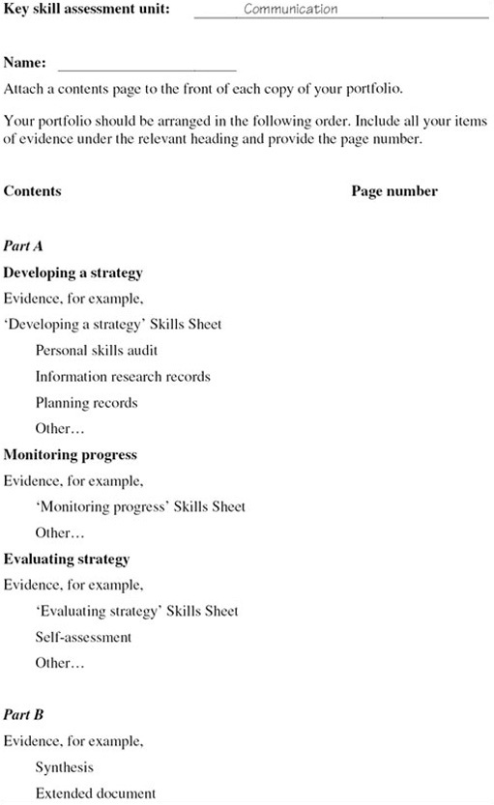
Figure 1 Sample key skills assessment course: contents page

Part A should give details of what you did to achieve your goal. It is concerned with the processes of improving and learning – how you plan, research tasks, adapt and apply your skills, learn new skills, implement ideas, get feedback, and evaluate your work overall. This framework comprises the three stages Develop a strategy, Monitor progress and Evaluate strategy that are introduced in the OpenLearn course U529_1 Key skills – making a difference.
Part B asks you to select evidence to show your capabilities in the particular key skill you are developing (for example communication, or information technology). You will need to select work that meets the set of criteria associated with the particular skill. This requires you to take responsibility for selecting your best work and checking that it meets the criteria.
Many activities you complete as part of your course or work may be eligible for inclusion in your key skills portfolio. However, because the portfolio is intended to be consciously and carefully selective, you should choose one or at most two pieces of work for Part B. If you choose more, be sure you can explain why these extra examples of your work are needed.
Overall, the two parts of the portfolio should integrate your selected work to show that you can improve and apply your skills. Your key skills work needs to be carefully planned to enable you to integrate it into the demands of your study or work activities. This means that at an early stage you need to identify your goals and plan what you will do to achieve them. As you implement your plans, you should schedule periods when you can concentrate on your skills, and review points to help you monitor and reflect on your progress. When you have completed your study or work activities, you need to be able to stand back, evaluate and reflect on how things have gone, what you have learned and how this will help you for future work.
In summary, Part A should tell the story of your learning journey in improving and applying your skills; Part B presents the results, the goals you have achieved.

5 Effective communication
The purpose of this assessment unit is for you to create a portfolio of your work to represent you as an effective communicator within your study or work activities. This will involve using criteria to help you select examples of your work that clearly show you can use and improve your communication skills. However, by far the most important aim is that you can use this assessment process to support your learning and improve your performance overall.
Communicating effectively involves applying your skills appropriately for different situations and reflecting on your performance, identifying how you might improve in the future. For a portfolio you will need to show that you can use written, oral and visual forms of communication. Improving your communication skills involves planning what you hope to achieve, using your skills and monitoring how things are going, and standing back at critical points to reflect on your performance.
It is important to plan ahead for the assessment work and carefully consider what you need to present as evidence. Make sure the work you are doing provides opportunities for you to obtain information from a variety of sources and to use this information within your work. You need to practise and apply your skills over a period of time. You should allow at least three months to improve, apply your skills and put together your portfolio.

6 What you should present
This assessment course has two parts. Part A requires you to plan, monitor, evaluate and reflect upon your skills, and present evidence of that process. Part B requires you to select concise examples of your work that demonstrate what you have done to improve and apply your skills. Together the two parts form a showcase portfolio of evidence and reflective commentary on your skills achievements. You can use the guidance, Bookmarks and Skills Sheets included in the OpenLearn course U529_1 Key skills – making a difference to help you structure and present your work.
You will need to make judgements about how well you have achieved the required standards, and make your own assessment of the quality of your work. To help you do this Table 2 contains statements about the criteria you should use to assess the quality of your work, and guidance about the evidence you need to present. If you were to present your work for assessment, the assessors would use the same criteria to judge the evidence you have selected.
Check your work carefully. Make sure that it shows the criteria have been met, and annotate it so that an assessor could identify the evidence that relates to each criteria. To help you select appropriate evidence refer to Table 2 while you are working on this assessment course.
Click here to view Table 2 (PDF, 3 pages, 0.1MB)
To complete your portfolio, include a contents page (see the example in Figure 1 above) that lists the items of evidence you are including for each part.

7 Part A: Evidencing skills to develop a strategy, monitor progress and evaluate performance

7.1 Evidence required
Part A is about showing that you can develop a strategy for using and improving your communication skills, that you can monitor your progress, and can evaluate your performance and strategy overall. The evidence you present needs to show what you have done as you worked through the processes of planning strategically, monitoring and evaluating in the production and presentation of work for Part B. Part A must, therefore, relate directly to the work you present for Part B. Thus, you will need to identify as part of your strategy when you can use written, oral and visual communication skills and the work you intend to include in your portfolio.
You must present evidence to show you can:
- Develop a strategy for using and improving your communication skills within the context of your study or work.
- Monitor your progress in applying and improving your communication skills and adapt your strategy, as necessary, to achieve the required standard.
- Evaluate the overall effectiveness of your strategy in developing the skills you set out to improve, and assess the overall quality of your work.

7.2 Developing a strategy
Present notes/records that show you have planned your use of communication skills. Include:
- the goals you hope to achieve for your communication skills, taking into account the work you have to do and your current capabilities;
- the resources you might use to achieve your goals and notes of your information research for your work on Part B; for example, discussions and e-conferences, online resources, skills books, course materials, workshops, specific help and feedback comments;
- a plan of action to use and improve your communication skills that includes:
  - targets you have set to achieve your goals and notes on how you might achieve them;
  - the opportunities you can use to practise your skills in written, oral and visual communication; for example, assignments, meetings, presentations, seminars and the work you plan to present for Part B;
- a schedule indicating deadlines and review points.
Be prepared to update your strategy periodically as your work develops. Think of it as a living document. You are likely to make many changes and adjustments to it over the time you are working on the course. Keep a record of your revisions and a log that records why you made modifications.
You could perhaps discuss your strategy with a study advisor and receive feedback. You could then use this feedback to help you assess your own progress as your work develops.

7.3 Monitoring your progress
Present a reflective commentary that makes reference to your notes/records and includes:
- What you did in obtaining information from a variety of sources to achieve your goals and for your work for Part B; for example, a library search, other search strategies including the internet, discussions and e-conferences, course books, manuals, textbooks, workshops and tutorials.
Keep an accurate list of the sources and describe which information was most relevant, which information was not very useful, and your reasons for your judgements. Reflect on what you did to search for and select information, identifying any changes you would make to your approach for the future.
- The use you made of resources and feedback comments to improve your skills and the quality of your work. With hindsight would you do anything differently in using resources and obtaining and using feedback?
- What you did as you applied your communication skills in particular situations. Assess how effective your communication was for the situation, making reference to criteria, if relevant, and commenting on how well you achieved the standard required. Reflect on the method(s) selected, discussing what worked, what didn't work, and how you would do things differently next time. For example, if you set out to improve your discussion skills to help you in meetings, what did you do? Did you prepare differently or ask for advice from a more experienced person? Did this help you to achieve what you wanted from the meeting? Or what did you do to deal with a situation involving conflict? What might you do differently with hindsight?

7.4 Evaluating your strategy and assessing your work
Present an evaluation that includes a summary of how effective your strategy has been in helping you use and improve your communication skills, giving details of:
- Those factors that worked well to help you improve and those that have worked less well. Which factors had the greatest effect on your achievement of what you set out to do?
- A judgement of your own progress and performance in those skills you set out to improve, including an assessment of where you feel you have made the greatest progress. Discuss how you have used criteria and feedback comments to help you assess your progress.
- An assessment of the effectiveness of your communication work based on your evidence and using criteria, feedback comments, etc. Are there changes you intend to make in your approach as a result of working on this course? What skills do you plan to work on in the future?

8 Part B: Evidencing your communication skills

8.1 Evidence required
This Part requires you to present an example of your work to show that you have used written, oral and visual communication skills within your study or work activities to achieve effective communication.
In selecting work for Part B, your example needs to show you have selected and used information from different sources.
For Part B you need to present:
- an extended written communication, for example, a report, essay, proposal (not a memo or short letter);
- a synthesis of information obtained from different sources.

8.2 Extended written communication
Your example needs to show you can:
- communicate relevant information with accuracy, e.g. use a spell check/dictionary, cite references correctly, proofread so that there are minimal errors and the meaning is clear, and use a form, structure and style that suits the purpose, e.g. making use of specialist vocabulary where appropriate;
- respond to contributions from others to improve the overall quality, e.g. discussions, feedback comments.

8.3 Synthesis of information
The synthesis needs to show you can:
- evaluate and synthesise information and present sources correctly;
- identify the various arguments and present your interpretation in a way that brings together information in a coherent way;
- prepare an oral presentation for delivery and be prepared to lead a discussion of it.
Your presentation and discussion needs to show you can:
- organise and clearly present relevant information, maintaining audience interest and using images to illustrate complex points;
- respond perceptively to others.
Your work will be assessed using the criteria in Table 2 below. You should also use Table 1 as a guide in preparing your work.

Table 1: Criteria for assessment of your improving own learning and performance portfolio and a checklist to help you assess your work against the criteria
Criteria for assessment: evidence you present must show you can: | Checklist: check that your evidence shows what you have done to:
Develop a strategy for improving your own learning and performance.
Review your current capabilities and clearly identify what you hope to achieve in the future. | Identify patterns of strengths and weaknesses to identify goals and explain why these are important to you.
Research information on relevant learning opportunities and ways to improve your performance, to inform planning. | Identify where you can use skills to improve your learning and performance (i.e. time management, methods of learning, and seeking and using feedback) within your study or work activities.
 | List reference sources that you might use, including people.
Set SMART targets and plan how these will be met, prioritising tasks and making a reasoned choice of methods and resources. | Write down a plan for accomplishing your goal(s) that:
 | • divides the work into parts;
 | • identifies interim targets;
 | • gives a time schedule/deadlines for the parts.
 | Keep notes of revisions and a log that records why you made modifications.
 | Include the methods you intend to use to achieve your goals.
Monitor progress and adapt your strategy to improve your performance.
Manage your time effectively and take responsibility for using different ways of learning to meet new demands. | Use plans and make adjustments when required.
 | Identify what the learning task involves and make decisions about the method to learn.
Seek and actively use feedback and support from a variety of sources, to help meet your targets. | Use feedback and your own self-assessment to develop a picture of your performance.
 | Use criteria to help you monitor your progress.
Reflect critically on your learning and adapt your strategy as necessary to improve your performance. | Use interim checks and adjustments to see if:
 | • targets/sub-goals are being met;
 | • attempted methods are approaching your goals.
 | Describe the changes you had to make in your plan along the way.
 | Identify modifications that have or should have taken place.
 | ‘Stand back’ at critical points to reflect on performance.
Evaluate your strategy and present the outcomes of your learning.
Review the different ways you have learned and the extent to which you have met your targets. | Identify and label activities you have learned using different ways of learning.
Bring together and clearly illustrate what you have learned, organising evidence to support your purpose. | Consider any aspects of your learning that have changed.
Assess the effectiveness of your strategy, including factors that affected the outcomes, and identify ways of further improving your own learning and performance. | Assess the quality of your work by making connections between criteria, feedback comments and your own judgement of your performance.
 | Identify those factors that affected the production and presentation of your work.
 | Relate goals for improvement to progress so far, and to possibilities for future development.

Table 2: Criteria for assessment of your communication skills portfolio and a checklist to help you assess your work against the criteria
Criteria for assessment: evidence you present must show you can: | Checklist: check that your evidence shows what you have done to:
Develop a strategy for using communication skills over an extended period of time.
Clearly identify the outcomes you hope to achieve. | Identify where you can use communication skills (i.e. written, visual and oral) within your study or work activities.
 | Identify goals and explain why these are important to you.
Plan your use of communication skills, and make a reseasoned selection of methods for achieving the quality of outcomes required. | List reference sources that you might use, including people.
Identify relevant sources and research the information. | Write down a plan for accomplishing your goal(s) that:
 | • divides the work into parts;
 | • identifies interim targets;
 | • gives a time schedule and deadlines for the parts.
 | Keep notes of revisions and a log that records why you made modifications.
 | Include the methods you intend to use to achieve your goals.
Monitor progress and adapt your strategy, as necessary, to achieve the quality of outcomes required in work involving at least: a) one group discussion about a complex subject; b) one document of 1,000 words or more about a complex subject.
Monitor and critically reflect on your use of communication skills, adapting your strategy as necessary to produce the quality of outcomes required. | Use feedback and your own self-assessment to develop a picture of your performance.
 | Use criteria to help you monitor your progress.
 | Use interim checks and adjustments to see if targets/sub-goals are being met and if attempted methods are approaching your goals.
Evaluate and synthesise information from different sources. | Use search strategies to obtain information.
 | Keep an accurate record of sources with notes on relevance and usefulness.
 | Check information for accuracy, bias, distortion.
 | Use and reference correctly the information obtained to develop arguments and interpretation in a coherent way.
Communicate relevant information with accuracy, effectively using a form, structure and style that suits your purpose, and respond perceptively to contributions from others. | In communicating your own work:
 | • select a form that suits the purpose, e.g. to inform, explore, persuade;
 | • lead discussions making points clear;
 | • write extended documents, making sure material is structured logically;
 | • check spelling, punctuation and grammar is accurate by proofreading and re-drafting;
 | • respond perceptively to others.
Adapt your strategy as necessary to produce the quality of outcomes required. | Describe the changes you had to make in your plan along the way.
 | Identify modifications that have or should have taken place.
Monitor and critically reflect on your use of communication skills. | ‘Stand back’ at critical points to reflect on performance
Evaluate your overall strategy and present the outcomes from your work, using at least one formal oral presentation. Include a variety or verbal, visual and other techniques to illustrate your points.
Organise and clearly present relevant information, illustrating what you say in ways that suit your purpose, subject and audience. | Develop the message and prompt action:
 | • integrate verbal and visual elements to create a whole;
 | • pace the use of images/visual aids to allow the audience time to view them;
 | • understand and give an enthusiastic presentation;
 | • draw comparisons and give examples to maintain interest
 | Use images to help the audience to follow and understand the presentation:
 | • ensure you can use any equipment needed;
 | • use images that are clear and make sense;
 | • structure your work with a beginning, middle and end.
Vary use of vocabulary and grammatical expression to convey particular effects; enable fine distinctions to be made; achieve emphasis and engage the audience. | Make contact with the audience.
 | Ensure presentation can be heard clearly.
 | Pace the presentation, making use of cues to identify beginning, middle and end.
 | Work within allotted time.
 | Use appropriate language, including specialist terms.
 | Show sensitivity to others.
Assess the effectiveness of your strategy, including factors that had an impact on the outcomes, and identify ways of further develop your communication skills. | Assess the quality of your communication work by making connections between criteria, feedback, comments, and your own judgement of your performance.
 | Identify those factors that affected the production and presentation of your work.
 | Relate goals for improvement to progress so far and to possibilities for future development.

9 Notes to help you complete your assessment
To complete your assessment portfolio, include a contents page to show what evidence you have included for each part. An example of a suitable format for the contents page is shown in Figure 1 above.
Click here to view Figure 1 (PDF, 1 page, 0.1MB)
Although the requirements of Parts A and B are listed separately you should think of them as parts of a whole in which each part relates to the others. Parts A and B together must show that you can plan strategically to improve your learning and performance, monitor your progress and evaluate your overall strategy as you produce a piece of work.
The work you present should meet the criteria given in Table 2. As you work on this assessment course, use the criteria to help you keep track of your progress and to check that it meets the required standard. Your evidence and commentary should be sufficient to allow an assessor to verify your achievements.

Conclusion
This free course provided an introduction to studying education. It took you through a series of exercises designed to develop your approach to study and learning at a distance and helped to improve your confidence as an independent learner.

Keep on learning



Study another free course
There are more than 800 courses on OpenLearn for you to choose from on a range of subjects.
Find out more about all our free courses.

Take your studies further
Find out more about studying with The Open University by visiting our online prospectus.
If you are new to university study, you may be interested in our Access Courses or Certificates.

What’s new from OpenLearn?
Sign up to our newsletter or view a sample.

For reference, full URLs to pages listed above:
OpenLearn – www.open.edu/openlearn/free-courses
Visiting our online prospectus – www.open.ac.uk/courses
Access Courses – www.open.ac.uk/courses/do-it/access
Certificates – www.open.ac.uk/courses/certificates-he
Newsletter – www.open.edu/openlearn/about-openlearn/subscribe-the-openlearn-newsletter

Acknowledgements
The content acknowledged below is Proprietary (see terms and conditions). This content is made available under a Creative Commons Attribution-NonCommercial-ShareAlike 4.0 Licence
Course image: tom.arthur in Flickr made available under Creative Commons Attribution-NonCommercial-ShareAlike 2.0 Licence.
Adapted from pixelfrenzy: www.flickr.com/photos/pixelfrenzy/374498454/ [Details correct as of 10th July 2007]
All other materials included in this course are derived from content originated at the Open University.
Don't miss out:
If reading this text has inspired you to learn more, you may be interested in joining the millions of people who discover our free learning resources and qualifications by visiting The Open University - www.open.edu/openlearn/free-courses

