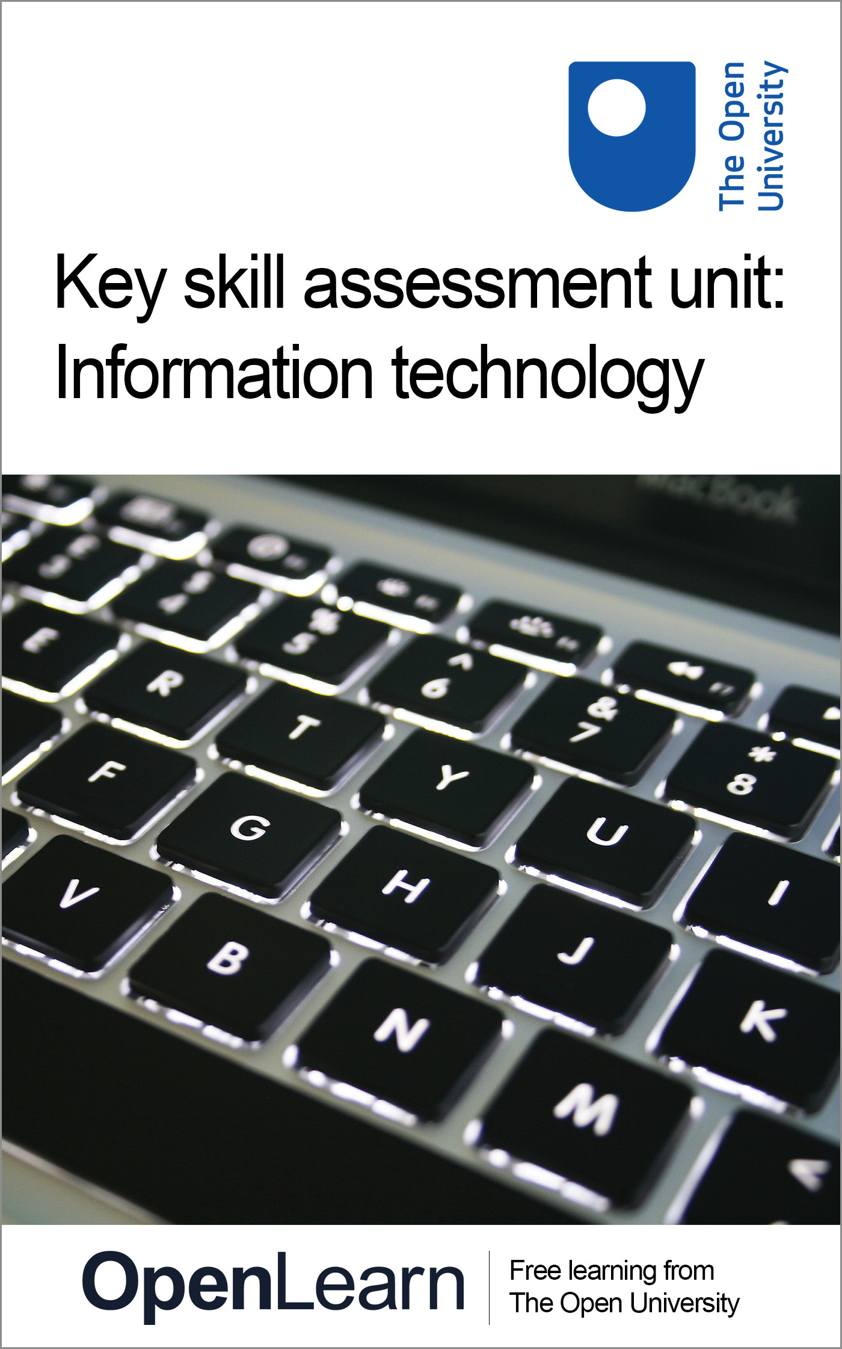

U073_1

Key skill assessment course: Information technology
About this free course
This free course provides a sample of Level 1 study in Information and Communication Technologies www.open.ac.uk/courses/find/computing-and-it.
This version of the content may include video, images and interactive content that may not be optimised for your device.
You can experience this free course as it was originally designed on OpenLearn, the home of free learning from The Open University – www.open.edu/openlearn/science-maths-technology/computing-and-ict/information-and-communication-technologies/key-skill-assessment-unit-information-technology/content-section-0
There you’ll also be able to track your progress via your activity record, which you can use to demonstrate your learning.
The Open University, Walton Hall, Milton Keynes, MK7 6AA
Copyright © 2016 The Open University
Intellectual property
Unless otherwise stated, this resource is released under the terms of the Creative Commons Licence v4.0 http://creativecommons.org/licenses/by-nc-sa/4.0/deed.en_GB. Within that The Open University interprets this licence in the following way: www.open.edu/openlearn/about-openlearn/frequently-asked-questions-on-openlearn. Copyright and rights falling outside the terms of the Creative Commons Licence are retained or controlled by The Open University. Please read the full text before using any of the content.
We believe the primary barrier to accessing high-quality educational experiences is cost, which is why we aim to publish as much free content as possible under an open licence. If it proves difficult to release content under our preferred Creative Commons licence (e.g. because we can’t afford or gain the clearances or find suitable alternatives), we will still release the materials for free under a personal end-user licence.
This is because the learning experience will always be the same high quality offering and that should always be seen as positive – even if at times the licensing is different to Creative Commons.
When using the content you must attribute us (The Open University) (the OU) and any identified author in accordance with the terms of the Creative Commons Licence.
The Acknowledgements section is used to list, amongst other things, third party (Proprietary), licensed content which is not subject to Creative Commons licensing. Proprietary content must be used (retained) intact and in context to the content at all times.
The Acknowledgements section is also used to bring to your attention any other Special Restrictions which may apply to the content. For example there may be times when the Creative Commons Non-Commercial Sharealike licence does not apply to any of the content even if owned by us (The Open University). In these instances, unless stated otherwise, the content may be used for personal and non-commercial use.
We have also identified as Proprietary other material included in the content which is not subject to Creative Commons Licence. These are OU logos, trading names and may extend to certain photographic and video images and sound recordings and any other material as may be brought to your attention.
Unauthorised use of any of the content may constitute a breach of the terms and conditions and/or intellectual property laws.
We reserve the right to alter, amend or bring to an end any terms and conditions provided here without notice.
All rights falling outside the terms of the Creative Commons licence are retained or controlled by The Open University.
Head of Intellectual Property, The Open University
Designed and edited by The Open University
978-1-4730-1682-8 (.kdl)
978-1-4730-0914-1 (.epub)

Contents
- Introduction
- Learning outcomes
- 1 Improving your information technology skills
- 2 Sources of help
- 3 Key skills assessment courses
- 4 Structure of the assessment courses
- 5 Effective use of information technology
- 6 What you should present
- 7 Part A: Evidencing skills to develop a strategy, monitor progress and evaluate performance
  - 7.1 Evidence required
  - 7.2 Developing a strategy
  - 7.3 Monitoring your progress
  - 7.4 Evaluating your strategy and assessing your work
- 8 Part B: Evidencing your IT skills
- 9 Notes to help you complete your assessment
- Conclusion
- Acknowledgements

Introduction
This key skill develops your information technology (IT) skills in your studies, work or other activities over a period of time. To tackle all of this key skill, you will need to plan your work over at least 3–4 months to give yourself enough time to practise and improve your skills, to seek feedback from others, to monitor your progress and evaluate your strategy and present outcomes.
Skills in information technology cover a broad range, from using software unitages to developing a critical understanding of the strengths and weaknesses of IT solutions. Learning how to use a word processor, database or spreadsheet are important but so, too, is thinking about how you can use IT efficiently to support what you are doing and to help you learn more effectively.
Improving your IT skills requires you to plan strategically how you will go about developing your skills, as well as what skills you should focus on. In monitoring your progress, you will need to apply and practise your IT skills to achieve the targets and goals you have set yourself and to reflect on, and possibly modify, your strategy in the light of your own assessment of progress and feedback from others. Evaluating your strategy and presenting results gives you the opportunity to demonstrate your IT skills and assess how successful your strategy was in achieving what you set out to do. This course is designed to be studied for 1 hour per week over 50 weeks.
This OpenLearn course provides a sample of Level 1 study in Information and Communication Technologies.

Learning outcomes
After studying this course, you should be able to:
- demonstrate a strategy for using information technology skills over an extended period of time
- monitor progress and adapt the strategy as necessary, to achieve the quality of outcomes required
- evaluate this overall strategy and present the outcomes from the work.

1 Improving your information technology skills
This Key Skill Assessment Course offers an opportunity for you to select and prepare work that demonstrates your key skills in the area of information technology.
This course provides you with advice and information on how to go about presenting your key skills work as a portfolio.
In presenting work that demonstrates your key skills you are taking the initiative to show that you can develop and improve a particular set of skills, and are able to use your skills more generally in your studies or at work. Skills development is all about taking responsibility for extending and improving your learning and performance in a wide range of contexts. We hope, therefore, that you will see this guide as a way of supporting your learning and skills development while you are studying, working and in your other activities. However you view it, we hope that they will help make skills development something you value personally.
You will need access to a computer to complete this key skill assessment course for information technology.

2 Sources of help
This assessment course is designed to be self-contained. However you might like to access the following sources for support and guidance if you need it. These sources include:
- U529_1 Key skills – making a difference: This OpenLearn course is designed to complement the assessment courses. It provides detailed guidance and activities to help you work on your key skills, gives examples of key skills work from students, and helps you prepare and select work for a portfolio.
- Your main course of study: If you are studying a course with the Open University or elsewhere which includes key skills outcomes you may get feedback from your tutor.
- Skills workshops/training courses: You may have opportunities to attend training courses at work.
- Skills resources: Your main course of study may recommend books, study guides and websites to help you tackle skills such as essay writing, using diagrams and graphs, or organising your learning.
- The Good Study Guide series: offers advice and examples of good practice: Chambers, E. and A. Northedge (1997) The Arts Good Study Guide. Milton Keynes: The Open University.
Northedge, A. (2005) The Good Study Guide. Milton Keynes: The Open University. There is a companion website to the book at www.open.ac.uk/goodstudyguide/index.htm.
Northedge, A. et al. (1997) The Sciences Good Study Guide. Milton Keynes: The Open University.
- SAFARI:www.open.ac.uk/safari This is an online tutorial with interactive activities that will help you to develop your information skills, including searching with electronic tools, evaluating and managing information.
- OU library and website:www.open.ac.uk/library
- Skills for OU study: www.open.ac.uk/skillsforstudy/index.php Offers online resources to help you develop skills needed for learning.
- OpenLearn information skills courses: Arts and History; Business and Management; Education; Health and Lifestyle; IT and Computing; Mathematics and Statistics; ModernLanguages; Science and Nature; Society and Technology.

3 Key skills assessment courses
This section gives advice and guidance to help you compile and present a portfolio of selected work. You are strongly advised to read through this section so that you have an idea of what is expected.
The key skills assessment courses provide an opportunity for you to integrate your development of key skills with your work or study. You may choose to concentrate on skills that you need to develop and improve for your job, for a new course, or personally to help you keep abreast of new developments or career changes. Developing skills is part of learning. The key skills approach provides you with a structure to help you think about how you learn and how you might improve both your learning skills and your performance. The key skills assessment courses give you an opportunity to demonstrate your capabilities in particular skills, and show that you can strategically plan your learning, monitor your progress and evaluate your work over a period of time.
Key skills are also about making connections between different aspects of your life – your study, your work and your other activities. All these might provide examples of work that you can select to demonstrate your skills. As you develop and improve your key skills you will also be improving the quality of your performance overall.
The Open University defines key skills in terms of seven broad areas: improving own learning and performance; communication; information technology; information literacy; application of number; problem solving and working with others. You, or your work place, may have used different terms to describe the skills but they are likely to cover broadly similar areas.
If you want to find out more about each of the key skills, the OpenLearn course U529_1 Key skills – making a difference includes detailed descriptions and more general information about learning and skills.
The key skills descriptions (except for information literacy) used by the Open University are based on national standards developed by the Qualifications and Curriculum Authority (QCA). Details of the national standards can be found by searching for key skills standards and guidance on the QCA website at: http://www.qca.org.uk/
The key skills assessment courses have been designed to take account of these national standards and are referenced against them.

4 Structure of the assessment courses
This key skill assessment course does not have specific questions with word limits and no statements indicating you include, say, an essay or a report. Instead, as you tackle the course you need to ask yourself ‘Which pieces of work show my skills and capabilities to best advantage?’ When you have identified and selected evidence of your skills, you must then relate this evidence directly to the criteria.
This method of building a portfolio is based not on providing right or wrong answers to questions but presenting selected work (called evidence) which shows your capabilities. However, submitting a portfolio of evidence for key skills is not simply a case of gathering together all your course or training material in a folder. Indeed, you are unlikely to show your achievements to best advantage by doing this. Your portfolio for key skills needs to be a ‘showcase’ of your work. It needs to be organised and indexed to both show and explain what it is you do as you go about improving and applying your skills within your study or work activities.
Each of the assessment courses asks you to select work to demonstrate achievement of particular criteria. The work or evidence you select may be from your study or work activities. However, there is an important aspect of creating a ‘showcase’ portfolio. It is that you select just enough evidence to meet the relevant criteria. For example, if you are selecting work for the IT key skill, your evidence may come from assignments associated with a course. Any one assignment may not provide exactly the evidence you need – you may find that you need to use work from two or even three different assignments. But the three assignments together may include material that is not relevant to the key skill. In this case, you need to create an example from your assignments that includes only the relevant material and annotate it to show what it is and what you are demonstrating.
All the key skills assessment courses have a common two-part structure that should tell the story of your learning journey as you completed the course. The two parts, A and B, are designed to help you create a portfolio of your work that will show how you applied your key skill capabilities within a particular discipline or work area.

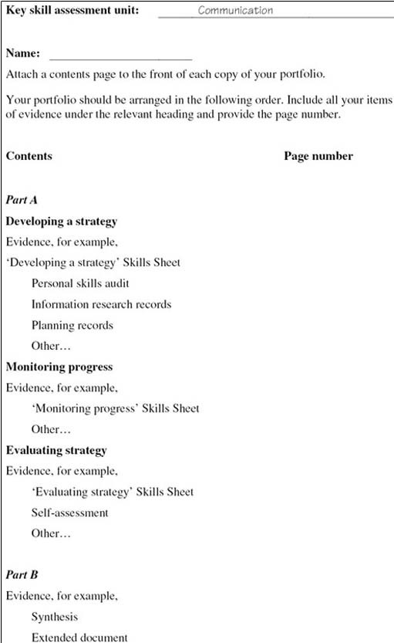
Figure 1 Sample key skills assessment course: contents page

Part A should give details of what you did to achieve your goal. It is concerned with the processes of improving and learning – how you plan, research tasks, adapt and apply your skills, learn new skills, implement ideas, get feedback, and evaluate your work overall. This framework comprises the three stages Develop a strategy, Monitor progress and Evaluate strategy that are introduced in the OpenLearn course U529_1 Key skills – making a difference.
Part B asks you to select evidence to show your capabilities in the particular key skill you are developing (for example communication, or information technology). You will need to select work that meets the set of criteria associated with the particular skill. This requires you to take responsibility for selecting your best work and checking that it meets the criteria.
Many activities you complete as part of your course or work may be eligible for inclusion in your key skills portfolio. However, because the portfolio is intended to be consciously and carefully selective, you should choose one or at most two pieces of work for Part B. If you choose more, be sure you can explain why these extra examples of your work are needed.
Overall, the two parts of the portfolio should integrate your selected work to show that you can improve and apply your skills. Your key skills work needs to be carefully planned to enable you to integrate it into the demands of your study or work activities. This means that at an early stage you need to identify your goals and plan what you will do to achieve them. As you implement your plans, you should schedule periods when you can concentrate on your skills, and review points to help you monitor and reflect on your progress. When you have completed your study or work activities, you need to be able to stand back, evaluate and reflect on how things have gone, what you have learned and how this will help you for future work.
In summary, Part A should tell the story of your learning journey in improving and applying your skills; Part B presents the results, the goals you have achieved.

5 Effective use of information technology
The purpose of this course is for you to create a portfolio of your work to represent you as an effective user of information technology (IT) within your study or work activities. This will involve using criteria to help you select examples of your work that clearly show you can use and improve your IT skills. However, by far the most important aim is that you can use this assessment process to support your learning and improve your performance overall.
Using information technology skills effectively within your study or work activities involves applying your skills appropriately in different situations, reflecting on your performance and identifying how you might improve in the future. For the assessment work, you will need to show that you can use information technology to handle text, images and numbers. Improving your IT skills involves planning what you hope to achieve, using your skills and monitoring how things are going, and standing back at critical points to reflect on your performance.
It is important to plan ahead for the assessment work and carefully consider what you need to present as evidence. Make sure the work you are doing provides opportunities for you to practise and apply your IT skills and the work you intend to present for assessment includes handling text, images and numbers. You need to take time to practise and apply your skills over a period of time. You should allow at least 3–4 months to improve, apply your skills and put together your portfolio.

6 What you should present
This assessment course has two parts. Part A requires you to show what you did to plan, monitor, evaluate and reflect upon your skills. Part B requires you to select examples of your work that demonstrate what you have done to improve and apply your skills. Together the two parts form a portfolio of your achievements. You can use the guidance, Bookmarks and Skills Sheets included in the OpenLearn course U529_1 Key skills – making a difference to help you structure and present your work.
You will need to make judgements about how well you have achieved the required standards, and make your own assessment of the quality of your work. To help you do this, Table 1 gives statements about the outcomes you should be aiming for, the criteria you should use to assess the quality of your work, and guidance about the evidence you need to present. If you presented your work for assessment, the assessors would use the same criteria to judge the evidence you have selected.
Check your work carefully, making sure that it actually shows the criteria have been met, and annotate it so that an assessor could identify the evidence that relates to each criteria. To help you select appropriate evidence, refer to Table 1 while you are working on this assessment course.
Table 1 (PDF, 4 pages, 0.1MB)
To complete your portfolio, include a contents page (see an example Figure 1 above) that lists the items of evidence you are including for each part.

7 Part A: Evidencing skills to develop a strategy, monitor progress and evaluate performance

7.1 Evidence required
This Part is about showing you can develop a strategy for using and improving your IT skills, that you can monitor your progress and can evaluate your overall performance and strategy. The evidence you present must show what you have done as you worked through the processes of planning strategically, monitoring, evaluating, and presenting your work. Part A must relate directly to the work you have selected for Part B.
You must present evidence to show you can:
- Develop a strategy for applying and improving your IT skills within the context of your study or work.
- Monitor your progress in applying and improving your IT skills and adapt your strategy as necessary to meet the required standard.
- Evaluate the overall effectiveness of your strategy in developing the skills you set out to improve, and assess the overall quality of your work.

7.2 Developing a strategy
Present notes/records that show you have planned your use of IT skills. Your evidence must include:
- the goals you hope to achieve over 3–4 months or so; you should indicate how these goals relate to the context in which you are working and to your current capabilities;
- notes about the resources you might use, and what information you need to research to achieve your goals; for example, discussions and e-conferences, online resources, skills books, course materials, workshops, specific help and feedback from others;
- a plan of action to use and improve your IT skills that includes notes on:
  - targets you have set to achieve your goals and how you intend to achieve them;
  - opportunities you can use to develop and practise your IT skills; for example, working on assignments and projects, online conferences, information searches, attending training sessions or skills workshops;
  - evidence you plan to present; for example, an assignment, project report, annotated printouts of drafts or screen displays etc., to show how you have developed your information technology skills;
- a schedule indicating deadlines and review points.
Be prepared to revise and update your strategy as your work develops. Think of it as a living document; you are likely to make many changes and adjustments to it while you are working on the course. Keep a record of your revisions and notes about why you made the changes.
You could perhaps discuss your strategy with a study advisor and receive feedback. You could use this feedback to help you assess your progress as your work develops.

7.3 Monitoring your progress
Use your records or logbook to help you provide a reflective commentary on:
- what you did to help you set up and use IT methods and techniques to achieve your goals; for example, what you did to:
  - search for information and explore alternative lines of enquiry;
  - exchange information to meet your purpose (e.g. email, computer conferencing, video conferencing, web pages, document sharing systems);
  - use IT to derive new information (e.g. in making calculations, integrating information from different sources, predicting trends or creating new designs);
  - choose criteria and use them to critically evaluate the quality of your work;
- the use you made of resources and feedback comments to improve your skills and the quality of your work; with hindsight, would you do anything differently in improving your skills and using IT to improve the quality of your work?
- the choices you made as you developed and used IT skills for particular purposes; assess, making reference to criteria and targets where relevant, how effective your use of IT has been. Include any changes you have made to your strategy; for example, what you changed to overcome problems, why you made the changes, and what was or was not successful.

7.4 Evaluating your strategy and assessing your work
Present a reflective summary that gives details of:
- a judgement of your own progress and performance in the IT skills you set out to improve, including an assessment of where you feel you have made the greatest progress; discuss your use of criteria and feedback comments to help you assess your progress;
- those factors that had the greatest effect on you achieving what you set out to do; include those that worked well to help you improve and those that worked less well;
- the changes you intend to make in your way of working as a result of working on this assessment course, and the skills you plan to work on in the future;
- an assessment of the evidence you have selected for your portfolio, using the criteria in Table 1 below; which aspects of your work demonstrate that you have developed your skills to the standard that you set out to achieve? Indicate clearly where your work provides evidence of your skills.

8 Part B: Evidencing your IT skills
This Part requires you to present a portfolio of your work to demonstrate that you have used and integrated your IT skills within your study or work activities to achieve the standard required. For example, you might include learning about new software for a particular task, using databases and other resources more effectively in searching for information, setting up and using different ways of communicating and sharing information, setting up and using computer-based models to predict, explain or design.
The work you select for your portfolio must meet the assessment criteria in Table 1 below and show that you can:
- use IT methods and techniques to aid searching, evaluating and selecting information;
- explore alternative lines of enquiry where appropriate;
- develop and exchange relevant information and derive new information for the purpose required;
- develop the structure for presenting your work and integrate different types of information;
- present information effectively, using a format and style to suit your purpose, subject and audience and ensure it is accurate and makes sense.
Your portfolio might contain one or more items based on your assignments, or from a project report or other work that includes activities where you have taken responsibility for developing your information technology skills to meet your purposes.
In choosing work for your portfolio, it is your responsibility to be selective and concise. Each item you include must be annotated clearly to show how it is relevant to the assessment criteria in Table 1. You may find that you do not need to include all your assignments, notes or a complete project report. Including material that is not relevant, or which is not closely related to the assessment criteria, will not strengthen the assessment of your skills. Remember that you are not being assessed on technical content but on the relevance of your evidence to the assessment criteria.

Table 1 Criteria for assessment of your information technology skills portfolio and a checklist to help you select the evidence you need
Criteria for assessment: the evidence you present must show you can: | Checklist: check that your evidence shows what you have done to:
Develop a strategy for using information technology (IT) skills over an extended period of time.
Establish opportunities for using IT skills and clearly identify the outcomes you hope to achieve. | Identify where you can use and improve your information technology skills (e.g. learning about new methods or techniques, seeking and using feedback) within your study or work activities.
 | Identify your targets and goals, explaining why you have chosen them (e.g. better use of software facilities, improved access to information, effective communication, more efficient design).
 | Establish the criteria you will use to judge your progress and performance, and in seeking feedback from others.
Identify relevant sources and research the information needed for planning purposes. | List reference sources and resources that you might use (e.g. databases, online help, textbooks and manuals, training courses, course materials, other people).
Plan your use of IT skills, making a reasoned selection of methods for achieving the quality of outcomes required. | Draw up a plan for achieving your goal(s) that:
 | • divides the work into stages;
 | • identifies interim targets;
 | • gives a time schedule and deadlines for each stage.
 | Keep notes and/or a log to record changes to your plans, and reasons for them.
 | Take into account factors that may affect your plans (e.g. access to IT, work patterns, health and safety, social, ethical, and moral issues associated with IT, other commitments).
 | Select, giving reasons for your choice, the methods you are going to use to achieve your goals and targets (e.g. internet searches, econferencing, CAD/CAM techniques, use of specific software and hardware).
Monitor progress and adapt your strategy, as necessary, to achieve the quality of outcomes required in work involving the use of IT for two different, complex tasks.
Prepare, and use IT to aid efficient searching, evaluation and selection of information, exploring alternative lines of enquiry where appropriate. | Summarise the methods and techniques you used to help you achieve your goals (e.g. in creating macros, linking spreadsheets, defining styles, creating database structures, monitoring experimental results, organising econferencing).
 | Use search strategies effectively (e.g. to assist in finding, organising and comparing information).
 | Establish and use criteria to evaluate and select information.
 | Make judgements (using criteria and feedback from others) on the reliability and quality of the information.
 | Explore different lines of enquiry (e.g. use and evaluate critically different search strategies, or different rules in spreadsheet models to make predictions and test alternative hypotheses).
 | Keep an accurate record and note your progress towards your goals.
Develop and exchange relevant information, and derive new information, to meet your purpose. | Choose appropriate ways of communicating and exchanging information (e.g. using email, online conferencing, shared access to documents, video conferences, web-based systems).
 | Describe how you are deriving new information (e.g. by making calculations, integrating information from a variety of sources to reach your own conclusions).
 | Reflect on how well you are meeting your purposes and your targets.
Monitor and critically reflect on your use of IT skills, adapting your strategy as necessary to produce the quality of outcomes required. | Establish and use criteria to help you monitor your progress and critically evaluate your results to check that they are meeting your requirements.
 | Use feedback and self-assessment to check your skills development.
 | Identify the choices you have made in achieving your targets, and judge how effective they have been (e.g. in their impact on the quality of your work).
 | Reflect on your progress, and performance, identifying any changes you have made to your plan and the reasons for them.
Evaluate your overall strategy and present the outcomes from your work using at least one presentation, showing integration of text, image and number.
Develop the structure for presenting your work, integrating different types of information and using the views of others, where appropriate, to guide refinements. | Identify the requirements for presenting your work.
 | Integrate different types of information to ensure consistency in the display of text, numbers and images.
 | Seek and record feedback comments from others, your response to it and the actions you took.
Present information effectively, using a format and style to suit your purpose, subject and audience, and ensure it is accurate and makes sense. | Identify the audience(s) for your work and make judgements about how best to present your information.
 | Give reasons for the style and format you chose. Check accuracy in terms of content and conventions (e.g. spelling, grammar, punctuation, labelling of images, charts, diagrams and graphs, word limit, layout, style of references).
 | Proofread and amend your work so that it makes sense.
 | Use criteria to judge the quality of your presentation.
Assess the effectiveness of your strategy, including factors that had an impact on the outcomes, and identify ways of further improving your IT skills. | Assess the quality of your information technology work by making connections between criteria, feedback comments and your own judgement of your performance.
 | Identify those factors that affected the production and presentation of your work (e.g. availability and quality of resources, working environment, level of your expertise).
 | Assess the effectiveness of your strategy for developing your skills. What worked well and what worked less well?
 | Relate your goals, targets and criteria to your progress so far and to possibilities for future development.

9 Notes to help you complete your assessment
To complete your assessment portfolio you must include a contents page indicating how your reflective commentary in Part A and your evidence in Part B are related. An example of a suitable format for the contents page is in Figure 1 below.
Figure 1 (PDF, 1 page, 0.1MB)
Although the requirements of Parts A and B are listed separately, you should think of them as parts of a whole in which each part relates to the others. Parts A and B together must show that you can plan strategically to improve your skills, monitor your progress and evaluate your overall strategy as you produce a piece of work.
The work you present should meet the criteria given in Table 1. As you work on this assessment course, use the criteria to help you keep track of your progress and to check that it meets the required standard. Your evidence and commentary should be sufficient to verify your achievements.

Conclusion
This free course provided an introduction to studying Information and Communication Technologies. It took you through a series of exercises designed to develop your approach to study and learning at a distance and helped to improve your confidence as an independent learner.

Acknowledgements
The content acknowledged below is Proprietary (see terms and conditions) and is used under licence.
Course image: William Hook in Flickr made available under Creative Commons Attribution-ShareAlike 2.0 Licence.
All other materials included in this course are derived from content originated at the Open University.
Don't miss out:
If reading this text has inspired you to learn more, you may be interested in joining the millions of people who discover our free learning resources and qualifications by visiting The Open University - www.open.edu/openlearn/free-courses

