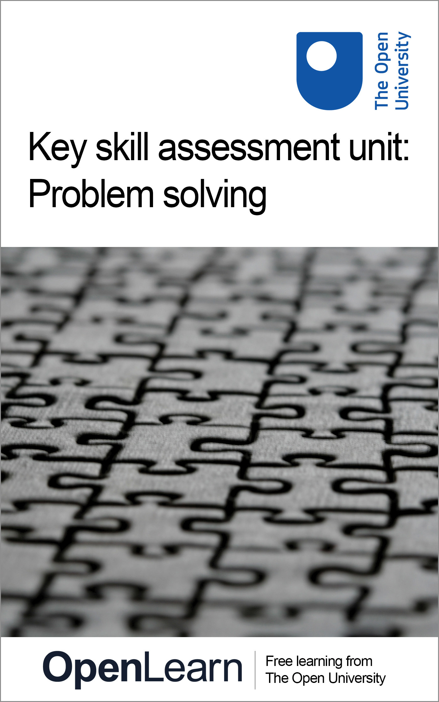

U076_1

Key skill assessment course: problem solving
About this free course
This free course provides a sample of Level 1 study in Education www.open.ac.uk/courses/find/education-childhood-and-youth.
This version of the content may include video, images and interactive content that may not be optimised for your device.
You can experience this free course as it was originally designed on OpenLearn, the home of free learning from The Open University – www.open.edu/openlearn/education/key-skill-assessment-unit-problem-solving/content-section-0
There you’ll also be able to track your progress via your activity record, which you can use to demonstrate your learning.
Copyright © 2016 The Open University
Intellectual property
Unless otherwise stated, this resource is released under the terms of the Creative Commons Licence v4.0 http://creativecommons.org/licenses/by-nc-sa/4.0/deed.en_GB. Within that The Open University interprets this licence in the following way: www.open.edu/openlearn/about-openlearn/frequently-asked-questions-on-openlearn. Copyright and rights falling outside the terms of the Creative Commons Licence are retained or controlled by The Open University. Please read the full text before using any of the content.
We believe the primary barrier to accessing high-quality educational experiences is cost, which is why we aim to publish as much free content as possible under an open licence. If it proves difficult to release content under our preferred Creative Commons licence (e.g. because we can’t afford or gain the clearances or find suitable alternatives), we will still release the materials for free under a personal end-user licence.
This is because the learning experience will always be the same high quality offering and that should always be seen as positive – even if at times the licensing is different to Creative Commons.
When using the content you must attribute us (The Open University) (the OU) and any identified author in accordance with the terms of the Creative Commons Licence.
The Acknowledgements section is used to list, amongst other things, third party (Proprietary), licensed content which is not subject to Creative Commons licensing. Proprietary content must be used (retained) intact and in context to the content at all times.
The Acknowledgements section is also used to bring to your attention any other Special Restrictions which may apply to the content. For example there may be times when the Creative Commons Non-Commercial Sharealike licence does not apply to any of the content even if owned by us (The Open University). In these instances, unless stated otherwise, the content may be used for personal and non-commercial use.
We have also identified as Proprietary other material included in the content which is not subject to Creative Commons Licence. These are OU logos, trading names and may extend to certain photographic and video images and sound recordings and any other material as may be brought to your attention.
Unauthorised use of any of the content may constitute a breach of the terms and conditions and/or intellectual property laws.
We reserve the right to alter, amend or bring to an end any terms and conditions provided here without notice.
All rights falling outside the terms of the Creative Commons licence are retained or controlled by The Open University.
Head of Intellectual Property, The Open University
978-1-4730-1685-9 (.kdl)
978-1-4730-0917-2 (.epub)

Contents
- Introduction
- Learning outcomes
- 1 Developing your problem solving skills
- 2 Sources of help
- 3 Key skills assessment courses
- 4 Structure of the assessment courses
- 5 Effective use of problem solving skills
- 6 What you should present
- 7 Part A: Evidencing the process of developing a strategy, monitoring progress and evaluating performance
  - 7.1 Evidence required
  - 7.2 Developing a strategy
  - 7.3 Monitoring your progress
  - 7.4 Evaluating your strategy and assessing your work
- 8 Part B: Evidencing your problem-solving skills
- 9 Notes to help you complete your assessment
- Conclusion
- Keep on learning
- Acknowledgements

Introduction
This key skill develops your problem-solving skills in your studies, work or other activities over a period of time. To tackle this key skill, you will need to plan your work over at least 3–4 months to give yourself enough time to practise and improve your skills, to seek feedback from others, and to monitor your progress and evaluate your strategy.
Problem solving runs through many other activities and, rather like the key skill in OpenLearn course U071_1 Improving own learning and performance, it can be thought as a ‘metaskill’ – something that helps you plan, choose, use and adapt the specific skills you need to tackle effectively a particular problem. The key skill of problem solving supports you in planning, monitoring and evaluating a range of problem-solving strategies and techniques.
What is defined as a problem tends to depend on the particular context in which it is framed. In mathematics, for example, problems may often be well defined and have particular solutions which can be assessed by commonly agreed methods. In other areas, however, particularly where different people, perspectives and values are brought together, agreeing the boundaries of a problem and how it might be tackled – or even whether there is a problem at all – can be difficult.
In a broader sense, sometimes problems are better not seen as things to be ‘solved’, but as contexts for focusing ideas and stimulating further investigation or discussion. Framing an issue appropriately – identifying why it is a problem, stressing the factors that might have a bearing on it, and outlining what an acceptable resolution might look like – then becomes a central activity. From this perspective, problems are seen as significant questions for negotiation and enquiry, not as solvable puzzles for which there is a single, unambiguous correct answer.
Using problem-solving skills, therefore, is not a question of simply selecting a well-defined problem, choosing a particular procedure to deal with it, and then coming up with a solution. It is about people understanding the context in which they are working, recognising a gap between the present situation and what is desirable, and then being able to move strategically towards their goal.
Being strategic means breaking down an overall goal into sub-goals and reducing a problem to manageable chunks which can then be solved individually and then moving forward. However, there is no guarantee that any particular set of sub-goals will work. The trick is to try to choose those sub-goals that will simplify the problem, and avoid those that will make it worse. The key skill of problem solving aims to raise your awareness of this process.
Improving your skills involves planning how you will frame, explore and simplify your problem area, as well as finding out about the tools and techniques you might use. You will also need to apply, practise and review your skills, using feedback from others to help you think about your progress in relation to your goals. Standing back and reviewing the stages in your work helps you develop a mental picture of ‘how far’ you are from your goals, and what you could do to reduce that distance. Finally, evaluating your strategy and presenting outcomes gives you the opportunity to demonstrate your problem-solving skills, and to assess how successful your strategy was in achieving what you set out to do. This course is designed to be studied for 1 hour per week over 50 weeks.
This OpenLearn course provides a sample of Level 1 study in Education.

Learning outcomes
After studying this course, you should be able to:
- demonstrate a strategy for using skills in problem solving over an extended period of time
- monitor progress and adapt the strategy as necessary, to achieve the quality of outcomes required when tackling a complex problem
- evaluate this overall strategy and present the outcomes from the work using a variety or methods.

1 Developing your problem solving skills
This Key Skill Assessment Course offers an opportunity for you to select and prepare work that demonstrates your key skills in the area of problem solving.
This course provides you with advice and information on how to go about presenting your key skills work as a portfolio.
In presenting work that demonstrates your key skills you are taking the initiative to show that you can develop and improve a particular set of skills, and are able to use your skills more generally in your studies or at work. Skills development is all about taking responsibility for extending and improving your learning and performance in a wide range of contexts. We hope, therefore, that you will see this guide as a way of supporting your learning and skills development while you are studying, working and in your other activities. However you view it, we hope that they will help make skills development something you value personally.

2 Sources of help
This assessment course is designed to be self-contained. However you might like to access the following sources for support and guidance if you need it. These sources include:
- U529_1 Key skills – making a difference: This OpenLearn course is designed to complement the assessment units. It provides detailed guidance and activities to help you work on your key skills, gives examples of key skills work from students, and helps you prepare and select work for a portfolio.
- Your main course of study: If you are studying a course with the Open University or elsewhere which includes key skills outcomes you may get feedback from your tutor.
- Skills workshops/training courses: You may have opportunities to attend training courses at work.
- Skills resources: Your main course of study may recommend books, study guides and websites to help you tackle skills such as essay writing, using diagrams and graphs, or organising your learning.
- The Good Study Guide series: offers advice and examples of good practice: Chambers, E. and A. Northedge (1997) The Arts Good Study Guide. Milton Keynes: The Open University.
Northedge, A. (2005) The Good Study Guide. Milton Keynes: The Open University.
Northedge, A. et al. (1997) The Sciences Good Study Guide. Milton Keynes: The Open University.
- SAFARI: This is an online tutorial with interactive activities that will help you to develop your information skills, including searching with electronic tools, evaluating and managing information.
- OU library and website
- Skills for OU study offers online resources to help you develop skills needed for learning.
- OpenLearn information skills courses: Arts and History; Business and Management; Education; Health and Lifestyle; IT and Computing; Mathematics and Statistics; ModernLanguages; Science and Nature; Society and Technology.

3 Key skills assessment courses
This section gives advice and guidance to help you compile and present a portfolio of selected work. You are strongly advised to read through this section so that you have an idea of what is expected.
The key skills assessment courses provide an opportunity for you to integrate your development of key skills with your work or study. You may choose to concentrate on skills that you need to develop and improve for your job, for a new course, or personally to help you keep abreast of new developments or career changes. Developing skills is part of learning. The key skills approach provides you with a structure to help you think about how you learn and how you might improve both your learning skills and your performance. The key skills assessment courses give you an opportunity to demonstrate your capabilities in particular skills, and show that you can strategically plan your learning, monitor your progress and evaluate your work over a period of time.
Key skills are also about making connections between different aspects of your life – your study, your work and your other activities. All these might provide examples of work that you can select to demonstrate your skills. As you develop and improve your key skills you will also be improving the quality of your performance overall.
The Open University defines key skills in terms of seven broad areas: improving own learning and performance; communication; information technology; information literacy; application of number; problem solving and working with others. You, or your work place, may have used different terms to describe the skills but they are likely to cover broadly similar areas.
If you want to find out more about each of the key skills, the OpenLearn course U529_1 Key skills – making a difference includes detailed descriptions and more general information about learning and skills.
The key skills descriptions (except for information literacy) used by the Open University are based on national standards developed by the Qualifications and Curriculum Authority (QCA). Details of the national standards can be found by searching for key skills standards and guidance on the QCA website.
The key skills assessment courses have been designed to take account of these national standards and are referenced against them.

4 Structure of the assessment courses
This key skill assessment course does not have specific questions with word limits and no statements indicating you include, say, an essay or a report. Instead, as you tackle the course you need to ask yourself ‘Which pieces of work show my skills and capabilities to best advantage?’ When you have identified and selected evidence of your skills, you must then relate this evidence directly to the criteria.
This method of building a portfolio is based not on providing right or wrong answers to questions but presenting selected work (called evidence) which shows your capabilities. However, submitting a portfolio of evidence for key skills is not simply a case of gathering together all your course or training material in a folder. Indeed, you are unlikely to show your achievements to best advantage by doing this. Your portfolio for key skills needs to be a ‘showcase’ of your work. It needs to be organised and indexed to both show and explain what it is you do as you go about improving and applying your skills within your study or work activities.
Each of the assessment courses asks you to select work to demonstrate achievement of particular criteria. The work or evidence you select may be from your study or work activities. However, there is an important aspect of creating a ‘showcase’ portfolio. It is that you select just enough evidence to meet the relevant criteria. For example, if you are selecting work for the IT key skill, your evidence may come from assignments associated with a course. Any one assignment may not provide exactly the evidence you need – you may find that you need to use work from two or even three different assignments. But the three assignments together may include material that is not relevant to the key skill. In this case, you need to create an example from your assignments that includes only the relevant material and annotate it to show what it is and what you are demonstrating.
All the key skills assessment courses have a common two-part structure that should tell the story of your learning journey as you completed the course. The two parts, A and B, are designed to help you create a portfolio of your work that will show how you applied your key skill capabilities within a particular discipline or work area.

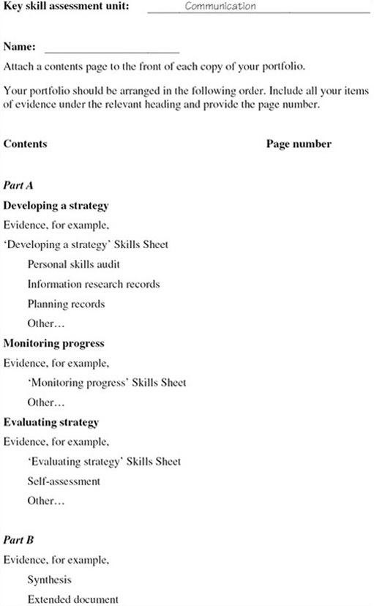
Figure 1: Sample key skills assessment course: contents page

Part A should give details of what you did to achieve your goal. It is concerned with the processes of improving and learning – how you plan, research tasks, adapt and apply your skills, learn new skills, implement ideas, get feedback, and evaluate your work overall. This framework comprises the three stages Develop a strategy, Monitor progress and Evaluate strategy that are introduced in the OpenLearn course U529_1 Key skills – making a difference.
Part B asks you to select evidence to show your capabilities in the particular key skill you are developing (for example communication, or information technology). You will need to select work that meets the set of criteria associated with the particular skill. This requires you to take responsibility for selecting your best work and checking that it meets the criteria.
Many activities you complete as part of your course or work may be eligible for inclusion in your key skills portfolio. However, because the portfolio is intended to be consciously and carefully selective, you should choose one or at most two pieces of work for Part B. If you choose more, be sure you can explain why these extra examples of your work are needed.
Overall, the two parts of the portfolio should integrate your selected work to show that you can improve and apply your skills. Your key skills work needs to be carefully planned to enable you to integrate it into the demands of your study or work activities. This means that at an early stage you need to identify your goals and plan what you will do to achieve them. As you implement your plans, you should schedule periods when you can concentrate on your skills, and review points to help you monitor and reflect on your progress. When you have completed your study or work activities, you need to be able to stand back, evaluate and reflect on how things have gone, what you have learned and how this will help you for future work.
In summary, Part A should tell the story of your learning journey in improving and applying your skills; Part B presents the results, the goals you have achieved.

5 Effective use of problem solving skills
The purpose of this assessment course is for you to create a portfolio of your work to represent your skills in problem solving within your study or work activities. This will involve using criteria to help you select examples of your work that clearly show you can use and improve your skills in problem solving. However, by far the most important aim is that you can use this assessment process to support your learning and improve your performance overall.
Using problem-solving skills is not a question of simply selecting a well-defined problem, choosing a particular procedure to deal with it, and then coming up with a solution. It is about you understanding the context in which you are working, recognising a gap between the present situation and what is desirable, and then being able to move strategically towards your goal.
To work on this course, you need to have opportunities in your study or at work that include problems that are complex, that is, have a number of sub-problems and are affected by a range of factors. The problems are likely to have several possible outcomes or solutions that will give you the opportunity to extend your knowledge of methods and resources and adapt your plans as you achieve the outcomes.
Working on this assessment course is like embarking on a learning journey. You need to identify your current capabilities and what you hope to achieve. Developing your skills in problem solving involves using different techniques in a variety of situations, using feedback to help you improve and standing back at critical points to reflect on your performance.
It is important to plan ahead for the portfolio work and carefully consider what you need to present as evidence. The work you include needs to present a ‘storyboard’ of your learning journey showing selected pieces of evidence to demonstrate what you did to tackle the problem and the outcomes you achieved. You need to take time to practise and apply your skills over a period of time. You should allow at least 3–4 months to improve, apply your skills and put together your portfolio.

6 What you should present
This assessment course has two parts. Part A requires you to show what you did to plan, monitor, evaluate and reflect upon your skills, and present evidence of that process. Part B requires you to select concise examples of your work that demonstrate what you did as you applied skills and techniques to tackle problems. Together the two parts form a portfolio of your achievements. You can use the guidance, Bookmarks and Skills Sheets included in the OpenLearn course U529_1 Key skills – making a difference to help you structure and present your work.
You will need to make judgements about how well you have achieved the required standards, and make your own assessment of the quality of your work. To help you do this, Table 1 contains statements about the outcomes you should be aiming for, the criteria you should use to assess the quality of your work, and guidance about the evidence you need to present. If you were to present your work for assessment, the assessors would use the same criteria to judge the evidence you have selected.
Check your work carefully. Make sure that it shows the criteria have been met, and annotate it to show your learning journey as you worked on particular problems. To help you select appropriate evidence refer to Table 1 while you are working on this assessment course.
Click here to view Table 1 (PDF, 2 pages, 0.1MB)
To complete your portfolio, include a contents page (see the example in Figure 1 above) that lists the items of evidence you are including for each part.

7 Part A: Evidencing the process of developing a strategy, monitoring progress and evaluating performance

7.1 Evidence required
Part A is about showing you can develop a strategy for using and improving your skills in problem solving, that you can monitor your progress and can evaluate your performance and strategy overall. The evidence you present must show what you have done as you worked through the processes of planning strategically, monitoring, evaluating and presenting your work. Part A must relate directly to the work you have selected for Part B.
You must present evidence to show you can:
- Develop a strategy for applying and improving your skills in problem solving within the context of your study or work.
- Monitor your progress in applying and improving your skills in problem solving and adapt your strategy, as necessary, to meet the required standard.
- Evaluate the overall effectiveness of your strategy in developing the skills you set out to improve, and assess the overall quality of your work.

7.2 Developing a strategy
Present notes/records that show you have planned your use of problem-solving skills in tackling a selected problem from your study or work. Your evidence must include:
- the goals you hope to achieve over 3–4 months or so; you should indicate how these goals relate to the context in which you are working and to your current capabilities;
- how you planned and explored the problem and set out the next stages of the work, for example, using a flow chart to break it down into sub-problems, or re-framing the problem to view it from different perspectives. You need to include a statement that describes the factors taken into account when planning;
- the critical features of the problem and how you established them, for example, using critical path analysis or a concept map;
- notes on the methods you have considered to work on and tackle the problem and an estimation of the likely success of these methods;
- a plan of action to do the work that includes:
  - targets you have set to achieve your goals;
  - the opportunities you can use to achieve your targets;
  - the resources you might use, including people, to develop your skills, for example, course materials, tutor feedback, discussions with others;
  - evidence you plan to present, for example, an assignment or project report;
  - a schedule that gives deadlines and review points.
Be prepared to revise and update your strategy as your work develops. Think of it as a living document; you are likely to make many changes and adjustments to it while you are working on the course. Keep a record of your revisions and notes about why you made changes.
You could perhaps discuss your strategy with a study advisor and receive feedback. You could use this feedback to help you assess your progress as your work develops.

7.3 Monitoring your progress
Use your records or logbook to help you present a commentary that includes:
- The methods you used to work on the problem.
- A statement that shows how you have used your knowledge of problem-solving methods for selecting particular methods and reasons for the selection to achieve the standard of work required.
- The checking procedures you used for the problem, for example, interim checks, progress reports, feedback comments, and the outcomes of the checks.
- The use you made of resources and feedback comments as you worked on the problem. With hindsight, would you do anything differently?
- The choices you have made as you worked on the problem. Make an assessment, using criteria where relevant, of the effectiveness of the choices and decisions you made. Include any changes you have made to your strategy, why you made the changes, and what was not successful.

7.4 Evaluating your strategy and assessing your work
Present a reflective summary that gives details of:
- A judgement of your own progress and performance in using problem-solving skills, including an assessment of your progress. Discuss your use of criteria and feedback comments to help you assess your progress.
- Those factors that had the greatest effect on your achieving what you set out to do, including those that worked well to help you improve and those that worked less well.
- The changes you intend to make in your way of working as a result of working on this course, and the skills you plan to work on in the future.
- An assessment of the evidence you have selected for your portfolio, using the criteria in Table 1. Which aspects of your work demonstrate that you have developed your skills to the standard that you set out to achieve in your plan? Indicate clearly where your work provides evidence of your skills.

8 Part B: Evidencing your problem-solving skills
This Part requires you to present an example of your work to show that you can explore a problem and follow it through to completion. For example, setting up a project to monitor landfill and associated pollution levels; or developing and implementing a work rota for a care course to cover 24 hours, 7 days per week with on-call facilities.
The example you select to evidence your skills in problem solving must meet the criteria in Table 1 and the results should be presented in an appropriate format (e.g. written report, visual display or video clip). You need to make sure that it illustrates the problem-solving process and gives the results with evidence to support the conclusions.
In choosing work for your portfolio it is your responsibility to be selective. If at all possible choose just one or two pieces of work. Each item you include must be annotated clearly to show how it is relevant to the criteria in Table 1. You may find that you do not need to include all your assignments, notes or a complete project report. Including material that is not relevant, or which is not closely related to the assessment criteria, will not strengthen the assessment of your skills. Remember that you are not being assessed on technical content but on the relevance of your evidence to the assessment criteria.

Table 1 Criteria for assessment of your problem-solving skills portfolio and a checklist to help you assess your work against the criteria
Criteria for assessment: evidence you present must show you can: | Checklist: check that your evidence shows what you have done to:
Develop a strategy for problem solving.
Identify opportunities for problem solving and clearly establish what you hope to achieve. | Describe the context in which you are working and identify where you can use problem-solving skills.
 | Present 1 or 2 goals with an explanation of why these are important to you.
Explore problems to identify their critical features and devise different ways of teckling them. | Using your example, provide notes to show what you did to explore the problem. For example, reframe the problem, divide it into sub-tasks, eliminate misleading information, make comparisons with similar situations. Label or include notes to show that you know what to do to ‘explore a problem’.
Identify relevant sources and research the information needed for planning purposes. | Give the critical features of the problem that you have identified and provide notes/reference lists, etc., to show what you did to establish these features. For example, include notes/references of information you have obtained from people, including specialists, and reference material you have used. Remember to include reference material you used to find out about problem-solving methods.
Negotiate with appropiate people the approach to use and plan how you will implement this. | Include a plan that you have used for the next stage of the work (e.g. a plan that includes a flowchart or critical-path analysis) and a statement describing the factors taken into account when planning.
 | Remember to keep notes/records of any revisions to the plan and the reasons for them.
 | Part of the planning process involves you considering ways to solve the problem. You need to show two aspects here. First, that you know and can use a range of problem-solving methods, e.g. working with others (collaborative); numerical (application of number); and visual. Second, that you can assess the usefulness of different methods in tackling the particular problem and context, e.g. by ranking methods against the main features of the problem, or doing a risk assessment.
Monitor progress and adapt your strategy for solving the problem.
Manage effectively and efficiently the problem solving process, using appropriate methods. | Continue the work you did as part of your strategic planning to show the option selected to tackle the problem and what you did to make the final decision. For example, you may have carried out a cost/benefit analysis or negotiated the option with a tutor/manager.
 | Use your plan to help show you can keep track of your work.
Keep track of progress and systematically check results. | Use interim checks and adjustments to see if targets/sub goals are being met and if your methods are helping you approach your goal.
Reflect critically on your approach to tackling the problem and adapt your strategy as necessary to improve your problem-solving skills. | Describe any changes you had to make in your plan along the way.
 | Review your progress by ‘standing back’ at critical points to assess the work and reflect on performance.
Evaluate your strategy and present the outcomes of your problem solving skills.
Bring together and clearly present the results of your approach to problem solving, including evidence to support your conclusions. | Present your work as a written report, visual display, demonstration, video clip, etc.
Assess the effectiveness of your strategy, including factors that affected the outcomes, and identify ways of further improving your problem solving skills. | Make an assessment of the quality of the work you have done using problem-solving skills by making connections between criteria/feedback comments and your own judgement of your performance.
Agree with appropriate people the extent to which the problem has been solved. | Identify those factors that affected the overall quality of your work.
 | Using this work identify progress so far and areas you want to work on in the future.

9 Notes to help you complete your assessment
To complete your assessment portfolio include a contents page to show what evidence you have included for each part. An example of a suitable format for the contents page is shown in Figure 1 above.
Click here to view Figure 1 (PDF, 1 page, 0.1MB)
Although the requirements of Parts A and B are listed separately you should think of them as parts of a whole in which each part relates to the others. Parts A and B together must show that you can plan strategically to improve your learning and performance, monitor your progress and evaluate your overall strategy as you produce a piece of work.
The work you put into your portfolio should meet the criteria given in Table 1. These criteria will be used in assessing your work. As you work on this course, use the criteria to help you keep track of your progress and to check that it meets the required standard. Your evidence and commentary should be sufficient to verify your achievements.

Conclusion
This free course provided an introduction to studying education. It took you through a series of exercises designed to develop your approach to study and learning at a distance and helped to improve your confidence as an independent learner.

Keep on learning



Study another free course
There are more than 800 courses on OpenLearn for you to choose from on a range of subjects.
Find out more about all our free courses.

Take your studies further
Find out more about studying with The Open University by visiting our online prospectus.
If you are new to university study, you may be interested in our Access Courses or Certificates.

What’s new from OpenLearn?
Sign up to our newsletter or view a sample.

For reference, full URLs to pages listed above:
OpenLearn – www.open.edu/openlearn/free-courses
Visiting our online prospectus – www.open.ac.uk/courses
Access Courses – www.open.ac.uk/courses/do-it/access
Certificates – www.open.ac.uk/courses/certificates-he
Newsletter – www.open.edu/openlearn/about-openlearn/subscribe-the-openlearn-newsletter

Acknowledgements
The content acknowledged below is Proprietary (see terms and conditions) and is used under licence.
Course image: INTVGene in Flickr made available under Creative Commons Attribution-ShareAlike 2.0 Licence.
All other materials included in this course are derived from content originated at the Open University.
Don't miss out:
If reading this text has inspired you to learn more, you may be interested in joining the millions of people who discover our free learning resources and qualifications by visiting The Open University - www.open.edu/openlearn/free-courses

