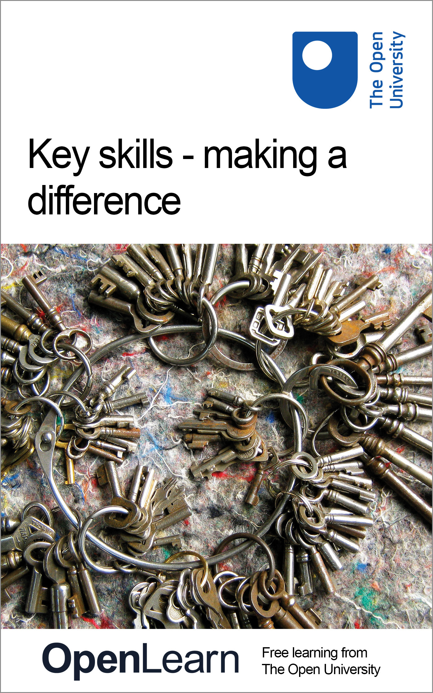

U529_1

Key skills - making a difference
About this free course
This free course provides a sample of Level 2 study in Education www.open.ac.uk/courses/find/education-childhood-and-youth.
This version of the content may include video, images and interactive content that may not be optimised for your device.
You can experience this free course as it was originally designed on OpenLearn, the home of free learning from The Open University – www.open.edu/openlearn/education/key-skills-making-difference/content-section-0
There you’ll also be able to track your progress via your activity record, which you can use to demonstrate your learning.
The Open University Walton Hall, Milton Keynes MK7 6AA
Copyright © 2016 The Open University
Intellectual property
Unless otherwise stated, this resource is released under the terms of the Creative Commons Licence v4.0 http://creativecommons.org/licenses/by-nc-sa/4.0/deed.en_GB. Within that The Open University interprets this licence in the following way: www.open.edu/openlearn/about-openlearn/frequently-asked-questions-on-openlearn. Copyright and rights falling outside the terms of the Creative Commons Licence are retained or controlled by The Open University. Please read the full text before using any of the content.
We believe the primary barrier to accessing high-quality educational experiences is cost, which is why we aim to publish as much free content as possible under an open licence. If it proves difficult to release content under our preferred Creative Commons licence (e.g. because we can’t afford or gain the clearances or find suitable alternatives), we will still release the materials for free under a personal end-user licence.
This is because the learning experience will always be the same high quality offering and that should always be seen as positive – even if at times the licensing is different to Creative Commons.
When using the content you must attribute us (The Open University) (the OU) and any identified author in accordance with the terms of the Creative Commons Licence.
The Acknowledgements section is used to list, amongst other things, third party (Proprietary), licensed content which is not subject to Creative Commons licensing. Proprietary content must be used (retained) intact and in context to the content at all times.
The Acknowledgements section is also used to bring to your attention any other Special Restrictions which may apply to the content. For example there may be times when the Creative Commons Non-Commercial Sharealike licence does not apply to any of the content even if owned by us (The Open University). In these instances, unless stated otherwise, the content may be used for personal and non-commercial use.
We have also identified as Proprietary other material included in the content which is not subject to Creative Commons Licence. These are OU logos, trading names and may extend to certain photographic and video images and sound recordings and any other material as may be brought to your attention.
Unauthorised use of any of the content may constitute a breach of the terms and conditions and/or intellectual property laws.
We reserve the right to alter, amend or bring to an end any terms and conditions provided here without notice.
All rights falling outside the terms of the Creative Commons licence are retained or controlled by The Open University.
Head of Intellectual Property, The Open University
The Open University
United Kingdom by Selwood Printing Ltd, Burgess Hill, West Sussex
978-1-4730-1688-0 (.kdl)
978-1-4730-0920-2 (.epub)

Contents
- Introduction
- Learning outcomes
- 1 Introduction to key skills
  - 1.1 What are key skills?
  - 1.3 About this course
  - 1.4 Using this course
  - 1.5 Getting started
- 2 Taking charge: redefining learning
  - 2.1 A framework for learning
  - 2.3 The key skills framework
  - 2.4 Using the framework
  - 2.8 Making the framework your own
  - 2.9 Putting it all together
  - 2.10 Summary
- 3 Improving own learning and performance
  - 3.1 Introduction to improving own learning and performance
  - 3.1a Working on the key skill of improving own learning and performance
  - 3.2 Developing a strategy
  - 3.4 Monitoring progress
  - 3.8 Evaluating strategy and presenting outcomes
  - 3.10 Drawing ideas together
- 4 Improving your skills in communication
  - 4.1 Introduction to improving your skills in communication
  - 4.1a Working on the key skill of communication
  - 4.3 Monitoring progress
  - 4.5 Drawing ideas together
- 5 Improving your skills in information technology
  - 5.1 Introduction to improving your skills in information technology
  - 5.1a Working on improving your IT skills
  - 5.2 Developing a strategy
  - Developing a strategy
  - 5.4 Monitoring progress
  - 5.5 Evaluating strategy and presenting outcomes
  - 5.6 Evaluating strategy and presenting outcomes
  - 5.7 Drawing ideas together
- 6 Improving your skills in information literacy (IL)
  - 6.1 Introduction to improving your skills in information literacy
  - 6.2 Working on improving your IL skills
  - 6.3 Developing a strategy
  - 6.4 Developing a strategy
  - 6.5 Monitoring progress
  - 6.6 Evaluating strategy and presenting outcomes
  - 6.7 Drawing ideas together
- 7 Improving your skills in application of number
  - 7.1 Introduction to improving your skills in number
  - 7.2 Working on improving your number skills
  - 7.3 Developing a strategy
  - 7.4 Developing a strategy
  - 7.5 Monitoring progress
  - 7.6 Evaluating strategy and presenting outcomes
  - 7.7 Drawing ideas together
- 8 Improving your skills in problem solving
  - 8.1 Introduction to improving your skills in problem solving
  - 8.2 Working on improving your problem-solving skills
  - 8.3 Developing a strategy
  - 8.4 Developing a strategy
  - 8.5 Monitoring progress
  - 8.6 Monitoring progress
  - 8.7 Evaluating strategy and presenting outcomes
  - 8.8 Evaluating strategy and presenting outcomes
  - 8.9 Drawing ideas together
  - 9 Improving your skills in working with others
  - Working on improving your skills in working with others
  - 9.3 Developing a strategy
  - 9.4 Activity: Developing your strategy for using skills in working with others
  - 9.5 Monitoring progress
  - 9.6 Monitoring progress
  - 9.7 Evaluating strategy and presenting outcomes
  - 9.7.1 Negotiate and develop effective ways of presenting the work
  - 9.7.2 Assess the effectiveness of your strategy
  - 9.7.3 Identify ways of further developing your skills in working with others
  - 9.8 Drawing ideas together
- Conclusion
- Acknowledgements

Introduction
This course focuses on higher level skills. Skills development is complementary to other learning – it cannot be done in isolation. The higher level skills in this material aim to raise your awareness of the processes of learning and development – other subject-based material must supply the context and motivation for this. Key skills underpin the ability to carry out successfully, and improve on, a wide range of tasks in higher education, employment and wherever there is a continuation of learning. We hope that you will study this course over a period of time in conjunction with a course or work situation. For example, you may complete 1 hour per week for selected skills over a 40-week period.
This OpenLearn course provides a sample of Level 2 study in Education.

Learning outcomes
After studying this course, you should be able to:
- set skills targets and provide evidence for learning and performance
- set skills targets and provide evidence for communication
- set skills targets and provide evidence for information technology
- set skills targets and provide evidence for information literacy
- set skills targets and provide evidence for application of number.

1 Introduction to key skills

1.1 What are key skills?
Key skills underpin our ability to carry out successfully a wide range of tasks in higher education, employment and whenever and wherever we continue to learn.
Developing skills is not a one-off task. It takes time, and is an active blend of actually using the skill and then thinking about what you are doing and how you are doing it. Give yourself opportunities to develop and practise your skills in different contexts – at home or at work, in clubs or societies – as well as during your studies.
However, simply applying skills repeatedly does not mean necessarily that you improve either your skills or your performance. Learning and improving involves change: changes of technique, changes in skill, changes in knowledge, changes in understanding. If we are not open to change, there may be little reason to invest time, energy and resources in learning. And being open to change means being open to ideas about what learning itself is:

Learning is that varied set of processes whereby individuals and groups of individuals acquire knowledge or skill, change attitudes, become better informed about something familiar, or discover, inquire about, or become aware of something new.
Learning involves the development of intellectual and emotional capabilities, the ability to think, to build skills, to find and solve problems, to be creative, to manage emotions, to change attitudes, to perform, and to learn from experience.
Today, learning is not the accumulation of information, but the subtle set of skills involved in knowing what to do with information. It is the ability to evaluate, synthesise and apply information. The purpose of learning is not just to inform but to transform. The goal is not just to cover material but uncover ideas and feelings. Above all, learning is not a spectator sport!
(Source: J. R. Davis & A. B. Davis (2000), Managing Your Own Learning, San Francisco, BK Publishers Inc., pp. 40–1)

This course invites you to think about and develop skills such as communicating effectively, using information technology confidently, and improving your own learning and, ultimately, your performance. As we analyse and understand the skills we use and need, we become more confident about assessing our own strengths, more effective in identifying where we need to improve, and better able to plan how we might go about it. There are a number of key skills which are recognised as being centrally important, both in higher education and in the workplace, to understanding and improving our own learning needs. This course focuses in particular on:
- improving your own learning and performance
- communication
- information technology
- information literacy
- application of number
- problem solving
- working with others.
These skills, other than information literacy, are based on the key skills national standards developed by the Qualifications and Curriculum Authority (QCA) in England, Awdurdad Cymwysterau, Cwricwlwm Ac Asesu (ACCAC) in Wales and the Council for the Curriculum, Examinations and Assessment (CCEA) in Northern Ireland. In Scotland the Scottish Qualifications Authority (SQA) has developed descriptions for six core skills. However, all the skills have an international relevance.
The skill of information literacy, that is finding and using information (for example, in library databases, CD-ROMs and on the web) is now essential in higher education and is included in this course.
In your work/ learning, you may come across different terms to describe skills in similar areas. No one set of terms is ‘correct’, but all the key skills are covered at a level appropriate to study in higher education, and at graduate level (or equivalent) for the workplace.

1.1.1 When do we use key skills?
Key skills underpin almost everything we do. In the following table, there are some examples of when we use key skills as part of our studies or in other areas of our lives. As you read through the list, think about how confident you are in each of the key skills.
Click here for a printable version of Table 1 that you can fill in.

Table 1 Key skills in daily life
Key skill | Examples of use | How confident are you?
Improving own learning and performance | Using different learning strategies effectively.
 | Seeking feedback to monitor and improve our own performance.
 | Using a learning diary to help us reflect on how we are learning.
 | Planning the next stages in career development.
Communication | Giving a presentation to other students or colleagues at work.
 | Writing up a project report.
 | Discussing the concepts and ideas, which might explain a particular issue or event.
 | Evaluating the outcomes of a piece of work and identifying key points for others.
Information and communication technology | Planning how we are going to make the best use of IT in our studies and information-gathering activities.
 | Setting up a database for a project.
 | Integrating text, images and tables in a report, or other piece of work.
Information literacy | Recognising a gap in our knowledge and identifying the information needed.
 | Planning and carrying out a search for information on a specific topic.
 | Evaluating and organising information so that it can be recorded effectively and presented to others.
Application of number | Planning how to collect and record data for a project in a way that will make it easy to analyse.
 | Selecting and applying appropriate statistical techniques to a set of raw data and checking the results.
 | Interpreting data and presenting it in an assignment or project using appropriate charts, graphs and diagrams.
 | Evaluating cost and design estimates for a project based on data collected.
Problem solving | Identifying and exploring problems.
 | Negotiating methods to resolve and manage problems.
 | Working with others to develop different strategies for solving problems.
Working with others | Working in a team to complete an assignment, or work-based problem.
 | Planning and organising an event.

While we talk about the key skills as ‘separate’ skills, in practice the boundaries between the skills are not well defined and there is overlap between them.
Students who have used the approach of this course for their own skills development have commented on how they feel it has made a difference to the way they study and think about their learning. Here are some of the points they made:

On planning
Now that I have really started on the Key Skills work I use the course calendar to plan how I can build this work into my assignment schedule. Planning also alerted me to think about how much time I had to spend for studying and doing the key skills work.
On feedback and support
I also let my tutor know that I was doing this because I needed to get some comments and help from her.
On learning from others
I had gone to a learning skills workshop in March and this was useful as I heard about different ways of working from other students.
On improving performance
I am very nervous about the exam and I feel I don't do as well as I could despite getting good marks in my assignments. This year I decided to use the Improving Own Learning and Performance Key Skill to help me prepare for the exam.

Increasingly, employers are seeing the ability to adapt and transform to meet changing work requirements as being as important as specialist subject knowledge. One student who used key skills for both work and study said:

After I'd started my course my job changed and I needed to do a lot of IT work – especially word processing and using a database. I had to do something about this fast! I'd also thought for a long time that I would like to word process my assignments. I decided to use the IT key skill to help me develop and improve my IT skills.

1.3 About this course
This course is for anyone studying in higher education, such as an Open University course, following a programme of studies leading to a qualification such as a diploma or a degree, or working more generally on their own career and professional development within, or external to, the workplace. You can use the course at any stage during your learning career whenever you want to improve or update your skills. If you are returning to study, you may find it particularly helpful to use this course at the beginning of your studies as part of your preparatory work since it is better to get into good habits from the start.
While the main text introduces you to key skills, this course is not a how-to-do-it manual of tips and techniques. What it aims to do is to show you how you can develop your own skills effectively to improve your overall performance by:
- helping you to identify those aspects you need to concentrate on;
- drawing up a plan of action for your learning needs;
- finding and using resources to help you to develop your skills;
- monitoring your progress as you work on the particular skills you have identified; and
- evaluating your work overall.
To help you make maximum use of the course there are a number of different components:
- this main text
- a Skills File that you create yourself. Use this to store the Bookmarks and Skills Sheets mentioned below, and to keep an ongoing record of your progress;
- Bookmarks, comprising one Bookmark for each key skill. Each Bookmark describes the skill and gives details of those aspects that you need to learn and practise. It also lists the standards to be achieved. The Bookmarks are designed so that you can print them out and file them with your work. We recommend that you store them in your Skills Files;
- Skills Sheet Templates that you should print out and use to record your ideas and responses to the main activities; they are designed to help you keep a record of your skills progress and achievements;
However, the most important component of the course is you. We have provided headings, lists and activities to help you as you work on the key skills. But we want you to take part as you read, get involved in using and adapting the skills as part of your study and learning and jot down your plans, ideas and reactions.
Since the focus of the course is you and your own learning and development, it is designed for you to work on it by yourself. However, there are a number of different sources you can draw on for help and guidance. Your own course may have time and support allocated explicitly for developing skills, you may have the opportunity to attend a skills workshop, or you may be involved in other training programmes. There are many books and online resources available that you can use to help you develop specific skills and techniques, including the Good Study Guide series.

1.4 Using this course
There is no single way to use this course and no single way to develop your key skills. The course is designed so that you can use it flexibly, moving around the sections to suit yourself. You can also choose when to use the course, but remember that skills development does not happen in isolation – it requires ‘content’. Therefore, you will find it helpful to use the course alongside a course or a specific project so that it provides you with opportunities to develop, practise and get feedback on improving your skills. Whenever you decide to use this course, plan your time carefully so that it fits in with your study and/or work schedules.
The structure of the course is straightforward. Section 1 introduces the course, its components and the key skills. Section 2, ‘Taking charge: redefining learning’, explains more about the way the key skills are described and how you can use this to support your skills development and as part of your learning overall. You need to work through this section before you start on the key skills sections (Sections 3 to 9).
Sections 3 to 9 focus on the seven different key skills. Section 3 relates to the key skill of improving your own learning and performance. Improving your own learning is the organising theme of this course and is central to all the other key skills. It is about you learning about how you learn and how you can learn more effectively. If you are not familiar with this key skill, this is the place to start because trying to improve your learning encompasses all the other skills you need for study and work. After that, the key skills sections can be tackled in any order and independently of each other. You can thus choose the key skill most relevant to your study at any particular time. Many students, for example, work on the key skill of improving own learning and performance with another skill, for example, IT or information literacy.
The course is structured so that you can, for example, use one or two sections at a time, incorporating them with your main study or work. But we hope you will use at least two or three of the key skills over time so that you become familiar with the approach to learning and be able to adapt it to suit your own purposes.

1.5 Getting started
After you have worked through Sections 1 and 2, the place to start is the key skill of improving your own learning and performance.
As you began to read through these materials, you were probably not surprised to see that we had included as key skills such things as communication, numeracy and information technology. These are certainly essential operational tools for students – indeed, many would say that they are also essential tools for most occupations.
However, including ‘improving your own learning and performance’ may have puzzled you, because at first sight it does not seem like a skill at all. Surely it is just part of being a student and something that most students want to do? In any case, doesn't trying to improve your learning encompass trying to improve all the other skills you need for study?
Improving your own learning and performance can be considered to be a ‘meta-skill'-that is, one that enables other skills and techniques, as well as knowledge and understanding, to be acquired and developed. It is, like this course, about the process of learning. This key skill, then, is a little different from the other key skills because improving your own learning and performance is not a separate option that you can choose to concentrate on or not – it is the basis of the key skills approach which you will use to develop and improve other key skills and your learning more generally.
Each key skill section is designed to be used by you as you actively develop and improve your skills. Just reading about a key skill won't help you improve – taking part, planning, practising, finding things out, using feedback – offers you the opportunity to make changes and improve your skills and performance. The sections are structured to help you do this and include activities and tips to guide you as you work on your skills.
As you think about the skills you want to develop and improve begin with an analysis of what you want to achieve. Ask yourself questions such as:
- What skills am I going to need in my course/ work activities?
- What are my strengths and weaknesses? For example, in producing written work, in handling numbers, graphs and diagrams, or in organising the way I approach learning tasks?
- What are my priorities for improving my skills?
These questions are from the key skill of ‘improving own learning and performance’, which underpins all the other skills. One student who started with this key skill wrote:

I knew I needed to do some work on note taking and essay planning. I felt the previous year I wasted a lot of time writing notes that I didn't use – and I wanted to improve my essay planning. To start with I didn't have a clear idea of how I was going to do this, so I decided to use the key skills materials to help me … and made the decision to do ‘improving own learning and performance’. I worked through the points relating to ‘developing a strategy’. This was really useful … it made me think about how I did things – before I think I just tended to make notes and plan without really thinking about why I was doing it.

By thinking about what you want to achieve in your own skills development, choosing the areas to work on and setting your own priorities you are becoming actively involved in your own learning. Try it for yourself!

2 Taking charge: redefining learning

2.1 A framework for learning
This section introduces the key skills approach to learning, outlining a three-stage framework to support the development of your skills, and relating this framework to learning tasks you are likely to come across.
All of us use key skills as part of our study and work. Working with others in teams, sharing ideas, solving problems, researching information and writing essays and reports are all activities using key skills. Developing our key skills is not about remembering facts – but about consciously identifying and using skills to help improve and manage our learning and performance.
This course is designed to help you develop selected skills at your own pace, taking into account the opportunities available to you. Each key skills sections focuses on a different key skill area so you can select what you need to work on. Each key skill section helps you to identify how you can improve your skills and apply them to meet new demands in the future, and enables you to benchmark your current capabilities against national standards. These standards are set out on the relevant Bookmark. For each key skill you are invited to think about ways of integrating the framework into your study and work activities.
When you work on a key skill area such as communication or information technology, you will be concentrating on a particular set of skills such as writing essays or interrogating a database. These are skills you personally want to improve or develop. But as you work through the material you are also likely to become more aware of the general skills you use, often unconsciously, as you study and learn. For example, most higher education courses expect you to be able to plan your time so you can meet deadlines, keep track of your own progress and recognise when you need to learn new skills and techniques. These skills are part of knowing yourself as a learner and knowing how to learn.

'My main aim is to develop my reading and note taking skills – these are my weakest link ...'

Getting to know yourself as a learner and ‘learning how to learn’ takes time and you may feel uncertain about what is involved. Being conscious of being a learner means that you are aware of what comes easily to you and what takes you more time. Managing your learning involves acknowledging your strengths and weaknesses and putting in appropriate time and resources to complete your learning task.
Take a moment to think about what distinguishes good learners from poor learners. It is not merely that good learners know more facts or techniques; what is central is a person's ability to monitor what they are doing, how they are doing it and how well they are doing it, and to adapt their approach accordingly. This self-awareness is an important aspect of key skills.
Being aware of how they approach learning is a characteristic of effective learners. People differ in how they think, how they go about handling information, how they solve problems and thus how they approach learning. But the central feature is that the individual is aware of the ways they use to learn. For example, some people like to study on their own in a quiet room at home with no distractions; some prefer to attend a training session or workshop where working with others helps keep them motivated; and some work best in front of a computer screen and joining an e-conference group. There are no rights or wrongs when it comes to learning – it's a question of finding out what works for you. At times you may need to stand back and ask yourself if your way of working is the most effective way for what you want to achieve. Asking yourself questions like this helps you become more critically aware of what you are doing.
As you become more aware of what you need to learn and how best to learn it, you are able to plan, monitor and adapt learning experiences so that you can get the most out of them. A first step in analysing how you learn best might be to try thinking about one learning experience that was very positive for you, and from which you learned a lot, and one learning experience that was not so positive. You don't have to restrict yourself to academic learning. You might want to think about learning to drive or swim, learning how to use a computer or your first few phrases of a foreign language. Jot down a few notes about each learning experience on a piece of paper. You can use the following questions to prompt you.
How do I learn best?
- What did I learn? Was it what I set out to learn? Did I learn what I intended?
- What was the purpose of learning? Was my learning leading towards an exam result, for solving a problem in the house, or to get a better position at work? Was it motivated by curiosity, necessity, personal interest or self-improvement?
- How did I learn? Was it by ‘doing’, or was it through study of books or manuals, magazines or TV? Was I learning on my own or as a member of a group?
- Where did I learn? Was it at work, in the classroom, in the lab, at a library, or on a train, for example? Was I on my own or were there other people present?
Now look over your notes. What do they tell you about your own preferred learning styles? Sum this up by completing the following statements.

I am the sort of person who learns well when...

I am the sort of person who does not learn well when...

Research shows that most people learn best when they have chosen to learn, when they have set their goals themselves, when they have clear criteria or targets to aim for, when they are in their preferred environment and when they get effective feedback on their performance. In other words, when they have some choice and control over their own learning.
The first step in taking control of your own learning is to become more aware of what is going on as you learn. To help you raise your awareness of this process, this course uses a three-stage framework that emphasises the role of planning your learning (developing a strategy), monitoring your progress and evaluating the strategy and your performance.
Understanding more about your learning and the ways you can improve your performance is sometimes described as a meta-skill. In an attempt to understand how people learn, researchers have developed a variety of explanations or models of the learning process. While these models differ in detail, many of them include the following components:
- the importance of building on experience by taking account of current skills and knowledge;
- the role of strategic planning and preparation as part of learning;
- the need to explore or research aspects of the work;
- the idea that the individual should pay attention to what they are doing while they are doing it through monitoring their performance, assessing their own work and seeking feedback and support.
For the learner, a number of features characterise more effective learning. These include:
- consciously making links from one situation to another and being aware of how you are adapting your skills to deal with new situations;
- setting targets using a framework of key skills based on accurate knowledge of your own strengths and weaknesses;
- using self-directed learning, and reflecting on how you have learned to improve your understanding;
- tracking and recording your progress to help you reflect on and review your learning methods;
- integrating theory and practice, such as, learning about how to communicate sensitively and putting that knowledge into practice when you work with different groups of people;
- using a variety of tasks and activities so you can see how, and to what extent, existing skills can be applied in new and unfamiliar tasks; that is, being consciously aware of how you are using and adapting your skills for new contexts and situations; and
- seeking and using constructive feedback to get a picture of how you are doing, and making use of the feedback to review the quality of your work.
Developing your key skills, then, is more than just picking up a set of helpful techniques; it is about setting up a flexible approach to your learning that you can continue to develop and use during and after your higher education studies, as well as in the workplace.

2.3 The key skills framework
In this course each key skill section uses a common three-stage framework to help you develop your skills. The stages of this framework are:
- developing a strategy for how you are going to tackle the key skill;
- monitoring your progress as you develop your skills;
- evaluating the strategy you have used and presenting outcomes of your work.
But working on your skills and techniques is only part of the story. The other part relates to how you develop and apply your skills in the different areas of your study and work. For example, the communication key skill section prompts you to plan how you will use and develop your communication skills; and as part of improving your IT skills you will need to know how to monitor your progress by using feedback on your performance. Combining the three-stage framework with your detailed requirements emphasises how you go about developing your skills as well as what skills you are developing.
The three stages of the key skills framework are described in detail below. When you move on to tackling the key skill sections you will find that each stage includes a number of ‘Time outs’, where you are invited to stop, think and sometimes ‘do’ a small task or activity. At the end of each stage, a final activity encourages you to pull your work together. This activity has an associated Skills Sheet template for you to print out and which you will use to summarise your responses to the activity as well as your progress through each framework stage. Thus, there are three activities and three Skills Sheets associated with each key skill.
You should allow time to think about and work through each stage and its associated activities. They are not meant to be done in a single session. Rather, you should plan to complete the work over a number of weeks as your ideas develop. You may prefer to read through each stage completely before you start work on it, to get an idea of what is involved. You can then focus on the specific details of each activity. Once you have worked through the activities, much of the process will seem like common sense, and you can adapt it to fit in best with your own way of working.

2.3.1 Developing a strategy
A common feature of how effective people work is that they take time to prepare well. They know which aspects they are competent to do and those that they need to work on, plan carefully and identify possible sources of information and support. In other words they develop a strategy.
A strategy is a plan for taking you towards and achieving a goal. The purpose of planning is to anticipate opportunities to learn that will improve your performance and develop your capabilities. A strategy is a systematic process, and detailed planning may involve interaction and negotiation with other people. In developing your skills you can build on what you know from past experiences and map out your steps towards achieving your goals, such as improving your essay writing, or being able to work effectively with others using computer conferencing. A set of clear goals makes it easier to measure your progress by comparing where you are with where you want to be.

Later this year I have to complete an ecology project that will involve statistical analysis and spreadsheet work. I intend to identify these two areas (improving my statistics and learning Excel) for key skills development.

In developing a strategy that will work for you, it is useful to break down the task into smaller, manageable parts. This involves setting realistic targets, identifying what information you will need, and planning what methods you are going to use to improve your skills. An important part of this stage is researching the resources you need for the work, including identifying how and when you need to get feedback on your performance.
Your strategy also needs to be flexible to enable you to adapt your approach in response to feedback from others (such as a tutor, line manager, colleagues or other students), or to changes in your work or personal circumstances. Being an effective learner means planning for learning, rather than hoping that good learning opportunities will just turn up. Developing a strategic approach, then, involves planning, deciding on targets and timetables, looking at what your study requirements are, and identifying the different skills and resources that you'll need. This approach is all part of improving your own learning and performance-one of the key skills.

2.3.2 Monitoring progress
As the focus moves from preparation to action it is important to keep a check on what you are doing and how well you are doing it. Use your plan to help you review your progress, noting your successes and achievements as well as whether you met your deadlines and targets. Often, learning involves bringing together different activities, ways of studying and approaches to the subject. Consciously draw these different strands together, and don't be afraid to make changes where necessary to help you make best use of the resources available to you. Taking control like this helps you to focus on what you want to get from your learning and is often called managing your own learning.
But keeping on track is only one aspect of this stage. The other important aspect involves using feedback to move things forward, adapting and applying your skills for use in different situations, learning new skills and being critically reflective. In this context it is important to note that the word ‘critical’ does not mean ‘finding fault’ or being negative or unkind. In thinking about your own learning, ‘critical’ has a more positive meaning. Being critical means not accepting things at their face value, but looking below the surface and enquiring what is going on, and keeping on enquiring until you have answers that satisfy you.
Critical reflection is a deliberate process. It involves taking time out from your work to focus on your ongoing performance and the thinking that led you to particular actions. It involves you asking yourself what you are doing and what you are learning from the experience. Ask yourself questions that begin: What if…? Have I considered…? Would it help if…? Your goal here is to act on your plans and then assess the outcomes of your action. Using critical reflection means bringing your knowledge and experience to an activity to challenge and modify your thoughts about it, and to generate new ideas. Most importantly, perhaps, the outcomes of your reflection can help inform what you do in the future, prompting you to restructure your strategy, actions or ways of framing a problem. Sometimes this is a painful business, but if you can discuss this with a colleague they can provide support and understanding, if you are willing to be honest about the adjustments you are trying to make. Keeping an ongoing record, such as a learning log or diary, helps you to reflect by focusing your attention on what you are doing, and how and why you are doing it. It can also help you to begin to assess how well you have achieved your goals.

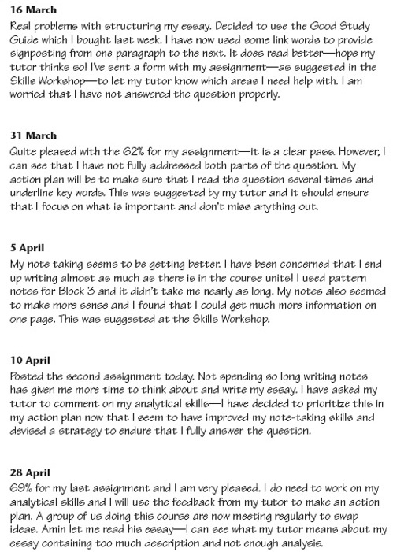
Learning diary entries from a student doing an OU course

2.3.3 Evaluating your strategy and presenting outcomes
This stage is about evaluating your strategy – what you've achieved and judging how well you achieved it-and presenting your work. An evaluation requires you to assess your overall strategy and work in terms of its strengths and weaknesses. Evaluating your strategy, however, is not simply describing what you have done, listing your successes, or even blaming yourself or others for things that didn't go according to plan.
Evaluation is about considering how successful were the methods and techniques that you used, why they were successful and whether you could have tackled any aspects of your work differently. Being aware of why things worked well, or why the problems occurred is important for future learning.
Assessing your own performance helps you to see what you can learn and take forward from your experience, including identifying those skills you want to develop further. To help you do this effectively you may need to make use of feedback from a tutor, say, or other students, colleagues, friends or family, as well as drawing on your own plans, reflections and feelings. If you have been given any criteria for the work, use them as well as relevant standards, such as the key skills criteria included on the Bookmarks. Whatever your assessment, you should be able to give reasons to support your conclusions and decisions. Be imaginative and try to ‘stand outside’ the situation to see it in a new light, as if you were an independent reviewer.

2.4 Using the framework
The three-stage framework focuses on the processes of learning, and is a general approach that you can use in different ways. However, skills development also needs a context and should be linked into your course or work activities. A useful starting point is to use your course or project to provide a timeframe for your skills development work.
If you are following a formal course of study, the course will have been designed to develop your knowledge and understanding of a subject area, and perhaps also develop particular skills, over a long period of time – probably several months. You can link in your key skills work to this timeframe by developing your strategy when you start, or even before you start, your course. You can then monitor your progress as you work through the course material and tackle the assignments. You will be able to evaluate your approach and your achievements as you near the end of the course, perhaps when you have completed the exams. If you are using these materials while developing your skills at work, then you may need to create your own timeframe and targets. You could do this by linking your skills development activities to a work-based project or a coherent set of work activities that have to be completed by a particular date, perhaps leading to a work review with your line manager or supervisor.
Of course, you may not want to spread your skills development over an entire course or project period. Many courses will be divided into smaller study blocks lasting a few weeks and often ending with a project or assessment activity. Work-based projects often have milestones that have to be achieved. You can use the same framework – planning, monitoring and evaluating – to help you organise your work for that block of study or the project milestone and to prepare for assessment or review. Nevertheless, you should allow at least 3–4 months to give yourself time to plan, practise, get feedback, and achieve your overall key skills targets. Over this period, print out and use the Skills Sheets to help you focus on each stage, to record your plans and goals, your work in progress and your overall evaluation and reflection on your skills development.

2.4.1 Keeping a Skills File
As you work on your skills development, you are likely to find that you'll need several skill files so that you can keep a helpful frequent record or log of your learning. In this course such a record is called a Skills File. Building up a Skills File as you go along will help you identify the skills you are using and how you are applying them to different tasks. You can also include your own reflective comments on how you think your work is progressing. The activities associated with each key skill are designed to provide you with opportunities to develop, apply and reflect on your learning systematically in the context of your studies or work activities. Recording your responses to the activities and ideas in your Skills File provides a record of your development.
A Skills File can be used to bring together different types of records, including:
- Examples of your work: you might include notes, drafts, or material that has been assessed or reviewed during your course or work programme. How you select items for your File depends on what you want to demonstrate. Alongside your examples you should include notes explaining why they have been selected.
- Feedback from others about your work: you might include comments from a tutor, or from other students or colleagues. You should also include your own responses to the feedback, and notes about what actions you intend to take.
- Reflections on your development: reflection is the process by which you think about your learning; how you tackled it, how effective your approach was, what you found easy, or difficult, and why.
- Evaluation of your approach: here you can record your successes and failures, how you decided what was or was not a success, and what learning and skills you can take forward and apply to your next course or project.
A Skills File need not be an elaborate affair. It might be notes from your diary or jottings on odd bits of paper in a loose-leaf file alongside the relevant key skills sections, Bookmarks and Skills Sheets. As you work through your course, you can add your own notes on planning, monitoring, and preparing for your course assessment. You can include tutors’ comments on your previous assignments, or your line manager's comments on your work to date, your responses to these comments and notes about what you are going to do about them. Building up a Skills File like this helps you to keep focused on your plans and your goals, and to develop an understanding about how you are learning as well as what you are learning. One student has commented:

Now I'm actually [planning my work] I feel a number of things have changed. I think more carefully about what I'm doing. I've started to keep a learning diary – I don't use it every time I study but I tend to use it when I'm looking at my key skills work to record progress. I try to stand back from what I'm doing and be critical about my work – for this I use the diary and the bookmarks to help me check on what I need to do and I go back to my stage 1 plan [Developing a strategy].

So what sort of activities might you include in your Skills File? The following table suggests some tasks and questions to think about if you are working towards an assessment, or planning your skills development over a longer period of time.

Using the three-stage framework to help structure a block of work or assignment
Developing a strategy
Course- or work-related tasks | Skills-related tasks
What work needs to be done over the block or period of study as a whole? | What key skills are needed for the work?
How will I organise my work over this period? | What skills gaps have been identified in feedback on my previous assignments and work activities?
How will I tackle the learning tasks? | How will I use the key skills in the assignment or block of work?
How does the work link with what I already know? | Do I need to spend time working on improving my existing skills or developing new ones? Modify my original plan to build in the time required.
What does the assignment or project require me to do? | Where will I find out about the skills I need?
When must the assignment or project be completed? | Use the Bookmarks to identify the skills standard I need to aim for, and the knowledge I need to achieve the standard.
Draw up a schedule for completion of the assignment, or block of work. Do I have any other commitments that I must build into my schedule? | What skills resources can I use to learn about specific techniques, or to develop and improve my skills?
Do I need to carry out any research to achieve my goals? Do I need to look things up in previous work or other sources or references?
How will I gain access to any reference material or information that I need?
Do I need to collect any data? How will I do this?
Where can I get feedback on my progress? Who can I ask for feed back and comments?
Monitoring progress
Course- or work-related tasks | Skills-related tasks
Working through the text and activities, and preparing an assignment. | Keep a check on my progress against the criteria set out in the Bookmarks.
Sending in an assignment or progress report with a self-assessment form requesting feedback. | Deciding what feedback might help perhaps by email or telephone.
Working through the detail of the project or task proposals and preparing a progress report. | Contacting my tutor to seek feedback.
Using the Internet, databases and library to check facts and ideas. | Keep a log of study time for a week or two to try and identify patterns.
Using the assignment or project criteria to help me self-assess my work. | Attend a skills workshop.
Using the different resources, such as audio, video, CD-ROM and computer conferencing. | Think about how I use different resources and discuss this with other students or colleagues.
Attending a tutorial, day school or training session. | Note how I use my skills and whether I adapt them for particular pieces of work.
Getting an assignment back or progress report from my tutor or line manager and thinking about the feedback comments. | Use feedback from others, e.g. tutor or mentor to help me identify areas for improvement.
Writing an essay, completing experimental work, sorting out and checking solutions to problems. | Keep a record of what I am learning and how I am learning to help me recognise my progress and reflect on my performance.
Organising my study or workload to cope with an unexpected emergency.
Putting my key skills into practice.
Evaluating my strategy
Course- or work-related tasks | Skills-related tasks
Selecting the most effective method to present my work. | Use the feedback from tutors, colleagues and supervisors and my own assessment to identify aspects of my learning that went well and areas where I feel less confident.
Thinking about how I studied the course materials or tackled the project and completed the work. | Reflect on how I applied my key skills. Was my strategy appropriate and effective?
How have I been learning? What methods and resources have I used? Have they been effective for me? | What else do I need to do to help make my learning effective and continue to improve my key skills?
Checking and assessing my completed assignment or project report before submitting it. | What are my priorities for skills development now?
Using the key skills Bookmarks to check standard of performance.
Getting my work back, reading my tutor's comments and thinking about what I am going to do about them.
Reviewing and reflecting on my assignment: what I did, how I did it and how well I got on.

Although the three stages in this framework are presented in a linear way – moving neatly from developing a strategy to monitoring progress and finally evaluating the strategy and presenting the outcomes, and completing each step before addressing the next – using and developing skills rarely follow this ideal pattern. It is more realistic to think of the stages as having a number of components: things that need to be attended to, but not necessarily one after the other, and with not all components necessarily being addressed every time. Think of the framework as being both open and flexible. You may find that you are moving backwards as well as forwards through the components, or find yourself working on more than one component at once.
Using a structure such as this is a bit like learning to drive a car. To begin with everything – steering, accelerating, braking, changing gear and so on – is a conscious effort. The pleasure of driving only starts when such actions become automatic and you stop worrying about the separate processes involved. Similarly, this structured approach to learning and developing skills will soon become a part of how you work, and you will not have to think about the different stages. Keep in mind, however, that there is more than one way to learn. The approach used here to help you develop and practise your key skills is just one way of working. You are likely to use other approaches as you learn different things and you may come across a variety of approaches in your course, in workshops or tutorial activities with other students, or within career and professional development schemes at work.
Learning and managing your learning is considered so important that there is a key skill – ‘Improving own learning and performance’ – that describes the different stages in detail. This key skill is different from the others because improving your own learning and performance is not a separate option that you can choose to concentrate on or not – it is the web that supports all the other key skills. The sections on communication, information technology, information literacy, application of number, problem solving, and working with others all guide you through the stages of developing a strategy, monitoring performance and presenting and evaluating your work in the relevant areas. The theme of improving your own learning and performance, however, runs through each section and underpins all your key skills work in this course.
There are a number of general points that are worth noting here:
- You need to be able to develop, apply and adapt your skills. Reading about it is not enough. You learn most when you have to apply your skill in a real context.
- Use your course activities and assessments or project work to help you to practise and apply your skills. Submitting an assignment or piece of work to your tutor or line manager at work gives you an opportunity to ask for feedback on particular skills.
- Plan carefully to avoid overloading yourself. Decide which key skills work you need to give priority to early on in your course and which can be left until a later date. Ask for feedback, keep a check on your progress and review your plans as you are studying.
- Let your tutor know what you are planning to do. You can offer your own self-assessment of your skills or ask for specific feedback to give you the information you need.
- At work, use your colleagues and line manager to help you identify those aspects you need to work on and ways to achieve your goals.
- Take time to think about which key skills you want to work on. Combining the key skill of ‘Improving own learning and performance’ with a specific skill area such as IT or communication is a good place to start. This dual approach keeps you focused on how you are learning and improving while gathering solid evidence about your specific skills.
- If you are aiming to complete specific key skills, you should allow at least 3–4 months to plan, monitor and evaluate your work.
- You can use examples of your work outside your courses to demonstrate your capabilities. If you decide to have your work fomally assessed, check that your work meets the relevant standards.

2.8 Making the framework your own
If there was a simple way to improve our own learning, we would all be geniuses by now. What this key skills approach tries to show is that learning is a complex process that draws on many skills and can be made more effective by becoming aware of what you are doing, how you are doing it and how well you are doing it. Once you are aware of what's going on, you can start to change things to suit your own learning style and the demands of the task or assignment you have to tackle.
The next step is to learn how to manage all the resources at your disposal in order to get the best results. Here we invite you to consider how you might adapt the framework – strategic planning, monitoring and evaluating – to suit your own approach to learning and to different sorts of learning tasks.

2.9 Putting it all together
One aim of completing a key skill is to pull ideas together, reflect on and evaluate the effectiveness of your work and identify those aspects that you can ‘take away with you’ for the next task.
The process of strategic planning, monitoring and reflection, and evaluation is one that you are encouraged to use throughout these materials. Activities prompt you to plan and monitor your work, think about what you have learned and how you have learned it, keep an ongoing record of how you adapt your skills, review your progress, record ideas on Skills Sheets and use what you have learned.
In all of this, the key skill of improving your own learning and performance forms the ‘web’ supporting the other key skills and provides a way to use your learning skills systematically.
A crucial aspect of all the key skills is critical reflection – this enables your learning to be long lasting. Learning that sticks takes time and effort and often you need to go back and try things again and again, think about what you did and which aspects were successful. This ‘thinking about’ or reflecting is not an end in itself. The outcomes of structured reflection might include a new way of doing things, the development of a new skill, the resolution of a problem or the consolidation of effective learning – recognising that you have done something really well and resolving to do it like that again in the future. Without a period of critical reflection and consolidation, skills and knowledge can just drift away. Critical reflection offers the opportunity to stand back from what you have learned to reconstruct it so that the ideas and skills you have acquired and developed become more coherent.
The reflective process consists of:
- Thinking about what you have done. This involves thinking back over the detail of the process, that is, how you tackled the different tasks. What you did and how well you did it. It also involves looking at the final product – the work you completed – as critically/objectively as possible; considering any feedback that you received; recognising your achievements and giving yourself a pat on the back when you deserve it!
- Identifying your learning. This involves looking beyond the concrete product of the work and thinking about the less tangible outcomes. What additional skills have you acquired? What have you learned about yourself as a learner and what sorts of strategies worked or didn't work well for you?
- Thinking about your next task. Once you are aware of what you have done, how you have done it and how well you have done it, you are in a good position to adapt what you have learned to help tackle the next task.
Or, in other words, you generalise from your learning experience by identifying the general principles and applying them to new situations. Becoming more aware of the process of learning and the skills you have used makes it more likely that you can build on your knowledge and skills in tackling different but related tasks.
In working through each of the key skills sections, you are invited to try out the tools to think about, manage and reflect on your learning. If you work on different key skills as well as ‘Improving own learning and performance’, and become familiar with the three-stage framework, you may feel you are ready to leave the written instructions behind. You should be able to adapt the processes and techniques you learn to suit the learning task and integrate the general principles of the framework into your everyday study and learning routine. This is what we mean by making the framework your own. Once you reach this stage, we hope that you feel ready to move on and tackle your next learning task with:
- greater confidence;
- greater awareness of your own learning process and what works for you;
- a growing portfolio of key skills and learning techniques to draw upon;
- a clearer idea of how to identify and develop any additional skills you might need;
- a knowledge of the resources and support available to help you develop additional skills;
- the ability to assess your own skills, learning and performance against outcomes and criteria; and
- a flexible approach to using the framework and the capability to adapt your skills to different situations.
In short, you will be more ready to start taking control of your own learning and will be on the way to becoming a fully independent learner. What is more, the knowledge and skills you have learned are not just useful in any one higher education course – they will stay with you throughout your higher education career and beyond to use as part of your personal development.
Key skills are not only valuable in higher education. If you are considering promotion or a career change, you will find that the key skills you acquire are highly valued by most employers. When employers take on staff with qualifications from higher education, they want people who are more than knowledgeable about their subject area. They want people who can ‘hit the floor running’ and operate as part of teams in the workplace, communicate effectively with their colleagues, use information technology and numeracy skills to carry out functions and solve problems, and so on. Above all, they want people who can take control of their own learning and development, identify what skills and knowledge they are going to need in their future work, and set about getting it on their own initiative using the resources available at work and through education and training materials.
You will also find that professional bodies and institutes are increasingly looking for key skills, too. Many now have formal requirements for ‘continuing professional development’ (CPD)—in other words, providing evidence that you have kept your professional knowledge and skills up to date. CPD schemes require you, on a regular basis, to identify what new knowledge and skills you need, to locate and use resources to update yourself and show how you have incorporated your improved knowledge and skills in meeting new standards in your professional practice. Does this sound familiar? It should.
We know that students in higher education, and especially if you are a part-time student, often find the volume of work daunting and feel under pressure. We know, too, that you put a lot of time and effort into completing this course alongside a course of study. We said at the beginning that you should look at this additional time as an investment in your future success. We hope you feel that the investment will pay off.

2.10 Summary
- This section has introduced the key skills approach to learning and emphasised the need for a flexible framework which supports you in thinking about how you are learning as well as what you are learning.
- A three-stage approach to key skills development underpins this course. The stages involve developing a strategy for improving your skills and learning, monitoring your progress as your skills develop, and evaluating the effectiveness of your strategy and presenting the outcomes of your work.
- The three-stage approach can be used across a course or a work-based project as you work through one or more of the key skills sections in this course. The approach can also be used to help you work through smaller courses of study or projects at work, perhaps preparing for an assignment or progress report.
- Setting up a Skills File can help you organise your learning and skills development as you go along. It provides a record that you can use to recognise and reflect on your progress and achievements.
- ‘Behind’ the three stages is the assumption that you want to improve. Consider carefully how you can use your own self-assessment and feedback from others to develop, make changes and learn from your experiences.

3 Improving own learning and performance

3.1 Introduction to improving own learning and performance
This key skill is about helping you understand how you learn; think about how you can improve your own learning and performance, and consider how you might generalise the principles and processes for future learning.
You saw in our discussion of ‘A framework for learning’, improving your learning and performance could be considered to be a ‘meta-skill’, that is the skill of learning how to learn. This section, then, is a little different from the other skills sections because improving your own learning and performance is not a separate option that you can choose to concentrate on or not – it is the basis of the three-stage framework of developing a strategy, monitoring progress and evaluating performance which you will use to develop and improve other key skills and your learning more generally. The key skill of improving your own learning and performance can be practised and developed like other skills, but unlike other skills it seems more difficult to measure and assess. What is possible, however, is to use the structure and activities presented in this course to help you think about what you are doing and how well you are doing it, and then at regular intervals stand back and look at your own progress objectively.
If you are just starting on your skills development this is the key skill to start with, perhaps coupled with another key skill you want to work on.

3.1a Working on the key skill of improving own learning and performance
Improving learning and improving your performance may sound simple enough, but experienced learners know that there is not always a direct route from a particular learning experience to improved performance. Many factors can affect this link – motivation, resources, support and feedback. You need to acknowledge that these, and many other factors, can and do influence the outcomes of your efforts. In other words, many influences can come along to knock learning off track. It is also important to acknowledge that there are limits to learning at any one time and that learning takes place in the broader context of other priorities and commitments, with improvement taking place over weeks or even months.
If it is true that learning is just one factor in a set of factors that influence performance, it is even more important that efforts to improve learning be as effective as possible. Everything directed towards maximising learning needs to be done well. This includes using the three-stage framework to help you structure your learning.
The three-stage framework for this key skill involves you:
- developing a strategy for using skills to improve your learning and performance; this includes reviewing what you do currently, setting targets to make changes and using skills to improve your learning and performance, and planning how you will meet your targets;
- monitoring your progress and critically reflecting on your learning and performance; this involves you knowing how to manage your time, use different ways to learn, and seek and use feedback;
- evaluating your strategy and presenting outcomes of your work; this involves bringing together what you have learned and identifying ways to further improve your learning and performance.
In working on this key skill, as with all other key skills, you will be learning two different things at once. You will be using skills to help you improve your learning and performance as well as using the processes of the three-stage framework to help you learn how to learn more generally.
Working on this key skill involves you consciously being aware of what you are learning and the skills you can use to improve your performance.
This is always going to be difficult to ‘measure’ but to help you assess your own capabilities, and demonstrate how you have used skills to improve, it is important to keep a record of your learning, perhaps as a log or diary, as part of your Skills File. A small notebook (electronic or paper) or exercise book is ideal for this. Keep it with your study materials so that you can make brief notes when you feel it is appropriate. You may not wish to make entries every time you study or tackle a learning task; you may decide to use it once a week, or even each time you submit a piece of work to your tutor or manager. Use your Skills File to keep your notes and comments together and to collect examples of your work and feedback requested and received. Keep in mind that the main purpose is to keep an ongoing record of:
- what you are learning, that is the skills you are developing;
- ways you are using to learn, for example working with colleagues, formal training, independent study; and how well you have learned. This should include a judgement on the ways you have used to learn;
- the feedback you receive and the use you make of it; and
- critical reflection on your learning and performance overall.
Making a start on this key skill means establishing what you want to achieve with reference to your current capabilities – your strengths and weaknesses – as well as areas you need to develop for the future. You can then plan carefully how you intend to do this alongside your study or work activities. This is likely to involve you identifying particular pieces of work, for example, projects or assignments, where you can practise your skills. You also need to build in opportunities to get feedback to help you check on your progress. Feedback may be from a variety of sources, including your tutor, manager, other students and colleagues. But you also need to take initiative and control in planning and monitoring your progress and reflecting on how you intend to improve further. Thus, working on this key skill (as with the other key skills), involves you planning for learning.
Many students combine this key skill with one or more of the other key skills and/or your main area of activity. For example, you may wish to improve your information literacy skills. You could then use examples of your work to show your performance in information literacy skills supported by records to show the methods you used to develop your skills. The common structure of the key skills should help you do this.
If you are aiming for key skills assessment you need to present examples of what you have learned and a commentary that includes details of your strategy to improve your learning and performance, records of your monitoring and progress checks, and an evaluation of the effectiveness of your overall strategy.
Click here to open the Bookmark for this section. It describes the key skill and gives the criteria you need to meet. You should keep it to hand by either printing it out or simply keeping it open on your desktop throughout this section. The notes that follow guide you through the process of developing a strategy, monitoring your progress and evaluating your strategy and performance.

3.2 Developing a strategy
In developing a strategy for this key skill you need to:
- review your current capabilities and identify what you hope to achieve in the future;
- identify opportunities for using skills to improve your own learning and performance and the resources you might need, for example, training manuals and people; and
- draw up a plan of action.

3.2.1Review your current capabilities, including your preferred learning style
Before you begin to plan in detail what you hope to achieve, it is useful to look at relevant examples of previous work or study as well as the feedback you received from different people. This review should help you to confirm those areas you need and/or want to work on. Feedback from others may also point out areas you need to work on which are different from the ones you expected. These areas might relate to specific skills, such as interrogating a database, or they might be more general, such as working in a team. Consider also your preferences in how you learn, for example, working on your own or with a group of people surrounded by noise.

Time out
Use your academic records, performance reviews, awards, information from your tutor or manager etc., to help you put together a skills audit of your current capabilities. You can use the other key skill descriptions from the Bookmarks to help you identify the different skills. When you have decided on those areas which have the highest priority for improvement, you may find it helpful to discuss your ideas and plans with a tutor, colleague, fellow student or manager.

3.2.2 Identify what you hope to achieve and opportunities to work on this key skill
It is always a good idea to know what you hope to achieve in the future in terms of your learning, personal or career goals. This might be very specific, for example to improve your report writing, or it might be more general, such as, to ask for and use feedback more effectively. If you are using this in a work context, you may wish to include personal and career goals.

This year I have set myself the goal of using WORD more effectively. I want to do this to improve the presentation of my work and also to improve my time management. I have four assignments that I have to submit over the next 6 months that will involve integrating tasks, text, and even graphics! And I can use these to practise my key skills. On my plan I have set aside time to practise my word processing skills and I have also enrolled on a short course at the local college.

Time out
Add comments to your skills audit about those aspects which have the highest priority for improvement and why you have selected them. Once you have identified your goals, you need to plan when you can develop and practise your skills over the next 3 months or so.

3.2.3 Identify and research relevant sources of information
This is about identifying and tracking down the resources you need – books, reports, manuals, training courses and people. It involves finding out what is available to help you with the task at hand – in this case improving a particular skill. Skills resources may be included as part of your course or you may have manuals and online resources available at work.
People represent important sources of information and support, for example your tutor, manager, other students and colleagues. Discussing ideas with others, either face-to-face or through e-conferencing can bring enormous benefits to your own learning and understanding. Many employers now expect people to be skilled at working collaboratively because it can be effective for both the individuals and the project they are working on. Higher-level tasks are demanding and at times difficult – we all get stuck at times. Using other people can bring enormous benefits to your overall performance. As part of your strategy, consider the resources you might need and how you can make use of them.
Keep a record of sources of information you have used. Annotate your records to show how you have used particular sources and your evaluation of their quality. You may wish to check how to reference sources correctly. Find out with whom you could discuss your ideas – a colleague, tutor or mentor – and let them know what you plan to do.

Time out
A good place to start in tracking down resources is your course material or work-place resources. An increasing number of resources are available online through library databases. There may also be skills workshops organised locally or you may have a resource centre nearby. Friends, colleagues and other students can also be of great value.

3.2.4 Set realistic targets
You are now in a good position to set yourself targets – the steps towards achieving your goals. As you begin to plan in more detail, think in terms of around 3 months to achieve particular targets, although the time period for some may be shorter/longer. This may depend on other commitments, priorities, and so on. Your targets need to be clear so that you can know when you have achieved them. A good way of helping you to formulate clear targets is to use the acronym SMART – Specific, Measurable, Achievable, Realistic and Timebound.

Time out
Use your audit work and discussions to set yourself some SMART targets. Focus on specific aspects you need to learn or develop – this could be either new skills or working to improve particular aspects. Make sure you describe the learning needed, not the way of getting it, such as ‘I intend to use this key skill to improve my team working skills’.

3.2.5 Plan how these targets will be met
You may be anxious to get on with achieving your targets but think first before you plunge in. In setting targets, think about how they will be achieved by identifying action points and deadlines, prioritising tasks and identifying resources and support from others. Include opportunities to discuss ideas/work with others and build in time to receive feedback and reflect on it. Planning how to achieve your targets involves all of the functions that take place before you start on the actual task. Time spent will pay off in the longer term. Plan and identify deadlines you need to meet and when you might need access to particular resources. At this stage it is also a good idea to think about when and how you can get feedback on your progress and give yourself time to make use of it. There may be times that are particularly busy – try to identify these and work around them.

Time out
Make a start at producing a plan of action and identify how you can develop your skills as part of your study or work.

3.2.6 Achieving your goals
Now that you have established what you intend to do and identified specific targets to achieve them, think about how you can meet your targets, taking into account what you are trying to do and looking carefully at the most effective way to do it. This might be by attending a training course or skills workshop, prioritising your time differently, taking an active part in e-tutorials, or checking out resources and giving yourself time to practise new ways of working.
Take into account the resources available to you and what you know about your own way of working. Try to ensure you have access to the resources that you need.

I found it really helpful to go to the Reading Skills workshop. It gave me new ideas to try out and it was useful to discuss different ways of speed-reading. I use the handouts and suggestions whenever I feel stuck or run out of time.

Time out
Add comments to your plan to indicate how you might achieve your learning goals.

You are now in a good position to put your notes and ideas together as your strategy for improving your own learning and performance. The next activity should help you do this.

Activity: Developing your strategy for improving own learning and performance

Present a strategy for improving your own learning and performance. In developing your strategy, include:
- background and context – give a brief statement of what you are doing currently, e.g. course or job role;
- your current capabilities in relation to your overall goals, that is what you hope to achieve as you complete this key skill;
- the resources you might use as you develop and improve your skills and the opportunities you have to practise your skills, for example when completing assignments or work projects; and
- include a plan of action that gives the targets you hope to achieve with:
  - deadlines and review points; and
  - what you plan to do to achieve your targets.
Refer to the figure below for an example of a completed Skills Sheet for this stage of the key skills framework.

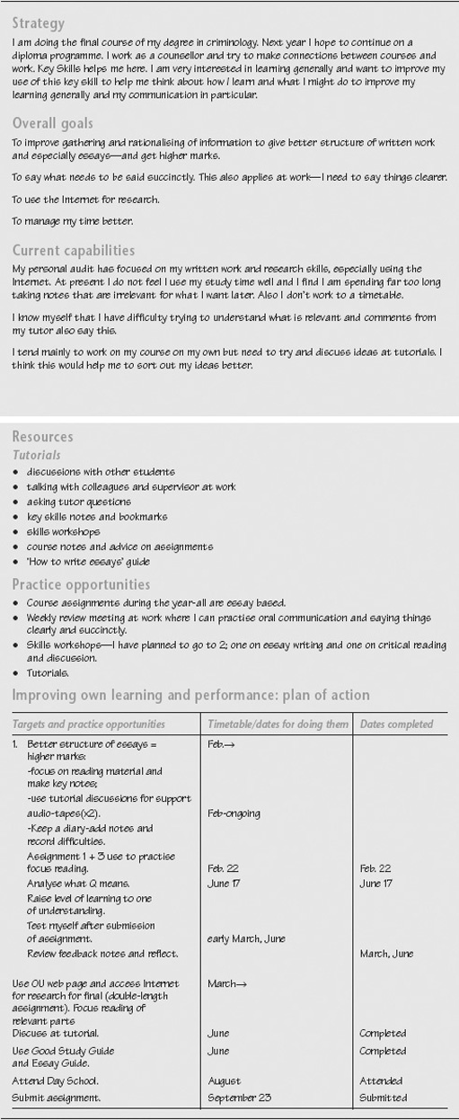
Example of a completed Skills Sheet for ‘Developing your strategy for improving own learning and performance’

3.4 Monitoring progress
Monitoring progress is about keeping track of what you are doing and how well you are doing it as you work towards your targets. It is about being able to make an assessment about yourself and being ‘self aware’ about your own capabilities, how you learn best, things that have helped you and so on. One problem in becoming more aware of yourself and making a self-assessment is that you may not know enough terms to describe yourself. Think of the first time you were asked to describe a painting, perhaps for a course in art appreciation or on a visit to an art gallery. At first you might have been stymied in terms of what to say about the painting. Adjectives such as ‘interesting’, ‘colourful’, and ‘imaginative’ might have been your first thoughts. Describing and assessing yourself, similar to describing a painting, requires skill. You could start by preparing a self-description which you could share with a friend. Describing and assessing yourself is important because it leads to more self-awareness and self-knowledge.
A practical use of knowledge about yourself is to use it as a method of strengthening your self-confidence. There are many ways to develop self-confidence. For example, hearing positive things about yourself from others is a good confidence builder. Other tactics include scoring a few easy victories, using positive self-talk and imagery, becoming self-directing (taking responsibility for events around you), developing a solid knowledge base, developing and publicising new skills, being proud of your work, and taking risks.
Assessing your own improvement is never going to be easy. At work you may have a ‘competency framework’ to refer to and if you are taking a course you may have been provided with criteria for an assignment or project.
On their own, such statements have limited value. You need to be able to interpret them against your own work and in your own particular context. Enlist help from your manager, tutor, and colleagues or other students. This is why getting feedback from others is so useful.
This key skill encourages you to consider ways to monitor your progress by knowing how to:
- manage your time effectively;
- use different ways and methods to learn; and
- seek and use feedback.
To help you keep track and monitor progress, use your log or diary comments. From the record of your learning, at a later date you can confidently look back at your notes and begin to assess how well you are achieving your targets to improve. It is also useful to begin to put together a ‘portfolio’ of your achievements, such as, for example, assignments and project reports, to show what you have learned and the ways you have learned. Comments are also useful on what has helped you to learn, difficulties you may have encountered, choices you made and reflections on your learning and performance.
The notes that follow guide you through monitoring and critically reflecting on your progress.

3.4.1 Manage your time effectively
The aim here is to develop good work habits and time-management practices. These are often a matter of developing the right attitudes towards your work and towards your time.
Here are 10 tips to help you look at your time management:
- establish goals and targets;
- work smarter, not harder; value your time;
- avoid attempting too much;
- carefully schedule activities, allowing time for emergencies, minimising interruption, using ‘energy peaks’ and scheduling similar tasks together;
- stay in control of paper work and electronic work;
- minimise day dreaming;
- use a time log to track time wasting;
- use a time limit for certain tasks;
- be decisive and finish things;
- work at a steady pace and review progress regularly.

Time out
Keep a log of your learning to help you reflect on how you manage your time. Do you feel you are managing your time effectively? Note how you deal with emergencies and unexpected demands and how you prioritise your tasks and time. Are you able to set and meet deadlines? How do you deal with a situation where you are not able to meet a deadline?

3.4.2 Using different ways and approaches to learn
Always aim to select the way of learning that fits with what you intend to learn. If your goal is to improve your presentation skills, you need to prepare and practise presenting your work. If you need to relate theory to practise in your job, you need to spend time understanding how theory can relate to practice, perhaps by reviewing and discussing case studies. This may seem obvious but people often make wrong choices out of habit. There is a natural tendency to use ways we feel most familiar with, yet these may not be the best for the outcome you hope to achieve.
Once you are clear about what the learning task involves, you are in a better position to make informed decisions about how best to go about it. For example, some people prefer learning IT skills through training courses, others are happy to use a manual and trial and error. Many people enjoy working on their own and ‘at a distance’, but some also enjoy the company and stimulus of working with others to discuss ideas and explore their understandings. Thinking about how you learn in relation to what you need to learn is key to managing your own learning.

Time out
As you develop and practise your skills, try to be critical of the way you learn and the approach you take. Do you need to do anything differently? Would it help to discuss this with other students or your tutor? When you have worked on a particular task, think about how you feel it went. Make a note in your file of the different ways you use to learn, as well as comments and evaluation of these ways.

3.6.1 Seek and actively use feedback to achieve your targets
Feedback can be an important aspect of improving your performance, but it can also have a negative effect if you take it too personally or if the giver is not skilled in offering feedback in a positive and constructive way. Feedback should not just be a matter of pointing out what you have done wrong; it should help confirm what you are doing well and give you pointers as to how you might improve in other areas. One important thing to remember when dealing with feedback is that the giver is commenting on your performance of a particular task or role, not on your value as a person. And by inviting feedback you are inviting the giver to go into the sort of hypothetical mode that may not apply in everyday life.
In asking for feedback you might like to suggest that your tutor or manager help you identify what you did well, what were your main weaknesses and how you could have done it better. Other students and work colleagues can be a particularly valuable source of feedback and support. Many people find a chance to talk to others electronically (for example, using e-conferencing) a real boost to their confidence – being able to check and collaborate on understanding and ideas.

Time out
Take time to think about what you need feedback comments on and when you are likely to find these comments useful. Ask others for specific comments so that you can really focus on those areas you want to improve. When you receive feedback, how do you use it? Try to give yourself time to consider the comments carefully and constructively to improve your performance.

To make maximum use of your comments and feedback from others you need to build in time and opportunities to look back at your records, work activities, and notes, and relate them to your targets. Reflect on what you have done so far and how you have achieved it. This is about using your own learning and experience to improve.
Learning from experience does not occur automatically just from being immersed in it. You can do something a hundred times and still learn nothing from the experience. You need to challenge what you have done and how you have achieved it – this is often called critical reflection. From our research we have found that critical reflection is a skill in itself and one that is quite difficult to develop. It can take much time and effort to be able to do this for yourself. One way to start is to ask another person to listen to you while you tell them about any problems you encountered, how you solved them, and to help you identify those opportunities that were effective for your learning. You will be surprised how much insight you can gain by just talking-through the experience.
Now that you have monitored your progress, you are in a good position to consider any changes you wish to make to your strategy overall.

Activity: Monitoring your progress

For this activity you will need to print out the Skills Sheet, ‘Monitoring your progress’: click here to open it.
Present a commentary, making reference to the work you are doing and your own notes, that includes:
- the targets you have met, any choices you made in achieving them and your judgement, based on criteria, of how well you achieved them;
- the different ways you have used to learn; for example attending a skills workshop where you work in groups, or working on your own interrogating online resources to research information;
- how you managed your time to meet your targets; for example meeting your deadlines and cut-off dates; coping with unexpected demands; allowing time to think and critically reflecting on your learning and progress;
- a summary of the feedback and support you requested and received and how you made use of it to meet your targets; and
- whether and how you adapted your strategy while you were working to achieve your targets.
Refer to the figure below for an example of a completed Skills Sheet for this stage of the key skills framework.

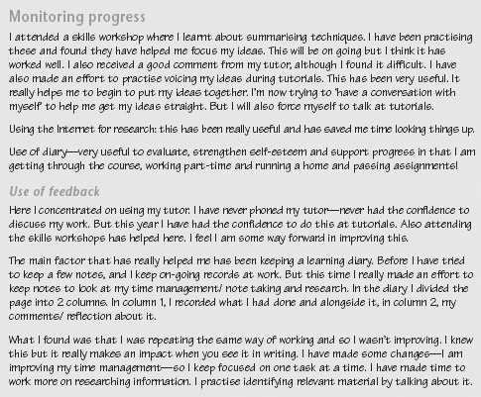
Example of a completed Skills Sheet for ‘Monitoring your progress’

3.8 Evaluating strategy and presenting outcomes
By now you will have found out about and sampled different resources for learning and used different ways to learn. But the structured approach used in this section is one of the main resources for developing and improving your other key skills.
So how do you know if you have learned? How do you know if you have improved? How do you know if you are meeting the standard for improving your own learning and performance expected of someone doing a course in higher education or using higher level skills at work?
There are two possible ways of finding out. First, you can look at the notes and comments in your Skills File, including the activities you have completed for this key skill. Your notes and the activities provide you with an ongoing record showing what you have done, factors that had an impact on your learning and any aspects you have changed. Feedback from your tutor or manager should help confirm your self-assessment of where you are now and the next steps for your learning and development.
Secondly, use the notes and activities relating to this key skill and begin to make use of other criteria that you have available; for example, the key skills criteria on the Bookmarks, competency statements at work, assignment criteria and so on. Practise using criteria together with feedback and discussion to help you accurately assess your own performance.
Developing and using the skills of improving your own learning and performance can enhance all other learning. You can apply the process to a section of a course, to other skill areas, or to activities at work. When you begin the process of evaluating your strategy, you may face several challenges. You may not be familiar with the process of ‘looking inward at learning’ and you may not be confident in doing so. Some people may actually resist participating – evaluations can then seem vague and superficial, as they focus more on the tutor and the course rather than on their own learning.
Honest evaluation of yourself and your own development can, at times, seem risky. For this key skill, try to focus on the depth of insight and self-knowledge rather than on evaluation of content.
In evaluating your strategy and presenting the outcomes of your work, you need to know how to:
- select and bring together effective ways to present outcomes;
- assess the effectiveness of your strategy; and
- identify ways of further improving your own learning and performance.

3.8.1 Select and bring together effective ways to present outcomes
The most appropriate method to present your work may depend on what you are required to do either for your course, or for a work-related project. For example you could be submitting a written assignment, making a presentation to work colleagues, or putting together a collection of designs.
You also need to look back at your notes and comments and take time to consider what you have learned while completing this key skill. Bring together what you have learned into a synthesis. A synthesis is not merely a description or a summary. It is about taking a critical attitude towards what you have learned, how you have learned it and how well you have learned.

Time out
Put together examples of work, assignments or parts of assignments in your Skills File to show what you have learned, and prepare a synthesis of what you have learned.

3.8.2 Assess the effectiveness of your strategy
If you were asked to assess how effective your planning, researching, monitoring and evaluating have been in improving your learning and performance, what would be your assessment? You may comment on factors that impacted on your learning, for example the feedback you received from your tutor or manager, a workshop you attended, or discussions with other students or colleagues. Other factors might be your improved awareness of what you are trying to achieve or having a structured approach to learning that the key skills provide. Think carefully about the effect these factors have had on your progress overall as you completed your work on the key skill of ‘Improving own learning and performance’.

Time out
Make a list of the factors which you think have had an impact on your learning and try to describe this impact.

3.8.3 Identify ways of further improving your own learning and performance
Remember that improving your own learning and performance is not something that you can do once and then forget about it. It is a process that needs to become an integral part of your normal approach to work and study throughout your career in higher education and in the world of work. Developing and using the skill of improving your own learning and performance can enhance all other learning. As you worked through this key skill, what is it that you have learned? What can you take away with you to the next task? And is there anything that you would do differently? You can apply the process to a section of a course or to other skill areas or to work-based activities and projects.

Time out
Now that you have used the key skills approach and worked through the three-stage framework for improvement, what are your plans for future development?

Activity: Evaluating your strategy and presenting outcomes

For this activity you will need to print out the Skills Sheet, ‘Evaluating your strategy and presenting outcomes’: click here to open it.
Present a synthesis of what you have learned from two different learning activities and include your skills in improving your own learning and performance.
Present an evaluation of the effectiveness of your overall strategy, noting ways of further developing your skills in improving your own learning and performance.
Refer to the figure below for an example of a completed Skills Sheet for this stage of the key skills framework.

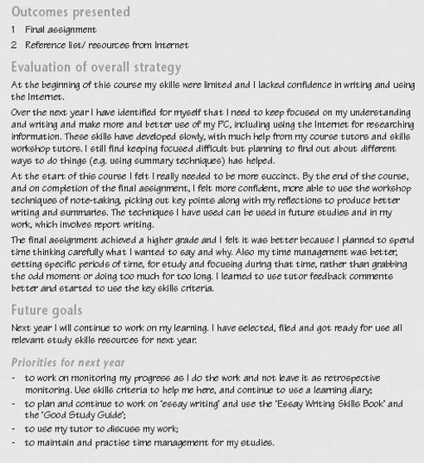
Example of a completed Skills Sheet for ‘Evaluating your strategy and presenting outcomes’

Evaluating your work can at first seem daunting. However, you may be reassured to know that most of us can become proficient in evaluation over time, particularly if we do it routinely. Initially, follow the processes of the activities included in this section, perhaps as you complete an assignment or piece of work. Over time you will develop your observational power (of yourself), fluency and familiarity with the process. Your aim is to become actively involved in developing and questioning your knowledge and skills so it becomes part of the way you work. As you learn how to use skills to improve your learning and performance, you are likely to develop a better understanding of what you value personally and professionally, what your work represents, what you have achieved and how you have changed.

3.10 Drawing ideas together
This key skill has used a three-stage framework for developing your skills. By developing a strategy, monitoring your progress and evaluating your overall approach, you take an active role in your own learning. But learning does not necessarily follow a path of steady improvement, it involves change: revisiting ideas, seeing things from different perspectives, tackling things in different ways.
You are unlikely to be able to complete your work by working through it from beginning to end in a straightforward manner. You will need to bring together your key skills and your subject knowledge to address the tasks you have been asked to complete. As you work, you may discover gaps you still have to fill, areas where you have to dig deeper for information. This is a normal part of trying to put ideas together. In effect, you are piecing together a jigsaw, bringing skills, knowledge, analysis, explanation and interpretation together to make a single coherent picture. Unfortunately, the pieces usually do not all come to hand at just the right moment. The trick is to build up parts of the picture, and then bring those parts together as you begin to see the overall design. The key elements of this approach are:
- Check that you really understand what the work requires. Recognise that your skills and understanding of the task develop over time.
- Break the task into manageable chunks; focus your work on one aspect at a time.
- Think strategically about your approach to the task as you are doing it. Be prepared to change your plan if you need to reschedule your work.
- Work flexibly, using the resources provided as and when you need them.
- Review and reflect on your own performance while you are tackling the work. Your Skills File offers a way of recording and monitoring your development to give you insights into how you are learning as well as into what you are learning.

4 Improving your skills in communication

4.1 Introduction to improving your skills in communication
This key skill focuses on the ways in which you receive and respond to information and communicate with other people in your work, study and everyday life. Communication skills include speaking, listening, reading and writing for different purposes. Techniques such as note taking and writing summaries are important, but so, too, are the techniques of evaluation and application, such as evaluating the relevance and quality of information.
Communication is part of everyone's life and improving your skills also involves you being able to integrate changes in the way you communicate into your study or work. Essentially, this means you will be improving your skills while communicating what you are learning. This is much more than developing your presentation skills or tackling an essay. It is also about strategically planning how to communicate, applying your skills in different situations, and critically reflecting on your performance, that is being consciously aware of what you are doing and how well you are doing it.

4.1a Working on the key skill of communication
A main aim of this key skill is for you to communicate effectively – orally, visually and in writing. For communication to be effective it must be managed. This involves consciously adapting your skills for different situations by selecting the appropriate method of communication for the work. Using the three-stage key skills framework will to help you become more confident in:
- developing a strategy for using oral, visual and written forms of communication so that you can improve your skills and learn increasingly complex material through reading, listening and writing;
- monitoring your progress as you use and apply your communication skills and critically reflecting on your performance so that you can speak or write about the material and provide visual versions of it; and
- evaluating your overall strategy and presenting the outcomes of your work – to improve your communication skills and encourage you in new situations and with new audiences.
The timescale for developing skills is, of course, different for all of us. But in higher education where you are involved with complex ideas and at work where you are sometimes faced with difficult or sensitive situations, you need sufficient time to make use of opportunities to practise and improve your communication techniques. You also need to be able to integrate the ideas you develop into your study or work routines. For example, you may spend some time exploring and using different techniques in note taking. You then need to have opportunities to practise those techniques in your day-to-day study or work. We estimate that you will need around 3 months or more to use and improve your communication skills before you can use those new skills confidently.
As you work on developing and improving your communication skills, you will undoubtedly need to collect notes, reference lists, feedback from colleagues, assignments, tutor comments and so on. Try to keep all your notes and records together with your own comments in your Skills File. These records will be helpful in planning and monitoring your progress and for recording your achievements.
Click here to open the Bookmark for this section. It describes the key skill and gives the criteria to help you monitor and assess your performance. You should keep it to hand by either printing it out or simply keeping it open on your desktop throughout this section.
If you are aiming for assessment of this key skill, you will need to show that you can develop a strategy, monitor your progress and evaluate your performance in completing work which uses written, oral and visual forms of communication through discussion and presentation work and presenting written material.
Next we guide you through the three-stage framework. In each stage, the ‘Time outs’ aim to help you think about and develop your strategy, implement it and present your outcomes. The work associated with each stage is not designed to be done in a one-off session. Each stage is likely to run over several weeks. You may need to consider some aspects more than once, adapting your strategy as things progress. At the end of each stage there is an activity that invites you to pull together your notes and ideas.

4.3 Monitoring progress
This stage is about keeping track of your progress. How confident are you that you are achieving the standards of communication required for your work? How can you check how well you are doing?
Monitoring progress in communication skills involves knowing how to:
- make judgements about the quality of information that you use from various sources;
- synthesise information; and
- communicate information in a form that suits the purpose.
Monitoring your own progress accurately is difficult – you need to be able to stand ‘outside of yourself’. Developing and improving communication skills involves practising your skills in different situations and then standing back to consider and reflect on how you adapted your skills for the purpose. Feedback can be especially useful here to help you be critically reflective about what you are doing and how you are doing it.
Monitoring progress is not just a one-off activity. Effective learners monitor regularly, checking what they are doing, how they are doing and how well they are doing. But this is often not as straightforward as it appears. Try to work with others to critique your work. This will help you to judge your work not only by your own standards but also by other ‘external’ standards, for example against written criteria given alongside a work project or assignment or the skills criteria on the Bookmark.
Monitoring your progress thus involves you thinking about and critically reflecting on what you doing and how you are doing as you produce documents, discuss and present your work.
Use your log or diary to comment on the choices you made in using communication skills and reflections on their effectiveness, including any changes you make to your strategy overall. Keep your notes, comments and work in your Skills File.

4.3.1 Judging the quality of information
Judging the quality of information is not the same as a description of it, nor is it the same as simply agreeing or disagreeing with it, and an evaluation of information should not include personal attacks. It does require you to assess the information in terms of its strengths and weaknesses and give adequate reasons to support your assessment. You may need to check facts, research other sources and question further.
There are vast amounts of information available today and magazines, books and papers all publish articles ranging from the highly technical through to advertising copy. And no one can ignore the increasing sources of information on the Internet.
To help evaluate information on the Internet Jan Alexander and Marsha Tate at Widener University suggest using the traditional criteria we apply to print information. These criteria include:

Accuracy | Is the information reliable and free from errors? When in doubt check information against other resources.
Authority | Who is the author, and is he/she qualified to write about the topic? If you can't find the author's name or credentials, check to see if there is a link to the author's web page or to a sponsoring organisation or publisher. A page's domain name (e.g., edu, gov, com) can sometimes be a clue.
Objectivity | Is there evidence of bias or overt attempts to persuade? Who is the audience and what is the purpose of the page? Is the information provided by an organisation or company that may have an agenda? Alexander and Tate recommend using the same critical eye we use to evaluate infomercials and try advertisements.
Currency | How up to date is this information? Are links from the page outdated? One place to start is to see if the page includes information about when it was first written and last modified.
Coverage | How comprehensive is the information provided and what is its value compared to other resources? What is the quality of pages linked to from the site? When evaluating a page's coverage, keep in mind that you many reach a web page that is taken out of context. Always try to go to the home page for the site to get an idea of what information is provided.

The above criteria are not fail-safe, but they are a good starting point for evaluating information on the Web.
(Source: Widener University, checklist for an information web page)
The above criteria also form a useful checklist for evaluating other forms of information, too. The best resources offer objectivity, timeliness, accuracy and authority. More importantly, readers can verify information provided by trustworthy sources.

Time out
Adopt a ‘critical eye’ for judging the quality and reliability of information you use from different sources. Look at different sources, check references and ‘seek’ opinions. Keep up-to-date records of sources of information.

4.3.2 Synthesise information
Synthesising information is about assessing the new information and prior information in relation to each other, looking for logical relationships in the material, identifying the important ideas, and taking a critical attitude towards the material by relating it to your own views and experiences and thinking about how the material can be used. Synthesising information is not just summarising the information or identifying main points.

Time out
Synthesise your information research and include sources. Comment on the choices you made in selecting the information and its quality, and critically reflect on the method you used to take notes and the synthesis you produced.

4.3.3 Communicate relevant information
A main outcome of this key skill is that you will be able to communicate complex information orally, visually and through writing.
Complex subjects are those that include a number of ideas, some of which may be abstract, very detailed, difficult to follow or require you to deal with sensitive issues or the interpretation of others’ viewpoints. Communicating information at this level may involve using technical vocabulary, carefully structuring what you say and/or write, and using diagrams/charts or other forms of visual aids, to help others understand the points being made. To communicate effectively you need to tailor what you say or write and the way you present it to the needs of each particular audience.
For example in preparing an information piece on the Human Rights Act for a non-specialist group, you might decide to keep it short, avoid technical language where possible and provide examples to illustrate meanings. On the other hand, if you were preparing an article for a journal such as the New Scientist on a research project you had been involved with, you could assume a common understanding of background issues. You could use scientific terms, illustrate the work with figures, refer to other research work, and provide a reference and further reading list.

Time out
Look back at your notes and comments on how you adapted your communication skills for a number of different tasks and audiences and reflect on the choices you made in communicating information. Is there anything you would do differently?

4.3.4 Monitor and critically reflect on your use of communication skills
You need to know how to track and record your progress on your use of communication skills. Try to assess the overall quality of your written and oral work and the way you produced the work. Checklists and criteria provided as part of the project or assignment and those set out in the Bookmark can be very useful tools in helping you to assess for yourself precisely what you are doing and how well you are doing it. Unless you know what you are doing wrong, it is very difficult to improve.
To help you critically reflect on how you have used and adapted your communication skills, you may need actively to seek feedback from others to help you make a judgement on your performance and to support your own assessment. It is often helpful to ask for feedback on a specific aspect. This will make it useful and relevant to you. If you can, look at work other people have done to help consider the quality of your own work. Take time to use feedback constructively, considering it thoughtfully and weighing up any action you might take.

Time out
Think about how you can keep track of and record your progress, perhaps by using your Skills File differently. You also need to identify reliable sources of feedback (such as your tutor) and be able to use feedback constructively to help you monitor your performance.

Judging and diagnosing precise problems in your own work is difficult. Below are two checklists. The first gives common criticisms of written work, and these may act as diagnostic cues. The second is a list of helpful hints or ideas to help you in reading and understanding written material. You may find it useful to use these to help you monitor progress and improve your communication skills. Most study skills books contain helpful hints like these.

Checklist to help diagnose common problems in written work
Choppy – ideas aren't connected very well
Hard to tell what the point is
Too much space given to one point
Argument ignores an obvious point of criticism
Doesn't give any reason to take the idea seriously
Part of the essay doesn't belong with the rest
Incomplete idea
Says something that is not believable
Puts ideas in a clumsy way
The reader will have thought of this already
Weak reasoning
Too few ideas
Example doesn't help to explain the ideas
(Source: Adapted from Scardamalia, M. and Bereiter, C. (1985) ‘Development of dialectical processes in composition’, in Olson, D. R., Torrance, N. and Hildyard, A. (eds), Literacy, Language and Learning: the nature and consequences of reading and writing, Cambridge, Cambridge University Press)

Checklist of hints and tips that students have found useful in relation to reading, understanding and remembering complex material
Reread some of the material
Underline or highlight the main ideas
Ask yourself questions to test your understanding
Re-state the materials in your own words
Take notes
Make an outline of the material
Summarise the material
Draw diagrams or pictures related to the material
Relate it to what you already know
Look for logical relations with the material
Mentally identify the most important ideas
Relate the material to your own ideas
Think about how the material could be used
Relate the material to your own experience
Think about your emotional or critical reaction to the material
(Source: Adapted from Spring, C. (1985), ‘Comprehension and study strategies reported by university freshmen who are good and poor readers’, Instructional Science, vol. 14, pp.157–67)

4.3.5 Adapt your strategy
Often, plans run into difficulties because of unforeseen or changing circumstances. For example, it may have taken you longer than expected to get the information you needed, or just as you were ready to print off your final version of a report, the computer crashed. Plans are only a means to an end and frequently need to be modified. If you run into difficulties, think about how they affect the production of your immediate work and your overall goals. Do you need to modify your short-term plan? What changes might you need to make in your overall strategy?

Time out
Record any problems or difficulties you face as you go along and note the effect they have on the production of your work and how you have overcome them.

Activity: Monitoring your progress

For this activity you will need to print out the Skills Sheet, ‘Monitoring your progress’: click here to open it.
You'll also need the communication Bookmark that you may already have open. If you don't, click here.
On the Skills Sheet, critically reflect on your use of communication skills by summarising:
- the feedback you requested and received;
- the choices you made in the light of your own monitoring and feedback comments; how effective were your choices in achieving your goals?
- the changes, if any, you made to your strategy and plans as your work progressed; briefly justify your changes.
Refer to the figure below for an example of a completed Skills Sheet for this stage of the key skills framework.

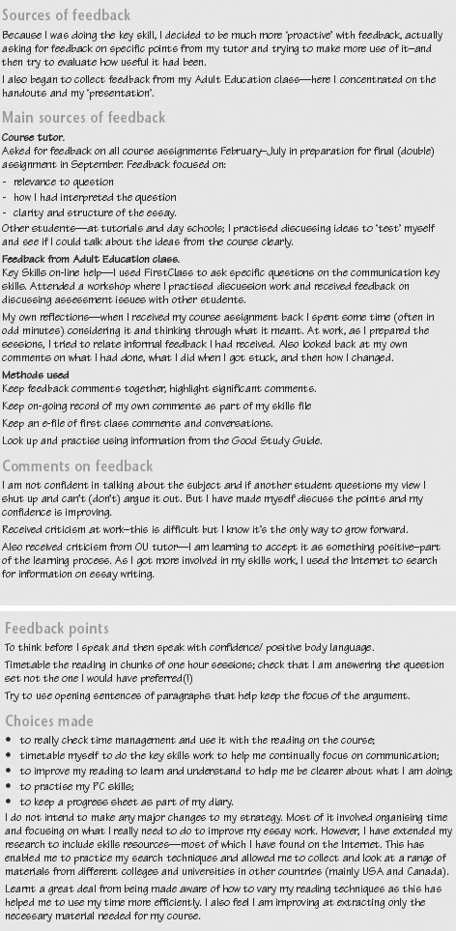
Example of a completed Skills Sheet for ‘Monitoring your progress’

Evaluating strategy and presenting outcomes
Evaluating work is an often-neglected process. When a piece of work has been completed you are probably keen to leave it behind, forget about its existence and get on with the next task. Even when your work is returned, you may just wish to file it away. However, if you want to improve, you need to consider carefully how well you did, take into account any comments you received from your tutor or manager and think about what changes you will make for future.
This stage of the framework focuses on identifying what you have achieved and how well you have achieved it. It involves evaluating both your communication work and the strategy overall and presenting your work. You can use the key skills criteria on the Bookmarks and the outcomes from your action plan to help you reflect on your own development and evaluate whether and how your performance has improved.
(Click here to open the Bookmark.)
In evaluating your strategy overall you are considering the communication work you have completed for this key skill and your strategy.
- To consider the communication work you have completed for this key skill, that is written work, presentation and discussion work, you need to consider whether the way you organised and presented the information was effective. Use criteria, feedback, and comments from peers to help you put together an evaluation. Consider the presentation of the information you used and its relevance, the clarity and structure. The aim here is to be objective – 'to stand outside yourself’. You may need to leave some time after completing the work before you can do this.
- To consider your strategy to improve your communication skills, that is the number of opportunities you used to practise, the use you made of your monitoring, the feedback you asked for and used, and so on; use your notes and comments and the criteria given on the Bookmark.
As you evaluate and assess your strategy, identify aspects of your communication skills you want to develop and improve further.
In evaluating your strategy and presenting the outcomes of your work you need to know how to:
- organise and clearly present relevant information;
- assess the effectiveness of your strategy; and
- identify ways of further developing your communication skills.

4.4.1 Organise and clearly present relevant information
You need to know how to present information in ways that best suit your purpose, subject and audience, that is how to structure coherently what you say so that a sequence of ideas may be followed easily; how to use a range of techniques to help present information and support your argument (such as diagrams and models), and when to use technical vocabulary and conventions. Check that your work meets relevant guidelines and conventions. You may have guidelines about this at work and different subjects have conventions that must be followed.

Time out
If you are giving a presentation, rehearse it and check in advance that you know how to use visual aids. Rehearse in front of a mirror or in front of a friend to make sure your main points are clear and that you can cover them in the time available. If you are involved in meetings/discussions, decide the points you want to make and prepare thoroughly. If you are negotiating particular issues, have the facts and evidence clearly recorded so you can refer to them during the discussions and keep returning to the strong points of the case.

4.4.2 Assess the effectiveness of your strategy
Think about how your decisions, the resources you have used, and the people you have consulted have all influenced the way you tackled the work. Consider the effect of your own communication strengths and weaknesses on the outcomes of your work. Use your notes and comments to identify what was and was not helpful in achieving your outcomes, and assess how your own capabilities in communication contributed to this. Assess your achievements against criteria in order to judge quality and success. Comment on those outcomes you feel have not been achieved or not completed. In the light of your assessment, what changes, if any, would you make to your overall strategy?

Time out
Look back at your notes and comments and consider:
- what has worked well in implementing your strategy for using and improving communication skills;
- what has been difficult and why; and
- what would you do differently?

4.4.3 Identify ways of further developing your communication skills
Think about your overall level of communication skills and suggest areas where you feel you need to improve, based on the experience you have gained. You might find it useful to discuss with your tutor or another student or work colleague how you might do this. There may be changes you feel you need to make so that you can move forward, such as trying to extend the facilities and resources available to you, changing the way you study to make best use of the time you have, or focusing on improving your own skills in specific areas.

Time out
When you have evaluated your performance thoroughly you will be more aware of areas where there is still room for improvement. Even the most experienced communicators need to go on improving and monitoring their skills.

Evaluating strategy and presenting outcomes

Activity: Evaluating your communication strategy and presenting outcomes

For this activity you will need to print out the Skills Sheet, ‘Evaluating your strategy and presenting outcomes’: click here open it.
Drawing on the notes and comments you have kept, comment critically on:
- the effectiveness of your strategy for improving your communication skills, identifying the factors that had an impact on your work;
- those aspects of communication where you feel you have made progress, and those where you feel you need more feedback or support;
- what you found useful in helping you to make progress, such as comments from tutors, other students or colleagues, particular resources, and particular ways of working or planning your work;
- your own performance as if you were assessing your work; and
- how you intend to develop further your communication skills.
Put together extracts of work that shows you can use written, oral and visual forms of communication and which includes:
- a synthesis of information, including referencing sources;
- a piece of written communication for a particular purpose; and
- a presentation and group discussion.
Refer to the figure below for an example of a completed Skills Sheet for this stage of the key skills framework.

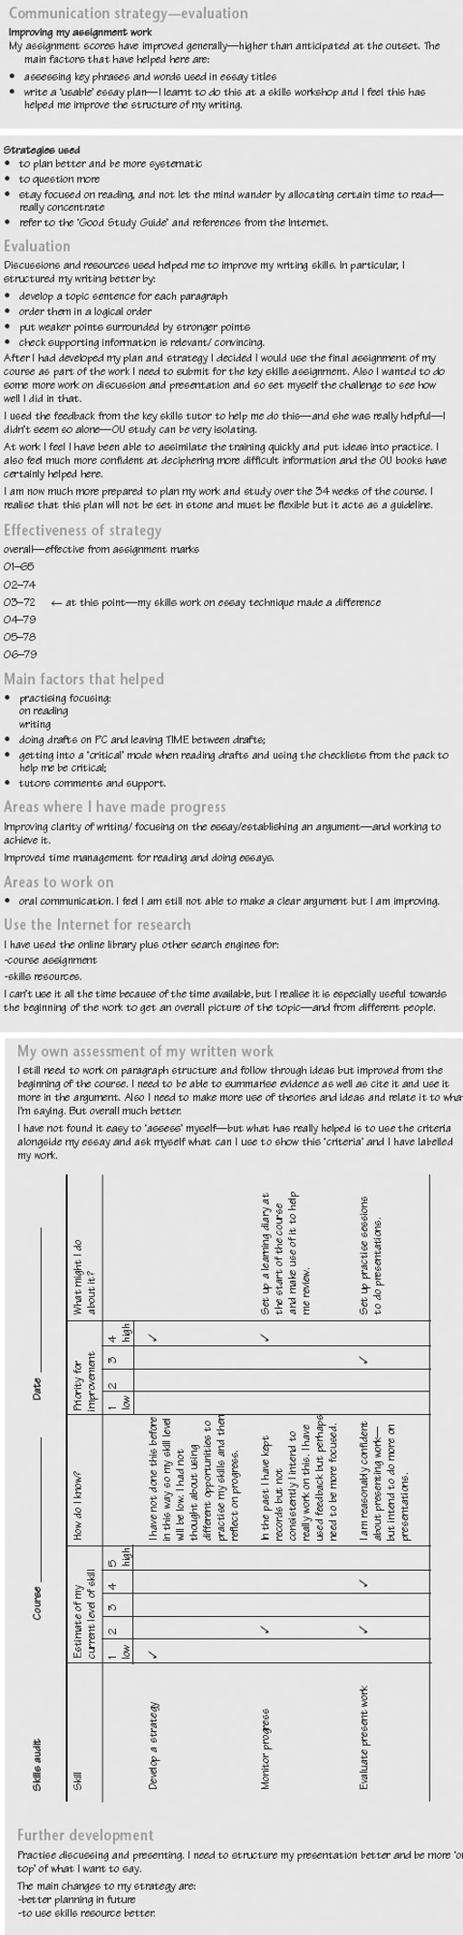
Example of a completed Skills Sheet for ‘Evaluating your communication strategy and presenting outcomes’

Learning involves changing, doing things differently, and seeing things from a different perspective. Evaluating how you tackled your work and then reflecting on your progress is an important part of learning. Although it may seem strange to be invited to ‘reflect’, the aim is to help you become more aware of how you did things and what helped you to do them. Critical reflection and evaluation involves:
- thinking about what you have done: being aware of what was involved in completing your assignment or work activity; for example what skills and knowledge you needed, what resources you found useful in developing and improving your skills, what support you called on, what were your problems and what were your successes;
- identifying your learning: focusing on things that worked well for you; identifying how successfully completing something can be helpful when things do not appear to be straightforward or you feel stuck on a particular task; and
- thinking about your next task: if you are aware of how you have tackled a problem, you can build on that experience for new tasks.
In developing your skills of communication, the processes of monitoring, reflecting, and evaluating are critically important. You need to monitor your progress as you go along and evaluate and reflect on it towards the end. You may need to wait until you have received feedback from your tutor or manager before you can carry out a full review of your work, but it is essential not to forget about it.

4.5 Drawing ideas together
This key skill has used a three-stage framework for developing your skills. By developing a strategy, monitoring your progress and evaluating your overall approach, you take an active role in your own learning. But learning does not necessarily follow a path of steady improvement, it involves change: revisiting ideas, seeing things from different perspectives, tackling things in different ways.
You are unlikely to be able to complete your work by working through it from beginning to end in a straightforward manner. You will need to bring together your key skills and your subject knowledge to address the tasks you have been asked to complete. As you work, you may discover gaps you still have to fill, areas where you have to dig deeper for information. This is a normal part of trying to put ideas together. In effect, you are piecing together a jigsaw, bringing skills, knowledge, analysis, explanation and interpretation together to make a single coherent picture. Unfortunately, the pieces usually do not all come to hand at just the right moment. The trick is to build up parts of the picture, and then bring those parts together as you begin to see the overall design. The key elements of this approach are:
- Check that you really understand what the work requires. Recognise that your skills and understanding of the task develop over time.
- Break the task into manageable chunks; focus your work on one aspect at a time.
- Think strategically about your approach to the task as you are doing it. Be prepared to change your plan if you need to reschedule your work.
- Work flexibly, using the resources provided as and when you need them.
- Review and reflect on your own performance while you are tackling the work. Your Skills File offers a way of recording and monitoring your development to give you insights into how you are learning as well as into what you are learning.

5 Improving your skills in information technology

5.1 Introduction to improving your skills in information technology
This key skill develops your information technology (IT) skills in your studies, work or other activities over a period of time. To tackle all of this key skill, you will need to plan your work over at least 3–4 months to give yourself enough time to practise and improve your skills, to seek feedback from others, to monitor your progress and evaluate your strategy and present outcomes.
Skills in information technology cover a broad range, from using software unitages to developing a critical understanding of the strengths and weaknesses of IT solutions. Learning how to use a word processor, database or spreadsheet are important but so, too, is thinking about how you can use IT efficiently to support what you are doing and to help you learn more effectively.
Improving your IT skills requires you to plan strategically how you will go about developing your skills, as well as what skills you should focus on. In monitoring your progress, you will need to apply and practise your IT skills to achieve the targets and goals you have set yourself and to reflect on, and possibly modify, your strategy in the light of your own assessment of progress and feedback from others. Evaluating your strategy and presenting results gives you the opportunity to demonstrate your IT skills and assess how successful your strategy was in achieving what you set out to do.

5.1a Working on improving your IT skills
The three-stage framework for developing your IT skills provides the basis for you to become more confident in:
- developing a strategy for using a variety of IT skills, including being clear about what you want to achieve, identifying relevant sources of information that will help you to achieve your goals, and planning how you intend to improve your skills;
- monitoring your progress and critically reflecting on your performance in searching for, exchanging, selecting, using, and evaluating information to meet your purposes; and changing your strategy if necessary;
- evaluating your overall strategy and presenting the outcomes of your work, including bringing together information presented in different ways, presenting information effectively, appropriately and accurately to others, and assessing how you developed and improved your IT skills.
You will be guided through each of these stages which aim to help you work on the relevant part of the key skill and are intended to help you think and plan strategically over a period of about 3–4 months. The stages are divided into ‘Time outs’ to prompt you to stop and think about what you are doing. All the Time outs should be seen as contributing to the process of that stage, not as independent tasks to be done one after the other and then ticked off the list. It is very likely that you will need to consider each Time out more than once as you pull together your approach to IT skills. Don't just read through them once. Set aside some time to think about how you are going to tackle each Time out and record in your Skills File the outcomes you hope to achieve and your strategy for achieving them. Remember also to note your sources of data, your preferred ways of working, and the help and support you need, as well as your comments and ideas about how you will develop and improve your IT skills.
At the end of each stage there is a longer activity for you to complete. A Skills Sheet is included for you to record your ideas on. The activity is a way of drawing together and reflecting on your work so far. Keep the completed Skills Sheets in your Skills File as part of your development record.
The components of the IT key skill are given in the Bookmark linked below. The Bookmark describes the key skill and gives the criteria to help you assess your performance. It is a reference to help you check up on what you should be aiming for, as well as providing brief examples to help you understand the requirements.
Click here to open the 'Information and communication technology' bookmark.

5.2 Developing a strategy
In developing a strategy for improving your IT skills you are aiming to:
- identify the opportunities you can use to develop and practise your IT skills;
- establish the outcomes you hope to achieve and targets for meeting them;
- identify the resources you might use for developing your skills, including people who might be able to help you as well as books, study guides, tutorials, specialist training, databases, libraries, the Internet, online support and computer conferencing;
- establish a timetable for developing and practising your skills, including deadlines for any assignments you must submit as part of your course or targets you must meet at work;
- consider how you intend to achieve the outcomes you want, and when you intend to complete your work.
In this stage you are laying down the foundations for your work over the next 3–4 months. Planning takes time and thought, so don't rush it. Make sure you allow yourself enough time – perhaps over a period of a week or two-to think about your strategy for improvement. Use the ‘Improving own learning and performance’ key skill to identify your strengths and weaknesses in using IT, and what you hope to achieve as you work on this skill.
The notes that follow guide you through the process of developing a strategy to improve your IT skills. Use the Time outs to help you plan, implement and evaluate your strategy. Finally, at the end of the stage, you should use the records in your Skills File to complete the activity ‘Developing your IT skills strategy’ and pull together this first stage in your IT skills development.

5.2.1 Identify opportunities for using IT skills
Where and how will you use information technology skills over the next 3–4 months? You may need IT to help you search for, develop, exchange and present information, including text, images and numbers. You may have to learn how to use a new software package, use email or computer conferencing, or search for, select and evaluate information from the Internet or online sources. Spend some time thinking about your study or work requirements and what opportunities you will have or can create to develop your IT skills.
Identifying just what your course or work practice will require and what you will need to focus on can be quite a complex process, so don't be discouraged if you find it difficult. At work you may be able to discuss requirements with colleagues or your manager. On a course, you can refer to the aims and outcomes to identify what you are expected to know and be able to do. In an assignment, there may be particular criteria you are expected to meet in order to be successful.
It is unlikely that you will be able to identify and pin down all the opportunities to use IT skills right at the beginning of your course or work activities. New ideas will probably occur as you go along and you may come back to modify and adapt your strategy several times as your work progresses. This is fine-plans should be flexible and responsive as your circumstances change. Discussing your ideas with others (such as your tutor, manager, other students or work colleagues) can be helpful in identifying those aspects of key skills you need to work on.

Time out
Make a list of those IT skills you will need. What will you be using those skills for, and when will you need them?

5.2.2 Identify the outcomes you hope to achieve
An outcome is the result or consequence of a process. For example, you may want to integrate information resulting from CD-Rom and Internet searches into a report, and to do this you may need to improve your word-processing skills. In this case your report is an outcome, and using your IT skills is part of the process by which you achieve that outcome.
Try to express the outcomes you hope to achieve as clearly and accurately as possible, asking others for help and comments if necessary. To help you work towards your outcomes you may need to set particular goals or targets to aim at. In producing a report, for example, you may need to learn how to use particular features of a word processor to present the different types of information you are bringing together in a consistent style. Using a word processor may be only one part of the process leading to your overall outcomes, but it may be an important goal to aim at along the way.
Setting outcomes and goals gives a structure to your activities and should help you identify where you need to focus your efforts. When you have completed your task they provide points of reference to help you judge your progress. As part of the evaluation process at the end of a piece of work, you should be able to say which goals and outcomes were achieved, or what the problems have been. To help you do this, think about how you will know whether you have achieved what you set out to do. For example, you may be seeking a better grade for an assignment, or positive feedback from your tutor or work colleagues. What criteria will you use to evaluate your progress?

Time out
List the outcomes you hope to achieve and the goals you have set to help you achieve them, noting which ones have a high priority for development. How will you judge whether you have achieved your outcomes satisfactorily?

5.2.3 Identify and research relevant sources of information
Spend some time finding out about what you will need to complete your IT work successfully and who you need to consult. You may need to arrange access to a library, to the Internet, databases on CD-ROM or online, or specialist training or publications. If you need to learn more about specific IT procedures or techniques (for example setting up a spreadsheet, using a database, archiving data), then look first at your course material and then at study guides or notes aimed at your area of interest. Find out about relevant tutorials or training sessions you can attend.
You may find that material or resources associated with courses or projects other than your own may be helpful. Find out who might be able to help you track down information; you may need the support of a tutor or manager, specialists such as librarians, or other students or work colleagues.
Establishing where your information is going to come from will help you to think about how you are going to manage and organise your work. Keep a full and accurate record in your Skills File of the sources and references you have tracked down so that you can find them again and provide accurate references for others. If you are using a web browser, make sure you know how to: bookmark relevant web pages so that you can find them again easily, download information, and save text and images in appropriate formats.

Time out
Make a note of what information you will need to find, where you might find it, and which people you should contact to help you.

Developing a strategy

5.3.1 Plan your use of IT skills and select methods
Exploring and planning an activity often results in a number of different options, possibilities and ways forward. Some approaches will be more feasible or will interest you more than others. At this stage, you need to think about how you will be using your IT skills and how you will assess the overall quality of your work.
Review the skills you will need to achieve your goals and the criteria you will use to check that you have achieved them. Opportunities and constraints to do with your level of personal expertise, availability of resources, access limitations, work patterns, health and safety issues, social, ethical and moral concerns may all influence your plans.
If you intend to communicate or process information, you will need to choose software and techniques that are appropriate for the tasks you want to do, and be able to justify your selection. If you are presenting information you should be able to explain the pros and cons of the methods you are using. What decisions have you made about the techniques you are going to use, and why have you made them?
Be realistic about what you can achieve in the time you have available and set yourself some deadlines. Remember that plans are guidelines against which you can check progress, but also that all plans are based on assumptions about the future. Keep your plans under review and be prepared to modify them if circumstances change or if your assumptions don't work out. Record your decisions, plans and actions in your Skills File.

Time out
What IT methods or techniques do you plan to use, and how will you use them? Go back to any plans you have made and check that they are relevant, up to date and realistic.

Activity: Developing your IT skills strategy

For this activity you will need to print the Skills Sheet, ‘Developing your strategy’.
Outline a strategy for developing and improving your information technology skills by focusing on the following questions. In developing your IT skills:
- What do you hope to achieve?
- What opportunities do you have for practising and improving your IT skills?
- What resources, including help and advice from others, can you draw on?
- How do you intend to achieve your goals and outcomes, and what timetable have you set yourself? Include dates of any relevant assignments you intend to submit.
Make brief notes:
- justifying why you have chosen your goals; and
- indicating the constraints – or your own learning styles and preferences – which may influence the way you learn and improve your skills.
Refer to the figure below for an example of a completed Skills Sheet for this stage of the key skills framework.

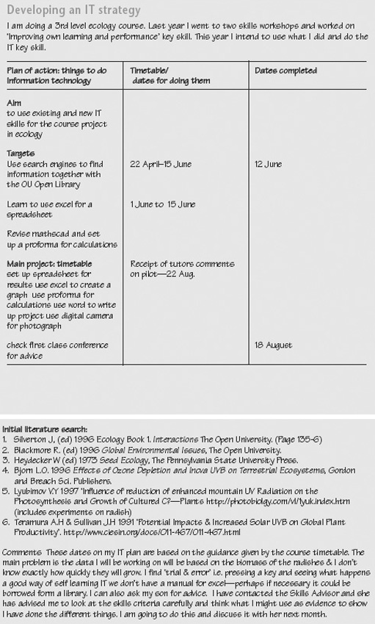
Example of a completed Skills Sheet for ‘Developing your IT skills strategy’

5.4 Monitoring progress
This stage of the framework is about keeping track of how you are doing and what progress you are making. Are you using IT effectively for your purposes? How do you know? Could you have done things differently, such as made use of different facilities and software packages, taken more advantage of training sessions or local expertise, or recognised that such support would have helped you?
Monitoring your own performance and progress needs practice; try to stand back and look at what you are doing as if you were an independent reviewer. Feedback from others can help you to identify your strengths and weaknesses. You may find it useful to discuss with a tutor, other students, work colleagues or manager how you might monitor your work.
As you work through this stage, take time to use your Skills File to record your own comments on your progress, as well as feedback from others. At the end of this stage there is an activity, ‘Monitoring and critically reflecting on your IT skills strategy’, to complete which asks you to review, reflect on and, if necessary, adapt your strategy for IT skills development.

5.4.1 Set up and use IT
In using IT effectively you may need to learn how to use particular features of the software applications involved. In word processing, style sheets and templates help you set up consistent formats for essays, reports and other documents. In spreadsheets, macros – sets of instructions that can be repeated as often as necessary – can help you to perform complex numerical operations more easily. In databases, you may need to know how to set up structures so that you can store and retrieve information in appropriate formats. In using computer conferencing systems, you may need to know how to contribute to, or set up and moderate different discussion groups. Identify which areas you need to focus on, and what you want to achieve.
If you need to search for, evaluate and select information from the Internet, CD-ROMs or other databases, find how to set up queries using search engines, and how to refine your search. Establish criteria (e.g. by date, author, subject, organisation, type, format and so on) to help you select the information you need. Be critically aware of the reliability and quality of information from different sources, taking into account factors such as commercial, political, academic or personal interests that may influence the content and presentation. How will you judge the quality of the information you find?
Set up different search strategies and criteria to explore alternative lines of enquiry. Explore and critically compare the assumptions and predictions of different models or descriptions of a situation, for example, setting up a model on a spreadsheet to explore and predict the consequences of changes in various factors. What predictions or hypotheses do you need to make or test?

Time out
In your Skills File, list your priorities for learning about IT techniques, and set some target dates to work towards.

5.4.2 Develop and exchange relevant information to meet your purposes
How does the way you communicate information affect the way you work? What opportunities do you have for developing or exploring different ways of working or sharing information using IT (e.g. using email, computer conferencing, video conferencing, web pages, sharing documents)? Depending on your requirements, you may need to consider factors such as the security, archiving and back-up of your data. What steps do you need to take to guard against the loss or misuse of your information? Can you easily retrieve earlier versions of your work? If you are developing and exchanging documents, for example in a group project, ensure that you can identify the current working version.

Time out
Identify what information you need, what you want it for and what access you have to it. Assess how your working practice helps you to do this effectively.

5.4.3 Gathering and producing new information
As your work progresses, what new information are you gathering or producing? For example are you using IT to handle ideas, plans, working documents, results of calculations, designs, predictions, evaluations and so on? Review the types of information you are dealing with and think about what IT skills you are using to bring together information and data from different sources to help you make decisions or draw conclusions. What new IT skills would help you handle this information more effectively? Monitoring progress means being actively aware of how your understanding of your task and the skills you need to tackle it are changing.

Time out
Note in your Skills File the different ideas, interpretations, insights and conclusions that you produce as you work.

5.4.4 Monitor and critically reflect on your use of IT skills
As you use IT in your work, refer back to the outcomes you hope to achieve and the goals you have set yourself. Ask yourself questions such as:
- am I on track to achieve my outcomes?
- what difficulties in using information technology have I experienced and what have I done about them?
- how have the choices and decisions I made impacted on the quality of my work?
- do I need to make any changes in the way I am learning about and using IT?
Identify reliable sources of feedback from others (such as your tutor, other students, project supervisor or work colleagues) and ask for their comments on specific aspects of your work. Use their comments constructively to help you monitor your performance, make decisions, and focus on those areas you need to work on.
Use any feedback from others together with your own assessment of how you are learning and improving to reflect critically on your progress, and to suggest ways to move forward (by improving existing skills, setting new priorities, or trying different approaches, for example). Remember that being critical does not mean ‘finding fault’. Rather, it means enquiring and being honest with yourself about your performance, your decisions, your strong points and your weaknesses.

Time out
Remember that we learn from successes as well as from mistakes. Include in your Skills File your critical reflections about what you feel has gone well, and why.

5.4.6 Adapt your strategy to overcome difficulties
Often plans run into difficulties because of unforeseen problems or changing circumstances. For example you may be running over your deadlines, the resources or support available to you may have changed, or your personal circumstances may have changed. Plans are only a means to an end, however. If you run into difficulties, take some time to think about what effect these difficulties are having on your plans, and what changes you may need to make to your overall strategy to achieve the outcomes you are aiming for.

Time out
Use your Skills File to record any difficulties or changes in circumstances, how they affect you and what you intend to do about them.

Activity: Monitoring your progress

For this activity you will need to print the Skills Sheet, ‘Monitoring your progress’.
On the Skills Sheet briefly summarise and reflect critically on your progress in developing your IT skills by considering:
- what methods and techniques you used to help you prepare and use IT to achieve your goals;
- what feedback, help or advice you requested and received on your performance in using IT;
- what decisions and choices you made about the approach, methods and techniques you used, as you worked on your IT skills and how effective were your choices in working towards your goals;
- Now that you have used the key skills approach and worked through the three-stage framework for improvement, briefly justifying any changes you made.
Refer to the figure below for an example of a completed Skills Sheet for this stage of the key skills framework.

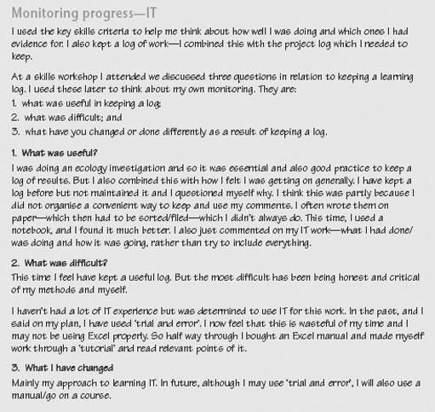
Example of a completed Skills Sheet for ‘Monitoring your progress’

5.5 Evaluating strategy and presenting outcomes
This stage of the framework focuses on identifying what you have achieved and how well you have achieved it. It involves you in evaluating your overall strategy and presenting the outcomes of your work. As you evaluate and assess your strategy, identify aspects of your IT skills that you want to develop further. At the end of this stage, use the records in your Skills File to complete the activity ‘Evaluating your use of IT strategy and presenting outcomes’ and pull together this final stage in your IT skills work.

5.5.1 Develop the structure for presenting your work
In presenting the results of your use of IT, you may need to integrate information of different types and formats. For example, in a report you may want to bring together text, numerical and symbolic data, equations and formulas, tables and graphs, charts or other images.
Check that your intended approach follows accepted conventions, and find out what guidelines or advice are available to you. If you are bringing information together in a single document or presentation, ensure that fonts, layout, number formats, sizes and shapes of graphs, images and tables are consistent and in acceptable styles.
Where appropriate, use your word processor to check spelling and grammar, but feedback from others is very useful to help you check the sense and organisation of your work.

Time out
Be clear who your intended audience is and select your information, style of presentation and language accordingly.

5.5.2 Use the views of others to guide your presentation
Asking others to read, listen to and comment on the presentation of your results can give you important feedback on your work. Think about who you can ask to provide you with constructive criticism and helpful comments on your work. To help others comment effectively, be clear about what you want them to focus on. For example do you want comments on technical detail, accuracy of content, quality of argument, general structure, grammar and spelling, presentation of results, and so on? Decide how you will present your work to them for their feedback.

Time out
Make notes of any feedback, comments and suggestions, and record how you intend to address these comments.

5.5.3 Present information effectively
Organise your information so that you can use it to illustrate and support your arguments or point of view. To do this successfully, you must be clear about what you want to say, and how you want your audience to interpret your information. Ensure that any illustrations, graphs, diagrams and charts are correctly labelled and that you have met any particular requirements for presentations. Use the word-count facility of your word processor to help you keep within limits. Remember to proofread your own work to check that it makes sense, that the information you have included is accurate and relevant, and that you have included references or acknowledgements to the sources you have used. Various software packages are now available for managing references to source material.

Time out
Remember to record accurately and fully all references to any information sources so that you can find them again, and cite them accurately in your presentation so that others will be able to find them.

5.5.4 Evaluate the effectiveness of your strategy
Using the records in your Skills File, look back over your IT development work and think about how your decisions, and the facilities and constraints of your working environment influenced the way you tackled the task. How effective was your strategy in improving your IT skills? Identify what was and was not helpful in achieving your goals and outcomes, and assess how your own IT strengths and weaknesses contributed to this.
Evaluate your achievements against the criteria you established at the outset to judge quality and success. What do you feel you have and have not achieved? What factors had the greatest impact on your strategy? In the light of your evaluation, what changes, if any, would you make to your overall strategy?

Time out
Make notes about the success of your strategy. Which skills do you now feel more confident about?

5.5.5 Identify ways of further developing your IT skills
Think about your overall IT skills and suggest areas where you feel you need to improve, based on the experience you have gained. You might find it useful to discuss with your tutor, manager, another student or work colleague how you might do this. There may be changes you feel you need to make so that you can move forward, such as trying to extend the facilities and resources available to you, changing the way you study to make best use of the time you have, or focusing on improving your own skills in specific areas.
Evaluation is an important stage in a project. Do take the time to evaluate your work when it is completed; don't neglect this stage or forget about your work. If you are studying a course, your tutor will have made comments which should help you assess how well you are doing, and what you need to focus on next. If you are improving your skills at work your manager or supervisor may be able to comment and give suggestions for further development. You may also have received feedback from other sources. You should consider all such feedback carefully and take it into account as you move onto the next stage of your work.
Remember to carry out a self-assessment of your skills when you start a new course of study, or a new project. You then have a benchmark or reference point against which to assess your skills development.

Time out
If you keep a record of feedback you have received and your responses to it, over a period of time you can see how it has influenced your learning and skills development. You will then be in a good position to know how to improve further.

5.6 Evaluating strategy and presenting outcomes

Activity: Evaluating your IT strategy and presenting outcomes

For this activity you will need to print out the Skills Sheet, ‘Evaluating your strategy and presenting outcomes’: click here to open it.
Drawing on the records you have kept in your Skills File, comment critically on:
- the effectiveness of your strategy for improving your IT skills, identifying the factors that had an impact on your work;
- those aspects of IT where you feel you have made progress, and those where you feel you need more feedback or support;
- what you found useful in helping you to make progress, such as comments from tutors, other students or colleagues, particular resources, particular ways of working or planning your work;
- your own performance in presenting your outcomes as if you were assessing your own work; and
- how you intend to develop further your IT skills.
Refer to the figure below for an example of a completed Skills Sheet for this stage of the key skills framework.

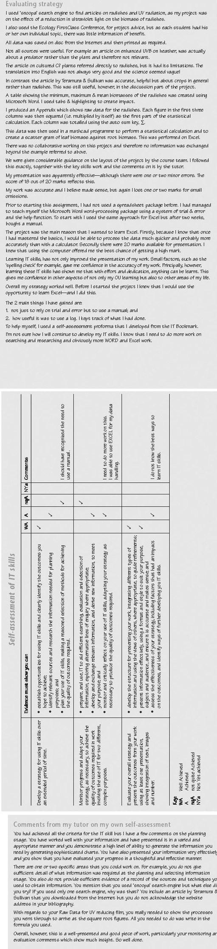
Example of a completed Skills Sheet for ‘Evaluating your IT strategy and presenting outcomes’

5.7 Drawing ideas together
This key skill has used a three-stage framework for developing your skills. By developing a strategy, monitoring your progress and evaluating your overall approach, you take an active role in your own learning. But learning does not necessarily follow a path of steady improvement, it involves change: revisiting ideas, seeing things from different perspectives, tackling things in different ways.
You are unlikely to be able to complete your work by working through it from beginning to end in a straightforward manner. You will need to bring together your key skills and your subject knowledge to address the tasks you have been asked to complete. As you work, you may discover gaps you still have to fill, areas where you have to dig deeper for information. This is a normal part of trying to put ideas together. In effect, you are piecing together a jigsaw, bringing skills, knowledge, analysis, explanation and interpretation together to make a single coherent picture. Unfortunately, the pieces usually do not all come to hand at just the right moment. The trick is to build up parts of the picture, and then bring those parts together as you begin to see the overall design. The key elements of this approach are:
- Check that you really understand what the work requires. Recognise that your skills and understanding of the task develop over time.
- Break the task into manageable chunks; focus your work on one aspect at a time.
- Think strategically about your approach to the task as you are doing it. Be prepared to change your plan if you need to reschedule your work.
- Work flexibly, using the resources provided as and when you need them.
- Review and reflect on your own performance while you are tackling the work. Your Skills File offers a way of recording and monitoring your development to give you insights into how you are learning as well as into what you are learning.

6 Improving your skills in information literacy (IL)

6.1 Introduction to improving your skills in information literacy
This key skill develops your information literacy (IL) skills in your studies, work or other activities over a period of time. To tackle all of this section you will need to plan your work over at least 3–4 months to give you enough time to practise and improve your skills, to seek feedback from others, and to monitor and evaluate your progress.
Information literacy is not the same as information technology. Information and communication technology skills tend to concentrate on using hardware and software effectively to process and communicate information. Information literacy, on the other hand, is concerned with recognising when information is needed, and locating, critically evaluating, using and presenting the information to suit a specific purpose.
Information literacy skills are important because of the rapid growth of information systems and information resources. In your studies, your work or other activities you are likely to be faced with an increasing range of information sources available through libraries, in online specialist databases, and on the Internet. But all this information raises questions about how to search for and locate what you need, as well as issues about the quality, accuracy and reliability of the information you find. A large quantity of information on its own does not make us better informed; the onus is on us to be critical and skilful users of that information and the sources to which we have access.
The key skill of information literacy is intended to develop your critical awareness and competence in handling information and information systems. Being information literate means being able to:
- recognise where there is a knowledge or information ‘gap’, and identify what type of information you need to fill it;
- locate appropriate information resources, and arrange access to them;
- plan and monitor a search of the resources;
- sort and critically evaluate the information you find;
- organise and present information to others as required by your situation;
- understand the social, legal and ethical issues surrounding the use of information.
Improving your skills in IL involves you planning strategically how you will go about developing your skills, as well as on which skills you should focus. In monitoring your progress you will need to apply and practise your IL skills to achieve the goals you set yourself and to reflect on, and possibly modify, your approach in the light of your own assessment of progress and feedback from others. Evaluating your strategy and presenting results gives you the opportunity to demonstrate your IL skills and assess how successful your strategy was in achieving what you set out to do.

6.2 Working on improving your IL skills
The three-stage framework for developing and improving your skills provides the basis for you become more confident in:
- developing a strategy for using a variety of IL skills, including being clear about what you want to achieve, identifying relevant sources of information that will help you to achieve your goals, and planning how you intend to improve your skills;
- monitoring your progress and critically reflecting on your performance in identifying, searching for, selecting, using and evaluating information to meet your purposes;
- evaluating your overall strategy and presenting the outcomes of your work, organising and presenting information effectively, appropriately and accurately to others, and assessing how you developed and improved your IL skills.
You will be guided through each of these stages, which aim to help you work on the relevant part of the key skill and are intended to help you think and plan strategically over a period of about 3–4 months. The stages are divided into ‘Time outs’ to prompt you to take time to stop and think about what you are doing. All the Time outs should be seen as contributing to the process of that stage, not as independent tasks to be done one after the other and then ticked off the list. Don't just read through them once. Set aside some time to think about how you are going to tackle each Time out and record in your Skills File the goals you hope to achieve and your strategy for achieving them. It is very likely that you will need to consider each Time out more than once as you pull together your approach to IL skills. Remember also to note your sources of data, your preferred ways of working and the help and support you need, as well as your comments and ideas about how you will develop and improve your IL skills.
At the end of each stage there is a longer activity for you to complete. A Skills Sheet is included for you to record your ideas on. The activity is a way of drawing together and reflecting on your work so far. Keep the completed Skills Sheets in your Skills File as part of your development record.
Click on 'View document' below where you'll find the components of the information literacy key skill. The Bookmark describes the key skill and gives the criteria to help you assess your performance. It is a reference to help you check up on what you should be aiming for, as well as providing brief examples to help you understand the requirements.
View document

6.3 Developing a strategy
In developing a strategy for improving your IL skills you are aiming to:
- identify the opportunities you can use to develop and practise your IL skills;
- establish the outcomes you hope to achieve and the targets for meeting them;
- identify the resources you might use for developing your skills, including people who might be able to help you as well as books, study guides, tutorials, specialist training, databases, libraries, the Internet, computer conferencing or online support;
- establish a timetable for developing and practising your skills, including deadlines for any assignments you must submit as part of your course or targets you must meet at work;
- consider how you intend to achieve the outcomes you want, and when you intend to complete your work.
In this stage you are laying down the foundations for your work over the next 3–4 months. Planning takes time and thought, so don't rush it. Make sure you allow yourself enough time – perhaps over a period of a week or two – to think about and work on your strategy for improvement. Use the ‘Improving own learning and performance’ key skill to identify your strengths and weaknesses in using IL, and what you hope to achieve as you work on this skill.
The notes that follow guide you through the process of developing a strategy to improve your IL skills. Use the Time outs to help you plan, implement and evaluate your strategy. Finally, at the end of the stage, you should use the records in your Skills File to complete the activity ‘Developing your IL skills strategy’ and pull together this first stage in your IL skills development.

6.3.1 Identify opportunities for using IL skills
Where and how will you use information literacy skills over the next 3–4 months? You may need IL to help you identify, search for, evaluate and present information for a specific task, such as an essay or project report. You may have to visit and learn how to use an academic library, or need to search for, select and evaluate information from specialist databases or the Internet. Spend some time thinking about your study or work requirements and what opportunities you will have or can create to develop your IL skills.
Identifying just what your course or work practice will require and what you will need to focus on can be quite a complex process, so don't be discouraged if you find it difficult. At work you may be able to discuss requirements with colleagues or your manager. On a course you can refer to the aims and outcomes to identify what you are expected to know and be able to do. In an assignment, there may be particular criteria you are expected to meet in order to be successful.
It is unlikely that you will be able to identify and pin down all the opportunities to use IL skills right at the beginning of your course or work activities. New ideas will probably occur as you go along and you may come back to modify and adapt your strategy several times as your work progresses. This is fine – plans should be flexible and responsive as your circumstances change. Discussing your ideas with others (such as your tutor, manager, other students and work colleagues) can be helpful in identifying those aspects of key skills you need to work on.

Time out
Make a list of those information literacy skills you think you will need. What will you be using those skills for, and when will you need them?

6.3.2 Identify the outcomes you hope to achieve
An outcome is the result or consequence of a process. For example, you may want to select information from a number of sources for a report, and to do this you may need to improve your use of information search facilities and your critical skills in comparing and contrasting information. In this case your report is an outcome and using and improving your information literacy skills is part of the process by which you achieve that outcome.
A more focused outcome might be related to recognising a gap in the knowledge or information you have in a particular subject area, and identifying the type of information required to fill it. For example you may need to find out about renaissance art. But what is it about renaissance art that you need to know? Your knowledge gap might be centred on:
- news – looking for current exhibitions, lectures or publications;
- history – the rise of Renaissance art, its origins and patrons;
- ideas and opinions – what do art historians, critics, art dealers and curators say?
- research – what is the latest research on cultural influences?
Try to express the outcomes you hope to achieve as clearly and accurately as possible, asking others for help and comments if necessary. To help you work towards your outcomes you may need to set particular goals or targets to aim at. In producing a report, for example, you may need to learn how to compile a set of references or a bibliography. Compiling a bibliography in a consistent style may be only one part of the process leading to your overall outcomes, but it may be an important goal to aim at along the way.
Setting outcomes and goals gives a structure to your activities and should help you identify where you need to focus your efforts. When you have completed your task they provide points of reference to help you judge your progress. As part of the evaluation process at the end of a piece of work, you should be able to say which goals and outcomes were achieved, or what the problems have been. To help you do this, think about how you will know whether you have achieved what you set out to do. For example you may be seeking a better grade for an assignment, or positive feedback from your tutor or work colleagues. What criteria will you use to evaluate your progress?

Time out
List the outcomes you hope to achieve and the goals you have set to help you achieve them, noting which ones have a high priority for development. How will you judge whether you have achieved your outcomes satisfactorily?

6.3.3 Identify and research relevant sources of information
Spend some time finding out about what you will need to help you complete you IL work and who you will need to consult. You may need to arrange access to a library, the Internet, databases online, or specialist training or publications. If you need to learn about specific aspects of IL (for example how to reference correctly articles, papers and books, or how to put together a bibliography), then look first at your course material and then at study guides or notes aimed at your area of interest. Find out about relevant tutorials or training sessions you can attend.
You may find that material or resources associated with courses or projects other than your own may be helpful. Find out who might be able to help you track down information; you may need the support of a tutor or manager, specialists such as librarians, or other students or work colleagues. Think carefully about what you are looking for and how you are going to communicate your requirements to the person or system you intend to consult.
There are many different types of sources, for example books, academic journals (print and electronic), web pages, conference proceedings, magazines, newspapers, dictionaries, encyclopaedias, libraries and specialist databases. Where is your information coming from? Think about the implications of different sources for the quality, reliability and accuracy of the information you need. For example papers in academic journals are likely to be peer-reviewed by other subject experts; articles in reputable magazines may be by informed journalists; web pages could be written by anyone. Where is your information going? Who will be using it and what will they be using it for? The way you use and cite different information sources will affect the way others perceive the quality and reliability of your work.
Establishing where your information is coming from and where it is going should help you manage and organise your work. Keep a full and accurate record in your Skills File of the sources and references you have tracked down so that you can find them again and provide accurate references for others. If you are using a web browser, make sure you know how to bookmark relevant web pages so that you can easily access them again, download information and save text and images in appropriate formats.

Time out
Make a note of what information you will need to find, what you have found and where you have found it. Who might be able to help you track down the information you need?

6.4 Developing a strategy

Plan your use of IL skills and select methods
Exploring and planning an activity often results in a number of different options, possibilities and ways forward. Some approaches will be more feasible or will interest you more than others. At this stage you will need to think about how you will be using your information literacy skills and how you will assess the overall quality of your work.
Review the skills you will need to achieve your goals and the criteria you will use to check that you have achieved them. Opportunities and constraints to do with your level of personal expertise, availability of resources, access limitations, work patterns, health and safety issues, social, ethical and moral concerns may all influence your plans.
What decisions have you made about the sources and techniques you are going to use to find the information you need, and why have you made them? Starting points for searches include library catalogues, online databases, and the Internet. Different sources will have different pros and cons. For example a library may contain rare and specialist printed material, but may be difficult to visit, or access may have to be negotiated. CD-ROMs and databases may contain a vast amount of reliable material but you may need to spend time in learning how to search them effectively; the Internet may be easy to access but there are no controls over the quality of information you may find.
What type of information do you want; what are the strengths and weaknesses of the sources you plan to use? For example newspapers are good for interviews; academic journals for recent research in specialist areas; textbooks for drawing work and results together from range of sources; the Internet for information that changes frequently.
In handling information it is important for you to be aware of the legal, ethical and moral issues surrounding its use. For example you may have to seek (and pay for) permission to use any text, images or data that are protected by copyright law. Information containing details about individuals is likely to be controlled by data protection laws. Intellectual property rights may be claimed over certain types of ideas and information. Passing others’ words and ideas off as your own by not acknowledging their work through accurate citations and references is plagiarism, and will be penalised in any academic work.
Be realistic about what you can achieve in the time you have available and set yourself some deadlines. Remember that plans are guidelines against which you can check progress, but also that all plans are based on assumptions about the future. Keep your plans under review and be prepared to modify them if circumstances change or if your assumptions don't work out. Record your decisions, plans and actions in your Skills File.

Time out
What information sources and tools do you plan to use, and how will you use them? Go back to any plans you have made and check that they are still relevant, up to date, legally and ethically sound, and realistic.

Activity: Developing your IL skills strategy

For this activity you will need to print out the Skills Sheet, ‘Developing your strategy’: click here to open it.
Outline a strategy for developing and improving your information literacy skills by focusing on the following questions. In developing your IL skills:
- What do you hope to achieve?
- What opportunities do you have for practising and improving your IL skills?
- What resources, including help and advice from others, can you draw upon?
- How do you intend to achieve your goals and outcomes, and what timetable have you set yourself? Include dates of any relevant assignments you intend to submit.
Make brief notes:
- justifying why you have chosen your goals;
- indicating the constraints – or your own styles and preferences for learning – which may influence the way you learn and improve your skills.
Refer to the figure below for an example of a completed Skills Sheet for this stage of the key skills framework.

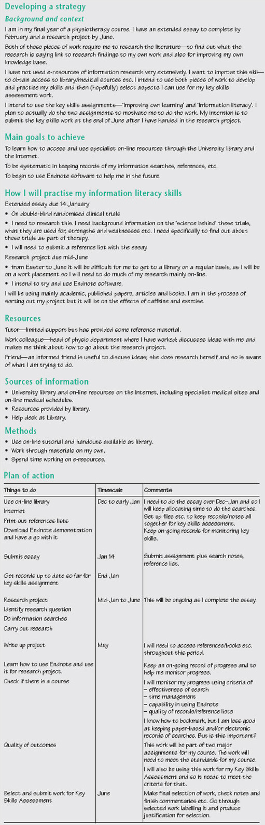
Example of a completed Skills Sheet for ‘Developing your IL skills strategy’

6.5 Monitoring progress
This stage of the framework is about keeping track of your progress. Are you using your information literacy skills effectively for your purposes? How do you know? Could you have done things differently: made use of different facilities and expertise, taken more advantage of tutorials, training sessions or local expertise, or recognised that such support would have helped you? Monitoring your own performance and progress needs practice; try to stand back and look at what you are doing as if you were an independent reviewer. Feedback from others can help you to identify your strengths and weaknesses; you may find it useful to discuss with a tutor, other students, work colleagues or manager how you might monitor your work.
As you work though this stage, take time to use your Skills File to record your own comments on your progress, as well as feedback from others. At the end of this stage there is an activity, ‘Monitoring and critically reflecting on your IL skills strategy’ to complete which asks you to review, reflect on and, if necessary, adapt your strategy for IL skills development.

6.5.1 Explore different information sources
Where and how are you going to look for your information? Finding information effectively involves being aware of techniques for locating and digging out the relevant information. Find out about how the sources you have identified are organised and indexed, and formulate your questions appropriately.
Set up different search strategies and criteria to explore alternative lines of enquiry. If you need to search for, evaluate and select information from the Internet or other databases, find how to set up queries using search engines, and how to refine your search. Different databases may offer different ways of searching for information and different search interfaces so you may need to spend time learning about the ones you intend to use.

Time out
List your priorities for learning about searching techniques, and set some target dates to work towards.

6.5.2 Use a variety of search strategies and tools effectively
How you search for information will depend on the subject area as well as the libraries, databases and other sources available to you. Each subject area will have its own way of talking about relevant information and the relationships between different groupings of knowledge within the discipline. The indexing of information sources associated with the subject area is likely to stress those areas which are considered central to the subject area, but may ignore other areas which are seen as fringe or unorthodox.
Understanding the language of the subject area, therefore, is important in making informed choices about key words and search terms that are likely to be successful. Similarly, understanding the language and structure of your chosen information-retrieval system (such as library catalogue, commercial or academic database, citation index, Internet search engine, or book index) will make your searches more effective. Take time to explore the use of Boolean operators (that is logical AND, OR, NOT operators for combining search terms), truncation and proximity formats in search engines to expand or narrow your search. Different search tools have different user interfaces, so be prepared to come across different command words, rules and parameters for searching, and ask for specialist help if you need it.

Time out
Outline your search strategy, noting the key words or search terms you are going to use.

6.5.3 Record and critically evaluate the results of your search
Keeping a record of what sources you have explored, and the strategies, keywords and search terms you have used, will help you make best use of the facilities and time you have. As part of this record you should note how useful the sources have been, what was returned from your search, and what adjustments you made to your search plan (for example new keywords, different search parameters, different combination of Boolean operators).
Establish criteria (such as by date, author, subject, organisation, type and format) to help you select the information you need. Be critically aware of the reliability and quality of information from different sources, taking into account factors such as commercial, political, academic or personal interests that may influence the content and presentation. How will you judge the quality of the information you find?
Review how you sort and evaluate the information you have found. What criteria are you using to help you decide what information to retain and what to reject? What would help you to do this more effectively? Monitoring progress means being actively aware of how your understanding and your skills develop as your task unfolds.

Time out
List the criteria you are using and comment on their usefulness in helping track down the information you need. Note any modifications you make to your search plans.

6.5.4 Monitor and critically reflect on your use of IL skills
As you develop your information literacy skills, refer back to the outcomes you hope to achieve and goals you have set yourself. Ask yourself questions such as:
- am I on track to achieve my outcomes?
- what difficulties in using information literacy techniques have I experienced and what have I done about them?
- how have the choices and decisions I made impacted on the quality of my work?
- do I need to make any changes in the way I am learning about and using IL?
Identify reliable sources of feedback from others (such as your work colleagues, tutor, librarian, manager) and ask for their comments on specific aspects of your work. Use their comments constructively to help you monitor your performance, make decisions, and focus on those areas you need to work on.
Use any feedback from others, together with your own assessment of how you are learning and improving, to reflect critically on your progress, and to suggest ways to move forward (for example by improving existing skills, setting new priorities, or trying different approaches). Remember that being critical does not mean ‘finding fault’. Rather, it means enquiring and being honest with yourself about your performance, your decisions, your strong points and your weaknesses.

Time out
Remember that we learn from successes as well as from mistakes. Include in your Skills File your critical reflections about what you feel has gone well, and why.

6.5.5 Adapt your strategy to overcome difficulties
Often plans run into difficulties because of unforeseen problems or changing circumstances. For example, you may be running over your deadlines, the resources or support available to you may have changed, or your personal circumstances may have changed. Plans are only a means to an end, however. If you run into difficulties try to take some time to think about what effect they will have on your plans, and what changes you may need to make to your overall strategy to achieve the outcomes you are aiming for.

Time out
Use your Skills File to record any difficulties or changes in circumstances, how they affect you and what you intend to do about them.

Activity: Monitoring your progress

For this activity you will need to print out the Skills Sheet, ‘Monitoring your progress’: click here to open it.
On the Skills Sheet briefly summarise and reflect critically on your progress in developing your IL skills by considering:
- what methods and techniques you used to help you prepare and use IL to achieve your goals;
- what feedback, help or advice you requested and received on your performance in using IL;
- what decisions and choices you made about the approach, methods and techniques you used, as you worked on your IL skills. How effective were your choices in working towards your goals?
- what changes, if any, you made to your strategy and plans as your work progressed, briefly justifying any changes you have made.
Refer to the figure below for an example of a completed Skills Sheet for this stage of the key skills framework.

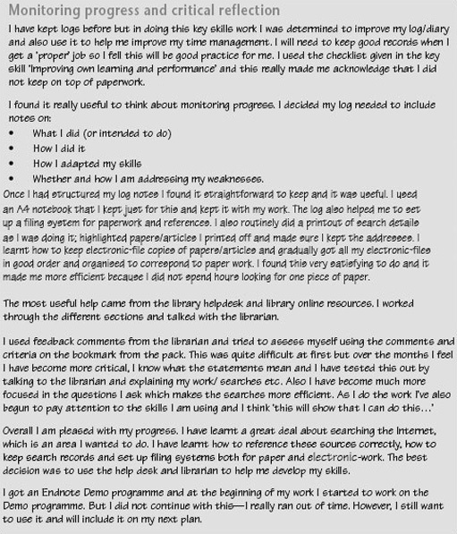
Example of a completed Skills Sheet for ‘Monitoring your progress’

6.6 Evaluating strategy and presenting outcomes
This stage of the framework focuses on identifying what you have achieved and how well you have achieved it. It involves you in evaluating your overall strategy and presenting the outcomes of your work. As you evaluate and assess your strategy, identify aspects of your IL skills that you want to develop further. At the end of this section use the records in your Skills File to complete the activity ‘Evaluating your use of IL strategy and presenting outcomes’ and pull together this final stage in your IL skills work.

Interpret results and identify your main findings
In interpreting your results, think about the coverage of your searches and whether you have missed anything or left out important areas. You cannot find everything, but you should be confident that you have located sources recognised for their accuracy, authority and authenticity. How will you judge the quality and coverage of your material? Be aware that while your information may be accurate and reliable, it may not be unbiased. Look carefully at the sources of your information (ask yourself: who are the authors, the publishers, the sponsoring bodies, the organisations involved?), and try to identify their aims and intentions in making the information available.

Time out
Comment on where your information has come from and who has made it available. Can it be trusted? Will it support what you want to say?

6.6.1 Organise and clearly present information
Organise the results of your searches so that you can use them to support and illustrate your arguments or point of view. For example you may want to use the information you have found to examine critically, support or reject some general statements associated with that topic, or to offer factual data in support of an analysis. To do this successfully you must be clear who is your intended audience and what you want them to understand from your information.
In presenting your results, you should accurately cite where the information has come from by, for example, compiling a list of references or a bibliography. Be aware of the different styles and conventions for drawing up reference lists and bibliographies. If you are writing a project report, an essay or a paper for publication, for example, choose an appropriate format for your purpose. Accurate referencing is important because it:
- acknowledges the work of others (passing others’ work off as your own is plagiarism);
- indicates those information sources (such as opinions, data, analysis) that are relevant to your work; and
- provides a trail so that others can find the sources you have used.
Seek advice or guidelines on how to use references correctly in your work to ensure that you do not disadvantage yourself by using inappropriate or unacceptable formats.

Time out
Find out about the referencing style you should be using in your work, and use it consistently.

6.6.2 Evaluate the effectiveness of your strategy
Using the records in your Skills File, look back over your information literacy development work and think about how your decisions, and the facilities and constraints of your working environment influenced the way you tackled the task. How effective was your strategy in improving your IL skills? Identify what was and was not helpful in achieving your goals and outcomes, and assess how your own IL strengths and weaknesses contributed to this.
Assess your achievements against the criteria you established at the outset to judge quality and success. What do you feel you have and have not achieved. What factors had the greatest impact on your strategy? In the light of your evaluation what changes, if any, would you make to your overall strategy?

Time out
Make notes about the success of your strategy. Which skills do you now feel more confident about?

6.6.3 Identify ways of further developing your IL skills
Think about your overall IL skills and suggest areas where you feel you need to improve, based on the experience you have gained. You might find it useful to discuss with your tutor, manager, another student or work colleague how you might do this. There may be changes you feel you need to make so that you can move forward, such as trying to extend the facilities and resources available to you, changing the way you study to make best use of the time you have, or focusing on improving your own skills in specific areas.
Evaluation is an important stage in a project. Do take the time to evaluate your work when it is completed, don't just neglect this stage or forget about your work. If you are studying a course, your tutor will have made comments which should help you in assessing how well you are doing, and what you need to focus on next. If you are improving your skills at work your manager or supervisor may be able to comment and give suggestions for further development. You may also have received feedback from other sources. You should consider all such feedback carefully and take it into account as you move onto the next stage of your work.
Remember to carry out a self-assessment of your skills when you start a new course of study, or a new project. You then have a benchmark or reference point against which to assess your skills development.

Time out
If you keep a record of feedback you have received, and your responses to it, over a period of time you can see how it has influenced your learning and skills development. You will then be in a good position to know how to improve further.

Activity: Evaluating your IL strategy and presenting outcomes

For this activity you will need the Skills Sheet, ‘Evaluating your strategy and presenting outcomes’: click here to open it.
Drawing on the records you have kept in your Skills File, comment critically on:
- the effectiveness of your strategy for improving your IL skills, identifying the factors that had an impact on your work;
- those aspects of IL where you feel you have made progress, and those where you feel you need more feedback or support;
- what you found useful in helping you to make progress (such as comments from tutors, other students or colleagues, particular resources, particular ways of working or planning your work);
- your own performance in presenting your outcomes as if you were assessing your own work; and
- how you intend to develop further your IL skills.
Refer to the figure below for an example of a completed Skills Sheet for this stage of the key skills framework.

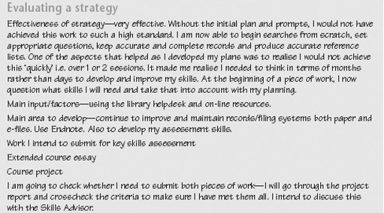
Example of a completed Skills Sheet for ‘Evaluating your IL strategy and presenting outcomes’

6.7 Drawing ideas together
This key skill has used a three-stage framework for developing your skills. By developing a strategy, monitoring your progress and evaluating your overall approach, you take an active role in your own learning. But learning does not necessarily follow a path of steady improvement, it involves change: revisiting ideas, seeing things from different perspectives, tackling things in different ways.
You are unlikely to be able to complete your work by working through it from beginning to end in a straightforward manner. You will need to bring together your key skills and your subject knowledge to address the tasks you have been asked to complete. As you work, you may discover gaps you still have to fill, areas where you have to dig deeper for information. This is a normal part of trying to put ideas together. In effect, you are piecing together a jigsaw, bringing skills, knowledge, analysis, explanation and interpretation together to make a single coherent picture. Unfortunately, the pieces usually do not all come to hand at just the right moment. The trick is to build up parts of the picture, and then bring those parts together as you begin to see the overall design. The key elements of this approach are:
- Check that you really understand what the work requires. Recognise that your skills and understanding of the task develop over time.
- Break the task into manageable chunks; focus your work on one aspect at a time.
- Think strategically about your approach to the task as you are doing it. Be prepared to change your plan if you need to reschedule your work.
- Work flexibly, using the resources provided as and when you need them.
- Review and reflect on your own performance while you are tackling the work. Your Skills File offers a way of recording and monitoring your development to give you insights into how you are learning as well as into what you are learning.

7 Improving your skills in application of number

7.1 Introduction to improving your skills in number
This key skill develops your number skills in your studies, work or other activities over a period of time. To tackle all of this key skill, you need to plan your work over at least 3–4 months to give yourself enough time to practise and improve your skills, to seek feedback from others, to monitor your progress and evaluate your strategy and present outcomes.
Application of number (simply called ‘number’ in this key skill) is all about using numerical and mathematical skills to frame and solve problems effectively. Applying these skills may help you to tackle an activity or a problem that is part of a larger task. Once you have identified that you need to solve numerical or mathematical problems, you can use the three-stage framework to help you organise your work. For example you may need to collect data from various sources to explore an issue or answer a question, then do something with that data such as display it appropriately, carry out calculations on it, or use it to check the predictions of a mathematical model, and then interpret and present what you have found. The three-stage framework supports all these components of the key skill.
But the key skill of using number is not simply about working through calculations or drawing graphs, although they are useful techniques that you may need. It is knowing when using mathematical techniques can help you complete a task more effectively, how to carry out a range of mathematical techniques proficiently, and being able to make decisions about which particular technique you should apply to achieve a desired outcome.
Improving your number skills involves you planning strategically how you will go about developing your skills, as well as identifying which skills you should focus on. In monitoring your progress you will need to apply and practise your skills to achieve the goals you have set yourself and to reflect on, and possibly modify your approach in the light of your own assessment of progress and feedback from others. Evaluating your strategy and presenting results gives you the opportunity to demonstrate your numerical and mathematical skills, and to assess how successful your strategy was in achieving what you set out to do.

7.2 Working on improving your number skills
The three-stage framework for developing and improving your skills provides the basis for you to become more confident in:
- developing a strategy for using a variety of numerical and mathematical skills, including being clear about what you want to achieve, identifying relevant sources of information that will help you to achieve your goals, and planning how you intend to improve your skills;
- monitoring your progress and critically reflecting on your performance in evaluating information from different sources, carrying out calculations and using mathematical techniques, and making appropriate decisions and choices to meet your purposes;
- evaluating your overall strategy and presenting the outcomes of your work, including identifying your main findings and interpreting your results; presenting your results effectively, appropriately and accurately to others; and assessing how you developed and improved your application of number skills.
You will be guided through each of these stages, which aim to help you work on the relevant part of the key skill and are intended to help you think and plan strategically over a period of about 3–4 months. The stages are divided into ‘Time outs’ to prompt you to take time to stop and think about what you are doing. All the Time outs should be seen as contributing to the process of that stage, not as independent tasks to be done one after the other and then ticked off the list. Don't just read through them once. Set aside some time to think about how you are going to tackle each Time out and record in your Skills File the goals you hope to achieve and your strategy for achieving them. It is very likely that you will need to consider each Time out more than once as you pull together your approach to number skills. Remember also to note your sources of data, your preferred ways of working, and the help and support you need, as well as your comments and ideas about how you will develop and improve your numerical and mathematical skills.
At the end of each stage there is a longer activity for you to complete. A Skills Sheet Template is included for you to print out and record your ideas on. The activity is a way of drawing together and reflecting on your work so far. Keep the completed Skills Sheets in your Skills File as part of your development record.
Click here to open the bookmark for this section where you'll find the components of the key skill. The Bookmark describes the key skill and gives criteria to help you assess your performance. It is a reference to help you check up on what you should be aiming for, as well as providing brief examples to help you understand the requirements.

7.3 Developing a strategy
In developing a strategy for improving your application of number skills you are aiming to:
- identify the opportunities you can use to develop and practise your number skills;
- establish the outcomes you hope to achieve and targets for meeting them;
- identify the resources you might use for developing your skills, including people who might be able to help you as well as sources of data, books, study guides, tutorials, specialist training, libraries, the Internet, online-support and computer conferencing;
- establish a timetable for developing and practising your skills, including deadlines for any assignments you must submit as part of your course or targets you must meet at work;
- consider how you intend to achieve the outcomes you want, and when you intend to complete your work.
In this stage you are laying down the foundations for your work over the next 3–4 months. Planning takes time and thought, so don't rush it. Make sure you allow yourself enough time – perhaps over a period of a week or two – to think about your strategy for improvement. Use the ‘Improving own learning and performance’ key skill to identify your strengths and weaknesses in using number, and what you hope to achieve as you work on this skill.
The notes that follow guide you through the process of developing a strategy to improve your number skills. Use the Time outs to help you plan, implement and evaluate your strategy. Finally, at the end of the stage, you should use the records in your Skills File to complete the activity ‘Developing your number skills strategy’ and pull together this first stage in your number skills development.

7.3.1 Identify opportunities for using number skills
Where and how will you use numerical and mathematical skills over the next 3–4 months? You may need to gather numerical information from different sources, form hypotheses about the information carried by the data, carry out statistical tests to check your hypotheses and then present your results and interpretations. Or you may be working with mathematical models (for example in engineering, environmental or financial applications) and need to understand and use formulas expressing relationships between different quantities, to be able to make predictions or forecasts. Spend some time thinking about your study or work requirements and what opportunities you will have or can create to develop your number skills.
Identifying just what your course or work practice will require and what you will need to focus on can be quite a complex process, so don't be discouraged if you find it difficult. At work you may be able to discuss requirements with colleagues or your manager. On a course you can refer to the aims and outcomes to identify what you are expected to know and be able to do. In an assignment, there may be particular criteria you are expected to meet in order to be successful.
It is unlikely that you will be able to identify and pin down all the opportunities to use number skills right at the beginning of your course or work activities. New ideas will probably occur as you go along and you may come back to modify and adapt your strategy several times as your work progresses. This is fine – plans should be flexible and responsive as circumstances change. Discussing your ideas with others (such as your tutor, manager, other students or colleagues at work) can be helpful in identifying those aspects of key skills you need to work on.

Time out
Make a list of those numerical and mathematical skills you will need. What will you be using those skills for, and when will you need them?

7.3.2 Identify the outcomes you hope to achieve
An outcome is the result or consequence of a process. For example, you may want to produce an accurate analysis of some survey data, and to do this you may need to improve and apply your statistical skills. In this case the result of your analysis is an outcome, and using your number skills is part of the process by which you achieve that outcome.
Try to express the outcomes you hope to achieve as clearly and accurately as possible, asking others for help and comments if necessary. To help you work towards your outcomes you may need to set particular goals or targets to aim at. In tackling data analysis, for example, you may need to learn how to use a computer spreadsheet to automate the calculations and produce graphs. Using a spreadsheet may be only one part of the process leading to your overall outcomes, but it may be an important goal to aim for along the way.
Setting outcomes and goals gives a structure to your activities and should help you identify where you need to focus your efforts. When you have completed your task they provide points of reference to help you judge your progress. As part of the evaluation process at the end of a piece of work, you should be able to say which goals and outcomes were achieved, or what the problems have been. To help you do this, think about how you will know whether you have achieved what you set out to do. For example, you may be seeking a better grade for an assignment, or positive feedback from your tutor or work colleagues. What criteria will you use to evaluate your progress?

Time out
List the outcomes you hope to achieve and the goals you have set to help you achieve them, noting which ones have a high priority for development. How will you judge whether you have achieved your outcomes satisfactorily?

7.3.4 Identify and research relevant sources of information
Spend some time finding out about what you will need to help you complete your number work successfully and who you need to consult. You may need to arrange access to a library, to the Internet, databases on CD-ROM or online, or specialist training or publications. If you need to learn more about specific numerical or mathematical techniques (for example statistical calculations, using algebra, drawing graphs), then look first at your course material, and then at study guides or notes aimed at your area of interest (social science, science, technology). Find out about relevant tutorials or training sessions you can attend.
You may find that material or resources associated with courses or projects other than your own may be helpful. Find out who might be able to help you track down information; you may need the support of a tutor or manager, specialists such as librarians, or other students or work colleagues.
Establishing where your information is going to come from will help you to think about how you are going to manage and organise your work. Keep a full and accurate record in your Skills File of the sources and references you have tracked down so that you can find them again and provide accurate references for others. If you are using a web browser, make sure you know how to: bookmark relevant web pages, download information, and save text and images in appropriate formats.

Time out
Make a note of what information you will need to find, where you might find it, and which people you should contact to help you.

7.4 Developing a strategy

7.4.1 Plan your use of number skills and select methods
Exploring and planning an activity often results in a number of different options, possibilities and ways forward. Some approaches will be more feasible or will interest you more than others. At this stage you need to think about how you will be using your number skills and how you will assess the overall quality of your work.
Review the skills you will need to achieve your goals and the criteria you will use to check that you have achieved them. Opportunities and constraints to do with your level of personal expertise, availability of resources, access limitations, work patterns, health and safety issues, social, ethical and moral concerns may all influence your plans.
If you intend to set up and test statistical hypotheses or make calculations, you will need to select methods for collecting and processing data that are valid and effective for the circumstances, and be able to justify your selection. If you are using a mathematical model, you should be able to explain and justify the set of conditions for which the model is valid. What are the strengths and weaknesses of the numerical and mathematical methods you plan to use?
Be realistic about what you can achieve in the time you have available and set yourself some deadlines. Remember that plans are guidelines against which you can check progress, but also that all plans are based on assumptions about the future. Keep your plans under review and be prepared to modify them if circumstances change or if your assumptions don't work out. Don't forget to record your decisions, plans and actions in your Skills File.

Time out
What numerical and mathematical methods do you plan to use, and how you will use them? Go back to any plans you have made and check that they are still relevant, up to date and realistic.

Activity: Developing your number skills strategy

For this activity you will need to print out the Skills Sheet, ‘Developing your strategy’: click here to open it.
Outline a strategy for developing and improving your number skills by focusing on the following questions. In developing your number skills:
- What do you hope to achieve?
- What opportunities do you have for practising, improving and demonstrating your skills?
- What resources, including help and advice from others, can you draw on?
- How do you intend to achieve your goals and outcomes, and what timetable have you set yourself? Include dates of any relevant assignments you intend to submit.
Make brief notes:
- justifying why you have chosen your goals;
- indicating the constraints – or your own styles and preferences for learning – which may influence the way you learn and improve your skills.
Refer to the figure below for an example of a completed Skills Sheet for this stage of the key skills framework.

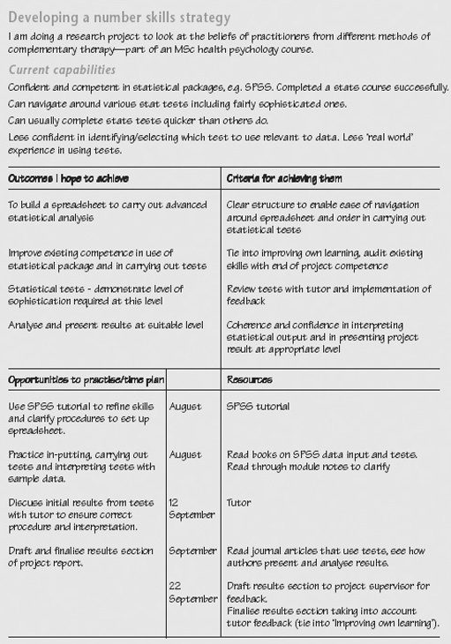
Example of a completed Skills Sheet for ‘Developing your number skills strategy’

7.5 Monitoring progress
This stage of the framework is about keeping track of your progress. Are you using number effectively for your purposes? How do you know? Could you have done things differently: made use of different tools (such as software packages) or facilities, taken more advantage of tutorials, training sessions or local expertise, or recognised that such support would have helped you?
Monitoring your own performance and progress needs practice; try to stand back and look at what you are doing as if you were an independent reviewer. Feedback from others can help you to identify your strengths and weaknesses. You may find it useful to discuss with a tutor, other students, work colleagues or manager how you might monitor your work.
As you work though this stage, take time to use your Skills File to record your own comments on your progress, as well as feedback from others. Finally, at the end of this stage, there is an activity ‘Monitoring and critically reflecting on your number skills strategy’ to complete which asks you to review, reflect on and, if necessary, adapt your number skills development strategy.

7.5.1 Evaluate information from different sources
Be critically aware of the reliability and quality of information from different sources, taking into account factors such as commercial, political, academic or personal interests that may influence selection, content and presentation. How will you judge the quality of the information you find?
You may need to question the validity of statistical information and the way data have been chosen. The size of a survey sample, for example, may be insufficient to support claims of general trends, or the way samples have been selected may introduce bias into the findings.
Explore and critically compare assumptions and predictions based on different data sources, models or mathematical descriptions of a situation. You may need to refer to more than one data source or model, and be able to justify how and why you have selected your data, in order to adequately support your findings or conclusions.

Time out
If you are working with data, note down how and why you have used a particular data source, and why you have confidence in it. If you are using a mathematical model, note down those aspects of the situation which your model stresses, and those aspects it ignores.

7.5.2 Title
Being able to understand and use a range of numerical, graphical, algebraic and other mathematical techniques is a central feature of number skills. Use the following list to help you identify the areas you may need to work on. Will you need to:
- make observations, measurements, and express and combine the units of measurement correctly?
- read and interpret scale drawings, graphs, tables and charts? If so, do you need to learn about the styles and conventions used to present graphical and numerical data?
- organise and classify data? If you need to use a software package to handle and present your data, you may need to schedule some time to learn how to use the software package effectively;
- make inferences and draw conclusions from sets of data by calculating statistics such as mean, standard deviation, and interquartile range? If so, can you interpret the mathematical notation used to express the relevant formula?
- use numerical, graphical and algebraic methods to develop models? You may need to find out how tables of data, graphs and formulae can be related to each other, and what the advantages and disadvantages are of each way of modelling a relationship;
- use ideas of proportion, variation and scaling, including inverse proportion and other non-linear variations? If so, do you understand the difference between a linear and a non-linear relationship?
- work with expressions, formulae and equations, including powers and roots? If so, can you rearrange a formula to express an unknown quantity in terms of known quantities?
- work with probability? You may need to find out how the probabilities of single or multiple events are calculated and interpreted;
- make deductions in algebraic and spatial reasoning and be able to manipulate symbols or shapes as part of your mathematical problem-solving technique?
In carrying out any calculations – whether manually, using a calculator, spreadsheet or other software package – you need to know how to choose the levels of accuracy appropriate to the task, and how to check for errors. Make sure you understand how errors can accumulate when you use approximate data or numbers rounded to significant figures, and what the effect will be on the overall result of your calculations.

Time out
In your Skills File, identify the mathematical areas you need to work on, including any that are not in the above list. Note the area you feel least confident about,

7.5.3 Monitor and critically reflect on your use of number skills
As you use number skills in your work, refer back to the outcomes you hope to achieve and the goals you have set yourself. Ask yourself questions such as:
- am I on track to achieve my outcomes?
- what difficulties in using numerical or mathematical techniques have I experienced and what have I done about them?
- how have the choices and decisions I made impacted on the quality of my work?
- do I need to make any changes in the way I am learning about and using numerical and mathematical skills?
Identify reliable sources of feedback (such as your tutor, other students, project supervisor or work colleagues) and ask for their comments on specific aspects of your work. Use their comments and suggestions constructively to help you monitor your performance, make decisions and focus on those areas you need to work on.
Use any feedback from others, together with your own assessment of how you are learning and improving, to reflect critically on your progress, and to suggest ways to move forward (by improving your existing skills, setting new priorities, or trying different approaches, for example). Remember that being critical does not mean ‘finding fault’. Rather, it means enquiring and being honest with yourself about your performance, your strong points and your weaknesses.

Time out
Remember that we learn from successes as well as from mistakes. Include in your Skills File your critical reflections about what you feel has gone well, and why.

7.5.2a Adapt your strategy to overcome difficulties
Often plans run into difficulties because of unforeseen problems or changing circumstances. For example you may be running over your deadlines, the resources or support you were expecting are unavailable to you, or your personal circumstances may have changed. Plans are only a means to an end, however. If you run into difficulties, take some time to think about what effect they will have on your plans, and what changes you may need to make to your overall strategy to achieve the outcomes you are aiming for.

Time out
Use your Skills File to record any difficulties or changes in circumstances, how they affect you and what you intend to do about them.

Monitoring your progress

For this activity you will need to print out the Skills Sheet, ‘Monitoring your progress’: click here to open it.
On the Skills Sheet briefly summarise and reflect critically on your progress in developing your number skills by considering:
- what numerical and mathematical techniques you used to help you achieve your goals;
- what feedback, help or advice you requested and received on your performance in using number;
- what decisions and choices you made about the approach, methods and techniques you used, as you worked on your number skills; how effective were your choices in working towards your goals?
- what changes, if any, you made to your strategy and plans as your work progressed. Justify briefly any changes you have made.
Refer to the figure below for an example of a completed Skills Sheet for this stage of the key skills framework.

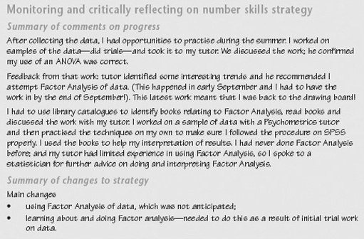
Example of a completed Skills Sheet for ‘Monitoring your progress’

7.6 Evaluating strategy and presenting outcomes
This stage of the framework focuses on identifying what you have achieved and how well you have achieved it. It involves you in evaluating your overall strategy and presenting the outcomes of your work. As you evaluate and assess your strategy, identify aspects of your number skills that you want to develop further. At the end of this stage, use the records in your Skills File to complete the activity ‘Evaluating your use of number strategy and presenting outcomes’ and pull together this final stage in your number skills work.

7.6.1 Interpret results and identify your main findings
In stating your conclusions and interpreting the results of your work, you should refer back to what you set out to investigate or demonstrate. Have you achieved your goals? What evidence have you got to support your conclusions? If you are making general statements based on your work (for example a statistical analysis of data), then you should be able to explain clearly the reasoning that has led to your conclusions. In quoting mathematical results you should be able to say whether the result is always, sometimes, or never true. In using mathematical models, be aware of the assumptions that you have made and the conditions under which your results are valid.

Time out
Numbers, graphs, equations and formulas do not speak for themselves. Make notes about what you understand the results of your numerical and mathematical work to mean in the context of your investigations.

7.6.2 Present information effectively
Organise your data so that you can use it to illustrate and support your arguments or point of view. To do this successfully you must be clear about what you want to say, who is your intended audience, and what points you want your audience to understand. Think about the most appropriate way to present your findings, and whether particular types of charts, graphs or diagrams will bring out the relationships you want to demonstrate. Choosing graph axes carefully (for example using non-linear scales), or using specialised forms of diagrams (for example in engineering applications) may help you to present your data more effectively.

Time out
Be clear who your intended audience is and select your information, style of presentation and language accordingly.

Ensure that any illustrations, graphs, diagrams and charts are correctly labelled and that you have met any particular requirements for presentations. Remember to proofread your own work to check that it makes sense, that the information you have included is accurate and relevant, and that you have included references or acknowledgements to the sources you have used.

Time out
Remember to record fully all references to any information sources as you use them so that you can find them again, and cite them accurately in your presentation so that others will be able to find them.

Check that your intended approach follows accepted conventions, and find out what guidelines or advice are available to you. If you are bringing information together in a single document or presentation, ensure that fonts, layout, number formats, sizes and shapes of graphs, images and tables are consistent and in acceptable styles.
Asking others to read, listen to and comment on the presentation of your results can give you important feedback on your work. Think about who you can ask to provide you with constructive criticism and helpful comments. To help others comment effectively, be clear about what you want them to focus on, such as technical detail, accuracy of content, quality of argument, general structure, grammar and spelling, presentation of results and so on. Decide how you will present your work to them for their feedback.

Time out
Make notes of any feedback, comments and suggestions, and record how you intend to address them.

7.6.3 Explain results in relation to your work
You should be able to explain the results of your work, drawing attention to any patterns, trends or relationships you have identified. What are the consequences of your work? Does it support the hypotheses or assumptions you started with? How did you carry out your work? What lines of enquiry did you follow to reach your conclusions? Were there any dead-ends where you felt you could not make further progress, or particular insights that you felt helped you to understand your work better? You should be able to explain why you pursued some approaches but rejected others; what decisions did you make to keep you on track?

Time out
Remember to record those approaches that don't appear to lead anywhere, as well as those that do. Often there are insights to be gained from apparently unsuccessful attempts to solve a problem.

7.6.4 Evaluate the effectiveness of your strategy
Using the records in your Skills File, look back over your number skills development work and think about how your decisions, and the facilities and constraints of your working environment influenced the way you tackled the task. How effective was your strategy in improving your skills? Identify what was and was not helpful in achieving your goals and outcomes, and assess how your own strengths and weaknesses contributed to this.
Evaluate your achievements against the criteria you established at the outset to judge quality and success. What do you feel you have and have not achieved? What factors had the greatest impact on your strategy? In the light of your evaluation, what changes, if any, would you make to your overall strategy?
Remember to carry out a self-assessment of your skills when you start a new course of study, or a new project. You then have a benchmark or reference point against which to assess your skills development

Time out
Make notes about the success of your strategy. Which skills do you now feel more confident about?

7.6.5 Identify ways of further developing your number skills
Think about your overall number skills and suggest areas where you feel you need to improve, based on the experience you have gained. You might find it useful to discuss with a tutor, manager, another student or work colleague how you might do this. There may be changes you feel you need to make so that you can move forward, such as trying to extend the facilities and resources available to you, changing the way you study to make best use of the time you have, or focusing on improving your own skills in specific areas. For example you may need to improve the precision with which you work with numerical and mathematical techniques, or the level of your own expertise.
Evaluation is an important stage in a project. Do take time to evaluate your work when it is completed; don't just neglect this stage or forget about your work. If you are studying a course, your tutor will have made comments which should help you assess how well you are doing, and what you need to focus on next. If you are improving your skills at work, your manager or supervisor may be able to comment and give suggestions for further development. You may also have received feedback from other sources. You should consider all such feedback carefully and take it into account as you move onto the next stage of your work.

Time out
If you keep a record of feedback you have received, and your responses to it, over a period of time you can see how it has influenced your learning and skills development. You will then be in a good position to know how to improve further.

Activity: Evaluating your number skills strategy and presenting outcomes

For this activity you will need to print out the Skills Sheet, ‘Evaluating your strategy and presenting outcomes’: click hereto open it.
Drawing on the records you have kept in your Skills File, comment critically on:
- the effectiveness of your strategy for improving your number skills, identifying the factors that had an impact on your work;
- those numerical or mathematical techniques where you feel you have made progress, and those where you feel you need more feedback or support;
- what you found useful in helping you to make progress, such as comments from tutors, other students or colleagues, particular resources, particular ways of working or planning your work;
- your own performance in presenting your outcomes as if you were assessing your own work;
- how you intend to develop further your number skills.
Refer to the figure below for an example of a completed Skills Sheet for this stage of the key skills framework.

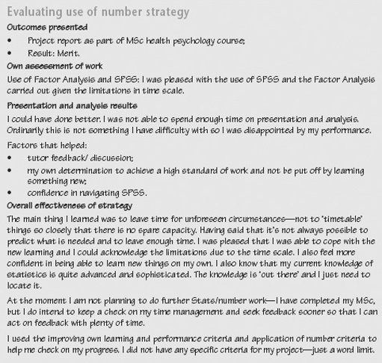
Example of a completed Skills Sheet for ‘Evaluating your number skills strategy and presenting outcomes’

7.7 Drawing ideas together
This key skill has used a three-stage framework for developing your skills. By developing a strategy, monitoring your progress and evaluating your overall approach, you take an active role in your own learning. But learning does not necessarily follow a path of steady improvement, it involves change: revisiting ideas, seeing things from different perspectives, tackling things in different ways.
You are unlikely to be able to complete your work by working through it from beginning to end in a straightforward manner. You will need to bring together your key skills and your subject knowledge to address the tasks you have been asked to complete. As you work, you may discover gaps you still have to fill, areas where you have to dig deeper for information. This is a normal part of trying to put ideas together. In effect, you are piecing together a jigsaw, bringing skills, knowledge, analysis, explanation and interpretation together to make a single coherent picture. Unfortunately, the pieces usually do not all come to hand at just the right moment. The trick is to build up parts of the picture, and then bring those parts together as you begin to see the overall design. The key elements of this approach are:
- Check that you really understand what the work requires. Recognise that your skills and understanding of the task develop over time.
- Break the task into manageable chunks; focus your work on one aspect at a time.
- Think strategically about your approach to the task as you are doing it. Be prepared to change your plan if you need to reschedule your work.
- Work flexibly, using the resources provided as and when you need them.
- Review and reflect on your own performance while you are tackling the work. Your Skills File offers a way of recording and monitoring your development to give you insights into how you are learning as well as into what you are learning.

8 Improving your skills in problem solving

8.1 Introduction to improving your skills in problem solving
This key skill develops your problem-solving skills in your studies, work or other activities over a period of time. To tackle this key skill, you will need to plan your work over at least 3–4 months to give yourself enough time to practise and improve your skills, to seek feedback from others, and to monitor your progress and evaluate your strategy.
Problem solving runs through many other activities and, rather like the key skill ‘Improving own learning and performance’, it can be thought as a ‘metaskill’ – something that helps you plan, choose, use and adapt the specific skills you need to tackle effectively a particular problem. The key skill of problem solving supports you in planning, monitoring and evaluating a range of problem-solving strategies and techniques.
What is defined as a problem tends to depend on the particular context in which it is framed. In mathematics, for example, problems may often be well defined and have particular solutions which can be assessed by commonly agreed methods. In other areas, however, particularly where different people, perspectives and values are brought together, agreeing the boundaries of a problem and how it might be tackled – or even whether there is a problem at all – can be difficult.
In a broader sense, sometimes problems are better not seen as things to be ‘solved’, but as contexts for focusing ideas and stimulating further investigation or discussion. Framing an issue appropriately – identifying why it is a problem, stressing the factors that might have a bearing on it, and outlining what an acceptable resolution might look like – then becomes a central activity. From this perspective, problems are seen as significant questions for negotiation and enquiry, not as solvable puzzles for which there is a single, unambiguous correct answer.
Using problem-solving skills, therefore, is not a question of simply selecting a well-defined problem, choosing a particular procedure to deal with it, and then coming up with a solution. It is about people understanding the context in which they are working, recognising a gap between the present situation and what is desirable, and then being able to move strategically towards their goal.
Being strategic means breaking down an overall goal into sub-goals and reducing a problem to manageable chunks which can then be solved individually and then moving forward. However, there is no guarantee that any particular set of sub-goals will work. The trick is to try to choose those sub-goals that will simplify the problem, and avoid those that will make it worse. The key skill of problem solving aims to raise your awareness of this process.
Improving your skills involves planning how you will frame, explore and simplify your problem area, as well as finding out about the tools and techniques you might use. You will also need to apply, practise and review your skills, using feedback from others to help you think about your progress in relation to your goals. Standing back and reviewing the stages in your work helps you develop a mental picture of ‘how far’ you are from your goals, and what you could do to reduce that distance. Finally, evaluating your strategy and presenting outcomes gives you the opportunity to demonstrate your problem-solving skills, and to assess how successful your strategy was in achieving what you set out to do.

8.2 Working on improving your problem-solving skills
The three-stage framework for developing and improving your skills provides the basis for you to become more confident in:
- developing a strategy for using a variety of problem-solving techniques and tools, including being clear about what you want to achieve, identifying relevant sources of information that will help you to achieve your goals, and planning how you intend to improve your skills;
- monitoring your progress and critically reflecting on your performance by evaluating information from different sources, using different approaches to tackling problems, making appropriate decisions and choices to meet your purposes, and adapting your strategy if necessary;
- evaluating your overall strategy and presenting the outcomes of your work, including selecting appropriate methods to illustrate your problem-solving process; presenting your results clearly, appropriately and accurately to others with evidence to support your conclusions; and assessing how you developed and improved your problem-solving skills.
You will be guided through each of these stages, which aim to help you work on the relevant part of the key skill and are intended to help you think and plan strategically over a period of about 3–4 months. The stages are divided into ‘Time outs’, to prompt you to take time to stop and think about what you are doing. All the Time outs should be seen as contributing to the process of that stage, not as independent tasks to be done one after the other and then ticked off the list. Don't just read through them once. Set aside some time to think about how you are going to tackle each Time out and record in your Skills File the goals you hope to achieve and your strategy for achieving them. It is very likely that you will need to consider each Time out more than once as you pull together your approach to problem solving. Remember also to note your sources of data, your preferred ways of working, and the help and support you need, as well as your comments and ideas about how you will develop and improve your problem-solving skills.
At the end of each stage there is a longer activity for you to complete. A Skills Sheet Template is included for you to record your ideas on. The activity is a way of drawing together and reflecting on your work so far. Keep the completed Skills Sheets in your Skills File as part of your development record.
Click here to open the Bookmark for this section where you'll find the components of the key skill. The Bookmark describes the key skill and gives criteria to help you assess your performance. It is a reference to help you check up on what you should be aiming for, as well as providing brief examples to help you understand the requirements.

8.3 Developing a strategy
In developing a strategy for improving your problem-solving skills you are aiming to:
- identify the opportunities you can use to develop and practise your problem-solving skills;
- establish the outcomes you hope to achieve and targets for achieving them;
- identify the resources you might use for developing your skills, including people who might be able to help you as well as sources of data, books, study guides, tutorials, specialist training, libraries, the Internet, online support and computer conferencing;
- establish a timetable for developing and practising your skills, including deadlines for any assignments you must submit as part of your course or targets you must meet at work;
- consider how you intend to the outcomes you want, and when you intend to complete your work.
In this stage you are laying down the foundations for your work over the next 3–4 months. Planning takes time and thought, so don't rush it. Make sure you allow yourself enough time – perhaps over a period of a week or two – to think about your strategy for improvement. Use the ‘Improving own learning and performance’ key skill to identify your strengths and weaknesses in problem solving, and what you hope to achieve as you work on this skill.
The notes that follow guide you through the process of developing a strategy to improve your problem-solving skills. Use the Time outs to help you plan, implement and evaluate your strategy. Finally, at the end of the stage, you should use the records in your Skills File to complete the activity ‘Developing your problem-solving skills strategy’ and pull together this first stage in your problem-solving skills development.

8.3.1 Identify opportunities for using problem-solving skills
Where and how will you use problem-solving skills over the next 3–4 months? What opportunities do you have to develop your skills? For example, you may be working on a course project with a defined goal but the best route to that goal is not clear; you might be involved in contributing to the design of a system, improving its performance or investigating the feasibility of ideas; you may be involved in resolving resource or staffing difficulties, or in planning a major event.
Problems like this are likely to involve a number of factors which you will have to consider, and this consideration involves more than just following a fixed procedure. On the other hand, what counts as an acceptable solution should not be just a matter of opinion, but should be discussed with others and supported by evidence. Problem solving should present you with a challenge. Spend some time thinking about your study or work requirements and what opportunities you will have or can create to develop your problem-solving skills.
Identifying just what your course or work practice will require and what you will need to focus on can be quite a complex process, so don't be discouraged if you find it difficult. At work you may be able to discuss requirements with colleagues or your manager. On a course you can refer to the aims and outcomes to identify what you are expected to know and be able to do. In an assignment, there may be particular criteria you are expected to meet in order to be successful.
It is unlikely that you will be able to identify and pin down all the opportunities to use problem-solving skills right at the beginning of your course or work activities. New ideas will probably occur as you go along and you may come back to modify and adapt your strategy several times as your work progresses. This is fine – plans should be flexible and responsive as circumstances change. Discussing your ideas with others (such as your tutor, manager, other students or colleagues at work) can be helpful in identifying those aspects of key skills you need to work on.

Time out
Make a list of the problems you expect to tackle over your work period. Identify ones for which you have techniques or procedures and those which you will need to tackle in new ways.

8.3.2 Identify the outcomes you hope to achieve
An outcome is the result or consequence of a process. For example, you may want contribute effectively to a design project in a course, or work in a team to improve a product or system. In this case the design or product improvement is an outcome, and using your problem-solving skills is part of the process by which you achieve that outcome. You may find it useful to discuss or negotiate the outcomes you hope to achieve with others. Solving problems will often depend to some extent on other key skills, in particular ‘Communication’ and ‘Working with others’.
Try to express the outcomes you hope to achieve as clearly and accurately as possible, asking others for help and comments if necessary. To help you work towards your outcomes you may need to set particular goals or targets to aim at. In project work, for example, you may need to learn how to organise the component activities so that you keep on schedule. Tackling this problem effectively may be only one part of the process leading to your overall outcomes, but it may be an important goal to aim for along the way.
Setting outcomes and goals gives a structure to your activities and should help you identify where you need to focus your efforts. When you have completed your task they provide points of reference to help you judge your progress. As part of the evaluation process at the end of a piece of work, you should be able to say which goals and outcomes were achieved, or what the problems have been. To help you do this, think about how you will know whether you have achieved what you set out to do. For example, you may be seeking a better grade for an assignment, or positive feedback from your tutor or work colleagues. What criteria will you use to evaluate your progress?

Time out
List the outcomes you hope to achieve and the goals you have set to help yourself achieve them, noting which ones have a high priority for development. How will you judge whether you have achieved your outcomes satisfactorily?

8.3.3 Explore problems
Recognising and framing problems so that you can tackle them effectively is a central part of a problem-solving strategy. Often, problems are not presented in a well-defined way, and it is up to you to define exactly why a problem exists and what its boundaries are.
Recognising a problem means identifying that there is a gap between the present situation and what is desirable, and establishing that no immediate solution is at hand. This exploratory stage is about finding out more about the nature of the problem, so that informed judgements can be made about whether a solution is possible and achievable. Approaches include:
- Reframing the problem. What is it that makes the problem a problem? Try to see the problem from different points of view to get a feel for what affects it and, in turn, what is affected by it. What is the scope of the problem? How relevant is it to different groups of people? How does it, or its proposed solution, impinge on others’ interests and concerns?
- Simplifying the problem. How might the problem be divided into smaller sub-problems which can be tackled separately and contribute to an overall solution? What are the important and unimportant features of the problem? Since you cannot take everything into account in every situation, what features do you need to emphasise to help you clarify and simplify the problem and which do you need to ignore?
- Making comparisons. Have you come across any similar problems that could offer useful ideas, methods or techniques? What other experiences can you bring to bear on the problem; what similar situations have you come across that might help you think about or re-state the problem? What specialist knowledge do you have that you can draw on?

Time out
Note the important features of your problem and say why they are important. What is the scope of the problem? Comment on or sketch out the main components and their interactions with each other, for example, using a spray diagram.

8.3.4 Research information from other sources
Spend some time finding out about what you will need to help you complete your problem-solving work successfully and who you need to consult. You may need to arrange access to a library, the Internet, databases on CD-ROM or online, or specialist training or publications. If you need to learn more about tools or techniques (for example concept maps, critical-path diagrams or flowcharts), then look first at your course material, and then at study guides or notes aimed at your area of interest (social science, science, technology). Find out about relevant tutorials or training sessions you can attend.
You may find that material or resources associated with courses or projects other than your own may be helpful. Find out who might be able to help you track down information; you may need the support of a tutor or manager, specialists such as librarians, or other students or colleagues.
Establishing where your information is going to come from will help you to think about how you are going to manage and organise your work. Keep an accurate record in your Skills File of the sources and references you have tracked down so that you can find them again, or provide accurate references for others to find them. If you are using a web browser, make sure you know how to: bookmark relevant web pages, download information, and save text and images in appropriate formats.

Time out
Make a note of what information you will need to find, where you will find it, and which people you should contact to help you.

8.4 Developing a strategy

8.4.1 Plan your use of problem-solving skills and select methods
Exploring and planning an activity often results in different options, possibilities and ways forward. Some approaches will be more feasible or will interest you more than others. At this stage you need to think about how you will be using your problem-solving skills and how you will assess the overall quality of your work. To help you make these decisions, you may find tools such as concept maps or critical-path analysis helpful in representing the different parts of the problem-solving activity, visualising the relationship of the parts to each other, and suggesting the order in which they might best be tackled.
What methods, tools or techniques do you intend to use to achieve your goals? You may want to consider collaborative, visual, verbal, numerical, auditory or physical methods. You should be able to explain and justify the methods you choose and show that they are valid in the circumstances. What are the strengths and weaknesses of your problem-solving techniques?
Review the skills you will need to achieve your goals and the criteria you will use to check that you have achieved them. Opportunities and constraints to do with your level of personal expertise, availability of resources, access limitations, work patterns, health and safety issues, social, ethical and moral concerns may all influence your plans. Planning approaches include:
- sequencing: preparing a timeline for your tasks, indicating how the tasks depend on each other; set up milestones and review points to help you monitor your progress;
- contingencies: unexpected events can throw a project off-course. What obstacles might be thrown up? What might go wrong, and what actions could you take if they do?
- resourcing: what do you need to help you complete your work? What roles will others be taking? What are your interim goals for each stage of the project?
Be realistic about what you can achieve in the time you have available and set yourself some deadlines. Remember that plans are guidelines against which you can check progress, but also that all plans are based on assumptions about the future. Keep your plans under review and be prepared to modify them if circumstances change or if your assumptions don't work out. Don't forget to record your decisions, plans and actions in your Skills File.

Time out
What problem-solving techniques do you plan to use and how will you use them? Go back to any plans you have made and check that they are still relevant, up to date and realistic. Include any sketches of concept maps or critical-path diagrams in your notes.

Activity: Developing your problem-solving skills strategy

For this activity you will need to print out the Skills Sheet, ‘Developing your strategy’: click here to open it.
Outline a strategy for developing and improving your problem-solving skills by focusing on the following questions. In developing your problem-solving skills:
- What do you hope to achieve?
- What opportunities do you have for practising and improving and demonstrating your skills?
- What resources, including help and advice from others, can you draw on?
- How do you intend to achieve your goals and outcomes, and what timetable have you set yourself? Include dates of any relevant assignments you intend to submit.
Make brief notes:
- justifying why you have chosen your intended outcomes;
- indicating the constraints – or your own styles and preferences for learning – which may influence the way you learn and improve your skills.
Refer to the figure below for an example of a completed Skills Sheet for this stage of the key skills framework.

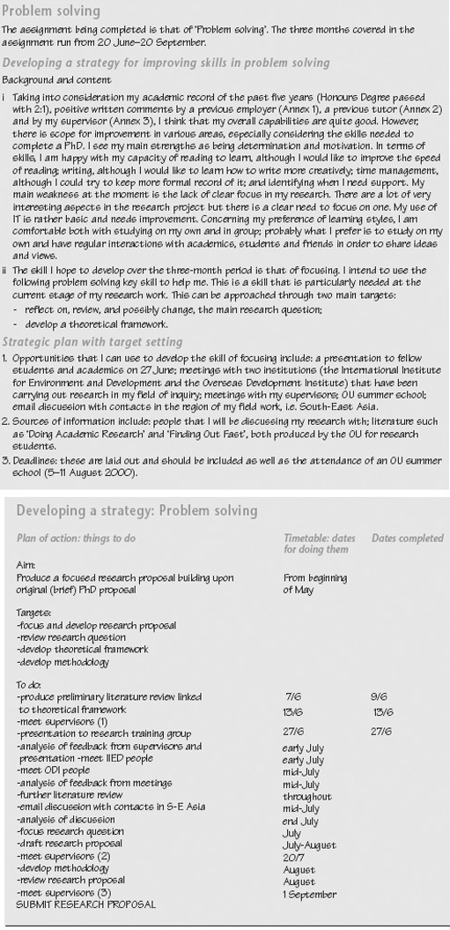
Example of a completed Skills Sheet for ‘Developing your problem-solving skills strategy’

8.5 Monitoring progress
This stage is about keeping track of your progress. Are you tackling your problem-solving activities effectively? How do you know? Could you have done things differently, made use of different tools (such as software packages) or facilities, taken more advantage of tutorials, training sessions or local expertise, or recognised that such support would have helped you?
Monitoring your own performance and progress needs practice; try to stand back and look at what you are doing as if you were an independent reviewer. Feedback from others can help you to identify your strengths and weaknesses. You may find it useful to discuss with a tutor, other students, work colleague or manager how you might monitor your work.
As you work though this stage of the framework, take time to use your Skills File to record your own comments on your progress, as well as feedback from others. At the end of this stage there is an activity ‘Monitoring and critically reflecting on your problem-solving skills strategy’ to complete. This activity asks you to review, reflect on and, if necessary, adapt your problem-solving skills development strategy.

8.5.1 Generate a variety of ways of tackling problems
Where the best way, or, indeed, any way, of tackling a problem is not obvious, there are a number of tools and techniques which can be useful to stimulate ideas and different ways of thinking:
- reasoning: reaching conclusions or deciding on paths of action by means-end analysis or critical-path analysis;
- matching: recognising similarities with other situations, drawing analogies, adapting solutions that have worked or shown promise elsewhere;
- fluency: using your imagination to come up with ideas, such as in brainstorming or group sessions;
- collaborative: getting others to contribute, for example by allocating roles and responsibilities in a team, or by involving a tutor, manager, colleague or client in discussions;
- written and visual: text or diagrams showing relationships, for example, concept maps, spray diagrams, graphs and charts;
- number: analysis involving calculations, such as summary statistics, graphs, correlation and regression analysis;
- physical: using 2D- and 3D-models and designs to illustrate shapes and spatial relationships;
- consulting: gathering information from others affected by the problem as well as from specialists and experts, as necessary, through discussions, surveys and interviews; and
- risk-limiting: establishing the least risky approach, such as, for example, using decision trees, or pay-off matrices.

Time out
Note ideas as they occur to you, and also note down the circumstances in which they were produced. You may find that you generate ideas more easily in some situations than others, for example when you are writing, or talking with others.

8.5.2 Identify options that have a chance of success
Explore and compare the options available to you. Be critically aware of the different factors such as technical, commercial, political, academic or personal interests that may influence your choice of options.
How will you arrive at those solutions most likely to meet the agreed conditions for success? In comparing possible approaches you might use:
- decision-making techniques: developing and applying a decision tree to help you select appropriate methods; seeking and gaining support, co-operation and advice from interested parties; reviewing the effectiveness of previous solutions;
- risk analysis: adopting or developing a risk model and using it to review methods, constraints, obstacles and disadvantages; clarifying and assessing the risks involved to individuals or the environment as a result of a particular course of action; assessing the acceptability or otherwise of particular risks;
- resources: ensuring that necessary resources are available and that you are permitted to use them; identifying alternative approaches if the resources or your access to them change.

Time out
Note in your Skills File how you chose the options to follow up, and the final choice you made. Do any of your approaches have additional benefits or a wider impact?

8.5.3 Negotiate the option to be taken forward
In many contexts problem-solving activities will involve other people. You may need to seek permissions, advice, support and resources from a range of people, such as your tutor, manager, group or team colleagues, or others who may have authority over or be affected by your work.
Some aspects of negotiation are:
- gaining the co-operation of colleagues, as necessary;
- establishing the availability of resources, including staffing;
- agreeing the roles of others based on their experience and expertise; and
- agreeing your schedule and deadlines.
You may need to explain to others who do not share your expertise or interest what you are setting out to achieve. To help you do this, make sure that your main goals are clear to yourself and are not obscured by technical detail. You should be able to explain clearly how you will demonstrate your problem's solution, perhaps to a non-specialist audience.

Time out
Make a list of people involved and how they will be affected by your proposals. Who can help you take your option forward?

8.5.4 Manage each stage of the work effectively
Effective management means putting your resources to work and monitoring your progress. For each stage of the work you will need to gather together the resources necessary in good time, and maintain the co-operation of other people working with you. Think about how you will keep the project moving forward for all those involved. Are the goals still clear, or have you become enmeshed in detail?
Use milestones or review points to keep your plan up to date and, if necessary, modify your plan to reflect improvements, setbacks or changed circumstances. By monitoring and recording your progress, you are setting up a trail which you can return to and learn what went right, what went wrong, what you did about it, and how effective your actions were.

Time out
Identify how you are going to check results and progress at each stage, and record in your Skills File any changes of strategy, or any difficulties, with the reasons.

8.6 Monitoring progress

8.6.1 Monitor and critically reflect on your use of problem-solving skills
As you use problem-solving skills in your work, refer back to the outcomes you hope to achieve and the goals you have set yourself. Ask yourself questions such as:
- am I on track to achieve my outcomes?
- what difficulties in using problem-solving techniques have I experienced and what have I done about them?
- how have the choices and decisions I made impacted on me and on others?
- do I need to make any changes in the way I am learning about and using problem-solving skills?
Identify reliable sources of feedback (such as your tutor, other students, project supervisor or work colleagues) and ask for comments on specific aspects of your work. Use their comments and suggestions constructively to help you monitor your performance, make decisions and focus on those areas you need to work on.
Use any feedback together with your own assessment of how you are learning and improving, to reflect critically on your progress, and to suggest ways to move forward (such as by improving your existing skills, setting new priorities, trying different approaches). Remember that being critical does not mean ‘finding fault’. Rather, it means being enquiring and honest with yourself about your performance, your strong points and your weaknesses.

Time out
Remember that we learn from successes as well as from mistakes. Include in your Skills File your critical reflections about what you feel has gone well, and why.

8.6.2 Adapt your strategy to overcome difficulties
Often plans run into difficulties because of unforeseen problems or changing circumstances. For example, you may be running over your deadlines, the resources or support you were expecting are unavailable to you, or your personal circumstances may have changed. Plans are only a means to an end, however. If you run into difficulties, take some time to think about what effect they will have on your plans, and what changes you may need to make to your overall strategy to achieve the outcomes you are aiming for.

Time out
Use your Skills File to record any difficulties or changes in circumstances, how they affect you and what you intend to do about them.

Activity: Monitoring your progress

For this activity you will need to print out the Skills Sheet, ‘Monitoring your progress’: click hereto open it.
On the Skills Sheet, briefly summarise and reflect critically on your progress in developing your problem-solving skills by considering:
- what problem-solving techniques did you use to help you achieve your goals;
- what feedback, help or advice you requested and received on your performance in using problem-solving;
- what decisions and choices you made about the approach, methods and techniques you used, as you worked on your problem-solving skills; how effective were your choices in working towards your goals?
- what changes, if any, you made to your strategy and plans as your work progressed. Justify briefly any changes you have made.
Refer to the figure below for an example of a completed Skills Sheet for this stage of the key skills framework.

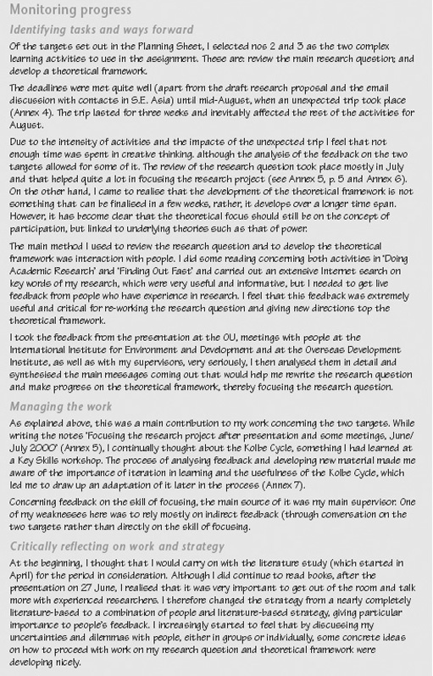
Example of a completed Skills Sheet for ‘Monitoring your progress’

8.7 Evaluating strategy and presenting outcomes
This stage of the framework focuses on identifying what you have achieved and how well you have achieved it. It involves you in evaluating your strategy and presenting the outcomes of your work. As you evaluate and assess your strategy, identify aspects of your problem-solving skills that you want to develop further. At the end of this stage, use the records in your Skills File to complete the activity ‘Evaluating your problem-solving strategy and presenting outcomes’ and pull together this final stage in your problem-solving skills work.

8.7.1 Illustrate your problem-solving process and present results
How will you best present your problem-solving process to others? You may need to produce a written account or report as well as an oral presentation. What material will you need to support your work? You may need to provide posters, organise a demonstration, a working model or a prototype product, or be able to offer other examples of your work. Find out what is expected of you and the format in which you should present your findings.
What evidence do you have to support your conclusions and demonstrate that your problem-solving strategy has been successful? You may have a particular product (for example some software, a report or analysis, or a different organisational structure) that has resulted from your approach. Can you report on any tests, trials or comments from others that indicate you have achieved your goals? If you are making general statements based on your work then you should be able to explain clearly the reasoning that has led to your conclusions.

Time out
Report those methods that did not lead anywhere, as well as those that did. Often there are insights to be gained from apparently unsuccessful attempts to solve a problem.

Organise your data so that you can use it to illustrate and support your arguments or point of view. To do this successfully you must be clear about what you want to say, who is your intended audience, and what points you want your audience to understand. Think about the most appropriate way to present your information, and whether particular types of graphs, charts or diagrams will bring out the relationships you want to demonstrate.
Ensure that any illustrations, graphs, diagrams and charts are correctly labelled and that you have met any particular requirements for presentations. Remember to proofread your own work to check that it makes sense, that the information you have included is accurate and relevant, and that you have included references or acknowledgements to the sources you have used.

Time out
Be clear about who is your intended audience and select your information, style of presentation and language accordingly.

Asking others to read, listen to and comment on the presentation of your results can give you important feedback. Think about who you can ask to provide you with constructive criticism and helpful comments. To help others comment effectively, be clear about what you want them to focus on, such as technical detail, accuracy of content, quality of argument, general structure, grammar and spelling, presentation of results and so on. Decide how you will present your work to them for their feedback.

Time out
Record any results, feedback, comments or suggestions your receive, and note how they demonstrate your problem-solving skills.

8.7.2 Assess the effectiveness of your strategy
How did you carry out your work? What lines of enquiry did you follow to reach your conclusions? Were there any dead-ends where you felt you could not make further progress, or particular insights that you felt helped you to better understand your work? You should be able to explain why you pursued some approaches but rejected others; what decisions did you make to keep you on track?
In stating your conclusions and interpreting the results of your work, you should refer back to what you first set out to investigate or to demonstrate. Have you achieved your goals? Review your Skills File or other records you have kept of your work to check how successful your methods were in tackling the problems you identified at the outset. You should assess:
- adequacy: compare the resources you used and time you spent with the estimates you made when you planned the work; check that your methods were appropriate for your task and that other people were satisfied with your work. Were there any good or bad side-effects of your approach?
- modifications: describe any difficulties you found and how you coped with them. What changes did you have to make to your plans or goals?
- alternatives: identify other approaches that, with hindsight, you should have tried. What other methods might have been more effective; why did you not try them at the time?

Time out
Comment on how effective your strategy was in tackling your problem. How might your solution have been improved?

Using the records in your Skills File, look back over your problem-solving skills development work and think about how your decisions, and the facilities and constraints of your working environment influenced the way you tackled the task. How effective was your strategy in improving your skills? Identify what was and was not helpful in achieving your goals, and assess how your own strengths and weaknesses contributed to this. Are there any areas in which you feel you need to improve your performance?
Assess your achievements against the criteria you established at the outset to judge quality and success. Comment on those outcomes you feel have not been achieved. In the light of your assessment what changes, if any, would you make to your overall strategy?
Carry out a self-assessment of your skills when you start your next course of study, or new project. You then have a benchmark or reference point against which to assess your skills development in the future.

Time out
Make notes about the success of your strategy. Which aspects of problem-solving do you now feel more confident about?

8.8 Evaluating strategy and presenting outcomes

8.8.1 Identify ways of further developing your problem-solving skills
Think about your overall problem-solving skills and suggest areas where you feel you need to improve, based on the experience you have gained. You might find it useful to discuss with your tutor, manager, another student or work colleague how you might do this. There may be changes you feel you need to make so that you can move forward, such as trying to extend the facilities and resources available to you, changing the way you study to make best use of the time you have, or focusing on improving your own skills in specific areas.
Evaluation is an important stage in a project. Do take the time to evaluate your work when it is completed; don't just neglect this stage or forget about your work. If you are studying a course, your tutor will have made comments which should help you assess how well you are doing, and what you need to focus on next. If you are improving your skills at work, your manager or supervisor may be able to comment and give suggestions for further development. You may also have received feedback from other sources. You should consider all such feedback carefully and take it into account as you move onto the next stage of your work.

Time out
If you keep a record of feedback you have received, and your responses to it, over a period of time you can see how it has influenced your learning and skills development. You will then be in a good position to know how to improve further.

Activity: Evaluating your problem-solving strategy and presenting outcomes

For this activity you will need to print out the Skills Sheet, ‘Evaluating your strategy and presenting outcomes’: click here to open it.
Drawing on the records you have kept in your Skills File, comment critically on:
- the effectiveness of your strategy for improving your problem-solving skills, identifying the factors that had an impact on your work;
- those problem-solving techniques where you feel you have made progress, and those where you feel you need more feedback or support;
- what you found useful in helping you to make progress, such as comments from tutors, other students or colleagues, particular resources, particular ways of working or planning your work;
- your own performance in presenting your outcomes as if you were assessing your own work; and
- how you intend to develop further your problem-solving skills.
Refer to the figure below for an example of a completed Skills Sheet for this stage of the key skills framework.

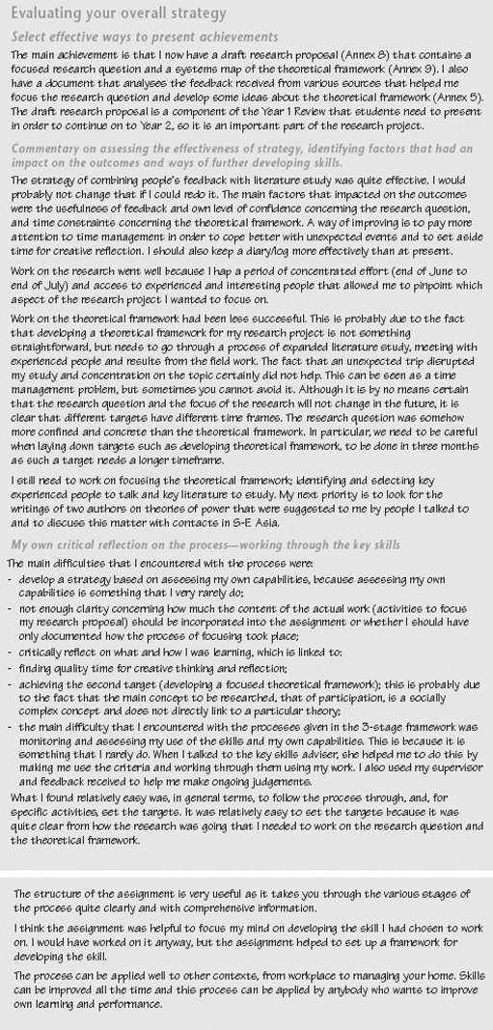
Example of a completed Skills Sheet for ‘Evaluating your problem-solving strategy and presenting outcomes’

8.9 Drawing ideas together
This key skill has used a three-stage framework for developing your skills. By developing a strategy, monitoring your progress and evaluating your overall approach, you take an active role in your own learning. But learning does not necessarily follow a path of steady improvement, it involves change: revisiting ideas, seeing things from different perspectives, tackling things in different ways.
You are unlikely to be able to complete your work by working through it from beginning to end in a straightforward manner. You will need to bring together your key skills and your subject knowledge to address the tasks you have been asked to complete. As you work, you may discover gaps you still have to fill, areas where you have to dig deeper for information. This is a normal part of trying to put ideas together. In effect, you are piecing together a jigsaw, bringing skills, knowledge, analysis, explanation and interpretation together to make a single coherent picture. Unfortunately, the pieces usually do not all come to hand at just the right moment. The trick is to build up parts of the picture, and then bring those parts together as you begin to see the overall design. The key elements of this approach are:
- Check that you really understand what the work requires. Recognise that your skills and understanding of the task develop over time.
- Break the task into manageable chunks; focus your work on one aspect at a time.
- Think strategically about your approach to the task as you are doing it. Be prepared to change your plan if you need to reschedule your work.
- Work flexibly, using the resources provided as and when you need them.
- Review and reflect on your own performance while you are tackling the work. Your Skills File offers a way of recording and monitoring your development to give you insights into how you are learning as well as into what you are learning.

9 Improving your skills in working with others

9.1 Introduction to improving your skills in working with others
This key skill focuses on developing your skills in working with others and applying these skills in your studies, work or other activities over a period of time. To tackle all of this key skill you will need to plan your work over at least 3–4 months to give yourself enough time to practise and improve your skills, to seek feedback from others, and to monitor and evaluate your performance.
A main purpose of this key skill is to guide you through the management of a group activity culminating in a group presentation of the outcomes of the work. It involves you in actively contributing to the presentation of information.
You will need to identify opportunities for developing your skills in working with others, for example, when:
- managing and presenting outcomes of a group project carried out at a residential school;
- contributing to community activities, such as organising a major event;
- investigating and implementing ways to improve work practice.

9.1.1 About working with others
Very few people study or work in complete isolation. Some courses now set projects and assignments that need to be completed in pairs or groups, either face-to-face or using e-conferencing. Even if your course does not formally require you to do this, working with others is an important part of your skills portfolio. Most jobs require you to work as part of a team, and employers value individuals who can demonstrate this.
In working on a work project or an assignment with others – in pairs or in a group – you will be learning two different things at once. You will be learning about the task or project that you have been set and you will also be learning about how to work with colleagues. The methods you choose to use to communicate and work together will relate to your particular circumstances, but the processes are similar.
Each member of a group influences how that group operates, even if only by remaining silent. The success of the group depends largely on whether everyone is prepared to take some responsibility for how the group operates and whether everyone feels free to contribute fully. Group working skills are not the sort of skills you can learn just by reading about them. To develop the skills needed to be an effective team member you need to practise them in a group setting with a real task.
Working in a group is not just about getting a job done. It is about communicating effectively, contributing ideas and listening to those of others, and receiving feedback approximately, keeping the level of interest and excitement going, and leading or following the lead as appropriate.
Because it is difficult to arrive at one definition of a group that is acceptable to all, it may be best to think instead of characteristics that describe a group. A collection of people is likely to be a group when it possesses the following characteristics:
- a definable membership – a collection of two or more people;
- consciousness of membership – members think of themselves as a group, have a collective perception of unity, and have a conscious identification with each other;
- a sense of shared purpose – members have the same goals or ideals;
- interaction – members communicate with one another, influence one another, and react to one another;
- ability to act in a unitary manner – the group can behave as a single organism.
Although each group will have its own particular qualities, most effective groups have the five general characteristics listed above.
A group then is a collection of people who interact with each other, are aware of each other, are working towards some common purpose, and perceive themselves to be a group. Groups are the building blocks of the larger organisation and most decisions in organisations are made by groups.
Some people tend to adopt particular roles within a group, such as, for example, individual dominance, when one individual dominates the group. This is not always helpful, since the most effective group members are those who are aware of what is going on at a social and emotional level – not just at a formal level – and can adapt their behaviour to suit the needs of the group at that moment, such as, for example, taking the initiative to lead when others are floundering; encouraging the more reticent group members to contribute; diffusing potential flash points; or suggesting a compromise that will allow others to move on without losing face.
One problem is that when you work with a partner or in a group, you are usually so caught up in the task or the problem to be solved that you do not always notice your own performance or think about the best ways of working. To improve your own effectiveness, you need to become consciously aware of what you are doing and how you are doing it while the group is operating. Then, when the group work is complete, you should take time to look back both on how the task has been accomplished and on how you have contributed as a group member. The dynamics of the group and the ways people work together on the task will inevitably affect your performance as an individual. So, to improve your own performance you also need to understand more about how groups operate and how you might be able to help the group function more effectively.
When you are faced with a project or an assignment that requires you to work with other people, it is easy to plunge into the task without considering what is involved and how you, individually and as part of the group, can help to achieve it. As with most complex tasks, the secret is not to try to tackle everything at once but to break down the task into manageable chunks. No one is good at everything; there are likely to be some aspects where you feel able to cope and some where you need help. Being able to work successfully with other people is such an important skill that it is worth taking time to think about how you work with others at the moment and how you might improve on this.

Working on improving your skills in working with others
The three-stage framework for developing and improving your skills provides the basis for you to become more confident in:
- developing a strategy for using a variety of techniques and tools for working with others, including being clear about what you want to achieve, identifying relevant sources of information that will help you to achieve your goals, and planning how you intend to improve your skills;
- monitoring your progress and critically reflecting on your performance by evaluating information from different sources, using different approaches, making appropriate decisions and choices to meet your purposes, and adapting your strategy if necessary;
- evaluating your overall strategy and presenting the outcomes of your work, including selecting appropriate methods to illustrate your skills in working with others; presenting your results clearly, appropriately and accurately to others with evidence to support your conclusions; and assessing how you developed and improved your skills in working with others.
You will be guided through each of these stages, which aim to help you work on the relevant part of the key skill and are intended to help you think and plan strategically over a period of about 3–4 months. The stages are divided into ‘Time outs’, to prompt you to take time to stop and think about what you are doing. All the Time outs should be seen as contributing to the process of that stage, not as independent tasks to be done one after the other and then ticked off the list. Don't just read through them once. Set aside some time to think about how you are going to tackle each Time out and record in your Skills File the goals you hope to achieve and your strategy for achieving them. It is very likely that you will need to consider each Time out more than once as you pull together your approaches to working with others. Remember also to note your preferred ways of working, and the help and support you need, as well as your comments and ideas about how you will develop and improve your skills in working with others.
At the end of each stage there is an activity for you to complete. A Skills Sheet Template is included for you to record your ideas on. The activity is a way of drawing together and reflecting on your work so far. Keep the completed Skills Sheets in your Skills File as part of your development record.
Click here to open the Bookmark for this section where you will find the components of the key skill. The Bookmark describes the key skill and gives criteria to help you assess your performance. It is a reference to help you check up on what you should be aiming for, as well as providing brief examples to help you understand the requirements.

9.3 Developing a strategy
In developing a strategy for improving your skills in working with others you are aiming to:
- identify the opportunities you can use to develop and practise your skills in working with others, and the goals you hope to achieve;
- identify the resources you might use for developing your skills, including people who might be able to help you as well as libraries, books, databases, the Internet or online support;
- establish a plan for working with others that has been negotiated with the team members, and has identified the expertise needed for the work. You will need to set any deadlines and negotiate the working arrangements to complete the task.
In this stage you are laying down the foundations for your work over the next 3–4 months. Planning takes time and thought, so don't rush it. Make sure you allow yourself enough time – perhaps over a period of a week or two – to think about your strategy for improvement. Use the ‘Improving own learning and performance’ key skill to identify your strengths and weaknesses in working with others, and what you hope to achieve as you work on this skill.
The notes that follow guide you through the process of developing a strategy to improve your skills in working with others. Use the Time outs to help you plan, implement and evaluate your strategy. Finally, at the end of the stage, you should use the records in your Skills File to complete the activity ‘Developing a strategy for using skills in working with others’ and pull together this first stage in your working with others skills development.

9.3.1 Establish opportunities for using skills in working with others
You need to identify activities that will provide you with opportunities for working with others over a period of 3 months or so. This could involve both one-to-one and group situations, such as working on a particular project at work, a group project as part of your course or e-conferencing on a group assignment.

Time out
Check that you have opportunities to work in a team and not simply alongside others. This means you need to have a project or piece of work that involves others where you need to collectively plan, research and do the work. You may find it helpful to discuss your ideas with a manager or tutor at an early stage.

9.3.2 Identify what you hope to achieve
It is a good idea to know not only what you are trying to achieve, but also when you have achieved it, so it is important that your goals are clear and that you can easily measure your progress against them. Setting realistic targets, planning actions and modifying those plans in the light of experience are all part of developing this key skill, but this time they need to be done and negotiated within the group.

Time out
Identify and negotiate what you hope to achieve and how you will determine or measure the quality of the work. Try to be as specific as you can by writing outcomes which you can then use to help you monitor and evaluate the work. Begin to make decisions about who will keep records of meetings, decisions and so on and how and where will they be kept. Also consider the records you need personally to keep to help you reflect on your own progress and contribution to the group.

9.3.3 Identify relevant sources of information
Exploring and identifying sources of information is about finding out what you don't know as well as using and adapting what you do know. Group projects and assignments frequently require you to carry out research and this will involve identifying specific resources you may need. For example, think about the materials and equipment that might be needed and whether the group needs to get specific expert advice and support and, if so, where you can obtain this.
It is also important to spend some time exploring the skills associated with working in a group and managing the group. There may be discussions and workshops on team working that you hope to make use of, or there may be expertise in the group itself that you can draw on. Group working skills may be new to you, but equally they may be skills you have used many times before in different contexts. Using key skills effectively involves thinking not only about which skills to use, but also about how to adapt them to different situations.

Time out
Find out about how groups function and how you can operate effectively as one of a group. Check that you know how you and others might work together effectively, including the allocation of areas of responsibility, the balance of expertise and experience needed, how different roles may contribute to a successful outcome and how to avoid discriminatory behaviour. Be aware of the boundaries to both the work and your own and others’ responsibility and accountability.
Keep a record of your information research including details of any expert help and advice of which you are planning to make use.

9.3.4 Plan work with others for achieving the quality outcomes required
If you are doing this to complete a project as part of your study, check if the work is going to be assessed, and make sure you know how marks will be allocated and what criteria will be used. Take time to read carefully any instructions you have been given on group work for the activity – ask your tutor for advice if you are unsure about anything, particularly if this is the first time you have been set a group task. Check whether you will be assessed as a group or as individuals. Will the way the group operates be assessed, as well as the product or solution produced by the group? This will help you prepare effectively both as individuals and as a group. Keep ongoing records of the planning process. If you have been assigned to a team at work, try to establish as clearly as possible what you are expected to do, and where you might get information and support. If you lack a clear picture of what you should be doing, it is difficult to get your job under control.
Once you have this information, you can begin to plan and schedule your work in more detail. You now need to decide who will do what. In allocating and negotiating your own and others’ responsibilities, you may need to make appropriate and sensitive suggestions, backed up with evidence of ability to fulfil these, as well as evidence of similar work undertaken successfully or other work experience.
Think about how often you intend to meet as a group and how you will monitor progress. Remember, you have to keep two important things in mind all the time: the work itself and how you work with others to complete it. It is also worth considering what the group will do if something goes wrong; for example if one member of the group is sick, or finds their allocated task too daunting. How will the group deal with such difficulties? Once you have sorted out the tasks and the timescale, it is a good idea to record the agreed schedule and make sure everyone has a copy. There should then be no confusion over meetings, deadlines, and so on.
Successful team working is possible only if everyone in the group is clear about the target the group is working towards, how this target will be met and how their contribution fits with those of others. All this sounds straightforward, but in practice many factors can, and do, disrupt the planning stage. For example, you may be assigned, or have to assign, tasks that are unpopular, or where you feel there are not the skills or experience within the group to complete the work successfully. You may be leading a group that includes people who are older than you, or more experienced. There are no absolutes when working with others but there are tactics and strategies you can use to help you work successfully with peers. As obvious as these suggestions may seem, many people ignore them. So many people think they are such experts at human relations that they do not bother to think systemically about their behaviour in relation to others. The following suggestions are particularly geared towards developing good relationships with others:
- adhere to group norms, that is, unofficial standards of the group;
- express an interest in their work;
- be a good listener;
- maintain honest and open relationships;
- display a helpful, co-operative and courteous attitude;
- do favours;
- phrase demands as requests for help; and
- give recognition to others.

Time out
Make sure you have a record of the actions that need to be taken and by whom and the resources needed. For instance, what timescales are involved, who will do particular tasks and by when, and at what stage might you need to get specific expert advice and support from others? Build in checkpoints so the group can make progress checks.

You may find it useful to refer to the checklist below to make sure that everything has been covered. This lists the sorts of things you need to think about when embarking on a project or piece of work to be completed by working in a group.

Checklist for working on a project in a group
Checklist | Comments
Have we defined the problem and are the targets clear and agreed?
Have we got all the information we need at the moment?
Do we have the resources and equipment we need?
What strategies are in place if the need for further resources emerges later?
Have the tasks and responsibilities been agreed?
Are we communicating clearly and honestly with each other?
Do we need to get assistance or advice from anyone?
Are we prepared to support each other when necessary?
Have we agreed an action plan or way forward?
Is the timescale realistic for each member of the group?
Have we discussed how we might deal with potential difficulties?

At this stage, and as part of your preparation, you may want to look again at your plans for completion of the work. As you begin to do the work, use your checkpoints to monitor progress and look at your strategy and plans. These may change. Keep your strategy and supporting documents up to date with the group's current thinking and ideas.
You will need to consult other members of the group to check that they each have sufficient time to complete all the different aspects of the task on time. Use the activity below to record an outline of your strategy supported by records of your information research, notes of your planning process and statements on the expected quality of outcomes.

9.4 Activity: Developing your strategy for using skills in working with others

Develop a strategy for using skills in working with others over a period of time. Your strategy should include:
- an identification of the opportunities you can use to practise your skills in working with others;
- an identification of what you hope to achieve by working on this key skill, expressed as targets;
- the resources you might use for developing your skills, including specific help and support you need for planning purposes; and
- a plan of how you will work with others, including methods and working relationships.
As part of your strategy document you need to include:
- records of your information research logged in an appropriate way;
- records of your planning process, with notes of how you negotiated responsibilities and working arrangements; and
- statements on the expected quality of outcomes with notes on selected methods.
Refer to the figure below for an example of a completed Skills Sheet for this stage of the key skills framework.

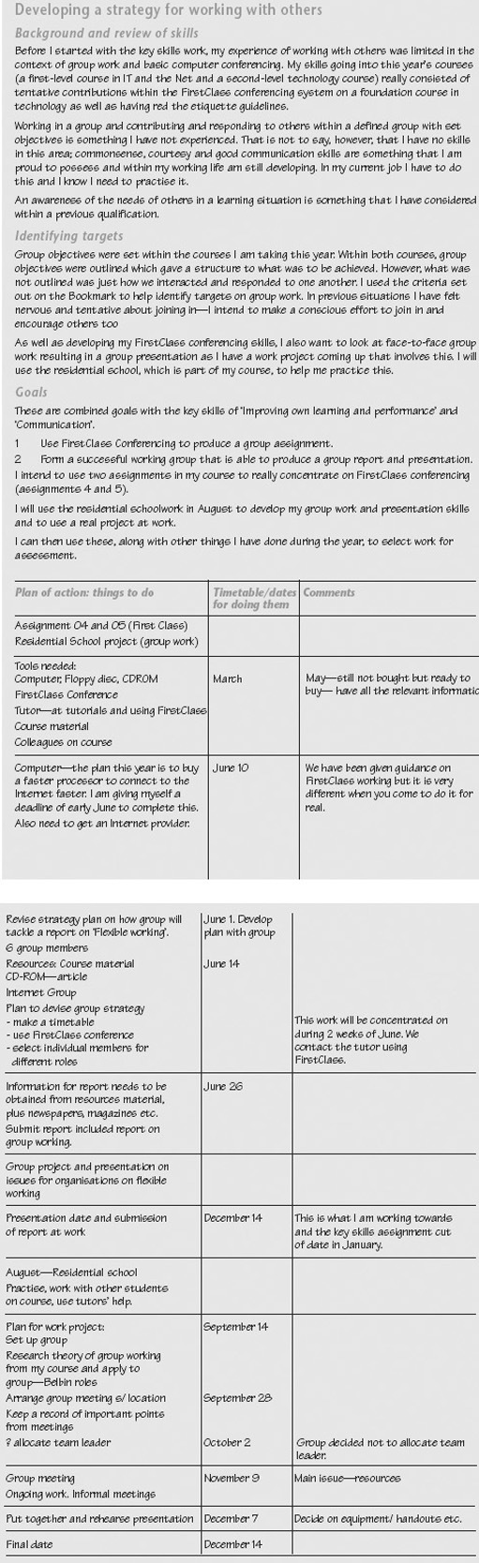
Example of a completed Skills Sheet for ‘Developing your strategy for using skills in working with others’

9.5 Monitoring progress
Monitoring progress is about keeping track of how the work with others is going, making sure you are ‘on task’ and ‘on time’. You need to know how to monitor progress in managing a group activity and being a team member. This will involve considering the relationships within the group and managing the quality of the work by using the checkpoints to review the progress towards your goals and outcomes.
Monitoring progress in working with others involves you considering your progress in:
- managing a group activity to enable the group to achieve its goals effectively and efficiently;
- establishing and maintaining co-operative working relationships, exchanging feedback and agreeing ways to solve difficulties; and
- monitoring and critically reflecting on your use of skills in working with others, and adapting your strategy as necessary.

9.7.1 Take a leading role in managing an activity
If the planning has been considered and negotiated and schedules and resources identified, managing the group progress may just involve checking on progress against agreed deadlines. You need to know how to obtain and use effectively the resources needed (such as materials, tools, access to equipment, help from others) and try to make constructive use of time, both yours and that of other group members. Managing an activity also means being able to delegate and negotiate quality and standards of work to be achieved. If the group works well, collective responsibility should share the load and achieve high-quality outcomes. But some groups work less well than others and require more intervention. You need to be alert to problems such as conflict or apathy and take steps to keep the work on task and on time.

Time out
Decide on those aspects of the activity that are critical for success and use the information to help you monitor progress.

9.5.2 Establish and maintain co-operative working relationships
Try to organise the work so that each member can benefit from working as part of a team and helpful relationships are maintained. At times you may need to offer support and encouragement, share resources, ask for help and advice yourself, deal with behaviour, which may discriminate against others or disrupt their work, and help to resolve conflict. If you are completely stuck on how to overcome difficulties, try to find someone who can support and help you and the group.
When things are going well, working in a team is stimulating and enjoyable. But working in a team can be a stressful, negative and upsetting experience when things do not go well. As both a team leader and a member of a team, understanding and dealing with conflict can be an important part of the job.
Conflict is related to strong emotions, such as stress, frustration and anger. Managing conflict to your advantage is an important aspect of getting the job done. Because of the inevitably of job conflict, we need to learn effective ways of resolving conflict. Below are a number of techniques for resolving conflict that you can use on your own. Most of them emphasise a win-win philosophy.
- Confrontation and problem solving – this is a highly recommended way of resolving conflict and involves identifying the true source of conflict and resolving it systematically. The confrontation is gentle and tactful in this approach because the person who takes the initiative wants to maintain a good working relationship.
- Negotiating and bargaining – use compromise; allow room for negotiation; begin with a plausible demand of offer; focus on interests not positions; make small concessions gradually; use deadlines; make a last and final offer and allow for face saving.
- Disarm the opposition, perhaps by agreeing to the criticism made of you.
- Exchange images with the other person; each side states its and the other side's point of view.
- Allow the other side to simmer down.
- Take your problem to a higher authority if gentler approaches do not work.
In choosing a technique for resolving conflict, consider both your personality and style and the nature of the situation facing you. The situation includes such factors as the gravity of the conflict and the type of person you are facing.

Time out
Have you had to resolve conflicts in the past? Which techniques have you used and what have you learned? Think about the positive as well as the negative effects of conflict.

9.5.2a Exchange feedback
It is important to listen to, and take into account, the views and feelings of others. As a member of the group, you need to provide information on the extent to which your own work is meeting expected timescales and quality requirements: ask for and accept feedback from others on the way you are working and the quality of work being done. These skills take time to develop. Try to establish a climate for learning and developing your skills within the group so you can all actively benefit from the work of the group and each other's comments.

Time out
Discuss how the group intends to give each other constructive feedback and those aspects on which you will provide feedback.

9.6 Monitoring progress

9.6.1 Monitor and critically reflect on your skills
As you work on the group task, you need to make time to reflect on how you are working with others. Try to identify factors that influence your ability to work effectively with others, such as levels of self-confidence, communication skills, gender, culture and the distribution of power and influence between those involved. Try to assess the effectiveness of the choices you have made – for example timescales and resources allocated, methods selected – in working towards the goals and your management of the activity.

Time out
At a convenient time, aim to encourage the group to pause and consider how well group members are working together. For example, most groups working together for the first time have to organise several meetings to progress the task. You all need to ensure that those meetings are effective and efficient, otherwise time is wasted and frustrations build up. You might like to use the following checklist towards the end of a group meeting, particularly if things have not gone too well.

Meetings checklist: what went well
Comments
It was clear that the meeting was well organised; for example someone led the discussions.
At a face-to-face meeting, it was clear who was taking notes.
We reviewed our last meeting.
We reviewed our progress since the last meeting.
Before we started it was clear what the meeting was meant to achieve.
It became clear at each stage what the meeting was meant to be achieving.
We had a clear list of things to discuss and work on.
We moved through the various topics in an orderly way.
We spent an appropriate amount of time on each of the different things we discussed.
The discussions were focused on decisions we needed to make.
We made clear decisions and recorded these.
There will be a written summary of what we agreed.
We agreed details of the next meeting
We know what the next meeting session will be for.
The meeting session was effective.
The meeting session was enjoyable.

Meetings checklist: what did not go well?
Comments
The meeting session was over-structured.
We didn't pay enough attention to each other.
We kept repeating arguments instead of moving on.
We constantly interrupted each other.
We just pushed our own views instead of developing and encouraging others’ ideas.
We allowed some members to dominate.
Some of us didn't contribute.
We didn't compromise enough.
We concentrated on making impressions rather than on getting the jobs done.
We didn't have clear tasks or objectives.
We aren't clear about what has been decided.
We didn't make it clear who is to take action on decisions.
We put each other down.
We were overly polite to each other.
We brought in irrelevant or unhelpful points.
We didn't take into account that others have feelings about what is happening in the team.
Source: Adapted from Gibbs, G. (1994) Learning in Teams: a student manual, Oxford Centre for Staff Development, Oxford: Oxford Brookes University.

This type of exercise can be very revealing, especially if you can keep it fairly light-hearted and avoid blaming individuals. Remember, groups work best when all the members are prepared to take some responsibility for how they function. So, for example, if some people are not contributing, you should ask yourselves as a group why that should be. Is it that others are being too dominant? Is it that some people are not being given a chance to get a word in edgeways? Should those who are shy or reticent be specifically invited to give their opinion? And so on.

9.6.2 Adapt your strategy to overcome difficulties and produce the quality of outcomes required
When you begin to put everything together you may realise you need to go back and find out about things you had not initially considered or just take more time to get things set up. Going backwards and forwards through the stages like this is quite usual, and for complex work or assignments you may need to build in extra time for it.
Use the group to help you identify the reasons for any difficulties and consider the effect of any changes in circumstances, such as availability of resources.
When you are faced with difficulties, consider what changes, if any, you need to make to your strategy overall. For example, you may need to renegotiate deadlines, reassign tasks, learn new technical skills quickly. Keep a check on how you are doing as an individual group member, how the group is working together and how well the work is going. If you have not allowed for this in your scheduling for this work, remember to build in more time for it in future projects.

Time out
Keep track of any ongoing difficulties and consider how you will deal with them. Using your notes and records, are there changes you need to make to your strategy to achieve the outcomes to the required standard?
You are now in a good position to put together your work in monitoring progress. Use the following activity to guide you through the main points.

Activity: Monitoring your progress in working with others

This activity requires you to monitor progress as you manage a group activity.
- Present a description of the activity, including group membership.
- Provide records to show how you took a leading role in managing the activity and established and maintained co-operative working relationships.
- Provide a commentary noting choices you made and reflections on their effectiveness, indicating an assessment of the quality of outcomes achieved and including any changes to your strategy
Refer to the figure below for an example of a completed Skills Sheet for this stage of the key skills framework.

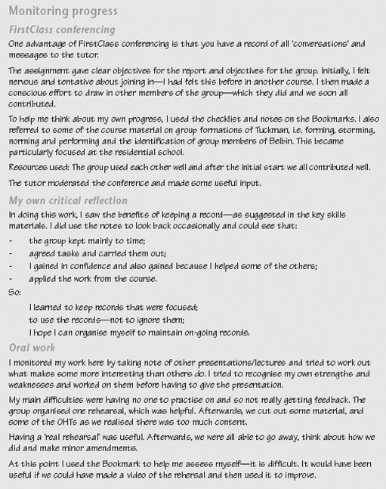
Example of a completed Skills Sheet for ‘Monitoring your progress in working with others’

9.7 Evaluating strategy and presenting outcomes
Evaluation should focus on both the outcomes of the work and the process. Two critical questions guide evaluation: ‘Did we accomplish our goals?’ and ‘Did we accomplish them in an effective and efficient way?’ Your evaluation should attempt to provide answers to both. Thus you need to know how to:
- negotiate and develop effective ways of presenting the work by using the skills of the group members;
- assess the effectiveness of the strategy; and
- identify ways of further developing your skills. The notes that follow guide you through this stage.

9.7.1 Negotiate and develop effective ways of presenting the work
As you complete the project, you need to finalise how you will present the work making sure that all involved agree with the decisions. Identify the advantages and disadvantages of the working methods you and others in the group proposed. This may be in terms of resource requirements, legal, health and safety regulations, and so on.

Time out
Consider how the group will present the work effectively to make use of each other's experience and skills. Draw on each other's strengths to maximise impact.

9.7.2 Assess the effectiveness of your strategy
When you come to make a final assessment of the effectiveness of your strategy, you need to consider aspects such as how progress was made, the quality of the work, the working relationships of the group members, and how difficulties and problems were addressed. If you have been able to maintain good records from meetings, progress reports, and your own reflective comments, you should be able to look back and be objective about the work and strategy that the group developed. Use the goals you established and the criteria provided by the key skill itself to help.

Time out
Part of your overall assessment involves recognising factors which had an impact on the effectiveness of collaborative working, such as motivation, the quality of communication, levels of confidence, commitment, and behaviour. What would you do differently if you worked on a group project again?

9.7.3 Identify ways of further developing your skills in working with others
Use your assessment and reflective comments to suggest ways of improving your own performance in working with others. How do you intend to make these changes? Working in a group is a skill that you may need to go on developing throughout your course of study and in the workplace. All groups vary, and to enhance the performance of any group, as well as to help individual group members develop their skills, it is helpful to look at how the group has operated.

Time out
Once your work is complete and you have all received feedback, try to hold a session again as a group to review the way you worked together.

Activity: Evaluating your strategy of working with others and presenting outcomes

For this activity you will need to print out the Skills Sheet, ‘Evaluating your strategy and presenting outcomes’: click here to open it.
- Present the outcomes of the work of the group in a form that suits the purpose.
- Present an evaluation of the effectiveness of your overall strategy, including those factors that had an impact on the outcomes.
- Identify those skills in working with others that you have assessed as needing further development and suggest ways of developing them.
Refer to the figure below for an example of a completed Skills Sheet for this stage of the key skills framework.

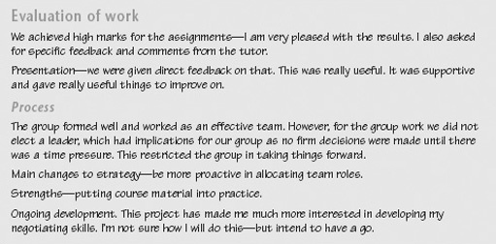
Example of a completed Skills Sheet for ‘Evaluating your strategy for working with others and presenting outcomes’

9.8 Drawing ideas together
This key skill has used a three-stage framework for developing your skills. By developing a strategy, monitoring your progress and evaluating your overall approach, you take an active role in your own learning. But learning does not necessarily follow a path of steady improvement, it involves change: revisiting ideas, seeing things from different perspectives, tackling things in different ways.
You are unlikely to be able to complete your work by working through it from beginning to end in a straightforward manner. You will need to bring together your key skills and your subject knowledge to address the tasks you have been asked to complete. As you work, you may discover gaps you still have to fill, areas where you have to dig deeper for information. This is a normal part of trying to put ideas together. In effect, you are piecing together a jigsaw, bringing skills, knowledge, analysis, explanation and interpretation together to make a single coherent picture. Unfortunately, the pieces usually do not all come to hand at just the right moment. The trick is to build up parts of the picture, and then bring those parts together as you begin to see the overall design. The key elements of this approach are:
- Check that you really understand what the work requires. Recognise that your skills and understanding of the task develop over time.
- Break the task into manageable chunks; focus your work on one aspect at a time.
- Think strategically about your approach to the task as you are doing it. Be prepared to change your plan if you need to reschedule your work.
- Work flexibly, using the resources provided as and when you need them.
- Review and reflect on your own performance while you are tackling the work. Your Skills File offers a way of recording and monitoring your development to give you insights into how you are learning as well as into what you are learning.

Conclusion
This free course provided an introduction to studying education. It took you through a series of exercises designed to develop your approach to study and learning at a distance and helped to improve your confidence as an independent learner.

Acknowledgements
The content acknowledged below is Proprietary (see terms and conditions). This content is made available under a Creative Commons Attribution-NonCommercial-ShareAlike 4.0 Licence
All materials included in this course are derived from content originated at the Open University.
Course image: plenty.r. in Flickr made available under Creative Commons Attribution-ShareAlike 2.0 Licence.
Don't miss out:
If reading this text has inspired you to learn more, you may be interested in joining the millions of people who discover our free learning resources and qualifications by visiting The Open University - www.open.edu/openlearn/free-courses

