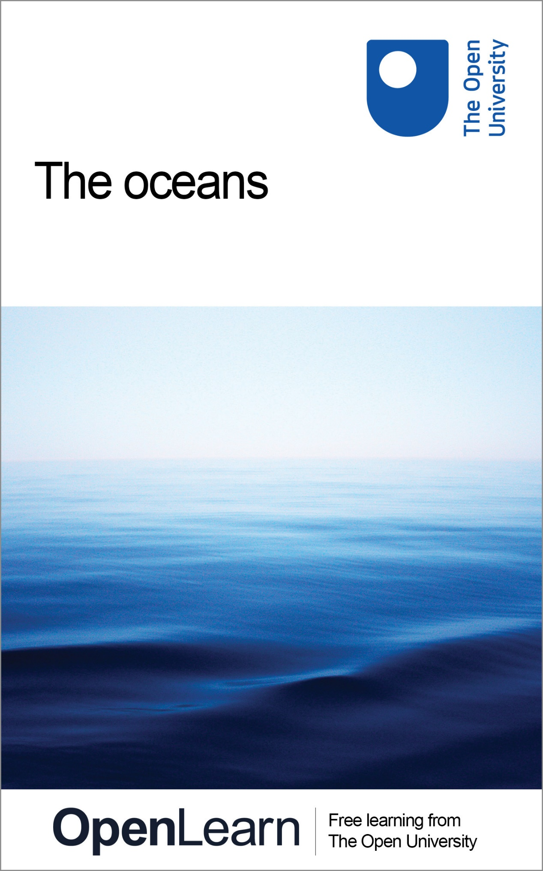

S206_1 Environmental science

The oceans

About this free course
This free course is an adapted extract from the Open University course S206 Environmental science http://www.open.ac.uk/courses/modules/s206.
This version of the content may include video, images and interactive content that may not be optimised for your device.
You can experience this free course as it was originally designed on OpenLearn, the home of free learning from The Open University: http://www.open.edu/openlearn/science-maths-technology/the-oceans/content-section-0.
There you'll also be able to track your progress via your activity record, which you can use to demonstrate your learning.
Copyright © 2016 The Open University
Intellectual property
Unless otherwise stated, this resource is released under the terms of the Creative Commons Licence v4.0 http://creativecommons.org/licenses/by-nc-sa/4.0/deed.en_GB. Within that The Open University interprets this licence in the following way: www.open.edu/openlearn/about-openlearn/frequently-asked-questions-on-openlearn. Copyright and rights falling outside the terms of the Creative Commons Licence are retained or controlled by The Open University. Please read the full text before using any of the content.
We believe the primary barrier to accessing high-quality educational experiences is cost, which is why we aim to publish as much free content as possible under an open licence. If it proves difficult to release content under our preferred Creative Commons licence (e.g. because we can't afford or gain the clearances or find suitable alternatives), we will still release the materials for free under a personal end-user licence.
This is because the learning experience will always be the same high quality offering and that should always be seen as positive - even if at times the licensing is different to Creative Commons.
When using the content you must attribute us (The Open University) (the OU) and any identified author in accordance with the terms of the Creative Commons Licence.
The Acknowledgements section is used to list, amongst other things, third party (Proprietary), licensed content which is not subject to Creative Commons licensing. Proprietary content must be used (retained) intact and in context to the content at all times.
The Acknowledgements section is also used to bring to your attention any other Special Restrictions which may apply to the content. For example there may be times when the Creative Commons Non-Commercial Sharealike licence does not apply to any of the content even if owned by us (The Open University). In these instances, unless stated otherwise, the content may be used for personal and non-commercial use.
We have also identified as Proprietary other material included in the content which is not subject to Creative Commons Licence. These are OU logos, trading names and may extend to certain photographic and video images and sound recordings and any other material as may be brought to your attention.
Unauthorised use of any of the content may constitute a breach of the terms and conditions and/or intellectual property laws.
We reserve the right to alter, amend or bring to an end any terms and conditions provided here without notice.
All rights falling outside the terms of the Creative Commons licence are retained or controlled by The Open University.
Head of Intellectual Property, The Open University
978-1-4730-1829-7 (.kdl)
978-1-4730-1061-1 (.epub)

Contents
- Introduction
- Learning outcomes
- 1 The effect of the oceans on climate
  - 1.1 Summary of Section 1
- 2 Mapping the oceans
  - 2.1 Mapping the deep
  - 2.2 Summary of Section 2
- 3 Seawater
  - 3.1 Salt in the oceans
  - 3.2 The density of fresh water and seawater
  - 3.3 The surface properties of the oceans
  - 3.4 The vertical distribution of properties
  - 3.5 The water properties along the Atlantic Ocean
  - 3.6 Summary of Section 3
- 4 Ocean currents
  - 4.1 The global surface circulation
  - 4.2 The effect of the wind on the oceans
  - 4.3 Ekman drift
  - 4.4 Divergence and convergence
  - 4.5 Surface water masses
  - 4.6 The frozen seas
  - 4.7 The global ocean circulation
- Conclusion
- Keep on learning
- Glossary
- Acknowledgements
- Solutions

Introduction
The oceans cover more than 70 per cent of our planet. In this free course you will learn about the depths of the oceans and the properties of the water that fills them, what drives the ocean circulation and how the oceans influence our climate.
This OpenLearn course is an adapted extract from the Open University course S206 Environmental science.

Learning outcomes
After studying this course, you should be able to:
- explain in your own words, and use correctly, all the bold terms in the text
- identify, classify and interpret various features visible on the ocean floor
- interpret temperature and salinity plots recorded in the oceans
- interpret spatial maps of temperature and salinity and deduce ocean circulation
- evaluate the role of the different oceans in the global ocean circulation.

1 The effect of the oceans on climate
You can see the effect of the oceans on regional climate by looking at the annual cycle of monthly air temperatures at two coastal locations at different latitudes. You might expect that the closer to the Equator, the warmer it would be. But is this the whole story?
Figure 1 shows the relative locations of Bergen, Norway (60° N, 5° E) and, 1700 km closer to the Equator, Halifax, Nova Scotia (44° N, 63° W). As it is further south you might expect Halifax to be much warmer than Bergen. But you can see in Figure 2 that this is not the case.

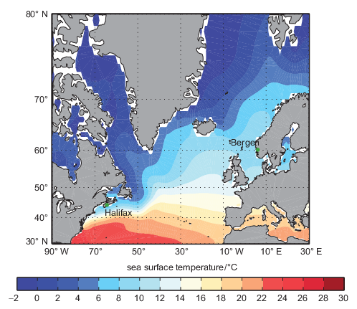
Figure 1 Locations of Bergen, Norway and Halifax, Nova Scotia, and the mean sea-surface temperature. White regions close to the coasts are areas with no temperature data in this data set.
View description - Figure 1 Locations of Bergen, Norway and Halifax, Nova Scotia, and the mean sea-surface ...

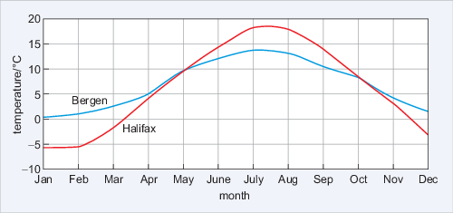
Figure 2 Monthly mean atmospheric temperatures for Bergen, Norway and Halifax, Nova Scotia.
View description - Figure 2 Monthly mean atmospheric temperatures for Bergen, Norway and Halifax, Nova ...

- What are the main differences between the atmospheric temperature cycles of Halifax and Bergen?
- Halifax is warmer than Bergen in summer, but colder in winter.

The range between the maximum and minimum temperatures is also different; in Halifax it is ~24 °C (-6 °C to +18 °C), whereas in Bergen it is ~12 °C (~0 °C to +12 °C). It is only from May to the end of September that Halifax is warmer than Bergen. This arises because a vast quantity of heat is being supplied by the ocean. You can see this heat in Figure 1 because the colours representing equal sea surface temperature are not along lines of equal latitude. North of the Spanish coast water temperatures are warmer on the east side than the west. And it is a remnant of a warm water current called the Gulf Stream which flows across the Atlantic Ocean towards Northern Europe.
In subsequent sections you will see that the shape of the ocean basins (Section 2) combined with the properties of seawater (Section 3) and the ocean currents (Section 4) and the cryosphere are responsible for the Gulf Stream.
So far, you have seen how the oceans can influence regional climate. In the following sections you will investigate the reasons for this in more detail.

1.1 Summary of Section 1
- The oceans cover more than 70 per cent of the Earth.
- Heat is moved around the planet by the oceans and this heat affects regional climates.

2 Mapping the oceans
The saline oceanic water absorbs electromagnetic radiation very efficiently, so we can see very little of what lies beneath the surface. Because of this, more is known about the shape of the surface of the Moon, Venus and Mars than about Earth. In this section you will explore how the ocean basins have been mapped, and examine some of the features of the ocean floor.

2.1 Mapping the deep
Until the late 1930s the only way to measure the depth of the ocean was to use a line with a weight on the end. For example, in 1521 Ferdinand Magellan stopped his ships in the Pacific Ocean during the first circumnavigation of the globe and lowered such a line. After paying out all the line they had he was sure that the weight had not touched the bottom, but how deep was it? He knew the ocean was deeper than his 400 fathoms of rope (~730 m) – so he concluded that his ship was over the greatest depths in the oceans!

2.1.1 Bathymetry techniques
The development and use of a technique called sonar (SOund Navigation And Ranging) revolutionised the investigation of the oceans' depths. Originally developed for hunting submarines, in sonar a ship sends out a pulse of sound (a 'ping'), which is reflected by the target and the reflected sound wave is detected. It was soon realised that if they were 'loud' enough the underwater pings could detect the sea floor. If you measure the time it takes for a reflected ping to be heard and know the speed of sound in water, then you can derive the water depth. Using sonar, ships could record continuous depth measurements without stopping.
Figure 3 shows the bathymetry (i.e. depth measurement) across the North Atlantic Ocean along a latitude close to 39° N. At the point −30° W is the Mid-Atlantic Ridge (MAR).The variability in depth is astonishing.

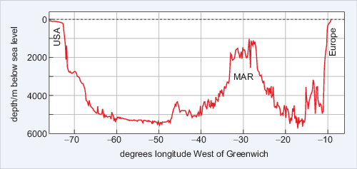
Figure 3 Bathymetry along latitude close to 39° N. Sea level is shown as a dashed line.
View description - Figure 3 Bathymetry along latitude close to 39° N. Sea level is shown as a dashed ...

A further technological development in the late 20th century has enabled scientists to derive bathymetry using data from satellites orbiting the Earth at unprecedented resolution. But because of the way the satellites orbit the Earth the resolution of the data decreases towards the North and South Poles.

- What will happen to the amount of detail that can be seen if the resolution of the data decreases?
- It will also decrease.

Imagine what a height contour map of a mountain range would look like if you had only one average height in each 10 km square - many hills and valleys would simply disappear.

2.1.2 Bathymetric data online
Today some of the very best bathymetric data are freely available online, as you will see from Activity 1. Here, you will use Google Earth to investigate some of the features of the ocean floor and to navigate around using latitude and longitude.

Activity 1 The ocean depths
Time guide: 1 hour

Part 1: Downloading and exploring a layered data file

Note: to complete every part of this activity, you will need to install the desktop version of Google Earth.
First watch Video 1, which demonstrates how to use Google Earth to look at the ocean. (You need to view this video in 'Full Screen' mode to see the details.)

Video content is not available in this format.
Video 1 Using Google Earth to look at the ocean.
View transcript - Video 1 Using Google Earth to look at the ocean.

Question 1

Using Google Earth find out the water depth at ~47° 34′ N, 7° 33′ 30″ W.

View answer - Question 1

Question 2

By moving your pointer, find out the approximate water depth off the coast of France and the depth of the darker (and so deeper) region to the west.

View answer - Question 2

Task 2

Now download the Activity 1 data file to your computer and open it in the desktop version of Google Earth. Video 2 demonstrates how to use Google Earth with a file containing information in layers.

Instructions for downloading and opening the data file
Note: the file for this activity may download as a '.zip' file. If so, you will need to change the file extension to '.kmz' in order to open it easily in Google Earth. You can do this selecting the 'Save as' option when you download the file and changing the extension so that the file name ends in '.kmz' (i.e. 's206_1_activity_1.kmz'), then saving the file to your computer.
You may find that double-clicking on your saved data file automatically causes Google Earth to open. However, if this does not happen, you can open the file manually from the 'File' menu in Google Earth by clicking on 'Open…' and then using the resulting dialogue box to navigate to where you saved the data file, selecting it, and clicking 'Open'.

Video content is not available in this format.
Video 2 Using Google Earth with a file containing information in layers.
View transcript - Video 2 Using Google Earth with a file containing information in layers.

Having watched the video, now answer the question below.

Question 3
Open the Google Earth layer 'Depth Section across the continental slope'. This yellow line represents a depth transect across the continental shelf, the continental slope and the abyssal plain.
Using the technique demonstrated in Video 2, what is the average depth and slope of the continental shelf, the abyssal plain and the continental slope? Also record the length of the section you highlighted.

View answer - Task 2

Task 3

Now watch Video 3 from the United States National Oceanic and Atmospheric Administration (NOAA), which shows some of the features of the sea floor using the same data you are using in Google Earth.

Video content is not available in this format.
Video 3 Features of the sea floor. (There is no audio associated with this video.)

Part 2: Examining other features

Exploring ridges and trenches
Now watch Video 4 which demonstrates how to measure some of the other layers in the Google Earth file you have downloaded.

Video content is not available in this format.
Video 4 Demonstration on how to use layers with Google Earth.
View transcript - Video 4 Demonstration on how to use layers with Google Earth.

The extremely large mid-ocean ridge and the trenches that you saw in Video 3 are part of the tectonic plate system of the planet. Using the Google Earth layers, explore some of the features you saw in Video 3: the mid-ocean ridge, and the sections across the Marianas Trench (the deepest known location), the Scotia Sea Trench (a more typical ocean trench) and the section shown in Figure 3. You should investigate and note the depths, gradients and general features you observe.
At divergent plate boundaries, tectonic plates are moving apart and new sea floor is being created in undersea volcanic eruptions. In convergent boundaries sea floor is being destroyed.

Question 4
Which sort of tectonic boundary are the Mid-Atlantic Ridge, the Marianas Trench and the Scotia Sea Trench?

View answer - Part 2: Examining other features

Exploring undersea vents

One of the most exciting discoveries in marine geology of recent years was the discovery of hydrothermal vents, where very hot water escapes from the Earth's crust into the oceans. If you click in the open box next to 'vents_InteRidge_2011_all.kml', all of the undersea vents known up to 2011 will be displayed on your map. The different coloured symbols indicate whether the vent has been directly or indirectly observed, and whether it is active or not.

Question 5

Are the vents typically found on divergent or convergent boundaries?

View answer - Question 5

Task 4

To get an idea of the physical environment of a deep-sea vent, now watch Video 5 from the BBC series Planet Earth, and answer the questions that follow.

Video content is not available in this format.
Video 5 Physical environment of a deep-sea vent.
View transcript - Video 5 Physical environment of a deep-sea vent.

Question 6
Why is the water leaving the vents like billowing black smoke?

View answer - Task 4

Question 7

How is life able to survive around the deep-sea vents?

View answer - Question 7

Question 8

What are the fastest-growing marine invertebrates?

View answer - Question 8

Question 9

Why do the animals on a deep-sea vent lead a tenuous existence?

View answer - Question 9

Exploring Arctic gateways

For the final part of this activity, click in the open box next to the file called 'Arctic Gateways'. This file contains two transects: 'The Bering Strait' and 'The Greenland-Iceland-Scotland Gap'.

Question 10

Looking at the bathymetry across the two transects, which has the deepest depths from the Arctic to the rest of the global ocean? Is it the transect between the Pacific and the Arctic Ocean or the transect between the North Atlantic and the Arctic Ocean?

View answer - Question 10

2.2 Summary of Section 2
- Typical features of the oceanic sea floor include the continental shelf, abyssal plains and mid-ocean ridges.
- Deep-sea vents provide a unique habitat far from the energy of the Sun.
- The deep passages to the northern seas are only in the Atlantic Ocean and they are relatively shallow.

3 Seawater
The presence of dissolved salts radically changes the physical properties of water.
In this section you will look at some of these properties and the typical vertical distribution of salinity and temperature throughout the oceans.

3.1 Salt in the oceans
The saltiness in seawater is due to a mixture of many different ionic constituents. If you boiled away 1 kg of seawater in a pan you would find, on average, 34.482 g of solid material left. (You would probably end up with less salt as some ionic constituents would form gases.) Almost 99.95% of the total mass of this solid material is made up of the constituents listed in Table 2.

Table 2 Major ionic constituents dissolved in seawater.
Ion | % by mass of 34.482 g | Weight/g kg⁻¹
Chloride Cl⁻ | 55.04 | 18.980
Sulfate SO₄²⁻ | 7.68 | 2.649
Hydrogen carbonate, HCO₃⁻ | 0.41 | 0.140
Bromide, Br⁻ | 0.19 | 0.065
Borate, H₂BO₃⁻ | 0.07 | 0.026
Fluoride, F⁻ | 0.003 | 0.001
Sodium, Na⁺ | 30.61 | 10.556
Magnesium, Mg²⁺ | 3.69 | 1.272
Calcium, Ca²⁺ | 1.16 | 0.400
Potassium, K⁺ | 1.10 | 0.380
Strontium, Sr²⁺ | 0.04 | 0.013

Quantitative analysis of the salt content in different oceans shows that although the total amount of dissolved salt varies from place to place, the major elements are always present in the same relative proportions. This amazing fact is called the principle of constancy of composition.

- If the ratio of the amounts of the ions of K⁺ to Cl⁻ in the Atlantic Ocean was 0.02, what would be the ratio of the two ions in the Pacific Ocean?
- The ratio of the K⁺ to Cl⁻ ions would be exactly the same at 0.02, because of the constancy of composition of seawater.

The dissolved salts mean that seawater conducts electricity well and conductivity is directly proportional to the salt content. Salinity is defined by comparing the conductivity of a water sample with that of a reference sample of 'standard seawater'. Since salinity is effectively describing a ratio it has no units - but it can be labelled 'practical salinity units' (PSU). In older books and on some websites, you may find salinity expressed in parts per thousand (abbreviated to ppt or given the symbol ‰). While this is technically incorrect, for all practical purposes they are equivalent. The salt composition in the global oceans has not significantly varied in the last 10⁸ years. The residence time of seawater is ~4000 years. So the processes that add salt to the ocean and the processes that remove salt from the ocean must be in balance.
The salinity of seawater of average ocean density is 34.482.

3.2 The density of fresh water and seawater
Fresh water and seawater have very different physical properties. Imagine a freshwater lake in winter. As the air temperature falls the temperature of the water at the surface decreases and its density changes (Figure 4).

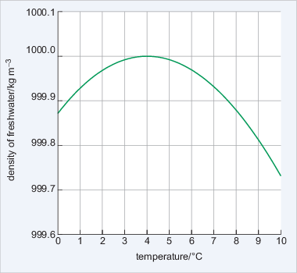
Figure 4 The density of fresh water plotted against temperature.
View description - Figure 4 The density of fresh water plotted against temperature.

- What is the temperature at maximum density?
- The maximum density is at ~4 °C (Figure 4). At both lower and higher temperatures than this the water is less dense.

While it is hard to see on the scale in Figure 4, the maximum density is at 3.98 °C. As a lake cools to this temperature in winter the surface waters will sink through convection and warmer water rises to the surface. With continued cooling this warmer surface water also becomes dense and sinks. As the surface water is being cooled the lake will become stratified. That is, the density will increase with depth to 1000 kg m⁻³, and the deep water will have a temperature of 3.98 °C. Imagine the convection continuing until all the water has reached 3.98 °C.

- What will happen to the water in the lake when all the water is cooled below to 3.98 °C?
- The water at the surface of the lake will cool and become less dense. This means that it will not sink away from the surface. So the lake will end up with a cool surface layer with warmer, denser water beneath.

Eventually the surface layer of water will be cooled to the freezing point (0 °C) and ice will form on the surface. At this point the temperature and density of the water will have a structure like that shown in Figure 5.

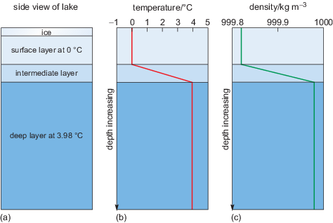
Figure 5 (a) Section through a lake showing ice on the surface. (b) Temperature structure throughout the lake: there are three layers: a cold surface layer, an intermediate layer and a warm deeper layer. (c) Density structure mirroring the shape of the temperature profile in (b).
View description - Figure 5 (a) Section through a lake showing ice on the surface. (b) Temperature structure ...

Figures 5b and c show that the temperature and the density increase with depth from the surface to the bottom layer, where the temperature is 3.98 °C and density is at its maximum.
Let us think about this a little more.
Usually when a liquid is heated the molecules acquire more energy and become more widely spaced, so in the same volume, the density decreases. In fresh water the opposite may happen, depending on the temperature. When fresh water at 3.97 °C (Figure 4) is cooled the density will decrease. You know from the lake (Figure 5) that ice (i.e. solid water) is less dense and floats. But cooling a liquid usually packs the molecules more closely, which increases the density. This means that below 3.98 °C cooling results in the water molecules spacing out and both the liquid and the solid water below this temperature expand. This is an amazing physical property and is why pipes burst and water in cracks shatters rocks in cold temperatures. The molecular structure of a water molecule is shown in Figure 6.

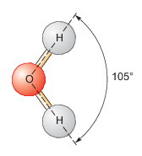
Figure 6 A molecule of water, H₂O, with the hydrogen and the oxygen atoms sharing electrons.
View description - Figure 6 A molecule of water, H2O, with the hydrogen and the oxygen atoms sharing ...

In H₂O, the oxygen and the hydrogen atoms share electrons, and the angle between the two hydrogen atoms is 105°. This results in a small net negative charge on the oxygen side of the molecule, and a small net positive charge on the hydrogen side. This is a polar structure in which molecules are weakly attracted to each other and form weak 'hydrogen bonds'. At low temperatures a more ordered packing of water molecules develops and the density is reduced. If the temperature is increased but is <3.98 °C, the hydrogen bonds break, but the molecules still pack together closely. Above 3.98 °C, the increase in internal energy means the molecules become more widely spaced and, following Figure 4, the density decreases.
Seawater is saline and the salt affects the density. Figure 7 shows the vertical structure of the temperature, salinity, and density at latitude 20° S in the Atlantic Ocean over an abyssal plain almost 5300 m deep.

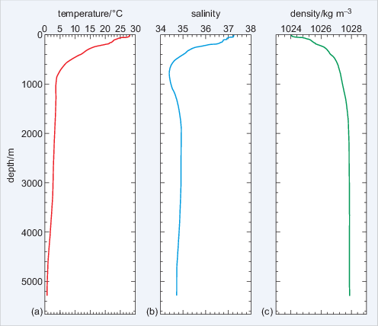
Figure 7 The physical properties of seawater at 20° S in the Atlantic Ocean against depth. (a) Temperature; (b) salinity; (c) density.
View description - Figure 7 The physical properties of seawater at 20° S in the Atlantic Ocean against ...

Figure 7a shows 28 °C temperature at the surface to below 1 °C at the sea floor. The variation in salinity in 7b clearly affects the temperature of maximum density shown in 7c. The seawater density ranges from 1024 to 1028 kg m⁻³, ~24-28 kg m⁻³ denser than fresh water (Figure 4), and density increases with depth and the water is stratified all the way to the sea floor (although >3 000 m depth there is only a small increase). Because seawater is typically 1024-1028 kg m⁻³ there is a density anomaly, σ_{t} (pronounced 'sigma t') given by:

(Eqn 1)
σ_{t} = (ρ - 1000) kg m⁻³

where ρ is the density of water.

- What is the range of σ_{t} for typical seawater?
- The density anomaly for typical seawater is in the range 24-28 kg m⁻³.

Box 1 explains how the physical properties shown in Figure 7 are measured.

Box 1 Measuring the physical properties of the ocean
Much of our knowledge about how the oceans circulate is based on measuring the various parameters such as temperature and salinity from the surface to the sea floor. The water which makes up this range is called the water column. The most important instrument used by oceanographers is called a CTD (Figure 8), which measures the conductivity and temperature of the seawater and depth (pressure).

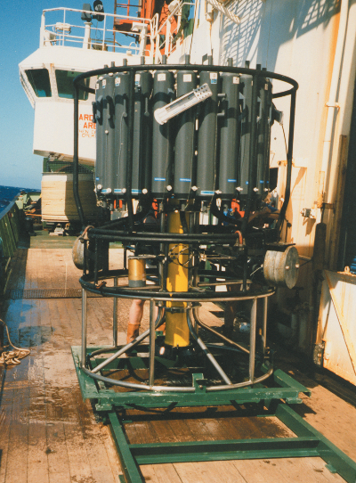
Figure 8 A CTD: the bottles on the side of the instrument collect samples of water and can be closed by the operator at any chosen depth.
View description - Figure 8 A CTD: the bottles on the side of the instrument collect samples of water ...

Because pressure in the ocean is proportional to the weight of the water above, it is given by the hydrostatic equation:

(Eqn 2)
p = -g ρ z

where p is pressure, z is a change in depth and g is the acceleration due to gravity. The minus sign indicates that the vertical coordinate z (depth) is positive in an upwards direction. So by measuring pressure, Equation 2 can be arranged to get depth.
Other parameters can also be measured, such as sediment particle density, the amount of chlorophyll present (in algae), and so on. A CTD is lowered from a ship on a winch at a rate of ~60 m min⁻¹. If the ocean is 5300 m deep, as in Figure 7, a round trip is 10 600 m and one profile can take almost three hours.

3.3 The surface properties of the oceans
The surface properties are the parts of the ocean that are most familiar to humans. They are also relatively straightforward to observe, and reveal a surprising amount about the underlying circulation.
The following sections explore briefly two of the fundamental properties of oceanic surface water.

3.3.1 The surface temperature
The only significant source of energy heating the oceans is from the absorption of solar radiation arriving at the surface. The low albedo of water means that most solar radiation is absorbed to heat the surface - and generally, the greater the intensity of the incoming solar energy, the warmer the water (Figure 9).

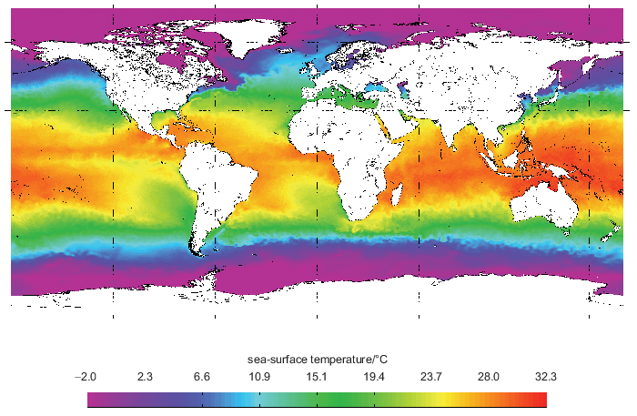
Figure 9 The global sea-surface temperature in January 2014 recorded by satellite. Areas of uniform sea-surface temperature are the same colour and the scale is in °C.
View description - Figure 9 The global sea-surface temperature in January 2014 recorded by satellite. ...

In general, the sea-surface temperature (SST) is colder at high latitudes and warmer in the mid-latitude and equatorial regions, but there are exceptions. For example, the North Atlantic coast of Africa has an SST of ~15 °C compared with >28 °C at the same latitude on the other side of the Atlantic. Note the light blue along the northwest European coast (see Figure 1), and the green 'tongue' of water extending up the west coast of South America. Clearly, there is more to the surface temperature distribution than simply incoming solar energy. The heat must be being redistributed.

3.3.2 The surface salinity
Sea-surface salinity is determined by two competing processes: precipitation and evaporation. Precipitation (P) (including rain and river flow) reduces the salinity of the sea surface while evaporation (E) increases surface salinity by the removal of water. The (E-P) balance is shown in Figure 10 along with the resulting approximate global surface salinity distribution.

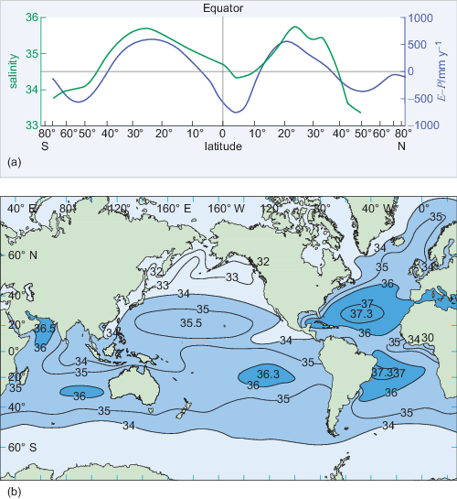
Figure 10 (a) The mean value of E-P against latitude (purple line) and typical values of the surface salinity (green line). (b) Mean annual values of the sea-surface salinity.
View description - Figure 10 (a) The mean value of E-P against latitude (purple line) and typical values ...

A negative E-P value freshens the sea surface, and the shape of the purple line in Figure 10a is interesting. The 'M' shape between 60° S and 60° N shows positive peaks at ~25° S and 20° N due to decreased rainfall and high evaporation, while the trough is due to high rainfall and river inputs.
Figure 10b shows a striking difference between the Atlantic and the Pacific Oceans: the salinity in the Atlantic is much higher. In the Pacific Ocean, lines of equal salinity, called isohalines, tend to follow lines of latitude, but not in the Atlantic because of the ocean's circulation. Another example can be seen off the coast of Portugal where less saline waters extend southwards. Like the SST, the surface salinity is being redistributed.

3.4 The vertical distribution of properties
The properties of the ocean surface are changed by (E-P) and solar input but, as you have already seen in Figure 7, there are variations in these properties with depth.

- How can surface changes be carried deeper into the ocean?
- The energy can be transported downwards by the conduction of heat and diffusion of salt, and by being mixed up by the wind.

Both conduction and diffusion in the ocean are slow processes that can effectively be ignored. It is the effect of the wind on the surface of the ocean that dominates. Wind creates turbulence, thus mixing water to create a layer of almost constant temperature, salinity and density called the wind-mixed layer (Figure 11).

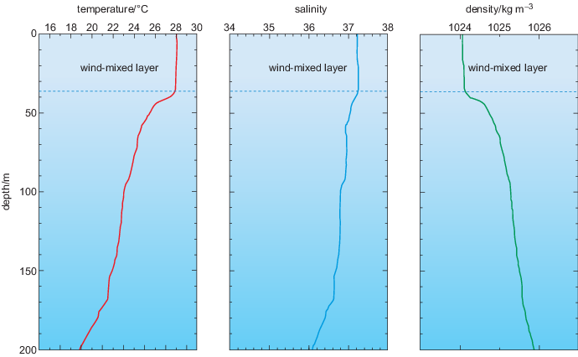
Figure 11 An expanded plot of the upper 200 m of Figure 7.
View description - Figure 11 An expanded plot of the upper 200 m of Figure 7.

Figure 11a shows the surface-mixed layer is approximately 38 m thick, with a temperature of ~28 °C, salinity of 37.2, and density of 1024 kg m⁻³. In locations where the winds are particularly strong, the mixed layer can be up to 200 m thick. Beneath the mixed layer temperature and salinity both decrease down to ~800 m depth (Figure 7). This region of rapidly decreasing temperature is called the permanent thermocline; below this, the water temperature decreases to <1 °C at the sea floor. While the temperature and salinity vary with depth, the density - which is a function of both - continues to increase.
Figure 12 shows a plot of temperature against salinity. The x-axis shows salinity and the y-axis is temperature. The density anomaly σ_{t} of seawater is shown by the contours (red lines), which are labelled in kg m⁻³.

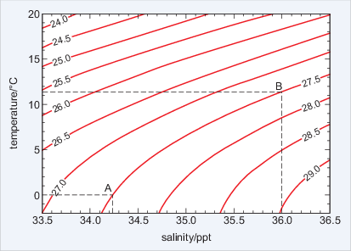
Figure 12 A temperature-salinity plot showing the range of typical temperatures and salinities and selected density anomalies found in the oceans. The two points, A and B, have the same density anomalies despite having different properties.
View description - Figure 12 A temperature-salinity plot showing the range of typical temperatures and ...

Figure 12 has two labelled points: A has a temperature of 0 °C and salinity of 34.23; point B has a temperature of 11.4 °C and salinity of 36.0. But you can see that both points lie on top of the 27.5 kg m⁻³ σ_{t} contour. Despite a very different temperature and salinity they have the same density anomaly. One final, very important point is that Figure 12 shows that the gradient of the density anomaly lines is not constant. If you look at point A, keeping salinity constant but increasing the temperature to +5 °C will decrease the density anomaly to approximately the 27.1 kg m⁻³ σ_{t} contour - a change of 0.4 kg m⁻³ (27.5-27.1). At point B, keeping the salinity constant but increasing the temperature by +5 °C to 16.4 °C would decrease the density anomaly to approximately the 25.9 kg m⁻³ σ_{t} contour - a change of 1.6 kg m⁻³ (27.5-25.9). This non-linear response is also clear if you keep temperature constant and vary salinity, and while there is a simple equation to calculate density in fresh water, the equivalent for saline water is very complicated.

- What is the density anomaly of seawater with a temperature of 15 °C and a salinity of 35.0?
- Using Figure 12 the density anomaly of seawater can be determined as σ_{t} = 26.0 kg m⁻³.

3.5 The water properties along the Atlantic Ocean
So far, you have looked at single profiles in one location. Figure 13 shows a line of CTD measurements called a hydrographic section. It shows the temperature and salinity distribution along the length of the Atlantic Ocean.

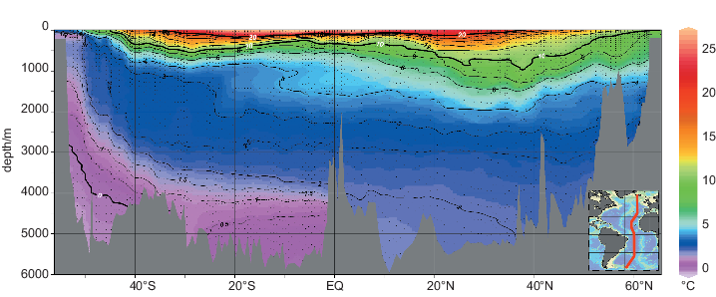
Figure 13 Temperature of a south-north hydrographic section across the Atlantic Ocean from 55° S to 65° N. The CTD profile shown in Figures 7 and 11 is at 20° S.
View description - Figure 13 Temperature of a south-north hydrographic section across the Atlantic Ocean ...

Figure 13 includes data from >120 CTDs and is created by plotting the latitude of each CTD station as the x-axis (which is over 11 000 km long), the y-axis as the depth measurements and colours representing equal temperatures and salinities measured at the CTD stations.
In Figure 13 the black lines of equal temperature - called isotherms - are superimposed on the colours and 0 °C, 10 °C and 20 °C are bold lines with white numbers. The spiky grey shaded region at the bottom of the plot is the sea floor along the section similar to that shown in Figure 3. The red line on the inset map shows the location of the section.
In the upper 1000 m the range of temperatures is very large (from blue to bright red) and the temperature can change as much as 20 °C. The isotherms are a squashed 'W' shape and are generally shallow at high latitudes above 40° N and 40° S, at their deepest points at about 30° N and 30° S, and shallow again at the Equator. Below 1000 m to the sea floor the temperature change is relatively small (4-5 °C). The isotherms at these depths have a 'U' shape across the Atlantic Ocean, rising towards the poles and deepest around the Equator. The mauve region in the south which contains the 0 °C water is close to the surface at 50° S. This is very cold water from the Antarctic that is descending and spreading throughout the deep ocean to be stopped by the seamounts of the Mid-Atlantic Ridge.

- Is there ice in the deep ocean close to Antarctica?
- No, there is no ice at this depth. Just as in fresh water, the ice would float because of the molecular structure of H₂O. The salt in the seawater has lowered the freezing point of the water below 0 °C.

- Based on what you have already learned, think of reasons why very cold water formed in the Arctic does not spread out through the deep ocean.
- When exploring with Google Earth you found that the gateways from the Arctic to the rest of the global ocean are relatively shallow. The densest cold Arctic water is not able to enter the rest of the global ocean.

Finally, Figure 13 shows that at the Equator the temperature between the surface and the sea floor varies over a wide range - almost 30 °C. In higher latitudes the temperature range between the surface and the sea floor is very much reduced, for example at 52° S the range is only ~3.5 °C. Solar radiation is mostly responsible for heating the surface of the ocean, and the lack of solar radiation in the high-latitude regions is responsible for cooling the surface. Waters of different temperature are then spread throughout the oceans because colder water is denser and sinks beneath the warmer waters.
The salinity distribution in Figure 14 is more complicated. It is almost as though a clockwise circulation is wrapping the colours up. The very low-salinity, mauve-coloured water at the surface at about 50° S sinks and extends north at ~900 m depth. This implies that the low-salinity water at about 800 m depth in the salinity profile in Figure 7 originates in the Antarctic. North of this blue 'tongue' of water, there is an orange-yellow patch of water between 20 and 40° N of salinity ~35.5. Lastly, note that in the South Atlantic water below 4000 m must be the most dense - denser than the fresher water from the north.

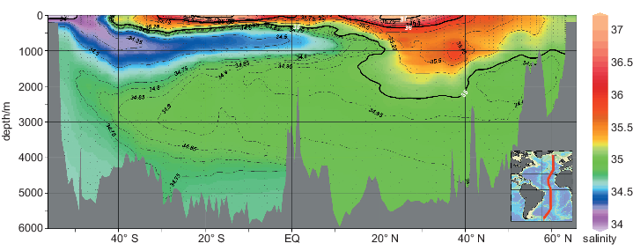
Figure 14 Salinity of a south-north hydrographic section across the Atlantic Ocean from 55° S to 65° N. The CTD profile shown in Figures 7 and 11 is at 20° S.
View description - Figure 14 Salinity of a south-north hydrographic section across the Atlantic Ocean ...

In Section 4 you will see that both Figures 13 and 14 show features which are a result of the circulation of the ocean.

3.6 Summary of Section 3
- The constancy of composition means that the ratio of many different dissolved salt ions in seawater is constant.
- Water has very unusual physical and chemical properties and the polar molecular structure means that in fresh water maximum density is not the freezing point. However, in seawater this is different and density is a non-linear function of temperature and salinity.
- Seawater is heated at the surface by solar radiation and the salinity of seawater is controlled by the balance between evaporation and precipitation, E-P.

4 Ocean currents
In Section 1 it was noted that ocean currents can affect regional climate and the global surface distribution of temperature and salinity. In this section the focus is on surface currents and the three-dimensional global ocean circulation. You will learn that what drives this complex three-dimensional system is ultimately due to the energy from the Sun.

4.1 The global surface circulation
Unusual items washed up on beaches indicate the existence of ocean currents. For example, tree trunks are often washed up on the beaches of eastern Greenland - yet no trees have grown there for thousands of years. Figure 15 is a schematic diagram of the surface currents.

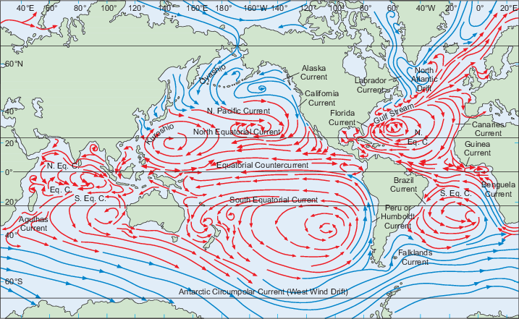
Figure 15 A schematic diagram of the surface currents of the Earth in the northern winter. Red arrows represent warm ocean currents; blue arrows represent cool currents. In some regions there are large seasonal differences.
View description - Figure 15 A schematic diagram of the surface currents of the Earth in the northern ...

The fresher waters off the coast of Portugal mentioned in reference to Figure 10 are part of a vast clockwise surface circulation in the North Atlantic which consists of the Gulf Stream, the North Atlantic Current and the North Equatorial Current. This clockwise circulation is reflected in an anticlockwise pattern in the South Atlantic Ocean.
In the Pacific Ocean a similar clockwise pattern exists in the Northern Hemisphere and likewise an anticlockwise pattern in the Southern Hemisphere. The main difference between the two oceans is that the circulation in the Pacific Ocean is orientated more along lines of latitude than that in the Atlantic Ocean.
In the higher latitudes of the Northern and Southern Hemispheres the situation is different:
- the north has a series of smaller closed circulation
- the south has a continuous current around the Antarctic continent called the Antarctic Circumpolar Current.

4.2 The effect of the wind on the oceans
The wind provides one of the main forces that move the surface of the oceans. When the wind moves across water, surface friction transfers energy from the wind to the water through wind stress. Wind stress has the Greek symbol τ (tau) and is proportional to the square of the wind speed, W:

(Eqn 3)
τ = cW²

where c is the constant of proportionality. So if the wind speed increases from 1 m s⁻¹ to 4 m s⁻¹ then wind stress will increase by a factor of 16. This large jump in the wind stress happens because when the winds are weak, the surface of the ocean is relatively flat (Figure 16a) and there are few wave tops for the wind to push against. As energy is transferred from the wind to the ocean, the surface becomes rougher and 'stretched', so more of the surface is in contact with the wind (Figure 16b). The increased surface area leads to more energy being transferred to the ocean and larger surface waves.

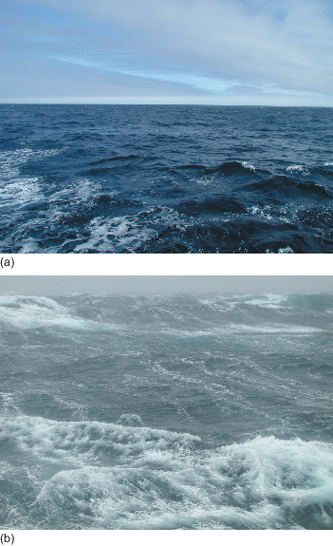
Figure 16 A typical sea surface when the wind speed is (a) low and (b) higher.
View description - Figure 16 A typical sea surface when the wind speed is (a) low and (b) higher.

Once the surface of the water is moving, some of the wind's energy is transferred downwards into the water column through internal friction called eddy viscosity. The result is that momentum is transferred downwards and the mixed layers you saw in Figure 11 develop.

- What effect will a rise in wind speed have on the thickness of the layer of well-mixed water?
- It will increase because the surface waters will be mixed to a greater depth as more energy is supplied.

When the wind blows across the oceans, the surface waters are mixed and they start to move. But the direction of movement is not simply the same as the direction of the winds. The Earth is rotating and moving currents are affected by the Coriolis force, which arises from the rotation of the planet. Moving objects in the Northern Hemisphere are deflected to the right and those in the Southern Hemisphere are deflected to the left. The understanding of how the rotation of the planet affects moving ocean currents was developed through an experiment in the polar seas as described next.

4.3 Ekman drift
The obvious way to observe whether the oceans move in the direction of the winds is to follow a floating object. Early Arctic explorers noted that icebergs did not drift exactly in the direction of the winds, but 20-40° to the right of the wind direction. The Swedish mathematician Vagn Ekman developed a theory of wind-driven ocean currents to explain this observation. He started with the theoretical idea of an infinitely deep and wide ocean with no variations in density and imagined the ocean as a series of infinite horizontal layers.
A wind will move the surface through wind stress, but the surface is then acted upon by the Coriolis force and so is deflected to the right (in the Northern Hemisphere). This moving surface layer is also acted upon by friction with its lower surface - the eddy viscosity - and the layer underneath starts to move. But the transfer of momentum by friction is an inefficient process and the energy transferred is greatly reduced. This means that when the forces are in balance, the speed of the second layer down will be much less than that of the top layer. In the second layer the balance of forces means that it too is deflected to the right by the Coriolis force. This second layer is in contact with the deeper third layer and exactly the same processes happen there, and so on.
The result is that the energy transferred downwards significantly decreases with each layer and, more importantly, each layer will be deflected progressively to the right (in the Northern Hemisphere). The consequent rotation pattern in the upper layers of the ocean is called the Ekman spiral (Figure 17). The total depth of the frictional influence of the wind is called the Ekman layer.
Ekman found that, in his ideal ocean, the direction of the surface current will be approximately 45° to the right of the wind direction in the Northern Hemisphere, and 45° to the left of the wind direction in the Southern Hemisphere. A limitation of Ekman's theory is that the oceans are not infinitely wide and deep and that the eddy viscosity (that is, the friction between successive layers) varies with depth.

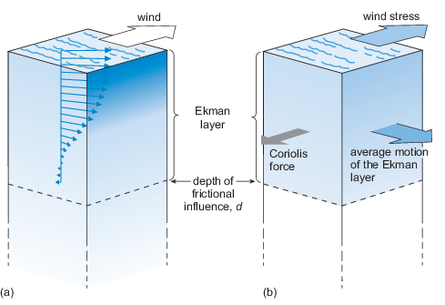
Figure 17 (a) The Ekman spiral pattern under ideal conditions in the Northern Hemisphere. Each successive layer of water is deflected to the right. The lengths of the arrows correspond to the strength and direction of the current. (b) The whole Ekman layer. The force from the wind is balanced by the Coriolis force. In the Southern Hemisphere the direction of the spiral and the average motion is reversed.
View description - Figure 17 (a) The Ekman spiral pattern under ideal conditions in the Northern Hemisphere. ...

The most important point about Ekman's theory is that there is a layer of water (shown in Figure 17) at the surface (not necessarily the same thickness as the mixed layer) which is influenced by the wind and moves with a mean current called the Ekman drift over the depth of the Ekman layer. This is to the right of the wind direction in the Northern Hemisphere and the left in the Southern Hemisphere. Under typical conditions the depth of the Ekman drift is strongly influenced by the thickness of the mixed layer and is largely dependent on the time of year and wind speed, typically varying from tens of metres up to 200 m.
From the Ekman drift velocity and the depth over which it acts, the total transport of water due to the Ekman drift, called the Ekman transport, can be calculated. Armed with this basic theory of the wind-driven surface circulation, you can now investigate the effect of the global surface winds (Figure 18) on the oceans.

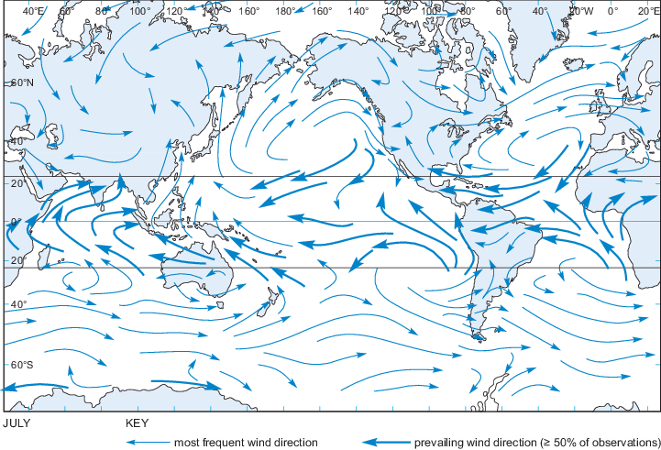
Figure 18 The mean global surface wind pattern in July.
View description - Figure 18 The mean global surface wind pattern in July.

Figure 18 compares well with the map of mean surface currents in Figure 15. Where surface currents join in continuous circulation patterns as in the North Atlantic, the effect of the Ekman drift is striking.

4.4 Divergence and convergence
Focusing on a closed surface wind circulation such as that in the North Atlantic Ocean (Figure 18), you can see a clockwise pattern repeated in the sea-surface current map in Figure 15. A large closed surface water circulation is called a gyre, and this particular one is the North Atlantic Gyre.

- What will be the effect of Ekman drift in the centre of the North Atlantic Gyre?
- There will be a slow movement of water into the centre of the gyre.
The drift of water into the centre of the gyre causes a surface convergence that pools water and actually raises the surface of the ocean by approximately a metre.

- What will happen to the level of water in the centre of a gyre in the Northern Hemisphere where the circulation of the winds and surface currents is anticlockwise?
- There will be a divergence. This will depress the surface of the ocean.

A clockwise circulation is called anticyclonic, and an anticlockwise one is cyclonic. Because of Ekman transport, an anticyclonic circulation causes a convergence of surface waters and a cyclonic circulation a divergence. Figure 19 shows that surface convergence and divergence have an effect beneath the surface.

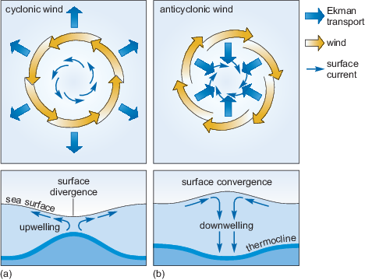
Figure 19 Effect of (a) a cyclonic and (b) an anticyclonic wind on the surface of the ocean in the Northern Hemisphere. In (a) there is a divergence at the surface which depresses the surface of the ocean and raises water from beneath the thermocline towards the surface (upwelling). In (b) the surface waters converge which pushes the sea surface upwards and depresses the thermocline (downwelling).
View description - Figure 19 Effect of (a) a cyclonic and (b) an anticyclonic wind on the surface of ...

4.5 Surface water masses
The surface circulation patterns (Figure 15) and the resulting Ekman drift can be compared with the SST (Figure 9) and the sea-surface salinity (Figure 10b). There are large volumes of water in the mixed layers where both the temperature and salinity are relatively constant. Such a water volume with relatively constant temperature and salinity is called a water mass. Section 3 noted that the surface temperature and salinity are determined by the regional climate and so water masses are regionally named (Figure 20).

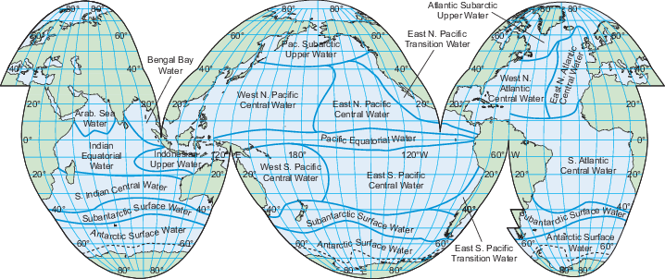
Figure 20 The global distribution of the most common upper ocean water masses. The boundaries between the different water masses are diffuse as properties gradually change.
View description - Figure 20 The global distribution of the most common upper ocean water masses. The ...

- Would all of the surface water masses shown in Figure 20 have the same density anomaly? Hint - you may have to look at Figures 9, 10b and 12.
- No, they would not. The density of water is a function of temperature and salinity, and each water mass has a different temperature and salinity value. You can see from Figure 12 that different temperatures and salinities lead to different densities.

4.6 The frozen seas
Because of the effects of temperature and salinity on the density of seawater (Figure 12), the cold polar seas have a tremendous climate impact on the rest of the planet.
Ice forms first as small crystals called frazil ice. These form at the surface and develop a layer that looks similar to an oil slick (Figure 21a). The crystals then coalesce to form small plates called pancake ice, which have rounded edges caused by constantly being bumped (Figure 21b). As more seawater freezes, the pancakes grow up to 3 m in diameter and eventually freeze together or are piled up on top of each other by storms to form larger ice floes. Water can freeze onto the bottom and snow falls on the surface, increasing their thickness to typically more than 2 m (Figure 21c).

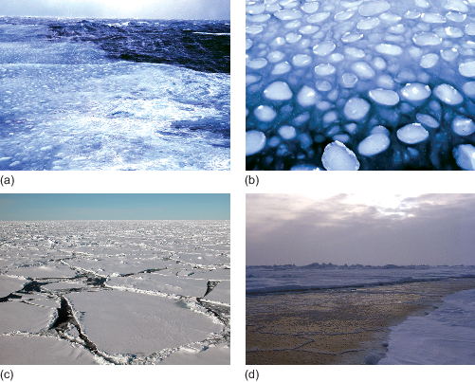
Figure 21 Sea ice growing on the surface of the ocean. (a) The first stage of ice formation is frazil ice forming a 'slick' on the surface of the sea; (b) pancake ice which has developed from the frazil; (c) older pack ice with a covering of snow; (d) the dark region is thin ice which has grown in the gaps between the older, thicker pack ice.
View description - Figure 21 Sea ice growing on the surface of the ocean. (a) The first stage of ice ...

A large area of this ice is called pack ice or simply 'the pack'. When conditions are calm the frazil ice can develop directly into large sheets of ice and so miss out the pancake stage. The ice floes can be kilometres wide and the gaps between individual floes small. The breakup of sea ice is not simply the reverse of the sequence when ice grows; the large ice floes break up into small floes and then melt straight into water.

Activity 2 Sea ice in the climate system
Time guide: 1 hour

Part 1: The growth of sea ice

Watch Video 6 about the process of sea ice generation, recorded for the BBC television series Life in the Freezer. Make notes as you watch it. Once you have watched the video, try to answer the questions below.

Video content is not available in this format.
Video 6 Process of sea ice generation.
View transcript - Video 6 Process of sea ice generation.

Question 1

At what temperature does the sea freeze?

View answer - Question 1

Question 2

What causes the sea ice crystals to develop into pancake ice?

View answer - Question 2

Part 2: Sea ice growth in Antarctica

Video 7 was recorded by satellite and shows the ocean around Antarctica covered by sea ice. At the bottom of the map is the date, on the left-hand side the day of the year, and on the right-hand side the day, month and year. Green, yellow, red and purple represent sea ice concentration, light blue represents open water and the grey areas represent land such as Antarctica and South America. View the clip now and focus on where the ice remains throughout the entire Antarctic summer.

Video content is not available in this format.
Video 7 Sea ice growth in Antarctica. (There is no audio associated with this video.)

Question 3

Where does the sea ice remain throughout the Antarctic summer?

View answer - Question 3

Question 4

Now view Video 8. It shows the same information as the previous clip but much faster. This time focus on the proportion of the year that the sea ice is growing compared with the proportion of time that it is decaying.

Video content is not available in this format.
Video 8 Faster view of sea ice growth in Antarctica. (There is no audio associated with this video.)

Does the sea ice in Antarctica grow and melt at the same rate throughout the year?

View answer - Question 4

Part 3: Sea ice growth in the Arctic

The Arctic Ocean is a deep sea covered by a relatively thin layer of sea ice a few metres thick. Video 9 is quite long, so you should start it now and then read the explanation below as you are watching it.

Video content is not available in this format.
Video 9 Sea ice growth in the Arctic. (There is no audio associated with this video.)

In the video the white and shades of light to dark blue that are expanding and shrinking show the concentration of sea ice similar to that in the previous clips in the Antarctic. This was recorded by the same satellite as previously. The date for the ice concentration is shown in the top left corner as year-month-day, so '1994 7 16' represents the ice concentration on 16 July 1994.
Finally, there are the locations and drift tracks of what are called IABP buoys. This stands for International Arctic Buoy Programme buoys: small scientific packages which are deployed on the ice and report their position and weather data such as air temperature and air pressure. The location of the actual scientific package is shown as a red dot and there is a trail showing where the buoy has been. When the ice melts the buoy sinks and then is lost.
Watch the video all the way through and then try to answer the following questions.

Question 5

The drift of the buoys can be shown to represent the movement of the sea ice, ocean currents and winds. However, the drift is generally not smooth: why do you think this might be?

View answer - Question 5

Question 6

In the bottom left quadrant of the picture is the Beaufort Sea. What is the general sense of movement of the ice which the buoy tracks reveal?

View answer - Question 6

Question 7

In some areas the buoy tracks are almost stationary (i.e. they have short trails behind the red dots), but in other places they seem to drift relatively rapidly (they have long trails behind the red dots). Can you identify the regions where the drift appears to be the most rapid?

View answer - Question 7

Question 8

The video of the Arctic showed the drift of the tracks of IABP buoys over (sometimes) many years. Based on what you saw in the distribution of Antarctic ice, why do you think that such buoy drift records have not been made for the Antarctic?

View answer - Question 8

Further information
Follow the link below if you would like to find out more about the voyage of the Fram when the eminent Norwegian scientist Fridtjof Nansen used the Transpolar Drift Stream in his attempt to reach the North Pole.
Fram expedition
Follow the link below if you want to know more about Ernest Shackleton's drift across the Weddell Sea in a clockwise direction when his ship - the Endurance - was crushed in the ice.
Imperial Trans-Antarctic expedition

4.7 The global ocean circulation
As seawater freezes and ice is formed in the annual cycles you saw in Activity 2, salt is squeezed from between the ice crystals into the ocean beneath in a process called salt rejection. The result is that if you took one pancake ice floe (Figure 21b) and melted it in a bucket, the water that resulted would be fresher than the seawater you started with. So what has happened to the salt?
The answer is it has increased the density of the seawater just beneath the ice. This is a small-scale physical process, but the effects are global and profound, as is clear from Figure 13. Salt rejection from sea ice generation in the Antarctic creates dense water which sinks and floods away from the continent. The coldest water is not the most saline; it is the combination of the cold temperatures and increased salinity that makes the water dense enough to sink to the sea floor.
The very large volume of water of uniform temperature and salinity flooding away from Antarctica is called Antarctic Bottom Water (AABW) because it is formed in the Antarctic and is dense enough to reach the bottom of the ocean and flow away from the continent. The lowest-salinity water at ~1000 m depth and ~40° S, coloured purple and blue in Figure 13, is formed by the climatic conditions in the mid-latitudes of the Southern Hemisphere and is not as dense as AABW.
You have investigated a section through the Atlantic Ocean, but had you looked at any section radiating from Antarctica along a particular longitude, the picture would have been broadly similar. The sea ice generation and resulting salt rejection is driving a cold, relatively salty, dense water current northwards along the sea floor at great depth.
If a deep, cold, salty current is flowing away at depth, there has to be water flowing towards Antarctica to replace it. Arctic salt rejection increases the density of the waters at the other end of the planet but, because of the shallow sea floor between Greenland, Iceland and the UK, the densest water is contained and cannot flow south. What can escape into the North Atlantic sinks to the sea floor, and so is called North Atlantic Deep Water (NADW). The resulting picture of ocean circulation in the Atlantic when these water masses meet is shown in Figure 23.

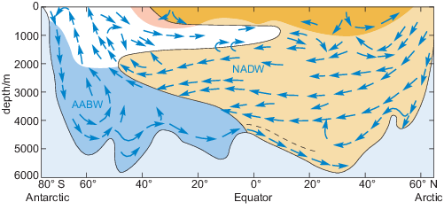
Figure 23 A schematic cross-section of the circulation in the Atlantic Ocean. Colours represent different water masses and blue arrows represent their movement. The AABW is dense enough to fill up the deep basins of the South Atlantic. The NADW is less dense and so it rises up over the AABW and fills up the mid-depths of the South Atlantic when the water masses meet.
View description - Figure 23 A schematic cross-section of the circulation in the Atlantic Ocean. Colours ...

The dense AABW (coloured blue) spreads northwards along the sea floor and the NADW (brown) spreads south.

- Based on Figure 23, which water mass is denser, AABW or NADW?
- The NADW flows over the AABW so it must be less dense.

Figure 24 shows that NADW is both warmer and more saline than AABW, so it is less dense (Figure 23). However, the NADW is denser than the water mass coloured white and consequently is sandwiched between this and the AABW.
The actual boundaries between the layers are not as distinct as the colours in the picture would suggest, but overall there is an overturning circulation along the length of the Atlantic Ocean. In the Pacific and Indian Oceans the picture would be similar to Figure 23 south of the Equator, but the northern end would be different.
The Indian Ocean does not reach the Arctic, and in the Pacific Ocean, as you have seen, the gap between Asia and North America is so narrow and shallow that the ocean is virtually closed off to the north. This means that virtually all of the deep waters formed in the Arctic enter the global ocean in the North Atlantic. The result is a vast three-dimensional circulation across the entire global ocean called the thermohaline circulation ('thermohaline' meaning heat and salt) (Figure 24). This was proposed in the 1980s by American climate scientist Wallace Broecker. It is often referred to as the 'conveyor belt'.

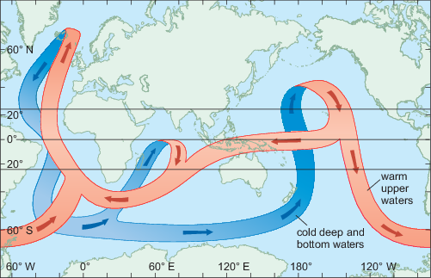
Figure 24 A schematic diagram of the thermohaline circulation that moves both heat and salt around the planet. A large component of the forcing in this conceptual circulation is coming from processes happening in the Arctic and the Antarctic.
View description - Figure 24 A schematic diagram of the thermohaline circulation that moves both heat ...

Figure 24 is of course a gross simplification, but it is useful to help you think about the way the global ocean circulates over hundreds of years. It makes clear that polar processes such as the sea ice growth can drive the global ocean circulation and move vast quantities of heat and salt around the planet. Ultimately it is these processes that are responsible for the sea surface temperature distribution you saw in Figure 1, making the UK and Norway warmer than locations at similar latitudes on the west side of the Atlantic.

- What could be the effect of reduced deep-water formation in the North Atlantic Ocean on the climate of Western Europe?
- Reduced deep-water formation in the North Atlantic could decrease the strength of the deep branch of the oceanic 'conveyor belt' in Figure 15. This could reduce the strength of the whole conveyor belt and so less heat would be carried from the Pacific Ocean into the Atlantic Ocean. Ultimately, it could lead to cooling of the climate of Western Europe.

Activity 3 The circulation of the oceans
Time guide: 45 minutes

Part 1: Ocean models

You are probably familiar with meteorological agencies such as the United Kingdom Meteorological Office (UKMO) using computer models to predict the weather. The models they use are 'coupled' models, with a model of the atmosphere and a model of the oceans passing data between them, which increases the accuracy of their predictions.
The latest high-resolution computer models need large computers to run them, and the results are both impressive and beautiful to watch. One large ocean model is called ECCO2, which stands for Estimating the Circulation and Climate of the Ocean, Phase II. It is easy to think of the ocean having a rather simplistic circulation pattern such as that shown in Figure 15, but that is only because it is hard to observe.
Video 10 shows modelled oceanic surface currents from June 2005 through to December 2007. Dark patterns under the ocean represent the undersea bathymetry. The land topography is exaggerated 20 times and the bathymetry is exaggerated by 40 times. When you have watched the clip, try to answer the questions below.

Video content is not available in this format.
Video 10 The perpetual ocean. (There is no audio associated with this video.)

Question 1

What is the most surprising thing about the flow of water around the coast of South Africa?

View answer - Question 1

Question 2

Is the strength of the currents the same on both sides of the northern Pacific and Atlantic oceans?

View answer - Question 2

Question 3

The previous video showed the surface currents. From the same ocean model Video 11 shows the sea surface temperature and the modelled sea ice concentration. What you will observe is the annual cycle of temperatures over several years. Note the difference in North Atlantic temperatures either side of the basin that was pointed out in Figure 1

Video content is not available in this format.
Video 11 Sea surface temperature. (There is no audio associated with this video.)

Can you identify the western boundary currents and the ocean eddies around South Africa that were so clear in the previous video?

View answer - Question 3

Part 2: The thermohaline circulation

Video 12 shows an animation of the schematic thermohaline circulation shown in Figure 24. It is important to note that this animation is purely on our understanding of the global ocean circulation rather than model output like in the previous two videos. It is also important to remember that one complete circulation would take several hundred years.
The shading on the beginning of the animation represents water density. Bright regions are less dense shallow currents and lighter arrows are dense and deep currents. The depths of the oceans and land topography are highly exaggerated (100× in oceans, 20× on land) so that the depth differences in the currents show up more clearly. When you have seen the video, try to answer the questions before.

Video content is not available in this format.
Video 12 Thermohaline circulation. (There is no audio associated with this video.)

Question 4

Between Greenland, Iceland and Scotland, is the densest current flowing southwards in the location of the deepest channel you identified in Activity 1?

View answer - Question 4

Question 5

In the western boundary current of the North Atlantic (the Gulf Stream), is the thermohaline circulation in the same direction at all depths?

View answer - Question 5

Question 6

In the previous videos you saw that the flow of water around South Africa appeared in the computer model output as a constant stream of eddies. How does this flow appear in the thermohaline circulation?

View answer - Question 6

Question 7

What is the main difference between the representations of the flow of water around Antarctica in Figure 24 (above) and this video?

View answer - Question 7
In this activity you have seen just how complex and beautiful the ocean circulation is.

Conclusion
- The effect of the wind stress on the surface of the ocean is passed down through the water column through eddy viscosity and energy is transferred into the water column.
- The net result of the Ekman spiral in the Northern Hemisphere is to cause a slow transport of moving water to the right of the wind. In the Southern Hemisphere it causes a slow transport of moving water to the left.
- Different climates produce water masses of different densities. Sea ice generation in the polar regions creates very dense water masses.
- The processes that drive a circulation pattern throughout the Atlantic Ocean also operate in the other oceans of the world. The differing densities of water have set up a global circulation pattern which is drawn schematically as an 'oceanic conveyor belt' that redistributes large amounts of heat around the Earth.

Keep on learning

Study another free course
There are more than 800 courses on OpenLearn for you to choose from on a range of subjects.
Find out more about all our free courses.

Take your studies further
Find out more about studying with The Open University by visiting our online prospectus.
If you are new to university study, you may be interested in our Access Courses or Certificates.

What's new from OpenLearn?
Sign up to our newsletter or view a sample.

For reference, full URLs to pages listed above:
OpenLearn - www.open.edu/openlearn/free-courses
Visiting our online prospectus - www.open.ac.uk/courses
Access Courses - www.open.ac.uk/courses/do-it/access
Certificates - www.open.ac.uk/courses/certificates-he
Newsletter - www.open.edu/openlearn/about-openlearn/subscribe-the-openlearn-newsletter

Glossary
abyssal plain
The flat part of the ocean floor that lies between about 4 and 6 km below the sea surface.
albedo
The reflection coefficient of a surface - the fraction of the amount of incoming radiation that is reflected from a surface.
Antarctic Bottom Water (AABW)
Cold, dense bottom water mass that forms around the Antarctic continent (especially in the Ross and Weddell Seas) and spreads northwards in all three ocean basins.
bathymetry
The study of underwater depth of lake or ocean floors.
constancy of composition
The principle for seawater that, although the concentration of dissolved salts can vary from place to place, the relative proportions of the ions remains virtually constant.
continental shelf
The part of the ocean floor bordering the continents at a depth of 200 m or less below the sea surface.
continental slope
The part of the ocean floor extending from the edge of the continental shelf to the start of the continental rise. The continental slope has an average gradient of around 4deg.
Coriolis force
An apparent force invented to explain the deflection of bodies moving over the surface of the Earth without being frictionally bound to it. It acts 90° to the right of the direction of motion in the Northern Hemisphere, and 90° to the left in the Southern Hemisphere.
eddy viscosity
Internal friction between the molecules of a liquid that transfers momentum.
Ekman drift
The mean current across the Ekman layer.
Ekman layer
The depth of influence of the Ekman spiral.
Ekman spiral
The vertical spiral pattern of water velocities that develops in the upper ocean as a result of the Coriolis force acting on moving water. The pattern develops to the right in the Northern Hemisphere, and to the left in the Southern Hemisphere.
Ekman transport
The volume of water transported by the Ekman drift.
frazil ice
The initial form of sea ice: a slurry-like suspension of ice crystals.
gyre
A large-scale circulatory feature of the ocean circulation, usually extending across many thousands of kilometres.
hydrographic section
The standard way for presenting a series of CTD (seawater conductivity and temperature, and depth) measurements taken across an ocean or a feature in the ocean.
hydrothermal vents
Fissures on the seafloor out of which flows water that has been heated by underlying magma.
isohalines
Contour line joining points of equal salinity either on maps or in vertical sections.
isotherms
Contours of constant temperature.
Mid-Atlantic Ridge (MAR)
A north-south suboceanic ridge in the Atlantic Ocean from Iceland to Antarctica on whose crest are several groups of islands.
North Atlantic Deep Water (NADW)
Deep water mass formed mainly in the Norwegian and Greenland Seas.
pack ice
A mass of ice floating in the sea, formed by smaller pieces freezing together.
pancake ice
Sea ice rind broken up into pieces a few centimetres in diameter, with upturned edges resulting from multiple collisions.
permanent thermocline
The region beneath the mixed layer where temperature decreases with depth.
salt rejection
A process that occurs during sea ice formation where salt is pushed from forming ice into the surrounding seawater, increasing the salt concentration there.
stratified
(In the context of water) Where water masses with different properties of salinity, oxygenation, density and temperature form layers that act as barriers to water mixing.
thermohaline circulation
Global oceanic circulation through a series of strong currents, driven by deep water formation in the polar seas and heating of water in the tropical seas; an effect of temperature and salinity differences. Also called the ocean 'conveyor belt'.
water mass
A very large volume of water with uniform temperature, salinity and, therefore, density.
wind stress
The frictional force that transfers energy from the wind to the surface of the water.
wind-mixed layer
Surface water that has been mixed by the wind to create a layer with uniform physical properties.

Acknowledgements
This course was written by Mark Brandon.
Except for third-party materials and otherwise stated in the acknowledgements section, this content is made available under a Creative Commons Attribution-NonCommercial-ShareAlike 4.0 Licence.
Course image: Joshua Conley in Flickr made available under Creative Commons Attribution-NonCommercial-ShareAlike 2.0 Licence.
The material acknowledged below is Proprietary and used under licence (not subject to Creative Commons Licence). Grateful acknowledgement is made to the following sources for permission to reproduce material in this course:
Figure 8: courtesy of Mark Brandon
Figure 9: http://www.ospo.noaa.gov/
Figure 10(a) and 10(b): from: Tait, R.V. (1968), Elements of Marine Ecology, Butterworth Heinemann
Figure 13 and 14: from Schlitzer, R. (2000) 'Electronic atlas of WOCE hydrographic and tracer data now available', Eos, Transactions American Geophysical Union, vol. 81, no. 5, p. 45
Figure 16: courtesy of Mark Brandon
Figure 18: from Perry, A.H. and Walker, J.M. (1977) The Ocean-Atmosphere System, Longman
Figure 20: adapted from Emery, W.J. and Meinke, J. (1986) 'Global water masses - summary and review', Oceanologica Acta, vol. 9, Copyright © 1986, Elsevier Science
Figure 21: courtesy of Mark Brandon
Figure 22: adapted from: MacDonald et al. (2005) 'Recent climate change in the Arctic', Science of the Total Environment, vol. 342, no. 1-3, 15 April 2005, Elsevier Inc.
Video 1: Using Google Earth to look at the ocean with Mark Brandon : © content: Google Earth/Data SIO, NOAA, U.S. Navy, NGA, GEBCO. https://www.google.co.uk/intl/en_uk/earth/
Video 2: Using Google Earth with a file containing information in layers with Mark Brandon © content: Google Earth/Data SIO, NOAA, U.S. Navy, NGA, GEBCO. https://www.google.co.uk/intl/en_uk/earth/
Video 3: United States National Oceanograph and Atmospheric Administration (NOAA) http://www.noaa.gov/
Video 4: Demonstration on how to use layers with Google Earth with Mark Brandon. © content: Google Earth/Data SIO, NOAA, U.S. Navy, NGA, GEBCO. https://www.google.co.uk/intl/en_uk/earth/
Video 5: extract (including transcript) from BBC Planet Earth Episode 11 'Ocean Deep' © BBC
Video 6: extract (including transcript) from BBC Life in the Freezer, Episode 4 © BBC
Video 7: Mark Brandon for The Open University using data from NASA
Video 8: Mark Brandon for The Open University using data from NASA
Video 9: The international Arctic Research Center University of Alaska Fairbanks
Video 10: NASA/Goddard Space Flight Center Scientific Visualization Studio
Video 11: NASA http://www.nasa.gov/
Video 12: NASA http://www.nasa.gov/
Every effort has been made to contact copyright owners. If any have been inadvertently overlooked, the publishers will be pleased to make the necessary arrangements at the first opportunity.
Don't miss out:
If reading this text has inspired you to learn more, you may be interested in joining the millions of people who discover our free learning resources and qualifications by visiting The Open University - www.open.edu/openlearn/free-courses

Solutions

Activity 1 The ocean depths

Question 1

Answer
The most straightforward way is to type 47 34 N 7 34 W in the 'Search' box, then use your mouse and the latitude and longitude information on the bottom right to move your cursor to the correct point and so find the water depth at 47°34′ N, 7° 33′ 30″ W.
The water depth is approximately 1103 m.
Back to - Question 1

Question 2

Answer
The water depth off the west coast of France is approximately 120 m and the depth in the dark blue region to the west is ~4600 m.
The light blue region is called the continental shelf and the deeper region is called the abyssal plain. The area between these two regions is the continental slope.
Back to - Question 2

Task 2

Answer
The average depth and slope of the continental shelf, abyssal plain and the length of the transect length over which the average is generated is shown in Table 1.

Table 1 Average depth and slope of the continental shelf, the abyssal plain and the continental slope.
Location | Average depth/m | Average slope/° | Transect length/km
Continental shelf | ~159 | 0.2 | 50
Abyssal plain | ~4727 | 0.2 and 1.0 | 27
Continental slope | ~2467 | 0.4 and -7.5 | 49

From your measurements you should be able to see that both the continental shelf and the abyssal plain are astonishingly flat. A slope of between 0.2° and -0.2° over 50 km is flatter than anything one would observe on land. And despite the continental slope looking steep, the average slope is only -7.5°. Features look abrupt and steep in Google Earth and in the way relative heights in charts are represented, when in fact they are not.
Back to - Task 2

Part 2: Examining other features

Answer
The Mid-Atlantic Ridge is a divergent boundary whereas the Marianas and the Scotia Sea Trenches are on convergent boundaries.
Back to - Part 2: Examining other features

Question 5

Answer
Overlaying the vent locations on the tectonic boundaries shows that the vents are typically found on divergent boundaries.
Back to - Question 5

Task 4

Answer
It is extremely hot and the water contains a chemical cocktail. The sulfides in the water solidify into chimneys and are presumably colouring the water black.
Back to - Task 4

Question 7

Answer
A particular type of bacterium can use the chemicals in the hot water, and this in turn is eaten by shrimps and other animals.
Back to - Question 7

Question 8

Answer
Giant tube worms are the fastest-growing invertebrates.
Back to - Question 8

Question 9

Answer
Each community is unique and vents can start and stop rapidly. When they stop, the inhabitants will die.
Back to - Question 9

Question 10

Answer
The deepest depths are between the North Atlantic and the Arctic Ocean along the Greenland to Scotland transect. Here water depths are in one region > 1000 m. The shallowest depths are between the Pacific and the Arctic Ocean across the Bering Strait, and water depths are only ~ 50 m.
You will see later in the course that the difference in maximum depths between the two ocean basins is critical for the circulation of the global oceans.
Back to - Question 10

Activity 2 Sea ice in the climate system

Question 1

Answer
The commentary says that the sea begins to freeze at -1.9 °C.
Back to - Question 1

Question 2

Answer
A slight swell on the surface of the ocean causes the crystals to coalesce and form the pancakes.
One feature notable by its absence in the clip you have just viewed is bad weather! That clip clearly focuses on film recorded either from the shore or in calm seas. Undoubtedly, most of the sea ice growth that happens at both poles takes place in winter, and in bad weather.
Back to - Question 2

Question 3

Answer
In January 1998, the sea ice remains mainly close to the coasts and in one location called the Weddell Sea.
Back to - Question 3

Question 4

Answer
No, the cycle is asymmetric. The sea ice grows over a longer period (~6 months) than its seemingly rapid retreat (~4 months).
Back to - Question 4

Question 5

Answer
The buoys sit on the sea ice and so are moved about by the winds. Storms will make them drift both faster and more slowly and in different directions, as will ocean currents.
Back to - Question 5

Question 6

Answer
The buoys drift generally in a clockwise direction around the Beaufort Sea - although sometimes this occasionally completely reverses.
Back to - Question 6

Question 7

Answer
Within the Arctic Ocean the region above the pole shows the fastest drift, from the left-hand side of the frame to the right-hand side. Once the buoys pass the gap between Greenland and Svalbard they rapidly increase in speed, and then disappear as the ice they are resting on melts. Overall the drift of the sea ice in the Arctic can be divided into the clockwise so-called Beaufort Gyre and the transpolar drift as shown in Figure 22.

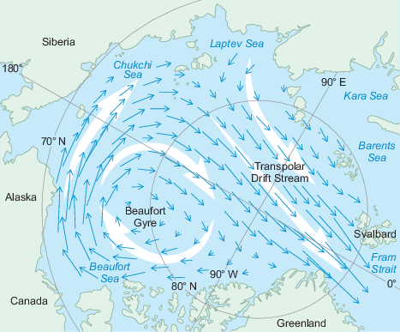
Figure 22 The mean ice drift across the Arctic Ocean. The ice is trapped in two major circulation features, the Beaufort Gyre and the Transpolar Drift Stream. White arrows show the general movement of the ocean currents; blue arrows show the general drift of the sea ice.
View description - Figure 22 The mean ice drift across the Arctic Ocean. The ice is trapped in two major ...

Back to - Question 7

Question 8

Answer
The videos of the Antarctic showed that most of the ice melts, so there would not be extensive tracks over many years. In areas where the ice does remain over the summer, such as the Weddell and Ross Seas, the drift has been shown to be clockwise.
Back to - Question 8

Activity 3 The circulation of the oceans

Question 1

Answer
From 37 seconds onwards in the clip you can see that, instead of a continuous flow of water, there are discrete, rapidly rotating patterns of closed circulation. These are called ocean eddies, and if you saw these patterns on a weather map you would call them storms.
Back to - Question 1

Question 2

Answer
No, the current is stronger on the western side of each of these great oceans. These currents are called western boundary currents and they include the Gulf Stream and the Kuroshio. There are also western boundary currents in the Southern Hemisphere, but they rotate in the opposite direction.
Back to - Question 2

Question 3

Answer
It is possible to see both of those features, although they are perhaps not as clear as in the previous visualisation.
Back to - Question 3

Question 4

Answer
Yes, the densest current is flowing southwards just north of Scotland.
Back to - Question 4

Question 5

Answer
No. It is only the surface waters that are flowing northeastwards towards Europe; at depth the waters are flowing in the opposite direction.
Back to - Question 5

Question 6

Answer
The constant stream of eddies around the coast is represented as a continuous flow of less dense water.
Back to - Question 6

Question 7

Answer
Figure 24 does not show a continuous clockwise circulation around Antarctica (the Antarctic Circumpolar Current - see Section 4.1), like the animation or the previous model output in this activity.
Back to - Question 7

Figure 1 Locations of Bergen, Norway and Halifax, Nova Scotia, and the mean sea-surface temperature. White regions close to the coasts are areas with no temperature data in this data set.

Description
Figure 1
This map is centred on the north Atlantic Ocean, showing ocean temperature, with blue representing colder temperature and red representing hotter temperature.
The map covers the area from the north of Greenland to North Africa and from the Great Lakes in North America to the east of the Mediterranean Sea.
Two cities are indicated on the map; Halifax, Nova Scotia in Canada and Bergen, in Norway.
There is no scale on the map but the longitude and latitude are marked and there are dotted black grid lines at the marked longitudes and latitudes.
Along the lower horizontal edge of the map, longitude is marked, from 90° W to 30° E in 20° intervals of even size.
Along the left vertical edge of the map, latitude is marked from 30° N to 80° N, in 10° intervals that are not even in size. The size of each 10° interval increases as you move north.
The key for ocean colour is provided in a horizontal bar below the map. It is labelled 'sea surface temperature/°C' and it is marked from −2° to 30° in 2° intervals. The colour changes from dark blue at −2°, through increasingly paler shades of blue to 12°. The colour then changes to yellow at 14° and the progresses through increasingly darker shades of orange to 20°,and then through increasingly darker shades of red to dark red at 30°.
The general pattern of temperature change seen is one of increasing temperature as you move from north to south, with dark blue colour dominating the waters to the east and west of Greenland and the orange /red colours restricted to a narrow band at the very south of the map.
There is also clear east west pattern noticeable and the colder temperatures extend much further south along the west side of the Atlantic, with a finger of the coldest water marked extending down as far south as Newfoundland in Canada.
The warmest temperatures maintain a more or less horizontal patterns across the Atlantic, but the contours for temperatures in the 4° to 12° range extend much further north along the east side of the Atlantic and there is a finger of paler blue protruding north along the coast of northern Scandinavia.
Back to - Figure 1 Locations of Bergen, Norway and Halifax, Nova Scotia, and the mean sea-surface temperature. White regions close to the coasts are areas with no temperature data in this data set.

Figure 2 Monthly mean atmospheric temperatures for Bergen, Norway and Halifax, Nova Scotia.

Description
Figure 2
This line graph shows the change in mean atmospheric temperature during a year for Halifax and Bergen.
The horizontal axis is labelled 'month' and is marked from Jan to Dec in monthly intervals.
The vertical axis is labelled 'temperature/°C' and is marked from −10 to 20 in intervals of 5 °C.
There are horizontal and vertical gridlines at the axes markers.
There are two lines on the graph representing the temperature: The temperature at Bergen is presented with a blue line and the temperature for Halifax is presented with a red line.
The temperature at Bergen shows a shallow inverted 'U' shape with low temperatures in the winter months at either end of the graph and high temperatures in the summer months in the middle of the graph. The temperature starts at approximately 0° in Jan and rises steadily through 5° (Apr) to a peak of 14° (July) and then decreases steadily to 2° (Dec).
The temperature at Halifax shows a more extended inverted 'U' shape with lower temperatures in the winter months at either end of the graph and higher temperatures in the summer months in the middle of the graph. The temperature starts at approximately −6° in Jan and Feb and then rises rapidly through 5° (Apr) to a peak of 18° (July) and then decreases steadily to −4° (Dec).
Back to - Figure 2 Monthly mean atmospheric temperatures for Bergen, Norway and Halifax, Nova Scotia.

Figure 3 Bathymetry along latitude close to 39° N. Sea level is shown as a dashed line.

Description
Figure 3
This line graph shows the change in ocean depth with longitude.
The horizontal axis is labelled 'degrees longitude West of Greenwich'. The axis scale begins at approximately −75° and ends at approximately −7°, but is marked at 20° intervals from −70° to −10°. There are vertical grid lines at the marked axis points.
The vertical axis is labelled 'depth/m below sea level' and is marked from 6000 m to 0 m, with 0 m at the top, in intervals of 2000 m. There are horizontal grid lines at intervals of 1000 m.
There is a black dashed line that runs horizontally at a depth of 0 m.
The depth data are represented by a solid red line which is labelled 'USA' at the left side and 'Europe' on the right side. There is also a label of 'MAR' at a peak in the line between −34° and −26°.
Moving right, from the left side (labelled 'USA'),
the ocean floor drops slowly at first and then rapidly to almost 3000 m (−70°) and then to near 5000 m (−60°),
the ocean floor then slowly drops further to approximately 5500 m before rising sharply to 4500 m (−45°),
this is the start of a gradual rise in the ocean floor with longitude followed by a sharp rise to 2000 m (−34°),
the ocean floor now stays above 2000 m, reaching as shallow as 1500 m, until it drops sharply back to 2500 m (−26°). This is the section labelled 'MAR'.
there is a steady drop in ocean floor back to 5500 m (−18°), then a section of sharp oscillations between 4500 m and 3500 m followed by a sharp rise to 0 m on the right side, labelled 'Europe'.
Back to - Figure 3 Bathymetry along latitude close to 39° N. Sea level is shown as a dashed line.

Figure 4 The density of fresh water plotted against temperature.

Description
Figure 4
This is a line graph showing the change in density with temperature.
The horizontal axis is labelled 'temperature/°C' and is marked from 0 °C to 10 °C in intervals of 1°.
The vertical axis is labelled 'density of freshwater/kg m⁻³' and is marked from 999.6 kg m⁻³ to 1000.0 kg m⁻³ in intervals of 0.1 kg m⁻³.
There are horizontal and vertical gridlines at the marked axes points.
The density data are represented by a solid green line.
The pattern in the line is an asymmetric inverted 'U' shape.
The density is approximately 999.86 kg m⁻³ at 0° and then increases steadily to a maximum of almost 1000.0 kg m⁻³ at approximately 4°.
The density then decreases steadily to 999.73 at 10°.
Back to - Figure 4 The density of fresh water plotted against temperature.

Figure 5 (a) Section through a lake showing ice on the surface. (b) Temperature structure throughout the lake: there are three layers: a cold surface layer, an intermediate layer and a warm deeper layer. (c) Density structure mirroring the shape of the temperature profile in (b).

Description
Figure 5
This is a series of 3 diagrams that show the change in temperature and density with depth in a lake and within designated layers within the depth profile of the lake.
Figure (a) is on the far left and is labelled 'side view of lake'
This diagram shows the depth profile of the lake along with 4 identified layers to this profile.
The top layer is labelled 'ice', is the narrowest of the 4 layers and is shaded very pale blue.
The layer below this is labelled 'surface layer at 0 °C', is the third narrowest of the 4 layers and shaded very pale blue.
The layer below that is labelled 'intermediate layer', is the second narrowest of the 4 layers and is shaded in slightly darker shade of blue than the top 2 layers.
The layer at the bottom is labelled 'deep layer at 3.98 °C', is the widest of the layers and is shaded in the darker blue.
Figure (b), in the middle, presents temperature data as a line graph. It has the same colour and layering as Figure (a), except there are no labels and the top 2 layers (ice and surface layer at 0 °C) have been merged into one layer.
The horizontal axis is located at the top of the figure and is labelled 'temperature/°C' and is marked from −1 °C to 5 °C in intervals of 1 °C.
The vertical axis is labelled 'depth increasing' with no quantitative markings. There is black directional arrow head pointing downward at the lower end of the axis.
There is a red line indicating the temperature. The red line runs vertically, at a temperature of 0 °C from the top of the graph to the top of the intermediate layer. In the intermediate layer the red line shows an linear increase in temperature with depth from 0 °C to approximately 4 °C. The red line then runs vertically down through the bottom layer at approximately 4 °C.
Figure (c), on the right presents density data as a line graph. It has the same colour and layering as Figure (a), except there are no labels and the top 2 layers (ice and surface layer at 0 °C) have been merged into one layer.
The horizontal axis is located at the top of the figure and is labelled 'density/kg m⁻³' and is marked from 999.8 kg m⁻³ to 1000 kg m⁻³ in intervals of 0.1 kg m⁻³.
The vertical axis is labelled 'depth increasing' with no quantitative markings. There is black directional arrow head pointing downward at the lower end of the axis.
There is a green line indicating the density. The green line shows the same pattern of change as the red temperature line in Figure (b). The density starts at approximately 999.82 kg m⁻³ at the surface and remains at that value down to the top of the intermediate layer. In the intermediate layer the green line shows a linear increase in density with depth from 999.82 kg m⁻³ to approximately 999.98 kg m⁻³. The green line them runs vertically down through the bottom layer at approximately 999.98 kg m⁻³.
Back to - Figure 5 (a) Section through a lake showing ice on the surface. (b) Temperature structure throughout the lake: there are three layers: a cold surface layer, an intermediate layer and a warm deeper layer. (c) Density structure mirroring the shape of the temperature profile in (b).

Figure 6 A molecule of water, H2O, with the hydrogen and the oxygen atoms sharing electrons.

Description
Figure 6
This is a schematic diagram of a water molecule.
The oxygen atom is represented by a circle, shaded red and labelled 'O'.
The hydrogen atoms are represented by a circle, shaded grey and labelled 'H'.
1 oxygen atom is connected to 2 hydrogen atoms and the connection is shown by an narrow elongated rectangle shaded pale orange.
The water molecule has an 'L' shape with the oxygen atom at the corner and the 2 hydrogen atoms radiating out from this corner.
There is a dashed black line that radiates from the oxygen atom to each of the hydrogen atoms, along the connecting rectangle.
These dashed lines extend past the hydrogen atoms and they are then connected by a solid black line in the shape of an arc with directional arrow heads at either end.
The arc represents the angle of the 'L' shape or the angle between the two hydrogen atoms and is labelled '105°'.
Back to - Figure 6 A molecule of water, H2O, with the hydrogen and the oxygen atoms sharing electrons.

Figure 7 The physical properties of seawater at 20° S in the Atlantic Ocean against depth. (a) Temperature; (b) salinity; (c) density.

Description
Figure 7
A series of three line graphs to show the change in temperature, salinity and density with depth in the Atlantic ocean.
All three graphs share the same vertical axis. The scale is the same for all three graphs and there are major and minor axis ticks on the left and right aides of each graph. However, the axis is only labelled and numbered on Figure (a) on the left. Here the vertical axis is labelled 'depth/m' and goes down from 0 m to 5300 m, with minor axis ticks at intervals of 200 m, but only the major axis ticks are numbered, from 0 m to 5000 m in intervals of 1000 m.
In all three graphs the horizontal axis is labelled and marked at the top of the graph, and the major and minor axis tick marks are also shown, unlabelled, at the bottom of the graph.
Figure (a), on the left, shows the temperature data with a red line.
The horizontal axis is labelled 'temperature/°C'. It is marked from 0 °C to 30 °C in intervals of 5 °C with unlabelled minor ticks at intervals of 1 °C.
The red line starts at 29 °C at the surface and temperature decreases rapidly to approximately 4 °C at 1000 m depth. From there the temperature drops more slowly as seen by an almost linearly change with depth to 1 °C at 5100 m.
Figure (b), in the middle, shows the salinity data with a blue line.
The horizontal axis is labelled 'salinity'. It is marked from 34 to 38 in intervals of 1 with unlabelled minor ticks at intervals of 0.2. No units are indicated.
The blue line starts at 37.2 at the surface and salinity decreases rapidly to approximately 34.2 at 800 m depth. From there the salinity increases slightly to 35 at a depth of 1800 m and then decreases slowly to 34.8 at 5100 m.
Figure (c ), on the right, shows the density data with a green line.
The horizontal axis is labelled 'density/kg m⁻³'. The axis scale is from range 1023.2 kg m⁻³to 1028.8 kg m⁻³ with unnumbered minor tick marks at intervals 0.4 kg m⁻³. The major tick marks are numbered from 1024 kg m⁻³ to 1028 kg m⁻³ in intervals of 2 kg m⁻³.
The green line starts at 1024 kg m⁻³ at the surface and density increases steadily with depth to approximately 1027.2 kg m⁻³ at 600 m depth. From there the density increases slowly to 1028 kg m⁻³ at 5100 m.
Back to - Figure 7 The physical properties of seawater at 20° S in the Atlantic Ocean against depth. (a) Temperature; (b) salinity; (c) density.

Figure 8 A CTD: the bottles on the side of the instrument collect samples of water and can be closed by the operator at any chosen depth.

Description
The photo shows the instrument sitting on the wooden deck of a ship. The deck is wet, so it's probably just been winched out of the water. The instrument is within a cylindrical frame about 2.5 metres high and 1.5 metres in diameter. The collection bottles are dark grey, about a metre long and thin, and lie within the top third of the instrument. There are about 20-25 of them arranged vertically in a concentric pattern.
Back to - Figure 8 A CTD: the bottles on the side of the instrument collect samples of water and can be closed by the operator at any chosen depth.

Figure 9 The global sea-surface temperature in January 2014 recorded by satellite. Areas of uniform sea-surface temperature are the same colour and the scale is in °C.

Description
Figure 9
This is a global map showing sea surface temperatures as indicated by range of colours.
There are evenly spaced horizontal and vertical gridlines that are unlabelled.
The land masses are shown in white and the ocean is shown in colour according to the surface temperature as indicated in the key.
The key is located underneath the map and consists of a horizontal band of colours.
The key is labelled 'sea surface temperature/°C' and is marked from −2.0 °C to 32.3 °C in intervals of 4.3 °C.
The colour scale begins with purple at the lowest temperature and then progresses through dark blue (2.3 °C) to pale blue and into green (15.1 °C). The shade of green gets darker and then fades into yellow above 24 °C and then into orange and red at the highest temperature.
The pattern on the map shows relatively even horizontal banding.
A similar pattern of banding is presented from the Antarctic to the Equator as is seen from the Arctic to the Equator. There is a band of purple colour at very high latitudes fading through blue, green and orange, with the orange and red colours along a central band along the Equator and in the tropics.
Noticeable deviations from the background pattern are fingers of green extending further north along the east coast of South America and Africa, as well as an extension of the green and blue colouration up the north Atlantic coast over Europe and an extension of the purple and dark blue down the northeast coast of Canada.
Back to - Figure 9 The global sea-surface temperature in January 2014 recorded by satellite. Areas of uniform sea-surface temperature are the same colour and the scale is in °C.

Figure 10 (a) The mean value of E-P against latitude (purple line) and typical values of the surface salinity (green line). (b) Mean annual values of the sea-surface salinity.

Description
Figure 10
There are two parts to this figure that show the change in salinity and E-P with latitude; part (a) is a line graph (above) and part (b) is a contour map (below).
Part (a): The line graph shows the change in both salinity and E-P with latitude.
The horizontal axis is labelled 'latitude' and is marked from 80° S to 80° N in intervals of 10°. There is an axis tick for 70° but no number on both the N and S sides. The scale of the axis is not linear and the size of each 10° interval increases the closer it is to the Equator. There is a single vertical gridline at the centre of the axis, at latitude of 0°, and this is labelled 'Equator'.
The vertical axis has two scales indicated. The vertical axis on the left is labelled 'salinity' and is marked from 33 to 36 in intervals of 1. There are no units indicated. The vertical axis on the right is labelled 'E−P/mm y⁻¹' and is marked from −1000 mm y⁻¹ to 1000 mm y⁻¹ in intervals of 500 mm y⁻¹. There is a single horizontal gridline at the centre of the axis, at E−P = 0 mm y⁻¹.
The salinity data are represented by a green line.
The E−P data are represented by a purple line.
Both lines follow a similar 'M' pattern with increasing and decreasing undulations.
The salinity line is low (33.8) at 70° S and steadily increases to a first peak of 35.6 near 25° S before falling again to 34.4 at approximately 3° N. There is another increase to 35.7 at 24° N and then a drop to 33.4 at 50° N.
The E−P line begins at approximately −100 mm y⁻¹ at 70° S and then has an initial drop to −600 mm y⁻¹ near 54° S before it rises steadily to its first peak of 500 mm y⁻¹ near 25° S. This is followed by a steady decrease to −750 mm y⁻¹ at 5° N and then an increase to a second peak of 500 mm y⁻¹ at 20° N. The line then decreases to −400 mm y⁻¹ at 50° N and rises to a minor peak of almost 0 mm y⁻¹ at 70° N.
Part (b) shows a world map, centred on the Pacific Ocean, showing contours of equal levels of salinity and with increasing levels of salinity indicated by increasingly darker shades of blue.
The edges of the map are marked to show longitude and latitude with labels along the top and left sides.
The longitude is marked along the top edge, in intervals of 20°, with numbered marks at intervals of 40°, from 40° E to 0°.
The latitude is marked, along the left edge, from 60° S to 60° N in intervals of 20°.
Contour lines of equal salinity are shown in the oceans with labelled, solid black lines. The salinity levels for the contour lines ranges from 32 to 37 in intervals of 1.
There are also some labels for specific point value for salinity.
The contour bands are indicated by different shades of blue. There is no key, but the shading is as follows:
salinity less than 34 = very pale blue
salinity from 34 to 36 = pale blue
salinity greater than 36 = dark blue.
The general patterns shown by the map are;
very pale blue bands at high latitudes.
a band of pale blue from approximately 50° S to 40° N with a finger of pale blue extending very far north in the Atlantic over Northern Europe and Scandinavia.
The dark blue areas are confined to five patches in the following general areas:
Arabian Sea between Saudi Arabia and India,
an area in the Indian Ocean off the east coast of Australia,
an area in the South Pacific Ocean between Australia and South America,
a large portion of the South Atlantic Ocean from the South American coast (20° S to 40° S) and extending almost to the west coast of Africa,
and the largest area is located in the North Atlantic Ocean from the Gulf of Mexico across to northwest Africa and Spain (10° N to 40° N), and also includes the Mediterranean Sea.
Back to - Figure 10 (a) The mean value of E-P against latitude (purple line) and typical values of the surface salinity (green line). (b) Mean annual values of the sea-surface salinity.

Figure 11 An expanded plot of the upper 200 m of Figure 7.

Description
Figure 11
A series of three line graphs to show the change in temperature, salinity and density with depth in the Atlantic Ocean.
All three graphs share the same vertical axis. The scale is the same for all three graphs and there are major and minor axis ticks on all graphs. However, the axis is only labelled and numbered in the graph on the left. Here the vertical axis is labelled 'depth/m' and goes down from 0 m to 200 m, with minor axis ticks at intervals of 10 m, but only the major axis ticks are numbered, from 0 m to 200 m in intervals of 50 m.
In all three graphs the horizontal axis is labelled and marked at the top of the graph and the major and minor axis tick marks are also shown, unlabelled, at the bottom of the graph.
All three graphs show the same colouration. The graph is pale blue at the top with a gradual transition to dark blue at the bottom.
In all three graphs there is a horizontal dashed line at a depth of 38. The area above this line is called the 'wind-mixed layer'.
The graph on the left shows the temperature data with a red line.
The horizontal axis is labelled 'temperature/°C'. It is marked from 16 °C to 30 °C in intervals of 2 °C with unlabelled minor ticks at intervals of 1 °C.
The red line starts at 28 °C at the surface and the temperature remains constant in the wind-mixed layer, with the red line running almost vertically to a depth of 38 m. Below this depth there is an initial sharp decrease in temperature to 26 °C at a depth of 45 m and then a gradual decrease to 19 °C at a depth of 200 m.
The graph in the middle shows the salinity data with a blue line.
The horizontal axis is labelled 'salinity'. It is marked from 34 to 38 in intervals of 1 with unlabelled minor ticks at intervals of 0.2. No units are indicated.
The blue line starts at 37.2 at the surface and salinity remains constant in the wind-mixed layer, with the blue line running almost vertically to a depth of 38 m. From there the salinity decreases gradually to approximately 36 at a depth of 200 m.
The graph on the right shows the density data with a green line.
The horizontal axis is labelled 'density/kg m⁻³' and is marked from 1024 kg m⁻³ to 1026 kg m⁻³ in intervals of 1 kg m⁻³.
The green line starts at 1024 kg m⁻³ at the surface and density remains constant in the wind-mixed layer, with the green line running almost vertically to a depth of 38 m. Below this depth there is an initial sharp increase in density to 1024.5 kg m⁻³ at 45 m, then a gradual increase in density to 1025.9 kg m⁻³ at a depth of 200 m.
Back to - Figure 11 An expanded plot of the upper 200 m of Figure 7.

Figure 12 A temperature-salinity plot showing the range of typical temperatures and salinities and selected density anomalies found in the oceans. The two points, A and B, have the same density anomalies despite having different properties.

Description
Figure 12
This is a graph of salinity against temperature showing 11 density anomalies as contour lines.
The horizontal axis is labelled 'salinity/ppt' and is marked from 33.5 ppt to 36.5 ppt in intervals of 0.5 ppt, with unmarked axis tick marks at intervals of 0.1 ppt.
The vertical axis is labelled 'temperature/°C' and the scale of the axis is from −2 °C to 20 °C with minor axis tick marks at intervals of 1 °C. The major axis tick marks are numbered from 0 °C to 20 °C in intervals of 5 °C.
The major and minor axes tick marks are repeated, unnumbered, along the top and right side of the graph.
Eleven density anomalies are presented with red contour lines on the graph.
Each contour line is labelled with the density ranging from 24.0 to 29.0 in intervals of 0.5. No units are indicated on the graph, but given in text as kg m⁻³.
The red lines show a regular diagonal banding pattern with the lines running from lower left to upper right of the graph.
The line representing the lowest density is located in the upper left of the graph and density increases toward the lower right of the graph, with an increase in the distance between each successive line as you move from top left to bottom right.
There are two points marked on the graph, labelled 'A' and 'B', and both of these points lie on the 27.5 kg m⁻³ density line.
Each of these points is connected to the horizontal and vertical axes by a dashed black line.
The values for each point are as follows:
Point A: salinity = 34.23 ppt, temperature = 0 °C
Point B: salinity = 36.0 ppt, temperature = 11.4 °C
Back to - Figure 12 A temperature-salinity plot showing the range of typical temperatures and salinities and selected density anomalies found in the oceans. The two points, A and B, have the same density anomalies despite having different properties.

Figure 13 Temperature of a south-north hydrographic section across the Atlantic Ocean from 55° S to 65° N. The CTD profile shown in Figures 7 and 11 is at 20° S.

Description
Figure 13
This is a vertical profile of the Atlantic Ocean showing contours of temperature with depth and latitude.
There is a small inset map in the lower right corner. This map is centred on the Atlantic Ocean and spans all latitudes. There is a solid red line running more or less north-south through the middle of the Atlantic Ocean.
The horizontal axis of the main profile represents latitude, but is unlabelled. The axis scale goes from approximately 25° S to 65° N. There are tick marks at intervals of 10°, but numbered tick marks only at 20° intervals from 40° S to 60° N. The latitude of 0° is labelled as 'EQ'.
The vertical axis is labelled 'depth/m'. There are tick marks at intervals of 500 m but numbered only at intervals of 1000 m, from 0 m to 6000 m, with 0 m at the top of the axis.
There are horizontal and vertical gridlines at the numbered axes markers.
Along the bottom of the profile is a grey-coloured area, representing the ocean floor. The depth of the ocean floor starts shallow at 25° S and drops rapidly to below 5000 m at 30° S. It then undulates sharply up and down around the 5000 m depth with peaks at 40° S, EQ, 40° N and then it rises again to near surface at 66° N.
Contours of equal temperature are shown by labelled dashed or solid lines, ranging from 0 °C to 25 °C in intervals of 0.5 °C. The labels are black and very small. The contour lines for temperatures of 0 °C, 10 °C and 20 °C are bold and the labels are white.
The temperature is also indicated by colour coding and this is indicated by the vertical colour key bar to the right of the profile. The key bar is labelled '°C' and is marked from 0 °C at the bottom to 25 °C at the top in intervals of 5 °C. The colour of the bar changes from purple at the bottom (low temperature) through blue, green, yellow, orange, red and then to pale red and orange again at the top (high temperature).
The general pattern of the profile shows a narrow band of red/orange colour at the surface indicating high temperatures and then a steady decrease in temperature with increasing depth.
The warmer temperatures extend further down between 20° N and 60° N as evidenced by the bulge of the green colour down to depths of almost 2000 m in this latitude.
There is a distinct band of purple at depth from EQ to 25° S and this band of very low temperatures follows the ocean floor to the surface at 25° S. The spread of this band of very low temperature stops abruptly at the peak of ocean floor at EQ where the ocean floor rises sharply to 2000 m.
Back to - Figure 13 Temperature of a south-north hydrographic section across the Atlantic Ocean from 55° S to 65° N. The CTD profile shown in Figures 7 and 11 is at 20° S.

Figure 14 Salinity of a south-north hydrographic section across the Atlantic Ocean from 55° S to 65° N. The CTD profile shown in Figures 7 and 11 is at 20° S.

Description
Figure 14
This is a vertical profile of the Atlantic Ocean showing contours of salinity with depth and latitude.
There is a small inset map in the lower right corner. This map is centred on the Atlantic Ocean and spans all latitudes. There is a solid red line running more or less north-south through the middle of the Atlantic Ocean.
The horizontal axis of the main profile represents latitude, but is unlabelled. The axis scale goes from approximately 25° S to 65° N. There are tick marks at intervals of 10°, but numbered tick marks only at 20° intervals from 40° S to 60° N. The latitude of 0° is labelled as 'EQ'.
The vertical axis is labelled 'depth/m'. There are tick marks at intervals of 500 m but numbered only at intervals of 1000 m, from 0 m to 6000 m, with 0 m at the top of the axis.
There are horizontal and vertical gridlines at the numbered axes markers.
Along the bottom of the profile is a grey-coloured area, representing the ocean floor. The depth of the ocean floor starts shallow at 25° S and drops rapidly to below 5000 m at 30° S. It then undulates sharply up and down around the 5000 m depth with peaks at 40° S, EQ, 40° N and then it rises again to near surface at 66° N.
Contours of equal salinity are shown by labelled dashed or solid lines, ranging from 34 to 37 in intervals of 0.25. The labels are black and very small. The contour lines for salinities of 34, 35 and 36 are bold and the labels are white.
The salinity is also indicated by colour coding and this is indicated by the vertical colour key bar to the right of the profile. The key bar is labelled 'salinity' and is marked from 34 at the bottom to 37 at the top in intervals of 0.5. No units are indicated. The colour of the bar changes from purple at the bottom (low salinity) through blue, green, yellow, orange, red and then to pale red and orange again at the top (high salinity).
The general pattern of the profile shows the highest salinity along the surface and decreasing salinity with increasing depth.
Notable deviations from the general pattern are:
the narrow surface band of high salinity penetrates deeper into the ocean between 20° N and 40° N as evidenced by the bulge downwards of the orange-red colouration to depths of approximately 1500 m in these latitudes,
surface salinity is low between 25° S and 40° S with a finger of low salinity (blue) extending from 40° S to 10° N at a depth of 1000m, there is a band lower salinity (pale blue) along the ocean floor as it drops rapidly away from the surface at 15° S and as far north as the rise in the ocean floor at 40° S.
Back to - Figure 14 Salinity of a south-north hydrographic section across the Atlantic Ocean from 55° S to 65° N. The CTD profile shown in Figures 7 and 11 is at 20° S.

Figure 15 A schematic diagram of the surface currents of the Earth in the northern winter. Red arrows represent warm ocean currents; blue arrows represent cool currents. In some regions there are large seasonal differences.

Description
Figure 15
This is a world map, centred on the Pacific Ocean, showing ocean surface currents.
The edges of the map are marked to show longitude and latitude with labels along the top and left sides.
The longitude is marked along the top edge, in intervals of 20°, from 40° E through 180°, 160° W and then to 0° and ending with 20° E.
The latitude ranges from approximately 70° N to 70° S and is marked, along the left edge, from 60° S to 60° N in intervals of 20°.
There are horizontal lines across the entire map at latitudes of 0°, approximately 23° N and S, and approximately 66° N and S.
Surface ocean currents are shown by a series of red or blue lines and are labelled.
The following currents are identified in the Pacific Ocean:
Oyashio (blue lines): Flows from the north from the Arctic Ocean through the Bering Strait into the Bering Sea and then south along the northeast coast of Russia with a slight clockwise motion over the north of Japan.
Alaska current (blue lines): A clockwise current located in the Gulf of Alaska.
California Current (blue line): a straight current flowing south along the northwest coast of the United States.
North Equatorial Current (red lines): a small clockwise current located the mid-Pacific, just above the horizontal line at 23° N.
N. Pacific Current (red lines): A straight current, travelling west to east and flowing out from the Oyashio current into the North Equatorial Current.
Kuroshio (red lines): A clockwise current from 0° to 40° N along the western Pacific, bordered by Papua New Guinea to the south, the Philippines to the west and Japan to the north.
Equatorial Countercurrent (red lines): Large straight current travelling east to west along the Equator.
South Equatorial Current (red lines): A large counter clockwise current dominating the South Pacific and centred off the west coast of South America, from 0° to 55° S.
Peru or Humbolt Current (blue lines): This feeds cold water north from the Antarctic into the western edge of the South Equatorial Current along the west coast of South America.
The following currents are identified in the Indian Ocean:
N. Eq. C (red lines): east to west current along coastal India.
Eq. C. (red lines): tight clockwise currents in the Indian Ocean between 0° and 10° S.
S. Eq. C. (red lines): clockwise current centred off the east coast of Australia and then feeding out to the south of Australia and east into the main South Equatorial Current in the Pacific.
Agulhas Current (red lines): This current comes from the boundary of the S. Eq. C. and Eq. C. and travels southwest along Madagascar and then turns west and east at the south tip of Africa.
The following currents are identified in the Atlantic Ocean:
North Atlantic Drift (blue lines): this current travels south along the east coast of Greenland and then forms into a small clockwise current at the south tip of Greenland.
Labrador Current (blue lines): this current travels south along the west coast of Greenland and joins the North Atlantic Drift at the south tip of Greenland.
N. Eq. C. (red lines): a large clockwise current that is centred off the east coast of the United States. This spans the Atlantic to western Europe and northwestern Africa.
Gulf Stream (red lines): a straight current that travels from the southwest coast of the United States, from the northern edge of the N. Eq. C., northeast across the Atlantic and extends past the UK and along the Scandinavian coast.
Florida Current (red lines): a small current that feeds into the Gulf Stream from the Gulf of Mexico.
Canneries Current (red lines): part of the N. Eq. C that travels south along the west coast of northern Africa.
Guinea Current (red lines): a small system of currents feeding into the Gulf of Guinea off the central West African coast.
S. Eq. C. (red lines): a counter-clockwise current centred in the south Atlantic and spanning the ocean from South America to Africa.
Brazil Current (red lines): the western edge of the S. Eq. C that travels south along the coast of Brazil.
Benguela Current ( blue lines): this current feeds cold water from the Antarctic into the western edge of the S. Eq. C along the southwest coast of Africa.
Falklands Current (blue lines): a current of cold water from the Antarctic that travels north along the southeast coast of South America.
Circumpolar current:
Antarctic Circumpolar Current (West Wind Drift) (blue lines): This current travels around the globe, from west to east along the coast of Antarctic.
Back to - Figure 15 A schematic diagram of the surface currents of the Earth in the northern winter. Red arrows represent warm ocean currents; blue arrows represent cool currents. In some regions there are large seasonal differences.

Figure 16 A typical sea surface when the wind speed is (a) low and (b) higher.

Description
(a) This photo shows a view out over the sea to the horizon. The sky is blue with some light grey cloud. The sea is dark blue and the surface is calm; only minor waves are visible and there is very little white water from breaking waves.
(b) This photo also shows a view out over the sea to the horizon. The sky is grey. The sea is dark grey and the surface is rough; numerous waves are visible and there is lots white water from breaking waves.
Back to - Figure 16 A typical sea surface when the wind speed is (a) low and (b) higher.

Figure 17 (a) The Ekman spiral pattern under ideal conditions in the Northern Hemisphere. Each successive layer of water is deflected to the right. The lengths of the arrows correspond to the strength and direction of the current. (b) The whole Ekman layer. The force from the wind is balanced by the Coriolis force. In the Southern Hemisphere the direction of the spiral and the average motion is reversed.

Description
Figure 17
A pair of schematic diagrams depicting the Ekman layer and the forces involved in water movement.
Part (a), on the left, shows a square three-dimensional column of water, shaded pale blue, with a darker blue shading at the top of the right face. The three-dimensional perspective of the diagram such that one of the diagonals of the column is aligned with the page surface and the other diagonal is suggested as protruding from the page, therefore presenting a frontal view of two faces of the column.
The top of the column has undulating blue lines, suggesting the water surface.
There is a dashed black line across the column faces with approximately one third of the column below the line.
The dashed line is labelled 'depth of frictional influence, d'.
The volume above the dashed line is labelled 'Ekman layer'.
On the top of the column there is a broad white arrow that is labelled 'wind' and is pointing to the back and right.
There is a blue line that runs vertically through the Ekman layer, from the top of the column to the dashed line.
Radiating from this vertical line are a series of 20 blue arrows, evenly spaced along the length of the vertical line.
The arrow at the top of the vertical line is the longest of the series of arrows and is pointing from the central vertical line, diagonally along the plane of the paper, to the right.
Each successive arrow down the central vertical line is shorter in length than the one above and is rotated slightly clockwise.
Part (b) on the right is the same basic shaped three-dimensional square column. In this diagram only the Ekman layer is shaded blue and the volume under the dashed line is unshaded.
There are three arrows in this diagram:
On the top of the column is a broad arrow shaded pale blue and pointing back and to the right: this arrow is labelled 'wind stress'. On the front left face of the column is a narrower arrow, shaded grey and pointing out the front to the left at an angle of 180° from the wind stress arrow: this arrow is labelled 'Coriolis force'. On the front right face of the column is a broad arrow shaded blue and pointing to the front and left, at an angle of 90° clockwise from the wind stress arrow and 90° counter clockwise from the Coriolis force arrow: this arrow is labelled 'average motion of the Ekman layer'.
Back to - Figure 17 (a) The Ekman spiral pattern under ideal conditions in the Northern Hemisphere. Each successive layer of water is deflected to the right. The lengths of the arrows correspond to the strength and direction of the current. (b) The whole Ekman layer. The force from the wind is balanced by the Coriolis force. In the Southern Hemisphere the direction of the spiral and the average motion is reversed.

Figure 18 The mean global surface wind pattern in July.

Description
Figure 18
This is a world map, centred on the Pacific Ocean, showing the global surface wind pattern with blue arrows.
The edges of the map are marked to show longitude and latitude with labels along the top and left sides.
The longitude is marked along the top edge, in intervals of 20°, from 40° E through 180°, 160° W and then to 0° and ending with 20° E.
The latitude ranges from approximately 70° N to 70° S and is marked, along the left edge, from 60° S to 60° N in intervals of 20°.
There are horizontal lines across the entire map at latitudes of 0°, approximately 23° N and S, and approximately 66° N and S.
The map is labelled 'July' in the bottom left corner.
There are two styles of arrows in the map; the key below the map indicates what they represent;
a narrow blue arrow is labelled as 'most frequent wind direction'
a thick blue arrow is labelled as 'prevailing wind direction (greater than or equal to 50 per cent of observations)'.
Some general patterns in the map:
The thick arrows are mostly restricted to the zone between the horizontal lines at 23° N and 23° S and the direction of the arrows is mostly from east to west, with notable exceptions along the coast of Arabia and India where the direction is more to the north and northeast, and over southern Saharan Africa where the direction is from west to east.
High latitudes in the south show a regular west to east pattern of narrow arrows.
High latitudes in the north show clockwise patterns of narrow arrows over the North Atlantic and North Pacific Ocean, but more variable patterns of narrow arrows over the land masses.
Back to - Figure 18 The mean global surface wind pattern in July.

Figure 19 Effect of (a) a cyclonic and (b) an anticyclonic wind on the surface of the ocean in the Northern Hemisphere. In (a) there is a divergence at the surface which depresses the surface of the ocean and raises water from beneath the thermocline towards the surface (upwelling). In (b) the surface waters converge which pushes the sea surface upwards and depresses the thermocline (downwelling).

Description
Figure 19
A series of four schematic diagrams that are arranged as a column of two diagrams on the left, labelled '(a)', to show the effect of cyclonic winds, and a column of two diagrams on the right, labelled '(b)', to show the effect of anticyclonic winds on the ocean.
The two diagrams on the top are supported by a key, located in the top right, that shows the meaning of the arrows presented in these diagrams as follows:
a wide arrow shaded blue is labelled 'Ekman transport',
a wide arrow shaded white and fading into orange at the arrow head end is labelled 'wind',
a narrow blue line arrow is labelled 'surface current'.
The diagram on the top left is labelled 'cyclonic wind' and shows an inner circle of six curved blue line arrows pointing in a counter-clockwise direction, with an outer circle of six curved broad white/orange arrows pointing also in a counter-clockwise direction. There are six straight broad blue arrows located outside the outer circle and pointing in an outward direction, radiating away from the centre of the circle.
The diagram on the top right is labelled 'anticyclonic wind' and shows an inner circle of six curved blue line arrows pointing in a clockwise direction, with an outer circle of six curved broad white/orange arrows pointing also in a clockwise direction. There are six straight broad blue arrows, this time located between the white/orange arrows and the blue line arrows and pointing inwards toward the centre of the circle.
The lower two diagrams show a vertical profile through the upper layer of the ocean.
There are three layers in each diagram.
There is a narrow horizontal blue line in both diagrams that divides the top two layers. This line is labelled in the left diagram only as 'sea surface'.
There is a thick horizontal blue line in both diagrams that divides the bottom two layers but labelled in the right diagram only as 'thermocline'.
The diagram in the lower left shows a sea surface line which is concave and a thermocline line that is convex and a resultant thinner layer between the two in the middle. There are blue arrows pointing from the thermocline up to the sea surface and then horizontally along the underside of the sea surface line. These lines are labelled 'upwelling'.
The diagram in the lower right shows a sea surface line which is convex and a thermocline line that is concave and a resultant thicker layer between the two in the middle. There are blue arrows that point along the sea surface toward the middle and then down to the thermocline. These lines are labelled 'downwelling'.
Back to - Figure 19 Effect of (a) a cyclonic and (b) an anticyclonic wind on the surface of the ocean in the Northern Hemisphere. In (a) there is a divergence at the surface which depresses the surface of the ocean and raises water from beneath the thermocline towards the surface (upwelling). In (b) the surface waters converge which pushes the sea surface upwards and depresses the thermocline (downwelling).

Figure 20 The global distribution of the most common upper ocean water masses. The boundaries between the different water masses are diffuse as properties gradually change.

Description
Figure 20
This is a global map, presented in the Goode homolosine projection (resembling an orange peel) that shows the location of upper ocean water masses.
Lines of latitude are presented at 10° intervals and numbered throughout the projection at 20° intervals from 80° S through 0° and to 80° N.
Lines of longitude are shown at 10° intervals with numbered markers found along 10° S (latitude line) and only for longitude 120° E, 180°, 120° W and 60° W.
The borders of the identified ocean masses are shown by solid blue lines.
The labelled ocean masses and approximate locations are listed below:
Pacific Subarctic Upper Water: North Pacific between North America and Russia, down to approximately 40° N
West North Pacific Central Water: Northwest Pacific from 40° N to 5° N and from the East Asian coast to 160° W.
East North Pacific Transition Water: a narrow band along the mid and west North American coast.
East North Pacific Central Water: Northeast Pacific between the West North Pacific Central Water and East North Pacific Transition Water
Pacific Equatorial Water: a narrow band across the Pacific straddling the Equator, approximately 5° N to 5° S.
Arabian Sea Water: confined to the Arabian Sea.
Indian Equatorial Water: Indian Ocean as far south as Madagascar and Northern Australia.
Indonesian Upper Water: including waters around Indonesia and Northern Australian coast.
Atlantic Subarctic Upper Water: Northwestern Atlantic, including waters to the east of Iceland, Baffin Bay and the northeast Atlantic as far south as the Canadian/American border.
West North Atlantic Central Water: the Western Atlantic from the Canadian/American border to the north coast of South America and as far east as approximately 35° W.
East North Atlantic Central Water: the northeast Atlantic from approximately 35° W to the coast of Europe and North Africa. As far south as 10° N and reaching as far north as Iceland.
South Atlantic Central Water: the entire south Atlantic between South America and Africa from 10° N to 40° S.
East South Pacific Transition Water: a narrow band along the South American coast from Peru to approximately 45° S.
East South Pacific Central Water: from South America and the boundary with the East South Pacific Transition Water to approximately 170° W from approximately 5° S and 40° S.
West South Pacific Central Water: in the same latitudinal band as the East South Pacific Central Water and extending to the east coast of Australia.
South Indian Central Water: a band in the Indian Ocean from Australia to Africa from 20° S to approximately 35° S.
Subantarctic Surface Water: an undulating circumpolar band from approximately 40° S to 55° S.
Antarctic Surface Water: an undulating circumpolar band from approximately 55° S to the Antarctic coast.
Back to - Figure 20 The global distribution of the most common upper ocean water masses. The boundaries between the different water masses are diffuse as properties gradually change.

Figure 21 Sea ice growing on the surface of the ocean. (a) The first stage of ice formation is frazil ice forming a 'slick' on the surface of the sea; (b) pancake ice which has developed from the frazil; (c) older pack ice with a covering of snow; (d) the dark region is thin ice which has grown in the gaps between the older, thicker pack ice.

Description
(a) This photo shows a rough sea; dark blue up to the horizon, but lighter blue/white in the foreground. Making up this lighter area there are rounded white lumps of ice at or very close to the surface.
(b) This photo looks down onto a small area of calm sea surface and shows a few dozen rounded lumps of ice floating in the water. The lumps are fairly well packed together and most probably touch each other just below the surface.
(c) This photo shows a sunny view across pack ice and includes the horizon and blue sky. In the foreground there are about a dozen flat white sheets of pack ice in close contact with one another. There are dark wedges of sea between the sheets where they don't touch. The edges of each area of pack ice appear crumpled where they have been in contact with one another. Further sheets are visible in the distance off to the horizon.
(d) This photo shows two areas of white pack ice under grey skies; one running across the middle of the photo up to the horizon, and one confined to the bottom right-hand corner. Between these two sheets is a channel of darker grey/brown water, the width of which reduces into the distance from bottom left to middle right. In the foreground, polygonal lines on the surface of the water suggest that thin ice is forming.
Back to - Figure 21 Sea ice growing on the surface of the ocean. (a) The first stage of ice formation is frazil ice forming a 'slick' on the surface of the sea; (b) pancake ice which has developed from the frazil; (c) older pack ice with a covering of snow; (d) the dark region is thin ice which has grown in the gaps between the older, thicker pack ice.

Figure 22 The mean ice drift across the Arctic Ocean. The ice is trapped in two major circulation features, the Beaufort Gyre and the Transpolar Drift Stream. White arrows show the general movement of the ocean currents; blue arrows show the general drift of the sea ice.

Description
A map of the Arctic with a line of longitude from 180 degrees in the upper left to 0 degrees in the lower right. This is crossed at right-angles at the North Pole by the 90 degrees west to 90 degrees east line of longitude. Circular lines of latitude are shown at 70 degrees north and 80 degrees north. Major land masses around the Arctic Ocean are marked with Siberia in the upper left, then moving anticlockwise via Alaska, Canada, Greenland and Svalbard (opposite Siberia). Sea areas are also marked with the Chukchi Sea adjacent to Siberia, then moving anticlockwise via the Beaufort Sea, Fram Strait, Barents Sea, Kara Sea and Laptev Sea (bordering the Chuckchi Sea). Two major ice flows are shown:
- The Beaufort Gyre is a clockwise flow centred at approximately 80 degrees north, 140 degrees west, north of Alaska. Between the Gyre and Alaska there is also linear flow westwards to the Chukchi Sea.
- The Transpolar drift stream is a linear flow beginning in the Laptev Sea passing near the North Pole and continuing to the Fram Strait between Greenland and Svalbard.
There are also local flows shown with smaller arrows, with length indicating strength of flow. The strongest flow begins in the Beaufort Sea, passing around the Beaufort Gyre and joining the Transpolar drift stream.
Back to - Figure 22 The mean ice drift across the Arctic Ocean. The ice is trapped in two major circulation features, the Beaufort Gyre and the Transpolar Drift Stream. White arrows show the general movement of the ocean currents; blue arrows show the general drift of the sea ice.

Figure 23 A schematic cross-section of the circulation in the Atlantic Ocean. Colours represent different water masses and blue arrows represent their movement. The AABW is dense enough to fill up the deep basins of the South Atlantic. The NADW is less dense and so it rises up over the AABW and fills up the mid-depths of the South Atlantic when the water masses meet.

Description
This chart shows major flows and water masses.
The horizontal axis is unlabelled but is marked in units of degrees latitude, from 80 degrees south (Antarctic) to 80 degrees north (Arctic), at intervals of 20 degrees, with the Equator marked at zero degrees.
The vertical axis is labelled 'depth' and is marked in units of metres, from zero to 6000, at intervals of 1000 metres beginning at the top.
The water masses and flows are complex, but two main water masses are labelled:
- The AABW. The upper boundary of this mass descends fairly steadily from around 500 metres depth at 75 degrees south to around 4500 metres depth at the Equator. Its lower boundary descends sharply to around 5200 metres at 60 degrees south then fluctuates between approximately 4500 and 5800 metres, linking with the upper boundary at the Equator. Within the AABW, the main flow follows the lower boundary from the Antarctic to the Equator with a rising branch at around 50 degrees south creating a vertical circulation.
- The NADW. The upper boundary fluctuates between 2000 metres depth at 50 degrees south, reaching the surface at approximately 60 degrees north. This lower boundary descends evenly to 5800 metres at 30 degrees north, then ascends to 1500 metres in the Arctic. Within the NADW, the main flows are southwards at various depths, with some northward flow at depth between the Equator and 30 degrees north.
Back to - Figure 23 A schematic cross-section of the circulation in the Atlantic Ocean. Colours represent different water masses and blue arrows represent their movement. The AABW is dense enough to fill up the deep basins of the South Atlantic. The NADW is less dense and so it rises up over the AABW and fills up the mid-depths of the South Atlantic when the water masses meet.

Figure 24 A schematic diagram of the thermohaline circulation that moves both heat and salt around the planet. A large component of the forcing in this conceptual circulation is coming from processes happening in the Arctic and the Antarctic.

Description
This chart shows a map of the world with major oceanic flows superimposed.
The horizontal axis is unlabelled but is marked in units of degrees longitude, from 60 degrees west to 120 degrees east, at intervals of 60 degrees, with tick marks every 20 degrees. The midpoint is at 120 degrees east corresponding approximately with the west coast of Australia.
The vertical axis is unlabelled but is marked in units of degrees latitude, from 60 degrees north to 60 degrees south. The only others latitudes labelled are 20 degrees north and south, and the Equator at zero degrees; all three of these are shown as lines of latitudes across the width of the map.
Labelled 'warm upper waters', one flow is shown rising in the North Pacific (approximately 30 degrees north, 180 degrees east), flowing south where it splits into two at the Equator. One branch flows south then east around the tip of South America, turning north into the South Atlantic to meet the other branch which flows west between Australia and South-East Asia then around the southern tip of Africa. From here it flows north, descending at approximately 70 degrees north, zero degrees east. Another rising flow meets this westward branch in the Indian Ocean.
This descent links to the flow labelled 'cold deep and bottom waters', flowing south in the Atlantic then turning east at approximately 50 degrees south, 30 degrees west. From here it splits into two. The main branch flows past Antarctica, turning north near New Zealand at approximately 50 degrees south, 180 degrees east, rising to meet the warm surface flow mentioned above. The smaller branch flows north-east into the Indian Ocean where it rises and completes the circulation.
Back to - Figure 24 A schematic diagram of the thermohaline circulation that moves both heat and salt around the planet. A large component of the forcing in this conceptual circulation is coming from processes happening in the Arctic and the Antarctic.

Video 1 Using Google Earth to look at the ocean.

Transcript
INSTRUCTOR
When I open the Google Earth application, slowly the Earth rotates into view. Now, you're most likely used to using Google Earth to look at land, but here we're going to use it to look at the ocean.
And the first thing I want you to do is to select the Search Box on the top left hand side and enter the coordinates 47, 34 degrees north and 7 degrees 34 west. Now, these are latitude and longitude coordinates. Now when I click Search, now the Earth rotates and it zooms into a particular area of the ocean.
Looking at the surface of the ocean, there are some things that we need to take notice of. The first is the bit in yellow is the data source. And the second bit is that when I put my mouse over the surface, you can see the latitude and longitude moving but also the elevation changing, as well. So the elevation is the water depth, and so what those numbers are showing us are the water depth at particular latitudes and particular longitudes.
Going back to my original view now, what I'm going to do is zoom out so you can see where the point is. Now I zoom out more and more and more, and in the bottom right hand corner, you can see the altitude above the ground.
And when I get to about 1000 kilometres, I'm going to stop. And you can see the coast of France come into view, Cornwall, Wales, and Ireland.
And different shades of blue in the ocean represent different water depths. Light blue is shallow, dark blue deep.
Back to - Video 1 Using Google Earth to look at the ocean.

Video 2 Using Google Earth with a file containing information in layers.

Transcript
INSTRUCTOR
Open the file that you just downloaded from the course website, and Google Earth will open. Now, the picture you get of the screen may be different to the one that you're used to seeing. On the top left-hand side, there's a box, and that box contains Google Earth layers. And these layers are information which we're going to use.
What I would like you to do is to left-click and so select the one which says Depth Section Across. And you can't see the rest of it, but you will in a moment. Then right-click and go to the drop-down menu and say Show Elevation Profile. Now when that happens, you can see that the picture in the main screen reorientates itself. The top of the screen has a yellow line, and the bottom has a graph.
Now I would like to make sure that you've got turned off the water surface effect. So go up to the View menu, left-click, and you can see I've got it selected as a tick. Click with your left mouse button, and you can see that the picture in the main window has now got much, much clearer.
Now that yellow line is a transect which runs from shallow water, light blue, across in the region in which we call the continental slope into deep water. The graph at the bottom represents the water depth along that profile.
And now the really good bit. We can use that transect and that graph to work out the water depth along the line in yellow, and also to work out the average water depth at particular locations. So if you put your mouse on that bottom plot, you can see that straightaway in the view picture we have a red arrow.
Now the minus 124 metres is the water depth. So the water depth is 124 metres at that point. The 2.72 kilometres is the distance from the beginning of the transect, the yellow line. And the minus 0.2% is the gradient of the sea floor at that location.
Now as I move my mouse along this plot in the bottom, you can see that the arrow actually moves water depths, the distance along the transect, and the slope for those particular locations. You can see now that as I go over the continental slope region, it gets much, much steeper. And the water depth's increasing.
And then finally we get to the bottom section. And you can see that the water is much deeper. At that location, 185 kilometres from the start of the section, it's 4563 metres deep. Really quite deep.
And the last thing we can do with this elevation plot is we can actually use it to find the average water depth at a particular location. So if we go back over the continental shelf region with our arrow by moving our mouse, now if I left-click with my mouse button and drag the mouse across, you can see that I've got now a red line on either side of my yellow line in the top picture. That means that I've got the average depth along that bit that's shaded in red.
If you look at the numbers in the bottom window, you can see that the area of shading, it gives us the minimum, the average, and the maximum elevation. So the first thing to look at is the minimum elevation. That's minus 167 metres. Then the average water depth along that section is minus 147 metres. And the maximum is minus 127 metres.
So along that bit that's shaded, the shallowest water depth is 127 metres. The deepest water depth is 167 metres. And the average water depth is 147 metres. And finally, when you look at the range totals just underneath those numbers, you can see that the length that I highlighted was 45.9 kilometres.
Back to - Video 2 Using Google Earth with a file containing information in layers.

Video 4 Demonstration on how to use layers with Google Earth.

Transcript
INSTRUCTOR
Finally, let's look at some other layers in the Google Earth file you downloaded from the course website. The different layers have different information. If you left click in the North Atlantic Transect, you get a yellow line across the Atlantic Ocean. And Figure 3 in the course shows the water depth along this line.
So if you were to right click and select Show Elevation Profile, you'd get the same plot that comes out. And you can see down the centre of the Atlantic Ocean is the Mid-Atlantic Ridge. Now, if we scroll down, you can see there's Earth's Tectonic Plates and also another layer called the Vent InterRidge.
First we'll select the Tectonic Plates. And you can see I've got red lines, and that red line marks the Mid-Atlantic Ridge across the Atlantic Ocean. And if I now select the Vents and then zoom in a little bit, you can see the location of lots of deep-sea vents in the North Atlantic.
And the different colours represent different things. If I click on one, you can see that that is the Vent Field Southern Oceanographer. It's an active field. It gives the position, the water depth, and there is actually a web link in there as well so you can click on it.
Now, if we unselect those two and select the Scotia Sea and then double click on it, we'll go down to the Southern Hemisphere across an oceanic trench. There's our oceanic trench. And so if we right click our Scotia Sea layer, Show Elevation Profile, perhaps the water depth and on the yellow profile.
So how deep is the oceanic trench? If you put your mouse there, you can see the red arrow, or the deepest point, 7245 metres, 7458, 7446. So a remarkably deep part of the world's ocean.
Back to - Video 4 Demonstration on how to use layers with Google Earth.

Video 5 Physical environment of a deep-sea vent.

Transcript
NARRATOR
The floor of the Atlantic Ocean is split in two by an immense volcanic mountain chain that winds, unbroken, for 45 000 miles around the globe. In places, it's riven by great fissures, from which superheated water loaded with dissolved minerals blasts into the icy depths. Clouds of sulphides solidify into towering chimneys as tall as a three-storey house.
At 400 degrees, this scalding cocktail of chemicals would be lethally toxic to most forms of life. But astoundingly, a particular kind of bacteria thrives here, and feeding on the bacteria, vast numbers of shrimps. So, beyond the farthest reach of the Sun's power, a rich, independent community exists that draws all its energy directly from the Earth's molten core.
On the other side of the planet, in the Western Pacific, bordering Japan, the dragon chimneys, another series of hot vents erupting in the darkness. Here, more but different bacteria thrive in a similar way. And here, too, more crustaceans, but quite different species from those around the hot vents in the Atlantic.
These are squat lobsters, clad in furry armour, jostling with one another beside the jets of superheated water for the best places from which to graze on bacteria. These vents, too, like those in the Atlantic, are isolated oases, so widely separated that each community is unique.
Cross to the other side of the Pacific to the deep, near the Galapagos Islands, and there are yet other fissures venting superheated water. One and one-half miles down, at a site known as 9 North, towering chimneys support a spectacular display of giant tube worms. These vents give off so much energy that some of the worms reach three metres in length. They're the fastest growing marine invertebrates known. All told, over 50 different species have so far been found living here.
The inhabitants of these bustling communities may grow at speed, but their existence can also be short, for the vents do not erupt indefinitely. Suddenly, unpredictably, they may become inactive.
Nine months have passed at 9 North. What were only recently chimneys teeming with life have turned into cold, sterile mineral monuments. Some eddy deep in the Earth's crust diverted the volcanic energy elsewhere, and an entire micro world was extinguished.
In places, volcanoes have erupted to build great submarine mountains. There are thought to be around 30 000 such volcanoes. Some, measured from the seafloor, are taller than Everest.
Sheer cliffs soaring to drowned volcanic peaks.
Back to - Video 5 Physical environment of a deep-sea vent.

Video 6 Process of sea ice generation.

Transcript
NARRATOR
At minus one point nine degrees centigrade, the sea begins to freeze. A slight swell on the surface produces pancake ice. In the frigid air, the ice above water grows into crystals. The early explorers called these fantastic shapes 'ice flowers'.
As it gets colder and colder, the ice thickens. On the coast, it freezes fast to the margins of the land. Farther out, the pack ice consolidates into sea ice. The belt of ice surrounding the continent widens, advancing northwards two miles a day, and driving life before it.
Back to - Video 6 Process of sea ice generation.

