Ethiopia’s One WASH National Programme

About OpenWASH

OpenWASH learning resources provide an innovative curriculum of study designed to be used in education and training programmes in the water, sanitation and hygiene (WASH) sector in Ethiopia. They have been written by Ethiopian WASH experts with the support of teaching specialists from The Open University UK (OU). The name ‘OpenWASH’ is derived from this link with the OU and also indicates that the resources are free to use as open educational resources.
The OpenWASH resources are the output from a partnership agreement between the OU, World Vision Ethiopia (WVE) and UNICEF. They are part of the capacity-building component of WVE’s Urban WASH programme. This is part of UNICEF’s One WASH plus programme, which is funded by UK aid from the UK Government as a contribution to the Ethiopian Government’s One WASH National Programme (OWNP).
The modules are designed for people engaged across a range of positions and levels in the WASH sector. The main audience is intended to be students who are training to work in the sector, but the modules may also be used for in-service training of new employees and by more experienced practitioners seeking to improve knowledge and skills in specific areas. The material could also contribute to training of community groups, in schools, etc.
There are five OpenWASH modules covering a range of WASH subjects, with an emphasis on WASH in urban settings. The module titles are:
- Ethiopia’s One WASH National Programme
- WASH: Context and Environment
- Urban Water Supply
- Urban Sanitation and Solid Waste Management
- Urban WASH: Working with People.
They have been written in such a way that they can be used separately or together. As a set of five, the modules provide a comprehensive set of resources that introduce students to a wide range of essential skills and knowledge about urban WASH. They can also be used individually or as a group of two or more modules to support particular training needs. Each module consists of 15 separate ‘study sessions’ that follow a consistent structure and length thus facilitating effective learning.
The modules are accompanied by the OpenWASH Trainers’ Handbook, which provides guidance on how the modules can be used in a variety of teaching contexts.

This Module, Ethiopia’s One WASH National Programme, was prepared by a team of Ethiopian authors with support from experts in blended learning pedagogy at The Open University UK. It was first published in February 2016. The contributors of original material are:
Muhammed Ebrahim, Federal Ministry of Water, Irrigation and Energy
Mesfin Getachew, Federal Ministry of Health
Abera Endeshaw, WaterAid Ethiopia
The Academic Editor of Ethiopia’s One WASH National Programme was Pam Furniss, Senior Lecturer in Environmental Systems in the Faculty of Mathematics, Computing and Technology, The Open University UK.
Additional thanks to:
Michele Paba, Urban WASH Specialist, UNICEF Ethiopia
Rahel Kaba, Urban WASH Specialist, UNICEF Ethiopia
Tamene Gossa, Urban WASH Specialist, UNICEF Ethiopia
Dr Sam Godfrey, Chief of WASH, UNICEF Ethiopia
Dereje Alemu, WASH Operations Director, World Vision Ethiopia
Felipe Chaparro, Team Leader Urban WASH Project, World Vision Ethiopia
Nicholas Owuor, Team Leader Urban WASH Project, World Vision Ethiopia
Ellen Scott, OpenWASH Project Manager
Gail Vardy, OpenWASH Project Coordinator
Hannah Juma, OpenWASH Curriculum Manager
This Module should be cited as follows:
OpenWASH (2016) Ethiopia’s One WASH National Programme, The Open University UK/World Vision Ethiopia/UNICEF.

Contents

Study session | Title | Page
 | Introduction to Ethiopia’s One WASH National Programme | 7
1 | Why Do We Need the OWNP? | 9
2 | Background to the OWNP | 21
3 | Development of the OWNP | 33
4 | Guiding Principles of the OWNP | 43
5 | The Pillars of the OWNP | 53
6 | Components of the OWNP | 61
7 | Organisational Structure of the OWNP | 73
8 | Cross-cutting Issues in the WASH Sector | 85
9 | Stakeholders of the OWNP | 95
10 | Approaches to Implementing the OWNP | 105
11 | Learning and Sharing in the WASH Sector | 115
12 | Financial Management of the OWNP | 125
13 | Key Aspects of Programme Management in the OWNP | 135
14 | OWNP Planning and Budgeting | 147
15 | Looking to the Future | 159
 | Notes on the Self-Assessment Questions (SAQs) for Ethiopia’s One WASH National Programme | 169
 | Key terms | 185
 | References | 187
 | Acknowledgements | 193

Introduction to Ethiopia’s One WASH National Programme

This Module describes how the One Wash National Programme (OWNP) sets out the Government of Ethiopia’s plan to radically improve the provision of safe water and sanitation throughout the country and bring significant benefits to millions of Ethiopian people. It covers the Programme’s background, scope, purpose and procedures, and is designed to inform anyone working in the WASH sector or related fields of the significance and future impact of the OWNP.
The Module begins with an introduction to water, sanitation and hygiene in Ethiopia, and explains why it is so important for human health and economic prosperity. It describes how the innovative and collaborative ‘One Plan, One Budget, One Report’ approach of the OWNP can bring real change across the country. The Module covers details of the key aspects of the OWNP, including its components, partnerships and financial arrangements, as well as providing contextual background information. The Module also focuses on implementation of the OWNP and how it will be operationalised at all levels.

Learning Outcomes for this Module
After you have studied this Module you should be able to:
- Discuss the background and challenges for WASH in Ethiopia, and explain why the OWNP was needed and how it will address the challenges.
- Describe the aims, components, scope, processes and funding of the OWNP.
- Understand the roles and responsibilities of different ministries and other stakeholders, and the relationships between them.
- Explain how the OWNP is being implemented and managed.
- Describe the contribution of the OWNP to development in Ethiopia and the implications for the future.

How to use this Module
This Module is designed for independent study, although you may in fact be studying in a group with others. Either way, we recommend that you use a Study Notebook that you keep with you as you work through the Module to note down answers to questions and keep a note of any important points.
The Module is divided into 15 separate study sessions, each expected to take about two hours to study if you are learning on your own. You will see that the study sessions all have a similar structure. Following a brief introduction, each study session has a set of learning outcomes that are linked to self-assessment questions (SAQs) at the end of the session. Within the text, there are in-text questions (ITQs) with answers immediately following. When you come across one of these questions, try to answer it in your head or by noting down your answer in your notebook before you read the response that is given. This will help you to learn.
Each session ends with a summary, which lists the key points that have been made, and the SAQs. Each SAQ tests one or more of the learning outcomes that were stated at the beginning of the session. When you have finished reading, you should work through the SAQs, writing answers in your notebook. Writing your answers, rather than just thinking about them, will reinforce your learning and enable you and anyone else to check how well you have achieved the learning outcome. You can check your answer with the notes on the SAQs, which you will find collected together at the back of this book.
Important terms are highlighted in bold and defined in the text. You will find that the first learning outcome for all study sessions is to be able to understand and use these key terms. All the key terms from this Module are listed alphabetically at the back of this book with a reference to the study session where they are defined.
You will see that the sources of information used in the text are indicated by the name of the author or organisation followed by the date of publication in brackets, for example ‘(Haddis and Genet, 2012)’. Full details of these sources are listed alphabetically by author in the list of references at the back of the book. If an article has more than two authors, we have used the notation ‘Faris et al., 2012’, where ‘et al.’ is a shortened form of the Latin words for ‘and others’.
Please note that we have used UK English spellings rather than US spellings. Please also note that all years are according to the Gregorian rather than Ethiopian calendar, unless otherwise stated.

Study Session 1 Why Do We Need the OWNP?

Introduction
The One WASH National Programme (OWNP) was created by the government of Ethiopia in response to the challenges of improving water, sanitation and hygiene throughout the country. The Module begins by asking the question: why do we need the OWNP?
In this study session you will be introduced to the concept of WASH and learn about its meaning and significance. You will identify the reasons why it matters to human health and economic development. In addition, you will also be introduced to the OWNP, the challenges the WASH sector was facing prior to the development of the Programme and how the OWNP aims to tackle those challenges.

Learning Outcomes for Study Session 1
When you have studied this session, you should be able to:
1.1 Define and use correctly all of the key words printed in bold. (SAQ 1.1)
1.2 Explain the importance of WASH to human health. (SAQ 1.2)
1.3 Explain the importance of WASH to education and economic development. (SAQ 1.3)
1.4 List the reasons why the OWNP is needed. (SAQ 1.4)
1.5 Describe the overall aims of the OWNP. (SAQ 1.5)

1.1 What is WASH?
WASH is an abbreviation that stands for water, sanitation and hygiene. The acronym has become popular during the last couple of decades as the focus on providing safe water supply, sanitation and hygiene to the global population has been growing. (Note that sometimes WASH is written with a small ‘a’, WaSH, from water, but the meaning is the same.)
The combination of water, sanitation and hygiene into one term recognises that the three are closely linked and should be considered together. However, before looking at their connections, it is important to understand their individual meanings. Box 1.1 provides some definitions of several key terms.

Box 1.1 Some important WASH definitions
Water supply is the provision of water by public utilities, commercial organisations, communities or individuals. Public supply is usually via a system of pipes and pumps. In order to sustain human life satisfactorily, a water supply should be safe, adequate and accessible to all.
Safe water supply means the supply of water is free from any form of disease-causing agents. The main criteria are:
- biological aspects: the water supply should be free from disease-causing microbes and parasites.
- chemical aspects: the water supply should be free from dissolved chemicals at the level that would damage health.
- radiological aspects: the water supply should be free from any naturally occurring radioactive substances.
In addition to being safe, the water must also be acceptable to consumers by being odourless, colourless and without objectionable taste.
An adequate water supply fulfils the minimum amount of supply per person per day. The World Health Organization defines this amount as 20 litres of water per person per day. (Note that ‘per person’ is sometimes written as ‘per head’ or ‘per capita’ – they all mean the same.)
Accessible water supply is within safe physical reach from the home or institution, usually within 1 km or a 30-minute round trip.
Sanitation generally refers to the prevention of human contact with wastes, but is also used to mean the provision of facilities and services for the safe disposal of human urine and faeces. Sanitation can be further classified as basic or improved sanitation.
Hygiene: the word hygiene originates from the name of the Greek goddess of health, Hygieia. It is commonly defined as a set of practices performed for the preservation of health and healthy living. Handwashing with soap or ash is the most important element, but it also includes personal cleanliness of the face, hair, body, feet, clothing, and for women and girls, menstrual hygiene.

Before the term WASH became popular, various other abbreviations such as WATSAN (water and sanitation) and WES (water and environmental sanitation) were used. These acronyms acknowledged the link between water and sanitation but, in practice, these two basic services were generally not considered as a package. The tendency was to consider them separately (either water or sanitation), one service at a time. Furthermore, in these older acronyms, the ‘H’ for hygiene was missing. This reflected a common approach that did not recognise the connections between the three services.
An example of how the missing hygiene component has negatively affected the intended impact of projects can be found in some regions of Ethiopia where trachoma is a problem. Trachoma is a bacterial infection of the eye that causes pain and irritation and can lead to blindness. It is spread by direct or indirect contact with an infected person and is associated with poor personal hygiene and lack of washing. In some parts of Ethiopia, although many water supply projects have been completed, it is common to see people, especially children, with dirty faces. Unwashed faces and eyes encourage the infection and despite the improved water supply, the prevalence of trachoma in some locations has remained unchanged for many years. This implies that people are not using the water for hygiene purposes, even though it is easily available. If hygiene promotion had been included with the improvements to water supply, the situation may be very different.
After many years of unsuccessful efforts to raise awareness of the connections between water, sanitation and hygiene by governments, non-governmental organisations (NGOs) and United Nations (UN) agencies such as UNICEF, the term WASH as a combination of the three inseparable elements has gradually become popular and is now recognised at all levels.

1.1.1 Improvements in water and sanitation
The goal of water and sanitation projects in Ethiopia and throughout the world is to bring benefits to the lives of people by improving the supply of safe water and access to sanitation. Assessing the status of water and sanitation provision and measuring improvement requires a standardised set of definitions of the different types and levels of service. The Joint WHO/UNICEF Monitoring Programme (JMP) is mandated to give globally recognised definitions to the terms. Figure 1.1 clarifies the terms and presents them as ladders of improvements in water and sanitation.
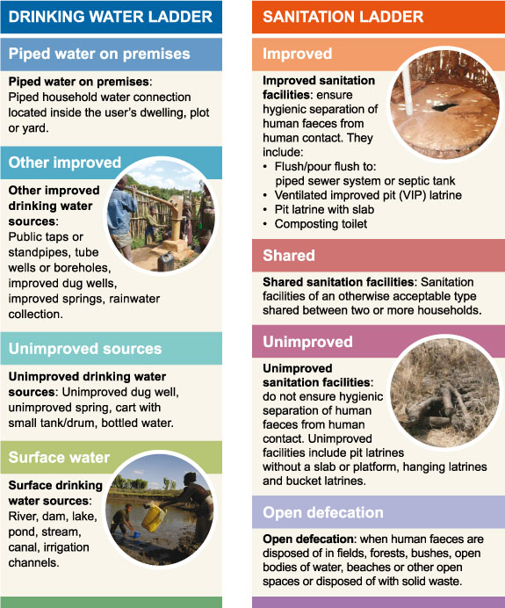
Figure 1.1 WHO/UNICEF Joint Monitoring Programme (JMP) water supply and sanitation categories.
- Figure 1.1 uses the terms ‘drinking water ladder’ and ‘sanitation ladder’. What does the concept of a ‘ladder’ mean to you and why do you think it is used in this way?
- A ladder is equipment for climbing from one level to a higher level by a sequence of rungs or steps. The use of ‘ladder’ in describing water supply and sanitation indicates that there is a progression from the basic unimproved provision in a sequence of steps up to improved services at the top of the ladder.
The idea of the ladder provides a useful measure of progress. Imagine you were employed as a community WASH worker with responsibility for promoting WASH improvements in your community. How do you think you might use the ladder concept in practice? You would need to start your work by collecting data about the WASH services that the community is using before you begin your promotional work. Once you have gathered this data, by using your knowledge of the sanitation and water supply ladders, you can identify where the majority of people are placed on the ladder. This will enable you, in collaboration with other partners, to come up with a plan to move the community members up the ladder.

1.2 Importance of WASH to human health
In developing countries like Ethiopia, most of the diseases affecting the public are related to poor WASH services.
- You have already read about trachoma as an example of a WASH-related disease. What other WASH-related diseases do you know of?
- You will have your own answer but you may have thought of diarrhoea, typhoid, cholera or intestinal worms and other parasites.
Trachoma is linked to inadequate washing often caused by insufficient quantity of water but many WASH-related diseases are linked to the quality of water. The diseases included in the answer above are caused by people ingesting (eating or drinking) bacteria or other infectious agents, frequently in contaminated water.
For all these diseases, there are three essential components involved in transmission from one person to another. These can be described as the epidemiologic triangle, shown in Figure 1.2. (Epidemiology is the study of the patterns of distribution and causes of disease in a population.) The three components, shown as the three corners of the triangle, are:
- Agent: causes the disease
- Host: has the disease
- Environment: external factors that allow transmission of the disease.
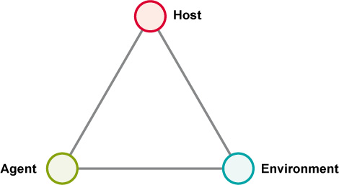
Figure 1.2 The epidemiologic triangle. Preventing diseases means making changes that will break the link in at least one side of the triangle.
All three components are involved in the spread of disease. For example, for trachoma, the agent is the bacteria that cause the infection, the host is the infected person and the environment includes the lack of water for washing. For diseases related to water quality, the agents are the bacteria, viruses and worms that cause disease, the hosts are the infected people, and the environment includes lack of safe water supply and lack of improved sanitation. These environmental conditions allow water to be contaminated with faeces. If the faeces originate from an infected person they will contain the disease-causing agent which can then infect a new host.
There are several different pathways or transmission routes, from faeces to host that are shown in Figure 1.3. This is a pictorial representation of how disease-causing agents spread from faeces through water, food or soil to another person. It is known as the ‘F diagram’ because the main elements all begin with the letter ‘F’, i.e. faeces, fluid, fingers, flies, fields and food. In each transmission route, the infection passes from faeces on the left through to the new host on the right. This is faecal-oral transmission of disease, meaning the infection passes from faeces to mouth (oral is from the Latin for mouth).

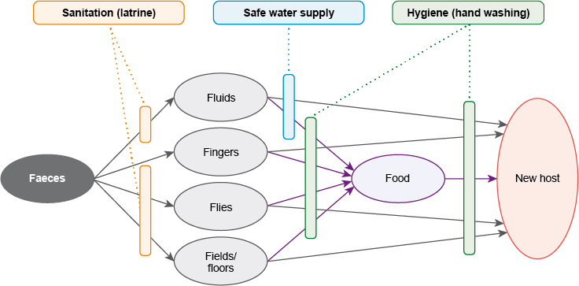
Figure 1.3 Pathways of disease transmission, known as the ‘F diagram’. Note how water, sanitation and hygiene are each identified as barriers to transmission at different steps in the transmission route.
In Ethiopia, only 24% of the population use latrines that meet basic standards, and worse still, about 37% of the population practises open defecation (JMP, 2014a). This lack of adequate sanitation obviously makes faecal contamination of the environment and the spread of disease more likely. A 2014 study (WVE, 2014) summarised the impact on young children as follows:
- Diarrhoea is the leading cause of under-5 mortality in Ethiopia, causing 23% of all under-5 deaths (73,341 children per year).
- Around 44% of under-5 children in Ethiopia are stunted (i.e. their height is less than expected for their age), which can be linked to the childhood incidence of diarrhoea and to the lack of WASH services. Important nutrients that the child requires for growth are wiped out through diarrhoea; intestinal parasites take up remaining nutrients and when this scenario continues for some time, the child becomes stunted.
As Figure 1.3 indicates, improving WASH creates barriers to the transmission of disease and has a direct and positive impact on the health and well-being of people.

1.3 Importance of WASH to education
Provision of WASH services in schools has a direct impact, not only on children’s health but also on their school attendance and educational performance. Preventing diarrhoea and parasitic infections that have the potential to make children sick can ensure they stay healthy and are not absent from school.
Schools should have child-friendly WASH services, meaning they should have improved sanitation with good handwashing facilities. It is particularly important that schools have separate latrine blocks for girls and boys. This is known to encourage girls to enrol in school and sustain attendance, which in turn enables them to achieve greater educational performance. As well as basic provision, the facilities should be convenient for older girls so they can take care of their personal hygiene during the menstrual cycle. The presence of good WASH facilities that are separate for girls and boys can be the factor that initiates parents to send their girl children to school.
For girl students, the WASH service away from school is also important. This is because in many areas of Ethiopia women and girls are responsible for fetching water for the family. Many water points are far away from villages, so girls may spend many hours collecting water which makes it difficult for them to attend school (Figure 1.4).

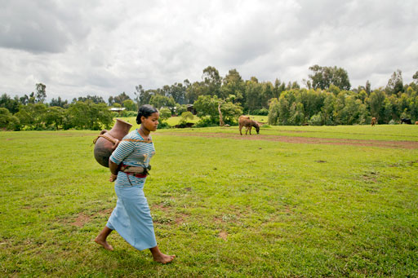 | 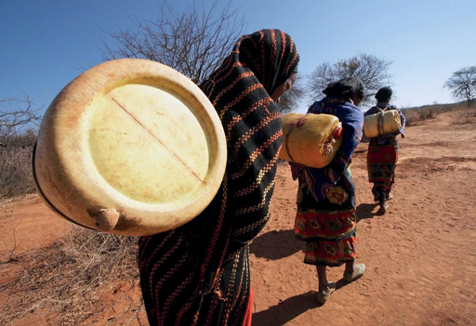
Figure 1.4 Women and girls usually have responsibility for collecting water for the home and may walk long distances several times a day to the nearest source.

1.4 Importance of WASH to economic development
In addition to the direct human health-related importance, WASH has a very strong association with economic development. Estimates of the economic benefits from water and sanitation vary but a 2012 study for the World Health Organization (WHO) put the global economic return on spending on sanitation alone as US$5.5 for every US dollar invested (Hutton, 2012). Hygiene practices, such as handwashing and the use of improved sanitation facilities in homes and schools bring economic benefits for households, communities and nations by saving time and by reducing direct and indirect health costs.
People without easy access to sanitation spend a great deal of time each day queuing up for public toilets or seeking secluded spots to defecate. This has been estimated as approximately 30 minutes per person per day, amounting to 14 hours a week for a household of four people (UN-Water, 2008). This is time they could otherwise spend doing productive work.
Hygiene and sanitation are among the most cost-effective public health interventions or, to put it another way, preventing disease is cheaper than treating it. The costs of treating diarrhoeal disease drain both national budgets and family finances. In sub-Saharan Africa, which includes Ethiopia, it has been estimated that treating preventable infectious diarrhoea uses up 12% of the total health budget (UN-Water, 2008).
In addition to these direct health costs, there are indirect costs caused by reduced productivity of people. When people or their children are sick they cannot work and have to stay at home. The loss of working days affects their income and the wider economy.
The national economy can also benefit from improved WASH services by making the country more attractive to tourists which could boost tourism revenues. By protecting the environment and maintaining a healthy living environment everyone could benefit.

1.5 Challenges of the WASH sector
As the previous sections have shown, providing WASH services brings many benefits. Unfortunately, however, the reality on the ground is that globally we are a long way from achieving these benefits for all people. Studies have shown that in many parts of the world, access to WASH services is still very low (Figures 1.5 and 1.6).
Figure 1.5 Percentage of population using improved sanitation facilities (data for 2008). (GLAAS, 2010)
Figure 1.6 Percentage of population obtaining drinking water from an improved source (data for 2008). (GLAAS, 2010)
- Based on the 2008 data in Figures 1.5 and 1.6, what percentage of the population in Ethiopia used improved sanitation and what percentage got their drinking water from an improved source?
- Less than 50% of Ethiopians used improved sanitation and less than 50% used an improved source for water.
Note that the data in Figures 1.5 and 1.6 is from 2008 and these numbers are changing quite rapidly. The situation is improving, but there is still a great challenge ahead. Data for 2012, the most recent available at the time of writing, indicates that in Ethiopia about 37% of the population are still practising open defecation (JMP, 2014a). In 1990 this figure was 92%, which indicates the significant change in the past 25 years but even with this improvement, the current situation is still appalling.
The first challenge facing the WASH sector in Ethiopia therefore is the scale of the problem. There needs to be a huge investment of time and money to design and build new infrastructure. The water supply system needs to be extended and be more reliable, with fewer breaks in service and less loss from leakage. Support services for the sector need to be improved to make it work effectively and sustainably. Monitoring needs to be increased so that breakdowns can be repaired in a timely manner. Regulations and enforcement should be stronger to protect the environment and human health. In addition there needs to be changes to the way projects are planned and implemented to overcome past difficulties. You have already learned about the problem of focusing on water supply in the majority of projects and missing the sanitation and hygiene components. There have been a number of other problems with past projects that have reduced their effectiveness. These problems include:
- Some projects have disregarded community participation. People were given a free service without community contributions in any form, e.g. labour, money. This meant the communities did not feel any sense of ownership of the service and failed to look after it. The experience of receiving free services has also created longer-term problems because communities can develop resistance to participatory approaches in future.
- Financial procedures were separate and different for each donor or aid organisation, which was inefficient and time-consuming. Each donor had different processes, needs and expectations.
- WASH is a cross-boundary sector that involves several different areas of responsibility within government at different levels but the need for collaboration between ministries, bureaus and offices has not been recognised in the past.
- In many cases, projects were implemented only in selected locations which did not bring benefits to everyone. In the past the focus was mainly in rural areas rather than towns, and serving agrarian rather than pastoralist populations.

1.6 The One WASH National Programme
In response to these many challenges, the Ethiopian government has developed the One WASH National Programme (Figure 1.7). The One WASH National Programme (OWNP) is a consolidated national programme designed to improve WASH services for the Ethiopian people. The overall objective of the OWNP is:
…to improve the health and well-being of communities in rural and urban areas in an equitable and sustainable manner by increasing access to water supply and sanitation and adoption of good hygiene practices (POM, 2014).
The Programme is designed to be implemented in two phases. The first phase was from July 2013 to June 2015 and the second phase from July 2015 to June 2020.
Figure 1.7 Logo for the One WASH National Programme.
The Programme was prepared by the active engagement and leadership of the Ethiopian government and with the full participation and all-round support of partners working in the sector. A special task force was established, consisting of experts drawn from relevant government ministries, NGOs and the UN agencies such as UNICEF, which played the central role in the preparation of the OWNP document. Recognition of WASH as a cross-boundary sector led to the initial involvement of the Ministry of Water, Irrigation and Energy, the Ministry of Health and the Ministry of Education. Later on the Ministry of Finance and Economic Development also became involved.
The Programme document (Figure 1.8) was published in September 2013. It includes a general description of the Programme elements such as its objectives and components, how the Programme is monitored and evaluated, funding and financial management, procurement, contract management, cost and budget, results, indicators, etc.
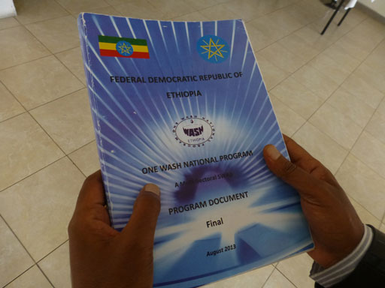
Figure 1.8 The OWNP document.
The OWNP is distinctive for several reasons but particularly because it recognises the multifaceted nature of WASH and brings together the previously diverse interests of different ministries and other actors. This integrated and collaborative approach is reflected in the motto of the OWNP which is ‘One Plan, One Budget, One Report’. One essential component of this integration is the creation of a unified funding channel called the Consolidated WASH Account (CWA) which allows all funds from major donors to be deposited in one bank account.
The main aims of the OWNP are:
- to harmonise and align activities and approaches to WASH improvement
- to avoid varied financial and procurement procedures by the different donors
- to ensure full ownership of WASH programmes by the government and end users
- to bring all WASH-relevant ministries on board
- to ensure equity in WASH service provision across the country for all
- to ensure the provision of WASH as a package without any compromise among the three important elements – water supply, sanitation and hygiene.
These aims are reflected in the principles, components and implementation of the OWNP. The details of all these aspects of the Programme are discussed in following study sessions of this Module.

Summary of Study Session 1
In Study Session 1, you have learned that:
- WASH is an abbreviation that stands for water supply, sanitation and hygiene.
- Before the term WASH was used there had been other terms used, but mostly the ‘H’ element was missed.
- Faecal-oral diseases are transmitted through various routes that transmit infection from faeces to the mouth of the next host, via food, fluids, fingers, flies and fields or floors. These routes are commonly depicted in the F diagram. The interventions that can prevent or block transmission are clean water supply, sanitation and hygiene.
- Combining water supply, sanitation and hygiene as a package of service has been recognised very recently. The three components are complementary and optimal results cannot be guaranteed if they are considered separately.
- The significance of WASH to human health, especially for people living in developing countries such as Ethiopia, is paramount because much sickness and death is directly or indirectly associated with poor WASH services.
- Improved WASH services in schools are essential for school children, particularly girls, to encourage enrolment and attendance.
- The provision of WASH services makes a significant contribution to enhanced economic and social development.
- The One WASH National Programme, abbreviated as OWNP, is a consolidated national programme designed to improve the drinking water supply, sanitation and hygiene services of the Ethiopian people. It has been developed in response to the challenges the WASH sector had been facing before the development of a unified national programme.
- The overall aim of the OWNP is to harmonise and align the WASH sector plan in such a way as to have one plan, one budget, and one reporting system nationwide. This will ensure equity in WASH service provision across the country.

Self-Assessment Questions (SAQs) for Study Session 1
Now you have completed this study session, you can assess how well you have achieved its Learning Outcomes by answering these questions. You can check your answers with the Notes on the Self-Assessment Questions at the end of this Module.

SAQ 1.1 (tests Learning Outcome 1.1)
Write the following words next to their correct definitions in the table below:
adequate water supply; child-friendly WASH services; hygiene; safe water supply; sanitation; water supply.
a set of practices performed for the preservation of health
sufficient quantity of water to meet minimum requirements
facilities and services for the safe disposal of human urine and faeces
water provided by public utilities, commercial organisations, community endeavours or by individuals
facilities that are designed for schools and take account of the needs of boys and girls
water that is free from any disease-causing agent

SAQ 1.2 (tests Learning Outcome 1.2)
The F diagram (Figure 1.3) shows how WASH provides different barriers at more than one point in the same transmission route. For example, there are two different barriers in the ‘fluids’ transmission route.
  - Which of the three barriers will block faecal-oral disease transmission at the source? Briefly explain why.
  - Give an example of a transmission route that could still occur if only the ‘sanitation’ and ‘safe water supply’ barriers are present.

SAQ 1.3 (tests Learning Outcome 1.3)
The benefit of improved WASH services to people is not limited to their health and well-being. It also has economic benefits at different levels. In what ways can an individual benefit economically from using improved WASH services?

SAQ 1.4 (tests Learning Outcome 1.4)
Briefly describe the main problems that non-unified WASH projects have faced.

SAQ 1.5 (tests Learning Outcome 1.5)
How does the motto ‘One Plan, One Budget, One Report’ reflect the main characteristics of the OWNP? Explain how the Programme aims to solve the problems you identified in SAQ 1.4.

Study Session 2 Background to the OWNP

Introduction
The development of the water, sanitation and hygiene, or ‘WASH’ sector in Ethiopia is said not to have a long history (not more than two decades). Nevertheless, it is important for you to know how the sector has reached its current status and how it has been influenced by past policies and strategies.
This study session outlines the key policies and strategies that existed in the WASH sector prior to the One WASH National Programme (OWNP). It describes their history and how they are enacted, and explains how the different policy documents relate to each other. This will help you understand how, at an operational level, plans and projects have been implemented.
Note that the sections of this study session that describe the various policies, strategies and programmes are only brief summaries of these important documents. If you would like the full details, you can find the original documents by following the information in the References list.

Learning Outcomes for Study Session 2
When you have studied this session, you should be able to:
2.1 Define and use correctly all of the key words printed in bold. (SAQ 2.1)
2.2 Summarise the background of the WASH sector in Ethiopia. (SAQ 2.2)
2.3 Describe the key policies related to the WASH sector. (SAQ 2.3)
2.4 Understand the differences between the main water policy, strategy and programme. (SAQ 2.4)
2.5 Outline the major national development plans relevant to WASH. (SAQ 2.5)

2.1 Background of WASH in Ethiopia
Ethiopia faces many challenges to provide safe water for all, however the country is not short of water. Across Ethiopia as a whole there is relatively high rainfall and there are many large rivers. It has been estimated that the annual surface run-off in Ethiopia is 122.8 billion m³ and groundwater potential is 2.6 billion m³ (Tafesse, 2008). However, these water resources are not distributed evenly, either by geographical area or through the year. Figure 2.1 shows a map of the main river basins of Ethiopia.
80–90% of Ethiopia's water resources is found in four river basins in the west of Ethiopia namely, Abbay (Blue Nile), Tekeze, Baro Akobo and Omo. These areas have most of the water but only about one third of the Ethiopian population lives in these regions. The east and central river basins have only 10–20% of water resources but the population there is over 60% of the total (MoWR, 1999).
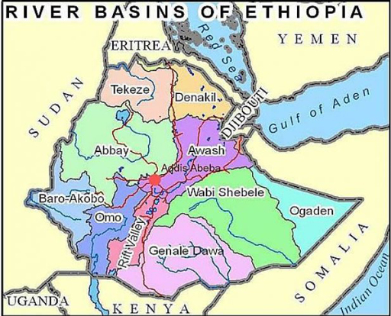
Figure 2.1 Map of Ethiopia showing main river basins.
The unevenness of distribution over time is also a problem. As you will know, different parts of the country have marked wet and dry seasons which means water is not always available when needed. Furthermore, the predicted seasons are not always reliable and rains may come early or late, or not at all in some years.
This mismatch in distribution means that water is not available at all times for everyone. This, coupled with limited financial and technical resources, has meant that Ethiopia’s abundant water resources have not been utilised to their full potential. Furthermore, there are the challenges facing the WASH sector that you learned about in Study Session 1. However, despite these many difficulties, there have been significant improvements in water supply and sanitation provision over the past 25 years. Figure 2.2 shows how access to water and sanitation has improved since 1990.
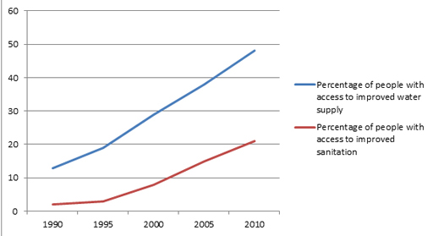
Figure 2.2 Changing percentage of Ethiopian population with access to improved water supply and sanitation from 1990 to 2010. (Data from JMP, 2014a)
- The population of Ethiopia in 2010 was approximately 87 million. Using data from Figure 2.2, how many people, to the nearest million, did not have access to improved water supply and how many did not have improved sanitation at that time?
- Reading from the graph, 48% of people had access to improved water in 2010. 48% of 87 million is 42 million (87 × 0.48). The figure for sanitation is 21%. 21% of 87 million is 87 × 0.21 = 18 million. The question asks for numbers of those who did not have access, therefore the answers are 87 − 42 = 45 million people did not have access to safe water and 69 million did not have access to improved sanitation.
Note that the data in Figure 2.2 is for the total population of Ethiopia, but you should also be aware of the differences between urban and rural areas. WASH provision in urban areas is generally much better. By 2012, 97% of people living in urban settings as opposed to 42% of the rural population had access to improved water. For open defecation, only 8% of urban dwellers compared to 43% of rural populations were practising open defecation in 2012 (JMP, 2014a). As a proportion of the total, far fewer people live in towns than in rural areas (less than 20%), but the density of the population is much greater in urban areas than in the countryside. In many cities the rivers and streams have become open sewers polluted with human wastes of all types (Figure 2.3).
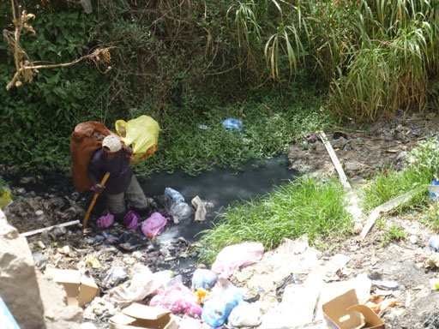
Figure 2.3 A waste-filled urban river in Addis Ababa.
The improvements over recent decades indicated in Figure 2.2 have come about in part because of developments in national plans and policies to address the problems of WASH. The following sections describe the main policies, strategies and programmes that preceded and established the foundation for the OWNP.

2.2 Policies in the WASH sector
This section is about the policies designed by the Ethiopian government that have shaped the WASH sector and led to the OWNP. By policy we mean a high-level statement of overall purpose and principles that will guide plans and decisions.
The Constitution of the Federal Democratic Republic of Ethiopia (1995), Article 10, sub-articles 1 and 2, state that:
Human rights and freedoms, emanating from the nature of mankind, are inviolable and inalienable.
and:
Human and democratic rights of citizens and peoples shall be respected.
These fundamental human rights form the foundation for the policies of the Ethiopian government – including those that relate to WASH. The Constitution also states in Article 90 that policies shall, to the extent that resources permit, aim to provide all Ethiopians with access to health and education, clean water, housing, food and social security.
In the WASH sector, there are three relevant policy areas that have underpinned the OWNP: water, health and environment. These are described in the following sections.

2.2.1 Water Resources Management Policy
The Ethiopian Water Resources Management Policy (WRMP) was issued in 1999. It deals with the overall water resources of the country, including both surface and groundwater. The Policy sets out how these water resources should be economically and sustainably used for different purposes, including water supply and sanitation, irrigation and hydropower.
The overall goal of the WRMP is ‘to enhance and promote all national efforts towards the efficient, equitable and optimum utilization of the available Water Resources of Ethiopia for significant socio-economic development on sustainable basis’ (MoWR, 1999). It establishes several fundamental principles to guide the management of water resources, including statements that ‘water is a natural endowment commonly owned by all the people of Ethiopia’, and ‘as far as conditions permit, every Ethiopian citizen shall have access to sufficient water of acceptable quality to satisfy their basic needs’ (MoWR, 1999). The Policy recognises the need for an integrated and comprehensive approach to management of water resources that is compatible with the goals of other sectors, including health. It also promotes the participation of all stakeholders, including user communities and particularly women. On water pricing and tariff setting, the Policy recognises water as a natural resource with an economic value that should be paid for, but the price for water should not be so high that it discourages water use, nor too low, which could encourage over-use and wasting of water.

2.2.2 Health Policy
The national Health Policy deals with overall health aspects of the Ethiopian citizen and how health services should be provided to them. The current policy on health in Ethiopia dates from 1993 and is titled Health Policy of the Transitional Government (TGE, 1993). (‘Transitional Government’ refers to the first few years of the current system of government in Ethiopia, from 1991 to 1995.)
The Health Policy was the result of a critical examination of the prevailing and newly emerging health problems of the country. It acknowledged that, based on conventional measures such as morbidity (sickness) and mortality (death) from communicable diseases, infant and maternal mortality, malnutrition and average life expectancy, Ethiopia was among the least-privileged nations in the world. To address the problems a strategic approach was needed that did not consider health in isolation, but recognised and integrated the links with other policies on population dynamics, food availability, acceptable living conditions and other requirements essential for health improvement. This included water supply and sanitation.

2.2.3 Environmental Policy
The Environmental Policy of Ethiopia (EPE), issued in 1997, goes beyond the statement of high-level policy to include implementation and regulatory aspects. Its overall goal (FDRE, 1997) is:
to improve and enhance the health and quality of life of all Ethiopians and to promote sustainable social and economic development through the sound management and use of natural, human-made and cultural resources and the environment as a whole so as to meet the needs of the present generation without compromising the ability of future generations to meet their own needs.
To support this goal, the EPE sets out 19 key principles, which include the following:
- Every person has the right to live in a healthy environment.
- The development, use and management of renewable resources shall be based on sustainability.
- The use of non-renewable resources shall be minimised and where possible their availability extended (e.g. through recycling).
- Appropriate and affordable technologies which use renewable and non-renewable resources efficiently shall be adopted, adapted, developed and disseminated.
The EPE also defines policies for ten separate environmental sectors covering soil and agriculture, forest and woodland, biodiversity, water, energy, minerals, human settlement, industrial waste, climate change and cultural heritage.

2.3 Water Sector Strategy and Programme
Strategies are documents developed to operationalise policies, in other words to translate policies into action. Programmes consist of sets of related activities, projects or events that are intended to enact policies and strategies. While policies require the approval of the national parliament, strategies and programmes are endorsed by ministries.

2.3.1 Water Sector Strategy
The Ethiopian Water Sector Strategy developed in 2001 has been described as a road map to achieve the objectives stated in the Water Resources Management Policy (WRMP) (Tafesse, 2008). The guiding principles of the Water Sector Strategy (WSS) remain the same as those of the WRMP. These principles are:
- Water is a natural endowment commonly owned by all the people of Ethiopia.
- As far as conditions permit, every Ethiopian citizen shall have access to sufficient water of acceptable quality to satisfy basic human needs.
- In order to significantly contribute to development, water will be recognised both as an economic and social good.
- Water resources development shall be underpinned by rural-centred, decentralised management, a participatory approach, and an integrated framework.
- Management of water resources shall ensure social equity, economic efficiency, systems’ reliability and sustainability norms.
- Promotion of the participation and community management of all stakeholders and user communities, particularly women’s participation in the relevant aspects of water resources management (MoWR, 2001).
The WSS is divided into separate strategies for four sub-sectors: general water resources, hydropower, water supply and sanitation, and irrigation. The section on general water resources uses similar section headings to the WRMP but expands on each of them to give more information on how they should be implemented. To select one example, the policy on gender issues in the WRMP is covered by one sentence: ‘Promote the full involvement of women in the planning, implementation, decision making and training as well as empower them to play a leading role in self-reliance initiatives’ (MoWR, 1999). In the Water Sector Strategy, this is extended to several paragraphs about ‘gender mainstreaming’. Gender mainstreaming means considering women’s needs and perspectives equally with men’s at all times and ensuring that both are at the centre (in the mainstream) of decision making. In particular, this means involving women in all stages from earliest identification of an issue and planning through to project completion and evaluation. In the WSS, the section specifies that gender mainstreaming should be part of all aspects of water resources planning, development and management. It gives details of how this could be done, e.g. by allocating a specific number of places for women on community-based groups; by educating women in water-environment-health issues; by training women in technical aspects of operation and maintenance, and by conducting research to better understand the reasons why women may feel constrained from playing leading roles in the management of local water systems (Figure 2.4).
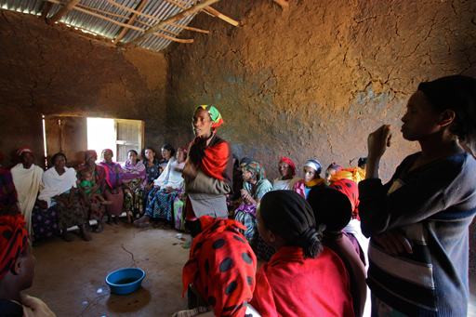
Figure 2.4 Women are encouraged to take leading roles in community projects.

2.3.2 Water Sector Development Programme
The Water Sector Development Programme (WSDP) was issued in 2002 to further elaborate on the Policy and the Strategy. The WSDP is a large document in two volumes that proposes plans and projects throughout all regions of Ethiopia covering the period from 2002 to 2016. It identifies priority intervention areas and projects for this 15-year time period. It includes specific targets for improving water supply and sewerage coverage, and also for irrigation, hydropower, water resource development, and institution and capacity building.
The WSDP focuses particularly on actions to (MoWR, 2002):
- make clean water available for drinking and improve sanitation
- make water available for livestock in nomadic and other special areas
- extend irrigation for agricultural development to the maximum possible
- expand generation capacity to meet hydroelectric power needs
- provide water for industrial development
- provide water for, among other uses, fisheries, tourism and transportation.
The WSDP therefore provides details for implementing the Water Resources Management Policy and the Water Sector Strategy. Figure 2.5 shows the links between the Policy, Strategy and Programme. The Policy was the first to come followed by the Strategy and then the Development Programme. The diagram indicates that this was not a one-way process. Changes in the Development Programme may lead to revisions to the Policy and Strategy as needed.
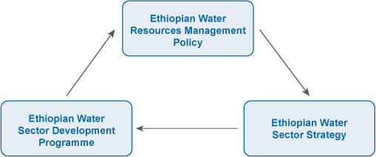
Figure 2.5 Dynamic relationship between Policy, Strategy and Programme.
In practice, these three documents – Policy, Strategy and Programme – provided the background and principles for water resource management that led to the development of the One WASH National Programme.

2.4 National Hygiene and Sanitation Strategy
The National Hygiene and Sanitation Strategy (NHSS) was developed by the Ministry of Health and published in 2005. It was designed to complement the existing Health Policy and Water Sector Strategy. Figure 2.6 shows the image on the front cover of the document.
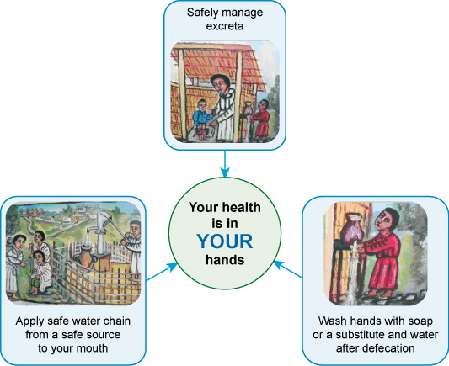
Figure 2.6 Image from the cover page of the National Hygiene and Sanitation Strategy. (MoH, 2005)
- What message is conveyed by the front cover image shown in Figure 2.6?
- The three pictures represent the three elements of WASH: safe water supply, sanitation, and hygiene, and shows that all three have a direct impact on personal health.
The Strategy starts with a ‘Sanitation Vision for Ethiopia’, which is ‘100% adoption of improved (household and institutional) sanitation and hygiene by each community which will contribute to better health, a safer, cleaner environment, and the socio-economic development of the country’ (MoH, 2005). The Strategy first describes the current situation (as it was in 2005), and then sets out objectives and plans for achieving the goal of the Vision Statement. It puts forward three strategic pillars for improved sanitation and hygiene:
Pillar 1: An enabling environment: this refers to such things as policies, regulation, co-operation between sectors, partnership, capacity building etc.
Pillar 2: Sanitation and hygiene promotion: this means efforts and activities to raise awareness of the importance of sanitation and hygiene to create demand and encourage behaviour change.
Pillar 3: Improved access to hardware: improved availability of appropriate technology solutions for latrines, handwashing and water supply.
These three pillars were designed to support the plans for improved sanitation and hygiene which would lead to prevention of disease and ultimately contribute to the long-term aim of eradicating poverty in Ethiopia. (You will learn more about the pillars and how they relate to the OWNP in Study Session 5.)

2.4.1 Strategic Action Plan
The full title for this plan is the National Hygiene and Sanitation Strategic Action Plan for Rural, Peri-urban and Informal Settlements in Ethiopia – but it is often referred to simply as the Strategic Action Plan (SAP). This covered the period from 2011 to 2015 and was designed to carry forward the work of the National Hygiene and Sanitation Strategy (NHSS). Its purpose was to be used as a general roadmap for achieving national goals for hygiene and sanitation (MoH, 2011). It is particularly relevant to the planning and budgeting of the OWNP, which you will learn more about in Study Session 14.

2.5 Health Sector Development Programme
The Health Sector Development Programme (HSDP) was developed to implement the policies of the Ministry of Health, including sanitation and hygiene activities. There have been several iterations of the HSDP. HSDP IV, published in 2010, covered the period from 2010 to 2015. HSDP IV is a high-level strategic document that adopts several key principles, including:
- government leadership
- enhanced responsiveness to community health needs
- extensive consultation and consensus with stakeholders
- comprehensive coverage of priority health sector issues (MoH, 2010).
HSDP IV was preceded by HSDP I, II and III, which covered successive periods starting from 1997/8. HSDP II and III saw the development of the Health Extension Programme (HEP). In 2004 the Ethiopian government implemented the HEP as the main vehicle for reaching people in the rural areas of Ethiopia. Health Extension Workers (Figure 2.7) promote health at the kebele level by implementing 16 clearly defined health service packages. Seven of these packages are concerned with promotion of and improvements in hygiene and environmental sanitation.
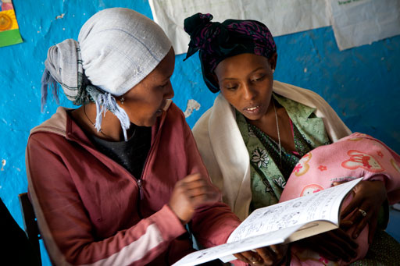
Figure 2.7 Health Extension Worker advising a client.
The early successes of the HEP led to its expansion from rural agrarian communities into pastoral and agro-pastoral communities in 2006, and into urban communities in 2010. The Urban Health Extension Programme (UHEP) is now bringing the knowledge and awareness of hygiene and sanitation to town and city dwellers through the activities of urban Health Extension Workers.

2.6 National development plans
Alongside these specific policies, strategies and programmes, the government of Ethiopia has also adopted several major plans for national improvement. The Growth and Transformation Plan (GTP) is a national development plan prepared by the Government of Ethiopia. It aims to improve the national economy and bring an end to poverty by increasing opportunities for commercial agriculture, large-scale industry and infrastructure development. All sector plans are aligned to the GTP. The first phase, GTP I, covered the period from 2010 to 2015. A follow-up plan, GTP II, will cover the next five years to 2020 and is expected to build on progress made so far and set further goals for economic development for Ethiopia. You will learn more about GTP II in Study Session 15.
In 2005, partly in response to the target in Goal 7 of the Millennium Development Goals (see Box 2.1), the Ethiopian government adopted the Universal Access Plan (UAP). The UAP is a national WASH plan that sets out the targets for WASH improvements. It initially covered the period from 2006 to 2010 and was revised to align it with GTP targets and strategies. This second iteration, UAP II, has been in place from 2011 to 2015.

Box 2.1 Millennium Development Goals
In September 2000, the Millennium Summit of world leaders adopted the UN Millennium Declaration, committing their nations to reduce extreme poverty and setting out a series of time-bound targets, with a deadline of 2015, which became known as ‘the Millennium Development Goals’ (Figure 2.8).
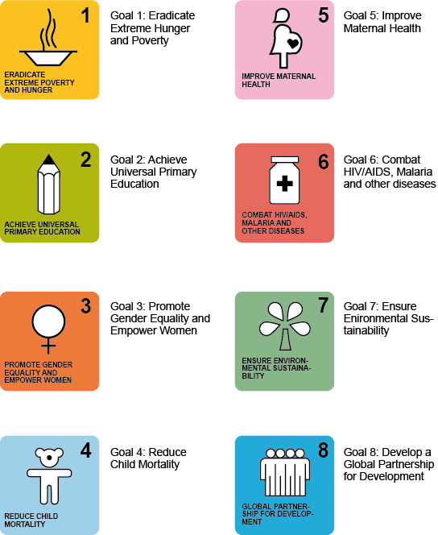
Figure 2.8 The Millennium Development Goals were grouped into eight areas.
Each goal had specific targets for improvements to be achieved by 2015. The target for access to water and sanitation was included in Goal 7 ‘Ensure Environmental Sustainability’, and aimed to:
Halve, by 2015, the proportion of people without sustainable access to safe drinking water and basic sanitation.
Note that this is stated as a proportion, which means it is not an absolute number of people but depends on the starting conditions. If 100% of a population were without access at the start then the target is achieved if this is reduced to 50% – but this could still amount to many millions of people.
The MDGs have been followed by the Sustainable Development Goals for the period from 2015 to 2030. These are described in Study Session 15.
(Millennium Project, 2000)

Very similar targets for improved water, sanitation and hygiene that had been stated in the Growth and Transformation Plan (GTP) and Universal Access Plan (UAP) were adopted by the One WASH National Programme. The OWNP targets for the Ethiopian population are:
- 98.5% of the population to have access to safe water supply (100% in urban areas; 98% in rural areas)
- reduction of the proportion of non-functioning water supply services to 10%
- 100% access to basic sanitation (improved or unimproved)
- 77% of the population to practise handwashing with soap at critical times
- 77% of the population to practise safe water handling and water treatment at home
- 80% of communities to be ‘open defecation free’ (OWNP, 2013).

Summary of Study Session 2
In Study Session 2 you have learned that:
- Ethiopia has plentiful water resources but they are not distributed evenly. Water and sanitation provision has improved in recent decades, but there is still a great deal more to do.
- The Water Resources Management Policy is the primary policy for water and was followed by the development of the Water Sector Strategy.
- Other related policies include the Health and Environmental policies of Ethiopia. Under the Health Policy, there are other national level strategies and development programmes which are very important for operationalising the policy.
- WASH policies are aligned with the government of Ethiopia’s Growth and Transformation Plan (GTP) to improve the national economy. A second iteration of the GTP is expected to cover the five years from 2015 to 2020.
- The Universal Access Plan (UAP) of 2006 was revised in 2011 to align it with the targets and strategies of the GTP.
- The OWNP targets of 98.5% access to safe water and 100% access to sanitation are based on GTP and UAP targets.

Self-Assessment Questions (SAQs) for Study Session 2
Now that you have completed this study session, you can assess how well you have achieved its Learning Outcomes by answering these questions. You can check your answers with the Notes on the Self-Assessment Questions at the end of this Module.

SAQ 2.1 (tests Learning Outcome 2.1)
- Define what is meant by a policy, a strategy and a programme. Briefly describe how they relate to each other (look at Figure 2.5).
- What is ‘gender mainstreaming’? Suggest two possible benefits of gender mainstreaming in WASH projects.

SAQ 2.2 (tests Learning Outcome 2.2)
Look at the graph in Figure 2.2. It shows that the percentage of people with access to improved water in 2005 is 37%. Give three reasons why this might not match the percentage of people with improved water access in a particular town or village in May 2005.

SAQ 2.3 (tests Learning Outcome 2.3)
Section 2.2 covers the three policy areas related to WASH. For each area, name the main policy leading up to the OWNP and briefly give one way in which it reflects Article 90 of the Ethiopian Constitution.

SAQ 2.4 (tests Learning Outcome 2.4)
For each of the following statements, decide if it applies to the Water Resources Management Policy (WRMP), Water Sector Strategy (WSS) or Water Sector Development Programme (WSDP). Bear in mind how they relate to each other.
- It has targets for actions in specific areas like hydropower.
- It contains general principles for the use of water nationwide.
- It prescribes actions to maximise agricultural irrigation, based on a more general objective to provide sustainable water supply and sanitation services.
- It is influenced by the goal to promote sustainable use of water resources across the country, and expands on how this should be done by giving more detailed aims and principles.
- It came first, but was shaped by the results of past actions and could be revised due to future actions.

SAQ 2.5 (tests Learning Outcome 2.5)
Briefly describe two major national development plans. How have they influenced the goals of the OWNP?

Study Session 3 Development of the OWNP

Introduction
The One WASH National Programme (OWNP) came into existence through a long process. The Programme is a result of a concerted effort by the Ethiopian government and its partners working in the sector. In the first two study sessions you have learned about the challenges that faced the WASH sector and about some of the policies, strategies and programmes that were developed in the 1990s and early 2000s and had begun to bring some improvements. These were the early stages of the process that led to the development of the OWNP. By the mid-2000s, the importance of cross-sector collaboration was increasingly being recognised and discussions were beginning about a new approach.
In this study session, you will learn about the main initiatives in both national and international arenas that have shaped the Programme in terms of its content, structure and implementation. You will be introduced to the major Programme implementation mechanisms and working documents, and therefore become acquainted with the evolution of the OWNP.

Learning Outcomes for Study Session 3
When you have studied this session, you should be able to:
3.1 Define and use correctly all of the key words printed in bold. (SAQs 3.1 and 3.3)
3.2 Explain how the OWNP emerged as a national plan. (SAQ 3.2)
3.3 Identify and describe the main documents that preceded the OWNP. (SAQ 3.3)
3.4 Summarise how national and international initiatives guided the OWNP’s development. (SAQ 3.4)

3.1 Sector-wide approach
As you may have noticed, in every walk of life the need to look for better ways of doing things never stops. We always learn from past experiences and, based on the lessons learned, we change our way of doing a particular task in order to yield better results. We can also expect that the new way of doing things will be cost-effective and shorten the time it takes to accomplish.
In the WASH sector, for many decades, a project-based aid approach, sometimes referred as ‘the traditional aid approach’, was applied at all levels. A project-based aid approach means aid is provided to support the implementation of a single project without integrated planning or use of resources. In the past, for instance, donors used to support either water supply, sanitation or hygiene education projects separately, one at a time, each funded by a single donor. The need to pool resources and integrate projects was not well recognised. However, when the project-based approach was evaluated, it was found to be inefficient in terms of resource use, and tended not to produce the expected results for donors and recipient governments. Consequently, a new sector-wide approach has been developed and is currently being applied in various development programmes – including the WASH sector.
A sector-wide approach, sometimes shortened to SWAp, is a development concept where all significant sector investments are channelled towards the same objectives and follow a consistent strategy that is guided by a consolidated investment plan. In the early 1990s, SWAp became popular as several donors recognised the comparative advantages it brought in maximising the effectiveness and efficiency of aid.
SWAp is based on a framework where all resources in a sector are managed in an integrated and harmonised manner. In addition to being more effective and efficient, SWAp can create the opportunity for aid-recipient governments to play the leading role, with all funds being disbursed and managed by the government.
The need to shift towards a sector-wide approach is supported by evidence from many WASH projects in the past which were unsatisfactory in terms of result, sustainability or empowerment of beneficiaries. For example, several years ago a project team was trying to promote latrine construction at household level. They provided latrine construction materials to households for free, including corrugated iron sheet for roofing, concrete rings for pit lining and concrete squatting slabs. However, no effort was made to create demand for latrine construction in the target communities; the team did not consider hygiene education to be part of the project. After a while, when the team visited households to monitor progress they found that, rather than constructing latrines, the families had used the materials provided for other purposes. Corrugated iron sheets had been used for making doors, the concrete rings were used to make grain store pits and the slabs were used to cover these pits. Experiences like this meant that the need to consider and involve all sectors, at all stages of a programme, was gradually recognised and became standard procedure.
The main differences between the two approaches are summarised in Table 3.1. Some of the terms used in the table are defined in the notes below it.
Table 3.1 Comparison of the two approaches: single versus sector-wide.
Parameters | Sector-wide approach | Single-sector (traditional) approach
Efficiency¹ | Maximised | Decreased
Equity² | Ensured | Compromised
Transaction costs³ | Minimised | Increased
Sustainability⁴ | Certain | Uncertain
Resource management | Integrated and coherent | Fragmented and incoherent
Government ownership and leadership | Improved | Weakened
¹ Efficiency: increasing output for a given input, or minimising input for a given output, while still maintaining quality.
² Equity: allocation of resources, services and opportunity to all segments of the population according to their needs, for example, all regions, agrarian and pastoralist, urban and rural, able and disabled, male and female, etc. In other words, equity means fairness and impartiality to all concerned.
³ Transaction costs: costs incurred in making an economic exchange.
⁴ Sustainability: generally refers to projects and interventions that give due consideration to social, cultural, and environmental factors, as well as the economic factors, and therefore are more effective and long-lasting.
- Compared with the traditional approach, what are the benefits of a sector-wide approach in the WASH sector?
- The sector-wide approach means that resources are consolidated and managed in an integrated and harmonised manner. It can bring improved efficiency, equity and sustainability of development projects. In addition, it ensures government ownership and enables them to play a leading role.
The sector-wide approach marked a shift of development thinking from single-sector into multi-sector perspectives. Accordingly, this concept of engaging all relevant sectors with a clear outline of the roles and responsibilities within each of the sectors has been well recognised and practically applied in the One WASH National Programme.

3.2 Memorandum of Understanding
Merely understanding and wanting to apply a sector-wide approach is not enough. To put wishes into action there needs to be a formal and legally binding agreement between the stakeholder organisations. (A stakeholder can be defined as an individual, organisation or institution with an interest in an enterprise, project or programme.) As a means to materialise the sector-wide approach for WASH, the stakeholder ministries had to agree on how to share roles and responsibilities. This led to the development of a Memorandum of Understanding. A Memorandum of Understanding, commonly abbreviated to MoU, is a formal working document that outlines the procedures and roles, responsibilities and accountability of the organisations that sign it towards meeting a specified objective.
- Do you recall from Study Session 1, which ministries were involved in developing the OWNP?
- The government ministries that are stakeholders in the OWNP are: the Ministry of Water, Irrigation and Energy; the Ministry of Health; the Ministry of Education and the Ministry of Finance and Economic Development. (You may also have remembered the Ministry of Water Resources from Study Session 2. This is the former name of the Ministry of Water and Energy, which was later renamed the Ministry of Water, Irrigation and Energy, and, in 2015, became the Ministry of Water, Irrigation and Electricity.)
Figure 3.1 shows the Memorandum of Understanding being signed by representatives of the Ministries of Water, Health, and Education in 2006.
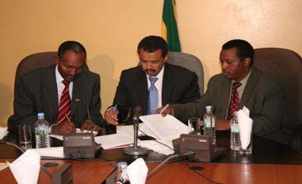
Figure 3.1 WASH Memorandum of Understanding signing ceremony in March 2006.
Following the signing in 2006, it was realised that the MoU had some gaps that were hampering the WASH promotion efforts. The main gap identified was the fact that the Ministry of Finance and Economic Development (MoFED) was not included as a signatory. All WASH projects and programmes needed to mobilise and manage funds, therefore it was essential to involve MoFED.
In addition to this, the original MoU did not include any mention of accountability. Accountability is an obligation or willingness to accept responsibility. Each of the WASH signatory ministries needed to be accountable for their activities to ensure they were fully addressing their respective roles and responsibilities as detailed in the MoU. Therefore, after about six years, in November 2012, a revised MoU was signed by four ministries: the Ministry of Water and Energy (MoWE); the Ministry of Health (MoH); the Ministry of Education (MoE), all of whom had all signed the first MoU, and the Ministry of Finance and Economic Development (MoFED).
The two main features of the revised (second) MoU were:
- MoFED, which has an essential role to play in managing WASH funds, became the fourth signatory.
- It has a dedicated section on accountability, which is crucial to check on the fulfilment of the roles and responsibilities of each of the signatory ministries.
The MoU signed by the respective ministers has been further cascaded down to all Regional States where it has been signed by heads of the respective regional bureaus, i.e., Health, Education, Water, Irrigation and Energy, and Finance and Economic Development.
The National WASH MoU that was revised and signed in November 2012 was an essential preliminary step in the development of the OWNP itself. The MoU has eight sections, which can be summarised as follows:

1. Introduction
This provides overall background information on the national WASH endeavour. Commitments of the Ethiopian government to achieve WASH-related targets set at both national and international level under the Millennium Development Goals are highlighted. The Introduction sets out the government’s intention to uplift the country’s economy to the level of middle-income countries by the year 2025. Associated with this aim is the need to work hard towards improving social services such as WASH. Progress and impact in WASH service delivery is described as hampered by the fragmented and uncoordinated efforts of different ministries.
The Introduction section concludes by underlining the purpose of the revised MoU: ‘to ensure the effective achievement of WASH targets set in the Growth and Transformation Plan’ (MoWE et al., 2012).

2. Rationale for the revision of the former MoU
A number of reasons for revising the 2006 MoU are mentioned. For example, new developments at national and international levels, reform of organisational structures and a change in the system for channelling funds by the major donors that had enhanced the role of MoFED. Also mentioned are the Urban Health Extension Programme and the growing need for the private sector to involve itself in WASH provision.

3. Rationale for integration of water, sanitation and hygiene
Under this section the benefits of providing WASH services as a package are described. This section also clearly indicates the shift from a project-based to a sector-wide approach, which paved the way for the development of the OWNP later in 2013.

4. Major areas of co-operation
Among others, the following areas of co-operation are listed:
- consideration of the principle of ‘one plan, one budget, one report’ in order to jointly prepare WASH ‘plans of action’
- joint monitoring and evaluation of WASH programme implementation
- to establish strong links with all WASH partners, including civil society organisations (CSOs) and the private sector.

5. Administrative and technical arrangements
This section outlines the technical and administrative arrangements with specified roles and responsibilities to ensure effective and efficient WASH programme management.

6. Undertakings by each WASH sector ministry
This section lists expected tasks of the four signatory ministries, geared towards the national WASH programme implementation process.

7. Specific responsibilities of sector ministries in planning and implementing the WASH programme
The particular responsibilities assigned to each ministry are exhaustively listed under this section. It also includes the responsibilities of major non-governmental WASH partners and financing institutions.

8. Accountability
The last but most important part of the MoU, missed in the first MoU, contains the specific areas of accountability shared amongst signatory ministries.

3.3 WASH Implementation Framework
The WASH Implementation Framework (WIF) is a guiding document for all WASH programmes across the country and one of the key documents associated with the OWNP.
The need for a comprehensive implementation framework was justified by practical lessons learned in the past where the lack of integration did not bring good results or achieve targets. As has been noted in Study Session 1, collaboration among relevant sectors was weak. In fact, there had been some attempts to bring the sectors on board and work together, but these were usually unsuccessful. For example, some committees had been created, but with informal terms of reference which resulted in them only functioning temporarily. The absence of established mechanisms to bind them legally through clear mandates, roles, responsibilities and accountabilities remained a big obstacle to success. Taking these practical lessons into consideration, the WASH Implementation Framework was formulated and signed among the four WASH ministries on 9 August 2011 in Addis Ababa.
By that time, it had been recognised for a few years that there needed to be a thorough and detailed assessment of the current status of WASH in Ethiopia in order to measure the attainment of the intended improvements. Whether these were the challenging targets of the Universal Access Plan (98.5% of the population with access to safe water and 100% access to sanitation), or the Millennium Development Goal of halving the number without access, all cases would need baseline data for comparison. (Baseline data means information collected at the start of a project which provides a basis for comparison with later changes.) This need was met by preparing the National WASH Inventory (NWI). The NWI is an integrated record of water supply, sanitation and hygiene service coverage data, first published in 2011 and created in response to the need for reliable national WASH data. Data collection had started in 2008 and included questions about distance from a water source, the type of latrine available, and so on. Households and commercial premises in rural and urban settings were systematically surveyed by teams of trained enumerators (researchers) (Figure 3.2).
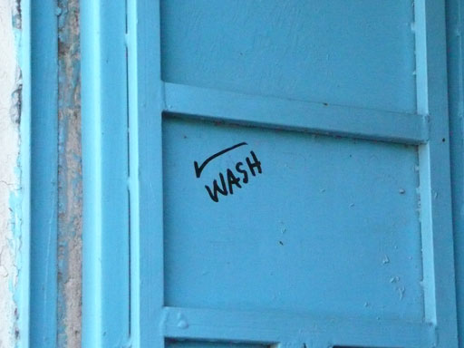
Figure 3.2 WASH inventory mark on a door in Harar, February 2011.
The 2011 NWI data established that, at that time, the baseline was only 52.1% and 63% access to water supply and sanitation respectively. The difference between this and the targets was huge and obviously demanded effective mechanisms to change the situation. As part of its function to describe those mechanisms, the WIF defined the roles and responsibilities of the four signatory ministries, broadly summarised as:
- Ministry of Water, Irrigation and Energy: water supply and water testing
- Ministry of Health: sanitation, hygiene, water quality monitoring and WASH in health institutions
- Ministry of Education: WASH and health clubs in schools, support to Technical and Vocational Training Colleges and Health Science Colleges
- Ministry of Finance and Economic Development: public financial management, channelling government and donor funds, and financial management and reporting.

3.4 WASH-related national initiatives
The development of the OWNP evolved through a series of processes from the late 1990s onwards. During those years, in addition to the Memorandum of Understanding and WASH Implementation Framework, various WASH-related policies, strategies and action plans were introduced by the government of Ethiopia and sector partners that were the springboard towards the development of the OWNP.
- You have read about these policies, strategies and plans in Study Session 2. What were the most important ones?
- Among others, the Ministry of Water introduced the National Water Resources Management Policy (1999), Water Sector Strategy (2001) and Water Sector Development Programme (2002). Similarly, the Ministry of Health had developed the National Hygiene and Sanitation Strategy (2005) and implemented the National Health Sector Development Programme. These were all aligned with national development plans such as the Growth and Transformation Plan (GTP) and the Universal Access Plan (UAP).
Another significant initiative from the Health Sector Development Programmes was the Health Extension Programme (HEP) and its innovative community-based health care delivery system. The whole philosophy of the HEP revolves around empowering communities and households to be able to foster their own health and well-being. The HEP has been dramatically accelerating the promotion of basic and primary health care, including sanitation and hygiene, especially in the rural areas of the country where the coverage of those services was very low.
The development phase for the OWNP also saw increasing recognition of the importance of protecting the environment from the negative impacts of development and safeguarding the lives and livelihoods of the population. For WASH developments, these principles form the basis of the Environmental and Social Management Framework (ESMF), which was prepared in collaboration with the World Bank. The ESMF sets out procedures to ensure that investments in WASH are implemented in an environmentally and socially sustainable manner (FDRE, 2013b).

3.5 WASH-related international initiatives
Meanwhile, the concern for WASH improvements has been growing globally (especially in low-income countries) and several initiatives in the forms of declarations, conventions, resolutions, protocols and commitments have been ratified internationally.
- Which WASH-related international initiative have you already read about?
- Millennium Development Goals, which set a target to halve the number of people without access to safe water and sanitation by 2015.

3.5.1 Conventions, protocols and resolutions
Over the past few decades, there have been several initiatives emanating from the United Nations (Figure 3.3), which have been enacted in terms of conventions, protocols and resolutions. These have mainly focused on ensuring people’s rights to water and sanitation and addressing the WASH needs of disadvantaged and marginalised groups of people.
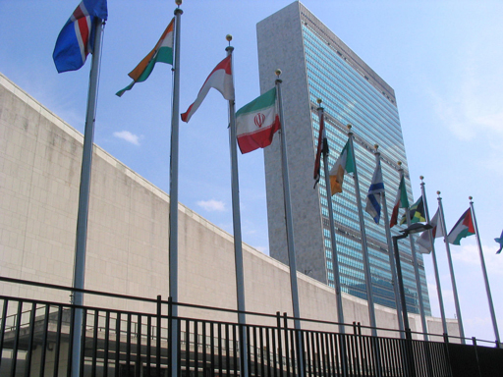
Figure 3.3 United Nations headquarters, New York.
Just some of these initiatives are briefly described below:
- In 1999, a United Nations Protocol on Water and Health stated in Article 5: ‘Equitable access to water, adequate in terms both of quantity and of quality, should be provided for all members of the population, especially those who suffer a disadvantage or social exclusion’ (UN, 1999).
- In December 2003, the United Nations General Assembly, proclaimed the period 2005–2015 to be the International Decade for Action ‘Water for Life’ (Figure 3.4). It focused on co-operation at all levels and on ‘action-oriented activities and policies that ensure the long-term sustainable management of water resources, in terms of both quantity and quality, and include measures to improve sanitation’ (UNDESA, n.d.).
- In 2010, according to the Statement on the Right to Sanitation of the UN Economic and Social Council: ‘States must ensure that everyone, without discrimination, has physical and affordable access to sanitation, in all spheres of life, which is safe, hygienic, secure, socially and culturally acceptable, provides privacy and ensures dignity’ (UN, 2010).
- In 2011, the United Nations Human Rights Council adopted the resolution, The human right to safe drinking water and sanitation. This followed the UN’s 2010 recognition of the human right to safe and clean drinking water and sanitation, affirming that this is ‘derived from the right to an adequate standard of living and inextricably related to the right to the highest attainable standard of physical and mental health, as well as the right to life and human dignity’ (UN, 2011).
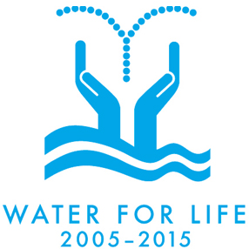
Figure 3.4 International Decade for Action, Water for Life, 2005–2015.
- Can you identify any recurring themes in these UN initiatives?
- Two themes that appear more than once are statement that access to water is a human right and that access should be equally available to all people, regardless of their differences.

3.5.2 International events
In addition to these UN resolutions, various special international events have been dedicated to WASH-related issues. They are used to create public awareness of WASH and its significant contribution to the overall economic development of a country.
Global Handwashing Day (Figure 3.5) is an annual worldwide advocacy day dedicated to increasing awareness and understanding about the importance of handwashing with soap as an easy, effective, and affordable way to prevent diseases and save lives. Celebrated annually on 15 October, Global Handwashing Day is an opportunity to encourage people to wash their hands with soap at critical times.
Figure 3.5 Global Handwashing Day logo.
In Ethiopia, this event has been celebrated all over the country every year since 2005. In most cases, the celebration focuses on school children with the aim of embedding handwashing practice as part of their life skills (Figure 3.6).
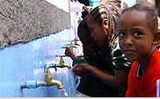
Figure 3.6 Children at the Ginfle Primary Public School in Addis Ababa wash their hands with soap and water during their lunch break on Global Handwashing Day, 15 October 2012.
World Toilet Day (Figure 3.7) is dedicated to improving people’s access to, and proper use of, a toilet. It is a day to raise the public’s awareness of the importance of toilets in blocking faecal-oral disease transmission and the need for all people to have access to a toilet. World Toilet Day has been celebrated in Ethiopia every year on 19 November since 2012.
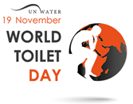
Figure 3.7 World Toilet Day logo.
World Water Day (Figure 3.8) is marked on 22 March. Since 1993 it has been celebrated around the world, every year focusing on a different issue of water supply and sanitation.
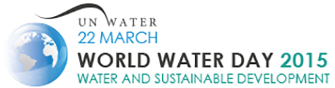
Figure 3.8 World Water Day logo.
In summary, the international initiatives and events that have been introduced and applied across many countries (including Ethiopia), have improved recognition of WASH among governments, decision makers, and practitioners. These events have raised public awareness and increased the commitment to take practical action at all levels, from families through to national government. In this way, the international and national initiatives have guided the formulation of the OWNP.

Summary of Study Session 3
In Study Session 3, you have learned that:
- The One WASH National Programme is the result of processes over many years during which the foundation was laid.
- A Sector-Wide Approach (SWAp) is a development concept where all significant sector investments are channelled towards the same objectives following a consistent strategy, guided by a consolidated investment plan. This has many advantages over the traditional project-based approach.
- Among the foundations for the development of the OWNP, the main documents are the Memorandum of Understanding (MoU) signed in 2006 and revised and signed again in 2012, and the WASH Implementation Framework (WIF).
- The WASH MoU is a formal working document that describes the roles and responsibilities of the signatory stakeholder ministries.
- The WASH Implementation Framework (WIF) is a guiding document for all WASH programme implementation across the country.
- The National WASH Inventory gives baseline data to provide comparison for assessing future changes in WASH provision.
- Several national and international initiatives have contributed to the formulation of the OWNP.

Self-Assessment Questions (SAQs) for Study Session 3
Now that you have completed this study session, you can assess how well you have achieved its Learning Outcomes by answering these questions. You can check your answers with the Notes on the Self-Assessment Questions at the end of this Module.

SAQ 3.1 (tests Learning Outcome 3.1)
The table below shows information about two WASH projects:
 | Project One | Project Two
Administration costs for supplying funding | ETB 1,500 | ETB 6,000
Cost of maintenance per household per year | Affordable | Unaffordable
Disabled access | No | Yes
Litres of clean water supplied daily per ETB 100 invested | 550 | 200
Look at the definitions in Section 3.1. They explain some of the main criteria used to assess the desirability of WASH projects. Think about what information in the table here is relevant to each of the criteria. Which of the projects above shows the highest:
- efficiency?
- equity?
- transaction cost?
- sustainability?

SAQ 3.2 (tests Learning Outcome 3.2)
Is the following statement true or false? Explain your answer.
The OWNP was developed because the project-based aid approach was very efficient and successful, and initiatives that adopted a sector-wide approach, like the WIF, made things worse.

SAQ 3.3 (tests Learning Outcomes 3.1 and 3.3)
Rewrite the paragraph below using terms from the list provided to fill the gaps.
accountability, baseline data, Memorandum of Understanding (MoU), Ministry of Finance and Economic Development (MoFED), National WASH Inventory (NWI), project-based aid approach, sector-wide approach, stakeholders, WASH Implementation Framework (WIF).
In 2003, an aid organisation from Europe sent workers to an Ethiopian village. The workers dug a well for the village, then went back to their home country. They did not coordinate the project with any government ministries. This is an example of a ……………… Because this is not a very efficient way of providing aid, in 2006 three government ministries signed the legally binding ………………, pledging that they would take a ……………… to WASH sector projects. This means that they agreed to work together to integrate the different elements of WASH, and involve all interested parties, which are known as ……………… A few years later some workers from the ……………… arrived in the village to record the WASH facilities. They needed to collect ……………… so that in the future the stakeholders would be able to tell if they had met their development targets. The workers found that the well had been contaminated from poor sanitation. Situations like this led to the creation of the ………………, so there were clearer plans for integrated WASH projects nationwide. These projects would require coordinated access to funding, so 2012 saw a new MoU, including the ……………… It outlined the areas of ……………… for each ministry, so everyone had definite responsibilities.

SAQ 3.4 (tests Learning Outcome 3.4)
The United Nations WASH sector initiatives you have read about have a strong focus on equitable access to WASH facilities. Give an example of a national programme, other than the OWNP, that promotes equitable access and briefly explain how.

Study Session 4 Guiding Principles of the OWNP

Introduction
In the first three study sessions of the Module you have learned about the background to the One WASH National Programme (OWNP) and how and why it came into existence. We now move on to the OWNP itself. In this and the following sessions we will look at the most important features of the document, starting with its Guiding Principles.
In this study session you will be introduced to the four core principles of the OWNP that guide its implementation. You will learn what the principles mean and why they are important. These Guiding Principles are applied individually as well as in a concerted manner towards the success of the programme.
In addition to the four core or Guiding Principles, you will also be introduced to the Basic Implementation Principles that are listed and defined in the OWNP Programme Operational Manual.

Learning Outcomes for Study Session 4
When you have studied this session, you should be able to:
4.1 Define and use correctly all of the key words printed in bold. (SAQ 4.1)
4.2 Outline the four Guiding Principles of the OWNP. (SAQs 4.1 and 4.2)
4.3 Explain how the four Guiding Principles contribute to the success of OWNP. (SAQ 4.2)
4.4 Outline the Basic Implementation Principles of the OWNP. (SAQ 4.3)

4.1 Origins of the OWNP Guiding Principles
During the early years of the twenty-first century there were a number of major international events that were organised to improve the impact of international aid. These events brought together both the donors who gave funds for development programmes and the countries that received the funds. Their purpose was to discuss and agree ways to make more effective use of the financial aid that was being given by donors to the recipient countries.
The first significant event was the High Level Forum on Aid Effectiveness which was held in Rome in 2003. This was followed by the Roundtable on Managing for Development Results in Marrakech in 2004, and then by the second High Level Forum (HLF) held in Paris in 2005. The output from this forum event was the influential Paris Declaration on Aid Effectiveness (see Box 4.1). In 2008, the Paris Declaration was endorsed and strengthened by the Accra Agenda for Action from the third HLF held in Accra (OECD, n.d. 1).
These global initiatives contributed to the introduction of principles intended to enhance the achievements of development programmes throughout the world and to increase the efficient use and effectiveness of aid resources. These initiatives formed the basis for the four Guiding Principles of the OWNP.

Box 4.1 Paris Declaration on Aid Effectiveness
The Paris Declaration was the significant output from the High Level Forum in Paris, France in 2005 (Figure 4.1). The Forum was attended by representatives from over 100 industrialised and less developed countries, including Ethiopia. Both donor and recipient countries agreed to change the way they were undertaking development programmes. In addition, about 26 aid organisations and 14 international civil society organisations were represented in the meeting.
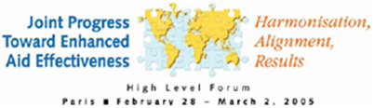
Figure 4.1 Logo of the second High-Level Forum on Aid Effectiveness held in Paris in 2005.
The Paris Declaration laid out a practical, action-oriented roadmap to improve the quality of aid and its impact on development. It put in place a series of specific measures for implementation and established performance indicators to assess progress. It also called for an international monitoring system to ensure that donors and recipients held each other accountable. The long list of partnership commitments mentioned in the Paris Declaration can be aggregated into five principles for making aid more effective (OECD, n.d. 2):
- Ownership: Developing countries should set their own development strategies, improve their institutions and tackle corruption.
- Alignment: Donor countries and organisations bring their support in line with developing countries strategies and use local systems.
- Harmonisation: Donor countries and organisations coordinate, simplify procedures and share information to avoid duplication.
- Results: Developing countries and donors focus on producing – and measuring results.
- Mutual accountability: Donors and developing countries are accountable for development results.
The first two principles established the importance of recipient countries determining their own priorities, and that donors should support this approach rather than imposing their own agendas. The third, harmonisation, also emphasised the need for collaboration and sharing. Harmonisation can be defined as bringing about agreement or standardisation among different people, plans or actions. It refers to the need for all stakeholders to work together, or, as you might say, to sing in harmony with each other. The fourth and fifth principles focused on the outputs, stating that aid should produce measurable results and all parties would share responsibility.
The OWNP adopted the development principles included in the Paris Declaration to guide its implementation. These principles are reflected in all related manuals, such as the WASH Memorandum of Understanding (MoU), the WASH Implementation Framework (WIF) and the OWNP’s Programme Operational Manual (POM). (The POM is the main guiding document for management of funds channelled through the Consolidated WASH Account.)

- Can you describe the main difference between the WASH MoU and WIF?
- The WASH MoU is a formal working document that outlines the procedures, roles, responsibilities and accountability of the signing ministries. It preceded the WIF, which is a more practical document mainly focused on how the WASH programmes are going to be implemented.
The need to adopt and incorporate these principles into the programme came out of the practical lessons learned from the national WASH sector endeavour during previous years. As you have already learned in Study Session 3, prior to 2004, WASH interventions were project-based, whereby any of the three components of WASH were implemented separately. Moreover, there was no appropriate policy or legal environment that supported integration between water supply, sanitation and hygiene interventions. Similarly, other essential considerations in programme design, such as community or beneficiary participation, gender and disability-related issues were overlooked. From the equity point of view, WASH interventions were concentrated in some geographic areas when others, especially hard-to-reach areas, were deprived of the opportunity and associated benefits.
However, since that time the situation has gradually been changing. As a result of various national and international initiatives, WASH interventions have become more programme rather than project-based and have become more participatory and inclusive in terms of geographic location, gender and disability. WASH programmes have been designed to include all regional states and to deal equitably with male and female, able and disabled people.
In line with these developments, the WIF set out four significant features for the national WASH programme which, after some development, became the Guiding Principles of the OWNP. These are described in the OWNP Final Document (OWNP, 2013):
- Integration of the water, health, education and finance sectors.
- Alignment of [implementing] partners’ activities with those of the Ethiopian government.
- Harmonisation of partners’ approaches and activities.
- Partnership between implementing parties at all levels.
Each of these principles is described in more detail in the following sections.

4.2 Integration
Integration means the act of combining or linking together two or more different activities to achieve certain objectives. To integrate can variously mean to repair, make whole, unite, connect or bring things together.
The OWNP Programme Operational Manual describes this principle as (POM, 2014):
This principle aims at integrating safe water use with good sanitation and hygiene practices at the household level, in schools and health facilities (institutional WASH) through synergy built among the four sectoral offices: water, health, education and finance. This includes coordinated and collaborative planning, implementation, monitoring, reporting and evaluation of program results.
The term ‘integration’ is frequently associated with the word ‘synergy’. Synergy refers to the results of coordinated actions being greater than the sum of the individual actions. If activities are described as synergistic, it means they achieve more together than they would have done separately or, to put it another way, there is an additional benefit that could not have been achieved by the separate actions. The aim of successful integration, therefore, is to produce synergies and to maximise the impact, sustainability, appropriateness and effectiveness of interventions, thereby creating greater benefits for all.
The concept of integration and its application in different development programmes, including WASH, has been realised in the past few years, and nowadays its importance as a core principle is widely recognised. People are aware that a lack of integration can lead to ineffectiveness of investments and end up with poor results. Figure 4.2 shows how there can be different levels of integration and how separate interventions will probably have fewer beneficiaries than integrated programmes.
Although the benefits associated with inter-sector (between two or more different sectors) or intra-sector (within one sector) integration are well understood by many, the practical know-how about how to achieve integration may still be doubtful. In any context, effective integration relies on good communication and coordination between the actors in order to achieve the best results.
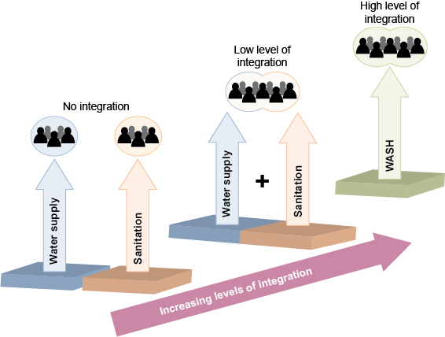
Figure 4.2 Different levels of sectoral integration.

4.3 Alignment
Alignment is the noun form of the verb to align, which literally means to arrange something in a correct position.
The POM states the aims of the principle of alignment as follows (POM, 2014):
The main goal of this principle is to ensure that OWNP will align with the policies, priorities, strategies and plans of the pertinent Ministries’ Sectoral Development Plans and with the administrative systems, standards and procedures of the Federal and Regional Governments of Ethiopia. The principle also ensures that WASH is recognized and affirmed as an integral, ongoing component of the Government’s broader developmental program and WaSH responsibilities are incorporated in the established process streams and mandates of the four sector agencies’ staff at all levels. The other goal is an internal alignment of structures and procedures within government, both vertically (i.e. from Federal to Kebele level) and horizontally (i.e. across the different subsectors which comprise WASH).
- Alignment was one of the principles included in the Paris Declaration. Who and what needed to be aligned in order to make aid more effective?
- Aid donors committed to align their support with the strategies and policies of the recipient countries.
Alignment, in the terms of the Paris Declaration, was between donors and partner countries. The OWNP took this principle and modified it to be applied within a country, i.e. Ethiopia. Alignment in the OWNP, as you can see in the extract from the POM, refers mainly to internal processes between the four ‘pertinent’ ministries (water, health, education and finance), aligning their activities with each other at all levels. Furthermore, for its full and practical implementation, the principle of alignment should be adopted by all participants of development programmes including non-governmental partners who align their activities with those of the Ethiopian government.
Alignment is an important principle to apply in practical situations at local level as well. Imagine you were an urban WASH worker in a small town. In that role you may come across many different and separate WASH plans of action prepared by different partners that were not coordinated. What steps could you take to try to align those plans of action with each other? One thing you could do is to call a meeting for all the partners involved and ask them to present their respective plans. With the principle of alignment in mind, you should try to focus the meeting on coming up with one consolidated WASH plan of action for the town. By bringing the interested parties together you are not only demonstrating alignment of activities, but also harmonisation, which is the next guiding principle to be discussed.

4.4 Harmonisation
In Box 4.1 you read a formal definition of harmonisation which was to bring about agreement or standardisation among different people, plans or actions. Harmonisation is all about applying common arrangements and simple procedures to implement development programmes. Like alignment, the inclusion of harmonisation as a principle in the OWNP followed the Paris Declaration on Aid Effectiveness, but again was adapted for the different context of within country, rather than between aid donors and recipient countries.
The Paris Declaration listed many separate commitments by donors and partner countries intended to achieve the goal of harmonisation. These included, for example, commitments from donors to (adapted from OECD, 2005):
- implement, where feasible, common financial arrangements at country level between donors and recipient countries for planning, funding and the disbursement of funds. Also to have common arrangements for monitoring, evaluating and reporting to the government on donor activities and aid flows.
- work together to reduce the number of separate, possibly duplicating, field missions, and to promote joint training to share lessons learned and build a community of practice. (A community of practice is a group of people who share an interest in doing something and learn how to do it better by sharing their experiences.)
- work together to harmonise separate procedures.
The OWNP adopted the spirit of these commitments and revised them to suit the particular context of the national WASH programme in Ethiopia. The POM defined the principle of harmonisation as:
This principle leads to One WASH Plan, One WASH Budget, One WASH Report; implying to OWNP. Harmonisation also assumes that One Consolidated WASH Account (CWA) will be opened where all Development Partners contributions are deposited from which WASH activities and investments would be supported (POM, 2014).
This reinforces the idea of a single collaborative programme and highlights the importance of joint financial arrangements. The principle establishes that development partners will pool their financial contribution into one consolidated fund for supporting WASH activities.
The principle of harmonisation is repeated in all the OWNP documents, but the wording is not exactly the same, indicating the range of applications of the principle. In the WIF (2011), harmonisation is ‘of diverse projects into a single program’. In the OWNP document (2013), it is ‘of partners’ approaches and activities’ and in the POM (2014) it is described with a focus on financial arrangements. In each case, the fundamental principle of common arrangements and simple procedures, or harmonising, is the same.

4.5 Partnership
Partnership is one of the most important development concepts to have emerged in recent years. The core concept of partnership is sharing tasks and responsibilities in any development sector (Figure 4.3). In other words, partnership is an agreement to carry out a certain task together that will benefit all involved according to their own interests, and bring results that could not be achieved individually. Good partnership reduces duplication of effort. It creates synergy, enhances the efficiency and effectiveness of resources used, promotes innovation and maximises the impact of development programmes.
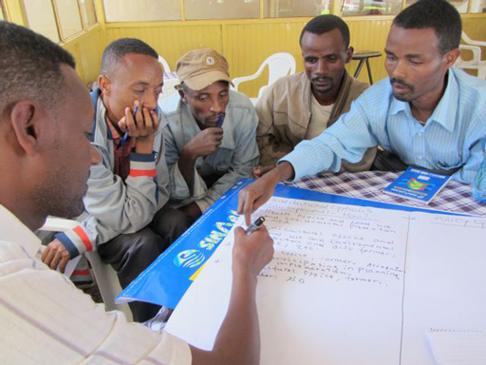
Figure 4.3 Effective partnerships need good communication and sharing of ideas.
Governments have been facing the ever-growing demand from their people for basic social services such as education, health, water and sanitation, which they could not address alone. This recognition has led to the inclusion of ‘partnership’ as one of the OWNP’s Guiding Principles. In the POM (POM, 2014), the general framework of partnership across the OWNP is described as:
The OWNP recognizes Civil Society Organizations (CSOs) and the Private Sector as significant partners playing an essential part in attaining OWNP target along with the four sector Ministries and Development Partners.
Let us consider a practical example of partnership in action. If you were a Health Extension Worker with an assignment to promote handwashing practice, it is possible that community members may challenge you. They might say that soap is not available at the local market or they may complain about the price. How would you solve this problem? You may not be able to find a solution to this problem on your own; you may need external support such as a private agent who is able to supply soap to local vendors or open an outlet to sell soap and other goods essential for the community. In other words, you will need a partner.
How should you go about arranging a partnership? We will continue with our example of access to soap as an illustration of the required steps:

Step 1: Preparation
Preparatory work is crucial for developing a steady and effective partnership. You need to carefully examine the condition in which your partnership will be operating. You should assess whether the people are willing and economically able to buy soap or not, and if alternatives are available. Also you need to identify the right partner and list clear roles for them, the community members and yourself.

Step 2: Draw up an agreement/contract
A partnership is often based on a formal commitment signed as a contract or agreement. Bound by the signed contract, you and your partner will share a strategy and implement the work schedule in a coordinated and agreed manner for a specified period. For example, you would make an agreement with your partner that they would supply soap of a specified quality and quantity with an agreed price at a certain outlet accessible to users. Your side of the agreement would be to facilitate marketing by creating demand through hygiene education in the community.

Step 3: Outline the work programme/schedule
The work schedule should indicate the interests and targets of yourself and your partner. It should include activities and measures that will contribute to the successful accomplishment of the activities, according to the roles and responsibilities mentioned in the partnership agreement. Your partnership agreement signed with the soap supplier, for instance, should set out the frequency of soap deliveries and the duration of the scheme.

Step 4: Implementation
In this phase you are required to be in regular contact with your partner to coordinate implementation, to extend and supplement the working programme with new measures, and in some cases to test new approaches if necessary. You work closely with your soap-supplying partner to see whether the joint plan is working properly.

Step 5: Monitoring
To assess the achievements of any partnership and determine possible improvements to be made, a comprehensive monitoring system should be used. A partnership should be evaluated periodically and reports shared. For the soap example, you could assess the achievements of your partnership by evaluating the status of users’ satisfaction in terms of access, price and quality of soap, as well as whether it has encouraged people to use soap routinely, etc. You both would also want to assess the feasibility of the scheme as a business.
Partnerships can be established not only with a private agent but also with any sort of organisation. However, partnerships between governments (public sector) and private parties are very common in development endeavours, including WASH. This type of work collaboration between a public or government office with a private sector operative is known as public–private partnership (PPP) and is depicted in Figure 4.4.
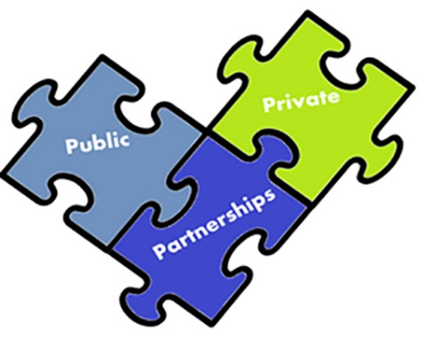
Figure 4.4 Diagram representing public–private partnerships.
- Figure 4.4 depicts public–private partnerships as three interlocking pieces of a jigsaw puzzle. Why is this an appropriate image for PPP?
- The jigsaw shows how partnerships can join public and private sectors together to build a bigger ‘picture’. Partnership enables both sectors to fill the gaps they each have. If you remove the partnership ‘piece’ of the jigsaw, both public and private will have unfilled gaps or spaces.

4.6 Basic Implementation Principles
In addition to the four Guiding Principles that have been described in the previous sections, the OWNP also has a set of Basic Implementation Principles for activities supported through the Consolidated WASH account. These principles are set out in the Programme Operational Manual (POM, 2014) and are described below:
- Decentralisation: Decisions should be made locally rather than centralised at higher levels. This should ensure they are more in line with local needs and give the user communities responsibility for the management of WASH service provision.
- Demand-responsive: User communities receive assistance in response to their demand for improved WASH services. They make informed choices on the technology options and service levels and demonstrate their readiness to participate, taking into consideration their own needs and ability to pay.
- Consistency: The OWNP is to be consistent with the Ethiopian Water Resources Management Policy, Water Sector Strategy and Hygiene and Sanitation Strategy, as well as the national Growth and Transformation Plan.
- Equity: OWNP addresses regional and social disparities in WASH coverage among and within regions, woredas and urban areas, prioritising underserved and unserved communities.
- Cost recovery and the right to access: Access to water is a right, however it is also recognised as an economic good, and its service must be paid for.
- Cost-effective design: The programme should avoid over-elaborate design in order to provide affordable and sustainable services, e.g. use appropriate WASH technologies that can be easily maintained.
- Transparency: The programme includes promotional activities to ensure that its implementation processes are well understood by all stakeholders.
- Gender: Activities and processes are designed to ensure participation by women in decision making and programme implementation.
- Sustainability: services provided should be sustainable, i.e. easily operated and maintained at local level.
- Stepped approach: Implementation is to follow a stepped approach, where towns, woredas and communities will obtain assistance based on their performance.
- Participatory monitoring and evaluation: Monitoring and evaluation of agreed indicators is to be carried out in a participatory manner involving all stakeholders, with results shared so that the programme can be improved through feedback.
These principles provide a foundation for the organisation and implementation of the OWNP, as you will see in following study sessions.

Summary of Study Session 4
In Study Session 4, you have learned that:
- The One WASH National Programme has four core Guiding Principles: integration, alignment, harmonisation and partnership.
- These principles were developed and adapted from global conventions and internationally agreed principles stated in the Paris Declaration on Aid Effectiveness, which established clear directions on each of the principles for donors and partner countries.
- The Guiding Principles emerged both at global and national level because of past experience of unsuccessful projects that had not followed the principles and had failed as a result.
- In addition to the four Guiding Principles, there are eleven Basic Implementation Principles which are presented in the Programme Operational Manual (POM).

Self-Assessment Questions (SAQs) for Study Session 4
Now that you have completed this study session, you can assess how well you have achieved its Learning Outcomes by answering these questions. You can check your answers with the Notes on the Self-Assessment Questions at the end of this Module.

SAQ 4.1 (tests Learning Outcomes 4.1 and 4.2)
Insert the following words into the spaces in the sentences below:
alignment; harmonisation; integration; partnership; synergy.
When two or more people or organisations agree to work together, this is a ………………
……………… means combining two or more activities together to improve coordination and bring ………………
……………… means all WASH ministries ensuring their activities are in agreement with each other and with national policies.
……………… means ensuring there are common procedures and arrangements shared between partners and other stakeholders so it is easier for them to work together.

SAQ 4.2 (tests Learning Outcome 4.3)
How do the Guiding Principles of the OWNP help towards the success of the programme:
        - from a resource perspective?
        - from a project result/achievement perspective?
        - from a sustainability perspective?

SAQ 4.3 (tests Learning Outcome 4.4)
The OWNP has four Guiding Principles and the Programme Operation Manual (POM) has 11 Basic Implementation Principles. Briefly explain what they have in common and how they are different.

Study Session 5 The Pillars of the OWNP

Introduction
The principles that you read about in Study Session 4 provide overall guidance about the approach to be taken in the OWNP. The Programme is further supported by three fundamental strategic pillars that underpin its contents and implementation. These pillars are sometimes referred to as overarching domains, a term which implies a broad general topic or relevant area, but the term pillar gives a more appropriate idea of the foundation and support upon which the structure of the OWNP is built.
In this study session you will learn what these pillars are and what they mean. As part of the description, we will discuss what is meant by an enabling environment and good governance, and how to create these conditions in the WASH sector. In addition, you will learn how demand for better WASH services should be created and about capacity development for WASH. The study session will therefore help you to understand how the pillars are practically applied in the OWNP implementation cycle, both individually and in a concerted manner, and how they contribute to the success of the programme.

Learning Outcomes for Study Session 5
When you have studied this session, you should be able to:
5.1 Define and use correctly all of the key words printed in bold. (SAQs 5.1 and 5.3)
5.2 Outline the pillars on which the OWNP rests. (SAQ 5.2)
5.3 Explain what is meant by each of the three pillars. (SAQs 5.3 and 5.4)
5.4 Describe how the pillars of the OWNP complement each other. (SAQ 5.5)

5.1 The pillars on which the OWNP rests
Before explaining about the three pillars of the OWNP, we will revisit some points about the Ethiopian National Hygiene and Sanitation Strategy (NHSS) that you were introduced to in Study Session 2. The NHSS identified three strategic pillars to support the effort towards ensuring 100% coverage of improved hygiene and sanitation services across Ethiopia.
- What were the three pillars of the NHSS?
- They were: an enabling environment; sanitation and hygiene promotion, and improved access to hardware.
These pillars are described in more detail in the NHSS (MoH, 2005) and can be summarised as:
Pillar 1: An enabling environment to support and facilitate an accelerated scaling-up [of sanitation and hygiene] through policy consensus, regulation, political commitment, inter-sectoral co-operation, partnership, capacity building, sustainable finance, research, monitoring and evaluation.
Pillar 2: Sanitation and hygiene promotion to create demand and change behaviour using participatory approaches, advocacy, communication and social marketing.
Pillar 3: Improved access to hardware to strengthen the provision of sanitation and hygiene through appropriate technology and product design for different situations (e.g. rural/urban, schools, health posts etc.).
The NHSS was followed in 2011 by the Strategic Action Plan (introduced in Study Session 2) which used the three pillars for its cover illustration in recognition of their importance (Figure 5.1).
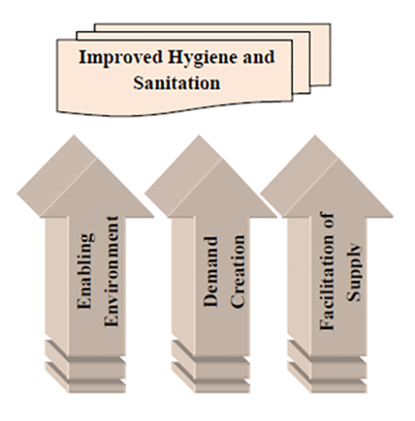
Figure 5.1 The three pillars of hygiene and sanitation improvement. (MoH, 2011)
Figure 5.1 depicts that the intended result of nationwide improved hygiene and sanitation can only happen if all three pillars are in place. If one of the pillars is neglected and efforts are inclined towards one or both of the others, it will ultimately end in failure. You can imagine this by its resemblance to house construction. It is common sense that, to build a durable house, you need strong pillars on which the whole structure will rest. The durability and reliability of the house is guaranteed not only by the strength of the pillars but also by their number. All the required number of pillars appropriate to the size of the house should be erected without any compromise, otherwise the house may not provide long service or may collapse immediately before it is finished.
This important principle of strong supporting pillars given balanced attention was adopted for the formulation of the OWNP. The original wording of the pillars of the NHSS gradually evolved and was improved and clarified to become the three pillars on which the OWNP is founded, shown in Box 5.1. You will notice these are very similar to the pillars of the National Hygiene and Sanitation Strategy, but the language has changed and the emphasis shifted in response to inputs from various stakeholders and developing priorities. Each of these pillars is described in detail in the following sections.

Box 5.1 The three pillars of the One WASH National Programme
- Creating an enabling environment and good governance.
- Maximising availability and efficient use of human and financial resources to create demand for better WASH services.
- Capacity development for improved delivery of WASH services at all levels.
(OWNP, 2013)

5.2 Enabling environment and good governance
The first pillar, as in the NHSS, is about an enabling environment, but for the OWNP this is extended to include good governance. These two terms are conceptually different but are similar in their relevance to WASH sector development effort in general and to OWNP implementation in particular. We will describe them separately and then summarise their overall significance.

5.2.1 Enabling environment
Put simply, an enabling environment refers to the fulfilment of conditions that can enable a certain phenomenon to happen. From your elementary school biology, you will know that a plant seed can germinate and grow only if important elements such as water, soil and sunlight are available. In this example, water, soil and sunlight create the enabling environment. If these factors are partially or totally unavailable, growth will not happen or at least will not be successful. Likewise, for the OWNP to be successful, several prerequisites must be fulfilled. These prerequisites are the foundation for the programme and are described as an ‘enabling environment’. They consist of a wide range of policies, strategies, institutional arrangements and formal agreements, together with the commitment and integrity of personnel at all levels, access to information, compliance with agreed norms and standards, and contractual relations among implementing bodies.
- As you have just read, policies, strategies and formal agreements are among the elements of an enabling environment. Can you name one policy, one strategy and one formal agreement that you would include as part of the enabling environment for the OWNP? (It may help you to think back to Study Sessions 2 and 3.)
- The Ethiopian Health Policy and the National Water Resources Management Policy are the two main policies. You may also have mentioned the Ethiopian Environmental Policy. From strategies, there is the National Hygiene and Sanitation Strategy and the Ethiopian Water Sector Strategy. The relevant formal agreements are the WASH Memorandum of Understanding (MoU) and the WASH Implementation Framework (WIF), both signed by Ministry of Health, Ministry of Water and Energy, Ministry of Education and the Ministry of Finance and Economic Development.
Commitment and integrity of personnel are also mentioned as elements of the enabling environment. What do commitment and integrity mean for a potential urban WASH worker? Commitment is the strong feeling and decisiveness of a person to carry out duties and fulfil obligations. Integrity is a person’s quality to carry out duties and responsibilities consistently and honestly. An urban WASH worker, working with communities, would have to be a role model to the people they were working for. This could mean working extra time, at the weekends, and on holidays if it is needed. However, an important aspect of integrity is honesty and no one should promise to people what they may not be able fulfil.
Creating an enabling environment for WASH sector development is a continuous process. The stronger the enabling environment that can be created, the better we can promote WASH to a wider population. In Ethiopia, the basic elements in the making of the enabling environment for WASH have been developed in the past decades and the achievements so far are encouraging. The policies and strategies in both health and water sectors and the formal consensus-building documents such as the MoU and WIF demonstrate this progress. However, there is still a need to strengthen the environment for even better results. For example, the shortage of suitably trained and qualified WASH personnel from federal to woreda levels is still visible. An integral part of the enabling environment for WASH sector development is having a sufficient number of WASH workers at all levels, and this is one of the areas to be improved in the future.

5.2.2 Good governance
Nowadays, the terms governance and/or good governance are widely used in the spheres of development and aid due to an ever-growing understanding and recognition of the key roles that governance plays for any sort of development endeavour. There is a general consensus that the fate of any development programme, either to succeed or fail, is directly related to the characteristics of existing governance. In other words, if there is good governance, then a programme will probably be successful, but if there is bad governance, it is likely to fail.
Good governance is about the processes for making and implementing decisions. It’s not about making ‘correct’ decisions, but about the best possible process for making those decisions (Good Governance Guide, n.d.). Good governance can be defined by a collection of several characteristics, as shown in Figure 5.2. For governance to be ‘good’ it should fulfil those characteristics, or at least be judged against them.

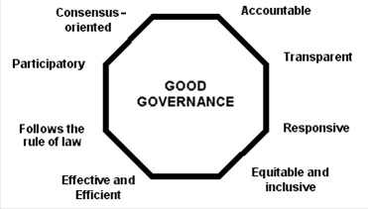
Figure 5.2 Characteristics of good governance. (UNESCAP, n.d.)
Figure 5.2 shows eight major characteristics of good governance, which are further described below (adapted from UNESCAP, n.d.).
- Participatory: Participation means taking part or being actively involved in something, usually a decision or activity. It is particularly relevant to decision making; participation by a wide range of stakeholders tends to lead to better decisions. WASH programmes, from planning to implementation, need the full participation of people regardless of gender, age, occupation, wealth, or any other differences. Participation of beneficiaries significantly increases their sense of ownership, which, in turn, improves sustainability.
- Consensus-oriented: This means that the governance processes should be aiming to reach consensus among stakeholders. Consensus means a general agreement. Good governance requires consideration of the different interests of the stakeholders in order to reach a decision or create a situation that is in the best interest of the whole community. It requires open thinking that is not trapped in a single perspective or biased towards one particular side of a debate. Reaching a consensus requires a good understanding of the historical, cultural and social contexts of a given society or community.
- Accountable: Accountability was defined in Study Session 3 as an obligation or willingness by an organisation or individual to account for their actions and accept responsibility for them. It is a key requirement of good governance. Not only governmental institutions but also the private sector and civil society organisations must be accountable to the public and to their stakeholders. In general an organisation or institution is accountable to those who will be affected by its decisions or actions.
- Which of the WASH documents explicitly included accountability as a required element of the new national WASH programme?
- The revised (second) WASH MoU, signed in 2012, emphasised the accountability of each of the WASH signatory ministries.
- Transparent: Transparency literally means you can see through something, so in the context of governance it means that decisions taken and their enforcement are done in such a way that is easy for anyone to see what procedures have been followed. In the Ethiopian WASH context, transparency means sharing of all information concerning the WASH programme (financial, material, human resource, etc.) in a given area. Providing this information is the duty of the programme coordinating body, while receiving the information is the right of the programme beneficiary.
- Responsive: To be responsive means to respond appropriately and in good time. Good governance requires that institutions and processes try to serve all stakeholders within a reasonable timeframe.
- Equitable and inclusive: You may remember the definition of equity as the allocation of resources, services and opportunity to all segments of the population according to their needs. Good governance requires that all members of society, especially the most vulnerable, are treated equitably and are not excluded or ignored by decisions and processes. Equity and inclusiveness of the WASH programme are among the basic implementation considerations that have been included in the One WASH National Programme Operating Manual.
- Effective and efficient: It is common sense that good governance should be effective (achieve its intended purpose) and efficient (make best use of resources). Efficiency of good governance also covers the sustainable use of natural resources and protection of the environment. In the Ethiopian WASH sector, the move from project-based to sector-wide approaches was made to enhance effectiveness and efficiency of WASH programmes so that resources (financial, material, time and human) can be used in such a way to yield maximum results and ensure sustainability.
- Follows the rule of law: Again, it is common sense that good governance should follow the rules of law. Impartial enforcement of fair legal frameworks that protect human rights is essential.
Looking at these characteristics of good governance, what is your opinion of them? Do you think it is possible to fulfil all eight elements? It may appear very difficult to achieve all of them. Only a few countries and societies have come close to achieving good governance by fulfilling these characteristics. But it is important to remember that without good governance it is impossible to ensure sustainable human development. Working towards the attainment of good governance by all responsible bodies, including individual citizens, is a continuous process.
As you can see from the detailed explanation above, an enabling environment and good governance, as one of the three pillars of the OWNP, embrace a wide range of issues. They are crucial for the success of the programme but, at the same time, implementing them all is very challenging. Nevertheless, as you have seen from the historical development of WASH in Ethiopia, the situation is changing, and with the joint effort of all partners and stakeholders more improvements in this essential pillar can be made.

5.3 Creating demand for better WASH services
The second pillar is about creating demand for WASH services through maximising the availability and efficient use of human and financial resources. Let us first look at the meaning of demand. You have probably come across the term before. Demand is a concept of economics that is frequently mentioned with supply. From a practical point of view, demand and supply are complementary. Simply put, demand is a strong need or desire for a certain commodity or service. It refers to how much (quantity) of a product or service is desired by users. Supply, on the other hand, refers to how a product or service can be provided to meet the expressed demand.
Accordingly, ‘demand creation’ is a process whereby the unrealised need of people for a certain commodity or service is converted to an expressed demand. To give an example, in Ethiopia the use of household water treatment chemicals, was not common in the past (Figure 5.3). However, after many years of activities to raise awareness of the importance of these chemicals in preventing waterborne diseases, more and more families are using them. Particularly during the 2006 acute watery diarrhoea epidemic in some parts of the country, the need for water treatment chemicals increased dramatically, resulting in a rapid rise in price that in some places even tripled. The demand had been created and nowadays these chemicals are commonly seen in shops.
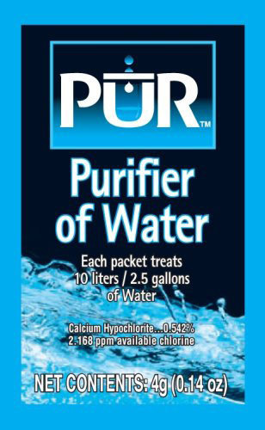 | 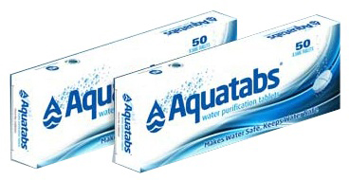
Figure 5.3 Water purification chemicals are increasingly popular.
Demand creation as a process requires systematic, targeted and continuous communication and engagement with the people in whom we are aiming to create demand. Let’s consider another practical example. In Ethiopia, many rural communities have been provided with a safe water supply that is close to their homes and available at all times of the day. However, it has been observed that the amount of water used remained the same as it had been in the past when people had to travel many hours every day and spend even more time queuing for water that was of very poor quality. This observation suggested that, regardless of the new water supply, people were still only using water for the same purposes as before, i.e. cooking and drinking.
Pause for a moment and analyse this practical case. What do you think were the reasons for communities using the same amount of water both before and after they were provided with a safe, adequate and accessible water supply? What were the main factors that prevented community members from using more water? Do you think they should use more water for purposes other than drinking and cooking? What actions could you take to encourage people to use more water?
Generally, demand for a product or service comes from the knowledge, awareness and belief of its value(s) to those involved. From this basic fact, we can deduce that the reason why community members continued to use the same amount of water is mainly associated with low awareness of the benefits of using water for hygienic purposes. In other words, the community members were not well aware of the importance of personal hygiene in preventing communicable diseases such as diarrhoea, intestinal parasitic infection, trachoma, scabies, jigger flea infestation, and many other hygiene-related diseases. They were not using as much water as they needed for adequate washing to prevent these diseases. If you come across such a case, your action should focus on creating the demand for more water use and the best way to do this would be by raising awareness through hygiene education.
As you can see from Box 5.1, the wording for this pillar in the OWNP document clearly states that the main mechanism to be applied in creating demand for better WASH services is maximising availability and the efficient use of human and financial resources. This implies that if there are sufficient numbers of trained people and sufficient funds, it is possible to carry out continuous and systematic WASH awareness-raising interventions in a given community. In this way, the demand for new or improved WASH services can be created.
The OWNP document emphasises the efficient use of resources (human and financial) rather than the mere availability of them. According to the programme document, the need to focus on efficiency came out of consultation with regional WASH bureaus and cities during the programme formulation. In this regard, the programme document states ‘during consultations with the regions and cities, human resources and capacity were mentioned more frequently than funding and other resources as constraints to effective implementation of WASH activities on the ground.’ (OWNP, 2013). This recognition of the importance of human resources for the successful implementation of the OWNP leads us to the third pillar.

5.4 Capacity development for improved delivery of WASH services
Capacity development for improved WASH services delivery is the third pillar for the OWNP. In short, capacity is all about the ability to do something. This brief definition, however, tells us little about what that ability entails. Capacity means all the different skills of individuals and groups that combine and interact to shape the overall capability of a given system or organisation. Capacity development (or capacity building) means changes in capacity over time. The United Nations Development Programme (UNDP) defines capacity development as ‘The process through which individuals, organisations, and societies obtain, strengthen, and maintain the capabilities to set and achieve their own development objectives over time’ (UNDP, 2008).
The WASH Implementation Framework (WIF) has a similar definition. It describes capacity development as: ‘A set of planned and linked activities, strategies, approaches, and methods designed to improve the performance of individuals, organisations, and systems by creating the conditions through which change and improvement can take place’ (WIF, 2011). It goes on to describe the capacity development strategy for the WASH programme, which aims to develop capacity at many different levels. This includes building:
- Individual capacities – skills, knowledge, attitudes, and confidence of individual players at all levels to effectively carry out their assigned tasks.
- Organisational capacities – institutional development and strengthening of the new WASH structures at different levels.
- Operational systems – that support harmonised planning, financial management, procurement, capacity development, supervision, reporting, information management, and monitoring and evaluation.
- Teamwork – communication and collaboration among implementing partners (governmental and non-governmental), donor agencies, private sector and other institutions in one integrated programme.
- Supply and logistical support – high-standard and timely inputs increasingly accessed by communities through the private sector to promote local ownership and management and enhance the sustainability of services.
- Strategic sector support – to inform WASH policy, implementation and coordination through strategic studies, evidence, sector reviews and support for networks and forums.
The significance of capacity development and the reason why it is included as one of the three pillars of the OWNP is highlighted in the OWNP document which states that ‘Capacity gaps at all levels have been identified as one of the most pervasive threats to the successful implementation of the programme’ (OWNP, 2013). The high importance given to improving WASH sector capacity is further emphasised by the inclusion of capacity building in one of the four components of the OWNP, which will be the focus of the next study session.

Summary of Study Session 5
In Study Session 5, you have learned that:
            - The OWNP has three pillars, namely: enabling environment and good governance, creating demand, and capacity development.
            - The OWNP pillars were developed from the pillars identified in the National Hygiene and Sanitation Strategy and the Strategic Action Plan.
            - An enabling environment and good governance are essential for the effective and efficient delivery of WASH services.
            - Good governance can be described by eight characteristics.
            - Providing improved WASH services is not enough; demand for the services also needs to be created. This can be done by raising awareness and education. The process of demand creation should make best use of human and financial resources.
            - Capacity development that improves the skills and capabilities of individuals, organisations and wider society is essential for successful implementation of the OWNP.
            - The three pillars of the OWNP complement each other in meeting the ultimate objectives of the programme. It needs a balanced focus on each of the pillars to achieve the objectives set out.

Self-Assessment Questions (SAQs) for Study Session 5
Now that you have completed this study session, you can assess how well you have achieved its Learning Outcomes by answering these questions. You can check your answers with the Notes on the Self-Assessment Questions at the end of this Module.

SAQ 5.1 (tests Learning Outcome 5.1)
Complete the following sentences with the appropriate word:
- To create ……………… for a certain commodity or service, you need to first create awareness of the importance of the commodity or service.
- Through the WASH MoU, the MoH, MoE, MoFED and MoWE have reached a ……………… to carry out their roles and responsibilities individually and collectively.
- According to UNDP ……………… is defined as the process through which individuals, organisations, and societies obtain, strengthen, and maintain the capabilities to set and achieve their own development objectives over time.
- In the Ethiopian WASH context ……………… means sharing of all information concerning the WASH programme (financial, material, human resource, etc.) in a given area.
- ……………… is not about making correct decisions; it is rather about following the best possible process in making decisions.

SAQ 5.2 (tests Learning Outcome 5.2)
The three pillars on which the One WASH National Programme is founded are:
- .............................................................................................................................
- .............................................................................................................................
- .............................................................................................................................

SAQ 5.3 (tests Learning Outcomes 5.1 and 5.3)
Match each of these descriptions with key words from among the pillars you identified in SAQ 5.2:
- A positive change, over time, in a group’s ability to achieve something.
- A strong need or desire for a certain commodity or service.
- This could be described as a wide range of policies, strategies, institutional arrangements, and formal agreements, together with the commitment and integrity of personnel at all levels, that supports access to information, compliance with agreed norms and standards, and contractual relations among implementing bodies.
- This has many characteristics that are hard to achieve all together, supporting the process for making and implementing good decisions.

SAQ 5.4 (tests Learning Outcome 5.3)
From the previous study session (Study Session 4, Section 4.5), you may recall the case of soap delivery to people through public–private partnership. Considering this particular case, if you found out that people are not buying the soap as much as was expected, which one of the three pillars do you think is not well addressed and is responsible for the problem? What action would you take to tackle the problem?

SAQ 5.5 (tests Learning Outcome 5.4)
The text described the complementary pillars of the OWNP as resembling the method of house construction. Why is this?

Study Session 6 Components of the OWNP

Introduction
The principles and pillars of the OWNP that you have learned about in previous study sessions provide the basis and foundation for the Programme. In this study session you will learn that the resources for the Programme are divided into four major components. You will look into the details of each of the components so that you can appreciate their similarities as well as their differences. You will also study how the components are tailored to be implemented separately but share a common objective: to improve the WASH provisions at all levels across the nation.
This study session describes the four major components. The ways in which approaches to implementing the Programme vary between these components is the topic of Study Session 10.

Learning Outcomes for Study Session 6
When you have studied this session, you should be able to:
6.1 Define and use correctly all of the key words printed in bold. (SAQ 6.1)
6.2 Outline the four components of OWNP and identify their key features. (SAQ 6.2)
6.3 Describe the WASH settings covered by the programme components, i.e. rural, pastoral, urban and institutional WASH. (SAQs 6.3, 6.4 and 6.5)
6.4 Outline programme management and capacity building in the context of the OWNP. (SAQ 6.6)

6.1 Introduction to the OWNP components
The OWNP has ambitious targets to increase the national safe water supply coverage to 98.5%, sanitation (latrine use) coverage to 100%, and meet all other WASH-related targets. To achieve these goals, resources have to be allocated strategically to meet the required improvements for all Ethiopians. Based on this consideration, the OWNP has been divided into four major components:
- Rural and pastoral WASH
- Urban WASH
- Institutional WASH
- Programme management and capacity building.
Components, in the OWNP context, are categories that divide the programme into appropriate sub-sections according to physical and financial planning needs, implementation, and monitoring and evaluation activities. The first three components cover the provision of WASH services in each of the named settings. The fourth component, programme management and capacity building, is a cross-cutting intervention that aims to reinforce and facilitate implementation of plans in the first three components.
The first three components are further divided into sub-components by sector as follows:
Component 1: Rural and pastoral WASH
- Rural water supply
- Rural sanitation and hygiene promotion
- Pastoral water supply
- Pastoral sanitation and hygiene promotion.
Component 2: Urban WASH
- Urban water supply
- Urban sanitation and hygiene promotion.
Component 3: Institutional WASH
- Institutional water supply
- Institutional sanitation and hygiene promotion.
Each of the components has its own individual features. These relate to the characteristics of the beneficiaries, the environmental setting the people are living in, available infrastructure and capacities, and the partners or stakeholders concerned with promotion of WASH. These differences mean that each component requires an approach or mechanism particularly tailored to those circumstances.
Note that rural and pastoral WASH are grouped together as a single component, but for this study session they will be discussed separately. This is because, even though they can be categorised as one component using a simple rural-urban perspective, there are many attributes that make rural WASH and pastoral WASH quite different. There are differences in life style, livelihood, and traditions, as well as geographic and environmental characteristics that have implications for WASH promotion in these two settings.
In an Ethiopian context and in other less developed countries, rural refers to areas where homes are dispersed or people live in small settlements of less than 10,000 inhabitants. In rural areas, almost all inhabitants base their livelihood on agricultural activities. Typically, infrastructure such as roads, electric supply, water and sanitation, banking, telecommunication, transportation and other services are either non-existent or underdeveloped. Urban refers to towns and cities with larger population and relatively better socio-economic infrastructure and service provision. Semi-urban or peri-urban refers to human settlement areas that are between rural and urban settlements and share features of both. (Note that semi- means half, as in semi-circle. Peri- means around, as in perimeter.) This categorisation of human settlements in terms of rural or urban is based mainly on three important features: population size (number of inhabitants), socio-economic infrastructure and type of livelihood.
The following sections discuss the four components in more detail.

6.2 Rural WASH
In common with other developing countries, the majority of Ethiopian people live in rural areas where the social and economic infrastructures and services are less developed. According to the JMP (2014a), 82% of the Ethiopian population, more than 81 million people, reside in rural areas. The required effort to address the demand for water and sanitation for this many people is huge but, if successful, can significantly change the overall picture in terms of WASH services in Ethiopia.
In past decades, the Ethiopian government followed a development direction for WASH and other services that focused on rural areas, and this has brought encouraging results. Using these past experiences and lessons learned to capitalise on previous results, the OWNP includes rural WASH as one of the core components. Moreover, the OWNP will be implemented in all regions and districts, which should resolve disparities in rural WASH service coverage that have existed in the past.

6.2.1 Rural water supply
Based on the Ethiopian Water Resources Management Policy (WRMP) of 1999 (which you read about in Study Session 2), the rural water supply sub-component of the OWNP emphasises decentralised management as well as integrated and participatory approaches to implementation. The WRMP also specified that rural water supply schemes should ensure the recovery of operation and maintenance costs. (Operation and maintenance or O&M, refers to all the activities required to keep a service functional. O&M costs are the running costs that will continue over time, as opposed to capital costs which refer to the initial costs of installing a new service. Recovery of O&M costs means that users of a service should pay enough money to cover all the running costs through a consented water tariff system. Water tariff is the price paid by consumers for water.)
In Ethiopia, sustaining water supply services over time is a major challenge. In many cases, after a short period of service, schemes fail due to technical faults and lack of maintenance (Figure 6.1). Studies have shown that about 30% of water supply schemes are non-functional, mostly because of minor problems.
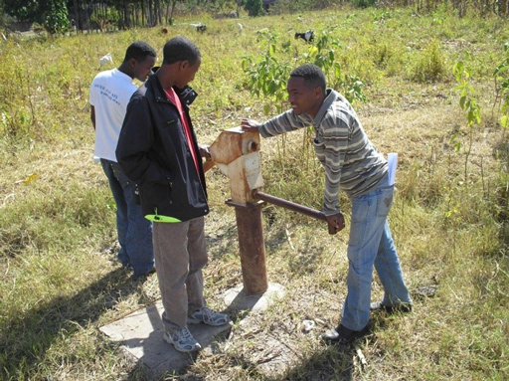
Figure 6.1 A hand pump – abandoned because it no longer works.
The missing element that frequently could have prevented failure is the establishment of a local operation and maintenance (O&M) system at community or village level that could find ways to recover the O&M costs.
The OWNP aims to address this and other problems for this sub-component through the following main activities:
- Studies on different issues of water supply, e.g. feasibility studies, situational analysis.
- Development and construction of new point sources and small piped schemes with distribution systems, including multi-village schemes. (Point sources of water supply include hand-dug wells and protected springs which are accessed at the source. Small piped schemes are water systems with a piped extension from the source for distribution. Users do not access water at the source but far away at the distribution point. Multi-village schemes extend from a single common source to many villages located around it, with separate distribution points for each village.)
- Rehabilitation of existing point sources.
- Expanding small piped schemes.
The first of these activities focuses on studies such as feasibility studies and situational analysis. You may be wondering how studies can contribute to the success of the rural water supply sub-component of the OWNP. A feasibility study is conducted before the construction of the water supply scheme to discover if the construction is technically possible and can be achieved at reasonable cost. It would also evaluate whether or not the amount of water from the intended scheme is sufficient for the community. Situational analysis means a critical review of all aspects of a current situation in order to inform planning and decision making. For WASH schemes this involves assessing population numbers and distribution, socio-economic status, local geography, existing WASH services and usage, and so on. Undertaking studies of this type and applying study results appropriately can help to define programmes more precisely in order to make them more effective in terms of achieving targets, and efficient in the proper use of resources (money, personnel and time).
The rural water supply sub-component of the OWNP includes clearly defined implementation modalities. Modality means the way or ‘mode’ in which something is done or, in other words, an approach or procedures followed to carry out a certain task. The implementation modalities are:
- Woreda-managed project (WMP) modality
- Community-managed project (CMP) modality
- NGO-managed modality
- Self-supply modality
- Multi-village water supply schemes.
Each of these modalities is described in more detail in Study Session 10. For now, we will simply provide brief introductions.

Woreda-managed project modality
For this mode of implementation, the Woreda WASH Team (WWT) plays the leading role in all aspects of project management. The WWT carries out its leadership role in close collaboration with kebele administration and community WASH Committees (WASHCOs). (Woreda WASH Teams and WASHCOs were established by the 2006 WASH Memorandum of Understanding (MoU). You will learn more about these and other aspects of the organisational structure for WASH in the next study session.)
Community-managed project modality
This implementation modality relies on community members, particularly WASHCOs. The distinguishing feature of this modality is that it enables communities to fully own their water supply projects, which consequently ensures sustained service. This modality mainly focuses on the development of low-cost and small-scale schemes such as hand-dug wells and springs.
- Why would ownership of the water supply, such as a well and hand pump, be empowering for a community?
- If the community owns the well and pump they will take pride in looking after it and ensuring it is well maintained. The collaboration required in managing the pump and the collective decision making and actions of the WASHCO is likely to strengthen relationships between community members and encourage collaboration on other matters.
NGO-managed modality
Non-governmental organisations (NGOs) are important actors in the WASH sector. (You will find more details about their role as stakeholders in Study Session 9.) Many NGOs pioneer new innovations in terms of WASH technologies and implementation approaches. To give some examples of NGO modality, Plan International is known for using the community-led total sanitation and hygiene (CLTSH) technique, JICA and WaterAid for promoting rope pumps (see Figure 6.2) and CRS-Ethiopia for the innovative latrine technology called the ArborLoo (see Figure 6.3).
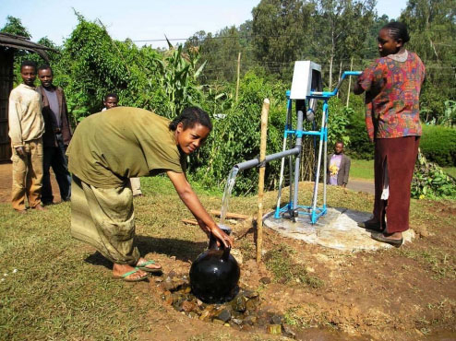
Figure 6.2 A hand-dug well with rope pump: an appropriate technology for rural supply because it is simple to operate and maintain, affordable, reliable, and can be locally manufactured.
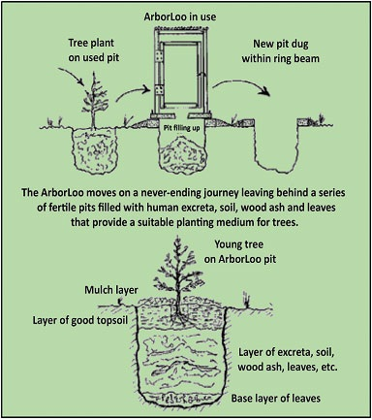
Figure 6.3 The Arborloo: a simple ecological latrine that helps people to see human excreta as resources to be utilised, rather than as wastes to be avoided. (Herbert, 2010)
Self-supply modality
Self-supply means the construction and use of small-scale water schemes at household level, such as hand-dug wells, and is particularly appropriate in rural areas.
Multi-village water supply schemes
Some water schemes may have the potential to be used by a cluster of villages. If a thorough feasibility study confirms that the source is adequate and that the design and construction of a water supply system can address multiple villages sustainably, this modality will be considered.

6.2.2 Rural sanitation and hygiene promotion
Since 2004, the progress made in sanitation and hygiene promotion in rural areas of Ethiopia has been remarkable. For example, between 1990 and 2012 Ethiopia reduced the percentage of the population using open defecation from 92% to 37%, the highest percentage point reduction of any country in the world (JMP, 2014b). This visible progress was attributed to the establishment of a good working environment, such as by developing and applying strategies, manuals and guidelines, and also the strong commitment and collaboration of the Ethiopian government and its partners. 2004 was also marked by the launch of the Health Extension Programme (HEP), which has resulted in more than 38,000 Health Extension Workers (HEWs) deployed to rural kebeles to promote preventive health. The HEP training is structured into 16 packages, of which seven are WASH-related. Along with the HEWs, the Health Development Army (Box 6.1) established by community members has been instrumental in promoting sanitation and hygiene for their respective communities.

Box 6.1 Health Development Army
The Health Development Army (HDA) started in 2010–2011. It is one of the community-level structures established to facilitate efforts to promote primary health activities, including WASH, at grassroots level (Figure 6.4). The HDA are organised groups of families who promote healthy activities and behaviour among other families.
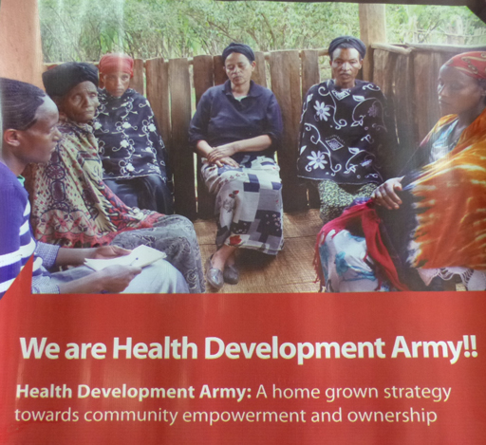
Figure 6.4 Health Development Army promotional banner.
The HDA comprises ‘one-to-five networks’, which each consist of one model family and five other households who live nearby. Model families are early adopters of desirable health practices. They act as role models for other households and encourage them to adopt desired practices and behaviours. Households are selected for model family training based on their involvement in other development work, and on acceptance and credibility within the community.
The one-to-five networks serve as a forum for exchange of concerns, priorities, problems and decisions relating to health. These networks were designed to empower women in particular, and the family in general, in health decision making leading to democratisation of health and to community partnership. The networks are supported by the local HEWs and are responsible for the preparation and completion of plans for collecting health information, conducting weekly meetings to review progress, and submitting monthly reports.
(Adapted from Teklehaimanot and Teklehaimanot, 2013)

6.3 Pastoral WASH
Pastoralism is a way of life in which people who keep livestock such as cattle, sheep, goats and camels move from place to place looking for sufficient water and food for their animals. People whose livelihood is based on these activities are known as pastoralists.
Pastoral areas in Ethiopia cover 61% of the land mass of the country (PFE, n.d.) and support 12–15% of the country’s human population and a large number of livestock. These areas, commonly called ‘rangelands’, are located in the arid and semi-arid lowland parts of the country (Figure 6.5).
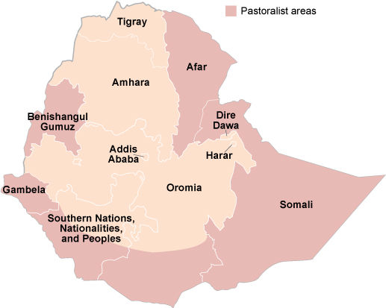
Figure 6.5 Pastoralist areas of Ethiopia. (Adapted from PFE, n.d.)
In general, access to safe water supply and sanitation facilities in pastoralist areas is lower than that of non-pastoralist areas. In most cases, water sources, such as traditional water wells do not produce sufficient water to satisfy human and livestock requirements. As shown in Figure 6.6, the water level is low and the craftsmanship of the well is poor, making drawing water very difficult and laborious.
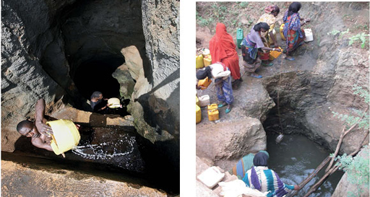
Figure 6.6 Traditional water wells in pastoral areas of Ethiopia.
- Why do you think access to water and sanitation in pastoralist areas is so low?
- The people move around with their animals so they do not have a fixed location where they live. Safe water supply and sanitation services require fixed constructions like pumps and latrines, therefore it is difficult to provide these for people on the move.
Pastoralist areas face particular difficulties. Major problems are reported to include ‘shortage of resources, lack of commitment and awareness, weak inter-sectoral collaboration, uncoordinated and ineffective sanitation promotion efforts and lack of affordable construction materials for latrines’ (OWNP, 2013).

6.4 Urban WASH
Ethiopia is predominantly a rural country with only 18% of the total population currently residing in urban areas. However, recent trends in urban population growth show how this figure is rapidly changing. It is estimated that the urban population will be 30% of the total by the year 2040 (Figure 6.7).
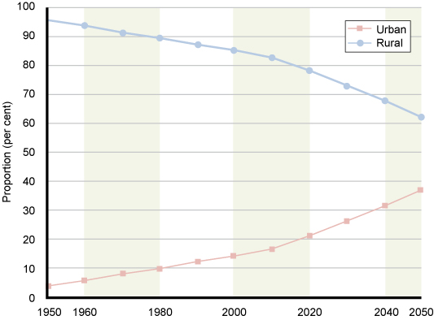
Figure 6.7 Changing proportion of urban and rural population in Ethiopia from 1950 to 2050 (estimated from 2014 onwards). (UNDESA, 2014)
The urban water supply component of the OWNP provides selected towns with technical assistance through grants and/or loans to improve their water supply service. Towns are classified according to their water supply provision and management status into three categories, as shown in Table 6.1. All three categories are supported by the urban WASH programme through various levels of interventions based on need assessment (FDRE, 2013c). Support may also include liquid waste management linked to sanitation and hygiene promotion.
Table 6.1 Categories of town for the OWNP urban water supply component. (OWNP, 2013)
Category | Description
1 | Towns/cities having utilities managed by a Water Board
2 | Towns/cities having utilities but not managed by a Water Board
3 | Small towns with water supply systems managed by WASHCOs or towns without a water supply system at all
Town Water Boards are committees of representatives from all the WASH sector offices (water, health, education) and from communities and other user groups.
The Board is responsible for monitoring and evaluation of the overall performance of the water supply system. The board is directly accountable to the town (or woreda or city) council or administration. Utilities or water utilities are organisations entrusted with the task of providing water supply service to their respective towns in a timely, cost- and quality-conscious manner. They may also be called Town Water Supply Enterprises, or Town Water Supply and Sewerage Enterprises in locations where there is, or will be, a sewer network. Water utilities are accountable to the Town Water Board.
An important difference between rural and urban is that full cost recovery is applied for urban water supply. Full cost recovery means that the water supply service is able to recover the cost of operation and maintenance of the water supply system as well as the cost of investment, Investment costs include, but are not limited to, costs for water source development, treatment, installation of distribution systems, electro-mechanical materials, installation of pumping stations, construction of office and auxiliary buildings etc.

6.5 Institutional WASH
Public institutions can include schools, colleges, health facilities, prisons, administration offices and other public buildings. In the OWNP, institutional WASH deals only with schools and health facilities because these have priority, based on the comparative benefits from WASH interventions. In Study Session 1, you read of the importance of WASH in schools.
- What are the main benefits of good WASH facilities in schools?
- They will improve children’s health which will result in better school attendance and consequently, better educational achievement. Schools with child-friendly services and separate facilities for boys and girls, will make school more appealing to children, especially girls, and also parents.
Improving school WASH services also has the potential to use students as change agents. (A change agent, or agent for change, is someone or something that helps to make changes happen.) The students will take their knowledge and experience home to their own families and reach other families, which will facilitate the community-level WASH promotion efforts at large.
Focusing on healthcare facilities also brings significant benefits. Reliable WASH services at health posts, centres and hospitals will prevent, or at least minimise, infections and ensure the recovery of patients. They provide a good model for people visiting the health facility that will help convince them to have WASH facilities at their home and also to use and maintain the facilities properly.
In schools and health facilities, it is always necessary to make sure that all the three sub-components of WASH – water supply, latrines and handwashing facilities, are available all together, as illustrated in Figure 6.8.
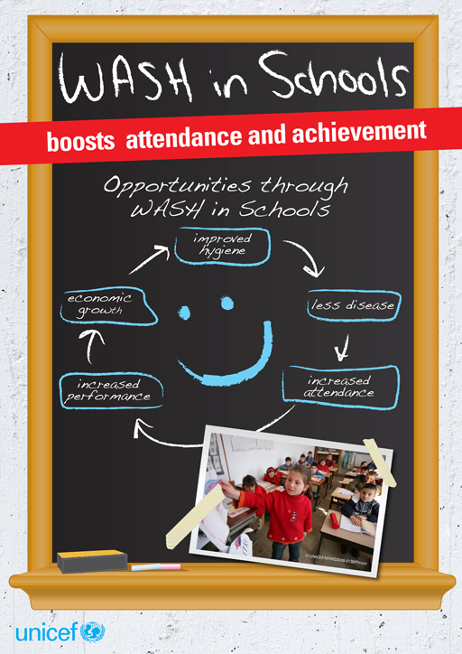
Figure 6.8 Promotion of WASH in schools.
According to the National WASH Inventory (introduced in Study Session 3), safe water supply for primary schools stands at 31%, while sanitation coverage is 33% in an estimated 27,000 primary schools across Ethiopia. In the country’s 3,200 health facilities, only 32% have safe water. Fortunately however, the commitment of the Ethiopian government to improve WASH services in schools and healthcare facilities is encouraging.

6.6 Programme management and capacity building
The fourth component of the OWNP covers programme management and capacity building. These are cross-cutting interventions across all the programme components described earlier. Programme management deals with all the processes involved in putting a programme into effect. It encompasses planning, implementation, monitoring and evaluation activities in terms of both finance and physical undertakings. Capacity building is similar to capacity development, which you read about in the previous study session. It is the process through which individuals, organisations and societies obtain, strengthen and maintain the capabilities to set and achieve their own development objectives over time.
This component includes support to improve the skills and capacity of WASH organisations and implementing parties at all levels. This is done through the provision of training, equipment, and tools, and, where required, software. Added to this, Technical and Vocational Education Training Colleges and Health Science Colleges will be supported to provide relevant training to WASH technicians. It is possible that you may be studying this Module as part of such a training programme.

Summary of Study Session 6
In Study Session 6, you have learned that:
1. The OWNP has four major components: rural and pastoral WASH, urban WASH, institutional WASH and programme management and capacity building. There are sub-components covering water supply and sanitation separately.
2. Rural water supply has five implementation modalities: woreda-managed projects, community-managed projects, NGO-managed, self-supply and multi-village schemes. In rural areas there is a history of failed water supply schemes due to lack of community participation.
3. Rural sanitation and hygiene promotion is mainly undertaken by Health Extension Workers and the Health Development Army.
4. Pastoral areas have particular difficulties accessing water and sanitation and need a different approach.
5. Urban water supply is the responsibility of Town Water Boards and water utilities.
6. Full cost recovery is expected to be applied for urban water supply whereas rural schemes are only expected to recover O&M costs.
7. Institutional WASH in the OWNP includes schools and healthcare facilities. Good WASH services in these institutions are especially important to prevent the spread of waterborne diseases and promote good hygiene behaviour among children and the wider community.
8. The programme management and capacity building component is a cross-cutting intervention that aims to strengthen and facilitate implementation of the WASH plans that are disaggregated into the first three components.

Self-Assessment Questions (SAQs) for Study Session 6
Now that you have completed this study session, you can assess how well you have achieved its Learning Outcomes by answering these questions. You can check your answers with the Notes on the Self-Assessment Questions at the end of this Module.

SAQ 6.1 (tests Learning Outcome 6.1)
Write the following words next to their correct definitions in the table below:
feasibility study; full cost recovery; modality; multi-village schemes; O&M costs; situational analysis.
water supply sources extended from a single common source to many villages located within same radius, with separate distribution points for each village
critical review to find out about a situation to inform planning and decision making
running costs of a project that will continue over time
a way of doing something or approaching a task
to recover the cost of operation and maintenance as well as the cost of investments
finding out if a project is technically possible and achievable at reasonable cost

SAQ 6.2 (tests Learning Outcome 6.2)
Name the four programme components of the OWNP, as described below:
- ………………, in which most beneficiaries depend on agriculture and cattle husbandry as their livelihoods.
- ………………, in which beneficiaries reside in areas where there are relatively better socio-economic infrastructure and service provision.
- ………………, in which schools and healthcare facilities are particularly focused.
- ………………, which is a cross-cutting intervention across the other three programme components.

SAQ 6.3 (tests Learning Outcome 6.3)
Consider the component you identified in SAQ 6.2 part (c). Why do schools and healthcare facilities receive particular attention?

SAQ 6.4 (tests Learning Outcome 6.3)
Consider the component you identified in SAQ 6.2 part (a). What are the five implementation modalities for the water supply element of this component?

SAQ 6.5 (test Learning Outcome 6.3)
Consider the component you identified in SAQ 6.2 part (b). What are the three categories of town within this component?

SAQ 6.6 (tests Learning Outcome 6.4)
Programme management and capacity building is one of the four components of OWNP. How would you describe its role in the programme implementation process?

Study Session 7 Organisational Structure of the OWNP

Introduction
In the previous study session you learned about the four components of OWNP, namely: rural and pastoral WASH, urban WASH, institutional WASH and programme management and capacity building. You also learned that, for each of these components, the scope of OWNP includes water supply, hygiene and sanitation service provision.
In this study session you will learn about the governance and guidance of WASH sector organisations from federal to woreda level including their structure, and the roles and responsibilities of the different actors. This will help you understand how water supply, sanitation and hygiene activities are implemented, organised and coordinated at different levels.

Learning Outcomes for Study Session 7
When you have studied this session, you should be able to:
7.1 Define and use correctly all of the key words printed in bold. (SAQ 7.1)
7.2 Describe the organisational structure of the OWNP. (SAQs 7.1 and 7.2)
7.3 Explain the overall leadership hierarchy of the OWNP. (SAQs 7.2 and 7.3)
7.4 Describe the roles and responsibilities of the WASH sector ministries in relation to the OWNP. (SAQ 7.4)
7.5 Differentiate between the role and responsibility of the Woreda WASH Steering Committee and the Woreda WASH Team. (SAQ 7.5)

7.1 Introduction to the OWNP’s organisational structure
A programme of the size and scale of the OWNP needs an organised structure to ensure that activities are properly planned and implemented at all levels. An organisational structure describes relationships and defines how job tasks are formally subdivided, grouped and coordinated.
The general organisational structure for the OWNP is shown in Figure 7.1. From this diagram, you can see there are committees, teams and other groups who have responsibility for different aspects of the programme at all levels of administration from federal through regional and zonal to woredas, and towns and cities.
There are both horizontal and vertical organisational relationships between these groups. Vertical organisational relationships refer to the flow of information and decisions from the higher governmental organisations to the lower levels. An example of information in a vertical relationship could be a letter of invitation for refresher training of Health Extension Workers that would pass from the Federal Ministry of Health to the Regional Health Bureau and then to the woreda Health Office.
Horizontal organisational relationships describe the links between groups at a similar level, for example between ministries, between regional bureaus, or between woreda offices. The small blobs in the diagram show the four WASH sectors which have a horizontal relationship between them at each level. An example here could be a request for professional support from a Regional Bureau of Health to the Bureau of Water in the same region to supervise the construction of public latrines.
- What are the four WASH sector ministries who share overall responsibility for the OWNP?
- You will recall from Study Session 3 that the four ministries are the Ministry of Water, Irrigation and Energy, the Ministry of Health, the Ministry of Education, and the Ministry of Finance and Economic Development.
The four main column headings in Figure 7.1 describe the four areas of responsibility within the OWNP. The following sections of this study session explain the organisational structure under each of these headings in more detail.
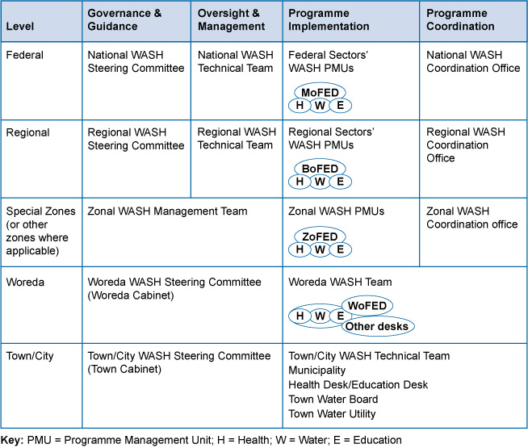
Figure 7.1 Organisational structure of the OWNP. (Adapted from WIF, 2011, OWNP, 2013 and POM, 2014)

7.2 Governance and guidance
Governance refers to high-level decision making and the development of strategies that will be implemented by others. Governance is closely linked to guidance, which means advice or counselling, in this instance on the proper implementation of the OWNP. Broadly speaking, in the context of WASH, governance means the range of political, social, environmental, economic and administrative systems that are in place to regulate the development and management of water resources and provision of water services at different levels (UNDP, 2005).

Federal level
The OWNP governing body at Federal level is the National WASH Steering Committee (NWSC). The NWSC is at the top of the OWNP hierarchy. It is responsible for providing the overall guidance and general direction for WASH sector ministries and their respective regional bureaus and woreda offices. The Committee’s responsibilities are wide ranging and include the approval of funding from partners and appropriate allocation of those funds, review and endorsement of strategic plans, and oversight of monitoring and evaluation of the OWNP among others (WIF, 2011; POM, 2014). (Monitoring and evaluation, often abbreviated to M&E, is an essential part of any project or programme. It involves collecting data before, during and after implementation so that success can be measured. It will be discussed in more detail in Study Session 13.) As national leaders, the NWSC announced the launch of the OWNP in September 2013, which received widespread publicity. Figure 7.2 shows members of the NWSC at the launch event.
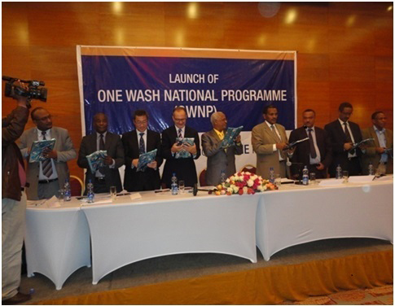
Figure 7.2 The OWNP launch by members of the NWSC on 14 September 2013 at the Hilton Hotel, Addis Ababa.
The NWSC includes representatives from the Federal WASH sector Ministries, as shown in Figure 7.3. The Committee is chaired by the Minister or State Minister of the Ministry of Water, Irrigation and Energy (MoWIE). The Chair of the National WASH Technical Team (NWTT), who is also Director of the Water Supply and Sanitation Directorate from the same Ministry, acts as Secretary. The other members are from the state ministries of Finance and Economic Development (MoFED), Health (MoH), and Education (MoE), and the Director General of the Water Resources Development Fund (WRDF). (You will learn about the WRDF in Study Session 9.) There may also be invited members representing the OWNP development partners and other stakeholders.
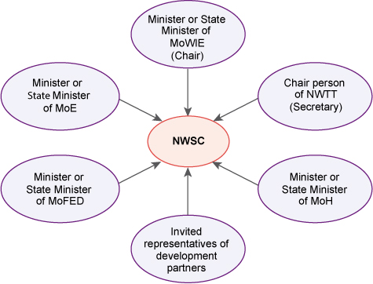
Figure 7.3 Composition of the National WASH Steering Committee (NWSC).

Regional level
The Regional WASH Steering Committee (RWSC) is responsible for WASH governance at regional level on behalf of the Regional State Council. Its responsibilities reflect those of the NWSC and include the preparation of consolidated regional WASH plans, budgets and reports, and M&E (POM, 2014).
RWSCs are composed of heads of the regional bureaus of the four WASH ministries. Depending on the regional context, they may add other sectors such as Women, Children and Youth Affairs, and Federal Affairs. The Chair of the RWSC is the Head of the Regional Water Bureau and the Secretary is the senior person with responsibility for water supply (the core process owner) from that bureau. The RWSC is accountable to, and receives guidance and information from, the NWSC. They cascade this guidance to regional WASH sector bureaus and Woreda WASH Steering Committees. RWSCs meet every quarter (i.e. four times a year) and report to the Regional State Council.

Woreda level
At woreda level, the Woreda WASH Steering Committee (WWSC) is responsible for governance of the OWNP. It is composed of members of the woreda cabinet from the offices of Water, Finance, Health, and Education. Other woreda offices such as Agriculture, and Women, Children and Youth Affairs may also be included. For example, the agriculture office may be represented on the team if there are local issues about a water source being used for both drinking water and irrigation.
Look again at Figure 7.1. You can see that the WWSC covers both governance and management. Its role is to provide guidance for the whole water supply, sanitation and hygiene programme; they are also responsible for planning, implementation and budget management in their woredas (POM, 2014).
Now compare it with Figure 7.4 which shows a sub-section from the larger diagram. This indicates how governance and guidance cascades down from national to lower levels, illustrating a vertical organisational relationship. Note that the town or city WASH Steering Committees are at an equivalent level to WWSCs and not one above the other. It also shows the horizontal relationship between steering committees and technical teams at national and regional level. The technical teams are responsible for managing the Programme, which is the subject of the next section.
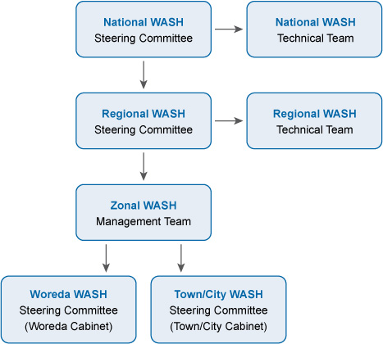
Figure 7.4 Flow of guidance and related information through the various OWNP organisational levels.

7.3 Oversight and management
For the OWNP, overall guidance of the programme is given by the steering committees, however they are not responsible for its management. Management can be described as the art of knowing what to do and then seeing that it is done in the best and most cost-effective way. In the OWNP context, management means knowing how the programme should be implemented and overseeing that implementation to make sure it is being done effectively and efficiently. There is, therefore, a close relationship between management and implementation. As you can see from Figure 7.1, implementation is the responsibility of the Programme Management Units (PMUs) and WASH teams. Implementation is described in Section 7.4.

Federal level
Management and oversight of implementing the OWNP at federal level is through the National WASH Technical Team (NWTT). They focus on managerial oversight of technical activities and are responsible for overseeing the plans that are executed by the WASH sector ministries. In their role they review and give advice on WASH proposals before they are sent to the NWSC for approval. They are also responsible for negotiating with regions about targets and the allocation of resources (POM, 2014).
The NWTT is accountable to the NWSC for performance against budget, plan and expected results in each of the WASH sector ministries. If there is an issue that requires a decision, the NWTT have to submit it to the NWSC. For example, there may be issues raised by a PMU about selecting the location of a new water supply scheme or choosing options for design and construction. The proposal and questions would be sent to the NWTT for technical advice. If the NWTT approves the scheme it then goes to the NWSC for endorsement, however if there is any disagreement, the final decision lies with the NWSC.
The team is composed of directors from relevant directorates in the four WASH ministries, the National WASH Coordinator and invited representatives of donors and Civil Society Organisations (CSOs). (These stakeholders are described in Study Session 9.) The assigned representative from the Ministry of Water, Irrigation and Energy is chair and the National WASH Coordinator serves as secretary.

Regional level
The Regional WASH Technical Team (RWTT) is responsible for managerial oversight of technical activities at regional level and has a similar membership profile to the national team. It comprises directors or process owners assigned by the four WASH bureaus, the Regional WASH Coordinator and representatives of donors and WASH CSOs in the region. The representative from the Water Bureau is chair and the Regional WASH Coordinator is secretary (POM, 2014).
The RWTT provides direct oversight and direction for planning and implementing regional programme activities. They review plans, budgets and reports from the WASH sector bureaus and are accountable to the RWSC. They have responsibility for negotiating about targets and resources both upwards with NWTT at national level, and downwards with woredas and towns.

7.4 Implementation
You can see from Figure 7.1 that the third section of the OWNP structure is made up of the organisations responsible for implementation of the Programme who will undertake the planned activities. The day-to-day programme implementers are either institutions or teams of professionals who belong to the PMUs or WASH teams. (Note that PMUs are also sometimes referred to as WASH Management Units (WMUs) or WASH Programme Management Units (WPMUs)).
The various implementing institutions and teams each have their own roles and responsibilities at different levels. OWNP implementation activities are divided up along the lines of the separate WASH sector ministries.
- Look at Figure 7.1. How does the organisational structure for implementation differ from that for governance and management?
- Governance and management both have a single committee or team at all levels with representatives from each of the WASH ministries. For implementation, the four ministries have separate units with responsibility for their own activities.

7.4.1 Implementation in the main WASH ministries
The OWNP supports the implementation plan of all four WASH ministries. They each have different roles and responsibilities and function in different ways but they all prepare and submit their OWNP plans and report to the NWTT through the National WASH Coordination Office.

Water, Irrigation and Energy
The Ministry of Water, Irrigation and Energy (MoWIE) is responsible for the provision of safe drinking water to all the peoples of Ethiopia as mandated in the Water Resources Management Policy, which you read about in Study Session 2.
At federal level, MoWIE is responsible for water policy, coordination and monitoring. Implementation is decentralised to regional, woreda and, in some cases, community level. In general, design and contracting of piped water supply schemes are managed at regional water bureau level, before handing over maintenance responsibility to woredas or towns. Implementation of schemes such as hand-dug wells or springs is managed by the woreda Water Offices, or by communities.

Health
The Ministry of Health (MoH) is responsible for the sanitation and hygiene condition of all the people of Ethiopia as mandated in the various health policy documents. It is also responsible for WASH facilities of health institutions, including hospitals, clinics, health centres and health posts.
In Study Session 2 you read about the Health Sector Development Plan (HSDP) prepared by the MoH. The sanitation and hygiene element of the OWNP was based on the HSDP. It is implemented by regional health bureaus, which aims to scale-up delivery of primary care services through the Health Extension Programme and health clinics at district level (see also Study Session 6). Health Extension Workers (HEWs) are trained and deployed to health posts at kebele level in both rural and urban areas. HEWs work with communities and households, and in rural areas with members of the Health Development Army (HDA) to promote behavioural change, including using improved sanitation facilities, hygiene promotion and the eradication of open defecation.

Education
You already know about the importance of WASH in schools and how WASH facilities can affect school attendance and educational achievement. The Ministry of Education (MoE) has responsibility for the water supply, sanitation and hygiene conditions of all school communities. The MoE has prepared an Education Sector Development Plan (ESDP) to achieve the education MDGs by 2015. The strategies and activities of the ESDP include providing safe drinking water, renovating existing latrines and handwashing facilities, constructing new facilities and integrating hygiene education into the curriculum (MoE, 2010).The school sanitation and hygiene aspect of the OWNP is based on this plan and supports its implementation to achieve the target.

Finance and Economic Development
The Ministry of Finance and Economic Development (MoFED) determines and allocates budgets to all public institutions. It is responsible for implementing efficient ways of utilising WASH resources in both federal and regional governments. It has an important role in allocating and channeling resources and monitoring fund utilisation.

7.4.2 Programme Management Units and WASH teams
Programme Management Units (PMUs) are responsible for implementing OWNP plans and activities at federal and regional level, and zonally where appropriate. They have been established within an appropriate department of the three main implementing ministries. (There is no need for a PMU at MoFED because they do not undertake active WASH projects.) Their staff may be permanent employees, contract staff or consultants. The size and composition of each of the units will vary from ministry to ministry, depending on the magnitude and nature of the particular ministry’s activities related to WASH.

Federal level
At federal level, the PMUs in each ministry will ensure their respective regional PMUs, woreda and town sector offices have the directions, information, systems, skills and resources necessary to carry out their WASH mandate and achieve expected programme results. For example, the PMU would provide training for staff, review plans and designs, support M&E and so on.

Regional level
At regional level there is a similar structure. Each of the three bureaus (water, health, and education) have PMUs within an appropriate department. The size, structure and composition of each of the units will vary from bureau to bureau depending on the nature of the particular bureau’s input to the OWNP. A Unit Head will be appointed whose duties will include serving as the focal person for their bureau in the Regional WASH Coordination Office (see Section 7.5).
The regional PMU role and responsibilities are similar to the national level but at the next step down in the hierarchy. They ensure that the WASH teams have what they need to carry out their WASH activities. They tend to be responsible for larger projects, such as the construction of water supply schemes.

Woreda/Town WASH Team
Woreda WASH Teams or Town WASH Teams are responsible for implementing planned activities under the direct supervision of their woreda or town WASH Steering Committee. Membership includes the heads or representatives of the water, health, education and finance offices, and other permanent or contract staff with a variety of roles. These include coordinators, accountants/clerks, environmental health workers, development agents, WASH consultants, community facilitators, and contractors and suppliers.
The Woreda WASH Team (WWT) coordinates the input of the various sector offices, supports the daily management of the activities and is accountable for achieving expected results (POM, 2014). They are responsible for such activities as the construction of small-scale water schemes for communities, schools and health facilities, giving training on CLTSH (community-led total sanitation and hygiene) and other relevant topics for communities, HEWs, the HDA and others.

Community WASH committee
In rural areas, the community WASH Committee or WASHCO plays an important role in OWNP implementation by managing the operation and maintenance of specific water schemes. WASHCOs are established for one community in order to manage one specific WASH facility. They are accountable to the WWT. In one kebele there may be many WASHCOs depending on the number of WASH facilities. They have between five and six members, at least 50% of whom must be women. Case Study 7.1 describes one WASHCO in Amhara region.

Case Study 7.1 WASHCO at Alem Sefer
Alem Sefer village is near Meksignit, a rural kebele in Fogera district, Amhara Region. The village has a new water point that has been in use since December 2014. It provides safe water close to a community of 270 people.
Figure 7.5 shows the WASHCO of three women and two men who have been elected from the community to manage their water point.
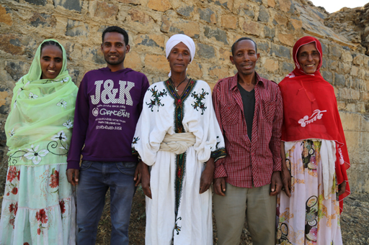
Figure 7.5 Alem Sefer WASHCO.
This community WASHCO is led by women. They have been chosen to lead because they understand that collecting water is predominately women’s responsibility: ‘It is us who are well aware of the challenges the lack of access to safe water brings to us and to our family,’ says Nurit Kalilu, the treasurer.
Hawa Wadajine, on the right in the photo, is the chairperson of this committee. She carries the overall responsibility of managing the water point. Nurit Kalilu, on the left, oversees the income which is generated from the collection of the monthly water tariff. This is 5 Birr/household, which is expected to bring in about 160 euros a year. The community has also deposited 60 euro as an up-front cash contribution to a bank account in the local micro-finance institution. This can later be used for the operation and maintenance of the water point.

7.5 Programme coordination
You will remember from Study Session 4 that one of the guiding principles of the OWNP is integration. To integrate water supply, hygiene and sanitation services there must be an effective organisational structure for coordination between WASH sector ministries. Programme coordination is the final part of the organisational structure shown in Figure 7.1, which shows how this is arranged at different levels.

7.5.1 National WASH Coordination Office
The National WASH Coordination Office (NWCO) is based in one of the federal WASH sector ministries by the decision of the NWSC; currently it is located in the MoWIE. It consists of a Coordinator (team leader), representatives from each of the partner ministries and professional staff contracted to implement daily activities.
The NWCO provides the NWTT with the information that they need in order to fulfil their role; they also ensure liaison between the three PMUs. They support the establishment and proper functioning of Regional WASH Coordination Offices, follow the functionality of the OWNP as per the signed MoU, WIF and POM and liaise between WASH sector ministries and their development partners.

7.5.2 Regional and zonal WASH coordination offices
Similar coordination offices also exist at regional and zonal levels. These offices are based in one of the WASH sector bureaus, usually the Bureau of Water, and have a similar pattern of membership to the national offices: namely a Coordinator (team leader), representatives from the three partner bureaus and contracted professional staff.
As before, the size and composition of the regional and zonal coordinating offices varies. Their roles are similar to the national office but operating at regional or zonal level respectively. They support the WWTs, develop capacity building programmes in their region/zone, ensure woredas have consolidated WASH plans and maintain WASH management systems and records.

Summary of Study Session 7
In Study Session 7, you have learned that:
- Major programmes of activities like the OWNP need a good organisational structure that clearly defines roles and responsibilities and describes relationships between groups at all levels of the organisation.
- Relationships within organisations may be vertical (between higher and lower levels) or horizontal (between groups at the same level).
- The OWNP structure is organised into four main types of activity: governance and guidance, oversight and management, implementation and coordination. There are separate committees or teams for each of these activities at federal, regional, zonal, and woreda or town/city levels.
- Governance and overall strategic leadership of the OWNP is the responsibility of the National WASH Steering Committee (NWSC).
- OWNP implementation is managed at national and regional levels by WASH technical teams. Implementation itself is the responsibility of Programme Management Units (PMUs) in the three main WASH ministries/bureaus. Each of these has their own areas of responsibility and undertake activities towards achieving WASH improvement targets.
- At community level, WASH Committees ensure communities take responsibility for the operation and maintenance of specific water schemes. Half of WASHCO members must be women.
- OWNP activities and communications are coordinated by coordination offices at national, regional and zonal levels. They exchange information between groups and liaise between different parts of the organisational structure.

Self-Assessment Questions (SAQs) for Study Session 7
Now that you have completed this study session, you can assess how well you have achieved its Learning Outcomes by answering these questions. You can check your answers with the Notes on the Self-Assessment Questions at the end of this Module.

SAQ 7.1 (tests Learning Outcome 7.1)
        - Management, governance and guidance are similar concepts, but have important differences. Use one of these three terms to complete the following sentences.
High-level decision making is an aspect of ………………
Coordination of resources within an organisation is the responsibility of ………………
Giving advice is part of the role of ………………
The ‘art of knowing what to do’ is a description of ………………
The development of strategies that will be organised by others is ………………
Organising people who implement projects is the responsibility of ………………
        - Insert the words ‘vertical’, ‘structure’ and ‘horizontal’ in this statement:
An organisational ……………… describes how relationships, tasks and communication flows are coordinated within and between organisations. If these links are between a higher level and a lower level, these are ……………… relationships; if they are between groups at a similar level they are ……………… relationships.
        - Write out in full what the following abbreviations stand for in the table below:
Abbreviation | Hint | Full term
NWSC | At the top of the OWNP hierarchy
RWSC | Responsible for WASH governance at regional level
NWTT | Focuses on managerial oversight of technical activities at the regional level.
RWTT | Responsible for managerial oversight of technical activities at regional level.
PMUs | Responsible for implementation at federal, regional and zonal levels.
WWTs | Responsible for implementation at the woreda or town level.
NWCO | Based in one of the federal WASH sector ministries.
WWSC | Responsible for governance of the OWNP at the woreda level.
WASHCO | Manages the operation and maintenance of specific water schemes.

SAQ 7.2 (tests Learning Outcomes 7.1 and 7.2)
Look at Figure 7.6 and fill in the missing labels using the following abbreviations: WWT, NWCO, RWTT, NWSC.
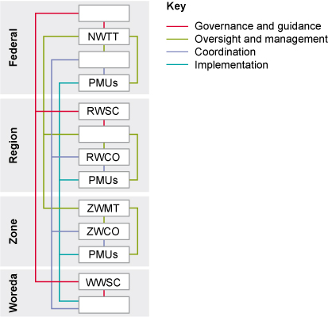
Figure 7.6 for SAQ 7.2.

SAQ 7.3 (tests Learning Outcomes 7.2 and 7.3)
Which of the following sequences represents the correct leadership hierarchy of the OWNP?
        - NWSC → RWSC → NWTT → WSC
        - NWTT → NWSC → NWCO → RWCO
        - RWSC → NWSC → RWTT → NWTT
        - NWSC → RWSC → WWSC → WWT

SAQ 7.4 (tests Learning Outcome 7.4)
Explain the main role and responsibilities of each of the four WASH sector ministries in relation to the OWNP.

SAQ 7.5 (tests Learning Outcome 7.5)
At woreda level, which aspects of the OWNP are the responsibility of the Steering Committee and which of the Woreda WASH Team?

Study Session 8 Cross-cutting Issues in the WASH Sector

Introduction
In this study session we broaden the scope away from the detail of the OWNP and look at some wider themes in the WASH sector. In the history of WASH programmes in Ethiopia, there are some issues that affect both planning and implementation but which have not been given sufficient attention, and this has contributed to the inequalities in WASH services. However, in the past few years these issues have become part of the main agenda in sector meetings and forums which the OWNP has been designed to address. This study session describes these issues in the WASH sector and explains why they are important. You will also learn how they are incorporated in implementing the OWNP in Ethiopia.

Learning Outcomes for Study Session 8
When you have studied this session, you should be able to:
8.1 Define and use correctly all of the key words printed in bold. (SAQ 8.1)
8.2 Identify the main cross-cutting issues in the WASH sector and explain why they are important. (SAQs 8.1 and 8.2)
8.3 Describe how these cross-cutting issues affect the implementation of the OWNP. (SAQ 8.3)

8.1 The concept of cross-cutting issues in the OWNP
It is commonly agreed that over that last few decades developments have been made in eradicating the world’s poor from absolute poverty. The economic growth and development success achieved by many countries is evidence of this. The joint efforts by the Ethiopian government, its development partners, the private sector and above all, the country’s citizens have made these great achievements possible. Despite this progress however, there are still millions of people who need the most basic services, including WASH. Some marginalised and unserved communities are still behind in benefiting from the success of WASH programmes. Part of the reason for this is the lack of attention given to some significant cross-cutting issues.
Cross-cutting issues are topics that affect all aspects of a programme (i.e. cut across) and therefore need special attention. They should be integrated into all stages of programmes and projects, from planning through to impact assessment – but this has not always been the case.
There are many cross-cutting issues in the WASH sector. This study session focuses on some of the most important, namely: gender mainstreaming, community empowerment, sustainability, equity and inclusion and social accountability. These themes will be covered one by one in the following sections.

8.2 Gender mainstreaming
- How would you define gender mainstreaming?
- The term means to consider women’s perspectives and needs equally with men's at all times. (This was defined in Study Session 2.)
Gender is not just about the biological differences between men and women but refers to their different roles, rights, and responsibilities, and the relations between them (UNDESA, n.d.). It is generally associated with unequal power and access to resources because, in many societies and cultures, men tend to dominate and consider women to be subordinate. Gender mainstreaming is a process that aims to address this imbalance.
This inequality is illustrated in Figure 8.1 which shows, in four major regions of the world, who is the usual person in a household responsible for collecting water.
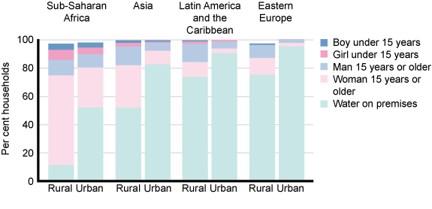
Figure 8.1 Distribution of households by person responsible for water collection, by selected world region and for urban and rural areas. Data for 2005–2007. (UNDESA, n.d.)
You can see from the graph that in rural areas of sub-Saharan Africa (which includes Ethiopia) women and girls are more than four times as likely to be the water collectors as men and boys. Sanitation is also a major challenge for gender inequality. If women and girls have no alternative to open defecation, they are likely to feel embarrassment and shame and may be vulnerable to attack, especially if they wait until dark.
In Ethiopia, gender issues have been included in policies and strategies for some time. You may recall from Study Session 2 that the Water Resources Management Policy (1999) and the Water Sector Strategy (2001) both included statements about gender mainstreaming. Even before that, the Ethiopian Women’s Policy of 1993 recognised the importance of integrating gender concerns and spelled out the government’s commitment to abolish laws and regulations that discriminated against women (MoLSA, 2012).
Despite these policies, women are still excluded from many of the privileges and opportunities available to men. Girls who should be in school are not properly attending their education because they are expected to help with fetching water and other domestic tasks. As a result, they perform less well than male students. Within a family, it is usually the males who take priority rather than females. Although women are actively involved in society and have an average working day of between 13 and 17 hours they usually earn far less than men and are frequently not paid at all (MoLSA, 2012). Participation in decision making outside the home and discussions about community priorities may also be limited. Because of cultural traditions, females are sometimes not allowed to talk in public, and even when they do participate, the opinions of women may not be accepted if they conflict with those of the men (World Bank 2001, cited in Yilmaz and Venugopal, 2008).
By increasing access to safe water and sanitation throughout the country, the OWNP will bring a big improvement to the position of women and girls. By no longer having to spend time collecting water, they will be free to do more productive work and attend school, with obvious benefits for them and their families (Figure 8.2).
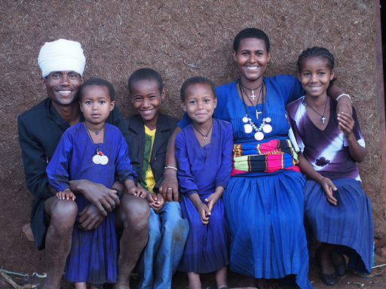
Figure 8.2 A happy family in Terefamba, Burie Woreda, Amhara Region. The wife and daughters are smiling now they no longer have to fetch unsafe water from a distant place owing to the arrival of clean water in their neighbourhood.
The Programme document includes a recommendation that training associated with the OWNP should follow gender mainstreaming guidelines (OWNP, 2013). The Gender Mainstreaming Field Manual for Water Supply and Sanitation Projects (MoWR, 2005) provides practical advice on how to make sure that all stages of Water Supply and Sanitation (WSS) projects including planning, surveys, data collection, analysis, implementation, operations and maintenance (O&M) and monitoring and evaluation (M&E) are all undertaken with gender mainstreaming at the forefront.
- What examples or WASH sector organisations can you think of where women are explicitly included?
- You may have thought of WASHCOs, in which 50% of the members must be women. Another example could be rural Health Extension Workers (HEWs), all of whom are women or the Health Development Army (HDA), which is led by women.

8.3 Community empowerment
In Study Session 5 you read about participation as one of the essential components of good governance. Evidence shows that the participation of users in any development project, especially in the WASH sector, is of paramount importance to ensure sustainability and to create a sense of ownership. If communities have been fully involved in developing and implementing a WASH programme, they gain a sense of authority, or power, and this helps them to build confidence in their own capabilities. This is known as community empowerment.
In the past, the people planning WASH interventions did not always appreciate how important it was to engage communities in the process. Sometimes donors and non-governmental organisations (NGOs) would provide new services such as a well and pump without involving the local people in planning and developing the scheme. These schemes were installed without considering the opinions of the local community and then handed over to them to look after without giving attention to the organisational arrangements needed to maintain the scheme. Communities need to be involved and share responsibility for a scheme to make it successful and sustainable. Figure 8.3 shows a rural community which has worked together in their efforts to bring water to their village. Having invested their own time and energy, they will have an enduring sense of ownership of the scheme.
Figure 8.3 Community members in Yiganda, Zegie, near Bahir Dar, wave their spades to reaffirm their commitment to finish excavation on schedule. They are digging trenches for pipelines as their labour contribution to a project to bring water to their village.
At the community level there is a requirement that WASHCOs for rural water schemes and WASH boards in urban settings should be formed to manage and maintain each water scheme. WASHCO members are elected by the community and, as you have learned, are constituted with a chair, secretary, treasurer and other officers. They are accountable to their communities and benefit greatly if they are given formal status so that they have a legal authority and can gain access to credit from micro-finance institutions.
The WASHCO’s duty is to plan and manage the community’s water and sanitation. The WASHCO is the prime agent of change in the process of mobilising people to undertake and sustain water and sanitation services. Communities also use the support of local artisans to implement water supply schemes.

8.4 Sustainability in WASH
You were introduced to the topic of sustainability in Study Session 3 where it was identified as one of the benefits of a sector-wide approach. It was defined as a concept referring to projects that gave due consideration to all factors (economic, social and environmental) and were successful and long-lasting. For WASH, it is about whether or not water and sanitation services and good hygiene practices continue to work and deliver benefits over time (WaterAid, 2011). The emphasis is on lasting benefits rather than short-term advantages.
Sustainability is among the most critical aspects of service provision in the WASH sector. Whatever technology is applied or approaches are used, if the service delivery is not sustainable, all the investment made will be lost. WASH actors need to consider the sustainability of their project from the planning phase onwards.
Achieving sustainability of WASH schemes has been difficult for a number of inter-related reasons, which include:
- limited capacity (in the sense of knowledge, skills and material resources) of communities, local government institutions and other service providers to manage the systems once they are in place
- inadequate financial revenues (income) to cover the full operation and maintenance costs
- historical fragmented approach to service delivery by different actors in the WASH sector (WaterAid, 2011).
This last point is the main reason why the approach and principles of the OWNP should make a difference to sustainability. By harmonising and integrating the activities of the different actors in the ‘One Plan’ sector-wide approach, the historical fragmentation should be avoided.
The problems caused by being unable to sustain a water scheme are obvious. If the scheme fails, the community no longer has access to safe water. It is also problematic for the organisations who paid for the scheme in the first place. Any money spent on services which fail quickly is money ill-spent. However, in addition to financial concerns, the donors also have a responsibility to ensure continuing and appropriate support for ongoing management of the projects. All WASH sector actors, whether government or non-government, should be accountable to the communities who will use the services and manage the facilities. The implementation of WASH programme works needs to be aligned with building the capacity of the local stakeholders, especially local government, so that the sustainability of projects can be ensured after the other stakeholders have moved on.
The chances of a project being sustainable in the long term are greatly improved if a number of conditions are met. WaterAid (2011) summarises these conditions as a need for:
- real and continuing demand from the user communities, demonstrated by consistent use of improved water and sanitation services, and improved hygiene behaviour
- enough income at least to cover the recurrent costs for rural WASH and full cost recovery principles for urban WASH – this requires justifiable tariff settings that also consider the poorest and marginalised groups of the community who are often excluded
- a properly functioning management and maintenance system. This needs trained people with clearly defined roles and responsibilities, with appropriate institutions and organisations to support them, as well as tools, supply chains, transport and other equipment
- effective technical support and an enabling environment, especially for community-level structures and institutions
- due attention given to the local natural resources and environment that may affect the system, for example, awareness of the possible risk of flooding (Figure 8.4).
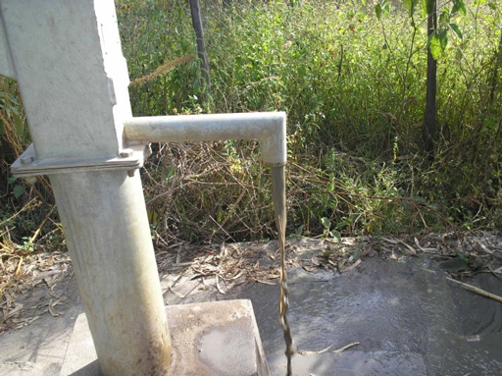
Figure 8.4 Water infiltrated this well in the Shashego district of the SNNPR during a flooding disaster and now the water is muddy and unusable.

8.5 Equity and inclusion in WASH
Like sustainability, equity was introduced to you as one of the advantages of a sector-wide approach. Equity means the fair distribution and sharing of resources (natural or manmade) to benefit everyone equally. The OWNP includes mention of gender equity, which it links to gender mainstreaming and the need to ensure women are included in WASH schemes (OWNP, 2013). Equity also applies to other marginalised and disadvantaged sections of society. If someone is marginalised it means they are treated as insignificant or not important, or literally, pushed to the edges, or margins. Marginalised groups include people with disabilities of many different types, older people, children and people living with long-term illnesses including HIV/AIDS. It can also include residents of geographically hard-to-reach areas, internally displaced people, informal settlers and slum dwellers. All these vulnerable groups, for different reasons, may face barriers that restrict their access to WASH services (Figure 8.5).
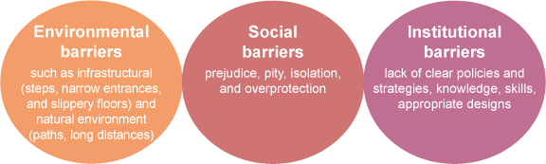
Figure 8.5 The different barriers faced by marginalised people in accessing WASH. (Adapted from WaterAid, 2013)
The term equity is frequently linked with inclusion. Inclusion means the process of including these marginalised and unserved communities within, and not separate from, society as a whole. For WASH, it means considering their needs at all stages of WASH programmes, from planning to evaluation. Equity and inclusion are important cross-cutting issues in WASH because these groups of people have frequently been neglected in the past.
(a) | (b)
Figure 8.6 (a) Eniyew Yisima, a disabled student in Grade 8, by the handwashing facility and (b) a latrine cubicle at Bruh Tesfa primary school, Addis Ababa.
- Look at Figure 8.6. Is the design of this facility helpful for Eniyew? How does the design of the cubicle make it easier for him to use? Will he have problems when he tries to wash his hands?
- This design is quite helpful for him because the taps are low down, though he may have some difficulty in reaching them. It is good that the concrete surround is flat without any steps that would prevent him wheeling his chair right up to the taps. The cubicle has a raised seat and handrails which should help him transfer from his wheelchair.
Many of the WASH policies and programme documents that you have read about in previous study sessions include statements about the importance of access to water and sanitation for all. For example, the introduction of the WIF explicitly states: ‘This document is introducing WASH for all, which also includes disabled, disadvantaged and low-income communities’ (WIF, 2011). The main OWNP document says that the Programme ‘will promote and support social inclusion as an important strategy to enhance equity and reduce disparities in access to WASH services’ and describes ‘social inclusion’ as including ‘gender equity and mainstreaming, resettlement areas and areas with high concentrations of ethnic minorities and pastoralists and institutional WASH facilities that do not restrict access to handicapped and disabled persons’ (OWNP, 2013).
The challenge for the OWNP and its implementation is ensuring that this goal of ‘including all’ is properly integrated into plans and schemes and that all the diverse needs of the different groups of marginalised and vulnerable people are considered. For example, among disabled people, the needs of wheelchair users like Eniyew are not the same as people with other problems (Figure 8.7). Older people and others who need support rails to hold onto, people with poor sight, and disabled children are just a few of these groups with very specific needs. It is important that stakeholders with responsibility for planning and implementation recognise these varying needs and ensure that individual groups are not overlooked.
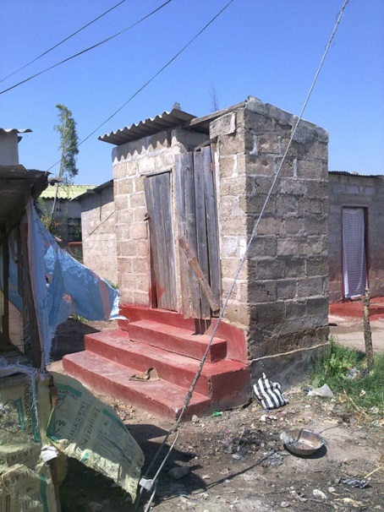  (a) | 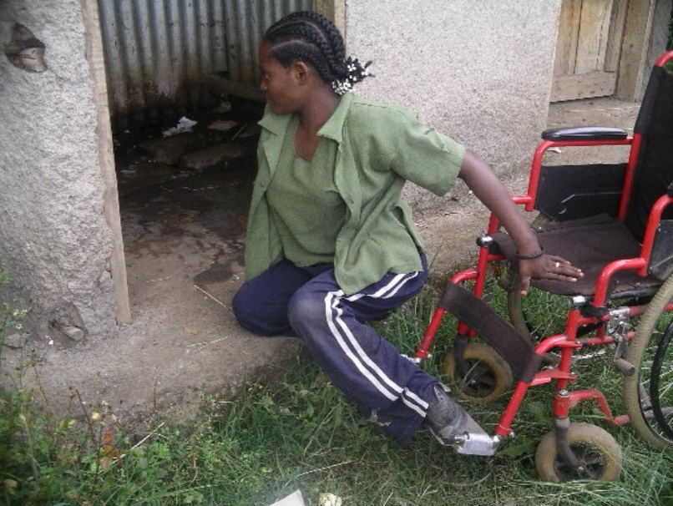  (b)
Figure 8.7 The different needs of people with disabilities must be considered when planning and building latrines.
- Look at Figure 8.7. How could these latrines be improved to make them more accessible to people with disabilities?
- In Figure 8.7(a), the steep steps would be difficult for disabled people but could be improved if there was a handrail to hold onto. In Figure 8.7(b) the young woman has to leave her wheelchair outside the latrine cubicle and drag herself across the dirty floor. It could be improved if it was big enough for her to wheel her chair inside and had a raised seat with hand rails, similar to the one in Figure 8.6 (b). It would also be improved if the floor was kept clean.
You have already come across the idea of accountability in the OWNP. The revised Memorandum of Understanding of 2012 specified that the four WASH ministries should be accountable for their actions to each other and to others (see Study Session 3). In the vertical relationships within any organisation, people are accountable upwards to their managers and downwards to the levels below them in the hierarchy.
Social accountability in WASH is a concept that deals with the accountability of the service providers (government, development partners, CSOs, private sector, etc.) to the user communities. It means that community members, who are the primary beneficiaries, can ask questions and claim their right to a full account of the service(s) provided.
Social accountability means that the users have the opportunity to access all the information about projects implemented for their benefit. This information could include the source of funding, cost of the project, duration, design, effects on the livelihood of community members, effects on plants and animals, and the roles and responsibilities of the beneficiaries during and after project implementation. If appropriate mechanisms are in place, social accountability allows community members to obtain all the important information regarding the projects in order to enable them to assess the service provider’s performance.

Summary of Study Session 8
In Study Session 8, you have learned that:
- There are several cross-cutting issues in WASH that affect all aspects of WASH projects and which have not always been given sufficient attention in the past. They require the attention of all stakeholders at different levels and need to be considered from the earliest planning phases onwards – not just sometime in the middle or at the end.
- Major cross-cutting issues include gender mainstreaming, community empowerment, sustainability, equity and inclusion, and social accountability.
- Women and girls are usually responsible for water collection in Ethiopian households but their opinions and needs are not always given due attention. Legislation and policy have recognised the need for gender equity and mainstreaming for some time, but for many social and cultural reasons women’s voices are not always heard.
- As the ultimate beneficiaries of WASH projects, communities need to be empowered to participate fully in planning and implementation of WASH services. This will give the community a sense of ownership that will support the long-term sustainability of the schemes.
- Sustainability of WASH interventions is critical and has frequently been neglected in the past. Many hand pumps and other schemes no longer function for various interconnected reasons. For a scheme to be sustainable there needs to be a demand from users, sufficient income, effective management and maintenance, technical support and a realistic awareness of the local environment.
- WASH services need to be equitable and include all types of marginalised and vulnerable people with often widely differing needs.
- Social accountability is a responsibility of WASH service providers who must be accountable to user communities.

Self-Assessment Questions (SAQs) for Study Session 8
Now that you have completed this study session, you can assess how well you have achieved its Learning Outcomes by answering these questions. You can check your answers with the Notes on the Self-Assessment Questions at the end of this Module.

SAQ 8.1 (tests Learning Outcome 8.1)
Identify the phrases from the jumbled up letters and write the correctly spelt words next to their definitions in the table below:
- ECMOPMOMWUENRIMTEYNT
- COLINUSIN
- LACISICYOTOUNCITABAL
Phrase | Definition
 | Involving communities in the development and implementation of a programme or project.
 | Making sure that marginalised and underserved communities are considered and incorporated within the programme or project.
 | The idea that service providers are accountable to the user communities. Community members can ask questions and have a right to be answered.

SAQ 8.2 (tests Learning Outcomes 8.1 and 8.2)
In addition to the phrases that appear in SAQ 8.1 there are two other cross-cutting issues that you will have seen in earlier study sessions. These are:
MAGINESANTERDEMIRNG and YABUSINTILASIT
Unscramble these two additional cross-cutting issues. Explain why each of the five issues you have named in your answers to SAQs 8.1 and 8.2 is important.

SAQ 8.3 (tests Learning Outcome 8.3)
Which of the following statements are false? In each case explain why it is incorrect.
- It is more important that rural communities get adequate water supplies than urban ones.
- It is more important to get a ‘quick fix’ even if everyone does not understand why an activity is being conducted.
- Girls should be free to go to school rather than fetch water.
- It is important to engage communities with planning.
- There are some things about planning you need to keep to yourself and not share with the community or from other levels in your organisation.

Study Session 9 Stakeholders of the OWNP

Introduction
You have already come across many stakeholders in the OWNP in previous study sessions, from the national government at the top through to consumer groups and individual users. A stakeholder was defined earlier as any individual, group or organisation that has an interest in something. In this instance we are talking about the stakeholders with an interest in the provision of water, sanitation and hygiene in Ethiopia in general, and in the OWNP in particular.
WASH activities associated with the OWNP are mainly the responsibility of different governmental and non-governmental organisations. In this study session you will identify the different types of organisation involved, such as civil society organisations, private sector companies and community groups. These are the main stakeholders or partners who will implement the OWNP. You will also learn about the roles and responsibilities of these different stakeholders in achieving the OWNP’s goals for the country.

Learning Outcomes for Study Session 9
When you have studied this session, you should be able to:
9.1 Define and use correctly all of the key words printed in bold. (SAQ 9.1)
9.2 Explain the contribution of government organisations, other than the WASH sector Ministries, to the OWNP. (SAQ 9.2)
9.3 Describe the involvement of development partners in the OWNP. (SAQ 9.3)
9.4 Describe the role of the private sector in implementing the OWNP. (SAQ 9.4)
9.5 Discuss the roles of community organisations in the OWNP. (SAQ 9.5)

9.1 Types of stakeholders
OWNP stakeholders can be divided into those that are part of or associated with government and those that are not. The governmental group is described in Section 9.2 below. Non-governmental stakeholders consist of various types of organisation and groups of people that contribute to the OWNP in different ways.
There are three main types of non-governmental stakeholder who contribute to the OWNP:
- Major stakeholders: These are organisations that directly contribute funds to the Consolidated WASH Account (CWA) at federal level. (You will learn more about the CWA in Study Session 12.) They are the main contributing partners at national level and are eligible to receive quarterly progress, financial and audit reports from the National WASH Coordination Office (NWCO) (You learned about this in detail in Study Session 7). They are each represented by a non-voting member on the National WASH Steering Committee.
- Associated stakeholders: These are organisations that provide funding for the construction of water supply, sanitation and hygiene facilities, technical assistance, supplies and other support to OWNP. They may be implementers themselves or they may provide funds for the government implementers outside the Consolidated WASH Account. Associated stakeholders at national level will prepare annual work plans and budgets in collaboration with the NWCO and will report to them through quarterly progress and financial reports. They will receive quarterly OWNP progress reports and can participate in the Joint Technical Review (JTR) and Multi-Stakeholder Forum (MSF). (You will learn more about these two groups in Study Session 11.)
- Collaborating stakeholders: These are organisations that provide assistance to OWNP other than construction of WASH facilities. For example, they may provide training manuals or communication and promotional products. Collaborating stakeholders may be national or international organisations that provide defined services relating to specific outputs of the Programme. They will sign a Memorandum of Understanding (MoU) with the coordinating offices at various levels, prepare annual work plans and budgets, and will report to the coordinating offices through quarterly progress and financial reports. They can also participate in the JTR and MSF.
As well as these various groups that make contributions of funds or activity to the OWNP, another very important set of stakeholders are all the people who use the WASH services. These could also be classed as ‘collaborating stakeholders’, although they are unlikely to have any type of formal agreement. Nevertheless, the consumers of water supply and users of sanitation facilities are all vitally important. Their involvement in implementation and participation in decision making is an essential part of the process and reflects the guiding principles of the OWNP, especially integration, harmonisation and partnership.

9.2 Government organisations
As you know from previous study sessions, the OWNP is a joint initiative led by the four WASH sector ministries: Water, Irrigation and Energy, Health, Education, and Finance and Development. In addition to these four main stakeholders, several other government ministries are involved.

9.2.1 Directorates of Women, Children and Youth Affairs
You may recall from Study Session 2 that one of the national policies underpinning the OWNP is the national Water Resources Management Policy. This policy sets out the need for women’s participation at all stages of water resource development activities, from planning to implementation and maintenance. The national Water Sector Strategy, also mentioned in Study Session 2, reinforces the point and specifies that gender mainstreaming should be secured in all aspects of water resources planning, new master plan studies and other water development projects. The Women, Children and Youth Directorate in each WASH sector ministry has a responsibility to assure the mainstreaming of gender issues when implementing the OWNP.

9.2.2 Ministry of Federal Affairs
The Ministry of Federal Affairs is a stakeholder in issues relating to pastoralist communities (Figure 9.1). The government has mandated the Ministry of Federal Affairs (MoFA) to coordinate and facilitate OWNP activities in pastoralist areas with due commitment to enhancing their socio-economic situation, based on its policies of equitable and just distribution of resources.
As stated in the WASH Implementation Framework, the MoFA is included in the National WASH Steering Committee and National WASH Technical Team on an invitation basis. They are invited to participate in any discussions relating to WASH issues in pastoralist parts of the country. At regional and woreda levels, pertinent government offices responsible for the pastoralist communities are included as members of WASH committees and teams.
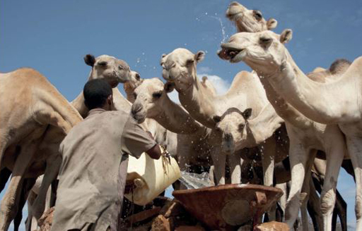
Figure 9.1 Pastoralist communities move around with their animals and have particular issues with access to water and sanitation.
The implementation of WASH under the OWNP in pastoral areas is aligned with the Pastoral Community Development Programme (PCDP). The PCDP is a 15-year programme that started in 2003. It was developed to establish effective models of public service delivery, investment and disaster management in the arid and semi-arid Ethiopian lowlands in order to address pastoral communities’ needs, improve their livelihoods, alleviate poverty and reduce their vulnerability.

9.2.3 Water Resources Development Fund
The Ethiopian government established the Water Resources Development Fund (WRDF) in 2002 as a semi-autonomous body within the then Ministry of Water Resources (which was renamed the Ministry of Water, Irrigation and Energy, and has since been renamed again as the Ministry of Water, Irrigation and Electricity). It was created to facilitate the funding arrangements for urban water supply and sanitation services throughout the country. The WRDF receives funds from the government and different development partners and provides loans to assist water supply and sanitation projects in large towns. The agreement between the WRDF and the town utility to recover the project cost within a fixed period of time mandates that towns will reimburse the loan within that timeframe.
The operational activity of the Fund started in 2004. Since that time, the WRDF has participated in a number of financing programmes by receiving funds from the government and donors which are then transferred by loan agreement to medium- and large-sized towns to support WASH activities. Through this experience, the Fund has had the opportunity to work with several organisations including the Federal Government, the World Bank, the African Development Bank, the Arab Development Bank, the European Investment Bank and the European Union.

9.2.4 Ministry of Urban Development, Housing and Construction
The Ministry of Urban Development, Housing and Construction (MoUDHC) is responsible for the safe collection and disposal of household solid waste through urban development bureaus, offices, municipalities and enterprises. As you read in Study Session 6, Urban WASH is one of the components of the OWNP and will address solid and liquid waste management in towns. (Solid waste is refuse and garbage; liquid waste means all types of wastewater, including human bodily wastes.) The MoUDHC is mostly concerned with solid waste, but it also works on liquid waste management in large town municipalities.

9.3 Development partners
Development partner is a term that is widely used in the field of international development aid to describe any organisation working in partnership with national and local government bodies. It does not have a precise definition – there are different types of partnership – but it is applied to organisations that provide development assistance in some form.
- Can you name some of the organisations working in your local area on WASH projects?
- There are many WASH organisations working throughout Ethiopia, some throughout the whole country and others in specific regions. You may have named USAID, UNICEF, IDE, World Vision, WaterAid, Save the Children, SNV, and at regional level, Relief for Society of Tigray, Relief for Amhara, Oromia Development Association and several others.

9.3.1 Donors
Donors are development partners that give funds directly to the government for any developmental activities. Sometimes the term donor partner is used. In the list of OWNP stakeholder types identified in Section 9.1, donors are categorised as major stakeholders. The main OWNP donors include the World Bank, the UK Department for International Development (DfID), the African Development Bank (AfDB) and UNICEF. These partners have pooled their funds into the Consolidated WASH Account.

9.3.2 Non-governmental organisations/civil society organisations
Non-governmental organisations (NGOs) and civil society organisations (CSOs) play an important role as stakeholders in the OWNP. Box 9.1 explains these two terms in more detail. In the stakeholder categories in Section 9.1, these are represented in the associated and collaborating stakeholder groups.

Box 9.1 Terminology explained: NGOs, CSOs, and other development partners
There are many terms associated with development assistance that have quite similar meanings and their use may be confusing. As well as development partners, you will have already heard of NGOs and CSOs. These two abbreviations are frequently used interchangeably and, in many circumstances, can be understood to mean the same thing.
Non-governmental organisation (NGO), in its broadest sense, means any organisation that is not part of a government. NGOs are non-profit organisations that typically ‘seek to influence the policy of governments and international organisations and/or to complement government services such as health and education’ (WHO, n.d.).
The term civil society organisation (CSO) is applied to organisations that are not commercial, not part of government, and not based on family. CSOs are groups of people who organise themselves to pursue shared interests. Examples include community-based organisations, village associations, environmental groups, women’s rights groups, farmers’ associations, faith-based organisations, labour unions, co-operatives, and professional associations (Advisory Group on Civil Society and Aid Effectiveness, 2008).
You can see that these two definitions are very similar. Not part of government and non-profit-making are common to both and, as noted above, for most purposes can be considered to be synonymous (have the same meaning).
There are some further distinctions to be aware of. NGOs may be local, national or international, depending on their geographical area of operation and influence. Well-known international NGOs (INGOs) include Plan International, WaterAid, and World Vision International. INGOs often also have country teams as well as international orginasations, e.g. Plan Ethiopia, WaterAid Ethiopia and World Vision Ethiopia.
NGOs like these raise most of their funds in industrialised countries from donations by individuals and businesses. Through publicity campaigns and fund-raising events, the NGOs raise awareness of the need for financial aid in the developing world and people donate money to be disbursed as development assistance.
Other terms you may come across are ‘bilateral’ and ‘multilateral’. Bilateral means two sides. Bilateral aid donors, sometimes known as bilaterals, are departments or agencies of national governments which donate funds to another country. For the OWNP, bilateral donors include DfID (UK), USAID, JICA (Japan), and the governments of Italy, the Netherlands, and Norway amongst others.
Multilateral institutions, or simply multilaterals, include the World Bank, the African Development Bank, the United Nations and its agencies such as UNICEF and UNESCO, and the World Health Organization (WHO). Note that sometimes all aid organisations including bilaterals and multilaterals may be labelled as NGOs even though, strictly speaking, some of them are not ‘non-governmental’.

NGOs work in WASH activities throughout the country. They play an important role in delivering water and sanitation services, hygiene promotion, piloting new approaches, reaching remote areas and groups and supporting learning and knowledge sharing. The valuable contribution of NGOs is recognised in the WASH Implementation Framework, where NGO-managed projects are included as one of the four implementation approaches.
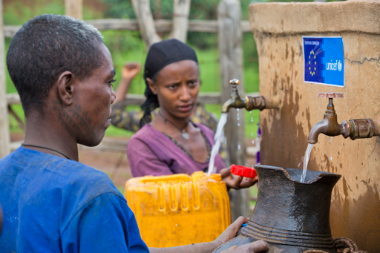
Figure 9.2 A water point in the Amhara region with emblems of UNICEF and the European Union indicating they provided funds for the installation.
NGOs working with WASH activities have formed the Water and Sanitation Forum (WSF), which meets regularly. The WSF has an executive body and a secretariat. WASH NGOs are also represented on a number of Task Forces in the MoWIE, the MoH and the MoE, as well as in the membership of the Water Sector Working Group (see next section). In the regions, WASH NGOs collaborate with sector bureaus by participating in Technical Working Groups and forming WASH Forums to coordinate planning and implementation.
NGOs play a number of important roles in OWNP implementation. NGOs participate in sector reviews and evaluations such as the semi-annual Joint Technical Review (JTR), an annual Multi-Stakeholder Forum (MSF), and regular meetings of the Forum for Learning on Water and Sanitation (described in more detail in Study Session 11). WASH NGOs also implement WASH projects and undertake studies, evaluations and other activities for international multilateral and bilateral organisations such as the European Union, UNICEF, DFID and others at all levels, from federal level to communities.

9.3.3 Development Assistance Group /Water Sector Working Group
The Development Assistance Group (DAG) for Ethiopia was established in 2001 to ‘foster information sharing, policy dialogue and harmonise donor support to Ethiopia in order to enable the country to meet the targets set in the Millennium Development Goals (MDGs)’ (DAG, n.d.). The DAG is a collaborative body consisting of development partners who provide development assistance in Ethiopia, according to the principles of the Paris Declaration on Aid Effectiveness (see Study Session 4). Membership includes all the main bilateral and multilateral donor partners.
The DAG structure has a number of Technical Working Groups (TWGs) for specific sectors. Some of these have been renamed as Sector Working Groups (SWGs), including the former DAG Water Technical Working group, which is now part of the Water Sector Working Group.
The Water Sector Working Group was established in 2014 to support the integrated development and management of water in all relevant sectors. It is a joint government-donor group intended to ‘provide a forum for the government and donors to jointly, promote, support and coordinate sustainable and integrated development and management of water resources.’ (MoWIE, 2014b).

9.4 Private sector
The private sector contributes to the implementation of the OWNP by constructing water supply and sanitation facilities. The private sector is the part of a country’s economy that is not run by the government. Private sector businesses are usually run with the aim of making a profit. In the WASH sector the tasks undertaken by private sector companies may include such things as the design and engineering of new facilities, drilling boreholes, laying pipes and constructing buildings, as well as supplying materials and equipment (Figure 9.3). Implementation also involves studies and research by different professional associations. These activities are usually undertaken by private contractors, consultants, suppliers and artisans.
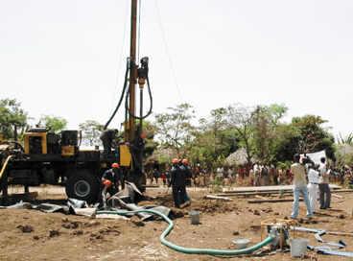  (a) | 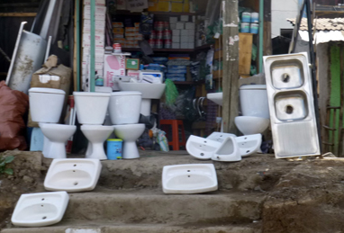  (b)
Figure 9.3 Private sector companies contribute in many ways including (a) drilling a deep well and (b) sale of bathroom fittings.
- Which type of stakeholder are these private sector groups?
- These are collaborating stakeholders because they do not provide funds for WASH activities.
There is a growing demand for groundwater development and borehole drilling in Ethiopia, however only a limited number of private drilling companies are available to carry out the work. To try to alleviate this problem, the government has suppled drilling machines to Regional State Water Enterprises (RSWEs) which bid for contracts for drilling and construction of water supplies in the same way as private enterprises, e.g.Oromia Water Works and Construction Enterprise, Amhara Water Works and Construction Enterprise. These are profit making but are established by the government and work on construction of water supply schemes for rural and urban areas, consultancy work, etc.
Also classified as a private sector stakeholder is the Ethiopian Association of Hydrogeologists, which was established in 2006 with the objective of using groundwater for development and to assist the expansion of education and research about groundwater in Ethiopia. This association contributes to the OWNP by identifying the hydrogeological problems of the country and proposing solutions for the government based on its scientific research.
Banks and microfinance institutions also play an important role. Microfinance institutions (MFIs) operate in rural communites, giving small loans to individuals and small-scale enterprises. MFIs and banks provide financial services to communities, particularly for community-managed projects (CMP), self-supply and sanitation marketing activities. These services include financing through WASH Committees (WASHCOs) for procurement, construction, maintenance, rehabilitaton, replacement, insurance and for providing credit to small-scale micro-enterprises for WASH services and supplies.
The private sector also provides consultancy services for studies and analyses, design, construction supervision and other activities. Private suppliers, artisans and other service providers will have an increasingly important role to play in the OWNP in establishing and servicing supply chains for WASH products, spare parts and repair services, as well as in supporting self-supply activities. Supply chain means the sequence of steps or processes or added components involved in making a product from start to finish.

9.5 Community organisations
In rural areas, the two main stakeholder organisations at community level in OWNP implementation are the WASH Committee (WASHCO) and Health Development Army (HDA). (You read about these in Study Sessions 7 and 6 respectively.)
- Can you explain the difference between the HDA and WASCHCOs?
- The HDA is a team of up to 30 households in the same neighbourhood. These teams comprise ‘1 to 5 networks’ which each consist of six team members, led by a model family with women representatives from five other families. The HDA works with Health Extension Workers (HEWs) to motivate families to adopt healthy behaviour. WASHCOs are a team composed of 5–6 members of a community who look after a specific water point. They are responsible for the overall operation and maintenance of the water scheme.
Each are involved in different but related aspects of the OWNP. In some locations, associations of WASHCOs are expected to plan, manage, operate and maintain water points. Health Development Armies are responsible for planning, managing, operating and maintaining household and public latrine sanitation facilities in their kebele. Members of the HDA working with HEWs are important in promoting sanitation and hygiene practices among households in communities.
Community ownership and management of the improved WASH facilities is important for enhancing impact and sustainability; a principle that is clearly illustrated in Case Study 9.1.

Case Study 9.1 Dalocha Women Water Development Association
Water supply in the Dalocha woreda, in the Silti Zone of the SNNPR has been greatly improved since the development of the Dalocha Women Water Development Association (DWWDA). The DWWDA has been responsible for water supply in the woreda since 1998. The water system has a network of three springs, seven boreholes, eight reservoirs, 75 km of pipeline and 48 water kiosks serving over 127,000 people (Figure 9.4). The unusual aspect of this project is that it is managed and led entirely by women. The project was initiated by the INGO ActionAid with the approach that, as women had responsibility for fetching water, they would be more concerned about the proper functioning and sustainability of the water system. They established an organisational structure for the DWWDA that consists of a General Assembly with 178 women and an Executive Board of 16 women drawn from the General Assembly representing the 16 Water Committees responsible for managing day-to-day matters. ActionAid provided regular training for the women in basic literacy and in more specialised subjects of management and administration, financial regulations, water regulations, water and health, gender and protection of the water network.
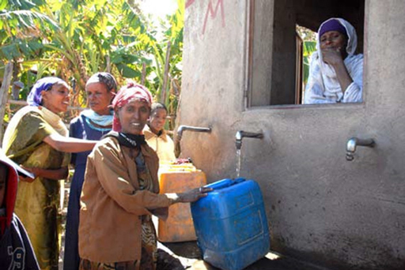
Figure 9.4 Women fetching water from a DWWDA water kiosk.
This improved water supply project has brought many advantages, including better health for all. Women no longer have to spend hours fetching water, and girls’ school enrolment has increased. Encouraging these women to take leadership roles has also brought other significant benefits. The DWWDA is recognised as a significant stakeholder in the woreda. Despite initial scepticism from some communities and officials, the women have demonstrated their capabilities as managers and leaders over several years. This has empowered them to take on other roles and has changed attitudes to women’s capabilities in communities and in homes. The DWWDA has been so successful that it has been used as a model for other projects, and ActionAid has started ten similar women-led water development associations elsewhere in Ethiopia (Berhane, 2014).
(Adapted from Pratt and Earle, 2004 and ActionAid, 2012)

- Which of the principles and cross-cutting issues that you have read about so far in this Module are demonstrated in Case Study 9.1?
- Gender mainstreaming is clearly a dominant feature of this story, with women leading the association. The success of the association over several years indicates it is a sustainable scheme. It is clearly a decentralised and participatory project that has empowered the women in the communities. Training and capacity building has enabled the women to take on new responsibilities and be successful leaders and managers.

Summary of Study Session 9
In Study Session 9, you have learned that:
- The OWNP is a government programme with ambitious goals which cannot be achieved by the government alone. Many other stakeholders groups need to be involved.
- The main government stakeholders are the four WASH ministries. Some other ministries are also involved.
- There are three main types of non-governmental stakeholder: major, associated and collaborating stakeholders.
- Major stakeholders include direct fund contributors to the Consolidated WASH Account such as The World Bank, the Department for International Development, the African Development Bank and UNICEF.
- Other important stakeholders are the direct WASH project implementers (NGOs or CSOs) like WaterAid, Plan International and UNICEF.
- Collaborating stakeholders include indirect contributors such as private sector businesses, community organisations, training centres and user groups.

Self-Assessment Questions (SAQs) for Study Session 9
Now that you have completed this study session, you can assess how well you have achieved its Learning Outcomes by answering these questions. You can check your answers with the Notes on the Self-Assessment Questions at the end of this Module.

SAQ 9.1 (tests Learning Outcome 9.1)
Complete the gaps in the following table:
Term | Explanation
 | Organisations that directly contribute funds to the Consolidated WASH Account (CWA) at federal level.
 | Organisations that provide funding for the construction of water supply, sanitation and hygiene facilities, technical assistance, supplies and other support to the OWNP.
collaborating stakeholders
 | Any organisation working in partnership with national and local government bodies.
civil society organisation
 | Non-profit organisations that typically ‘seek to influence the policy of governments and international organisations and/or to complement government services such as health and education’.
 | Departments or agencies of national governments that donate funds to another country.
private sector | The part of a country’s economy that is not run by the government.

SAQ 9.2 (tests Learning Outcome 9.2)
Which ministries and other government departments are responsible for the following in the implementation of OWNP:
- Mainstreaming gender
- Contributing specifically to issues relating to pastoralist communities
- Providing loans to assist water supply and sanitation projects in large towns
- Solid and liquid waste management.

SAQ 9.3 (tests Learning Outcome 9.3)
Briefly describe three ways in which NGOs contribute to achieving OWNP targets.

SAQ 9.4 (tests Learning Outcome 9.4)
What type of activities are undertaken by the private sector to support the OWNP?

SAQ 9.5 (tests Learning Outcome 9.5)
- What are the two main organisations at community level that are stakeholders in OWNP implementation?
- Why is community involvement important in the OWNP?

Study Session 10 Approaches to Implementing the OWNP

Introduction
The One WASH National Programme is new for Ethiopia. When it was introduced, no one had any previous experience of implementing a programme of this kind. It required new arrangements and adjustments to ways of working, i.e. new approaches and/or modalities, at federal, regional and woreda levels so that appropriate plans could be developed for putting the OWNP into practice.
In this study session you will learn about these new approaches and the conditions that need to exist within these various levels before OWNP implementation can take place. The study session describes some of the ways the implementation of the OWNP has been approached for water supply, sanitation and hygiene provision in both rural and urban settings, and in particular in schools and health facilities.

Learning Outcomes for Study Session 10
When you have studied this session, you should be able to:
10.1 Define and use correctly all of the key words printed in bold. (SAQs 10.1 and 10.2)
10.2 Describe the readiness criteria for implementing the OWNP at different levels. (SAQ 10.2)
10.3 Identify the implementation approaches for providing water supply and sanitation services. (SAQ 10.3)
10.4 Explain the difference between a community-managed and a woreda-managed project approach. (SAQ 10.4)

10.1 Readiness criteria at different levels
To implement any project, programme or activity you need to assess the situation before you start and consider if the right conditions for success exist. To give a simple example, if you were going shopping you would take some money, maybe a bag and possibly an umbrella. You could say these were your readiness criteria for shopping. Readiness criteria are conditions or things that need to exist or be done before starting an activity. For the OWNP, readiness criteria have been created for all the various implementing organisations at different levels of government, from federal down to local communities. The purpose of these criteria is to ensure that the right conditions exist for OWNP implementation or, in other words, that there is an enabling environment.
- You were introduced to the concept of an ‘enabling environment’ in Study Session 5. Do you remember its definition?
- An enabling environment means that the conditions are right for an activity or phenomenon to happen.
For the implementation of the OWNP, the enabling environment refers to the sum of conditions such as policies, laws, and physical infrastructure that allow (or limit) implementation of the OWNP at various levels. The readiness criteria for the OWNP have particular significance because they are tied to the release of funds. There is a requirement that conditions set out in the readiness criteria have to be met before money is disbursed and physical implementation can take place.
Readiness criteria for implementing the OWNP have been set from federal government down to kebele and community levels. The details vary at different levels but they follow a common pattern. For example, at the federal, regional and zonal levels the criteria include establishing the required organisational structure and recruiting staff for programme management units. Operational WASH budget accounts have to be set up with separate budget lines for all implementing organisations, i.e. each implementing ministry at federal level and each WASH sector bureau at regional level. Each level must also have a consolidated WASH plan prepared and approved by the appropriate higher authority. A consolidated WASH plan is a single plan that combines water supply, sanitation and hygiene schemes and integrates the separate plans from all WASH implementing organisations.
Readiness criteria at lower levels follow a similar pattern. All cities and towns are expected to have prepared a consolidated annual WASH plan and had this approved. They have to establish the necessary organisational structure (e.g. Town Water Board) and have appropriate staff in place. They need to organise their financial systems so there are separate budget lines for water supply and sanitation. They also need to ensure that staff and procedures for monitoring and evaluation (M&E) are established and that National WASH Inventory (NWI) data has been made available.
At woreda level, the criteria are much the same. They have to prepare WASH plans and budgets and have these approved by the woreda council. These plans might be for new small water schemes such as hand-dug wells in specific locations. The organisational structure that you read about in Study Session 7 must also be in place. For example, members of the Woreda WASH Team must be recruited. They also need to have separate budget lines and make NWI data available to all relevant stakeholders in the same way as towns and cities.
At kebele level, there also has to be a consolidated WASH plan. In rural areas, community WASH committees (WASHCOs) must be established. These must be formally recognised and registered at kebele or woreda level and have the appropriate gender-balanced membership and elected officers. WASHCOs must have opened a bank account for collecting and administering contributions from users of the WASH services. Like the higher levels, communities must have a single annual WASH plan and this must be approved by community and WASHCO members.

10.2 Rural WASH implementation approaches
The programme for rural settings is similar to that of urban environments in some respects, but different in others. Both include providing water, sanitation and hygiene services for their respective communities as well as for health facilities and schools, but the approaches to providing these services are different because the living conditions and needs of the people are different in urban and rural settings.

10.2.1 Rural water supply approaches
To address the low access to water supply in rural areas the Water Resources Management Policy (MoWR, 1999) supported decentralised management, and integrated and participatory approaches to providing improved water supply services. As you have read, this policy was part of the background to the OWNP which also encourages decentralisation of management and the involvement of different stakeholders, including NGOs and communities. The recovery of operation and maintenance (O&M) costs is also recognised and supported by this policy.
- What makes the Water Resources Management Policy and OWNP similar?
- Both documents support decentralised management, integration and the participatory approach of both stakeholders and the wider community.
In Study Session 6, you read that the OWNP’s rural water supply activities include various studies; constructing new point sources or small piped schemes with distribution systems, including multi-village schemes where appropriate; the rehabilitation of existing point sources and expanding small piped schemes. You were also introduced to the different approaches or modalities to implement and manage these activities. We will now describe these in a little more detail.

Woreda-managed project
The woreda-managed project (WMP) is a rural WASH implementation modality in which the Woreda WASH Team (WWT) takes the lead. They are responsible for administering funds allocated to woreda, kebele or the community for capital expenditure on water supply and sanitation activities. Although the kebele administration and WASHCOs are involved in project planning, implementation, monitoring and commissioning the project, the WWT is effectively the Project Manager and is responsible for contracting, procurement, inspection, quality control and handover to the community. Typically a WMP approach is used for small schemes such as spring development, hand pumps, and the software component of sanitation. (Software components are any activities that focus on knowledge, attitude and behavioural changes of the individual or the whole community. Hardware components are the physical parts of a scheme such as well linings, pumps, latrine slabs, lavatory pans, construction materials etc.)
The construction of WMP schemes is supervised by woreda staff and projects are transferred to the community after the design and implementation stages are completed by the woreda. This has traditionally resulted in very low community participation and ownership.

Community-managed project
The community-managed project (CMP) is a rural WASH implementation approach where communities are supported to undertake all stages of a project, from initiation through planning to implementation and management continuing into the future. These projects use funds that are transferred to, and managed by, the community. The major features of the CMP approach are:
- Fund Transfer: Funds for physical construction are transferred to the communities from woredas or through intermediaries selected by the communities, thus making communities responsible during the full project cycle from planning and implementation (including procurement of most materials and labour) to O&M.
- Community Project Management: The communities, through water and sanitation committees (WASHCOs), are responsible for the full development process through planning, financial management, implementation and maintenance. The communities contribute a minimum of 15% in cash or in kind (usually labour). WASHCOs manage not only community-generated funds, but also the government subsidy provided for capital expenditures.
- Procurement: A further aspect of community management is that the WASHCO is directly responsible for procuring (buying) the goods and services required for water scheme construction and installation.
The CMP mechanism is intended mainly for low-level technologies such as hand-dug wells and spring protection. An example of a community-managed project is the Debero-Garmojo water point (Figure 10.1). Debero-Garmojo is in the Abichugena woreda, Oromia region. The water point was constructed by local community with the support of the woreda administration and the government of Finland. The water comes from a spring and is piped into a collection tank which has three taps and serves 30 households. The WASHCO was responsible for its planning, procurement, contracting, management, and operation and maintenance.
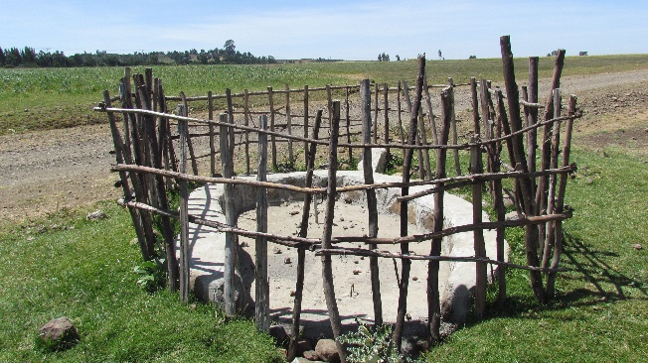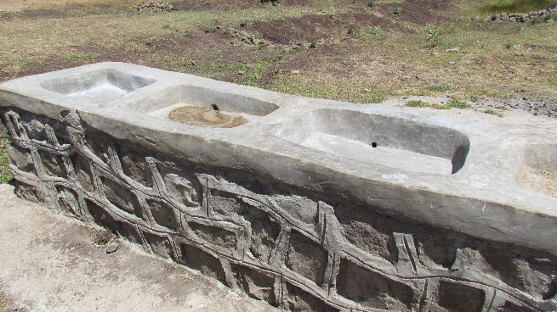
Figure 10.1 Debero-Garmojo water supply system showing (left) protected spring eye and (right) the cloth washing basin.

NGO-managed project
As you know by now, non-governmental organisations (NGOs) are important stakeholders in the OWNP as donors, implementers and knowledge disseminators. Their funding and management arrangements vary considerably but, combined with national WASH principles and practices, they foster community initiatives, develop community leadership and require community investment in water supply projects. In some cases, NGOs administer external resources on behalf of the community. In others, they make external resources available to the community directly or through microfinance institutions to support construction and management.
NGOs have flexibility and are able to increase community involvement, ownership and accountability. NGO-supported projects follow procedures agreed between the NGO, its partners, the Ethiopian government and the region or woreda where the activities are located. They should comply with policies on cost-sharing, community contributions, reporting and monitoring indicators. NGOs are included in resource mapping at all levels and will be requested to provide information for preparing consolidated annual WASH plans and budgets. (Resource mapping is the identification of the sources and amounts of all possible funds for a project.) NGOs will also be requested to provide periodic progress reports on their projects to WASH Coordinators at various levels.
You have already seen several examples of NGO-managed projects in this Module. As discussed in Box 9.1 in the previous study session, the term NGO may be used loosely, and in this context is frequently applied to projects managed by organisations like UNICEF and the World Health Organization (Figure 10.2), which are not NGOs in the strict sense of the term.
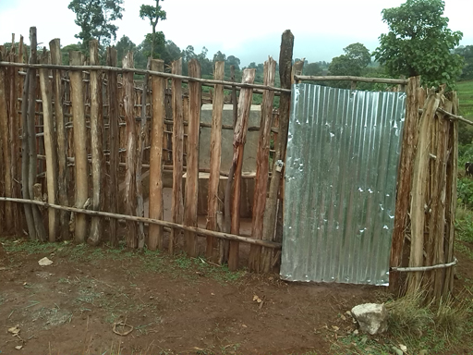
Figure 10.2 NGO-managed project: Well-fenced water point constructed by WaterAid at Gidachemo kebele, Sore woreda, in SNNPR.

Self-supply
Self-supply was defined in Study Session 6 as the construction and use of small-scale water schemes at household level, such as hand-dug wells. As stated in the manual prepared by Ministry of Water, Irrigation and Energy (MoWIE, 2014a) self-supply means ‘improvement to water supplies developed largely or wholly through user investment by households or small groups of households’. Self-supply involves households taking the lead in their own development and investing in the construction, upgrading and maintenance of their own water sources, water-lifting and treatment devices and storage facilities.

Multi-village water supply schemes
As the name suggests, these are schemes designed to provide water to several villages from a single source (Figure 10.3).
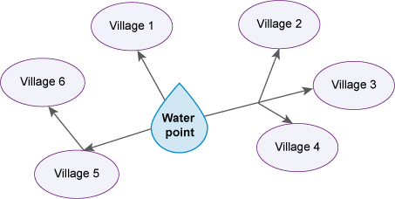
Figure 10.3 A multi-village water scheme system used to serve different villages.
Regions and zones are mainly responsible for this type of scheme and they undertake all the studies, design, management, construction and supervision. These schemes are more complicated and construction requires higher-level technology to serve larger populations of up to 100,000 people in the combined villages. Multi-village water supply schemes will be supported under certain conditions, provided that feasibility studies verify that the proposed sources are adequate and that the schemes can be socially, technically and financially sustainable.

10.2.2 Rural sanitation and hygiene promotion
Currently there are a number of different approaches to promoting rural community sanitation and hygiene in Ethiopia. We will highlight two of the most important: community-led total sanitation and hygiene, and sanitation marketing.

Community-led total sanitation and hygiene
Community-led total sanitation (CLTS) is an approach which emphasises changing the behaviour of all people in a community in order to stop open defecation and encourage good hygiene practices in and around the home. CLTS was introduced in Ethiopia following a hands-on workshop in October 2006, organised by Vita, an Irish international development agency working in the Horn of Africa, and led by Dr. Kamal Kar (Figure 10.4). The Federal Ministry of Health had taken the initiative to use this approach as the main tool to improve rural sanitation by training Health Extension Workers (HEWs) in the technique. Since that time, the approach has been developed and renamed in Ethiopia to explicitly include hygiene and is now known as community-led total sanitation and hygiene (CLTSH).
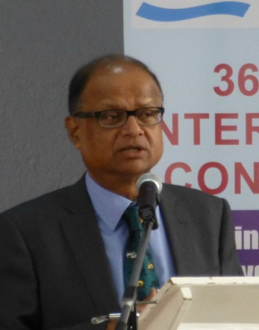
Figure 10.4 Dr Kamal Kar, developer of the CLTS approach.
The aim of CLTSH is to achieve open defecation free (ODF) status. This is awarded to villages and communities when they have achieved the situation whereby everyone has access to a latrine and no one defecates in the open at any time. The award of ODF status is cause for great celebration in the community (Figure 10.5). ODF status is achieved through a process of social awakening stimulated by facilitators from within or outside the community. The approach concentrates on the behaviour of the community as a whole rather than on individuals.
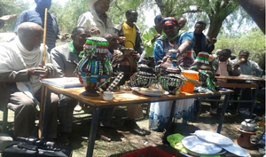
Figure 10.5 ODF celebration in Dugda woreda, Oromia.
The CLTSH process involves trained facilitators working with communities to inspire and empower them to stop open defecation and to build and use latrines for themselves. The facilitators encourage people to take responsibility and consider their own behaviour rather than rely on external subsidies to buy hardware such as latrine slabs. Community members come together with the facilitators in group discussions to analyse the extent of open defecation in and around the village (Figure 10.6). They consider the implications of this for faecal-oral contamination and the resulting detrimental impact on human health that could affect every one of them.
The CLTSH approach works by creating a sense of disgust and shame among the community in a stage in the process called triggering or igniting. The process brings them collectively to the realisation that they quite literally will be eating one another’s ‘shit’ if open defecation continues. When they realise this shocking fact, the people become very enthusiastic about taking action to improve the sanitation situation in the community (Kar, 2005).
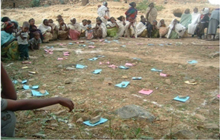
Figure 10.6 Community mapping of defecation areas in a village in Tigray region as part of a CLTSH process.

Sanitation marketing
Since the introduction of CLTSH, significant numbers of households have gained access to self-constructed basic latrines. However, many self-constructed latrines fall short of fulfilling the minimum standard of improved sanitation and hygiene facilities, as shown in Figure 10.7. This is one of the reasons for introducing sanitation marketing.
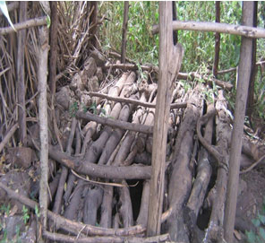
Figure 10.7 An example of an inadequate pit latrines.
- Why is the latrine shown in Figure 10.7 inadequate?
- The pit is covered with logs rather than a slab. This will not provide separation between the people using the latrine and their waste. It is unstable and difficult to find a secure footing and is likely to break and collapse while someone is using it. Also there is no proper infrastructure around the pit to provide privacy.
Sanitation marketing is a relatively new approach to improving sanitation provision and does not have a single precise definition. The Water and Sanitation Program’s Introductory Guide to Sanitation Marketing explains that ‘some practitioners define sanitation marketing as strengthening supply by building capacity of the local private sector; others discuss it in terms of “selling sanitation” by using commercial marketing techniques to motivate households to build toilets’ (Devine and Kullman, 2012).
In Ethiopia, the National Sanitation Marketing Guideline defines sanitation marketing as ‘satisfying improved sanitation requirements (both demand and supply) through social and commercial marketing process as opposed to a welfare package’ (MoH, 2013). The national guideline sets out three pillars for the approach which are:
- Strengthening an enabling environment for sanitation marketing programme.
- Creating access for improved sanitation technology options.
- Generating demand for improved sanitation technology options (MoH, 2013).
In practice this approach includes a range of different activities that encourage people to build latrines and adopt good hygiene behaviour and also to create business and commercial opportunities. An important feature is that new sanitation services are not provided for free. Figure 10.8 shows an example of a sanitation marketing enterprise where latrine slabs are constructed for sale.
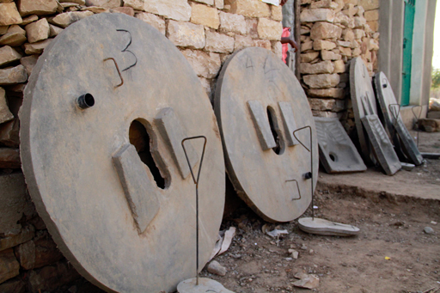
Figure 10.8 New slabs for VIP latrines ready for sale.

10.3 Pastoralist WASH
Pastoral communities generally have limited access to water supply and consequently, improved sanitation and hygiene practices also tend to be poor. Pastoral communities (in Somali, Afar and parts of Tigray, Oromia and SNNPR regions) also require water for grazing their cattle and other animals. This means that, where hydrological and hydro-geological conditions permit, water supply schemes should be constructed close to pasture lands and along migration routes.
In areas with natural resource scarcity, there is a risk that water development may trigger underlying conflicts over land ownership and access to resources, especially during dry periods or droughts. The development of water supply schemes in pastoralist areas must be sensitive to these possible conflicts and pay particular attention to the timing and quality of community consultation at every stage of the project cycle.
Implementation in pastoral areas is similar to the approaches mentioned above for the rural WASH programme except that it requires closer coordination with schemes designed to respond to emergency WASH situations.

10.4 Urban WASH
In Study Session 6 you learned about the categories of town for the urban WASH component of the OWNP. These are repeated in Table 10.1.
Table 10.1 Categories of town for the OWNP urban water supply component. (OWNP, 2013)
Category | Description
1 | Towns/cities having utilities managed by a Water Board
2 | Towns/cities having utilities but not managed by a Water Board
3 | Small towns with water supply systems managed by WASHCOs or towns without a water supply system at all
The OWNP sets out two modalities for implementing the urban WASH component, which refer principally to the funding arrangements (described further in Study Session 12). These are:
- Grant financing for capacity building, planning and improvements to administration and management systems (i.e. financial support from a donor, which is not paid back).
- Soft loan financing for water supply expansion (i.e. a loan from foreign government or international financing institution, such as the World Bank, to be paid back but with a minimal interest rate).
Accordingly, the process and institutional arrangements differ. At town level there are two WASH structures and processes: one for water supply and one for urban sanitation and hygiene. Both will be integrated in the consolidated annual WASH plan to be approved by the City Council or Town Board.

10.5 Institutional WASH
As you know, this component of the OWNP is about schools and health facilities. The OWNP supports the construction or rehabilitation of water supply facilities and latrines at schools (primary and secondary) and health facilities. It also proposes to support school curriculum by producing visual aids on hygiene and sanitation, using educational materials to promote good sanitation and hygiene practices, and supporting participation in school health clubs and events like Global Handwashing Day. The Ministry of Education, through its regional/city bureaus and woreda/town education offices is responsible for implementing the Programme’s activities in schools. WASH activities can also be combined with other activities such as vegetable gardening to provide additional benefits to schools and possibility to support learning about nutrition. Through its bureaus and local offices, the Ministry of Health is responsible for WASH construction activities in health facilities. For both schools and health facilities, implementation may be through either woreda-managed project (WMP), community-managed project (CMP), or NGO-managed modalities.
In line with this, manuals for the design and construction of WASH facilities in schools and health facilities have been prepared and are being applied nationwide (see UNICEF, n.d.). These manuals are a multi-sectoral effort with inputs across education, health and WASH sectors and contain detailed design drawings as well as lists of required materials and equipment. These manuals are essential tools that will provide guidelines for supporting WASH infrastructure in Ethiopia’s schools and health facilities.

10.6 Water quality
Another important aspect of implementation is the regular monitoring and assessment of drinking water quality, both before and after new schemes have been installed. Responsibility for water quality is shared by the Ministry of Health (MoH) and the Ministry of Water, Irrigation and Energy (MoWIE), and their regional bureaus.
The MoWIE tests the water quality of proposed surface water and groundwater sources before undertaking the construction and commissioning of new schemes. In some parts of the country there are problems caused by the natural water chemistry such as high levels of fluoride, iron and salinity. The MoWIE is responsible for identifying these issues and implementing mitigation measures where appropriate.
The MoH is responsible for the periodic monitoring of water quality after water supply schemes are commissioned through its regional bureaus and woreda offices, testing the microbiological quality of the water to ensure the water is not contaminated and is safe to drink (Figure 10.9).
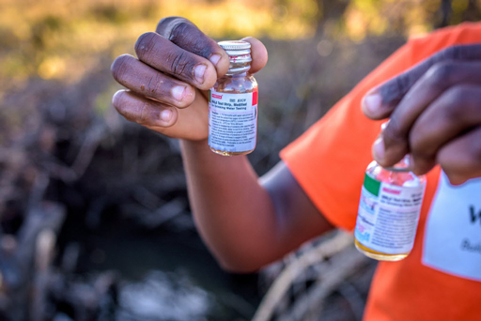
Figure 10.9 Water quality should be routinely monitored to ensure the water is safe to drink.

Summary of Study Session 10
In Study Session 10, you have learned that:
- The OWNP has established readiness criteria for all levels of administration that have to be fulfilled before funds are released for implementing WASH activities.
- The main approaches to implementing rural water supply schemes are woreda-managed projects (WMP), community-managed projects (CMP), NGO-managed projects, self-supply and multi-village schemes.
- Two important approaches to rural sanitation and hygiene promotion are community-led total sanitation and hygiene (CLTSH) and sanitation marketing.
- In pastoralist areas, the same approaches described for rural water supply can be used, but need to consider special conditions that apply in pastoral communities.
- The OWNP uses three categories of town based on water supply provision and management status. There are two financing arrangements used for urban WASH, grants and soft loans.
- Institutional WASH provision covers schools and health facilities. Implementation may be by WMP or CMP approaches.
- The quality of drinking water is another important aspect of WASH implementation. Monitoring and assessment of sources before development is by the MoWIE. The MoH is responsible for monitoring of water quality after installation is complete.

Self-Assessment Questions (SAQs) for Study Session 10
Now that you have completed this study session, you can assess how well you have achieved its Learning Outcomes by answering these questions. You can check your answers with the Notes on the Self-Assessment Questions at the end of this Module.

SAQ 10.1 (tests Learning Outcome 10.1)
Fill in the gaps in the following sentences:
- A ……………… is a single combined plan for water supply, sanitation and hygiene schemes that integrates the separate plans from all WASH implementing organisations.
- ……………… are any activities that focus on knowledge, attitude and behavioural changes of the individual or the whole community.
- ……………… are the physical parts of a scheme such as well linings, pumps, latrine slabs, lavatory pans, construction materials etc.
- ……………… is the construction and use of small-scale water schemes at household level, such as hand-dug wells.
- ……………… is the identification of the sources and amounts of all possible funds for a project.

SAQ 10.2 (tests Learning Outcomes 10.1 and 10.2)
- Give a general definition for readiness criteria.
- Why are the readiness criteria for the OWNP particularly important in terms of the flow of resources?
- What sort of readiness criteria are expected to be in place for OWNP at city/town level?

SAQ 10.3 (tests Learning Outcome 10.3)
Listed in the table below are various approaches to implementing the OWNP. In the second column, write down if the approach is relevant to water, sanitation or hygiene, or more than one of these three. In the third column, identify whether the approach is used in rural, urban, pastoralist or institutional WASH.
Approach | Water? Sanitation? Hygiene? | Rural? Urban? Pastoralist? Institutional?
Community-managed project
Sanitation marketing
Multi-village scheme
Grant financing
CLTSH
NGO-managed project

SAQ 10.4 (tests Learning Outcome 10.4)
What are the differences between the community-managed project (CMP) approach and the woreda-managed project (WMP) approach?

Study Session 11 Learning and Sharing in the WASH Sector

Introduction
In this study session we step back again from the main OWNP documents and processes to focus on learning and sharing. We will consider the importance of creating, learning and sharing new knowledge and best practice across the WASH sector and of using it effectively to meet the aims of the OWNP in Ethiopia. You will be introduced to examples of national, regional and local forums and events where multiple stakeholders meet to discuss and exchange knowledge and experience of WASH policies, processes and services. The benefits and the challenges of learning and sharing in the WASH sector are also briefly reviewed.

Learning Outcomes for Study Session 11
When you have studied this session, you should be able to:
11.1 Define and use correctly all of the key words printed in bold. (SAQs 11.1, 11.3 and 11.4)
11.2 Describe the main features of successful knowledge management in the WASH sector. (SAQ 11.1)
11.3 Explain why documentation in the WASH sector is an essential component of best practice. (SAQ 11.2)
11.4 Give examples of the main forums and events in the WASH sector and summarise the contributions they make to best practice. (SAQs 11.3 and 11.4)
11.5 Give examples of how learning and sharing can promote the scale-up of effective WASH services and interventions. (SAQ 11.5)

11.1 The significance of learning and sharing for the OWNP
Think back to the four guiding principles of the OWNP that were discussed in Study Session 4: integration, alignment, harmonisation and partnership. To enact and follow these principles requires collaboration among stakeholders, and part of that process is learning and sharing. All the partners in the OWNP have knowledge and expertise that can be shared with others who learn from that experience, which in turn brings benefits to the Programme as a whole. Planners and implementers at all levels become more effective if they can learn from others about successful ways of working, and also learn of past mistakes that can then be avoided in future. The central unifying focus of the OWNP, characterised by the motto ‘One Plan, One Budget, One Report’, is dependent on a system that encourages learning and sharing among stakeholders.
In Study Session 9 you were introduced to the Water Sector Working Group and its secretariat. The objectives of this group include providing a forum for sharing experiences and exchanging information between WASH partners and acting as a knowledge hub for the entire water sector. The secretariat has knowledge management as one of its core functions in meeting these aims (WSWG, 2014).

11.1.1 What is knowledge management in the WASH sector?
Knowledge management is a set of principles that arose in business organisations in the 1990s, and has been defined as ‘the process of capturing, distributing, and effectively using knowledge’ (Davenport, 1994).
In the WASH sector, knowledge management refers to the processes and behaviours that:
- create new knowledge relevant to WASH aims, policies and procedures
- ensure relevant information is shared within and between the four WASH ministries and with other stakeholders
- enables all actors at all levels to use the knowledge effectively to deliver reliable and sustainable WASH services.

11.1.2 Why is knowledge management so important?
Efforts to provide universal WASH services can be undermined by poor knowledge management. For example, if WASH sector practitioners in a particular location or organisation have developed ways to solve a difficult problem, such as making safe drinking water accessible to people in informal urban settlements, their new knowledge cannot bring the same benefits to other communities if it is not shared so others can learn from it. Local solutions may not be publicised regionally and knowledge gained from national or international innovations may not trickle down to the local level.
A particular challenge for knowledge management in the WASH sector is that relevant information is often fragmented between different stakeholders, each holding part of the knowledge needed to solve problems. Combining diverse sources of information can lead to new ways to achieve more sustainable service delivery.
Shared learning and good knowledge management require a commitment by all participants to search for improvements in processes and policies. This can only be achieved if decisions and actions are well-documented, clearly communicated throughout all levels of the organisation and backed up by continuous monitoring of outcomes. We discuss documentation in Section 11.2.
Important opportunities for learning how to improve WASH services can be gained not only from sharing information on achievements, but also from reflecting on unsuccessful experiences. Regular reviews, two-way communication and joint learning are essential to ensure that more effective ways of working are extended to new locations and scaled up to benefit more people, as Section 11.4 describes.

11.1.3 Sharing experience with others
Effective knowledge management can support an organisation to become a ‘learning culture’ in which all stakeholders – including WASH employees – are encouraged and empowered to investigate shared problems and collaborate in finding and adapting locally relevant solutions. Achieving a vibrant learning culture throughout the WASH sector may require some adaptations within WASH organisations to enable shared learning to occur. Finding the time and space to bring people together in an environment where relationships and understanding can develop can be difficult. However, the benefits are that everyone – not just the WASH experts – will be inspired to share their knowledge and experiences to solve problems jointly.
Another benefit of shared learning is that it integrates the human and technological assets of an organisation and improves coordination, productivity and effectiveness. It utilises resources more efficiently by reducing duplication of effort and minimising overlaps between activities. A good example of this in Ethiopia is the Forum for Learning on Water and Sanitation (FLoWS). This brings stakeholders together to discuss topical issues and to share experiences of the technologies and approaches they use in their various projects. FLoWS is described in more detail in Section 11.3.2.
Knowledge sharing between the WASH sectors in different countries is also vitally important. The exchange of information is a two-way process recognising that all participants in knowledge partnerships have much to offer and much to learn (Figure 11.1).
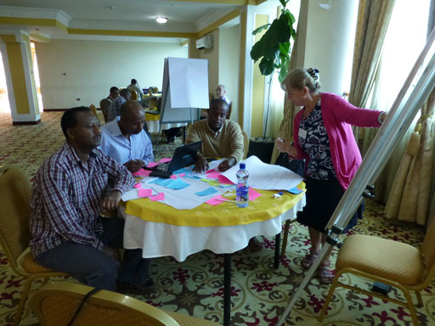
Figure 11.1 OpenWASH Module production workshop. The OpenWASH Modules are a product of a knowledge partnership between Ethiopian subject experts and The Open University.
A well-designed knowledge management system need not require advanced information technology or new staff, but it must have processes in place to ensure that essential information is documented and held securely by the organisation or sector, and that it can be reliably retrieved and shared. The next section looks in more detail at documentation in the WASH sector.

11.2 Documentation in the WASH sector
Think carefully about the purposes of documenting the processes, policies and actions in a learning community such as a WASH project team. Good documentation is more than just record-keeping; it places as much emphasis on process as it does on facts and figures. Good documentation attempts to capture the guiding principles that govern a team’s discussions and actions, how and why they are organising their activities in certain ways, and what else they need to know or discover about the problems they are seeking to resolve. It helps them to look forward to the next steps, as well as recording the relevant background and the present position. Documentation that meets these criteria is a rich resource for learning in the wider WASH community.
To be effective as a tool for communication and therefore for learning and sharing, documentation in any field should have the following basic characteristics:
- a logical structure using headings and sub-headings to organise the material sensibly and avoid repetition
- headings that are relevant to the content beneath them and vice versa
- terms and titles used consistently throughout, with any unusual or technical terms defined and explained
- a clear and concise writing style, avoiding long and complicated sentences.
If you are writing a report or other document, another important aspect is to consider your target audience and its capabilities and characteristics. For example, documents may need to be written in more than one language as appropriate for your project in order to meet the needs of the people reading your report.
The importance of documentation is illustrated in the next section, which describes some of the main forums and events in the WASH sector where reports of discussions and activities form part of their output.

11.3 Learning and sharing through WASH sector forums and events
There are many opportunities for stakeholders in the WASH sector to participate in local, regional, national and even international forums and events, where learning and sharing takes place on a huge scale.
Here we are using forum to mean a formal meeting of a large number of participants representing a wide range of stakeholders, usually held over several days. Their purpose is to share knowledge and experience on multiple WASH sector themes or to debate and resolve several identified problems in parallel sessions. (Note that forums may also be referred to as ‘platforms’.) In contrast, an event usually focuses on a single theme (e.g. water supply or hygiene promotion). Events could be special activity days, meetings, gatherings or celebrations. Although some events are very localised, others are huge international events involving hundreds or thousands of participants.
In this section, you will read about some of the most important WASH sector forums and events in Ethiopia, so you can see how they contribute to learning and sharing, and how the documentation is used to spread knowledge and experience to others.

11.3.1 The Multi-Stakeholder Forum (MSF)
The largest forum in the WASH calendar in Ethiopia is the Multi-Stakeholder Forum or MSF. This was mentioned in Study Session 9 as one of the mechanisms for collaboration between stakeholders. It brings together all the main stakeholders from government at federal and regional levels of the four WASH ministries, development partners, NGOs, and representatives of the private sector and academic institutions. The first MSF was held in Addis Ababa in 2006 and was attended by over 200 participants. The third forum in 2009 was when the concept of the OWNP was first presented to WASH stakeholders who greeted the idea enthusiastically (WIF, 2011). The fifth and sixth were both held in Addis Ababa in 2012 and 2014. These forums were held over two or three days and chaired by the State Minister of MoWIE. Their purpose was to improve communications between stakeholders and support mutual programme objectives and strategies (USAID, 2014).
Preparations for the MSF illustrate the principles of learning and sharing across the entire WASH sector. Planning for the next forum begin as soon as the outcomes of the previous one have been cascaded to all stakeholders. As part of this process, two other consultative meetings known as Joint Technical Reviews (JTRs) are held in each year. Their purpose is to review progress on previous plans and brainstorm the current key strategic challenges in order to decide on the priority thematic areas for the next MSF. The JTR sends task teams on field visits to selected regions, woredas, towns and kebeles to gather information on the identified topics, using an agreed method and checklist.
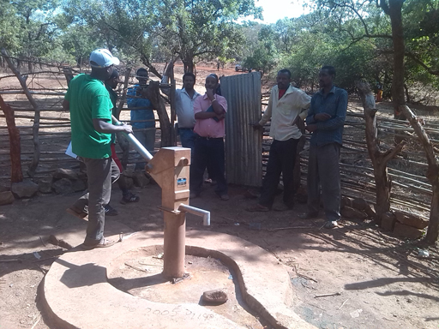
Figure 11.2 A team on a field visit to learn from local residents about WASH projects in the rural area of Bulen Woreda in Benishangul-Gumuz region.
The identified themes determine which locations are visited. For example, if self-supply and construction of domestic water supplies at household level is one of the thematic areas, this method is most extensively applied in SNNPR so this would be the selected region for JTR task team visits. If rural gravity schemes (water supply systems distributed over long distances using gravity feeds) are the selected theme, the visits would probably take place in Oromia region because this technology is widely available for review there.
The task team reports on the field visits in the two rounds of the JTR are combined into a single document, which is presented to the National WASH Technical Team in consultation with the National WASH Coordination Office for validation and endorsement. This document informs and directs the work of the organising committee for the next MSF. Note that this document meets the criteria outlined in Section 11.2 for ‘rich’ documentation in that:
- it draws on the background and history from earlier work (e.g. in the previous MSF)
- it reports on current practice gathered during the field visits for the JTR
- it identifies the themes for the next MSF.
Every MSF concludes with a report on the proceedings which is circulated for comments and feedback at regional level. The regions are responsible for ensuring that agreed MSF strategies are cascaded down to zonal, woreda and town level. The front page of the proceedings of the sixth MSF is shown in Figure 11.3.
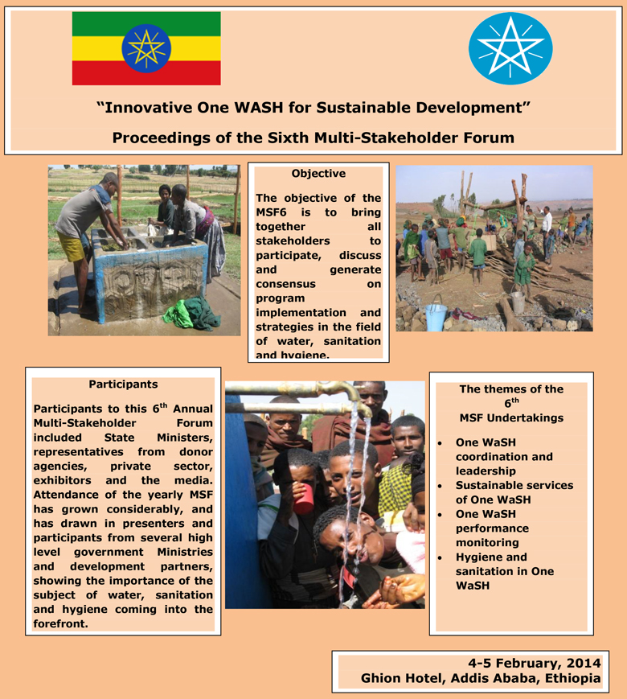
Figure 11.3 Proceedings of the sixth Multi-Stakeholder Forum, showing the objective, participants and themes of the undertakings on the cover. (NWCO, 2014)
The MSF proceedings include four or five action points or ‘undertakings’ identified by the delegates that every level of the WASH sector must agree to adopt. Table 11.1 shows the undertakings from the fifth MSF that took place in November 2012.
Table 11.1 Undertakings from the fifth Multi-Stakeholder Forum in 2012. (FDRE, 2012)
Number | Agreed undertaking
1 | Implementation of the One WASH Programme as per the WASH Implementation Framework (WIF)
2 | Implementation of signed MoUs at all levels
3 | Ensuring the functionality of WASH services
4 | Establishment of robust monitoring and evaluation systems
5 | Development of water and improved sanitation safety procedures, capacity and processes.
It will help you to see how these high-level undertakings contribute to learning and sharing throughout the WASH sector if we take undertaking 2 as an example. Every level in the WASH sector from the regions, zones, woredas and towns each have to sign a version of the national MoU which has been ‘downsized’ in scope to fit their specific context and the responsibilities appropriate to that level. These MoUs are also examples of documentation from the MSF.

11.3.2 Forum for Learning on Water and Sanitation (FLoWS)
As mentioned earlier, FLoWS is another important forum in the WASH sector, led by the Federal Ministry of Water, Irrigation and Energy in collaboration with an Ethiopian NGO known as RiPPLE (Research-inspired Policy and Practice Learning in Ethiopia). RiPPLE conducts action research and organises research-focused events with other key stakeholders almost exclusively in the WASH sector.
FloWS was launched in 2008. The report from that meeting set out its goal to link research with practice in order to support delivery of the MSF undertakings. To achieve this they planned to:
- provide a series of national learning events across the year, bridging the MSFs, that enhanced understanding of the challenges and opportunities involved in implementing the undertakings
- document the learning from these events in a series of reports and briefing notes that allows the fullest possible sharing of knowledge and information across the sector
- consult widely during this process on future learning priorities in the sector and help to consolidate national priorities in sector learning into a document presented each year at the MSF (MoWR, 2008).
The importance of learning and sharing is clearly central to these intentions. FLoWS take place regularly and can be anywhere in Ethiopia, depending on the thematic areas selected for the forum and the willingness of hosting organisations to hold the forum in their town. The scope of each FLoWS is narrower than the MSF in its themes, its duration and number and range of participants, so you can think of them as ‘mini-MSFs’. As an example, the eighth edition of FLoWS held in June 2013 took rainwater harvesting as its theme (Figure 11.4). The one-day workshop heard presentations from researchers and practitioners on rainwater harvesting experiences in Ethiopia and a range of related topics (RiPPLE, 2013).

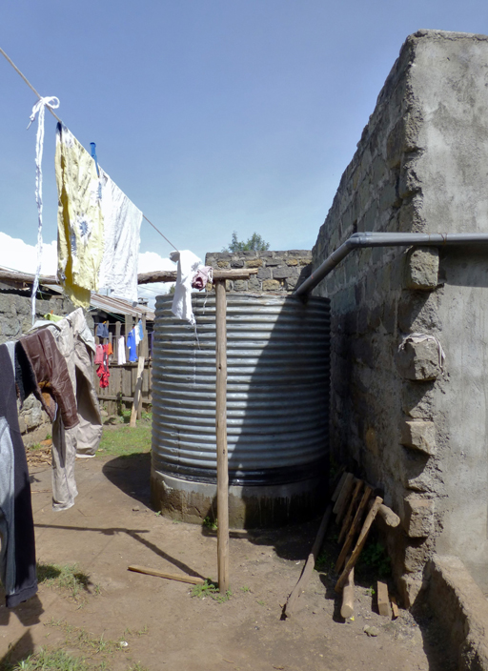
Figure 11.4 Rainwater harvesting tank collecting water from the roof of a housing block.

11.3.3 Other WASH sector forums
A complete list of all the WASH sector forums would be very long, so we have chosen a few examples to illustrate the range of levels: national Ethiopian forums, a pan-African forum and a global forum.

National forums
A good example of a national forum is the Water and Sanitation Forum (WSF), where NGO members and other interested parties meet regularly to debate sector needs. Another is the WASH Media Forum, managed by the WASH Ethiopia Movement and WaterAid. This is a forum for media professionals designed to enable them to engage in WASH sector promotion and policy dialogue (WEM, n.d.).

Pan-African forum
AfricaSan (African countries Sanitation and Hygiene Platform) is a pan-African forum that meets annually for between three and five days, bringing together the knowledge and experience of different African countries so they can learn from each other.

Global forum
At the global level, there is Stockholm World Water Week, held annually in September in Sweden. Delegates come from all over the world representing governments, NGOs, donors, public and private sector companies, universities and consultancies, as well as other interested individuals (Figure 11.5).
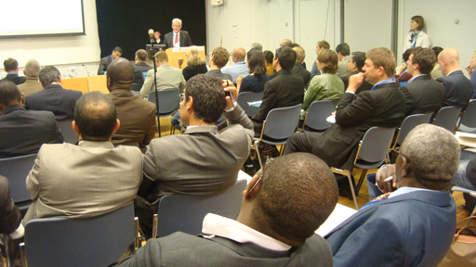
Figure 11.5 Delegates at Stockholm World Water Week 2014.

11.3.4 WASH events
WASH events differ from the forums by focusing on a single identified theme. They may be local, national or international and are often given the title of ‘festivals’. An example is the annual National Sanitation and Hygiene Festival, led by the Ministry of Health in collaboration with the WASH Ethiopia Movement, hosted by WaterAid Ethiopia. This event occurs in a different regional town each year; for example it was held in Dire Dawa in Yekatit 2007 EC (February 2015 GC). Figure 11.6 shows the opening celebration. The festival was created to facilitate learning and sharing experiences within the sanitation and hygiene sector, supporting dialogues between stakeholders and mobilising the media and the private sector. This was a public event that anyone with an interest in sanitation and hygiene could attend, not just invited experts and delegates. Like the forums, the festival concludes with the production of proceedings and action points for different bodies, including the government, donor agencies, the private sector and civil society organisations.
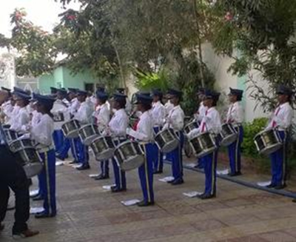
Figure 11.6 A police music band playing at the opening of the National Sanitation and Hygiene Festival in Dire Dawa, February 2015.
As an example of the outputs from one of these events, the 2015 Festival agreed a number of key points to be taken forward as a focus for further action in the coming year. These included:
- controversy about differences in the figures for improved access to sanitation and hygiene services in regional health bureaus administrative reports compared to the JMP report
- communicable diseases attributed to poor sanitation and hygiene are still the leading causes of morbidity and mortality
- health institutions and school WASH facilities and services are poorly constructed and unhygienically managed. Menstrual hygiene management (MHM) is not included within routine requirements.
Another annual event in Ethiopia is known as Hidar Sitaten, which was initiated by Emperor Menelik II in the nineteenth century. This focuses on environmental sanitation through mobilising the mass population in rural and urban settings to clean up their local areas by collecting up all their garbage and other solid waste on a day of action each year on 21 November.
In addition to these national festivals, you have already read in Study Session 3 about some WASH sector events celebrated in Ethiopia that take place on the same day all over the world.
- What global WASH events do you already know of?
- You may have mentioned Global Handwashing Day which occurs every year on 15 October, World Water Day on 22 March and World Toilet Day on 19 November.
In the final section of this study session, we show you how the outcomes of learning and sharing opportunities, including at WASH forums and events, can be scaled up from small pilot projects to meet national strategic priorities.

11.4 Scaling up best practice in the WASH sector
If evaluation shows that a small-scale innovation in technology, policy or process is an advance on previous best practice, there is an obligation to spread the impact of the new knowledge to additional sites and/or expand existing capacity to benefit a larger number and a wider range of service-users. Scaling up a ‘tried-and-tested’ intervention is likely to be more successful than starting from scratch, and it makes more efficient and cost-effective use of human, financial and technical resources.
- Can you think of an example of scaling up that you have read about in a previous study session?
- The Dalocha Women Water Development Association (in Study Session 9) has been used as a model, and several similar women-led associations have since been created in other parts of Ethiopia, based on this successful example.
You may also have thought of community-led total sanitation and hygiene (CLTSH). This was piloted in Ethiopia by Plan International in 2007 and has since been applied across the country. By 2011, the approach had reached all nine main regions and was supported in 439 of 550 woredas (Crocker and Rowe, 2015).
Another example of scaling up is the legalisation of WASHCOs. An earlier study session mentioned that legalising WASHCOs (giving them formal recognition and authority), was important for their success. During MSF-5 in 2012, experiences of WASHCO legalisation in Benishangul-Gumuz region were presented to the forum participants, who acknowledged they demonstrated good practice. This led to expanding the process within the region as well as other regions, some of which have taken WASHCO legalisation as one of their key undertakings. Currently the legalisation of WASHCOs is being implemented in all the woredas of Benishangul-Gumuz and in SNNPR and Tigray regions. They are adopting the initiative after a sharing visit to Benishangul-Gumuz facilitated by WaterAid.
Scaling up depends on all the elements of learning and sharing that we have discussed in this study session. It requires effective knowledge management and good documentation to ensure a thorough and complete record of both processes and outcomes. It also needs a mechanism for sharing information with other stakeholders. This can be achieved by forums and events, which provide opportunities for others to learn about best practice in order to introduce it elsewhere.
Joint learning and sharing of knowledge and experience across the sector gives each organisation and stakeholder access to a more diverse range of perspectives and specialised information than they could hope to acquire through their own individual efforts. As a consequence, WASH organisations and practitioners are able to work in a more holistic or ‘joined up’ manner that contributes to the bigger process of providing effective WASH services across Ethiopia.

Summary of Study Session 11
In Study Session 11, you have learned that:
- Learning and sharing of knowledge and experience are essential for the successful outcome of programmes in general and OWNP in particular. It is important to reflect on, evaluate and learn from effective activities.
- Knowledge management in WASH requires information from many stakeholders to be gathered, organised and disseminated in order to avoid fragmentation and encourage collaboration. It is one of the objectives of the Water Sector Working Group Secretariat.
- Learning and sharing requires reliable, thorough and accessible documentation of WASH services and innovations. Good documentation should capture the principles, processes and implications of activities.
- Forums and events are effective ways of sharing between stakeholders. The main WASH forums in Ethiopia are the Multi-Stakeholder Forum with the Joint Technical Reviews, and the Forum for Learning on Water and Sanitation.
- Festivals and other events are also valuable ways of learning and sharing that allow the wider population to engage with the activity.
- One ultimate aim of learning and sharing is to ensure effective scaling up of activities. If evidence shows that a particular method, process or activity is successful on a small scale, this can be shared and extended to reach more service-users in new locations.

Self-Assessment Questions (SAQs) for Study Session 11
Now that you have completed this study session, you can assess how well you have achieved its Learning Outcomes by answering these questions. You can check your answers with the Notes on the Self-Assessment Questions at the end of this Module.

SAQ 11.1 (tests Learning Outcomes 11.1 and 11.2)
Explain what is meant by knowledge management and briefly describe why it is important in the WASH sector.

SAQ 11.2 (tests Learning Outcome 11.3)
Which of the following statements about documentation are false? In each case explain why it is incorrect.
- Documentation involves collectively analysing, interpreting, and evaluating individual and group observations.
- Documentation should use multiple languages.
- Documentation shouldn’t involve the use of subheadings, which are distracting.
- Documentation should avoid the use of long and complicated sentences.
- Documentation should repeat important content regularly.
- Documentation is an important element of best practice in knowledge management.

SAQ 11.3 (tests Learning Outcomes 11.1 and 11.4)
The following statements refer either to forums or events. Cluster or group the statements according to which of the two they describe.
- formal meetings of a large number of participants representing a wide range of stakeholders
- usually focus on a single identified theme
- sometimes given the title of ‘festival’
- usually held over several days
- public events
- their purpose is to share knowledge and experience on multiple WASH sector themes.

SAQ 11.4 (tests Learning Outcomes 11.1 and 11.4)
Describe how the Multi Stakeholder Forum and Joint Technical Review can contribute to meeting the goals of the OWNP.

SAQ 11.5 (tests Learning Outcome 11.5)
Describe how an international conference might be a good opportunity for learning and sharing to promote scaling up effective WASH services and interventions.

Study Session 12 Financial Management of the OWNP

Introduction
From previous study sessions you should now have a good understanding of the OWNP’s components and approaches towards its implementation. However, one critical aspect of implementation that we have not yet considered is finance. A sound financial management system is an essential element of any programme, especially one of the scale and complexity of the OWNP.
You will remember from Study Session 4 that one of the guiding principles for implementing the OWNP is alignment. Alignment in this context means the coalition of all implementation processes (planning, budgeting, procurement, monitoring, evaluation etc.) with the government of Ethiopia's policies, strategies, manuals and guidelines. Financial management of the OWNP is aligned with the government’s existing rules, policies and guidelines for sound financial management. In this study session you will learn how the financial arrangements of the OWNP are aligned with the government’s system.

Learning Outcomes for Study Session 12
When you have studied this session, you should be able to:
12.1 Define and use correctly all of the key words printed in bold. (SAQ 12.1)
12.2 Identify the different sources of funds for the implementation of the OWNP. (SAQ 12.2)
12.3 Explain the mechanisms for channeling of funds and how they flow from federal to woreda and town levels. (SAQ 12.3)
12.4 Outline the roles and responsibilities in financial management at different levels of government. (SAQ 12.4)
12.5 Describe the financial reporting mechanisms of the OWNP. (SAQ 12.5)

12.1 Good financial management
All projects and programmes require a sound financial management system to ensure they are implemented efficiently and successfully. There are five key components:
- Planning and budgeting system: This enables managers to plan and forecast expenditure on all elements of a programme. Plans should include all proposed activities and items associated with the programme. The budget sets out how much each item is expected to cost and is therefore a forecast of the amount of money required. Plans and budgets are usually prepared annually to include details of programme activities in the year ahead, and often also quarterly or monthly, giving a more detailed breakdown of forthcoming activities.
- Book-keeping and accounting: Accurate and complete records of all expenditure e.g. what was bought, when, by whom and for what purpose.
- Internal control: This means having procedures in place that provide checks and balances within the financial management system. For example, ensuring that all purchases are properly authorised and checking regularly on accurate record keeping.
- Financial reporting: Regular reports that allow comparison of actual expenditure with the forecast amounts included in the budget. Reports may be required on a monthly, quarterly or annual basis, depending on the programme.
- Auditing: Independent external review by a suitably qualified professional who examines financial records to ensure that proper procedures have been followed.
These five principles are reflected in the processes of the OWNP. The financial management system is governed by policies, strategies, manuals and guidelines designed by the Federal Ministry of Finance and Economic Development (MoFED). Before we discuss the responsibilities for financial management at different levels of government, we will look at the sources and channelling of funds for the OWNP.

12.2 Sources of OWNP funding
You have already read about the stakeholders of the OWNP and seen the important role of some of these as sources of funding for the Programme. OWNP funding comes from the following sources, which are described in turn:
- The government of Ethiopia
- External financing agencies (development partners who are donors)
- Non-governmental organisations (NGOs)
- Participating communities in rural areas
- Water utility earnings.

12.2.1 Government of Ethiopia
Direct government financial support for WASH comes from a block grant that is channelled from federal to regional governments for both recurrent and investment costs. A block grant is an allocation of funds, usually on an annual basis, from federal to local levels of government. Investment costs, also known as capital costs, are the costs of new programmes and projects that only occur once. These include design, construction and commissioning costs. Recurrent costs include all the continuous costs of running an organisation or programme. Staff salaries are usually the largest component of recurrent costs.
In addition to the block grant amount there may also be federal government contributions that come as special purpose grants like the MDG fund, Food Security Programme, etc. to regions. Part of these funds may be allocated to WASH at regional level.

12.2.2 External financing agencies
(Note: You may recall from Study Session 9 that there is some confusion and overlap between the terms used to describe organisations that provide developmental assistance. ‘External financing agencies’ in the OWNP context means all donors other than NGOs [which are considered separately below]. External financing agencies are also referred to as ‘development partners’, even though this term can have a broader meaning, as discussed in Box 9.1. Frequently this term is capitalised as ‘Development Partners’, also abbreviated to DP, and is generally used to refer to the major donors only.)
Contributions from donors that are made specifically for the OWNP constitute the core budget and are held in the Consolidated WASH Account (CWA), which is described more fully in the next section. Development partners may also provide resources that contribute to the OWNP but not through the CWA. These are included in the resource mapping process for the consolidated annual WASH plans at all levels. (This was described in Study Session 10.)

12.2.3 Non-governmental organisations
NGOs can be both investors in, and implementers of, the OWNP. Their budgets are not aligned with the government financial management rules and policies because they each have their own processes and systems. Their contributions may directly fund their own projects or be channelled to other implementing bodies. However, NGO-planned expenditures on WASH are also included in resource mapping for consolidated annual WASH plans at all levels, from federal to kebele.

12.2.4 Communities
Communities undertaking WASH projects may contribute to construction, installation, or to operation and maintenance. The contribution may be in cash or ‘in kind’ (i.e. providing goods or services instead of money, for example by providing labour or materials (Figure 12.1). Cash contributions from a community will only be used for the specific WASH project being implemented in their village. The amount of contribution depends on the residents' capacity to pay. People who cannot afford to pay the amount in cash, will contribute materials or work as a daily labourer for the project.
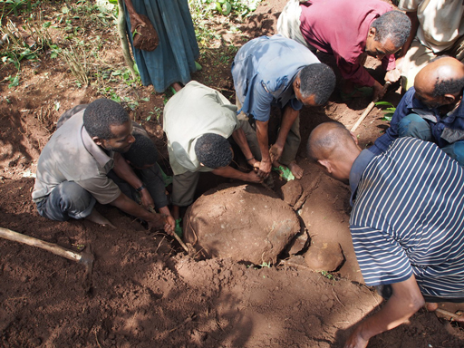
Figure 12.1 Community members in Yiganda, Zegie, near Bahir Dar, excavate trenches as they prepare for water pipes to be laid.

12.2.5 Water utility earnings
Contributions from urban residents are through water service charges that provide earnings for the water utilities. The water utilities measure how much water is used by their customers and charge them accordingly (Figure 12.2). They contribute to the OWNP from these earnings.
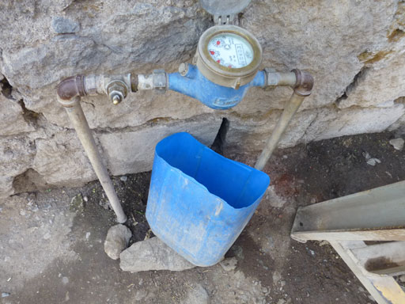
Figure 12.2 A water meter in the yard of a household. Regular meter readings measure the volume of water used and are used to calculate the payment due to the water utility.

12.3 Fund flow and channelling funds
The financial systems of Ethiopia are generally categorised into three ‘channels’, described in Box 12.1.

Box 12.1 Donor funding channels
Channel 1 is ‘on-budget’ and is managed by MoFED, regional Bureaus of Finance and Economic Development (BoFEDs) and woreda Finance Offices. ‘On-budget’ means included in the national annual budget description. Channel 1 is further divided into:
- Channel 1a: funds are transferred through MoFED to regional BoFEDs, and then to WASH sector bureaus and offices
- Channel 1b: also through MoFED but funds go directly to WASH sector bureaus and offices.
Channel 2 funds are made available directly to the WASH sector ministries (MoWIE, MoH, MoE) and then to their respective bureaus and offices at lower levels. Channel 2 is also ‘on-budget’.
Channel 3 funds are directly transferred by donors and aid agencies to service providers and the donor retains financial control. Channel 3 funds are ‘off-budget’, meaning they are outside the control of government and are not included in the national annual budget.

The preferred fund flow for the OWNP uses Channel 1b through the Consolidated WASH Account (CWA). The creation of the CWA marked a major change in fund flow for WASH activity that came about as part of the OWNP. The CWA, as you first read in Study Session 1, is a unified funding channel which allows all funds from major donors to be deposited in one bank account. The CWA provides a mechanism for all the major donors (fund contributors) to pool their resources. This simplifies the fund allocation process and avoids the fragmentation between different donors and programmes, a significant problem in the past. The CWA is opened and controlled by MoFED. Any transfers from the fund are controlled by MoFED, based on the rules and regulations of the government.
The CWA is a very important aspect of the One WASH approach. In the past, overseas donors would each have separate accounts in their own currency. It is a significant change that the CWA is a birr account. This means all WASH funds in any foreign currency contributed from development partners are changed into Ethiopian currency (birr) before being disbursed and used by implementing organisations. CWA funds are therefore considered to be government funds and are not linked to the identity of the fund source.
The term ‘non-CWA’ is applied to all funds that are not pooled in the CWA. Non-CWA fund contributors give their commitments directly to the implementing organisations at federal, regional or woreda levels. In this situation, the government financial management system is not applied.
- In Study Session 9 you learned about the different types of stakeholder in the OWNP. Based on the flow of funds, how would you categorise the stakeholders channelling funds through the CWA and those outside the CWA?
- Major stakeholders channel funds through the CWA and associated stakeholders channel theirs outside the CWA.
The relationship between the funding channels described in Box 12.1 and the CWA, and how this fits into the overall picture of finance in the OWNP is shown in Figure 12.3. As you can see, the CWA is only a part of the overall funding system for the OWNP. Significant contributions to the OWNP budget also come through Channels 1a, 2 and 3.
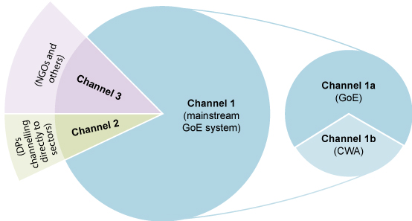
Figure 12.3 Financing of the OWNP. The CWA is part of a much bigger financing system.

12.3.1 Flow of funds through the CWA
There are two main stages in the flow of funds from Development Partners through the CWA, which are, simply, in and out. These two stages can be broken down into six steps:
Step 1: Development Partners (DPs) establish bilateral agreements with MoFED.
Step 2: DPs inform MoFED of their annual contribution.
Step 3: DP contributions are channelled to foreign currency special accounts at the National Bank of Ethiopia for each DP.
Step 4: DPs’ contributions are transferred from each foreign special account into the Consolidated WASH Account (birr).
Step 5: MoFED disburses funds into WASH accounts established for the implementing agencies at federal and regional levels.
Step 6: On instruction from MoFED, the National Bank of Ethiopia transfers funds to the three WASH sector Ministries (MoWIE, MoH and MoE) and MoFED for federal level expenditures. The Bank also transfers funds to BoFEDs for onward transfer into accounts opened for the three WASH sector Bureaus and BoFED for regional level expenditures. Where applicable, zonal finance offices will receive funds from BoFED for WASH expenditure at zonal level. At woreda level, woreda finance offices will open a bank account to receive funds from BoFED for Woreda WASH Team expenditure, including disbursement to WASHCOs.
Figure 12.4 summarises these main steps in the flow of funds through the CWA.
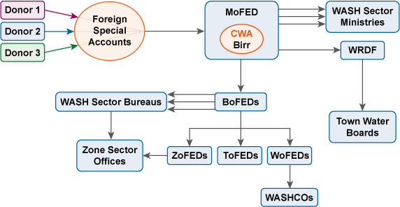
Figure 12.4 OWNP fund flows through the CWA. (OWNP, 2013)
To give an example of how this system operates: World Bank Ethiopia has given US$205 million to the Ethiopian government to increase the provision of water supply and sanitation services. From the total budget, US$43 million is allocated to WRDF for the construction of WASH facilities for medium-sized towns. MoFED opened a dollar account for the World Bank and received this budget, then changed this to birr and deposited in the CWA. Based on requests made through approved consolidated plans, MoFED disbursed this budget to WRDF and the other federal and regional implementers, down to woreda level.

12.4 Responsibilities for financial management
Each level of government has specific financial management responsibilities as outlined below.

12.4.1 Financial management at federal level
Responsibility for the overall financial management system of the Programme at federal level lies with MoFED. They are responsible for opening foreign currency accounts to receive funds from donors and then transferring these funds into the CWA. From the CWA, funds are transferred by MoFED to special accounts opened for the other three WASH Ministries (MoWIE, MoH, and MoE) and the regional BoFEDs on the basis of approved plans and budget reports.
All BoFEDs and the WASH sector ministries are responsible for reporting to MoFED on all OWNP financial matters. Based on these reports, MoFED prepares a single consolidated report and distributes this to the Development Partners and other stakeholders.

12.4.2 Financial management at regional level
The regional BoFEDs are responsible for managing government and CWA funds at regional level. They have a number of specific tasks, including opening regional, zonal and woreda bank accounts at the nearest area branch of the Commercial Bank of Ethiopia and transferring funds for OWNP implementation. (Note that the National Bank of Ethiopia is used for accounts at federal level and the Commercial Bank of Ethiopia at regional and lower levels.) They also provide technical support to the implementers to ensure that proper accounting systems are established and competent accounting staff employed. They are responsible for preparing and submitting regional financial reports to MoFED and to regional government.

12.4.3 Financial management at woreda level
Woreda offices of Finance and Economic Development (WoFEDs) have similar responsibilities for proper accounting systems and competent accounting staff at woreda level. As a member of the Woreda WASH Team (WWT), the WoFED assists the WWT in the planning and budgeting process. They collect and aggregate the required financial data and information and submit reports to the Woreda Administrative Council (Cabinet) and BoFED.

12.4.4 Financial management at town level
As you learned in Study Session 10, towns are categorised into three levels:
- What are the three categories of town?
- Towns that have utilities managed by a Water Board, towns with utilities but without a Water Board, and those with only WASHCOs.
Larger towns in the first two categories with populations greater than 20,000 receive funds by loan through the Water Resources Development Fund (WRDF). Towns with a population of fewer than 20,000 receive funds by grant through the relevant BoFED. These two funding arrangements for towns are further described below.
Loan financing
Water utilities are directly responsible for opening a special bank account to receive loans from the WRDF and must have proper accounting systems in line with government policies and procedures. (You learned about the WRDF in Study Session 9.) They also collect and aggregate required financial data and report regularly to the WRDF. Like the federal WASH sector ministries, the WRDF is responsible for reporting to MoFED on all financial matters with respect to towns financed through loans under the Programme.
Grant financing
The grant component for urban WASH projects may be transferred in two possible ways. One option is from BoFED to the town’s Finance and Economic Development office (ToFED). The other is for the region or zone to control funds on behalf of the town, which may be the case if the town does not have the capacity to do this for themselves. If small towns recognise that they lack capacity to implement the WASH fund, they can assign the regional or zonal WASH bureaus to take on this role. They will request BoFED to transfer the grant amount to the regional or zonal water sector institution to implement their activities.
Any grant transferred from BoFED to the ToFED office is disaggregated into water supply and sanitation components based on the approved budget. The grant for water supply improvement is transferred to the water utility, if there is one. Other WASH components (sanitation and hygiene) are managed by the Town Finance and Economic Development office.

12.5 Budget preparation
Budget preparation means drawing up a detailed plan that sets out all the activities of a project and allocates an amount of money, the forecast expenditure, against each item. A budget is an essential part of planning for the implementation of projects and programmes so that future costs are fully understood. As noted in Section 12.1, budget preparation is an important component of good financial management.
For the OWNP, each implementing agency starting at woreda level is required to prepare a work plan with a related budget for each budget year and send it to the next higher level for review, approval and consolidation. The Regional WASH Coordination Office (RWCO) is responsible for consolidating the regional budget from all regional implementers and for getting it approved by the Regional WASH Steering Committee (RWSC) before submission to the National WASH Coordination Office (NWCO). The NWCO prepares a consolidated budget for all regional and federal implementing ministries and submits this to the National WASH Steering Committee (NWSC) for approval.
- Think back to Study Session 7 where the organisational relationships of the OWNP were described. What types of relationship are demonstrated by these budget approval processes?
- The RWCO has a horizontal relationship with the RWSC and a vertical relationship with the NWCO, to which it submits the budget for approval. The NWCO and NWSC are both at national level and so have a horizontal relationship, but the NWSC has overall responsibility for the OWNP so there is also an element of vertical relationship between them.
Budgeting takes place based on forms and procedures designed by MoFED. Sector offices at all levels from federal ministries to woreda offices are responsible for requesting WASH budgets from the level above them. This is based on a comprehensive resource mapping of all resources available to WASH at the given level, i.e. federal, regional, zonal or woreda/town.

12.6 Financial reporting
The purpose of financial reporting is to provide information about the OWNP that is useful to participants, both for accountability and for decision making. As described in Section 12.1, financial reports should compare actual expenditure with the budget that was set. The OWNP requirements are that financial reports should be prepared and submitted quarterly (four times a year) by WoFED, BoFED and MoFED. WoFED reports to BoFED and BoFED reports to MoFED. MoFED compiles these reports and submits a consolidated report to its development partners. The financial reporting at each level provides information to the fund providers on how much of the budget has been spent over the specified time period and for what purposes. This is used to inform the decisions about setting budgets and the disbursement of funds for the following phase.
Disbursement of funds by MoFED and BoFEDs to the implementing agencies follows a regular pattern. Initially, each implementing agency receives a first quarter and second quarter advance based on its approved annual work plan and budget. At the end of the first quarter (three months), the agency prepares a report on expenditure during that quarter, together with a request for replenishment of the funds to cover the amount budgeted for the third quarter, less the amount of unused funds from the first quarter. This ‘rollover’ system means that implementing agencies always have in hand their budget for the forthcoming quarter. The system is shown diagrammatically in Figure 12.5.
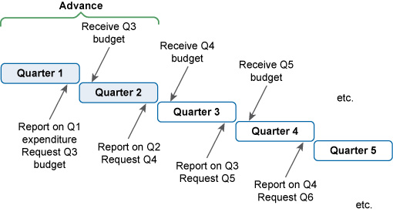
Figure 12.5 Quarterly financial reporting and funding system. (Q5 and Q6 are the first and second quarters of the next financial year.) (WIF, 2011)
To give an example, imagine that a region has a 4 million birr budget (one million birr for each quarter) for the current year to implement WASH activities in their region. Based on the approved budget plan, the region has received 2,000,000 birr for the first two quarters (six months) to fund the initial phase of the programme. After three months, the regional BoFED compiles a financial report on funds used by the regional water, health and education bureaus. Let’s say this compiled report of all first quarter expenditure was 650,000 birr. BoFED reports this figure to MoFED and asks them to disburse the 1,000,000 birr for the third quarter. However, MoFED deduct the unspent 350,000 birr from this figure, and therefore disburses only 650,000 for the third quarter instead of one million birr.
The complete process of reporting is illustrated in Figure 12.6.
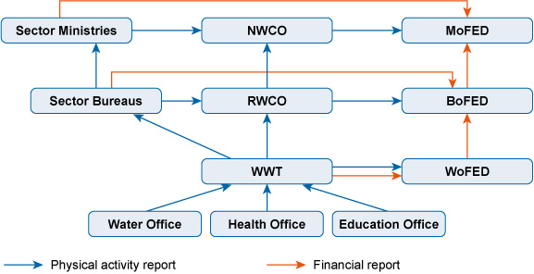
Figure 12.6 Financial reporting arrangements. (POM, 2014)
This diagram shows the interconnections between the upwards reporting on WASH activities undertaken by the implementing agencies and how this feeds into the financial reporting from the woredas and regions to MoFED.

Summary of Study Session 12
In Study Session 12, you have learned that:
- Good financial management requires a planning and budgeting system, book-keeping and accounting, internal control mechanisms and financial reporting and auditing processes.
- The financial management of the OWNP is governed by policies, strategies, manuals and guidelines developed by the Ministry of Finance and Economic Development (MoFED). This also assures the alignment principle of the OWNP.
- OWNP funding comes from the government of Ethiopia, external financing agencies (development partners), non-governmental organisations (NGOs), participating communities in rural areas, and water utilities’ earnings.
- Channelling of funds from the Consolidated WASH Account is through MoFED, BoFEDs and WoFEDs. Other sources, such as NGOs, either give directly to the implementing organisations or are implementers themselves.
- For urban WASH, funds are transferred to towns based on their population. Large towns with populations greater than 20,000, have utilities with a Water Board and receive funds by loan through the Water Resources Development Fund. Towns with a population of fewer than 20,000 receive funds by grant.
- MoFED is responsible for receiving funds from the development partners, opening foreign and birr accounts and the overall financial management system of the OWNP. BoFEDs, WoFEDs and ToFEDs also have responsibility for managing at their own levels.
- Financial reports start at woreda level. These should include information on expenditure of all funds from different sources which are consolidated, reported to BoFED and then to MoFED.

Self-Assessment Questions (SAQs) for Study Session 12
Now that you have completed this study session, you can assess how well you have achieved its Learning Outcomes by answering these questions. You can check your answers with the Notes on the Self-Assessment Questions at the end of this Module.

SAQ 12.1 (tests Learning Outcome 12.1)
Identify the terms being described in the following sentences:
- All the continuing costs of running an organisation or programme, of which staff salaries are usually the largest component.
- An allocation of funds, usually on an annual basis, from federal to local levels of government.
- Funds that are outside the control of government and are not included in the national annual budget.
- Banking facility when all WASH funds in any foreign currency contributed from development partners are changed into Ethiopian currency (birr) before being disbursed and used by implementing organisations.
- The costs of new programmes and projects that only occur once. They include design, construction and commissioning costs.

SAQ 12.2 (tests Learning Outcome 12.2)
From the following list, identify which are possible sources of funding for implementing the OWNP.
- Water utility earnings
- Communities
- Development partners/non-governmental organisations
- Government
- All of the above.

SAQ 12.3 (tests Learning Outcome 12.3)
Which one of the following statements about the flow of Consolidated WASH Account funds is correct?
- From MoFED to WASH sector ministries and BoFED, then from BoFED to WASH sector bureaus and WoFED.
- From MoFED to WASH sector ministries and BoFED, then from WASH sector ministries to WASH sector bureaus.
- Both are correct.

SAQ 12.4 (tests Learning Outcome 12.4)
- What is the role of the Ministry of Finance and Economic Development in the financial management of OWNP at the federal level?
- What is the difference between CWA funds and non-CWA funds?

SAQ 12.5 (tests learning Outcome 12.5)
Which one of the following statements about the financial reporting of Consolidated WASH Account funds is correct?
- Reports are sent from WoFED to WASH sector ministries and to BoFED, then from BoFED to regional WASH sector bureaus and MoFED.
- Reports are sent from WoFED to BoFED, and from regional WASH sector bureaus to federal sector ministries, and then to MoFED.
- Reports are sent from WoFED and from regional WASH sector bureaus to BoFED, then from BoFED to MoFED who also receive reports from federal WASH sector ministries.

Study Session 13 Key Aspects of Programme Management in the OWNP

Introduction
By this stage in your study of the Module, you should be well aware of the complexities of the OWNP. You have already learned about many aspects of programme management, for example the management structure (in Study Session 7) and the financial management approach (Study Session 12). In this study session we have selected some particularly important aspects of programme management for closer examination.
Following on from Study Session 12 and its discussion of financial management, we start with an explanation of the role and processes of procurement in the delivery of the OWNP. However, the main focus for this study session is monitoring and evaluation (M&E). These two closely related processes are critical aspects of all projects and programmes. You will learn about the principles behind M&E and how these are planned and applied in the OWNP. We describe the role of the National WASH Inventory in M&E and explain how this links to the WASH Management Information System. The final section explains how the OWNP’s overall targets for WASH improvement are detailed in the results framework and how progress towards achieving the targets is measured.

Learning Outcomes for Study Session 13
When you have studied this session, you should be able to:
13.1 Define and use correctly all of the key words printed in bold. (SAQs 13.1, 13.5 and 13.6)
13.2 Outline procurement processes in the OWNP. (SAQ 13.2)
13.3 Explain why and how monitoring and evaluation is incorporated in the OWNP. (SAQs 13.3 and 13.4)
13.4 Describe the National WASH Inventory and the link to the WASH Management Information System. (SAQ 13.5)
13.5 Explain the use of the results framework and key performance indicators (KPIs) in the OWNP. (SAQ 13.6)

13.1 Procurement in the OWNP
Procurement can be simply defined as buying or obtaining goods and services. You could say that shopping for everyday goods is a type of procurement. In programme management, however, procurement is a more complex process that needs to be undertaken carefully to ensure money is well spent. All implementing units of the OWNP need to adopt appropriate procurement processes in order to obtain the necessary goods and services they need, from buying hardware such as pumps, tanks and IT equipment to contracting services with consultants and artisans (Figure 13.1).
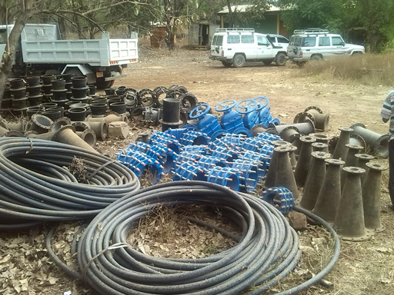
Figure 13.1 Procurement of pipes and fittings is part of most water supply projects.
For anything other than simple purchases of inexpensive items, there are several necessary steps in any procurement process:
- Planning and preparation: e.g. identifying a need for something, considering when you need it and ensuring that you have the finance available, etc.
- Specification: written details of the item(s) to be purchased or service(s) required.
- Identifying and selecting suppliers: finding out who can supply the goods/service(s) and at what price. In some situations, formal procurement processes are applied that require quotes from a minimum number of suppliers so that a sensible comparison can be made between them and that the best choice is made in terms of value for money and quality.
- Decision: decide which supplier to choose, considering all relevant factors including quality and reliability as well as price; place the order.
- Delivery: Receive the goods or, for procurement of services, manage the ongoing contract until the work is completed.
For a lot of WASH projects, there are many different types of goods and services required that all need to be available at the right time and in the right order. It can be costly and inconvenient if a project is delayed because an essential component is late being delivered. This means the steps in the procurement process with different suppliers have to be coordinated and aligned with the required schedule, which adds to the challenge.
Some examples of the types of procurement required by the Programme are shown in Table 13.1.
Table 13.1 OWNP procurement: Selected examples of services, works and goods that will be required to implement the OWNP. (Adapted from OWNP, 2013)
Category | Provided by | Examples
Services | Service providers, including artisans, at woreda level | - Post-construction support to communities  - Community mobilisation and training of WASHCOs
 | Consultants (firms or individuals) at regional and national level | - Build capacity of Woreda WASH Teams, prepare WASH plans  - Hydrogeological investigations including borehole siting  - Planning, feasibility study and design for water supply schemes
Works | Contractors | - Construction of new hand-dug wells and installation of pumps  - Drilling boreholes and installation of hand pumps/distribution systems  - Construction of institutional and public sanitation facilities
Goods | Woreda-level suppliers including artisans | - Hand pumps and spare parts  - Construction materials  - Sanitation materials, e.g. latrine slabs
 | Regionally based suppliers | - Office supplies  - Pipes and fittings  - Generators with accessories.
Procurement is therefore a complex process requiring the people responsible to have a range of skills and knowledge. In the OWNP, procurement and contract management have been identified as major constraints in implementing WASH activities because of past inefficiencies. To try to overcome this problem, the Programme will use standardised systems and procedures to ensure good practice is followed. For procurement of services, works, and goods, the ministries, regional bureaus and woreda offices use standard bidding and contract documents which comply with government rules and regulations. Guidelines and manuals for procurement have been prepared to support the process and to advise on correct and efficient procedures. As an illustration, if you were the person responsible for procurement, one option you might consider is packaging a group of services into one contract to make savings and improve efficiency. For example, the design and supervision of four or five water supply schemes or construction of latrines for several schools or health facilities could be packaged as one contract which could be less costly and more efficient than several separate contracts (OWNP, 2013).
For major contracts, competitive bidding procedures are used. Competitive bidding is where several service providers compete with each other to bid for the work. A specification for the required work is advertised and service providers submit proposals that describe how they propose to do the work, the timescale and how much it will cost. These bids are compared and evaluated, and the contract awarded to the winner of the competition, i.e. the provider with the best proposal. For the OWNP, there are specified procedures to be followed for very large, high-cost projects. Depending on the overall value of the contract, they require either national or international competitive bidding.
At the other end of the scale, at local level, woredas, towns and communities also have responsibility for procurement. Based on the government policies of decentralisation and devolving responsibility, WASH procurement should be carried out as far as possible at the level where goods are utilised and services are delivered. Employing people who are skilled in procurement processes at the local level will:
- minimise delays in delivering goods or services and the resulting costs
- increase the sense of ownership and management capability among communities
- encourage entrepreneurship and strengthen the supply of spare parts
- further advance and modernise the sustainability of operations and maintenance.
To this end, the community-managed project (CMP) approach is actively promoted. In this modality, the procurement of materials required for water point construction is carried out by the WASHCOs themselves or by artisans contracted by the WASHCO. Similar principles also support the self-supply approach, where households directly provide or procure the labour and materials for the construction or maintenance of their hand-dug wells and sanitation facilities.
Keeping records of procurement processes and reporting on expenditure is part of the financial management system you read about in Study Session 12. This is also part of the essential monitoring of overall progress towards achieving the aims of the programme, which is the main focus of this study session.

13.2 Monitoring and evaluation in the OWNP
Monitoring and evaluation (M&E), first introduced in Study Session 7, are critically important aspects of planning and management of any programme. Monitoring is the systematic and continuous assessment of the progress of a piece of work over time, in order to check that things are going to plan. Evaluation is an assessment of the value or worth of a project or programme and the extent to which the stated objectives have been achieved. Evaluation is not continuous and usually takes place periodically through the course of project/programme, or after completion. Together, monitoring and evaluation are a set of processes designed to measure the achievements and progress of a project or programme. The two terms are closely connected and are frequently combined, and therefore the abbreviation M&E is widely used.

13.2.1 What is M&E?
An effective M&E system measures the outputs, outcomes and impacts resulting from the implementation of a project or programme (see Box 13.1). To provide useful knowledge, these results need to be compared with the situation before the project/programme started, which requires baseline data. Baseline data gives information about the situation at the start of a project and provides a point of comparison against which future data, collected as part of a monitoring process, can be compared. Overall progress can be evaluated by comparing the two.
Monitoring requires regular and timely feedback in the form of reports from implementers to project managers so they can keep track of progress.
- What two types of report are submitted upwards from implementers to managers in the OWNP?
- Implementers submit WASH reports of physical activities undertaken and financial reports.
These reports provide information about activities and what has been achieved in terms of outputs, and the financial reports give information on budgets and expenditure. Managers can use this information to assess progress and plan the next steps for their project.

Box 13.1 Outputs, outcomes and impacts
There are several words used in M&E that can be confused. They sound similar but have important differences in their meaning.
Outputs are the things produced by the project or programme. In WASH, examples include tangible products like new or rehabilitated wells and pumps, new water supply systems, new latrines and training manuals; they could be events and activities like running a training workshop for technicians, CLTSH promotion in a kebele, or producing hygiene promotion posters (Figure 13.2).
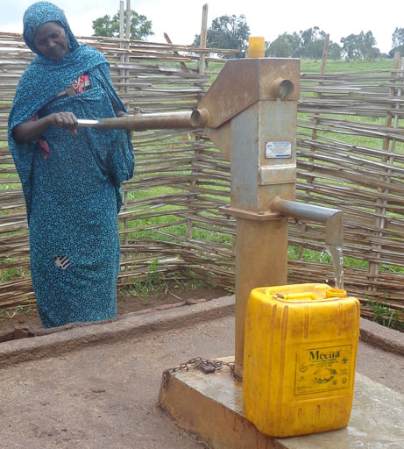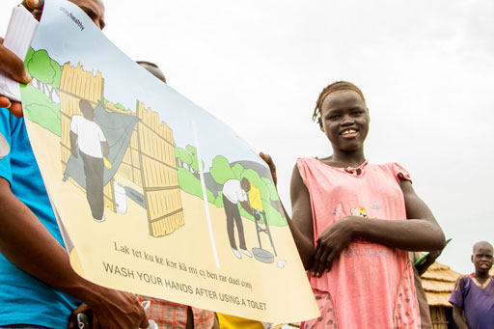
(a) (b)
Figure 13.2 Outputs from WASH projects include (a) water points and (b) hygiene promotion materials.
Outcomes are the effects of the outputs, usually in the short- to medium-term. Examples following those above, could be the number of people who now have access to safe water as a result of the new water schemes, attendance at the training workshop or the number of communities that achieve ODF status.
Impacts are long-term effects and consequences. Examples could be a fall in the incidence of diarrhoeal disease, improved school attendance and pumps that last longer because they are well-maintained.

13.2.2 Why is M&E so essential?
A well-managed M&E system will:
- Track progress: M&E assesses inputs (expenditure), outputs and outcomes, which enables managers to track progress towards achieving specific objectives. For the OWNP, at national level this means progress towards meeting the UAP targets.
- Measure impact: M&E reduces guesswork and possible bias in reporting results by asking questions such as: What is the impact of the programme? Are the expected benefits being realised? Is health improving? Is school enrolment rising? Is the use of facilities and services increasing? Is community management expanding?
- Increase accountability: M&E can provide the basis for accountability if the information gathered is reported and shared with users and other stakeholders at all levels.
- Inform decision making: M&E provides evidence about the successes and failures of current and past projects that planners and managers need to make decisions about future projects. It should also encourage reflection on lessons learned in which managers ask themselves: What worked well in this project? What mistakes did we make? How can we do this better?
- Encourage investment: a good M&E system builds trust and confidence from government and donors which will increase possibilities of further investment.
- Build capacity: a good M&E system supports community participation and responsibility. It encourages the user communities to look regularly at how well their water schemes are working, what changes need to take place in hygiene and sanitation behaviours, what health benefits are resulting and what more needs to be done. It enables a community to build its own capacity, recognise its own successes and record them regularly.
Reporting on monitoring activity is essential, otherwise the information cannot be used. It is no use collecting data and then filing it away without sharing it (Figure 13.3). As noted above, one of the reasons for undertaking M&E is to inform decision makers and enable lessons to be learned–therefore they need to be provided with the information in a timely way for that benefit to happen.
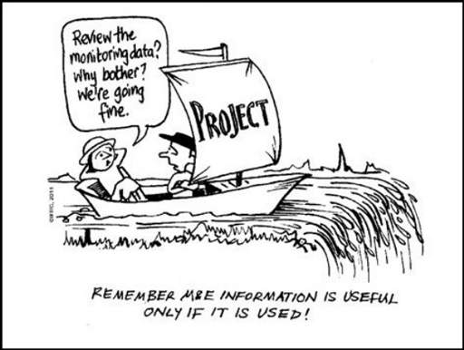
Figure 13.3 Why M&E is important.

13.2.3 Who manages WASH M&E?
The WASH M&E system is managed by the coordination offices at national and regional levels and by WASH teams at woreda and kebele levels. Figure 13.4 shows the lines of communication. The two-directional arrows between the boxes indicate the links from woreda to national level are both upward in reporting to the higher levels and downwards as evaluation of the programme is incorporated in implementation.
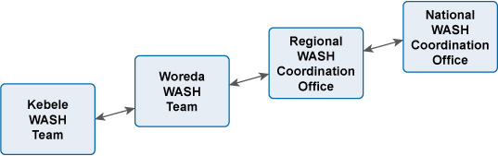
Figure 13.4 Flow of WASH M&E information. (WIF, 2011)
WASH progress reports include information about physical activity and financial status and information about progress towards meeting planned targets and providing value for money. There are also regular review meetings at the various levels to consider the progress reports. These range from kebele WASH team meetings with all local WASH stakeholders to national level forums.
- What are the two main WASH review meetings at national level?
- The Multi-Stakeholder Forum and Joint Technical Reviews. (You read about these in Study Session 11.)

13.2.4 What is monitored in WASH?
An enormous amount of information is gathered in the regular WASH monitoring process. The following includes only a selection of the types of data collected.
Water supply monitoring includes:
- location, number, type and current functionality status of water schemes/utilities both in rural and urban areas
- number and percentage of community users and the levels of service
- level of satisfaction of user communities
- quality of scheme/utility management and the level of financial sustainability
- level of accessibility to spares and repairs for operations and maintenance
- achievement of construction and rehabilitation targets.
Sanitation and hygiene monitoring includes:
- number of households with unimproved latrines or better
- number of households/people using a latrine – and number practising open defecation
- number of households/people with handwashing facilities near to a latrine
- number of households/people practising handwashing after defecation or handling children’s faeces.
Institutional WASH monitoring includes:
- types, functionality and use of drinking water sources either in or near school/institution compounds
- types, number and use of latrines and handwashing facilities in schools/institutions.
This data, together with the physical and financial WASH reports and household survey data is collected in the National WASH Inventory and related Management Information Systems, which are described in the next section.

13.3 National WASH Inventory and WASH Management Information System
The National WASH Inventory (NWI) was introduced to you in Study Session 3 as an integrated record of water supply, sanitation and hygiene service coverage data in Ethiopia. Its purpose was to establish, for the first time, a single comprehensive set of baseline data for the whole country. The first phase of the NWI, in 2010/2011, was a major undertaking, as you can see from the figures in Box 13.2. Financing came from federal and regional governments and development partners. It required surveying of more 730 woredas and 16,000 kebeles and involved approximately 70,000 data collectors, known as ‘enumerators’.

Box 13.2 National WASH Inventory: facts and figures
70,000 enumerators inventoried:
- 92,588 rural water supply schemes
- 1,605 town water supply schemes
- 30,000 schools
- 20,000 health institutions
- 12 million households.
Total cost: more than 100 million birr (which equalled US$ 5.3 million in 2013).
(Welle, 2013)

In the early phases, the data collection methods relied on paper-based surveys. Enumerators visited all rural community water schemes and urban water supply systems. Each water point was identified according to its geographical coordinates and information was collected on functionality, number of users and other details outlined above in Section 13.2.4. There were also household visits to survey WASH access and behaviours.
The paper-based system was found to be time-consuming, expensive and unreliable so, in a second phase in 2013/14, data from the Somali Region was collected using smartphone technology (Figure 13.5). Specially-trained enumerators visited households and water points to gather data which they recorded directly on their mobile phones using previously uploaded survey forms (Tatge, 2014). They saved the exact GPS location of water points and could take pictures too. Data from many sites could be collected and stored on a single phone, then later transferred via the internet (access permitting) to a database located on a server.
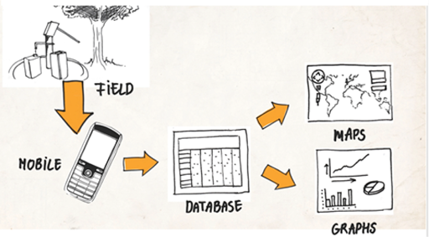
Figure 13.5 Mobile phones can be used to collect WASH data.
The enormous amount of data generated by an inventory of the size and scale of the NWI presents major challenges in organising, collating and storing it in a systematic and accessible way. This is the purpose of the WASH Management Information System. A management information system (MIS) is a computer-based system that provides managers with tools for collecting and organising information so that it supports their decision making. A MIS is used to record, process, integrate and store relevant data in such a way that it can be updated regularly and accessed by managers and other relevant stakeholders.
The WASH MIS is designed to be a repository for monitoring data and to enable production of reports at national, regional, zonal and woreda levels. The idea is that data can be extracted, collated with other data, and used to produce reports, graphs and maps to facilitate all aspects of programme management.
Two issues have been identified that affect the value of the NWI to WASH stakeholders: how to make the NWI results accessible to those who need them, and how to keep the data current (Welle, 2013). NWI data is currently in a database (using the Microsoft Access system) designed to enable data entry at regional level for the purpose of regular updating. However, to maximise its value, access should also be available to woreda staff. This requires the procurement of computers and staff training in database management. Making the data available in Excel format would make it more accessible to users, which could facilitate both regular updating of the system and the production of maps and other output reports. Despite these current limitations, the NWI and WASH MIS are significant steps towards achieving harmonised and aggregated data management and access by different stakeholders for informed planning and decision-making processes.

13.4 Results framework and key performance indicators
M&E is about measuring progress towards achieving the stated objectives of a programme. For the OWNP, the objectives are itemised in a results framework which sets out in detail the outputs, outcomes and impacts for each component of the Programme. A results framework is a compilation, usually in a diagram or table, of the expected results from a project or programme. It presents a summary picture of the main targets.
The OWNP results framework includes specific targets for the four components of the Programme. As an illustration, Table 13.2 is a small extract from the OWNP results framework that shows the target outputs for improved water supply for the three main components.
Table 13.2 Extract from the OWNP results framework showing the number of new facilities the Programme aims to provide. (OWNP, 2013)
Rural and pastoralist WASH
55,865 conventional and 42,529 self-supply water facilities constructed
20,010 water schemes rehabilitated
Improved functionality of water supplies
Urban and peri-urban WASH
777 feasibility study and design reports prepared
777 water supply systems constructed/rehabilitated/expanded
Institutional WASH
22,342 primary and 643 secondary school improved water supply facilities provided
7772 water supply facilities constructed in health institutions
The complete results framework has similarly precise targets for other intended outcomes of the Programme (see OWNP, pp.144–148).
- Why is a results framework useful for M&E?
- One of the purposes of M&E is for tracking progress towards meeting project targets so a results framework helps by clearly showing what those targets are.
The people and organisations responsible for monitoring use indicators to assess how well a project is doing and to what extent targets have been met. An indicator is something that can be seen or measured or counted, which provides evidence of progress towards a target. The terms ‘performance indicator’ or key performance indicator (KPI) are often used by organisations to describe the most important measures of their performance in terms of meeting their strategic and operational goals.
The OWNP has different KPIs for different aspects of the programme. There are KPIs for access to water, functionality of water supply schemes, water quality, access to sanitation, access to handwashing facilities, WASH provision in schools and health facilities, management, gender representation, equity, capital costs and O&M costs. To illustrate the KPIs, we have selected an extract from the OWNP Programme Operational Manual, reproduced in Table 13.3. This shows the data required at woreda or town/city level to assess one performance indicator for WASH provision in schools. The indicator is the percentage of schools with improved access to water supply with at least one tap for every 50 students.
Table 13.3 Performance indicator: ‘Percentage of schools with improved access to water supply – ratio of tap to student 1:50’. Data collection required at woreda and town/city level. (POM, 2014)
Parameter | Required data | Data collected
Input | Procurement of contractor for:  School WASH facility construction that takes women, girls and disabled groups’ preferences into consideration | Progress in the procurement process for each bid
 | Rehabilitation of water supply facilities and latrines at primary and secondary schools | Stages of construction: percentage completion of rehabilitation of WASH facility at primary and secondary schools for each contract
 | Construction of new water supply facilities and latrines at primary and secondary schools | Stages of construction:  %age completion of new construction of WASH facility at primary and secondary schools for each contract
Output | Rehabilitated water supply facilities at primary and secondary schools | Number of schools with existing water supply facilities rehabilitated
 | New water supply facilities at primary and secondary schools | Number of schools with new water supply facilities
Outcome | Improved access to water supply in schools – ratio of tap to student of 1:50. | Number of schools having access to water supply with a tap to student ratio of 1:50.
You should be aware that the extract in Table 13.3 is just a very small part of the full range of data collection required for monitoring of the OWNP implementation and progress towards meeting the targets. As you will realise from your study of this Module, the size and scale of the OWNP means that M&E of its progress and achievements will be a significant and continuing activity into the future.

Summary of Study Session 13
In Study Session 13, you have learned that:
- Procurement of a wide range of goods, services and works is an important part of WASH programme management.
- Procurement processes can be complex and require appropriately trained staff. Guidelines, manuals and standard procedures are available to support people responsible for procurement.
- Monitoring and evaluation (M&E) is a critical component of all projects and programmes.
- M&E is intended to track progress, measure impact, increase accountability, inform decision making, encourage investment and build capacity.
- All levels of the OWNP organisational structure have some responsibility for M&E.
- Data on many aspects of WASH access and behaviour is collected as part of the M&E process.
- The National WASH Inventory and WASH MIS are data collection and management systems to provide comprehensive data on WASH in Ethiopia and are designed make the data accessible to stakeholders.
- The OWNP results framework sets out the targets for the programme. KPI data is compared with the framework to assess progress towards meeting the targets.

Self-Assessment Questions (SAQs) for Study Session 13
Now that you have completed this study session, you can assess how well you have achieved its Learning Outcomes by answering these questions. You can check your answers with the Notes on the Self-Assessment Questions at the end of this Module.

SAQ 13.1 (tests Learning Outcomes 13.1 and 13.3)
Fill in the blanks in the following sentences:
……………… is the systematic and continuous assessment of the progress of a piece of work over time, in order to check progress.
……………… is an assessment of the value or worth of a project or programme and the extent to which the stated objectives have been achieved.
Something that can be seen, measured or counted, providing evidence of progress towards a target, is called an ………………
The things produced by a programme or project are known as ……………… and their short- to medium-term effects are called………………
Impacts are the long-term effects and ……………… of a programme or project.
In ……………… bidding, several service providers submit bids for the same piece of work.

SAQ 13.2 (tests Learning Outcomes 13.1 and 13.2)
Here is a jumbled up list of the main steps in a procurement process. Rearrange them so they are in the correct order and briefly explain what happens at each step.
- Specification
- Delivery
- Plan and prepare
- Identify and select suppliers
- Make decision

SAQ 13.3 (tests Learning Outcome 13.3)
Give four examples of reasons why M&E is essential.

SAQ 13.4 (tests Learning Outcome 13.3)
Listed below are some of the types of data collected to monitor the OWNP. Group the items in this list according to whether they are water supply monitoring, sanitation and hygiene monitoring, or institutional WASH monitoring.
- Number of households/people using a latrine and number practising open defecation.
- Types, number and use of latrines and handwashing facilities in a school.
- Location, number, type and current functionality status of water schemes.
- Types, functionality and use of drinking water sources either in or near a school.
- Achievement of construction and rehabilitation targets.
- Quality of scheme/utility management and the level of financial sustainability.
- Number of households with unimproved latrines or better.
- Number of households/people with handwashing facilities near to a latrine.
- Number of households/people practising handwashing after defecation or handling children’s faeces.

SAQ 13.5 (tests Learning Outcomes 13.1 and 13.4)
- What is the National WASH Inventory and why was it established?
- What are the two key challenges that are identified for the National WASH Inventory?
- What is the purpose of the WASH MIS?

SAQ 13.6 (tests Learning Outcomes 13.1 and 13.5)
Why does the OWNP use a results framework and key performance indicators as well as monitoring and evaluation?

Study Session 14 OWNP Planning and Budgeting

Introduction
Every project or programme has its own planning process and financial requirements. In Study Session 12 you learned about the source of funds for the full implementation of the OWNP, namely the government, NGOs and communities. In Study Session 13 you learned about the planned results for new and rehabilitated WASH facilities. In this study session we bring these facets together and you will learn about the processes of how activities are planned and the budgets estimated to enact the OWNP and achieve the intended results.

Learning Outcomes for Study Session 14
When you have studied this session, you should be able to:
14.1 Define and use correctly all of the key words printed in bold. (SAQ 14.1)
14.2 Describe the planning process of the OWNP and give examples of planned WASH improvements. (SAQs 14.2 and 14.3)
14.3 Outline the different types of plan used in the planning framework of the OWNP. (SAQ 14.4)
14.4 Summarise the overall costs and benefits of the OWNP. (SAQs 14.2, 14.3 and 14.5)

14.1 Introduction to planning
Planning is an essential activity for any organisation that wants to succeed and achieve its objectives. In spite of this, it is an aspect of management that is often neglected or performed in a less than adequate fashion. Planning is the systematic process of establishing a need and then working out the best way to meet it. It is a process through which we decide objectives and activities, with their sequences and resources.
Planning answers six basic questions about any intended activity:
- What? (the goal or goals)
- When? (the timeframe in which it will be accomplished)
- Where? (the place to implement the plan)
- Who? (which people will perform the tasks)
- How? (the specific steps or methods to reach the goals)
- How much? (resources necessary to reach the goals)
These questions were integral parts of the process that led up to the publication of the OWNP final document, which sets out the overall plans and budget for the Programme. These same principles are the basis of planning and budgeting for the implementation of the OWNP by all the different levels of administration. The next section explains the process that led to the formulation of the OWNP plans and budgets. Subsequent sections describe the continuing processes used to put the overall plans into practice.

14.2 OWNP planning process
The overall planning process of the OWNP involved two broad steps. First, the country's WASH status (before 2013) was assessed; service levels and problems were also identified. Then, goals were set to address the problems or increase service levels to reach the intended targets. The targets to be achieved, as you read in Study Session 2, had been set out in the Universal Access Plan (UAP) and the National Hygiene and Sanitation Strategic Action Plan (SAP). Box 14.1 reminds you of these important targets.

Box 14.1 Original targets for the OWNP
The Government of Ethiopia (GoE) set out its goals in the Growth and Transformation Plan (GTP). This identified water and sanitation as priority areas for achieving sustainable growth and poverty reduction. In line with the GTP, the GoE prepared the Universal Access Plan (UAP) with the following targets, which were adopted for the OWNP:
- 98.5% access to water supply (100% for urban populations and 98% for rural areas)
- reduction of the proportion of non-functioning water supply services to 10%
- 100% access to basic sanitation (improved and unimproved)
- 77% of the population to practise handwashing at critical times
- 77% of the population to practise safe water handling and water treatment in the home
- 80% of communities to achieve open defecation free (ODF) status.
The 98.5% target for water supply is derived from the average for all regions. In most regions the target is 100% but in Somali and Afar the regional water supply targets are 74% and 75% respectively. These lower figures reflect the challenges of providing water services in these pastoralist regions. The effect of these lower targets on the overall figure (only 1.5% less than 100%) is due to the relatively low population density in these two regions. The ultimate target is 100% for the entire country.

The Programme was divided into two phases over the full seven-year duration to allow review and adjustment at the end of 2015 when the GTP, UAP and Millennium Development Goals periods ended. It was foreseen that there could be changes in GoE policies, strategies and plans at that time, so the end of Phase 1 was timed to allow for these changes to be accommodated in Phase 2 of the Programme, which was originally planned for 2016–2020.
(It should be noted that the schedule has since changed. Full implementation of the Programme, which was planned for 2013, did not start until late 2014. This followed the endorsement of the Programme Operational Manual (POM) in September 2014 and the opening of the Consolidated WASH Account at MoFED to receive funds from donors.)
By comparing these targets with the situation at the outset, the size of the task could be defined and possible solutions identified. From Study Session 13, you know about the detailed targets for new and improved services that were itemised in the results framework. Once the number and scale of all the new services required had been identified, then cost estimates for each could be made, which added up to the total budget required for the Programme. OWNP planning used two complementary processes on which to base the estimates of work required and budget. The two processes were:
- Projections based on updated models used in preparing the Universal Access Plan (UAP) and Strategic Action Plan (SAP).
- A process based on information received from the regions and towns.
Budget estimates from these two processes were approximately the same and the figure of US$2.41 billion was taken as the overall OWNP planned budget.

14.2.1 Planning criteria
The targets in Box 14.1 were the overall goals for the Programme, but it also needed to specify how achievement of the targets should be assessed. For example, to measure progress towards the target of 98.5% access to water supply there needs to be a standard, or criterion, for what ‘access to water supply’ means. The criteria for water supply and sanitation for both rural and urban settings determined the number of water schemes and sanitation facilities to be constructed. For OWNP planning, the government used the standards for water and sanitation from the UAP and SAP, which were as follows:
- Rural water supply: 15 litres per capita per day within 1.5 km radius.
- Urban water supply: 20 litres per capita per day within 0.5 km radius.
- Rural and peri-urban sanitation: reduce open defecation by constructing both traditional and improved latrines using the community-led total sanitation and hygiene (CLTSH) approach (described in Study Session 10).
- Urban sanitation: sewerage will be considered in Addis Ababa, while desludging facilities and the provision of public toilets will be considered for other towns (OWNP, 2013).
Some of the terms used in these criteria may need explanation. Per capita is Latin and means per head or per person. Sewerage is the network of underground sewer pipes in a town or city. (Note this is not the same as sewage, which is the wastewater that flows through a sewer.) Urban areas without sewerage rely on pit latrines and septic tanks. These need to be desludged regularly, i.e. sludge that accumulates over time has to be removed. Desludging facilities include vacuum truck services and sludge drying beds. Vacuum trucks suck out the sludge from the pit or septic tank and take it away for disposal. Sludge drying beds are shallow tanks where sludge is left to dry out and can then be used as a soil improver.
- Rewrite the criterion for rural water supply as a complete sentence using your own words.
- The criterion for assessing if people in rural areas have access to water supply is that there should be sufficient quantity of water available to provide 15 litres for each person every day and the source of water must be within 1.5 km of their home.
The planners used these criteria and several other data inputs to calculate the number of facilities required and their costs. They needed to know the number of people living in an area and where they lived, the number of kebeles, the location of water sources or potential water sources and how much water they could provide, as well as sources and amounts of financial support. For budgeting purposes, they took account of regional factors such as the availability and costs of labour and materials, and also made a financial forecast of inflation. Plans and budgets were developed for all regions of Ethiopia and for each of the OWNP components. For water supply there are plans for new rural water schemes, for rehabilitating existing rural water schemes and for new urban water supply systems. For sanitation the plans cover combined rural and peri-urban areas, and urban areas. There are also plans for water supply and sanitation improvements in institutions. The OWNP document sets out the details of the facilities and costs for each of these components. The next section describes the plans for rural water supply in more detail. For full details of all the regional plans for all components of water and sanitation you should refer to the OWNP document.

14.3 Plans for rural water supply
Rural water supply plans in the OWNP are detailed and complex and clearly illustrate the size and scale of the Programme.

14.3.1 Rural water supply – new construction
Plans for new rural water schemes were developed using several different types and sources of data. In addition to the population and water source information mentioned above, they also considered the range of water supply technologies available, the number of people each could serve, and their service life (how many years each was expected to last). The type of scheme and number for each region depended on the size of geographical area, population and potential source of water. This complex process resulted in plans to create nearly 100,000 new rural water supply schemes across Ethiopia in order to achieve 100% access, of which more than 40,000 are self-supply schemes at household or community level.
- Do you recall from Study Session 13, roughly how many of these planned new schemes for rural water supply are self-supply schemes?
- According to the extract from the results framework in Table 13.1, more than 42,000 self-supply water facilities are planned.
The regional distribution and the range of different technologies to be constructed are shown in Table 14.1. Table 14.2 shows how many people were expected to benefit from each of the potential technologies considered. You can see illustrations of a few of these technologies in Figure 14.1.
Table 14.1 New rural water supply facilities by region and type of scheme. (Note: The figures in columns and rows in this table do not add up to the totals shown but are as published in the OWNP document.) (OWNP, 2013)
Region | Household-dug well  with rope pump | Community-dug well  with rope pump | Dug well with hand pump | Capped spring | Spring with piped system | Shallow borehole  with hand pump | Shallow borehole  with submersible pump | Deep borehole  with piped scheme | Multi-village scheme | Rainwater harvesting | Cistern | Hafir dam | Total
Tigray | – | – | 947 | 185 | – | 785 | 186 | 138 | 1 | – | – | – | 2242
Gambella | – | 101 | 268 | 87 | – | 237 | 6 | 4 | – | – | – | – | 702
B. Gumuz | – | – | 711 | 309 | – | 414 | 22 | 20 | – | – | – | – | 1,476
Dire Dawa | – | – | – | – | – | 32 | 5 | 3 | – | – | – | – | 41
Harari | – | – | – | – | – | 7 | 4 | 1 | 0 | 30 | – | – | 42
Somali | – | – | – | – | – | – | 35 | 88 | 2 | 244 | 1397 | 879 | 2645
Amhara | 7088 | 9479 | 8068 | 1724 | 17 | 2718 | 326 | 135 | – | – | – | – | 29,555
Afar | – | – | – | – | – | 267 | 27 | 51 | – | 475 | 670 | – | 1491
SNNPR | 1299 | 1955 | 4438 | 4588 | 143 | 2640 | 684 | 356 | – | 1467 | – | – | 17,571
Oromia | 8724 | 13,959 | 9785 | 5145 | 51 | 3681 | 805 | 479 | – | – | – | – | 42,628
Total | 17,034 | 25,495 | 24,217 | 12,037 | 211 | 10,781 | 2076 | 1275 | 4 | 2216 | 2067 | 879 | 98,393

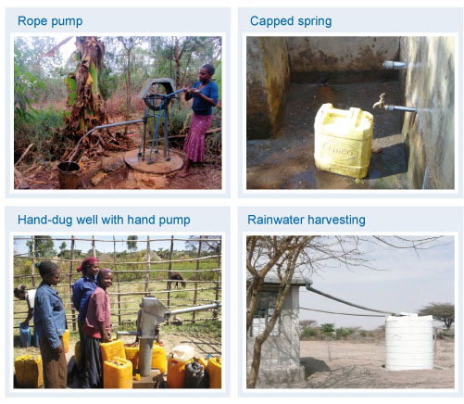
Figure 14.1 Examples of water supply schemes from Tables 14.1 and 14.2.
Table 14.2 Estimated beneficiaries by type of scheme. (OWNP, 2013)
Type of scheme | Number of beneficiaries from each new scheme
Household-dug well with rope pump | 6
Community-dug well with rope pump | 75
Dug well with hand pump | 270
Capped spring | 350
Spring with piped system | 4000
Shallow borehole with hand pump | 500
Shallow borehole with submersible pump | 1500
Deep borehole with piped scheme | 3500
Multi-village scheme | 5000
Rainwater harvesting | 100
Cistern | 100
Hafir dam | 500
Other | 800
- Based on the data in Tables 14.1 and 14.2, approximately how many people in the Harari region are expected to benefit from shallow boreholes with submersible pumps and how many from rainwater harvesting schemes?
- In the Harari region, the estimates are that 4 shallow boreholes with submersible pumps will serve 4 × 1500 = 3000 people and 30 rainwater harvesting schemes will serve 30 × 100 = 3000 people.

14.3.2 Rural water supply - rehabilitation
Rehabilitation means restoring a non-functional water scheme to an efficient working condition by repair or construction methods. The reasons for the non-functionality of water schemes include poor selection of site, poor design and construction, and poor operation systems. Figure 14.2 shows an example of a water scheme in need of rehabilitation. The OWNP plans to rehabilitate 20,010 non-functional water supply schemes in order to achieve the target of reducing non-functionality to 10% of the total number of schemes.
- If a rural water scheme managed under the CMP approach becomes non-functional, who is responsible for repairing it?
- As a community-managed project, the WASHCO would be responsible for maintaining and repairing the scheme in collaboration with the Woreda WASH Team.
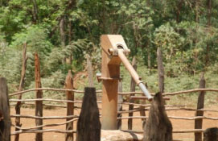
Figure 14.2 A non-functional hand-dug well. Only 2000 birr was needed to repair the pump.

14.3.3 Rural water supply – financial requirement
In the list of six planning questions that you read in Section 14.1, the last is ‘how much?’ Estimates for the financial requirement included programme management, study and design, post-construction support, capacity building, water quality monitoring, catchment management, and environmental safeguards were all determined, in addition to construction and rehabilitation of water supplies for households, schools and facilities. For rural water supply, the financial requirement was estimated at a total of more than US$ 1.13 billion.

14.4 Plans for other components
There are also physical and financial plans for urban water, rural and urban sanitation, and institutional WASH, which are summarised briefly below. (Some were also mentioned in Table 13.1.) Note that the OWNP financial requirements are estimated very precisely to the nearest dollar, but we have amended them here to give approximate figures in millions of dollars.
For urban water supply, activities are planned in 777 towns across the country to achieve 100% access during OWNP Phase I, which will require more than US$780 million.
Plans for improvements for institutions include the construction or rehabilitation of water supply facilities for 22,342 primary schools, 643 secondary schools and 7772 health centres/posts at an approximate cost of US$82 million and US$50 million respectively.
Sanitation improvements for institutions and communities include plans for some 36,712 facilities to be constructed or rehabilitated to meet OWNP targets, as shown in Table 14.3.
Table 14.3 Institutional and communal sanitation facilities. (OWNP, 2013)
Location | Type | Number
Schools | New | 6122
 | Rehabilitated | 15,122
Health posts/centres | New | 7037
 | Rehabilitated | 7141
Prisons | New | 350
 | Rehabilitated | 342
Public latrines | Rehabilitated | 95
Communal latrines | New | 95
 | Rehabilitated | 408
Total |  | 36,712
Public latrines (Figure 14.3) are open to anybody, in public places or in residential areas; typically there is a charge for each use. Users of public toilets generally feel less ‘ownership’ than users of communal latrines. Communal latrines are toilets shared by a group of households in a community. In some cases each household will have a key to one of the toilets within a block. This may be one toilet per household or one toilet for a group of households.
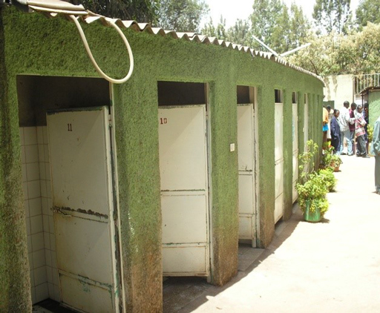
Figure 14.3 A public latrine block in Addis Ababa.
For rural and peri-urban sanitation, the estimated financial requirement is nearly US$400 million, of which approximately US$250 million is for hardware and construction activities and US$150 million for software activities.
- The WASH club in a school arranged a health education session during break time to demonstrate handwashing. Is this software or hardware activity?
- This is software activity because it focuses on knowledge, attitude and behaviour of people.
Urban sanitation activities consist of promoting on-site sanitation facilities by Health Extension Workers, the construction of public toilets, desludging equipment and drying beds. A total of US$96 million is required for desludging and public toilets in towns. More than 45% of this is for Addis Ababa alone.

14.5 Planning framework
Planning is not just a one-off activity in the OWNP. There is a continuous planning cycle in place to ensure the overall plans described in the previous sections are enacted. This planning activity takes place at all levels of the WASH management system, from federal down to kebele levels and involves all stakeholders. This activity follows a consistent framework that was established to harmonise the plans and budgets of all the implementing agencies into one plan and one budget.
There are a number of different types of plans included in the framework. This starts with Strategic Plans and Annual Plans at national, regional/zonal and woreda levels.
Strategic Plans comprise three elements in line with the planning process we have described above. Strategic Plans include the targets that are to be achieved, the baseline that states the current situation and resource mapping, which identifies the financial resources that are available (POM, 2014). To update strategic plans and ensure they continue to be relevant, the targets, baseline and resources are adjusted regularly to reflect the changing situation. For example, after two or three years of any ongoing project, some progress should have been made so the baseline would have changed, there may be more or less finance available, and the targets may need adjusting. A strategic plan should reflect these changes so it remains useful.
Once Strategic Plans are finalised, the next step is to prepare Annual WASH Plans. These translate the broader objectives and priorities of the Strategic Plan into practical activities and detailed budgets. Annual WASH Plans should be prepared in consultation with stakeholders including relevant government institutions, development partners, NGOs and, at woreda and kebele levels, the community. Both Strategic and Annual plans need to be reviewed and approved by the WASH Steering Committee at each level.
Annual WASH planning is done in two stages through the course of each year:
  - Core Plans: includes physical and financial plans and provide the basis for building detailed Annual WASH Work Plans. Physical plans describe the work to be done and financial plans describe the costs and budget allocation.
  - Annual WASH Work Plans: include specific details of activities, assignments, schedules and proposed expenditure from all sources.
Do you remember the discussion in Study Session 7 about vertical relationships in the OWNP organisational structure? The planning process demonstrates these vertical relationships and involves a dialogue between implementers at different levels, both upwards and downwards. Core planning is essentially a top-down process in which higher levels set out their targets and allocations for the forthcoming planning period and hands them down to lower levels. Annual planning, on the other hand, should be bottom-up. Communities identify their needs, establish their priorities and plan their activities. As plans are consolidated at each level the implementers at the next higher level incorporate them in their plans and calculate what they need to do in terms of activity and budget expenditure to support the plans of the lower level (WIF, 2011). This process is illustrated in Figure 14.4.
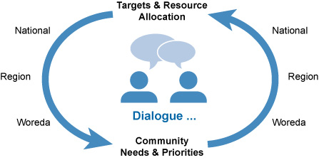
Figure 14.4 Dialogue in the WASH planning process. (WIF, 2011)
The development of Core Plans and Annual Work Plans takes place in an annual cycle that follows the same pattern each year. Core planning takes place from August through to November and annual work planning from December to February. This is part of a much larger and more complex sequence of events in the annual planning and budgeting cycle that links the various levels according to the vertical relationships described above. Plans and budgets are consolidated at the different levels and submitted for review and approval. (You read about this process in Study Session 12.) Budgeting is tied in to the annual contributions from development partners that set the budget ceilings each year, the resource mapping exercise that confirms financial resources available from all possible sources, and the revised targets. In this way, the plans are revised every year so they correspond to the needs and priorities, and the available resources in order to make progress towards achieving the desired targets.

14.6 Overall costs and benefits of the OWNP
You read earlier that the total cost of the OWNP was estimated to be US$2.41 billion over the two phases of the Programme. The distribution of this total across the components is shown in Figure 14.5.
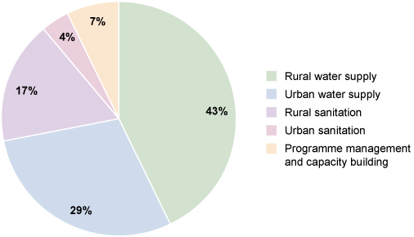
Figure 14.5 Proportion of the financial requirement by main component. (OWNP, 2013)
This massive investment will bring great benefits. Many millions of people will benefit from the programme and will have access to water and sanitation for the first time. A total of 26.6 million people in rural areas and 4.4 million people in urban areas are expected to benefit from OWNP water supply interventions alone. These changes will transform lives, especially for women and girls, and will be celebrated throughout the country (Figure 14.6).
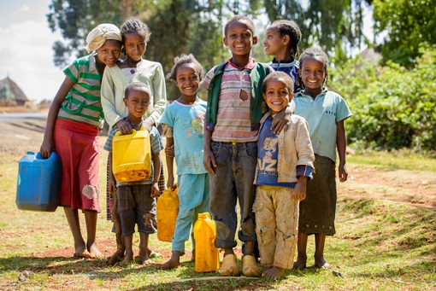
Figure 14.6 The OWNP will bring smiles to many faces.

Summary of Study Session 14
In Study Session 14, you have learned that:
- Planning of projects and programmes should ask six basic questions: ‘What?’, ‘When?’, ‘Where?’, ‘Who?’, ‘How?’ and ‘How much?’
- OWNP planning was governed by the goal of achieving WASH targets that had been set out in the Growth and Transformation Plan (GTP) and Universal Access Plan (UAP).
- Specific criteria were established for assessing when the water supply and sanitation targets were considered to be achieved.
- The planning process involved using data on the baseline conditions in all regions of Ethiopia and a complex range of assessments of population size and distribution, types of water supply scheme and their costs and benefits, etc.
- Planning outputs are detailed breakdowns of the number and costs of new and rehabilitated schemes required to achieve the targets.
- Planning of the OWNP is a continuous process that follows a specified schedule through the year and involves dialogue between all levels of the WASH organisational structure.
- The process includes Strategic Plans, Annual WASH Plans, Core Plans and Annual Work Plans.
- The total budget for the OWNP is US$2.41 billion and will have millions of beneficiaries in Ethiopia.

Self-Assessment Questions (SAQs) for Study Session 14
Now that you have completed this study session, you can assess how well you have achieved its Learning Outcomes by answering these questions. You can check your answers with the Notes on the Self-Assessment Questions at the end of this Module.

SAQ 14.1 (tests Learning Outcome 14.1)
Complete the crossword below by answering the across and down clues.
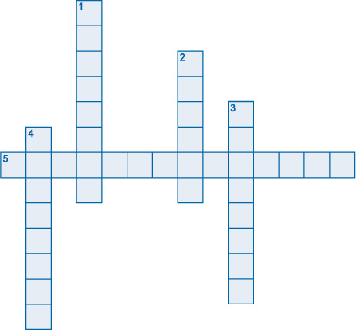
Across
5. Restoring a non-functional water scheme to an efficient working condition by repair or construction methods.
Down
1. Latrines that are shared by a group of households in a community.
2. Latrines that are open to anybody, in public places or in residential areas; typically with a charge for each use.
3. A process through which we decide objectives and activities, with their sequences and resources.
4. The network of underground sewer pipes in a town or city.

SAQ 14.2 (tests Learning Outcome 14.2)
Read the following paragraph and answer the questions below.
OWNP is the Programme of the Government of Ethiopia to achieve the targets stated in the GTP, i.e. 98.5% access for water supply and 100% for sanitation. It requires US$2.41 billion. The two phases for its full implementation originally planned were Phase 1 from 2013 to 2015, and Phase 2 from 2016 to 2020. Among the modalities to achieve the targets are CMP, WMP, NGO-managed project, self-supply, CLTSH and sanitation marketing. All WASH sector ministries and regional, zonal and woreda WASH bureaus and offices are responsible for the implementation of the Programme in all regions across the country.
- What is the goal of the Programme?
- What was the original schedule in which it will be accomplished?
- Where will the plan be implemented?
- Who will implement the Programme?
- What activities will contribute to reaching the goals?
- What is the financial resource allocated for reaching the goals?

SAQ 14.3 (tests Learning Outcome 14.2)
Based on the data in Tables 14.1 and 14.2, approximately how many people in Dire Dawa are expected to benefit from:
- shallow boreholes with submersible pumps?
- shallow boreholes with hand pumps?
- deep boreholes with piped schemes?
Why might it not be appropriate to add together these three figures to give a total number of beneficiaries?

SAQ 14.4 (tests Learning Outcome 14.3)
What are the key differences between the two OWNP stages of planning: Core Plans and Annual WASH Work Plans?

SAQ 14.5 (tests Learning Outcome 14.4)
Based on Figure 14.5, what are the relative proportions of OWNP budget allocation to water supply, to sanitation and to other components?

Study Session 15 Looking to the Future

Introduction
We started this Module with the broader global context for WASH and the challenges that led to the creation of the One WASH National Programme. As you reach the end of the Module, you have learned about the ambitious goals of the OWNP and the plans for achieving them. In this final study session we broaden the scope again and look to the future to consider some of the changing issues in Ethiopia and the wider world that may affect OWNP plans and implementation. Planning for the future can never be entirely certain but it’s possible to manage the uncertainty by recognising that change will happen and being prepared to adapt to its influence.
The design of the OWNP in two phases was intended to allow for review and adjustment in response to change at the end of Phase 1, with Phase 2 following for the next five years. In the OWNP document the possible redirection of the Programme is acknowledged. It suggests that in future there could be ‘different policy priorities, targets, institutional roles and responsibilities and/or implementation modalities’. Broadening the Programme in future may consider such topics as ‘watershed and water resources management, productive uses of water, environmental protection, and climate resilience’ (OWNP, 2013).
In this study session we will first consider the dynamics of the OWNP itself and the developments in national policy. Then we will look to wider issues of urbanisation, industrialisation and climate change that may affect implementation of the OWNP. Finally, the study session returns to the Millennium Development Goals that set the international agenda until 2015 and considers what happens next.

Learning Outcomes for Study Session 15
When you have studied this session, you should be able to:
15.1 Define and use correctly all of the key words printed in bold. (SAQs 15.1, 15.4 and 15.5)
15.2 Outline how the Growth and Transformation Plan II and other developments may affect OWNP implementation. (SAQ 15.2)
15.3 Explain the possible effects of increasing population, urbanisation and industrialisation on water supply. (SAQs 15.1 and 15.3)
15.4 Describe the possible influence of climate change on the OWNP. (SAQ 15.5)
15.5 Outline the possible impact of the Sustainable Development Goals. (SAQ 15.6)

15.1 The OWNP and its dynamics
The world is a dynamic place and for any long-term programme like the OWNP the possibility of change needs to be taken into account. Some future changes may be expected and predictable, others may be unforeseen. Some will have positive effects, others may be negative. Being aware of and understanding possible change is important so that impacts can be mitigated. Mitigation means reducing the negative effects of some undesirable event or situation.
In previous study sessions you have learned about the policies that underpin the OWNP, the institutional arrangements and organisation at different levels of government, and the approach to financial management. As the Programme develops it is possible that these central structures and its organisation may change over time, especially if monitoring reveals there are better ways of doing things that could improve efficiency. The review at the end of Phase 1 and the ongoing M&E process that you read about in Study Session 13 will provide feedback on the Programme that may require changes to timescale and implementation plans.
In Study Session 14 you read that the total amount of money required for the OWNP is estimated to be US$2.41 billion. The contributions to the Consolidated WASH Account and funds from other donors have provided a large part of this fund, but the full amount is not yet secured. Furthermore, like any financial estimate, there is always some degree of uncertainty about possible variations in budget forecasts due to unforeseen circumstances. One possible example of the unforeseen is an uncontrollable natural disaster or crisis that requires reallocation of funds in response to a shift in national priorities. There is no guarantee that all the necessary funds for WASH improvements will be committed to the Programme.
The dynamics of the OWNP are also a function of its ‘newness’ in Ethiopia. The ‘One Plan, One Budget, One Report’ principle of the OWNP has led to innovative collaborations and partnerships that are still relatively new. The challenges of integration and harmonisation among stakeholders and of developing new ways of working require changes in long-standing practices, and this can take time before new relationships are fully developed. These cultural and behavioural changes all contribute to the challenge of achieving the OWNP goals.

15.2 Growth and Transformation Plan II
As you read previously in this Module, the targets of the OWNP were developed from the Growth and Transformation Plan (GTP) and Universal Access Plan (UAP), with the National Hygiene and Sanitation Strategic Action Plan. The first GTP covered the period from 2010 to 2015 and a revised version, GTP II, was launched in 2015 and will cover 2016 to 2020. The overall objective of GTP II will be further development of the national economy and to contribute to the plan for Ethiopian to be a middle-income country by 2025. GTP II recognises the challenges for WASH over the next few years. Several of these, including climate change and industrialisation, are discussed in further detail in the following sections. Other challenges have been identified including:
- problems of good governance, especially of urban water supply schemes where leakage management is an issue
- weak integration and coordination between stakeholders in the urban development programme, especially within key ministries
- high costs and delays in delivering imported spare parts and installation materials.
In terms of impacts and change affecting WASH, the main strategic directions for GTP II reinforce many of the principles of the OWNP such as good governance, building capacity, empowerment of women, support for private sector development, support for pastoralist regions, community mobilisation and strengthening of M&E (MoWIE, 2015). For water supply and sanitation infrastructure, GTP II aims to upgrade the water supply service to the level of middle-income countries by 2020 and establish urban wastewater management systems. But probably the most significant changes are new water supply service level standards.
The new criteria for access are set at a higher level than they were in the OWNP. The goal for rural water supply is now a minimum service level of 25 litres per person per day (previously 15 litres) within a distance of 1 km (previously 1.5 km). For urban supply, the new criteria vary with the size of the town. Table 15.1 shows the classification of towns based on population size and the required amount of safe water to be supplied to a single person per day.
Table 15.1 Classification of towns based on population and their respective standard of water supply service in GTP II. (MoWIE, 2015)
Town level | Population | Service level (litre/person/day)
1 | >1,000,000 | 100
2 | 100,000–1,000,000 | 80
3 | 50,000–100,000 | 60
4 | 20,000–50,000 | 50
5 | <20,000 | 40
(Note that for towns in levels 1 to 4, the water should be available at the premises; for level 5, the minimum service level is within a distance of 250 m.)
Changing the criteria for water access could have a significant impact on the OWNP. As you know from Study Session 14, these criteria are used as the basis for planning the number and location of new water schemes, so these new criteria will affect both physical and financial plans.

15.3 Increasing population
One significant trend putting pressure on water and sanitation provision in many parts of the world is population growth. As you can see in Figure 15.1, Ethiopia shows a steepening curve as the population grows each year. This puts ever-growing demands on limited resources, including water.
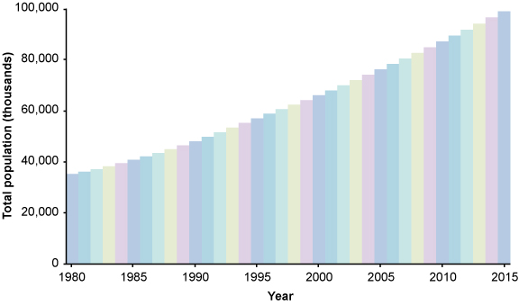
Figure 15.1 Graph of Ethiopian population from 1980 to 2015. (Data from JMP, 2014a)
- How would you summarise the availability of water resources in Ethiopia?
- From Study Session 2, you may remember that Ethiopia as a whole has plentiful water resources, but these are not distributed evenly throughout the country either geographically or seasonally.
In areas where there are limited resources and demand is high, water use can lead to depletion of groundwater resources. Groundwater depletion means that the stores of water held underground within the rocks are gradually reduced because too much water has been extracted via wells and boreholes. This leads to a lowering of the water table so that wells have to be dug or drilled deeper and deeper before water is found.
As well as the added direct demand for water to meet basic needs, an increasing population can also lead to growing competition for water for other purposes such as agriculture and industry. Greater use of irrigation in order to grow more food to feed a larger number of people can mean that less is available for water supply. In the longer term, the OWNP, and any WASH programmes that follow it, will have to adjust to the continuing increase in demand from the growing population.

15.4 Urbanisation
In Ethiopia, not only is the total population growing fast, but it is also on the move. Many people are moving away from rural areas and into the towns and cities, resulting in an increase in the urban population. The urban population is the percentage of the total population resident in urban areas. In Ethiopia in 2015 this is about 18%. Urbanisation is the increase in the number of people living in towns and cities, relative to rural areas. Figure 15.2, which you first saw in Study Session 6, shows the trend in urbanisation from 1950 onwards. Note that this includes predicted figures to the year 2050. The gradient (steepness) of the red line is slightly greater beyond 2015, indicating that urbanisation is predicted to increase at a faster rate.
Figure 15.2 Changing proportion of urban and rural population in Ethiopia from 1950 to 2050 (estimated from 2014 onwards). (UNDESA, 2014)
The movement of people from rural to urban settings is becoming a major issue. These people arrive in need of somewhere to live, and although there are many signs of economic growth and development in urban areas, it is a challenge for towns in Ethiopia to absorb migrants from rural parts of the country and provide them with adequate housing. The current stock of urban housing is both insufficient and of poor quality. Only 27% of the urban population has access to improved sanitation, with another 42% using shared facilities, leaving 31% with unimproved or no latrine access (data for 2012, JMP, 2014a). The serious deficiencies in sanitation services and random defecation in urban areas have created dangerous health and environmental problems.
New construction to meet the demands of urbanisation may not solve these problems. In Addis Ababa and other cities in Ethiopia many condominiums and other housing are being built to provide accommodation for the growing urban population (Figure 15.3). Rapid construction without adequate planning procedures can mean that buildings are erected without having the necessary infrastructure in place, i.e. water supply and sanitation may not be part of the construction or may be inadequate or delayed. Poorly designed buildings can be short-term solutions to meet the pressing need for more housing but they will not be sustainable. These are the growing challenges that the OWNP in its future implementation will need to take into account.
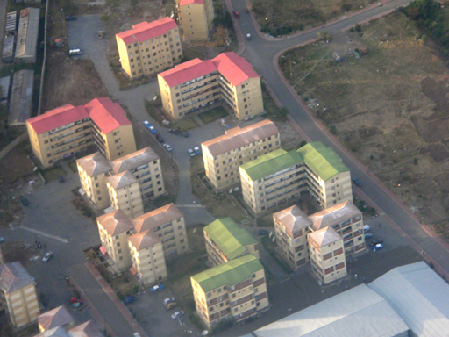
Figure 15.3 Aerial photo of condominiums on the outskirts of Addis Ababa.

15.5 Industrialisation
Industrialisation is the process of change from an agriculture-based economy, with most people working on the land, to one based on industry with people employed in manufacturing, construction and other sectors. It is linked to urbanisation because many of the people moving to urban areas do so in search of work and most factories and other forms of industry are located in towns and cities. Industry in Ethiopia has an important role in contributing to the economy of the country by alleviating poverty, and providing opportunities for employment for jobless citizens. However, it can also create problems and potentially have negative effects on water resources and the environment.
Many industries are growing fast in Ethiopia and can exert added demand for water supply. Industry may also cause pollution of water resources. Pollution can be defined as the presence or release into the environment of any substance that can cause harm. If industrial expansion is not controlled, and if appropriate regulations are not in place and enforced, then the environment may suffer. Water sources may become polluted and unsafe for human consumption. In Addis Ababa, the Akaki River has become severely contaminated by industrial wastewater that has been discharged untreated into the river with damaging impacts on local people, domestic animals and wildlife, both in the immediate location and downstream of the source of pollution (Figure 15.4).
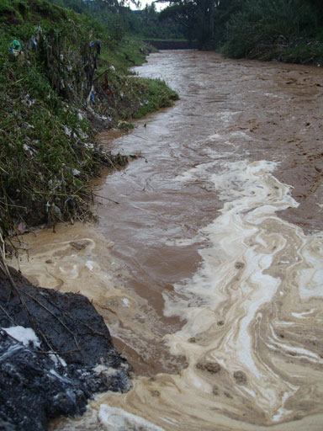
Figure 15.4 The Akaki River is polluted by industry and other sources.

15.6 Climate change
The effects of climate change are already being experienced in Ethiopia (EPA, n.d.). Climate change is the long-term variation in global climate largely attributed to human activities, especially the production of greenhouse gases (e.g. carbon dioxide, methane). These are gases that, when released to the atmosphere, trap the heat from the sun and cause warming of the global climate. Figure 15.5 shows how this process operates.
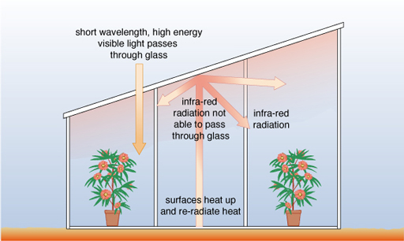
Figure 15.5 The greenhouse effect. Greenhouse gases in the atmosphere act like the glass in a greenhouse and trap heat close to the surface of the Earth.
In recent decades, Ethiopia has become warmer and rainfall has become more variable. Table 15.2 shows this historical trend and how the climate models have predicted the possible future changes. As you can see, as well as changes to temperature and rainfall, there are also expectations of increased uncertainty about extreme events of flood and drought. The weather in Ethiopia is likely to become more unpredictable and this will impact on many sectors, including health, agriculture and natural resources, including water.
Table 15.2 Effects of climate change in Ethiopia. (EPA, n.d.)
 | Temperature | Rainfall | Extreme events
Historical trend | Mean temperature increased by 1.3°C from 1960 to 2006. More hot days and nights, fewer cold days and nights | Highly variable from year to year, season to season, decade to decade. No significant trend | Regular, severe floods and drought events. No evidence of changes in frequency or intensity of extremes
2020s | +1.2°C (range 0.7–2.3°C) | +0.4% increase in rainfall | Greater increases in rainfall from October to December, especially in the south and east
2050s | +2.2°C (range 1.4–2.9°C) | +1.1% increase in rainfall | Heavier rainfall events, uncertain future El Niño behaviour brings large uncertainties
2090s | +3.3°C (range 1.5–5.1°C) | Wetter conditions | Flood and drought events likely to increase, heatwaves and higher evaporation
The future uncertainties of climate change are acknowledged in the OWNP document and it recognises that water supplies are vulnerable to climate variability. Some existing water sources may dry out during prolonged dry periods, but it is also possible that increased rainfall will improve supply. Future plans need to incorporate how they will adapt to these possible changes. Adaptation to climate change means modifying actions and behaviours to cope with the changed situation, for example, using scarce water resources more efficiently would be one way of adapting to reduced water supplies. The greatest problem with climate change is the level of uncertainty about the future which makes it very difficult to prepare strategic plans for the longer term.
In response to these challenges, the Ethiopian government has mandated the Environmental Protection Authority (EPA) to coordinate the national response to climate change and to develop national plans for a climate-resilient economy. Climate resilience is the ability to cope with and manage a changing and uncertain climate. A climate-resilient economy is an economy designed to withstand the possible negative impacts of extreme weather events and long-term climate trends, so that the well-being of the people and the national economy are not damaged (EPA, n.d.).
In 2014, Ethiopia’s Programme of Adaptation to Climate Change (EPACC) was launched. This is a programme of action to build a climate-resilient economy involving all levels, from sectoral and regional to local communities. It aims to involve the whole population in planning and implementing adaptation to climate change and includes the objective to ‘manage water effectively to make it always available to humans, animals and crops’ (EPA, n.d.).
Ethiopia is not responsible for the historic atmospheric greenhouse gas emissions, but nevertheless it has developed plans for actions to mitigate climate change. These are called the Nationally Appropriate Mitigation Actions (NAMAs). They cover seven areas of activity, all designed to decrease the production of greenhouse gases in Ethiopia. One of the most important is electricity generation by renewable energy such as hydropower, wind power and geothermal power, both at national grid and local level and on a domestic scale. Figure 15.6 shows an example of a renewable energy scheme.
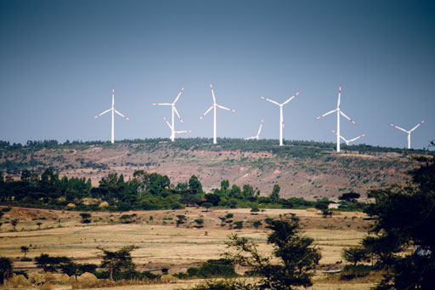
Figure 15.6 Wind farm near Adama producing renewable energy.
- What is the difference between adaptation to climate change and mitigation of climate change?
- If you adapt to something you make changes that allow you to cope with the change, so adaptation to climate change means changing programmes, activities, behaviours etc. in response to a changing situation. Mitigation means reducing the negative effects of something, so in this instance it would mean trying to prevent further climate change from happening.

15.7 International development goals
The year 2015 sees the end of both Ethiopia’s GTP I and the planned first phase of the OWNP. It was also the target date set by the United Nations in 2000 for achieving the Millennium Development Goals (MDGs).

15.7.1 Millennium Development Goals
You will recall from Study Session 2 that there were eight MDGs, and that Goal 7 included the aim to halve, by the end of 2015, the proportion of people without sustainable access to safe drinking water and basic sanitation. The goal for basic sanitation has not yet been achieved but, after a concerted effort by the Ethiopian government, the public and development partners, in March 2015, Ethiopia celebrated meeting the target for water supply. This made Ethiopia one of the few countries in sub-Saharan Africa to fulfil this global commitment. Figure 15.7 shows a UNICEF poster designed for the event and the celebration by assembled stakeholders held at the Sheraton Hotel, Addis Ababa on 23 March 2015.
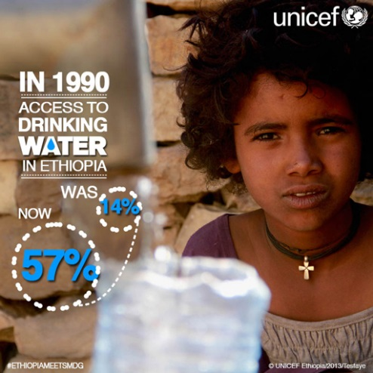 | 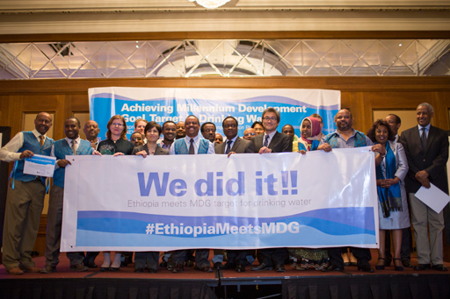
Figure 15.7 Celebrating the achievement of the water MDG in March 2015.
This was a great achievement for Ethiopia but, despite huge improvements across all eight goals across the globe, there are still many targets that have not been met. The global community has therefore developed a new set of goals called the ‘Sustainable Development Goals’.

15.7.2 Sustainable Development Goals
The Sustainable Development Goals (SDGs) were finalised at a world summit in September 2015. There are 17 goals, rather than the previous eight, allowing more specific details to be included. Box 15.1 has details of the goal that relates to WASH.

Box 15.1 Water and the Sustainable Development Goals
Goal 6, which applies to WASH, is: ‘Ensure access to water and sanitation for all’. It has the following specific targets:
- By 2030, achieve universal and equitable access to safe and affordable drinking water for all.
- By 2030, achieve access to adequate and equitable sanitation and hygiene for all, and end open defecation, paying special attention to the needs of women and girls and those in vulnerable situations.
- By 2030, improve water quality by reducing pollution, eliminating dumping and minimizing release of hazardous chemicals and materials, halving the proportion of untreated waste water, and increasing recycling and safe reuse globally.
- By 2030, substantially increase water-use efficiency across all sectors and ensure sustainable withdrawals and supply of freshwater to address water scarcity, and substantially reduce the number of people suffering from water scarcity.
- By 2030 implement integrated water resources management at all levels, including through trans-boundary co-operation as appropriate.
- By 2020 protect and restore water-related ecosystems, including mountains, forests, wetlands, rivers, aquifers and lakes.
- By 2030, expand international co-operation and capacity-building support to developing countries in water and sanitation related activities and programmes, including water harvesting, desalination, water efficiency, wastewater treatment, recycling and reuse technologies.
- Support and strengthen the participation of local communities in improving water and sanitation management.
(UNDP, 2015)
You can see that these new goals introduce aspects of water management that were not included in the MDGs. Water quality, for example, has been added in recognition of the problems caused by pollution and the impact this can have on the availability of usable water. Inclusion of water quality targets brings another dimension that could affect the OWNP implementation.
What other impacts will these new goals have on the WASH programme in Ethiopia? In short, we don’t know. The previous MDG was framed in terms of halving proportions, but the new SDG is less compromising and requires availability for all by 2030. The current OWNP Phase 2 is scheduled to end in 2020, and already has the target of 100% access to water and sanitation by that time. If it succeeds that will precede the SDG target by ten years! There are great challenges ahead in achieving this target, but the harmonisation, integration, alignment and partnership principles of the OWNP will all be profoundly important in achieving this goal.

15.8 Conclusion
The One WASH National Programme is a new development for Ethiopia. Having studied this Module you will know there are several reasons why the OWNP is exceptional. It is:
- united: it brings together four ministries who have agreed to implement one programme
- inclusive: all aspects of WASH are included
- comprehensive: it will be rolled out nationwide in all regions of Ethiopia
- innovative: it is the first sector-wide approach in the Ethiopian WASH sector
- effective: funds are pooled into one account
- progress-oriented: it will lead towards achieving national results faster
- supportive: all relevant stakeholders in the sector work together.
To conclude this study session and this Module, we would like briefly to refer back to the fourth component of the OWNP and the requirement for capacity building in WASH. We hope that, having studied this Module, you are now fully aware of the significance of Ethiopia’s One WASH National Programme, including its aims, principles, approaches, structure and management. We hope that your capacity has also been developed and you feel able to contribute to achieving the goals of the OWNP.

Summary of Study Session 15
In Study Session 15, you have learned that:
- Dividing the OWNP into two phases recognises the need for review and adjustment to allow for change. It is therefore probable that the policies, principles, institutional and financial arrangements of the OWNP will change in future.
- GTP I ended in 2015, to be replaced by GTP II. GTP II reinforces the improvements in many themes of GTP I, including good governance, involvement of women, better integration and coordination among stakeholders.
- GTP II includes new access criteria for water supply that will affect OWNP targets, and therefore physical and financial plans.
- An increasing population means an increasing demand for water for household use and also for agriculture and industry.
- The urban population is increasing, with additional demand for efficient, reliable and sustainable water and sanitation provision.
- Climate change has an uncertain impact on water supply into the future, but planning should take account of adaptation and mitigation measures. The Environmental Protection Authority has responsibility for the national response to climate change and is promoting steps to achieve a climate-resilient economy.
- The Millennium Development Goals target date was 2015. Ethiopia achieved the target for access to water in March 2015. New goals called Sustainable Development Goals have been agreed for the period to 2030.

Self-Assessment Questions (SAQs) for Study Session 15
Now that you have completed this study session, you can assess how well you have achieved its Learning Outcomes by answering these questions. You can check your answers with the Notes on the Self-Assessment Questions at the end of this Module.

SAQ 15.1 (tests Learning Outcomes 15.1 and 15.3)
Fill in the gaps in the following sentences:
- Urbanisation is the increase in the ………………, relative to rural areas.
- ……………… means reducing the negative effects of some undesirable event or situation.
- Urban population is the ……………… of the total population resident in ……………… areas.
- ……………… is the long-term variation in the global climate, largely attributed to human activities, especially the production of ……………… gases.
- The presence or release into the environment of any substance that can cause harm is known as ………………

SAQ 15.2 (tests Learning Outcome 15.2)
Identify the main ways in which GTP II will affect WASH and the OWNP.

SAQ 15.3 (tests Learning Outcome 15.3)
In the context of WASH, explain why simply building more houses is not a sustainable solution for urbanisation.

SAQ 15.4 (tests Learning Outcomes 15.1 and 15.3)
The leather industry is one of the key industries in Ethiopia, and traditionally the main leather-related export has been hides and skins. The government has been driving the leather industry to focus instead on producing high-value finished leather products, for example shoes and handbags, encouraging the evolution from a traditional industry to a modern industry that functions within a global high-value market.
- In terms of social and national change, this is an example of what?
- Identify one possible advantage of this development, and one possible disadvantage.

SAQ 15.5 (tests Learning Outcomes 15.1 and 15.4)
- Why is it difficult to plan for climate change?
- The EPA is developing national plans for a climate-resilient economy. What does this mean?

SAQ 15.6 (tests Learning Outcome 15.5)
Which of the following statements is false? In each case explain why it is incorrect.
- Water quality was not an indicator in the WASH-related MDG.
- Ethiopia has met its aim to halve, by the end of 2015, the proportion of people without sustainable access to safe drinking water and basic sanitation.
- The targets within the new WASH-related SDGs specify women and girls as needing particular support in achieving access to adequate and equitable sanitation and hygiene for all.
- The OWNP is more ambitious than the SDGs, aiming to reach a target of 100% access to water and sanitation ten years sooner than the SDGs.
- The target date for the SDGs is 2035.

Notes on the Self-Assessment Questions (SAQs) for Ethiopia’s One WASH National Programme

Study Session 1

SAQ 1.1
hygiene | a set of practices performed for the preservation of health
adequate water supply | sufficient quantity of water to meet minimum requirements
sanitation | facilities and services for the safe disposal of human urine and faeces
water supply | water provided by public utilities, commercial organisations, community endeavours or by individuals
child-friendly WASH services | facilities that are designed for schools and take account of the needs of boys and girls
safe water supply | water that is free from any disease-causing agent

SAQ 1.2
- The barrier labelled sanitation (latrine) in the diagram will block faecal-oral disease transmission at the source. The origin of disease-causing germs is faeces. If faeces are safely disposed of then the risk of faecal contamination of water, food or the environment is minimised.
- ‘Faeces – Fingers – New host’ or ‘Faeces – Fingers – Food – New host’.

SAQ 1.3
An individual can benefit economically from improved WASH services because they will save money on treatment for diseases. Improving WASH services also minimises time away from work or productive activities due to sickness, caring for sick children and queuing at public toilets.

SAQ 1.4
The main problems facing non-unified WASH projects are:
- Many people in Ethiopia do not have access to improved WASH services. The scale of the problem makes it difficult for smaller projects to tackle. There has been an unequal spread of projects across the country and between different groups.
- Some projects did not recognise the importance of having all three elements of WASH, making improvements in one barrier less effective at preventing disease.
- Implementing successful WASH projects involves many different areas of government but they have not been organised to work together. This means that projects could be delayed, or fail, because of lack of coordination between the different areas of government.
- The effectiveness of WASH projects has also been reduced because different donors and aid organisations had separate and different financial procedures.
- Different approaches to projects in the same area can make them less effective; for example, communities may not want to contribute to a project if they have previously been given free services. Where free services have been given to a community, this has sometimes resulted in poor maintenance because they did not feel ownership of the service.

SAQ 1.5
The motto of ‘One Plan, One Budget, One Report’ highlights the unified approach of the OWNP, which is in sharp contrast with previous fragmented and divided interventions.
- The OWNP brings together the government ministries and major donors involved in implementing WASH projects, and has a single plan unifying them all. This ensures that everyone is working together towards the same aims, helping to eliminate problems of unclear responsibilities, poor timing, or different approaches to projects, e.g. free services versus community input. It also means that all the agencies involved consider water, sanitation and hygiene together as a package.
- The OWNP has a unified fund, the Consolidated WASH Account, to reduce the waste of time and money through different financial and procurement procedures.
- The OWNP has a unified method of reporting changes, so that progress can be more easily and evenly tracked. This helps to ensure the equitable spread of services across the country and through different communities.
The motto provides a brief and memorable summary of these core elements of the OWNP.

Study Session 2

SAQ 2.1
- A policy is a high-level document (approved by the national government) that states overall purpose and guiding principles. A strategy gives more detailed goals and plans for implementing the policy. A programme is a plan for specific activities, projects or events to implement policies and strategies – for example outlining who, where and what will be done to achieve the strategy goals. Figure 2.5 shows that policies set general principles to guide strategies, strategies shape programmes by setting goals and general plans, and programmes in turn shape policies.
- Gender mainstreaming means to keep both men and women in the central focus or ‘mainstream’ of projects, involving them in all aspects and decisions throughout. In practice this means making sure that women are fully involved. There are many benefits you may have suggested. For example, in Ethiopia women and girls are often responsible for collecting water for the family, so involving them in projects allows them to keep ownership of the task and have control over what they will have to do in the future. It also means women will have the chance to shape projects that are suited to their specific needs, such as menstrual hygiene.

SAQ 2.2
The graph shows the national average for the year. The percentage of people with improved water access might differ from this in a particular town or village in May 2005 because:
- Water is not distributed evenly throughout the year – there are wet and dry seasons.
- Water is not distributed evenly geographically. Some areas of the country have much more water than others.
- There is a marked difference between access in urban and rural populations. Urban populations on average have much greater access to improved water, but they are more densely polluted so often natural resources such as rivers and streams are contaminated.

SAQ 2.3
The policy areas are water, health and environment. Article 90 of the constitution states that ‘policies shall, to the extent that resources permit, aim to provide all Ethiopians with access to health and education, clean water, housing, food and social security.’
- The main water policy is the Water Resources Management Policy (WRMP). It reflects Article 90 by (you only need to have included one of these):
- promoting efficient, equitable and optimum utilisation of water resources nationally
- stating that water is commonly owned by all the people of Ethiopia
- aiming as far as possible to give all Ethiopian citizens access to a sufficient quantity of acceptable quality water
- recognising the need to adopt strategies that are compatible with other sectors’ goals e.g. health
- promoting involvement of all stakeholders
- setting pricing guides for water so that it is affordable to all and discourages wastage.
- The main health policy is the Health Policy of the Transitional Government. It reflects Article 90 by:
- Integrating with other policy areas (including sanitation and water) to improve health provisions.
- The main environment policy is the Environmental Policy of Ethiopia. It reflects Article 90 by:
- aiming to improve all Ethiopians’ health and quality of life
- ensuring that methods adopted today are compatible with adequate provisions for future generations
- stating that every person has the right to a healthy environment
- aiming to extend the availability of non-renewable resources
- pledging to disseminate affordable technologies.

SAQ 2.4
- WSDP
- WRMP
- WSDP
- WSS
- WRMP.

SAQ 2.5
The Growth and Transformation Plan (GTP) is a plan for national economic development and eradication of poverty. The Universal Access Plan (UAP) is a national plan for WASH improvements. They have influenced the goals of the OWNP because it has adopted similar targets to remain in line with these plans.

Study Session 3

SAQ 3.1
- Project One. It has a higher output (litres of water) for a given input (per ETB 100 invested)
- Project Two. It has disabled access.
- Project Two. It has higher administration costs for supplying the funding.
- Project One. It is more sustainable because the maintenance is affordable.

SAQ 3.2
False. The new development concept that shaped the OWNP is commonly known as a Sector-Wide Approach, which is sometimes shortened to SWAp. It is more successful, equitable and efficient than the project-based aid approach because all significant sector investments are channelled towards the same objectives and follow a consistent strategy that is guided by a consolidated investment plan. The OWNP was developed to build on the successes of sector-wide initiatives like the WIF.

SAQ 3.3
In 2003, an aid organisation from Europe sent workers to an Ethiopian village. The workers dug a well for the village, then went back to their home country. They did not coordinate the project with any government ministries. This is an example of a project-based aid approach. Because this is not a very efficient way of providing aid, in 2006 three government ministries signed the legally binding Memorandum of Understanding (MoU), pledging that they would take a sector-wide approach to WASH sector projects. This means that they agreed to work together to integrate the different elements of WASH, and involve all interested parties, which are known as stakeholders. A few years later some workers from the National WASH Inventory (NWI) arrived in the village to record the WASH facilities. They needed to collect baseline data so that in the future the stakeholders would be able to tell if they had met their development targets. The workers found that the well had been contaminated from poor sanitation. Situations like this led to the creation of the WASH Implementation Framework (WIF), so there were clearer plans for integrated WASH projects nationwide. These projects would require coordinated access to funding, so 2012 saw a new MoU, including the Ministry of Finance and Economic Development (MoFED). It outlined the areas of accountability for each ministry, so everyone had definite responsibilities.

SAQ 3.4
The Health Extension Programme (HEP) reflects equitable access as it brings sanitation and hygiene education to rural communities – especially where this has been lacking.

Study Session 4

SAQ 4.1
When two or more people or organisations agree to work together, this is a partnership.
Integration means combining two or more activities together to improve coordination and bring synergy.
Alignment means all WASH ministries ensuring their activities are in agreement with each other and with national policies.
Harmonisation means ensuring there are common procedures and arrangements shared between partners and other stakeholders so it is easier for them to work together.

SAQ 4.2
- The application of the four Guiding Principles avoids duplication of effort. This, in turn, avoids unnecessary expenses in the course of programme implementation and enables resources to be used efficiently by pooling them.
- From a project achievement perspective, application of the Guiding Principles will help by pooling the financial and human resource capacity, which therefore maximises the results or achievements of the Programme.
- The Guiding Principles emphasise the importance of community ownership of the Programme, which is a very important factor for sustainability of its outcomes.

SAQ 4.3
Both the Guiding Principles and Implementation Principles are important considerations that all professionals, government bodies, partner organisations, communities, etc. need to respect and keep in mind through all their work. The difference between them is that while the Guiding Principles are broad and general, relevant from formulation up to implementation, the Implementation Principles are considered specifically during implementation of the Programme.

Study Session 5

SAQ 5.1
- demand
- consensus
- capacity building
- transparency
- good governance.

SAQ 5.2
- Creating an enabling environment and good governance
- Maximising availability and efficient use of human and financial resources to create demand for better WASH services
- Capacity development for improved delivery of WASH services at all levels.

SAQ 5.3
- Capacity development
- Demand
- Enabling environment
- Good governance.

SAQ 5.4
The pillar that is not well addressed is demand creation for better WASH services. You could address this problem by putting more effort towards hygiene education and raising awareness of the need for soap for personal hygiene so that the use of soap will be enhanced over time.

SAQ 5.5

If the structure of a house is not well balanced as it is being built then it will fall apart. Similarly, the pillars of OWNP are designed so that they complement each other, and each must be fully in place to bring about the intended results of nationwide improved WASH services.

Study Session 6

SAQ 6.1
multi-village schemes | water supply sources extended from a single common source to many villages located within same radius, with separate distribution points for each village
situational analysis | critical review to find out about a situation to inform planning and decision making
O&M costs | running costs of a project that will continue over time
modality | a way of doing something or approaching a task
full cost recovery | to recover the cost of operation and maintenance as well as the cost of investments
feasibility study | finding out if a project is technically possible and achievable at reasonable cost

SAQ 6.2
- Rural and pastoral WASH
- Urban WASH
- Institutional WASH
- Programme management and capacity building

SAQ 6.3
Focusing on schools aims to improve the health of school children and reduce absenteeism caused by sickness resulting from lack of WASH services in the school. As a result of better school WASH services, educational performance is improved. In addition, proper WASH services and related education in the school is a means to spread WASH-related messages to families and the wider community using students as ‘change agents’.
Similarly, the availability of WASH services in healthcare facilities significantly improves the quality of medical services and prevents infection and helps the healing process in patients. Moreover, the existence of proper WASH services in health facilities can be a good model for people visiting the health facility to adapt at home if they can.

SAQ 6.4
The implementation modalities for the rural water supply component are:
- Woreda-managed project (WMP) modality
- Community-managed project (CMP) modality
- NGO-managed modality
- Self-supply modality
- Multi-village water supply schemes.

SAQ 6.5
- Towns/cities having utilities managed by a Water Board
- Towns/cities having utilities but not managed by a Water Board
- Small towns with water supply systems managed by WASHCOs or towns without a water supply system at all.

SAQ 6.6
Programme management and capacity building are cross-cutting interventions that are applied to boost the implementation of the OWNP and consequently maximise the results in terms of quantity and quality. The actual activities in this component include, but are not limited to, supporting WASH organisations and implementing parties at all levels to help them to improve their skills and capacities. This can be achieved through the provision of training, equipment, and tools, and, where required, software used for various WASH undertakings.

Study Session 7

SAQ 7.1
- High-level decision making is an aspect of governance.
Coordination of resources within an organisation is the responsibility of management.
Giving advice is part of the role of guidance.
The ‘art of knowing what to do’ is a description of management.
The development of strategies that will be organised by others is governance.
Organising people who implement projects is the responsibility of management.
- An organisational structure describes how relationships, tasks and communication flows are coordinated within and between organisations. If these links are between a higher level and a lower level, these are vertical relationships; if they are between groups at a similar level they are horizontal relationships.
- The answer is below:
Abbreviation | Hint | Full term
NWSC | At the top of the OWNP hierarchy | National WASH Steering Committee
RWSC | Responsible for WASH governance at regional level | Regional WASH Steering Committee
NWTT | Focuses on managerial oversight of technical activities at the regional level. | National WASH Technical Team
RWTT | Responsible for managerial oversight of technical activities at regional level. | Regional WASH Technical Team
PMUs | Responsible for implementation at federal, regional and zonal levels. | Programme Management Units
WWTs | Responsible for implementation at the woreda or town level. | Woreda WASH Teams
NWCO | Based in one of the federal WASH sector ministries. | National WASH Coordination Office
WWSC | Responsible for governance of the OWNP at the woreda level. | Woreda WASH Steering Committee
WASHCO | Manages the operation and maintenance of specific water schemes. | community WASH Committee

SAQ 7.2

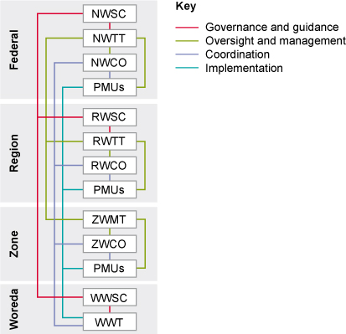
Figure 7.7 for SAQ 7.2.

SAQ 7.3
Option (d) is the correct sequence. It shows the vertical relationship of steering committees at different levels from national to regional to woreda, and the horizontal relationship at woreda level from Woreda Steering Committee to the Woreda WASH Team.

SAQ 7.4
- The Ministry of Water, Irrigation and Energy (MoWIE) is responsible for the provision of safe water.
- The Ministry of Health (MoH) is responsible for the provision of sanitation and hygiene for the community and provision of WASH facilities for health institutions.
- The Ministry of Education (MoE) is responsible for the provision of WASH facilities for schools.
- The Ministry of Finance and Economic Development (MoFED) is responsible for the financial management of the OWNP.

SAQ 7.5
At every level, steering committees have responsibility for governance, however the Woreda Steering Committee also has responsibility for management at the woreda level. The Woreda WASH Team is responsible for implementation and coordination. The Woreda WASH Team will also work with community WASH Committees (WASHCOs) on specific projects.

Study Session 8

SAQ 8.1
Phrase | Definition
Community empowerment | Involving communities in the development and implementation of a programme or project.
Inclusion | Making sure that marginalised and underserved communities are considered and incorporated within the programme or project.
Social accountability | The idea that service providers are accountable to the user communities. Community members can ask questions and have a right to be answered.

SAQ 8.2
MAGINESNTRDEAEMIRNG = gender mainstreaming
SAUBSITLAIITNY = sustainability
All the cross-cutting issues are important when considering initiatives because ignoring them will lead to greater inequality and inefficiency.
Gender mainstreaming ensures participation by women and girls in all aspects of programme planning and implementation and supports equality between both genders.
Community empowerment will make projects more likely to succeed because it encourages a sense of ownership among the people who benefit from the scheme.
Sustainability of projects means that their benefits will be sustained into the future which provides long-term improvements for more people.
Inclusion of all marginalised, elderly, disabled and underserved communities is essential to achieve equitable WASH services for all.
Social accountability is important for community empowerment so that users of WASH services can be properly informed by the service providers.

SAQ 8.3
A is false. Everyone has a right to a safe water supply although this may be harder to achieve for some rural and pastoral communities.
B is false. ‘Quick fixes’ are unlikely to be sustainable. It is important for communities to participate in decision making so they can contribute their local knowledge.
E is false. Sharing information with others in the spirit of transparency (which you read about in Study Session 5) will make for better decisions and more effective and sustainable projects.

Study Session 9

SAQ 9.1
Term | Explanation
major stakeholders | Organisations that directly contribute funds to the Consolidated WASH Account (CWA) at federal level.
associated stakeholders | Organisations that provide funding for the construction of water supply, sanitation and hygiene facilities, technical assistance, supplies and other support to the OWNP.
collaborating stakeholders | Organisations that provide assistance to the OWNP other than construction of WASH facilities. (For example, they may provide training manuals or communication and promotional products.)
development partner | Any organisation working in partnership with national and local government bodies.
civil society organisation | Organisations that are not commercial, not part of government, and not based on family.
non-governmental organisation (NGO) | Non-profit organisations that typically ‘seek to influence the policy of governments and international organisations and/or to complement government services such as health and education’.
bilateral donors | Departments or agencies of national governments that donate funds to another country.
private sector | The part of a country’s economy that is not run by the government.

SAQ 9.2
- Directorate of Women, Children and Youth Affairs
- Ministry of Federal Affairs
- Water Resources Development Fund
- Ministry of Urban Development, Housing and Construction.

SAQ 9.3
NGOs contribute in several ways. You may have included NGO-managed projects where the NGO is both funder and manager; by providing funds as an associated stakeholder; by participating in the Joint Technical Review and Multi-Stakeholder Forums, and by being a member of the Water Sector Working Group.

SAQ 9.4
In the WASH sector the tasks undertaken by private sector companies may include such things as designing and engineering new facilities, drilling boreholes, laying pipes, constructing buildings, as well as supplying materials and equipment. Implementation also involves studies and research by different professional associations, private contractors, consultants, suppliers and artisans.

SAQ 9.5
            - The WASH Committee (WASHCO) and Health Development Army (HDA).
            - Community ownership and management of the improved WASH facilities is important for enhancing impact and sustainability, and is particularly valuable for empowering disadvantaged groups in the consultation and development processes.

Study Session 10

SAQ 10.1
            - A consolidated WASH plan is a single combined plan for water supply, sanitation and hygiene schemes that integrates the separate plans from all WASH implementing organisations.
            - Software components are any activities that focus on knowledge, attitude and behavioural changes of the individual or the whole community.
            - Hardware components are the physical parts of a scheme such as well linings, pumps, latrine slabs, lavatory pans, construction materials, etc.
            - Self-supply is the construction and use of small-scale water schemes at household level, such as hand-dug wells.
            - Resource mapping is the identification of the sources and amounts of all possible funds for a project.

SAQ 10.2
- Readiness criteria are conditions or things that need to exist or be done before starting an activity.
- The readiness criteria for the OWNP have particular significance because they are tied to the release of funds. There is a requirement that conditions set out in the readiness criteria have to be met before money is disbursed and physical implementation can take place.
- All cities and towns are expected to have prepared a consolidated annual WASH plan and had this approved. They have to establish the necessary organisational structure (e.g. Town Water Board) and have appropriate staff in place. They need to organise their financial systems so there are separate budget lines for water supply and sanitation. They need to ensure M&E staff and procedures are established and that National WASH Inventory data has been made available.

SAQ 10.3
Approach | Water? Sanitation? Hygiene? | Rural? Urban? Pastoralist? Institutional?
Community-managed project | water | rural, pastoralist and institutional
Sanitation marketing | sanitation | rural (mostly) but also the others
Multi-village scheme | water | rural
Grant financing | water, and also sanitation and hygiene | urban
CLTSH | sanitation and hygiene | rural (mostly) but also the others
NGO-managed project | water | rural, pastoralist and institutional

SAQ 10.4
In the CMP approach, communities are supported to undertake all stages of a project from initiation through planning to implementation and management continuing into the future. These projects use funds that are transferred to, and managed by, the community.
In the WMP approach, the Woreda WASH Team takes the lead. They are responsible for administering funds allocated to woreda, kebele or community for capital expenditure on water supply and sanitation activities. Although the kebele administration and WASHCOs are involved in project planning, implementation, monitoring and commissioning the project, the WWT is the Project Manager and is responsible for contracting, procurement, inspection, quality control and handover to the community.

Study Session 11

SAQ 11.1
Knowledge management means collecting, recording, sharing and using knowledge in a way that is helpful to you and to others. It is important in the WASH sector so that information can be shared by all types of stakeholders with different experiences and knowledge of the issues and challenges facing the sector. Effective knowledge management provides a means to share best practice so that mistakes are not repeated and successes can be replicated and developed.

SAQ 11.2
B is false. It’s possible for documentation to be produced in multiple languages but it is not essential. The driver should be your understanding of the audience with which it needs to be shared. If all key stakeholders are confident in one shared language then it would be most efficient to produce the documentation in that language alone.
C is false. Whilst it is true that too many subheadings can be distracting, sensible use of headings is important and helpful in making the writing easy to follow.
E is false. Some repetition might be necessary, for example from an executive summary to the main content of a paper, but generally you should avoid repeating anything in a document. Keep it as simple as possible!

SAQ 11.3
Forums:
- formal meetings of a large number of participants representing a wide range of stakeholders
- usually held over several days
- their purpose is to share knowledge and experience on multiple WASH sector themes.
Events:
- usually focus on a single identified theme
- sometimes given the title of ‘festival’
- public events.

SAQ 11.4
The Multi Stakeholder Forum (MSF), as the name suggests, brings together many different stakeholders so they can share and discuss their experiences. The Joint Technical Review (JTR) informs this process by identifying key issues for the next MSF so that discussion items can be prioritised. The JTR members make field visits and document their trips to ensure the MSF is accurately informed and can therefore discuss knowledgeably based on facts. Reporting on and publication of the proceedings of the MSF ensures that information is shared and available to others. The undertakings by the MSF provide targeted action points for moving ahead with OWNP targets.

SAQ 11.5
An international conference would bring together delegates from different countries with a range of experiences to share. For example, you might learn how people have already faced challenges that you are currently experiencing, and how they dealt with them successfully. Others might be reporting on pilot activities, and, through discussions with an expert community, can reflect on their learning and make informed decisions about the next step in scaling up those activities.

Study Session 12

SAQ 12.1
- Recurrent costs
- Block grant
- Off-budget
- Birr account
- Capital costs

SAQ 12.2
- In different ways these groups can all provide funding for the OWNP.

SAQ 12.3
A is correct. The flow goes from MoFED to WASH sector ministries and BoFED, then from BoFED to WASH sector bureaus and WoFED. (Look at Figure 12.4 to help you answer this question.)

SAQ 12.4
- MoFED is responsible for the opening of foreign currency accounts to receive funds from development partners and transfers these funds into a Consolidated WASH Account (CWA) (birr account).
- CWA funds are considered to be government funds and are not linked to the identity of the fund source. The term non-CWA is applied to all funds that are not pooled in the CWA. Non-CWA fund contributors give their commitments directly to the implementing organisations at federal, regional or woreda levels.

SAQ 12.5
C is correct. Reports are sent from WoFED and from regional WASH sector bureaus to BoFED, then from BoFED to MoFED who also receive reports from federal WASH sector ministries. (Look at Figure 12.6 to help you answer this question.)

Study Session 13

SAQ 13.1
Monitoring is the systematic and continuous assessment of the progress of a piece of work over time, in order to check progress.
Evaluation is an assessment of the value or worth of a project or programme and the extent to which the stated objectives have been achieved.
Something that can be seen, measured or counted, providing evidence of progress towards a target, is called an indicator.
The things produced by a programme or project are known as outputs and their short- to medium-term effects are called outcomes.
Impacts are the long-term effects and consequences of a programme or project.
In competitive bidding, several service providers submit bids for the same piece of work.

SAQ 13.2
- Plan and prepare: Identify a need for something, consider when you need it, ensure that you have the finance available etc.
- Specification: Obtain written details of the item(s) to be purchased or service required.
- Identify and select suppliers: Find out who can supply the goods/service and at what price.
- Make decision: Decide which supplier to choose and place the order.
- Delivery: Receive the goods or manage the ongoing contract until the work is completed.

SAQ 13.3
You may have identified any four of the following reasons. M&E is essential because it helps:
- Track progress in achieving project goals.
- Measure impact of actions and programmes.
- Increase accountability by making results available to others.
- Inform decision making by providing evidence and information on lessons learned.
- Encourage investment in future activities.
- Build capacity among all involved by sharing knowledge and experience.

SAQ 13.4
Water supply monitoring:
- Location, number, type and current functionality status of water schemes.
- Quality of scheme/utility management and the level of financial sustainability.
- Achievement of construction and rehabilitation targets.
Sanitation and hygiene monitoring:
- Number of households with unimproved latrines or better.
- Number of households/people using a latrine and number practising open defecation.
- Number of households/people with handwashing facilities near to a latrine.
- Number of households/people practising handwashing after defecation or handling children’s faeces.
Institutional WASH monitoring:
- Types, functionality and use of drinking water sources either in or near a school.
- Types, number and use of latrines and handwashing facilities in a school.

SAQ 13.5
- The National WASH Inventory (NWI) is an integrated record of water supply, sanitation and hygiene service coverage data in Ethiopia. Its purpose is to have a single comprehensive set of baseline data for the entire country that can be updated regularly.
- How to make the NWI results accessible to those who need them, and how to keep the data current.
- The purpose of the MIS is to collect and organise information about WASH in Ethiopia. The enormous amount of data generated by an inventory of the size and scale of the NWI presents major challenges in organising, collating and storing it in a systematic and accessible way. The WASH MIS is designed as a repository for monitoring data and to produce reports at national, regional, zonal and woreda levels. The idea is that data can be extracted, collated with other data, and used to produce reports, graphs and maps to facilitate all aspects of programme management.

SAQ 13.6
M&E is about measuring progress towards achieving the stated objectives of a programme. Having lots of data is of no use if the data isn’t set out in some meaningful way. For the OWNP, the objectives are itemised in the results framework that sets out in detail the outputs, outcomes and impacts for each component of the Programme. The results framework is a compilation of the expected results from the Programme, with the actual results captured by the M&E process. This is still a large amount of information, so the key performance indicators are the summary points that tell us almost at a glance how well the programme is keeping to its plans.

Study Session 14

SAQ 14.1
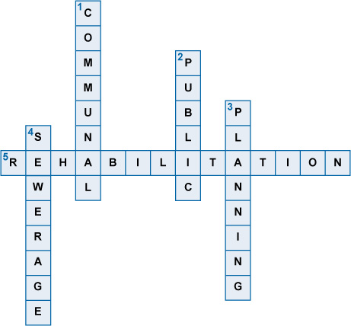

SAQ 14.2
  - The goal is 98.5% access for water supply and 100% for sanitation.
  - Phase 1 from 2013 to 2015 and Phase 2 from 2016 to 2020.
  - Across the country.
  - All WASH sector ministries and regional, zonal and woreda WASH bureaus and offices.
  - CMP, WMP, NGO-managed project, self-supply, and CLTSH and sanitation marketing.
  - US$2.41 billion.

SAQ 14.3
In Dire Dawa region, the estimates are that:
- 32 shallow boreholes with submersible pumps will serve 32 × 1500 = 48,000 people
- 5 shallow boreholes with hand pumps will serve 5 × 500 = 2500 people
- 3 deep boreholes with a piped scheme will serve 3 × 3500 = 10,500 people.
The total number for these plans is 48,000 + 2500 + 10,500 = 61,000. However, some people could benefit from having access to more than one scheme and be in more than one group, so if you just add the totals together those people would be counted more than once.

SAQ 14.4
Core Plans includes physical and financial plans and oversight, providing the basis for building detailed Annual WASH Work Plans. Physical plans describe the work to be done and financial plans describe the costs and budget allocation.
Annual WASH Work Plans includes specific details of activities, assignments, schedules and proposed expenditure from all sources.

SAQ 14.5
According to Figure 14.5, just under three-quarters of the budget is allocated to combined rural and urban water supply, just under a quarter to rural and urban sanitation and the remaining tenth (approximately) to programme management and capacity building.

Study Session 15

SAQ 15.1
- Urbanisation is the increase in the number of people living in towns and cities relative to rural areas.
- Mitigation means reducing the negative effects of some undesirable event or situation.
- Urban population is the percentage of the total population resident in urban areas.
- Climate change is the long-term variation in global climate largely attributed to human activities, especially the production of greenhouse gases.
- The presence or release into the environment of any substance that can cause harm is known as pollution.

SAQ 15.2
The water supply service level standards in GTP II are higher than they were when the OWNP was planned. This means that more water per person is required closer to their homes in order to meet the requirements for minimum service level. GTP II also aims to improve water supply infrastructure to the level of middle-income countries and establish new urban wastewater management systems.

SAQ 15.3
Rapid construction without adequate planning procedures can mean that buildings are erected without having the necessary infrastructure in place, i.e. water supply and sanitation may not be part of the construction or may be inadequate or delayed. Poorly designed buildings can be short-term solutions to meet the pressing need for more housing but these will not be sustainable.

SAQ 15.4
- Industrialisation.
- Advantages could include alleviating poverty, providing improved physical infrastructure and generating opportunities for employment. Disadvantages could include increased pollution for both the environment and the water supply.

SAQ 15.5
- The greatest problem about climate change is the level of uncertainty about the future, which makes it very difficult to prepare strategic plans for the longer term.
- A climate-resilient economy is an economy designed to withstand the possible negative impacts of extreme weather events and long-term climate trends so that the well-being of the people and the national economy are not damaged.

SAQ 15.6
B is false. Ethiopia has reached the goal for water supply but not for sanitation.
E is false. The target year is 2030.

Key terms

Key term | Study session
accessible water supply | 1
accountability | 3
adaptation (to climate change) | 15
adequate water supply | 1
alignment | 4
baseline data | 3
bilateral | 9
birr account | 12
block grant | 12
capacity | 5
capacity development/capacity building | 5
change agent | 6
child-friendly WASH services | 1
climate change | 15
climate-resilient economy | 15
CLTS/community-led total sanitation | 10
CLTSH/community-led total sanitation and hygiene | 10
communal latrines | 14
community empowerment | 8
community managed project (CMP) | 10
community of practice | 4
competitive bidding | 13
components | 6
consensus | 5
Consolidated WASH Account (CWA) | 1
consolidated WASH plan | 10
cross-cutting issues | 8
CSO | 9
demand | 5
desludging facilities | 14
Development Assistance Group | 9
development partner | 9
efficiency | 3
enabling environment | 5
epidemiology | 1
equity | 3
evaluation | 13
event (WASH sector) | 11
faecal-oral transmission | 1
feasibility study | 6
FLoWS /Forum for Learning on Water and Sanitation | 11
forum (WASH sector) | 11
full cost recovery | 6
gender mainstreaming | 2
good governance | 5
governance | 7
grant financing | 10
greenhouse gases | 15
groundwater depletion | 15
Growth and Transformation Plan (GTP) | 2
guidance | 7
hardware components | 10
harmonisation | 4
Health Development Army | 6
horizontal organisational relationship | 7
hygiene | 1
inclusion | 8
indicator | 13
industrialisation | 15
integration | 4
investment costs | 12
impacts | 13
Joint Technical Review (JTR) | 11
key performance indicator (KPI) | 13
knowledge management | 11
management | 7
management information system (MIS) | 13
marginalised | 8
Memorandum of Understanding (MoU) | 3
microfinance institution | 9
Millennium Development Goals (MDGs) | 2
mitigation | 15
modality | 6
monitoring | 13
monitoring and evaluation (M&E) | 7
multilateral | 9
Multi-Stakeholder Forum (MSF) | 11
multi-village schemes | 6
National WASH Inventory (NWI) | 3
National WASH Steering Committee (NWSC) | 7
National WASH Technical Team (NWTT) | 7
NGO | 9
off-budget | 12
on-budget | 12
One WASH National Programme (OWNP) | 1
open defecation free (ODF) | 10
operation and maintenance (O&M) costs | 6
organisational structure | 7
outcomes | 13
outputs | 13
participation | 5
partnership | 4
pastoralism | 6
per capita | 14
planning | 14
point source (of water supply) | 6
policy | 2
pollution | 15
private sector | 9
procurement | 13
Programme Management Units (PMUs) | 7
Programme Operational Manual (POM) | 4
programmes | 2
project-based aid approach | 3
public latrines | 14
public–private partnership (PPP) | 4
readiness criteria | 10
recurrent costs | 12
Regional WASH Steering Committee (RWSC) | 7
Regional WASH Technical Team (RWTT) | 7
rehabilitation (of a water scheme) | 14
resource mapping | 10
results framework | 13
rural | 6
safe water supply | 1
sanitation | 1
sanitation marketing | 10
sector-wide approach (SWAp) | 3
self-supply | 6
sewerage | 14
situational analysis | 6
sludge drying beds | 14
small piped schemes | 6
social accountability | 8
soft loan financing | 10
software components | 10
stakeholder | 3
strategies | 2
supply chain | 9
sustainability | 3
synergy | 4
Town WASH Team/City WASH Team | 7
Town Water Board | 6
transaction cost | 3
transparency | 5
Universal Access Plan (UAP) | 2
WASH Implementation Framework (WIF) | 3
urban | 6
urban population | 15
urbanisation | 15
vacuum truck | 14
vertical organisational relationship | 7
WASH | 1
WASH committee (WASHCO) | 7
water supply | 1
water tariff | 6
water utilities | 6
woreda managed project (WMP) | 10
woreda WASH team (WWT) | 7

References

ActionAid (2012) Unleashing Women’s Leadership Potentials and Sustaining Water Supply [Online]. Available at http://www.actionaid.org/sites/files/actionaid/dallocha_good_practice_0.pdf (Accessed 25 May 2015).
Advisory Group on Civil Society and Aid Effectiveness (2008) Synthesis of Findings and Recommendations [Online]. Available at http://tinyurl.com/q8r843p (Accessed 10 March 2015).
Berhane, L. (2014) ActionAid Project Becomes a Model Partner [Online]. Available at http://www.actionaid.org/ethiopia/2014/10/actionaid-project-becomes-model-partner (Accessed 25 May 2015).
Crocker, J. and Rowe, R. (2015) Community-Led Total Sanitation in Ethiopia: Findings from a Situational Analysis. Water Institute at UNC/Plan International [Online]. Available at http://www.communityledtotalsanitation.org/sites/communityledtotalsanitation.org/files/SituationalAssessmentEthiopia.pdf (Accessed 17 June 2015).
Davenport, T.H. (1994) ‘Saving IT's soul: Human centered information management’, Harvard Business Review, March–April, vol. 72, no. 2, pp. 119–31.
Development Assistance Group (DAG) (n.d.) Development Assistance Group, Background and Structure [Online]. Available at http://tinyurl.com/pk4yqz7 (Accessed 15 June 2015).
Devine, J. and Kullman, C. (2012) Introductory Guide to Sanitation Marketing, Water and Sanitation Program [Online]. Available at http://www.wsp.org/sites/wsp.org/files/publications/WSP-Introductory-Guide-Sanitation-Marketing.pdf (Accessed 14 March 2015).
Environmental Protection Authority (EPA) (n.d.) CRGE Vision, Ethiopia’s Vision for a Climate Resilient Green Economy, Federal Democratic Republic of Ethiopia [Online]. Available at http://www.preventionweb.net/files/24317_24317crgegevision40pagesforprinting.pdf (Accessed 5 January 2016).
Federal Democratic Republic of Ethiopia (FDRE) (1997) Environmental Policy of Ethiopia, Federal Democratic Republic of Ethiopia [Online]. Available at http://www.mfa.gov.et/docs/ENVIRONMENT%20POLICY%20OF%20ETHIOPIA.pdf (Accessed 3 June 2015).
Federal Democratic Republic of Ethiopia (FDRE) (2011) The WaSH Implementation Framework (Full Document) [Online]. Available at https://cmpethiopia.files.wordpress.com/2011/11/full-wif.pdf (Accessed 9 June 2015).
Federal Democratic Republic of Ethiopia (FDRE) (2012) Proceedings of the Fifth Multi-stakeholder Forum 2012 [Online]. Available at http://www.cmpethiopia.org/media/msf_5_proceeding/(language)/eng-GB (Accessed 14 January 2016).
Federal Democratic Republic of Ethiopia (FDRE) (2013a) One WASH National Program, Program Document, Final [Online]. Available at http://www.cmpethiopia.org/media/ownp_project_document (Accessed 3 June 2015).
Federal Democratic Republic of Ethiopia (2013b) Environmental and Social Management Framework (ESMF), Water Supply and Sanitation Program – WaSH-II, Addis Ababa [Online]. Available at http://tinyurl.com/nayrw26 (Accessed 5 November 2015).
Federal Democratic Republic of Ethiopia (2013c) The WaSH Implementation Framework (Summary) [Online]. Available at http://www.cmpethiopia.org/media/wash_implementation_framework_wif_summary (Accessed 5 October 2015).
Federal Democratic Republic of Ethiopia (FDRE) (2014) One WASH National Program, Program Operation Manual for the Consolidated WASH Account [Online]. Available at http://www.cmpethiopia.org/page/884 (Accessed 19 June 2015).
GLAAS (2010) UN Water Global Annual Assessment of Sanitation and Drinking Water, WHO/UN Water [Online]. Available at http://www.unwater.org/downloads/UN-Water_GLAAS_2010_Report.pdf (Accessed 3 October 2015).
Good Governance Guide (n.d.) What is Good Governance? [Online]. Available at http://www.goodgovernance.org.au/about-good-governance/what-is-good-governance/ (Accessed 9 June 2015).
Herbert, P. (2010) (2010) Rapid Assessment of CRS Experience with Arborloos in East Africa, Baltimore, Catholic Relief Service [Online]. Available at http://tinyurl.com/h567ec8 (Accessed 6 November 2015).
Hutton, G. (2012) Global Costs and Benefits of Drinking-water Supply and Sanitation Interventions to Reach the MDG Target and Universal Coverage, World Health Organisation, Geneva, Switzerland [Online]. Available at http://www.who.int/water_sanitation_health/publications/2012/global_costs/en/index.html (Accessed 3 October 2015).
Joint Monitoring Programme (JMP) (2014a) Ethiopia: Estimates on the Use of Water Sources and Sanitation Facilities (1980–2015), Joint Monitoring Programme for Water Supply and Sanitation, WHO/UNICEF [Online]. The 2015 update of the resource used for this Module is available at http://www.wssinfo.org/documents/?tx_displaycontroller[type]=country_files (Accessed 25 May 2015).
Joint Monitoring Programme (JMP) (2014b) Progress on Drinking Water and Sanitation, 2014 update, WHO/UNICEF [Online]. Available at http://www.wssinfo.org/fileadmin/user_upload/resources/JMP_report_2014_webEng.pdf (Accessed 10 June 2015).
Kar, K. (2005) Practical Guide to Triggering Community-Led Total Sanitation, Institute of Development Studies [Online]. Available at http://www.communityledtotalsanitation.org/sites/communityledtotalsanitation.org/files/Guidelines_for_triggering_CLTS_0.pdf (Accessed 14 March 2015).
Millennium Project (2000) Millennium Development Goals (MDGs) [Online]. Available at http://www.unmillenniumproject.org/goals/ (Accessed 19 October 2015).
Ministry of Education (MoE) (2010) Education Sector Development Plan IV, ESDP IV [Online]. Available at: http://planipolis.iiep.unesco.org/upload/Ethiopia/Ethiopia_ESDP_IV.pdf (Accessed 11 June 2015).
Ministry of Health (MoH) (2005) National Hygiene and Sanitation Strategy, Federal Democratic Republic of Ethiopia [Online]. Available at http://www.wsp.org/sites/wsp.org/files/publications/622200751450_EthiopiaNationalHygieneAndSanitationStrategyAF.pdf (Accessed 3 June 2015).
Ministry of Health (MoH) (2010) Health Sector Development Programme IV, Federal Democratic Republic of Ethiopia [Online]. Available at http://phe-ethiopia.org/admin/uploads/attachment-721-HSDP%20IV%20Final%20Draft%2011Octoberr%202010.pdf (Accessed 3 June 2015).
Ministry of Health (MoH) (2011) National Hygiene and Sanitation Strategic Action Plan for Rural, Peri-Urban and Informal Settlements in Ethiopia (2011–2015), Addis Ababa, Ethiopia [Online]. Available at http://www.cmpethiopia.org/media/national_hygiene_and_sanitation_strategic_action_plan_sap_part_ii/(language)/eng-GB (Accessed 9 June 2015).
Ministry of Health (MoH) (2013) National Sanitation Marketing Guideline, Federal Democratic Republic of Ethiopia [Online]. Available at http://www.cmpethiopia.org/media/national_sanitation_marketing_guideline_20132 (Accessed 5 November 2015).
Ministry of Labour and Social Affairs (MoLSA) (2012) Gender Mainstreaming Manual for Labour and Social Affairs Sector, Women’s Affairs Directorate, Federal Democratic Republic of Ethiopia [Online]. Available at http://www.molsa.gov.et/English/SWD/Documents/Gender%20Mainstreaming%20Mannual%20for%20Labour%20and%20Social%20Affairs.pdf (Accessed 12 June 2015).
Ministry of Water and Energy (MoWE), Ministry of Education, Ministry of Health and Ministry of Finance and Economic Development (2012), Memorandum of Understanding (November 2012) [Online]. Available at http://www.cmpethiopia.org/media/signed_mou_nov_2012/(language)/eng-GB (Accessed 6 November 2015).
Ministry of Water, Irrigation and Electricity (MoWIE) (2015) Second Growth and Transformation National Plan for the Water Supply and Sanitation Sub-sector 2015/16 – 2019/20. Federal Democratic Republic of Ethiopia [Online]. Available at http://www.cmpethiopia.org/media/english_gtp_2_for_water_sector_final_draft (Accessed 9 November 2015).
Ministry of Water, Irrigation and Energy (MoWIE) (2014a) Manual for Accelerating Self Supply Program, Water Supply and Sanitation Directorate, Federal Democratic Republic of Ethiopia [Online]. Available at http://www.rural-water-supply.net/_ressources/documents/default/1-628-2-1413877896.pdf (Accessed 15 June 2015).
Ministry of Water, Irrigation and Energy (MoWIE) (2014b) Water Sector Working Group and its Secretariat, Federal Democratic Republic of Ethiopia [Online]. Available at http://www.cmpethiopia.org/media/water_sector_working_group_leaflet_jan_2014/(language)/eng-GB (Accessed 15 June 2015).
Ministry of Water Resources (MoWR) (1999) Water Resources Management Policy, Federal Democratic Republic of Ethiopia [Online]. Available at: http://www.mfa.gov.et/docs/Ethiopian%20Water%20Policy.pdf (Accessed 3 June 2015).
Ministry of Water Resources (MoWR) (2001) Water Sector Strategy 2001, Federal Democratic Republic of Ethiopia [Online]. Available at http://www.mowr.gov.et/attachmentfiles/Downloads/Water%20strategy.doc (Accessed 3 June 2015).
Ministry of Water Resources (MoWR) (2002) Water Sector Development Programme (2002) Volume I, Federal Democratic Republic of Ethiopia [Online]. Available at http://www.mowr.gov.et/ (Accessed 3 June 2015).
Ministry of Water Resources (MoWR) (2005) Gender Mainstreaming Field Manual for Water Supply and Sanitation Projects, Women’s Affairs Department, Federal Democratic Republic of Ethiopia [Online]. Available at http://tinyurl.com/jcrkuvq (Accessed 12 June 2015).
Ministry of Water Resources (MoWR) (2008) Meeting Report of the first Forum for Learning on Water Supply and Sanitation (FLoWS), Federal Democratic Republic of Ethiopia [Online]. Available at http://www.rippleethiopia.org/library.php/files/file/20080806-flows-meeting-report (Accessed 17 June 2015).
Nassef, M. and Belayhun, M. (2012) Water Development in Ethiopia’s Pastoral Areas: A Synthesis of Existing Knowledge and Experience, Save the Children USA [Online]. Available at http://www.usaid.gov/sites/default/files/documents/1860/Water%20Development%20in%20Pastoral%20Areas%20of%20Ethiopia_0.pdf (Accessed 3 November 2015).
National WASH Coordination Office (NWCO) (2014) Proceedings of the Sixth Multi-Stakeholder Forum, Ministry of Water, Irrigation and Energy [Online]. Available at http://www.cmpethiopia.org/media/msf_6_proceedings_summary/(language)/eng-GB (Accessed 14 January 2016).
OECD (2005) Paris Declaration on Aid Effectiveness, DCD/DAC/EFF(2005)1/FINAL [Online]. Available at: http://acts.oecd.org/Instruments/ShowInstrumentView.aspx?InstrumentID=141&Lang=en (Accessed 8 June 2015).
OECD (n.d.1) Paris Declaration and Accra Agenda for Action [Online]. Available at http://www.oecd.org/dac/effectiveness/parisdeclarationandaccraagendaforaction.htm (Accessed 8 June 2015).
OECD (n.d. 2) The Paris Declaration on Aid Effectiveness: Five Principles for Smart Aid [Online]. Available at: http://www.oecd.org/dac/effectiveness/45827300.pdf (Accessed 8 June 2015).
OWNP – see FDRE, 2013a.
Pastoralist Forum Ethiopia (PFE) (n.d.) Facts about Ethiopian Pastoralists [Online]. Available at http://www.pfe-ethiopia.org/about.html (Accessed 10 June 2015).
POM – see FDRE, 2014
Pratt, B. and Earle, L. (2004) Study on Effective Empowerment of Citizens in Ethiopia (pp. 81–104) [Online]. Available at http://www.intrac.org/data/files/resources/656/Study-on-Effective-Empowerment-of-Citizens-in-Ethiopia.pdf (Accessed 25 May 2015).
Research-inspired Policy and Practice Learning in Ethiopia and the Nile Region (RiPPLE) (2013) FLoWS June 2013 [Online]. Available at http://www.rippleethiopia.org/index.php/documents/info/20130821-flows-june-2013 (Accessed 17 June 2015).
Tafesse, T. (2008) ‘A review of Ethiopia’s water sector policy, strategy and program’ in Assefa, T. (ed.) Digest of Ethiopia’s National Policies, Strategies and Programs, Addis Ababa, Forum for Social Studies.
Tatge, N. (2014) ‘Mobile technology aids Ethiopian National WASH Inventory (NWI)’. UNICEF Ethiopia – Unite for Children of Ethiopia [Online]. Available at https://unicefethiopia.wordpress.com/2014/06/12/mobile-technology-aids-ethiopian-national-wash-inventory-nwi/ (Accessed 19 June 2015).
Teklehaimanot, H.D. and Teklehaimanot, A. (2013) ‘Human resource development for a community-based health extension program: a case study from Ethiopia’, Human Resources for Health, vol. 11, p. 39 [Online]. Available at http://www.human-resources-health.com/content/pdf/1478-4491-11-39.pdf (Accessed 10 June 2015).
Transitional Government of Ethiopia (TGE) (1993) Health Policy of the Transitional Government of Ethiopia [Online]. Available at http://phe-ethiopia.org/resadmin/uploads/attachment-157-Health_Policy_Sept_1993.pdf (Accessed 3 June 2015).
UNICEF (n.d.) Design and Construction Manual for Water Supply and Sanitary Facilities in Primary Schools [Online]. Available at http://www.unicef.org/wash/schools/files/WASH_in_Schools_Design_Manual.pdf (Accessed 15 June 2015).
UNICEF Ethiopia (2015) ‘Ethiopia meets MDG 7c target for drinking water supply’, Unite for Children of Ethiopia [Online]. Available at https://unicefethiopia.wordpress.com/2015/03/23/ethiopia-meets-mdg-7c-target-for-drinking-water-supply/ (Accessed 23 June 2015).
United Nations (UN) (1999) Protocol on Water and Health to the 1992 Convention on the Protection and Use of Transboundary Watercourses and International Lakes, UN Economic and Social Council [Online]. Available at http://www.unece.org/env/documents/2000/wat/mp.wat.2000.1.e.pdf (Accessed 5 June 2015).
United Nations (UN) (2010) Statement on the Right to Sanitation, Committee on Social, Economic and Cultural Rights (45th session, E/C.12/2010/1), UN Economic and Social Council [Online]. Available at http://www2.ohchr.org/english/bodies/cescr/docs/statements/E-C-12-2010-1.doc (Accessed 2 November 2015).
United Nations (UN) (2011) The Human Right to Water and Sanitation, A/HRC/RES/16/2, UN General Assembly, Human Rights Council [Online]. Available at http://www.un.org/waterforlifedecade/pdf/human_right_to_water_and_sanitation_milestones.pdf (Accessed 2 November 2015).
United Nations (UN-Water) (2008) Sanitation Generates Economic Benefits, Factsheet No.2 [Online]. Available at http://tinyurl.com/hjkj5qr (Accessed 3 June 2015).
United Nations Department of Economic and Social Affairs (UNDESA) (2014) World Urbanisation Prospects, 2014, UN Population Division [Online]. Available at http://esa.un.org/unpd/wup/Country-Profiles/Default.aspx (Accessed 10 June 2015).
United Nations Department of Economic and Social Affairs (UNDESA) (n.d.) International Decade for Action ‘Water for Life’ [Online]. Available at http://www.un.org/waterforlifedecade/ (Accessed 5 June 2015).
United Nations Development Programme (UNDP) (2008) Capacity Development Practice Note [Online]. Available at http://www.undp.org/content/undp/en/home/librarypage/capacity-building/capacity-development-practice-note.html (Accessed 9 June 2015).
United Nations Development Programme (UNDP) (2015) Goal 6: Clean Water and Sanitation [Online]. Available at http://www.undp.org/content/undp/en/home/mdgoverview/post-2015-development-agenda/goal-6.html (Accessed 9 November 2015).
United Nations Economic and Social Commission for Asia and the Pacific (UNESCAP) (n.d.) What is Good Governance? [Online]. Available at http://www.unescap.org/sites/default/files/good-governance.pdf (Accessed 9 June 2015).
United States Agency for International Development (USAID) (2014) WASH Sector Status and Trends Framework, Desk Review: Ethiopia [Online]. Available at http://pdf.usaid.gov/pdf_docs/PA00KMCQ.pdf (Accessed 17 June 2015).
WASH Ethiopia Movement (WEM) (n.d.) WASH Media Forum [Online]. Available at http://www.washethiopiamovement.com/index.php?option=com_content&view=frontpage&Itemid=1&lang=en (Accessed 17 June 2015).
WaterAid (2011) Sustainability Framework [Online]. Available at http://www.wateraid.org/publications (Accessed 12 June 2015).
WaterAid (2013) Analyzing Policy Blockages to Equitable and Inclusive WASH in Ethiopia [Online]. Available at http://www.cmpethiopia.org/page/697 (Accessed 6 October 2015).
Welle, K. (2013) ‘Ethiopia National WASH Inventory: lessons learned and maximising value, summary of a seminar held on 8 April 2013, Addis Ababa, Ethiopia’ [Online]. Available at http://www.ircwash.org/sites/default/files/nwi_seminar_8_april_2013_final.pdf (Accessed 19 June 2015).
WIF – see FDRE, 2011.
World Bank (2001) ‘Ethiopia woreda studies’ in Yilmaz, S. and Venugopal, V. (2008) Local Government Discretion and Accountability in Ethiopia, International Studies Program, Working Paper 08-38, Andrew Young School of Policy Studies [Online]. Available at http://siteresources.worldbank.org/EXTSOCIALDEVELOPMENT/Resources/Ethiopia.pdf (Accessed 12 June 2015).
World Health Organization (WHO) (n.d.) Trade, Foreign Policy, Diplomacy and Health Glossary: Civil Society [Online]. Available at http://www.who.int/trade/glossary/story006/en/ (Accessed 10 March 2015).
World Vision Ethiopia (WVE) (2014), WASH-Knowledge, Attitude and Practices (KAP) Analysis of 8 Towns and 27 Satellite Villages, WVE Urban WASH Project.

Acknowledgements

Except for third party materials and otherwise stated below, this content is made available under a Creative Commons Attribution-ShareAlike licence (http://creativecommons.org/licenses/by-nc-sa/4.0/). The material acknowledged below is Proprietary and used under licence for this project, and not subject to the Creative Commons Licence. This means that this material may only be used unadapted within the OpenWASH project and not in any subsequent OER versions.
We have used some images of products for illustrative purposes only. The Open University is not endorsing or recommending such branded products but illustrating what may be available and what they achieve. There are other brands available other than those illustrated.
Grateful acknowledgement is made to the following sources for permission to reproduce the material in this unit:
Cover image: © UNICEF Ethiopia in Flickr made available under https://creativecommons.org/licenses/by-nc-nd/2.0/.
Figure 1.1: © WHO/UNICEF; Figure 1.2: © The Open University; Figure 1.3: http://water.worldbank.org (redrawn); Figure 1.4: (left) © UNICEF Ethiopia in Flickr made available under https://creativecommons.org/licenses/by-nc-nd/2.0/ (right) © Save the Children USA Ethiopia Country Livelihood Office, http://www.usaid.gov/sites/; Figures 1.5 and 1.6: WHO/UNICEF (2010); Figure 1.7: One WASH National Programme; Figure 1.8: Pam Furniss.
Figure 2.1: © http://www.mowr.gov.et/AWMISET/Pages/Map.html; Figure 2.2: © The Open University; Figure 2.3: Pam Furniss; Figure 2.4: © EU/ECHO/Martin Karimi in Flickr made available under https://creativecommons.org/licenses/by-nc-nd/2.0/; Figure 2.6: adapted from Ministry of Health (MoH) (2005) National Hygiene and Sanitation Strategy, Federal Democratic Republic of Ethiopia, http://www.wsp.org/; Figure 2.7: © UNICEF Ethiopia/2012/Getachew in Flickr made available under https://creativecommons.org/licenses/by-nc-nd/2.0/; Figure 2.8: adapted from Millennium Project (2000) Millennium Development Goals (MDGs), http://www.unmillenniumproject.org/goals/.
Figure 3.1: The World Bank authorises the use of this material subject to the terms and conditions on its website, http://www.worldbank.org/terms; Figure 3.2: Pam Furniss; Figure 3.3: Ashitaka San in Flickr; Figure 3.6: UNICEF Ethiopia, http://www.unicef.org/ethiopia.
Figure 4.1: http://tinyurl.com/hl2o84p; Figure 4.2: adapted from http://tinyurl.com/gu8ms2r; Figure 4.3: Dr Beth Cullen; Figure 4.4: http://nawicindy.com/.
Figure 5.1: adapted from Ministry of Health (MoH) (2011) National Hygiene and Sanitation Strategic Action Plan for Rural, Peri-Urban and Informal Settlements in Ethiopia (2011–2015), Addis Ababa, Ethiopia, http://www.cmpethiopia.org/; Figure 5.2: http://www.unescap.org; Figure 5.3: (left) http://www.pur.com, (right) http://www.aquatabs.com/.
Figure 6.1: Mesfin Getachew; Figure 6.2: Practica Foundation, http://practica.org; Figure 6.3: drawing by Peter Morgan in http://www.crs.org/water-sanitation/downloads/WATSAN-innov-arborloo-final.pdf; Figure 6.4: Pam Furniss; Figure 6.5: adapted from Pastoralist Forum Ethiopia (PFE) (n.d.) Facts about Ethiopian Pastoralists, http://www.pfe-ethiopia.org/about.html; Figure 6.6: Nassef, M. and Belayhun, M. (2012) Water Development in Ethiopia’s Pastoral Areas: A Synthesis of Existing Knowledge and Experience, Save the Children USA, http://www.usaid.gov/; Figure 6.7: adapted from http://esa.un.org/unpd/wup/; Figure 6.8: UNICEF Ethiopia, http://www.unicef.org/.
Figure 7.1: adapted from Federal Democratic Republic of Ethiopia (FDRE) (2011) The WaSH Implementation Framework (Full Document), Federal Democratic Republic of Ethiopia (FDRE) (2013) One WASH National Program, Program Document, Final and Federal Democratic Republic of Ethiopia (FDRE) (2014) One WASH National Program, Program Operation Manual for the Consolidated WASH Account, http://www.cmpethiopia.org/; Figure 7.2: Muhammed Ebrahim; Figures 7.3, 7.4, 7.6 and 7.7: adapted from Muhammed Ebrahim by The Open University; Figure 7.5: COWASH/Benti Ejeta.
Figure 8.1: adapted from http://www.un.org/waterforlifedecade/gender.shtml; Figures 8.2 and 8.3: WaterAid/Behailu Shiferaw, http://www.wateraid.org/; Figure 8.4: Mesfin Getachew; Figure 8.5: adapted from WaterAid (2013) Analyzing Policy Blockages to Equitable and Inclusive WASH in Ethiopia, http://www.cmpethiopia.org/; Figure 8.6: WaterAid/Guilhem Alandry, http://www.wateraid.org/; Figure 8.7: (a) SuSanA Secretariat in Flickr, https://creativecommons.org/licenses/by/2.0/, (b) WaterAid/Mahlet Mairegu, http://www.wateraid.org/.
Figure 9.1: Nassef, M. and Belayhun, M. (2012) Water Development in Ethiopia’s Pastoral Areas: A Synthesis of Existing Knowledge and Experience, Save the Children USA, http://www.usaid.gov/; Figure 9.2: UNICEF Ethiopia in Flickr made available under https://creativecommons.org/licenses/by-nc-nd/2.0/; Figure 9.3: (a) Digital Media Centre World Vision, http://dmc.merlinone.net/mx, (b) Pam Furniss; Figure 9.4: http://www.actionaid.org/.
Figure 10.1: COWASH; Figure 10.2: WaterAid/Abera Endeshaw, http://www.wateraid.org/; Figure 10.3: © The Open University; Figure 10.4: Pam Furniss; Figure 10.5: Mesfin Getachew; Figures 10.6 and 10.7: Mulugeta Chernet; Figure 10.8: UNICEF Ethiopia in Flickr, https://creativecommons.org/licenses/by-nc-nd/2.0/; Figure 10.9: © 2014 World Vision, photo by Jon Warren, http://dmc.merlinone.net/mx.
Figures 11.1 and 11.4: Pam Furniss; Figures 11.2 and 11.5: WaterAid/Abera Endeshaw, http://www.wateraid.org/; Figure 11.3: National WASH Coordination Office (NWCO) (2014) Proceedings of the Sixth Multi-Stakeholder Forum, Ministry of Water, Irrigation and Energy, http://www.cmpethiopia.org/; Figure 11.6: WaterAid/Mesay Birhanu, http://www.wateraid.org/; Table 11.1: Federal Democratic Republic of Ethiopia (FDRE) (2012) Proceedings of the Fifth Multi-stakeholder Forum 2012, http://www.cmpethiopia.org/.
Figure 12.1: WaterAid/Behailu Shiferaw, http://www.wateraid.org/; Figure 12.2: Pam Furniss; Figure 12.3: UNICEF Ethiopia, http://www.unicef.org/ethiopia; Figure 12.4: adapted from Federal Democratic Republic of Ethiopia (FDRE) (2013) One WASH National Program, Program Document, Final, http://www.cmpethiopia.org/; Figure 12.5: Federal Democratic Republic of Ethiopia (FDRE) (2011) The WaSH Implementation Framework (Full Document), http://www.cmpethiopia.org/; Figure 12.6: Federal Democratic Republic of Ethiopia (FDRE) (2014) One WASH National Program, Program Operation Manual for the Consolidated WASH Account, http://www.cmpethiopia.org/.
Figure 13.1: WaterAid/Abera Endeshaw, http://www.wateraid.org/; Figure 13.2: UNICEF Ethiopia in Flickr, https://creativecommons.org/licenses/by-nc-nd/2.0/, http://www.unicef.org/; Figure 13.3: Julie Smith (illustrator), © International Federation of Red Cross and Crescent Societies, http://www.ifrc.org/; Figure 13.4: Federal Democratic Republic of Ethiopia (2013) The WaSH Implementation Framework (Summary), http://www.cmpethiopia.org/; Figure 13.5: UNICEF Ethiopia, http://tinyurl.com/o8lng27, http://www.unicef.org/ethiopia; Tables 13.1 and 13.2: Federal Democratic Republic of Ethiopia (FDRE) (2013) One WASH National Program, Program Document, Final, http://www.cmpethiopia.org/; Table 13.3: Federal Democratic Republic of Ethiopia (FDRE) (2014) One WASH National Program, Program Operation Manual for the Consolidated WASH Account, http://www.cmpethiopia.org/.
Figure 14.1: (a) Kris Fricke in Flickr, https://creativecommons.org/licenses/by-nc-nd/2.0/, (b) Ryans Well Foundation in Flickr, https://creativecommons.org/licenses/by-nc-nd/2.0/, (c) Mesfin Getachew, (d) Pam Furniss; Figure 14.2: Tesfaye, Y. (2012) A Comparative Study on Woreda Managed and Community Managed Rural Water Supply Projects, with Respect to Their Planning, Implementation Functionality and Utilization: The Case of Amhara National Regional State, Ethiopia, http://www.cmpethiopia.org/; Figure 14.3: Mesfin Getachew; Figure 14.4: Federal Democratic Republic of Ethiopia (FDRE) (2011) The WaSH Implementation Framework (Full Document), http://www.cmpethiopia.org/; Figure 14.5: Federal Democratic Republic of Ethiopia (FDRE) (2013) One WASH National Program, Program Document, Final, http://www.cmpethiopia.org/; Figure 14.6: © Jon Warren/World Vision (2013), http://dmc.merlinone.net/mx; Table 14.1: Federal Democratic Republic of Ethiopia (FDRE) (2013) One WASH National Program, Program Document, Final, http://www.cmpethiopia.org/; Tables 14.2 and 14.3: adapted from Federal Democratic Republic of Ethiopia (FDRE) (2013) One WASH National Program, Program Document, Final, http://www.cmpethiopia.org/.
Figures 15.1 and 15.5: © The Open University; Figure 15.2: adapted from http://esa.un.org/unpd/wup/; Figure 15.3: Basiro Davey; Figure 15.4: © Magnus Franklin in Flickr, https://creativecommons.org/licenses/by-nc/2.0/; Figure 15.6: CIFOR in Flickr, https://creativecommons.org/licenses/by-nc-nd/2.0/; Figure 15.7: UNICEF Ethiopia in Flickr, https://creativecommons.org/licenses/by-nc-nd/2.0/, http://www.unicef.org/ethiopia; Table: 15.1: Ministry of Water, Irrigation and Electricity (MoWIE) (2015) Second Growth and Transformation National Plan for the Water Supply and Sanitation Sub-sector 2015/16 – 2019/20. Federal Democratic Republic of Ethiopia, http://www.cmpethiopia.org/; Table 15.2: Environmental Protection Authority (EPA) (n.d.) CRGE Vision, Ethiopia’s Vision for a Climate Resilient Green Economy, Federal Democratic Republic of Ethiopia, http://www.preventionweb.net/.
Every effort has been made to contact copyright owners. If any have been inadvertently overlooked the publishers will be pleased to make the necessary arrangements at the first opportunity.

