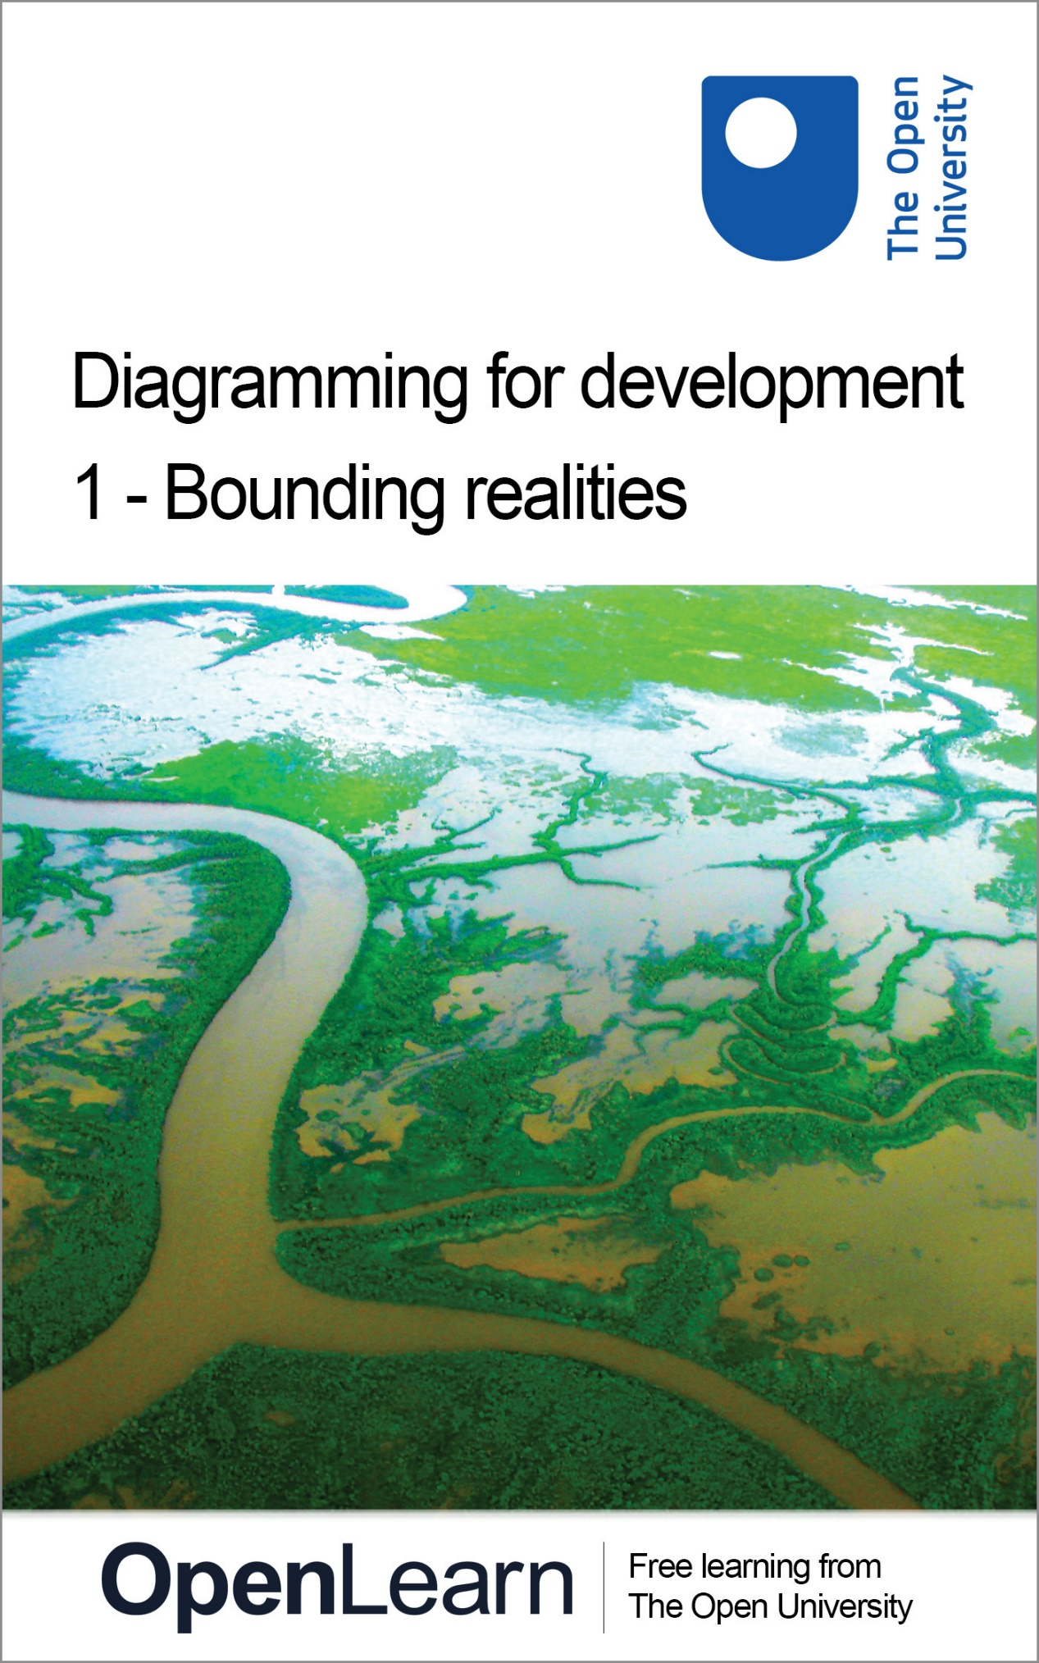

TU872_1

Diagramming for development 1: Bounding realities

About this free course
This free course is an adapted extract from the Open University course TU872 Institutional development: Conflicts, values and meanings http://www3.open.ac.uk/study/postgraduate/course/tu872.htm.
This version of the content may include video, images and interactive content that may not be optimised for your device.
You can experience this free course as it was originally designed on OpenLearn, the home of free learning from The Open University: http://www.open.edu/openlearn/science-maths-technology/computing-and-ict/systems-computer/diagramming-development-1-bounding-realities/content-section-0.
There you’ll also be able to track your progress via your activity record, which you can use to demonstrate your learning.
First published 2012.
Unless otherwise stated, copyright © 2024 The Open University, all rights reserved.
Intellectual property
Unless otherwise stated, this resource is released under the terms of the Creative Commons Licence v4.0 http://creativecommons.org/licenses/by-nc-sa/4.0/deed.en_GB. Within that The Open University interprets this licence in the following way: www.open.edu/openlearn/about-openlearn/frequently-asked-questions-on-openlearn. Copyright and rights falling outside the terms of the Creative Commons Licence are retained or controlled by The Open University. Please read the full text before using any of the content.
We believe the primary barrier to accessing high-quality educational experiences is cost, which is why we aim to publish as much free content as possible under an open licence. If it proves difficult to release content under our preferred Creative Commons licence (e.g. because we can’t afford or gain the clearances or find suitable alternatives), we will still release the materials for free under a personal end-user licence.
This is because the learning experience will always be the same high quality offering and that should always be seen as positive – even if at times the licensing is different to Creative Commons.
When using the content you must attribute us (The Open University) (the OU) and any identified author in accordance with the terms of the Creative Commons Licence.
The Acknowledgements section is used to list, amongst other things, third party (Proprietary), licensed content which is not subject to Creative Commons licensing. Proprietary content must be used (retained) intact and in context to the content at all times.
The Acknowledgements section is also used to bring to your attention any other Special Restrictions which may apply to the content. For example there may be times when the Creative Commons Non-Commercial Sharealike licence does not apply to any of the content even if owned by us (The Open University). In these instances, unless stated otherwise, the content may be used for personal and non-commercial use.
We have also identified as Proprietary other material included in the content which is not subject to Creative Commons Licence. These are OU logos, trading names and may extend to certain photographic and video images and sound recordings and any other material as may be brought to your attention.
Unauthorised use of any of the content may constitute a breach of the terms and conditions and/or intellectual property laws.
We reserve the right to alter, amend or bring to an end any terms and conditions provided here without notice.
All rights falling outside the terms of the Creative Commons licence are retained or controlled by The Open University.
Head of Intellectual Property, The Open University
978-1-4730-2008-5 (.kdl)
978-1-4730-1240-0 (.epub)

Contents
- Introduction
- Learning outcomes
- 1 Case study: the Working for Water Programme
- 2 The role of diagramming
  - 2.1 When to use each diagram
- 3 Using diagramming techniques to explore the WWP
  - 3.1 Rich pictures
  - 3.2 Final diagram
  - 3.3 Spray diagram
  - 3.4 Final diagram
  - 3.5 Systems maps
  - 3.6 Final diagram
- Conclusion
- Acknowledgements
- Descriptions

Introduction
This unit introduces you to rich pictures, spray diagrams and systems mapping, taking you step by step through the processes of developing visual representations which have proven practical value amongst international development practitioners. These particular diagramming techniques are helpful in making some initial sense of complex realities.
The unit uses the Working for Water Programme (WWP) case study, introduced as a programme that actively addresses the impoverishment of black South Africans. 14 million South Africans currently have no or inadequate water supplies.
In 1997, unemployment stood at 37%, and 50% of the population was classified as ‘poor’. With 240 projects since its inception, the WWP has generated 42,000 new jobs at the same time as creating environmental awareness and systems of social welfare benefits and clearing 450,000 hectares of the invasive plants.
The diagramming techniques develop skills in understanding complex situations of intervention and revealing significant challenges as well as opportunities of development intervention.
This OpenLearn course provides a sample of level 3 study in Computing and IT courses.

Learning outcomes
After studying this course, you should be able to:
- describe and discriminate between three different diagramming techniques for making sense of realities
- appreciate how each technique can be used to explore a complex situation, issue or problem
- use particular diagramming techniques for brainstorming ideas and concepts associated with complex situations
- analyse some links between variables in development intervention
- identify initial strengths and weaknesses, opportunities and threats associated with development intervention.

1 Case study: the Working for Water Programme
Before we look at the diagrams, take a moment to read this case study. You will be referring to it throughout this unit, so for convenience a printer friendly version is also supplied.
Should you need to refer back to this case study at any time, simply click “1 Case study: the Working for Water Programme” in the left-hand menu, and then the Back button on your browser to return to the page you were on previously.

The Working for Water Programme - working for human welfare in South Africa
A printer friendly version of this case study is available (please click on ‘View document’ below). You might find it useful to have a hard copy to hand as you work through the rest of this unit.
View document
South Africa is waging a new sort of battle. Beginning at dawn each day, thousands of citizens wield scythes, axes and pesticides against a rapidly advancing and thirsty enemy: the alien trees, shrubs and aquatic plants that thrive in South Africa’s mountains. These invasive non-native plants have infested 8% of this semi-arid country. In addition to depriving South Africans of needed water, these plants obstruct rivers, exacerbate the risk and damage of wildfires and floods, increase soil erosion and reduce biodiversity by crowding out native ecosystems.

Overview
South Africa’s response to the invasion may be the largest and most expensive programme of alien plant control ever undertaken. The South African government, in full agreement with various international biodiversity conventions, is keen to protect the biodiversity of its country. Through a multi-agency effort called the Working for Water Programme (WWP), the government has hired thousands of citizens to hack away the thirsty invasive plants and to turn the by-products of their labour into saleable goods such as fuel wood, furniture and toys. Through an inter-disciplinary approach, this integrated programme addresses the crucial issue of competing needs for water (be they of people, growing urban centres, industrial activities or ecosystems). Since its inception in 1995, the Programme has offered people opportunities to acquire a living wage and new skills. In some project areas, the Programme provides childcare, community centres, national water conservation education and has also improved general health (the lack of water or use of polluted water can generate ‘water-related diseases’).
The WWP therefore actively addresses the impoverishment of black South Africans, which is a serious issue. 14 million South Africans currently have no or inadequate water supplies. In 1997, unemployment stood at 37%, and 50% of the population was classified as ‘poor’. With 240 projects since its inception, the WWP has generated 42,000 new jobs at the same time as creating environmental awareness and systems of social welfare benefits and clearing 450,000 ha of the invasive plants. These complement the relatively recent promotion of stakeholders’ participation in the implementation of sustainable resource management. The end of apartheid has also contributed to the crafting of water reforms that encourage local participation in decision-making. However, it is a slow process and, in certain places, landowners who still favour the lucrative planting of invasive species (for example, pines for timber production) benefit from preferential water charges.
The WWP has prompted the introduction of innovative water pricing and charges. There is a commitment to supplying water for all citizens, and the national water strategy has established a ‘basic needs reserve’ for humans - an allocation of water for drinking, food preparation and personal hygiene. The competition for various water uses is strong and, through the establishment of water charges for consumption beyond the basic needs reserve, the South African government is trying to discourage over-use and wastage, and hence save water.
New concerns and debates at international levels on the importance of water and water law have also helped formulate the South African national water strategy. Since the democratic elections of 1994, the nation has crafted a suite of water policies and laws to redress past inefficiencies, inequities and environmental degradation. For example, a 1998 law makes all water public property, repealing the previous statute that assigned water rights based on property ownership. These new policies are considered among the most progressive in the world and aim at returning a voice to all citizens.
Research on the impact of invasive species on water supply has helped generate interest in today’s integrated invasive plant control effort. More economic studies that illustrate the impacts of invaders and the financial benefits of control are essential to justify the increasingly large-scale funding that the Working for Water Programme requires.
By uniting social goals with ecosystem restoration, and by capitalising on public pressure to provide water to millions of people, WWP has mustered political will, public support and funding at a time of fierce competition among the many social welfare projects visualised by South Africa’s new democratic government. Although success is far from assured, the multiple dividends that WWP pays are substantial: a healthier ecosystem, more water at less cost, and employment for thousands in a country where opportunities to escape poverty are rare.

Reference
United Nations Development Programme, United Nations Environment Programme, World Bank, and World Resources Institute (2001) ‘Freshwater Systems: Working for Water, Working for Human Welfare in South Africa’ in: World Resources 2000−2001: People and Ecosystems, the Fraying Web of Life, pp. 193−205, Washington, World Resources Institute.

2 The role of diagramming
The diagrams in this unit are designed to help you analyse and reflect on situations, make decisions and plan action. Each diagramming technique is taught around a case study of the Working for Water Programme in South Africa. The case is used to demonstrate what purposes the techniques serve and how they may be used. These techniques can be applied to problems in other contexts, including institutional change and development, or violent conflict and post conflict reconstruction, or project design and management.
Diagramming serves three general purposes:
- to note down your thoughts on a particular problem, situation or issue (sometimes called your system of interest) in a way that organises those thoughts so you can see links and relationships between the different factors you’ve identified
- to communicate your ideas to others, possibly across different cultures, in circumstances where the right words can be hard to find to establish the shared understanding needed to enable more meaningful dialogue
- to help you, either as an individual or part of a group, to analyse a problem and to think creatively and in new ways about possible solutions, especially around difficult and contested issues.
In planning an intervention diagramming also serves three more specific operational tasks:
- brainstorming, in which all ideas, concepts, issues, stakes, stakeholders, etc. relevant to an intervention are noted;
- analysis, where the relationships and links between the items identified are explored;
- diagnosis, where the strengths, weaknesses, opportunities and threats to intervention are examined.

2.1 When to use each diagram
For each diagram description below there is a suggested Activity which is itself an animated tutorial. These are generic tutorials associated with the Study pack T552 Systems Diagramming.

Rich picture

I will use this type of diagramming | … when I want to: | Examples of use
 | - Brainstorm ideas using imagery and other visual means  - Convey my personal impressions or understanding without being constrained by conventional forms of expression (or lack of language skills) | - Before the analysis stage in an intervention to:  - Bring out stakeholders’ general impressions of a situation; and  - Build confidence amongst stakeholders to engage with further discussions (e.g. as a form of purposeful ‘ice-breaking’)

Activity 1 What is a rich picture?

Watch the video on rich pictures.

Spray diagram

I will use this type of diagramming | … when I want to: | Examples of use
 | - Represent the outcome of an initial brainstorming session in a more structured way  - Identify the main components (or characteristic key words) of the issue I am interested in | - To take notes, order thoughts and explore links around, e.g. a briefing document, book, journal article, lecture, seminar or other group discussion  - To express a complex issue by representing its general characteristics in a simple way

Activity 2 What is a spray diagram?

Watch the video on Spray diagrams.

Systems map

I will use this type of diagramming | … when I want to: | Examples of use
 | - Identify conceptual or biophysical boundaries placed around a particular issue  - Identify elements outside that boundary which might be significant  - Explore the significance of changing where the boundary is placed | - To explore and possibly challenge existing or proposed boundary judgements  - To provide an initial stakeholder analysis (i.e. those involved = groups inside the boundary; those affected = outside the boundary).

Activity 3 What is a systems map?

Watch the video on Systems maps.

3 Using diagramming techniques to explore the WWP
Diagramming techniques can be used to address some of the questions that might arise as you read the summary:
- How can I make sense of the issues and the context in which the programme is being implemented?
- What are the main elements associated with WWP and what are the broad associations or relationships between these elements?
- How can I look in more detail at the structure of the WWP? What elements (e.g., stakeholder groups) might be needed to implement the WWP? What other elements might lie outside the boundary of the WWP but might be very relevant to success or failure of the programme? What value might there be in focussing at different levels of interest (e.g. an individual WWP project, or more generalised strategies of agricultural development)?
- How can I identify the factors that are key in building on the success of WWP?
- What might support the continued success of WWP − or act as an obstacle? Where might an intervention take place and resources be deployed in order to encourage success and/or lessen any such obstacles?
- What decisions need to be made in order to sustain the success of WWP? What might be the implications of such decisions and what assumptions are being made regarding previous decision making?

3.1 Rich pictures

Definition
Rich pictures are a compilation of drawings, pictures, symbols and text that represent a particular situation or issue from the viewpoint(s) of the person or people who drew them.
Rich pictures can show relationships, connections, influences, cause and effect. They can also show more subjective elements such as character and characteristics as well as points of view, prejudices, spirit and human nature.
Rich pictures can both record and evoke insight into a situation. They can be regarded as pictorial ‘summaries’ of the physical, conceptual and emotional aspects of the situation at a given time.

Use
Rich pictures are often used to depict complicated situations or issues. They are drawn prior to analysing a situation, when it is unclear which parts of a situation are particularly important. They help show which parts should be regarded as structure and which as process.
They are an attempt to encapsulate the real points of interest in a situation through words and imagery.
Rich pictures can be invaluable in communicating issues between groups of people where there are cultural or language differences. Drawings, pictures and text can provide the basis for the shared understandings needed to enable further dialogue (and perhaps further rich pictures).
A rich picture offers a great deal of scope for creative thinking and freedom in how you represent your ideas. A lack of drawing skill is no drawback as symbols, icons, photographs and/or text can be used to represent different elements.

Diagram components

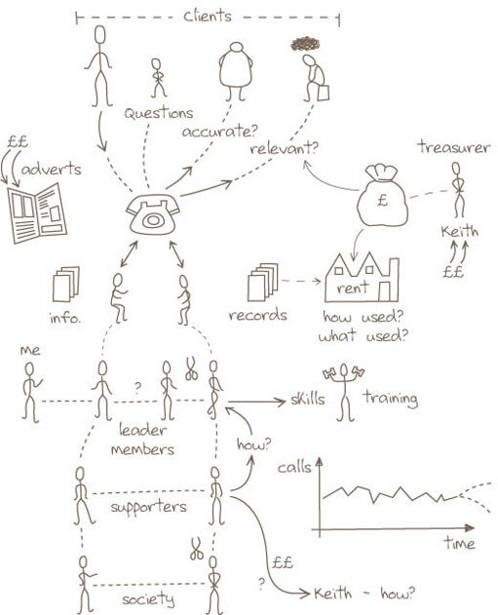
Figure 1 A rich picture
View alternative description - Figure 1 A rich picture

A rich picture can include some or all of the following elements:
- pictorial symbols
- keywords
- sketches
- cartoons
- symbols
- arrows and other lines to show flows of resources and/or relationships
- title.

Conventions
- Interpretation: Choose symbols, scenes or images that best represent the situation for you. Use as many colours as necessary and draw the symbols on a large piece of paper. (A3 is an ideal size; it can always be reduced down to A4 size for inclusion in any reports.
- Connections: Put in whatever connections you see between your pictorial symbols; note where there are no obvious connections, as this might later prove significant.
- Words: text can be part of any rich picture but be concise. Speech bubbles are quite a common device.
- Boundaries: Don’t worry too much about drawing boundaries around groups of components. They can be useful to include but aren’t really the main focus of this technique. (Systems maps are used to establish and investigate boundaries.)

Guidelines
- A rich picture is an attempt to assemble everything that might be relevant to a complex situation. (For example, as you gather data through interviews and other types of research, rich pictures might help you think about how best to represent the information.)
- Use words only where you cannot represent your meaning in a sketch.
- Place all elements on your sheet wherever it feels right to put them. Drawing elements on sticky notes can be very effective in the early stages of drawing a rich picture. You can move them around until the rich picture clearly represents the situation as you see it.
- Include both factual data and the subjective information.
- Look at the social roles that are regarded as meaningful by those involved, and look at the kinds of behaviour expected from people in those roles. If you see any conflicts, indicate them.
- Include yourself in the picture. Make sure that your roles and relationships in the situation are clear. Your values, beliefs and norms are important.
If you don’t know how to begin drawing a rich picture try the following.
- Look for the elements of structure in the situation; these would include parts of the situation that change relatively slowly over time and are relatively stable, e.g. the people, the set-ups, the hierarchy of authority.
- Look for elements of process within the situation (these are ongoing activities).
- Look at how the structure and the processes interact (or don’t interact).

3.2 Final diagram
You may wish to refer back to the WWP case study as you work through the activity on this page.

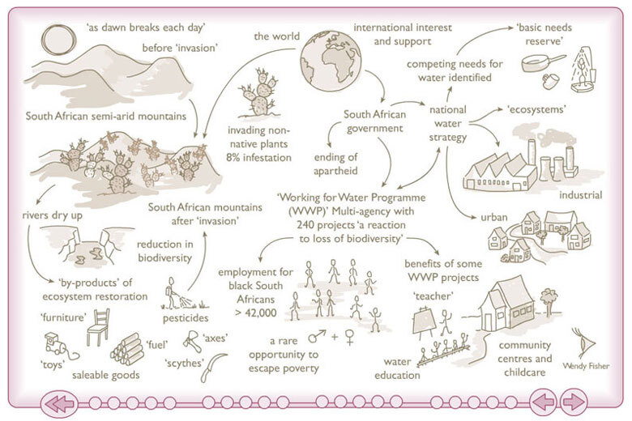
Figure 2 Printable rich picture
View alternative description - Figure 2 Printable rich picture

For a printable A4 size copy of this diagram, click on ‘View document’.
View document

Activity 4 Rich picture

Choose one of the following:
- your impression of the South African Working for Water Programme; or
- a topic for which you have a particular interest; or
- an intervention that you have recently been involved with and which you found challenging (this might be work-related or home/leisure-related).
Using any types of imagery and accompanying text that you think is appropriate, sketch a rich picture to show the various dimensions of your interest as you envisage it. Include any personal experiences that you feel might be relevant and important.
After completing your picture, list down two or three key themes that have emerged from your drawing which you think would be of interest for further enquiry.

3.3 Spray diagram

Definition
Spray diagrams show the connections between related elements or concepts associated with a particular issue. They do not show the nature of the relationship between the elements. A spray diagram can be thought of as a conceptual map of a situation or issue.

Use
Spray diagrams are widely used as thinking tools. They can be used in a number of different ways:
- for thinking about an issue from scratch
- to help you organise various facts, issues or ideas into a structured form
- for taking notes; and
- for setting out the structure of an argument.
You can use a spray diagram to organise material into a basic structure, both to clarify your own understanding, or as the basis for a report or presentation. The spray diagram you create can therefore be used as a tool to give an overview of your understanding of a situation and enable you to share your understanding of a situation as you discuss it with others.

Components

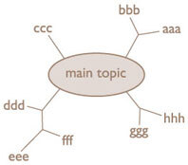
Figure 3 Format for a spray diagram
View alternative description - Figure 3 Format for a spray diagram

- A title.
- Central circle or blob (irregular enclosed boundary) for main topic you are going to focus on.
- Blobs for sub-topics (optional, depending on importance of sub-topics).
- Lines branching out from topic/sub-topics.
- Words to identify main topics and sub-topics within the blobs.
- Words where lines branch or at the ends of lines.

Conventions and guidelines
The form of a spray diagram is very simple: it consists of lines, a few blobs and words at the ends of lines or where they branch. There are no arrows. It’s a good idea to circle the topic or central idea that the diagram sprays out from. Some people also find it useful to circle other sub-topics on the diagram. You don’t have to think about the nature of the connection between two nodes joined by a line. The line simply means that in your mind there is some association. In spray diagrams, you:
- express ideas in one or a few words
- keep track of the key topics or sub-topics by circling them
- use lines to join up the components or concepts that appear related in some way
- do not show directional links on the lines.
In drawing a spray diagram the main steps are:
- Write down the main topic you wish to explore, leaving plenty of space round it.
- Identify branches from the main topic you want to explore further. Note them down and draw lines linking them to the main topic. Keep going by considering each branch in turn and ideas (new branches) that link from it.
Spray diagrams can be useful to leave and add to over time as situations or arguments develop or you gain new insights.

3.4 Final diagram
You may wish to refer back to the WWP case study as you work through the activity on this page.

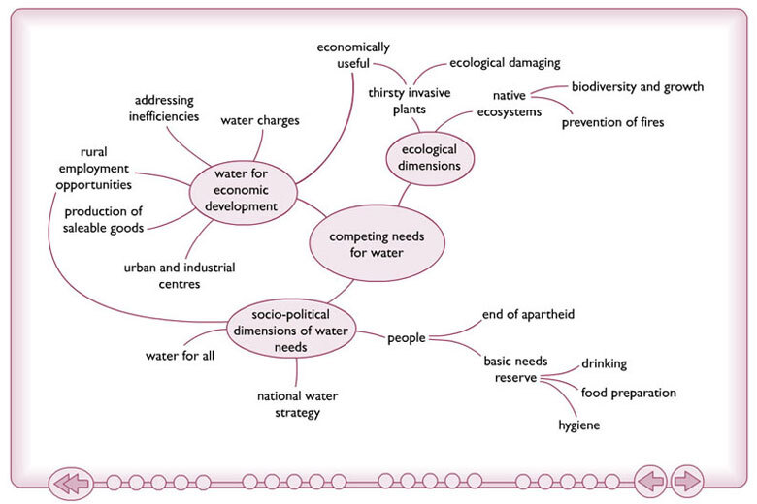
Figure 4 Issues around competing needs for water in South Africa
View alternative description - Figure 4 Issues around competing needs for water in South Africa

For a printable A4 size copy of diagram, click on ‘View document’.
View document

Activity 5 Spray diagram

Choose one of the following.
- Re-read the South African Working for Water Programme case study and construct your own spray diagram. Choose a main topic on which to structure or hang your sub-topics and associated branches. How does your spray diagram differ from the one presented in the tutorial? What further clarifications and insights are offered in your own spray diagram?
Keep this diagram handy as you work through the other tutorials. It can act as a useful aide memoir of your understanding of the WWP.
- After skimming the text to get a general sense of the subject matter covered, go through it again but this time constructing a spray diagram on a sheet of scrap paper.
Begin your diagram with a central theme or topic to which the article or reading relates (you ought to be able to identify this through a combination of the title and your initial quick review of the reading). Identify the topics and sub-topics, drawing lines between parts that relate to each other.
As this isn’t a diagram that you’ll be sharing with others, don’t worry too much about the messiness of the final outcome, and feel free to annotate various parts of the diagram where you feel questions arise or issues are not clearly expressed.
From your final spray diagram list down what you consider to be the key arguments associated with the reading, and your own responses to them. These represent the structural features of the reading.

3.5 Systems maps

Definition
A systems map is a snapshot of a system and its environment at a given time.
Note that ‘system’ has a specialised meaning here. It is the term used to describe any situation or issue you want to explore. It is what you are interested in investigating and hence is known as the system of interest. A system of interest is separated from its environment by a boundary. Boundaries also exist between components of a system ( or sub-systems).
A system of interest (SoI) is defined by its purpose. The purpose thus represents the general boundary of a system. The components of a systems map are therefore related to each other as if they collectively fulfil that purpose. Examples of a SoI could include an entity like an organisation or an activity like planning an intervention.
A systems map shows how themes or elements might be grouped together as components of the specified SoI or as elements in the environment of the SoI. Some components might be grouped together (or bounded) as sub-systems. Single components might themselves be sub-systems.
A systems map derives from the perspective of the person or people constructing it. A systems map thus illustrates boundary judgements.

Use
Systems maps help to identify the themes and elements that you see as being relevant to an issue. Where you draw the boundaries for your SoI is key to deciding at what level to focus upon. For example, is a particular development project an appropriate focus for intervention? It might be more beneficial to focus down a level, examining one aspect of the project, say the budgetary or personnel component. Or conversely, it might be more beneficial to go up at different levels and to focus instead on the policy domain, programme or strategy in which the project is embedded. Perhaps a global focus might be more appropriate than a regional, national, or local focus. Development practice is continually informed by such boundary judgements.
Once a particular level of interest (e.g. level of intervention) is decided upon, systems mapping can prompt investigation into the following types of boundary judgement or questions.
- What is the purpose of intervention? (What exactly is the SoI?)
- What needs to be done to fulfil that purpose? (What are the components of the SoI?)
- What obstacles might there be to fulfilling that purpose? (What are the elements in the environment?)
In addition, systems maps can be used to analyse existing systems of interest. They can:
- signal and question exactly what is (as against what ought to be) in the SoI (for example, stakeholders involved in an intervention)
- signal and question what is (as against what ought to be) in the environment (for example, relevant stakeholders marginalised from the process of intervention, or other factors outside the terms of reference that might be relevant to the success of the intervention).
In brief systems mapping can be used to:
- Clarify thoughts at an early stage of analysis.
- Establish structural elements for a more detailed diagram.
- Experiment with systems boundaries.
- Focus on a level of interest (and various sub-systems of interest within it).
- Communicate to others the basic structure of the SoI you are describing.

Diagram components

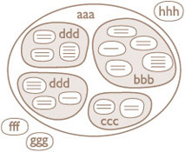
Figure 5 Format of a systems diagram
View alternative description - Figure 5 Format of a systems diagram

- A title defining the purpose of your SoI (the situation or issue you are exploring).
- Blobs (regular or irregular rounded shapes) to show the boundaries of the system, sub-system components, and elements in the environment.
- Labels within the blobs to describe the system, sub-system components, and elements in the environment.
Note that lines and arrows are not used within systems maps.

Conventions and guidelines
In drawing a systems map the main steps are as follows.
- Identify the main issue on which you are going to draw a system of interest.
- Draw the main boundary around your system of interest, thereby specifying what falls within the system itself and what is in the environment.
- Identify each sub-system and draw a blob around it to establish its boundary.
- Use words within appropriate boundaries to name
  - the system (this will be the title of your main system of interest)
  - component sub-systems, and
  - elements in the environment.
- Blobs (boundaries) may occasionally overlap if some components are seen as belonging to more than one system. However, you should overlap only when the sharing of components is important from your particular viewpoint or when you are still uncertain as to where a component should lie. Overlaps generally work against the aim of clearly identifying a system of interest.
Don’t worry if it takes several iterations through each step before you are happy with your diagram, or even if it takes several versions of the diagram. Each time you draw or redraw the diagram helps to clarify or refocus your thinking about the situation or issue you are investigating.

3.6 Final diagram
You may wish to refer back to the WWP case study as you work through the activity on this page.

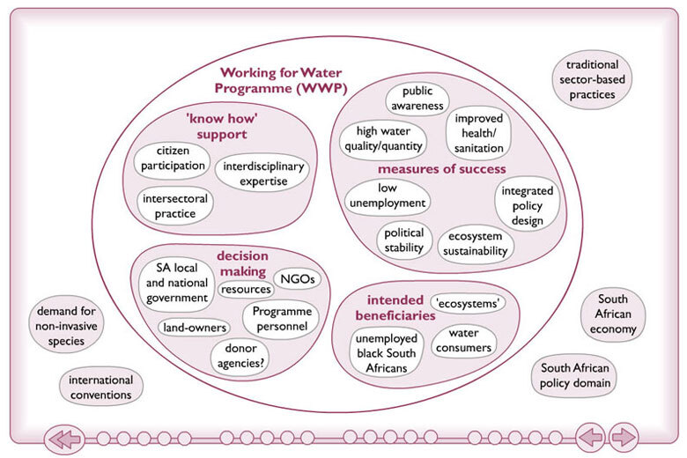
Figure 6 Factors associated with WWP
View alternative description - Figure 6 Factors associated with WWP

For a printable A4 size copy of diagram, click on ‘View document’.
View document

Activity 6 Systems map

Draw a systems map illustrating one of the following.
- your impression of the South African Working for Water Programme, possibly from a different level of interest to that demonstrated in the tutorial (e.g. a higher level such as an international perspective or a lower level such as the stakeholders associated with the programme); or
- an intervention that you have been involved with (either home- or work-related).
For the intervention that you choose:
- name the system of interest (SoI) being focused upon, in terms of a purpose (e.g., a system to. reduce ethnic conflict);
- think of and map four or five bounded sub-system components key to the success of your chosen SoI;
- if you have more then five components, examine how some might be grouped together and present these on your map as sub-systems of sub-systems (or sub-sub-systems);

Conclusion
In this unit you have been introduced to rich pictures, spray diagrams and systems maps. You have seen how they can help with understanding complex situations by organising your thoughts; particularly thoughts on linkages about different factors associated with complex realities. The systems diagramming techniques here help towards bounding your thoughts in a visual manner that can help communicate ideas to others, possibly across different cultures, in circumstances where the right words can be hard to find to establish the shared understanding needed to enable more meaningful dialogue. Rich pictures, spray diagrams and systems maps can help in brainstorming and analysing issues, revealing significant challenges as well as opportunities for intervention.
This is a companion course to Diagramming for development 2: exploring inter-relationships.
This OpenLearn course provides a sample of level 3 study in Computing and IT courses.

Acknowledgements
Grateful acknowledgement is made to the following sources for permission to reproduce material in this unit:
Dr Martin Reynolds (lead academic author)
Wendy Fisher (author of the WWP ‘rich picture’)
Jane Bromley (interactive media developer)
Karen Shipp and the OU Systems Group for animations in ‘2.1: When to use each diagram.’ These animations form part of T552 Systems thinking and practice: Diagramming from which much of the diagramming source material for this unit was derived. T552 is a diagramming pack which supported modules in the undergraduate Systems Diploma and Systems Residential School and supports modules in the postgraduate Systems Thinking in Practice qualifications. Further details of this pack and associated Systems courses can be found at the Open University’s Systems Group website.
U316 The environmental web from which the spray diagram tutorial and WWP case study are derived.
Particular thanks are also due to Sandrine Simone, Gloria Median, Bina Sharma and Rissa de la Paz.
adapted from an image by Angela Sevin: the original can be seen at http://www.flickr.com/photos/angela7/261618376 [Details correct as of 24 October 2011]
Except for third party materials and otherwise stated (see terms and conditions), this content is made available under a Creative Commons Attribution-NonCommercial-ShareAlike 4.0 Licence.
Every effort has been made to contact copyright holders. If any have been inadvertently overlooked, the publishers will be pleased to make the necessary arrangements at the first opportunity.
Don’t miss out:
If reading this text has inspired you to learn more, you may be interested in joining the millions of people who discover our free learning resources and qualifications by visiting The Open University - www.open.edu/openlearn/free-courses

Descriptions

Figure 1 A rich picture
Figure 1 A rich picture
Back to - Figure 1 A rich picture

Figure 2 Printable rich picture
Figure 2 Printable rich picture
Back to - Figure 2 Printable rich picture

Figure 3 Format for a spray diagram
Figure 3 Format for a spray diagram
Back to - Figure 3 Format for a spray diagram

Figure 4 Issues around competing needs for water in South Africa
Figure 4 Issues around competing needs for water in South Africa
Back to - Figure 4 Issues around competing needs for water in South Africa

Figure 5 Format of a systems diagram
Figure 5 Format of a systems diagram
Back to - Figure 5 Format of a systems diagram

Figure 6 Factors associated with WWP
Figure 6 Factors associated with WWP
Back to - Figure 6 Factors associated with WWP

