

TU875_1

Diagramming for development 2: Exploring interrelationships

About this free course
This free course provides a sample of level 3 study in Computing & IT http://www.open.ac.uk/courses/find/computing-and-it
This version of the content may include video, images and interactive content that may not be optimised for your device.
You can experience this free course as it was originally designed on OpenLearn, the home of free learning from The Open University: http://www.open.edu/openlearn/science-maths-technology/computing-and-ict/systems-computer/diagramming-development-2-exploring-interrelationships/content-section-0.
There you’ll also be able to track your progress via your activity record, which you can use to demonstrate your learning.
First published 2012.
Unless otherwise stated, copyright © 2024 The Open University, all rights reserved.
Intellectual property
Unless otherwise stated, this resource is released under the terms of the Creative Commons Licence v4.0 http://creativecommons.org/licenses/by-nc-sa/4.0/deed.en_GB. Within that The Open University interprets this licence in the following way: www.open.edu/openlearn/about-openlearn/frequently-asked-questions-on-openlearn. Copyright and rights falling outside the terms of the Creative Commons Licence are retained or controlled by The Open University. Please read the full text before using any of the content.
We believe the primary barrier to accessing high-quality educational experiences is cost, which is why we aim to publish as much free content as possible under an open licence. If it proves difficult to release content under our preferred Creative Commons licence (e.g. because we can’t afford or gain the clearances or find suitable alternatives), we will still release the materials for free under a personal end-user licence.
This is because the learning experience will always be the same high quality offering and that should always be seen as positive – even if at times the licensing is different to Creative Commons.
When using the content you must attribute us (The Open University) (the OU) and any identified author in accordance with the terms of the Creative Commons Licence.
The Acknowledgements section is used to list, amongst other things, third party (Proprietary), licensed content which is not subject to Creative Commons licensing. Proprietary content must be used (retained) intact and in context to the content at all times.
The Acknowledgements section is also used to bring to your attention any other Special Restrictions which may apply to the content. For example there may be times when the Creative Commons Non-Commercial Sharealike licence does not apply to any of the content even if owned by us (The Open University). In these instances, unless stated otherwise, the content may be used for personal and non-commercial use.
We have also identified as Proprietary other material included in the content which is not subject to Creative Commons Licence. These are OU logos, trading names and may extend to certain photographic and video images and sound recordings and any other material as may be brought to your attention.
Unauthorised use of any of the content may constitute a breach of the terms and conditions and/or intellectual property laws.
We reserve the right to alter, amend or bring to an end any terms and conditions provided here without notice.
All rights falling outside the terms of the Creative Commons licence are retained or controlled by The Open University.
Head of Intellectual Property, The Open University
978-1-4730-2009-2 (.kdl)
978-1-4730-1241-7 (.epub)

Contents
- Introduction
- Learning outcomes
- 1 Case study: the Working for Water Programme
- 2 The role of diagramming
  - 2.1 When to use each diagram
- 3 Using diagramming techniques to explore the WWP Case Study
  - 3.1 Influence diagram
  - 3.2 Final diagrams
  - 3.3 Multiple cause diagram
  - 3.4 Final diagram
  - 3.5 Cognitive map
  - 3.6 Final diagram
- Conclusion
- Acknowledgements
- Descriptions

Introduction
This unit introduces you to influence diagrams, multiple cause diagrams and cognitive maps, taking you step by step through the processes of developing visual representations which have proven practical value amongst international development practitioners. These particular diagramming techniques are helpful in analysing inter-relationships between factors associated with development intervention.
The unit uses the Working for Water Programme (WWP) case study, introduced as a programme that actively addresses the impoverishment of black South Africans. 14 million South Africans currently have no or inadequate water supplies.
In 1997, unemployment stood at 37%, and 50% of the population was classified as ‘poor’. With 240 projects since its inception, the WWP has generated 42,000 new jobs at the same time as creating environmental awareness and systems of social welfare benefits and clearing 450,000 ha of the invasive plants
The diagramming techniques develop skills in understanding complex situations of intervention and revealing significant challenges as well as opportunities of development intervention.
This OpenLearn course provides a sample of level 3 study in Computing and IT courses.

Learning outcomes
After studying this course, you should be able to:
- describe and discriminate between three different diagramming techniques for exploring inter-relationships
- appreciate how each technique can be used to explore a complex situation, issue or problem
- use particular diagramming techniques for brainstorming ideas and concepts associated with complex situations
- analyse relationships and links between variables in development intervention
- diagnose strengths and weaknesses, opportunities and threats associated with development intervention.

1 Case study: the Working for Water Programme
Before we look at the diagrams, take a moment to read this case study. You will be referring to it throughout this unit, so for convenience a printer friendly version is also supplied.
Should you need to refer back to this case study at any time, simply click “1 Case study: the Working for Water Programme” in the left-hand menu, and then the Back button on your browser to return to the page you were on previously.

The Working for Water Programme - working for human welfare in South Africa
A printer friendly version of this case study is available (please click on ‘View document’ below). You might find it useful to have a hard copy to hand as you work through the rest of this unit.
View document
South Africa is waging a new sort of battle. Beginning at dawn each day, thousands of citizens wield scythes, axes and pesticides against a rapidly advancing and thirsty enemy: the alien trees, shrubs and aquatic plants that thrive in South Africa’s mountains. These invasive non-native plants have infested 8% of this semi-arid country. In addition to depriving South Africans of needed water, these plants obstruct rivers, exacerbate the risk and damage of wildfires and floods, increase soil erosion and reduce biodiversity by crowding out native ecosystems.

Overview
South Africa ’s response to the invasion may be the largest and most expensive programme of alien plant control ever undertaken. The South African government, in full agreement with various international biodiversity conventions, is keen to protect the biodiversity of its country. Through a multi-agency effort called the Working for Water Programme (WWP), the government has hired thousands of citizens to hack away the thirsty invasive plants and to turn the by-products of their labour into saleable goods such as fuel wood, furniture and toys. Through an inter-disciplinary approach, this integrated programme addresses the crucial issue of competing needs for water (be they of people, growing urban centres, industrial activities or ecosystems). Since its inception in 1995, the Programme has offered people opportunities to acquire a living wage and new skills. In some project areas, the Programme provides childcare, community centres, national water conservation education and has also improved general health (the lack of water or use of polluted water can generate ‘water-related diseases’).
The WWP therefore actively addresses the impoverishment of black South Africans, which is a serious issue. 14 million South Africans currently have no or inadequate water supplies. In 1997, unemployment stood at 37%, and 50% of the population was classified as ‘poor’. With 240 projects since its inception, the WWP has generated 42,000 new jobs at the same time as creating environmental awareness and systems of social welfare benefits and clearing 450,000 ha of the invasive plants. These complement the relatively recent promotion of stakeholders’ participation in the implementation of sustainable resource management. The end of apartheid has also contributed to the crafting of water reforms that encourage local participation in decision-making. However, it is a slow process and, in certain places, landowners who still favour the lucrative planting of invasive species (for example, pines for timber production) benefit from preferential water charges.
The WWP has prompted the introduction of innovative water pricing and charges. There is a commitment to supplying water for all citizens, and the national water strategy has established a ‘basic needs reserve’ for humans - an allocation of water for drinking, food preparation and personal hygiene. The competition for various water uses is strong and, through the establishment of water charges for consumption beyond the basic needs reserve, the South African government is trying to discourage over-use and wastage, and hence save water.
New concerns and debates at international levels on the importance of water and water law have also helped formulate the South African national water strategy. Since the democratic elections of 1994, the nation has crafted a suite of water policies and laws to redress past inefficiencies, inequities and environmental degradation. For example, a 1998 law makes all water public property, repealing the previous statute that assigned water rights based on property ownership. These new policies are considered among the most progressive in the world and aim at returning a voice to all citizens.
Research on the impact of invasive species on water supply has helped generate interest in today’s integrated invasive plant control effort. More economic studies that illustrate the impacts of invaders and the financial benefits of control are essential to justify the increasingly large-scale funding that the Working for Water Programme requires.
By uniting social goals with ecosystem restoration, and by capitalising on public pressure to provide water to millions of people, WWP has mustered political will, public support and funding at a time of fierce competition among the many social welfare projects visualised by South Africa ’s new democratic government. Although success is far from assured, the multiple dividends that WWP pays are substantial: a healthier ecosystem, more water at less cost, and employment for thousands in a country where opportunities to escape poverty are rare.

Reference
United Nations Development Programme, United Nations Environment Programme, World Bank, and World Resources Institute (2001) ‘Freshwater Systems: Working for Water, Working for Human Welfare in South Africa’ in: World Resources 2000 − 2001: People and Ecosystems, the Fraying Web of Life , pp. 193−205, Washington, World Resources Institute.

2 The role of diagramming
The diagrams in this unit are designed to help you analyse and reflect on situations, make decisions and plan action. Each diagramming technique is taught around a case study of the Working for Water Programme in South Africa. The case is used to demonstrate what purposes the techniques serve and how they may be used. These techniques can be applied to problems in other contexts, including institutional change and development, or violent conflict and post conflict reconstruction, or project design and management.
Diagramming serves three general purposes.
- To note down your thoughts on a particular problem, situation or issue (sometimes called your system of interest) in a way that organises those thoughts so you can see links and relationships between the different factors you’ve identified.
- To communicate your ideas to others, possibly across different cultures, in circumstances where the right words can be hard to find to establish the shared understanding needed to enable more meaningful dialogue.
- To help you, either as an individual or part of a group, to analyse a problem and to think creatively and in new ways about possible solutions, especially around difficult and contested issues.
In planning an intervention diagramming also serves three more specific operational tasks:
- brainstorming, in which all ideas, concepts, issues, stakes, stakeholders, etc. relevant to an intervention are noted;
- analysis, where the relationships and links between the items identified are explored;
- diagnosis, where the strengths, weaknesses, opportunities and threats to intervention are examined.

2.1 When to use each diagram
For each diagram description below there is a suggested Activity which is itself an animated tutorial. These are generic tutorials associated with the Study pack T552 Systems Diagramming.

Influence diagram

I will use this type of diagramming | … when I want to: | Examples of use
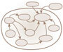 | - identify structural factors of influence (including actors or agents)  - differentiate between strong and weak influences  - identify what might be obstacles (‘bad’ influences) | - To explore the strengths and weaknesses of the structural factors from different viewpoints.  - To identify factors that might need particular attention in order to bring about constructive change.

Activity 1 What is an influence diagram?

Watch the video on Influence diagrams.

Multiple cause diagram

I will use this type of diagramming | … when I want to: | Examples of use
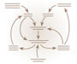 | - identify the process of why an event happened (the causes and sub-causes of a phenomenon) and hence the agency of change  - identify how these causes relate to each other through flows of causation  - identify a suitable point of intervention to support success or inhibit or reduce problems. | - To explore the strengths and weaknesses of the structural factors from different viewpoints.

Activity 2 What is a multiple cause diagram?

Watch the video on multiple cause diagrams.

Click on multiple cause diagram to see the description of the animated tutorial.

Cognitive mapping

I will use this type of diagramming | … when I want to: | Examples of use
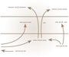 | - reveal or illuminate patterns of reasoning about (or making sense of) a particular situation  - reach a decision about a particular option which will generate minimum negative consequences | - To choose between various options for intervention in which the consequences of each option might not be immediately apparent.
There is no ‘What is …’ animation for cognitive mapping.

3 Using diagramming techniques to explore the WWP Case Study
Diagramming techniques can be used to address some of the questions that might arise as you read the summary:
- How can I make sense of the issues and the context in which the programme is being implemented?
- What are the main elements associated with WWP and what are the broad associations or relationships between these elements?
- How can I look in more detail at the structure of the WWP? What elements (e.g., stakeholder groups) might be needed to implement the WWP? What other elements might lie outside the boundary of the WWP but might be very relevant to success or failure of the programme? What value might there be in focussing at different levels of interest (e.g. an individual WWP project, or more generalised strategies of agricultural development)?
- How can I identify the factors that are key in building on the success of WWP?
- What might support the continued success of WWP − or act as an obstacle? Where might an intervention take place and resources be deployed in order to encourage success and/or lessen any such obstacles?
- What decisions need to be made in order to sustain the success of WWP? What might be the implications of such decisions and what assumptions are being made regarding previous decision making?

3.1 Influence diagram

Definition
Influence diagrams identify the factors (structural features such as people and events) that have direct and indirect influence on a system and its environment. (See the definition of a systems map for an explanation of ‘system’.)
Unlike a multiple cause diagram which traces change over time, influence diagrams identify factors with the capacity to influence at any particular point of time. An influence diagram is more like a systems map in providing a snapshot of a situation.
Influence diagrams differentiate between two types of influences: strong influences and weak influences.

Use
Influence diagrams are used to:
- present an overview of areas of activity, groupings of people or other organisational features relevant to the situation or issue under consideration (the system of interest)
- express a broad view of how things are interrelated in the area you are considering
- explore interrelationships, perhaps leading to re-grouping and re-definition of a system and its components.
An influence diagram is particularly useful as a tool for communication − as a means of sharing or exchanging perspectives or views on a particular situation during initial stages of negotiation and collaborative planning.

Diagram components

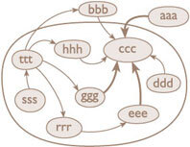
Figure 1 Format of an influence diagram
View alternative description - Figure 1 Format of an influence diagram

- Title: describing the factors of influence being represented by the diagram.
- System boundary (optional but recommended).
- Blobs of varying size.
- Arrows, sometimes of different thickness.
- Words labelling blobs.

Conventions and guidelines
An influence diagram is made up of blobs and arrows. The real message of this type of representation emerges from the arrows. The main steps are:
- Define the system of interest.
- Use blobs to represent components (sub-systems).
- Use words to label components.
- Use arrows to denote capacity to influence (not sequences in time).
- Use different line thickness (or colour) to indicate different influence strengths.
- Do not use double-headed arrows. Influences between two components are rarely, if ever, truly reciprocal and of the same type. Where there is thought to be dynamic two-way influences, use two separate arrows pointing in opposite directions.
- Use labels on arrows if the nature of the influence is not obvious from the context.
Click on WWP Influence diagram to see the description of the animated tutorial.

3.2 Final diagrams
You may wish to refer back to the WWP case study as you work through the activity on this page.

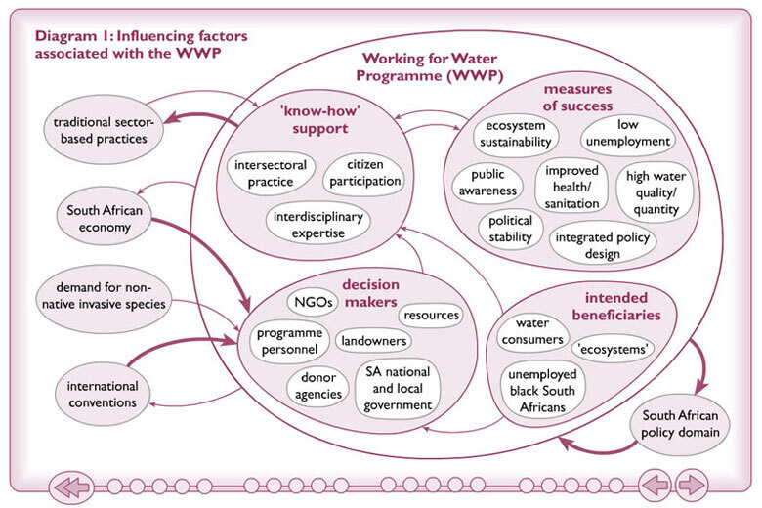
Figure 2 Influencing factors associated with WWP, diagram 1
View alternative description - Figure 2 Influencing factors associated with WWP, diagram 1

For a printable A4 size copy of this diagram, click on ‘View document’.
View document

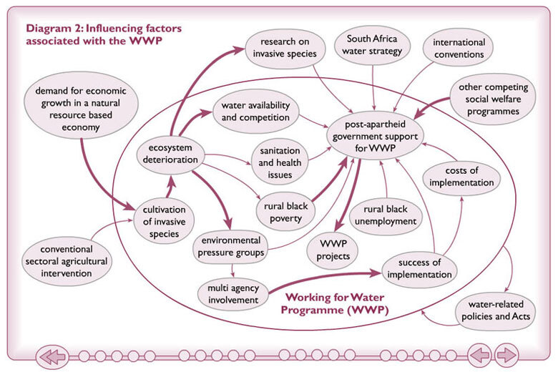
Figure 3 Influencing factors associated with WWP, diagram 2
View alternative description - Figure 3 Influencing factors associated with WWP, diagram 2

For a printable A4 size copy of this diagram, click on ‘View document’.
View document

Activity 3 Systems map

Copy out or retrieve the systems map that you drew for the activity on systems mapping and sketch in arrows to indicate areas of strong and weak influences.
In addition, draw an influence diagram of one of the following starting from a blank sheet of paper:
- your impressions of key influences on the South African Working for Water Programme; or
- another example of an intervention or event that you have personal experience of, or familiarity with, in relation to work or other areas of interest.
Identify the key structural features of influence and arrange them clearly on your diagram. See if you can draw a boundary between structural features that might be components of the system of interest and elements that lie outside the immediate concerns of a system of interest. Distinguish between strong and weak lines of influence.
After completing your diagram, note the strong and weak influences associated with your diagram and write down brief notes on which structural features need attention in the event of further intervention.

3.3 Multiple cause diagram

Definition
Multiple cause diagrams show the various causes of a certain event or situation and the relationships between the variables. They show causal chains of why something has occurred.

Use
In development studies and development intervention a distinction is often usefully made between issues of structure and issues of agency. Spray diagrams, systems maps and influence diagrams focus on structural elements of a situation; sometimes including ‘agents’ or stakeholders but little or no detail on their precise ‘agency’. Multiple cause diagrams illustrate the agency (the process) of change. Various causes of a certain event or situation are represented, and relationships between variables in a given situation are investigated.
A multiple cause diagram goes a step further than an influence diagram. Whereas an influence diagram describes the capacity of structural components to exert weak and strong influences at any one time, a multiple cause diagram specifically focuses on actual causes over a period of time. Tracing back the various causes of a problem - or contributors to a solution - can help to improve intervention. As well as showing the causes themselves, multiple cause diagrams show how they are interlinked.
Multiple cause diagrams explore why something has happened (often why something went wrong) or why a situation is as it is (often why a problem recurs). They don’t predict behaviour, but can be used to create a checklist of factors (or variables) when considering comparable circumstances in the future.
They can also be useful in identifying solutions to problems: for instance, having identified two possible points of intervention to avoid an event, the diagram might show that intervening at one of them is likely to be more effective.

Diagram components

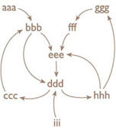
Figure 4 Format of a multiple cause diagram
View alternative description - Figure 4 Format of a multiple cause diagram

- A title explaining the event or state you are trying to explain. The diagram addresses the question: what caused this?
- Phrases depicting a state (e.g. impoverished community), a variable (something that has a value that can go up or down) relating to a state (e.g. poverty), or an event (e.g. implementation of structural adjustment programme or some form of armed intervention)
- Arrows depicting the direction of causality
- Chains or loops of causality.

Conventions and guidelines
A multiple cause diagram looks a bit like an influence diagram. However, whereas the arrows in an influence diagram signal the capacity to influence at any one point of time (that is, in providing a snapshot), the arrows of a multiple cause diagram signal an actual path of causality over a sequence of time. In a multiple cause diagram:
- A title is essential naming the prime factor or event being explored.
- Begin at the factor/ event to be explained and work backwards. Start with the immediate (proximate) causes and move to more distant causes.
- Phrases are used to relate either to a state, a variable or to an event. These cause, directly or indirectly, the main event we are looking at. It is not necessary to encircle phrases, although putting blobs around selected variables you wish to emphasise as being important, might improve clarity.
- Arrows indicate the causal connections between the phrases. The arrows can mean ‘contributes to’, ‘leads to’ or ‘enables’. In general arrows are not labelled. However, it is acceptable to do so if you wish to add information about the type of causal connection where this is either not clear or actually misleading. For example drawing an arrow from ‘armed intervention’ to ‘poverty’ signals an affirmative causal link: armed conflict causes poverty! If you wished to argue that armed intervention had an opposite causal effect in a particular situation (i.e., armed intervention reduced poverty) it would be appropriate to label the arrow with ‘reduces’. In general, where an increase in one variable leads to a decrease in the second variable, a label on the arrow is required.
- The diagram can be sequential or it might contain loops.
Click on WWP multiple cause diagram to see the description of the animated tutorial.

3.4 Final diagram
You may wish to refer back to the WWP case study as you work through the activity on this page.

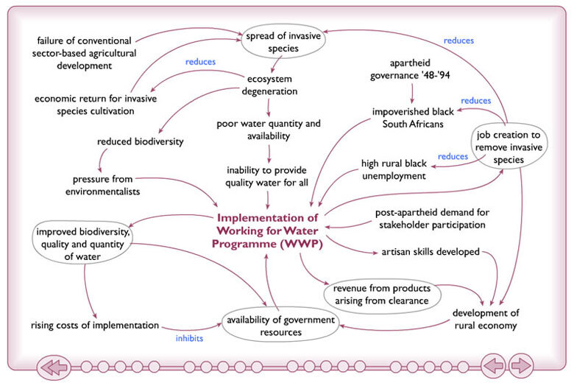
Figure 5 Causal factors associated with implementing WWP
View alternative description - Figure 5 Causal factors associated with implementing WWP

For a printable A4 size copy of this diagram, click on ‘View document’.
View document

Activity 4 Construct a multiple cause diagram

Choose one of the following.
- Choose an event associated with the South African Working for Water Programme (you could choose the ‘implementation of WWP’ as in the animated tutorial, or something a little different as a starting point, like ‘review of WWP’ or ‘cultivation of invasive species’ etc.)
- Choose a particularly significant event, such as an implementation of a programme of institutional change or the outbreak of violent conflict, which you are familiar with.
Construct a multiple cause diagram following the guidelines below.
- Trace the various agencies of change that brought about the event.
- Explore any consequences (either intended or unintended) arising from the chosen event and map these out as variables/ events on your diagram.
- Encircle those variables or events that you feel are particularly significant.
- Explore any interconnections between variables on your diagram.
- Try and identify any causal loops either inhibiting or reinforcing activities shown on your diagram.
Examine your final diagram and make short notes of where significant points of intervention might be identified to ensure action to promote or prevent the event being examined.

3.5 Cognitive map

Definition
A cognitive map indicates the nature of the beliefs held about a problem. Although primarily used to capture individual patterns of reasoning, cognitive mapping can also be used in groups as a means of sharing understandings of a situation.

Use
Cognitive mapping provides a visual language for setting down thoughts about a problem situation as an ordered network of understandings in order to enable improved decision making. It was originally devised by Colin Eden and colleagues in 1983.
There are several practical situations in which cognitive mapping can be useful:
- for structuring, analysing and making sense of verbal or documented accounts of problems
- as an interviewing device for (1) structuring an agenda for an interview, (2) as a note-taking method during the course of an interview, thereby acting as a prompt for further questions, and/or (3) interpreting transcripts of interviews in a way that promotes analysis, questioning and understanding of the data
- facilitating group discussions by enabling individual members to see their lines of reasoning in the context of others, thereby improving mutual understandings and the search for possible alternative options
- supporting decision-makers in making explicit subconscious values and possible consequences associated with particular decisions.

Diagram components

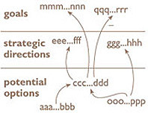
Figure 6 Format of a cognitive map
View alternative description - Figure 6 Format of a cognitive map

- Title: describing the core ‘problem situation’ being explored.
- Bipolar constructs. These are phrases which represent an action item on one pole and a contrasting action item on the other. The two poles of a construct are separated by three dots (which mean ‘rather than’). The diagram conventions and guidelines give some examples.
- Hierarchical template (optional though recommended) dividing the network of constructs between three levels of decision making (from top to bottom): (1) general ideals or ‘goals’ (2) ‘strategic directions’ , and (3) more specific ‘potential options’.
- Arrows between different phrases. All the arrows generally follow upwards hence contributing to a map with action items being linked from ‘potential options’ towards higher level ‘goals’. The head of each arrow ought to point directly to the three dots in the bipolar construct if possible.
- Plus or minus signs on the arrows. These indicate the nature of the link between constructs. A plus (+) sign indicates that the first pole of the ‘tail’ construct leads to the first pole of the ‘head’ construct (and similarly for the second poles); a minus (−) sign indicates that the reverse is the case, and that the first pole of the ‘tail’ construct leads to the second pole of the ‘head’ construct (and vice versa). Where there are no signs present, you can assume that all the links are positive.

Diagram conventions
A cognitive map is made up of bipolar phrases and arrows. The main steps are:
- Define the core problem situation in terms of a title for the map.
- Translate the problem situation in terms of an action item. If you are interpreting a text describing a problem situation in order to understand the reasoning of the author or main players in the situation being described, you might find it useful to first list down as many action items as you can think of which are associated with the text.
- Devise the first pole of your first bipolar construct. For example, if the problem situation is centred on issues of unco-ordinated governance, you might simply write this down as ‘improve integration of governance structures’. For the second pole, simply write down the contrasting item to the first pole; an alternative thought on the subject, for example ‘do not improve integration of governance structures’. Both poles of the construct are separated by three dots (which mean ‘rather than’). This is the seed construct from which your cognitive map will grow.
- Ask yourself what you believe this situation (or its contrast) will lead to. This activity is a type of ‘forecasting’ exercise. If you are interpreting someone’s text or transcript, review the imperatives originally listed and choose those which would follow more as a direct consequence from original construct. There may be a number of implications which you should set down separately as consequential constructs using the bipolar notation described above.
- Draw an arrow between the ‘tail’ construct (that is, the original bipolar construct) and each of the new ‘head’ (consequential) constructs, ensuring that the arrow head points near to the three dots within the construct. The arrows between the phrases thus closely resemble the function of arrows on a multiple cause diagram.
- Ask the same question about the next level of consequences for each of the implications identified, and follow any chains of argument as far as you feel you are able, continuing to use the same notation.
- Return to the initial seed construct and ask yourself about its antecedents; what action item(s) is (are) required in order to bring about this original action? This activity represents a type of ‘backcasting’ exercise. Again, continue along this downward path of reasoning until you have a set of constructs providing more precisely defined ‘potential options’.
- Some cognitive maps have arrows with signs attached to them. These indicate the nature of the link between the tail and head constructs. A plus (+) sign indicates that the first pole of the ‘tail’ construct leads to the first pole of ‘head’ construct (and similarly the second pole of the ‘tail’ leads to the second pole of the ‘head’). Most diagrams are drawn so that all the constructs are linked in this way. In such cases there is no need to attach a sign to the arrow. In some diagrams you may find minus (-) signs on some arrows. This indicates a reversal in that the first pole of the ‘tail’ construct leads to the second pole of ‘head’ construct (and similarly the second pole of the ‘tail’ leads to the first pole of the ‘head’).
Click on WWP cognitive map to see the description of the animated tutorial.

3.6 Final diagram
You may wish to refer back to the WWP case study as you work through the activity on this page.

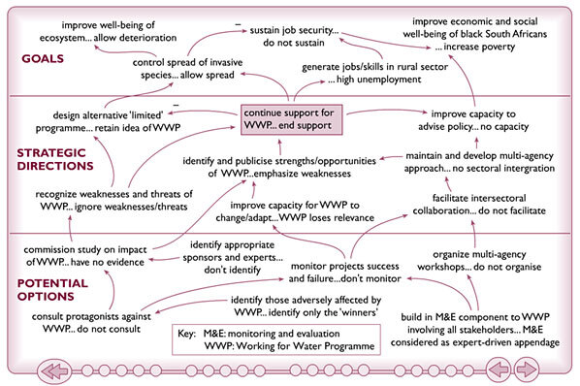
Figure 7 Decision making associated with continued support for WWP
View alternative description - Figure 7 Decision making associated with continued support for WWP

For a printable A4 size copy of this diagram, click on ‘View document’.
View document

Activity 5 Construct a cognitive map

Either:
- Choose an issue associated with the South African Working for Water Programme around which a decision is required. This can be the same as used in the animated tutorial (decision on whether to continue support for WWP) or you can explore a different issue that might have arisen from other diagramming activities, for example, a ‘decision on implementing inter-sectoral collaboration’.
- Choose an issue where a particularly important decision was made or required in order to carry out an intervention. The issue you choose can either relate to your own experience or to what you have already studied in this unit.
Construct a cognitive map following the guidelines below.
- Devise a bipolar construct around the key decision.
- Distinguish between three levels of planning (from bottom to top): goals (ideals); strategic options (objectives); and potential options (tasks).
- Trace the immediate and less immediate implications (goal-orientation) in terms of consequences of the decision, constructing bipolar constructs for each perceived consequence (i.e. forecasting).
- Ask yourself what (task-oriented) actions are required in order to bring about the decision being made. (i.e. backcasting) and represent these actions as bipolar constructs on your cognitive map.
- Ensure that your links between bipolar constructs are logically constituted (first pole of tail construct leads to first pole of head construct). If not put in a minus sign on the arrow.
Examine your cognitive map and note down the key and possibly contentious assumptions relating to different parts of the decision making process, and implications with regards to immediate actions required to progress the interventions.

Conclusion
In this unit you have been introduced to influence diagrams, multiple cause diagrams and cognitive maps. You have seen how they can help with analysing complex situations by organising your thoughts, particularly thoughts on inter-relationships and interdependencies amongst different factors associated with complex situations. The systems diagramming techniques here help towards analysing inter-related factors in a visual manner that can help communicate ideas to others, possibly across different cultures, in circumstances where the right words can be hard to find to establish the shared understanding needed to enable more meaningful dialogue. Influence diagrams, multiple cause diagrams and cognitive maps can help personal reflection and diagnosis of complex issues, revealing significant challenges as well as opportunities for intervention.
This is a companion course to Diagramming for development 1: bounding realities.
This OpenLearn course provides a sample of level 3 study in Computing and IT courses.

Acknowledgements
Grateful acknowledgement is made to the following sources for permission to reproduce material in this unit:
Dr Martin Reynolds (lead academic author)
Wendy Fisher (author of the WWP ‘rich picture’)
Jane Bromley (interactive media developer)
Karen Shipp and the OU Systems Group for animations in ‘2.1: When to use each diagram.’ These animations form part of T552 Systems thinking and practice: Diagramming from which much of the diagramming source material for this unit was derived. T552 is a diagramming pack which supported modules in the undergraduate Systems Diploma and Systems Residential School and supports modules in the postgraduate Systems Thinking in Practice qualifications. Further details of this pack and associated Systems courses can be found at the Open University’s Systems Group website.
U316 The environmental web from which the spray diagram tutorial and WWP case study are derived.
Particular thanks are also due to Sandrine Simone, Gloria Median, Bina Sharma and Rissa de la Paz.
United Nations via Flickr: the original can be seen at http://www.flickr.com/photos/un_photo/3839892431 [Details correct as of 17 November 2011]
Except for third party materials and otherwise stated (see terms and conditions), this content is made available under a Creative Commons Attribution-NonCommercial-ShareAlike 2.0 Licence.
Every effort has been made to contact copyright holders. If any have been inadvertently overlooked, the publishers will be pleased to make the necessary arrangements at the first opportunity.
Don’t miss out:
If reading this text has inspired you to learn more, you may be interested in joining the millions of people who discover our free learning resources and qualifications by visiting The Open University - www.open.edu/openlearn/free-courses

Descriptions

Figure 1 Format of an influence diagram
Figure 1 Format of an influence diagram
Back to - Figure 1 Format of an influence diagram

Figure 2 Influencing factors associated with WWP, diagram 1
Figure 2 Influencing factors associated with WWP, diagram 1
Back to - Figure 2 Influencing factors associated with WWP, diagram 1

Figure 3 Influencing factors associated with WWP, diagram 2
Figure 3 Influencing factors associated with WWP, diagram 2
Back to - Figure 3 Influencing factors associated with WWP, diagram 2

Figure 4 Format of a multiple cause diagram
Figure 4 Format of a multiple cause diagram
Back to - Figure 4 Format of a multiple cause diagram

Figure 5 Causal factors associated with implementing WWP
Figure 5 Causal factors associated with implementing WWP
Back to - Figure 5 Causal factors associated with implementing WWP

Figure 6 Format of a cognitive map
Figure 6 Format of a cognitive map
Back to - Figure 6 Format of a cognitive map

Figure 7 Decision making associated with continued support for WWP
Figure 7 Decision making associated with continued support for WWP
Back to - Figure 7 Decision making associated with continued support for WWP

