HYB_6 Hybrid working: digital communication and collaboration

Hybrid working: digital communication and collaboration

This publication forms part of the Open University module [module code and title]. [The complete list of texts which make up this module can be found at the back (where applicable)]. Details of this and other Open University modules can be obtained from Student Recruitment, The Open University, PO Box 197, Milton Keynes MK7 6BJ, United Kingdom (tel. +44 (0)300 303 5303; email general-enquiries@open.ac.uk).
Alternatively, you may visit the Open University website at www.open.ac.uk where you can learn more about the wide range of modules and packs offered at all levels by The Open University.
The Open University,
Walton Hall, Milton Keynes
MK7 6AA
First published 200X. [Second edition 200Y. Third edition ....] [Reprinted 200Z]
Unless otherwise stated, copyright © 200X, 200Y The Open University, all rights reserved.
All rights reserved. No part of this publication may be reproduced, stored in a retrieval system, transmitted or utilised in any form or by any means, electronic, mechanical, photocopying, recording or otherwise, without written permission from the publisher or a licence from The Copyright Licensing Agency Ltd. Details of such licences (for reprographic reproduction) may be obtained from: The Copyright Licensing Agency Ltd, 5th Floor, Shackleton House, 4 Battle Bridge Lane, London, SE1 2HX (website www.cla.co.uk).
Open University materials may also be made available in electronic formats for use by students of the University. All rights, including copyright and related rights and database rights, in electronic materials and their contents are owned by or licensed to The Open University, or otherwise used by The Open University as permitted by applicable law.
In using electronic materials and their contents you agree that your use will be solely for the purposes of following an Open University course of study or otherwise as licensed by The Open University or its assigns.
Except as permitted above you undertake not to copy, store in any medium (including electronic storage or use in a website), distribute, transmit or retransmit, broadcast, modify or show in public such electronic materials in whole or in part without the prior written consent of The Open University or in accordance with the Copyright, Designs and Patents Act 1988.
Edited and designed by The Open University.
Printed and bound in the United Kingdom by [name and address of printer].

ISBN XXX X XXXX XXXX X
X.X

Contents
- Introduction
- Learning outcomes
- 1 Why communication and collaboration skills matter
- 2 Your digital persona
  - 2.1 Developing your personal brand
  - 2.2 Creating your professional online profile
- 3 Your ‘remote’ environment
  - 3.1 ‘Digital tools’ for communication and collaboration
  - 3.2 Hybrid communication and collaboration
  - 3.3 Inclusive communication and collaboration
- 4 Team working agreements
- 5 Digital text-based communication
  - 5.1 Direct and mass emails
  - 5.2 Instant messaging
  - 5.3 Collaboration chat channels
  - 5.4 Emojis
- 6 Digital collaboration
  - 6.1 Case study: collaboration to create this course
  - 6.2 Exploring digital collaboration tools
  - 6.3 Exploring digital file sharing
- 7 Do you really need a meeting?
- 8 Hybrid meetings
  - 8.1 How to have good hybrid meetings
  - 8.2 Being a remote attendee
- 9 Steps for effective meetings
  - 9.1 Planning your meeting
  - 9.2 Preparing your meeting
  - 9.3 The agenda
  - 9.4 Inviting participants
  - 9.5 The meeting
  - 9.6 Actions and review
- 10 The future of communication and collaboration
- Conclusion
- References
- Acknowledgements
- Solutions

Introduction
Communication and digital collaboration skills are now essential for new ways of working, and working online. As more organisations move to permanent hybrid working, being able to connect with others, use digital tools and understand expectations is becoming more important.
This course aims to develop your own skills and those of your teams, in order to succeed in a digital hybrid world. It is recommended that you also study the Hybrid working: skills for digital transformation course that is part of this collection; it focuses on the essential skills and capabilities you require for working digitally.
While communication and collaboration can cover many areas, the focus of this course is the basic skills that everyone within an organisation requires when using tools to work collaboratively with others.

Learning outcomes
After studying this course, you should be able to:
- manage your digital persona
- collaborate and work in a supportive, safe manner online with others
- identify choose and use digital communication and collaboration tools
- interpret and respect the approaches to communicating in different spaces
- develop your ability to run effective hybrid meetings
- share and manage files effectively.

1 Why communication and collaboration skills matter
As organisations move to hybrid working, communication and collaboration have changed. The opportunities for ‘water cooler’ moments or to ask a colleague a quick question across the desk have become less frequent, and new ways of sharing information have developed.
Not only did having to move to remote working at an organisational level change how many of us needed to work, it has impacted workplace culture and expected behaviours. During the COVID-19 pandemic, due to the frequently changing rules, everyone was having to continually adapt, at short notice and sometimes with minimal guidance from the organisation.
As new ways of working have become embedded, organisations are now focusing on how to build a new culture and set of values but also on re-establishing expectations of the workforce, expectations that reflect the needs of individuals and teams as well as the organisation.
The reliance on digital communication and collaboration tools will continue, and developing organisational capabilities requires the individuals within it to be supported through formal and informal training and development.
All individuals need to have the essential digital skills to succeed. These are based on the ‘Essential Digital Skills Framework’ for the United Kingdom (GOV.UK, 2019), which sets out the digital skills and understanding all adults require to interact in a digital world (see Figure 1). The skills relate to:
- being safe and responsible online
- using devices and handling information
- communicating
- creating and editing
- transacting
- problem solving.

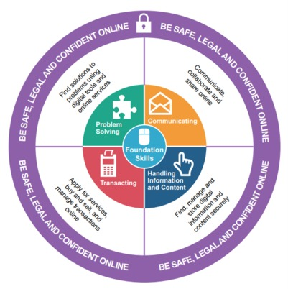
Figure 1 The UK’s ‘Essential Digital Skills Framework’ diagram. Essential Digital Skills – Framework Diagram (Crown Copyright, Gov.uk, 2018)
View description - Figure 1 The UK’s ‘Essential Digital Skills Framework’ diagram. Essential Digital ...

Activity 1 How digitally confident are you?
5 minutes

Read a summary in Table 1 of the six skills which are based on the ‘Essential Digital Skills Framework’ (GOV.UK, 2019).

Table 1 Essential digital skills
Being safe and responsible online and offline | Digital wellbeing, responsibilities when working online – security, privacy and data protection, accessibility, understanding processes and policies, behaviour and non-digital considerations – for example, your desk setup, not writing down your password.
Using devices and handling information | Understanding hardware, software, operating systems and applications and how to manage and store digital information and assets.
Communicating | How to communicate effectively digitally depending on the ‘tools’ and ‘context’.
Creating and editing | Developing the skills to create and edit using digital tools and reflect best practice and guidelines for creation of digital content and products.
Transacting | The ability to interact with digital forms, systems and payments.
Problem solving | The ability to find solutions and approaches and use digital tools to assist with this.

Think about how digitally confident you are. Depending on how competent and confident you are, you may wish to complete Hybrid working: skills for digital transformation before doing this course.

How digitally confident you are may reflect your digital persona. In the next section we start to explore your digital persona, as who you are, how you approach digital tasks, and your digital behaviours will influence how you communicate and collaborate digitally with others.

2 Your digital persona
Consciously or subconsciously, you make a decision about how you want present yourself to the world when you meet people face to face, through how you dress or style your hair and the way you communicate with others.

Activity 2 What is your face-to-face persona?
5 minutes

Take some time to think about the image you present to the world. Do you consciously decide what your persona is? Do you adapt it in different situations? What would you change?
Write a short summary of the things you consider when you present yourself to the world in face-to-face contexts.

Provide your answer...

Chances are that you adapt how you present yourself depending on the situation. However, how often do you think about your digital (online) persona? Your digital persona requires you to make decisions about how you want to present yourself online, but how much thought do you put into this?

Social media and social networks
Outside our work context, many of us use social media or networks to connect and share information about ourselves. It can be useful to understand the difference between social media and networking, as, to some extent, the terms are used and understood interchangeably. Here are a couple of definitions:

‘Social media is a collective term for websites and applications that focus on communication, community-based input, interaction, content-sharing and collaboration.’
(Lutkevich, 2021)

‘Social media requires a social network in order to disburse content to those that wish to consume and interact with it. Thus, the social media network is the underlying technology and human connections, while social media focuses strictly on what is being published and consumed within the social networking platform.’
(Froehlich, 2020)

Activity 3 What do you consider when you post on social media?
5 minutes

If you use social media, think about the following:
When you choose your profile photos, which of the following do you base your choice on?

Interactive content is not available in this format.

When you post a message or a photo on social media, which of the following do you consider?

Interactive content is not available in this format.

How do you describe your use of social media/networking platforms?

Interactive content is not available in this format.

I set the security settings to reflect how I use them, such as public vs private.

Interactive content is not available in this format.

While these might seem simple questions, they help you to start thinking about your digital persona and how you use social media and networking. In your personal life, you choose what platforms/apps you engage with, what you share and whom you connect with. You’ll have an awareness of whether you are sharing to a private group or publicly to the world.
Your confidence interacting online may depend on whether you prefer to keep everything private, so you have more control over the interactions you have online, or whether you are happy to publicly share information about yourself with the world. If you tend to be more open, you should understand that by doing that, you may receive more feedback, even from people you do not know. Keeping yourself safe online and looking after your ‘digital’ mental health is important. We will look at this later in the course, and in the Hybrid working: wellbeing and inclusion course within this toolkit.

2.1 Developing your personal brand
Having thought about your digital persona in your personal life, now think about how you present yourself in a work context. If you have uploaded a photo onto work-related platforms, how do you think this portrays you? How do you behave in meetings – is this different in person, hybrid or virtual only? You might like to ask a trusted colleague how they perceive you.
If you use social media/networking in a work context, have you considered the blurring of your professional and personal digital personas, especially if you use the same accounts for both? One example might be LinkedIn.

Activity 4 Using social media for professional purposes
10 minutes

If you use social media/networking for both professional and personal use, how much thought do you give to the impact a personal post might have on your professional brand? Does your post adhere to your organisational guidelines and policies?
Take time to find and review your organisational social media guidelines and policies.
Are you confident that how you use social media/networking considers these policies? How do you feel about having to be mindful of organisational requirements, even if what you are doing is outside of work?

You may be familiar with the term ‘personal brand’. This is something that you need to be mindful of within a professional setting and how your ‘personal’ persona is an extension of this. Understanding the difference between your personal brand and personal branding is useful. The following definitions help explore the difference:

‘A personal brand is a widely-recognized and largely-uniform perception or impression of an individual based on their experience, expertise, competencies, actions and/or achievements within a community, industry, or the marketplace at large.
‘Personal Branding is the conscious and intentional effort to create and influence public perception of an individual by positioning them as an authority in their industry, elevating their credibility, and differentiating themselves from the competition, to ultimately advance their career, increase their circle of influence, and have a larger impact.’
(PersonalBrand, n.d.)

As hybrid working has become more commonplace due to the COVID-19 pandemic, for many of us, so has our acceptance of a more casual approach to our personal brand and how we behave online.
Our remote working environments may now include children and pets in the background, what we wear is perhaps more casual and our workstations are set up anywhere there is space in our homes or co-working locations. This has led to uncertainty for us as employees. We need to have the ‘know-how’ and ‘environments’ to understand what hybrid behaviours are expected (George, 2021).
One of the most important elements of your ‘brand’ is your profile photo. Often these are the only visual reference someone will have for you, as we rely on online environments to communicate and collaborate, do not always turn our cameras on in virtual meetings and often never physically meet the people we interact with. Profile photos remove anonymity and provide information about your gender, age and ethnicity that can be helpful to provide a visual cue to you as a person. It is also useful to remember that people will also form an opinion of you based on your photo.
As an experiment, I uploaded two profile photos of me to Photofeeler, which uses human opinion and AI to provide feedback on how your profile photo may be perceived. It is worth noting, as I monitored the poll, the scores fluctuated. It was disappointing to drop from 8.7 to 7.6 for competence, but it is worth remembering that how you are perceived is subjective.

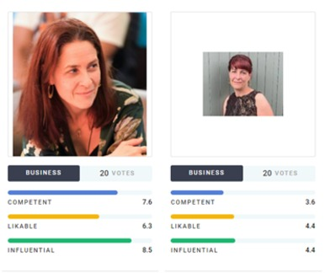
Figure 2 Comparing the author’s profile photos
View description - Figure 2 Comparing the author’s profile photos

Activity 5 Your profile photo
10 minutes

There are some simple steps you can take to develop your digital brand and behaviours.

Step 1
Review your profile photo across all work and personal online platforms.
You profile photo is important, especially when you haven’t and are unlikely to meet someone face to face. It provides a visual cue for the other person as to who you are and sets the tone for how the organisation may be reflected to others. It also means that if you are engaged in audio-only calls, the person you are talking to is not looking at blank screen. Equally, it is useful to have seen a picture of your work colleague if you do arrange to meet them face to face, as you will know whom to look for when you arrive at the meeting place.

Step 2
Look at the images below – which one would you use for a work profile picture?

Figure 3 Work profile photo poll
View description - Figure 3 Work profile photo poll

Which do you think is the most suitable professional profile picture?

Interactive content is not available in this format.

Why did you think that is the most suitable picture? Note your reasons in the box below.

Provide your answer...
View feedback - Part

Step 3

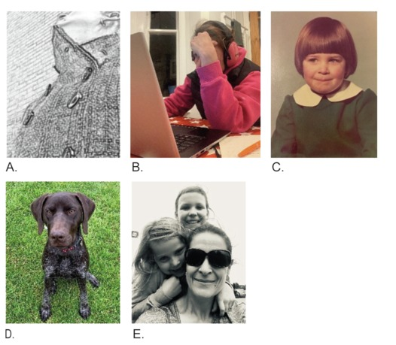
Figure 4 Author profile picture poll
View description - Figure 4 Author profile picture poll

Interactive content is not available in this format.

View feedback - Part

The simplest approach for choosing a profile photo is if you have a staff identity badge, either use that photo, if not too old, or a similar one that reflects how you look now. Choose something that reflects the image you want at work. Then use it consistently on all platforms you use for work that require a profile picture.

2.2 Creating your professional online profile
So, you’ve thought about your personal brand, and you’ve reflected on any images you currently have on social media. Now you can think about improving your online profile.

Activity 6 What is the image you want to reflect?
5 minutes

Look at the two photos below. In both photos, the person is drinking. What is your opinion of the people? In what context might these photos be used on social media?

Figure 6 Photos on social media
View description - Figure 6 Photos on social media

View feedback - Activity 6 What is the image you want to reflect?

When using social media, you need to consider how you are using it and which social media accounts are open to the public or set to private. For example, because I use Facebook to share pictures of my children so my family around the world can see how we are doing, it is set to private, and my posts are more relaxed. My Instagram account is open to the public, so I tend only to post photos that I am happy for the world to see. However, although I don’t have a formal remit within my role to use social media, I use LinkedIn and Twitter for work-related networking and sharing, so when posting, I am mindful about what I want to say as a professional but also that I am not doing anything that suggests I am reflecting the views of the organisation.
In a professional capacity, you may publish an online profile to promote yourself, be this your HEI staff pages or, like many people, a LinkedIn profile. LinkedIn is a platform designed for the business community that you should consider engaging with. Not only does it give you access to an extensive network, it also provides useful reports and information that you can use within the workforce and keep up with the latest trends.
Creating a good online profile and building your online network is becoming an essential digital skill. It is not only about your own personal brand but also how you reflect your organisation. Increasingly, LinkedIn is being used for attracting and recruiting staff and building external partnerships. Those interested in an organisation will often look at what their staff are doing and whom they might be working with and also look to reach out to people. In creating this toolkit, we checked the LinkedIn profile of many of the contributors we approached as part of our assessment for selection, and we reached out to them via the LinkedIn messaging system.

Activity 7 Create your LinkedIn profile
10 minutes

Step 1
Read the following articles by LinkedIn:
- ‘How do I create a Good LinkedIn profile?’ (LinkedIn, n.d.)
- ‘20 steps to a better LinkedIn profile in 2022’ (Deehan, 2022)
And you may wish to study the Learning LinkedIn course (Schinkten, 2022) at a later date – which at the time of writing was free to access.
Step 2
Then, if you already have one, review your own LinkedIn profile. If you are in an HEI, review your staff page profile at the same time.
Is all the information up to date? Could you enhance it? How do you want to describe who you are and what you do?
How do you feel about posting on LinkedIn? Are you a ‘liker’ or a ‘poster’?
If you do not have a profile on LinkedIn, consider creating one. It is often useful to write the content in an online document first to make it easier to edit. Once you’re happy with your content, you can publish it.

There are many approaches to developing your personal brand, and you should always do what feels comfortable for you.
If you are interested in developing your understanding further, the OpenLearn course Personal branding for career success is a good place to start.
While the majority of time posting on social media has positive consequences, it is useful to be mindful that some posts can result in unwanted comments. In the UK, you have a right to share your opinions and views (though this is not the case in all countries around the world, so do bear that in mind if you are working elsewhere). Your view of what is ‘inappropriate’ will vary depending on your beliefs and values. Within a work context, you should understand what your organisation defines as ‘inappropriate’. If your organisation has a social media policy, you should find the definition there. At a basic level, the following is how Social Intelligence, an online background screening organisation based in the USA, defines what is inappropriate:

‘“Inappropriate” can mean a variety of things
‘At Social Intelligence, we categorize flagged content into four broad filters: intolerance, violence (including threats), potentially illegal activity, and sexually explicit content. Additionally, any type of post can fall into these categories, including text posts, images, videos, memes, third-party URLs, shared content, or reposted content. Other types of content that may fall under the inappropriate category may include company-specific content. For example, trade secrets, photos of minors, or photos of fieldwork are all types of content that could raise flags in various industries, respectively’.
(Social Intelligence, 2020)

Activity 8 What can people find?
20 minutes

It is sensible to check your privacy settings and what is in the public domain about you. If you have ever been ‘hacked’ or have friends/work colleagues this has happened to, you will know it can have serious implications. Equally, is someone using your picture, name or email address for a fake profile? This is something I have experienced and only discovered when I started receiving emails from the company. I was lucky, as the company removed the profile from their site within 24 hours of me reporting it.
Step 1
Read the following articles which provide more information about privacy and securing your online profiles:
- ‘Privacy in the digital age: Is it “An Englishman’s home is his castle” or “I’ve got nothing to hide”?’ (‘OpenLearn’ – The Open University, 2022)
- ‘Keep hackers out of your email and social media accounts’ (ActionFraud, n.d.)
Step 2
Then do a review of your privacy settings. A good way to find what is in the public domain about you is to ask a friend to google your name. Asking a friend to do this will give you a better reflection of what is in the public domain.

In the next section on the remote environment, we will consider how to make the most of your physical space when hybrid working.

3 Your ‘remote’ environment
In this section we consider your physical working environment. If you have had to change to remote working, you may not previously have had a space you can use solely for work. Maybe you have had to adjust your home environment and were working on the premise that it was going to be temporary. Now that most organisations are planning to continue hybrid working, it is a good time to consider reviewing how you work in your remote location.

Activity 9 Review your remote environment
15 minutes

If your organisation provides a display screen assessment (DSE assessment), consider doing one again, as this can help you think about how you are working and what support you may require. The webpages Health Working safely with display screen equipment | Health and Safety Executive provide an overview of DSE assessments.
While many of us have to work where we can when working remotely – for example, at home, in an office space or a coffee shop – consider what small improvements you can make, especially for communication and collaborating. Think about your background when you are in meetings and whether your equipment is suitable for your role. (We cover setting up your equipment for online meetings later in the course.)
You may wish to make some notes below.

Provide your answer...
View feedback - Activity 9 Review your remote environment

During the COVID-19 lockdown, I eventually adjusted my remote working environment and made the decision to create a dedicated space. Below you can see the before and after.
Initially, I used to work with just a laptop at my kitchen table, with my daughter trying to home-school. Where appropriate, I had one-to-ones (1:1s) with colleagues who didn’t mind her being about during calls, and the eagle-eyed of you may see that we were living through an ongoing renovation project. At the end of the day, everything had to be packed up so we could have dinner together.

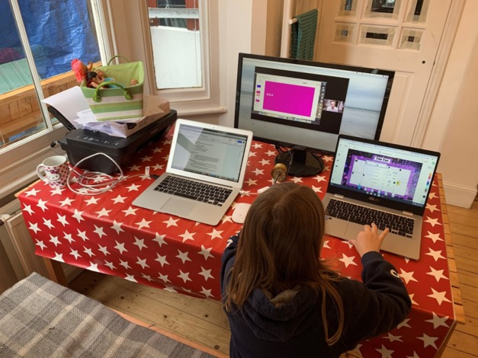
Figure 8 Before adjusting a home-working space
View description - Figure 8 Before adjusting a home-working space

Now I have created a proper environment for working. It’s in my living room, but I have converted part of it into an office space and made a desk out of old loft boards and the best buy in lockdown – white boards! For my own wellbeing the whiteboards transformed how I worked: I get to stand up, move around and quickly work through problems, as I often struggle with online whiteboards.

Figure 9 After creating a specific office space at home
View description - Figure 9 After creating a specific office space at home

I do have one home-working rule. When I finish work for the day, I put my laptop out of sight. This not only ensures that I have switched everything off, which helps reduce my carbon footprint, but it helps me mentally block out the ‘office’ area when I am in my living room and not working.

3.1 ‘Digital tools’ for communication and collaboration
The use of information and communications technology (ICT)-based tools is a central part of many roles in the workplace. Within an HEI, you will use various digital tools, software and systems. For the purposes of this section, we will refer to them as ‘digital tools’. Some of these will be bespoke (the organisation has designed and built them), but most will have been brought in from third-party suppliers.
These ‘digital tools’ are often grouped as follows:
Core supported technologies: Evaluated, licensed and fully supported by the organisation, such as the main operating system, cloud-based office suite tools – such as Microsoft Office or Google Docs – virtual learning platforms, content management systems. These normally are digital tools that are required for an organisation to operate.
Networked or integrated technologies into core systems: Not always fully licensed or supported, as they may be bought at the local departmental level for specific uses.
These are technologies that enable data exchange between large and small information systems within a networked infrastructure. This often allows different tools and systems to ‘talk to each other’. For example, Microsoft Office 365 applications – if you make a comment on a Word document, you get a notification to Outlook.
Recognised technologies: Not licensed or supported by the institution but required by an area for specific reasons.
Some HEIs were using many of these tools before the COVID-19 pandemic, but with the requirement during lockdowns to work from home wherever possible, this resulted in many HEI workforces moving to remote working, and consequently the reliance on and ability to use these tools accelerated. Many HEIs therefore had to invest in ‘digital tools’ to operate effectively.

Activity 10 What ‘digital tools’ do you use in your organisation?
10 minutes

Think about the ‘digital tools’ you use daily for work, and list them. Then consider:
- Why and how do you use these tools?
- How comfortable are you using them?
- Do you understand your responsibilities when using them?
- Do you need to have non-standard digital tools?
Then familiarise yourself with other tools your organisation may use. If your organisation has listed these, you can normally find them either through a web search or searching your internal intranet.
What guidance and support are available for you to use these tools?
If you are in an HEI, now do a search on the tools for students. How do these differ to the tools for operating as an organisation?
Make notes in the box below:

Provide your answer...
View feedback - Activity 10 What ‘digital tools’ do you use in your organisation?

As we start to focus on new ways of working and embedding hybrid working, it is not just being able to use the tools that is important but also understanding the context and behaviours expected and required by your organisation.
In the next section we cover some of the approaches for common digital communication and collaboration tasks within the workplace.

3.2 Hybrid communication and collaboration
As organisations move to hybrid working, communication and collaboration have changed. The opportunities to ask a colleague a quick question across the desk or have ‘water cooler’ moments have disappeared, and new ways of sharing information have developed.
Not only did having to move to remote working at an organisational level change how we worked, it impacted the culture and expected behaviours. Due to the changing rules, everyone was having to continually adapt during the pandemic, often with little guidance from the organisation.
As new ways of working become embedded, organisations are now not only focusing on building a new culture and set of values but also on re-establishing expectations of its workforce, expectations that reflect the needs of individuals, teams and the organisation. In the video below, contributors share their insights into hybrid communication and collaboration.

Video content is not available in this format.
View transcript - Uncaptioned interactive content

The most common tasks requiring communication and collaboration in the workplace are:
- email/instant messaging/collaboration chat channels (e.g. via Microsoft Teams, Slack, Google Chat)
- collaborating online
- hybrid and virtual meetings
- digital file sharing and storage.
We’ll explore these in detail throughout this section of the course. There are many tools and systems used for online cloud-based communication and collaboration, but their underlying purpose and functionality are very similar. To understand how these work, the article ‘Unified communications (UC)’ from TechTarget (2021) provides useful guidance.
These tasks all rely on ‘digital tools’, and how they are used is central to helping evolve new ways of working. As the infrastructure to ensure these tools meet the needs of the organisations and digital capabilities and skills to use them develop, now there is a focus on how these tools should be used and how you can effectively communicate using them.
Communication is not just the conversations you have in meetings or via email or instant messaging but also how you use the tools; the information you include within them; and how you agree upon the guidelines, processes and polices. This all provides information that enables you to understand expectations and your organisation’s digital culture – ‘the way things are done’ is important.
How you decide as a team to use the comment review function on documents, how to create a presentation, what kind of posts can or should be made on an internal community channel, or verbally agreeing how you will store digital files in your collaboration storage areas are all examples of communication in relation to digital tools.
Remember: your online communication (meeting, chat transcript, recording, etc.) may be stored on a server and only deleted in line with your organisation’s information retention and communication compliance policies. Therefore, when using communication and collaboration channels, consider the most appropriate methods to use, and ensure that any written communication is appropriate for the workplace.

Activity 11 Is monitoring necessary?
10 minutes

Read the following article ‘The employee surveillance that fuels worker distrust’ (BBC, 2022), which provides an overview of why organisations have monitoring in place and what may be for legal reasons as opposed to organisational reasons.
Then explore what monitoring your organisation has in place.

3.3 Inclusive communication and collaboration
While it is important to ensure that our communications and collaborations are meaningful and engaging, it is essential that they also be inclusive. Where possible, reasonable adjustments should be made to ensure that those who may be neurodiverse or with a disability, impairment or health condition can participate.

Activity 12 Making hybrid working inclusive
15 minutes

Read the article ‘Making hybrid working inclusive’ (MacLachlan, 2022), and watch the video within it. Make notes on the key areas of concerns. Hybrid working might not be as inclusive as first thought, and consider your own experiences. You may wish to make notes in the box below.

Provide your answer...

Prior to using communication and collaboration tools and physical meeting spaces, check in advance in case participants have any access requirements. Your organisation may have its own guidelines, and depending on the technology you use, it is sensible and considerate to familiarise yourself with how accessible the tools are and learn to use the functionality designed to improve accessibility.
Examples of steps you might take to ensure your meeting is more inclusive and make reasonable adjustments are:
- Record the meeting and provide the transcript.
- Schedule breaks.
- Provide material in advance of the meeting.
- If your video meeting platform has a closed captions functionality, make people aware of how to use it.
- If someone’s network is poor, suggest using audio only.
If you frequently chair or facilitate online meetings, develop your skills in engaging with others. Some useful tips for engaging with others are:
- Set expectations, such as cameras and microphones on/off, raising hands to notify you wish to speak.
- Learn how to listen actively.
- Ask questions in response to what someone has said – a really good way to develop this is to interview a colleague and summarise what they have told you.
- Make eye contact. This is actually easier in remote meetings if you both have your cameras on, as you tend to look directly at people for longer.
- Tell stories to help bring context and create a mental visual reference.
- Be enthusiastic and animated. If you are passionate about the subject, others will be more interested in what you are saying.
- Bring others into the conversation, ask people’s opinions and give people time to speak.
- Think about the collaboration tools you can use to provide opportunities for all to contribute and engage – such as reactions, breakout rooms, raising hands, and so on.

Activity 13 You say tomato, I say tomato
15 minutes

I struggle with pronunciation. One of my family’s favourite past times is trying to get me to say the name of a chocolate bar, ‘Toblerone’, which I really can’t pronounce! If you are interested, the video below will help!
How to Pronounce Toblerone? (CORRECTLY) (Miquel, 2020)
When it comes to pronouncing names, it can be a sensitive topic to approach both for the person whose name is continually mispronounced and the person who mispronounces it. While we are often happy correcting people if they do something incorrectly or asking for help if we don’t know something, when it comes to names, we often say nothing.
Read the article ‘How to get someone’s name right if it’s unfamiliar to you’ (The Conversation, 2020) and consider how you can support those who struggle with pronunciation.

Digital accessibility and inclusion
Digital accessibility and inclusion is a broad topic which we do not cover in detail in this course. However, it is important to understand how you can be more inclusive and what responsibilities you have to make reasonable adjustments to ensure that you and your organisation are creating an accessible and inclusive environment.
You organisation should have guidance that you can refer to, and you may wish to explore the following resources, which provide further information:
- How to make your online content accessible | Digital Culture Network
- Introduction to Web Accessibility | Web Accessibility Initiative (WAI) | W3C
- Accessibility of eLearning | OpenLearn – The Open University
The courses Hybrid working: organisation development and Hybrid working: wellbeing and inclusion within the ‘Supporting hybrid working and digital transformation’ collection explore digital accessibility and inclusion further.
In the next section we will focus on how you can communicate and collaborate as a team. First, though, a reminder that you need to consider security, safety and governance, which are covered in more depth in the Hybrid working: skills for digital transformation course.

4 Team working agreements
Before exploring communication and collaboration further, understanding the context in which you work is key to good communication. This is especially true if you are part of a team, as how you communicate and collaborate is an extension of both your team and your organisation, so you need to be mindful of how you operate.
A useful approach for hybrid working, if you are part of specific team/group of people, is to create a ‘team working agreement’ together, focused on your expectations of how you collaborate and communicate. Without the opportunities that being in the office together enable, agreeing how you want to work becomes even more important.
In the video below, Lisette Sutherland, director of Collaboration Superpowers, discusses how to keep the feeling and sense of a team when hybrid working, and she explains the purpose and benefit of creating a ‘team working agreement’.

Video content is not available in this format.
View transcript - Uncaptioned interactive content

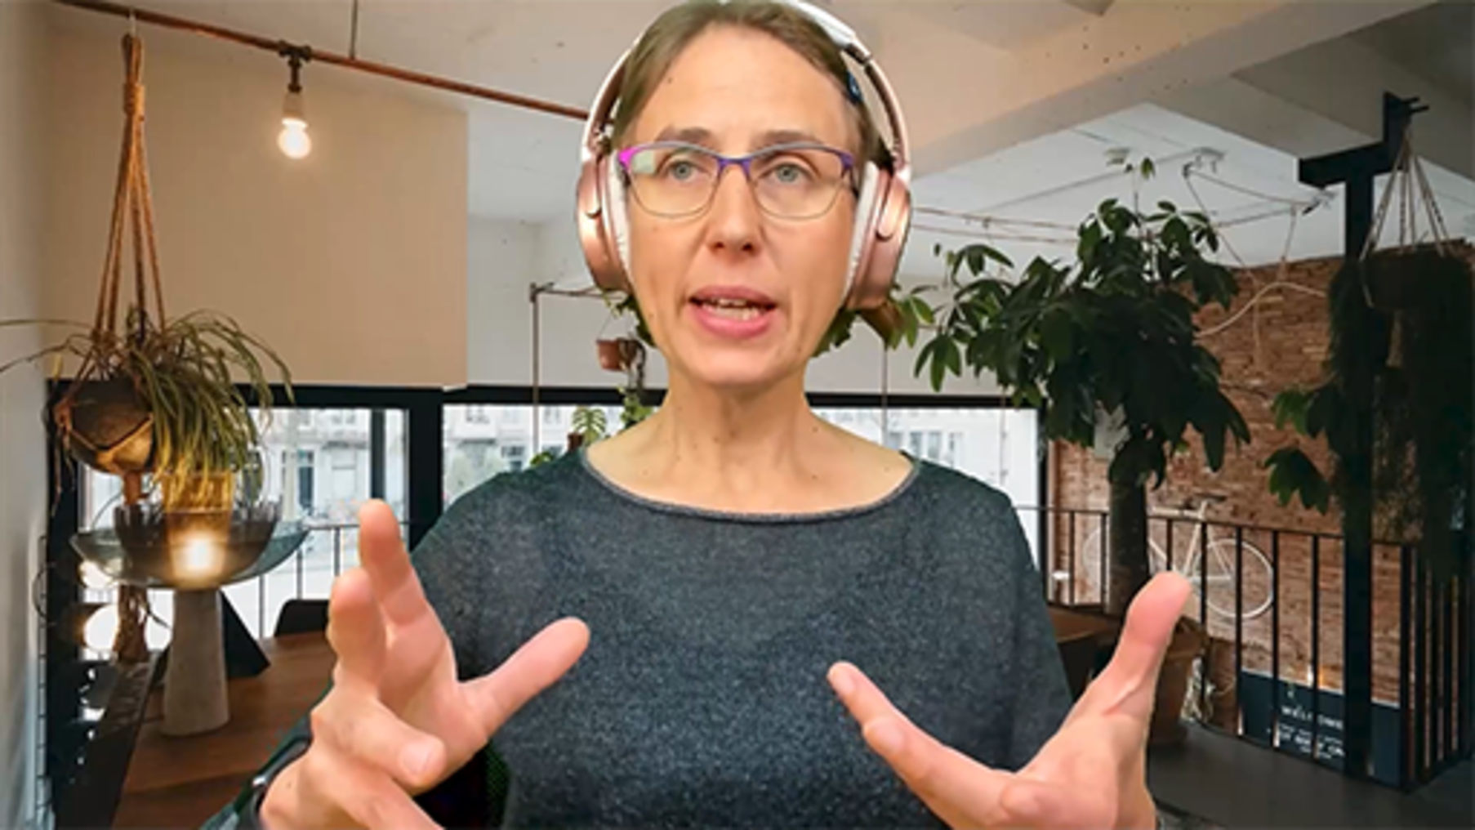

Activity 14 Create your own team working agreement
Read through steps: 10 minutes. Creation of agreement: Outside of the course study time with your team, allow 2–3 hours

In this activity you will have the opportunity to explore how team working agreements can be created, and we take you through the steps to do this. This is an activity you may prefer to do once you have finished the course; in Step 4 there are links to further guidance for creating you team working agreement.

Step 1: What communication channels do you have?
Consider the primary channels of communication within your organisations. Review the list below and make a note of what these are within your own organisation and how you use them in your team.
The following are considered the primary channels of communication in a workplace:
- In person
- Documents
For example, can include:
  - Company and HR policy documents
  - Benefits forms
  - Legal guidelines
- Emails
- Instant messaging platforms
- Video conference
- Phone calls
- Social media.

Step 2: How effective are these channels?
Consider how effective the management of communication channels is within your organisation and team and whether they enable the following. Make a note of what works well and what might require improvement.
The primary channels of communication are important, as they deliver communication in an instant and timely manner, which ensures:
- All team members receive the same information
- Employees know what is expected of them
- Discussion, feedback and interaction
- Opportunities for employees to make suggestions and voice concerns or questions
- Stronger relationships between employees.

Step 3: What communication channels are best?
Read the article from Gartner (Wiles, 2017), ‘How to choose the right communication channel’, and take time to look at the table within the article which helps you consider – How does your target audience like to consume information?
The article was written in 2017. Consider how you communicate now. Are there better ways and tools available to you for communicating and collaborating now?

Step 4: Create your ‘team working agreement’
Lisette Sutherland is an expert in remote working and collaboration, and she has provided a freely available ‘Facilitator's guide’ with tips, step-by-step instructions and resources to help you run a meeting with your team to create a ‘team working agreement’. The following extract provides the context:

‘This meeting agenda template helps remote teams create a “working team agreement.” This is a living document that sets expectations and captures agreements about how a remote team will work together. Together, you'll establish a basic set of guidelines for working together, to remove costly misunderstandings.
‘During this meeting, you'll lead the group through a series of questions that explore everyone's preferences and expectations. Then, you'll work together to create your team agreement.’
(Sutherland, n.d.).

Download the ‘Lucid Facilitator’s Guide: Create a Remote Team Working Agreement’, and review the process within it. If you feel it is a tool that would benefit how you work as a team, and you are comfortable facilitating a meeting, work with your team to create a ‘Team Working Agreement’.
You can download the guide from Lucid website at the link below.
- How to Create a Remote Team Working Agreement
- Create a remote team working agreement (to download)
You may also like to explore this article that provides further information and a podcast on how to create your agreement:
- ‘Create a team agreement for your remote team: a guideline for creating a Remote Team Agreement’ (Collaboration Superpowers, n.d.)
- Create a team agreement for your remote team: a guideline for creating a Remote Team Agreement (to download)

Digital wellbeing
Digital wellbeing is an important topic. You should bear in mind the wellbeing of your team members and other people you communicate or collaborate with digitally, as well as your own wellbeing.
You organisation may have guidance that you can refer to, and the course Hybrid Working: wellbeing and inclusion within the ‘Supporting hybrid working and digital transformation’ collection explores digital wellbeing further.

5 Digital text-based communication
The options for digital ‘text-based’ communication to ‘talk’ to each other have rapidly evolved from just relying on emails. There are now many options available that also allow you to use different forms of communication, including video and audio. In this section we focus on ‘text-based’ communication.
Choosing the right written communication channel often depends on the communication you wish to send and whom you are sending it to. In most workplaces you can choose:
- Direct and mass emails
- Instant messages (e.g. Microsoft Teams chat, Slack, Google Chat, WhatsApp)
- Group team/project chat channels.
While we do not focus on digital files in depth within this course, remember they are also a form of text-based communication.

Activity 15 What forms of text-based communication do you use in your organisation?
10 minutes

In the previous section you considered what communication channel is best. Review your notes from the activity and focus on those which involve written communication.
Which tools are available within your organisation, and how do you use them?

5.1 Direct and mass emails
Direct and mass emails tend to be more formal and contain important information or information that needs to serve as a record. Most email tools allow you to categorise and file emails. Emails are also easy to track; for example, you can see if an email has been opened or read. They also allow you to communicate in a targeted way, company-wide.
When writing emails, you need to consider what you are trying to communicate and how it might be received. It can be very easy for miscommunication to happen via emails. The following table provides some guidance for communicating via email which you could use as a checklist:

Table 2 Email checklist
Item | Guidance
Clear subject matter | Make sure that you include meaningful relevant information in the subject line matter. This makes it easier for the receiver to know what the email is about and if they need to engage immediately. For example:  ACTION: Please approve this contract  FYI: This report might be of interest  PROJECT NAME: Weekly progress report
Use of greetings and sign-off | The use of a greeting often depends on your relationship with the receiver. I use ’Hi’ for a colleague I know, but for an external client I am not familiar with, I use ‘Dear’.  If you are emailing more than one person, consider whether you use include all their names, ‘Dear/Hi all’ or just ‘Hi’.  Equally how you sign emails off – Kind regards, Best wishes, BW, Thanks – will depend on the nature of the email and often your preference. For example, I very rarely use anything but ‘Kind regards’.
Consider the purpose of the email and importance | Be clear what the purpose of your email is for the receiver(s).  If you require a response/action, ensure this is clear within the email.  It can be useful to use the Importance and Sensitivity settings for emails, where something is important or confidential. Equally if you are sending something just for information, use low importance guides to indicate that it does not have to be read immediately.  If you have to deliver ‘bad news’, consider if email is the appropriate method and how a receiver might react.
Length of emails | Where possible, keep emails brief and to the point.  Use headings or bullet points to break the text up.  If you require the receiver to do something, make this clear.  If you need to provide a lot of information, consider if this would be better communicated via a meeting or, if you need a written record, attaching the information in a document, but within the body of the text, summarise the key points and actions you require.
Tone of emails | Consider the tone within your email and the approach to writing it. What are you trying to convey? This is particularly important if you are sending an email due to an issue.  A good approach is to focus on the facts, not how you feel, and try to remove emotion and blame from the content.
Think about ‘the life’ of your email | Emails can remain on servers long after you have deleted them, or they can be forwarded by others.  It is important to consider the content in your email and avoid inappropriate language and comments.
Spelling, missing words and accuracy | It can be easy for mistakes to creep into emails, and spell checkers do not always get it right.  Double-check your email; a good approach is to write the email, and then take a break and come back to it. If I am concerned about spelling, I often read an email from bottom to top, as it helps me spot mistakes more easily.  Equally important is to consider data security – double-check you have included the correct people in the ‘send to’ list.  If you have difficulties with written communication, and you feel comfortable doing so, it is often useful making those with whom you are in regular communication aware that you find it challenging. This allows you to prioritise which emails you spend more time ensuring are correct.  If you have a colleague who is prepared to double-check important emails for you, it can be very helpful. This is an approach I take, as I cannot always guarantee I will spot mistakes, despite checking before I send.
Email signatures | Most organisations recommend including an email signature and provide a template for this. Ensure your email signature is correct and update it as required.  It is also useful to include your working hours if they are not standard. I work flexible hours, often emailing at night, so I include the following on my signature:  There are times when I work flexibly – if this email comes at a time outside of your normal hours then please don’t respond until it is your working hours.
Attaching files | Where possible, send links to files that are in your ‘collaboration’ areas, such as stored in the cloud or a shared area. This helps with version control and helps to encourage people to work in collaborative spaces.
Only send and reply to those you need to | Think who needs to receive the email and aim to only send to those that are necessary. Make sure you’re not sending it to everybody. Ask yourself: is it really a reply all or just specific people?  If you are cc’ing someone into an email, do they need to see the email, or have you agreed they will be cc’d for information only?  A former colleague used to not read any emails they were cc’d in; their view was if it was important, they wouldn’t have been cc’d.
Reply to email in a timely fashion | Aim to reply ideally within 48 hours, even if it is a holding email to acknowledge you have seen it, or use your out of office if it is likely you cannot respond in a timely manner.  Some areas of the organisation may have agreed timeframes for email responses, but often it is an individual choice.
Out-of-office messages | If you are out of the office or not going to be online for a long period of time, set your out-of-office message.  Where possible, include contact names of people who can be contacted in your absence. However, check that they will be in the office when you are not.  Providing generic email boxes can be challenging. While they are often an essential and beneficial tool for teams who support large numbers of people, the policy as to how soon someone can expect a reply and how you deal with genuinely urgent issues needs to be considered.
Manage your inbox – don’t let it manage you! | Emails can quickly get out of control, and this can lead to poor email management and missing important information.  Put some time aside to manage your inbox and to explore the support pages of your email providers, as most email tools for the workplace have a range of functions for better inbox management.

Hybrid working has led to a more flexible work pattern, and text-based communication has increased. Email, for many, is still the preferred way of communicating, and for many this has led to an unmanageable inbox.
People are working more flexibly and as a result may work with those in other time zones or work weekends, so emails can arrive in your inbox any time of the day or night, and this has led to debates about whether you should only be allowed to email during ‘normal’ working hours. Encouraging thinking in terms of core hours may be an organisational cultural approach to consider. For example, in a previous role, my team was based in India, so our working patterns were different. To work around this, we had core hours – a period of time when we would all be online at the same time.
Nevertheless, we have a duty of care to our employees, for example, understanding the impact of emails received outside of core hours. They may feel they need to reply, and if it is ‘bad news’, this can lead to upset and worry, or if you receive emails from someone where a flexible working pattern is not known, this could be a sign of a workload issue.
I only use the delay function when it is an email I feel I need to be available to respond to; for example, it may contain information that may be unexpected or requires an immediate response. Otherwise, I will email at the time I am working, so I can ensure those I am working with have the information they require when they log on to work. While I could use the delay email function, many may actually be working at the same time as I am or start much earlier in the day than I expect.

Activity 16 Managing your email
5 minutes

Think about how you manage emails and when you respond to them. Is there a more effective way for you to do this?

View feedback - Activity 16 Managing your email

5.2 Instant messaging
Instant messaging, often referred to as IM or ‘chat’, normally involves written messages that take place in real time as a back-and-forth conversation. They normally take place between two people, although with the use of collaboration tools, group IMs and use of ‘chat’ functions in meetings is becoming more common. ‘Team chat’ channels are slightly different and are covered in the next section.
IM can offer more immediacy; be more informal; and, when working in a hybrid manner, replicate those in-person ‘water cooler’ conversations. Many also have built in emojis and animated GIFs, and, as with email, you can attach files. The use of emojis, memes, stickers and GIFs has become an accepted norm when IMing.
It is important, though, to remember what is appropriate in the workplace: whereas you might be less guarded with IM discussions that are of a private nature than in person, remember that depending on your organisational setup, instant messages are stored on servers, so they are not truly confidential.
IM is instant and less formal, but good practice should be followed, as outlined in the table below:

Table 3 Instant messaging checklist
Item | Guidance
Use informally | While there are no hard and fast rules, people often use instant messenger once they have established a relationship with the other person, either via emails, meetings or team channels. It is a less formal environment and not often used to reach out in the first instance to someone.
It is instant… usually | Use it for informal, quick messages that require an immediate response or for replicating an across-the-desk chat with a colleague.  The reality is that IM within the workplace has become another place to share information, which is changing its original purpose. Instant messaging these days is not always ‘instant’.
Check before you send | It can be all too easy if having a quick conversation or doing a quick reply not to think about what you are sending. Ideally check your message before you send.  It is worth noting, for those who do struggle with communication, that there is more tolerance working in IM, and it is accepted that spelling and grammar mistakes might occur often due to the speed of the conversation. If you are using an IM tool that has predictive text, this can be a hindrance at times, especially when it ‘helpfully’ changes a word just as you go to hit ‘send’!  It is also interesting that for some people, they only see the mistakes once the message is sent, as often the background colour of messages changes once sent.
Keep it business-like | As you use IM more, you will build different relationships with colleagues and potentially establish your own informal rules. However, if you know people less well, it’s always a good idea to keep your messages on topic and make sure they are appropriate. Sharing experiences using IM when we’re remote working is always helpful to support relationship building (replacing those water cooler or catch-up-over-a-quick-cup-of-coffee moments), but be mindful of what you are discussing and consider whether a video chat might be more suitable.
Respect a person’s availability status | Most workplace IM tools will indicate a person’s status, for example, if available, in a meeting or on ‘do not disturb’.  If someone is not available, you should respect this and avoid IMing. If you need to talk to someone, enquire when they are available and agree on a time to talk to them.  It has become very easy to have IM chats as a ‘back channel’ when you are in a meeting; however, while there are times when this is legitimate, it is the equivalent of having a side conversation with someone, which you probably would not do if you were in a face-to-face meeting.

The rise in the use of WhatsApp and other IM applications
It is also useful to consider that while there are organisational IM tools, possibly as a result of hybrid working, WhatsApp and other IM applications are becoming frequently used for different reasons. When working in teams that include members external to the organisation, these are often easier to use than trying to use organisational channels, as it can be difficult for them to have reliable access, or informal ‘team’ groups are set up that act more as a social space for teams.
These informal spaces bring teams together and have replaced socialising outside work but can lead to a feeling of having to be always present, as messages can arrive in the evening or at weekends. This also raises concerns about wellbeing, equity and online security, if personal mobile devices are being used. Unless you are using a work-issued mobile device and there is an organisational agreement regarding the use of your own phone for valid work reasons, you should consider if it is appropriate to expect people to use their own personal devices.

5.3 Collaboration chat channels
We use the term ‘collaboration chat channels’ rather than ‘teams/group/project’ as, depending on the system and the purpose of the channel within your organisation, these mean different things. Here we are focusing only on the use of the ‘chat channel’ that is associated with a collaboration workspace and not the tools and applications you may be able to access within the workspace.
Collaboration chat channels on, for example, Teams, Slack, Cisco Webex, Google Workspace, Stack Overflow, Basecamp and so on tend to operate on a more formal basis. You will often find that there is more than one chat channel, as channels are set up to reflect specific workstreams and needs of your team, working group or project. This may mean monitoring conversations in more than one place and across collaboration workspaces.
I am currently a member of over 15 workspaces with 80 chat channels on my organisation’s collaboration platform, which will continue to increase and doesn’t include those I am a member of on other platforms, of which I have many. So I have to rely on the notifications that are sent to my email inbox or the activity notifications within the system we use. This can be challenging, but using ‘online’ communication in this manner is a skill I have developed, and I have developed an understanding of how the platforms work which enables me to manage the constant stream of information and messaging I receive.
I have been using various ‘online’ communication channels for over 30 years and often learnt how to use them by reviewing official technical support and asking others. I’ve found the most valuable approach is to set up ‘team working agreements’ considering the purpose, how we want to use collaboration chat channels, who requires access and how they will be managed.
It is essential to be clear what you are using the channels for and who has access in order to work effectively and ensure that expectations for behaviour are understood. If a channel is for an immediate team, how you communicate might be less formal, but if you have members who are external to your organisation, you may have a more formal approach, and you need to be mindful of sharing sensitive or confidential information.

Activity 17 Effective channel chats
10 minutes

All teams/projects are different: talk to those who need access about how you will set up your collaboration ‘chat’ channels and their purpose. Read the following articles to help decide how you will approach ‘collaboration chat channels’.
- ‘Your guide to chat etiquette in the workplace’ (Microsoft 365 Team, 2021)
- ‘Collaborate with kindness: consider these etiquette tips in Slack’ (Haughey, 2022)
- ‘Group Chat etiquette: 10 tips to help your family navigate the digital chatter’ (Birdsong, 2018)
What will the key considerations be for your team? Use your ideas to create a set of guidelines for managing your team’s chat channels. You may wish to refer back to the team agreement activity earlier in the course.

5.4 Emojis
Emojis are now an everyday form of communication, and many of us will use them in the workplace across all forms of communication and even within our learning materials 😊. While they are great for quickly expressing feelings, empathy, support or just a simple acknowledgement of something, you should consider their meaning. This also applies to abbreviations – Are you Laughing out Loud or Loving you Loads! LOL!

Activity 18 How do you feel about feel about emojis?
5 minutes

Read the following article:
- ‘Beyond the smile: how emoji use has evolved in the workplace’ (Slack, 2022)
What do you think about emojis?

Interactive content is not available in this format.

If you are interested, you can visit Emojipedia (n.d.) to find out what an emoji means.

6 Digital collaboration
Every day we are synchronously and asynchronously digitally collaborating (collaborating digitally in live time or at separate times to suit our own schedules). In our personal lives we share stories and make plans using apps and social media. In the workplace we have a vast range of collaboration tools available.

Activity 19 What does digital collaboration mean to you?
5 minutes

Think about the digital collaboration activities you take part in on a daily basis, other than attending online meetings, and list them below.

Provide your answer...
View feedback - Activity 19 What does digital collaboration mean to you?

Digital collaboration happens in many ways, and often you may not realise that is what you are doing, as it may feel like an everyday task. How often have you left a comment in a document? This is a form of collaboration and probably one of the most effective and simple ways to communicate, share information and solve issues/problems. To help put digital collaboration into context, and for you to consider how you could collaborate in the future, the following case study describes how we worked on this course.

6.1 Case study: collaboration to create this course
During the production of this course, we used emails; chat channels; and onsite, hybrid and virtual meetings. We also communicated and collaborated using many other digital tools, as the team was based worldwide and had external suppliers. We continually adapted both our approach and the tools we used, depending on the outcome we needed to achieve. The following are some examples of the tools we used, though please note they may not be suitable for all contexts or organisations, and other options will be available.

Microsoft Word
The image below shows an early draft of the text for this course before it was built in the online platform. The author wrote a draft in Word and then shared it for others to review. There are notes to different team members; Track Changes to see what has been changed; and also, because we know each other well, personal interactions in the comments.

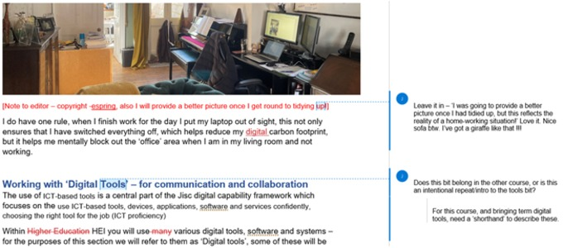
Figure 10 Shared Word document using Tracked Changes and Comments
View description - Figure 10 Shared Word document using Tracked Changes and Comments

Microsoft Teams
We used a Microsoft Teams chat channel to share information and possible resources to use. We were fairly informal in this channel, also using it to provide quick updates on progress among the core team. (This was in addition to a regular formal progress report emailed to senior stakeholders following ad hoc meetings, with them held only when absolutely necessarily.)

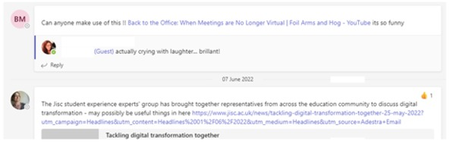
Figure 11 Microsoft Teams chat for informal communication
View description - Figure 11 Microsoft Teams chat for informal communication

Online whiteboards
Throughout production we used a Mural board for learning design, to understand the approach we wanted to take and to work on the structure. We had sessions where we worked in live time (synchronously) on the board, using it during virtual workshops, or we used it at different times to suit us (asynchronously) and then updated one another via our chat channels.

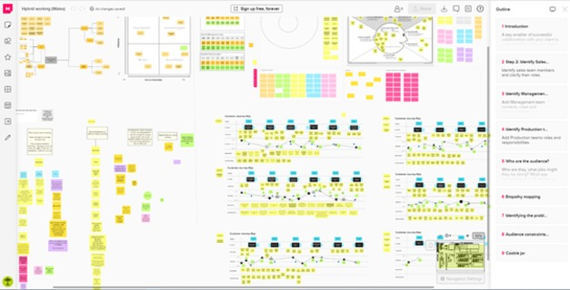
Figure 12 Mural board for working together both synchronously and asynchronously
View description - Figure 12 Mural board for working together both synchronously and asynchronously

Excel, Trello, Frame.io
For the production of the videos, we used a combination of digital tools.
We used Excel for a high-level overview and to track progress at that high level. We used it to list all the videos and provide brief updates and links to the various other collaboration tools we were using, including Trello and Frame.io (see below).

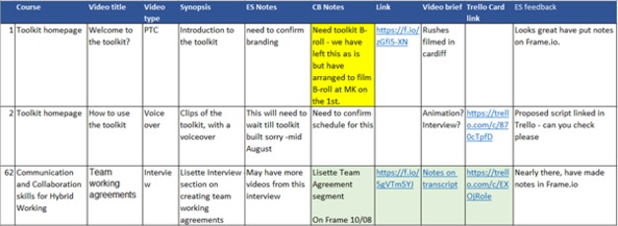
Figure 13 Excel for a high-level overview
View description - Figure 13 Excel for a high-level overview

For tracking progress of the creation of the videos at a more detailed level, we used Trello, as shown below.

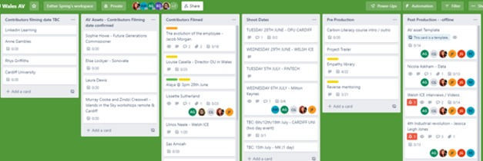
Figure 14 Trello for tracking more detailed progress
View description - Figure 14 Trello for tracking more detailed progress

Finally, to allow us to review the videos during the editing process, we used a system called Frame.io. This helped us to see progress or areas that needed immediate attention by using colours.

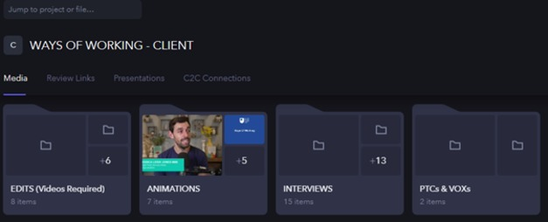
Figure 15 Frame.io for video production
View description - Figure 15 Frame.io for video production

WhatsApp, Microsoft Teams, phone calls
During filming, where some members could not attend in person but needed to provide input, we took a hybrid approach. This involved the producer joining the filming via video conferencing to provide direction and brief the contributors. When setting up the filming, we also used phone calls and WhatsApp.

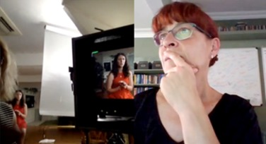
Figure 16 Using video conferencing to join an in-person session: a hybrid approach
View description - Figure 16 Using video conferencing to join an in-person session: a hybrid approa ...

What enabled us to communicate and collaborate effectively was a clear team working agreement and a defined approach to file and information sharing. We were very strict on who had access to certain areas, how we saved documents – everything had to be stored in the shared areas and in the right folders (see the figure below) – and how we used communication channels. There was a common terminology, we produced clear briefs for different workstreams and everything was allocated an ‘owner’.

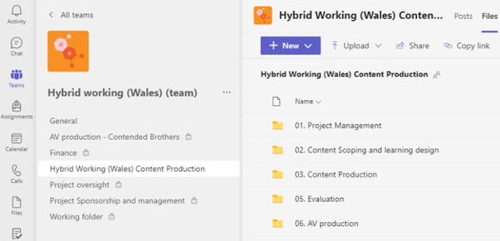
Figure 17 Shared areas with restricted access
View description - Figure 17 Shared areas with restricted access

6.2 Exploring digital collaboration tools
From the case study, you can see there are many ways to communicate and collaborate. As tools and systems evolve, it is sensible to keep up to date and understand your organisation’s policies for their use. To help develop your confidence in using these tools, test out new tools with trusted colleagues to explore what they can do, and how you might use them, and search for support and guidance either within your organisation or online.
In the following activities you are encouraged to explore and play with some the online collaboration tools ,discover those your organisation recommends, and others that are available.

Activity 20 Explore online whiteboards
15 minutes

During the COVID-19 pandemic, online whiteboards became a tool of choice for collaboration for many, and you may have used these within your workplace. Organisations adopted them for activities such as training and development where face-to-face workshops had to go online, and these offered an opportunity for participants to do tasks together, such as learning and course design, scenario planning and problem solving, and to help with project management.
While there are many online white boards available, Miro, Mural and Microsoft Whiteboard are popular. Take some time to explore one of these or an online whiteboard of your own choice. Many are free to use, and you may wish to create an account to ‘play’ with the whiteboard, as this can be the best approach to discover what it can do.
If you need inspiration for collaboration activities, the fun retrospectives website has numerous activities and ideas. You may wish to choose a few to try within your organisation.
Online collaboration in these spaces works best when you have prepared and agree how you will use them. Here are some basic principles:
- Be clear on the outcome of the activity you are doing.
- If you are facilitating the session, learn how to use the tool.
- While many people can use these tools without training, providing basic guidance at the start of a session and tips throughout will build confidence and allow you to use the tool more effectively.
- Consider ‘locking down’ content in the boards to avoid unintentional mistakes.
- These tools are not fully accessible, so consider support others may require, and allocate a buddy if required.

In the video, Anne Gambles, senior project manager, Library Services, The Open University, and Murray Cook, strategy and scenario practitioner, share their experience using online collaboration tools for running future planning sessions with teams within The Open University. This may give you insights and tips for collaborating more effectively online.

Video content is not available in this format.
View transcript - Uncaptioned interactive content

The list below takes you to support areas for:
- Miro
- Mural
- Microsoft Whiteboard

Activity 21 Exploring collaboration tools
in course 10 minutes / then time outside the course to use tools further

The range of collaboration tools now available is vast, and deciding which one is most appropriate for the outcomes you require and the preferred approach for your teams is important to ensure effective collaborative working.
When choosing any collaboration tool you should be mindful of the guidance and governance requirements of your organisations, for both security and budgetary reasons. For example, some online tools may not meet GDPR regulations.
Spend some time exploring the following:
What collaboration tools does your organisation already use?
Then review the following sites that provide some recommendations and think about how you might use some of these tools. If there are tools that could enable better collaboration, it can be useful to familiarise yourself with these using your own content, and then work with colleagues to see how you might use the tool.
- ‘Best online collaboration tools of 2022’ (McCaskill and Turner, 2022)
- ‘Tools for remote workers’ (Collaboration Superpowers, 2022)

6.3 Exploring digital file sharing
In the case study, you will note that we communicated and collaborated successfully, in part due to our approach to file sharing and storage. For organisations to operate successfully and efficiently, developing capabilities and ways of working with documents is essential. It is an area that can often lead to poor practice, and this has a hidden cost for organisations not just in terms of financial cost for having to have the server space and infrastructure, but also time: if you can’t find a digital file, you either lose time finding it or having to duplicate it. There is also a risk of poor version control, loss of a valued piece of information and asset, the need for security and keeping digital files safe and an impact on your digital carbon footprint.

Activity 22 Good working practices for collaborative file sharing and storage
15 minutes

In the case study, collaboration was effective as the approach to file sharing and storage had been agreed in line with the organisation’s policies. When hybrid working, it is essential that you have good processes and systems in place to ensure all members of the organisation have access to the information and data they require to do their roles, and to ensure that all are working in a safe and secure manner.
Read the following article, ‘Make collaboration painless with these 11 file sharing best practices’ (Hogan, 2020), and then consider the tools and systems you use for file sharing and storage. Explore your organisation’s resources and policies for usage of these. Then make notes on anything you may do differently or areas in which you would benefit from developing your knowledge and understanding further.

Data management is important, and you are encouraged to review the sections in the Hybrid working: skills for digital transformation and Hybrid working: organisational development courses within this collection to explore this topic further.

7 Do you really need a meeting?
We are spending more time in meetings, and the first question you need to ask is: ‘Why do you need a meeting?’ Is another communication channel better or more effective? The image and table below, based on the ‘Productivity trends report: one-on-one meeting statistics’ by reclaimai (2021), provide a useful visual overview of just how much of our working life is taken up by meetings.

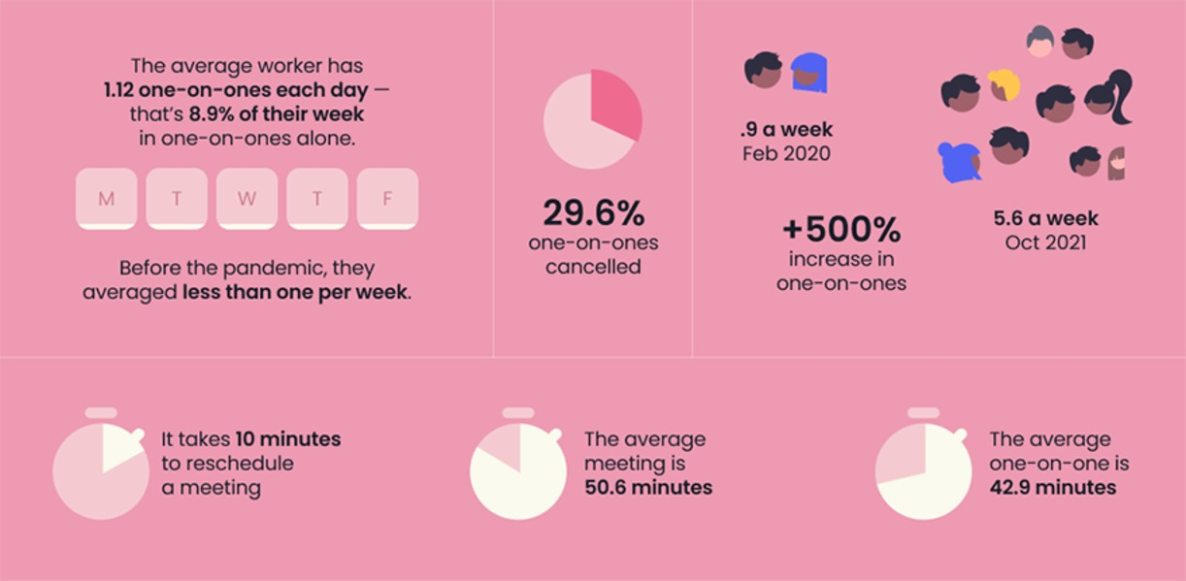
Figure 18 How much of our working life is taken up by meetings, adapted from reclaimai (2021)
View description - Figure 18 How much of our working life is taken up by meetings, adapted from reclaimai ...

Table 4 Time spent in meetings
Activity | Average Professional | Busy Professional
Meetings per week | 21.5 hours | 39.9 hours
One-on-ones rescheduled a year | 118.7 | 182.3
One-on-ones cancelled per year | 82.9 | 127.3
1:1 a year Feb 2020 | 45 | 100
1:1 a year Oct 2021 | 278 | 430
Workday Feb 2020 | 7.5 hours | 9.0 hours
Workday Oct 2021 | 8.9 hours | 10.13 hours

Source: reclaimai (2021)

Activity 23 How much time do you spend in meetings?
10 minutes

Have a look at ‘Productivity trends report: one-on-one meeting statistics’ (reclaimai, 2021) and think about the meetings you have. Spend some time defining what type of meetings you have (Who are they with? What are they for?), and decide which are essential.
Are there other ways of gathering the information you require instead of from a meeting? What is the value of the meeting for you, for your role or for your wellbeing?

Provide your answer...
View feedback - Activity 23 How much time do you spend in meetings?

What’s the purpose of the meeting?
Being clear on the purpose of the meeting, what type of meeting it needs to be – in person, hybrid or remote – and how it will be run will lead to more effective and valuable meetings.
How confident and curious you are, and your preferred way of working, will often be reflected in your choice of meeting type. I am comfortable attending any type of meeting and don’t really distinguish between them, as for me it is just a meeting, and my approach and behaviour will focus on the purpose of the meeting rather than how the meeting is being held.
For others, different meeting types can be challenging, and some people may find that their confidence is a little lower now, especially if they are new to the organisation or in their first job. In addition, expectations for attending meetings are now different, and workplace ‘norms’ are not necessarily as transparent when working in hybrid ways as when everyone was working in the office.
Wellbeing is also an important consideration when deciding if a meeting is really needed. During the pandemic, especially in periods of lockdowns, meetings often helped to reduce the feelings of isolation and loneliness. However, as restrictions have lifted, our lives have become busier, and the need for meetings for human interaction is potentially reducing. Meetings can impact productivity and can lead to employees having to ‘catch up’ with day-to-day work at the end of the day. People may experience ‘meeting fatigue’, which we explored in the Hybrid working: wellbeing and inclusion course.
Type of meeting
The table below captures some of the different types of meetings you might participate in. You may want to reflect on the activity earlier in the course about what type of meetings you attend. You will note for most that you can take any approach, as the best choice will depend on the purpose and those involved.

Table 5 Types of meetings
In person only | Hybrid | Remote
Regular 1:1 check ins |  | Regular 1:1 check ins
Complicated and/or sensitive conversations |  | Complicated and/or sensitive conversations
Regular team meetings | Regular team meetings | Regular team meetings
Project progress meetings | Project progress meetings | Project progress meetings
Planning meetings | Planning meetings | Planning meetings
 | Presentations to large numbers of people | Presentations to large numbers of people
 | Unit/All company updates | Unit/All company updates
Longer meetings, such as committee meetings |  | Longer meetings, such as committee meetings
Workshops, design and problem-solving sessions | Workshops, design and problem-solving sessions | Workshops, design and problem-solving sessions
Training and development |  | Training and development
Third-party clients/suppliers | Third-party clients/suppliers | Third-party clients/suppliers

Microsoft (n.d.a) suggests there are five types of hybrid meeting. Considering which work mode and collaboration experience you need, as shown in the figure below, can help you decide which approach to meetings to take.

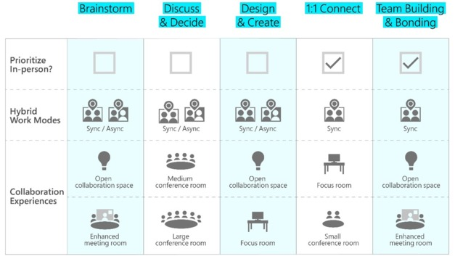
Figure 20 Types of hybrid meeting
View description - Figure 20 Types of hybrid meeting

Activity 24 How often do you need a meeting?
10 minutes

Having considered the types of meetings you arrange/attend, think about the frequency of these.
Read the following article, ‘How to find the most productive meeting schedule for a team like yours’ (Keith, 2020), and use the figure below to think about the frequency of meetings you arrange or attend.

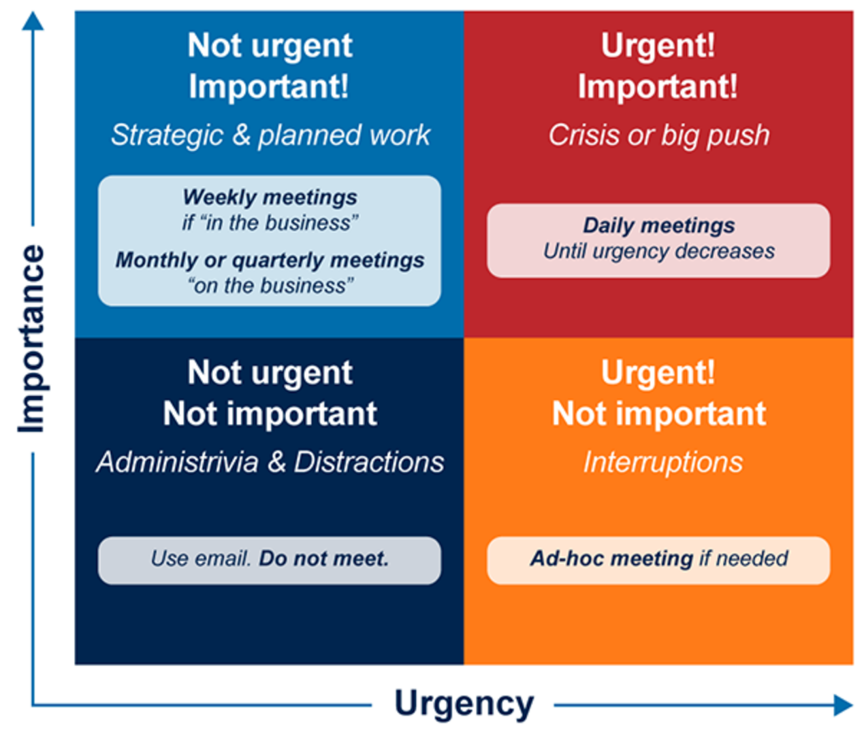
Figure 21 Frequency of meetings
View description - Figure 21 Frequency of meetings

Once you have considered the purpose of meetings, you can establish if you actually require a meeting or if you need to work on a specific task. There may be an asynchronous solution to solve it, or you may need arrange a ‘working’ session using other digital tools.
In the collaboration section we explored different ways to collaborate. Often when I meet with others, either in person or virtually, it is to work on something. We may use a variety of tools to achieve the desired outcome synchronously (in live time). These are not meetings but focused activities where, rather than talking about what needs to be done, we do something. Often, we don’t even have to talk to each other: we use the tools available to us to contribute and share information asynchronously (not in live time) to progress the outcomes required.

Activity 25 What is your alternative to a meeting?
15 minutes

HEIs are becoming more ‘digital’ and may be looking to use non-traditional tools. This article by doist, a remote organisation, provides insight into alternative ways of communication and collaboration and breaks down how they use tools in the figure below: ‘The pyramid of remote team communication tools’ (doist, n.d.)

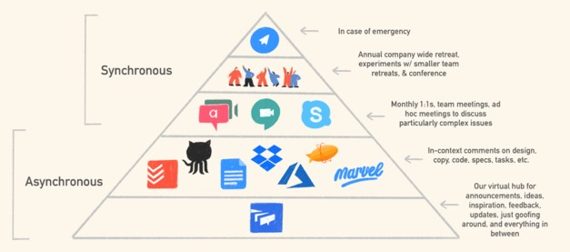
Figure 22 Alternatives to meetings
View description - Figure 22 Alternatives to meetings

Think about the outcomes you often want to achieve through a meeting or actions that are required and how you else might approach this. The articles below may give you some ideas to consider. Then list approaches you can easily implement and those that may require wider engagement with others – think about the team working agreement.
- ‘What happened when we stopped having meetings and sending emails | Government Digital Service’ (GOV.UK, 2020)
- ‘How to transform your culture? Have two days with no meetings’ (Make Work Better, 2022)
- ‘Stop having meetings. Start having conversations’ (Berry, 2022)
- ‘How to stop having “too many meetings” by building an asynchronous culture’ (Kergaravat, 2021)

8 Hybrid meetings
So, you’ve considered whether a meeting is necessary; you’ve considered alternatives. In some cases, a meeting is still the most useful approach. ‘Hybrid’ meetings happened before the COVID-19 pandemic, especially where you might be meeting with those not based in your organisation. You would connect via conferencing tools and have meetings with teams based in various locations. Before the pandemic, the most marked difference to how we are operating now was probably in the technology used: often you would have one video and speaker or microphone that everyone co-located would huddle around. Not always a very satisfactory experience for all involved.
Now with the acceleration of technology and options for online collaborative tools, and a move almost exclusively to virtual remote-only meetings during the pandemic lockdowns, our expectations of and approach to hybrid meetings has changed.
The following figure defines a hybrid meeting as the overlap between an in-person and virtual meeting.

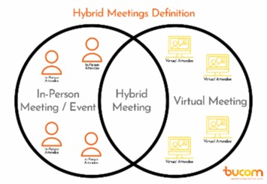
Figure 23 Hybrid meeting definition
View description - Figure 23 Hybrid meeting definition

We build on this and define a hybrid meeting as:

‘One or more remote participants and two or more people in a meeting room. A good hybrid collaborative meeting is one where all participants, in the meeting room and remote, can see and hear each other and can all participate in the meeting equally.’

Hybrid meetings can be challenging, and to ensure effective meetings, it is important that those leading the meeting have great facilitation skills and that all participants are clear on what’s expected of them.
In the video below, Lisette Sutherland, director of Collaboration Superpowers, provides guidance on what to consider for hybrid meetings.

Video content is not available in this format.
View transcript - Uncaptioned interactive content

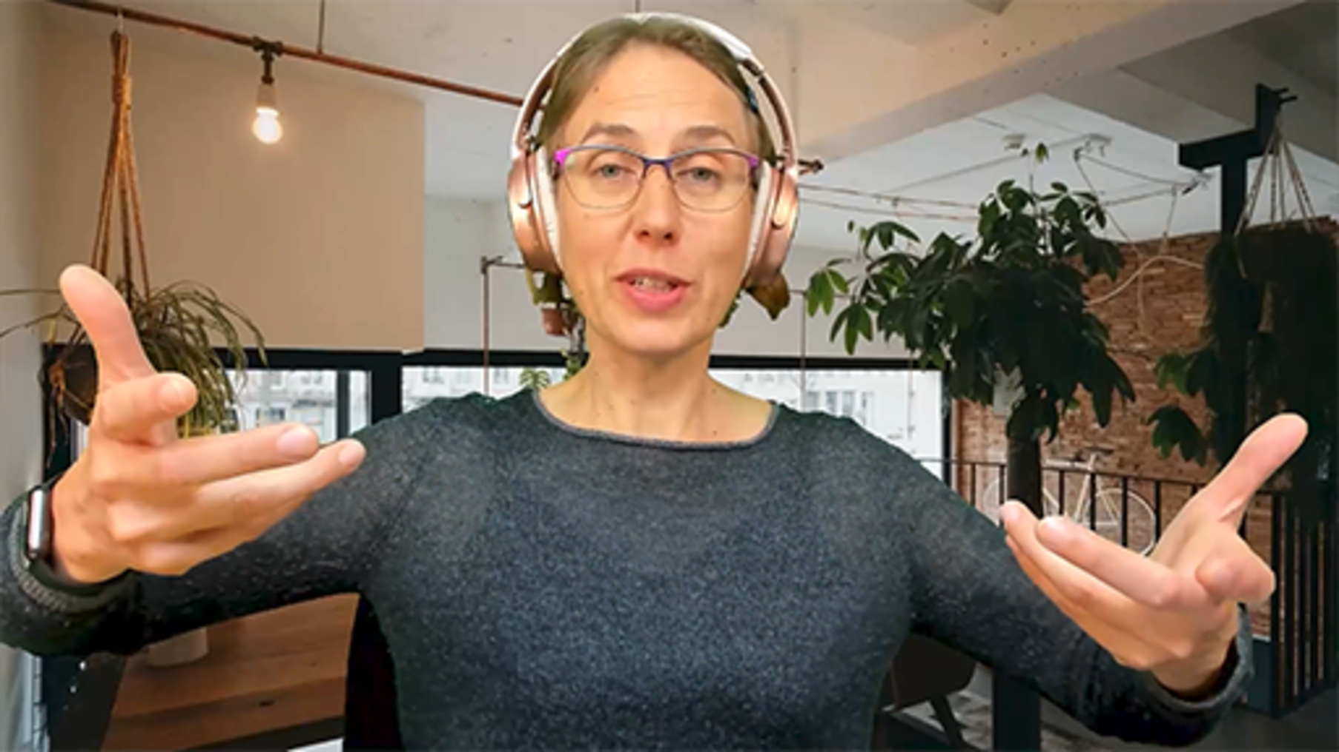

The extract below is from the GitLab 2022 open source handbook which summarises some of the downsides of hybrid meetings:

Hybrid calls are annoying
In calls that have remote participants everyone should use their own equipment (camera, headset, screen).
When multiple people share equipment, the following problems arise for remote participants:
- Can't hear the sharing people well.
- Background noise since the microphone of the sharing people is on all the time.
- Can't clearly see facial expressions since each face takes up only a small part of the screen.
- Can't easily see who is talking since the screen shows multiple people.
- Hard getting a word in since their delay is longer than for the sharing people.
The people sharing equipment also have problems because they don't have their own equipment:
- Can't easily screen share something themselves.
- Trouble seeing details in screen sharing since the screen is further away from them.
- Can't scroll through a slide deck at their own pace.
- Sharing people can't easily participate (view or type) in a shared document with the agenda and meeting notes.
The disadvantages for remote people are much greater than for the sharing people and hard to notice for the sharing people. The disadvantages cause previously remote participants to travel to the meeting to be in person for a better experience. The extra travel is inefficient since it is time consuming, expensive, bad for the environment, and unhealthy.
Theoretically you can have multiple people in a room with their own equipment but, in practice, it is much better to be in separate rooms:
- It is annoying to first hear someone talk in the room and then hear it over audio with a delay.
- It is hard to consistently mute yourself when not talking to prevent someone else's voice coming through your microphone as well.
(GitLab, 2022)

Activity 26 What annoys you about meetings?
5 minutes

Reflect on the extract from GitLab’s (2022) handbook, and think about what annoys you about hybrid meetings. You may see a pattern form: could your list apply to any type of meeting?
Then think about what measures you can take as an individual to reduce these annoyances.

Provide your answer...

While there can be many downsides for hybrid and virtual meetings, sometimes due to technology, they can also open up the world and allow for greater flexibility and opportunities.
Some organisations are considering the ‘one remote, all remote’ approach, but the reality is that there are going to be times when a hybrid meeting is the most appropriate option, as the workforces are distributed between onsite and other locations.
Hybrid and virtual meetings offer the following benefits:
- More participants can come together from locations all over the world.
- They offer flexibility; meetings can be held across time zones.
- You can quickly share information with all those who need it.
- They can easily be recorded, so those who can’t attend can still access the information shared in a meeting, and content from meetings can be reused.
- Well-run meetings tend to be more structured, giving everyone the chance to speak, especially if you use the ‘raise hand’ function.
- You can collaborate on work more easily, sharing screens and doing live planning through online collaboration tools such as whiteboards or shared edited documents.
- You can expand your network, as the need to bring everyone together to share information means team members who might not have previously been included in meetings are now being invited to join.
- They can be more focused, as the purpose of the meetings is normally clarified. ‘Handouts’ are easier to share, and often someone is nominated as the facilitator. In addition, while it can pose difficulties for some, there are two forms of communication – spoken (those who are talking) and written (comments/information captured in written chat functions and in any online collaboration tools) which can help both with reinforcing messages and giving opportunities for more active participation.
- They can be more cost effective, as not everyone has to travel, you don’t necessarily need to supply refreshments and smaller meeting rooms can be used.
- By reducing the need to travel, you are contributing to reducing your HEI’s carbon footprint and supporting better wellbeing for participants who do not have to commute.
These are just a few of the benefits of hybrid and remote meetings that we know about now, and as organisations and individuals become more confident, more will evolve.

8.1 How to have good hybrid meetings
In the following sections we explore how to improve meetings and team collaboration in a hybrid workplace.
In the video below, How to have a hybrid meeting that works for everyone (Harvard Business Review, 2021), social psychologist Heidi Grant shares best practices for hybrid meetings.

Watch the video at YouTube.com.
You are viewing this video in Youtube: The Open University is not responsible for external site content
View transcript - You are viewing this video in Youtube: The Open University is not responsible for ...

Good hybrid meetings require a clear purpose and technology that works.

Technology
Your organisation will have preferred technology in terms of hardware and software. The most popular video conference platforms (VCPs) are Zoom, Microsoft Teams, Google Chat, Webex by Cisco and Adobe Connect. It is also useful to consider mobile apps such as WhatsApp and Facetime: I use these informal tools when I am away from my normal location and need a ‘quick call’ or if I’m working with people whose mobile technology is more stable than online tools.

Onsite meeting areas
Even before the pandemic, how we managed hybrid meetings was evolving; they often didn’t take place in formal meeting rooms. Participants who had virtual conferencing platforms on their laptops or mobile app technology were often having hybrid meetings wherever was convenient.
For example, I used to travel to India, where my previous team was based. If our connecting flight was delayed, my colleague and I used to sit in airport lounges, with a laptop, and meet online with the team based in the office so we could rearrange schedules.
As organisations redesign how buildings are used and the technology they either already have or plan to invest in, they are thinking differently about what a meeting space needs to be.
In the Hybrid working: organisational development course, you can explore how The Open University has created show homes. These are areas within the campus that have been repurposed and designed to provide workspaces and meeting rooms,and access to technology to allow for onsite, hybrid and remote meetings.

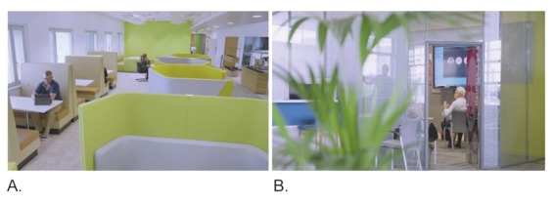
Figure 24 Workspaces with technology to support hybrid meetings
View description - Figure 24 Workspaces with technology to support hybrid meetings

Formal meeting rooms
Most organisations are likely now to be investing in and designing meeting spaces for the future, but the reality is not all will be able to implement purpose-built meetings rooms, such as those designed by Microsoft, who have done extensive research and have design teams exploring ‘Designing the new hybrid meeting experience—for everyone’ (Microsoft, n.d.).
How you use formal meeting room spaces will depend on the technology available and design of the room. While you may have technical equipment provided, many people now will also expect to be able to use their own laptop or tablet, and it can often be easier to have everyone join the meeting through their devices, as well as using the main shared screen, especially if you are using a ‘single’ external camera device.
If you are the meeting organiser, ensure that you understand how the room was designed to be used and how to use the technology within it. If you require training, arrange this in advance to avoid things going wrong during your meeting, which can happen.
Positioning of cameras is really important. Where possible, you should aim for all attendees’ cameras to be at eyeline, as this helps support non-verbal communication and ‘cues’.
While investing time to prepare will help your meetings run efficiently, if you frequently attend hybrid meetings, you and those who attend will eventually find that you will naturally adapt to the spaces and technology, and so time needed for preparation will gradually reduce.

8.2 Being a remote attendee
The equipment used by those attending remotely may well vary, as well as their location and space. Some people may be using a laptop and its built-in tools, whereas others may have access to external cameras, headphones with microphones and additional lighting, with a designated workspace. Others may be working flexibly wherever they can, in a space which they have to set up for work every day. Others again may be using their mobile phone, may be on the move, may be in a non-private space (e.g. train or café) or may not have a good internet or mobile data connection.
Setting up your remote working space is important, and ensuring you have the technology you need and understanding how to use it will help you work efficiently, safely and effectively.

Check your equipment
In most cases, if you are using a laptop, tablet or phone, you will probably be familiar with how it works and you have already set it up for meetings. The use of built-in equipment (e.g. speakers and microphone) should be perfectly acceptable.
However, if you regularly chair large meetings or deliver training or presentations, you may wish to consider using external equipment so that the sound and video are of higher quality (e.g. headphones or external camera and microphone).
You may wish to use the table below as a checklist and make notes for future reference – and it may also be useful to think about the common film phrase: Lights, audio, camera, action!

Table 6 Hybrid meeting equipment checklist
Item | Check
Set up your ‘room’ | Ensure that the area where you will be having your meeting either onsite or remote is set up appropriately. This is the first step for a good meeting.  Do you need to use a virtual background available via the virtual conference platform you are using?
Lighting | If you are in shadow or the sun is catching your camera, this can be distracting for others but also means they might not be able to see you.
Virtual conference platform and Video conferencing technology (VCT) | Are the platforms ones you are familiar with? If you are meeting with someone external to your organisation, you may be using their platform of choice.  Have you used the conferencing technology in a meeting room before?  The functionality of VCPs and VCTs is constantly evolving. Ensure you schedule ‘play’ time with a trusted colleague to learn how they work, and look for training offered via your organisation.  Being familiar with the functionality avoids unintentional mistakes. (I have a habit of leaving meetings when I go to share my screen, as the buttons in our VCP are next to each other.)
VCP organisational policy | Most organisations have a preferred VCP. You may need to check the policy on the use of other platforms.
Audio | Check how your audio device works: can you change sound levels? Are there alternative options if there is a problem?  One reason I don’t use my headphones is I frequently accidentally catch the ‘mute’ button due to where it is located on the headphone lead.
Camera | Check how your camera works and where it is located; think about your positioning and how you appear on screen.  Is the camera at the attendees’ eye line?  If it is an external camera, is it in the right location, especially if it is one designed to sit in the middle of a table and moved on voice command?  For example, ‘Welcome to Owl Labs’ (Owl Labs, 2021).
Profile image | Do you have a profile image so that if you have your camera switched off, other attendees will have a visual cue for you?  You may wish to review the ‘your persona’ section of this course.
Profile name | Some organisations will add your name by default. It is worth checking it is as you want it. This is particularly important if joining meetings outside your own organisation where you may need to change how your name is displayed.  Having the correct name displayed is important so others on the call can easily identify who is talking.
Joining instructions | Check that you have the link to the meeting so that you can join easily and are not looking for it at the last minute.  I have more than once been caught out thinking the meeting link was in the invitation I received, but it wasn’t.  It can be helpful to send a reminder email to all attendees before the meeting including the link, especially if the meeting was set up some time in advance.

9 Steps for effective meetings
In this section we consider the steps for setting up and holding a meeting and carrying out the actions after a meeting. While the type of meeting will influence how much effort is required, the following steps are normally followed, including for hybrid meetings:
- Plan – what is the approach, and what is required for the meeting?
- Prepare – what is the purpose and outcome desired from the meeting?
- Agenda – all meetings should have an agenda to provide clarity on the purpose.
- Invite – who needs to attend?
- Meet – ensure effective, engaging and accessible meetings.
- Action – what are the actions from the meeting?
- Review – have the actions been completed, what are the next steps?
This seven-step approach can help provide clarity and remind you how to ensure an effective hybrid meeting. There is a checklist for most steps.

9.1 Planning your meeting
Regardless of whether you are the meeting organiser or an attendee, understanding the requirements and expectations for meetings is important. Most people will at some point arrange a meeting, even if it is just with one other person.
Hybrid meetings require some people to be in a physical space together, so you need to allow time to arrange that. Depending on where the meeting is to be held, you need to check availability and suitability of the space for the type of meeting you wish to host and ensure that you are aware of any specific requirements; for example, does the organisation require a risk assessment? This might be the case if you work on unusual or high-risk work and your meetings take place on location, with remote attendees – for example, construction projects or field work. Using a risk assessment form can be helpful to consider the needs of all those participating.
For those attending remotely, check if they have any additional requirements for their ability to participate effectively but also if they are not from within your organisation. If they are not from your organisation, they may require additional guidance on how to join your virtual communications platform, especially if it is one that their own organisation does not use, and they may have to arrange access or seek permission.
Remember that if you are arranging a hybrid meeting, that does not mean you have to be ‘present in the room’; you can join virtually. Prior to the pandemic, I was a remote worker. My organisation’s head office was based three hours away, and my team was in India. While I would set up and chair meetings, the hybrid meetings would involve people in meeting rooms in two or more countries with three or four remote workers joining virtually. It didn’t matter that I was not physically in the same room with any of my team.
As you become more experienced arranging and attending meetings, planning meetings becomes second nature, you will devise your own system and practices and often it will be larger or more complex meetings which will require more focused time to plan. However, even if you are having a 1:1 meeting, it is useful to plan what you want to cover.

9.2 Preparing your meeting
When preparing for your meeting, it is useful to consider the following:
- What are the purpose and outcome you hope to achieve from the meeting?
- Spend time preparing for meetings; what information do you need to share or gather?
- What will be the etiquette for the meeting, and how will this be shared – in advance or established at the start of the meeting when you do the housekeeping! This includes asking people to have cameras on/off and microphones muted and use of the ‘raised hand’ function if they wish to speak. Will people be using chat? Do you need to share your screen?
- Do you need breaks depending on the length?
- How is the information going to be shared – spoken only, via a presentation, a group activity – will this require breakout rooms, will you be using ‘whiteboards’ or other collaboration tools, will more than one person be required to present?
Think about the outcome: are you just sharing information, do you require a discussion or are participants expect to learn or carry forward action?
This article ‘How to lead better remote meetings’ (Mesaglio, 2020) provides additional useful advice.

9.3 The agenda
Often you will start to work on an agenda before inviting the participants, or in parallel, in order to ensure that you have clarity on who needs to attend.
An agenda sets out the purpose of the meeting. It is the list of items to be discussed within a meeting and the proposed order of the items. Depending on the type of meeting and those involved, agendas may be formal with detailed information or informal with just a list of items. Where it is a reoccurring meeting and the same items are always discussed, they can often be ‘standing agendas’.
A good agenda can act as a guide for those attending the meeting, which can help for better meetings. For meetings that are linked to projects, it can be helpful to include an overview of the project for those who might not be directly involved in the project.
Agendas should be sent out in a timely manner, ideally a week in advance to give people time to complete any actions required before a meeting and, if necessary, to send an update.
In many cases, the meeting invitation will go out before the agenda is finalised. Ideally the body of a meeting invitation will contain basic information, and when the agenda is finalised, it can be useful to attach or add it to the meeting invitation and resend it to all participants. The advantage of including all information in an invitation is that it makes it easier for participants to find information, as it is often easier to check an invitation than find an email.
You may wish to use the following checklist for creating your agenda.

Table 7 Agenda checklist
Information to include | Purpose
Basic information  Name of meeting  Name of the chair/facilitator for the meeting  Time  Date  Location  Link for meeting  Who has been invited and, ideally, who has confirmed they will attend | This is to ensure all those attending have the basic information. It is also good practice to include this in the meeting invitation.
Purpose | Include the purpose of the meeting in the agenda so participants can make an informed decision if they need to attend.  This is also something you may wish to include in the meeting invitation.
Housekeeping | While this is normally a verbal action, it can be useful to include important information and list any expectations for the meeting.  If you have a team working agreement or terms of reference for the meeting, you may wish to link to those.
Review of actions from previous meeting | If the meeting is a reoccurring one, it is sensible to include a review of any actions from the previous meeting’s minutes to ensure progress has been made. Listing actions on an agenda provides a reminder to participants and prepares action owners that they will be expected to provide an update.
Timings for items | It can be useful to include timings for items on the agenda, as this will help meetings stay on track, but also, in planning for the meeting, it might identify that you have too many items to discuss.
Items for discussion | This is the list of what will be discussed in the meeting. You may wish to provide context for each item to explain to participants why something has been included.
Links to documents required for the meeting | Under each item where there are documents to refer to, it is sensible if they are stored in a collaboration space to provide a link to the documents.  Otherwise, attach the documents to the meeting invitation/email with the agenda.
Any other business (AOB) | Always include AOB on an agenda. In advance of the meeting, check if participants have AOB they wish to add, and normally it would be checked at the start of a meeting if anything else needs to be added.
Times of breaks | If the meeting is long enough to warrant breaks to be scheduled, try to be clear on the timing for this.
Date and time of the next meeting | If the meeting is a reoccurring one, it is useful to list future meetings, as it may be noted that a meeting clashes with other events, such as a ‘closure day’, which might have been missed at the time of setting the meeting up.
Optional additional information | It can be useful to include additional information about any projects and the key participants who attend. This can be a link to a website if there is one connected to the meeting.
Risk assessments | If a meeting has required a risk assessment, this should be attached to the agenda/meeting invitation so all participants are aware of any risks.  If there is a significant risk, participants should be aware, so ensure that this is communicated in the meeting invitation or an email.

Not all meetings will require a formal agenda. Often if I am having a 1:1 or meeting with people I work with daily, my agenda might be a bullet list on a scrap of paper to remind me what information I require from the meeting.

Activity 27 Create an agenda template
5 minutes

Spend time reviewing the agenda checklist above. Your organisation may have standard template that is used for meeting agendas, or you may need to create one. If you need to create one, or improve an existing one, use the checklist to create an agenda template.

9.4 Inviting participants
Ensuring that all participants can attend can be challenging if you are arranging a large meeting. To assist with this, arrange the meeting at a time the key participants are available and agree if a recording will be made available for those who cannot attend. Gather any items they may wish to raise and plan to contribute on their behalf.
If you are responsible for organising reoccurring meetings, such as committee or steering group meetings, you often find that ‘guest’ participants attend for an allocated time slot to contribute or present on their agenda item. When confirming their availability, you need to ensure they understand the format of the meeting and what will be expected of them during the time they are due to attend. Do not assume that the person who has requested they attend has done this.

Activity 28 Set up a meeting, use a meeting poll tool
10 minutes

If you are responsible for sending out meeting requests, most work-based office email tools have a ‘scheduler function’ that allows you to see when people are free. If it is not clear, reach out to participants and ask for their availability rather than sending a meeting request when they have time blocked out. For those in less senior positions, it can make them feel obliged to change their plans or be concerned how it will be perceived if they can’t accept a meeting. If your organisation allows you to, where you have large numbers of participants, there are online tools you can use to assist with arranging meetings.
Explore if your organisation’s calendar tool has a built-in meeting poll tool.
For example, if you use Microsoft 365, with Outlook there is an add-in for scheduling meetings. The article from Microsoft Support (n.d.), ‘How to create a FindTime poll’, takes you through the steps to do this.
Or you can do an internet search using ‘free meeting availability poll’, which will return a number of tools that are free to use. If you do use these, ensure you are working with your organisation’s guidelines for use of third-party tools.
I often use Doodle, as it is free to use and does not require me to create an account. I can create a poll and email to potential participants so they can select the times they are free and submit, so I can be sure to choose the time that is most suitable.

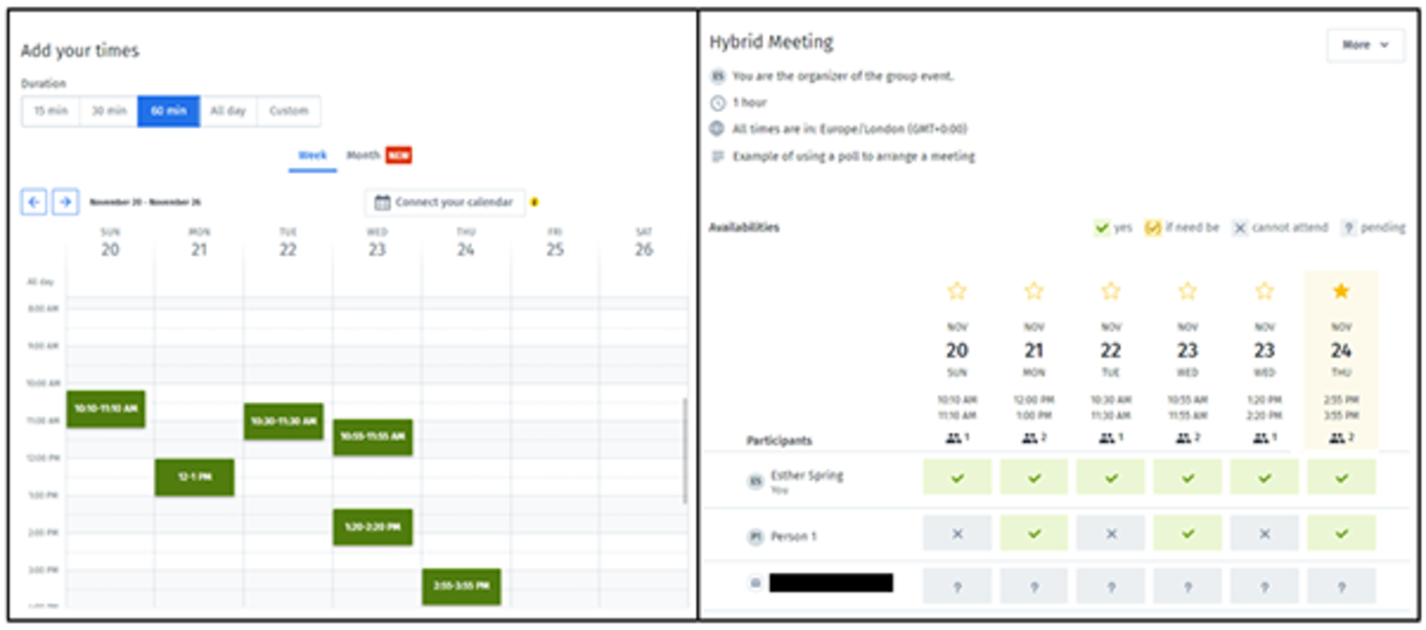
Figure 25 Using a poll to find a suitable meeting time
View description - Figure 25 Using a poll to find a suitable meeting time

Once you are happy that your agenda is ready, it can then be circulated to all participants. Where a participant has indicated they may require additional support, it is sensible to message them directly with information as to how they will be supported.

9.5 The meeting

Hosting your hybrid meeting
Before your meeting starts, give yourself time to be ready. Use the checklist below as a guide for the key elements for hosting your meeting. You may also wish to review the checklists provided earlier in this course.

Table 8 Hosting a hybrid meeting checklist
Item | Guidance
Check your equipment and environment | Are you familiar with the virtual conference platform and video conferencing technology, and is it set up correctly?  Is the ‘location’ of the meeting set up correctly?
Purpose and agenda | Remind yourself of the purpose and check the agenda is still correct. If you have timings on the agenda, think about how you will follow them.
Participants | Who is/isn’t attending; will anyone be late joining?  Did any of the participants have additional needs?
Reasonable adjustments | Do you need to make any adjustments for the participants?  Do you need to let other participants know of adjustments required (if the participant with the requirement is happy for this to be shared)?
Meeting etiquette | Are you clear on the etiquette for the meeting; has this been shared in advance, or will this be covered at the start of the meeting?  Will there be breaks during the meeting?
Recording the meeting | If you are recording the meeting, are all participants aware and happy for you do so?
Collaboration activities | Have you planned collaboration activities?
Meeting roles | What are the roles that are needed within the meeting? (This is covered in this section in more detail.)
Chairing/facilitating the meeting | Think about how you will do this: how well do you know the participants, and how will you keep to time?
Note-taking | If you are not recording, will someone be taking notes and actions and be responsible for sharing the meeting minutes?
Closing the meeting | How will you bring the meeting to a close and agree on next steps?
Thank you | Don’t forget to thank participants for attending!

Meeting roles
Most meetings involving more than two people will have a chair or a facilitator to ensure that the meeting is focused and covers the items that need to be discussed. Depending on the size of the meeting, you may decide to have more roles, some of which might be shared.
The table provides some detail of possible roles in a meeting.

Table 9 Roles in a meeting
Role | Description
Meeting organiser | The person who organised the meeting might not, in all cases, chair or facilitate the meeting, or even attend. Often an organiser asks for meetings to take place on their behalf or if a specific task is required that others are better placed to take forward.
Chair | The person in charge of the meeting who ensures all items are covered and everyone has the opportunity to participate.  They are also responsible for ensuring that actions from meetings are agreed on and completed.
Facilitator | Not all meetings have a chair. Instead the facilitator may assume this role.  Most facilitators support the chair and take on the responsibility of running the meeting and co-ordinate all the activities within the meeting. They are useful if the meeting has a large number of participants and/or collaboration activities within it.
Time keeper | It can be useful to nominate someone to keep track of time, if you have a long agenda, numerous activities or a large number of participants.
Note taker | While most hybrid meetings can be recorded, a note taker can ensure that pertinent points and actions are captured. These then can be shared after the meeting.
Presenting participants | These are participants who are attending for a specific purpose, normally to share information, or have a request from other members of the meeting.
Non-presenting participants | These are participants who need to hear the content of meeting – for example, members of a unit at all team meetings where updates are given or part of a wider project team.  It is expected, though, that these participants will contribute to the meeting, as appropriate.
Observers | Sometimes a participant might attend a meeting to observe. This can be for a number of reasons; they may have an interest in finding out about a project, or it might be a development opportunity. They might not, however, be an active participant.
Meeting co-ordinator | This is the person who has made the arrangements for the meeting. They may or may not be a participant in the meeting.
Room support | In many organisations there is a unit or team who is responsible for meeting rooms. It is unlikely they will attend your meeting but are a point of contact should you require support.
IT support | In most organisations the technology and equipment for both meeting rooms and internal remote staff is managed and supported by an IT team, which is a point of contact should you require support. For complex and large meetings, they may be present at the meeting.

Facilitating your meeting
Before your meeting starts, ensure you have set up both the physical and virtual environments and that the technology works. For virtual environments, if you are planning to use in-platform collaboration tools such as polls or breakout rooms, or if the platform allows you to add other ‘apps’, make sure everything is in place.
Check your settings and familiarise yourself with how to use the tools such as screen sharing, recording, transcripts, captioning and the reactions available. You may wish to set a digital background, depending on the environment you are in. It is also useful for you to consider accessibility and inclusion. ‘Accessibility of remote meetings’ (W3C, 2022) by the World Wide Web Consortium (W3C) provides useful guidance, on which many organisations base their approach for online accessibility.
Once all participants have joined the meeting and are ready, you may wish to use the following checklist to help you run the meeting effectively.

Table 10 Running a hybrid meeting checklist
Item | Guidance
Welcome to the meeting | Introduce yourself, state the purpose of the meeting and summary of agenda, ask for any other business. If the meeting is covering confidential or sensitive topics, ensure all participants are aware and that content discussed within the meeting should not be shared with others.
Housekeeping | Set the expectations for the meeting:  - Is it to be recorded (is everyone happy with this)?  - Use of cameras and microphones.  - Use of reactions – hands up to ask questions.  - Does everyone have what they need to be able to fully participate – is their technology working, do they have additional needs (ideally this will be known to you prior to the meeting)?  - Ensure that people in the room are visible and audio is working correctly for all.  - Request that all other work tools be closed to encourage participants to focus on the meeting and not multi-task.  - If collaboration activities are planned, check that people are familiar with using the tools for the activities.  - Use of the chat function.  - Reminder of location of any shared documents, in case they would prefer to have them on their own screens, in addition to any screen sharing – many organisations store meeting documents in shared file storage areas/collaboration tools.  - Note – if it is a regular meeting, it is often useful to have terms of reference and a summary of key activities available for those who may be new so they have access to background information known to pre-existing members.
Introductions | Not all meetings will require introductions.  Check if people have met each other before; if not, ask them to introduce themselves.  Introduce key participants of the meeting or, if a regular meeting, those who have joined.
Work through the agenda | Each meeting will run differently, and as the facilitator, you need to control the meeting.  - Keep on time.  - Allow those who wish to speak time to do so, or, if time is a challenge, encourage them to share their contribution in the chat.  - Ensure people stay focused on items on the agenda, unless appropriate to explore a new item.  - Consider how you will ensure no-one dominates the meeting and everyone has a chance to contribute.  - Check that participants are OK during the meeting and that they are having the conversations expected.  - Ensure actions and owners are recorded during the meeting.  - If a topic is being discussed which would benefit from allowing the conversation to continue, check to see if participants are able to continue with the meeting; if not …  - Bring the meeting to a close.
Draw the meeting to a close | You should plan for the last five minutes of a meeting to focus on summarising and agreeing on next steps.  - Bring the meeting to a close.  - Summarise the key points of the meeting.  - Review the actions and agree on owners and timeframes.  - Confirm how meeting notes and the recording (if recorded) will be circulated.  - Confirm if another meeting is required.  - If another meeting is required, agree who will set this up, or if you attend a reoccurring meeting, confirm the date of the next meeting.  - Thank participants for their time and contribution.
Post-meeting housekeeping | - If you are in a physical room, ensure that is left clean and tidy.  - Make your own action list as result of the meeting.

9.5.1 Effective communication in hybrid meetings
All meetings are most effective when people understand the purpose and are made to feel safe to participate. If you have prepared in advance and you have a clear plan to how you would like to run the meeting, this will enable a more engaging experience. This can be even more important for regular routine meetings because, as you are in a routine, you can easily fall into the habit of just turning up without really thinking about the purpose.
A planned meeting is when people come together to discuss something. It requires a purpose, effective communication and for the meeting to be controlled. The main elements of a meeting are:
- Interaction: how participants communicate and interact
- Content: the contributions made by participants and information used (either documents/presentations/chat discussions)
- Structure: how the meeting is organised – a formal or informal approach.
Effective communication is the critical element of a meeting, and treating meetings as a conversation is increasingly being advocated. The figure below is adapted from the article by Ian Berry (2022), ‘Stop having meetings. Start having conversations’, which is based on his experiences. In the article he proposes nine essential elements that focus on ‘Human Being Centred Conversations’ while developing your active listening skills to hear not only what someone is saying but also what they might not be saying, as well as your ability to read body language.

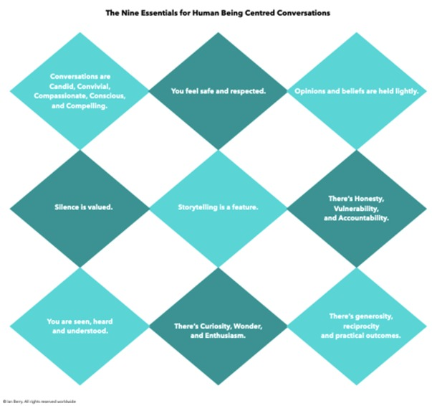
Figure 26 Human being-centred conversations, adapted from Berry (2022)
View description - Figure 26 Human being-centred conversations, adapted from Berry (2022)

Activity 29 How do you listen?
15 minutes

Study the image above and read the article by Berry (2022), ‘Stop having meetings. Start having conversations’. One key theme throughout is listening.
Listening is not the same as hearing. According to the following article, research shows we spend 45% of our time listening. Read the article ‘Listening skills’ (SkillsYouNeed, 2022) and consider how much you actually listen when you are interacting with others.
The next conversation you have, sit down afterwards and try to recall what you heard, what you observed, what might have been unsaid and what you would want to find out more about. List your observations in the box below.

Provide your answer...

9.6 Actions and review
After a meeting, you need to allow time for follow-up actions and reviewing meeting notes for any actions that may have been missed or information that is useful for further use.
While some meetings may not require a detailed review and only a short follow-up email, others may need a more formal set of actions to be considered and implemented.
The following table may be a useful checklist for you.

Table 11 Actions and review checklist
Item | Guidance
Review actions and meeting notes | Make a list of actions and issues.  Review the meeting notes for additional information that needs to be captured or shared.
Meeting notes | Ensure meeting notes are written up and checked.  Good meeting notes will have the list of actions and issues at the top and the date of the next meeting (if one is required).
Recording and transcript of meeting | - Check recordings and transcript of meetings.  - This is important, although you should not need to amend these. It is worth checking if conversations continued after most of the participants left; check that the conversation did not evolve into a personal catch-up which may not be appropriate to share.  - If you had participants attend for only part of a meeting and other topics are confidential or sensitive, you need to agree on a policy as to what information can be shared to all participants, and it needs to be in line with your organisation’s policies and processes. As a rule, if someone is a ‘guest’ for only part of a meeting, notes are not expected to be shared with them.  - It is worth checking recording settings, as some systems will automatically share the recording.  - If you need to continue a conversation after a meeting, good practice for virtual meetings is to leave the original meeting and start a new meeting.
Record actions | Depending on the nature of the meeting, you may have an online planning/tracking tool for actions and issues. These systems should be updated prior to meeting notes being circulated.  Ensure all actions have owners and expected timeframes for completion.
Set up the next meeting | If another meeting is required, arrange for it to be set up.  If it is a reoccurring meeting, check that the date is still suitable and all requirements for it have been confirmed.
Circulate meeting notes | Most meeting notes are shared either within a collaboration space or by email.  - Thank participants for their time;  - Provide a brief summary;  - Highlight any important items;  - Share the meeting notes and recording with participants – ideally as a link to the shared area or an attachment;  - Confirm next steps;  - Date and time of the next meeting.  If your meeting is classed as confidential/sensitive, you need to ensure that you follow the agreed process for saving and sharing meeting notes. Many workplace collaboration tools rely on permissions being set, and often you may find that your documents are visible to everyone in an organisation.  If you have participants external to your organisation, unless they have been given access to your systems, in most cases you will need to attach meeting notes in an email.  For those ‘guest’ participants who should not have access to the full meeting notes, follow up separately to thank them for their time and any actions required.

10 The future of communication and collaboration
The tools and understanding of hybrid and virtual communication and collaboration have accelerated due to the COVID-19 pandemic. While we adapted quickly and are becoming more comfortable with both the technology and the behaviours required for new ways of working, the technology is still rapidly evolving.
The term ‘metaverse’ is now fairly well known, in part due to Facebook relaunching to reflect the many products it owns under the corporate name Meta and to reflect what the next version of the internet could be. Mark Zuckerberg says in his ‘Founder’s letter, 2021’:

‘We’ve gone from desktop to web to mobile; from text to photos to video. But this isn’t the end of the line.
‘The next platform will be even more immersive — an embodied internet where you’re in the experience, not just looking at it. We call this the metaverse, and it will touch every product we build.
‘The defining quality of the metaverse will be a feeling of presence — like you are right there with another person or in another place. Feeling truly present with another person is the ultimate dream of social technology. That is why we are focused on building this.
‘In the metaverse, you’ll be able to do almost anything you can imagine — get together with friends and family, work, learn, play, shop, create — as well as completely new experiences that don’t really fit how we think about computers or phones today. We made a film that explores how you might use the metaverse one day.’
(Meta, 2021)

Already organisations and individuals are experimenting with new ways of interacting, and meetings are being held using technology to enable mixed-reality environments. While some of the technology is not new, the development of the software for these realities is opening new possibilities. The image below is reproduced from the article ‘AR vs. VR vs. MR: differences, similarities and manufacturing uses’ (TechTarget, 2020) and provides a simple definition of the realities you might need to start to engage with.

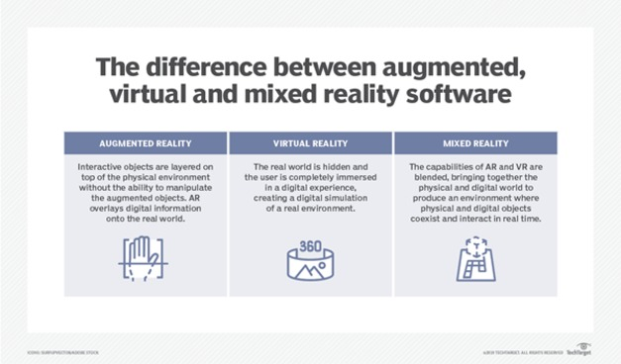
Figure 27 Augmented, virtual and mixed reality
View description - Figure 27 Augmented, virtual and mixed reality

Activity 30 What might the future of communication and collaboration in HEIs look like?
20 minutes

Watch the video Online conferences, remote work, virtual events: are shared virtual experiences the future? by John Koetsier (2021):

Video content is not available in this format.
View transcript - Uncaptioned interactive content

Then browse the articles below and do your own research on the internet. How do you feel about these tools and approaches to communication and collaboration? Could meetings become something of the past?
- ‘Are virtual reality meetings the future of remote work?’ (Comber, 2022)
- ‘A step into Meta’s VR meeting world, Horizon Workrooms’ (Germain, 2022)
- ‘Tech trends 2022: Meet me in the metaverse’ (Accenture, n.d.)
- ‘Ed on the metaverse’ (Deloitte, n.d.)

Conclusion
Communication and digital collaboration skills will continue to become more important, and keeping up to date with new technology is a requirement for all individuals. As you reflect on what you have learned through this course, consider how you will continue to develop your skills and confidence to try new ways of collaborating and engage with the tools available.
Hybrid working opens up the opportunity to connect and work with others globally. By developing your communication skills and approaches for more inclusive working through team working agreements, sharing better information and learning to listen, you will be able to ensure greater engagement and better conversations.
It is important, however, to ensure that you look after your digital wellbeing, hopefully something you have more awareness of and know where to find resources to help support both for yourself and others.

Activity 31 Taking positive steps
15 minutes

Watch this final video in which Lisette Sutherland provides advice to organisations and their leaders on how to navigate the challenges of communicating and collaborating in a hybrid working environment.
What positive steps could you take, in your organisation, to address some of the challenges you may face?

Video content is not available in this format.
View transcript - Uncaptioned interactive content

This course is part of the Supporting hybrid working and digital transformation in Wales collection, which you may wish to explore further.

References
Accenture (n.d.) Tech Trends 2022: Meet me in the Metaverse [Online]. Available at: https://www.accenture.com/gb-en/insights/technology/technology-trends-2022?c=acn_glb_technologyvisiogoogle_12935299&n=psgs_0422&gclid=EAIaIQobChMInL-12eiI-QIVdWHmCh2QkAThEAAYASAAEgKbY_D_BwE (Accessed: 23 September 2022).
ActionFraud (n.d.) Keep hackers out of your email and social media accounts [Online]. Available at: https://www.actionfraud.police.uk/secureyouraccounts (Accessed: 12 September 2022).
BBC (2022) The employee surveillance that fuels worker distrust [Online]. Available at: https://www.bbc.com/worklife/article/20220621-the-employee-surveillance-that-fuels-worker-distrust (Accessed: 12 September 2022).
Berry, I. (2022) Stop having meetings. Start having conversations, 12 April [Online]. Available at: https://www.linkedin.com/pulse/stop-having-meetings-start-conversations-ian-berry/?trk=articles_directory (Accessed: 22 September 2022).
Birdsong, T. (2018) Group chat etiquette: 10 tips to help your family navigate the digital chatter, 7 April [Online]. Available at: https://www.mcafee.com/blogs/consumer/family-safety/group-chat-etiquette-10-tips-help-family-navigate-digital-chatter/ (Accessed: 19 September 2022).
Collaboration Superpowers (n.d.) Create a team agreement for your remote team: a guideline for creating a remote team agreement [Online]. Available at: https://www.collaborationsuperpowers.com/42-how-to-create-a-team-agreement-for-your-remote-team/ (Accessed: 15 September 2022).
Collaboration SuperpowersTools for remote workers [Online]. Available at: https://www.collaborationsuperpowers.com/tools/ (Accessed: 17 November 2022).
Comber, I. (2022) Are virtual reality meetings the future of remote work?, 23 May [Online]. Available at: https://employmenthero.com/uk/blog/virtual-reality-meetings/ (Accessed: 23 September 2022).
Deehan, J. (2022) 20 steps to a better LinkedIn profile in 2022 [Online]. Available at: https://www.linkedin.com/business/sales/blog/profile-best-practices/17-steps-to-a-better-linkedin-profile-in-2017 (Accessed: 6 September 2022).
Deloitte (n.d.) Ed on the metaverse [Online]. Available at: https://www2.deloitte.com/uk/en/pages/consulting/articles/what-is-the-metaverse.html?gclid=EAIaIQobChMInL-12eiI-QIVdWHmCh2QkAThEAAYAiAAEgL4cvD_BwE (Accessed: 23 September 2022).
Digital Culture Network (n.d.) How to make your online content accessible [Online]. Available at: https://digitalculturenetwork.org.uk/knowledge/how-to-make-your-online-content-accessible/ (Accessed: 14 September 2022).
Doist (n.d.) The pyramid of remote team communication tools [Online]. Available at: https://blog.doist.com/remote-team-communication-tools/ (Accessed: 21 September 2022).
Emojipedia (n.d.) Emojipedia [Online]. Available at: https://emojipedia.org/ (Accessed: 21 September 2022).
Froehlich, A. (2020) What's the difference between social media and social networking? 24 September [Online]. Available at: https://www.techtarget.com/searchunifiedcommunications/answer/Whats-the-difference-between-social-media-and-social-networking (Accessed: 26 August 2022).
George, E. (2021) What hybrid behaviours do we need, and how can we make them stick? 2 June [Online]. Available at: https://www.linkedin.com/pulse/what-hybrid-behaviours-do-we-need-how-can-make-them-stick-emma-george (Accessed: 26 August 2022).
Germain, J. M. (2022) A step into Meta’s VR meeting world, Horizon Workrooms, 17 March [Online]. Available at: https://www.technewsworld.com/story/a-step-into-metas-vr-meeting-world-horizon-workrooms-87448.html (Accessed: 23 September 2022).
GitLab (2022) ‘Hybrid calls are annoying’, Handbook [Online]. Available at: https://about.gitlab.com/handbook/communication/#hybrid-calls-are-annoying (Accessed: 22 September 2022).
GOV.UK (2019)Essential digital skills framework [Online]. Available at: https://www.gov.uk/government/publications/essential-digital-skills-framework (Accessed: 26 August 2022).
GOV.UK (2020) What happened when we stopped having meetings and sending emails [Online]. Available at: https://gds.blog.gov.uk/2020/10/07/what-happened-when-we-stopped-having-meetings-and-sending-emails/ (Accessed: 21 September 2022).
Harvard Business Review (2021) How to have a hybrid meeting that works for everyone, 3 June [YouTube]. Available at: https://www.youtube.com/watch?v=qRSrgLtok7I (Accessed: 22 September 2022).
Haughey, M. (2022) Collaborate with kindness: Consider these etiquette tips in Slack, 21 March [Online]. Available at: https://slack.com/intl/en-gb/blog/collaboration/etiquette-tips-in-slack (Accessed: 19 September 2022).
Hogan, J. (2020) Make collaboration painless with these 11 file sharing best practices, 28 December [Online]. Available at: https://www.glasscubes.com/best-practice-tips-for-online-file-sharing/ (Accessed: 21 September 2022).
Keith, E. (2020) ‘How to find the most productive meeting schedule for a team like yours’, Lucid, 4 August [Online]. Available at: https://blog.lucidmeetings.com/blog/how-to-find-the-most-productive-meeting-schedule-for-a-team-like-yours (Accessed: 21 September 2022).
Kergaravat, C. (2021) ‘How to stop having "too many meetings" by building an asynchronous culture’, yac, 5 August [Online]. Available at: https://www.yac.com/blog/too-many-meetings (Accessed: 22 September 2022).
Koetsier, J. (2021) Online conferences, remote work, virtual events: Are shared virtual experiences the future? 30 March [YouTube]. Available at: https://www.youtube.com/watch?v=cRtoskpJ37Y (Accessed: 23 September 2022).
LinkedIn (n.d.) How do I create a good LinkedIn profile? [Online]. Available at: https://www.linkedin.com/help/linkedin/answer/a554351/how-do-i-create-a-good-linkedin-profile-?lang=en (Accessed: 6 September 2022).
Lutkevich, B. (2021) Social media, September [Online]. Available at: https://www.techtarget.com/whatis/definition/social-media (Accessed: 26 August 2022).
MacLachlan, M. (2022) ‘Making hybrid working inclusive’, Country Navigator, 28 June [Online]. Available at: https://www.countrynavigator.com/blog/making-hybrid-working-inclusive/ (Accessed: 14 September 2022).
Make Work Better (2022) How to transform your culture? Have two days with no meetings, 30 March [Online]. Available at:https://makeworkbetter.substack.com/p/how-to-transform-your-culture-have (Accessed: 22 September).
McCaskill, S. and Turner, B. (2022) ‘Best online collaboration tools of 2022’, TechRadar [Online]. Available at: https://www.techradar.com/best/best-online-collaboration-tools (Accessed: 17 November 2022).
Mesaglio, M. (2020) ‘How to lead better remote meetings’, Gartner, 29 May [Online]. Available at: https://www.gartner.com/smarterwithgartner/how-to-lead-better-remote-meetings (Accessed: 23 September 2022).
Meta (2021) Founder’s Letter, 2021, 28 October [Online]. Available at: https://about.fb.com/news/2021/10/founders-letter/ (Accessed: 23 September 2022).
Microsoft (n.d.a) How to get hybrid meetings right [Online]. Available at:https://www.microsoft.com/en-us/worklab/hybrid-work-guides/how-to-get-hybrid-meetings-right (Accessed: 21 September 2022).
Microsoft (n.d.b) Designing the new hybrid meeting experience—for everyone [Online]. Available at:https://www.microsoft.com/en-us/worklab/designing-the-new-hybrid-meeting-experience (Accessed: 22 September 2022).
Microsoft 365 Team (2021) Your guide to chat etiquette in the workplace. 17 June [Online]. Available at: https://www.microsoft.com/en-us/microsoft-365/business-insights-ideas/resources/your-guide-to-chat-etiquette-in-the-workplace (Accessed: 19 September).
Microsoft Support (n.d.) How to create a FindTime poll [Online]. Available at:https://support.microsoft.com/en-us/topic/how-to-create-a-findtime-poll-4dc806ed-fde3-4ea7-8c5e-b5d1fddab4a6 (Accessed: 23 September 2022).
MindTools (n.d.) Managing email effectively: strategies for taming your inbox [Online]. Available at: https://www.mindtools.com/pages/article/managing-email.htm (Accessed: 19 September 2022).
Miquel, J. (2020) How to pronounce Toblerone? (CORRECTLY), 18 June [YouTube]. Available at: https://youtu.be/2-7AwGCauGE (Accessed: 14 September 2022).
Owl Labs (2021) Welcome to Owl Labs, 23 February [YouTube]. Available at: https://www.youtube.com/watch?v=c2C7wOQDrjo&t=2s (Accessed: 23 September 2022).
PersonalBrand (n.d.) Definition of a personal brand vs. personal branding [Online]. Available at: https://personalbrand.com/definition/ (Accessed: 26 August 2022).
Prior, G. (2019) 4 steps to a clean and stress-free email Inbox [Online]. Available at: https://www.linkedin.com/pulse/4-steps-clean-stress-free-email-inbox-geoff-prior/ (Accessed: 19 September 2022).
reclaimai (2021) Productivity trends report: one-on-one meeting statistics, 2 November [Online]. Available at: https://reclaim.ai/blog/productivity-report-one-on-one-meetings (Accessed 21 September 2022).
Schinkten, O. (2022) Learning LinkedIn, 28 February [LinkedIn course]. Available at: https://www.linkedin.com/learning/learning-linkedin-2021 (Accessed: 19 September 2022).
SkillsYouNeed (2022) Listening skills [Online]. Available at: https://www.skillsyouneed.com/ips/listening-skills.html (Accessed: 23 September 2022).
Slack (2022) Beyond the smile: how emoji use has evolved in the workplace, 13 July [Online]. Available at: https://slack.com/intl/en-gb/blog/collaboration/emoji-use-at-work (Accessed: 19 September 2022).
Social Intelligence (2020) What is an inappropriate social media post? [Online] Available at: https://www.socialintel.com/what-is-an-inappropriate-social-media-post (Accessed: 12 September 2022).
Sutherland, L. (n.d.) How to create a remote team working agreement [Online]. Available at: https://www.lucidmeetings.com/templates/how-create-remote-team-working-agreement (Accessed: 15 September 2022).
Sylvester, R. and Real Simple (2021) 12 Smart habits to help you manage your email inbox for good [Online]. Available at: https://www.realsimple.com/work-life/life-strategies/time-management/email-management-tips (Accessed: 19 September 2022).
TechTarget (2020) AR vs. VR vs. MR: Differences, similarities and manufacturing uses [Online]. Available at: https://www.techtarget.com/searcherp/feature/AR-vs-VR-vs-MR-Differences-similarities-and-manufacturing-uses (Accessed: 23 September 2022).
TechTarget (2021) Unified communications (UC) [Online]. Available at: https://www.techtarget.com/searchunifiedcommunications/definition/unified-communications (Accessed: 12 September 2022).
The Conversation (2020) How to get someone’s name right if it’s unfamiliar to you, 22 November [Online]. Available at: https://theconversation.com/how-to-get-someones-name-right-if-its-unfamiliar-to-you-149671 (Accessed: 14 September 2022).
The Open University (2018) Accessibility of eLearning [Online]. Available at: https://www.open.edu/openlearn/education-development/education-careers/accessibility-elearning/content-section-0?active-tab=description-tab (Accessed: 14 September 2022).
The Open University (2022) Privacy in the digital age: is it ‘An Englishman’s home is his castle’ or ‘I’ve got nothing to hide’? [Online]. Available at: https://www.open.edu/openlearn/health-sports-psychology/psychology/privacy-the-digital-age-is-it-an-englishmans-home-his-castle-or-ive-got-nothing-hide (Accessed: 12 September 2022).
W3C (2022) Accessibility of remote meetings [Online]. Available at: https://www.w3.org/TR/remote-meetings/#holding-accessible-remote-meetings (Accessed: 23 September 2022).
W3C (n.d.) Introduction to web accessibility [Online]. Available at: https://www.w3.org/WAI/fundamentals/accessibility-intro/ (Accessed: 14 September 2022).
Wiles, J. (2017) ‘How to choose the right communications channel’, Gartner, 1 July [Online]. Available at: https://www.gartner.com/en/marketing/insights/articles/how-to-choose-the-right-communications-channel (Accessed: 15 September 2022).

Acknowledgements
This free course was written by Esther Spring and Jo Parker, with support from Beccy Dresden and Sue Lowe. It was first published in November 2022.
Except for third party materials and otherwise stated (see terms and conditions), this content is made available under a Creative Commons Attribution-NonCommercial-ShareAlike 4.0 Licence.
The material acknowledged below is Proprietary and used under licence (not subject to Creative Commons Licence). Grateful acknowledgement is made to the following sources for permission to reproduce material in this free course:
Images
Course Image: Doha Stadium Plus Qatar; photo by Mohan; https://creativecommons.org/licenses/by/2.0/
Figure 1: From: Essential Digital Skills Framework © Crown copyright 2018 Essential Digital Skills Framework (publishing.service.gov.uk)
Figure 2: courtesy: Esther Spring
Figure 3: adapted: fizkes/Shutterstock.com
Figure 4: courtesy: Esther Spring
Figure 5: courtesy: Esther Spring
Figure 6: (a) XQuadro/Shutterstock.com; (b) courtesy: Esther Spring
Figure 7: left (2)FXQuadro/Shutterstock.com; right: courtesy: Esther Spring
Figures 8 and 9: courtesy: Esther Spring
Figure 10: image: courtesy: Esther Spring
Figure 18: courtesy of Reclaim.ai Productivity Trends Report: One-on-One Meeting Statistics | Reclaim
Figure 20: from The WorkLab Guide How to Get Hybrid Meetings Right: ©Microsoft
Figure 21: https://blog.lucidmeetings.com, https://blog.lucidmeetings.com/blog/how-often-should-you-meet-selecting-the-right-meeting-cadence-for-your-team, https://blog.lucidmeetings.com
Figure 22: https://blog.doist.com, https://blog.doist.com/remote-team-communication-tools/, https://blog.doist.com
Figure 23: from: https://bucom.com/what-are-hybrid-meetings/, https://bucom.com
Figure 24: courtesy: Esther Spring
Figure 26: adapted courtesy Ian Berry https://www.ianberry.biz/lets-chat
Figure 27: adapted from: https://www.techtarget.com/searcherp/feature/AR-vs-VR-vs-MR-Differences-similarities-and-manufacturing-useshttps://www.techtarget.com
Tables
Table 4: Courtesy of Reclaim.ai Productivity Trends Report: One-on-One Meeting Statistics | Reclaim
Audio/Visual
Video: Future of Work and Meetings courtesy: John Koetsier $SMRT, johnkoetsier.com
Every effort has been made to contact copyright owners. If any have been inadvertently overlooked, the publishers will be pleased to make the necessary arrangements at the first opportunity.
Don't miss out
If reading this text has inspired you to learn more, you may be interested in joining the millions of people who discover our free learning resources and qualifications by visiting The Open University – www.open.edu/openlearn/free-courses.

Solutions

Activity 5 Your profile photo

Part

Feedback
All three photos could be used for a profile picture, but your choice is likely to be linked to personal preference and what you feel is appropriate for a profile picture.
Photo A reflects someone who is approachable and looks natural. However, her head is turned slightly to far away from the camera, and is she smiling too much for a professional photo?
Photo B reflects someone who is serious, and the headshot filling the whole frame can feel that they are invading your personal space.
Photo C reflects a person who comes across as friendly because she is smiling, but she is not engaged with you. This photo would be better as an image with a post or website to reflect activities someone is involved with, rather than a profile picture.
Ideally in a profile photo, you would aim to have as much of your face pointed towards the camera as you can, and it is fine to slightly turn your head, as it can help to soften your appearance and help to put you at ease, especially if you are uncomfortable having your picture taken. Smiling is a personal preference; it can project warmth and being approachable. Ideally your profile photo would not have other distractions; it is designed to allow people to have a visual reference as to who you are.
Back to - Part

Part

Feedback
This is a trick question, as none of these photos are ideal for my work profile photo, and yet all too frequently these are the kinds of images you see uploaded for work profile pictures.
A and B: Neither of these show ‘me’. They are abstract and provide no frame of reference for anyone wanting to know what I look like in case we ever meet in person.
C and D: While pictures of me as a child or my pets may give an insight into other parts of my life, they do not reflect me in my professional life and so should not really be used.
E: Photos with your children, family or friends should not be used in a work context. Apart from permission issues, there are also online safety concerns to consider, especially in respect to keeping children safe online.
This is the image I use professionally; you can clearly identify me, I am leaning forwards as if in a conversation with someone, which hopefully reflects that I am approachable and interested in listening to you.

Figure 5 Suitable professional profile photo
View description - Figure 5 Suitable professional profile photo

However, there is one issue with this photo, in that it is now out of date. I have a new hairstyle, so it is not a current reflection of what I look like. Updating your profile picture to reflect changes in your appearance is as important as choosing a suitable one in the first place.
Back to - Part

Activity 6 What is the image you want to reflect?

Feedback
You may have had various reactions to the photos and drawn on unconscious bias in who you think these people are. Without knowing the context of the photos, you tend to draw your own conclusions.
While both might be used for a personal profile photo or in a message on social media, Photo A is probably less suitable for use in a work context, as the T-shirt and drinking from the bottle imply it was an informal setting. Photo B could potentially be used in a work context if it were highlighting an external work event, such as an awards evening. Remember, too, that in some cultures and contexts, presenting images of people drinking alcohol is not acceptable at all.
However, if these were linked to the following posts, the context changes again. It is important when you post online or are reviewing other people’s posts that you think about the context.
Figure 7 Photos in context

Launch of our new campaign in partnership with the rugby community to create a non-alcoholic beer and campaign to help promote healthy lifestyle choices.

Can’t beat free drinks at work events!!! … .Probably won’t make it to work tomorrow!!!😊🍷

Back to - Activity 6 What is the image you want to reflect?

Activity 9 Review your remote environment

Feedback
You may have identified the following:
- Physical space – Do you have dedicated space at home?
- Background – What’s behind you that people might see?
- Equipment – Do you have all the equipment you need, for example, technology, desk, chair?
- Comfort – Temperature, DSE, noise levels?
- Safety – Is your equipment safe from a health and safety point of view, for example, trailing wires, plugs, and so on?
- Security – Can you lock anything confidential away?
Back to - Activity 9 Review your remote environment

Activity 10 What ‘digital tools’ do you use in your organisation?

Feedback
Your list will vary depending on your role and organisation. While your organisation may have access to training and support, often you may find that you need to understand how to do a task with a specific tool.
Most ‘digital tool’ providers have extensive guidance on their websites, or you can usually find videos on YouTube explaining how to do things. For example, browse the two main cloud-based ‘office suite tools’ support websites.
- Microsoft support
- Google Help
Back to - Activity 10 What ‘digital tools’ do you use in your organisation?

Activity 16 Managing your email

Feedback
One effective way of dealing with your inbox is to keep it closed until you have time to deal with your emails, as this helps with limiting your distractions throughout the day. While this is not always possible, and takes confidence to feel comfortable doing, it is effective.
When managing your emails, you may wish to consider the 4 Ds:
- Delete
- Delegate
- Defer
- Do.
The following articles provide further useful tips:
- ‘4 steps to a clean and stress-free email inbox’ (Prior, 2019)
- ‘Managing email effectively’ (MindTools, n.d.)
- ‘12 smart habits to help you manage your email inbox for good’ (Sylvester and Real Simple, 2021)
Back to - Activity 16 Managing your email

Activity 19 What does digital collaboration mean to you?

Feedback
On a daily basis, other than online meetings, I may collaborate digitally in the following ways:
- Emails
- Chat channels and instant messaging – to individuals and groups – Microsoft Teams, Google Chat, WhatsApp
- Hybrid/virtual workshops – using various tools to collaborate synchronously and solve problems in real time
- Task and project management planning and tracking tools – Trello, Monday, Todoist
- Project communication channels – Slack, Basecamp
- Online whiteboards – Miro, Mural
- Using social media – LinkedIn, specific subject matter sites
- Using comments and review functions in online documents – Word, Excel, PowerPoint, Google Docs and Google Sheets
- Documents set up to track progress and share information
- Specialised collaboration tools for tasks – Frame.io (for reviewing videos), GitHub (for coding)
- Having fun – digital escape rooms, online gaming.
While you possibly already use some of the tools mentioned in the list, for those you are not familiar with, you may wish to make a note of them and explore any you think are appropriate for the context of your role. We’ll discuss some in the following section.
Back to - Activity 19 What does digital collaboration mean to you?

Activity 23 How much time do you spend in meetings?

Feedback
I spend most of my time in meetings, and they have different purposes. The image below shows my four main groups of meetings, and these can vary from being face to face, completely virtual or hybrid. While most of the meetings have a formal business purpose, some are for informal catch-ups or because I need to ask questions to understand something I am working on.

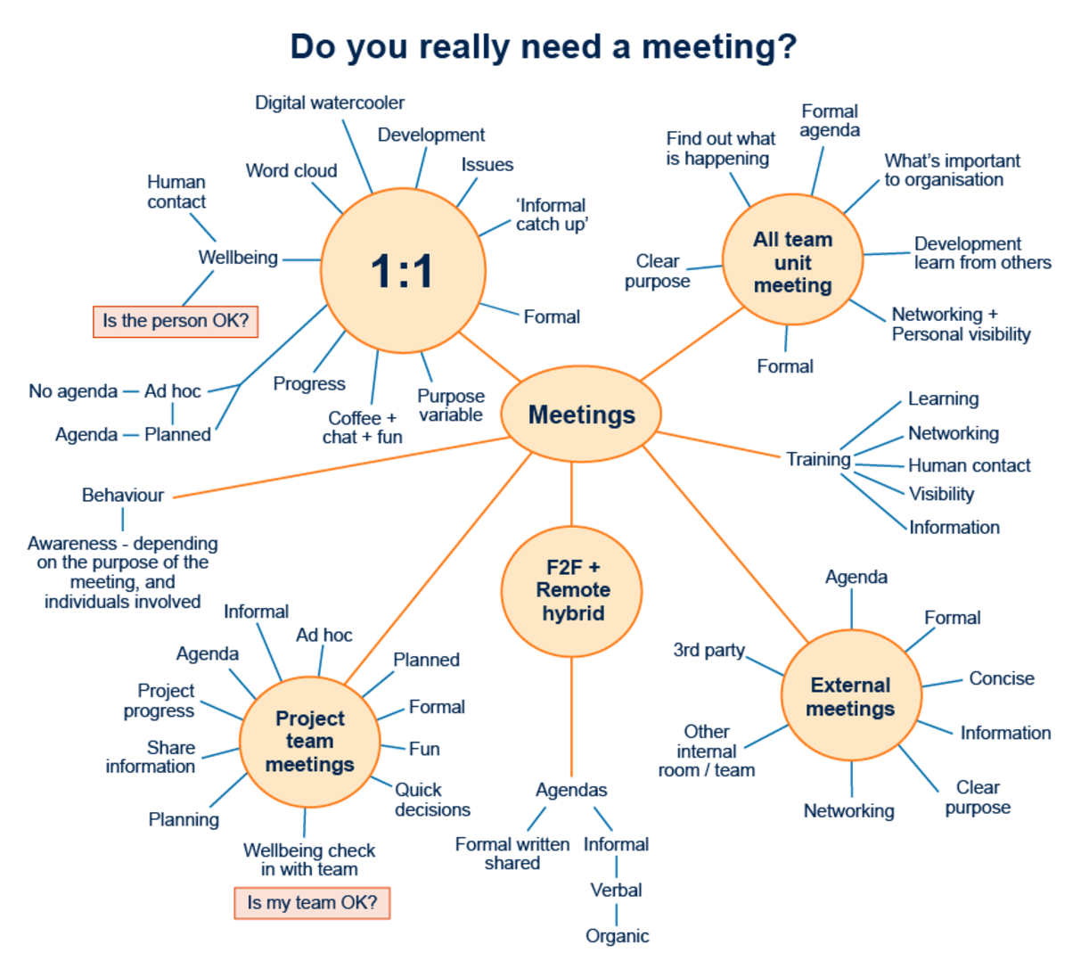
Figure 19 Different types of meetings and their purposes
View description - Figure 19 Different types of meetings and their purposes

The most important thing for me, though, is the wellbeing of those I work with and my own wellbeing. Meetings are also opportunities for human connections, which is important for those who are working remotely.
Back to - Activity 23 How much time do you spend in meetings?

Figure 1 The UK’s ‘Essential Digital Skills Framework’ diagram. Essential Digital Skills – Framework Diagram (Crown Copyright, Gov.uk, 2018)

Description
Image showing the essential digital skills framework, circle in middle – text – Foundation skills. Large circle spilt into four sections. Communicating – Communicate, collaborate and share online. Handing information and content – Find, manage and storge digital information and content securely. Transacting – Applying for services, buy and sell, and manage transactions online. Problem solving – Find solutions to problems using digital tools and online services. Outer circle repeats the phrase – Be safe, legal and confident online.
Back to - Figure 1 The UK’s ‘Essential Digital Skills Framework’ diagram. Essential Digital Skills – Framework Diagram (Crown Copyright, Gov.uk, 2018)

Figure 2 Comparing the author’s profile photos

Description
Two headshots of a lady in her 40s, to show how people feel about different profile photos for work. Underneath each photo is a summary of the poll results out of a score of 10 for each. Image 1 – competent – 7.6, likable – 6.3, influential – 8.5. Image 2 – competent – 3.6, likable – 4.4, influential – 4.4.
Back to - Figure 2 Comparing the author’s profile photos

Figure 3 Work profile photo poll

Description
A: Smiling African American woman looking out of a window into the distance.
B: Close up portrait of beautiful confident serious African American woman
C: Busy African American woman sitting at a desk, writing in a notebook
Back to - Figure 3 Work profile photo poll

Figure 4 Author profile picture poll

Description
Alt text: A: black-and-white photo from waist height of person looking up
B: person at a laptop with ear defenders on and hand up to head
C: portrait photo of a child
D: picture of a puppy
E: picture of a mum and two children
Back to - Figure 4 Author profile picture poll

Figure 5 Suitable professional profile photo

Description
Professional head shot of lady in her 40s
Back to - Figure 5 Suitable professional profile photo

Figure 6 Photos on social media

Description
A: Bearded male with tattooed arm, drinking a beer from a bottle.
B: Picture of lady in evening dress, with a champagne glass in her hand.
Back to - Figure 6 Photos on social media

Figure 8 Before adjusting a home-working space

Description
Child sitting at a kitchen table working on a laptop, with another laptop and monitor next to her, to show setup for working at home with children during the COVID-19 pandemic.
Back to - Figure 8 Before adjusting a home-working space

Figure 9 After creating a specific office space at home

Description
Home office space in middle of a lounge to show how people create specific working areas within their homes.
Back to - Figure 9 After creating a specific office space at home

Figure 10 Shared Word document using Tracked Changes and Comments

Description
Screenshot of part of a Word document to show how course content is edited and comments used to collaborate
Back to - Figure 10 Shared Word document using Tracked Changes and Comments

Figure 11 Microsoft Teams chat for informal communication

Description
Screenshot of Microsoft Teams channel chat to show use of tool for communicating and collaboration
Back to - Figure 11 Microsoft Teams chat for informal communication

Figure 12 Mural board for working together both synchronously and asynchronously

Description
Screenshot of online whiteboard showing a lot of different coloured notes and ideas
Back to - Figure 12 Mural board for working together both synchronously and asynchronously

Figure 13 Excel for a high-level overview

Description
Screenshot of Excel spreadsheet to show how it was used for communication and collaboration
Back to - Figure 13 Excel for a high-level overview

Figure 14 Trello for tracking more detailed progress

Description
Screen shot of a Trello board to show it was used for communication and collaboration
Back to - Figure 14 Trello for tracking more detailed progress

Figure 15 Frame.io for video production

Description
Screenshot of Frame.io to show how it was used for communication and collaboration
Back to - Figure 15 Frame.io for video production

Figure 16 Using video conferencing to join an in-person session: a hybrid approach

Description
Screenshot of Microsoft Teams meeting to show hybrid filming, team on location and producer in home office
Back to - Figure 16 Using video conferencing to join an in-person session: a hybrid approach

Figure 17 Shared areas with restricted access

Description
Screenshot of Microsoft Teams channel folders, to show how it is used for file sharing
Back to - Figure 17 Shared areas with restricted access

Figure 18 How much of our working life is taken up by meetings, adapted from reclaimai (2021)

Description
There are five sections, the first says the average worker has 1.12 one-on-ones each day, that’s 8.9% of their week in one-on-ones alone. Before the pandemic they averaged less than one per week. The next is a pie chart showing 29.6% one-on-ones cancelled. The next section shows +500% increase in one-on-ones, there were 0.9 a week in Feb 2020 and 5.6 a week in Oct 2021. The final section shows it takes 10 minutes to reschedule a meeting, the average meeting is 50.6 minutes, the average one-on-one is 42.9 minutes.
Back to - Figure 18 How much of our working life is taken up by meetings, adapted from reclaimai (2021)

Figure 19 Different types of meetings and their purposes

Description
Mind map of meetings types and purpose. Title of meeting type, then list of considerations. 1:1, Ad-hoc, no agenda, Planned, agenda, Is the person OK, Wellbeing, Human contact, Progress. Coffee, chat and fun, Purpose. Next section – Formal, Informal ‘catch up’, Issues, Development, Digital Watercooler, Workload. Next section – Project team meetings, Is my team OK, Wellbeing, Checking in with team, Quick decisions, Fun, Formal, Planned, ad-hoc, Agenda, Project progress, Share information, Planning, Solve a problem. Next section – External meetings, Agenda, Formal, Concise, Information, Clear purpose, Networking, Other internal teams. Next section – Training, Learning, Networking, Human contact, Visibility, Information, Knowledge and experience sharing. Next Section – All team unit meeting, Formal, Clear purpose, Find out what is happening, Formal agenda, What’s important to the organisation, Development, learn from others, Networking and personal visibility. Next Section – F2F + Hybrid + Remote, Agendas, Formal – written, shared, Informal – Verbal, organic. Next Section – Behaviour, Varies depending on purpose
Back to - Figure 19 Different types of meetings and their purposes

Figure 20 Types of hybrid meeting

Description
Image showing five types of hybrid meetings, brainstorm, discuss and decide, design and create, 1:1s and team building and bonding. Then if they should be synchronous or asynchronous and the type of collaboration approach, meeting rooms, open spaces or focused
Back to - Figure 20 Types of hybrid meeting

Figure 21 Frequency of meetings

Description
Urgency and importance Eisenhower matrix with meeting frequency and examples. Quadrant, top left hand – Not Urgent, important – strategic and planned work; top right hand Urgent, important, crisis or big push; bottom left, Not urgent, Not important, Administrivia and Distractions; bottom right, Urgent, Not important, Interruptions
Back to - Figure 21 Frequency of meetings

Figure 22 Alternatives to meetings

Description
The tools doist uses in a pyramid, showing those that are classed as asynchronous, used for announcements, ideas, feedback or comments on design or synchronous, meetings, in person meetings or calls in case of emergency
Back to - Figure 22 Alternatives to meetings

Figure 23 Hybrid meeting definition

Description
Image representing what in-person meetings, hybrid and virtual meetings are. Two circles interlocking, one side figure drawings of people, other side computers, in middle text – hybrid meeting
Back to - Figure 23 Hybrid meeting definition

Figure 24 Workspaces with technology to support hybrid meetings

Description
Images show ‘show home’ offices with people in them
Back to - Figure 24 Workspaces with technology to support hybrid meetings

Figure 25 Using a poll to find a suitable meeting time

Description
Screenshot from Doodle poll showing options to choose for a meeting
Screenshot from Doodle poll showing results of the poll
Back to - Figure 25 Using a poll to find a suitable meeting time

Figure 26 Human being-centred conversations, adapted from Berry (2022)

Description
Image shows nine essentials for human being–centred conversations.
1. Conversations are candid, convivial, compassionate, conscious and compelling.
2. You feel safe and respected.
3. Opinions and beliefs are held lightly.
4. Silence is valued.
5. Storytelling is a feature.
6. There’s honesty, vulnerability and accountability.
7. You are seen, heard and understood.
8. There’s curiosity, wonder and enthusiasm.
9. There’s generosity, reciprocity and practical outcomes.
Back to - Figure 26 Human being-centred conversations, adapted from Berry (2022)

Figure 27 Augmented, virtual and mixed reality

Description
Image shows the difference between augmented, virtual and mixed reality software. Augmented reality – interactive objects are layered on top of physical environments without the ability to manipulate the augmented objects. AR overlays the digital information onto the real world. Virtual reality – the real world is hidden, and the user is completely immersed in a digital experience, creating a digital simulation of a real environment. Mixed reality – the capabilities of AR and VR are blended, bringing together the physical and digital world to produce an environment where physical and digital objects coexist and interact in real time.
Back to - Figure 27 Augmented, virtual and mixed reality

Uncaptioned interactive content

Transcript
ELISE LOCKYER:
So, communication is the absolute essential tool for making sure that there's a variation of communication. So, be it through open Q&As, where you actively have sessions where you really listen to what your people are saying and you answer them authentically, and if you don't know the answer, go away and find out and come back. You know, thank them for their time, their engagement.
They may have brought something up to you that you had no visibility of and that is the amazing part of really engaging and opening up lines of communication with the team. You work on different things. You do different things. You have different areas of specialism. There is no one more important in the team.
And making sure you've got eyes everywhere – you can do that when you're having open communication with your team. Because they would bring things to you that they had no idea of. And you would bring things to them that they had no idea of. So, it's really about communication, collaboration, and teamwork.
When I say different methods of communication, you've got different people who operate in different ways, work in different ways, learn in different ways. So, you have to mix up your methods of communication, be it through a newsletter and having it a little bit more colourful and documented down and the statistics being very clear, versus having a company-wide huddle or presentation where you are engaging with people either remotely or in the office and taking them through the key and most important things within the business. Following it up in a written format, a CEO report, or a documentation, using Slack as an open way of communication to colleagues that's there and available for them.
But one of the most important things that we've done throughout the pandemic, and we've changed a load of ways in which that we operate is ensuring that we have the technology and the tools to enable these conversations to have happen on a one-to-one basis, on a team basis, on a company-wide basis, on a written format. And making sure then that the messages are transparent and are repeated multiple times for them to be heard across the organisation.
MATT WINTLE:
To be at the forefront of using some of these tools, collaboration tools, messaging tools, those sorts of things. And now that has to be everybody because that's the way that we're communicating most of the time. So, the real shift is in the way that we communicate and the tools we use to do it. And when I talk about communication, that could be a meeting, or it could be a document that you're sharing. And that's fundamentally changed through the pandemic.
In terms of knowledge sharing and production of collateral, if you like, within the business, I feel there's always been an opportunity to do things better. The technology has actually been around for quite a while, but it's the adoption that's difficult.
So, I'll give you an example. It used to be that – let's say we're writing a Word document because we need to do a proposal or a business case or something that's important for the business. Somebody would write it. They'd send it around. Somebody would comment on it. And that's quite a long, verbose process.
Well, now the behaviour that we expect is much different because it's all live and dynamic. So, the document is stored somewhere. Everybody can see it. Everybody can access it in real time. If you want to go and change it and I'm changing at the same time, the technology allows you to do that.
So, you get much more speed, and you get much more collaboration. And if you think of the power of that on a meeting, so no longer we are on a meeting and I'm taking notes and I'm going to update that later.
We're going to do it together as we're having the discussion.
So, the power is actually really, really strong, but the behaviour change is necessary. And that's difficult for some people because they're not used to working in that way. And whether that's because you now need to work a bit quicker and you need to be a bit more dynamic. Or for some people, it's that loss of control. Some people like the fact that they're in control of that document. And it's a change of culture, and it's all about collaboration and speed.
In terms of the balance between a fast-moving collaborative world and the governance that needs to surround that, I feel that we need to address it with some structure at one level and an acknowledged flexibility at another. And therefore, at Admiral, there are now slightly different frameworks in place to manage that. So, everybody's quite comfortable to be online sharing these ideas and creating these documents. But actually, now, if you want to send that somewhere, you want to circulate it, it needs to be classified in a certain way. So, to balance out that flexibility, there's a level of governance.
So, for example, I find, and I'm certain others do, that if you're doing Teams calls all day, they're calls that you have to have because they're work related and they're scheduled and it's for a reason. Whereas, if you're in the office for the day, you have meetings that you were never meant to have, whether that's making a coffee or over the water cooler or whatever it is. And those meetings – I'll call them meetings, they're just conversations – are really valuable because you learn more about what's going on in other areas of the business, you share some of the ideas of what it is to be Admiral, especially with new starters. So, we want people to be in the office some of the time.
LOUISE CASELLA:
Those of us who work in UK-wide organisations but sit in Wales, like us, we're used to sitting on not very good Skype for Business calls before pandemic and that really being a very second-class experience for the people who are at the other end of that call. Whereas now, we've really kind of learned how to use Teams in the best way we can and learned how to use Zoom or whatever technology somebody is using, Google Meet. We now switch between them with relative ease. Like what were we worried about before? We just do it.
But I think one of the things that we could learn more is how we exploit the most – how we get the most out of those technologies. Because it's like using your washing machine, you use two programs whereas there’s 18 there. There's probably loads more within that we could all learn how to use and make an even better experience for each other. So, I love it when somebody tells me there's something else I can do with it, there's something else I can switch to, and then you start adding to your repertoire all the time.
But I think the key thing has been about seeing them as tools. You still have to communicate. They're not, the solution. They're the means to a solution. And to remember that you still have to have those conversations. You still have to connect with people and that the tools just enable you to do it.
JONATHAN MORGAN:
So, there are many reasons why regular communication is fundamental to building trust between the company at all levels for interaction. The pandemic changed the way that Object Matrix worked in so much that it has changed the way that people live and organise their lives. It's changed the way we organise the work. It's changed the way we schedule the work even, because the schedule of the work should allow smaller units of work with regular communication so that we don't just leave someone for a month and then come back to them.
So, in many ways, the pandemic has changed the nature of the organisation, much for the better and some things have been challenges. Biggest challenges for Object Matrix post the pandemic that we have a workforce that has been admirable, has been brilliant, actually, at delivering quality software products and support for our customers. But that has a potential to drift. And by drift, I mean there's a communication of what is the purpose of the company, where are we going with the company, and making sure everybody is 100% involved in setting that direction, but also in the delivery of that direction and the communication of that direction. It's very possible if you spend too long apart that you start to drift in your directions. You might be working just as hard, but you may not be fully aware of where the company is going.
So, the real challenge for me is how do we keep on the same page? How do we have camaraderie? How do we have cross-training of people so that they are all equally up to speed with the technologies that are happening? And how do we deliver that in a hybrid way of working?
Mental health of employees is a very important subject indeed. It's hard enough to manage that when you're in the office and you see somebody on a day-to-day basis and you see them and know them and understand them, yet alone when they're working from home. We should also be encouraging conversation and meetings at a personal level. It could be a "HR," "HR" in quotes. Because, ultimately, it's two people speaking together and seeing how they are.
And that doesn't need to be a manager to an employee kind of a relationship. That could be either co-workers. But it could be coffee clubs that way people meet up online and just talk about whatever they want to talk about. It could be ensuring that we have regular meetups of the staff. And it could be, as I say, the HR side of things. So, they are three really clear ways that Object Matrix is trying to work to make sure that the mental health of the employees is noticed, and then we can, if something is amiss, we can always talk about that and what the best action is.
NATASHA DAVIES:
We did some research, actually, during the pandemic that helped us highlight a number of areas where training might be needed. And it was around things like managing virtual teams, self-awareness, how different leadership styles might impact or work differently in a hybrid-dispersed world of work. Training around resilience, motivating team members, well-being, managing well-being being a particularly key area. And training around some of the softer skills that we think might be really important. So, we're prioritising things like well-being, but also thinking about communication and empathy and that kind of thing.
Through the same research that we did, we also identified a number of attributes that our stakeholders felt that leaders and managers are going to need. And that is very much leaders who are effective communicators, who can actively listen, who prioritise regular contact with staff, who embrace new ways of communicating in a virtual and digital world. Empathetic leaders who understand how different ways of working, how changes in how we work might affect individuals differently. Leaders who can act as role models, who set out clearly what they expect, who don't regularly overwork themselves, because we know overworking really is a risk in a more dispersed world of work. Leaders who really lead by example, managing their own well-being and the well-being of their teams. And then also leaders who are emotionally intelligent, who are open and transparent and are visible across the organisation.
This is something – we're not going to implement new ways of working now that are just going to stay static. I think we're going to constantly be finding new ways of organising our workplaces, particularly as new technology becomes available that can facilitate that collaborative working that perhaps we've relied upon doing in person in the past. So, I think we're going to need leaders who are open to learning, adapting, and embracing new ways of doing things as we move forward.
I think there are many things that can be done to help leaders develop a more empathetic approach. Inevitably, training is going to be part of that. But I think something that perhaps gets missed in this conversation sometimes is that empathy requires self-reflection, and self-reflection requires time.
Back to - Uncaptioned interactive content

Uncaptioned interactive content

Transcript
LISETTE SUTHERLAND:
How do we keep the feeling, that sense of team, when we're all over the place? So, some people are at home, and some people are at the office. And in some ways, it was easier during the pandemic when everybody was remote because it levelled the playing field a little bit. And now that we're going hybrid, it's like herding cats. You've got some people in the office and some people at home. And now teambuilding has to evolve to match this new multimodal way of working.
I just recently sent out a survey as I'm building a new course on hybrid leadership, because that's clearly – I feel like leadership, the leaders in hybrid organisations, are the ones that are having to make the biggest transition right now because leading in a hybrid way is very different than leading in person or remote.
So, I've been studying a lot about leadership. And the question that I asked to my mailing list was, what is the number one thing that you're challenged with right now as a leader in your organisation? And it came back, by and large without a doubt, it's personal connections and that sense of team. So, we know that this is the one place that people are suffering and just really creating personal connections.
And what I always say around this is connection happens when we pay attention to each other. So, the key to building personal connections in a hybrid environment is finding new ways of paying attention to each other. The other thing to consider, though, is to take a step back and to really start to think about, well, what is it that your team needs in order to feel connected? Because it's very different for people.
For example, some people come to work because they're excited about solving challenging problems. They want to dive in and solve things. Other people come to work because they like the people that they work with. It's like more important to them who they work with than what they're working on. And still others come to work, it's just a job. And it's fine. They like their jobs fine. But at the end of the day, they go home. It's just a job. They turn off, and they go back to their families or whatever else that they're interested in.
And so, when you're thinking about teambuilding, you have to really understand your team's intrinsic motivations for coming to work to begin with, and what do they need to feel connected? Because, if you're a leader in an organisation, and you're busy building teambuilding sessions, like pizza parties and quiz nights and fun things for people to do, you may not be hitting at what people need to feel connected on the team to begin with.
So, I would say, take a step back, really understand what is your team's intrinsic motivation for being there, and then you can build an environment for teambuilding that matches what they need to feel connected.
A really wonderful tool for doing this comes from the Management 3.0 community, and it's a game – or it's really a card game called Moving Motivators. And it's very simple. You just take your top 10 intrinsic motivations. I can actually show you. I've got the set of cards right here. You take these cards, and each card has an intrinsic motivator on it, so this one's relatedness, or freedom, or mastery.
And then you order the cards, in order from the thing that motivates you the most to the thing that motivates you the least, and then you have a conversation about it with your team. And it's absolutely fascinating what comes out in these conversations. And you can get a really good understanding of that.
So, one, start by understanding what does your team need to begin with, because there are some teams that are not into team building at all. I interviewed a company once who had a team that they never met. They never spoke. They did everything through a ticketing system. And they didn't have teambuilding. And they didn't want teambuilding. So, there are teams out there that are like that.
So, start with that. And then the next thing that I would say is, we want to make team building multi-modal. And what I mean by that is you don't want to just have activities happening in the office or activities happening online. You want to have a variety of activities at any given point of time. And one of the new roles that seems to be emerging after the pandemic is the role of a remote office manager or a remote team leader.
And I like this idea because when we had the physical office as a headquarters, we often had an office manager, somebody who made sure that coffee was there, and people's birthdays got celebrated and things got organised. The same holds true for online or in a hybrid environment.
We want to have somebody who is remembering birthdays and organising teambuilding activities in a variety of ways and just making sure that people stay connected, because if you leave it up to the individual, we're all busy with our own work. And probably you're going to need a variety of individuals to organise this. But you need somebody to head it up and to lead that.
So, those are sort of two starting things, I would say, to start by understanding what your team needs, and then make sure you're doing multi-modal teambuilding activities in between. On top of that, though, there is the organisational side of just being a team.
And so, for that, we can dive probably more into this in a bit, but for that I would say, one of the things about team building and what we know about trust on a remote team, is that it's built on reliability, consistency, and responsiveness. So, you need to create an environment in which you can build reliability, consistency, and responsiveness.
So, in order to do that, we start by creating agreements for how we're going to work together. And that's just basic, like what information are we going to share? How are we going to communicate? How do we know how each other are doing? And then we build regular feedback loops.
So, agile software teams have retrospectives once every week or once every two weeks. And it's not about the work. It's more on how they're doing as a team. And I think the number one thing that leaders can do there is creating a team agreement together for defining what is normal behaviour for our team.
So, there's a there's an exercise that we start with. One is creating – we start with defining what are the company values because I know it sounds like it's just going to be one of those motivational posters that we hang on the wall, and everybody walks by, and yeah, yeah, there's no I in team, yeah, yeah.
But, in fact, values and our culture at a company is how we behave when the boss isn't looking. So, it's actually really important to define our company values because it helps guide people in what their behaviour is going to be. If you have a company value of transparency, then that does guide you on how to behave. You would want to ask your question in an open forum or post your file in a public place if the company value is transparency, for example.
For example, another example is that my company, one of our values is fairness. I have 50-plus facilitators, who are also giving workshops all around the world. Some of them are close friends of mine. And they pay an annual license fee. And of course, when it comes time to renew their license, they'll ask for a discount because they're good friends. So, they feel free to do that. But because our value is fairness, my whole team knows that the answer is no because we treat all of our facilitators the same, so we treat everybody exactly fairness. And that builds trust within the community.
So, if you're building a team agreement, definitely the company values is where you want to start. And that does inform decision-making behaviour. And then you want to talk about, where is the information stored? Are there security protocols that we need to follow? One of the biggest things that people complain about is not being able to find information or duplicating work that already exists.
And some of the statistics out there show that we spend one to two hours a day looking for stuff. So, that's actually a pretty important part of team cohesion, is actually defining where the information is stored and what are the protocols around that.
The second would be communication. What are the expected response times? Some people are instantaneous responders on email. I'm 24 hours at best. If it's really important, I can do it. But I batch my emails. I just get so many. So, it's just important for your team to define that. Or, also, if the boss sends an email on the weekend, does that mean you have to answer it? How responsive do we need to be? What are the working hours?
So, all these questions sound really simple. But when you're when you're with a hybrid team, everybody's got different ways of being productive and different times of day when they're productive. It's like herding cats. So, you actually should define a little bit what are the basic operating procedures.
And then the last thing that I always add to the team agreement is the wellbeing. What do we need to take care of ourselves and our team in order to have a sustainable way of working? During the pandemic, productivity was not an issue. Globally, worldwide, people were measuring productivity. We did not have a decrease in productivity. But we did have a huge increase in burnout because people's work and lives were blending so much, and we're also stuck at home, and the stress of the pandemic as well.
But mostly, it's people's works and lives are blending so much that we were working ourselves to death during the pandemic. So, burnout is much more of an issue. So, in terms of team agreements, it's really good to – like on my team, we've established that we don't work on the weekends. You can if you want. But there's no expectation that anybody else on the team will be around. So, if you need to get a message to somebody, then the emergency channel on the weekend would be the WhatsApp group. But that's really in case of an emergency.
But every team really needs to work through these things, otherwise it can be a 24/7 bombardment of email. And the alignment that you normally have when you're in person, needs to be done in a different way. And that, in a hybrid environment, is usually done through documentation and agreements like this for how to sort of normalise team behaviour.
Back to - Uncaptioned interactive content

Uncaptioned interactive content

Transcript
MURRAY COOK:
I think one of the things we did which helped people actually was focus on what's our way. Why are we here? Because often, we go through life, don't we? And we do things. We do transactional stuff. We deliver an objective.
And one of the things I think worked in this environment was what's our why, why are we doing this? Why should we be doing this? Should we be doing this? Should we stop this perhaps? Or should it be faster? And for me, that was really important.
We talked about how the transactional environment is changing. So, a transactional environment is where if you can virtually shake people's hands. So, be it students, staff, regulators, funders. We talked about the contextual environment, where you have demographics.
You've got things like geopolitical activity going on. And that, I think, really helped. And I knew at this point it will help you figure out why all you here, what's unique about us.
ANNE GAMBLES:
I think the workshop had kind of a gentle approach really to that. We kind of ease people in. We were very mindful of that we were doing this in an online environment and that working with people who didn't necessarily know each other or the technology that we're using. We used the Miro online whiteboard.
So, we gave people a little bit of kind of pre-work, I guess, if they wanted to and they had time to. And we gave them a link so that they could explore some online learning materials which are just 10 minutes of exposure to how to use Miro. And then in the workshop sessions, we generally started with an introductory activity, where people could sort of do a bit of an icebreaker, and introduce themselves, and have a little bit of a play in Miro in a safe kind of way.
So, they can have a bit of experience of how to create a sticky note and write things on it. It was a learning experience, I would say, running workshops in Miro online was a learning experience. I think one of the key things we learnt was to share the link to the Miro board and enable people to navigate it for themselves is a far better user experience than sharing a screen with Miro on it. If you do that as a facilitator, then it's possible that some of your participants will experience motion sickness because they're not controlling the screen.
MURRAY COOK:
One of the things we talked about in quite depth actually was what they almost the behaviours we expect. So, we expect people to have an equal voice. We expect people to contribute and be there. Actually, we expect people to, if you like, have respect for others' viewpoints.
At first, quite important because the future is not here yet. It's not defined. And people have very often quite strong views about what it should look like. The future's agnostic to you. So, it's about exploring that future, which is not what you want it to be.
So, one of the things we did or talked about was how we try and let those voices come through. And equally, when you're on a call, or a Miro board, or a virtual environment, some people are even in if you like a some people are quieter. And if you're in a room, you can spot those people. You can try and bring them into conversation. In a virtual environment, it's a little bit more difficult.
ANNE GAMBLES:
I guess some people just need a bit of time, don't they, to, I guess immerse themselves in the session and gain just a little bit more understanding of what's going on, what it's about, we're doing futures thinking, this is a new thing. And yeah, I’m in with these new people who I don't necessarily know. But yeah, they gain confidence as they go together and realise that whoever they are, their view is really important. And I think just setting those ground rules was really helpful towards that, gave people that confidence to say, to put their views over.
MURRAY COOK:
It's so important that everyone has – everyone's opinion's the same. So, if you're SLT, you're a big person, actually everyone has a different view of the world. So, let's acknowledge that. Secondly, the other thing we had a couple of people came back a couple times, they started refining their views.
So, they said, first time around it was like, OK, this is going on. second time, right, oh, actually, I've been reflecting on this. And suddenly, I'm seeing something different happening in the world because I'm joining up the dots. I'm joining up the conversation. I thought it was very powerful as well.
Back to - Uncaptioned interactive content

Uncaptioned interactive content

Transcript
LISETTE SUTHERLAND:
Good hybrid meetings are a combination of good infrastructure, good design, and good facilitation, and I'll start with infrastructure. So, one of the important things is if you've got an old conference room table with the old spider phone in the middle of the desk and you're leaning over like, hey, Bob, it's Lisette. Can you hear me?
If you still have that kind of infrastructure in your office spaces, which some companies still do, that's not going to be a very – I would say the remote participants in that situation are going to be more like the mosquitoes in the room. You kind of know that they're there, and you can hear them, but you really wish that they weren't there.
So, in your conference rooms and offices, one, we're going to need more of them because there's going to be a lot more hybrid calls, as this is the new way of working. So, some companies have converted a whole bunch of their smaller offices into just a whole bunch of video conferencing rooms. And you're going to just need the basic equipment, which is cameras, being able to see each other, and a good microphone system, and easy to use equipment.
Now, the good thing is that conference room equipment is so easy to use now. I mean, it's so easy to install and use. It's not like the old days when you had to have the IT department come in and help you set everything up. But we just need enough of them, and the important part is just to be easily seen and heard.
Now, it's not just up to the companies to have good equipment. It's up to the individuals to also have a proper setup at home as well. So, if you're going to be working in a remote place, at the very least, like have a quiet background, a good internet connection, maybe a headset or a webcam, something, a way that you can connect with your team if you need to.
And in fact, I interviewed a company several years ago named Envato, they were in Australia, and they were founded by digital nomads, and they encouraged people in their company to work anywhere they wanted for three months of the year. They said, go anywhere you want, but if you go, you have to have an internet connection of a minimum of 20 megabits per second upload or download. Otherwise, you're considered on vacation. So yes, go wherever you want, but here's the minimum requirements that you need in order to work like that.
So, I would say if we're going into this hybrid environment – during the pandemic, we were all at our kitchen tables, in the corners of our houses trying to make ends meet and make do. But if you're going to work remotely moving forward, you're going to have to have a proper setup wherever you're working, whether that's at home or if you're on the road somewhere.
So that's infrastructure. So that's pretty easily solvable. It just needs a little attention and focus. The bigger questions though are design and facilitation.
And a couple of years ago, Atlassian came out with a report on what was considered a good online meeting or what was considered a good online meeting. And all that was considered was it had to have a purpose, an agenda, and it had to start and end on time. That's it. And if you had those three things, most people would consider your meeting to be good. So, for me, that's a pretty low bar of just having a purpose, an agenda, and starting and ending on time.
So, the next aspect of the meeting is really designing. Do we really need to have this meeting to begin with, or can any part of the meeting be done asynchronously? If we're going to brainstorm, we should brainstorm separately, come to the table with our own ideas already formed, and then use our valuable time together synchronously for discussions or decision making.
Or for instance, if I'm going to come to a meeting, excuse me, if I'm going to come to a meeting and just give a presentation, why not record the presentation before the meeting starts, and then use your valuable time together for discussions and decision making. So, we have to really now with – because we're having so many meetings, we really need to design for either a more asynchronous, things that we're preparing for before the meeting starts, or more engagement during the meeting. Maybe we want to have more breakout rooms or getting to ways to have more people speak, and then that's where we come into the facilitation.
So, when we had meetings in-person, we could kind of get away with sloppy facilitation skills or agendas that weren't fully formed because we have so much information with each other in the room. When we go hybrid or online, especially hybrid, we have to have good facilitation skills so that we can bring out every voice that's there in the room. Because every person attending is there for a reason if you're designing for a good meeting. You don't have hundreds of people in a meeting.
So, if you're facilitating, you want to know, well, how can I bring out some of the quieter voices? How can I redirect the conversation? And there's all kinds of skills like paraphrasing, summarising, asking things like, who's got something different?
Or maybe you try a liberating structure where you – one of my favourites is called 1-2-4-all. So, you start with a one-minute silent brainstorm. Then you pair people into groups of two, then you combine those groups of two into fours, and then you bring everybody back. And what happens is the quieter voices, if they have good ideas, those ideas get amplified by the louder voices as the group, as the size of the group increases, and that brings everybody's idea to the surface.
So, there's all kinds of techniques like this that we can learn in terms of facilitation, to how to address conflict in a meeting. There's ways of doing that. And even just having a few of these things in your toolbox will increase the quality of any meeting going forward.
So yeah, in the past, maybe it was more fun or more efficient or more productive to all meet in-person, but that is no longer our reality. And so, the reality now is meetings need to be done a little bit differently. And for that, we need design, infrastructure, and facilitation skills.
So, it sounds complicated, but really, I think we all benefit so much more by having a few of these skills in our toolbox. But there's no reason not to do it. It makes meetings more fun and productive. Because ultimately that's what we want, right? We want to reduce the number of meetings that we need and improve the ones that we're having.
One of the biggest engagement hacks that I can recommend for meetings is starting every meeting with an icebreaker. And I can hear the groans already. Like oh, some people really like icebreakers, and some people really don't.
Now, the thing to recognise is icebreakers don't have to be silly. It doesn't always have to be your favourite vacation spot or what are you wearing on your feet right now. Take a picture of something on your desk. It doesn't have to be funny stuff. You can also set the tone by saying, what are you here – what are you hoping to get out of this meeting today, or what expertise are you bringing to the table today to help solve problem X that we're here to try to solve?
So, we can start a meeting with an icebreaker question, and the point of an icebreaker is to get everybody speaking once. Because science shows that when people have spoken once before a meeting starts, they're more likely to speak up again. They're more comfortable speaking into a group. So, the point of an icebreaker is not just to be silly or team building, which also has its function, but it's also an engagement hack to bring it out.
Now, there's other things that we'll need to do as a facilitator. That's why it's so important to have a facilitator to begin with. Our role as a facilitator is to bring out the voices in the group in order to accomplish the purpose that we're there for.
So, we want to recognise if somebody is not speaking, is it because they have nothing to say or is it because they're scared of speaking? You want to make sure that everybody's contributing. Whether you do that through polling or through whiteboards or through breakout groups, this is why it's important to have facilitator training so that you can see like, oh, maybe we need to go in a breakout group right now, or oh, let's do an anonymous poll and take a temperature check of how everybody feels about this issue in the room. You want to be able to set those things up on the fly and recognise when they're needed.
There's a lot of things that we can do to set expectations. I set expectations for meetings before they start. So, in the meeting invite, I'll say, this is going to be an interactive meeting. You'll be expected to have the cameras on. Or maybe your team has a team agreement, and you've discussed for people that we want to have a cameras-on environment.
There are a lot of people who really hesitate with cameras-on. And for that one, I would advise, it's good to learn about why they don't want to have it on. Sometimes there's a very good reason. One woman had just come back from a dentist appointment, and her whole face was numb or like a surgery, and so there's valid reasons, of course.
But then the other thing to recognise or the approach I always like to take is from Zig Ziglar, who is a famous salesperson in the United States. And he always said in his talks, you want to listen to WII FM radio, which stands for What's In It For Me. So, we want to think in terms of what's in it for the person if they turn on their camera. So, what would be in it for them? So, we want to turn it a little bit like, OK, what do you get when you turn the camera on, instead of trying to convince them that that's the right thing to do. So, there's that.
I never force people to do it, but I do try to set the expectations, or I'll do an exercise where they need to show something, so they'll have to turn it on, or they'll have to participate through the chat. I recognise that some people have valid reasons.
And the way that I started is I am an always-on person, so my camera will always be on, and I'll just do it even if I'm the only person. I'll just do it as a matter of course. Usually, the extroverts in the group will then turn the cameras on because they enjoy it a little bit more, and slowly the culture will build.
But it does take somebody to lead the charge and be a champion, and also to figure out why is it that people don't want to turn their cameras on to begin with, because sometimes there's valid reasons.
Maybe they have kids in the background, or I'm not sure what it might be. I love having my camera on. I love seeing other people on the side of the screen.
I get so distracted whenever there's no cameras on, I mean, that emails are coming in and other things are pinging me, so I like the focus of having the cameras on, but I do understand some people don't like it. I think it's a conversation to have as a team of why people don't want to do it. It's a culture that we build.
Back to - Uncaptioned interactive content

You are viewing this video in Youtube: The Open University is not responsible for external site content

Transcript
HEIDI GRANT:
As we enter this new post-COVID world of hybrid work between virtual and in-person, a lot of our old habits are really not going to keep working. We have a lot of stuff that we need to figure out. How to have meetings? How to show up cameras on cameras off? There's a lot we know about the science of human behavior of perception that we can apply to figure out what the new normal should look like.
[MUSIC PLAYING]
So you'll see these articles that say, well, it's important to have cameras on. Then you see these other set of articles. They talk about Zoom fatigue, let people keep their cameras off. That's what you should be doing. So which is it?
The important thing to realize is that you have to do one or the other and not a bit of both. A bit of both is terrible. When some people are on and some people are off, that's going to create a very, very uncomfortable dynamic.
The people whose cameras are on feel more vulnerable. "You can see me, you can see how I'm reacting, but I don't know how anybody else is reacting because their cameras are off." The people whose cameras are off are also less likely to be the focus of conversation. They have to fight to get in. What you have to do is really decide when will we decide cameras will be on and when will we decide cameras will be off.
Anything delicate, we have to talk about something that's a little sensitive should be a cameras on meeting. When you are giving feedback, particularly constructive feedback, or you have to share some bad news, that is a time to put cameras on. A remarkable amount of our ability to understand each other comes through our ability to interpret facial cues, particularly around emotions.
It's actually why emojis exist. They are filling the gap in communication that doesn't have faces in it. But faces are the best thing.
Celebratory meetings, that's one of the hardest ones if the purpose of the meeting is to celebrate something and everyone's going to be laughing and talking and clapping and that thing. If some people have to be virtual, then everyone has to be virtual, meaning if you're in the office, go to your desk and participate in that meeting actually from your computer because those are the worst meetings for virtual participants. You can't hear anything.
People are making jokes. They're all talking at the same time. It's impossible to break into that conversation, and it's better to have everyone be virtual in a celebration if you can't have everyone be in person.
It's about, OK, when do we need to have it on? We want this to be a bonding experience. The purpose of this meeting is to strengthen team connection? Cameras on.
Everything else, like this is just a check in, this is just logistics, this is just we have to share some information back and forth, cameras off. Give people a break. It's important to also let people know what the thing is going to be so. If this is going to be a cameras on meeting, you tell people in the invite, this is a camera's on meeting. So everyone's on that level playing field.
Let's face it, what we're doing now really isn't working. When we kind of play it by ear, we let people make these decisions for themselves. The temptation to be cameras off is enormous. It's that same temptation to not put on actual pants, to just stay in your pajama pants. The reality is it isn't necessarily what's best for you. Your self image is actually starting to shift a bit and not in a good direction. There's actually a lot of research that shows that bothering to get dressed, bothering to groom yourself, that has an enormous impact on how we see ourselves, because at some point during the day you are going to look in the mirror.
If you just go in the bathroom to wash your hands or brush your teeth, you're going to see what you look like. It impacts us in ways that we often don't realize that are often implicit. Making yourself like how you look in the mirror is something that is actually self esteem boosting and is actually good for your well being.
[MUSIC PLAYING]
There's a real danger in that I think as we go back to an in-person world that we are just going to pick up our in-person world habits not thinking about how that's going to impact our virtual colleagues inadvertently creating a tier status where the people who are there in person are like the first tier and everybody else is the second tier. So one very simple practice, whenever it's time for people to comment, to ask questions to provide input, you make it a practice of going to the virtual people first. It's one bias will counteract another.
So the bias you have with virtual participants is called distance bias. We tend to value things more that are closer to us. So already they're kind of at a disadvantage.
But what you then give them is primacy effects. They get to speak first. So they're the first thing that is heard. They set the direction the conversation goes in. So in a way you compensate for one bias that you can't do anything about, which is that distance bias, by introducing a bias in their favor. So simple things like thinking about what is visible to the virtual people in the room. I've sat in meetings where there's a camera in the room that's capturing the conference, the people who are at the table and people will have their back to the camera, because they're just used to focusing on each other. So training ourselves to think of that camera as another person, that you would never turn your back on.
We basically can't use whiteboards anymore. Not physical ones. Lot of conferencing technology now has virtual whiteboards which are great. Even simple things like working lunches, if the company is paying for everybody who's in office to have a working lunch, you have to make accommodations for the virtual participants. You actually have to make sure they can order something too. You really have to get into that mindset of if this is something that cannot work for everyone on this call, then we can't have it.
It's like your grandmother used to say, if you don't have enough gum for everyone, then you can't have it. Thanks so much for watching. And if you have more questions about how you and your colleagues can adjust a little more effectively to this new normal, please leave them in the comments and I'll try to address them in future videos.
Back to - You are viewing this video in Youtube: The Open University is not responsible for external site content

Uncaptioned interactive content

Transcript
JOHN KOETSIER:
Our shared virtual experience is the future of meetings and work.
[MUSIC PLAYING]
Toyota is a global corporation with over 350,000 employees, almost $300 billion in revenue, and manufacturing or sales outposts in over 140 countries globally. How do you connect, develop, and train a company of this geographical diversity and size when even the Olympics in Japan will be held without foreign visitors this year? Perhaps, in virtual reality.
According to the Leadership Network, the results of training in VR include 15 times more knowledge retained at 72% less cost, and 98% less time wasted in travel. TLN recently signed a deal with the automotive manufacturing giant to teach its executive master class leading the Toyota way in virtual reality. So I recently took a tour to experience it myself. First impressions, it's nothing like the vision that Microsoft has unleashed on the world in the form of Microsoft Mesh. That's of course, a seamless blending of the real and the virtual. Microsoft's gorgeous cinematic video introduction of mesh makes digital connection and virtual reality seem rich with detail, and context, and metadata capable of much more than even physical engagement today.
It's in a sense, sensual in a very baseline understanding of that word. It engages all your senses. It is important to note, of course, that the Mesh highlight reel video is mostly that-- a vision, at least at this point.
TLN's Gemba technology developed for Toyota and other global brands is very different. For starters, it's shipped and currently in use right now. It's available via $250 VR headset, the Oculus Quest, not a $3,500 HoloLens 2. Also, it's less about rich details of a human-like avatar and more about the simpler act of Telepresence and engagement with others.
That's of course, a bit of a kind way of saying it. The hard way of saying it is that in the Gemba technology, people look like animated boxes, sort of one or two steps up from stick figures with floating heads and somewhat expressive hands. That's kind of the point, says Nathan Robinson, CEO of TLN. He told me that seeing more photorealistic avatars can be distracting. Also, he says, we've heard that some feel, they get treated more equally this way. That's completely understandable in an era of heightened awareness of sexual or racial bias and harassment, just as some female computer gamers find. They get treated very differently when they use a typically male avatar or name.
It's not surprising, even if it is disappointing that the same can be true in corporate and business environments. Also, let's be honest. If you're bringing 35 executives together for a business meeting in VR, do you really want to have them spending the first 20 minutes customizing an avatar with colors and hairstyles and shapes? I can't even build a Facebook avatar that I like.
And executives trend a lot older than the general workforce population with likely less experience in VR and less ability to use technology. I could see a meeting starting off as a disaster with half of the attendees struggling to finish customization, and the others remaining unhappy with rush choices of clothing or eye color or nose type.
You arrive in Gemba at a gathering point. TLN calls it the "lounge." This is where every single person is where they join says Robinson. We can interact with spaces, and we can have a quick chat in here. But this is just designed to open up and introduce the world of Gemba to everybody. You get used to the controls and environment there, including how to move around in the world.
Anyone who knows and uses an Oculus Quest will find it incredibly easy. And that's probably the headset that more people are familiar with than just about any other. It's also the VR headset that Walmart chose for its virtual reality training program, buying 17,000 units to distribute.
From the lounge, you can teleport to what Chemicals an island. Different groups and different companies have their own islands. You can literally walk up to a teleport station and transfer over, or a group leader can magic you away. There is a lecture hall. There are breakout rooms, and there are virtual analogs for paper, notes, whiteboards, and pretty much everything else that you need for collaboration.
Speakers in the lecture hall can bring up slides on an apparently ginormous screen up front as big as you want it. Basically, you can move forward or backward. They can put basically, any digital content you can imagine up there-- videos, slide, decks websites, notes, and so on. As I said, you can sit closer or farther, in different seats. Virtually sit, you can't actually sit-in VR. And your proximity to others impacts what you can hear and what you can't hear just like real life.
SPEAKER:
It's all designed to be as intuitive as possible.
JOHN KOETSIER:
Yes.
SPEAKER:
Because it might feel complicated at the beginning. But there are essentially two buttons, one that you click with your index finger in your left hand, and one that you click on with your middle finger on your right hand. And that's it.
JOHN KOETSIER:
Yes.
SPEAKER:
Everything else is a one to move, one to pick up.
JOHN KOETSIER:
You can also bring in 3D models and examine them together. So you could use this technology for more than a group chat or a big meeting. You could use it for interactive design sessions. Engineers, for example, could share engine designs. Explode them visually, and essentially walk around inside them.
Don't get too excited. Of course, this is Oculus VR. And what it gives in cheap and accessible hardware, it takes away in some fine resolution. While the Quest 2 has a resolution of 1832 by 1920 pixels per eye, in practice, it's not as clear on some small details as that might imply. For most meetings, however, it's more than enough. And if you lean into the technology, it does provide a much richer experience of being there than watching on a two dimensional screen on your laptop. It also enables much better workplace collaboration because you're in a VR space. It's not your typical computer or smartphone where a notification is always buzzing away, demanding your attention, interrupting your flow, and distracting you from the meeting.
What it result in me learning 15 times the knowledge compared to a traditional remote training or collaboration experience? I'm not sure about that. That's a tall order. What I do think is that it would retain my attention at least, in bursts of 90 to 120 minutes, much better than a traditional remote conference would. And that might indeed make for a much higher level of learning. Simply thanks to better, deeper, and longer engagement.
Ultimately, I think we do want something like Mesh. Here, can be anywhere Microsoft says, and COVID taught us that over the past year. Mesh will enable high fidelity interactions and collaboration at a cost of high quality equipment and a learning curve as well.
But Mesh isn't just a hardware platform. It's a platform specification. It runs on HoloLens, but it isn't limited to HoloLens. And that means that other hardware, including Oculus, phones, tablets, PCs, and interfaces we haven't even thought of yet can participate in Mesh, or they can participate in whatever technology or sets of technologies win.
That could be Mesh. That might be Gemba. And that might be some combination or synthesis of the two like, different worlds in Ready Player One. One thing know, the future of work and meeting isn't what it used to be. This is John Koetsier with Tech First.
[MUSIC PLAYING]
Back to - Uncaptioned interactive content

Uncaptioned interactive content

Transcript
LISETTE SUTHERLAND:
The key things that I would advise organisations to consider as we go more hybrid is, one, we have to recognise that we have to change the way we're communicating with each other. I'll go into that in just a second. The second thing is we have to define what is normal behaviour for our team through team agreements. And then the third is we need to explore new ways of being present with each other. So, what does that even what does it mean to go into the modern-day workforce, where some people are virtual, and some people are in person? So, there are new forms of presence that we can create with each other. And I can talk about that as well.
To start with, though, when we talk about how modifying how we communicate with each other, one of the things that we know is that, over time, email and instant messaging have become more and more prevalent. And in fact, most of us can absolutely relate to information overload. And now that we've got all these tools and that we've got this multimodal way of working, it's like our email inboxes are almost a form of presence that we have with each other on the team, where we can say like, hey, good morning, how's it going? Oh, it's going fine. I want to meet a little bit later. Yeah, let's go. Wednesday at two o’clock, let's have lunch. And you suddenly playing ping pong with your colleagues about a variety of different subjects.
But now, with the plethora of tools that we have, it's like we're playing ping pong on 10 different tables. And the problem with it is that most of us are knowledge workers. And we need time for focus and deep thinking and concentration to really dive into our work. And this constant game of ping pong of going back and forth is not allowing for the type of deep work that most of us need.
On top of that, it's exhausting us. This context switching of going back and forth between work and message and work and message is really Cal Newport in his book, A World Without Email he calls it a cognitive catastrophe. And that's what it is. Like, most of us are reaching the end of the day. And we're just toasted. And it's because of this context switching that's going back and forth.
So, the first thing that we have to do in order to tame this, what Cal calls, the hyperactive hive mind behaviour is we have to change our workflows so that we minimise the number of unscheduled, unstructured messages going back and forth. And then we can talk about meetings after this, too, because it's not just emails that is contributing to communication overload, it's also meetings. Everybody's just meeting-ed out. Zoom fatigue is now a thing since the pandemic.
So, in order to tame our hyperactive hive minds and to change the way we work, there's an example that I can give that maybe will help make it a little less abstract. And that example was a team that they had four or five it's a small team with four or five people, but they were working on 20 to 25 different projects. It was a design team, so they have 25 different design projects going on at any given time. And they were constantly emailing and Slack as their tool of choice they were Slacking each other back and forth.
And when they realised that this was not a sustainable working behaviour and you're just bombarded by Slack and email messages all day long, they decided that they were going to develop a dashboard.
So, their tool they used Trello but you could use any tool. And they built a dashboard with all of their design projects on Trello. And any time now somebody has a question, they don't have to email each other. They can simply visit the dashboard. And they can see the status. Because it's kept updated in real time.
So, in fact, they said that they went from having two meetings a week to one meeting a month once they implemented the dashboard and got it all up and running. So that's one way that you might tame that back-and-forth email. So that's the one thing I would advise organisations is, if you're going to go in this hybrid way, you will experience communication overload. Because email is so easy. And everybody knows how to use it. But it's not a sustainable way of working.
So, one of the things as leaders you want to make sure that you're thinking about how your work is flowing and then use a proper tool like a dashboard or some other project management tool to visualise the work, so you don't have to constantly be messaging each other back and forth. It's just an impossible scenario. There's no way to keep up.
We know that the inbox zero movement was really popular for a long time. We've set up filters. We've got flags. We've got snooze. We've got all kinds of things to manage the communication overload. But we know that it's not working. And it's never worked. We really have to change the way we're working.
And I think the key is more transparency and more visualisation into what's happening with our work. So, a good workflow shows who's working on what and where the status of that task is. So, in the past when we were working together in a physical office, we knew what was going on by proximity. Nothing was too far away. You could always correct it by just walking over to a desk.
When we go remote, we have to create. We have to visualise that environment in a different way or when we go hybrid. So, our work needs to go online, but so does our task planning and how or where, we have to visualise that somehow. Every company has a different system. So, there is no one right system. But we definitely know that visualising the work and making it more transparent one, it helps with everybody knowing what's going on. And it helps build trust in the environment.
Because we have to go from being time-oriented to being results-oriented, which sounds super easy to say until you really start to dive into just think about how do on any given week for yourself if you've been productive or not? How do you measure that for yourself? I've got my own way of measuring it. But it took me years to come up with a system that really worked for me, that actually measured my productivity.
Now, extrapolate that to a team. How do you know your team is being productive, especially on tasks that don't necessarily have a numerical goal that you can measure? Sales is easy. Are you making enough sales? But what if you're doing HR or something where it's like do you what is the metric there? Are people happy? Are people staying, retention?
So, everybody's got a different metric that we have to measure. And that's what makes it so hard to go from time-based to results-based. So, for leaders, I think transitioning to this hybrid environment, that's the one place to start. And it's really, how do you make it transparent? And then how do you measure it?
Because you're going to have to measure something if we're going to pay people for value. Because you have to figure out what is that value? Because it's no longer 9:00 to 5:00. That is not the reality anymore.
So, you can say you're going to pay people 40 hours a week. But what does that mean in reality?
In the past, leaders could lead through their charisma and their personalities. Come on, team. Follow me. I know what I'm doing. And then everybody follows. We know what they're doing. Online, that charisma falls a little bit flat. And what we've seen from the research is what workers want from their leaders is more insight into how the work flows
So, what is my role? And what are my responsibilities? How does that fit into the bigger picture? We want our leaders to set expectations and to really define what does success look like so that we know how to make that happen.
And in the Management 3.0 community, they always teach with leadership that leaders should be the ones who set the goals and define the broad general parameters. But then they need to get out of the way and focus on removing the roadblocks so that our team can take us there.
So, we've hired professionals to help meet our goals. Leaders can't micromanage in this hybrid-ed environment. We've got to get more into the creating a good work environment for people to work in so that they can take us where we need to go. But that means setting expectations, roles, and responsibilities.
I've got my list of leadership traits here – making more time for personal connection, more transparency in the system, and regular feedback loops. That's what people really want from their leaders.
One of the things that I actually teach in the workshop is we do an exercise where I ask people to draw the answer to the question. When you're working at your best, you're like what? And so, I have them actually visualise it and draw it out. And for example, one of mine is I'm like a lighthouse. When I'm working at my best, I am strong and standing firm against all the challenges. I'm shining out for others to warn people or to show them the way.
And one of the interesting things that we find is that with remote teams, we communicate a lot via text and via words. And that is not always enough. In the office, one of the powers, one of the things people loved about working together in one place is the ability to go to a whiteboard and draw out your idea very quickly. On virtual teams, we have to really remember that's one of the tools that I think is most important to learn is the virtual whiteboard so that we can draw out our ideas.
Now, the other thing that I've noticed, though, from doing this exercise is we know 20% of the population doesn't think in images. So, it's also important to recognise that actually when you say to somebody, visualise this, there's 20% of the population that are not able to visualise that. They think in a different way. So, they think in words instead.
So, there's never one right way. But in general, visualising together is a very powerful tool that on remote teams, we don't do enough. And one of the hardest things because I think one of the hardest things about this remote environment is, in the past, we had physical barriers or the time barriers. We would go to the office. And we would work there and be focused there. And then at 5:00, we would go home.
And there was this once you're home, you're home. there was no access to work. Back in the olden days, you couldn't even get the files. You couldn't do anything, really, unless you were at the office.
Now we can do everything everywhere. And we have to be disciplined about our own boundaries. And I think that we need to acknowledge that it's a lot harder than we think it is.
Back to - Uncaptioned interactive content

