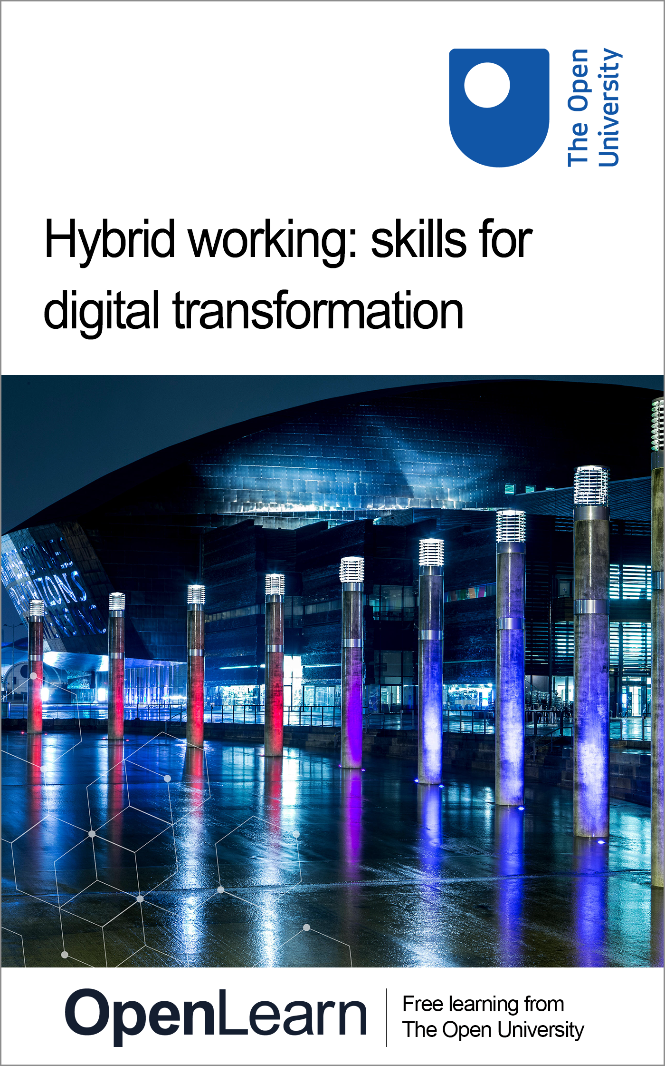

HYB_5 Hybrid working: skills for digital transformation

Hybrid working: skills for digital transformation

About this free course
This free course is an adapted extract from the Open University course .
This version of the content may include video, images and interactive content that may not be optimised for your device.
You can experience this free course as it was originally designed on OpenLearn, the home of free learning from The Open University –
There you’ll also be able to track your progress via your activity record, which you can use to demonstrate your learning.
Copyright © 2022 The Open University
Intellectual property
Unless otherwise stated, this resource is released under the terms of the Creative Commons Licence v4.0 http://creativecommons.org/licenses/by-nc-sa/4.0/deed.en_GB. Within that The Open University interprets this licence in the following way: www.open.edu/openlearn/about-openlearn/frequently-asked-questions-on-openlearn. Copyright and rights falling outside the terms of the Creative Commons Licence are retained or controlled by The Open University. Please read the full text before using any of the content.
We believe the primary barrier to accessing high-quality educational experiences is cost, which is why we aim to publish as much free content as possible under an open licence. If it proves difficult to release content under our preferred Creative Commons licence (e.g. because we can’t afford or gain the clearances or find suitable alternatives), we will still release the materials for free under a personal end-user licence.
This is because the learning experience will always be the same high quality offering and that should always be seen as positive – even if at times the licensing is different to Creative Commons.
When using the content you must attribute us (The Open University) (the OU) and any identified author in accordance with the terms of the Creative Commons Licence.
The Acknowledgements section is used to list, amongst other things, third party (Proprietary), licensed content which is not subject to Creative Commons licensing. Proprietary content must be used (retained) intact and in context to the content at all times.
The Acknowledgements section is also used to bring to your attention any other Special Restrictions which may apply to the content. For example there may be times when the Creative Commons Non-Commercial Sharealike licence does not apply to any of the content even if owned by us (The Open University). In these instances, unless stated otherwise, the content may be used for personal and non-commercial use.
We have also identified as Proprietary other material included in the content which is not subject to Creative Commons Licence. These are OU logos, trading names and may extend to certain photographic and video images and sound recordings and any other material as may be brought to your attention.
Unauthorised use of any of the content may constitute a breach of the terms and conditions and/or intellectual property laws.
We reserve the right to alter, amend or bring to an end any terms and conditions provided here without notice.
All rights falling outside the terms of the Creative Commons licence are retained or controlled by The Open University.
Head of Intellectual Property, The Open University

Contents
- Introduction
- Learning outcomes
- 1 Why digital skills matter
  - 1.1 Essential functional skills
  - 1.2 Digital skills for the workplace
- 2 The digital divide and inclusion
  - 2.1 A framework for building digital capabilities
- 3 Everyday digital skills
- 4 Developing your digital confidence and curiosity
  - 4.1 Case study: fostering a healthy digital culture
  - 4.2 How digitally curious are you?
- 5 Understanding your responsibilities
  - 5.1 Digital wellbeing, safety and security
  - 5.2 Digital governance and information security
  - 5.3 General Data Protection Regulations (GDPR)
  - 5.4 Intellectual property (IP) and copyright
  - 5.5 What is information security?
  - 5.6 Data, information and digital knowledge management
- 6 Digital futures: digital transformation
  - 6.1 Exploring your digital carbon footprint
- Conclusion
- References
- Acknowledgements
- Solutions

Introduction
This course aims to develop the digital transformation skills for hybrid working as an individual or a team rather than focussing on how digital capabilities relate to organisations. For organisations to build digital capabilities it starts with their people having the confidence and competence to develop their skills and behaviours, so that they can make an effective contribution to the organisation.
Digital capabilities are the skills, behaviours and understanding to enable you to thrive in a digital world. Nearly every aspect of your life has a reliance on technology and you need the digital capabilities to use these technologies appropriately and effectively, across a range of platforms, environments and situations, in your personal life and in the workplace.
As the digital transformation of the workplace continues to accelerate and organisations adopt hybrid working practices, employers are focusing on the expected digital capabilities employees should have. Communicating via email and online meeting platforms, creating documents, presentations and spreadsheets, understanding file and data management, and an awareness of online security are some of the key skills.
This free course is part of the Supporting hybrid working and digital transformation collection which focuses on hybrid working – where workers spend some of their time working remotely and some in the employer’s workspace.

Learning outcomes
After studying this course, you should be able to:
- examine your organisation’s current practices and norms around working digitally in hybrid environments (e.g. remote and onsite)
- describe digital responsibility and behaviours, including GDPR, data, network security and digital wellbeing and inclusion
- explore frameworks, tools and technologies for building digital capabilities
- examine how organisations can take responsibility for digital sustainability
- recognise that digital transformation is continuing and consider approaches for planning for digital change.

1 Why digital skills matter

Essential digital skills are a step towards learning lots of other new things. They can improve your confidence to use technology for work, learning and daily life.
Many jobs today require digital skills. You need them even for jobs that do not ask for high levels of qualifications or experience. For example, if you work in a warehouse or a shop you may need to keep digital records of stock.
You also need digital skills every day for shopping, banking, learning, and keeping in touch with family and friends.
National Careers Service (n.d)

Activity 1 Why digital skills matter
10 minutes

Watch the video in which contributors share why digital skills and capabilities matter, the impact of the digital skills shortage and the digital skills organisations require.

Video content is not available in this format.
View transcript - Uncaptioned interactive content

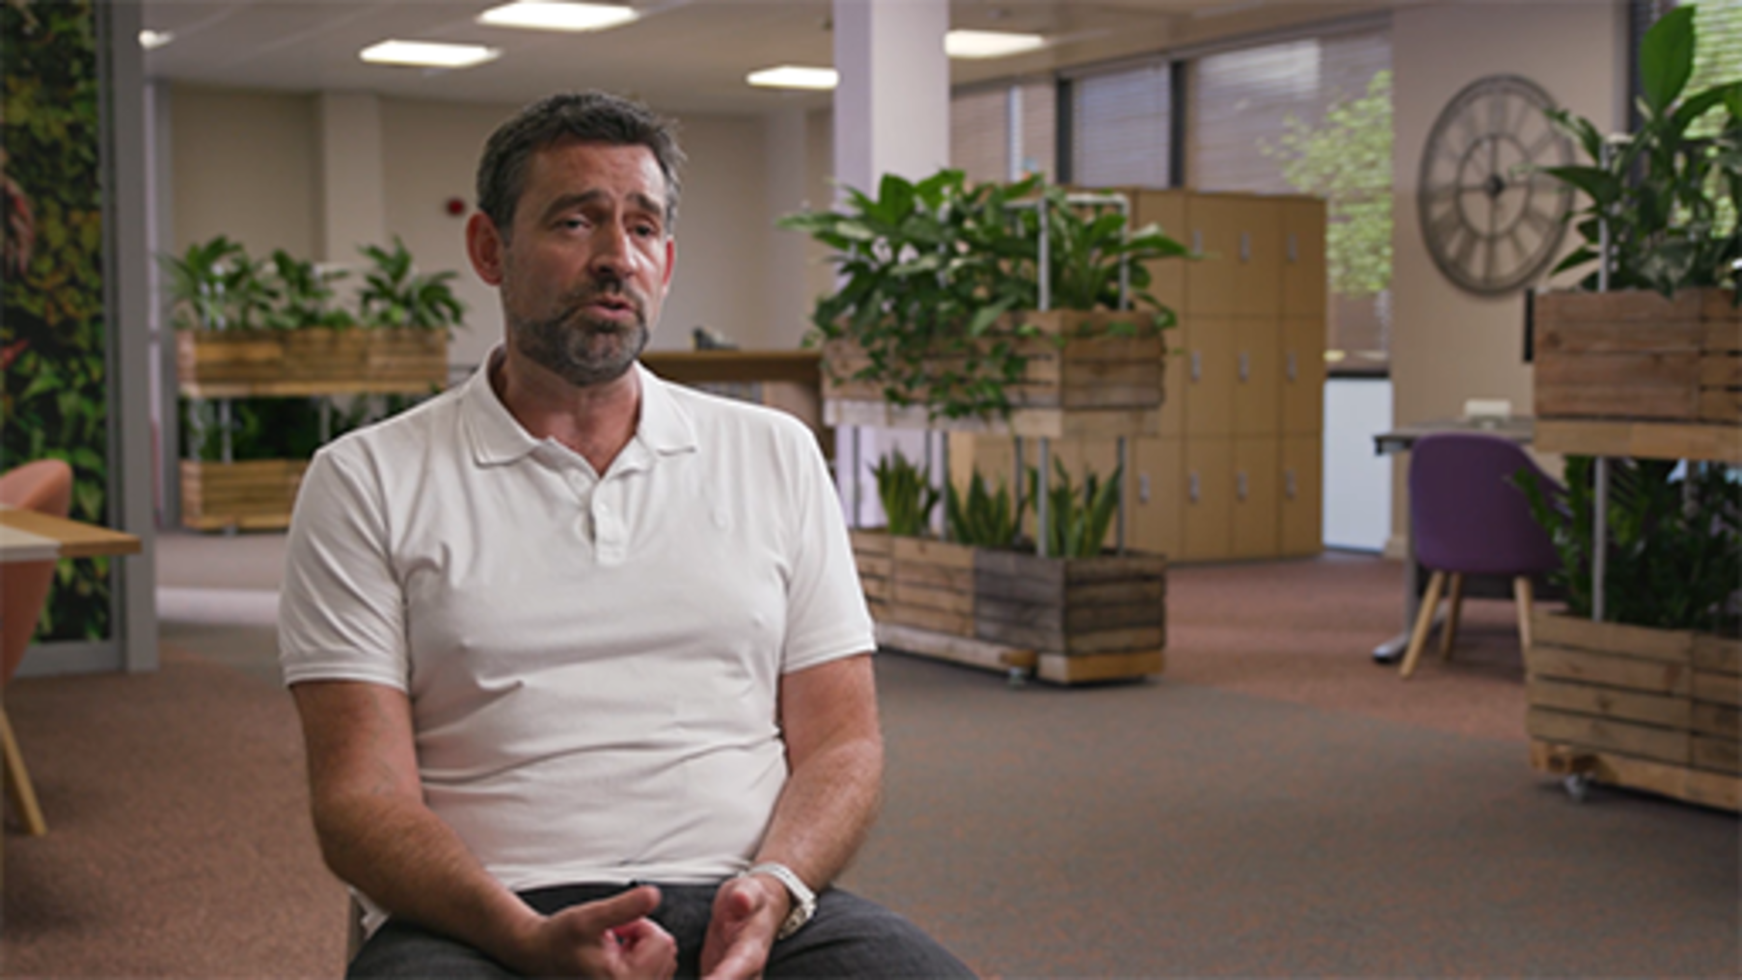

Now consider the following and add your thoughts in the box below:
- What were the skills they highlighted as being most important?
- How has the digital world evolved?
- What skills do you feel need to be developed by your organisation and yourself?

Provide your answer...

Digital skills for the future are essential not only to ensure organisations thrive, but also for communities and nations to protect future generations. The Well-being of Future Generations (Wales) Act 2015, A Prosperous Wales wellbeing goal, specifically focuses on the skills for the future: ‘Encouraging organisations to develop a skilled population, fit for future technological change’.

Activity 2 Skills for the future
20 minutes

Read Section 5 of A journey to a prosperous Wales and then watch the video below, in which Sophie Howe, The Future Generations Commissioner for Wales, explains the skills that will be required for the future.

Video content is not available in this format.
View transcript - Uncaptioned interactive content

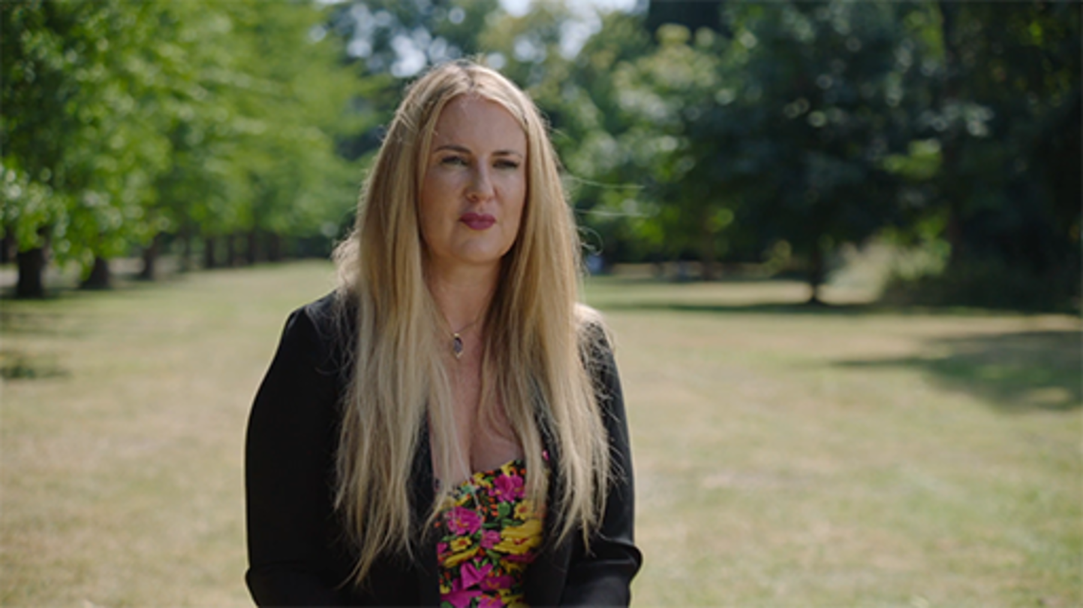

How might your organisation contribute to raising the digital skills for those within it and for future generations?
Add your thoughts in the box below.

Provide your answer...

1.1 Essential functional skills
The Essential Digital Skills Framework for the United Kingdom (Gov.uk, 2018) sets out the digital skills and understanding all adults require to interact in a digital world. There are five categories:

- communicating
- handling information and content
- transacting
- problem solving
- being safe and legal online.

Figure 1 illustrates how these categories relate to each other.

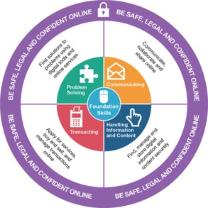
Figure 1 Essential Digital Skills – Framework Diagram (Crown Copyright, Gov.uk, 2018)
View description - Figure 1 Essential Digital Skills – Framework Diagram (Crown Copyright, Gov.uk, ...

Table 1 breaks the categories down further and provides more detailed definitions.

Table 1
Being safe and responsible online and offline | Digital wellbeing, responsibilities when working online – security, privacy and data protection, accessibility, understanding processes and policies, behaviour, and non-digital considerations – e.g. your desk set up, not writing down your password.
Using devices and handling information | Understanding hardware, software, operating systems and applications, and how to manage and store digital information and assets.
Communicating | How to communicate effectively digitally depending on the ‘tools’ and ‘context’
Creating and editing | Developing the skills to create and edit using digital tools, and reflect best practice and guidelines for the creation of digital content and products.
Transacting | The ability to interact with digital forms, systems and payments.
Problem solving | The ability to find solutions and approaches, and use digital tools to assist with this.

Table 2 provides some examples of digital skills and capabilities required in the workplace:

Table 2
Essential basic skills all individuals require | Advanced/specialist skills
- Behaving safely and legally online  - Email, instant messaging and virtual meetings  - Word processing  - Web-based research  - Data entry and handling  - Using social media/networking  - Problem solving  - Understanding your digital carbon footprint | - User experience design, and digital design  - Coding  - Programming, web, and app development  - SEO, SEM, and content creation  - Data science, analysis, and visualisation  - Digital learning and development  - Digital project and product management  - Digital marketing and social media  - Digital leadership capabilities  - Digital transformation decision making

Activity 3 How digitally confident are you?
15 minutes

Read the descriptions of the skills and examples in the Essential Digital Skills Framework, which can be accessed via either:
- Essential Digital Skills Framework website (we recommend this if you use a screen reader).
- Essential Digital Skills Framework interactive PDF.
Then use the polls below to consider how digitally confident you are.
Digital foundation skills

Interactive content is not available in this format.

Communicating

Interactive content is not available in this format.

Handling information and content

Interactive content is not available in this format.

Transacting

Interactive content is not available in this format.

Problem solving

Interactive content is not available in this format.

Being safe and legal online

Interactive content is not available in this format.

View discussion - Activity 3 How digitally confident are you?

1.2 Digital skills for the workplace
The COVID-19 pandemic accelerated the need for both digital transformation, and the ability to develop digital skills and capabilities, as individuals and organisations rapidly moved to new ways of working. Reports suggest that digital transformation has accelerated by about seven years during the height of the pandemic in 2020–21. At the point of the first lockdowns individuals and organisations achieved digital adaption (i.e. implementation of remote-working solutions) in an average of 11 days which pre-COVID may have taken years to implement (McKinsey & company, 2020).
This has changed our ways of working and the associated digital capabilities we need in an unprecedented way, but the pandemic has also widened the digital divide – ‘the gap between people who have easy access to the benefits of digital technology and those who don’t.’ (Centre for Digital Public Services, 2022).
As organisations now adapt to new ways of working post-pandemic, many are permanently adopting a hybrid approach, with more than 80% of workers suggesting they planned to work in this way. Organisations need to plan for the long term, and involve both their staff and external organisations to build digital skills and integrate preventive measures to reduce the digital divide. Leaders need to develop their confidence, curiosity, and understand government and ‘industry’ strategies, in order to build digital capabilities that lead to effective digital transformation (ONS, 2022).
For higher education institutions (HEIs) it is also useful to consider the heightened digital capabilities and expectations of students alongside those of staff. This is because the experience of the new generation of students compared to previous generations has been different, and is influenced by the use of technology during the pandemic and the focus by government on digital skills within the curriculum. The Welsh Government, Education Wales Digital Competence Framework for schools provides a useful reference to understand the expectations for digital skills to be developed within schools.
When thinking about the digital skills required for hybrid working, focusing on the ‘employee experience’ from an organisational and individual point of view helps to ensure that the behaviour and the skills to use technology effectively can be considered together, to build the digital capabilities you require.
Some of the key behaviours and skills you may need to consider developing in your organisation to support hybrid working are listed in the table below.

Table 3
Behaviours | Skills
Empathy | Tools and systems
Communication | Collaborating online
Psychological safety and trust | Policies and processes
Collaboration | Data governance
Resilience | Online and offline security
Transparency | Managing information
Curiosity | Writing for digital platforms
Problem solving | Copyright
Team building | Equity, diversity, accessibility and inclusion
Sustainability | Digital sustainability

It is useful to apply a digital lens to these behaviours as a way to think about how digital capabilities should look for you as an individual and in your organisation as a whole. Throughout this course and toolkit, we explore these skills further, and you may find that The Skills Toolkit created by the National Careers Service is a useful additional resource.

Activity 4 Skills for content creation
20 minutes

Watch the video in which Sas Amoah, a Digital Media Producer at The Open University, talks about the importance of digital skills and responsibilities.

Video content is not available in this format.
View transcript - Uncaptioned interactive content

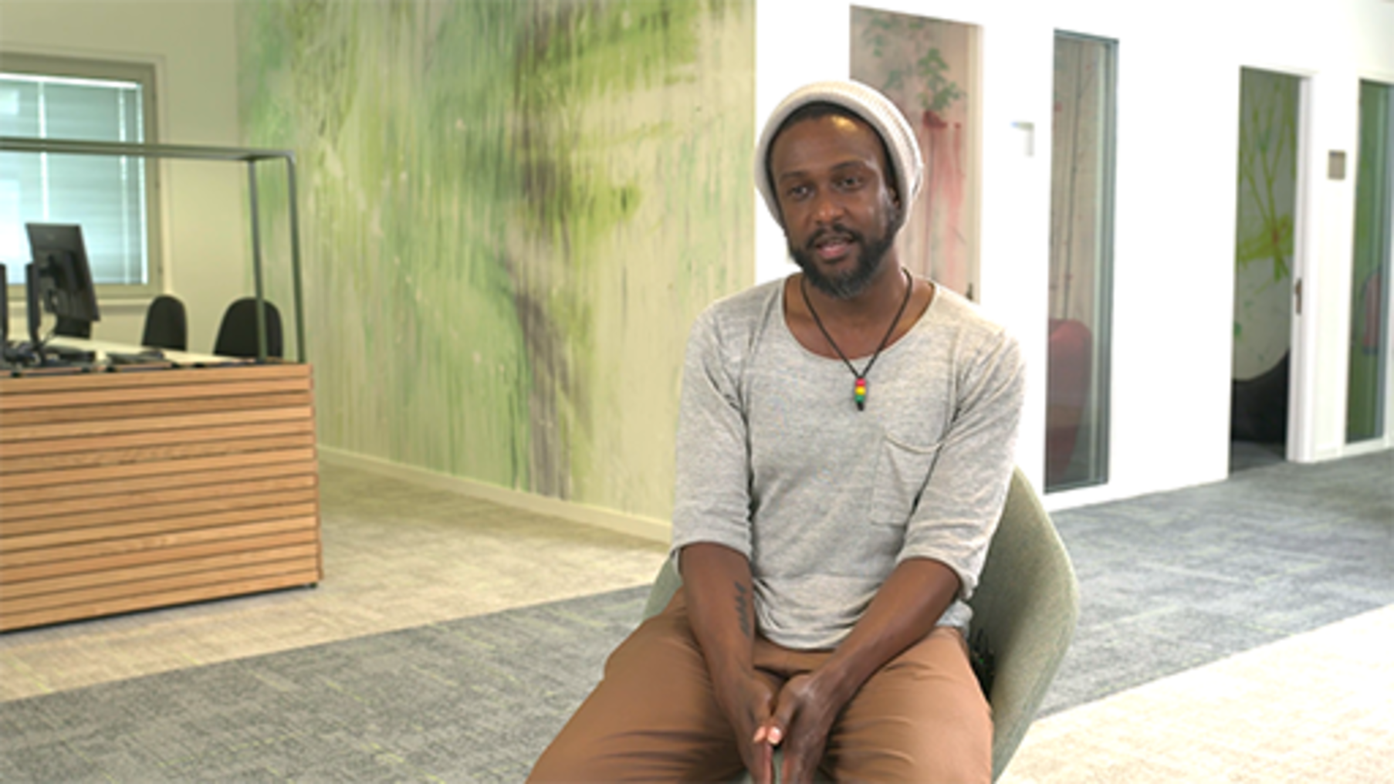

Drawing on the behaviours and skills in Table 3 above and the notes you made while watching the video, which are the areas you feel your organisation might wish to focus on?

2 The digital divide and inclusion
The digital divide is the gap between people in society who have full access to digital technologies (such as the internet and computers) and those who do not (UK Parliament, 2020).
The pandemic highlighted the issue of the digital divide. During periods of home-schooling there were frequent media reports of children who did not have access to technology to be able to join remote lessons. There were also many people who were not able to shop online due to lack of access to technology, digital capabilities or poor infrastructure – often lack of internet access.

A lack of digital skills and access can have a huge negative impact on a person’s life, leading to poorer health outcomes and a lower life expectancy, increased loneliness and social isolation, less access to jobs and education.
It can mean paying more for essentials, financial exclusion, an increased risk of experiencing poverty. People who are digitally excluded also lack a voice and visibility in the modern world, as government services and democracy increasingly move online.
What’s more, it’s those already at a disadvantage – through age, education, income, disability, or unemployment – who are most likely to be missing out, further widening the social inequality gap.
Good Things Foundation (2021)

The Welsh Government’s report on digital inclusion and basic digital skills (gov.wales, 2020) indicates that:
- 60,000 personal internet users (aged 16 or over) can’t demonstrate the skill of using a search engine
- 730,000 personal internet users can’t demonstrate the skills of managing privacy settings
- 19% of disabled people do not personally use the internet and are therefore deemed digitally excluded
- 76% of social housing tenants have internet access compared to 90% owner occupied.
The Digital inclusion and basic digital skills in Wales: 2019–2020 infographic, which summarises the Welsh Government’s Digital inclusion forward look: towards a digital confident Wales strategy, captures the scale of the digital divide in Wales. While some of the numbers may seem low, those in the digital divide are often those that are most vulnerable, excluded from basic inclusion in society or in areas where digital infrastructure is limited.
In the video below, contributors share their insights about digital inclusion, and how to narrow the digital divide.

Video content is not available in this format.
View transcript - Uncaptioned interactive content

Activity 5 Research the digital divide and inclusion
20 minutes

Gaining an understanding of the digital divide and approaches to closing the gap within your organisation and local community is essential. This is an area that can be overlooked when thinking about inclusion, as there is an assumption that if you are working you already have the basic skills and access to infrastructure. As more people are working in a hybrid manner, requirements for digital inclusion of those working remotely may go unnoticed.
Reflect on the video above. Then do your own research into the digital divide and inclusion, and think about the following questions.
- Do you recognise any of the challenges raised in relation to your own personal circumstances?
- What do you feel organisations should focus on, and how might they do this?
You may wish to use some of the resources below to help with your research.
- Digital inclusion forward look: towards a digitally confident Wales (gov.wales)
- The digital divide (Good Things Foundation)
- Digital Communities Wales (gov.wales)
- Inclusive education: knowing what we mean (Wales) (OpenLearn, The Open University)

Provide your answer...

2.1 A framework for building digital capabilities
Many higher education and further education institutions have adopted the Jisc digital capabilities framework, which expresses the essential digital skills every adult should have in the context of the workplace and provides a means of articulating and understanding digital capabilities in an FE/HE setting. The framework states that:

- At an individual level we define digital capabilities as those which equip someone to live, learn and work in a digital society.
- At an organisational level we need to look beyond the capabilities of individuals and consider the extent to which the culture and infrastructure of an institution enables and motivates digital practices.
(Jisc, n.d).

The framework defines these capabilities as follows.

Table 4
The six elements of the individual digital capability framework are: | The six elements of the organisational digital capability framework are:
- Digital proficiency and productivity (functional skills)  - Information, data and media literacies (critical use)  - Digital creation, problem solving and innovation (creative production)  - Digital communication, collaboration and participation (participation)  - Digital learning and development (development)  - Digital identity and wellbeing (self-actualising) | - Organisational digital culture  - Content and information  - Research and innovation  - Communication  - Learning, teaching and assessment  - ICT infrastructure

In the video below, Dr Becki Vickerstaff, Higher Education Senior Consultant at Jisc, explains the Jisc digital capabilities framework.

Video content is not available in this format.
View transcript - Uncaptioned interactive content

When thinking about a digital capabilities framework, it is important to define the following in order to ensure that you understand the digital skills and behaviours needed for different contexts within your HEI – one size does not fit all!
- People: The group of people who need the skills
- Places: The context in which they need to use the skills
- Technology: The tools and systems that they need the skills to use
- Period: The time frame in which these skills are relevant (Orlik, 2018).

Activity 6 Jisc’s framework: how digitally confident are you?
20 minutes

Research the Jisc digital capability framework in more detail. Consider what it means to you as an individual, and how digitally confident and capable you feel you are.
Jisc Digital Capabilities Framework
You may wish to use one of the following tools to help assess your own digital capability:
- If your HEI is a member of Jisc you may have access to the Jisc Discovery Tool which is a self-assessment tool to help you to understand and develop your digital capabilities.
- If your organisation is not a member you may wish to use The Digital Competence Wheel.
Write a summary of how digitally confident and capable you are and identify the areas you would like to develop. Think about which digital skills and behaviours are important in your personal life and in your role within an organisation. If you work in a HEI also consider the digital skills and tools you use, both in order to operate effectively as an organisation, and the skills to provide the best outcomes for your students.

View discussion - Activity 6 Jisc’s framework: how digitally confident are you?

Using the Jisc framework
In the video below, Becki Vickerstaff recaps what the framework is, then contributors discuss how it has been used in their organisations so far and areas to consider for the future.

Video content is not available in this format.
View transcript - Uncaptioned interactive content

Many HEIs and FEIs work with Jisc and other organisations to develop resources to help build digital capabilities. In the video below Becki Vickerstaff explains how the Jisc framework has been used to create digital resources areas to help build digital capabilities of staff and students.

Video content is not available in this format.
View transcript - Uncaptioned interactive content

Activity 7 Explore the DigiCentre
10 minutes

The University of Wales Trinity Saint David worked with Jisc to create the DigiCentre, their one-stop shop for digital skills needs.
In the video below Sarah Jones, Head of Academic Services, Library and Learning Resources, University of Wales Trinity Saint David, discusses how it can be used and areas to consider.

Video content is not available in this format.
View transcript - Uncaptioned interactive content

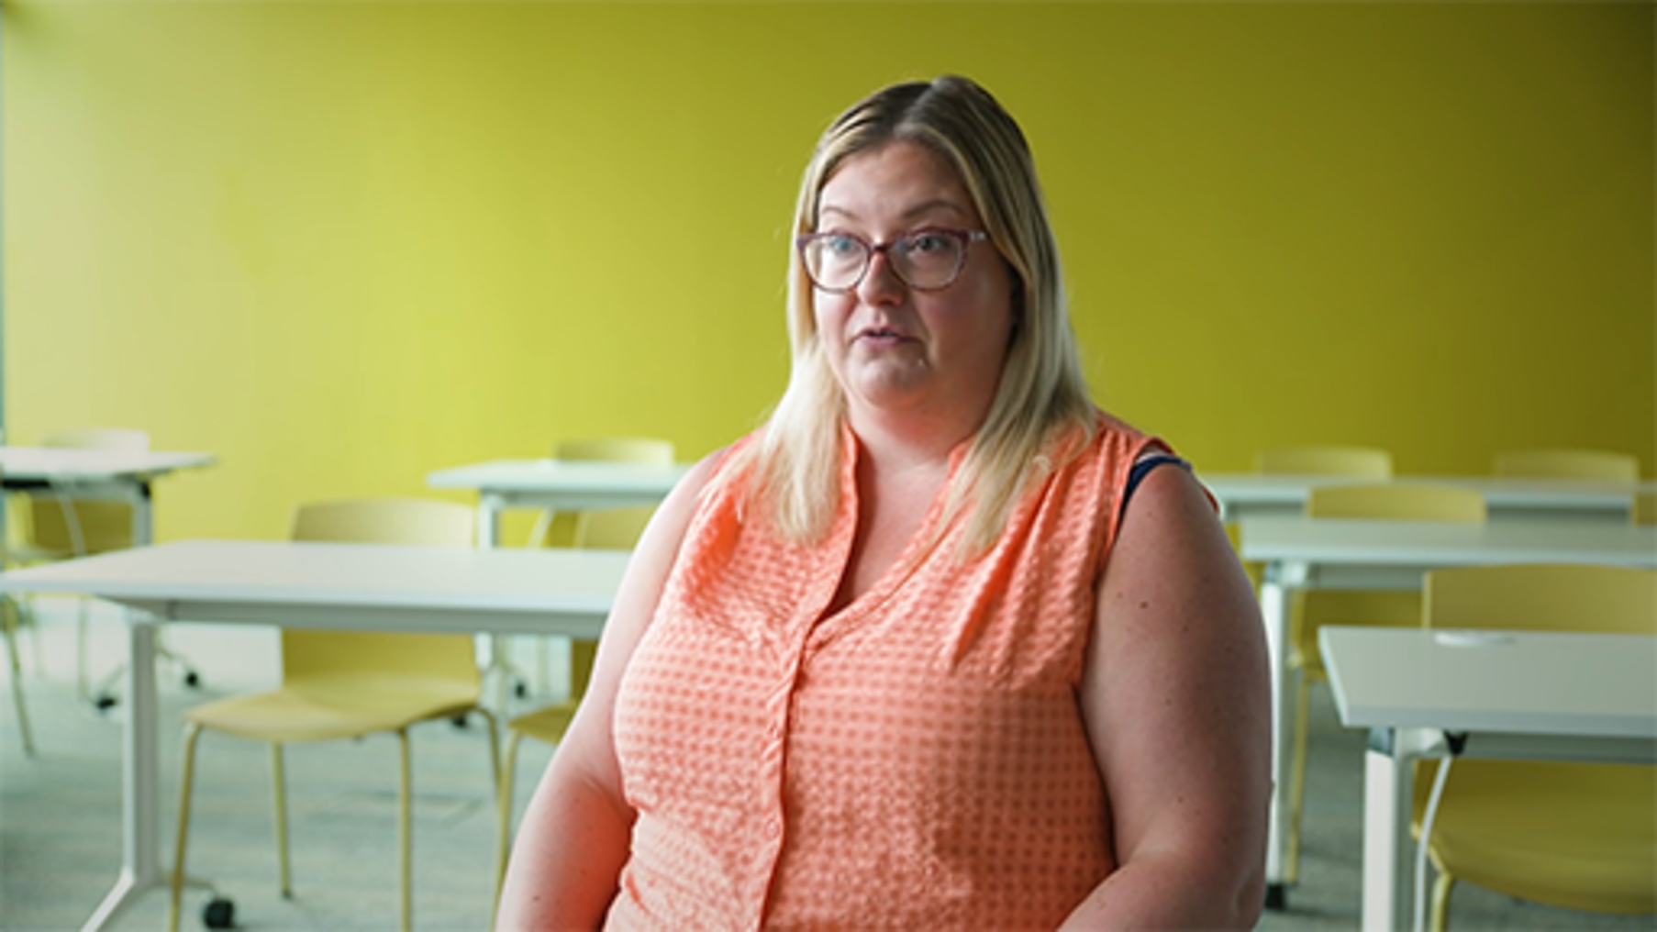

Take some time to explore the DigiCentre. You may also wish to read the Jisc case study about this project: University of Wales Trinity St David, Building digital capability (jisc.ac.uk).
Consider how you might approach developing resources to raise digital capabilities in your own organisation.

3 Everyday digital skills
Think about the digital skills you use in everyday life from when you get up to when you go to bed, outside of your work environment and the support you have there for using the required technology.
The chances are you figured out how to use a piece of technology or software yourself, or asked a partner/friend/child to tell you how to do something. Thinking about your digital life, what do you actively engage with digitally because it provides a benefit to you?

Activity 8 What activities in your digital life rely on technology?
10 minutes

Draw a mind map of your digital life: put technology in the middle, then surround it with examples of the ways you use technology in everyday life. For example, ordering shopping online, using the sat nav in your car or setting up a new smartphone. What digital skills do you need to use in relation to these activities? List your ideas in the box below.

Provide your answer...
View answer - Activity 8 What activities in your digital life rely on technology?

Activity 9 Understanding skills for the workplace
10 minutes

Look at the articles below and think about how you use these technologies and the digital skills you have in relation to them. As you do so, consider your approach to online safety and security, and personal digital wellbeing.
- Which of these skills are ones you also use in the workplace?
- Why do you use them?
- How does this differ in the workplace and your personal life?
List your answers in the box below.
- Top 11 Essential Uses of Technology in Everyday Life (javaassignmenthelp.com)
- The 7 Main Ways Technology Impacts Your Daily Life – Tech.co
- 20 internet safety tips and checklist to help families stay safer online | Norton
This course covers online safety and security, and personal digital wellbeing later, but it is useful to start to think about this as you work through each section.

Provide your answer...

4 Developing your digital confidence and curiosity
HEIs by their nature encourage continuous learning and being curious. They tend to have informal and formal approaches to this, often with opportunities to ‘play’.
Building digital capabilities is not just about formal training courses on how to use the tools, but also includes informal learning from others, playing with digital tools and being comfortable with learning from failure. Building a digital-first culture, where organisational leaders lead by example, by focusing on people, embracing technology and having a shared vision that is communicated, encourages digital confidence and curiosity (Slack, 2022).

Activity 10 How digitally confident are you?
5 minutes

Reflect on the questions below, and then place your vote in the poll.
I am happy to try new things.

Interactive content is not available in this format.

I will work out solutions.

Interactive content is not available in this format.

I don’t mind not knowing how to do something.

Interactive content is not available in this format.

Depending on how comfortable you are with ambiguity and your own confidence, developing your digital capabilities (and transformation) will either be an opportunity to have fun and push the limits of what can be done or may be bewildering and scary. Individuals may be afraid they will break something, do something wrong, or lose something. The latter is unlikely these days, as now most organisations use cloud-based services. As long as you are saving your work in the correct place (for example, not on your computer desktop) most things are retrievable and you can usually access previous versions.
Occasionally things do go wrong that are not fixable – and usually this is not your fault! This was my laptop that just stopped working due to a total hardware failure. However, I didn’t lose any of my work or files as it was all on the servers – in the cloud – and accessible when I logged onto my new laptop.

Figure 3 A photograph of a broken laptop
View description - Figure 3 A photograph of a broken laptop

Learning from others is an essential part of developing your own digital capabilities. Often someone can help you use a digital tool, giving you insights into the way you approach a task or encourage you to do your own research to enhance your understanding.
If you are reimagining products, processes and systems you may have no idea what is and isn’t going to be successful. You will have to learn to have the confidence to develop the mindsets and expectations of the stakeholders while being comfortable with stopping or adapting developments. You may need to draw on the data available and gain input from subject matter experts to make decisions.
More leaders are participating in ‘reciprocal mentoring’ – which normally involves a junior employee mentoring someone more senior than them, but those in the same roles can also benefit from this approach to consider different approaches to digital tasks and learn from each other.
It is important to acknowledge that the capabilities and skills of individuals will vary. For example, don’t assume that younger people are automatically experts in using all types of technology: they might be competent using mobile devices and apps, but not tools for work e.g., Microsoft Office 365 or Google Drive. They may also lack the behavioural experience for working online in the workplace.
Have the confidence to ask questions and share your own experiences within your team or those with specialist skills, to create opportunities to build collaboration and confidence within teams and the organisation.
As you become more digitally competent and confident, share your knowledge and support others. Learn to listen and see what is happening in digital environments. If you are curious and not afraid to admit you don’t know how to do something, most people are more than happy to show you. This not only develops your skills but fosters a culture of sharing and trust with those you work with, and encourages those who might be in a junior role or new to the organisation to be more confident in contributing to discussions.

4.1 Case study: fostering a healthy digital culture
The approach taken within one of the short course production teams at The Open University is an example of how to foster a healthy digital culture. Regardless of role, each member brings a different digital skill set that is of equal importance to delivering the product. There is a high level of trust, asking questions, showing others in the team how to approach all tasks and proactive behaviour is a fundamental way of working, to ensure that products can be developed quickly. There is never an assumption that someone knows how to do something or a mindset of ‘that is someone else’s job’. Everyone is flexible and helps out when required.

Case study: fostering a healthy digital culture?
The table below is an extract from production guidance for course authors who often have never used the online platform to which we deliver. The focus is very much on the skills they already have to build confidence, set expectations and create a safe, open environment to build trust quickly. People are encouraged to ask for help, while being able to access the necessary digital guidance and tools. The aim is to ensure that, when work begins on the online platform, people have developed the capability to understand how to deliver the best course possible.

Table 6
Get to know the platform  Sign up for a short course and look around to see how the platform works. | Write conversationally  Write as though you were talking to someone directly rather than writing an academic paper or textbook.
Tell stories and take the learner on a journey  What is the key thing you want the learner to take away and talk about? | Focus on skills  Write your content around skills that will improve the learners’ employability.
Have a big question and know who your learner is  This will help you shape the course in the right direction. | Flag third-party content early  Identify any third-party content you’d like to use as soon as possible. Don’t assume if it is in an OU course that we can use without clearance.
Plan media early  Consider what you want in terms of video, audio, graphics, interactives to allow time for production. | Vary content and learning types  Use the different step types and media options to give learners variety and keep them engaged.
Think big  We love big ideas, and where possible we will find a way to achieve them. | Ask for help  The team is here to help you, there are no stupid questions.
Be prepared to hear No, but we will work with you to find a solution.
The platform does not have the same functionality or approach as our platform. We will always let you know if we feel something is not right, or not possible. This means we say ’No’ a lot but we will try to find a way round it.
We are also really strict on word count!
Our aim is to ensure you have fun and deliver the best course possible.

4.2 How digitally curious are you?
The following activities give you an opportunity to be curious with a range of tools, and to think about how you approach digital tasks. There are no detailed instructions, which is deliberate.

Activity 11 Explore Freerice
10 minutes

The only instruction for this activity is visit the Freerice site and explore it. NB You do not need to create an account unless you wish to do so.
Freerice

Activity 12 Draw a person
15 minutes

Create a new document in a word processing program (e.g., Microsoft Word, Google Docs, Apple Pages), draw a person, and save the document.

Activity 13 How did you feel?
10 minutes

How did you feel?
- I wasn’t sure how to do this, and didn’t do it
- I wasn’t sure how to do this, so I searched/asked for help
- I wasn’t sure what I needed to do, but just played till I worked it out
- Fine, I worked out what I need to do
- Fine, I knew what I needed to do
Capture your thoughts on doing these activities and make notes in the box below.

Provide your answer...
View discussion - Activity 13 How did you feel?

Developing your confidence
Activities 11 and 12 were designed to allow you to play – there was no right or wrong way of doing them.
The Freerice website incorporates play, learning and sustainability. The site is designed to be very easy to use, so much so that they do not provide any guidance on how to use it. If you took the time to explore the menu, you will have seen that you could change the difficulty level, see information on challenges and choose different type of questions.
The game I played was about the meaning of words: this in itself developed my skills in using different words to describe something. To use this skill in future, I could challenge myself to use the alternative meaning I learned during the game, rather than the more familiar word.
A motivating factor to encourage engagement with the game is that it is supporting the United Nations World Food Programme (WFP) and United Nations Sustainable Development Goals (UN SDG) and involvement in this wider purpose may help boost your own wellbeing.
If you signed up an account you can create a group and invite members of your team or organisation to join. Or you can join the Digital Skills group, and use this tool as part of your wellbeing toolkit, for having a break, while continuing to contribute to the UN SDG.
To do this, once logged in go to the menu, select groups, and enter the following code into Join existing group: R5V4ABYR

Freerice is an educational trivia game that helps you get smarter while making a difference for people around the world. Every question you answer correctly raises 10 grains of rice for the World Food Programme (WFP) to support its work saving and changing lives around the world.
Source: United Nations World Food Programme (n.d)

Drawing a person may have been more challenging, as you first had to decide which program to use, and then even if you use regularly use the word processing features of your chosen program, drawing with it may well have been an unfamiliar task. However, knowing how to insert shapes and text boxes can be useful if you want to add visual representations of information and data to your documents, so this is a digital capability worth developing.
Activities 11 and 12 gave you an opportunity to play, test your confidence, and perhaps learn a new digital skill. Trying things out is often the best way to understand how you learn and develop the capability to search for help and support, to enable you to find answers more efficiently, when you may not be able to reach out to others for help.

5 Understanding your responsibilities
When working digitally you need to understand your responsibilities and behaviours in line with your organisation’s requirements and expectations. As you saw from the list earlier in this course it has become more important to have this understanding when hybrid working. Organisations are now more reliant on trusting those working remotely to respect their requirements and to have the capability, tools and environment to do so.
Most HEIs will have guidance and polices to ensure their staff understand the requirements for safety and security, digital governance, accessibility, inclusion and intellectual property. However, working responsibly is more wide-reaching.
Depending on your role, and the products and services you may deliver, there often are a set of formal and informal guidelines that you also need to consider. These can range from organisational brand guidelines, use of systems and tools, and importantly, your digital behaviour, both in terms of how you manage your devices and how you communicate with others.

5.1 Digital wellbeing, safety and security
While many organisations approach digital wellbeing, safety and security as separate entities, it is useful to consider them together, as there are overlaps: safety is inherently linked to wellbeing and security. If you do not feel ‘safe’, because your digital security is not sufficient, this can affect your wellbeing (see Figure 4).

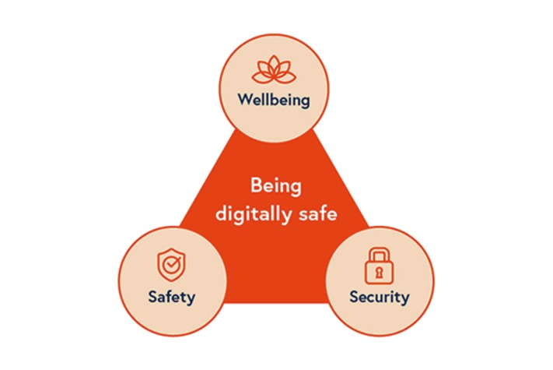
Figure 4 Being digitally safe
View description - Figure 4 Being digitally safe

In a more digitally-driven world, our needs and the reliance on technology has meant that our digital life merits consideration as a basic need. Maslow’s Hierarchy of Needs, adapted to consider our digital life, provides a useful framework for considering organisational and individual needs. Similarly the Well-being of Future Generations (Wales) Act 2015 seven wellbeing goals, five ways of working, and the Jisc Digital Wellbeing model take a holistic approach to building digital capabilities and skills, with an emphasis on wellbeing.

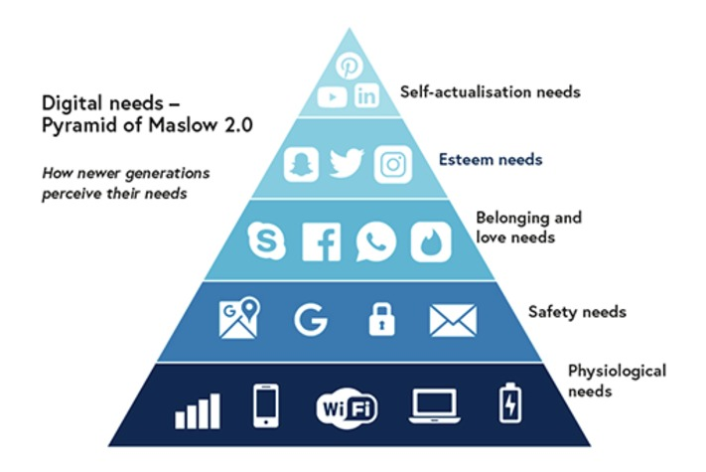
Source: Chando (2019)
Figure 5 Maslow 2.0: digital needs
View description - Figure 5 Maslow 2.0: digital needs

In this course we do not focus on digital wellbeing in detail, but the Hybrid working: wellbeing and inclusion course within this collection has more information about digital wellbeing and safety. The Jisc model for digital wellbeing for individuals is also a useful resource on this topic.

Activity 14 What are your digital security responsibilities in the workplace?
20 minutes

Your responsibilities for digital security within an organisation will vary on your role and the policies, processes and guidance within your organisation. Take some time to explore these within your organisation, consider what you are required to do, and what you actually do. You may wish to list the key responsibilities you have in the free text box below.

Provide your answer...
View answer - Activity 14 What are your digital security responsibilities in the workplace?

5.2 Digital governance and information security
Some organisations have separate departments to lead digital governance and information security activity. They normally ensure that legal responsibilities, professional and internal standards, processes and strategies are in place. This allows organisations and individuals to develop the behaviours which ensure a consistent approach to operating in a digital environment.
Digital governance and information security can include areas such as:
- GDPR (General Data Protection Regulations)
- information security
- data, information and digital knowledge management
- intellectual property and copyright
- accessibility and inclusion
- digital brands
- communication and content.
Many organisations use the Data Management Association (DAMA) international framework as an approach to data governance and understanding what needs to be considered.

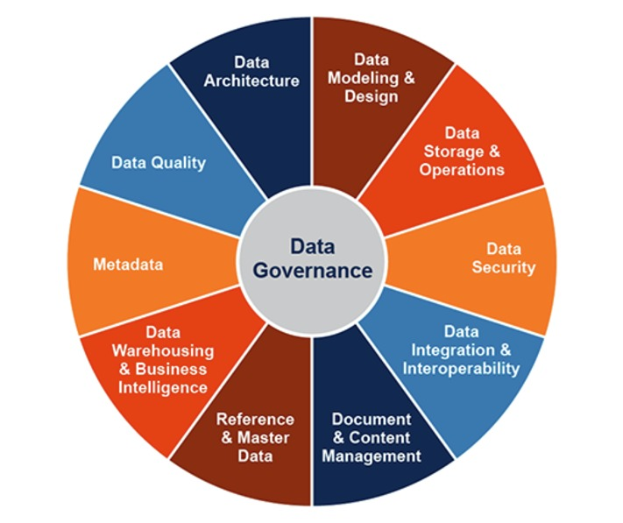
Figure 6 The DAMA-DMBOK data governance wheel
View description - Figure 6 The DAMA-DMBOK data governance wheel

In the video below, Nicola Askham, The Data Governance Coach, explains the framework and considerations for good data governance.

Video content is not available in this format.
View transcript - Uncaptioned interactive content

Activity 15 Think about what should be within a digital governance framework
15 minutes

This course does not cover all your responsibilities in detail, as these will vary from organisation to organisation: we recommend you spend some time considering what policies, processes and compliance training you are required to do within your HEI or place of work.
Not all organisations have a detailed digital governance framework in place. They may have frameworks and strategy elements of ‘digital activity’. A digital governance framework is different to a data governance framework which focuses on the management of data.
Watch the video about the ‘The OCED Digital Government Policy Framework’ which provides insights into what as an organisation you may wish to consider to support the development of a digital governance framework.
OECD Digital Government Policy Framework
You may wish to make some notes in the free text box below.

Provide your answer...

5.3 General Data Protection Regulations (GDPR)
This is a European data protection law that gives individuals more control over their personal information. For organisations, this means ensuring that there are robust data privacy policies and processes, which limit how personal data is accessed and what an organisation can do with that data.
It is important to understand that data and information is not restricted to that contained in documents, but it is content that is used in any system, asset or communication that exists digitally or physically.
Data and information can exist in:
- documents, spreadsheets, presentations
- database systems
- content on online learning platforms
- video, audio, image assets
- websites
- emails
- reports
- staff records
The UK GDPR sets out seven key principles:

Table 8
Principle | Article 5(1) requirement
Lawfulness, fairness and transparency | Personal data shall be processed lawfully, fairly and in a transparent manner in relation to individuals
Purpose limitation | Personal data shall be collected for specified, explicit and legitimate purposes and not further processed in a manner that is incompatible with those purposes; further processing for archiving purposes in the public interest, scientific or historical research purposes or statistical purposes shall not be considered to be incompatible with the initial purposes
Data minimisation | Personal data shall be adequate, relevant and limited to what is necessary in relation to the purposes for which they are processed
Accuracy | Personal data shall be accurate and, where necessary, kept up to date; every reasonable step must be taken to ensure that personal data that are inaccurate, having regard to the purposes for which they are processed, are erased or rectified without delay
Storage limitation | Personal data shall be kept in a form which permits identification of data subjects for no longer than is necessary for the purposes for which the personal data are processed; personal data may be stored for longer periods insofar as the personal data will be processed solely for archiving purposes in the public interest, scientific or historical research purposes or statistical purposes subject to implementation of the appropriate technical and organisational measures required by the GDPR in order to safeguard the rights and freedoms of individuals
Integrity and confidentiality (security) | Personal data shall be processed in a manner that ensures appropriate security of the personal data, including protection against unauthorised or unlawful processing and against accidental loss, destruction or damage, using appropriate technical or organisational measures
Accountability | The controller shall be responsible for, and be able to demonstrate compliance with, these principles (Article 5(2))
Source: Information Commissioner’s Office

Note: While there may be a nominated ‘controller’ who has oversight of GDPR for an organisation, anyone who handles personal data has a responsibility to adhere to the seven Principles as set out through the relevant organisational policies and processes. In most HEIs, you are required to complete GDPR training on an annual basis to ensure that you understand your responsibilities. Check – what is in place in your organisation?

Activity 16 Think about the information and data you handle
15 minutes

How often do you consider GDPR when you handle information and data? Are you confident that, when you do so, your behaviour would meet the requirements of your organisations policies and processes?
The GitLab open-source handbook has a simple approach to help you make informed choices, and they have created the ‘SAFE’ framework to act as a guide, which includes examples of what to do if unSAFE information is shared and how they reinforce SAFE.

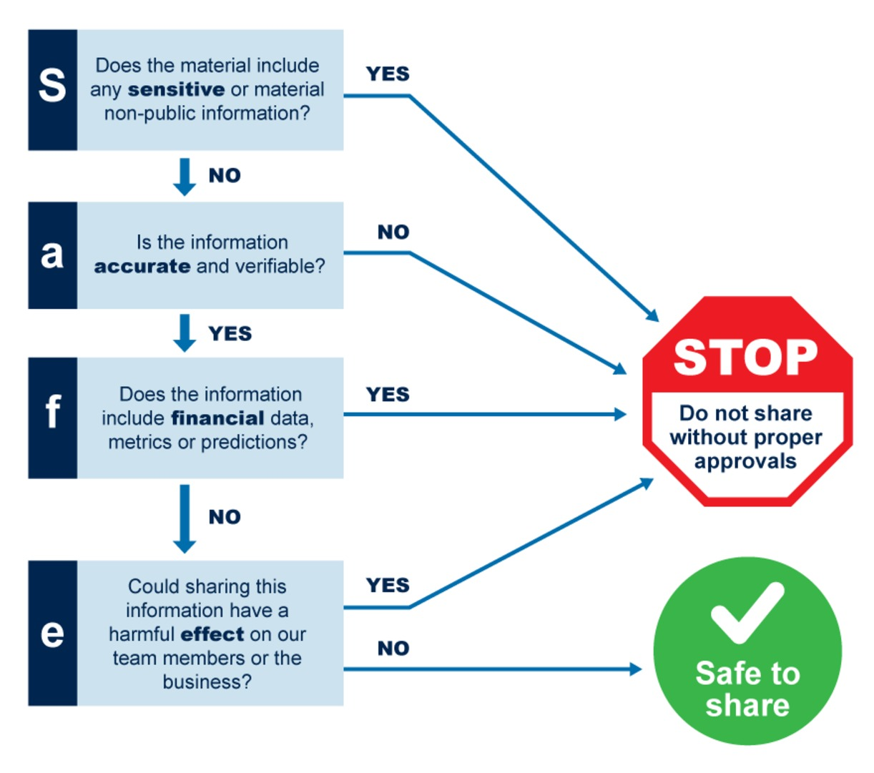
Figure 7 GitLab SAFE framework
View description - Figure 7 GitLab SAFE framework

Make some notes below. What action if any do you need to take now?

Provide your answer...

5.4 Intellectual property (IP) and copyright
When considering how you handle information and data, you also need to think about intellectual property and copyright. It is a broad topic, but it is important to be aware of your responsibilities and understand the expectations of your organisation.
Intellectual property normally covers:
- the names of your products or brands
- your inventions
- the design or look of your products
- things you write, make or produce.
Intellectual property and your work: What intellectual property is (gov.uk).
Copyright normally covers:
- literary, dramatic musical and artistic work
- software, web content, and databases
- sound and music recordings
- film, television and online broadcasting
- published editions.
Adapted from Copyright, Designs and Patents Act, 1988.
IP and copyright need to be considered from two angles.
- Use and sharing of your organisation’s information, products, services and content – your organisation owns the IP and copyright. Therefore, you need to be aware of what you can and cannot share in the public domain. For example, it may be inadvisable to share details about a commercially sensitive innovation project or an extract from a course that you authored – you may not own the rights to do this.
- Use of others’ materials – when using any ‘third party’ content – when using content that is not owned by you or your organisation, you need to check the conditions of use. Some organisations such as NASA provide these clearly on their website, but others are more complicated, as often the ‘author’ is not the ‘owner’. Common issues arise from linking to articles on the web. Although they may be freely available to access, many organisations charge for a concept called ‘deeplinking’ – which is sending users to a specific page on a website, rather than the homepage. One of the reasons for this is it can lead to a loss of income for the site owner.

Activity 17 Explore intellectual property and copyright further
10 minutes

A basic rule for IP and copyright is that, if you are unsure, always seek advice and permission. Check what guidance and requirements your own organisation has in place. For example, you may have a dedicated page such as the one below from the University of Wales Trinity Saint David.
Copyright Hub | University of Wales Trinity Saint David
If this is an area you are interested in, you may wish to look at these resources.
Patents, trade marks, copyright and designs (gov.uk)
UK Copyright Law fact sheet: The UK Copyright Service

5.5 What is information security?
Information security protects the confidentiality, integrity and availability – often referred to as the ‘CIA triad’ – of all assets, information and systems, be they digital or physical.

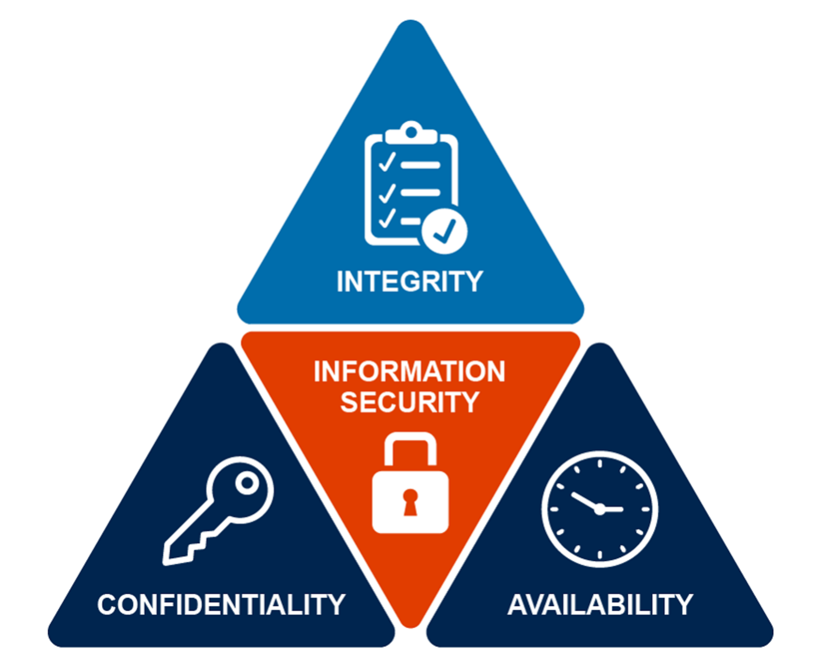
Figure 8 Preferred IT Group (2019)
View description - Figure 8 Preferred IT Group (2019)

Below is a brief definition of each element of the triad (based on National Cyber Security Centre, 2021b):
Confidentiality: only authorised personnel in relation to their role should have access to information, to ensure it has not be shared or accessed without permission.
Integrity: information and data needs to be accurate, consistent, and used for its intended purpose. This requires strong non-repudiation and authenticity controls to stop data being modified or destroyed.
Availability: information and data is readily available and there is reliable access to (and use of) information.
The primary focus of information security is to ensure that organisations and individuals operate securely, with minimal disruption to work processes. Achieving this means aiming to reduce the risk of security incidents, which include the theft of, tampering with, or deletion of information and data. Most organisations will have an information security policy that provides guidance on using IT and digital assets safely.

Common security threats
Poorly secured systems – which increase the risk of attacks from third parties or misuse, either intentionally or unintentionally by individuals within an organisation.
Social media and email attacks – where accounts are hacked, or emails trick users into an action that compromises security.
Malware – software that disrupts, damages, or gains unauthorized access to a computer system.
Malware on endpoints – (the devices you use, e.g. laptops, tablets and mobile phones) can be threatened in various ways, and traditional antivirus software is not often sufficient to block those threats. While organisations can take steps to reduce the risks on organisational owned devices, when people use their own devices for work, organisational control is limited.
Lack of encryption – using encryption processes to access devices can help prevent the loss of data or corruption of equipment.
Security misconfiguration – ensuring that all technology platforms and tools, including web-based tools are configured and updated correctly is essential. While many configurations and updates are automatic, some rely on individuals to do the updates, and it is important that they understand how to do this (Imperva, n.d).

Cyber security
Cyber security is how individuals and organisations reduce the risk of a cyber attack. The main focus is to protect devices and services from theft or damage. Whereas information security aims to protect both digital and physical information, cyber security only focuses on digital protection (National Cyber Security Centre, n.d).

Activity 18 Find out more about information security and cyber security
Time: as long as you’ve got

These are complex areas to cover, and it is recommended that you do further investigation into your organisation’s approach and policy in these areas. A good place to start is:
Information Security guidance from the Information Commissioner’s Office
What is Cyber Security from the National Cyber Security Centre
Or you might like to study the OpenLearn Course – Introduction to cyber security

5.6 Data, information and digital knowledge management
As well as the security of our systems, we also need to think about the security of the information we have, how we protect it and how we share it.
It is important to understand that data and information is not restricted to just documents, but it is content that is used in any system, asset or communication that exists digitally or physically.
Information is normally grouped into the following classifications: unclassified, internal, confidential. You should understand your responsibilities for how you handle information and data within these areas, which are part of the Information Classification Software for ISO 27001.

Table 9
Unclassified | Internal only | Confidential
The information is not particularly valuable, nor is the organisation required to protect it. It can be accessed by anyone for any purpose, including release to the public or clients. It may include press releases, job vacancies, and so on. | The information has value internally and may have some value to competitors. It may be distributed freely to anyone within the organisation. It may include internal memos, employment data, contract information, and so on. | The information has significant value and there may be legal requirements for its protection. Access is limited to designated roles or tiers within the organisation. It may include intellectual property, customer payment details, long-term strategic planning, and so on.
Source: IT Governance (n.d)

Information therefore has value: it is essential, then, that you understand digital knowledge management. Digital knowledge management is the process for identifying, capturing, organising, storing, and sharing digital information effectively so that it is easily accessible for all those who require access. The right metadata (data about the data) is also needed to enable computer-automated tools to access – or search – the assets.
In the video Nicola Askham, The Data Governance Coach, explains what is meant by data management, and the consideration for managing data.

Video content is not available in this format.
View transcript - Uncaptioned interactive content

Digital knowledge management
Digital Knowledge Management (DKM) is a key digital capability, which is integrated throughout the Jisc Digital Capabilities framework. DKM is the process of identifying, collecting, documenting, organising and storing digital information and knowledge so that everyone, including computer-automated systems, can find and access the information with ease. Increasingly, it covers how the digital tools and systems within your organisation are connected and ‘talk’ to each other, and how they are used.
At an organisational level there will be specialists who understand and design workflows, develop technology and produce policies and guidelines to support everybody. However, everyone in an organisation needs to have an understanding of the behaviour required to manage knowledge effectively.
At a basic level this includes:
- saving files to the correct location
- not keeping files on your own hard drives
- backing up files regularly
- not duplicating copies of files, and saving them in more than one place
- adding correct file names and metadata.
Managing your digital world effectively is probably the most useful digital capability you can learn. The acceleration in collaboration tools and ‘machine learning’ applications and systems requires better digital knowledge management, so that organisations and individuals can thrive in a digital world.

Activity 19 How do you manage digital media assets?
20 minutes

Many HEIs are starting to create more digital media assets such as audio and videos. As you watch the video below, in which Jonathan Morgan, CEO Object Matrix Ltd, shares how Object Matrix manages data and digital media assets, and their security and governance, consider how your organisation manages digital media assets.

Video content is not available in this format.
View transcript - Uncaptioned interactive content

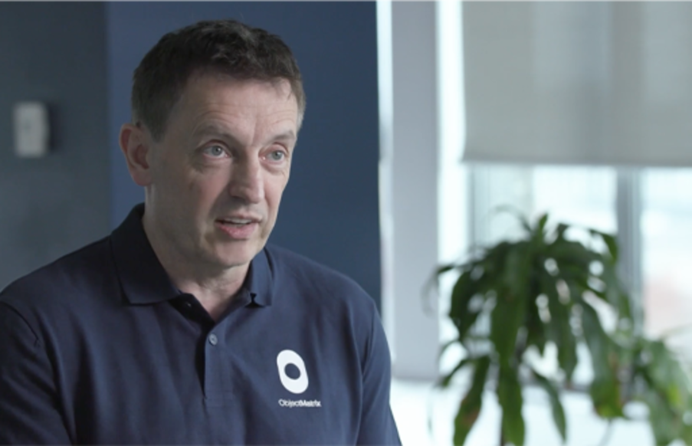

Then take some time to familiarise yourself with your own organisation’s policies and guidance for managing data.
You may wish to make notes in the box below.

Provide your answer...

6 Digital futures: digital transformation
Digital transformation accelerated during the pandemic:

According to a new McKinsey Global Survey of executives, their companies have accelerated the digitization of their customer and supply-chain interactions and of their internal operations by three to four years. And the share of digital or digitally enabled products in their portfolios has accelerated by a shocking seven years
Source: COVID-19 digital transformation & technology, McKinsey

Digital transformation is how organisations implement business models that consider and leverage the development of technology. It aims to enhance the capability of its people and develop processes to ensure it can succeed in the future.
This rapid acceleration has seen companies introduce temporary solutions that are now embedded and evolving to meet the need for new ways of working. For organisations and individuals this will require the resilience to continue to work with uncertainty and learn new skills as new technology is adopted.
Some key themes organisations are considering for the future include:
- automation of business processes – machine learning and artificial intelligence (AI)
- cloud computing
- use of data to drive decision making
- attracting talent with the right digital capabilities
- zero-trust approach to security
- how the metaverse will develop
- sustainability – reaching net-zero, and carbon footprints.
In the video contributors explain what organisations need to consider for digital transformation and the digital capabilities required for the future:

Video content is not available in this format.
View transcript - Uncaptioned interactive content

We are frequently hearing the term ‘the 4th Industrial revolution’. In the following video, Jessica Leigh Jones MBE, Chief Executive Officer of iungo Solutions briefly explains what this means.

Video content is not available in this format.
View transcript - Uncaptioned interactive content

Activity 20 What is driving digital transformation?
15 minutes

Read The 5 great shifts driving digital transformation (digileaders.com) ,which explores some of the areas that leaders of organisations need to consider, and The New Reality group’s research themes and then use the infographic from it to think about what is needed to enable digital transformation in your organisation.
Which steps seem appropriate or most relevant in your context?

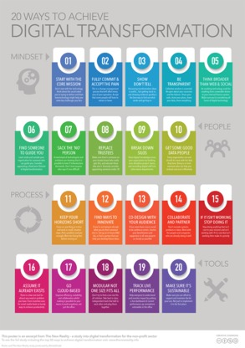
Figure 9 Source: The New Reality (n.d)
View description - Figure 9 Source: The New Reality (n.d)

Activity 21 Explore what digital transformation for HEIs might involve
15 minutes

Explore the resources below:
Leading the digital transformation of higher education, The Campus Learn, Share, Connect (timeshighereducation.com)
Dx: Digital Transformation of Higher Education | EDUCAUSEConsider the Three Ds When Talking about Digital Transformation | EDUCAUSE
Educause suggest the three Ds in the image below. Where do you feel your HEI is in its journey to digital transformation?

Interactive content is not available in this format.

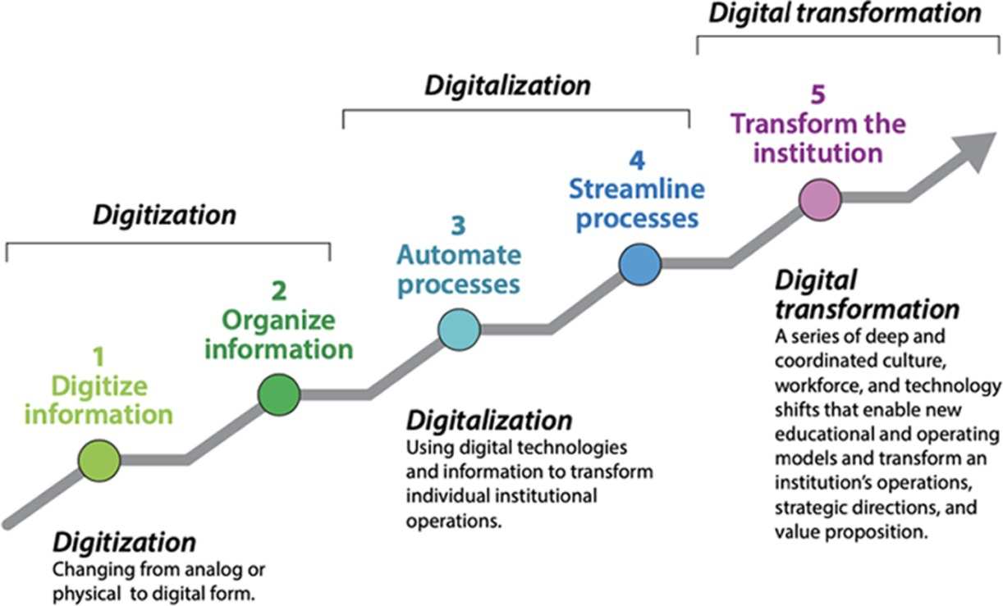
Figure 10 Digital transformation
View description - Figure 10 Digital transformation

Digital transformation has to be considered in the wider context of organisational development and the environment you are operating in, including reducing carbon emissions to reach net-zero by 2050.

6.1 Exploring your digital carbon footprint
Sustainability is now essential, and part of the digital transformation that organisations need to consider. In this section we consider what HEIs can do to manage their carbon footprint.
‘IT is often one of the biggest contributors to an education institution’s own carbon footprint, with one UK college attributing 20% of its emissions to IT alone.’ (Exploring digital carbon footprints, Jisc, 2022). Reducing digital carbon footprints whether those of organisations or individuals will become a priority as HEIs have committed to get to net zero by 2050 or before.
The Exploring digital carbon footprints report from Jisc focuses on source and impact of four key areas: procurement, on-premises IT, cloud technologies and remote working, which we recommend you read outside of this course due to its length.
In the video below Scott Stonham, the author of the report, provides an overview of the key areas of the report.

Video content is not available in this format.
View transcript - Uncaptioned interactive content

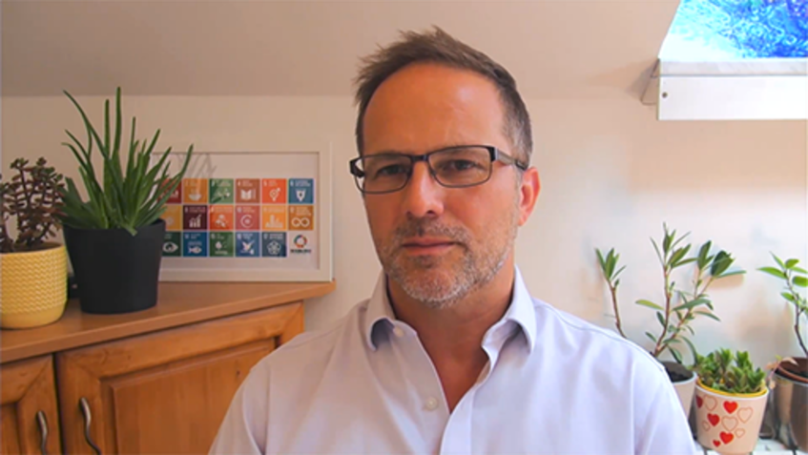

You may wish to read the following articles on OpenLearn by Scott Stonham that provide further insights:
- Reducing the digital carbon footprint of the cloud
- Reducing the carbon footprint of on-premises IT
- How we can all tackle our digital carbon footprints
- Reducing digital carbon footprint through responsible procurement
- Digital carbon footprints and remote working
- How can corporations reduce digital carbon footprints
- What is a digital carbon footprint?
The strategy for reducing your digital carbon footprint needs to be considered alongside all elements of organisational development. If this is an area you have an interest in we would recommend you review the Hybrid working: Organisational development course within this collection.
As organisations adopt more sustainable practices, you as an individual need to be open to new ways of working, and commit to changes you can make both in your professional and personal lives.
Digital carbon emissions can be difficult to visualise as how often do you think about what is involved for technology to exist? When you talk about cloud computing what image comes to mind?
At a basic level the cause of the rising digital carbon footprint is due to:
- manufacturing and shipping of parts and products
- powering and cooling of technologies infrastructures
- disposal of electronic waste (e-waste)
- behaviour of consumers.
Manufacturing processes are not always sustainable, data centres (the cloud – the physical servers that store and process data) consume energy continually and require cooling ventilation. Electronic devices require energy to run, and e-waste can be difficult to recycle due to the non-renewable resources within products.

Activity 22 Reducing your digital data carbon footprint
10 minutes

The amount of digital data within organisations grows daily, and managing this is challenging. While organisations will have policies, processes and automated systems to try to help reduce redundant data, some of these are dependent on individuals to manage digital data responsibly.
In the video below Scott shares insights into how digital data impacts digital carbon footprints and the measures organisations and individuals can take. As you watch, make notes on areas you believe could be easily adopted, and commit to changes you can make as an individual.

Video content is not available in this format.
View transcript - Uncaptioned interactive content

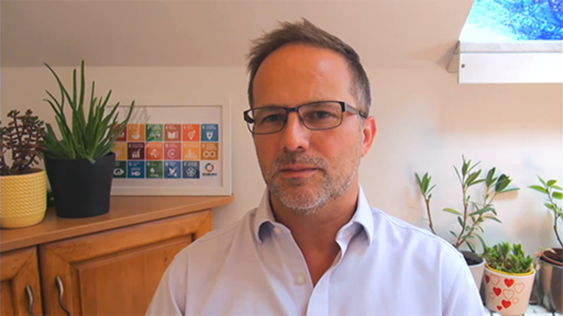

The Exploring Digital Carbon report includes simple tips that can help reduce carbon footprint and tools to help understand your emissions, including the following.
- Consider how much you are using your smartphone (the average usage is 2.5 hours day).
- Reduce the brightness of your monitor.
- Turn off devices, even in ‘stand-by mode’.
- Reduce the use of email – read the article ‘The hidden cost of your emails on the planet’
- Simplify email signatures – remove unnecessary images.
- Delete electronic files and emails you no longer need and empty your deleted items folders.
- Download instead of stream audio and video.
- Unsubscribe from enewsletters you no longer want to receive.
- Extend the life of your products – do you really need the latest model? Think of the four Rs: reduce, repair, reuse, recycle.
In this video Scott provides further tips and advice on how you can reduce your digital carbon footprint.

Video content is not available in this format.
View transcript - Uncaptioned interactive content

Conclusion
Developing digital skills, capabilities and behaviours, both as an individual and as an organisation, is a continual process as technology and ways of working evolve. Our reliance on technology is essential to live and work.
As your confidence and competence grow you will be able to make more informed decisions and use technology responsibly and sustainably to your advantage, to ensure that your organisation's needs and the needs of your employees, students and the wider community can be met in a digital world.
Digital in Wales: an opportunity
At the start of this course we asked you to read A journey to a prosperous Wales – Section 5 Skills for the future.
Wales is considered one of the most advanced countries in the world for its innovative approach to sustainability through the Well-being of Future Generations (Wales) Act 2015, and its digital strategy clearly sets out what is required to develop the skills and infrastructure for the future.
Drawing on the notes you have made throughout this course, and reviewing the Digital Strategy for Wales, reflect on what you think HEIs need to focus on for the future to build digital capabilities and ensure that their digital transformation will support the wellbeing of future generations.
This course is part of the Supporting hybrid working and digital transformation collection, which you may wish to explore further.

References
Askham, N. (2019) ‘Why You Need Data Governance’, Nicola Askham The Data Governance Coach, 7 June [Blog]. Available at: https://www.nicolaaskham.com/blog/tag/DMBOK (Accessed: 1 September 2022).
Brown, A. (2022) ‘The 5 great shifts driving digital transformation’, Digital Leaders, 19 May [Blog]. Available at: https://digileaders.com/the-5-great-shifts-driving-digital-transformation/ (Accessed: 1 September 2022).
Center for Digital Dannelse (n.d.) The Digital Competence Wheel [Online]. Available at: https://digital-competence.eu/dc/ (Accessed: 1 September 2022).
Centre for Digital Public Services (2022) ‘Bridging the digital divide in Wales’, Welsh Government, Centre for Digital Public Services, 7 April [Blog]. Available at: https://digitalpublicservices.gov.wales/bridging-the-digital-divide-in-wales/?_ac=true&confirm=77ffd48435 (Accessed: 1 September 2022).
Chando, L. (2019) Maslow hierarchy of digital needs to youth: digital needs in business contexts [Online]. Available at: https://www.linkedin.com/pulse/maslow-hierarchy-digital-needs-youth-business-contexts-laston-chando/ (Accessed: 1 September 2022).
CWJobs (n.d.) The hidden cost of your emails on the planet [Online]. Available at: https://www.cwjobs.co.uk/insights/environmental-impact-of-emails/ (Accessed: 1 September 2022).
Future Generations Commissioner for Wales (2019) A journey to a prosperous Wales [Online]. Available at: https://www.futuregenerations.wales/wp-content/uploads/2019/09/FINAL-Prosperous-Wales-Topic-5-1.pdf (Accessed: 1 September 2022).
Future Generations Commissioner for Wales (2022) Well-being of Future Generations (Wales) Act 2015 [Online]. Available at: https://www.futuregenerations.wales/about-us/future-generations-act/ (Accessed: 1 September 2022).
GitLab (n.d.) GitLab SAFE Framework [Online]. Available at: https://about.gitlab.com/handbook/legal/safe-framework/ (Accessed: 1 September 2022).
Good Things Foundation (2021) The digital divide [Online]. Available at: https://www.goodthingsfoundation.org/the-digital-divide/ (Accessed: 1 September 2022).
Gov.uk (2018) Essential digital skills framework [Online]. Available at: https://assets.publishing.service.gov.uk/government/uploads/system/uploads/attachment_data/file/738922/Essential_digital_skills_framework.pdf (Accessed: 1 September 2022).
Gov.uk (2019) Essential digital skills framework [Online]. Available at: https://www.gov.uk/government/publications/essential-digital-skills-framework (Accessed: 1 September 2022).
Gov.uk (n.d) The Skills Toolkit [Online]. Available at: https://theskillstoolkit.campaign.gov.uk/ (Accessed: 1 September 2022).
Gov.uk (n.d) Learn how to use the internet [Online]. Available at: https://www.learnmyway.com/ (Accessed: 23 August 2022).
Gov.uk (n.d) Intellectual property and your work [Online]. Available at: https://www.gov.uk/intellectual-property-an-overview (Accessed: 1 September 2022).
Gov.uk (n.d) Patents, trade marks, copyright and designs [Online]. Available at: https://www.gov.uk/browse/business/intellectual-property (Accessed: 1 September 2022).
Gov.wales (2020) Digital inclusion and basic digital skills [Online]. Available at: https://gov.wales/sites/default/files/publications/2020-12/digital-inclusion-and-basic-digital-skills-in-wales-2019-to-2020.pdf (Accessed: 1 September 2022).
Gov.wales (n.d) Digital competence framework [Online]. Available at: https://hwb.gov.wales/curriculum-for-wales/cross-curricular-skills-frameworks/digital-competence-framework (Accessed: 1 September 2022).
Gov.wales (n.d) Digital inclusion forward look: towards a digitally confident Wales [Online]. Available at: https://gov.wales/digital-inclusion-forward-look-towards-digitally-confident-wales-html (Accessed: 1 September 2022).
Gov.wales (n.d) Digital communities Wales [Online]. Available at: https://www.digitalcommunities.gov.wales/ (Accessed: 1 September 2022).
Imperva (n.d) What is Information Security (InfoSec)? [Online]. Available at: https://www.imperva.com/learn/data-security/information-security-infosec (Accessed: 1 September 2022).
Information Commissioner’s Office (n.d) Guide to the UK General Data Protection Regulation (UK GDPR): Principles [Online]. Available at: https://ico.org.uk/for-organisations/guide-to-data-protection/guide-to-the-general-data-protection-regulation-gdpr/principles/ (Accessed: 1 September 2022).
Information Commissioner’s Office (n.d) Guide to the UK General Data Protection Regulation (UK GDPR): Security [Online]. Available at: https://ico.org.uk/for-organisations/guide-to-data-protection/guide-to-the-general-data-protection-regulation-gdpr/security/ (Accessed: 1 September 2022).
Intellectual Property Office (1988) Copyright, Designs and Patents Act 1988 [Online]. Available at: https://assets.publishing.service.gov.uk/government/uploads/system/uploads/attachment_data/file/957583/Copyright-designs-and-patents-act-1988.pdf (Accessed: 1 September 2022).
IT Governance (n.d.) Information Classification Software for ISO 27001 [Online]. Available at: https://www.itgovernance.co.uk/data-classification-software (Accessed: 1 September 2022).
Java Assignment Help (2021) ‘Top 11 essential uses of technology in everyday life’, Java Assignment Help, 14 September [Blog]. Available at: https://www.javaassignmenthelp.com/blog/uses-of-technology/ (Accessed: 1 September 2022).
Jisc (2022) Exploring digital carbon footprints, 10 June [Online]. Available at: https://www.jisc.ac.uk/reports/exploring-digital-carbon-footprints (Accessed: 1 September 2022).
Jisc (n.d) What is digital capability [Online]. Available at: https://digitalcapability.jisc.ac.uk/what-is-digital-capability/ (Accessed: 1 September 2022).
Jisc (n.d) Discovery tool [Online]. Available at: https://www.digitalcapability.jisc.ac.uk/our-service/discovery-tool/ (Accessed: 1 September 2022).
Jisc (n.d) Individual digital capabilities [Online]. Available at: https://www.digitalcapability.jisc.ac.uk/what-is-digital-capability/individual-digital-capabilities/ (Accessed: 1 September 2022).
Jisc (n.d) Digital wellbeing [Online]. Available at: https://digitalcapability.jisc.ac.uk/what-is-digital-capability/digital-wellbeing/ (Accessed: 1 September 2022).
Learn My Way (n.d.) Online safety [Online]. Available at: https://www.learnmyway.com/subjects/online-safety/ (Accessed: 1 September 2022).
McKinsey & Company (2020) How COVID-19 has pushed companies over the technology tipping point—and transformed business forever, 5 October [Online]. Available at: https://www.mckinsey.com/business-functions/strategy-and-corporate-finance/our-insights/how-covid-19-has-pushed-companies-over-the-technology-tipping-point-and-transformed-business-forever (Accessed: 1 September 2022).
National Careers Service (n.d.) Careers advice [Online] Available at: https://nationalcareers.service.gov.uk/careers-advice (Accessed: 1 September 2022).
National Cyber Security Centre (2021a) Top tips for staying secure online [Online]. Available at: https://www.ncsc.gov.uk/collection/top-tips-for-staying-secure-online (Accessed: 1 September 2022).
National Cyber Security Centre (2021b) Connected places cyber security principles [Online]. Available at: https://www.ncsc.gov.uk/collection/connected-places-security-principles/understanding-your-connected-place/understanding-the-risks-to-your-connected-place (Accessed: 1 September 2022).
National Cyber Security Centre (n.d.) What is cyber security? [Online]. Available at: https://www.ncsc.gov.uk/section/about-ncsc/what-is-cyber-security (Accessed: 1 September 2022).
Norton (2021) 20 internet safety tips and checklist to help families stay safer online, 13 August [Online]. Available at: https://us.norton.com/internetsecurity-kids-safety-stop-stressing-10-internet-safety-rules-to-help-keep-your-family-safe-online.html# (Accessed: 1 September 2022).
OECD Digital Government Policy Framework (31 March 2021) YouTube video, Added by OECD KPC Public Governance Programme [Online]. Available at: https://www.youtube.com/watch?v=3Gj8cvrrTsg (Accessed: 1 September 2022).
Office for National Statistics (ONS) (2022a) Is hybrid working here to stay? 23 May [Online]. Available at: https://www.ons.gov.uk/employmentandlabourmarket/peopleinwork/employmentandemployeetypes/articles/ishybridworkingheretostay/2022-05-23 (Accessed: 1 September 2022).
Office for National Statistics (ONS) (2022b) Business insights and impact on the UK economy, 10 March 2022 [Online]. Available at: https://www.ons.gov.uk/businessindustryandtrade/business/businessservices/bulletins/businessinsightsandimpactontheukeconomy/10march2022 (Accessed: 1 September 2022).
Orlik, J. (2018) Four steps to define digital skills, 13 February [Online]. Available at: https://www.nesta.org.uk/blog/four-steps-to-define-digital-skills/ (Accessed: 1 September 2022).
Preferred IT Group (2019) ‘The three goals of cyber security-CIA Triad defined’, Preferred IT Group, 27 August [Blog]. Available at: https://www.preferreditgroup.com/2019/08/27/the-three-goals-of-cyber-security-cia-triad-defined/ (Accessed: 1 September 2022).
Reinitz, B. (2020) Consider the Three Ds When Talking about Digital Transformation, 1 June [Online]. Available at: https://er.educause.edu/blogs/2020/6/consider-the-three-ds-when-talking-about-digital-transformation (Accessed: 1 September 2022).
The New Reality (n.d) Key themes from the research [Online]. Available at: https://thenewreality.info/all-themes (Accessed: 1 September 2022).
The New Reality (n.d) 20 Ways to achieve digital transformation [Online]. Available at: https://thenewreality.info/poster (Accessed: 1 September 2022).
The Open University (2019) Introduction to cyber security: stay safe online [Online]. Available at: https://www.open.edu/openlearn/science-maths-technology/introduction-cyber-security-stay-safe-online?active-tab=description-tab (Accessed: 1 September 2022).
The Open University (2020) Inclusive education: knowing what we mean (Wales) [Online]. Available at: https://www.open.edu/openlearn/education-development/education-careers/inclusive-education-knowing-what-we-mean-wales/content-section-overview?active-tab=description-tab (Accessed: 1 September 2022).
Times Higher Education (n.d) Leading the digital transformation of higher education [Online]. Available at: https://www.timeshighereducation.com/campus/spotlight/leading-digital-transformation-higher-education (Accessed: 1 September 2022).
Turner, J. (2022) The 7 Main Ways Technology Impacts Your Daily Life, 20 August [Online]. Available at: https://tech.co/vpn/main-ways-technology-impacts-daily-life (Accessed: 1 September 2022).
UK Copyright Service (2022) UK Copyright Law: Fact sheet P-01 [Online]. Available at: https://copyrightservice.co.uk/copyright/p01_uk_copyright_law (Accessed: 1 September 2022).
UK Parliament (2020) COVID-19 and the digital divide, 17 December [Online]. Available at: https://post.parliament.uk/covid-19-and-the-digital-divide/ (Accessed: 1 September 2022).
United Nations World Food Programme (n.d.) Freerice [Online]. Available at: https://freerice.com/categories/english-vocabulary (Accessed: 1 September 2022).
University of Wales Trinity Saint David (2022) Copyright Hub [Online]. Available at: https://www.uwtsd.ac.uk/library/help-and-support/support-for-staff/copyright-hub/ (Accessed: 1 September 2022).
World Food Programme (n.d) WFP and the Sustainable Development Goals [Online]. Available at: https://www.wfp.org/sdgs (Accessed: 1 September 2022).

Acknowledgements
This free course was written by Esther Spring, with support from Jo Parker.
Except for third party materials and otherwise stated (see terms and conditions), this content is made available under a Creative Commons Attribution-NonCommercial-ShareAlike 4.0 Licence.
The material acknowledged below is Proprietary and used under licence (not subject to Creative Commons Licence). Grateful acknowledgement is made to the following sources for permission to reproduce material in this free course:
Images
Course image: Chris Canon; Alamy Stock Photo
Figure 1: © Crown Copyright 2018; from https://assets.publishing.service.gov.uk/government/uploads/system/uploads/attachment_data/file/738922/Essential_digital_skills_framework.pdf
Figure 2: The Open University; source https:https://www.javaassignmenthelp.com/blog/uses-of-technology/
Figure 3: courtesy of Esther Spring
Figure 5: © Akbayrak Emre; https://bluesyemre.com/2019/08/19/digital-needs-pyramid-of-maslow-2-0/
Figure 6: © Dama International (2017)
Figure 7: © 2022 Gitlab B.V.,
Figure 9: © Julie Dodd; CC BY-NC-SA
Figure 10: © 2020 Betsy Tippens Reinitz. taken from Consider the Three Ds When Talking about Digital Transformation
Every effort has been made to contact copyright owners. If any have been inadvertently overlooked, the publishers will be pleased to make the necessary arrangements at the first opportunity.
Don’t miss out
If reading this text has inspired you to learn more, you may be interested in joining the millions of people who discover our free learning resources and qualifications by visiting The Open University – www.open.edu/openlearn/free-courses.

Solutions

Activity 3 How digitally confident are you?

Discussion
For those in the workplace, most of the skills given here may be familiar. They draw on the UK Government’s Essential Digital Skills Framework document, which this activity is based on.
How confident do you feel about the essential foundation skills that are described within the document? If there are areas you would like to develop the HM Government Skills Toolkit provides resources to help you develop specific skills. Within it is the Learn My Way set of resources that provide basic computer skills training.
Back to - Activity 3 How digitally confident are you?

Activity 6 Jisc’s framework: how digitally confident are you?

Discussion
Within The Open University the following approach has been taken to set Jisc’s digital capabilities into the OU context. Subject matter experts from across The Open University have collaborated to develop an approach to build and support digital capabilities, through guidance, training, support and processes.

Table 5
Capability | This means that we….
Using technology​  (ICT proficiency)​ | - use ICT-based tools, devices, applications, software and services confidently, choosing the right tool for the job (ICT proficiency)​
Digital communication, collaboration and participation​ | - communicate effectively, appropriately and respectfully in digital spaces (digital communication)​​  - collaborate effectively in digital teams; we understand the features of different digital tools for collaboration, and understand the range of cultural and social norms for working together (digital collaboration)​​  - participate in, facilitate and build digital networks; we behave safely and ethically in networked environments (digital participation) ​
Digital creation, problem solving and innovation​ | - know how to create and design new digital materials e.g. audio, web pages (digital creation) ​  - know how to use digital evidence to solve problems; we collect and collate new evidence and share it, and evaluate its quality (digital research and problem solving)​​  - adopt and develop new digital practices in different settings (digital innovation)​
Information, data and media literacy​ | - know how to find, evaluate, manage, curate, organise and ethically share digital information (information literacy)​  - use data to inform our decisions: we manage, collate, access and use it, we interpret it, and know how to keep it safe (data literacy)​  - know how to receive, evaluate and respond to messages in a range of media (text, graphics, video, animation, audio) – and to curate, re-edit and repurpose it, crediting its creators (media literacy)​
Digital learning and teaching​  (digital learning and development)​ | - participate in and benefit from digital learning opportunities (digital learning)​​  - we support and develop others to teach in digital settings (digital teaching)​
Digital identity, wellbeing​ and sustainability | - develop a positive digital identity, managing our digital reputation (digital identity management)​​  - look after personal health, safety, relationships and work-life balance in digital settings, and act safely and responsibly in digital environments (digital wellbeing)​  - consider how we can work in a more digitally sustainable way to assist the organisation meet its net zero targets. (Digital sustainability)

Note: The Open University has included digital sustainability as an additional capability, that is not part of the Jisc framework.
Back to - Activity 6 Jisc’s framework: how digitally confident are you?

Activity 8 What activities in your digital life rely on technology?

Answer
The image below shows just some of the areas of daily life where technology is used. As you can see, it impacts almost every aspect of our lives.

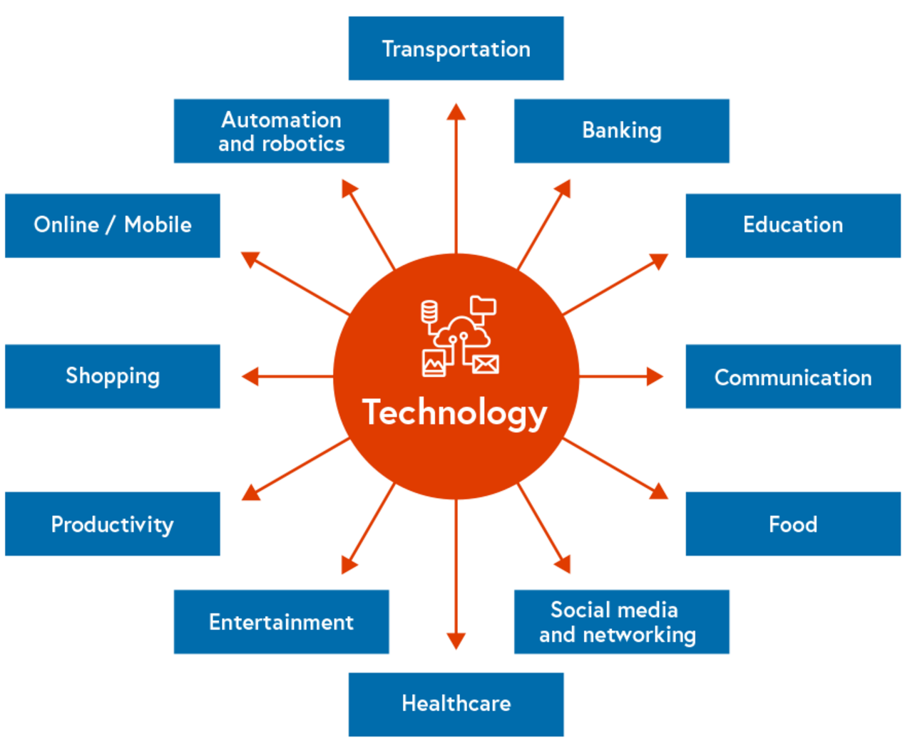
Figure 2 Some of the ways in which technology is used
View description - Figure 2 Some of the ways in which technology is used

Back to - Activity 8 What activities in your digital life rely on technology?

Activity 13 How did you feel?

Discussion
You may have been very wary of attempting these activities with minimal instructions, and even uncomfortable. Or you may have been very willing to explore. What support did you require? Did you look for guidance? Each of us has different levels of curiosity and confidence when faced with digital tasks – read more about our responses, in the next section.
Back to - Activity 13 How did you feel?

Activity 14 What are your digital security responsibilities in the workplace?

Answer
It is important to remember that digital wellbeing, safety and security can refer to both online and offline environments. Table 7 presents some simple tips on this subject:

Table 7
Online | Offline
Do you have bitlocker keys for your devices? | Where do you secure your devices when not in use?
How secure is your password? Do you change it regularly?  You can check it on:  How Secure Is My Password?  Does it comply with your organisation’s guidance? | Do you lock your computer if you leave your work area?  Do you know who to contact if you cannot access your systems or get online?
Does your organisation use Multi-Factor Authentication (MFA) and have you set yours up correctly? | Who can see your screen when working?
Do you consider how you share information both internally and externally? How sensitive is it? | What work matters do you discuss with others?
Do you use passwords on sensitive documents when necessary? | How do you store physical documents?
Do you know what to do if you receive spam emails? | Who do you let use your devices?

The National Cyber Security Centre has further tips for staying secure online and the Learn My Way website has a basic introduction to Online Safety resource that you may wish to explore.
Back to - Activity 14 What are your digital security responsibilities in the workplace?

Figure 1 Essential Digital Skills – Framework Diagram (Crown Copyright, Gov.uk, 2018)

Description
Image showing the Essential Digital Skills Framework using a circular diagram of circles within circles. The smallest circle in middle is labelled with ‘Foundation skills’, this expands to a larger circle split into four sections: ‘Communicating: Communicate and collaborate and share online’. ‘Handling information and content: Find, manage and store digital information and content securely.’ ‘Transacting: Apply for services, buy and sell, and manage transactions online.’ ‘Problem solving: Find solutions to problems using digital tools and online services.’ Finally, there is another surrounding circle that repeats the phrase ‘Be safe, legal and confident online.’
Back to - Figure 1 Essential Digital Skills – Framework Diagram (Crown Copyright, Gov.uk, 2018)

Figure 2 Some of the ways in which technology is used

Description
Image shows a central box titled ‘Technology’ with arrows pointing out to multiple other boxes titled as follows: Banking, Education, Communication, Food, Social media and networking, Healthcare, Entertainment, Productivity, Shopping, Online/mobile, Automation and robotics, Transportation.
Back to - Figure 2 Some of the ways in which technology is used

Figure 3 A photograph of a broken laptop

Description
A photograph of a broken laptop. The keyboard section of the laptop is separated from the screen and both have been placed on a glass desk. There is a second laptop on the table, which doesn’t appear to be broken.
Back to - Figure 3 A photograph of a broken laptop

Figure 4 Being digitally safe

Description
Image shows a diagram on being digitally safe. This text is in the centre and there is a triangle around it with the terms safety, security and wellbeing at each triangle point.
Back to - Figure 4 Being digitally safe

Figure 5 Maslow 2.0: digital needs

Description
Image shows the Maslow 2.0 pyramid of digital needs, showing how newer generations perceive their needs. The pyramid is split into five levels. From bottom to top, the levels are denoted Physiological, Safety, Belonging and love, Esteem, Self-actualization.
Back to - Figure 5 Maslow 2.0: digital needs

Figure 6 The DAMA-DMBOK data governance wheel

Description
Image shows a circle split into segments around the phrase ‘Data Governance’. Segment labels from the top of the circle clockwise are: Data Modelling & Design, Data Storage & Operations, Data Security, Data Integration & Interoperability, Document & Content Management, Reference & Master Data, Data Warehousing & Business Intelligence, Metadata, Data Quality and Data Architecture.
Back to - Figure 6 The DAMA-DMBOK data governance wheel

Figure 7 GitLab SAFE framework

Description
Image shows a boxes and lines diagram expanding on the SAFE acronym and how it works. There are four boxes on the left that sit vertically and two further boxes on the right of the image. Top left box: Does this material include any SENSITIVE or material non-public information? If the answer is yes, then the arrow points to the upper of the two boxes on the right that reads: Do not share without proper approvals. If the answer is no, then the arrow points to the next box down on the left. Second left box: Is the information ACCURATE and verifiable? If the answer is no, then the arrow points to the upper of the two boxes on the right that reads: Do not share without proper approvals. If the answer is yes, then the arrow points to the next box down on the left. Third left box: Does this information include FINANCIAL data, metrics, or predictions? If the answer is yes, then the arrow points to the upper of the two boxes on the right that reads: Do not share without proper approvals. If the answer is no, then the arrow points to the bottom box on the left. Bottom left box: Could sharing this information have a harmful EFFECT on our team members or the business? If the answer is yes, then the arrow points to the upper of the two boxes on the right that reads: Do not share without proper approvals. If the answer is no, then the arrow points to the lower box on the right that reads: SAFE to share.
Back to - Figure 7 GitLab SAFE framework

Figure 8 Preferred IT Group (2019)

Description
Image shows a triangle representing the three goals of cyber security. The centre is titled Information security. The top area is titled Integrity, the bottom left Confidentiality, and the bottom right Availability.
Back to - Figure 8 Preferred IT Group (2019)

Figure 9 Source: The New Reality (n.d)

Description
Image of a poster that is titled 20 ways to achieve digital transformation. There are 20 boxes, labelled 1 to 20, split into four rows of five boxes per row. The rows are titled (top to bottom): Mindset, People, Process, Tools. Boxes are titled: 1 Start with the core mission, 2 Fully commit and accept the pain, 3 Show don’t tell, 4 Be transparent, 5 Think broader than web and social, 6 Find someone to guide you, 7 Sack the ‘no’ person, 8 Replace trustees, 9 Break down silos, 10 Get some good data people, 11 Keep your horizons short, 12 Find ways to innovate, 13 Co-design with your audience, 14 Collaborate and partner, 15 If it isn’t working stop doing it, 16 Assume it already exists, 17 Go cloud-based, 18 Modular not one size fits all, 19 Track live performance, 20 Make sure it’s sustainable
Back to - Figure 9 Source: The New Reality (n.d)

Figure 10 Digital transformation

Description
Image shows the process to achieve and differences between digitization, digitalization, and digital transformation. An arrow with five stages along it goes from bottom left to top right. Stages 1 (Digitize information) and 2 (Organize information) sit under Digitization (changing from analogue or physical to digital form). Stages 3 (Automate process) and 4 (streamline process) sit under Digitalization (using digital technologies and information to transform individual institutional operations). Stage 5 (Transform the institution) sits under Digital transformation (A series of deep and coordinated culture, workforce, and technology shifts that enable new educational and operating modules and transform an institution’s operations, strategic directions, and value proposition)
Back to - Figure 10 Digital transformation

Uncaptioned interactive content

Transcript
MATT WINTLE
When I think about the types of skills and knowledge that a business is going to need to be able to run effectively into the future, you can't deny that digital and data are going to be ubiquitous skills and knowledge that people will need across the business.
But it's not that simple. It's a very simple thing to say, well, let's retrain everybody so they understand data and digital. Well, how do you do that and what do you actually mean by that? Certainly, in a business of our size, there are so many different types of employee. And actually, there are businesses within the business.
Our claims department is very different to our IT department. So, it's not a one size fits all. But the recognition that this is coming, and you have to do something about it is really important. I think then what you need to do is understand the roles that you've got and what knowledge they need.
So, for example, in our business, somebody who is working in the call centre, what do they need to know about data? Well, they need to have an understanding about what the business is talking about when it talks about machine learning and AI and rating models and all of those things.
But they don't really need to know how to do it, and they don't need to know in depth of it. But that understanding is really good for them, because it'll help them understand some of the solutions that we put out and the products that we sell. The industry is catching up in terms of technology, but we're looking to redress that balance now and make sure that we give our internal staff the opportunity to go for some of these roles.
Because these roles are where the future is. The future is data and digital. It's inevitable that that's where we're heading. So, you want your people to develop those skills and move into those areas. So, that's what we do. We offer people opportunity, but we acknowledge that sometimes that's not always going to be the answer. And we try and strike that balance the best we can.
GEMMA HALLETT
Actually, 90% of Fintech jobs are tech jobs. The Fin is already taken care of by the organisation or by the founder or whatever it might be. The finance part of it is already done. We need now, coders, engineers, testers, to go and build these products out, scale these products in Wales. And we don't have the talent pipeline.
So, this awareness piece that is part of our strategy is to help raise awareness of Fintech as a viable career option and what those jobs could look like right here in Cardiff. Right. Build around the bigger companies, the admiral principalities, all these start-ups, all these high energy, high scaling, huge opportunities. And that's now, we're just on the take-off of this.
And over the next two or three years, I think Fintech is going to be a priority sector with so much support from the Government and from a collective of companies that I really think it can fly. And for me, it's about making everybody aware that there could potentially be a job for them.
The other side of our strategy is the skill shortages right now. We have a dire skill shortages. It's those kind of lower entry-level jobs we can find talent for. But it's those more acute skill jobs. Like I said before, we haven't done the work to build up that talent pool in Wales yet. So, the awareness piece will do that, but how do I find the talent today? How do I help these Fintechs in Wales find people to employ today to fill these skill shortages? And it's incredibly difficult, because the talent doesn't exist, or it’s being shipped around from one member to the other.
Or jobs are going overseas, and that's the last thing we want. It's really hard to generalise digital skills, because it really depends on the destination the young person or the employee's going. Technology is so different in the workplace. I see it all the time with our innovative start-up, high growth, fast moving companies, start-ups. Exciting places to work of the latest technology.
And then I see maybe, for want of a better position, I'll pick the local authority. I've walked into council buildings, where they're using big desktop monitors, keyboard, and mouse. It's just that if that's the world of work people are going into, then that's a different skill set, especially a digital skill set than the ones for high, fast-growing, fast-moving companies.
So, it depends on where the destination is of what's needed in terms of skill set and how do we achieve that. It's hard to define it in there at school level. But we're also seeing it in the care sector as well. That's gone from writing down daily reports and leaving it in the kitchen, especially in domestic care, where care workers are gone from using pen and paper to now there's an iPad mounted there. And they're having to record everything digitally.
And the skill shortage there, when it comes to digital skills, is huge. The training they have to do to bring somebody that's been in care for the last 10, 20, 30 years to be able to use an iPad and the apps that they use to monitor everything. That's the way the care sector is going, so that needs that skill set as well.
NICOLA ASKHAM
It's really important to help people understand what data they have and then manage it correctly, so it's good enough quality to support good decisions. Data is an interesting term, and it's quite interesting how many people don't actually understand what it is when they're talking about it
Data literacy is a relatively new term, but I don't think the concept is relatively new. So, what it means in the same way that you and I can read books and understand what these words mean, we get to the same degree of confidence with data.
I think it's fair to say that a majority of people either don't think about data as being part of their job, or if they do, it's a kind of necessary evil or an inconvenience. It makes their life harder as far as they're concerned, whereas I feel that nearly everybody in an organisation has some responsibility for either producing data or using data and doing perhaps a bit of both.
So, what is really important is that people understand the value of the data that they're using as part of their day-to-day job, that they recognise it as an asset, and manage it as an asset.
DR NICK BARRETT
Something we all discovered overnight when the pandemic first struck was that we all needed a different range of digital skills. And I think that's been one of the big learning curves. There are some digital literacy skills, and there are some digital capability skills, which are out there.
But we never thought to apply that to ourselves. Getting used to Teams, for example, as the main means of running a meeting was really quite stressful for a lot of people. And of course, there's a whole range of other skills about doing more work in a paperless environment, making sure that we're storing our content and sharing it effectively, being able to think about digital planning, digital workshops.
So, some of this is organisational, some of it is using new software packages. Some of it is just simply working out the new etiquette. Even now, we have people still on mute or not raising hands. And we'll get there eventually. But once again, it was a real wake up call, if you like, to how many students experience the OU.
This for the first time was us looking through the mirror in the different direction. And that's really sharpened our focus, not just on the skills we need to bring new people into the OU, but how important those skills are when we encourage our students to study with us.
And in many ways, these skills are life skills. These aren't just skills that help you study, these are skills that employers will be looking for. So, building more tools to help people and sharing those tools, of course, to help people with their daily digital lives as more and more of society remains digital. This could be, I think, the greatest or most lasting legacy of the pandemic for the OU.
SARAH JONES
It's hugely important that we raise the digital capabilities of students and staff for a variety of reasons. Most immediately is that we're preparing our students for a very digital workforce. So, digital skills have to be integral to the curriculum. For staff to be able to deliver this and for professional services staff to be able to support this, they also need to have those same levels of digital skills. We're sending people into a increasingly digital environment.
DR BECKI VICKERSTAFF
I think digital capability as a whole, there's no kind of differentiation initially between the staff and the students in terms of that digital capability. If we think outside of the education sector initially, if we look at just our digital world, pretty much everything we need to do is needing to be done online. If we think about even paying our car tax, things like that, that requires us to be able to do these things online.
So, it's having that awareness of the appropriate technology and the appropriate techniques to be able to – again, it's about thriving successfully in a digital world – but also that having that awareness of where our own digital capabilities lie is really important.
And I think with staff and students initially, I think there is a bit of a consensus, if you like, that when students come into the university, they're very naturally digitally literate, if you like. They're very happy with it. But whether that's necessarily true, I think what we have to understand is it's about the correct use of these digital technologies and it's about supporting staff and students.
And it doesn't really matter what role you're in, I think there is this generic need for digital capability across any role, and that could be anyone across a role in an institution, whether that's somebody in your senior leadership team, whether that's a teacher, whether that's an administration member of staff. It doesn't really matter.
And I think it's having that – and this is where that framework is great – because it has that building block that you can build on. And then you do that further in-depth work to identify where you can help with those interventions as well. And that's what we see a lot of our institutions doing.
Back to - Uncaptioned interactive content

Uncaptioned interactive content

Transcript
SOPHIE HOWE
It’s so important for us to be thinking about the sorts of skills that are going to be relevant for people to be able to enter into the world of work in the future, but also to lead good lives. And the world of work is changing exponentially. We know that we have a huge number of skills gaps in industries that we will need to meet our climate targets, for example.
We know that digital is becoming increasingly important. And yet, perhaps in our schools, the digital skills are not as good as they could be. We know that, increasingly, rote learning and regurgitation of knowledge are not the sorts of things that people are going to need in the future. Already, automation and artificial intelligence is outperforming humans in terms of knowledge.
And so the things that we will need to focus on are those human skills, so the things that robots can’t do, cooperation, collaboration, teamwork, empathy, critical thinking. And that means that our whole education system is going to have to shift from where it has been in the past towards helping people to develop those skill sets. It also means that lifelong learning is going to have to become the new normal if we are all to keep up with the changing nature of technology and the changing nature of work.
So we need a big shift in the way in which we’re thinking about skills for the future if we’re going to meet our climate change targets. We know that across the industries in terms of the jobs that are going to be essential to meet those decarbonisation targets, there are huge skills gaps. So we’ve got gaps in terms of skills for people working in nature, gaps in terms of skills of engineers, the people who are going to install our electric vehicle infrastructure, the people who are going to be rebuilding our public transport networks.
And my analysis shows that there are the possibility of creating around 26,000 new jobs in the green economy here in Wales in the next two years. But we need to do that quickly in order to be able to deliver against our climate change targets. We also need to do it in a purposeful way because at the moment, the people who occupy those industries are predominantly white men.
And there is a risk that if we do not focus on targeting underrepresented groups, women, disabled people, those from Black ethnic minority communities into those jobs, there’s a real risk that we exacerbate existing inequality in the workforce. If we get this right, however, there’s a real opportunity for us to be tackling inequality whilst also doing what we need to do to meet our climate change targets.
Back to - Uncaptioned interactive content

Uncaptioned interactive content

Transcript
SAS AMOAH
So, I think there are one or two programmes during the pandemic that we started using a lot more of, and that includes Teams and Zoom. But we also started doing a lot of online only podcasts, as well. And I think, actually, it was really interesting to see members of my team, not necessarily myself, adapt to those new forms of technology and being able to capture academics and discussions purely online to create content that we needed for our website. So, I think, actually, what will be really useful for me is to really start to get my head around those new forms of technology when it comes to capturing media online in a really effective, useful, concise way, so yeah, I think taking a lot of the skills that I've got now and just translating them to an online space.
I have a good idea, I think, of the responsibilities we have working online. At the OU, we do have cybersecurity courses, as well as GDPR courses. And because I'm working in the online space with the public, we're really mindful to be sure that we follow the rules and procedures.
But I suppose in addition to that, we're quite mindful about levels of accessibility, as well, and what the rules and guidance is there. We have lots of training courses that we can go on as part of the OU. But there's also additional subgroups within our unit, which tend to focus on specific areas. So, they tend to communicate with us frequently and give us updates if we need any.
I think I have a good level of understanding when it comes to managing my digital skills and digital spaces. However, I think there's always a need to keep on learning. The digital space evolves so quickly. And even if you did a course last year, actually the landscape could have changed so quickly that you need to update all the skills that you've had. So, I think I'm in a safe-ish space at the moment in terms of my knowledge, but no doubt, I should keep my training refreshed, and I'll have a new course to do, surely.
I think probably the Open University – maybe in particular, because of the nature of the way the University works and being a distance learning organisation – but organisations in general would probably benefit from just making that type of training and digital skills training mandatory. You can't really give people the option to dip in and out when it's such an integral part of the way people work and likely to be a more important part of the way people work looking forward in the future. Maybe one of the key things any institution could do is just to make it mandatory to ensure that people do engage with the training, because they have no choice.
Back to - Uncaptioned interactive content

Uncaptioned interactive content

Transcript
JESSICA LEIGH JONES:
The Well-being of Future Generations Act is a legal framework in Wales that encourages organisations to improve and enhance their social, environmental, economic wellbeing. We're actually the first country in the world to have what you might consider a minister for the unborn. So we have a wellbeing of future generations Commissioner in Wales. The Well-being of Future Generations Act itself is comprised of seven key goals.
So some of those goals, for example, are to create a more resilient Wales, a more prosperous Wales, and a more equal Wales. And digital is one of the key enablers in making that happen. However, it can also be a double-edged sword. Some of the digital infrastructure that we have in Wales isn't quite at the level that it needs to be to enable that digital equity. And actually what happens is we get digital exclusion.
So within the Centre for Digital Public Services, we ran a really amazing alpha program for adult social care, where we completely transformed one of the processes. So we used SMS text message to increase the amount of communication, reduce wait times for patients and carers. And the results were absolutely fantastic.
However, there are still 12% of households in Wales that don't have access to proper broadband or proper mobile phone signals. And those individuals would be completely excluded from a fantastic process like that. So there's still a lot of work that we have to do in order to invest in that digital infrastructure and some work that we have to do to consider people who don't have access to that.
Where I live, which is very rural, I've been unable to use two-factor authentication, which is an essential cybersecurity measure for any organisation. Again, because I can't receive text messages. So developers of digital tools and standards have to think beyond what the majority of the population can access because some people will be completely excluded from using those tools.
Jobs for life are a thing of the past. It's not even about changing career multiple times anymore. It's about actually creating your own jobs in the future. And so the role that further education and higher education can play in equipping people with those digital skills is to really look at how we create short, sharp, upskilling interventions for individuals and for industries and for employers who are going on that journey.
GEMMA HALLETT:
I'm not anti-university, I'm just pro showing all the options and in a way that's digitally inclusive, accessible, to young people. The ones that are going off to university, that 20%, 30%, they're taken care of. You don't need to worry about them. But we need to worry about the 70%, 80%. So using a tool, a digital application that they've engaged with, that they've co-created is a way of showing all those opportunities, so many opportunities, particularly in Wales right now, you've got growth emerging in priority sectors.
That ultimately, these school leavers, young people can-- I say it's not about jobs of the future, it's about sectors of the future. But for young people, it's getting into work early, earning that skill, learning and earning. In this economy, it's a difference between leaving with debt or leaving with a degree and no debt. There are so many options. I've met young people in the valleys that are upskilling through various micro-credential courses that are running side hustles through-- self-taught through YouTube. There's incredible opportunity.
We have people in industry making decisions, we’re still coming from the hierarchical perspective. It's OK, we've always done it this way, so we'll continue doing it this way. And we're coming up against barriers then and blockages. But all you've got to do is speak to young people or speak to the people you're employing, speak to the people you're working with, what works best for you.
We can't just generalise that everybody’s coming with digital skill sets. Especially in rural Wales, we just don't have access to it. A lot of people, young people in south Wales, are living in generational poverty, we’re in third generational poverty in some of the valleys. If we can break down those barriers using a very simple concept the young people help design to bring these opportunities into their communities and with working as it is, hybrid models. We got the companies in Cardiff that can employ people from the valleys. And without having to travel, they can work.
There is an opportunity and equally a challenge for Welsh organisations. So if we just centralise around Cardiff right now, Cardiff companies are able to employ people in the valleys, people who may find traveling to Cardiff it's more of an occasion than a commute. So it opens up that talent pool. We can get into the communities because of remote working. We can offer Welsh people Welsh jobs.
Conversely, because the skill set is maybe not there, those jobs are actually going remote elsewhere. 99.7% of businesses in Wales are SME, 70% of them are one-man bands. So they don't have the resource to upskill handhold staff. So there's a challenge there. And I'm trying to solve that challenge.
MATT WINTLE:
Equality in people working from home, I think, is really important to us. And that is ensuring that people have the same opportunities. And that's ensuring that people have the same or equal working environment because of that. And it's being able to react to that and listen to that and give people what they need to be able to do the job well. And we've done that in a number of ways. We've done that through financial support, we've done that through technical support, we've resisted saying, well, actually you'll have to come back in then because that, again, creates that two-tier system.
So I think being very aware that not all things are equal and being able to react to that and give people the support they need has been really important for us. And it wasn't easy. Those first three or four months, I was still working in technology at that point, was a Herculean task. To be able to get everybody the tools that they needed to be able to do the job effectively is really tough. And if you didn't go through that concentrated period of doing it, then I think the focus on that over time, you have to retain that focus because otherwise, you'll leave people behind.
And you only need to leave a few people behind to start breaking down that positive culture that you might have in your business. It's really important that as a business you continue to focus on the equality of people working at home and working in the office and making that experience great for everybody, especially with the potential inequities of people's home environments and their technology and what they have to work with. And you can't forget that because even if you've done a lot of effort to get people there, it may not always be the same. So now that just becomes a normal part of running the business.
MICHAEL WOODS:
So one of the things which have to be considered by organisations who are trying to encourage people from working from home is also thinking about equity of access to that, because another dimension of this is, of course, that in order to work from home, you do need a reliable broadband connection. You need that accessibility of digital infrastructure.
So there are concerns. I think in thinking through that, there's a need to how people living in different areas have different ability to work from home, there is a sense that the growth of this may be geographically uneven, it may favour some regions over others. And organisations and companies which are encouraging work from home might wish to consider that, may wish to consider what support they might need to give to employees who maybe are already living in areas which have less strong access to the digital infrastructure.
Whether there's ways in which they can support them, whether they need to, for example, consider rather than working from home, remote hubs or supporting remote access sites. So there are a number of small scale initiatives which are being taken to try to address some of the real blackspots in terms of access to digital infrastructure. But the other way of approaching this is to actually try to think about provision of more collective facilities.
So looking at communal workspaces and hubs, say in small towns. Where there might be access to fast broadband, there might be access to other digital equipment, there might be spaces for meetings, other workspaces, as well those who are working from home, as well as those who have, maybe, local businesses in the area could come in and use. Those might, for example, be joined onto existing facilities like libraries and so on. Or they could be new facilities.
So again, there are some initiatives starting to develop in that way, and there are some historic models of these kind of hubs existing. But I think this is becoming more part of people's planning about how we need to equip Wales, in particular rural Wales, with the infrastructure. Not just in terms of the technical infrastructure, the wires, and the cables, but also the infrastructure of hubs, of access to facilities to ensure that the benefits of the digital economy are equally accessible across all parts of Wales.
NATASHA DAVIES:
The reality is we're going to be incredibly reliant upon digital technology. And if we don't take action to address the quite different levels of digital skills and digital competence that we have across the workforce, I think we are at risk of excluding people, particularly if our ways of ensuring good communication, collaboration, management of mental health and wellbeing, are increasingly reliant upon new and emerging technologies.
So I think as businesses, but also from the government, we absolutely need to have investment in basic digital skills to make sure that everybody's got a good baseline. I think, some organisations had to quite quickly during the pandemic, adopt a far more digital first approach. So I also think it goes beyond the basic digital skills and making sure that we're supporting staff and our workforce and our leaders to be confident in embracing and trying out new technology as it comes.
It can't be a static thing. Technology can be a great way of including people, but it can, if not used in the right way or isn't thought about from an equalities perspective, it can exclude as well. So I think this is really an important space for everybody to have a basic level of understanding around equality and inclusion. And to be switched on to how that needs to affect decisions about how we're using technology, how we're communicating, how we're structuring things like team meetings, collaborative workspaces, socials, and that kind of thing. If we're going to have a massive shift to more remote working, which does seem inevitable and it's certainly-- it's the goal of the Welsh Government here to have 30% of the workforce moving to working away from the office as the norm. We're going to have to think about the infrastructure that's in place to support that at a very basic level to all parts of Wales.
For example, we've got very large rural parts of the country. Does everybody have access to good high-speed broadband? Not at the moment. So that needs to be fixed as a matter of urgency. Is there good mobile phone coverage? Because we're not always at our desks, in the home office, or we might be reliant upon-- if we’re out and about, on our phones. And again, the coverage isn't great in terms of mobile phone signal.
But I think it also stretches into decisions about building, for example. Are we building properties that as standard, have space for a home office? More of an issue, I think in urban areas, but we have a large number, for example in Cardiff, of HMOs where people literally have a bedroom or studio flats or one-bed flats.
But I think there needs to be a much bigger discussion about the wider implications of a more dispersed and remote working norm. And those conversations have started, but I think they probably need to happen at a much quicker pace to make sure that we're not putting people in a situation that doesn't really work for them where they might not have the space at home, they might not have the access to the broadband that's needed to be able to take up new opportunities.
JO PARKER:
In terms of building an organisation which is digitally inclusive, you can't make one-size-fit-all. You just can't. Everybody's individual, everybody's got different backgrounds, everybody's got different needs and experiences, and you bring all of that with you when you come to work. In terms of inclusion, I think probably, the things that came to the fore-- you know, I work in a library, most of our services are virtual. We were able to shift to online support for our students and deliver most of our services online, anyway.
But I think what we found in our interactions with each other, what was trickier was people having the space to be able to do their work. So appropriate setting to be in work but then make that shift to being at home and preserve that work-life balance. So the space was an issue. Kit. Decent access to kit, decent access to broadband. The relevant hardware and software, making sure that was all set up and working. But then also, there's an issue around skills as well. And I think for me, they're the three main things. When it comes to being inclusive, there are three key things to think about. Have you got the kit, have you got the space, have you got the skills? Thinking about digital skills and the future and where we're going, I think we're looking at more equality of access, I think. I think people who have, perhaps, grown up with more digital stuff will start to-- I was going to say take over, but I don't mean take over.
Will start to really come to the fore and you think about my kids, they're playing with their devices and they're teaching me stuff. And I think just the possibilities of learning from other people and from younger people teaching older people and whatever, I think that's a really exciting prospect.
Back to - Uncaptioned interactive content

Uncaptioned interactive content

Transcript
BECKI VICKERSTAFF
The Jisc digital capability framework is really a way of looking at digital capabilities from a higher level, if you like. And it focuses on six different areas of digital capability. So, we've got ICT proficiency, information data, and media literacies, for example. But this was a framework that was actually designed and worked with and collated and collaborated with the sector as well. And it's one that's used across a lot of higher education institutions, and the sector both nationally and internationally as well.
Within the framework, we have those main six areas of digital capability. So, we have ICT proficiency. So, that's kind of looking at digital proficiency and digital productivity and looking at those in terms of what a user may need to be able to really successfully navigate a digital world. And particularly in an educational setting, we would then be looking at the different types of technologies and methods to be able to really successfully navigate that technology, so they're using it really effectively in the different ways.
We also have information, data, and media literacies as well. So that's looking at areas such as data literacy, information literacy, and media literacy. So, it's being able to successfully navigate data and to be able to look at it successfully in terms of making sure that we're able to retrieve information, but also knowing what to do with that information as well.
We then have digital creation, problem solving, and innovation as well. So, that kind of goes and breaks down into areas, such as digital creation, digital research, and problem solving. So, that problem solving is really important, as obviously we're moving forward in a digital world, particularly with students as well as they look to become the agile graduate of those transferable skills. But also, digital innovation, so being able to understand what digital capabilities are needed to successfully navigate those as well.
We then go into another area on our framework, which is digital communication, collaboration, and participation. So, that's where we start to look at things like digital communication, digital collaboration, and digital participation. So, we're thinking about how we may be particularly thinking about the pandemic as well, how we look at working together online, how that looks successfully, what digital capabilities we may need to be able to do that. So, identifying the correct type of technology or platform to be able to successfully communicate together, and also, obviously, with all of those things is looking at a safe way to do that as well.
And then we have digital learning and development as another area on our framework. So, that's looking at digital learning and digital teaching. So again, that's really important being able to understand the digital capabilities that are needed to support those areas and to allow an individual, whether that's a staff member or a student, to be able to successfully do their role, choose those appropriate technologies, but be able to understand what's needed to develop that area.
And then we've got digital identity and wellbeing, and that kind of really encapsulates across the whole framework. So, we're thinking about all of those different areas, but really looking at that digital wellbeing able to know how long we should be spending online, keeping ourselves safe online, looking at online bullying, that sort of thing. So, it's looking at that digital identity management, so thinking about your digital footprint but also digital wellbeing. So, knowing when maybe spending an hour in front of a Zoom class or a Zoom lecture, and how that impacts our digital wellbeing. So, all of those, sort of, main areas of the framework. We have those six main areas of the framework, which then stem off into a further 15 areas of digital proficiency.
Back to - Uncaptioned interactive content

Uncaptioned interactive content

Transcript

BECKI VICKERSTAFF
The Jisc digital capability framework is really a way of looking at digital capabilities from a higher level, if you like. And it focuses on six different areas of digital capability. So, we've got ICT proficiency, information, data, and media literacies, for example, but this was a framework that was actually designed and worked with and collaborated with the sector as well. And it's one that's used across a lot of higher education institutions and the sector, both nationally and internationally as well.
JO PARKER
We've used it pretty extensively in work with students because one of the things that it enables you to do is think about digital capability from an individual’s perspective, whether that's staff or students, and from an organisational perspective too.
So, we've used it to inform the development of student facing resources. So, for instance, we have our own digital and information literacy framework at the OU to help us think about the skills that we embed into modules for students. So, we've used some of Jisc's thinking there to shape and frame what we mean when we talk about it in a student facing context.
SARAH JONES
The University decided to map to the Jisc digital capabilities framework because essentially the mapping has been done for us. Digital capabilities, digital skills is a very broad area, from creating a Word document, logging into your email, doing your online shopping, engaging online, up to more complex tasks like programming. Just learning in a digital environment poses skills' barriers for some people.
So, Jisc having done that work already made it easier for us, and also some of the resources that we were using, for example, LinkedIn Learning have also already mapped their own resources to the Jisc digital capabilities framework.
BECKI VICKERSTAFF
One of the main benefits, if you like, of the framework is it really enables those important discussions and it helps build that consensus around what digital capability is and why it's important for a higher education institution, and particularly thinking about how we then empower staff and students, how that digital capability is really important at being able to help support staff to support the students in being able to thrive in that digital world.
And obviously, as things are developing, as the jobs of tomorrow don't even exist yet, that digital capability understanding is really important, but what it also does is that the framework allows the institutions to be able to signpost and align to their own provisions.
And we see a lot of our customers and members do that. So, they'll take that framework. They'll break it down. They'll align it to their own provisions. And it really creates this wonderful starting point, to aid those communications across the institution, to help build that kind of work on that digital transformation as well
But I think one of the strongest areas with the framework is that it breaks down those areas for an institution and then allows them to identify areas that will align again to their own provisions, their own initiatives and just be able to kind of support that.
So, if we think about things like digital creation, for example, an institution may say, well, we can align that to some of our own workshops that we're offering. This ties in lovely where we're doing some redevelopment work on our curriculum. We want staff to create more online material. So, there's lots of different ways that they will use that framework as a starting point, adapt it, and make it more localised and specialised.
JO PARKER
What I have found in my conversations with people who are involved in skills development across the OU is that all those individual digital capabilities that are articulated in the framework are positioned slightly differently in the organisation. So, there's no shared understanding about what the big picture looks like, but there's lots of areas of the University that have responsibility for those digital skills areas.
So, what it enables us to do is build that thinking and that shared language around the whole thing, bringing people on board, but then also having conversations with them about, well, what stuff have you got that would help us build this big institutional picture?
So, from a staff point of view, it's enabled us to audit what we've got, and it's enabled us to build a hub where we bring all this stuff together. So, it makes sense to people in terms of what their digital skills look like at the OU.
BECKI VICKERSTAFF
So, the pandemic, I think, has created lots of different new ways of working. I think it's given us a lot of thoughts that we need to think about. It's given us a lot of experiences and thinking about what we need for the future.
We've certainly seen, as I'm sure most institutions have, a sudden acceleration and a sudden implementation of all these wonderful digital education tools and approaches. I think one of the things that's highlighted is that we need to have that attitude of lifelong learning.
So, we're thinking about the digital needs of our students and our graduates as well. When they go out into the workplace, the workplace is changing phenomenally at the moment in terms of the digital space. So, we need to provide them with those transferable digital skills.
Back to - Uncaptioned interactive content

Uncaptioned interactive content

Transcript
DR BECKI VICKERSTAFF
Thinking in terms of how some of our higher education institutions have used both our digital capability framework, the discovery tool, et cetera, we've seen some excellent uses of how that's impacted and empowered the University as well. And if I can draw on the University of Wales Trinity Saint David, they're a really good example of where you've got a really clear digital strategy and how that can have that really great impact across that institution.
So, what they did is they initially took again our digital capability framework, and they created a dedicated hub area, so very much thinking about, they've aligned it across their own initiatives and resources as well. But they've created a way that their staff and students can really evaluate their digital capabilities. So again, using the discovery tool as well as a way for that the individual, in a really safe space, to be able to reflect on their digital capability.
But also, then reflect on their needs and again, identifying their strengths. And then plan their way forward in terms of how they improve that. And what they've done is, again, they created this great online space for their staff and students where they can build on those digital capabilities. And because it's broken down and it's adapted, it's being brought more in line with their own institution as well. So, thinking about the different resources they have there, they've embedded, it is part of their induction process as well.
So again, really important with staff and students, understanding that digital capability right at the start of that University journey is really important, but also embedding it as well. So, they've embedded it in appraisals as well and they've run sessions with the leaders. So those responsible for those high-level institution initiatives, they've been brought in as part of this as well. So, having that really holistic approach to it is really important.
But again, one of the things that they've done is taken our role profiles for example, and they've adapted them, they've created some bespoke subject level ones as well. So again, really making that more customised for their institution but still aligning it to that nationally recognised framework as well. And then they've run workshops. And because you can pull on that data from the discovery tool, you can identify where there may be some requirements for development in different digital capabilities.
But one of the other things they've done is they've used the LinkedIn Learning mapping exercise. So, LinkedIn Learning did a wonderful mapping exercise against our framework. So, all of the resources that obviously form part of LinkedIn Learning, they've aligned them to our digital proficiency and our framework. So, it's a really good way for institutions that have that subscription to have them all aligned. So, time is incredibly precious. So, having that already mapped for you provides a really good way for staff and students to be able to go in and have a look at, these are some areas that might help improve my digital capability as well.
So, they've done a really good job of, again, taking our framework, adapting our own profiles, embedding in the discovery tool so that they can have that meaningful data to help drive that staff development and supporting their staff in digital capability as well. And then another institution that's done some amazing work again with our discovery tool and framework is Edinburgh University. So again, they did a slightly different approach, but they again have mapped our digital capability framework against their own service.
So, what they've done is for all of those different areas of digital capability, they've looked at their own internal offerings so in that digital skills team. So, they created a resource area for their staff, again, which broke down all of those different areas as well. They created a University Resource Finder. So, under those digital areas, the staff could identify what areas, based on the discovery tool, that they might need to improve on and increase their understanding on.
And that Resource Finder was a really quick way to signpost staff to, this is what you can do to improve that area. But what they also did which was fantastic and we see again a lot of this, is they did some work with student champions. So those student champions became digital advocates, if you like. And that helped with that peer approach to supporting digital capability so they would go out and train other students, make them aware of the discovery tool, et cetera. So that was a great way of improving that as well.
And one of the things I really loved that Edinburgh have done as well is, with the digital discovery tool and that digital capability, they've aligned that with new programmes as well. So, created some bespoke programs to help staff increase that digital capability and understanding and really again use that data to drive those initiatives as well. And they also redesigned one of their management and leadership courses as well.
So really again, that importance of bringing digital capability to that really higher-level stakeholder buy in across that institution because you need that to really continue that digital innovation as well across an institution. But they also used the LinkedIn Learning mapping exercise as well to create a really great bespoke area for their staff to go in and improve that digital capability because creating resources takes time. And if there's something that's already there and is being used extensively, then it's a really good way to draw on those really good content to help support that digital capability.
Back to - Uncaptioned interactive content

Uncaptioned interactive content

Transcript
SARAH JONES
My name is Sarah Jones. I'm Head of Academic Services for University of Wales Trinity St. David. I'm based within the library and the library is then based within the digital services directorate. So, my team is the teaching and learning arm of the library and also for digital services, in a sense. It includes the digital skills advisors, the digital skills development support, and also the digital information literacy skills that sit with the academic liaison librarians. So, we deal with a whole variety of skills development.
It's hugely important that we raise the digital capabilities of students and staff for a variety of reasons. Most immediately is that we're preparing our students for a very digital workforce. So digital skills have to be integral to the curriculum. For staff to be able to deliver this, and for professional services staff to be able to support this, they also need to have those same levels of digital skills. We're sending people into a increasingly digital environment. Most jobs that primary school children now will be going to do not exist.
SSo, we're also preparing them for a continuous development approach throughout their careers also. The main challenge for doing this is the buy-in of your users, of your staff, and students. Because if they can't see the relevance, if it's not something that works for them, not something that's built with the barriers that they might face in mind, then it won't succeed.
The most important thing for us is the conversations that we had along the way, listening to our user, having conversations with them, finding out what the barriers that we – unique barriers to them were and responding to that as reflectively as possible. And if you can do that, you will take people along with you.
HEIs can support their own staff to prioritise developing their digital skills and capabilities by prioritising it themselves, by creating these opportunities for staff to engage with their digital skills and to develop a continuous development mindset within the institution. They can also support staff by investing in it.
We were very fortunate in that we were provided with new posts. We were provided with time and space to think out what we needed to do and do it in the most sensible and useful way. Not everybody will have that luxury. However, there is a middle ground. And I think having that top-level support is crucial.
HEIs this can support the wider community in developing the digital skills and capabilities by being as open and as accessible as possible. For example, our libraries are available for the public to come in and use. If they don't have access to technology at home, they can come in and make use of it here.
The DigiCentre is a one-stop-shop for staff and students to upskill and to develop their digital skills. The purpose of it is to provide one location where they can come to assess their digital skills using the Jisc discovery tool, and then to use a wealth of resources to fill any training gaps. And we also provide some structured learning routes so that people can come in, follow a short course, earn a digital badge, and develop their skills as best fits them.
The university decided to map to the Jisc digital capabilities framework because, essentially, the mapping has been done for us. Digital capabilities, digital skills, is a very broad area, from creating a Word document, logging into your email, doing your online shopping, engaging online up to more complex tasks like programming. Just learning in a digital environment poses skills barriers, for some people.
So Jisc having done that work already made it easier for us and also some of the resources that we were using, for example, LinkedIn Learning have also already mapped their own resources to the Jisc digital capabilities framework. We worked with Jisc to create the digital centre.
We worked closely with our account manager who was able to provide us with a wealth of advice as to what Jisc could provide us with to get us started. They also were able to provide us with case studies and feedback from other institutions who had already done what we were trying to do. They have communities of practice that we were able to join and to learn from the experiences of others.
The key learnings from developing the DigiCentre are really that digital skills and digital capabilities are not so much about the digital, they're not about the technology. They're about people. They're about people's fear, about people's willingness to engage, about people understanding what they're doing and things working for them.
The DigiCentre has been received very well by staff and students. We've started with a gradual roll out to different groups. That means that we can tailor what we're providing, starting with teaching staff. So, we've engaged with a huge range of teaching staff over the last few months. And the feedback that we've received so far has been overwhelmingly positive.
We're in the early stages. So, we're in the process of evaluating some of the usage data that we have and some of the qualitative data we have from some of the semi-structured interviews that we've been doing with staff also. The main benefit of the DigiCentre is that we've been filling a gap that people want, that people need. There is huge demand for our roll out for people to know when it would be available. And we feel that we've provided something that, during the pandemic, people have really discovered quite acutely that they needed. So that would be the main benefit.
We use the Jisc discovery tool as a starting point for staff and students to evaluate their digital skills levels. So, they would be suggested that they – it would be suggested that they complete the discovery tool. The discovery tool then gives them a personalised report that is private to them. We don't get to see it. And it evaluates their current digital skills levels against the Jisc criteria.
This then allows them to consider what upskilling they might need, which areas of strength and which areas of weakness that they might have. From this, as an institution, we also have access to a dashboard within the Jisc website that provides us with data, anonymised data, so that we can use this to spot trends and to spot improvements, spot areas of need across the institution, to help us to tailor the support we provide better.
The Well-being for Future Generations Act recognises that digital skills are one of the areas in skills for the future that need to be concentrated on. It also recognises that digital poverty and digital exclusion in Wales is higher than it is in the rest – in the whole of the UK as an average. Therefore, for me, that's where the key issue is. You can't transform if you can't provide the access and the skills to the whole of your population or as much of it as you possibly can.
Also, whilst developing the DigiCentre, we try to make as much as possible freely available rather than behind a login screen. At some times, that's unavoidable. For example, where there are licensing restrictions that mean you can only provide access to resources to your own staff and students. But as far as possible, we try to make everything available.
We're also working on packaging up our services for the school transition, because as we see it, we have a role in the community to support the development of digital skills from childhood up to old age, throughout people's careers, not just at 18 when they start education or at whatever time they start education.
Back to - Uncaptioned interactive content

Uncaptioned interactive content

Transcript

NICOLA ASKHAM
Data governance is obviously my favourite of the data management disciplines. It's most commonly thought of as quite boring. It just doesn't sound exciting, data governance. Other things sound like they're going to deliver something that people get and understand, like data quality. But data governance is actually at the centre of the DAMA-DMBOK Wheel for a reason because it actually provides the underlying foundation for you to do all these other data management disciplines to manage your data better.
So, data governance gives you the roles and responsibilities, the authority, and the processes, so that people make consistent decisions about your data, because you don't want somebody to decide to manage their data better and perhaps initiate a data quality cleansing initiative without understanding the full impact of that. So quite often, people do things tactically before they have data governance in place. And that starts you thinking both more holistically about your data in an organisation, but also thinking about the priorities of what you do. So, we fix things that are the most strategic for your organisation.
DAMA is the Data Management Association. And there is a DAMA International which is the overarching organisation. And then in many countries around the world, there is a local chapter. Now, DAMA International has created what they call the DAMA-DMBOK which is the body of knowledge. And in this body of knowledge, there is a chapter for every single one of the data management disciplines.
So, you have data governance, data quality, master data management, data security, data operations. I won't list them all, but, so they are all there in this book. Now, this is quite a lot to get your head around and to think of all the things that you might need to do to manage your data. So, DAMA actually have drawn a diagram. And it's a simple wheel. And it's often called the DAMA wheel or the DAMA-DMBOK wheel.
And you have a circle in the middle. You have a smaller circle where it says Data Governance. And then all around the circle, you have a number of segments. And, basically, every segment in that wheel represents one of the chapters in the body of knowledge. So, it's a good way for you to say, these are all the disciplines that you really ought to be doing if you're going to manage your data well.
And I think it's also worth considering that for every segment, plus the little circle in the middle for data governance, you probably need at least one if not a team of different experts. Now, if you looked at that wheel and compared your organisation's activities against it, there's probably some that you can immediately put a big tick against, because I don't think I know a single organisation that's not doing data security and cybersecurity these days.
But you might not be doing master data management or reference data management. So, it's a really good place to have a really good overarching view of these were all the activities that in an ideal world, we would be doing. And are we doing all of these? And in more importantly, are we doing enough?
So, the wheel itself doesn't answer all those questions. You'd need to go to the DMBOK and have a look. But the wheel is a really good summary of all the data management disciplines. It's really important to help people understand what data they have and then manage it correctly so it's good enough quality to support good decisions.
Data is an interesting term. And it's quite interesting how many people don't actually understand what it is when they're talking about it. And people, unfortunately, use the term data and information interchangeably. And that does cause a problem. So, I think the best way to think of it is data is the building blocks.
So, you could have me on your system. And you could have, perhaps, a date. And you don't know what this date is though because data on its own doesn't tell you anything. So, what you actually need is data in context when it becomes information. So, you could just have this date, and you have no idea what it is. But when you actually make it as part of a record, it turns into something useful. And you suddenly find out it's actually my date of birth. And it becomes something valuable.
So, data on it's own has to be managed because if it's wrong, we won't actually get the right answer. So, you'd have, perhaps, somebody else's date of birth, not mine. But yeah, so data is the building blocks. But you actually have to have it in context for it to become useful. I think it's fair to say that everything on that wheel represents ways that you can look after and manage your data better.
But they're all different areas of expertise. And you'd need different people in your organisation to support it. An example would be data security is a data management discipline. Everybody understands data security. That's who should access your data? What level of encryption should we put on it?
But you also have data management disciplines, like data quality. Is the data good enough to use? And perhaps even master data management, which is where we've got the same records on multiple different systems in an organisation. We quite often like to create a master or golden record. Some people call it a single version of the truth. Now, those are just three of, I think, it's ten different data management disciplines according to DAMA. And you need different areas of expertise to do all of those things for your data.
Data governance gives you a range of roles. And I think anybody that's done a quick Google of data governance will know the obvious. A data owner and a data steward of that data. But to be honest, they're going to be a relatively small number of people out of the total number of people working in your organisation. And then I had the lightbulb moment and realised that I had to get everybody in the organisation involved in this because nearly everybody, I think, fairly safe to say, everybody in an organisation either produces or consumes data or probably a bit of both. And data governance could only deliver so much if we didn't address all of those people as well.
So, I started talking about two more roles, which I have continued to use to this day called a data producer and a data consumer. And, obviously, you're not accountable for the data in the same way that a data owner or a data steward would be. But you do have some responsibilities. So, if you're a producer of data, you're responsible for capturing it correctly in accordance with the requirements.
I use the two roles of owners and – of consumers and producers to start breaking down silos because I think every organisation I've ever worked with has told me that they're the most siloed organisation that I'm ever going to work with. And it's true. We all, it's what we do naturally. We like to work in our little tribes, the people that we know and that we understand. So, what we need to do is break those down by using these roles because quite often, the people who produce the data in the organisation are not the same people who consume that data. And we need to get them talking to each other and understanding what that data needs to be so the producers can do it correctly.
The data landscape is really rapidly changing these days. And I think if anything, it really makes the need for data governance more and more important because there are some amazing technologies out there. And artificial intelligence and machine learning, they can really help us analyse and use our data, get some amazing insights that perhaps we never would have noticed. But they're only as good as the underlying data that you point them at.
What we have to do first is make sure that we understand what data we have and where it is. Then we can use these technologies to do the really clever stuff. And most of the clever things come around the analytics of that data and understanding and getting some insights from it that perhaps just we didn't realise before. But I think as we go forward, it's really important more so now than ever before that we put a good data governance foundation in place. And then we're going to do some – be able to do some really amazing things with our data.
Back to - Uncaptioned interactive content

Uncaptioned interactive content

Transcript
NICOLA ASKHAM
Data management is an interesting topic. Because everybody likes to think it's just one thing that we do to manage our data and make it better. Managing data is vitally important for all organisations. Because when you think about it, data is the lifeblood of every organisation, whether it's understanding how many students you've got over your university to how many parts you're making if you're a manufacturer, but also understanding what you need to support whatever it is your organisation does.
And if you don't manage your data well, there's every chance that you could make decisions based on that data that could be to the detriment of your organisation. I've worked with many clients over the years that have made quite catastrophic decisions. And they didn't make them because they were bad people or stupid people. They just made it because they believed that the report they'd been given contained the correct data, and they made what they felt was the best decision in the circumstances. But with the benefit of hindsight turned out to be not the right decision.
The impact of COVID on data management has been really interesting. I'd say the first few months, a lot of organisations almost like stop thinking about their data because they went into panic mode, and how are we going to survive with everybody working at home? And then I think it became really obvious to them that they were having to make decisions that were perhaps going to impact the survival of their organisation during the pandemic.
And at that point, we were expecting a recession. So, they were having to make decisions that are really going to count for the survival of their organisation. And a lot of organisations have really upped the game on data management. So, I think it was quite interesting that this hybrid working and people working in different ways has really changed things.
And I think it's really help people understand the need to document your understanding of your data. Because, before you could be sitting next to somebody and you could turn to them and say, what's this data? Or am I allowed to use it? Or what does this mean? Does this look right? Now, everybody's isolated and working at home.
And what you may have turned to your neighbour and asked, you're not necessarily going to jump on a Teams call and ask them. So, I think it's made people understand the value of data management. And I think it's really put a focus on it, and actually, in a good way. And it's increased the level of data management that I'm seeing across many sectors.
I think that remote working hasn't really changed how you do data governance. But what I think it has done is actually made it harder to progress in your organisation. Because an awful lot of data governance is based on a culture change and a mindset change. People understanding that their data is an asset and managing it as such. And that is so much easier to influence if you're in person. Building a data culture when you're working remotely is even harder when you're on site and with people in front of you. And I always say, even before the pandemic, that what you really have to do is have a formal communications and training plan. We can't leave this to chance.
And this means that we have to make sure that everybody in our organisation is getting the message that data is an asset. Now, this isn't one message. Because the message you're going to deliver to your senior stakeholders, like your directors, they're going to be interested in, how is data governance and managing data as an asset going to help them support your organisation's objectives. But the person who's very junior in your organisation, who's likely to be entering some of the data in the first place, doesn't care about you meeting your strategic objectives.
So, we've got to explain to them how it affects them, and what it means to them, and why it's important to get it right. And that's why I think that doing the communication side is absolutely vital to successful data literacy and data governance. Data has such an impact on a customer's experience, whether they're a student and learning online or whether they're a customer that you want to buy off of you.
And this is why it is so important to get the data right. Because if you were, say, a university, and you're timetabling data is not very well captured, you might find that students are turning up for lessons that are not being taught at that point. That's not a good experience for the student. And it's the same thing in the corporate world.
You could be trying to sell more things to your customers. But to do that, you've got to have good data about them. Or even a lot of organisations are embarking on digital transformation programmes because they're trying to save money. Let's be honest. A lot of what comes behind such programmes is efficiency and cost saving.
A lot of organisations just dive into what can we digitise, what could we make quicker and easier without thinking about the data. But digital transformations are normally trying to automate processes, speed things up, make things better. And I'm biased, but I think that data underpins all of those things. So digital transformations always require data.
And they always require data to be managed well. Unfortunately, I've seen a lot of organisations dive into digital transformation, because they want the efficiencies, they want the cost savings, and they want to perhaps deliver a better experience for their customers. And they don't think about the data.
In an ideal world, you would have started doing data governance and managing your data more proactively before you even started doing a digital transformation programme. Sadly, most people don't. And I think if you don't have a really good programme in place for that already, you should be doing that as part of a digital transformation because it just won't be successful without it.
Back to - Uncaptioned interactive content

Uncaptioned interactive content

Transcript
JONATHAN MORGAN
Object Matrix is a software company based in Cardiff. We make data storage solutions for the media industry. The data storage solutions typically are purchased by the companies that use them, be that a broadcaster, a post-production company, a stadium, just basically anyone with a media workflow. And digital data is huge and growing. More and more cameras, more and more things being filmed. They need to be able to store media libraries and what they're making.
Data, in our case, quite often is media data. So that could be video. Of course, once upon a time was on film. Of course, now, it's digital. It's data. And that gets stored into our solutions. Asset management is how do you handle all of that video? How do you find what you need to be able to find to make your production? How do you recall from a media library and news event that happened years ago? All of these things come into our solution and the usage of the solution.
Asset management is several things. But maybe the one that is most commonly used is just finding your video. You may have hundreds or even thousands of hours of video, and you need to be able to find that quickly. Maybe you're making a new programme, and you need to take an insert from another video and put that in the video that you're making. Or it could just be that you are a user, a customer, if you like, of a video on-demand service, and you want to be able to find a video to play a film.
All of these things involve search. So, asset management at the core level is search. It goes on from there and can be about the whole production process at a broadcast or a post-production house or anywhere else for that matter.
Good data management benefits organisations because you can find your data quicker. And you can do more intelligence, for instance, searching, in order to be able to find the asset that you need. Maybe there's a level of artificial intelligence in there that allows you to home in on the exact video and the clip of the video that you want to find. There's a lot that you can do with good data searching, in order to make the editors and the users of that data much more efficient.
The cloud is a very strange concept. And maybe over the years, people have got a little bit confused, because some people think the cloud is just some magic place you push data to, and you get data from. But really, it's someone else's computer. It's a physical device that lives somewhere and is managed by a company.
The cloud can be the public cloud. It can be one of the huge, big-four cloud vendors that we have all heard of. But the cloud could also be a private cloud, maybe a cloud of computers that are managed, in order to provide a service for an individual company or for a small group of companies. There are many clouds – public, private, on-premises, in the customers premises, hybrid. There are many types of cloud.
Object Matrix makes a scalable storage solution that is a cloud in its own way, because it manages itself and allows our customers to be able to keep their data in a scalable, secure way. There are several different ways this is used in reality. Some customers, they have a small system on premises. Some customers have portable systems even. And other customers have very large, managed storage solutions that are managed even by ourselves, and are used like a public cloud.
The key things that organisations should be thinking about when managing data are, how can I reduce the time that I am spending managing my data because I want to do the things that my company does, not manage data? They want to be thinking about security because, absolutely, they do not want to have a hack or a loss of data, either through a malicious act, or maybe a hardware failure, or these types of things.
And then thirdly, how do I make that data work with all of the other applications, software, and other ways that need to use that data and the users that need to use that data. So, the usability of the data, the security of the data, and I want to not be managing that data myself.
Data governance of something like a media asset library is very, very important. Governance to some people means regulations, rules, if you like. When data is accessed, who can access that data? Is that access audited? What can they do with that data when they get that data? Can they read it? Can they change it? Can they delete it even? So, there are many aspects of governance that you want to have with a very important, potentially very valuable, media data set.
If the software can help to enable those governance rules, you've won half the battle. And then if the software is very good, it makes it very simple and straightforward for the organisation to keep the data in a safe and secure manner, that's what we're trying to enable for organisations and enabling through the software set that we provide.
The main principle of security is only authorised people should be accessing that data. They really shouldn't be allowing people, who, for malicious reasons or just for privacy reasons, shouldn't be accessing the data. People want to see media libraries for whatever reason. It could be media library that's kept by a broadcaster, and somebody wants to access that. Security is really important on large data sets and, particularly, in the media industry.
When people are working with offline media, that could be several different things, depending on the organisation. But with the organisations we work with, perhaps a production has been made, somebody has been filmed. And that film has been sent to an editor to work on. And in the past, always you would see that editor go to the office and work on the data, on the media, on the video, in the office.
Nowadays, there's more and more remote working. So, you might see that video being sent to the editor to work on in their home. There are huge security considerations nowadays when you start to think about this world of working from home. Some of those security considerations might be just who is going to be able to see that? Can someone else in the house – in the household – see the data that the editor is working on? Is that data being kept securely? Is it just being left on a coffee table and could be picked up by anyone who comes into the house?
The security aspects that you can keep tight control of in the office, sometimes they're a little bit harder to keep control of as video is sent around to different households.
Media can and has been leaked. That is very much a fact. There have been plotlines that have sneaked into the public sphere from major movie productions just because of home working. And people seeing what's happening. There are leaks that have happened because data storage devices have been hacked. And they have gone out into the wild. And sometimes, they've gone out into the wild, and they've been put onto a YouTube equivalent. Or sometimes, it's ransomware or ransomed. We're going to release this unless you pay us some money Mr. Film Production Company. So, leaks absolutely happen, and security is, of course, incredibly important for valuable data.
One approach that you can take with using media data is called a zero-trust approach. In the zero trust, what you are saying is it's very hard for an organisation to say that person's home environments are safe. Their Wi-Fi is secure. Their devices don't have other applications running on them. They don't have a telephone in the home that's connected the same Wi-Fi as their laptop.
So effectively, you're saying that the environments that the data has been accessed from cannot be trusted, not as much as you can from the office, for instance. So, you take a zero-trust approach on the data. You firewall, you sandbox where the media data is being kept. And you very much control what can access that data at a very granular level. That's a zero-trust approach. You're basically giving up on, I can secure every single aspect, but you're very tightly controlling just the data.
A post-production house that we are very aware of, and is multinational, was hacked very badly going back a few years. And actually, the hackers were reputedly a country hacking into that post-production company. They hacked every single system in that post-production company. Once they were through the firewalls, they were able to get to all of the data in the company.
And, even to the extent where, they took away the computers, they reloaded the operating systems, and they found the hacks were coming back because the hackers had put the hacks into the firmware of the computers that had been hacked. That post-production company, the only systems that weren't hacked in there were the systems with zero trust, because they actually didn't trust on the overall firewall of the company. They had their own firewall that had to be breached. So, they didn't trust other computers in the same network that they were in to be safe.
And that's why zero trust is so important. And that was a very specific case where the systems that were provided there with zero trust actually withstood a very serious hack.
When the pandemic hit, we saw a huge amount of trust being transferred from the management to the workforce. And in the main, the workforce has absolutely 100% responded by delivering the level of quality of work and the level of amounts of work that they always did when they were in the office. And that's been an amazing thing to see.
In the office, of course, you're there, you're seeing them, you're helping them, hopefully, to achieve their aims. When they're working from home, yes, there is an element of trust there. Yes, there is an element of not being able to watch them on every minute of the day. But actually, the results of the work, and the results are in every meeting that we have, and the quality of the work that they deliver.
Back to - Uncaptioned interactive content

Uncaptioned interactive content

Transcript
JESSICA LEIGH JONES
The word digital has really evolved in terms of its meaning. So, when I first came across the word digital as an engineer, I assumed that meant ones and zeros, binary, now digital has grown to have this much broader, much more holistic meaning about workflow and leadership and agile ways of working. So, when we think about standards in digital, I think it's very easy to get caught up in the idea of using specific tools.
And in our organisation, previously, we made the mistake of mandating certain tools. We don't mandate what tools they use. So, if they’re using an iPad, they might use Procreate, if they’re using a Windows machine, they might use Inkscape. And that's fine as long as the format is the same. But also, I think it's less about the tool itself and more about the way that those tools are used.
So, for example, mind-mapping tools like Miro, like MURAL, Google Jamboard, they are great for collaboration, but only if you put the preparation in to take your users through that journey. So, the tool itself does not compensate for the workflow. The tool is part of the workflow.
There are three types of digital role within a modern organisation. So, there are digital architects or digital leaders, and they are the people who really understand digital workflows, understand how to create and facilitate collaboration within the workforce. Then you have your digital developers. So, these are the typical people that we think of when we talk about digital. These are your coders, your programmers. The people who develop the tools that we use to enable our organisations to become digital.
And then you have everybody else. Everybody else sits in that box of being a digital consumer. And so, no matter what level, no matter what role, when you're recruiting somebody into an organisation or you're going through a digital transformation with your existing workforce, you have to think about those basic-level digital consumer skills that everybody needs.
GEMMA HALLETT
Technology is so different in the workplace. I see it all the time with our innovative start-up, high-growth, fast-moving companies, start-ups. Exciting places to work, of the latest technology. And then I see maybe – for want of a better position, I'll pick the local authority. I've walked into council buildings where they're using big desktop monitors, mouse. It's just that, if that's the world of work these young people are going into, then that's a different skill set, especially digital skill set, than the ones for high, fast-growing, fast-moving companies. Suppose technology-wise, digital-wise.
But we're also seeing it in the care sector as well. That's gone from writing down daily reports and leaving it in the kitchen or – especially in domestic care where care workers have gone from using pen and paper to now there's an iPad mounted there and they're able to record it digitally. And the skill shortage there when it comes to digital skills is huge. The training they have to do, to bring somebody that's been in care for the last 10, 20, 30 years, to be able to use an iPad and the apps that they use to monitor everything. That's the way the care sector is going. And that needs that skill set as well.
JONATHAN MORGAN
It's very easy, when you're in an education environment, to play with a concept or a tool. But actually, in the real world, what the customer wants is a rounded product, 100% working, without flaws, with documentation, that horrible word nobody likes. But actually, a product that's thought through from beginning to end. And perhaps, in education, as we do digital transformation, as we look at new technologies that can be used, it's also about the quality of delivery that ultimately customers will want to have in the real world.
New ways of working are phenomenal. Some of the productivity that comes out of new tools, some of the new things that are happening in my world and in asset management. How do you search a video? Can you search on people's faces? Can you search on the text? Can you have analysis of video to know that's a car chase, that's a romantic scene, that's something else happening, and be able to search on that. So, some of the technologies that are coming up productivity-wise, functionality-wise, they are going to transform the way that data in the media industry is used and that is so exciting.
BECKI VICKERSTAFF
If we think outside of the education sector initially. If we look at just our digital world, pretty much everything we need to do is needing to be done online, if we think about even paying our car tax, things like that. That requires us to be able to do these things online. So that initial – it's having that awareness of the appropriate technology and the appropriate techniques to be able to – again, it's about thriving successfully in a digital world but also having that awareness of where our own digital capabilities lie is really important.
And I think with staff and students initially, I think, there is a bit of a consensus, if you like, that when students come into the University, they're very naturally digitally literate, if you like. They're very happy with it. But whether that's necessarily true, I think what we have to understand is about the correct use of these digital technologies and it's about supporting staff and students. So, we're thinking about the digital needs of our students and our graduates as well. When they go out into the workplace, the workplace is changing phenomenally at the moment in terms of the digital space.
So, we need to provide them with those transferable digital skills. And I think as technology is evolving so quickly, I mean, suddenly, everyone is probably more aware of Teams than they ever were before and Zoom. So, it's given us the idea that we need to be able to adapt with that. So, we need to really embed that lifelong learning, embed the space to broaden those skills and also to be able to learn them as well.
MYLES OGILVIE
The pandemic made it clear that every organisation is enabled by software. So, whether you're a pub or you're a university or you're a school or you're a business, software is making the difference between your ability to survive or fail. If you're a pub, being able to track people during the pandemic, to pick up shopping from your front door or outside or somehow interact with your customers. Equally important.
So, software is eating the world is one of the phrases that's used. This has been true for many years. We are in the age of digital and, unlike in the age of mass production where work was optimised around consistency and standardisation and output per minute, with software, users don't know what they need until they see it. And everything is unique, and a different optimisation is needed.
What does digital transformation look like in the future? There are a few key things to bear in mind. Firstly, across industry, we see organisations really at the beginning of this journey. And so, there is lots of change ahead of us. And it won't stop. It's not like there's a finite end point you get to, but there is a key shift going on at the moment.
And in making those shifts, we'd say firstly, as a leader, you need to be thinking hard about the type of leadership on offer, getting clarity on purpose and challenging themselves how to evidence and detect success. You need to think hard about your organisation’s structure. Are you optimised for the flow of value, or are you in role-based silo still? And thinking hard about the system of work. How to really visualise, from strategy through to execution, how to regularly re-prioritise based on knowledge and lessons that have been learnt and pivoting to focus on the right thing.
NATASHA DAVIES
So, I think, as businesses, but also from the government, we absolutely need to have investment in basic digital skills to make sure that everybody's got a good baseline. I think some organisations had to quite quickly, during the pandemic, adopt a far more digital first approach. We've seen a mass take up of systems like Teams, which are constantly evolving and changing as new features are rolled out to help collaborative working.
So, I also think it goes beyond the basic digital skills and making sure that we're supporting staff, and our workforce, and our leaders to be confident in embracing and trying out new technology as it comes. It can't be a static thing. So, we're going to need to make sure that we're creating a culture in which constant learning is the norm. And making sure that we've got the support measures in place, the training in place, and to make sure that people are confident as new technology comes out. Or changes to the technology we're using every day are coming out, because they come out faster than – you can keep up with a lot of the time.
I think we're going to need to make sure that leaders, in particular, have a good understanding about how different digital tools can be best used to support agile and inclusive ways of working. No one digital solution is going to offer everything that we need. So, our leaders are going to have to really be confident in doing that and able to lead by example on that, because if you've got a leader who's very hesitant about new technology, that's going to roll down into the way that teams are able to work.
ELISE LOCKYER
Digital transformation, if you ask me what's going to happen in the next 5, 10 years, I can't tell you. I couldn't have told you what would have happened pre-pandemic. So, the best skills that any individuals can have within an organisation, or coming into employment for their first time, is the desire to constantly learn, grow, develop, ask questions, stay curious, and be constantly open, and driven to learn, grow, and evolve their skills.
Of course, all the basic digital skills that children of today, adults of today, within a professional working environment have are very, very important. But the ability and the openness and drive to develop those skills, learn more, adapt, grow, are the soft skills that are going to enable you to enhance and drive yourself forward and businesses forward.
Back to - Uncaptioned interactive content

Uncaptioned interactive content

Transcript
JESSICA LEIGH JONES
Industry 4.0 is a term that originated in Germany. So, it originally came from the manufacturing industry. And it describes the fourth Industrial Revolution. Now, the original meaning of Industry 4.0 was very much around technology, and in particular, how technologies can be brought together to increase productivity, to increase efficiency, to improve quality within a manufacturing organisation.
Now, that definition of Industry 4.0 has broadened in recent years. And it now goes across almost every industry. And it means digital transformation. But it's less about the technology. Yes, technology is a part of it. Robots are a part of it.
Process automation is a part of it. But actually, Industry 4.0 is more about an evolution in human behaviour. It describes how consumer behaviours have changed, that expectation of having an immediate service, for example. And so, Industry 4.0 is what techniques, what technologies, what tools, what ways of working, can we adopt to meet the needs of the modern consumer.
Back to - Uncaptioned interactive content

Uncaptioned interactive content

Transcript
SCOTT STONHAM
I was recently invited by Jisc to work with them on what turned out to be a very timely and very interesting report on digital carbon footprints. They wanted to raise the discussion. Set a line in the sand and start talking about digital carbon footprints. There's been – I think we all realise there have had lots of interesting conversations, some really – I mean, over the last few decades, if you look back, there's been some amazing research already that's gone into understanding the carbon footprint and the energy consumption of our technological lifestyles and the digital usage.
When we were putting this report together, we decided to focus on four areas – procurement, on-premises IT, cloud, and the kind of remote piece – because you have the procurement piece, the on-prem IT, cloud technology, as well as remote working. The purchasing piece, we really went into the scope 3 impact of purchasing, from the equipment we buy, how do we use it longer, how do we bring the philosophy and practice of refurbish, re-manufactured IT into our environments to help us stretch the lifetime of these assets so we don't have to keep buying new things.
We also looked at how do we make sure that we're implementing the right policies to ensure that once we are done with the equipment, it doesn't just get trashed or end up in a landfill or – but molten down and all of these harmful gases. There's various different approaches and tips and techniques that we can look at there, from understanding how do you get down to a product level scope 3 understanding, which can help individuals buy in to change much more than just a cost or financial incentive.
And then it also looked at – when we're thinking about the on-premise, when we're thinking about the procurement side, how do we make sure we have the right baselines to make sure that we have the right questions to ask when we're purchasing things? We talked a bit about baselines and measuring things. And it's important for us to be able to put that baseline into play, but understand that baseline is going to change as we developed our understandings further.
The procurement piece is really important because, if we look at the carbon emissions of IT in general, 80% of the carbon emissions are attributed to what's called the embodied carbon and carbon equivalent within that product. So that means that the carbon emissions that have been generated in the process of manufacturing, building, distributing your equipment.
Then of course, you have the e-waste problem as well. So, what happens to it once it's gone? Do you reuse it? Do you recycle it? Do you break it down into its minerals and reuse those? All of that is a tremendous amount of the total carbon footprint of a piece of IT. On top of that, you have the energy and the emissions that are related to the things that happen when you're using it. But it tends to be 20%.
So, if we're looking for the biggest area to focus on, it's got to be making sure that we're making wiser, more long-term decisions about the things that we are buying and what happens to them once we've finished using them. And ideally, how do we make sure that the time – the usable lifetime is longer? How do we make that a longer service time?
So, procurement is really important. But not all the information is there yet. And this is one of those things to do with uncertainty in working in a world where we don't know everything, but we need to. So, this is where we can start looking at scope 1, scope 2, scope 3 within the GHG protocol as well. Scope 1, just to recap, is the energy that we buy and we consume, scope 2 is the energy and the emissions associated from running our buildings and our fleets around. Everything else goes from the products and services we buy and the emissions that have been generated in producing and distributing those, through to where our money is being used, in the pensions and our investments, through to the energy being used by the end users of our products, and our staff, and our teams.
There's 15 categories of scope 3. It's the lion's share of all emissions for all organisations. Within that scope 3, the purchasing of services and goods is, again, the chunk of that. That is around 90% of most people's scope 3 is in that, 70 to 90%. So that is something that supply chain and procurement has control over. In on-premises section, we looked primarily at things like the primary technology you would imagine an IT organisation being responsible for – so laptops, screens, mice, and all sorts of other things.
But the other thing that we've got to think about is the world of IT is also stretching now into our buildings and our estates as well. As things are becoming smarter, smart buildings, our buildings are a tremendous – have a tremendous environmental impact, but they can also have a more positive impact as well if we think about them carefully.
And IT is being enabled – is being put into place to help enable that as well. So, on-prem side, it's not just about laptops and servers, it's about other things related to IT as well. Cloud is an interesting area because, again, we kind of think of cloud as being out of sight, out of mind, most of the time. But there is a cost to storing data, there's a cost to accessing it, cost of processing it. And that's not just, obviously, a financial cost, there's a carbon cost there as well.
So, we looked at some of the things that we can do to help understand what those costs are and some of the things that we can do to help cut those things down. There are applications that we all have running in the cloud all the time that we don't need all the time. There are HR systems running – sitting there spun up on the servers that we don't need if the organisation is on holiday or out of season. So, there are things we can do there.
There are – from all of the major manufacturers, cloud providers, they provide now their own scorecards, their own carbon dashboards as well. So, understanding they're there and knowing how to use them can help bring awareness. The big piece of this as well is bringing out that data and making sure we understand what that data is so we know what the baseline is, and again, so we can improve it.
From the remote point of view, we looked at the cost of energy. How do we understand the energy that's being used by our workforce? How do we improve the access to equipment in a way that means that we're not adding extra carbon footprint for – I don't know, if your laptop breaks down, you don't have to go into the office to replace that and then come back again to get a new one. How do we solve things in a smarter way?
So, all of that is in the report. And there's a lot of different tips and tricks from how do you optimise fan speeds in an on-premise data centre, through to how could you, maybe, use a smart plug like this to understand and gamify change through different departments, but also through remote working and remote learning as well.
Back to - Uncaptioned interactive content

Uncaptioned interactive content

Transcript
SCOTT STONHAM: In order to make some of these changes, we really need to nudge these behavioural changes, kind of, incentivise these behavioural changes. And in the digital realm, there are certain things that we can look at and communicate.
And I think the key to making this happen is knowing what to measure and knowing what to communicate. And then once we've measured something and created a baseline, we can reward for improvement against that baseline. But first of all, we need to get that baseline.
So, there's different areas we can look at. A few of them we touched on in the report, as well. An example would be data storage. Data storage is out of sight, out of mind, unless you've got these old-fashioned – oh, I’ve got one over here – hard disks you plug-in, you don't really think about where your data is being stored. And we think, again, digital is carbon-free. It's not. Digital is not carbon-free.
Storing data in the cloud, getting it to the cloud, reading it back from the cloud, has a carbon footprint. In fact, I think it was Stanford University said that storing 100 gigabytes of data would generate about 0.2 tons of carbon emissions a year.
I mean, there's a lot of 100 gig chunks of data just sitting around doing nothing. There's another piece of research. I think, it came from Jisc, actually, that said that 90% of data is generated, and stored, and never used again.
So, there's all this data that's just left around. Now, in terms of the measurement piece, we could start off by measuring how much data do individuals have dotted around by working out how often this data is being accessed and utilised and finding those pieces of data that have been sitting there for ages, and just not done anything with.
And then working out how to communicate to those people. How do they just get rid of it? How do they get rid of it? Make it easy.
As soon as you make anything more than two steps, then people are not going to do it. So, you've just got to make it easy, two or three steps, and it's going to be done. But they've got to know what they're going to do and why they're going to do it.
So that's a measuring, communicating, and incentivising based on data storage. Another one could be sharing huge documents and emails, replying all of these things. The data is there for us to analyse. It's there sitting in our systems.
We just need to figure out what it is and how we communicate that in a way that allows people to make simple changes. The other one could be video calls, as well. Incentivising people to turn the video off for even five minutes of a one-hour call can make a big difference.
And again, that can be tracked through the systems, as well. So, measure, communicate, and reward for the good behaviour. But it requires us being able to set those baselines. And that's what we need to work on first.
Back to - Uncaptioned interactive content

Uncaptioned interactive content

Transcript
SCOTT STONHAM
We've all become very accustomed to just leaving stuff on. Many things don't have a huge consumption when they're doing nothing. Typical TV today will have, if you have a relatively large screen TV and you leave that on standby, it's going to be generating, it's going to be drawing about 0.7 watts just from doing nothing, which isn't a tremendous amount, but it is some.
A smart speaker, like the one I've got over there, will generate up to I think it's 3.8 watts doing nothing, just sitting there. Now, if you think about that's doing – it's doing at least 3.8 watts, 24 hours a day, 365 days a year, and I don't use it all that time. I only use it when I'm awake. It's a huge amount of wasted power for something that just sits there doing nothing.
There's so many things that we've got used to just leaving on because it's either convenient or we don't actually realise that it needs to be – it is actually on. Leaving our things plugged in, our power supplies, even though they're not doing anything, they do generate – they do consume energy. So, there's this idea that I've got to – you don't standby. Turn off. Let's try and make sure we turn things off as much as we can.
There's another really simple thing we can all do, and that's to turn things down. I'm looking now at my 4K screen in front of me. It shipped with a default brightness of 95%. I've turned it down to 55%. To me, it's no different. I can use it in exactly the same way even in bright sunlight like I have here right now. But that change between 95% and 55% is saving me 10 watts every single hour of use. So that kind of all adds up, and this is just me. If we multiply that across thousands or tens of thousands of people, those 10 watts suddenly become quite significant.
And I think the other thing is it's a really obvious – a really non-obvious, I think I should say, dark mode. I never really understood the impact of dark mode, but if you've got an OLED screen on your phone or you're on your laptop or on your screen in front of you, if you're – if one of those pixels is black, it's off, not consuming any power. So actually, you can – on my phone here, this is an OLED screen. If I use dark mode all the time, I can get almost 30% more battery life out of this, meaning I have to charge it much less than I used to. Again, just a small thing, but multiply that by tens or thousands, and we've got quite a cumulative effect.
There's always a question why – if 80% of our emissions are in the things that we buy and the things that we use, why do we need to worry so much about cutting down the energy that we use when using a laptop and switching things off? I think this is really a story about changing behaviour in a preventative way. Our use of our technology in our digital lives is only accelerating. We're finding more and more ways to use technology in ways we've never thought about before.
You see, as we go on, we create more and more things for convenience that are just creating layers and layers of laziness on top of things. Definitely moving in that direction with digital as well. As things become convenient, we've become kind of more lazy to understanding what's going on behind them. So, what I'm hoping we can do with all of this work we're talking about right now is, before we get too far down that road where that 20% is no longer 20, it's the 80 because we've solved the procurement side because we will get better at that. At some point, there'll be a tipping point where we're just using more and more and more and more and more, and that energy we're using becomes the biggest factor in that equation.
So, before we get there, I'm trying to say let's be more aware. Let's be more conscious of the things we're doing and start to build in that decision making and that awareness in everything we do. So, instead of just consuming, consuming, consuming, consuming, we start to slow things down because, as in that example about the turning the brightness down on the screen, I didn't need it at 95%, it works perfectly well at 55%. But if I hadn't done that, the rest of my life I'd be using screens at 95% instead of 55%. So, in terms of preventing things, that's where I think this conversation is starting, it's helping us prevent a runaway scenario in the future.
Back to - Uncaptioned interactive content

