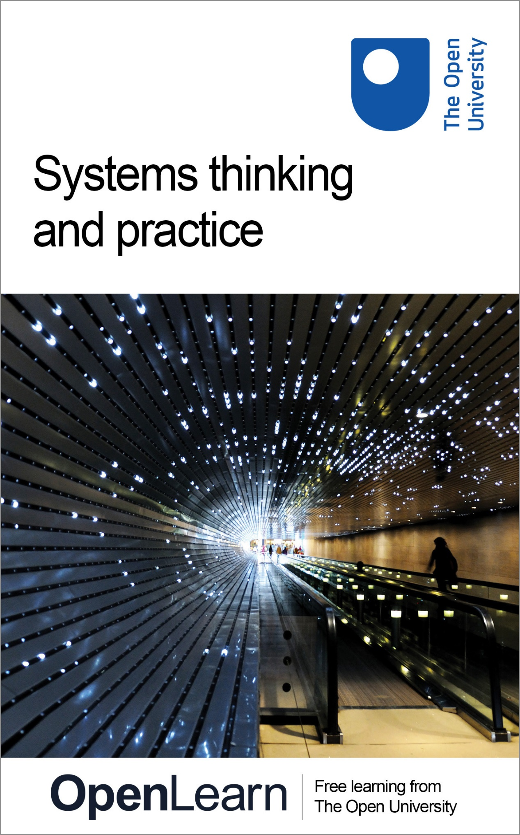

T551_1

Systems thinking and practice

About this free course
This free course provides a sample of level 2 study in Computing & IT www.open.ac.uk/courses/find/computing-and-it
This version of the content may include video, images and interactive content that may not be optimised for your device.
You can experience this free course as it was originally designed on OpenLearn, the home of free learning from The Open University: /www.open.edu/openlearn/science-maths-technology/computing-and-ict/systems-computer/systems-thinking-and-practice/content-section-0.
There you’ll also be able to track your progress via your activity record, which you can use to demonstrate your learning.
The Open University
Walton Hall, Milton Keynes
MK7 6AA
Copyright © 2016 The Open University
Intellectual property
Unless otherwise stated, this resource is released under the terms of the Creative Commons Licence v4.0 http://creativecommons.org/licenses/by-nc-sa/4.0/deed.en_GB. Within that The Open University interprets this licence in the following way: www.open.edu/openlearn/about-openlearn/frequently-asked-questions-on-openlearn. Copyright and rights falling outside the terms of the Creative Commons Licence are retained or controlled by The Open University. Please read the full text before using any of the content.
We believe the primary barrier to accessing high-quality educational experiences is cost, which is why we aim to publish as much free content as possible under an open licence. If it proves difficult to release content under our preferred Creative Commons licence (e.g. because we can’t afford or gain the clearances or find suitable alternatives), we will still release the materials for free under a personal end-user licence.
This is because the learning experience will always be the same high quality offering and that should always be seen as positive – even if at times the licensing is different to Creative Commons.
When using the content you must attribute us (The Open University) (the OU) and any identified author in accordance with the terms of the Creative Commons Licence.
The Acknowledgements section is used to list, amongst other things, third party (Proprietary), licensed content which is not subject to Creative Commons licensing. Proprietary content must be used (retained) intact and in context to the content at all times.
The Acknowledgements section is also used to bring to your attention any other Special Restrictions which may apply to the content. For example there may be times when the Creative Commons Non-Commercial Sharealike licence does not apply to any of the content even if owned by us (The Open University). In these instances, unless stated otherwise, the content may be used for personal and non-commercial use.
We have also identified as Proprietary other material included in the content which is not subject to Creative Commons Licence. These are OU logos, trading names and may extend to certain photographic and video images and sound recordings and any other material as may be brought to your attention.
Unauthorised use of any of the content may constitute a breach of the terms and conditions and/or intellectual property laws.
We reserve the right to alter, amend or bring to an end any terms and conditions provided here without notice.
All rights falling outside the terms of the Creative Commons licence are retained or controlled by The Open University.
Head of Intellectual Property, The Open University
Edited and designed by The Open University.
978 1 47300 085 8 (.kdl)
978 1 47300 180 0 (.epub)

Contents
- Introduction
- Learning outcomes
- 1 How to use this course
- 2 What is this systems thing about?
- 3 Ways of thinking
  - 3.1 Logical thinking
  - 3.2 Causal thinking
  - 3.3 Reductionist thinking
  - 3.4 Holistic thinking
  - 3.5 Multiple partial views
  - 3.6 Perspectives
  - 3.7 Distinguishing worldview from perspective
  - 3.8 Summary
- 4 Systems thinking
  - 4.1 Thinking in systems
  - 4.2 Summary
- 5 Types of systems
  - 5.1 Definition of a system
  - 5.2 The language of systems
  - 5.3 Summary
- Conclusion
- References
- Acknowledgements
- Solutions

Introduction
What is systems thinking and practice? The essence of systems thinking and practice is in ‘seeing’ the world in a particular way, because how you ‘see’ things affects the way you approach situations or undertake specific tasks. This course will help you to learn about the problems of defining a system and meet some of the key concepts used in systems theory: boundary, environment, positive and negative feedback, etc.
This OpenLearn course provides a sample of level 2 study in Computing & IT.
You might also be interested in the OpenLearn course Mastering systems thinking in practice. This course offers a digital badge as evidence of your participation.

Learning outcomes
After studying this course, you should be able to:
- display confidence in using systems concepts and language
- describe accurately the set of key systems concepts
- understand what is distinctive about systems thinking as opposed to other forms of thinking
- understand how systems thinking is useful in analysing and improving situations
- understand the notion of a system as a creation of the observer, i.e. as an intellectual construct, as opposed to using the term system in other ways, i.e. as entities that exist ‘out there’.

1 How to use this course
This course is a learning resource. Like all resources, there are different ways to use it depending upon what you are trying to achieve. You may be reading it as your only introduction to systems thinking or it may be the first part in a much larger course. You may simply be interested in knowing what others mean when they talk about systems or in using it as a route map to direct you to the wider world of systems thinking. Whatever you are trying to achieve it is important that you not only read the text thoroughly but also undertake the exercises. After all, this is a book about systems thinking and practice, and without practising your thinking you may not learn how powerful systems ideas can be. You can't get good at carpentry, or playing the piano, or driving a car simply by reading the books – you have to try out the ideas and techniques for yourself.
The exercises come in two types: Self Assessment Questions (SAQs) and Activities. SAQs test your understanding of the key concepts and ‘set’ answers are provided to compare your answers to. Activities examine how you think about situations you face using those same concepts. There are no ‘set’ answers to these Activities as they are personal to you. Indeed the best opportunities to practice will come whenever you're working with a situation and you realise that you don't quite understand it, or you can't quite see what to do, or you don't know if what you did before has helped – in other words, times when you are puzzled, intrigued or worried. These times are, for you, the equivalent of a field trip for a geologist, a visit to a gallery for an art historian, or gathering vital economic data to an economist. They provide the raw material with which you can work.
Some people seem to have a natural talent for systems thinking, just as some have a natural talent for playing the piano. But most people find it rather awkward and difficult at first. In a way, that is an encouraging sign; it shows that you are genuinely coming to grips with something unfamiliar; and, after all, there is no point in studying to learn what you already know. But it will require perseverance and you aren't expected to grasp it all straight away.
It is the interaction of theory and practice that brings knowledge and understanding of systems. The theoretical statements will lead you to practice certain concepts and techniques. And as you practice, and think about that practice, you will find yourself amending, refining and changing the theories with which you started. Those changed theories will then inform what you do next (see Figure 1). You can go round the cycle as often as you like. Each time you do, your ideas about systems will be more powerful, and your practice in working with them will be more effective.

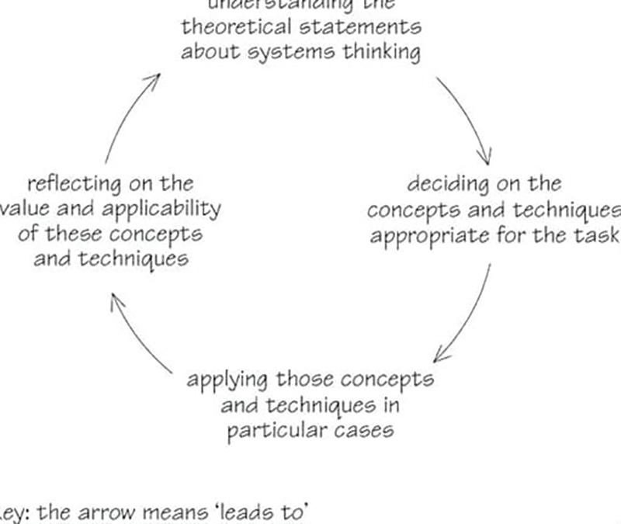
Figure 1 A diagram adapted from Kolb (1984) to show the interaction of theory and practice as a learning cycle
View description - Figure 1 A diagram adapted from Kolb (1984) to show the interaction of theory and ...

However, learning by experience is not always simple. First, sometimes we don't learn from our experiences! Or, at least, we don't recognise the mistakes we make, or we learn the wrong lessons, and so don't do much better next time. It is usually easier to account for things going wrong in terms of what the other person did, or in terms of other external factors. Such explanations are usually at least partly true. The snag is that they may obscure ways in which we might have handled the situation differently.
Secondly, thinking about our own practice isn't something that most of us take seriously as a matter of course. Indeed, as far as much of our life is concerned, there are definite pressures that work against it. They spring from the distinctive characteristics of work and the increasing complexity of our lives. In particular, the pace, variety, fragmentation and interruptions of work make sustained thought about problems difficult. Superficial understandings and responses are one way of coping, and any deeper reflection feels like a luxury we cannot afford.
Lastly, you will learn a great deal more, and a great deal more quickly, if you are ruthlessly strict with yourself. If, for example, you draw a diagram and it doesn't seem quite right, you could suppress the feeling and press on. But there'll be huge dividends in stopping, trying to see what is wrong, drawing another version and so on until you are satisfied. To take another example, when you try to use the concept of a boundary, you may say to yourself it was quite useful even though it didn't reveal much. If you do that, you'll be missing what's interesting – why didn't it reveal much? Did you just repeat what you already knew? Did you start to see some of the implications and draw back from expanding them? Or, if you made genuine efforts, why do you think the concept wasn't useful in that particular case? The answer to any one of these questions will be far more valuable than an activity completed in a lifeless but ‘officially correct’ way.
If you follow these guidelines you will be well on your way to learning to learn – which is important for any subject you may want to study.

2 What is this systems thing about?
Most people reading their first systems book or starting their first systems course have one question that they want answered: ‘What is this thing called systems?’ Almost all will have found their answer by the end of the book or course. But it won't just be in the form of a simple definition: it will be something they will have learnt by experience. (In fact this isn't unique to systems. All subjects can only really be understood by experience; it's just that in well established subjects like physics we don't often ask the question ‘What is physics?’.)
So I will be teaching systems by example as well as by theory. You will learn about the problems of defining a system. You will meet some of the key concepts used in systems theory: boundary, environment, positive and negative feedback, etc. You will encounter selected extracts from the writings of noted systems thinkers. But the essence of systems is not just communicated by these words and ideas. The essence of systems thinking and practice is in ‘seeing’ the world in a particular way, because how you ‘see’ things affects the way you approach situations or undertake specific tasks. And how you ‘see’ things is influenced heavily by the culture of the society in which you live and work and by your education and training.
I recall a story (told by a marketing person) about a group of professionals, each given a barometer and asked to find the height of a church tower. The physicist, who remembered that air pressure changes with height, took the barometer reading at the bottom and at the top of the tower to calculate the height. The engineer dropped the barometer and timed its descent to the ground to work out the tower's height. The architect lowered the barometer on a piece of string till it touched the ground and measured the string. The surveyor measured the shadow cast by the upright barometer and by the tower and used the ratio so found to calculate the tower's height. The marketing person went to the Sexton and said ‘If you tell me the height of the tower, I will give you this barometer’.
The story illustrates two important points – first that people and their viewpoints are part of the situations we normally have to deal with and secondly there is more than one way to handle any situation. Systems thinking can help to resolve complex situations involving people and things, where it is as important to focus on the relationships between the people and things as on the structure of a particular situation. System thinking involves looking at the interconnections between parts of a whole rather than concentrating just on the parts. To borrow a phrase from a British politician, systems thinking is about ‘joined-up thinking’, where the key is how the joining up is done.
But is systems thinking really useful? I can best answer that by giving you some quotes from five different students who have studied and used systems thinking:

Frances Chapman:
Systems thinking is important for me because it helps extend my apparently natural way of thinking, providing tools for handling the complexity more adequately and helping deepen understanding; particularly regarding interactions – where once I would have known they were there but remained unsure of quite how some were operating and affecting the basic ‘central’ scenario. Also, by understanding more of the complexity I find this aspect helps me to retain an open mind on most topics, aids reducing prejudice and helps me work to what I feel may be a more balanced viewpoint.
John Robles:
It [systems thinking] allows me to tackle problems not only in a scientific way but in a holistic way which demonstrates a caring approach to all persons at all levels connected with the problem or system(s) involved.
Paul Warren:
Systems thinking is important for me because it provides a formal recognised framework to explain organisational events, and other happenings, which hitherto had to be explained by vague notions of ‘common sense’.
Sarah Smith:
Systems thinking is important for me because it has given me a new and better way to view complex situations, both in organisations and personally.
Bob Saunders:
I recognise the need to take a holistic view of situations in my field of expertise – project management. So many projects fail because consideration of the human element is omitted, or badly covered by the project manager. ‘Systems’ has helped me to grapple with the complexities.

Your next question may well be: ‘But will systems thinking work for me?’. I can't answer this but urge you to read on and discover this for yourself. What I can say is that among those people who use systems ideas there are at least two sorts:
Those wanting to get on with understanding their particular field of interest and who see systems ideas as useful additions to the ‘tools of thought’ they regularly use. They attach no great significance to the ideas themselves and see that many come from, or are used in, a range of other disciplines. A toolbox is a useful analogy. A good toolbox contains within it enough tools to cope with a wide variety of applications. An adjustable spanner, for example, can be used on bolts under the car bonnet, for assembling furniture delivered in a flat package, for tightening joints in the pipes under the sink and, most significantly for the present discussion, for future jobs I know nothing about yet. The point is that once I know that the spanner is in the toolbox, with a little practice I can recognise situations where a spanner is the right tool to use. This book can be thought of in a similar way, as a kit containing ‘tools for thought’. It introduces the tools, shows you how to use them, and illustrates contexts in which they can be useful. These tools, which may not always be directly useful in resolving complex situations, will give you new insights and understanding of various issues resulting in improvements and new learning.
Those claiming systems ideas and methods have important characteristics in common, not least a common philosophical base. For these people systems has emerged as an important discipline or field of interest in its own right. They are interested not just in particular sorts of systems, but in systems thinking in general. And although systems has drawn ideas and techniques from engineering, biology, sociology, psychology and many other fields some say there is something special about systems, just as the different disciplines mentioned above are said to have different ways of thinking about the topic that characterises them.

3 Ways of thinking
The fact that there are different ways of thinking comes as a surprise to some people. That is because our previous training and experience often locks us into a particular way of thinking about a situation. Sir Geoffrey Vickers wrote with great insight and simplicity about the whole business of how we think about ourselves and our institutions:

Lobster pots are designed to catch lobsters. A man entering a lobster pot would become suspicious of the narrowing tunnel, he would shrink from the drop at the end: and if he fell in, he would recognise the entrance as a possible exit and climb out again – even if he were the shape of a lobster. A trap is a trap only for the creatures which cannot solve the problems it sets. Man traps are dangerous only in relation to the limitations of what men can see and value and do …
(Vickers, 1972, p. 15)

So a lobster pot is a trap for lobsters only because they behave the way they do. They are trapped by their own limitations at least as much by the external obstacle. It may be that, like the lobster, you always think, speak or act in response to certain stimuli in the same way. The clearest evidence of being stuck in your thinking is when you find yourself in a situation that you have faced before, and all you can think of doing is what you did before; and you know that didn't work. As Sir Geoffrey Vickers also wrote:

We the trapped, tend to take our own state of mind for granted - which is partly why we are trapped.

On such occasions, it is often useful to have different ‘tools for thought’ in order to set about thinking about the situation, exploring new ‘angles’, trying out different boundaries and generating a more rounded appreciation of a situation, however complicated, familiar or unusual. An important part of this is the ability to explore and value others’ points of view, trying out their perspectives and incorporating their insights. All these features characterise ‘systems thinking’, although they are not exclusive to it.
Two points about these ‘ways of thinking’ are worth mentioning. First, they are the basis for genuine intellectual skills and that is why this book is both academic and practical. Secondly, some of them may initially appear strange and feel decidedly awkward. Others you will find come more naturally. Which ones prove easy or difficult will depend on your existing patterns of thought. This means that you will not be able to decide how useful a particular ‘tool’ will be until you have acquired a reasonable measure of proficiency and tried it on some actual problems. But to some extent too it will also be a case of ‘horses for courses’. Which tools work for you will also depend on the sorts of problem you encounter.
At one level, we each have a way of thinking which is unique. Most of the time I can barely glimpse how even my closest family think. But at another level our Western society and education has trained us all in certain ways of thinking. The two main kinds are logical thinking and causal thinking.

3.1 Logical thinking
The classic example of logical thinking is a form of reasoning which goes like this: ‘If all cows are animals, and this is a cow, then it is an animal’. It starts with a generalisation, a premise which is assumed to be true and then deduces a conclusion about a particular case. There are three things worth noticing about this form of thinking. The first is that it attempts to be objective. The conclusion shouldn't depend at all on your particular point of view, your opinions and values about the world. The truth of the conclusion should be apparent to right-wing and left-wing politicians, freetraders and interventionists. The second is that it is necessary: that is, the conclusion always follows from the premise. You can't say ‘Well it all depends, sometimes the cow will be an animal and sometimes it won't.’ Finally, the structure of this thinking is sequential: it has the form ‘if a, then b’ – often called a chain of reasoning, and the chains are usually much longer than this one. As the word ‘chain’ suggests, logical thinking is a way of linking ideas or statements together.
This is a powerful and useful way of thinking, responsible for a good deal of the clarity we need to make sensible decisions. But we can't expect it to be good for everything. For example, logic isn't always a good way of sorting out emotional problems, such as who to marry or whether or not to have a child.

3.2 Causal thinking
Causal thinking is a way of linking activities or events together. A car mechanic explaining why your car won't start might tell you that a crack in the distributor head has caused the damp to get in which then caused a leakage of the current, which stopped the spark igniting the petrol. The same sort of reasoning lay behind the design of the engine in the first place: the petrol is mixed with air, then ignited, which causes an explosion, which pushes the crankshaft, which moves the wheels.
As you can see from this example, the three points I made about logical thinking apply to causal thinking too. To start with, it is objective; the political opinions of the car mechanic do not affect his explanation. As far as the reasoning being necessary is concerned, admittedly there is more scope for saying ‘it all depends’ – for example how damp the morning is, or how wide the crack is in the distributor head. But once you accept the premise of what damp does to ignition, then the conclusion will follow. Finally, there is the same sequencing ‘if a, then b, then c’ and so on to the conclusion.
Before moving on from the concept of causality, I want to raise the issue of thinking about chains of causes and consequences or multiple causes, as this an important feature of systems thinking.
When we say that A causes B (e.g. rising damp causes peeling wallpaper), or B is the consequence of A (e.g. peeling wallpaper is the consequence of rising-damp) we are also saying that if you alter rising-damp, then peeling-wallpaper will also alter. In other words, we are suggesting a way of altering B via A. This is why analysing patterns of causes and consequences can be useful when deciding upon actions. If you understand the network of direct and indirect causes that lead to B then, in principle, you have a large number of potential intervention points for changing B. Conversely, if you know all the direct and indirect consequences of your chosen intervention (e.g. change A), you can judge whether it will actually have the effect you want (e.g. change-in-B), and whether it is also likely to have other effects that you may or may not want.
Since systems is about developing understandings of situations that support practical change, causality is obviously a key area. Causality is not usually a simple matter of an isolated statement such as A-causes-B, however. You can trace causes back almost indefinitely if you want to. Consider:

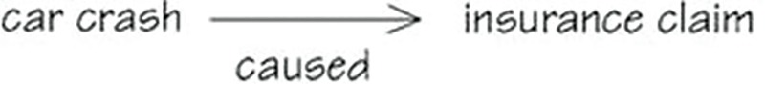
Figure 2

The car crash didn't just happen spontaneously. Why did the car crash? Perhaps the driver lost control. That is

Figure 3

But why did the driver lose control? Perhaps

Figure 4

We can also go forward. What will be the further consequences? Perhaps

Figure 5

Why did the tyre burst in the first place? Perhaps it was some combination of a manufacturing defect, damage to the tyre wall caused by clumsy parking, and stress due to a particularly sharp turn:

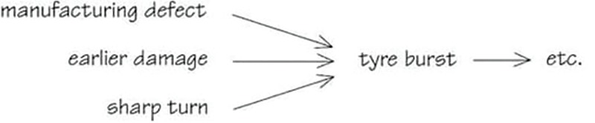
Figure 6

So the event, tyre-burst, is the result of a set of causes that converge on it. Similarly, any event is likely to have a set of immediate consequences resulting from it; for example

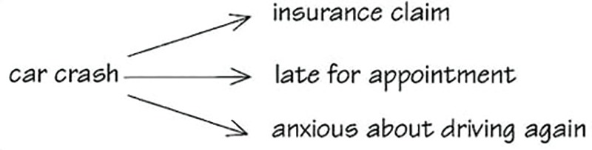
Figure 7

The tendency of many people faced with a situation is to only think about single causes, or several causes in isolation, rather than consider the network of multiple causes.

3.3 Reductionist thinking
Logical and causal ways of thinking aren't so good at helping us to think about systems for four reasons.
First, the tendency of much logical and causal thinking is to observe the characteristics of specific situations and try to derive general principles or recognise general patterns about the chosen class of activities. In contrast, when dealing with complex situations we are often looking to take specific actions to improve them.
Second, logical and causal thinking attempts to be rational and objective and ignore what are seen as subjective, emotional factors. Certainly it is possible to be objective about the workings of the ‘car engine system’, but a lot harder to be objective about a ‘system for choosing a whole car’ – people have distinct preferences. The first example is of a ‘simpler’ mechanical system, the last example a ‘complex’ human activity system. The difference is that in the latter the views of particular people, and the views of groups, are almost certain to conflict (rather than just may conflict), and these conflicts will often be over what they want from the systems they design, run or use.
Third, we cannot always predict the behaviour of ‘complex’ systems – any changes can lead to unintended consequences. Most of the time we have to say ‘it all depends’. In the case of installing a new information system, whether the software was well specified for the task and whether the people involved adapt well to using computers, and how well they adapt, will all influence how easy the people find it to use the software – which should have been considered as part of the original specification.
Fourth, systems are characterised by interconnectedness, and in particular by feedback loops. So thinking of separate, simple cause and effects isn't going to help us to consider the many different interacting factors and feedback loops in, say, a public transport system or a family system for shopping and cooking.
These features of looking for general principles from particular instances, ignoring subjective elements, concentrating on ‘simpler’ systems and breaking situations down into smaller parts where single cause and effects are likely, are typical of the scientific method. Such reductionism artificially restricts the components in a system to make it possible to observe repeatable experiments. In spite of this, reductionism has proved so effective in practice and produced such outstanding results that it has become embedded in our language, literature and thought. Another reason for restricting what is looked at is the scale of calculating any quantitative changes but the advent of computers means that scientists are also beginning to look at more complex situations that are characterised by non-linear, dynamic interactions rather than the simple, linear relationships.
However, systems thinking tries to take account of these particular factors by adopting a holistic approach that complements reductionist activity and/or by tackling situations where scientific thinking and the scientific method are inappropriate.

3.4 Holistic thinking
Holistic thinking deals with wholes rather than parts. The basic idea is pretty straightforward. Imagine you are trying to decide what to plant in a new garden, and you choose all sorts of plants and shrubs which you like. You can't just go on buying individual plants without, sooner or later, coming to some view of the whole of the garden, otherwise you'll have too many things for one part of the garden and not enough for another, or you may chose plants unsuited to the conditions, or that shade out each other.

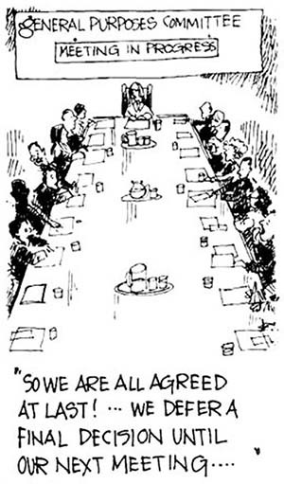
Figure 8

Imagine, to take another example, that you are a member of a group which isn't working well. Much of its meetings are taken up with people defending themselves against real (or imaginary) criticisms and talking at cross purposes. Somehow, unimportant decisions are debated for hours and big ones go through on the nod. Everybody leaves the meeting feeling drained, but also feeling that not much has been achieved. If you wanted to understand why this was so, you could start by looking at each person individually – does he or she have the qualities which are needed to work in this group? You could list them one by one, and decide, in relation to each individual, whether or not that person was contributing to the problems. You might even decide that one person was really unsuited to the task, get them removed from the group and expect all to be well. The chances are that it wouldn't. Your way of thinking about this problem, by looking at the parts, overlooks the relationships between the people, and these are crucial to what is going on. And, when you think about it, the same is true if you look first at the relationships between two of the members, and then at relationships between another two and so on.
It is the interplay of all the relationships between all the members which is one of the major factors making the group function as it does. The behaviour of the group emerges from the interactions of the whole, and can't be predicted by looking separately at the behaviour of each of the parts.
So the basic idea of holistic thinking is that you need to think about wholes rather than just about parts. The problem with this idea is that it isn't always clear what is a whole and what is a part. A person is a whole, but he or she will be a part of a group, such as a family or workgroup. And that group, which is a whole, is a part of a larger group, such as a community or organisation. So all of them seem to be both parts and wholes at the same time. Similarly, a fish is a whole, but it won't survive long unless it remains part of the pond in which it lives; and the pond is part of an ecological system and so on. So it looks as if, whatever you decide to think about, it is bound to be a whole! That is true: but what matters in practice is the way you go about trying to understand a phenomenon, or tackle a situation. One way is to start by breaking things up into separate bits, and then tackle each bit separately and draw inferences or take actions based on your understanding of these parts; if this doesn't seem to work, then the next step is often to break things into even smaller bits. As we saw earlier, this is the reductionist approach that has underpinned most scientific and technological activity. The holistic approach starts by looking at the nature and behaviour of the whole you are concerned with, and if this doesn't yield results, the next step will be to look at the bigger whole of which it forms a part. In other words, the two approaches go in different directions.
But this seems to raise another problem, which is: How do you look at wholes? You'll never understand the whole of the behaviour of a group or a pond, let alone a society or an ecological system. Isn't it simply impossible to think holistically? The answer to that question needs a short discussion. Because the brain is bombarded by information collected all the time by the senses, it has to order or structure it in some way. In this process the brain selects some pieces of information as important and ignores others, and the information it retains is fitted into pre-existing categories. People tend to remember incidents which confirm their view of the world. If I think someone is trying to do me down, I will notice and remember things she does which seem to confirm that view – even to the point of distorting what is really happening. She may be making overtures of friendship, but I will probably interpret them as part of a cunning plot. It is much simpler and easier to interpret what happens as confirming what I think, than to rethink and re-assess every belief I have all the time. In other words, like everyone else, my thoughts simplify the mass of ideas and information I receive into some familiar patterns. In fact, all ways of thinking simplify, because full knowledge and understanding of reality is impossible. So holistic thinking is bound to simplify wholes; what is interesting is how it does it.

3.5 Multiple partial views
One way holistic thinking simplifies things is by taking multiple partial views. That needs some explanation. Consider this analogy: imagine the Albert Hall in London, with the stage set up for a concert by a symphony orchestra. Imagine too that the only way you can find out what the Albert Hall is like is through sectional drawings of it; slices if you like, cut through it. Now if you cut through vertically very near the edge, you will learn something about it – the shape of the roof, for example – and you would be able to guess quite a lot more: that it might not be square, for example; Figure 9(a). If you took a horizontal slice, you could confirm the guess; Figure 9(b). Another vertical slice, nearer the middle, will tell you a lot more: it will show how the dome rises in the middle and the seats face inwards; Figure 9(c). Another slice might catch the edge of the stage, adding to the picture. Finally, if you are lucky, you might get a slice which goes right through the stage with some of the instruments on it, and then you would know a great deal about the place and its particular state on that evening. The point of this analogy is that if you take the Albert Hall as the whole, then each slice is a slice of the whole, but it is a simplification – a partial view. The more slices you have the more you will know about the whole. Notice too, that no slice is wrong or untrue – they are simply more or less helpful in understanding the whole.

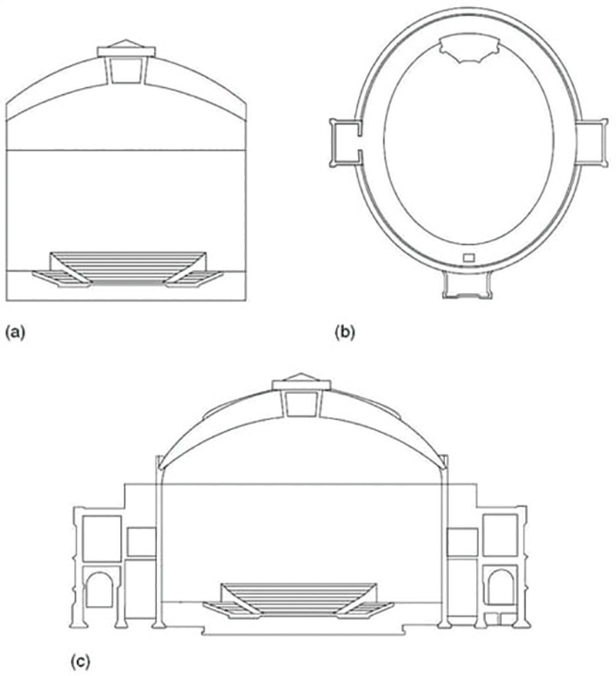
Figure 9 Sections through the Albert Hall
View description - Figure 9 Sections through the Albert Hall

3.6 Perspectives
A more feasible way of taking multiple partial views of the Albert Hall is to consider the perspectives or points of view of the people involved in its use. The commissionaires might notice the layout of the entrances and exits, and how quickly queues disperse; the acoustics engineer will see the drawbacks of the shape of the hall and how they might be remedied for better sound quality; the safety officer will see potential hazards, and so on. Once again, the more points of view you have, the more you will know about the whole. This much is obvious, but it does present a difficulty. If we each have our own perspective, how can we broaden our awareness by adopting different ones? I will briefly mention three ways in which different perspectives can be gained and put together to get a helpful picture of the whole.
The first is to be clear and explicit about your own point of view. This may seem obvious, but it is something we rarely do. People bring to any problem a whole host of beliefs, assumptions, values and interests, something known as their Worldview or Weltanschauung (this German word is often used because it is a much richer expression of the concept than the English word Worldview). Imagine a discussion at a Parent Teachers Association as to whether or not everyone should take a turn on the door at school events. I might have a prior belief that all parents should be treated as equals, so I vote immediately for the option of all of us staffing the door. After the meeting, another parent says she prefers fundraising, so can't people do what they're best at? I then realise that I have a number of other beliefs which, if I had applied them to this case, might have led me to vote the other way. I hate fundraising and I would prefer not to have to take equal turns with that. So why don't I swap my turn at fundraising with another parent's turn at doorkeeping? In other words, I can gain a new perspective simply by considering my own values and beliefs more carefully.
The second way of getting a different perspective is to make a serious effort to see the system through the eyes of others. Box 1 describes one way of doing that, through the technique of role playing.

Box 1: Gaining a different perspective: role playing
A top City stockbroker took part in a business game in which he had to play the role of a shop steward. In view of his opinions of shop stewards, he felt this would be very difficult. Yet after about 10 minutes he was deep in bargaining and using phrases like ‘My members’ expectations’ and ‘I can't take that back to the members. They would laugh at me.’ At one point, late in the afternoon, he lost his temper, banged his briefcase down on the desk and walked out of the meeting; the first time in living memory that he had ever done so – but of course it wasn't really him who was losing his temper!
The most impressive demonstration of the power of the technique came at the end of the game. When it finished he discovered that although he had won similar wage rates to other shop stewards in the game, the company which employed his workers had made far higher profits. As he has spent his professional life finding out information of exactly this kind before any negotiation, he was deeply shocked at his failure. But, again, he wasn't really himself when he overlooked the importance of this information; he was adopting someone else's role.

The third way in which we can gain new and different perspectives of a system is to look for the unintended consequences of its operation. The way to do this is to look at what the system actually does, then to assume that is its purpose, then to describe the system as one to achieve that purpose (i.e. the systems does something). For example I could describe a meeting of six people in a small room as a heat production system. The meeting wasn't held in order to produce heat, but that is one of the things it actually did, so I take that to be its purpose and describe the system accordingly. To re-perceive the meeting in this way might yield good ideas about how to heat and ventilate the room more effectively. But there is a deeper rationale for this search for unintended consequences of systems than simply generating some new and possibly useful ideas.
Very many of the systems designed or managed by human beings have unintended consequences or by-products: when code is changed in a computer program the system as a whole often behaves in ways not predicted by the designers. To take another example, a good deal of legislation ends up having contrary effects to those intended by governments. The same is true of our interventions into natural systems. It is a common mistake to brush aside these side effects as little local difficulties. When systems have been working for some time, it may well be the case that what they do was not intended by anyone – for a host of reasons they've just evolved, and you will persistently misunderstand them if you think they are still achieving what they were designed to do. Quite a few organisations have clerical systems in which many copies of many documents are faithfully made and filed, never to be looked at again. Before simply abolishing this practice it would be as well to look at its unintended consequence: does filing the documents make people more careful, and hence avoid costly mistakes? Does the employment of the filing clerks provide a crucial pool of labour at particularly busy times?

3.7 Distinguishing worldview from perspective
Differences of perspective and worldview can both give rise to differences of opinion. Both concepts can be useful in understanding and working with differences of opinion, so it is valuable to understand the distinction between them.
The metaphor used for each is a useful guide to their difference in meaning. Perspective refers to how things look from your current position. Worldview refers to how you see the world, regardless of your current position.
People sometimes say ‘if you'd been in my position, you'd have done the same …’ Where this is true – where swapping role, responsibilities, relationships and other circumstances would result in swapped opinions–then the difference is one of perspective.
Worldview is about deeper values which may have their origins in upbringing or cultural experience: a sense of what is ‘fair and right’, fundamental beliefs about the nature of things. If swapping circumstances would not change your view, then the difference is more likely to be one of worldview.
In general it is possible to gain additional perspectives by imagining yourself into other circumstances. Your own worldview is harder to set aside, precisely because it is about your most fundamental assumptions.

3.8 Summary
There are many different ways of thinking. Logic alone is inadequate to deal with complex situations because it deals with simple, timeless cause and effect links between statements. Causal thinking underlies much of science where the tendency is to look at simple cause and effects by isolating components or parts of a whole. Systems thinking tries to look at the complicated pattern of multiple causes that make up a whole, and to simplify by taking multiple partial views or perspectives. Reductionist and holistic thinking can be complementary.
You should now further your understanding of the main concepts covered in this section by tackling the SAQs below.

SAQ 1

Which of the following describes a person stuck in a trap through the way they think or act?
- Sally and Jim spent hours with holiday brochures each year; the problem was finding the right summer holiday for themselves and their three teenage daughters. Partly it was a problem of timing. In the summer, all three daughters had different activities, one was in an orchestra, one rode horses and one spent a couple of weeks with her grandparents. It was also a question of money. If all three daughters came they couldn't afford as expensive a holiday as if only one came, and there was the added complication that two of the daughters might bring boyfriends, and what they could afford had to be considered. Finally, it was never easy to find a place they all wanted to go to. Much to Sally and Jim's regret, they hadn't had a family holiday together for three years.
- Helen was the director of a small charity for which she needed to raise money each year. It was always an effort. It took a long time filling in grant application forms which always needed a lot of detail about past achievements and future plans. It was also difficult to dovetail the end of one grant with the start of another, especially as the funders made decisions at different times of the year. Although she had managed the juggling trick, as she called it, for the past five years, she was becoming increasingly frustrated at the amount of time it took.
- David and Penny were genuinely fond of David's widowed mother, who had helped them a lot in the early years of their marriage, and were glad when she came to stay; it gave them the opportunity to repay her generosity. They took her out to dinner, to the theatre and to visit gardens, and invited old friends of hers to join them. However, in spite of this, the visits always ended with a strained and difficult atmosphere between them all, and the gaps between visits was growing noticeably longer. David and Penny decided that they would make more of an effort the next time she came, and organise a party for her.

View answer - SAQ 1

SAQ 2

Which of the following statements about holistic thinking are true, and which are false?
- It separates causes and effects.
- It always considers the motives of the people involved.
- It simplifies the ideas and information in a given situation.
- It takes wholes as its unit of analysis.
- It examines each aspect of a problem separately

View answer - SAQ 2

SAQ 3

Identify, in the following story, examples of logical, causal and holistic thinking:
Sophie Hunting desperately wanted to pass her driving test. She lived in the country and there was no bus service which would take her into the local town in the evening and get her back after a film or a party. But she wasn't learning fast. When she had lessons with her father, most of the time was taken up with lectures on how the car worked. If she kangarooed forwards, he would explain the clutch mechanism and the principle of gearing. When she went out with her mother and stalled at junctions her mother said it was peculiar because her elder brother was less well co-ordinated than Sophie and he had learned easily, so Sophie ought to be able to do it
In some despair, Sophie phoned her brother for advice. He pointed out that their mother, who had always been very protective about Sophie, was probably reluctant to see Sophie going to town alone in the car at night. As for their father, he had always been protective about his car, and was bound to be nervous that Sophie would scrape or bump it when she was learning. He pointed out too that Sophie had never taken kindly to being told what to do by her parents. He suggested that she ask a friend to teach her, in the friend's car, and spend some time reassuring her mother that in the evenings she would only go to town with a friend.

View answer - SAQ 3

SAQ 4

What are the three different ways of gaining new perspectives of a system?

View answer - SAQ 4

SAQ 5

Identify four perspectives in the following story:
A voluntary organisation used to hold an annual meeting for all of its workers to keep them informed of what it was doing. It noticed that most of the staff who worked at head office turned up, but very few of the local representatives who organised events in the regions and distributed information to members. Concerned about this, the Management Committee decided to hold a one-day meeting especially for the local representatives, and set up an ad hoc group to plan the day. It had a lively debate.
The Chairperson of the ad hoc group started the meeting by suggesting that they should draw up an agenda for the day focused on local issues. This raised a storm of objections. Some people said that what was needed was a speech from the Chairman and reports on future plans from senior staff. Others felt that any agenda would be a strait-jacket and would prevent local representatives talking to head office staff about what was important to them. There followed a debate about the state of communications with local reps, which somehow got diverted into whether or not they should pay for their own lunches.
Some argued that the free lunch was a way of showing the reps that their work was appreciated, and that was the real point of the day. Others thought funds shouldn't be spent on free lunches, and insisted that the real point was to integrate the reps more closely by telling them about future plans; in the past they had been the last to hear of changes of policy and direction.
This prompted a more radical idea. In the morning, any rep who wanted to could write a topic on a piece of paper, stick it on the wall, and wait to see if others wanted to discuss it. If they did, a group would gather and discuss it: if not that rep would simply join another group. The three or four topics which had attracted most interest in the morning would be debated fully with head office staff in the afternoon. This idea gained a lot of support, but was just defeated in a vote. In another vote, it was decided, again by a small majority, that the meeting would have a formal agenda of speeches by head office staff.
News that the more radical idea for the day had been defeated leaked out to the local reps who took this as confirmation that head office wasn't interested in what they had to say. Hence, most of them refused the invitation to attend the day, and it was cancelled.

View answer - SAQ 5

4 Systems thinking
You can think about anything holistically. But when you apply holistic thinking to systems, you find that some ideas and techniques are particularly useful; these ideas and techniques constitute systems thinking. In other words, systems thinking is a specialised branch of holistic thinking. This section describes the main ideas and techniques of systems thinking.
Before I turn to them, there are a couple of general points I need to make.
First, don't be surprised that some of the examples and exercises that follow are not specifically about systems. As I said, holistic thinking isn't confined to systems, and sometimes it is easier to grasp the ideas and techniques in other contexts first.
Second, most people have an innate ability to think systemically, but, in spite of this, it can be quite difficult to do at first. It is worth persevering though because systems provides helpful ways of thinking about complex situations.
Third, many people think that what I call systems or systemic thinking is systematic thinking. Although both words are derived form the same Greek word for ‘a setting or placing together’, systematic means ‘having a plan or a method’ while systemic means ‘affecting entire body or organism’. So systematic thinking deals with orderly, methodical thinking and systemic thinking with the behaviour of wholes. Systematic thinking is more reductionist, since it reduces the overall activity to a set of discrete parts that only recognise the importance of the previous and next steps. If you iterate back to an earlier step or follow a different set of steps in response to external influences you are starting to become more holistic. Thus we can carry out a mixture of reductionist and holistic activities, and you can take a systematic approach to systems thinking, but they are not the same.

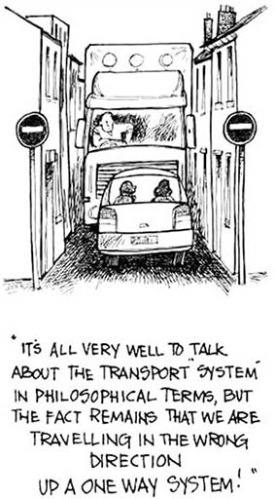
Figure 10

4.1 Thinking in systems
One of the difficulties facing newcomers to systems ideas is the notion that thinking about a topic or situation in a different way actually makes a difference. When confronted with a complex situation most people want to do something to solve it or change it; it is not part of everyday culture that simply thinking in a different way will help the situation.
One of the reasons why many people find difficulty with this idea is that the reductionist way of thinking has come to dominate our culture. This is a very powerful way of tackling problems, as witnessed by the successes of industrial technology in the realms of increasing levels of material production, well-being and comfort. So successful has this way of thinking become that there is a widespread, though often unrecognised, assumption that this is the best way to think about everything. Consequently reductionist methods are used in just about every academic discipline and in all aspects of life.
Although the reductionist way of thinking is a powerful one, it is, nevertheless, limited. There are situations in which the reductionist approach doesn't work. Reductionist methods cannot help to cope with problems that arise as a result of the complexity and interconnectedness between components in a system. Under these circumstances, any severing of the connections in order to make the situation simpler actually changes the situation. It's not too bad when one knows that the situation is caused by connectedness, but in many situations one isn't even sure of this, and one is certainly not sure which connections are significant and which are not. In these circumstances it is necessary to take the situation as a whole, and approaches which do this are termed holistic. One of the strongest characteristics of systems thinking is that it is holistic.
Thinking holistically does not mean that one cannot do anything to simplify the issue at hand. Owing to our inability to think of many things simultaneously, it is essential to simplify complex situations in some way like using multiple partial views in Section 3.5. A holistic approach emphasises that the simplification should be accomplished in a way that does not overlook the significant connectedness. There are two conclusions that follow directly from this.
- Since in many situations we will not know which the significant connections and factors are, we should not expect our first attempt to analyse the situation to lead us to the best representation or ‘answer’. In general, we should expect to need several attempts at approaching the situation before gaining the confidence that we have identified the important features. This is in contrast to the reductionist approach, which usually presumes that there is one, and only one, right approach and right answer until proven otherwise. The holistic thinker will welcome techniques that generate many approaches, whereas the reductionist thinker will be looking for criteria for reducing the approaches to just one.
- In order to simplify the situation without reducing the connectedness it will normally be necessary to reduce the level of detail in the representation. This will usually involve regarding the situation in a more abstract fashion. This is another strong characteristic of systems thinking – that in tackling an issue the first steps are to go up several levels of abstraction; the later stages involve ‘coming back down to earth’ (even using reductionist methods where appropriate) and relating the general conclusions reached to the specific issue in hand.
One way of representing complex issues more simply is by the use of diagrams. The use of diagrams to represent situations is an important theme of systems work, as connectedness can be simply represented and understood. (Text, like this, is essentially linear and emphasises just one order of connection.)
One of the central devices used in facilitating a holistic approach to problems is the representation of an issue or situation as system. Perceiving an issue as a system entails somehow representing the issue in such a way as to capture the essential connectedness of the issue. This requires the identification of boundary that separates the system from its environment and a method or device for representing the system (such as a diagram). Alternatively, it is possible to describe a system by analogy with a ‘standard system’ of some sort. At an abstract level a surprising number of systems seem to work in the same way. A readily understood ‘standard system’ is the ‘vicious circle’. Most of us have experienced vicious circles of one sort or another. For example, if I have an unproductive day, I tend to work late into the night to try and make up lost time. The next day, I'm tired out and even less productive. (Another example is shown in Figure 10(b) Vicious circle.)

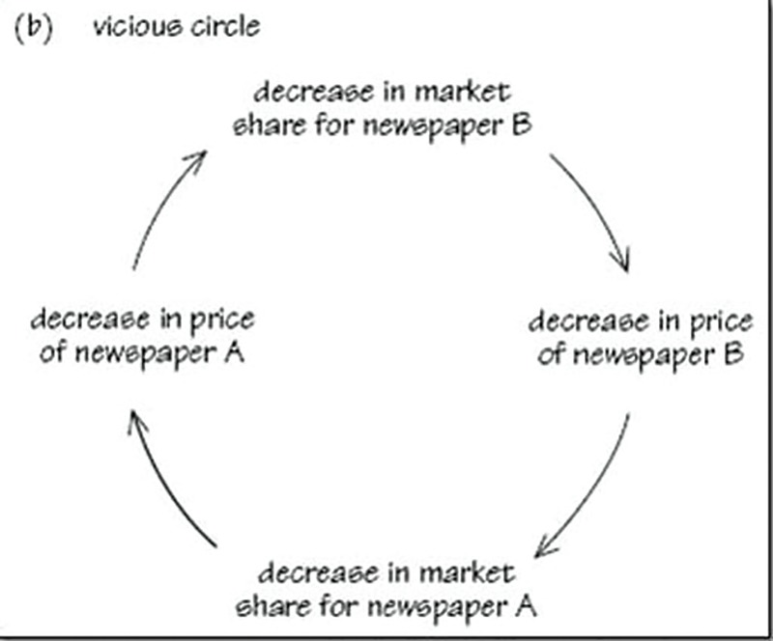
Figure 11

It cannot be emphasised too much that the point of using the systems way of describing an issue is not to say ‘this is how it actually is’ but deliberately to generate variety in the way the issue is thought about. This variety is useful, indeed usually necessary, where our conventional or established way of thinking about the issue has not led to a satisfactory outcome.
The point of looking at something as if it were a system is to generate a new, yet adequately rich, representation of the issue so as to make it easy to think about in a new way. The only criterion for deciding whether a particular representation is a ‘good’ one or not, is whether it leads to fruitful insights. With practice, most people start to get the knack of being able to identify quickly two or three representations that all generate insights and new learning (as set out in the learning cycle shown in Figure 1 and an example of a virtuous circle), while beginners take longer and are pleased if they can get more than one.
Perhaps these remarks will make it clear why in this book I talk about ‘tools for thought’ and different approaches to the same issue. Everyone has his/her own ways of thinking about other people, conflict, power issues, organisational politics and so on, and, to the degree that these ways of thinking work, this is fine. The time when we all get stuck is when our usual ways of thinking about the issue totally let us down, when everything we try seems to make the situation worse, when every attempt to reduce conflict seems to increase misunderstandings, and so on. That is the time we need a ‘fresh approach’, a new way of looking at the whole thing, a new set of ideas to bring to the situation – and it is at such times that the systems approach can provide rewarding results. The systems approach to complex situations can also help in less extreme situations; indeed, if consistently used it would enable one to avoid getting into most extreme positions, because maintaining a flexible view of a situation allows one to anticipate and forestall unpleasant surprises sooner than someone who holds a fixed view.

4.2 Summary
Systems thinking is useful for investigating complex situations. It involves a holistic approach that looks at the behaviour of wholes, and the many interconnections between the components, using a variety of methods. Some of these methods are systematic and orderly but in general systematic thinking is more prevalent in reductionist thinking where situations are broken down into parts and mostly simple, linear cause and effect relationships examined.

SAQ 6

What are the main characteristics of systems thinking and why are they held to be of positive benefit?

View answer - SAQ 6

SAQ 7

Illegal drug use and its associated criminality is a vexing problem for European governments. Plant-derived drugs, grown by peasant farmers in less-developed countries and processed, shipped and distributed by organised crime syndicates, are a major part of the problem. Chemically-derived drugs, produced in illegal laboratories all over Europe have lately been gaining ground. Some drugs are addictive or dangerous or both. Most are expensive, tempting users into petty crime to raise money for their purchases.
A number of solutions have been proposed to alleviate the problem. Without attempting to evaluate their acceptability or practicability, identify which ideas arise from a reductionist, closely focused, approach to the issue and which from a broader holistic approach.
- Increase police powers to stop and search so that suspected drug users can be identified more easily.
- Use aerial spraying (illegally if necessary) to eliminate drug crops identified by satellite.
- Pay farmers (the principal growers) not to grow drug crops.
- Legalise all drugs to eliminate the criminality associated with the drug production and distribution.
- Provide free, confidential help to anyone using illegal drugs.
- Provide cheap, safe drugs on the free market to undercut the criminal interest.
- Increase customs vigilance at all points of entry to the European Union.

View answer - SAQ 7

5 Types of systems
Everyone is involved with things called systems – information systems, financial systems, ecological systems, computer systems, education systems; and to this list I can add many things which are often called systems by professionals in a particular field. For example, doctors talk of the nervous system in the body, therapists of the family system to which each of us belongs, engineers of fail-safe systems in a car or power station. In general, all these systems seem complicated and often behave in unpredictable ways. Many firms, to take one instance, have introduced computerised information systems and found that the information particular people need is so buried in the piles of computer printout that it takes longer to find the relevant information than it did when it was kept in shoe boxes. Or, another common experience, the system has changed people's jobs in unexpected and unintended ways leading to industrial difficulties and then to an awkward restructuring of the firm.

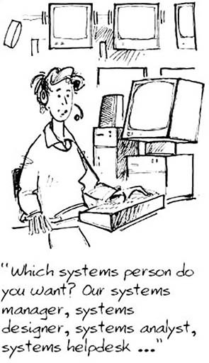
Figure 12
View description - Figure 12

Activity 1

What systems do you come across in your life? Write down three or four examples under the two headings below
- Work-based systems
- Personal systems

View discussion - Activity 1

5.1 Definition of a system
At first sight, a computer system and the body's respiratory system don't seem to have much in common, nor do the world financial system and an ecological system. On the other hand, each of them is called a system, so they must have something in common.
When I am not sure what something means I find it helpful to look for opposites: so what isn't a system? Just looking around I can see a brick, a book, a shelf, a packet of mints and a ticket for a concert. None of them seems to be a system. But the shelf with books on (and the brick to stop them falling off the edge) does look like a system, and I suppose the ticket could be thought of as part of a system of organising concerts.
One difference seems to be something to do with connections. The shelves, the brackets holding them up, the screws holding the brackets up, the books and the brick are all connected: but not simply physically connected. I wouldn't describe the same set of things lying on the floor together, before I put the shelves up, as a system. A second difference is that once they are up they have been put together for purpose. The connections between them have been planned and organised.
The activities which have to happen to put on the particular concert – the hiring of the hall, the rehearsals, the ticket selling – are connected too. Although the connections are not of the same kind as those between the screws and brackets, they have been put together for a purpose; it makes sense to talk of a system for putting on the concert. So my first attempt at a definition is that a system is set of things interconnected for a purpose.
This definition needs a little elaboration. First, the ‘things’ may be physical objects – like the shelf, books and brick – or they may be activities like those needed to put on the concert. They may even be ideas, such as those which make up a system of thought. It is helpful to have a generic word which will cover all these possible ‘things’, and because that word suggests only physical objects, I'm going to use the word ‘components’ instead; so I want to redefine a system as set of components interconnected for a purpose.
Next, I want to look at the idea of ‘purpose’ in the definition. On the one hand, it is natural to use the word system only when a set of components seems to have some purpose that we have ascribed to it – some aim or goal. So, the purpose of a car braking system is to enable us to stop the car, and the purpose of the respiratory system is to enable our bodies to take in oxygen. On the other hand, it may occur to you that there are some things called systems in common speech which don't seem to have a purpose; most people would be lost for words if you asked them to describe the purpose of the solar system. In that case why not just drop this idea of purpose from the definition?
There is a good reason. When you are confronted with a set of components and you want to find ways of working with them, or making them work better, it is always useful to look at them as if they had a purpose. In other words: the interconnected set of components – the system – has been identified by someone as being of particular interest. An urban transport system may have grown up over the past fifty or more years, without any overall purpose; but if you want to replan or redesign it, it will always be helpful to look at it as if it had the purpose of enabling people to move easily around the city. It is possible, to take a different example, to look at the chatter of office gossips as if it had the purpose of spreading information quickly around the organisation. You would then be describing it as an (unofficial) information system, and that might tell you quite a lot about the ways in which the official information system was supplemented or bypassed. In other words, for practical purposes, this pack is only going to be concerned with systems where those sets of interconnected components – whether ideas, objects or activities – can sensibly be described as if they had a purpose because we have an interest in them.
We can now elaborate on our definition of system of interest to include other aspects, namely:
- A system is an assembly of components connected together in an organised way.
- The components are affected by being in the system and the behaviour of the system is changed if they leave it.
- This organised assembly of components does something.
- This assembly as a whole has been identified by someone who is interested in it.
This is not the only definition used by systems thinkers. Two other definitions that come from noted writers on systems are:
- Ackoff:
A system is a set of two or more elements that satisfies the following three conditions:
  - The behaviour of each element has an effect on the behaviour of the whole. […]
  - The behaviour of the elements and their effects on the whole are interdependent. […]
  - However subgroups of the elements are formed, each has an effect on the behaviour of the whole and none has an independent effect on it. […]
A system, therefore, is a whole that cannot be divided into independent parts. […]
The essential properties of a system taken as a whole derive from the interaction of its parts, not their actions taken separately.
(Ackoff, 1981, pp. 64–5)
- Checkland:
The central concept ‘system’ embodies the idea of a set of elements connected together which form a whole, this showing properties which are properties of the whole, rather than properties of its component parts.
(Checkland, 1982, p. 3)

5.2 The language of systems
Whichever definition you prefer, the term system is closely, indeed logically, associated with two other terms environment and boundary. The definition and essential meaning of these terms is straightforward. The environment of a system comprises those elements, activities, people, ideas and so on that are not part of the system but which may nevertheless be important in understanding it. System is the foreground; environment is the background, the relevant context of the system. As for the term boundary, that is basically where the system ends and the environment begins. We can therefore add a fifth part to our definition:
5 Putting a boundary around this organised assembly of components distinguishes it from its context or environment.
None of these ideas, in itself, should present any difficulty. However, their use in thinking about situations is both trickier and more rewarding than you might expect.
Messes can be distinguished from difficulties by their characteristic of being unbounded in important respects. Of course, if a problem is literally and completely unbounded it extends to include ‘Life, the Universe and Everything’. In practice things are usually not that bad. Nevertheless, there is a genuine and important dilemma: on the one hand one wants to avoid too limited and local an analysis; on the other hand, one really cannot rethink and change everything at once. The area of interest extends in numerous directions. So in tackling messy situations there is a recurring dilemma: how much one bites off. Enough to deal with the hunger pangs, but not more than those concerned can chew. But how much is that and can such a mouthful actually be separated from what is not eaten?
The language of systems does not solve this problem, but it does provide a way of addressing it. The task is essentially one of finding a workable provisional boundary for the system containing the problem, or at least a significant part of the problem. But in distinguishing between system and environment one accepts that the problem is not self-contained, that it can only be partially disentangled from its broader context. The simplest way to introduce the fruitful use of the term ‘system’ is to give an example (see Box 2).

Box 2: The blindness system
The blindness system is the complex that includes:
- the set of persons with severe visual impairments;
- the set of agencies, groups, and institutions that serve and support them;
- the research and training that affects the provision of services;
- the laws, policies and programmes under which services are provided.
To call all of this a ‘system’ is not to imply that it has well-defined, consensual goals and co-ordinated programmes for achieving them. The institutions included in the blindness system tend, in fact, to behave in a fragmented and disorganised way. In this sense, it is a non-system. Nevertheless, all the components listed above are relevant to the experience of people with severe visual impairment in the United Kingdom.
Agencies specifically concerned with blind people exist at both national and local levels. They fall into two parallel systems, one public and the other private although the clarity of this distinction has been eroded in recent years as private agencies have sought and received more public funds. There are approximately 800 agencies for blind people. They differ with respect to the service they provide and the basis on which they are organised. Some specialise in particular functions, such as aid to blind people in economic need or residential schools for blind people. Others are consulting agencies or producers and distributors of materials for blind people. In addition to the providers of services, there are special ‘subsystems’ concerned with research, both medical and non-medical, and with skills training. All of this is the official blindness system which provides services specifically to blind people under the heading of blindness. There is, beyond that, a substantial unofficial system which provides benefits or services to blind people under headings other than blindness: for example, the systems involved with welfare, social security, and health. Finally, there is an informal blindness system which consists of services provided by no established agencies, but by families, friends and neighbours.
Adapted from Schon (1971)

The passage in Box 2 illustrates a number of points of considerable importance. First, the system described is not solely comprised of tangible elements – departments, people, workshops, and so on. The assumptions and norms that shape behaviour are all important elements. One cannot really understand how the ‘system’ works without understanding how things look to those inside it. Such established norms and assumptions account for many of the persistent relationships and behaviour patterns that occur.
Secondly, the complex described is not contained within any recognised institutional boundary. Although the people, agencies, activities, policies and so on, have not been chosen arbitrarily, the overall configuration is slightly unusual and probably not what you would have expected if you had thought about it beforehand. It includes a number of agencies and institutions that are clearly related, and the people they serve, but it also includes parts of other institutions as well as people who are not part of any relevant institution. It is clear that the complex distinguished ‘makes sense’, but it is not a system that is publicly recognised. In one sense, it obviously exists ‘out there’; or rather, the various elements in the ‘system’ obviously exist. But the focusing on this particular configuration of elements is the writer's own view, and, in this sense, the ‘system’ does not exist: it is simply a way of conceptualising the various elements and their relationships, which is useful for the writer's purpose.
This leads to an important distinction between two ways in which the term system is used:
- Recognised systems that it is convenient to think of as existing ‘out there’. Such systems are widely acknowledged either because they are deliberately created (a stock control system, a computer system, for example); or because they are fairly discrete, naturally occurring phenomena that have long since been delineated and analysed by scientists (the nervous system and the solar system for example); or just because they are popularly referred to as systems in a vague though useful way (the legal system, the economic system, are examples). In general, such systems are based on widely shared perceptions.
- Explanatory systems, such as in the phrase ‘it's the system’, whose status as entities is much more problematic. Indeed, if a system of this sort exists anywhere, it is in the mind of the individual who conceives it. It is simply a particular way of thinking about selected aspects of the world and their interrelationships which is useful in relation to the individual's concerns. Systems of this second sort embody particular points of view and are useful to the extent that they offer some insight into what is puzzling or troublesome.
You may have noticed that in making the distinction between the two ways in which the term system is used, I carefully avoided saying that systems of the first sort really do exist out there. I said that it is ‘convenient to think of’ them as existing out there, and this was in order to side-step a philosophical issue. The point is that it is rather doubtful whether the recognised systems really exist either: arguably, they too are just particular conceptualisations of phenomena, albeit ones that are widely shared. If advances in physics or physiology lead scientists to think about the movement of the planets or the functioning of organisms in rather different ways, our ideas of the solar system and nervous systems might change significantly, even though the phenomena themselves remained the same. Nor is a computer system quite the discrete entity that it first appears: does it include the software, the people who operate it, the data it manipulates, the uses to which it is put? In this sense all systems are in the eye of the beholder. On the other hand, if this argument is sound it may also be rather trivial, because it applies to everything, and not just systems. When we talk about the world we are not talking about the world as some absolute or ideal entity, but about what we mean by ‘the world’. We can never talk about ‘reality’ except within the confines and conventions of a language. Reality itself is what the term reality is conventionally used to refer to. So in this view the claim that ‘systems do not really exist’ is a bit trivial; the same is true of everything, in an extremely weak sense. Yet we know perfectly well that the terms we use map well on to those aspects of the world to which they refer – otherwise life would be very much more confusing and difficult than it is! So, following this line of argument, if the ‘system’ is a useful conceptualisation then it, too, can be said to exist ‘out there’.
In fact, it may help to think of explanatory systems and recognised systems as opposite poles on a continuum: in between are the systems perceived by groups of people with shared concerns, and those views of systems that are personal modifications and elaborations of more widely recognised systems. There is some shifting about between the poles too: the person who first coined the term ‘old-boy network’ was delineating an explanatory system, but it caught on, and has become a recognised one.
The third general point to make from Box 2 is that systems are nested within other, wider systems. Saying that ‘this’ is the environment, ‘this’ is the system, and ‘these’ are the sub-systems, of which the system is constituted, reflects a choice of the level at which you will work. Russian dolls, which fit snugly one inside another, provide a useful analogy. No single one of them is ‘the doll’; each one fits inside a larger one. Instead of trying to identify ‘the system’ it is more helpful to think of a hierarchy of systems which fit inside each other from which you have to select the system-level at which you will work by exploring the most relevant ones.
The use of the Russian doll analogy is an example of a set of techniques that can be used to explore complex situations, others being the use of metaphors, diagrams, and models. We can build up our view of the system being considered by wheeling in particular models of various systems and using them to highlight the presence or absence of particular interrelationships and patterns of behaviour within the system. It is as if we display the raw complexity of the system on an overhead projector slide and then superimpose different sorts of systems on it as overlays, to draw attention to different aspects of the way the system works and the way the system can be perceived by other people who are interested in it.
This is important because if thinking in terms of systems is to be of any use it must involve more than mentally grouping a number of elements together and calling them a system. The whole point is that these elements are interrelated, so it is important to be able to grasp the ways in which they characteristically combine and interact. An understanding of these interrelationships, of how certain elements ‘hang together’, is likely to provide a basis for deciding what to include in the system in the first place.

Activity 2

- Think of a situation which you find puzzling, awkward or unpredictable. Describe it briefly, and jot down the reasons why it presents you with a problem
- Ask yourself: Whose purpose does it serve? Write down your answer; specify both the people and the goals, and then ask yourself if these goals explain the system's behaviour. Write down any ideas or insights you have from answering this question
- Ask yourself: What does the system do? – behaviour which is apparently unintended by anyone, but nevertheless results from its actions. Write your answer to this question, and any ideas or insights which it gives you
- Do all the answers you have written give you any ideas about improving the behaviour of the system? Write them down.

5.3 Summary
The brief definition of a system is set of components interconnected for a purpose. Joseph O'Connor and Ian McDermott (1997) distinguish a system from a heap using the longer definition as follows:

A system | A heap
Interconnecting parts functioning as a whole | A collection of parts
Changed if you take away pieces or add more pieces. If you cut the system in half you do not get two smaller systems, but a damaged system that will not properly function | Essential properties are unchanged whether you add or take away pieces. when you halve a heap, you get two smaller heaps
The arrangement of the pieces is crucial | The arrangement of the pieces is irrelevant
The parts are connected and work together | The parts are not connected and can function separately
Its behaviour depends on the total structure. Change the structure and the behaviour changes | Its behaviour (if any) depends on its size or on the number of pieces in the heap.
(O'Connor and McDermott, 1997, p. 3)

I have also used the word ‘system’ to make five points about thinking in terms of systems:
- The intangible elements, e.g. norms and assumptions, are essential factors in understanding how a system works.
- The boundary of a system need not correspond with recognised departmental, institutional or other ‘physical’ boundaries. Explanatory systems are identified in relation to the observer's interests.
- Often one has to extend the boundary (take a helicopter view) in order to achieve a coherent understanding of a complex situation.
- A system at one level of analysis can be viewed instead as a sub-system in its environment at a higher level of analysis.
- Models and analogies of systems are powerful tools in helping to identify patterns and regularities.

SAQ 8

Which of the following do you recognise as a system, according to the definitions given above?
- The houses in an old village.
- Your personal computer.
- Activities needed to get this course to you on time.
- A small wood.
- The spare parts in the store of a garage.
- Mathematics.
- Meetings of the board of directors of a company.

View answer - SAQ 8

Conclusion
This free course provided an introduction to studying Computing & IT. It took you through a series of exercises designed to develop your approach to study and learning at a distance, and helped to improve your confidence as an independent learner.
You might also be interested in the OpenLearn course Mastering systems thinking in practice. This course offers a digital badge as evidence of your participation.

References
Ackoff, R. (1974) Redesigning the Future, New York, John Wiley.
Ackoff, R. (1981) Creating the Corporate Future, New York, John Wiley.
Boulding, K. (1956) ‘General Systems Theory: The Skeleton of Science, Management Science, April, pp. 197–208.
Bronte-Stewart, M. (1997) ‘Using Diagrams and Muller-Merbach's Framework to Tech Systems Theory’, Systemist, Vol. 19, No. 3, pp. 174–186, United Kingdom Systems Society.
Casti, J. (1994) Complexification. Explaining a Paradoxical World Through the Science of Surprise, London, Abacus.
Checkland, P. (1981) Systems Thinking, Systems Practice, New York, John Wiley.
Eden, C; Jones, S. and Sims, D. (1983) Messing About with Problems, New York, Pergamon Press.
Kolb, D. (1984) Experiential Learning: experience as the source of learning and development, New York, Prentice-Hall.
Lovelock, J. (1979) Gaia, Oxford, Oxford University Press.
Miller, J. (1978) Living Systems, New York, McGraw-Hill.
O'Connor, J. and McDermott, I. (1997) The Art of Systems Thinking, London, Thorsons.
Schon, D. (1971) Beyond the Stable State: Public and Private Learning in a Changing Society, London, Maurice Temple Smith.
Shannon, C. (1969) ‘Information Theory’, Encyclopaedia Britannica, Vol. 12, pp. 246B-249, Chicago, William Benton.
Vickers, G. (1972) Freedom in a Rocking Boat, London, Penguin.

Acknowledgements
All materials included in this course are derived from content originated at the Open University.
Except for third party materials and otherwise stated (see terms and conditions), this content is made available under a Creative Commons Attribution-NonCommercial-ShareAlike 4.0 Licence
Andy Lane, course team chair and author (1999)
Karen Shipp, course team chair (2002)
Rosalind Armson, author and critical reader
John Hamwee, author
John Martin, author
Rob Paton, author
Laurence Newman, course manager
Mike Aiken, critical reader
Mandy Anton, graphic designer
Simon Bell, critical reader
Christine Blackmore, critical reader
Susan Carr, critical reader
Alexandra Di Stefano, critical reader
Tony Duggan, project controller Eion Farmer, critical reader
Pip Harris, compositor
Ray Ison, critical reader
Jane Moore, editor
Dick Morris, critical reader
Elizabeth Parsons, critical reader
Pat Shah, course secretary
Roger Spear, critical reader
John Taylor, graphic artist
Don't miss out:
Course image: drpavloff in Flickr made available under Creative Commons Attribution-NonCommercial 2.0 Licence.
If reading this text has inspired you to learn more, you may be interested in joining the millions of people who discover our free learning resources and qualifications by visiting The Open University - www.open.edu/openlearn/free-courses

Solutions

SAQ 1

Answer
No clear-cut answer here but numbers 1 and 3 certainly look like traps. In both cases the people concerned care a good deal about the issue, they keep on trying to get what they want, but it doesn't seem to work. Sally and Jim are defining their problem in a way that makes it impossible to solve. David and Penny are trying to solve their problem by doing more of the same – ignoring the fact that what they are already doing may well be the source of the problem.
Number 2 doesn't look like a trap; at least not yet. Although Helen is getting frustrated, what she is doing works well. If she never managed to decide that her real abilities were in campaigning, for example, but she never managed to find time to do that, then she might be in a trap.
Back to - SAQ 1

SAQ 2

Answer
- False – this is a feature of casual thinking.
- False – it may do so, but not always. It can be applied to mechanical or natural systems.
- True – as do all ways of thinking.
- True – this is its key feature.
- False – without the word 'separately' the statement would be true. Certainly, holistic thinking can look separately at different aspects of a problem, but it doesn't stop there. It always seeks to put them together and to see the interconnections between things.
Back to - SAQ 2

SAQ 3

Answer
Sophie's father is using casual thinking, her mother's logical thinking and her brother's holistic thinking; her bother is taking multiple partial views of the situation as a whole.
Back to - SAQ 3

SAQ 4

Answer
One is by reconsidering our own perspective, another is by adopting the perspective of another person and the third is by looking for the unintended consequences of the system's operation.
Back to - SAQ 4

SAQ 5

Answer
There are, at least the following aspects – some of which may overlap. You may well have expressed them differently; that doesn't matter as log as you are able to recognise a multiplicity of perspectives:
- That there should be a formal agenda of speeches and reports – designed to integrate the reps more closely in the organisation.
- That there should be no agenda for the day – its purpose was for head office staff to listen to the reps.
- That the point was to show appreciation of the work of the reps – the 'free lunchers'.
- That the agenda should be drawn up by the reps themselves – by the radical procedure in the morning.
- That the head office didn't care about the reps – the unintended consequence of the meeting to design the day.
Back to - SAQ 5

SAQ 6

Answer
These are the main characteristics of systems thinking discussed in Section 4.
- Changing one's perspective on an issue or problem. This leads to changes in attitude and approach which make it easier to identify the social components required to 'solve' complex situations.
- Holistic thinking. This avoids losing the issues which are intimately associated with the connections of the situation.
- Simplifying by making more abstract. Some simplification is essential to make a problem tractable, but the simplification must not reduce the connectedness. By becoming more abstract the connectedness is maintained and the problem simplified.
- Using standard systems and diagrams. These are 'tools of the trade', rather than 'characteristics of systems thinking'. They allow the other characteristics to be realised.
Back to - SAQ 6

SAQ 7

Answer
- Reductionist. Identifying illegal drug users is only a very small part of the problem.
- Holistic. Drug crops are an entry point to the 'drugs system'. Eliminating all the drugs crops would at least eliminate the plant-based drugs problems.
- Reductionist. Although superficially related to 2 above, this solution tackles only part of the problem and so allows the system to adapt. Traffickers could increase payments to farmers, use intimidation or grow their own supplies.
- Holistic. This might well eliminate the criminality part of the problem although legal producers may well exploit cusomers' need by charging high prices. It does nothing to address the personally harmful effects of drug use.
- Reductionist. This addresses only a very small part of the problem. Not all users are in need of help. Many enjoy taking drugs and would continue to do so.
- Holistic. Like 4 above, it would eliminate organised criminality and the petty crime needed to support expensive drug use.
- Holistic. This could prevent the entry of plant-based drugs into Europe although it might divert the market to other places. Whether it could be implemented rigorously enough is another matter.
Back to - SAQ 7

Activity 1

Discussion
My own list of systems for this activity are:
Work based – internal telephone system, budgeting system, departmental planning system, accommodation allocation system;
Personal – central heating system, personal computer system, holiday planning system, personal transport system.
It is apparent from this list, and probably from your list too, that the word ‘system’ can be used in a number of ways.
Back to - Activity 1

SAQ 8

Answer
Numbers 2, 3 and 6 appear straightforward; all have a set of components interconnected for a purpose. In one case the components are objects, in another activities and in the third they are ideas, but they are all familiarly called systems.
However, these only become systems if we have an interest in doing something with them. The personal computer or laptop on your desk is not a sytem until you take an interest in it, by, for example, using it ti do your assignments, or until an engineer comes to repair it when it is not working properly. Numbers 4 and 7 are not usually called sytems, and it may seem a bit strange to call them so. But they fit the definition given in the text, and as you will see, there are real advatages in using the concept of a system in these kinds of cases. With the wood, it makes sense to speak as if it had the purpose of enabling plants to grow, birds to nest and feed and so on. In case of the Board meeting, it makes sense to speak as if it had the purpose of making decisions about the running of the company (doing so might reveal the fact that a particular Board doesn't in fact make the important decisions).
Numbers 1 and 5, as described in the question, aren't systems. In neither case are the components necessarily interconnected for a purpose, they are more akin to a collection of things. Of course, only a small change in the description could make a big difference. A storekeeper dishing out the spare parts looks like a system. So would the houses, if I included the services which link them or the activities of the people living in them.
Back to - SAQ 8

Figure 1 A diagram adapted from Kolb (1984) to show the interaction of theory and practice as a learning cycle

Description
Figure 1 A diagram adapted from Kolb (1984) to show the interaction of theory and practice as a learning cycle
Back to - Figure 1 A diagram adapted from Kolb (1984) to show the interaction of theory and practice as a learning cycle

Figure 9 Sections through the Albert Hall

Description
Figure 9 Sections through the Albert Hall
Back to - Figure 9 Sections through the Albert Hall

Figure 12

Description
Figure 12
Back to - Figure 12

