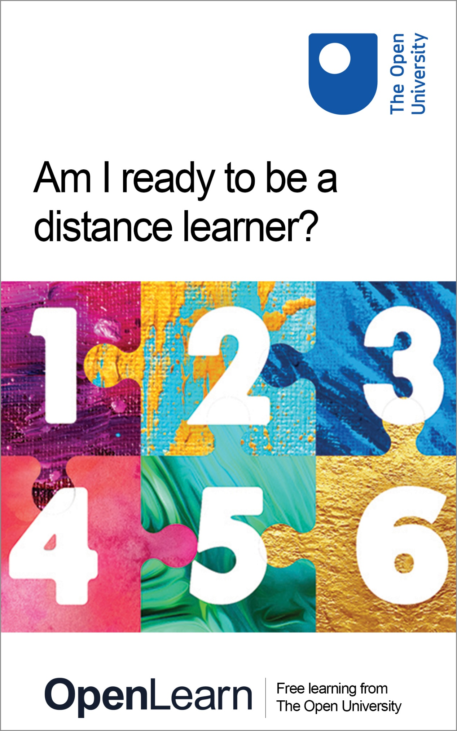

ONL_1 Am I ready to be a distance learner?

Am I ready to be a distance learner?

About this free course
This version of the content may include video, images and interactive content that may not be optimised for your device.
You can experience this free course as it was originally designed on OpenLearn, the home of free learning from The Open University – http://www.open.edu/openlearn/education-development/am-i-ready-be-distance-learner/content-section-0?
There you’ll also be able to track your progress via your activity record, which you can use to demonstrate your learning.
Copyright © 2017 The Open University
Intellectual property
Unless otherwise stated, this resource is released under the terms of the Creative Commons Licence v4.0 http://creativecommons.org/licenses/by-nc-sa/4.0/deed.en_GB. Within that The Open University interprets this licence in the following way: www.open.edu/openlearn/about-openlearn/frequently-asked-questions-on-openlearn. Copyright and rights falling outside the terms of the Creative Commons Licence are retained or controlled by The Open University. Please read the full text before using any of the content.
We believe the primary barrier to accessing high-quality educational experiences is cost, which is why we aim to publish as much free content as possible under an open licence. If it proves difficult to release content under our preferred Creative Commons licence (e.g. because we can’t afford or gain the clearances or find suitable alternatives), we will still release the materials for free under a personal end-user licence.
This is because the learning experience will always be the same high quality offering and that should always be seen as positive – even if at times the licensing is different to Creative Commons.
When using the content you must attribute us (The Open University) (the OU) and any identified author in accordance with the terms of the Creative Commons Licence.
The Acknowledgements section is used to list, amongst other things, third party (Proprietary), licensed content which is not subject to Creative Commons licensing. Proprietary content must be used (retained) intact and in context to the content at all times.
The Acknowledgements section is also used to bring to your attention any other Special Restrictions which may apply to the content. For example there may be times when the Creative Commons Non-Commercial Sharealike licence does not apply to any of the content even if owned by us (The Open University). In these instances, unless stated otherwise, the content may be used for personal and non-commercial use.
We have also identified as Proprietary other material included in the content which is not subject to Creative Commons Licence. These are OU logos, trading names and may extend to certain photographic and video images and sound recordings and any other material as may be brought to your attention.
Unauthorised use of any of the content may constitute a breach of the terms and conditions and/or intellectual property laws.
We reserve the right to alter, amend or bring to an end any terms and conditions provided here without notice.
All rights falling outside the terms of the Creative Commons licence are retained or controlled by The Open University.
Head of Intellectual Property, The Open University
978 1 4730 2514 1(.kdl)
978 1 4730 2515 8 (.epub)

Contents
- Introduction
- 1 How will I find time to study?
- 2 Do I have the right skills for study?
- 3 Do I have the digital skills to be a distance learner?
- 4 Am I ready to learn?
- 5 Do I understand how assessment will help my learning?
- 6 Self-assessment activity
- References
- Acknowledgements
- Solutions

Introduction

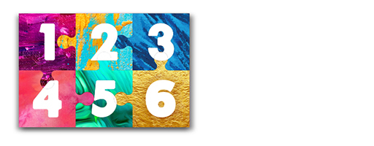
View description - Uncaptioned Figure

Students new to distance learning often return to study after a gap. Many say they feel unprepared and not confident that the skills they already have will enable them to succeed.
This free course will help to support you in becoming a confident distance student. It will guide you through five simple interactive steps to refresh your approach to learning. You will explore useful study skills, time management, assessment, becoming digitally ready, and effective engagement with course materials.
You will complete the course with an exercise to enable you to reflect on your readiness to be a distance learner.
After studying this course you should be able to:
- identify areas of study strengths in preparation for becoming a distance learner
- explore and reflect on skills that are valuable for distance study
- identify opportunities to further develop your skills as a distance learner
- understand the attributes of a successful distance student.
The Open University would really appreciate a few minutes of your time to tell us about yourself and your expectations for the course before you begin, in our optional start-of-course survey . Participation will be completely confidential and we will not pass on your details to others.

1 How will I find time to study?

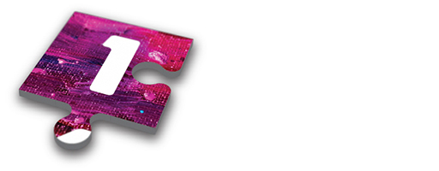
View description - Uncaptioned Figure

Finding time to learn can be challenging in our day-to-day lives, so before committing to study it is useful to consider the time it will take to ensure you have time to study. Although learning at a distance does come with flexibility, it will often be up to you as the student to decide on your own study routine.
One of the things that many students tell us is that they worry about getting distracted in the time they have available for study.

Activity 1
Duration 20 mins

As a first activity to help you to get a sense of the time you might have available for study complete this time planner.
The time planner will help you to think about all the things you spend time doing across a week. Try to include everything you do to help you map out the time that you might have available for study. Inevitably, some of you will be incredibly busy and juggling lots of things, while some of you might realise that you already have time available for study.

Now you have mapped out your available time for study, it is worth considering how to ensure you make the most of it in order to learn as effectively as possible.
One of the things that many students tell us is that they worry about being distracted in the precious time they have available for study.
Here are a few tips that students have shared with us about staying on track when studying:
- Plan your study time so that you have a realistic goal in mind and reward yourself on achieving it. (For example, I will read this section for 40 minutes before I make that cup of coffee.)
- Try to balance your free time and your study time – this will help you to maximise the learning opportunities available to you. It is good to take study breaks to socialise, as this can help with your studies, but do try to prioritise your learning. (For example, arrange to meet a friend an hour later than usual knowing that you have used that extra hour for study.)
- Studying at a distance often means using personal technology, such as your computer or mobile device. Try not to be distracted by text messages, emails or social media updates. (For example, why not switch off notifications for these things when studying, and perhaps turn your mobile to silent or leave it in another room?)
- Make the most of the time you have available to study. This might mean having a regular study space at home that you don’t have to tidy before you start learning. If you are studying while travelling make sure you have the relevant materials with you. (Some materials can be downloaded to smart devices, which means you can listen or read them while on the move.)
- If you feel yourself putting off study, tidying your work space, gazing out of the window or even sharpening your pencils, you have fallen into the trap of procrastination. When it comes to finding the time to study, just do it and make the most of the time you have available.

Reflection
Duration 10 mins

Having completed the activity, if there are any things that you are worried about when it comes to finding the time to study, you might find it helpful to note them here.

Provide your answer...

We hope that in working through the rest of this course you discover helpful strategies and resources to address your worries.

2 Do I have the right skills for study?

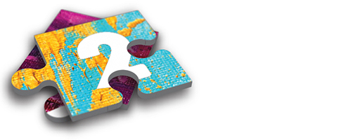
View description - Uncaptioned Figure

Having found the time to study it is important to review your study skills. Learning is a journey and distance learners in particular need to draw on a range of skills to help them on their way. Activity 2 will support you in reflecting on your skills, taking stock and discovering where you might need to develop new skills.
Students tell us that the skills they need to be successful in distance learning are a mixture of what might be called soft and hard skills. On the soft side, the kinds of thing they talk about are self-motivation, dealing with stress and becoming more confident as a learner. On the hard side, which is more likely to depend on the discipline studied, they value being able to take detailed notes, write essays or do mathematical calculations.

Activity 2
Duration 20 mins

What sort of approach best fits your attitude to study? Select five skills from the following list that best match your preferred study approach. Then copy and paste them into the box below.
- I don’t like to give up, I tend to persevere at a task.
- I am confident about reading in order to learn from different points of view.
- I am curious, I like to learn new things, and then apply this new knowledge.
- I am competent at making useful notes from my study materials.
- Learning can be challenging at times. However, I am confident in my capacity to learn effectively.
- I can write in a structured manner to answer a question.
- I might get stressed at times when learning. However, I know I can manage my time and expectations effectively.
- I can process my learning in order to address the assessment tasks asked of me.
- I respond to feedback positively, using it to develop myself as a learner.
- I can interpret information from a variety of media (books, DVDs, spreadsheets, graphs and audio).

Provide your answer...

What does this suggest?
If you picked mainly even numbers (2, 4, 6, 8 or 10), this suggests you are more confident in what academics refer to as ‘hard’ discipline skills. If you selected mainly odd numbers (1, 3, 5, 7 or 9), this suggests you are more confident with ‘soft’ skills.
Don’t worry about the outcome of this task as you will need both sets of skills to be a successful distance learner. Being aware of them is the first step on your study journey – engaging in learning will develop these skills.

Next steps
Have a chat with someone who knows you well about your approach to study. Many of us can be overly critical of ourselves and it can be motivating to have an impartial perspective on your skills as a learner.
Based on your response to the activity and your conversation, look at the example below of free OpenLearn resources to help you develop more effective study skills. This is a short informal course designed to help you get a taste of what distance learning in higher education is like.
Developing good academic practice

3 Do I have the digital skills to be a distance learner?

View description - Uncaptioned Figure

Studying as a distance learner will mean that you will need to use a range of digital technologies. Before you start your studies, it might be helpful to reflect on your digital skills.
Technology and education are developing and increasingly go hand in hand. As it’s likely you will use a computer or a tablet to study, it is important to ensure that you are confident in your digital skills to help you be an effective learner.
To be a distance learner, the following digital skills are likely to help you be successful in your studies:
- Knowing how to use the internet to assist you in your studies; for example, listening to a podcast or watching a video. You may also need to know how to upload digital files to a course website for assessment or to share with fellow students.
- Knowing how to use the internet to complete research tasks.
- Being able to find your way round a study website. (Nowadays course information is often presented online and there is no guarantee that your study materials will be in printed books.)
- Being able to use word processing packages to present your work.
- Knowing how to write online messages to your tutor or peer group or how to take part in live interactive sessions over the internet (like Skype, message boards or forums).
- Knowing how to submit written materials like assignments electronically, for your tutor to mark and provide feedback.

Activity 3
Duration 20 mins

Read this brief description of a new distance learner, Jane.
- Jane has not studied in a while.
- She is a bit nervous about what to expect as a distance learner.
- Her computer is old.
- Her son bought her a smart device for her recent birthday and she uses social media to interact with friends.
- Her course requires her to register online.
- Her course will require her to exchange emails with her tutor.
- Her course assumes she can take part in live online sessions.
- She will need to upload pictures to share with others.
- She will be expected to contribute to student forums.
- As part of her assessment she will need to complete online quizzes.
- She will have to submit her assignments electronically.
If she was your friend, what advice would you give Jane about her digital skills, prior to her commencing her studies?

Provide your answer...
View comment - Activity 3

Next steps
If you want to know more about how to develop or expand your digital skills, this OpenLearn course might be helpful for you to explore:
Digital skills: succeeding in a digital world

Optional activity

View description - Uncaptioned Figure

This activity is optional and just for fun. One of the technologies used to share learning and engage with the wider educational community is Twitter. Short messages can be written and shared easily. If you have a Twitter account use that. If you don’t yet have one, it’s free and very straightforward to set up.
Your task is to compose a tweet (of no more than 140 characters) in which you write about what you are looking forward to as a distance learner.
Tweet your message to @OpenLearn, using this hashtag: #ready4distancelearning.
Congratulations – you have now taken your first step to becoming a digital learner.

4 Am I ready to learn?

View description - Uncaptioned Figure

Learning at a distance may feel very different from learning in a traditional classroom environment. Just as in face-to-face teaching, some online learning experiences include support from a tutor or an educator. However, other distance learning courses will embed the teaching within the material. Because this may be different from how you have studied in the past, this can take a little bit of getting used to. For example, you might not be instantly able to ask the tutor a question to check your understanding; instead you might ask your peer group on a student forum.
The crucial thing to being a successful distance learning student is to engage fully with the teaching materials. Students have shared with us the key approaches that lead to successful learning outcomes. These include:
- read
- take notes
- learn with others
- demonstrate what you have learned.
Read – When you engage with your learning materials it is important to remember that you are reading for understanding and need to digest significant points in the text. You will learn to develop reflective reading skills so that you check your own understanding as you go. Sometimes difficult concepts might need to be read more than once. Your learning materials may be in print or on a screen, but the skills you use to read and understand them are similar.
Take notes – When reading through your learning materials, it is a good idea to take notes. Students tell us they develop their own approaches to making notes. This might be highlighting text in a printed book or on screen, summarising notes on a separate piece of paper or in an electronic document. They may even produce mind maps. One student we knew would use a mini whiteboard to practise her Maths calculations so she could easily rub out any mistakes and take photos of her correct answers.
Learn with others – As a distance learner it is quite likely that you won’t meet other students face to face. However, research tells us that learning is most effective when done with other people. Increasingly in distance education, students will interact with one another through the use of technology; for example, through forums, discussion threads and live video streams (like Skype).
Learning with others by using the range of technologies available can be a really creative way to check your understanding with your peers or tutor. Collaboration in this way can help you take on feedback from others and learn from different points of view. You will also enhance the learning of your peers by your comments and feedback.
Demonstrate what you have learned – The ultimate demonstration of your learning will come in your response to assessment tasks. This can include formal report writing, writing essays, presentations, scientific reports and calculations, academic posters, quizzes, portfolios, blogging, contributing to wikis or creative writing.

Activity 4
Duration 30 mins

Read and reflect on Jon Rosewell’s article on Learning styles (2004).
In the box below, note the learning style that most closely aligns with your own approach to learning.
Example: I am more of a pragmatist because I like to try out new things and just get on with it. I am practical and I can apply what I have learned to my own situation.

Provide your answer...

Activity 5
Duration 20 mins

In Rosewell’s article you will have seen a reference to Kolb’s learning cycle (Kolb, 1984). Learning approaches are visually overlaid on Kolb’s cycle to describe effective ways of learning. The most successful learners follow a four-step circular approach:
- Experiencing – doing something
- Reviewing – thinking about what has happened
- Concluding – drawing some conclusions
- Planning – deciding what to do in the future.

In the box below note the approaches to learning that you feel most confident with.

Provide your answer...

You might also want to note the approaches to learning you may wish to develop.

Provide your answer...

Next steps
As a result of reflecting on these learning activities, you may have been thinking about your own English language and number skills. The following free short courses on OpenLearn might be helpful for you to explore:
English: Skills for Learning
Essay and report writing skills
Numbers, units and arithmetic

5 Do I understand how assessment will help my learning?

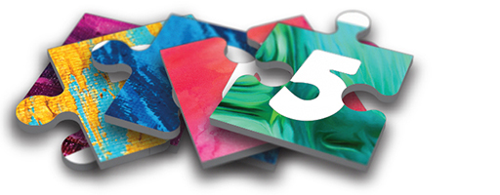
View description - Uncaptioned Figure

Students tell us that they often bring with them a quite negative experience of assessment from their school days. They recall assessment being ‘done to them’ and often associate it with being punished if they did not do well. As a result it is not surprising if students struggle with the idea that assessment is a key element of effective learning.
When coming back to a period of study it is important to think about assessment in a different way. It is not simply an assessment of what you have learned but contributes significantly to you becoming an effective learner.
The key to effective learning from assessment tasks is your engagement with the feedback you receive. Think of assessment as a tool with which to improve your learning – the feedback you gain is a crucial element in your learning journey. By thinking of assessment as an embedded part of your learning rather than just a test tacked on at the end you are much more likely to become a successful distance learner.
Some assessment tasks in distance education will be a mixture of formal tasks (such as report writing, writing essays, presentations, scientific reports and calculations) and informal tasks (such as quizzes, blogging, contributing to wikis, forum posts or discussion threads).
Often courses have learning aims or outcomes (such as those from this course, which are listed below in Activity 6) and the assessment strategy of a course is designed to help you demonstrate what you have learned.
One way to engage with assessment more confidently is to develop self-assessment skills.

Activity 6
Duration 30 mins

Practise your self-assessment skills by reviewing this course’s learning outcomes (listed below) and then considering the extent to which you have met them while working your way through this course.

Course learning outcomes
After studying this course you should be able to:
- identify areas of study strengths in preparation for becoming a distance learner
- explore and reflect on skills that are valuable for distance study
- identify opportunities to further develop your skills as a distance learner
- understand the attributes of a successful distance student.

Imagine a tutor is going to read your answers and provide feedback, so ensure you are detailed in your response and give reasons for your answers.

Write a short paragraph to complete each line of text in the boxes below.

1. I have identified my study strengths, which are…

2. I have identified opportunities to further develop my skills as a distance learner. They are…

3. I have explored and reflected upon skills that are valuable for distance study. These are…

4. I understand the attributes of a successful distance student. For me this includes…

If you found answering these questions difficult, go back to the ‘Next steps’ suggestions in previous sections.

Next steps
The following free short courses on OpenLearn might be helpful for you to explore to discover more skills in this area:
Learning how to learn
Key skill assessment: Improving your own learning and performance

6 Self-assessment activity

View description - Uncaptioned Figure

Throughout this short course you have engaged in a range of self-assessment activities to check your readiness to study as a distance learner.
We hope this course has boosted your confidence while helping you to explore useful skills, discover how ready you are to study, and how to develop your study skills.
If you like the idea of becoming a distance learner engaging in formal study, speak to an educational advisor. Students have told us that the level you start at and how well prepared you are for study makes a big difference to your study success.
We have one final activity to prepare you for further study.

Activity 7
Duration 30 mins

Open this Self-assessment worksheet. Complete it, save it and print it. Why not pin it up in your study space, so it is to hand during your studies? You might want to use it to revisit the resources that have been signposted for you.
It might also be helpful as you progress with your studies to update the sheet regularly to track your developing study confidence.

Now you’ve come to the end of the course, we would appreciate a few minutes of your time to complete this short end-of-course survey

References
Kolb, D.A. (1984) Experiential Learning: Experience as the Source of Learning and Development, Englewood Cliffs, NJ, Prentice-Hall.
Rosewell, J. (2004) ‘Learning styles’ in Living with the Net: Using Computing to Enrich Your Life, Milton Keynes, The Open University.

Acknowledgements
This free course was written by Dr John Butcher and Jay Rixon.
The content acknowledged below is Proprietary (see terms and conditions). This content is made available under a Creative Commons Attribution-NonCommercial-ShareAlike 4.0 Licence
The material acknowledged below is Proprietary and used under licence (not subject to Creative Commons Licence). Grateful acknowledgement is made to the following sources for permission to reproduce material in this free course:
Images
Optional Activity Image: © Anatolii Babii/iStockphoto.com/Getty Images Plus
Keep on Learning Image: © Konstantin Chagin/iStockphoto.com
Every effort has been made to contact copyright owners. If any have been inadvertently overlooked, the publishers will be pleased to make the necessary arrangements at the first opportunity.
Don't miss out
If reading this text has inspired you to learn more, you may be interested in joining the millions of people who discover our free learning resources and qualifications by visiting The Open University – www.open.edu/openlearn/free-courses.

Solutions

Activity 3

Comment
It might be helpful if Jane explored the course website and read material about how to prepare for study. She should look for links, guidance and help online.
While Jane is becoming more confident using social media, she should be aware that becoming a digital learner is a different experience. It might be helpful for Jane to see if there some short courses to help her learn more about using digital skills for study.
Check that all the software on Jane’s computer is up to date (well in advance of the start of her course).
A smart device might be really helpful for Jane to use in a flexible way for some of her study, e.g. sending emails or contributing to student forums while out and about.
Jane might find it better to work on a computer to produce assignments if she has to submit them electronically. It is worthwhile ensuring that her computer is fit for purpose for studying.
It’s easy to feel overwhelmed and frustrated with IT issues, so it is best to advise Jane to plan ahead and give herself lots of time.
It might be helpful for Jane to see if there is an IT Helpdesk available or support online, so that she can note down their contact details if she does have an issue or a concern.
Back to - Activity 3

Uncaptioned Figure

Description
Six multicoloured jigsaw puzzle pieces, joined in two rows of three. They are labelled 1,2 and 3 on the top row; 4, 5 and 6 on the bottom row.
Back to - Uncaptioned Figure

Uncaptioned Figure

Description
Jigsaw puzzle piece no. 1.
Back to - Uncaptioned Figure

Uncaptioned Figure

Description
Two jigsaw puzzle pieces. Number 2 is on top.
Back to - Uncaptioned Figure

Uncaptioned Figure

Description
Three jigsaw puzzle pieces. Number 3 is on top.
Back to - Uncaptioned Figure

Uncaptioned Figure

Description
Someone holding a smart phone and checking their Twitter account.
Back to - Uncaptioned Figure

Uncaptioned Figure

Description
Four jigsaw puzzle pieces. Number 4 is on top.
Back to - Uncaptioned Figure

Uncaptioned Figure

Description
Five jigsaw puzzle pieces. Number 5 is on top.
Back to - Uncaptioned Figure

Uncaptioned Figure

Description
SIx jigsaw puzzle pieces. Number 6 is on top.
Back to - Uncaptioned Figure

