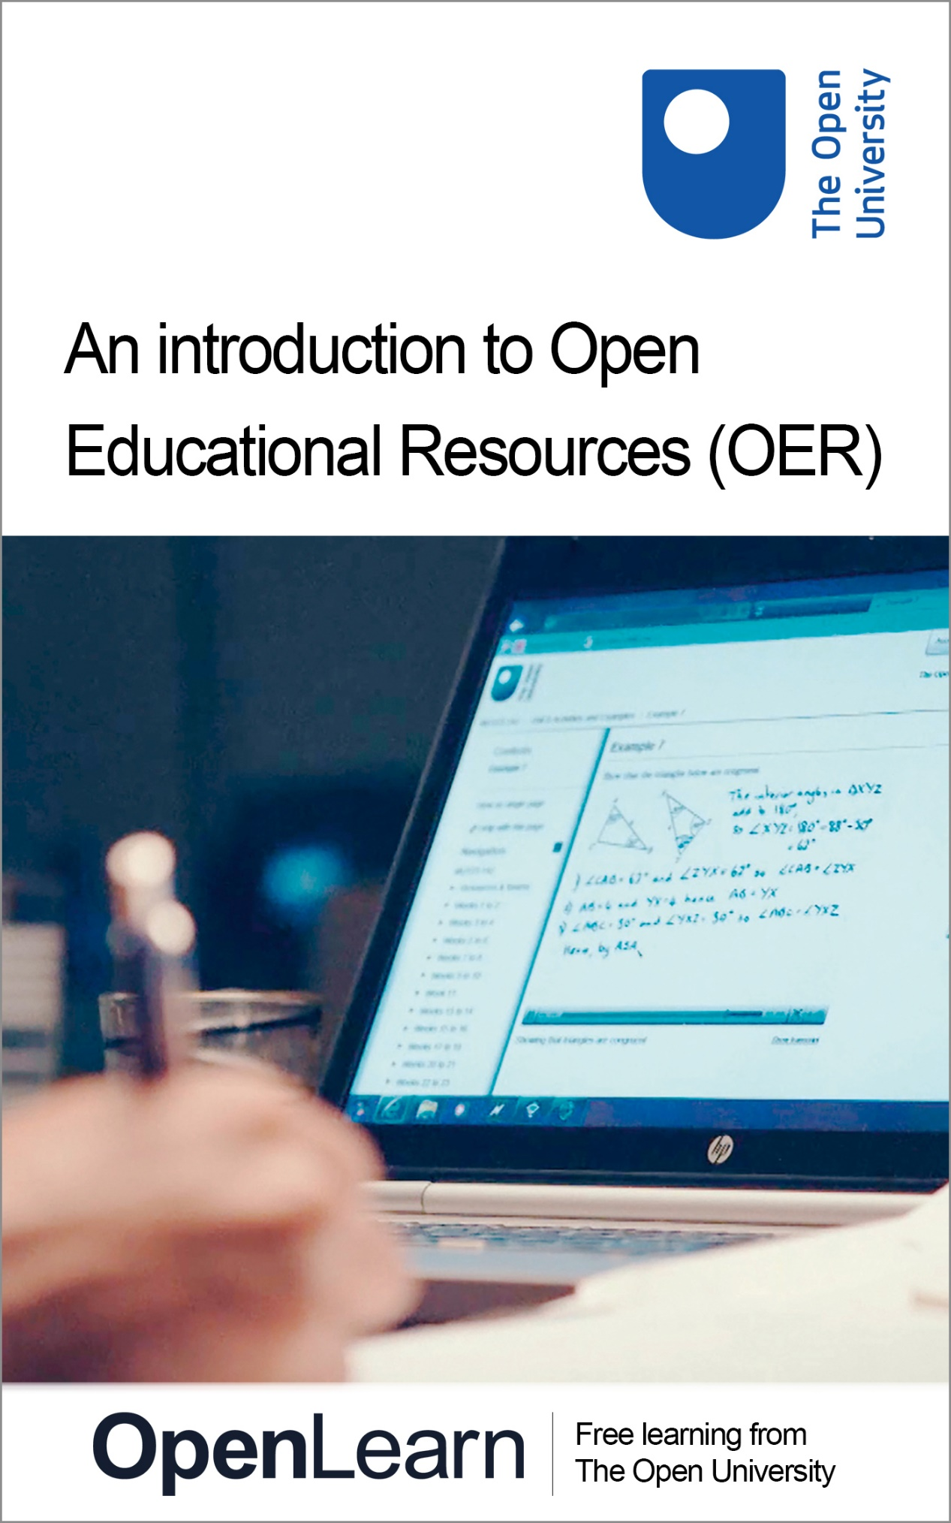

H800_1

An introduction to Open Educational Resources (OER)

About this free course
This free course is an adapted extract from the Open University course H800 Technology-enhanced learning: practices and debates : www.open.ac.uk/postgraduate/modules/h800 .
This version of the content may include video, images and interactive content that may not be optimised for your device.
You can experience this free course as it was originally designed on OpenLearn, the home of free learning from The Open University – www.open.edu/openlearn/education/introduction-open-educational-resources-oer/content-section-0
There you’ll also be able to track your progress via your activity record, which you can use to demonstrate your learning.
Copyright © 2016 The Open University
Intellectual property
Unless otherwise stated, this resource is released under the terms of the Creative Commons Licence v4.0 http://creativecommons.org/licenses/by-nc-sa/4.0/deed.en_GB . Within that The Open University interprets this licence in the following way: www.open.edu/openlearn/about-openlearn/frequently-asked-questions-on-openlearn . Copyright and rights falling outside the terms of the Creative Commons Licence are retained or controlled by The Open University. Please read the full text before using any of the content.
We believe the primary barrier to accessing high-quality educational experiences is cost, which is why we aim to publish as much free content as possible under an open licence. If it proves difficult to release content under our preferred Creative Commons licence (e.g. because we can’t afford or gain the clearances or find suitable alternatives), we will still release the materials for free under a personal end-user licence.
This is because the learning experience will always be the same high quality offering and that should always be seen as positive – even if at times the licensing is different to Creative Commons.
When using the content you must attribute us (The Open University) (the OU) and any identified author in accordance with the terms of the Creative Commons Licence.
The Acknowledgements section is used to list, amongst other things, third party (Proprietary), licensed content which is not subject to Creative Commons licensing. Proprietary content must be used (retained) intact and in context to the content at all times.
The Acknowledgements section is also used to bring to your attention any other Special Restrictions which may apply to the content. For example there may be times when the Creative Commons Non-Commercial Sharealike licence does not apply to any of the content even if owned by us (The Open University). In these instances, unless stated otherwise, the content may be used for personal and non-commercial use.
We have also identified as Proprietary other material included in the content which is not subject to Creative Commons Licence. These are OU logos, trading names and may extend to certain photographic and video images and sound recordings and any other material as may be brought to your attention.
Unauthorised use of any of the content may constitute a breach of the terms and conditions and/or intellectual property laws.
We reserve the right to alter, amend or bring to an end any terms and conditions provided here without notice.
All rights falling outside the terms of the Creative Commons licence are retained or controlled by The Open University.
Head of Intellectual Property, The Open University
978-1-4730-1778-8 (.kdl)
978-1-4730-1010-9 (.epub)

Contents
- Introduction
- Learning outcomes
- 1 Open Educational Resources (OER)
- 2 An introduction to OER
- 3 Exploring OER
- 4 Redesigning some OER
- 5 An interactive quiz question about OER
- 6 Ideas for further reading and exploration
- Conclusion
- Acknowledgements
- Solutions

Introduction
In this free course you will get to know more about open educational resources (OER), which can be used on their own or alongside social learning tools that allow learners to share content and experiences.
This OpenLearn course provides a sample of postgraduate level study in Online and Distance Education.

Learning outcomes
After studying this course you should be able to:
- understand and have a better knowledge of some of the choices that practitioners make about ways of applying technologies for a variety of learners across the globe in education, training or professional development
- understand and have a better knowledge of the potential and actual advantages of open educational resources, and how these might benefit learners in a wide range of contexts.

1 Open Educational Resources (OER)
The internet provides vast amounts of OER for use and reuse. This may be text, video, graphics or audio and is free of charge. It’s usually produced by educational institutions and published online to the general public for their immediate use or for repurposing according to the users’ needs. This fast-paced Short History of English , for example, was loaded onto YouTube by The Open University in 2011.

Video content is not available in this format.
Short History of English
View transcript - Short History of English

OER can also be created by individuals, so the production of OER is not exclusive to educational institutions although largely dominated by them.
In this course you will look at three institutional OER initiatives – MIT’s open courseware, Carnegie Mellon’s Open Learning Initiative and The Open University’s OpenLearn. You will get a flavour of how different OER initiatives design and present the content for their audiences.
You will also have the option to find, discuss and redesign some OER material. You can choose your audience for the material and redesign it to fit their needs.

2 An introduction to OER

Activity 1
About an hour

- To get a sense of the global and governmental context of OER, explore this presentation by Sir John Daniel, a former vice-chancellor of The Open University, where he sets out the context of the 2012 Paris Declaration on OER.
- Search on ‘Creative Commons’ if you’re not familiar with the concept, and read/skim some of your hits.
- Read one of Martin Weller’s blog entries from early in 2013 – Openness has won – now what? – where he argues that:
  - ‘it’s hard not to conclude that openness has prevailed… Whether it’s open access publishing, open data, MOOCs, OERs, open source or open scholarship – the openness battle has largely been won.’
Later that year, he argued that ‘it’s a mistake to talk about openness as if it’s one thing’.

3 Exploring OER
Many educational institutions worldwide are offering OER. This is a way to widen access to educational material to a variety of audiences with diverse interests. Note, too, that the Commonwealth of Learning declaration stressed its goal that OER should ‘enter the educational mainstream’.
In this activity we would like you to visit some OER websites. You will notice that the sites vary in format, in what they offer and in how they expect the user to engage with their materials.

Activity 2
About two hours

- Please visit the following initiatives and reflect upon their differences in purpose, content design and the tools available for the learner. You might wish to make brief notes, or draw up a table, comparing the features of each site that interests you.
  - MIT Open Courseware (Massachusetts Institute of Technology, USA)
MIT was the first institution to offer OER. It presented the first pilot website in 2002 with 50 courses, and by early 2015 was offering extracts from more than 2000 courses with free lecture notes, tests and videos. It’s an interesting site to look around, including under the ‘About’ tab.
  - Open Learning Initiative (OLI, Carnegie Mellon University, USA)
The ‘Learn with OLI’ tab is a good place to start, to see the range of courses that is offered. ‘Studying Effectively’ (at the time of writing, it’s at the bottom of the home page) will give you an idea of the learning strategy that OLI proposes, including ‘learn by doing’. This captioned video from The Open Learning Initiative begins by arguing that higher education faces a major challenge:
‘We’re asking faculty and institutions to teach many, many, many more students. And we’re giving them 50 minutes to try and address the needs of that much larger group with a much greater diversity. And then we wonder why pass rates, failure rates are so high. It’s an undoable task without better tools and better support.’

Video content is not available in this format.
Exploring OER
View transcript - Exploring OER

  - OpenLearn (The Open University, UK)
There’s plenty of material to choose from here. You might like to pick an area you know about already, and decide what you think about the material you find. Or choose an area you know little or nothing about…
  - iTunes U (International) and The Open University on iTunesU
At iTunes U numerous universities make their content available, in the form of lectures, videos, films and other resources. You can download the content in different formats, such as PDF or MP3. The Open University joined iTunes U in 2008 and currently provides content from over 130 of its modules.

4 Redesigning some OER
In Activity 3 we give you the option to redesign some OER material for learners that you choose. You may be working in training or education and have some learners in mind. You may be thinking of your friends or family, and of things you feel they might like to learn.

Activity 3
Between two and three hours

- Find some OER material (for example, from one of the sites in Activity 2) that interests you, or that you think you might like to develop. It could be on a topic you know about, or something completely new.
- Decide who your learners are – what they already know (if anything) about the topic you’ve chosen, what might get them interested. (You may need to cycle through these first two bullet points a few times, before you settle on some material and some learners.)
- Now that you’ve found the material, and have decided on your learners, set out what you see as the material’s strengths and weaknesses. What’s missing? Does it go into too much detail, or not enough? If the material’s on a topic that is completely new to you, you can test it against your own requirements: does it help you learn?
- Find or suggest some new content – and explain what this adds to the existing material, and why you feel it will be useful and relevant for your learners.

5 An interactive quiz question about OER

Activity 4
About 5 minutes

Of these three institutions, which was the first to provide free online open educational resources (OER)?

The Open University
Carnegie Mellon University
Massachusetts Institute of Technology
View answer - Activity 4

6 Ideas for further reading and exploration
- Here are three blogs you might enjoy exploring. Their authors raise a number of interesting questions, including those of relevance to openness:
  - Doug Clow’s Imaginatively-titled Blog
  - e4innovation.com
  - The Ed Techie , written by Martin Weller.
You could also try Stephen Downes’ blog , and sign up to daily alerts.
- ‘ “OER university” to cut cost of degree ’, wrote the Times Higher Education in early 2011. You could search to see how it has developed.
- If you enjoy UK literature, you may be interested to see how the connections between twentieth-century UK novelists have been presented in OpenLearn.
- OER Readiness in Africa (2010) by Pauline Ngimwa – a report focusing on the technological and human factors that have a bearing on the distribution and use of OER in three African countries.
- There’s more on OER in the developing world in Perryman, L., Buckler, A. and Seal, T. (2014) Learning from TESS-India’s approach to OER localisation across multiple Indian states . This explores the challenges of repurposing OER to meet the needs of India’s teacher educators, and shows how the context in which OER are to be used can affect the ways in which they are repurposed.
- D’Antoni, S. and Savage, C. (eds) (2010) Open Educational Resources – Conversations in Cyberspace , Paris, UNESCO; also available online at http://portal.unesco.org/ci/en/ev.php-URL_ID=28899&URL_DO=DO_TOPIC&URL_SECTION=201.html .
- Weller, M. (2014) The Battle for Open: How Openness Won and Why it Doesn’t Feel Like Victory , London, Ubiquity Press; DOI: http://dx.doi.org/10.5334/bam .

Conclusion
We hope you’ve enjoyed studying this short course. If you’ve worked through the first activity, you’ll have a sense of the underlying ethos of OER and the principles set out in the Paris Declaration. That dates from 2012, of course – a long time ago in the fast-moving world of technology-enhanced learning. But the principles continue to inspire and generate exciting work and research. And in Technology-enhanced learning: practices and debates (H800) , from which this material is extracted, we encourage students to explore the latest developments in digital education and learning.
You may have already been familiar with the OER sites in Activity 2. If so, you may have decided to look further afield. But if you weren’t familiar with those resources from MIT, Carnegie Mellon and The Open University, that activity will have given you ideas about what’s available.
And finally, with Activity 3, you had the chance to redesign some material for your own learners. And if you skipped it because you don’t have any learners? You can always go back and spend a few minutes thinking about how you would adapt some OER material for friends or people in your family.
All in all, we hope this sample material has whetted your appetite to continue exploring OER, and to further your interest in the rich field of technology-enhanced learning. For example, you could study a much larger block of free material, where you can explore several facets of ‘openness’ – including MOOCs, other aspects of OER, and ‘rhizomatic learning’. That block is adapted from the Open University course H817 Openness and innovation in elearning , which is a companion course to H800 within The Open University’s Masters in Online and Distance Education .

Acknowledgements
This free course is adapted from a former Open University course called 'Technology-enhanced learning (H800)', which was superceded by a new course: 'Technology–enhanced learning: foundations and futures (H880)'.
This course was written by Andreia Inamorato dos Santos and John Pettit for the H800 course team.
Except for third party materials and otherwise stated (see terms and conditions ), this content is made available under a Creative Commons Attribution-NonCommercial-ShareAlike 2.0 Licence .
The material acknowledged below is Proprietary and used under licence (not subject to Creative Commons Licence). Grateful acknowledgement is made to the following sources for permission to reproduce material in this course:
Course image: www.pexels.com/photo/book-macbook-pro-working-studying-7354/ in Pexels made available under www.creativecommons.org/publicdomain/zero/1.0/legalcode
Video: Short History of English © The Open University
Activity 2: Profiles Next Generation Learning, Open Learning Initiative/Carnegie Mellon University: Made available under https://creativecommons.org/licenses/by-nc-sa/2.5/ .
Every effort has been made to contact copyright owners. If any have been inadvertently overlooked, the publishers will be pleased to make the necessary arrangements at the first opportunity.
Don't miss out:
If reading this text has inspired you to learn more, you may be interested in joining the millions of people who discover our free learning resources and qualifications by visiting The Open University - www.open.edu/openlearn/free-courses

Solutions

Activity 4

Answer
Right:
Massachusetts Institute of Technology
Wrong:
The Open University
Carnegie Mellon University
Massachusetts Institute of Technology (MIT). Here’s the link to MIT's Open Courseware .
Back to - Activity 4

Short History of English

Transcript
The History of English in 10 Minutes
Chapter Two, the Norman Conquest, or Excuse My English. 1066. True to his name, William the Conqueror invades England, bringing new concepts from across the Channel, like the French language, the Doomsday Book, and the duty-free Gauloises multipack.
French was de rigueur for all official business, with words like judge, jury, evidence, and justice coming in and giving John Grisham’s career a kick start. Latin was still used ad nauseum in church, but the common man spoke English, able to communicate only by speaking more slowly and loudly until the others understood him.
Words like ‘cow’, ‘sheep’ and ‘swine’ come from the English-speaking farmers, while the a la carte versions – ‘beef’, ‘mutton’ and ‘pork’ – come from the French-speaking toffs, beginning a long running trend for restaurants having completely indecipherable menus. All in all, the English absorbed about 10,000 new words from the Normans, though they still couldn’t grasp the rules of cheek kissing.
The bonhomie all ended when the English nation took their new war-like lingo of armies, navies and soldiers and began the 100 Years’ War against France. It actually lasted 116 years, but by that point, no one could count any higher in French, and English took over as the language of power.
Back to - Short History of English

Exploring OER

Transcript
Candace Thille
Higher education is confronted with a pretty significant challenge. We're asking faculty and institutions to teach many, many, many more students. And we're giving them 50 minutes to try and address the needs of that much larger group with a much greater diversity. And then we wonder why pass rates, failure rates are so high. It's an undoable task without better tools and better support.
The Open Learning Initiative is an open educational resources project that brings together the learning science researchers who are studying what do we know about how people learn. The software engineers who are looking at what are the affordances of the technology, the human computer interaction experts who look at the interface between humans and computers, and the domain experts, the faculty who teach statistics, chemistry, philosophy. This is not just about online courseware. It's really revolutionising how we think about learning, and how we think about teaching.
We make learning environments, and learning environments include what a student might do with the computer.
Speaker 1
Worrying is discouraging.
Speaker 2
Worrying is discouraging.
Candace Thille
But it also includes what a student does in the classroom with their peers.
Natalie Baker Shirer
‘Con-summit’. Now, if you said ‘con-summit’, it would be a northern English dialect. I definitely know that when they are studying, using the tool, they know the sounds much better.
Speaker 2
Demur. Oh, demur.
Wilfried Sieg
You are providing an environment in which students can prepare for meetings by themselves and be intelligently tutored.
Speaker 3
Plus, this will give them an idea of like –
Candace Thille
One of the most powerful features of web-based learning environments is we can collect this data about students and use that to drive very powerful feedback loops. Now, the first feedback loop is to the student. So as they're working through the environment, they're getting immediate feedback just in time to refine their performance.
The second feedback loop is to the instructor. We created the instructor learning dashboard. The idea behind the learning dashboard is to be able to give the instructors a really quick view of where’s my class.
So the instructor has a much better sense of where their class is getting it, and where they’re struggling it. So they can spend that very precious class time in a much more informed position.
Wilfried Sieg
You can see where they have difficulties, and you can focus on those particular areas instead of just giving a lecture. To look at one particular set theoretic problem.
Candace Thille
The third feedback loop is to the course design team.
Speaker 4
Long term we really need these little introductory animated films.
Candace Thille
Every semester, we have hundreds of students using these environments. And while the instructor’s going to get just that feedback on what’s working and not working for just their class, the design team gets that feedback across all classes. So we can use that information to say, where do we need to focus our attention on improving the course.
Speaker 5
I’d like your permission to record this session with our camera –
Candace Thille
The fourth feedback loop is to the science of learning. How did we figure out how to design effective learning environments to support students and give them feedback? That's based on a huge body of work that’s been going on for years in the area of learning science research.
As students are working through the course, the science of learning can introduce experimental conditions into the learning environment that will help them refine and develop new theories of human learning.
I think for a lot of people it makes sense that you could teach math, or science, or even formal logic with a computer. So how do you teach something where there isn’t an answer, for example, speech?
Class
[Inaudible]
Candace Thille
The way that we use the computer may be very different from one course to the next, but it’s the design process that’s key.
Speaker 6
Actor’s picture.
Natalie Baker Shirer:
They could hear. They could be tested. They could give feedback. They were given feedback. Everything worked.
Speaker 7
Tumult and thunder.
Natalie Baker Shirer
Right-o.
Candace Thille
We thought, let’s try and take the same methodology and see if we can create learning environments that will support the community college faculty and the students.
Wilfried Sieg
The problem in such relatively formal classes is always that some students have an appropriate background. Others don’t. And in this way, students depending on their background can prepare themselves appropriately at their own pace. The course is being offered successfully not only at research universities, but also at institutions that have a quite different student population. That is students who are involved already and working, have families, and it works very successfully there too.
Candace Thille
What difference does it make? How is that really any better than what we’re currently doing? We’ve done a number of evaluation studies to answer exactly that question, and the results have showed that the students, even though they took the class for half the time, with half the number of contacts hours during that time, did as well or better than the students in the traditional instruction.
Wilfried Sieg
We are teaching more and more rigorously than we used to. With students who have already some form of mathematical background, I go through this full term course in one month. Without OLI, I could not ever try to achieve this.
Candace Thille
For the last 100 to 200 years, we’ve been using the same methods to try and develop and disseminate knowledge. Now, both with the development of the learning sciences and the development of the affordances of the technology and the web, we are revolutionising higher education.
Back to - Exploring OER

