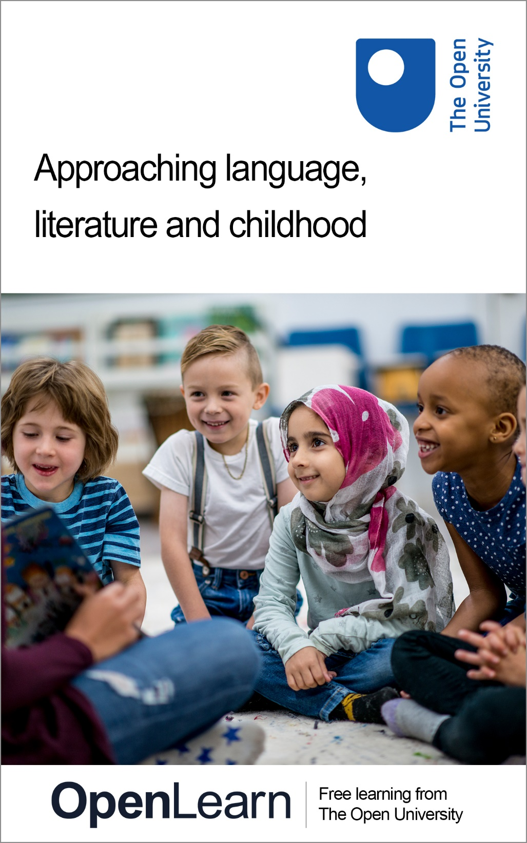

L301_1 Approaching language, literature and childhood

Approaching language, literature and childhood

About this free course
This free course is an adapted extract from the Open University course L301 Language, literature and childhood.
This version of the content may include video, images and interactive content that may not be optimised for your device.
You can experience this free course as it was originally designed on OpenLearn, the home of free learning from The Open University –
https://www.open.edu/openlearn/education-development/approaching-language-literature-and-childhood/content-section-0
There you’ll also be able to track your progress via your activity record, which you can use to demonstrate your learning.
Unless otherwise stated, copyright © 2024 The Open University, all rights reserved.
Intellectual property
Unless otherwise stated, this resource is released under the terms of the Creative Commons Licence v4.0 http://creativecommons.org/licenses/by-nc-sa/4.0/deed.en_GB. Within that The Open University interprets this licence in the following way: www.open.edu/openlearn/about-openlearn/frequently-asked-questions-on-openlearn. Copyright and rights falling outside the terms of the Creative Commons Licence are retained or controlled by The Open University. Please read the full text before using any of the content.
We believe the primary barrier to accessing high-quality educational experiences is cost, which is why we aim to publish as much free content as possible under an open licence. If it proves difficult to release content under our preferred Creative Commons licence (e.g. because we can’t afford or gain the clearances or find suitable alternatives), we will still release the materials for free under a personal end-user licence.
This is because the learning experience will always be the same high quality offering and that should always be seen as positive – even if at times the licensing is different to Creative Commons.
When using the content you must attribute us (The Open University) (the OU) and any identified author in accordance with the terms of the Creative Commons Licence.
The Acknowledgements section is used to list, amongst other things, third party (Proprietary), licensed content which is not subject to Creative Commons licensing. Proprietary content must be used (retained) intact and in context to the content at all times.
The Acknowledgements section is also used to bring to your attention any other Special Restrictions which may apply to the content. For example there may be times when the Creative Commons Non-Commercial Sharealike licence does not apply to any of the content even if owned by us (The Open University). In these instances, unless stated otherwise, the content may be used for personal and non-commercial use.
We have also identified as Proprietary other material included in the content which is not subject to Creative Commons Licence. These are OU logos, trading names and may extend to certain photographic and video images and sound recordings and any other material as may be brought to your attention.
Unauthorised use of any of the content may constitute a breach of the terms and conditions and/or intellectual property laws.
We reserve the right to alter, amend or bring to an end any terms and conditions provided here without notice.
All rights falling outside the terms of the Creative Commons licence are retained or controlled by The Open University.
Head of Intellectual Property, The Open University

Contents
- Introduction
- Learning outcomes
- 1 Reading as a child and as an adult
- 2 Instruction or delight?
  - 2.1 The key questions
  - 2.2 Defining children’s literature
  - 2.3 Content, censorship and understanding
- 3 Constructing a world of fantasy
  - 3.1 Marianne Dreams and Tom’s Midnight Garden
  - 3.2 Direct and indirect speech
  - 3.3 A text of its time?
- 4 Visibility and inclusion in children’s books
- 5 Bringing it all together
- 6 Summary
- References
- Acknowledgements
- Glossary
- Solutions
- Descriptions

Introduction
This free course, Approaching language, literature and childhood, introduces you to the field of children’s literature. In this course, you’ll consider issues such as: How do children acquire and use languages and literacies? Why (and how) is language important in children’s literature? Why (and how) is literature important for children and young adults? How is childhood socially constructed? And how is the child represented in literature?

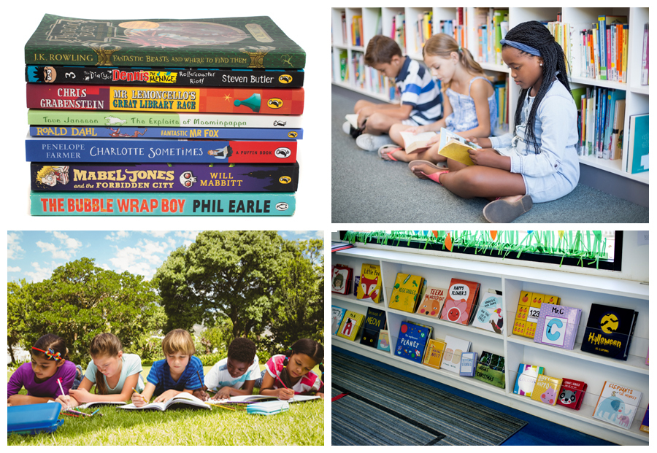
Figure 1 Reading and writing in English
View description - Figure 1 Reading and writing in English

Children’s literature is a vast and growing area of academic study. Interdisciplinary in nature, the field draws on theories, methods and applications from language, literature and childhood studies. While an academic domain in its own right, the study of children’s literature generally has a personal connection for individuals, hooking into our own memories of reading and viewing particular works.
Most of us have some level of familiarity with poems, rhymes, cartoons, graphic novels and other forms of storytelling from our own childhood, from children we interact with as adults, or from engaging with literature for children as adults ourselves. But how does this material influence us as children or as adults? Do the books we read – or engage with through films, computer games, plays or other means – serve to expand or limit our worldviews? And how can the disciplines of linguistics, literature and childhood studies help us to explore the world of children’s books?
In this short course, you’ll begin to address these and other questions. You’ll start by considering what it means to revisit children’s literature as an adult reader and begin thinking about literature in terms of its purpose. You’ll start considering two novels written for children, Marianne Dreams and Tom’s Midnight Garden, and learn some introductory linguistic techniques to help you identify how these works achieve their intended effects. You’ll then consider diversity and inclusion, and at the end of the course, you’ll think about how you could recommend children’s books to others.
This OpenLearn course is an adapted extract from the Open University course L301 Language, literature and childhood. L301 situates children’s literature in the context of language practices and conceptualisations of childhood from the late twentieth century to present day literature through the lenses of three disciplines: language studies, literature, and childhood studies.

Box 1 A few definitions
You will find a few terms emboldened in the course text, which are then defined in the glossary (found at the end of the course). If you hover over the term, the definition will appear, or you can click to be taken to the glossary page. Here are a few definitions before getting started with the course:
- ‘Children’s literature’ refers to stories or factual writing produced for children aged under 18 and encompasses everything from picturebooks, short stories and graphic novels to biographies and dictionaries.
- This course’s use of the umbrella term ‘children’s literature’ includes hard-copy books with illustrations, ebooks and audiobooks, as well as literature engaged with through films, television, plays, video games or other formats.
- ‘Childhood’ is taken to mean the period of time from 0–18 years old.
- ‘Text’ will refer to any piece of language, whether spoken or written, long or short, which forms a unified whole.

Learning outcomes
After studying this course, you should be able to:
- discuss some of the different theories, approaches and debates in the interdisciplinary field of children’s literature
- reflect on your own and others’ memories of children's literature
- consider how the academic disciplines of literature and childhood intersect, bringing different perspectives to the field
- describe how texts for children and young people convey and challenge ideas around diversity through an exploration of ethnic diversity.

1 Reading as a child and as an adult

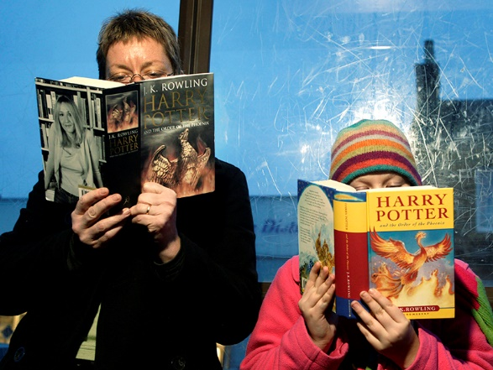
Figure 2 Child and adult readers
View description - Figure 2 Child and adult readers

Reading a book for pleasure, or reading it to someone else, is very different from reading a book in order to evaluate it academically. The purpose of the following activity is to encourage you to start thinking critically about children’s literature. Bear in mind that when a book is an old favourite, this can be particularly difficult: it’s hard to separate your own personal memories of it, and the circumstances in which you first read it, from a dispassionate critique of the writing style, analysis of the ways it depicts children and childhood, or consideration of its place in the history of children’s literature.

Activity 1 How adults experience children’s literature
Allow about 30 minutes

Think of any children’s book in any language that you’ve read. You may have read the book as a child, or have experienced it with a child more recently, or you may have read it for the first time as an adult. Then reflect on the following questions, writing notes for each:

1. What is the main storyline in the work you’ve chosen? (make this very brief)

Provide your answer...

2. In what ways do you think reading your chosen book as an adult might differ from reading it as a child? (you don’t have to reread the book!)

Provide your answer...

3. What is it about your book that makes it a children’s book? The subject matter? The level of the language and choice of particular words? The pictures? The format?

Provide your answer...

4. How are children portrayed in your book, and what assumptions are made in it about childhood? Is childhood seen as happy and carefree, for example, or as more problematic?

Provide your answer...

5. Can you think of any themes in the book that are repeated in other children’s books you know of? Does it rely, for example, on fantasy? On a child going on a journey or undertaking a quest? On a child operating without parents or protectors?

Provide your answer...

View discussion - Part

A key point of this activity was to encourage you to think and read critically, and consider the possible differences in how you may have read or experienced a story as a child and as an adult. While children may not notice covert messages around the way the world is portrayed, they still internalise these as part of their worldview. To take a rather extreme example, if a child today were to only read works by Lewis Carroll (Alice in Wonderland), Enid Blyton (the Famous Five series), and Mary Norton (The Borrowers), they would construe the world as white, middle-class and populated almost entirely by nuclear families (albeit including tiny ones in the form of the borrowers!) This is not to say that children today should not read these three authors, but rather that a greater range of authors and subject matter has much to offer – as this course aims to make clear.

2 Instruction or delight?
The focus of this course so far has been on adults’ memories and views towards engaging with children’s literature. If you’ve previously studied creativity in language, you’ll be familiar with the concept of creativity having a purpose other than straightforward enjoyment. While reading is probably considered by most children to be simply for fun, adults have often regarded the activity as having a didactic or educational purpose for child readers. In the next activity, you’ll look at what children’s literature is traditionally considered to be for.

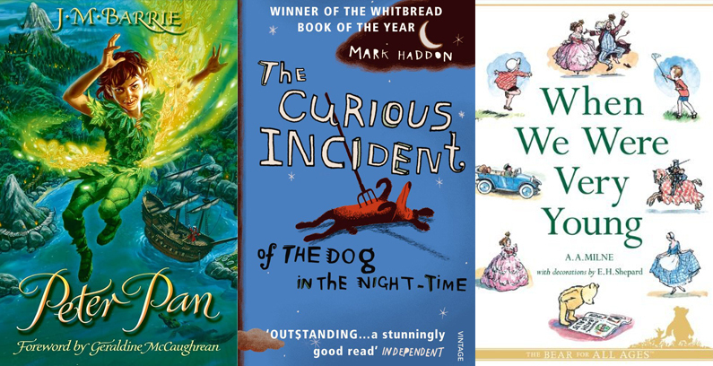
Figure 3 Writing for instruction or delight?
View description - Figure 3 Writing for instruction or delight?

2.1 The key questions
During the rest of this section, you’ll read and reflect on some academic material over the course of three linked activities (which you should allow about an hour in total to complete). These activities are based around readings excerpted from a longer piece titled ‘Instruction and delight’ by Peter Hunt (2009). Guided reflections and discussion are provided for each part.
Before you read the first part, consider the following three short quotations. You might like to make some notes on the extent to which you agree or disagree with each. Reflecting on these ideas as you get started will support you in critically evaluating Hunt’s argument.
- ‘Children’s books are nice; they take us back to a golden world, one which we might also want to share with our children or grandchildren.’
- ‘Adults write, children read, and this means that, like it or not, adults are exercising power, and children are either being manipulated, or resisting manipulation.’
- ‘Children’s books are not innocent or simple; […] Sure it’s simple, writing for kids. Just as simple as bringing them up’ (Le Guin, 1992, p. 49)’

Activity 2 Understanding the purposes of children’s literature (Part 1)
Allow about 15 minutes for this section

Now read the first excerpt of ‘Instruction and delight’ by Peter Hunt.

Peter Hunt: Instruction and delight (2009)

Part 1 – The Key Questions
Many people come to children’s literature as a relief, as a rest from the rigours of ‘adult’ studies, and their image of the texts is often based on nostalgia or wishful thinking. Children’s books are nice; they take us back to a golden world, one which we might also want to share with our children or grandchildren. Books people enjoyed when they were children have a special, and often very personal, value and meaning (which is not surprising, considering the change that a single book may make to an inexperienced reader), and there is a perfectly natural urge to revisit them. But if we look a little more closely, problems arise. It might be that the books read as a child were actually an escape, and that it is the escape, not the childhood, that the reader wishes to relive: far from being a happy, lost state, many (perhaps most) childhoods are difficult, and many adults (and adult writers) have an ambivalent relationship with their own childhood. To reread a children’s book from childhood, perhaps as an escape from the stresses of adulthood, evades both the real now and the real then. Is childhood innocent? Are the books innocent?
As Judy Blume, who wrote some of the most controversial children’s/teenage books of the late twentieth century, including Forever (the first ‘full-frontal’ children’s book (1975)) wrote:

I don’t know what childhood innocence is supposed to mean. Children are inexperienced, but they are not innocent. Childhood can be a terrible time of life. No kid wants to stay a kid. It is only adults who have forgotten who say, ‘If only I could be a kid again.’ The fantasy of childhood is to be an adult.
(West, 1988, pp. 11–12)

And so it soon becomes clear that the relationship between children’s books and childhood is far from simple; even the bright world of Winnie-the-Pooh carries within it echoes of Milne’s traumatic experiences in the First World War – the need to create a retreatist, idyllic world – and his ambivalence towards real childhood, shown in the oversentimentalised image of Christopher Robin. The filmed versions, of course, are notable (or notorious) for their commodification of childhood.
[…]
Children’s books, adults, and children
Questions such as those raised in the paragraph above are vital because, unlike other forms of literature, children’s literature is at root about power – about a power struggle. Adults write, children read, and this means that, like it or not, adults are exercising power, and children are either being manipulated, or resisting manipulation: there is a tension between the reader implied by the writer, and the real readers. Children’s books are thus inevitably didactic in some way: even the most child-friendly is adopting some implicit attitudes. It is generally assumed that those who write for children will, naturally, be persons of goodwill, wishing to do ‘good’ in some form, for their readers. The difficulty with that, of course, is establishing the nature of ‘good’ – are we here for entertainment or instruction, and just what should those two things mean?
[…]
However, it cannot be denied that 99.9 per cent of children’s books are written by adults, nor that all those writers will, necessarily, have an agenda. Even those writers who claim to be nothing but entertainers have their own ideological stance, their own ideas of what is right and wrong, their own way of seeing the world, and it is impossible that they should not in some way convey this in their writing, manipulatively or not. Equally, however childhood is defined, an adult writer cannot think their way into it: there is inevitably some gap. Some writers, such as Enid Blyton, or Arthur Ransome or J.K. Rowling, seem to have a close empathy with their audience; some books, such as Pat Hutchins’s Rosie’s Walk or Shirley Hughes’s Dogger seem, from all visible signs, to bridge the gap. But however sensitive the mediator – the parent or the teacher – they are working with imperfect instruments. The very nature of the relationship between adulthood and childhood precludes the existence of a ‘true’ children’s book. The surprising difficulty of this area demonstrates how carefully we have to step in what looks at first to be a sunny, carefree world!
Children’s books are not innocent or simple; Ursula Le Guin once observed sardonically: ‘Sure it’s simple, writing for kids. Just as simple as bringing them up’ (Le Guin, 1992, p. 49), and involving ourselves with children’s literature means involving ourselves in a complex, active literary–social system.
[…]
This means that dealing with children’s literature involves responsibility, because what may at first sight seem like trivial or ephemeral texts are in fact immensely powerful. They have been read by millions upon millions of people at the period in their lives when they are most susceptible to new ideas. It is inconceivable that these texts have not shaped society in fundamental and lasting ways. More people, probably, have read the books of Enid Blyton, more often and more repetitively, than those of any other author ever. Is it possible to imagine that her middle-class, middle-England, rather racist and sexist attitudes and values, and her patterns of narrative pass through the minds of her child-readers without, as it were, touching the sides?
The question is: if we, as adult readers, see horror and incest and murder in fairy tales, or male exploitation and female repression in Little Women, or sexism and class distinctions in Thomas the Tank Engine (the carriages are female, the trucks working-class), do we not have a duty to do something about it? What goes into children’s minds is our responsibility, just as much as what goes into their stomachs.
At this point, I suspect that we should confront perhaps the most common objection to this kind of approach: ‘but surely the children won’t see that!’ All this interpretation, this detection of hidden meanings and subtexts is what adults do, not children. I’m afraid that the simplest answer is that the assumption that children somehow, like shellfish, live among unsavoury things, but filter them out, and subsist in a pure, innocent state, is wishful thinking. We can, perhaps, make pragmatic guesses about what a child can understand, or what is irrelevant to the child and might thus be ignored – but these are only guesses. And if one is prepared simply to believe that books do not have the potential to pass on subliminal messages, then why are we as a culture so concerned with the influence of advertising or propaganda on the young? Is it because with children’s literature we are dealing with stories, and that stories are, by definition, fiction, untrue and therefore not influential? Surely not, when we acknowledge that stories are so powerful throughout the culture.
References
- Le Guin, U. K. (1992) The Language of the Night. New York, HarperCollins.
- West, M. (1988) Trust Your Children: Voices Against Censorship in Children’s Literature. New York, Neal-Schuman.

View discussion - Activity 2 Understanding the purposes of children’s literature (Part 1)

2.2 Defining children’s literature
Another key question that Hunt considers is: what is children's literature? This may sound like an easy question, but as Hunt demonstrates, there are several tricky issues that we must contend with before we answer it.

Activity 2 Understanding the purposes of children’s literature (Part 2)
Allow about 15 minutes for this section

Now read the second excerpt of ‘Instruction and delight’ by Peter Hunt. As you do, pay particular attention to how Hunt defines literature and childhood – then make some notes in the boxes underneath the excerpt.

Peter Hunt: Instruction and delight (2009)

Part 2 – Defining children’s literature
In discussing literature, there are, fundamentally, two views. The first is that there are absolute standards of quality or goodness; these are generally undefined (and undefinable), but may be perceived by the cultured, the elite, or the gifted: whether you regard the priesthood who elect themselves to make these decisions as part of the divine order, or as the preservers of cultural continuity, or as oppressive egomaniacs (canonising the dead white males) is, of course, up to you. The alternative view (oddly called ‘relativist’ by the first group – to whom everything is relative to their own standards), is to value everything as fit for purpose; thus you can’t compare, say, apples and oranges, because although they are both fruits, what is good about either is intrinsic to the species. Mozart wrote good music of its kind, the Beatles wrote good music of its kind; War and Peace is good of its kind, We’re Going on a Bear Hunt is good of its kind.
Therefore, to say that one form (children’s books) is, by definition, inferior to another (adults’ books) may be an interesting philosophical discussion, but it is a dangerous one in the context of children and their books. The ‘inferior’ form will not be taught or taken or analysed seriously (as was the case not so long ago with ‘women’s writing’), and that can cause serious multiple confusions in the education system. Shakespeare at school and Jackie Wilson at home should be seen as doing different things, rather than one being ‘superior’ to the other. Both are leading their readers into different aspects of the culture, and to compare them directly is not a useful exercise.
When Harry Potter and the Prisoner of Azkaban came up against Seamus Heaney’s translation of the Old English poem Beowulf for the 2000 Whitbread literary award, the critic Antony Holden wrote that it would be a ‘national disgrace’ if Harry won. (Beowulf won.) Much of the hot air generated in that discussion came from a confusion of what is meant by good in the abstract (undefinable except by assertion) as opposed to good for (demonstrable empirically), and from not comparing like with like. Children’s books are most usefully seen as part of their own separate literary system, which has its own special qualities and values and techniques, and which relates primarily to children. As the New York Times commented:

Whereas adults see in Harry Potter a fairly conventional supernatural adventure story – one not nearly as brilliant or literary as, say, The Hobbit or the Alice in Wonderland books [sic] – something more fundamental evidently reverberates in the minds of children, something as powerful as the witch of ‘Hansel and Gretel’.
(quoted in Zipes, 2001, p. 184)

The problem is that – with a few exceptions – children’s books are equated with ‘popular’ texts in the adult system, and are therefore, by definition, inferior. Any teachers or parents who have at the back of their mind the idea that the majority of what they are giving their children – and what they and their children enjoy – is inescapably inferior, has an unnecessary problem. Thus the Harry Potter books are most usefully seen from the point of view of children.
Defining children’s literature: some case studies
Having said that, how do we define this body of texts that we are going to look at? At this point, the pragmatist will say: surely, it is obvious what a book is, from its cover and layout (the peritext). There might be some marginal cases, books that cross over between children and adults, such as the work of Philip Pullman, or J.R.R. Tolkien, or Mark Haddon’s The Curious Incident of the Dog in the Night Time. And there seems to be some sliding around over time – so that fairy tales and Sherlock Holmes, both originally for adults, are now commonly marketed for children, while The Water-Babies finds itself in the annotated Oxford ‘World’s Classics’. But most children’s books are obviously children’s books, for example, Roger Hargreaves’s ‘Mr Men’ and ‘Little Miss’ books, Jill Murphy’s Five Minutes’ Peace¸ A.A. Milne’s Winnie-the-Pooh, or anything by J.K. Rowling or Enid Blyton. What else can they be?
[…]
And many children’s books might not actually be for children. Jill Murphy’s Five Minutes’ Peace is one of a very successful series featuring anthropomorphised elephants, the Large family. It begins with Mrs Large regarding her family (off-page) with the verbal text: ‘The children were having breakfast. This was not a pleasant sight.’ The question is – whose point of view is this? The rest of the book, for all the ‘obvious’ trappings of the children’s book, deals with adult preoccupations entirely from an adult viewpoint: the implied reader is not the child. What, then, does the child-reader, or the child-read-to make of this? Is he/she learning a lesson in empathy? Perhaps, but this may not be what one naturally assumes to be a children’s book.
Other books, like Winnie-the-Pooh, which has been a children’s classic for generations, are in fact books aimed at two audiences. Barbara Wall, in her analysis of how authors address their narratee (the reader), The Narrator’s Voice (1991, p. 35), suggests that there are many books marketed for children where writers actually write for adults and children separately:

their narrators will address child narratees overtly and self-consciously, and will also address adults, either overtly, as the implied author’s attention shifts away from the implied child reader to a different older audience, or covertly, as the narrator deliberately exploits the ignorance of the implied child reader and attempts to entertain an implied adult reader by making jokes that are funny primarily because children will not understand them.

[…]
C.S. Lewis, in a statement very often quoted with approval, when it is in fact denigrating children’s literature, wrote: ‘I am almost inclined to set it up as a canon that a children’s story which is enjoyed only by children is a bad children’s story’ (Lewis, 1966, p. 24). We might well argue the exact opposite: the real children’s books are the ones read only by children – ones that do not have anything to say to adults, and which are not, therefore, subject to adult judgements. This is a radical thought, that places, say, Enid Blyton in the forefront of children’s literature (rather than more respectable, adult-like writers such as Kenneth Grahame or Philip Pullman). For Barbara Wall (1991, p. 35), these genuine children’s books are marked by writers who talk directly to the child reader, ‘showing no consciousness that adults too might read the work’.
[…]
The fact that J.K. Rowling’s books are widely read by adults says more about adult attitudes to fantasy than it does about J.K. Rowling, whose focus, like that of Blyton, is her developing audience, not other adults. To criticise her books as if they were written for adults is to miss the point, and to misdirect the criticism.
A working definition of ‘children’s literature’, or, perhaps better, ‘literature for children’, then, might be arrived at by choosing your own interpretation of the three elements, the literature, the children and the ‘for-ness.’
The word ‘literature’ is a spectrum: at one end is the small handful of ‘canonical’ texts ‘generally’ agreed to have some kind of eternal value; at the other is the vast range of ‘texts’ routinely and traditionally absorbed by the category: myth, legend and folk tale, verse, picture books, ‘chapter books’, novels, cartoons, films, video games, websites, merchandise, and so on. You may feel that the oral tale or seventeenth-century chapbooks are no longer for children, and therefore do not fit into your idea of children’s literature, or you may feel that the study of electronic media is different from the study of printed texts, or you may feel that the printed book is really of little relevance to the modern child and that what we should be looking at is the mediation of story through electronic and multimedia channels. Or, perhaps, that there are many kinds of children’s literature, and that only certain ones are within your field of interest.
When we describe literature as being ‘for’ children, do we exclude those texts which, as we have seen, address adults over the heads of children? If so, do we exclude the huge industry of ‘children’s’ films, such as Shrek, or Toy Story, which are clearly for a mixed audience, or, indeed, any of the classic Walt Disney feature-cartoons, almost all of which are concerned with courtship and marriage? Or do we include or exclude books according to whether they are designed to instruct or to amuse their audience? Most histories of children’s literature suggest that children’s books were initially entirely designed for educational purposes, with ‘delight’, if any, an incidental sugar-ing of the pill. In the course of the nineteenth century, instruction gave way to entertainment, religion to fantasy – with Alice’s Adventures in Wonderland seen as a kind of anarchic, liberating turning-point. One problem here is that childhood was very different 200 years ago, especially in terms of what we would now call media input; children had fewer things to entertain them, and different mindsets.
[…]
Which leaves us with deciding what we mean by ‘children’. Childhood is generally defined either by physical and mental characteristics – size, development or immaturity, and so on – which are common to all children, or by local, cultural decisions. This second idea of childhood changes with time, place, commercialism, politics, and even with individuals; in the West, it has been commonly associated with lack of responsibility. Consequently, how do we categorise children’s books – as suitable for children of certain ages, or certain developmental levels, or for children in certain social or geographical areas? Are we happy to accept such generalisations, or would we prefer to think about individual children? And even if we are happy to accept such generalisations, is it practical to do so?
[…]
Equally, it is important to realise that it is the concepts of childhood held by writers and publishers, rather than ‘real’ childhoods, which determine what appears in texts. What is important for children’s literature is that the inevitable variety of childhood and childhoods is acknowledged in its real readers, and its variability as a social and commercial construction is acknowledged in the texts.
References
- Lewis, C. S. (1966) ‘On Three Ways of Writing for Children’, in Of Other Worlds. London, Geoffrey Bles.
- Wall, B. (1991) The Narrator’s Voice. Basingstoke, Macmillan.
- Zipes, J. (2001) Sticks and Stones. The Troublesome Success of Children’s Literature from Slovenly Peter to Harry Potter. New York and London, Routledge.

How does Hunt define literature?

Provide your answer...

How does Hunt define childhood?

Provide your answer...

View discussion - Part

2.3 Content, censorship and understanding
Now you’ll read the third and final excerpt from ‘Instruction and delight’. This activity asks you to reflect on the reading overall.

Activity 2 Understanding the purposes of children’s literature (Part 3)
Allow about 20 minutes for this section

In this reading, Hunt challenges many of the assumptions that are made about children’s literature: in particular, that it is easy and less complex or serious than adult literature. Looking back at the reading overall, think about the idea that children’s literature is concerned with ideology and power relations. Then write a paragraph in response to each of the following questions:
- What do you think is meant by ‘ideology’ in this essay?
- What does Hunt think is the relationship between power and childhood?

Peter Hunt: Instruction and delight (2009)

Part 3 – Content, censorship and understanding
A more obvious way of deciding what constitutes a children’s text might seem to be by looking at the contents. Are there certain things that, in our view, should not appear in children’s books – things, perhaps, that are solely adult concerns (such as sexuality) or which society tends to shy away from (such as death)? There are those who cannot understand what the savage and brutal myths and folk tales, concerned with murder, rape, incest and other horrors, have to do with children at all: as J.R.R. Tolkien observed,

the association of children and fairy-stories is an accident of our domestic history. Children as a class – except in a common lack of experience they are not one – neither like fairy-stories more, nor understand them better than adults do.
(Tolkien, 1964, p. 34)

Melvin Burgess’s Junk is about drugs; Pullman’s His Dark Materials trilogy is about the death of God – and there is even a death joke on the second page of Beatrix Potter’s The Tale of Peter Rabbit. Should some books – such as picture-books depicting the bombing of Hiroshima – only be given to children under adult supervision? Both fantasy and realism have been frowned on: fantasy as providing easy, impractical answers, and realism as raising more problems than it can solve.
[…]
Children’s books are relatively vulnerable to acts of censorship because people in general feel confident of their authority to intervene. In the UK, unlike the USA, direct acts of censorship are rare: control is built into the children’s book ‘system’ by publishers and booksellers. Generally, however, the logic of censorship is often unclear. Does reading about, teenage sexual activity for example, encourage such activity, or is ignorance of such activity actually more dangerous? Very often, it seems that it is the adults who are protecting themselves, or their idea of childhood.
[…]
The study of children’s literature, then, is often hampered by unclear thinking – as when the second and third editions of Enid Blyton’s ‘Noddy’ series were simplified to match the reputation that Noddy has for being simple. It is a complex field, traversed by literary idealists and commercial marketers, literacy experts and committed parents, and graced by some of the most innovative talents at work in the arts. Far from being a marginalised study, it is central to the way culture develops – but to negotiate its many delights, we need to realise that, perhaps more than in any study in the humanities, we have a duty to make our own decisions and to realise our responsibilities. The study of children’s texts is technically more complex than the study of adult books, partly because the audience is different, and their responses more obviously unknowable, and partly because of the range of texts and the range of purposes. With the rapid growth of electronic texts, we are at a turning point, or a new starting point, in literacy and narrative, and children’s literature is in a key position. To understand what is happening to narrative and our children we need to understand the processes of decoding texts, as well as their history and their contemporary forms: the study of children’s literature can provide us with this understanding.
References
- Tolkien, J. R. R. (1964) Tree and Leaf. London, George Allen & Unwin.

What do you think is meant by ‘ideology’ in this essay?

Provide your answer...

What does Hunt think is the relationship between power and childhood?

Provide your answer...

View discussion - Part

Box 2 Ideology
Ideology refers to systems of established beliefs that people have about aspects of social life. These systems of beliefs are viewed by some research traditions as negative; for example, followers of Karl Marx view ideology as a form of ‘false consciousness’ or illusory thinking which causes people to have a distorted view of reality. Other researchers view ideology in a more neutral way as referring to different ways of construing the world and how it works; often these beliefs and assumptions are so taken for granted that they appear to naturally be ‘the way things are’.
Ideology is, however, a contested concept and, as a scholar, it is important to be clear about what meaning you ascribe to the term. In this course, the term ‘ideology’ is used to refer to the existence of cultural beliefs around language, literature and childhood, that is, what these are and how they function as part of social life. These conceptions can be both explicit and implicit (i.e. we can refer to them overtly, or they can unconsciously influence our behaviour), but in either case they constitute a shared belief system that influences the way in which we, as users of language, interact with language and understand texts.

3 Constructing a world of fantasy
You’re probably aware of many labels applied to both adult and children’s fiction, such as adventure, science fiction, mystery, thriller and horror to name a few. In this section, you will be looking at Tom’s Midnight Garden by Philippa Pearce, and Marianne Dreams by Catherine Storr. These books have usually been categorised as belonging to the genre of fantasy. But what, exactly, is a fantasy text within children’s literature? Take a moment to reflect on your own understanding of fantasy within literature, then turn to the next activity.

Activity 3 The fantastic and the real
Allow about 10 minutes

Look at the five definitions of fantasy below. What do they suggest about the relationship between the fantastic and the real in children’s books?

Fantasy is any departure from consensus reality…
(Hume, 1984, p. 21)

One element characteristic of fantasy is the presence of magic, or any other form of the supernatural, in an otherwise realistic, recognizable world …
… The essence of fantasy is a confrontation of the ordinary and the fabulous …
… [T]he best examples of fantasy for children use the fantastic form as a narrative device, as a metaphor for reality.’
(Nikolajeva, 2006)

… [T]he fantastic [is] a form of writing which is about opening up subversive spaces within the mainstream …
(Armitt, 1996, p. 2)

a type of story or literature that is set in a magical world, often involving traditional myths and magical creatures and sometimes ideas or events from the real world, especially from the medieval period of history: Characters in children’s fantasy fiction often cross between worlds by magic.
(CED definition of ‘Fantasy fiction’, 2022)

The fantastic can intrude upon the world the reader knows, or the reader can choose to remain in the liminal space between the real and the unreal.
(Thomas, 2019)

View discussion - Activity 3 The fantastic and the real

What precisely constitutes ‘fantasy’ literature has given rise to a great many articles and books (e.g. Rhetorics of Fantasy (2008) by Farah Mendlesohn). While adult fantasy has traditionally been categorised as popular rather than prestigious literature, the fantastic has been a more acceptable and sometimes highly valued feature within children’s literature. Perhaps this is because it can be appreciated both as pleasurable play in relation to a conception of childhood as innocent and joyful, and also, in more pedagogic terms, as metaphorically conveying important insights that contribute to the child reader’s development and preparation for adulthood.

3.1 Marianne Dreams and Tom’s Midnight Garden
Marianne Dreams by Catherine Storr and Tom’s Midnight Garden by Philippa Pearce were both first published in 1958. You may have read one or both books as a child, or you may have watched a film, theatre or television adaptation. Figures 4 and 5 show some of the book covers and film and television stills produced since the novels were published. Reflect for a moment on what themes you think each book deals with, based on these images.

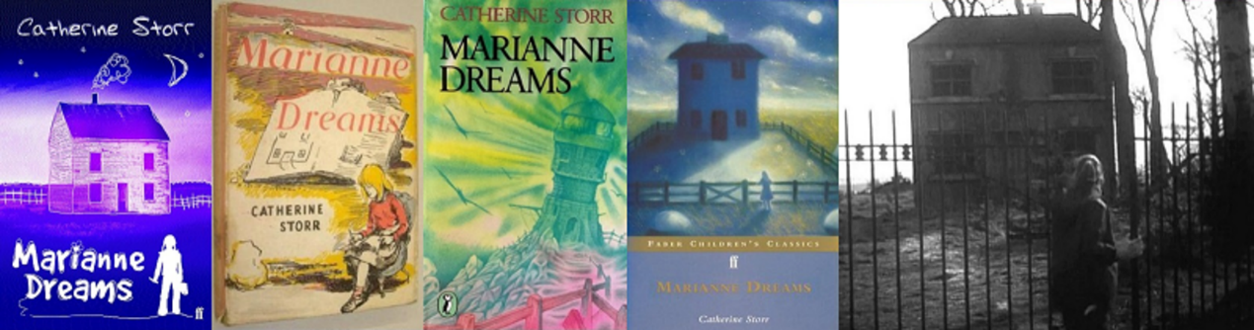
Figure 4 Book covers and film stills from Marianne Dreams

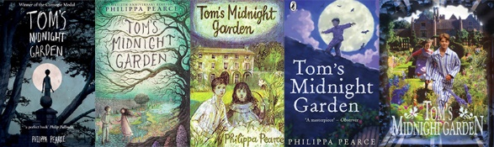
Figure 5 Book covers and film stills from Tom’s Midnight Garden
View description - Figure 5 Book covers and film stills from Tom’s Midnight Garden

The different images from Marianne Dreams and Tom’s Midnight Garden illustrate the wide range of media through which the main characters of Marianne (from Marianne Dreams) and Tom and Hatty (from Tom’s Midnight Garden) have been presented.
Some of the images from Marianne Dreams have a house prominently displayed, and two of the covers include Marianne holding a pencil or drawing, all of which are important features of the story. These images may have struck you as having a fantastical quality, possibly even sinister, especially the image of the lighthouse at an angle and the television still which shows harsh-looking metal fencing and a dark, muddy landscape.
The images from Tom’s Midnight Garden may also have struck you as having a fantastical quality, such as the image of Tom being shown outlined against the moon. As with Marianne Dreams, we learn that a house will feature in the story, but as you might expect from the title, the garden is more prominent. You may have felt that these images seem less unsettling and sinister than the ones in Figure 4, and you are probably curious as to why a young boy is shown in his pyjamas in the garden.
In the next few activities, you’ll be directed to read extracts from the start of both novels, and think about how the reader is persuaded to believe in the fantastical elements, as well as some of the literary techniques used. The activities are based around short excerpts (which will be provided), but if you have a copy of the books you may prefer to read Chapters 1 to 6 of Tom’s Midnight Garden and Chapters 1-2 of Marianne Dreams in full and then return to this course to complete the activities.

Activity 4 First impressions of Marianne Dreams
Allow about 15 minutes

Read this extract from the opening to Marianne Dreams, and note down your first impressions of the story so far. How do you feel about the main character or protagonist, Marianne? What do you imagine the story will be about?

Catherine Storr: Marianne Dreams
Marianne had imagined the lesson in a hundred different ways before it ever happened …
Sometimes, forgetting her age and size, she rode a Shetland pony who, at first sight, loved and obeyed her, and was so unhappy when she left the stables that she had to be allowed to take it home and keep it. Sometimes, on her first visit to the stables, she met a nervous Arab mare who appeared vicious and unsafe to her owners. Marianne had only to speak to her quietly, and lay a gentle hand on her black satin neck, and she became docile and tractable at once. The stable hands were amazed. ‘We have never seen anything like this before,’ they said. And so on, and so on, and so on.
Marianne knew that this was half nonsense and that people didn’t become experienced horsewomen in an hour …
Perhaps no riding lesson could have come up to quite so much expectation … But it was exciting to be on the back of a real horse at last; and the riding master, though he didn’t say he couldn’t believe she was a beginner, did say that she seemed to take to it naturally, which was as much as anyone in their senses could hope for.
It wasn’t till the lesson was over, and she was home again, that Marianne realized how tired she was: not agreeably, after-exercise tired, but extraordinarily, aching tired all over; an unpleasant sensation … It was when the smell of chicken and peas came floating up the kitchen stairs that she first realised that she wouldn’t be able to eat any of it.
Not to be able to eat your lunch in the ordinary way is bad enough. It is worse if you have had your first riding lesson and know that you ought to be hungry. But not to be able to eat your birthday lunch is worst of all. A birthday lunch which you have chosen yourself is the peak of the day. You aren’t, or shouldn’t be, too tired to enjoy it, and there is still more to come. Marianne knew this. So when she saw the chicken, golden and crackling, and the roast potatoes and the peas and the bread sauce and the gravy, and found that as far as she was concerned they were all going to be wasted, she burst into tears.
Chapter 1, pp. 7-9

Provide your answer...
View discussion - Activity 4 First impressions of Marianne Dreams

While the protagonist is the main character in the story, any information we learn about the protagonist will come from the narrator, the voice telling us the story. An important step in analysing fiction is therefore considering not just who the protagonist is, but also who is telling us about them, and how they are doing this.

Activity 5 Narrative voice
Allow about 5 minutes

For events to be told, the novel needs a narrator. A narrator may, for example, tell the story in the first person as an autobiographical participant in the events. Alternatively, the narrator may be external to the events, be omniscient (know everything that has and will happen in the story, including characters’ inner thoughts and feelings), and narrate in the third person.
Here is an extract from Roll of Thunder, Hear My Cry by Mildred D. Taylor. What kind of narrator can you identify here?

I glanced across at Little Man, his face lit in eager excitement. I knew that he could not see the soiled covers or the marred pages from where he sat.
(Taylor, 1976, p. 24)

First-person autobiographical narrator
Third-person omniscient narrator
View answer - Part

Now here is an extract from Tom’s Midnight Garden. What kind of narrator did Philippa Pearce use here? Here is a short extract from the opening of the book:

He knew he was being rude, but he made no excuses for himself; he did not much like Uncle Alan, and he did not want to like him at all.
(Pearce, 1958, p. 3)

First-person autobiographical narrator
Third-person omniscient narrator
View answer - Part

The narrator’s knowledge of and positioning towards the events in a narrative is important to consider in any analysis of fiction, because how they tell us the story can have a significant impact on our interpretation. Narrators might appear to be objectively reporting on events, or they might give us very subjective opinions, affecting our understanding of the narrative as a whole. One very significant way that narrators might take more or less control of the narrative is how they report any dialogue between the characters.

Activity 6 Dialogue
Allow about 10 minutes

Fiction usually employs passages of direct speech and dialogue. Dialogue dramatises events and characters, showing through scenes that are enacted in the reader’s imagination, rather than telling through narration.
Here is another extract from Chapter 2 (pp. 9-10) of Tom’s Midnight Garden, in which Tom argues with his aunt and uncle about his bedtime. Highlight all the dialogue that you can find.
Note: To insert or erase highlighting, click on the word(s). Click and drag the mouse pointer over the text to highlight full sentences or paragraphs. To erase all highlighting and start again, use the reset button. When you’re done, click on ‘Reveal answer’ underneath to see a completed version.

Interactive content is not available in this format.

You will have noticed that while some of the dialogue is accompanied by explanatory narrative (telling us who is speaking and how), these are rare, which gives a sense that the conversation is fast-moving.
There is a long chunk of text where Tom’s uncle speaks without interruption either from Tom or the narrator. He is allowed to dominate both Tom and the narrative. This increases the sense of Tom’s lack of power and the authority of his uncle.

3.2 Direct and indirect speech
When the dialogue is presented with reporting clauses such as ‘shouted his uncle’ or ‘said Tom’, this is called direct speech. When dialogue is presented without reporting clauses, such as with Uncle Alan’s long speech and Tom’s single word reply, this is called free direct speech. With direct speech, we assume that the words in the speech marks are exactly the words that the character spoke and that the narrator is reporting them exactly.
Now read this extract from chapter 2 of Marianne Dreams and notice how the writing uses both dialogue (direct speech) and narration, giving the narrator more input and control:

Catherine Storr: Marianne Dreams
… she heard her mother come up the stairs, talking to someone. Marianne knew it must be the doctor.
‘Good,’ she thought. ‘Now he’ll say I can get up and go back to school. I’m frightfully bored with being here all the time.
But when the doctor had examined her, and asked all the usual sort of questions that doctors do ask, he didn’t say she could get up and go back to school. In fact he still looked rather grave.
‘Now, young lady,’ he said, ‘I don’t know if this is going to be good news or bad news, but I’m afraid you won’t be going back to school this term. You’ve got to stay in bed for at least another six weeks, possibly more. I’ll come and see you fairly often and I’ll tell you when you can get up, but until then, it’s bed all the time.’
Marianne stared at him. She had never imagined anything like this. The three weeks she had already spent in bed had seemed endless and the idea of another six weeks, perhaps more, was terrible. ‘But I must go back to school,’ she protested. ‘I’m acting in the school play at the end of term!’
‘I’m sorry,’ said Dr Burton. ‘But you can’t get up even for that.’
‘But six weeks is a terribly long time,’ said Marianne, ‘I can’t stay in bed for six weeks and not do anything.’
‘I’m afraid you’ve got to,’ Dr Burton said gravely. ‘If you don’t, you might make yourself ill in a way that would last the rest of your life, and we don’t want that to happen.’
‘I don’t care,’ Marianne said, nearly crying, ‘I’d rather be ill for the rest of my life than have to stay in bed any more now.’ She knew it was silly, and that she didn’t really mean it, but she was too upset to mind.
Chapter 2, pp. 15-16

In this last paragraph, the narrator reports on thoughts instead of speech. Direct speech can also be used to describe thought, when it occurs in quotation marks, such as when Tom imagines the letter that he will write to his brother:
To begin with, the narrator reports on Marianne’s thoughts. Direct speech can also be used to describe thought, when it occurs in quotation marks, such as when Marianne imagines what the doctor will say:

‘Good,’ she thought. ‘Now he’ll say I can get up and go back to school. I’m frightfully bored with being here all the time.

The words in the quotation marks represent Tom’s exact thoughts, word for word, and the reporting clause allows the narrator to separate out Tom’s thoughts from the narrative commentary on them.
Another way of presenting speech and thought is indirectly. In indirect speech, we cannot be entirely sure of what words the character thought or said, such as in this example:

She had never imagined anything like this. The three weeks she had already spent in bed had seemed endless and the idea of another six weeks, perhaps more, was terrible.

Here, we know that we are reading about Marianne’s thoughts because we are told that ‘she had never imagined anything like this’, but we cannot be sure if what we are reading is word-for-word what Marianne was thinking. The narrator is explaining Marianne’s thoughts and feelings, but without restricting this to the exact words in her head. Consider this example, from later on in the extract:

She knew it was silly, and that she didn’t really mean it, but she was too upset to mind.

Here we have a reporting clause ‘she knew’ but what follows may not be Marianne’s exact thoughts. It’s clear from what the narrator tells us that she is not thinking clearly, and is overwhelmed, so the narrator must give us their interpretation of her thoughts in order to better explain them to us. Indirect speech gives the narrator more control, therefore, and this can be useful when authors want to describe or explain the thoughts of child characters while using descriptive language the child may not have used themselves.
At this point in the novel, it becomes clear to the reader that Marianne’s tiredness from the earlier activity is actually a symptom of a more serious illness. This illness and the bed rest that Dr Burton recommends to deal with it leads to her spending more time both drawing and dreaming, and it is in the fantasy world of these dreams that her drawings come to life.

Activity 7 Perspective in Tom’s Midnight Garden and Marianne Dreams
Allow about 10 minutes

One of the challenges for writers of fantasy is to persuade readers to suspend disbelief and accept that, within the terms of the constructed world, characters and events are believable. From what you’ve read of the novels so far, consider: how do the techniques we’ve looked at so far help the authors to draw the reader into their protagonist’s world? How do the authors portray this world from the child protagonist’s perspective? Make some notes and select short quotes from what you’ve read so far to support your points.

Provide your answer...
View discussion - Activity 7 Perspective in Tom’s Midnight Garden and Marianne Dreams

Free indirect speech takes the mixing of the character with the narrator one step further. In free indirect speech, the thoughts or speech of the character is described indirectly, but without any reporting clauses that make it clear that it is the character’s thoughts rather than the narrator’s which are being reported on. This can have the effect of confusing the distinction between the character’s thoughts or words and the narrator’s commentary.

Activity 8 Free indirect speech
Allow about 10 minutes

Continue reading Chapter 2 of Tom’s Midnight Garden, in which Tom is lying in bed listening to the clock strike thirteen. Most of this is written in free indirect speech. Which parts do you think represent Tom’s thoughts and what comes from the narrator instead?

Philippa Pearce: Tom’s Midnight Garden
And at last—One! The clock struck the present hour; but, as if to show its independence of mind, went on striking—Two! For once Tom was not amused by its striking the wrong hour: Three! Four! ‘It’s one o’clock,’ Tom whispered angrily over the edge of the bedclothes. ‘Why don’t you strike one o’clock, then, as the clocks would do at home?’ Instead: Five! Six! Even in his irritation, Tom could not stop counting; it had become a habit with him at night. Seven! Eight! …
Nine! Ten! ‘You are going it,’ thought Tom, but yawning in the midst of his unwilling admiration. Yes, and it hadn’t finished yet: Eleven! Twelve! ‘Fancy striking midnight twice in one night!’ jeered Tom, sleepily. Thirteen! proclaimed the clock, and then stopped striking.
Thirteen? Tom’s mind gave a jerk: had it really struck thirteen? Even mad old clocks never struck that. He must have imagined it. Had he not been falling asleep, or already sleeping? But no, awake or dozing, he had counted up to thirteen. He was sure of it.
He was uneasy in the knowledge that this happening made some difference to him: he could feel that in his bones. The stillness had become an expectant one; the house seemed to hold its breath; the darkness pressed up to him, pressing him with a question: Come on, Tom, the clock has struck thirteen—what are you going to do about it?
‘Nothing,’ said Tom aloud. And then, as an afterthought: ‘Don’t be silly!’
What could he do, anyway? He had to stay in bed, sleeping or trying to sleep, for ten whole hours, as near as might be, from nine o’clock at night to seven o’clock the next morning. That was what he had promised when his uncle had reasoned with him.
Uncle Alan had been so sure of his reasoning; and yet Tom now began to feel that there had been some flaw in it … Uncle Alan, without discussing the idea, had taken for granted that there were twenty-four hours in a day—twice twelve hours. But suppose, instead, there were twice thirteen? Then, from nine at night to seven in the morning—with the thirteenth hour somewhere between—was more than ten hours: it was eleven. He could be in bed for ten hours, and still have an hour to spare—an hour of freedom.
Chapter 2, pp. 10-11

View discussion - Activity 8 Free indirect speech

3.3 A text of its time?
Children reading these books today may find the idea of Tom being quarantined with measles and sent to live with relatives quite an alien one (the first measles vaccine was introduced in 1963, and measles then became a fairly rare disease in the UK). Horse riding lessons may also be outside the normal experiences of many children reading these books.
More generally, Tom’s Midnight Garden and Marianne Dreams present the reader with a very white, middle class, anglophone world. For white children growing up in Britain, this may not be something that they notice. However, many child readers presented with these or similar books may feel excluded on grounds of ethnicity or simply not fitting into the nuclear families presented as normative. While still regarded as ‘classic’ texts (Tom’s Midnight Garden was the winner of the 1958 Carnegie Medal in Literature and Marianne Dreams was adapted into an opera in 2004), these books could be described as quintessential middle-class white English children’s novels.

4 Visibility and inclusion in children’s books
This section considers who is visible in books written for children, and why this visibility – or invisibility – matters. You’ll first consider a well-known paper in the field of children’s literature which highlights the issue, using the metaphors of windows, mirrors and sliding glass doors.

Activity 9 Mirrors, windows and sliding glass doors
Allow about 30 minutes

What do you imagine is meant by the image and caption in Figure 5? Consider the different functions of a mirror, a window and a sliding glass door and how these objects could relate to children’s views of themselves.

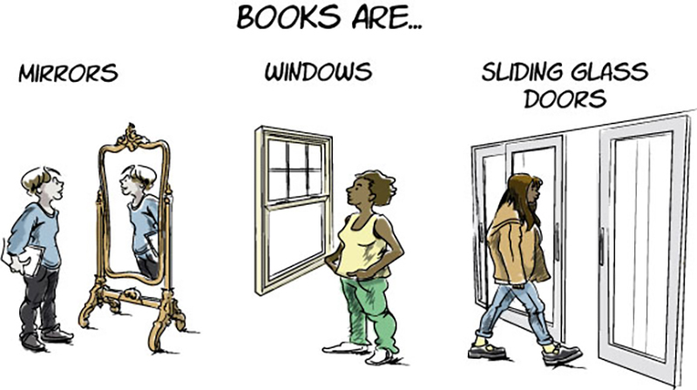
Figure 5 Mirrors, windows and doors
View description - Figure 5 Mirrors, windows and doors

View discussion - Part

Now read the short yet very powerful essay by Rudine Sims Bishop, Professor Emerita at Ohio State University. While written in 1990, the messages of this essay are highly relevant today and have been drawn on by many other scholars. As you read, think about the real and imaginary worlds a child reader might inhabit.

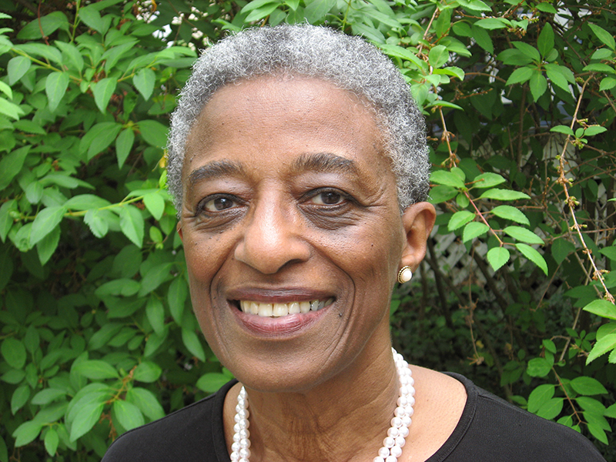
Figure 6 Professor Rudine Sims Bishop
View description - Figure 6 Professor Rudine Sims Bishop

Rudine Sims Bishop: Mirrors, Windows and Sliding Glass Doors
Books are sometimes windows, offering views of worlds that may be real or imagined, familiar or strange. These windows are also sliding glass doors, and readers have only to walk through in imagination to become part of whatever world has been created or recreated by the author. When lighting conditions are just right, however, a window can also be a mirror. Literature transforms human experience and reflects it back to us, and in that reflection we can see our own lives and experiences as part of the larger human experience. Reading, then, becomes a means of self-affirmation, and readers often seek their mirrors in books.
For many years, nonwhite readers have too frequently found the search futile. This year marks the twenty-fifth anniversary of the publication, in the Saturday Review, of Nancy Larrick’s landmark article, ‘The All-White World of Children’s Books.’ ‘Across the country,’ she stated in that piece, ‘6,340,000 nonwhite children are learning to read and to understand the American way of life in books which either omit them entirely or scarcely mention them.’ A quarter of a century later, census data indicate that about 30% of the school population are members of so-called minority groups – Latinos, Afro-Americans, Asian-Americans, Native Americans – and where will they find their mirrors?
A former colleague at the University of Massachusetts, Sonia Nieto, found that in the decade between 1972 and 1982, an average of only five and half books a year were published about Puerto Ricans. Perusal of my shelves of review books and new and recent publishers’ catalogs indicate that if we were to examine the past eight years, the numbers are likely to be the same – if not lower. Stories about contemporary Mexican-Americans are few and far between. Isabel Schon’s recent bibliography in the Journal of Youth Services (Winter, 1989) lists a total of nineteen books about Hispanics, fifteen nonfiction and four books of folk stories and legends. Contemporary Asians and contemporary Native Americans do not fare much better. The largest number of books about so-called minority groups is about Afro-Americans. In the quarter century since the Larrick article, the numbers of books about Afro-Americans has increased considerably, despite a major decrease of such books in the early and mid-1980s.
When children cannot find themselves reflected in the books they read, or when the images they see are distorted, negative, or laughable, they learn a powerful lesson about how they are devalued in the society of which they are a part. Our classrooms need to be places where all the children from all the cultures that make up the salad bowl of American society can find their mirrors.
Children from dominant social groups have always found their mirrors in books, but they, too, have suffered from the lack of availability of books about others. They need the books as windows onto reality, not just on imaginary worlds. They need books that will help them understand the multicultural nature of the world they live in, and their place as a member of just one group, as well as their connections to all other humans. In this country, where racism is still one of the major unresolved social problems, books may be one of the few places where children who are socially isolated and insulated from the larger world may meet people unlike themselves. If they see only reflections of themselves, they will grow up with an exaggerated sense of their own importance and value in the world – a dangerous ethnocentrism.
Consider some of the possibilities. From reading, for example, children can become aware of some of the many variations in the way English is spoken in this country, and the richness those variations add to the language. Take Belva Jean Copenhagen, who tells us in Sandra Dutton’s Tales of Belva Jean Copenhagen (Atheneum, 1989): ‘I thought I would put one of these (a preface) onto my books because I seen one in a couple of other books of stories. It’s where the author tells the reader what to look out for and where she got the ideas for she’s written up.’ Belva Jean tells her own stories in her own voice, which echoes the rhythms, the grammar, and the color of many of the people who inhabit the Appalachian Mountain region. In her afterword, Belva Jean states: ‘Now I could have told you these stories in Standard English, but I’m not on TV, and this ain’t a formal occasion. This was just me rambling on about times I’ve had and people I’ve knowed, and things we’ve did together...’
In one of my old favorites, Lucille Clifton’s My Brother Fine With Me (Holt, 1975; now out of print, but available in many libraries), Johnetta’s narration reflects an informal Black vernacular: ‘Me and Baggy the only child. I was the only child till he come being born. Everything was all right, me and Mama and Daddy doing fine till Mama come spreading out like a pancake and Aunt Winnie who don’t even like children come to watch me for a while and Mama go off and come back here with Baggy. I was mad for a long time and I ain’t all that glad now, but I don’t let on.’
Both those voices are authentic, and their authenticity makes the characters believable and identifies them as members of a particular social group. Changing their voices to Standard English would take away a large part of their distinctiveness.
Books can also introduce readers to the history and traditions that are important to any one cultural group, and which invite comparisons to their own. One of the 1989 Caldecott Honor Books, Patricia McKissack’s Mirandy and Brother Wind, illustrated by Jerry Pinkney (Knopf, 1988), is the fictionalized story of how her grandparents got together as teenagers, by dancing a cakewalk as if they were ‘dancing with the Wind!’ It also introduces readers to a bit of history of the cakewalk, a dance introduced by slaves and rooted in Afro-American culture.
Folk tales, too, help to keep alive the traditions and values that are important to social groups. Laurence Yep’s The Rainbow People (Harper & Row, 1989) is a collection of stories told by Chinese immigrants, starting with those who arrived in the middle of the nineteenth century who were unable to bring their families to America, and lived their lives as bachelors. In his introduction, Yep states that the stories express the ‘loneliness, anger, fear, and love that were part of the Chinese-American experience.’
Recently, a spate of Afro-American stories have been published, beginning with Virginia Hamilton’s The People Could Fly (Knopf, 1985), and followed by the retellings of the Brer Rabbit stories illustrated by Barry Moser and published by Harcourt Brace Jovanovich: Jump! (1986), Jump Again! (1987), and Jump on Over! (1989). Julius Lester has also published two collections of his retellings of the Brer Rabbit stories in The Tales of Uncle Remus (Dial, 1987) and More Tales of Uncle Remus (Dial, 1988). Many of the animal stories reflect the hopes and dreams, and some of the reality of the lives of people who were in many ways powerless over the plantation owners who thought of them as so much property. It is easy to understand how Brer Rabbit, the trickster figure who, small though he was, managed to outsmart animals much larger and more powerful than he, became a favorite of people who saw in him something of themselves. The stories have appeal to all children, for what child has not felt small and powerless in an adult world?
Those of us who are children’s literature enthusiasts tend to be somewhat idealistic, believing that some book, some story, some poem can speak to each individual child, and that if we have the time and resources, we can find that book and help to change that child’s life, if only for a brief time, and only for a tiny bit. On the other hand, we are realistic enough to know that literature, no matter how powerful, has its limits. It won’t take the homeless off our streets; it won’t feed the starving of the world; it won’t stop people from attacking each other because of our racial differences; it won’t stamp out the scourge of drugs. It could, however, help us to understand each other better by helping to change our attitudes towards difference. When there are enough books available that can act as both mirrors and windows for all our children, they will see that we can celebrate both our differences and our similarities, because together they are what make us all human.
Bishop, R.S. (1990) ‘Mirrors, Windows, and Sliding Glass Doors’, Perspectives: Choosing and Using Books for the Classroom, 6(3) Summer, pp. ix–xi.

View discussion - Part

This section will now focus on the range of ethnicities featured in children’s books, beginning with two short videos featuring Professor Rudine Sims Bishop.
In Activity 9 you read a short essay by Bishop on how children are reflected – or not − in the books they read. While this essay has been widely read and frequently discussed since its publication in 1990, the issue of representation in children’s literature remains a prevalent issue in the twenty-first century.
In the next activity, Bishop discusses the topics raised in her 1990 essay and praises the current drive towards diversity in children’s literature.

Activity 10 Rudine Sims Bishop on diversity
Allow about 15 minutes

You will now watch two short videos from 2015 featuring Professor Rudine Sims Bishop. In the first video, Bishop outlines the importance of being able to see yourself in the books you read. As you watch, consider the extent to which you see yourself reflected in books that you read in childhood or as an adult. Make some notes in the box below.
Please note: the captions in the embedded YouTube videos below are automatically generated and may contain some transcription errors. If you would prefer to read the text rather than watch the video, please use the transcript available below each video.

Watch the video at YouTube.com.
Video 1 Mirrors, windows and sliding glass doors – Rudine Sims Bishop on diversity
View transcript - Video 1 Mirrors, windows and sliding glass doors – Rudine Sims ...

Provide your answer...
View discussion - Part

In this second video, Bishop talks about the social media movement #WeNeedDiverseBooks, and she discusses a 1965 article by Nancy Larrick called ‘The all-white world of children’s books’. As you watch, think about what has changed – or not – since Larrick was writing. Make some notes in the box below.

Watch the video at YouTube.com.
Video 2 Rudine Sims Bishop on #WeNeedDiverseBooks
View transcript - Video 2 Rudine Sims Bishop on #WeNeedDiverseBooks

Provide your answer...
View discussion - Part

To get a sense of current discussions on diversity, you could search Twitter (now known as ‘X’) for the hashtags #WeNeedDiverseBooks or #MirrorsWindowsSlidingGlassDoors if you have an account, or are prepared to make one. Figure 7 is one tweet found by searching for #WeNeedDiverseBooks.

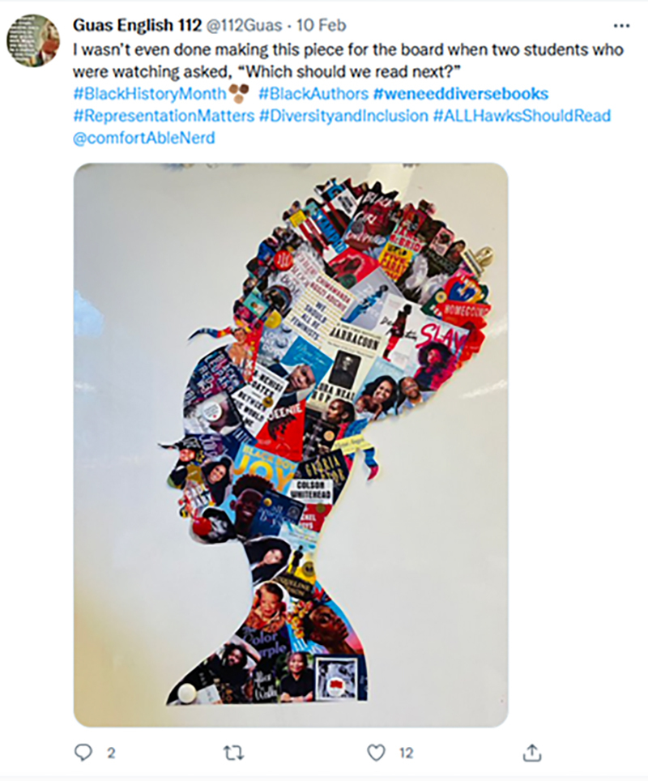
Figure 7 A tweet on the subject of #WeNeedDiverseBooks
View description - Figure 7 A tweet on the subject of #WeNeedDiverseBooks

An important issue within diversity that you may have come across is that of whose voice is able to be heard. The ‘own voices’ argument states that stories about minority groups should be written by members of those groups and is a particularly widespread debate in the field of young adult (YA) fiction (aimed at 11–18 year olds). If you’re interested you can read more about this debate in a blog post titled ‘What is #OwnVoices doing to our books?’ by columnist and podcaster Kat Rosenfield (linked in the References section).

Activity 11 Measuring ethnic diversity
Allow about 30 minutes

In this activity, you’ll use a set of questions to help you to measure the level of ethnic diversity in a book which you feel displays a range of ethnic diversity.
Select one book aimed at children which you feel, from the cover or the blurb, portrays some level of ethnic diversity. You might find a book you own, choose one from a school or local library, or select one from the free online resource International Children’s Digital Library.
Then consider the questions below, adapted from the 2020 CLPE ‘Reflecting Realities’ report. While some of the questions could be answered with a simple ‘yes’ or ‘no’, try to give a more nuanced response in note form.

Table 1 Measuring the book’s ethnic diversity
 | Brief comment on your book
Book chosen | Provide your answer...
Characterisation
1. Are the characters in the book thoughtfully developed, multi-dimensional individuals? | Provide your answer...
2. Does the author provide sufficient cues to make the ethnicity of the character clear? | Provide your answer...
3. Does the book challenge misconceptions and prejudices about an under-represented group or does it reinforce them? | Provide your answer...
4. Are ethnic minority characters well-drawn, well-developed and well-rounded individuals who are not solely defined by their ethnicity? | Provide your answer...
Illustration
5. Has careful consideration of skin tones, facial features and hair texture been made to ensure that a character’s ethnicity is recognisable without being overstated? | Provide your answer...
6. How do the props, background and other visual cues add layers to our understanding and appreciation of the character and their world? | Provide your answer...
Plot
7. Is the character’s ethnicity incidental to the narrative? | Provide your answer...
8. Is the plot driven by the character’s ethnicity? If yes, to what extent is this necessary and appropriate in furthering the narrative and is the portrayal sensitively depicted? | Provide your answer...
(Adapted from CLPE ‘Reflecting Realities’ report 2020, pp. 24–25)

Take a moment to reflect on the experience of answering these questions. Did any of your findings surprise you?

Provide your answer...
View discussion - Activity 11 Measuring ethnic diversity

5 Bringing it all together
In this final activity of the course, you’ll reflect on books which have been important to you.

Activity 12 Sharing books
Allow about 30 minutes

Many people like to keep a record of books they’ve read and enjoyed, found helpful or intend to recommend to others.
In this activity you’re encouraged to think of an example and reflect on it, using what you’ve learned in this course.
You might like to share the results of this activity with people you know, and see if this inspires them to recommend a book to you in return.
- Think of one children’s book that you’d like to recommend to others. Make a note of the title, author and date of publication.
- Find some images of the book cover online, or take a photograph. Don’t forget to include the author and date of publication.
- Write a sentence or two giving a brief explanation of why you chose this particular book. Perhaps it has personal memories for you, or maybe you feel it is innovative in some way. Did you feel that you were personally reflected in the book, or that it opened a door to another worldview for you? It could be important to a child you work with, or maybe you simply enjoyed reading it.
- Once you’ve completed this activity, read the sample recommendations below, and see how they compare to yours.

View discussion - Activity 12 Sharing books

6 Summary
In this course, you’ve begun exploring how the three disciplines of linguistics, literature and childhood studies interact within the exciting and fast-developing interdisciplinary area of children’s literature. Some of these ideas were introduced and examined through examples from significant works of children’s literature (Philippa Pearce’s Tom’s Midnight Garden and Catherine Storr’s Marianne Dreams).
You’ve spent time reflecting on your experiences of engaging with books intended for children, and considered the issue of reading children’s literature as an adult reader, taking into account how this may be different to encountering particular works as a child. You’ve looked at two significant academic readings, and explored the potentially competing purposes of reading to educate and reading for fun (‘instruction or delight?’). You’ve also started to consider some important issues in the field, such as the perceived purpose of children’s literature, theories and ideological considerations, and ethnic diversity.
After studying this course, you should now be able to:
- discuss some of the different theories, approaches and debates in the interdisciplinary field of children’s literature
- reflect on your own and others’ memories of children's literature
- consider how the academic disciplines of literature and childhood intersect, bringing different perspectives to the field
- describe how texts for children and young people convey and challenge ideas around diversity through an exploration of ethnic diversity.
This OpenLearn course is an adapted extract from the Open University course L301 Language, literature and childhood.

References
Armitt, L. (1996) Theorising the fantastic. London: Arnold.
Bishop, R.S. (1990) ‘Mirrors, windows, and sliding glass doors’, Perspectives: choosing and using books for the classroom, 6(3), pp. ix–xi.
‘Fantasy fiction’ (2022) Available at: https://dictionary.cambridge.org/dictionary/english/fantasy-fiction (Accessed: 26 October 2022).
Centre for Literacy in Primary Education (CLPE) (2020) ‘Reflecting Realities – Survey of Ethnic Representation within UK Children’s Literature 2019’. Available at: https://clpe.org.uk/system/files/2021-11/CLPE%20Reflecting%20Realities%20Report%202021.pdf
Hume, K. (1984) Fantasy and mimesis: responses to reality in Western literature. New York and London: Methuen.
Hunt, P. (2009) ‘Instruction and delight’, in J. Maybin and N. Watson (eds) Children’s literature: Approaches and territories. Milton Keynes: The Open University
Rosenfield, K. (2019) ‘What Is #OwnVoices Doing To Our Books?’. Available at: https://www.refinery29.com/en-us/2019/04/228847/own-voices-movement-ya-literature-impact
Le Guin, U. K. (1992) The Language of the Night. New York: HarperCollins.
Lewis, C. S. (1966) ‘On Three Ways of Writing for Children’, in Of Other Worlds. London: Geoffrey Bles.
Nikolajeva, N. (2006) ‘Fantasy’, in J. Zipes (ed.) The Oxford encyclopedia of children’s literature. Oxford: Oxford University Press. Available at: https://doi.org/10.1093/acref/9780195146561.001.0001
Stephens, J. (1992) Language and ideology in children’s fiction. London: Longman.
Taylor, M. D. (1976) Roll of Thunder, Hear My Cry. Reprint. London: Puffin, 2014.
Tolkien, J. R. R. (1964) Tree and Leaf. London: George Allen & Unwin.
Thomas, E.E. (2019) The dark fantastic: race and the imagination from Harry Potter to the Hunger Games. New York: New York University Press.
Wall, B. (1991) The Narrator’s Voice. Basingstoke: Macmillan.
West, M. (1988) Trust Your Children: Voices Against Censorship in Children’s Literature. New York: Neal-Schuman.
Zipes, J. (2001) Sticks and Stones. The Troublesome Success of Children’s Literature from Slovenly Peter to Harry Potter. New York and London: Routledge.

Acknowledgements
This free course was compiled and adapted by Nicola Snarey, based on materials written by Maria Leedham and Noga Applebaum for L301.
Except for third party materials and otherwise stated (see terms and conditions), this content is made available under a Creative Commons Attribution-NonCommercial-ShareAlike 4.0 Licence.
The material acknowledged below is Proprietary and used under licence (not subject to Creative Commons Licence). Grateful acknowledgement is made to the following sources for permission to reproduce material in this free course:
Course image: FatCamera / iStock / Getty Images
Figure 1 (clockwise from top left): Ben Molyneux / Dreamstime; Wavebreak Media Ltd / 123RF; rawpixel / 123RF; Wavebreak Media Ltd / 123RF
Figure 2: Murdo MacLeod - murdophoto.com
Figure 3 (left to right): © David Wyatt, with permission from GOSH; © Michael Ian Kaye; © A.A. Milne, E. H. Shepard
Figure 4 (left to right): Pub. Oxford University Press; Jaime Zollars (illustrator). Pub. https://blackwells.co.uk; Jaime Zollars (Illustrator). Pub. Greenwillow Books; Pub. Puffin; courtesy BS24 / Hyperion Productions / Isle of Man Film Commission / Ronald Grant Archive / Mary Evans
Figure 5 (left to right): Faber Childrens; Faber & Faber; Puffin; Faber & Faber; taken from https://johnnyalucard.com/2020/04/13/tv-review-escape-into-night/
Figure 7: © James J. Bishop and Rudine Sims Bishop
Figure 8: © Heather Gaus
Video 1: Mirrors, windows and sliding glass doors – Rudine Sims Bishop on diversity https://www.youtube.com/watch?v=_AAu58SNSyc
Video 2: Rudine Sims Bishop on #WeNeedDiverseBooks https://www.youtube.com/watch?v=_yQ49ItLMJ0
Every effort has been made to contact copyright owners. If any have been inadvertently overlooked, the publishers will be pleased to make the necessary arrangements at the first opportunity.
Don’t miss out
If reading this text has inspired you to learn more, you may be interested in joining the millions of people who discover our free learning resources and qualifications by visiting The Open University – www.open.edu/openlearn/free-courses.

Glossary
children’s literature
This refers to stories or factual writing produced for children aged under 18 and encompasses everything from picturebooks, short stories and graphic novels to biographies and dictionaries. This course’s use of the umbrella term ‘children’s literature’ includes hard-copy books with illustrations, ebooks and audiobooks, as well as literature engaged with through films, television, plays, video games or other formats.
childhood
The period of time from 0–18 years old.
dialogue
The spoken words of fictional characters within the story.
didactic
A didactic text is intended to have an instructive purpose – for example, by representing people, situations and societies in particular ways.
direct speech
When the words of characters are presented in the narrative exactly as spoken, using speech marks and a reporting clause. In the following example, the direct speech is ‘Good morning’ because those are the exact words that were spoken, and ‘she said’ is the reporting clause: ‘Good morning,’ she said. If the reporting clause is not present, it is known as free direct speech: ‘Good morning.’
free direct speech
When the words of characters are presented in the narrative exactly as spoken, using speech marks and a reporting clause. In the following example, the direct speech is ‘Good morning’ because those are the exact words that were spoken, and ‘she said’ is the reporting clause: ‘Good morning,’ she said. If the reporting clause is not present, it is known as free direct speech: ‘Good morning.’
free indirect speech
Sometimes called free indirect discourse. Refers to when the words (or thoughts) of characters are reported by the narrator, but without reporting clauses. This can make it tricky to separate the narrator’s thoughts from the character’s thoughts. For example, ‘Tom did not at once turn to see what it showed him of the clock-face. Instead he took a step forward on to the doorstep. He was staring, at first in surprise, then with indignation, at what he saw outside. That they should have deceived him—lied to him—like this!’ (from Tom’s Midnight Garden, Pearce, p. 19).
indirect speech
When the words of characters are reported by the narrator rather than directly quoted, as is the case of direct speech. An example of indirect speech is: ‘She wished him a good morning.’
narrator
In literary studies this refers to the person who tells the story, mediating between the readers and the events.
omniscient
Literally ‘all knowing’. Omniscient narrators know everything that is happening, even if the characters in the story do not. They may report on the thoughts and feelings of multiple characters.
protagonist
A literary term used to refer to the main character in any story.
text
Any piece of language, whether spoken or written, long or short, which forms a unified whole.

Solutions

Activity 1 How adults experience children’s literature

Part

Discussion
Below are two example responses from this activity. Of course, there is no ‘right’ answer to this activity. You may well have very different responses, as different books will inevitably provoke different reactions. In considering your own different responses, you are developing an ability to mediate between different standpoints and perspectives.

Example answer #1: The Giraffe and the Pelly and Me by Roald Dahl (1985)
- A boy called Billy sees a sweet shop for sale which is then taken over by the ladderless window-cleaning company. Intrigued by this, he waits around to meet the new owners and discovers a giraffe, a pelican and a monkey with extraordinary powers. They are hired to clean the all the windows at the Duke of Hampshire’s estate, where they discover a robbery and foil it. The Duke and Duchess are so pleased they invite the animals to live and work on their estate, and turn the shop back into a sweet shop for Billy to run.
- As a child I remember thinking this book was magical and funny. I liked that I wasn’t given one of Roald Dahl’s more popular books as a gift, and it always felt special to me, like it was my secret. As an adult, I recently reread this book to my three year old and was shocked that it wasn’t anything like I remembered it. I picked up on social class differences, misogyny, stereotypes and outdated views. I felt a little shocked and wondered if it was the right sort of book to be reading to my daughter.
- It has pictures and a small boy as a protagonist. It was originally published as a book for children by an author considered to be a children’s writer. The writing and structure is simple. There are sections of rhyming throughout. (Some of the language is outdated now.)
- The boy has a mother but this is only mentioned in brief on the first page and his parents are never seen, even when at the end he is running a sweet shop! The boy appears incredibly grown up and capable for his age, almost like a mini adult, helping manage and run businesses. There is no background information for him or any mention of school. He is polite, helpful and good.
- Child operating without parents – finding another family of sorts which raises questions for me as an adult reader. The fantastical elements in it – talking animals with almost magical abilities – are like a lot of children’s books and programmes (can’t think of any off the top of my head that combine the two but I know they exist!)

Example answer #2: novelisation of Disney’s Hercules (1997)
- Hercules goes on a journey of transformation, finds love and a place of belonging. The end.
- I was mostly looking at the illustrations (scenes from the movie) and re-reading the most ‘romantic’/’climactic’ parts of the story.
- The scenes taken from the film, the simple language and dialogue and the simple relationship dynamics of good, evil, love and happy ending indicates it to me as a children’s book. The hero’s journey might also count as one, but a lot of epic novels/ancient tales also follow that pattern and they may not have been written necessarily with children in mind.
- Oh no - no children!!! But baby Hercules was portrayed to be a happy baby who is literally shining with potential and a bright future; adolescent Hercules was going through a tough transitional time but is nonetheless portrayed with a supportive family even if his environment/peers didn’t connect with him (relatable feelings!) Overall, it seems like a more simplistic representation of youth, but with enough angst to let the reader connect and empathise with the character.
- Themes of good vs evil, going on a quest, defeating the bad guy(s)/monsters, and returning to the ‘real world’ and being acknowledged for those deeds are quite common, and tend to be rooted in fantasy, or have some fantastical elements. Hercules starts off his journey with the consent and support of his adoptive parents, but Phil not only takes on a mentor role but also as a sort of parental figure so he’s not without guidance throughout his journey.

Interestingly, both writers comment on the child being separated from their parents (question 5) – a common feature in children’s books. The figure of the orphan is central to many children’s books, and the child who can go on adventures or undertake a quest without parental involvement is a feature that occurs again and again – for example, in both the Harry Potter series by J.K. Rowling and the His Dark Materials trilogy by Philip Pullman.
In the book that you chose, there are probably other figures or plot similarities that are repeated in other children’s books, such as time travel, relationships between children and animals, or the use of fantasy.
Back to - Part

Activity 2 Understanding the purposes of children’s literature (Part 1)

Discussion
Hunt’s reading is a good starting point for the study of children’s literature, challenging some of the often-held assumptions about writing for children: that it is trivial, easy, often ephemeral and fundamentally ‘childish’; that it is marginal to literature for adults; that it is intrinsically conservative and that reading it constitutes merely an escape from the harsh realities of adult life. He tackles the specific question of what children’s literature is for, what its appropriate subject matter is, and discusses the perennial question of whether its role is primarily to entertain or to instruct. In addition, Hunt brings in the issue of the adult-child power struggle at the heart of children’s literature since books for children always reflect what adults wish childhood to be, rather than actual childhoods, so are inevitably didactic.
Back to - Activity 2 Understanding the purposes of children’s literature (Part 1)

Activity 2 Understanding the purposes of children’s literature (Part 2)

Part

Discussion
Literature
Hunt specifically focuses on literature, describing it as a spectrum or continuum comprising

at one end is the small handful of ‘canonical’ texts ‘generally’ agreed to have some kind of eternal value; at the other is the vast range of ‘texts’ routinely and traditionally absorbed by the category: myth, legend, and folk tale, verse, picture-books, ‘chapter books’, novels, cartoons, films, video games, web-sites, merchandise and so on.

In the quoted passage, Hunt appears to equate longevity with the literary canon, and to consign those texts and other forms which are shorter and/or oral-based and/or more recent to the less literary end of the continuum. Looking more closely at this passage, however, you’ll see that Hunt uses scare quotes – single quote marks which serve to highlight a word as unusual or to distance the author from the word – around canonical and generally, indicating that he questions this judgment.
Hunt discusses two views towards literature: the first that there are ‘absolute standards of quality or goodness’ and the second that there are no ‘absolute’ values but rather that each text should be judged within its own context. Consider your own view on this: to what extent is your view of a work influenced by the format it is presented in (as comic book, TV programme, glossy hardback)? How far are you aware of any acclaim for the creator or prizes awarded?
Hunt’s piece was first published in 2009; do you think commonly-held views of what constitutes ‘literature’ have shifted substantially since the time of writing?
Childhood
Next, we turn to a definition of childhood. Hunt discusses childhood as ‘generally defined either by physical and mental characteristics – size, development or immaturity, and so on – which are common to all children, or by local, cultural decisions.’ Perhaps your definition aligns with one or both of these? The age at which someone is considered an adult very much depends on where and when they live. There are many different rationales for defining and constraining what is determined by the term ‘childhood’.
You may also have noted Hunt’s comment on how childhood has changed and in particular how children 200 years ago had less ‘media input’ and ‘different mindsets’. Reflect for a moment on the effect that the rapid increase in technology surrounding childhood (such as computer games or interactive books) might have on children and on literature for children. In what ways might childhood change from a generation ago, and from 200 years ago?
Back to - Part

Activity 2 Understanding the purposes of children’s literature (Part 3)

Part

Discussion
In this reading, Hunt argues that children’s literature is deeply concerned with issues of power and politics, and that adults impose, consciously or not, their own particular ideologies on children. Whether this is the Christianity of C.S. Lewis’s Narnia series or the sexism of the Reverend W. Awdrey’s Thomas the Tank Engine books, children’s literature is never politically or ideologically neutral. This argument is also made by John Stephens (1992) who sees all books as intrinsically ideological, such that if a book appears to be ideology-free, this is because its ideology precisely reflects the reader’s own.
Back to - Part

Activity 3 The fantastic and the real

Discussion
Fantasy, clearly, has to be defined in relation to reality (otherwise it could not be recognised as fantastic) but the nature of this relationship is more controversial. Is it simply any departure from reality, or will the best fantasy in some way provide insights into reality, or even undermine it?
You may like to revisit these quotations, and reflect on your own view of the relationship between fantasy and realism, when you come to the end of the course.
Back to - Activity 3 The fantastic and the real

Activity 4 First impressions of Marianne Dreams

Discussion
There are many possible responses to this text. You may have felt sorry for Marianne, or you may have thought that her tears were an overreaction. It’s interesting that the text begins with Marianne fantasising about how her first riding lesson will go, but there is relatively little focus on the lesson itself. Perhaps this puts our focus on the unrealistic world of Marianne’s imagination, preparing ourselves for the fantastic events to come.
You might also think about how we know so much about Marianne’s imagination. Readers learn what Marianne is thinking and feeling because the narrator – the voice telling us the story – is all-knowing or omniscient.
In terms of where you think the story will go from this rather everyday starting point, this may depend on how much you know about the novel already. Perhaps you have already read the blurb, or thought about the front cover, or seen one of the adaptations. From this opening, you might think that Marianne’s reaction to being overwhelmed and tired are a character trait that will be explored in the book, but you might also suspect that she is unwell, and that this illness will be related to the dreams of the title.
Back to - Activity 4 First impressions of Marianne Dreams

Activity 5 Narrative voice

Part

Answer
Right:
First-person autobiographical narrator
Wrong:
Third-person omniscient narrator
Back to - Part

Part

Answer
Right:
Third-person omniscient narrator
Wrong:
First-person autobiographical narrator
Back to - Part

Activity 7 Perspective in Tom’s Midnight Garden and Marianne Dreams

Discussion
In Tom’s Midnight Garden, the narrator focuses very closely on Tom’s perspective (we know little of the thoughts and feelings of the Kitsons or Peter), and we need to see and feel through his eyes and sensibilities for the story to work. Characters and places are presented from his perspective: Peter as a valued playmate and Uncle Alan as morose and authoritarian. In what you’ve read in the activities so far, you may have thought that Tom is being annoyingly pedantic by interrupting his uncle to ask if staying in bed means he can’t go to the lavatory, but there is nothing in the narrator’s words that would indicate this. Despite Tom’s frustrating responses, when Uncle Alan loses his temper, this is described as ‘sudden’ because it is unexpected to Tom, even though you might have predicted that Tom’s answers would make him angry. The narrator calls him ‘poor Tom’, making it clear who we should be empathising with.
In the extracts of Marianne Dreams you’ve read so far, the narrator uses indirect speech to report on Marianne’s thoughts, in which Marianne’s words are reported with the narrator’s words. This mixing of the narrator’s voice with Marianne’s feelings strengthens the reader’s identification with her. Through this colouring, the reader accepts her experiences in the dreamworld as believable within the framework of Storr’s constructed world.
However, at times the narrator does give us information that does not come solely from Marianne’s perspective. In the opening chapter (some of which you read in Activity 4), the narrator helps us to understand Marianne’s feelings by using the pronoun ‘you’ to explain why ‘It is worse if you have had your first riding lesson and know that you ought to be hungry. But not to be able to eat your birthday lunch is worst of all’. Without this context, Marianne’s tears might strike us as a strange overreaction, making it harder for us to empathise with her.
The third-person narrators tell us the story closely from Tom and Marianne’s perspective, therefore, but this narration is also omniscient, and so can give us information and ideas that the protagonists do not know or are not concerned with.
Back to - Activity 7 Perspective in Tom’s Midnight Garden and Marianne Dreams

Activity 8 Free indirect speech

Discussion
You probably found this difficult, and there are no clear answers! One of the key features of free indirect speech is that it often becomes almost impossible to separate out the narrator from the character being narrated. The phrase ‘mad old clocks’ could be Tom’s words, whereas a phrase like ‘uneasy in the knowledge that this happening made some difference to him’ is unlikely to be the word-for-word thoughts of a child. Some of the questions (‘had it really struck thirteen?’ and ‘Had he not been falling asleep, or already sleeping?) seem more likely to come from Tom’s mind than the narrator’s, but they could also be questions the narrator is asking the reader.
What did you think the effect of this narration style is? Towards the end, you may have noticed that there is a sense that something magical is about to happen: when the narrator tells us that ‘the house seemed to hold its breath’ it could just be to Tom that this seemed the case, but because this is unclear, it’s possible that something more magical really is occurring, and this isn’t just Tom’s interpretation. When the narrator tells us that ‘the darkness pressed up to him’ this could be Tom’s thoughts, but it’s also possible that the narrator is describing literal fantastic events. The narrator even uses direct speech to describe what the darkness asks him, which gives the impression that this question is not merely something Tom is imagining. The result is that we not only get insight into what Tom is thinking and feeling, but the confusion between his thoughts and the more objective account from the narrator heightens the sense of magic. This isn’t just in Tom’s imagination: something incredible is about to happen!
Tom does of course use this extra hour of freedom to leave his bed, and discovers that the back door by the Grandfather clock no longer opens onto a tiny, walled-in courtyard but a huge and beautiful garden (the ‘midnight garden’ of the title). As both Tom’s Midnight Garden and Marianne Dreams continue, the lives of the protagonists are split between the mundane and restricted lives they lead during the day and the unsupervised (and sometimes dangerous) fantasy worlds of the midnight garden and Marianne’s dreams.
Back to - Activity 8 Free indirect speech

Activity 9 Mirrors, windows and sliding glass doors

Part

Discussion
The literal function of a mirror is to see your own reflection; a window is designed to be looked through; and a sliding glass door can be opened or closed to allow us to walk from one space (inside) to another (outside).
You may have wondered what the purpose of this question could be! In the rest of this activity you’ll consider the metaphorical purposes of these objects and how they relate to children’s literature.
Back to - Part

Part

Discussion
Since Bishop was writing, children’s literature has moved on in its considerations around representing all children, as demonstrated through shortlists for prizes such as the Carnegie and Greenaway medals for children’s literature each year.
While much progress has been made, much remains to be done. One example of research in this area is that of researcher Ebony Elizabeth Thomas who studied the portrayal of Black female characters in several recent fantasy texts and the film or television versions, including The Hunger Games, Harry Potter, Merlin and The Vampire Diaries (e.g. Thomas, 2019). Her evaluation of the characters points to what she terms ‘an imagination gap’ for Black readers, who can only rarely imagine themselves as a character in the story. Thomas shows how far children’s literature has to go to provide a mirror for all readers.
Back to - Part

Activity 10 Rudine Sims Bishop on diversity

Part

Discussion
Someone who watched this commented: ‘An interesting watch. I’ve not really thought about seeing myself in books as a child even though my childhood books were all by white, Western writers and I’m an Asian, born in an Asian country. It’s a good video to get people thinking about their own engagement with books and the topic of representation and diversity.’
Bishop comments that understanding diversity is a two-way process and that it isn’t just the under-represented groups who need more diverse books to hold up a ‘mirror’ to themselves – other groups need the ‘window’ offered by books in order to see other lives and other worlds.
Back to - Part

Part

Discussion
Bishop comments on how social media and technology have enabled the work on diversity to spread more widely. You may be surprised, however, that movements such as #WeNeedDiverseBooks are still required, given Bishop’s point that these issues were discussed as long ago as 1965 when Larrick was writing.
Back to - Part

Activity 11 Measuring ethnic diversity

Discussion
Here are two example responses:

Table 2 Example responses
 | A | B
Book chosen | Queen Yaa Saves the Golden Stool by Louisa Olafuyi and Oladele Olafuyi with artwork by Isabelle Irabor and Tiolu Yoloye. | Julian is a Mermaid by Jessica Love.
1 | Yes. It is based on real events in Ghana in the 1800s and the characters appear real. | Yes. The characters are African American, presumably living in NY since they end up at the Coney Island Mermaid Parade.
2 | Yes, clearly depicted throughout the book. | Yes, through the use of Spanish, in the ways the characters refer to each other, the choice of dress for the characters, and the physical features of characters. [Note: not all versions of the book use Spanish.]
3 | As it is based on true events, it somehow highlights and shows the strength that a Black queen warrior had all those years ago and how important it is to see that shown in this present day. | Yes, it challenges misconceptions that older people and Black people are less accepting of queerness/transness than younger, white people. It challenges the misconception that queer/gender nonconforming people are mostly white.
4 | Yes. | Yes, ethnicity is not the overriding theme of the book and characters are not defined by their ethnicity.
5 | Yes, evident throughout the book. | Yes, all the characters are Black but there is a wide variety in skin tone. There is a wide range of hair textures and styles.
6 | Careful consideration of visual cues to ensure relatability. One example is the hairstyles of the characters. | There are many background characters who show that Julian lives in a predominantly Black neighbourhood. They are all depicted in positive ways, showing that Julian lives in a supportive community.
7 | No, as it is based on true events in Ghana in the 1800s. | Yes.
8 | Based on a historical event where a Black queen warrior fought to protect the golden stool which was a symbol of culture and wealth for the people of Ghana. | No.

You may have been surprised, encouraged or dismayed by your findings. Perhaps the presence of characters of colour in the illustrations did not always match their visibility in the text itself.
You may wish to share your findings with other teachers, librarians, teaching assistants, parents or friends with children. Perhaps you could use the questions or your results to influence future book purchases.
Back to - Activity 11 Measuring ethnic diversity

Activity 12 Sharing books

Discussion
Here are a couple of recommendations from course author Nicola Snarey:

The first book I’d like to recommend is The Wolves of Willoughby Chase, by Joan Aiken, first published in 1962, because it was my favourite book as a child! It was also so much fun to read it as a bedtime story to my own children recently and I’d love for more people to discover it! As a child, I loved the extreme drama of the adventure; even the two protagonists are extremes – Bonnie is strong and improbably fearless, whereas Sylvia is almost comically timid and frail. As an adult, I can now see that the whole thing is a pastiche or even a parody of Victorian sensationalist fiction, and recognising that made me appreciate it from an entirely new angle!
Another book I’d like to recommend is Loki, A Bad God’s Guide to Being Good, by Louie Stowell, first published in 2022. I read this to my children when they developed an interest in mythology, and we all thoroughly enjoyed it! In this story, Loki, the Norse god of mischief, is banished from Asgard to live as an English school boy, and must demonstrate to Odin that he can be good before he is allowed to return. The book is chock full of fun details taken from the Norse myths, and the doodles and cartoons are very funny. I was pleased that Loki has no fixed gender, and sometimes uses a female form, just like he does in the myths, but while this makes him more fun, it’s never played for laughs. I found the book refreshingly diverse considering it was aimed at the under 12s.

Back to - Activity 12 Sharing books

Descriptions

Figure 1 Reading and writing in English
This is a collage of four colour photos. The first is of a stack of eight books, the spines facing the viewer. Many of the spines include illustrations and are brightly coloured. The second photo is of three children sitting in front of a full bookshelf, looking down at open books. The third photo is of five children lying on the grass, propped up on their elbows and writing in books. The fourth photo is a long bookshelf with shelves full of books in varying sizes and colours.
Back to - Figure 1 Reading and writing in English

Figure 2 Child and adult readers
This is a colour photograph of two people reading books; they are positioned side by side and facing the viewer. The figure on the left is an adult with dark cropped hair and glasses; they wear a black top and have a ring on their left ring finger. The lower half of the figure’s face is obscured by the book they hold. This is a hardback copy of J.K. Rowling’s Harry Potter and the Order of the Phoenix. The cover uses dark colours and has a golden phoenix spreading its wings; the reverse is a photograph of the author. The figure on the right is a child wearing a striped beanie hat and a red top. They hold a hardback copy of Harry Potter and the Order of the Phoenix. The cover uses bright colours and has an illustration of a phoenix spreading its wings; the reverse has a further illustration and a blurb. The background of the photograph is a window.
Back to - Figure 2 Child and adult readers

Figure 3 Writing for instruction or delight?
This is a composite image of three book covers: The first book cover is for Peter Pan by J.M. Barrie. The cover has the author’s name at the top, and the title in a larger font in the bottom quarter. Below the title is the text: ‘Foreword by Geraldine McCaughrean’. The illustration shows a boy in bright green clothes with sparks of yellow around him. His arms are lifted as he flies above an island, sea, and sailing ship below. The second book cover is for The Curious Incident of the Dog in the Night-Time by Mark Haddon. The cover has the text: ‘Winner of the Whitbread Book of the Year’ in white at the very top. Under this is the author's name; this is also in white but uses a handwriting font in capitals. In the same font above the central illustration is the text: The Curious Incident. Below the illustration of a brown dog on its back, speared by a gardening fork, is the rest of the title: of the Dog in the Night-Time. At the bottom the cover is the text: ‘Outstanding... a stunningly good read’ quoted from The Independent. The third book cover is for When We Were Very Young by A.A. Milne. The cover has the title in large green text centred over four lines. Below this is the author’s name, and the text: ‘with decorations by E.H. Shepard’. Circling the text are eight illustrations at regular intervals. These illustrations show (clockwise): two dancers; a small boy holding a flat; a knight on a horse; a figure in a blue dress; Winnie-the-Pooh bending over a newspaper; a figure in a pink dress; a blue convertible car; a figure skipping. Along the bottom of the cover there is a gold-coloured bar, containing a silhouette of Winnie-the-Pooh walking with Piglet, with the tagline ‘The bear for all ages’.
Back to - Figure 3 Writing for instruction or delight?

Figure 5 Book covers and film stills from Tom’s Midnight Garden
This is a collage of four book covers and a film still. The first book cover has the title at the top. It uses a handwriting font for the following text in capitals and in white: Tom’s Midnight Garden. At the bottom in white is a quote: ‘a perfect book’ Philip Pullman. Underneath this in a larger font but still in white, the author’s name Philippa Pearce. The full page illustration uses dark colours as if the scene is in shadow. In the foreground, there are tree branches and part of a wall. Beyond, a figure stands in a spotlight. The second book cover has the text, ‘Sixtieth Anniversary Edition’ followed by the author’s name, Philippa Pearce, in purple block capitals. Below this, in irregularly shaped capitals is the title, Tom’s Midnight Garden. This text sits in three lines in between the bare branches of an illustrated tree, the trunk of which is on the left side of the cover. In the lower third of the cover, a boy and girl stand facing each other in a walled garden. The third book cover has the title, Tom’s Midnight Garden, at the top in a handwriting font. The dark text is on a brighter glow in the dark sky of the illustration. Below the title, there is a large, three-storey house and a garden. In the foreground, there are two children, a boy on the left wearing pyjamas, and a girl on the right wearing a white Edwardian-style pinafore dress over dark sleeves. Both have serious expressions. At the bottom of the page is the author’s name, Philippa Pearce. The fourth book cover has large white text placed approximately in the centre: ‘Tom’s Midnight Garden’. Below the text in italics is: ‘A masterpiece’ – Observer. At the bottom of the page in white block capitals is the author’s name, Philippa Pearce. The illustration shows the night sky with a large moon and clouds. Against this sky, a child walks along a wall with arms outstretched. Finally, on the right, is a film still showing a boy in blue and white striped pyjamas walking through a garden; he is smiling. In the background is a large brick house. The garden is quite formal with topiary and colourful flowerbeds.
Back to - Figure 5 Book covers and film stills from Tom’s Midnight Garden

Figure 5 Mirrors, windows and doors
This is an illustration showing three people under text reading ‘Books are… mirrors, windows, sliding glass doors’. On the left, under the text ‘Mirrors’, a white man is looking at his reflection in an ornate full-length mirror. In the centre, under the text ‘Windows’, a Black woman with her hands in her pockets looks out through an open window. On the right, under the text ‘Sliding glass doors’, a Black woman is walking towards an open set of sliding glass doors.
Back to - Figure 5 Mirrors, windows and doors

Figure 6 Professor Rudine Sims Bishop
This is a photograph of Rudine Sims Bishop, showing her head and shoulders. She is looking into the camera and smiling.
Back to - Figure 6 Professor Rudine Sims Bishop

Figure 7 A tweet on the subject of #WeNeedDiverseBooks
This is a screenshot of a tweet. The tweet reads as follows: ‘I wasn’t even done making this piece for the board when two students who were watching asked, “Which should we read next?” #BlackHistoryMonth #BlackAuthors #weneeddiversebooks #RepresentationMatters #Diversityandinclusion #ALLHawksShouldRead’. Below the text is an image of a woman’s head and shoulders in profile, created from a collage of book covers. The woman appears to have a large, high hair wrap.
Back to - Figure 7 A tweet on the subject of #WeNeedDiverseBooks

Video 1 Mirrors, windows and sliding glass doors – Rudine Sims Bishop on diversity

Transcript
RUDINE SIMS BISHOP
We need diverse books because we need books in which children can find themselves, see reflections of themselves.
I wrote a piece, maybe 1990 it was published, which I called ‘Mirrors, Windows, and Sliding Glass Doors’. And I think that’s really why we– children need to see themselves reflected.
But books can also be windows. And so you can look through and see other worlds and see how they match up or don’t match up to your own.
But the sliding glass door allows you to enter that world as well. And so that’s the reason that the diversity needs to go both ways. I mean, it’s not just children who have been under-represented and marginalised who need these books. It’s also the children who always find their mirrors in the books, and therefore get an exaggerated sense of their own self-worth and a false sense of what the world is like, because it’s becoming more and more colourful and diverse as time goes on. So, I think that’s why.
Back to - Video 1 Mirrors, windows and sliding glass doors – Rudine Sims Bishop on diversity

Video 2 Rudine Sims Bishop on #WeNeedDiverseBooks

Transcript
RUDINE SIMS BISHOP
When I was at ALA this summer, I somehow ended up wearing this button that says ‘#WeNeedDiverseBooks’, and I just think that’s an exciting new development. I’m not very good on tweeting and texting and all that good stuff, but I think one of the things that’s exciting about this campaign is that they are taking advantage of social media, so that it has the potential to reach a lot of people that something like the Nancy Larrick piece would not reach.
I like the idea. I understand that they’re really focusing on classrooms, on books in the classroom, which is where we absolutely need to focus these books, and I think that’s exciting. I understand that they’re planning a festival of diverse books in 2016, so I think it’s really an exciting new development and has the potential to have an impact that’s similar to, if not greater than, the Larrick piece of almost 50 years ago. It’s something new and exciting in the field.
The Council on Interracial Books for Children started about the time of the Nancy Larrick piece, in fact I think Nancy was one of the founding members. It had a profound impact in its day; it was responsible for getting the first books of Walter Dean Myers, Mildred Taylor and Kristin Hunter, perhaps, her first childrens’ book, and calling attention to artists like Pat Cummings, and so on.
I think that if it were to be reconstituted it might have … I think it could still be effective. It would again, like #WeNeedDiverseBooks, need to take advantage of today’s technology, but it was a thorn in the side of publishers and maybe that wouldn’t be such a bad thing if it were to happen again. But that contest that they sponsored was a very effective move with, as I said, a really profound effect.
Back to - Video 2 Rudine Sims Bishop on #WeNeedDiverseBooks

