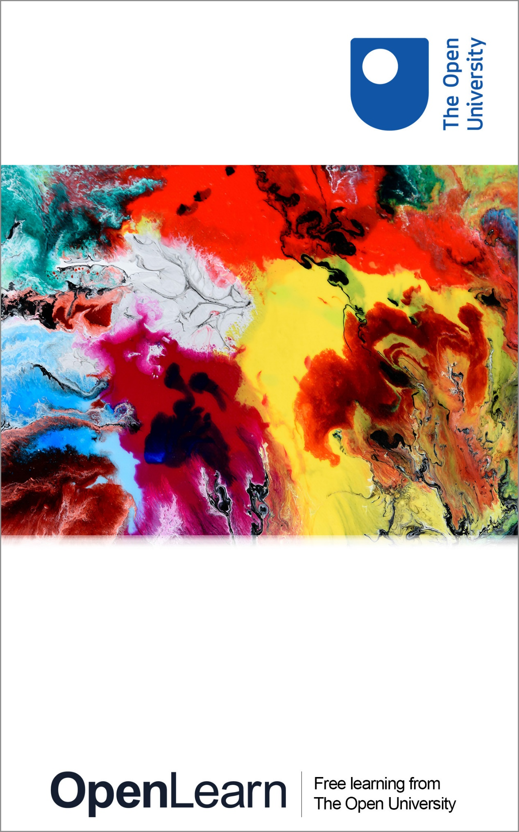

H810_1

Assistive technologies and online learning

About this free course
This free course is an adapted extract from the Open University course H810 Accessible online learning: supporting disabled students www.open.ac.uk/postgraduate/modules/h810.
This version of the content may include video, images and interactive content that may not be optimised for your device.
You can experience this free course as it was originally designed on OpenLearn, the home of free learning from The Open University –
www.open.edu/openlearn/education/assistive-technologies-and-online-learning
There you’ll also be able to track your progress via your activity record, which you can use to demonstrate your learning.
Copyright © 2016 The Open University
Intellectual property
Unless otherwise stated, this resource is released under the terms of the Creative Commons Licence v4.0 http://creativecommons.org/licenses/by-nc-sa/4.0/deed.en_GB. Within that The Open University interprets this licence in the following way: www.open.edu/openlearn/about-openlearn/frequently-asked-questions-on-openlearn. Copyright and rights falling outside the terms of the Creative Commons Licence are retained or controlled by The Open University. Please read the full text before using any of the content.
We believe the primary barrier to accessing high-quality educational experiences is cost, which is why we aim to publish as much free content as possible under an open licence. If it proves difficult to release content under our preferred Creative Commons licence (e.g. because we can’t afford or gain the clearances or find suitable alternatives), we will still release the materials for free under a personal end-user licence.
This is because the learning experience will always be the same high quality offering and that should always be seen as positive – even if at times the licensing is different to Creative Commons.
When using the content you must attribute us (The Open University) (the OU) and any identified author in accordance with the terms of the Creative Commons Licence.
The Acknowledgements section is used to list, amongst other things, third party (Proprietary), licensed content which is not subject to Creative Commons licensing. Proprietary content must be used (retained) intact and in context to the content at all times.
The Acknowledgements section is also used to bring to your attention any other Special Restrictions which may apply to the content. For example there may be times when the Creative Commons Non-Commercial Sharealike licence does not apply to any of the content even if owned by us (The Open University). In these instances, unless stated otherwise, the content may be used for personal and non-commercial use.
We have also identified as Proprietary other material included in the content which is not subject to Creative Commons Licence. These are OU logos, trading names and may extend to certain photographic and video images and sound recordings and any other material as may be brought to your attention.
Unauthorised use of any of the content may constitute a breach of the terms and conditions and/or intellectual property laws.
We reserve the right to alter, amend or bring to an end any terms and conditions provided here without notice.
All rights falling outside the terms of the Creative Commons licence are retained or controlled by The Open University.
Head of Intellectual Property, The Open University
978-1-4730-2175-4 (.kdl)
978-1-4730-2174-7 (.epub)

Contents
- Introduction
- Learning outcomes
- 1 What is assistive technology?
  - 1.1 What do you know about assistive technology?
  - 1.2 Lifeskills technologies and curriculum assistive technologies
- 2 Built-in assistive technology
  - 2.1 Trying out built-in assistive technology
- 3 Specialist assistive technology
  - 3.1 Students’ voices on assistive technology
- Conclusion
- References
- Acknowledgements
- Solutions

Introduction
In this free course, Assistive technologies and online learning, you will explore some of the technology that disabled students use when accessing computers. We will take a look at the tools and techniques that make it possible for disabled students to engage with online learning.
This OpenLearn course is an adapted extract from the Open University course H810: Accessible online learning: supporting disabled students.

Learning outcomes
After studying this course, you should be able to:
- understand what is meant by assistive technology
- recognise different forms of assistive technology
- understand some students’ experiences of using assistive technology.

1 What is assistive technology?
In this course, the term ‘assistive technology’ is used to refer to any technology that makes it possible for a disabled person to use a computer, to make their use of that computer more efficient or to enable them to access online information.
‘Assistive technology’ can also be used in a wider sense to refer to any technology used by disabled people to enable them to carry out an action or task. ‘Enabling technology’ is another term used to describe such technology.
Banes and Seale (2002) give the following explanation:

One of the ways in which access to learning resources and teaching material can be facilitated is through the use of specialised technologies often called assistive technology. Assistive technology can be defined as:
equipment and software that are used to maintain or improve the functional capabilities of a person with a disability [Doyle and Robson, 2002, p. 44].
In thinking about how assistive technology can facilitate access to learning resources or teaching material, the focus is on providing access to technologies that will bridge the ‘access gap’ between the teaching material and the student. The material itself may not have to be altered if appropriate assistive technologies can be utilised.
For students in further and higher education the kinds of assistive technology they may need to use include:
- technology that facilitates access to a standard PC,
- technology that facilitates access to the Internet,
- technology that facilitates access to and manipulation of written word[s],
- technology that facilitates access to and manipulation of spoken word[s],
- technology that helps to compensate for cognitive deficits.
Assistive technology includes hardware such as scanners, adapted keyboards or hearing aids and software such as speech recognition software or thought organisation software. Assistive technology is often associated with high-tech systems such as speech recognition software, but it can include low-tech solutions such as arm rests or wrist guards.
(Banes and Seale, 2002, p. 2.)

1.1 What do you know about assistive technology?
In this activity, you will explore a number of different assistive technologies, including IT hardware, non-IT hardware, built-in software, and specialist software. You may be familiar with some of the technologies already.

Box 1 Assistive technology list
Information technology hardware
- Chording keyboard
- Keyguard
- Rollerball
- Joystick
- Graphics tablet
- Wheel mouse
- Touch screen
- Switches (with mounting device)
- Video magnifier
- Cassette recorder
- Minidisc recorder
- Digital recorder
- OCR pen
- USB memory stick
- PDA Digital camera
- Camcorder
- Video phone
Specialist software
- Screen reader
- Magnifier
- Word prediction
- Mind mapping
- Voice recognition
- Icon/toolbar design
Built-in hardware
- Magnifier
- Sticky keys
- Mouse keys
- Narrator
- On screen keyboard
- Filter keys
- Pointer options
- Toggle keys
- Display properties
Other hardware
- Adjustable table
- Lap tray
- Table lamp
- Wrist rest
- Foot rest
- Arm support
- Monitor arm
- Document holder
(Adapted from JISC TechDis, undated)

Activity 1
2 hours

From the technologies listed above:
- make a list of those you haven’t heard of before
- make a list of those you have knowledge of.
For each technology, make a note of which impairments you think they address.
Pick four technologies from your list of those that you haven’t heard of. Using a search engine, such as Google, explore what they are and how they are used.

View discussion - Activity 1

1.2 Lifeskills technologies and curriculum assistive technologies
Another way to break down the different types of assistive technology is in terms of ‘lifeskills technologies’ and ‘curriculum assistive technologies’ (JISC TechDis, undated).
Lifeskills assistive technologies are those that aid someone in their daily living (such as Stephen Hawking’s text-to-speech software, remote door openers, talking measuring jugs for cooking, tilting chairs for easier access, talking handheld global satellite positioning for blind people or video phones for British sign language users).
Curriculum assistive technologies are those that are only really ever used in a learning context (such as mind mapping software).
There are some technologies that could be included in both categories. For instance, a talking measuring jug is a lifeskill technology for most people but if you are doing a module in catering it becomes a curriculum tool.

2 Built-in assistive technology
Personal computer platforms such as Apple Mac OS and Microsoft Windows supply a range of accessibility tools that are built into the operating system or into provided software.
These operating system tools have basic functions that are similar to those in more expensive software, but in some cases they lack some of the features and customisation options that enable disabled people to use a computer with complete independence. Many people with less severe impairments do find these tools useful and they are freely available. They also offer an opportunity for you to try some assistive technology for yourself.
Simple assistive tools are also built into essential software such as web browsers. As an introduction, spend two minutes viewing the video.

Video content is not available in this format.
TechDis Essentials
View transcript - TechDis Essentials

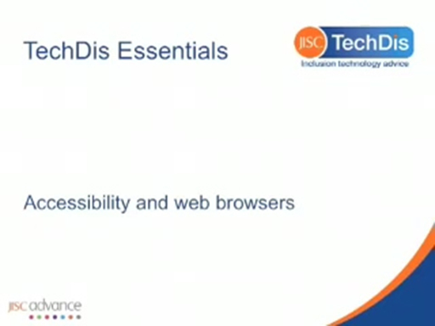

2.1 Trying out built-in assistive technology
In this activity, you will try some assistive technology using tools that come with an operating system.

Activity 2

Use the resources below to help you find built-in assistive technologies on your electronic devices.
- Microsoft Windows – Find detailed tutorials about finding and using built-in assistive technology on the Microsoft Accessibility website (Microsoft, 2014)
- Apple OS – Find similar information on the Apple Accessibility website (Apple, 2014)
- Android – Find similar information on the Android Accessibility website (Google, 2016).
Try out at least four tools that you are less familiar with, covering the range of types; for example, one each, relating to colour, text size, audio alternatives and not using the mouse. Make notes on your experience of using each of these tools.
- Is it straightforward?
- How long is it taking?
- Do you have to remember the layout of the screen?
- How long do you think it would take you to become an expert user?
- Did you need more help? If so, did you find help and was it useful?

View discussion - Activity 2

3 Specialist assistive technology
In Activity 2, you tried some assistive technology using tools that come with an operating system. For those students who have sufficient funding, there are more powerful tools. These have features such as customisation for different user needs and different applications. Here we have a look at some of those by listening to some of the students who use them.
Firstly, we should read what students have to say about how these specialist technologies enabled them to participate in online learning:

In the Glasgow Caledonian University Library there is a disability room. This is equipped with items such as large display screens on computers, screen readers, screen magnifiers, scanners, CCTV units to enlarge the print of any document and Braille printers that are invaluable to students with disabilities. The room can also be used for exams where the exam papers are provided in large print or electronic format. I additionally have the use of a computer at home that has all the software installed to enable me to complete the course.
James Owens (SKILL, 2006).

But there are problems that are faced by the students too:

They have done my DSA (Disabled Students’ Allowance) assessment, and I’m waiting for approval, which should come through this Friday, then my equipment will be in place. I applied in September but it’s taken about a term. I tried to apply earlier but it took ages to get the application form so by the time I sent it, it was too late to have equipment organised for the first term.
Emmanuel Osei-Tutu (SKILL, 2007).

3.1 Students’ voices on assistive technology
In the following activity, you will spend more time understanding assistive technologies and the issues surrounding them, from the student’s perspective.

Activity 3

View the following videos:
- Caroline talks about her experience of using a computer (AbilityNet, 2007)
- Assistiveware YouTube channel (AssistiveWare, undated) Choose three or four videos that reflect your interests. Most of the videos have subtitles that are indicated by ‘CC’; others do not have transcripts or subtitles.
- Students talk about assistive technology provided via Disabled Students’ Allowance: How can DSAs help? (Microlinkvideos, 2012).
As you watch the videos make notes about the differences and similarities between your experience of trying assistive technology and the experiences of the people in the videos.

Conclusion
This free course, Accessible online learning: supporting disabled students, has introduced some aspects of assistive technologies and how they can support learning. While greater knowledge of each technology is important in providing practical support, we hope this material has introduced you to some of the issues that disabled students experience around the use of assistive technology.
If you are interested in understanding assistive technologies further, and exploring these issues, The Open University offers a course in Accessibility and Inclusive Learning.

References
AbilityNet (2007) Caroline Talks about her Experience of Using a Computer [online], YouTube – AbilityNet’s Channel, http://uk.youtube.com/watch?v=ux1EYqmCeTU (last accessed 1 July 2015).
AssistiveWare (undated) Assistiveware YouTube channel [online], http://www.youtube.com/assistiveware (last accessed 1 July 2015).
Banes, D. and Seale, J. (2002) ‘Accessibility and inclusivity in further and higher education: an overview’ in Phipps, L., Sutherland, A. and Seale, J. (eds) Access All Areas: Disability, Technology and Learning (pp. 1–5) [online], JISC Techdis Service and Association for Learning Technology, http://www.alt.ac.uk/docs/accessallareaslow.pdf (last accessed 1 July 2015).
Doyle, C. and Robson, K. (2002) Accessible Curricula: Good Practice for All, Cardiff, University of Wales Institute; previously available online at http://www.jisctechdis.ac.uk/techdis/resources/detail/investinyou/Accessible_Curricula (no longer available).
JISC Techdis (undated) Assistive Technology ‘Familiarity Audit’ [online], https://learn2.open.ac.uk/mod/subpage/view.php?id=702415 (last accessed 1 July 2015).
Microlinkvideos (2012) How can DSAs help? [online], https://www.youtube.com/watch?v=tNvuFg3Wx4k (last accessed 1 July 2015).
SKILL (2007) Student Experiences: Emmanuel Osei-Tutu [online], National Bureau for Students with Disabilities, http://www.skill.org.uk/page.aspx?c=146&p=248 (last accessed 1 July 2015).
SKILL (2006) Student Experiences: James Owens [online], National Bureau for Students with Disabilities, http://www.skill.org.uk/page.aspx?c=146&p=254 (last accessed 1 July 2015).

Acknowledgements
This free course was written by John T.E. Richardson, Chetz Colwell and Tim Coughlan.
We would like to acknowledge the JISC TechDis project, which created useful resources on assistive technologies that are drawn upon here.
Except for third party materials and otherwise stated in the acknowledgements section, this content is made available under a Creative Commons Attribution-NonCommercial-ShareAlike 4.0 Licence.
The material acknowledged below is Proprietary and used under licence (not subject to Creative Commons Licence). Grateful acknowledgement is made to the following sources for permission to reproduce material in this course:

Images
Course image: Vladgrin/Shutterstock.com

Video
TechDis Essentials video used with permission from Jisc TechDis https://www.youtube.com/watch?v=pdfFvsetdKg.
Adapted extract from: JISC Techdis (undated) Assistive Technology ‘Familiarity Audit’ [online].
Every effort has been made to contact copyright owners. If any have been inadvertently overlooked, the publishers will be pleased to make the necessary arrangements at the first opportunity.
Don't miss out:
1. Join over 200,000 students, currently studying with The Open University – http://www.open.ac.uk/choose/ou/open-content
2. Enjoyed this? Find out more about this topic or browse all our free course materials on OpenLearn – http://www.open.edu/openlearn/
3. Outside the UK? We have students in over a hundred countries studying online qualifications – http://www.openuniversity.edu/ – including an MBA at our triple accredited Business School.

Solutions

Activity 1

Discussion
This activity gave you an overall sense of the scope of technologies available. The activities that follow will help you to think about the experience of using some of these assistive technologies.
You may have noticed that the list of technologies includes some that are relatively old, such as cassette recorders. It is also rather PC-focused and does not include Mac built-in technologies such as VoiceOver.
In addition, the list does not fully reflect the way in which mainstream technologies may be used by disabled people, such as mobile devices and e-book readers. This reflects the changing nature of technology and its quick pace. Of course some people, perhaps older people, may still be using older technologies such as cassette recorders as they may feel more comfortable and confident with them. However, they are likely to find there are fewer cassettes available.
Back to - Activity 1

Activity 2

Discussion
If you are not a technology enthusiast, remember that disabled students may not be either. If you are nervous about trying the assistive technology, so are some disabled students. Think about whether the potential benefits will make the extra effort worthwhile, both for your understanding of assistive technology, and for disabled students.
Back to - Activity 2

TechDis Essentials

Transcript
LILIAN SOON:
Accessibility and web browsers. Web browsers have many features to make exploring the internet easier. Here are four ideas to try.
Caret browsing. Navigate the text in a web page using your arrow keys by pressing the F7 key when you're using Internet Explorer 8 and above or Firefox. This can give you more control over the scrolling or allow you to select text with your keyboard more easily. You can select text by pressing the Shift-Alt and arrow keys.
Zooming. You can enlarge your web page by pressing Control and plus. Control and minus will zoom out while Control and 0 will return you to the default size. On a Mac, you would use the Command key instead of the Control key.
Fonts, sizes, and colours. Look in the Preferences or Advanced Options Settings of your browser to make changes to font, font size, and colours. This is useful for anyone who needs larger fonts or high contrast colours.
Find key words. Press Control-F on your keyboard, and use the Search tool to quickly locate a word or phrase. The word or phrase will usually be highlighted, and you can press the Next button to jump to the next instance of the word.
In this video, we have covered caret browsing; zooming; changing fonts, sizes, and colours; and finding keywords. Apart from these ideas, you may want to explore plug-ins or extensions for your browser. Look for the other videos on this topic.
Back to - TechDis Essentials

