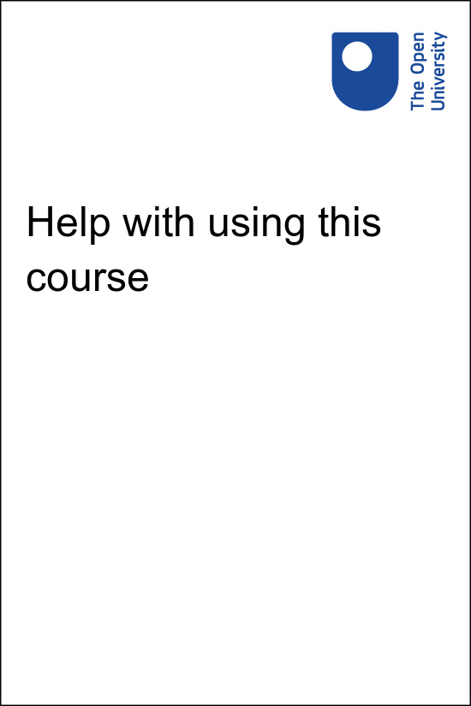

EE831_2

Help with using this course

About this free course
This free course is an adapted extract from the Open University course .
This version of the content may include video, images and interactive content that may not be optimised for your device.
You can experience this free course as it was originally designed on OpenLearn, the home of free learning from The Open University –
There you’ll also be able to track your progress via your activity record, which you can use to demonstrate your learning.
Copyright © 2015 The Open University
Intellectual property
Unless otherwise stated, this resource is released under the terms of the Creative Commons Licence v4.0 http://creativecommons.org/licenses/by-nc-sa/4.0/deed.en_GB. Within that The Open University interprets this licence in the following way: www.open.edu/openlearn/about-openlearn/frequently-asked-questions-on-openlearn. Copyright and rights falling outside the terms of the Creative Commons Licence are retained or controlled by The Open University. Please read the full text before using any of the content.
We believe the primary barrier to accessing high-quality educational experiences is cost, which is why we aim to publish as much free content as possible under an open licence. If it proves difficult to release content under our preferred Creative Commons licence (e.g. because we can’t afford or gain the clearances or find suitable alternatives), we will still release the materials for free under a personal end-user licence.
This is because the learning experience will always be the same high quality offering and that should always be seen as positive – even if at times the licensing is different to Creative Commons.
When using the content you must attribute us (The Open University) (the OU) and any identified author in accordance with the terms of the Creative Commons Licence.
The Acknowledgements section is used to list, amongst other things, third party (Proprietary), licensed content which is not subject to Creative Commons licensing. Proprietary content must be used (retained) intact and in context to the content at all times.
The Acknowledgements section is also used to bring to your attention any other Special Restrictions which may apply to the content. For example there may be times when the Creative Commons Non-Commercial Sharealike licence does not apply to any of the content even if owned by us (The Open University). In these instances, unless stated otherwise, the content may be used for personal and non-commercial use.
We have also identified as Proprietary other material included in the content which is not subject to Creative Commons Licence. These are OU logos, trading names and may extend to certain photographic and video images and sound recordings and any other material as may be brought to your attention.
Unauthorised use of any of the content may constitute a breach of the terms and conditions and/or intellectual property laws.
We reserve the right to alter, amend or bring to an end any terms and conditions provided here without notice.
All rights falling outside the terms of the Creative Commons licence are retained or controlled by The Open University.
Head of Intellectual Property, The Open University

Contents
- Activities and tools
- Using the forum
- Taking screenshots
- Finding copyright-cleared images
- Acknowledgements

Activities and tools
This free course, Becoming an ethical researcher, uses a variety of interactive tools to help you develop your ideas. The following pages of this guidance section should provide you with all the information you need to use these tools and approaches effectively. You may prefer not to read through all at once, but to refer back to it as necessary while you work through the course.
The main ways you will participate in this course are:
- ‘Think about’ points, in which you are asked questions designed to help you reflect on the ideas discussed in the course. You may find it useful to take notes about these reflections, as the ideas you have at these points will feed into later activities. It is up to you whether you take these notes on paper or as a digital file. You will not need to share these notes but they will help you when drafting your course forum posts. They will also be useful to refer to when you answer the quiz questions.
- A course forum in which you will respond to set tasks and be able to read the responses of other learners on the course. Reading others’ contributions will help you think further about the ideas raised in this course, especially when the responses are from people of different backgrounds and nationalities to you. Documents, such as mind maps and photos, can be uploaded as part of your responses. For the forum activities you will sometimes be asked to post a response and also to refer to other participants’ responses. This may require coming back to the discussion forum on more than one occasion, as posts will appear over time. You can find more information on how to use the course forum on the next page, Using the forum.
You will also be invited to engage in the following activities to help you develop your ideas and articulate your thinking:
- Interactive activities in which you will be asked to choose between optional statements and drag and drop your selections into tables, in order to try out your thinking about ethical principles and practices. You can press ‘Reveal answer’ after having a go to review your selections.
- Mind mapping to help you brainstorm ideas and connect them with one another. Again this can be on paper or digitally – such as using the online tool Mindmup.com. These mind maps will be for personal reference but you will sometimes be encouraged to upload and share these to the course forum via screenshot or an image/photograph/scan. Further guidance on Taking Screenshots is available in this help document.
- Polls are included in Activity 4 of Session 3. You are asked to vote in response to questions by selecting possible scenarios. You can vote for more than one scenario. Anonymous results will be published after you answer.
The course is open for 11 months of the year but is designed to take about six weeks of study. You may experience that some peer learners will join or leave the interactive and collaborative areas while you are studying. However, you will therefore have others to interact with.

Using the forum
Our badged course forum is an online discussion area where you will be invited to post comments on a topic and respond to comments made by other people. You will be asked to contribute to this forum regularly throughout the course. When you are directed to use the forum as part of an activity, look for the discussion that is titled with the corresponding week and activity number.

Please be aware that we may wish to to reuse some of your forum contributions, anonymously, in future sessions of this course as examples of good practice. Email FELS-Masters-Admin@open.ac.uk if you wish to opt out of this.

To reply to a post: Click the title of a discussion in the forum to read the posts. To reply to a post, click ‘Reply’. You can edit your post up to 30 minutes after posting it – this allows you to correct spelling mistakes, for example, or amend the tone of your post if you think it could be misinterpreted.
To add an image: First make sure you have saved the image file to your computer, and then click on the image icon (an image of a mountain and sun) and select ‘Browse repositories...’. Click on ‘Browse’ so that you can locate and upload the image. Once you have seleted your image, give it a description and click ‘Save image’. The image will then be applied to your post. Please ensure that you are only using images that are copyright-cleared (for guidance on how to do this see Finding copyright-cleared images).
To add audio: To add your post as an audio, drag and drop an MP3 file into the attachment area.
To link to a post: Click ‘Permalink’ to obtain the web address for a specific post.
To delete a post: If the forum allows you to delete your post (for example, it is within the 30-minute edit period), click the ‘Delete post’ button. The post will remain in position but the content will be removed.
To search the forum: Use the ‘Search this forum’ box within the navigation bar at the top of each page in the forum.
To navigate: Use the ‘crumb trail’ at the top of each page in the forum to return to the forum home page. The format is: Module home page > Forum home page > Discussion.

Acceptable conduct
Please ensure that you treat all other users with respect in any comments you make, and think carefully about how others might react to what you have written. You must also ensure you do not post images of children – such as students from your classrooms – in this forum.
Here are a few tips for making valuable contributions to the online forum:
- make the title of your post relevant and helpful
- only use images that are copyright-cleared
- if you are referring to or using text or images taken from elsewhere, make the source clear
- avoid using sarcasm, as this can be easily misinterpreted
- stay on topic
- be concise
- use appropriate language.

Taking screenshots

PC users
There are a few easy ways to take screenshots of your work.
If you are using a PC running a modern version of Windows (Vista, 7, 8 or 10) the easiest thing is to access the Snipping Tool in your program files. This allows you to select the part of the page you want and save it as a JPG file.
Alternatively if you press the Print Screen button on your keyboard, that will save whatever you have on your screen at that moment onto your clipboard. You can then paste this into a graphics editing program such as Microsoft Paint (which is available in program files) and save that as a JPG file.
If your keyboard doesn’t have a Print Screen button, you can use the on-screen keyboard (OSK), which is available on all modern Windows operating systems.
- Navigate to: Start > All Programs > Accessories > Accessibility > On-screen Keyboard.
- Select Start > Run (or Windows key + R).
- Type OSK and click OK.
- Once the on-screen keyboard opens, press the PrintScreen button and follow instructions above. The on-screen keyboard will be part of the screenshot as well, although you can click and drag the keyboard anywhere on the screen to move it out of the way.

Apple Mac OS X users
If you are using Apple’s OS X (Snow Leopard and Lion) you can use the following options to create a screenshot:
- Open the ‘Preview’ application.
- Go to the File menu and then select Take Screenshot.
- You have three options to choose from:
  - Selection
  - Window
  - Entire Screen.
If you prefer, you can use keyboard shortcuts to take the screenshots and skip ‘Preview’ altogether. Here are the keyboard shortcuts to take screenshots:
- Command + Shift + 3 lets you take a screenshot of the entire desktop.
- Command + Shift + 4 lets you select an area of the screen to capture.
- Command + Shift + 4, Spacebar: lets you capture a window.
- Command + Control + Shift + 3 lets you take a screenshot of the entire screen and save it to your clipboard to be pasted in elsewhere.
- Command + Control + Shift + 4 lets you can take a screenshot of an area of the screen and save it to the clipboard.
- Command + Control + Shift + 4, Spacebar lets you take a screenshot of a window and save it to the clipboard.
Your screen captures automatically open in ‘Preview’, where they can be edited and saved.

Finding copyright-cleared images

Can I use any image I find on the Internet?
Not unless you have explicit permission from the copyright owner of the image. The majority of images available online are fully copyright protected. Just because you can access an image does not mean you can freely use it as you wish. All images are protected by copyright.
In order to copy, share, manipulate, reproduce or use an image you will need to gain permission from the copyright owner, or make use of copyright cleared material. A good way to do this is to look for images with Creative Commons licensing.

Where can I look for Creative Commons images?
Photo sharing websites such as Flickr are a good way to source images for your work.
During your search for images you may come across some symbols referring to Creative Commons. Creative Commons allows you to use images under certain conditions.
There are four types of Creative Commons licenses:
- Attribution: Others can copy, distribute, display and perform this copyrighted work – and derivative works based upon it – but only if they give credit the way that is requested.
- Share Alike: Others can distribute derivative works only under a licence identical to the licence that governs this work.
- Non-Commercial: Others can copy, distribute, display and perform the work – and derivative works based upon it - but for non-commercial purposes only.
- No Derivative Works: Others copy, distribute, display and perform only verbatim copies of the work, not derivative works based upon it.

How can I search Flickr for Creative Commons images?
You can search for images on Flickr according to the type of Creative Commons licence they have been assigned.
To search for images go to Flickr's Creative Commons page. Do not use the first search box located in the top right hand corner of the screen as this will search the whole of Flickr.
You will need to decide which licence you want to search for images under. Click on the ‘see more’ option next to your chosen licence. Then type your search term into the search box. This will return all images posted on Flickr under that Creative Commons licence for your search term.

Remember to credit your source
Regardless of what licence the image is under, the same elements apply across them all. You should always:
- credit the creator (copyright owner)
- provide the title of the work
- provide the URL
- indicate the type of licence it has been made available under
- keep intact any copyright notices placed by the copyright holder.

Acknowledgements
This free course was written by Alison Fox, Deborah Cooper and Clare Lee, with welcome contributions and feedback from Gill Clifton, Claire Hewson, John Oates and Simon Rea. It was first published in October 2020.
Except for third party materials and otherwise stated (see terms and conditions), this content is made available under a Creative Commons Attribution-NonCommercial-ShareAlike 4.0 Licence.
The material acknowledged below is Proprietary and used under licence (not subject to Creative Commons Licence). Grateful acknowledgement is made to the following sources for permission to reproduce material in this free course:
Course image: : Vadym Malyshevskyi; 123rf
Every effort has been made to contact copyright owners. If any have been inadvertently overlooked, the publishers will be pleased to make the necessary arrangements at the first opportunity.
Don't miss out
If reading this text has inspired you to learn more, you may be interested in joining the millions of people who discover our free learning resources and qualifications by visiting The Open University – www.open.edu/openlearn/free-courses.

