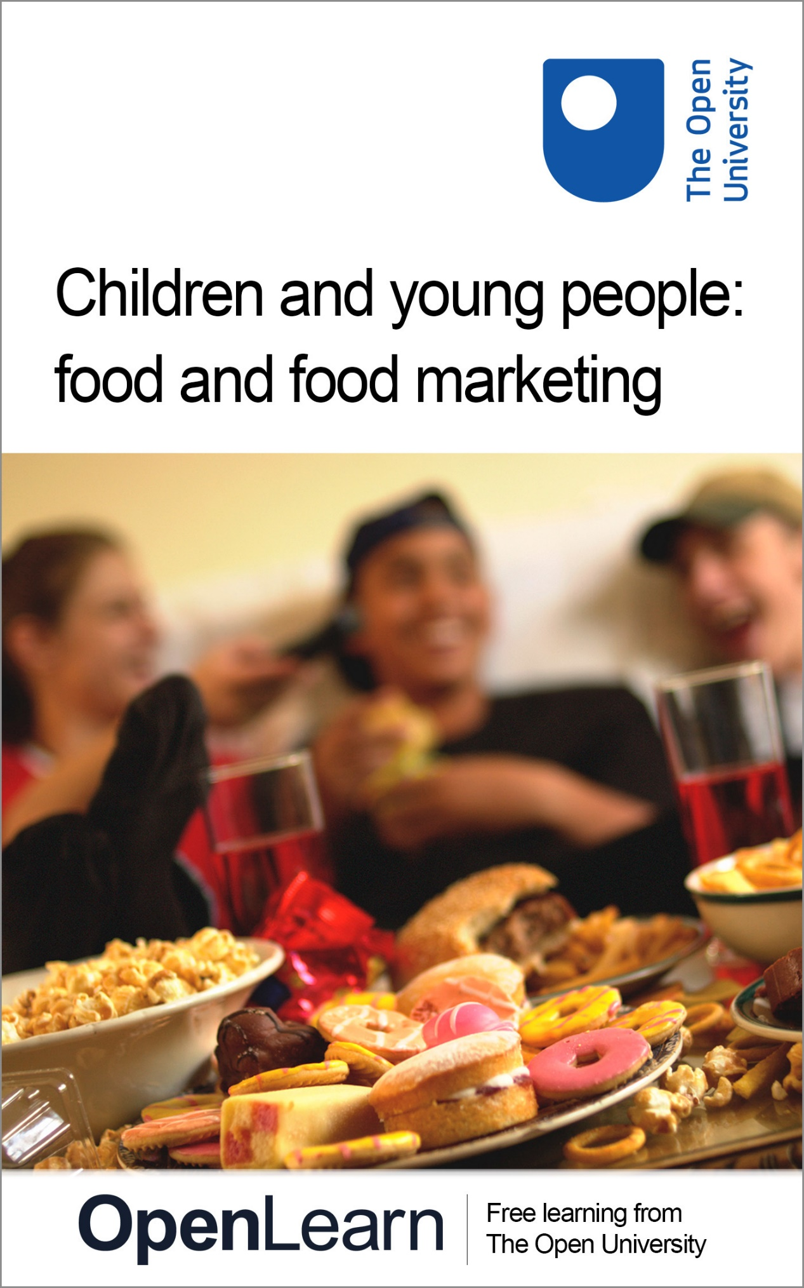

E808_1

Children and young people: food and food marketing

About this free course
This free course is an adapted extract from the Open University course E808 Children and young people’s worlds: www.open.ac.uk/postgraduate/modules/e808 .
This version of the content may include video, images and interactive content that may not be optimised for your device.
You can experience this free course as it was originally designed on OpenLearn, the home of free learning from The Open University –
www.open.edu/openlearn/education-development/children-and-young-people-food-and-food-marketing/content-section-0
There you’ll also be able to track your progress via your activity record, which you can use to demonstrate your learning.
Copyright © 2018 The Open University
Intellectual property
Unless otherwise stated, this resource is released under the terms of the Creative Commons Licence v4.0 http://creativecommons.org/licenses/by-nc-sa/4.0/deed.en_GB. Within that The Open University interprets this licence in the following way: www.open.edu/openlearn/about-openlearn/frequently-asked-questions-on-openlearn. Copyright and rights falling outside the terms of the Creative Commons Licence are retained or controlled by The Open University. Please read the full text before using any of the content.
We believe the primary barrier to accessing high-quality educational experiences is cost, which is why we aim to publish as much free content as possible under an open licence. If it proves difficult to release content under our preferred Creative Commons licence (e.g. because we can’t afford or gain the clearances or find suitable alternatives), we will still release the materials for free under a personal end-user licence.
This is because the learning experience will always be the same high quality offering and that should always be seen as positive – even if at times the licensing is different to Creative Commons.
When using the content you must attribute us (The Open University) (the OU) and any identified author in accordance with the terms of the Creative Commons Licence.
The Acknowledgements section is used to list, amongst other things, third party (Proprietary), licensed content which is not subject to Creative Commons licensing. Proprietary content must be used (retained) intact and in context to the content at all times.
The Acknowledgements section is also used to bring to your attention any other Special Restrictions which may apply to the content. For example there may be times when the Creative Commons Non-Commercial Sharealike licence does not apply to any of the content even if owned by us (The Open University). In these instances, unless stated otherwise, the content may be used for personal and non-commercial use.
We have also identified as Proprietary other material included in the content which is not subject to Creative Commons Licence. These are OU logos, trading names and may extend to certain photographic and video images and sound recordings and any other material as may be brought to your attention.
Unauthorised use of any of the content may constitute a breach of the terms and conditions and/or intellectual property laws.
We reserve the right to alter, amend or bring to an end any terms and conditions provided here without notice.
All rights falling outside the terms of the Creative Commons licence are retained or controlled by The Open University.
Head of Intellectual Property, The Open University

Contents
- Introduction
- Learning outcomes
- 1 The ‘advertised diet’
- 2 A child’s phone as a junk food marketer
- 3 Top five things junk food marketers know about children
- 4 Ads of our time: are teens susceptible to food ads in digital media?
- 5 Looking for solutions: is making food and drinks ‘sugar free’ an answer?
- 6 How children’s food ‘choices’ are affected by wider environmental factors
- 7 Food in children and young people’s lives
- 8 Test your knowledge
- Conclusion
- References
- Acknowledgements
- Solutions

Introduction
This free course, Children and young people: food and food marketing, will introduce you to some key contemporary issues regarding children’s relationships with food, such as whether this should be thought of primarily as a health issue, or also as a way of expressing identities (family, class, cultural, or generational). It will also introduce you to issues about food marketing in the digital age; environmental factors affecting children’s abilities to make healthy ‘choices’; and how considering children’s rights can help to create positive food environments.
This OpenLearn course is an adapted extract from the Open University course E808 Children and young people’s worlds.

Learning outcomes
After studying this course, you should be able to:
- identify and analyse the importance of food in various aspects of children’s and young people’s lives
- understand the impact of food marketing on children from pre-schoolers to teenagers
- critically discuss the idea of whether it is up to individuals to make ‘healthy choices’ when it comes to food
- analyse the need for a rights-based approach to children, young people and food.

1 The ‘advertised diet’

Figure 1 A selection of chocolate bars
View description - Figure 1 A selection of chocolate bars

One of the defining features of the world today is a high level of obesity among children worldwide. This is not only in countries such as the UK, where nearly a third of children aged 2–15 are overweight or obese, but also in the rest of the world, where obesity is rising rapidly. This includes countries where malnutrition is also found. Obesity brings risks to health and mental health through childhood and the rest of life.
This rapid rise in obesity is thought to be caused by environmental factors. This is because obesity has risen recently and rapidly. Among these environmental factors are:
- how food is produced and processed
- poverty that makes it challenging to afford healthier foods which are more expensive
- urban planning that doesn’t support physical activity or healthy food supply, such as lack of safe walking and cycling options and lack of healthy foods in some parts of cities, and near schools
- living and working conditions that promote stress, job and housing insecurity, and don’t support home food preparation
- interacting with all these factors, the very widespread promotion (marketing and advertising) of unhealthy foods in the media, in shops, on transport, and in sports and entertainment venues, which has been shown to increase children’s unhealthy food preferences, requests, and hence eating (look at the article Obesity and the economics of prevention: fit not fat).

Activity 1

While you watch the following video, look out for these key points:
The video features two Open University academics, Heather Montgomery and Mimi Tatlow-Golden.
- What does Mimi mean when she talks about an ‘advertised diet’?
- What ages do children start becoming aware of food marketing?
- Why might this be problematic?

Video content is not available in this format.
View transcript - Uncaptioned interactive content

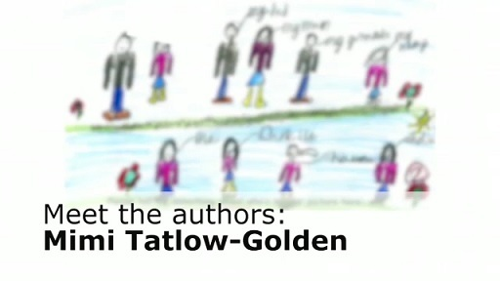

Provide your answer...
View discussion - Activity 1

2 A child’s phone as a junk food marketer
Recognising that food marketing influences children and young people’s food preferences and their eating, the UK has introduced rules that try to reduce marketing of junk foods to children and young people. By international standards, these rules are quite strict – yet so far, their impact is still weak. How can that be?
Audits of television advertising after the first regulations were introduced in 2007 have shown that children’s exposure to such advertising actually increased. This was because regulations targeted programmes that were made specifically for children, yet children and young people also view a lot of other programmes – and advertising for junk food increased around these, such as around sports programmes and shows after 6pm.
During the Covid pandemic in 2020, links for Covid outcomes to obesity began to be understood. The UK government announced it would reduce how children are ‘bombarded by advertisements and promotions for food’ (GOV.UK, 2020) by introducing a 9pm watershed for unhealthy advertising on television – but also online. This is due to be introduced in 2022 and it remains to be seen what kind of impact this will have.
Elsewhere in the world, regulation of unhealthy food promotion in digital media is almost completely absent (see Tackling food marketing to children in a digital world). In a world of overweight and obesity, the opportunity this presents for brands to build relationships with children and promote unhealthy foods is a concern.
So where do kids see junk food marketing online? Find out in the following video.

Video content is not available in this format.
View transcript - Uncaptioned interactive content

3 Top five things junk food marketers know about children
Beware the junk food marketer with their hashtags, games and sponsored tweets! Watch the following video which shows the Top 5 things junk food marketers know about your child.
An ongoing conversation is taking place about the kind of relationship young people have with digital media. Calls have been made for an international regime to address this by balancing children’s protection and participation online. Part of this would involve limiting the ability for those selling unhealthy items to target children with advertising online. In the UK, current advertising regulations aim to restrict targeting of children and young people with unhealthy advertising online. Yet it’s unclear how effective these are, as young people report still seeing many ads for fast food, fizzy drinks and other brands online – nearly half of young people aged 11-19 saw such ads online at least twice a week, and one in five saw them daily (Critchlow et al., 2020).
As digital media become ever more part of our lives, at all ages, it is essential we find ways to protect children and young people’s right to health, while at the same time protecting their right to use these media to avail of information and engage in civic life.

4 Ads of our time: are teens susceptible to food ads in digital media?

Figure 2 Junk food and children
View description - Figure 2 Junk food and children

Later, in their teens, young people are expected to be able to make what is often referred to as ‘better choices’ about their food. Yet their views of food, and their expectations and feelings about it, are affected by the media they consume – and when using social media they largely encounter advertising for unhealthy foods, that uses immersive, entertaining, and emotionally engaging techniques that encourage users to like and share, linking in their friends and spreading marketing messages through their networks. This makes the advertising particularly powerful in ways that counteract young people’s growing ability to understand what is healthy and why. Importantly, it also affects the other ways that they perceive food – as an item that expresses fun, excitement, being young, physically active and part of friendship groups. And research such as this paper from Public Health Nutrition has shown that watching food brand video content on YouTube and seeing favourite food brands advertised online is linked to consuming more unhealthy foods and drinks in young people aged 10 to 16 years.
In the short article Ads of our time Mimi Tatlow-Golden discusses what psychology can tell us about teens’ susceptibility to food ads in digital media.
Mimi Tatlow-Golden’s research ‘See, Like, Share, Remember: Adolescents’ Responses to Unhealthy-, Healthy- and Non-Food Advertising in Social Media’ also shows that social media ads for unhealthy foods have a stronger impact on teens than ads for healthier foods or for non-foods (e.g., sports, electronics, games, clothes or makeup brands). This impact is seen in multiple ways, ranging from how long they look at the ads, through how they rate others, and how well they remember them. Teens pay more attention to ads for unhealthy items; they rate people their age more positively when they see unhealthy food ads in their social media feeds, and they are more likely to share this content with their peers. Finally, they remember these unhealthy food brands more than other brands when asked about them afterwards.

5 Looking for solutions: is making food and drinks ‘sugar free’ an answer?

Figure 3 Sweeteners
View description - Figure 3 Sweeteners

Large amounts of sugar are added to many foods and drinks, particularly those aimed at children, to increase their appeal. One proposed solution to childhood overweight and obesity is to try and cut down the amount of sugar that children consume.
In April 2018 the UK government brought in a sugar tax which meant manufacturers had to pay a levy on fizzy drinks with a high sugar level (see Soft drinks industry levy comes into effect and Soft drink sugar tax starts, but will it work?). Many manufacturers dropped the sugar content of their drinks in anticipation of this tax (see The untapped power of soda taxes).
The UK is by no means alone in this as sugar taxes are increasingly adopted worldwide. By May 2018, 25 countries and 6 U.S. municipalities had adopted sugar taxes or were about to (see Accelerating the worldwide adoption of sugar-sweetened beverage taxes). These were countries in Europe, South and Central America, Africa, the Middle East, the Pacific and the Caribbean. Further countries are examining these options. In Mexico, two years after the tax was implemented, consumption had dropped by nearly 10% (see Sustained consumer response: evidence from two years after implementing the sugar sweetened beverage tax in Mexico). Interestingly, however, in Mexico, young people interviewed said they were not aware of the tax and that it would not affect what they bought as the price increase was too low and they felt ‘addicted’ to the taste of the sugar (see Exploring perceptions of the Mexican sugar-sweetened beverage tax among adolescents in North West Mexico). Indeed, many countries are setting their tax levels too low to expect much impact – experts recommend that taxes should raise prices by 20% to achieve substantial effects (see Accelerating the worldwide adoption of the sugar-sweetened beverage taxes).
One frequent response to sugar taxes by companies is to reduce sugar by adding artificial sweeteners to food and drinks. Is this a good solution? The article Why ‘sugar-free’ is not recommended as a substitute for sugary drinks and foods explains why it may not be.

6 How children’s food ‘choices’ are affected by wider environmental factors

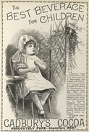
Figure 4 An example of an advertisement.
View description - Figure 4 An example of an advertisement.

The next activity introduces you to some factors that influence the foods that children eat.

Activity 2

Before you watch a video (in the following activity), consider the reasons you believe children and families eat the way they do – you may find it helpful to make a quick note of these first.

Provide your answer...

Public media discourse about food and eating focuses almost exclusively on ‘choices’, placing responsibility squarely with parents and children. However, this video explores some other ways we might think about the wider, systemic factors that affect the foods that parents and children buy and eat.
In this video you will hear Anna Taylor talk about the work of the UK-based Food Foundation, an organisation that aims to change people’s ability to eat healthily through policy and building public understanding about how the food we eat is affected by entire food systems rather than by individuals. You will also listen to Professor of Law at the University of Liverpool, Amandine Garde, who discusses how using the United Nations Convention on the Rights of the Child to invoke child rights might improve children’s diets and who argues that the rights to both protection and participation enshrined in the CRC need to be considered when advocating for children’s rights to be healthy. Her work relates to the very widespread marketing of unhealthy food and drink that has been demonstrated to affect children’s food preferences, requests, and purchases and thus the quality of their diet.

Activity 3

Before watching this video, consider these questions:
- Do you think that children have the right to engage in social life, including media and digital worlds, without encountering marketing for unhealthy foods? Or do you think they should be allowed to make their own eating choices?
- Why is the ‘healthy choices’ agenda problematic?
- What do you think of a ‘children’s rights’ approach to children and food?
Now watch the video.

Video content is not available in this format.
View transcript - Uncaptioned interactive content

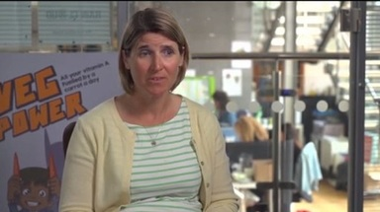

Now consider: did anything you heard from these two experts surprise you? And do you think that children can be persuaded to pester parents for vegetables – instead of sweets and snacks?

7 Food in children and young people’s lives
In the previous sections you learned about interdisciplinary research and advocacy on children and young people’s well-being relating to food. The reading in the next activity will expand on these ideas, focusing in particular on the choices that children and adults are expected to make and the contexts in which they are expected to make them. It focuses on four aspects of children and young people’s relationship with food.
- The discourses, moralities and identities around food.
- Children’s and young people’s control about their eating: their agency and autonomy.
- ‘Big Food’, or the role of the food industry in our diet.
- The construction of children’s desires about food and eating.

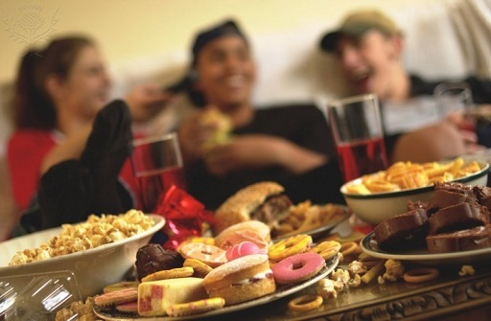
Figure 5 Junk food and young people
View description - Figure 5 Junk food and young people

Activity 4

You should now read extracts from ‘Food in children and young people’s lives: ambiguous agency and contested moralities’ by Mimi Tatlow-Golden. As you read, consider the following questions:
- What different moralities and identities of food are discussed?
- How do food moralities and identities intersect with notions of ‘healthy’ choices?
- What is ‘generational positioning’ regarding food and eating?
These excerpts are taken from Mimi Tatlow-Golden’s chapter, ‘Food in children and young people’s lives: ambiguous agency and contested moralities’, in Montgomery, H. and Robb, M. (eds) (2018) Children and Young People’s Worlds, Bristol, Policy Press, pp. 231-46

Provide your answer...

8 Test your knowledge
Try the following quiz to find out what you know and what you’ve learned about children’s relationship with food.
End-of-course quiz

Conclusion
In this free course, Children and young people: food and food marketing, you learned that children and young people’s relationships with food are a key, lifelong aspect of their daily lived experience. Although all children have individual taste preferences, their attitudes to food are strongly influenced by the many features of the worlds they live in, including their families, friends, schools, and the marketing and sale of food all around them. Children and young people thus develop moralities and identities about food that are complex, that depend on their class, generational and cultural positioning, and that are influenced by the media and by the shops on their streets. Children and young people have rights to live and grow in environments that are nurturing and healthy, where they can easily encounter, taste and enjoy good food, and it is up to all elements of the adult world to create these environments for them.
Well done, you have now completed the course! Now that you’ve come to the end of the course, we would appreciate a few minutes of your time to complete this short end-of-course survey.
This OpenLearn course is an adapted extract from the Open University course E808 Children and young people’s worlds.

References
Critchlow, N., Bauld, L., Thomas, C., Hooper, L., and Vohra, J. (2020) Awareness of marketing for high fat, salt or sugar foods, and the association with higher weekly consumption among adolescents: a rejoinder to the UK government’s consultations on marketing regulation [Online]. Available at https://www.cambridge.org/core/services/aop-cambridge-core/content/view/BC9D5770726F02AF72149992FB2D9965/S1368980020000075a.pdf/awareness_of_marketing_for_high_fat_salt_or_sugar_foods_and_the_association_with_higher_weekly_consumption_among_adolescents_a_rejoinder_to_the_uk_governments_consultations_on_marketing_regulation.pdf (Accessed 30 July 2020).
GOV.UK (2020) Tackling obesity: empowering adults and children to live healthier lives [Online]. Available at https://www.gov.uk/government/publications/tackling-obesity-government-strategy/tackling-obesity-empowering-adults-and-children-to-live-healthier-lives (Accessed 30 July 2020).

Acknowledgements
This free course was written by Mimi Tatlow-Golden and Heather Montgomery. It was first published in January 2019. It was updated in July 2020.
Except for third party materials and otherwise stated (see terms and conditions), this content is made available under a Creative Commons Attribution-NonCommercial-ShareAlike 4.0 Licence.
The material acknowledged below is Proprietary and used under licence (not subject to Creative Commons Licence). Grateful acknowledgement is made to the following sources for permission to reproduce material in this free course:

Images
Figure 1: Cordelia Molloy/Science Photo Library/Universal Images Group
Figure 2: Rawpixel/iStock/Getty Images Plus
Figure 3: Clay Junell. This file is licensed under the Creative Commons Attribution-Non-commercial Licence https://creativecommons.org/licenses/by-nc/4.0/
Figure 4: British Library/Science Photo Library
Course image and Figure 5: Bluestone/Science Photo Library/Universal Images Group

Text
‘Food in children and young people’s lives: ambiguous agency and contested moralities’ by Mimi Tatlow-Golden: © The Open University.
Every effort has been made to contact copyright owners. If any have been inadvertently overlooked, the publishers will be pleased to make the necessary arrangements at the first opportunity.
Don't miss out
If reading this text has inspired you to learn more, you may be interested in joining the millions of people who discover our free learning resources and qualifications by visiting The Open University – www.open.edu/openlearn/free-courses.

Solutions

Activity 1

Discussion
Mimi’s research has shown that from their earliest days, children recognise more unhealthy food brand logos than healthy ones (see the article Young children’s food brand knowledge), and this knowledge of food brands increases rapidly from the age of 3 years. Indeed, their knowledge of unhealthy food brands increases earlier than their understanding of which foods are not healthy to eat (see the article ‘Big, strong and healthy’: young children’s identification of food and drink that contribute to healthy growth) – suggesting that advertisers and marketers are communicating with children about food effectively in the earliest years of life.
Children’s ‘advertised diet’ is largely unhealthy – about three-quarters of ads that even very young children see on television are for items such as fast food, sweets, chocolate and other foods high in saturated fats, sugar, artificial sweeteners, and salt, that the World Health Organization recommends should not be advertised to children (see Creative good feelings about unhealthy food). This creates the impression that it is quite the norm for children to eat such foods frequently – when in fact the opposite is what’s recommended. Furthermore, these ads create powerful emotional associations with such foods, with imagery and stories that evoke delicious tastes and aromas, fun, magic, imagination, humour and powerful pleasure. They also often show children running around and playing energetically – creating the impression that these foods are associated with being active and healthy.
Back to - Activity 1

Figure 1 A selection of chocolate bars

Description
This is a photograph of a selection of chocolate bars.
Back to - Figure 1 A selection of chocolate bars

Figure 2 Junk food and children

Description
This is a photograph of a child drinking a soft drink while holding a burger.
Back to - Figure 2 Junk food and children

Figure 3 Sweeteners

Description
This is an image of a number of packets of sweeteners.
Back to - Figure 3 Sweeteners

Figure 4 An example of an advertisement.

Description
This is an image of an old print advertisement for Cadbury’s cocoa. The title is ‘The best beverage for children’.
Back to - Figure 4 An example of an advertisement.

Figure 5 Junk food and young people

Description
This is a photograph of a table of fast food in the foreground with a group of teenagers in the background.
Back to - Figure 5 Junk food and young people

Uncaptioned interactive content

Transcript
[MUSIC PLAYING]
HEATHER MONTGOMERY
Hello. I'm Heather Montgomery. I'm here today with my colleague psychologist, Dr. Mimi Tatlow-Golden, who's going to be talking about the work she's done on children. And you've worked on children and food, I believe?
MIMI TATLOW-GOLDEN
I have. Yeah. Yeah. I also do some work around children, they're learning about food, and what do they absorb from the environment around them as it were in a broad sense. So one of the things I'm really interested in is children's learning about food from food marketing. So that will be the advertising that sort of saturates the world around us. And we call that their advertised diet. So obviously, there is what they eat, but there's also the world of visual representations that they're surrounded by as well. And children's advertised diet is really dominated by things that aren't very healthy to eat a lot. And there's a lot of evidence that suggests that that affects the choices that they make and the things that they and their parents feel is normal to eat. So I was interested in finding out working with little children, three to five-year-olds, and finding out at what age does their knowledge about food brands start to jump up and comparing that to their understanding of what's healthy to eat. And I found that their knowledge of food brands is at least a year ahead of their early understanding of this is healthy or that's unhealthy. So that suggests to us that the food companies are getting in there well before the impact of parenting and the family and saying this is what's good to eat will start to have an effect. And that's genuinely a concern.
HEATHER MONTGOMERY
And as is digital marketing to children, which is another of your interests.
MIMI TATLOW-GOLDEN
Yes. So that work that I did with preschoolers was focused quite a lot on their television viewing. And now, of course, digital media are becoming very powerful in children's lives. So I don't really take the position that a lot of adults and policymakers that I hear have heard quite a lot of people say, well, get them off Facebook or get them away from whatever social media or devices they're on. I don't think that's realistic. This is the world that we're living in. So it's really about understanding how do young people engage with those media and what kind of an effect might that be having on them. So early research that we're doing at the moment is discovering that unhealthy food is an important part of children's self-presentation in social media and also how they rate people their own age who they view in social media. So they're more likely to rate them positively if they are associated with unhealthy food ads than if they're associated with healthy food ads in their social media streams. So that suggests to us that there's something going on here in early adolescence where children's developing identity is really important, and they're growing their relationships with their peer group. And, at that time, they're using unhealthy food as a way of presenting themselves, as a way of assessing their peers, and, of course, obesity is such a concern globally actually now, even in countries where there's malnutrition as well. So we believe that that's something that policymakers really need to be attending to now.
HEATHER MONTGOMERY
Mimi, that was fascinating. Thank you so much for joining us today.
Back to - Uncaptioned interactive content

Uncaptioned interactive content

Transcript
[MUSIC PLAYING]
NARRATOR
Where do kids see junk food marketing online? Let's find out. Young Oscar's got a message from Danny. It's a link to a new music video! But when he clicks on it, he's first got to watch this junk food advert, which asks him to upload a picture of himself holding the new burger.
[CLOCK TICKING]
Finally, he gets to watch the video.
[DOG BARKS]
Then he's invited to like the band on social media.
[DOG BARKS]
[MUSIC PLAYING]
Their social media page has a sponsored post for chocolate-- a fun game where you can win a month's supply of chocolate.
[MUSIC PLAYING]
And the more chocolate you collect, the higher your score. There are some laws against marketing junk food to children and young people on the telly, but those laws don't apply online. To find out more about who's feeding your kids online, head to OpenLearn, the home of free learning, from the Open University.
Back to - Uncaptioned interactive content

Uncaptioned interactive content

Transcript
ANNA TAYLOR
We have really a national crisis of overweight and obesity. 1 in 5 of our primary school-aged children start school already overweight or obese. By the time they've left primary school, that's turned to 1 in 3. And if you're poor and living in Britain, your chances of being obese as a child are double those of children who are in very wealthy parts of the country.
AMANDINE GARDE
Very often, in public discourses, there is this idea that children have to make healthy choices, that parents have to make healthy choices on their behalves, and so on and so forth. But shift the emphasis and the onus for health on children, their families, et cetera. A children's rights approach places children and their interests at the heart of the policy process, and, in so doing, it helps shift the emphasis from a purely personal responsibility approach to a more societal approach to obesity and its underlying causes and the response that is therefore required.
ANNA TAYLOR
At the end of the day, you can make lots of great, healthy choices. Parents can do that on behalf of their children. And I think we don't want to take away from the people's individual agency and say, yes, if you have got the knowledge, you've got the money, you've got the right shops available to you, you've got the cooking facilities you need at home, the skills to prepare that food in the right way, yes, you can really carve your furrow. And there are households in the UK on extremely low incomes who are managing to do that and a huge credit to them. However, that whole idea that you just have to make healthy choices is dependent on all of those different assets and resources being in place. And, at the end of the day, it relies on us as consumers or children as consumers doing all of the heavy lifting.
AMANDINE GARDE
States have an obligation to ensure that children's rights to health is protected, that children's rights to nutritious food is protected. So as far as obesity is concerned, that requires that states should promote a nurturing environment where healthy food is easily accessible and affordable.
ANNA TAYLOR
Children are vulnerable to food marketing for a few reasons. One is marketing and advertising helps to normalise things. One of the tricks of the trade, if you're an advertiser, is that you want to present your product as being something that everybody uses, and that you're kind of missing out. You're not like everybody else if you're not using it. They normalise these products. And they also build in a degree of aspiration into those products as they present them to children. We did a report called Force-Fed a couple of years ago now, which really tells the story of the food system in Britain through the lens of an average income family in the UK. And the conclusion from that report, we looked at what the health outcomes are, what a typical shopping basket is, where they're eating out, what are the nutrients in their diet, and what's the food environment that they experience. So by the food environment, I mean where we as individuals interact with the food system. So it's what we see when we walk into a takeaway. It's what we see on a billboard in the street. It's what we see on telly when we are seeing adverts between something we're watching. It's what the environment's like when we walk into the supermarket. That's all about food environment. And what we found with Force-Fed is that the food environment is so stacked against us making healthy choices. This is not a level playing field.
AMANDINE GARDE
I'm hoping-- and this is perhaps very naive of me-- that a children's rights approach will remind states of their obligations towards children and will ensure that children's best interests are indeed recognised as a primary consideration. And, in so doing, hopefully, the political will develop to translate evidence into action.
ANNA TAYLOR
But we think that vegetables in the UK needs an entirely new transformation in the image that they have. At the moment, they're associated with something worthy, that your mum makes you eat, you have to eat it, it's good for your health. It's not something you want to eat. We want to change that. So we are trying to mobilise a bit of resource to run and do some pilot campaigns which get kids really excited about eating veg. Can you imagine a situation where children were pestering their parents to get them to buy them certain vegetables to try? It's sort of unimaginable at the moment for most parents that their children would be asking for those things rather than junk food. But what we want to try and do is change that and actually drive the pester power towards veg.
Back to - Uncaptioned interactive content

