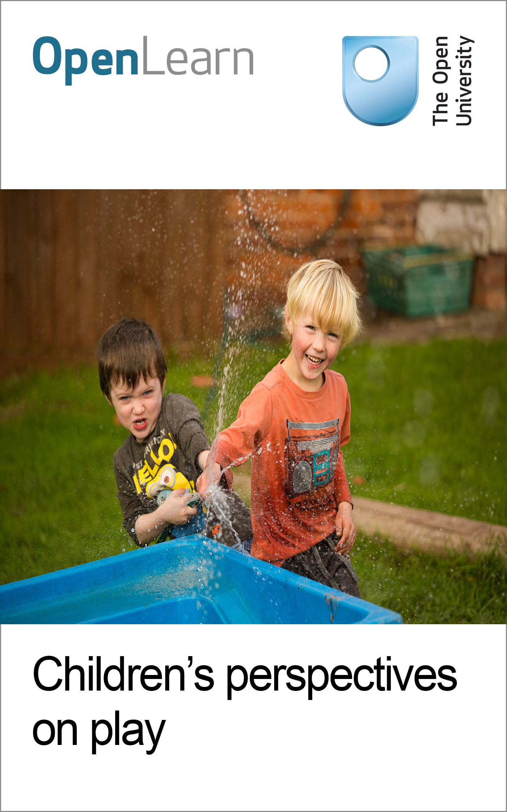

E110_1

Children’s perspectives on play
About this free course
This free course is an adapted extract from the Open University course E110 Young children’s play and creativity: www.open.ac.uk/courses/modules/e110.
This version of the content may include video, images and interactive content that may not be optimised for your device.
You can experience this free course as it was originally designed on OpenLearn, the home of free learning from The Open University –
www.open.edu/openlearn/education-development/childrens-perspectives-on-play/content-section-0
There you’ll also be able to track your progress via your activity record, which you can use to demonstrate your learning.
Copyright © 2017 The Open University
Intellectual property
Unless otherwise stated, this resource is released under the terms of the Creative Commons Licence v4.0 http://creativecommons.org/licenses/by-nc-sa/4.0/deed.en_GB. Within that The Open University interprets this licence in the following way: www.open.edu/openlearn/about-openlearn/frequently-asked-questions-on-openlearn. Copyright and rights falling outside the terms of the Creative Commons Licence are retained or controlled by The Open University. Please read the full text before using any of the content.
We believe the primary barrier to accessing high-quality educational experiences is cost, which is why we aim to publish as much free content as possible under an open licence. If it proves difficult to release content under our preferred Creative Commons licence (e.g. because we can’t afford or gain the clearances or find suitable alternatives), we will still release the materials for free under a personal end-user licence.
This is because the learning experience will always be the same high quality offering and that should always be seen as positive – even if at times the licensing is different to Creative Commons.
When using the content you must attribute us (The Open University) (the OU) and any identified author in accordance with the terms of the Creative Commons Licence.
The Acknowledgements section is used to list, amongst other things, third party (Proprietary), licensed content which is not subject to Creative Commons licensing. Proprietary content must be used (retained) intact and in context to the content at all times.
The Acknowledgements section is also used to bring to your attention any other Special Restrictions which may apply to the content. For example there may be times when the Creative Commons Non-Commercial Sharealike licence does not apply to any of the content even if owned by us (The Open University). In these instances, unless stated otherwise, the content may be used for personal and non-commercial use.
We have also identified as Proprietary other material included in the content which is not subject to Creative Commons Licence. These are OU logos, trading names and may extend to certain photographic and video images and sound recordings and any other material as may be brought to your attention.
Unauthorised use of any of the content may constitute a breach of the terms and conditions and/or intellectual property laws.
We reserve the right to alter, amend or bring to an end any terms and conditions provided here without notice.
All rights falling outside the terms of the Creative Commons licence are retained or controlled by The Open University.
Head of Intellectual Property, The Open University

Contents
- Introduction
- Learning outcomes
- 1 Children’s perspectives on play
  - 1.1 What does play mean?
  - 1.2 What are children’s play preferences?
  - 1.3 Children’s experiences of the outdoors
  - 1.4 A different approach to play
- 2 Elodie’s day
  - 2.1 Views of play
  - 2.2 Using facts, opinions or arguments
- 3 William and Megan
  - 3.1 Home education and learning
- 4 Street play
  - 4.1 Views on play and creativity
- Conclusion
- Keep on learning
- References
- Acknowledgements

Introduction
What influences children’s play decisions and creative choices, and how do they show their preferences and have their voice heard through their play? In this free course, Children’s perspectives on play, you will explore children’s play and creativity in a range of different situations, and consider what influences their play decisions and creative choices. You’ll think about children as active learners and participants, fully capable of constructing and communicating their perspectives on their experiences (Mardell and Carpenter, 2012). When children have freedom to choose, they are highly self-motivated and ‘active’ in their engagements with everything around them. You are asked to put yourself in ‘young children’s shoes’, listening to what they think, noting their responses and taking their perspectives seriously.
In Section 1, you are briefly introduced to two studies where researchers wanted to listen to young children’s talk and opinions about their play. In Sections 2 and 3, you are encouraged to think about children’s play experiences in different contexts. First, you will read about Elodie (aged three years) and how she plays at home as observed by Mia, her mother. You will then read an account by Michael, the father of William (five years) and Megan (three years), both of whom are being home-educated. Finally, Section 4 focuses on children’s street play. The street was a place that children once fairly freely occupied and adapted for play in various spontaneous and imaginative ways. Today, of course, streets are, in the main, claimed by moving and parked vehicles. This section includes some memories from adults reflecting on their childhood days spent playing in their streets.
This OpenLearn course is an adapted extract from the Open University course E110 Young children’s play and creativity.

Learning outcomes
After studying this course, you should be able to:
- understand and outline the significance of play and creativity in listening to children and understanding their perspectives
- describe different ways that children ‘tell’ about their experiences of play in different contexts
- describe the impact of different contexts on children’s views of play
- recognise how a socio-cultural understanding of children leads to taking their perspectives seriously.

1 Children’s perspectives on play

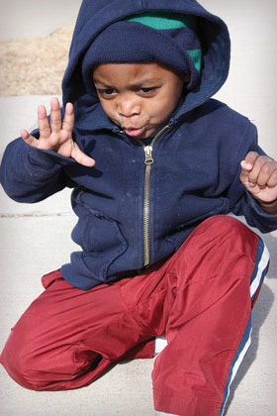
Figure 1 ‘Let me just see if I can touch that – it looks interesting!’ Child’s perspectives on play.
View description - Figure 1 ‘Let me just see if I can touch that – it looks interesting!’ Child’s perspectives ...

In this section you will consider two pieces of research that sought to find out what children think about play and their playing. The first piece of research is from the United States and involved the research team interviewing children aged from 3–10 years about their views on play. The second research study looks at children’s social play experiences, following seven 4-year-old children from England.

1.1 What does play mean?
Based in Oakland, California, USA, Julie Nicholson and her colleagues interviewed 98 school pupils (most between the ages of three and ten, but some were teenagers) about their perspectives on both children’s and adults’ play. The majority of these children were living in economically distressed urban environments. The impetus for the research arose from a wish to listen to the voices of children, given that most published writing about children’s play reflects adults’ perspectives on children’s play, rather than children’s views.
Describing what play meant for her, seven-year-old Angelica seems to capture something essential not just for herself but adults too; she stated, ‘Play is having fun for the rest of your life.’ And four-year-old Yenee commented, ‘Play means you have to play from some house with toys or peoples.’

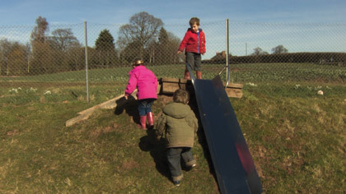
Figure 2 Playing outdoors in free-ranging active ways was much valued by children in Nicholson et al.’s (2014) research.
View description - Figure 2 Playing outdoors in free-ranging active ways was much valued by children ...

The researchers found that children often associated play with toys and games and saw play to be very much part of their social interactions and relationships with other children. Laughing and having fun featured strongly, as did being able to choose how they played and what they played with.
Many of the older children interviewed also expressed clear ideas about how adults might play. According to a number of children, the primary form of adult play was adults playing with their own children. One child, Jose (aged nine), felt he had to encourage his mother to play with him. Others recognised that adults might play sports and games of their own kind – cards, soccer, or a game on their phone. Neela (aged eleven), widened things by saying:

I think they play with their friends ... not exactly the same way we play ... their play probably is talking, going to lunch maybe, going shopping, um, at night-times, going to people’s houses, eating, talking about grownup stuff.

These seem to be astute suggestions, coming from a young person, about the possibility of play in an adult’s world. It could be argued that playful thinking is visible in a design such as that of the ‘Gherkin’ skyscraper in London, designed by Norman Foster and Ken Shuttleworth and later nicknamed the ‘Gherkin’ because of its unique shape.


Figure 3 A number of children in Nicholson et al.’s (2014) study suggested that adults do not play enough.
View description - Figure 3 A number of children in Nicholson et al.’s (2014) study suggested that adults ...

Nicholson et al. (2014, p. 150) concluded that many children had ‘profound comments to make about why play was important to their own lives’. Through their study, the researchers came to believe that children can in fact cause adults to stop and think, to pause in their busy lives, and to reconsider their personal beliefs and actions that can affect their children’s lives. Listening to children in order to better understand their perspectives on play and playing, the researchers urge, is an essential dimension of respecting children’s human rights to be heard and for their opinions to be respected (United Nations, 1989). The Italian philosopher and founder of Reggio Emilia nurseries, Loris Malaguzzi, reminds us in his poem, ‘No way. The hundred is there’, that children are born ‘with a hundred languages’ (Gandini, 1998). Even before they are talking, babies are subtly communicating their feelings, perspectives and ideas about the world with those nearest to them, and, of course, it can be a challenge for adults to learn how to respond to the pre-linguistic sounds and expressions of babies.
As you read the different accounts of children’s perspectives on play in the following sections, reflect on these and think about the various ways in which children share their views.

1.2 What are children’s play preferences?
Natalie Canning’s doctoral study looked in detail at the child-initiated play of seven children (four boys and three girls, aged four years old), all of whom were living in central England and attending a range of early years settings. Her case studies of the children included video recordings of the children’s social play in their early years settings and in their homes, conversations with the children and interviews with practitioners and parents. Her central research question was: In what ways can child-initiated social play empower children? The video and interview data were examined under three themes:
- children’s choices and their decisions
- the context of children’s play
- the interactions between children.
Canning (2015) noted, in her video data, that there never seemed to be a moment when children ran out of ideas for play. For example, the children creatively thought of den-making in the woods, rolling a large pipe in a field, sliding down a pole and establishing a running circuit in a garden.
In addition to her own observations and discussions with parents, Canning (2015) sought to understand how the seven children regarded their play: she asked them about their likes and dislikes about play, and supported this with still photographs printed from the video footage of them playing. In their responses, the word ‘fun’ was often used, confirming a long-recognised essential play ingredient for children and, indeed, for adults too. In early years settings (and schools), the art of making things fun for children would seem to be central to stimulating their interest and involvement in learning. Although seemingly obvious to many, this probably cannot be said too often.
Canning (2015) acknowledges that, with such young children, it is not easy to elicit their thoughts and comments about play. However, it was important that she endeavoured to do this in her research design, thus showing the children the respect they deserve as people. She concludes that by using video recordings to observe and re-observe children at play, practitioners can gain a deeper understanding of children’s play and how they are empowered through different play situations.

Key points
- It is a right of children to be consulted and their views on play (or anything else) to be taken into account by adults.
- Taking young children’s perspectives seriously can involve listening to the many ways they communicate their ideas and responses.
- Using video/digital photos to observe children at play can be another way to listen to and understand children’s views.
- Play can be seen as important not only for children but adults too. Play doesn’t stop after childhood; it enters into adult activities in many ways.

1.3 Children’s experiences of the outdoors
In the video in the following activity, you will hear Donna explain why play is important in the forest school. After viewing the video, think about the experiences the children have in the forest and how those experiences enhance their learning and development. In the video you will see children mark-making on the ground with sticks. Take particular notice of what the children are doing, as this will form part of the next activity.

Activity 1
Allow 30 minutes to complete this activity

By the time you have completed this activity, you should be able to:
- recognise why play and creative experiences in the forest are important for children
- understand the connection between play and positive learning experiences.
Watch the short video below, showing a group of children playing in the forest school, and listen to Donna explain why play is so important for children.

Video content is not available in this format.
Forest school: why play is important
View transcript - Forest school: why play is important

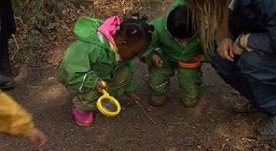

- Select from the list below the top three things you consider the children to be gaining from the forest school experience. Write your three choices in the table below.
  - Physical movement
  - Handling oversized objects such as the sticks
  - Making marks with the sticks on the ground
  - Running through the leaves
  - Throwing the leaves in the air
  - Being able to move around in the forest
  - Moving on different terrain, e.g. paths, leaves, around trees
  - Social interaction with other children
  - Verbal communication
  - Non-verbal actions
  - Fun and excitement
  - Exploring the space

1. | Provide your answer...
2. | Provide your answer...
3. | Provide your answer...

- Now explain briefly why you have chosen your first selection, keeping in mind that your decision should focus on the children’s experience.

Why I chose my first selection:
View comment - Activity 1

1.4 A different approach to play
Keep in your mind the way children were playing in the forest school and now watch the video of Grace and her friend painting in a more structured, indoor environment. The children are demonstrating similar skills in both videos, but are very different.

Activity 2
Allow 45 minutes to complete this activity

By the time you have completed this activity, you should be able to:
- understand that children’s play experiences can be very different
- consider play from a child’s perspective.
Watch the short video clip of Grace and her friend painting in a more structured, indoor environment.

Video content is not available in this format.
Children painting
View transcript - Children painting

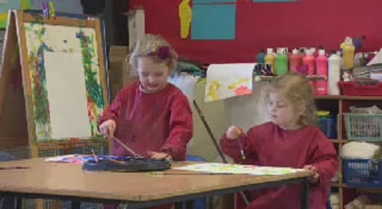

- What are the similarities and differences between the two play situations?

The similarities are … | Provide your answer...
The differences are … | Provide your answer...

- Click on the link to view five statements about the play environment. Rate to what extent you think the environment is influencing what Grace and her friend are doing in their play.

Interactive content is not available in this format.
Rating the influence of environment on the children’s play

- Now put yourself in Grace and her friend’s shoes. What do you think they would say about their play experience?

Provide your answer...
View comment - Activity 2

2 Elodie’s day
The following account is from Mia Jenkins, Elodie’s (aged three years) mother. She talks about what Elodie likes to do, what she chooses to play with and her interest in music.

Box 1 Elodie playing
When Elodie wakes up in the morning, she immediately wants to play rather than have breakfast. She’s always so excited about playing but a little unfocused because she can move from one thing to another very quickly. Perhaps this is because she was a premature baby, being ten and half weeks early, so she needs time to develop. Her doll’s house is a massive thing with her and so is music. At the moment, at age three, from what I gather from our health visitor and various books, she should sometimes be playing in slightly different ways – games where it’s your-turn, my-turn like, for example, snap and snake and ladders.
But she often just wants to play her musical instruments. She’s got a guitar, just a little one, and she’s also got access to my guitar. She loves her toy piano and she loves all her percussion things. So she’s either working on her music or she is singing, or she is playing making me tea and breakfast in her little play kitchen. She is an only child and she wants to play with me all the time so I’m trying to stretch her gradually so she will play on her own a little more.
If we are playing in her doll’s house, she likes it if I also have my hands in the doll’s house getting the furniture out and so on. I do make suggestions but they can get over-ridden and when I mention breakfast or lunch, she’ll say ‘No, it’s night time’. She likes me around to make suggestions but she needs to take control. I don’t mind this because I like to think it’s good that she’s imagining something. She’s definitely got her own agenda on the play.
Up to a year or so into her life, I wasn’t quite sure how to play with her. Before she was born, I’d not had very much experience of playing with small children. I think I learned how to play with Elodie from watching my mother. She appeared to know how to do it; she’s wonderful. It seems to be about bringing imagination into what’s happening. A stick, of course, can be so many things in play. The role now comes more naturally to me. In fact, I think Elodie has reminded me how to play. I did use to have a very good imagination when I was a child.
When she was little I sang to her all the time. Even when she was in an incubator in hospital I sang to her. When she was crying and upset I would sing to help calm her. So she’s heard music a lot. She was very late to talk, late to do everything, in fact. Her language has only really taken off in the past few months. Previously to that, she wasn’t forming many words but she could sing the melodies of countless songs – maybe 30 well-known nursery songs.
Since 10 months she’s been a very good sleeper but she wouldn’t be quick to go to sleep. She would just lie in her cot and, on the monitor downstairs, we could hear that she wasn’t sleeping for perhaps an hour after we put her to bed, but she was going through one song after another. At first the tunes were perfect then the words started to come. Some of the words she hasn’t quite got yet so she makes up her own. I think singing is a form of playing. She’s entertaining herself, comforting herself, soothing herself …

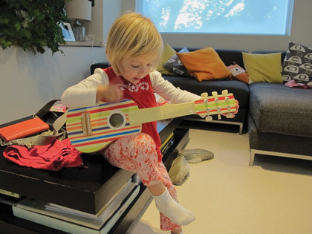
Figure 4 ‘I would say Elodie’s interest in music started right from the very beginning. When I was pregnant, I was having singing lessons and guitar lessons’.
View description - Figure 4 ‘I would say Elodie’s interest in music started right from the very beginning. ...

2.1 Views of play

Developmental perspectives
Mia comments that from conversations with her health visitor and other parents and books she has read that, at three years, Elodie should be playing in more sophisticated ways – for example, in turn-taking games. As a parent, Mia would be aware that these expectations are based on UK developmental frameworks for monitoring a child’s development of significant skills and milestones. How useful is it to have such idealised developmental expectations for the play of young children? Mia seems to acknowledge the uniqueness of her daughter’s acquisition of skills and, rather than focus on what Elodie is not yet demonstrating in her play (sometimes referred to as taking ‘a deficit view’), describes her preference for music and love of playing her instruments. The danger of strictly applying developmental norms is that parents and professionals can become overly concerned as to what children cannot do, rather than noting and praising what they can do at any point in time.

Sociocultural perspectives
Mia records how Elodie likes her to participate when she’s playing in her doll’s house. Elodie wants her mother to make suggestions, but, you will have noticed, Mia recognises that Elodie also has ‘her own agenda on the play’ and ‘needs to take control’. If children are regarded as active learners, the seeking of ownership by Elodie is not surprising, of course. Participating in activities with others, engaging in conversations and sharing in play with roles are key concepts in sociocultural theories of play and learning. Barbara Rogoff (2003, p. 287) refers to such mutual learning and meaning-making as a part of the process of ‘guided participation’ through which children learn as they participate with others.

Music and play
There is a sense in which all music-making and participation involves aspects of exploration, experimentation, trial and error and, as Mia suggests, play. For example, think of a composer working on a new manuscript or musicians working together to create an original composition. From what Mia tells us, Elodie seems to be enjoying the textual, rhythmic and melodic features of the songs she is getting to know. Small (1998) referred to such spontaneous musical-making as ‘musicking’ (from the verb to music). Before she slips into sleep, Elodie plays with the melodies, rhythms and the words known to her in her own creative way. Many of the early pioneers of early childhood education (including Froebel and Montessori) recognise the value of music and musical activities for young children (Rowe, 2012).
In the next section, you will read about William and Megan’s experiences – for this family, the home and the local environment are contexts where playing and learning seem to be inextricably linked.

2.2 Using facts, opinions or arguments
From the two videos you watched in Activities 1 and 2, you will have formed an opinion about the children’s play and their creative experiences from that play. It is important to understand the difference between facts, opinions or arguments. The next activity will help you to distinguish between them and think about how you can use them effectively.

What are facts?
Facts can be checked against evidence. Facts used in academic writing are those that have been gathered and recorded in a formal way, such as part of a research study published in a journal or official records or statistics. For example:

Many of the early pioneers of early childhood education recognise the value of music and musical activities for young children.
(Rowe, 2012)

This is a fact because the early pioneers did recognise the value of music and this has been extensively written about.

What are opinions?
Opinions are personal beliefs. They are not always based on good evidence and, in some cases, may even be the opposite to what evidence suggests. Even if most people agree with what you are saying, it is still an opinion unless you can back it up with supporting evidence. For example, Elodie’s Mother, Mia, offers her opinion on what Elodie likes to play with:

She loves her toy piano and she loves all her percussion things. So she’s either working on her music or she is singing, or she is playing making me tea and breakfast in her little play kitchen.

How does Mia know that Elodie loves her toy piano? Or her percussion things? What evidence is there to support her claim? It is just Mia’s opinion from watching her daughter play because there is no evidence to support what she is saying. It is good to have opinions, but in academic study opinions must be backed up with a fact or an argument.

What is an argument?
Arguments are reasons, which can include facts, given to support a point of view. For example:

Participating in activities with others, engaging in conversations and sharing in play with roles are key concepts in sociocultural theories of play and learning. Barbara Rogoff (2003, p. 287) refers to such mutual learning and meaning-making as a part of the process of ‘guided participation’ through which children learn as they participate with others.

Here the research by Rogoff (2003) is being used to back up what the author wants to say. It is an informed argument because an opinion (first sentence) is supported by published research which agrees with the point being made (second sentence).

Activity 3
Allow 1 hour to complete this activity

By the time you have completed this activity, you should be able to:
- recognise the difference between facts, opinions and arguments
- describe how they are used in paragraphs to answer a question.
From the paragraph below, decide whether each sentence is a fact, opinion or argument:

There is a sense in which all music-making and participation involves aspects of exploration, experimentation, trial and error and, as Mia suggests, play. For example, think of a composer working on a new manuscript or musicians working together to create an original composition. From what Mia tells us, Elodie seems to be enjoying the textual, rhythmic and melodic features of the songs she is getting to know. Small (1998) referred to such spontaneous musical-making as ‘musicking’ (from the verb to music). Before she slips into sleep, Elodie plays with the melodies, rhythms and the words known to her in her own creative way. Many of the early pioneers of early childhood education (including Froebel and Montessori) recognise the value of music and musical activities for young children.
(Rowe, 2012)

Write your answer in the table below.

Sentences from paragraph | Fact, opinion, argument?
There is a sense in which all music-making and participation involves aspects of exploration, experimentation, trial and error and, as Mia suggests, play. | Provide your answer...
For example, think of a composer working on a new manuscript or musicians working together to create an original composition. | Provide your answer...
From what Mia tells us, Elodie seems to be enjoying the textual, rhythmic and melodic features of the songs she is getting to know. | Provide your answer...
Small (1998) referred to such spontaneous musical-making as ‘musicking’ (from the verb to music). | Provide your answer...
Before she slips into sleep, Elodie plays with the melodies, rhythms and the words known to her in her own creative way. | Provide your answer...
Many of the early pioneers of early childhood education (including Froebel and Montessori) recognise the value of music and musical activities for young children (Rowe, 2012). | Provide your answer...

View answer - Activity 3
View comment - Activity 3

3 William and Megan
Parents who home-educate their children in England are under no obligation to inform their local council, so the numbers of parents who decide to do this are not known. However, there is reason to think (see BBC News, 2015) that this total number may be increasing because of parental dissatisfaction with, for instance, the formal nature of schools, an inability of schools to meet the special needs that their children have, bullying between children, and the wish to pass on family and community religious beliefs in more concerted ways than might be done in schools.
Michael is the father of William (six years old) and Megan (three years old). As you read the following account of how he is home-educating his two children, focus on how the children’s views are accommodated each day and Michael’s reflections on his approach.

Box 2 Educating William and Megan
I haven’t gone back to work since William’s been about two so I’ve kind-of forgotten what it’s like to have a whole day to myself. With home education you really are around all the time with the children. I don’t think it’s nearly as hard as people might imagine it to be. The way we do home education is for them to play – that’s all they do really. Most of the time they’re exploring their ideas through play. It’s about communication, conversation and trying something out – experiments with ice, progressing their ideas for games, or examining stick insects, for instance.
We meet up with other parents and children all the time. William and Megan play very differently when we’re out with other children. William does have a tendency to run off with the older boys and they’ll do their own thing. A lot of Megan’s contemporaries aren’t that interested in group play. Sometimes she finds a little friend to play with. There are a couple of forest groups that we go to and it depends on who’s there as to how it unfolds.* We sometimes meet up in a forest and sometimes on a heath. The groups can be quite large when the weather’s good. We link up through social media but it’s also steered by word of mouth. When you’re starting out, you look at the big wide world of home education but then choose whatever works for you. Some parents initiate groups and activities. I tend to join groups rather than lead them. We may have ideas for activities but we often go with what the children want to do.
There’s quite an age gap between William and Megan so between them they tend to find a common denominator in their play, and they do play together quite well. When we’re in the house together, they’re often into their small world play characters. There’s a big castle and a doll’s house set up. Megan’s characters are living in the doll’s house and William’s are in the castle – true to their gender stereotypes. At first, Megan was immersed in William’s world of tractors and so on but she’s more into her own interests now like dressing up as a princess. I just let this happen because you’ve got a job on your hands to prevent it.
For a lot of the time today they were drawing little characters and cutting them out for their play. They were very productive and the characters were all over the table. Megan’s figurative drawing is coming along quite nicely. As soon as they draw them they act them out and move on to the next game. When they’re drawing it’s very verbal and their imagined people don’t seem to have much of a lifespan. With their small world play characters, they use them as a vehicle for their little adventures. They themselves also get dressed up. So, sometimes they project characters onto their toys and sometimes onto themselves. I used to have a role where I might get things going and they would then go with them. It’s less so these days because they’re sort of self-starting.
My background as a photographer, video engineer and someone who’s interested in science means I have always been an explorer and a life learner. I finished my science degree with The Open University when I was first looking after William. I just try to encourage them to be interested in the world around them and when you’ve got small children who are curious about everything, that’s not a difficult job. With our stick insects they used hand lenses to distinguish between what was poo and what were eggs. In their minds, this was fun and play. I don’t think children make the kind of distinctions between say play, fun, and exploration that adults can make.
There are some children who receive a very formal home education and they respond to it. The parents plan it out each term and tailor it to their child. Some home educators are teachers, of course. I expect the outcomes are very good. There is one child I know who is reading quite well at four. What’s nice about home education is you have the flexibility to do what you’re comfortable with. I do think I lean towards a holistic approach to learning.

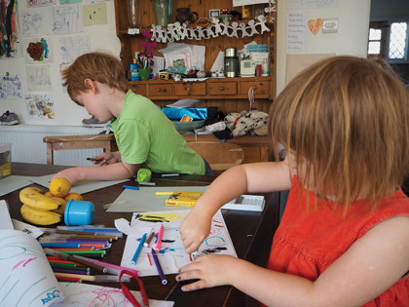
Figure 5 ‘For me, it’s difficult to know what is play and what isn’t. Sometimes they really focus on what they’re doing; sometimes it’s short-lived’.
View description - Figure 5 ‘For me, it’s difficult to know what is play and what isn’t. Sometimes they ...

* Note: a ‘forest’ approach offers children opportunities to achieve and develop confidence through hands-on learning in a natural environment.

3.1 Home education and learning
As Michael states in his account, some parents lean more towards a school-based formal home curriculum and some, like him and others he links with, approach it in more informal ways. So, the extent to which play as a way of learning might feature in home education varies considerably across families. Michael comments: ‘…I lean towards a holistic approach to learning’. Broadly speaking a holistic approach involves acknowledging that children do not compartmentalize their play experiences (Duffy, 2010). The informal curriculum Megan and William experience is situated in their home and community and based directly on their interests and concerns. If parents are prepared to listen to their children while carrying out home education, children will, of their own accord, introduce play into their home learning. Of course, the same conclusion can be drawn for practitioners in early years settings.

First-person narratives
A way of appreciating how playing might seem from a child’s perspective is to write what Paige-Smith and Rix (2011) term a ‘first-person narrative’. This involves carefully observing a child at play, imaging you are thinking like the observed child, and then constructing short sentences that reflect what they are doing. The grandfather of Megan and William wrote this short example below during a day when his wife and he looked after both children.

Sea-life fuzzy felt
I (Megan) get the fuzzy felt box off the shelf. I open the box. I put the board on the floor. I bend over the board. I put a starfish from the tray on the board. I put two fish next to each other. I pat down the fish to stick to the board. I put eyes on the starfish. I add another fish to the two on the board. I say to Granny ‘They’re having a party’. I get up from the floor and climb on the settee.

Writing a first-person narrative is a method of carefully observing children and recording what they do when they are playing. The observation (and the construction of a short text about what is observed) takes place over a relatively short time – perhaps 5 minutes at the most. It can provide insights into the fine details of children’s play and, therefore, help adults to better appreciate what is involved when children are playing. Those who have tried this method invariably report that they are surprised at how much is happening over a few minutes – in terms of children’s actions and interactions when a child is engaged in play. Of course, the text created is an adult-constructed text which does not truly reflect what a child might write were they able to write about what they are doing. This observational technique, arising from research on young children (Paige-Smith and Rix, 2011), could be of use in early years settings. You may like to try it out in your home or your professional setting.

Key points
- There is a sense in which every new parent learns afresh about play through observing and interacting with their own child.
- Being a parent enables an intimate personal revisiting of play in collaboration with one’s own child – an adult’s license to play (once again) as though a child.
- A holistic approach to learning involves acknowledging that children do not compartmentalise their play experiences into subjects.
- If children take some control over their own learning, they are very likely to introduce play.

4 Street play

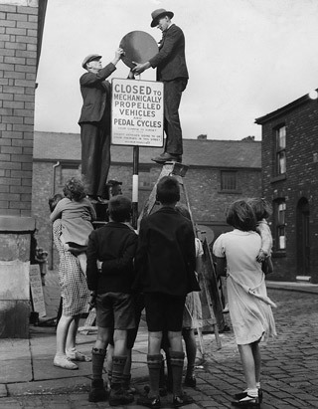
Figure 6 Children playing in a street with no cars in sight.
View description - Figure 6 Children playing in a street with no cars in sight.

It was in 1908 that the Ford Model T went into mass production and greatly increased the number of cars on roads. During 1922 to 1933, over 12,000 children in England and Wales died as a result of being involved in motor vehicle accidents and over 300,000 were seriously injured (Hansard, 1938). This resulted in Nancy Astor, the first female Member of Parliament, expressing concern in 1926 about the increasing dangers for children who sought to play, as children had long done, close to their homes and in neighbourhood streets. During the twentieth century (and in recent times with the wedding of Prince William and Catherine Middleton in 2011), royal events unwittingly served to reclaim streets for community parties and children’s play, albeit for short periods.
In an attempt to respond to these issues, the Department of Health in England is promoting street play, not least because there is growing concern about children’s physical inactivity and the rising levels of child obesity. Funds have been made available to enable local authorities across the country to work with communities in order to develop ‘play streets’, especially in areas of high deprivation. From a young child’s perspective, walking and running with some freedom is impulsive and playing outside must be seen as a natural thing to do. One only has to think about a two-year-old’s reluctance to hold a parent’s hand on leaving the safety of home. A child may not welcome such adult constraints, but the dangers presented by moving cars need to be learnt.
In Brooke Road, Waltham Forest, London, a group of parents have worked with the local authority to set up a play street for two hours on the first Sunday of each month (see London Play, 2015). The appointed street stewards display traffic cones and temporary signs to alert any unwitting driver. This means the road is closed to through traffic for a given period, allowing children to play outside safely. A Brooke Road reminiscence event was attended by a number of adults who wished to share their childhood memories of playing in streets. One resident, Keith, remembered how, when the road became very wet due to periodic flooding, he and others would have fun in the water together. Delia recalled playing skipping games in the street using two ropes which were swung faster and faster. The skipper would run in and out of the swinging ropes, while children chanted: ‘Salt, pepper, mustard, vinegar’.
Reminiscences of this kind contribute to an oral history of children’s past play, helps adults to understand a child’s perspective on playing and reminds us about the places where spontaneous play and imagining was once much more possible. The loss of streets as safe spaces to play is regrettable, but adults and children, of course, also benefit from cars. The family car might be used to support play interests when children are transported to a swimming pool or an adventure playground, for instance. Herein lies a dilemma as progress can often bring both advantages and disadvantages for people.
Evaluations of play streets have highlighted the potential benefits of providing children with increased opportunities for outside play, including:
- more social interaction with children of all ages
- making new friends (who may not just be attending the same early years or school setting)
- increasing the likelihood of children playing with others from a range of cultural backgrounds.
Wider benefits include:
- promoting children’s health (Ferguson and Page, 2015)
- improved neighbourliness
- increased community contact for people of all ages and improved inter-generational contact (Gill, 2015).

Key points
- From a child’s point of view, a local street can be seen as an attractive rather than a dangerous place to play.
- Play street projects are an important way of reclaiming and making streets safe for children and communities, if only for limited periods.
- It is important to be aware of how environmental change and technological developments, albeit embraced as progress by adults, might have unintended consequences for children’s freedom to play and the available spaces in which to play.

4.1 Views on play and creativity
Throughout this course you have been asked to think about your own understanding, values and beliefs about children’s play and creativity. In this final activity, you have the opportunity to consolidate your thinking by listening to the views and personal positions of two people working in the field of early childhood.

Activity 4
Allow 1 hour to complete this activity

By the time you have completed this activity, you should be able to:
- describe how a personal position can be translated into supporting young children.
Watch the video of the nursery in central London and listen to Sarah’s personal position about the importance of play and how she defends it through what happens in her early childhood setting.

Video content is not available in this format.
Provision at ‘stay and play’
View transcript - Provision at ‘stay and play’

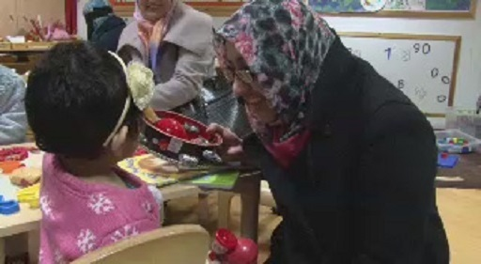

Now watch the video of Morag talking about her views on ‘purposeful play’. Morag is the head teacher of a primary school in Fife, Scotland, so, as you would expect, her personal position is mindful of children’s learning and development.

Video content is not available in this format.
Exploring in Primary 1
View transcript - Exploring in Primary 1

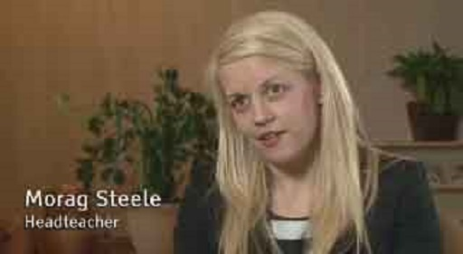

Relate Sarah and Morag’s views to the questions in the grid. The questions are based on what Sarah and Morag say when they are talking about the significance of play and creativity.

Questions | Sarah’s position | Morag’s position
What emotions do you feel when hearing Sarah’s and Morag’s responses about the significance of play to them and to the children and families they support? | Provide your answer... | Provide your answer...
How are Sarah’s and Morag’s responses represented in the brief glimpse you have of their settings? | Provide your answer... | Provide your answer...
What impression do you have of the ability of Sarah and Morag to talk about and share their positions on play? | Provide your answer... | Provide your answer...
How do you think their position has been informed by literature, theory or ‘expert opinion’ to inform their understanding and knowledge? | Provide your answer... | Provide your answer...

View comment - Activity 4

Conclusion
In this free course, Children’s perspectives on play, you have been encouraged to think about children’s perspectives on play and how these might differ from, or even support, what adults think play is. The two accounts from parents, Mia and Michael, give emphasis to the ways in which children can use play, notably in spontaneous and intuitive ways, to engage with, enjoy and learn about what is around them. In terms of research, however small or informal the study, there is a need for more enquiries into what young children themselves think about play and why they are compelled to play. It isn’t easy for adults to tap into the views of very young children. However, we hope that this course Young children’s play and creativity will be the beginning of your own explorations as you seek to better support young children, listening to them, respecting their voices and taking their views seriously.
This OpenLearn course is an adapted extract from the Open University course E110 Young children’s play and creativity.

Keep on learning



Study another free course
There are more than 800 courses on OpenLearn for you to choose from on a range of subjects.
Find out more about all our free courses.

Take your studies further
Find out more about studying with The Open University by visiting our online prospectus.
If you are new to university study, you may be interested in our Access Courses or Certificates.

What’s new from OpenLearn?
Sign up to our newsletter or view a sample.

For reference, full URLs to pages listed above:
OpenLearn – www.open.edu/openlearn/free-courses
Visiting our online prospectus – www.open.ac.uk/courses
Access Courses – www.open.ac.uk/courses/do-it/access
Certificates – www.open.ac.uk/courses/certificates-he
Newsletter – www.open.edu/openlearn/about-openlearn/subscribe-the-openlearn-newsletter

References
BBC News (2015) ‘Home education rises by 65% in UK in last six years’, 21 December [Online]. Available at www.bbc.co.uk/news/education-35155356 (Accessed 17 September 2016).
Canning, N. (2015) ‘Children’s empowerment in play’, Doctoral study, Milton Keynes, The Open University.
Duffy, B. (2010) ‘Creativity across the curriculum’, in Cable, C., Miller, L. and Goodliff, G. (eds) Working with Children in the Early Years, 2nd edn, Abingdon, Routledge, pp. 139–52.
Ferguson, A. and Page, A. (2015) ‘Supporting healthy street play on a budget: a winner from every perspective’, International Journal of Play, vol. 4, no. 3, pp. 266–9.
Gandini, L. (1998) ‘Part 1: Starting points’, in Edwards, C., Gandini, L. and Forman, G. (eds) The Hundred Languages of Children: TheReggio Emilia Approach – Advanced Reflections, 2nd edn, London, Ablex, pp. 1–4.
Gill, T. (2015) ‘Hackney play streets’, Evaluation report, London, Hackney Play Association [Online]. Available at www.hackneyplay.org/playstreets/home (Accessed 13 January 2017).
Hansard (1938) Street Playgrounds Bill, House of Lords debate, 31 March, vol. 108, cc. 543–53 [Online]. Available at http://hansard.millbanksystems.com/lords/1938/mar/31/street-playgrounds-bill (Accessed 17 September 2016).
London Play (2015) ‘Play streets past and present: Brooke Road, Waltham Forest’ [Online]. Available at www.londonplay.org.uk/resources/0000/1822/Brooke_Road_Waltham_Forest.pdf (Accessed 3 January 2016).
Mardell, B. and Carpenter, B. (2012) ‘Places to play in Providence: valuing preschool children as citizens’, Young Children, November, NAEYC (National Association for the Education of Young Children), pp. 78–80.
Nicholson, J., Shimpi, P.M., Kurnik, J., Carducci, C. and Jevgjovikj, M. (2014) ‘Listening to children’s perspectives on play across the lifespan: children’s right to inform adults’ discussions of contemporary play’, International Journal of Play, vol. 3, no. 2, pp. 136–56.
Paige-Smith, A. and Rix, J. (2011) ‘Researching early intervention and young children’s perspectives – developing and using a “listening to children approach”’, British Journal of Special Education, vol. 38, no. 1, pp. 28–36.
Rogoff, B. (2003) The Cultural Nature of Human Development, Oxford, Oxford University Press.
Rowe, V. (2012) ‘Young children’s thinking in music’, in Robson, S. (ed.) Developing Thinking and Understanding in Young Children: An Introduction for Students, 2nd edn, Abingdon, Routledge, pp. 192–9.
Small, C. (1998) Musicking: The Meanings of Performing and Listening, Middletown, CT, Wesleyan University Press.
United Nations (1989) United Nations Convention on the Rights of the Child, UNCRC Europe, UN Rights Committee.

Acknowledgements
This free course was written by Roger Hancock, Gill Goodliff and Natalie Canning.
Except for third party materials and otherwise stated (see terms and conditions), this content is made available under a Creative Commons Attribution-NonCommercial-ShareAlike 4.0 Licence.
The material acknowledged below is Proprietary and used under licence (not subject to Creative Commons Licence). Grateful acknowledgement is made to the following sources for permission to reproduce material in this free course:

Images
Course image: Two boys playing with a hose, Copyright © 2016 The Open University
Figure 1: © Umoja Turner / iStockphoto.com
Figure 3: © dynasoar / iStockphoto.com
Figure 6: © Nick Yapp / Stringer / Getty Images
Every effort has been made to contact copyright owners. If any have been inadvertently overlooked, the publishers will be pleased to make the necessary arrangements at the first opportunity.
Don't miss out
If reading this text has inspired you to learn more, you may be interested in joining the millions of people who discover our free learning resources and qualifications by visiting The Open University – www.open.edu/openlearn/free-courses.

Activity 3

Answer

Sentences from paragraph | Fact, opinion, argument?
There is a sense in which all music-making and participation involves aspects of exploration, experimentation, trial and error and, as Mia suggests, play. | Opinion
For example, think of a composer working on a new manuscript or musicians working together to create an original composition. | Argument
From what Mia tells us, Elodie seems to be enjoying the textual, rhythmic and melodic features of the songs she is getting to know. | Opinion
Small (1998) referred to such spontaneous musical-making as ‘musicking’ (from the verb to music). | Argument
Before she slips into sleep, Elodie plays with the melodies, rhythms and the words known to her in her own creative way. | Opinion
Many of the early pioneers of early childhood education (including Froebel and Montessori) recognise the value of music and musical activities for young children (Rowe, 2012). | Fact

Back to Session 2 Activity 1

Activity 1

Comment
In this relatively short video, there is quite a lot happening: you can see children engaging in different experiences with different natural materials found in the forest. This engagement and playing, exploring and experimenting supports children’s learning and development. Donna focuses on the gross and fine motor skills that children are practising; however, the social aspect of the play and the way in which the children are communicating is equally important. From a child’s perspective, they will remember having fun and the excitement of experiencing the freedom of the space for the first time. It is the adult that places significance on what the children are gaining from the experience.
Back to Session 1 Activity 1

Activity 2

Comment
In the two videos, you watched children mark-making, but in very different ways. The children in the forest school were using large sticks in the mud on the forest floor, whereas Grace and her friend were mark-making using paint in a more structured situation. The children in both the videos are practising the same skills through play, but having very different experiences. This key observation highlights the need to allow children to have multiple opportunities to play in different contexts or situations so that they can experience new ways of doing things. This experience will help them to develop their preferences on where they enjoy playing and what they like to do in that play environment. Arguably the children in the forest school had more choices about what they could do within the forest space, although Grace and her friend looked happy to be painting and were focused on what they were doing. From the children’s perspective, they were exploring and testing out what they could do, for example Grace mixing the colours of the paint. In both videos the children were experimenting with the resources they had available to them.
Back to Session 1 Activity 2

Activity 3

Comment
As you can see there is a balance between opinions, arguments and facts in the paragraph. There are many ideas about play and creativity, and you may well have come across very different opinions and perspectives as a result of your own study of the subject. One of the best ways to identify what your values and beliefs are about children’s play is to listen to children and take their thoughts and actions seriously. They communicate their ideas and responses in different ways, as you have learnt in this course. Listening to children, and thinking about the choices and decisions they make in their play, will help you to form your own responses to children’s motivation for play and creative experiences.
Back to Session 2 Activity 1

Activity 4

Comment
Putting yourself in someone else’s shoes to consider their position or perspective on something is indeed a skill. You have to forget what you would do, think or say, and consider where the other person is coming from. The ability to do this relies on having an open mind and a non-judgemental approach. This is not easy, especially when you find yourself facing challenges to long-held opinions about children’s play and creativity. Perhaps you can use your responses to the questions about the videos as starting points for reflection on your personal position and see whether this leads you to bring about changes to the way you approach supporting young children’s play and creativity.
Back to Session 4 Activity 1

Figure 1 ‘Let me just see if I can touch that – it looks interesting!’ Child’s perspectives on play.

Description
The photograph shows a small boy, about five years old, facing but not directly engaging with the camera. He is wearing a blue, zipped, hooded jacket, a ski hat and trousers. His right hand is open, showing his five fingers, and his left hand is slightly clenched. He looks down at something in the foreground and his lips are pursed – it’s an interesting gesture but the photograph doesn’t reveal the reasons for it, and there is no discernible background.
Back to Session 1 Figure 1

Figure 2 Playing outdoors in free-ranging active ways was much valued by children in Nicholson et al.’s (2014) research.

Description
This photograph shows three children, all around four years old, playing on a long black slide built into a hill within a grassy outdoor play area. One boy, wearing a coat and trousers, is about to go down the slide. He is followed by a girl wearing a coat and jeans, and a boy wearing a khaki-coloured coat and grey trousers. These two children can be seen climbing the grassy incline to take their turn. In the background are trees forming a hedge that marks the boundary of the play area.
Back to Session 1 Figure 2

Figure 3 A number of children in Nicholson et al.’s (2014) study suggested that adults do not play enough.

Description
The photograph is an aerial view of a tall, glass-paned tower shaped like a cucumber, a spaceship or even a gherkin. On its surface can be seen diamond-shaped windows that reflect neighbouring buildings, the sky and the sun. The tower is so tall that it overshadows some of the other buildings around it. These buildings are square, high-rise office buildings; the river Thames is in the background.
Back to Session 1 Figure 3

Figure 4 ‘I would say Elodie’s interest in music started right from the very beginning. When I was pregnant, I was having singing lessons and guitar lessons’.

Description
This photograph shows a three-year-old girl, Elodie, sitting on a seat and holding a child’s six-string acoustic guitar. The instrument has coloured stripes running along its body and the headstock. Elodie is holding the headstock with her left hand and strumming the strings with her right. Her right leg is slightly raised to support the instrument’s weight. Behind her is a large window and a black sofa with scatter cushions. The floor carpet is beige. To the left of the image can be seen a houseplant and a lamp.
Back to Session 2 Figure 1

Figure 5 ‘For me, it’s difficult to know what is play and what isn’t. Sometimes they really focus on what they’re doing; sometimes it’s short-lived’.

Description
This photograph shows two children – one, a girl aged three, and the other, her brother aged five. They are engaged in paper and felt-tip activities on a kitchen table. The boy is furthest away from the camera and he is wearing a short-sleeve shirt. His sister is in the foreground and she is wearing a sleeveless dress. The table is covered with items including felt-tip pens, paper showing their previous drawings, and two bananas and three lemons. A kitchen dresser with miscellaneous items, including some of the children’s artistic work, can be seen in the background.
Back to Session 3 Figure 1

Figure 6 Children playing in a street with no cars in sight.

Description
This is a black-and-white photograph of children – boys and girls ranging in age from a toddler to a seven-year-old – standing around and watching two men put up a sign in a residential street. Two men are standing on ladders leaning against either side of the signpost. The sign reads, ‘Closed to mechanically propelled vehicles and pedal cyclists’. The image appears to be from the 1950s.
Back to Session 4 Figure 1

Forest school: why play is important

Transcript
[CHILDREN TALKING]
CHILD 1
Whoa!
CHILD 2
Whee!
DONNA
Play’s really important because children develop all their skills through play. For example, at forest school, when they’re running around or they’re climbing, they’re developing those physical skills. So before they can actually learn to use a pen and write – so use their fine motor skills – they’re developing those skills on a larger scale, really.
Back to Session 1 MediaContent 1

Children painting

Transcript
GIRL 1
Can I take it home later?
GIRL 2
[INAUDIBLE]
GIRL 1
Can I have your work?
GIRL 2
[INAUDIBLE]
GIRL 1
Do you like mine? I like yours.
Mine – do you think mine is really pretty? Oh, thanks.
GIRL 2
Grace?
GIRL 1
Yeah?
GIRL 2
[INAUDIBLE] mix up colours?
GIRL 1
Yeah. Do you?
GIRL 2
Yeah.
GIRL 1
And me. I'm getting white, purple, green, orange, purple, blue, red.
GIRL 2
Green, orange, purple, blue, [INAUDIBLE].
GIRL 1
White, pink, blue, purple, red, orange.
Back to Session 1 MediaContent 2

Provision at ‘stay and play’

Transcript
WOMAN
What is it?
SARAH STIMSON
Everything that they could possibly need for physical play, creative play, small block work is there. They don't have to ask for it. It's there in some form or another. They can be very quiet and go to a quiet area and read books, or they can run around in the garden. The whole curriculum is there, and that's what's important.
Children don't have to ask, parents don't have to ask. It's there. And the idea is that children access themselves. The baskets are small enough for children to pick down, so they're independent, they're confident, and they're making choices. And that's what makes a happy child. And hopefully when they go on to the next setting they've got those skills. And for us that would be what we want – children that are happy and busy, and exploring and interested.
Back to Session 4 MediaContent 1

Exploring in Primary 1

Transcript
GIRL
21, 22, 23, 24, 25, 26.
MORAG STEELE
Purposeful play is very important. It is probably the most effective way of encouraging children to learn at the early level. There has to be a balanced approach, and we very much take a balanced view in Primary 1. For your children there is a place for skill and drill, of course there is, but children need time to explore, they need time to be creative, and to make choices.
And I think that is so important in the Primary 1 setting. If they aren't given these opportunities to explore, really, you know, everything else you might as well just stop, because really, if they don't have that, and they don't have those firm foundations, you know, then everything else becomes a challenge for them later on in their school career.
Back to Session 4 MediaContent 2

