

DBT_1

Supporting babies and toddlers

About this free course
This free course is an adapted extract from the Open University course .
This version of the content may include video, images and interactive content that may not be optimised for your device.
You can experience this free course as it was originally designed on OpenLearn, the home of free learning from The Open University –
There you’ll also be able to track your progress via your activity record, which you can use to demonstrate your learning.
First published 2025.
Unless otherwise stated, copyright © 2025 The Open University, all rights reserved.
Intellectual property
Unless otherwise stated, this resource is released under the terms of the Creative Commons Licence v4.0 http://creativecommons.org/licenses/by-nc-sa/4.0/deed.en. Within that The Open University interprets this licence in the following way: www.open.edu/openlearn/about-openlearn/frequently-asked-questions-on-openlearn. Copyright and rights falling outside the terms of the Creative Commons Licence are retained or controlled by The Open University. Please read the full text before using any of the content.
We believe the primary barrier to accessing high-quality educational experiences is cost, which is why we aim to publish as much free content as possible under an open licence. If it proves difficult to release content under our preferred Creative Commons licence (e.g. because we can’t afford or gain the clearances or find suitable alternatives), we will still release the materials for free under a personal end-user licence.
This is because the learning experience will always be the same high quality offering and that should always be seen as positive – even if at times the licensing is different to Creative Commons.
When using the content you must attribute us (The Open University) (the OU) and any identified author in accordance with the terms of the Creative Commons Licence.
The Acknowledgements section is used to list, amongst other things, third party (Proprietary), licensed content which is not subject to Creative Commons licensing. Proprietary content must be used (retained) intact and in context to the content at all times.
The Acknowledgements section is also used to bring to your attention any other Special Restrictions which may apply to the content. For example there may be times when the Creative Commons Non-Commercial Sharealike licence does not apply to any of the content even if owned by us (The Open University). In these instances, unless stated otherwise, the content may be used for personal and non-commercial use.
We have also identified as Proprietary other material included in the content which is not subject to Creative Commons Licence. These are OU logos, trading names and may extend to certain photographic and video images and sound recordings and any other material as may be brought to your attention.
Unauthorised use of any of the content may constitute a breach of the terms and conditions and/or intellectual property laws.
We reserve the right to alter, amend or bring to an end any terms and conditions provided here without notice.
All rights falling outside the terms of the Creative Commons licence are retained or controlled by The Open University.
Head of Intellectual Property, The Open University

Contents
- Introduction
- Moving around the course
- Week 1: The incredible years
- Introduction
- 1 What babies can do
  - 1.1 Reflexes
  - 1.2 Senses
- 2 Listening to babies’ voices
- Summary of Week 1
- Week 2: Building the brain
- Introduction
- 1 How babies learn
  - 1.1 Piaget
  - 1.2 Vygotsky
- 2 The brain–body connection
  - 2.1 Supporting children to get moving
  - 2.2 Physical development
- 3 Risk and challenge
- Summary of Week 2
- Week 3: Playing
- Introduction
- 1 Learning to play: schema
- 2 The importance of floor play
- 3 Treasure Baskets
- 4 Loose parts
- Summary of Week 3
- Week 4: Making connections
- Introduction
- 1 Why relationships matter: attachment
- 2 A sense of self
- 3 Self-regulation
- 4 Identity and belonging
- Summary of Week 4
- Week 5: Building relationships
- Introduction
- 1 Building positive relationships
- 2 Children’s relationships
- 3 Families and friends
- 4 Key person
- Summary of Week 5
- Week 6: Putting it into practice
- Introduction
- 1 Observing, planning and recording
  - 1.1 Types of observation and recording
  - 1.2 Using and sharing observations and records
- 2 Reflective practice
  - 2.1 What is reflective practice?
- Summary of Week 6
- Further resources
- Course summary
- References
- Acknowledgements
- Solutions
- Descriptions

Introduction
This course, Supporting development of babies and toddlers, has been developed to provide an introduction for early childhood practitioners and those interested in joining that workforce to some of the key aspects of working with very young children. The course explores how theories inform us about early child development, examines the importance of playful movement and schemas and uses these to understand a baby or toddler’s needs in order to plan engaging activities in accessible and enabling environments, both indoors and outdoors. It looks at the significance of attachment, the role of the key person and the importance of the partnership with parents and the home learning environment.
Learning outcomes
After studying this course, you should be able to:
- consider current research into child and brain growth and how this informs our understanding of development in early childhood
- recognise the role schematic behaviours have in creating an accessible and enabling environment, both indoors and outdoors
- identify how attachment relates to the role of the key person
- recognise and promote the importance of the partnership with parents, including the home learning environment
- demonstrate understanding of how to observe, assess, plan and record the care and learning needs of a child to enable the next steps in the child’s development and learning.
Course content
Week 1: The incredible years
Week 2: Building the brain
Week 3: Playing
Week 4: Making connections
Week 5: Building relationships
Week 6: Putting it into practice

Moving around the course
In the ‘Summary’ at the end of each session, you will find a link to the next session. If at any time you want to return to the start of the course, click on ‘Full course description’. From here you can navigate to any part of the course.
It’s also good practice if you access a link from within a course page, to open it in a new window or tab. That way you can easily return to where you’ve come from without having to use the back button on your browser. You can do that by holding down Ctrl [or Cmd on a Mac] when you click on the link.
You will probably want to make notes as you go along, so choose your preferred method for this, either writing in a notebook or on your computer or tablet. There are free response box options inside some of the activities. Please note: anything you add into these boxes will be saved for you to return to, provided you are signed into OpenLearn and enrolled on the course. But the information saved is only accessible to you and cannot be viewed by anyone else. You can collate and download all of your answers and notes for the course by clicking ‘Download your answers for the documents on this course’, which is on the left-hand column of the course.
The activities have individual timings, this is an approximate, suggested time that the activity might take. If working through the course as a group rather than individually, you might want to consider doubling the suggested timings, to allow for discussions.
Enrolling on the course will track your progress and give you the opportunity to earn your OpenLearn statement of participation. Statements are not accredited by The Open University but they’re a great way to demonstrate your interest in the subject and commitment to your learning and your career, and to provide evidence of continuing professional development. Once you are signed in, you can manage your OpenLearn statement of participation online from My OpenLearn. In addition, you can download and print it.
To gain a statement of participation, you need to read every page of the course, including the introduction and guidance section. You will be notified by email if you have received a statement of participation but please allow up to 24 hours for this to happen.
You can now go to Week 1.

Week 1: The incredible years

Introduction
The first 1000 days from conception to the age of two is a time of rapid growth, when little brains are growing and developing. Our brains are shaped by the experiences we have in those early years and our parents and other caregivers around us. These early experiences lay the foundations for the rest of our lives, so providing the right support at this stage is vital in supporting the wellbeing of the babies in your care.
There is a growing number of babies splitting their time between home and baby rooms, and the care that children require in the first 1000 days looks different to that of practice with older children. As a caregiver in a baby room it is vital not only to provide care but also to support the child’s emotional, cognitive, and physical development. Building a strong, communicative relationship with parents is equally important as it ensures consistency, trust, and mutual support between the home and nursery environments.
This collaboration significantly benefits the child’s overall development and wellbeing, creating a holistic support system that nurtures the child in their most formative years. A strong relationship between caregivers and parents fosters trust. When parents trust the caregiver, they feel more comfortable and secure leaving their child in their care. Open communication ensures that parents are informed about their child’s day, progress, and any concerns that may arise.

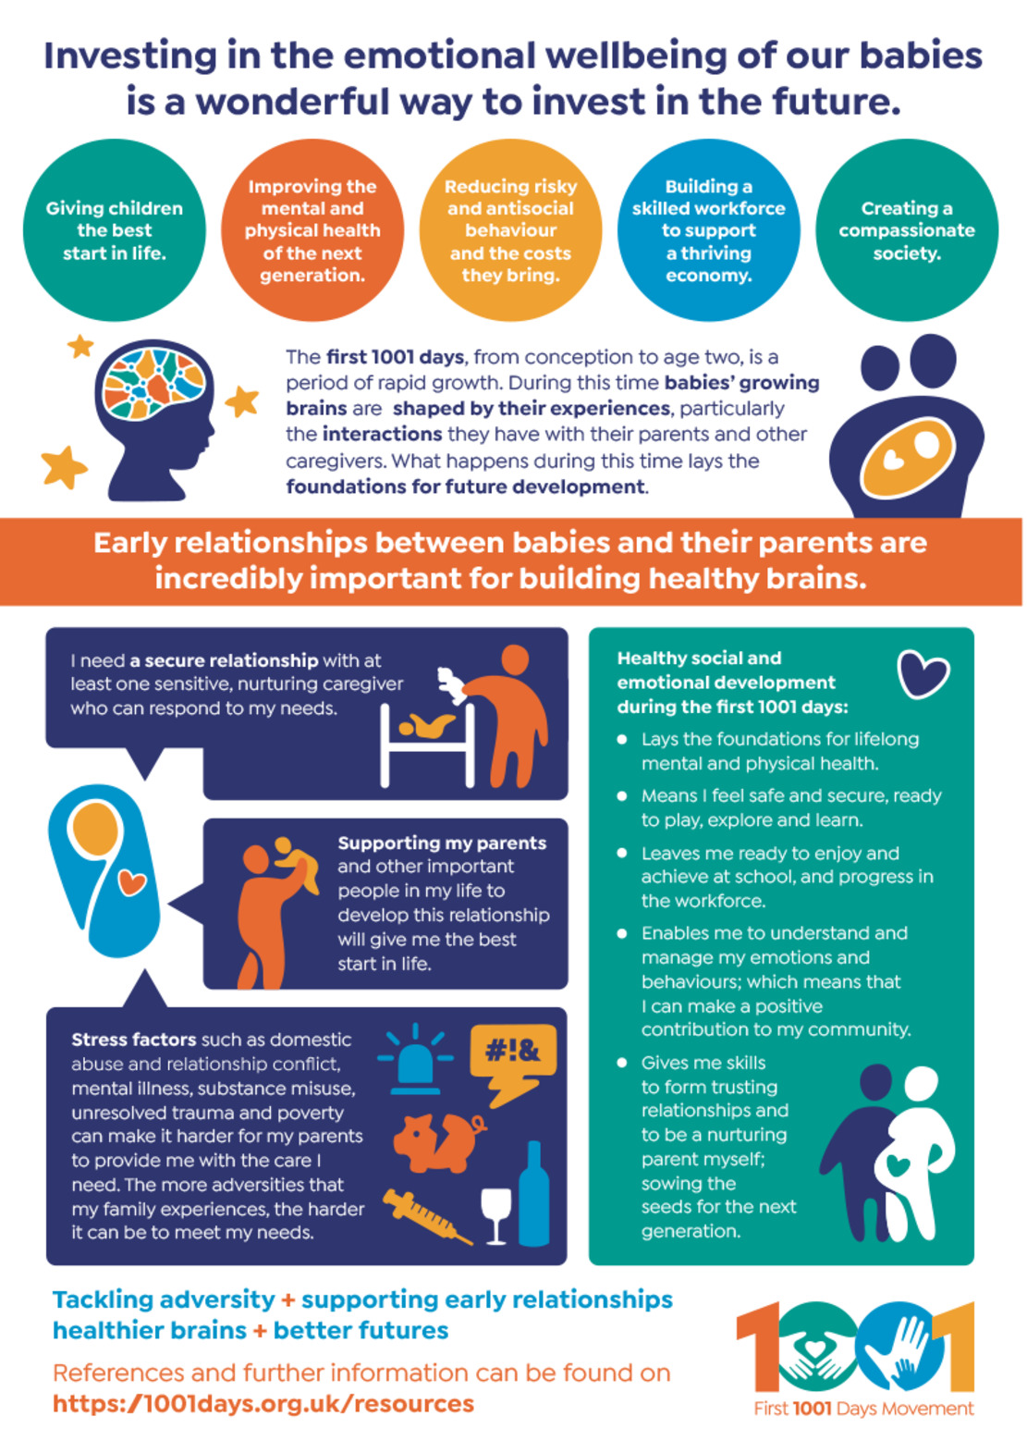
Figure 1 An information sheet from First 1001 Days Movement
View description - Figure 1 An information sheet from First 1001 Days Movement

By the end of this week, you will be able to:
- understand how senses and reflexes form part of brain development
- recognise how adults can support a baby’s brain development.

1 What babies can do
Babies have been described as ‘the most powerful learning machine in the universe’ (Gopnik, Meltzoff and Kuhl, 2001). More than a million new connections a second are made in a baby’s brain in their first year of life and these are influenced by their relationships, the experiences they have, and the environment around them. These early years are a critical time when the foundations of the baby’s brain’s architecture is being built. Architecture is how the brain is constructed, which is an ongoing process that begins before birth and continues into adulthood. In this section you are going to look at how a baby’s brain helps them to interact with the world around them from the moment they are born.
The number and quality of physical, social, emotional encounters and interactions that babies have all contribute to the development of the architecture of the brain. Research confirms that practitioners working with children in the first 1001 days are building foundations for their lifelong learning, health and wellbeing. So it is essential that practitioners working in the baby/toddler room are well equipped to ensure that all the children in their care receive optimum benefit from their experiences. You will find out more about best practice when working in the baby room in Week 6.
Our brains are most flexible or ‘plastic’ in the early years of life and this is when they have the greatest ability to reorganise and adapt. At this time the brain can accommodate an incredible range of experiences and interactions. For example, within its first year, the parts of a baby’s brain that differentiate sounds can recognise the difference between their mother’s language and another language. All aspects of a baby’s development are becoming established in these early days and the cognitive and linguistic capacities, social skills, emotional health and physical wellbeing that develop in their first 1001 critical days form the foundations for future success.

Activity 1 How the brain develops
Allow about 10 minutes

Watch this Open University video to find out more about how the experiences a baby has affect the development of their brain. As you watch, reflect on why you think it is important for babies to have a range of different experiences right from their earliest days, and type your thoughts into the box below.

Video content is not available in this format.
Video 1
View transcript - Video 1

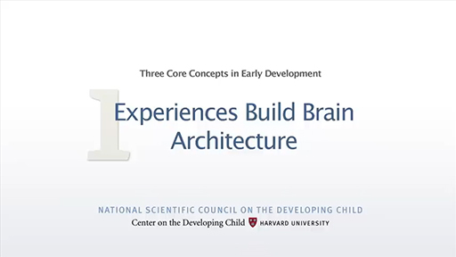

Provide your answer...
View discussion - Activity 1 How the brain develops

Despite all this amazing development that is going on, people often think that babies do not do much other than eat and sleep – but they are interacting, learning and communicating with us right from the start. The Welsh Government Framework for Early Childhood Play, Learning and Care (2023) provides lots of details about what babies and toddlers can do and what they need from the adults who support and care for them. The information in the boxes below is taken from the framework and describes what a child needs and what they enjoy as they develop. When you work with babies and young children you can use this information to help you make sure you’re responding to their needs effectively.

Here I am! (0-12 months)
‘I need to feel safe and secure within our relationship. I look to you to support me when I feel unsure or afraid. Your facial expressions, your gestures, the way you hold me, and your tone of voice will soothe me or share in my joy. My world is slowly expanding to become a little more each day. When we are together, I learn that new people, new things, and new ways of playing can be fun. With your help, I am learning to explore the room, the outdoors and the resources around me. I am becoming more confident with you by my side. I rely on you to nurture me and my growing independence through consistent care routines which put my needs first. As I grow and develop, I do not always need you next to me. I have learned to trust that you will be there when I need you to comfort me or share in my delight. By knowing me well, you have learned to respond to what I show you I need.’

I’m exploring! (1-2 years)
‘I’m growing fast, changing every day. I’m happy with a little more separation at times but I still like you near and this reassures me. There is so much to explore, and I don’t like to be stopped as I become so absorbed in what I am doing. With you near me I use your reactions to check that new experiences and people are safe, and you support me through change. I like it when you communicate with me, about everything we do; I like the tone of your voice, the expressions you make and the tactility between us. I like that you give me time to process and to respond.
I love being outside where I experience so many natural wonders: I feel the sun, the breeze, the wind and snow. Outside is where shadows and puddles shift and change and where there are new sensations to be explored. I am exploring more independently and begining to show resilience through practising and revisiting. By knowing me well, you support change in my routines as I develop. It is a great age to be, one where everything can be exciting as I meet new situations, new people and explore different places. Being together, playing togther and sharing in play experiences can make me happy and is an important part of my world.’

In the next section you are going to look at some of the very first responses that babies make and why it is important to support these.

1.1 Reflexes

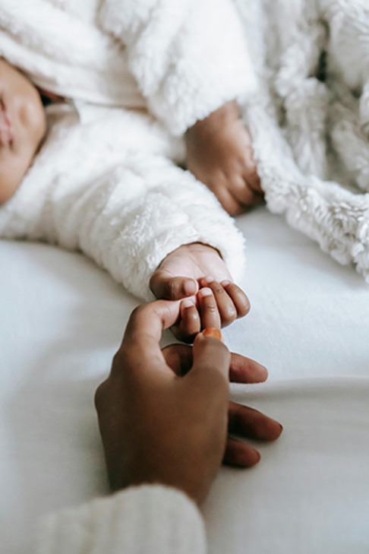
Figure 2 Reflexes help a baby make essential connections with their carers
View description - Figure 2 Reflexes help a baby make essential connections with their carers

Even before a baby is born the construction of the brain is taking place. Have you ever put your finger onto the palm of a new baby? If you have, you will know that their fingers will grasp around yours and hold it tight. This is one of the reflexes that the baby is born with, and it helps them to make those essential early connections with their carers. Babies are born with primitive reflexes that are there to aid the baby’s birth and survival in the first few weeks of life.

Reflex types
Name of primitive reflex | Description
Startle/Moro | When the baby hears a loud noise their arms and legs will extend out and then jerk back in towards their body.
Palmer Grip | Using the fingers to tightly grip an object placed in the palm of the hand.
Plantar | When the sole of the baby’s foot is stroked their toes will flex upwards and outwards.
Sucking | The baby will suck on an object placed into their mouth.
Rooting | When the baby’s cheek is stroked they will turn their face in that direction.
Stepping | When the baby is held up with their feet on a flat surface they will place one foot in front of the other.
Asymmetric Tonic Neck | When the baby’s head is turned to one side the arm and leg on that side will straighten and the arm and leg on the other side will bend.

These primitive reflexes are usually switched off by the developing brain between 6-12 months. These are replaced by postural reflexes which continue to develop up to three and a half years of age, and once developed they should remain for life. These postural reflexes are movements that help the baby develop their basic motor skills by controlling their balance and body position. If practitioners do not understand the importance of the developing reflexes, they may miss key developments taking place.
Providing opportunities for babies to move is a very important part of supporting reflex development, as each time a baby uses their hands and feet or wriggles, kicks or reaches out, it begins a chain of movement and strengthens connections in the brain. With repetition this allows the baby to move and balance, and you will find out more about how to support this when you look at the importance of ‘tummy time’ in Week 3.

1.2 Senses
Babies and toddlers need stimulating experiences to help them develop, so an environment full of interesting sounds, sights, smells, tastes and textures is really important. Having lots of different experiences builds and strengthens connections between brain cells, which ultimately shapes behaviour, memory, emotions, intelligence and other essential mental skills. Babies’ senses play a key role in the interactions they have with their environment. Click on the image below to show more information about that sense.

Figure 3 The senses
View description - Figure 3 The senses

Senses can be nurtured by giving babies plenty of loving attention and comfort. Close physical contact and sensitive, responsive care builds emotional brain connections that lead to happy, healthy relationships. Babies also gain weight faster, develop stronger immune systems, crawl and walk sooner, sleep more soundly and cry less than babies deprived of close physical contact.
Much of what babies learn comes through using their senses – but did you know that, as well as the senses you have looked at here, there are other important senses that are often overlooked? We have a sense of where our body is in space – this is called ‘proprioception’ – and a sense of balance and movement which is our ‘vestibular’ sense. These two senses are important for us to consider when working with babies and toddlers because they play a key role in child development.

1.2.1 Proprioception

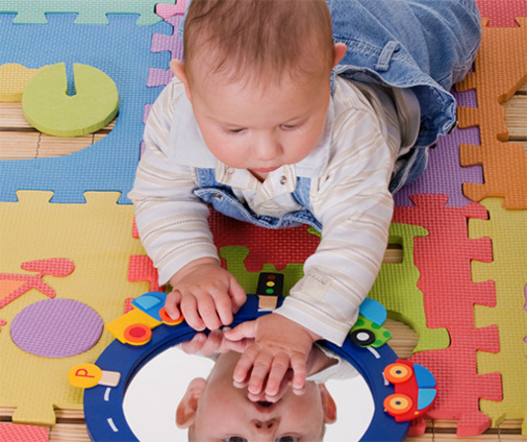
Figure 4 Good proprioception is important for a child’s physical development
View description - Figure 4 Good proprioception is important for a child’s physical development

This sense uses tiny receptors located in muscles, tendons and joints that send messages to tell the brain about where the different parts of the body are and what force or resistance is being felt. Our proprioception helps us make sure we can walk through a door without hitting the frame, it tells us how tightly we need to hold a glass of water and how much we need to tip it to take a sip. If a child’s proprioceptive sense is underdeveloped they can seem clumsy and unaware of other people’s personal space.

1.2.2 Vestibular


Figure 5 Vestibular receptors are essential for play and movement
View description - Figure 5 Vestibular receptors are essential for play and movement

The vestibular receptors are in the inner ear and they act like a gyroscope, telling the brain if the body is upside down or upright. This sense also tells us how fast we are moving and which direction we are going in. This sense is essential for children to be able to engage in play and movement activities.

2 Listening to babies’ voices
Some of the most important experiences that will shape the architecture of a baby’s brain come from their interactions with the significant adults in their lives. Babies naturally reach out for interaction through babbling, facial expressions and movements. The adults caring for them respond in kind with sounds and gestures. This back-and-forth process, known as ‘serve and return’, plays a vital role in developing the brain’s architecture.

Actvity 2 Serve and return
Allow about 10 minutes

The video below gives an example of a ‘serve and return’ situation between a baby and their mother, and also shows what happens if the baby’s interactions are not responded to. As you watch it, use the box below to make a note of all the ways that the baby uses to communicate their feelings. (Open the video in a new tab or window by holding down Ctrl [or Cmd on a Mac] when you click on the link.)
Tronick’s still face experiment

Provide your answer...
View discussion - Actvity 2 Serve and return

Summary of Week 1
- Babies have reflexes and senses that allow them to interact with their environment as soon as they are born.
- The experiences that a baby has help its brain to develop.
- Babies can communicate their feelings and needs to us, and our responses to their communications make a significant impact.

Something to think about this week
What playful activities can you introduce to support the development of a baby’s postural reflexes and motor skills?

You can now go to Week 2.

Week 2: Building the brain

Introduction
If you have ever played peek-a-boo with a baby, you’ll know that they find it endlessly fascinating and are always surprised to see that you are still there when you open your hands. But have you ever wondered why that is the case? Understanding how babies’ and toddlers’ thinking develops is key to being able to support their progress, and learning theories can help us to do this.

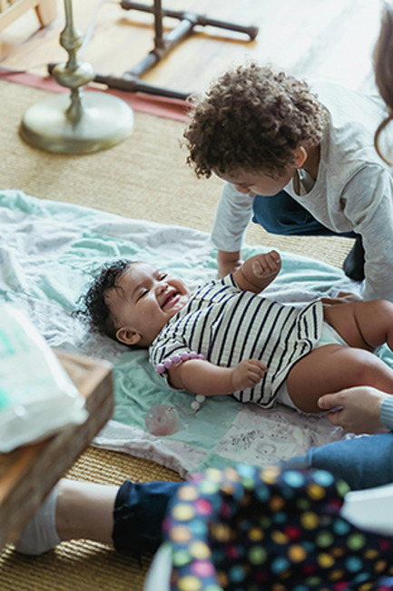
Figure 1 Learning is a complex process
View description - Figure 1 Learning is a complex process

By the end of this week, you will be able to:
- understand some of the key theories related to how babies and children learn
- recognise the importance of movement in a child’s holistic development
- understand why babies and toddlers need to be able to explore and investigate by themselves to help them learn and develop.

1 How babies learn
Learning is a complex and complicated process, but as you explored in the previous week, babies’ brains have an inbuilt ability to develop the connections that allow learning to happen. There is not one way of learning; we can learn by imitating what we see others doing, we can learn by experimenting, we can learn by using our senses to interact with our environment, we can learn by having a conversation with someone, and there are many other ways too. To help us understand some of the ways that babies and toddlers learn, it is helpful to look at learning development theories and see what they tell us.

1.1 Piaget
Jean Piaget was a Swiss psychologist who was interested in how children’s thinking and understanding develop. He undertook observations and set up a range of tasks for children to undertake, and his findings showed that children’s thinking and understanding develop in a series of stages that could be loosely related to their age. The period from birth until around the age of 2 is known as the ‘sensorimotor’ stage, and one of the key features of this period is the development of object permanence. The video below explains what this means.

Activity 1 Development of object permanence
Allow about 5 minutes

Watch this Open University video which explains development of object permanence.

Video content is not available in this format.
Video 1
View transcript - Video 1



View discussion - Activity 1 Development of object permanence

Piaget’s work focused on how the individual child develops their understanding, and he highlighted the importance of providing babies and children with a range of experiences in lots of different environments in order to support development. Practitioners can use Piaget’s work to inform what they do in the baby/toddler room by making sure they let the babies play and explore lots of different objects and toys. This will help them to develop their sense of object permanence and give them lots of opportunities to begin to create their understanding.
Piaget’s work also highlighted the importance of the environment in a child’s development, recognising that they learn by interacting with what’s around them. We can see this aspect of his work in the ‘effective environments’ focus in the Welsh Government’s A Curriculum for Funded Non-maintained Nursery Settings (2022, p. 13), which highlights the role played by the physical and emotional environments we create in motivating children to explore, think creatively and solve problems.

1.2 Vygotsky
Lev Vygotsky was a Russian psychologist who was interested in how a child’s relationships support the development of their thinking and understanding. He identified that a child reaches their next stage of understanding when they are supported by a more knowledgeable adult or child. Vygotsky showed that as a child’s thinking develops, there are windows of opportunity when the ideas or skills they are learning are just beyond their current understanding, and effective interactions at those critical points help them to move their learning forward. He called this the ‘Zone of Proximal Development’.
An example of this might be a child learning to ride a bike. They can balance and push themselves along but often they need an adult to explain what they need to do, hold and push them along, and give reassurance and help. With the adult’s help the child is able to move from not being able to balance and pedal at the same time to being able to ride by themselves. Whilst they might be able to make this progress alone, the contribution of the adult makes the process more effective.

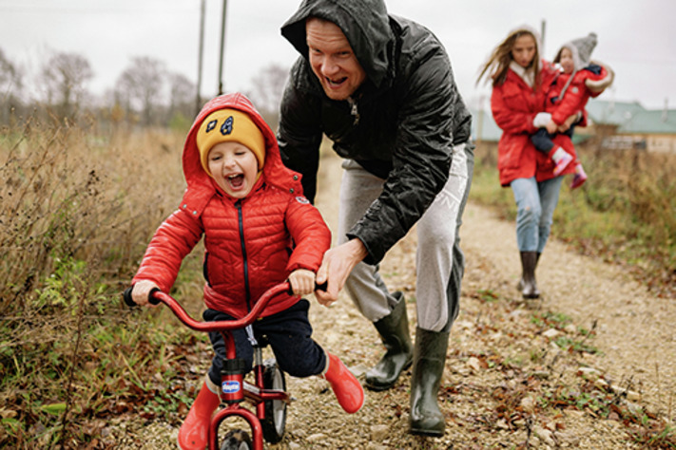
Figure 2 A dad supporting his son in learning to ride a bike
View description - Figure 2 A dad supporting his son in learning to ride a bike

Vygotsky’s work built on Piaget’s, recognising the importance of the child’s environment in developing their thinking and understanding, but also highlighting the important role that adults and others play in this development too.
Looking at these learning development theories shows us that babies learn in lots of different ways and need to be provided with lots of different opportunities and experiences to help support this.

2 The brain–body connection
Babies and young children are not designed to sit still – they need to move around to explore how their body works and to find out about the environment around them. Every time a baby moves they are having experiences that help their brains develop and this helps them to learn, but research shows that the amount of time babies and toddlers are spending being physically active is decreasing.

The World Health Organisation (2022) recommends that in a 24-hour day:
Infants (less than 1 year) should;
- Be physically active several times a day in a variety of ways, particularly through interactive floor-based play; more is better. For those not yet mobile, this includes at least 30 minutes in prone position (tummy time) spread throughout the day while awake.
- Not be restrained for more than 1 hour at a time (e.g., prams/strollers, high chairs, or strapped on a caregiver’s back). Screen time is not recommended. When sedentary, engaging in reading and storytelling with a caregiver is encouraged.
- Have 14-17h (0-3 months of age) or 12-16h (4-11 months of age) of good quality sleep, including naps.
Children 1-2 years of age should;
- Spend at least 180 minutes in a variety of types of physical activities at any intensity, including moderate- to vigorous-intensity physical activity, spread throughout the day; more is better.
- Not be restrained for more than 1 hour at a time (e.g., prams/strollers, high chairs, or strapped on a caregiver’s back) or sit for extended periods of time. For 1 year olds, sedentary screen time (such as watching TV or videos, playing computer games) is not recommended. For those aged 2 years, sedentary screen time should be no more than 1 hour; less is better. When sedentary, engaging in reading and storytelling with a caregiver is encouraged.
- Have 11-14h of good quality sleep, including naps, with regular sleep and wake-up times.

What percentage of children aged between 2 and 4 do you think are meeting these recommended physical activity levels? (Kipping et al., 2019)

10%
20%
50%
100%
View answer - Activity

Before babies start crawling and walking it can seem that they are not really moving very much, but we need to be aware that they have to master lots of small movements to develop the control needed to start moving around.

Activity 2 Exploring movement
Allow about 5 minutes

As you watch the video below, note down the different movements and skills that the baby is using.

Video content is not available in this format.
Video 2



Provide your answer...
View answer - Activity 2 Exploring movement
View discussion - Activity 2 Exploring movement

2.1 Supporting children to get moving
Early Years Wales has developed a number of programmes designed to support movement in babies and toddlers. The activity card below is part of a wider series aimed at sharing key information with both practitioners and parents, promoting the importance of early movement in child development.
The resources are intended to encourage confident, informed support for young children’s physical growth through everyday activities and play. For more information and to access the full range of materials, visit the Early Years Wales website.

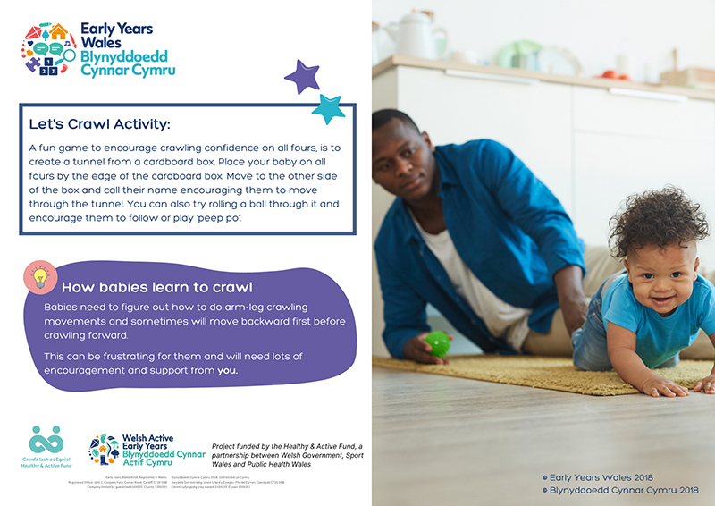
Figure 3 Early Years Wales activity card
View description - Figure 3 Early Years Wales activity card

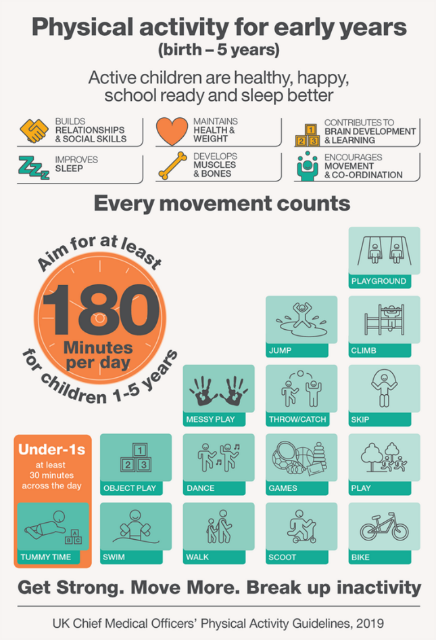
Figure 4 Physical activities children should be involved in
View description - Figure 4 Physical activities children should be involved in

The baby room plays a very important role in introducing and supporting the development of lots of different movement opportunities. This can ultimately lead to competence in physical skills as well as the confidence and motivation to engage in physical activity long term. The development of movement skills gives children the confidence to participate in life skills, much in the same way a child learns to speak by being surrounded with language from birth, the same is true of learning to move with confidence. This is called physical literacy, and the Welsh Government’s A Curriculum for Funded Non-maintained Nursery Settings (2022) highlights this as an important part of early years practice. It doesn’t require special equipment, just knowledge of the importance of movement; a natural desire to provide the right building blocks from the start is key in ensuring children become confident, competent movers.
Babies develop control over their movements in a clear order:
- The muscles of the neck and core muscles of the trunk develop first, enabling the baby to hold up its own head and begin to roll over.
- Next, the back, shoulders and upper arms develop as the baby pushes itself up on its elbows and begins to be able to sit propped and eventually unaided.
- Once the upper arms and upper legs have developed (through pulling, pushing and kicking movements), the baby can creep, shuffle and crawl.
- The refinement of muscles of the shoulder to wrist, and the legs from knee to ankle enable the toddler to stand and begin to move around by holding on to people, objects and furniture.
- When the muscles controlling the ankles and feet are ready, toddlers can stand unaided and eventually walk. Walking, running, standing, hopping, skipping, riding, kicking, swinging, pulling are all possible now, and toddlers and young children can perfect these skills through lots of practise.
- Fine motor skills development is complete once the child has control of their hands and fingers, and these skills are among the last to be refined. Until a child can confidently hold, release, catch, throw, play finger games, fix things and take them apart, they are not ready to write.
The muscle groups of young children can only mature successfully if each stage is built on the completion of earlier stages of development. This is gained through plenty of practise in play and activity. A missed or incomplete earlier stage will affect a later stage – a child who has not had time to develop shoulder, arm and wrist muscles will not be able to control fine movements of their fingers as easily as a child who has had plenty of unfettered time to play indoors and outside, with toys and equipment appropriate to both their age and their stage of development.

2.2 Physical development
Physical development is closely related to growth, but it also includes all body senses and systems, reflexes and the gaining of a wide range of physical skills. Physical development is about overall and progressive changes in the body, meaning that as children become more confident and competent movers they can enjoy wider and ever more challenging opportunities to be physically active.
Physical development is also described as ‘structural’, ‘functional’ and ‘organisational’ – which means that as their skills develop, they can use them in a variety of situations and environments, while becoming increasingly aware of how to successfully manage risk and adventure. Physical development is ‘qualitative’ in nature, meaning that as children get stronger and more able, you will see the transition with an action like walking, as it goes from an emerging skill to a mature and fluent version with time and practise.
Providing activities that encourage children from birth to move their limbs, head and neck, particularly through floor-based activities, shouldn’t stop because they are mobile. As per the guidelines previously discussed, children capable of walking should be physically active daily for at least 3 hours, and a large part of this should involve unstructured active play. Infants should be discouraged from being sedentary; no sedentary behaviour should last for more than 1 hour. This includes time in a pushchair or in a bouncer or car seat!
As well as supporting babies’ brain development, movement and physical activity is also connected to other aspects of their health, as children need to move in order to be safe and strong.

 | Bone: Whole-body movements like rolling, crawling, walking, running, jumping and climbing encourage bone growth. Being active outside supports the manufacture of vitamin D which promotes healthy bone growth, and this is needed to help calcium gained through food and drink pass from the bloodstream into the bone structure.
 | Blood: Being active improves blood flow in the lymphatic system so the immune system can respond quickly to viruses and infections.
 | Muscle: Moving every day benefits muscle tissue and the growth of healthy tendons and ligaments through increased blood flow. Being physically active ensures the muscles properly support the joints and reduces the possibility of accidents and fractures.

It is important to provide babies with lots of opportunities to practise their movement skills from a very early age to help with all aspects of their development. Creating an environment that lets them practise reaching and grasping for objects, interacting with them so they turn their head towards you or a toy. Pulling, pushing and playing with other people and toys are all essential in giving them the best start.

3 Risk and challenge
One of the challenges faced when providing play and movement opportunities for babies and toddlers is how to manage risks. If babies didn’t take risk, they would never learn to navigate the world through rolling, crawling, standing, taking their first steps and running, so we need to introduce risk and allow them to learn from mistakes so they can develop these skills. Accidents are part of the learning that children need to undertake, and it is our job to be alert to potential hazards and balance these against the learning opportunities to minimise the risks.

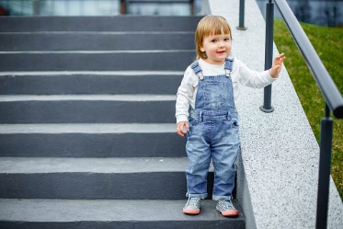
Figure 5 Navigating the world
View description - Figure 5 Navigating the world

Activity 3 Risky play
Allow about 10 minutes

This video shows an example of risky play. As you watch it, notice how you feel as the boys crawl down the staircase. Are there times when you might say something or intervene? Please note: the video has no audio and plays at slow speed.

Video content is not available in this format.
Video 3

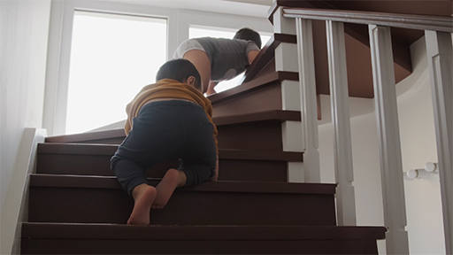

Now watch this Open University video to see how risky play is managed in a nursery and a forest school setting.

Video content is not available in this format.
Video 4
View transcript - Video 4

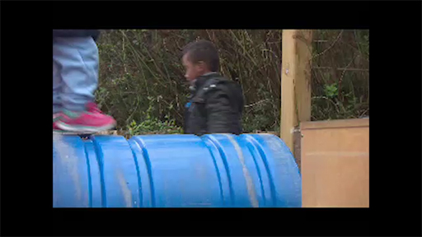

View discussion - Part

The examples above show the important role practitioners play in enabling children to take risks and to learn from those experiences. How can risky play be supported?:
- Observation is key to this, and the willingness to encourage babies and toddlers to participate in risky play. Practitioners need to lead the way in order to provide children with the encouragement and resilience to persist and create their own challenge.
- Providing plenty of opportunities for children to experiment and explore risk throughout the day, both inside and outdoors. Plan the environment and set up with irresistible invitations to play and take risk, then stand back and observe.
- Respond sensitively to requests for help, don’t jump in too soon, practitioners may need to encourage that persistence and ‘I can do’ attitude, especially for children who have little experience of risk.
- Using positive vocabulary and scaffold actions with the language. Stringing actions to form sequences is similar to linking words to form sentences, and when children demonstrate meanings of words physically, their understanding of the words is more immediate and longer lasting. For example, action words such as crawl and slither.
- Practitioners should try not to be too overprotective with the children in their care, as this creates tension between ensuring safety and allowing for risk. It can lead to an underuse of materials, which leads to boredom.
- Practitioners can be champions for supporting balanced risk opportunities, by helping parents and other adults to understand why it is important. Babies and toddlers soon become aware of the capabilities and limitations of their own bodies.
- Let children find out things for themselves through trial and error. It is also important to recognise that every child follows a unique inner timetable and skills are acquired when they are ready.
Risky play is a great example of how the ‘enabling adults’, ‘engaging experiences’ and ‘effective environments’ that underpin the Welsh Government’s A Curriculum for Funded Non-maintained Nursery Settings (2022) and their Framework for Early Childhood Play, Learning and Care (2023) overlap to help support babies and toddlers to develop and progress.

Summary of Week 2
- Babies and toddlers need stimulating environments and supportive adults to help them develop.
- Learning theories can help us understand how babies and toddlers develop their thinking and understanding.
- Movement and physical activity is essential for all aspects of a baby’s development.
- Babies and toddlers need opportunities to learn from making mistakes and having accidents.
- Practitioners need to support babies and toddlers to engage in risky play by providing managed situations where they can explore.

Something to think about this week
How do you facilitate age-appropriate opportunities for risk and movement in your space?

You can now go to Week 3.

Week 3: Playing

Introduction
Play is a fundamental aspect of childhood and a cornerstone of early development. For young children, play is not merely a pastime but a vital way of learning about themselves, others, and the world around them. It encompasses a wide range of activities – both structured and unstructured – that allow children to explore, create, imagine, and interact.
One of the defining characteristics of play is that it is self-directed and intrinsically motivated. Unlike adult-led tasks, play is driven by a child’s interests and choices. This autonomy allows children to test ideas, take risks, and express themselves freely, all of which contribute to a strong sense of self and agency. Through activities such as role play, storytelling, and game-playing, children also develop their communication skills, empathy, and understanding of social rules and relationships.
The environments in which children play, and the attitudes of adults towards play, significantly impact its quality and effectiveness. Supportive, play-rich settings that provide a variety of resources and opportunities for exploration encourage deeper engagement. Furthermore, when adults observe, listen, and occasionally participate in children’s play without dominating it, they help to extend learning while respecting the child’s autonomy.

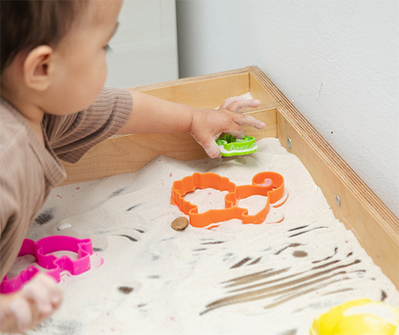
Figure 1 Individual patterns of behaviour
View description - Figure 1 Individual patterns of behaviour

By the end of this week, you will be able to:
- understand what schemas are
- recognise why floor play is important in supporting babies’ development
- recognise the opportunities that loose parts play and Treasure Baskets provide to support learning.

1 Learning to play: schema
Chris Athey was a lecturer in education in the UK who noticed that children sometimes engage in repetitive actions, such as filling and emptying containers, lining objects up in rows or hiding items away. These repeated actions are known as ‘schemas’ and Athey defined them as ‘a pattern of repeatable behaviour into which experiences are assimilated and that are gradually co-ordinated’ (Athey, 1990, p. 37). Her work built upon the work of Piaget, who you read about in Week 2. He identified schemas as a means that a child uses to make sense of their world and construct their knowledge. A range of observable schemas have been identified from this basis.

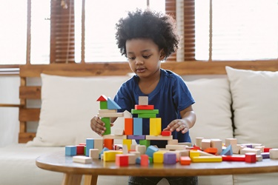
Figure 2 An example of transporting schema
View description - Figure 2 An example of transporting schema

The picture above shows an example of a transporting schema – the child is piling the blocks up and moving them around. The table below provides information that helps us identify the characteristics of a transporting schema.
(If you’d like to find examples of each schema the further resources section at the end of this week provides a link.)

(Welsh Government, 2021, p. 39–40)
Children can demonstrate their schemas in many different ways, including how they move their bodies, how they use resources and how they interact with apparatus. Thomas (2021) suggests that having an informed knowledge of schemas can provide practitioners with a ‘window into a child’s world’ (p. 110) that can be used to provide children with resources and activities that support their schema(s), helping to maximise their learning opportunities.

Activity 1 Identifying schemas
Allow about 1 minute

Based on the schema descriptions in the table above, what schema do you think is being demonstrated in this picture?

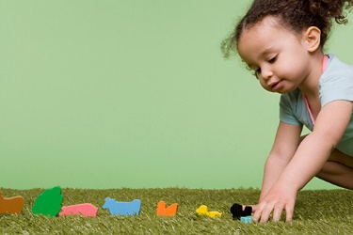
Figure 3 Little girl arranging animal-shaped wooden toys
View description - Figure 3 Little girl arranging animal-shaped wooden toys

Provide your answer...
View discussion - Activity 1 Identifying schemas

If you work in an early years setting in Wales you will probably have seen the A Curriculum for Funded Non-maintained Nursery Settings (Welsh Government, 2022) which contains information about how to use children’s schemas as a basis for planning for learning, and outlines the role of the adult in supporting learning and development.

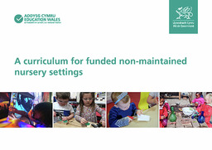
Figure 4 The front cover of A Curriculum for Funded Non-maintained Nursery Settings guidance (Welsh Government, 2022)
View description - Figure 4 The front cover of A Curriculum for Funded Non-maintained Nursery Settings ...

This approach requires practitioners to take a more open approach to planning which is less focused on targets or skill outcomes. This approach still requires an element of recording what happens during play interactions in order to inform decisions about children’s future learning experiences – everything is not completely spontaneous and improvised. You will find out more about this in Week 6.

2 The importance of floor play
Many babies spend a lot of time in ‘containers’ – like car seats, buggies and bouncing chairs – that can limit their opportunities to move freely. Spending time on the floor gives them the opportunity to explore their full range of movement, in a place where they can practise, investigate, and challenge themselves. When they are lying on their back, babies can lift up their legs and grab their feet, a movement which helps to strengthen their core and also promotes the proprioceptive sense that you looked at in Week 1.
When babies are on their tummies in a prone position they are strengthening their neck, back and arm muscles, and this position gives opportunity for visual development as they focus on the world around them. Being on the floor helps to strengthen and tone muscle development; it promotes balance and it enables babies to start to move by themselves. The figure below shows two resource cards produced by Early Years Wales (in English and Welsh) that give parents information about the importance of tummy time and ideas about how to provide it.
Early Years Wales has developed a number of programmes designed to support movement in babies and toddlers. The activity cards below are a part of a wider series. The resources are intended to encourage confident, informed support for young children’s physical growth through everyday activities and play. For more information and to access the full range of materials, visit the Early Years Wales website

Figure 5 Early Years Wales activity cards
View description - Figure 5 Early Years Wales activity cards

Activity 2 Tummy time
Allow about 5 minutes

To help you recognise the opportunities that floor play and tummy time offer, find a space and a moment to lie on the floor and see how it feels to be on the ground, on your tummy, back, side rolling and crawling. Think about what your view is, what you can smell, what you can feel, what movements you can make in the different positions and what muscles you use.

View discussion - Activity 2 Tummy time

3 Treasure Baskets
When babies learn to sit they view the world from a new perspective and they can see things that were previously invisible to them. This is exciting but it can also be frustrating as they notice objects and activities that are out of reach. This is the stage when a Treasure Basket can be helpful, providing scope for exploration in spite of the child’s lack of mobility.
The Treasure Basket concept was inspired by Elinor Goldschmied in the 1980s and 1990s. It is a simple yet profound idea, opposing the trend to give commercial plastic toys to babies by providing them instead with a richer sensory experience. As you have found out in previous weeks, babies learn by actively doing things and engaging in activities with all their senses and limbs. As well as providing space for them to develop their motor abilities, we need to nurture their curiosity. The Treasure Basket was conceived with this in mind, providing objects of various sensory qualities for babies to investigate. In the process of enjoying the activity, babies learn about their world.
The Treasure Basket is made of sturdy wicker, strong enough for a sitting baby to lean an elbow on without flipping the basket. It is approximately fourteen inches across and four or five inches deep. It has straight sides, and is filled with objects of varying tactile qualities for babies to enjoy.
Plastic should be avoided because it offers very little sensory stimulation – even if plastic items vary in size and colour, they still smell, taste, and feel like plastic. In comparison, natural objects provide a wide variety of sensory stimuli, so they offer lots more opportunities. Many everyday household articles also afford a variety of sensory experience and can be popped into the Treasure Basket as well. As a baby shakes or bangs a whisk or a bunch of keys, they notice the sounds it has produced as well as the sensations in their arm and hand. When they pick up a wooden block or a piece of knitted fabric to explore with their fingers, gums and tongue they are exploring texture, colour, scent and flavour. Such actions strengthen cognitive development and motor control.

Activity 3 Exploring the possibilities of a Treasure Basket
Allow about 10 minutes

Take a look at the picture of a Treasure Basket below. Choose three of the items and write down a few ways that a baby might interact with it. Here’s an example for you to follow:

Feather | Hold it up in the air and drop it to see it fall  Stroke it against their cheek or nose to see how it feels  Tap the quill on the floor to hear the sound that makes

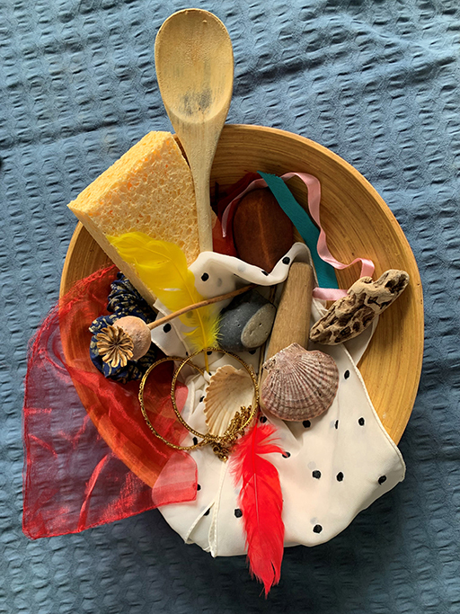
Figure 6 Treasure Basket
View description - Figure 6 Treasure Basket

Object | Possible interactions
Provide your answer... | Provide your answer...
Provide your answer... | Provide your answer...
Provide your answer... | Provide your answer...

View discussion - Activity 3 Exploring the possibilities of a Treasure Basket

While babies are enjoying the Treasure Basket, the practitioner’s role is often about sitting nearby, quietly observing and enjoying the action but not interfering unless necessary. Babies need opportunities to make their own discoveries, and an adult’s talk or interventions can pose a distraction to their concentration. Your quiet presence will give the children security, and they can always look up to make eye contact or exchange a smile if they wish. They will let you know with body language and other signals when they have had enough, at which point you can put the Treasure Basket away for another day.

4 Loose parts
Have you ever given a group of children a box to play with? If you have, you’ll know that they will think up lots and lots of different ways of using it – it could be a car, a rocket, a cave, a tunnel or hundreds of other things. This shows that when children play with an object they do not see it as something with one defined purpose, they see it in terms of what it has the ‘potential to do or be’ (Casey and Robertson, 2019, p. 7).
Objects and materials that provide these open-ended possibilities are often called ‘loose parts’ (Nicholson, 1971). Providing children with environments that allow them to explore, experiment and create with loose parts helps them to use their schemas to support the construction of their knowledge and understanding.

Activity 4 Playing with loose parts
Allow about 10 minutes

Watch this video below of a nursery setting.

Video content is not available in this format.
Video 1
View transcript - Video 1



View discussion - Activity 4 Playing with loose parts

Summary of Week 3
- Children use patterns of behaviour called schemas when they are playing to help them develop their thinking and understanding.
- Babies need to spend time playing on the floor to allow them to explore movement and build their strength.
- Treasure Baskets and loose parts play give babies and toddlers opportunities to use their senses to explore the world and develop their learning.

Something to think about this week
How do you ensure that the children you work with are provided with opportunities to engage in schematic play?

You can now go to Week 4.

Week 4: Making connections

Introduction
Babies and toddlers need to feel safe and secure in order to be ready to play, explore and learn. We know that it is not always easy to manage a child’s emotions, and providing a secure environment for learning is a major factor in any baby or toddler room. Developing sensitive, responsive and trusted relationships with key practitioners in the baby or toddler room is fundamental to infant mental health.
Practitioners help babies and toddlers learn how to experience, manage and express their emotions and to feel safe to explore the world. Good infant mental health enables young children to feel safe and secure, ready to play, explore and learn. You can support all this by laying the groundwork for children’s ongoing social and emotional development, including resilience and adaptability – these competencies will help them to thrive and achieve lifelong physical and mental health and wellbeing.

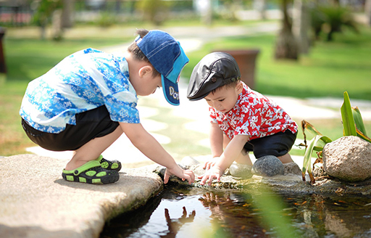
Figure 1 Playing and exploring
View description - Figure 1 Playing and exploring

By the end of this week, you will be able to:
- understand the role that attachment plays in a child’s development
- recognise how a child’s relationships affect their self-regulation, identity and sense of belonging.

1 Why relationships matter: attachment
Babies’ earliest relationships have a lifelong influence. You might have heard people say things like ‘She is very attached to her dad’ or ‘His mum had a few difficulties bonding with him when he was born’. These ideas of attachment and bonding have become a part of everyday discussions about babies and children. Attachment is the connection created between a baby and their primary caregiver, which is usually their mother.
Understanding of the importance of attachment emerged from work done by John Bowlby in the mid-twentieth century which indicated that the emotional bond between the baby and their mother was the foundation for their future social and emotional development and wellbeing (Bowlby, 1952).
The fact that Bowlby’s work only looked at the mother/baby relationship has been criticised in more recent times as families have become more diverse, and this has highlighted that other caregivers, such as fathers, foster carers, adoptive parents and same-sex parents have an equally critical role to play in attachment (Glazzard, Potter & Stones, 2019).

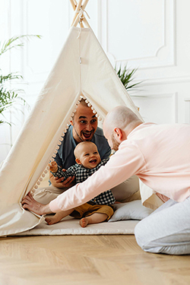
Figure 2 Families have become more diverse
View description - Figure 2 Families have become more diverse

In 1978, Mary Ainsworth and her colleagues built upon Bowlby’s work by identifying different types of attachment. They devised an experiment called the ‘strange situation’ where they observed the reactions of a child as a series of events take place (illustrated below).
Ainsworth’s ‘strange situation’ experiment

Figure 3 ‘Strange situation’ experiment
View description - Figure 3 ‘Strange situation’ experiment

From the observations of the child’s reactions and behaviour at the different points in the experiment, Ainsworth and her team identified different types of attachment. Click on the types of attachment to find out more about each one.

If children do not have a secure attachment, their ideas and understanding of how relationships work is confused, and this can reduce the chances of them developing positive and supportive connections with other people. Poor attachments can also affect how children see and value themselves. Babies and young children who feel secure are more likely to explore and investigate, as they are confident that their ‘special’ person(s) or attachment figure(s) will protect them and help them to negotiate new situations and experiences. Feeling secure helps children to trust others, and builds their confidence and empathy.

2 A sense of self
Babies are social beings from birth. You saw in Week 1 how they can initiate interactions and respond to others’ reactions, and how this recognition of the impact of their actions helps them to develop their idea of themselves as individuals. By the time they are toddlers they are able to recognise themselves in pictures, they can talk about ‘me’ and see family members and objects as theirs (‘my mum’, ‘my teddy’).
This sense of self is developed through the experiences and interactions the babies and toddlers have. They need to have opportunities to use their bodies to explore their environment and the objects within it, and share these experiences with others to form relationships. When a baby gets a response or reaction from an adult that shows they understand how they are feeling, this helps them feel valued. This feeling of being valued and understood encourages the baby to continue exploring ways of expressing themselves and creating connections which gives them the skills to form relationships.

Activity 1 Positive early relationships
Allow about 5 minutes

The earliest connections that a baby makes are with its parents. The video below explains the impact that building those positive early relationships has on the development of the baby’s sense of self and the impact this has on their future.

Video content is not available in this format.
Video 1
View transcript - Video 1

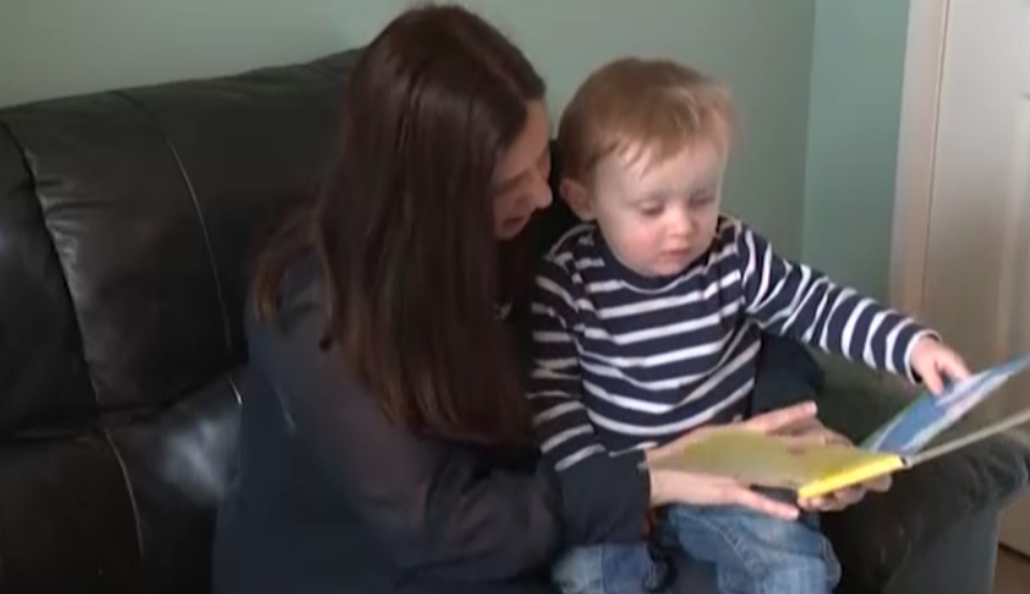

View discussion - Activity 1 Positive early relationships

Having a secure attachment helps children to feel confident and to deal with the full range of emotions they will experience, including those that can seem overwhelming.

3 Self-regulation
As babies and toddlers experience new and different situations they will have emotional responses, they might be surprised, shocked, pleased, frustrated and so on. In order to manage these feelings and responses they need to be able to self-regulate – this means they are able to control their impulses and either stop doing something or do something they are being asked to do. Developing self-regulation is an important part of a child’s wellbeing, and it also helps them to develop social and emotional skills that will be important as they progress through their learning (Bingham and Whitebread, 2012).
Babies are dependent on the adults around them to reassure them in order to develop self-regulation. When an adult is in tune with a baby’s needs, they are able to calmly soothe and distract them to show them that they are safe. These responses help them to learn to calm and distract themselves the next time they are in that situation. When toddlers experience strong emotions and feelings, they need help from adults to find their way back to calmness. This process of working alongside the baby or toddler to support them as they deal with situations is called ‘co-regulation’.
By the time toddlers reach their first birthday, they are usually starting to become more independent and want to do the things that they want to. This kind of behaviour tends to continue – you might have heard people talk about their child going through the ‘terrible twos’. This can be a tricky time, as the child often gets frustrated or angry and adults (parents and professionals) can find it challenging to deal with the situation, but it is a normal stage in the development of self-regulation.

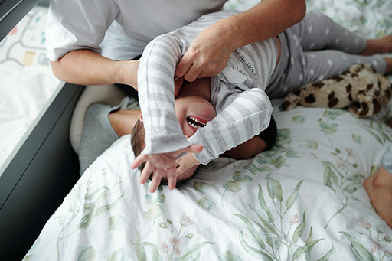
Figure 4 The ‘terrible twos’ can be a challenging time
View description - Figure 4 The ‘terrible twos’ can be a challenging time

To help a toddler develop their self-regulation when they are going through this period, it can be helpful to have a strategy to follow that provides a step-by-step approach to dealing with the situation. Here is an example of a strategy devised by Canale (2020) that can be used. Which step do you think you would find the most challenging and why?

The Seven C’s of Responding to Behaviour (Canale, 2020)
Step 1 | Consider: How can I be with my child during this tricky moment?
Step 2 | Calm yourself: Check whether you are feeling calm and in control of your own emotions. It’s important to calm yourself first so that you are able to respond to the child instead of reacting to them.
Step 3 | Calm the child: If the child is overwhelmed by big emotions they will need your help to calm down. Every child is unique and you need to use your knowledge of the child to identify what will help them. Some children like to be hugged and others may need a bit of space with you sitting nearby and using your voice to help them return to a state of calm.
Step 4 | Curiosity: Be curious about some of the underlying emotions or unmet needs that would explain why the child is behaving in this way. A useful acronym to remember is HALT. This stands for Hungry, Angry, Lonely, Tired. Are any of these needs unmet? Could this be the cause of their behaviour?
Step 5 | Connection: Join the dots for the child. Connect the underlying emotion or need to the behaviour you are seeing, e.g., ‘I think you are tired and that’s why you are throwing your toys…’ Connecting the child’s emotion to their behaviour helps them to feel understood and soothed, and will also help to develop their self-regulation skills as they grow.
Step 6 | Correction: This is where you provide a limit or boundary around the behaviour, e.g., ‘I think you are tired and that’s why you are throwing your toys, we need to put the toys away and have a rest’. If an age-appropriate consequence is needed, then natural consequences work best, e.g., ‘you hurt someone with the toy, the toy is going away’ or ‘you wouldn’t put your wellies on so there is not enough time to go outside’.
Step 7 | Connect (again): Once you’ve set down the limit and stuck to it, reconnect with the child, maybe with a hug or reading a story together. Don’t revisit the behaviour at a later time in the day – this re-connect time acts as the end of the episode.

4 Identity and belonging
Right from birth, babies and young children meet lots of different people that they will form relationships with, and to do this they need to develop a sense of belonging. They need to be able to make connections with other people in a range of situations, and this means they have to develop an understanding of who they are and how they interact with others.

Activity 2 Who am I?
Allow about 10 minutes

Take a moment to think about how you would answer the question: ‘Who am I?’
What was the first thing that came into your mind? What other answers came up? You may have thought about your nationality, your family role, your interests, your religion, your job, your background, your home and lots of other things. The diagram below shows some of the answers that one of the course authors came up with.

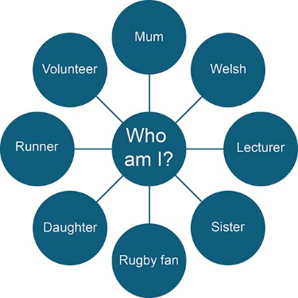
Figure 5 ‘Who am I?’ diagram
View description - Figure 5 ‘Who am I?’ diagram

Type your response to the question ‘Who am I?’ in the box below.

Provide your answer...
View discussion - Activity 2 Who am I?

In the same way that our identities change and develop, babies and young children are also exploring their identity and finding out how this relates to the people around them.

Activity 3 Developing relationships
Allow about 10 minutes

Watch the Open University video below that follows Harvey and Lizzie in the baby room of a nursery. As you watch, use the box to note down any behaviours that you think show how Harvey and Lizzie are beginning to develop their identities and their relationships with others.

Video content is not available in this format.
Video 2
View transcript - Video 2

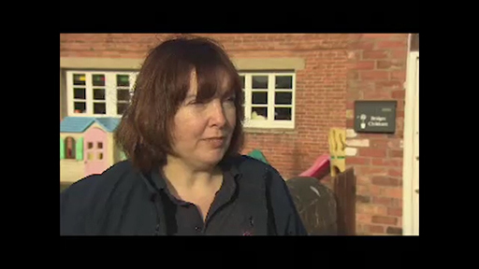

Provide your answer...
View discussion - Activity 3 Developing relationships

Nurturing a sense of belonging through sensitive care in the very earliest stages of a child’s life is essential for a child’s wellbeing. Experiencing positive, loving and warm relationships helps babies and toddlers learn to understand and express their feelings, as well as to develop a firm sense of belonging. If a child experiences traumatic events, these can have a negative impact on their ability to develop a sense of belonging. These experiences are sometime called Adverse Childhood Experiences, or ACEs.
Whilst ACEs have been shown to have long-term negative effects on children’s physical and mental health and wellbeing, early intervention by early childhood professionals can significantly reduce the impact of the experiences and improve the child’s outcomes (Grimmer, 2022). ACEs are recognised in the Welsh Government’s Framework for Early Childhood Play, Learning and Care (2023) and in A Curriculum for Funded Non-maintained Nursery Settings (2022) as an issue that practitioners need to be aware of, and these documents provide useful additional information and links to further support.

Summary of Week 4
- Having a secure attachment to their primary caregiver provides the foundations for a baby’s social and emotional development.
- Tantrums are a normal part of a child’s self-regulation development.
- Relationships are key to a child’s identity and sense of belonging.

Something to think about this week
How can a collaborative relationship with parents help the children in a baby room?

You can now go to Week 5.

Week 5: Building relationships

Introduction
Trusting, positive relationships with the adults that are around them is a vital aspect of a child’s development, and for baby room practitioners this is one of the most important parts of the role. As well as the relationships that the child has with their parents or carers and their key person in the nursery setting, the relationship between the key person and the parents or carers is also significant. All these relationships need to be working effectively in order for the child to grow and develop.
By the end of this week, you will be able to:
- recognise the significance of all the relationships that a child has
- understand some of the barriers that can affect the relationship between parents and settings
- understand the professional role of the practitioner.

1 Building positive relationships
You have looked at the importance of providing positive, nurturing experiences for babies and young children, but in order for this to happen it is vital that parents feel confident and supported.

Activity 1 Supporting parents
Allow about 15 minutes

Watch this Open University video, which looks at the ‘Incredible Babies’ programme in Wales. As you watch it, note down anything that you notice the parents or practitioners say about what they and their babies get from relationships they have formed within the group.

Video content is not available in this format.
Video 1
View transcript - Video 1

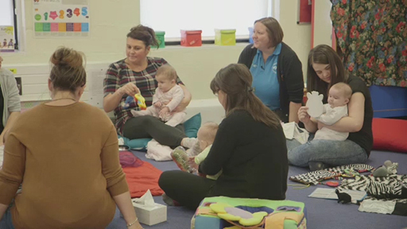

Provide your answer...
View discussion - Activity 1 Supporting parents

When practitioners work with babies and young children, they build relationships with lots of people. These can include:

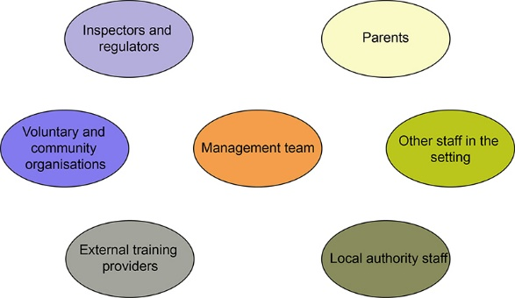
Figure 1 Practitioners building relationships
View description - Figure 1 Practitioners building relationships

You might be able to think of other people who are involved in a setting too. Working with each of these groups requires lots of different skills and knowledge. For example, the way you communicate with parents would not be the same as the way you communicate with regulators, and the information shared with the local authority would not be the same as that given to community organisations. Managing these different requirements is one of the professional skills that early childhood practitioners need in order to build effective relationships.
Traditionally, working with very young children was seen as an informal role that did not need any formal training or qualifications rather than a professional position, and it was assumed that women would be best at it because they were predisposed to ‘mothering’. As a result of research into child development and recognition of the connection between quality care and improved outcomes for children, these attitudes have begun to change. This has resulted in actions being taken to try and professionalise the early childhood workforce by introducing training and qualification pathways that provide clear evidence of practitioners’ skills, knowledge and understanding.
The professional characteristics of practitioners working with young children in Wales are outlined in these ‘Enabling Adult’ descriptors:

Enabling Adults:
- Are warm, attentive and responsive to babies and young children.
- Are skilful, observant and interested in babies and young children and how they develop.
- Use knowledge and understanding of child development to support all children.
- Use knowledge and understanding of how babies and young children learn to plan experiences and environments.
Welsh Government, 2023, p.7

2 Children’s relationships
The ‘Enabling Adult’ characteristics highlight how important it is that we build strong connections with the babies and children that we work with, and to do this it is vital that we understand and value all the relationships they have. The diagram below shows some of the relationships of 18-month-old Seren who lives with her mum and grandma. Seren’s dad, who no longer lives with them, looks after her on the weekend and she goes to her other grandparents after nursery on weekdays when her mum and grandma are working. She is very close to her mum’s elder sister, Bethan and her son, Tomos.
The diagram below shows that Seren already has lots of relationships, and she will be interacting in lots of different ways with all these people.

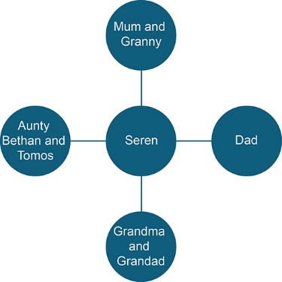
Figure 2 Seren’s relationships
View description - Figure 2 Seren’s relationships

All the interactions that a child has have the potential to shape the way they respond in future situations. Understanding and valuing the connections and relationships a child has is an important part of supporting them. As discussed in previous weeks, babies and toddlers play an active role in developing relationships, and they respond to situations based on their previous experiences. Their patterns of behaviour, emotions, ways of interacting and communicating, and their expectations will change or be reinforced by all the experiences they have with other people.

Activity 2 Exploring relationships
Allow about 5 minutes

If we think about the relationships that children have and the relationships that practitioners have, we can see there are lots of potential overlaps. The list below shows some of the people that children and practitioners have relationships with. Where would you place each one of these on the table? Drag and drop them under the heading you think best fits.

View discussion - Activity 2 Exploring relationships

Whilst all these connections have an impact on work you do with babies and young children, the child’s most significant relationship is the one they have with their family.

3 Families and friends
What do you think of when you hear the word ‘family’?

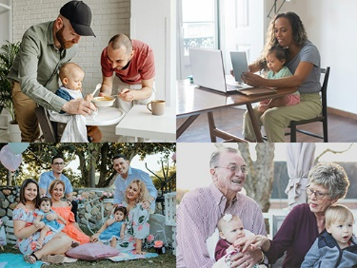
Figure 3 What is ‘family’?
View description - Figure 3 What is ‘family’?

For many years the idea of family was the ‘traditional’ married mother and father and their children, but that image no longer fits. Statistics show that families are increasingly made up of co-habiting couples, lone parents, same-sex partners, blends of previous family structures, foster carers and lots of other make-ups (Office for National Statistics, 2024).
When we think about the relationships in the lives of babies and very young children, there can still be a tendency to focus on the relationship between the child and one or both of their parents. However, most young children quickly start to develop networks of relations with their siblings, grandparents, other family members, carers, peers, and so on.
The role of dads in caring for babies has been overlooked for a long time, with mothers often seen as being primarily responsible for childcare. Dads can face particular challenges with regard to caring for babies. For example, childcare settings and groups are almost entirely staffed by women and this can be isolating for dads. In recent years more work is being done to support dads’ involvement. Examples of this include projects like Dad Matters Cymru which provide support to help dads have positive parent experiences during pregnancy and early years, and encourage participation in services that have traditionally been targeted for mums.
A child’s developing sense of who they are and their place in the world is a process that begins within the family. It is connected to the relationships they experience at home and the way that the family goes about things. The importance of building effective relationships between the home and the setting is highlighted in A Curriculum for Funded Non-maintained Nursery Settings (Welsh Government, 2022), but there can be all sorts of barriers that make it difficult to make these connections. These barriers can be organised into four categories (Hornby and Blackwell, 2018).

Barriers
Type of Issue | Examples
Parent/family factors | Parents’ own experiences of school having a negative impact. Complex family situations making it more difficult for information to get to the right person. Parents’ low levels of confidence in their skills, such as literacy.
Parent/practitioner factors | Practitioners assuming parents are ‘fussy’ or ‘over-anxious’ and dismissing their concerns. Parents worrying that they will be told they are doing something ‘wrong’. Parents not wanting to ‘bother’ practitioners or ‘waste their time’. Practitioners not understanding the family’s circumstances.
Societal factors | Parents dealing with mental health issues, disabilities, mobility problems, isolation, agoraphobia, financial problems, etc. Conflicts between parents in the local community. Different cultural expectations around childcare. Language barriers.
Practical barriers | Clashes between working hours and opening hours. Lack of transport to get to a setting outside ‘normal’ hours. Lack of technology and associated skills to access information.

The range of examples shown above make it clear that there is no ‘one size fits all’ answer to this issue. Every setting will have its own unique set of circumstances that could be impacting on the relationship they have with the families they work with. But there are some key points to bear in mind:
- The first contact you have with parents is key. You need to demonstrate genuine engagement, interest and positive intent.
- Try to find out from parents what is needed and what is possible, rather than making assumptions and expecting them to fit into the settings’ plans.
- Recognise parents’ anxieties and work to build their confidence. Think back to the comments from the parents in the video earlier this week about the importance of feeling listened to.

Activity 3 First contact with childcare provider
Allow about 5 minutes

Take a moment to think about the first contact a parent or carer has with a childcare provider. What would make it a positive experience? How could they make the adults and the child feel welcomed and relaxed?
If you work with babies or young children, think about the first experience you had as a practitioner meeting parents – was it positive? How did you make the child and parent feel relaxed? What did you do? Did you reflect on it afterwards?

Provide your answer...
View discussion - Activity 3 First contact with childcare provider

4 Key person
When babies and young children begin to extend their connections outside their family and close friends – for example, when starting nursery or being cared for by a childminder – they have to deal with making a new set of connections with different groups of children and adults. These connections are sometimes called ‘secondary attachments’, building on the attachment to parents and carers that you explored in Week 4. To support this move outside the family circle and establish these positive relationships right from the start, many early childhood settings operate a ‘key person’ approach where a close relationship between a baby or toddler and one specific adult is developed. The relationship between the child, their parents and the practitioner has been described as a ‘triangle of trust’ (Wheeler, 2022).

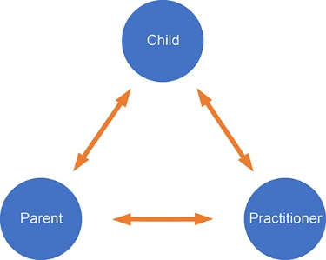
Figure 4 Triangle of trust
View description - Figure 4 Triangle of trust

Often there are overlaps between the relationship the baby or toddler has with their key person and the experiences they have at home with their parents or carers, but unlike at home the key person will have a number of other children of a similar age to support. And the key person themselves may not always be present when the child is in the setting or is in need of emotional support. It is possible that less reliance on a single adult within a setting may support the development of rich and more numerous interactions with children of a similar age, and the Welsh Government’s Framework for Early Childhood Play, Learning and Care (2023) and A Curriculum for Non-maintained Nursery Settings (2022) highlight that all the practitioners in a setting have a responsibility to act as ‘enabling adults’ who ‘should take the time to get to know individual children’ (2023, p. 8) and also ‘recognise our role is integral to the progress of all children’ (2022, p. 8).
Each key person will have responsibility for more than one child, so an important feature of the role is to try and be consistent across the needs of each child. To do this it is helpful to consider these questions (adapted from Johnson, 2010):
- How much time within a day or session is likely to be needed with each child in a key group?
- How many colleagues should share the relationship with the key child, and what does their contribution entail?
- How are the differing needs of each child in the group met fairly?
- As a key person are you focusing on gaining holistic knowledge of the child, or specialist knowledge in some specific areas?
- What role do you play in sharing information with parents or carers?
However settings choose to organise it, the key person role is an important part of early childhood practice and has been described as ‘professional love’. Page (2008) uses this term to try to show the importance of the closeness of the relationship between the key person and the child, while making it clear that it does not replace or diminish the quality or significance of children’s loving relationships with their parents. An important part of developing a bond with babies and toddlers is being able to ‘tune-in’ to their feelings, interests and reactions, and this process starts from the first moment you meet them.

Activity 4 How babies communicate
Allow about 10 minutes

Watch this Open University video and then use the box below to note down the ways that you can see the baby communicating their interest and feelings.

Video content is not available in this format.
Video 2
View transcript - Video 2

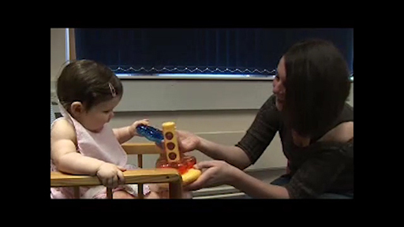

Provide your answer...
View discussion - Activity 4 How babies communicate

Summary of Week 5
- Right from birth babies are developing relationships with lots of different people.
- As practitioners it is important that you understand the uniqueness of all the families you work with.
- The role of the key person or enabling adult is a professional one.

Something to think about this week
To find out more about how dads can be involved in early childhood care and education take a look at The Daddy Factor: How Fathers Support Development.

You can now go to Week 6.

Week 6: Putting it into practice

Introduction
In 2009 Dr Kathy Goouch and Professor Sacha Powell from Canterbury Christ Church University recognised there was a lack of information and research that related to what happens in baby rooms. They started a study called ‘The Baby Room Project’ which highlighted the important work that was being done and recognised the need for practitioners working in those rooms to have professional development opportunities that enabled them to support the holistic development of the babies in their care. As a result of the project, a lot more focus has been put on how to observe what is happening in the baby room and how to record these observations to use as a basis for planning.
By the end of this week, you will be able to:
- recognise a range of observation techniques
- understand the role of observation and recording in supporting learning
- understand what reflective practice is.

1 Observing, planning and recording
In order to make informed decisions about the opportunities and experiences practitioners provide for the babies and toddlers they work with, they need to get to know them and build a picture of their interests, skills and motivations. To do this, they start by observing them – but what does that really mean?

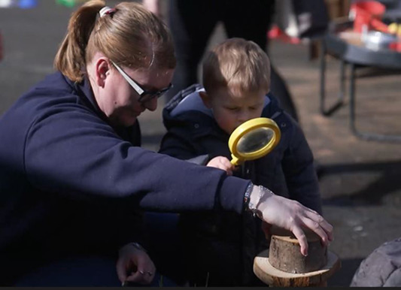
Figure 1 What does observing mean?
View description - Figure 1 What does observing mean?

Activity 1 Words and meanings
Allow about 1 minute

Take a moment to think about the words below and consider if you think they have different meanings:
- Watching
- Looking
- Noticing
- Seeing
- Observing

View discussion - Activity 1 Words and meanings

Trying to keep track of what we see babies and young children doing can be tricky, because there are often lots of things happening at the same time.

Activity 2 Observing an activity
Allow about 10 minutes

Watch this video of children playing together in a nursery and note down what you see.

Video content is not available in this format.
Video 1
View transcript - Video 1

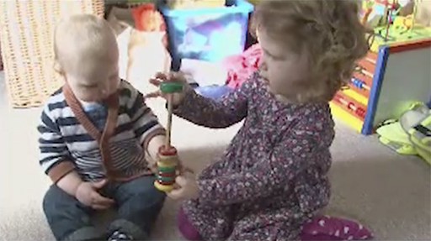

Provide your answer...
View discussion - Activity 2 Observing an activity

To be able to focus on a specific area of development or learning, you need to think about what your role in the observation is. Are you part of the action or are you watching from afar? Does the child know that you are looking at what they are doing or not? Take a look at the descriptions of the role of the observer in the box below.

The role of the observer
Overt | The child knows they are being observed.
Covert | The child is not aware that they are being observed. You might think that this would not apply to babies, but if you remember what was discussed in Week 1 about babies being aware of the adults around them and the communication techniques they use to engage them, this shows that babies know when they are being observed.
Participant | The observer is taking part in the activity while undertaking the observation.
Non-participant | The observer is not part of the activity that is being observed.

These elements can be combined. For example, if you were sat on the other side of the baby room watching a child using a Treasure Basket, that would be a covert, non-participant observation. If you were on the floor using a toy to encourage a baby to roll over, that would be an overt, participant observation.

- What effect do you think these different approaches can have on what we see?
- If a child knows they are being watched they are more likely to change their behaviour, in the same way that we do as adults. Have you ever been in a coffee shop or on a bus and realised that someone is looking at you? A soon as you get that sensation you become more aware of what you are doing or how you are moving, and that is the same for babies and toddlers.
Undertaking an observation when you are part of the activity can make it difficult to capture what you have seen. It is not always possible to stop what you’re doing and make a note, so you have to remember what happened – and in a busy baby room that can be difficult.

Now that you have thought about what your role in observation is, you can then consider what you want the observation to focus on. Different types of observation will provide different types of information.

1.1 Types of observation and recording
It is important that you take time to observe so that your planning is well informed and every child’s needs are met. It also allows you an opportunity to slow down and make sure that you provide opportunities for children to revisit activities that interest them and support their developing needs. Observations also help to track a baby’s progress in reaching key developmental milestones, such as sitting up, crawling, or babbling.
When practitioners regularly observe children’s progress they ensure that children are developing appropriately and can identify any areas where additional support might be needed. Observations in the baby room can look like the examples that follow: narrative, sampling, checklist and tracking. Each one has a different purpose and you may have used other approaches in your own practice – there is no ‘right’ way to do observations.

Narrative
This type of observation involves taking notes that capture what the observer is seeing. This could be in the form of a child study where the observer makes regular notes over a period of time – that could be weeks, months or even a whole year – or a diary where incidental observations are noted down.

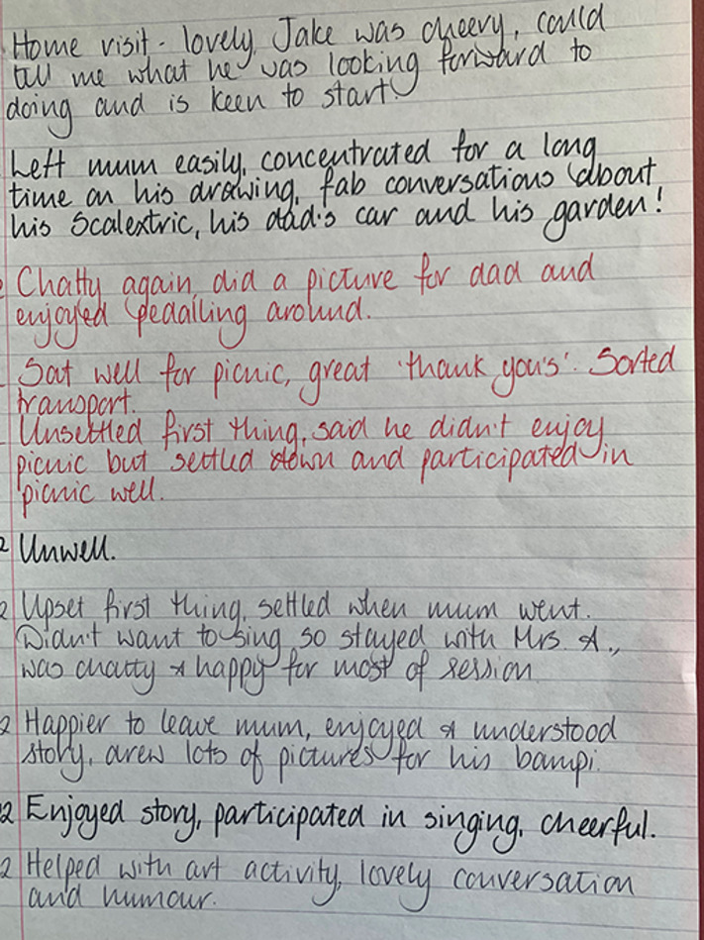
Figure 2 A page of handwritten notes that describe a child’s first days attending nursery
View description - Figure 2 A page of handwritten notes that describe a child’s first days attending ...

Narrative observations can also be reflective, as the example below shows. A reflection observation means really watching and listening to the child. Looking at a stage of development and the interest that motivates them. The detail in this reflection highlights what motivates Arthur, and the practitioner is able to use this to reflect on what this means for the child.

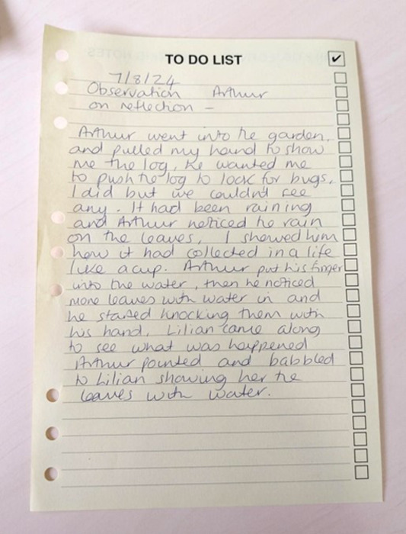
Figure 3 A piece of paper with a handwritten reflection about an interaction between the practitioner and a child called Arthur
View description - Figure 3 A piece of paper with a handwritten reflection about an interaction between ...

Sampling
Sampling involves taking a series of focused observations. Time sampling involves planning to undertake a number of observations at set time periods, for example, every 2 minutes within a half hour, and noting down what the child is doing at that time. Event sampling happens when a child’s behaviour is observed in relation to a particular event, for example, getting ready to play outside. A target observation such as the one below shows how the child behaves in their learning environment alongside other children. Target observations are helpful when looking at a specific skill set but they also capture a child’s unique all-round development.

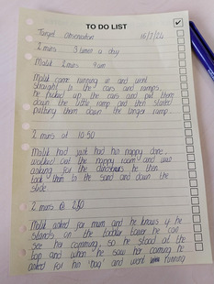
Figure 4 A piece of paper with handwritten notes outlining what a child called Malik was doing at specific times of the day
View description - Figure 4 A piece of paper with handwritten notes outlining what a child called Malik ...

A sampling observation could be structured, which involves taking notes that focus on specific criteria, for example, how the child is communicating with their peers, or unstructured where the observer writes down everything that a child does over a set period of time.

Checklist
This type of observation is based on a pre-set list of skills, knowledge or behaviours which the practitioner ticks off as they see them demonstrated, usually within a specific activity or session.

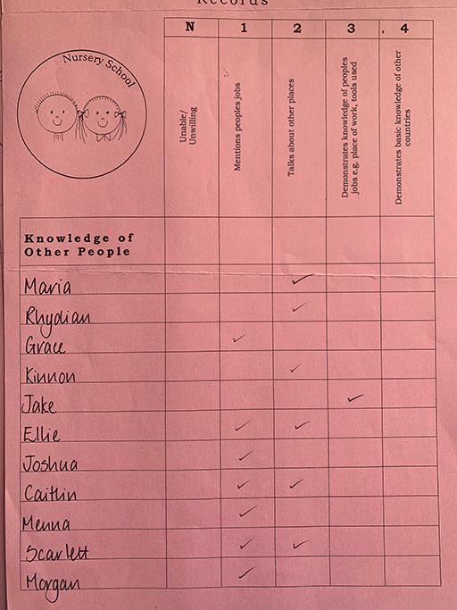
Figure 5 An example of a checklist observation
View description - Figure 5 An example of a checklist observation

Tracking
In these observations a child’s movements are noted down on a map of the room or setting over a period of time. This can show which areas of a room or setting are most popular, or where a particular child likes to spend their time.

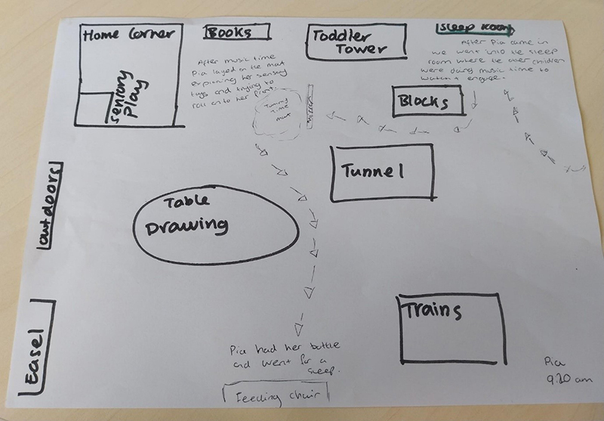
Figure 6 An example of how tracking is recorded
View description - Figure 6 An example of how tracking is recorded

Observation descriptions
These examples show that there are lots of different ways to record what children are doing, and each of the approaches gives different information about the child.

Activity 3 Matching observation techniques
Allow about 2 minutes

Match and drag the types of observation into the blank description boxes to see what types of information each one can provide.

Figure 7

View discussion - Activity 3 Matching observation techniques

Observations recorded using a tablet can also be a helpful way to capture information, allowing the practitioner more time with the child and less time writing on paper during the session. It may also capture some events or actions that are difficult to articulate on paper, such as evidencing a child’s emerging schemas.

1.2 Using and sharing observations and records
The information presented in Section 1.1 shows that it is possible to think that ‘observation’ is a more formal or organised term than watching or seeing, and that it’s something that professionals do – you could be in hospital ‘under observation’ but you wouldn’t be in hospital ‘being watched’. While it is true that we are more aware of undertaking a range of observations in a structured way when in the baby room, we do need to be aware that the fact ‘observations’ seem more formal can create a barrier where parents might be reluctant to share what they have ‘seen’ or ‘noticed’ while ‘watching’ their child, because those approaches are not as valued.
Making sure that you include the information that parents share with you in the records the setting keeps and making them a part of the observation portfolio, ensures a shared understanding of the child. Practitioners can do this by responding to comments that parents make in home/nursery diaries and by including the information in the displays and information that are on show around the setting.
Practitioners also need to make sure they use the information gathered from observations in a clear and organised way. An example of this is shown below, where the practitioners have captured children’s participation in activities by jotting information on sticky notes and putting these onto a piece of paper. These notes are snapshots of time that show what and how activities were played with, what the children were interested in, what questions they were asking, and lots of other issues. This information is then used to inform planning for the following month.

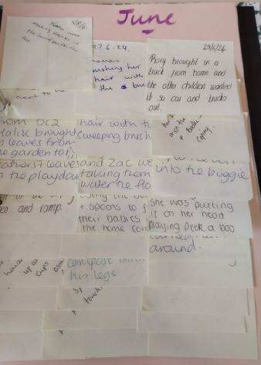
Figure 8 A large piece of paper covered in sticky notes recording what different children have done during an activity
View description - Figure 8 A large piece of paper covered in sticky notes recording what different ...

The mind map below was then developed using observations gathered from the sticky notes. This is done at the end of each week to inform the activities for the following week. In this example the writing in green has been added to show activities that have been included or extended as a result of observations taken throughout the preceding week.

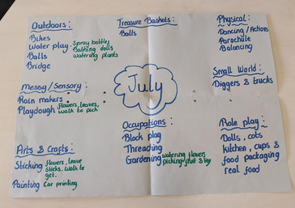
Figure 9 Mind map showing observations
View description - Figure 9 Mind map showing observations

When you have completed an observation, you need to use it to help you build up a picture of the child, so that you can support them to develop and progress. The diagram below outlines the kind of things that you should focus on noticing when building the picture, and shows what the next steps are.

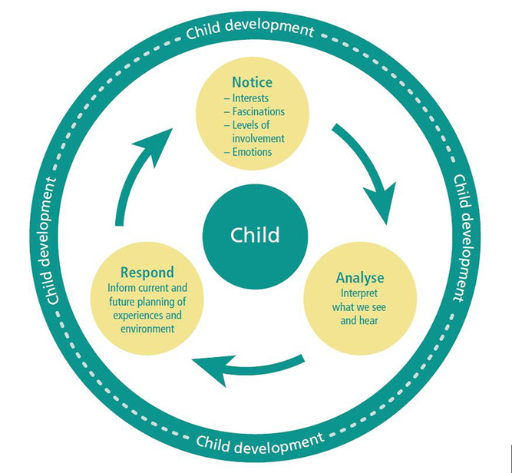
Welsh Government, 2022, p. 37
Figure 10 Building up the picture of the child
View description - Figure 10 Building up the picture of the child

To analyse the observations, it can be useful to have a set of key questions to work through. Doing that helps to make sure that you are considering the same factors every time, and this helps in identifying areas where there is lots of information and areas where there are gaps. Here are some example questions, but you can create your own too.
- What skills did we see the child use?
- What was the child interested in?
- Were there any other factors that might have affected what we saw (e.g. the weather, the time of day, the child’s health)?
- How does the information from this observation compare with previous ones?
- Is there anything I need to check or discuss with colleagues or the child’s parents as a result of this observation?
When you have analysed the information from the observations, you then need to think about how you are going to use it. There are lots of different ways this might be done, ranging from putting a note into the child’s record, to adding the observation to evidence for a referral to a specialist professional (like a speech therapist). The findings from your observation might show you that you need to do more observations to explain what is going on, or you might want to ask a colleague to look at the findings and ask their opinion. The important thing to remember is that all these elements are part of an ongoing process of observing, recording, analysing, responding and then observing again to ensure that the best learning experiences and support are being provided for all the children.

2 Reflective practice


Figure 11 It’s important to always consider areas you can improve on
View description - Figure 11 It’s important to always consider areas you can improve on

This course has focused on the babies and toddlers in the work setting, trying to understand the developmental processes they are going through and showing how opportunities and experiences can be provided to help them progress. As well as thinking about what the children are doing, it is important to take time to consider your role too. You need to be able to consider your actions carefully, thoughtfully and honestly to identify areas that you can improve and aspects that you can explore further. Using reflective practice techniques can help with this.

2.1 What is reflective practice?
Reflective practice is a process that can be used to help practitioners to think about their work and actions in a structured way. Often when thinking back to an event we remember the ‘headlines’, the aspects that stand out, and these are usually the things that went really well or the things that went really badly. Using reflective practice techniques helps practitioners to explore an event in a more structured and in-depth way, and that helps to uncover the more subtle points and gain a better understanding of the whole event. Gibbs (1988) devised a set of questions that can be used to structure this reflective process:
- Description: What happened?
- Feelings: What were you thinking and feeling?
- Evaluation: What was good and bad about the experience?
- Analysis: What sense can you make of the situation?
- Conclusion: What could you have done differently?
- Action plan: If the situation was repeated what would you do?
These questions can be applied to any situation to help us develop a clearer understanding of why we responded in the way we did, and identify areas we can change or develop in the future. In the same way that we need to use the observations we do to help us make progress, we need to act on the outcomes of our reflections and see them as part of a process. One of the best-known models used to support reflective practice is the ‘plan-do-review’ cycle (Johnston and Nahmad-Williams, 2009). In this approach we experience something, then later on we remember it and reflect on what happened. After reflecting we think about how we might change our response or actions to improve the experience, and then we implement this change to see if they make a difference.
As well as reflecting on specific activities or experiences, we can reflect on wider aspects of our practice. The Welsh Government Quality Framework for Early Childhood Play, Learning and Care in Wales (2023) sets out a whole series of reflective questions that encourage us to think about how we support children’s development, how we plan, how we create effective environments and lots of other areas of our work. Here is an example of the reflective questions that support consideration of how we plan the experiences we provide in our settings.

Quality planning: reflective questions
- How well does our planning support the shared vision of our setting?
- When planning, how effectively do we use our observations and knowledge of babies and young children’s needs and interests? How do we capture the child’s voice in our planning?
- How do we use a range of observations from different team members to collaborate on future planning?
- How do we ensure that our planning is reflective of all children, their families and our community throughout the year?
- How well does our planning develop and enrich children’s Welsh language skills?
- How effectively do we plan for engaging outdoor experiences?
- How well do we monitor the impact of our planning on all children’s progress?
- How do we ensure that our pedagogy is supporting the wellbeing of babies and young children?
Welsh Government. 2023, p. 12

Using a combination of reflections on the experiences we provide alongside reflections on our practice as a whole will help to ensure that the babies and toddlers we work with are receiving the highest quality care and education.

Summary of Week 6
- Observation is an umbrella term that covers all the different ways that information can be gained about what a baby or toddler can do.
- Use as many different observation and recording techniques as possible to gain a clear picture of a baby or toddler’s skill and interests, so you can best support their learning and development.
- Reflective practice helps you to understand your responses and reactions, and use this to improve the experiences and support provided for the babies and toddlers you work with.

Something to think about this week
How can you make sure your observations are fair and free from influences of stereotyping and personal assumptions?

Further resources
Read more about the Baby Room Project:
EYFS Best Practice: All about… Baby Room Projects
The Welsh Government Reflective Practice Toolkit:
Early Childhood Play, Learning and Care: Reflective Practice Toolkit

Course summary
Congratulations on completing this course, we hope that you have enjoyed it!
Over the course of the six weeks you have explored how babies’ brains develop and how the experiences they have, right from the moment they are born, support their future learning. You have found out about how babies make connections with the people around them and looked at how to provide environments that enable babies and children to develop. You have also looked at how settings use observations to inform their planning and make sure that parents feel valued and included.
If you would like to take your learning further, take a look at the Open University’s Early Years courses and qualifications. You can also find more resources and information on the Early Years Wales website.

References
Goldschmied, E. and Jackson, S. (2004) People under Three, Young Children in Day Care (2nd edition). London: Routledge.
Gopnik, A., Meltzoff, A. and Kuhl, P. (2001) How babies think: the science of childhood. London: Phoenix.
HM Government (2021) The best start for life – The Early Years Healthy Development Review Report. Available at: https://assets.publishing.service.gov.uk/media/605c5e61d3bf7f2f0d94183a/The_best_start_for_life_a_vision_for_the_1_001_critical_days.pdf (Accessed: 15 April 2025).
Roberts, A. & Featherstone, S. (2002) The Little Book of Treasure Baskets. Leicestershire: Featherstone Education Ltd.
Shea, T. (2004) A Learning Experience to Treasure, A Treasured Experience to Learn. Northampton: Childcare Innovations Partnership.
Welsh Government (2023) Framework for Early Childhood Play, Learning and Care. Available at: https://hwb.gov.wales/api/storage/031bbc2d-d2f8-429d-a944-5fc33484827d/a-quality-framework-for-early-childhood-play-learning-and-care-v1.pdf (Accessed: 15 April 2025).
Kipping, R., Langford, R., Brockman, R. et al. (2019) ‘Child-care self-assessment to improve physical activity, oral health and nutrition for 2- to 4-year-olds: a feasibility cluster RCT’, Public Health Research, 7(13). Available at https://pubmed.ncbi.nlm.nih.gov/31343857 (Accessed: 15 April 2025).
Welsh Government (2022) ‘A Curriculum for Funded Non-maintained Nursery Settings’. Available at: https://hwb.gov.wales/api/storage/b1801d78-38c3-4320-9818-d9996c21aef8/220914-a-curriculum-for-funded-non-maintained-nursery-settings.pdf (Accessed: 15 April 2025).
Welsh Government (2023) ‘Framework for Early Childhood Play, Learning and Care’. Available at: https://hwb.gov.wales/api/storage/031bbc2d-d2f8-429d-a944-5fc33484827d/a-quality-framework-for-early-childhood-play-learning-and-care-v1.pdf (Accessed: 15 April 2025).
World Health Organisation (2022) ‘Physical Activity’. Available at: https://www.who.int/news-room/fact-sheets/detail/physical-activity (Accessed: 15 April 2025).
Athey, C. (1990) Extending Thought in Young Children. London: Paul Chapman.
Casey, T. and Robertson, J. (2019) ‘Loose Parts Play, a Toolkit’, Scottish Government. Available at: https://inspiringscotland.org.uk/wp-content/uploads/2019/07/Loose-Parts-Play-Toolkit-2019-web.pdf (Accessed: 16 July 2025)
Nicholson, S. (1971) ‘How Not To Cheat Children: The Theory of Loose Parts’, Landscape Architecture, v62, p. 30–35.
Thomas, A. (2021) ‘Exploring schemas in the Welsh curriculum: A coming to know for practitioners and children’, Journal of Early Childhood Research: ECR, 19(1), pp. 98–112. https://doi.org/10.1177/1476718X20969750
Welsh Government (2021) ‘Curriculum for Wales Guidance, Cardiff’. Available at https://hwb.gov.wales/curriculum-for-wales/curriculum-for-funded-non-maintained-nursery-settings (Accessed: 15 April 2025).
Welsh Government (2022) ‘A Curriculum for Funded Non-maintained Nursery Settings’. Available at: https://hwb.gov.wales/api/storage/b1801d78-38c3-4320-9818-d9996c21aef8/220914-a-curriculum-for-funded-non-maintained-nursery-settings.pdf (Accessed: 15 April 2025).
Welsh Government (2023) ‘Framework for Early Childhood Play, Learning and Care’. Available at: https://hwb.gov.wales/api/storage/031bbc2d-d2f8-429d-a944-5fc33484827d/a-quality-framework-for-early-childhood-play-learning-and-care-v1.pdf (Accessed: 15 April 2025).
Bingham, S. and Whitebread, D. (2012) School Readiness: A Critical Review of Perspectives and Evidence. Croome D’Abitot, Worcs: TACTYC.
Bowlby, J. (1952) Maternal Care and Mental Health. Geneva: World Health Organisation.
Canale, N. (2020) The Seven C’s of Responding to Behaviour. Available at: Error! Hyperlink reference not valid. (Accessed: 15 April 2025).
Glazzard, J., Potter, M. and Stones, S. (2019) Meeting the Mental Health Needs of Young Children 0-5 Years. St. Albans: Critical publishing.
Grimmer, T. (2022) Supporting Behaviour and Emotions in the Early Years. Abingdon: Routledge.
New Zealand Ministry of Education (1996) Te Whariki: Every Childhood Curriculum. Wellington: Learning Media Ltd.
Office for National Statistics (2024) ‘Children in families in England and Wales: Census 2021’. Available at: Error! Hyperlink reference not valid.(Accessed: 15 April 2025).
Page, J. (2008) ‘Permission to love them’, in C. Nutbrown and J. Page (eds) Working with Babies and Children from Birth to Three, London: Sage, pp. 181–97.
Waller, T. and Davies, G. (2014) An Introduction to Early Childhood. London: Sage.
Welsh Government (2022) A Curriculum for Funded Non-maintained Nursery Settings. Available at: https://hwb.gov.wales/api/storage/b1801d78-38c3-4320-9818-d9996c21aef8/220914-a-curriculum-for-funded-non-maintained-nursery-settings.pdf (Accessed: 15 April 2025).
Welsh Government (2023) ‘Framework for Early Childhood Play, Learning and Care’. Available at: Error! Hyperlink reference not valid. (Accessed: 15 April 2025).
Hornby, G. and Blackwell, I. (2018) ‘Barriers to parental involvement in education: an update’, Educational Review, 70(1), pp. 109–119.
Johnson, J. (2010) Positive and Trusting Relationships with Children in Early Years Settings. Exeter: Learning Matters.
Office for National Statistics (2024) ‘Children in families in England and Wales: Census 2021’. Available at: Error! Hyperlink reference not valid.(Accessed: 15 April 2025).
Page, J. (2008) ‘Permission to love them’, in C. Nutbrown and J. Page (eds) Working with Babies and Children from Birth to Three, London: Sage, pp. 181–97.
Waller, T. and Davies, G. (2014) An Introduction to Early Childhood. London: Sage.
Welsh Government (2022) A Curriculum for Funded Non-maintained Nursery Settings. Available at: https://hwb.gov.wales/api/storage/b1801d78-38c3-4320-9818-d9996c21aef8/220914-a-curriculum-for-funded-non-maintained-nursery-settings.pdf (Accessed: 15 April 2025).
Welsh Government (2023) ‘Framework for Early Childhood Play, Learning and Care’. Available at: Error! Hyperlink reference not valid. (Accessed: 15 April 2025).
Wheeler, S. (2022) Outdoor Play for Healthy Little Minds. London: Routledge
Gibbs, G. (1988) Learning by Doing: A Guide to Teaching and Learning Methods. Birmingham: SCED.
Goouch, K. and Powell, S. (2015) ‘The Baby Room Project: Findings and implications’, Early Years Educator, 17(1). Available at: https://www.magonlinelibrary.com/doi/abs/10.12968/eyed.2015.17.1.38 (Accessed: 15 April 2025).
Johnston, J. and Nahmad-Williams, L. (2009) Early Childhood Studies. London: Pearson Longman.
Mathieson, K. (2013) I am two! Working effectively with two year olds and their families. London: British Association for Early Childhood Education.
Welsh Government (2022) A Curriculum for Funded Non-maintained Nursery Settings. Available at: https://hwb.gov.wales/api/storage/b1801d78-38c3-4320-9818-d9996c21aef8/220914-a-curriculum-for-funded-non-maintained-nursery-settings.pdf (Accessed: 15 April 2025).

Acknowledgements
This free course was written by Jane Dorrian and Julie Powell and first published in July 2025.
OpenLearn course editor: Dale Harry.
Except for third party materials and otherwise stated (see terms and conditions), this content is made available under a Creative Commons Attribution-NonCommercial-ShareAlike 4.0 Licence.
The material acknowledged below (including any Proprietary material referenced in the course) is Proprietary and used under licence (not subject to Creative Commons Licence). Grateful acknowledgement is made to the following sources for permission to reproduce material in this free course:
Course Image:
Images
Figure 1: An information sheet from First 1001 Days Movement: Infographics - Parent-Infant Foundation.
Figure 2: William Fortunato/Pexels.
Figure 4: courtesy Early Years Wales https://www.earlyyears.wales/en.
Figure 5: Dragan Smiljkovic/Getty Images.
Figure 1: Keira Bufrton/Pexels
Figure 2: Yan Krukau/Pexels
Figure 3: Early Years Wales activity card: courtesy Early Years Wales. Early Years Wales, membership services to the Early Years sector in Wales.
Figure 4: UK Chief Medical Officers’ Physical Activity Guidelines, p. 23 (Published 7 September 2019). Crown Copyright 2019 Open Government Licence https://www.nationalarchives.gov.uk/doc/open-government-licence/version/3/ .
Figure 5: Ermilo/Getty Images
Figure 1: courtesy Jane Dorrian.
Figure 2: zGel/Getty Images.
Figure 3: Image Source/Getty Images.
Figure 4: Front cover (including logos): Welsh Government (2022) A Curriculum for Funded Non-maintained Nursery Settings. https://www.nationalarchives.gov.uk/doc/open-government-licence/version/3/ © Crown copyright 2022.
Figure 5: Early Years Wales activity cards. Courtesy Early Years Wales https://www.earlyyears.wales/en
Figure 6: Courtesy Early Years Wales https://www.earlyyears.wales/en.
Figure 1: Haibaron/Pixabay.
Figure 2: Karolina Kaboompics/Pexels.
Figure 4: Jep Gambardella/Pexels.
Figure 3: What is ‘family’? top left: Karolina Kaboompics/Pexels; top right: Kampus Production/Pexels; bottom left: Catalina Carvajal Herrera/Pexels; bottom right: Pexels.
Figure 1: Courtesy Jane Dorrian
Figure 2: Courtesy Jane Dorrian
Figure 3: Courtesy Ely and Caerau Children’s Centre https://www.cardiffeccc.cymru/
Figure 4: Courtesy Ely and Caerau Children’s Centre https://www.cardiffeccc.cymru/
Figure 6: Courtesy Ely and Caerau Childrens Centre https://www.cardiffeccc.cymru/
Figure 8: Courtesy Ely and Caerau Childrens Centre https://www.cardiffeccc.cymru/
Figure 9: Courtesy Ely and Caerau Childrens Centre https://www.cardiffeccc.cymru/
Figure 10: Child development graphic in Early Childhood Play, Learning and Care: Reflective Practice Toolkit: (p37) © Crown copyright 2023, Welsh Government, WG43340, Digital ISBN 978-1-83504-187-1 Open Government Licence
Figure 11: Engin Akyurt/Pexels
Video
Video 1: Experiences Build Brain Architecture: Courtesy: Center on the Developing Child at Harvard University https://developingchild.harvard.edu/.
Video 1: Babies Minds (extract) ©The Open University.
Video 2: Crawling – Feldenkrais with Baby Liv’ https://www.youtube.com/watch?v=14gWirURq6I courtesy Irene Lyon.
Video 3: Jep Gambardella:/Pexels.
Video 4: Risky play © The Open University .
Video 1: Invitations to Play: Courtesy Early Years Wales https://www.earlyyears.wales/en.
Video 1: Attachment and Bonding https://www.youtube.com/watch?v=2x9n16OuT6w courtesy Tusla, Child Family Agency https://www.tusla.ie/ .
Video 2: Harvey and Lizzie: ©The Open University.
Video 1: Incredible Babies Programme in Wales ©The Open University (2019).
Video 2: How babies communicate ©The Open University (2017).
Video 1: Thomas making a tower with girls; help © The Open University (2016)
Every effort has been made to contact copyright owners. If any have been inadvertently overlooked, the publishers will be pleased to make the necessary arrangements at the first opportunity.
Don’t miss out
If reading this text has inspired you to learn more, you may be interested in joining the millions of people who discover our free learning resources and qualifications by visiting The Open University – www.open.edu/openlearn/free-courses.

Solutions

Activity 1 How the brain develops

Discussion
The video shows us that every experience a baby has causes a reaction in their brain cells which triggers a response. The more times these reactions occur the stronger the connections between the brain cells become, and if the experiences are repeated enough the connections become permanent.
Different types of experience create responses in different parts of the brain, and providing this range of experiences allows these different parts of the brain to connect and work together. Giving babies as many different types of experience as possible right from the start, gives their brains the best chance of creating all the connections needed to support their future development.
Back to - Activity 1 How the brain develops

Actvity 2 Serve and return

Discussion
In the clip the baby uses her eyes to make sure her mother is paying attention, she smiles, she squeals, she points, she cries and she moves her body. When her mother is responding the baby shows her happiness and pleasure, but when there is no response given to her communications she shows confusion, worry and sadness. This video clearly shows what effective communicators babies are, they can tell us how they are feeling or what they want. They have lots of skills that they can use to get our attention. It’s important for practitioners to recognise the communication skills that babies have and remember the role that they play in responding to these.
Back to - Actvity 2 Serve and return

Activity 1 Development of object permanence

Discussion
The concept of object permanence shows us why babies are so fascinated by playing peek-a-boo: they are surprised and excited to see the face or object again because it appears new to them. In order to understand that objects continue to exist even when they are unseen, the baby must develop an idea of the object in their mind, and to do this they need to use their senses to play with them and explore them. By finding out what the object looks, feels, tastes, smells and sounds like the baby builds up a mental image of what it is. This then helps them to realise that the object still exists even when they can’t actually see it.
Once a baby has developed their sense of object permanence, they use this knowledge to develop their thinking by trying to match new experiences and information to their existing understanding, identifying the differences and using this information to create new understanding.
Back to - Activity 1 Development of object permanence

Activity

Answer
Right:
10%
Wrong:
20%
50%
100%
Back to - Activity

Activity 2 Exploring movement

Answer
Back to - Activity 2 Exploring movement

Discussion
You might have noted down that you saw the baby stretching, balancing, reaching, rocking and crawling, as well as lots of other movements. The video helps us to realise that every movement a baby makes involves them thinking, exploring, experimenting and practising. By giving babies and toddlers opportunities to move we are supporting their brain development.
Back to - Activity 2 Exploring movement

Activity 3 Risky play

Part

Discussion
In the video you saw how the practitioners used their knowledge of each child to decide what level of support or encouragement they needed. Some children needed to hold Fernando’s hand to face the challenge of balancing on the equipment, but with other children, he knew they could cope as he increased the challenge by moving equipment to create gaps for them to jump over. These examples show us the important role practitioners play in enabling children to take risks and to learn from those experiences.
Back to - Part

Activity 1 Identifying schemas

Discussion
This shows a positioning schema, where the child has ordered wooden farm animals and arranged them into a row.
Back to - Activity 1 Identifying schemas

Activity 2 Tummy time

Discussion
Taking a moment to experience this helps us to realise just how important floor play is, and reminds us that it is an invaluable resource for babies and toddlers as it offers opportunities to develop and revisit early movement skills.
Back to - Activity 2 Tummy time

Activity 3 Exploring the possibilities of a Treasure Basket

Discussion
Your answers show just how many opportunities Treasure Baskets provide, and you can have fun finding and choosing items to put in them, then watch the babies scrutinise, squeeze, rub, bang, shake, mouth, drop, and pick them up. Of course, you will need to regularly check for safety and cleanliness of objects as well as replenishing the basket to maintain the babies’ interest. Treasure Baskets are a good example of an ‘engaging experience’ (Welsh Government, 2022, 2023) that provide an opportunity for a child to learn in a hands-on way, at their own pace and using their own interests.
Back to - Activity 3 Exploring the possibilities of a Treasure Basket

Activity 4 Playing with loose parts

Discussion
In this clip, children are making decisions, choosing activities and resources and deciding whether they want adults to be involved in their play or not. The practitioners tell us how their knowledge of each child informs their practice, and allows the children to use their imagination, to model their own experiences, talk about family and learn about the world around them. This shows us the huge range of opportunities that loose parts can play to support all aspects of babies’ and toddlers’ development.
Back to - Activity 4 Playing with loose parts

Activity 1 Positive early relationships

Discussion
In the video you saw how having a secure attachment enables babies and young children to be confident in exploring their emotions and their environment, and how it allows them to become curious and interested in what is happening around them. Having a strong bond also allows babies and young children to develop resilience and perseverance, knowing that it is ok to fail and try again because they have someone to support and reassure them. All these aspects are essential life skills that we all need.
Back to - Activity 1 Positive early relationships

Activity 2 Who am I?

Discussion
All these elements make up our identity, and looking at all these different aspects shows us that our identities are complicated. They are affected by lots of factors and situations and these are constantly changing. If you had been asked this question five years ago, it is likely that some of your answer would be different. Looking at the different aspects identified also shows us how our identity is linked to our relationships – if we see ourselves as a carer, a sibling, a friend, or an employee, all these roles are connected to other people.
Relationships are the foundation of everyone’s sense of identity, and particularly of babies’ and toddlers’ developing identities. They affect how a child will respond to their future experiences. You can find out more about how setting supports babies’ and children’s sense of belonging by looking at the ‘Belonging’ pathway in the Welsh Government’s A Curriculum for Funded Non-maintained Nursery Settings
Back to - Activity 2 Who am I?

Activity 3 Developing relationships

Discussion
You might have noted Harvey looking intently at Millie and touching her foot to get her attention, or noticed how Millie was using the books in the same way that her mum told us that her sister does. Watching the video we can see that the babies are constantly looking around the room, noticing what is happening or focusing on a toy or activity, and these experiences all provide opportunities for them to develop their sense of identity and belonging.
Back to - Activity 3 Developing relationships

Activity 1 Supporting parents

Discussion
Throughout the video, the importance of having trusting, effective relationships is mentioned. Helene, the group leader, tells us that once the group has gelled and the relationships are strong, no new members are introduced. The mums highlight that within the group they feel comfortable to ask for help, share experiences, look for reassurance and explore ideas because of the relationships they have developed. They are able to build connections with their wider community and develop confidence. The mums also recognise that the group gives their babies opportunities to start to make relationships with the other children who they will be going to school with.
All these aspects show us the impact that relationships have on lots of different elements of practice. In this case the relationships are positive and are helping the members of the group to gain confidence and make progress, and we need to try and make sure these are the types of relationship we are promoting.
Back to - Activity 1 Supporting parents

Activity 2 Exploring relationships

Discussion
Some of these relationships are easy to place under one heading, but for others it might depend on the individual child or the setting, for example, one child’s grandparents are known because they collect them from the setting, but for another child this wouldn’t be the case. This activity shows the importance of getting to know each child’s individual circumstances and relationships, so that you can build effective connections with them and support them as they develop.
Back to - Activity 2 Exploring relationships

Activity 3 First contact with childcare provider

Discussion
Reflecting on your own experiences can be a useful starting point to help you think about how you would welcome new children and parents into your setting. Seemingly small things, like smiling and making sure to speak to the adult and child, make a big difference.
Listening carefully and making it clear that any questions are welcome is a good starting point to develop a positive relationship. Having plenty of time for parents and children to explore and chat can be challenging in a busy setting, but if you can do this then it is definitely worthwhile.
Back to - Activity 3 First contact with childcare provider

Activity 4 How babies communicate

Discussion
These are just a few indicators (below) and you might have noticed others too. Tuning in to all these signs and indicators and responding to them helps us to develop our relationship with the babies and toddlers.
- The facial expressions that the baby used.
- The way they were sitting or leaning forward at different times.
- What they reached out for and what they touched.
- The movements they made.
- What they were looking at and how their attention and focus moved around.
Back to - Activity 4 How babies communicate

Activity 1 Words and meanings

Discussion
It is difficult to highlight any clear or specific differences between these words – they all overlap. It can be useful to think as ‘observation’ as an umbrella term that covers all the different approaches practitioners use to find out more about the babies and toddlers they work with. Doing this helps them to make sure they are using as many different types of observation as possible in order to get the clearest picture.
Back to - Activity 1 Words and meanings

Activity 2 Observing an activity

Discussion
As you watched the video you might have focused on the language the children used, or the physical skills that they showed as they played. Perhaps you noticed the involvement of the adult, or the different social and emotional responses the children demonstrated. It is almost impossible to capture everying that a child is doing in a situation, so when we undertake observations it can be helpful to have a clear idea of what we are focusing on before we start.
Back to - Activity 2 Observing an activity

Activity 3 Matching observation techniques

Discussion
Each of these observation techniques creates a different record, as shown by the examples that you’ve seen for the different approaches. Alongside these formal records of observations other information can be used: photos, videos, drawings, sound recordings, post-it notes – anything that tells us something about the child.
Back to - Activity 3 Matching observation techniques

Descriptions

Figure 1 An information sheet from First 1001 Days Movement
A poster from the 1001 Days Movement website which gives details about the impact that positive early experiences and relationships have on babies. At the very top the poster reads: Investing in the emotional wellbeing of our babies is a wonderful way to invest in the future. This is followed by five circles which carry the following advice: Circle 1, Giving children the best start in life; Circle 2, Improving the mental and physical health of the next generation; Circle 3, Reducing risky and antisocial behaviour and the costs they bring; Circle 4, Building a skilled workforce to support a thriving economy; Circle 5, Creating a compassionate society. The next main heading text reads: Early relationships between babies and their parents are incredibly important for building healthy brains. Just below and to the left, is an illustration of a baby wrapped in a blanket. There are three blocks surrounding the illustration. The first block reads: I need a secure relationship with at least one sensitive, nurturing caregiver who can respond to my needs. The second block reads: Supporting my parents and other important people in my life to develop this relationship will give me the best start in life. The third block reads: Stress factors such as domestic abuse and relationship conflict, mental illness, substance misuse, unresolved trauma and poverty can make it harder for my parents to provide me with the care I need. The more adversities that my family experiences, the harder it can be to meet my needs. In the bottom right hand section of the poster has a title which reads: Healthy social and emotional development during the first 1001 days. This is followed by a bullet pointed list which reads: Lays the foundation for lifelong mental and physical health; Means I feel safe and secure, ready to play, explore and learn; Leaves me ready to enjoy and achieve at school, and progress in the workforce; Enables me to understand and manage my emotions and behaviours; which means that I can make a positive contribution to my community; Gives me skills to form trusting relationships and be a nurturing parent myself, sowing the seeds for the next generation.
Back to - Figure 1 An information sheet from First 1001 Days Movement

Figure 2 Reflexes help a baby make essential connections with their carers
A photograph showing a baby laying on their back with arm outstretched. The baby’s hand is clasping the finger of an adult’s hand. Only the hand and part of the arm of the adult is visible.
Back to - Figure 2 Reflexes help a baby make essential connections with their carers

Figure 3 The senses
This is an interactive of a baby with pop-up boxes positioned on the face, head and hand of the bady describing the various sesnes. Touch: Babies need to touch interesting objects and textured materials in order to develop and strengthen connections between the brain cells. Whenever an object is grasped or explored with the fingertips, millions of sensory receptors send messages to the brain, which then processes, analyses and stores the information. Touch also stimulates parts of the brain that govern action, coordination and thinking. Vision: At birth, the eye and brain areas responsible for vision are not fully developed. Although babies can see colours, they may appear blurred so using black and white images can help to refine the muscles of the eyes, and objects should be held about 30cm from the baby’s face. By 6 months significant advances have been made in the vision centre of the brain. Colours can be seen clearly, and both eyes can track and focus accurately on a moving object. At 8 months, babies can see with much better accuracy. Even so, it takes another four years for vision to reach the full adult level, which is why continual visual stimulation is so important. Smell: At birth, the sense of smell is fully mature and babies can distinguish thousands of different smells. Most babies are responsive to smells that they encounter daily such as breast milk, their mother’s perfume or a familiar blanket. Such smells are associated with comfort and security. Smells are received by receptors at the top of the nasal passage, but they are processed and interpreted by the temporal lobe in the brain. Signals also pass through the limbic system, which is associated with memory, mood, behaviour and basic thought processes. Stimulating babies with different smells develops brain connections and helps them to learn about the world. Hearing: The part of the brain that is responsible for hearing becomes functional at about 25 weeks gestation. This is the time when the ear and the brain tune into specific frequencies and intensities such as the mother’s voice and the rhythmic sound of her heart. These same sounds provide comfort and reassurance to the newborn baby. Hearing continues to develop up to 6 months after the birth. Sound experiences, verbal interactions, rhymes, singing and stories build important brain cell connections for speech and language skills, and they contribute to all-round development of the brain. Taste: Taste buds on the tongue can distinguish sweet, sour, bitter and salt, all other tastes are detected by smell receptors in the nose. When a baby brings an object to its mouth, their lips and tongue provide a very accurate image of texture, size, weight, shape and temperature. Mouthing is often accompanied by noises called vocalisations, which play an important role in speech and intellectual development. Mouthing also develops skilful jaw and tongue movements in readiness for solid foods.
Back to - Figure 3 The senses

Figure 4 Good proprioception is important for a child’s physical development
A baby is laying on a colourful playmat looking at their reflection in a mirror that is on the floor in front of them.
Back to - Figure 4 Good proprioception is important for a child’s physical development

Figure 5 Vestibular receptors are essential for play and movement
Photograph showing a young girl balancing on her hands, feet and head in a field.
Back to - Figure 5 Vestibular receptors are essential for play and movement

Figure 1 Learning is a complex process
A baby lying on their back and smiling up at an older child who is crouching down next to them.
Back to - Figure 1 Learning is a complex process

Figure 2 A dad supporting his son in learning to ride a bike
A toddler wearing a red coat and red wellies is on a bike being pushed along a stony path by a man who is supporting the bike by holding one of the handlebars and the seat. Both of them are laughing.
Back to - Figure 2 A dad supporting his son in learning to ride a bike

Figure 3 Early Years Wales activity card
An Early Years Wales activity card that has information about how to support babies’ crawling skills.
Back to - Figure 3 Early Years Wales activity card

Figure 4 Physical activities children should be involved in
Poster produced by the UK Chief Medical Officer showing different physical activities that young children can be involved in to reach the recommended 180 minutes of activity per day. The activities are playground, jump, climb, messy play, throw/catch, skip, object play, dance, games, tummy time, swim, scoot, and walk.
Back to - Figure 4 Physical activities children should be involved in

Figure 5 Navigating the world
A young girl is taking steps down a staircase. She is stretching for the handrail with one hand.
Back to - Figure 5 Navigating the world

Figure 1 Individual patterns of behaviour
A small child leaning into a sand box to play with coloured plastic pastry cutters that are in the sand.
Back to - Figure 1 Individual patterns of behaviour

Figure 2 An example of transporting schema
A young child is stacking and playing with building bricks on a table.
Back to - Figure 2 An example of transporting schema

Figure 3 Little girl arranging animal-shaped wooden toys
A small girl is playing on some artificial grass in a room. She has arranged some wooden farm animals, such as a chicken, a duck and a pig, in a line one behind the other.
Back to - Figure 3 Little girl arranging animal-shaped wooden toys

Figure 4 The front cover of A Curriculum for Funded Non-maintained Nursery Settings guidance (Welsh Government, 2022)
The front cover of A Curriculum for Funded Non-maintained Nursery Settings. There are logos at the top of the document and the bottom has pictures of various children in different settings.
Back to - Figure 4 The front cover of A Curriculum for Funded Non-maintained Nursery Settings guidance (Welsh Government, 2022)

Figure 5 Early Years Wales activity cards
Early Years Wales activity cards with information on the importance of tummy time. One is written in English, the other is written in Welsh.
Back to - Figure 5 Early Years Wales activity cards

Figure 6 Treasure Basket
A wooden bowl containing a sponge, a wooden spoon, a white cloth with black spots, a piece of red gauze, ribbons, some gold-coloured metal hoops, pieces of wood, shells and stones.
Back to - Figure 6 Treasure Basket

Figure 1 Playing and exploring
Two young boys playing by a shallow pond.
Back to - Figure 1 Playing and exploring

Figure 2 Families have become more diverse
A baby is sitting in the doorway of an indoor tepee. There is a smiling man inside the tepee holding the baby up and another man is kneeling outside the doorway peeping inside. The baby is looking at the man and laughing.
Back to - Figure 2 Families have become more diverse

Figure 3 ‘Strange situation’ experiment
This is a series of illustrated images demonstrating the ‘strange situation’ experiment. The text at the bottom of the first slide reads: Step 1 + 2, Mother and child enter the room. Mother sits and the child plays with toys in the room. The second slide reads: Step 3 + 4, Stranger enters and talks to mother before interacting with the child and initiating play. Mother then leaves. The third slide reads: Step 5, Mother returns and stranger leaves. The fourth slide reads: Step 6, Mother leaves again. Leaving child alone. The fifth slide reads: Step 7, Stranger returns, interacts with child and offers comfort. The sixth slide reads: Step 8, Mother returns and stranger leaves.
Back to - Figure 3 ‘Strange situation’ experiment

Figure 4 The ‘terrible twos’ can be a challenging time
A baby is stretched on their back, holding their hands in front of their face. An adult is holding the baby’s arm, and the baby appears to be resisting.
Back to - Figure 4 The ‘terrible twos’ can be a challenging time

Figure 5 ‘Who am I?’ diagram
A spider diagram, with ‘Who am I?’ written in the centre circle. The circles around the outside are connected to the centre circle and contain the labels; Mum, Welsh, Lecturer, Sister, Rugby fan, Daughter, Runner, Volunteer.
Back to - Figure 5 ‘Who am I?’ diagram

Figure 1 Practitioners building relationships
A diagram showing seven ovals, each containing a group or organisation involved with babies’ and young children’s care and education. The groups are: Inspectors and regulators, Parents, Voluntary and community organisations, Management team, Other staff in the setting, External training providers, Local authority staff.
Back to - Figure 1 Practitioners building relationships

Figure 2 Seren’s relationships
A spider diagram with ‘Seren’ in the centre circle. The circles around the outside are connected to the centre circle and are labelled; Mum and Granny, Dad, Grandma and Grandad, Aunty Bethan and Tomos.
Back to - Figure 2 Seren’s relationships

Figure 3 What is ‘family’?
A collage of pictures showing grandparents looking after toddlers, a gay couple feeding their baby, straight couples and their children, and a lone parent.
Back to - Figure 3 What is ‘family’?

Figure 4 Triangle of trust
Three circles are arranged as the points of a triangle, with double-ended arrows pointing between each one. The circles are labelled; Child, Parent, Practitioner.
Back to - Figure 4 Triangle of trust

Figure 1 What does observing mean?
A female practitioner is holding a piece of wood while a young boy next to her is using a large yellow framed magnifying glass to look closely at it.
Back to - Figure 1 What does observing mean?

Figure 2 A page of handwritten notes that describe a child’s first days attending nursery
A page of handwritten notes that describe a child’s first days attending nursery. The first entry reads: Home visit. Lovely Jake was cheery, could tell me what he was looking forward to doing and is keen to start. Another entry reads: Chatty again did a picture for dad and enjoyed pedalling around. An entry further down the page reads: Upset first thing. Settled when mum went. Didn’t want to sing so stayed with Mrs A. Was chatty and happy for most of the session.
Back to - Figure 2 A page of handwritten notes that describe a child’s first days attending nursery

Figure 3 A piece of paper with a handwritten reflection about an interaction between the practitioner and a child called Arthur
A piece of paper with a handwritten reflection about an interaction between the practitioner and a child called Arthur. It reads: 7/8/24 Observation on reflection. Arthur went into the garden and pulled my hand to show me the log. He wanted me to push the log to look for bugs. I did but we couldn’t see any. It had been raining and Arthur noticed the rain on the leaves. I showed him how it had been collected in a leaf, like a cup. Arthur put his fingers into the water. Then he noticed more leaves with water in and he started knocking them with his hand. Lilian came along to see what was happening. Arthur pointed and babbled to Lillian showing her the leaves with water.
Back to - Figure 3 A piece of paper with a handwritten reflection about an interaction between the practitioner and a child called Arthur

Figure 4 A piece of paper with handwritten notes outlining what a child called Malik was doing at specific times of the day
A piece of paper with handwritten notes outlining what a child called Malik was doing at specific times of the day. The title reads ‘Target Observation’ and below that ‘2 mins 3 times a day’. The description that follows for that first entry reads: Malik, 2 mins, 9am. Malik came running in and went straight to the cars and ramps. He picked up the cars and put them down the little ramp and then started putting them down the longer ramp. Second entry: 2 mins at 10.50, Malik had just had his nappy done. Walked out the nappy room and was asking for the dinosaurs. He then took them to the sand and down the slide. Third entry: 2 mins at 2.50, Malik asked for mum and he knows if he stands on the toddler tower he can see her coming, so he stood at the top of it when he saw her coming. He asked for his ‘bag’ and went running.
Back to - Figure 4 A piece of paper with handwritten notes outlining what a child called Malik was doing at specific times of the day

Figure 5 An example of a checklist observation
A sheet of pink paper with a grid that has five skills listed at the top and children’s names running down the left-hand column. There are ticks on the grid that show which skill each child has demonstrated.
Back to - Figure 5 An example of a checklist observation

Figure 6 An example of how tracking is recorded
A large piece of paper has the activity areas of a classroom mapped onto it. A dotted track has been added that shows where a child called Pia went during the course of the observation. Some of the areas shown are: toddler tower, books, home corner, sensory play, blocks, tunnel, table drawing, outdoors.
Back to - Figure 6 An example of how tracking is recorded

Figure 8 A large piece of paper covered in sticky notes recording what different children have done during an activity
A large piece of paper covered in sticky notes recording what different children have done during an activity. The top sticky note is dated and reads: Rory brought in a truck from home and other children wanted it so car and truck out.
Back to - Figure 8 A large piece of paper covered in sticky notes recording what different children have done during an activity

Figure 9 Mind map showing observations
A large piece of paper with ‘JULY’ written in the middle and activities listed around the edge that are organised into areas such as ‘outdoors’, ‘arts and crafts’ and ‘role play’. Outdoors – bikes, water play, balls, bridge; Messy/sensory – rain makers, playdough; Arts and crafts – sticking, painting; Treasure Baskets – balls; Occupations – block play, threading, gardening; Physical – dancing/actions, parachute, balancing; Small world – diggers and trucks; Role play – dolls, cots, kitchen, cups, food packaging, real food.
Back to - Figure 9 Mind map showing observations

Figure 10 Building up the picture of the child
This is a circular flow diagram. In the centre is a smaller circle with the word ‘child’. The top circle has a title ‘Notice’ with ‘interests’, fascinations’, ‘levels of involvement’ and ‘emotions’ written below it. In a clockwise direction there is an arrow which leads to another circle with the title ‘Analyse’ followed by ‘interpret what we see and hear’ below it. Continuing clockwise, the next circle is titled ‘Respond’ with ‘Inform current and future planning of experiences and environment’ below it. ‘Child development’ is written around a larger outer circle containing the whole diagram.
Back to - Figure 10 Building up the picture of the child

Figure 11 It’s important to always consider areas you can improve on
A person wearing an orange jumper is sitting by the water’s edge looking out towards the horizon.
Back to - Figure 11 It’s important to always consider areas you can improve on

Video 1

Transcript
[MUSIC PLAYING]
SPEAKER
A child’s experiences during the earliest years of life have a lasting impact on the architecture of the developing brain. Genes provide the basic blueprint, but experiences shape the process that determines whether a child’s brain will provide a strong or weak foundation for all future learning, behaviour, and health. During this important period of brain development, billions of brain cells called neurons send electrical signals to communicate with each other.
These connections form circuits that become the basic foundation of brain architecture. Circuits and connections proliferate at a rapid pace and are reinforced through repeated use. Our experiences and environment dictate which circuits and connections get more use. Connections that are used more grow stronger and more permanent. Meanwhile, connections that are used less fade away through a normal process called pruning.
Well-used circuits create lightning fast pathways for neural signals to travel across regions of the brain. Simple circuits form first, providing a foundation for more complex circuits to build on later.
[MUSIC PLAYING]
Through this process, neurons form strong circuits and connections for emotions, motor skills, behavioural control, logic, language, and memory during the early critical period of development. With repeated use, these circuits become more efficient and connect to other areas of the brain more rapidly. While they originate in specific areas of the brain, the circuits are interconnected. You can’t have one type of skill without the others to support it. Like building a house, everything is connected and what comes first forms a foundation for all that comes later.
[MUSIC PLAYING]
Back to - Video 1

Video 1

Transcript
PETER WILLATTS
The newborn infant, the infant in the first two months, has no way of understanding, for example, the continued existence of objects when they can’t be perceived directly, or they can’t be acted upon. So with an object that goes out of view, the parent that leaves the field of view, goes out of the room, ceases to exist. Really, what Piaget is saying is that babies come into the world with the very minimum of knowledge. They have a set of actually fairly complicated reflex activities. But these are reflexes.
These are triggered by situations, such as, touching the baby’s hand will trigger a grasping activity. Seeing something move in the front of the baby will trigger tracking. But the baby only understands very, very little of what’s going on. Perceptual experiences are fleeting. They’re not organized. The baby doesn’t know anything about space and depth and distance, can’t interpret what’s happening. There is simply no understanding of the world, as you or I would understand it.
SPEAKER
Piaget’s ideas about the nature of early mental representations were based on simple but careful observations of babies searching for objects that have been placed out of view.
PETER WILLATTS
That’s good. There you are, down here.
SPEAKER
Piaget found that, with babies like Rebecca, who’s five months old, although she might be interested and excited by a toy, if it’s then hidden while she’s watching, then she behaves as if the toy simply ceases to exist. Piaget reported that there is a blank reaction. The baby just stops, doesn’t know what to do, doesn’t show any indication that she’s aware the toy continues to exist.
PETER WILLATTS
Here. There you are. I bet, if you did it with this one, and we’ll cover it over. If you’ll let her come forward, see if you can find it. Where’s it gone? It disappeared! Where’s it gone? Oh, where’s it gone? Look, here it is! Here it is.
Gradually, the baby begins to focus some attention on the cover, but only for its own sake. So the child will reach out, grab the cover, play with it in some way, and then would notice, this toy, this object, was hidden underneath, and would pick that up.
And gradually, through this repeated experience, and also other experiences, other activities, such as the baby handling an object, moving it out of view, bringing it back in again, moving it behind something else, seeing it go out of existence, out of sight, out of existence-- come back again, beginning to understand that the way to interpret what’s happening is that the object does continue to exist.
Back to - Video 1

Video 4

Transcript

MOHAMED
It’s the best day ever.
FERNANDO
Well, my name is Fernando. I’m 24. And I come from Spain. I came here five months ago in November. I decided to try teaching in early years because I think it’s like, a challenge for me, and I really wanted to get to know the children and how they learn, how they develop their skills. And I don’t know, I think I’m going to stay here for quite a long time because I honestly love this profession.
[INAUDIBLE] Eunice. Mohamed, what will happen if we put these steps a little bit forward? You think you can jump this distance?
MOHAMED
Oh, yeah.
FERNANDO
This is for-- going to be too much. Maybe try it from this distance. OK? There we go. There you go. Well done. I think risky play is one important thing in any child’s development, because it helps them to develop skills that are going to be really useful for them in the future.
If they feel like they’re doing it on their own, and they’ve taken the risk-- I don’t know-- they will know that for some things in life, they need to actually take risks, and they will learn from that. Well, that’s going to be too much, you think? OK. That’s perfect.
I know all the children, so I can tell which one of them are really ready to take the risks. Jump. 1, 2. Eunice. A little bit more?
MOHAMED
Not much.
FERNANDO
Wow. That was incredible, Mohamed. Well done. It’s too far away, right, Eunice? Maybe we’ll move this red one a little bit more. Keep going, Eunice. Mohamed, careful with Eunice head. Whoa! What happened here? Eunice, have you go. Let’s go.
MOHAMED
I want to jump.
FERNANDO
Whoa! Wibbly wobbly. Mohamed.
IAN POWELL
Oh, Delay is running. Delay is up ahead. Yacine. Another aspect at Forest School that I observe quite a lot is children sort of self risk taking and working out what’s their limit in feeling safe or even feeling unsafe.
Because at Forest School, we give the children the freedom to roam and explore. And some children would just go running ahead. They’ll just want to run and run and run. And what intrigues me is that with some children, they’ll just keep running and some children will run so many yards and then look back to the adult. And what’s interesting is, when did children decide for themselves, do I feel safe or do I feel unsafe?
So we do allow the children to have that freedom to do that. On the odd occasion we might have to run after a child, but most children will look back and return to you. Another aspect is in terms of climbing trees. We climb a lot of fallen trees. A few children might want to climb up a tree, and what we encourage there is, rather than the adults helping the child physically, we encourage them to work out what they can achieve themselves.
And some children might only climb one foot up a tree and then ask for help, and we’ll say, we’ll just reward them for, oh, that’s really good. You’ve climbed so high. And I wonder how you’re going to get down. And so they have to try and figure out how they’re going to get down. And then the next time they go they might climb two foot up a tree. So over time children think for themselves. When do I feel safe? How high can I climb a tree? So they’re sort of like self-regulating their own sense of awareness on that.

Back to - Video 4

Video 1

Transcript
[MUSIC PLAYING]
SPEAKER
OK. So these are our weaving looms. We introduced these a couple of years ago. And you’ll often hear children telling you what they’re going to do with their blankets once they’re finished. So today the one particular child that was invited into the weaving, she’s just had a new baby sister as well, so she’s really, really eager to make her new sister a lovely blanket like she’s made previously in Tiddlers. So again, it’s that knowing the child, knowing her family really well. And I think she engaged in a lovely conversation with Chloe and is quite excited about finishing this blanket for her sister.
[MUSIC PLAYING]
So the mud kitchen area, it’s always here. It’s always got all of the equipment that the children need. However, what’s in here today might have been different to what’s in here yesterday. For example, today is really strong smelling spices that we can smell, whereas tomorrow might be more herbs, which might not have that same sensory experience for the children. There’s always an adult within this area, and they’re always engaging with the children, but they very often will stand back and be invited into their place.
So a lot of our educators are very much internally active, externally passive. So it might look like they’re not actually doing very much, but they’re just waiting to be invited into the play. And that’s whether that’s verbally or whether sometimes they can just be a look or a hand hold. But that’s how that play evolves in the mud kitchen.
[MUSIC PLAYING]
So of course, we’ve got our loom weaving indoors, and then we’ve got our Willow weaving. So this is our small hand movements, large hand movements. And this is another extension of that weaving. And again, this will look very different each time we do it. It’ll never be replicated. Today, they’ve obviously been some of them practicing their knots. They’ll often seek the adult out if they want support, but they’ll also collaborate on projects together, as well as working from their own ideas. So sometimes this will be long grasses, sometimes it might be branches. This is t-shirt yarn that the children have made inside. So today, we’re having a go at it on a much larger scale. So, yeah, and I think it looks very beautiful.
[MUSIC PLAYING]
Back to - Video 1

Video 1

Transcript
[MUSIC PLAYING]
SPEAKER
Attachment and bonding is the physical and emotional connection that you have with your baby. Do you ever get the feeling that you know what your baby is feeling just by looking at them? Well, that’s all part of attachment and bonding. We can think of bonding as an intense and positive relationship that develops over time. And a secure attachment is a healthy two-way relationship that protects your baby, makes them feel loved, and believe it or not, actually helps them to learn.
Bonding is very important for your baby’s wellbeing. The way that you respond to your baby’s signals will have an effect on their emotional, social, and intellectual development. When you pay attention to your baby’s crying in a consistent way, your baby forms a strong sense of security and belonging. Once your child feels secure and looked after, they are better able to control their reactions to situations that they find scary or stressful.
Being able to control our feelings is an important part of emotional and intellectual development. We know that the bonds that develop between parents and their infants provides a baby with its first model for close relationships and helps young children to form positive relationships throughout their childhood and on into adulthood.
Back to - Video 1

Video 2

Transcript
SAL
Harvey. Well, Harvey is 7 and 1/2 months now. And he started coming when he was six months. So he’s only been coming a couple of months since January. He’s very happy. He’s very busy and he likes to be crawling around and have lots of people around him. So being here is lovely because he has lots of friends and the staff are lovely with him as well.
So they give me a little write up at the end of each day. And he spends a lot of time watching other children. And I’ve noticed that when we’re out and about, he does like other children. And being an only child at home, in effect, that’s the benefit of being here really is. It’s nice.
SPEAKER 1
Would you like to come and play with the trains, too, Harvey? Would you move to that side, sweetheart? Are you after Millie’s feet?
MILLIE
Oh.
SPEAKER 1
Oh. What’s he doing, Millie?
MILLIE
Ah.
SPEAKER 1
Do you not want him to do that? Good girl. Harvey, would you like some trains? I don’t think Millie wants you to pull her feet. Here you go, sweetheart. You want the train track, do you?
MILLIE
Ah.
SPEAKER 1
Oh, it’s OK. We’ll fix it, shall we? There you go.
MILLIE
Oh.
SPEAKER 1
What’s the matter?
BECKY
Lizzie is-- she’s always been very cheeky, very active from a young age. Big smiler. Lizzie’s now just gone one. She’s just about learning to walk. Very active at home. Good eater. Was beginning to say lots of words. Her one big, big passion is our dog. We’ve got a black Labrador, which is her best friend.
Well, play is very important and it’s something that bridges here. The staff have always stressed to us in how they learn through play. And certainly, as a mom of two, when you’ve got two of them trying to play together, it’s important that they can share toys and also a huge advantage to learning.
Lizzie has always enjoyed looking at books with her older sister Maisie. And certainly, they interact together. Maisie explains the books to her and Lizzie’s really started to study the pages. And it’s that understanding she’s beginning to understand certain animals. Lizzie and her sister spent a long time looking at animal books. Maisie explains to her what a cow is. And she’s beginning to point out and she’s beginning to do the sounds also.
The few books that she’s really got into recently are the musical books. But yeah, having an older sister, we do story time every night, which she’s part of. So we do story time together. So I guess it’s developed from that really.
(SINGING) --point to the window and point to the door
When we used to go to baby groups, she always enjoyed singing songs, interacting, doing the actions. And it’s something I’ve certainly picked up on from talking to staff is that sometimes, the one thing she really enjoys. But it’s also having the different toys to what we’ve got at home.
So she enjoys the interaction with other children. Again, because we’re in a rural community. A lot of the children here, she knows outside of Bridges. Also from different baby groups and also their friends.
SPEAKER 2
--like that in the basket behind me. Did I go through it or is it stuck already? Yes? You are in [INAUDIBLE] kids. Is there a tee in the ball pit, too?
SPEAKER 3
No.
SPEAKER 2
No? And he’s getting out, is he?
SPEAKER 4
Are you OK? Would you like some help?
SPEAKER 2
Oh, hello.
SPEAKER 4
Can you manage?
SPEAKER 2
Oh, good boy.
Back to - Video 2

Video 1

Transcript
HELEN DOCHERTY
And topic today-- as you can see, we’ve set the room up quite different today. So we’ve got lots of areas of different tactile and visual stimulation.
The Incredible Babies programme is an evidence-based programme. It runs for eight sessions, and we talk about different topics each week looking at stimulating the baby’s brain, the importance of talk, the importance of communication, getting to know your baby’s cues, as well as other topics such as weaning, safety, and baby massage.
SPEAKER 1
Yeah, I was checking [INAUDIBLE].
HELEN DOCHERTY
Once parents come along to Incredible Babies, we usually close the group off by about week 2. So by then, everybody’s gelled, everybody’s built up that relationship, and then we will offer the programme then in the next term. So it is a rolling programme.
SPEAKER 2
I enjoy coming to Incredible Baby group because it’s nice for the children to meet each other. And Lola’s got an older brother, but when she’s seen other babies, it was nice to see her reaction and just play with each other. And they end up growing up because they’re all in the same area. They go through school and play group. It’s nice to meet other mums as well.
SPEAKER 3
Does she like that?
SPEAKER 4
I think that it’s welcoming. I feel really comfortable here. And if I got a concern or worry, we can just come across to other mothers, and then they’ll give us their advice what they’ve done. So if the baby’s not sleeping or if they’re not eating tidy, they’ll just explain what they do different to what I’m not doing. So it gives us tips, really.
SPEAKER 2
If we didn’t have the group, I’d probably be searching on the internet, and there’d be different answers to what we get from other mums and from what we get from the group leaders, which is good. So it’s nice to have someone to talk to face-to-face rather than a computer screen.
HELEN DOCHERTY
Also, it’s a good idea to actually give time for the brain to connect. So where you think that they might or they’re not interested in that, actually give it time to process as well, and give them time to respond.
Lots of discussion comes about in groups. Sometimes if there is extra support needed, as if there is domestic violence or financial issues in the home and housing difficulties, then we have a good network of other agencies that we can actually refer the parents onto, or sometimes we’ve even-- may even have them coming in and just having a chat with parents at the centre.
A topic that came up was a parent was struggling to pay her rent and her bills. We had somebody come in from Communities First, and they helped and supported that family. They also helped and supported the rest of the group because they weren’t aware of the warm grant funds and financial support that was out there.
When mum did raise the issues in the group, they did actually all support her, and they were very empathic as well. So that was nice for her to be able to have that confidence to discuss that in the group and feel confident to do that. And the group then reassured her that it was OK, and there is help out there.
They also mentioned that Cobain Farm, which is another project that’s close by. They actually do food sessions where you can go and get bags of food.
SPEAKER 5
[INAUDIBLE]
SPEAKER 6
I don’t feel judged when I come, and I know that if I got something to ask, I haven’t got to be afraid because they-- or if they haven’t got the answer, they’ll find the answer for me. And I like the fact that I’ve got other mums to talk to. And, well, if I got a question, I’ll ask them. The main thing is not being judged. I’m a worrier.
HELEN DOCHERTY
When you go home now--
SPEAKER 7
I think without this course, it can be quite isolating in the area, not knowing many people with a young baby. I mean, I don’t go out like I used to. So to have this group and these friends and stuff has been amazing. It’s been absolutely amazing.
HELEN DOCHERTY
The programme is evaluated via Topsy and it’s a little booklet that the parents have at the beginning of the programme, and then they can score themselves and their babies. And then we do it again after the programme.
They can look at the Topsy done prior to see if they wanted to make some changes. Sometimes, it shows that they thought that they knew things, but after doing the programme, they’re like, wow! Actually, I didn’t really know as much as I thought I did.
[INTERPOSING VOICES]
HELEN DOCHERTY
What’s good about my job is I’m doing something that I wanted to do, and I’ve always wanted to work with children. To work with parents as well, it was like, wow! This is different. But it’s so rewarding to know that you have sometimes made a difference. Or if you haven’t, then you can refer on to another agency. But making that difference in that family, child, or that mum or dad or carer’s life is rewarding.
Back to - Video 1

Video 2

Transcript
SPEAKER 1
[INAUDIBLE]
[TOY CHIMING]
[GASPS] Where’s it gone? Where is it gone? [GASPS] There it is. Can you put it on? Can you put it on? [GASPS] Very nice. [GASPS] Ba, ba, ba. [GASPS] Where’s it gone? [GASPS] Where’s it gone? [GASPS]
[TOY CHIMING]
How about this one? What about this one? [GASPS] Oh, no. Where’s it gone? Where’s it gone? Where’s it gone? Boo! Peekaboo! [GASPS] Where’s it gone? Where’s it gone? There it is. Do you want it? Do you want it? [GASPS] Ta! Lily Mae! [GASPS]
[TOY SQUEAKING]
Boo!
[TOY SQUEAKING]
[GASPS] Boo!
[TOY SQUEAKING]
Da! Da! The chicken, can you do shaky? Shaky, shaky, shaky. Shaky, shaky, shaky. [GASPS] Shaky, shaky. Shaky, shaky. Clever girl. [GASPS] Uh-oh! Where has he gone? [GASPS] Where’s he gone? Ready? Here he comes.
[TOY SQUEAKING]
Peekaboo!
[TOY SQUEAKING]
Peekaboo!
[TOY SQUEAKING]
Peekaboo!
[TOY SQUEAKING]
[GASPS] Oh, no. Where’s he gone? Where’s he gone? [INAUDIBLE]?
SPEAKER 2
Ta!
SPEAKER 1
Uh-oh! Uh-oh! [GASPS] Where’s he gone? Where is he gone?
[TOY SQUEAKING]
I’m coming to get you.
[TOY SQUEAKING]
Boo!
[TOY SQUEAKING]
Rah!
[TOY SQUEAKING]
Rah!
[TOY SQUEAKING]
You want it? [GASPS] Uh-oh! [GASPS] Where’s he gone? Where has he gone? [GASPS] [TRILLING LIPS] [GASPS, SMACKS LIPS] Pretty kisses. Mwah! [SMACKS LIPS] Mwah!
[BABY MUMBLING]
No.
[BABY MUMBLING]
[RASPBERRY]
[BABY MUMBLING]
You’re gonna drop it on the floor.
[BABY MUMBLING]
Ah! [RASPBERRY] [GASPS]
[BABY MUMBLING]
Yeah, yeah.
Back to - Video 2

Video 1

Transcript
[INTERPOSING VOICES]
SPEAKER 1
Are you [INAUDIBLE] doing that way?
SPEAKER 2
Just I’m doing this way.
SPEAKER 3
Are you helping Thomas now?
SPEAKER 1
Oops. This one, easy.
SPEAKER 2
You’re going in the garden.
SPEAKER 3
[INAUDIBLE] . Quick, now!
SPEAKER 2
What is that? Let him go now!
SPEAKER 1
Do you want me to do it, silly little boy? Good job. Good boy. Good boy!
SPEAKER 2
And then we have it.
SPEAKER 1
Can we have a candle? No, don’t snatch from him.
SPEAKER 2
Papa.
SPEAKER 3
I don’t think [INAUDIBLE] was helping.
SPEAKER 4
It’s fine. It’s just--
SPEAKER 3
What’s Thomas doing?
SPEAKER 1
Hungry?
SPEAKER 3
Mm-hmm.
Back to - Video 1

