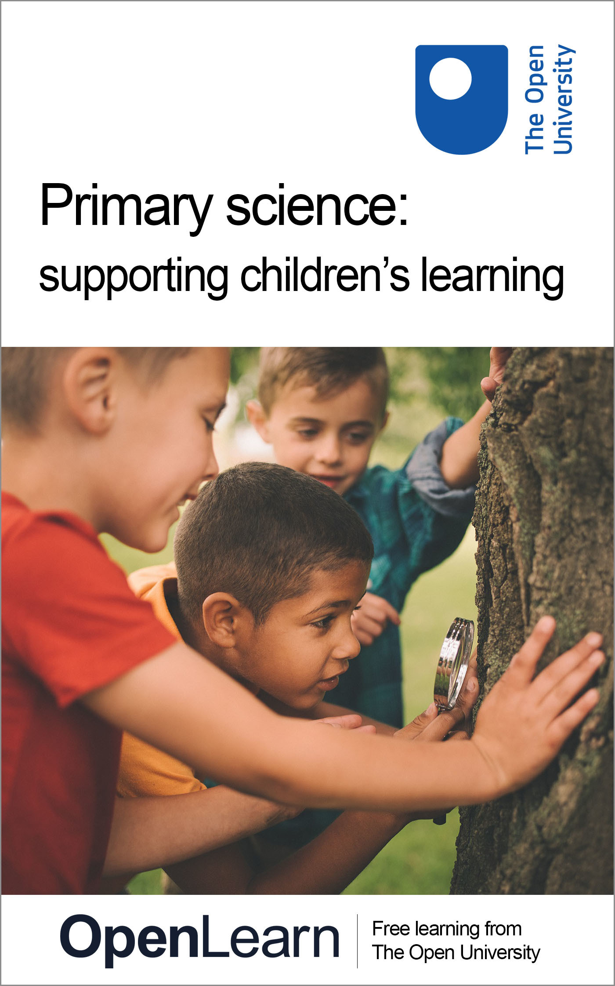

E209_1

Primary science: supporting children’s learning

About this free course
This free course is an adapted extract from the Open University course E209 Developing subject knowledge for the primary years: www.open.ac.uk/courses/qualifications/details/e209.
This version of the content may include video, images and interactive content that may not be optimised for your device.
You can experience this free course as it was originally designed on OpenLearn, the home of free learning from The Open University –
www.open.edu/openlearn/education-development/education/primary-science-supporting-childrens-learning/content-section-0
There you’ll also be able to track your progress via your activity record, which you can use to demonstrate your learning.
Copyright © 2018 The Open University
Intellectual property
Unless otherwise stated, this resource is released under the terms of the Creative Commons Licence v4.0 http://creativecommons.org/licenses/by-nc-sa/4.0/deed.en_GB. Within that The Open University interprets this licence in the following way: www.open.edu/openlearn/about-openlearn/frequently-asked-questions-on-openlearn. Copyright and rights falling outside the terms of the Creative Commons Licence are retained or controlled by The Open University. Please read the full text before using any of the content.
We believe the primary barrier to accessing high-quality educational experiences is cost, which is why we aim to publish as much free content as possible under an open licence. If it proves difficult to release content under our preferred Creative Commons licence (e.g. because we can’t afford or gain the clearances or find suitable alternatives), we will still release the materials for free under a personal end-user licence.
This is because the learning experience will always be the same high quality offering and that should always be seen as positive – even if at times the licensing is different to Creative Commons.
When using the content you must attribute us (The Open University) (the OU) and any identified author in accordance with the terms of the Creative Commons Licence.
The Acknowledgements section is used to list, amongst other things, third party (Proprietary), licensed content which is not subject to Creative Commons licensing. Proprietary content must be used (retained) intact and in context to the content at all times.
The Acknowledgements section is also used to bring to your attention any other Special Restrictions which may apply to the content. For example there may be times when the Creative Commons Non-Commercial Sharealike licence does not apply to any of the content even if owned by us (The Open University). In these instances, unless stated otherwise, the content may be used for personal and non-commercial use.
We have also identified as Proprietary other material included in the content which is not subject to Creative Commons Licence. These are OU logos, trading names and may extend to certain photographic and video images and sound recordings and any other material as may be brought to your attention.
Unauthorised use of any of the content may constitute a breach of the terms and conditions and/or intellectual property laws.
We reserve the right to alter, amend or bring to an end any terms and conditions provided here without notice.
All rights falling outside the terms of the Creative Commons licence are retained or controlled by The Open University.
Head of Intellectual Property, The Open University

Contents
- Introduction
- Learning outcomes
- 1 Science subject knowledge
  - 1.1 Attitudes to science
  - 1.2 The nature of scientific knowledge
  - 1.3 Seeing the bigger picture
- 2 Subject knowledge and teaching and learning
  - 2.1 Getting a sense of scale
  - 2.2 Scientific vocabulary
  - 2.3 Classification: order or confusion?
  - 2.4 Conceptual development
  - 2.5 Constructivism and science
- 3 Discovering children’s ideas
  - 3.1 Children expressing their ideas
  - 3.2 Concept mapping
  - 3.3 Constructing a concept map
  - 3.4 Uses of concept mapping
- 4 Using models in science
  - 4.1 Modelling electricity
  - 4.2 Sweets and cups model
  - 4.3 Rope model
- Conclusion
- References
- Further reading
- Acknowledgements
- Solutions

Introduction
This free course, Primary science: supporting children’s learning, provides a brief insight into the nature of scientific knowledge and some of the factors that affect our attitudes to science. As you evaluate, revise and extend your knowledge of a selection of science topics that are commonly found within the primary curriculum, you will focus on how children learn scientific concepts and how they can be supported to develop scientific knowledge, understanding and skills.
This OpenLearn course is an adapted extract from the Open University course E209 Developing subject knowledge for the primary years, relevant to anyone interested in the education of 3 to 11 year old children.

Learning outcomes
After studying this course, you should be able to:
- evaluate and advance science subject knowledge
- reflect upon some key scientific concepts and skills relevant to children’s learning in the primary years
- consider what can make science difficult or easy to learn, and explore some common misconceptions about science and how they can be addressed
- reflect upon the importance of promoting positive attitudes to science and making children’s science learning meaningful, relevant and engaging
- use and evaluate some different approaches to teaching science, such as those involving concept maps and modelling.

1 Science subject knowledge
Many of the activities in this course involve you reviewing elements of your science subject knowledge. Questions often focus on aspects that cause confusion for children and adults, so don’t worry if you find them challenging. Sample answers and commentaries are provided so that you can develop your science subject knowledge while thinking about how to support primary-aged children’s learni\ng in science.
Please note: while a range of science topics have been selected to illustrate how children’s learning can be supported, this course does not touch on experimental design, practicals or inquiry-based learning.

1.1 Attitudes to science
Attitudes to science and scientific knowledge are not fixed – they change over time and between different groups of people. Here you will consider how and why attitudes vary.

Activity 1 Popular views about science
Allow about 10 minutes

Consider the following questions, and note down your thoughts. You don’t need to respond to every point, or to comment in great depth.
What is the popular media view about science? Has this changed over the last few decades, or even in recent years? How do you think general attitudes to science might affect science teaching and learning in the primary years? What about the attitudes of educational practitioners and children?
Consider your own position too. What is your attitude to science, and what has influenced this?
Many people view science as ‘difficult’, ‘boring’, ‘irrelevant’ and only for the ‘clever’ students. Why do you think people might feel this way about science?

Provide your answer...
View comment - Activity 1 Popular views about science

Some people associate science with high-level specialists and feel that science does not actively influence their lives (Metcalfe, 2014). Others may have been put off by lacklustre teaching that failed to engage them or help them to see the relevance of science to their lives and interests. When asked to describe ‘a scientist’, some trainee teachers depicted a scientist as a stereotypical ‘boffin’ – a bespectacled man with wild curly hair, dressed in a white coat and exhibiting eccentric behaviour – as shown in Figure 1 below!

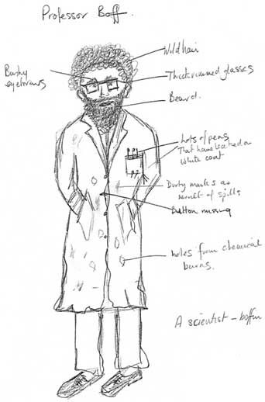
Figure 1 Professor Boff
View description - Figure 1 Professor Boff

A challenge for those working in primary education is to address these stereotypes, and to make science appealing and relevant to children who have different interests and views.

1.2 The nature of scientific knowledge
The nature of scientific knowledge is closely tied to the nature of science itself. The scientific method tries to eliminate biases, subjectivity and idiosyncratic ideas from its body of knowledge, in order to produce objective paradigms or theories.

Activity 2 Theories
Allow about 5 minutes

Science develops theories. But what is a theory? What purposes do theories have in science? Answer these questions below, illustrating your explanation with some examples of scientific theories.

Provide your answer...
View answer - Activity 2 Theories

Metcalfe (2014, p. 11) found that some primary school children believed that scientists ‘got things right the very first time because they are clever and never make mistakes’. He argued that helping young people to recognise that scientific knowledge is incomplete and may be wrong, and giving them a ‘genuine experience of science’ where they can experiment and develop their own enquiries, will help to develop their tenacity and creativity.

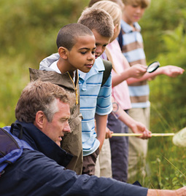
Figure 2 Genuine experiences of science
View description - Figure 2 Genuine experiences of science

1.3 Seeing the bigger picture
Science encompasses a wide range of topics, theories and ideas. When developing subject knowledge in science, it is useful to think about such knowledge (yours and children’s) in terms of small and big ideas. As in other curriculum areas, children normally start by learning about specific events or features that have limited application (small ideas) so that they develop an understanding of big ideas over time.

Activity 3 Big and small ideas
Allow about 10 minutes

From your own experience, whether as someone who works with children or has children, or just from your own scientific subject knowledge, can you think of a small idea that children might focus on in science and suggest how it relates to a bigger idea? You could think about small ideas that a four-year-old might learn about, and contrast them with what an eleven-year-old would learn.

Provide your answer...
View comment - Activity 3 Big and small ideas

Children can develop ‘small ideas’ as steps towards the bigger ones. Braund and Leigh (2013) argued that in this way, adults can make science accessible and meaningful for young children.
Figure 3 shows one representation of big ideas from the European Commission Go-Lab project, which aims to support school science learning. Harlen (2010) argued that:
- science teaching and learning should start with small ideas
- big ideas should not to be taught directly
- relevance to big ideas should be a reason for children spending time learning about scientific phenomena, and about science itself
- adults should know how the small ideas fit in with big or powerful ideas.

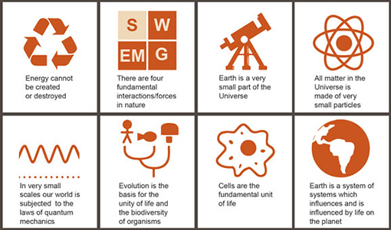
Figure 3 Go-Lab’s big ideas of science (Go-Lab, n.d.)
View description - Figure 3 Go-Lab’s big ideas of science (Go-Lab, n.d.)

Right click on the following link to open the video Building the Science curriculum in Millersneuk primary in a new window. Listen to how school staff explain their approach to supporting progress in children’s conceptual knowledge and understanding. Note the emphasis on conceptual development throughout the primary years.
You can read a transcript of the video here: Millersneuk Primary transcript

2 Subject knowledge and teaching and learning
In the following sections, you should answer the questions and complete the activities related to a range of science subjects. The surrounding commentaries focus on issues to consider when supporting children’s science learning.

2.1 Getting a sense of scale
In spite of ‘joined up’ planning in schools like Millersneuk Primary, children learn about different science topics in school as distinct blocks of work. One result of this is that the relative sizes of the things they’re learning about are not immediately clear to them. For example, consider how the girls in Figure 4 would know how the ladybirds in their ‘bug hotel’ compare to other objects such as a plant cell or the Earth in terms of scale.

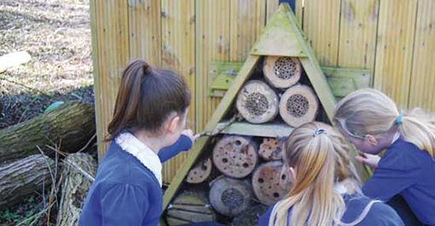
Figure 4 Observing the ‘bug hotel’ in the school bug garden
View description - Figure 4 Observing the ‘bug hotel’ in the school bug garden

Activity 4 Scale
Allow about 10 minutes

Put the following in order of magnitude, from smallest to largest:

Table 1 Placing objects in size order
ladybird | bacterium | the Earth | flea | galaxy
human being | atom | molecule | plant cell | proton
red blood cell | solar system | star | universe | virus

Provide your answer...
View answer - Activity 4 Scale

Learning about these things as separate topics means children don’t get a sense of the size of things that cannot be seen by the naked eye, or are so large that size is just a number (a very large one). You can help children to get a sense of scale by including opportunities for them to think across topics, and supporting them to make meaningful comparisons.

2.2 Scientific vocabulary
The same word may have different meanings depending on the context in which it is used. Those supporting children need to be aware of these different meanings. Children’s ideas may become partly or completely misconceived due to confusion about vocabulary.

Activity 5 Everyday and scientific meanings
Allow about 10 minutes

Consider the everyday meanings and the scientific meanings of these words. If you’re unsure of their scientific meaning, look them up. There’s a space provided for you to note down any observations you make.

Table 2 Words with different meanings
atmosphere | space | dense
reaction | energy | reflection
solution | cells | tissue

Provide your answer...
View comment - Activity 5 Everyday and scientific meanings

It is possible for children to use scientific words correctly in scientific conversations, but then find it difficult to express all the complex ideas behind the concept when asked to define or explain what they mean. Exploring their ideas through talking and observing can help to dispel some of their confusion or identify under-developed ideas. As you answer the questions in this course, consider whether scientific vocabulary is a barrier for you. Are you able to provide good definitions that would support primary-aged children’s learning? Or could some of your definitions mislead children and actually be unhelpful, as illustrated in the following activity?

Activity 6 Atoms and molecules
Allow about 20 minutes

For each of the definitions provided in Table 3 for an atom (definitions 1-6) and a molecule (definitions 7-10), decide whether:
- it is right
- it is wrong
- it could be potentially misleading
AND decide whether:
- it would be helpful to an eleven-year-old learner
- it would not be helpful to an eleven-year-old learner
Note your decision in the boxes beside each definition – and explain your reasoning if you can.

Table 3 Definitions of atoms and molecules
Definitions of ‘atom’

1. The simplest structure in chemistry. It contains a nucleus with protons and neutrons, and electrons moving round in shells. | Provide your answer...
2. The smallest part of an element that can exist as a stable entity. | Provide your answer...
3. The building blocks of life, the LEGO® of nature. | Provide your answer...
4. The smallest particle of an element that still shows the chemical properties of the element. | Provide your answer...
5. The smallest particle that can be obtained by chemical means. | Provide your answer...
6. The smallest particle that can be found. It is made up of protons, neutrons and electrons. | Provide your answer...
Definitions of ‘molecule’

7. The smallest particle of matter that can exist in a free state. | Provide your answer...
8. Something that is formed by two atoms bonding together. | Provide your answer...
9. The smallest portion of a substance that is capable of existing independently and retaining the properties of the original substance. | Provide your answer...
10. Group of two or more atoms bonded together. A molecule of an element consists of one or more like atoms; a molecule of a compound consists of two or more different atoms bonded together. | Provide your answer...

View answer - Activity 6 Atoms and molecules

Extending children’s scientific vocabulary will help them to build on their understanding, develop their thoughts and to express ideas. However, just because a child uses a scientific term, this does not necessarily mean that they understand it! Through questioning, their level of understanding can be assessed. Embedding new scientific terminology within meaningful texts, or giving children the chance ‘to use them in discussion, debates and their own writing’ will make them more likely to understand and retain learning (Kearton, 2011).

2.3 Classification: order or confusion?
Classification is used to bring some order to scientific knowledge, but as with all human constructions, there are debates and contentious issues surrounding the topic. For example, the concept of whether something is living or not is central to the study of biology. It may seem obvious to us, but it’s much more complicated than you might think. Children learn about the criteria for ‘living’ and ‘dead’ through experience as well as formal learning, and the criteria they use to identify living things change as they develop their conceptual frameworks. Children under six are unlikely to have any concept of ‘living’. At first, children associate ‘living’ with something being active in any way. In the next stage, living is associated with movement. Around the age of nine to eleven years, children start to view living things as those organisms that move by themselves. You will explore this in the next activity.

Activity 7 Living, non-living or dead?
Allow about 25 minutes

1. What are the seven characteristics of living things? Explain how each applies to a plant.

Provide your answer...
View answer - Part

2. Look at the list of objects in Table 4. Classify them as ‘living’, ‘non-living’, ‘once lived (dead)’ or as ‘other’. Note your classifications in the table along with any potential causes of confusion for primary-aged children, and outline any misconceptions you think they might have.
Compared to children, you will have a more sophisticated view of the definition of ‘living’, and you may start off thinking that this question is very straightforward. However, the examples in the list may get you thinking and questioning your decisions. For example, children seeing a lump of coal are unlikely to classify this as ‘once lived’, but if you know how coal is made, you may be less sure. Although coal is made from things that once lived and have undergone tremendous pressure and heat over time, coal as a substance has not ‘once lived’. This is an example of how a little bit of knowledge can actually confuse matters.

Table 4 Classifying living and non-living items
Object: | Living / non-living / once lived (dead) / other:
Fire | Provide your answer...
Tree | Provide your answer...
Mushroom | Provide your answer...
Seed | Provide your answer...
Bird’s egg | Provide your answer...
Milk | Provide your answer...
Egyptian mummy | Provide your answer...
Bottle cork | Provide your answer...
Ammonite fossil | Provide your answer...
Virus | Provide your answer...

View answer - Part

2.4 Conceptual development
Concepts are generalisations based on particular features relating to different objects or events. They allow us to ‘use past experience in dealing with new experience’ (Harlen and Jelly, 1989, p. 69). Some concepts are concrete, such as ‘plant’ or ‘beach’, while others are abstract, such as ‘biodiversity’ or ‘erosion’. Watts explained that:

We each have a ‘mental’ store in which our ideas and experiences are organised, so that similar ones are grouped together. In such a group there will be a general definition of the topic, some specific related pieces of knowledge and an idea of the contexts in which it is applicable. These broad, organising groupings are known as concepts, and are an essential aspect of developing understanding.
Watts (1998, p. 51)

Children can become confused when they are introduced to new scientific concepts. The constructivist theory of learning explains that children have pre-existing ideas about the world and how it works. These ideas and conceptual frameworks will have developed through their experience (both in and outside of school), from the way ideas are talked about by their family and friends, and how they are portrayed in the media. This can result in children developing ‘alternative frameworks’ or ‘misconceptions’.
Because prior knowledge and intuitive ideas are ‘anchors’ for conceptual development (Pine et al., 2001), children need time and opportunities to explore and develop their conceptual understanding (Mooney, 2013). Across the curriculum, teaching should ensure that children reconstruct ‘faulty alternative’ frameworks and change their conceptual understanding, to restructure what has been previously learned. This is particularly the case in science, as Vosniadou et al. pointed out:

… scientific explanations of physical phenomena often violate fundamental principles of intuitive physics, which are confirmed by our everyday experience. For this reason learning science requires the radical reorganization of existing conceptual structures and not just their enrichment, and the creation of new, qualitatively different representations.
Vosniadou et al. (2001, p. 384)

2.5 Constructivism and science
Linking new ideas with old, adapting and modifying ideas to inform thinking and ways of working are all in keeping with a social constructivist view of learning. This involves connecting learning with children’s prior experience and building on their existing skills. If insufficient account is taken of children’s existing understanding (including ideas that may be incorrect), children are unlikely to see the relevance or make connections with their own experience.
Questions that ask a child to remember something or apply a rule are unlikely to reveal their conceptual understanding. Various techniques can be used to find out what ideas a child holds about a topic or scientific concept. For example, you could use a concept cartoon depicting a situation, with two or three statements about what is happening. Children then look at the cartoon, decide which statement(s) they agree or disagree with, and say why. Engage with the example below to see this technique in action.

Activity 8 Using concept cartoons
Allow about 5 minutes

In Figure 5, children are building a snowman. They want to keep it for as long as possible. One child wants to put a coat on it, but the other isn’t sure this will help preserve it. Do you think the coat will delay or speed up melting or have no effect? Why? Add your thoughts to the box below.

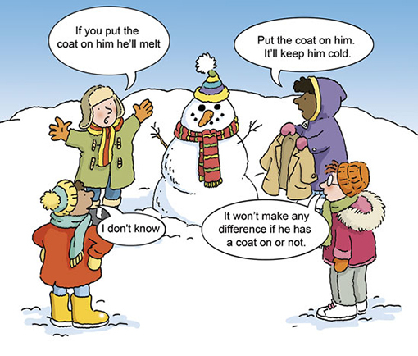
Figure 5 Concept cartoon. Adapted from Keogh and Naylor (1997)
View description - Figure 5 Concept cartoon. Adapted from Keogh and Naylor (1997)

Provide your answer...
View answer - Activity 8 Using concept cartoons

3 Discovering children’s ideas
If we are not aware of the ways in which children think, then leading them towards ideas that are accepted as scientific fact becomes a difficult task. Children can be very tenacious in holding onto ideas from their prior experience. Their ‘alternative frameworks’ may work alongside or, in some cases, be in opposition to accepted scientific ideas, preventing the development of scientific understanding. Thus, it is necessary to elicit children’s prior learning and alternative frameworks so we can help them to progress.
From your own experiences, can you think of any instances of such ‘alternative frameworks’? For example, some children think that as the Sun moves in the sky through the day, it is the Sun that orbits the Earth.
After you’ve considered these frameworks, move on to the next activity below.

Activity 9 Techniques to discover children’s ideas
Allow about 15 minutes

In addition to using concept cartoons, what other approaches could you use to help you to discover children’s ideas?

Provide your answer...
View comment - Activity 9 Techniques to discover children’s ideas

When trying to discover children’s understanding of scientific concepts, the most suitable approach to use will depend on the age of the children and the concepts you want to find out about (Pine et al., 2001).

3.1 Children expressing their ideas
One of the most important things an adult can do is listen to children, and give them opportunities to express their ideas in different ways.

Activity 10 Listening to children
Allow about 10 minutes

Watch the following two video clips, and observe how children are given opportunities to express their ideas at the start and end of a topic. What roles do you think the adults have played? Note any thoughts in the box.

Video content is not available in this format.
Video 1: Observing seeds
View description - Video 1: Observing seeds
View transcript - Video 1: Observing seeds

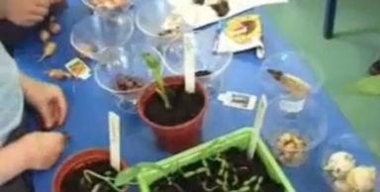

Video content is not available in this format.
Video 2: Christopher explains about friction
View description - Video 2: Christopher explains about friction
View transcript - Video 2: Christopher explains about friction

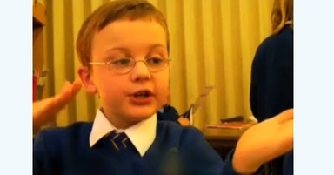

Provide your answer...
View comment - Activity 10 Listening to children

It’s become widely accepted that language plays a key role in learning science, and Bruner (1978) stressed the importance of language as a way of learning how to think. If we are given opportunities to communicate our ideas, we begin to examine and perhaps question our preconceptions, and to develop our conceptual understanding.

3.2 Concept mapping
Another way to find out about children’s existing knowledge is to use concept maps. These are not the same as brainstorms, spider diagrams or flow charts. Concept mapping is concerned with the organisation of ideas and the relationships between concepts (the term ‘concept’ is used to mean any term or phrase that has a scientific meaning). They are more sophisticated than mind maps because they reveal the conceptual understanding of the person devising the map. Pairs of concepts are connected by words and phrases along an arrow that shows the direction in which each pair should be read. An example is given in Figure 6.

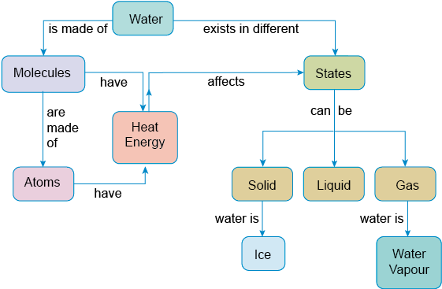
Figure 6 An example of a concept map
View description - Figure 6 An example of a concept map

Concept maps are not flow diagrams. Although a concept might be linked to several others, the reading of a relationship is between pairs of words only. You do not link three concepts to make a longer phrase, for example. Each pair of linked concepts stands independently from the other pairs.

3.3 Constructing a concept map
There is no one right way to construct a concept map. However, there are some key steps and principles that need to be kept in mind. Read the following example before making your own concept map.
Identify the concepts or key terms
Focus on a few key concepts. Single words should be used to represent each concept, so for example, the chemistry of water might include ‘molecule(s)’, ‘water’, ‘electron(s)’, ‘charge’, ‘polar’, ‘atom(s)’, ‘bond(s)’, ‘oxygen’ and ‘hydrogen’.
Concepts can be represented by pictures. When working with children you might provide them with a list of concepts or generate them with children through a brainstorm activity.
Sort through the concepts
Write the concept words or draw pictures on small pieces of paper so they can be moved about. Sort through the concepts and leave out ones you do not know or do not think are related to the other words (Figure 7).

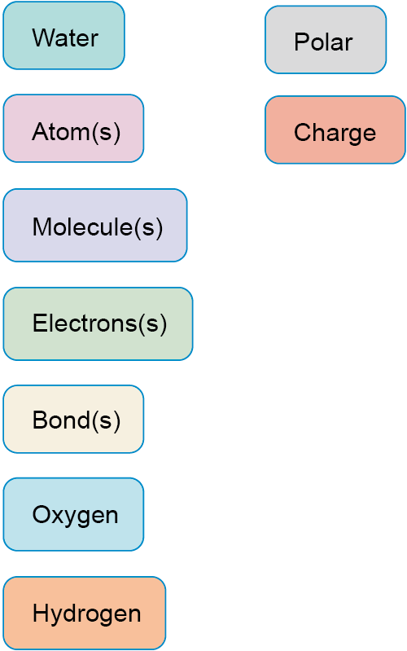
Figure 7 Sorting concepts
View description - Figure 7 Sorting concepts

Forming the map
Put the remaining concept words on a sheet of paper. Arrange them in a way that makes sense to you, so that words that you see as closely connected are near each other (Figure 8).

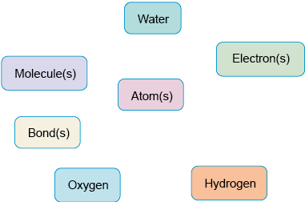
Figure 8 Arranging concepts
View description - Figure 8 Arranging concepts

Sticking down the terms
When you are satisfied with the arrangement, stick them down or write the concepts on the sheet, surrounding each with a box to denote that it is a concept.
Linking the pairs
Next, identify pairs of concepts that you see as being directly connected (Figure 9).

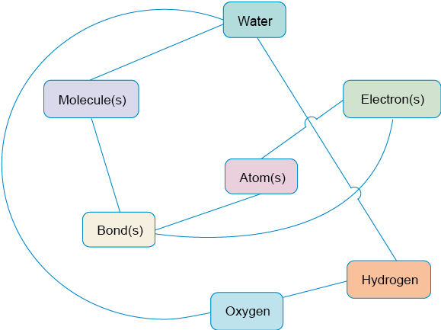
Figure 9 Linking concepts
View description - Figure 9 Linking concepts

Remember that in a concept map, only pairs of concepts are linked – each line is a separate, independent link and can be read forwards or backwards.
Adding the connecting phrases
Writing in the link words and adding arrows are crucial steps. Without these, concept maps are of little value (White and Gunstone, 1992).The arrow indicates the direction in which to read – which word is first in the ‘sentence’ (Figure 10).

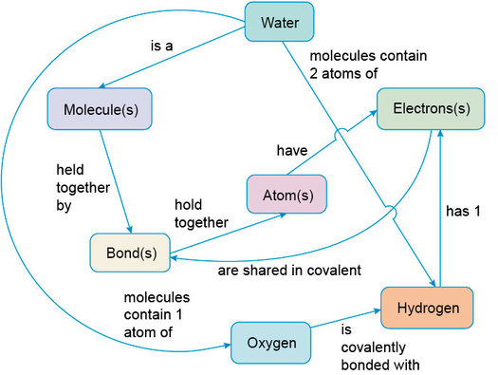
Figure 10 Adding details
View description - Figure 10 Adding details

Final checks
Go back to any concept words that you did not include in the first step, and see if you can include them in your map.

3.4 Uses of concept mapping
Concept mapping is a useful technique for assessing understanding. Not only do the linkages show how a person understands concepts, but words not used or with poor connections suggest a weaker understanding. Concept maps can be used to support learning as well as to assess understanding. For example, completing a concept map as a group to consolidate new work enables children to discuss their ideas (socio-constructivism) and by listening to the conversations, you can assess children’s understanding. Concept maps can also be useful for adults in revising their own understanding.
Concept mapping is used across all age groups and phases of education. However, it takes some time to learn how to construct them. A variety of methods have been suggested to teach the technique to individuals, but all rely on practising with simple examples first. Concept maps are particularly appealing to visual learners, but all children can benefit from using them. Remember, that as concept maps are personal, there is no one ‘right’ map.

Activity 11 Making a concept map
Allow about 30 minutes

Follow the previous instructions to produce your own concept map. You can choose your own subject and concepts or use those listed below for plant nutrition.
- food
- green plant
- chlorophyll
- carbon dioxide
- oxygen
- water
- soil
- micronutrients
- glucose
- light
- respiration.

Once you have completed the concept map, spend 5 or 10 minutes researching the subject and the concepts. Would you change anything in your map?

4 Using models in science
Science develops and uses models which are simplified representations of the real world. Concept maps are a type of model that aid and show our understanding. Other models allow us to make predictions. In the following activity, you will think about models in general, before revising some of your subject knowledge about electricity and evaluating two models that could be used with primary-aged children.

Activity 12 Scientific models
Allow about 15 minutes

1. What purposes do models have in science? Give some examples of scientific models to illustrate your explanation. Can you identify some limitations of the models you identify?

Provide your answer...
View answer - Part

2. Briefly explain what is meant by the following terms.

Table 5 Key terms related to current electricity
electric current | Provide your answer...
conductor | Provide your answer...
insulator | Provide your answer...
series circuit | Provide your answer...
voltage | Provide your answer...
resistance | Provide your answer...

View answer - Part

3. Here are some statements about current electricity. Are they true or false? Note your answer in the box, along with any relevant thoughts.

Table 6 Statements about electricity
 | True or false?
Electricity is the flow of electrons in a circuit. | Provide your answer...
Positive and negative charges move in opposite directions in an electric circuit. | Provide your answer...
Batteries push electrons around a circuit. | Provide your answer...
Electricity is made in a battery when it is connected to a circuit. | Provide your answer...
Electricity is used up as it goes through a lightbulb in a circuit. | Provide your answer...
When you switch off a light in your home, the electricity is still in the wires connected to the bulb. | Provide your answer...

View answer - Part

4.1 Modelling electricity
Some of the ideas you have encountered are challenging because they are abstract in nature. Building and using circuits will help children to develop their understanding.

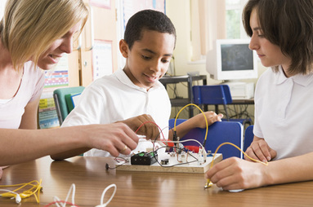
Figure 11 Making circuits
View description - Figure 11 Making circuits

We can also use models and analogies to help children relate new abstract ideas to familiar situations. Two models are outlined in the following sections. Read about and evaluate each model.

4.2 Sweets and cups model
Read the instructions and imagine using the model. Answer the questions and consider how effective this model would be in helping children to relate new abstract ideas to situations they are already familiar with. How closely do the equipment and the process model an electric current moving through a circuit? What benefits would there be in using this model? Do you foresee any problems?

Activity 13 Modelling a circuit (1)
Allow about 15 minutes

What you need:
- a packet of wrapped sweets
- two boxes
- two paper cups.
What to do:
Before you start, choose one person from the group to read out the instructions and the ‘applying your knowledge’ questions.
- Start with everyone, except one, in a circle. The one outside the circle is an observer.
- One person has a box with some wrapped sweets in it (the ‘battery’): they pass one sweet every second to the person on their right, who immediately passes each sweet to the person on their right, and so on. (It may help to have someone outside the circle keeping time by tapping the table once a second.)
- One person in the circle has a cup to represent a lamp/resistor. When a sweet arrives, they hold it in the cup for a second before they pass it on. Soon, all the sweets in the box are moving steadily around the circle. The observer stands behind the person on the left of the ‘battery’ and claps every time the person they are standing behind passes a sweet back to the battery. The rate the sweets are moving around is the current. Allow the sweets to go round several times, so that everyone settles into the rhythm before you make any changes.
- Now give a cup to a second person, so there are now two lamps/resistors in the circuit. What happens to the rate that sweets pass round the circuit (how often the observer claps) now?
- Now give someone else in the group a box, and half of the sweets. They also pass one sweet a second, so now there are two people passing sweets to the rest of the circle (so there are two sweets a second being passed). This increases the rate that sweets pass round the circle, and the observer claps twice as fast.
Applying your knowledge:
The following prompts will help you and children to evaluate this model:
- What forms the circuit in this model?
- What represents the current moving round the circuit?
- What represents energy in the circuit?
- Where does the current collect energy?
- In what ways is this model similar to your own ideas about electricity? In what ways is it different?

Provide your answer...
View answer - Activity 13 Modelling a circuit (1)

4.3 Rope model
The rope model is another model that demonstrates electric current moving around a circuit. Once more, read the instruction, answer the questions and consider how effective the model is for helping children to develop their conceptual understanding.

Activity 14 Modelling a circuit (2)
Allow about 15 minutes

What you need:
- a (large) loop of rope, ideally with a pattern or marks on it every metre, so you can see how fast it is moving.
What to do:
Before you start, choose one person from the group to read out the instructions and the ‘applying your knowledge’ questions.
- Everyone in the group stands in a circle and holds the rope so that the loop is not pulled too tightly, but does not sag anywhere either.
- One person pulls the rope around steadily, i.e. with a steady amount of pull.
- Everyone else should grip the rope very lightly as it passes through their hands.
- Everyone should grip more tightly and notice what happens. Be careful though, not too tightly! (This is not a tug of war game: the person pulling is meant to give a constant amount of pull, and should not start pulling harder and harder as everyone else grips more tightly.)
Applying your knowledge:
The following prompts will help you and children to evaluate this model:
- What forms the circuit in this model?
- What represents the current moving round the circuit?
- What represents energy in the circuit?
- Where does the current collect energy?
- In what ways is this model similar to your own ideas about electricity? In what ways is it different?

Provide your answer...
View answer - Activity 14 Modelling a circuit (2)

Conclusion
Achieving and maintaining confidence in relation to personal subject knowledge is a challenge for all primary education practitioners. In science, the challenges include:
- rapid advances in knowledge, understanding and technology
- shifting views in science and attitudes to science
- the breadth of ‘content’ across the main sub-disciplines.
No matter how good your science subject knowledge, to effectively support children’s learning, you must understand the ways children think about science, and you need to ‘be able to evaluate the thinking behind students’ own methods, and identify students’ common misconceptions’ (Coe et al., 2014, p. 2). You will also need to challenge stereotypes about science, and make science learning experiences engaging and relevant to children.
This OpenLearn course is an adapted extract from the Open University course E209 Developing subject knowledge for the primary years, relevant to anyone interested in the education of 3 to 11 year old children.

References
Braund, M. and Leigh, J. (2013) ‘Frequency and efficacy of talk-related tasks in primary science’, Research in Science Education, vol. 43, no. 2, pp. 457–78.
Bruner, J. S. (1978) ‘The role of dialogue in language acquisition’, in Sinclair, A., Jarvelle, R. J., and Levelt, W. J. M. (eds) The Child’s Concept of Language, New York, Springer-Verlag.
Coe, R., Alioisi, C., Higgins, S. and Major, L. E. (2014) What Makes Great Teaching? Review of the Underpinning Research [Online]. Available at www.suttontrust.com/wp-content/uploads/2014/10/What-Makes-Great-Teaching-REPORT.pdf (Accessed 14 September 2016).
Go-Lab (n.d.) Big Ideas of Science [Online]. Available at www.golabz.eu/big-ideas (Accessed 12 November 2016).
Harlen, W. (2010) Principles and Big Ideas of Science Education, Hatfield, ASE [Online]. Available at www.ase.org.uk/documents/working-with-the-big-ideas-in-science-education/ (Accessed 5 September 2016).
Harlen, W. and Jelly, S. (1989) Developing Science in the Primary Classroom, Edinburgh, Oliver and Boyd.
Kearton, V. (2011) ‘Developing literacy skills within science lessons: what does research say?’, Education in Science, vol. 241, pp. 26-27 [Online]. Available at www.ase.org.uk/journals/education-in-science/2011/02/241/3913/826.pdf (Accessed 7 November 2017).
Keogh, B. and Naylor, S. (1997) Starting Points for Science, Sandbach, Millgate House.
Metcalfe, G. (2014) ‘Think big! The human condition project’, Primary Science, vol. 134, pp. 8–11.
Mooney, L. (2013) ‘Early years children think too!’, Primary Science, vol. 130, pp. 32–34 [Online]. Available at www.ase.org.uk/journals/primary-science/2013/11/130/ (Accessed 28 June 2016).
Pine, K., Messer, D. and St. John, K. (2001) ‘Children’s misconceptions in primary science: a survey of teachers’ views’, Research in Science & Technological Education, vol. 19, no. 1, pp. 79–96 [Online]. Available at dx.doi.org/10.1080/02635140120046240 (Accessed 16 May 2016).
Vosniadou, S., Ioannides, C., Dimitrakopoulou A. and Papademetriou, E. (2001) ‘Designing learning environments to promote conceptual change in science,’ Learning and Instruction, vol. 11, no. 4-5, pp. 381–419.
Watts, D. (1998) ‘Children’s learning of science concepts’, in Sherrington, R. (ed) ASE Guide to Primary Science Education, Cheltenham, Stanley Thornes.
White, R. and Gunstone, R. (1992) Probing Understanding, London, Falmer Press.

Further reading
Peacock, G., Sharp, J., Johnsey, R. and Wright, D. (2014) Primary Science: Knowledge and Understanding, 7th edn, London, Sage.

Acknowledgements
This free course was written by Paula Addison-Pettit.
Except for third party materials and otherwise stated (see terms and conditions), this content is made available under a Creative Commons Attribution-NonCommercial-ShareAlike 4.0 Licence.
The material acknowledged below is Proprietary and used under licence (not subject to Creative Commons Licence). Grateful acknowledgement is made to the following sources for permission to reproduce material in this free course:

Images
Course image © wundervisuals / iStockphoto.com
Figure 1 © The Open University
Figure 2 © Alamy
Figures 3–10 © The Open University
Figure 11 © Catherine Yeulet / iStockphoto.com

Videos
Video 1 © Primary Science Teaching Trust
Video 2 © The Open University
Every effort has been made to contact copyright owners. If any have been inadvertently overlooked, the publishers will be pleased to make the necessary arrangements at the first opportunity.
Don’t miss out
If reading this text has inspired you to learn more, you may be interested in joining the millions of people who discover our free learning resources and qualifications by visiting The Open University – www.open.edu/openlearn/free-courses.

Solutions

Activity 1 Popular views about science

Comment
Those who influence attitudes towards science and how scientific knowledge develops include researchers, government, industry and religious and lobby groups. Attitudes change – for example, over recent years there has been a growing interest about science related to medicine and the environment. There has also been much cynicism in some quarters about some scientific evidence and theories – for example, in relation to climate change. These attitudes impact on science teaching and learning: the topics that are included in the curriculum, how science is portrayed, children’s engagement and how children ‘do’ science.
Whatever the content and conception of science presented in the science curriculum, the role of adults in mediating the science curriculum and in engaging and enthusing young learners is critical. Your attitude to science will have been influenced by your own experiences including in:
- education (formally at school, and beyond that, informally through actions including visiting museums or sites concerned with environmental education, reading, watching television and using the internet, via finding out about health, diet and environmental issues)
- work (for example, in roles in education, medicine or in industry)
- hobbies (finding out about weather for holiday plans, the soil if you are a keen gardener, habitats and migration if you are a birdwatcher).
Back to - Activity 1 Popular views about science

Activity 2 Theories

Answer
A scientific theory explains some aspect of the natural world. A theory is well-substantiated and widely accepted because it will have been tested and confirmed through observation and experimentation. Theories are used to make predictions and explain observations. Examples include the theory of natural selection and evolution, atomic theory and the theory of gravity. It should be noted that though these examples are ‘theories’ this is not meant to imply doubt – the evidence to support them is so substantial that they are often treated as ‘fact’. Nevertheless, scientists work on the basis that a theory can never be proved absolutely, because it would only take some additional evidence to disprove it. Knowledge is constructed through human senses – a process that will always involve an element of subjectivity. So, scientific theories are not infallible, and even when there is robust evidence, human values, ethics and beliefs may result in competing views. We are left to judge which theory or finding is valid.
Back to - Activity 2 Theories

Activity 3 Big and small ideas

Comment
There are many examples that you may have identified, including:
- Young children might plant stones and seeds in soil to see if they grow, to identify living and non-living things (small idea), while older children might learn about cellular structures that are unique to living things (big idea).
- Children may observe that the sun appears to ‘move’ during the day and that stars ‘appear’ at night (small idea). Later on, this will develop into an understanding of the fact that the Earth turns on its axis and that our planet is part of a wider solar system (big idea).
- Young children may play with parachutes and observe that they ‘slow down’ a falling object (small idea). Older children will learn about the gravitational and air resistance forces involved in this interaction (big idea).
Back to - Activity 3 Big and small ideas

Activity 4 Scale

Answer
The objects should be listed in the following order:
(smallest)
- proton
- atom
- molecule
Note: A micrometre (micron) is 1 millionth of a metre (note the English spelling). Protons, atoms and molecules are too small to be measured in this way.
- virus
- bacteria
- red blood cell
- plant cell
- flea
- ladybird
- human being
- the Earth
- star
- solar system
- galaxy
- universe
(largest)
Back to - Activity 4 Scale

Activity 5 Everyday and scientific meanings

Comment
In everyday language, these words are regularly used in ways that can vary quite a bit from their scientific meaning. For example, you might hear ‘she’s got so much energy’ or ‘I caught my reflection in the shop window’, while these words are used for quite specific purposes in biology and physics.
Back to - Activity 5 Everyday and scientific meanings

Activity 6 Atoms and molecules

Answer

Table 3 Definitions of atoms and molecules
Definitions of ‘atom’

1. The simplest structure in chemistry. It contains a nucleus with protons and neutrons, and electrons moving round in shells. | Whether it is the simplest structure in chemistry is debatable and potentially confusing. The reference to electrons moving round in shells is not helpful because children will have different ideas about ‘shells’ than those that apply to atoms.
2. The smallest part of an element that can exist as a stable entity. | True, but not helpful because of the use of the term ‘stable entity’.
3. The building blocks of life, the LEGO® of nature. | True. This is probably the most helpful for younger primary children because it avoids other complicated words and uses something they are more likely to be familiar with.
4. The smallest particle of an element that still shows the chemical properties of the element. | True, but this explanation requires an understanding of chemical properties.
5. The smallest particle that can be obtained by chemical means. | True, but not useful because ‘by chemical means’ adds complexity.
6. The smallest particle that can be found. It is made up of protons, neutrons and electrons. | True. This explanation is useful, even though it includes protons, neutrons and electrons. They are easier concepts to understand than expressions like ‘chemical means’ or ‘stable entity’.
Definitions of ‘molecule’

7. The smallest particle of matter that can exist in a free state. | True, but not very useful because of the use of the term ‘free state’.
8. Something that is formed by two atoms bonding together. | True and useful because it is put in simple terms.
9. The smallest portion of a substance that is capable of existing independently and retaining the properties of the original substance. | True, but not useful because it is too complicated.
10. Group of two or more atoms bonded together. A molecule of an element consists of one or more like atoms; a molecule of a compound consists of two or more different atoms bonded together. | True, but takes the definition into elements and compounds.

Back to - Activity 6 Atoms and molecules

Activity 7 Living, non-living or dead?

Part

Answer

A common acronym to remember the seven characteristics is MRS GREN.
M | - movement: this may be obvious movement or internal movement of substances such as sap.
R | - respiration: the process of releasing energy from food, not to be confused with breathing. Like all living things, plants need to respire.
S | - sensitivity: detecting changes in the environment. Plants respond to light, gravity, and some respond to touch (e.g. the venus flytrap).
G | - growth: this is not just growing bigger, but also includes the replacing of cells that die, and the repair of wounds.
R | - reproduction: passing on of genetic information to new individuals. Plants produce seeds (sexual reproduction), or reproduce vegetatively (asexual reproduction) with the new individuals being identical to the parent plant.
E | - excretion: the process of getting rid of metabolic waste products. Oxygen is a plant waste product, released during photosynthesis.
N | - nutrition: all living things need nutrients to make new material and drive the living processes. Plants take in nutrients and the energy needed to drive these processes. Plants also take in micronutrients, usually dissolved in the water taken in by the roots.

Back to - Part

Part

Answer

Table 4 Classifying living and non-living items
Object: | Classification: | Notes:
Fire | non-living | Children may classify it as living because it moves.
Tree | living | Plants are often not classified as living by children, because they are not obviously active and moving.
Mushroom | living | Even when children categorise plants as living, fungi such as mushrooms may not be included. (If the mushroom has just been picked and is still respiring it’s still living. When it stops respiring, it’s dead.)
Seed | living | Whether a seed is living or dead is hard to tell until they are planted or tested to see if they are respiring. Seeds start off as living – if they didn’t, the world would be in deep trouble!
Bird’s egg | living | Like the plant seed, it can be hard to tell if the egg is dead or alive. If it’s been bought from the supermarket, it has probably never been alive because it will not have been fertilised. The embryo in an egg that has been fertilised will die if not kept warm though. Like seeds, fertilised eggs start off as living.
Milk | non-living | This is an animal product, produced by a living thing, but not in itself alive or once alive.
Egyptian mummy | once lived | Of course, the movies would have you believe that they can still get up and about!
Bottle cork | non-living | This is an interesting one, because it conflates material from a once living thing that has been crafted into an object. Would you say a wooden table once lived? The material it is made from came from a tree that once lived, but tables and bottle corks have not once lived. So, the bottle cork was part of a living tree once, but as an object it was never alive. To add to the conundrum, much like hair, cork bark is made of dead cells.
Ammonite fossil | non-living | This is another interesting one that leads to arguments. To classify it, you need to have a clear idea of what a fossil is. An ammonite was a living thing, but any traces of the living cells have long gone and been replaced with rock. Essentially, the fossil ammonite is a mould made of rock.
Virus | other – viruses cannot be clearly placed in any of these categories | They meet some of the biological requirements for being defined as living, but not all of them. This shows that imposing such definitions on the world is not as simple as we would like to think. Human constructions of ‘living’ are philosophical as well as biological, and where to draw the line is the source of much debate.

Back to - Part

Activity 8 Using concept cartoons

Answer
The coat would delay melting because it would reduce the energy being transferred from the external environment. It is the same principle as using cooler bags to carry frozen food when shopping. However, coats are associated with keeping warm, so it is not unusual to reach the wrong conclusion that the coat would increase the rate of thawing.
Back to - Activity 8 Using concept cartoons

Activity 9 Techniques to discover children’s ideas

Comment
The techniques described below can all help.
- 1. Using pictures
Drawing or annotating diagrams does not rely on language skills and can reveal understanding that cannot be revealed through questioning.
For example:
  - Draw what’s inside your body or what happens to food after you have eaten it.
  - Use arrows on this diagram of a flower, the Sun and an eye to show how we see objects.
  - Draw a plant to show how it gets its food.
  - Draw what happens to a drop of blood leaving the heart, visiting the big toe on its journey.
  - Use arrows to indicate the forces acting on a ball after it has been kicked; compare this to a ball rolling across the floor.
Activities that involve sorting or selecting pictures can be employed with all children, but may be particularly useful for younger children or pupils with some special educational needs (SEN).
- 2. Creative writing or drama
For example:
  - Pretend you are a water particle, and describe what happens to you as you go from being in frozen water to evaporating.
  - What would happen if we got our food like plants get their food? What would happen if friction was switched off?
  - Pretend you are a drop of blood, and describe what happens to you as you go around the body.
- 3. Sorting activities
These activities are useful to find out what criteria children use to classify objects. Real objects or pictures can be used. For example:
  - Sort these things/pictures of things into living, non-living, once living.
  - Sort these things/pictures of things into solid, liquid, gas.
- 4. True/false statements
True/false statements can be used to reveal misconceptions. To use these, you will need to know what the common misconceptions or confusions are and ensure they are included in the statements.
- 5. Predict and explain
Give children a situation, and ask them to predict what will happen next, explaining their reasoning. For example, you might ask young children to predict what will happen when objects made from different materials are placed in water. This will reveal what ideas they hold about floating and sinking.
- 6. Exploratory play
Allowing children to play and explore can engage them and help us to identify children’s knowledge, understanding and skills prior to adult-led learning. For example, playing outside, looking for evidence of seasonal changes, or playing with soil and seeds.
Back to - Activity 9 Techniques to discover children’s ideas

Activity 10 Listening to children

Comment
In the first film, the teacher has created an environment where young children share their ideas as they start their observations in pairs. Time, space and resources have been organised and the children are encouraged to touch and look at the seeds. The teacher stands back and gives the children time to explore the seeds and to share their existing knowledge as they start the topic, with one girl sharing her belief that one of the seeds is a bean.
In the second clip, it is clear that much of Christopher’s learning has taken place as a result of observing or measuring, and then discussing what his observations might mean with the other children and adults. Being able to put what he has seen into his own words, and indeed ‘teaching’ someone else, helps him to articulate what he knows. He might need some prompts but, crucially, his ideas are valued as someone listens to him. Although we do not see the teaching prior to Christopher’s interview, it is evident that he has had opportunities for extended investigation and exploration.
Back to - Activity 10 Listening to children

Activity 12 Scientific models

Part

Answer
Possible examples include:
- A scale model of a wind tunnel to test the impact of an aeroplane’s shape on its flying efficiency.
- A crash dummy enables us to examine the impacts of a crash on a human body.
- Computer models used to predict the weather.
- Animals used as models for testing medicines.
Models have limitations though. For example: animals are not the same as humans and do not always react in the same way; car crash dummies don’t move and are not constructed like humans.
Back to - Part

Part

Answer

Table 5 Key terms related to current electricity
electric current | An electric current is the flow of electric charge, often carried by electrons in wires.
conductor | A conductor is a material that will carry an electric current. Metals are good conductors.
insulator | An insulator is a material that will not carry an electric current. Plastics, wood, ceramics are good insulators.
series circuit | A circuit has a set of components linked by wires which allow an electric current to pass through them. A series circuit is one in which the bulbs and other components are in line and the electric current passes through each, one after another.
voltage | Voltage, also called electromotive force or potential difference, is the size of the difference in the charge between two points in an electrical field. It’s a measure of how much ‘push’ there is. A 9V battery provides more push than a 1.5V battery.
resistance | Resistance is a measure of how much a material or system, such as a circuit or device, reduces the electric current flow through it. Resistance is measured in units of ohms (Ω). The higher the resistance, the more the current is reduced. A commonly used analogy is water flowing through pipes. The resistance is bigger when the pipe is thinner, so the water flow is decreased. Resistance also increases as the length of the conductor (wire) increases.

Back to - Part

Part

Answer

Table 6 Statements about electricity
Electricity is the flow of electrons in a circuit. | False. | This statement highlights the confusion caused by the word ‘electricity’ and it is best to avoid using it when possible. The correct way to describe the flow of electrons is to use the term ‘electric current’. It is important to use precise language consistently.
Positive and negative charges move in opposite directions in an electric circuit. | False. | Only the electrons move in an electric circuit. Although it is possible to model a circuit on the idea that positive charges move one way while negative charges move the other way, this is not the case at an atomic level.
Batteries push electrons around a circuit. | True. | This is a useful way to imagine the role of the battery. The electrons are already in the circuit and the battery provides the electromotive force (emf) that pushes the electrons around the circuit. The common misconception is that the electrons originate in the battery.
Electricity is made in a battery when it is connected to a circuit. | False. | Batteries do not make electricity. Being connected to a circuit or not in this case is irrelevant.
Electricity is used up as it goes through a lightbulb in a circuit. | False. | This is a common misconception. The electric current (electricity) continues to flow around the circuit, so it cannot be ‘used up’ in the bulb. Energy is transferred to components in the circuit. The current carries this energy.
When you switch off a light in your home, the electricity is still in the wires connected to the bulb. | False. | Using the word ‘electricity’ in this sentence doesn’t make sense – the flow of electrons in the wires is the electric current. Once the light is turned off, the electric current stops, though the electrons are still in the wires.

Back to - Part

Activity 13 Modelling a circuit (1)

Answer
The circuit in this model is the circle of children. The current is the rate of moving sweets. The energy is the number of sweets. The current collects energy from the battery (box).
Back to - Activity 13 Modelling a circuit (1)

Activity 14 Modelling a circuit (2)

Answer
The circuit in this model is the children’s hands. The current is the moving rope. The energy is the rate of the rope’s movement. Energy comes from the person pulling the rope.
Back to - Activity 14 Modelling a circuit (2)

Figure 1 Professor Boff

Description
A caricature, drawn in pencil, of a scientist wearing a white coat. He is called ‘Professor Boff’. Particular characteristics are drawn and labelled: his wild hair, bushy eyebrows, thick-rimmed glasses and beard. Other labels point to lots of pens in his pocket that have leaked onto his white coat, the dirty marks as a result of spills, a button missing and holes from chemical burns. The illustration has a hand-written caption, ‘A scientist-boffin’.
Back to - Figure 1 Professor Boff

Figure 2 Genuine experiences of science

Description
Five children are in a natural grassy area, with shrubs in the background. One child holds a magnifying glass, another holds a net and another has some kind of sample clutched in their hand. Watched by some of the children, a teacher crouches and points to a feature which is out of frame.
Back to - Figure 2 Genuine experiences of science

Figure 3 Go-Lab’s big ideas of science (Go-Lab, n.d.)

Description
A grid of eight symbols, in two rows of four, each with some text represent Go-Lab’s big ideas of science. On the top row, starting on the left: three bending arrows point in a clockwise direction to form a triangle, as in the recycling symbol. The text below reads ‘Energy cannot be created or destroyed’. Next is a box divided in four, with a letter in each quarter: S, W, EM and G. The text below reads ‘There are four fundamental interactions/forces in nature’. A telescope is drawn in the third part of the grid, with the label ‘Earth is a very small part of the Universe’. A three-dimensional image of three interlocking rings with a solid circle in the middle is in the final box on the top row, representing an atom. ‘All matter in the Universe is made of very small particles’ is written below the symbol. In the second row, from left to right, the images are: firstly, a horizontal dotted line and a parallel solid wavy line, which represent the duality of particles and waves. The text below this reads ‘in very small scales our world is subjected to the laws of quantum mechanics’. Secondly, a line rises from the bottom of the box and slits in two, on the left hand side it branches again, on the end of the branches are symbols to represent a person and a fish (i.e. animals). On the single line on the right is a mushroom to represent plants. Below, the text reads ‘Evolution is the basis for the unity of life and the biodiversity of organisms’. In the penultimate box, a wavy line encircles a space with a large solid circle in the middle and six distributed, small solid ovals in the rest of the enclosed area. The text below reads ‘Cells are the fundamental unit of life’. Finally, a circle with the outline of North and South America represents the Earth and is labelled ‘Earth is a system of systems which influences and is influenced by life on the planet’.
Back to - Figure 3 Go-Lab’s big ideas of science (Go-Lab, n.d.)

Figure 4 Observing the ‘bug hotel’ in the school bug garden

Description
In a wooded area, three girls are crouched next to some logs. They are in front of a triangular structure which has stems, twigs and logs wedged onto shelves to create a ‘bug hotel’. One girl is inserting a twig to fill one of the gaps.
Back to - Figure 4 Observing the ‘bug hotel’ in the school bug garden

Figure 5 Concept cartoon. Adapted from Keogh and Naylor (1997)

Description
A cartoon shows four children standing around a snowman that is dressed with a hat and scarf. One child holds a coat and says ‘Put the coat on him. It’ll keep him cold.’ Another child responds ‘It won’t make any difference if he has a coat on or not,’ while a third child argues ‘If you put the coat on him he’ll melt.’ Finally, the fourth child says ‘I don’t know.’
Back to - Figure 5 Concept cartoon. Adapted from Keogh and Naylor (1997)

Video 1: Observing seeds

Description
At a classroom table, in pairs, children examine and handle different kinds of seeds laid out on paper, or contained in bowls. One child uses a magnifying glass. Pots of seedlings site alongside the seeds. They share their observations which each other.
Back to - Video 1: Observing seeds

Video 2: Christopher explains about friction

Description
The clip opens with a caption ‘what do you know about friction?’. Christopher sits at a classroom desk and speaks to camera, he uses his hands to mimic a stone skimming over water and sinking. The next caption reads ‘are there any other kinds of friction?’ he answers and uses his hands to show something drop from a plane and ‘air coming up’. He throws a piece of paper in the air and then talks about how a pair of scissors, that he keeps in his hand would drop more quickly.
Back to - Video 2: Christopher explains about friction

Figure 6 An example of a concept map

Description
A concept map for ‘water’ is shown. There is a series of text boxes linked by single headed arrows, with text labels running beside the arrows. A text box at the top which reads ‘water’ is linked directly by an arrow labelled ‘is made of’ to a text box with ‘molecules’ written in it. From ‘molecules’ one arrow labelled ‘are made of’ points to a box labelled ‘atoms’, and a second arrow labelled ‘have’ leads to ‘heat energy’. ‘Atoms’ also has an arrow labelled ‘have’ which leads to the same ‘heat energy’ box. From the ‘water’ box at the top, another arrow labelled ‘exists in different’ points to a text box that reads ‘states’. ‘States’ is joined to the ‘heat energy’ box by an arrow in the opposite direction, so that together the text boxes and arrow read ‘heat energy affects states’. Three downward arrows labelled ‘can be’ link ‘states’ to three boxes which read ‘solid’, ‘liquid’ and ‘gas’. ‘Solid’ connects by an arrow labelled ‘water is’ to ‘ice’. ‘Liquid’ connects by an arrow labelled ‘water is’ to ‘water vapour’.
Back to - Figure 6 An example of a concept map

Figure 7 Sorting concepts

Description
Nine discrete coloured text boxes each contain one word: water, atom(s), polar, charge, molecule(s), electron(s), bond(s), oxygen and hydrogen.
Back to - Figure 7 Sorting concepts

Figure 8 Arranging concepts

Description
Seven boxes remain, each containing an individual word. They are arranged with ‘atom(s)’ in the centre and the other words placed around it. At the top is ‘water’ and moving clockwise, the boxes are ‘electron(s)’, ‘hydrogen’, ‘oxygen’, ‘bond(s)’, and ‘molecule(s)’.
Back to - Figure 8 Arranging concepts

Figure 9 Linking concepts

Description
The seven boxes are shown, each containing an individual word. They are arranged with ‘atom(s)’ in the centre and the other words placed around it. At the top is ‘water’ and moving clockwise, the boxes are ‘electron(s)’, ‘hydrogen’, ‘oxygen’, ‘bond(s)’, and ‘molecule(s)’. Around the outside an arcing line goes anticlockwise from ‘water’ to ‘oxygen’ and then on to ‘hydrogen’. A straight line goes down to the right from ‘water’ to ‘hydrogen’. Running next to the first arcing line, a line goes from ‘water’ to ‘molecule(s)’ and on to ‘bond(s)’, then ‘atom(s)’ and ‘electron(s)’. Finally a line goes directly from ‘bond(s)’ to ‘electron(s)’.
Back to - Figure 9 Linking concepts

Figure 10 Adding details

Description
The seven boxes are shown as in Figure 9, each box containing an individual word, and various boxes linked by lines. They are arranged with ‘atom(s)’ in the centre and the other words placed around it. At the top is ‘water’ and moving clockwise, the boxes are ‘electron(s)’, ‘hydrogen’, ‘oxygen’, ‘bond(s)’, and ‘molecule(s)’. The following bracketed words describe the placement of arrows and the text written on them. Around the outside an arcing line goes anticlockwise from ‘water’ to ‘oxygen’ (‘molecules contain 1 atom of’) and then on to ‘hydrogen’ (‘is covalently bonded with’). A straight line goes down to the right from ‘water’ to ‘hydrogen’ (‘molecules contain 2 atoms of’). Running next to the first arcing line, a line goes from ‘water’ to ‘molecule(s)’ (‘is a’) and on to ‘bond(s)’ (‘held together by’), then ‘atom(s)’ (‘hold together’) and ‘electron(s)’ (‘have’). A line goes from ‘hydrogen’ to ‘electron(s)’ (‘has 1’), and finally, a line goes directly from ‘electron(s)’ to ‘bond(s)’ (‘are shared in covalent’).
Back to - Figure 10 Adding details

Figure 11 Making circuits

Description
An adult and two children are sitting at a desk using components to make a circuit.
Back to - Figure 11 Making circuits

Video 1: Observing seeds

Transcript
[INTERPOSING VOICES]
TEACHER
We’re all going to do it. We’re all going to do it. So you need to come around here. What will you need to plant your bean seed? You can pick anything up and have a good look at it.
CHILD
What are they?
TEACHER
All right. These are your bean seeds.
CHILD
Can I see them?
GIRL 1
Little tiny seeds. Tiny seeds.
GIRL 2
And these are lovely big ones.
CHILD
So you can cook the bigger ones.
GIRL 1
Good. Now the beans are very small.
GIRL 2
They’re tiny, aren’t they? Those are the biggest ones and these are the tiniest. This is the biggest, actually.
[INTERPOSING VOICES]
GIRL 1
These are the same colour.
GIRL 2
I think they’re beans.
Back to - Video 1: Observing seeds

Video 2: Christopher explains about friction

Transcript
[text on screen] What do you know about friction?
CHRISTOPHER
It slows things down … it can come between almost any two surfaces – even air and water. The things don’t have to be solid.
I’ll do a demonstration.
This is the water. This is a stone skimming. You throw the stone, it skims the water and every time it skims the water it slows down because of the friction on the water and then eventually it slows down and sinks.
[text on screen] Are there any other kinds of friction?
CHRISTOPHER
Well, there’s air resistance, so when you’re dropping from a plane then air’s coming up and it slows you down. There’s only air resistance with certain like things down here. Watch … see, that’s a little bit of air resistance that slows it down, whereas if it was this pair of scissors it would just go neeoooww!
Back to - Video 2: Christopher explains about friction

