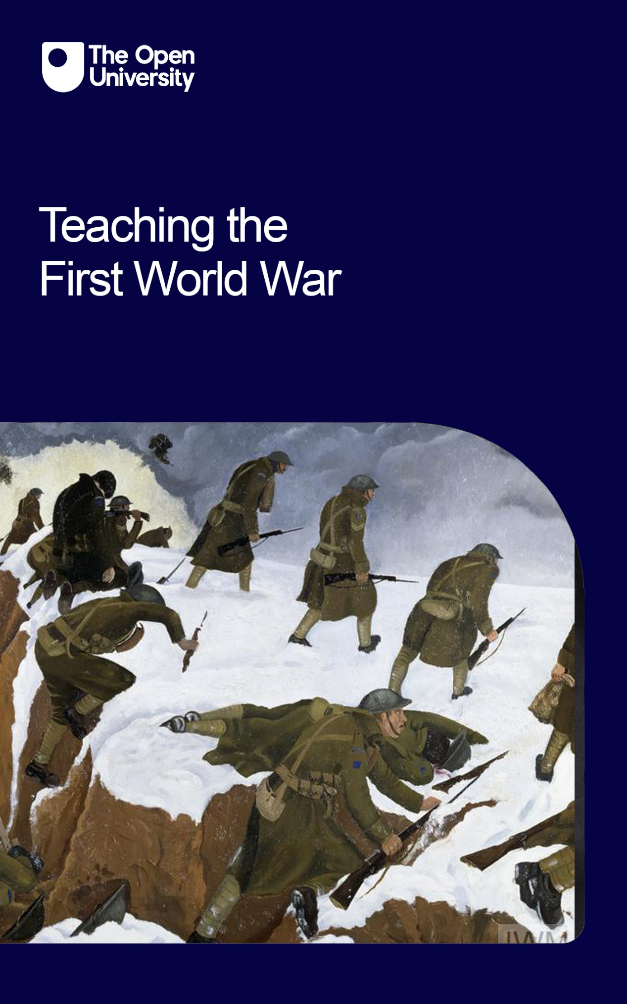

TWW_1

Teaching the First World War

About this free course
This free course is an adapted extract from the Open University course .
This version of the content may include video, images and interactive content that may not be optimised for your device.
You can experience this free course as it was originally designed on OpenLearn, the home of free learning from The Open University –
There you’ll also be able to track your progress via your activity record, which you can use to demonstrate your learning.
First published 2023.
Unless otherwise stated, copyright © 2023 The Open University, all rights reserved.
Intellectual property
Unless otherwise stated, this resource is released under the terms of the Creative Commons Licence v4.0 http://creativecommons.org/licenses/by-nc-sa/4.0/deed.en_GB. Within that The Open University interprets this licence in the following way: www.open.edu/openlearn/about-openlearn/frequently-asked-questions-on-openlearn. Copyright and rights falling outside the terms of the Creative Commons Licence are retained or controlled by The Open University. Please read the full text before using any of the content.
We believe the primary barrier to accessing high-quality educational experiences is cost, which is why we aim to publish as much free content as possible under an open licence. If it proves difficult to release content under our preferred Creative Commons licence (e.g. because we can’t afford or gain the clearances or find suitable alternatives), we will still release the materials for free under a personal end-user licence.
This is because the learning experience will always be the same high quality offering and that should always be seen as positive – even if at times the licensing is different to Creative Commons.
When using the content you must attribute us (The Open University) (the OU) and any identified author in accordance with the terms of the Creative Commons Licence.
The Acknowledgements section is used to list, amongst other things, third party (Proprietary), licensed content which is not subject to Creative Commons licensing. Proprietary content must be used (retained) intact and in context to the content at all times.
The Acknowledgements section is also used to bring to your attention any other Special Restrictions which may apply to the content. For example there may be times when the Creative Commons Non-Commercial Sharealike licence does not apply to any of the content even if owned by us (The Open University). In these instances, unless stated otherwise, the content may be used for personal and non-commercial use.
We have also identified as Proprietary other material included in the content which is not subject to Creative Commons Licence. These are OU logos, trading names and may extend to certain photographic and video images and sound recordings and any other material as may be brought to your attention.
Unauthorised use of any of the content may constitute a breach of the terms and conditions and/or intellectual property laws.
We reserve the right to alter, amend or bring to an end any terms and conditions provided here without notice.
All rights falling outside the terms of the Creative Commons licence are retained or controlled by The Open University.
Head of Intellectual Property, The Open University

Contents
- Introduction
- Learning outcomes
- Using JSTOR
- Session 1: Origins of the First World War
- Introduction
- Learning outcomes
- 1 Why did we fight?
- 1.1 Propaganda posters
- 1.2 The developing debate
- 2 The counter argument
- 2.1 Centenary debates
- 2.2 Evaluating opposing interpretations: John Röhl and Christopher Clark
- 3 Document analysis
- 3.1 A sample discussion
- 3.2 Evaluating historical interpretations
- 4 Summary
- Session 2: Propaganda
- Introduction
- Learning outcomes
- 1 Defining propaganda
- 2 Propaganda in Britain
- 2.1 British propaganda – Example 1
- 2.2 British propaganda – Example 2
- 2.3 Useful resources for studying British propaganda in the First World War
- 3 Propaganda in Germany
- 3.1 German propaganda – Example 1
- 3.2 German propaganda – Example 2
- 3.3 Useful resources for studying German propaganda in the First World War
- 4 Propaganda in the USA
- 4.1 American propaganda – Example 1
- 4.2 American propaganda – Example 2
- 5 Useful resources for studying American propaganda
- 6 Summary
- Session 3: Global war experiences
- Introduction
- Learning outcomes
- 1 A global war
- 1.1 African-American soldiers and the First World War
- 1.2 Racism in the US Army
- 1.3 Colonial soldiers in the French Army
- 1.4 Case Study: The ‘Harlem Hellfighters’
  - 1.4.1 Horace Pippin
  - 1.4.2 Horace Pippin’s wartime notebook
  - 1.4.3 James Reese Europe
- 1.5 Case Study: The war experience of Mountain Horse
  - 1.5 1 Dominion Forces in the war
  - 1.5.2 Mike Mountain Horse
- 2 Summary
- Session 4: Memory, representation and remembrance
- Introduction
- Learning outcomes
- 1 Historiography
- 2 Primary source analysis – literary responses to the war in Britain
- 2.1 War poetry – Example 1
- 2.2 War poetry – Example 2
- 3 Primary source analysis – war art
- 3.1 War art – Example 1
- 3.2 War art – Example 2
- 4 Primary source analysis – war memorials and commemorative rituals
- 4.1 War memorial – Example 1
- 4.2 War memorial – Example 2
- 5 Summary
- Session 5: Skills and resources for teaching the First World War
- Introduction
- Learning outcomes
- 1 Searching for secondary sources online
- 2 Building online searches
- 3 Using Google Scholar
- 4 Employing filters
- 5 Using JSTOR
- 6 Evaluating academic literature
- 7 Using PROMPT in practice
- 8 Finding and assessing online primary sources
- 9 Other collections
- 10 Summary
- References
- Acknowledgements
- Solutions
- Descriptions

Introduction
Annika Mombauer
This CPD course for secondary school teachers explores a range of resources and skills for historians to help you prepare classroom teaching on the First World War and to enable your students undertake their own research into aspects of the war. Skills explored here include locating primary and secondary sources online and evaluating their usefulness for the study of the First World War. It includes some topics that you likely already cover in your teaching – such as the origins of the war, and the role of propaganda – and we have supplemented these more familiar topics with new sources and detailed case studies to add richness to your teaching.
We have also included topics that have not traditionally been included in the school curriculum and have been excluded for too long – for example the role and experience of combatants who were not British and white, and the role of commemoration in our understanding and shared memory of the war. And we try to bring you up to date with recent historiographical developments and suggest reading that is readily available online to help overcome access issues to academic literature that may not be available in school libraries. With this in mind, we devote one session to developing strategies for online searches which will benefit you and your students, particularly for any non-exam assessment (NEA) projects they may be producing.
This course consists of five teaching weeks and will take around 12 hours to complete. We have included some activities for you to complete and indicated approximate timings for these. We have also included students’ skill development sections which give suggestions for work that your students could engage in.
This free course, Teaching the First World War, covers the following topics:
Session 1
Session 1 examines the ongoing historiographical debate on the war’s origins. You will be able to listen to interviews with two leading historians of the First World War who debate the causes of the conflict with one of the course authors. These interviews could be useful resources for teaching your students about the nature of historiographical debates. This session also offers a detailed document analysis case study to help students develop their skills in this area, with tips for analysing and finding additional documents to evaluate in class.
Session 2
This session discusses wartime propaganda in Britain, Germany and the USA. We explain how the term can be defined in the classroom, before discussing the broad purposes and functions of propaganda in wartime. This session emphasises developing and practising primary source skills using visual sources. Our worked examples from three countries demonstrate how visual sources can be analysed methodically, and we provide information on where to access more examples of wartime propaganda.

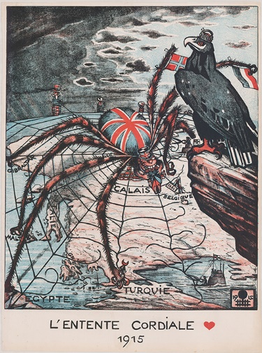
Figure 1 L’Entente Cordiale 1915
View description - Figure 1 L’Entente Cordiale 1915

Session 3
Session 3 builds further on these analytical skills. It addresses different wartime experiences, focusing on the experiences of some African American soldiers and on indigenous Canadian troops. This topic may be new to students, and we have provided information on online resources that can be used in the classroom to enrich this topic. We have included some unconventional primary sources here, too, including a unique memoir of an indigenous Canadian soldier, Mike Mountain Horse, and a decorated story robe calf skin, to continue the practice of analysing unconventional primary sources.
Session 4
This session offers suggestions on how to use representation, commemoration and memory of the First World War to develop students’ ability to analyse further unconventional primary sources. We discuss some of the historiography on memory and commemoration and explore how poems, paintings and war memorials can be used by historians as primary sources.
Session 5
This session uses First World War examples to provide detailed information on how to conduct effective internet searches for primary and secondary sources. It also demonstrates techniques for evaluating the sources such searches uncover, enabling you, and your students, to make informed choices about which sources to consult. This session has been designed to give practical guidance on a range of skills and resources that you can use for your own professional development or encourage your students to adopt. The session links to the rest of the course by focusing on specific First World War examples and exercises, but the skills taught here are transferable to other periods of history.

Learning outcomes
After studying this course, you will be able to:
- understand topics relating to the history of the First World War, including its origins, the role of propaganda, the experiences and memories of non-European combatants, and aspects of commemoration and memory
- analyse primary sources, including documents, paintings and objects, and develop ideas for how these sources can by analysed by students in the classroom
- use advanced search techniques for locating primary and secondary sources on different online platforms
- evaluate search results to identify the most suitable literature for your own work and your students
- explain search techniques which will be helpful for students’ non-exam assessment (NEA) projects.

Using JSTOR
Before we start with the course content, this section helps you to familiarise yourself with JSTOR searches. Being skilled in using this online resource will make recent literature available to you and your students, so it’s worth spending some time practising this skill.

Activity 1 JSTOR
Spend up to 20 minutes on this activity

Before you start Session 1, we recommend that you go to the Skills Section in Session 5 to practise some searching skills in JSTOR. Take particular note of Section 5: Using JSTOR, which teaches you advanced searching techniques. If you already use JSTOR regularly, you may not need to do this step, although it might be useful to check if any of the tips in Session 5 might be helpful to how you use this resource.

Did you know?
JSTOR offers registered users to view up to six articles or book chapters a month free of charge. This scheme covers all of the collection’s content and it is available to everyone – including individual students. This should certainly help students to complete their essays and coursework, and to prepare for the types of academic material with which they will be expected to engage if they go on to university.
We recommend that you opt to sign up for JSTOR to use six free articles a month as this will help you access some recent publications. We have included suggestions for articles to download from JSTOR in some of the sessions. We also make suggestions for other sources that are freely available online.

Once you have familiarised yourself with JSTOR, go to Session 1.

Session 1: Origins of the First World War

Introduction
This session was written by Annika Mombauer.
Determining why the First World War broke out has exercised historians ever since the first shots were fired in the summer of 1914. For students, this is a topic rich in documents to analyse, but also one that really emphasises that to study history is more than just to study facts, figures and events. It is a topic that focuses on historical interpretations developed at a particular time, on how they reflect particular political concerns, and on how there is not just one version of history that is ‘the truth’.

Three hours of study materials
This session contains approximately three hours of study materials and additional suggestions of materials to use in the classroom.

Learning outcomes
After studying this session, you should be able to:
- understand aspects of the historiographical debate on the origins of the First World war
- understand different interpretations from leading historians and why they developed
- understand how to help your students develop document analysis skills using the worked example of document analysis provided.

1 Why did we fight?
Some contemporaries had no idea why they were fighting in the First World War, as Harry Patch, Britain’s oldest surviving Tommy, recalled in his autobiography:

By the time I was demobilised I was thoroughly disillusioned. I could never understand why my country could call me from a peacetime job and train me to go out to France and kill a man I never knew. Why did we fight? I asked myself that, many times. At the end of the war the peace was settled round a table, so why the hell couldn’t they do that at the start, without losing millions of men.
(Patch, 2007, p. 137)

This question – ‘why did we fight?’ – has troubled generations of historians. Why did Harry Patch, and millions like him, have to kill men they never knew?

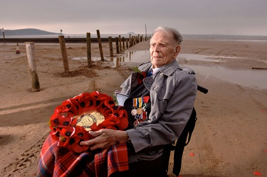
Figure 1 Harry Patch (1898–2009) was Britain’s oldest surviving Tommy
View description - Figure 1 Harry Patch (1898–2009) was Britain’s oldest surviving Tommy

In 1919, when the victorious Allies met at Versailles, they believed that Germany and its allies had started the war. But the losers also thought that their enemies had started the war. Every nation had used propaganda to convince its people that it was justified to go to war – and it had painted the enemy as the aggressor.
You can find discussions of this type of propaganda in Error! Hyperlink reference not valid..

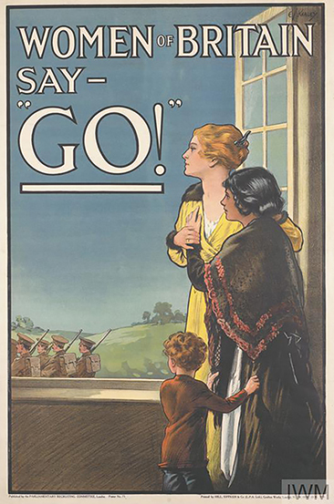
Figure 2 Women of Britain say – ‘Go’
View description - Figure 2 Women of Britain say – ‘Go’

Everyone involved in the First World War thought that they had fought a defensive war. This is a key point to stress to students because it helps to explain the outrage with which Germans greeted the Treaty of Versailles and their determination to disprove what they considered to be the ‘war-guilt lie’.
Germans remembered Kaiser Wilhelm II and Chancellor Theobald von Bethmann Hollweg declaring in August 1914 that Germany had been the victim of a vicious attack by her enemies.

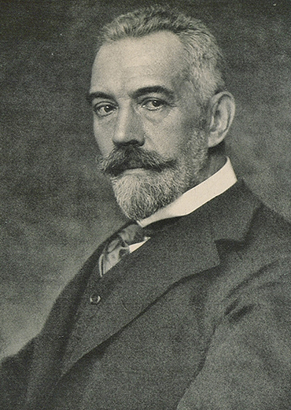
Figure 3 Theobald von Bethmann Hollweg
View description - Figure 3 Theobald von Bethmann Hollweg

The German Chancellor declared in a public address at the beginning of August 1914:

Should all our attempts [for peace] be in vain, should the sword be forced into our hand, we shall go into the field of battle with a clear conscience and the knowledge that we did not desire this war.
(Cited in Jarausch, 1973, p. 177)

And the Kaiser declared in a speech to the nation that Germany ‘was attacked in the midst of peace’, a message that was distributed across the nation, for example with propaganda posters such as the announcement ‘to the German people’ in Figure 4, which claimed that Germany was attacked by enemies.

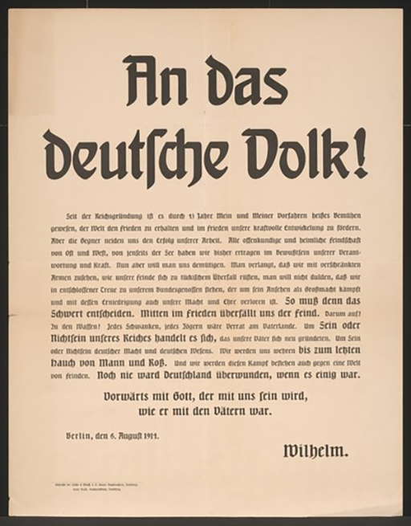
Figure 4 ‘To the German People’, 6 August 1914, contains the phrase ‘attacked in the midst of peace’
View description - Figure 4 ‘To the German People’, 6 August 1914, contains the phrase ‘attacked in ...

This poster tells Germans that their country was attacked by its neighbours and that Germany was innocent in the events that led to the international tensions of the summer of 1914 and to the outbreak of war. The final sentence reads: ‘Advance with God, who will be with us like he was with our fathers’, an allusion to the victorious Franco–Prussian war of 1870-71.

1.1 Propaganda posters
Posters like the examples in Section 1 would have been displayed in public places and were an effective propaganda tool for the German government, alongside newspaper articles that confirmed the impression of Germany’s innocence. As a result, Germans were convinced that Germany had been attacked and did not start the war, a conviction that would make it impossible to accept the Treaty of Versailles. The statement about God’s support is important, not least because the belief that God was on one’s side was widespread and not restricted to Germany.

Activity 1 Finding primary sources online
Allow around 20 minutes

The website ‘German History in Documents and Images’ has documents that could be used to inform a discussion about propaganda and what Germans considered the reasons for the outbreak of the war. If you are unfamiliar with this resource, turn to Session 5, where it is discussed in more detail. For this activity find a document that supports the argument that Germans were convinced they had been attacked in 1914.

View discussion - Activity 1 Finding primary sources online

The Allies’ decision at Versailles to blame Germany (in the infamous Article 231) seemed to settle the matter as far as the victors were concerned, but in Germany it was never accepted. Although Germany emerged politically fragmented and disunited from the war, there was one important agreement among the different factions – their rejection of the Treaty of Versailles. The war-guilt allegation was the basis for Allied reparation demands as well as an attack on national pride and honour, and Germans could not make their peace with this unloved treaty. Session 3 gives an example of this hurt pride, outlining the German reaction to the French decision to use Black soldiers to occupy the Rhineland.

Students’ skills development: Finding primary sources online
Your students can access primary sources like the Treaty of Versailles online, for example, at the WW1 Document Archive site run by Kansas University. It’s a useful site for exploring official documents like this. Documents are organised by year: the Treaty of Versailles can be located in the ‘Post-1918’ section. They could pick out some of the clauses that would have been particularly objectionable for Germans.

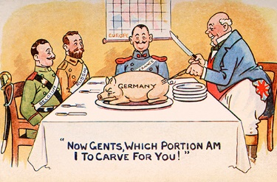
Figure 5 A postcard depicting the effect of the Treaty of Versailles on Germany
View description - Figure 5 A postcard depicting the effect of the Treaty of Versailles on Germany

In the next section, you will look at how a debate on the origins of the war developed after the Treaty of Versailles.

1.2 The developing debate
The Allies’ desire to punish Germany did not last long, for several reasons: new enemies threatened Europe, in particular the Soviet Union, and Germany became important as a future ally rather than a former enemy. But, even more significantly, following vociferous protest from within Germany and much work from the German governments and historians to prove German innocence with countless publications and propaganda initiatives, a new revisionist interpretation became dominant. Rather than blaming one country, it was now held that that the war had been an accident.
This comfortable interwar consensus remained largely unchallenged until the 1960s, with the exception of the Italian historian Luigi Albertini, whose three-volume study The Origins of the First World War was published in Italy in 1942–3 but only translated into English in 1952. Albertini puts the main responsibility for the outbreak of war squarely on Germany’s shoulders. However, there had been little interest in his work and certainly nothing to suggest a huge debate might soon erupt on this topic.
The most important challenge to the established post-war consensus that the war had been an accident came from a German professor at Hamburg University, Fritz Fischer. He challenged the revisionist orthodoxy and started an unprecedented historiographical controversy. Fischer suggested not only that Germany had caused the war, but that its policy makers had been motivated by war aims similar to Hitler’s in the Second World War. In his view, the outbreak of war had been no accident; rather, it had been designed and deliberately brought about by Germany’s decision makers.
His first book on the subject, published in Germany in 1961, marked the beginning of the so-called Fischer controversy. Fischer asserted:

As Germany willed and coveted the Austro-Serbian war and […] deliberately faced the risk of a conflict with Russia and France, her leaders must bear a substantial share of the historical responsibility for the outbreak of the general war in 1914.
Fischer, 1961 (citation from English translation 1967, p. 88)

This, arguably, was not that dissimilar to the Allies’ view at Versailles in 1919.
Fischer argued that Germany embarked on the war with clearly defined and wide-ranging war aims. The so-called ‘September Programme’ of Chancellor Bethmann Hollweg and his private secretary, Kurt Riezler, was one of the key documents to come to light in his work. Fischer claimed that it showed Germany’s aggressive foreign policy aims.
In a second major publication in 1969, Fischer argued even more forcefully that Germany’s leading decision makers were willing to seize the opportunity offered by a crisis in the Balkans, such as the one provoked by Franz Ferdinand’s assassination.
This book included another set of new documents related to the so-called ‘War Council Meeting’ of December 1912. Fischer argued that this new evidence showed that the German government considered going to war at that time – but decided to postpone the war for around 18 months – which is, of course, exactly when war did break out. You will return to this point later in the course.
For Fischer and others who argued for German responsibility, this decision to postpone the war was no coincidence but pointed to long-term planning and a deliberate desire to unleash a war when the opportunity presented itself. The assassination of Archduke Franz Ferdinand in Sarajevo was the perfect opportunity, given that it ensured that Austria would be involved in a war (after all, it was the wronged party!) and that all European governments were outraged at the murder of the Archduke.

2 The counter argument
Fischer’s view that Germany had designed and deliberately started the First World War attracted many critics who were quick to counter his ‘heretical’ claims. Among them was the eminent German historian Gerhard Ritter who was Fischer’s most critical and outspoken opponent. Ritter, who had himself fought in the First World War, summed up his reaction to Fischer’s first publication:

I could not put the book down without feeling deep melancholy: melancholy, and anxiety with regard to the coming generation.
(Quoted in Joll, 1984, p. 31)

For Ritter, the war was:

... one of the most important historical conditions of our current life’, and the question of responsibility for its outbreak was particularly stirring for us Germans, because if it was caused solely or primarily by the excessive political ambition of our nation and our government, as our war-opponents claimed in 1914, and has recently been affirmed by some German historians, then our national historical consciousness darkens even further than has already been the case through the experiences of the Hitler times!
(Cited in Mombauer, 2002, p. 138)

Ritter had fought in a war that he, like most other Germans, had ardently believed to have been a defensive war. Seeing another German argue that Germany had been the aggressor in 1914 appeared like a national and personal attack to Ritter – as indeed it did to many other veterans who did not share Fischer’s views.
Ritter might have worried about the next generation because there was already so much guilt attached to German history – accounting for the crimes of Nazi Germany was enough of a burden for future generations without adding further to this charge sheet.
In many ways, the Fischer controversy says as much about Germany in the 1960s as it reveals about imperial Germany. Fischer’s book appeared in 1961, the year that saw the building of the Berlin Wall and the trial of Nazi war criminal Adolf Eichmann in Jerusalem. The new West German state was a vulnerable outpost on the front line of the Cold War and was deeply troubled by its Nazi past, with which it was having to come to terms.
The debate on the causes of the war has always been fuelled by current political concerns, in the immediate aftermath of the war as much as in the 1960s when Fischer published his first book on the subject. After 1919, as you have seen, the main driving force behind wanting to change the current view on the causes of the war (for historians, but particularly for German governments) was the desire to revise the Treaty of Versailles. In the 1960s, the Fischer controversy occurred at the height of the Cold War, with Germany only very recently divided. Against this background, the German political establishment tried to discredit Fischer. The debate intensified against the background of the trials of Auschwitz guards and while the fledgling Federal Republic was at the mercy of its allies, blaming Germany for the origins of both wars put West Germany’s western European integration in jeopardy.

Activity 2 Finding historiographical information online
Allow up to one hour

The database 1914–1918 Online is an excellent resource for studying the First World War. It includes biographical information about many individuals and longer articles on a huge range of topics, including the historiography of the First World War. It is overseen by a large editorial team of historians and articles are of high quality. They include useful bibliographies and are an excellent starting point for researching any topic on the First World War.
To learn more about the historiographical debate discussed in this section, you could explore 1914–1918 Online and read the article by William Mulligan: ‘The Historiography of the Origins of the First World War’.

View discussion - Activity 2 Finding historiographical information online

In the next section, you will explore the renewed debates on the centenary of the outbreak of war.

2.1 Centenary debates
By the 1980s, the Fischer controversy had run out of steam, and many of Fischer’s claims, once so controversial, had found their way into mainstream history books in Germany as well as elsewhere. Historians moved away from their focus on Germany and examined the actions of other governments to explain this international crisis. By the time the war’s centenary approached, it seemed as if this 100-year controversy had run its course.
However, the centenary became the occasion for old arguments to come to the fore, as revisionist approaches gained popularity again. In this context, the work of historian Christopher Clark stands out. His publication, The Sleepwalkers: How Europe Went to War in 1914, had almost as great an impact as Fischer’s work had all those decades ago. Clark (2012) argued for more responsibility to be attached to France, Russia and Serbia. His interpretation is more lenient towards Germany and Austria-Hungary. He rejects the idea of ‘guilt’ altogether and asks: ‘Do we really need to make the case against a single guilty state, or to rank the states according to their respective share in responsibility for the outbreak of war?’ (Clark, 2012, p. 560). In this, he went against the long-established views that highlighted German responsibility. Even though he argues that we should not ‘minimize the belligerence and imperialist paranoia of the Austrian and German policy-makers that rightly absorbed the attention of Fritz Fischer and his historiographical allies’, he argues that ‘the Germans were not the only imperialists and not the only ones to succumb to paranoia.’ Rather, the crisis of 1914 ‘was the fruit of a shared political culture’ (Ibid, p. 561).
The centenary brought a somewhat unexpected revival of the debate on the origins of the war, and the topic was once again of public interest, particularly in Germany where Clark’s thesis enjoyed great popularity. Many Germans took from Clark that Germany had not been the main culprit and that the slate had been wiped clean following the publication of The Sleepwalkers.

Activity 3 Accessing review articles
Allow up to one hour

Using your JSTOR personal registration (see Session 5), access a review article that will give you an overview of the debate during the centenary and bring you up to date with more recent scholarship.
Examples include:
- Andrew G. Bonnell (2015) ‘New Histories of the Origins of the First World War: What Happened to the “Primacy of Domestic Politics?”’, Australian Journal of Politics and History, 61 (1), pp. 121–7.
- Annika Mombauer (2015) ‘Guilt or Responsibility? The Hundred-Year Debate on the Origins of World War I’, Central European History, 48, pp. 541–64.
- William Mulligan (2014) ‘The Trial Continues: New Directions in the Study of the Origins of the First World War’, English Historical Review, 129(538), pp. 639–66.
If you want to spend more time on this activity, you could also access, via JSTOR, some book reviews of the most relevant recent publications. Good starting points would be:
- Christopher Clark, The Sleepwalkers: How Europe Went to War in 1914
- Sean McMeekin, Russia and the Origins of the First World War
- T.G. Otte, July Crisis: The World’s Descent into War, Summer 1914
A useful recent summary of the arguments can be found in the revised and updated edition of Joll and Martel, The Origins of the First World War, fourth edition (London, 2022). Joll’s classic text has been updated by Gordon Martel and is one of the best overviews of the topic and suitable for students. For an up-to-date discussion of the historiographical debate, see Annika Mombauer, The Causes of the First World War. The Long Blame Game (London, 2024).

View discussion - Activity 3 Accessing review articles

In the next section, you will explore the opposing arguments of two leading historians on this topic: John Röhl and Christopher Clark.

2.2 Evaluating opposing interpretations: John Röhl and Christopher Clark
In this section, you will listen to two leading historians of the First World War, Professor John Röhl, a British-German historian who shares Fischer’s interpretation, and Professor Christopher Clark, an Australian historian who teaches at Cambridge University and whose revisionist approach to the subject made him a household name in Germany during the centenary years.
Röhl and Clark have rather opposing views on why the war broke out and they also differ in their interpretations of some of the key evidence given in this course on German decision-making before the war.
The interviews that you will listen to were recorded just after the publication of Clark’s book, The Sleepwalkers: How Europe Went to War in 1914.

Activity 4 Historians talk about their interpretations
Allow around 10 minutes

The first person you’ll hear in this activity is John Röhl. Listen to the discussion and briefly summarise his view of the causes of the war.

Audio content is not available in this format.
John Röhl 1
View transcript - John Röhl 1

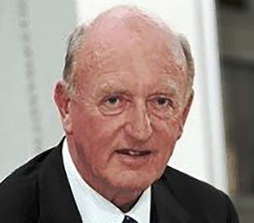
Figure 6 John Röhl

Provide your answer...
View discussion - Part

Now listen to the next audio clip, in which John Röhl expands on this view. How convinced is he by the evidence?

Audio content is not available in this format.
John Röhl 2
View transcript - John Röhl 2


Figure 7 Annika Mombauer

As you have heard, as far as Röhl is concerned, the evidence provided by Fischer and others, himself included, allows no other conclusion but that Germany had aggressive war aims.

Did you know?
In his interview, Röhl refers to the Kautsky documents. In November 1918, Karl Kautsky, a member of the independent Social Democratic Party, was given the task of editing some secret official documents, but, when his edition was finished, it was vetted by the German foreign office for showing German pre-war policy in a bad light.

Activity 5 The opinion of Christopher Clark
Allow around 10 minutes

In the next audio, Christopher Clark explains that, for him, Germany is just part of the story, but that the origins of the war were about much more than Germany. Listen to the interview with Christopher Clark and briefly summarise his position.


Figure 8 Christopher Clark

Audio content is not available in this format.
Christopher Clark 1
View transcript - Christopher Clark 1

Provide your answer...
View discussion - Part

Now listen to the final audio clip for this activity. How do Clark’s views differ from Röhl’s with regard to evidence such as the September Programme?

Audio content is not available in this format.
Christopher Clark 2
View transcript - Christopher Clark 2

View discussion - Part

In the next section, we’ll take a closer look at some of this evidence and interrogate the sources ourselves.

3 Document analysis
The second part of this session offers examples of document analysis skills. Primary sources are at the heart of this long debate. Historians have long sought evidence in the archives that conclusively ‘proves’ their interpretation. Where they differ in their views, they often also argue over how to interpret documents; sometimes, the same piece of evidence might be used to support opposing interpretations. This topic is rich in sources for historians to analyse and debate. It is ideal for teaching students document analysis skills.

Students’ skills development: Analysing primary sources
To help students with source analysis, they could apply a number of questions. It is of course not always possible to address all of these questions but, after a classroom discussion and perhaps with further research online, it should be possible to answer many of them. Here are some of the questions they could ask:
What type of document is it?
- It would be useful to discuss with students why it is important to reflect on the type of document (was it written for private or public consumption, for example, and what could be inferred from this?)
- Was it a document written at the time, or later?
- Was the document produced for publication, or a secret account?
- What was its purpose?
Who is the author?
- What do we know about them already?
- Can we find out more?
- How informed or reliable is the author?
What is the document about?
- Read the details of the events described.
- Who or what is mentioned?
- What do we already know about the event or people described?
- Use short citations of important points in the document.
What is the historical context?
- What do we already know about the context, such as key political or military events?
- Are there other documents we know about that relate to this?
- This is a chance to relate the document to your wider knowledge.
How might historians use this document?
- Has there been any debate about the interpretation of this document, or about its authenticity?
- Does the document relate to others we know about and either confirm or contradict other sources?
What are the uses and limitations of this source for historians?
- How useful is this source and what can it tell us more broadly about the history of the First World War?
- How does this document relate to others, how does it inform debate, etc.

In the next activity, you can apply this list of questions to an example which would also work well in the classroom.

Activity 6 Analysing the ‘blank cheque’
Allow around 10-15 minutes

Download the ‘blank cheque’ document and identify the parts of the document that address these questions.
You could also ask students to discuss why this document is known as the ‘blank cheque’ and how useful it is in supporting Fritz Fischer’s interpretation of the origins of the war.

View discussion - Activity 6 Analysing the ‘blank cheque’

In the next section you can find a sample discussion of this document.

3.1 A sample discussion
In this section we have provided an example of document analysis using the ‘blank cheque’ document. We have included the questions listed in ‘Skills development analysing primary sources’ above as part of our analysis. The ‘blank cheque’ is an often-evoked metaphor for the promises given by Berlin to Vienna in early July 1914.

A sample discussion on the 'blank cheque' telegram
This document is a confidential telegram [what type of document?] from the Austro-Hungarian Ambassador in Berlin, Count Szögýeny-Marich [who is the author?], to his superior, Foreign Minister Leopold von Berchtold, in Vienna. It is dated 5 July 1914, just a week after the assassination of Archduke Franz Ferdinand and his wife in Sarajevo [historical context]. The document was not intended for publication, being a confidential telegram.
Count Szögýeny describes the events at the Kaiser’s palace when he delivered to the monarch a handwritten letter by the Austrian Emperor, Franz Joseph, which had been delivered to Berlin by special envoy Count Hoyos [what is the document about?]. This is the so-called ‘Hoyos Mission’, an event whose importance has been discussed by historians debating the origins of the First World War [historical context; your wider knowledge].
Vienna despatched the envoy to ascertain if their German ally would come to Austria-Hungary’s aid in case of a war with Serbia over the assassination of Franz Ferdinand. It was believed that Serbian nationalists (and possibly even the Serbian government) had been behind the murder of the Austro-Hungarian heir to the throne and the government in Vienna was trying to decide how to react to this provocation [historical context; your wider knowledge].
In his telegram, Szögýeny makes it clear that, after some initial hesitation because he could not first confer with the Chancellor, Kaiser Wilhelm gave his unconditional support to Vienna: ‘the Kaiser authorised me to inform our Gracious Majesty that we might in this case, as in all others, rely upon Germany’s full support’. He needed to consult with the German Chancellor but was certain that he, too, would want to support Vienna: ‘he did not doubt in the least that Herr von Bethmann Hollweg would entirely agree with him.’ [Short citations of important points]
This reassurance, which was indeed backed up by the Chancellor the following day, amounted to a ‘blank cheque’ for the Viennese government who could now feel free to act aggressively towards Serbia, knowing that their ally would back them if a war ensued [historical context; your wider knowledge].
The critical part of the document is: ‘even if a war between Austria-Hungary and Russia were to result, we could be convinced that Germany would stand by our side with the usual faithfulness of an ally.’ Historians like Fritz Fischer have used this document to argue that there was planning on the parts of Vienna and Berlin to risk a war [how might historians use this document?].
The document shows that the allies, Austria-Hungary and Germany, discussed their responses to the assassination, and that they decided to support each other. Kaiser Wilhelm promised that Austria could ‘rely upon Germany’s full support […] regarding an action on our part against Serbia’ [short citations of important points]. This is what amounts to issuing a blank cheque.
But it also shows that Germany was urging its ally not to delay any action: the Kaiser said he ‘would regret if we did not make use of the present moment, which was so favourable for us’. The document also spells out why this was a ‘favourable’ moment: ‘Russia was, by the way, at the present time not prepared for war, and would certainly think very hard before appealing to arms.’ [short citations of important points]
The Kaiser’s statement supports the Fischerite argument that Germany wanted to use the present opportunity to push for war while there was a chance of winning against Russia and its ally, France. This document seems to confirm Fischer’s thesis that Germany, and its ally Austria-Hungary, plotted behind the scenes to bring about a war during favourable circumstances [how might historians use this document?]. It can be supplemented with other documents that support this view, such as a telegram dated 6 July from Austrian diplomat Count Forgách to Hungarian Prime Minister Tisza in which Forgách explains that Germany urged Austria-Hungary to strike against Serbia (Cited in Mombauer (2013), No. 31, p. 208).
However, not all historians agree with Fischer that this is a significant piece of evidence for German culpability. Christopher Clark, for example, advocates less focus on Berlin and Vienna, and more focus on Serbia and its backers. In this interpretation, decisions taken in Germany and Austria-Hungary are less central than Fischer and his followers would argue. He also contends that Vienna was not bullied by Berlin but had decided on action in any case [how might historians use this source?]. And, of course, the document only tells us about decisions taken in two capital cities [limitations of the source].
To evaluate the diplomatic origins of the war properly, one would need to compare this evidence with examples from the capitals of all the major powers, and of course Serbia. Nonetheless, this is a key document in the debate on the origins of the First World War, which sheds light on decision-making in Berlin and Vienna at a time when it would still have been possible to avert a European war. Instead of exercising caution, Kaiser Wilhelm put pressure on his ally to act decisively while issuing an unconditional statement of support that did indeed amount to a ‘blank cheque’.
Historians are not agreed on whether the government in Vienna would have steered the course it did had it not been expressly encouraged by Berlin to do so.

Below is cartoonist Peter Brookes’ take on the ‘blank cheque’. This cartoon, and other contemporary takes on our topic, can be found on the 14–18–NOW website.

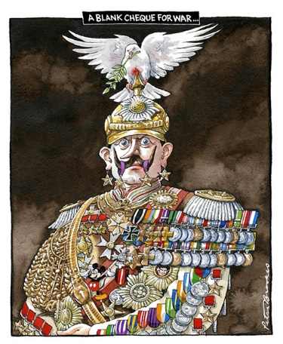
Figure 10 A blank cheque for war by Peter Brookes
View description - Figure 10 A blank cheque for war by Peter Brookes

Students’ skills development
Your students can find additional relevant documents on the German History in Documents and Images website. For example, this document, dated 10 July 1914, reproduces some of the Kaiser’s famous marginal notes, which he often scribbled in the margins of documents, and which were often rather unguarded and revealing.

In the next section, you will explore how historians differ in their interpretation of the ‘blank cheque’.

3.2 Evaluating historical interpretations
Not everyone is convinced of the central role of the ‘blank cheque’ during the July 1914 crisis, as has already been alluded to in the document analysis in the previous section. In this final audio clip, Christopher Clark discusses whether, in his opinion, the ‘blank cheque’ is evidence for German responsibility for the outbreak of war.

Activity 7 Interpreting the evidence
Allow around 10 minutes

Listen to the audio clip and summarise Clark’s view of the ‘blank cheque’.

Audio content is not available in this format.
Christopher Clark 3
View transcript - Christopher Clark 3

View discussion - Activity 7 Interpreting the evidence

4 Summary
In this first session of the course ‘Teaching the First World War’, we have examined the debate on the origins of the First World War, including some recent interpretations, and reflected on the fact that historical interpretations are shaped by contemporary political concerns.
We explored document analysis techniques and provided a template for future document study for classroom use. And you have been able to hear first-hand from leading historians in this field who disagree on how to interpret key documents.
You can use the resources provided to equip your students with the skills needed to analyse the debate and the primary sources on which the arguments are based. We have seen that historical interpretations reflect contemporary concerns and political conditions. In 1919, the topic was of contemporary political importance as much as it was during the Cold War or in 2014, when a newly confident Germany wanted to wipe the slate clean of some of its uncomfortable history.
We’ve also briefly alluded to the importance of war-time propaganda in shaping popular attitudes towards why the war broke out. In the Error! Hyperlink reference not valid., we will explore propaganda during the First World War in more detail

Session 2: Propaganda

Introduction
This session was written by Vincent Trott.
In this session, you will explore three case studies of First World War propaganda in Britain, Germany and the USA. It begins with a brief overview of the topic, explaining how the term can be defined in the classroom, before discussing the broad purposes and functions of propaganda in wartime. The emphasis here will be on primary source skills, with a focus on how individual examples of propaganda, and especially visual sources, can be analysed.

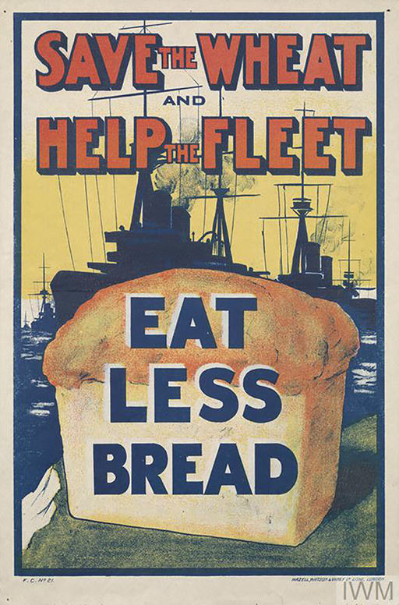
Figure 1 ‘Save the Wheat and Help the Fleet: Eat Less Bread’. British propaganda poster (1917)
View description - Figure 1 ‘Save the Wheat and Help the Fleet: Eat Less Bread’. British propaganda ...

Two hours of study materials
This session contains approximately two hours of study materials as well as additional suggestions of materials to use in the classroom. You’ll be able to put into practice some of the searching and assessing skills you’ve developed in Session 1.

If you have opted to sign up for JSTOR to use six free articles a month then this will help you access some recent publications on this subject (for details see Session 5). There are also suggestions for other sources that are freely available online.

Learning outcomes
After studying this session, you should be able to:
- trace the history of propaganda and its definition
- summarise the broad functions of propaganda during the First World War
- analyse how different types of propaganda material can be used as primary sources.

1 Defining propaganda
Propaganda is information designed to support a particular cause or damage an opposing cause. It is information produced to persuade its audience to think or act in a certain way. Though it has not always been associated with falsehood, propaganda now has negative connotations, and is generally used to describe information that distorts the truth or is intentionally misleading. This does not mean, however, that propaganda has to be entirely false; it may well contain elements of the truth.
Propaganda has often been ‘top-down’ in nature, orchestrated by the state with the aim of persuading the wider populace. Students may understand it in this light. But propaganda does not have to function in this way. During the First World War, the production of propaganda often depended on the cooperation between the state and private institutions – it was not solely produced by government agencies. And propagandistic content also appeared in magazines, newspapers, books, songs and postcards, for example, that were not commissioned by the state.
Students need to understand why propaganda was so important during the First World War, and here it is useful to introduce the concept of ‘total war’, a term used to describe a conflict that permeates every aspect of society, engaging both the military and civilians. In ‘total wars’, which depend on the support of entire populations, propaganda is especially important. We’ve already seen how this held true at the start of the war in Germany, where the government needed its people to think they were fighting a defensive war. The same held true of all governments at the time (and arguably since!) – people will choose to fight to defend their country and their families. It is much harder to persuade them to attack another country without provocation.

Activity 1 The functions of propaganda
Allow around 5 minutes

Before your read on, take a few minutes to consider the potential functions or purpose of propaganda. Why did governments use propaganda during the war?

View discussion - Activity 1 The functions of propaganda

Did you know?
Students can find further resources for studying the functions of propaganda during the First World War in the following places:
- The British Library’s First World War website has a number of fully referenced articles on propaganda, written by experts.
- This First World War propaganda video also provides a useful introduction to the topic.
- There are also a number of useful articles on the 1914–1918 Online encyclopaedia. These are all freely available, fully referenced and written by academic experts. For example:
- Propaganda at Home and Abroad provides a valuable overview of propaganda during the war.
- Making Sense of the War discusses how various countries used propaganda to understand the war.

In the next activity, you will consider what questions we can ask of propaganda material.

Activity 2 Asking questions when analysing propaganda
Allow around 5 minutes

Before you look at some examples of war-time propaganda and analyse them, take a moment to jot down some questions you think students should ask of the material.

Provide your answer...
View discussion - Activity 2 Asking questions when analysing propaganda

In the next sections, you’ll analyse propaganda from three different countries with worked examples for each. Each section will begin with a brief overview of the organisation, character and functions of propaganda in each of these countries, before introducing two examples that can be analysed as sources in the classroom.

2 Propaganda in Britain
At the start of the war, before the government had introduced conscription, propaganda often focused on encouraging young men to volunteer for the army. This involved the production of numerous posters, a task which was overseen by the Parliamentary Recruiting Committee and led by members of parliament. The British also created the War Propaganda Bureau, which was usually known as ‘Wellington House’ after its central London location.
Wellington House focused on the production of propaganda aimed at neutral countries and especially the USA, with the hope of persuading these nations to join the war on the side of Britain and its allies. Wellington House often worked with non-governmental organisations and individuals, including well-known authors and private publishing houses, to arrange the production of books and pamphlets that promoted the British war effort.
In 1917, Wellington House was combined with a number of smaller propaganda organisations to form the Department of Information, which oversaw most foreign and domestic propaganda. In 1918, this organisation was expanded again to form the Ministry of Information.
You can read more about British war propaganda on the War Propaganda Bureau page of 1914–1918 Online.

2.1 British propaganda – Example 1
In this section examples have been provided that students can use to develop their skills in document analysis using the suggested questions given earlier. Model answers have been provided for your reference.

Activity 3 Primary source analysis
Allow around 10 minutes
Let’s use the same questions we applied to primary source documents in the following analysis of the propaganda poster: Women of Britain say “Go!” (1915).

View description - Uncaptioned Figure

Some contextual information about this poster can be found on the Imperial War Museum website.
You have the option to consider each question yourself before revealing our specimen answers or use our worked example for students’ skills development.

Who?

View answer - Part

When?

View answer - Part

What?

View answer - Part

Purpose

View answer - Part

How?

View answer - Part

Uses for historians

View answer - Part

2.2 British propaganda – Example 2
The Report of the Committee on Alleged German Outrages (The Bryce Report)
The Report of the Committee on Alleged German Outrages, often known as ‘The Bryce Report’, was commissioned by Wellington House and published in 1915. The report was overseen by the former British ambassador to the USA, James Bryce, and provided details of atrocities committed by the German army during its invasion of Belgium in 1914.
As a Wellington House publication, the Bryce Report was primarily intended for American audiences, with the intention of turning American public opinion against Germany and encouraging the USA to intervene on the side of the allies.
The report included some unsubstantiated descriptions of German atrocities, including the murder of civilians and the looting and destruction of towns. In the years after the war, many investigations into wartime propaganda failed to verify the claims made in the Bryce Report, and interwar histories dismissed it as an example of misleading propaganda. However, more recent historical research – such as John Horne and Alan Kramer’s German Atrocities, 1914 (2002) – argued that many of the atrocities described in the report were in fact perpetrated at various points by the German army during its invasion of Belgium.
The debate over whether Belgian franctireurs (a term used to describe civilian snipers) attacked German troops and therefore caused some of the violent behaviour towards the Belgian population seemed to have been settled by Kramer and Horne, but their conclusions have in turn been disputed in two German publications (Spraul, 2016; Keller, 2017). The authors do not deny that atrocities were committed but claim that violent Belgian resistance was the cause of some of these excesses. These publications are not currently available in English, but this conference report summarises the arguments.

Activity 4 Primary source analysis
Allow around 10 minutes

Read this short extract from the Bryce Report and consider the questions posed for analysing this source before revealing the specimen answers.

(d) Looting, Burning and Destruction of Property
There is an overwhelming mass of evidence of the deliberate destruction of private property by the German soldiers. The destruction in most cases was effected by fire, and the German troops, as will be seen from earlier passages in the Report, had been provided beforehand with appliances for rapidly setting fire to houses. Among the appliances enumerated by witnesses are syringes for squirting petrol, guns for throwing small inflammable bombs, and small pellets made of inflammable material. Specimens of the last-mentioned have been shown to members of the Committee.
Besides burning houses the Germans frequently smashed furniture and pictures; they also broke in doors and windows. Frequently, too, they defiled houses by relieving the wants of nature upon the floor. They also appear to have perpetrated the same vileness upon piled up heaps of provisions so as to destroy what they could not themselves consume. They also on numerous occasions threw corpses into wells, or left in them the bodies of persons murdered by drowning.
(Bryce, 1915)

More pages of the report can be viewed on the British Library website.

Who?

View answer - Part

When?

View answer - Part

What?

View answer - Part

Purpose

View answer - Part

How?

View answer - Part

Uses for historians

View answer - Part

2.3 Useful resources for studying British propaganda in the First World War
Students might benefit from reading the following articles on the 1914–1918 Online encyclopaedia:
- Propaganda: Media in War Politicsprovides an overview of the various national propaganda organisations, including those in Britain.
- War Propaganda Bureau explores the centre for British propaganda abroad.
- Propaganda at Home explores domestic propaganda in Great Britain and Ireland.
- Othering/Atrocity Propaganda overviews atrocity propaganda more generally.
- Atrocity propaganda is also discussed on the British Library’s website.
If you have access to free articles on JSTOR , you may find it useful to consult this journal article, in which historians John Horne and Alan Kramer provide evidence from soldiers’ diaries to demonstrate that atrocities were committed by the German army against Belgian civilians:
- John Horne and Alan Kramer (1994) ‘German “Atrocities” and Franco-German Opinion, 1914: The Evidence of Soldiers’ Diaries’, The Journal of Modern History, 66(1), pp. 1–33.
Horne and Kramer’s 2002 book is freely available online.
Students can also find reviews freely online, including Rachamimov on Horne and Kramer, ‘German Atrocities, 1914: A History of Denial’ (more information on accessing reviews can be found in Session 5).
The next section discusses German wartime propaganda.

3 Propaganda in Germany
In Germany, wartime propaganda was more closely controlled by the military than it was in Britain. The German army’s supreme command (Oberste Heeresleitung or OHL) had a dedicated department that took responsibility for censorship, propaganda and the monitoring of public opinion.
Like the British, German propagandists were also concerned with how Germany was viewed in neutral nations: the German government established the Zentralstelle für Auslandsdienst (Central Office for Foreign Service), which was dedicated to countering foreign propaganda overseas, including in the USA.
German propagandists often justified their war effort by portraying it as a necessary, defensive response to foreign aggression. Again, just like the British, they sought to demonise the enemy, often portraying Britain as an imperialist power intent on world domination.
You will now look at two examples of German propaganda during the war using the same basic questions outlined in the previous section. We have selected posters as it is possible to analyse these without any German language skills.

3.1 German propaganda – Example 1
The first example of German propaganda is a poster from 1915.

Activity 5 Primary source analysis
Allow around 10 minutes

Figure 3 L’Entente Cordiale 1915
View description - Figure 3 L’Entente Cordiale 1915

The first example is the propaganda poster: ‘L’Entente Cordiale’ from 1915. Look at the contextual information provided and consider the questions we pose for analysing this source. You have the option to consider each question yourself before revealing our specimen answers or you can use our worked example for students’ skills development.

When?

View answer - Part

What?

View answer - Part

How?

View answer - Part

Purpose

View answer - Part

Uses for historians

View answer - Part

Did you know?
Some contextual information about this poster is available on the website of Cornell University Library.

3.2 German propaganda – Example 2
The second example is another German propaganda poster: ‘This is how it would look in German lands if the French reached the Rhine’ (1918).

Activity 6 Primary source analysis
Allow up to 5 minutes

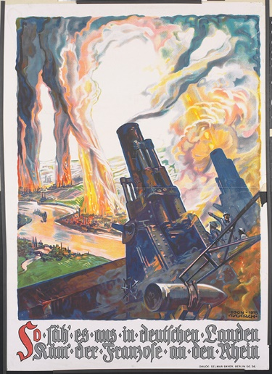
Figure 4 This is how it would look in German lands if the French reached the Rhine
View description - Figure 4 This is how it would look in German lands if the French reached the Rhi ...

You have the option to consider each question yourself before revealing our specimen answers or use our worked example for students’ skills development.

Who?

View answer - Part

When?

View answer - Part

What?

View answer - Part

Purpose

View answer - Part

How?

View answer - Part

Uses for historians

View answer - Part

In the next section you’ll find some useful resources for studying German propaganda in the First World War.

3.3 Useful resources for studying German propaganda in the First World War
Students who want to learn more about German propaganda might find the following sources useful.

Students’ skills development: Studying German propaganda in the First World War
The following articles on the 1914–1918 Online encyclopaedia are useful for our topic:
- Propaganda: Media in War Politics provides an overview of the various national propaganda organisations, including those in Germany.
- Propaganda at home (Germany) discusses domestic propaganda in Germany.

The next section looks at American propaganda.

4 Propaganda in the USA
The USA did not join the war until April 1917. Prior to intervention, there was no state-directed propaganda to influence American public opinion regarding the conflict. Despite this, the war permeated American culture in the years before its entry, and many publications and organisations sought to shape the popular response to the conflict.
Whereas some anti-war organisations, such as the American Union Against Militarism, hoped to maintain American neutrality, other groups, such as the National Security League, pressed for military preparedness and eventually favoured intervention.
Moreover, following the news of German atrocities and the sinking of the Lusitania in May 1915, attitudes towards Germany began to harden, and many publications began to demonise Germany and German immigrants living in the USA, often using similar techniques to those employed by Allied propagandists in Europe.
Immediately following American intervention in the war, President Woodrow Wilson established a special propaganda agency, the Committee on Public Information (CPI), often known as the ‘Creel Committee’, after its chairman, former journalist George Creel. The CPI consisted of a domestic section, to influence public opinion at home, and a foreign section to shape attitudes to the USA abroad. The CPI worked with artists, cartoonists, writers, actors and filmmakers to disseminate propaganda in a range of different media. The Division of Pictorial Publicity, for example, produced an enormous quantity of propaganda posters and advertisements.
As in Britain, much of this propaganda worked to demonise Germany, portraying it as an aggressive, autocratic nation. American propaganda also presented the US war effort as a crusade for democratic values, following Wilson’s claim that the USA was intervening to make the ‘world safe for democracy’ (1917). Propagandists also tried to persuade the American public to support the conflict in a number of ways, encouraging them to purchase ‘liberty bonds’ to help fund the war effort. We will now look at two examples of American propaganda, one from the period of American neutrality and the other from the period after US intervention. The next section has the first example.

4.1 American propaganda – Example 1
This first example was published in 1916 before the USA entered the war.

Students’ skills development: Primary source analysis

Print propaganda: Life magazine (1916)
You have the option to consider each question yourself before revealing our specimen answers or use our worked example for students’ skills development. (A larger version of this map can be viewed and downloaded from the website of Cornell University Library.)

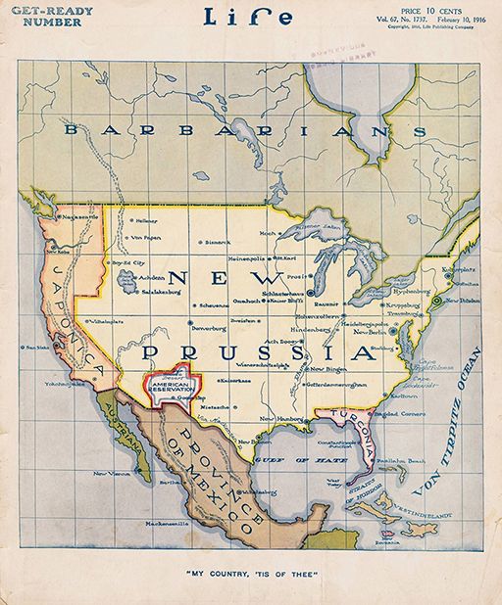
Figure 5 Front cover of Life magazine, 10 February 1916
View description - Figure 5 Front cover of Life magazine, 10 February 1916

Analysis

Who?

View answer - Analysis

When?

View answer - Part

What?

View answer - Part

Purpose

View answer - Part

How?

View answer - Part

Uses for historians

View answer - Part

The next section has the second example of American propaganda.

4.2 American propaganda – Example 2
The second example is an American war-time poster from 1918. You have the option to consider each question yourself before revealing our specimen answers or use our worked example for students’ skills development.

Students’ skills development: Primary source analysis
Poster: Beat back the Hun with Liberty Bonds (1918)

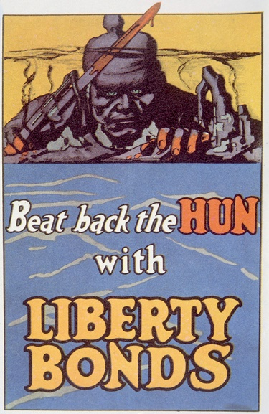
Figure 6 Beat back the Hun with Liberty Bonds (1918)
View description - Figure 6 Beat back the Hun with Liberty Bonds (1918)

Analysis

Who?

View answer - Part

When?

View answer - Part

What?

View answer - Part

Purpose

View answer - Part

How?

View answer - Part

Uses for historians

View answer - Part

In the next section you’ll find some useful resources for studying American propaganda in the First World War.

5 Useful resources for studying American propaganda
Students who want to learn more about US propaganda in the First World War might find the following sources useful.

Students’ skills development: Primary source analysis
The following articles on the ‘1914–1918 Online’ encyclopaedia are useful:
- Propaganda: Media in War Politics provides an overview of the various national propaganda organisations, including those in the USA.
- Propaganda at Home discusses propaganda in the USA.
- Creel, George discusses the head of the CPI.
- War Bonds provides a general overview of the significance of these financial loans in various countries during the war.

6 Summary
This session of the course has defined propaganda and discussed its broad functions during the First World War.
The three case studies of Britain, Germany and the USA discussed will allow students to compare and contrast the character and uses of propaganda across these three countries, with suggestions for further resources to extend this practice. The case studies also allow students to develop their primary source skills, especially with regard to visual sources such as posters.
There is a wealth of relevant primary source material available online, and the skills developed through these activities can also be applied to other examples of propaganda during the First World War.
In the Error! Hyperlink reference not valid., you will develop primary source analysis further.

Session 3: Global war experiences

Introduction
This session was written by Annika Mombauer.
The First World War was a global war which affected and drew in people from around the globe, as soldiers, carriers, nurses and civilians who suffered from the direct and indirect consequences of war. In this session, you will consider war experiences of African-American, First National Canadian and French colonial soldiers before examining two case studies: the war experiences of African-American soldiers in the infantry regiment known as the ‘Harlem Hellfighters’, and those of an indigenous native Canadian, Mike Mountain Horse. We also look at war time attitudes towards non-white combatants by examining French and German views which reveal similarities in the prejudices that existed.

Three hours of study materials
This session contains approximately three hours of study materials and additional suggestions of materials to use in the classroom.

Learning outcomes
After studying this session, you should be able to:
- describe some of the war experiences of African-American and Canadian First Nations combatants
- evaluate unique primary sources, including examples of war art, as historical evidence
- explain some of the war-time attitudes towards non-white combatants in Europe.

1 A global war

Please be aware that some of the sources in Session 3 contain racially offensive language. If you are concerned that you might find this content distressing, you might like to skip this section.

In Britain, the First World War has for a long time been seen as a primarily European and largely white endeavour – in fact, from a British vantage point one might have been excused for thinking it was fought on the Western Front only. In recent years, much more emphasis has been put on the fact that this was a global war with combatants from all around the world and with theatres of war far beyond the Western Front. This has resulted in a better understanding of the nature of fighting in these different theatres of war, in examining the war’s effect on communities in different countries and in understanding the different experiences of diverse soldiers.
Because the major combatants were also global empires, non-European troops from Asia and Africa served in all theatres of war. In total, some 65 million soldiers were mobilised in the First World War. More than six million of them came from outside Europe. (Fogarty and Tait, 2021) Their experiences have long been marginalised, but historians no longer exclude them from their studies of the war.
Major combatants like Britain and France were able to draw on their imperial ‘reserves’ and draft troops from their empires and dominions. This meant, for example, that more than one million Indians served overseas as part of the British war effort; more than 53,000 of them were killed and more than 64,000 were wounded. Canada, Australia and New Zealand recruited indigenous people for the fight in Europe – we will encounter an example of this later. The French used what they called ‘troupes indigènes’ throughout the war; around 500,000 such soldiers fought for France during the war (Fogarty and Tait, 2021). The Tirailleurs Sénégalais or Senegalese riflemen, for example, had a long tradition of fighting for the French and were recruited in large numbers during the First World War 30,000 lost their lives (Fogarty, 2016).
The war experiences of colonial troops were different and arguably worse than those of their white comrades, as they found themselves often fighting far from home in climates they were unused to, exposed to different customs and cultures, and facing not just the wrath of the enemy but often also racism from within the armies in which they served. That their experiences were marginalised for so long after the war was perhaps just one final insult among many.

Did you know?
A good starting point for considering the war as a global endeavour is David Olusoga’s The World’s War. Forgotten Soldiers of Empire, which helps us to reframe our understanding of the war. It is easily accessible in paperback and could be read (in excerpts, at least) by students.
The encyclopedia 1914–1918 Online has some relevant articles that are freely accessible, including: ‘African American Soldiers’ which outlines experiences from the USA and their impact on the Civil Rights Movement.
Further freely available secondary sources that can be accessed online are listed throughout this session.

In the next section, you will explore the role of African-American soldiers in the war.

1.1 African-American soldiers and the First World War

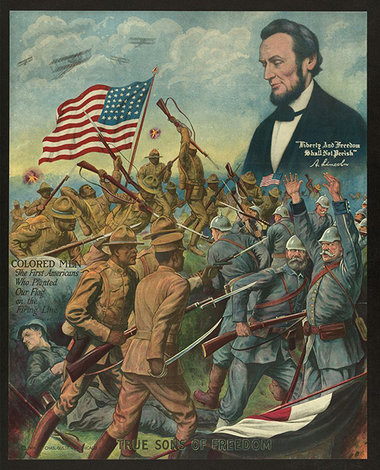
Figure 1 An American propaganda poster from 1918 (by Charles Gustrine)
View description - Figure 1 An American propaganda poster from 1918 (by Charles Gustrine)

African-American soldiers served in every military conflict since the founding of the USA, and the First World War was no exception. Around 400,000 enlisted or were drafted into the US army. By the end of the conflict, around 200,000 African-Americans had gone overseas, others supported the war effort in military camps in the USA. As American historian Chad Williams describes, ‘they entered a racist army’.

The “race question” informed the thinking of white politicians and military officials and dictated their actions in regard to black servicemen. Black men were excluded from the marines and limited to only menial positions in the navy. War planners deemed racial segregation, just as in civilian life, the most logical and efficient method of managing the presence of African Americans in the army.
(Williams, 2010, p. 6)

The first American troops arrived in France in June 1917, including some African-Americans. Of those African-American troops who made it to France, most (some 80 per cent) ended up in non-combative support roles, particularly working in the Service of Supply (SOS) section of the American Expeditionary Force (AEF) in France. As David Olusoga shows, African-Americans were disproportionately represented in these support roles, making up 30 per cent of the SOS but less than 10 per cent of all draftees (Olusoga, 2014, p. 338). These support roles consisted in the main of supplying materials, transport routes and support for others at the front, working long hours in gruelling conditions and all weathers – a far cry from the image presented in Figure 1.
The main reason why some African-American soldiers finally ended up in fighting roles, rather than serving in these supply roles (as the General Staff initially only wanted them to), was pressure from African-American public opinion back home, coupled with demands from the French to have additional troops join the French army.
Two all-Black divisions, the 92nd and 93rd Divisions (Colored), were despatched to Europe and some of their members were allowed to fight. The 93rd Division included four infantry regiments, including the 369th Infantry Regiment, known as the ‘Harlem Hellfighters’ (of whom more below), and the 370th Infantry Regiment, known as the ‘Black Devils’ – both names coined by German soldiers. However, the commander of the American Expeditionary Force, General John J. Pershing, was unsure how best to use them. As David Olusoga explains:

…the two black divisions were a political inconvenience, against which there existed considerable hostility among white troops and officers. Pershing was warned that white US troops would find it “distasteful” to serve alongside African Americans, and that the orders of African-American officers were unlikely to be obeyed by them. White soldiers were already refusing to salute African Americans of superior rank.
(Olusoga, 2014, pp. 342–3)

Rather than being incorporated into the AEF, these ‘all-coloured’ units were assigned to the French Army. ‘Loaning’ African-American troops to the French helped to get around the problem of the US Army wanting to fight independently from the French while the French Army asked for reinforcements from the Americans. The French Army was already multiracial and included soldiers from the French empire; its leaders readily incorporated the African-American units. Being excluded from the American forces for which they had volunteered must have been crushing to African-Americans who had heeded their country’s call to arms. For Pershing, it was the perfect solution.

1.2 Racism in the US Army
The French were unusual in being so willing to absorb African-American soldiers. As David Olusoga shows, while the French were willing to include the Black soldiers in their ranks, the British were not. Pershing transferred the four regiments of the 93rd Division to the French Army which removed ‘a perceived problem’. He offered the British the 92nd Division. ‘But the British, who had refused to deploy both African and Caribbean troops from their own empire to the Western Front, had absolutely no intention of absorbing into their ranks America’s unwanted black regiments and so refused Pershing’s offer’ (Olusoga, 2014, p. 343). It is worth noting that they were more than happy for white American troops to serve under their command. As for the US army, even when Black soldiers were allowed to fight, they were treated like second-class soldiers, as we will see in the next activity.

Activity 1 Racism in the US armed forces
Allow around 20 minutes

Debra Sheffer provides an example of when men of the 92nd division were allowed to fight alongside the AEF. Read her article here Racism in the Armed Forces (USA). What went wrong for the Black troops on this occasion?

View discussion - Activity 1 Racism in the US armed forces

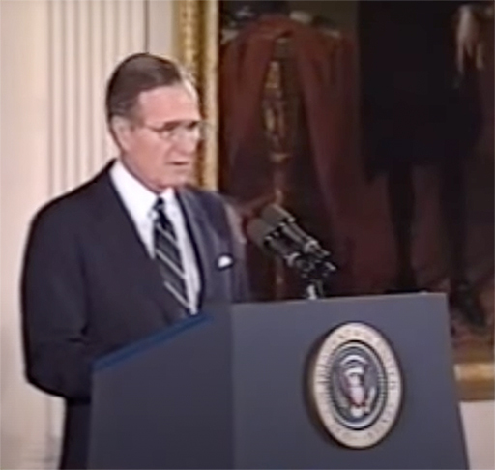
Figure 2 President George H W Bush at the ceremony to award the Medal of Honor to Freddie Stowers
View description - Figure 2 President George H W Bush at the ceremony to award the Medal of Honor to ...

Did you know?
More details on Stowers can be found on the National Veterans Memorial and Museum.

After the war, newspapers like the Bismarck Daily Tribune (Figure 3) may have suggested that African-Americans had earned the right of full citizenship, but in reality the veterans were treated no better than before the war. Segregation and discrimination continued. African-American veterans held a victory parade in New York on 12 February 1919, but were not allowed to take part in the larger parades held in New York and Washington in July. When 25,000 members of the AEF marched down Fifth Avenue in New York on 19 July, African-American soldiers were absent. Worse still, whatever hopes they may have harboured of being treated better by their fellow Americans after the war vanished in the light of at least 19 lynchings of African-American soldiers in 1919 alone, some of whom were attacked for wearing their uniform in public. Black communities were attacked in 26 American cities in what was known as the ‘Red Summer’ of 1919 (Olusoga, 2018).

Did you know?
Some photographs and newspaper coverage of the February parade can be found on the Library of Congress Blogs. You can watch some film footage of one of the July parades.

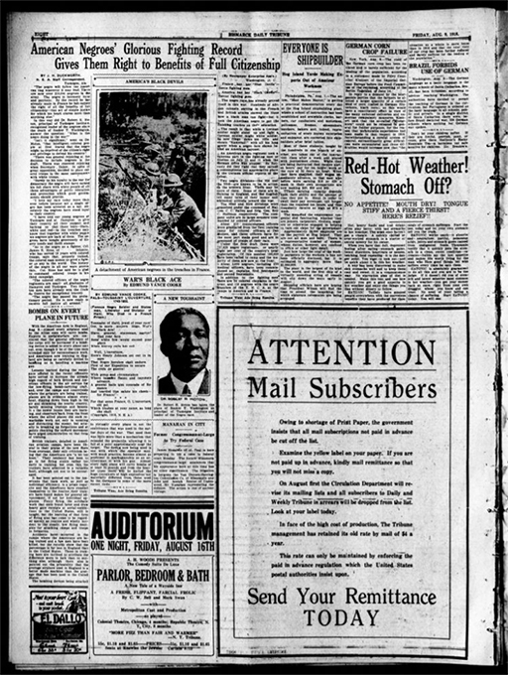
Figure 3 Bismarck Daily Tribune from August 1918
View description - Figure 3 Bismarck Daily Tribune from August 1918

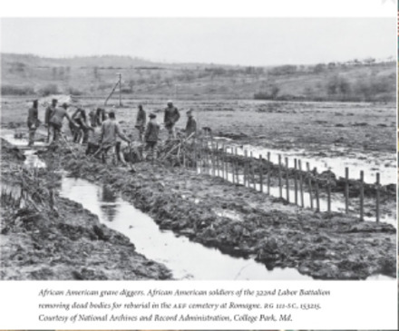
Figure 4 African-American soldiers removing bodies for burial after the war
View description - Figure 4 African-American soldiers removing bodies for burial after the war

In the next section, you will explore attitudes towards colonial troops in the French Army.

1.3 Colonial soldiers in the French Army
African-American soldiers were not the only Black troops to remain far from home after the war had ended. Many French colonial troops were also in Europe long after the Armistice. As part of the Treaty of Versailles, the German Rhineland was occupied by French troops. The French chose soldiers from various colonies of their empire for this purpose. Around 200,000 troops from Algeria, Morocco, Tunisia, Senegal and Madagascar were used to occupy the territory. Cynically, the French believed ‘in the strategic psychological effect of these troops’ on Germans (Campts, 2004, p. 32). As Tina Campts shows, the French and the Germans had the same stereotypical views of Black soldiers who were believed to possess ‘robustness, endurance, tenacity and instinct for combat, an absence of nerves, and incomparable power to shock [intimidate] their enemies’ (cited in 2004, p. 32). The French chose these troops to intimidate and humiliate the Germans.
At the beginning of the war, the French had conducted a concerted propaganda campaign in which they painted their African soldiers as brutal and bloodthirsty barbarians, with the intention of intimidating the Germans. As Kenneth J. Orosz describes:

During the first few months of the war, the French press worked to boost morale at home and terrify the enemy by popularizing the myth that their African soldiers (Tirailleurs) were ruthless, savage barbarians armed with bush knives intent on beheading Germans. For example, in an August 1914 article, La Dépêche Coloniale described Tirailleurs as black demons who would retaliate against German barbarism. The Marseille-based journal
Midi colonial ran a cartoon of a Muslim soldier wearing a necklace made of ears, with a caption cautioning that the enemy was listening. Similarly, a French postcard entitled Nos bons Sénégalais depicted a Tirailleur seeking praise from his captain for delivering a row of severed German heads. Other illustrations hinted at cannibalism by showing a grinning Tirailleur cooking dinner in a German Picklehaube helmet, referring to it as a treat from the “Boche”.
(Orosz, 2021)

Many French soldiers seem to have believed this propaganda, too. For example, Henri Barbusse felt that the presence of Moroccans among his comrades lent the war an exotic air. They were ‘intimidating and even a little frightening’, ‘devils … made for attacking… (Fogarty and Jarboe, 2021).
The occupation of the Rhineland continued until 1930 (which means that, for many of the occupying forces, their war did not end in 1918 but carried on for more than a decade!) and was referred to as the Black Shame (‘die schwarze Schande’) by Germans. The anti-Black propaganda in Figure 5, taken from the front cover of a German satirical magazine in 1916, gives a flavour of the views of the time.

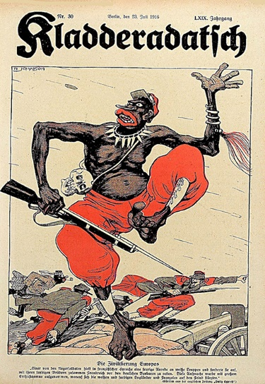
Figure 5 Front page of the magazine Kladderadatsch, 23 July 1916, entitled ‘The Civilising of Europe’
View description - Figure 5 Front page of the magazine Kladderadatsch, 23 July 1916, entitled ‘The Civilising ...

Did you know?
The satirical magazine Kladderadatsch started life in 1848 and had then been critical of the government and in favour of moderate reform, but a critic of socialism. At the outbreak of war, the journal supported the war effort and, after the war, it became increasingly right wing. For a short account of the history of this important source, see Kladderadatsch.

It is interesting to note that this kind of propaganda was also used elsewhere, for example in the USA. The cartoon in Figure 6, which is aimed at pro-German Americans, uses very similar imagery

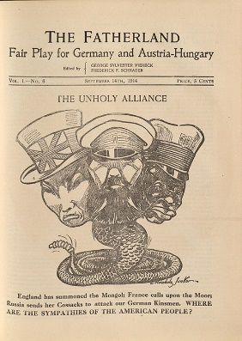
Figure 6 Front page of the US-American publication The Fatherland, 14 September 1914
View description - Figure 6 Front page of the US-American publication The Fatherland, 14 September ...

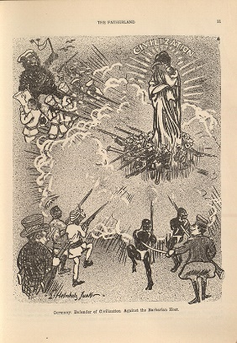
Figure 7 From The Fatherland entitled ‘Germany: Defender of Civilisation. Against the Barbarian Host’
View description - Figure 7 From The Fatherland entitled ‘Germany: Defender of Civilisation. Against ...

The next section is the first of two case studies in which we look in detail at the war-time experiences of two members of the so-called ‘Harlem Hellfighters’.

1.4 Case Study: The ‘Harlem Hellfighters’
Some of the contributions to the First World War by African-American soldiers have only recently come to be publicly appreciated. One example is the ‘Harlem Hellfighters’ (or ‘Höllenkämpfer’ in German), a term given to them by the Germans on account of their tenacity.

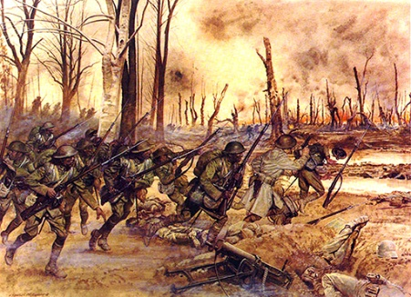
Figure 8 Members of the 369th Infantry Regiment in the Battle of Séchault, 29 September 1918
View description - Figure 8 Members of the 369th Infantry Regiment in the Battle of Séchault, 29 September ...

Let’s start the case study by investigating a unique primary source: the wartime notebook of Horace Pippin.

1.4.1 Horace Pippin
Horace Pippin (1888–1946) was a member of the 369th Infantry Regiment. He was a self-taught artist. After the war he became one of the first Black painters to be recognised widely and was one of the most well regarded African-American painters of his time. Horace Pippin trained as an infantryman at Fort Dix, New Jersey and Camp Wadsworth, South Carolina in the autumn of 1917 before shipping out to Brest in France on 17 December 1917. He spent a year in France before being shipped home on a hospital ship having sustained injuries that rendered his right arm unusable (Rodman, 1947).

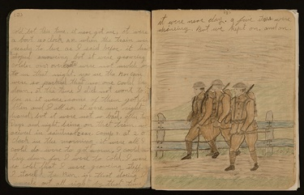
Figure 9 A page from Pippin’s original wartime notes
View description - Figure 9 A page from Pippin’s original wartime notes

1.4.2 Horace Pippin’s wartime notebook
In this next activity, you will take a closer look at this interesting and unusual primary source.

Activity 2 Horace Pippin’s wartime notebook
Allow up to 30 minutes

Pippin’s wartime notes provide a fascinating example of the experience of African-American soldiers in France. It is available online and is a useful tool for primary source analysis. (See Session 1, Section 3 for primary source analysis skills that could be used to analyse excerpts of this document.)
Take a look at the notebook and pick a passage that strikes you as noteworthy or interesting and comment on it in the light of what you know about the war experiences of African-American soldiers.

View discussion - Activity 2 Horace Pippin’s wartime notebook

In the 1930s, Horance Pippin made a name for himself as a painter. The painting in Figure 10 is his first oil painting, entitled ‘The Ending of the War, Starting Home’ (1930–33). It is based on his experience at the Battle of Séchault, where he was wounded, and is one of his most famous pictures. It might be a useful starting point for using war art as part of students’ analysis.

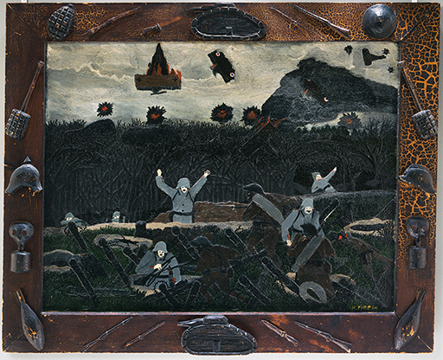
Figure 10 Horace Pippin, The Ending of the War, Starting Home, 1930–33
View description - Figure 10 Horace Pippin, The Ending of the War, Starting Home, 1930–33

The painting depicts trench warfare, with several German soldiers, recognisable by their uniform (and their moustaches!), surrendering to a small group of black soldiers, one of whom has already scaled the barricades protecting the German trench.
He decorated the frame with hand-carved objects, such as helmets, tanks and weapons. The painting, including the frame, is approximately 80x100 cm. It forms part of the permanent collection of the Philadelphia Museum of Art. This link takes you to a description of the painting.
In the next section, we’ll look at another famous member of the 369th Infantry Regiment, the jazz musician James Reese Europe.

1.4.3 James Reese Europe
Among the soldiers in the 369th Infantry Regiment were 44 members of the regimental band under the leadership of James Reese Europe (1880–1919). He was an African-American jazz musician, conductor and composer whose claim to fame is introducing jazz (or ragtime) music to Europe. He was also an officer in charge of the machine gun squad, and in this role the first African-American to command troops in wartime.
In June 1918, James (Jimmy) Europe was hospitalised following a German gas attack. While recovering in a field hospital, he composed the song On Patrol in No Man’s Land, which became a popular song for his band to play after their return to the USA. You can listen to the song in full via the link above, or alterntaively, a short excerpt from the link here:

Video content is not available in this format.
Audio excerpt On Patrol in No Man’s Land

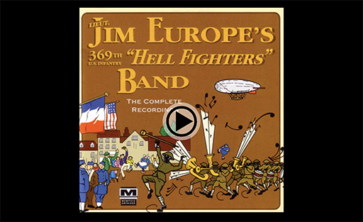

Figure 11 shows a picture of the album cover – which is an interesting document in itself, suggesting rather a more fun time in France than was likely had by the band and the rest of the regiment. Here the Black soldiers march in a band led (presumably) by Europe, playing their music to appreciative civilian audiences. A soldier can be seen dancing in the background. Here, too, a Zeppelin is in the sky, but this one, unlike Pippin’s in Figure 10, is not on fire.
After his return to the USA, Europe’s band went on tour, but Europe was murdered by a band member in an argument in May 1919. In acknowledgement of his services to US music, he received an official funeral in New York City – the first African-American to be given such an honour.

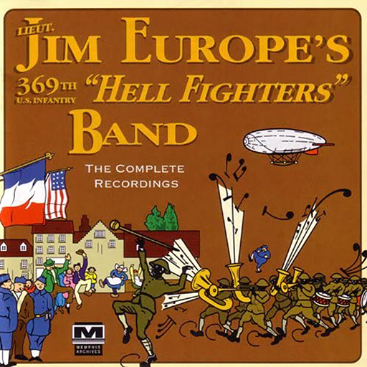
Figure 11 Record Sleeve
View description - Figure 11 Record Sleeve

There is plenty of material online to allow students to research this topic, and many photographs and posters to make this a very visual topic, too. Perfect for a project, perhaps even with the Music Department..
As we have seen, participating in the war in Europe did not immediately open up opportunities for African-Americans. Racist views and segregation persisted. A 1919 publication quoted a white man from New Orleans who exclaimed in response to the raising of money for the war effort by African-Americans: ‘You niggers are wondering how you are going to be treated after the war. Well, I’ll tell you, you are going to be treated exactly like you were before the war. This is a white man’s country and we expect to rule it’ (cited in McDaniels, 2014).

Did you know?
Further reading
There is a lot of information available online, and students could be encouraged to do a research project on the ‘Harlem Hellfighters’ or extend this into a more general project on African-American soldiers in the war. There is additional information in Olusoga’s The World’s War (2014).
An excellent monograph on the subject is Nelson’s A More Unbending Battle (2009), which is freely available in the internet achive.
Another source which is freely available is Harris, Harlem’s Hell Fighters (2003). Harlem's hell fighters : the African-American 369th Infantry in World War I : Harris, Stephen L
There are photographs of members of the 369th Infantry Regiment and interesting propaganda posters in this online article in the German magazine Der Spiegel (although the text is in German).
This articlewritten by an archivist at the American National Archives who identifies nine soldiers from the 369th Infantry Regiment in a photograph and provides a detailed account of their war experiences and their backgrounds and is an interesting piece of historical detective work.
In addition to Anne Monahan’s 2008 article, there is also a monograph on Pippin: Anne Monahan, Horace Pippin, American Modern (Yale University Press, Yale 2020).

In the next section we will examine the war experiences of First Nation Canadians with a case study of Mike Mountain Horse who fought in Europe as part of Britain’s dominion troops.

1.5 Case Study: The war experience of Mountain Horse
At the start of the war, only France considered using its imperial subjects to fight in the European conflict. By 1915, however, rising casualties meant that Britain needed more manpower and requested troops from its five Dominions: Canada, Australia, New Zealand, South Africa and Newfoundland
In this section, you will study the experiences of one individual First Nation Canadian soldier, Mike Mountain Horse. First, you’ll look at some statistics which give a sense of the contribution dominion forces made to the war.

1.5 1 Dominion Forces in the war
This section reflects on the numbers of dominion troops who participated on the side of the British Empire.

Activity 3 Dominion First World War Statistics
Allow around 10 minutes

The table below gives an overview of the contribution made to the British war effort by Dominion soldiers. Take a look at these figures, reflecting on the numbers involved, and comment on anything you find interesting.

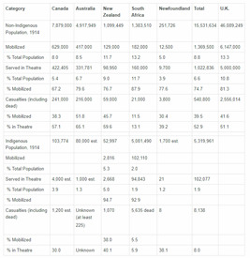
Figure 12 Dominion First World War Statistics (Riseman and Winegard, 2015)

View discussion - Activity 3 Dominion First World War Statistics

In the next section, you will look in detail at the war contribution of Canadian First Nation soldiers with the example of Mike Mountain Horse.

1.5.2 Mike Mountain Horse
In this section, you will examine the experience of Mike Mountain Horse (1888–1964), one of the estimated 4,000 Canadian First Nations soldiers who fought in Europe. While First Nations people were at first prevented from joining the army, by December 1915 unofficial policies of exclusion came to an end and they were able to volunteer to join the army. In August 1917, conscription was introduced and participation of First Nations people in the war effort was now demanded.
Casualty figures are difficult to obtain and are often based on estimates because military records did not generally record race. We also do not have official numbers for honours awarded to Canadian First Nations soldiers, but Veterans Affairs Canada states that ‘at least fifty medals were awarded to aboriginal people in Canada for bravery and heroism.’ (Riseman and Winegard, 2015).
There is evidence to suggest that First Nations soldiers in the Canadian Army were not subject to the same humiliations that plagued African-American soldiers. One veteran, for example, remembered: ‘The army treated us all right … there was no discrimination “over there” and we were treated good.’ (Private Daniel Pelletier, cited in Riseman and Winegard, 2015.) After the war, however, Canadian First Nations people suffered the same inequality as they had prior to it. Nothing was gained by their sacrifice. For example, they did not receive the same pensions or disability and war veterans’ allowances as other veterans.
Mike Mountain Horse was from the Kainai (Blood) First Nation in southwestern Alberta, Canada. He enlisted in the army in 1916. In France, he first served with the 191st Battalion and was later in the machine gun section of the 50th Battalion. He took part in several battles, including Vimy Ridge, Cambrai and Amiens, and he was wounded three times. At Cambrai he witnessed ‘the first massed tank attack in history, and was buried under the ruins of a shelter for four days after it was covered by rubble thrown up by explosions’ (Olusoga, 2014, p.12). He returned home to his Reserve in 1919 having been awarded a Distinguished Conduct Medal.

Did you know?
Mountain Horse’s service records have been digitised and can be found on this Imperial War Museum website.

His autobiography, which he dictated to Ambrose Two Chiefs, gives a sense of his battlefield experience. Here is a short excerpt:

Lying on top of Vimy Ridge one night along with a number of the other Indian boys, the scene before our eyes might best be described as that of a huge stage with lighting effects – Verey lights from the Hun lines, and flames from bursting shells in the city of Lens. The red glare thrown back appeared like a great fire in the sky all the time. The trenches ran through almost to the heart of the French coal mining city. Here a Brigade of the Germans had entrenched themselves so well that incessant bombardment by artillery and bombing from the air did not aid the boys from the Dominion to any great extent … Along the miles of trenches one could see planes dropping bombs on German lines, followed by geysers of smoke and dirt shooting skywards like volcanoes in eruption. One could witness houses bursting suddenly into flame as projectiles from heavy artillery of the enemy struck them. One could walk past Canadian howitzer batteries about a mile from the trenches and hear the 57inch shells from these guns screaming overhead on their errands of death and destruction.
(Cited in Olusoga, 2014, p.11)

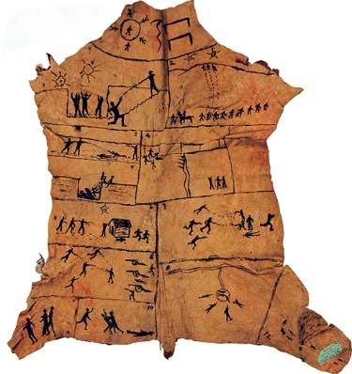
Figure 13 ‘Story Robe’ by Ambrose Two Chiefs (Es-Kim-Ar-Wo-Ta-Me), The “Great War” Deeds of Corporal Mike Mountain Horse
View description - Figure 13 ‘Story Robe’ by Ambrose Two Chiefs (Es-Kim-Ar-Wo-Ta-Me), The “Great War” ...

Figure 13 shows a story robe on calf skin, produced by the artist Ambrose Two Chiefs, possibly in the 1930s. The artist used this traditional way to illustrate his friend Mountain Horse’s war experiences on the Western Front. The events are depicted in order of the importance to Mountain Horse, including the four days he spent buried in a bomb shelter (Olusoga, 2014, pp.12-13).

Activity 4 ‘Story Robe’ by Ambrose Two Chiefs
Allow around 5 minutes

Take a moment to study the story robe closely. What experiences did the artist depict? This might also be a good activity for students to complete.

View discussion - Activity 4 ‘Story Robe’ by Ambrose Two Chiefs

Some indigenous Canadian troops observed their traditional warrior traditions on the Western Front. David Olusoga describes how a member of the Blood tribe named George Strangling Wolf prepared for battle in November 1917.

[He] took a knife and cut off a strip of his own flesh from around his knee. Holding up the bloody offering towards the sun, he prayed aloud: “Help me, Sun, to survive this terrible war, that I may meet my relatives again. With this request, I offer you my body as food.” He then buried his flesh in the mud of northern France. Strangling Wolf, whose official army records list his religion as “Church of England”, survived the war under the gaze of the Sun Spirit of his ancestors.
(Olusoga, 2014, p. 12)

This quote shows the juxtaposition of fighting a modern war in Europe with deadly weapons designed to inflict maximum casualties while bringing to bear ancient rituals, which, if anything, made Strangling Wolf more likely to die given the risk of infection such a self-inflicted wound carried. But it also highlights that army records do not always tell the truth about the people they recorded. We can only speculate here whether there were only limited options of what to record in the record or whether Mountain Horse perhaps considered himself to belong to the Church of England alongside holding his ancestral beliefs.

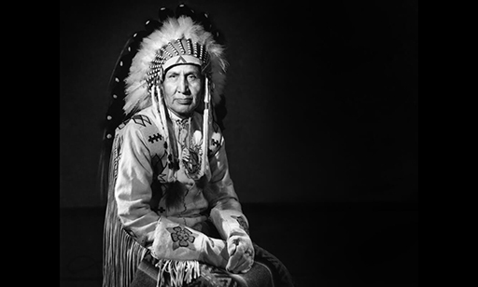
Figure 14 Mike Mountain Horse
View description - Figure 14 Mike Mountain Horse

Did you know?
Resources and further reading
Mountain Horse dictated his reminiscences of the war years to Ambrose Two Chiefs. In them, he recalls when Britain declared war on Germany. Students could analyse this source and discuss the usefulness of it to historians. It might be worth discussing, for instance, why Mountain Horse dictated his memories and what his motivation may have been. Mountain Horse (1979)is available digitised with free downloads at Internet Archive.
Riseman and Winegard (2015) provide a useful overview of the indigenous experience of the British Dominions.
Monographs on Canadians in the First World War include Cook (2007) and Winegard (2012)
There is some information on Mountain Horse on the Valour Canada website.
This short videotells the story of Mountain Horse and his contribution to the war.

2 Summary
In this session of the course, you have encountered a variety of examples of the war experiences of different combatants and studied two case studies which had at least one common theme: African-American soldiers and First Nation soldiers in Canada joined the fighting to defend their country and hoped for an end, or at least an alleviation, of the segregation they suffered in civilian life. They were to be sorely disappointed.
You now have a number of references for further reading and primary sources to illustrate this topic for classroom discussion.
In the Error! Hyperlink reference not valid., you will look at examples of commemoration of the war.

Session 4: Memory, representation and remembrance

Introduction
This session was written by Vincent Trott.
This session focuses on the representation, commemoration and memory of the First World War and discusses how these topics can be used to develop students’ ability in analysing unconventional primary sources.

Two hours of study materials
This session contains approximately two hours of study materials and additional suggestions of materials to use in the classroom. You’ll be able to put into practice some of the searching and assessing skills you’ve developed in Sessions 1 and 2.
If you have opted to sign up for JSTOR to use six free articles a month, then this will help you access some recent publications on this subject.

The section begins with an overview of the relevant historiography, before discussing how poems, paintings and war memorials can be analysed as primary sources. In each case, it provides sample exercises and answers. These focus primarily on Britain, but many of the exercises could also be applied to sources originating from other combatant nations.

Learning outcomes
After studying this session, you should be able to:
- understand how the First World War has been remembered and represented
- understand some of the historiography on the cultural history of the war
- use non-conventional primary sources, such as poems, paintings and artefacts, in historical analysis.

1 Historiography

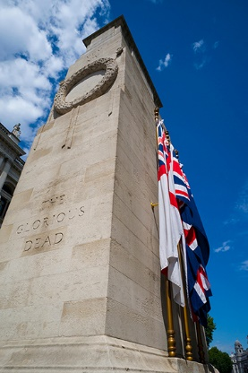
Figure 1 The Cenotaph on Whitehall in central London
View description - Figure 1 The Cenotaph on Whitehall in central London

The boom in cultural history during the 1990s led to various studies discussing the remembrance and ‘cultural memory’ of the First World War. One of the most influential was Jay Winter’s Sites of Memory, Sites of Mourning: The Great War in European Cultural History (1995).
Through focusing on memorialisation, artistic responses and mourning practices in Britain, France and Germany during the immediate aftermath of the war, Winter argued that the Great War did not necessarily lead to a break with the past in terms of how people chose to remember and commemorate the dead. Rather, in many cases, people turned to traditional, consoling forms of commemoration, rather than experimental or modernist representations.
The popular memory of the First World War in Britain has also attracted the attention of numerous historians, including military historians keen to counter various ‘myths’ of the conflict. For example, Brian Bond in The Unquiet Western Front: Britain’s Role in Literature and History (2002) and Gary Sheffield in Forgotten Victory: The First World War: Myths and Realities (2001) have argued that popular representations of the war in Britain tend to portray the conflict misleadingly as a futile tragedy, with an undue emphasis on ‘incompetent’ generals, disillusioned war poets and pointless suffering. Instead, they stress that the war was a necessary conflict for Britain during which skilled generals led the nation to an important military victory.
In the run-up to the centenary of the First World War, historians revisited this issue. Niall Ferguson, for example, argued that the First World War was a futile war for Britain and that it should have stayed out of the conflict, whereas others, such as Max Hastings, stressed that Britain had fought in a ‘necessary war’ with no option other than to intervene. Both Ferguson and Hastings expressed their views in a number of outlets, including this article for the Radio Times.
Dan Todman in The Great War: Myth and Memory (2005) has examined the development of various ‘myths’ about the war in Britain. Todman explains that a range of views existed about the conflict during the interwar years: whereas some poems and war memoirs tended to depict the war as tragic and futile, many Britons, including veterans, still viewed the war as a patriotic triumph during this period. Since the 1960s, however, a ‘mythology’ or simplified story of the war has begun to dominate British perceptions: patriotic interpretations gave way to narratives centred on the horror, futility and tragedy of the war.
The accuracy of these ‘myths’ of the war, and the extent to which they still dominate British understandings of the conflict, are still debated. Nevertheless, when introducing students to the commemoration and representation of the First World War, it’s worth asking them to consider whether their sources reinforce or challenge this mythology. Do they portray the war as a pointless disaster or as a heroic victory? Or do they convey more complex or ambiguous messages about the war?
Although many students are perhaps most familiar with canonical war poetry – which tends to reinforce this ‘mythology’ of the war – it’s also worth noting that many war memorials and popular literary works from during and shortly after the conflict promoted a more patriotic, heroic interpretation of the conflict.

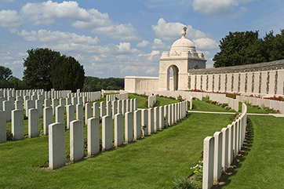
Figure 2 Tyne Cot Commonwealth War Graves cemetery in Belgium
View description - Figure 2 Tyne Cot Commonwealth War Graves cemetery in Belgium

The next section examines how war poetry can be interpreted as a primary source by historians.

2 Primary source analysis – literary responses to the war in Britain
The First World War is often seen to be a ‘literary war’, not only because it inspired an outpouring of literature, but also because literary works, and especially its poetry, have gone on to shape how the First World War is remembered in Britain.
Students may well have encountered some of this literature – and especially the ‘war poets’ – in English lessons, but these poems can also be examined as primary sources in the History classroom. Combatant poetry by Wilfred Owen and Siegfried Sassoon, for example, provides evidence of how soldiers responded to the terror of trench warfare and how they protested against these conditions.
There are two potential pitfalls when studying trench poems as historical sources. First, there is a risk that ‘realistic’, vivid poetry of this nature will be accepted as presenting the ‘truth’ about the experience of war. It is important that students bear in mind that trench poems are imaginative responses that do not necessarily reflect the experiences or perspectives of all soldiers.
Conversely, there is a risk that literary sources may immediately be dismissed as fictional or fabricated and therefore not as valuable as other more apparently ‘truthful’ historical documents. It’s important to encourage students to appreciate that these sources, however problematic, can still tell us something about the experience of war – including its emotional and cultural impact.
We can apply the primary source analysis skills we’ve practiced in earlier sessions to poems. Students should be encouraged to ask some of the following questions when analysing poems (of course, they may not be able to answer them all):
- Who wrote the poem? Soldier or civilian? Officer or private?
- When was the poem written? What was the historical context when this poem was written (development of the war, major battles etc.)? Or was it written after the war?
- Where was this poem written? Home front or fighting front? In the trenches or elsewhere?
- Why and for what purpose might this poet have written this poem?
- Where, when and why was the poem read and published? This is often overlooked (and it may be difficult to find this information), but it’s important to consider how wide the audience for the poetry was. To what extent was it likely to have influenced or reflected public opinion? For example, was the poem printed in a newspaper, and therefore likely to reach a large audience, or was it only published in an anthology of poems with a narrower readership?
- What can this poetry tell us about the experience and/or memory of the war? How useful is it as a primary source?
- What are the limitations of this poem as a primary source?
In the next section, you will analyse two poems of the First World War according to the criteria above. We chose two very well-known poems, and you should be able to find sufficient information online to answer all of these questions. As canonical poems, both have had a profound influence on how the First World War is remembered in Britain, albeit in different ways.

2.1 War poetry – Example 1
This section provides a worked example of how students can use the primary source analysis skills we’ve already practised and apply them to war poetry.

Students’ skills development: analysing the poem ‘The Call’
Jessie Pope ‘The Call’ (1914)
Who’s for the trench—
Are you, my laddie?
Who’s fretting to begin,
Who’s going out to win?
And who wants to save his skin—
Do you, my laddie?
Who’s for the khaki suit—
Are you, my laddie?
Who longs to charge and shoot—
Do you, my laddie?
Who’s keen on getting fit,
Who means to show his grit,
And who’d rather wait a bit—
Would you, my laddie?
Who’ll earn the Empire’s thanks—
Will you, my laddie?
Who’ll swell the victor’s ranks—
When that procession comes,
Will you, my laddie?
Banners and rolling drums—
Who’ll stand and bite his thumbs—
Will you, my laddie?
Pope, 1915

Analysis

Who?

View answer - Part

When?

View answer - Part

Where?

View answer - Part

Why?

View answer - Part

Published?

View answer - Part

What can this poem tell us?

View answer - Part

Limitations

View answer - Part

2.2 War poetry – Example 2
Here’s another example of war poetry as a primary source: Wilfred Owen’s iconic poem ‘Dulce et Decorum est’.

Students’ skills development: analysing the poem ‘Dulce et Decorum est’
Wilfred Owen ‘Dulce et Decorum est’ (1918)
Bent double, like old beggars under sacks,
Knock-kneed, coughing like hags, we cursed through sludge,
Till on the haunting flares we turned our backs,
And towards our distant rest began to trudge.
Men marched asleep. Many had lost their boots,
But limped on, blood-shod. All went lame; all blind;
Drunk with fatigue; deaf even to the hoots
Of gas-shells dropping softly behind.
Gas! GAS! Quick, boys!—An ecstasy of fumbling
Fitting the clumsy helmets just in time,
But someone still was yelling out and stumbling
And flound’ring like a man in fire or lime.—
Dim through the misty panes and thick green light,
As under a green sea, I saw him drowning.
In all my dreams before my helpless sight,
He plunges at me, guttering, choking, drowning.
If in some smothering dreams, you too could pace
Behind the wagon that we flung him in,
And watch the white eyes writhing in his face,
His hanging face, like a devil’s sick of sin;
If you could hear, at every jolt, the blood
Come gargling from the froth-corrupted lungs,
Obscene as cancer, bitter as the cud
Of vile, incurable sores on innocent tongues,—
My friend, you would not tell with such high zest
To children ardent for some desperate glory,
The old Lie: Dulce et decorum est
Pro patria mori.
(Owen, 1920, p. 15)

Analysis

Who?

View answer - Part

When?

View answer - Part

Where?

View answer - Part

Why?

View answer - Part

Published?

View answer - Part

What can this poem tell us?

View answer - Part

Limitations

View answer - Part

For the purposes of this activity, you will probably find it most useful to work with the reproduction of the poem above. But students might also be interested in seeing the manuscript version in Figure 3. Students could be asked to reflect on the various changes that Owen has made to this draft of the poem. It was first addressed directly to ‘Jessie Pope’, for example, before Owen changed this to ‘a certain Poetess’.

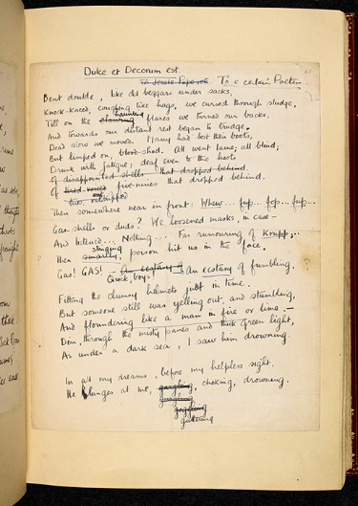
Figure 3 Original manuscript of ‘Dulce et Decorum est’ (page 1)
View description - Figure 3 Original manuscript of ‘Dulce et Decorum est’ (page 1)

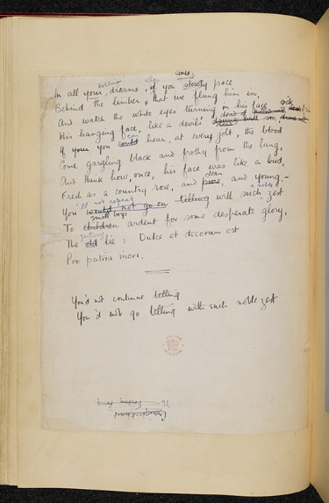
Figure 4 Original manuscript of ‘Dulce et Decorum est’ (page 2)
View description - Figure 4 Original manuscript of ‘Dulce et Decorum est’ (page 2)

Did you know?
The following online resources are useful for finding other poems and useful contextual information:
First World War Poetry Digital Archive
The Poetry Foundation

In the next section, you’ll explore how war art can be interrogated as a primary source by historians.

3 Primary source analysis – war art
Students may be less familiar with First World War art than they are with poetry from the conflict, but artworks can also provide useful insights into how the war was experienced, represented and remembered.

Activity 1 What questions can we ask of war art?
Allow around 5 minutes

Thinking back to the questions about war poems, what questions do you think students could fruitfully ask when analysing artworks?

View discussion - Activity 1 What questions can we ask of war art?

The first example of war art is covered in the next section.

3.1 War art – Example 1
The first example is C. R. W. Nevinson’s painting ‘Paths of Glory’.

Students’ skills development: ‘Paths of Glory’

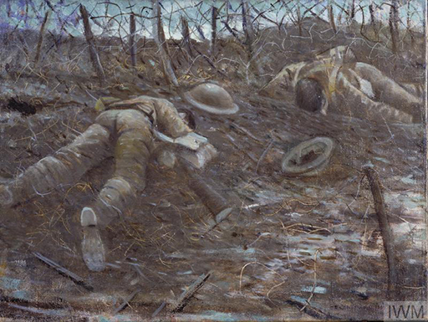
Figure 5 C.R.W. Nevinson, ‘Paths of Glory’ (1917)
View description - Figure 5 C.R.W. Nevinson, ‘Paths of Glory’ (1917)

From the Imperial War Museum’s Collection (Height: 457 mm; Width: 609 mm).

Analysis

Who?

View answer - Part

When?

View answer - Part

Why?

View answer - Part

Exhibited?

View answer - Part

What does this painting depict?

View answer - Part

Limitations

View answer - Part

3.2 War art – Example 2
The second example is of the famous painting ‘Gassed’ by John Singer Sargent.

Students’ skills development: ‘Gassed’

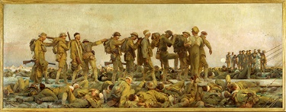
Figure 6 John Singer Sargent, ‘Gassed’ (1918)
View description - Figure 6 John Singer Sargent, ‘Gassed’ (1918)

In the Imperial War Museum collection (Height: 2300 mm; Width: 6111 mm).

Analysis

Who?

View answer - Part

When?

View answer - Part

Why?

View answer - Part

Exhibited?

View answer - Part

What does this painting depict?

View answer - Part

Limitations

View answer - Part

Did you know?
You can find other examples of First World War art on the Imperial War Museum’s website. First click on ‘Objects & History’ and then on ‘Find an Object’. This will allow you to search for items in the museum’s collections. By searching for an artist’s surname (e.g., ‘Nevinson’) and filtering the object category to ‘art’, users can quickly view many of the artist’s paintings held at the museum.
The museum also produces learning resources for school students of various ages. Click on ‘Learn’ and then ‘Learning Resources’ to view these. You can then filter the results to find material relating to the First World War. This article, for example, discusses interesting examples of First World War art that could be used as primary sources in the classroom. Useful historical context is also available on the British Library’s website.

The next section will focus on war memorials as a source for historians.

4 Primary source analysis – war memorials and commemorative rituals
Asking students to reflect on the origins of familiar commemorative rituals – such as the two minutes’ silence and the wearing of poppies – is often a useful starting point when discussing the war’s memory and cultural legacy in Britain. This section outlines the emergence of these practices and demonstrates how war memorials can be examined as primary sources.
The two minutes’ silence emerged in the immediate aftermath of the war and resulted from a perceived need to honour the dead. It was important for the British government to offer consolation for the bereaved and to assure them that their loved ones had not died in vain. In Britain, at 11 o’clock, on 11 November 1919, the first two minutes’ silence was used to mark the anniversary of the armistice.
The idea came from Sir Percy Fitzpatrick, who had served as high commissioner in South Africa during the war. He modelled the silence on a practice he had observed there known as ‘the three minutes’ pause’, which had been used to honour those, living and dead, who had served their country. Though three minutes was considered too long for the armistice day anniversary, the introduction of a two minutes’ silence was a great success and became an annual tradition.
11 November 1919 was also marked by the unveiling of the Cenotaph, which literally means ‘empty tomb’. A monument to soldiers who had not returned from the battlefield, it was initially intended to be a temporary structure used for the Peace Day Parade in 1919. It proved to be a popular focus for mourners and a permanent stone structure was unveiled on Whitehall in London on 11 November 1920. This was a setting for great displays of emotion, as people laid wreaths in honour of the dead.

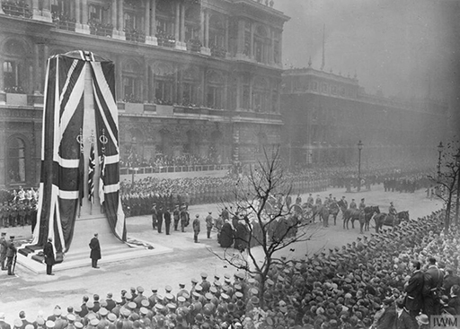
Figure 7 The unveiling of the cenotaph in London, 1920
View description - Figure 7 The unveiling of the cenotaph in London, 1920

On the same day, the body of the Unknown Warrior – an unidentified soldier chosen randomly from the Western Front – was buried in Westminster Abbey. The burial of the Unknown Warrior also triggered an outpouring of grief. The remains of many dead soldiers had never been found or identified. The families of these men had no grave to visit, and many found it comforting to believe that it was their loved one who lay at rest in the abbey. Similar memorials were established elsewhere. In Paris, an unknown soldier was laid to rest in the Arc de Triomphe on Armistice Day 1920, and other countries, such as Italy and Belgium, followed this practice during the decade after the war.
Alongside national memorials like these, hundreds of other memorials were built across Britain and many other combatant nations. These included local war memorials in towns and villages, honouring the men from the area who had served in the war. Memorials like these were sometimes funded with private contributions and subscriptions from the local population, again reflecting a public need for commemoration and consolation. Rolls of honour, listing men who had died, were also constructed in schools, clubs, churches and workplaces. Students can be encouraged to look out for and photograph examples of these in their local area.
In the 1920s, the wearing of poppies became a commemorative tradition in Britain. This practice was first introduced by an American, Moina Michael, who had been inspired to wear one by John McCrae’s poem ‘In Flanders Fields’ (1915). Michael successfully campaigned for the poppy to be used as a symbol of remembrance by American veterans and, in 1921, the newly formed British Legion decided to sell them to raise money for ex-servicemen. The practice of wearing poppies rose in popularity throughout the 1920s, and by 1928 they were almost universally worn.
It’s worth asking students to reflect on how these commemorative practices – which were designed to honour the sacrifices of the dead – contrast with bitter poetry by the likes of Wilfred Owen. The inscriptions on war memorials, for example, provide an example of how people in Britain sought to remember the war during its immediate aftermath, but differ greatly to poems like ‘Dulce et Decorum est’.

Activity 2 Asking questions of war memorials
Allow around 5 minutes

Due to the wide variation in war memorials and commemorative practices, it is not possible to provide a generic set of questions that will apply to all examples. Instead, you may prefer to ask specific questions that allow students to compare and contrast specific examples.
The first object we discuss is the Tomb of the Unknown Warrior. Before turning to the next section, spend a few minutes thinking about the questions students could ask of such an artefact.

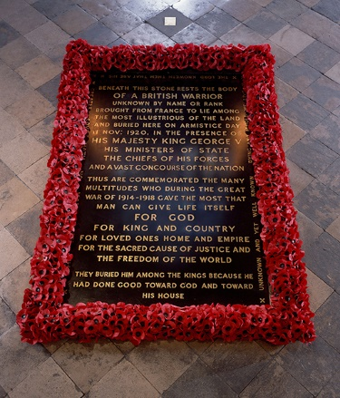
Figure 8 The Tomb of the Unknown Warrior in Westminster Abbey (1920)

View discussion - Activity 2 Asking questions of war memorials

The next section has a specimen discussion of this memorial using the questions above.

4.1 War memorial – Example 1
Now you’ll apply the questions you just developed to the first memorial below: the ‘Tomb of the Unknown Warrior’.

Students’ skills development: the ‘Tomb of the Unknown Warrior’
Students could use the following questions to analyse the inscription on this memorial:

Analysis

What do you think was the intended purpose of this memorial?

View answer - Part

What can memorials tell us about how the war was remembered during its immediate aftermath?

View answer - Part

What can’t memorials like this tell us?

View answer - Part

How do the messages inscribed on war memorials contrast with the poetry of Wilfred Owen?

View answer - Part

Not all memorials to the First World War were official, state-sanctioned responses to the war. The next section looks at a more personal memorial.

4.2 War memorial – Example 2
The second example is ‘The Grieving Parents’, two sculptures by the German artist Käthe Kollwitz.
Käthe Kollwitz lost her only son in October 1914, and expressed her grief in a range of sculptures, drawings and paintings. Completed in 1932, ‘The Grieving Parents’ took Kollwitz 18 years to complete. Today the sculptures are located in Vladslo German war cemetery in Belgium where Kollwitz’s son is buried alongside more than 25,000 German casualties.

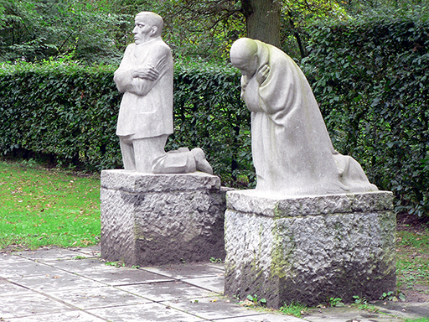
Figure 9 Käthe Kollwitz, ‘The Grieving Parents’ (1932)
View description - Figure 9 Käthe Kollwitz, ‘The Grieving Parents’ (1932)

Students’ skills development: ‘The Grieving Parents’
When analysing these sculptures, students could be asked to consider the same questions as before:

What do you think was the intended purpose of this memorial?

View answer - Part

What can this memorial tell us about the way the war was remembered during the inter-war years?

View answer - Part

What can’t this memorial tell us?

View answer - Part

How does this memorial contrast with national war memorials, such as the Tomb of the Unknown Warrior in Westminster Abbey?

View answer - Part

5 Summary
This session has discussed how the representation and memory of the First World War can be taught in the history classroom, and how this topic can be used to develop students’ ability to analyse unconventional primary sources, including poems, paintings and war memorials. This will help students to develop their understanding of the limitations and uses of artistic representations as historical sources. It will also deepen their knowledge of the conflict and its post-war commemoration.
The next session provides practical guidance on a range of skills and resources that you can use to inform your teaching of the First World War.

Session 5: Skills and resources for teaching the First World War

Introduction
This session was written by Stuart Mitchell.
This session has been designed to give practical guidance on a range of skills and resources that you can use to inform your teaching or encourage your students to adopt. Your skills may be advanced, in which case you can bypass some of the guidance here; or you may benefit from spending a bit longer on certain activities to develop and practise skills you have not yet mastered.
The session focuses on specific First World War examples and exercises, but the skills here will be transferable to other periods of history. They should be particularly useful for passing on to your students, especially for any non-exam assessment (NEA) projects that they may be producing.
We start by examining how to locate appropriate secondary sources, before moving to their assessment and use. The session then examines some of the more useful places to discover primary sources for the study of the First World War.

Two hours of study materials
This session contains approximately three hours of study materials and additional suggestions of materials to use in the classroom.

Learning outcomes
After studying this session, you should be able to:
- locate quality academic content online
- evaluate secondary sources for professional development and classroom teaching purposes by using JSTOR and Google Scholar
- locate useful primary sources online
- critically evaluate primary source material found online.

1 Searching for secondary sources online
There are an increasing number of resources now freely available online that can be adapted for classroom practice. One of the principal difficulties of using these resources is that they can be time-consuming to search and can occasionally produce unsatisfactory results, which only adds to the problem of ‘information overload’ that frequently impedes teaching and makes it difficult to keep up with the most recent research in the discipline. The purpose of this session is to help you manage information, find quality academic content, and assess its value to you both for professional development and classroom teaching purposes.


Figure 1 A computer monitor displaying the Google Scholar logo and search box
View description - Figure 1 A computer monitor displaying the Google Scholar logo and search box

Below, we give guidance on constructing searches, principally for secondary literature. No doubt you know some of this already, but there may be areas in which you could adopt a more targeted approach that will save you time in the longer term. The principal resources that will be discussed in this section are Google Scholar and JSTOR, though most of the skills and techniques can be applied to other collections such as publisher databases.
- To begin with, where should you search? Most of us are naturally drawn towards using Google or an equivalent search engine when looking for historical content. Of course, the problem with that is that it can generate enormous numbers of ‘hits’ with little in the way of quality assurance, so the most useful sites for us as educators might be buried several pages into search results. Where possible, searching for academic literature ought instead to be more focused than typical internet searches. It should involve more precise search terms and employ different search tools and collections.
- If you want to get a general overview of a field or find out about recent research, Google Scholar is generally a much better place to start for secondary literature. It is an academic subset of Google, which sometimes provides links to open access versions of academic papers. A note of caution: not all Google Scholar materials have been quality checked by academics before release, whereas most formal academic publishing guarantees quality by ‘peer review’. That said, if you carefully evaluate the content that you find this should be the most useful one-stop-shop for your everyday practice. We’ll discuss how to do this in this session.
- For narrower and more focused searches, it can be worth looking at specialist academic publishers, as they sometimes make their published content available online. Usually these take the form of focused collections in a defined subject area, and most use peer review to ensure quality of content; they will consequently provide precise search results of reliable quality. Many will include open access materials: that is, scholarly research that is made free at point of use. There is an increasing move towards making research available open access, and it’s always a good idea to consult open access repositories at UK universities. If you have identified a particular historian, for example, finding their institutional repository will give you access to some of their publications.
- It is also worth your while to investigate the library collections that might be available to you as a university alumnus. Increasingly, academic libraries are offering their former students access to some subscription collections, such as academic journal databases like JSTOR and EBSCO. Most library online catalogues also have the facility to search across multiple databases simultaneously to generate a results list. This may well give you access to materials that are not freely available by other means; plus, if you have an account with a university library, you can usually link it to your Google Scholar account, of which more shortly.
You will now take a look at different online search techniques.

2 Building online searches
Most of what follows in this section on more efficient searching will be applicable to all these different types of collection, even if their interfaces and layouts are dissimilar. Some of these suggestions will doubtless already be familiar to you, but we hope that you’ll gain confidence by developing and employing your search skills. As most exam boards have an NEA requirement that students use scholarly literature that they have found for themselves, it is probably worthwhile spending some time in passing on good techniques to them.
Boolean searching
Boolean searching is an advanced search technique: it allows you to specify how your search terms are combined and makes your searching more precise. Basic searches of key terms in most databases will often generate unmanageable lists of results. Even adding quote marks around a phrase, though it can help, may still offer up too many hits, so we recommend that you use the advanced search function of your chosen database and add in Boolean operators wherever you can. Let’s look at different options:
OR: ‘OR’ will broaden your search and return all documents that contain either one or other of two search terms.
AND: ‘AND’ will narrow the search to include only results that include all your search terms.
NOT: ‘NOT’ includes results only where the first term is present; if the second term is present then results will be excluded.
It is possible to link together terms in subqueries too, by using brackets. So, for example, (psychology OR psychiatry) AND “first world war” should give you results featuring the phrase in quote marks where one or other of the words psychology or psychiatry is also present. If you are using OR as your Boolean operator, it is advisable to use brackets if you don’t want your search to go wrong.
You can also replace a letter in a search phrase with a ‘?’ if you want variants on a term or put an asterisk at the end of a word if you would like to try variations on its ending.
For example, “conscrip*” should return documents containing conscript, conscripted or conscription.

Did you know?
Many search tools, including Google, will automatically ‘AND’ your terms together unless you specify otherwise using advanced search options.

You can use these extra variables to put together search strings in most databases that you might encounter, so it’s worth taking a moment to think about your search question, and how that might translate into precise terms that you might use. Terms must be grouped as phrases to return meaningful results. In the next section, you will get an opportunity to try out some searches using Google Scholar.

3 Using Google Scholar
Since it is likely to be your first port of call for a lot of secondary texts, this first activity uses Google Scholar.

Activity 1 Finding literature using Google Scholar
Allow around 20 minutes

Imagine that you are searching for suitable secondary literature on medicine in the First World War, specifically on the effects of shell shock. This is a reasonably common topic at both GCSE and A Level, and some exam boards may allow students to write their NEA projects on the subject. Spend a few minutes considering what search terms you might employ to return the best results in Google Scholar, and then use them to conduct your own search.

View discussion - Activity 1 Finding literature using Google Scholar

Google Scholar search results look more uniform than those produced by its standard search engine. That is because each result uses similar scholarly publishing conventions. The different elements provide further clues to help you judge the value of material you find. Underneath the title in blue, the authors are always listed in green. The host site could be a journal, as three of these are, but it could be a conference paper, a book chapter or a research paper of some kind.

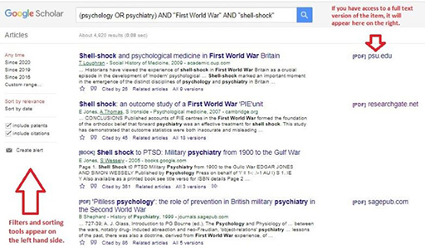
Figure 2 An example of Google Scholar search results
View description - Figure 2 An example of Google Scholar search results

‘Cited by’ gives a rough indication of the value of an academic paper by the number of times other authors have referenced this article in their own work (although, naturally, recent articles are likely to have been cited less).
‘Related articles’ provides links to other results that are similar to the article in question; this can be useful when your search hasn’t generated many results, or where you have used complex search criteria.
Lastly, ‘All X versions’ will list all the available versions found, which might include open access versions as well as articles hosted by academic publishers.
Try not to be fazed by the number of results a search generates – in most cases, there will be lots and you will need to cut them down before evaluating their quality, but that can normally be done quite quickly. You’ll see that the example of my search above found almost 5,000 items, which of course is pretty unmanageable. So, although in this case at least two of these four top items look very promising, the likelihood is that you will want to filter your list, if only to bring it down to a manageable size.

4 Employing filters

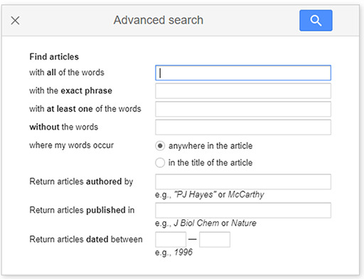
Figure 3 Google Scholar’s ‘advanced search’ box
View description - Figure 3 Google Scholar’s ‘advanced search’ box

Applying filters to your results set allows you quickly to reduce the numbers of returned hits. A date limiter can be particularly useful if the purpose of your search is to keep abreast of the most recent research in a field, but Google Scholar allows you to use several different filters. You can select particular authors or publications, for instance. If you think that the search is one that you will want to repeat in the future, you can also create an email alert for any new entries using the icon in the left column.
Crucially, the site will give you direct links to full content on the right-hand side if you have access to them. For open access content, these should appear regardless, but that is only a small fraction of total published secondary sources. For other content, you will need to have set up a Google Scholar account and linked it (with the same email address) to another account that provides you with access. A JSTOR account (detailed in the next section) should link to the Scholar search engine, and so should a library account, if you have one, with your former university.
The Google Scholar account also allows you to save references in a feature called ‘My library’, by clicking on the star icon beneath each result in the list. That said, although it is likely to be the first place to search to get a sense of the terrain of scholarship in a particular field, Google Scholar can be daunting, especially for students. If you are unfamiliar with using Google Scholar, we would recommend that you spend some time acquainting yourself with it before guiding your students to the resource.
Despite Google Scholar being at present the only search tool that has such a global reach, its tendency to produce a glut of ‘hits’ and the difficulty in assessing individual articles means that, for students at least, it should be used with considerable caution. There are many other databases available that will offer more focused, or more readily accessed, content. Most of these use the same principles for searching secondary scholarly literature as Google Scholar, and search techniques and tools (such as Boolean operators) can be adapted to most of them. Of these, the most useful is probably JSTOR.

5 Using JSTOR


Figure 4 The JSTOR logo
View description - Figure 4 The JSTOR logo

JSTOR is the largest global database of scholarly journal articles, and lately it has also started to include single book chapters. It is highly likely that, for the purposes of A Level coursework, students may want to conduct a search of the database to check if there is any relevant content to the topic that they are pursuing. The database also contains some open access articles that students can view and download for free, although they tend to be quite specialised. Nonetheless, careful searching, using some of the techniques described above, might yield suitable material.
You can go directly to JSTOR’s free content. Starting with a basic search and then adding filters onto the search results may, in this case, be the best method for extracting relevant results. You will have a go at this in the next activity. As a test, I tried: “first world war” AND commemoration. At the time of writing, the results page returned 617 hits, though even a cursory glance at the titles reveals that many are rather niche. The filter options on the left-hand side allow your search to be narrowed. Clicking on ‘history’ (under subject) and ‘book chapters’ (under academic content) reduced the results to 102, as shown in the example below; a more manageable number to assess. You’ll see in my search result, below, some random titles that do not relate to the First World War which I could immediately discard.

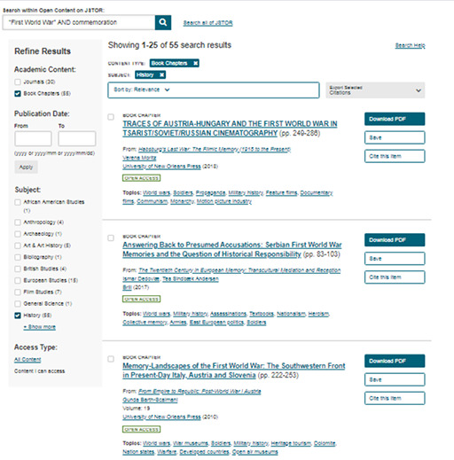
Figure 5 An example of JSTOR search results
View description - Figure 5 An example of JSTOR search results

More useful still is that the database permits users who have registered for a JSTOR account to view up to six articles or book chapters a month free of charge (if they don’t have access via an institutional account). That scheme covers all of the collection’s content and it is available to everyone – including individual students. One downside for schools and their students is that, unlike the open access collections above, it does not allow for free downloads of material. Still, it should certainly help students to complete their essays and coursework and to become familiar with the types of academic material with which they will be expected to engage if they go on to university.

Activity 2 Conducting a JSTOR search
Allow around 10 minutes

Register with JSTOR (if you haven’t already), then go straight to JSTOR’s advanced search page and repeat the search exercise on First World War commemoration above. Because this is likely to return a huge number of results, it would be advisable to scroll down and add in filters on subject, document type and language before hitting the search button. Even the first page of results should return half-a-dozen scholarly items that are directly relevant to issues of the First World War’s memorialisation and remembrance.
Then go on to test the capabilities of JSTOR further by looking for historiographical reviews. These types of journal article can be good entry points to a topic, as they summarise recent developments in historical scholarship, methods and interpretation. They are likely to be of more direct use to you than your students, but they can prepare you to help them when they are confronted by a bewildering range of secondary sources.
Try the following search in the database: (("first world war") AND ("historiographical review")). On the results page, you can add filters if you want to.

View discussion - Activity 2 Conducting a JSTOR search

Did you know? Open access databases offering academic material
JSTOR contains ample secondary source material, as we’ve seen, but it is limited to scholarly journals and a few book chapters. To widen the search still further, there are several open access databases that offer academic material that might be suitable for students’ use in their coursework.
It is likely that each of these will only offer up a small number of appropriate results, but, since they can be relied upon for accessibility and permanence of access, it could be worthwhile directing your students towards them. The same principles of searching apply as you would use with the other resources we’ve discussed. The ones most likely to yield results on First World War topics are as follows:
- The Directory of Open Access Books (DOAB) contains a small collection of full volumes from academic publishers in PDF format.
- The Directory of Open Access Journals is a community-curated online directory that indexes and provides access to high quality, open access, peer-reviewed journals.
- Open Research Library has some overlaps in content with the DOAB but holds a fair amount of material about the First World War. It is better to search the database than to browse it.
- Google Books contains much secondary literature, and though full text versions of recently published volumes are rare, one can often pick up a single chapter or enough text to use in an assignment.
- Project Gutenberg is one of the more famous open resources on the internet, collecting out-of-copyright books and making them publicly available. It is unlikely that you will find any books here published much after the mid-twentieth century, but since most exam boards happily permit students to use older secondary material in their NEA work, this could nonetheless be a useful point of call.
- Similar to Project Gutenberg is the Internet Archive, a searchable meta-database of books and other free scholarly material. There’s not much from the last forty years, but some secondary (and primary) material from earlier that would be particularly suitable to a historiographical project.

In the next section you’ll consider how to make a sensible selection if your search reveals many hits by considering how to evaluate the literature that your search has found.

6 Evaluating academic literature
Now that we’ve practised finding secondary literature, let’s move to the slightly more challenging subject of evaluating the usefulness of that literature. Although you are probably well equipped to undertake this task, it is likely that your students might initially struggle with it, so we have provided a worked example here that could be adapted for classroom use.
There can be tension between how easily you can access an item and how germane it is to the topic that you are researching. As we have already seen, careful searching can easily find lots of secondary sources using resources such as JSTOR, but this may not help you, or your students, unless it is both relevant to your research and free at point of use online. Equally, if a source is readily available, free to use and relevant to your topic, that does not automatically make it suitable scholarly matter. Given that, especially for NEA projects, exam boards insist that candidates utilise appropriate scholarly work, especially for NEA projects, this is a major consideration.
The Open University’s Library has developed a mnemonic tool that can help your students to assess a source relatively quickly to decide whether it is worth reading the whole thing and using it in their work. We call this PROMPT. It is designed to interrogate secondary literature, but some of its core principles can equally be applied to primary sources. The tool below summarises PROMPT and has been adapted for use with this course.
PROMPT (open the tool in a new tab or window by holding down Ctrl [or Cmd on a Mac] when you click on the link)

Activity 3 Using PROMPT to evaluate a source
Allow around 15 minutes

You can download a PDF version of the PROMPT criteria. Spend a few minutes familiarising yourself with this information and consider how your students might benefit from using the PROMPT criteria and what the likely shortcomings are.

View discussion - Activity 3 Using PROMPT to evaluate a source

7 Using PROMPT in practice
Although these types of books and articles serve slightly different purposes and may well be written in rather different registers, the way in which you would go about assessing them using PROMPT is fairly similar. Remember that we are looking here for the most efficient way of evaluating what might be a fairly long list of potential sources.
Assuming that you’ve searched Google Scholar, JSTOR or another suitable database and have used filters to reduce the number of options to a manageable size, the next step would be to skim over the titles in the list (including the titles of the journals or books) and also, if available, examine the ‘keywords’ or ‘topics’ to check that the article is potentially relevant (this is a helpful feature in JSTOR, but not all databases have it).


Figure 6 A pile of books in front of book-filled library shelves
View description - Figure 6 A pile of books in front of book-filled library shelves

With luck, that check ought to help answer some of the provenance, relevance and timeliness sub-questions, which in turn should whittle the possibilities down to single figures. From those results, we’d recommend that you choose the three or four that seem most relevant and then interrogate them in the following order, looking again for the answers to the PROMPT questions.
For journal articles, ordinarily the most efficient order in which to assess the text itself is Abstract > Conclusion > Introduction > Body Text.
The abstract (or summary) is an important indicator of relevance, since it is therein that authors tend to summarise their arguments, explain briefly their methods, situate their work within historical debates and indicate the structure of the piece. Although they are sometimes rather densely written, and need to be read carefully, you can usually gather sufficient information from the abstract to decide whether or not it is worth continuing with the article.
If, however, it does not satisfy you in terms of the PROMPT criteria, then the subsequent stage would usually be to examine the article’s conclusion, since that is likely to be the next shortest segment of the article and the place where the author should make their interpretation explicit. It is unlikely that you would be unable to decide on an article’s utility by that point, but there may be occasions on which, for instance, the methodology adopted by the historian is unclear from those sections; in that event, the introduction would likely be useful.
More on PROMPT process
For your students, it would be helpful to call attention to the complexity of the language and concepts employed in any articles they find; those complications should also be revealed by the PROMPT process of reading and assessing. Scholarly articles are written principally for historians’ peers, so are sometimes pitched at an inappropriate level for GCSE and A Level students’ comprehension. That, too, is covered under the PROMPT criteria (under presentation) and should help rule out an article that is too complicated for students to understand.
That said, there is a downside to this method. Until perhaps 20 years ago, it was entirely normal in our discipline for articles to appear without an abstract. So, for older works, which are of course regularly used by the boards in their examination papers, it would be wise to start with the first couple of paragraphs of an article’s introduction, which often have similar features to an abstract, before moving to the conclusion and then back to the remainder of the text, looking especially at topic sentences in the first instance. This is not perfect, and is likely to be slightly more time-consuming, but should nevertheless yield enough information to make an evaluation using PROMPT.
For books, there’s a comparable procedure, though the first thing to establish is whether the volume is a monograph (i.e., single-authored) or a collection of essays (multi-authored). For multi-authored volumes on a single theme, it is normally best to treat each chapter like a journal article – though the caveat about absence of abstracts should be borne in mind. Single-authored books, on the other hand, are more likely to sit with the ‘seminal literature’ that advances wider interpretations, and you may well want your students to engage with those in addition to, or instead of, journal articles. (Incidentally, most exam boards consider the use of a single chapter from a book to be one acceptable source for an NEA project.) As with shorter forms of academic literature, though, the principle still holds of examining first those sections of the book that are most likely to offer answers to the PROMPT questions. That means an order of reading that probably follows this pattern: opening pages of the introduction > conclusion > initial pages of individual chapters – but this is not a hard-and-fast rule.

Activity 4 Assessing potential secondary sources
Allow around 15 minutes

As this process can be baffling for students when they first encounter it, you might like to try this worked example with them in the classroom. It uses the subject of the causes of the First World War – which, as Error! Hyperlink reference not valid. of this course makes clear, remains a highly contested debate – to illustrate the steps that the students should go through.
First, go to JSTOR and search for ((“first world war”) AND (“ Kaiser Wilhelm II”) AND causes). If you limit your search to journal articles and select History in the subject section, you should have Wolfgang Mommsen’s ‘Kaiser Wilhelm II and German Politics’ (1990) in the Journal of Contemporary History as one of your top hits.
Reflect on which of the PROMPT questions can be answered simply from the information in the results list. What advice might you give students to interrogate the source further before they decide whether or not to read the article?

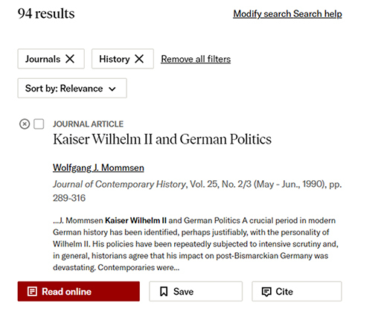
Figure 7 The result from a JSTOR search
View description - Figure 7 The result from a JSTOR search

View discussion - Activity 4 Assessing potential secondary sources

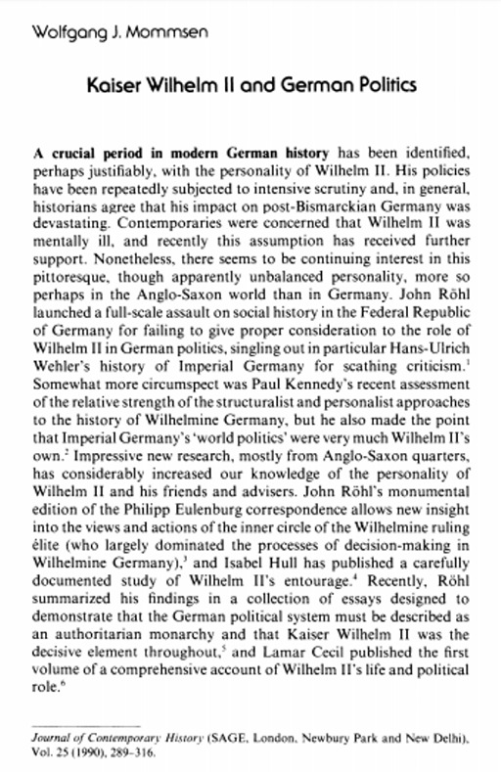
Figure 8 An example of a journal page
View description - Figure 8 An example of a journal page

Switching to the conclusion provides a clear sense of his argument. Obviously, Mommsen’s concerns in the article were far wider than simply addressing the question of the First World War’s origins. Having read the conclusion, and depending on their exact focus, a few students might decide that the piece is insufficiently relevant to use. There is no harm in that – it demonstrates the utility of the PROMPT technique because it has spared them the necessity of reading the whole article. Those who want to continue should then go to the body text and read topic sentences in the first instance to see how the article is structured and its principal topics.
At this stage, it can also be fruitful to glance at footnote references to check the types of evidence on which an author has drawn. In any article or book chapter, students are likely to encounter several terms, places and names with which they will be unfamiliar. It is best not to stop and look up such things while still making an assessment of a source’s value, since it will deflect from the purposes of the PROMPT exercise. Naturally, if a secondary source is thought worth using, then investigating those terms forms part of the process of learning and composition.
Skimming through the article, reading topic sentences chiefly, ought to reveal that only one quarter or so of the text deals directly with Germany’s role in the outbreak of the First World War. Students whose topic or assignment is concerned primarily with the war’s causes would probably have been correct to reject the article on the grounds of relevance at an earlier stage. In cases where their focus is less narrow, though – on pre-war diplomacy, say, or the internal politics of Imperial Germany – then the article should satisfy all the PROMPT criteria and students can happily use it in their work. Moreover, if the focus is historiographical, then Mommsen is making an important intervention, and his work could be usefully included in an assignment.
There are, of course, other ways in which students can contextualise and understand secondary material once it has been chosen. If the source is a book, for example, then searching for reviews on Google Scholar and/or JSTOR might well be helpful. Indeed, long book reviews and historiographical overviews, such as those found on the Institute of Historical Research’s Reviews in History site, could themselves be classed as legitimate sources for the type of sustained investigation envisaged by NEA projects.
Hopefully these tips will assist your students in selecting their secondary sources. In the next section, you will look in detail at strategies for helping them find and assess online primary sources.

8 Finding and assessing online primary sources
Finding appropriate primary sources both for classroom use and for students to employ in their work is somewhat easier than locating good secondary sources. That is not to say, though, that there aren’t snags, or resources that you might have overlooked. Before giving an overview of some of the most helpful primary source collections for studying the First World War, let’s look briefly at some principles and safeguards for when you search. No doubt you’re familiar with these, but it is probable that your students aren’t.
To begin with, some websites present very partial information, in both senses of the word. Others are pressed into the service of a preconceived ideological agenda. This is perhaps less problematic in the case of our chronological period than it would be, say, for the Soviet Union or Nazi Germany, but deceptive sites do exist, nonetheless. More troublesome can be those sites, such as Pinterest, that are not obviously curated and instead rely on the good will and sense of those who contribute to them; the chances of an inaccurate or misleading source appearing on those sites by accident are much higher than on established ones on which there is some editorial oversight.
Of course, you will come across many web pages that offer collections of primary sources. In this case, you need to ask whether they are presented in full or edited in some way (the latter need not make the internet site unreliable, but it should make you wary). Some primary sources are a little more difficult to alter – visual sources are the principal example – but still there are cases of visual material being altered or faked (sometimes for the purposes of humour) and subsequently being taken as genuine historical artefacts.
When students are required independently to find their own primary sources, as they generally have to for A-Level NEA projects, they are likely to be less discriminating. It would be helpful, then, to offer them some basics in assessing primary source collections, and – as with secondary sources – steer them away from generalised Google-type searches.
The resources we list below are all robust and sufficiently scholarly, but they are far from the only collections available. On discovering a primary source anthology, students first need to enquire of its provenance and presentation as a collection. That critical assessment is, in fact, a hybrid of the document analysis techniques that we employ throughout this course and the types of questions that we looked at above when evaluating secondary literature.
Each of the other sessions of this course uses a series of questions to interrogate the provenance, nature and potential uses of primary sources. Essentially, they are:

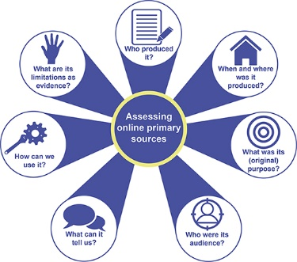
Figure 9 Assessing online primary sources
View description - Figure 9 Assessing online primary sources

No doubt you use a comparable typology in your classroom practice, and you’ll have noticed, too, that some of those questions resemble those asked in the PROMPT model. Encouraging your students to ask similar critical questions of online primary source collections is likely to help them assess their value for assignments and other assessment tasks. The most crucial ones to pose here are: who put this together, why and on what principles?
For most collections, this is relatively easy – almost invariably the more trustworthy sites will explain their purposes, sources of information, curation guidelines and limitations in a separate information page, frequently labelled ‘About’ or ‘Info’. For a particularly good example, look at the collaborative National Archives/IWM ‘First World War: Sources for History’ website. If an online collection does not provide that type of explanatory material, it may be better for students to avoid it.
The second consideration to be aware of is the structure of the database. This is complicated by the fact that primary source collections are frequently structured in a more inconsistent way than secondary source databases. There are plenty of good quality websites containing valuable primary material that, often because of their age, are structured as thematic or chronological lists. Although a lot of these have taken to providing a rudimentary search function with a customised Google search, nonetheless they can be laborious to go through without a clear idea in advance of what one is looking for.
Two otherwise excellent collections that suffer from this snag are the Avalon Project and First World War.com. That said, an increasing number of sites offer the facility to employ more sophisticated forms of search on their holdings, as we saw in the case of JSTOR. Of these, one of the best is the First World War Poetry Archive, which has a well-structured advanced search page and the facility to browse sources by tags (such as ‘propaganda’ and ‘medicine’). Another well-arranged website of that type is Oxford University’s World War I Centenary collection. You encountered these websites in the course sessions on ‘Memory and Representation’ (Session 4) and ‘Propaganda’ (Session 2) respectively.

Activity 5 Evaluating an online primary source collection
Allow around 15 minutes

An excellent site for primary sources on the First World War is German History in Documents and Images. Take a look at the site and evaluate its usefulness for your students. This activity would also make relatively quick classroom activity to give your students confidence in critical assessment of online collections allowing them to explore it by concentrating not on individual primary documents but rather on its authorship, purpose, principles of construction and structure.

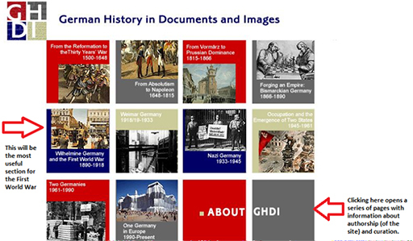
Figure 10 An example of a German History in Documents and Images webpage
View description - Figure 10 An example of a German History in Documents and Images webpage

View discussion - Activity 5 Evaluating an online primary source collection

9 Other collections
Besides the resources listed earlier, there’s a handful of others that are worth highlighting.
Sourced from many of Europe’s major museums and from public submissions, Europeana 1914–18 collects together primary sources of all types, including audio and visual material. It also includes secondary blog commentary. The site has some useful filters to apply post-search, including the rights for re-use of material (important if you are intending to use sources for anything other than the classroom). A few UK museums have collections in a similar vein, such as the Imperial War Museum (which you already encountered in Session 4), the Wellcome Collection, and the Science Museum.


Figure 11 Picture of film reels
View description - Figure 11 Picture of film reels

Finally, since audio-visual material is generally very popular with students, you should also consider looking at EUScreen, which offers online access to videos, stills and audio from European broadcasters and other archives, as well as the European Film Gateway. For students’ assignment-writing purposes, though, the most useful (because it is in English) is British Pathé, which contains the entire 3,500-hour British Pathé Film Archive, covering 1896 to 1976. Low resolution ‘preview’ downloads are free, but for classroom use you’ll have to play the media direct from the site as downloading complete videos is not permitted.

10 Summary
In this session of the course, you’ve learned how to construct more efficient searches for secondary literature and how to evaluate the usefulness of those sources.
You’ve also explored different ways of locating and analysing primary sources and have asked critical questions of the structure of primary source databases.
We hope that these techniques will enable you to expand your own knowledge and to equip your students with new and transferable skills that they can employ across the history curriculum and beyond.

References
This free course was written by Annika Mombauer, Vincent Trott and Stuart Mitchell and was first published in December 2023.
Except for third party materials and otherwise stated (see terms and conditions), this content is made available under a Creative Commons Attribution-NonCommercial-ShareAlike 4.0 Licence.
The material acknowledged below is Proprietary and used under licence (not subject to Creative Commons Licence). Grateful acknowledgement is made to the following sources for permission to reproduce material in this free course:
Albertini, L. (1952) The Origins of the First World War. 3 vols., Oxford: Oxford University Press.
Bonnell, A.G. (2015) ‘New Histories of the Origins of the First World War: What Happened to the “Primacy of Domestic Politics?”’, Australian Journal of Politics and History, 61 (1), pp. 121–7.
Clark, C. (2012) The Sleepwalkers: How Europe Went to War in 1914. London: Penguin.
Fischer, F. (1961) Griff nach der Weltmacht, Düsseldorf, Droste (English translation Germany’s Aims in the First World War. London: Norton & Co 1967)
Jarausch, K. (1973) The Enigmatic Chancellor. Bethmann Hollweg and the Hubris of Imperial Germany. New Haven, Conn.: Yale University Press.
Fischer, F. (1969) Krieg der Illusionen, Düsseldorf, Droste 1969 (English translation War of illusions. German policies from 1911 to 1914, New York 1975: Norton).
Joll, J. (1984) The Origins of the First World War. Oxford: Routledge. [4th edition, London 2022]
McMeekin, S. (2011) Russia and the Origins of the First World War. Cambridge, MA, Harvard University Press.
Mombauer, A. (2002) The Origins of the First World War. Controversies and Consensus. Longman.
Mombauer, A. (ed.) (2013) The Origins of the First World War: Diplomatic and Military Documents. Manchester: Manchester University Press
Mombauer, A. (2015) ‘Guilt or Responsibility? The Hundred-Year Debate on the Origins of World War I’, Central European History, 48, pp. 541–64.
Mombauer, A. (2024) The Causes of the First World War. The Long Blame Game. London: Routledge.
Otte, T.G. (2015) July Crisis: The World's Descent into War, Summer 1914. Cambridge: Cambridge University Press.
Patch, H. (2007) The Last Fighting Tommy. London: Bloomsbury.
Images
Session 1
Figure 1: Adrian Sherratt / Alamy Stock Photo
Figure 2: ***Imperial War Museum. © IWM (Art.IWM PST 2763). https://www.iwm.org.uk/collections/item/object/14592
Figure 3: Unknown author / Digital image Lucius Castus; cropped by Emiya1980. This file is licensed under the Creative Commons Attribution-Share Alike Licence http://creativecommons.org/licenses/by-sa/3.0/
Figure 4: taken from https://de.m.wikipedia.org/wiki/Datei:AnDasDeutscheVolkWilhelm1914.jpg
Figure 5: Popperfoto / Contributor / Getty Images
Figure 6: John Röhl
Figure 7: Courtesy of Annika Mombauer
Figures 8 and 12: Christopher Clark
Figure 9: Annika Mombauer (ed.), The origins of the First World War: Diplomatic and Military Documents, Manchester University Press, Manchester 2013, Doc. No. 120, pp. 192-193.
Figure 10: © Peter Brookes Cartoon, The Times ‘A Blanket Cheque for War’ The Times, Ref 459670
Figure 1: ***Imperial War Museum: © IWM Art.IWM PST 4470;
Session 2
https://www.iwm.org.uk/collections/item/object/41180
Activity 3: ***Imperial War Museum: © IWM (Art.IWM PST 2763). https://www.iwm.org.uk/collections/item/object/14592
Activity 5: Baumgarten, Eugen von/ Cornell University – PJ Mode Collection of Persuasive Cartography. Digital image: Historic Images / Alamy Stock Photo
Activity 6: ***Imperial War Museum: © IWM (Art.IWM PST 7194). https://www.iwm.org.uk/collections/item/object/26583
Figure 5: Life Magazine; https://en.wikipedia.org/wiki/File:Life_Magazine_February_10_1916.jpg
Figure 6: photo_beat_back_the_hun_with_liberty_bonds: Strothmann, F. (Frederick), b/ crediting UNT Libraries Rare Book and Texana Collections. © Everett Collection / Shutterstock
Figure 7: ***Imperial War Museum: © IWM Art.IWM PST 0235 https://www.iwm.org.uk/collections/item/object/25800
Text
Mombauer, A; extract from The Origins of the First World War: Controversies and Consensus, Longman 2002
Audio/Visual
Audio of John Röhl: The Open University
Audio of Annika Mombauer: The Open University
Audio of Christopher Clark: The Open University
Every effort has been made to contact copyright owners. If any have been inadvertently overlooked, the publishers will be pleased to make the necessary arrangements at the first opportunity.
Burger, B.L. (2017), ‘And they thought we wouldn’t fight’: Remembering the nine soldiers in a World War I photograph’, blog, US National Archives Archives “And They Thought We Couldn’t Fight:”* Remembering the Nine Soldiers in a World War I Photograph – Rediscovering Black History (archives.gov).
Campts, T. (2004) ‘“Resonant Echoes”: The Rhineland Campaign and Converging Specters of Racial Mixture’, in Other Germans. Black Germans and the Politics of Race, Gender, and Memory in the Third Reich. Ann Arbor: University of Michigan. Available online.
Fogarty, R. (2016) ‘Tirailleurs Sénégalais’ in: 1914-1918-online. International Encyclopedia, Berlin 2016-04-01. doi: 10.15463/ie1418.10876
Fogarty, R. and Jarboe, A.T. (2021) ‘Non-European soldiers’, in: 1914-1918-online. International Encyclopedia, Berlin 2021-04-29. DOI: 10.15463/ie1418.11543.
Harris, S.L. (2003) Harlem’s Hell Fighters. The African-American 369th Infantry in World War 1, Washington D.C, Pontomac Books
McDaniels, P. III (2008) ‘African American Soldiers (USA)’ in: 1914-1918-online. International Encyclopedia, Berlin 2014-10-08. DOI: 10.15463/ie1418.10175.
Monahan, A. (2008) ‘I Rember the Day Varry Well. Horace Pippin’s War’, Archives of American Art Journal, 47(3/4), pp. 17–23. Available online.
Mountain Horse, M. (1979) My people, the Bloods. Calgary: Glenbow-Alberta Institute; Standoff: Blood Tribal Council.
Nelson, P.N. (2009) A More Unbending Battle. The Harlem Hellfighters’ Struggle for Freedom in WWI and Equality at Home, New York, BasicCivitas [Available on Internet Archive]
Olusoga, D. (2014), The World’s War. Forgotten Soldiers of Empire. London: Head of Zeus.
Olusoga, D. (2018) ‘Black soldiers were expendable – then forgettable’, First world war , The Guardian, 11 Nov.
Orosz, K.J. (2017) ‘Propaganda in the Colonies (Africa)’ in: 1914-1918-online. International Encyclopedia, Berlin 2017-02-21. DOI: 10.15463/ie1418.11056.
Riseman, N. and Winegard, T.C. (2015) ‘Indigenous Experience of War (British Dominions)’, in: 1914-1918-online. International Encyclopedia, Berlin 2015-02-24. DOI: 10.15463/ie1418.10563.
Rodman, S. (1947) Horace Pippin, a Negro painter in America. New York: The Quadrangle Press.
Sammons, J.T. and Morrow, J.H. Jr. (2014) Harlem’s Rattlers and the Great War. The Undaunted 369th Regiment and the African American Quest for Equality. Lawrence: University Press of Kansas.
Sheffer, D.J. (2014) ‘Racism in the armed forces (USA)’ in: 1914-1918-online. International Encyclopedia, Berlin 2014-10-08. DOI: 10.15463/ie1418.10470.
Stein, J.E. (1993) ‘An American Original’, in Stein et al (eds), I Tell My Heart: The Art of Horace Pippin. Philadelphia: Pennsylvania Academy of the Fine Arts, pp. 2–43.
Williams, C.L. (2010) Torchbearers of Democracy: African American Soldiers in the World War I Era. Chapel Hill: University of North Caroline Press.
Horne, J. and Kramer, A. (1994) ‘German “Atrocities” and Franco-German Opinion, 1914: The Evidence of Soldiers’ Diaries’, The Journal of Modern History, vol. 66, no. 1, pp. 1–33.
Horne, J. and Kramer, A. (2002) German Atrocities, 1914. New Haven and London: Yale University Press.
Keller, U. (2017) Schuldfragen: Belgischer Untergrundkrieg und Deutsche Vergeltung im August 1914, Paderborn, Schöningh
Scianna, B.M. (2017), ‘German Atrocities Revisited’ – conference report. Available at German Atrocities 1914 – Revisited | H-Soz-Kult. Kommunikation und Fachinformation für die Geschichtswissenschaften | Geschichte im Netz | History in the web (hsozkult.de) (Accessed 23 February 2023)
Spraul, G. (2016) Der Franktireurkrieg 1914: Untersuchungen zum Verfall einer Wissenschaft und zum Umgang mit nationalen Mythen, Berlin, Frank & Timme
Wilson, W. (1917) ‘Address to Joint Session of Congress, April 2, 1917’. Woodrow Wilson Papers, Manuscript Division, Library of Congress.
Burger, B.L. (2017), ‘And they thought we wouldn’t fight’: Remembering the nine soldiers in a World War I photograph’, blog, US National Archives Archives “And They Thought We Couldn’t Fight:”* Remembering the Nine Soldiers in a World War I Photograph – Rediscovering Black History (archives.gov).
Campts, T. (2004) ‘“Resonant Echoes”: The Rhineland Campaign and Converging Specters of Racial Mixture’, in Other Germans. Black Germans and the Politics of Race, Gender, and Memory in the Third Reich. Ann Arbor: University of Michigan. Available online.
Fogarty, R. (2016) ‘Tirailleurs Sénégalais’ in: 1914-1918-online. International Encyclopedia, Berlin 2016-04-01. doi: 10.15463/ie1418.10876
Fogarty, R. and Jarboe, A.T. (2021) ‘Non-European soldiers’, in: 1914-1918-online. International Encyclopedia, Berlin 2021-04-29. DOI: 10.15463/ie1418.11543.
Harris, S.L. (2003) Harlem’s Hell Fighters. The African-American 369th Infantry in World War 1, Washington D.C, Pontomac Books
McDaniels, P. III (2008) ‘African American Soldiers (USA)’ in: 1914-1918-online. International Encyclopedia, Berlin 2014-10-08. DOI: 10.15463/ie1418.10175.
Monahan, A. (2008) ‘I Rember the Day Varry Well. Horace Pippin’s War’, Archives of American Art Journal, 47(3/4), pp. 17–23. Available online.
Mountain Horse, M. (1979) My people, the Bloods. Calgary: Glenbow-Alberta Institute; Standoff: Blood Tribal Council.
Nelson, P.N. (2009) A More Unbending Battle. The Harlem Hellfighters’ Struggle for Freedom in WWI and Equality at Home, New York, BasicCivitas [Available on Internet Archive]
Olusoga, D. (2014), The World’s War. Forgotten Soldiers of Empire. London: Head of Zeus.
Olusoga, D. (2018) ‘Black soldiers were expendable – then forgettable’, First world war , The Guardian, 11 Nov.
Orosz, K.J. (2017) ‘Propaganda in the Colonies (Africa)’ in: 1914-1918-online. International Encyclopedia, Berlin 2017-02-21. DOI: 10.15463/ie1418.11056.
Riseman, N. and Winegard, T.C. (2015) ‘Indigenous Experience of War (British Dominions)’, in: 1914-1918-online. International Encyclopedia, Berlin 2015-02-24. DOI: 10.15463/ie1418.10563.
Rodman, S. (1947) Horace Pippin, a Negro painter in America. New York: The Quadrangle Press.
Sammons, J.T. and Morrow, J.H. Jr. (2014) Harlem’s Rattlers and the Great War. The Undaunted 369th Regiment and the African American Quest for Equality. Lawrence: University Press of Kansas.
Sheffer, D.J. (2014) ‘Racism in the armed forces (USA)’ in: 1914-1918-online. International Encyclopedia, Berlin 2014-10-08. DOI: 10.15463/ie1418.10470.
Stein, J.E. (1993) ‘An American Original’, in Stein et al (eds), I Tell My Heart: The Art of Horace Pippin. Philadelphia: Pennsylvania Academy of the Fine Arts, pp. 2–43.
Williams, C.L. (2010) Torchbearers of Democracy: African American Soldiers in the World War I Era. Chapel Hill: University of North Caroline Press.
Bond, B. (2002) The Unquiet Western Front: Britain’s Role in Literature and History, Cambridge: Cambridge University Press.
McCrae, J. (1915) ‘In Flanders Fields’. Available at: https://www.poetryfoundation.org/poems/47380/in-flanders-fields (Accessed 6 March 2023).
Owen, W. (1918) ‘Dulce et Decorum Est’, [Poem] in Owen, W. (1920) Poems. London: Chatto & Windus, p. 15.
Pope, J. (1915) ‘The Call’ [online]. Available at https://warpoets.org.uk/worldwar1/blog/poem/the-call/ (Accessed 6 March 2023).
Radio Times (2014) ‘Was Britain right to enter the Great War’, Radio Times, 25 February [online]. Available at https://www.radiotimes.com/tv/documentaries/was-britain-right-to-enter-the-great-war/ (Accessed 6 March 2023).
Sheffield, G. (2002) Forgotten Victory: The First World War: Myths and Realities, London: Review.
Todman, D. (2005) The Great War: Myth and Memory, London: Continuum.
Winter, J. (1995) Sites of Memory, Sites of Mourning: The Great War in European Cultural History, Cambridge: Cambridge University Press.
Jones, H. (2013) ‘As the Centenary Approaches: The Regeneration of First World War Historiography’, The Historical Journal, 56(3), pp. 857-878.
Mommsen, W.J (1990) ‘Kaiser Wilhelm II and German Politics’, Journal of Contemporary History, 25(2/3), pp. 289–316. Available at https://www.jstor.org/stable/260734?seq=1 (Accessed: 26 February 2023).
The Open University (n.d.) OU Library, ‘Evaluation using PROMPT’ [Online]. Available at http://www.open.ac.uk/libraryservices/beingdigital/activity/XK1087#page1 (Accessed: 26 February 2023).
Don't miss out
If reading this text has inspired you to learn more, you may be interested in joining the millions of people who discover our free learning resources and qualifications by visiting The Open University – www.open.edu/openlearn/free-courses.

Acknowledgements
This free course was written by Annika Mombauer, Vincent Trott and Stuart Mitchell and was first published in December 2023.
Except for third party materials and otherwise stated (see terms and conditions), this content is made available under a Creative Commons Attribution-NonCommercial-ShareAlike 4.0 Licence.
The material acknowledged below is Proprietary and used under licence (not subject to Creative Commons Licence). Grateful acknowledgement is made to the following sources for permission to reproduce material in this free course:
Images
Course image: *** © IWM Art.IWM ART 1656; https://www.iwm.org.uk/collections/item/object/20015
Figure 1: Baumgarten, Eugen von/ Cornell University – PJ Mode Collection of Persuasive Cartography. Digital image: Historic Images / Alamy Stock Photo
Figure 1: Chicago : Chas. Gustrine, 1918, Library of Congress, https://tile.loc.gov/storage-services/service/pnp/ppmsca/18600/18640v.jpg
Figure 2: President George H W Bush:AACL: Albanian American Civic League
Figure 3: taken from: https://chroniclingamerica.loc.gov/lccn/sn85042243/1918-08-09/ed-1/seq-8/
Figure 4: ***Imperial War Museum: (c) IWM 26583; https://www.iwm.org.uk/collections/item/object/26583
Figure 5: Pictorial Press Ltd / Alamy Stock Photo
Figures 6 and 7: Digital Library@Villanova University; taken from: https://digital.library.villanova.edu/Item/vudl:145752#?c=&m=&s=&cv=2&xywh=-4738%2C-263%2C12832%2C5247
Figure 8: artist H. Charles McBarron, Jr., (c) Federal Government of the United States
Figure 9: Horace Pippin. Horace Pippin memoir of his experiences in World War I, ca. 1921. Horace Pippin notebooks and letters, circa 1920. Archives of American Art, Smithsonian Institution.
Figure 10: Horace Pippin (American, 1888–1946), Philadelphia Museum of Art, www.philamuseum.org.
Figure 12: Esplanade Arts & Heritage Centre
Figure 13: Glenbow Archives NA-2164-1 via Alberta Historic Places
Figure 14: Hill 70; https://www.hill70.ca/Battle-of-Hill-70/Hill-70-Gallery/Story-Robe/The-Story-of-Mike-Mountain-Horse.aspx
Figure 1: Chicago : Chas. Gustrine, 1918, Library of Congress, https://tile.loc.gov/storage-services/service/pnp/ppmsca/18600/18640v.jpg
Figure 2: President George H W Bush:AACL: Albanian American Civic League
Figure 3: taken from: https://chroniclingamerica.loc.gov/lccn/sn85042243/1918-08-09/ed-1/seq-8/
Figure 4: ***Imperial War Museum: (c) IWM 26583; https://www.iwm.org.uk/collections/item/object/26583
Figure 5: Pictorial Press Ltd / Alamy Stock Photo
Figures 6 and 7: Digital Library@Villanova University; taken from: https://digital.library.villanova.edu/Item/vudl:145752#?c=&m=&s=&cv=2&xywh=-4738%2C-263%2C12832%2C5247
Figure 8: artist H. Charles McBarron, Jr., (c) Federal Government of the United States
Figure 9: Horace Pippin. Horace Pippin memoir of his experiences in World War I, ca. 1921. Horace Pippin notebooks and letters, circa 1920. Archives of American Art, Smithsonian Institution.
Figure 10: Horace Pippin (American, 1888–1946), Philadelphia Museum of Art, www.philamuseum.org.
Figure 12: Esplanade Arts & Heritage Centre
Figure 13: Glenbow Archives NA-2164-1 via Alberta Historic Places
Figure 1: PATRICK ANTHONISZ / Alamy Stock Photo
Figure 2: GaryBlakeley; https://creativecommons.org/licenses/by-sa/4.0/
Figures 3 and 4: MS 43721 ‘Dulce et Decorum est.’, Poems, 1911-18 (ink on paper), Owen, Wilfred (1893-1918) / English, BL3468052. © British Library Board. All Rights Reserved / Bridgeman Images
Figure 5: ***Imperial War Museum: © IWM Art.IWM ART 518; https://www.iwm.org.uk/collections/item/object/20211
Figure 6: ***Imperial War Museum: © IWM (Art.IWM ART 1460). https://www.iwm.org.uk/collections/item/object/23722
Figure 7: ***Imperial War Museum: © IWM Q 31513; https://www.iwm.org.uk/history/what-is-the-cenotaph
Figure 8: Angelo Hornak / Alamy Stock Photo
Figure 9: Käthe Kollwitz, Public domain, via Wikimedia Commons
Figure 1: photograph Jarretera / Shutterstock.com
Figures 2 and 3: Google Scholar
Figure 4: JSTOR logo © JSTOR; photograph II.studio / Shutterstock.com
Figures 5 and 7: search results from JSTOR
Figure 6: Jure Divich/Shutterstock.com
Figure 8: Taken from: https://www.jstor.org/stable/26073; Journal of Contemporary History, Vol. 25 (1990) 289-316, Sage Publications Ltd.
Figure 10: sample from German History in Documents and Images webpage: http://germanhistorydocs.ghi-dc.org/home.cfm; © GHDI
Figure 11: Steven Frame / 123RF
Text
‘The Call’: Jessie Pope, 1914
‘Dulce et Decorum Est’: Wilfred Edward Salter Owen, 1918
Audio/Visual
Audio: ‘On Patrol in No Mans Land’ taken from: James Reese Europe's 369th U.S. Infantry "Hell Fighters" Band; https://www.youtube.com/watch?v=YeIET9ZIkGk
Audio: ‘On Patrol in No Mans Land’ taken from: James Reese Europe's 369th U.S. Infantry "Hell Fighters" Band; https://www.youtube.com/watch?v=YeIET9ZIkGk
Every effort has been made to contact copyright owners. If any have been inadvertently overlooked, the publishers will be pleased to make the necessary arrangements at the first opportunity.
Don’t miss out
If reading this text has inspired you to learn more, you may be interested in joining the millions of people who discover our free learning resources and qualifications by visiting The Open University – www.open.edu/openlearn/free-courses.

Solutions

Activity 1 Finding primary sources online

Discussion
One document included in this database is Kaiser Wilhelm’s announcement to the German people, below, which stresses the defensive nature of the war and illustrates the points made above.

Berlin, August 1, 1914 I thank all of you for the love and loyalty that you have shown me these past days. These were serious days like none before them. Should there be battle, all political parties will cease to exist! I, too, have been attacked by one party or another. That was in times of peace. It is now forgiven with all my heart. I no longer think in terms of parties or confessions; today we are all German brothers and only German brothers. If our neighbors want it no other way, if our neighbors do not grant us peace, then I hope to God that our good German sword will emerge victorious from this hard battle.(German History in Documents and Images, GHDI - Document (ghi-dc.org))

Back to - Activity 1 Finding primary sources online

Activity 2 Finding historiographical information online

Discussion
Hopefully you found this article useful and also took time to explore some other articles in the encyclopaedia. It is a useful source for recent authoritative summaries on most topics relating to the First World War and a great resource for your students.
Back to - Activity 2 Finding historiographical information online

Activity 3 Accessing review articles

Discussion
Hopefully you have found and read a review article that relates to the centenary debate. In this activity we’ve suggested some articles for you; in Session 5 you will look at strategies for finding secondary sources, including literature reviews.
Back to - Activity 3 Accessing review articles

Activity 4 Historians talk about their interpretations

Part

Discussion
For Röhl, the war was no accident; it was caused by Germany’s desire to dominate Europe. There is, according to Röhl, overwhelming evidence that Germany intended to start a war.
Back to - Part

Activity 5 The opinion of Christopher Clark

Part

Discussion
For Clark, the fact that a Balkan crisis was the trigger for war is no coincidence as he sees the Balkan states as ‘players’ in this story (in fact, he was one of the first historians to shine a spotlight on the ‘powder keg’ of the Balkans and to stress Serbia’s responsibility).
Back to - Part

Part

Discussion
Clark does not think that war was planned at the war council meeting in 1912 and he is not convinced that the September Programme is a good indicator of German war aims, as it was written in September, i.e., after the war had started, when it was still going well for Germany and a German victory seemed likely.
Back to - Part

Activity 6 Analysing the ‘blank cheque’

Discussion
Below is an image of the document, annotated to provide an example of a model answer.

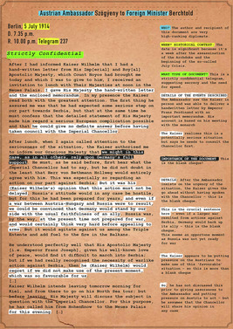
Figure 9 A typed copy of the so-called ‘blank cheque’ with annotations to illustrate how the document can be analysed
View description - Figure 9 A typed copy of the so-called ‘blank cheque’ with annotations to illustrate ...

Back to - Activity 6 Analysing the ‘blank cheque’

Activity 7 Interpreting the evidence

Discussion


Figure 11 Christopher Clark
View description - Figure 11 Christopher Clark

Clark argues that the ‘blank cheque’ made ‘a contribution to the escalation of the crisis’. Germans were no ‘innocent lambs’ – he says that it would be crazy to argue this way and refers to some of the revisionists who tried to make this argument in the interwar years. But he does not believe that Germany ‘bullied’ Austria and put pressure on its ally.
However, he distinguishes here between ‘pressuring for war’, which he does not think the Germans did, and ‘pressuring to secure a swift action’ so that they could then implement a ‘plausible localisation strategy’.
Back to - Activity 7 Interpreting the evidence

Activity 1 The functions of propaganda

Discussion
Broadly speaking, propaganda often performed one or more of the following key functions during the conflict:
- To persuade the population to support the war effort in various ways. In countries without conscription, such as in Britain at the start of the war, this involved encouraging men to enlist and women to support men in doing so.
- To instil certain behaviours in the population, such as encouraging them to buy bonds or not waste food, for example.
- To demonise and ridicule the enemy.
- To influence public opinion in enemy countries.
- To help win over and gain the support of neutral nations.
When asking students to analyse examples of propaganda, it’s useful for them to consider which of these categories their sources might fall into. In many cases, they might perform more than one of these functions.
Back to - Activity 1 The functions of propaganda

Activity 2 Asking questions when analysing propaganda

Discussion
Here are some questions you may have thought about:
- Who produced this propaganda? In which country was it produced? Was it produced by the state or by a private organisation, such as a newspaper or magazine? (In some cases, this last question may be difficult to answer.)
- When was it produced? What was the historical context (key political and military events, for example)?
- Who was the likely audience? Did it address a particular group of society or a particular nation, for example?
- What does the propaganda tell us? If it is an image, which countries or people are depicted? If it is a textual example, what does the author of the piece discuss and describe?
- What was the purpose of this propaganda? You may find it useful here to refer again to the four key functions of First World War propaganda outlined above. Students should consider the intended audience of the propaganda and what it was designed to achieve.
- How does this example of propaganda persuade its audience? Does it play on people’s fears? Does it use humour and ridicule? Does it attempt to shame or encourage people to act in a certain way?
- What are the uses and limitations of this source for historians? How useful is this source and what can it tell us more broadly about the history of the First World War? What doesn’t it tell us?
Your list might have looked similar, or you might have come up with different questions. This would also be a useful exercise for your students to complete.
When analysing propaganda as a primary source, students can use these questions as a guide. They may not be able to answer all of them, but, with further research online, it should be possible to answer many of them.
Back to - Activity 2 Asking questions when analysing propaganda

Activity 3 Primary source analysis

Part

Answer
This is a British propaganda poster, produced by the Parliamentary Recruiting Committee (the text to the bottom left of the image confirms this).
Back to - Part

Part

Answer
The date of the poster’s production is not clear from this image, but students may be able to work out an approximate date based on their additional contextual knowledge of the First World War. Because this is a recruiting poster, we know that it must pre-date the introduction of conscription in January 1916. The information on the Imperial War Museum’s website confirms that the poster was created in 1915.
Back to - Part

Part

Answer
The poster depicts two women and a young child standing at an open window and looking out at armed troops marching to war.
Back to - Part

Part

Answer
This is a recruiting poster designed to encourage men to enlist in the army. It also encourages women to pressurise men into enlisting. At the outbreak of the war, Britain had a relatively small standing army and no system of conscription. Before introducing conscription, the government relied on men to volunteer their services, using posters such as this to promote recruitment.
Back to - Part

Part

Answer
The poster’s design is clearly intended to persuade and capture attention. The word ‘Go’, for example, is capitalised, underlined and presented in a larger typeface, reinforcing the poster’s central message.
Back to - Part

Part

Answer
This poster has a number of uses as a primary source for historians. First, it provides evidence of how the Parliamentary Recruiting Committee sought to encourage men to enlist in the army during the First World War. More broadly, it also provides evidence of attitudes to masculinity and femininity during the First World War.
Like all sources, however, the poster has its limitations. For instance, it does not tell us how men and women viewed enlistment in reality. And, as with all examples of propaganda, it is difficult to gauge how people responded to posters like this. Whether they were successful or not is open to debate.
Back to - Part

Activity 4 Primary source analysis

Part

Answer
The Bryce Report is an example of British propaganda commissioned by Wellington House. The report was overseen by the former British ambassador to the United States, James Bryce.
Back to - Part

Part

Answer
The report was published on 12 May 1915, around nine months after the German invasion of Belgium. This was only a few days after the sinking of the Lusitania, an event which hardened US attitudes against Germany. For this reason, the report may have had a greater impact on American public opinion than it would have done if published before.
Back to - Part

Part

Answer
This specific extract describes alleged examples of looting, burning and the destruction of property committed by the German army. It suggests that German soldiers intentionally set fire to Belgian houses and were even provided with equipment for this purpose. The extract also lists examples of destruction and vandalism committed by German soldiers when they entered Belgian homes. The extract ends with the shocking description of German soldiers leaving corpses of murdered civilians in wells.
Back to - Part

Part

Answer
As a Wellington House publication, the Bryce Report was primarily intended to convince American readers of German immorality and wrongdoing. In doing so, Wellington House encouraged Americans to sympathise with the Allied cause, with the hope that it might persuade the USA to intervene on the side of the Allies. The report therefore fulfils two of the key purposes of propaganda outlined above: first, it demonises the enemy; and, second, it aims to influence public opinion in a neutral nation.
Back to - Part

Part

Answer
The report uses graphic and sensational details to achieve its goals. Although it does not directly cite evidence to support its claims, parts of this extract add a veneer of credibility to the claims. We are told, for example, that the committee has seen evidence of the bombs used to set fire to the Belgian homes. There is also a direct, matter-of-fact quality to the prose, which adds to the impression that this is an accurate portrayal events.
Back to - Part

Part

Answer
The Bryce Report provides evidence of how the British government sought to influence opinion in neutral nations, and it reveals how propagandists exploited German atrocities in order to demonise the enemy. The report also provides evidence regarding the German invasion of Belgium, though its uses here are limited: many of the descriptions are not substantiated and cannot be verified without turning to other sources.
As noted above, recent historical research, drawing on the diaries of German soldiers, for example, has proven that atrocities similar to those described in the report did occur.
Back to - Part

Activity 5 Primary source analysis

Part

Answer
The map was published in 1915. At this early stage in the war, German propagandists attempted to justify the nation’s reasons for going to war by blaming the outbreak of the conflict on foreign aggression.
Back to - Part

Part

Answer
The poster depicts a map of Europe and various caricatures of the major world powers. Dominating the image is Great Britain, depicted as a giant spider with long legs stretching across the entire continent. In place of the spider’s head is a man with a top hat – this is ‘John Bull’, the personification of Britain.
The spider sits in a web that engulfs all of France, while Germany is depicted as a proud eagle on a perch overlooking the spider. In the background, we can also see Uncle Sam, the personification of the USA, caught in the spider’s web. In the sea, submarines are cutting through the spider’s web.
The poster’s caption – L’Entente Cordiale – is a reference to the diplomatic agreement signed between France and Britain in 1904. Turkey, Germany’s ally in the war, is also labelled on the map and presented as under threat from British expansionism.
Back to - Part

Part

Answer
To make these points, the artist has employed a number of techniques typically used by satirical cartoonists. By using recognisable symbols (the British flag, John Bull, Uncle Sam), the artist has ensured that all the major powers in this cartoon are instantly recognisable. The large spider (often perceived as an aggressive, ugly and fearsome animal) dominates the image and is used to demonise the enemy. The use of the French language is also a clear attempt to appeal to a specific audience.
Back to - Part

Part

Answer
This poster portrays Germany’s war effort as a defensive necessity in the face of the aggressive, expansionist policies of Britain. It also implies that other major nations – including Britain’s ally France and the neutral USA – are under the thrall of this aggressive power.
The depiction of the German submarines, which appear to be gradually destroying the spider’s web, promote one of Germany’s major strategies during the war, which aimed to disrupt Allied shipping. The major countries on the map are labelled in French (Belgique, Egypte, Turquie etc.), which suggests that this poster was intended for French as well as German audiences, with the aim of causing the French to question their alliance with Britain.
Back to - Part

Part

Answer
This poster provides important evidence of how German propagandists sought to portray their war effort as defensive rather than aggressive. It is also a useful example of propaganda intended for an enemy audience. However, there are reasons to be sceptical regarding the effectiveness of propaganda like this. France did of course continue to fight, not least because it had been invaded by Germany. Indeed, German efforts to portray itself as the victim were undone by the fact that its army had invaded Belgium and France upon the outbreak of the war. German audiences, however, may have been more receptive to the poster’s message, though this is difficult to gauge.
Back to - Part

Activity 6 Primary source analysis

Part

Answer
This is a German propaganda poster. The exact organisation responsible for the poster is not clear from the image itself, but we can see the artist’s name, Egon Tschirch, printed in the bottom right corner.
Back to - Part

Part

Answer
The image is dated 1918. Though the month is unclear, this poster appears to have been made during the final months of the war, after the German army had been forced back by the Allies and a French invasion of Germany was a distinct possibility. At the same time, order was breaking down on the German home front and support for the war effort was beginning to wane.
Back to - Part

Part

Answer
The poster depicts large artillery guns firing shells towards German territory, which is engulfed by flames and huge plumes of smoke. The River Rhine, which runs close to the French border, and through a major industrial area, is depicted flowing through the centre of the scene. The poster claims that these scenes will result if the French army continues its advance.
Back to - Part

Part

Answer
By warning of the consequences of a French invasion and its potential threat to German territory, this poster persuades both soldiers and civilians to continue to support the war effort. This is likely to have been an effort to counter waning military and civilian morale.
Back to - Part

Part

Answer
Like many examples of propaganda, the poster plays on the potential fears of its audience. The dramatic scenes of German territory being destroyed by the enemy were clearly intended to shock. Enemy troops had not entered German territory during the war, so the likelihood of this would have been a very sobering message. The short, simple message – coupled with the devastating imagery – warns against inaction in the face of the enemy.
Back to - Part

Part

Answer
The poster reflects how German propagandists sought to maintain morale during the latter stages of the war. It demonstrates how the very real threat of enemy invasion could be used to persuade the population to stand firm. Nevertheless, as with all examples of propaganda, this poster alone cannot tell us how people responded to it. We do know, however, that continued military setbacks, coupled with waning civilian morale and revolution on the home front, eventually led to Germany’s defeat. In this sense, it could be argued that propaganda like this was ultimately unsuccessful.
Back to - Part

Students’ skills development: Primary source analysis

Analysis

Answer
This cartoon was drawn for the front cover of Life magazine, a popular American satirical magazine based in New York City. The artist is unknown.
Back to - Analysis

Part

Answer
The cartoon was published in February 1916. This was just over a year before the USA intervened in the First World War, but amid growing clamours for military preparedness and increasing concerns regarding the threat posed by Germany.
Back to - Part

Part

Answer
The cartoon depicts an imaginary map of North America, in which the USA appears to have succumbed to foreign invasion. The bulk of the USA has been invaded by Germany and has been named New Prussia, after Germany’s largest state. Major cities within the USA have been given Germanic names – New York, for example, has been renamed ‘New Potsdam’ after the Prussian city. Other geographical features have also been renamed: the Atlantic Ocean is now the ‘Von Tirpitz’ Ocean, named after the German admiral. Florida has been renamed Turconia – a reference to Turkey, Germany’s allies in the war. Students might also notice that the west coast has been renamed Japonica – this reflected American concerns regarding Japanese aggression, though Japan by this stage in the war had in fact intervened on behalf of the Allies.
Back to - Part

Part

Answer
The exact message behind this image is open to interpretation, and students might approach it in a number of ways. On the one hand, by using humour, the cartoon appears to be making light of the impact of a German invasion. However, Life was one of a number of American publications that regularly demonised Germany and pushed for military preparedness. When this is explained to students, they are likely to realise that the map is perhaps best understood as a warning against the potential threat of German invasion and a call for greater military preparedness.
Back to - Part

Part

Answer
To capture the reader’s attention, the cartoonist has employed a colourful, eye-catching design. The juxtaposition of German names alongside the familiar outline of the USA is humorous, but it also reinforces a serious message regarding the potential consequences of a German invasion.
Back to - Part

Part

Answer
This cartoon provides evidence of the process that led the USA from neutrality to intervention in the First World War. It is an example of how public opinion began to turn against Germany and how gradually many influential American publications began to favour military preparedness. This would eventually develop into widespread support for intervention among the nation’s elites. However, like many examples of humour in history, there is ambiguity, and we cannot be certain of how readers responded to this cartoon.
Back to - Part

Analysis

Part

Answer
This is an American propaganda poster, drawn by Frederick Strothmann (his name is in the bottom right-hand corner) and commissioned by the Publicity Bureau of the United States Department of Treasury.
Back to - Part

Part

Answer
The poster was produced in September 1918. By this stage the United States had been officially involved in the First World War for over a year, but its troops had only recently arrived in Europe in significant numbers. The poster was produced to coincide with the issue of the Fourth Liberty Bond (the purpose of this is explained below).
Back to - Part

Part

Answer
The poster depicts a bestial and intimidating caricature of a German soldier staring across the ocean and by implication towards the USA. The German’s hands and bayonet are covered in blood, and he is surrounded by smouldering ruins (an allusion to German atrocities during the invasion of Belgium). The poster’s text, in bold lettering, says ‘Beat back the Hun with Liberty Bonds’.
Back to - Part

Part

Answer
The poster’s purpose is to promote ‘liberty bonds’. Students may not be familiar with the concept of bonds, so it is worth explaining that, when people purchase a bond from the government, they are effectively loaning it money with the expectation that this money will be paid back with interest.
Like many other nations, in order to help fund its war effort, the American government sold bonds – branded as ‘liberty bonds’ – to the American public. There were four sets of bonds issued in the USA during the war – this poster was produced to promote the final wartime drive in September 1918. A fifth and final liberty bond, known as the ‘Victory Bond’, was issued in May 1919.
Back to - Part

Part

Answer
To encourage the American public to purchase bonds, the poster demonises the enemy in a similar fashion to many other examples of Allied propaganda during the First World War. By alluding to perceived German aggression and barbarism, the poster builds on stereotypes that Allied propagandists had developed since the beginning of the conflict and particularly since the allegations of German atrocities in Belgium began to surface.
The use of the word ‘Hun’ – a derogatory nickname for the Germans, used by both the British and the Americans – was also commonly employed in Allied propaganda. It was intended to invoke the image of barbarism that was used in relation to the atrocities committed by German soldiers early in the war. The German soldier is looking across the ocean towards the USA, and the poster urges the American public to ‘beat back’ the Germans by supporting the war effort – in this sense, like the map from Life magazine (Example 1), it plays on fears of a German invasion.
Back to - Part

Part

Answer
The poster is an excellent example of how American propagandists played on existing fears and stereotypes regarding Germany in order to persuade the American public to support the war effort. However, the poster itself does not help us to assess the success of these promotional efforts. To gauge this, we would need to look at other sources, including economic data detailing how much money was raised from the sale of the liberty bonds in the autumn of 1918.
Back to - Part

Activity 1 Racism in the US armed forces

Discussion
As Debra Sheffer explains, the 368th Regiment of the 92nd Division participated in the Argonne Offensive in September 1918 but without being supplied with the necessary tools and weapons. White officers then accused them of cowardice and saw their low expectations of Black soldiers confirmed. Sheffer argues that the division was haunted by this experience ‘for years after the war’. She contrasts this experience with that of the 93rd Division which served under the French.
The 369th regiment became part of the 16th Division of the French Fourth Army. They felt like ‘forgotten children’, as Major Arthur Little, a white officer in the regiment, described: ‘Our great American general simply put the black orphan in a basket and set it on the doorstep of the French, pulled the bell and went away’ (Olusoga, 2014, p. 343).
Arthur Little later stood up to defend Black servicemen who were being singled out for often brutal treatment by the American military police after the war had ended. At least on one occasion, Little intervened to prevent more serious trouble. Little was later told by a police captain that he had been instructed to deal harshly with the ‘Niggers’ of the regiment, ‘just as soon as they arrived, so as not to have any trouble later on’ (cited in Williams, 2010, p. 192).
This was not the only way in which African-American combatants were treated differently to their white countrymen. In sharp contrast to the propaganda poster in Figure 1, African-American soldiers would have looked different in the field to the ones whom the artist, Charles Gustrine, depicted as fighting for ‘liberty and freedom’ beneath Abraham Lincoln’s benign gaze. African-American soldiers were given poor quality cast-off uniforms or overalls which were considered unsuitable for the combat troops. Due to the lack of preparation for the war, some of the early African-American units were kitted out in old Union “Blues” – Civil War-era uniforms, dug out of the stores by an enterprising quartermaster. The men who wore those uniforms, the sons and grandsons of slaves, went off to war in the uniforms of the army that had won their emancipation (Olusoga, 2014, p. 339).
The 20 per cent of African-American soldiers who made it to the front and fought with the French army retained their American uniforms but wore French helmets, while their white comrades wore the British helmets that had been supplied to the US army. Upon joining the French Army, the African-American soldiers swapped their American Springfield rifles for French Lebels. Their long bayonets can be seen in Figure 1. The poster, showing well-equipped and smartly-uniformed Black soldiers fighting gallantly against portly Germans with an array of hand-held weapons while carrying forward the American flag, is far removed from reality. (It serves as another useful example for the study of wartime propaganda we undertook in Session 2). The soldiers may well have been ‘true sons of freedom’, as the poster suggests, but they were not treated like true sons of the USA during, or indeed after, the war.
Some African-American troops saw action on the Western Front, for example at the Second Battle of the Marne in July 1918 and the Meuse-Argonne offensive of 26 September to 11 November 1918 (both saw great losses for the Americans). This included the 369th Infantry Regiment, which had been trained and sent to France having been promised that they would fight there (Olusoga, 2014, p. 341). They proved to be an effective fighting unit and were feared by the Germans for their tenacity (hence the name ‘Hellfighters’). In fact, the contribution of the 369th was impressive, as Barbara Lewis Burger, an archivist at the National Archives in Washington, explains:

The 369th proved the skeptics wrong and went on to achieve a remarkable combat record: they served more time in continuous combat than any other American unit — the regiment fought for 191 days on the front, the longest of any unit; never lost a man captured; never lost a foot of ground to the Germans; and was the first Allied unit to cross the Rhine River during the Allied offensive. In recognition of its bravery under fire, the French government awarded the regiment with the country’s military decoration, the Croix de Guerre [French Iron Cross]. In addition, 171 men of the regiment were also presented with an individual Croix de Guerre for their valor. Several soldiers were also awarded the Distinguished Service Cross. The 369th was not the only black World War I regiment, nor the only one to fight valiantly, but it is perhaps the most famous.
(Burger, 2017)

Among the 171 members of the 369th Infantry Regiment who received an Iron Cross for bravery, Private Henry Johnson was the first US soldier to receive such an honour. In the 371st Infantry Regiment, Corporal Freddie Stowers was recommended for a Medal of Honor (the highest US military award for valour) for saving his troops during an ambush despite being mortally wounded. However, this award was only given posthumously in 1991 by President George H. W. Bush. Stowers was the first black soldier honoured with a US Medal of Honor from the First World War, 73 years after he was recommended for it.
Back to - Activity 1 Racism in the US armed forces

Activity 2 Horace Pippin’s wartime notebook

Discussion
I found the following excerpt, in which Pippin describes that, for the first few months after their arrivals, members of his regiment laid 500 miles of rails from the sea to enable the transport of US supplies, but that he and his comrades looked forward to seeing the trenches:

… we were all glad that we were dun there. all tho, oir next move, were to the trenches, or that way, but we did not cear, it was a place that we all wonted to see, and at that time we did not think it right to go there and not see it. every Day you could hear some one say sometheing a bout the old mudy trenches, but of coars we did not no it, be for I seen them I heard some bad news a bout them. all kind of talk, some good and some bad.

This entry is interesting because it confirms that African-American soldiers were not used for front line fighting when they first arrived, but that Pippin and his fellow soldiers expressed a desire to see the front. The statement backs up what we have already discussed. Black soldiers had been promised that they would be deployed as a fighting unit, but instead they were used as ‘laborers in uniform’ and received initially little further training. Pippin’s diary confirms that, instead of fighting, they built railway tracks and warehouses. As David Olusoga outlines, many of these men had been ‘animated by a genuine sense of patriotism’ when they joined the army. To be ‘consigned to the Services of Supply was a profound humiliation […]. Men who had dreamed of fighting for their nation or who had felt inspired by President Wilson’s evocation of a world “safe for democracy” found themselves in a branch of army service that, although of critical importance, was routinely the butt of jokes’ (Olusoga, 2014, p. 338). Pippin’s notes bear out the frustration he and his comrades felt at being used as labourers rather than as soldiers. If their war contribution was to have a positive effect on their status back home, it was surely necessary for them to see some fighting action so that their war effort could not be denigrated later.

Students’ skills development: Pippin’s notebook as a classroom resource
The notebook makes fascinating reading and is full of detail about Pippin’s experiences. It is also transcribed so that it is easy to read. Students could, for example, analyse an excerpt from the diary that describes his combat experience and the injury he sustained (pages 54–5, image 30 in the digitised files). These pages describe an offensive campaign on 26 September 1918 when Pippin was shot in the right shoulder and arm. In this somewhat gruelling extract, Pippin described being stuck on the ground, unable to move and lying in No Man’s Land.

that Battle line were about 50 miles of pairs [Paris?] northeast, Marne River thats where the Marines were, and there the germens loss 1.600 Dead 2.500 wounded out of 8,000 that took some of the sand of the Germens.
(Pippin, p. 41)

Students could reflect on the limitations of this account for understanding the broader war experience of African-American soldiers. For example, the wartime notes do not comment on Pippin’s motivation for joining the army, nor do they mention how Black soldiers were treated in the USA before departure. While we know from some of the accounts we’ve read about the ‘Harlem Hellfighters’ that some of them hoped to bring about a change to segregation, Pippin’s diary does not mention this as a motivation.
Students could discuss whether these notes were made at the time or later and why this might be important. Using the free article allowance on JStor (see Session 5 for more details), they could access Anne Monahan’s article (2008). She concludes that the version we can read today was likely written in 1920. ‘Pippin constructed each of his World War I memoirs as a continuous narrative. The long sentences, infrequent corrections, and relentless focus on advancing the story suggest that he worked out initial drafts elsewhere, yet those preliminary sources have not survived’ (Monahan, 2008, p. 21). Certainly, there are parts of the notes that suggest they were based on knowledge acquired after the event. One example is a description of a shell attack.

Back to - Activity 2 Horace Pippin’s wartime notebook

Activity 3 Dominion First World War Statistics

Discussion
There is a lot of information in this table, and chances are you honed in on something different to me. I noted, for example, the high percentage of mobilised indigenous populations in New Zealand and South Africa, compared with the non-indigenous population.
As this section is about a Canadian First Nations soldier, I used the table to find out more about their involvement in the war effort. Mountain Horse was one of over 4,000 Canadian First Nations people who served ‘in the theatre’ for the Canadian Expeditionary Force (CEF). Overall, about 3.9 per cent of male Canadian First Nations people served in the army (at least 4,000 out of a total population of 103,774). More than a quarter of them became casualties of the war (the table does not distinguish between wounded and dead). For First National Canadian soldiers, these figures are estimates, as they are for Aboriginal soldiers, and the same is true for the number of combatants.
Back to - Activity 3 Dominion First World War Statistics

Activity 4 ‘Story Robe’ by Ambrose Two Chiefs

Discussion
Ambrose Two Chiefs painted figures fighting with guns, the German soldiers clearly recognisable by their Pickelhaube helmets. He depicted detonating shells, bullets flying through the air and explosions. We can make out trenches, depictions of hand-to-hand combat, and soldiers surrendering – a host of details of fighting on the Western Front. One panel shows an attack in which the Canadians captured German artillery.
Back to - Activity 4 ‘Story Robe’ by Ambrose Two Chiefs

Analysis

Part

Answer
The author, Jessie Pope, was a writer, poet and journalist who contributed to a range of popular newspapers and magazines.
Back to - Part

Part

Answer
The poem was written in the autumn of 1914, shortly after the outbreak of the First World War. Britain had not yet introduced conscription and so propagandists sought to encourage men to enlist voluntarily – students could be asked to speculate on how effective a poem like this might have been for this purpose.
Back to - Part

Part

Answer
Pope was based on the home front and almost certainly wrote the poem whilst in Britain.
Back to - Part

Part

Answer
The poem has a clear propagandistic purpose, written to encourage men to enlist in the army. It is directed at young men, using insistent, rhetorical questions to persuade them that they should serve their country. It asks, for example, whether they’ll ‘follow French’, referring to Sir John French, the commander of the British Expeditionary Force in 1914.
The fact that Pope was a woman writing for a male audience is also significant. Traditional notions of masculinity emphasised a man’s role as a protector of his country and of his family (including women and children). Pope’s words were therefore more powerful coming from a woman than they would have been if written by a man. Women were not able to fight in the war, but many still had a sense of patriotic duty – encouraging men to enlist was one way of serving their country.
Back to - Part

Part

Answer
The poem was first published in the Daily Mail newspaper on 26 November 1914. It was one of dozens of patriotic poems that Pope wrote for the Daily Mail, which was the largest newspaper in the country at the time, with a circulation of over a million.
Back to - Part

Part

Answer
The poem is useful for historians because it provides evidence of the forms of propaganda that newspapers used to encourage men to enlist. The poem is also an example of the patriotic and jingoistic sentiment that existed upon the outbreak of the war. The fact that it was published in a popular newspaper suggests that these sentiments were widespread in November 1914.
Viewed now, the poem appears manipulative – students might be tempted to assume that men were shamed into volunteering against their will. But it’s worth noting that, although propagandistic, this poem was not produced by the state in order to manipulate the population. Pope was not commissioned to write these poems by the government: she did so because she, like many other British citizens, supported the war effort. Most newspapers like the Daily Mail also printed this poetry because they voluntarily supported the war effort – they were not cajoled into doing so.
Back to - Part

Part

Answer
Although many Britons did indeed share Pope’s patriotism, this source alone cannot tell us how other people responded to the war in 1914. Newspapers usually printed opinions that appealed to their readers, but we do not know how readers responded to this poem or whether they all agreed with it. It is also difficult to tell whether this poem itself was successful in encouraging young men to enlist.
It would be worth discussing this issue of reception more generally with students – how can we assess how ordinary people responded to newspapers, and why might this be challenging in many cases?
Back to - Part

Analysis

Part

Answer
The author, Wilfred Owen, was a junior officer who served on the Western Front with the Manchester Regiment.
Back to - Part

Part

Answer
We know that the poem was first drafted in late 1917 and completed in early 1918. By this stage in the war, major battles, including the Somme and The Third Battle of Ypres (Passchendaele), had resulted in enormous death toll for the British. War weariness and, in some cases, disillusion can be detected in personal accounts from this period. In early 1918, the German Spring Offensives forced the allied forces back and led many in Britain to fear that they would lose the war.
Back to - Part

Part

Answer
Owen first started writing the poem when he was being treated for ‘shell shock’ in Craiglockhart hospital in Scotland. Here, he had the time to reflect on what he had witnessed whilst serving in the trenches.
Back to - Part

Part

Answer
By depicting, in vivid detail, the horrific effects of a poison gas attack on a soldier, Owen challenges the notion that ‘it is sweet and honourable to die for one’s country’ (‘Dulce et Decorum Est Pro Patria Mori’). This was a well-known Latin phrase at the time (taken from the Roman poet Horace), which was used on many memorials and monuments to justify death in service of one’s country. Owen argues that if people at home could see the horrors that he had witnessed they might not be so inclined to rehearse this patriotic rhetoric (‘The old lie’).
Some published versions of the poem are addressed to ‘a certain poetess’. Owen is referring here to Jessie Pope (and in fact addressed a draft of the poem directly to her), so ‘Dulce et Decorum Est’ should be seen as a riposte to poems like the ‘The Call’ (discussed above).
Back to - Part

Part

Answer
It’s important to note that, although the poem was written during the war, it was not published until 1920 (Owen had been killed in action in November 1918). Owen is now the most famous poet of the war, but he was not well known during the conflict and only a few of his poems were published during his lifetime.
Unlike popular wartime poets like Rupert Brooke, Owen’s poetry was not printed in newspapers and did not appear in bestselling poetry collections during the conflict. For this reason, we should not assume that his views reflected or influenced the views of the wider population during the war – it was not until later in the twentieth century that Owen became a recognised and celebrated poet.
Back to - Part

Part

Answer
The poem is useful for its descriptions of the impact of a poison gas attack, a subject which is dealt with in very few other poems from the First World War. As Owen experienced similar events himself, the poem can read as a form of first-hand testimony from the front. Owen depicts the chaos and confusion of the gas attack (‘An ecstasy of fumbling/Fitting the clumsy helmets just in time’) and the potentially devastating effects of poison gas on the human body (‘the froth corrupted lungs’). The poem also provides a prime example of protest against the conditions of the war and especially against the patriotic rhetoric that abounded on the home front.
Back to - Part

Part

Answer
Despite these uses, we also need to be aware of the poem’s limitations. First, as noted above, we should not assume Owen’s poetry reflected broader views regarding the war whilst it was taking place. It’s also worth noting that Owen was a well-educated officer: his views did not necessarily reflect those of other soldiers. Many soldiers maintained a patriotic outlook and not all protested against the war. We also need to bear in mind that this poem is an imaginative response to the war – we cannot say for certain that it is an entirely accurate depiction of scenes that Owen himself had witnessed.
Back to - Part

Activity 1 What questions can we ask of war art?

Discussion
Here are some questions a student could ask, which are similar to those used in earlier activities.
- Who was the artist? Soldier or civilian? Officer or private?
- When was it painted? What was the historical context when this picture was painted?
- Why and for what purpose might the artist have painted it?
- Where was the painting first exhibited? How did people respond to it?
- What does this painting depict? What can it tell us about the experience and/or memory of the war? How useful is it as a primary source?
- What are the limitations of this painting as a primary source?
Back to - Activity 1 What questions can we ask of war art?

Analysis

Part

Answer
Christopher Richard Wynn Nevinson was an established artist by the time of the First World War. He served with the Friends Ambulance Unit in 1914, helping to treat wounded soldiers. He continued to produce art during the war and was appointed as an official war artist by the Department of Information (which oversaw the production of propaganda) in 1917. This role required Nevinson to travel to the Western Front in order to depict scenes from the battlefields.
Back to - Part

Part

Answer
Nevinson painted ‘Paths of Glory’ in 1917, whilst employed as an official war artist. This was after costly campaigns, such as the Battle of Third Ypres (Passchendaele). Nevinson had observed the devastating impact of these events whilst visiting the Western Front.
Back to - Part

Part

Answer
As an official war artist, Nevinson was appointed specifically to document the war, and this partly explains why he painted ‘Paths of Glory’. But Nevinson also had his own motivations for choosing to paint this particular scene, which provided a grim but realistic representation of the human cost of warfare. The title of the painting is also sarcastic, because the image clearly counters the notion that the war was in any way glorious.
Back to - Part

Part

Answer
The Department of Information disapproved of the painting because of its depiction of dead men and refused to allow it to be displayed in an exhibition of Nevinson’s work in London in 1918. Despite this, Nevinson chose to exhibit the painting anyway, but covered the image with a strip of brown paper bearing the word ‘censored’. The exhibition courted considerable controversy, and many newspapers and critics expressed offence. But other newspapers, and even some soldiers, defended Nevinson’s work.
Back to - Part

Part

Answer
By depicting two dead men face down in a muddy battlefield, surrounded by barbed wire, the painting depicts a realistic scene from the battlefield. But the painting is perhaps more useful for what it tells us about public attitudes to the war and the nature of propaganda during this period. The fact that the image was censored shows us that grim images of the war, which focused on death and destruction, were suppressed in favour of more uplifting representations of the British war effort.
The controversy that Nevinson’s work provoked also illustrates that many people disapproved of morbid depictions of the war. Young men were still fighting, and morale on the home front needed to be maintained, despite a war-weary population.
Back to - Part

Part

Answer
Despite its realism, this painting is an imaginative response to the war and not necessarily an exact reproduction of a battlefield scene. For a more complete understanding of the what the battlefields of the Western Front looked like, we would need to examine paintings like this alongside other sources, such as photographs and eyewitness accounts. We also need to be aware that Nevinson may have intentionally intended to shock his audience and may have embellished the painting for this purpose.
To gain a greater understanding of Department of Information and the role of official war artists, we would also need to look at other examples of official war art. Because it was censored, it is fair to assume that ‘Paths of Glory’ was not representative of the art that the Department of Information promoted.
Back to - Part

Analysis

Part

Answer
John Singer Sargent was an American artist and well-known portrait painter by the time of the First World War. He was too old to serve in the conflict himself but was commissioned by the War Memorials Committee to document the war in the summer of 1918. He travelled to the Western Front and spent time with both British and American forces.
Back to - Part

Part

Answer
The painting was painted in late 1918 and early 1919 and was based on a scene that Sargent had witnessed when touring the Western Front in 1918. The painting was made after the armistice – a time when individuals and the British state were seeking to memorialise the conflict.
Back to - Part

Part

Answer
Sargent was commissioned specifically to produce a large, ‘epic’ painting that could be used for commemorative purposes. The Ministry of Information (the successor to the Department of Information) had created the War Memorials Committee in February 1918 in order to commission artworks for this purpose. It intended these paintings to be housed in a ‘Hall of Remembrance’, which was never built. The painting was eventually acquired by the Imperial War Museum, which was established in 1917 with the purpose of commemorating the war.
Back to - Part

Part

Answer
‘Gassed’ was first displayed at the Royal Academy in London in 1919. Over 6 metres in length, and more than 2 metres tall, this imposing painting had a powerful impact on those who viewed it. It was very well received and was awarded painting of the year by the Royal Academy of Arts.
Back to - Part

Part

Answer
This oil painting depicts the consequences of a poison gas attack: a line of temporarily blinded soldiers with bandaged eyes are being led by a medical orderly to a dressing station (indicated by the tent ropes to the right of the picture). Other men injured by poison gas are depicted lying down in the foreground, whilst another line of soldiers in the background can be seen walking towards the dressing station. In the far background, we can see men playing football in front of the setting sun.
Like Owen’s ‘Dulce et Decorum Est’, the painting provides an insight into the impact of poison gas on the human body. The painting was based on a scene that Sargent himself had witnessed, and photographic evidence of similar scenes exists. The source also reflects how people sought to memorialise the war during its immediate aftermath. Though the painting does not directly critique the war in the same way as Nevinson’s ‘Paths of Glory’, it does emphasise suffering rather than heroism. Even official forms of war art, therefore, had to recognise the human cost of the war by this stage. It was also easier for artists do so after the war, when military recruitment and civilian morale were no longer major concerns.
Back to - Part

Part

Answer
As with all artistic works, the painting needs to be understood as an imaginative interpretation rather than a direct reproduction of the events witnessed. Sargent’s exact views on the war are also hard gauge from this painting alone; in this sense, it has limitations as a source. It’s important that students don’t immediately characterise this as a an ‘anti-war’ piece, despite its depiction of suffering.
The painting should not be read as a condemnation of the British war effort. Nevertheless, though it was an officially commissioned artwork, it’s clear that Sargent did not want to depict the war as glorious or heroic. These ambiguities should be stressed.
Back to - Part

Activity 2 Asking questions of war memorials

Discussion
Some of the questions you might have considered are:
- What was the intended purpose of the memorial?
- What can the memorial tell us about how the war was remembered during its immediate aftermath?
- What are the limitations of the memorial as a source?
Back to - Activity 2 Asking questions of war memorials

Analysis

Part

Answer
Memorials were built to offer consolation to the bereaved but were also often used to justify the war, portraying death in battle as a patriotic sacrifice in service of a higher cause. Many memorials, including the Tomb of the Unknown Warrior, reinforce loyalty to nation and empire.
Back to - Part

Part

Answer
Memorials like this are useful for understanding official, state-sanctioned narratives of the war. The popularity of the Tomb of the Unknown Warrior (like the cenotaph) also suggests that these efforts at memorialisation resonated with the wider public. Many of the bereaved sought consolation and a focal point for mourning.
Back to - Part

Part

Answer
Official, public memorials like these do not necessarily reflect the ways in which people mourned in private, and nor we should we assume that all Britons agreed with the messages that these memorials conveyed.
Back to - Part

Part

Answer
The patriotic inscription on the Tomb of the Unknown Warrior contrasts greatly with the disillusionment in poems like ‘Dulce et Decorum Est’, which questioned the validity and meaning of the war.
Back to - Part

Activity

Part

Answer
Kollwitz designed these sculptures specifically as a memorial to her son Peter, who was killed in the war on 22 October 1914. Rather than choosing to depict her son in the sculpture, however, Kollwitz chose to represent herself and her husband Karl in despairing postures, as if they are grieving at their son’s grave. In doing so, Kollwitz not only expressed the grief within her own family, but also articulated the feelings of countless other parents who had lost sons in the war.
Back to - Part

Part

Answer
This memorial is particularly valuable as a record of the personal grief caused by the war. Most of the victims in the war were young men, and the sculptures remind us that many of those most deeply affected by grief were the parents of the dead. Kollwitz’s son’s remains were placed in a common grave, and this memorial (like many others) fills the need for a focal point which may have offered similar consolation to other grieving parents.
Back to - Part

Part

Answer
The memorial does not tell us how other parents responded to the war, and nor does it necessarily reflect state-sanctioned narratives of the conflict. Viewing the sculptures themselves, moreover, does not tell us how other people responded to them or whether they offered any consolation.
Back to - Part

Part

Answer
As a personal reflection on grief, ‘The Grieving Parents’ are rather different to official war memorials like the Tomb of the Unknown Warrior. The ‘Grieving Parents’ reflect only Kollwitz’s response to the war, whereas the Tomb of the Unknown Warrior presents a state-sanctioned narrative of the conflict. Though both memorials were designed with the bereaved in mind, the Tomb of the Unknown Warrior presents a patriotic affirmation of the war effort, with the aim of offering consolation to the bereaved whilst also reinforcing the legitimacy of the nation and its empire. ‘The Grieving Parents’, on the other hand, offers no such consolation – it is a narrower, more personal response to the war, devoid of any patriotic sentiment.
Back to - Part

Activity 1 Finding literature using Google Scholar

Discussion
I went to Google Scholar and used the following search string, which is composed of some of the elements of Boolean searching mentioned above, in the search box.
(psychology OR psychiatry) AND “first world war” AND “shellshock”.
Another way of conducting this search is through the ‘Advanced Search’ options. The search string will determine not only the documents that the site finds, but also the order in which they appear.
By default, they will be sorted by what the search engine sees as ‘relevance’ – that is, the total number of matches for the phrases in each document.
You should get a search result like the example in Figure 2. Don’t worry if it’s not exactly the same because Google occasionally tweaks its search algorithm to make sure that certain results do not always dominate the lists.
Back to - Activity 1 Finding literature using Google Scholar

Activity 2 Conducting a JSTOR search

Discussion
In my search, a review article by Heather Jones (2013) is top of the list. It is a good example of a review article. Even a superficial reading should give you a sense of recent scholarship and debates.
Back to - Activity 2 Conducting a JSTOR search

Activity 3 Using PROMPT to evaluate a source

Discussion
If you have picked up material from an academic site such as a university publisher, or even from a more general academic search facility such as Google Scholar, then you can skim through most of these questions because the answers will be obvious. If you are intending to use this typology with your students, it might be advisable to emphasise that it will only provide answers as to whether a source is appropriate and sufficiently relevant. Whether or not you or your students agree with the interpretation offered in a source is, of course, a different matter and one that – in any case – is deliberately tested in the composition of assignments and coursework.
There are some generic considerations that can be applied to this process and understanding the genre of literature in front of you is one of them. It is likely that, at least for NEA purposes, the literature that your students will employ will be either chapters from academic books or articles from scholarly journals.
Each type has certain common features. Other than textbooks, academic books tend to be pioneering and important works in a particular field of study that are generally published several years after the research for them has been conducted.
Single author volumes are usually detailed explorations of a topic, which form part of the seminal literature in individual subject areas. At times, these books can be decades old yet still ‘current’, and that is no doubt one of the reasons why most exam boards consider them legitimate to include as interpretations in a piece of coursework.
Journal articles such as those found in JSTOR are also considered to be scholarly output and are likewise peer-reviewed (that is, their content is scrutinised by other experts before publication). The research that informs a scholarly journal article tends to have been conducted more recently than that for books, so finding one that was published relatively recently will tend to bring the reader up to date with the latest scholarship. Naturally, they are shorter than books, but they can also be denser and more complicated for the general reader.
Chapters in edited collections can also increasingly be accessed openly. They tend to focus on the overall subject or topic of the edited collection. They are often peer-reviewed, but less stringently so than journal articles.
Now that we have considered the parameters in which PROMPT can help students in their literature search, let’s turn to the next section to see how it works in practice.
Back to - Activity 3 Using PROMPT to evaluate a source

Activity 4 Assessing potential secondary sources

Discussion
Some of the questions on provenance, relevance and timeliness can be answered from this information alone. So far, the article is passing the test. Before opening the PDF copy, though, it would be a good idea to suggest to your students to investigate the author. Mommsen was one of the many important contributors to the Fritz Fischer debate that you can read about in Session 1, but it’s unlikely that your students would know that.
Since some exam boards require A Level project work to assess the academic and political context in which historians write, as well as the approaches that they take, fostering the habit of ‘getting to know your historian’ is likely to be useful. If a historian is still active, they are likely to be attached to a university department, most of which (in the UK, at least) will have a public web page that lists staff and their research specialities.
Generally, it should be painless enough to find the scholar via a standard search engine. Your students could try this by looking up Heather Jones, the author of the historiographical review mentioned in Activity 2, as an example.
Wolfgang Mommsen, on the other hand, is no longer with us, but that does not mean the trail has gone cold. It is perfectly acceptable in such cases to use Wikipedia, or an equivalent tertiary source, to discover more. Students should be looking for indicators such as authors’ bibliographies, major works, institutional affiliations and positions in key debates. Mommsen’s Wikipedia entry provides information on all of these; consequently, it should both reassure students about the article’s provenance and give them material to help in their coursework.
Opening the PDF will confront the students with a common predicament: it has no abstract. Following the reading sequence outlined above ought to deliver enough clues to answer the remainder of the PROMPT questions on method, relevance, presentation and objectivity. The article’s opening paragraphs give a sense of the debates with which Mommsen intends to engage and hints at some of the sources he means to employ. Looking at the introductory and concluding paragraphs would be a good way to assess if the article is potentially useful.
Back to - Activity 4 Assessing potential secondary sources

Activity 5 Evaluating an online primary source collection

Discussion
The site has an unusually detailed information section, which has several subpages outlining much of the information for which the students should be looking. For instance, the page on ‘editors’ gives a list of the scholars who have been involved in the direct authoring on the site, and their academic affiliations, while the ‘overview’ page explains the purpose of the site, its processes of compilation and how it is constructed.
Moving to the individual section on ‘Wilhelmine Germany’ will demonstrate the site’s arrangement in practice. Under ‘Introduction’, there is a series of secondary commentaries written by specialist academics, detailed biographies of whom are available under the ‘Editor’ tab of each article.
The other tabs reveal lists of sources, each of which has an explanatory headnote written by the academic editors. We suggest looking for ‘mobilization’ within the period ‘1914–18’ to demonstrate the search capacities of the site; it should bring up at least 14 sources of different types, and will, incidentally, allow you to make a point about different common spellings to your students (‘mobilisation’ does not return any hits!).
In the next section you’ll be introduced to some other useful online resources.
Back to - Activity 5 Evaluating an online primary source collection

Descriptions

Figure 1 L’Entente Cordiale 1915
The poster depicts a large spider with a British Union Jack painted on its back, its long legs splayed out over the whole of Europe and into Turkey and Egypt, while Germany is depicted as a proud eagle on a perch overlooking the spider.
Back to - Figure 1 L’Entente Cordiale 1915

Figure 1 Harry Patch (1898–2009) was Britain’s oldest surviving Tommy
A picture of Harry Patch wearing the medals he was decorated with during his military service.
Back to - Figure 1 Harry Patch (1898–2009) was Britain’s oldest surviving Tommy

Figure 2 Women of Britain say – ‘Go’
The poster depicts two women and a young child standing at an open window and looking out at armed troops marching to war.
Back to - Figure 2 Women of Britain say – ‘Go’

Figure 3 Theobald von Bethmann Hollweg
Theobald von Bethmann Hollweg
Back to - Figure 3 Theobald von Bethmann Hollweg

Figure 4 ‘To the German People’, 6 August 1914, contains the phrase ‘attacked in the midst of peace’
Poster in German with the title ‘To the German People’.
Back to - Figure 4 ‘To the German People’, 6 August 1914, contains the phrase ‘attacked in the midst of peace’

Figure 5 A postcard depicting the effect of the Treaty of Versailles on Germany
A postcard depicting a dining table with four gentlemen around it. Three gentlemen have sashes around their torso saying, respectively, Belgium, Russia, France and the fourth has a Union Jack waistcoat depicting Britain. On the table is a serving plate with a pig on it. The pig has Germany written on its side. The British gentleman has a carving knife in his hands and is asking the others, ‘Now gents, which portion am I to carve for you’.
Back to - Figure 5 A postcard depicting the effect of the Treaty of Versailles on Germany

Figure 9 A typed copy of the so-called ‘blank cheque’ with annotations to illustrate how the document can be analysed
A typed copy of the document known as the ‘blank cheque’ with highlights and annotations in the margins.
Back to - Figure 9 A typed copy of the so-called ‘blank cheque’ with annotations to illustrate how the document can be analysed

Figure 10 A blank cheque for war by Peter Brookes
A blank cheque for war by Peter Brookes. A cartoon image of the German Kaiser Wilhelm, adorned with military medals. Impaled on his spiked helmet is a bleeding white dove, which has an olive branch in its beak.
Back to - Figure 10 A blank cheque for war by Peter Brookes

Figure 11 Christopher Clark
A photograph of Christopher Clark
Back to - Figure 11 Christopher Clark

Figure 1 ‘Save the Wheat and Help the Fleet: Eat Less Bread’. British propaganda poster (1917)
This is a poster showing a loaf of bread over an image of a ship, with the caption ‘Save the Wheat and Help the Fleet’.
Back to - Figure 1 ‘Save the Wheat and Help the Fleet: Eat Less Bread’. British propaganda poster (1917)

Uncaptioned Figure
The poster depicts two women and a young child standing at an open window and looking out at armed troops marching to war.
Back to - Uncaptioned Figure

Figure 3 L’Entente Cordiale 1915
The poster depicts a large spider with a British Union Jack painted on its back, its long legs splayed out over the whole of Europe and into Turkey and Egypt, while Germany is depicted as a proud eagle on a perch overlooking the spider.
Back to - Figure 3 L’Entente Cordiale 1915

Figure 4 This is how it would look in German lands if the French reached the Rhine
A scene of fire and devastation in the background, while smoking cannons are depicted in the foreground.
Back to - Figure 4 This is how it would look in German lands if the French reached the Rhine

Figure 5 Front cover of Life magazine, 10 February 1916
A map of North America depicting Canada as ‘Barbarians’, the USA as ‘Japonica’ on the Pacific coast and ‘New Prussia’ for the remaining territory across to the Atlantic coast, except Florida, which is named ‘Turconia’.
Back to - Figure 5 Front cover of Life magazine, 10 February 1916

Figure 6 Beat back the Hun with Liberty Bonds (1918)
The poster depicts a bestial and intimidating caricature of a German soldier staring across the ocean and by implication towards the USA.
Back to - Figure 6 Beat back the Hun with Liberty Bonds (1918)

Figure 1 An American propaganda poster from 1918 (by Charles Gustrine)
This poster could be used as an additional example for students’ skills development and analysed within the context of African-American war experiences using the questions suggested in Session 2.
Back to - Figure 1 An American propaganda poster from 1918 (by Charles Gustrine)

Figure 2 President George H W Bush at the ceremony to award the Medal of Honor to Freddie Stowers
President George H W Bush standing at a podium at the ceremony to award the Medal of Honor to Freddie Stowers.
Back to - Figure 2 President George H W Bush at the ceremony to award the Medal of Honor to Freddie Stowers

Figure 3 Bismarck Daily Tribune from August 1918
A single page from the Bismarck Daily Tribune. There are around seven articles on the page. The main story is headlined ‘American Negroes’ Glorious Fighting Record Gives Them Right to Benefits of Full Citizenship’, and carries a photograph of soldiers on the frontline standing in a trench.
Back to - Figure 3 Bismarck Daily Tribune from August 1918

Figure 4 African-American soldiers removing bodies for burial after the war
Members of the 93rd Division started to be repatriated on 31 January 1919. However, some African-American troops remained behind, tasked with ‘salvaging battlefields, clearing barbed wire, filling trenches, and removing unexploded shells, […] reburying the dead and constructing cemeteries for the Graves Registration Service’ (Williams, 2010, p. 201). The work went on for several months, and the reburying of corpses in particular was described by a contemporary as ‘gruesome, repulsive and unhealthful’. (Ibid) There was fear of mutiny over being assigned such a ghastly task and because of the continual racial discrimination the soldiers suffered at the hands of racist superiors.
Back to - Figure 4 African-American soldiers removing bodies for burial after the war

Figure 5 Front page of the magazine Kladderadatsch, 23 July 1916, entitled ‘The Civilising of Europe’
Figure 5’s title ‘The Civilising of Europe’ was a sarcastic allusion to France’s alleged ‘civilising mission’ in its empire. The cartoonist was Arthur Johnson (1874–1954), a German-American artist who often portrayed his subjects as grotesque. Our image here certainly bears this out. This issue of the magazine reported on the Battle of the Somme, which had begun on 1 July, and the front page features a cartoon depicting a Senegalese infantryman apparently dancing a tribal dance and wearing a skull instead of a standard issue bag, while clad only in remnants of the French uniform. The depiction is meant to make the viewer question the nature of French civilisation and of France’s civilising mission. The soldier is both menacing and ridiculous, but he is certainly supposed to be threatening. His stance, as if stepping out of the picture and towards the viewer, suggests that he is entering the viewer’s private space.
Back to - Figure 5 Front page of the magazine Kladderadatsch, 23 July 1916, entitled ‘The Civilising of Europe’

Figure 6 Front page of the US-American publication The Fatherland, 14 September 1914
The caption of the images read: ‘England has summoned the Mongol; France calls upon the Moor; Russia sends her Cossacks to attack our German Kinsmen. WHERE ARE THE SYMPATHIES OF THE AMERICAN PEOPLE?’ The image shows a three-headed rattlesnake. One head has sinister-looking exaggerated Asian features, and snake’s fangs, wearing a top hat with the British flag, one head is a bearded Cossack, wearing a Russian sailor’s hat, and one is that of a Black man with exaggerated features wearing a French hat.
Back to - Figure 6 Front page of the US-American publication The Fatherland, 14 September 1914

Figure 7 From The Fatherland entitled ‘Germany: Defender of Civilisation. Against the Barbarian Host’
‘Germany: Defender of Civilization. Against the Barbarian Host’, and shows Germania, who personifies Germany and who hides her face in fear or horror while standing under the word ‘Civilization’. She is surrounded by German soldiers who defend her in all directions against attackers on all sides. The attackers include Russia, in the shape of a bear, with Cossack troops shooting at Germania, a portly business man who represents Britain, and who is accompanied by an Indian and a colonial soldier shooting at the Germans, and a French general who fights alongside two African soldiers depicted near-naked and who are shooting at Germania.
Back to - Figure 7 From The Fatherland entitled ‘Germany: Defender of Civilisation. Against the Barbarian Host’

Figure 8 Members of the 369th Infantry Regiment in the Battle of Séchault, 29 September 1918
Painting depicting a group of African-American soldiers wielding bayonets as they storm forward into a devastated landscape of burnt down tree trunks and flames. One soldier lies on the ground, another has been shot and is stumbling, dropping his weapon. The painter portrayed the soldiers in heroic poses as they advance purposefully towards the battlefield.
Back to - Figure 8 Members of the 369th Infantry Regiment in the Battle of Séchault, 29 September 1918

Figure 9 A page from Pippin’s original wartime notes
An open notebook showing handwritten notes on the left page, and a drawing of soldiers on the right page.
Back to - Figure 9 A page from Pippin’s original wartime notes

Figure 10 Horace Pippin, The Ending of the War, Starting Home, 1930–33
Painting in a naïve style, depicting a number of German soldiers leaving a trench and surrendering to a small group of Black soldiers. In the background are explosions and planes in the sky, as well as a zeppelin on fire. The frame of the painting is decorated with small replicas of helmets, grenades, guns and tanks.
Back to - Figure 10 Horace Pippin, The Ending of the War, Starting Home, 1930–33

Figure 11 Record Sleeve
A record sleeve with the words Lieut. Jim Europe’s 369th US Infantry “Hell Fighters” Band. The Complete Recordings. The image shows Black soldiers marching in a band led by Europe, playing their music to appreciative civilian and military audiences. French and American flags can be seen above a small group of houses. A soldier can be seen dancing in the background. A zeppelin is in the sky.
Back to - Figure 11 Record Sleeve

Figure 13 ‘Story Robe’ by Ambrose Two Chiefs (Es-Kim-Ar-Wo-Ta-Me), The “Great War” Deeds of Corporal Mike Mountain Horse
This picture shows a story robe on calf skin.
Back to - Figure 13 ‘Story Robe’ by Ambrose Two Chiefs (Es-Kim-Ar-Wo-Ta-Me), The “Great War” Deeds of Corporal Mike Mountain Horse

Figure 14 Mike Mountain Horse
A picture of Mike Mountain Horse
Back to - Figure 14 Mike Mountain Horse

Figure 1 The Cenotaph on Whitehall in central London
An image taken looking up at the inscription ‘The glorious dead’ on the Cenotaph on Whitehall in central London.
Back to - Figure 1 The Cenotaph on Whitehall in central London

Figure 2 Tyne Cot Commonwealth War Graves cemetery in Belgium
A landscape image of the cemetery, the sun highlighting the chapel.
Back to - Figure 2 Tyne Cot Commonwealth War Graves cemetery in Belgium

Figure 3 Original manuscript of ‘Dulce et Decorum est’ (page 1)
The handwritten first page of the poem ‘Dulce et Decorum est’, showing how the author made various changes to the text.
Back to - Figure 3 Original manuscript of ‘Dulce et Decorum est’ (page 1)

Figure 4 Original manuscript of ‘Dulce et Decorum est’ (page 2)
The handwritten second page of the poem ‘Dulce et Decorum est’, showing how the author made various changes to the text.
Back to - Figure 4 Original manuscript of ‘Dulce et Decorum est’ (page 2)

Figure 5 C.R.W. Nevinson, ‘Paths of Glory’ (1917)
An image depicting two dead soldiers face down in a muddy battlefield, surrounded by barbed wire.
Back to - Figure 5 C.R.W. Nevinson, ‘Paths of Glory’ (1917)

Figure 6 John Singer Sargent, ‘Gassed’ (1918)
An image of a line of temporarily blinded soldiers with bandaged eyes being led by a medical orderly to a dressing station while other men injured by poison gas are depicted lying down in the foreground.
Back to - Figure 6 John Singer Sargent, ‘Gassed’ (1918)

Figure 7 The unveiling of the cenotaph in London, 1920
The cenotaph on Whitehall in central London, draped in two giant Union Jack flags, with crowds of soldiers lining each side of the road.
Back to - Figure 7 The unveiling of the cenotaph in London, 1920

Figure 9 Käthe Kollwitz, ‘The Grieving Parents’ (1932)
Two large stone sculptures depicting a man and a woman kneeling in despairing postures, as if they are grieving at a grave.
Back to - Figure 9 Käthe Kollwitz, ‘The Grieving Parents’ (1932)

Figure 1 A computer monitor displaying the Google Scholar logo and search box
A computer screenshot of a Google Scholar web page showing the search bar.
Back to - Figure 1 A computer monitor displaying the Google Scholar logo and search box

Figure 2 An example of Google Scholar search results
A computer screenshot of Google Scholar search results for the search string ‘(psychology OR psychiatry) AND first world war AND shell-shock’.
Back to - Figure 2 An example of Google Scholar search results

Figure 3 Google Scholar’s ‘advanced search’ box
An image screen-grab of the Google Scholar search window.
Back to - Figure 3 Google Scholar’s ‘advanced search’ box

Figure 4 The JSTOR logo
A computer screenshot of a JSTOR advanced search web page with the word JSTOR viewed through a magnifying glass.
Back to - Figure 4 The JSTOR logo

Figure 5 An example of JSTOR search results
A computer screenshot of JSTOR search results for the search string ‘first world war AND commemoration’.
Back to - Figure 5 An example of JSTOR search results

Figure 6 A pile of books in front of book-filled library shelves
An image of a stacked pile of books in the foreground with library shelves full of books in the background.
Back to - Figure 6 A pile of books in front of book-filled library shelves

Figure 7 The result from a JSTOR search
A computer screenshot of a search for a journal article using the search string ‘first world war AND Kaiser Wilhelm II AND causes’.
Back to - Figure 7 The result from a JSTOR search

Figure 8 An example of a journal page
A short abstract of a journal conclusion page. A crucial period in modern German history has been identified, perhaps justifiably, with the personality of Wilhelm II. His policies have been repeatedly subjected to intensive scrutiny and, in general, historians agree that his impact on post-Bismarckian Germany was devastating. Contemporaries were concerned that Wilhelm II was mentally ill, and recently this assumption has received further support. Nonetheless, there seems to be continuing interest in this picturesque, though apparently unbalanced personality, more so perhaps in …
Back to - Figure 8 An example of a journal page

Figure 9 Assessing online primary sources
A graphic showing a centre circle saying assessing online primary sources. Around the centre circle are seven satellite circles saying Who produced it? When and where was it produced? What was its (original) purpose? Who were its audience? What can it tell us? How can we use it? What are its limitations as evidence?
Back to - Figure 9 Assessing online primary sources

Figure 10 An example of a German History in Documents and Images webpage
A computer screenshot of a German History in Documents and Images webpage.
Back to - Figure 10 An example of a German History in Documents and Images webpage

Figure 11 Picture of film reels
An image of several reels of old film lying on a table. Some of the film is loose and is lying on top of the reels.
Back to - Figure 11 Picture of film reels

John Röhl 1

Transcript
JOHN RÖHL
The world war, the First World War, for me was an attempt by Germany, by imperial Germany, to dominate Europe by force of arms and yes, of course, France and Russia and to some extent Britain had to respond to that but, my God, we’re not talking about an accidental war that in my view could have been stopped again if it had been an accident in two or three weeks’ time. No – the French bled to death in their millions and the British lost also a million young men and their whole wealth in order to stop their subjugation by a militaristic power in the heart of Europe. And you have Germans saying the same thing – you have Albert Ballin, the industrial leader, the head of the HAPAG shipping line, virtually in tears saying to the German leaders themselves, how could you do this, we’ve built up Germany’s prosperity over two hundred years and you throw it away with this absolutely stupid ridiculous attempt to dominate Europe by force of arms when in fact we would have dominated Europe anyway by economic terms and trade terms within 10 or 15 years. You have the foreign secretary, Gottlieb von Jagow, spending a whole night in tears confessing that he’d made a terrible mistake by supporting this policy. Prince Lichnowsky, the German ambassador, who’s the only one in the German leadership who knows what’s going on, who actually tries to try to stop this idiocy, as he sees it. He calls his own leaders gangsters for starting this war. I mean the evidence is just so overwhelming now of German intent to start a war which of course went terribly wrong, they didn’t want the war they actually got, they wanted a war of five weeks, and then victory over France, plus another six or eight weeks in Russia, walkover, and then they’d be back in Berlin for Christmas with victory in their hands. That was the plan – it went wrong.
Back to - John Röhl 1

John Röhl 2

Transcript
ANNIKA MOMBAUER
Could you talk a little bit about what sort of evidence there is to make that point – for example in December 1912, the infamous war council about which you in particular have written a lot, I wonder if you could tell us a little bit about why this is an important event.
JOHN RÖHL
The war council was a wonderful, exciting discovery back in the 1960s which I picked up because the original document recording it was actually published in a slightly adulterated form and I went back to the original diary entry of one of the people present, an Admiral, and said, hang on, what he actually says is this and not what was published. Again, coming back to the point which I think is so important, that we have to go back to the original documents and not rely on what was printed, by people who were perhaps falsifying the documents for patriotic reasons. And essentially what that document and five others that we’ve discovered meantime were describing was a meeting called by the Kaiser on a Sunday morning, 8th December 1912. It was a meeting of him and three or four of his generals and three or four of his admirals. And the important point there is that the Reich-Chancellor Bethmann Hollweg was not invited, the foreign secretary was not invited and what they were doing, they were discussing whether to have an immediate war or whether to postpone the war for another, they said, year and a half, 18 months, until certain things had been put in place. The interesting thing is that when these documents were first discovered and discussed there was great interest, and then interest waned, didn’t it. We’ve had a period of about 25 years now where I virtually alone have been saying, look, this is important, you can’t just ignore it. Let’s try and work out what it’s about. Then many years later, after Hitler was defeated and Germany was divided, a completely new discovery, something that nobody anticipated, which was the discovery of Germany’s war aims, of the extent of Germany’s war aims during the First World War and, in particular, one document which was Bethmann Hollweg, Chancellor Bethmann Hollweg’s September Programme of 9th September 1914 outlining what Germany was going to demand in the expected victory over France, expected just in a day or two maybe. Now unfortunately for Bethmann Hollweg, that very day in which he signed this document and sent it off was the day the Battle of the Marne began, which of course stopped the German advance into France in its tracks, and so Bethmann never actually got to the point where he could impose these terms on a hapless France. But from the document, which is long, which has a preamble, which is four weeks in the making, we have notes in his handwriting, Bethmann Hollweg’s handwriting, going back to the 16th of August 1914, where verbatim some of these demands are formulated. He says very clearly the general aim of this war for Germany is to secure the safety, the power of Germany, in west and east, for all imaginable time. And then he goes on to spell out the details of how Belgium is going to be divided up including the acquisition of a so-called Mittelafrika, a central African empire stretching from the east coast to the west coast and including the whole of the Congo. Now that is a massive blueprint for the domination of Europe and beyond. And this is early in the war, it is written not by some crazy pan-German, not by some general who’s lost his marbles, but by decent, philosophical, civilian Theobald von Bethmann Hollweg who sends it quite officially to his deputy in Berlin. And ever since we’ve had that document, all sorts of arguments were advanced to try to demean it in some way – oh it’s just a shopping list, he’s just doodling because as a chancellor there’s nothing he can do in war time anyway – that was how it was denigrated. But just as there’s no way back behind the Kautsky documents of 1919, so there’s no way back, in my view, behind the Bethmann Hollweg September Programme and all the other things that Fritz Fischer and others have been able to discover.
Back to - John Röhl 2

Christopher Clark 1

Transcript
CHRISTOPHER CLARK
The story I would like to tell is about the interaction between five great powers and intermittently also lesser players, in particular the Balkan states, and how these interactions created a climate of distrust, levels of trust were very low even within the European alliances but certainly between them, a high level of aggressivity, the anticipation of feared future aggression, arms races, and how against that background, the interactions between at least five executive decision-making centres in the capital cities of Europe produced and then escalated a Balkan crisis producing the outcome which we call the First World War.
Back to - Christopher Clark 1

Christopher Clark 2

Transcript
ANNIKA MOMBAUER
So when we look at evidence of German culpability, the documents that stand out in particular which were first found by Fritz Fischer are those relating to the war council of December 1912 and then those relating to war aims, the famous September Programme of 1914, and I just wonder what your take is on these events and on these documents?
CHRISTOPHER CLARK
I think some of the most interesting work has focused on the complexity of Fischer’s motivations. I mean this was a man who had had a very substantial and quite a deep flirtation with national socialism himself, who felt profoundly unhappy about that, unsettled by it, and was determined to dedicate his adult life as an intellectual to decontaminating German history, to overcoming the legacy, the horrific legacy of Nazi criminality, and that’s where I think the story starts to go slightly awry. I mean the 1912 war council is not a council at which war was planned, or its timing was established, and I’m afraid the most powerful statement about this council is one which was unearthed and published by John Röhl himself, which is Admiral Müller’s recollection and his diary entry ends the account of the meeting of that day by saying the result of this meeting was exactly zero, so the war council isn’t a war council and it didn’t have the consequences that have been attributed to it. Now it’s true that John Röhl has said that what happens at the war council is that war, having been planned, is now postponed. There is in my view no persuasive evidence of that. The war council is called not in order to postpone a war that the Germans have already planned but rather in response to a note which has reached the Kaiser from the German ambassador in London, Lichnowsky, it looks like the British are preparing a war, are we ready for one – that’s what the so-called war council was about. As for the September Programme, that of course loomed very large in Fritz Fischer’s account of the origins of the war. The key problem with the September Programme is the word September. The programme was conceived and devised after the war was underway. A cause has to be precedent in time, the war can’t be caused by something that happened after the war broke out. The September Programme was formulated to justify the war that was underway in September 1914. All the belligerent states come up with hair raising war plans once they are at war.
Back to - Christopher Clark 2

Christopher Clark 3

Transcript
ANNIKA MOMBAUER
Now, looking at the evidence we have on decision making, particularly in Berlin and Vienna. Now, it seems to me that Berlin put a lot of pressure on Vienna at various points during the July crisis, particularly if you look at the blank cheque. It's not just a blank cheque saying yes, we'll support you, but it is the case of saying, but you need to do it now and now or never. And there is the fear in Vienna that the ally might abandon them if they don't appear strong enough. Does that, in your opinion, constitute to some extent, german responsibility for the outbreak of war?
CHRISTOPHER CLARK
I think that the Germans, in offering the blank cheque in the first place, and then in pressing the Austrians to take action, they certainly made their contribution to the escalation of the crisis, there's no question. And it would be crazy to pick the Germans as German propagandists stood up to the verse treaty in the as the innocent lambs in this story, that it'd be crazy. But on the other hand, I think it's not true, as some scholars have argued, including incidentally Jean Roux, that the Germans bullied the Austrians into seeking a war against Serbia. The Austrians were grown ups. They made up their minds about what they wanted to do as soon as the assassinations took place. You can trace this in the Austrian documents. There's a kind of groupthink, they say, right, this time it's war. We can't tolerate any further provocations of this kind from Serbia. We've got to take action. And the language of the Austrian appeal to Germany made this absolutely clear. We know what we're doing. Will you back us, however, once the Austrians have assured the Germans that that's what they want to do, and the Germans have assured the Austrians of their support, yes. Berlin then does start worrying about the time that it's taking. I mean, the days pass, then weeks. And so the Germans get more and more anxious about their localization strategy. They think the war can only be localised if action is taken quickly. So they press very hard on Vienna. They keep on saying, when is something going to happen? What's up? What's going on? But it's not pressuring for war. It's pressuring to secure swift action, which will enable them to maintain a plausible localization strategy.
Back to - Christopher Clark 3

