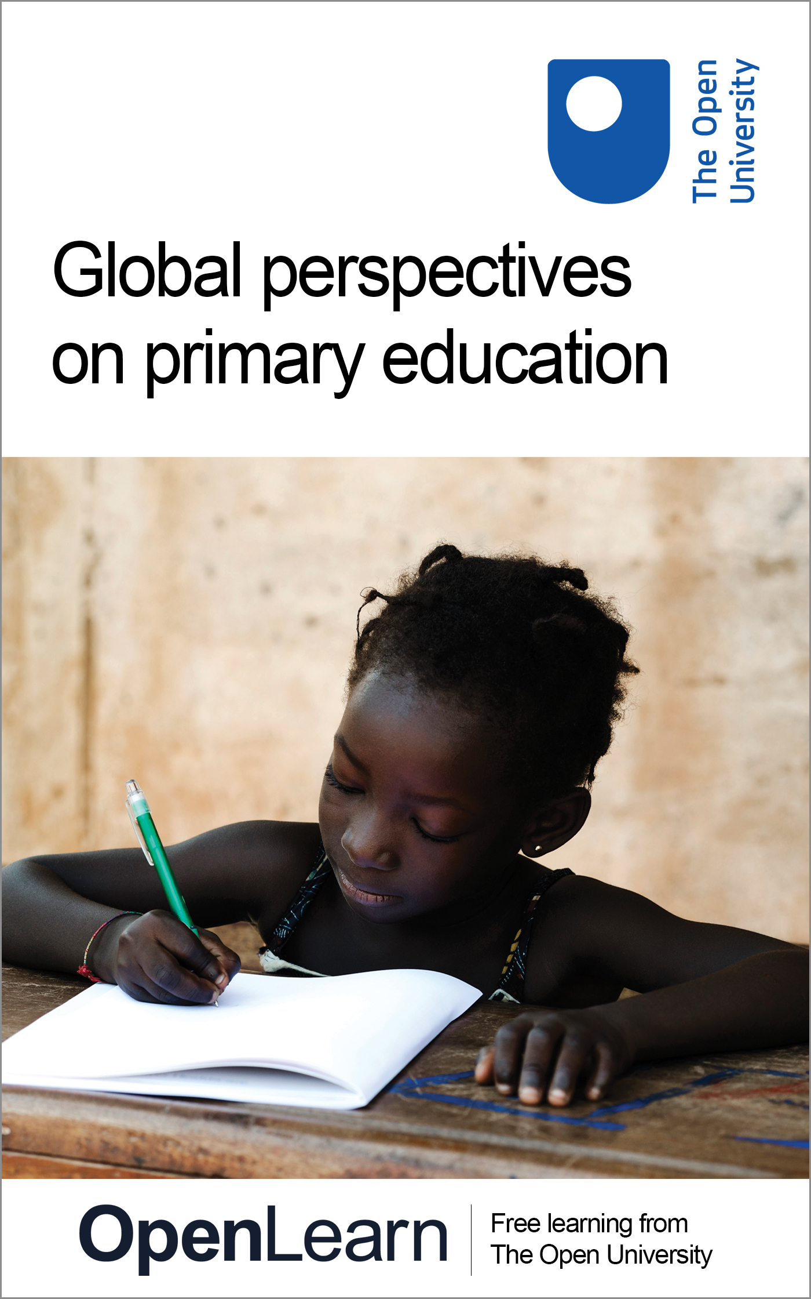

E309_1

Global perspectives on primary education
About this free course
This free course is an adapted extract from the Open University course E309 Comparative and international studies in primary education: www.open.ac.uk/courses/qualifications/details/e309..
This version of the content may include video, images and interactive content that may not be optimised for your device.
You can experience this free course as it was originally designed on OpenLearn, the home of free learning from The Open University –
www.open.edu/openlearn/education-development/global-perspectives-on-primary-education/content-section-0
There you’ll also be able to track your progress via your activity record, which you can use to demonstrate your learning.
Copyright © 2020 The Open University
Intellectual property
Unless otherwise stated, this resource is released under the terms of the Creative Commons Licence v4.0 http://creativecommons.org/licenses/by-nc-sa/4.0/deed.en_GB. Within that The Open University interprets this licence in the following way: www.open.edu/openlearn/about-openlearn/frequently-asked-questions-on-openlearn. Copyright and rights falling outside the terms of the Creative Commons Licence are retained or controlled by The Open University. Please read the full text before using any of the content.
We believe the primary barrier to accessing high-quality educational experiences is cost, which is why we aim to publish as much free content as possible under an open licence. If it proves difficult to release content under our preferred Creative Commons licence (e.g. because we can’t afford or gain the clearances or find suitable alternatives), we will still release the materials for free under a personal end-user licence.
This is because the learning experience will always be the same high quality offering and that should always be seen as positive – even if at times the licensing is different to Creative Commons.
When using the content you must attribute us (The Open University) (the OU) and any identified author in accordance with the terms of the Creative Commons Licence.
The Acknowledgements section is used to list, amongst other things, third party (Proprietary), licensed content which is not subject to Creative Commons licensing. Proprietary content must be used (retained) intact and in context to the content at all times.
The Acknowledgements section is also used to bring to your attention any other Special Restrictions which may apply to the content. For example there may be times when the Creative Commons Non-Commercial Sharealike licence does not apply to any of the content even if owned by us (The Open University). In these instances, unless stated otherwise, the content may be used for personal and non-commercial use.
We have also identified as Proprietary other material included in the content which is not subject to Creative Commons Licence. These are OU logos, trading names and may extend to certain photographic and video images and sound recordings and any other material as may be brought to your attention.
Unauthorised use of any of the content may constitute a breach of the terms and conditions and/or intellectual property laws.
We reserve the right to alter, amend or bring to an end any terms and conditions provided here without notice.
All rights falling outside the terms of the Creative Commons licence are retained or controlled by The Open University.
Head of Intellectual Property, The Open University

Contents
- Introduction
- Learning outcomes
- 1 Schools around the world
  - 1.1 Schools from around the world: a closer look
- 2 Primary education: why compare?
  - 2.1 Different purposes of comparative education studies
  - 2.2 Ranking purposes
- 3 Primary education: the global context
  - 3.1 Global agendas
  - 3.2 Sustainable Development Goal 4
  - 3.3 Progress towards SDG4
  - 3.4 Quality and learner-centred education
  - 3.5 Frameworks for learner-centred education
- 4 Making comparisons
  - 4.1 Comparing national achievement outcomes
  - 4.2 Comparing interviews
  - 4.3 Teachers on teaching
  - 4.4 Comparing the teachers
  - 4.5 Learning in different context: forest school and refugee camp
- Conclusion
- Glossary
- References
- Further reading
- Acknowledgements
- Solutions

Introduction
Welcome to this free course, Global perspectives on primary education. The course is an introduction to comparative education studies, where you will begin to compare and contrast primary schooling around the world.
The content and activities of this course content are drawn from a range of education settings, educators and countries. You will look into classrooms and hear from teachers, teacher educators and policy makers. You will also learn about United Nations Sustainable Development Goal 4 and the agenda for free, universal, quality primary education.
There are some glossary terms which appear in bold text. You can find definitions for these in the glossary at the end of the course.
This OpenLearn course is an adapted extract from the Open University course E309 Comparative and international studies in primary education, a compulsory Level 3 course in the BA Hons Education Studies (Primary) qualification.

Learning outcomes
After studying this course, you should be able to:
- know the basics about the field of comparative and international education studies
- understand the purposes of international goals for quality education
- develop the skills to compare and contrast education policies and practices.

1 Schools around the world
Comparative and international education studies is an exciting and interesting field.
You’ll start this course by watching a short film and then in the next section you’ll look at a slideshow of images.

Activity 1

To start, watch a short film. In the activity in the next section you’ll have the opportunity to look at a series of photographs of schools around the world and the children and adults in them.
Watch the 3-minute film and think about the questions below as you watch (you may wish to make notes in the box below).
- What do you notice about the age of the learners?
- How are the classrooms organised?
- Which classroom looks most like the one you attended?
- Which classroom looks most different to the one you attended?
You can pause the film at any time to look more closely.

Video content is not available in this format.
Video 1: Schools around the world
View transcript - Video 1: Schools around the world

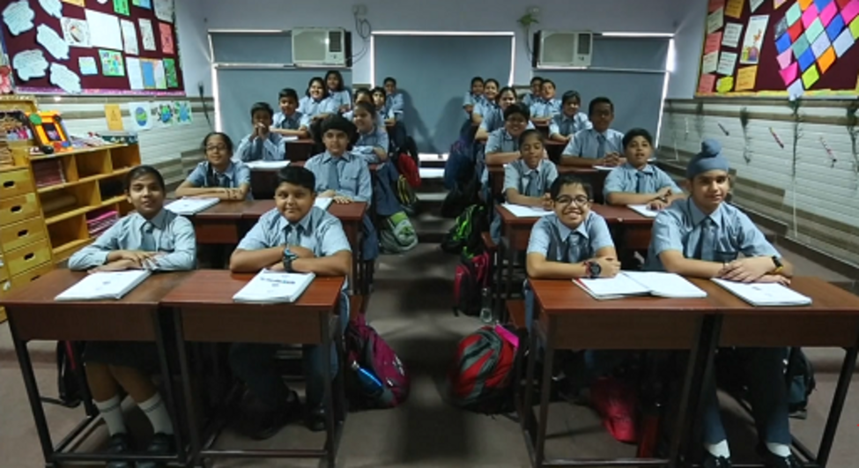

Add your notes in the box below and then click on ‘Save and Reveal Discussion’ to compare your reflections with those in the discussion.

Provide your answer...
View discussion - Activity 1

1.1 Schools from around the world: a closer look
Now you’ll look through a series of photographs of 25 classrooms around the world. You will recognise many of these scenes from the video you just watched, and there are more classrooms in different countries.

Activity 2

Have a look at the photographs on the Guardian website: Schools around the world: in pictures.
Read the information for each photograph. After you have looked at the photos and read the information about each one, answer the following questions:
- What single image inspires you the most, and why?
- Which two countries do you think show the greatest differences in classroom organisation, and what are these differences?
You can, if you wish, make your own notes to answer these questions in the text box below. Your notes will be saved for you, so you can use them again at the end of this course.

Provide your answer...
View discussion - Activity 2

Now that you have had a look at some classrooms around the world, in the next section you will look at the different purposes of comparing education systems.

2 Primary education: why compare?

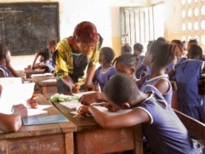
Figure 1 Children and their Learning Assistant in a classroom in Sierra Leone, Africa.
View description - Figure 1 Children and their Learning Assistant in a classroom in Sierra Leone, A ...

Comparative education studies, broadly speaking, has two strands: large-scale cross-national comparisons that use numerical data to evaluate educational outcomes and achievements; and small-scale empirical comparisons (evidence gathered through first-hand observations, interviews or conversations) of teaching and learning in classrooms. Both approaches are valid, depending on what you wish to find out. In this course, you will learn a bit about each strand.

2.1 Different purposes of comparative education studies
Education is a rich site for comparative study because, as the comparativist Harold Noah noted, it is the ‘touchstone’ of any society (Noah, 1986, pp. 553–4): a standard by which a society is judged, where we ﬁnd its core values embedded, and where such values may be examined and challenged. The comparative scholar Mark Bray has written about the different actors and the wide and varied purposes of comparative education studies, for instance:

- Parents commonly compare schools and systems of education in search of the institutions which will serve their children’s needs most effectively.
- Practitioners, including school principals and teachers, make comparisons in order to improve the operation of their institutions.
- Policy makers in individual countries examine education systems elsewhere in order to identify ways to achieve social, political and other objectives in their own settings;
- International agencies compare patterns in different countries in order to improve the advice they give to national governments and others.
- Academics undertake comparisons in order to improve understanding of both the forces which shape education systems and processes in different settings, and of the impact of education systems and processes on social and other development.
(Bray, 2007, pp. 15–16)

A sixth important purpose of comparative studies is to improve knowledge and skills for effective teaching that will help children reach their full potential.

2.2 Ranking purposes
Look again at the six purposes of comparative study of education.

Activity 3

How would you rank them yourself? Use the interactive table below to rank the purposes in terms of their importance, from 1 for ‘not very important’ to 6 for ‘very important’.

Interactive content is not available in this format.

Reflect and record. How did you decide to make your rankings? Did you draw on certain experiences, knowledge or evidence to make your decisions?

Provide your answer...
View discussion - Activity 3

3 Primary education: the global context
It is likely that you are familiar with some version of a primary or elementary school system from having gone to school yourself, from the experiences of your own children or children that you know. In primary schools around the world, children learn to read, write and count. There are also distinctive cultural additions to curriculum: children in a rural school in Uruguay, for example, may learn how to milk a cow, primary school children in Vietnam perhaps learn etiquette, and children in Russia traditionally learn ballroom dancing. Perhaps when you were a child in primary school you learned something that was distinctive to your country in terms of its history, geography, culture or language.
Primary education or elementary education generally refers to the first phase of formal education for children between the ages of 5 and 12, with a national policy and curriculum created specifically for this age phase. However, around the world there are older learners in primary classrooms, where young people start school late due to economic circumstances or are kept back after failing examinations. ‘Primary’ children also do a considerable amount of learning when they are not in school, as they play at home and watch and listen to others in their communities. Basic education covers the primary age phase but can apply to learners of any age and aims to provide literacy and numeracy skills for life and work.
Early childhood refers to a distinct phase of development, from birth to age 8, encompassing nutrition and physical and emotional well-being as well as cognitive growth. This phase overlaps with primary education, since most children go to school at age 5 or 6. Early childhood education is often distinct from primary education, focusing on young children’s social and emotional health, and learning through guided play and exploration (Figure 2). There is much interest globally in Early Childhood Education (ECE) and Early Childhood Development (ECD), because children who experience high quality ECE are more likely to thrive and succeed in primary school. In many countries, education policy increasingly promotes a less formal, more child-centred approach in the early years of primary school.

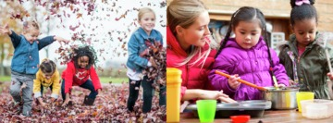
Figure 2a and b Young children learning through play in an Early Years setting.
View description - Figure 2a and b Young children learning through play in an Early Years setting.

Around the world, the primary school curriculum is often described as ‘the basics’, that is, learning to read, write and count. But there are often many other aspects to school learning for young children, such as science and environmental or sustainability studies, history and geography, personal, social and emotional health, citizenship, physical education, creative arts and, often, learning a second or third language. Around the world, children are taught the same subjects in different ways. In some classrooms children learn by memorisation. In others, children learn through exploration and play. In many settings it is a combination of both.

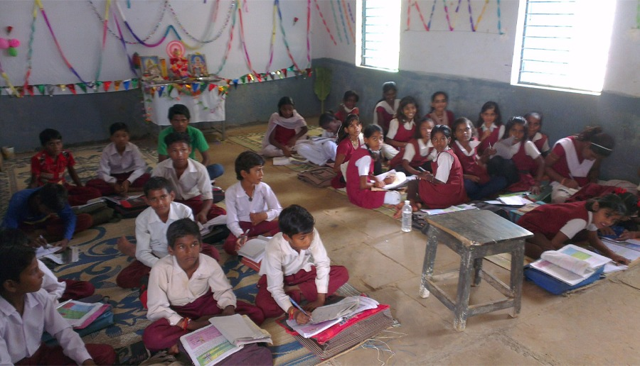
Figure 3 A classroom in India.
View description - Figure 3 A classroom in India.

3.1 Global agendas
In terms of making comparisons, globalisation has made many aspects of education more similar around the world. For example, a comparative study of early childhood education in Japan, the US and China (Tobin, 2011) found that over a generation these curricula became MORE alike owing to the global spread of progressive educational theories and child-centred teaching approaches. However, the curriculum of early childhood and primary schooling, and ways of teaching the curriculum, vary depending on cultural norms, traditions, history and national expectations. Tobin also found the three curricula in his study became LESS alike in other ways, as cultural heritages unique to each nation flourished and became embedded in school practices.
Much education policy research today compares information such as the number of children enrolled or completing their education. This reflects the modern aim of achieving free, universal and compulsory primary education, which was established in the 1948 Universal Declaration of Human Rights.
The ambition to achieve free and compulsory primary education for all children has been defined and specified through a series of international agendas and targets. The Education For All movement was launched in 1990 and had a goal of achieving universal primary education by 2000 through increasing school enrolments. While much progress was made, this goal had not been achieved by 2000, when the World Education Forum (WEF) renewed the call to eliminate all barriers to children’s education:

For the millions of children who live in poverty, who suffer multiple disadvantages, there must be an unequivocal commitment that education be free of tuition and other fees, and that everything possible be done to reduce or eliminate costs such as those for learning materials, uniforms, school meals and transport.
(UNESCO, 1998, p. 15)

The Education For All agenda became part of the United Nations’ Millennium Development Goals, one of which was to ‘…ensure that, by 2015, children everywhere, boys and girls alike, will be able to complete a full course of primary schooling’ (UN General Assembly, 2000). This goal is yet to be achieved.

3.2 Sustainable Development Goal 4
UNESCO (2017) reported that in 2014, 61 million children of primary school age were not in school and 70 per cent of the global out-of-school population in primary and secondary education were in Sub-Saharan Africa and Southern Asia. Of those attending school, many make less than expected progress in literacy and numeracy. The UN also raised concerns about attainment differences within countries: children from wealthier households were assessed as having greater reading proficiency than their poorer counterparts and those in urban areas fared better than those in rural areas.
Against the backdrop of these educational concerns, the Millennium Development Goals were replaced by the Sustainable Development Goals (SDGs) in 2016. SDG4 is about education.

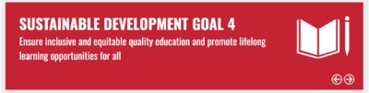
Figure 4 Sustainable Development Goal 4.
View description - Figure 4 Sustainable Development Goal 4.

SDG4 has the following aims:
- By 2030, ensure that all girls and boys complete free, equitable and quality primary and secondary education leading to relevant and Goal-4 effective learning outcomes.
- By 2030, ensure that all girls and boys have access to quality early childhood development, care and pre-primary education so that they are ready for primary education.
- By 2030, eliminate gender disparities in education and ensure equal access to all levels of education and vocational training for the vulnerable, including persons with disabilities, indigenous peoples and children in vulnerable situations.

3.3 Progress towards SDG4
The UN’s online Sustainable Development Knowledge Platform has information on progress towards SDG4.
Today, the target of enrolling all children in school has been superseded by much more complex goals, including: the provision of quality education with effective and relevant learning outcomes, and safe, non-violent, inclusive and effective learning environments for all. There has been progress towards aspects of SDG4, and these focus on access and participation. However, in 2017 there were still 262 million children and young people out of school. You can read more about the progress that has been made since 2016 on the UN’s online Sustainable Development Knowledge Platform (explored in the following activity).

Activity 4

Read the page entitled Progress of Goal 4. You will need to read the information from all of the tabs. Then answer the following questions:

Based on this report, identify the findings in these areas:
1. What was the global primary enrolment rate?

56%
72%
91%
View answer - Part

2. Globally, how many primary school age children across the globe were not in school?

44 million
61 million
93 million
View answer - Part

3. As reported in 2018, what was the participation rate in early childhood and primary education in 2016?

70%
63%
49%
View answer - Part

4. In 2019, what was the percentage of trained primary teachers in Sub-Saharan Africa?

25%
64%
88%
View answer - Part

5. Worldwide, what percentage of primary and lower secondary age children attain minimum proficiency levels in reading and in mathematics?

Less than 50%
More than 50%
Nearly 100%
View answer - Part

3.4 Quality and learner-centred education
As you have just learned, international education agendas today call for ‘quality’ education – not just enrolment of children in school or, to put it bluntly, ‘bums on seats’. If children are enrolled in school, what kinds of experiences are they having there? What does ‘quality education’ actually look like in reality? In the quality classroom, what are children and teachers doing?
In the global agendas such as SDG4’s aim to promote and ensure quality education for all, there is increasing focus on pedagogy: the visible act of teaching and the discourses (ideas, theories and debates) which inform and make sense of teaching. National and global education policies often refer to learner-centered and child-centered pedagogy as an aspect of quality education.
In the next section, you will read about the core elements of learner-centered education.

3.5 Frameworks for learner-centred education
There are two frameworks that provide practical starting points to observe and evaluate the educational experiences of children and the practices of teachers. These frameworks have been developed from research in classrooms around the world.
Michelle Schweisfurth (2013, p. 146) has proposed a set of minimum standards for learner-centered education:
- Lessons are engaging to pupils, motivating them to learn (bearing in mind that different approaches might work in different contexts).
- Atmosphere and conduct reflect mutual respect between teachers and pupils. Conduct such as punishment and the nature of relationships do not violate rights (bearing in mind that relationships might still be relatively formal and distant).
- Learning challenges build on learners’ existing knowledge (bearing in mind that this existing knowledge might be seen collectively rather than individualistically).
- Dialogue (not only transmission) is used in teaching and learning (bearing in mind that the tone of dialogue and who it is between may vary).
- Curriculum is relevant to learners’ lives and perceived future needs, in a language accessible to them (mother tongue except where practically impossible) (bearing in mind that there will be tensions between global, national, and local understandings of relevance).
- Curriculum is based on skills and attitude outcomes as well as content. These should include critical and creative thinking skills (bearing in mind that culture-based communication conventions are likely to make the ‘flavour’ of this very different in different places).
- Assessment follows up these principles by testing skills and by allowing for individual differences. It is not purely content-driven or based only on rote learning (bearing in mind that the demand for common examinations is unlikely to be overcome).
Drawing on Schweisfurth (2013), Wagner et al. (2012), Alexander (2009) and Wiggins and McTighe (2005), Mary Mendenhall and colleagues (2015) used a framework of ‘core elements’ of learner-centered education to observe teaching and learning in refugee schools in Kenya:
- meaningful and active pupil engagement
- inclusive and respectful learning environment
- differentiated instruction
- constructive classroom discourse
- varied comprehension checks and assessments
- conceptual learning and critical thinking
- relevant curriculum and language(s) of instruction.
No classroom will evidence all these descriptors all the time. Also, what constitutes ‘meaningful and active’ engagement and ‘constructive’ discourse will differ from classroom to classroom. Nevertheless, frameworks such as these begin to make the abstract concept of learner-centered education more concrete and real. The development and application of such frameworks that focus on the day-to-day interactions of teachers and children will offer practical indicators of quality education for all.
In the rest of this course, keep in mind the core elements of learner-centered education. See if you can identify the elements in the examples that you see and compare.

4 Making comparisons
In the activities in the following sections, you will look at examples of the two research orientations of comparative education: large-scale, cross-national comparisons, and small-scale interview comparisons. These two orientations are not always separate. For instance, large-scale surveys can be illuminated by small-scale case studies that give depth and detail to numerical data and ‘humanise’ the numbers.

4.1 Comparing national achievement outcomes
PISA is a global education survey of more than half a million 15 year olds in over 30 countries. The purpose is to evaluate the effectiveness of education systems, and how far children’s primary school education prepares them for educational success in post-primary education (bearing in mind that in many countries children can leave school at age 16).
PISA is carried out by the Organisation for Economic Cooperation and Development (OECD). OECD has produced a video to explain what PISA is and how it is used, which you will watch. The video states:

PISA shows countries where they stand – in relation to other countries in how effectively they educate their children ... It shows similarities and differences between education systems around the world.

Activity 5

Watch the 12-minute video about PISA.
First, view it without making notes to get an overall sense of the content and the graphic mode of presentation and explanation.

Video content is not available in this format.
Video 2: PISA explained
View transcript - Video 2: PISA explained

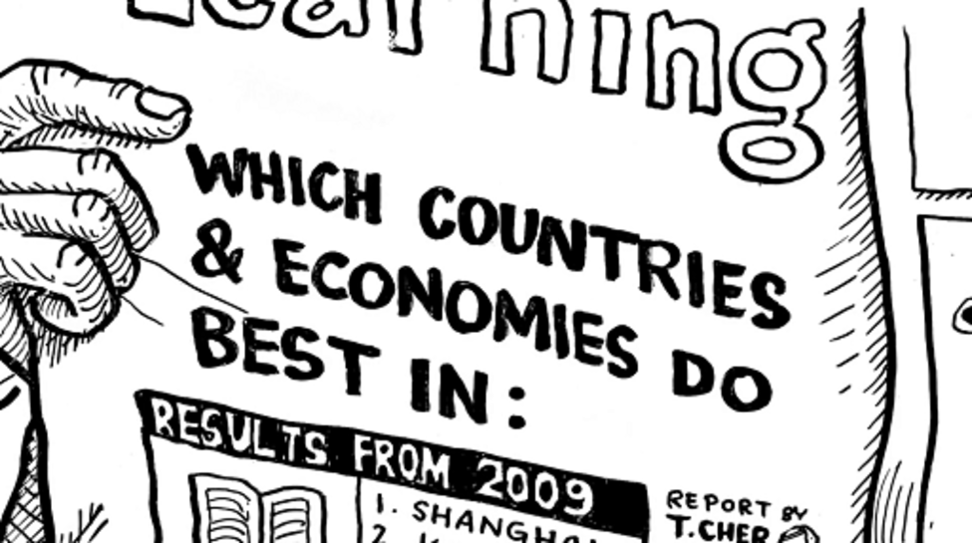

Then, watch it again, and ask yourself some questions. You can, if you wish, write notes in the box below and save the notes.

Provide your answer...
View discussion - Activity 5

Next you will look at primary education with a close-up lens for a small-scale, qualitative comparison.

4.2 Comparing interviews
Qualitative research is about the nature of the thing investigated, and often involves the collection and interpretation of data that tends to be words rather than numbers.
There are two interviews for you to listen to. The sociologist Amitai Etzioni believed that comparison serves to increase our ‘scope of awareness’ (1969, p. vi). For this reason, you should examine and compare the two interviews. You may need to listen to the audios several times, and you may find it helpful to ‘pause’ to listen more carefully at each one.
In many parts of the world, primary school completion rates for girls are lower than for boys. This has an ongoing impact on girls’ education, health and opportunities for employment. The UK’s Department for International Development (DFID) is a major funder of development-focused research across the globe. DFID has prioritised funding for the education of girls in developing countries.

Comparing interviews: part 1
In the following ten-minute interview, Sally Gear, Senior Education Adviser at DFID, talks to Liz Chamberlain, Senior Lecturer at The Open University, about key issues for the education of girls around the world.

Activity 6a

Listen to this interview and then answer the questions that follow.

Audio content is not available in this format.
Audio 1: Educating girls
View transcript - Audio 1: Educating girls

What are the issues that Sally Gear raises with regard to a worldwide need for a focus on facilitating girls’ access to schooling and fostering their continued attendance?

Provide your answer...

What is the concept of ‘wrap around needs’ in relation to the socio-economic factors that can affect girls’ attendance at school and their transitioning through a country’s educational system?

Provide your answer...

What are the reasons why some countries may be reluctant to be included in PISA tests and the consequent ranking of shared results?

Provide your answer...

Comparing interviews: part 2
Sister Elizabeth Amoako-Athena is principal of Our Lady of Apostles College of Education in Ghana, with many years of experience of teacher training. Matha Josephine Apolot is a lecturer in Primary Education at Shimoni Primary Teacher Training College in Kampala, Uganda, and has recently begun working in higher education.

Activity 6b

In the following 10-minute interview, Elizabeth and Matha talk to Kris Stutchbury, Senior Lecturer in Education at The Open University, about quality education in Ghana (in West Africa) and Uganda (in East Africa).
Listen to this interview and then answer the questions that follow.

Audio content is not available in this format.
Audio 2: What is quality education?
View transcript - Audio 2: What is quality education?

What aspects do both interviewees believe to be important if there is to be quality education in Ghana and Uganda?

Provide your answer...

What emphasis do they place on teacher education and trainees’ school experience as a means of enabling teachers being trained to provide quality in their teaching of pupils?

Provide your answer...

Comparing interviews: part 3
In the previous audio, Sister Elizabeth and Matha Josephine mention how their own educational experiences have played a part in their current wishes and designs for children in Ghana and Uganda. Our early school experiences can carry a motivational power in this way – some would argue that there should be continuity and tradition as with many public schools in the UK; others might seek something very different for children, giving them a change from what their parents experienced when young.
They also make much of the role of teachers in the realisation of quality education. They lay emphasis on empowerment of teachers, on applicants’ entry qualifications, on the shift from standards (a required level of attainment) to competencies (what someone can do), and the importance of increasing the time that trainees spend in classrooms.
Such features of teacher training can be found in the policies of many countries, not least in the UK where some would argue that teacher empowerment has been put at risk by the way successive governments have specified, in some detail, what should be taught in primary schools.

Activity 6c

You’ll now compare the two audios. Note your comparisons in the boxes in the table below.

Your comparison of the two interviews
Comparator | Sally Gear interview | Elizabeth Amoako-Athena and Matha Josephine Apolot interview | Same, similar or different? | Evidence for same, similar or different?
1. Views and purposes of schooling | Provide your answer... | Provide your answer... | Provide your answer... | Provide your answer...
2. Views of teachers | Provide your answer... | Provide your answer... | Provide your answer... | Provide your answer...
3. The stated priorities | Provide your answer... | Provide your answer... | Provide your answer... | Provide your answer...
4. Views on teacher training | Provide your answer... | Provide your answer... | Provide your answer... | Provide your answer...
5. Selection of learning outcomes | Provide your answer... | Provide your answer... | Provide your answer... | Provide your answer...
6. Views of difficulties faced | Provide your answer... | Provide your answer... | Provide your answer... | Provide your answer...
7. Another aspect of comparison that you have noticed | Provide your answer... | Provide your answer... | Provide your answer... | Provide your answer...

View discussion - Activity 6c

Next, you will hear from three teachers in Peru, Vietnam and Germany, and compare their perspectives on teaching and learning.

4.3 Teachers on teaching
In this activity you will hear from three primary school teachers in different countries. At the end of the interviews, you will make a comparison of their ideas and experiences.

Activity 7

Lucy Conde is a teacher with over 30 years of experience. As you watch the following 10-minute video, think about the areas that appear to be most important to Lucy.

Video content is not available in this format.
Video 3: Lucy Conde
View transcript - Video 3: Lucy Conde

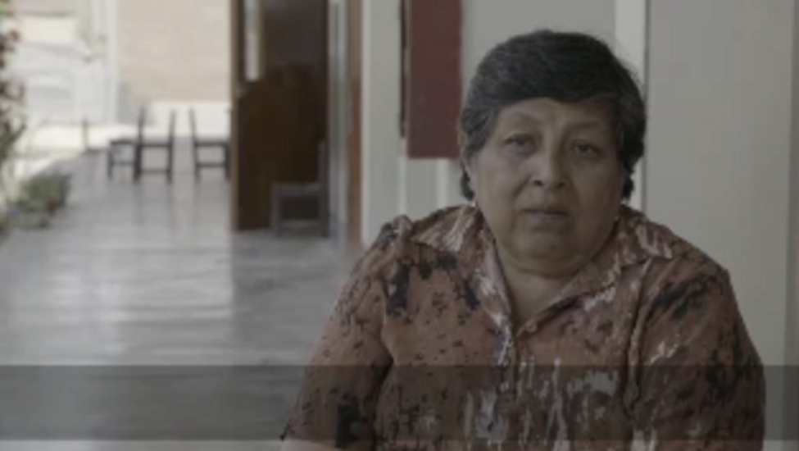

Provide your answer...
View discussion - Activity 7

Activity 8

As you watch and read about Pham Thi Vi’s experiences and perspectives, observe how she uses terminology like ‘methodology’ to explain her work. Listen as she explains the length of her teacher training programme and how her current school was also her training school, how long she spends in school and the time she starts her day.

Video content is not available in this format.
Video 4: Pham Thi Vi
View transcript - Video 4: Pham Thi Vi

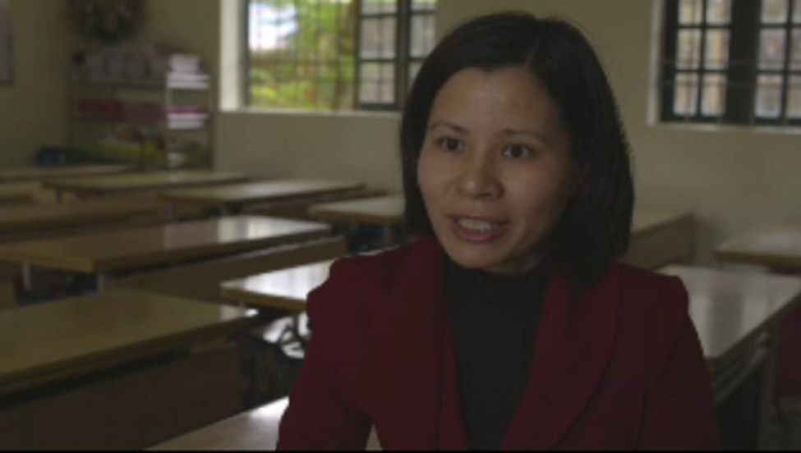

Provide your answer...

Activity 9

In Germany, teachers spend five years studying a degree subject and a further two years learning to teach. Listen to Birgit talking about her experiences of teaching and compare and contrast her comments with those of Lucy and Pham Thi Vi.

Audio content is not available in this format.
Audio 3: Birgit Gedicke
View transcript - Audio 3: Birgit Gedicke

Provide your answer...
View discussion - Activity 9

4.4 Comparing the teachers
What is evident from the teachers you have listened to so far, is that teaching goes far beyond being an imparter of subject knowledge and despite your geographical location, there is something that those who want to be teachers have in common. Something about the values they share and the job satisfaction they enjoy from being a teacher and working with children. Maybe you noticed similarities in the way that Birgit spoke about teaching compared to Lucy and Pham Thi Vi, or maybe you noticed some key differences.

Activity 10

Listen again to the three teachers talking about their practice, or read the transcripts (or refer back to any notes you have made) and make a small comparative study by completing the table below. It has been started for you.

 | Lucy Conde, Peru | Pham Thi Vi, Vietnam | Birgit Giedicke, Germany
Number of children in class | Between 34 and 35 students | Provide your answer... | Provide your answer...
Favourite subject taught | Communication and maths | Provide your answer... | Provide your answer...
Route into teaching | Graduated from the Superior Institute of Education in Chincha. | Provide your answer... | Provide your answer...
Purpose of primary education | Provide your answer... | To establish basic knowledge for secondary school. To nurture moral qualities and develop skills. | Provide your answer...
Parents and the community | Few parents are involved because they work and live a distance away. | Provide your answer... | Provide your answer...
Other things you noticed | The impact of the earthquake on schooling. | Provide your answer... | Provide your answer...

4.5 Learning in different context: forest school and refugee camp
In the next activity you will see two contrasting examples of primary education.

Activity 11

Read the introductions about the two interviewees before watching the slideshows and listening to their comments about teaching and the learning in their schools. As you read, watch and listen, ask yourself the following questions:
- Do you think what each school offers to the children is appropriate? Why or why not?
- Thinking back to the activities on quality education and learner-centered education, what would you identify as elements of ‘quality’ and ‘learner centeredness’ in each of these schools?
British headteacher Rory Fox runs a small charity called Edlumino, which raises funds to set up emergency schools in refugee camps around the world. In 2015 he set up a school in Faneromeni refugee camp in central Greece. First, watch the slideshow of images from Faneromeni camp and its primary school. Then listen to the interview with Rory Fox.

Video content is not available in this format.
Video 5: Faneromeni Refugee Camp, Greece
View transcript - Video 5: Faneromeni Refugee Camp, Greece

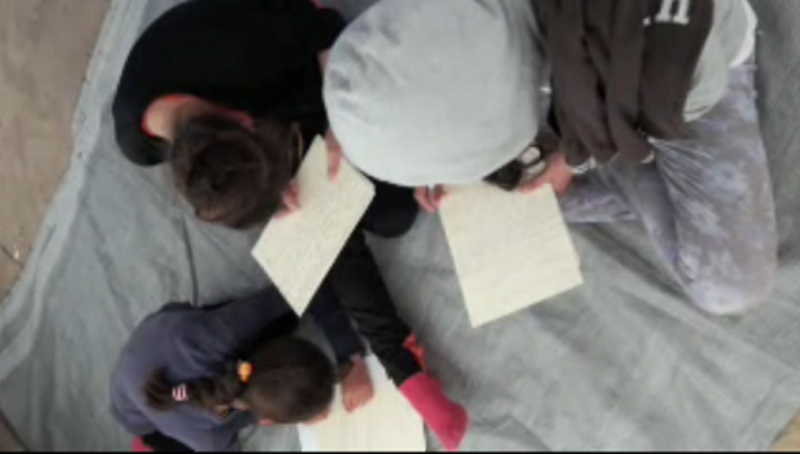

Audio content is not available in this format.
Audio 4: Interview with Rory Fox, Edlumino
View transcript - Audio 4: Interview with Rory Fox, Edlumino

Jane Williams-Siegfredsen trained as a teacher in England and went on to become a teacher educator. In 1990 she went on a study trip to Denmark, where she visited a ‘nature kindergarten’. Since then, Jane has become a leading figure in the Forest School movement. First, watch the slide show of a variety of forest schools in Denmark. Then listen to the interview with Jane Williams-Siegfredsen.

Video content is not available in this format.
Video 6: Danish Forest Schools

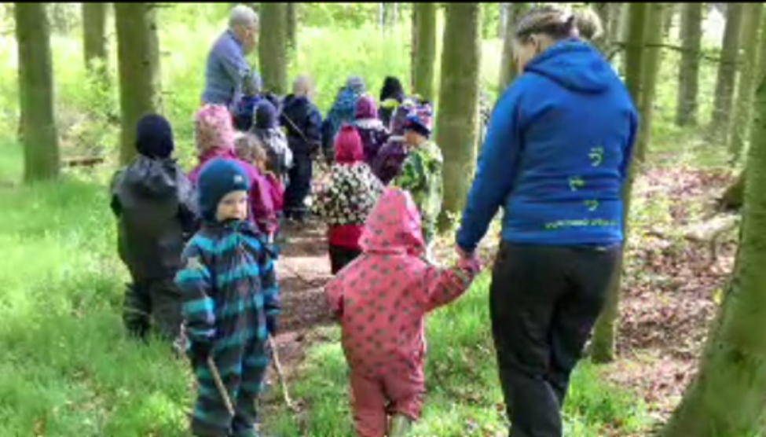

Audio content is not available in this format.
Audio 5: Interview with: Jane Williams-Siegfredsen, Forest School Pedagogue
View transcript - Audio 5: Interview with: Jane Williams-Siegfredsen, Forest School Pedagogue

Add your reflections to the box below.

Provide your answer...
View discussion - Activity 11

Conclusion
In this free course, Global perspectives on primary education, you have developed your knowledge about the field of comparative and international education studies. Hopefully the readings, audio-visual resources and activities have stimulated your thinking about teaching, learning, and making comparisons of education. Whether you are a teacher or you plan to teach in the future, or if you are interested in the field of education generally, hopefully you have enjoyed this course and it will help you to you take your studies further.
This OpenLearn course is an adapted extract from the Open University course E309 Comparative and international studies in primary education, a compulsory Level 3 course in the BA Hons Education Studies (Primary) qualification.

Glossary
Basic education
A range of educational activities that take place in various settings, both formal and informal, to meet basic needs. It comprises primary education and secondary education.
Department for International Development
A United Kingdom government department responsible for administering overseas aid and lead the UK’s work to end extreme poverty.
Early childhood
A range of learning and educational activities underpinned by a holistic approach to support children’s physical, social, emotional and cognitive development. The age of early childhood education differs across countries.
Early school experiences
Young children’s early learning experiences in a formal education setting.
Elementary education
Also called primary education. Usually the first stage of formal education.
Organisation for Economic Cooperation and Development (OECD)
Organisation for Economic Cooperation and Development (OECD) aims to promote policies that will improve the economic and social wellbeing of people around the world. The 25 member countries span the globe, from North and South America to Europe and Asia-Pacific. They include many of the world’s most advanced countries but also emerging countries like Mexico, Chile and Turkey.
Primary education
The UNESCO definition is as follows: Primary education provides learning and educational activities typically designed to provide students with fundamental skills in reading, writing and mathematics (i.e. literacy and numeracy), and to establish a sound foundation for learning and solid understanding of core areas of knowledge and personal development, preparing for lower secondary education. It aims at learning at a basic level of complexity with little if any specialisation (http://uis.unesco.org/en/glossary-term/primary-education-isced-1).
Quality education
UNICEF state that children have a right to an education, a quality education. Their definition includes: learners who are healthy, well-nourished and ready to participate and learn, and supported in learning by their families and communities; environments that are healthy, safe, protective and gender-sensitive, and provide adequate resources and facilities; content that is reflected in relevant curricula and materials for the acquisition of basic skills, especially in the areas of literacy, numeracy and skills for life, and knowledge in such areas as gender, health, nutrition, HIV/AIDS prevention and peace; processes through which trained teachers use child-centred teaching approaches in well-managed classrooms and schools and skilful assessment to facilitate learning and reduce disparities; outcomes that encompass knowledge, skills and attitudes, and are linked to national goals for education and positive participation in society.
Role of teachers
Teachers’ core roles is to educate children and young people by fostering their learning development. Beyond that, teachers carry out many other roles including nurturing relationships, supporting social and emotional aspects of learning, as well as being a mentor and guide.

References
Alexander, R. (2009) ‘Towards a comparative pedagogy’, in Cowen, R. and Kasamias, A.M. (eds) International handbook of comparative education. New York: Springer, pp. 911–29. Available from: http://robinalexander.org.uk/wp-content/uploads/2019/12/IHCE-chapter-59-Alexander.pdf (Accessed: 6 February 2020).
Bray, M. (2007) ‘Actors and purposes in comparative education’, in Bray, M., Adamson, B. and Mason, M. (eds) Comparative education research approaches and methods. New York: Springer.
Etzioni, A. (ed) (1969) The semi-professions and their organisation. New York: Free Press.
Mendenhall, M., Dryden-Peterson, S., Bartlett, L., Ndirangu, C., Imonje, R., Gakunga, D., Gichuhi, L., Nyagah, G., Okoth, U. and Tangelder, M. (2015) ‘Quality education for refugees in Kenya: pedagogy in urban Nairobi and Kakuma refugee camp settings, Journal on Education in Emergencies, 1(1), pp. 92–130.
Noah, H.J. (1986) ‘The use and abuse of comparative education’, in Altbach, P. and Kelly, G. (eds) New approaches to comparative education. Chicago: University of Chicago Press.
Schweisfurth, M. (2013) Learner-centered education in international perspective: whose pedagogy for whose development?. Abingdon: Routledge.
Tobin, J. (2011) Preschool in three cultures revisited: China, Japan and the United States. Chicago: University of Chicago Press.
UN General Assembly (2000) United Nations Millenium Declaration, Resolution Adopted by the General Assembly, 18 September. Available at: https://www.refworld.org/docid/3b00f4ea3.html (Accessed 23 April 2020).
UNESCO (2017) One in Five Children, Adolescents and Youth is Out of School, Fact Sheet No. 48, February, UIS/FS/2018/ED/48.
Wagner, D., Murphy, K. and Haley de Korne, H. (2012) Learning first: a research agenda for improving learning in low-income countries. Washington, D.C.: The Brookings Institution.
UNESCO (1998) World Education Report, Paris: UNESCO.
Wiggins, G. and McTighe, J. (2005) Understanding by design, Alexandria, VA: Association for Supervision and Curriculum Development,

Further reading
Find out more about the Sustainable Development Goal 4.
UNESCO also produces an annual Global Education Monitoring (GEM) Report, which tracks progress.
In his interview, Rory Fox refers to the Unicef curriculum. Look at Unicef’s ‘School in a Box’ resources for education in emergencies.
For more information about the UK Department For International Development and its work, visit the DFID website.
The UNESCO eAtlas of Teachers provides visual and up-to-date data on a number of themes, including an overview of teacher data, women in the teaching profession.

Acknowledgements
This free course was written by Liz Chamberlain. It was first published in May 2020.
Except for third party materials and otherwise stated (see terms and conditions), this content is made available under a Creative Commons Attribution-NonCommercial-ShareAlike 4.0 Licence.
The material acknowledged below is Proprietary and used under licence (not subject to Creative Commons Licence). Grateful acknowledgement is made to the following sources for permission to reproduce material in this free course:

Images
Course image: © borgogniels/iStock
Figure 1: courtesy of Martin Crisp
Figure 2a: © FatCamera/iStock
Figure 2b: © SolStock/iStock
Figure 3: © The Open University
Figure 4: © United Nations Sustainable Development Knowledge Platform

Audio-visual
Audio 1: © The Open University
Audio 2: © The Open University
Audio 3: © The Open University
Audio 4: © The Open University
Audio 5: © The Open University
Video 1: © Screan Ocean
Video 2: EduSkills OECD, http://creativecommons.org/licenses/by-nc-sa/3.0/
Video 3: © The Open University
Video 4: © The Open University
Video 5: © The Open University
Video 6: © The Open University
Every effort has been made to contact copyright owners. If any have been inadvertently overlooked, the publishers will be pleased to make the necessary arrangements at the first opportunity.
Don't miss out
If reading this text has inspired you to learn more, you may be interested in joining the millions of people who discover our free learning resources and qualifications by visiting The Open University – www.open.edu/openlearn/free-courses.

Solutions

Activity 1

Discussion
This film was chosen to open the course because it shows the very wide range of learners, teachers and classrooms around the world today. The film begins to show us what kinds of comparisons you might make of children’s education in different contexts.
In the film, you can look closely at some of the details of the children and the classrooms, for instance, at the kinds of clothes the children wear, how classrooms are resourced and decorated, and where the teacher places herself or himself. You can see how children are organised, for instance, whether boys and girls are sitting together or are separated, and whether classrooms are indoors or outside (one classroom is on the water). You can guess at the relationships between children and teachers, whether these seem to be warm and friendly or hierarchical and strict.
Clearly, some children and teachers have more, and better, resources than others. The film illustrates the great inequalities between the richest and the poorest countries in terms of education. There are of course differences within countries that you don’t see by looking at a single classroom.
Yet, whatever the context, there is something inspirational about seeing children, young people and adults in the daily endeavour of learning.
Back to - Activity 1

Activity 2

Discussion
The information with each photograph allows you to better interpret and understand learners and teachers, and what their classrooms are like. You learn, for instance, that the school in Minas, Uruguay, is a rural setting where children learn about milking cows, planting crops and cooking. You learn that the setting in Manacapuru, Brazil is a tribal school for Indigenous children. The school in Harrow-on-the Hill in England has some famous former students including Winston Churchill and the poet Byron. These social, cultural and historical factors all influence the ways children learn and how teachers teach.
In comparative education studies it’s important to keep an open mind, to reserve judgement of what’s ‘better’ or ‘worse’ in favour of taking a clear look at what is similar and what is different. Key questions in any comparison are what makes education different in different contexts, and what makes it the same for all learners.
Back to - Activity 2

Activity 3

Discussion
Each of the purposes listed in this activity has its own complexities.
Take the example of one purpose: ‘parents commonly compare schools and systems of education in search of the institutions which will serve their children’s needs most effectively’. Such a comparison may not be straightforward. Firstly, what evidence does a parent have to make a judgement? There will be hearsay, then there’s a visit to a school and the perception (by both parent and child) of its functioning and ambiance. It may be possible to tap into the views and experiences of any known children who are currently attending the school. Finally, there are measures in the form of publicly available examination scores and performance tables, and also reports from school inspection services. Which of these sources of evidence are most likely to help in a parent’s decision-making?
Likewise, practitioners, policy makers, international agencies and academic researchers will have their distinctive sources of information and knowledge when they undertake comparisons of education. Each of these actors will use different methods to gather and compare evidence. For instance, practitioners and policy makers may look for very different kinds of evidence of children’s learning: the former may draw on observations of children’s enjoyment or participation, while the latter might favour the numerical evidence of examination scores.
There is no single correct answer to these rankings. Your own ranking relates to your interests, values and beliefs. Other individuals or institutions will prioritise the purposes differently.
Back to - Activity 3

Activity 4

Part

Answer
Right:
91%
Wrong:
56%
72%
Back to - Part

Part

Answer
Right:
61 million
Wrong:
44 million
93 million
Back to - Part

Part

Answer
Right:
70%
Wrong:
63%
49%
Back to - Part

Part

Answer
Right:
64%
Wrong:
25%
88%
Back to - Part

Part

Answer
Right:
Less than 50%
Wrong:
More than 50%
Nearly 100%
Back to - Part

Activity 5

Discussion
The video is about the purposes of PISA. It could be characterised as an unproblematic justification of PISA. Ask yourself how such data might be used by national governments and education policy makers. Would this data be useful, for instance, to a classroom teacher? Why or why not?
PISA tests are said to assess something more than the memorising of facts – they focus on how pupils use and apply the knowledge they have acquired. This is a commendable focus, but how far would you say that this is possible in a paper and pencil test? Give an example, if you can, of a paper test that measures the application of academic knowledge.
PISA brings together the educational systems of over 30 countries which are OECD members. But many countries are not included; these are the areas not coloured blue on the global map in the video – perhaps a third of the world.
The PISA finding that ‘home background’ is very significant for children’s educational success has a long-established research history. In countries where great numbers of children are disadvantaged in comparison to children in other countries, how far can schooling compensate or equalise for social, economic and cultural factors?
Back to - Activity 5

Activity 6c

Discussion
The audios illustrate the way in which interviews can provide ‘data rich’, in that a small amount of audio can yield a great deal of qualitative information.
In completing this activity, you have carried out a small comparative study of education.
Back to - Activity 6c

Activity 7

Discussion
Are you surprised that her focus appears to be on aspects other than teaching and learning? She talks about children coming to school for love and protection, and that the purpose of primary education is to teach children to love themselves.
Lucy also mentions the importance of children being sufficiently nourished in order to learn well. This isn’t just an issue in low-income countries. While teachers need to know a great deal about a lot of subjects, what Lucy emphasises is that successful teaching is much more than just standing in front of a class of students.
Back to - Activity 7

Activity 9

Discussion
Did you notice similarities in the way that Birgit spoke about teaching compared to Lucy and Pham Thi Vi, or maybe you noticed some differences? For instance, Birgit comments on the importance of pupils learning more than one language and about the success the children enjoy when they can speak in a new language. The three teachers have different backgrounds and they all took different pathways into teaching. Birgit works in a much better resourced environment than Lucy and Pham Thi Vi, and Birgit has had many more years of formal education.
Back to - Activity 9

Activity 11

Discussion
The two types of school described in these interviews could not be more different. One is extremely challenging and chaotic, where children are traumatised and teachers work with few – and sometimes inappropriate – resources. The other is highly resourced and child-led, where teachers have considerable freedom to plan and support children’s exploratory play and learning. The activities in the Danish forest school are familiar to all the participants and are based on the country’s cultural and educational heritage. The activities in the refugee camp school in Greece may be very unfamiliar to the children, and in a language they do not use.
But notice how, in both schools, the teachers are agile and adaptive to the needs of the children. And in both schools there is the same dedication of teachers to the children in their care, and the commitment of teachers to creating educational experiences that sustain children to grow and develop in a positive direction. In both schools teachers strive to provide quality, learner-centered education.
Back to - Activity 11

Figure 1 Children and their Learning Assistant in a classroom in Sierra Leone, Africa.

Description
This colour photograph shows a crowded classroom in Sierra Leone, in Africa. The classroom has breeze block walls, a black chalkboard and children at wooden desks writing in notebooks. A female adult Learning Assistant is with a group of children at their desks. The children wear blue uniforms.
Back to - Figure 1 Children and their Learning Assistant in a classroom in Sierra Leone, Africa.

Figure 2a and b Young children learning through play in an Early Years setting.

Description
In the first photograph a group of four young children are outside throwing leaves around. In the second photograph two young girls are making cakes with an adult.
Back to - Figure 2a and b Young children learning through play in an Early Years setting.

Figure 3 A classroom in India.

Description
Girls and boys use texts in separate areas of an Indian classroom.
Back to - Figure 3 A classroom in India.

Figure 4 Sustainable Development Goal 4.

Description
The icon for Sustainable Development Goal 4 has an image of an open book and a pencil alongside the written goal: ‘Ensure inclusive and equitable quality education and promote lifelong learning opportunities for all.
Back to - Figure 4 Sustainable Development Goal 4.

Video 1: Schools around the world

Transcript
[CHILDREN CHATTER IN LOCAL LANGUAGES]
Back to - Video 1: Schools around the world

Video 2: PISA explained

Transcript
[MUSIC PLAYING]
VOICE ON RADIO
These are—
NARRATOR
If you read or listen to news reports about education, you've probably noticed periodic surges of interest in which country's students do best in reading or mathematics or science and where your country fits into the grand scheme of things. You've probably also heard or read the word PISA in connection with some of these reports.
What is PISA? PISA is an acronym that stands for the Programme for International Student Assessment. It's the brainchild of the OECD. And what's the OECD? It's another acronym that stands for the Organisation for Economic Cooperation and Development. The OECD brings together 34 countries with the aim of developing better policies for better lives.
In the late 1990s, countries that are members of the OECD came up with the idea to measure whether 15-year-olds around the world are well-prepared to participate in society. We chose 15-year-olds, rather than 12- or 17-year-olds, because most 15-year-olds are about to complete their compulsory education. Experts in the field of education from around the world worked together to create a two-hour test that focuses on core subjects like reading, mathematics and science. Participating countries decided to administer this test every three years and to rotate the main focus of the test among the three core subjects. All very well, but testing students is nothing new.
So what's so special about PISA? PISA surveys are designed to find out whether students can use what they have learned in school and apply that knowledge to real-life situations and problems. PISA is less interested in knowing whether students can repeat, like parrots, what they have been taught in class. Rather, the survey is designed to find out whether, for example, students can use the reading skills they have learned at school to make sense of the information they find in a book, a newspaper, on a government form or in an instruction manual.
But the point of PISA is not to tell each individual student how well he or she has mastered a set of skills. Instead, PISA results are analysed and extrapolated to the national level. Picture one student sitting at a desk in a classroom somewhere taking the PISA test. Now zoom out as though you're on the space shuttle, and you can see the entire country in which that student is sitting. That's what PISA does with its test results.
PISA shows countries where they stand, in relation to other countries and just by themselves, in how effectively they educate their children. While PISA doesn't say this education policy or practice causes that effect, it shows what's possible and shows similarities and differences between education systems around the world. That helps governments rethink their own policies and design new ones to improve their students' performance in school.
It also helps governments, educators and parents track their country's progress towards a more successful education system. In fact, many countries now set national goals and benchmarks based on PISA's international results.
PISA considers an education system successful not only if its students achieve high scores on the PISA surveys, but also if all students from all backgrounds perform well on the tests, not just those who come from wealthier or more intellectual or more culturally sophisticated families. For example, a relatively large percentage of disadvantaged students in places like Hong Kong, Shanghai, Korea and Finland achieve some of the highest scores in PISA.
Analysts then look at the PISA test results, along with the responses to questionnaires that are given to students and school principals, and try to determine the main characteristics of these successful education systems. Are teachers in these systems paid more? Are classes generally larger or smaller? Do individual schools get to decide what their teachers teach, or is the curriculum determined by a central government authority? Once the profile of a successful system emerges, it can be used as a model for others.
So what's the test like? Here are a couple of problems that students had to solve. The first one was part of the reading assessment. Students were shown a graph and an accompanying text that read, ‘Figure 1 shows changing levels of Lake Chad in Saharan North Africa. Lake Chad disappeared completely in about 20,000 BC, during the last ice age. In about 11,000 BC, it reappeared. Today, its level is about the same as it was in AD 1000.’
Students were asked, ‘why has the author chosen to start the graph at this point?’ This was considered a rather difficult question. In fact, across OECD countries, only 37 per cent of students answered it correctly. Those students showed an ability not only to read, but to think about what they read and draw some conclusions from it. They figured out that the reason the graph starts at around 11,000 BC is because that's when Lake Chad reappeared after having disappeared completely during the Ice Age.
The second problem was part of the mathematics assessment. It sets a scene: ‘in a pizza restaurant, you can get a basic pizza with two toppings, cheese and tomato. You can also make up your own pizza with extra toppings. You can choose from four different extra toppings: olives, ham, mushrooms and salami. Ross wants to order a pizza with two different extra toppings.’ Students are then asked, ‘how many different combinations can Ross choose from?’ Now, this is a problem we can all relate to. To answer the question, students had to show their ability to make connections, in this case, juggling several foodstuffs and realising that the choices are not, in fact, infinite, much as the students might like them to be. This was also a relatively tough problem for students to solve. Just 49 per cent of students could calculate that only six different variations were possible.
So when we take individual students' scores in PISA and their responses to those questionnaires that we circulate with the test and then zoom out to see a whole country, what kinds of things do we learn? Well, one thing we've learned is that girls do better in reading than boys in every country that participates in PISA. And among the countries that are members of the OECD, girls do so much better than boys in reading, it's as if they had gone through an additional year of school. We also found out that boys generally do better than girls in mathematics and that there's no real difference between boys and girls in how they do in science.
We also found out that some school policies may not be very good for students. For example, early tracking of students, which means deciding that some students should go through an academic programme, while others should go through a vocational programme, is not associated with better overall performance. Tracking is also related to greater inequalities between advantaged and disadvantaged students. Students are often tracked in the mistaken belief that not everyone can learn the same things, that only some children are gifted and can reach for the stars. But PISA results show that if given the opportunity and support to excel, all children have the potential to do so.
Having students repeat grades is also not associated with high scores in PISA. School systems that invest in helping students learn their subjects the first time around do much better than those where teachers know that they can, if necessary, drill the same material year after year after year into the heads of the same struggling students.
As we mentioned before, the most successful schools, according to PISA, are the ones whose students do well regardless of where they come from. Still, results from PISA show that home background has a major influence on students' success in school. In many ways, this finding is all too obvious. We know, for example, that by the time they're three, children in advantaged families are exposed to many more words than their less advantaged peers. In fact, a recent study in the United States put the number at around 30 million more words. And in general, if there are no books at home or if children don't see their parents reading, they'll be less inclined to read themselves.
PISA results also show that regardless of their own backgrounds, students who attend schools that have a largely disadvantaged student population tend to do worse than students who attend schools with relatively advantaged peers. Why would this be so? Well, there are many possible reasons. For example, PISA found that in most OECD countries, disadvantaged students have access to the same number of teachers, and to sometimes even more teachers, than their more advantaged peers. The problem, though, is that more isn't necessarily better. In fact, the best teachers are often found in schools attended by advantaged students, who generally do well on their subjects anyway, but not in disadvantaged schools, where high-quality teachers are most desperately needed.
Governments around the world can be inspired by two significant findings from PISA. The first is that a country doesn't have to be wealthy to provide high-quality education to its students. Shanghai and Poland, for example, score above the OECD average in reading, but rank below the OECD average in measures of national wealth.
And a country's PISA ranking is not carved in stone. Trends in PISA have revealed the great capacity for all countries to improve. Countries as diverse as Chile, Germany, Poland and Portugal, among others, showed improvements in student reading performance between 2000 and 2009.
Although it seems obvious, it's still worth reminding ourselves successful education systems make education a priority. They share the belief that skills can be learned and that all students can achieve at high levels. They show that they value the teaching profession by investing in it so that they can attract highly qualified candidates, train them well and retain the best teachers among them. Just as every student has the potential to achieve, every country has the potential to raise the standards of its education.
So PISA is about a lot more than test scores. Sure, countries that participate in the PISA survey are keen to know where their students rank compared to students in other countries. But PISA's ultimate aim is not to create a competition for its own sake. Its aim is to encourage all participating countries to use the survey findings to improve their own teaching and student performance to give every student the best opportunities to achieve the best possible results.
Back to - Video 2: PISA explained

Audio 1: Educating girls

Transcript
LIZ CHAMBERLAIN
Our students are interested in knowing a little bit more about some of DFID’s education projects, for example, the Girls’ Education Challenge. Could you share some headlines from the project?
SALLY GEAR
The Girls’ Education Challenge was a slightly different model when we first set it up because as you know DFID normally works very decentralised with government. Some of our money will be in partnership with government, some with projects. So it’s looking at reforming the whole of the education system. The Girls’ Education Challenges are what we call a centrally managed programme. So that was across around 30 countries, £355M is the largest ever global fund for girls’ education. And the aim was to work with at least one million girls to achieve a better learning outcome. It was also in the new context of the SDG’s before they actually were established that the outcomes for success were about improving learning, not just getting girls in school. The target was very much on the most marginalised girls. So we were working in some really challenging contexts like Afghanistan, Somalia, South Sudan and when we were in countries that were relatively stable we were working with the most marginalised students. So, for example, in Kenya we’ve got a programme in Dadaab, at the refugee camp there working with marginalised girls. Most of the projects are multisectoral. So we’re not just doing education interventions. We’re looking at the wrap around needs of girls, for example, risk of violence, potentially also marriage. So working with the communities, with girls clubs, etc. to try and look at those different needs too.
LIZ CHAMBERLAIN
Why is it important to have that wrap around? Why not just education?
SALLY GEAR
I think we’ve learnt over the years, in this country as well, that when you’re working with very marginalised children, yes you need excellent teaching and learning. But also they bring to school lots of issues from home and it’s exactly the same in developing country contexts. And there’s specific needs for girls but for marginalised boys and girls, nutritional needs for example. Health needs are really important because children can’t learn if they’re not sufficiently well fed or they haven’t got support. In addition in countries like Somalia a lot of these girls would have gone through a civil war, for example. So there is sort of trauma as well which can affect learning.
LIZ CHAMBERLAIN
And is there one project that you feel has made a difference to the broader community beyond the original aim of supporting the girls?
SALLY GEAR
One of our programmes is in partnership with Avanti which is a private sector company working in Kenya. And that’s now been going for about three or four years. We found that part of it was improving learning outcome through technology, edtech. And that was quite complicated because there was no access to electricity. There was no access to broadband, etc. They used satellite technology but actually they involved the local community and they found that some of the local community pay a small amount and then are able to use that for businesses, etc. It’s still early days. But I think that’s got a really interesting example of how a school can also be a community basis as well as an educational establishment.
LIZ CHAMBERLAIN
You mentioned the SDGs there. So to what extent does sustainable development goal four, drive the way the different projects are designed and delivered?
SALLY GEAR
I’m just going to pick up on the word projects because for DFID we are around changing and reforming national education systems on a larger scale ideally. That is about looking at how a whole education system actually is geared towards improving learning outcomes. That’s looking at teacher policy and teacher reform. It’s like driving up standards through assessment, good curriculum linked with teacher curriculum, particularly for us as DFID, the sort of basic literacy, numeracy levels which are very, very low as you are aware in many of the countries we work in at the moment.
LIZ CHAMBERLAIN
And you’ve talked about some of the obstacles to girls’ access to primary education. Are there particular obstacles that you find are recurrent across the countries that you work with?
SALLY GEAR
We’ve got a new programme developing in Tanzania, for example, which is looking at child protection alongside education. So we’re recognising we need to bring those together. I think that’s a big issue. Early marriage is a key one. And again I think we’ve got much more information about that and how that can affect. And I think a more nuanced idea about access. I mean access actually to primary education at the lower levels is vastly improved for girls across the piece. If you look at the data from 20 years ago the major challenge now is girls staying in school. And actually once they stay in school in many countries they’d be better than boys. So it’s a gender issue this as you’re probably aware of it in the UK as well. But where we’re losing girls is very much at adolescence. It’s where these pressures, these societal pressures come in for early marriage or when the cost of sending a girl to school for a family, is the opportunity cost much better if the girls are at home helping or they can marry her out, in a way. I think it is now it’s not so much about access to primary school but about girls staying and transitioning through the system.
LIZ CHAMBERLAIN
I believe you’ve got quite an extensive background in girls’ education and international development. I understand you worked for VSO, the British Council and now a senior adviser at DFID. Have you found similarities between the ways in which the different organisations set their priorities for primary education?
SALLY GEAR
Working for international NGO such as VSO you are working much more with projects. It’s different than potentially working with ministers of education and looking at sort of system reform. There is definitely a difference. I think the other difference obviously is DFID is, we’re a government department. So ultimately our priorities are set by the government. And so we have a certain technical response to how we approach education and development but at the same time we have to support our minister’s vision for development across the world. And with VSO obviously there’s a lot more freedom in terms of how you approach what you approach. But also you’re limited because there’s fund raising elements. I would say between VSO and DFID there’s quite a lot of difference. But that said I think we are fairly aligned with our international non-governmental organisations in this country. In terms of our actual vision on the learning outcomes and girls’ education I think we’re very aligned. With the British Council there was also it’s a cultural organisation too. So a lot of what I did with the British Council was about looking at how UK institutions can support development work overseas. So we did school linking. We looked at bringing ministers of education over to show them UK best practice. And interestingly that’s coming in very much now to DFID’s work.
LIZ CHAMBERLAIN
You talked a lot about learning outcomes for the girls and that it isn’t just about access now it’s about staying in school and good teaching and learning. So what are your reflections on the notion of quality, which is something that’s talked about quite a lot in terms of teaching and learning across the countries you work in?
SALLY GEAR
It’s a very good question. I think for me, this is very much a personal reflection over the years is, I feel we really need a push on the sort of teaching effectiveness and good teaching. I think we’ve had a period where obviously we had the push on access because many children were out of school so there was a lot of infrastructure projects. And we were just about numbers. And I think there was a shift to learning but we went on to sort of measuring learning outcomes. And I feel now if you look at a lot of the evidence that’s coming out there’s definitely not one silver bullet for education. But if you don’t have a good teacher teaching you you’re very unlikely to succeed. And I think we’ve got a vast challenge, particularly in Africa. And with the demographic challenges now we’re a million short of sufficient teachers. But also teachers of good quality that are able and that are supported and incentivised to teach well. For me now I think we do need an international push on the value of teaching. And I know it’s always a challenge. It has been in this country. I was a trained teacher myself. And in many of the countries that we work in it’s still, it’s increasingly not a profession of choice for the brightest and the best young people. We need to work and help countries to shift that. But also the model of teacher training is still in many countries again a sort of throw back from potentially colonial times where we had a very elite sort of university based teacher education. And we need to shift that to much more school based approaches. For me that’s where I feel the next big push should be. But that’s very much a personal reflection.
LIZ CHAMBERLAIN
And you work with a number of different countries and institutions of education. How do you make the sort of comparison data, you talked about data and outcomes, how do you make use of that data to inform the decisions about where to deploy resources?
SALLY GEAR
I mean data is really, really important. And I think with the role of edtech and mobile technology we’ve got the potential now of actually getting live data. Much of the data we used in the past was based on UNESCO Institute for Statistics which was regarded as the sort of quality assured. The only challenges with that was that it was often two or three years out of date by the time we were using it. In terms of things like PISA, for example, obviously many of the countries DFID works in they don’t have PISA. And also they can be quite controversial these international comparisons, particularly now with the learning data because obviously not many ministers of education want the world to know that their education system is delivering very poor learning outcomes. So I think they need to be handled sensitively by the international community. And for me data is much more useful actually for the country itself and also to put assessment for learning using data to actually improve practice as opposed to just extracting it for international comparisons.
LIZ CHAMBERLAIN
How confident are you that the international community will have met its education 2030 goal to ensure that all girls and boys complete free, equitable and quality and primary and secondary education leading to relevant and effective learning outcomes?
SALLY GEAR
That’s a hugely ambitious goal. We’re not there in primary let along secondary for every child. If we’re really serious about it and that’s not just going to be another set of international words we really need a step up. And equally domestic governments themselves need to prioritise it. It’s not just about international aid. So I think we need the work the international Education Commission recently, for example is a good start in raising commitment and advocacy but we all need to make a big change because otherwise I think it’s unfortunately going to be an idea, rather a vision, rather than an achievable goal.
Back to - Audio 1: Educating girls

Audio 2: What is quality education?

Transcript
KRIS STUTCHBURY
Thank you Sister Elizabeth and Matha for agreeing to talk to me. The first thing that I was going to ask, can I ask you first Sister EliZabeth. What does quality education mean to you?
ELIZABETH
Quality education. The word quality is very big and depending on the circumstances or contexts it will mean different things to different people. But in terms of when you come to education, and I’m looking at the teacher education where I work, it’s more like a holistic kind of education given to teacher to empower the teacher to be versatile, to be able to help people. The type of education which affects the mind, heart, soul, body, and that means the person is very wholesome. That would be my type of education. I mean quality education. There are different aspects of quality. I mean like different dimensions that go to make up the quality education, which I’m sure Matha will pick up from there.
MATHA
Thank you Sister and interviewer. Yes, like Sister has put it, quality education depends on different contexts. In my own view I look at quality education in a way that I probably have to look at the indicators that can really show us that maybe we are getting quality education. First and foremost, I consider having qualified teachers who would be able to give us quality education. Having good schools. Having good infrastructure, generally the roads, and so on. And then also quality education is also seen in what the learners are able to demonstrate. Are they able to demonstrate the literacy and numeracy skills we are looking for? Are they able to communicate? Do they have the life skills and values that can help them, you know, fit in the society? That is my feel of quality education.
KRIS STUTCHBURY
Following on then from that, when the Millennium Development Goals changed into the Sustainable Development Goals there was a shift from an emphasis on access to an emphasis on quality. What changes have you noticed amongst the education community? How is this drive for quality? How has it changed what people are doing in your communities?
ELIZABETH
So in Ghana a lot of interventions were put in place to make sure that people have access. Schools were expanded. And now the emphasis is on the quality. Quality, so they are looking at how teachers are trained. What goes to training of teachers? For the first time we have not had any formal sort of standards for teachers. Now standards have been developed. And because of quality we have also put in this intervention teachers are going to be licensed. But teachers are going to be licensed from after your initial teacher training, you become an NQT, they give you one or two years’ induction, then you do professional tests.
KRIS STUTCHBURY
And what about Uganda, Matha? Have you noticed any changes in your college now the emphasis has changed?
MATHA
Our curriculum was reviewed in the PTC [Primary Teachers College]. And you realise that now the students are able to specialise. You either specialise in your second year. OK, first year you do general subjects. In second year you specialise either in lower primary or you specialise in upper primary. All colleges in Uganda have now ICT labs. They have computers, a standby generator, and some of them have got in funding from outside. They have given them solar panels. So that when electricity is not there the solar panelling is on and the computers just switch on automatically. And then the other one also, we changed now the objectives, we used to look at objectives. Now we are focusing on competencies, what students can do. So I think all this is focusing on quality. And then the other one is the admission of our students in the PTC has improved a lot. Previously we used to admit students who are just gotten passes. Passes, passes and passes. As long as you have six passes, you’d have the opportunity to join a primary teacher’s college. But we are saying now, no, since it is now quality, it is now credits. We want a credit in mathematics and we want a credit in English. And we want you to at least have passed two sciences from the two categories. So you must pass either of the two categories in order for you to qualify to go to that college.
ELIZABETH
It’s the same thing with ours.
MATHA
We are also suggesting that the school practice of the students should take longer than one month. Actually we are saying it should go to a minimum, a minimum, of six months. And then, before that, we have also introduced the school attachment programme. In this programme, in first year, students go to schools, to various schools in their different settings, in their different villages to have just the experience on how children interact with quality just like childhood study.
ELIZABETH
We call it school observation.
MATHA
Exactly. So that by the time you come to the college you have something. You have an experience. You have something at the back of your mind, oh this is how things are supposed to be done. And when I reach second year, you know what exactly you are supposed to do. So that is what I can say.
KRIS STUTCHBURY
I want you to tell me a bit about your own experience of being educated now, your own experience of being at school?
MATHA
I used to walk from home to school. It was almost like three kilometres, a small thing going to primary one. Yeah, you walk like six kilometres every day, Monday to Friday, going to school. And to make matters worse, you walk on an empty stomach. Imagine you leave home without breakfast. Those other siblings are dragging you, you have to move very fast in order not to be beaten because of late. And then when you reach the classroom you find the teacher waiting every day. You are supposed to come with a book, you’re supposed to come with a pencil. You don’t have all those. I was so unfortunate probably. I lost my father when I was still very young, and I was brought up by my mother who was very young. So that is my bitter kind of experience. But then what enticed me in my life is that when I was in that school I used to see rich parents bringing their children to school, driving them to school. They had beautiful uniforms. They had shoes. I had no shoes. Then I said, when I grow I have to work hard and make sure that my children in future will be driven to school. That’s what made me continue, reading and reading and reading.
KRIS STUTCHBURY
What about you Sister? What’s your early experiences at primary school?
ELIZABETH
Well my early experience it’s a bit opposite of hers. We lived in this gold mining town, a very popular town in Ghana, called Taqwa. My father was a goldsmith, you know, and he had a shop. And he had apprentice. They made jewellery, gold jewellery, you know, trinkets, watches, you know. And my mother used to take them in a glass case and go and sell them. I was lucky I had good parents. But where we were there were missionaries, Catholic missionaries anyway, a big Catholic school, very disciplined. I those days we didn’t even pay fees. I don’t think we paid fees. It was all sponsored by the Catholic priests. They were from France and Ireland. I remember them very well. So they used to give books, pencils. You go in there and they’re all lying on the table. They inspect your clothes, go and sit down, and just get [inaudible]. And there were teachers who were paid by the government but they were supervised. And I mean supervised closely by the Catholic priests.
KRIS STUTCHBURY
So it was well disciplined, but what was obviously missing from Matha’s was kindness. Did you experience the kindness of teachers and adults in your school?
ELIZABETH
Oh yes. The teachers together worked very seriously. Very, very seriously. And as I said maybe they did because of the supervision. They took their work very, very seriously.
KRIS STUTCHBURY
If you had the power just to change one thing, which thing do you think would make the biggest impact and improve the quality?
ELIZABETH
The good thing about me is that I’ve taught in primary, I’ve taught in middle, I’ve taught in secondary, I’ve taught in college. But now what is missing. The Ghana education system is, I would say, lack of accountability of teachers. You see, they don’t have that sense of accountability, and with that comes lack of commitment somehow. And what we need is true supervision. Luckily I’m part of the new Education Council in Ghana. And I’m pushing for that. We need to strengthen supervision.
KRIS STUTCHBURY
And what about Uganda, Matha?
MATHA
If I was given the mandate to change something in my country as far as teachers, quality, schools and my focus would be on the training of teachers. I would actually extend their training from two years to four years so that we get quality teachers. These students should be given time even a full year to be in the schools to practice. There are many things you practice, you know. You practice how to make materials for people, for the children. You study children, you get to know how the children are going to behave. You practice how to teach. You practice how to interpret all the materials, and all the materials that support the curriculum should be coming out as a specialist. So that is my own view.
Back to - Audio 2: What is quality education?

Video 3: Lucy Conde

Transcript
TEXT ON SCREEN (TRANSLATION)
I’ve been a teacher since 1985 when I graduated from the Superior Institute of Education in Chincha. I teach children aged 6, 7, 9, 10 and 11 years old. When I qualified as a primary teacher I had just got married. I didn’t work for a year and dedicated that time to my son. After that I did supply work and took two short contracts. One was to this school, in September 1988, covering a period of leave. I then took a risk by asking the regional council to be assigned as a permanent teacher to this specific school, where I had worked. And so I was named an official teacher here at the end of December 1988. I started working here the following April as a Year 1 teacher. In the past the school buildings were built from Adobe or mudbrick. But after the 2007 earthquake it was all replaced with the help of two NGOs, ‘The Spanish Red Cross’ and ‘Telefonica Espanola’. They changed the entire structure, made everything from new because after the earthquake we were teaching in wooden huts. At that time we were also helped by a local businessman, to build temporary classrooms in the yard. Then the Civil Defence decided to take it all down and the necessary steps were taken to permanently rebuild the school with the help of the two NGOs. All out classes have around 28 to 30 pupils. Sometimes we go up to 34 or 35 children in a class. Quite often the Headteacher says we don’t have vacancies, but then she asks the teachers if we are willing to take on a new child and we decide that we can. We always try to give each student proper care and attention. Primary teachers need to be like encyclopedias because we teach many different subjects, but here, we put an emphasis on maths skills and communication, especially communication. We make sure that the children are able to write and speak properly. I really like teaching communication and maths: they go side by side. Every year I try to learn new techniques and strategies to use in the classroom. I enjoy being close to the children - being with them and the care and protection we can offer them. Often a child looks for someone that can protect them, they want to feel loved, maybe that’s missing for them. In a similar way that we defend our children at home, we defend our children in school, like lions. This is how I feel, I love my children a lot. I like them to be well-mannered and respectful and I look to set an excellent example so they learn from it and develop good values. Our aim is to educate the child fully, in an integral way so he understands himself, and can then get to know others. If a child knows and loves himself, he will love others and want to give to others. I think for a child to grow and to be a good person, you have to get him to know, accept and love himself, then he can begin to grasp everything else. I hope that in the future my pupils become good people for society, for their families and for the country. They are … how can I explain it? Each parent expects good things from their children, something better. Here most parents work in agriculture and they don’t want that for their children. They want them to be professional, to move to different places and serve their country. They are the future, our hope. Few parents take part in their children’s schooling. Many of them work all day, from very early to 5pm. They make breakfast really early for their children, but frequently children come to school without having had breakfast or even combing their hair. Fortunately the government provides breakfast for them at school. Most of the children come to school looking forward to being fed. Some hard working parents just don’t have the time to prepare meals for their children. Sometimes the parents can be a bit distant from their children. We get help from the local council and also a foundation called La Calera, run by a lady called Beatriz, who used to come here herself. Now she has left us in the hands of the foundation that continues to help us. After the earthquake, when the school was rebuilt we had help from a company called Cargill who provided the breakfasts. Today we get support from the National School Feeding Programme, who give us eggs and help provide a tasty breakfast for the children. Cargill still help with Christmas parties; they set up a show and bring along chocolate and presents. At the moment Peru is going through a difficult period with a lot of child delinquency, and that’s what we want to prevent. Usually it’s not the fault of the schools but there are many broken families that lead to children growing up alone without support. Teachers can’t do everything. It would be great if we were magicians that could go home with every child, but we can’t, we have our own responsibilities at home too.
Back to - Video 3: Lucy Conde

Video 4: Pham Thi Vi

Transcript
TEXT ON SCREEN (TRANSLATION)
My name is Pham Thi Vi. I am 38 years old. I teach class 1A at Ngoc Lam primary school, in Hanoi City, Long Bien province. I have been teaching for 16 years, since 2000, at this school. In my grade 1 class, there are 51 students in all. I teach the basic subjects, such as Maths, Vietnamese, moral education, social science and handcrafting. I am also responsible for weekly class meetings, extra curriculum activities and some activities in other classes. To be honest, my favourite subject changes depending on the lesson and time. Generally the current teaching methodology consists of converting various subjects into educational activities. I particularly enjoy teaching moral education. Maths teaches students how to think logically, Vietnamese evokes the love of words and the students’ mother tongue. Social science is about understanding life around us, but moral education is the one subject that can be integrated into all the other subjects to help develop the students’ love of the subject, the country, nature, people, the proper way to behave and to become a good human being. Moral education is generally the subject that we enjoy the most in our teaching careers. I finished high school in 1996 and then applied to the primary education department. I started my training in this school the same year and I graduated in 2000. Since then I have been working in primary schools. I teach grade 1 students and have done so for 16 years. In Vietnam many of our first grade students want to become teachers in the future. Becoming a teacher allowed me to achieve my dream from a little girl especially a primary school teacher teaching first grade students. At this age, the students are at their most natural and unspoilt. Being a teacher, the most interesting thing for me is that I can perform three different roles, as their mother, their teacher, and their friend. I love sharing sadness and happiness with my beloved students. The main purpose of primary education is to establish three elements for the students: the first is the most basic knowledge they need when they enter secondary school. Secondly, we try to develop students’ skills and lastly to nurture their moral qualities. When I teach my students, acting as their mother, their teacher and friend, I want my children to grow up well and achieve two things. Firstly, to have a loving heart to appreciate the beauty of nature. Secondly, to have well-developed thinking. These are two things that I really want my children to have. These will help them to grow up and start working and achieving in their lives. In Vietnam, children normally leave school after they finish grade 12, at 18 years of age. If they study hard and pass the entrance exam to university, they can continue to study. If not, when they are 18, they can enrol at vocational schools and find work in firms, manufacturing companies and so on. In Vietnam the contribution from different organisations, such as parents groups or local committees is very important. Apart from the school, parents and the local community also support us by providing furniture if they can afford it. On special occasions local committees also show their encouragement and support for the teachers and the students. They help to improve and maintain school safety and security around the school. Parent groups help the teachers a lot, also providing equipment for the children. They also take part in educating the children, coordinating with the teachers in case there is any problem with the child - it’s always a joint effort! We work five days each week from Monday to Friday. Saturdays and Sundays are days off so we can prepare lesson plans or spend time with our families. I work an eight-hour day, but if there’s work to do we come in earlier and leave late. Teachers must arrive at school 15 minutes before the start of classes so we need to be here by 7:45. But most of us arrive much earlier, at 7:00 or 7:15 - we are happy to do this if it helps our children. We might have preparation or planning work to do. Because grade 1 students are very young, we come to school early to welcome them and check they are OK. Are their clothes warm enough for the winter, have they opened the windows to get some fresh air in, or do their cups need washing up? Some days are busier than other before school starts. At lunch-time in primary schools we need to manage the children’s meals, so at the end of lessons the majority of the teachers will serve food to the children and look after them. We sit with them whilst they’re eating. After they’ve finished their meals, the teachers can have our lunch with the children. After lunch, we help them have a short nap before lessons start again.
Back to - Video 4: Pham Thi Vi

Audio 3: Birgit Gedicke

Transcript
BIRGIT GEDICKE
My name is Birgit Gedicke. I’m an English and German teacher at Roter Hahn Schule in Lubeck Germany.
I think that they are very concentrated in listening. Listening comprehension is a very important point. I think that the children like to listen to the English language. They are used to it by songs and they use it for games, and I think they like it. And yah, I think therefore this is the best for them to have it very early, these lessons.
I don’t see any problems by teaching children when they are so young in English. For me it’s important that they are very young because they learn very quickly. They have a better ear to understand the English language. They get used to it very early and they get used to the listening concentration. And I think this is a good thing for them.
I try to speak as much English as I can with them. I avoid to translate. I show a lot. I use pictures. We used lots of TPR so that the children do something by speaking and it should be something that is used every day, things they do every day. So they are topics which come from their normal lives. And yah, I think this is what is very important, that you have topics which the children like.
I started reading and writing a little bit later, the beginning of the second form. In the first class we did a lot of talking and acting, acting out, singing, playing games. And starting with Class 2 I started showing them the words and started to write down some little sentences. And now in Class 3 they really can write some little texts in English.
I want them to be sure that they understand everything, all the most important things. And when I have a special aim for the lesson I want them to get this aim, to reach this aim so I can be sure that they reach this aim I have in my mind. So I want them to speak mostly in English if it’s possible but sometimes they must change in to German so that they can ask me questions they can’t ask in English. They’re not able to, the words they don’t know. And it’s speaking about problems and sometimes about feelings, and this is what they can’t do in English so very well.
I think the children are very relaxed to know that they can switch over into German if it’s possible or if they have to, and if they don’t know how to explain it in English, but they try to do it in English if it’s possible for them.
I try to use it in all subjects, English. I try to say what they have to do, what is the next step. I try to do that in English, to say that in English. Mostly the children know what I want from them. But some things I must do in German because it’s too complicated. For example, when there are special problems I have to clear with the children when they had a quarrel, I do that in German. So that I’m sure that they understand the problem and how to handle it.
The children love learning English. They are very proud of doing it. And they are very proud that they understand special texts, for example, in songs. And that they feel that there is a progress, that they are getting better and understand more than in the first grade. I think they like it very much, yah.
Outside the school they are looking for English words. Sometimes they come back the next day and say, oh I saw on the internet this word, that word, can you translate it. Or they have special t-shirts. There are some sentences on their t-shirts and they want to know the meaning of the sentence or the words. This is the normal life. We live with English here in Germany, in all surroundings and I think this is why children see that it is so important to learn English. And they always come and ask me questions about English words, mmm.
I think that globalisation is so normal for us. For example, when you are travelling or there is a tourist downtown, people talk in English. And I think that in our normal lives English is a very important language here in Europe. So I think that they will use it very often, especially when they are adults. They know how to ask a question or how to answer a question when they meet persons they don’t know and they have another language so they can talk to them.
I think the job market is a very important fact. Nowadays I think you must use English in so many jobs. I think of computer expressions or special handouts they have. I think they will use it very often in other jobs, yes.
For me it’s so much fun to teach English in primary school beginning with the first class. Because I think the children are free of anything. They are not shy. They try to do it without thinking. And, yes, they are spontaneous and they do it without thinking what they are doing and therefore they do it very well and learn it very quickly.
Back to - Audio 3: Birgit Gedicke

Video 5: Faneromeni Refugee Camp, Greece

Transcript
[SLIDE SHOW WITH NO SOUND UNTIL THE VERY LAST IMAGE, WHICH IS A SHORT VIDEO OF CHILDREN COUNTING]
CHILDREN
5, 6, 7, 8, 9, 10, 11, 12.
Back to - Video 5: Faneromeni Refugee Camp, Greece

Audio 4: Interview with Rory Fox, Edlumino

Transcript
INTERVIEWER
Can you describe the school? What it looked like?
RORY FOX
We went through several phases of school structure I suppose is a better word. We started out teaching literally in the open air sitting on mats. We’d use a couple of ground sheets just sitting on rubble. Quite often we’d have one of the children sitting at the edge on snake watch because the children got quite worried about the snakes that were there. So sometimes the children were just watching out. And it literally was sitting on rubble so it was quite uncomfortable sometimes. Also very, very exposed to the sun. During the summer it was quite unpleasant. Sometimes we had umbrellas. Sometimes we didn’t. Sometimes when it rained we’d get wet and we’d work as long as we could because for the children it was their only interaction some days. So we’d work as long as we could but it was very, very hit and miss.
So we progressed from working outside to taking the loan of a tent. But again it wasn’t ideal. It used to get flooded when the rain came. And then we progressed from that to a structure that was put up by essentially hammering pieces of scaffolding into the ground, stretching a cover, a groundsheet around the outside and then putting some corrugated plastic on the top. And that provided a structure that had three classrooms.
INTERVIEWER
Did you have any training or preparation for this kind of teaching?
RORY FOX
No. Just the standard training that we’ve had as school teachers. By and large that was sufficient because children are children wherever you find them. Some of the circumstances were a little more challenging and we did have days where we’d be teaching in tents that would be collapsing and struggling to remember how to tie a reef knot to keep the tent up or find a bit of a tree to replace a broken pole. But by and large the teaching side is, teaching is teaching.
INTERVIEWER
When you’re teaching in this context what are your goals? What are you trying to achieve and how is it different from a normal school?
RORY FOX
I think what we’re trying to achieve each time is to get the children to the age-related expectations. So if you’re working with a ten-year-old it’s about trying to get that ten-year-old in terms of reading, writing and maths to the levels that we would expect of a ten-year-old. Broadly international standards are broadly comparable, I mean there are some differences. But it’s trying to get that standard that we would recognise here in England and that qualifications like International Baccalaureate also recognise.
INTERVIEWER
How many children were there and what was the age range?
RORY FOX:
There was about 200 children in the camp and we would take about 100 daily. We were teaching mainly 5- to 11-year-olds but the older girls really found it difficult getting out of the camp. And some of that was about the fact they were on baby duty a lot of the time. Some of it was about the fact that the parents were very protective of the children. So the teenage girls would hang around the camp and as they heard what we were doing and had confidence in it they would then start presenting themselves for lessons. One day I walked in and found a group of 6-, 7-, 8-year-olds with a couple of 17-year-olds sitting there alongside them.
INTERVIEWER
Were there any surprises for you apart from the teenage girls?
RORY FOX
Yeah. I think every day had at least one surprise. Because sometimes the children would turn up with injuries and they’d be saying things like, you know, look my arm is bleeding. And you’d be saying, yeah, yeah, it’s bleeding. Right let’s stop the lesson. Let’s get some bandages out. And sometimes the children were hungry or they didn’t have clothing. Or sometimes there’d be a crisis in the camp. I remember one day we had a thunderstorm and the children thought ISIS were attacking again because they’d fled a village where they’d been attacked and the thunder sounded like gun fire. And we just had pandemonium, children running everywhere. We had to stop lessons for the rest of the day because they were just too traumatised by it.
INTERVIEWER
And the curriculum. Were you using the UNICEF curriculum? Can you tell us about that?
RORY FOX
We had a very, very simple curriculum actually. We essentially focused on English and maths. You might say why focus on English when the children mostly didn’t speak any English. But it was the one request that we consistently got from every family is to do English. They wanted English more than maths. They wanted English more than their own language. And I think that came as a little bit of a surprise to me about how valued English was. So we taught a lot of English.
And part of the reason for that as well is that in the camps English is the lingua franca of the international aid community. So in terms of what we taught the children with English we would often start with emergency phrases. So we would do parts of the body so that they could explain if they’re injured, you know, my arm hurts or my eye hurts. We would work through items of clothing and items of food so they could explain if they needed something. A bit of basic vocabulary again so they can explain if there’s a problem. And then the focus was on the English for maths because to teach maths you need vocabulary like equals and plus and takeaway. So we do that kind of vocabulary. And I think what we found is that trying to get the English and maths moving we often didn’t have time to get to the broader UNICEF curriculum, where there were the lessons on wellbeing and hygiene and health. Sometimes we did that sort of stuff but actually we would try and get other groups to do it because having professional teachers present it didn’t seem like the best use of the teachers when we could do the English and maths which the other groups couldn’t do but they could to the health and hygiene as well as us. So I think it was better to ask those groups to do that kind of stuff.
INTERVIEWER
Was the UNICEF curriculum helpful or useful?
RORY FOX
I think as a vision it was logical and coherent. But I think it’s a little bit like what you find in any normal school that you give teachers a curriculum and the first thing that they’re going to do is start adapting it and modifying it. Because every group of children is a little bit different. And even with something like that national curriculum I’d be surprised if any school in the UK ever teaches just the national curriculum. You know, the whole national curriculum and nothing but the national curriculum. Normally there’s a little bit of modification.
INTERVIEWER
What do the children themselves want to learn?
RORY FOX
English. Very much. English, English, English. And maths actually. One of the things that really surprised me is that when we started out teaching maths initially we would get the response ‘no maths, no maths’ just English. But after a little bit of time we actually had girls turning up saying, maths, please maths. Because of the girls had never learnt any maths at all. And I remember a group of 15-year-old girls who had never, ever done any maths in their life. And my first lesson with them was trying to convey the concept of taking away. And I wasn’t entirely successful because some of the girls grasped it straightaway, you know, hold your fingers up, here’s five fingers. And look I’m taking these two away, how many fingers are left. And actually the girls just struggled with the concepts. They couldn’t conceptualise taking away. I’ve never encountered anything quite like it. And it may be that some of the children had special needs. I think definitely some of them had special needs.
But I think also what it showed me is that children learn things at particular points in their life. And learning those fundamental concepts like adding and taking away. If you haven’t got it early sometimes it takes a lot of trouble to acquire it later. But I think the teenage girls in particular they came to really enjoy the maths. And they would come and ask for it. And there was one girl that I worked with that had never done any before and in about a week she did as much as we would normally do in a month, a phenomenally able young lady.
INTERVIEWER
Are there things that you know now, having done more of it, that you didn’t know at the time?
RORY FOX
Yes. I think one of the things that we came to realise is that teaching reading from a phonic series doesn’t work in an ESOL context. Because the phonic series, the kind of words that are used for phonics are not the high frequency words that you would be introduced to when you’re first learning the English language.
You’d often get words included because of their sounds. Like you’d get kangaroo, because you get a nice roo sound. Which is great if you’re a natural speaker of the language then you approach school with quite a large vocabulary. But if you are a Kurdish or Arab child who has had a little bit of English but not a lot of English, or you’d been out of school for three or four years, as many of these children had, then you’re approaching the lessons with very, very little English. And the English that the children need is really the high frequency words.
So the kind of language that you would use to start reading and writing in English is very, very different than the words that you would learn, like kangaroo, you’re not going to use that generally every day.
RORY FOX
I think generally the resources were entirely inappropriate because they generally consisted of what we could scavenge from other sources. So we would have books that were literally the remains at the back of cupboards from schools in either England, France or Germany. At one point I remember having a set of books in front of me where I had a set of atlases. I had a French one, a German one and an English one. And, you know, poor old teachers are having to translate, Allemagne, which country is that? That’s Germany, that’s the French word for Germany, and here I’ve got the German word for Germany. And actually it’s quite a strain.
INTERVIEWER
When you look back on that experience what do you think the lessons are that you have learnt and how has it changed you as a teacher or as a person?What we found as well is it was very, very difficult to report crimes. You’d have children potentially alleging quite serious matters. And you’d go to the police and the police first question was ‘Is the child an EU national?’ And we’d say well no obviously. And then their response was not interested. So you’d have children trying to report rape, attempted murder, kidnapping and the police are not interested. And as a teacher I really didn’t know what to do about that. And I’m still not quite sure what I should have done. Because in the UK if you’ve got a child protection issue or a social services issue you’ve got a phone number, you ring someone and someone can do something. At Fanomeri we had a very, very dubious situation of a local resident that would wander in to the camp and take little boys off on his own. And go missing for a long time with these children and then bring them back with loads of presents. Now to my mind that rings so many alarm bells but I couldn’t get anyone to take that seriously. In fact we only finally got it resolved because I found a local Greek lawyer. And then the lawyer was able to take it up with the police and threaten all sorts of legal stuff if something wasn’t done about it.
INTERVIEWER
Something else we haven’t really touched on is the trauma that the children had experienced. How was that felt in the classroom?
RORY FOX
I think there’s two very different issues that trauma gave rise to. On the one hand because some of the children had come from very, very difficult backgrounds there was a tendency amongst some of the aid workers to lower their expectations. So I was told several times that I shouldn’t be teaching children to write, that they should be colouring in, because they’re too traumatised. And there was one crazy day where we had a group of teenagers actually doing algebra and getting it all correct. And someone wandered in and said they shouldn’t be doing that, they should be colouring in. And actually here were children making up for years of missed education. Some of those children have not been in school for three years. They were catching up. They were catching up quickly and yet there were aid workers potentially, for very good reasons, potentially wanting to deny them that catch up because of their trauma. Now having said that there were days when the children were very traumatised. You know, the day we had thunder and they thought they were being attacked, we just had to stop lessons that day. Other days children would come in and sometimes they’d be weeping. What could we do about that? Well very little because we had no one to refer children to. There were no kind of psychologists going to come in and do something. So we largely had to work through the trauma issues. When the children were traumatised we’d sort of talk to them a little bit in the way that any school pastoral system would work. We would do what we could. Sometimes that would help the children, sometimes we had to let it just play out a little bit because we could only do what we could do.
INTERVIEWER
You talked about trauma. What about the general mental health and wellbeing of the children?
RORY FOXI think some of the children were extremely unwell, that had quite considerable mental health issues that weren’t being picked up. We encountered, you know I’m thinking now of one young lady that was so depressed she wouldn’t come out of her tent. And the other children came to us and said she’s got the sadness sickness, that she wouldn’t come out. And over a period of about six weeks we enticed her out of the tent. We enticed her to the door of our tent, but she wouldn’t come in. Then she came in but she wouldn’t sit down. Then she sat down but she wouldn’t get involved. And finally after six weeks she started getting involved in lessons.
And actually the lessons normalised her experiences. And actually started to help her to recover. And I think one of the things that people don’t reflect enough on in schools in camps is that they’re often described as activities. So school is an activity for the children. And it’s often equated with things like they’re doing jigsaws or playing football, you know, they’re all activities. But I think what is sometimes forgotten is that for children school is their normal life. Providing school in a camp is normalising the children’s experiences. And for children that have got mental health issues and issues arising because of the lack of normality, then providing a school is an incredibly important part of helping with them with their mental health issues.
Back to - Audio 4: Interview with Rory Fox, Edlumino

Audio 5: Interview with: Jane Williams-Siegfredsen, Forest School Pedagogue

Transcript
INTERVIEWER
Jane, my first question is how you got in to this type of teaching and what drew you to the forest school environment as a teacher?
JANE
I think first of all it was when I trained to be a teacher and my main subject was environmental science. So I used the outdoor environment as much as possible when I first started teaching an in inner city school in Liverpool, which was quite difficult because there really wasn’t any green area around, so I had to be imaginative how I could use environmental education.
I then moved on and did other things, worked in other schools. And then I was working at a college in the south west of England. And we’d heard a lot about the early years practice in Denmark and how good it was. So we arranged a study trip for some students and we came over, it must be about 25 years ago now. The first kindergarten I went to with some students was a nature kindergarten. And I was completely bowled over. I just saw these children being so competent and confident, and the pedagogues trusting them so much in what they did.
I was also terrified, The first thing I saw was a child really high up in a tree. And the pedagogues, the educators here weren’t really concerned, didn’t seem to be taking any notice of this child who was high up in the tree. And I was screaming and shouting underneath the tree to the educators, the pedagogues, to make them aware that this child, it looked very dangerous to me. And with their typical Danish humour they said, well they don’t usually fall out of the trees. So, yes, it was a life changing experience I would say.
INTERVIEWER
What is it about taking risks like that? It’s very different to what we call health and safety practices in the UK.
JANE
Very much so. The difference I see here is the word trust. There’s a great deal of trust in the Danish society, you’re trusted to do that job, and that trust seems to filter throughout society here. So the parents trust the pedagogues and the pedagogues trust the children. The children trust the pedagogues. It’s part of that mind set, this trust that there is in society here, and the children learn how to take risks and they learn how to assess risks. What I saw in the UK before moving here was really that we disabled children because we didn’t trust then. It was a case of get down, you’ll fall, don’t do that you’ll cut yourself. Always pre-proposing that they’re incompetent. Whereas here I feel that the children are treated as competent. And those competencies are developed by the pedagogues in the kindergartens.
INTERVIEWER
So, in your view, what are the goals of this type of early years education in Denmark in terms of outcomes of that kind of education?
JANE
Those who work in nature kindergartens are very committed though to the children being outside every day all year round. Not necessarily all day, but a part, a large part of every day all year round. And developing those competencies and skills and self-awareness that actually being outdoor gives more than being indoors.
INTERVIEWER
Why do you think the outdoors gives that kind of confidence more than being in the indoors classroom?
JANE
I think one thing I would stress is that there’s a lot of physical work outside, a lot of physical development, a lot of social and emotion development outside where children are being outdoors and walking over uneven terrain and swinging in branches of trees. And this develops their sensory development a lot. And from recent research it looks like that we really need that all-round sensory development if we’re going to be able to learn at school, to read, write, do mathematics, all those sorts of things, it’s really important that we have that sensory development.
INTERVIEWER
Can you talk a bit about how the pedagogue would plan the forest school session or the day in the forest school?
JANE
When they go outside it could be something that’s planned, so rather adult-led in what they’re doing, where the pedagogues have decided, for example, in a kindergarten that’s right by the fjord they might have planned, right this is the time we’re going to get all the waders and safety vests on. And groups of children are going to go into the water to maybe look for shrimps or whatever there is in the water. And that would be a planned thing.
More often than not, it’s child led. They go outside and the children find their own things. They want to swing. They want to slide. They want to run around. They want to dig. And then maybe at lunchtime, it may be a time where they’ve lit the fire outside and they’re cooking outside.
Children are naturally inquisitive and want to find out how things work and what things are and there’s a wealth of things outdoors for children who are inquisitive. Some children like different things. Some children maybe like, not climbing, but they like digging or they like transporting, they like moving things from one area to another. So individual children’s needs can be taken into account in the outdoors as well.
INTERVIEWER
That’s really interesting, thinking about the early years understanding of schemas. How is that observed in the forest school? You talked about climbing, about digging.
JANE
Yes. I mean you see all the schemas in the outdoor environment because everything is there ready for children to develop those schemas and move on and work things out. There’s so much chance for transporting things, for going round things and under things and climbing things. There’s just every possibility I think outdoors.
INTERVIEWER
Can you talk about the difference between a teacher and a pedagogue, because you’ve used that word a few times, and the meaning of the word pedagogue?
JANE
In Denmark there are teachers and they teach in the mainstream schools, which is from six years to 16 years. And the pedagogues work around everything else I would say. They work in early years. They work also in the school supporting the teachers with the younger children. They work in special needs. They work with out-of-school care. They work with teenagers. They work with adults. They work with families. And they also work with the elderly.
Interviewer:
And what kind of knowledge and skills do pedagogues need that is different to what a teacher does?
JANE
I think the main role that a pedagogue has is supporting the child holistically. They’re not just looking at their cognitive development, for example, or what they’re learning as such. They really firstly want to create a safe environment where the children can thrive and develop in creatively stimulating surroundings.
INTERVIEWER
If you’re a forest school or an outdoor kindergarten pedagogue, isn’t it stressful to see children taking risks? You talked about your own shock at seeing a child going up a tree. I would imagine that they have to be very calm about seeing children taking risks.
JANE
The pedagogue training is now three and a half year Bachelor level training. And a lot of the training first of all is about the training pedagogues own self-awareness. So they go away, for example, kayaking or abseiling. They learn about their own risk taking and their own views about risk.
INTERVIEWER
Yes, if you become aware of your own sense of risk then you’re more able to assess a child’s risk-taking behaviour. With children taking these risks in an outdoor environment, in your experience has anything ever really bad happened to a child, anything physically traumatic to a child in these environments?
JANE
Well again talking to the lead pedagogue at the kindergarten that’s right by the fjord was asked what’s the worst accident that’s happened. And he said, well in his 17 years of working there he’s only ever had to take a child to hospital once. And that was because a parent backed their car up and ran over a child’s foot.
INTERVIEWER
Do you think the outdoor environment, the outdoor classroom, is more gender neutral than the indoor school environment?
JANE
Yes, definitely, definitely.
INTERVIEWER
Why is that, do you think?
JANE
I think because the outdoor environment is natural. There are trees. There are pieces of wood. There’s soil. There’s sand. There’s hammocks. There’s all those sorts of things. There’s nothing saying this is boy, this is girl. It’s there for everyone and the children use it in their own way. I think outdoors, it’s neutral.
I think the outdoor environment is so rich in what’s out there for the children to use and they use their imaginations rather than picking up something that’s been designed to be used in a certain way. Outside, the tree trunk could be a tree trunk or it could be an aeroplane or it could be a boat in the middle of the ocean. It can be anything that the child imagines it to be.
INTERVIEWER
So, if one of our students wants to become a forest school pedagogue, you talked about kind of assessing their own sense of risk. But how else would a student prepare to enter this kind of professional area?
JANE
Well obviously you have to like the outdoors, whatever the weather. You have to be playful and creative and imaginative. You have to have many competencies. You have to have knowledge about plants and trees and creepy crawlies and birds. But you don’t have to have a PhD in that. There are many ways that we can find things out. Quite often we find things in the forest with the children and we don’t know what they are. So we have to maybe get our iPad out, or we go back to the kindergarten and get the reference books out. Children love finding out. And the pedagogues help them. They don’t tell them what things are. We discover things together. I would say to practitioners, I’d say take the risk and try it, go outside. Take small steps. Don’t try and become a Danish Nature Kindergarten overnight, it’s not possible. You have to bear in mind the culture and environment that you’re working in. So what’s OK for Denmark maybe isn’t OK in Australia or the UK or America. So you have to think about your own culture and what’s accepted and what’s not accepted.
You also have to work with parents because the parents need to understand that you are also taking their child very seriously and their welfare seriously. You need to have the parents on your side so that they know that you are going to care for them, when they’re outside they’re not going to fall out of a tree or cut their finger off or, yes, be bitten by a snake or whatever it might be in your country. I have many people come from Australia or China or America, the UK, wherever, and when we talk at the end of each day’s session of being out in a kindergarten, I ask them, so what could you get from, what have you got from today? Is there anything there you could take back and develop in your practice? And it’s generally the things of ... like the trust, like the stepping back more often than you step in. So you wait and see if children can do something by themselves before you start doing it for them. The idea of looking at a child holistically and individually and seeing them as unique and competent in their own right.
Back to - Audio 5: Interview with: Jane Williams-Siegfredsen, Forest School Pedagogue

