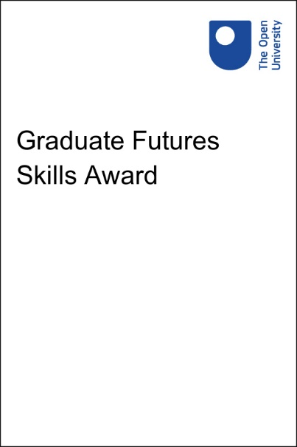

future_skills_award

Graduate Futures Skills Award

Copyright © 2022 The Open University
All rights reserved. No part of this publication may be reproduced, stored in a retrieval system, transmitted or utilised in any form or by any means, electronic, mechanical, photocopying, recording or otherwise, without written permission from the publisher.

Contents
- Confirm completion

Confirm completion
Congratulations – you have earned your Graduate Futures Skills Award digital badge.
Badges demonstrate evidence of participating in professional development and a commitment to studies.
There’s one more step before your badge will be issued. You will need to access the ‘Confirm completion’ question and answer ‘yes’, and then submit your answer. Your participation in the course will then be confirmed and you should receive your badge within 48 hours. You will receive an email to notify you that your badge has been issued and you will be able to view and manage it in My OpenLearn.
Your badge will be downloadable from your My OpenLearn Profile. It can be shared on social media and displayed within eportfolio platforms (e.g. LinkedIn).
Access Confirm completion question now.

