

INL_2

Inclusive Leadership: Collaborating for professional development

About this free course
This version of the content may include video, images and interactive content that may not be optimised for your device.
You can experience this free course as it was originally designed on OpenLearn, the home of free learning from The Open University –
There you’ll also be able to track your progress via your activity record, which you can use to demonstrate your learning.
First published 2023.
Unless otherwise stated, copyright © 2023 The Open University, all rights reserved.
Intellectual property
Unless otherwise stated, this resource is released under the terms of the Creative Commons Licence v4.0 http://creativecommons.org/licenses/by-nc-sa/4.0/deed.en_GB. Within that The Open University interprets this licence in the following way: www.open.edu/openlearn/about-openlearn/frequently-asked-questions-on-openlearn. Copyright and rights falling outside the terms of the Creative Commons Licence are retained or controlled by The Open University. Please read the full text before using any of the content.
We believe the primary barrier to accessing high-quality educational experiences is cost, which is why we aim to publish as much free content as possible under an open licence. If it proves difficult to release content under our preferred Creative Commons licence (e.g. because we can’t afford or gain the clearances or find suitable alternatives), we will still release the materials for free under a personal end-user licence.
This is because the learning experience will always be the same high quality offering and that should always be seen as positive – even if at times the licensing is different to Creative Commons.
When using the content you must attribute us (The Open University) (the OU) and any identified author in accordance with the terms of the Creative Commons Licence.
The Acknowledgements section is used to list, amongst other things, third party (Proprietary), licensed content which is not subject to Creative Commons licensing. Proprietary content must be used (retained) intact and in context to the content at all times.
The Acknowledgements section is also used to bring to your attention any other Special Restrictions which may apply to the content. For example there may be times when the Creative Commons Non-Commercial Sharealike licence does not apply to any of the content even if owned by us (The Open University). In these instances, unless stated otherwise, the content may be used for personal and non-commercial use.
We have also identified as Proprietary other material included in the content which is not subject to Creative Commons Licence. These are OU logos, trading names and may extend to certain photographic and video images and sound recordings and any other material as may be brought to your attention.
Unauthorised use of any of the content may constitute a breach of the terms and conditions and/or intellectual property laws.
We reserve the right to alter, amend or bring to an end any terms and conditions provided here without notice.
All rights falling outside the terms of the Creative Commons licence are retained or controlled by The Open University.
Head of Intellectual Property, The Open University

Contents
- Introduction
- Learning outcomes
- 1 Inclusive Leadership and communities of practice
  - 1.1 A collective view?
  - 1.2 Whose community?
- 2 Inclusive Leadership and collaborative enquiry
  - 2.1 Trying to be collaborative, inclusive and distributed?
- 3 Inclusive leadership for professional development in context
- 4 Inclusive Leadership for agency and institutional change
  - 4.1 A matter of internal politics?
- Conclusion
- References
- Acknowledgements
- Solutions

Introduction
This course will help you to consider different approaches to inclusive leadership and professional development. You will be introduced to concepts and practices for collaborative enquiry and contextually relevant professional development. You will be encouraged to reflect on how these approaches can contribute to inclusive communities of practice within your organisation and how you might support the needs of educators at different stages of their career. You will also examine how inclusive leadership and professional development can foster agency in staff members as well as driving institutional change.
If you haven’t already, you might want to consider exploring the related OpenLearn course Inclusive Leadership: Effecting change before starting this course. You might also be interested in the other OpenLearn courses:
- Leadership for inclusion: thinking it through
- Leadership for inclusion: what can you do?
You might also be interested in the Open University Inclusive Practice Leadership and Management Masters pathways.

Learning outcomes
After studying this course, you should be able to:
- understand a range of approaches to inclusive leadership of professional development
- engage with inclusive strategies for leading professional development for educators at different stages in their career
- identify ways in which inclusive professional development can foster individual agency
- consider how inclusive leadership for professional development can support change within an educational institution.

1 Inclusive Leadership and communities of practice

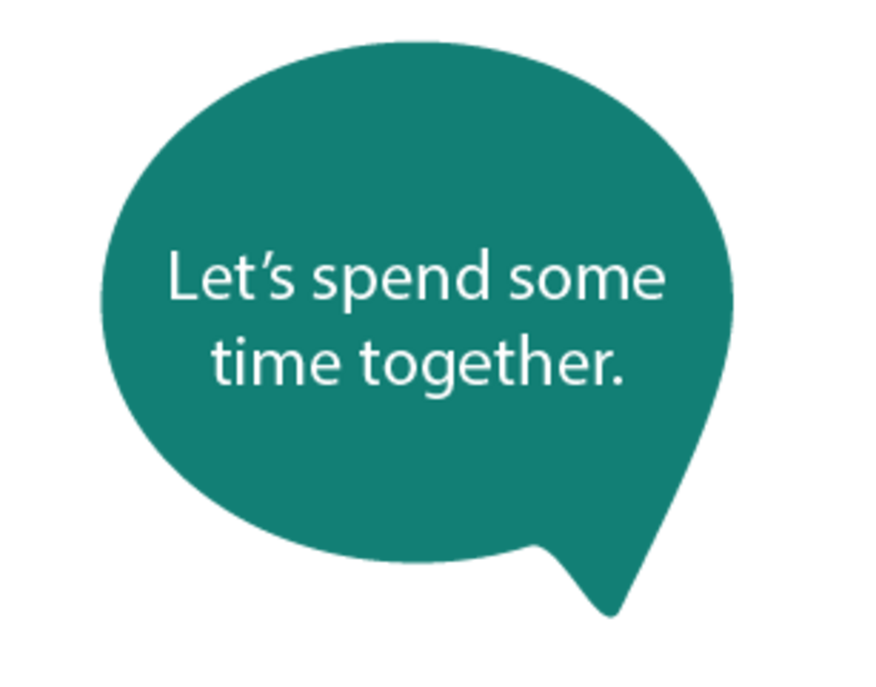
Figure 1
View description - Figure 1
View alternative description - Figure 1

A real difficulty for a course on inclusive leadership and professional development is the lack of an evidence-base which can directly help us. As noted by Waitoller & Artiles in their review of professional development research for inclusive education (2013), the knowledge base is limited and fragmented because of the different ways in which people conceptualise inclusive education and teacher learning.

‘The act of dismantling exclusion occurs in dynamic, politically charged, and historically contingent contexts. The degree of success of inclusive education, and how success is defined, depends on the work of local actors and their meaning making process situated in historically evolving activity systems. Thus, drawing broad generalizations about the practices, tools, and work of local actors from one program or school to another without regard for the complexities and idiosyncrasies of particular institutional contexts may result in unintended consequences. To understand inclusive education, researchers need to understand locally situated forms of exclusion.’
(Waitoller & Artiles (2013, p. 347)

A similar review (Holmqvist & Lelinge, 2021) facing the same challenge, identified four broad definitions of inclusive education: basic inclusion, classroom inclusion, general inclusion, and content inclusion. They also recognised that these were implemented differently in different social contexts (for example, inclusion may have a focus upon disabilities or have a focus upon wider socioeconomic and cultural perspectives with an aim to foster social justice).
As authors we have to make a choice in how we represent this field. For example, many people would suggest that inclusive leaders of inclusive schools should be calling for professional development that focuses upon categories of need or types of behaviour. However, in this course we choose not to do this. This is because the research base that would answer such a call is also very limited, rarely tested in meaningful school contexts, and very hard to carry out with fidelity (Rix, 2023). This reminds us that the calls for ‘evidence-informed policy’ are understandable but not sufficient. The focus cannot simply be about ‘what works’ but must be part of a debate around ‘what matters’, with an emphasis upon the importance of context (Stevenson, 2017).

1.1 A collective view?
This course is also premised upon a widespread recognition of the importance of collaborative practices. Much of the inclusive literature talks about forming partnerships amongst key stakeholders as part of a whole school approach, with policies and practices arising from the experience and expertise of all those involved (Ainscow, 2020). This is not to say that collaboration is a miracle cure, nor guaranteed. Perhaps ironically, its limitations are often related to the nature of our institutions. For instance, a study from 6 schools in Denmark (Hansen et al, 2021) showed how collaborative processes did not have any real impact on the development of an inclusive school culture, because people continued to focus upon student’s deficits and how to compensate for or treat them. They lacked leadership in collaborative processes and so did not explore and resolve people’s different understandings and assumptions. Similarly, a study in Germany (Jurkowski & Mueller, 2018) exploring classroom teachers and special education teachers working together over a year, concluded that cooperation did not change across the year and that they did not appear to affect each other’s practice. (From the student perspective their cooperation was increasingly worse.) The researchers concluded that structural conditions were at the root of the problem.
The idea of collaboration is at the heart of many calls to overcome the kinds of structural issues experienced in the Danish and German studies, though. For instance, a study in six early childhood and primary settings in Spain and Chile recognised that Leadership practices arise from interactions among members of the school community. They depend upon the context in which they emerge and upon people having common interests. The settings sought collaboration and shared understandings of educational inclusion, with a focus upon the professional development of the community and positive responses to diversity (Gómez-Hurtado et al, 2021).
So let us consider the kinds of professional development that are frequently called for.

Activity 1 A collective view?
20 minutes

Watch the following video:

Watch the video at YouTube.com.
Video 1 What are the most effective professional development activities for teachers and school leaders? EduSkills OECD (The Open University is not responsible for external content.)

As you are watching make notes and reflect upon the following questions:
- What types of research and activities are people talking about?
- Why do they value these types of research and activities?
- What is your experience and opinion of these types of approaches?

Provide your answer...
View discussion - Activity 1 A collective view?

1.2 Whose community?
In a study set in 3 South African schools, exploring the work of their school governing body and management team, Setlhodi (2020) drew on the notion of collaborative circles (Farrell, 2001). A collaborative circle is a group of peers, from the same field, who support each other and openly engage in developing a group with a common vision. They critically explore ideas, to enable creative activity that takes their work forward. Setlhodi explored how the two school leadership groups decide on: what needs to be developed and by who, as well as how and when it should happen and what should be prioritised. This collaborative process involved reflecting upon people’s attachment to their attitudes and their understanding of the capacity of the school (and the people in it) to respond to change. Consequently, they had to rethink established visions and strategies to create shared purpose, taking collective responsibility for the state of the school, acknowledging their interdependence. This involved a creative process of reflection and the development of new routines that initiated their ideas.
As part of this process, the school leaders had to invite inputs to improve these ideas, whilst ensuring the process was agreeable to those involved and could be sustained. To be effective, the leaders needed to know how to influence people as well as how to inspire and oversee collaborative action. They had to want to improve and feel able to persuade people about a call for action, so as to develop and implement the action plan. This included the formation of circles of influence, so that people volunteered their services to support the proposed plan, creating a web of social teams within the school, that were interactive and able to communicate effectively.
Setlhodi identified the need for courage, consistency, preciseness, and honesty in engaging each other in constructive conversation. People’s views needed to be acknowledged, considered, and affirmed. The nature of their conversations needed to be deliberated upon, as did their reception, interpretation, and the degree to which participants were given the chance to fully explain their understandings and views. He suggested that collective action flourishes when people understand what is expected, recognising that less experienced participants may require significant support to be successfully involved in the process. All of this required strong bonds, that encouraged commitment and trust-based relationships.
Another issue raised in Video 1 in Activity 1 was about working with people from outside the immediate school setting, for example visiting another school with a consultant or attending a training programme. Looking across a dozen research and development projects in secondary schools, Schenke et al (2016), talked about projects in which school leaders, teachers, researchers, and advisers took over each other’s tasks, and often had a deep level of cross-professional exploration. They suggested that there are four types of cross-professional collaboration that take place in the examination of practice:
- School-directed -with external people as supporters, supervisors, or critical friends,
- School- and researcher-directed – with external partners as co-collaborators, sharing responsibilities,
- School- and adviser-directed – with external advisors in control of achieving goals set by school management,
- Researcher-directed - with external partners following their own commercial or academic interests.
In thinking about these kinds of collaborations, you may also have considered something that has not been mentioned so far (and is the title of this section), communities of practice (Lave & Wenger, 1991). In the following paper, drawing on the work of Richard McDermott, they suggest that a successful community of practice includes people who:
- focus on topics of vital interest to the community members
- are facilitated by a well-respected community member
- create time and encouragement so people can participate properly
- build on the core values of the discipline community
- get key thought leaders involved
- build personal relationships among community members
- contain an active passionate core group
- use forums for thinking together as well as systems for sharing information
- are technically easy to access and contribute to, and
- create real dialogue about cutting edge issues.
This seems to encapsulate many of the issues raised above. So, let’s explore this a bit further.

Activity 2 Whose community?
45 minutes

Read Akinyemi, A., Rembe, S., Shumba, J. and Adewumi, T. (2019) ‘Collaboration and mutual support as processes established by communities of practice to improve continuing professional teachers’ development in high schools’, Cogent Education, 6(1), p. 1685446.
Focus on pages 7–16, from the start of Results to the end of Conclusion. As you are reading, think about the following questions and make notes:
- In what ways are the characteristics associated with a successful community of practice in evidence?
- In what ways do the teachers and school leaders participate effectively?
- What ideas and experiences raised in this article challenge your expectations of a successful community of practice?

Provide your answer...
View discussion - Activity 2 Whose community?


Figure 2 being a part?
View description - Figure 2 being a part?
View alternative description - Figure 2 being a part?

2 Inclusive Leadership and collaborative enquiry

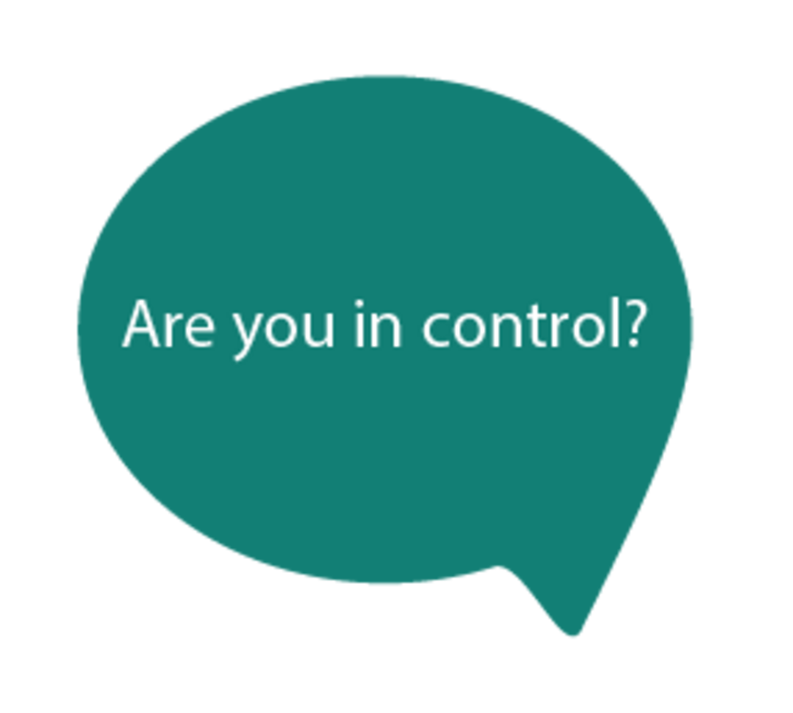
Figure 3
View description - Figure 3
View alternative description - Figure 3

In Video 1 in Activity 1, one of the participants said that professional development was helpful ‘As long as we are part of groups that have identified the needs of a school.’ A reason for this is that having agreed the needs of a setting, you can then collectively explore possible ways forward. An aim for many leaders is to make such exploration part of the school’s culture. Miles, Ainscow & Moore (2011) situate a culture in the basic beliefs and assumptions shared by people in an organisation, which operate unconsciously and through which people view themselves and the contexts in which they work. They also suggest that effective, inquiry-based approaches require an element of challenge, involving new thinking and relationships that encourage active connections between people, stimulating risk taking and creative actions. The development of inclusive practices requires social learning within particular cultural contexts. ‘Developing’ people involves providing intellectual stimulation and using information to create a culture of inquiry. This calls for making interruptions to people’s thinking, to challenge existing assumptions and practices.
These ideas are evident in a piece of research looking at two elementary school principals in the United States (DeMatthews, 2021). This work explored how the principals sought to create an effective inclusive school, as well as what they saw as the challenges and necessary change processes. These school leaders saw a need to focus their collaboration, relying upon a group of staff to explore school challenges, to decide on priorities and initial steps as well has how to problem solve specific problems that emerged from chaotic everyday school life. Their first step in establishing their ways of working was to develop routines where staff regularly collaborated. They set up teams of five to seven-people who regularly met and developed plans for change. The principals looked for quick wins and small steps, rather than focussing upon what they viewed as bigger issues. At the heart of their approaches was collaborative inquiry. They recognised that time was needed to develop the structures to enable this, given people’s already busy daily workload and the need to consider multiple variables and perspectives to implement inclusion effectively. This fitted with their understanding of inclusion as an ongoing process. As a result, they focussed on specific goals to begin with; for instance, in the first-year prioritising how to support marginalised students they felt could be immediately successful in general education classrooms, whilst providing professional development on co-planning and co-teaching. They also encouraged collaborative inquiry as a way to deal with individual issues that emerged, gathering a group to work out what was going on. They sought shorter feedback loops, to explore problems and proposed solutions. They recognised that there was a need for open communications and ensuring people had access to information, and for responses that were both effective and as quick as possible.
So, let’s consider some of the ways in which collaborative enquiry can take place in a school.

Activity 3 Better than one?
60 minutes

Read: Harris, A. and Jones, M., (2012) ‘Connecting professional learning: Leading effective collaborative enquiry across teaching school alliances’, National College for School Leadership, UK.
Read the Appendix 1, pp. 38–39. This text outlines four approaches (Learning walks; Instructional rounds; Peer triads; Lesson study). You can find out more about these approaches by searching online if you wish to; there are lots of resources out there, even though they can often give contradictory advice! Included here are some resources. Video 2 includes mention of OFSTED, the school inspection service in England.

Video content is not available in this format.
Video 2 Learning walks: what are they?
View transcript - Video 2 Learning walks: what are they?

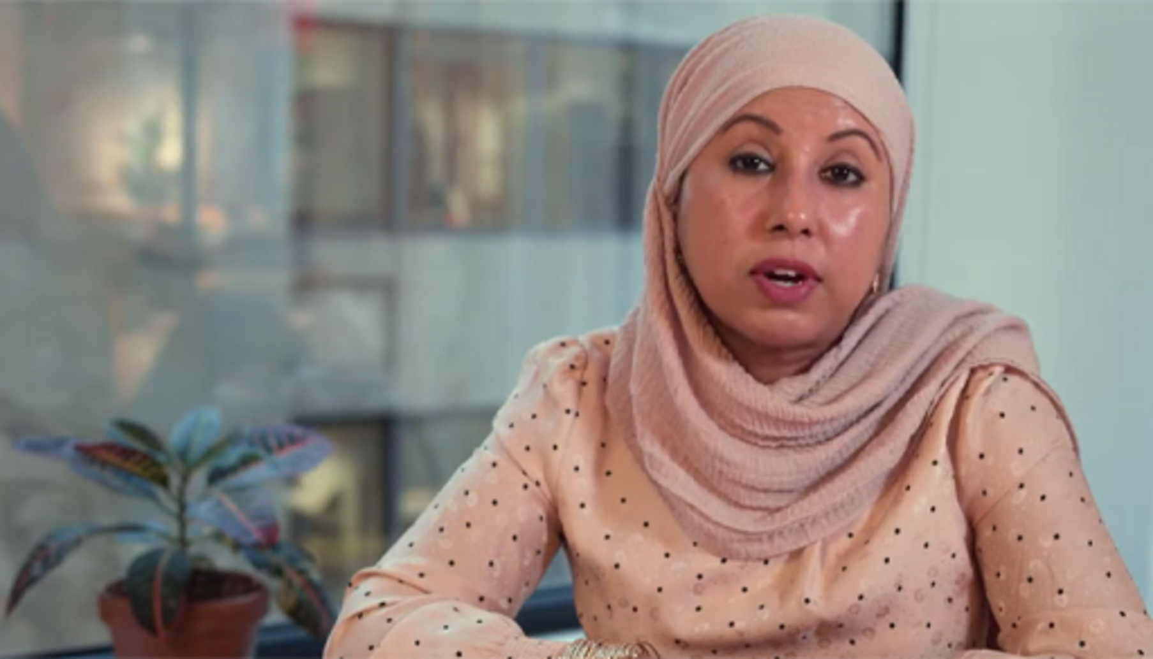

Video 3 is a more collaborative approach.

Video content is not available in this format.
Video 3 Learning walks: structured observation for teachers
View transcript - Video 3 Learning walks: structured observation for teachers



Video content is not available in this format.
Video 4 Lesson study: a powerful approach to improve teaching
View transcript - Video 4 Lesson study: a powerful approach to improve teaching



- Text 1: Instructional rounds
- Text 2: Teachers in Triad Teams: Three is not a crowd (The Open University is not responsible for external content.)
Having considered these approaches, study this image of the connect to learn method from the report by Harris and Jones? Ask yourself the following questions?
- Who might be in an enquiry team?
- What sort of data could they use?
- What sort of enquiry methods are you aware of?
- What sort of issues do you think could be explored this way?
- Who would you want to disseminate findings to in a school community?

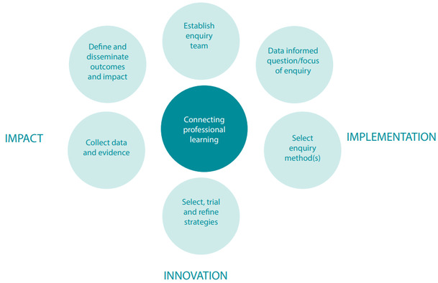
Figure 4 Connect to learn method
View description - Figure 4 Connect to learn method
View alternative description - Figure 4 Connect to learn method

Provide your answer...
View discussion - Activity 3 Better than one?

2.1 Trying to be collaborative, inclusive and distributed?
In reflecting upon the sorts of issues that can be explored in Activity 3, you probably concluded that the answer is as long as a piece of string! Schools are hugely complex places and spaces. From a research perspective, one could say they are filled with endless variables. This is why many of the methods explored in Activity 3 will suggest a frame for observation or a set of agreed targets to assess against. A simpler way to think of this, perhaps, is simply an agreed question; an issue that those involved feel it is useful to talk about; an itch that needs to be scratched; a need that has been identified by all those involved. This openness also feels appropriate to the issue of disseminating findings. Clearly, the answer is to share them with those who will find them useful and relevant. But it is always worth asking yourself, who decides this? If they are not available to everyone in some way, how can they know if they find them useful and relevant?
So now let’s go back to the group who are so often left out of leadership groups and the process of professional collaborative enquiry.

Activity 4 Trying to be collaborative, inclusive and distributed?
45 minutes

Read the following article. Volin, K. C. (2018) ‘The challenges and possibilities of including students in middle school leadership: Building and sustaining change’, Journal of Ethical Educational Leadership, (1), pp.1–9.
Read from the section Researcher (p68) to the end of the article (p74). The following acronyms are used in this extract: School Based Initiatives Team (SBI), Student Leadership Group (SLG), School Advisory Council (SAC)
The researcher in this study is basing her work around values that underpin collaborative, distributed, and inclusive leadership, in that she wants to work with a group to identify a challenge and then empower them to come up with manageable solutions. As you are reading consider the following questions:
- What issues emerge that involve critique, disagreement, difference, and conflict?
- Which parts of the school community become involved in the projects?
- In what ways is this an example of effective or ineffective collaborative leadership and inquiry?
- What experiences have you had that reflect the kinds of challenges evident in this study?

Provide your answer...
View discussion - Activity 4 Trying to be collaborative, inclusive and distributed?

So let’s go on to explore the contextual nature of these communities.

3 Inclusive leadership for professional development in context

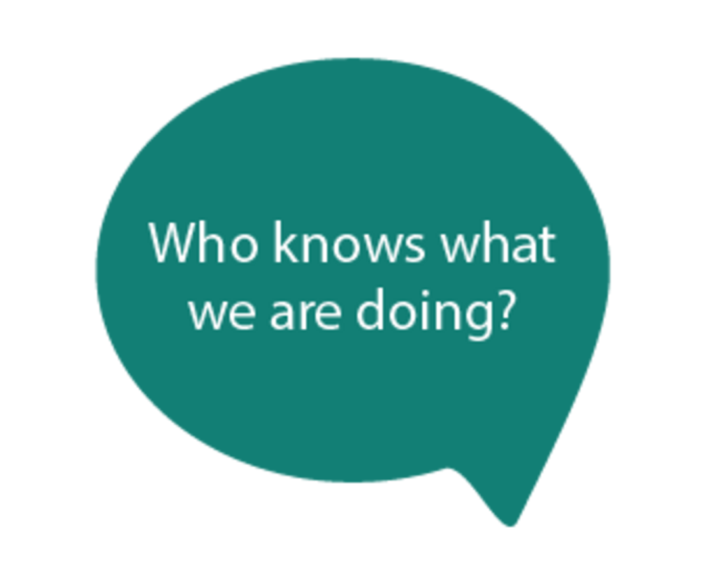
Figure 5
View description - Figure 5
View alternative description - Figure 5

Learning and professional development are always situated within relationships. These in turn can be part of formal and informal processes. For instance, the study mentioned above (Flores & Kyere, 2021) tells of a school leader who learned the value of getting new parents to laugh early in meetings (so as to break down walls between them and the institution). He had learned this not from formal training, but from watching a principal when he was a young teacher working in an alternative setting. The relationships which school leaders and practitioners find themselves in are not just personal and physical either. They are also closely entwined with the policy context. For example, in Scotland (where professional growth through career-long professional learning is strongly embedded in school systems), school leaders and practitioners are expected to fully engage with social justice principles. These principles are, for instance, strongly in evidence in the Scottish professional standards. As a consequence, in the Scottish context, professional development can be seen as intertwined with social justice for all. Such an expectation is not as simple as it might appear however, since people generally have different understandings of what social justice means (Thomas et al, 2019). It also puts considerable pressure on those school leaders, because to be effective in supporting individuals in their learning and development as professionals, school leaders need to be well connected (Jones, 2017b). To support social justice, therefore, they need to know what opportunities are available and have the resources to support their staff to engage in them.
Resolving such issues is made harder too because so much professional development is a top-down affair where teachers voices are secondary and the goals are decided by others; consider this tale from a professor who had returned to school to work as a teacher:

‘Having students record and (re)present their neighborhoods gave him many insights into his students lives. However, when he suggested that practice be shared during a professional development day at his school, administrators shot him down in favor of a focus on the literacy issue du jour’
(Sieben & Johnson, 2018, p109)

As a consequence, individuals can find themselves unable to explore the issues that seem relevant to them and in ways that help them to unravel underlying challenges. It was as a response to this inability to explore relevant issues, that the first Inquiry to Action Groups were set up. (You read about a study that emerged from an Inquiry to Action Group in Activity 4). These were established to allow teachers to make connections between social justice issues and classroom practice, through the sharing of experiences, ideas and readings, alongside the development of plans of action. Contrast the experience of the former professor mentioned above with this one from a teacher at an Inquiry to Action Group:

‘There is a genuine concern for each other, for teachers and they can go and discuss something as simple as ‘how was your day,’ to abstract ‘let’s talk about this policy.’ There’s a place for the conversation and it feels authentic as opposed to a generic PD or some cliché workshops. There’s a sense of love I feel in the space which is something I don’t think we get to talk about enough.’
(Kohli et al, 2015, p16)

So, let’s explore how teachers feel when they are involved in one-to-one supportive professional development over an extended period of time. The following reading looks at teachers and student-teachers developing their practice over an extended period.

Activity 5 Shared moments?
45 minutes

Read Lofthouse, R. and Thomas, U. (2017) ‘Concerning collaboration: teachers’ perspectives on working in partnerships to develop teaching practices’, Professional development in education, 43(1), pp. 36–56.
Read from Findings p, 10 to the start of Discussion on p. 20. As you are reading think about and make notes about the following issues:
- The relationships between interviewees
- The nature of power between the interviewees and in the practices they discuss
- The feelings that the processes have encouraged
- What lessons from these personal interactions might be applied more widely in a leadership context?

Provide your answer...
View discussion - Activity 5 Shared moments?

So, let’s explore this a bit more, by reflecting upon these kinds of processes when applied across schools within a local cluster.

Activity 6 Is co-operation about ongoing learning?
45 minutes

Read this chapter about the development of an 8-school co-operative in the UK: Swaffield, S. and Major, L. (2019) ‘Inclusive educational leadership to establish a co-operative school cluster trust? Exploring perspectives and making links with leadership for learning’, International Journal of Inclusive Education, 23(11), pp. 1149–1163.
Read from Interviews with headteachers and governors to the end of the chapter (p1157–p1162) (In this chapter the acronym LfL stands for the Leadership for Learning framework outlined above)
As you are reading make notes about the following questions.
- In what ways is this organisational process, a process of:
  - relationship building
  - learning
  - professional development?
- Can you see the principles from the Leadership for Learning framework in action?

Provide your answer...
View discussion - Activity 6 Is co-operation about ongoing learning?

So, let’s move on to consider this issue a bit more deeply, by looking at the role of the individual and how leaders can support them to collectively change their organisation.

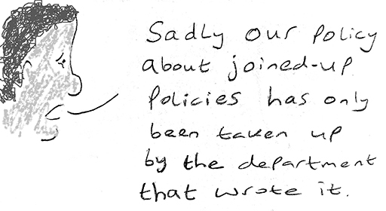
Figure 6 Does it matter?
View description - Figure 6 Does it matter?
View alternative description - Figure 6 Does it matter?

4 Inclusive Leadership for agency and institutional change


Figure 7
View description - Figure 7
View alternative description - Figure 7

Ryan (2006) suggests that Inclusive leadership involves being an advocate and educator of people, supporting critical consciousness and dialogue, with a focus upon classroom practice and learning. He suggests that it involves seeking to be inclusive in the decisions one makes, the policies and strategies one establishes, and by working across the whole school. This is something which the headteacher in a study about an Elementary school in the United States would probably agree with (Hoppey & McLeskey, 2013). He saw his role to be about ‘growing people’. This required building relationships, encouraging reflection, and providing school-based professional development. He particularly valued the role of mentoring and the individual and collective growth which arose through a focus on topics that mattered to the staff. This included working through university-based professional development seminars. Significantly, he did not see this involvement with outside ‘experts’ as being about providing answers. He saw it as being about questions, inquiry, reflection and ‘being honest with ourselves’. Subsequently, he encouraged teachers to connect their plans to wider school plans. Through such processes he sought to encourage teachers to assume various leadership roles which were not formal but sustained a collaborative culture of learning that focused on improving practice. He was looking to develop more leaders, rather than followers. This required ongoing support, helping people to overcome their natural resistance to change, their frustration at doing something new and being faced with the scepticism of others. He saw it as a moral purpose to improve the lives of people in the school and to buffer people from external pressure.
The challenge is not just about growing the people within the setting, of course. As discussed previously it involves a great many other people and institutions of influence. For instance, a study of 25 schools in Spain (Crisol-Moya et al, 2022) looking at families’ views on the actions of school leadership teams, highlighted the need for schools to be open to all families and responsive to their needs. They sought mutual exchange, active participation, and the feeling of belonging. Even more broadly, an action research study in a secondary school in Cyprus (Charalampous & Papademetriou, 2021), explored the obstacles faced by a leader and how they can transform them into opportunities for creating an inclusive environment. Working with the school leadership team and teaching staff, they not only recognised that the headteacher, the teachers and the carers of pupils were obstacles but so too was the Ministry of Education and Culture. Building upon the school leadership style, they sought to promote a bottom-up change, seeking to shift from a pyramid of hierarchy (Figure 8) to a pyramid of collaboration (Figure 9). They recognised that in cooperation with the headmaster, intermediate leaders could be key players in changing the culture of the school. Exemplifying the effectiveness of this process, across the year of the intervention the staff identified a change in the school environment and greater support for inclusive ways of working. At the heart of this was role played by feedback. So let’s explore this a bit more deeply.

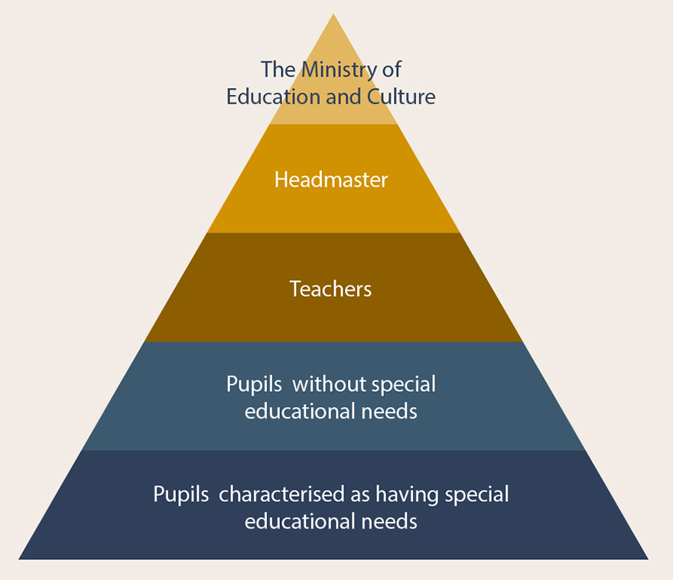
Figure 8 Obstacles in pyramid of hierarchy
View description - Figure 8 Obstacles in pyramid of hierarchy
View alternative description - Figure 8 Obstacles in pyramid of hierarchy

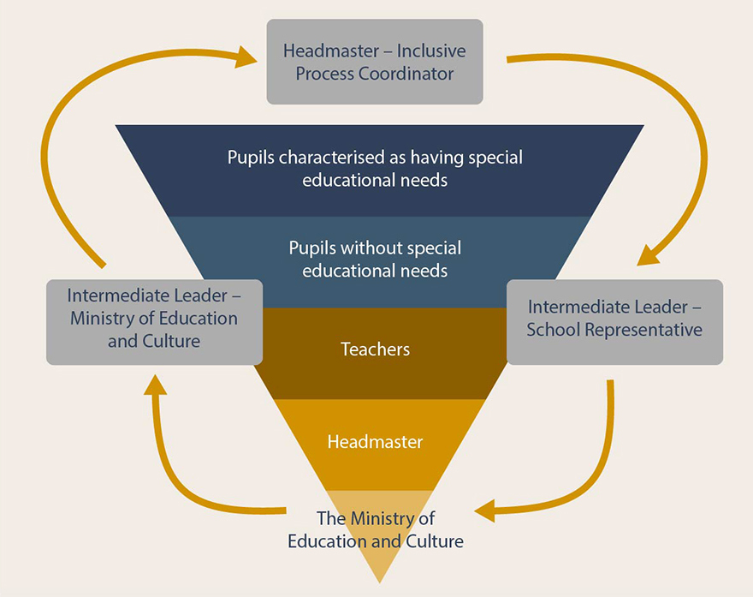
Figure 9 Obstacles in pyramid of collaboration
View description - Figure 9 Obstacles in pyramid of collaboration
View alternative description - Figure 9 Obstacles in pyramid of collaboration

Activity 7 Round and round we go?
45 minutes

Read about Feedback loops: Schenke, W., van Driel, J., Geijsel, F. & Volman, M. (2017) ‘Closing the feedback loop: a productive interplay between practice-based research and school development through cross-professional collaboration in secondary education’, Professional Development in Education, 43(5), pp. 860–880.
This study explores interplay between practice-based research and school development in 19 projects undertaken in Dutch secondary schools. Read from Results on p866 to the end of Conclusion and Discussion on p875. As you are reading ask yourself the following questions in relation to your own personal and professional experiences.
- What effective examples have you of
  - productive interplay?
  - short-term feedback loops?
  - long-term feedback loops?
- What made these examples effective?
- What barriers were part of these examples?

Provide your answer...
View discussion - Activity 7 Round and round we go?

4.1 A matter of internal politics?
Another paper which recognised the emotional work of change is Lindle et al, (2017). In their study of 17 Principals and District leaders in the United States, they talked about how emotions of leadership emerged as an influence upon the way in which professional development was experienced and undertaken. Issues such as budgets and state funding, local and national policy debates had a long-lasting effect on the participants, leaving many feeling both under-valued and under attack. In another study from Australia (Jones, 2017a) Female head teachers, described the gendered expectations around school leadership, and talked about how these overlapped with other assumptions around issues such as race, age, and family life.

‘The biggest cost is your stress levels- your immediate home life, family...social circle, you don’t have time for them…it’s so easy to get sucked into a vortex of work.’
(Jones, 2017a, p. 917)

Against such a background, these head teachers consistently constructed themselves as trying to be empathetic and supportive, seeking to enable the career progression of their staff.
Clearly the emotional work of leading, collaborating and personal development cannot be underestimated. So let us conclude by considering this a bit more deeply.

Activity 8 A matter of internal politics?
45 minutes

The following paper reports on three teachers collaborating as they investigate a program in the school of modern languages (FML) of a public university in Mexico.
Read Keranen, N. and Encinas Prudencio, F. (2014) ‘Teacher collaboration praxis: Conflicts, borders, and ideologies from a micropolitical perspective’, Profile Issues in Teachers Professional Development, 16(2), pp. 37–47.
Read from Results (p. 42) to the end of conclusion (p. 45). As you are reading reflect upon a collaborative experience you have had in a workplace. Make notes in response to the following questions:
- How did you feel about yourself?
- How did you feel about others?
- How did these feelings enable or restrict your collaboration and achieving its goals?
- What other challenges did you find in working with others?
- How were you supported to deal with these issues?

Provide your answer...
View discussion - Activity 8 A matter of internal politics?

Hopefully, this course has made it very clear that at the heart of this collaborative process are openness, flexibility, authenticity, criticality, and agency. Hopefully it has also made clear that this is not a simple process. In developing our practices and systems, we are invariably faced by a need to have difficult conversations. These are not difficult because people have to listen to each other (see Figure 4.2), but because they are about our attitudes, beliefs, underlying values, and the ways in which we organise our lives and our institutions. The challenge for School leaders is to find ways to support people to have these conversations as part of their day to day working lives; and to do so in ways that do not feel top-down but emerge from the community they are intended to serve. This is where the kinds of professional development opportunities discussed in the previous sections may be of some use. What do you think?


Figure 11 So what shall we talk about?

Conclusion
During this course you have explored a range of challenges that leaders face in developing communities of practice through collaborative enquiry. You have considered the contextual nature of such development and importance of agency for all those involved. You have considered the wide range of voices who can be part of the professional development process that leads to institutional and personal change. There have been a variety of approaches and strategies shared with you, along with discussions of the challenges and opportunities that can arise. It seems appropriate though to end with the thoughts of a head teacher, one working in a large early-years setting in Ghana. Not only did he recognise the importance of school leaders leading by example, but also that leading change requires leading as part of the community.

The school is in the community; we need them for our work. Schools are for communities. If we’re to achieve our [inclusive education] goals for children, we need parents and others…we must work together, share ideas…We [the school] depend on the community or the other way round.
(Ackah-Jnr, 2022 p16)

If you haven’t already, you might want to consider exploring the related OpenLearn course Inclusive Leadership: Effecting change. You might also be interested in the other OpenLearn courses:
- Leadership for inclusion: thinking it through
- Leadership for inclusion: what can you do?
You might also be interested in the Open University Inclusive Practice Leadership and Management Masters pathways.

References
Ackah-Jnr, F., 2022. Enabling inclusive education: the leadership ecosystem in an early childhood-school-community context.International Journal of Leadership in Education, pp.1-19.
Ainscow, M. (2020). Inclusion and equity in education: Making sense of global challenges. PROSPECTS, 49(3), 123–134.
Aydarova, E., Rigney, J. and Dana, N.F., 2022. “If you’re not at the table, you’re on the menu”: Learning to participate in policy advocacy as a teacher educator. Action in Teacher Education, 44(2), pp.143-159.
Benjamin, S., Nind, M., Hall, K., Collins, J. and Sheehy, K., 2003. Moments of inclusion and exclusion: Pupils negotiating classroom contexts. British Journal of Sociology of Education, 24(5), pp.547-558.
Charalampous, C.A. and Papademetriou, C.D., 2021. Intermediate inverted leadership: The inclusive leader’s model. International Journal of Leadership in Education, 24(3), pp.349-370.
Crisol-Moya, E., Romero-López, M.A., Burgos-García, A. and Sánchez-Hernández, Y., 2022. Inclusive Leadership from the Family Perspective in Compulsory Education. Journal of New Approaches in Educational Research, 11(2), pp.226-245.
DeMatthews, D. (2021). Undoing systems of exclusion: exploring inclusive leadership and systems thinking in two inclusive elementary schools. Journal of Educational Administration, 59(1), 5-21.
Farrell MP 2001. Collaborative circles: Friendship dynamics and creative work. Chicago, IL: University of Chicago Press.
Flores, O.J. and Kyere, E., 2021. Advancing equity-based school leadership: The importance of family–school relationships. The Urban Review, 53, pp.127-144.
Gómez-Hurtado, I., Valdés, R., González-Falcón, I. and Vargas, F.J., 2021. Inclusive leadership: Good managerial practices to address cultural diversity in schools. Social Inclusion, 9(4), pp.69-80.
Hansen, J.H., Jensen, C.R., Molbæk, M. and Schmidt, M.C.S., 2021. Cross-professional collaboration and inclusive school development in Denmark. International Journal of Inclusive Education, pp.1-15.
Holmqvist, M. and Lelinge, B., 2021. Teachers’ collaborative professional development for inclusive education. European Journal of Special Needs Education, 36(5), pp.819-833.
Hoppey, D. and McLeskey, J., 2013. A case study of principal leadership in an effective inclusive school. The Journal of Special Education, 46(4), pp.245-256.
Hulme, R., Cracknell, D., and Owens, A., 2009. Learning in third spaces: developing trans-professional understanding through practitioner enquiry. Educational action research,17(4), 537–550.
Jones, D., 2017a. Constructing identities: Female head teachers’ perceptions and experiences in the primary sector. Educational Management Administration & Leadership, 45(6), pp.907-928.
Jones, K., 2017b. Collaboration, creativity and capital in professional learning contexts. Professional development in education, 43(1), pp.1-5.
Jurkowski, S. and Mueller, B., 2018. Co-teaching in inclusive classes: The development of multi-professional cooperation in teaching dyads. Teaching and Teacher Education, 75, pp.224-231.
Kohli, R., Picower, B., Martinez, A.N. and Ortiz, N., 2015. Critical professional development: Centering the social justice needs of teachers. The International Journal of Critical Pedagogy, 6(2).7-23
Lave, J., & Wenger, E. (1991). Situated learning: Legitimate peripheral participation. Cambridge, UK: Cambridge University Press.
Lelinge, B., & Alwall, J. (2022). School improvement and teachers’ collaborative professional development for inclusive education: A Swedish case. International Journal of Whole Schooling, 18(2), 28-54
Lindle, J.C., Della Sala, M.R., Reese, K.L., Klar, H.W., Knoeppel, R.C. and Buskey, F.C., 2017. A logic model for coaching experienced rural leaders: Lessons from year one of a pilot program. Professional Development in Education, 43(1), pp.121-139.
MacBeath, J. and Dempster, N. (eds) (2008) Connecting Leadership for Learning: Principles for Practice. Routledge: London
Miles, S., Ainscow, M. and Moore, M. (2011) ‘Conclusion: Learning through inquiry’, in Responding to Diversity in Schools. United Kingdom: Routledge, pp. 171–194
Muresherwa, E., & Jita, L.C. (2021). School heads’ construction and understanding of instructional leadership for inclusive secondary schools: Taking context and personal identity out of the shadows of school leadership narratives. International Journal of Whole Schooling, 17(2), 1-37
Nguyen, D. and Ng, D., 2020. Teacher collaboration for change: Sharing, improving, and spreading. Professional Development in Education, 46(4), pp.638-651.
Olmo-Extremera, M., Fernández-Terol, L. and Domingo-Segovia, J., 2023. Leading a professional learning community in elementary education: A systematic review of the literature. Journal of Research on Leadership Education, p.19427751221145207.
Pearce, T. & Wood, B. (2019). Education for transformation: An evaluative framework to guide student voice work in schools. Critical Studies in Education, 60(1), 113-130.
Pearce, T. and Wood, B., 2019. Education for transformation: An evaluative framework to guide student voice work in schools. Critical Studies in Education, 60(1), pp.113-130.
Rix, J. (2023) Re-examining special needs – What could be better? In: Tierney, R.J., Rizvi, F., Erkican, K. (Eds.), International Encyclopaedia of Education, vol. 9. Elsevier.
Ryan, J., 2006. Inclusive leadership and social justice for schools. Leadership and Policy in schools, 5(1), pp.3-17.
Schenke, W., van Driel, J.H., Geijsel, F.P., Sligte, H.W. and Volman, M.L., 2016. Characterizing cross-professional collaboration in research and development projects in secondary education. Teachers and Teaching, 22(5), pp.553-569.
Setlhodi, I, 2020. Collaboration practices between the two tiers of school leadership in eradicating underperformance. South African Journal of Education, 40(3).
Sharp, K., Jarvis, J.M. and McMillan, J.M., 2020. Leadership for differentiated instruction: Teachers’ engagement with on-site professional learning at an Australian secondary school. International Journal of Inclusive Education, 24(8), pp.901-920.
Sieben, N. and Johnson, L.L., 2018. Professional development pathways through social justice frameworks. English Education, pp.108-115..
Starratt, R.J., 2007. Leading a community of learners: Learning to be moral by engaging the morality of learning. Educational Management Administration & Leadership, 35(2), pp.165-183.
Stevenson, H., 2017. Harnessing the power of collaboration: time for collective learning to speak back against corrosive competition. Professional development in education, 43(3), pp.315-317
Strand, M.K. and Emstad, A.B., 2020. Developing leadership by participating in principal professional learning communities (PPLCs) and the added value of transnational collaboration, Research in Educational Administration & Leadership 5:2 485-516.
Swaffield, S. and Major, L., 2019. Inclusive educational leadership to establish a co-operative school cluster trust? Exploring perspectives and making links with leadership for learning. International Journal of Inclusive Education, 23(11), pp.1149-1163.
Thomas, M., Clayton, C., Huang, S., & Garcia, R. (2019). Being in Tension: Faculty Explorations of the Meaning of Social Justice in Teacher Education. Excelsior: Leadership in Teaching and Learning, 12(1), 17-36.
Waitoller, F.R. and Artiles, A.J., 2013. A decade of professional development research for inclusive education: A critical review and notes for a research program. Review of educational research, 83(3), pp.319-356.
Philpott, C. and Oates, C., 2017. Teacher agency and professional learning communities; what can Learning Rounds in Scotland teach us?. Professional development in education, 43(3), pp.318-333.

Acknowledgements
This free course was written by Jonathan Rix.
Except for third party materials and otherwise stated (see terms and conditions), this content is made available under a Creative Commons Attribution-NonCommercial-ShareAlike 4.0 Licence.
The material acknowledged below is Proprietary and used under licence (not subject to Creative Commons Licence). Grateful acknowledgement is made to the following sources for permission to reproduce material in this free course:
Course image
Courtesy: Caroline Rix
Readings
Activity 2 Reading: Adeola Folasade Akinyemi, Symphorosa Rembe, Jenny Shumba & Toyin Mary Adewumi | (2019) Collaboration and mutual support as processes established by communities of practice to improve continuing professional teachers’ development in high schools, Cogent Education, 6:1, 1685446, DOI: 10.1080/2331186X.2019.1685446 https://doi.org/10.1080/2331186X.2019.1685446
Activity 3 Reading: Alma Harris and Michelle Jones (pp 38/39) in Connecting professional learning: leading effective collaborative enquiry across teaching school alliances. National College for School Leadership https://assets.publishing.service.gov.uk/government/uploads/system/uploads/attachment_data/file/335719/Connecting-professional-learning-leading-effective-collaborative-enquiry-across-teaching-school-alliances.pdf © 2012 Alma Harris and Michelle Jones, published by the National College for School Leadership
Activity 3 Text 1: Instructional Rounds 3 September 2015 https://education.gov.scot/media/gijjneew/sacfi12b-instructional-rounds.pdfEducation Scotland 2015 https://www.nationalarchives.gov.uk/doc/open-government-licence/version/3/https://education.gov.scot/terms-of-use/
Activity 4 Reading: THE CHALLENGES AND POSSIBILITIES OF INCLUDING STUDENTS IN MIDDLE SCHOOL LEADERSHIP: BUILDING AND SUSTAINING CHANGE Katherine Cohen Volin special Issue 1 Journal of Ethical Education Leadership 2018 https://jecel.scholasticahq.com/article/37375.pdfhttps://jecel.scholasticahq.com/about
Activity 5 Reading: Lofthouse R, Thomas U. Concerning collaboration; teachers’ perspectives on working in partnerships to develop teaching practices. Professional Development in Education 2015. This is an Accepted Manuscript of an article published by Taylor & Francis in Professional Development in Education on 28-07-2016 http://www.tandfonline.com/10.1080/19415257.2015.1053570CC BY-NC-ND 4.0 Deed |
Activity 6 Reading: Swaffield, S. and Major, L., 2019. Inclusive educational leadership to establish a co-operative school cluster trust? Exploring perspectives and making links with leadership for learning. International Journal of Inclusive Education, 23(11), pp.1149-1163. https://www.repository.cam.ac.uk/items/62e30f51-65bb-4390-be19-2d00a9c0194d
Activity 7 Reading: Wouter Schenke, Jan H. van Driel, Femke P. Geijsel & Monique L.L. Volman (2017) Closing the feedback loop: a productive interplay between practice-based research and school development through cross-professional collaboration in secondary education, Professional Development in Education, 43:5, 860-880, DOI: 10.1080/19415257.2016.1258654
Activity 8 Reading: Keranen, N., & Encinas Prudencio, F. (2014). Teacher collaboration praxis: Conflicts, borders, and ideologies from a micropolitical perspective. PROFILE Issues in Teachers’ Professional Development, 16(2), 37-47. http://dx.doi.org/10.15446/profile.v16n2.39994
Figures
Figure 2: being a part? courtesy Jonathan Rix
Figure 4: Connect to learn method page 13 in https://assets.publishing.service.gov.uk/government/uploads/system/uploads/attachment_data/file/335719/Connecting-professional-learning-leading-effective-collaborative-enquiry-across-teaching-school-alliances.pdf
Figure 6: Does it matter? courtesy: Jonathan Rix
Figures 8/9: Obstacles in pyramid of in Charalampous, C.A. and Papademetriou, C.D., 2021. Intermediate inverted leadership: The inclusive leader’s model. International Journal of Leadership in Education, 24(3), pp.349-370. DOI: 10.1080/13603124.2019.1623925
Figure 10: Process of teacher collaboration for implementation of change. (Nguyen & Ng, 2020) adapted from Nguyen & Ng, 2020 Teacher collaboration for change: Sharing, improving, and spreading. Professional Development in Education, 46(4), pp.638-651.
Figure 11: You ignored the Elephant in the Room, so I traded him in: Cartoonist: Bannerman/Xunise/Konar/Lawton/Patrinos/Piro Cartoonstock.com
Videos
Activity 3 Video 2: Learning walks: what are they? https://www.youtube.com/watch?v=d2jY6D0VcEsCourtesy: opogo.com
Activity 3 Video 3: Learning walks: structured observation for teachers
https://www.youtube.com/watch?v=AUTIIOfma90Edutopia https://www.edutopia.org/
Activity 3 Video 4: Lesson study: a powerful approach to improve teaching https://www.youtube.com/watch?v=JMiRIRro86Ecourtesy: Lesson Study Alliance https://www.lsalliance.org/
Every effort has been made to contact copyright owners. If any have been inadvertently overlooked, the publishers will be pleased to make the necessary arrangements at the first opportunity.
Don't miss out
If reading this text has inspired you to learn more, you may be interested in joining the millions of people who discover our free learning resources and qualifications by visiting The Open University – www.open.edu/openlearn/free-courses.

Solutions

Activity 1 A collective view?

Discussion
You probably noted people talking about action research, coaching, peer to peer work, professional learning communities, networks and lesson study, as well as the importance of having collective goals, a reflective attitude and a positive mindset. At the heart of approaches discussed was recognition of the importance of professional development being relevant to the context of the school leader or teacher. It needs to be based upon what people know; a practical activity undertaken in collaborative ways. This echoes many of the ideas behind the notion of principal professional learning communities. These are groups of school leaders working together to develop their leadership skills, in order to facilitate and support teachers’ learning, creating professional learning communities in their own schools that seek to develop teaching quality and improve students’ experiences of learning. By being part of these communities, school leaders have been shown to (Strand & Emstad, 2020):
- enhance their leadership skills,
- be more aware of and confident in their leaderships skills
- build greater collaboration in their settings
Back to - Activity 1 A collective view?

Activity 2 Whose community?

Discussion
At times this paper presents its’ findings in a very descriptive manner. It makes it clear that people are working well in their communities of practice. It is clear too that most of them attend regularly, and that they value the outcomes. They talk about mutuality and encouragement for instance. But there is not a lot of evidence about what is happening in this community, and very little to suggest it represents the successful characteristics identified earlier in the paper. There are some concerns that point in the other direction too. For example, they talk about people feeling exposed, humiliated, and worried about workload. They talk about it as an event organised for them, with the outcomes being about gaining skills and knowledge. In contrast, a study in Sweden (Lelinge & Alwall, 2022), highlights the importance of mutual commitment and joint work, as well as sharing experiences and materials. The school principals recognised that providing staff with opportunities to participate actively in school decisions and being supported in professional development increased job satisfaction and self-confidence. By being involved in discussions in collaborative groups, staff also became aware of issues such as power relations that they had previously not considered.
An interesting challenge for members of communities of practice is how those on the margins are brought into the main body of the community. Lave and Wenger refer to this as a process of peripheral participation. People need time to figure out the rules of the community and how to get their voice heard. For instance, a study looking at people joining policy communities (Aydarova et al, 2022), showed how people initially felt that they were observers, learning rules of engagement and tactical strategies to engage with other policymakers. They talked of learning rituals and the importance of tact and respect. It was important for them to have mentors, role models and guides in the group, who not only explained things but helped them get their voices heard. At the heart of this experience was having the confidence and capacity to jump in; only then could the newcomers fully participate in the community of practice and enter the policy conversations.
Back to - Activity 2 Whose community?

Activity 3 Better than one?

Discussion
Looking across a range of examples, it is clear that enquiry teams are very often made up of practitioners exploring their own practice, but as the work by Schenke et al (2016) discussed above makes clear, such teams could also include school leaders, researchers, and advisers. It is also commonplace to include administrative staff in such activities, and also learning support staff. Less frequently do people choose to include other staff in the school, such as those involved in maintenance or food preparation, but there is no reason why they should not. They would certainly bring new insights and understandings. Another group worth considering are the young people in the school. We will return to these possible team members in the next activity.
The nature of data is also more variable than you might have felt at first. In many of the online resources explored in developing this activity, data was seen as something hard and fast. It was a target, something that could be measured or had been agreed on as the focus prior to the activity. But data can be understood in many other ways. In the first Learning Walks video listed above, the school leader talks about a member of staff who has had a mishap. This is an example of an anecdote from someone’s life as data. Stories, opinions, ideas, notes, pictures, memories, are all powerful data sources. This is one of the reasons for working with other people; if you have open discussions, you are far more likely to think about things “outside the box”. If you narrow your understanding of data, the danger is that the group is just ticking the same box alongside each other.
You may have thought of other formal approaches to collaborative enquiry, but in some ways the formality of the process can get in the way. In searching the internet for example, the course author came across a wide variety of ways to undertake all the activities listed above; however, many of the resources had a very strict method of undertaking the activity. Often these were associated with local standards or frameworks for practice. A more helpful way to think about methods is to view them as a third space (Hulme et al, 2009). Collaborative inquiry can be seen as a recognised place in which professionals can put aside the pressures of the workplace for a while, to think through practice. It can be seen as a navigational space, that serves to allow them to move between different personal and professional understandings of situations. It can be seen as a conversational space, in which competing knowledges and ways of thinking are contested, explored, and translated so a closer understanding can emerge.
Back to - Activity 3 Better than one?

Activity 4 Trying to be collaborative, inclusive and distributed?

Discussion
This reading begins with an act of self-critique, which is informed by involvement as a middle leader within the school on the SBI and with groups external to the school. Having identified issues in her own practice, the author joins a local group engaged in collaborative inquiry and action research. In developing the project, she establishes a group and opens up the possibility of them choosing their focus of activity. Both the identified issues seem meaningful to the SLG, and the disruption they create within the system suggests they are in some ways transformatory. However, the capacity of senior leaders in the school to constrain the change and disrupt the ideas of the young people (and the SBI team) underlines that the leaders have control of the tools of persuasion, compulsion and power. The teacher’s reflections upon her own failings in maintaining and supporting the SLG also highlights some of the internal political challenges within the group itself and that she faces in trying to bring about change in her setting.
This tale seems both inspiring and dispiriting. It reflects a number of issues that are evident in relation to student voice and to involving them in the decision making and reflective process of a school. The resistance of teachers and school leaders to the group echoes a common theme in student voice literature that children and young people are seen as lacking competence in some way. Consequently, since adult leaders retain power over the spaces to be heard, they exclude voices that they see as not acceptable, relevant or intelligible. Despite the efforts of the teacher to facilitate leadership amongst the students and facilitate interactions with the staff, the goals and structures of activities are framed by the institution and as a result seem to reinforce existing school power relations and keep the children on the boundaries (Pearce & Wood, 2019). Perhaps unsurprisingly, the students are not really allowed to be members of the community of practice. They are perhaps allowed a temporary position of peripheral participation, as discussed at the end of Section 1.
It seems particularly relevant to reflect on issues of power in this context. Children and young people may seem to be on the extreme edge of this issue when considering professional collaboration and enquiry. But this tale can also be understood as being relevant to those others that are frequently placed on the margins of the school’s decision-making processes (e.g.: the support staff, the maintenance staff, the food preparation staff; parents and families). For instance, a study of 5 school principles in the United States (Flores & Kyere, 2021) identified how they recognised the power of relationships when engaging with parents, the need to resist deficit thinking about families, and that working with families was an issue of equity. They all believed that without a trusting relationship with parents they lost an opportunity to build on the strengths and resources families brought with them. Leading a community can be understood as both a moral and intellectual activity (Starratt, 2007), engaged in an examination of who we are, and our relationships and responsibilities to the natural, cultural, and social worlds. In this context leadership is about restructuring and re-culturing, it is an authentic practice, involving the development of the people around us, building their capacity to explore new possibilities and support others. It is up to the leader(s) to decide if this includes everyone in that community of enquiry.
Back to - Activity 4 Trying to be collaborative, inclusive and distributed?

Activity 5 Shared moments?

Discussion
It was evident that this paper was focussing upon mainly positive experiences, but there were still clear examples of power relations at play, such as those emerging from student-teaching dyads and teacher & student-teacher dyads. But it was also clear that the process of professional development brought people together, without participants feeling judged. Noticeable by their absence were words such as exposed or humiliated! It was also interesting to see the recognition of risk taking that was being encouraged and supported, which allowed for new ideas to emerge and be explored. Evidently this was facilitated by people not feeling in competition nor formally evaluated, as in previous assessments and observations they had experienced. This removal of top-down control could also be why collaboration emerged when compulsion was removed. Another noticeable observation was of people talking about teaching whilst teaching. This suggests that people are relaxed with each other and very open to being flexible and responsive to others in the moment. This is particularly important because, being aware of moments is an essential aspect of inclusive practice. It is through everyday moments that schools impact on the experiences of adults and young people, in academic, physical, social and emotional contexts (Benjamin et al, 2003).
When reading this study, a model called the Leadership for Learning Framework (The Open University is not responsible for external content), came to mind (MacBeath & Dempster, 2008). This has 5 principles and emphasises moral purpose. The principles are not independent of each other, but are interrelated and complementary. They can be summarised as:
- Everyone is a learner. Learning is context based, involving social, emotional and cognitive processes. Learning enables and arises from leadership.
- Cultures, physical spaces, social spaces, tools and strategies, and having opportunities to reflect are central to creating favourable learning conditions.
- Dialogue about leadership should make practices explicit, develop shared understanding, shared values and explore different perspectives
- Leadership should be shared in the day-to-day flow of activities, drawing upon people’s expertise whatever their role or position, allowing all people to be leaders and participants in learning communities.
- Accountability should feel shared, involving self-evaluation, drawing upon evidence and its relation to the school’s core values, with attention paid to sustainability and legacy.
Such a moral, situated set of principles, which recognises the importance of the context, seems a useful reference point for those who are concerned about how top-down processes and hierarchical power structures can negatively impact on people’s ability to engage with professional development. It also seems relevant when we are considering such activity beyond the level of individuals and as part of a wider organisational activity.
Back to - Activity 5 Shared moments?

Activity 6 Is co-operation about ongoing learning?

Discussion
It seems evident that this process is inextricably linked with the three issues mentioned in the blurb above. It also seemed that the ways in which the leaders set about changing their cultures and ways of working reflected the framework. It began with a unified understanding on behalf of the headteachers and governors. They had been aware that without this trust, their collaboration was potentially fragile and unsustainable, being reliant on a few key people. In setting up the trust, there had been a meeting of all the governors and a mapping of all existing collaborations, followed by a meeting of school leaders and other stakeholders to make their shared values and vision explicit. This included setting up democratic processes in which each school had one vote, so that no single voice could dominate, and they could maintain school identities. They also shared information about pupil enrolment and finances. At the outset the head teachers had a slightly more predominant role to ensure coherence across schools, but more collaborative ways of working developed over time. Whole trust working groups and networks were established and individuals could play a leading role across all schools based on particular areas of expertise or interest, with professional expertise being audited and made available to everyone. This included the expertise of teaching assistants, headteachers, governors and parents. Peer headteacher support had also become part of everyday practice as well as schools sharing bureaucratic tasks. The focus was upon specific needs, as well as joint professional development provision, workshops for governors, and learning days for families and community partners.
In this reading it was clear that the headteachers and governors greatly valued the collaboration between the 8 schools, and they saw the formation of the co-operative trust as an act of leadership that strengthened ways of working. This view of leadership is evident across many school contexts too. For example, a study in 3 secondary schools of Zimbabwe (Muresherwa & Jita, 2021), revealed a shared view of leadership as an equity-focused, collaborative, multidimensional, social activity. Similarly, a large-scale systematic review of research into leadership of sustainable Professional Learning Communities (Olmo-Extremera et al, 2023) concluded that:
- distributed leadership as part of collaborative teaching culture with a focus upon the emotional well-being of a whole community contributes towards school improvement.
- Leadership is not just about the school leader; everyone else in the school can exercise leadership, sharing responsibilities and be involved in horizontal and shared decision-making.
- A collaborative school culture enables teacher leadership and allows for professional networks and interrelationships to develop within or outside the school.
- Collaboration between schools, local institutions and families can support student learning and school functioning.
At the heart of such processes are the same kinds of issues which we explored in Activity 5. It requires people to feel they have a role to play, that their voice is valued and that the nature of the change matters to themselves and those around them.
Back to - Activity 6 Is co-operation about ongoing learning?

Activity 7 Round and round we go?

Discussion
When reflecting on this activity the course author recalled a vignette from a study in Singapore Primary Schools. This seemed to exemplify both productive and unproductive interplay:

Janet had been working as a teacher for fifteen years. She recalled an incident in her previous school when she was a novice teacher. She commented on the professional relationship with her mentor: ‘My previous mentor was trying to guide me, but at the same time she was restricting me. When I proposed something, her first reaction would be “no” and then she would list down problems I would face if I enacted the idea’. Janet proposed an idea to support students with lived experiences. However, her formal mentor was hesitant in supporting the idea. The initiative was delayed until her head of department heard about it and encouraged her to proceed with implementation. The school principal endorsed her proposal. Janet’s colleagues helped to promote the idea with their students and to organise learning trips (part of this initiative) and the initiative was finally commenced with students’ interests.
(Nguyen & Ng, 2020 p. 645–6)

The same study included a model of the collaboration evident across the four schools which enabled the implementation of change (see Figure 10). Teachers tended to begin the collaboration process to implement Initiatives by sharing resources, practices, or strategies. This paved the way for them to focus on challenges and how they could enable the initiative. Through the collective process, they continued to resolve emerging issues, with the aim of improving the effectiveness of what they were trying to achieve. As they became more certain about the potential effectiveness of their change, they began spreading the idea to more teachers. Throughout this process though, the teachers had required affective support. For example, teachers reported increased workload and feeling discouraged when things did not go as hoped. Some talked about feeling isolated if only a few of them were involved in an initiative. They recognised therefore the importance of supporting peers emotionally throughout the collaboration process. This was not a complex form of support though. It could be as simple as mutual verbal encouragement and discussing the possible benefits of their work. Such support not only reduced a possible sense of isolation but also helped them to stay motivated.

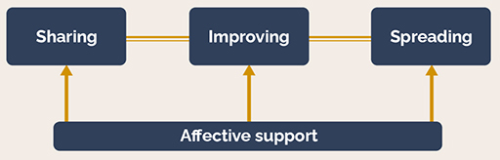
Figure 10 Process of teacher collaboration for implementation of change. (Nguyen & Ng, 2020)
View description - Figure 10 Process of teacher collaboration for implementation of change. (Nguyen ...
View alternative description - Figure 10 Process of teacher collaboration for implementation of change. (Nguyen ...

Back to - Activity 7 Round and round we go?

Activity 8 A matter of internal politics?

Discussion
On reading this article it is striking how the first point of reference is self doubt. The notion of ‘imposter syndrome’, is far more prevalent than many of us might recognise. At the heart of imposter syndrome is an irony though; often, we feel we are the only ones experiencing it. It was helpful to see too that the act of being part of a professional development process can leave people feeling as if they are falling behind and exposed. You may also have recognised the response of these teachers and their wish to be seen to be making a contribution, which could be linked to this sense of not being good enough. At the same time, it was clear that there was an openness to their relationships and a willingness to change, as well as a mutual respect and acceptance of their contrasting approaches to an issue. This seemed a particularly important point; despite their tendency to compromise, these three professionals did not feel they were abandoning their creativity and control. It would appear, that at the heart of it all they still felt that they had agency.
It is interesting to consider these findings in relation to other studies. Philpott & Oates (2017), for instance, in their study of Scottish professional learning communities suggest that people need to explicitly articulate and be willing to critique their assumptions. They also benefit from detailed information on issues and from having a diversity of voices present. This includes moving beyond expert notions of knowledge towards discussions of such things as purposes, values, identities or relationships. These researchers recognise too that the process of professional development should be a proactive space for agency. It should serve to enable people to play an active part in the development and application of their professional learning and the space in which it occurs. Part of this process is to give people more time to work collaboratively with facilitators and critical friends to enhance their agency in the longer term. This underlines that the process of professional development is also a process of change for a person’s identity, as a leader, a practitioner and as a member of a wide variety of communities.
The issue of time and working with mentors was also acknowledged in an Australian study at a secondary school (Sharp, Jarvis & McMillan, 2020). Here the school leaders provided structural and administrative assistance to professional development, amending timetables to support collaborative planning. Practice development however was mostly driven by staff at middle management level, who facilitated changes in understandings and practices by discussing issues in departments meetings. It was also facilitated by working with a project lead acting as mentor. This mentor role proved more valuable for some staff compared to voluntary training sessions, because it was ongoing, practical, context specific and frequently part of informal everyday discussions. It was recognised that schools had to develop their own expertise, not simply relying upon external advisors, and create their own opportunities for professional conversations.
The reading in Activity 8 and the studies mentioned in the comment have not been directly about school leadership. However, they raise a variety of issues (and possible solutions) that seem to be relevant to the experience of collaborative development across contexts. Which brings us back to where this course started, and the need to form partnerships amongst key stakeholders as part of a whole school approach, with policies and practices arising from the experience and expertise of all those involved.
Back to - Activity 8 A matter of internal politics?

Figure 1

Description
Speech bubble image with the text: Let’s spend some time together
Back to - Figure 1

Figure 2 being a part?

Description
Cartoon image of a person shouting ‘Hello! Hello!! Hello?’ Above, the text: Tyrone felt sure he had something useful to say.
Back to - Figure 2 being a part?

Figure 3

Description
Speech bubble image with the text: Are you in control?
Back to - Figure 3

Figure 4 Connect to learn method

Description
Diagram of 6 circles surrounding one circle in the centre. The centre circle has the following text: Connecting professional learning. From the top left, going clockwise around the centre circle, the circles have the following text:
- Define and disseminate outcomes and impact
- Establish enquiry team
- Data informed question/focus of enquiry
- Select enquiry method(s)
- Select, trial and refine strategies
- Collect data and evidence
On the left side of the image, outside the circles, there is the text: IMPACT
On the right side of the image, outside the circles, there is the text: IMPLEMENTATION
On the bottom of the image, outside the circles, there is the text: INNOVATION
Back to - Figure 4 Connect to learn method

Figure 5

Description
Speech bubble image with the text: Who knows what we are doing?
Back to - Figure 5

Figure 6 Does it matter?

Description
Cartoon image of a person with text: Sadly our policy about joined-up policies has only been taken up by the department that wrote it.
Back to - Figure 6 Does it matter?

Figure 7

Description
Speech bubble image with the text: So, is that sorted, then?
Back to - Figure 7

Figure 8 Obstacles in pyramid of hierarchy

Description
Diagram of a pyramid. From top to bottom, there are the following levels with text:
The Ministry of Education and Culture
Headmaster
Teachers
Pupils without special educational needs
Pupils characterised as having special educational needs
Back to - Figure 8 Obstacles in pyramid of hierarchy

Figure 9 Obstacles in pyramid of collaboration

Description
Diagram of an upside down triangle. From the top of the image to the bottom, there are the following levels with the text:
Pupils characterised as having special educational needs
Pupils without special educational needs
Teachers
Headmaster
The Ministry of Education and Culture
Surrounding the triangle are arrows going clockwise around the triangle, joined up to create a circle. In between these arrows there are three text boxes.
Top middle box: Headmaster – Inclusive Process Coordinator
Right-hand box: Intermediate Leader – School Representative
Left-hand box: Intermediate Leader – Ministry of Education and Culture
Back to - Figure 9 Obstacles in pyramid of collaboration

Figure 10 Process of teacher collaboration for implementation of change. (Nguyen & Ng, 2020)

Description
Illustration of a diagram with four boxes, with arrows going to one another. From the top left, the box ‘Sharing’ is linked to the box to the right, labelled ‘improving’. The box then linked again to the right, is labelled ‘spreading’. Below these three boxes is a box spanning the width of them all, with arrows linking to all three of them. This box is labelled ‘Affective support’.
Back to - Figure 10 Process of teacher collaboration for implementation of change. (Nguyen & Ng, 2020)

Video 2 Learning walks: what are they?

Transcript
[MUSIC PLAYING]
SPEAKER
There's always challenges in schools, which make you sit-in your office, that email to be answered, that parent to be dealt with, or that matter that's arisen. But nothing is more important than the learning walk. The learning walk tells you about your school and you know about things before people are telling you. Knowledge is power. It's really important that as a senior leader, you do those learning walks every day, perhaps twice a day because that will give you the evidence of what is going on in your school.
When that Ofsted call arrives, Ofsted inspectors naturally want to do a learning walk with you. So there should be no surprises whatsoever when you are wandering around through your school. You should be well-versed in knowing what happens on an everyday basis. Don't be surprised if they ask you questions because you should be able to answer them. You should be able to lead that discussion and be able to even challenge effectively if they see something that is out of place. It might be a member staff that you know and trust, that had a bit of a mishap. Or it might be a member or staff who you're working with in order to develop the CPD and make sure that they're an effective practitioner.
When you are wandering around with Ofsted, have a dialogue with them. Talk to them about the school and talk about what you've done to improve things. They're interested in knowing what you can do and what you've done about it with your leadership team. They want to know whether you are thorough and you really do know your stuff. They've come in as a blank canvas. Yes, they've had the data, but they don't know the picture that you're going to paint without you telling them. They're intelligent people. These are well-seasoned leaders. But they're not out to get you.
The new Ofsted focus is about curriculum and how the curriculum enriches and enhances young people's lives each and every day and how we are building to make children into 21st century learners. So they're interested in what you have to say. Point to them displays that showcase the curriculum. Also, talk to them about events. These are the kind of conversations that are golden nuggets to an Ofsted inspector's ears. They are interested in what you've done and how you're promoting, teaching, and learning, but mostly, how you're making sure that those children are getting quality-first education.
Look after your staff as well when you're doing the learning walks. Highlight and showcase their best practice. Sometimes though, things don't happen to plan. Be honest and integrity learn when observing with Ofsted inspectors. They know what's going on, they will pick it up. Or sometimes, they're even surprised that you're that transparent, and that you've actually shared a piece of information that they haven't picked up.
This is you leading the process. Take ownership and make sure that they hear what you need to say. Also, talk to them about the difficulties that you have faced. No need to tell them everything but the important things. But most importantly, what are you doing about it? How are you making sure that children have the best opportunities and the best education each and every day?
The new vision set out by Amanda Spielman, the government's chief HMI for Ofsted, actually focuses on the curriculum. So it's about enriching pupils' lives, making sure that they get the best curriculum so that they're well prepared to be the next generation of movers and shakers. So for you as a leader, showcase what you are doing. What interests have you pursued with your children? How have your staff developed an ambitious agenda so that every child can succeed no matter what background they come from?
Ofsted are particularly interested in projects that are driven by middle leaders. Talk to them about your middle leaders as well. That learning walk will give them a snapshot of what you are like as a leader, how perceptive you are, how incisive you are, and a snapshot of your school and what's going on. Remember, they're only here for a day or two. Although Ofsted inspectors have a lot of information in terms of statistics, they won't know what's going on on an everyday basis. They'll be keen to learn from you and ask their own questions. It's not just you who needs to know the knowledge and be observant, and look for things that are great, and look for things that need to improve, it's everyone.
So from all levels, make sure that you do joint learning walks because they are powerful in you addressing issues that need to be addressed straight away, but also knowing your school inside out. So when that Ofsted call does come, you know exactly what to do and you know what to speak about. The other thing learning walks do is that they show Ofsted that you are a diligent leader. Great teaching and learning needs to be an expectation and a right for every pupil. And it needs to be high on your agenda. For more advice on success in leadership content, browse on the videos below.
[AUDIO LOGO]

Back to - Video 2 Learning walks: what are they?

Video 3 Learning walks: structured observation for teachers

Transcript
[MUSIC PLAYING]

SPEAKER 1
Turn around 60 degrees.
SPEAKER 2
What's another strategy?
SPEAKER 3
Area model.
SPEAKER 2
Area model? OK, who wants to do an area model?
MARGARET HUDSON
Because the Lab School staff gets regular opportunities to participate in learning walks, both as participants and also as hosts, it really strengthens the culture of the school. It helps build the shared vision and allows a spirit of continuous learning.
[MUSIC PLAYING]

The Lab School is located on the university campus, in the College of Education. And we have a dual mission to serve the children at the school, which is currently kindergarten through grade 8, as well as pre-service teachers.
THERESA WILLIAMS
Learning walks is a big part of our mission. It gives people who are teaching in our school as well as people who are learning how to be teachers the opportunity to watch other people teach, which you don't generally get because you're in your classroom teaching all the time.
MARGARET HUDSON
A learning walk is just a structured observation through a school. It's used for continuous growth and improvement. It is important that all teachers get to experience what it's like to observe in other teachers' classrooms and learn from others as well as to have teachers come in and visit them and learn from them.
ABBY MARKLEY
I really like learning walks, especially as a fairly new teacher to this building. It's really helped me gain perspective on what my students have experienced. It facilitates this we're all in this together, what can we learn from each other? Some of the times, the best things that are going on are happening in your own building. And you might miss them because you're doing your own thing too.
SPEAKER 4
Can run at a rate of 11 feet per second.
MARGARET HUDSON
The learning walks follow a pretty specific protocol. It starts with an overview of the process and sets some parameters for participation. Thanks everyone for joining our learning walk team today. A focus is identified for the learning walks. And it can be a really broad focus, like teaching and learning, or a pretty specific focus, like classroom management. Today's learning walk focus is going to be on math. We're going to be looking at the power of mistakes and struggle, rich mathematical tasks, and assessment for a growth mindset.
Learning walk participants' role is to observe what's happening and know that they're going to get an opportunity to talk about those things later, but to avoid making judgments and to reframe any kind of thinking along those lines into questions.
SPEAKER 5
Did you understand Myles' answer?
SPEAKER 6
Yes.
SPEAKER 7
How would you know that you made a mistake?
MARGARET HUDSON
Participants are encouraged to take notes and jot down what they observe, what they see, what they hear, and also what their questions are, things they wonder about. It gives us a snapshot of other teachers teaching.
SPEAKER 8
How many do I have across tiers?
SPEAKER 9
15.
JULIE KORTUM
And it reminds us of, oh, they did an exit ticket. I keep forgetting to do those, I really need to pull those back in. We catch those little things because we're always watching and trying to get new ideas. So the learning walk for teachers, I think, is really beneficial.
MARGARET HUDSON
I do carry a timer. And I rely on that timer to keep the learning walk moving. After going through all the observations, it's a time for reflection. And we generally start the reflection process by having a few broad reflection questions. Take a minute and look over the reflection questions. Reflection is probably the most valuable part of the learning walk. One of my favorite reflection questions is, does anyone want to start and share any questions, wonderings, surprises that you noted?
SPEAKER 5
The kindergartners, when they were done with a task, they partner up with the next person done. And I added that to my ideas that I might apply in my classroom. I thought that was really neat.
MARGARET HUDSON
Anything that you would recommend be changed?
SPEAKER 10
I would always like to stay two minutes longer in each class.
MARGARET HUDSON
The amount of time is always hard. But the benefit of going to six different classrooms in a short amount of time is that you get a glimpse of many classrooms instead of an extended observation of one. And now you know where you might want to go back and do some more observing in that specific classroom.
MARLA SCHERR
This is the first learning walk that I've been on. It was clear after being on this today that it's a powerful tool because I could see what my colleagues were doing in grades behind me and then grades all the way up to middle school. So I can see where I fit in that picture.
SPEAKER 11
What would the clock look like up here? And then when we get here, it would be what?
MARLA SCHERR
I never get to step outside and go next door and see what my colleagues are doing. I'm always here. So I think that's really powerful.
SPEAKER 7
You could use a fifth grader's right?
MARGARET HUDSON
It's amazing how when teachers go into classrooms, even if there are different levels and different content areas from what they teach, what they can learn from each other. And I've never had a learning walk where people didn't walk away with some ideas about something new that they saw, something they wanted to try, something that they were interested in.
[MUSIC PLAYING]

Back to - Video 3 Learning walks: structured observation for teachers

Video 4 Lesson study: a powerful approach to improve teaching

Transcript
[MUSIC PLAYING]
NATE ORTEGA
Working together is a way to improve things, not trying to do it by yourself in your own classroom.
ERENDIRA ALCÁNTARA
It was something that I was looking for, more collaboration with colleagues.
NATE ORTEGA
A lot of times, teachers, we have so much going on during the school day. We're always busy. Getting time to just have teachers meet together, it's something that's not so common practice, I think.
THOMAS MCDOUGAL
I heard about the Chicago Lesson Study Conference, which was organised by Dr. Takahashi at DePaul University. And I went to this conference. And we observed a lesson that had been carefully planned by a team of teachers.
And the lesson ended. And we sat down. We had a very in-depth discussion about that lesson. It was very respectful of the complexity of teaching. The fact that you could watch a 45-minute lesson and then have a one and a half hour discussion about it and maybe still even at that point not be done, I thought, this is what I want to do.
We help create a professional but critical discussion about the lesson, what worked in the lesson, what didn't work, what is our evidence, what did we see students do, what does that tell us about how they're thinking, and what does that tell us about how we need to move forward in future lessons.
JOSHUA LERNER
As these cycles continue, teachers start to build on their skills. It's really built my ability to react in the moment in the classroom to respond to what a student might do or say and to have a sense of where the discussion or where the lesson might lead.
NATE ORTEGA
Lesson study is the way of bettering your practice. I haven't seen any other professional development that has been as effective and impactful in my teaching life and on the learning of my students as lesson study.
Back to - Video 4 Lesson study: a powerful approach to improve teaching

Figure 1

Alternative description
Speech bubble image with the text: Let’s spend some time together
Back to - Figure 1

Figure 2 being a part?

Alternative description
Cartoon image of a person shouting ‘Hello! Hello!! Hello?’ Above, the text: Tyrone felt sure he had something useful to say.
Back to - Figure 2 being a part?

Figure 3

Alternative description
Speech bubble image with the text: Are you in control?
Back to - Figure 3

Figure 4 Connect to learn method

Alternative description
Diagram of 6 circles surrounding one circle in the centre.
Back to - Figure 4 Connect to learn method

Figure 5

Alternative description
Speech bubble image with the text: Who knows what we are doing?
Back to - Figure 5

Figure 6 Does it matter?

Alternative description
Cartoon image of a person with text: Sadly our policy about joined-up policies has only been taken up by the department that wrote it.
Back to - Figure 6 Does it matter?

Figure 7

Alternative description
Speech bubble image with the text: So, is that sorted, then?
Back to - Figure 7

Figure 8 Obstacles in pyramid of hierarchy

Alternative description
Diagram of a pyramid.
Back to - Figure 8 Obstacles in pyramid of hierarchy

Figure 9 Obstacles in pyramid of collaboration

Alternative description
Diagram of an upside down triangle.
Back to - Figure 9 Obstacles in pyramid of collaboration

Figure 10 Process of teacher collaboration for implementation of change. (Nguyen & Ng, 2020)

Alternative description
Illustration of a diagram with four boxes, with arrows going to one another.
Back to - Figure 10 Process of teacher collaboration for implementation of change. (Nguyen & Ng, 2020)

