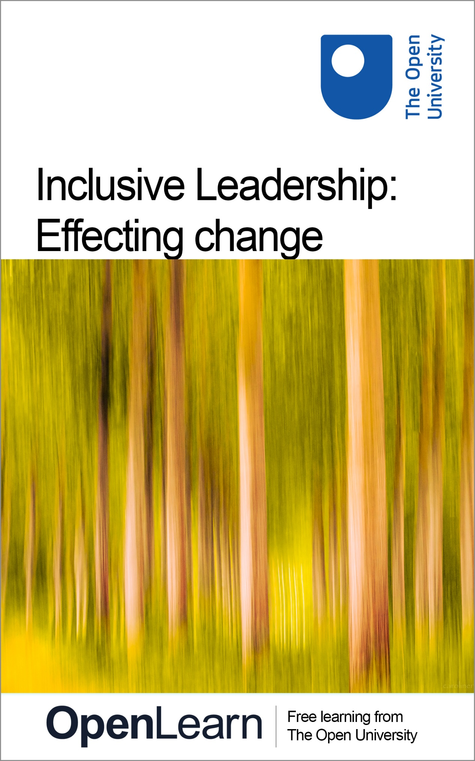

INL_1

Inclusive Leadership: Effecting change

About this free course
This version of the content may include video, images and interactive content that may not be optimised for your device.
You can experience this free course as it was originally designed on OpenLearn, the home of free learning from The Open University –
There you’ll also be able to track your progress via your activity record, which you can use to demonstrate your learning.
First published 2023.
Unless otherwise stated, copyright © 2023 The Open University, all rights reserved.
Intellectual property
Unless otherwise stated, this resource is released under the terms of the Creative Commons Licence v4.0 http://creativecommons.org/licenses/by-nc-sa/4.0/deed.en_GB. Within that The Open University interprets this licence in the following way: www.open.edu/openlearn/about-openlearn/frequently-asked-questions-on-openlearn. Copyright and rights falling outside the terms of the Creative Commons Licence are retained or controlled by The Open University. Please read the full text before using any of the content.
We believe the primary barrier to accessing high-quality educational experiences is cost, which is why we aim to publish as much free content as possible under an open licence. If it proves difficult to release content under our preferred Creative Commons licence (e.g. because we can’t afford or gain the clearances or find suitable alternatives), we will still release the materials for free under a personal end-user licence.
This is because the learning experience will always be the same high quality offering and that should always be seen as positive – even if at times the licensing is different to Creative Commons.
When using the content you must attribute us (The Open University) (the OU) and any identified author in accordance with the terms of the Creative Commons Licence.
The Acknowledgements section is used to list, amongst other things, third party (Proprietary), licensed content which is not subject to Creative Commons licensing. Proprietary content must be used (retained) intact and in context to the content at all times.
The Acknowledgements section is also used to bring to your attention any other Special Restrictions which may apply to the content. For example there may be times when the Creative Commons Non-Commercial Sharealike licence does not apply to any of the content even if owned by us (The Open University). In these instances, unless stated otherwise, the content may be used for personal and non-commercial use.
We have also identified as Proprietary other material included in the content which is not subject to Creative Commons Licence. These are OU logos, trading names and may extend to certain photographic and video images and sound recordings and any other material as may be brought to your attention.
Unauthorised use of any of the content may constitute a breach of the terms and conditions and/or intellectual property laws.
We reserve the right to alter, amend or bring to an end any terms and conditions provided here without notice.
All rights falling outside the terms of the Creative Commons licence are retained or controlled by The Open University.
Head of Intellectual Property, The Open University

Contents
- Introduction
- Learning outcomes
- 1 What is inclusive leadership?
  - 1.1 Is this inclusive?
  - 1.2 Where would you like to be?
- 2 Mindset and models for inclusive leadership
  - 2.1 Choose your theory
  - 2.2 How different is difference?
- 3 Inclusive leadership in challenging circumstances
  - 3.1 Reflecting upon all this
  - 3.2 Principal views?
- 4 Inclusive leadership with others
  - 4.1 Bringing together?
- Conclusion
- References
- Acknowledgements
- Solutions

Introduction
This course will help you to think about your professional educational situation and the nature of leadership within it. It will provide you with a better understanding of models of leadership and the challenges and opportunities to lead in an inclusive way. This course will enable you to reflect upon how you and others can support diverse teams within diverse learning contexts, with particular reference to collaborative and distributed practices. You will explore the issues through research from around the world, so that you reflect on personal and institutional responses to enacting leadership that support the involvement of all.
If you haven’t already, you might want to consider exploring the related OpenLearn courses after completing this course:
- Inclusive Leadership: Collaborating for professional development
- Leadership for inclusion: thinking it through
- Leadership for inclusion: what can you do?
You might also be interested in the Open University Inclusive Practice Leadership and Management Masters pathways.

Learning outcomes
After studying this course you should be able to:
- understand a range of perspectives on the nature of inclusive leadership
- engage with positive strategies for leading diverse teams
- identify the challenges of being an effective leader across a range of contexts
- consider how inclusive leadership can support change within an educational institution.

1 What is inclusive leadership?

Figure 1
View description - Figure 1
View alternative description - Figure 1

Leadership is to do with doing the right thing and management is about doing things right. Leadership is thus strategic, concerned with values, moral purpose, and a long-term vision of where an organisation wants to be in the future. Management is about making that vision a reality. Inclusive education needs both to happen.
(Precey & Mazurkiewicz, 2013, p.112)

Inclusive leadership is a concept whose popularity has spread in recent years, in and out of education. The values which underpin this approach can be seen as being broadly associated with leadership that emphasises equitable, horizontal and collective relationships. These values sit in contrast to more bureaucratic and hierarchical forms of organization which can be seen to reinforce wider social biases and injustices in relation to notions such as ability, class, gender, race, ethnicity, sexuality and socio-economic background. The values underpinning inclusive leadership also sit in contrast to the single, hero model of leadership. They are rooted in collaborative notions that seek to include those often left out of leadership-related activities. They seek to have greater influence than is associated with individual leaders, to produce deeper change and to avoid short-termism (Ryan, 2006).
Inclusive leadership is also based on a recognition that the leadership of an institution needs to be understood in its socio-cultural context. Leadership is historically, culturally and politically situated. Its nature is interwoven with the tools and artifacts associated with a particular place (such as the curriculum, official standards, facilities), as well as with people in interaction (Spillane & Orlina, 2005). Consequently, beneficial changes will arise from a diverse mix of people coming together, in different roles and working with varying resources, in various ways. Such a mix allows institutions to benefit from different understandings of the tools and artefacts, as well as the contrasting experiences and insights that arise from distinctive socio-cultural heritages.

1.1 Is this inclusive?
Inclusive leadership is an approach which is also associated with an ethical dimension, producing change not only at a local level but in wider society. It seeks to encourage people to recognise injustices, so that they can work together to change those injustices and/or the conditions from which they emerge. As such, inclusive leadership both aims to achieve greater inclusion as well as to be inclusive in its operation. This fits with much literature associated with the promotion of equity and inclusion. Ainscow (2020), for example says that strategies need to be informed by the impact of current practices on the involvement and achievement of all students, as part of a local and national promotion of equity and inclusion in all schools. However, Ainscow also notes the need for policies that are based on clear and widely understood definitions of what the terms equity and inclusion mean. As Sarid (2021) argues social justice policies take on different meanings and forms depending on the ethical worldview of leaders, allied to the specific needs of their educational context.

Activity 1 Is this inclusive?
45 minutes

Watch these three videos. All of them are about inclusive leadership, though not specifically in the context of education.

Video content is not available in this format.
Video 1 Inclusive leadership (Please note this video has no spoken audio.)
View transcript - Video 1 Inclusive leadership (Please note this video has no spoken audio.)

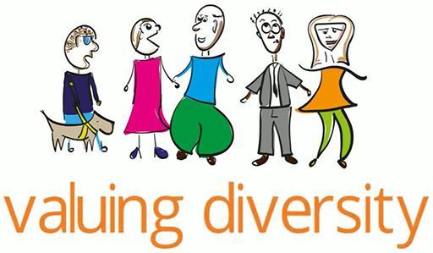

Watch the video at YouTube.com.
Video 2 What is inclusive leadership – EmberinPtyLtd (Please note this video has no spoken audio. The Open University is not responsible for external content.)

Watch the video at YouTube.com.
Video 3 What is inclusive leadership – Pern Kandola (The Open University is not responsible for external content.)

As you are watching make notes about:
- The understanding of inclusive leadership that is being presented.
- The values and priorities that are evident in the videos.
- Your own feelings about the value and nature of inclusive leadership.

Provide your answer...
View discussion - Activity 1 Is this inclusive?

1.2 Where would you like to be?
The experience of being within cultures underpinned by the values and priorities evident in Activity 1 will be profoundly different and produce very different teaching practices. In a Turkish study of more than 400 teachers for instance (Sonmez & Gokmenoglu, 2023), the more that school leaders shared leadership duties, the more likely staff were to support each other, to critically engage with their practice and school process, and to behave in inclusive ways (for example being open to different cultures and languages). Similarly, in a study of 6 schools in the US, when principals drew on teachers’ ideas and expertise in developing reforms, school initiatives were far more successful than when they expected them to adopt and implement top-down practices (Kraft et al, 2015).

Activity 2 Where would you like to be?
60 minutes

So let us try and get some sense of the different experiences that teachers have, as result of the differing approaches of ‘inclusive’ leaders. Here are two articles discussing experiences in Early Years settings. One in New Zealand and one in Thailand.
- Higginson, R., (2019) ‘Walking the talk: Leadership in New Zealand early childhood settings’, Early Education, 65, pp. 11–15.
Read from Findings (p. 12) until the end of the discussion (p. 14). In this chapter the acronym DL stands for designated leader.
- Agbenyega, J. S. and Klibthong, S., (2022) ‘Giving voice: inclusive early childhood teachers’ perspectives about their school leaders’ leadership practices’, International Journal of Leadership in Education, pp. 1–17.
Read from Findings (p. 7) until the end of the discussion (p. 13).
As you read consider the following questions:
- To what degree is the practice being described hierarchical?
- How do the staff view their leaders?
- How would you describe the relationship between the staff and their leaders?
- Is any of the practice you are reading about close to what you would think of as inclusive practice?
- What other practices would you look for in an inclusive leader?

Provide your answer...
View discussion - Activity 2 Where would you like to be?

The issue of levels, raised in the discussion for Activity 2, was also one taken up in a study funded by the European Union (Óskarsdóttir et al, 2020). This study looked at policies and practices across the European Union and concluded that inclusive leaders need to set a strategic vision, whilst attending to both organisational and human development. This was across a variety of levels too, the national and regional Macro level, the community Exo level, the school Meso level, and the individual Meso level. They also identified a range of roles and responsibilities for those leaders at each of these levels. As you read this list below it is interesting to reflect upon whether these are all functions that can be undertaken by all members of a staff team in all types of settings or if these behaviours by necessity feed into some notion of hierarchy and the individual hero model of leadership. You might want to share this list with friends and colleagues and discuss your views.

Table 1
Macro (national/regional)
Influence the development of national policy on equity and inclusive education through consultation and communication.
Translate and implement policies in ways appropriate to their school context and values and manage school level change regarding: curriculum and assessment frameworks; professional development; funding and allocation of resources; quality assurance and accountability.
Exo (community level)
Build partnerships with support agencies, other schools/institutions at other system levels, businesses in the community.
Build school capacity for diversity through research engagement and collaborative professional development activities, e.g. with universities.
Manage human resources, securing commitment to the shared vision of inclusion.
Manage financial resources to meet the needs of the whole school community.
Meso (school level)
Guide and influence school organisation and resources according to principles of equity.
Engage the learning community in self-review and reflect on data to inform ongoing school improvement.
Provide opportunities for professional development.
Ensure a continuum of support for all stakeholders.
Show commitment to the ethic of everybody.
Ensure curriculum and assessment are fit for purpose and meet the needs of all learners.
Actively engage all families.
Micro (individual level)
Influence learner-centred practice/listening to learners, personalisation (centre).
Ensure that teachers take responsibility for all learners.
Support innovative and flexible evidence-based pedagogy/practice in classrooms.
Monitor classroom practice ensuring high-quality education for all.
Develop a culture of collaboration – positive and trusting relationships.
Use data as a basis for teacher reflection and ongoing improvement.

Having introduced some models of the behaviours associated with inclusive leaders, let’s explore more deeply the models that are generally seen to underpin this approach.

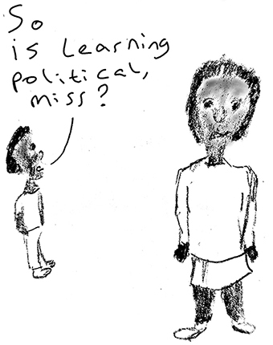
Figure 3 At what level?
View description - Figure 3 At what level?
View alternative description - Figure 3 At what level?

2 Mindset and models for inclusive leadership

Figure 4
View description - Figure 4
View alternative description - Figure 4

The EU project mentioned above conceptualised inclusive leadership by drawing upon three main theories of school leadership linked to successful inclusive practices: instructional leadership, transformational leadership and distributed leadership. Historically, such models have been seen to operate in contrast to each other. Instructional leadership models, for example, emerged in the 1970’s with a focus on three activities: Defining the School Mission, Managing the Instructional Programmes, and Creating a Positive School Climate (Hallinger & Murphy, 1985); whilst transformational leadership came to the fore in the 1990’s, and has been represented by four dimensions: Idealized Influence, Inspirational Motivation, Intellectual Stimulation, and Individualized Consideration (Bass & Avolio, 1995). However, it has also been recognised that adopting the two models can have a moderating effect on student outcomes. Kwan (2020), for instance, in a large scale study in Hong Kong secondary schools, suggests that transformational behaviour is a necessary condition for effective instructional measures.
Óskarsdóttir et al (2020) draw upon a wide range of literature to outline the three theories underpinning their inclusive leadership model:
They talk about instructional leadership as involving the setting and communication of clear goals and expectations for instruction. It involves the development, planning and coordination of the curriculum, all the time seeking to enhance the quality of teaching and learning in the classroom. There is a focus too upon evaluating teachers and teaching, whilst promoting and improving measurable outcomes for learners, and at the same time creating a supportive, encouraging work environment, that enables the development of teaching practices that improve academic performance. This involves coordinating the efforts of teachers and teacher-leaders to support each other and the school mission, leading to more collaboration and reflective dialogue between teachers, greater recognition of their innovation and more positive interactions between teachers and learners.
In discussing transformational leadership, they identify inspiring others as central to its practice, building a shared vision and providing support that facilitates change and innovation through impacting people and cultures within schools. The focus is upon developing both a collaborative culture and the people within the school, (re)designing the organisation to establish structures and ways of working that enhance the quality of teaching and learning. The aim is to give adequate support, that influences school staff so they become highly engaged and motivated, so they are inspired by goals they believe in and feel are aligned with their values. Clearly, leaders need to identify which values are critical to the performance of their staff and need to focus on practices most likely to have a positive influence on those values. All of this means the ability to be transformative depends upon their analysis and understanding of the school’s needs and priorities.
In considering distributed leadership, they note that the emphasis is on collaborative efforts which are in turn based on a network of relationships between people. They suggest that at the core of this are people’s social ties and the trust that arises from these. The consequence of this social capital is evident in the benefits and resources which emerge for the organisation and the people who are within it. Consequently, the aim is to draw on the collective talent and capacities within the school, connecting people in meaningful and productive ways, whilst facilitating the sharing of knowledge and skills. This means there is a focus on the development of others, on the sharing of responsibility across leadership teams, and on the interactions between people in formal and informal leadership roles. This includes devolving responsibility to middle management teams and seeking to organise everyone to be flexible, to share practice and to take responsibility for change. Anyone can be a driver of the change process, multiplying the head teacher’s actions.

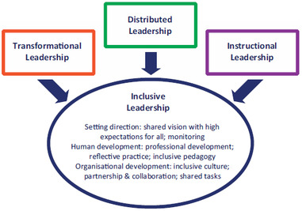
Figure 5 The theories underpinning a model of inclusive leadership (Óskarsdóttir et al, 2020)
View description - Figure 5 The theories underpinning a model of inclusive leadership (Óskarsdóttir ...

2.1 Choose your theory
These next readings are an opportunity to spend some more time thinking about a leadership theory that interests you.

Activity 3 Choose your theory
60 minutes

Read these Abstracts and then choose at least one section of a paper to read in detail. As you are reading make notes about:
- What are the characteristics of the theory that are in evidence?
- What are the positive aspects of these experiences as they are presented?
- What kinds of challenges emerge for the teachers and the leaders?
- How does the experience relate to your own experiences of leading and being led?
- Can you see benefits from this way of leading that speak to your understanding of inclusive education and the challenges it faces?
- Why do you think that Óskarsdóttir et al (2020) felt it was necessary to use more than one theory in developing their model of inclusive leadership?
When you have finished reading you may want to have a discussion with friends or colleagues about leadership styles and their experiences of them.

Table 2
Read Gómez-Hurtado, I., González-Falcón, I., Coronel-Llamas, J. M. and García-Rodríguez, M. D. P. (2020) ‘Distributing leadership or distributing tasks? The practice of distributed leadership by management and its limitations in two Spanish Secondary Schools’, Education Sciences, 10(5), p. 122.
Read from Results (p. 5) to the end of the paper (p. 12).
Abstract: The need to explore new forms of leadership in schools, among other available alternatives, leads to the reflection upon the way in which--specifically from the principal's office--it is developed, implemented and distributed. This paper presents two case studies in Spanish secondary schools in which the practices are analyzed and the limitations recognized in the exercise of distributed leadership by their principals. This study used interviews and shadowing of the principals, recording the observations of meetings and interviews with other influential agents from each school. Despite the particular differences in each case and a greater role of social interaction processes, the outcomes reflect the persistent focus on the individual action of the principals and the pre-eminence of formal and bureaucratic components in the development of distributed leadership. This situation prevents progress beyond the mere distribution of management tasks and hinders the possibilities of consolidating other forms of leadership expression that involve more agents and groups.
Chabalala, G. and Naidoo, P., (2021) ‘Teachers’ and middle managers’ experiences of principals’ instructional leadership towards improving curriculum delivery in schools’, South African Journal of Childhood Education, 11(1), pp. 1–10. http://www.scielo.org.za/scielo.php?script=sci_arttext&pid=S2223-76822021000100017
Read from Findings (p. 5) to the end of the paper (p. 10).
Background: This study was designed to explore teachers’ and middle managers’ experiences regarding their principals’ instructional leadership practices aimed at improving curriculum delivery in schools. Literature on instructional leadership indicates how failing schools can be turned around to become successful if principals consider instructional leadership to be their primary role within schools. The authors, therefore, argue that it is the responsibility of principals to ensure that learners’ results are improved through intervention and support provided by the principals to capacitate teachers and middle managers in delivering the curriculum effectively. Globally, literature promotes the significance of the continued professional development of teachers, and many scholars allude to the pivotal role principals or school heads play in teachers’ skills advancement.
Aim: The aim of this article was to identify principals’ instructional practices that improve curriculum delivery in schools, which are examined through the experiences of teachers and middle managers.
Setting: The study was conducted in two schools in the Gauteng province of South Africa.
Method: The researchers employed a qualitative approach, utilising three domains of instructional leadership as its framework, and these are defining the school mission statement, managing the instructional programme and promoting a positive school learning climate. Four teachers and four middle managers were purposefully selected at two schools for data collection conducted through semi-structured individual interviews, which were analysed using thematic content analysis.
Results: Three themes emerged, namely, understanding good instructional leadership practices, teacher development as an instructional practice and instructional resource provisioning.
Conclusion: The study highlights the importance of teachers and middle managers in understanding that principals are merely not school managers or administrators, but rather instructional leaders whose primary role is to direct teaching and learning processes in schools. Principals need to create time within their constricted schedules to become instructional leaders, which is their main purpose in schools. If the roles and responsibilities of middle managers are not explicit, their ability to simultaneously perform the dual task of being teachers and middle managers will be compromised.
Asare, K. B., (2016) ‘Are basic school head teachers transformational leaders? Views of teachers’, African Journal of Teacher Education, 5(1).
Read from Results and Findings (p. 7) to the start of the Discussion (p. 15).
Abstract: Transformational leadership practice is associated with improved school functioning and quality education delivery through teacher commitment and willingness to exceed targets or educational benchmarks (Balyer, 2012; Nedelcu, 2013). The establishment of the Leadership for Learning (LFL) program in Ghana in 2009 aimed at improving the effectiveness of basic school head teachers to better lead schools to promote student learning. In this study, the perceptions of basic school teachers as to the transformational leadership conduct of head teachers who had received training under the LFL model were collected and reviewed. The purpose of this qualitative inquiry was to determine from teachers’ perceptions how the conduct of head teachers related to transformational leadership. From the study results, the findings indicated that while teachers largely perceived their head teachers as transformational leaders, more than the influence of head teachers is required to motivate teachers to give of themselves to improve education outcomes. Recommendations and implications of the study for practice and research were considered.

Provide your answer...
View discussion - Activity 3 Choose your theory

It is also worth noting that there are a wide variety of other models associated with leadership. Precey & Mazurkiewicz (2013), for example, mention Transformative leadership. This is an approach that is founded on critique and aspiration, underpinned by values of democracy, social justice and equity. Leaders who adopt this style are interested in how systems and processes de-construct and reconstruct institutions, social norms and cultural knowledge; they seek to transform individuals and organisations; and they wish to encourage activism and moral courage, recognising the challenges and tensions in the lives we live.

2.2 How different is difference?
Another central challenge is that all these models and theories are in many ways value free. They can talk about particular values but they will mean different things to different people. For example, in a study exploring understandings of social justice, amongst educators concerned with social justice (Thomas et al, 2019), conflicting and contradictory understandings emerged. There was not a single unified goal. Some practitioners didn’t want to support activism, some wanted to create agents of change. Some saw social justice as being about changing learners and some saw it as being about changing institutions. Some felt social justice was constrained by assessment, some feared a checklist approach to difference, and some thought that the simple act of focussing upon the idea of social justice would alienate people from the outset. In seeking social justice they were all seeking something slightly different. Consequently, as these differences emerged, the practitioners recognised that they needed to explore concepts and language, as well as who was served by practices and why, and what the practices might look like. Thomas et al suggested that these diverse perspectives and views could be seen as being in tension, requiring deeper understanding. For them, a way forward involved ‘embracing the questions’ (p31) posed by the tensions.
The next reading will help you to consider this a bit more.

Activity 4 How different is difference?
45 minutes

Read this article by Van Knippenberg, D., (2022) ‘You may need to change how you manage Diversity, Equity, and Inclusion’, California Management Review Insights.
As you are reading make notes about the following questions:
- What difficulties can emerge from a commitment to diversity, equity, and inclusion?
- How do you understand the notion of synergy as it is used in this article?
- Can you think of any examples of challenges and opportunities that arise from seeking synergy within an educational context?
- How do you think that an issue such as this might impact upon the models discussed above?
- Is this an issue which can be utilised as part of the inclusive leadership model produced by Óskarsdóttir et al (2020)?

Provide your answer...
View discussion - Activity 4 How different is difference?

3 Inclusive leadership in challenging circumstances

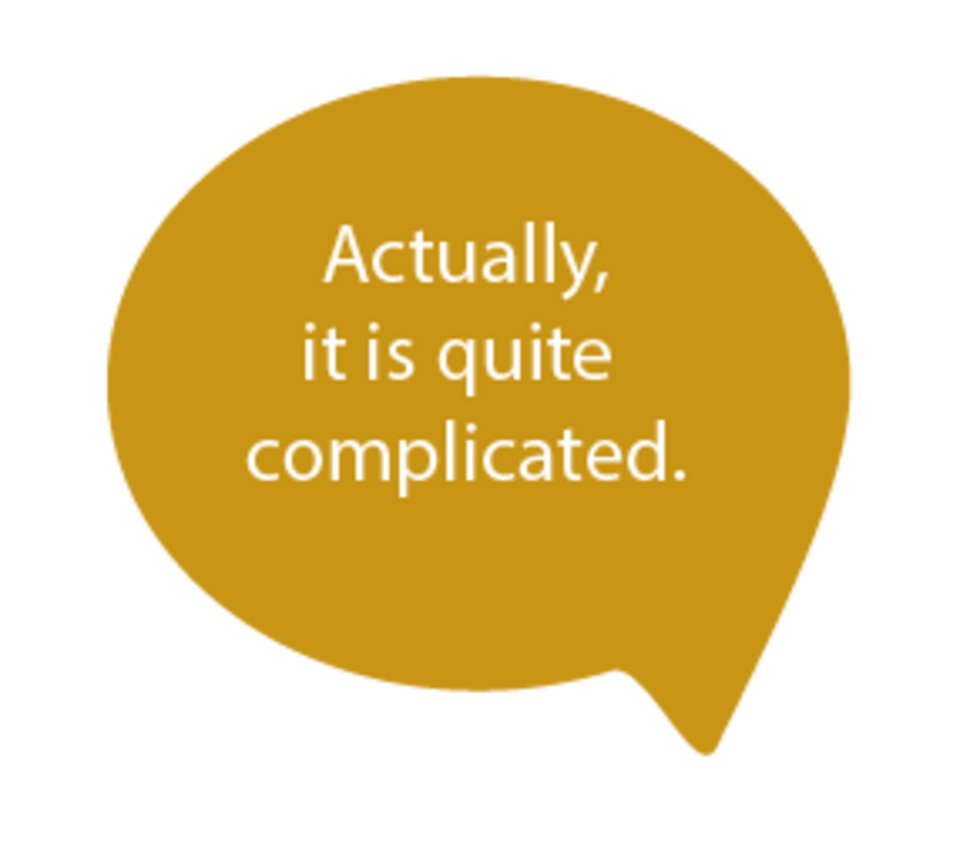
Figure 7
View description - Figure 7
View alternative description - Figure 7

In the previous activity you considered how professional discussions can be quite closed affairs. This might have made you think back to the video in activity 1 which talked about groupthink. This concept emerged from the field of psychology (Janis, 1982) and means a group has eight supposed symptoms:
- a sense of invulnerability
- moral superiority
- explaining away things that are contrary to the dominant view
- a stereotyped views of others
- self censorship of deviations from the group consensus
- a shared illusion of unanimity
- putting pressure on dissenters
- a collective, protective set of beliefs that keeps away uncomfortable information.
The evidence to support the existence of these 8 symptoms is very limited however, as well as disagreements about the nature of what groupthink might actually involve. For example, studies from health settings suggest its impact on clinical and educational outcomes is unclear, with some researchers suggesting benefits can arise from a group’s unified position (DiPierro et al, 2022). Even if the existence of groupthink can be questioned, there is less doubt about the existence of power structures within group contexts that marginalise (or maintain the marginalisation) of particular people or views. In considering how we can challenge such power dynamics, it is useful to recognise that each member of a group has a range of understandings. For instance, there will be varying understandings of the team itself, of roles in it and varying perceptions of other people’s understandings. Van Knippenberg & van Ginkel (2022) suggest that in trying to develop collective and shared understandings, leaders can advocate for their own view of the team and teamwork. They can also invite diverse input and encourage discussion which brings together those perspectives, followed by a discussion of the team process, what to aim for and how to achieve this, and to reflect upon experiences and insights that have emerged from previous developments. This will further underline that different members know different things and have different experiences of seeming similar events. They suggest its positive effects will be strongest for people from historically marginalised groups, and consequently will emphasise inclusive principles in action.

3.1 Reflecting upon all this
Of course, school leaders are facing a great many other challenges. Since reflection has been a key part of the theory and models discussed, it seems appropriate to give you some time to reflect upon your own views on the underlying challenges in developing and delivering inclusive leadership.

Activity 5 Reflecting upon all this
30 minutes

Think back to your own experiences of school leadership; this might be as a practitioner, child, parent or as an external professional or in a leadership role. As you think back make notes about the challenges which school leaders face in leading students, staff, parents and the wider community.
Here are some quotes about school leaders and leadership to help you with your reflection. These come from three papers exploring experiences in Ghana and Spain and of Irish teachers working in England.
- Where I am now, the headmaster is very passionate about the policy, but there is nothing he can do to support us. Schools don’t have money or the means to generate finances. It’s a public school, which is free, so they don’t charge any fees, and the government has not been giving them money to run the schools. The headmaster here at times uses his own money to buy books for the children. (Opoku, 2022, p14)
- Different attitudes were observed among the teachers. The maths teacher was receptive and showed his willingness and considerable involvement with the project. In contrast, resistance was perceived from some of the language teachers. (Traver-Marti et al, 2023, p568)
- All the schools care about here is how good they look on paper to the outside world, and pretty much it is just run like a business. In my opinion, they are more concerned about getting as much money in to that school as they can, and showing grades in the best possible way than it is about actual students in school. (Skerritt, 2019, p584)
- Personally, I have not had any training in inclusive education since I started teaching. I went to training college, so I was taught special education, where I was taught how to embrace diversity and support such students. At the departmental level, it has not come up in our discussions. (Opoku, 2022, p16)
- Participation was understood as family involvement and collaboration. Students’ participation has not been considered. It is assumed that the students are already in school and they don’t need to be involved further. This idea of participating as being present, accessing and being taken into account in certain specific activities prevails over the idea of taking decisions. (Traver-Marti et al, 2023, p566)
- You have to put some values on the backburner to appease what the school wants you to do. It’s as simple as that. (Skerritt, 2019, p585)
- Another mother said she thought decisions about homework should be left to the teachers, that families don’t have sufficient knowledge or criteria to form an opinion. (Traver-Marti et al, 2023, p567)
- Look at this classroom, for instance (points to a building). They couldn’t climb to the third or second floor and had to rely on the mercy of other students to carry them or help them reach the classrooms. Sometimes, if they feel like urinating or going to the toilet, it is a problem since in our schools, toilets are separate from the main buildings. Sometimes, too, when they are doing group work, where to sit and actively participate becomes a problem. (Opoku, 2022, p10-11)
- You feel like you’re more of a manager. You’re managing these little people to get through and get the results rather than being a teacher. It’s more admin than anything else. Most of my job is just admin. (Skerritt, 2019, p584)
- Just like he does every Monday, A [the head teacher] slipped into [the meeting]. This time it was something to do with a bottle of cologne. Maybe A systematically drops in on the committee on purpose . . . It’s become a feature of every Monday meeting. He makes no noise, but he makes his presence felt and it’s a reminder that we are in ‘his’ school. (Traver-Marti et al, 2023, p567-8)

Provide your answer...
View discussion - Activity 5 Reflecting upon all this

3.2 Principal views?
So let’s read about school leaders’ views of some of these challenges and how they deal with them.

Activity 6 Principal views?
45 minutes

Read Sider, S., Maich, K., Morvan, J., Villella, M., Ling, P. and Repp, C., (2021) ‘Inclusive school leadership: Examining the experiences of Canadian school principals in supporting students with special education needs’,Journal of Research in Special Educational Needs, 21(3), pp. 233–241.
Read from Results on p. 235 to the end of the discussion on p. 240. As you are reading make notes in response to the following questions:
- What issues did you anticipate the principals raising, and what come as a surprise?
- What do you feel about the relationship between the competencies the paper identifies and the role of professional development? Do these competencies all require training?

Provide your answer...
View discussion - Activity 6 Principal views?

So let’s move on to consider leadership and the involvement of others.

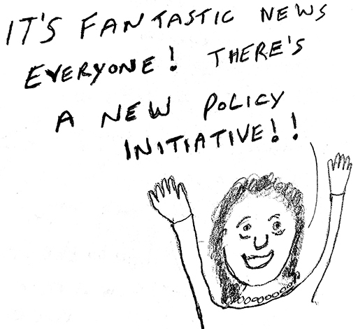
Figure 8 A moment of inspiration?
View description - Figure 8 A moment of inspiration?
View alternative description - Figure 8 A moment of inspiration?

4 Inclusive leadership with others

Figure 9
View description - Figure 9
View alternative description - Figure 9

It is perhaps unnecessary to point out that leadership is about working with others. However, as with the teacher in figure 1, some might struggle with the notion that this means it is about politics. Is it fair, as stated in the last section, to suggest that making long and short term decisions, about such things as resources, which directly impact on children and their families is fundamentally political? After all, many practitioners and school leaders, would suggest that their priority is about building relationships and being supportive of others. They may struggle with the advice given to school leaders by the Chief Executive of the Royal School for Deaf Children, at the National Association of Specialist Education Colleges to:
- get in at the start of projects
- liaise at the top of organisations
- be shrewd
- consider issues of competition
- think strategically
- ‘be a politician!’ (Rix, 2015)
But when we step back from the notion of politics as a party-political process, and instead recognise that it is a process of ‘world-making’ that arises through ‘critique, disagreement, difference, and conflict’ (Postero & Elinoff, 2019), then it is easier to accept that any decision we make about a child, family, colleague or institution is political. It will affect their world, it will involve negotiating potential disagreements, whilst working with different views and the risk of conflict. It is not unreasonable to expect the leader to critically reflect upon a wide range of issues in this context. Consider, for example, a couple of studies of Israeli school leaders. In one study, it was clear that school leaders deliberately created time and space to build interpersonal relationships with staff, which they saw as particularly valuable when seeking to transform multiple deeply rooted aspects of an institution (Friedman & Berkovich, 2020); whilst in a second study of school leadership teams, the heads rewarded supporters by placing them in formal leadership roles (which ensured a core of support), whilst placing adversaries in sligthly lesser positions within the management team (which ensured they were close enough to control – Berkovich, 2020).

Activity 7 Thinking about the politics of all this
30 minutes

Spend some time thinking about the component parts of a political system and how these might be reflected in schools that you know. Kamecka-Antczak (2020) suggests that a political system involves:
- an interdependent community, made up of groups of similar and contrary interests
- organisations, which through execution of influence and the acquisition and exercising of power represent the interests of these groups
- institutions having tools of persuasion, compulsion and power
- formal standards and customs governing mutual relations and component parts, ideologies and strategies
- membership of international institutions and other organisations
Now make notes about:
- examples of each of these 5 components of political systems as they function in a school context
- the ways in which school leaders by engaging with these 5 components are involved in ‘critique, disagreement, difference, and conflict’.

Provide your answer...
View discussion - Activity 7 Thinking about the politics of all this

4.1 Bringing together?
So let’s reflect a little more on how school leaders can work in this way.

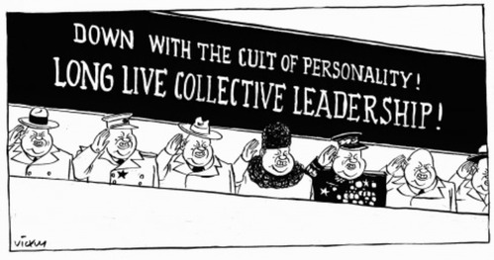
Figure 10 Getting it wrong
View description - Figure 10 Getting it wrong
View alternative description - Figure 10 Getting it wrong

Activity 8 Bringing together?
45 minutes

Read this article Valdivieso, P., (2020) ‘School leaders and inclusive education in Peru: A case study of principal leadership in an effective inclusive school’, International Journal of Innovative Business Strategies, 6(2), pp. 453–461.
Read from Leadership Strategies on p. 457 to the end of the article on p. 459. The acronyms in this extract are: Jose Antonio Encinas (JAE), Inclusive Education (IE) and Special Educational Needs (SEN)
As you read consider the following questions:
- In what way are the challenges identified by the principal political challenges?
- In what ways are the solutions about bringing people together and creating opportunities for communication?
- Are there strategies which surprise you or you feel are missing from this description?
- Thinking back to sections 1 & 2, do you feel that this is an example of inclusive leadership?

Provide your answer...
View discussion - Activity 8 Bringing together?

If you want to explore these issues further there is a second course on Inclusive Leadership, Inclusive Leadership: Collaborating for professional development, which explores how Inclusive Leadership can work with communities of practice, collaborative enquiry and professional development to facilitate agency and create institutional change.

Conclusion
In this course you have explored what is meant by Inclusive leadership and its theoretical underpinnings. There has been discussion of people’s experiences on being led and models of the behaviours associated with inclusive leadership. We have considered the importance of the leader’s mindset to this process and the challenges and practicalities of developing this mindset and encouraging it in others. You have been asked to reflect upon the political nature of schools and the change process and to recognise that the only way through this for inclusive leaders is to seek collaboration and support. An evident message has been: if we wish to have inclusive systems we have to demonstrate inclusive practices.
As one of the teachers said in the study from Thailand (Agbenyega & Klibthong, 2022):

‘If you are a leader it means you are there to support those who support your work, leaders can’t do it alone and teachers can’t do it alone. We need each other to make things work well.’ (p. 10)

If you haven’t already, you might want to consider exploring the related OpenLearn courses after completing this course:
- Inclusive Leadership: Collaborating for professional development
- Leadership for inclusion: thinking it through
- Leadership for inclusion: what can you do?
You might also be interested in the Open University Inclusive Practice Leadership and Management Masters pathways.

References
Agbenyega, J.S. and Klibthong, S., 2022. Giving voice: inclusive early childhood teachers’ perspectives about their school leaders’ leadership practices. International Journal of Leadership in Education, pp.1-17.
Ainscow, M. (2020). Inclusion and equity in education: Making sense of global challenges. PROSPECTS, 49(3), 123–134.
Bass, B. M., & Avolio, B. J. (1995). The Multifactor Leadership Questionnaire. Palo Alto, CA: Mind Garden.
Berkovich, I., 2020. Micro-politics, senior management teams, and principals’ inner circle: a structural exploration. Leadership and Policy in Schools, 19(2), pp.290-303.
DeMatthews, D.E., Serafini, A. and Watson, T.N., 2021. Leading inclusive schools: Principal perceptions, practices, and challenges to meaningful change. Educational Administration Quarterly, 57(1), pp.3-48
DiPierro, K., Lee, H., Pain, K.J., Durning, S.J. and Choi, J.J., 2022. Groupthink among health professional teams in patient care: A scoping review. Medical Teacher, 44(3), pp.309-318.
Dor-Haim, P. (2021). Expressions of loneliness: Different perspectives of loneliness among school deputy principals. Educational Management Administration & Leadership,
EASIE (2018) European Agency Statistics on Inclusive Education, 2018-19 Dataset Cross-Country Report
Epstein, J.L., Galindo, C.L. and Sheldon, S.B., 2011. Levels of leadership: Effects of district and school leaders on the quality of school programs of family and community involvement. Educational Administration Quarterly, 47(3), pp.462-495.
Friedman, D. and Berkovich, I., 2020. Influence tactics and “second-order” change in schools: case study research of principals' political behaviors and strategies. International Journal of Educational Management, 35(1), pp.327-339.
Gómez-Hurtado, I., Valdés, R., González-Falcón, I. and Vargas, F.J., 2021. Inclusive leadership: Good managerial practices to address cultural diversity in schools. Social Inclusion, 9(4), pp.69-80.
Hallinger, P., & Murphy, J. (1985). Assessing the instructional management behavior of principals. Elementary School Journal, 86, 217-247.
Higginson, R., 2019. Walking the talk: Leadership in New Zealand early childhood settings. Early Education, 65, pp.11-15.
Hoppey, D. and McLeskey, J., 2013. A case study of principal leadership in an effective inclusive school. The Journal of Special Education, 46(4), pp.245-256.
Janis IL. 1982. Groupthink: psychological studies of policy decisions and fiascoes. 2nd ed. Boston: Houghton Mifflin.
Kamecka-Antczak, C. 2020., School political culture. What is it and how to study it?. Culture – Society – Education 1(17), pp. 199–217
Korkmaz, A.V., Van Engen, M.L., Knappert, L. and Schalk, R., 2022. About and beyond leading uniqueness and belongingness: A systematic review of inclusive leadership research. Human Resource Management Review, p.100894.
Kraft, M. A., Papay, J. P., Johnson, S. M., Charner-Laird, M., Ng, M., & Reinhorn, S. (2015). Educating amid uncertainty: The organizational supports teachers need to serve students in high-poverty, urban schools. Educational Administration Quarterly, 51(5), 753-790.
Kwan, P., 2020. Is transformational leadership theory passé? Revisiting the integrative effect of instructional leadership and transformational leadership on student outcomes. Educational Administration Quarterly, 56(2), pp.321-349.
Leo, E. and Barton, L. (2006) Inclusion, Diversity and Leadership: Perspectives, Possibilities and Contradictions, Educational Management Administration and Leadership, 34, pp. 167-180.
MacBeath, J. (2005) Leadership as Distributed: A Matter of Practice, School Leadership and Management. Vol. 25, No. 4, pp. 349 – 366.
Macbeath, J., Galton, M., Steward, S., Macbeath, A., & Page, C. (2006). The costs of inclusion, University of Cambridge, Faculty of Education.
Moolenaar, N.M. and Sleegers, P.J., 2015. The networked principal: Examining principals’ social relationships and transformational leadership in school and district networks. Journal of Educational Administration.
Office of National Statistics (2021), Schools, pupils and their characteristics, https://www.iicsa.org.uk/key-documents/27114/view/INQ006503.pdf
Opoku, M.P., 2022. Inclusive School Leadership in Developing Context: What Are the Levers of Change?. Journal of Research on Leadership Education, p.19427751221087731.
Óskarsdóttir, E., Donnelly, V., Turner-Cmuchal, M. and Florian, L., 2020. Inclusive school leaders–their role in raising the achievement of all learners. Journal of Educational Administration, 58(5), pp.521-537.
Postero, N. and Elinoff, E., 2019. Introduction: A return to politics. Anthropological Theory, 19(1), pp.3-28.
Precey, R. & Mazurkiewicz, G. (2013). Leadership for Inclusion: An Overview. In in Ruairc, G.M., Ottesen, E., Precey, R., Precey, R. and Mazurkiewicz, G.,(eds) Leadership for Inclusive Education: Values, Vision and Voices, pp.105-119. Brill
Rix, J. 2015. Must inclusion be special? Rethinking educational support within a community of provision (2015) London, Routledge
Ryan, J., 2006. Inclusive leadership and social justice for schools. Leadership and Policy in schools, 5(1), pp.3-17.
Sarid, A., 2021. Social justice dilemmas: A multidimensional framework of social justice educational leadership. Leadership and Policy in Schools, 20(2), pp.149-167.
Selfe, L., & Richmond, R. (2022). A review of policy in the field of special needs and inclusive education since the 1990s. SEN Policy Forum, Department for Education.
Setlhodi, I.I., 2020. Collaboration practices between the two tiers of school leadership in eradicating underperformance. South African Journal of Education, 40(3).
Skerritt, C., 2019. Irish migrant teachers’ experiences and perceptions of autonomy and accountability in the English education system. Research Papers in Education, 34(5), pp.569-596.
Sonmez, E.D. and Gokmenoglu, T., 2023. The impact of principals’ distributed leadership behaviors on teachers’ attitudes toward multiculturalism: Social justice leadership as mediator. Education and Urban Society, 55(4), pp.433-462.
Spillane, J. P., & Orlina, E. C. (2005). Investigating leadership practice: Exploring the entailments of taking a distributed perspective. Leadership and Policy in Schools, 4(4), 157–176.
Thomas, M., Clayton, C., Huang, S., & Garcia, R. (2019). Being in Tension: Faculty Explorations of the Meaning of Social Justice in Teacher Education. Excelsior: Leadership in Teaching and Learning, 12(1), 17-36.
Traver-Marti, J.A., Ballesteros-Velazquez, B., Beldarrain, N.O. and Maiquez, M.D.C.C., 2023. Leading the curriculum towards social change: Distributed leadership and the inclusive school. Educational Management Administration & Leadership, 51(3), pp.554-574.
Van Knippenberg, D. and van Ginkel, W.P., 2022. A diversity mindset perspective on inclusive leadership. Group & Organization Management, 47(4), pp.779-797.
Warren Little, J. (2003). Inside Teacher Community. Teachers College Record, 105, 6, 913–945.
Woodrow, C. and Busch, G., 2008. Repositioning early childhood leadership as action and activism. European Early Childhood Education Research Journal, 16(1), pp.83-93.

Acknowledgements
This free course was written by Jonathan Rix.
Except for third party materials and otherwise stated (see terms and conditions), this content is made available under a Creative Commons Attribution-NonCommercial-ShareAlike 4.0 Licence.
The material acknowledged below is Proprietary and used under licence (not subject to Creative Commons Licence). Grateful acknowledgement is made to the following sources for permission to reproduce material in this free course:
Images
Figure 2: adapted from Korkmaz, A.V., Van Engen, M.L., Knappert, L. and Schalk, R., 2022. About and beyond leading uniqueness and belongingness: A systematic review of inclusive leadership research. Human Resource Management Review, p.100894.
Figure 3: courtesy of Jonathan Rix
Figure 5: Óskarsdóttir et al, 2020
Figure 6: adapted from MacBeath, J. (2005) Leadership as Distributed: A Matter of Practice, School Leadership and Management. Vol. 25, No. 4, pp. 349 – 366.
Figure 8: courtesy of Jonathan Rix
Figure 10: Victor Weisz; New Statesman, supplied by British Cartoon Archive, University of Kent.
Text
Higginson, R., 2019; Walking the talk: Leadership in New Zealand early childhood settings; Early Education; https://creativecommons.org/licenses/by-nc-sa/4.0/
Agbenyega, J.S. and Klibthong, S., 2022; Giving voice: inclusive early childhood teachers’ perspectives about their school leaders’ leadership practices; International Journal of Leadership in Education; Taylor and Francis, https://creativecommons.org/licenses/by-nc-nd/4.0/
Inmaculada Gómez-Hurtado, Inmaculada González-Falcón, Jose M. Coronel-Llamas and María del Pilar García-Rodríguez., 2020; Distributing Leadership or Distributing Tasks? The Practice of Distributed Leadership by Management and Its Limitations in Two Spanish Secondary Schools, Education Sciences; https://creativecommons.org/licenses/by/3.0/
Chabalala, G. and Naidoo, P., 2021; Teachers’ and middle managers’ experiences of principals’ instructional leadership towards improving curriculum delivery in schools; South African Journal of Childhood Education; https://creativecommons.org/licenses/by/4.0/deed.en
Asare, K.B, 2016; Are Basic School Headteachers Transformational Leaders? Views of Teachers, African Journal of Teacher Education; https://creativecommons.org/licenses/by-nc/4.0/
Van Knippenberg, D. 2022; You May Need to Change How You Manage Diversity, Equity, and Inclusion, California Review Management
Sider, S., Maich, K., Morvan, J., Villella, M., Ling, P. and Repp, C., 2021; Inclusive school leadership: Examining the experiences of Canadian school principals in supporting students with special education needs, Journal of Research in Special Educational Needs
Valdivieso, P. 2020; School Leaders and Inclusive Education in Peru: A Case Study of Principal Leadership in an Effective Inclusive School, International Journal of Innovative Business Strategies (IJIBS), https://creativecommons.org/licenses/by/4.0/
Audio/Visual
Video 1: visEUalisation Project; https://creativecommons.org/licenses/by/3.0/legalcode
Every effort has been made to contact copyright owners. If any have been inadvertently overlooked, the publishers will be pleased to make the necessary arrangements at the first opportunity.
Don't miss out
If reading this text has inspired you to learn more, you may be interested in joining the millions of people who discover our free learning resources and qualifications by visiting The Open University – www.open.edu/openlearn/free-courses.

Solutions

Activity 1 Is this inclusive?

Discussion
The three videos seem to have quite different views on inclusive leadership.
- The first video focuses on many of the concepts raised above. It has a focus upon diversity, listening and being able to express oneself. It suggests that it means different things to different people, but involves an ethical dimension, as well as having a commitment to being innovative and creating social change that offers opportunities for everyone.
- The second video also touches on ideas raised above. It has a focus upon diversity, but represents this as a set of categories. It raises the need to listen and be open to everyone but frames this in relation to various theories (the pyschological theory of ‘groupthink’; the economic theory of organisational performance; and the sociological theory of human capital). It also individualises the experience and frames voice as consultation.
- The third video does not focus upon the issues raised above. It focuses upon on the notion that you can identify what inclusive leadership involves, how it can be measured, compared and trained for. It seems to be suggesting that inclusive leadership is a leadership style that individuals have or do not have; it takes us back towards the hero model and away from the collective model. In this video the collective is at best a collection of individual leaders, cascading ideas down to people below them.
In looking across these three videos it is evident that people have different views of inclusive leadership which do not match up with the original intentions behind it. What seems evident is that the notion has been attached to other worldviews, and in the process been transformed into something it was not meant to be. These kinds of contradictory impulses are also evident in school leadership. For example, effective school leaders have traditionally been required to build vision, develop people, redesign the organization and manage programmes of teaching and learning. It would seem that these activies can all lend themselves to inclusive leadership. However, a study of 6 elementary school principals on the U.S.–Mexico border (DeMatthews et al, 2021), shows how different values produce a different school experience. In this study, some leaders who saw themselves as inclusive, priortised the development of teacher engagement with research-based practice. They focused upon student achievement through assessment and the use of resources, whilst aiming to increase teacher capacity and expectations for all students. However, this did not mean that they necessarily critically engaged with ideas around disabilty, race, socio-economic status and so forth. In constrast, other principals preferred to adopt a critical approach. They encouraged a rethinking of traditional approaches and working with the different cultures of their students and their low-income communities. Their priorities looked beyond the academic to supporting the children, family and community in holistic ways.
Back to - Activity 1 Is this inclusive?

Activity 2 Where would you like to be?

Discussion
These two papers deliver quite different views of teacher experiences of being led in early years contexts.
- The New Zealand staff recognise that there is a hierarchical role to be played by the leader of the setting, set against the pressure to make a profit for the setting, but their primary experience is that their leaders trust them to make decisions too. There are mentions of making the big calls, being ultimately accountable and having hold of the bigger picture, but it is also clear that they advocate for and empower staff, recognising their contribution and seeking ways to reward them. At the heart of the relationship is a collaborative ethos, based on trust, and a feeling that the leaders are generally true to their inclusive vision.
- In contrast the Thai staff see themselves as being held in a very hierarchical relationship, being expected to follow top-down decisions and to accept being blamed and publically rebuked if the leader feels under pressure. Consequently, these staff do not feel trusted or respected, but have a sense of a low status. They do not feel supported or able to contribute to the overall running of the settings but are held responsible for its shortcomings. It is perhaps unsurprising that they feel stressed and dispirited, relying upon informal networks to resolve difficulties. It is interesting to note that the authors feel that training of the leaders is the solution, whilst the data suggests the problem is more about an economic culture of profit.
Neither of these papers specifically refer to inclusive leadership, rather they talk of leading an inclusive setting. Within the New Zealand setting, staff seem to recognise that the inclusive approach of their leader supports the development of their own inclusive practice, whilst in the Thai context the staff recognise that their marginalisation works against claims of inclusion and the development of practice that might be considered inclusive. This seems to echo some of the central ideas associated with inclusive leadership. In a systematic review of 107 papers which attempted to address the conceptual confusion about inclusive leadership, Korkmaz et al (2022) identified many of the characteristics from the New Zealand paper (see Figure 2), but also mentioned the importance of leadership impacting upon different levels of the system (e.g.: the personal, the team and the wider organisation). They noted that the boundaries between levels are not always clear, particularly if people are trying to work in flexible and fluid ways. But they also noted that taking a multi-level view of inclusive leadership was an important consideration point within the literature.

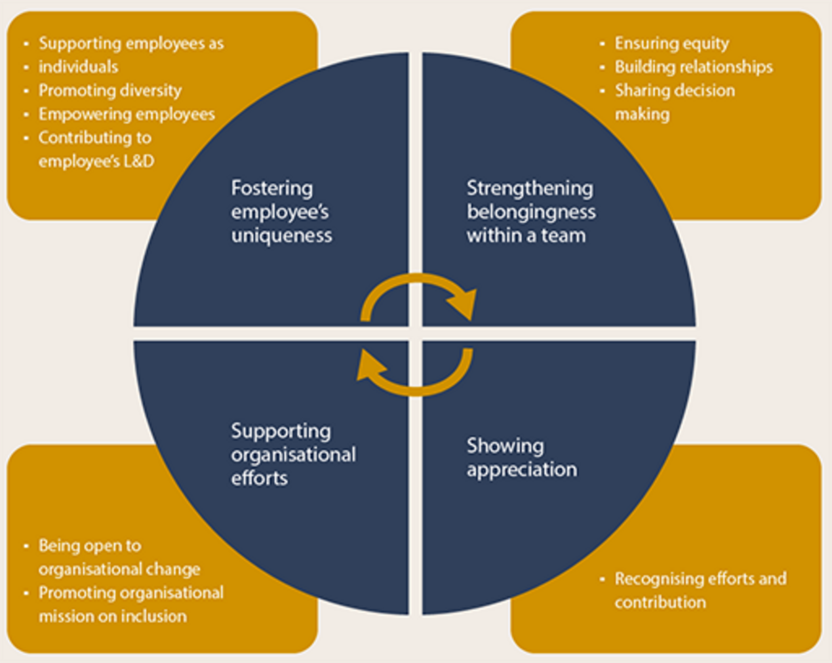
Figure 2 Consolidated conceptualisation of inclusive leadership.(Korkmaz et al, 2022)
View description - Figure 2 Consolidated conceptualisation of inclusive leadership.(Korkmaz et al, 2022) ...
View alternative description - Figure 2 Consolidated conceptualisation of inclusive leadership.(Korkmaz et al, 2022) ...

Back to - Activity 2 Where would you like to be?

Activity 3 Choose your theory

Discussion
When reading papers such as these, it seems that some people are seeking to solve complex educational leadership issues by using a single theoretical lens. But as Kwan (2020) notes, there is an underlying inadequacy when we reduce organisational leadership into a singular, conceptual framework. For example, Leo and Barton (2006) point to a couple of inherent challenges for distributive leadership. Firstly, the decision-making authority about what is distributed and to whom is almost certainly going to reside with an executive role, and secondly, many staff members do not wish to undertake additional responsibilities, even if they wish to work in inclusive ways.
It is important to recognise too that there are many different models associated with these theories and useful variations which can help with reflecting upon our practices. For example, MacBeath produced a taxonomy of distribution, to explore the different options available to leaders as they work with the power and authority (see Figure 5). The model includes six typologies of distributed leadership: Formal, Pragmatic, Strategic, Incremental, Opportunities and Cultural. The typologies do not represent single styles since they are evidenced in various ways according to the context and the nature of the people involved. As you work your way clockwise around the figure below, you will see that it starts by describing more formalised ways of distributing leadership and then less tangible ones. It is possible to see here, how a headteacher might find ways to distribute leadership without making it feel like taking on ‘additional responsibilities’.

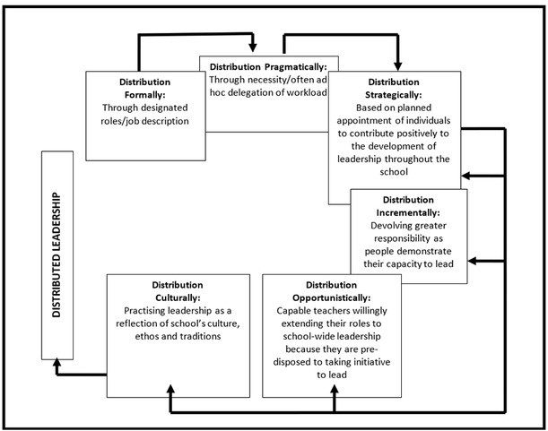
Figure 6 Taxonomy of Distribution, (Macbeath, 2005)
View description - Figure 6 Taxonomy of Distribution, (Macbeath, 2005)

Back to - Activity 3 Choose your theory

Activity 4 How different is difference?

Discussion
It is evident that when an organisation focuses upon the diversity of its stakeholders and balanced representation, it can fail to build meaningful working relationships between them. You may well have experienced being in meetings where you do not feel you can say something because you know it will be going against the flow or would be an unpopular view. You may feel you do not know as much about an issue, or doubt people would be interested in what you have to say or feel it would be too complicated to explain. It might simply be that you want to get the meeting over so you can move on with your day. Whatever the reasons, it has long been recognised that professional discussions in school settings can be selective, partial and highly contextualised (e.g. Warren Little, 2003). The notion of synergy is useful when reflecting on this. Having a clear strategy and goal which specifically seeks to confront the constraints of professional discussions means you are looking for things that go against the flow or might be unpopular to hear. Naïve or complex questions are ones that can be embraced.
The need to build trusting relationships and encourage reflective practice, based around a common vision is something which is evident in all the models discussed above. The challenge of enabling synergy is one which should be embraced in all the models. Of course, where the responsibility for that challenge lies would vary depending upon the theory of leadership and on the context in which it was being operationalised. Regardless of the theory underpinning the approach there seem to be a couple of key challenges for developing synergy, both of which are evident in the previous readings. Firstly, there is the challenge of people being open to each other and their perspectives. This is often something which people need support with. This feeds into the second challenge too. It will take time for synergy to emerge. This will be a slow process, particularly in a culturally rich school environment. As such it is not an approach which can be dipped into and out of; it needs to be a fundamental component of practice. It is a mindset. As Óskarsdóttir et al identify, it is a commitment to the ethic of everybody.
So let us spend a little more time thinking about the challenges and practicalities of developing this mindset and leading in inclusive ways.
Back to - Activity 4 How different is difference?

Activity 5 Reflecting upon all this

Discussion
The quotes above make clear reference to issues such as the nature of the building, the attitudes of people in the setting, external pressures on the school, clashes of personality, expectations and resistance. In the study of primary school leaders mentioned above (DeMatthews et al, 2021), even though the head teachers shared a deep belief in being inclusive and responsive to all, they faced many similar challenges and struggles. These included uncertain regional policies and the amount of paperwork, and also issues such as: the legacies of previous regimes, the historic use of labels, the nature of other programmes in the area and of the support services available to them. They identified difficulties in prioritising scarce resources, building a culture of collaboration, inquiry, and high expectations, as well as the task of staff training. If they wanted to make a difference, therefore, they had to challenge the status quo and many taken-for-granted assumptions.
One of the key assumptions they had to face was a widely held belief in a role for separate provision. As with so many of the issues they identified, they were referring to an issue that is globally relevant. For example, the European Agency for Development in Special Needs Education defines segregation as being in separate special classes or special schools for the largest part (80%) or more of the school day. In 2019, 35% of pupils with identified special educational needs (SEN) in European schools met this definition, spending all or most of their time out of mainstream classrooms (EASIE, 2022). Statistics also highlight the problems of dealing with a whole range of behaviours which are seen as challenging in the mainstream school context. In England, in 2017, for instance, over 7000 pupils were permanently excluded from all types of state schools, with over 400,000 receiving fixed term exclusions (Selfe & Richmond, 2020). These schools also had to respond to an increasingly diverse school population, so In England in 2021 over 20% of pupils were on free school meals, over 30% were from a minority ethnic background and over 19% had a language other than English as their first language (ONS, 2021).
Back to - Activity 5 Reflecting upon all this

Activity 6 Principal views?

Discussion
Many of the issues discussed by the school leaders seem to match with the thoughts raised in the study by DeMatthews et al, but the issue of principal isolation and a sense of being unprepared for the role may be more surprising. This challenge seems to be related to the statistics mentioned at the end of the last section too. The diversity of the school population and the fairly rigid outcomes of the school system puts a great demand on school leaders. They have to be able to access information about a huge range of issues, to make knowledgeable decisions or facilitate meaningful discussions about issues that are personal, professional, cultural, value-laden and ethical. It is easy to see how people can feel isolated, particularly in smaller settings, when faced with such challenges. This is not just an issue for the principals in schools either, but also reflects experiences of other school leaders. For instance, interviews with 19 Deputy principals in Israel highlighted their lack of social relationships with colleagues and resulting sense of loneliness. This included as sense of isolation from those ‘above them’. They identified issues around an imbalance in commitment, expectations and responsibility at work, as well as distrusting school leadership and/or their lack of accountability (Dor-Haim, 2021).
Reflecting on these issues, may make you wonder if there is still something about the hero-leader model that effects our thinking even when we are seeking collaborative and distributed processes. Clearly leaders need to pay attention to how they build alliances with staff, students and local communities to nurture and support both the goals and means of inclusive leadership; this includes considering issues such as succession planning and whether there is a critical mass of people invested in developments. It also feeds back to the issue of building values on a shared understanding, not on one that is simply parachuted in by the school leader but arises using synergistic processes from within the school community. As Macbeath et al (2006) identify, the everyday decisions that teachers and leaders make are fundamentally political. They are interpreting behaviours, deciding where resources should go, making long-terms and short-terms decisions which directly impact on children and their families.
Back to - Activity 6 Principal views?

Activity 7 Thinking about the politics of all this

Discussion
School communities are composed of groups with similar and contrary interests, including pupil groups, parents, subject areas, types of support role, and leadership teams. These groups have formal structures that give them influence and power, such as governing bodies, school councils, class councils, parent associations, subject departments and local authority administrations. They have various institutional functions, with differing capacities to persuade people and make demands on them. Issues such as appointments to roles, line management and promotion are all examples of this, but so too are decisions about curriculum and the provision of additional or special education. All of these are also linked to externally determined norms, regulations, codes of practice and legal acts, and also to a national curriculum, exam boards and funding structures. Schools are situated within the wider community too. They are affected by commitments to such things as children’s rights, pupil exchange programmes or national volunteer services.
These different aspects of the political system are not isolated from each other, of course. For instance, a study in Holland suggested that a benefit for school leaders of being closely involved in collaborations with other schools, was that they were more likely to be approached for advice from their own staff (Moolenaar & Sleegers, 2015). Similarly, working closely with local district administrative leaders can assist head teachers in their relationships with families and communities (Epstein et al, 2011). The interweaving nature of structures, process and their underlying values, means there is always a challenge in relation to balancing priorities. Woodrow & Busch (2008), for instance, provide a couple of examples of how different sets of values can create difficulties for leaders and compromise their intentions. Firstly, an early years leader who fines a very supportive parent for picking up their child late, because she believed that all parents had to be treated the same; and secondly a school leader who chose not to challenge a child’s assertion that you had to be married to have children to avoid upsetting the girl’s mother who worked at the setting. The researchers suggest that the institution’s commitment to (and understanding of) an ethic of care undermined their pedagogical leadership in the curriculum context.
It is against this complex background that senior leaders in schools need to be ‘courageous in their conversations’ (Setlhodi, 2020). If they wish to develop and sustain cooperation across boundaries, they need to involve people from the school community in dialogue about plans and intentions, sharing ideas as part of everyday conversations. This approach is clear in a case study of a principal in the United States, who had a record of success in leading change efforts and developing inclusive schooling (Hoppey & McLeskey, 2013). This principal was focussed upon relationships with the teachers. He displayed trust in them, listened to their ideas and concerns, and sought to treat them fairly.

‘I think my teachers or my big people need to believe that I believe in them and I’m invested in their success. Not just because I want them to be happy, [but] because if they are happy, then there is a better chance that they will be professionally successful.’ (p. 249)

The researchers give examples of the principle doing this: for instance, he invests in software that staff suggest; he pays for them to go to a conference they say will help them support students; and because he believes trust is reciprocal he institutes an annual vote of confidence in his leadership.
This principal wanted to get to know the staff and what was important in their lives. He wanted them to feel supported. Consequently, he often worked with his door open and ensured that he did not have a full diary so that he could informally meet with people for the majority of the school day. He had a belief that he needed to be available for anyone to bounce ideas off him. He liked to listen too, for a long time, before joining in, often with a question.

‘If you want to know what’s important in an organisation, just walk around and listen to what people talk about and that’s what’s important…If people are never talking about school, then that says something. If people are talking about kids, that says a whole lot about the school’. (p. 249)

Back to - Activity 7 Thinking about the politics of all this

Activity 8 Bringing together?

Discussion
In reflecting upon this paper you may have considered the nature of inclusive education under discussion. This seems a political issue from the outset. It is obvious that in the context of this school (or this research), inclusion is being seen as an issue related to Special Education and not as a broader issue related to the full range of people who experience marginalisation as part of the school community. This is despite saying that the school is shifting to a system which is responsive to the needs and characteristics of all students. Earlier in the paper, too, they frame professional development needs as being related to categories of disability, suggesting that the deficit view of the child’s needs is still at play in the setting. Having said this, there are clear examples of the principal trying to drive transformational change. She creates new processes, establishes new roles and prioritises collaborative ways of working. She encourages reflection, feedback and critical engagement with issues. She widens the network of people who have a voice within the institution, too, though it is noticeable that this does not include the children and their families. The children and families seem to be positioned as passive recipients rather than active participants in the leadership process.
There are many aspects of this Peruvian headteacher’s practice that echo the US case study mentioned in the discussion for Activity 7. As with the Peruvian head teacher, the US principal focuses upon the professional and leadership development of his staff. He sees this as a key part of building a collective sense of being fair and of being respectful. Both of these school leaders also see themselves as dealing with national and regional policy issues and see the importance of building professional and personal relationships with local organisations and community members. For the US principal, this includes having key community leaders serve on the School Advisory Council, to assist in preparing the annual school plan and budget; for the Peruvian leader it includes awareness talks and pedagogic strategies.
Both of these school leaders seem to be demonstrating some but not all of the characteristics and theoretical ideas identified in sections 1 & 2. It would be interesting to know if they would consider themselves to be inclusive leaders. But perhaps this should not worry us. As with all tales of leadership there are shortcomings we can identify. In reflecting upon these case studies (and the earlier readings in this course), it should be clear that inclusive leadership is not simply a top-down process, but one which recognises the contextual nature of the school. Afterall, it welcomes critique and reflection upon disagreement, difference, and conflict, and seeks to do this by building relationships between the many voices within its community.
Back to - Activity 8 Bringing together?

Figure 1

Description
Speech bubble image with the text: Are we talking about the same thing?
Back to - Figure 1

Figure 2 Consolidated conceptualisation of inclusive leadership.(Korkmaz et al, 2022)

Description
Diagram of a circle cut into four, and a square following on from each segment of the circle. In the centre of the circle, there are two arrows, going clockwise, creating a circle shape.
From the top left, the first segment has the text: Fostering employee’s uniqueness. The square linked with this segment has the following text:
- Supporting employees as individuals
- Promoting diversity
- Empowering employees
- Contributing to employees’ L&D
The top right segment has the text: Strengthening belongingness within a team. The square linked with this segment has the following text:
- Ensuring equity
- Building relationships
- Sharing decision making
The bottom left segment has the text: Supporting organisational efforts. The square linked with this segment has the following text:
- Being open to organisational change
- Promoting organisational mission on inclusion
The bottom right segment has the text: Showing appreciation. The square linked with this segment has the following text: Recognising efforts and contribution.
Back to - Figure 2 Consolidated conceptualisation of inclusive leadership.(Korkmaz et al, 2022)

Figure 3 At what level?

Description
Cartoon image of a child and an adult. The child is asking the adult ‘So is learning political, miss?’
Back to - Figure 3 At what level?

Figure 4

Description
Speech bubble image with the text: What do you think?
Back to - Figure 4

Figure 5 The theories underpinning a model of inclusive leadership (Óskarsdóttir et al, 2020)

Description
A diagram with one big circle in the centre. In the centre circle, there is the following text:
Inclusive Leadership
Setting direction: shared vision with high expectations for all; monitoring
Human development: professional development; reflective practice; inclusive pedagogy
Organisational development: inclusive culture; partnership & collaboration; shared tasks
Above this are three boxes, all with arrows pointing towards the centre circle. From left to right, the boxes have the following text
Transformational leadership
Distributed leadership
instructional leadership
Back to - Figure 5 The theories underpinning a model of inclusive leadership (Óskarsdóttir et al, 2020)

Figure 6 Taxonomy of Distribution, (Macbeath, 2005)

Description
A box diagram that shows a process. The first box has the following text:
Distribution Formally: Through designated roles/job description
This then has an arrow going to the next box:
Distribution Pragmatically: Through necessity/often ad hoc delegation of workload
This then has an arrow going to the next box:
Distribution Strategically: Based on planned appointment of individuals to contribute positively to the development of leadership throughout the school
This then has an arrow going to the next box:
Distribution Incrementally: Devolving greater responsibility as people demonstrate their capacity to lead
This then has an arrow going to the next box:
Distribution Opportunistically: Capable teachers willingly extending their roles to school-wide leadership because they are pre-disposed to taking initiative to lead
This then has an arrow going to the next box:
Distribution Culturally: Practising leadership as a reflection of school's culture, ethos and traditions
This then has an arrow going to the final box:
DISTRIBUTED LEADERSHIP
Back to - Figure 6 Taxonomy of Distribution, (Macbeath, 2005)

Figure 7

Description
Speech bubble image with the text: Actually, it is quite complicated.
Back to - Figure 7

Figure 8 A moment of inspiration?

Description
Cartoon image of a person with their hands in the air with the text: It’s fantastic news everyone! There’s a new policy initiative!
Back to - Figure 8 A moment of inspiration?

Figure 9

Description
Speech bubble image with the text: Are we really in this together?
Back to - Figure 9

Figure 10 Getting it wrong

Description
A cartoon image of different leaders sat at a table with their hands on their ears. Behind them is the text: Down with the cult of personality! Long live collective leadership!
Back to - Figure 10 Getting it wrong

Video 1 Inclusive leadership (Please note this video has no spoken audio.)

Transcript
[TEXT ON SCREEN]
Inclusive leadership
Some say inclusive leadership is about…
valuing diversity
active listening
giving up power and empowering others
going the path together
we believe it is all of this and much more…
about truly being myself with my emotions, strengths and weaknesses
it is about being aware that we are all interconnected
taking decisions that value the resources in our world
it is about having the courage to break down barriers for people at risk of being excluded from society
the aim of inclusive leadership is to…
CREATE CHANGE INNOVATE
whilst balancing everybody’s need
inclusive leadership
want to unwrap your own inclusive leadership package?
check out our website www.alp-network.org
This video has been funded with support from the European Commission. It reflects the views only of the Author, and the Commission cannot be held responsible for any use which may be made of the information contained therein.
Co-funded by the Erasmus+ Programme of the European Union.
VisEUalisation - How to develop innovative digital educational videos
Back to - Video 1 Inclusive leadership (Please note this video has no spoken audio.)

Figure 1

Alternative description
Speech bubble image with the text: Are we talking about the same thing?
Back to - Figure 1

Figure 2 Consolidated conceptualisation of inclusive leadership.(Korkmaz et al, 2022)

Alternative description
Diagram of a circle cut into four, and a square following on from each segment of the circle.
Back to - Figure 2 Consolidated conceptualisation of inclusive leadership.(Korkmaz et al, 2022)

Figure 3 At what level?

Alternative description
Cartoon image of a child and an adult. The child is asking the adult ‘So is learning political, miss?’
Back to - Figure 3 At what level?

Figure 4

Alternative description
Speech bubble image with the text: What do you think?
Back to - Figure 4

Figure 7

Alternative description
Speech bubble image with the text: Actually, it is quite complicated.
Back to - Figure 7

Figure 8 A moment of inspiration?

Alternative description
Cartoon image of a person with their hands in the air with the text: It’s fantastic news everyone! There’s a new policy initiative!
Back to - Figure 8 A moment of inspiration?

Figure 9

Alternative description
Speech bubble image with the text: Are we really in this together?
Back to - Figure 9

Figure 10 Getting it wrong

Alternative description
A cartoon image of different leaders sat at a table with their hands on their ears. Behind them is the text: Down with the cult of personality! Long live collective leadership!
Back to - Figure 10 Getting it wrong

