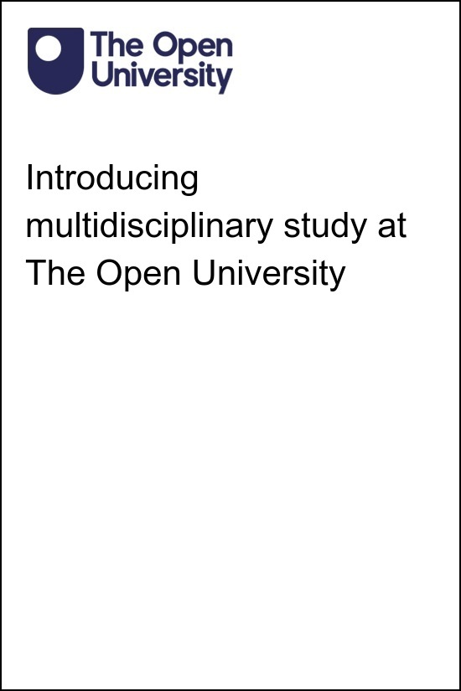

MOU_1 Introducing multidisciplinary study at The Open University

Introducing multidisciplinary study at The Open University

This publication forms part of the Open University module MOU_1 - Introducing multidisciplinary study at The Open University . Details of this and other Open University modules can be obtained from Student Recruitment, The Open University, PO Box 197, Milton Keynes MK7 6BJ, United Kingdom (tel. +44 (0)300 303 5303; email general-enquiries@open.ac.uk).
Alternatively, you may visit the Open University website at www.open.ac.uk where you can learn more about the wide range of modules and packs offered at all levels by The Open University.
The Open University,
Walton Hall, Milton Keynes
MK7 6AA
First published 2023.
Unless otherwise stated, copyright © 2023 The Open University, all rights reserved.
All rights reserved. No part of this publication may be reproduced, stored in a retrieval system, transmitted or utilised in any form or by any means, electronic, mechanical, photocopying, recording or otherwise, without written permission from the publisher or a licence from The Copyright Licensing Agency Ltd. Details of such licences (for reprographic reproduction) may be obtained from: The Copyright Licensing Agency Ltd, 5th Floor, Shackleton House, 4 Battle Bridge Lane, London, SE1 2HX (website www.cla.co.uk).
Open University materials may also be made available in electronic formats for use by students of the University. All rights, including copyright and related rights and database rights, in electronic materials and their contents are owned by or licensed to The Open University, or otherwise used by The Open University as permitted by applicable law.
In using electronic materials and their contents you agree that your use will be solely for the purposes of following an Open University course of study or otherwise as licensed by The Open University or its assigns.
Except as permitted above you undertake not to copy, store in any medium (including electronic storage or use in a website), distribute, transmit or retransmit, broadcast, modify or show in public such electronic materials in whole or in part without the prior written consent of The Open University or in accordance with the Copyright, Designs and Patents Act 1988.
Edited and designed by The Open University.

ISBN XXX X XXXX XXXX X
1.0

Contents
- Introduction
- 1 Welcome to your Open qualification
- 2 Finding your way around
- 3 Planning your studies
  - 3.1 Open YXM modules
- 4 Community and belonging
- 5 Career development and planning for your future
- 6 End-of-course quiz
- Conclusion
- Acknowledgements
- Solutions
- Descriptions

Introduction
Our Open qualifications are one of the most popular pathways of study at The Open University (OU). These qualifications allow you to combine different subjects in your qualification, enabling you to see how they can relate, connect and even influence each other. This is also known as multidisciplinary study.
There are a number of modules and qualifications at the OU which support multidisciplinary study from the Social Sciences, Arts and Sciences curriculum areas. However, for this course, we’re focusing on the Open qualifications which are the OU’s most flexible qualifications. The Open qualifications include:
- BA/BSc (Hons) Open degree
- BSc (Hons) Combined STEM degree
- MA/MSc Open

Activity 1

Watch our short animation introducing our qualifications. What are your first impressions? What do you think the value of qualifications like these are?

Video content is not available in this format.
Video 1: The Open qualifications
View transcript - Video 1: The Open qualifications



Provide your answer...
View discussion - Activity 1

1 Welcome to your Open qualification
Did you know the Open degree was the OU’s first degree and it was called a ‘General BA’? It was the precursor to the BA/BSc (Hons) Open degree that we know today. The Open degree was the only degree programme awarded at the OU until the 2000s which is when named degrees were introduced. The BSc Combined STEM degree was introduced in 2017 due to student demand for an interdisciplinary Science, Technology, Engineering and Mathematics degree and the MA/MSc Open is our most recent addition at postgraduate level.
You can learn more about the history of the Open qualifications by visiting the Open digital exhibition.

Activity 2

Choose two sections of the digital archive to read. Which sections did you choose and why?

Provide your answer...
View discussion - Activity 2

Open qualifications provide the opportunity to choose from a range of different subjects, allowing you to learn in different ways and to develop a wide range of skills. At other universities, multidisciplinary qualifications may include combined honours, joint honours and interdisciplinary degrees. To refresh your knowledge about Open qualifications visit the online prospectus pages for each qualification:
- BA/BSc Open
- Combined STEM BSc
- MA/MSc Open

Reflection

Why did you/would you choose an Open qualification?

Provide your answer...
View discussion - Reflection

2 Finding your way around

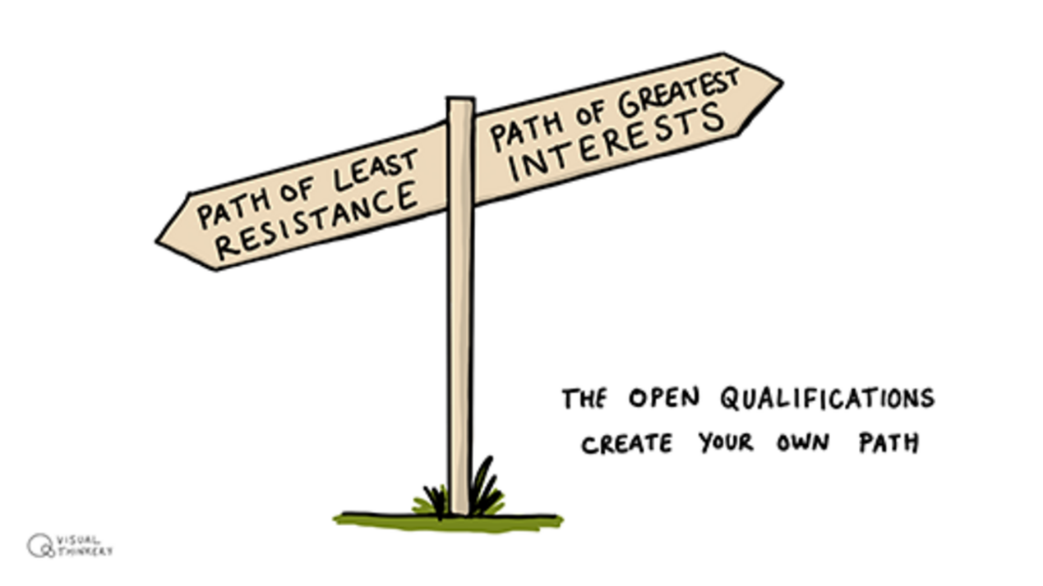
Figure 1: Create your own path
View description - Figure 1: Create your own path
View alternative description - Figure 1: Create your own path

You can find lots of information about your Open qualification through the Open qualification study websites. There are five different dropdown tabs for you to explore on these sites:
- Connect
- Discover
- Skills
- Plan
- Succeed
Here you can access resources to help connect with other students also studying Open qualifications, discover what subjects are available with links to faculty specific information and guidance relevant to your module selection, explore the skills you need, plan your qualification and find out what happens when you succeed.
The qualifications site has an online room where drop-in sessions and workshops are held on employability, choosing your next module and referencing and there are even opportunities to chat with the team who support the Open qualifications.
You can find the qualification study sites here:
- BA/BSc Open degree website
- Combined STEM website
- MA/MSc Open website
Registered students with the OU can also access the qualification sites via their StudentHome page by clicking on the Study tab.

Activity 3

Go to the qualification study site for your Open qualification and spend 15 minutes having a look around. Note down here what you spent the most time looking at and why.

Provide your answer...
View discussion - Activity 3

The Open qualification study sites are in addition to your module specific website, TutorHome and remember there’s the HelpCentre which also has useful information to support your studies.

3 Planning your studies

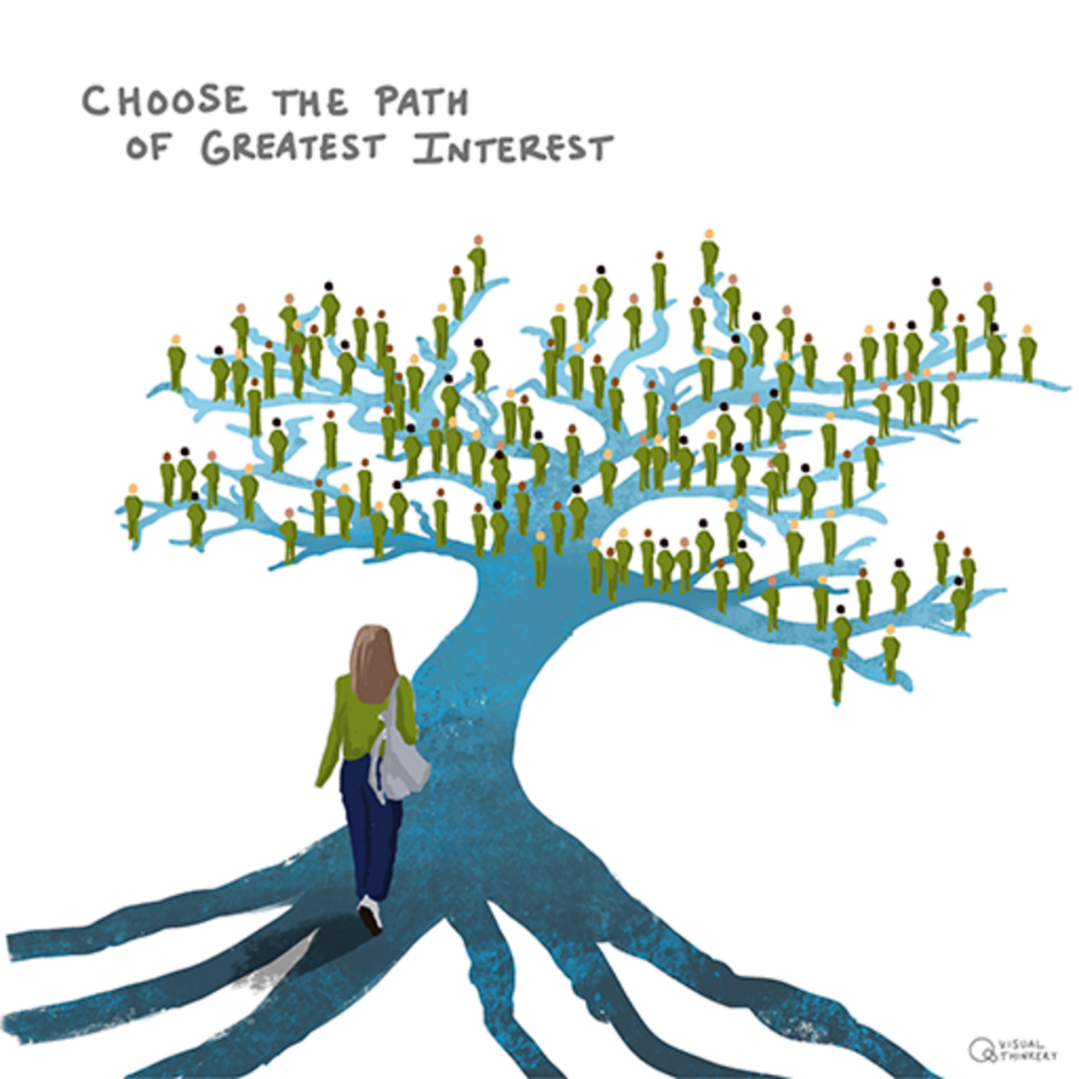
Figure 2: Choose the greatest path of interest
View description - Figure 2: Choose the greatest path of interest
View alternative description - Figure 2: Choose the greatest path of interest

The Open qualifications provide you with the opportunity to study any subject(s) you like in many combinations; Figure 3 shows some of the subject areas offered.

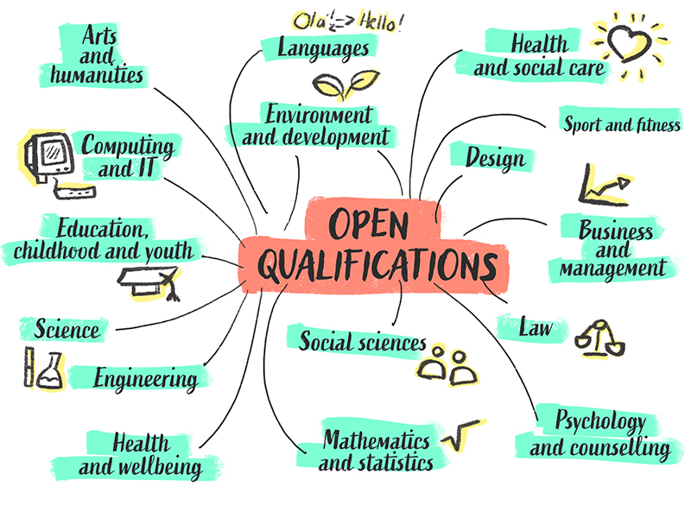
Figure 3: The Open qualifications subject areas
View description - Figure 3: The Open qualifications subject areas
View alternative description - Figure 3: The Open qualifications subject areas

However, it is still important to choose your modules carefully because with so many modules to choose from, we appreciate it can be difficult to know where to start!
We recommend your first step is to explore the information on the Open qualifications study sites which have a section of resources to help you plan your study and choose your modules, at all stages of your qualification. You can find these resources on the Plan tab (Plan your qualification) here:
- BA/BSc Open degree website
- Combined STEM website
- MA/MSc Open website
These pages are designed to help and support you to plan ahead so you are in the best place to do well. Ensuring you have a good foundation in the earlier stages of your study will place you in a strong position to succeed.

Activity 4

Spend 10 minutes reading the section on Plan your qualification on the appropriate qualification site and see if you can map out the subjects you’d like to study or, if you’re considering studying at Masters level, have a look at the different study routes and find the one that fits with your interests and aspirations.

Provide your answer...
View discussion - Activity 4

You can also seek individualised information, advice and guidance from your Student Support Team (SST). Our Student Support Teams are specialists made up of experienced academics, educational advisers and other staff with subject-specific expertise. They can provide advice and guidance both on module choice and on qualification planning.
If there is a specific subject area you would like to concentrate your study on, they can help ensure you include the necessary pre-requisite modules to help you succeed in the later stages of your qualification. If you decide to change direction in your subject areas, they can help with module choice and preparation.
We understand students’ interests and aims can change over time and that’s ok. We can work with you to adapt your study plans and ensure your focus is in line with new goals.
The flexibility of the Open qualification means you have the ability to change your plans and our SSTs are always on hand to help guide you.

3.1 Open YXM modules
Did you know we also offer Open modules which you can count towards your Open qualification? These modules are unique and allow students to personalise their study. Currently there are two Open modules:
- Undergraduate module: Making your learning count (YXM130)
- Postgraduate module: Advance your independent learning (YXM830)
YXM130 is an OU Level 1 module that allows you to count different forms of study, like OpenLearn courses (including this one), professional qualifications, Coursera and other Open Educational Resources (OERs) towards a formal OU qualification, including the Open degree. You can find out a little more about YXM130 by visiting here and by watching the short animation below.
The range of options for building your YXM130 study is endless. To help with the choices, the module team have created some example study pathways to see how you can create your own module.

Video content is not available in this format.
Video 2: Making your learning count
View transcript - Video 2: Making your learning count

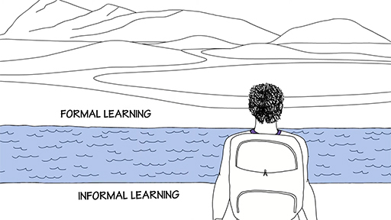

YXM830 is a postgraduate module which is personalised and offers the flexibility of exploring in depth a topic of your choice at Masters level. You can include YXM830 as part of a MA/MSc Open. This module also allows you to draw on different types of learning as a way of advancing your research skills. There’s more on the module here and in this video:

Video content is not available in this format.
Video 3: Advance your independent learning
View transcript - Video 3: Advance your independent learning



4 Community and belonging

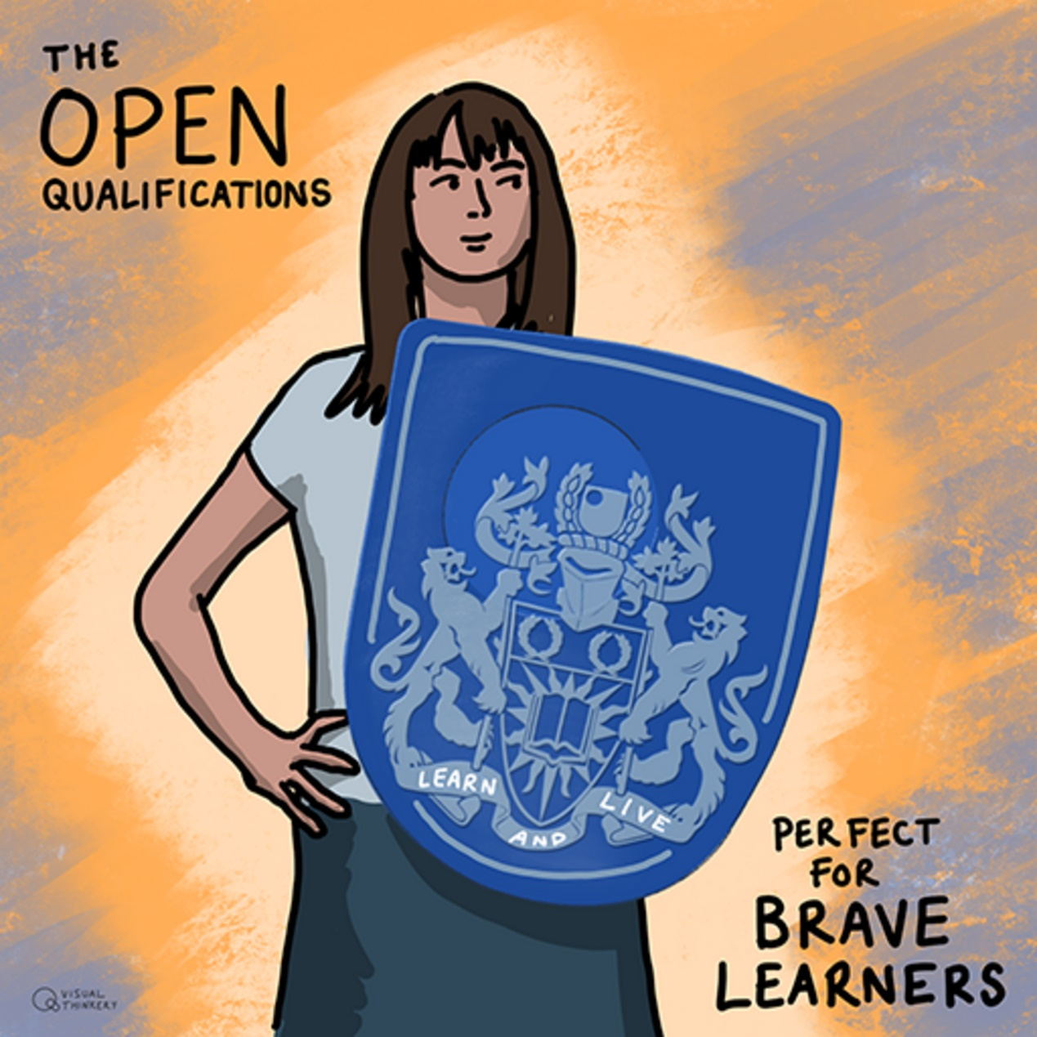
Figure 4: Brave learners
View description - Figure 4: Brave learners

Open qualifications bring together a diverse network of students with different backgrounds, motivations for study, interests and career aspirations. You may find you’re one of a few students on your module studying for an Open qualification whilst other students are on a named degree pathway and so may have studied previous modules relating to that subject.
Studying an Open qualification makes you a brave learner as you’re using your own knowledge and experience to direct your course of study. Whilst there are many benefits to this way of studying, we also recognise some of the challenges this might bring, including making decisions about what module to study next, adapting to different approaches in disciplines (such as referencing) or how to access timely advice and guidance. We support a virtual community of multidisciplinary students and have created opportunities for you to embrace the space between your modules to connect with other students, reflect on your study pathway and qualification aims.
You can connect with other students studying an Open qualification in various ways including via the student-led Facebook group student forums, hosted on the qualification subject site, where students can ask questions about module choices, pathways and module combinations.
Don’t forget the Open University Students Association has a thriving community with several opportunities to get involved in their different interest groups.

Activity 5

Select one of these opportunities to engage with the wider Open community and explore it further. Note down some of the benefits engaging with the wider study community might bring you.

Provide your answer...

5 Career development and planning for your future

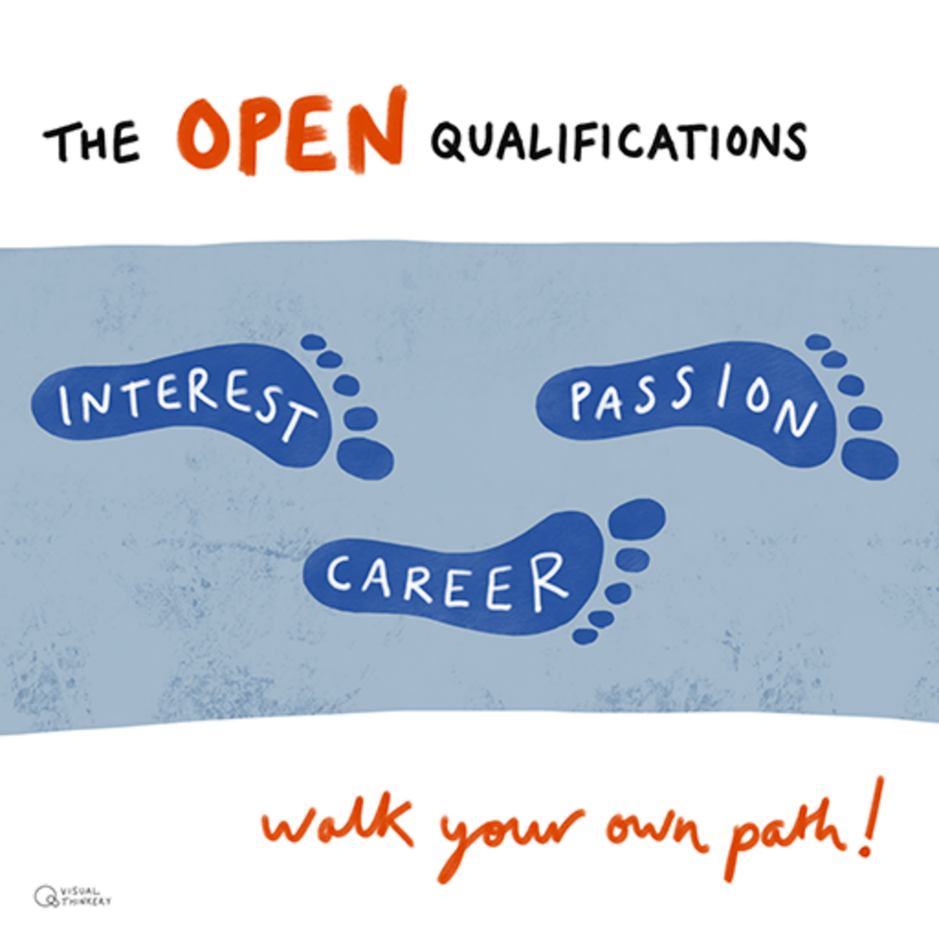
Figure 5: Walk your own path
View description - Figure 5: Walk your own path
View alternative description - Figure 5: Walk your own path

Part of your learning journey will include thinking about your future career choices and planning for your future. It is therefore important to consider and carry out research into career options. Studying across subjects helps you to bring together skills, knowledge and different perspectives which can help open up your career options. On the Qualification Sites there are specific resources under the Plan tab (Plan your career) here:
- BA/BSc Open website
- BSc Combined STEM website
- MA/MSc Open website
The Open qualifications site provides links to online career tools, such as FutureYOU, that can be used to identify careers based on your interests and skills. This tool is a personal space where you can reflect on your achievements and plan your future.

Activity 6

Watch the short video presenting FutureYOU and explore the resources and assets offered. Note down any skills that you might want to develop in your studies or areas for you to focus on.

Video content is not available in this format.
Video 4: FutureYOU
View transcript - Video 4: FutureYOU

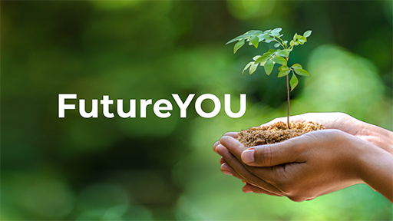

Provide your answer...

On the Qualification Sites you will find information from the Careers and Employability Services (CES) who can also support you with ensuring you’re studying the right modules for your career aspirations.

Activity 7

Take the time to explore materials from the Careers and Employability Service (CES) on these sites. Knowing how to articulate your studies and qualification to employers and the combinations of subjects you have chosen is something students have said is an important skill. You can also explore resources to help produce CVs, learn more about employers and engage in forums.

These sites also include interesting case studies of students who have completed their Open qualification so you can see how they used their knowledge and skills to develop their careers.
To further support your understanding of multidisciplinary study and what this means for your career development and future planning, the Open qualifications team have created a short, badged OpenLearn course: ‘Multidisciplinary study: the value and benefits’.


Figure 6: Multidisciplinary study: the value and benefits
View description - Figure 6: Multidisciplinary study: the value and benefits
View alternative description - Figure 6: Multidisciplinary study: the value and benefits

The course is interactive and features videos to explore what multidisciplinary study is, what you can gain by studying a multidisciplinary qualification and how it can benefit your career prospects. If you’re interested in learning more about the benefits of multidisciplinary study you can find some great articles on OpenLearn too, including this article, ‘What are the benefits of interdisciplinary study?’, written by Professor Martin Weller, Director of the Open Qualification . Other resources related to studying across subjects which you might find helpful can be found in this interdisciplinary study collection.

Reflection

Where do you see yourself in five-years time? What steps do you need to put in place to help you to get where you want to be? What help or support do you need to help you along the way?

Provide your answer...
View discussion - Reflection

6 End-of-course quiz
Now it’s time to complete the compulsory badged quiz.
End-of-course quiz
Remember, this quiz counts towards your badge. If you’re not successful the first time, you can attempt the quiz again in 24 hours.
Open the quiz in a new window or tab then come back here when you’ve finished.

Conclusion

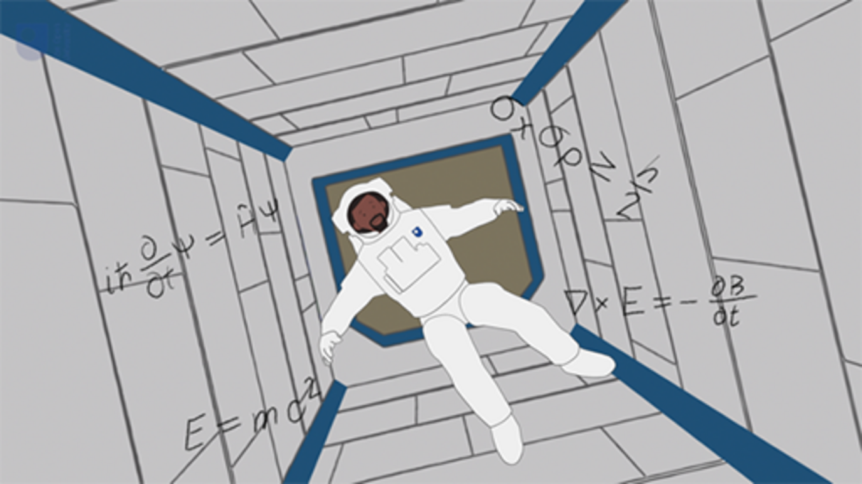

Bringing together knowledge from different subjects, understanding how and where they cross over or influence each other can be exciting and daunting at the same time. Coupled with learning how to find your way around the wealth of information on the OU’s systems, this can be challenging.
We hope your journey in this short course has gone some way to helping you to navigate some of these challenges and set you up to succeed in your studies.
Remember, with the Open qualifications the sky’s the limit!
What will your Open qualification look like?

Acknowledgements
This free course was written by Rehana Awan with support from Jay Rixon and Mary Keys.
Except for third party materials and otherwise stated (see terms and conditions), this content is made available under a Creative Commons Attribution-NonCommercial-ShareAlike 4.0 Licence .
The material acknowledged below (and within the course) is Proprietary and used under licence (not subject to Creative Commons Licence). Grateful acknowledgement is made to the following sources for permission to reproduce material in this free course:

Course image
Course Image: Bryan Mathers, Visual Thinkery, https://creativecommons.org/licenses/by-nc-nd/4.0/

Figures
Figures 1, 2, 4 and 5: Bryan Mathers, Visual Thinkery; https://creativecommons.org/licenses/by-nc-nd/4.0/
Figure 6: DrAfter123/iStockphoto.com

Audio Visual
All videos © The Open University and its Licensors
Every effort has been made to contact copyright owners. If any have been inadvertently overlooked, the publishers will be pleased to make the necessary arrangements at the first opportunity.
Don’t miss out
If reading this text has inspired you to learn more, you may be interested in joining the millions of people who discover our free learning resources and qualifications by visiting The Open University – www.open.edu/ openlearn/ free-courses.

Solutions

Activity 1

Discussion
This type of study enables students to draw on the skills, knowledge and expertise of different subjects and is said to be the future of learning. Being able to understand and analyse a project or problem from a number of viewpoints or through different lenses can generate creative solutions to some of the world’s most challenging problems, like climate change or poverty.
Back to - Activity 1

Activity 2

Discussion
We hope you enjoyed finding out a little more about the Open qualifications, innovative curriculum design, the value of multidisciplinary study or being a brave learner.
Back to - Activity 2

Reflection

Discussion
You may have said it’s because you wanted to tailor your modules to suit your career or personal interests or perhaps you decided to change to an Open qualification part-way through your studies because you found another subject which excited you. Whatever your reasons for combining different subjects from across the curriculum, we’re delighted you’re studying an Open qualification and are able to benefit from combining different subjects!
Back to - Reflection

Activity 3

Discussion
We hope you found the Open qualifications site useful. It’s a really important resource to support students and we want to make sure all Open qualification students know where to find it.
Back to - Activity 3

Activity 4

Discussion
What you’ve written will be individual to your needs and interests. Hopefully this activity got you thinking about what modules or study route you’re interested in, but also when the modules start, what prerequisite knowledge you might need (what previous modules you need to have studied) and how your qualification fits together.
Back to - Activity 4

Reflection

Discussion
Wherever you want to end up, having a plan to get you there is more likely to guarantee success of you achieving your goals. There are a number of resources, people and support materials to help you to make your goals realisable and we hope we’ve managed to signpost to some of those here.
Back to - Reflection

Descriptions

Figure 1: Create your own path
An illustration showing a two-way sign post pointing northeast and southwest
Back to - Figure 1: Create your own path

Figure 1: Create your own path
An illustration showing a two-way signpost: the left post points southwest with the text ‘Path of least resistance’. The right post points northeast with the text ‘Path of greatest interests’. On the bottom right, it has the text ‘The Open qualifications create your own path’ All text in capitals.
Back to - Figure 1: Create your own path

Figure 2: Choose the greatest path of interest
An illustration of a large tree with little people figures on the branches.
Back to - Figure 2: Choose the greatest path of interest

Figure 2: Choose the greatest path of interest
An illustration of a large tree with many branches. Its trunk and roots are thick, and on its branches are little people figures. The words ‘Choose the greatest path of greatest interest’ are displayed at the top left corner. Text in capitals.
Back to - Figure 2: Choose the greatest path of interest

Figure 3: The Open qualifications subject areas
Illustration showing different Open qualification subject areas:
Back to - Figure 3: The Open qualifications subject areas

Figure 3: The Open qualifications subject areas
Mind map illustration showing different Open qualification subject areas. The general structure is three vertical sections with ‘Open qualification’ at the centre of the middle section:
First section:
Arts and humanities
Computing and IT
Education, childhood and youth
Science
Engineering
Health and wellbeing
Middle section:
Languages
Environment and development
Social sciences
Mathematics and statistics
Third section
Health and social care
Sport and fitness.
Design
Business and management
Law
Psychology and counselling
Back to - Figure 3: The Open qualifications subject areas

Figure 4: Brave learners
An illustration showing a young woman standing with her left hand on her hip and the right hand holding a large blue shield that has the Open University crest. On the bottom of the crest is the text ‘Live and learn’. At the top right corner is the text in caps ‘The Open qualifications’ and at the bottom right corner is the text in caps ‘Perfect for brave learners’. All text in capitals.
Back to - Figure 4: Brave learners

Figure 5: Walk your own path
An illustration of footprints
Back to - Figure 5: Walk your own path

Figure 5: Walk your own path
An illustration showing three footprints in a blue shaded box. Inside the footprints are the text in caps (from left to right): ‘Interest', ‘Career’, and ‘Passion’. Above the shaded box are the words in caps ‘The Open qualifications’ and beneath the box are the words ‘walk your own path!’
Back to - Figure 5: Walk your own path

Figure 6: Multidisciplinary study: the value and benefits
Image showing various illustrations and icons representing student thinking.
Back to - Figure 6: Multidisciplinary study: the value and benefits

Figure 6: Multidisciplinary study: the value and benefits
Image showing various illustrations and icons representing student thinking (speech bubbles, cogs, question mark etc.). At the top left corner is the Multidisciplinary study: the value and benefits OpenLearn BOC badge.
Back to - Figure 6: Multidisciplinary study: the value and benefits

Video 1: The Open qualifications

Transcript
In today’s world solutions to key challenges like pollution, climate change, or sustainable growth require expertise from a range of subjects.
Exploring everyday problems through the lens of different disciplines provides exciting opportunities to find ways in which subjects connect and influence each other.
Flexible study has always been at the heart of the Open University.
Our unique Open qualifications allow you to combine subjects and develop your knowledge and skills across a range of disciplines.
Enabling you to study in a multidisciplinary way.
You set the direction of your learning, creating a personalised pathway to match your interests, aspirations and objectives.
The BA or BSc Open is one of the most flexible qualifications in the UK, you can study many subjects in various combinations.
From criminology and computing to business and languages.
Or you can build your own individual science, technology, engineering and mathematics degree with the BSc Combined STEM.
Finally, the MA/MSc Open is an innovative masters degree, which means you can expand your existing discipline-related knowledge to pursue options related to your professional development.
People change jobs and careers throughout their life. The open qualifications enable you to align your study to your goals and aspirations.
Complex problems need flexible and creative solutions from people who can adapt.
With the Open qualifications the sky is the limit.
What will your Open qualification look like?
Back to - Video 1: The Open qualifications

Video 2: Making your learning count

Transcript
Your learning journey at The Open University may be for pleasure, or you may wish to work towards a formal qualification.
For example, a certificate a diploma or a degree potentially giving you more choices in your career and increasing your income, but whatever journey lies ahead, crossing from informal learning such as taking free courses on OpenLearn, to learning which is formally assessed and costs money can be easier than you think.
'Making your learning count' is a highly flexible OU module, which lets you use informal learning that you may have already completed, to make a start on more formal learning, working towards getting a valuable qualification.
You may have already studied a short OpenLearn course for example in psychology or climate change.
These will be the starting point as you plan your module. With the one-to-one support of a personal tutor you can choose a blend of subjects that interest you, and that could form part of your future learning.
Your assessment for the module is based on a series of tasks such as designing a poster, and making a video about courses you studied, or reflecting on a topic from more than one angle. All these elements put together will make up your first steps in formal learning.
Your tutor will be with you throughout, marking your tasks and giving you invaluable feedback not only earning you credit towards a qualification, but helping to map out your future learning and plan for your ongoing learning journey, at The Open University.
Back to - Video 2: Making your learning count

Video 3: Advance your independent learning

Transcript
What if you had the freedom to design your very own module? Think of a question or problem that you’d like to explore. It could be anything, such as 'What are the benefits of outdoor swimming?'.
In time you may well refine your question into something more specific, such as 'How does exercise improve mental health?' The quest to unravel the answer to your question could be the start of a unique journey of study tailored just for you.
It may be that you have a particular challenge in your life, either at home or at work. The module is your chance to answer your own question in a rigorous and structured way.
Working with your tutor on YXM830, you are in the driving seat. You can navigate topics and cross subject disciplines in your own learning adventure. You get a chance to take control of your studies and design and complete your own investigation to suit your own long term objectives.
You’ll be exploring and bringing together information from a wide range of sources and different media: Academic journals, reports, research papers, multimedia content and blogs as well as books.
You can include in your learning time free online courses or professional development courses you’ve already completed.
As well as working with you tutor, you get input from other students taking the module, which gives you different perspectives, as you present your work for feedback at each step of the process.
At the end of the module, you can present your findings in a variety of ways from an animation to an in-depth written report. You'll also have a chance to reflect on your learning journey, how your ability to research and learn independently has improved and how you may use your new skills in other aspects of your life.
What's your question?
Back to - Video 3: Advance your independent learning

Video 4: FutureYOU

Transcript
[MUSIC PLAYING]
AYESHA:
To get ahead it’s hugely important to be prepared. Planning your future in an uncertain world may seem harder than ever. But the OU designed FutureYOU will help you do just that.
FutureYOU is an online tool that helps you plan your personal development, plan your study journey, and review your progress. Here are some of the ways that FutureYOU can help you.
The reflection area helps to highlight the employability skills and attributes to develop as you study your own module. Identify and plan prompts you to identify the learning you gain from your experience in the world and reflect on and draw learning from these experiences.
The action and record area introduces learning logs to help keep you on track.
You will build up an invaluable set of resources as you move towards your personal, academic and professional goals.
It’s an ongoing process of reviewing and reflecting.
FEMALE:
It’s very easy to forget how many skills and experiences one accumulates through life. The FutureYOU site allows you to layout what you have achieved so you can match the necessary skills to your goals.
FEMALE:
FutureYOU has definitely helped me to think about goals and my employability.
MALE:
I’m starting to understand I have more assets than I first realised and that with a new approach I can broaden my horizons.
AYESHA:
FutureYOU is available to you throughout your studies and for three years after qualifying too.
FutureYOU could be just what you need to turn your OU learning into success beyond study. Take some time to explore FutureYOU and see how it can help you plan for a successful future.
[MUSIC PLAYING]
Back to - Video 4: FutureYOU

